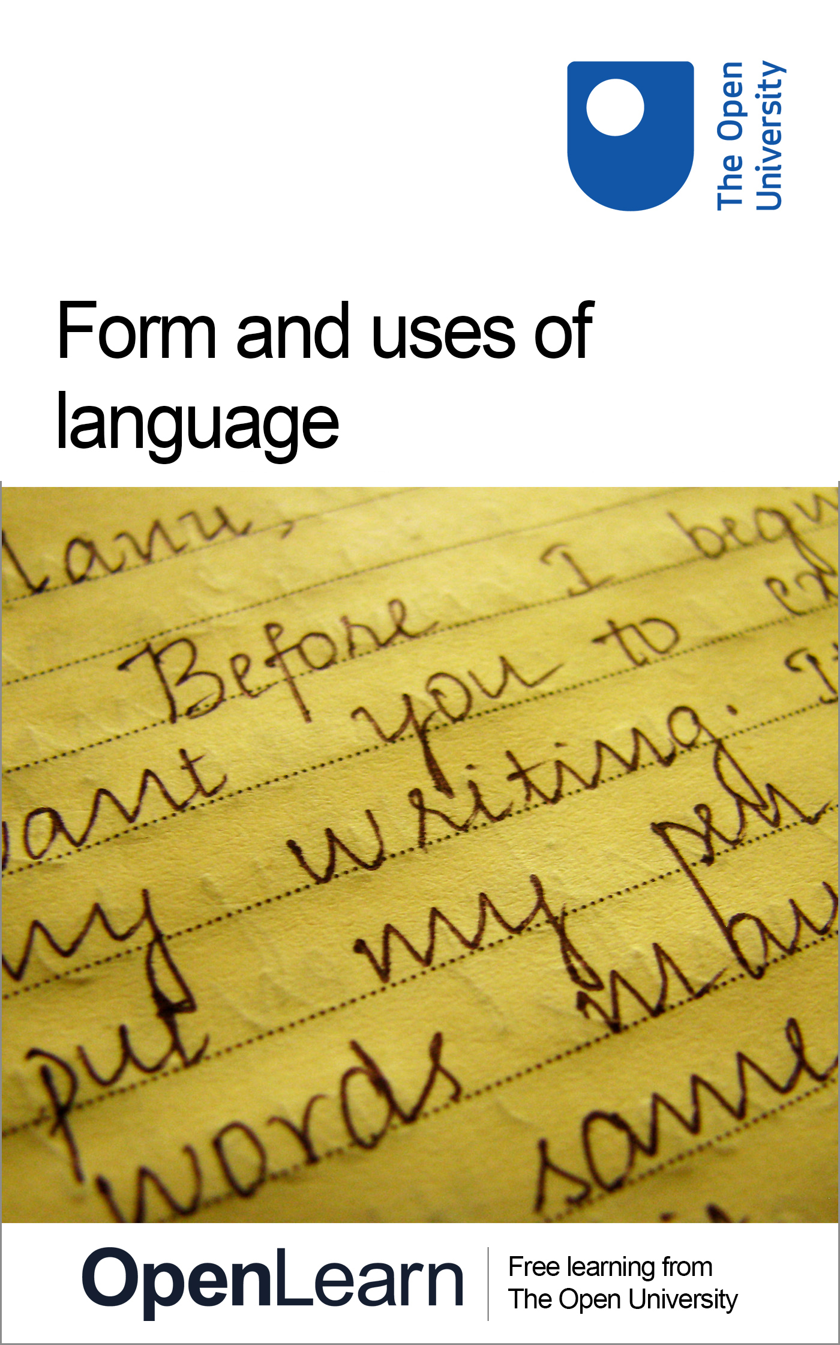

A103_5

Form and uses of language
About this free course
This free course provides a sample of Level 1 study in Arts and Humanities: http://www.open.ac.uk/courses/find/arts-and-humanities.
This version of the content may include video, images and interactive content that may not be optimised for your device.
You can experience this free course as it was originally designed on OpenLearn, the home of free learning from The Open University – www.open.edu/openlearn/history-the-arts/culture/english-language/form-and-uses-language/content-section-0
There you’ll also be able to track your progress via your activity record, which you can use to demonstrate your learning.
The Open University, Walton Hall, Milton Keynes MK7 6AA
Copyright © 2016 The Open University
Intellectual property
Unless otherwise stated, this resource is released under the terms of the Creative Commons Licence v4.0 http://creativecommons.org/licenses/by-nc-sa/4.0/deed.en_GB. Within that The Open University interprets this licence in the following way: www.open.edu/openlearn/about-openlearn/frequently-asked-questions-on-openlearn. Copyright and rights falling outside the terms of the Creative Commons Licence are retained or controlled by The Open University. Please read the full text before using any of the content.
We believe the primary barrier to accessing high-quality educational experiences is cost, which is why we aim to publish as much free content as possible under an open licence. If it proves difficult to release content under our preferred Creative Commons licence (e.g. because we can’t afford or gain the clearances or find suitable alternatives), we will still release the materials for free under a personal end-user licence.
This is because the learning experience will always be the same high quality offering and that should always be seen as positive – even if at times the licensing is different to Creative Commons.
When using the content you must attribute us (The Open University) (the OU) and any identified author in accordance with the terms of the Creative Commons Licence.
The Acknowledgements section is used to list, amongst other things, third party (Proprietary), licensed content which is not subject to Creative Commons licensing. Proprietary content must be used (retained) intact and in context to the content at all times.
The Acknowledgements section is also used to bring to your attention any other Special Restrictions which may apply to the content. For example there may be times when the Creative Commons Non-Commercial Sharealike licence does not apply to any of the content even if owned by us (The Open University). In these instances, unless stated otherwise, the content may be used for personal and non-commercial use.
We have also identified as Proprietary other material included in the content which is not subject to Creative Commons Licence. These are OU logos, trading names and may extend to certain photographic and video images and sound recordings and any other material as may be brought to your attention.
Unauthorised use of any of the content may constitute a breach of the terms and conditions and/or intellectual property laws.
We reserve the right to alter, amend or bring to an end any terms and conditions provided here without notice.
All rights falling outside the terms of the Creative Commons licence are retained or controlled by The Open University.
Head of Intellectual Property, The Open University
The Open University
Printed in the United Kingdom by the Bath Press, Bath.
978-1-4730-1397-1 (.kdl)
978-1-4730-0629-4 (.epub)

Contents
- Introduction
- Learning outcomes
- 1 Siegfried Sassoon: a case study
  - 1.1 Introduction
  - 1.2 The early years
  - 1.3 The realities of war – a protest
  - 1.4 ‘The General’
  - 1.5 Sassoon's ‘Protest’
  - 1.6 Sassoon's 'Protest': exercise
  - 1.7 More Sassoon voices: exercise
- 2 Using language in poetry and prose
  - 2.1 Using poetry: exercise
  - 2.2 Conveying meaning through prose
  - 2.3 Choosing your voice: exercise
- Conclusion
- Keep on learning
- References
- Acknowledgements

Introduction
In this course we will consider how language can be used in different ways for different purposes. To do this we will use the theme of memorial and commemoration. After briefly discussing the life of the poet Siegfried Sasoon we will examine both his poetry and prose. Through this we will see how he conveys meaning in different ways for different audiences using different forms. Following this we will discuss more generally how different meanings can be conveyed using prose and poetic language.
This OpenLearn course provides a sample of Level 1 study in Arts and Humanities.

Learning outcomes
After studying this course, you should be able to:
- understand how language can be used for different purposes
- understand the importance of form and word choice when addressing different audiences.

1 Siegfried Sassoon: a case study

1.1 Introduction
Apart from writing poetry, Sassoon kept a diary during his war years, and after the war he wrote a semi-autobiographical novel. These writings are an example of how a writer can use language for different purposes and different audiences, while expressing the same theme – in this case, opposition to war. Before we look more closely at Sassoon's work, we need a few more details about his life.

1.2 The early years
He was born in 1886 into a wealthy family. After being educated at home until he was 13, he was sent to a prominent public school, Marlborough. Although he had begun to write poetry at an early age, his expectations – like those of many young men of his generation – were that his privileged life would continue without the need for him to do much more than indulge his hobbies of golf, hunting and socialising. He continued to develop a poetic style and by 1914 had published some poetry and prose. Following his horse-riding interests, he enlisted in 1915 in the Yeomanry, and was sent to the front in France in early 1916. In May 1916 he was engaged in a battle where he showed great bravery. and was awarded the Military Cross. Later he was wounded, and was sent home on sick leave.

1.3 The realities of war – a protest
While he was on leave, his conviction grew that those at home had little idea of the realities of war, and that the war was being deliberately prolonged by the politicians and generals who had the power to end it. He wrote a powerful statement to this effect, and sent it to his commanding officer. He also hoped that his protest would be read in the House of Commons, though fully recognizing that the punishment for this would be the enormous disgrace of a court martial and even prison.
But his protest failed. His commanding officer turned a blind eye to it. and his friends with influence in high places made sure that it was not made public at that time. Sassoon himself was sent to Craiglockhart, the medical hospital for shell-shocked officers. He actively sought to be returned to the front, and was considered sufficiently recovered to do so in 1918. His medical case sheet (Figure 1) is signed by Dr W.H.R. Rivers, who appears as a character in Pat Barker's fictional trilogy about the First World War.

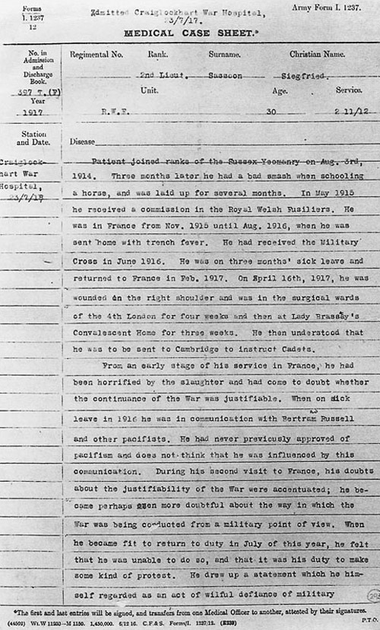

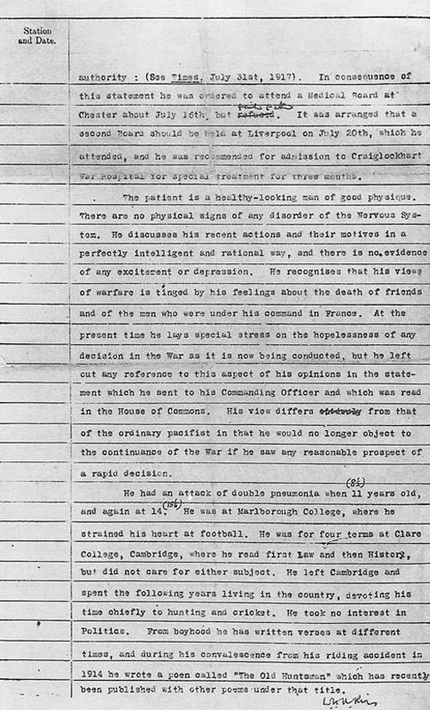
Figure 1 Siegfried Sassoon's medical case sheet, dated 23 July 1917, from Craiglockhart War Hospital; note the handwritten alterations – for example, the change from ‘refused’ to ‘failed to attend’ on the second page. (Sassoon Papers, Department of Documents, Imperial War Museum)
View description - Figure 1 Siegfried Sassoon's medical case sheet, dated 23 July 1917, from ...

At the end of the war he published his diaries and a semi-autobiographical novel The Complete Memoirs of George Sherston in which the details of his protest, and his disillusionment with the conduct of the war, were made public.
Much of Sassoon's writing serves as his personal memorial to the dead of the First World War. He continued to commemorate his brothers-in-arms by writing about them for the next thirty or more years. After publishing the last of the three volumes of The Complete Memoirs of George Sherston in 1936, he published three volumes of autobiography – the last Siegfried's Journey 1926-1930, in 1945.

1.4 ‘The General’

Sassoon could be eloquent in both prose and poetry. Looking at examples of his writing, you can see how he uses words differently for different audiences and different occasions. First, consider his poem ‘The General':
Look at the manuscript in Figure 2 and listen to the audio (click on the play button, or listen in separate player below Figure 2). You will notice several variations between what you hear and the manuscript text. Sassoon must have re-worked this handwritten text before the poem was published. The reading is taken from Siegfried Sassoon: Collected Poems 1908–1956 (Sassoon, 1961).

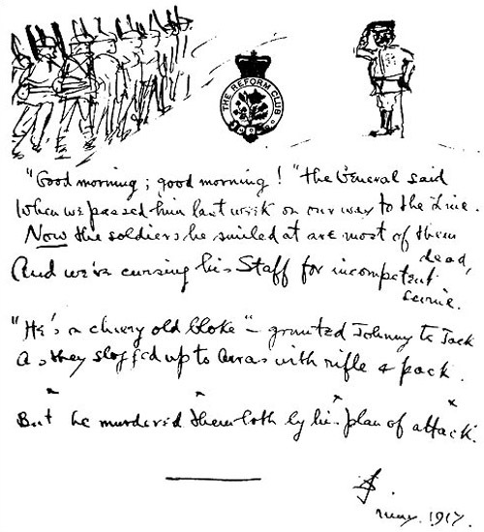
Figure 2 Sassoon's manuscript of ‘The General’, written on stationery from the Reform Club in London and dated May 1917. (Harry Ransom Humanities Research Center, The University of Texas at Austin; by permission of George Sassoon)
View description - Figure 2 Sassoon's manuscript of ‘The General’, written on stationery from ...

Click on the play button (or listen in a separate player if you prefer) to hear a reading of 'The General'.

Audio content is not available in this format.
The General
View transcript - The General

Sassoon wrote this poem in May 1917 when he was sent home wounded from the front. The language is noticeably simple: line 2 consists entirely of words of one syllable, and much of the rest of the poem is the same, with only one word of more than two syllables (‘incompetent’) in the whole poem. There are no unusual or unfamiliar words. Its simplicity is almost exaggerated.
Interestingly, though, he did not spell out an explicit message in this poem. If you feel that you have understood the gist of it, even at a distance in time of well over three-quarters of a century, he was probably right that it was not necessary to do so. Not spelling out his meaning allowed him to be brief and concise, and also to add colour and interest by encapsulating it in a little scene, complete with characters (the General, Harry and Jack, the ‘we’ who met the General, the General's ‘staff, the ‘soldiers’ who are ‘most of ‘em dead’ – and perhaps, separately. the speaker of the very last line whose sardonic comment suggests a detachment from the other characters). He also conveys a sense of relationships between the characters, a sense of place (‘slogged up to Arras’), and a sense of time – enough time to have elapsed, since the snapshot of the encounter, for Harry, Jack and their comrades to be ‘done for’.

1.5 Sassoon's ‘Protest’
If Sassoon had spelled out his meaning, he would have needed more words than he used in the poem. He did spell it out in the protest he wrote about the war. Although it is headed A Soldier's Declaration’, it is often referred to simply as Sassoon's ‘Protest’. Please read it now:

Finished with the War
A Soldier's Declaration
I am making this statement as an act of wilful defiance of military authority, because I believe the war is being deliberately prolonged by those who have the power to end it.
I am a soldier, convinced that I am acting on behalf of soldiers. I believe that this war, which I entered as a war of defence and liberation, has now become a war of aggression and conquest. I believe that the purposes for which I and my fellow soldiers entered upon this war should have been so clearly stated as to have made it impossible to change them, and that, had this been done, the objects which actuated us would now be attainable by negotiation.
I have seen and endured the suffering of the troops, and I can no longer be a party to prolong these sufferings for ends which I believe to be evil and unjust.
I am not protesting against the conduct of the war, but against the political errors and insincerities for which the fighting men are being sacrificed.
On behalf of those who are suffering now I make this protest against the deception which is being practised on them; also I believe that I may help to destroy the callous complacence with which the majority of those at home regard the continuance of agonies which they do not share, and which they have not sufficient imagination to realize.
(Sassoon, quoted in Barker, 1992)

1.6 Sassoon's 'Protest': exercise

Exercise 1

Look back at Sassoon’s biographical details to see who the intended audience for his ‘Protest’ was, and jot down your comments on the way Sassoon has used language here, in comparison with his approach in ‘The General’. Has he suited words to audience? Think about whom he is addressing and how he uses words and sentences to get his point across.

View discussion - Exercise 1

1.7 More Sassoon voices: exercise

Exercise 2

I have not commented directly on what Sassoon is saying in ‘The General’ and in his ‘Protest’, but you probably have a good idea of what he meant. Now read the three further extracts from Sassoon's writings below, in all of which he expresses himself more openly. (The ‘Rivers’ in the second extract is of course the ‘Rivers’ whose signature appears at the bottom of the medical record sheet: Figure 1. The third extract is from Sassoon's semi-autobiographical novel.)

Of all the officers having dinner, I saw no face with any touch of distinction in it. They were either utterly commonplace and self-satisfied, or else tired-looking, feeble, goggle-eyed, or otherwise deficient. Why does one see so few proper-looking officers?
(from Sassoon's diary, May 1916; in Hart-Davis, 1983)

As they say, the war situation looks more hopeless than ever, and the bolstering speeches only make it seem worse. I am afraid I cannot do anything ‘outrageous’. They would only say I had a relapse and put me in a padded room … I have told Rivers that I will not withdraw anything that I have said or written, and that my views are the same, but that I will go back to France if the War Office will give me a guarantee that they really will send me there … After all I made my protest on behalf of my fellow-fighters, and (if it is a question of being treated as an imbecile for the rest of the war) the fittest thing for me to do is to go back and share their ills.
(from a letter that Sassoon wrote to his friend Lady Ottoline Morrell, 17 October 1917)

Neither of us had the haziest idea of what the politicians were really up to … Nevertheless we argued as though the secret confabulations of Cabinet Ministers in various countries were as clear as daylight to us, and our assumption was that they were all wrong, while we, who had been in the trenches, were far-seeing and infallible
(Sassoon, 1972)

How clear do you find Sassoon's meaning here? How does his use of language compare with the language he used in his ‘Protest? Is his choice of words influenced by his audience? Use your notebook to record your reactions.

View discussion - Exercise 2

2 Using language in poetry and prose

2.1 Using poetry: exercise

Exercise 3

We have seen that writers make different choices of words, and ways of using them, according to why they are writing – and to whom. People often like to use poetry, or ‘poetic language’, when they are writing in commemoration of someone or something. We will now consider this point.
Note down any further reasons why you think writers might consider poetry particularly suitable for memorials.

View discussion - Exercise 3

2.2 Conveying meaning through prose
But prose, too, can convey much more than the sum of the meanings of individual words. The poet Rudyard Kipling lost his only son in the trenches in 1915. (John Kipling, despite poor eyesight, had joined the Irish Guards.) Kipling's response to his son's death may or may not have been a verse memorial; if so, it was not published. But he left a memory of his son in the form of a letter to his friend L.C. Dunsterville. It demonstrates how a simple, mundane and factual piece of writing can effectively fulfil the function of a memorial too:

He led the platoon over a mile of open ground in the face of shell and machine-gun fire, and was dropped at the further limit of the advance, after having emptied his pistol into a house full of German MGs … He was senior ensign though only 18 years and 6 weeks … it was a short life. I'm sorry that all the year's work ended in that one afternoon but – lots of people are in our position – and it is something to have bred a man
(Kipling, letter to L.C. Dunsterville, 1915; in Simkin (ed.), 1981)

Kipling himself was too old to be wanted in the army. His terse, understated emphasis on bald fact in this letter conveys loss, horror at the waste of a life, a sense of history, and pride in his son, without any poetic trappings at all. In his history of the Irish Guards, which he started to write two years later, his son appears only as a name on a casualty list. Although poetry seems special for us if we are not poets, it may have been too much Kipling's stock-in-trade for him to use it publicly to convey private emotion. Use of language can depend on who we are, as well as what we want to say, when we want to say it, and whom we want to listen.
The exercises you have completed in this section were designed to make you more aware of the choices that all writers have when they set out to express something in words. By working through them, you may have learned something of how – when you are reading – you can spot the choices that authors have made. You may also have acquired more insight into how you make choices when you yourself are the writer. The next exercise aims to give you some experience of making these choices.

2.3 Choosing your voice: exercise

Exercise 4

Imagine – and it may be true – that you feel strongly about a local planning issue, such as the erection of a piece of sculpture in a public place, or the building of a new road, out-of-town shopping centre or leisure facility. If you wanted to express your feelings in writing. you might need to choose different ‘voices’ – depending on the person you are writing to. To practise this now, draft three versions (150–200 words each) of what you might say in each of the following:
- a letter or electronic mail message (email) to a friend
- a letter to the local newspaper
- a piece of written evidence to go before a judicial inquiry.

View discussion - Exercise 4

Conclusion
This free course provided an introduction to studying the arts and humanities. It took you through a series of exercises designed to develop your approach to study and learning at a distance and helped to improve your confidence as an independent learner.

Keep on learning



Study another free course
There are more than 800 courses on OpenLearn for you to choose from on a range of subjects.
Find out more about all our free courses.

Take your studies further
Find out more about studying with The Open University by visiting our online prospectus.
If you are new to university study, you may be interested in our Access Courses or Certificates.

What’s new from OpenLearn?
Sign up to our newsletter or view a sample.

For reference, full URLs to pages listed above:
OpenLearn – www.open.edu/openlearn/free-courses
Visiting our online prospectus – www.open.ac.uk/courses
Access Courses – www.open.ac.uk/courses/do-it/access
Certificates – www.open.ac.uk/courses/certificates-he
Newsletter – www.open.edu/openlearn/about-openlearn/subscribe-the-openlearn-newsletter

References
Barker, P. (1992) Regeneration, Harmondsworth, Penguin Books
Hart-Davis, R. (ed.) (1983) Siegfried Sassoon: Diaries, 1915–18, London, Faber and Faber.
Sassoon, S. (1961) Siegfried Sassoon: Collected Poems 1908–1956, London, Faber and Faber.
Sassoon, S. (1972) The Complete Memoirs of George Shertson, London, Faber and Faber.
Simkin, J. (ed.) (1981) Contemporary Accounts of the First World War, Brighton, Tressell Publications.

Acknowledgements
Except for third party materials and otherwise stated (see terms and conditions), this content is made available under a Creative Commons Attribution-NonCommercial-ShareAlike 4.0 Licence
Grateful acknowledgement is made to the following sources for permission to reproduce material in this course:
Course image: Manoj Vasanth in Flickr made available under Creative Commons Attribution 2.0 Licence.
Figure 1 © Crown Copyright, held in the Department of Documents, Imperial War Museum;
Figure 2 Harry Ransom Humanities Research Center, The University of Texas at Austin; © Siegfried Sassoon, by kind permission of the Estate of George Sassoon.
Every effort has been made to trace all the copyright owners, but if any have been inadvertently overlooked, the publishers will be pleased to make the necessary arrangements at the first opportunity.
Don't miss out:
If reading this text has inspired you to learn more, you may be interested in joining the millions of people who discover our free learning resources and qualifications by visiting The Open University - www.open.edu/openlearn/free-courses

Exercise 1

Discussion
You may have noticed some or all of the following:
- In his ‘Protest’ there is only one ‘character’ – Sassoon himself, who addresses his audience in the first person. Every sentence except one (the one that begins the last paragraph, which is all one sentence) begins with I, presumably because what Sassoon was trying to convey so passionately was his motives, his beliefs, his identity, his experience. He also conveys that his decision to write a protest was his alone.
- His identification of his audience is less precise than his identification of himself. He conveys a strongly accusing tone, without saying whom he is accusing. For example: ‘the purposes for which I and my fellow soldiers entered upon this war should have been so clearly stated’ (by whom?); ‘the political errors and insincerities for which the fighting men are being sacrificed’ (by whom?). ‘I make this protest against the deception which is being practised on them’ (by whom?). He does not say who is sacrificing fighting men or practising deception on them. Instead he refers to ‘those who have the power to end it [the war]’ and ‘those at home’. He resorts to convoluted sentences in order to avoid apportioning blame. Consider how he might have expressed himself if he had allowed himself to blame the politicians or the military: ‘I believe the Prime Minister should have stated the purposes for which I and my fellow soldiers…’ and ‘I make this protest against the deception the Cabinet and the Generals are practising on them’.
- The language is much more formal than that in ‘The General’ and the proportion of words of more than one syllable – indeed more than three syllables – is much higher.
- The formality is achieved partly by the complex sentence formations mentioned above, but also by the repeated choice of words that are ‘things’ (nouns) – for example, ‘authority’, ‘defence’, ‘liberation’, ‘aggression’, ‘conquest’, ‘conduct’, ‘errors’, ‘insincerities’, ‘complacence’, ‘continuance’. This use of abstract nouns is another device Sassoon uses to avoid having to pin the blame, or say whose errors, insincerities, complacency and so on he is criticizing. (Abstract nouns are things that do not exist materially: you cannot see, hear or touch them.) In ‘The General’, he can blame ‘the general’ for everything: ‘the general’, after all, is fictional. If you look back at the poem, you will find that there is only one thing there you could call an abstraction – ‘plan of attack’.
- Sassoon uses repetition: the most frequently used words are ‘war’. ‘soldiers’ and ‘suffering’ (and similar words are also used, adding to the impression of repetition: ‘troops’, ‘men’, ‘agonies’). Repetition is a device commonly used for emphasis, which seems to be Sassoon's purpose here
Back to Session 1 Activity 2

Exercise 2

Discussion
I imagine that you will have found the language in both Sassoon's diary and his letter more direct and straightforward than in his ‘Protest’, and noticed that he uses a greater proportion of normal, everyday, even slang words. His meaning seems to come through clearly. We may not get an exact picture of what he thinks ‘proper-looking officers’ ought to look like, but we get a clear idea of his low opinion of the officers he describes in his diary. Similarly, although we cannot clearly identify the ‘they’ that Sassoon describes to Lady Ottoline Morrell, we can tell that he respects their power over him – if not either their judgement or their motives. Presumably Sassoon felt able to be open and honest with his single reader in each case – himself in his diary and Lady Ottoline in the letter – and felt no need in his attack to introduce the obscurity that he used in his ‘Protest’.
In the third extract Sassoon stands back slightly to put his views into the mouth of his fictional character, George, but when he wrote this in 1930 there was no need to be cautious, even in a published work.
Back to Session 1 Activity 3

Exercise 3

Discussion
People often consider poetry a suitable form for making a public statement of feelings. It may be because a poem can seem more complete than a prose statement. Some people might see a poem – perhaps ‘tied up’ with rhymes – as a neat verse package, like a gift: others may associate poetry with a sense of occasion. Or perhaps people find it easier to use poetry as a vehicle for conveying feelings. Feelings are difficult to pin down, but in poetry you can suggest meanings more subtly and obliquely than you can in the plain statements we associate with prose.
Back to Session 2 Activity 1

Exercise 4

Discussion
In order to communicate best with each of these different audiences, you needed to select the appropriate ‘voice’. I hope you found that this depended on a careful choice of words.
- In a personal communication to a friend, particularly if you are a regular letter-writer, you may have found you could just ‘write as you speak’, so you did not need to make conscious choices when selecting your words. The ‘voice’ that comes through will be informal and individual, and perhaps recognisably ‘you’. An email message often carries with it a greater sense of haste and immediacy than a letter, so in an email people often use a sparse, ‘clipped’ voice, which aims to communicate information in fewer words. rather like the style that used to be common when telegrams were the quickest way of sending messages. They were priced by the word, and punctuation cost extra. They were typically written in upper-case type. and you might consider whether or not the necessary economy of expression, and the upper-case letters, added a further dimension to the message – perhaps a sense of drama or urgency (‘HAVE GUN WILL TRAVEL’, or ‘SMALL EARTHQUAKE IN CHILE NOT MANY DEAD’).
- In a letter to the local paper, unlike a communication with a friend, you could not rely on any shared knowledge – except perhaps the shared knowledge of the plans you were writing about. You could not assume that your reader shared your opinions. So you may have found that you spelled out more carefully what you felt about the proposals. You may have felt the need to use exaggeration in order to ensure no one missed your point. But your letter may still have been fairly informal.
- I would expect that your voice when writing ‘evidence’ for a judicial inquiry would be more formal and sober than in either of the two previous pieces of writing. You may have found yourself using longer and less conversational words. You may have tried hard to avoid exaggeration this time, in order to avoid discrediting yourself as a witness. Your ‘voice’ here may not have sounded like you at all.
Consider which, if any, of these voices will be most appropriate for writing essays. You may conclude that you'll need to use elements of all three.
Back to Session 2 Activity 2

Figure 1 Siegfried Sassoon's medical case sheet, dated 23 July 1917, from Craiglockhart War Hospital; note the handwritten alterations – for example, the change from ‘refused’ to ‘failed to attend’ on the second page. (Sassoon Papers, Department of Documents, Imperial War Museum)

Description
Figure 1
Back to Session 1 Figure 2

Figure 2 Sassoon's manuscript of ‘The General’, written on stationery from the Reform Club in London and dated May 1917. (Harry Ransom Humanities Research Center, The University of Texas at Austin; by permission of George Sassoon)

Description
Figure 2
Back to Session 1 Figure 3

The General

Transcript
STEPHEN EARLE:
“Good morning, good morning!” the General said When we met him last week on our way to the line. Now the soldiers he smiled at are most of ‘em dead, And we’re cursing his staff for incompetent swine “He’s a cheery old card,” grunted Harry to Jack As they slogged up to Arras with rifle and pack. But he did for them both by his plan of attack.
Back to Session 1 MediaContent 1

