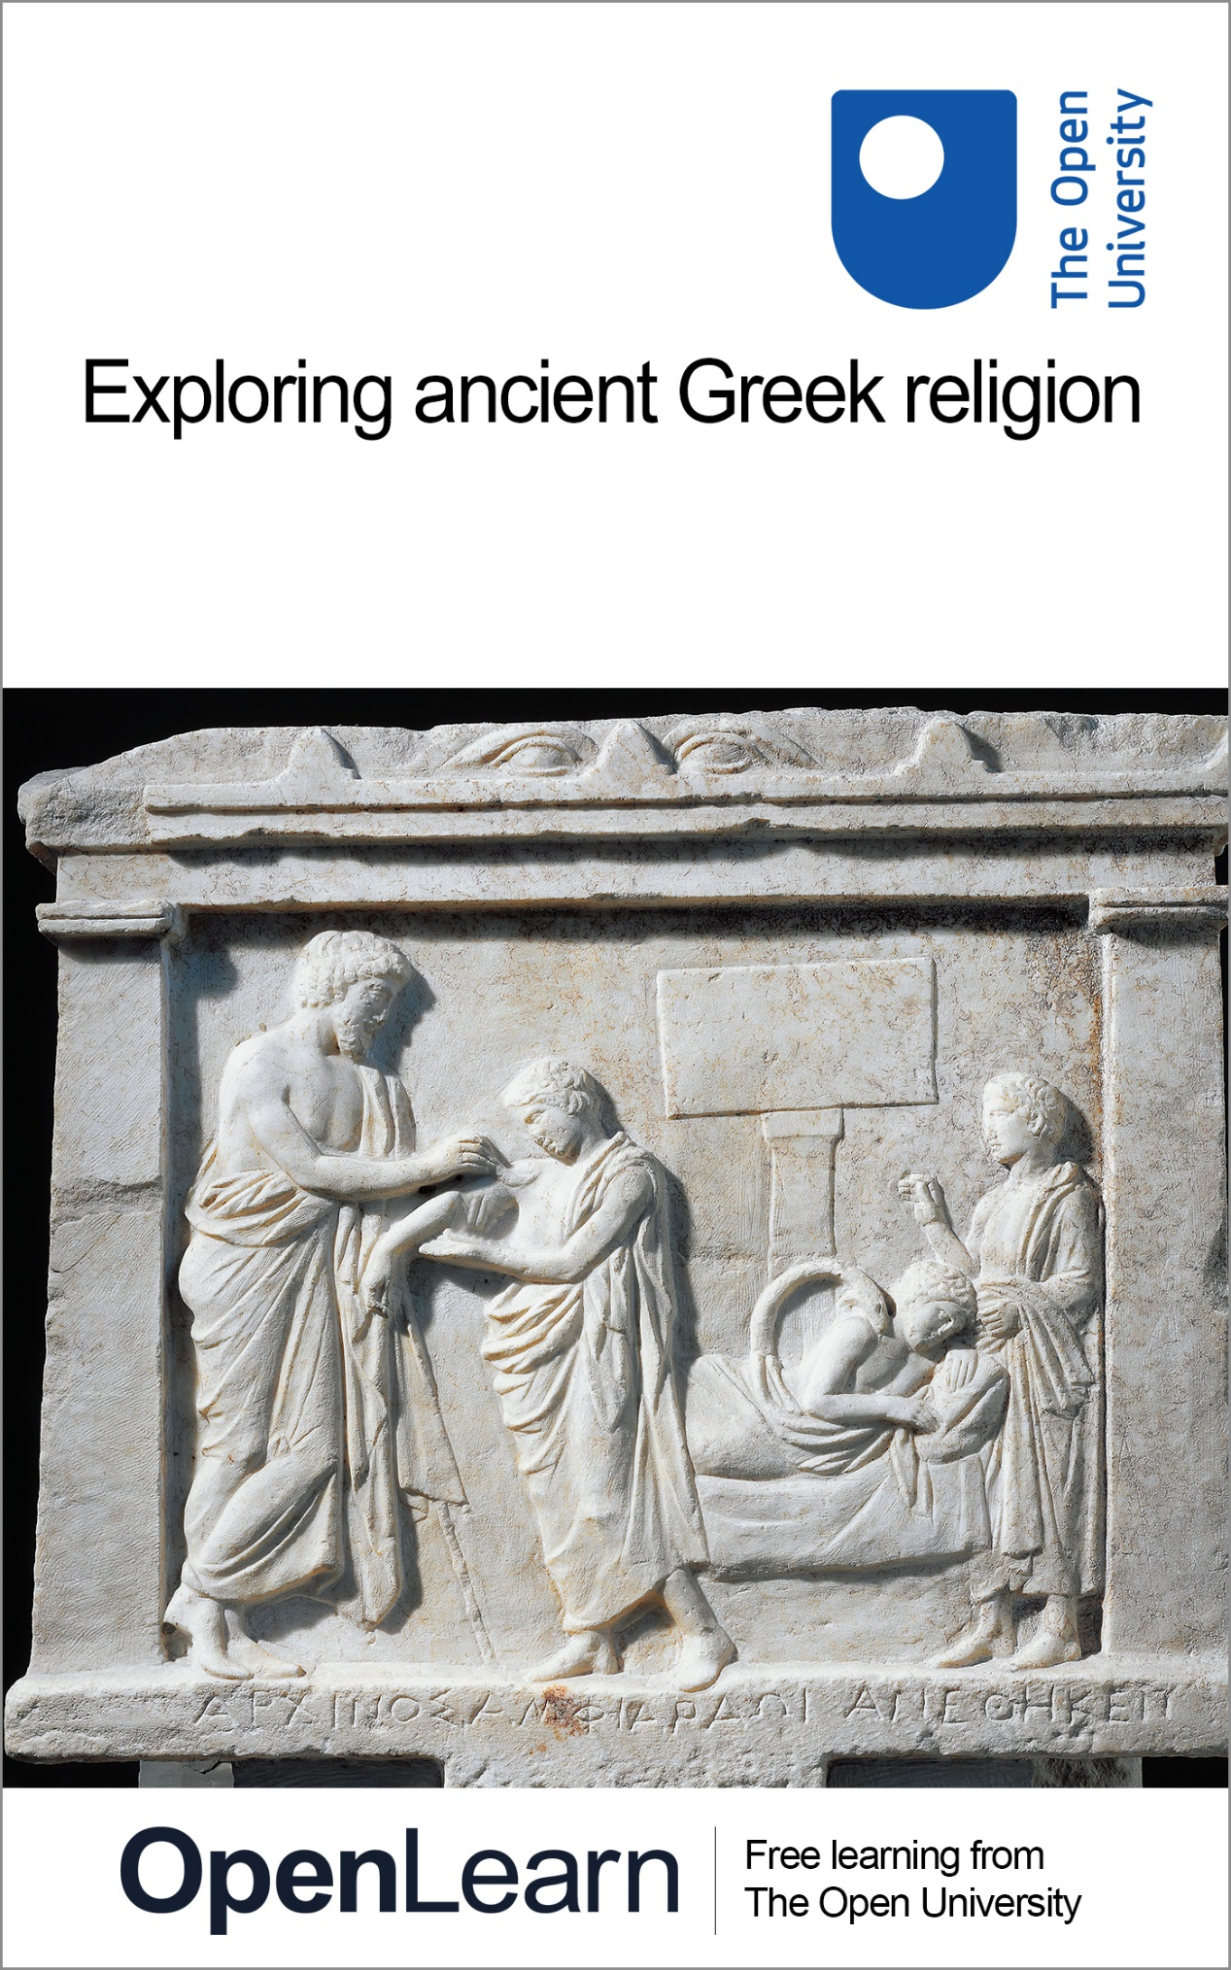

HDS_2

Exploring ancient Greek religion

About this free course
Find out more about The Open University’s Classical Studies courses and qualifications: www.open.ac.uk/courses/search-result/classical-studies.
This version of the content may include video, images and interactive content that may not be optimised for your device.
You can experience this free course as it was originally designed on OpenLearn, the home of free learning from The Open University –
www.open.edu/openlearn/history-the-arts/exploring-ancient-greek-religion/content-section-0
There you’ll also be able to track your progress via your activity record, which you can use to demonstrate your learning.
Unless otherwise stated, copyright © 2024 The Open University, all rights reserved.
Intellectual property
Unless otherwise stated, this resource is released under the terms of the Creative Commons Licence v4.0 https://creativecommons.org/licenses/by-nc-sa/4.0/deed.en. Within that The Open University interprets this licence in the following way: www.open.edu/openlearn/about-openlearn/frequently-asked-questions-on-openlearn. Copyright and rights falling outside the terms of the Creative Commons Licence are retained or controlled by The Open University. Please read the full text before using any of the content.
We believe the primary barrier to accessing high-quality educational experiences is cost, which is why we aim to publish as much free content as possible under an open licence. If it proves difficult to release content under our preferred Creative Commons licence (e.g. because we can’t afford or gain the clearances or find suitable alternatives), we will still release the materials for free under a personal end-user licence.
This is because the learning experience will always be the same high quality offering and that should always be seen as positive – even if at times the licensing is different to Creative Commons.
When using the content you must attribute us (The Open University) (the OU) and any identified author in accordance with the terms of the Creative Commons Licence.
The Acknowledgements section is used to list, amongst other things, third party (Proprietary), licensed content which is not subject to Creative Commons licensing. Proprietary content must be used (retained) intact and in context to the content at all times.
The Acknowledgements section is also used to bring to your attention any other Special Restrictions which may apply to the content. For example there may be times when the Creative Commons Non-Commercial Sharealike licence does not apply to any of the content even if owned by us (The Open University). In these instances, unless stated otherwise, the content may be used for personal and non-commercial use.
We have also identified as Proprietary other material included in the content which is not subject to Creative Commons Licence. These are OU logos, trading names and may extend to certain photographic and video images and sound recordings and any other material as may be brought to your attention.
Unauthorised use of any of the content may constitute a breach of the terms and conditions and/or intellectual property laws.
We reserve the right to alter, amend or bring to an end any terms and conditions provided here without notice.
All rights falling outside the terms of the Creative Commons licence are retained or controlled by The Open University.
Head of Intellectual Property, The Open University

Contents
- Introduction
- Learning outcomes
- 1 Religion in the ancient Greek world
  - 1.1 Sacred places and the Greek gods
  - 1.2 The cult of Amphiaraos
- 2 Worshipping Amphiaraos: personal religion and ‘polis’ religion
  - 2.1 The cult of Amphiaraos: orientation
  - 2.2 The cult of Amphiaraos: the god and his sanctuary
- 3 Keeping it personal
  - 3.1 The sacred regulation of the Amphiareion
  - 3.2 The sacred regulation in context
  - 3.3 What does the sacred regulation say?
  - 3.4 ‘Seeing’ Amphiaraos
- 4 The politics of religion
  - 4.1 The politics of Amphiaraos’ sanctuary: literary evidence
  - 4.2 The politics of Amphiaraos’ mythical tradition
  - 4.3 The chariot dismount competition
  - 4.4 Competing traditions: Athens and Oropos
  - 4.5 Picturing the dismount competitions: the visual evidence
  - 4.6 Merging traditions? Oropos, Athens and polis religion
- Conclusion
- Taking it further
- Pronunciation guide
- Tell us what you think
- References
- Acknowledgements
- Glossary
- Solutions
- Descriptions

Introduction
The ancient Greeks did not have a term equivalent to the English word ‘religion’. However, their world was populated by numerous figures they both recognised and worshipped as divinities. Among these figures was Amphiaraos (pronounced am-fi-ah-RAY-os), an ancient Greek hero who was later worshipped as a god and popularly associated with healing through the medium of dreams. But there was no sacred book (like those which exist in many religions today) which told the ancient Greeks what to believe about Amphiaraos or how to communicate with him. How, then, did people and communities know how to worship Amphiaraos?
In this free course, you will explore this question by looking at textual and visual evidence relating to Amphiaraos’ sanctuary, which was located at a town called Oropos, in northeast Attica. You will engage with this material to learn about some of the different ways the ancient Greeks interacted with Amphiaraos, both individually and as part of their community.

Study note: glossary and pronunciation guide
As you study this course you may come across some key words or terms with which you are unfamiliar. We have therefore produced a pronunciation guide and glossary to help you. Clicking on terms which feature in bold text will take you to the pronunciation guide, where you can listen to audio recordings of the words featured. Clicking on terms which feature in bold text and are underlined will take you to the glossary where you will find definitions of those terms. Alternatively, hovering the cursor over the glossary entries within the text will show you the definition.

Before you get started we would really appreciate a few minutes of your time to tell us about yourself and your expectations for this course, in our optional start-of-course survey. Participation will be completely confidential and we will not pass on your details to others.

Learning outcomes
After studying this course, you should be able to:
- develop awareness of the rich and complex relationship between politics and religion in the ancient Greek world
- understand how to uncover personal experiences in the study of ancient religions
- feel confident in working with both ancient texts and visual source material to answer questions about ancient Greek religion
- use Amphiaraos’ sanctuary as a case-study for understanding the broader political and personal aspects of ancient Greek religion.

1 Religion in the ancient Greek world
The sanctuary of Amphiaraos, which lay about 55 kilometres (35 miles) northeast of the centre of ancient Athens, was just one of an enormous number of shrines and temples built by Greek-speaking communities across the ancient Mediterranean. Such buildings formed a focus for religious activities in the ancient world and provided ways for the inhabitants of ancient Greece to connect with their deities, that is to say the gods and heroes that they worshipped.

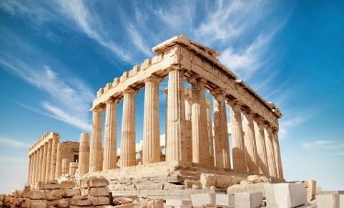
Figure 1 The Parthenon on the Acropolis, in Athens, Greece.
View description - Figure 1 The Parthenon on the Acropolis, in Athens, Greece.
View alternative description - Figure 1 The Parthenon on the Acropolis, in Athens, Greece.

But what does ‘religion’ in the world of ancient Greece signify, and who were the gods that they worshipped? To kick off your studies on this course, you’ll begin with two introductory activities. First, you’ll think about what religion means to you, and then you’ll consider what, if anything, you may already know about Greek deities. You don’t need any prior knowledge, though, so don’t worry if you don’t yet know anything about ancient Greece, or Greek religion!

Activity 1
Allow around 5 minutes for this activity

Take a few minutes to think about what the word ‘religion’ means to you. Then jot down four or five key words or phrases which spring to mind.

Provide your answer...
View discussion - Activity 1

Study note: a note on dates
You will notice that this course uses the abbreviations ‘BCE’ and ‘CE’ when dating events, texts and objects. These abbreviations stand for ‘Before the Common Era’ and ‘Common Era’. You may be familiar with an alternative method of referring to dates as ‘BC’ (‘Before Christ’) and ‘AD’ (Anno Domini, Latin for ‘in the year of our Lord’), and you may find that the authors of other things you read on the topics discussed here use instead BC and AD instead of BCE and CE. Remember that BCE years count backwards – therefore the eighth century BCE is earlier than the seventh century BCE.

1.1 Sacred places and the Greek gods
Now that you’ve had time to consider what the term ‘religion’ means to you today, you may be wondering what it meant to the ancient Greeks. This question is a little tricky to answer because, as noted earlier, the ancient Greeks didn’t have a word for ‘religion’. However, that doesn’t mean that they completely lacked thoughts or actions which fall under this category.
Like many religions today, the ancient Greeks had sacred places, objects, people and gods associated with religious beliefs and behaviour. For example, people often visited temples (such as that of the goddess Aphaia on the island of Aegina, depicted in Figure 2) to pray and make offerings to their divinities, and such visits would have consisted of a series of expected actions and performances deemed appropriate for the occasion. However, unlike many religions today, there was no central book or text guiding the ancient Greeks how to go about their daily worship. This absence means that there is no direct ancient source which outlines what the ancient Greeks believed in. As you will learn in this course, though, there are other pieces of ancient evidence which shine light on this complex matter.

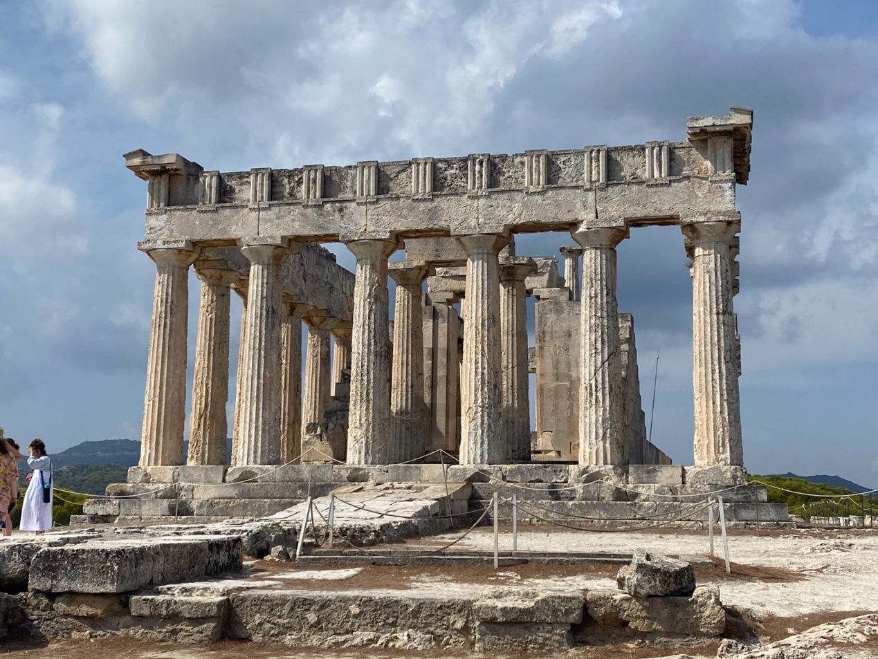
Figure 2 Temple of the goddess Aphaia at Aegina, c.500 BCE.
View description - Figure 2 Temple of the goddess Aphaia at Aegina, c.500 BCE.
View alternative description - Figure 2 Temple of the goddess Aphaia at Aegina, c.500 BCE.

Activity 2
Allow around 5 minutes for this activity

What, if anything, do you know about ancient Greek gods? If the answer is ‘nothing at all’, don’t worry! Otherwise, make a note of four or five key words or phrases.

Provide your answer...
View discussion - Activity 2

Something which you might find interesting about the nature of gods and goddesses in the ancient Greek world is that, although they were numerous, each divine figure commonly had their own special qualities (in other words, they could be thought of as ‘the god/goddess of X’). Quite often, though, the special quality that a deity possessed overlapped with those of other gods or goddesses. For example, if a particular divine figure was associated with bringing about a good harvest, that did not necessarily mean that only that divine figure had such a capability. Indeed, the ancient Greeks had a large number of divinities to whom they could turn in times of need.

1.2 The cult of Amphiaraos
In this course, you will be thinking in depth about the figure of Amphiaraos, whose cult site (that is, the main location where he was worshipped) at Oropos was popularly associated with healing by the late fifth century BCE (see Map 1). However, Amphiaraos was not the only divinity associated with this quality: there were more ‘popular’ figures who shared this same attribute. The most famous god associated with healing was arguably Asklepios, who had a major cult site at Epidauros in the Peloponnese, among other places (see Map 1).

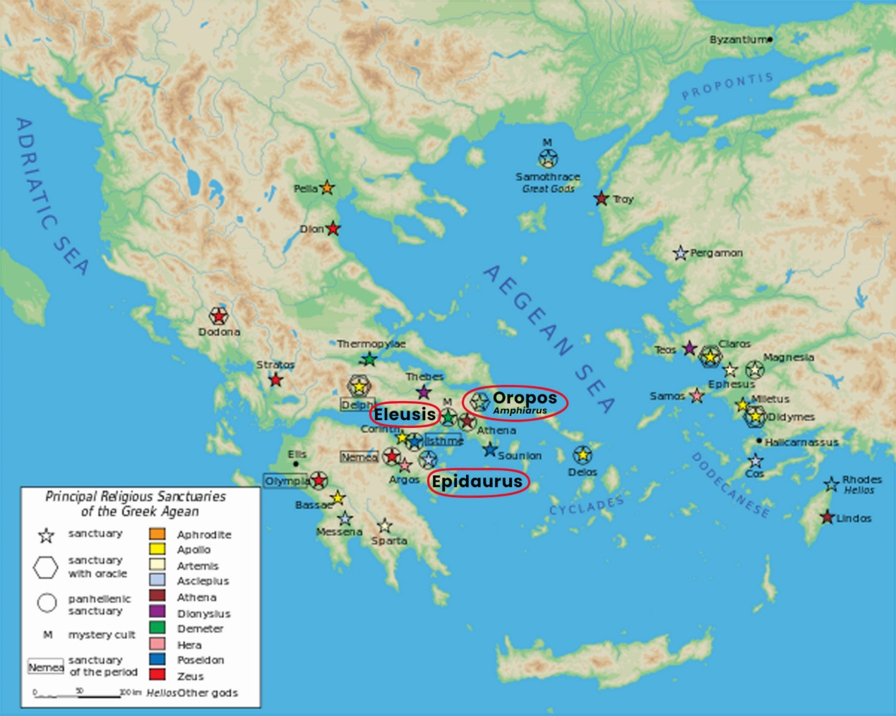
Map 1 Map depicting key religious sanctuaries of the Greek Aegean.
View description - Map 1 Map depicting key religious sanctuaries of the Greek Aegean.
View alternative description - Map 1 Map depicting key religious sanctuaries of the Greek Aegean.

Study note: names of Greek places and people
Many Greek names have more than one English spelling. For instance, you will find Asclepius as well as Asklepios, Aphaea as well as Aphaia and Herodotus as well as Herodotos. The reason is that there are different conventions for transliterating words from Greek into the English alphabet.
In this course, ‘Hellenised’ spellings are generally used, for example, ‘k’ rather than ‘c’, ‘ai’ rather than ‘ae’, and ‘os’ rather than ‘us’ at the end of names: Asklepios, Aphaia, Herodotos. These ‘Hellenised’ spellings closely reflect the way these names were spelt in ancient Greek. Elsewhere, you will often find modern authors and translators using ‘Latinised’ spellings, however: ‘c’ rather than ‘k’, ‘ae’ rather than ‘ai’, and so on (Asclepius, Aphaea, Herodotus).

At Asklepios’ sanctuary at Epidauros, temple officials aimed to promote the healing capabilities of the god to visitors by setting up stone inscriptions which recorded the experiences of individuals and the cures they received. These cures contain several fantastical elements and recount miraculous tales of Asklepios’ healing of both humans and even objects. Although we do not have comparable tales from the Amphiareion which describe Amphiaraos’ medical expertise, we do have text-bearing dedications (that is, religious objects often erected within religious settings to honour a divinity – such as the one depicted in Figure 3) which clearly relate to acts of healing. Such evidence, which you’ll have the opportunity to explore later in this course, can help us to learn more about the activities of individuals who visited the god’s sanctuary to seek a cure.

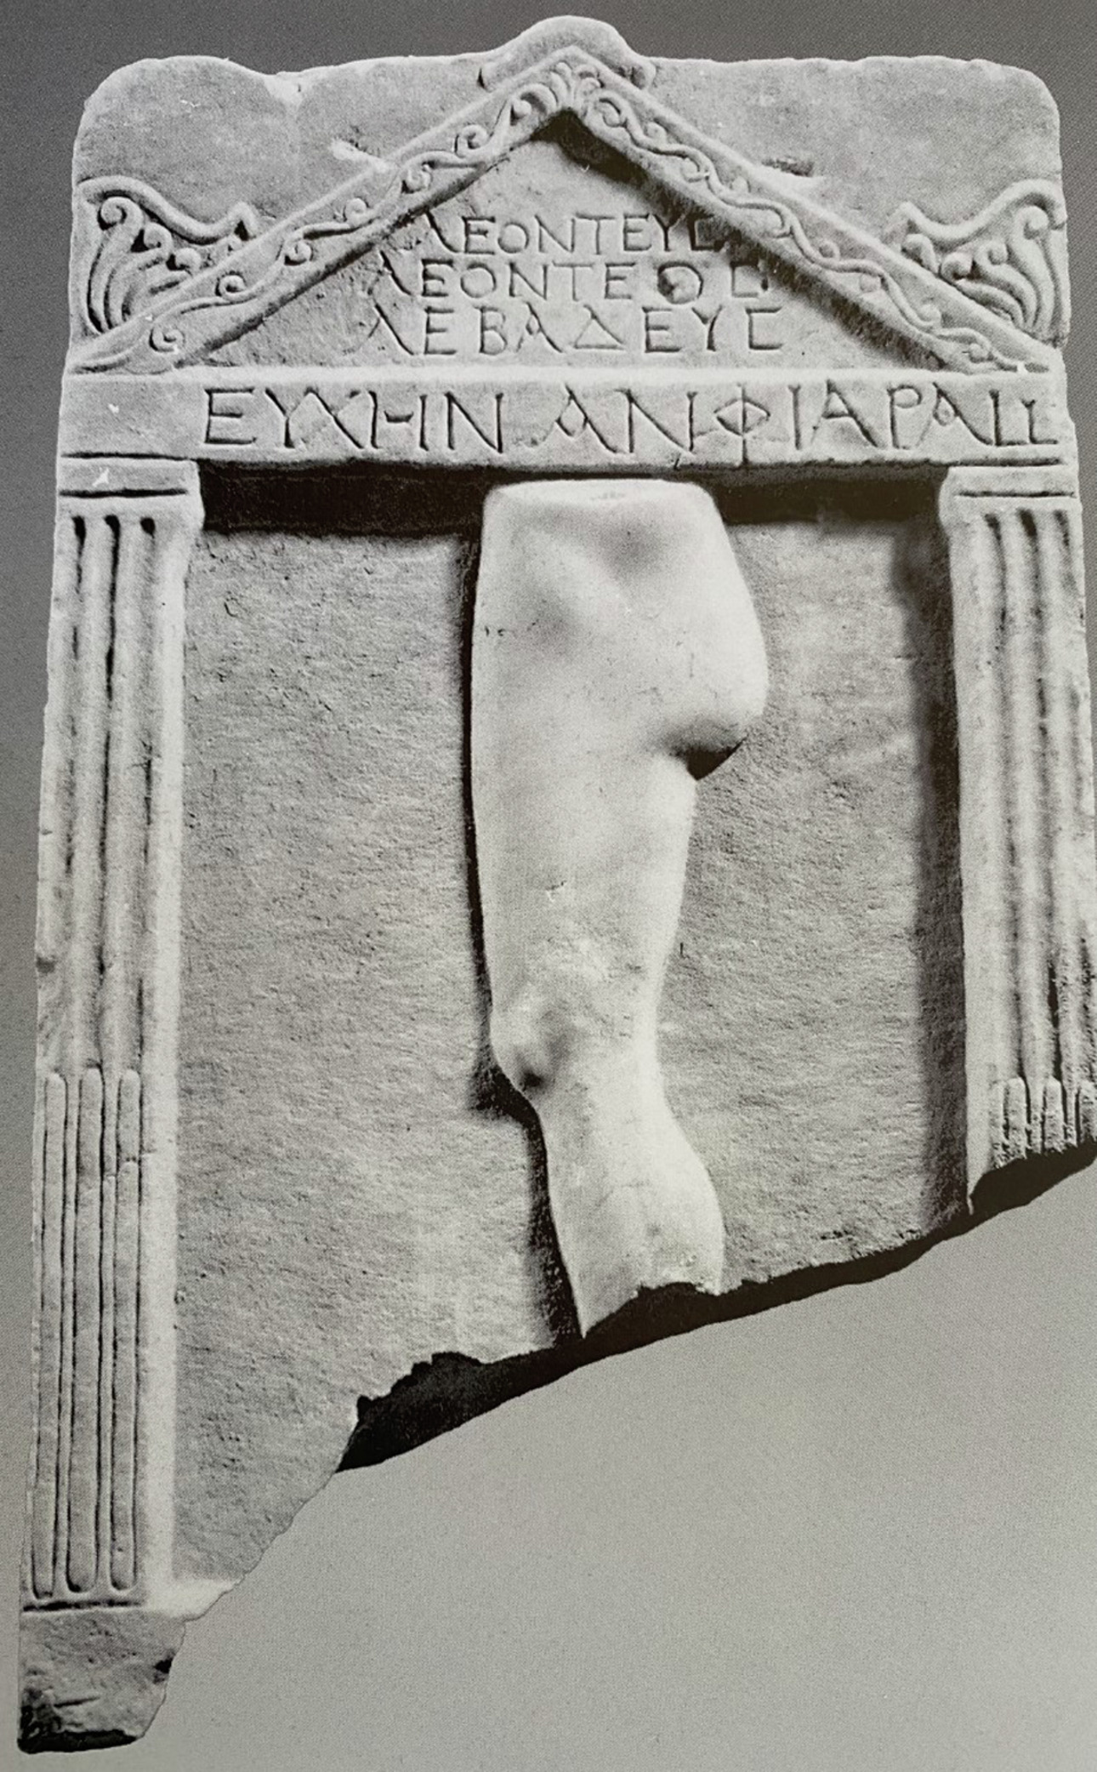
Figure 3 Marble stele with relief depicting a leg and buttock within a temple border, c. third century CE; 0.51m (height) x 0.31m (width). The inscription reads: ‘Leonteus son of Leonteus from Lebadeia [set this up] as a vow to Amphiaraos’. Image taken from V.C. Petrakos (1997), Οἱ ἐπιγραφὲς τοῦ Ὠρωποῦ (The Inscriptions of Oropos), Athens, no. 469.
View description - Figure 3 Marble stele with relief depicting a leg and buttock within a temple border, ...
View alternative description - Figure 3 Marble stele with relief depicting a leg and buttock within a temple border, ...

Different divinities, then, had different ways of being consulted for medical treatment. In Amphiaraos’ case, surviving pieces of ancient evidence make it clear that the ancient Greeks communicated with him through the medium of dreams. This doesn’t mean that Amphiaraos spontaneously visited people as they were tucked up in their beds at night, but that those seeking the god’s help made the journey to his sanctuary at Oropos where they slept overnight. This process is also known as incubation.

2 Worshipping Amphiaraos: personal religion and ‘polis’ religion
But what did it mean to worship Amphiaraos and how exactly did the ancient Greeks encounter him? In this section, you will explore these questions from two main perspectives which have been applied to modern studies of ancient religions. The first one is known as ‘personal’ religion: as the title suggests, this perspective is concerned with thinking about the needs of the individual person in their religious experiences with the divine. As one scholar summarises, personal religion seeks to understand ‘how individuals in the ancient Greek city adapted… culturally-given religious beliefs and practices to fit their personal religious needs’ (Kindt, 2015, p. 45). The cult of the Eleusinian Mysteries celebrated at the town of Eleusis (see Map 1) in honour of the goddesses Demeter and Persephone is a good example of personal religion, given that the choice to partake in its rituals and practices was very much based on individual initiative and personal aspirations.

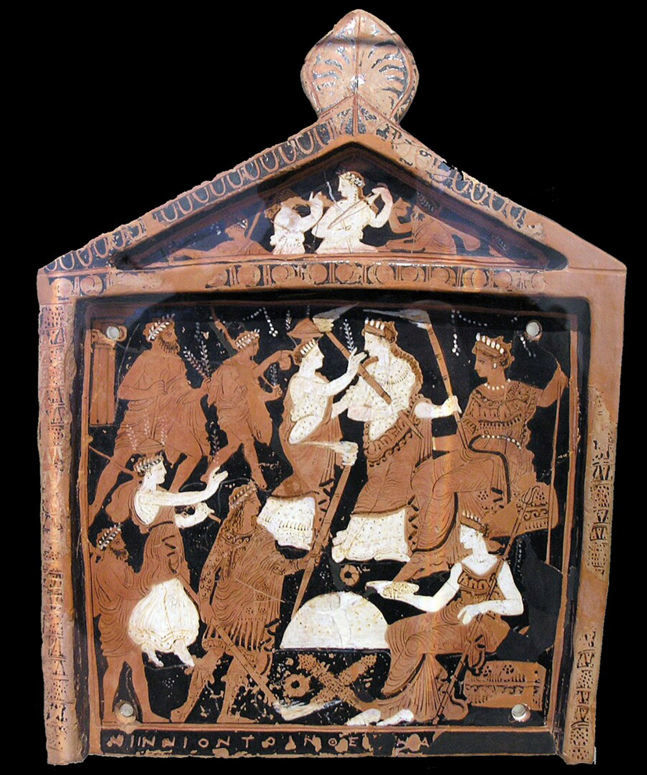
Figure 4 The Ninnion Tablet, c. 370 BCE.
View description - Figure 4 The Ninnion Tablet, c. 370 BCE.
View alternative description - Figure 4 The Ninnion Tablet, c. 370 BCE.

The second perspective is known as the ‘polis-religion’ model – ‘polis’ being the ancient Greek word for city-state or community. This model views ancient Greek religion as intricately connected to the values of the city-state and supporting the city’s ideals (e.g. Sourvinou-Inwood, 2000). Although this view is arguably less fashionable than it once was, there are still certain contexts in which this model may be usefully applied to understand ancient religion. The biggest festival in the Athenians’ religious calendar, for example, known as the Panathenaia, was an opportunity for the Athenians to celebrate Athena, who as patron goddess of the city played a crucial role in its citizens’ self-identity.
An important point to bear in mind, however, as one scholar of ancient Greek religion points out, is that the terms ‘personal’ and ‘polis’ religion are modern ways of looking at the ancient Greek religious system (Kindt, 2015, p. 37). This means that the ancient Greeks did not consciously distinguish between these two terms as we do today in their everyday religious activity. As such, we can usefully look for elements of both ‘polis’ and ‘personal’ beliefs and practices within the same cult. This is the approach which will be adopted in this course, using the example of the cult of Amphiaraos as your case-study. In the following sections, you will examine material remains from Amphiaraos’ sanctuary to discover how the ancient Greeks worshipped him both as individuals and as part of broader communities.

2.1 The cult of Amphiaraos: orientation
If this is the first time you’ve come across the name Amphiaraos, don’t worry! No knowledge of Amphiaraos or his cult site is required for you to complete this course. However, you may find Activities 3 and 4 helpful for bringing you up to speed before you go on to look more closely at aspects of his cult worship in later sections.

Activity 3
Allow around 35 minutes for this activity

Read The Amphiareion at Oropos: An Introductory Guide (open it in a new tab or window so you can easily find your way back to the course).
Then, using this guide, complete the missing words in the short text below using the drop-down list provided.

Interactive content is not available in this format.

View discussion - Activity 3

2.2 The cult of Amphiaraos: the god and his sanctuary
Now that you’ve become acquainted with Amphiaraos and his cult site at Oropos, you’ll now think more about the types of ancient evidence available to you about the god and his sanctuary.

Activity 4
Allow around 20 minutes for this activity

Using the Introductory Guide once again, make a list of the different types of ancient evidence we can use to find out about the Amphiareion and the activities which took place within it. Aim to come up with a list of at least three different types of evidence.

Provide your answer...
View discussion - Activity 4

Hopefully you now feel more informed about Amphiaraos and the Amphiareion as well as about the different types of ancient evidence available to you about the god and his sanctuary. If you do find yourself needing a refresher of the basics later on in this course, you may find it helpful to look back at Activities 3 and 4. In the rest of this course you will explore how the ancient Greeks might have viewed and performed Amphiaraos’ worship, both as individuals and as members of a broader community.

3 Keeping it personal
Unlike many religions today, the ancient Greeks lacked sacred books which told them what to believe and how to act in a pious manner. You might well be wondering, then, ‘how did people know how to worship Amphiaraos?’, ‘how did people know what to expect?’, or ‘how is it even possible recover their personal experiences?’. To seek answers to these questions, we need to look to a different kind of evidence.
As you learned in Activity 3, more than 500 inscriptions (that is, text-bearing objects, in this case usually made of stone) survive at the Amphiareion. These inscriptions could take several different forms, such as extended pieces of writing on thin slabs of stone (known as stelai, or stele in the singular: see Figure 5) or short texts accompanying artistic representations on objects of all different shapes and sizes (Figure 3).

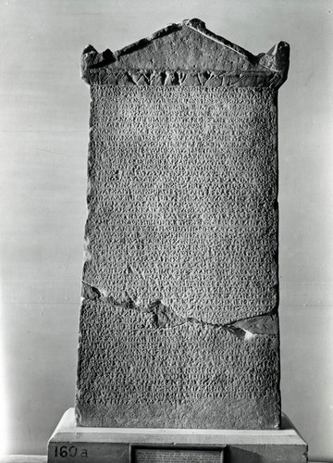
Figure 5 Side A of a marble stele from the Amphiareion concerning the melting down of votive objects, c. late third century BCE; 77.47cm (height) x 38.10cm (width).
View description - Figure 5 Side A of a marble stele from the Amphiareion concerning the melting down ...
View alternative description - Figure 5 Side A of a marble stele from the Amphiareion concerning the melting down ...

As objects which come down to us directly from the ancient world, inscriptions don’t always survive intact: their texts can have gaps in them (or lacunae as they are otherwise known) or break off in unexpected places; the stone itself may also be damaged and have pieces missing (see Figures 3 and 5). Despite their breakages, these inscriptions offer us glimpses into the religious life of the sanctuary as they were commissioned by the very people and communities who lived and experienced Amphiaraos’ cult worship in ancient times. As such, they permit consideration of the types of personal emotions and expectations people might have had when they visited Amphiaraos’ sanctuary. You will now examine some of these inscriptions for yourself.

3.1 The sacred regulation of the Amphiareion
Although the ancient Greeks lacked sacred books, at times they did choose to publish religious guidance on stone. Such inscribed guidance (which you may see referred to as a ‘sacred regulation’ or ‘sacred law’) was often specific to a particular sanctuary or particular group of worshippers and, importantly, never sought to set out religious beliefs. As such, this type of evidence cannot tell you about the entire history of a particular cult and its belief system, but it can offer insight into important elements of it, especially relating to its administration.

Activity 5
Allow around 10 minutes for this activity

You have a sense from Figures 3 and 5 of what inscriptions could look like. Figure 6 now shows you another inscription: the sacred regulation from the Amphiareion.
Take a moment to examine Figure 6 and to read the image description beneath it in order to gain a sense of the object’s dimensions and the material it is made from.
You will consider what the inscription says later on, but for now take a few minutes jot down a few thoughts in response to the following questions:
- Why might someone have chosen to set up an inscription in stone (rather than using another material, such as wood)?
- How easy or difficult do you think it would have been to create something like this?

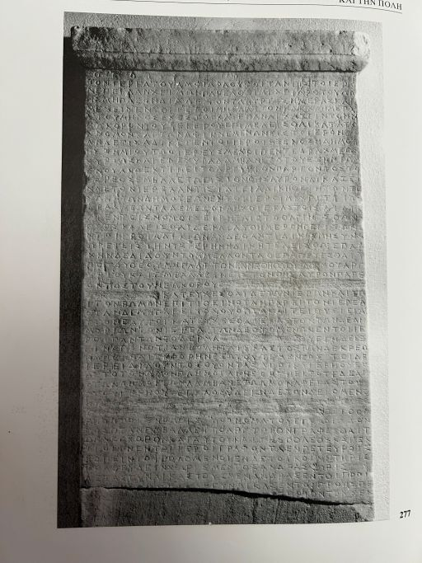
Figure 6 Stone stele recording the sacred regulations of the Amphiareion, c. 386–374 BCE; 1.49m (height) x 0.3m (width).
View description - Figure 6 Stone stele recording the sacred regulations of the Amphiareion, c. 386–374 ...
View alternative description - Figure 6 Stone stele recording the sacred regulations of the Amphiareion, c. 386–374 ...

Provide your answer...
View discussion - Activity 5

3.2 The sacred regulation in context
The Amphiareion’s sacred regulation was inscribed in the fourth century BCE. It was later found during an excavation at the sanctuary in the late nineteenth century, by which time the shrine had long been abandoned and several of its monuments had been removed from their original locations. This inscription was found in an old aqueduct at the sanctuary, marked with a red cross in Figure 7.

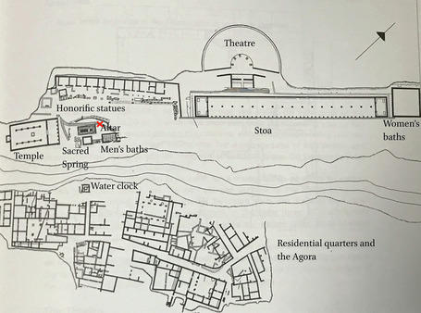
Figure 7 Topographical outline of the Amphiareion.
View description - Figure 7 Topographical outline of the Amphiareion.
View alternative description - Figure 7 Topographical outline of the Amphiareion.

As for its original location, it is likely that the sacred regulation was displayed near Amphiaraos’ altar (see Figures 7 and 8) as was customary for similar types of inscriptions at other sanctuaries (Petropoulou, 1981, p. 42; Wilding, 2021, p. 65).

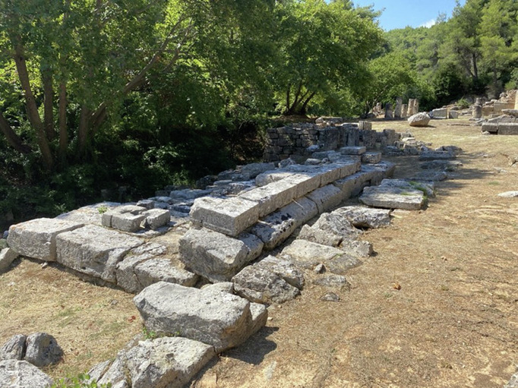
Figure 8 Remains of the altar at the Amphiareion.
View description - Figure 8 Remains of the altar at the Amphiareion.
View alternative description - Figure 8 Remains of the altar at the Amphiareion.

This location means that the Amphiareion’s regulation was displayed alongside important building structures central to Amphiaraos’ worship, such as his altar (Figure 8) and temple (Figure 9), which visitors to the sanctuary would have interacted with as part of their religious practice.

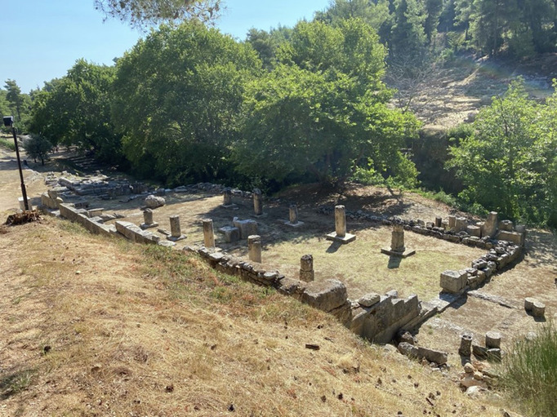
Figure 9 Remains of the temple of Amphiaraos.
View description - Figure 9 Remains of the temple of Amphiaraos.
View alternative description - Figure 9 Remains of the temple of Amphiaraos.

3.3 What does the sacred regulation say?
Given that literacy rates in classical Greece would have been extremely low by modern standards, not everyone would have had the literary skills to read what the sacred regulation said, but that does not mean that such people missed out on understanding the inscription’s importance. The habit of reading aloud in the ancient world (Thomas, 1992, p. 64) means that people could listen to others as they read the content of an inscription; a person might also reasonably gauge that they were looking at something official and important when they came across an inscription in a public setting and so ask another about what it said.

Activity 6
Allow around 45 minutes for this activity

Imagine that it is the fourth century BCE and that you are planning a visit to the sanctuary of Amphiaraos for the first time. Your shoulder has been giving you trouble for months now and you’ve heard good things about Amphiaraos’ medical expertise. As this is your first visit to the sanctuary, you’re a bit nervous: you want to make sure you know the sanctuary’s rules, what to expect, and how to behave as piously as possible while you’re there. Fortunately, a friend of yours has been before and is able to fill you in on the dos and don’ts based on their knowledge of the sanctuary’s sacred regulations.
To help you plan for your visit to the sanctuary, answer the following questions below using the set passages taken from the sacred regulations of the Amphiareion to help you. Note that parts of the text marked ‘[---]’ indicate places where there are gaps in the inscription.
The sections of text you need to answer each question appear under each of the four questions below. Note that, to help you easily locate the information you need, some of the passages are repeated under more than one question

Glossary for Activity 6
You should use the following short glossary to help you:
Drachma, drachmas: name of an ancient Greek coin, worth 6 obols. In fourth-century BCE Athens, an unskilled labourer could earn up to 1 and a half drachmas a day and a skilled labourer between 2 and 2 and a half drachmas (Rhodes and Osborne, 2003, p. xxiii).
Incubate: in an ancient Greek context, the act of sleeping in a temple or sacred space to communicate with the divine for oracular or healing purposes. (This word derives from the Latin cubare, ‘to lie down’ or ‘sleep’ + in, ‘in, inside’.)
Obol, obols: name of an ancient Greek coin, worth 1/6th of a drachma.

All translations are taken from Osborne and Rhodes (2003, pp. 129, 131).
- What do you need to take with you on your visit to the Amphiareion?
Whoever comes to be cured by the god is to pay a fee of not less than nine obols of good silver and deposit them in the treasury in the presence of the keeper of the temple. The priest is to make prayers over the offerings and place them on the altar if he is present; but whenever he is not present the person sacrificing (is to do so) and each is to make his own prayers for himself at the sacrifice, but the priest is to make the prayers at the public sacrifices (lines 20–28).
- What religious actions do you expect to undertake?
The skin of every animal sacrificed in the sanctuary is to be sacred. Any animal anyone wishes may be sacrificed, but there is to be no taking meat outside the boundary of the sanctuary (lines 29–32).
Whoever needs to incubate in the sanctuary [---] obeying the laws. The keeper of the temple is to record the name of whoever incubates when he deposits the money, his personal name, and the name of his city, and display it in the sanctuary, writing it on a board for whoever wants to look. Men and women are to sleep separately in the dormitory, men in the part east of the altar and women in the part west [---] those incubating in the dormitory [---] (lines 36–44).
- What types of actions should you avoid during your visit?
If anyone commits an offence in the sanctuary, either a foreigner or a member of the community, let the priest have power to inflict punishment of up to five drachmas and let him take guarantees from the man who is punished, and if he pays the money let him deposit in the treasury when the priest is present. The priest is to give judgement if anyone, either a foreigner or a member of the community, is wronged privately in the sanctuary, up to a limit of three drachmas, but let the larger cases take place where it is stated in the laws for each (lines 9–16).
The skin of every animal sacrificed in the sanctuary is to be sacred. Any animal anyone wishes may be sacrificed, but there is to be no taking meat outside the boundary of the sanctuary (lines 29–32).
- How do you expect to communicate with Amphiaraos? Where within the sanctuary will this communication take place?
Gods. The priest of Amphiaraos is to frequent the sanctuary from when the winter has ended until the season of ploughing, not being absent for more than three days, and to remain in the sanctuary for not less than ten days each month. He is to require the keeper of the temple in accordance with the law to look after both the sanctuary and those who come to the sanctuary (lines 1–8).
Whoever comes to be cured by the god is to pay a fee of not less than nine obols of good silver and deposit them in the treasury in the presence of the keeper of the temple. The priest is to make prayers over the offerings and place them on the altar if he is present; but whenever he is not present the person sacrificing (is to do so) and each is to make his own prayers for himself at the sacrifice, but the priest is to make the prayers at the public sacrifices. (lines 20–28).
Whoever needs to incubate in the sanctuary [---] obeying the laws. The keeper of the temple is to record the name of whoever incubates when he deposits the money, his personal name, and the name of his city, and display it in the sanctuary, writing it on a board for whoever wants to look (lines 36–41).

Provide your answer...
View discussion - Activity 6

The sacred regulations of the Amphiareion, then, provide some guidance on religious action and provide an indication of what individuals might expect on their visit to the sanctuary. Visitors would need money to seek a cure, possibly an animal to sacrifice, and time and resources to be able to visit the sanctuary in the first place and sleep there overnight. But by not including specific guidance for all areas of one’s visit (such as how to prepare for certain religious actions), the inscription implies that there was room for manoeuvre when it came to some aspects of cult worship. Since the sacred regulations provide information about expectations rather than experience, it is useful to examine other material remains for the sanctuary to gain insight into the latter.

3.4 ‘Seeing’ Amphiaraos
The sacred regulations of the Amphiareion allow us to recover the rules which visitors were expected to follow when they visited the sanctuary. While they therefore provide some indication of personal expectation, you may still be wondering what kind of religious experience individual visitors actually had beyond following the shrine’s rules. How did a visitor personally encounter Amphiaraos? In what ways did they communicate with him? Fortunately, answering these questions is possible due to the survival of dedications (that is, religious objects often erected within religious settings to honour a divinity) set up by visitors to Amphiaraos himself.
Sometimes these dedications include a short text which details the name of the dedicant (that is, the person setting up the dedication) and the name of divinity it is intended to honour. They also on occasion include images which appear to represent religious activities associated with the context of their creation, as you saw earlier in the case of Leonteus’ dedication depicted in Figure 3. In Activity 7, you will meet another such dedication from the Amphiareion and will be taken through how its textual and iconographical elements (i.e. not only the wording of the dedication but also the images that accompany it) may take us closer to thinking about personal religious experience.

Activity 7
Allow around 25 minutes for this activity

Watch the following recording in which Alexandra Wilding, the course author, talks about a dedication from the Amphiareion dating to the fourth century BCE.

Video content is not available in this format.
View transcript - Uncaptioned interactive content

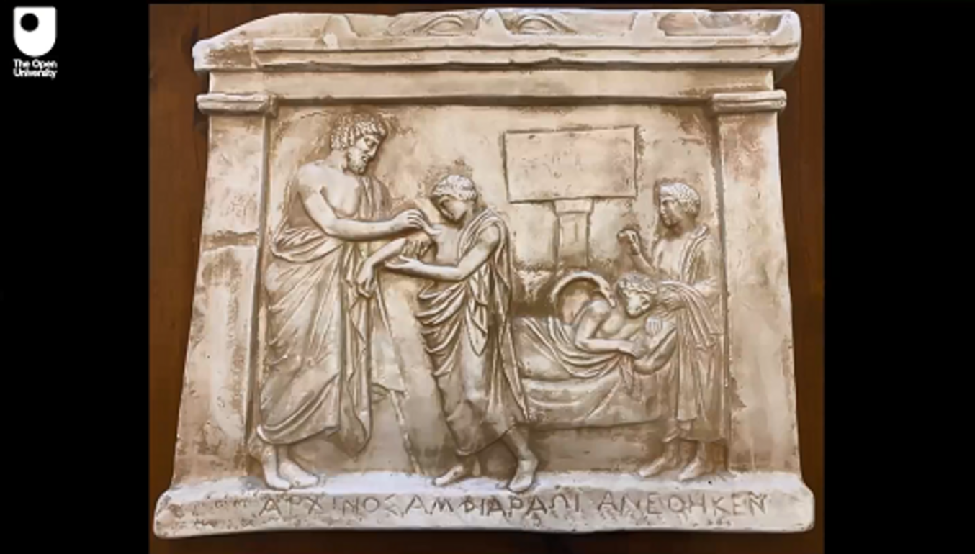

Once you have watched the recording once, watch it again, this time with the following question in mind:
- In which ways might the dedication be thought to represent personal religious experience?
Aim to capture your thoughts in three or four bullet points.

Provide your answer...
View discussion - Activity 7

So far you have examined material remains from the Amphiareion in order to reimagine the expectations and experiences of visitors to the sanctuary. Hopefully you have found it rewarding to engage with visual evidence as a way of approaching the personal dimensions of ancient religion.

4 The politics of religion
In this section you will now think about cult worship of Amphiaraos from the perspective of the polis-religion model (that is, the ways in which religion may be seen as connected to the values of the city-state and supporting the city’s ideals).
As you learned in Section 2, both Oropos and the Amphiareion attracted interest from the cities and regions which surrounded them and which often competed to control the town and its sanctuary.
There were several reasons why Oropos and Amphiaraos’ sanctuary were much sought after (see Wilding, 2021, Chapter 2). From a geographical point of view, Oropos was of strategic value to the Athenians and the Boiotians because it facilitated easy access to the sea (see Map 2) and it also had strategic significance in their frequent conflicts with one another. Oropos was located in between Attica and Boiotia, and was therefore an ideal place to control when these two regions clashed. In the Introductory Guide you will find references to ancient writers, such as Thucydides and Xenophon, who mention the importance of Oropos in relation to instances of conflict between Attica and Boiotia in the classical era (the fifth and fourth centuries BCE).

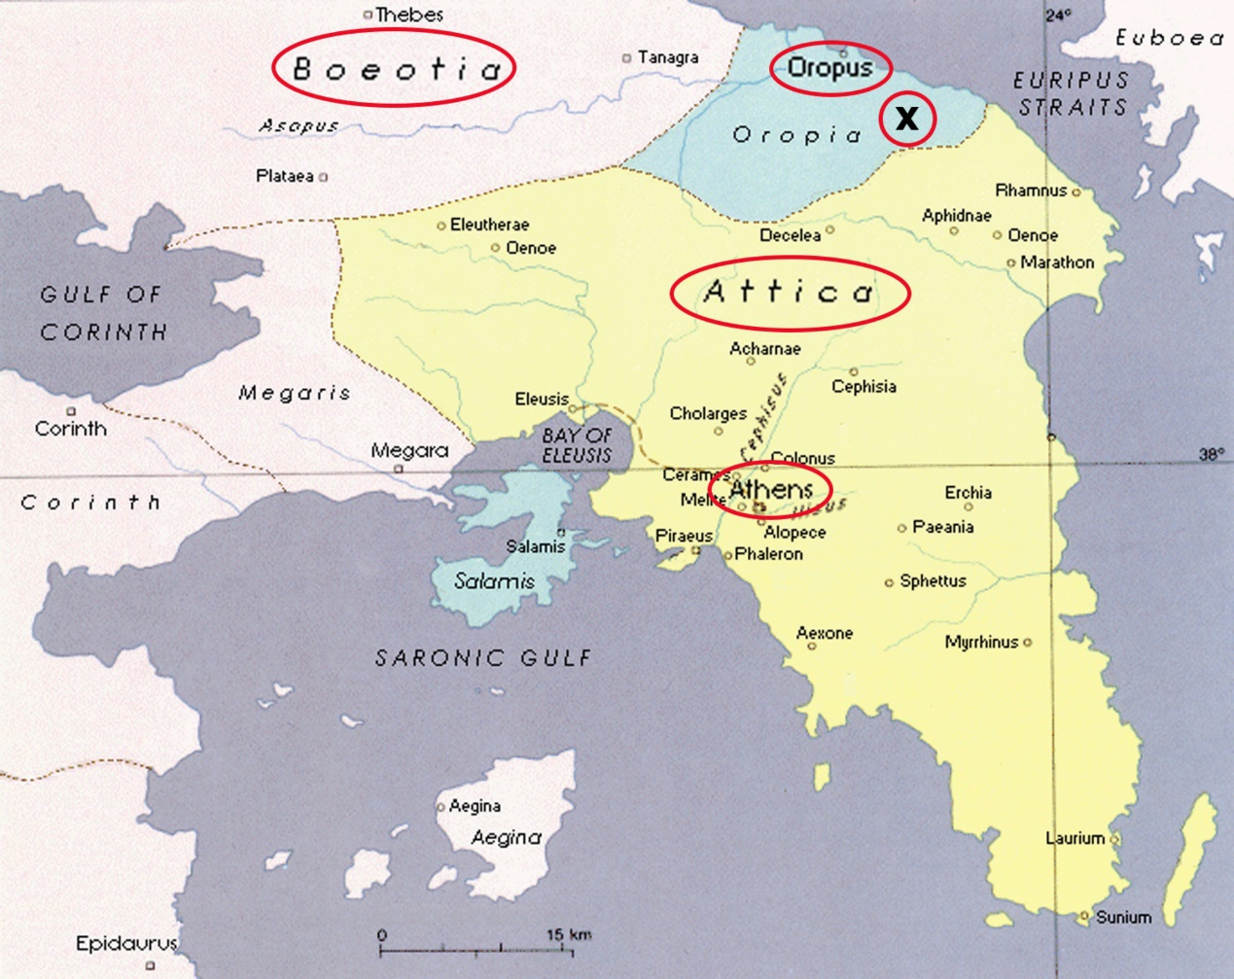
Map 2 Map of Attica and Central Greece; ‘X’ marks the Amphiareion.
View description - Map 2 Map of Attica and Central Greece; ‘X’ marks the Amphiareion.
View alternative description - Map 2 Map of Attica and Central Greece; ‘X’ marks the Amphiareion.

The figure of Amphiaraos also appealed to both the Athenians and the Boiotians, but in different ways. For the Boiotians, Amphiaraos was intimately connected with a collection of lost epic poems known as the ‘Theban cycle’ which told of the mythology of the Boiotian city of Thebes. These poems included stories about the mythical king Oedipus, and the war of the so-called ‘Seven Against Thebes’, and were important to shaping the history and identity of the region more broadly.
For the Athenians, however, Amphiaraos’ association with the collection of myths of the Theban cycle ultimately made him a traditional enemy of Thebes. When Athenian tragic playwrights such as Aeschylus and Euripides began retelling the stories of the Theban cycle in a fifth-century BCE Athenian context, they often spun them in such a way as to highlight the undesirable nature of Thebes in comparison with Athens. For the Athenians, then, Amphiaraos was more than just an important healing figure: he also possessed military significance since he could be cast as someone hostile to Thebes, a city with which the Athenians were often in conflict themselves.

4.1 The politics of Amphiaraos’ sanctuary: literary evidence
You will now consider Amphiaraos’ worship from the perspective of polis-religion by exploring how politics was tied to religion, and in particular, how communities sought to align themselves with Amphiaraos’ cult worship to express political values. A good place to start when thinking about the political dimensions of Amphiaraos’ cult practice is the literary evidence (this means pieces of writing of different genres, such as histories and plays, which have come down to us from the ancient world). Although you learned in the Introductory Guide that literary evidence in fact says very little about Oropos and the Amphiareion, it offers some indication about the political importance of both. Such information in turn helps us interpret the sanctuary’s material remains and look for clues about the political significance of Amphiaraos’ cult worship.

Activity 8
Allow around 20 minutes for this activity

An important ancient author to examine is Pausanias, an ancient Greek writer interested in geography who lived in the second century CE. Pausanias travelled to lots of different Greek cities and wrote his Description of Greece based on his travels. One of the places Pausanias visited was Oropos and its sanctuary of Amphiaraos. His account provides us with one of the most detailed literary descriptions of the city and sanctuary which survives from the ancient world.
Read the following passage in English translation taken from Pausanias’ Description of Greece in which he describes the communities interested in Oropos and the mythological tradition of Amphiaraos.
- As you read, make a list of the places that Pausanias mentions and locate them on Map 3 below.
Then re-read the passage, answering the following questions:
- Which two regions, according to Pausanias, controlled Oropos at different times?
- In what place or places was Amphiaraos’ chariot said to have disappeared into the earth?
(Note that in the first passage, Pausanias mentions King Philip II of Macedon (the father of Alexander the Great) who became the dominant power in the ancient Greek world in the mid fourth century BCE. Following the victory of his forces at the decisive Battle of Chaironeia in 338 BCE, most Greek states that had previously resisted Philip (including Athens) came to terms with Macedon.)
Pausanias, Description of Greece (translation: A. Wilding)

1.34.1 ‘The land of Oropos lies between Attica and Tanagra. Originally, Oropos belonged to Boiotia but in our times in belongs to the Athenians [i.e. the inhabitants of Athens and Attica], who always fought for it but never had secure possession until Philip [of Macedon] gave it to them after taking Thebes.’
1.34.2: ‘It is said that the earth opened up to receive Amphiaraos together with his chariot when he took flight from Thebes, except they say it did not happen here but at a place called Harma [literally meaning ‘Chariot’] as one goes from Thebes to Chalkis. It is believed that Amphiaraos was first established as a god by the people of Oropos, and that later all the Greeks believed the same.’

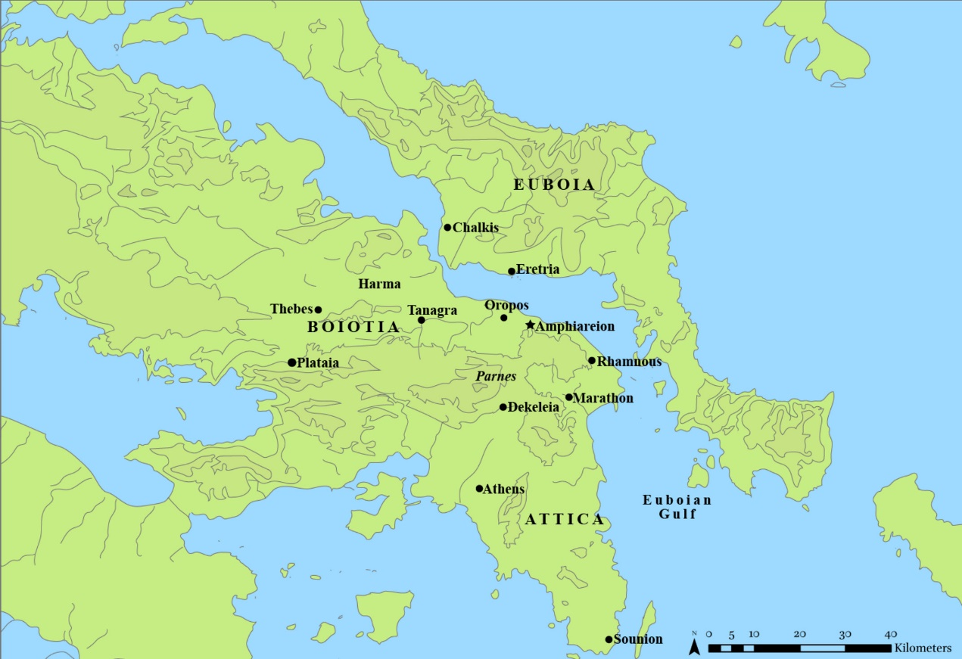
Map 3 Map of central Greece.
View description - Map 3 Map of central Greece.
View alternative description - Map 3 Map of central Greece.

Provide your answer...
View discussion - Activity 8

4.2 The politics of Amphiaraos’ mythical tradition
As your work on Pausanias’ description of Oropos and the myth of Amphiaraos makes clear, there were several places within Attica and Boiotia which were interested in possessing the territory of Oropos. However, the account of Pausanias also implies that some of these places wanted to place their own mark upon Amphiaraos’ mythological tradition, especially in relation to the stories spun about his demise. Upon fleeing the mythological battle of the Seven Against Thebes the earth opened up to receive Amphiaraos and his chariot, as you learned in Activity 3. The passage by Pausanias seems to imply that different places claimed to be the spot where Amphiaraos disappeared. If this is correct, then claiming to be the site where Amphiaraos disappeared with his chariot was perhaps one way for communities to try and align themselves with his myth and cult.
Communities also tried to relate to the myth and cult of Amphiaraos without explicitly claiming to be the site of his disappearance. The city of Athens, for example, which frequently controlled Oropos and the Amphiareion, never made such a claim. Similarly, the first source to mention Oropos as the place where Amphiaraos disappeared comes very late on (indeed not until the thirteenth century CE), a striking omission given the centrality of Oropos to Amphiaraos’ cult site.

4.3 The chariot dismount competition
Claiming to be the site of Amphiaraos’ demise may have been one way in which communities sought to connect themselves to his myth, but let’s now look elsewhere for signs of Amphiaraos’ political importance by returning to the mysterious chariot dismount competition (known as the agon apobasis in ancient Greek), which you met in Activity 3. As the name suggests, this event involved chariots – but with a twist: competitors raced each other by leaping in and out of them. It goes without saying not to try this at home!
The chariot dismount competition was the main event of the festival held in Amphiaraos’ honour at Oropos, known as the Great Amphiaraia. This festival attracted visitors from all over the Greek world (but mainly from the regions of Attica and Boiotia) who competed and watched competitions in athletic, musical and equestrian events. The Great Amphiaraia was first celebrated at Oropos under the control of the Athenians in the year 329/8 BCE (though it was likely a reorganisation of an earlier festival held at Oropos from the late fifth/early fourth century BCE). Importantly, this celebration followed a series of recent political changes for the cities of Athens, Thebes and Oropos.
Alexander the Great had recently destroyed the city of Thebes for trying to revolt against Macedonian power; as a result, control of Oropos was no longer contested and the town came under the permanent control of Athens.

Study note: transliterating Greek words
The standard Greek alphabet contains 24 letters, some of which have equivalents in English, e.g. β (beta) which was pronounced in the classical era like ‘b’ in modern English, ν (nu) which was pronounced like English ‘n’, and π (pi) which was equivalent to English ‘p’.
The standard alphabet used in classical Athens from the end of the fifth century BCE contained seven vowels. These included a long ‘o’ sound, ω (omega, meaning ‘big o’) and a short ‘o’ sound, ο (omicron, meaning ‘small o’) as well as a long ‘e’ sound, written as η (eta) and a short ‘e’ sound, ε (epsilon). When words containing the long vowels ω (omega) or η (eta) are transliterated into English, a line called a macron (pl. macra) is sometimes written above the ‘o or ‘e’ to reflect the original spelling: i.e. ō and ē. According to these conventions, the Greek word for ‘contest’, ἀγών, is transliterated in English as agōn and the Greek word for an athlete who dismounts from a chariot, ἀποβάτης, is transliterated as apobatēs. Note that macra are not used in this course, though you may well see them elsewhere.

4.4 Competing traditions: Athens and Oropos
The Athenians’ connection to the Great Amphiaraia in the late fourth century BCE, then, makes the festival an ideal place to look for clues about the politicising dimensions of Amphiaraos’ cult practice. In the following activity, you will learn more about the chariot dismount competition at Athens and Oropos and think about how iconographical evidence relating to it may provide insight into its political importance.

Activity 9

Part 1
Allow around 10 minutes for Part 1 of this activity

Watch the following video in which Open University academic Christine Plastow discusses the Panathenaia festival.

Watch the video at YouTube.com.

Once you have watched the video once, watch it again, this time with the following questions in mind:
- Where and when was the Panathenaia held?
- Which god or goddess did it honour?
- What activities took place there?

Provide your answer...
View discussion - Part 1

Part 2
Allow around 20 minutes for Part 2 of this activity

Read the following extract taken from Wilding (2021, pp. 89–91 (excerpted)).
As you read, make some notes on the following questions:
- At which festivals was the chariot dismount competition (agon apobasis) celebrated?
- What relationship did the event have with the festivals at which it was celebrated?
- Where did the victors of the chariot dismount competition come from at these festivals?

The … quadrennial festival for Amphiaraos [i.e. the Great Amphiaraia, which occurred every four years] included a procession, gymnastic and equestrian events, and a competition in chariot dismounts; we also know from the sole surviving victor list from these games that the Great Amphiaraia consisted of musical competitions as well … Overall, the programme of the festival was modelled closely on the Panathenaia…
The Great Amphiaraia’s inclusion of an agon apobasis, likely one of its closing events, also enabled the Athenians to revitalise an image of themselves through Amphiaraos’ worship. This event resonated both with stories told about Amphiaraos’ mythological demise … and with the Athenians’ celebration of this agon [i.e. ‘contest’] at the Panathenaia as an exclusively Athenian event. As Julia Shear shows, it reaffirmed the Athenians’ closeness with its purported divine inventors, Athena and her offspring Erichthonios, and formed part of the broader commemoration of the Panathenaia of Athena’s victory over the Giants …
Unfortunately, the sole victor list for the celebration of the Great Amphiaraia under the Athenians [in 329/8 BCE] is worn at the bottom … but in all likelihood it once preserved a record of this competition [the chariot dismount] and the name of its esteemed Athenian victor.

Provide your answer...
View discussion - Part 2

4.5 Picturing the dismount competitions: the visual evidence
The inclusion of the chariot dismount competition at the Great Amphiaraia and the Panathenaia meant that the event was important to both festivals. In fact, the evidence of an ancient Greek grammarian of the second century CE implies that the chariot dismount competition was celebrated only by the people of Athens and Oropos. As you learned in Part 2 of Activity 9, the competition spoke to the mythological tradition of Amphiaraos and Athens’ patron goddess, Athena. With this in mind, you now return to close analysis of visual evidence, this time to consider how it might shine light on the political importance of religious practice.

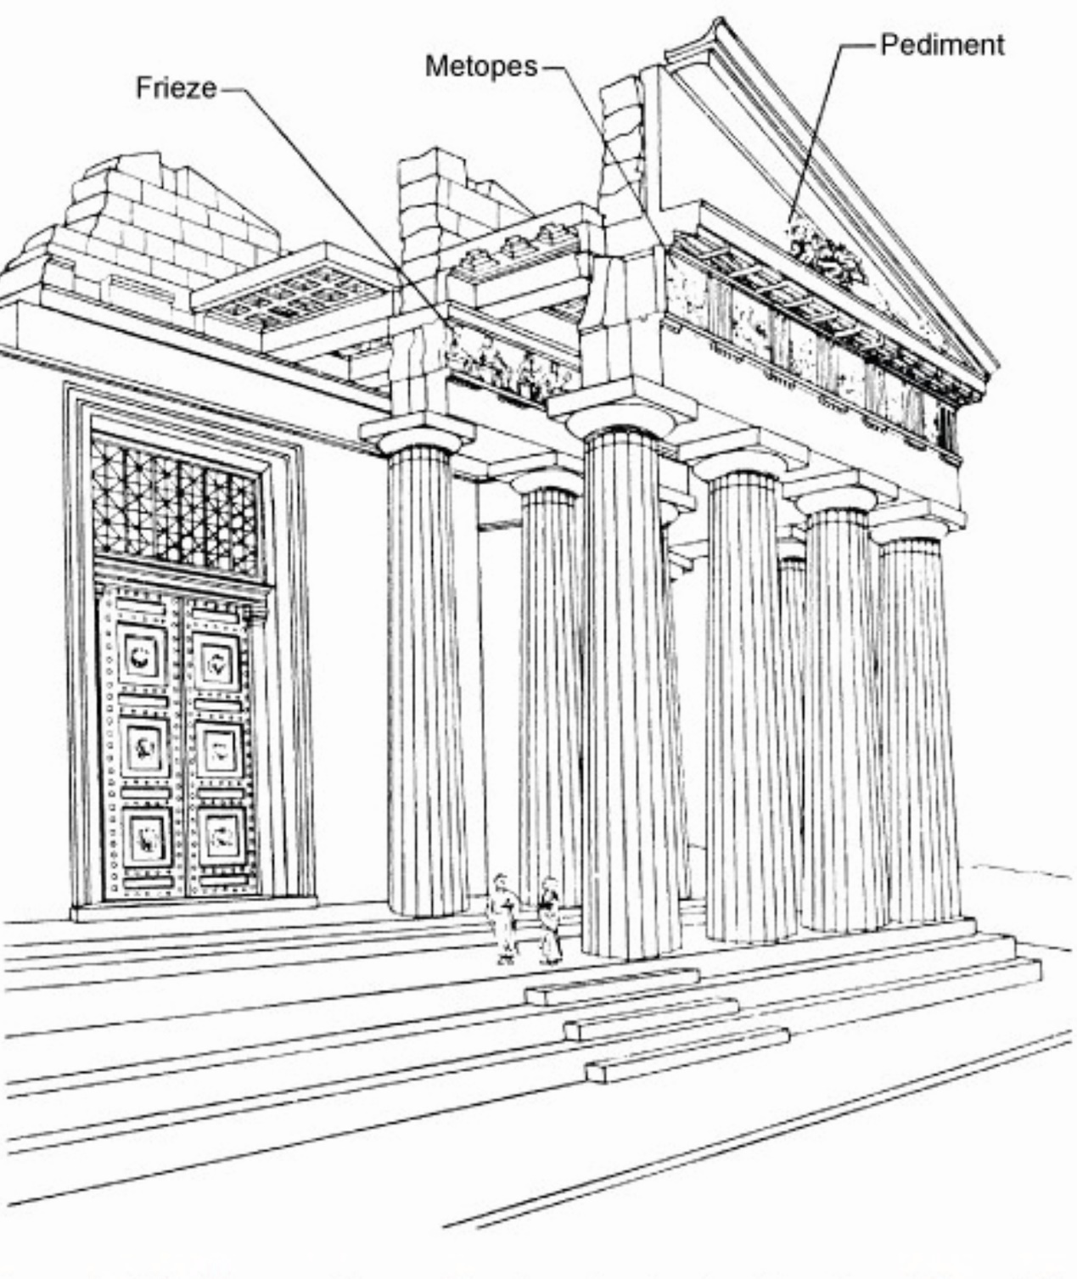
Figure 10 Drawing of the Parthenon at Athens, showing the location of the frieze and other architectural elements.
View description - Figure 10 Drawing of the Parthenon at Athens, showing the location of the frieze ...
View alternative description - Figure 10 Drawing of the Parthenon at Athens, showing the location of the frieze ...

Activity 10
Allow around 30 minutes for this activity

Examine the following three artefacts (Figures 11, 12 and 13) which depict the chariot dismount competition. Figures 11 and 12 show the artistic representations of two sections of the Parthenon frieze (this is a continuous decorative band made up of rectangular panels visible from the outside of a temple: see Figure 10). As you learned in Activity 9 Part 1, the Parthenon frieze consisted of scenes believed to depict scenes from the Panathenaia. Figure 13 is a relief which was dedicated to Amphiaraos at the Amphiareion by an unknown individual after his success in the chariot dismount competition.
- Using the image descriptions to help you, list two or three similarities and two or three differences between the Parthenon scenes on the one hand (Figures 11 and 12) and the Amphiareion scene on the other (Figure 13). Differences to look out for include:
  - their state of preservation
  - the posture and position of the figures such as the charioteer(s) and the apobates (that is, the athlete who will dismount from the moving chariot)
  - the nature of the scene depicted
You will also find it useful to think about what moment you think has been captured in each scene.
- If it weren’t for the image captions, would you be able to tell which monuments came from the Parthenon and which came from the Amphiareion?

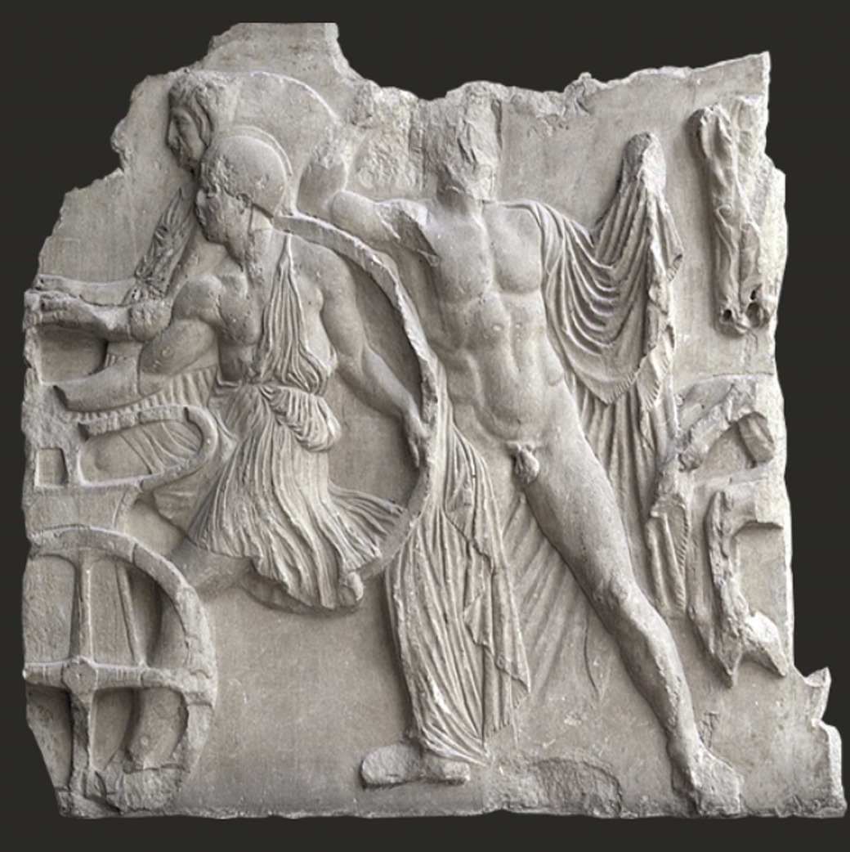
Figure 11 Parthenon frieze, N XXIII.
View description - Figure 11 Parthenon frieze, N XXIII.
View alternative description - Figure 11 Parthenon frieze, N XXIII.

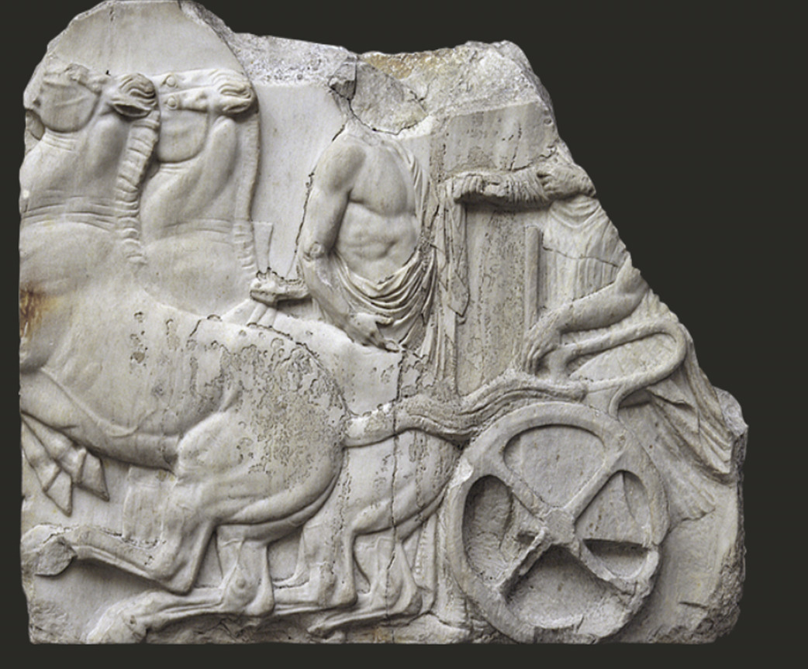
Figure 12 Parthenon frieze, N XXIV
View description - Figure 12 Parthenon frieze, N XXIV
View alternative description - Figure 12 Parthenon frieze, N XXIV

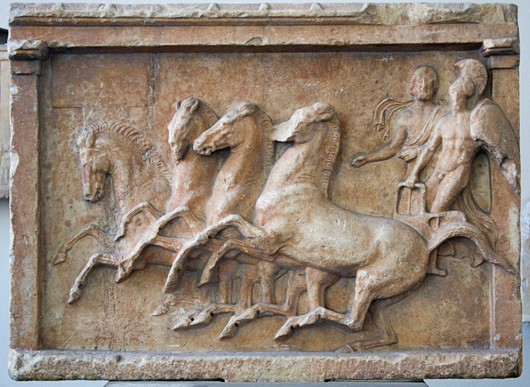
Figure 13 Dedicatory relief from the Amphiareion, fourth century BCE.
View description - Figure 13 Dedicatory relief from the Amphiareion, fourth century BCE.
View alternative description - Figure 13 Dedicatory relief from the Amphiareion, fourth century BCE.

Provide your answer...
View discussion - Activity 10

4.6 Merging traditions? Oropos, Athens and polis religion
The iconographical similarities observed in the scenes from the Parthenon frieze and dedicatory relief from the Amphiareion raise interesting questions about what participants at the Panathenaia and Great Amphiaraia understood as they encountered these monuments and witnessed the chariot dismount competition.
Would participants at the Great Amphiaraia, for example, have been reminded of the Panathenaia and the chariot dismount’s association with Athena as they observed (or even took part in) the competition and viewed dedications depicting it? Certainly, for those Athenians attending the festival it is reasonable that the answer to this question would be ‘yes’, especially given that Athens controlled the sanctuary and its associated festival of Amphiaraos for much of the classical period and that the competition was likely reserved for Athenians.
In the case of the chariot dismount competition, then, we see an example of how religious practice may relate to the idea of polis religion. Here the mythological tradition of Amphiaraos, and his particular association with chariots, merged with the Athenians’ celebration of the chariot dismount competition at their most important religious festival. By celebrating the chariot dismount competition at the Great Amphiaraia of 329/8 BCE, the Athenians may be seen as merging Amphiaraos’ mythology with their own religious traditions so as to align with their broader political agenda to control Oropos and its sanctuary – especially after the destruction of Thebes by Alexander the Great. Such cultic overlap ultimately brought Amphiaraos into closer contact with Athens’ patron goddess, Athena, thus strengthening the Athenians’ claims over Oropos and the figure of Amphiaraos.

Conclusion
In this course, you explored the concepts of ‘personal’ and ‘polis’ religion by using the cult of Amphiaraos at Oropos as your case-study. In particular, you learned to approach visual source material as a means of interpreting how this deity’s cult practice was lived and experienced by the ancient Greeks. As set out in the Introduction to this course, the ancient Greeks did not distinguish between personal and political religious acts as scholars of ancient religions do today. In fact, in your studies of the Amphiareion you discovered traces of both through close examination of the sanctuary’s material remains.
On the one hand, you tapped into the expectations and experiences of individuals who sought to consult Amphiaraos for healing purposes by close analysis of the sanctuary’s sacred regulation and the dedication offered by Archinos. On the other hand, you also explored how political communities (most notably Athens) could merge their own religious practices with Amphiaraos’ mythological tradition as a means of bolstering their own political agenda to control Oropos and its sanctuary. The case of the chariot dismount competition and the resonances it also bore to the Athenian celebration of the Panathenaia highlight the potential for religious festivals to have underlying political meaning.

Taking it further
If you want to find out more about the Amphiareion at Oropos, there is a useful overview of the sanctuary and the religious activity that went on there on the University of Warwick’s Greek Religion database: Amphiareion at Oropos.
If you’re interested in learning about the original language in which the inscriptions and texts you’ve read in this course were written, try this free introductory course: Getting started on Ancient Greek.
You may want to find out more about Amphiaraos’ mythological background. A good starting point would be to read the Athenian dramatist Aeschylus’ tragic play, Seven Against Thebes, first produced in 467 BCE. This play relays the dispute between the sons of Oedipus and the subsequent Argive expedition against Thebes (note that Amphiaraos is mentioned in this tragedy, although not as a main character). You may access the text freely via the Perseus Digital Library.
In Activity 10 you examined two sections of the Parthenon frieze of the Parthenon. You may wish to find out more about the Parthenon frieze, its iconography, and connection to the Panathenaia, which you can do so via the Parthenon frieze’s website.
In this course you have been introduced to a festival, the Great Amphiaraia. You may wish to explore videos about other festivals in the Greek and Roman world and think about their implications in relation to personal and polis religion. The videos are freely available on this Classical Studies: festivals page.
This course is part of a series of courses under the title HeadStart Classical Studies. You can find details about this series as well as links to its other courses on this page.

Pronunciation guide

Audio content is not available in this format.
Aegina

Audio content is not available in this format.
Aeschylus

Audio content is not available in this format.
Agon apobasis

Audio content is not available in this format.
Amphiaraia

Audio content is not available in this format.
Amphiaraos

Audio content is not available in this format.
Amphiareion

Audio content is not available in this format.
Aphaia

Audio content is not available in this format.
Apobates

Audio content is not available in this format.
Asklepios

Audio content is not available in this format.
Athena

Audio content is not available in this format.
Attica

Audio content is not available in this format.
Boiotia

Audio content is not available in this format.
Boiotians

Audio content is not available in this format.
Chalkis

Audio content is not available in this format.
Demeter

Audio content is not available in this format.
Drachma

Audio content is not available in this format.
Eleusinian Mysteries

Audio content is not available in this format.
Eleusis

Audio content is not available in this format.
Epidauros

Audio content is not available in this format.
Erichthonios

Audio content is not available in this format.
Euripides

Audio content is not available in this format.
Exomis

Audio content is not available in this format.
Harma

Audio content is not available in this format.
Himation

Audio content is not available in this format.
Lebadeia

Audio content is not available in this format.
Leonteus

Audio content is not available in this format.
Obol

Audio content is not available in this format.
Oropos

Audio content is not available in this format.
Panathenaia

Audio content is not available in this format.
Parthenon

Audio content is not available in this format.
Pausanias

Audio content is not available in this format.
Peloponnese

Audio content is not available in this format.
Persephone

Audio content is not available in this format.
Polis

Audio content is not available in this format.
Poseidon

Audio content is not available in this format.
Stele

Audio content is not available in this format.
Tanagra

Audio content is not available in this format.
Thebes

Audio content is not available in this format.
Zeus

Tell us what you think
Now you’ve come to the end of the course, we would appreciate a few minutes of your time to complete this short end-of-course survey. We’d like to find out a bit about your experience of studying the course and what you plan to do next. We will use this information to provide better online experiences for all our learners and to share our findings with others. Participation will be completely confidential and we will not pass on your details to others.

References
Kindt, J. (2015) ‘Personal religion: a productive category for the study of ancient Greek religion?’, Journal of Hellenic Studies, 135, pp. 35–50.
Osborne, R. and Rhodes, P.J. (2003) (eds) Greek Historical Inscriptions, 404–323 BC. Oxford: Oxford University Press, no. 27.
Petropoulou, A. (1981) ‘The Eparche documents and the early oracle at Oropus’, GRBS, 22, pp. 39–63.
Shear, J.L. (2021) Serving Athena: The Festival of the Panathenaia and the Construction of Athenian Identities. Cambridge: Cambridge University Press.
Sourvinou-Inwood, C. (2000) ‘What is polis religion?’, in R. Buxton (ed.) Oxford Readings in Greek Religion. Oxford: Oxford University Press, Oxford, pp. 13–37.
Thomas, R. (1992) Literacy and Orality in Ancient Greece. Cambridge: Cambridge University Press, Cambridge.
Wilding, A.R. (2021) Reinventing the Amphiareion at Oropos. Leiden: Brill, Leiden.

Acknowledgements
This free course was written by Alexandra Wilding with contributions from James Robson.
Except for third party materials and otherwise stated (see terms and conditions), this content is made available under a Creative Commons Attribution-NonCommercial-ShareAlike 4.0 Licence.
The material acknowledged below is Proprietary and used under licence (not subject to Creative Commons Licence). Grateful acknowledgement is made to the following sources for permission to reproduce material in this free course:
Images
Course image: DeAgostini; SuperStock
Figure 1: anyaivanova; Getty Images
Figures 2, 8 and 9: Courtesy of Dr Alexandra Wilding
Figures 3 and 6: courtesy of The Archaeological Society
Figure 4: Marsyas; https://creativecommons.org/licenses/by/2.5/
Figure 5: The British Museum, https://creativecommons.org/licenses/by-nc-sa/4.0/
Figure 7: courtesy of The Archaeological Society at Athens; Topographical outline of the Amphiareion. Image adapted from V.C. Petrakos (1995) The Amphiareion of Oropos. Athens, figure 15.
Figure 10: The Open University
Figure 11: courtesy of The Acropolos Museum
Figure 12: © Socratis Mavrommatis and 2022 Ministry of Culture and Sports - Acropolis Museum - Acropolis Restoration Service
Figure 13: Ealdgyth; https://creativecommons.org/licenses/by-sa/3.0/; from https://es.wikipedia.org/wiki/Juegos
Map 1: adapted from Marsyas, (2012, April 26). Map of Classical Greek Sanctuaries. World History Encyclopedia. Retrieved from https://www.worldhistory.org/image/325/map-of-classical-greek-sanctuaries/; https://creativecommons.org/licenses/by-sa/4.0deed.en
Map 2: taken from Plato Dialogues, Bernard SUZANNE
Map 3: courtesy of Dr Maeve McHugh (University of Birmingham)
Every effort has been made to contact copyright owners. If any have been inadvertently overlooked, the publishers will be pleased to make the necessary arrangements at the first opportunity.
Don't miss out
If reading this text has inspired you to learn more, you may be interested in joining the millions of people who discover our free learning resources and qualifications by visiting The Open University – www.open.edu/openlearn/free-courses.

Glossary
Aegina
a Greek island in the Saronic Gulf, located roughly 27km from Athens
Athenian
relating to the city of Athens or its inhabitants
Attica
the name given to the region which comprises Athens and its countryside
Aphaia
an ancient Greek goddess, associated with fertility, worshipped on the island of Aegina
cult
the worship of a specific figure through ritual and ceremony, often centred on a particular religious site, such as a temple or shrine
dedicant
a person who sets up a dedication
deity
(pl. deities) a divine being, such as a god, goddess or other figure, such as a hero, who is worshipped
Eleusinian Mysteries
a religious festival celebrated in the town of Eleusis in honour of Demeter and Persephone, goddesses of fertility
Eleusis
a town in Attica, roughly 13 miles or 20 km to the west of Athens
excavation
the act of excavating (or unearthing) something, in this context from an archaeological site
frieze
a continuous decorative band made up of rectangular panels visible from the outside of a temple
grammarian
a person who studies grammar
iconographical
pertaining to iconography: the representation of ideas through artistic forms (such as images, drawings or engravings)
incubation
in an ancient Greek context, the process by which people slept in a temple or sacred space to communicate with the divine for oracular or healing purposes
inscriptions
words that are carved or cut into a material such as stone, clay or metal, often for public display
Lebadeia
a city within the region of Boiotia
pious
the act of showing dedication or obedience to a god/religious order
relief
a type of artwork, such as a sculpture, in which moulded shapes and images jut out from a flat background
stele
(pl. stelai) An upright stone slab, often bearing an inscription and/or some form of decoration or artistic representation
Votive
an object placed or deposited in a religious setting for a religious purpose

Solutions

Activity 1

Discussion
There is no right or wrong answer to this activity. Your four or five words/phrases will depend a lot on your own personal experiences and interests. You may have thought about a particular faith with which you are familiar, for example, or a set of rituals, places and objects associated with certain religious activities. You may have even thought about religion in terms of a particular recipient of worship or in relation to the types of peoples who commit their lives to serving a religious order.
Back to - Activity 1

Activity 2

Discussion
Again, there is no right or wrong answer here. Depending on what knowledge you have already about ancient Greek gods, you may have noted down the names of some major divinities, such as Zeus, Poseidon and Athena – or, indeed, simply observed that the ancient Greeks had lots of gods and goddesses. You may even have seen some images of, or perhaps visited, a particular Greek temple or sanctuary, or have some memory of seeing a particular divinity in a modern context (such as a film, book, video game or part of a museum exhibit).
Back to - Activity 2

Activity 3

Discussion
Here is an example of a completed text. If you didn’t get all of the words in the right places, take note of their correct placement now.
The sanctuary of Amphiaraos is also known as the Amphiareion. It is situated within a town called Oropos between Attica and Boiotia in a wooded grove. The Athenians probably founded the sanctuary in the fifth century BCE. According to Herodotos, the Amphiareion was once a popular dream oracle, but by the late fifth century BCE it was associated with healing.
In Greek mythology Amphiaraos is associated with the Seven Against Thebes. He allegedly met his fate when he fled from Thebes on his chariot and was swallowed up by the earth.
Oropos was a politically weak city-state. The Athenians and the Boiotians often competed to control the city and the sanctuary of Amphiaraos, but at times the city of Oropos was independent. In later periods, the Romans were also interested in the Amphiareion.
To understand the history of Oropos and the Amphiareion we mainly rely on material culture (that is, physical objects which come down to us from the ancient world) rather than literary evidence. For example, objects tell us about the Great Amphiaraia, a festival celebrated in Amphiaraos’ honour which included an event in which competitors leapt in and out of moving chariots.
More than 500 inscriptions are known to have been set up at the sanctuary. These inscriptions help us unravel the interactions that took place within the confines of the sanctuary. They also helpfully tell us about how individuals and cities sought to identify with Amphiaraos’ religious practice.
Back to - Activity 3

Activity 4

Discussion
You may have identified the following types of ancient evidence:
- Literary texts, which provide snippets of information about Amphiaraos and the relationship the town of Oropos had with its neighbours.
- Archaeological remains, such as building structures at the sanctuary, which provide insight into some of the ways people used the shrine – such as for the celebration of games and festivals.
- Reliefs, which reflect the experiences of individuals at the sanctuary, such as their victories in certain competitions at Amphiaraos’ games.
- Monuments and inscriptions, which provide information about the activities and decisions of individuals and communities in relation to the sanctuary.
Back to - Activity 4

Activity 5

Discussion
- You may have thought about factors such as durability (that is, how long something might last before becoming damaged) and the importance of the text itself: things carved onto stone are likely to last for a long time and create a sense of permanence too (you may be familiar with the phrase ‘set in stone’ as a way of referring to something which cannot be changed). You may also have thought about visibility (that is, making something noticeable or clear) or even about increasing access to a piece of information.
- In terms of the effort it might have taken to create an inscription, you may have thought about factors such as the size, cost and material of the monument and the different skills required to carve letters onto a hard surface. Each letter would have been carved individually by hand which must have been painstaking and highly skilled work. Indeed, you may have remarked on the neatness and precision of the inscribed letters.
Back to - Activity 5

Activity 6

Discussion
Reading inscriptions can be tricky at first, so don’t worry if you found this activity a bit challenging. Hopefully you enjoyed engaging with the very rules of the ancient Greeks of the fourth century BCE and managed to come up with some ideas about the dos and don’ts for your first visit. Your answers may differ slightly from these, but here are some examples:
- You would expect to take money with you on your visit to pay for your consultation with Amphiaraos (the regulations stipulate 9 obols, which, as you might have worked out from the glossary entry on ‘drachma’, could be as much as one day’s pay). You might even take something to sacrifice upon the altar while you are there, such as an animal.
- The sacred regulations don’t go into great detail about specific actions you should undertake, but it does mention the possibility of offering sacrifice and the chance to be healed by the god via the process of incubation. There is no guidance for how you ought to prepare for either of these actions other than paying the fee and providing a record of your name.
- From the inscription, it is clear that you shouldn’t take any of my sacrificial meat outside of the sanctuary and that the shoulder of the animal should be kept as sacred for the priest; the skin is also to remain sacred. The inscription also mentions not committing any offences to avoid paying a fine, but it doesn’t elaborate upon what those offences are. As a new visitor, you will have to be on my best behaviour.
- While the inscription doesn’t explicitly mention communication with the god, it does mention the process of incubation, but unfortunately the details of this process no longer survive on the stone! What is clear, however, is that this process involves going to sleep at the sanctuary and that and this was achieved by sleeping in a dormitory (with men and women sleeping separately). You should therefore expect to communicate with Amphiaraos in a dream.
- The priest doesn’t seem overly important to the visit. The inscription records that he has to be at the sanctuary for at least 10 days every month and not be absent for more than three days at a time. However, it also says that you are allowed to offer your own personal sacrifice upon the altar in the priest’s absence. The temple keeper seems to be more important as it is to them that you must pay my consultation fee and give your name for the sanctuary’s official records.
Back to - Activity 6

Activity 7

Discussion
Hopefully you enjoyed finding out more about Archinos’ dedication in the recording. Your own reflections on the ways in which this monument might reflect personal religious experience may well differ to these, but here are some ideas:
- The text of the dedication ‘Archinos set this up to Amphiaraos’ implies a personal relationship between the dedicant and the god.
- The appearance of Archinos in three different scenes in the relief suggests that these scenes are there to explain the context of his dedication and therefore his personal experience of his visit to the sanctuary.
- The fact that Archinos depicts the act of healing in two very different ways suggests that he held more than one view about his encounter with Amphiaraos, which may well reflect the conflicting visions Archinos had as he slept at the sanctuary.
- The possible interpretation that Archinos is gesturing towards his own dedication in one of the three scenes reinforces the idea that his dedication was set up to commemorate his personal experience of healing at the sanctuary.
Back to - Activity 7

Activity 8

Discussion
- Hopefully you were able to find the locations mentioned by Pausanias on the map.
- The regions of Attica and Boiotia, which surround Oropos, are the ones Pausanias mentions as controlling Oropos at different times: he says that the Athenians and Boiotians fought for possession of the land for most of its history.
- Pausanias mentions two places within the region of Boiotia – Thebes, and a village called Harma – in his account of the mythological tradition of the Amphiaraos. The passage arguably implies the existence of different traditions about where he was swallowed up by the earth, with this either happening as he was fleeing from Thebes or, alternatively, in the village of Harma (whose name means ‘chariot’ in ancient Greek).
Back to - Activity 8

Activity 9

Part 1

Discussion
The Panathenaia was the Athenians’ most important religious festival. It was held in the summertime at Athens in honour of the city’s patron goddess, Athena. The festival went on for several days and consisted of lots of competitions in athletics, music, poetry and even chariot racing. The highlight of the festival was the procession to the Acropolis, where a new robe was dedicated to a statue of Athena. On the Acropolis participants would have seen the Parthenon, which in turn was decorated with sculpted scenes of both the religious procession and the dedication of Athena’s robe.
Back to - Part 1

Part 2

Discussion
- The chariot dismount competition was celebrated at the Great Amphiaraia and the Panathenaia.
- The celebration of the chariot dismount competition appears to have been closely linked to mythological stories relating to both Amphiaraos and Athena: it resonated with the descent of Amphiaraos into the earth alongside his chariot and with the mythological victory of Athena over the Giants.
- At the Panathenaia, the event was open only to Athenians. The author of this passage says that the victor the Great Amphiaraia of 329/8 BCE is likely to have been Athenian as well.
Back to - Part 2

Activity 10

Discussion
- The most obvious difference is that the two metopes from the Parthenon frieze are fragmentary whereas the relief from the Amphiareion is almost perfectly preserved. All three artefacts depict horse-drawn chariots with their apobates (that is, the athlete who will dismount from the moving chariot) and charioteers, but the scenes from the Parthenon frieze appear to capture the ‘action’ of the competition that bit more. Indeed, one of the images from the Parthenon frieze depicts the apobates as he once again mounts his chariot (Figure 11) and both Parthenon monuments also show the marshal offering signals as guidance throughout the event. The Amphiareion relief (Figure 13), on the other hand, appears to show a slightly more relaxed scene which may represent the victory of the dedicant rather than the battle of the contest itself. The charioteer in this relief is noticeably not looking straight ahead but towards the viewer while the apobates almost leans on his chariot in a more relaxed way.
- If it weren’t for the image captions (and other small differences, such as the colour of the marble) you might not have been able to distinguish which scenes were from the Parthenon, and therefore represented the chariot dismount competition at the Panathenaia, and which depicted the event celebrated at the Amphiaraia.
Back to - Activity 10

Descriptions

Figure 1 The Parthenon on the Acropolis, in Athens, Greece.
A photograph of the Parthenon. It is located on the Athenian Acropolis, in the heart of the ancient city. This temple was built between 447 and 432 BCE in honour of Athens’ patron deity Athena, who was worshipped here as ‘Parthenos’ (or ‘maiden’).
Back to - Figure 1 The Parthenon on the Acropolis, in Athens, Greece.

Figure 1 The Parthenon on the Acropolis, in Athens, Greece.
A photograph of the Parthenon. It is located on the Athenian Acropolis, in the heart of the ancient city. This temple was built between 447 and 432 BCE in honour of Athens’ patron deity Athena, who was worshipped here as ‘Parthenos’ (or ‘maiden’).
Back to - Figure 1 The Parthenon on the Acropolis, in Athens, Greece.

Figure 2 Temple of the goddess Aphaia at Aegina, c.500 BCE.
A photograph of the temple of the goddess Aphaia, Aegina.
Back to - Figure 2 Temple of the goddess Aphaia at Aegina, c.500 BCE.

Figure 2 Temple of the goddess Aphaia at Aegina, c.500 BCE.
A photograph of the temple of the goddess Aphaia, Aegina.
Back to - Figure 2 Temple of the goddess Aphaia at Aegina, c.500 BCE.

Map 1 Map depicting key religious sanctuaries of the Greek Aegean.
Map depicting key religious sanctuaries of the Greek Aegean.
Back to - Map 1 Map depicting key religious sanctuaries of the Greek Aegean.

Map 1 Map depicting key religious sanctuaries of the Greek Aegean.
Map depicting key religious sanctuaries of the Greek Aegean.
Back to - Map 1 Map depicting key religious sanctuaries of the Greek Aegean.

Figure 3 Marble stele with relief depicting a leg and buttock within a temple border, c. third century CE; 0.51m (height) x 0.31m (width). The inscription reads: ‘Leonteus son of Leonteus from Lebadeia [set this up] as a vow to Amphiaraos’. Image taken from V.C. Petrakos (1997), Οἱ ἐπιγραφὲς τοῦ Ὠρωποῦ (The Inscriptions of Oropos), Athens, no. 469.
A photograph of a marble stele with relief.
Back to - Figure 3 Marble stele with relief depicting a leg and buttock within a temple border, c. third century CE; 0.51m (height) x 0.31m (width). The inscription reads: ‘Leonteus son of Leonteus from Lebadeia [set this up] as a vow to Amphiaraos’. Image taken from V.C. Petrakos (1997), Οἱ ἐπιγραφὲς τοῦ Ὠρωποῦ (The Inscriptions of Oropos), Athens, no. 469.

Figure 3 Marble stele with relief depicting a leg and buttock within a temple border, c. third century CE; 0.51m (height) x 0.31m (width). The inscription reads: ‘Leonteus son of Leonteus from Lebadeia [set this up] as a vow to Amphiaraos’. Image taken from V.C. Petrakos (1997), Οἱ ἐπιγραφὲς τοῦ Ὠρωποῦ (The Inscriptions of Oropos), Athens, no. 469.
A photograph of a marble stele with relief.
Back to - Figure 3 Marble stele with relief depicting a leg and buttock within a temple border, c. third century CE; 0.51m (height) x 0.31m (width). The inscription reads: ‘Leonteus son of Leonteus from Lebadeia [set this up] as a vow to Amphiaraos’. Image taken from V.C. Petrakos (1997), Οἱ ἐπιγραφὲς τοῦ Ὠρωποῦ (The Inscriptions of Oropos), Athens, no. 469.

Figure 4 The Ninnion Tablet, c. 370 BCE.
The Ninnion Tablet is a terracotta plaque which was dedicated at the sanctuary of Demeter and Persephone at Eleusis around 370 BCE. It gets its name from the woman who set it up, which we know from an inscription scratched onto the bottom of the plaque. The scenes are thought to represent affairs at the Eleusinian Mysteries, a secret religious festival held in honour of the two goddesses. At the bottom on the right a seated Demeter is depicted. Before her stands the god Iakchos who is leading a group of initiates towards her. They hold torches in their hands.
Back to - Figure 4 The Ninnion Tablet, c. 370 BCE.

Figure 4 The Ninnion Tablet, c. 370 BCE.
The Ninnion Tablet is a terracotta plaque which was dedicated at the sanctuary of Demeter and Persephone at Eleusis around 370 BCE. It gets its name from the woman who set it up, which we know from an inscription scratched onto the bottom of the plaque. The scenes are thought to represent affairs at the Eleusinian Mysteries, a secret religious festival held in honour of the two goddesses. At the bottom on the right a seated Demeter is depicted. Before her stands the god Iakchos who is leading a group of initiates towards her. They hold torches in their hands.
Back to - Figure 4 The Ninnion Tablet, c. 370 BCE.

Figure 5 Side A of a marble stele from the Amphiareion concerning the melting down of votive objects, c. late third century BCE; 77.47cm (height) x 38.10cm (width).
A photograph of part of a marble stele.
Back to - Figure 5 Side A of a marble stele from the Amphiareion concerning the melting down of votive objects, c. late third century BCE; 77.47cm (height) x 38.10cm (width).

Figure 5 Side A of a marble stele from the Amphiareion concerning the melting down of votive objects, c. late third century BCE; 77.47cm (height) x 38.10cm (width).
A photograph of part of a marble stele.
Back to - Figure 5 Side A of a marble stele from the Amphiareion concerning the melting down of votive objects, c. late third century BCE; 77.47cm (height) x 38.10cm (width).

Figure 6 Stone stele recording the sacred regulations of the Amphiareion, c. 386–374 BCE; 1.49m (height) x 0.3m (width).
A photograph of part of a stone stele.
Back to - Figure 6 Stone stele recording the sacred regulations of the Amphiareion, c. 386–374 BCE; 1.49m (height) x 0.3m (width).

Figure 6 Stone stele recording the sacred regulations of the Amphiareion, c. 386–374 BCE; 1.49m (height) x 0.3m (width).
A photograph of part of a stone stele.
Back to - Figure 6 Stone stele recording the sacred regulations of the Amphiareion, c. 386–374 BCE; 1.49m (height) x 0.3m (width).

Figure 7 Topographical outline of the Amphiareion.
The plan shows the main features of the Amphiareion, as reconstructed from archaeological finds. At the top of the site is a theatre, below which there is a long colonnaded stoa. The women’s baths lie to the right of this stoa, while the men’s baths lie to the left, close to the temple, which is at the far left of the plan. Other features include a sacred spring and an altar, located between the baths and the temple. Above these is the site of a series of honorific statues and below is a water clock. From the bottom left to the bottom centre of the plan, a large, interconnected series of walls and buildings is labelled ‘residential quarters and the agora’, i.e. the market place.
Back to - Figure 7 Topographical outline of the Amphiareion.

Figure 7 Topographical outline of the Amphiareion.
The plan shows the main features of the Amphiareion, as reconstructed from archaeological finds. At the top of the site is a theatre, below which there is a long colonnaded stoa. The women’s baths lie to the right of this stoa, while the men’s baths lie to the left, close to the temple, which is at the far left of the plan. Other features include a sacred spring and an altar, located between the baths and the temple. Above these is the site of a series of honorific statues and below is a water clock. From the bottom left to the bottom centre of the plan, a large, interconnected series of walls and buildings is labelled ‘residential quarters and the agora’, i.e. the market place.
Back to - Figure 7 Topographical outline of the Amphiareion.

Figure 8 Remains of the altar at the Amphiareion.
The altar of the Amphiareion was constructed by the mid fourth century BCE. The sanctuary’s sacred regulations tell us that it was used both by the priest of Amphiaraos and visitors to the sanctuary to offer sacrifices to the god. A small stepped theatre overlooked the altar allowing pilgrims to observe such religious sacrifice.
Back to - Figure 8 Remains of the altar at the Amphiareion.

Figure 8 Remains of the altar at the Amphiareion.
The altar of the Amphiareion was constructed by the mid fourth century BCE. The sanctuary’s sacred regulations tell us that it was used both by the priest of Amphiaraos and visitors to the sanctuary to offer sacrifices to the god. A small stepped theatre overlooked the altar allowing pilgrims to observe such religious sacrifice.
Back to - Figure 8 Remains of the altar at the Amphiareion.

Figure 9 Remains of the temple of Amphiaraos.
The temple of Amphiaraos was constructed by the mid fourth century BCE. Like other ancient Greek temples, it would have housed sacred objects and treasures as well as a cult statue.
Back to - Figure 9 Remains of the temple of Amphiaraos.

Figure 9 Remains of the temple of Amphiaraos.
The temple of Amphiaraos was constructed by the mid fourth century BCE. Like other ancient Greek temples, it would have housed sacred objects and treasures as well as a cult statue.
Back to - Figure 9 Remains of the temple of Amphiaraos.

Map 2 Map of Attica and Central Greece; ‘X’ marks the Amphiareion.
Map of Attica and Central Greece
Back to - Map 2 Map of Attica and Central Greece; ‘X’ marks the Amphiareion.

Map 2 Map of Attica and Central Greece; ‘X’ marks the Amphiareion.
Map of Attica and Central Greece
Back to - Map 2 Map of Attica and Central Greece; ‘X’ marks the Amphiareion.

Map 3 Map of central Greece.
Map of central Greece.
Back to - Map 3 Map of central Greece.

Map 3 Map of central Greece.
Map of central Greece.
Back to - Map 3 Map of central Greece.

Figure 10 Drawing of the Parthenon at Athens, showing the location of the frieze and other architectural elements.
Ancient Greek temples had similar architectural elements. This image shows you the location of the Parthenon frieze, a decorative band located above the architrave of the temple. Friezes were made up of rectangular architectural features, known as metopes, which often had painted of sculptured decoration. This image also shows you the location of the temple’s pediment, a form of gable usually of triangular shape.
Back to - Figure 10 Drawing of the Parthenon at Athens, showing the location of the frieze and other architectural elements.

Figure 10 Drawing of the Parthenon at Athens, showing the location of the frieze and other architectural elements.
Ancient Greek temples had similar architectural elements. This image shows you the location of the Parthenon frieze, a decorative band located above the architrave of the temple. Friezes were made up of rectangular architectural features, known as metopes, which often had painted of sculptured decoration. This image also shows you the location of the temple’s pediment, a form of gable usually of triangular shape.
Back to - Figure 10 Drawing of the Parthenon at Athens, showing the location of the frieze and other architectural elements.

Figure 11 Parthenon frieze, N XXIII.
On this and the next block are two chariots each with apobates [the athlete who dismounts the moving chariot], charioteer and two marshals. A marshal is frontal to the viewer, striding to the left while turning back to give a signal of some sort with his raised right hand. With his left hand he holds up his richly folded himation [a type of cloak] which has just slipped from his right shoulder leaving his body virtually nude. To the left, almost touching the marshal, is the apobates. He wears a helmet and exomis [a short, sleeveless, garment which left one shoulder bare], his shield hangs by a strap over his back and he has just leapt onto the chariot, which is driven by a very small charioteer.
Back to - Figure 11 Parthenon frieze, N XXIII.

Figure 11 Parthenon frieze, N XXIII.
On this and the next block are two chariots each with apobates [the athlete who dismounts the moving chariot], charioteer and two marshals. A marshal is frontal to the viewer, striding to the left while turning back to give a signal of some sort with his raised right hand. With his left hand he holds up his richly folded himation [a type of cloak] which has just slipped from his right shoulder leaving his body virtually nude. To the left, almost touching the marshal, is the apobates. He wears a helmet and exomis [a short, sleeveless, garment which left one shoulder bare], his shield hangs by a strap over his back and he has just leapt onto the chariot, which is driven by a very small charioteer.
Back to - Figure 11 Parthenon frieze, N XXIII.

Figure 12 Parthenon frieze, N XXIV
On this block is another chariot with apobates [the athlete who dismounts the moving chariot], charioteer and a marshal. Preserved are the left hand of the apobates, grasping the chariot he has just mounted, and the lower part of the body and the forearm of the charioteer holding the reins. Behind the horses stands a marshal, head missing, turning in opposite direction to the course of the chariots.
Back to - Figure 12 Parthenon frieze, N XXIV

Figure 12 Parthenon frieze, N XXIV
On this block is another chariot with apobates [the athlete who dismounts the moving chariot], charioteer and a marshal. Preserved are the left hand of the apobates, grasping the chariot he has just mounted, and the lower part of the body and the forearm of the charioteer holding the reins. Behind the horses stands a marshal, head missing, turning in opposite direction to the course of the chariots.
Back to - Figure 12 Parthenon frieze, N XXIV

Figure 13 Dedicatory relief from the Amphiareion, fourth century BCE.
Chariot with a nude apobates [the athlete who dismounts the moving chariot] armed with a helmet and shield alongside his charioteer, possibly set up by a victor at the Great Amphiaraia.
Back to - Figure 13 Dedicatory relief from the Amphiareion, fourth century BCE.

Figure 13 Dedicatory relief from the Amphiareion, fourth century BCE.
Chariot with a nude apobates [the athlete who dismounts the moving chariot] armed with a helmet and shield alongside his charioteer, possibly set up by a victor at the Great Amphiaraia.
Back to - Figure 13 Dedicatory relief from the Amphiareion, fourth century BCE.

Uncaptioned interactive content

Transcript
Hello, I’m Alex Wilding from The Open University. In this recording, I’m going to be talking about this marble relief from the Amphiaraos which dates to the fourth century BCE. You may remember from earlier on in your studies, that the term relief denotes a type of artwork, such as a sculpture which has raised moulded shapes and images against a flat background.
As you can see, there’s a lot of imagery going on in this relief, which I’m going to take you through over the course of this recording. In particular, I want to give you a sense of how we might interpret iconography, that is the way in which drawings and figures have been used to represent ideas to think a bit more about personal religious experience. As a starting point, we know that this relief was set up as a dedication, because of an inscribed text at the bottom. The inscription reads Archinos, that is the name of the person making the dedication, set this up, meaning the relief, to Amphiaraos. It is with this information that we may look at the imagery of the relief for clues about the religious experiences of Archinos and reasons why he might have made this dedication.
There are four male figures depicted in the relief. Looking closely at their facial features and their hairstyles, we see that three of them are the same person. These three figures are best identified as Archinos himself. The fact that Archinos appears in the relief three times means that we should see each of his representations as belonging to a different scene if you like, each of which seeks to explain an aspect of Archinos’ personal religious experience.
If we begin with the middle scene, we find Archinos lying down on a bed. As Archinos sleeps, a snake appears to bite or lick his right shoulder. In the ancient world, snakes were commonly associated with healing deities and so the snake here is in fact healing Archinos’ sore shoulder.
Indeed, one fragment of a lost play called Amphiaraos, produced in the late fifth century BCE by the Athenian comic playwright Aristophanes, refers to the use of snakes in medical healing at the Amphiareion. It is therefore likely that this scene shows Archinos undergoing the process of incubation, whereby he would have slept overnight at the sanctuary to receive a cure.
This interpretation goes some way to helping us understand the broader context of the dedication. It was set up to commemorate Archinos’ religious healing after he had slept at the Amphiareion. This reading of the central scene is confirmed when we look at the scene on the left.
We still find Archinos now in a standing position with an injured right shoulder. However, this time he raises it towards another male figure on the left, who offers him treatment. This other figure has to be a god because of his overly large size and stature, and he is almost certainly Amphiaraos given the relief’s location within his sanctuary.
Taking the two scenes together, they appear to offer very different perspectives about Archinos’ medical treatment. They may well represent different ideas Archinos held about his own religious experience and interaction with the god. Indeed, at the very top of the relief, almost looking down on these scenes, are a pair of eyes.
These eyes likely represent ideas of a vision or a dream, and hence symbolise a version of events Archinos might’ve encountered or thought he encountered when he slept at the Amphiareion. Finally, in the third and final scene on the right, Archinos is once again shown.
This time he is looking and gesturing his right hand towards an object in the background. This object is a pinax or a board which is supported by a tall tenon. Different interpretations of the subject have been put forward. One is that Archinos is gesturing toward our relief here. In other words, the dedication he set up for Amphiaraos after being cured.
A second theory is that the pinax represents the wooden board mentioned in the sanctuary’s sacred regulation, which you met in Activity 6. You may remember that it was the job of the temple keeper to write up all the names of those who had come to be cured by the god for all to see.
Whatever its precise identification, this third scene may be interpreted as the final stage of Archinos’ religious experience, by representing him as a thankful worshipper who had successfully been cured at the Amphiareion.
Back to - Uncaptioned interactive content

