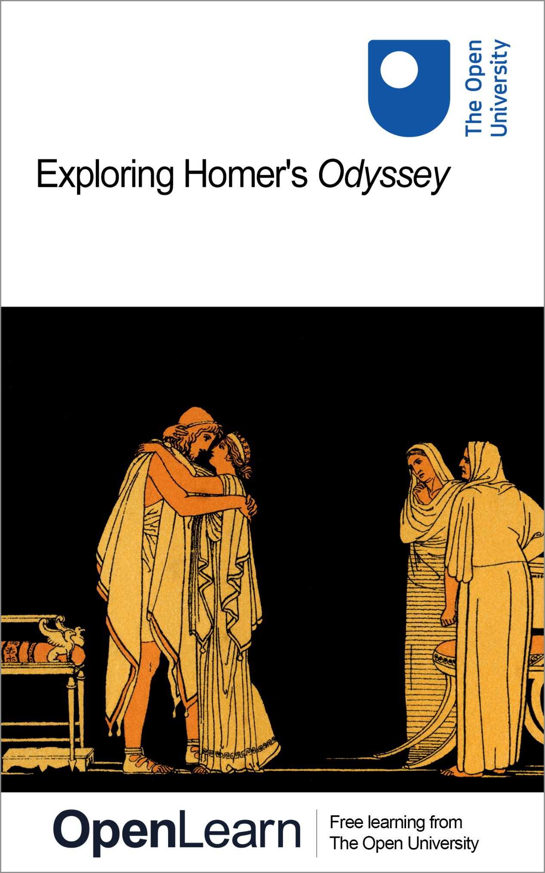

HDS_1

Exploring Homer’s Odyssey

About this free course
Find out more about The Open University’s Classical Studies courses and qualifications: www.open.ac.uk/courses/arts/degrees/ba-arts-humanities-classical-studies-r14-cs.
This version of the content may include video, images and interactive content that may not be optimised for your device.
You can experience this free course as it was originally designed on OpenLearn, the home of free learning from The Open University –
www.open.edu/openlearn/history-the-arts/exploring-homers-odyssey/content-section-0
There you’ll also be able to track your progress via your activity record, which you can use to demonstrate your learning.
Unless otherwise stated, copyright © 2023 The Open University, all rights reserved.
Intellectual property
Unless otherwise stated, this resource is released under the terms of the Creative Commons Licence v4.0 https://creativecommons.org/licenses/by-nc-sa/4.0/deed.en. Within that The Open University interprets this licence in the following way: www.open.edu/openlearn/about-openlearn/frequently-asked-questions-on-openlearn. Copyright and rights falling outside the terms of the Creative Commons Licence are retained or controlled by The Open University. Please read the full text before using any of the content.
We believe the primary barrier to accessing high-quality educational experiences is cost, which is why we aim to publish as much free content as possible under an open licence. If it proves difficult to release content under our preferred Creative Commons licence (e.g. because we can’t afford or gain the clearances or find suitable alternatives), we will still release the materials for free under a personal end-user licence.
This is because the learning experience will always be the same high quality offering and that should always be seen as positive – even if at times the licensing is different to Creative Commons.
When using the content you must attribute us (The Open University) (the OU) and any identified author in accordance with the terms of the Creative Commons Licence.
The Acknowledgements section is used to list, amongst other things, third party (Proprietary), licensed content which is not subject to Creative Commons licensing. Proprietary content must be used (retained) intact and in context to the content at all times.
The Acknowledgements section is also used to bring to your attention any other Special Restrictions which may apply to the content. For example there may be times when the Creative Commons Non-Commercial Sharealike licence does not apply to any of the content even if owned by us (The Open University). In these instances, unless stated otherwise, the content may be used for personal and non-commercial use.
We have also identified as Proprietary other material included in the content which is not subject to Creative Commons Licence. These are OU logos, trading names and may extend to certain photographic and video images and sound recordings and any other material as may be brought to your attention.
Unauthorised use of any of the content may constitute a breach of the terms and conditions and/or intellectual property laws.
We reserve the right to alter, amend or bring to an end any terms and conditions provided here without notice.
All rights falling outside the terms of the Creative Commons licence are retained or controlled by The Open University.
Head of Intellectual Property, The Open University

Contents
- Introduction
- Learning outcomes
- 1 Introducing Homer’s Odyssey
  - 1.1 The Odyssey: a first encounter
- 2 Thinking about heroes
  - 2.1 Heroes in ancient Greek poetry
- 3 Penelope and Odysseus
  - 3.1 Meeting Odysseus
  - 3.2 Meeting Penelope
  - 3.3 Comparing Penelope and Odysseus
  - 3.4 Exploring Penelope’s story
- 4 Homecoming and reunion
  - 4.1 The reunion of Penelope and Odysseus
  - 4.2 Odysseus in disguise
  - 4.3 The problem of recognition
  - 4.4 Penelope and Odysseus reunited
- 5 Who is the hero?
- 6 Rewriting Penelope and Odysseus
- Conclusion
- Taking it further
- Pronunciation guide
- Tell us what you think
- References
- Acknowledgements
- Glossary
- Solutions
- Descriptions

Introduction
This free course introduces Homer’s ancient Greek epic poem, the Odyssey, which tells of Odysseus’ long journey home after fighting in the Trojan War, and his eventual reunion with his wife Penelope. Odysseus is famous for his cunning and his courage, and for the exploits he undertakes on his travels; meanwhile Penelope is renowned for her patience and faithfulness as she awaits his return. Meet Penelope and Odysseus and learn more about what it means to be a hero in their world as well as in our own.

Study note: glossary and pronunciation guide
As you study this course you may come across some key words or terms with which you are unfamiliar. We have therefore produced a pronunciation guide and glossary to help you. Clicking on terms which feature in bold text will take you to the pronunciation guide, where you can listen to audio recordings of the words featured. Clicking on terms which feature in bold text and are underlined will take you to the glossary where you will find definitions of those terms. Alternatively, hovering the cursor over the glossary entries within the text will show you the definition.

Before you get started we would really appreciate a few minutes of your time to tell us about yourself and your expectations for this course, in our optional start-of-course survey. Participation will be completely confidential and we will not pass on your details to others.

Learning outcomes
After studying this course, you should be able to:
- understand the plot and structure of the Odyssey
- identify some of the ways in which Homer constructs the characters of Penelope and Odysseus
- read in detail short passages of text and analyse the effects of the poetic techniques used
- discuss some key themes of the Odyssey including: homecoming; disguise and recognition; gender roles; and the representation of the figure of the hero.

1 Introducing Homer’s Odyssey
The Odyssey is one of two ancient Greek epic poems, traditionally attributed to a poet named Homer, which were composed and written down sometime between the late eighth and mid sixth centuries BCE. These lengthy narrative poems – the earliest-surviving complete epic poems in the Greek language – tell stories relating to the mythical Trojan War, during which the Greeks laid siege to and eventually sacked the city of Troy. The Iliad (whose title comes from ‘Ilium’, the Latin name for Troy) is set during the war itself, and the Odyssey focuses on the convoluted and fantastical journey home of one of the Greek warriors, Odysseus, after the Greeks destroyed Troy. The war itself was said to have lasted for ten years, and Odysseus’ journey back to his palace on the island of Ithaca took a further ten years. The lengthy timescales involved in these stories reflect the fact that everything about epic poetry seems to take place on a grander scale than in real life; epic heroes seem to have longer lifespans, and to remain fit and active for much longer than ordinary humans would.

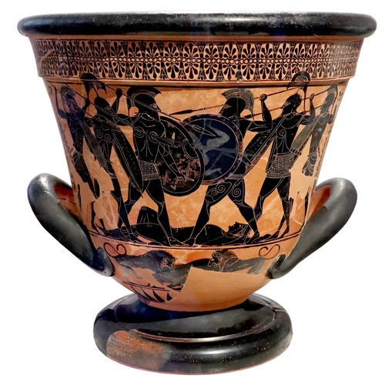
Figure 1 Attic black figure calyx krater (large painted pot used for mixing wine) showing a battle scene which may depict an episode from Homer’s Iliad. c. 530 BCE. National Archaeological Museum, Athens.
View description - Figure 1 Attic black figure calyx krater (large painted pot used for mixing wine) ...
View alternative description - Figure 1 Attic black figure calyx krater (large painted pot used for mixing wine) ...

The Iliad and Odyssey are many thousands of lines long (each was divided into 24 subsections, or books, by later editors) yet they still do not tell the whole story of the Trojan War, nor were they the only version of these stories known to ancient Greeks. They form part of a much wider mythical tradition which was told and retold in different literary genres and artistic media across the ancient Greek world, and which still today continues to be reinvented by writers and artists. The characters in these tales, and the activities they undertake, often seem to be larger than life, and the stories can feature incidents which we might describe as supernatural or fantastical. For example, gods become involved in the affairs of humans (the gods often take sides and have their own favourite mortals), and the Odyssey in particular features a whole host of monstrous characters who try to intercept Odysseus on his way home.

Study note: a note on dates
You will notice that this course uses the abbreviations ‘BCE’ and ‘CE’ when dating events, texts and objects. These abbreviations stand for ‘Before the Common Era’ and ‘Common Era’. You may be familiar with an alternative method of referring to dates as ‘BC’ (‘before Christ’) and ‘AD’ (Anno Domini, Latin for ‘in the year of our Lord’), and you may find that the authors of other things you read on the topics discussed here use instead BC and AD instead of BCE and CE. Remember that BCE years count backwards – therefore the eighth century BCE is earlier than the seventh century BCE.

1.1 The Odyssey: a first encounter
You may be wondering how, if the Odyssey is such a long poem which forms part of an even longer story, everything is going to fit into a 6-hour course! Don’t worry, you are not going to be expected to get to grips with the entire text. Instead you’ll gain an overview of the story before focusing in on a key episode – the reunion of Odysseus with his wife Penelope – as a way of thinking about some of the poem’s characters, poetic techniques and important themes.
To get you started, the plot of the Odyssey has been condensed into an animation which is less than three minutes long. Your first activity involves watching this animation to get an overview of the story which this poem tells.

Activity 1
Allow around 20 minutes for this activity

Watch the short animation, ‘Troy Story II’, which gives a brief overview of the plot of the Odyssey.

Video content is not available in this format.
View transcript - Uncaptioned interactive content

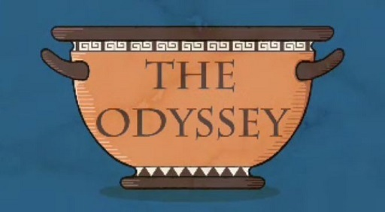

Watch the whole animation once without taking notes. Then replay it and fill in the table below with a few notes summarising the role of each of the characters listed.
Aim to write a sentence or two, or a couple of bullet points, for each.

Character name | Brief description
Odysseus | Provide your answer...
Penelope | Provide your answer...
Telemachus | Provide your answer...
Athena | Provide your answer...
Poseidon | Provide your answer...

View discussion - Activity 1

You probably noticed when watching the animation that there is a much larger cast of characters – both human and divine – in the poem than those who you were asked to look out for in Activity 1. These include the suitors back on Ithaca, and the Phaeacians who help Odysseus on the final leg of his journey, as well as the various monstrous or supernatural figures who intercept him. Epic poetry really does do everything on a grand scale – whether in terms of the length of the text and the timescales of the stories involved, the larger than life characters and the exploits they undertake, or the sheer number of people involved. In the next section you’ll think about a particular character type – the hero.

2 Thinking about heroes
As you learned in Section 1, the mythical stories of the Trojan War centre around characters who are in many ways larger than life. The main characters who appear in Homeric poetry – the Greek warrior Achilles in the Iliad, and Odysseus in the Odyssey, along with other key figures on both the Greek and Trojan sides – are usually referred to as ‘heroes’.
Before you examine more closely the hero(es) of the Odyssey, however, think about what the term ‘hero’ means to you.

Activity 2
Allow around 10 minutes for this activity

- What does the word ‘hero’ mean to you? Jot down three or four words or phrases which come to mind.
- Write down an example of a person whom you consider to be a hero based on the answer you gave for question 1.
Note that there is no single right answer to either of these questions. Since you were asked for your own ideas about heroes, no doubt your responses depended very much on your own experiences and interests.

Provide your answer...
View discussion - Activity 2

2.1 Heroes in ancient Greek poetry
The heroes we encounter in Greek epic poetry may share some of the characteristics that you thought of in your answer to Question 1 of Activity 2. In particular they are all special in some way. When we think about heroes in ancient Greek texts like the Odyssey, however, they also share some other characteristics. An ancient Greek hero:
- undertakes actions (such as complex and dangerous quests or challenging battles) which are extraordinary in some way
- often has the support of one or more gods
- tends to have special powers – for example, great fighting ability, courage, or cunning – which are beyond those of ordinary humans
- is usually (although not always) of high status
- is somewhere between a god and an ordinary mortal (often heroes have a divine parent or ancestor).
How far did this list overlap with the ideas you came up with for Question 1 of Activity 2? Again, this may depend on whether you were thinking of, for example, fictional heroes or ordinary people. Also, was your idea of a hero entirely a positive one? Often today the term is seen as denoting a wholly good character. By comparison, the heroes we find in Greek myth often do things which have negative consequences for those around them. They may display extreme anger or arrogance, for example, and they aren’t always easy to like. Despite their superhuman abilities, the heroes of Greek epic are still subject to human flaws and weaknesses; among other things, epic poetry explores what it means to be human.

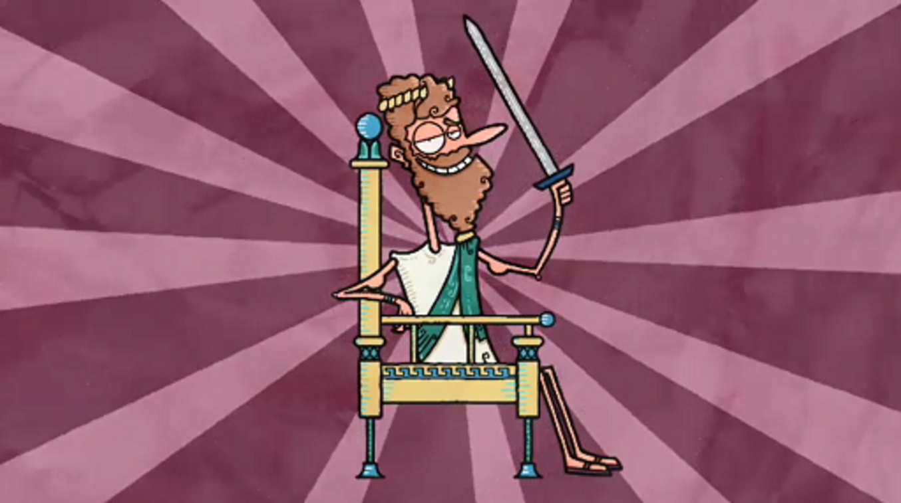
Figure 3 Odysseus, ‘hero’ of the Odyssey.
View description - Figure 3 Odysseus, ‘hero’ of the Odyssey.
View alternative description - Figure 3 Odysseus, ‘hero’ of the Odyssey.

Activity 3
Allow around 5 minutes for this activity

Thinking back to what you learned about Odysseus in the animation you watched for Activity 1, which elements of his character and story as it is told in the Odyssey do you think make him a hero in the ancient Greek sense? Remind yourself of the list above, and note down two or three points.

Provide your answer...
View discussion - Activity 3

Odysseus also features in several other ancient texts (for example, Athenian tragic plays of the fifth century BCE) as well as the Odyssey, and aspects of his character can be quite unappealing. He is famous for his cunning – he is credited with coming up with the idea of hiding Greek soldiers inside a wooden horse (Figure 4), which is how the Greeks were finally able to enter and conquer Troy – but this means that he can also come across as sneaky and deceptive. In the Odyssey, although he survives and returns home successfully, he shows some of his flaws along the way. For example, he is a consummate liar; this can be useful as it gets him out of some sticky situations, but we are often left wondering how far he can be trusted.

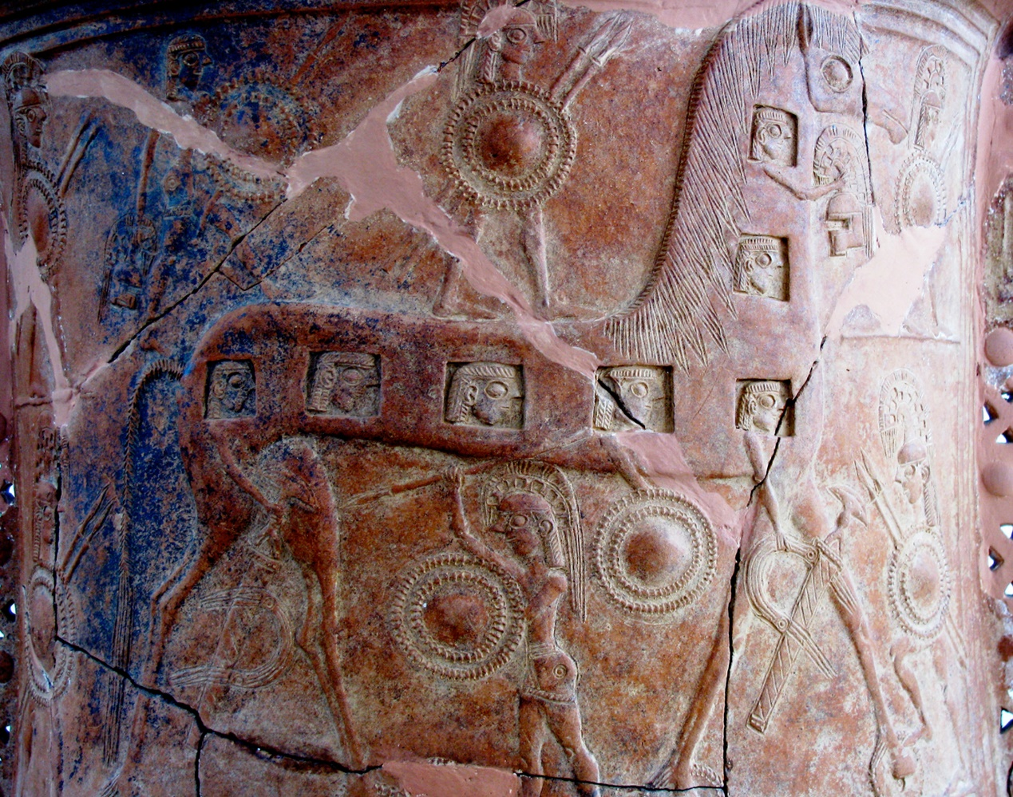
Figure 4 Detail from a decorated pithos (storage container), found in Mykonos, Greece, and thought to show one of the earliest depictions of the Trojan horse. c. 670 BCE. Archaeological Museum, Mykonos.
View description - Figure 4 Detail from a decorated pithos (storage container), found in Mykonos, Greece, ...
View alternative description - Figure 4 Detail from a decorated pithos (storage container), found in Mykonos, Greece, ...

There is one other vital detail about the heroes of ancient Greek epic poetry which hasn’t yet been mentioned, and which you’ll now explore further. All of the characters who perform typically heroic deeds (in the ancient Greek sense of ‘heroic’, as outlined earlier, that is) in both the Odyssey and the Iliad are male. Odysseus is the centre of attention throughout the Odyssey – he’s usually to be found either talking about himself or being talked about by someone else – and this in itself very much encourages the audience to think of him as the poem’s hero. You’ll focus a bit more closely on his wife Penelope too, however, and ask whether we might find in her a different kind of hero.
In the next section of the course you will find out how the poet introduces both Odysseus and Penelope, and you will consider what these introductions might tell us about these two important characters.

3 Penelope and Odysseus
As you now know, much of the narrative of the Odyssey focuses on the story of Odysseus’ adventures while travelling home from Troy to Ithaca. He has been away for 20 years in total: ten years fighting at Troy, and ten years making his way back home, including a seven-year stay hosted by the alluring nymph Calypso on the island of Ogygia (there is a clear suggestion in this episode of the poem that he is unfaithful to Penelope).

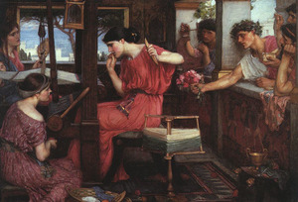
Figure 5 John William Waterhouse (1849–1917), Penelope and the Suitors. Oil on canvas, 1912. Dimensions: 130 x 188 cm. Aberdeen Art Gallery and Museums.
View description - Figure 5 John William Waterhouse (1849–1917), Penelope and the Suitors. Oil on canvas, ...
View alternative description - Figure 5 John William Waterhouse (1849–1917), Penelope and the Suitors. Oil on canvas, ...

You may also remember a little of Penelope’s story from the animation which you watched in Activity 1. When Odysseus left for Troy, Penelope remained behind in the palace on Ithaca, along with the couple’s son Telemachus, who was a baby when the war with Troy began. For 20 years she has had no way of knowing whether Odysseus is alive or dead, and whether he will ever return home. During this time, Penelope has been besieged by 108 suitors who have occupied the palace, vying for her hand in marriage in an attempt to get their hands on Odysseus’ land and his possessions, as well as his wife. These uninvited guests are inconsiderate and loutish, spending much of their time enjoying lavish feasts at the absent Odysseus’ expense. Penelope – famous for her faithfulness, and a match for her husband in cunning – has devised a clever ruse to delay having to marry one of them, in the hope that Odysseus will come home before she has to accept a marriage proposal from another man. She told the suitors that she would marry one of them only when she had finished weaving a burial shroud for Odysseus’ father, Laertes. By day she would weave the shroud, but each night she would unpick it in secret, thereby putting off the decision indefinitely (Figure 5). However, when the Odyssey opens, the suitors have discovered her scheme and so she cannot put off a new marriage much longer; it is becoming increasingly urgent that Odysseus makes it back home soon.

3.1 Meeting Odysseus
Now you’ll think about how Homer introduces Odysseus, and what this might tell us about his character in the poem. Then you’ll consider how Penelope is introduced in the Odyssey.

Study note: referencing the Odyssey
The conventional way of referring to a section of the text of the Odyssey is to provide the book and line numbers. So the reference ‘Odyssey 1.1–5’ refers to Book 1, lines 1 to 5. You may also sometimes see ‘Odyssey’ abbreviated to ‘Od.’ (and ‘Iliad’ to ‘Il.’).

Activity 4
Allow around 15 minutes for this activity

Read the opening lines of the Odyssey in the extract below once without making notes. (The opening words, ‘Tell me, Muse’, are a traditional call to one of the nine muses, divine figures who were thought to inspire the creative work of poets and other artists. The ‘man of many turns’ to whom the poet refers here is Odysseus.)
Then reread it as many times as you wish, considering the following question:
- What impression do we get of Odysseus on the basis of just these five lines of poetry?
Jot down three or four points. If you wish, you can pick out some words or short phrases from the text to support your points.

Tell me, Muse, of the man of many turns, who was driven
far and wide after he had sacked the sacred city of Troy.
Many were the men whose cities he saw, and learnt their minds,
many the sufferings on the open sea he endured in his heart,
struggling for his own life and his companions’ homecoming. [5]
(Odyssey 1.1–5)

Provide your answer...
View discussion - Activity 4

You perhaps also got the impression even from just these few lines that the poet is making it very clear that Odysseus will be the centre of attention throughout this poem. The Greek text makes this even clearer than the translation you have just read. In the Greek the very first word of the whole poem is ἄνδρα (pronounced andra), which translates as ‘man’; this is a poem about a man so famous that the poet doesn’t even need to give his name, so sure is he that his audience will know who is being referred to.

3.2 Meeting Penelope
Now you’ll think about how the poet introduces us to Penelope. We don’t meet her until a little later in the first book of the Odyssey, when the poet shows us what has been going on back at Odysseus’ palace on Ithaca during the king’s long absence. At this point in the poem Homer sets a scene where the suitors of Penelope are being entertained in the palace by Phemius, a bard. Bards were skilled singers and musicians, said to be inspired by the gods, who improvised songs based around stories like the ones told in the Homeric poems (indeed, the appearance of bards in the Odyssey might give us an insight into how Homer himself performed his work).

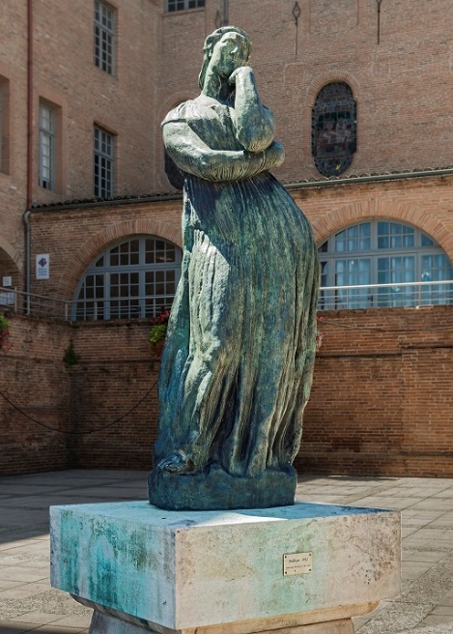
Figure 6 Émile Antoine Bourdelle (1861-1929), Penelope. Bronze statue, 1905-1912. Dimensions: 119 x 43 x 35 cm. National Museum of Wales, Cardiff.
View description - Figure 6 Émile Antoine Bourdelle (1861-1929), Penelope. Bronze statue, 1905-1912. ...
View alternative description - Figure 6 Émile Antoine Bourdelle (1861-1929), Penelope. Bronze statue, 1905-1912. ...

In this scene Phemius is singing a song about the homecomings of the Greeks from Troy. Penelope hears the song and comes downstairs from her rooms to listen; typically in an ancient Greek wealthy household the women would spend most of their time in a more private part of the house, separate from the more public rooms where men would conduct business and receive guests.

Activity 5
Allow around 20 minutes for this activity

Consider the passage below (Odyssey 1.325–336), in which the poet describes Penelope for the first time.
Read it through once without making notes.

Explanatory notes on the text:
- Achaeans is one of several names which Homer uses to refer to the Greeks who fought at Troy.
- Pallas is one of the names given to the goddess Athena.

The renowned singer was singing to them, and they sat and [325]
listening in silence as he sang of the Achaeans’ return home,
a bitter ordeal, sent them by Pallas Athena after they left Troy.
In her upstairs room the daughter of Icarius, circumspect
Penelope, heard and understood his divinely inspired song,
and came down the tall staircase from her part of the house, [330]
not on her own, but attended by two women servants.
When she, glorious among women, reached the suitors,
she stood next to a pillar supporting the strongly built
roof, holding her shining veil in front of her face, and
a devoted woman servant stood on either side of her. [335]
Through tears she addressed the god-inspired singer:

Then reread the passage as many times as you wish and consider the list of words and short phrases which have been picked out from the text below. Each of these represents an aspect of the way in which the poet describes her character when we first meet her.
Now write a short paragraph (four or five sentences) incorporating those words and phrases, and describing the impression we get of Penelope’s character in this scene. An example sentence about the first one is given to show you an idea.
- ‘circumspect’ (1.328)
- ‘glorious among women’ (1.332)
- ‘holding her shining veil in front of her face’ (1.334)
- ‘Through tears’ (1.334)
Here’s an example based on the first word on the list: ‘The poet’s description of Penelope as “circumspect” (1.328) suggests that she is a cautious character.’

Provide your answer...
View discussion - Activity 5

If you were to read more of the Odyssey you would notice that some of the descriptions of individual characters are used over and over again throughout the poem. For example, Penelope is often referred to throughout the text as ‘circumspect’ (the Greek term used is περίφρων – pronounced periphrōn, with a long ‘o’ sound – which can also be translated as ‘very thoughtful’ or ‘very careful’). These epithets – repeated adjectives or short descriptive phrases – are a feature of Homeric poetry. Along with other formulaic phrases in the text they worked as a memory aid for a poet who was reciting a poem from memory, or improvising on a story and composing new lines as they were performing. They also, however, indicated key attributes of particular characters. Odysseus is often referred to as ‘much-enduring’, ‘much-wandering’, or ‘of many wiles’; all of these phrases capture elements of his character and his experience.

3.3 Comparing Penelope and Odysseus
You may have begun to notice some differences between the ways in which Penelope and Odysseus are represented in the Odyssey. From the outset Odysseus is positioned as the poem’s central character; this is very much going to be a story about him and his adventures. While he is out exploring the world, Penelope is waiting patiently at home; we might even say that she is hidden away. Figures 7 and 8, both showing painted pottery from the fifth century BCE (several centuries after the Odyssey was first composed), depict elements of the story of the Odyssey and capture this contrast in visual form. Figure 7 shows one of Odysseus’ adventures aboard his ship: his encounter with the monstrous Sirens, which is related in Book 12 of the Odyssey. The Sirens are usually depicted as hybrid creatures, half-woman and half-bird; in the Odyssey they lure sailors to their deaths with their beautiful singing (Figure 7). As depicted in this image, Odysseus, in order to be able to hear their singing, has his crew tie him to the ship’s mast while they block their own ears with wax. By comparison, Figure 8 depicts Penelope at home, at her loom.

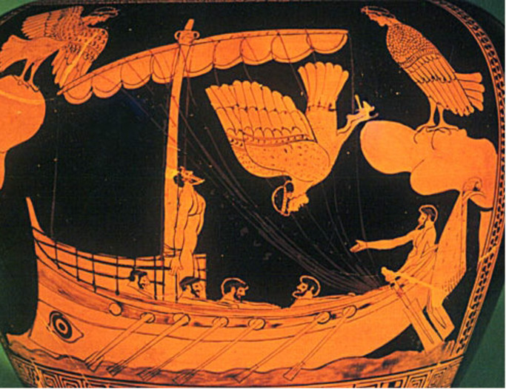
Figure 7 Attic red-figure stamnos (pot used to store liquids) depicting Odysseus and the Sirens. c. 480-470 BCE. Dimensions: 38 x 29 cm. British Museum.
View description - Figure 7 Attic red-figure stamnos (pot used to store liquids) depicting Odysseus ...
View alternative description - Figure 7 Attic red-figure stamnos (pot used to store liquids) depicting Odysseus ...

The contrast between Penelope’s confinement at home and Odysseus’ adventures far and wide is reinforced shortly after the extract which you read in Activity 5. Penelope asks the bard to sing a different song as the story of the Greeks’ returns from Troy is upsetting for her to hear, as it reminds her of Odysseus. She says:

a
singular grief, one that I cannot forget, comes over me as I
yearn for someone whom I think of constantly, a man whose
fame spreads widely throughout Hellas.
(Od. 1.341–344)

In response, her son Telemachus steps in and rebukes her for making this request, dismissing her feelings on the matter and instructing her:

Go back to your rooms and take charge of your own tasks,
the loom and the distaff, and order your women servants
to go about their work. Talk must be men’s concern, all of
them, and mine especially, for the power in the house is mine.
(Od. 1.356–359)

Telemachus’ words silence Penelope’s attempt to describe her own experience and emotions, and he quite literally tells her to hide away. There is a clear division of gender roles here, too. Having emerged from her seclusion in the women’s part of the house, Penelope is swiftly sent back again and told to attend to tasks relating to cloth production which were traditionally the work of women in ancient Greek society; as pointed out earlier, one of the things with which Penelope is particularly associated is her work at the loom (Figure 8). It is also made very clear here that if there is any talking to be done, it will be done by men. This might set us thinking about who is given the space to tell their story, or to have their story told, in the Odyssey. You’ll think some more about this when you examine the reunion of Penelope and Odysseus later in the course.

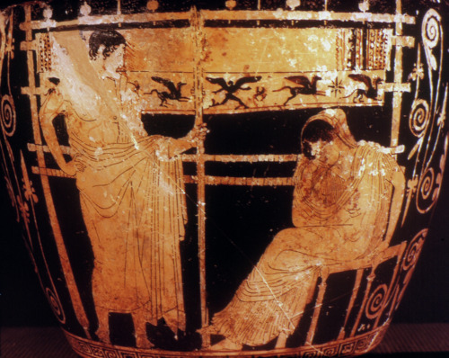
Figure 8 Attic red-figure skyphos (two-handled wine cup) depicting Penelope at her loom, visited by Telemachus. c. 450-400 BCE. Chiusi, Museo Archeologico Nazionale.
View description - Figure 8 Attic red-figure skyphos (two-handled wine cup) depicting Penelope at her ...
View alternative description - Figure 8 Attic red-figure skyphos (two-handled wine cup) depicting Penelope at her ...

Despite this obvious contrast between the situations of Penelope and Odysseus, you may still have spotted some possible similarities between the way in which the two characters are described. Both are special in some way – you’ll remember that we read that Penelope is described as ‘glorious among women’ (Odyssey 1.332) which suggests that she stands out from other women, just as Odysseus is an extraordinary character. Her thoughtfulness or circumspection might also be seen to mirror one of Odysseus’ key attributes – his cunning – and it is clear from these early encounters with both characters that, although their experiences differ vastly, both have suffering of different kinds to endure.

3.4 Exploring Penelope’s story
You have already spent some time thinking about the silencing of Penelope in the Odyssey, and about how her experience in the poem compares with that of her husband Odysseus. As the main focus of the poem is Odysseus and his adventures, we need to examine the story Homer tells a little more closely to get a sense of Penelope’s character. In Activity 6 you will find out more about the way in which Homer depicts Penelope, and how this compares with the way in which Odysseus is represented.

Activity 6
Allow around 25 minutes for this activity

Listen to the audio recording, in which Emma Bridges talks to Christine Plastow about the character of Penelope in the Odyssey.
Listen to it as many times as you wish and answer the following questions:
- What descriptive words, or adjectives, does Christine Plastow use to describe Penelope’s character? Pick out two or three from the discussion.
- As a woman in a patriarchal society (that is, a society which is ruled by and for men), how does Penelope use the tools at her disposal to exert some control? Write a sentence or two in your response.
- What problems does Penelope face while Odysseus is away? Try to come up with a list of three or four bullet points.
- What similarities between Penelope and her husband Odysseus does Christine Plastow identify? Write one or two sentences in your response.

Audio content is not available in this format.
View transcript - Uncaptioned interactive content

Provide your answer...
View discussion - Activity 6

One word which came up on the audio discussion which you probably had not heard before is the Greek word ὁμοφροσύνη (homophrosunē), which is sometimes translated as ‘likemindedness’. When Odysseus meets – and flirts with – the Phaeacian princess Nausicaa on his travels, he uses this term in his description of what makes an ideal marriage (6.182-5). There is a sense throughout the poem that, although Odysseus and Penelope undergo very different experiences, they exhibit similar qualities such as resourcefulness and persistence in the face of the challenges they encounter.
In the next section you will find out more about what happens when Odysseus and Penelope are eventually reunited.

4 Homecoming and reunion
Although much of the Odyssey narrates Odysseus’ adventures between the end of the Trojan War and his return to Ithaca, this is ultimately a poem about finding one’s way home. The Greek term for homecoming is νόστος (pronounced nostos, plural nostoi; combined with the Greek for ‘pain’, ἄλγος, pronounced algos, it produces the English word ‘nostalgia’, which might quite literally mean something more like ‘homesickness’ than the idea of longing for the past which it carries today). A whole strand of the Trojan War tradition seems to have revolved around the nostoi of the Greek heroes after Troy; you may remember that the bard Phemius sings of the Greeks’ homecomings in the first book of the Odyssey. As you may also remember from the animation you watched in Activity 1, in the Odyssey the action builds towards Odysseus’ return to Ithaca and his eventual reunion with Penelope. This takes place in Book 23 of the poem. You are going to spend some time thinking about how the reunion plays out in the poem, and what the reunion scene might reveal about the characters of Penelope and Odysseus.

4.1 The reunion of Penelope and Odysseus
The reunion of Penelope and Odysseus is far from straightforward. When he first arrives back on Ithaca, the goddess Athena disguises him as a beggar, wearing filthy clothes, so that he can approach the palace and observe what has been happening in his absence. When he first meets Penelope he is still wearing this disguise; they even have a conversation in which Odysseus pretends to be a Cretan prince who once entertained Penelope’s husband (Odyssey 19.164–202). He tells her in the course of this conversation that Odysseus will soon be home, although Penelope, after twenty years of waiting, finds it hard to believe that this is true (Odyssey 19.261–316). Now that her shroud trick has been revealed she is unable to delay the decision as to which suitor to marry any longer, so she announces that she will stage a contest: she will marry whichever man is able to string Odysseus’ enormous bow and shoot an arrow through twelve axes (Odyssey 21.1–79). With Penelope elsewhere in the palace, the suitors each try their hand; none of them is able to fulfil the task. Eventually the ‘beggar’ steps forward and successfully carries out the challenge, thereby revealing himself as Odysseus. In brutal scenes in Book 22, Odysseus, with the help of Telemachus, slaughters the suitors along with the female slaves of Penelope who had been disloyal to her.

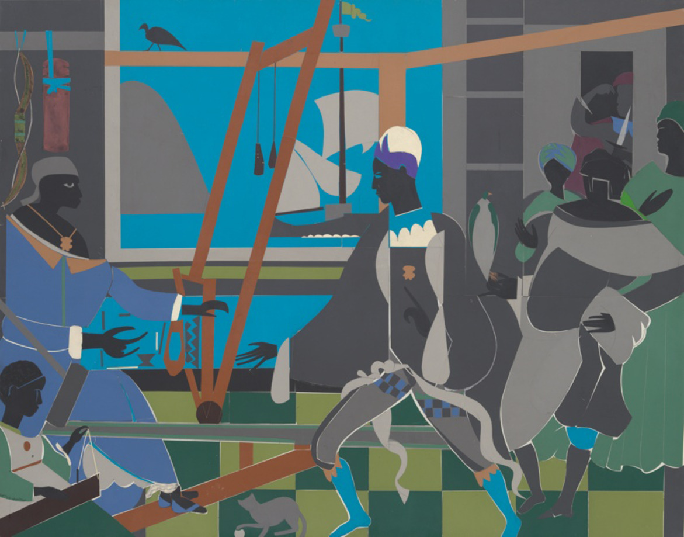
Figure 9 Romare Bearden (1911–1988), The Return of Odysseus. Collage, 1977. Dimensions: 112 x 142 cm. Art Institute of Chicago.
View description - Figure 9 Romare Bearden (1911–1988), The Return of Odysseus. Collage, 1977. Dimensions: ...
View alternative description - Figure 9 Romare Bearden (1911–1988), The Return of Odysseus. Collage, 1977. Dimensions: ...

4.2 Odysseus in disguise
At the opening of Book 23, Penelope has no idea yet what has happened in her absence. She first receives the news that the disguised man is Odysseus, and that he has killed the suitors, from the elderly nurse Eurycleia. As you’ll learn in the activities which follow, she still has a hard time believing that this is really her husband, and that he has finally returned home after such a long time away.

Activity 7
Allow around 30 minutes for this activity

Read the extract below (Odyssey 23.88–110), which describes the moment when Penelope first goes to see Odysseus after she has learned that the man she thought was a stranger is really her husband. You don’t need to make any notes just yet, but notice as you read that we are given three different perspectives on Penelope’s reaction – one from the point of view of the poet (lines 93–95), one in the words of Telemachus (lines 97–103) and one in Penelope’s own words (lines 105–110).

When she [Penelope] had crossed the stone threshold and entered the hall,
she sat down in the brightness of the fire facing Odysseus,
by the wall opposite him. He was sitting leaning against a tall [90]
pillar, eyes cast down, waiting to see if his handsome wife
would have anything to say to him when she set eyes on him.
But for a long time she sat in silence, bafflement in her heart;
sometimes when she looked for him in the face she saw a likeness,
but then could not recognize him in the foul clothes he wore. [95]
Telemachus rebuked his mother, speaking directly to her:
‘Mother—my hard mother, with an unbending heart in you!
How can you turn away from my father like this? Why not
sit beside him, ask him questions and find out about him?
No other woman would have had the stubbornness of spirit to [100]
stay away from her husband, when after much hard suffering
he has returned to her in the twentieth year, back to his native land.
But your heart has always been more unyielding than a rock.’
Then in turn circumspect Penelope addressed him:
‘My child, the heart in my breast is dumbfounded; [105]
I cannot say a single word to him, or ask him a question,
or look him full in the face. If he really is Odysseus, and
has come back to his house, we two have better ways to
recognize each other with certainty; we have shared tokens,
which we alone know, and which are hidden from others.’ [110]

Now reread the passage, and this time fill in the table below. In the first column write some adjectives or short phrases of your own to describe how Penelope is characterised from each of the three different perspectives mentioned above; then in the second column make a note of the words in the text (with their line numbers) which create this impression. You can fill in more than one line for each if you wish. The first line has been filled in for you as an example.

Whose perspective? | How is Penelope characterised? | Supporting evidence from the text
The poet (lines 93–93) | confused | ‘bafflement in her heart’ (line 93)
 | Provide your answer... | Provide your answer...
 | Provide your answer... | Provide your answer...
Telemachus (lines 97–103) | Provide your answer... | Provide your answer...
 | Provide your answer... | Provide your answer...
 | Provide your answer... | Provide your answer...
Penelope herself (lines 105–110) | Provide your answer... | Provide your answer...
 | Provide your answer... | Provide your answer...
 | Provide your answer... | Provide your answer...

View discussion - Activity 7

You may have found it particularly interesting here that Telemachus’ impression of his mother’s character is very different from the explanation which she gives of her own state of mind. Telemachus seems to have misread the situation. Where her son judges Penelope harshly, surmising that she is being stubborn or cruel by refusing to approach Odysseus, her own words suggest something quite different. It seems from what she says here that her reluctance to speak to Odysseus comes from a deep uncertainty that this man is who he says he is. She has good reason to doubt the truth; not only does his disguise make him difficult to recognise but, as you may remember from my earlier discussion, he has already deceived her once by pretending to be someone else. You may also have noticed that Penelope is once again described as ‘circumspect’ here, in line 104. The description is particularly appropriate given how cautious she is being about approaching Odysseus. Elsewhere in the poem she also reveals that she has been tricked before by strangers telling false tales of her husband (14.126–130).

4.3 The problem of recognition
The reunion of this mythical couple also reflects some of the challenges faced by couples in real-life situations where they have been apart for a long time. The partners of serving military personnel still report today, for example, that sometimes when their spouse returns from a long time in a war zone it can feel hard for them to relate to one another as their experiences have been so different during their time apart. Although, unlike Odysseus, the returning partner is not literally in disguise, both partners will have faced challenges and may have changed during their time apart. Like Penelope and Odysseus, each person needs time to get to know the other once more.


Figure 10 An emotional military reunion.
View description - Figure 10 An emotional military reunion.
View alternative description - Figure 10 An emotional military reunion.

Shortly after the meeting between Penelope and Odysseus which you thought about in Activity 7, Odysseus takes a bath and puts on clean clothes. The goddess Athena helps him out with a divine makeover to make him seem more attractive than before, and, appearance restored, he returns to Penelope once more (23.153–165). Yet even though he now looks like the man she knew before he set out for Troy, Penelope is still wary and needs further proof that this is really Odysseus. She assures herself of his identity using a test which – like her shroud trick, and the contest of the bow which she initiates – reveals that she is her husband’s equal in intelligence and cunning and that she is just as resourceful as he is when it comes to dealing with a challenging situation. Penelope asks that Eurycleia move their bed outside the bedroom to make up a place for somewhere to sleep (23.177–180). Their bed is, however, immovable – it was carved by Odysseus himself from a single olive tree growing at the centre of their household. Apart from Penelope, Odysseus is the only person who could know this. Odysseus’ reaction when he thinks that someone has moved his bed (and perhaps at the associated suggestion that Penelope may have been unfaithful in his absence) is one of outrage: he says that ‘There is no man alive, not even one in the prime of life, / who could shift it without difficulty’ (23.198–199). By revealing this knowledge of the way the bed was constructed, Odysseus proves to Penelope that he is really her husband.

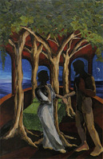
Figure 11 Leslie Peterson, Athena Stays the Dawn. Paper collage. Dimensions: 97 x 71 cm.
View description - Figure 11 Leslie Peterson, Athena Stays the Dawn. Paper collage. Dimensions: 97 x ...
View alternative description - Figure 11 Leslie Peterson, Athena Stays the Dawn. Paper collage. Dimensions: 97 x ...

When Penelope finally has the proof that it is Odysseus who is standing before her, she bursts into tears and rushes to embrace him. She asks Odysseus not to be angry with her for her reticence and explains that while he has been away she has always been worried that someone else would try to trick her into believing that he was Odysseus, for his own advantage (23.205–217).

4.4 Penelope and Odysseus reunited
In the next activity you will read some more of the reunion scene between Penelope and Odysseus, in which the poet uses a detailed simile – a figure of speech in which one thing is compared with something different – to describe the couple’s first embrace. Extended similes like the one you will read in Activity 8 are, like the epithets you learned about in Section 3.2, another distinctive characteristic of Homeric poetry. By drawing comparisons between the scene or person being described and something else from a very different context, the poet adds richness and depth to his work. As well as creating vivid images in the mind of the audience, similes like the one you are about to read can also highlight key themes of the text as well as important aspects of particular characters.

Activity 8
Allow around 20 minutes for this activity

Read the following passage (Odyssey 23.231–240), which describes Penelope’s response when she realises that the man in front of her is really Odysseus. The simile starts at line 233, with the words ‘As welcome as…’ introducing the comparison between the reunion scene and the response of sailors who reach dry land after a shipwreck.

So she spoke, and aroused in him a greater desire to weep;
he wept, holding his heart-gladdening, faithful wife to him.
As welcome as the sight of land appearing to swimmers,
men whose strong-constructed ship, driven by winds
and heavy seas, Poseidon has shattered in open waters— [235]
only a few escape the grey sea by swimming to the shore,
their skin covered with a think crust of brine, and with joy
they set foot on land, for they have avoided a grim death—
just so did Penelope look with joy upon her husband, and
would not quite release her white arms’ hold on his neck. [240]

Then consider the following questions and, rereading the passage as many times as you wish, jot down a sentence or two in response to each.
- What emotions does the simile convey?
- Why do you think the poet chose to use an image of shipwrecked sailors as the point of comparison here?
- Notice what happens in line 239. Did you find anything surprising about this line?

Provide your answer...
View discussion - Activity 8

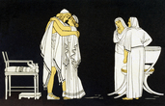
Figure 12 Penelope and Odysseus reunited.
View description - Figure 12 Penelope and Odysseus reunited.
View alternative description - Figure 12 Penelope and Odysseus reunited.

The simile which you just read in Activity 8 is one of several such similes used in the Odyssey, where a woman is compared to a man. In this scene the poet confounds the audience’s expectations by revealing only after giving the description in the simile that he is describing Penelope’s response rather than that of Odysseus. By doing this he frames Penelope’s experiences in a way which seems to suggest that, despite the difference in context, they are of equal importance to those of Odysseus. In reversing conventional gender roles, the simile draws attention to the fact that Penelope too, as the waiting wife, has been through a distressing ordeal of her own in Odysseus’ absence. We might even go so far as to suggest that, in all that she has endured, and in the resourceful ways she has tackled the problems she has faced, she has become something of a hero too.
Yet despite this apparent acknowledgement of Penelope’s own trials, there is still much less space devoted to her story than to Odysseus’. After this embrace the couple retire to bed where they reconnect through sex and conversation (Odyssey 23.295–301). In what follows, each shares their own version of the events which have taken place while they have been apart; the poet gives an edited-down summary of the plot of the whole poem (although Odysseus’ retelling of his story here carefully glosses over his own infidelities). Here Penelope’s story is summarised in only four lines (23.302–305); by comparison, despite the fact that much of the poem so far has focused on Odysseus’ exploits, the recap of his escapades occupies thirty-two lines. It seems, then, that the heroism of the male adventurer is still thought to be more important and interesting than that of his wife back home.

5 Who is the hero?
You have now spent some time with both Odysseus and Penelope, and you have thought about how their characters are represented in the Odyssey the first time they are introduced as well as at the point where they finally reunite after twenty years apart.
Now you’ll think about how these two characters compare.

Activity 9
Allow around 10 minutes for this activity

Based on what you now know about their stories in the Odyssey, use the grid below to jot down a short list of similarities and differences between Penelope and Odysseus. You might think about their characters, their experiences, or the way in which Homer tells their stories. Aim to come up with at least two similarities and at least two differences.

Similarities | Differences
Provide your answer... | Provide your answer...

View discussion - Activity 9

Your list in the previous activity may have looked different from the example, but perhaps when you were writing it you thought about how, even though their experiences were quite different, Penelope and Odysseus actually have quite a lot in common. In particular, they both have to deal with extraordinary challenges and both endure grief and suffering. They share some characteristics too: Penelope’s cunning certainly seems to be a match for Odysseus’. In this respect the poet seems to suggest that they are well-matched, even if he spends less time focusing on Penelope’s story than on that of Odysseus. All of this leads us to think that even if Odysseus is set up as the hero right from the start, we might think of Penelope as a hero of a different kind – she may not go out to fight a war and have adventures like Odysseus does, but she displays her own brand of courage in keeping things together at home in his absence.

6 Rewriting Penelope and Odysseus
Over the centuries since the Odyssey was first composed, many writers and artists have revisited the story of Odysseus and Penelope to retell it in different media and from different perspectives. One writer who offered a different perspective on the figure of Penelope which aligns with the suggestion just made was the American poet Dorothy Parker. Her poem ‘Penelope’ was written when the First World War was a recent memory; she herself had been a wartime bride and had been separated from her husband when he enlisted in the armed forces. You will read this poem, which is written from the perspective of a wife left behind while her husband is away having adventures, in the final activity of this course.

Activity 10
Allow around 15 minutes for this activity

Read Dorothy Parker’s poem ‘Penelope’ (below) once without making any notes. Then reread it as many times as you wish while thinking about the question below:
How does Dorothy Parker’s modernised Penelope compare with your own thoughts (which you considered in Activity 9) on the similarities and differences between Penelope and Odysseus in the Odyssey?
Finally, try writing a short paragraph (four or five sentences) in response to the question. You may wish to pick out some words or short phrases from the poem to include in your paragraph.

In the pathway of the sun,
In the footsteps of the breeze,
Where the world and sky are one,
He shall ride the silver seas,
He shall cut the glittering wave.
I shall sit at home, and rock;
Rise, to heed a neighbor’s knock;
Brew my tea, and snip my thread;
Bleach the linen for my bed.
They will call him brave.
(Parker, 1928)

Provide your answer...
View discussion - Activity 10

In her ‘Penelope’, Dorothy Parker imagines what Penelope might say or think if she were transplanted from the world of Homeric poetry to a modern-day setting. The poem contrasts with the Odyssey not only in its content but also in its form – it is a much shorter and more focused take on events than the lengthy epic of Homer. By providing us with Penelope’s perspective Parker invites her reader to reconsider what heroes do and who they are; she reminds us that heroes aren’t always men, and that heroism, like that of the waiting wife in her poem, can be quiet and unassuming as well as loud and attention-grabbing.

Conclusion
In this course you have gained an understanding of the overall plot and structure of the Odyssey as well as focusing in on some key episodes – particularly the reunion of Penelope and Odysseus in Book 23 – which have helped you to understand more about some of the poem’s important characters. By closely reading short passages of text you have thought in detail about some of the ways in which Homer constructs these characters, as well as learning about some key features of epic poetry – for example, the use of epithets and similes. You have also spent time thinking about some of the key themes of the Odyssey, for example:
- different types of heroism – both in the modern world and in the world of Homeric poetry
- gender roles in the poem
- homecoming
- disguise and recognition.
Now that you have developed some of the key skills required for close reading of a poem, you might consider reading more of the Odyssey in a translation of your choice. You may also wish to explore more ancient texts.
If you would like to expand your skills and knowledge further, follow up some of the suggestions in the ‘Taking it further’ section.

Taking it further
If you enjoyed learning about Homeric poetry you might also like to watch our short animation on the Iliad, and to read the accompanying list of characters: Troy Story: Homer’s Iliad and Odyssey.
For more in-depth study on the Iliad, try the free OpenLearn course Introducing Homer’s Iliad.
If your curiosity was piqued by the brief references to the ancient Greek language in this course, you may enjoy the free OpenLearn course Getting started on ancient Greek.
This short article by Emma Bridges compares the experiences of soldiers’ wives – like Penelope – in ancient myth, with those of contemporary military spouses: Military homecomings: ancient myths and modern truths.
This article by Charlotte Higgins compares Odysseus’ homecoming with those of modern-day soldiers: The Odyssey: a soldier’s road home.
The BBC podcast series ‘Natalie Haynes Stands Up for the Classics’ features episodes (30 minutes each) on both the Iliad and the Odyssey.
If you were intrigued by Penelope’s shroud trick and would like to know more about the role of weaving in the lives of real and mythical women in the ancient world, you may enjoy this Classics Confidential podcast on ‘Weaving Women’s Stories’ (42 minutes).
There are many English translations of the Odyssey available in print and online. Each translation has different characteristics. Some are written in verse, and others as prose, for example. Meanwhile some translators try to remain as closely as they can to the precise phrasing of the Greek text, while others translate more freely in order to capture the overall spirit of the ancient poem. You may like to dip in to different translations to see which you are most drawn to. Translations in this course are taken from Anthony Verity (2016) Homer: The Odyssey. Oxford: Oxford University Press. Also recommended is Emily Wilson (2018) The Odyssey: Homer. New York and London: Norton. The Perseus Digital Library provides free access to online translations of the Odyssey along with many other ancient Greek and Latin texts, although these may sometimes seem a little dated as they are all versions whose copyright has now expired.
For further reading relating to some of the topics discussed in this short course, you could start with the following:
- Elton Barker and Joel Christensen (2013) Homer: A Beginner’s Guide. London: Oneworld. An introductory work which discusses both the Odyssey and the Iliad.
- Emma Bridges (2023) Warriors’ Wives: Ancient Greek Myth and Modern Experience. Oxford: Oxford University Press. A discussion of the representation of soldiers’ wives (including Penelope) in ancient myth, as compared with the experiences of modern-day military spouses. You can listen to the author talking about the book, and about some of the themes of this course, on this New Books Network podcast (48 minutes).
- Barbara Graziosi (2016) Homer. Oxford: Oxford University Press. A short and accessible introduction to the composition of the Iliad and Odyssey, and to some of the poems’ key themes.
- Edith Hall (2008) The Return of Ulysses: A Cultural History of Homer’s Odyssey. London and New York: I. B. Tauris. An exploration of the ways in which the Odyssey, its key theme and its characters have been adapted and reworked by writers and artists in many different cultural contexts over the millennia since it was first composed.
This course is part of a series of courses under the title HeadStart Classical Studies. You can find details about this series as well as links to its other courses on this page.

Pronunciation guide

Audio content is not available in this format.
Achaeans

Audio content is not available in this format.
Eurycleia

Audio content is not available in this format.
Laertes

Audio content is not available in this format.
Nausicaa

Audio content is not available in this format.
Ogygia

Audio content is not available in this format.
Phaeacians

Audio content is not available in this format.
Phemius

Audio content is not available in this format.
Telemachus

Tell us what you think
Now you’ve come to the end of the course, we would appreciate a few minutes of your time to complete this short end-of-course survey. We’d like to find out a bit about your experience of studying the course and what you plan to do next. We will use this information to provide better online experiences for all our learners and to share our findings with others. Participation will be completely confidential and we will not pass on your details to others.

References
Dorothy Parker, ‘Penelope’ published in Parker, D. (1928) Sunset Gun. New York: Sun Dial Press.

Acknowledgements
This free course was written by Emma Bridges. Many thanks to Danny Pucknell and James Robson for their feedback on the content.
Except for third party materials and otherwise stated (see terms and conditions), this content is made available under a Creative Commons Attribution-NonCommercial-ShareAlike 4.0 Licence.
The material acknowledged below is Proprietary and used under licence (not subject to Creative Commons Licence). Grateful acknowledgement is made to the following sources for permission to reproduce material in this free course:
Images
Course image: whitemay/Getty Images
Figure 1: Pottery: In the manner of Exekias, Photograph: George E. Koronaios - edited by Kathleen Vail; https://creativecommons.org/licenses/by-sa/4.0/deed.en
Figure 2: Spiderman: United Archives GmbH / Alamy Stock Photo; Greta Thunberg: INA FASSBENDER / Contributor/Getty Images; Exhausted doctor: bymuratdeniz; Getty Images
Figure 3: The Open University
Figure 4: Travelling Runes; https://creativecommons.org/licenses/by-sa/2.0/deed.en
Figure 5: Penelope and the Suitors (1912). Oil on canvas, 129.8 x 188 cm (51.1 x 74 in). City of Aberdeen Art Gallery and Museums Collection, Public Domain
Figure 6: By Antoine Bourdelle - Taken on 2 August 2016 Didier Descouens, https://creativecommons.org/licenses/by-sa/4.0/deed.en
Figure 7: taken from https://commons.wikimedia.org/wiki/File:Odysseus-siren_Parthenope,_the_mythological_founder_of_Naples.jpg; Public Domain
Figure 8: GRANGER - Historical Picture Archive / Alamy Stock Photo
Figure 9: Romare Bearden Foundation/VAGA at ARS, NY and DACS, London 2023
Figure 10: jacoblund; Getty Images
Figure 11: LESLIE PETERSON SAPP
Figure 12: Ivy Close Images / Alamy Stock Photo
Audio/Visual
Activity 1: Animation: Troy Story II; The Open University
Activity 6: Audio: The Open University
Every effort has been made to contact copyright owners. If any have been inadvertently overlooked, the publishers will be pleased to make the necessary arrangements at the first opportunity.
Don't miss out
If reading this text has inspired you to learn more, you may be interested in joining the millions of people who discover our free learning resources and qualifications by visiting The Open University – www.open.edu/openlearn/free-courses.

Glossary
Achaeans
one of the names Homer uses to refer to the Greeks who fought at Troy
bard
a skilled singer and musician who improvised songs on mythical themes while performing them for a live audience
epic
in ancient literature, lengthy narrative poems (such as Homer’s Iliad and Odyssey), usually telling of the exploits of a hero or heroes, and often involving battles or difficult journeys as well as supernatural characters
epithets
in Homeric poetry, adjectives or short phrases used repeatedly to describe a particular character
Hellas
Greek term meaning ‘Greece’
nostos
(plural nostoi) Greek term meaning ‘homecoming’
nymph
one of several minor divinities, usually taking the form of a young woman and often associated with a particular location or natural feature. The nymph Calypso lives on the island of Ogygia in the Odyssey and rescues Odysseus when he is shipwrecked there
Pallas
one of the names given to the goddess Athena
simile
a figure of speech in which one thing is compared to something different. In English, these are usually introduced by the words ‘like’ or ‘as’
Sirens
mythical creatures, often depicted as half-woman and half-bird. In the Odyssey they lure sailors to their death with their singing

Solutions

Activity 1

Discussion
Your completed table might look something like this:

Character name | Brief description
Odysseus | King of Ithaca, who spends ten years journeying home after the war at Troy. His journey is delayed by various supernatural characters and a long stay on the island of Ogygia with the nymph Calypso.
Penelope | Wife of Odysseus, who waits faithfully for him in his 20-year absence despite being pestered by 108 suitors who want to marry her.
Telemachus | Son of Odysseus and Penelope. In the poem he travels in search of news of his father while Odysseus is on his way home, and he helps his father to kill the suitors of Penelope.
Athena | Daughter of Zeus; the goddess who supports Odysseus, including by disguising him as a beggar when he first returns to Ithaca.
Poseidon | Sea god who tries to stop Odysseus from returning home (he is angry because Odysseus blinded the Cyclops, Poseidon’s son).

Back to - Activity 1

Activity 2

Discussion


Figure 2 Heroes in the modern world.
View description - Figure 2 Heroes in the modern world.
View alternative description - Figure 2 Heroes in the modern world.

- Perhaps when you were asked what the word hero means to you, you thought about films you have seen or books you have read to help you to formulate your answer, or maybe you considered the way in which people are sometimes described as heroes in news stories. You probably had your own particular ideas about what kinds of actions and personal characteristics make someone a hero, but whatever you wrote down for the first question, your answer probably touched on the idea that heroes are special in some way. You’ll come back to this idea shortly.
- In answer to this question you may have thought of a fictional character or a real person – someone you know or an individual who is in the public eye – or perhaps you selected a particular type of person, for example human rights activists, military personnel, or people who work in the caring professions.
Back to - Activity 2

Activity 3

Discussion
You may have come up with something like this list:
- Odysseus undertakes extraordinary actions in the Odyssey (an extremely long journey home, and lots of fighting with monsters as well as mortal characters)
- he has the support of the goddess Athena
- he is of high status (as king of Ithaca).
Back to - Activity 3

Activity 4

Discussion
The opening of the Odyssey makes it clear that Odysseus has undergone a lot of adventures and faced many difficulties since the fall of Troy; he was ‘driven far and wide’ (Od. 1.1–2). We get the impression here of a courageous traveller who ‘endured in his heart’ (Od. 1.4) many sufferings. Line 5 also suggests that he was desperate to return home, and that his life was at stake.
Back to - Activity 4

Activity 5

Discussion
Starting with the example sentence given, here is a paragraph based on some of the words and phrases picked out:

The poet’s description of Penelope as ‘circumspect’ (1.328) suggests that she is a cautious character. She is also referred to here as ‘glorious among women’ (1.332), which might indicate that she stands out as being particularly special compared with other women. Although we are not given much information about her appearance, the reference to her ‘holding her shining veil in front of her face’ (1.334) makes her seem very modest, particularly as she is appearing before the suitors who want to marry her. She addresses the bard ‘through tears’ (1.334); the first impression we get of her is therefore of someone who is dealing with grief or sadness.

Back to - Activity 5

Activity 6

Discussion
- You may have chosen something like ‘cunning’, ‘cautious’, or ‘powerful’.
- By devising the shroud trick (weaving and unpicking a shroud as a way of delaying the decision to marry the suitors), Penelope uses a skill – textile making – which is normally associated with women in the ancient world as a way of exerting control.
- Your list might contain the following problems:
  - Penelope is worried about whether Odysseus is alive or dead, and there is no reliable way of knowing whether he will come home.
  - She has to manage the household in her husband’s absence.
  - She needs to decide whether or not to marry one of the suitors, who are behaving very badly.
  - The lack of news she has about Odysseus, including not knowing whether he is still alive.
- Christine Plastow suggests that Penelope shares cunning, intellect and resourcefulness with her husband Odysseus. Both are problem solvers who, when faced with challenges, try to find solutions.
Back to - Activity 6

Activity 7

Discussion
Here is an example of a completed table. Don’t worry if you picked out different parts of the text or used different descriptions, however – what’s important is that you used your own words to summarise what we can learn about Penelope from the extract you read.

Whose perspective? | How is Penelope characterised? | Supporting evidence from the text
The poet (lines 93–93) | confused | ‘bafflement in her heart’ (line 93)
 | stunned | ‘she sat in silence’ (line 93)
 | unsure that this is really Odysseus | ‘sometimes when she looked at him she saw a likeness, / but then could not recognize him’ (lines 94-95)
Telemachus (lines 97–103) | harsh or cruel | ‘hard’, ‘unbending heart’ (line 97), ‘your heart has always been more unyielding than a rock’ (line 103)
 | obstinate | ‘stubbornness of spirit’ (line 100)
Penelope herself (lines 105–110) | stunned | ‘the heart in my breast is dumbfounded’ (105)
 | nervous | ‘I cannot say a single word to him…or look him full in the face’ (lines 106–107)
 | wants to be certain who he is before she approaches him | ‘If he really is Odysseus…we two have better ways to recognize each other’ (lines 108–109)

Back to - Activity 7

Activity 8

Discussion
- The overwhelming emotion here seems to be one of relief, like that of shipwrecked sailors who have seen land. The poet also directly mentions ‘joy’ in line 237.
- The image of shipwrecked sailors seems particularly appropriate in a poem which spends a lot of time focusing on Odysseus’ journey at sea and his attempts to get home, which have been thwarted at times by the sea god Poseidon (who is also mentioned in line 235). Here the poet brings the domestic scene in front of us, and the background to Odysseus’ story, together using this simile.
- Were you surprised to find that the simile was referring to Penelope’s emotions here rather than to those of Odysseus? After all, he is the character we know as a sailor, whereas Penelope has been firmly on dry land throughout the poem.
Back to - Activity 8

Activity 9

Discussion
Here is an example list:

Similarities | Differences
Both are resourceful and cunning – Odysseus in the way he finds his way home after the Trojan War and Penelope in the ways she deals with challenges at home (e.g. the shroud trick and the bed trick). | Odysseus is the main focus of the story e.g. he is mentioned in the first line, and lots of space is given to his adventures; Penelope gets much less attention and fewer opportunities to tell her story.
Both endure suffering – Penelope as she waits for Odysseus’ return while she tries to keep the suitors at bay, not knowing if he is still alive, and Odysseus in the challenges he encounters on his travels. | Penelope is confined to the palace on Ithaca but Odysseus travels far and wide.
Both are relieved when Odysseus returns home. | Odysseus is unfaithful to his wife (e.g. with the nymph Calypso), but Penelope goes to great lengths to avoid infidelity.
 | Odysseus is in disguise, and unrecognisable to Penelope when he returns home; Penelope does not conceal her identity from him.

Back to - Activity 9

Activity 10

Discussion
Like the Odyssey, Dorothy Parker’s poem draws a striking contrast between the domestic setting for Penelope’s story and the adventures of Odysseus, although in this case Penelope is sewing and making tea rather than weaving at a loom. Odysseus gets all the attention for having adventures (the descriptions ‘silver seas’ and ‘glittering wave’ suggest glamour and excitement), but Penelope has a much quieter life at home. This Penelope reflects that people will ‘call him brave’; there is perhaps some resentment here, and the implication from this final line seems to be that Penelope too deserves recognition for her own courage. Her life might seem more mundane than Odysseus’ but she, in waiting patiently for his return, demonstrates a different kind of bravery, yet one which goes largely unnoticed.
Back to - Activity 10

Descriptions

Figure 1 Attic black figure calyx krater (large painted pot used for mixing wine) showing a battle scene which may depict an episode from Homer’s Iliad. c. 530 BCE. National Archaeological Museum, Athens.
A large, footed, terracotta pot with two handles close to the base. The pot is decorated with figures painted in black, which contrasts with the terracotta-coloured background. In the centre are two warriors, depicted in profile, carrying round shields and pointing spears at one another. Both wear crested helmets. At their feet lies the naked body of a fallen warrior. Other warriors carrying spears and wearing helmets stand behind the two central figures. The pot also has a decorative floral pattern at the rim, and images of lions around the base.
Back to - Figure 1 Attic black figure calyx krater (large painted pot used for mixing wine) showing a battle scene which may depict an episode from Homer’s Iliad. c. 530 BCE. National Archaeological Museum, Athens.

Figure 1 Attic black figure calyx krater (large painted pot used for mixing wine) showing a battle scene which may depict an episode from Homer’s Iliad. c. 530 BCE. National Archaeological Museum, Athens.
A large, footed, terracotta pot with two handles close to the base. The pot is decorated with figures painted in black, which contrasts with the terracotta-coloured background. In the centre are two warriors, depicted in profile, carrying round shields and pointing spears at one another. Both wear crested helmets. At their feet lies the naked body of a fallen warrior. Other warriors carrying spears and wearing helmets stand behind the two central figures. The pot also has a decorative floral pattern at the rim, and images of lions around the base.
Back to - Figure 1 Attic black figure calyx krater (large painted pot used for mixing wine) showing a battle scene which may depict an episode from Homer’s Iliad. c. 530 BCE. National Archaeological Museum, Athens.

Figure 2 Heroes in the modern world.
A montage showing three figures who might be considered heroes: a cartoon figure of Spiderman; climate activist Greta Thunberg; and an exhausted-looking medical worker dressed in blue surgical scrubs, disposable gloves and a hair covering, and holding a disposable face mask.
Back to - Figure 2 Heroes in the modern world.

Figure 2 Heroes in the modern world.
A montage showing three figures who might be considered heroes: a cartoon figure of Spiderman; climate activist Greta Thunberg; and an exhausted-looking medical worker dressed in blue surgical scrubs, disposable gloves and a hair covering, and holding a disposable face mask.
Back to - Figure 2 Heroes in the modern world.

Figure 3 Odysseus, ‘hero’ of the Odyssey.
A cartoon depiction of a bearded figure sitting on a golden throne, wearing a crown and carrying a sword. The figure wears a tunic and sandals and has a smug grin.
Back to - Figure 3 Odysseus, ‘hero’ of the Odyssey.

Figure 3 Odysseus, ‘hero’ of the Odyssey.
A cartoon depiction of a bearded figure sitting on a golden throne, wearing a crown and carrying a sword. The figure wears a tunic and sandals and has a smug grin.
Back to - Figure 3 Odysseus, ‘hero’ of the Odyssey.

Figure 4 Detail from a decorated pithos (storage container), found in Mykonos, Greece, and thought to show one of the earliest depictions of the Trojan horse. c. 670 BCE. Archaeological Museum, Mykonos.
A close-up image of a piece of pottery, decorated in relief with a stylised image of a horse. The horse has several square ‘windows’ along its body and neck, and in each of the windows is a face. Surrounding the horse are several figures carrying shields and weapons, and wearing helmets. The pottery is terracotta in colour, with several cracks. Also visible are the remnants of a coat of dark blue paint, which has mostly worn away.
Back to - Figure 4 Detail from a decorated pithos (storage container), found in Mykonos, Greece, and thought to show one of the earliest depictions of the Trojan horse. c. 670 BCE. Archaeological Museum, Mykonos.

Figure 4 Detail from a decorated pithos (storage container), found in Mykonos, Greece, and thought to show one of the earliest depictions of the Trojan horse. c. 670 BCE. Archaeological Museum, Mykonos.
A close-up image of a piece of pottery, decorated in relief with a stylised image of a horse. The horse has several square ‘windows’ along its body and neck, and in each of the windows is a face. Surrounding the horse are several figures carrying shields and weapons, and wearing helmets. The pottery is terracotta in colour, with several cracks. Also visible are the remnants of a coat of dark blue paint, which has mostly worn away.
Back to - Figure 4 Detail from a decorated pithos (storage container), found in Mykonos, Greece, and thought to show one of the earliest depictions of the Trojan horse. c. 670 BCE. Archaeological Museum, Mykonos.

Figure 5 John William Waterhouse (1849–1917), Penelope and the Suitors. Oil on canvas, 1912. Dimensions: 130 x 188 cm. Aberdeen Art Gallery and Museums.
In the centre of the image is a seated female figure clothed in a long red/orange dress. She sits in front of a large wooden loom. In her hand is a shuttle and she holds a length of thread between her teeth. She is utterly focused on the task of weaving. Behind her back four men hang through the windows of the room, attempting to get her attention. One holds out a bunch of flowers; another is playing a stringed instrument. There are also two other female figures assisting with the weaving.
Back to - Figure 5 John William Waterhouse (1849–1917), Penelope and the Suitors. Oil on canvas, 1912. Dimensions: 130 x 188 cm. Aberdeen Art Gallery and Museums.

Figure 5 John William Waterhouse (1849–1917), Penelope and the Suitors. Oil on canvas, 1912. Dimensions: 130 x 188 cm. Aberdeen Art Gallery and Museums.
In the centre of the image is a seated female figure clothed in a long red/orange dress. She sits in front of a large wooden loom. In her hand is a shuttle and she holds a length of thread between her teeth. She is utterly focused on the task of weaving. Behind her back four men hang through the windows of the room, attempting to get her attention. One holds out a bunch of flowers; another is playing a stringed instrument. There are also two other female figures assisting with the weaving.
Back to - Figure 5 John William Waterhouse (1849–1917), Penelope and the Suitors. Oil on canvas, 1912. Dimensions: 130 x 188 cm. Aberdeen Art Gallery and Museums.

Figure 6 Émile Antoine Bourdelle (1861-1929), Penelope. Bronze statue, 1905-1912. Dimensions: 119 x 43 x 35 cm. National Museum of Wales, Cardiff.
Bronze sculpture, which has weathered to a greenish-blue colour, depicting a standing female figure wearing a full-length draped dress. She holds her left arm across her torso, resting her right elbow on her left forearm and leaning her chin against her left hand. Her facial expression is unclear but the tilt of her head suggests a melancholy mood. The statue stands on a square stone plinth and there is a brick building with large windows in the background.
Back to - Figure 6 Émile Antoine Bourdelle (1861-1929), Penelope. Bronze statue, 1905-1912. Dimensions: 119 x 43 x 35 cm. National Museum of Wales, Cardiff.

Figure 6 Émile Antoine Bourdelle (1861-1929), Penelope. Bronze statue, 1905-1912. Dimensions: 119 x 43 x 35 cm. National Museum of Wales, Cardiff.
Bronze sculpture, which has weathered to a greenish-blue colour, depicting a standing female figure wearing a full-length draped dress. She holds her left arm across her torso, resting her right elbow on her left forearm and leaning her chin against her left hand. Her facial expression is unclear but the tilt of her head suggests a melancholy mood. The statue stands on a square stone plinth and there is a brick building with large windows in the background.
Back to - Figure 6 Émile Antoine Bourdelle (1861-1929), Penelope. Bronze statue, 1905-1912. Dimensions: 119 x 43 x 35 cm. National Museum of Wales, Cardiff.

Figure 7 Attic red-figure stamnos (pot used to store liquids) depicting Odysseus and the Sirens. c. 480-470 BCE. Dimensions: 38 x 29 cm. British Museum.
Detail of a terracotta pot, with a black painted background and the figures the colour of the terracotta, with details drawn in fine black lines. The image shows a ship with a row of oars being pulled by four bearded men, and a tall mast with a furled sail. A fifth crew member steers the ship using a rudder. Tied to the mast is a naked bearded man. A hybrid creature with the face of a woman and the wings, tail and feet of a bird, dives down towards the deck of the ship. Two more of these hybrid creatures are also visible perched on rocks either side of the ship.
Back to - Figure 7 Attic red-figure stamnos (pot used to store liquids) depicting Odysseus and the Sirens. c. 480-470 BCE. Dimensions: 38 x 29 cm. British Museum.

Figure 7 Attic red-figure stamnos (pot used to store liquids) depicting Odysseus and the Sirens. c. 480-470 BCE. Dimensions: 38 x 29 cm. British Museum.
Detail of a terracotta pot, with a black painted background and the figures the colour of the terracotta, with details drawn in fine black lines. The image shows a ship with a row of oars being pulled by four bearded men, and a tall mast with a furled sail. A fifth crew member steers the ship using a rudder. Tied to the mast is a naked bearded man. A hybrid creature with the face of a woman and the wings, tail and feet of a bird, dives down towards the deck of the ship. Two more of these hybrid creatures are also visible perched on rocks either side of the ship.
Back to - Figure 7 Attic red-figure stamnos (pot used to store liquids) depicting Odysseus and the Sirens. c. 480-470 BCE. Dimensions: 38 x 29 cm. British Museum.

Figure 8 Attic red-figure skyphos (two-handled wine cup) depicting Penelope at her loom, visited by Telemachus. c. 450-400 BCE. Chiusi, Museo Archeologico Nazionale.
Detail of a terracotta pot, with a black painted background and the figures the colour of the terracotta, with details drawn in fine black lines. To the right of the image is a seated female figure wearing a long draped garment. Her head is bowed and covered by a veil. A male figure stands in front of her carrying a tall staff. Behind the two figures is a large loom on which is a piece of cloth depicting winged horses and a human-like figure with wings.
Back to - Figure 8 Attic red-figure skyphos (two-handled wine cup) depicting Penelope at her loom, visited by Telemachus. c. 450-400 BCE. Chiusi, Museo Archeologico Nazionale.

Figure 8 Attic red-figure skyphos (two-handled wine cup) depicting Penelope at her loom, visited by Telemachus. c. 450-400 BCE. Chiusi, Museo Archeologico Nazionale.
Detail of a terracotta pot, with a black painted background and the figures the colour of the terracotta, with details drawn in fine black lines. To the right of the image is a seated female figure wearing a long draped garment. Her head is bowed and covered by a veil. A male figure stands in front of her carrying a tall staff. Behind the two figures is a large loom on which is a piece of cloth depicting winged horses and a human-like figure with wings.
Back to - Figure 8 Attic red-figure skyphos (two-handled wine cup) depicting Penelope at her loom, visited by Telemachus. c. 450-400 BCE. Chiusi, Museo Archeologico Nazionale.

Figure 9 Romare Bearden (1911–1988), The Return of Odysseus. Collage, 1977. Dimensions: 112 x 142 cm. Art Institute of Chicago.
Image with a central male figure, his face in profile, approaching a seated female figure who is behind a large loom. Through a window in the background a ship is visible. There are other male figures behind the central figure, and a small child-like figure sits at the feet of the female figure. The image consists of shapes which look as though they have been cut out; shades of grey and blue predominate, with the faces and hands of the figures in black.
Back to - Figure 9 Romare Bearden (1911–1988), The Return of Odysseus. Collage, 1977. Dimensions: 112 x 142 cm. Art Institute of Chicago.

Figure 9 Romare Bearden (1911–1988), The Return of Odysseus. Collage, 1977. Dimensions: 112 x 142 cm. Art Institute of Chicago.
Image with a central male figure, his face in profile, approaching a seated female figure who is behind a large loom. Through a window in the background a ship is visible. There are other male figures behind the central figure, and a small child-like figure sits at the feet of the female figure. The image consists of shapes which look as though they have been cut out; shades of grey and blue predominate, with the faces and hands of the figures in black.
Back to - Figure 9 Romare Bearden (1911–1988), The Return of Odysseus. Collage, 1977. Dimensions: 112 x 142 cm. Art Institute of Chicago.

Figure 10 An emotional military reunion.
Close-up head-and-shoulders photograph of a man hugging a woman. The man wears a grey long-sleeved T-shirt. The woman’s face is not visible but she has a long ponytail and wears a military camouflage uniform with a US flag stitched to the pocket at the top of her arm.
Back to - Figure 10 An emotional military reunion.

Figure 10 An emotional military reunion.
Close-up head-and-shoulders photograph of a man hugging a woman. The man wears a grey long-sleeved T-shirt. The woman’s face is not visible but she has a long ponytail and wears a military camouflage uniform with a US flag stitched to the pocket at the top of her arm.
Back to - Figure 10 An emotional military reunion.

Figure 11 Leslie Peterson, Athena Stays the Dawn. Paper collage. Dimensions: 97 x 71 cm.
A male and female figure, their faces in shadow, stand in front of a bed which has a green cover. The posts of the bed are made of the trunks of living trees, with the trees’ canopy forming a covering overhead. The scene is set against a night sky in shades of deep blue, with a crescent moon and stars visible.
Back to - Figure 11 Leslie Peterson, Athena Stays the Dawn. Paper collage. Dimensions: 97 x 71 cm.

Figure 11 Leslie Peterson, Athena Stays the Dawn. Paper collage. Dimensions: 97 x 71 cm.
A male and female figure, their faces in shadow, stand in front of a bed which has a green cover. The posts of the bed are made of the trunks of living trees, with the trees’ canopy forming a covering overhead. The scene is set against a night sky in shades of deep blue, with a crescent moon and stars visible.
Back to - Figure 11 Leslie Peterson, Athena Stays the Dawn. Paper collage. Dimensions: 97 x 71 cm.

Figure 12 Penelope and Odysseus reunited.
A line drawing showing a male and female figure in ancient Greek clothing embracing one another. Two women look on from the right of the image.
Back to - Figure 12 Penelope and Odysseus reunited.

Figure 12 Penelope and Odysseus reunited.
A line drawing showing a male and female figure in ancient Greek clothing embracing one another. Two women look on from the right of the image.
Back to - Figure 12 Penelope and Odysseus reunited.

Uncaptioned interactive content

Transcript
[MUSIC PLAYING]
NARRATOR
Our tale, the Odyssey, starts with a nymph, a king and the aftermath of war at Troy. It's a decade since Odysseus left for his home, Ithaca, after the Trojan War. For seven years, he's been ensnared by the nymph Calypso. But he's pining for his wife Penelope and son Telemachus.
The goddess Athena is rather a fan of Odysseus. She persuades her father Zeus to compel Calypso to free him. He's been gone 20 years, feared dead, and Penelope's fending off 108 suitors. She says she'll marry one when she finishes her weaving. Sneaky.
Telemachus searches for news. But meanwhile, a higher power plots his father's downfall. The sea god Poseidon really dislikes Odysseus. Well, he did blind his cyclops son. On a Mediterranean cruise, that's unfortunate, and Odysseus is left stranded once more.
But Odysseus entrances his hosts, the Phaeacians, with tales of his odyssey and his many escapes from, among others, the cyclops, Polyphemus, the sorceress, Circe, the sirens, the supernatural Scylla, and the whirlpool of Charybdis. His reward for this stirring story? Home.
But Odysseus needs to stay incognito. Ever helpful Athena turns him into a beggar. And reunited with his son, they celebrate by agreeing Penelope's suitors must die. The fair Penelope arranges a competition. She'll marry whoever can string Odysseus's huge bow. The suitors lose more than the contest.
Odysseus is home, and Ithaca's his again. Athena celebrates. Poseidon doesn't. The suitors families are angry, too. But they'll get over it with Athena's help. Odysseus is in the clear and ready for life with Penelope, or another adventure.
[MUSIC PLAYING]
Back to - Uncaptioned interactive content

Uncaptioned interactive content

Transcript
EMMA BRIDGES
Hello. I’m Emma Bridges from the Department of Classical Studies at The Open University. I’m here to talk about the Odyssey with my Open University colleague, Christine Plastow. Welcome, Christine, and thank you for joining me today.
CHRISTINE PLASTOW
Hi, Emma.
EMMA BRIDGES
Now, the Odyssey, as its title suggests, focuses mainly on the character of Odysseus, his adventures on his journey back from Troy and his eventual return home to Ithaca. So for much of the poem, he’s either doing the talking or he’s being talked about by other people. But meanwhile, his wife, Penelope, is back at home dealing with challenges of her own. So Christine, Penelope’s perhaps most famous for being Odysseus’ faithful wife. But what else can you tell us about her?
CHRISTINE PLASTOW
I think one of the most interesting things about Penelope is that she’s often thought of as being cunning in a way that is almost equal to the way that Odysseus is considered to be cunning. So she’s very clever, as well as being cautious. She’s always looking for ways to solve problems. And she’s quite a powerful figure, I think. Even though she’s in some ways quite reserved, she certainly looks for ways to exert her power and to have control over her life.
EMMA BRIDGES
So it sounds as though she’s a lot more interesting than the description of her just as a faithful wife suggests. How do you think the fact that Penelope is a woman in a society ruled by men influences the ways in which she responds to some of the challenges she faces?
CHRISTINE PLASTOW
Well, as you say, Penelope is a woman in a patriarchal society. So that’s a society that is controlled by men, ruled by men, and really centred around men. So within that society, we would assume that women, obviously, are in a less powerful position. But this doesn’t necessarily restrict Penelope as much as we might think, or rather, Penelope finds ways to exert her power, even within that patriarchal society. So as Odysseus is gone from Ithaca for such a long time, for 20 years, Penelope has to rule in his stead. So she has to manage the household, and of course, in a royal household, that’s more than just managing the bills and looking after the family, but actually managing the state as well. She has to keep everything safe, Homer tells us, so she has control of Ithaca. And that’s part of why the suitors are turning up because they want to have that control. They want to take that from her. And go back to having a man in charge. But she also uses some of her things that are available to her as a woman as ways of exerting her control and her power. So for example, her trick, her ruse with weaving the shroud and then unpicking her weaving at night, weaving and all kinds of textile work are really associated with women in the ancient world. It’s considered to be women’s work. And so it’s really interesting that Penelope makes use of something that is really considered to be a woman’s job, a woman’s art, as a way of exerting a bit of power and control in a patriarchal society.
EMMA BRIDGES
So we’re getting a real sense here of the practical responsibilities that Penelope has to take on in Odysseus’ absence and some of the ways in which, even within the limits imposed by her gender, she deals with those. So aside from those practical responsibilities, what, if anything, do we learn in the Odyssey about her emotional experiences during this time?
CHRISTINE PLASTOW
Well, obviously, Penelope has been essentially left at home by her husband for 20 years. And that is a really difficult situation for her. And we can see that in the way Penelope is characterised in the poem. So she has to bear an enormous emotional burden associated with Odysseus’ absence. For a start, she doesn’t know whether her husband is alive or dead. He’s been gone for 20 years. There’s been this enormous war between the Greeks and the Trojans, and then obviously, a perilous journey back home. So she has no idea if he’s going to even come back alive, or if he does, what kind of state he’ll be in if he does return to her. We see this, I think, really powerfully in the scene where she’s coming down to listen to the Bard Phemius telling stories of how the other heroes of the Trojan War have returned home and what they’ve been doing since the war. She’s desperate for news of Odysseus. We’re talking about an ancient society where news doesn’t travel fast like it does in the modern world. There’s no modern communication. There’s no mobile phones, no way of finding out what’s going on, other than these kind of stories that get passed down. So when we see Penelope coming down to try and hear a story about what might have happened to Odysseus, you get that sense of almost desperation to know what’s going on and to have some kind of comfort or some kind of confirmation as to whether her husband is alive or dead. We also see Penelope weeping quite often in the poem. She’s lying awake at night, crying. And she says the worry is crowd into her mind. And I think that’s quite a relatable experience, probably, for most people. Although this is a poem set in the distant past and in a kind of mythological past, that’s a very present image, isn’t it, sort of lying in bed at night, worries crowding into your mind, kind of building up and up. And you don’t know what to do about a situation. It has that kind of overwhelming feeling. And she’s also in a really difficult situation. Besides not knowing what’s happening with Odysseus, she has these suitors in her home, these men who are trying to marry her, essentially, but also who are really abusing the hospitality of the household. So they’re being really obnoxious. They’re being very badly behaved. They’re using up the household’s resources. And she’s got this dilemma, really. She doesn’t know whether she should marry one of these horribly behaved suitors or whether she should carry on waiting and hoping that Odysseus is going to come back. So she’s also got a lot of weight on her shoulders, I think. There’s a lot at stake in that decision that she has to make.
EMMA BRIDGES
So Penelope really doesn’t have it easy, does she? She’s got all those practical challenges to deal with while she’s coping on her own, but also, of course, all the emotional turmoil that you’ve talked about while Odysseus is away. How does her experience and the way she deals with it compare with that of her husband, do you think?
CHRISTINE PLASTOW
Well, one of the things that I think is really interesting about Penelope and Penelope’s relationship with Odysseus is, as I mentioned earlier, she has this cunning that is kind of equal to her husband. And in a lot of ways, actually. The poem suggests that Odysseus and Penelope are-- they have an equal partnership. The poet uses this word ‘homophrosyne’ to describe them, which could be translated as something like likemindedness. They share a way of seeing the world. They share a way of thinking. And so I think that one of the things that I really like about Penelope as a character is she has access to that same kind of intellect and resourcefulness that Odysseus does. She’s not just lamenting and weeping. She’s also trying to find solutions. She’s interrogating the problem. She’s asking questions about it, seeking information, in ways that are really similar to the way that we see Odysseus treating problems that he encounters in his journey. So I think it’s really interesting to see how Odysseus and Penelope, even when they’re apart from each other, which they are, obviously, for most of the poem, share this likemindedness, this kind of way of approaching problems and using their resourcefulness in attempts to solve them.
EMMA BRIDGES
So I think we really get a sense here, Christine, that Odysseus might be the one who has all the adventures and who comes home with lots of exciting tales to tell. But I think the quiet persistence of Penelope in the face of a very different set of challenges makes her just as worthy of our attention. And it’s really just the case that we have to look a little more carefully to find her and to hear about her experiences in the poem.
CHRISTINE PLASTOW
I completely agree. I think Penelope is such an interesting character if we take the time to actually look at her and see what she’s doing in the poem.
EMMA BRIDGES
Absolutely. This has been really interesting. Thank you very much for talking to me today, Christine.
CHRISTINE PLASTOW
You’re welcome!
Back to - Uncaptioned interactive content

