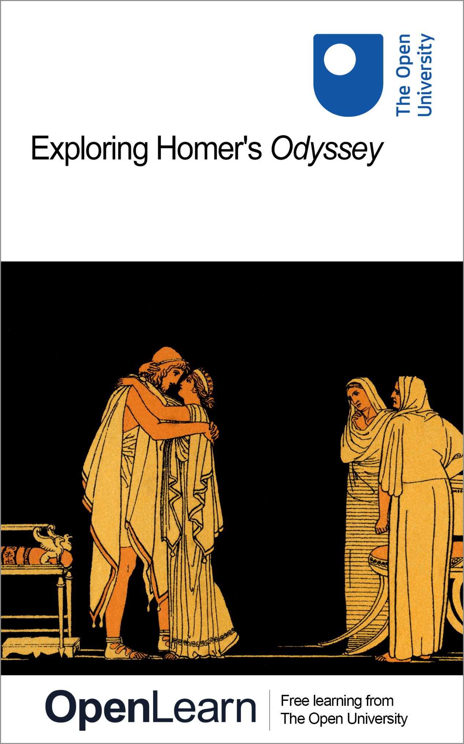

HDS_5

Exploring Ovid’s big ideas

About this free course
Find out more about The Open University’s Classical Studies courses and qualifications: www.open.ac.uk/courses/arts/degrees/ba-arts-humanities-classical-studies-r14-cs.
This version of the content may include video, images and interactive content that may not be optimised for your device.
You can experience this free course as it was originally designed on OpenLearn, the home of free learning from The Open University –
www.open.edu/openlearn/history-the-arts/exploring-homers-odyssey/content-section-0
There you’ll also be able to track your progress via your activity record, which you can use to demonstrate your learning.
Unless otherwise stated, copyright © 2025 The Open University, all rights reserved.
Intellectual property
Unless otherwise stated, this resource is released under the terms of the Creative Commons Licence v4.0 https://creativecommons.org/licenses/by-nc-sa/4.0/deed.en. Within that The Open University interprets this licence in the following way: www.open.edu/openlearn/about-openlearn/frequently-asked-questions-on-openlearn. Copyright and rights falling outside the terms of the Creative Commons Licence are retained or controlled by The Open University. Please read the full text before using any of the content.
We believe the primary barrier to accessing high-quality educational experiences is cost, which is why we aim to publish as much free content as possible under an open licence. If it proves difficult to release content under our preferred Creative Commons licence (e.g. because we can’t afford or gain the clearances or find suitable alternatives), we will still release the materials for free under a personal end-user licence.
This is because the learning experience will always be the same high quality offering and that should always be seen as positive – even if at times the licensing is different to Creative Commons.
When using the content you must attribute us (The Open University) (the OU) and any identified author in accordance with the terms of the Creative Commons Licence.
The Acknowledgements section is used to list, amongst other things, third party (Proprietary), licensed content which is not subject to Creative Commons licensing. Proprietary content must be used (retained) intact and in context to the content at all times.
The Acknowledgements section is also used to bring to your attention any other Special Restrictions which may apply to the content. For example there may be times when the Creative Commons Non-Commercial Sharealike licence does not apply to any of the content even if owned by us (The Open University). In these instances, unless stated otherwise, the content may be used for personal and non-commercial use.
We have also identified as Proprietary other material included in the content which is not subject to Creative Commons Licence. These are OU logos, trading names and may extend to certain photographic and video images and sound recordings and any other material as may be brought to your attention.
Unauthorised use of any of the content may constitute a breach of the terms and conditions and/or intellectual property laws.
We reserve the right to alter, amend or bring to an end any terms and conditions provided here without notice.
All rights falling outside the terms of the Creative Commons licence are retained or controlled by The Open University.
Head of Intellectual Property, The Open University

Contents
- Introduction
- Learning outcomes
- 1 What is Ovid’s Metamorphoses?
- 2 How did the world begin?
  - 2.1 A world of stories
  - 2.2 Ovid and his world
- 3 Who was Ovid?
- 4 What makes a human human?
  - 4.1 The shapes humans can take
  - 4.2 Defining the human
- 5 And then came … monsters
- 6 Actaeon’s transformation
- 7 Classical reception
- 8 Should we eat animals?
- Conclusion
- Taking it further
- Pronunciation guide
- Tell us what you think
- References
- Acknowledgements
- Glossary
- Solutions
- Descriptions

Introduction
The Roman poet Ovid has always been a bit of a mystery. Hugely controversial in his own time, he was banished from Rome – if we are to take him at his own word – for his poetry. But this did not stop him from being extraordinarily influential on everyone from William Shakespeare to Rachel Smythe, whose 2018 webcomic based on mythological figures, Lore Olympus, had, as of 2024, over a billion views. What was it that made Ovid so influential? Why do writers, artists and creatives of all kinds return to his stories year after year, and century after century, reshaping his myths for their modern audience? One answer is that Ovid’s poems ask big questions, especially in his most famous poem, The Metamorphoses. Ovid’s myths ask questions that even today many people are still unable to answer – like whether there is such a thing as god(s), how the world came to be, and what it is that makes humans human.

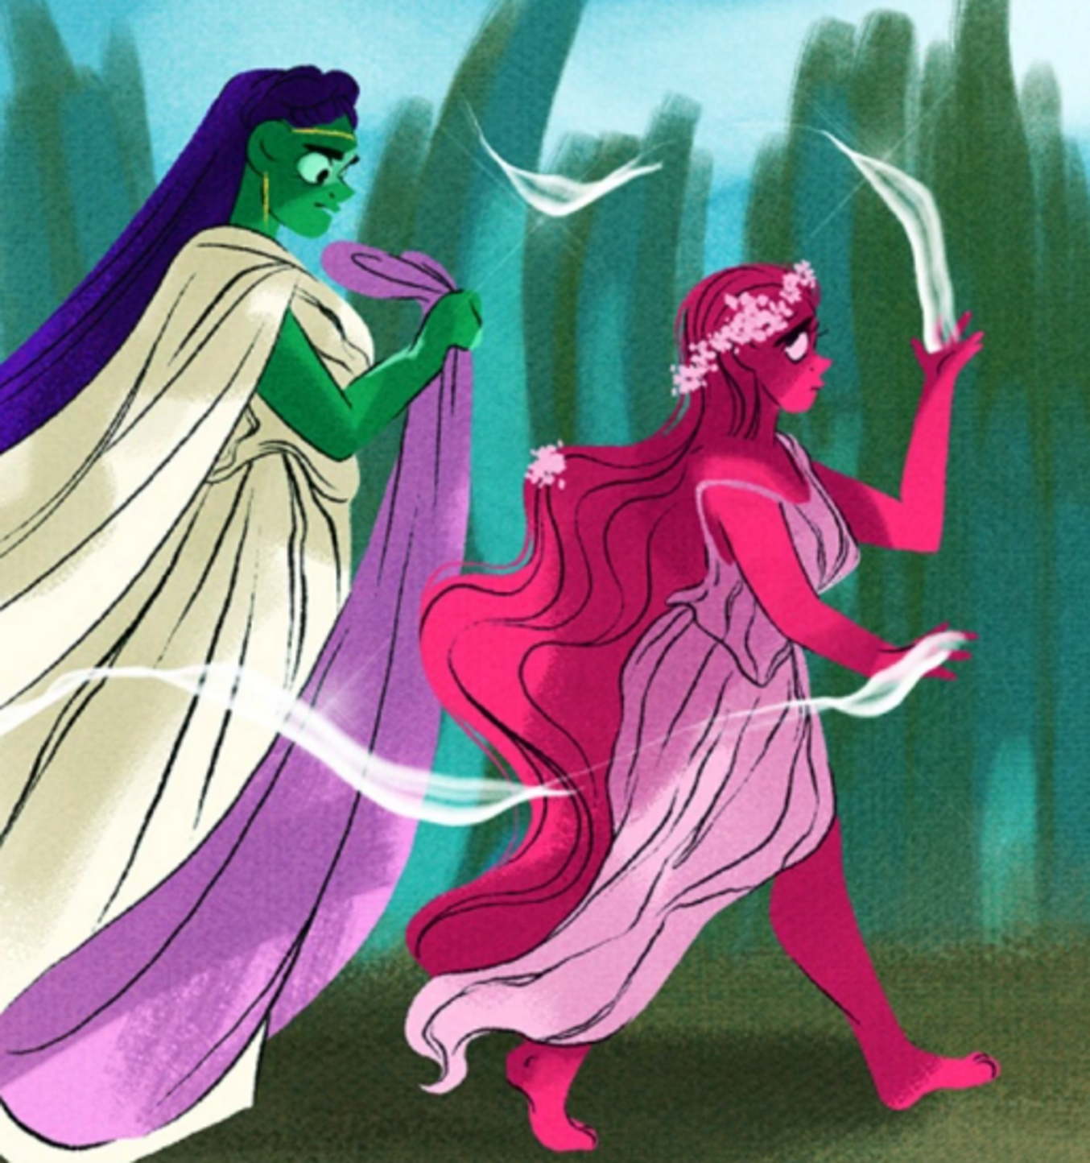
Figure 1 Persephone and her mother Demeter, from Lore Olympus. Ovid tells the story of the abduction of Persephone (who Latin poets called Proserpina) in Book 5 of his Metamorphoses.
View description - Figure 1 Persephone and her mother Demeter, from Lore Olympus. Ovid tells the story ...

Study note: glossary and pronunciation guide
As you study this course you may come across some key words or terms with which you are unfamiliar. We have therefore produced a pronunciation guide and glossary to help you. Clicking on terms which feature in bold text will take you to the pronunciation guide, where you can listen to audio recordings of the words featured. Clicking on terms which feature in bold text and are underlined will take you to the glossary where you will find definitions of those terms. Alternatively, hovering the cursor over the glossary entries within the text will show you the definition.

Before you get started we would really appreciate a few minutes of your time to tell us about yourself and your expectations for this course, in our optional start-of-course survey. Participation will be completely confidential and we will not pass on your details to others.

Learning outcomes
After studying this course, you should be able to:
- understand how Ovid’s Metamorphoses relates to the poet’s other works
- feel more confident working with Roman poetry, and in particular making sense of how ancient poetry asks questions that remain relevant in the present
- use critical thinking and analysis skills to explore texts and images
- know what is meant by ‘classical reception’ and understand the importance of studying how ancient texts, images and artefacts have been interpreted by ancient and modern audiences.

1 What is Ovid’s Metamorphoses?
It is difficult to sum up Ovid’s Metamorphoses. It is an epic poem, but one that disobeys almost every expectation that a Roman audience would have had about epic. It does not have a central hero, it takes the form of multiple stories told over 15 books, and frequently shifts in tone from comic to tragic and from irreverent satire to political statement. The poem was difficult to categorise even for its ancient readers. The Roman writer Quintilian (who was born in what is now Spain in the first century CE) described its author as ‘naughty even in his epic verse, and too in love with his own brilliance’! Ovid was living in a time of huge change (43 BCE–17/18 CE). Rome was transforming from a republic into a new system – an empire – under the control of one man, the first Roman emperor, Augustus. Against this backdrop, it makes sense that the main thread of the Metamorphoses should not be the story of a brave hero or a great queen or the foundation of a city, but transformation itself. The poem is full of stories of women who are transformed into trees, men who become deer, cows with human feelings and humans who are turned into gods.

Study note: a note on dates
You will notice that this course uses the abbreviations ‘BCE’ and ‘CE’ when dating events, texts and objects. These abbreviations stand for ‘Before the Common Era’ and ‘Common Era’. You may be familiar with an alternative method of referring to dates as ‘BC’ (‘before Christ’) and ‘AD’ (Anno Domini, Latin for ‘in the year of our Lord’), and you may find that the authors of other things you read on the topics discussed here use BC and AD instead of BCE and CE. Remember that BCE years count backwards – therefore the eighth century BCE is earlier than the seventh century BCE.

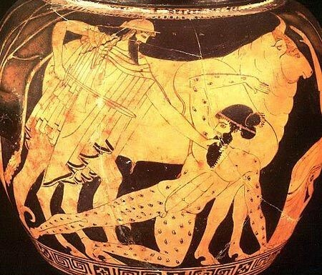
Figure 2 On this painted pot, Io is seen after her transformation into a cow, with Argus and Hermes. Ovid tells this story in Book 1 of the Metamorphoses. Kunsthistorisches Museum, Vienna.
View description - Figure 2 On this painted pot, Io is seen after her transformation into a cow, with ...

At the beginning of his poem, Ovid himself tells us what the poem will be about. Let’s read it now, and investigate what insights it offers into the Metamorphoses.

Activity 1 Beginnings
This activity should take about 10 minutes

Read the opening lines of the Metamorphoses reproduced below, translated by Stephanie McCarter. These lines are puzzling, but important. They are the readers’ first encounter with the poem, and help to set up their expectations about what will follow. Choose two phrases that tell you something about the themes of Ovid’s poem, and explain what they might tell readers about what sort of a poem the Metamorphoses is going to be.
Make some notes in the text box below.

My spirit moves me to tell of shapes transformed
into new bodies. Gods, inspire my work
(for you’ve transformed it too) and from creation
to my own time, spin out unceasing song.
(1.1–4, trans. McCarter 2023)

A note on book and line numbering:
You may have noticed that McCarter’s translation of the Metamorphoses (which you will sometimes see abbreviated to Met.) is divided into books from 1 to 15, and into lines – here you are reading lines 1–4. Conventionally, when researchers refer to Ovid’s Metamorphoses, they tell their readers how to find the passage they are referring to by way of a numbering system which gives the number of the book followed by a full stop, then the number of the lines. For instance, in this activity, you are asked to read the first four lines of book 1, which is referenced as ‘1.1–4’. The line numbers that are given in a translation like McCarter’s correspond relatively closely to the line numbers of the Latin text, but not exactly. This is because certain expressions in Latin are longer or shorter than they are in English. You do not need to refer to the Latin text at any point in this course.

Provide your answer...
View discussion - Activity 1 Beginnings

The two phrases – ‘shapes transformed into new bodies’ and ‘spin out unceasing song’ – which were picked out in the discussion give us important clues about Ovid’s poem – and there may be other clues in the phrases you picked out in Activity 1, too. Like many ancient poets, Ovid believed the poem to have come to him from a ‘spirit’ – sometimes called a Muse by other poets. The metaphor of the poem being spun out like a thread might seem strange to modern readers, but it was a frequently used image in the ancient world. It is a reference to the idea of the Fates (known as Moirai in Greek and Parcae in Latin), three sisters who in mythology were said to spin out the destiny of mortals as if they were spinning thread on a wheel.

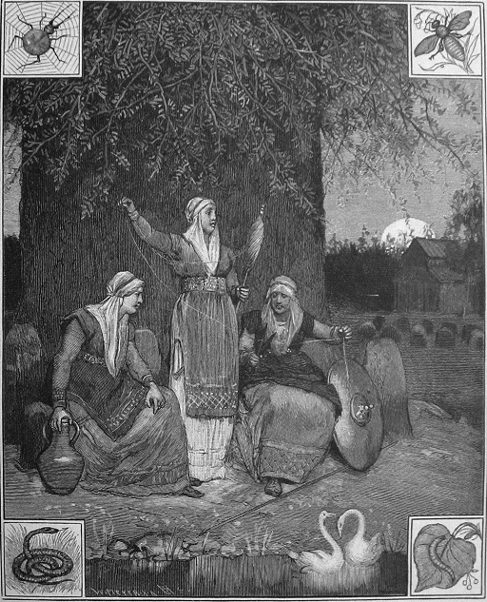
Figure 3 Many groups of ancient people similarly imagine destiny to be spun as a thread on a spinning wheel by three sisters. This engraving shows the Norns, spinning the thread of fate at the foot of Yggdrasil, the sacred tree of the world in Norse mythology. Hittite mythology – from ancient West Asia – also depicts goddesses who spin the thread of life, but there are two (Istustaya and Papaya) rather than three.
View description - Figure 3 Many groups of ancient people similarly imagine destiny to be spun as a ...

In your answer to Activity 1, you might also have remarked on the long time span of the poem. Ovid tells his readers that the poem will tell of transformations ‘from creation / to my own time’. In fact, creation is the very first act of transformation that takes place in the poem. To delve a bit deeper into the Metamorphoses and the big questions it asks, you’ll begin where Ovid begins: with the creation of the world.

2 How did the world begin?
The first book of Ovid’s Metamorphoses begins with a story about how the world came to be – a creation myth. In the modern world, many people still use stories to make sense of how the world came to be. These stories are called cosmologies. Putting Ovid’s cosmology into the context of other cosmology stories will help you to get a sense of the world he is imagining in the Metamorphoses, and allow you to develop a deeper understanding of the big questions that the poem asks.

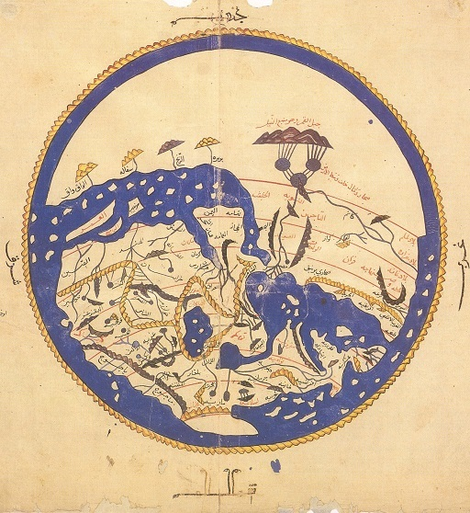
Figure 4 World map designed by the Muslim scholar Al-Idrisi for the Norman king Roger II of Sicily in the 12th century. The map is oriented with the South at the top.
View description - Figure 4 World map designed by the Muslim scholar Al-Idrisi for the Norman king Roger ...

2.1 A world of stories
In the next activity you will gather together as many different stories about how the world began as you can think of. Comparing and contrasting the story that Ovid tells in his poem will help you to understand the world that Ovid is imagining.

Activity 2 The beginning of the world
This activity should take about 5 minutes

Set a timer for 5 minutes, and make a list of as many different ways of telling the story of the beginning of the world as you can. These could be religious stories, or myths, or scientific models for the beginning of the universe. They can be ancient or modern and can come from anywhere in the world – you do not have to personally believe them to be true!

Provide your answer...
View discussion - Activity 2 The beginning of the world

You’ll think now about one cosmology story that may (or may not!) have featured in the list you made in the previous activity. It is a story that was first told by the ancient people of what is now Tahiti and Aotearoa (New Zealand), about how the world came from a shell. In the next activity you will read, or listen to, the opening chapter from a book for young children that collects together some cosmology stories from around the ancient world, and hear about that creation story about the world that came from a shell. You do not need to write a formal response to it, but you may wish to take some notes so that you can compare it with Ovid’s creation story in the next activity.

Activity 3 The world that came from a shell
This activity should take about 20 minutes

Read this story – or listen to the audio version. Remember that the story was written for young children, so it will not be as detailed as the ancient texts that you are dealing with elsewhere in this course. As you read or listen, write make notes on the outline of the story so that you can compare it with Ovid’s version of a creation myth in the next activity. Aim to make about 4–6 bullet points, noting down the elements of the story that you think will best help you to remember it.

The World That Came From a Shell
Each of the Pacific islands has its own story for how the world was made. In Tahiti they said that it began with a shell. There was no Earth, no land, no sea, no time – just a single shell. And in that shell was a single god: Ta’aroa.
Ta’aroa had been curled up all alone in his shell for all of eternity until one day he decided to stretch his arms and legs, and step outside. He slid out carefully and stood gazing at the enormous, empty expanse of the universe. He called out across the dark nothingness, but there was no reply. He was all alone. He got back into his shell, curled himself into a ball, and stayed there for another eternity.
Eventually he came out again. He was still alone and, although he would not have admitted it even if there had been anyone to admit it to, he was lonely. Suddenly, he had an idea. What if he and his shell could create a whole new world? That way, he would never be alone again. He broke off the curved side of his shell and held it up to make the sky. Then he cupped his hands together to make the Earth and everything in it.
Across the ocean on the island of Aotearoa, the ancient people told a different story. Here, people said that the sky, named Ranginui, and the Earth, named Papatūānuku, were parents to many children, who lived squeezed inside the darkness between them. There was Tūmatauenga, the god of war, Tāwhirimātea, the god of weather, and Tāne, the god of the forests and birds. There was Rogno, the god of growing food, and Haumia, the god of gathering food. There was Tangaroa, too, their name for Ta’aroa. Tangaroa was the god who created scaly creatures, like fish and lizards. But none of the children could be the gods of any of these things yet, because nothing existed expect the sky father and the Earth mother and their children, and the darkness.
As the children got older, they grew tired of living in darkness. They dreamed of a different world, where there would be light and space to stretch out their limbs. In whispers, so that their parents would not hear, they planned their escape. Tūmatauenga spoke first. He was angry that his parents had kept them cooped up in the dark all this time. He wanted to kill them. But the other siblings refused to do it. Tāne had another idea – they could push their parents apart and free themselves.
Rongo reached up and tried to push the sky further upwards, away from the Earth mother, but their grip on each other was too tight. Then Tangaroa tried. It was as if their parents each has as many arms as an octopus, and held tightly to one another with each limb. Eventually, Tāne tried, lying on his back and pushing with both of his legs against the sky until a tiny chink of light opened up between their parents. Stars rushed in, first one by one and then thousands all at once, and Tāne stacked them up into pillars so that their father was pushed further and further up into the sky away from their mother.
The siblings blinked, wide-eyed, at a light they had never seen before. When Tāne was finished, he went up to the sky and sat with his father. As a way of making amends for having separated him from the Earth other, he collected together all the lights that he could find and hung them in the night sky. These stars, he thought, would make a suitable outfit for his father to wear.
The other siblings set about building the rest of the world. All of them, that is, except Tāwhirimātea, who was angry. He had not joined in the escape plan, and was upset that the only life he had ever known had changed forever. He joined his father in the sky and started to attack the trees to punish the forest god Tāne, sending harsh winds that blew away the leaves. Then he set on Tangaroa, who fled into the ocean and became the god of the sea. Every day the sea, Tangaroa, would flee away from his brother, Tāwhirimātea, and then return. This created the tides.
Almost as soon as the sea and the land had been created, they filled up with humans – though no one could ever agree on exactly how the humans came to be. More and more humans filled up the islands, bringing love and life, and friendship and families. Very soon the humans had spread all across the world. The endless darkness did not return. And Ta’aroa would never know loneliness like the eternity he had spent all alone in his shell ever again.
(Ward, 2022, pp. 22–5)

Audio content is not available in this format.
The World That Came From a Shell (audio version)

Provide your answer...
View discussion - Activity 3 The world that came from a shell

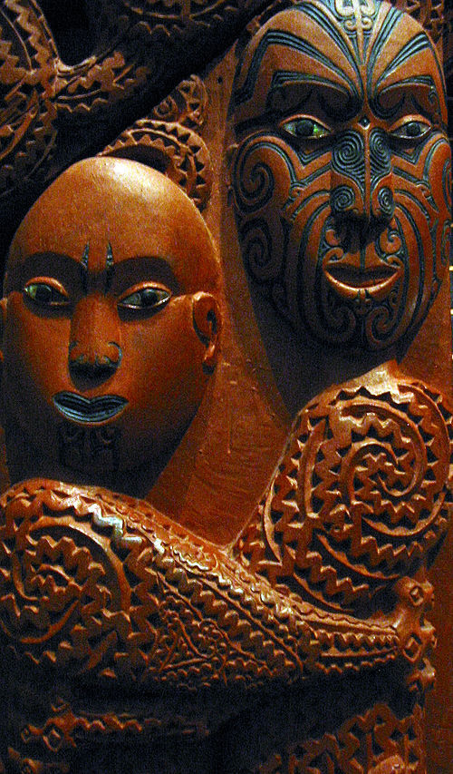
Figure 5 The embrace of the two gods Ranginui and Papatūānuku is still often depicted in Pacific Islander art to this day. This Maori carving is today at the Museum of Auckland.
View description - Figure 5 The embrace of the two gods Ranginui and Papatūānuku is still often depicted ...

Now that you have a sense of what a cosmology is, and how they can vary across different groups of people through time and around the world, let’s apply that knowledge to reading Ovid’s cosmology. The story that Ovid tells about how the world came to be is similar to the one told by many other ancient authors – like Hesiod, for example, who lived around 700 BCE and whose work the Theogony told a story about how the world began. You will find out, however, that Ovid’s version is quite different from the cosmology stories you have met in this course so far.

2.2 Ovid and his world
Let’s read Ovid’s creation story together and compare it with the one you read earlier.

Activity 4 Ovid’s creation story
This activity should take about 20 minutes

In this activity, you have been given six fragments of Ovid’s creation story that have been muddled up so that they are no longer in the order in which Ovid tells the story. Put them in the order that you think Ovid’s story might follow. You might want to use the engraving in Figure 6 to help you. It shows how a much later reader of Ovid’s story thought it should be best represented, and includes images of the story fragments you have been given.

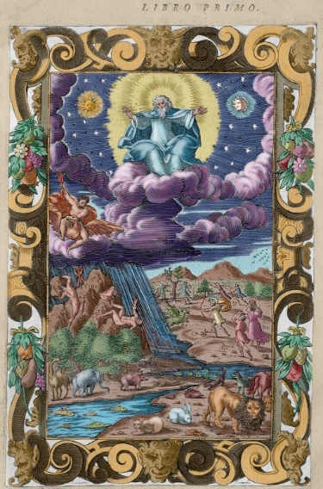
Figure 6 This engraving is taken from an Italian edition of the Metamorphoses, published in 1584.
View description - Figure 6 This engraving is taken from an Italian edition of the Metamorphoses, published ...

Humans were made, moulded from clay by Prometheus the Titan. Whereas other animals walked on all fours, humans were made to stand upright and were given the ability to think abstract thought.
A god separated out all of the parts of the universe, sifting the land from the sky and squeezing the air out of the sea. He hung the stars in the sky and ordered the whole world. He made the tides rise and fall so that the sea set the rhythm for the day.
The first age of time was called the Golden Age. Goodness characterised this age, and everyone did what was right without needing laws or punishments to keep them in check. There was no need to plough the land or farm animals because the earth simply gave up food of its own free will.
Zeus sent an enormous flood covering the whole of the earth. All mortals were killed as punishment for having gone to war with the gods. Deucalion and his wife Pyrrha were the only humans left alive, floating in their little boat.
Before the world began, there was nothing but a huge formless void which was called Chaos. Earth and sea and sky were all mixed up together in the darkness, and cold was mixed up with hot, wet with dry and light with dark.
Zeus overthrew Cronus, the Titan who thought himself to be king of the gods. The Golden Age turned to Silver, and after that followed the Bronze Age in which weapons were invented and a huge war broke out between the gods and the Titans.
Fragment 3
Fragment 2
Fragment 4
Fragment 6
Fragment 1
Fragment 5
View answer - Activity 4 Ovid’s creation story

Now that you have the order of the story, you will be able to compare it with the story of The World that Came from a Shell that you read earlier.

Activity 5 Comparing cosmologies
This activity should take about 10 minutes

Referring back to the notes you made in Activity 3, write down one difference and one similarity between the ancient story Ovid tells and the story of The World that Came from a Shell that you read earlier.

Provide your answer...
View discussion - Activity 5 Comparing cosmologies

There are many more similarities between the cosmology stories that circulated in the ancient world than you will have the time to delve into as part of this course. One example is the flood, which you learned was a key part of Ovid’s tale of how the world began. It was also a particularly frequent feature of these types of stories. It appears, for instance, in the stories from ancient Mesopotamia (the ancient region between the Tigris and Euphrates rivers, covering parts of what is now Iraq, Iran, Kuwait, Syria and Türkiye). In these stories – like in Ovid’s story – the flood functions as a way of renewing the world, and there are very few surviving humans. You might even be able to think of other creation stories that share this same flood motif.

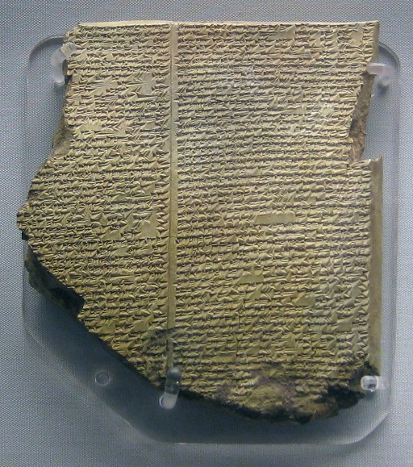
Figure 7 The ancient Mesopotamian story of the flood is found in many different texts, including The Epic of Gilgamesh and another epic poem called Atra-Hasis. This object is one of the places the story is found. It is a tablet made from clay and inscribed with the story written in a language called Akkadian. Seventh century BCE, British Museum.
View description - Figure 7 The ancient Mesopotamian story of the flood is found in many different texts, ...

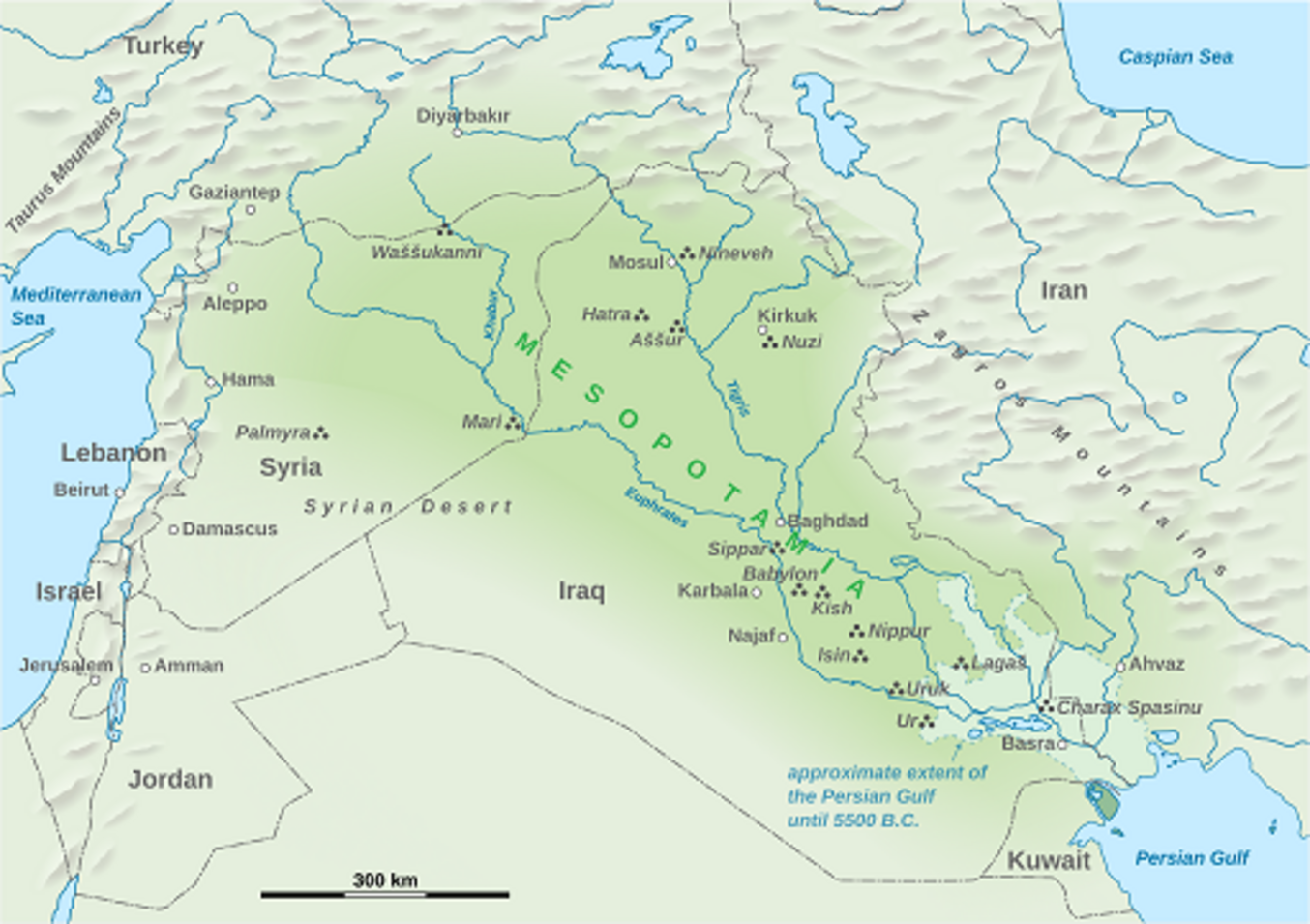
Figure 8 Modern map showing the location of Mesopotamia.
View description - Figure 8 Modern map showing the location of Mesopotamia.

Ovid’s poem about transformation begins with the creation of the world, or rather with the transformation from nothing into everything. This opening story in the Metamorphoses also asks the first one of the epic’s big questions: how did the world come to be? Now you will leave this question behind and follow Ovid’s own description of his poem a little further. As you read in Activity 1, Ovid says that his poem will take us ‘from creation to my own time’. You’ll explore Ovid’s ‘own time’ in the next section, and find out what (if anything!) it is possible to know for sure about Ovid’s own life.

3 Who was Ovid?
Our main source for what Ovid’s life was like is Ovid’s own writing. This poses a number of problems, as it makes it very difficult to distinguish between who Ovid was in real life, and the image of himself that he describes to his readers. The most well-known aspect of Ovid’s life is said to have taken place in 8 CE. Ovid tells us that he was exiled from Rome to Tomis, a town on coast of the Black Sea (in what is now Romania). The reason for his exile has been the subject of much debate. Ovid himself leaves tantalisingly few clues. He was exiled, he tells us, for two reasons: ‘a poem and a mistake’. Or, as Ovid wrote in Latin: carmen et error.

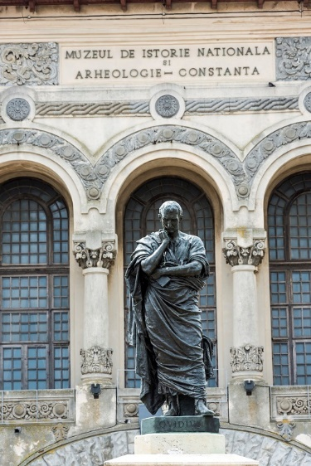
Figure 9 Photograph of a statue of Ovid that still stands today in Constanta, Romania (the location of the town that was called ‘Tomis’ in Ovid’s time). The statue was put up in 1887 and is the work of an Italian sculptor, Ettore Ferrari. The same sculptor also made a copy of this statue which was installed in Ovid’s hometown Sulmo in 1925.
View description - Figure 9 Photograph of a statue of Ovid that still stands today in Constanta, Romania ...

In the next activity, you will have a go at a task that many scholars working on Ovid today still find difficult: establishing the events of Ovid’s life. The outline that you will create in Activity 6 will show you what most scholars think happened to Ovid, but you should bear in mind that there is very little evidence for his life outside of his poems. As you work through this activity, think critically about each of the pieces of information you have been given. Which of them do you think are real, and which might Ovid have exaggerated or perhaps even made up in order to make his life seem more interesting to his readers?

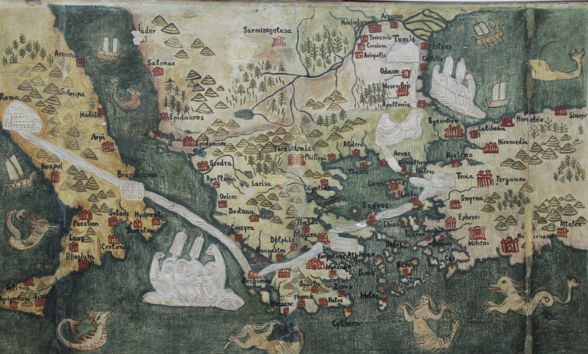
Figure 10 Map showing Ovid’s dangerous journey from Rome to Tomis. The map shows the locations of real cities, but you can also see mythical creatures in the sea, giving a sense of the danger of his journey!
View description - Figure 10 Map showing Ovid’s dangerous journey from Rome to Tomis. The map shows ...

Activity 6 Ovid: a life
This activity should take about 15 minutes

Place these events in Ovid’s life into the order in which you think they might have happened, starting with the poet’s birth. You can use any of the information you have learned so far in this course to help you – and by reading the descriptions of the events carefully you will also find some clues!

1
6
2
8
5
4
7
3
20 March, 43 BCE, Ovid is born in Sulmo, Italy. The date is well known because Ovid was born two years after Julius Caesar had put in place a new calendar, the Julian calendar.
8 CE, Ovid’s is exiled (or so he says!) to Tomis. By the time of his exile he had written the Metamorphoses and was working on a poem called the Fasti, about the Roman calendar and its religious holidays.
As a young man, Ovid started out on a political career but quickly abandoned it, committing his life instead to poetry.
Ovid died in Tomis around 17/18 CE.
After establishing himself as a love poet, Ovid wrote didactic poetry, which was designed to educate his readers (although the educational content of this poetry often concerned scandalous themes!). Famous works from this period include Ars Amatoria (‘The Art of Love’) and Remedia Amoris (‘Cures for Love’).
Early in his career, Ovid was famous for his poetry about love and sex. He wrote a book of love poems called the Amores, and also wrote the Heroides (‘The Heroines’). In the Heroides, Ovid often took up the point of view of famous women characters from myth (like Medea and Phaedra) and imagined what they would write to their lovers.
After Ovid’s exile his work changed dramatically. He wrote the Tristia (‘Sadnesses’) and Epistulae Ex Ponto (‘Letters from the Black Sea’), attempting to convince the emperor to bring him back to Rome.
19 BCE, death of two of Rome’s most famous poets, Virgil and Tibullus.
View answer - Activity 6 Ovid: a life

So far you have followed the path that Ovid himself sets out for you in the opening lines of his poem, ‘from creation to my own time’. Now, you will move on from the first major act of transformation in the Metamorphoses (i.e. the creation of the world out of nothing) to the second: the metamorphosis of humans out of clay.

4 What makes a human human?
Ovid’s tales of transformation, where humans are changed into gods, plants or animals, complicate the question of what makes a human human. Characters who have been transformed into trees continue to speak to their readers, expressing emotions and thoughts and using language. This forces Ovid’s readers to ask a big philosophical question: what is a human, and how do we define the category of humanity?
In the modern world, this question is being constantly asked. With machines and artificial intelligence threatening to take on roles that had previously been occupied by human workers, it is a huge philosophical question that is everywhere in our lives today. The question itself is not new, however. You will see that it has often been on the minds of those who have wondered about why humans and animals do not have the same rights, for instance, or have wanted to secure equal opportunities for all humans and work towards more equal societies.

4.1 The shapes humans can take
Many of Ovid’s stories of metamorphosis involve a human becoming a plant, animal or god/goddess.
In the next activity, you will encounter some of these stories of transformation from Ovid’s Metamorphoses, through some of the art works that they have inspired.

Activity 7 The art of transformation
This activity should take about 10 minutes

Below are two modern art works that take their inspiration from the stories of transformation that Ovid tells in his Metamorphoses. Study each image for about five minutes, and write down which figures are changing and how. What kind of transformation do you think is taking place in each story (e.g. from human to animal, from human to god etc)?

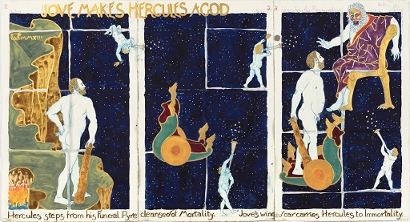
Figure 11 From ‘Metamorphoses: Ovid According to Wally Reinhardt’, Wally Reinhardt, 2013 (Hercules).
View description - Figure 11 From ‘Metamorphoses: Ovid According to Wally Reinhardt’, Wally Reinhardt, ...

Note: ‘Jove’ is another name for the god Jupiter.

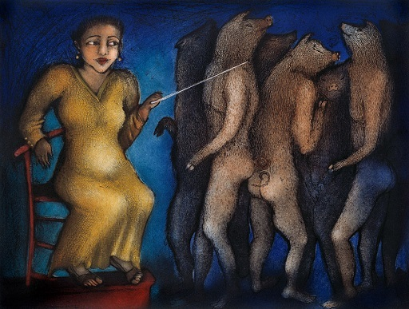
Figure 12 From ‘Tales of Transformation I-V’, Ana Maria Pacheco, 1998 (Circe).
View description - Figure 12 From ‘Tales of Transformation I-V’, Ana Maria Pacheco, 1998 (Circe).

Provide your answer...
View discussion - Activity 7 The art of transformation

If you would like to know more about these stories, you could read the story that inspired each of these paintings in Stephanie McCarter’s translation in the ‘Taking it further’ section of this course. Rather than delve into the story of Hercules transformed into a god (Metamorphoses Book 9) or of Circe who transforms Odysseus’ shipmates into pigs (Metamorphoses Book 14) further here, you are going to think about the big question that is common to these kinds of stories about transformation: when does a human stop being human?

4.2 Defining the human
When a human character is transformed into a non-human form in myth, readers have to think about where the boundary line is drawn between humans and non-humans. Being human is only a temporary condition in Ovid’s poem. It is not something static, that all humans can be assured of until the end of their lives. This invites Ovid’s readers to ask an enormous question: what makes a human a human? Where does the human stop and the animal, or plant or god begin?
In one sense, we can all answer this question. We all are human, and so we know from experience how to identify human beings as a category. But it is much more difficult to produce a definition of a human. Throughout the history of the modern world, certain humans have been denied recognition as humans. This is the case, for instance, for African people who were enslaved in the Atlantic (and other) slave trades, and who were not considered to be fully human by their enslavers. History makes it obvious how contested this definition of the word ‘human’ can be – and it also shows how much cruelty and violence can result from excluding certain humans from the category ‘human’.
Even in the contemporary world, some people are still fighting to be fully recognised as humans. These images from protest movements show people using declarations like ‘We are humans’ to fight for the rights of refugees, queer people, Black people and other people of colour.

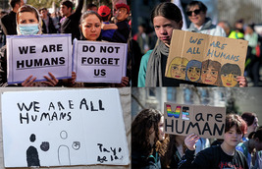
Figure 13 Top left: At a protest in Athens against the closure of borders, Afghan refugees hold signs declaring their humanity. Top right: On the International Day for the Elimination of Racial Discrimination, a young person holds a sign that states ‘We are all humans’. Bottom left: This placard bearing the text ‘We Are All Humans’ is from a Black Lives Matter protest against racism in Edinburgh. Bottom right: In Iowa, students walked out in protest against laws that restricted LGBTQIA+ freedom. In this photo the students hold signs saying ‘We are human’.
View description - Figure 13 Top left: At a protest in Athens against the closure of borders, Afghan ...

Activity 8 Define a human
This activity should take about 5 minutes

Set a timer for five minutes, and write down a single sentence definition of a human being. Try to write your definition so that it will only include human beings, and not animals, artificial intelligence or anything else that might share some characteristics with humans.

Provide your answer...
View discussion - Activity 8 Define a human

The question ‘what makes a human human?’ in some ways feels like a thoroughly modern question. You may have encountered this question in the context of the development of technology, like artificial intelligence, which sometimes seems to threaten to be able to do tasks that had previously been thought to be specific to human beings. But writers in the ancient world were also concerned with this question. In ancient Greece, the philosopher Aristotle (who lived in the fourth century BCE) tried to come up with a solution. In the next activity, you will consider Aristotle’s definition and explore how it compares with the single sentence definition that you worked on in Activity 8.

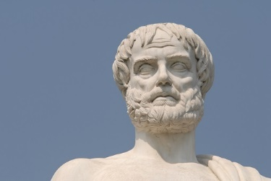
Figure 14 Aristotle, from Aristotle’s Park in Halkidiki, Greece.
View description - Figure 14 Aristotle, from Aristotle’s Park in Halkidiki, Greece.

Activity 9 An ancient definition
This activity should take about 15 minutes

Read this short extract from Aristotle’s Nicomachean Ethics. This excerpt is short, but it is philosophically quite complex. You may like to read it through two or three times to make sure that you understand the stages of Aristotle’s argument. Comparing it with your own definition (from Activity 8), answer the following two questions:
- What is it that distinguishes humans from other forms of life, according to Aristotle?
- How convincing do you find Aristotle’s argument? Can you think of any arguments against his conclusion?
To provide some context, at this point in the text, Aristotle is trying to discover how it is that humans can be most ethical. This requires him to identify what it is that is specific to humans. If he can find out what it is that humans alone are able to do (their function), he suggests, then he will be able to argue that doing this to the best of their ability is what it means to be ethical. For example, if rational thought is the function of humans, then their most ethical behaviour is thinking rationally as well as they can.
The definition of human function that Aristotle gives is as follows:

What then can this function be? The simple fact of being alive is something shared with plants, but we are looking for that which makes humans special. We must therefore set aside nutrition and growth, those activities that are simply for the purpose of living. Next, we could consider activities like perceiving and feeling, but these things too are shared with horses, oxen and most other animals. What remains, then, is the use of rational thought.
(1.7, 1097–1098)

Provide your answer...
View discussion - Activity 9 An ancient definition

5 And then came … monsters

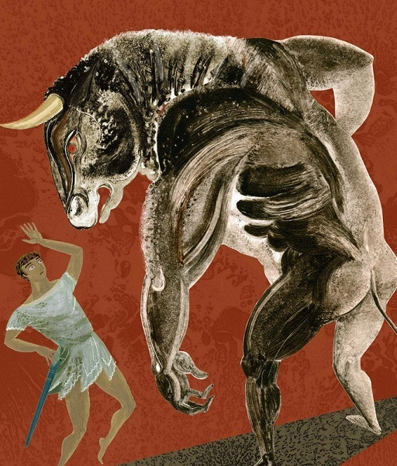
Figure 15 ‘Minotaur’ by Sarah Young, from Turnbull, A. (2023) Greek Myths, Walker Books/Candlewick Press.
View description - Figure 15 ‘Minotaur’ by Sarah Young, from Turnbull, A. (2023) Greek Myths, Walker ...

It is very difficult for us in the modern world to give a complete definition of a human being. But in the world of ancient myth, things are even more complicated. As you have discovered, texts like Ovid’s Metamorphoses were full of characters that crossed boundaries between human and animal, plant, god, constellation, river and many other kinds of transformation besides. But there is one category of creatures in ancient myth that make this task of defining a human even more difficult: monsters.
What is a monster? That is a question almost as difficult to answer as ‘what is a human?’! But we can use the examples of monsters that we find in texts like Ovid’s Metamorphoses to help us to try to answer it. Monsters are often marked in myths by having bodies that are part human and part animal. They might have the head of a human and the legs of a bull, for example, or many other combinations. These creatures are known as hybrid creatures, because they are a hybrid of humans and animals. In the next activity you will meet some of these hybrid creatures.

Activity 10 Hybrid creatures
This activity should take about 10 minutes

Below are three ancient images of hybrid creatures. In no more than three sentences, describe the hybrid creature in each image. All of these monsters play a role in Ovid’s Metamorphoses, but you do not need to be able to identify any of them by name, or know their stories.
Example: In the first image, you might say that the figure on the left is a hybrid creature which has the tail of a horse. You might also point out that his face, torso and hair look human. You may notice, too, that the creature seems to be attacking the other figure in the image.

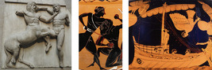
View description - Uncaptioned Figure

Provide your answer...
View discussion - Activity 10 Hybrid creatures

Monsters do not only appear in Ovid’s poetry, and monsters from all across ancient literature have had a huge influence on the modern world. The fact that ancient monsters are so commonly returned to has led to many scholars asking the question: why are monsters so popular? What is it that these hybrid creatures do for us? In the next activity you will try to get to grips with this question.

Activity 11 Tracking monsters
This activity should take about 20 minutes

Listen to this interview with Liz Gloyn about ancient monsters and the role they play in modern imaginations. In the interview, she explains why ancient monsters are so popular in the modern world – in other words, she offers some answers to the question ‘what do ancient monsters do in the modern world?’. As you listen, write down three possible answers to this question.

Video content is not available in this format.
View transcript - Uncaptioned interactive content

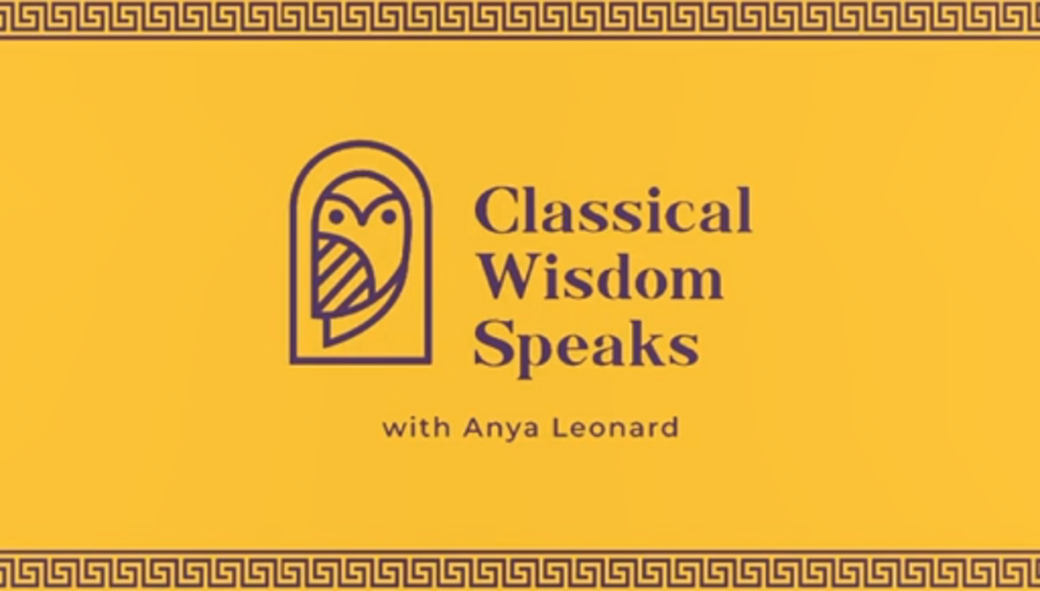

Provide your answer...
View discussion - Activity 11 Tracking monsters

Monsters are not the only hybrid creatures that you might meet in ancient myths. Heroes, too, are usually part human and part god or goddess. Unlike monsters, heroes often take a human form, but they sometimes have special abilities and challenges as a result of being partly divine.
Ovid’s transformation stories engage with the complexity of hybrid beings frequently. Even after transformation into animals or plants, his characters keep hold of certain aspects of their humanity. This complicates the question of what a human is. Would you behave differently towards an animal – like a deer or a cow for instance – if you knew that it might once have been a human, or might still be a human internally? In the next section you will read a story that engages with exactly this question.

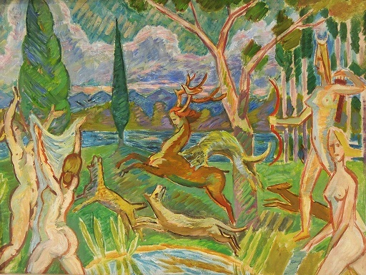
Figure 16 ‘Diana and Actaeon’, Zygmunt Waliszewski, 1935.
View description - Figure 16 ‘Diana and Actaeon’, Zygmunt Waliszewski, 1935.

6 Actaeon’s transformation
Ovid tells the story of Actaeon in Book 3 of his poem The Metamorphoses. The story is particularly interesting for the question you have focused on in the previous section: what makes a human human? In the story, the hunter Actaeon is transformed into a stag by the goddess Diana. After his transformation, however, he still seems to have some of the qualities that we might think of as human. He is upset and tries to shout using recognisably human language, but because he is now a stag he is unable to speak.

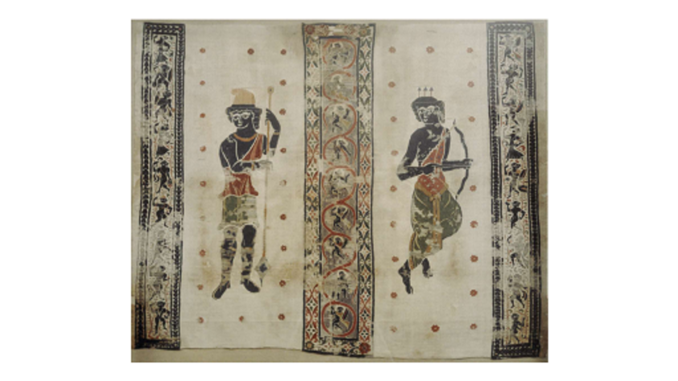
Figure 17 Linen textile from Egypt decorated with tapestry wool depicting figures identified as Diana (right) and Actaeon (left). British Museum.
View description - Figure 17 Linen textile from Egypt decorated with tapestry wool depicting figures ...

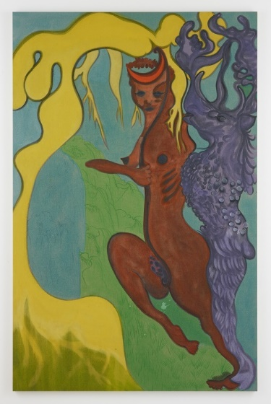
Figure 18 Stag, by Chris Ofili (2012), Victoria Mira Gallery, London
View description - Figure 18 Stag, by Chris Ofili (2012), Victoria Mira Gallery, London

Many modern artists have responded to Ovid’s story by making Actaeon the stag look recognisably part human. Chris Ofili’s version in Figure 18 is quite abstract, but you can see that Actaeon is standing on his hind legs in an upright human posture. You may wish to compare this version of Actaeon with the depiction of Actaeon before his transformation on the tapestry from Egypt in Figure 17. Art works often freeze the myth at a particular moment, right in the middle of Actaeon’s transformation – like the ancient art work you will examine in the next activity.
Let’s look now at how this transformation is represented in ancient art. Here, you will study an ancient vase painting by an artist whose name is not known. Scholars refer to this artist as ‘the Choephoroi Painter’, because of another famous vase that they painted which is decorated with a scene from a play called Choephoroi. The Choephoroi Painter lived in Lucania (central Italy) in the 4th Century BCE. The vase is tall, with two long handles and was probably used to hold wine.

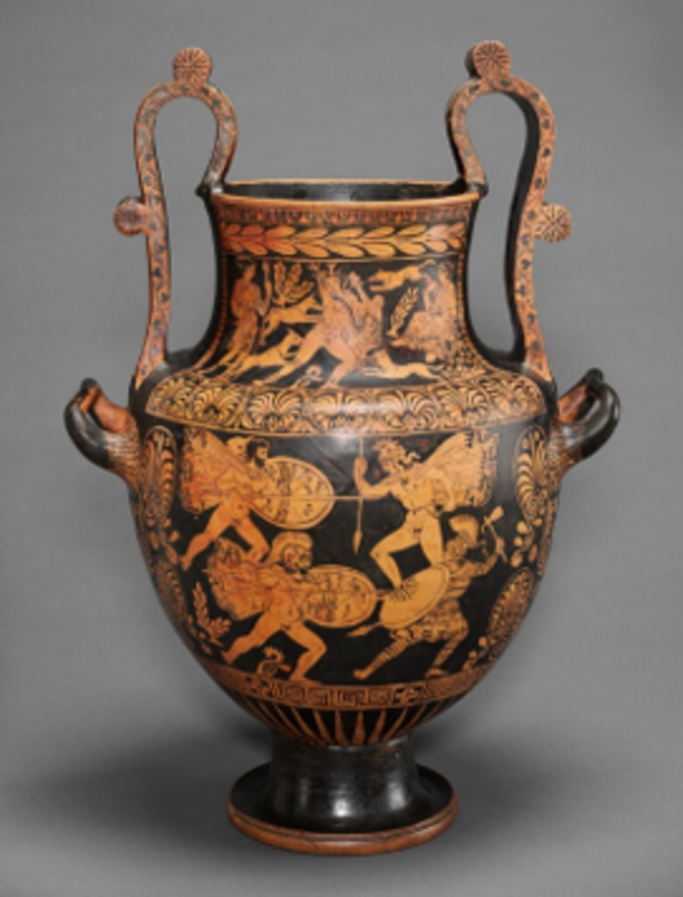
Figure 19 Vase by the Choephoroi painter, painted with mythological scenes in orange on a black background.
View description - Figure 19 Vase by the Choephoroi painter, painted with mythological scenes in orange ...

The vase is decorated with multiple different mythological scenes. In the next activity you are going to focus on the one that is at the top of the pot, around its neck. You will zoom in on this mythological scene so that you can explore it in more detail.

Activity 12 Decoding a mythical image
This activity should take about 10 minutes

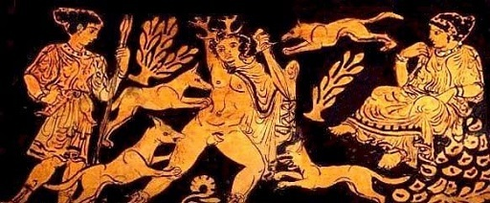
View description - Uncaptioned Figure

Using the zoomed in picture above, write a description of this scene in five bullet points. Try to take note of the as many of the details as possible, but make sure that you are describing the image rather than interpreting it. Use only the information given to you in the image itself and make sure that you do not jump to conclusions about what you are seeing based on external information.

Provide your answer...
View discussion - Activity 12 Decoding a mythical image

So far, you might have an idea about what is being depicted in this scene – but you are not yet able to identify what it is depicting solely from the evidence given to you on this painted pot. To find out more about this object and what it is depicting, you will need to look to different kinds of evidence. Combining evidence of different types is a crucial skill for the study of the ancient world. In this case, the evidence that will fill in the missing pieces so that you can understand the story that is being depicted here is found in a passage from Book 3 Ovid’s Metamorphoses. In the next activity, you will read this story, in a translation made in the early modern period by Arthur Golding. This will allow you to better understand the painted pot that you have examined. You will also have the opportunity to develop your reading skills by examining a more challenging literary text. By reading the passage twice, you will be able to understand both what the text means, and how Golding attempted to convey that meaning.
Arthur Golding translated Ovid’s Metamorphoses in 1567. This translation is still famous today because it was read by William Shakespeare, who used it to inspire his plays. In this activity, you will read Ovid’s tale of Actaeon, from Book 3 of the Metamorphoses, in Golding’s translation. You will see how the unlucky nephew of King Cadmus is harshly punished by the goddess Diana (who is also called Phebe in Golding’s version) for making a terrible mistake…
Note on reading older texts: English spelling is not consistent across time, which means that older texts can spell words in ways that we are not familiar with today. This text was first published in 1567, which means that you may not recognise the spellings of some of the words. A useful trick when dealing with older texts with archaic spellings is to try to read the text out loud, if you are able to. Sometimes you will recognise a word by ear, even if it looks very different to how you would write it in modern English. This is an important skill when reading older texts, as well as when reading texts in other languages.

Activity 13 Golding’s Ovid
This activity should take about 35 minutes

Read this passage from Golding’s Metamorphoses aloud. Try to get a feel for the text’s rhythm and the pattern of its rhyme and verse – which is quite different to modern English poetry. Note down anything you notice about these aspects of the text in this box.
Then, read the text a second time. This time you are going to pay more attention to the meaning of the text – but it does not matter if you do not know every word. Try to record what you think the plot of the story is in five bullet points. You can use the other types of evidence (especially the ancient vase painting you looked at in the previous activity) to help you. In the next activity you will compare this with a more modern translation, but for now focus on trying to decode the story from this early modern version.

There was a valley thicke
With Pinaple and Cipresse trees that armed be with pricke.
Gargaphie hight this shadie plot, it was a sacred place
To chast Diana and the Nymphes that wayted on hir grace.
Within the furthest end thereof there was a pleasant Bowre
So vaulted with the leavie trees, the Sunne there had no power.
[…]
When Phebe felt hir selfe waxe faint, of following of hir game,
It was hir custome for to come and bath hir in the same.
That day she having timely left hir hunting in the chace,
Was entered with hir troupe of Nymphes within this pleasant place.
She took hir quiver and hir bow the which she had unbent,
And eke hir Javelin to a Nymph that served that intent.
Another Nymph to take hir clothes among hir traine she chose,
Two losde hir buskins from hir legges and pulled of hir hose.
[…]
Now while she keepes this wont, behold, by wandring in the frith
He wist not whither (having staid his patime till the morrow)
Comes Cadmus’ Nephew to this thicke: and entring in with sorrow
(Such was his cursed cruell fate) saw Phebe where she washt.
The Damsels at the sight of man quite out of countnance dasht,
(Bicause they everichone was bare and naked to the quicke)
Did beate their handes against heir brests, and cast out such a shricke,
That all the wood did ring thereof: and clinging to their dame
Did all they could to hide both hir and eke themselves fro shame.
But Phebe was of personage so comly and so tall,
That by the middle of hir necke she overpeerd them all.
[…]
And casting backe and angrie looke, like as she would have sent
An arrow at him had she had hir bow there readie bent:
so raught the water in hir hande, and for to wreake the spight,
Besprinckled all the heade and face of the unluckie Knight,
And thus forespake the heavie lot that should upon him light.
“Now make thy vaunt among thy Mates, thou sawste Diana bare.
Tell if thou can: I give thee leave: tell heardly, doe not spare.”
This done, she makes no further threates, but by and by doth spread
A payre of lively olde Harts hornes upon his sprinckled head.
She sharpes his eares, she makes his necke both slender, long and lanke.
She turnes his fingers into feete, his armes to spindle shanke.
She wrappes him in a hairie hyde beset with speckled spottes,
And planet in him fearfulness – and so away he trottes.
[…]
He sight and brayed: for that was then the speech that did remaine,
And downe the eyes that were not his, his bitter teares did raine.
No part remayned (save his mind) of that he earst had beene.
What should he doe? Turne home again to Cadmus and the Queene?
Or hyde himself among the Woods? Of this he was afrayd,
And of the tother ill ashamed. While doubting thus he stayd:
His hounds espyde him where he was, and Blackfoote first of all
And stalker special good of scent began aloud to call.
[…]
He strayned oftentymes to speake, and was about to say,
“I am Actaeon! Know your Lorde and Master sirs, I pray.”
But use of wordes and speech did want to utter forth his mind.
Their crie did ring through all the Wood redoubled with the winde.
[…]
Not knowing that it was their Lord, the huntsmen cheere their houds
With wonted noyse and for Actaeon looke about the grounds.
They hallow who could lowdest crie still calling him by name
As though he were not there, and much his absence they do blame,
In that he came not to the fall, but slackt to see the game.
As often as they named him he sadly shooke his head,
And faine he would have been away thence in some other stead,
But there he was. And well he could have found in heart to see
His dogges fell deedes, so that to feele in place he had not bee.
They hem him in on everie side, and in the shape of Stagge,
With greedie teeth and gripping pawes their Lord in peeces dragge.
So fierce was cruell Phebe’s wrath, it could not be alayde,
Till of his fault by bitter death the ransome had he payde.
(Golding, 1567)

Provide your answer...
View discussion - Part

Now you are going to read a more modern version of the same story by Stephanie McCarter, published in 2022. You will be able to check whether you have understood the story in Golding’s version. But more importantly: pay careful attention to the difference between these two versions. Which do you like best, Golding or McCarter’s?

There was a valley thick with pines and slender
cypresses, named Gargaraphie and sacred
to girt Diana. Deep within a recess
there was a woodland cave no art had made.
Nature, with her own genius, mimicked art,
shaping an arch of pumice and light tufa.
On its right side, a lustrous fountain purled
with shadow eddies. Round it were broad pools
enclosed by grass. The goddess of the woods,
when weary from her hunting, liked to bathe
her virginal limbs in this translucent water.
Arriving here, she hands her spear and quiver
and bow, now slackened, to that nymph who bears
her weapons, while another grabs her robe
as it slips off. […]
Diana bathes in this familiar stream,
when look! His hunt postponed, Cadmus’ grandson
gets lost in unknown woods, steps faltering,
and comes into this grove. Fate guides his path.
As soon as he goes in the spring-soaked cave,
the nymphs, still naked, see the man and pound
their chests, filling the woods with sudden shrieks.
They crowd around Diana to conceal her
with their own bodies. Yet the goddess stands
much taller, and her neck outstrips them all.
[…]
Having no arrows near, she used what was
at hand and splashed that many face with water.
Then, sprinkling his hair with vengeful drops,
she added words that warned of coming doom:
“Now tell how you have seen me nude, if you
can tell.” She uttered no more threats but placed
the antlers of a long-lived stag atop
his sprinkled head. She stretched his neck out long
and added pointed tips to both his ears.
She turned his hands to feet, his arms to legs,
and wrapped his body in a spotted hide
She made him skittish too. Autonoe’s
heroic son takes flight and is amazed
at his own speed. But when he saw his face
and horns reflected in a stream, he tried
to call out “Wretched me!” Yet no voice came.
He groaned – that was his voice. Tears drenched a face
not his. His former mind alone remained.
What should he do? Return home to the palace
or hide inside the woods? His shame prevents
the former but his fear the latter. While
he hesitates, his dogs catch sight of him.
[…]
He flees through places where he’d often chased!
He flees from his own pets! He yearned to shout,
“I am Actaeon – recognize your master!”
The longed-for words won’t come. Barks fill the air.
[…] As they hold down their master,
the whole pack gathers round and bites his flesh
until there’s no room left for wounds. He groans,
sounding not human nor yet like a stag,
and fills familiar woods with wretched cries.
[…] But his companions, unaware,
goad the swift pack with customary cheers.
Their eyes search for Actaeon. Each one vies
to shout “Actaeon!” loudest, thinking he’s
not there. Hearing his name, he turns his head.
They mourn his absence and that, being late,
he’ll miss the spectacle of such a lucky
prize. Though he’d rather be away, he’s there.
He’d rather see, not feel, his dogs’ fierce feats.
All round, jaws sink into his flesh and tear
their master underneath the false deer’s likeness.
Not till he’d died from countless wounds, it’s said,
was quiver-clad Diana’s anger sated.
(McCarter, 2022, pp. 74–6)

Provide your answer...

Now that you have explored the story of Actaeon in full, think back to the image on the painted pot that you analysed in Activity 12. You have now experienced the story of Actaeon told in two different media: text and image. In this next activity you are going to think about the strengths and weakness of each of these two different media for conveying stories about transformation. What can a text do, that images cannot do, and vice versa?

Activity 14 Texts and images
This activity should take about 15 minutes

Think about the three versions of the Actaeon story that you have engaged with so far – the painted pot and the two translations. What are the strengths and weaknesses of each of these two different media, image and text? Fill in the table below. Try to include at least one bullet point in each box.

 | Image | Text
Strengths | Provide your answer... | Provide your answer...
Weaknesses | Provide your answer... | Provide your answer...

View discussion - Activity 14 Texts and images

The transformation of Actaeon has been frequently represented not just in text and art in the ancient world, but across many different media in the modern world too. Different artists and creatives have responded to the myth in different ways, drawing out particular resonances from the ancient story and creating new ones that speak to them and their modern audiences. In the next section you will discover an approach that is known as ‘classical reception’, which you can use to study the way that ancient stories change their meaning as they move through different versions, reimaginings and adaptations into the modern world.

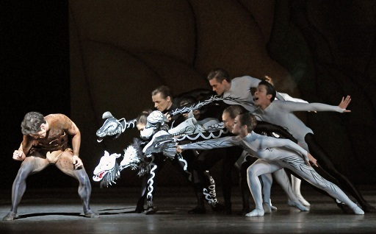
Figure 20 Still from the ballet ‘Diana and Actaeon’ by Liam Scarlett, Will Tuckett and Jonathan Watkins (2012). Dancers: Federico Bonelli, Romani Pajdak, Tom Whitehead, Paul Kay, Brian Maloney, Deirdre Chapman, Sabrina Westcombe, Kenta Kura.
View description - Figure 20 Still from the ballet ‘Diana and Actaeon’ by Liam Scarlett, Will Tuckett ...

7 Classical reception
Classical reception is an approach that you have been using throughout this course, without using its name. When you compared the painted pot with the Ovidian text in Activity 14, that was classical reception, and when you examined different artists’ versions of the Actaeon myth throughout the previous section, that was classical reception in action too! Now you will learn more about this approach, practise applying it with more precision to some modern poetry, and find out how it helps us to understand why Ovid is still relevant to the modern world.

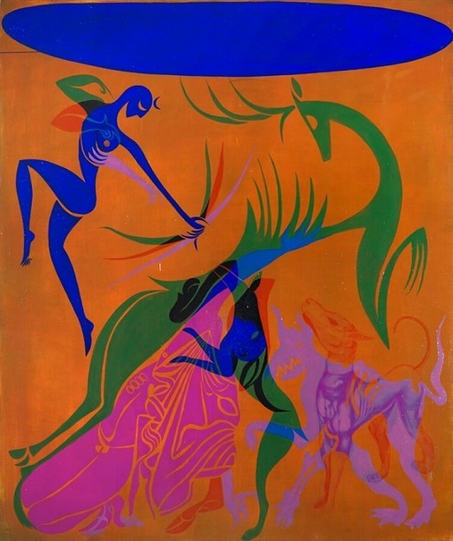
Figure 21 ‘Yellow (Diana and Actaeon)’ by the contemporary Cuban-American artist Lino Bernabe. This painting was made to change under different colours of light. The image shows what it would look like under white light, but under different colours of light other details become more apparent. This reflects the variety of ways readers have interpreted the myth.
View description - Figure 21 ‘Yellow (Diana and Actaeon)’ by the contemporary Cuban-American artist ...

Activity 15 What is classical reception?
This activity should take about 10 minutes

Watch the following video introducing you to classical reception. Then, write a single sentence summary of what you understand classical reception to be.

Video content is not available in this format.
View transcript - Uncaptioned interactive content

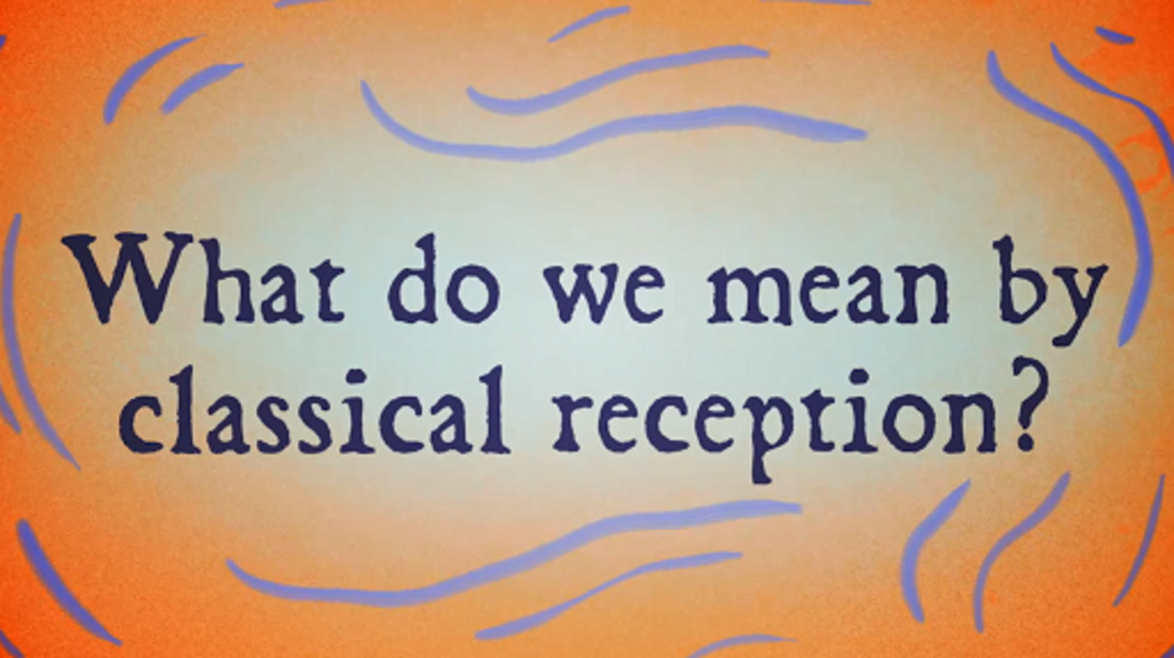

Provide your answer...
View discussion - Activity 15 What is classical reception?

Let’s dig into some specific versions – or receptions – of the Actaeon story, and put what you have learned about classical reception into practice. In the next two activities you will study two paintings by the Italian painter Titian, who died in 1576 CE, and a poem that responds to these paintings by the British-Nigerian poet Patience Agbabi. Now that you know Ovid’s version of the story of Actaeon quite well, you can focus on how Titian and Agbabi adapt it and provide new interpretations.
Between 1551 and 1562 CE, Titian painted six large paintings which he called his ‘poesie’ (poems) for Philip II, who was then King of Spain. The story of Diana and Actaeon takes up not one but two paintings in this series. Look at the paintings carefully now, and see whether you can identify which moments in the story of Actaeon they represent.

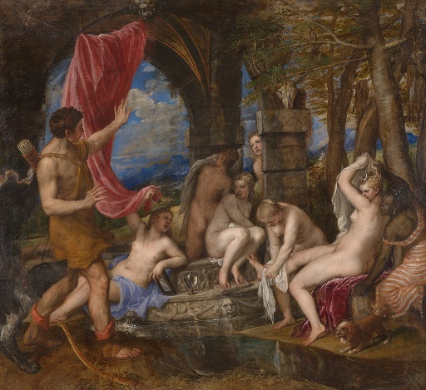
View description - Uncaptioned Figure

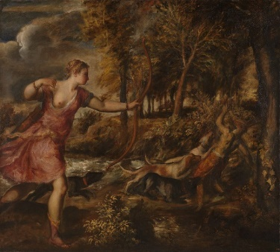
View description - Uncaptioned Figure

In 2012, a series of poems was commissioned in response to these two paintings by Titian. These poems showcase something important about classical reception. They make clear that reception is not just a conversation between something ancient and something modern. It is a dynamic process that can involve multiple webs of texts, art and ideas and it can make loops in time that connect up multiple historical moments.
One of the poems that was commissioned in 2012 was a poem called ‘About Face’ by Patience Agbabi. It takes as its subject one of the figures in Titian’s painting – the Black woman who is on the right of the ‘Diana and Actaeon’ painting. In this next activity you will engage with Agbabi’s poem and the way it transforms Ovid’s myth of transformation by responding to Titian’s painting.

Activity 16 About Face
This activity should take about 20 minutes

Watch Patience Agbabi read her poem ‘About Face’ and read along in the transcript if you would like to. You will engage with this poem multiple times as part of this activity.

Watch the video at YouTube.com.

Transcript
Actaeon, you’ll pay the price for looking
like a god; athletic, proud, immortal.
Diana, goddess of the hunt, will hound you.
She is too harsh; you should have looked at me.
I am her shadow, black yet fairer than
the mistress, clad in cloth finer than cirrus.
I want you, Actaeon. I wish I were
shroud white; O that you’d notice me and mouth
each monumental curve. Her handsome face
off-guard, you brushed aside the drape to see
how cool she bathed; with the pool’s spray, she cursed you
for looking. In this pine-sweet grove, you turned
from man to horned and dappled stag: sentenced.
Look how your fate reflects itself in water.
Look! How your fate reflects itself in water
from man to horned and dappled stag, sentenced
for looking. In this pine-sweet grove, you turned.
How cool she bathed! With the pool’s spray she cursed you.
Off-guard, you brushed aside the drape to see
each monumental curve, her handsome face
shroud white. O that you’d notice me and mouth
I want you. Actaeon, I wish I were
the mistress clad in cloth finer than cirrus.
I am her shadow, black yet fairer than
she is. Too harsh! You should have looked at me.
Diana, goddess of the hunt, will hound you
like a god, athletic, proud, immortal.
Actaeon, you’ll pay the price for looking.

The first time, simply try to make sense of the poem. What is it about? What ideas and emotions does it convey? Then listen to/read the poem again. This time, pay close attention to the way the poem is structured, and to the characters that Agbabi directs our attention to in the poem. Then answer the following questions.
- Whose point of view is Agbabi writing from, and how does this change the reader’s perception of the story?
- What do you notice about the structure of this poem that makes it particularly effective?

Provide your answer...
View discussion - Activity 16 About Face

This poem could be read as Agbabi re-imagining Ovid’s myth through Titian’s re-imagining of it. Classical reception is constantly being influenced by these kinds of choices, which are themselves shaped by the choices of earlier writers and creatives as well as broader societal contexts. The meaning of ancient texts and artefacts is constantly changing in response to new kinds of interpretations and re-imaginings. Here we see another of Ovid’s big questions: why do myths continue to matter in the modern world? And classical reception provides us with as many different answers as there are different re-imaginings of these stories. If you have found studying this poem interesting, you might want to return to it in the ‘Taking it further’ section, where you will find more resources to explore it.

8 Should we eat animals?
Reception is not something that only modern writers and artists engage in. It was also a frequent practice in the ancient world. In fact, towards the end of Ovid’s Metamorphoses, in Book 15, Ovid returns to the key idea in the story of Actaeon: the question of whether it is possible to draw a boundary between humans and animals. Within the body of the stag, Ovid invites us to recognise a human who has feelings and who is asking for our sympathy. In Book 15 we meet a character who takes this very seriously: Pythagoras. Here we see Ovid take the idea that humans can transform into animals one step further.
The Greek philosopher Pythagoras appears in Book 15 and argues that the fact that human souls can be found in animals is proof that animals should not be eaten. Pythagoras was not a character that Ovid invented – he was a real person, a philosopher who is still well known today for mathematical concepts like Pythagoras’ theorem. He was born on a Greek island called Samos in the sixth century BCE. He was also, famously in the ancient world, a committed vegetarian. Pythagoras believed in an idea known as metempsychosis – the idea that souls are immortal, and at the time of death pass from one living being into another. It was for this reason, he argued, that animals should not be eaten – because they might at one point have been human. In this final activity you will find out how closely Ovid’s mythical stories of transformation could reflect ancient philosophical beliefs. You will engage with the final one of Ovid’s big questions that you will be exploring in this course: should we eat animals?

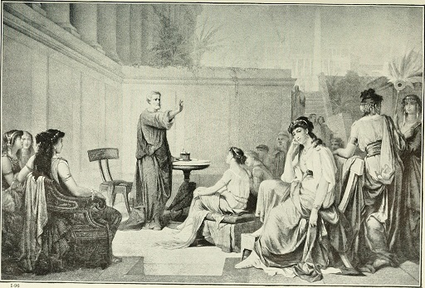
Figure 22 Engraving showing Pythagoras teaching a class of women, as imagined by an artist in 1915.
View description - Figure 22 Engraving showing Pythagoras teaching a class of women, as imagined by ...

Activity 17 An ancient vegetarian
This activity should take about 15 minutes

The following extract is from Pythagoras’ attempt to make the case for vegetarianism in Book 15 of Ovid’s Metamorphoses in Stephanie McCarter’s translation. As you study this passage in this activity, you will be analysing the similarities between Pythagoras’ metempsychosis and Ovid’s metamorphosis. Read the passage through for the first time, and try to follow the logic of Pythagoras’ argument (even if you do not agree with it!). Then read it again and write down two examples of transformation that Pythagoras tells the reader about in this passage.

Souls do not die. Leaving their former post,
they come to new homes where they live and dwell.
I too recall that in the Trojan War
I was Euphorbus, son of Panthous,
whose heart the grievous spear of Menelaus
once pierced. I lately recognized a shield
my left hand bore in Argive Juno’s temple.
Everything changes, nothing dies. Our spirit
roams here and there, taking whatever limbs
it meets, moving from beasts to human bodies,
then back to beasts. It never perishes.
As soft wax is imprinted with new shapes
and does not keep the same form that it had,
yet it is the same, so is the soul the same,
while moving, as I teach, through various shapes.
Don’t let your belly’s lust break duty’s bonds.
Do not, I warn you, banish kindred souls
with evil slaughter, nor let blood feed blood.
(15.171–188)

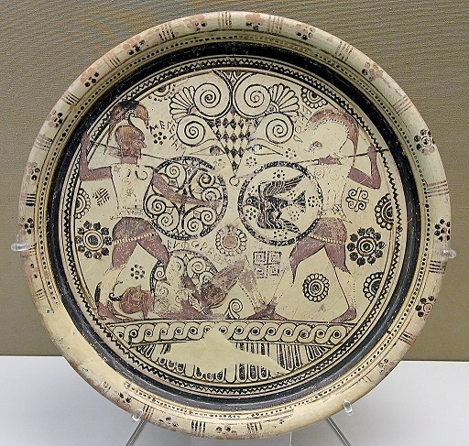
Figure 23 This plate shows two warriors, Menelaus and Hector at war. Beneath Menelaus’ feet is the body of Euphorbus. The plate was made at Rhodes and was likely made around 600 BCE.
View description - Figure 23 This plate shows two warriors, Menelaus and Hector at war. Beneath Menelaus’ ...

Provide your answer...
View discussion - Part

Transformation is key to the argument Pythagoras makes, which is that animals should not be eaten because they might contain human souls. Now that you have analysed the theme of transformation in this passage, you can think a little bit more deeply about how this relates to other stories about transformation that you have met in this unit. Read the passage through one more time. What similarities do you see between the kind of transformation that Pythagoras warns his readers of here, and the kind that you have read about in the story of Actaeon being transformed into a stag? Write a few sentences on the similarities between these two stories.

Provide your answer...
View discussion - Part

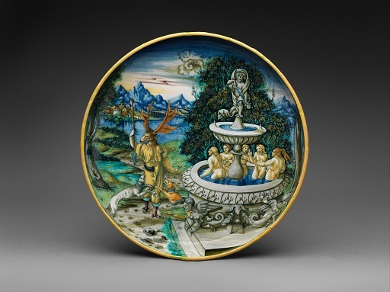
Figure 24 This dish was made in Italy around 1525. Take note of the way that the artist depicts Actaeon standing upright even after his transformation into a stag.
View description - Figure 24 This dish was made in Italy around 1525. Take note of the way that the ...

Where metempsychosis and metamorphosis overlap is the idea that the human is not a stable category. Both of these stories advise readers to be cautious in how they treat animals because the distinction between humans and animals is not as clear as it might seem. Comparing metempsychosis and metamorphosis in this way makes it possible to understand that the tales of transformation in Ovid’s poem were not just stories told for entertainment. They had deeper meanings, and help us to gain an insight into how people in the ancient world thought about big ideas and questions. In this case, they help us to understand how ancient answers to the question ‘what makes a human, human?’ might be different to the many ways that question could be answered today. Myths are not direct evidence for real life, of course. Actaeon was a mythical character, not a real person and many of the events that take place in Ovid’s Metamorphoses are fantastical and beyond belief. But these stories are engaged with big ideas and questions that tell us something about how Ovid’s readers made sense of the world around them.
Comparing metempsychosis and metamorphosis in this way helps me to understand that the tales of transformation in Ovid’s poem were not just stories told for entertainment. They have deeper meanings, and help us to gain an insight into how people in the ancient world thought about big ideas and questions. In this case, they help us to understand how ancient answers to big questions like ‘what makes a human, human?’ might be different to the many ways those questions could be answered today. Myths are not direct evidence for real life, of course. Actaeon was a mythical character, not a real person and many of the events that take place in Ovid’s Metamorphoses are fantastical and beyond belief. But these stories are engaged with big ideas and questions that tell us something about how Ovid’s readers made sense of the world around them.

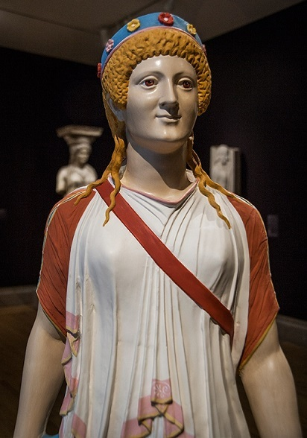
Figure 25 The Greek goddess Artemis, colour reconstruction of a first century AD statue found in Pompeii, an imitation of Greek statues of the sixth century BC, reconstructed using analysis of trace pigments.
View description - Figure 25 The Greek goddess Artemis, colour reconstruction of a first century AD ...

Conclusion
In this course you have gained an understanding not just of what Ovid’s Metamorphoses is about, but of why it continues to inspire artists, writers and other creatives into the modern world. You have learned that myths are not just stories told to pass the time, and that the fantastical, magical or divine elements in these stories did not stop them from shaping how ancient people thought about the world around them. These connections might not be direct – it is not easy to argue that Ovid’s readers would have believed in all of the stories he tells. But much as it still does today, storytelling helped to explain some of the things that remain difficult to explain in the world. Questions like ‘how did the world begin?’ or ‘what makes a human human?’ or ‘should we eat animals?’ might not be answered scientifically or conclusively by myths – but it is through stories that they can still be asked, explored and interrogated.
As well as learning why myths like Ovid’s remain influential in the modern world, you have also gained a greater understanding of how this influence happens – classical reception. You have explored how to use the tools of classical reception (as well as other critical reading and analysis skills) to examine texts and images from the past and present. This course has equipped you to ask big questions of your own, like: how do stories change their meaning across time, as they are adapted to suit the interests of different audiences? What is it that makes a work of literature feel ‘relevant’ across so many centuries and for so many different groups of people with different contexts and experiences of the world? You now have the skills that you need to explore other ancient texts and their receptions across literature, art and other media, or to investigate more of tales in the Metamorphoses in translation if you would like to. For some suggestions on how to expand your skills and knowledge further, please take a look at the ‘Taking it further’ section of this course. You might also find it useful to explore some similar related free courses.

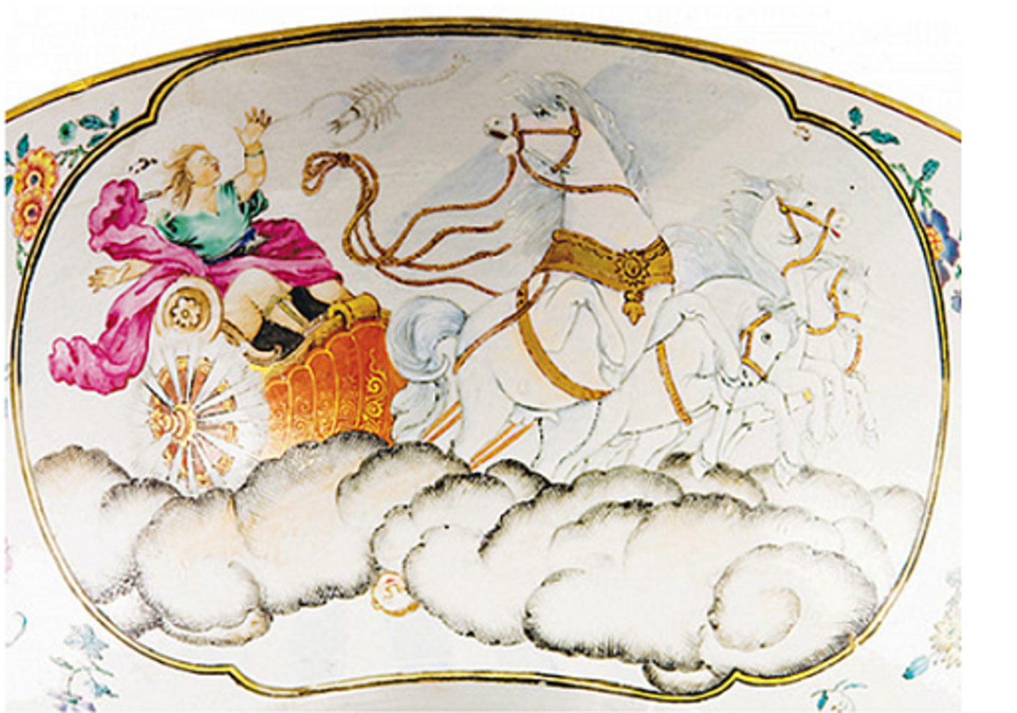
Figure 26 This porcelain bowl was made in China during the eighteenth century. It features a scene from the fall of Phaethon, a story told in book 2 of Ovid’s Metamorphoses.
View description - Figure 26 This porcelain bowl was made in China during the eighteenth century. It ...

There is one final metamorphosis that Ovid leaves us with at the end of his poem. The very last metamorphosis in the Metamorphoses is of Ovid himself. In the final lines, Ovid imagines a future where he is transformed from a poet of his own time into a name that will live on forever, as long as people are still reading his poetry. Read it, in Stephanie McCarter’s translation, and decide for yourself whether you think Ovid was right!

I’ve made a masterpiece Jove’s wrath cannot
destroy, nor flame, nor steel, nor gnawing time.
That day, which governs nothing but my body,
can end at will my life’s uncertain span.
And yet my finer half will be eternal,
borne among stars. My name can’t be erased.
Where Roman power spreads through conquered lands,
I will be read on people’s lips. My fame
will last across the centuries. If poets’
prophecies can hold any truth, I’ll live.
(15.933–942)

Taking it further
If you have enjoyed learning about the Roman context of Ovid’s poetry, you might want to study the free course The many guises of the emperor Augustus by Ursula Rothe, or if you have enjoyed studying epic poetry as part of this course, you might want to study Exploring Homer’s Odyssey, a free course by Emma Bridges.
If you would like to know more about the language in which Ovid wrote his poetry, you might want to try your hand at the OpenLearn course Getting Started on Classical Latin.
Drawing on what you have learned from studying classical reception on this course (and from the artistic and literary receptions of the myths you have studied) you might want to think about how you personally would approach the myth of Actaeon if you were going to write (or draw, or paint, or perform, or animate in any other way) your own version. Which aspects of the story would you focus on? Whose perspective would you choose to tell the story from, and what kind of an interpretation of the myth would you produce? Are there elements of Ovid’s story that you would want to change, or would you stick close to this ancient version? You could write a short reflection on these questions.
You might like to return to some of the stories that you have been introduced to in this course. One way to do this is to read more of Ovid’s Metamorphoses itself. In this course you have mostly referred to Stephanie McCarter’s translation, Metamorphoses by Ovid (2023, Penguin) which is a modern translation, but you can also find the text in different (usually older) translations available freely on the Internet. The Perseus Digital Library will give you free access to a translation of the Metamorphoses by Brookes More. And the Poetry In Translation project will provide you with free access to a translation by A.S. Kline. The story ‘The World that Came from a Shell’ that you read in Activity 3 came from a collection of stories from around the ancient world called Gods of the Ancient World (2022, Dorling Kindersley) by Marchella Ward, the author of this course. In that book you will find more stories from different groups of ancient people about how the world began, as well as other myths about gods and goddesses.
If you enjoyed learning about Patience Agbabi’s poem About Face, you could listen to it or read it again. You could also watch this video in which the poet explains some of her motivations in writing her version of the Actaeon story: Poets Inspired by Titian: Patience Agbabi
If you would like to know more about the process of translation that led to Stephanie McCarter’s version of the Metamorphoses, you could read this interview with the translator: Having Their Say by Lily Meyer (Poetry Foundation). You may also be interested in this academic lecture that McCarter gave, where she goes into the process of creating her translation in a lot of detail: Morse Lecture 2024: Translating Ovid’s Metamorphoses with Professor Stephanie McCarter.
To learn even more about the context of Ovid’s Metamorphoses, you might like to listen to this podcast by the London Review of Books: Emily Wilson and Thomas Jones: Among the Ancients: Ovid.
If you enjoyed listening to the excerpt from the interview with Liz Gloyn, you can listen to the rest of the interview.

Pronunciation guide

Audio content is not available in this format.
Actaeon

Audio content is not available in this format.
Aristotle

Audio content is not available in this format.
Choephoroi

Audio content is not available in this format.
Hesiod

Audio content is not available in this format.
Mesopotamia

Audio content is not available in this format.
Metamorphoses

Audio content is not available in this format.
Nicomachean Ethics

Audio content is not available in this format.
Ovid

Audio content is not available in this format.
Patience Agbabi

Audio content is not available in this format.
Pythagoras

Audio content is not available in this format.
Quintilian

Audio content is not available in this format.
Samos

Audio content is not available in this format.
Theogony

Audio content is not available in this format.
Tomis

Tell us what you think
Now you’ve come to the end of the course, we would appreciate a few minutes of your time to complete this short end-of-course survey. We’d like to find out a bit about your experience of studying the course and what you plan to do next. We will use this information to provide better online experiences for all our learners and to share our findings with others. Participation will be completely confidential and we will not pass on your details to others.

References
Hughes, T. (1997) Tales from Ovid, Faber and Faber, pp. 105–12.
McCarter, S. (2023) Metamorphoses by Ovid, Penguin.
Ward, M. (2022) ‘The World That Came From a Shell’ in Gods of the Ancient World: A Kids’ Guide to Ancient Mythologies, DK Children, pp. 22–5.

Acknowledgements
This free course was written by Marchella Ward. Many thanks to Danny Pucknell, Emma Bridges and James Robson for their support and extremely helpful feedback on the content.
Except for third party materials and otherwise stated (see terms and conditions), this content is made available under a Creative Commons Attribution-NonCommercial-ShareAlike 4.0 Licence.
The material acknowledged below is Proprietary and used under licence (not subject to Creative Commons Licence). Grateful acknowledgement is made to the following sources for permission to reproduce material in this free course:
Images
Course image: Simon_Arvin on Unsplash
Figure 1: from Fandom and licensed under https://creativecommons.org/licenses/by-sa/3.0/
Figure 2: akg-images / Erich Lessing
Figure 3: Photograph by Haukur Þorgeirsson from Fredrik Sander’s 1893 edition of the Poetic Edda.
Figure 4: A map that Al-Idrisi made for Roger II of Sicily in 1154 AD, from https://commons.wikimedia.org/wiki/File:Al-Idrisi%27s_world_map.JPG
Figure 5: Kahuroa
Figure 6: The Creation, The Battle of the Giants, Decaulion and Pyrrha and Apollo and the serpent.; PHAS / Contributor; Universal Images Group; Getty Images
Figure 7: © The Trustees of the British Museum; https://creativecommons.org/licenses/by-nc-sa/4.0/
Figure 8: Goran tek-en; https://creativecommons.org/licenses/by-sa/4.0/deed.en
Figure 9: Joel ARPAILLANGE; Getty Images
Figure 10: from The Monumental Statue of Ovid / The History of Romania in One Object, Romanian Cultural Institute in New York
Figure 11: Wally Reinhardt ‘Joves Makes Hercules a God’, 2013, Watercolor, gouache, Prismacolor colored pencil, graphite, and tape on prepared Arches paper, 18 x 33 in. New York University Art Collection. Gift of the artist, 2018.2.62
Figure 12: Ana Maria Pacheco, Tales of Transformations II, 1997-8, ©Ana Maria Pacheco. All Rights Reserved 2024/ Bridgeman Images, Repro courtesy of PRATT CONTEMPORARY, UK
Figure 13, top left: dpa picture alliance / Alamy Stock Photo; top right; OLIVIER HOSLET/EPA-EFE/Shutterstock; bottom left: City of Edinburgh Council Museums & Galleries; People’s Story, www.capitalcollections.org.uk; bottom right: courtesy of Phil Roeder
Figure 14: sneska; Getty Images
Figure 15: artist Sarah Young, from Greek Myths written by Ann Turnbull courtesy of Walker Books Limited
Figure 16: Zygmunt Waliszewski Diana and Actaeon | 1935 NationalMuseum in Poznan, photograph by Ablakok; https://creativecommons.org/licenses/by-sa/4.0/deed.en
Figure 17: © The Trustees of the British Museum. Shared under a Creative Commons Attribution-NonCommercial-ShareAlike 4.0 International (CC BY-NC-SA 4.0) licence.
Figure 18: © Chris Ofili, courtesy the artist and Victoria Miro
Figure 19: Harvard Art Museums/Arthur M. Sackler Museum, Bequest of David M. Robinson
Figure 20: © courtesy of Dave Morgan
Figure 21: courtesy of Lino Bernabe Fernandez
Figure 22: By Internet Archive Book Images - https://www.flickr.com/photos/internetarchivebookimages/14783288925/Source book page: https://archive.org/stream/storyofgreatestn01elli/storyofgreatestn01elli#page/n586/mode/1up, Public Domain, https://commons.wikimedia.org/w/index.php?curid=42033593
Figure 23: photographer Jastrow (2006); https://en.wikipedia.org/wiki/Euphorbos_plate#/media/File:Plate_Euphorbos_BM_GR1860.4-4.1.jpg
Figure 24: from https://www.metmuseum.org/art/collection/search/198701; public domain
Figure 25: Alaskanspaceship; https://creativecommons.org/licenses/by-sa/4.0/
Figure 26: from Ovid and China, A Roman poet, 18th-century punch bowls and a Monmouth College professor; Barry McNamara | Published 2 November 2021
Activity 10: Left: ClemRutter; https://creativecommons.org/publicdomain/zero/1.0/deed.en; centre: Getty Museum Collection, https://creativecommons.org/publicdomain/zero/1.0/; right: © The Trustees of the British Museum; https://creativecommons.org/licenses/by-nc-sa/4.0/
Activity 12: Harvard Art Museum/Arthur M. Sackler Museum, Bequest of David M. Robinson
Activity 15: Diana and Actaeon, after Titian; National Galleries of Scotland; Bequeathed by George Watson through Art Fund, 2015; https://www.creativecommons.org/licenses/by-nc/4.0/deed.en
The Death of Actaeon; National Gallery, London, photographer: Carlo Bollo / Alamy Stock Photo
Text
Activities 1,13 and 17: 1.1–4, McCarter, Stephanie; Ovid’s Metamorphoses, Penguin 2022
Activity 3: Marchella Ward, The World that came from a Shell, Gods of the Ancient World, 2022, D K Publishing
Activity 13: Golding, Arthur; Metamorphoses, John Danter, 1567
Audio Visual
What Makes a Monster: courtesy of Anya Leonard, Classical Wisdom
What do we mean by Classical Reception: The Open University
About Face: The National Gallery
Every effort has been made to contact copyright owners. If any have been inadvertently overlooked, the publishers will be pleased to make the necessary arrangements at the first opportunity.
Don't miss out
If reading this text has inspired you to learn more, you may be interested in joining the millions of people who discover our free learning resources and qualifications by visiting The Open University – www.open.edu/openlearn/free-courses.

Glossary
Achaeans
one of the names Homer uses to refer to the Greeks who fought at Troy
bard
a skilled singer and musician who improvised songs on mythical themes while performing them for a live audience
Choephoroi
Greek word meaning ‘the libation bearers’ (i.e. those who carried offerings at a funeral). It is the title of a play by the Greek tragedian Aeschylus in the fifth century BCE. The play is one part of a three part series of tragedies that are referred to under the title ‘The Oresteia’. These plays are the earliest extant trilogy of Greek tragedies and tell the story of King Agamemnon who returns from the Trojan war and his family (including his son Orestes after whom the trilogy is named).
cosmologies
theories that explain the origin and nature of the universe. Here we are referring to cosmologies in the form of stories, but they can also take the form of philosophical theories or scientific hypotheses. The Greek words ‘cosmos’ (world) and ‘logos’ (word, thought or explanation) make up the word cosmology.
epic
in ancient literature, lengthy narrative poems (such as Homer’s Iliad and Odyssey), usually telling of the exploits of a hero or heroes, and often involving battles or difficult journeys as well as supernatural characters
epithets
in Homeric poetry, adjectives or short phrases used repeatedly to describe a particular character
Euphorbus
a Trojan warrior, who is well known from Homer’s poem The Iliad. He was killed by Menelaus, the king of the Spartans. After he had killed him, Menelaus took Euphorbus’ shield to the temple of Hera (who is called Juno in Latin) at Argos, in Greece, and put it on display. This is what Ovid is referring to in line 177 in this passage.
Hellas
Greek term meaning ‘Greece’
human exceptionalism
refers to the idea that humans are unique and special, and are more important than animals, plants or other living organisms because of this special uniqueness.
hybrid
a mixture of two different things, making one thing with two different types of characteristics. (The term is often used of cars: a hybrid car is a car that uses two different energy sources, usually electricity and petrol).
Julian calendar
a calendar proposed (and taking its name from) Julius Caesar in 46 BCE. It uses the position of the sun and comprises a year of 365 days most years, and a 366-day leap year every four years. Julius Caesar intended this new calendar to solve a problem with the earlier Roman calendar. The earlier version had 355 days, and so an extra 27 or 28 day period (known as the Mensis Intercalaris in Latin) had to be inserted some years to make sure that a year encompassed all of the seasons. Julius Caesar hoped that the Julian calendar would keep the calendar aligned to a whole year without need for the insertion of these extra days.
Jove
another name often used for the god Jupiter, the king of the gods (who is usually said to overlap with the Greek god Zeus).
metaphor
a figure of speech that compares two things directly, usually by using one of them in place of the other or by saying that one is the other. A famous example of a metaphor is found in William Shakespeare’s As You Like It, in the line ‘All the world’s a stage’ (Act 2, Scene 7, line 139). Here, Shakespeare does not literally mean that the world is a stage, but that a stage is a metaphor for the world. Shakespeare uses this comparison to describe what the world is like.
muse
the name often given in Greek (and later) poetry to the goddess who is said to have inspired poetry, songs, stories and other creative work. In many Greek texts we are told that there were nine muses. In some texts they are said to be the daughters of Zeus, while in others they are said to have been followers of the Egyptian god Osiris.
nostos
(plural nostoi) Greek term meaning ‘homecoming’
nymph
one of several minor divinities, usually taking the form of a young woman and often associated with a particular location or natural feature. The nymph Calypso lives on the island of Ogygia in the Odyssey and rescues Odysseus when he is shipwrecked there
republic
a state in which power is held by representatives of the people (who are usually elected) rather than by a monarch. The phrase ‘Roman Republic’ usually refers to the time period 509–27 BCE, before Rome became an empire under the emperor Augustus.
Pallas
one of the names given to the goddess Athena
simile
a figure of speech in which one thing is compared to something different. In English, these are usually introduced by the words ‘like’ or ‘as’
Sirens
mythical creatures, often depicted as half-woman and half-bird. In the Odyssey they lure sailors to their death with their singing

Solutions

Activity 1 Beginnings

Discussion
There are lots of different phrases that you might have focused on here. Your attention might immediately have been drawn to the phrase ‘shapes transformed into new bodies’, which announces that the poem will be about the idea of transformation and change – as you have already noted. You may have also noticed the importance of the gods and their inspiration to Ovid, and you may have noted down the phrase ‘Gods, inspire my work’, which highlights the enormous role that the gods will play in the stories Ovid tells.
You may have also picked out the phrase ‘spin out unceasing song’. Here, Ovid is using the image of spinning thread (i.e. transforming it from natural fibres – like a woollen fleece for example – into yarn) as a metaphor for writing poetry. The word ‘unceasing’ (which just means ‘without stopping’) gives the impression of one long continuous thread that is spun. This phrase made it seem likely to me that the Metamorphoses would be a poem in which Ovid’s own voice as a poet plays an important role because of the reference to ‘my own time’. It also suggested a concern with larger themes like fate and the long span of history.
Back to - Activity 1 Beginnings

Activity 2 The beginning of the world

Discussion
You might have thought of stories from major world religions, like Islam or Christianity (in which a god creates the world). Or you might have included scientific stories like the Big Bang. If you have a special interest in cosmology stories and the way they vary among different groups of people you may have thought of the stories about how Brahma, Vishnu and Shiva create the world, from the coils of the great snake Ananta and the cosmic dance of Shiva – a group of stories that are still told today in many Hindu texts. Other stories include stories that the ancient Egyptians used to tell about how Atum, the creator of the world, was born from a giant lotus flower, and stories told by the Taino people of the ancient Caribbean about how the world came from a vegetable called a gourd, and came into being on the back of a turtle named Caguama.
Back to - Activity 2 The beginning of the world

Activity 3 The world that came from a shell

Discussion
Hopefully you enjoyed this ancient story and were able to come up with the 4–6 bullet points to help you remember it. Keep this summary close by as you continue on to the next activity, so that you can refer to it if you need to.
Back to - Activity 3 The world that came from a shell

Activity 4 Ovid’s creation story

Answer
The correct matches are:
Humans were made, moulded from clay by Prometheus the Titan. Whereas other animals walked on all fours, humans were made to stand upright and were given the ability to think abstract thought.
Fragment 3
A god separated out all of the parts of the universe, sifting the land from the sky and squeezing the air out of the sea. He hung the stars in the sky and ordered the whole world. He made the tides rise and fall so that the sea set the rhythm for the day.
Fragment 2
The first age of time was called the Golden Age. Goodness characterised this age, and everyone did what was right without needing laws or punishments to keep them in check. There was no need to plough the land or farm animals because the earth simply gave up food of its own free will.
Fragment 4
Zeus sent an enormous flood covering the whole of the earth. All mortals were killed as punishment for having gone to war with the gods. Deucalion and his wife Pyrrha were the only humans left alive, floating in their little boat.
Fragment 6
Before the world began, there was nothing but a huge formless void which was called Chaos. Earth and sea and sky were all mixed up together in the darkness, and cold was mixed up with hot, wet with dry and light with dark.
Fragment 1
Zeus overthrew Cronus, the Titan who thought himself to be king of the gods. The Golden Age turned to Silver, and after that followed the Bronze Age in which weapons were invented and a huge war broke out between the gods and the Titans.
Fragment 5
Back to - Activity 4 Ovid’s creation story

Activity 5 Comparing cosmologies

Discussion
One point of difference that may have stood out to you from comparing these two stories is the fact that for Ovid, the beginning of the world is a story of decline. He explains how the perfect ‘Golden Age’ falls into war, corruption and exploitation of the earth. The story of The World that Came from a Shell, by contrast, is structured as a progression out of the darkness and into the light. Things improve for Ta’aroa and his brothers and sisters once the world has been created.
You may have thought that the most striking similarity is the way that the multiple gods in both stories are family relations, with each god and goddess having a specific responsibility in the world. In both stories, the gods have to fight for their power; it is not automatically given to them. You might well have come up with different suggestions for this activity, as there are many possible answers!
Back to - Activity 5 Comparing cosmologies

Activity 6 Ovid: a life

Answer
The correct matches are:
1
20 March, 43 BCE, Ovid is born in Sulmo, Italy. The date is well known because Ovid was born two years after Julius Caesar had put in place a new calendar, the Julian calendar.
6
8 CE, Ovid’s is exiled (or so he says!) to Tomis. By the time of his exile he had written the Metamorphoses and was working on a poem called the Fasti, about the Roman calendar and its religious holidays.
2
As a young man, Ovid started out on a political career but quickly abandoned it, committing his life instead to poetry.
8
Ovid died in Tomis around 17/18 CE.
5
After establishing himself as a love poet, Ovid wrote didactic poetry, which was designed to educate his readers (although the educational content of this poetry often concerned scandalous themes!). Famous works from this period include Ars Amatoria (‘The Art of Love’) and Remedia Amoris (‘Cures for Love’).
4
Early in his career, Ovid was famous for his poetry about love and sex. He wrote a book of love poems called the Amores, and also wrote the Heroides (‘The Heroines’). In the Heroides, Ovid often took up the point of view of famous women characters from myth (like Medea and Phaedra) and imagined what they would write to their lovers.
7
After Ovid’s exile his work changed dramatically. He wrote the Tristia (‘Sadnesses’) and Epistulae Ex Ponto (‘Letters from the Black Sea’), attempting to convince the emperor to bring him back to Rome.
3
19 BCE, death of two of Rome’s most famous poets, Virgil and Tibullus.
Back to - Activity 6 Ovid: a life

Activity 7 The art of transformation

Discussion
In the first image by Wally Reinhardt, the painter gives us quite a lot of information about the transformation that is taking place. The text at the top of the painting reads ‘Jove makes Hercules a god’, and we can tell from the comic strip style panels that Hercules is being transformed from a hero into an immortal god.
In the second image by Ana Maria Pacheco, we have to do a bit more detective work because the artist does not tell us exactly what is happening. The pig-like creatures on the right-hand side of the image are standing on their hind legs and raising their heads to look at each other. We might hypothesise that they are humans who have recently been transformed into pigs.
Back to - Activity 7 The art of transformation

Activity 8 Define a human

Discussion
Here is an example answer:

I did not find a definition that I found completely satisfactory, but I learned something important in the process. I started off trying to produce a definition of the human on the basis of ability. By this, I mean that I tried to single out what humans can do that animals (or robots) cannot do. I tried ‘A human is an animal that can speak.’ first of all, but this did not hold up to scrutiny. Computers or robots, after all, can speak (though it could be argued that they rely on a human programmer to do so). More importantly, though, this definition of the human risked being discriminatory. Babies cannot speak, but they are no less human for not being able to do so. And many disabled humans would be excluded from the category of the human if the human were defined on the basis of a particular ability – so such a definition would be ableist. I concluded that how we define what a human is changing all the time and that humans are perhaps not as special or separable from other living things as I had previously thought! In other words, I concluded that I no longer thought human exceptionalism to be a particularly useful way of thinking about what it means to be human.
I hope you managed to come up with a definition. Or, if you were like me and struggled to answer this question, that you found the struggle useful!

Back to - Activity 8 Define a human

Activity 9 An ancient definition

Discussion
Here is a sample answer for each of the two questions:
- For Aristotle, what distinguishes humans from other forms of life is their capacity for rational thought. This argument is often simplified into the phrase ‘a human is a rational animal’.
- I did not find Aristotle’s argument particularly convincing. I was worried about the idea of assuming that all humans are capable of rational thought. There are many situations that I thought of in which humans are not able to think rationally, and I would not want to argue that the humans in these situations are not human!
Back to - Activity 9 An ancient definition

Activity 10 Hybrid creatures

Discussion
In the second image, the hybrid creature seems to have the body of a human and the head of a bull, with horns. The creature seems to be being attacked by the human standing to the creature’s right.
In the third image there are three hybrid creatures. Each of the three creatures has the body and wings of a large bird, with sharp talons on their feet. Each of the creatures also has the head of a human woman.
Back to - Activity 10 Hybrid creatures

Activity 11 Tracking monsters

Discussion
Liz Gloyn gives lots of potential answers to this question in the interview, but the three that stood out in particular were:
- Monsters help us to articulate our fears, especially the fear of not being in control of the natural world.
- They give a physical shape to societal prejudices, and allow us to understand the prejudices that societies have towards those they consider to be their ‘others’ (which are often racist and xenophobic). They also help us to undermine the misleading assumption that internal goodness is reflected in external body and form (Gloyn explains this using the Greek phrase ‘kalos kagathos’ – beautiful and good – and explains that this mis-assumption that externally beautiful people are always good does not hold up in analysing myth).
- Monsters allow us to reflect on what makes us human. By reflecting human fears, ancient monsters encourage us to compare our fears in the modern world with the fears of ancient people. They invite us to see ourselves as both similar to (in some ways) and very different from ancient people.
Back to - Activity 11 Tracking monsters

Activity 12 Decoding a mythical image

Discussion
There are a number of interesting things you might have noticed about this scene. For example:
- There are three figures in human form, one on the left and one on the right, and one in the centre.
- There are four dogs surrounding the central figure, who seem to be biting at the figure’s flesh.
- You can see the shapes of leaves and plants between the figures.
- The figure on the left is holding a spear and is dressed in a shorter dress than the figure on the right.
- The figure in the middle is holding a sword, and there are small antlers on the top of his head.
Back to - Activity 12 Decoding a mythical image

Activity 13 Golding’s Ovid

Part

Discussion
There are many characteristics of Golding’s verse that you may have chosen to focus on. I found it particularly interesting that Golding had chosen to write in rhyming couplets, two lines which end with words that rhyme. I felt that this gave a sense of speed to the passage and kept it running quickly on through the drama of the story. The rhythm of Golding’s translation also interested me. I noticed that each line has fourteen syllables, and that because he tried to keep strictly to this number of syllables, Golding often altered the word order of the sentence so that it is very different to what we would expect in modern English.
Back to - Part

Activity 14 Texts and images

Discussion
There are many ways to answer this question, as experiencing art is always subjective and you will have your own opinion on the merits and limitations of each medium. Here is an example table:

 | Image | Text
Strengths | Visual art can use colour and shape in ways that draw the viewer’s attention and help them to imagine things they might not have ever seen before. | Texts can convey the internal voice of the characters as well as what they are doing. Ovid uses this to great effect in this story, when he tells us that Actaeon in stag form cannot speak (‘his only voice was a groan’) but still manages to communicate to us what Actaeon would have said if he could (‘what has happened to me?’). This helps the reader to empathise with Actaeon.
Weaknesses | Images are static and so it is difficult for them to convey change that happens over more than a single moment. The artist must therefore choose a moment in the transformation to paint, and cannot show the process occurring over time. | Texts tend to focus on the main characters in the scene – if the poet had to describe what every character was doing, the story would become very long! It therefore is not always possible to know in detail what the other characters (for instance the women who are with Diana in the woods) are doing.

Back to - Activity 14 Texts and images

Activity 15 What is classical reception?

Discussion
There are many different ways that you could sum up classical reception. For example: classical reception is an approach that tries to understand the way that ancient things (stories, artefacts, ideas) acquire their meaning as they travel through time and space.
Back to - Activity 15 What is classical reception?

Activity 16 About Face

Discussion
Here is an example answer:
- Agbabi is writing from the point of view of the Black woman who appears on the right-hand side of Titian’s painting. This changed the way I viewed Titian’s painting, because it made me realise that all of the other characters had been assumed by the painter to be white. It also changed how I thought about Diana, because in Agbabi’s poem this character calls her ‘too harsh’ in her punishment of Actaeon.
- The poem is in two halves, with the first half reflecting the second half – this is called a mirror poem. I found this to be particularly effective because it draws attention to the importance of water in Ovid’s story, and the reflection in the water that we can see in Titian’s painting.
Back to - Activity 16 About Face

Activity 17 An ancient vegetarian

Part

Discussion
In this passage, Pythagoras is using the idea that the soul moves into a different body after death to make the case that humans should not eat animals. He gives the example of the soul ‘moving from beasts to human bodies’ and ‘then back to beasts’. Then he gives another example of transformation in lines 173–177, when he explains that his soul remembers being the soul of a different person, Euphorbus.
Back to - Part

Part

Discussion
Pythagoras implies that animals might have human souls in this extract. In the Actaeon story, we do not see this expressed in exactly the same way, but the idea is there. In his final moments the reader is told that Actaeon tried to speak as if he were still human – as if he had a human voice inside of his stag form. This is similar to Pythagoras’ argument that animals might contain a human soul on the inside of their animal bodies because of metempsychosis.
Back to - Part

Descriptions

Figure 1 Persephone and her mother Demeter, from Lore Olympus. Ovid tells the story of the abduction of Persephone (who Latin poets called Proserpina) in Book 5 of his Metamorphoses.
This image is a cartoon-style line drawing, with bright colours. It shows Demeter, left, a green figure wearing a long cream coloured dress and holding a purple cloak. Her daughter Persephone is smaller and walks in front of her. She is a pink figure wearing a light pink dress and a crown of flowers. The background is green and suggests an abstract dark forest.
Back to - Figure 1 Persephone and her mother Demeter, from Lore Olympus. Ovid tells the story of the abduction of Persephone (who Latin poets called Proserpina) in Book 5 of his Metamorphoses.

Figure 2 On this painted pot, Io is seen after her transformation into a cow, with Argus and Hermes. Ovid tells this story in Book 1 of the Metamorphoses. Kunsthistorisches Museum, Vienna.
This image is a photograph of a painted pot. The background is black and the figures (including the cow depicted in the middle) are orange in colour. The god Hermes stands on the left hand side of the pot, with a long beard and a tunic. He is threatening Argus to his right, who is bearded and naked. There are small eyes visible all over Argus’ body especially on his legs and arms. Between the two stands a large and muscled cow.
Back to - Figure 2 On this painted pot, Io is seen after her transformation into a cow, with Argus and Hermes. Ovid tells this story in Book 1 of the Metamorphoses. Kunsthistorisches Museum, Vienna.

Figure 3 Many groups of ancient people similarly imagine destiny to be spun as a thread on a spinning wheel by three sisters. This engraving shows the Norns, spinning the thread of fate at the foot of Yggdrasil, the sacred tree of the world in Norse mythology. Hittite mythology – from ancient West Asia – also depicts goddesses who spin the thread of life, but there are two (Istustaya and Papaya) rather than three.
This image is a black and white drawing of three women spinning. They wear long dresses and their hair is covered with a long scarf. One woman stands in the middle holding a spindle and thread, and two other women sit on either side of her holding other tools. There is a large tree in the background and a small farm outbuilding. In the foreground there is a lake with two swans.
Back to - Figure 3 Many groups of ancient people similarly imagine destiny to be spun as a thread on a spinning wheel by three sisters. This engraving shows the Norns, spinning the thread of fate at the foot of Yggdrasil, the sacred tree of the world in Norse mythology. Hittite mythology – from ancient West Asia – also depicts goddesses who spin the thread of life, but there are two (Istustaya and Papaya) rather than three.

Figure 4 World map designed by the Muslim scholar Al-Idrisi for the Norman king Roger II of Sicily in the 12th century. The map is oriented with the South at the top.
World map drawn inside a circle, with the seas shaded in blue and the land in a pale beige. Mountain ranges are drawn in and the names are cities are marked in red in Arabic. The region that is known in Arabic as the Hijaz – in the modern state of Saudi Arabia – is at the centre of the map.
Back to - Figure 4 World map designed by the Muslim scholar Al-Idrisi for the Norman king Roger II of Sicily in the 12th century. The map is oriented with the South at the top.

Figure 5 The embrace of the two gods Ranginui and Papatūānuku is still often depicted in Pacific Islander art to this day. This Maori carving is today at the Museum of Auckland.
This image is of an artefact that shows two gods intricately carved. It is golden brown in colour with some details – especially the face tattoos on one of the gods – picked out in black. The arms of the deities are carved with an abstract pattern, and are locked into an embrace. Their faces are both turned towards the viewer as if making direct eye contact with them.
Back to - Figure 5 The embrace of the two gods Ranginui and Papatūānuku is still often depicted in Pacific Islander art to this day. This Maori carving is today at the Museum of Auckland.

Figure 6 This engraving is taken from an Italian edition of the Metamorphoses, published in 1584.
This colourful engraving shows creation scenes. A large bearded male figure in a blue robe is in the middle at the top, sitting on a purple cloud. The sun is to his right and the moon is to his left. Both of his arms are outstretched. Below him on the left hand side of the image three naked figures appear to be falling from a mountain with a winged figure flying over the top of them. On the right people hunt with a bow and arrow. Below them wild animals (including a lion, a rabbit, an elephant and a camel) and fish can be seen by and in the river. The image has an elaborate gold coloured border with vegetable motifs.
Back to - Figure 6 This engraving is taken from an Italian edition of the Metamorphoses, published in 1584.

Figure 7 The ancient Mesopotamian story of the flood is found in many different texts, including The Epic of Gilgamesh and another epic poem called Atra-Hasis. This object is one of the places the story is found. It is a tablet made from clay and inscribed with the story written in a language called Akkadian. Seventh century BCE, British Museum.
This image is a photograph of a museum object. It is a light-brown coloured tabled, with cuneiform writing (which looks like lines and triangles close together) in neat lines across it. The edges are irregular except the top edge which looks straight.
Back to - Figure 7 The ancient Mesopotamian story of the flood is found in many different texts, including The Epic of Gilgamesh and another epic poem called Atra-Hasis. This object is one of the places the story is found. It is a tablet made from clay and inscribed with the story written in a language called Akkadian. Seventh century BCE, British Museum.

Figure 8 Modern map showing the location of Mesopotamia.
This is a modern map of the Middle East with the area that was known as ‘Mesopotamia’ shaded in darker green. The area covers the East of Iraq, roughly from Mosul to Basra, and also covers some parts of Northern Syria and a small area of Iran close to the border with Iraq.
Back to - Figure 8 Modern map showing the location of Mesopotamia.

Figure 9 Photograph of a statue of Ovid that still stands today in Constanta, Romania (the location of the town that was called ‘Tomis’ in Ovid’s time). The statue was put up in 1887 and is the work of an Italian sculptor, Ettore Ferrari. The same sculptor also made a copy of this statue which was installed in Ovid’s hometown Sulmo in 1925.
This photograph is of a dark coloured bronze statue of the poet Ovid in front of the archaeological museum in Constanta. The statue depicts the whole body of Ovid, who is wearing a toga and looking down at the ground with his hand resting on his chin and a pensive expression on his face. The building of the archaeological museum behind him is ornate with three archways visible and a sign that says Muzeul de Istorie Nationala şi Arheologie Constanta.
Back to - Figure 9 Photograph of a statue of Ovid that still stands today in Constanta, Romania (the location of the town that was called ‘Tomis’ in Ovid’s time). The statue was put up in 1887 and is the work of an Italian sculptor, Ettore Ferrari. The same sculptor also made a copy of this statue which was installed in Ovid’s hometown Sulmo in 1925.

Figure 10 Map showing Ovid’s dangerous journey from Rome to Tomis. The map shows the locations of real cities, but you can also see mythical creatures in the sea, giving a sense of the danger of his journey!
A historic map, with faded blue and green colours and details picked out in white and red. Ovid’s journey from ‘Roma’ on the map to ‘Tomis’ is mapped out in a white line which meanders around the coastline. Some settlements are drawn in as little houses and buildings in red and some forests are shown as small green clumps of trees. In the sea there are sea monsters and mermaids as well as images of a large ship.
Back to - Figure 10 Map showing Ovid’s dangerous journey from Rome to Tomis. The map shows the locations of real cities, but you can also see mythical creatures in the sea, giving a sense of the danger of his journey!

Figure 11 From ‘Metamorphoses: Ovid According to Wally Reinhardt’, Wally Reinhardt, 2013 (Hercules).
This modern painting is divided into three panels. Above the three panels yellow handwritten text reads ‘JOVE MAKES HERCULES A GOD’. In the first panel a man stands naked, with his back to the viewer, resting on a club. He is standing on a green cliff and there is a dark blue background. A small cherub-like figure hangs upside down over his head blowing a trumpet. In the second panel there is a green winged chariot and two similar small cherub-like figures against a dark blue background. In the third panel an older male figure with a white beard in a purple robe sits on a chair at the top of the panel. The male figure from the first panel is standing upright on the winged chariot from the second panel with his head raised towards the older figure, who stretches out his right hand to-wards the younger figure’s head. A small cherub is at the bottom of the panel and there is a dark blue background. There is a handwritten line of text running at the bottom of the panels that reads: ‘Hercules steps from his Funeral Pyre cleansed of Mortality’ then after a small gap ‘Jove’s winged car carries Hercules to Immortality’.
Back to - Figure 11 From ‘Metamorphoses: Ovid According to Wally Reinhardt’, Wally Reinhardt, 2013 (Hercules).

Figure 12 From ‘Tales of Transformation I-V’, Ana Maria Pacheco, 1998 (Circe).
This is a modern painting with dark strong colours. On the left a woman sits on a red chair wearing a long yellow dress. She holds a white wand which she points towards the right of the image. Here, there is a crowd (at least six are visible) of figures. They stand upright on two legs in a manner reminiscent of humans, but they are covered in brown fur and they have heads shaped like those of pigs and curly pigs’ tails. There is a dark blue back-ground.
Back to - Figure 12 From ‘Tales of Transformation I-V’, Ana Maria Pacheco, 1998 (Circe).

Figure 13 Top left: At a protest in Athens against the closure of borders, Afghan refugees hold signs declaring their humanity. Top right: On the International Day for the Elimination of Racial Discrimination, a young person holds a sign that states ‘We are all humans’. Bottom left: This placard bearing the text ‘We Are All Humans’ is from a Black Lives Matter protest against racism in Edinburgh. Bottom right: In Iowa, students walked out in protest against laws that restricted LGBTQIA+ freedom. In this photo the students hold signs saying ‘We are human’.
Top left: This is a modern photograph of a protest scene. In the foreground are two Afghan women, wearing headscarves. One of them wears a mask and looking directly at the camera. The woman wearing a mask carries a sign saying ‘WE ARE HUMANS’. The other woman on her left carries a sign saying ‘DO NOT FORGET US’. In the background are other people that cannot be clearly seen. Top right: In the foreground of this photograph a young woman holds a cardboard sign with ‘WE ARE ALL HUMANS’ written in blue bubble writing. Below the words is a drawing of four differently racialised women. The young woman has dark hair and is wearing a beige scarf and turquoise coat and looking directly into the camera. Behind her there are other people attending the demonstration who are out of focus. Bottom left: This is a sign with the wording ‘WE ARE ALL HUMANS’ on it. Bottom right: In this photograph two students hold a handmade cardboard sign that says ‘WE are HUMAN’. The W of the word ‘WE’ has been coloured in the colours of the rainbow pride flag, and the letter E of the word ‘WE’ has been coloured in the colours of the transgender pride flag.
Back to - Figure 13 Top left: At a protest in Athens against the closure of borders, Afghan refugees hold signs declaring their humanity. Top right: On the International Day for the Elimination of Racial Discrimination, a young person holds a sign that states ‘We are all humans’. Bottom left: This placard bearing the text ‘We Are All Humans’ is from a Black Lives Matter protest against racism in Edinburgh. Bottom right: In Iowa, students walked out in protest against laws that restricted LGBTQIA+ freedom. In this photo the students hold signs saying ‘We are human’.

Figure 14 Aristotle, from Aristotle’s Park in Halkidiki, Greece.
This is a photograph of a statue of Aristotle. It appears to be in white marble. Aristotle has a beard and wavy hair. The photograph has been taken from below so that we only see his shoulders and head against a clear, bright blue sky.
Back to - Figure 14 Aristotle, from Aristotle’s Park in Halkidiki, Greece.

Figure 15 ‘Minotaur’ by Sarah Young, from Turnbull, A. (2023) Greek Myths, Walker Books/Candlewick Press.
This is an illustration from a story book. Against a dark orange background, a small man wearing a tunic and with a sword at his waist cowers from the minotaur standing over him. The minotaur stands upright on human-like legs but has the head of a bull with large horns. He wears a very fierce expression and is dark grey/brown in colour.
Back to - Figure 15 ‘Minotaur’ by Sarah Young, from Turnbull, A. (2023) Greek Myths, Walker Books/Candlewick Press.

Uncaptioned Figure
Left: This is part of a metope from the Parthenon Sculptures, and shows a figure with the body of a horse and the head of a man. One of his arms is missing, but the other arm is holding the neck of the man on his left who he is fighting. Middle: Against an orange background, two black figures are fighting each other. The one on the left is human and is pointing a sword towards the one on the right. This one has a recognisably human body, but his head is that of a bull with horns. He is crouching low to the ground and clearly struggling against his opponent, though his arm is raised in an attempt to fight back. Right: This image is another detail from a vase painting, this time with orange figures on a black background. At the centre of the image is a ship, with a man bound to the mast in the middle so that he cannot move and the sail above him. There are four other figures rowing the boat and one standing in front of the rowers directing them. Above the boat a figure with a woman’s head and the body of a bird swoops towards the man who is tied to a mast. Two further figures with the bodies of large birds and the heads of women are on the right and left corner of the image.
Back to - Uncaptioned Figure

Figure 16 ‘Diana and Actaeon’, Zygmunt Waliszewski, 1935.
This modern painting has a figure in the middle which looks like a stag with large antlers but has a recognisably human head (with mid-length red hair). Around this stag figure there are four dogs which are jumping and biting at the stag. In the foreground on the left there are two naked female figures, one of whom is trying to cover the body of the other with cloth. On the right are two more female figures. One stands higher than the others pointing a bow towards the stag. The background scene is a clearing in a forest with a pool of water in the foreground. The colours are bright and there are many different shades of green – and the painting has a slightly abstract style.
Back to - Figure 16 ‘Diana and Actaeon’, Zygmunt Waliszewski, 1935.

Figure 17 Linen textile from Egypt decorated with tapestry wool depicting figures identified as Diana (right) and Actaeon (left). British Museum.
This image is a photograph of a museum object, a beige-coloured undyed linen textile with two dark-coloured human figures woven in tapestry wool. The left figure is male, he wears a red cloak and yellow hat and sandals, and holds a large spear. The right figure is female, she wears a red top and green skirt with a crown on her head and holds a bow. Both of the figures have dark curly hair. A floral border is on either side of them and also separates the two figures in the middle.
Back to - Figure 17 Linen textile from Egypt decorated with tapestry wool depicting figures identified as Diana (right) and Actaeon (left). British Museum.

Figure 18 Stag, by Chris Ofili (2012), Victoria Mira Gallery, London
This is a very abstract painting, with unidentifiable shapes in bright yellow and green on a blue back-ground. In the middle is a dark red figure of a stag standing upright, though it is not realistically represented. To the right of the stag there is a purple abstract figure that is reminiscent of an animal standing on its back legs but it is not possible to clearly identify the animal. It has the texture of fur drawn on its body.
Back to - Figure 18 Stag, by Chris Ofili (2012), Victoria Mira Gallery, London

Figure 19 Vase by the Choephoroi painter, painted with mythological scenes in orange on a black background.
This photograph shows the whole vase, with two handles at the top. The scene that you will study in the next activity comes from the neck of the vase. Beneath it is another mythological scene and all around it there are floral and vegetal motifs.
Back to - Figure 19 Vase by the Choephoroi painter, painted with mythological scenes in orange on a black background.

Uncaptioned Figure
The detail from this vase shows orange figures picked out against a black background. In the middle is a man, with antlers on his head holding a sword. Four dogs are biting his skin. On his left a female figure is sitting, wearing a long dress, looking towards him. On his right another female figure is standing, wearing a shorter dress and holding a spear. She is looking towards him. Between the figures there are a number of leaf motifs.
Back to - Uncaptioned Figure

Figure 20 Still from the ballet ‘Diana and Actaeon’ by Liam Scarlett, Will Tuckett and Jonathan Watkins (2012). Dancers: Federico Bonelli, Romani Pajdak, Tom Whitehead, Paul Kay, Brian Maloney, Deirdre Chapman, Sabrina Westcombe, Kenta Kura.
This is a production photograph from a ballet. A male dancer dressed in a dark brown costume is in the bottom left corner of the image. In the centre of the image a group of about 70 dancers in white costumes hold puppets with dogs heads stretched out on their arms towards him. The stage is black and no other scenery is visible.
Back to - Figure 20 Still from the ballet ‘Diana and Actaeon’ by Liam Scarlett, Will Tuckett and Jonathan Watkins (2012). Dancers: Federico Bonelli, Romani Pajdak, Tom Whitehead, Paul Kay, Brian Maloney, Deirdre Chapman, Sabrina Westcombe, Kenta Kura.

Figure 21 ‘Yellow (Diana and Actaeon)’ by the contemporary Cuban-American artist Lino Bernabe. This painting was made to change under different colours of light. The image shows what it would look like under white light, but under different colours of light other details become more apparent. This reflects the variety of ways readers have interpreted the myth.
This painting has an orange background, with abstract shapes picked out in contrasting colours. On the left, the bright blue silhouette of a figure holding a bow twists their body away from the centre of the painting, with their gaze looking back to the centre. A small crescent moon is visible on top of their head, as if worn on a head-dress. Their bow and gaze point towards a green stag figure, with human rear legs being bitten by a dog below it, both in a deep green silhouette. The shapes of other dogs, more abstract in design, stand out in different shades of pink from the orange background. Where the figures overlap the colour changes, giving the impression that the silhouettes are placed on top of each other. Over the top of the image hangs a large blue flat disk above the head of the stag and the figure carrying the bow.
Back to - Figure 21 ‘Yellow (Diana and Actaeon)’ by the contemporary Cuban-American artist Lino Bernabe. This painting was made to change under different colours of light. The image shows what it would look like under white light, but under different colours of light other details become more apparent. This reflects the variety of ways readers have interpreted the myth.

Uncaptioned Figure
On the left hand side of this richly detailed Renaissance painting, a man dressed in hunting clothes (short brown tunic and sandals, arrows in a quiver on his back) pushes back a red cloth hanging from a tree and enters into a grove where Diana and other women are bathing. A glittering pool of water lies between the man and the six naked women, who are trying to cover themselves with bits of fabric and clothing, looking shocked and horrified. These six women are all white women, and on the far right side of the image a Black woman, wearing an orange and white striped dress, is helping to cover up one of the white women. She stares directly back at the man, while the other women look away. The background shows a forest with thick trees and some architectural ruins and blue sky in the gaps between the trees. The colours are dark and dramatic and the scene is very detailed, with a small dog visible as well as other details like faces carved into the architectural ruins.
Back to - Uncaptioned Figure

Uncaptioned Figure
The colours of this image are darker than the previous one. On the left Diana, a young female figure wearing a short red dress with light hair is running from left to right, holding out her bow towards the right hand side of the image. On the right hand side we see a male figure, which still has human legs but has the head of a stag, being attacked by two hunting dogs. The image is densely packed with trees and leaves and swirling dark clouds which gives the painting a dramatic feel.
Back to - Uncaptioned Figure

Figure 22 Engraving showing Pythagoras teaching a class of women, as imagined by an artist in 1915.
This black and white engraving shows Pythagoras standing in the middle of a classroom with high walls and female students sitting all around him. The viewer sees over the backs of the students so that Pythagoras, facing the class, is also facing the viewer. He is holding up one finger as if in the middle of explaining something. The female students are very ornately dressed, including with elaborate jewellery. Some of them are very attentive to their teacher, others appear to be day-dreaming or talking amongst themselves.
Back to - Figure 22 Engraving showing Pythagoras teaching a class of women, as imagined by an artist in 1915.

Figure 23 This plate shows two warriors, Menelaus and Hector at war. Beneath Menelaus’ feet is the body of Euphorbus. The plate was made at Rhodes and was likely made around 600 BCE.
This is a photograph of a round flat plate that is sandy white in colour with details picked out in orange and black. It shows two warriors on the left and right fighting with the body of a third warrior lying between them. They are holding very elaborately decorated shields and pointing spears at each other. All three of the figures (including the one lying on the floor) wear helmets. The space between the figures is filled in with floral and vegetal motifs in black and borders around the edge of the plate, so that almost all of the space on the plate is decorated.
Back to - Figure 23 This plate shows two warriors, Menelaus and Hector at war. Beneath Menelaus’ feet is the body of Euphorbus. The plate was made at Rhodes and was likely made around 600 BCE.

Figure 24 This dish was made in Italy around 1525. Take note of the way that the artist depicts Actaeon standing upright even after his transformation into a stag.
This is a photograph of a colourful plate, especially greens and blues, with a gold rim. On the left hand side is Actaeon, standing upright on human legs but with a stag’s head, being bitten by two hunting dogs. On the right there is a fountain with two tiers full of water. In the bottom tier five women stand, naked and with expressions of shock on their faces, looking towards Actaeon. The rest of the plate is filled in with the background, a forest scene with a lake and mountains behind. Some houses can be seen in the mountains and there are clouds overhead.
Back to - Figure 24 This dish was made in Italy around 1525. Take note of the way that the artist depicts Actaeon standing upright even after his transformation into a stag.

Figure 25 The Greek goddess Artemis, colour reconstruction of a first century AD statue found in Pompeii, an imitation of Greek statues of the sixth century BC, reconstructed using analysis of trace pigments.
This is a reconstruction of an ancient statue that has been painted in bright colours. The statue has bright yellow hair, and is wearing a blue headband with red and yellow flowers. Their tunic is white but has bright red sleeves and a red sash, with further trim details picked out in pink. The statue’s arms and face have been painted a light beige colour.
Back to - Figure 25 The Greek goddess Artemis, colour reconstruction of a first century AD statue found in Pompeii, an imitation of Greek statues of the sixth century BC, reconstructed using analysis of trace pigments.

Figure 26 This porcelain bowl was made in China during the eighteenth century. It features a scene from the fall of Phaethon, a story told in book 2 of Ovid’s Metamorphoses.
This image zooms in on a detail from a porcelain bowl. Most of the background is white, with gold edges, and in the centre there is a male figure falling from a golden chariot. The figure wears a green tunic with a pink cloak which is billowing in the wind as he falls. On the right hand side of the image we see four white horses wearing golden bridles and with flowing manes, who are tossing their heads and rearing up with their front legs and throwing off their reins. Beneath them are fluffy clouds.
Back to - Figure 26 This porcelain bowl was made in China during the eighteenth century. It features a scene from the fall of Phaethon, a story told in book 2 of Ovid’s Metamorphoses.

Uncaptioned interactive content

Transcript
ANYA LEONARD
In chapter one of your book, you ask, what makes a monster? So I think this is an excellent starting point and perhaps we should begin there. What makes a monster?
LIZ GLOYN
Loads of different things make a monster. It really depends on what you’re thinking about in terms of what the work a monster does culturally. So are we thinking about monsters as things that help-- things that we’re afraid of, obviously. But where does that fear come from?
There’s been some really important work done in the field of monster studies about what precisely the key characteristics of a monster are. So some of those possibilities include being policing factors. So you don’t do something because otherwise the monster will get to you, very familiar one.
Categorisation things. Monsters exist because they break categories. So the Centaur in classical myth is a really good example of this. You have humans. You have animals. And then the monster is the thing that combines the two of them and breaks down the category. So they’re there to help humans articulate what category boundaries are in some interesting ways about the world.
They can be there to reinforce social norms. They can be there to help us articulate fears of the other, whoever the other might be. And what a surprise the other tends to be women, people of colour, people who aren’t like us in terms of religious background, whatever that might be. And that then becomes in its turn because the other has become monsterised-- monsterises the other, and then that sort of legitimates all sorts of unpleasant treatment on the basis of monstering. And sexual orientation, obviously, is sort of a very popular one. But I mean, it’s the social factors that come together to create monsters in some really interesting ways and monsters that are very specific to their cultures. That’s why in the modern era, we find so many types of monster that are really about a fear of not being able to spot the monster in time and a way in which we can’t see the monster at all.
So you have the serial killer. You don’t know the serial killer. It’s a serial killer until it’s too late, and the camera pans into the basement and you get the moment of revelation. You have the very closely related cousin to the serial killer, the terrorist, who is kind of weird because you kind of can spot a terrorist because often they have a different colour skin than everyone else, which obviously is a huge problem with racialising the monster.
But then, again, of course, the terrorist, you also can’t see the terrorist and they slip away. And yeah, so that pattern of racialising is sort of quite interesting because obviously people try and spot terrorists, but you can’t. You misidentify people. So again, the monster always escapes in that sense.
You have people who are-- you have films and horrors where the monster is the big faceless government agency, who looks like all the other government agencies. But when you go into the building, they are in fact engaged in some sort of horrible, I don’t know, organ harvesting or whatever it might be. Those kinds of films very much always in the Bourne conspiracy kind of stuff, that sort of end of things.
You have the virus, which of course, I say that now in the current circumstance. But so many films--
ANYA LEONARD
I know that one very much.
LIZ GLOYN
Yeah, exactly. But so many films in which the virus is the monster, the unseeable, the unprotectable. Of course, what the coronavirus does not do is turn people into zombies, which, of course, is what it does in most of the horror movies. But it’s still that same fear of the invisible.
And then the fourth kind of trope, which we’re seeing more monsters of in the contemporary world is monstrous nature. So everything that’s lovely and beautiful and wonderful. And then Mother Earth bites back and there’s a tsunami, there’s a sword, there’s a giant shark, whatever it might be.
Nature getting its own back on humans who have ignored or overseen or somehow violated the pact with nature, very much kind of the unseen monster in the idle, perhaps might be one way of thinking about it. Those are all very modern fears, and they are very much focused on not being able to spot a monster in time to respond to it, which is a very modern paranoia. Very sort of twentieth and twenty-first century fear of not being able to control stuff in a highly controlled and structured society.
Whereas if you look at classical monsters, how do you spot a classical monster? It’s got three heads. Yeah, exactly. Yeah. Tails. Exactly. They’re very obvious and clear and straightforward. And so when you see classical monsters used in popular culture, they’re kind of really reassuringly retro.
ANYA LEONARD
When we think about Greek mythology and you’re saying about these differences how we're re-examining that and those deviations are showing us something about our society. But as a general question, how does studying ancient monsters and mythology help us today? Like, what can we learn about ancient monsters that will make a difference in our lives now?
LIZ GLOYN
I think the fact that people keep on going back to classical reception and keep on wanting to learn more about these stories and tell them again and what we want to-- where we want to go with these issues. And I think it tells us, I mean, this is a very hackneyed phrase, but I’ll use it anyway. That myth is good to think with.
Myth is a good way of exploring those issues and playing out those tensions and taking those rough bits in our own society and not quite thought experimenting because that isn’t quite what I’m after. But using it as a vehicle through which we express and expand our own understanding of what it means to be human.
Now, obviously, the ancient world is hugely different to ours. It’s a different country. It’s a different time. They are very different. They have different value systems. I don’t want to nod towards a world in which it’s like, well, the Greeks were just like us and therefore because they weren’t. They were not at all like us.
But through looking at the way that they construct and they understand and they think about the world, we then can use that same kind of reflectiveness to look at our own constructions, our own beliefs, our own positions and say, well, does it have to be like this really, or is there something here that we might want to unpick a bit? Does the ancient world help us unpick it? Where can we go with this?
So it’s both about mythology, of course, but also just about antiquity in general. It’s a way of helping us to critically engage with the modern world around us, and start to think through some of those issues about constructions of power, constructions of gender, constructions of race, all that kind of stuff, which, if you are unreflectively living in the moment, TM, look like they’re immutable and they should never change.
And actually, there are a lot of questions about whether the systems that we have are actually the systems that we should have. And classics and the ancient world is one way of starting to unknot some of that thread.
Back to - Uncaptioned interactive content

Uncaptioned interactive content

Transcript
[MUSIC PLAYING]
PRESENTER
What do we mean by classical reception? In simple terms, it's how we describe what happens to things from antiquity. Texts, images, objects, myths, as they travel through time and take on new forms and meanings as they go. It's a process that starts in the ancient world. Watch Aphrodite as she heads from the heights of Mount Olympus in Greece and travels over to Rome.
The Romans adopted most of the Greek pantheon and adapted them to fit Roman culture, worshipping them and telling stories about them in distinctively Roman ways. In Rome, Aphrodite becomes Venus, and is honoured as the mother of the Roman people. Each culture, as it encounters a myth, interprets it and reshapes it to fit its own needs. And the myth keeps on evolving over time.
Even after antiquity, people don't stop being interested in Aphrodite, and the journey of the myth is far from over. Here we are in the mediaeval world, where classical myth takes on new flavours. While Venus was celebrated as a symbol of romantic love by some, she also had to be made suitable for a Christian culture. Her myths turned into moral allegories.
As Aphrodite moves through the centuries, she remains a favourite subject of painters and poets, framed as an icon of beauty in their stories of love and passion. Each new artist and storyteller, and each new audience, is free to shape the goddess and the myth however they want. But the earlier versions aren't forgotten and can keep on influencing each new reception.
As we move towards the present day, the myth still reverberates through popular culture. Aphrodite can be a star of the silver screen, or a platform for exploring feminism or confronting racism. And this isn't a straightforward, one-track journey through time. At every stage, our myth can proliferate and replicate, sending new versions off on a web of new paths.
Aphrodite as a character in a novel might be very different from Venus in a music video, say. And just as that web grows over time, it can extend through space too. Aphrodite travels around the globe, finding new meanings, encountering and blending with other myths in many different cultural settings.
So we see the process of reception as a journey in which there is no such thing as the original myth, but only an ever-changing version of it. Each new retelling or reimagining adds a new layer, building on and adapting what has gone before, while also reflecting the time and culture in which it is produced.
Back to - Uncaptioned interactive content

