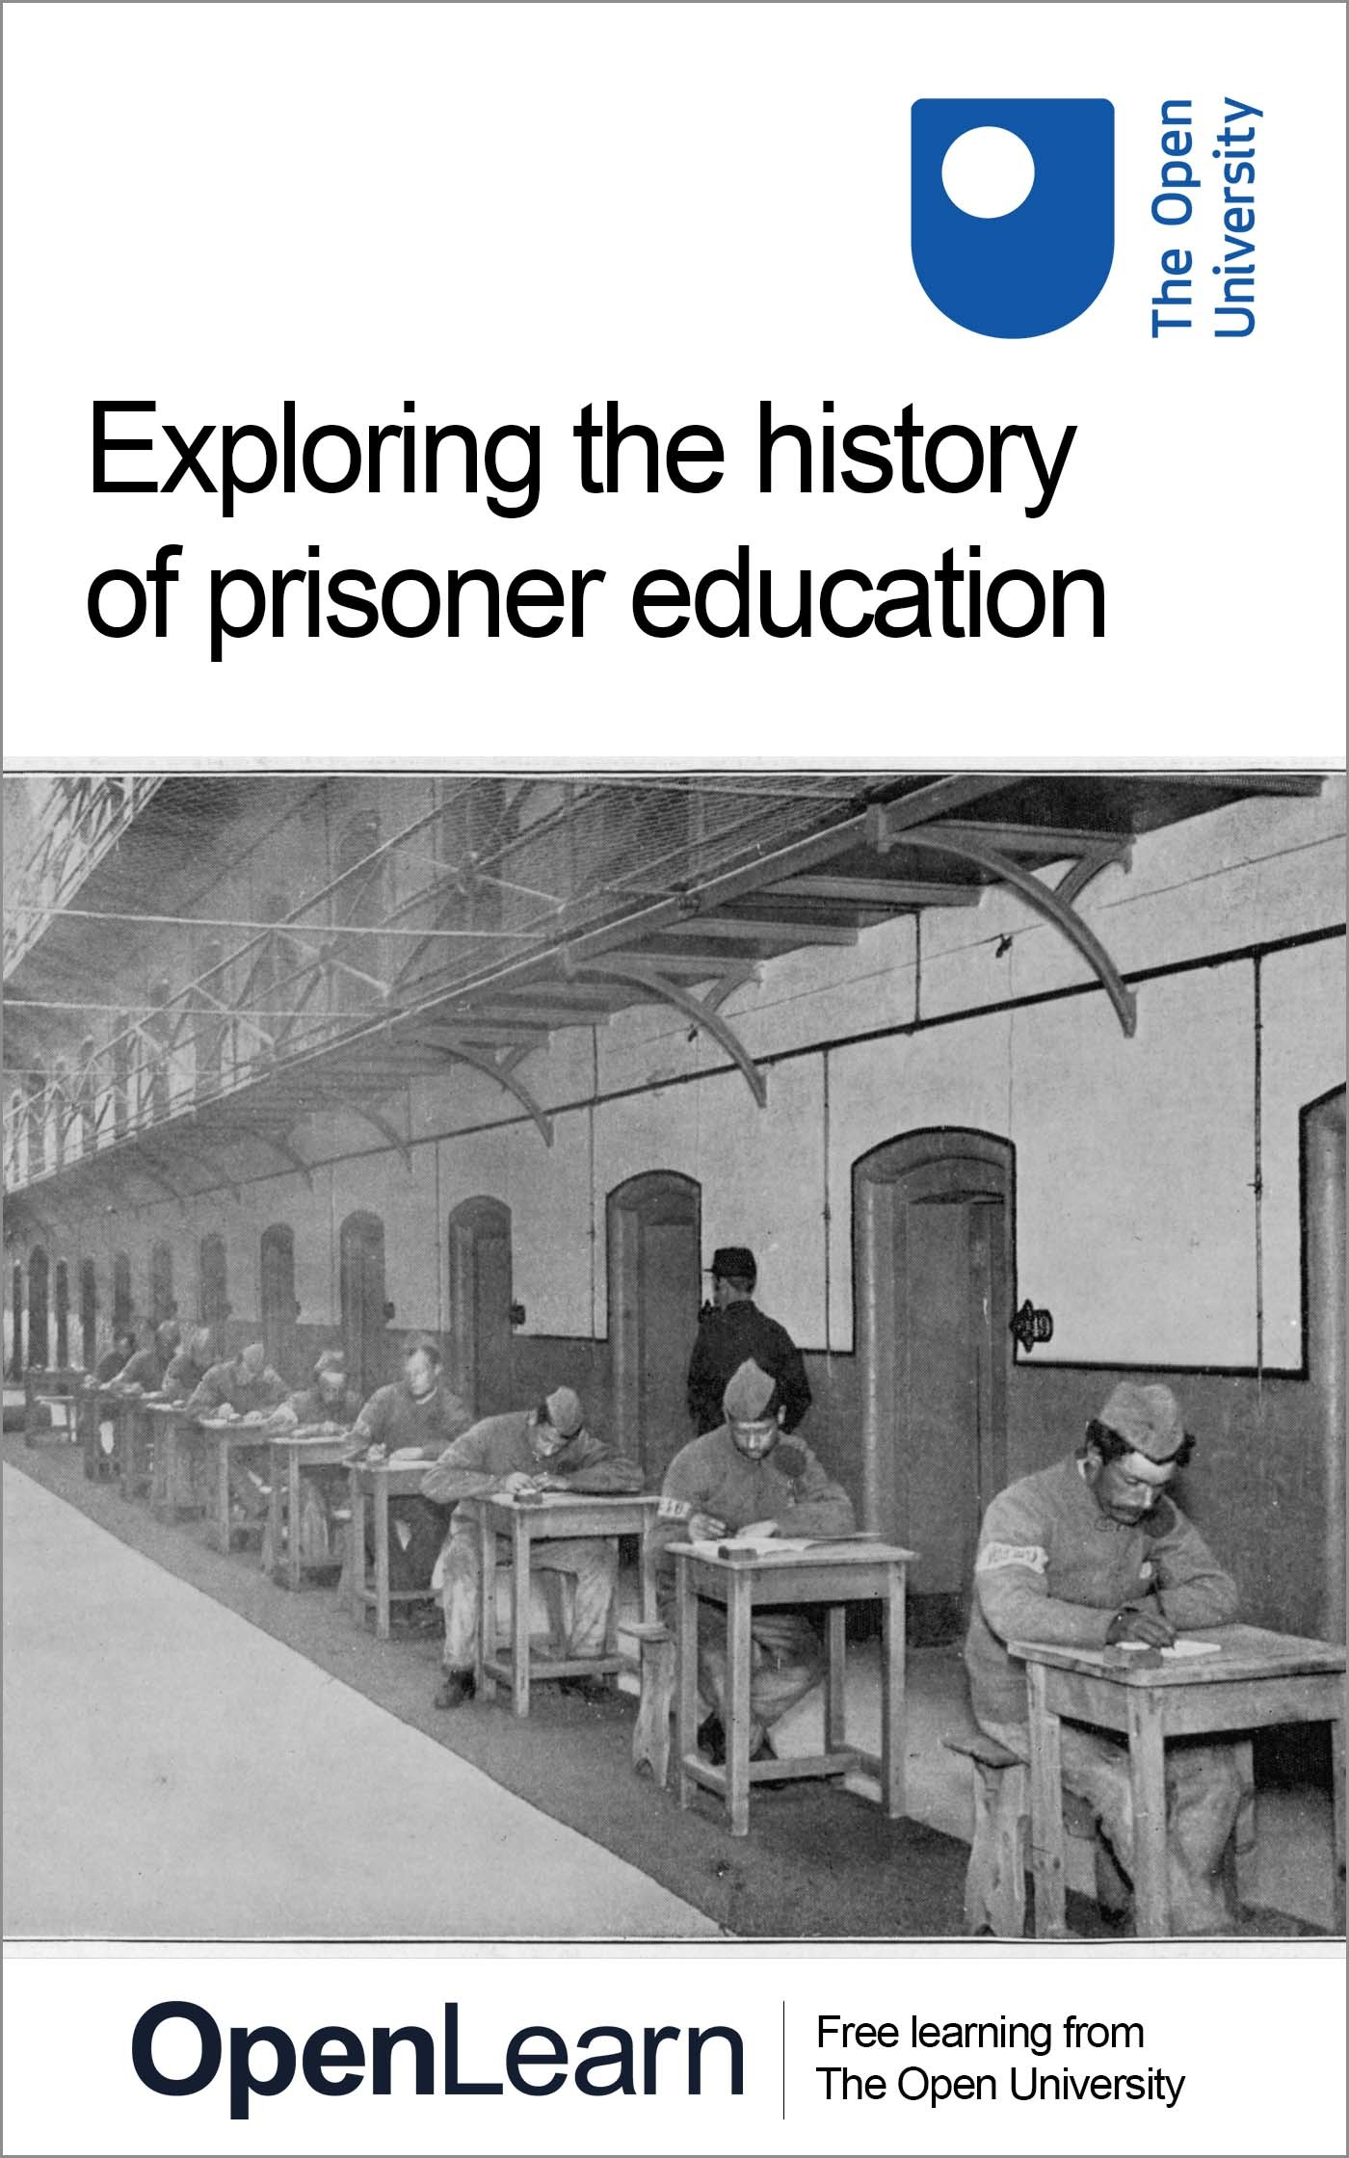

ALT_1

Exploring the history of prisoner education

About this free course
This free course is an adapted extract from the Open University course .
This version of the content may include video, images and interactive content that may not be optimised for your device.
You can experience this free course as it was originally designed on OpenLearn, the home of free learning from The Open University –
There you’ll also be able to track your progress via your activity record, which you can use to demonstrate your learning.
Copyright © 2020 The Open University
Intellectual property
Unless otherwise stated, this resource is released under the terms of the Creative Commons Licence v4.0 http://creativecommons.org/licenses/by-nc-sa/4.0/deed.en_GB. Within that The Open University interprets this licence in the following way: www.open.edu/openlearn/about-openlearn/frequently-asked-questions-on-openlearn. Copyright and rights falling outside the terms of the Creative Commons Licence are retained or controlled by The Open University. Please read the full text before using any of the content.
We believe the primary barrier to accessing high-quality educational experiences is cost, which is why we aim to publish as much free content as possible under an open licence. If it proves difficult to release content under our preferred Creative Commons licence (e.g. because we can’t afford or gain the clearances or find suitable alternatives), we will still release the materials for free under a personal end-user licence.
This is because the learning experience will always be the same high quality offering and that should always be seen as positive – even if at times the licensing is different to Creative Commons.
When using the content you must attribute us (The Open University) (the OU) and any identified author in accordance with the terms of the Creative Commons Licence.
The Acknowledgements section is used to list, amongst other things, third party (Proprietary), licensed content which is not subject to Creative Commons licensing. Proprietary content must be used (retained) intact and in context to the content at all times.
The Acknowledgements section is also used to bring to your attention any other Special Restrictions which may apply to the content. For example there may be times when the Creative Commons Non-Commercial Sharealike licence does not apply to any of the content even if owned by us (The Open University). In these instances, unless stated otherwise, the content may be used for personal and non-commercial use.
We have also identified as Proprietary other material included in the content which is not subject to Creative Commons Licence. These are OU logos, trading names and may extend to certain photographic and video images and sound recordings and any other material as may be brought to your attention.
Unauthorised use of any of the content may constitute a breach of the terms and conditions and/or intellectual property laws.
We reserve the right to alter, amend or bring to an end any terms and conditions provided here without notice.
All rights falling outside the terms of the Creative Commons licence are retained or controlled by The Open University.
Head of Intellectual Property, The Open University

Contents
- Introduction and guidance
  - Introduction and guidance
  - What is a badged course?
    - How to get a badge
  - Conclusion
- Session 1: The origins of prison education
  - Introduction
  - 1 Thinking about the past
  - 2 1823: the birth of prison education
  - 3 Prison in the 1700s
  - 4 The rise of imprisonment
    - 4.1 Irish and Scottish prisons
  - 5 Penal reform after 1800
  - 6 Social unrest
  - 7 Christian Evangelicalism
  - 8 Utilitarianism
  - 9 The expansion of education
  - 10 How do people know about the past?
  - 11 This session’s quiz
  - 12 Summary of Session 1
- Session 2: The rise of the prison school
  - Introduction
  - 1 Tracking the spread of prison education
  - 2 Inclusion and exclusion
  - 3 Ways of educating
  - 4 The rise of the prison schoolmaster
  - 5 Schoolrooms
  - 6 Time for instruction
  - 7 Reflection
  - 8 This session’s quiz
  - 9 Summary of Session 2
- Session 3: Inside the prison school
  - Introduction
  - 1 Searching for the causes of crime
  - 2 What was taught in the prison school
  - 3 The role of religion
  - 4 Drilling and memorisation
  - 5 Prisoners as scholars
  - 6 This session’s quiz
  - 7 Summary of Session 3
- Session 4: Education outside the prison school
  - Introduction
  - 1 Books behind bars
  - 2 Reading in seclusion
  - 3 Expanding the prison library
  - 4 Censorship
  - 5 Borrowing books
  - 6 This session’s quiz
  - 7 Summary of Session 4
- Session 5: Systems of measurement
  - Introduction
  - 1 Prison registers
  - 2 Evidence-based policymaking
  - 3 Expanding the Criminal Returns
  - 4 Interpreting and using the data
  - 5 Illiteracy – a criminal problem?
  - 6 Measuring the effectiveness of the prison school
  - 7 Evidence of rehabilitation
  - 8 This session’s quiz
  - 9 Summary of Session 5
- Session 6: Education in a changing penal regime
  - Introduction
  - 1 Penal policy under challenge
  - 2 The persistence of prison education
  - 3 Reviewing the prison school curriculum
  - 4 Incentives for learning
  - 5 Facilities for self-instruction
  - 6 Cellular instruction
  - 7 This session’s quiz
  - 8 Summary of Session 6
- Session 7: Uniformity in prisons and prison education
  - Introduction
  - 1 The Revised Code in convict prisons
  - 2 The nationalisation of local prisons
  - 3 The Fenwick Committee
  - 4 Evaluating the Fenwick scheme
  - 5 Uniformity across the UK
  - 6 Warders as teachers
  - 7 This session’s quiz
  - 8 Summary of Session 7
- Session 8: A new era for prison education?
  - Introduction
  - 1 Behind the prison walls
  - 2 Opposing voices
  - 3 Pressure for reform: the 1895 Gladstone Committee
  - 4 Reforming prison education
  - 5 A new scheme for prison education?
  - 6 The limits of reform
  - 7 Learning from history
  - 8 Reflection
  - 9 This session’s quiz
  - 10 Summary of Session 8
  - Where next?
  - Tell us what you think
- References
- Further reading
- Acknowledgements
- Solutions

Introduction and guidance

Introduction and guidance
As a society we need to understand how we got to where we are. This free course, Exploring the history of prisoner education, has been developed for learners who are in prison, who work in prisons, who visit prisons and who are interested in the history of prisons and prison education. This course has 8 sessions, each with approximately 3 hours of studying to be done at your own pace. The eight sessions are linked to ensure a logical flow through the course. They are:
- The origins of prison education
- The rise of the prison school
- Inside the prison school
- Education outside the prison school
- Systems of measurement
- Education in a changing penal regime
- Uniformity in prisons and prison education
- A new era for prison education?
Each session should take you around 3 hours. There are a number of activities throughout the course where you are asked to note down your response. A text box is provided for you to do this, however if you would prefer to record your answers in another way that is fine.
At the end of each session there is also a quiz to help you check your understanding. And, if you want to receive a badge and statement of participation, at the end of Sessions 4 and 8 there is a quiz which you need to pass.
After completing this course, you should be able to:
- understand the history of prison education in the British Isles
- recognise that especially literacy and numeracy programmes have been offered to prisoners in a range of contexts and for a variety of purposes
- understand the variety of ways in which prisoners responded to schemes for their educational improvement and rehabilitation
- understand some of the ways in which the study of the past can aid policymaking and practice in the present.

Moving around the course
In the ‘Summary’ at the end of each session, you will find a link to the next session. If at any time you want to return to the start of the course, click on ‘Full course description’. From here you can navigate to any part of the course.
It’s also good practice, if you access a link from within a course page (including links to the quizzes), to open it in a new window or tab. That way you can easily return to where you’ve come from without having to use the back button on your browser.
The Open University would really appreciate a few minutes of your time to tell us about yourself and your expectations for the course before you begin, in our optional start-of-course survey. Participation will be completely confidential and we will not pass on your details to others.

What is a badged course?
While studying Exploring the history of prisoner education you have the option to work towards gaining a digital badge.
Badged courses are a key part of The Open University’s mission to promote the educational well-being of the community. The courses also provide another way of helping you to progress from informal to formal learning.
Completing a course will require about 24 hours of study time. However, you can study the course at any time and at a pace to suit you.
Badged courses are available on The Open University’s OpenLearn website and do not cost anything to study. They differ from Open University courses because you do not receive support from a tutor, but you do get useful feedback from the interactive quizzes.

What is a badge?
Digital badges are a new way of demonstrating online that you have gained a skill. Colleges and universities are working with employers and other organisations to develop open badges that help learners gain recognition for their skills, and support employers to identify the right candidate for a job.
Badges demonstrate your work and achievement on the course. You can share your achievement with friends, family and employers, and on social media. Badges are a great motivation, helping you to reach the end of the course. Gaining a badge often boosts confidence in the skills and abilities that underpin successful study. So, completing this course could encourage you to think about taking other courses.

How to get a badge
Getting a badge is straightforward! Here’s what you have to do:
- read each session of the course
- score 50% or more in the two badge quizzes in Session 4 and Session 8
For all the quizzes, you can have three attempts at most of the questions (for true or false type questions you usually only get one attempt). If you get the answer right first time you will get more marks than for a correct answer the second or third time. Therefore, please be aware that for the two badge quizzes it is possible to get all the questions right but not score 50% and be eligible for the badge on that attempt. If one of your answers is incorrect you will often receive helpful feedback and suggestions about how to work out the correct answer.
For the badge quizzes, if you’re not successful in getting 50% the first time, after 24 hours you can attempt the whole quiz, and come back as many times as you like.
We hope that as many people as possible will gain an Open University badge – so you should see getting a badge as an opportunity to reflect on what you have learned rather than as a test.
If you need more guidance on getting a badge and what you can do with it, take a look at the OpenLearn FAQs. When you gain your badge you will receive an email to notify you and you will be able to view and manage all your badges in My OpenLearn within 24 hours of completing the criteria to gain a badge.
Get started with Session 1.

Conclusion

Session 1: The origins of prison education

Introduction
The late 1700s to early 1800s was a time of significant social change in the four nations of the British Isles which created tensions and crises. Revolutionary ideas from America and France threatened the social hierarchy and encouraged an uprising in Ireland. There were struggles between workers and their employers, and disputes between slave owners and anti-slavery campaigners.
Between 1793 and 1815, Britain was almost continuously at war with France. Criminal statistics suggested that crime was increasing. A debate about the benefits of imprisoning criminals, rather than executing them, developed. Interest grew in building prisons where prisoners might learn remorse and self-improvement.

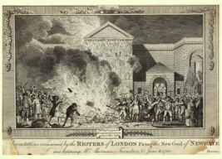
Figure 1 Newgate Gaol in London, sacked by rioters during the Gordon Riots of June 1780. The prison had only just been rebuilt and the repairs took several years to complete.
View description - Figure 1 Newgate Gaol in London, sacked by rioters during the Gordon Riots of June ...
View description - Figure 1 Newgate Gaol in London, sacked by rioters during the Gordon Riots of June ...

The first session of this course places the origins of prison education within the context of these major changes in society. The following sessions will explore how prison education evolved in the four nations during the 1800s.
Most of the evidence and examples in this course come from England, because that country has received the most attention from historians of prison education. However, schemes to educate prisoners could be found in all four nations of the British Isles – England, Scotland, Wales and Ireland (i.e. present-day Northern Ireland and the Republic of Ireland combined) – from the beginning of the 1800s. In 1801, the nations which comprised Great Britain (England, Wales and Scotland) were brought together with Ireland to form the United Kingdom of Great Britain and Ireland. Despite this, both Scotland and Ireland continued to have their own systems of criminal justice, including prisons.
Over the next eight sessions you will encounter examples of education in many different UK prisons, including gaols, bridewells, penitentiaries, local prisons and convict prisons. However, you will keep returning to one: Lincoln Castle Gaol. Now a prison museum, Lincoln Castle Gaol provides both a captivating backdrop and a fascinating case study for your exploration of the history of the prison and of prison education. In Sessions 1–7, Rosalind Crone, Senior Lecturer in History at The Open University and one of the authors of this course, will present a new chapter in the history of Lincoln Castle Gaol.
Watch the first video now, in which Rosalind Crone uses the history of Lincoln Castle Gaol to explain the birth of the modern prison and how it has been conceptualised by historians. If you can, write some brief notes about the ideas being presented. You will return to these later in the session.

Video content is not available in this format.
View transcript - Uncaptioned interactive content

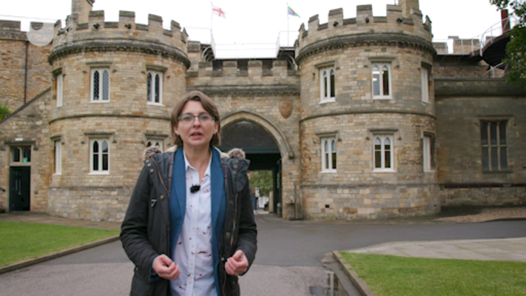

Did you enjoy that introduction to the history of the prison? Was there anything that struck you as unusual, or which was unexpected? Perhaps you were intrigued to learn that historians interpret events or processes in different ways. Don’t worry if any of the ideas presented were difficult to grasp; you will revisit them in detail.
By the end of this session, you should:
- be able to outline the development of the prison from dungeon and lock-up to purpose-built penitentiary
- have a sense of the wider political and social events and ideas which framed the rise of the prison and prison education
- be aware of the types of sources historians use to gain a sense of what happened in the past.
The Open University would really appreciate a few minutes of your time to tell us about yourself and your expectations for the course before you begin, in our optional start-of-course survey. Participation will be completely confidential and we will not pass on your details to others.

1 Thinking about the past
We often hear, and tell, stories which are designed to explain how we, as individuals or as a society, got to where we are today. Some accounts offer a specific idea or circumstance as an explanation, others refer to a national trait such as ‘British pluck’. One step towards being a critical thinker is to be aware of our preconceptions.

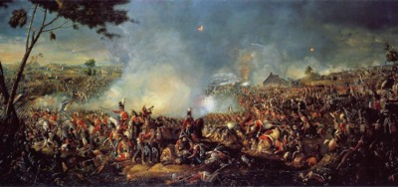
Figure 2 An important event in British national memory is the Battle of Waterloo, fought in 1815 in Belgium, in which a French army under Napoleon Bonaparte was defeated by a coalition of states which included the United Kingdom.
View description - Figure 2 An important event in British national memory is the Battle of Waterloo, ...
View description - Figure 2 An important event in British national memory is the Battle of Waterloo, ...

Activity 1 Assumptions about life in 1800
Allow approximately 10 minutes for this activity

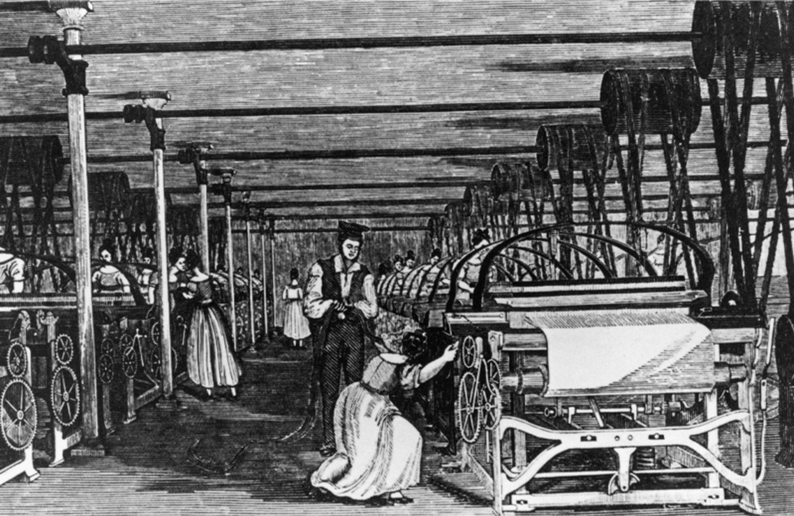
Figure 3 Women working on looms in a factory, around 1800.
View description - Figure 3 Women working on looms in a factory, around 1800.
View description - Figure 3 Women working on looms in a factory, around 1800.

Try to list some of your assumptions about life in 1800. You might want to consider some of the following questions:
- Did most people live in towns?
- Were most adults allowed to vote?
- Was the economy more rural than industrial?
- Was the country at war?
- Who had the most power, the Prime Minister or the monarch?
- Did British people own slaves?
- Were criminals more likely to be flogged, transported, executed or sent to prison?
- Could most people read or write?

Provide your answer...
View discussion - Activity 1 Assumptions about life in 1800

2 1823: the birth of prison education
In 1823, MPs at Westminster did something momentous. They passed new legislation (the Gaols Act) aimed at improving conditions in prisons which included the following clause:

Provision shall be made in all Prisons for the Instruction of Prisoners of both Sexes in Reading and Writing…
(Gaols Act 1823, section 10(10))

While it is true that the Gaols Act applied only to England and Wales, and only to around one-third of all local prisons in those two nations, it was still highly significant. It reflected steps already being taken in prisons across the four nations of Ireland, Scotland, Wales and England to provide prisoners with instruction in reading and sometimes writing.

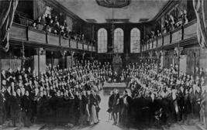
Figure 4 This painting, commissioned to commemorate the Great Reform Act of 1832, shows the newly reformed House of Commons where laws governing the whole of the United Kingdom (which included Ireland) were made in the 1800s. Some important features in common with the Parliament of 1823 stand out: all the MPs were men; they were also gentlemen who did not need a salary; there were much fewer of them than there are today.
View description - Figure 4 This painting, commissioned to commemorate the Great Reform Act of 1832, ...
View description - Figure 4 This painting, commissioned to commemorate the Great Reform Act of 1832, ...

Why was legislation passed for England and Wales and not for Scotland and Ireland? The particular penal and educational circumstances of each nation provide an answer. In 1823, there was no national system of elementary education in England and Wales. Several attempts by MPs to introduce one had failed. The failure of one education bill, on which many hopes were pinned, coincided with the insertion of the ‘reading and writing clause’ into the 1823 Gaols Act. In other words, penal legislation was used to bring about educational reform more broadly (Crone, 2022, ch.1).
Irish penal reform legislation predated that for England and Wales by a couple of years, and this timing could explain why a similar clause had not appeared in the Irish Prisons Acts. Penal reform was delayed in Scotland, but there was also perhaps less urgency for prison education there because Scotland already had a national system of elementary education of sorts: parish schools. This was lacking in the other nations. Educational and penal reformers in the decade leading up to 1823 proclaimed that lower crime rates in Scotland, compared with England, Wales and Ireland, were the consequence of its parish school system.
After 1823, education continued to spread across penal institutions in all four nations. You’ll look at how, and to what extent, in Session 2. First, you’ll take a closer look at where this idea of educating criminals came from.

3 Prison in the 1700s
Prisons have existed for centuries in the British Isles. In the 1700s, in all four nations, prisons were run by local authorities, mainly by those in charge of counties, boroughs and parishes, but also by universities and even cathedrals. There were different types of prison. Lock-ups temporarily held those who had been arrested for crimes and were waiting to see the magistrate, as well as drunks who needed to sober up. Gaols were used for prisoners on remand. Bridewells, or Houses of Correction, were for those convicted of petty crimes – vagrants, prostitutes and drunks – where efforts were made to correct their behaviour.
Prisons were not just for those accused and convicted of crime. Children were often imprisoned with their mothers, or some for their own crimes. Across Britain, over half of people in gaols were debtors. Another significant category of prisoner was those deemed a threat to the state for political reasons. After the 1715 and 1745 rebellions in Scotland, the prisons were filled with political prisoners and in 1794 habeas corpus (an arrested person’s right to a trial) was suspended. This enabled people to be held without trial indefinitely.
Many prisons in the mid-1700s were pit-like castle dungeons. Prisons had no heating, no bedding and little access to running water. Sanitation was rudimentary. There was no segregation of women and children from men. Often the ventilation was poor and prisoners were chained to one another. There was little to do and prisoners frequently had access to alcohol. There were many cases of contagious diseases, notably gaol fever, a form of typhoid. Gaolers were typically unpaid officials who made their money by extracting fees from prisoners – for necessities such as food and bedding, and even for release.

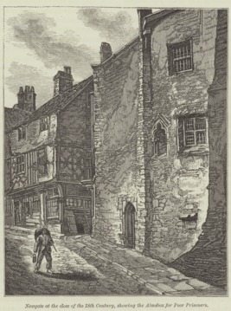
Figure 5 Bristol Newgate Gaol at the end of the eighteenth century, showing the alms box for poor prisoners attached to the prison wall. Passers-by, who felt charitable, could donate coins to help feed and clothe those inside the prison.
View description - Figure 5 Bristol Newgate Gaol at the end of the eighteenth century, showing the alms ...
View description - Figure 5 Bristol Newgate Gaol at the end of the eighteenth century, showing the alms ...

4 The rise of imprisonment
From about 1760, efforts were made across the British Isles to reform prisons. The most famous reformer was John Howard. In 1773 Howard was appointed High Sheriff of Bedfordshire which gave him control over the county gaol. He was appalled by the conditions he found there. His demands for reform led him to travel the length and breadth of the United Kingdom creating a catalogue of prisons, with details of the conditions he found in each. His catalogue, published as The State of the Prisons in 1777, became a model for the next generation of penal reformers and, later, for prison inspection.

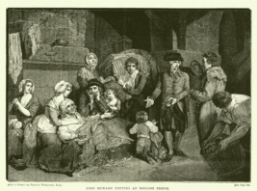
Figure 6 John Howard visiting an English prison. Originally drawn in the late 1700s by Francis Wheatley. Note the squalor of the prison, the lack of separation between men and women, and the presence of children, imprisoned with their mothers.
View description - Figure 6 John Howard visiting an English prison. Originally drawn in the late 1700s ...
View description - Figure 6 John Howard visiting an English prison. Originally drawn in the late 1700s ...

Howard’s work was extremely influential and informed a raft of legislation which encouraged local authorities to reform their prisons. Between 1780 and 1799, around 60 prisons were built or substantially rebuilt in England and Wales. When Howard visited Ireland, he noted some attempts were already being made at prison reform. In 1786, Ireland witnessed the appointment of the first government-salaried prison inspector in the Western world. Jeremiah Fitzpatrick was an energetic man and has often been called ‘the second Howard’. Through his efforts, many Irish prisons were built or reformed (Butler, 2016, p. 727).
As well as efforts to reform prisons, the use of imprisonment as a punishment underwent a significant transformation. In the 1700s, sentences of imprisonment were used relatively infrequently and typically only for very minor offences. In law, most crimes were punishable by whipping, branding or death by hanging. Although many crimes were officially punishable by death, the death penalty was used sparingly. It was meant to provide an example to deter others. Many of those sentenced to death were pardoned or had their sentences commuted to transportation, a form of exile, first to America and later to Australia.
At the end of the 1700s, more people accused of crime were being brought before the courts, and more of those who were accused were being convicted. This suggested to contemporaries that crime was increasing, though it is hard to tell from the available evidence whether this was true. The threat of execution, it seemed, was not deterring crime. This was compounded by the fact that, because it was not desirable to hang large numbers of people, the chance of being executed if capitally convicted was decreasing. By 1815, 90% of those condemned to death were either pardoned or transported (Gatrell, 1994, p. 21).
This led to calls for the reform of punishment and especially the greater use of sentences of imprisonment which were considered both proportionate (matching the gravity of the offence) and certain (prisoners would go to prison, rather than being pardoned). In 1816, the first penitentiary run by central government was opened at Millbank, London. This prison was for men and women, convicted of crimes punishable by death or transportation, who were selected to serve long sentences of imprisonment instead.

Activity 2 Mapping the prison system in England and Wales during the 1800s
Allow approximately 10 minutes for this activity

The replacement of bodily or physical punishments – such as death, transportation, and whipping (among others) – with imprisonment led to the rise of new types of prisons in the early 1800s.
The penal system in all four nations became a complex web of institutions through which men, women and children flowed depending on the seriousness of the crime of which they were accused and, if convicted, the punishment given. Until 1877, local prisons were managed by local authorities and convict prisons were managed by central government.
Have a look at the diagram below which maps the prison system for England and Wales in the 1800s. It’s quite detailed, because it was a complicated system! Don’t worry, you don’t need to remember everything, but the detail should enable you to identify three important points which are essential knowledge for this course. To help, here are three questions – have a go at answering them using the diagram.
- The prison system comprised two sectors – the local and the convict. Local prisons accommodated remand prisoners (those awaiting trial) and those sentenced to imprisonment. Convict prisons held those convicted of serious offences and sentenced to transportation or (later) penal servitude (a long prison sentence which was served in stages). Can you identify the other crucial difference between local and convict prisons?
- Although they held prisoners with different sentences, there was a relationship between the local and convict prison sectors. Can you briefly explain what that was?
- The prison system was not static, but continued to evolve as punishments changed and new types of prison appeared. Can you identify any broad trends?
Click on the following link to access the diagram: Prison system in England and Wales.
Click on the individual entries (for instance, ‘Lock-up’) to be taken to a more detailed account of that entry. Then click on ‘Return to map’.

Provide your answer...
View discussion - Activity 2 Mapping the prison system in England and Wales during the 1800s

4.1 Irish and Scottish prisons
The diagram in the previous section only maps the prison system for England and Wales in the 1800s. Scotland and Ireland developed their own prison systems but these had many common features and, in the case of Scotland, connected with the English and Welsh prison system too.
Both Ireland and Scotland had local prisons which served as a point of entry into the prison system for those accused of crime, and which were used to accommodate those sentenced to short periods of imprisonment.
In 1840, a General Prison was established at Perth in Scotland for prisoners with sentences of imprisonment which exceeded nine months. In time it was also used for those serving the probationary stage of their transportation or penal servitude sentence. Otherwise, Scottish convicts were sent to convict prisons (and hulks) in England until the erection of Barlinnie Prison in 1882.
Ireland had its own convict prison system but there were similarities. The Richmond General Penitentiary in Grangegorman, opened in 1820, was Ireland’s Millbank, and Mountjoy Prison (which opened in 1850) was Ireland’s Pentonville. In 1853, Ireland diverged somewhat when it adopted a three-stage punishment for penal servitude sentences. Convicts served a first stage in separate confinement, a second stage on public works, and a third stage in open prisons.

5 Penal reform after 1800

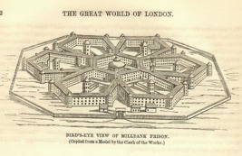
Figure 7 Millbank Penitentiary. Built between 1812 and 1816, for male and female convicts sentenced to transportation who would serve a sentence of imprisonment here instead. The geometric design and individual cells indicate the importance attached to routine, discipline and control.
View description - Figure 7 Millbank Penitentiary. Built between 1812 and 1816, for male and female ...
View description - Figure 7 Millbank Penitentiary. Built between 1812 and 1816, for male and female ...

Rising crime rates and the expanding use of imprisonment soon caused prisons which had been reformed in the late 1700s to become overcrowded and appear inadequate once more. Many prisons across Britain and Ireland had also remained untouched by the work of reformers such as Howard and Fitzpatrick.
A new generation took up the cause of penal reform. Like their predecessors, these new penal reformers also drew attention to the dreadful conditions in which prisoners were held. However, in the context of rising crime rates and the growing use of sentences of imprisonment, they paid greater attention to the character of the offender. Convicted criminals, they argued, should not be made worse as a result of their imprisonment but should be reformed and returned to society as productive Christian subjects.
Through the formation of lobby groups, including the Society for the Improvement of Prison Discipline in Britain and the Association for the Improvement of Prisons and Prison Discipline in Ireland, penal reformers put pressure on central government to act. Legislation to reform Irish prisons was passed in 1819 and 1821, and legislation for English and Welsh prisons in 1823, in the form of the Gaols Act. Attention focused on:
- the classification of prisoners to separate the convicted from the untried, and serious offenders from minor offenders
- the provision of employment to prevent idleness and foster good work habits
- religious instruction to reform the soul.
These core principles were combined with other reforms such as the prohibition of alcohol, a ban on the use of manacles (i.e. iron hand- or ankle-cuffs), and the provision of female warders for female prisoners. Such reforms helped to provide better conditions for teaching and learning in the prison. However, to explain the appearance of schemes to teach prisoners to read and write, developments outside of prisons also need to be considered.

6 Social unrest
In the late 1700s and early 1800s, Britain and Ireland were in the grip of a social crisis. Under pressure from the increasing pace of industrialisation and urbanisation, the old order appeared to be breaking down.
During the 1700s, many people moved from the countryside to towns for work. By the 1790s, about 60% of people in Britain and Ireland lived in the countryside and 40% in towns and cities. London was by far the largest city with about one million people, followed by 187,000 in Dublin. There had been rapid population growth over the last 40 years and with more people than there were jobs, wages were low. In Manchester, for example, unemployment was high and the endemic poverty was made worse by poor harvests and (due to the war with France between 1793 and 1802) fewer sales overseas.
Political unrest followed social change. In France, there was a revolution in 1789. Revolutionaries abolished aristocratic titles, called everybody citizen, and ended the practice of slavery in French colonies.
Across the British Isles, ideas spread about the ‘rights of man’. These ideas were dangerous for the ruling elites, given that, in Britain and Ireland, about half the land was owned by just 12,000–13,000 families. It was also possible to buy a variety of influential jobs, including that of MP, which further cemented the inequalities in society.

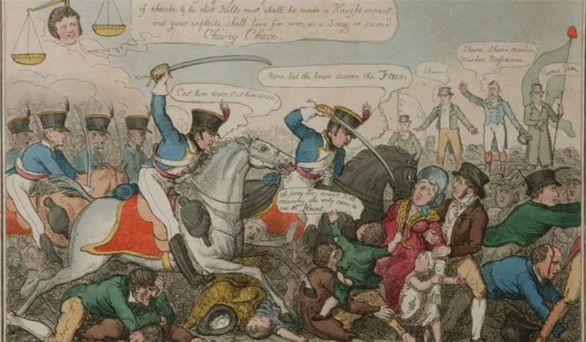
Figure 8 On 16 August 1819, local magistrates ordered the cavalry to charge a crowd of more than 60,000 people who had gathered at St Peter’s Fields, Manchester, to demand parliamentary reform. The event became known as ‘Peterloo’.
View description - Figure 8 On 16 August 1819, local magistrates ordered the cavalry to charge a crowd ...
View description - Figure 8 On 16 August 1819, local magistrates ordered the cavalry to charge a crowd ...

Rebellion broke out in Ireland in 1798 and there were violent protests by Catholics against the Protestant elite. Nor was such fighting confined to Ireland. Over 200 people died in a week of anti-Catholic rioting in London in June 1780. This involved attacks on metropolitan prisons, including Newgate Gaol, the New Gaol Southwark, the Surrey House of Correction and the Marshalsea prison. Hundreds of prisoners were released by the rioters.
There were riots in Birmingham in 1791 in defence of Church and King. In 1819, a Manchester protest meeting dispersed by armed cavalry resulted in approximately 18 deaths, and over 600 people injured. This last event, Peterloo, rapidly became a symbol of the tyranny of the old order, the fecklessness of the mob and the need for change.
Illiteracy (the inability to read and write), which had been acceptable in traditional, rural societies, began to look out of place and uncivilised in new, urban environments. Industrial employment combined with migration to the towns was stalling the spread of literacy among the lower classes. At the same time, the dissemination of cheap, seditious literature, such as Thomas Paine’s Rights of Man (1791), suggested to the ruling elite that the acquisition and use of the skills of reading and writing needed to be controlled. A growing number of philanthropic individuals and groups sought to combat poverty, radicalism and crime by teaching the poor and prisoners to read and write.

7 Christian Evangelicalism
One proposed solution to the social crisis was the promotion of Christianity, or the evangelisation of the masses. In 1800, about 90% of the UK’s population were Christians. Despite this, social elites believed that many of the poorer people had stopped attending church and knew little about God. Reacquainting them with the Bible, they argued, would secure social harmony and reduce crime.
Proponents of this belief were leaders of an Evangelical revival which began around 1740. This movement led to the formation of an Evangelical party within the Church of England, the revitalisation of older dissenting congregations (such as the Society of Friends, or Quakers, and the Independents), and the formation of new denominations, notably Methodism. All placed great emphasis on personal salvation and individual access to the Bible. The ability to read was therefore an essential tool for Christianisation. Instruction in writing helped to reinforce the skill of reading and to aid the memorisation of key messages from the Bible.
Evangelicals of all stripes took a particular interest in prisons and prisoners. John Wesley (1703–91), the founder of Methodism, preached at least 67 times in prisons, raised money for clothing and blankets and encouraged followers to visit prisons too. His campaigns led the authorities at Bristol’s Newgate Prison to separate male and female prisoners, end drunkenness, and provide Bibles for prisoners to read. Wesley provided inspiration for penal reformer John Howard who was himself an Independent.
After 1800, Quakers took a leading role in the penal reform movement. Most famous was Elizabeth Fry (1780–1845). After visiting Newgate Gaol in 1813, Fry successfully campaigned for the improvement of conditions on the female side of the prison. She also established a school for children imprisoned with their mothers which was later expanded to include adult prisoners.

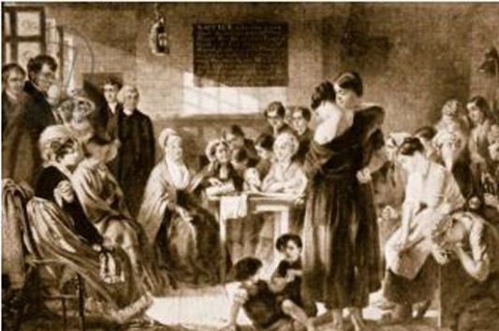
Figure 9 ‘Mrs Fry Reading to the Prisoners at Newgate in the Year 1816’, by Jerry Barrett. This famous scene was painted in 1860 by an artist who had not been present at the event. It is representative and allegorical rather than accurate. To Fry’s left are several notable prison reformers. Some of the prisoners are flouting Fry’s prison rules by drinking beer and gambling.
View description - Figure 9 ‘Mrs Fry Reading to the Prisoners at Newgate in the Year 1816’, by Jerry ...
View description - Figure 9 ‘Mrs Fry Reading to the Prisoners at Newgate in the Year 1816’, by Jerry ...

As a result of Fry’s efforts, prison visiting became fashionable and associations of lady visitors were established throughout the UK. Quakers, some of whom were related to Fry, banded together to establish the Society for the Improvement of Prison Discipline in 1816. In this undertaking, they were joined by several leading Church of England Evangelicals. Focused on redemption, or the saving of souls from damnation, Anglican Evangelicals believed that the country’s most troubled and troublesome people – alcoholics, slaves, prostitutes and prisoners – needed Christianity.

8 Utilitarianism
An alternative solution to society’s ills was offered by Utilitarians. Their goal was the arrangement of society to achieve the ‘greatest happiness of the greatest number’. Social harmony, they argued, could be achieved through legislation which channelled the people’s impulses in ways that best served society. Literacy offered a means of self-improvement and, therefore, a solution to poverty.
Utilitarians also became active in penal reform. Jeremy Bentham (1748–1832) provided early leadership through his involvement in the quest to establish a national penitentiary (what became Millbank Penitentiary). His design for what he termed the ‘Panopticon’ assumed that humans wanted to maximise their pleasure and minimise their pain.
If prisoners believed that they were constantly under surveillance they would be motivated to regulate their own behaviour. He rejected hard labour, arguing that more interesting employment would lead the idle to love work. In his opinion, literacy made people more useful and productive.

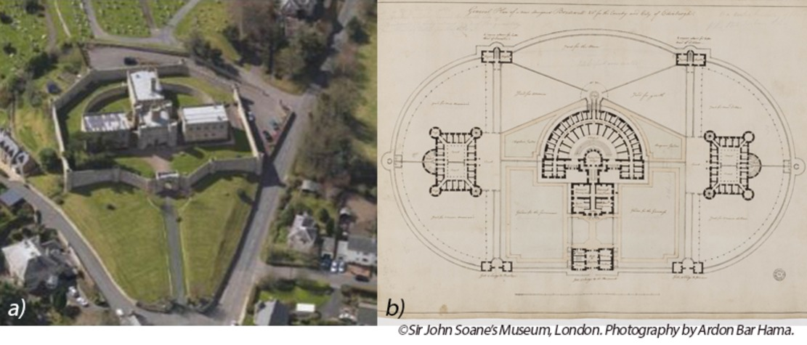
Figure 10 (a) and (b) Jedburgh Prison, in Scotland, was built in 1823. Each individual prisoner was in a single cell which was designed to be visible by a single guard concealed in the central tower. This was to be an economic and utilitarian solution to prison design. The design took direct inspiration from Bentham’s proposal. There was also separation of prisoners by class with three accommodation blocks for male or female criminals, male debtors and young prisoners. The aim was to improve the physical and moral health of the prisoners. The jail is now a museum.
View description - Figure 10 (a) and (b) Jedburgh Prison, in Scotland, was built in 1823. Each individual ...
View description - Figure 10 (a) and (b) Jedburgh Prison, in Scotland, was built in 1823. Each individual ...

While approaching the problem from different perspectives, both Fry (or the Evangelicals) and Bentham (or the Utilitarians) supported the classification of prisoners, the use of productive labour in prisons, and the provision of both religious and scholarly education. Both saw people as capable of bettering themselves, and of improving their behaviour by controlling their desires.

9 The expansion of education
Both Utilitarians and Evangelicals favoured the spread of education. They were united in the idea that literacy could have ‘a profound impact on the mental and moral character of the individual and by extension [wider] society’ (Vincent, 1989, p. 6).

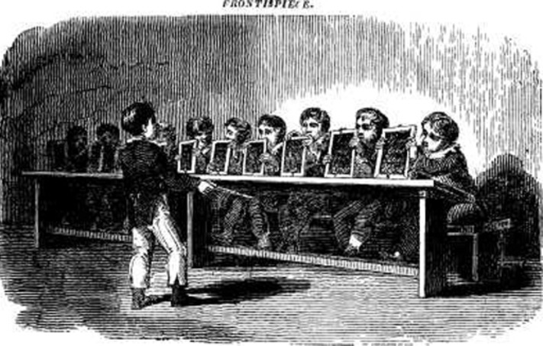
Figure 11 Frontispiece from Joseph Lancaster, The British system of education: being a complete epitome of the improvements and inventions practised at the Royal Free Schools, Borough Road, Southwark, 1810. The monitor, the boy with the stick, has just given the command ‘Show slates!’ and can see that every pupil has written ‘Long live the King’. Lancaster, J. and Corston, W. (1810) The British System of Education: Being a Complete Epitome of the Improvements and Inventions Practised at the Royal Free Schools, Borough-Road, Southwark, London, Longman & Co.
View description - Figure 11 Frontispiece from Joseph Lancaster, The British system of education: being ...
View description - Figure 11 Frontispiece from Joseph Lancaster, The British system of education: being ...

Members of both movements were involved in the expansion of education in England, Wales and Ireland from the late 1700s. As Scotland already had a parish school system, the task was considered less urgent. In Ireland, England and Wales, Christian bodies moved to supplement the teaching of the poor provided by private schools (i.e. schools run by working men or women who were themselves barely literate). Sunday schools (which were not only for children) appeared in the 1780s and spread throughout England, Wales and into Scotland.
In England and Wales, two rival school societies were established, the British and Foreign Schools Society (1808), which was run by Christians who did not belong to the Church of England (non-conformists), and the Church of England-run National Schools Society (1811). Both promoted a system of teaching called ‘monitorial’, in which pupil-monitors assisted trained teachers to drill their peers to memorise the letters of the alphabet and build up to words. Concerns about adult illiteracy led to the establishment of an ‘adult school’ by non-conformists in Nottingham in 1798. Methodists began an Adult School Movement in 1812. By 1818, there were more than 200 adult schools in England and Wales.
Reports published by the school societies and MPs at Westminster increasingly proclaimed that crimes were most often committed by those with the least education. Low levels of crime among Quakers, who were often highly educated, and Scots, who had access to a national system of education, were cited as evidence. Thomas Pole, one of the founders of the adult school movement, wrote in 1816:

By a comparison of the criminal calendars of England and Scotland, it is found that criminal offences are ELEVEN times more frequent in England, in equal portions of the population, than they are in Scotland! … What constitutes the difference? In Scotland the poor are educated – in England they are not.
(Pole, 1816, p. 60)

This view, combined with the expansion of education in British and Irish society, and the role of Quakers and Utilitarians in the penal reform movement, led to experiments with education in prisons. In 1814, the Coventry Branch of the National Schools Society helped to establish a school for juvenile offenders in Warwick County Gaol (Crone, 2022, ch.1). The chaplain at Millbank Penitentiary was tasked with providing instruction in reading and writing when the prison opened in 1816.
Reports of inspections carried out by the Society for the Improvement of Prison Discipline in Britain and the Association for the Improvement of Prisons and Prison Discipline in Ireland revealed the development of many more schemes, some of which were quite advanced. At prisons in Sligo, Naas and Carrickfergus, for example, schoolmasters were employed to teach reading, writing and arithmetic to prisoners.

Activity 3 What have been the reasons for supporting learning in prison?
Allow approximately 10 minutes for this activity

- Summarise the reasons why reformers in the early 1800s promoted the education of prisoners.
- Note any other reasons you can think of which support the case for prison education.

Provide your answer...
View discussion - Activity 3 What have been the reasons for supporting learning in prison?

There are some important similarities between these two lists. In the early 1800s and today there is a belief in the transformative potential of education – that the ability to read and write and the acquisition of new knowledge can change a person’s life for the better. You will explore this theme further in the sessions that follow. How did the authorities try to harness the transformative power of education? How successful were they?
At the same time, it is important to remember that education can be used for other purposes too, some of which have little to do with improving lives. Education can be used as a tool for pacification, or to occupy otherwise idle prisoners. In certain forms it might also serve as a tool for discipline. The magistrates in charge of Reading Gaol in the 1840s supported the programme of rote learning (the memorisation and recitation of passages of text) carried out there because they saw its value as a punishment. They believed it was more irksome than some forms of hard labour.

10 How do people know about the past?

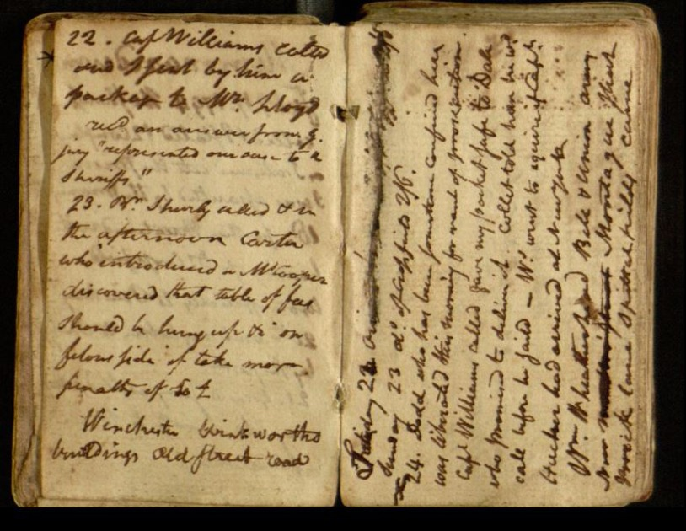
Figure 12 Entry in the Diary of Thomas Lloyd kept in Newgate Prison, 1794–1796. Thomas Lloyd (1756–1827) was an American who was imprisoned in the Fleet Prison London for debt. While in prison, Lloyd posted a ‘declaration of republican principles’ on a chapel door. He was found guilty of seditious libel and fined, sentenced to an hour in the pillory and three years in Newgate Prison.
View description - Figure 12 Entry in the Diary of Thomas Lloyd kept in Newgate Prison, 1794–1796. Thomas ...
View description - Figure 12 Entry in the Diary of Thomas Lloyd kept in Newgate Prison, 1794–1796. Thomas ...

We can learn about the past by using different types of evidence and sources. You could, for example, read a specialist book written by a historian. This will have been written after the event. It will use selected evidence and will provide a commentary and the views of the author. Such a book is called a secondary source.
To write secondary sources, authors study primary sources. These are materials created during the period being studied. They might include official reports, accounts of what was said in Parliament, correspondence or diaries from the time. Other primary sources might be newspaper reports, posters and images (for example, drawings of prisons or prisoners). From the 1820s, prison chaplains and inspectors began to keep records of what was being taught in prisons and how it was taught. These records are useful primary sources for the topic you are studying now.
However, just because a source was written at the time does not mean it is necessarily ‘true’ or unbiased. When writing accounts people contradict themselves, omit, interpret or even lie. They also write with a specific purpose in mind. Take, for example, the accounts of prison reformers such as Elizabeth Fry and members of the Society for the Improvement of Prison Discipline, who provided many descriptions of the squalor and misery they found in British prisons. Officials such as governors, chaplains and magistrates who were in charge of prisons often countered these with declarations of their good management and care of prisoners. Historians now acknowledge that both groups were selective in their descriptions of imprisonment in order to make their case for and against reform.
When looking at any sources (primary or secondary), try to assess the purpose, values or motive of the author. Perhaps you can see where the author has been selective or remained silent? Maybe you can make a judgement based on a comparison with another source, such as another prisoner’s diary, another article from a different newspaper, or another history book on the same topic.

Activity 4 Using a source
Allow approximately 30 minutes for this activity

Part 1

Write a list of questions that you might ask to assess the relevance and value of a written source. You might find it helpful to use the source shown in Figure 13 as inspiration.

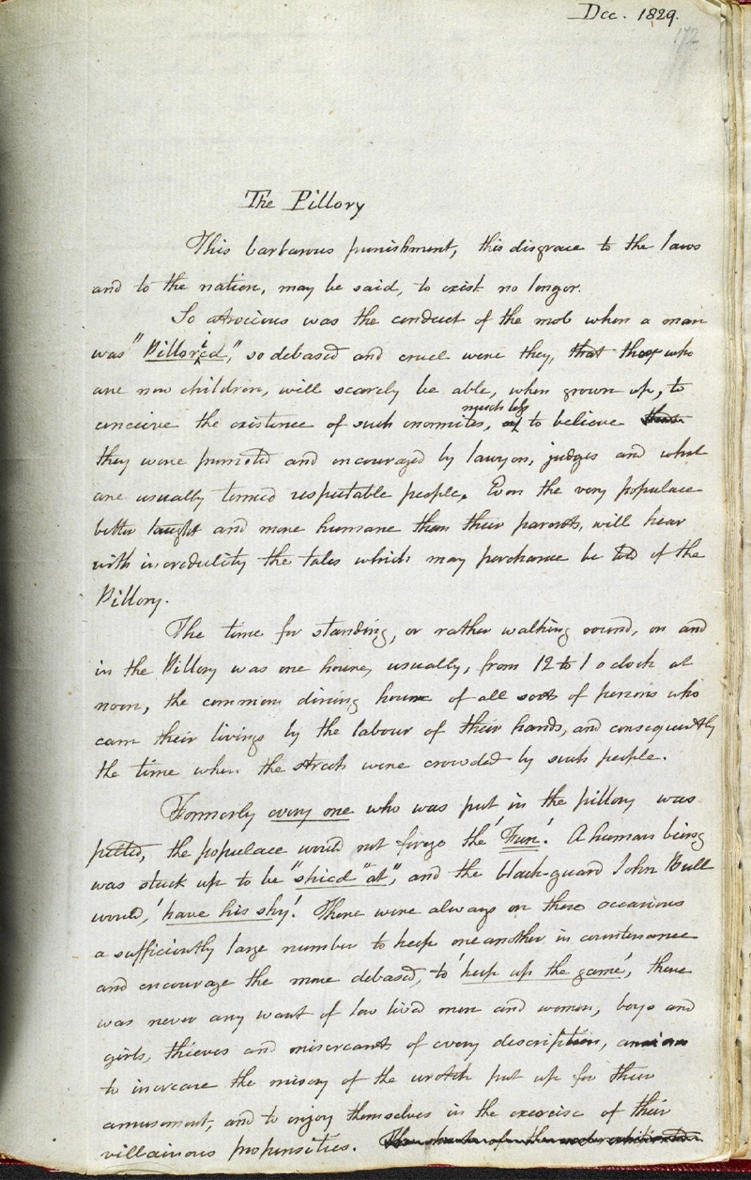
Figure 13 An 1829 diary entry by Francis Place, 1771–1854. A radical campaigner for public education and friend of Jeremy Bentham, here he describes the pillory. A person could be locked into this wooden framework. It had holes for the head and hands and was placed in a public location. People could abuse the prisoner and throw things at them. Here is a transcript of the text shown in the figure. The term ‘John Bull’ was first used in 1712. He is a representation of the country.
View description - Figure 13 An 1829 diary entry by Francis Place, 1771–1854. A radical campaigner for ...
View description - Figure 13 An 1829 diary entry by Francis Place, 1771–1854. A radical campaigner for ...

The pillory
This barbarous punishment, this disgrace to the laws and to the nation, may be said to exist no longer.
So atrocious was the conduct of the mob when a man was “pilloried”, so debased and cruel were they, that those who are now children, will scarcely be able, when grown up, to conceive the existence of such enormities, much less to believe they were permitted and encouraged by lawyers, juries and what are usually termed respectable people. Even the very populace better taught and more humane than their parents will hear with incredulity the tales which may perchance be told of the pillory.
The time for standing, or rather walking round, on and in the Pillory, was one hour usually, from 12 to 1 O’Clock at noon, the common dining hour of all sorts of persons who earn their livings by the labour of their hands, and consequently the time when the streets were crowded by such people.
Formerly every one who was put in the pillory was pelted, the populace would not forgo the “fun”. A human being was stuck up to be “shied at”, and the blackguard John Bull would “have his shy”. There were always on these occasions a sufficiently large number to help one another in countenance and encourage the more debased, to “help up the game”, there was never any want of low lived men and women, boys and girls, thieves and miscreants of every description, and to increase the misery of the wretch put up for their amusement, and to enjoy themselves in the exercise of their villainous propensities.

Provide your answer...
View discussion - Part 1

Part 2

Return to any notes you made about the video in the Introduction to this session and see if you want to change them in the light of what you have read. Try to summarise the different approaches to the history of the prison outlined in the video.

Provide your answer...
View discussion - Part 2

11 This session’s quiz
Well done – you have reached the end of Session 1. You can now check what you’ve learned this session by taking the end-of-session quiz.
Session 1 practice quiz
Open the quiz in a new or window and come back here when you have finished.

12 Summary of Session 1
In this session, you have explored the transformation of the prison in the late 1700s and early 1800s and you have looked at how and why schemes to educate prisoners began to appear in prisons across the UK from c.1800.
You should now:
- be able to outline the development of the prison from dungeon and lock-up to purpose-built penitentiary
- have a sense of the wider political and social events and ideas which framed the rise of the prison and prison education
- be aware of the types of sources historians use to gain a sense of what happened in the past.
Nowadays it is widely recognised that learning is a social activity, that rather than simply receiving wisdom from teachers, we build knowledge together. You might also see learning as framed by the built environment, the culture of the wider society, the calibre of the teachers and the resources as well as the enthusiasm, skills and motivation of the learner.
In the next few sessions there will be opportunities to learn about life in prisons, the spread of prison education and where and how the teaching and learning took place. And you will have a chance to consider for yourself some of the sources used by historians, including the personal testimony of prisoners.
You can now go to Session 2.

Session 2: The rise of the prison school

Introduction
While the 1823 Gaols Act was significant as the first example of state-funded support for education in England and Wales – limited state aid for elementary schools had to wait another 10 years – there were limits. The Act applied only to local prisons – those run mostly by county and large borough authorities – and specifically only to one-third of these. It contained no mechanism to force the authorities in charge of these prisons to comply with it. In other words, local authorities were not obliged to educate their prisoners.
Despite this, by 1847 over half of all English local prisons had made arrangements to teach prisoners to read and often to write and cipher as well. On any given day, roughly 20 to 30 percent of prisoners in local prisons were receiving scholarly instruction. Convict prisons built after Millbank Penitentiary in 1816 – Parkhurst Juvenile Prison (1838) and Pentonville Prison (1842) – followed its example and developed education programmes. In 1848, all convicts on prison hulks (decommissioned naval vessels used as prisons) were held back from hard labour for half a day to attend ‘school’.

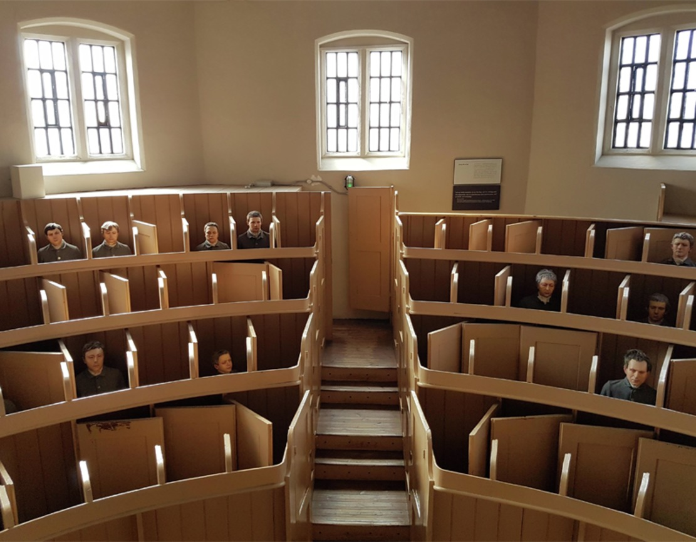
Figure 1 Inside the austere chapel at Lincoln Castle County Gaol.
View description - Figure 1 Inside the austere chapel at Lincoln Castle County Gaol.
View description - Figure 1 Inside the austere chapel at Lincoln Castle County Gaol.

In order to accommodate education in the prison changes had to be made – to space and timetables, for example. At the same time, the penal environment and new forms of prison discipline shaped the delivery of education in the prison. Formal prison schools replaced many informal modes of imparting instruction.
In this second session you will learn more about the expansion of prison education in Britain and Ireland after the penal reforms of the early 1820s. This session also outlines ideas about how you might plan your studies.
By the end of this session, you should be able to:
- discuss the expansion of educational provision in prisons
- discuss how the penal environment shaped forms of learning in the prison
- use a timetable to organise your study time.
Let’s begin by returning to Lincoln Castle Gaol. In the next video, Rosalind Crone explains the impact that the rise of two rival forms of prison discipline – silence and separation – in the 1830s had on the architecture and experience of imprisonment at Lincoln Castle Gaol. Watch this video now, and try to write down some brief notes about the ideas being presented in it. You will refer back to these later in this session.

Video content is not available in this format.
View transcript - Uncaptioned interactive content

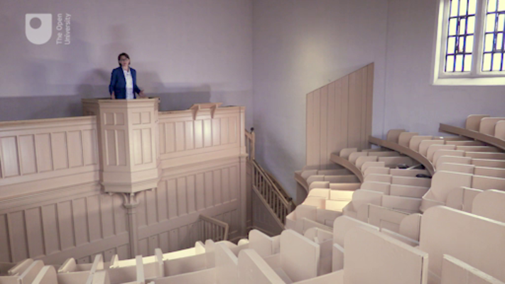

1 Tracking the spread of prison education
From the 1820s, as a result of the penal reform movement, the central government began to collect information on prisons in Britain and Ireland. Two new prison inspectors in Ireland began to visit and to deliver official reports on prisons. Their reports showed that arrangements to teach reading and writing were being made in many prisons.

Figure 2 The back page of the Horsley House of Correction Prison Register. Here you can see the prison clerk summarising personal information collected in the register in preparation for the annual return which had to be submitted to the prison inspector.
View description - Figure 2 The back page of the Horsley House of Correction Prison Register. Here you ...
View description - Figure 2 The back page of the Horsley House of Correction Prison Register. Here you ...

In England and Wales, those who managed the gaols and houses of correction which came under the terms of the 1823 Gaols Act were required to submit annual reports to the Home Secretary. Governors had to provide information about the number of prisoners and to say whether prisoners had been supplied with books and given instruction. Chaplains were asked to remark on the ‘condition’ of prisoners. Often, they described how many prisoners could read and write and what they were doing for those who could not.
Reports mentioned the appointment of teachers, the purchase of books and writing equipment and the use of prisoners to help teach reading and writing. They suggest that education was spreading through the local prison sector, albeit slowly. Historians who use these documents need to recognise that when reporting to the Home Secretary governors might have wished to highlight some issues and minimise others.
Concern that so many prisons in England, Wales and Scotland remained unreformed – either because they were not covered by the 1823 Gaols Act, or because the prison authorities refused to comply with it – led to calls for the establishment of a British prison inspectorate. In 1835, five inspectors were appointed. Four men covered England and Wales and one covered the whole of Scotland (as well as part of north-east England for a time).
They were primarily information gatherers. They could remind prison governors of the legal requirement to instruct prisoners, and they could recommend changes to education programmes, but they could not force governors to act. The inspectors were also inconsistent in their approach. Only some took a keen interest in education. Where they found that arrangements for instruction had not been made, they did not always insist that prisoners should be educated.
Nevertheless, education spread. Between 1823 and 1850, it appears that many local prison officials were keen to introduce education, either because they believed in its transformative potential, or because they saw it as a useful tool for discipline and maintaining order, or both. The prison inspectors’ reports also suggest that the spread of prison education was driven by the closure of small, inefficient prisons which could never have provided prisoners with instruction. As small prisons closed, and those which continued to operate grew bigger, education in prisons became more likely and cost-effective. So, from around 1850, while the number of prisons with education programmes stabilised, the proportion of prisons with programmes continued to rise, until it reached approximately 100 per cent in the 1800s (Crone, 2022, ch.1).

2 Inclusion and exclusion
Even though arrangements to instruct prisoners in reading and writing might have existed within a prison, it does not mean that every prisoner in that prison had access to education. In convict prisons in Britain and Ireland, where populations were larger, and convicts remained for much longer periods of time, efforts were made to educate men and women, adults and children alike, even though the physical separation of these groups created a need for bespoke arrangements. Because the teaching of reading and writing was often bound up with moral instruction, and the Bible was used as the principal text, there was a strong belief that all could benefit from attending school, whatever the level of their knowledge. In practice, those prisoners working in the prisons as cooks, bakers, cleaners, nurses or in artisanal trades, were often unable to attend classes, and infirmary patients also tended to miss out.

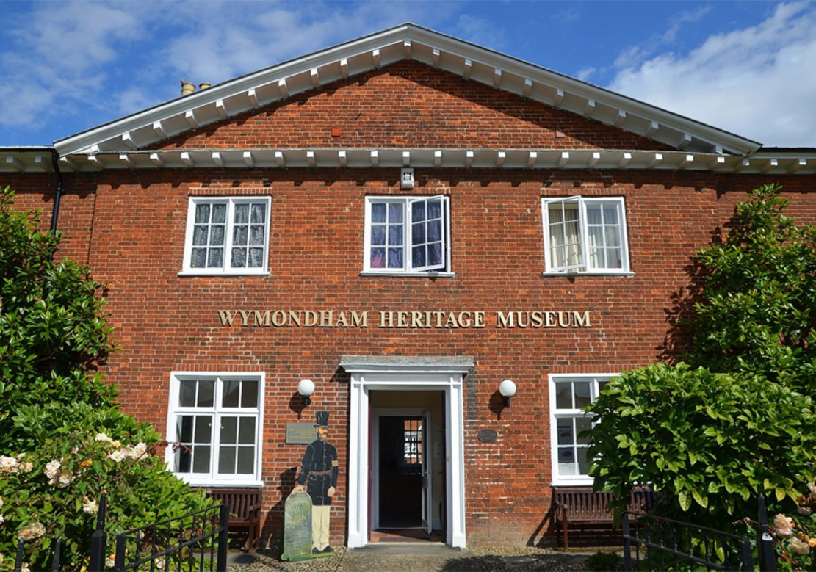
Figure 3 Wymondham Bridewell in Norfolk was one of the first female prisons in Britain. Because of their small number and short sentences, the women imprisoned here did not receive any instruction until the late 1840s when the matron began to teach reading and spelling. Before then, prison officials argued that the women were too busy doing the washing to be given any schooling. Wymondham Bridewell is now a heritage museum and open to the public.
View description - Figure 3 Wymondham Bridewell in Norfolk was one of the first female prisons in Britain. ...
View description - Figure 3 Wymondham Bridewell in Norfolk was one of the first female prisons in Britain. ...

Populations were even more fragmented in local prisons. Legislation required that male prisoners were kept separate from female prisoners, that prisoners awaiting trial (or on remand) were kept separate from those who had been convicted, and that petty offenders (i.e. misdemeanants) were kept separate from serious offenders (i.e. felons).
Physical separation could lead to exclusion from education. For example, in the 1820s and 1830s female prisoners frequently missed out because there were often relatively few of them and because they required special arrangements. Male schoolmasters and chaplains could only teach them if a female officer was in the room. Female prisoners were often dependent on instruction offered by the matron (if she had time and was able) or charitable lady visitors. Male juveniles were sometimes given instruction in order to separate them from adult male prisoners, who were left uninstructed. Over time, barriers to education based on gender and age eroded (Crone, 2022, ch.1).
At some local prisons the authorities experimented with compulsion. Daily attendance at lessons was made compulsory at Chester County Gaol in 1836, and by 1838 no one was exempt from attending classes taught by the schoolmaster (in the presence of the matron for the female prisoners) at Leicester County Gaol (Inspectors, Northern & Eastern, 2nd Report, 1837, p. 17; Inspectors, Southern & Western, 4th Report, 1839, p. 222).
However, participation in scholarly instruction in most local prisons was voluntary, and in 1843 new rules and regulations drawn up by the Home Office and circulated to local prisons in England and Wales stated that prisoners should not be compelled to ‘receive instruction’ (Regulations for Prisons, 1843, rule 129). Instead, it was suggested, and in many prisons enacted, that access to education should be given as a reward for good conduct. Prisoners aged under 17 years, however, were usually forced to attend school while in prison.
Some local prison officials questioned whether prisoners confined for short periods could benefit from instruction and restricted access to education to those with sentences of three months or more. This worked against female prisoners, who tended to be imprisoned for much shorter periods than men. Often prisoners who were already able to read, or read and write, were excluded from the prison school, though they continued to receive some religious instruction. A small number of officials began to suggest that some prisoners were unable to learn how to read and write. In 1835 the chaplain at Swaffham House of Correction argued that the prisoner aged under 25 might be taught to read in six months, but for those above that age it was much more difficult and many refused to learn (Inspectors, Northern & Eastern, 1st Report, 1836, p. 48).

Activity 1 Arrangements for instruction at Preston House of Correction
Allow approximately 10 minutes for this activity

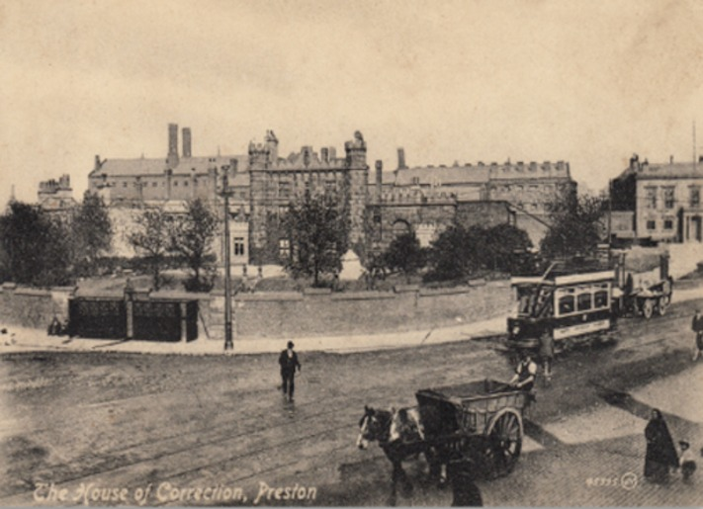
Figure 4 Prisons in the 1800s were often built to look like castles in order to remind local populations of the authority of the law. This is Preston House of Correction, first built in 1789 and substantially rebuilt in the early 1840s. Between 1823 and 1858, the Rev. John Clay was chaplain at Preston.
View description - Figure 4 Prisons in the 1800s were often built to look like castles in order to remind ...
View description - Figure 4 Prisons in the 1800s were often built to look like castles in order to remind ...

Read the following extract from the annual report of the Rev. John Clay, prison chaplain at the Preston House of Correction, for the year 1825. As you read it, take notes which address the following questions:
- What arrangements were made to teach prisoners to read at this prison?
- Were they effective?
- What might have been the benefits of such arrangements?
- Can you think of any drawbacks?

Annual report of Rev. John Clay, 1825
A system of mutual instruction is still practised among the prisoners of all classes. They are supplied with the necessary books; and it is generally found that those who can read are not only willing, but in many cases anxious, to instruct their more ignorant fellow prisoners … In the two principal wards of the prison, viz., the misdemeanants’ and convicted felons’, rooms are appropriated to a school, and it is not an unusual thing to find on a Sunday morning twenty-eight or thirty prisoners in the former, and fifteen or twenty in the latter – all of them assembled by their own free choice, and all of them occupied in giving or receiving instruction…
(Clay, 1969, p. 132)

Provide your answer...
View discussion - Activity 1 Arrangements for instruction at Preston House of Correction

3 Ways of educating
Education within the prison took a variety of forms. In some prisons, like Preston House of Correction, prisoners were given books – primers, spelling books, and grammars – and writing implements – pens and paper or pencils and slates – and told to instruct each other. While some chaplains found prisoners were uninterested, other chaplains were impressed with how they got on. The governor at Louth House of Correction declared in 1837, ‘[the prisoners] instruct themselves as well as they can, and it is quite wonderful to see in this way the improvement they make’ (Inspectors, Northern & Eastern, 3rd Report, 1837–38, p. 52).

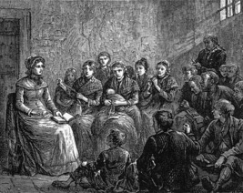
Figure 5 Sarah Martin, visiting the prisoners at Great Yarmouth Borough Gaol. In this picture, Sarah Martin is reading to men and women as some of them work. She also taught prisoners how to read and write.
View description - Figure 5 Sarah Martin, visiting the prisoners at Great Yarmouth Borough Gaol. In ...
View description - Figure 5 Sarah Martin, visiting the prisoners at Great Yarmouth Borough Gaol. In ...

More often, some kind of teacher was appointed to instruct the prisoners. Sometimes a literate prisoner who had behaved well filled the role. Other times, the authorities benefited from the visits of a charitable lady or gentleman who took it upon themselves to teach the prisoners to read and write. One of the most famous prison visitors was Sarah Martin who, between 1818 and 1843, taught the prisoners at Great Yarmouth Borough Gaol to read and write (Rogers, 2009).
Family members of prison officers were also asked to teach. At Ely Gaol in 1849, the governor’s daughter, aged 11, taught the female prisoners. Prison officers – warders, matrons, and even chaplains – sometimes stepped in to provide instruction. At some prisons, paid schoolmasters, or, less often, paid schoolmistresses, were employed to teach the prisoners (Crone, 2022, ch.1).
Officials, then, drew on a range of available resources in order to teach prisoners to read and write. However, as you shall see, those arrangements which appeared to offer the least disruption to the penal environment – such as prisoners teaching each other – or required minimal financial outlay – the use of prisoner-schoolmasters, charitable visitors, or family members – soon proved to be the most problematic for the authorities.

Activity 2 Silence and separation
Allow approximately 5 minutes for this activity

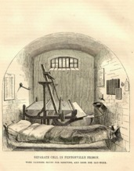
Figure 6 A separate cell at Pentonville Prison. The cells were large enough to enable prisoners to work in them during the day. This one is fitted with a handloom. Others had hand cranks. The cells also had running water, their own toilet facilities and heating, which was highly advanced at the time, but which also meant that there was little need for the prisoner to leave his cell. The sole purpose of the window was to supply natural light. It was deliberately high so that prisoners had no way of seeing out into the world.
View description - Figure 6 A separate cell at Pentonville Prison. The cells were large enough to enable ...
View description - Figure 6 A separate cell at Pentonville Prison. The cells were large enough to enable ...

In the Introduction to this session, you watched a short video on the rise of silence and separation, two competing forms of prison discipline that appeared in the mid-1830s. Take another look at any notes you made. Considering the various ways in which prisoners were taught to read and write, what impact do you think the imposition of silence or separation might have had on prison education?

Provide your answer...
View discussion - Activity 2 Silence and separation

4 The rise of the prison schoolmaster
The period 1835 to 1855 witnessed the rise of the prison schoolmaster. This was in part a consequence of the imposition of silence and separation. Schoolmasters were often employed to replace prisoners who had been teaching. The new importance given to education meant that prison officials were eager to employ qualified teachers rather than relying on the efforts of family members and subordinate officers. Regulations for local prisons in England and Wales published by the Home Office in 1840 insisted that schoolmasters and schoolmistresses had to be employed in large prisons (Regulations for Prisons, 1840, rule 178).

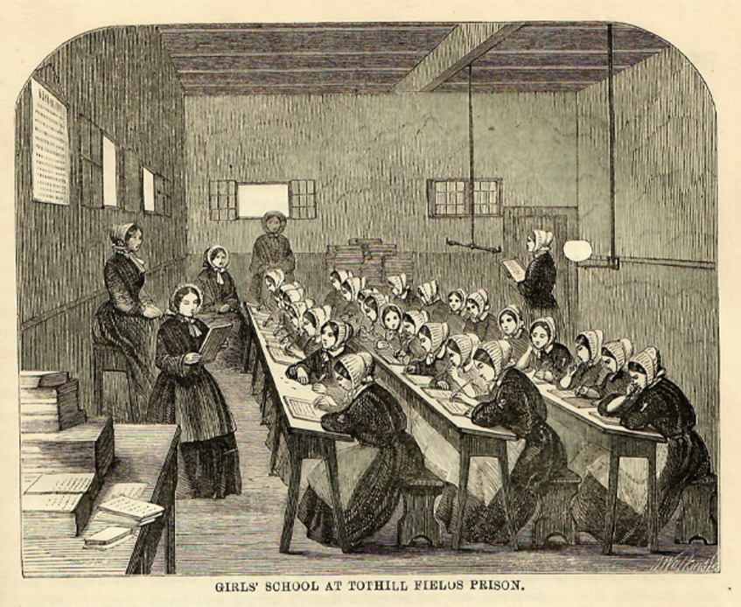
Figure 7 Girls’ schoolroom at Tothill Fields Prison in the late 1850s. By this time, Tothill Fields had become a prison for women and juvenile males. This concentration of female prisoners meant that there were enough to justify the appointment of a schoolmistress. In many other local prisons, the matron took on the duties of the schoolmistress.
View description - Figure 7 Girls’ schoolroom at Tothill Fields Prison in the late 1850s. By this time, ...
View description - Figure 7 Girls’ schoolroom at Tothill Fields Prison in the late 1850s. By this time, ...

At the same time, prison visiting by charitable ladies and gentlemen began to decline. The famous prison visitors Elizabeth Fry and Sarah Martin both died in the mid-1840s, removing two powerful examples of philanthropy for others to imitate. Prison officials had also become wary of prison visitors who were not in their pay and so not under their control. Prisons were increasingly becoming closed worlds, cut off from civilian life outside.

Activity 3 Employing teachers
Allow approximately 5 minutes for this activity

Take a look at the following two advertisements for prison schoolmasters which appeared in local newspapers in 1842 and 1852. Answer the following question:
- What qualifications must applicants have for these roles?

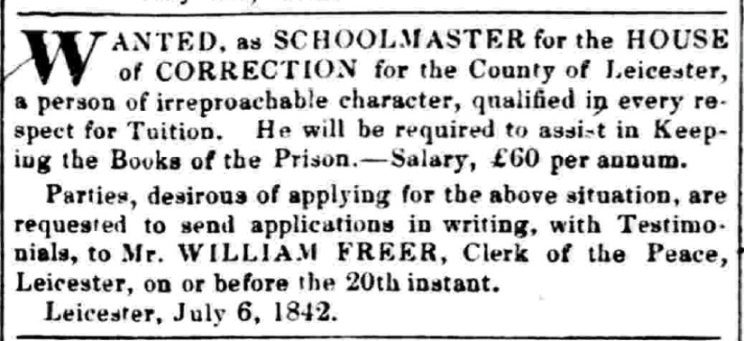
Figure 8 Leicester Chronicle, 9 July 1842.
View description - Figure 8 Leicester Chronicle, 9 July 1842.
View description - Figure 8 Leicester Chronicle, 9 July 1842.

WANTED, as SCHOOLMASTER for the HOUSE of CORRECTION for the County of Leicester, a person of irreproachable character, qualified in every respect for Tuition. He will be required to assist in Keeping the Books of the Prison – Salary, £60 per annum.
Parties, desirous of applying for the above situation, are requested to send applications in writing, with Testimonials, to Mr. WILLIAM FREER, Clerk of the Peace, Leicester, on or before the 20th instant.
Leicester, July 6, 1842.
(Source: Leicester Chronicle, 9 July 1842)

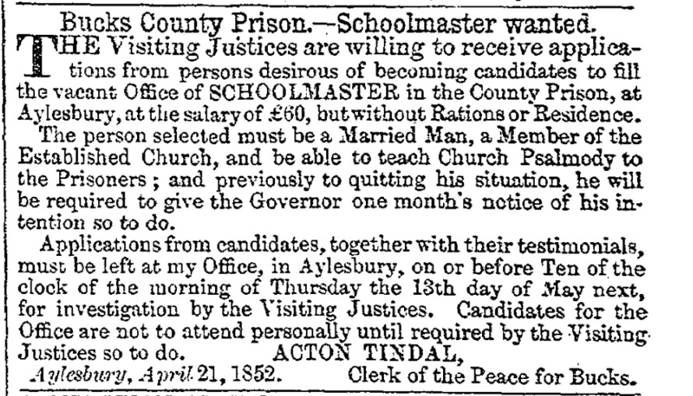
Figure 9 Jackson’s Oxford Journal, 24 April 1852.
View description - Figure 9 Jackson’s Oxford Journal, 24 April 1852.
View description - Figure 9 Jackson’s Oxford Journal, 24 April 1852.

Bucks County Prison. – Schoolmaster wanted.
The Visiting Justices are willing to receive applications from persons desirous of becoming candidates to fill the vacant Office of SCHOOLMASTER in the County Prison, at Aylesbury, at the salary of £60, but without Rations or Residence.
The person must be a Married Man, a Member of the Established Church, and be able to teach Church Psalmody to the Prisoners; and previously to quitting his situation, he will be required to give the Governor one month’s notice of his intention so to do.
Applications from candidates, together with their testimonials, must be left at my Office, in Aylesbury, on or before Ten of the clock of the morning of Thursday the 13th day of May next, for investigation by the Visiting Justices. Candidates for the Office are not to attend personally until required by the Visiting Justices so to do.
ACTON TINDAL
Aylesbury, April 21, 1852 Clerk of the Peace for Bucks.
(Source: Jackson’s Oxford Journal, 24 April 1852)

Provide your answer...
View discussion - Activity 3 Employing teachers

5 Schoolrooms

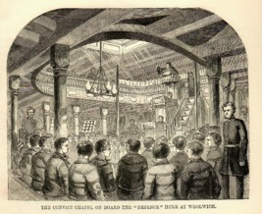
Figure 11 The chapel on board the Defence prison hulk at Woolwich. From 1847, convicts on hulks were given half a day for school each week and were taught in the chapel. In the body of the chapel, black, slanting desks with inkstand holes were arranged for school.
View description - Figure 11 The chapel on board the Defence prison hulk at Woolwich. From 1847, convicts ...
View description - Figure 11 The chapel on board the Defence prison hulk at Woolwich. From 1847, convicts ...

Before the 1860s, even in prisons which had adopted the separate system, prisoners were mostly assembled together for instruction. This required space. In the early 1800s, instruction in reading and writing often took place in any available space within the prison. Between 1816 and 1850, convicts at Millbank took the stools from their cells and gathered in groups of sixteen in the corridor for lessons. Convicts on hulks congregated in spaces on the accommodation decks. In local prisons, dayrooms, wards and yards were used. The governor’s kitchen was used at Abingdon House of Correction in the 1830s. Some prisoners were taught at their place of work. At Bury St Edmunds County Gaol, men were taught next to the treadwheel during their rest intervals. At Maidstone County Gaol in 1837, the women were taught in the laundry.
These spaces were often unsuitable for education. The prisoners at York County Gaol were forced to use books for seats to protect against the cold of stone benches until wooden seating was introduced in 1842, while the dayrooms used at Leicester County House of Correction in 1842 were too hot for the schoolmaster to deliver a lesson. Therefore, from the 1830s, specially designated schoolrooms, either purpose-built or converted, began to appear in prisons (Crone, 2022, ch.3).

Activity 4 Designing schoolrooms for prisons
Allow approximately 5 minutes for this activity

The following pictures (engravings) of prison schoolrooms date from the 1850s. Take a look at them now and jot down any distinguishing features. It might help to compare them – they are rather different!

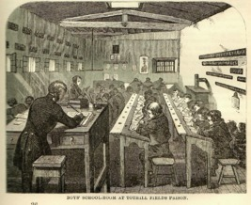
Figure 12 The boys’ schoolroom at Tothill Fields House of Correction in the 1850s.
View description - Figure 12 The boys’ schoolroom at Tothill Fields House of Correction in the 1850s. ...
View description - Figure 12 The boys’ schoolroom at Tothill Fields House of Correction in the 1850s. ...

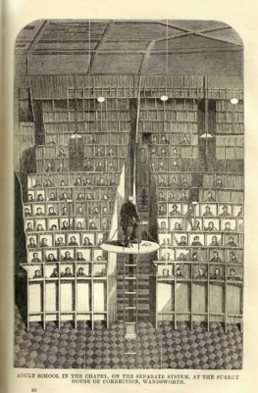
Figure 13 Adult School at the Surrey House of Correction, i.e. Wandsworth Prison, in the late 1850s.
View description - Figure 13 Adult School at the Surrey House of Correction, i.e. Wandsworth Prison, ...
View description - Figure 13 Adult School at the Surrey House of Correction, i.e. Wandsworth Prison, ...

Provide your answer...
View discussion - Activity 4 Designing schoolrooms for prisons

6 Time for instruction
Education – when delivered by appointed teachers to classes of prisoners – needed designated time in the prison timetable. Initially, prison officials attempted to schedule school when prisoners were not at hard labour or employed in other types of work.
Sundays presented one option, if instruction in reading and writing could be done during time set aside for religious instruction, and if sufficient prison staff could be secured to supervise prisoners. Evenings were another possibility but only in prisons with a gas supply for artificial light; before 1850, few local prisons in Britain were illuminated after dark (McConville, 1981, p. 360). In larger prisons, including convict prisons, the sheer number of prisoners enrolled in the prison school often meant that there wasn’t enough time on Sundays or in the evenings to teach everyone.

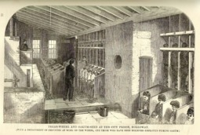
Figure 14 The treadwheel (or treadmill) and oakum shed at the City of London House of Correction (i.e. Holloway Prison). The image shows two different forms of hard labour – walking the treadwheel and picking oakum. Partitions kept the prisoners separate during labour.
View description - Figure 14 The treadwheel (or treadmill) and oakum shed at the City of London House ...
View description - Figure 14 The treadwheel (or treadmill) and oakum shed at the City of London House ...

Therefore, in most prisons, officials were left with no alternative but to schedule classes during the day and to withdraw prisoners from labour. Some officials complained that prisoners used school to escape part of their punishment. Others protested that labour interfered with education. Where prisoners were paid for their labour, or where non-completion of hard labour tasks led to punishment, prisoners refused to leave their work to attend school.

Activity 5 Timetabling
Allow approximately 25 minutes for this activity

This course is likely to take you at least 24 hours to complete. It is recommended that you study it over eight weeks. This could allow you time to think over questions and compose responses.
This course is not just about the history of prison education. It is also about how to read historical sources. Understanding the context in which a source is produced, and whether it is written by a witness or a later historian, helps us to interpret it. Being sensitive to different perspectives and being empathic to other people’s cultures or the experiences of minority groups can often be crucial to your ability to solve problems and interpret meaning.
Learning all this can take time and energy. Now that you are a few hours into the course you should have an idea as to how long it took you to complete the first session. This activity provides ideas about planning your study time for the whole course.
Complete the grid below with your ideas for study time. You might find it easier to make your own grid.
- Start with your non-study activities. Put in mealtimes and sleep. You’ll need to go online to complete the quizzes which occur at the end of each session. If your online access is restricted put that in and plan around it.
- Studying after a full day can be tiring. Even if you feel motivated now, you are advised to build in some time away from studying.
- Once you have drafted your grid, look at the discussion below. While scheduling is a matter for each individual, seeing the ideas of others can be helpful.
Below is an example grid.

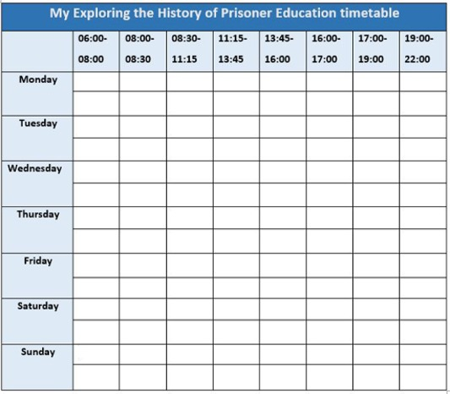

You can find an editable Word version of the grid when you access the following link: Example timetable

View discussion - Activity 5 Timetabling

7 Reflection
For this session, there is an opportunity for reflection. Like the quiz, it is designed to help you check on your progress. Reflection is an important way of reviewing and consolidating your learning. At the end of each session in this course, try to use the scheme laid out in the following activity. It might feel artificial at first, but if you keep it up it will likely become second nature to you.

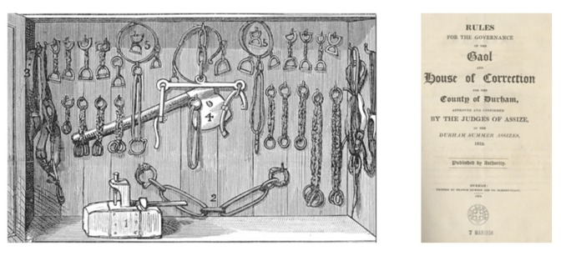
Figure 15 While chaplains strove to reform criminals through encouraging them to memorise Biblical passages, prisons remained places in which non-compliance could lead to punishment. Instruction was framed by fear. Durham, opened in 1819, had this collection of items for flogging and fettering inmates.
View description - Figure 15 While chaplains strove to reform criminals through encouraging them to ...
View description - Figure 15 While chaplains strove to reform criminals through encouraging them to ...

Activity 6 Reflection
Allow approximately 20 minutes for this activity

Ask yourself the following three questions:
- What happened?
- So what?
- What next?
You might find it useful to write two or three sentences in response to each question. Before you write the sentences, read the notes below about these questions.
What happened?
Reflection can start with a summary of what happened and what you felt. Was the content useful or interesting?
So what?
What is the value of the knowledge you have just acquired? Did you learn or improve a skill? Connect the material to the core concepts of the course. In Session 1 there was an introduction to the idea of reading critically, looking for the gap, what writers did not say as well as how they presented their ideas. Was this an important idea to understand? Have you noticed whether your understanding of the concepts, practices, themes and issues of prison history have changed since you started the course?
What next?
To ensure that you do not just learn the content of the course, but also consider how you might use the content in the future, think of skills that you might have gained. You might find that there are some skills which can be applied beyond the course. For example, you might want to apply the material on timetabling in another context. To what extent have Sessions 1 and 2 addressed your needs? Reflecting on the content, you might also ask what questions you want to answer in the coming sessions.

Provide your answer...

8 This session’s quiz
Well done – you have reached the end of Session 2. You can now check what you’ve learned this session by taking the end-of-session quiz.
Session 2 practice quiz
Open the quiz in a new tab or window by holding down Ctrl (or Cmd on a Mac) when you click on the link. Return here when you have finished.

9 Summary of Session 2
During this session you have looked at how and why schemes for educating prisoners spread across the penal estate before 1850. You also looked at patterns of inclusion and exclusion: just because arrangements had been made to teach prisoners to read and write, this did not mean that all were allowed to attend lessons.
In this session you also explored the many ways by which instruction could take place. While prison officials initially adopted a range of strategies, increasingly the penal environment and prison discipline determined what was possible, facilitating the rise of prison schools. Prisoners were organised into classes and were taught by paid (and often qualified) teachers in classrooms, at appointed times.
You should now be able to:
- discuss the expansion of educational provision in prisons
- discuss how the penal environment shaped forms of learning in the prison
- use a timetable to organise your study time.
To what extent did adjustments made to enable delivery of education within the prison compromise the value and meaning of instruction? Were prisons ever suitable environments for education? You will consider these questions further in the next session when you will go inside the prison school, to see what prisoners were taught, how they were taught it, and how they responded to the instruction they were given.
You can now go to Session 3.

Session 3: Inside the prison school

Introduction
In this third session, you will now go inside the prison school to discover what was taught and how it was taught in the years between 1823 and 1855. Superficially at least, both curriculum and pedagogy (teaching methods) mirrored those in elementary schools outside the prison. However, the penal environment, and especially evolving views about the causes of crime, led to some divergence.
You will also look at what some prisoners said about their learning. The modern prison was designed to suppress the agency of the prisoner (that is, his or her capacity to act independently). However, the voices of prisoners can still be found scattered throughout the sources. In this session, you will listen to them, discuss their authenticity, and begin to consider the meaning of education to the individual.
By the end of this session, you should be able to:
- understand the ways in which prisoners’ experiences of education can be recovered and the challenges of interpreting what they mean
- understand what was taught in the prison school, how it was taught, and why it was taught
- understand the intentions of educators and how the methods they used to instruct prisoners affected the usefulness and value of the education received by individuals.

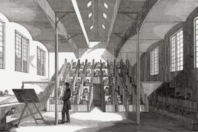
Figure 1 The schoolroom for boys in the probationary ward at Parkhurst Prison for Juveniles in 1847. Because the boys were undergoing a probationary period, they were accommodated in separate cells and taught in a partitioned schoolroom. Those who behaved well were invited to sit in the open desks at the front of the room.
View description - Figure 1 The schoolroom for boys in the probationary ward at Parkhurst Prison for ...
View description - Figure 1 The schoolroom for boys in the probationary ward at Parkhurst Prison for ...

What follows is, at times, a complicated story, which might well challenge some of your preconceptions about education and schools. Our case study, Lincoln Castle Gaol, should help to bring some of the threads together. Watch the next video now, in which Rosalind Crone charts the evolution of the school for prisoners at Lincoln. What were prisoners taught at Lincoln and how did they respond to efforts to teach them? Write down some brief notes on the ideas presented in the video.

Video content is not available in this format.
View transcript - Uncaptioned interactive content

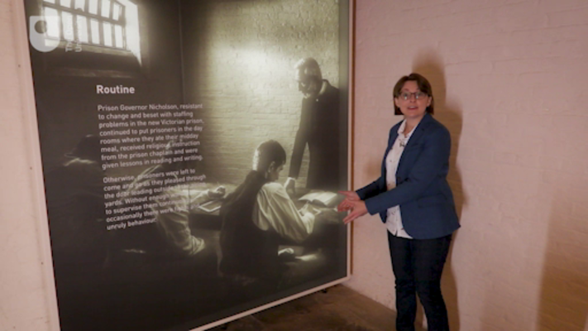

1 Searching for the causes of crime

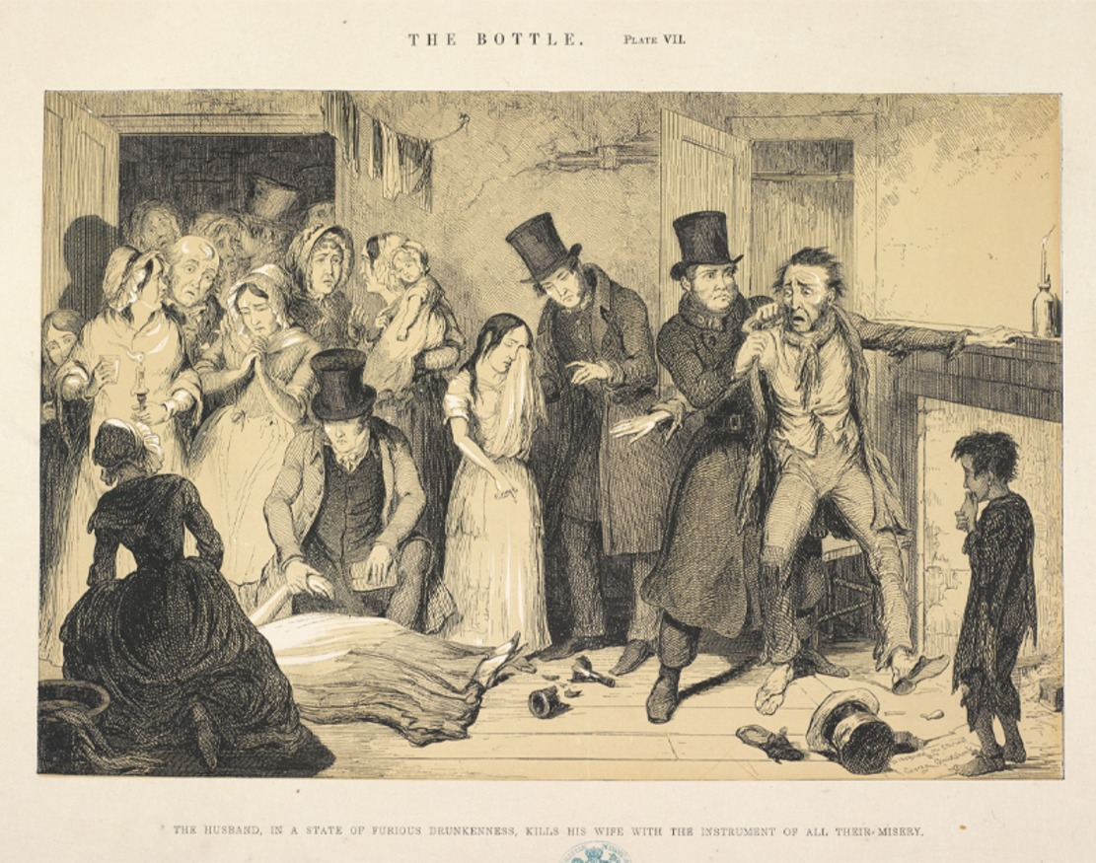
Figure 2 George Cruikshank, The Bottle. In 1847, the illustrator George Cruikshank published a series of eight plates (drawings) charting the decline of a man and his family as a result of drinking alcohol. The man loses his job and plunges the family into poverty. The sequence ends with his murder of his wife, all as a result of drinking.
View description - Figure 2 George Cruikshank, The Bottle. In 1847, the illustrator George Cruikshank ...
View description - Figure 2 George Cruikshank, The Bottle. In 1847, the illustrator George Cruikshank ...

By the 1830s, Britain was once again in the grip of a social crisis. Industrialisation (the rise of manufacturing) and rapid urbanisation (the movement of people from the countryside to towns) had led to a deterioration in living conditions and the expansion of poverty. Unhealthy and overcrowded neighbourhoods – or slums – had become a common feature of most large towns and cities. At the same time, crime rates continued to rise, and some groups of people began to express their unhappiness through rioting.
The government was eager for solutions, and prison chaplains, with their easy access to those who had been convicted of crime, were keen to contribute. In order to illuminate the causes of crime, prison chaplains began to interview prisoners and to collect information about their lives. Foremost among them was the Rev. John Clay, chaplain at the Preston House of Correction from 1823 to 1858 (Forsythe, 1987). His reports were filled with tables which described prisoners’ degree of literacy and religious knowledge, and which demonstrated a close relationship between the commission of crime and drunkenness.
The evidence from Clay and other chaplains was used to demonstrate that crime was a consequence of increasing immorality which was in turn largely caused by a lack of education – both scholarly and religious. In support of this view Clay used extracts from the testimonies of prisoners – collected via interviews, or in letters addressed to him or others – in his annual reports.
The evidence that Clay collected needs to be treated with some caution. When giving an account of their lives, prisoners, like other people, might have left out information or restructured it, or they might have lied. In a conversation with a chaplain, prisoners might have had reasons to manipulate their stories. They might have wished to try to gain early release or other privileges, to deflect their guilt, or to avoid a taboo subject.
However, such accounts can also provide useful information and a different viewpoint from official records. Even if they draw on stock narratives about the causes of crime or life in prison, prisoners’ testimonies can shed light on the lives of individuals outside the prison, and tell us how they coped inside the prison. As with all sources, prisoners’ testimonies reflect the biases of the authors, and of those who collected and arranged them for publication.

Activity 1 Testimonies of prisoners
Allow approximately 15 minutes for this activity

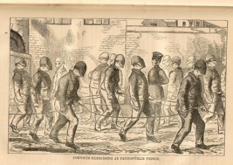
Figure 3 Prisoners at exercise at Pentonville Prison in the late 1850s. The men were forced to wear peaked caps to cover their faces and were referred to by number not name. This was, ostensibly, to prevent them from being recognised by other prisoners, though the imposition of anonymity – and with it, the deprivation of agency – was also part of the punishment.
View description - Figure 3 Prisoners at exercise at Pentonville Prison in the late 1850s. The men were ...
View description - Figure 3 Prisoners at exercise at Pentonville Prison in the late 1850s. The men were ...

The Rev. John Clay was a firm supporter of the separate system of prison discipline. He argued that the moral condition of individuals would improve if they were kept apart from other prisoners and conversed solely with the chaplain. Clay was keen to prove that the separate system could be a success and that the Scriptures aided reform. Clay encouraged prisoners confined in separate cells to review their lives as a part of a process of repentance and reform. Between 1843 and 1846, Clay took personal testimonies from 1,234 males and 199 females (Clay, 1846, p. 21).
The testimony of J.M., aged 17 and sentenced to 12 months imprisonment for a felony (a serious offence), was included in Clay’s annual report for 1849. Read the following extract from J.M.’s testimony and then try to answer the following questions:
- What does J.M. consider to be the cause of his criminal behaviour?
- Comment on the language this prisoner uses. Does anything strike you as a little odd or out of place?
- How authentic, or trustworthy, do you consider J.M.’s testimony to be?

J.M.’s testimony
My mother did her best to send me to Sunday School, and I believe I should have taken her advice, but for seeing my father’s bad example. There is one lesson it has learnt me, that is never to be a drunkard, as bad as I am. If my father had been as my mother, instead of being in prison I should have been in an honourable situation.
(cited in Bennett, 1981, p. 81)

Provide your answer...
View discussion - Activity 1 Testimonies of prisoners

2 What was taught in the prison school
Between 1820 and 1850, the curriculum (skills and subjects) taught in prisons expanded.
Initially, prisoners in many institutions were taught only to read, primarily in order to read the Bible. Soon, instruction in writing was added. By 1850, schools in a large proportion of local prisons and in all convict prisons and on prison hulks were teaching basic arithmetic. At the same time, reports from some local prisons and from all convict institutions indicate that lessons in other subjects, notably geography and history, had been added. Women and girls sometimes received instruction in sewing or knitting as well.
In terms of reading, writing and arithmetic there was increasingly little difference between what men and women, adults and children were taught, at least officially (Crone, 2022, ch.4). In its essentials, the curriculum of the prison school largely reflected that of British and Irish elementary schools outside.

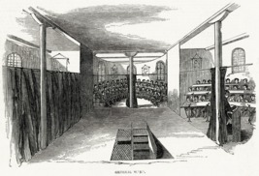
Figure 4 Classrooms at Parkhurst Juvenile Prison in 1847. Originally, this was one large schoolroom in which all the boys were taught together. With the introduction of the ‘Battersea System’ – a new method of teaching – in 1842, large curtains were used to divide the space into several classrooms.
View description - Figure 4 Classrooms at Parkhurst Juvenile Prison in 1847. Originally, this was one ...
View description - Figure 4 Classrooms at Parkhurst Juvenile Prison in 1847. Originally, this was one ...

Nonetheless, there were a number of important differences. In local prisons at least, the curriculum expanded and contracted according to institutional circumstances – for example, the departure of a teacher, or the appointment of a new teacher who could not teach parts of the curriculum might mean that prisoners were denied lessons they formerly enjoyed. Many prisoners in local prisons who arrived unable to read and so had to start from scratch were never given lessons in history or geography because their sentences were too short – there just wasn’t enough time. For example, 165 prisoners (132 males and 33 females) were permitted to attend school at Lewes House of Correction in 1846. But only 17 of them, all men, who could already read when committed, received lessons in geography (Gaol Act Reports, 1847, p. 228).
At some local prisons, officials used access to different parts of the curriculum as a way to incentivise prisoners. Only the ‘well conducted’ at Swaffham House of Correction in 1851 were allowed the ‘privilege’ of instruction in writing and arithmetic (Inspectors, Northern & Eastern, 17th Report, 1852–53, p. 70). Prisoners wanted to learn to write in order to communicate with loved ones through letters. Instruction in arithmetic was prized, mainly by boys, because it offered a different mental exercise. In the eyes of the prison authorities, both writing and arithmetic threatened to make the curriculum too secular (non-religious).

3 The role of religion
Concern about the morality of the education that prisoners received also put some limits on the expansion of the curriculum. Education was meant to be ‘reformatory’ – to make convicted criminals into better people. Prison education was not about giving men, women and children particular skills to enable them to get jobs. Instead, it was thought that better people – made so through Christianisation and the civilising effects of literacy and numeracy – would make better workers.

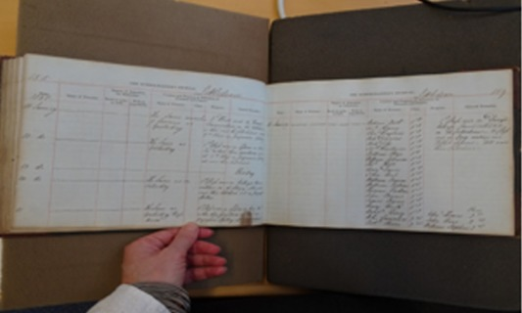
Figure 5 Pages from the schoolmaster’s journal at Littledean House of Correction, Gloucestershire. The schoolmaster recorded attendance and gave an account of what was covered in lessons. The entry for 16 January 1851 reads ‘1st class read in “Davy’s Village Conversations” [a religious text] on the Catechism. 2 class read in East reading in Tablet Lessons. All said their catechism.’
View description - Figure 5 Pages from the schoolmaster’s journal at Littledean House of Correction, ...
View description - Figure 5 Pages from the schoolmaster’s journal at Littledean House of Correction, ...

Earlier, you looked at how prison chaplains were collecting evidence to prove that a lack of Christian knowledge and belief was the cause of rising crime rates. By the 1840s, chaplains had firmly taken charge of education in prisons, at least in England and Wales. Supported by new rules and regulations for local prisons, chaplains directed the course of instruction, frequently attended schools to supervise the teaching, and regularly examined the progress made by prisoners.
Some chaplains welcomed the addition of secular subjects to the curriculum. The assistant chaplain at Millbank Penitentiary in 1839 explained that since the convicts had been exposed to ‘useful secular knowledge, their minds and tempers have certainly appeared to him to be in a more elastic and altogether healthier state – a state of mind which may be deemed generally favourable to their spiritual advancement’ (Inspectors, Home District, 4th Report, 1839, p. 97). For similar reasons, prison inspectors encouraged chaplains at local prisons to make their curriculum ‘a little more secular’.
However, there were limits. Captain Williams, the Northern District inspector, described education at Lancaster County Gaol in 1842 as too narrowly confined to reading and writing. While the prisoners were reading well and forming letters perfectly on slates, they were entirely deficient in religious knowledge (Inspectors, Northern & Eastern, 8th Report, 1843, p. 83). At Wakefield House of Correction in 1845, the chaplain suspended the teaching of writing and arithmetic because he thought the prisoners were ‘careless and inattentive’ during religious instruction, and interested only ‘in obtaining information on secular subjects, with a view of bettering their temporary condition, and making the time pass more easily’ (Inspectors, Northern & Eastern, 11th Report, 1846, p. 42). The study of geography and history were often limited to knowledge which aided the study of the Scriptures. Chaplains at Lewes and Fulham convict prisons ensured that Christianity pervaded every lesson taught in the prison school.

Activity 2 Lesson plans
Allow approximately 10 minutes for this activity

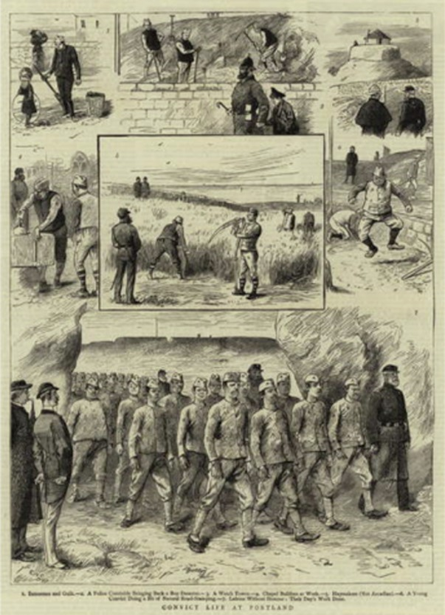
Figure 6 Convict life at Portland. Illustration for The Graphic, 31 March 1883. Portland Prison was opened in November 1848 for male convicts who had already served a term of separate confinement. The men were put to hard labour in the Admiralty Quarries breaking stone for the construction of the harbour.
View description - Figure 6 Convict life at Portland. Illustration for The Graphic, 31 March 1883. Portland ...
View description - Figure 6 Convict life at Portland. Illustration for The Graphic, 31 March 1883. Portland ...

In 1850 there were, on average, about 800 convicts on any given day at Portland Convict Prison for men. All the convicts were enrolled in the prison school. They were divided into 11 classes, and each class was excused from labour to attend school for half a day (or three hours) each week. The classes were taken sequentially, starting with the first on Monday morning and ending with the 11th on Saturday morning. Each class was further sub-divided into two groups.
Here is a copy of the school lesson plan for the morning class each day. The lesson plan for the afternoon class was identical, except that the school was held from 12.30 to 15.30. Look at the plan now, and try to answer the following questions:
- What conclusions can you make about the lessons and the time devoted to each activity?
- Are there any activities, or terms, which look unusual?

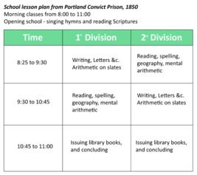
Figure 7 School lesson plan from Portland Convict Prison, 1850 (‘Second report on Portland Prison’, 1851, p. 33).
View description - Figure 7 School lesson plan from Portland Convict Prison, 1850 (‘Second report on ...
View description - Figure 7 School lesson plan from Portland Convict Prison, 1850 (‘Second report on ...

Provide your answer...
View discussion - Activity 2 Lesson plans

You have ventured into a discussion of method – how prisoners were taught. Now, you’ll explore that further.

4 Drilling and memorisation
When prison officials were establishing schools, they looked for guidance on how to teach reading, writing, arithmetic and other subjects from educational experts outside the prison. Until the imposition of silence and separation in the 1830s, the monitorial system, a method of instruction popular in elementary schools, was adopted in several prisons, including Millbank Penitentiary, Brixton House of Correction and Chester City Gaol. Prisoners requiring instruction were taught in small groups by monitors (fellow prisoners) who received their instructions on what to teach from the schoolmaster or mistress. Even after silence and separation prohibited the use of monitors, the core method of instruction remained much the same.
The monitorial method relied on drilling and memorisation. Language was broken down into a series of discrete units, or stages, each of which had to be mastered before the student could advance. Students began with the letters of the alphabet, which had to be learned by name (not sound); next they began the process of joining two letters; and then they advanced through words of one syllable, then two, and three, until they could master words with any number of syllables. At the same time, students were required to memorise the Lord’s Prayer (a Christian prayer recited during church services) and the Catechism (a set of questions and answers affirming someone’s belief in Christianity and commitment to the church). When they had reached polysyllabic words, they began to read, and commit to memory, passages from the New Testament (Vincent, 1989, p. 77).
Writing was sometimes taught after progress in reading had been made; at other times it was taught alongside reading. After instruction in basic penmanship, students were put to work ‘making copies’ – writing out chunks of text, often religious, which were either displayed on a blackboard or, to test spelling, dictated by the teacher. In order to ensure that students understood what they read and wrote, they were tested by question and answer, a method otherwise known as being ‘catechised’.
These methods of instruction were bolstered by the use of popular school textbooks in the prison, such as Mrs Trimmer’s Charity School Spelling Book. Written in the late 1700s it featured alphabets for copying, spelling lessons, and moral lessons about the godly and the ungodly told in words of one syllable. Reading lesson books published by the Society for the Promotion of Christian Knowledge, the Sunday School Union, and the National Schools Society were also used. Readers and spelling books specifically designed for adult learners were purchased for use in convict prisons. Prisoners navigated the Bible, and were ‘catechised’, with the help of Albert Judson’s Questions on the Holy Scriptures, Matthew Henry and Thomas Scott’s Commentary Upon the Holy Bible, and Sarah Timmer’s Lessons on Scripture History.

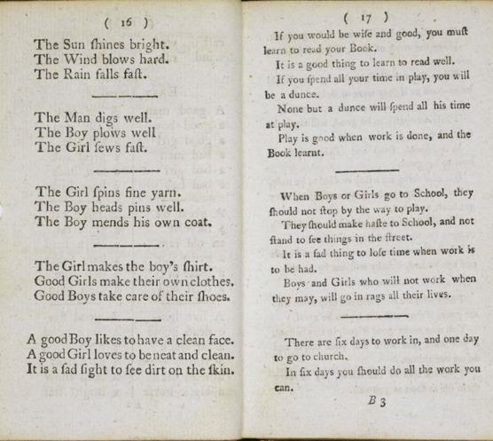
View description - Uncaptioned Figure
View description - Uncaptioned Figure

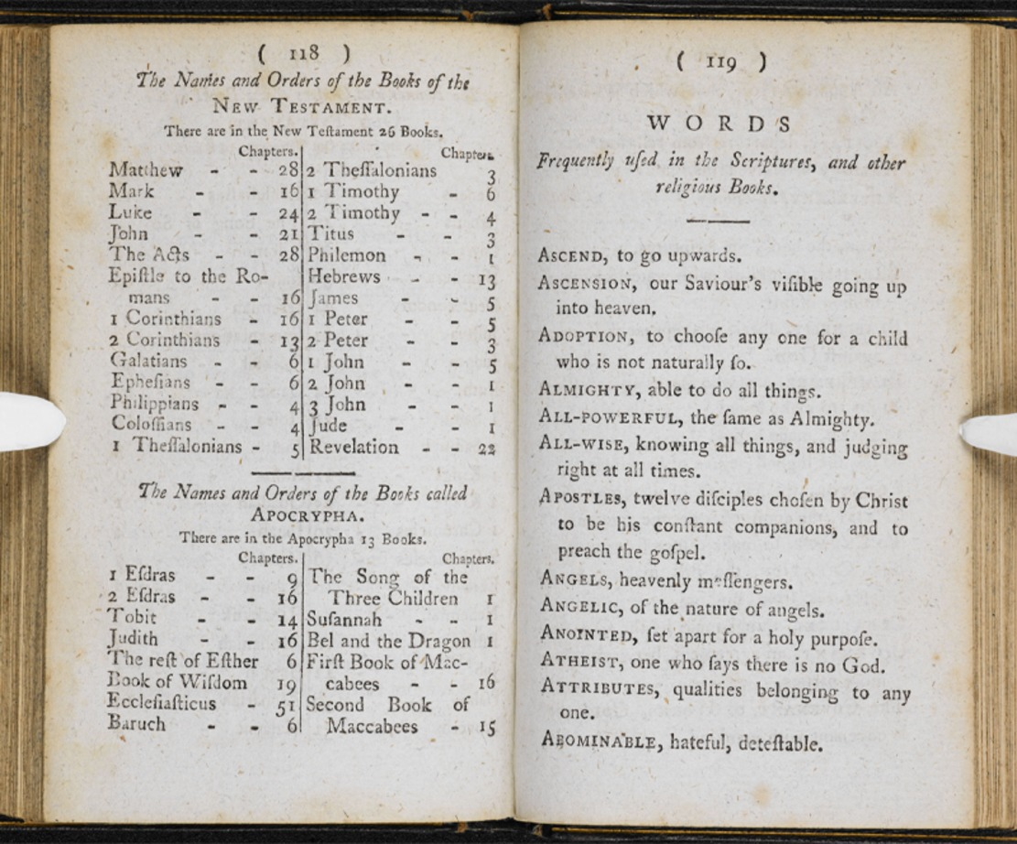
Figures 8 and 9 Mrs Timmer’s Charity School Spelling Book was a frequently used primer. It was designed for children who attended charity schools. There were adapted alphabets for copying, spelling lessons, moral messages told in words of one syllable, and definitions of words found in the Bible and transcripts of prayers.
View description - Figures 8 and 9 Mrs Timmer’s Charity School Spelling Book was a frequently used primer. ...
View description - Figures 8 and 9 Mrs Timmer’s Charity School Spelling Book was a frequently used primer. ...

The convict prison chaplains also approved the acquisition of schoolbooks to support lessons in history and geography. Again, the titles and content of these books reveal the emphasis that was placed on the acquisition and recitation of facts. For example, women at Brixton Convict Prison made use of Wilson’s Catechism of Modern History and Wilson’s Catechism of Geography. Gleig’s School History of England, which contained a chronology, tables of sovereigns and questions for examination, was popular at male convict prisons (Crone, 2022, ch.4).

Activity 3 Case study: Reading Gaol
Allow approximately 20 minutes for this activity

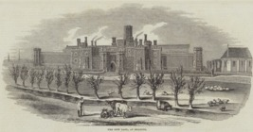
Figure 10 The new gaol at Reading. Illustration for the Illustrated London News, 17 February 1844. Built in the neo-gothic style, Reading Gaol was meant to look like an imposing castle, a symbol of authority overlooking the town of Reading. It cost three times the original estimate to build. The architect, Sir Gilbert Scott (1811–1878) was also responsible for the design of the Midland Grand Hotel at St Pancras Station, London.
View description - Figure 10 The new gaol at Reading. Illustration for the Illustrated London News, ...
View description - Figure 10 The new gaol at Reading. Illustration for the Illustrated London News, ...

In 1840 the new chaplain at Reading Gaol, the Rev. John Field, campaigned for the introduction of the separate system. The county magistrates, who were in charge of the prison, agreed and a new prison, resembling a medieval castle, was built in its place. The building survives, although the prison was closed in 2014.
From 1844, prisoners who arrived at the new gaol were confined in separate cells. They were given no work, and if they asked for something to do they were given a Bible to read. If they could not read the Bible, the schoolmaster was sent to their cell to teach them. All the male prisoners attended school in the partitioned chapel as well. Female prisoners were excluded from school because of the burden of the prison laundry, but by the late 1840s attempts were made to give them some instruction too.
Field’s scheme was based on the memorisation of passages from the Bible. If a prisoner could successfully recite the lessons he had learned, he was given labour in his cell – typically oakum picking (picking out the fibres from old rope) – for ‘relaxation’. Field believed that rote learning could turn prisoners into non-offending Christians. The county magistrates in charge of the prison thought that rote learning was a form of punishment more irksome than some types of hard labour (Crone, 2012).
Prisoners who could read and who had shown evidence of reformation were either taught, or allowed, to write. Field asked these men to complete examinations to test their learning. Below is a copy of one of the examinations completed by I.N., a prisoner who had, at this stage, been imprisoned for three months. Field set a question, and then asked I.N. to respond using what he had learned in the prison.
Some prisoners at Reading Gaol were entitled to send letters home. This one was written by J.I., who was sentenced to 18 months imprisonment, to his sister, in February 1848. Read it and compare it with the exam script above it.
Now read and compare I.N.’s exam script and J.I.’s letter using the following questions:
- What similarities stand out?
- Can you spot any differences?
- Both were written by prisoners – how authentic are they?
- Are these the voices of prisoners?

Exam script
Give reasons why we should not frequent the public house:
- Because we can get no good there. Luke xi. 4.
- Because we should not go into bad company. Psalm i. 1. 1 Thess. v. 22. Proverbs i. 10.
- Because we should not set a bad example. Luke xvi. 28. James iv. 17. Psalm cxl. 11.
- Because we can employ our time better. Ephes. V. 15, 16. Titus ii. 11, 12. 2 John xi. 11. Psalm xc. 12.
- Because we shall have to render a strict account of our lives at the day of judgement. Luke xvi. 2. Proverbs xxix. 1. Eccles. iii. 15, 17.
- Because we should not encourage drunkenness, folly and vice. 1 Cor. vii. 31. Psalm ix. 17. Proverbs iv. 14, 15.
(Field, 1848, II, pp. 121–2)

Letter
The particular [sin] is drinking, which brought me very low; and if you read the following verses, you will see that I have proved them. Prov. xx. 1; Prov. xxiii. 21 & 32; Haggai. i. 6; Prov. i. 31; Prov. xiii. 15-21; Prov. xi. 21; Isaiah xlviii. 22; Jer. xxii. 21. And now my dear sister, seeing I have proved this, I do heartily pray that you will correct your son betimes, and he will give you comfort and joy … if you read the following Scriptures, you will see that your thoughts cannot stand. Ezekiel xviii; Colos. iii. 25; Mark xvi. 16; Luke xii. 3 & 5; Psalm ix. 17; Psalm xi. 6. This shows us plainly that all who don’t repent must suffer the vengeance of eternal fire. Read St John’s gospel, and there you will see that Jesus died for sinners.
(Field, 1848, I, p. 298)

Provide your answer...
View discussion - Activity 3 Case study: Reading Gaol

5 Prisoners as scholars
It is difficult to tell how the prisoners felt about these methods of instruction. Did they want to:
- attend the prison school?
- learn how to read and write, or to do some sums?
- be drilled to memorise Biblical passages?

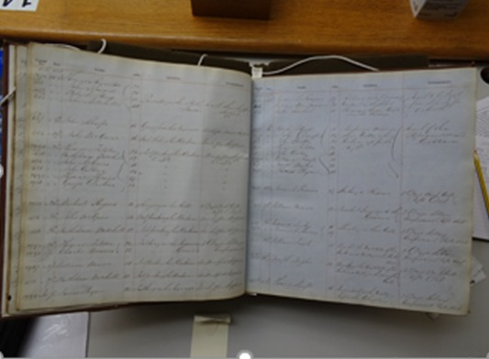
Figure 11 Misconduct book from Chester City Gaol. The pages shown include, in November 1852, the following: ‘Jeremiah Kearnes (19), William McCormack (21) and Walter Lambert (18), for riotous and disorderly conduct in the school room and throwing coals at another prisoner. Each to be kept from school for one month.’
View description - Figure 11 Misconduct book from Chester City Gaol. The pages shown include, in November ...
View description - Figure 11 Misconduct book from Chester City Gaol. The pages shown include, in November ...

The sources from Reading Gaol that you looked at in Activity 3 suggest some level of engagement, but they do not tell us much about the willingness or motivation of the prisoners as learners. Annual and inspection reports from local prisons in England and Wales overwhelmingly emphasise the eagerness of prisoners to attend lessons, their attentiveness during instruction, and their gratitude which was expressed in conversations with officials.
Relatively few reports described prisoners as indifferent or obstructive. This might have been because most schooling in local prisons was voluntary – the prisoners had to want to be there. At some prisons, attendance was limited to those who behaved well, and at most prisons misconduct in the schoolroom led to expulsion. The local prison authorities were keen to ensure that education was regarded as a privilege.
At convict prisons, however, attendance at school was compulsory. It is here, then, that we might look for some alternative perspectives, but where can we find them in a system which was set up to suppress the voice of the prisoner? One possibility is to look at records of prison offences, which ranged from acts of violence to attempts to communicate with other prisoners. Could committing an ‘offence’ in prison be regarded as a form of protest?

Activity 4 Misconduct records at Pentonville Prison
Allow approximately 20 minutes for this activity

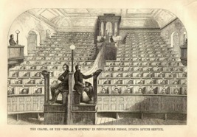
Figure 12 The chapel, on the ‘separate system’ at Pentonville Prison. The partitions placed between prisoners were meant to prevent communication but soon became covered in graffiti, and had to be stripped and cleaned. Warders placed at inspection points could not prevent prisoners from drawing on the stalls. Sometimes this was because they fell asleep on duty.
View description - Figure 12 The chapel, on the ‘separate system’ at Pentonville Prison. The partitions ...
View description - Figure 12 The chapel, on the ‘separate system’ at Pentonville Prison. The partitions ...

Pentonville was a convict prison. It had been constructed in 1842 to provide a new stage of punishment in the convict prison system. Men found guilty of serious offences and sentenced to transportation (exile to Australia) were sent to Pentonville for 18 months (later reduced to 9 months) if the authorities believed they had the potential to be reformed. If they behaved well at Pentonville, they were given conditional pardons on arrival in the Australian penal colonies. If not, then they risked being assigned to a chain gang to labour on public works in Van Diemen’s Land (modern day Tasmania).
Pentonville operated on the separate system. Its designers hoped it would be a model which other prisons would follow. The men were confined in cells and let out only to attend chapel and school (which was held in the chapel). The chapel had been fitted with partitions to keep prisoners separate. The men exercised alone in separate yards. When out of the cell, convicts had to wear a peaked cap to preserve their anonymity. Absolute silence was the rule at all times.
The following tables appeared in Pentonville’s annual report for 1852. Table 1 contains a summary of all the offences committed by prisoners in 1852 for which they were punished. Table 2 tells us how many prisoners committed these offences – some prisoners committed multiple offences, while others committed no offences.
Take a look at the tables now and try to answer the following questions:
- How many offences occurred at, or were related to, the prison school?
- From the information given, can we draw any conclusions about the character of these offences?
- Can you find the number of prisoners who did not commit a prison offence? What conclusions might you draw from that number?

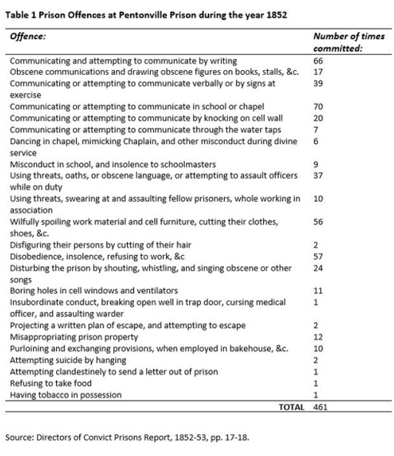

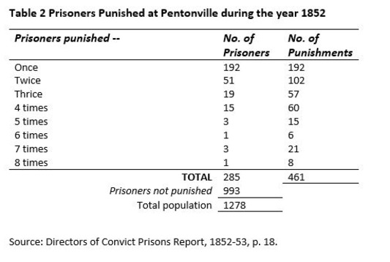

Provide your answer...
View discussion - Activity 4 Misconduct records at Pentonville Prison

It is possible that there was more misconduct in school which went unrecorded and unpunished and, apart from ‘insolence to the schoolmasters’ (in other words, talking back), it is not clear what was meant by ‘misconduct’. The table produced for the year 1855 provides a little more detail – 12 men were punished for ‘disturbing school, [by] talking aloud, shouting, whistling, [and] mimicking schoolmasters’. In 1854 one case of misconduct in school was brought to the attention of the prison’s visiting director (or manager on behalf of the government), Captain Donatus O’Brien. The details were recorded in the Commissioners’ (i.e. Directors’) Visiting Book:

1 May 1854. A question has arisen respecting the case of a [Roman Catholic] prisoner who interrupted the school on a doctrinal subject. The Governor has suggested that the [prisoner] should be deprived of attending school for a fortnight. The chaplain would be glad if he were absent entirely; but it is stated to me that the prisoner’s object is to avoid school. I see the prisoner, who says he will not stand by and hear the doctrines of his church found fault with. I warn him that he must attend school, that whether he does or does not like what is taught he must not interrupt the schooling; and that if he does interrupt the schooling it must be treated as a prison offence and he will be punished accordingly.
(Pentonville Prison, Commissioners’ Visiting Book, 1843–1854, entry for 1 May 1854)

Many prison chaplains believed that the route to redemption lay in the doctrines of the Church of England. Other denominations, such as Roman Catholicism, were sometimes disparaged during instruction, and some prisoners openly objected to this. But many did not. They might have seen school as a break from more irksome activities, or they might have been able to extract what they wanted from the curriculum and ignore the bits that were unwelcome.
Like the example of Reading Gaol earlier this session, there are also hints of a darker side of prison education. The prisoner here is forced to attend school, even though he doesn’t want to. Education had a disciplinary function. It could be punishing as well as enlightening.

6 This session’s quiz
Well done – you have reached the end of Session 3. You can now check what you’ve learned this session by taking the end-of-session quiz.
Session 3 practice quiz
Open the quiz in a new tab or window by holding down Ctrl (or Cmd on a Mac) when you click on the link. Return here when you have finished.

7 Summary of Session 3

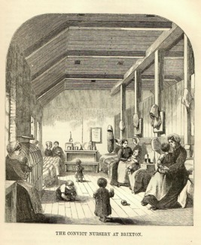
Figure 13 Women who had given birth shortly before entering prison or who gave birth in prison were permitted to stay with the child. This illustration from the late 1850s is of the ‘nursery’ at Brixton Convict Prison for women which accommodated children up to the age of 4.
View description - Figure 13 Women who had given birth shortly before entering prison or who gave birth ...
View description - Figure 13 Women who had given birth shortly before entering prison or who gave birth ...

In this session, you have looked at what prisoners were taught in prison schools between 1823 and 1855. Curriculum expanded in many prisons during this period, perhaps in ways that surprised you. Yet most, if not all of it, was geared towards the development of religious knowledge. You also looked at forms of evidence which reveal prisoners’ perspectives on learning.
You should now have an understanding of:
- the ways in which prisoners’ experiences of education can be recovered and the challenges of interpreting what they mean
- what was taught in the prison school, how it was taught, and why it was taught
- the intentions of educators and how the methods they used to instruct prisoners affected the usefulness and value of the education received by individuals.
Deciding what should be taught and the best ways to learn have been matters of debate for centuries. For much of the 1800s learning was seen as a way of getting information into people’s heads. You might agree that some information is useful to memorise. For example, if you are asked to subtract any whole number from 10 it is likely that you can instantly give the answer. You don’t have to use a tool, such as your fingers or a calculator. However, this does not demonstrate that you know about mathematics.
The same is true of learning extracts of the Bible by heart, as prisoners were forced to do. This did not necessarily mean they understood the meaning of what they had memorised, or that this equipped them to read other texts and reflect on them. Sometimes reflection was not the intention, as instruction was used as a tool for discipline – to make prisoners docile (submissive).
Still, at least some prisoners recognised the value of the skills they learned and were able to make use of them, inside and outside the prison. Education could be transformational, in spite of the methods used and the conditions under which it was experienced. You will consider the results of prison education more broadly in Session 5. First, in Session 4, you will explore another form of education available inside the prison: the provision of books for self-instruction and the birth of the prison library.
You can now go to Session 4.

Session 4: Education outside the prison school

Introduction
Education in prison did not begin and end with the prison school. In this session, you will look at other forms of learning available to prisoners in the 1800s, specifically the provision of books which prisoners were able to use for self-improvement.

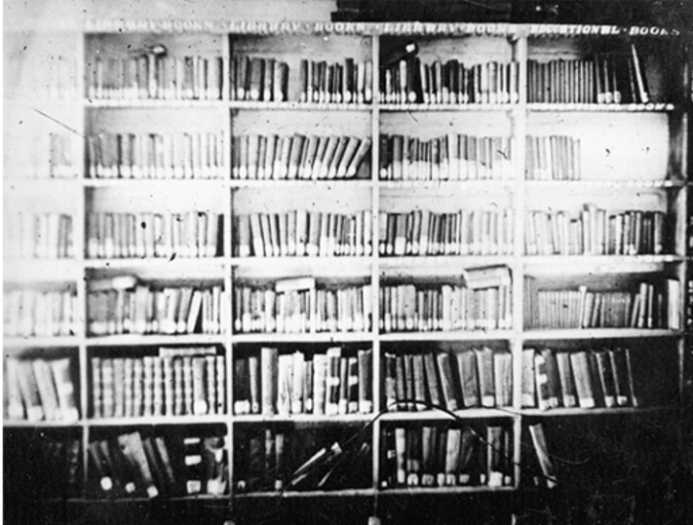
Figure 1 Prison library at Strangeways, Manchester, 1910.
View description - Figure 1 Prison library at Strangeways, Manchester, 1910.
View description - Figure 1 Prison library at Strangeways, Manchester, 1910.

Throughout the 1700s, the openness of the prison to the outside world meant that reading matter could be taken to prisoners. Efforts were made to provide Bibles and Christian tracts. Some politically radical pamphlets and sheets containing pictures and songs about executions also found their way to prisoners. Legislation in the early 1800s gave control over books in the prison to the chaplain and the prison authorities.
At the same time, the penal reform movement gave new importance to books in the prison, and acts of reading by prisoners. While chaplains almost universally acknowledged the great potential that books offered for self-improvement, their attempts to control the effects of reading were constantly challenged.
By the end of this session, you should be able to:
- identify other forms of learning and self-improvement outside the prison school
- discuss debates about the suitability of reading matter for prisoners
- describe how prisoners accessed and used the books available to them.
To begin with, watch this video in which Rosalind Crone describes the prison library at Lincoln Castle Gaol in the 1800s. Consider what books prisoners had access to, and the evidence that survives on how they used them. It will be useful to reflect on this case study during this session. Please note that in the video, where Rosalind says ‘Captain Cook, who circumnavigated Australia’, this should say ‘Captain Cook, who circumnavigated the east coast of Australia’.

Video content is not available in this format.
View transcript - Uncaptioned interactive content

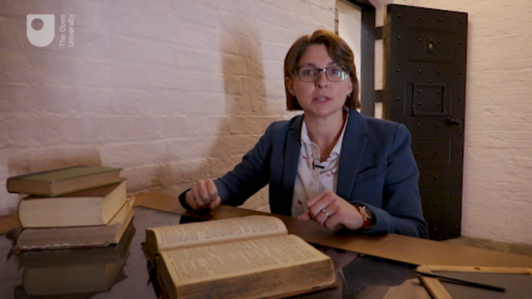

1 Books behind bars
An alternative form of education and self-improvement in the prison was provided through access to books and time to read them. Deliberate schemes to provide prisoners with books date to the early 1700s.
In 1698, an English clergyman, Thomas Bray, established the Society for the Promotion of Christian Knowledge (SPCK) to spread Christianity through the distribution of Bibles and religious tracts (small books or pamphlets) in Britain and abroad. In 1702, the SPCK began to supply Newgate Gaol with Bibles, prayer books and tracts. Soon after, the SPCK sent a packet of tracts to every county gaol in England and Wales (Fyfe, 1992, pp. 3–6).

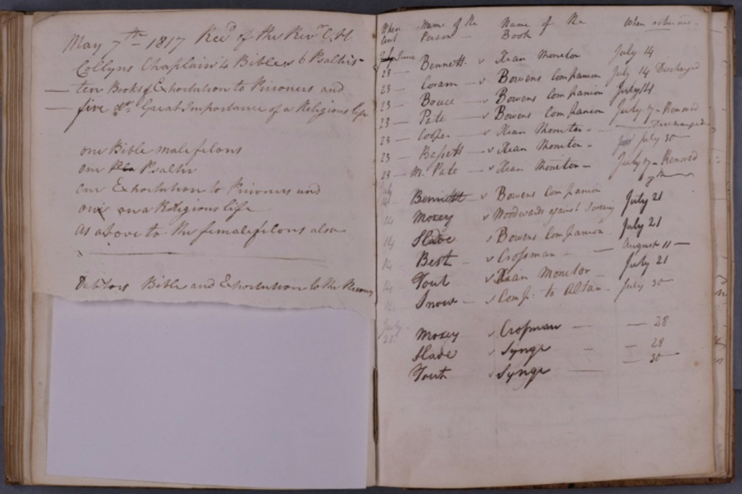
View description - Uncaptioned Figure
View description - Uncaptioned Figure

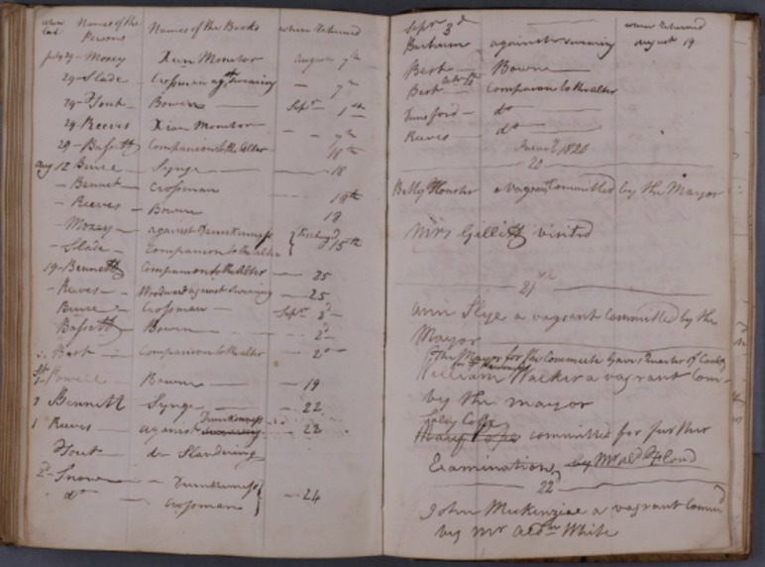
Figures 2 and 3 The ‘Southgate Prison’ book, from Exeter City Gaol, contains a record of loans of religious books from the chaplain to prisoners in 1819.
View description - Figures 2 and 3 The ‘Southgate Prison’ book, from Exeter City Gaol, contains a record ...
View description - Figures 2 and 3 The ‘Southgate Prison’ book, from Exeter City Gaol, contains a record ...

As the number of paid prison chaplains grew and interest in soul-saving in prisons expanded, there was a greater demand for appropriate reading matter for prisoners. The 1823 Gaols Act gave prison chaplains in England and Wales authority over the acquisition and distribution of books (Gaols Act 1823, section 30).
Governors, in their annual returns to the Home Secretary, had to declare whether prisoners were supplied with Bibles and other books. Rules for the new Penitentiary at Millbank stated that the chaplain should be supplied with books from the SPCK and that he should distribute them among the prisoners as he saw fit. The SPCK continued to be the main supplier of books and reading matter for local prisons in England and Wales. Sometimes the SPCK sent packages of tracts for free, other times the prison authorities paid for them. By the 1830s, there were very few prisons at which prisoners did not have access to Bibles, prayer books and religious tracts.
Often chaplains distributed the books freely among prisoners. They handed out copies of tracts to individuals on arrival, or they left tracts, Bibles and prayer books in the day rooms for prisoners to pick up and read. According to the chaplain at Horsemonger Lane Gaol in 1832, prisoners were well supplied with religious books: many read them, some neglected them, and others tended to destroy them (Gaol Act Reports, 1833, p. 242).
Tracts were often flimsy publications which could fall apart if passed through many different hands. There are many examples in the primary sources of prisoners using pages torn from Bibles to roll tobacco, to make playing cards, and to curl their hair. Several chaplains restricted the supply of religious books to prisoners who requested them and promised not to mutilate them.

Activity 1 Bible reading at Reading Gaol
Allow approximately 15 minutes for this activity

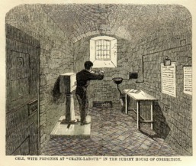
Figure 4 A prisoner working at ‘crank labour’ in his cell in the Surrey House of Correction, in the late 1850s. The invention of the hand crank allowed hard labour to be brought into prison cells, limiting further opportunities for prisoners to leave their cells. A prisoner would turn the crank until he had completed the number of revolutions set for him by the taskmaster. The resistance of the crank could be tightened to increase the pain. In this image, there is an open book on the table in the cell indicating that the prisoner might have used the opportunity to read during breaks.
View description - Figure 4 A prisoner working at ‘crank labour’ in his cell in the Surrey House of ...
View description - Figure 4 A prisoner working at ‘crank labour’ in his cell in the Surrey House of ...

Part 1

You looked at the regime established at Reading Gaol in the mid-1840s in Session 3. Using the knowledge you acquired then, read the following extract from the journal kept by the prison governor which was included in the 1845 report of the Home District inspectors of prisons and try to answer the following questions:
- What do you think the prisoners were reading?
- What evidence is there to suggest that they were enthusiastic readers?
- How might we interpret the prisoners’ enthusiasm for reading?

March 16th 1845. – I went through the male prison at 7.30pm, and looked in upon every prisoner through the inspection slides, 97 in number, and found them all reading but 12, ten of whom were walking about, and two warming their hands over the gas light; … [I] have made numerous similar inspections of prisoners at all hours, and have invariably found about the same number in proportion reading.
(Inspectors, Home District, 10th Report, 1845, p. 34)

Provide your answer...
View discussion - Part 1

Part 2

Read the below statement made in 1848 by a prisoner to the Rev. John Field, chaplain at Reading Gaol. In Session 3 there was some consideration of personal testimony. What do you make of this evidence?

What a blessing it is that I was put into a cell with nothing but my Bible, and could not get away from it! For the first three or four weeks I used to take it up and throw it down again, and curse it; but I could not help taking it up; and what a blessing it has turned out! I seem to have been brought here that I might read the Bible, and now I believe it. I shall forever bless God that I was brought to this prison.
(Field, 1848, I, p. 331)

Provide your answer...
View discussion - Part 2

2 Reading in seclusion

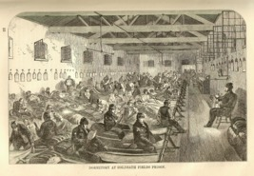
Figure 5 The dormitory at Coldbath Fields Prison, London, in the late 1850s. Coldbath Fields operated on the silent system. Prisoners were kept under close surveillance by guards and those who broke the silence were punished, sometimes severely. This engraving shows several prisoners are taking the opportunity to read before lights out.
View description - Figure 5 The dormitory at Coldbath Fields Prison, London, in the late 1850s. Coldbath ...
View description - Figure 5 The dormitory at Coldbath Fields Prison, London, in the late 1850s. Coldbath ...

The imposition of silence and separation in British and Irish prisons from the mid-1830s gave books new importance in the penal regime. Reading the Bible and other religious books was a key component of the reformatory project. Chaplains wanted prisoners to read the Scriptures for themselves.
Reading was also a useful activity to fill long stretches of time when prisoners were not working or sleeping. Idle prisoners were not just an annoyance to officials (who believed that idleness was a cause of crime), but idleness, in the context of extremely limited contact with other humans, was potentially dangerous. It could cause mental health problems – and the authorities were keenly aware of this. Prisoners were subconsciously aware of the dangers too. Faced with soul-destroying boredom, prisoners who could read picked up the books made available to them.
The 1839 Prisons Act for England and Wales specified that all prisoners confined in separate cells should each be provided with a Bible and Common Prayer Book – as part of the standard ‘cell furniture’ – as well as ‘additional books’. Annual and inspection reports from the late 1830s and 1840s suggest that formal libraries were being established at an increasing number of local prisons. At the same time, libraries became commonplace at convict prisons. By the 1850s, libraries could be found on every convict prison hulk (Crone, 2022, ch.3).

3 Expanding the prison library
At first many libraries consisted of collections of religious books already in the prisons.
As early as 1823, concerns were expressed that the exclusive diet of Bible reading and religious tracts at Millbank Penitentiary had led to feelings of depression and low spirits among the convicts serving long periods of separate confinement there (Select Committee on the Penitentiary at Millbank, 1823, p. 4). Despite the enthusiasm of the prisoner quoted in Activity 1 (Part 2), similar concerns were raised about the programme of Bible reading at Reading Gaol in the late 1840s when prison health statistics showed a worrying increase in the number of prisoners being sent to the asylum (Crone, 2012).
Moral, secular tracts were added to prison libraries, as were educational works which could expand upon the subjects taught in the schoolroom, such as history, geography and mathematics. Additions at some prisons also included books on natural history (studies of wildlife and plants), practical works to assist with learning a new trade or skills for a new occupation (such as domestic service), and self-help books, including those on managing personal or family finances.

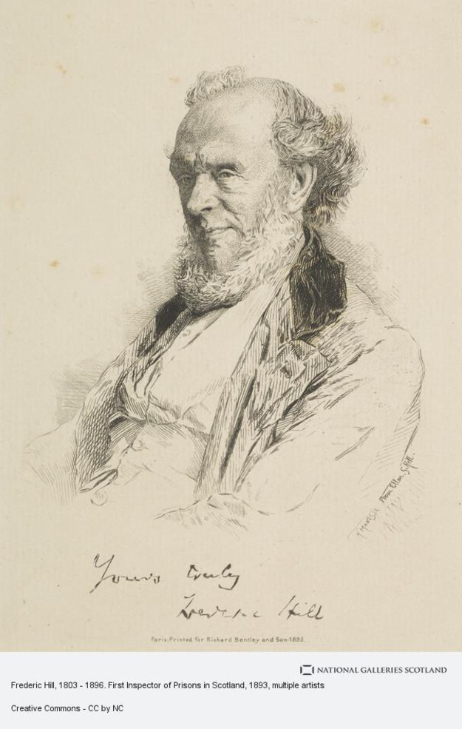
Figure 6 Frederic Hill (1803–1896), prison inspector for Scotland (1836–49) and for the North of England (1850–1). Frederic Hill was the son of a schoolmaster, brother of Rowland Hill who established the penny post, and brother of Matthew Davenport Hill who was one of the leaders of the reformatory schools movement. On becoming inspector of prisons for Scotland, Frederic Hill campaigned for the improvement of prison libraries. In 1837 he completed a survey of towns in Scotland which showed that crime was higher in places with poor library facilities. In 1843, he compiled a list of books which should feature in a prison library and sent it to prison governors in his district.
View description - Figure 6 Frederic Hill (1803–1896), prison inspector for Scotland (1836–49) and for ...
View description - Figure 6 Frederic Hill (1803–1896), prison inspector for Scotland (1836–49) and for ...

From the late 1830s, some prison chaplains, and the inspector for prisons in Scotland, Frederic Hill, began to argue that prison libraries should also include some lighter literature. Hill believed that amusing but moral stories would encourage those who could not read to make efforts to learn (Inspectors, Scotland, 7th Report, 1842, p. 8). The chaplain at Glasgow Prison argued that prisoners on long sentences in particular needed to be kept cheerful, by reading entertaining books as well as books of a serious character (Fyfe, 1992, p. 48).
The expansion of the prison library led to a vigorous debate about what was appropriate reading material for prisoners – what could encourage them to reform, what risked easing the pain of their imprisonment, and what had the potential to make them more criminal.

Activity 2 The dangers of reading
Allow approximately 10 minutes for this activity

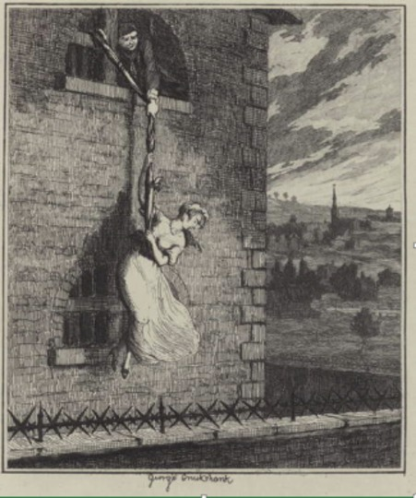
Figure 7 Jack Sheppard with Edgeworth Bess escaping from Clerkenwell Prison in London. This is one of the many illustrations of Jack’s exploits which appeared in the novel written by William Harrison Ainsworth, published in instalments between January 1839 and February 1840. The great popularity of the novel meant that cheap, pirated versions quickly appeared in the market.
View description - Figure 7 Jack Sheppard with Edgeworth Bess escaping from Clerkenwell Prison in London. ...
View description - Figure 7 Jack Sheppard with Edgeworth Bess escaping from Clerkenwell Prison in London. ...

In the late 1840s, the journalist and social investigator, Henry Mayhew, organised a meeting in the schoolroom of the British Union School in Shadwell, London. He put up a notice inviting thieves and vagabonds (the homeless) who were under 20 years old. One hundred and fifty attended the meeting. Mayhew used the opportunity to talk with them about their lives and habits.
Read the extract from Mayhew’s account of the meeting, and consider the following questions:
- What does Mayhew suggest led these boys into a life of crime?
- Do the boys agree with him?

Respecting their education, according to the popular meaning of the term, 63 of the 150 were able to read and write, and they were principally thieves. Fifty of this number said they had read Jack Sheppard and the lives of Dick Turpin, Claude du Val, and all the other popular thieves’ novels, as well as the Newgate Calendar and Lives of the Robbers and Pirates. Those who could not read themselves, said they’d had Jack Sheppard read to them at the lodging houses. Numbers avowed that they had been induced to resort to an abandoned course of life from reading the lives of notorious thieves, and novels about highway robbers. When asked that they thought of Jack Sheppard, several bawled out “He’s a regular brick” – a sentiment which was almost universally concurred in by the deafening shouts and plaudits which followed. When asked whether they would like to be Jack Sheppards, they answered “Yes, if the times was the same now as they were then.”
(Mayhew, 1968 [1861–62], p. 419)

Provide your answer...
View discussion - Activity 2 The dangers of reading

4 Censorship
Mayhew’s was one of several studies of the pernicious effect of reading fiction – especially stories about famous criminals – published in the 1840s and 1850s. The Rev. John Clay, chaplain at the Preston House of Correction, and Captain Williams, prison inspector for the Northern and Eastern District, also conducted interviews with juveniles in prisons in which Jack Sheppard was identified as a dangerous book (Select Committee on Criminal and Destitute Juveniles, 1852, pp. 406–22, 422–5). Close attention was paid to the content of stories acquired for the prison library to ensure that books were devoid of any representations of criminal activity, even when those books had been written by leading or highly respected novelists (including Charles Dickens).
Concern about the effects of reading on prisoners was not limited to the novel, or ‘crime fiction’. In 1856, a senior official in Her Majesty’s Stationery Office, the government department which supplied books to convict prisons, objected to instructions he had received from Sir Joshua Jebb, chair of the Directors of Convict Prisons, to supply Portsmouth Prison with two copies of Treatise on Law of Banker’s Cheques (a text of which there had been many editions since its publication in 1799). The official wrote:

Now one would naturally suppose that the majority of convicts know a great deal too much of the arrangement of Country and other Banks, and that the less they are acquainted with these matters and with the law of cheques, the safer private property is likely to remain.
(Fyfe, 1992, p. 85)

On this occasion, Jebb successfully argued the case, and the books were subsequently dispatched to Portsmouth.

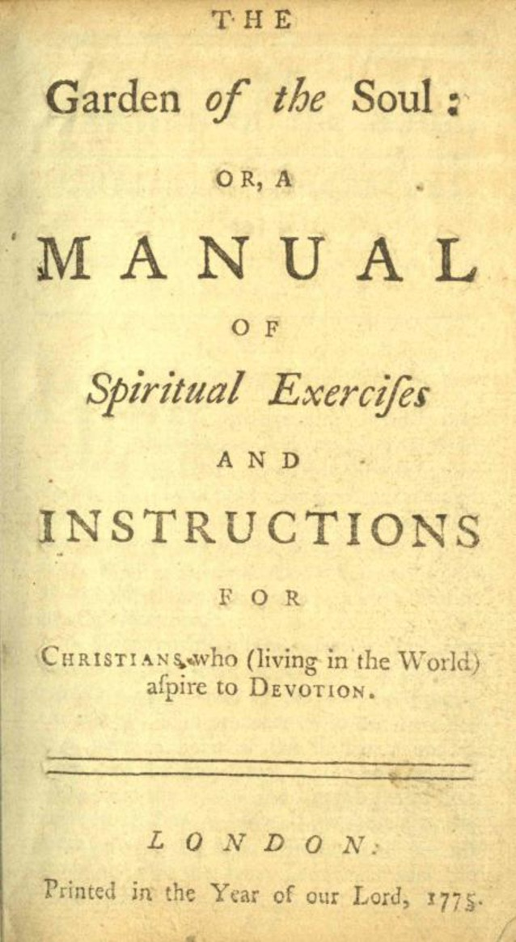
Figure 8 The Garden of the Soul; or, A Manual of Spiritual Exercises and Instructions, was given to Roman Catholic convicts, along with The Poor Man’s Catechism, in place of protestant tracts in the early 1850s.
View description - Figure 8 The Garden of the Soul; or, A Manual of Spiritual Exercises and Instructions, ...
View description - Figure 8 The Garden of the Soul; or, A Manual of Spiritual Exercises and Instructions, ...

Even religious works were intensely scrutinised. The Garden of the Soul and The Poor Man’s Catechism, religious books selected for Roman Catholic prisoners, had to be published in a different edition for prisons after a prison governor objected to ‘certain passages suggesting indecent ideas’ (Fyfe, 1992, p. 84).
Even the Bible presented problems for prison officials. As early as 1828, George Holford, one of the managers of Millbank Penitentiary, expressed concern that prisoners left alone with the Bible would view it ‘merely as a storybook, to choose out such parts as shall afford him entertainment, and even to dwell upon those chapters or expressions which, in his ignorance, and with his bad dispositions, he may misinterpret into something like a sanction or precedent for his own acts of vice or folly’ (Holford, 1828, p. 160).
The prison library represented an ideal opportunity to shape common reading tastes. Through a carefully chosen catalogue, prisoners could be taught what they should read. Yet, however hard they tried, prison officials could not dictate precisely how a book should be read, nor how it should be interpreted, by the individual.

Activity 3 Accessing books in the library
Allow approximately 10 minutes for this activity

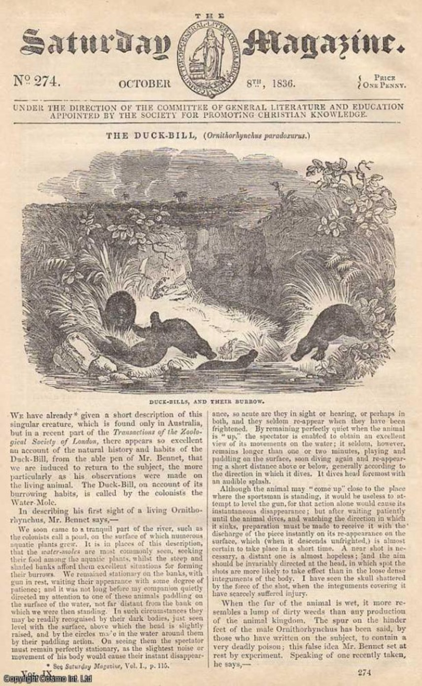
Figure 9 Front cover of The Saturday Magazine, published by the Society for the Promotion of Christian Knowledge. From 1832, the SPCK published a range of secular books and magazines. The idea behind The Saturday Magazine was to provide a cheap weekly publication which was full of ‘useful knowledge’ but was also entertaining and engaging. This issue, dated 8 October 1836, featured an article on the Australian platypus.
View description - Figure 9 Front cover of The Saturday Magazine, published by the Society for the Promotion ...
View description - Figure 9 Front cover of The Saturday Magazine, published by the Society for the Promotion ...

The following extract is from a report by an inspector of prisons on Lancaster Castle County Gaol. It was published in 1837. Read the extract, and make some notes on the information it provides about access to the prison library.

A circulating library has been formed in the prison, under the superintendence of the chaplain; it was first commenced by donations of books, but others were subsequently added by purchase: among the books are Constable’s Miscellany and others of a similar description. They are selected from a catalogue by the prisoners themselves, or at their desire by the schoolmaster, and are changed every Saturday. The usual choice is for books of a short, or entertaining character, [such] as history, voyages, travels. The Saturday Magazine is oftener called for than any other publication. The females are likewise permitted the use of the library, but are restricted to works of a religious tendency. The matron states “that the females refuse to avail themselves of the books, saying they want some of a livelier sort”.
(Inspectors, Northern & Eastern, 2nd Report, 1837, p. 43)

Provide your answer...
View discussion - Activity 3 Accessing books in the library

5 Borrowing books
As suggested by the report on Lancaster County Gaol, the existence of a library in a prison did not mean that all prisoners were able to borrow books, or the books they wanted, from it. At many local prisons, access to the library was limited to prisoners who could read.
At Northampton County Gaol in the late 1840s, prisoners serving long sentences were given a wider choice than those serving shorter sentences who could only access religious books (Inspectors, Midland & Eastern, 13th Report, 1847–48, p. 82). Good behaviour also seems to have determined access in many local prisons.

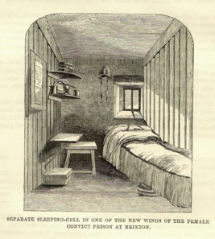
Figure 10 Separate cell in Brixton female convict prison in the late 1850s. On the top shelf is a pile of books. It is impossible to tell if library books are included in the pile, or if it contains just the religious books which were left in cells for prisoners. Female prisoners at Brixton and Fulham convict prisons were given 45 minutes in the evening to read before lights out.
View description - Figure 10 Separate cell in Brixton female convict prison in the late 1850s. On the ...
View description - Figure 10 Separate cell in Brixton female convict prison in the late 1850s. On the ...

In the 1840s, convicts at Millbank and Pentonville (opened 1842) were each given a library book in addition to devotional books (Bible, Prayer Book and Hymn Book) and a certain number of schoolbooks, all to use in their cells.
At Parkhurst Juvenile Prison, the boys were not permitted to have books in their cells or dormitories. Only boys who behaved well were given the privilege of reading a library book in the evening (Reports relating to Parkhurst Prison, 1849, p. 14). At Mountjoy Prison, Dublin’s Pentonville, which opened in 1850, more stringent restrictions were applied. To receive a library book, a prisoner had to:

- pay attention to instruction imparted by the teacher at school
- if competent, write out the substance of lessons and lectures delivered in school
- practice the moral qualities inculcated by the teachers.
(Fyfe, 1992, p. 170)

In 1856, the Rev. Kingsmill (Pentonville’s second chaplain) proposed the removal of library books from all prisoners except for a small class of the best educated. ‘Most only cull the stories out of the library books,’ he wrote, ‘and many grievously abuse them’ (Directors of Convict Prisons Report, 1857, p. 20). His plan was blocked by one of the prison’s directors, but there was damage to books. Prisoners tore pages out of books when they needed paper and scribbled between the text in the hope of passing on a message.
After the introduction of book-inspection systems, chaplains noticed that prisoners took better care of the books. Incidents of wilful damage were reduced largely to those in which prisoners, when venting their anger or frustration, threw whatever objects they could find in their cells.
The authorities were well aware of the value of books and reading to many prisoners. Accounts of positive and in some cases transformational reading experiences can be found in different types of sources describing life in prison. The governor at Hamilton Prison in Scotland recorded the following incident in his journal on 27 October 1845:

I was much gratified to day by learning the following interesting circumstances. The first act of a person who was liberated this morning was to go spontaneously to a stationer’s shop and purchase several of Chambers’ Miscellany of Tracts. I believe that during the time he was imprisoned here, he acquired a taste for reading, and a thirst for knowledge, which he would never otherwise have had. He was exceedingly anxious to obtain Tract No. 2 (a Tale of Norfolk Island), stating that he meant to read it to the villagers of his acquaintance who had never heard of such things.
(Inspectors, Scotland, 12th Report, 1847, p. 99).

Of course, we must be cautious when using statements about prisoners’ reading which appear in records kept by officials. Still, there must have been some truth in their claims of the pleasure that many prisoners derived from reading because, when the authorities wanted to increase the pain of imprisonment, the prison library and access to books were obvious targets.
Books in prisons could be used by prisoners who could read to practise their skills and learn on their own. They could also be offered as reward for good behaviour. While the Bible, or at least most parts of it, was considered essential reading by prison officials, they recognised that too much religious reading could be unhealthy. They also provided books to aid self-improvement, to expand secular knowledge, and even to entertain with tales of upright, loyal behaviour.
Those who did read the books did not necessarily receive the messages that the author, or the authorities, hoped they would. Books mean different things to different people. The Bible could provide a powerful message of salvation through repentance. It could also be read as a collection of captivating stories. Once a book was in the hands of a prisoner, it was the reader who had control over the meanings derived from it.

Activity 4 Reflecting on your learning
Allow approximately 15 minutes for this activity

In Session 2 you were introduced to one form of reflection. Here is another way to structure your reflection. You are welcome to use either, or both suggestions. Below are the main topics you covered in Session 4. One way to structure your reflection on this part of the course is to complete the grid below, scoring on a scale of 1 (negative) to 5 (positive).

Table 1: Reflection table
 | How interesting was this section? | How much did I understand about this section? | How useful was this section?
Section |  |  | Provide your answer...
1 Books behind bars | Provide your answer... | Provide your answer... | Provide your answer...
2 Reading in seclusion | Provide your answer... | Provide your answer... | Provide your answer...
3 Expanding the prison library | Provide your answer... | Provide your answer... | Provide your answer...
4 Censorship | Provide your answer... | Provide your answer... | Provide your answer...
5 Borrowing books | Provide your answer... | Provide your answer... | Provide your answer...
Activities | Provide your answer... | Provide your answer... | Provide your answer...
1 Notes on the video | Provide your answer... | Provide your answer... | Provide your answer...
2 Bible reading | Provide your answer... | Provide your answer... | Provide your answer...
3 The dangers of reading | Provide your answer... | Provide your answer... | Provide your answer...
4 Accessing books in the library | Provide your answer... | Provide your answer... | Provide your answer...

Revisit any topics that you scored 3 or less for ‘how much you understood the topic’. For any sections which you scored 1 or 2 for interesting, make a note about how the course might be improved.
For any sections which were not useful, try to imagine why that exercise or information was included and if you can relate the section to the learning outcomes. Once you have done this for Session 4 you can adopt the procedure for other sessions.

6 This session’s quiz
It’s now time to complete the Session 4 badged quiz. It’s similar to the previous quizzes but this time instead of there being 3 questions there are 15, covering Sessions 1 to 4.
Session 4 compulsory badge quiz
Remember, this quiz counts towards your badge. If you’re not successful the first time, you can attempt the quiz again 24 hours later.
Open the quiz in a new tab or window by holding down Ctrl (or Cmd on a Mac) when you click on the link. Return here when you have finished.

7 Summary of Session 4

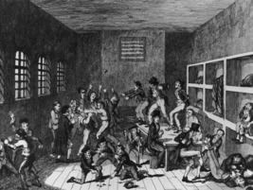
Figure 11 This image of a small prison, in which most of the prisoners were debtors, indicates that it was relatively clean and there was a lot of violence. From your studies, do you think this is an accurate portrayal?
View description - Figure 11 This image of a small prison, in which most of the prisoners were debtors, ...
View description - Figure 11 This image of a small prison, in which most of the prisoners were debtors, ...

In this session, you have learned about how books and libraries provided another means of educating prisoners during the 1800s. Prisoners were gradually offered a wider variety of text beyond the Bible and Christian tracts. While control was still exercised over which books would be made available, for some prisoners, often the literate and well-behaved, there was a choice of reading matter. Books provided prisoners with opportunities to improve their literacy skills and to gain new knowledge. Books could also affect prisoners’ mental health in positive and negative ways.
You should now be able to:
- identify other forms of learning and self-improvement outside the prison school
- discuss debates about the suitability of reading matter for prisoners
- describe how prisoners accessed and used the books available to them.
You are now halfway through the course. The Open University would really appreciate your feedback and suggestions for future improvement in our optional end-of-course survey, which you will also have an opportunity to complete at the end of Session 8. Participation will be completely confidential and we will not pass on your details to others.
In Session 5, there will be opportunities to look more closely at the results of efforts to educate prisoners. Were prisoners becoming more literate and more knowledgeable as a result of forms of education provided in the prison? Were prisoners who received instruction less likely to reoffend?
You can now go to Session 5.

Session 5: Systems of measurement

Introduction
In Session 1 you learned that at the beginning of the 1800s many believed there was a relationship between criminal behaviour and illiteracy. However, there was little evidence to support this claim. By the late 1830s, the literacy of every man, woman and child committed to prison was being recorded and numerical summaries of this information were being published, annually, by the Home Office.
In this session, you will learn about the reasons why data on the education of prisoners on committal (their arrival at prison) was collected locally and nationally and you will look at how it was used. You will also look at systems of measurement used to capture the effectiveness of the prison school. How many of those who arrived at prison unable to read and write learned these skills before their release? If prisoners became more literate, did they also become less criminal?
By the end of this session, you should be able to:
- explain the reasons for the collection of data on prisoner literacy and the various uses to which it was put
- assess and use tables and graphs containing statistical evidence
- discuss the merits and drawbacks of systems of measurement for assessing prisoner literacy and rehabilitation.
Let’s start at the beginning, with the arrival of new prisoners at prisons during the 1800s. In the video for this session, Rosalind Crone visits the reception cell at Lincoln Castle Gaol. What happened to prisoners on arrival? Why was there such an interest in recording information about them? Make some brief notes in answer to these questions to prepare for Activity 1 (in the next section).

Video content is not available in this format.
View transcript - Uncaptioned interactive content

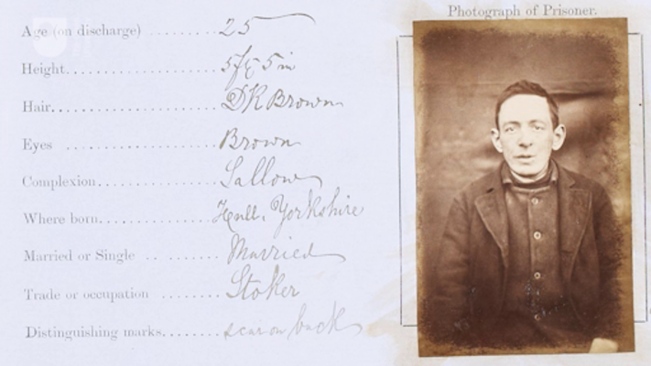

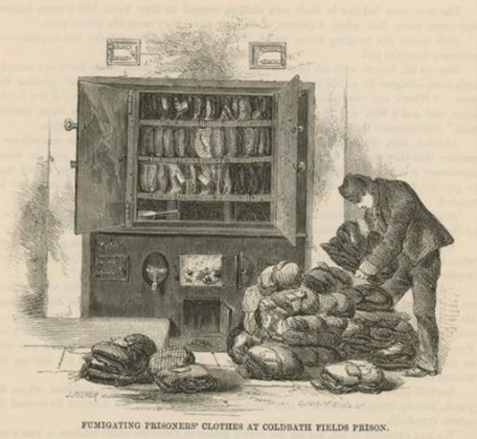
Figure 1 On arrival at Coldbath Fields House of Correction, prisoners were required to surrender their clothes and put on a uniform. Their clothes were then fumigated with sulphur, to get rid of any vermin which might be present. Next, they were tied in a bundle, and a wooden label was attached to indicate who owned it. The clothes were returned to prisoners on their release.
View description - Figure 1 On arrival at Coldbath Fields House of Correction, prisoners were required ...
View description - Figure 1 On arrival at Coldbath Fields House of Correction, prisoners were required ...

1 Prison registers
In the early 1800s, officials at local prisons had significant latitude to design their own systems of record-keeping. At just about every prison there was a register (sometimes called a receiving book) to record the arrival and departure of prisoners. Some officials found they could not squeeze all the information they wanted into the register, and so invented new types of records to store additional details about prisoners. Officials at Ilchester County Gaol in Somerset, England kept both a ‘prison register’ and a ‘description book’.

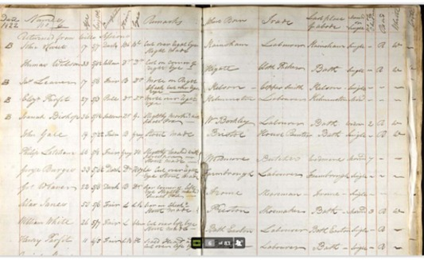
Figure 2 A page from the Ilchester County Gaol description book dated January 1822.
View description - Figure 2 A page from the Ilchester County Gaol description book dated January 1822. ...
View description - Figure 2 A page from the Ilchester County Gaol description book dated January 1822. ...

Box 1 Notes for reading Figure 2
Handwriting from the early 1800s can be hard to read, so here are some notes to help you to decode Figure 2 if you need them.
The names of prisoners incarcerated in the gaol are provided in the second column. There is a note at the top of the list which says ‘Returned from Wells Sessions’, meaning that the men in this list have returned to the prison having been convicted at their trial held in the courthouse at Wells. They had probably been held on remand (awaiting trial) at Ilchester Gaol before their conviction.
The titles of the other columns in the description book are as follows (left to right): age, height, complexion, hair, eyes, remarks (used in this book to record further physical characteristics, such as scars, moles and tattoos), where born, trade, last place of abode (i.e. residence), married or single, number of children, read, and write.

Activity 1 Recording education in prison registers
Allow approximately 10 minutes for this activity

Using the information in the Ilchester Gaol description book (Figure 2 and associated notes), try to answer the following questions:
- Can you identify the column(s) in which information about a prisoner’s previous education was noted?
- What types of information being collected here would support the argument that prison registers were used to increase the control of the state over the lives of individuals?
- What types of information being collected here would support the argument that prison registers were an early form of ‘criminology’, the study of criminal lives in order to better understand the causes of crime?
- Can you think of any other reason for collecting information on the previous education of prisoners?

Provide your answer...
View discussion - Activity 1 Recording education in prison registers

2 Evidence-based policymaking
The general election of 1830 brought a new ‘Whig’ (predominantly liberal political party) government to power in the United Kingdom. Widespread political and social reform was at the top of their agenda.
They began with tackling political corruption by redrawing electoral boundaries and extending the franchise (right to vote) to the large sections of the growing ‘middle class’. Next, the government turned its attention to the social crisis being caused by industrialisation and rapid urbanisation. Poverty had expanded, the living conditions of the working classes had deteriorated, recorded crime continued to rise, and expressions of discontent were mounting.

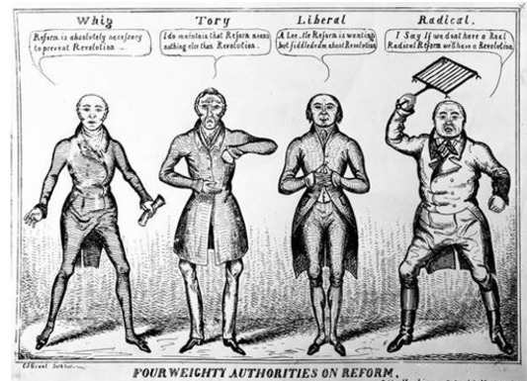
Figure 3 A cartoon featuring representatives from the four major political groups (not parties) in the UK Parliament in the early 1830s. Each gives his (there were no female MPs) view on Reform: a Whig, Charles Grey (1764–1845) says ‘Reform is absolutely necessary to prevent Revolution’; a Tory, the Duke of Wellington (1769–1852) says ‘I do maintain that Reform means nothing else than Revolution’; a Liberal, possibly John Lee Lee (1802–74) says ‘A Leetle Reform is wanting but fiddlededee about Revolution’; a Radical, William Cobbett (1763–1835) brandishing a gridiron says ‘I say if we don’t have a Real Radical Reform we’ll have a Revolution’.
View description - Figure 3 A cartoon featuring representatives from the four major political groups ...
View description - Figure 3 A cartoon featuring representatives from the four major political groups ...

However, in a marked departure from any UK government that had preceded them, the ruling Whig politicians wanted evidence – both comprehensive and reliable – on which to base their social policy. The search for quantitative evidence – namely statistics – was given priority. Some government departments were asked to revise and expand the statistical series they already compiled. In 1832, a new government Statistical Department was established within the Board of Trade. From 1833, new statistical societies were founded in London, Manchester and other provincial towns to support the civil service and supply the necessary numbers.
The expansion of education was once again looked to as a solution for social ills. A national system of elementary schooling had been established in Ireland in 1831 and there was appetite for something similar in England and Wales. The government resisted, claiming that there was a lack of evidence to suggest that such an expensive intervention was necessary. Instead, in August 1833, Parliament approved a Treasury grant of £20,000 to aid the building of schoolhouses by the National School Society (Church of England) and the British and Foreign School Society (non-conformist) for the education of the poor. This marked the beginning of state-funding for mainstream education in England and Wales. It also made the need for educational data more urgent as the government wanted to measure the effects of state intervention.
National surveys of schooling facilities were proposed. The new statistical societies spent large amounts of money on local surveys. While debating and waiting for the results of these initiatives, educational reformers and policymakers discovered another potential source of data: prisons. From the early 1820s, prison chaplains had been using the information on literacy contained in the prison registers to fulfil the legislative requirement to comment on the condition of prisoners in their annual reports. The number of incarcerated men and women at particular prisons who could read, read and write, or possessed neither skill began to appear in parliamentary debates on education and in reformist literature.

3 Expanding the Criminal Returns
The search for educational data and the growing awareness of the potential utility of prisons and prisoners coincided with the reorganisation of the national criminal statistics (known as the Criminal Returns) by the Home Office in 1833 to 1834. This work initially focused on the categorisation of indictable offences (crimes tried before a jury) in order to enable better analysis. In 1834, a decision was made to go further and include information on the personal characteristics of criminals – namely their sex, age and literacy – in the Criminal Returns.

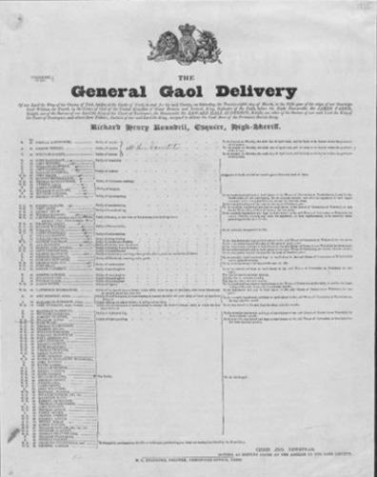
Figure 4 A Criminal Calendar for the County of York, which features a list of prisoners tried at the York Quarter sessions on 28 March 1835. The literacy of each prisoner is recorded to the left of their name and age. Just under half were found ‘not guilty’ and released.
View description - Figure 4 A Criminal Calendar for the County of York, which features a list of prisoners ...
View description - Figure 4 A Criminal Calendar for the County of York, which features a list of prisoners ...

On 31 October 1834, a Home Office circular was sent to all the governors of prisons in England and Wales asking them to place, in their Criminal Calendars (lists of prisoners about to go to trial), against the name of each individual prisoner:

- a ‘W.R.’ for those who could read and write
- an ‘R’ for those who could read only
- an ‘N’ for those with neither skill
(Home Office Circular to Keepers of Prisons, 1834).

Not every keeper complied with the request, but many did, possibly because such information was already available in a large number of prison registers. The result of the initiative – national statistics on prisoner literacy – first appeared in the Criminal Returns for 1835 (published in 1836).

Activity 2 Literacy in the Criminal Returns for 1835
Allow approximately 10 minutes for this activity

Below is a summary table created from the information in the Criminal Returns for 1835 (Table 1).
It gives the proportion of male and female prisoners committed for trial who could read and write, who could read only, who could neither read nor write, and for whom literacy could not be ascertained. Look at the table now, and consider the following questions:
- ‘Literacy comprises two skills: the ability to read and the ability to write.’ With this in mind, how literate were prisoners tried for indictable offences in 1835?
- What differences can you see between male and female prisoners?
- Can you see any problems with the categories being used here?

Table 1 Literacy of persons committed for trial or bailed, 1835
 | % Read and write | % Read only | % Neither read nor write | % Literacy not ascertained
Males | 46 | 18 | 33 | 3
Females | 26 | 34 | 38 | 2
(Source: Criminal Offenders (England & Wales) 1835, 1836, p. 113)

Provide your answer...
View discussion - Activity 2 Literacy in the Criminal Returns for 1835

Officials were aware of problems with the categories. In December 1835, new instructions were sent to governors of prisons in England and Wales, asking them to use the following scheme which graded prisoner literacy:
- ‘N’ for those who could neither read nor write
- ‘Imp’ for those who could read, or read and write imperfectly
- ‘Well’ for those who could read and write well
- ‘Sup’ for those who had a superior education.
Meanwhile, in 1836, a new statistical series was created – the Digest of Prisons – which included data on the literacy of all those committed to local prisons either to await trial or to serve sentences of imprisonment. For the Digest, literacy was also graded (i.e. N, Imp, Well, Sup).
The need to grade literacy increased the testing of prisoners and introduced a degree of subjectivity, or ‘observer bias’, into the data. This did not detract from the value of the statistics which were primarily being used to measure the literacy of the unskilled working class, from which many prisoners came, and for which there was, for much of the 1800s, no alternative system of measurement.

4 Interpreting and using the data
The statistical movement of the 1830s and 1840s was motivated by a set of moral preoccupations. Crime, drunkenness, illegitimacy and political unrest were seen as consequences of increasing immorality among the working classes caused by a lack of education, poor sanitation and overcrowding. Of all the possible interventions available, education was regarded as critical to the creation of a more moral society. Mere instruction in how to read and write was not enough, the statisticians argued. For education to be of any value, it had to include the teaching of morality, preferably through religious instruction.

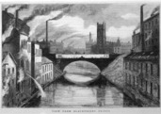
Figure 5 Manchester was so affected by rapid industrialisation and urbanisation that it became known as Britain’s ‘shock city’. Factories poured smoke into the air and pollutants into the water. Many of the workers lived in slum conditions.
View description - Figure 5 Manchester was so affected by rapid industrialisation and urbanisation that ...
View description - Figure 5 Manchester was so affected by rapid industrialisation and urbanisation that ...

These preconceptions shaped both the collection and the interpretation of prisoner literacy data. Grading was introduced precisely to avoid the misinterpretation of the statistics. Large numbers of prisoners were described as having imperfect reading and writing skills (see Table 2). As a result, the correlation between illiteracy and crime was extended to include semi or poor literacy as well.

Table 2 Literacy of persons committed for trial or bailed, 1836–1838 (%)
 | 1836 | 1837 | 1838
Unable to read and write | 33.52 | 35.85 | 34.40
Able to read, or read and write imperfectly | 52.33 | 52.08 | 53.41
Able to read and write well | 10.56 | 9.46 | 9.77
Instruction superior | 0.91 | 0.43 | 0.34
Instruction could not be ascertained | 2.68 | 2.18 | 2.08
(Source: Criminal Offenders (England & Wales) 1838, 1839, p. 4)

Prison chaplains provided social policymakers with additional evidence to aid their interpretation of the prisoner literacy data. Tables in their reports highlighted the lack of religious knowledge possessed by those prisoners graded ‘imp’ and even ‘well’. Even more significant were their surveys of schools attended by prisoners. Large numbers had received their ‘imperfect’ education at schools run by the National Society or the British and Foreign Society which had been given tax-payers’ money. In 1846, the Rev. John Clay at Preston House of Correction declared that ‘no one sees more clearly than the chaplain to a gaol that public education is lamentably imperfect’ (Gaol Act Reports, 1847, p. 120).
In 1839, the prominent Whig politician, Lord John Russell, used the data on prisoner literacy and schooling to win Parliamentary support for the establishment of an inspectorate of schools in order to raise the quality of education in state-subsidised schools. At the same time, the association of imperfect education with criminal activity provided new ammunition for those who argued that any system of national elementary education must include religious instruction supplied by the Church of England. However, MPs who belonged to other Christian denominations insisted that national elementary education should be non-denominational. As a result, the introduction of universal schooling in England and Wales was delayed until the 1870s (Crone, 2022, ch.2).

5 Illiteracy – a criminal problem?
From the 1830s to the 1850s, prisoner literacy data was used by policymakers to shed light on the spread and quality of popular education in England and Wales and to guide their interventions. In 1856, the introduction of a new series of national criminal statistics – the Judicial Statistics – which continued to include prisoner literacy data reaffirmed the commitment of civil servants and penal administrators to the collection of this information. However, doubts emerged about how useful this data would be to the outside world.
From 1839, annual reports of the Registrar General for Births, Deaths and Marriages included the number of brides and grooms who had signed the marriage register with a mark (for example, an X), indicating that they could not write, and therefore were illiterate. By counting these marks, the first report published in 1840 estimated that 67% of males and 51% of females in England and Wales were literate. As an annual measure of population literacy for the whole country which was free from ‘observer bias’, marriage registers superseded other forms of measurement, such as prisoner literacy (Vincent, 2014).
The late 1850s witnessed the passing of a generation of prison chaplains who had played a leading role in the interpretation of prisoners’ educational attainments. In 1861, the advent of the Revised Code – a new system of instruction in reading, writing and arithmetic introduced in state-subsidised schools – generated a new scheme of graded literacy and numeracy for policymakers and reformers to experiment with. Prisoner literacy rates were notably absent from debates surrounding the establishment of a universal system of elementary schooling in England and Wales in 1870, and the advent of compulsory elementary education in 1880.

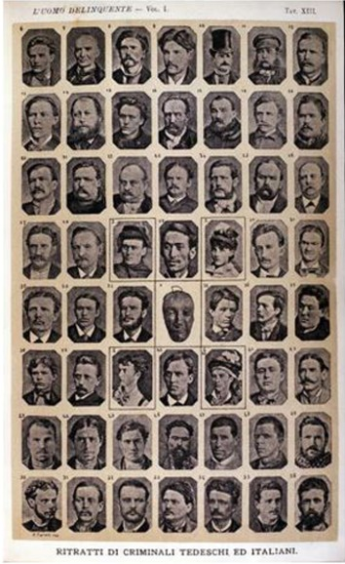
Figure 6 Portraits of German and Italian criminals. Album of photographs gathered by Cesare Lombroso (1835–1909), Italian criminologist, for his book, The criminal man, 1875. Lombroso believed that criminality was hereditary and that criminals could be identified by physical defects. Lombroso’s work lent a scientific basis to the idea of the existence of a ‘criminal class’ and influenced some early criminologists in Britain.
View description - Figure 6 Portraits of German and Italian criminals. Album of photographs gathered ...
View description - Figure 6 Portraits of German and Italian criminals. Album of photographs gathered ...

However, in the 1880s prisoner literacy rates found a new audience: positivist criminologists. Whereas previously, crime had been regarded as a choice committed by immoral individuals, positivist criminologists argued that the criminal was fundamentally different from law-abiding citizens.
He or she was the product of external forces which acted on his or her will; for example, their physical environment, or their physical and mental constitutions. Crime was not committed by immoral individuals who shunned honest labour. It was the result of ‘inherited or physical deficiency’ (Bailey, 2019, pp. 19–20; Wiener, 1990, pp. 236–44).

Activity 3 Interrogating the statistics
Allow approximately 20 minutes for this activity

The Rev. William Douglas Morrison, chaplain at Wandsworth Prison, was heavily influenced by positivist criminology. In his book, Crime and its Causes (1891), Morrison used data on population literacy from the marriage registers and data on prisoner literacy from the Judicial Statistics to investigate the relationship between crime and illiteracy.
He drew attention to the fact that, in 1881–84, while 85.5% of the general population could read and write (as he gleaned from marriage registers), 72% of prisoners could only read and write imperfectly and 25% could not read and write at all. The difference, he claimed, could not be explained by the defective early training of the prisoners. Instead, it showed that:

… a certain number of criminals are almost incapable of acquiring instruction. The memory and reasoning powers of such persons are so utterly feeble that attempts to school them are a waste of time.
(Morrison, 1891, pp. 194–5)

Part 1

Consider the following question:
- Can you see any flaws in Morrison’s comparison of these two data sets?

Provide your answer...
View discussion - Part 1

Part 2

Now take a look at the two graphs (Figures 7 and 8) below which compare, respectively, the proportion of grooms and brides who signed the marriage register with a mark with the proportion of those committed to prison who could neither read nor write.
- Are there any trends in these graphs which could be used to challenge Morrison’s conclusions?
The following advice on reading graphs might be helpful. Have a look at the titles of each of the graphs and at what is being represented. Along the horizontal axis, known as the x axis, is time. The y axis, which is vertical, indicates percentages from 0 to 100. One way to remember which is which, is that the letter y has a tail hanging down so the y axis is the one which runs down. The letter x is also a cross so the x axis runs across the page.
Check that the divisions are equal, for example that one centimetre represents 10 years. Sometimes this is not the case. If the data covers a large range of values then sometimes another type of scale is used. Note that there are graphs where the y-axis doesn’t start at 0. Before you decide on the data you wish to discover, take a look at the general trends being depicted.

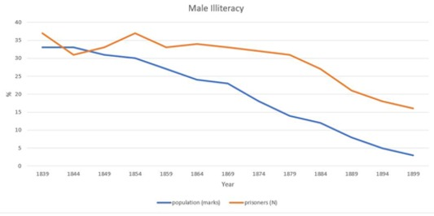
Figure 7 Rates of male illiteracy in England and Wales derived from prisoner literacy statistics and the marriage registers, 1839–1899.
View description - Figure 7 Rates of male illiteracy in England and Wales derived from prisoner literacy ...
View description - Figure 7 Rates of male illiteracy in England and Wales derived from prisoner literacy ...

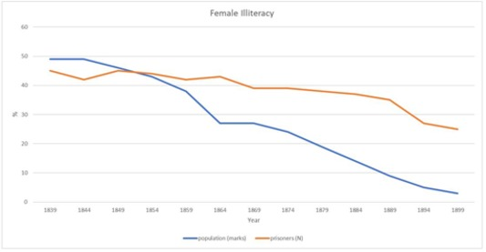
Figure 8 Rates of female illiteracy in England and Wales derived from prisoner literacy statistics and the marriage registers, 1839–1899.
View description - Figure 8 Rates of female illiteracy in England and Wales derived from prisoner literacy ...
View description - Figure 8 Rates of female illiteracy in England and Wales derived from prisoner literacy ...

Provide your answer...
View discussion - Part 2

There were many reasons for prisoner illiteracy in the late 1800s. Some prisoners did struggle to learn to read and write, possibly because they had special educational needs. After around 1850, chaplains and penal administrators were becoming more aware of ‘mental incapacity’ as those who could not read and write were increasingly forced to learn in prison. There were some limited attempts to cater for those with learning disabilities. A small number of prisoners were excluded from school after being ‘diagnosed’ as incapable of learning.
There were also many prisoners who had not attended school, even after the advent of compulsory education. Elementary schooling did not become free until 1891. Sending a child to school deprived the household of their financial contribution. Many who did attend school left at about age 11, the limit of compulsory education, with little more than a basic competence in reading, writing and arithmetic. If these skills were not used regularly, they deteriorated.

6 Measuring the effectiveness of the prison school
The establishment of prison schools in the early 1800s not only triggered the collection of data on prisoners’ pre-existing educational attainments. It also prompted prison authorities to develop new systems of record-keeping to monitor instruction, and it encouraged some officials to summarise the outcomes of prison education.
By the 1820s, the schoolmaster at Millbank Penitentiary was maintaining an account of the progress each prisoner was making at school in registers modelled on those in use at the Central National School (the training school run by the National Schools Society) (Holford, 1828, p. 151). In his report for 1825, the chaplain at Durham County Gaol wrote, ‘Since my last general report, 58 prisoners have attended the school, 26 of whom have been taught to read and write; the rest, who could read a little, have improved themselves in both reading and writing’ (Gaol Act Reports, 1826, p. 82).

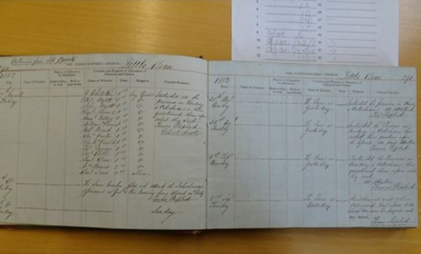
Figure 9 Two pages from the journal of the schoolmaster, Thomas Shepherd, at Littledean House of Correction in Gloucestershire. Shepherd gave an account of the progress being made by prisoners at each lesson, as well as a summary of what was taught (on the days shown here, mainly reading and the Catechism). The journal likely served two purposes: to monitor the progress made by prisoners, and to enable the chaplain to keep an eye on the schoolmaster.
View description - Figure 9 Two pages from the journal of the schoolmaster, Thomas Shepherd, at Littledean ...
View description - Figure 9 Two pages from the journal of the schoolmaster, Thomas Shepherd, at Littledean ...

The enthusiasm for numbers in the 1830s as a means of evaluating the effectiveness of government policy enlarged and expanded these early efforts. Prison inspector Frederic Hill encouraged local officials to record the abilities of prisoners at admission and discharge in an ‘Educational Register’. Regulations for local prisons published in 1840 and the rules for Pentonville Prison (1842) required schoolmasters and schoolmistresses to submit written reports on the conduct and progress of prisoners to the chaplain at regular intervals (Regulations for Prisons in England and Wales, 1840, rule 183; Rules for the Government of the Pentonville Prison, 1842, rule 161). Governors and surgeons also recorded data about prisoners.
From the mid-1830s, tables which summarised the outcomes of learning in prison schools began to appear in the annual reports of prison chaplains and prison inspectors. These sat alongside other numerical descriptions of the results of religious instruction – for example, the number of prisoners permitted to take Holy Communion – and the products of prisoners’ labour – from the number of boots, mats or jackets made to the quantities of stone broken in quarries for the construction of naval defences (Vincent, 2020, pp. 144–5).

Activity 4 Evaluating the results of the prison school
Allow approximately 20 minutes for this activity

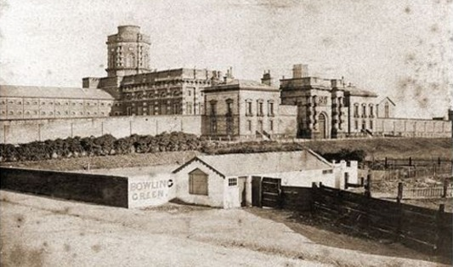
Figure 10 Manchester Borough Gaol, also known as Belle Vue Prison, was opened in 1849. It was a large prison and held, on average, between 420 and 780 prisoners at a time between 1853 and 1883. It was, however, considered largely unfit for purpose. The prison closed in 1887 and was demolished in 1892.
View description - Figure 10 Manchester Borough Gaol, also known as Belle Vue Prison, was opened in ...
View description - Figure 10 Manchester Borough Gaol, also known as Belle Vue Prison, was opened in ...

In his report on Manchester Borough Gaol published in 1851, prison inspector Herbert Voules included a table compiled by the prison chaplain which summarised the progress made by prisoners who had attended the prison school. This is reproduced below (Table 3).
- What does this table suggest is taught in the prison school? (Hint: it might be useful to know that ‘learning to cipher’ meant instruction in arithmetic.)
- Does the table suggest that prisoners make much progress in their learning? (Hint – you’ll need to compare the ‘entrance’ and ‘discharge’ columns for each area of learning.)
- According to the table, what is the single biggest factor affecting the progress of prisoners?

Table 3 The state of education of 198 male prisoners discharged from Manchester Borough Gaol between July and September 1850. Source: Inspectors, Northern & Eastern, 17th Report, 1852–53, p. 40 (note: cipher = arithmetic).

Access the following link to see a larger version of this table.

Provide your answer...
View discussion - Activity 4 Evaluating the results of the prison school

It is worthwhile comparing the results from Manchester Borough Gaol with those from Pentonville Prison published in 1847 (see Table 4). The progress made by most convicts at Pentonville was substantial, especially in arithmetic. However, these convicts had been confined at Pentonville for about 18 months, attended school there for four hours each week, had time set aside for private study, and the most illiterate received extra tuition from the schoolmasters.

Table 4 Summary of the improvement of the first 1000 convicts received into Pentonville Prison
Reading
On Admission |  | On Removal
Read well | 432 | Read well | 823
tolerably | 166 | tolerably | 129
imperfectly | 220 | imperfectly | 40
scarcely at all | 76 | scarcely at all | 8
not at all | 106 | not at all | 0
 | 1000 |  | 1000
Writing
Write well | 240 | Write well | 521
tolerably | 124 | tolerably | 316
imperfectly | 192 | imperfectly | 110
scarcely at all | 91 | scarcely at all | 45
not at all | 353 | not at all | 8
 | 1000 |  | 1000
Arithmetic
Higher rules | 102 | Higher rules | 713
All common rules | 61 | All common rules | 127
To multiplication | 79 | To multiplication | 81
To addition | 119 | To addition | 57
Scarcely at all | 639 | Scarcely at all | 22
 | 1000 |  | 1000
General Knowledge
Considerable | 165 | Considerable | 696
Some | 314 | Some | 254
A little | 226 | A little | 39
Scarcely any or none | 295 | Scarcely any or none | 11
 | 1000 |  | 1000
(Source: Commissioners of Pentonville Report, 1847, p. 45)

It could also be argued that the categories used at Manchester Borough Gaol to describe the progress made by prisoners at school hid some of their achievements. Chaplains at other prisons provided a more granular account of progress. For example, 117 prisoners at Springfield County Gaol made progress in learning to read in 1844. Of these, only 21 learned enough to read the New Testament (about the level of reading tolerably). Of the remainder, 39 learned to read easy lessons, 22 learned to read words of one syllable, 6 learned to join letters, and 29 only learned the alphabet (Gaol Act Reports, 1845, p. 50).
Although representing progress, these skills were fragile and easily lost if not practised. In 1845, an officer at Wakefield House of Correction explained that although prisoners made considerable progress, especially in writing and arithmetic, ‘on recommittal we find they have lost the greatest part of what they had acquired in prison’ (Inspectors, Northern & Eastern, 11th Report, 1846, p. 42).

7 Evidence of rehabilitation
Throughout the 1800s, summaries of prison school outcomes suggest that many prisoners – especially when imprisoned for long enough – did improve their skills in reading, writing and arithmetic. At least until 1860, many also expanded their religious knowledge and, to a lesser extent, their secular knowledge. Learning provided an opportunity, a set of tools, which prisoners could use to build better – and less criminal – lives outside of prison, but it was not in itself evidence of reform or rehabilitation.
In 1847, government commissioner Jelinger Symons declared that, although ‘esteemed by many educated people as at least highly satisfactory educational progress’, numerical statements of the number of prisoners who had learned to read, or of the number of Biblical verses that had been memorised, provided no evidence of reform (Symons, 1847, pp. 44–5). Some prison chaplains reported that although prisoners made good progress in acquiring or improving their literacy and numeracy, they showed no signs of moral improvement.

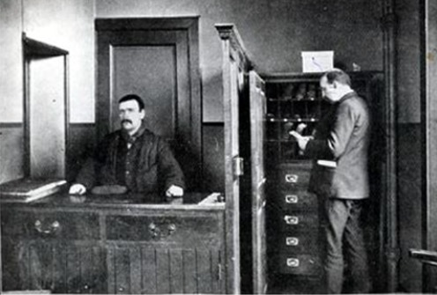
Figure 11 Recognising the difficulties faced by released prisoners in gaining employment and accommodation, from the early 1800s philanthropic societies were established to offer support. By the middle of the 1800s these had evolved into more formal Discharged Prisoners’ Aid Societies attached to local prisons, and eventually to districts. They were recognised by statute in 1862. The Glasgow Discharged Prisoners’ Aid Society, pictured here, was established in 1856.
View description - Figure 11 Recognising the difficulties faced by released prisoners in gaining employment ...
View description - Figure 11 Recognising the difficulties faced by released prisoners in gaining employment ...

There were good intentions. The Rev. J. Dobie, chaplain at Dartmoor Convict Prison, wrote in his annual report for 1855:

School training has, in numberless instances, given a new direction to their minds. Some of them promise me that they will attend evening schools after their discharge on licence, and thus complete what they began in prison, adding a promise that their children also shall be sent to school, even if they have to pinch to raise the money.
(Directors of Convict Prisons Report, 1856, p. 174)

In his journal, the schoolmaster at Yarmouth Borough Gaol expressed hopes for Robert Godfrey, aged 19, who had come to the end of his six-month prison sentence on 21 December 1854:

… he was very ignorant did not know his letters but by attention and perseverance he obtained a good knowledge in reading and writing and at one time signs of the grace of God were visible in his deportment. He made great promises of future amendment and said he had greatly profited by his imprisonment.
(‘Yarmouth Gaol Schoolmaster’s Journal’, 1853–1862)

The real test came after release when prisoners were once again confronted with the realities of life outside prison. The chances were better when there was support. Some chaplains gave Bibles to those who had learned to read and a few helped prisoners to secure employment. The schoolmaster at Norwich Borough Gaol invited prisoners to continue their instruction with him after liberation (Crone, 2022, ch.4). Some former prisoners wrote to chaplains, providing evidence of how prison education had made a positive difference to their lives. The Rev. Dobie claimed that because of the ‘sound, plain education’ that the convicts had received at Dartmoor, many had been able to obtain employment for which they would otherwise have been ineligible (Directors of Convict Prisons Report, 1856, p. 174).
These correspondents were self-selecting. Efforts by chaplains to trace former prisoners for quantitative studies of rehabilitation largely failed. Anecdotal evidence sat uneasily beside rates of re-offending and the educational assessments of re-offenders, who tended to be more literate and numerate than first-time offenders because of their previous experience of the prison school.

8 This session’s quiz
Well done – you have reached the end of Session 5. You can now check what you’ve learned this session by taking the end-of-session quiz.
Session 5 practice quiz
Open the quiz in a new tab or window by holding down Ctrl (or Cmd on a Mac) when you click on the link. Return here when you’ve finished.

9 Summary of Session 5
In this session, you have looked at the origins of prisoner literacy rates. Information about prisoners’ pre-existing educational attainments began to appear in prison registers in about the first decade of the 1800s. While some historians have argued that this information was collected in order to better understand the criminal, there was also a functional purpose: to facilitate instruction in reading and writing.
National collation of this data – annual prisoner literacy rates – was triggered by a need for evidence to support educational policymaking. Preconceptions about crime shaped both the measurement and interpretation of prisoner literacy data throughout the century. Prisoners were not necessarily more illiterate than the general population and the reasons for illiteracy within this community were complex. Systems of measurement were also used to assess the effectiveness of prison education. While many prisoners did learn something, gains were often modest and fragile. Rehabilitation proved to be very difficult – if not impossible – to measure.
You should now be able to:
- explain the reasons for the collection of data on prisoner literacy and the various uses to which it was put
- assess and use tables and graphs containing statistical evidence
- discuss the merits and drawbacks of systems of measurement for assessing prisoner literacy and rehabilitation.
Even if the improved literacy of departing prisoners was no proof of rehabilitation, measurement did provide evidence of useful activity within the prison. At the same time, prisoner literacy rates, especially when compared to the evidence of population literacy in the marriage registers, continued to highlight an educational deficiency among prisoners that needed to be addressed. So, in the 1860s, when a new generation of penal reformers who were sceptical about rehabilitation insisted on making the experience of imprisonment more punishing, the continued association of illiteracy with crime sustained the prison education project.
In the next session, you will look at the content and delivery of education in the context of a changing penal regime.
You can now go to Session 6.

Session 6: Education in a changing penal regime

Introduction
During the 1850s, ‘the reformatory objective in penal policy underwent an almost total eclipse’ (McConville, 1981, p. 347). Doubts were expressed about whether imprisonment could reform convicted criminals and, increasingly, about whether prisons should even try to do so.
By the mid-1860s, new legislation had been passed and penal policy had been reformulated with the aim of ensuring that prisons were places of punishment, which brought habitual criminals under control and which deterred any would-be offenders.

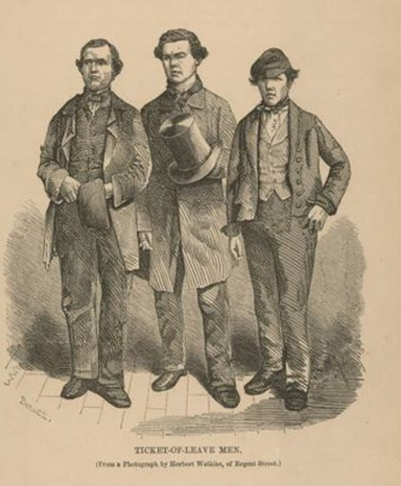
Figure 1 The illustration shows three ‘ticket-of-leave men’ from the 1850s. Convicts granted release on licence (or parole) were commonly known as ‘ticket-of-leave men’. They could marry, but needed to carry their ‘Ticket of Leave’ with them at all times and were subject to recall to prison to serve the remainder of their sentence if they broke the terms of their licence or were convicted of another crime.
View description - Figure 1 The illustration shows three ‘ticket-of-leave men’ from the 1850s. Convicts ...
View description - Figure 1 The illustration shows three ‘ticket-of-leave men’ from the 1850s. Convicts ...

Yet, despite this, education continued to be delivered in prisons. The proportion of prisons with schools continued to rise. The curriculum in many ways was expanded and secularised. Education, in other words, became more deeply entrenched in the penal regime.
This session looks at why and how this happened. First, you will examine the reasons for growing disillusionment with reformatory projects and the increasing emphasis on punishment in the penal regime. Next, you will explore the reasons behind the retention of education. The remainder of the session will look at the impact of policymakers’ desire to punish and deter on teaching and learning inside prisons, including the extent to which the transformative potential of education was undermined.
By the end of this session, you should be able to:
- outline the reasons for a change in penal policy during the 1860s
- explain why education continued to be provided in prisons, and how the desire for a more punitive regime affected its delivery and potential results
- understand the use of Standing Orders in the convict prison sector after 1850
- compare and contrast two primary sources.

1 Penal policy under challenge
What were the reasons for such a dramatic shift in the direction of penal policy during the 1860s?

Activity 1 The causes and effects of change in penal policy
Allow approximately 15 minutes for this activity

Watch the video for this session in which Rosalind Crone explains the development of penal policy in the 1860s and examines its impact on one institution, Lincoln Castle Gaol. As you watch, try to do the following:
- Briefly summarise the causes of the change in penal policy (you could, for example, create a bullet-point list).
- List the key changes in penal policy which focused attention on the punishment, rather than the reformation, of prisoners.
- Summarise the effects of these new measures on imprisonment at Lincoln Castle Gaol.

Video content is not available in this format.
View transcript - Uncaptioned interactive content

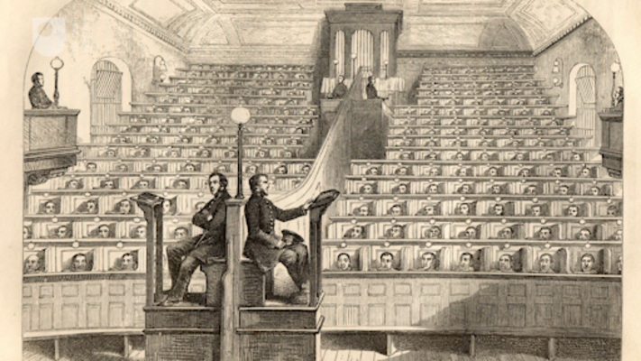

Provide your answer...
View discussion - Activity 1 The causes and effects of change in penal policy

As explained in the video, between 1853 and 1857, sentences of transportation were replaced with sentences of penal servitude – or long-term imprisonment – which were served by convicts in ‘stages’. A more detailed account of those stages is provided in Table 1.
Historians have shown how the garrotting panic of 1862 played a key role in the reformulation of penal policy (Davis, 1980; Sindall, 1987). Although concerns were already being expressed in some circles about discipline within prisons, and while it drew on public unease about the end of transportation, voluminous newspaper coverage of violent crime galvanised public opinion and put pressure on legislators to act. This is not the only time in history when criminal justice policy has been based on a knee-jerk reaction.
Crucially, the garrotting panic promoted the idea of the existence of a professional and identifiable ‘criminal class’: men (and to a lesser extent, women) who, through immorality and laziness, had chosen to pursue a ‘criminal career’ over honest employment. Undeterred by the relatively ‘soft’ punishment of penal servitude, once released from prison they returned to lives of crime. There were doubts about whether these habitual criminals could be reformed. Instead, many argued that criminal justice policy should aim to control them.
Historians have called into question the existence of a distinct ‘criminal class’ in the 1800s, arguing that most crime was committed to supplement low wages or during periods of unemployment (Davis, 1980, p. 213). The garrotting panic of 1862 demonstrates how perceptions of crime are often more important than the reality. The belief in the existence of a ‘criminal class’ also shaped views of prison learners. Some chaplains argued that the pursuit of ‘criminal lives’ had rendered some convicts incapable of learning.

Table 1 Stages in which sentences of penal servitude were served from the introduction of the punishment in 1853
ON CONVICTION
(Those accused of serious offences which carried a penalty of penal servitude were held on remand (awaiting trial) in local prisons, and also for a period of time after conviction, until their transfer to a convict prison could be organized)
 | Britain |  | Ireland
 | Men | Womenª | Men | Women
Stage One | Separate confinementª  9 months  (Prisons: Pentonville, Millbank) | Separate confinement  4 months  (Prison: Millbank) | Separate confinement  9 months  (Prison: Mountjoy) | Separate confinement  4 months  (Prison: Mountjoy)
Stage Two | Hard labour (associated) at public works  (Prisons: Portland, Portsmouth, Chatham, Dartmoor, Woking) | Associated labour (domestic focus)  (Prison: Brixton; from 1869 Woking) | Hard labour (associated) at public works  (Prison: Spike Island, Phillipstown) | Associated labour  (Prison: Mountjoy)
Intermediate Stage | None | Preparation for release.  For prisoners who show promise in stage two.  (Prison: Fulham)  Abolished 1869. | Preparation for release.  For convicts deemed fit.  Convicts given short periods of liberty on condition of return to the prison.  (Prisons: Smithfield, Lusk) | Best conducted prisoners in second stage sent to Catholic (Golden Bridge) or Protestant (Haytesbury Street) refuges.
Stage Three  (earned through good conduct and industry) | Release ‘on licence’ (i.e. parole) to serve remainder of sentence ‘at large’. | Release ‘on licence’ (i.e. parole) to serve remainder of sentence ‘at large’. | Release ‘on licence’ (i.e. parole) to serve remainder of sentence ‘at large’. | Release ‘on licence’ (i.e. parole) to serve remainder of sentence ‘at large’.
Notes: a) The General Prison at Perth in Scotland was sometimes used for males sentenced to penal servitude in Scotland serving their first stage, and for female convicts sentenced to penal servitude in Scotland.

2 The persistence of prison education
Despite the new focus on punishment in prisons, schools for prisoners persisted. The provision of education was included in the new rules for local prisons laid out in the 1865 Prison Act. The Convict Prison Directors issued new Standing Orders on education in convict prisons – some of which you will learn about shortly – signalling their commitment to some degree of provision. Given the significant disillusionment with reformatory projects in prisons, where did this commitment to education come from?
Although there was significant appetite among policymakers to punish, it should be remembered that they did not (or could not) entirely abandon the reformatory aim of imprisonment. As historian Lawrence Goldman has explained, the reformation of offenders was expedient, as a penal system that reformed prisoners was cheaper than one that did not because it tackled reoffending (Goldman, 2002, p. 147). Prisons, in a democratic society and funded by taxation, need to maintain public support. The continuation of education, as well as the curtailed religious facilities, showed that something was being done to ensure that prisoners did not leave prison worse than when they came in.
For another equally, if not more plausible explanation for the persistence of education in prisons, we need to look outside the penal world. In Session 1 you learned that the desire for a national system of schooling in England – and the failure to establish one – played a key role in the initial establishment of schools in prisons during the 1810s and 1820s.

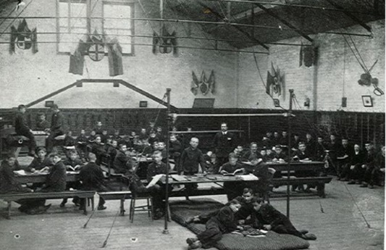
Figure 2 Boys at lessons in the gymnasium at the Leeds Reformatory School for Boys, which opened in 1857 (n.d.). The 1854 Youthful Offenders Act enabled magistrates and justices to sentence criminally convicted boys and girls up to the age of sixteen to a period of between 2 and 5 years in a reformatory school certified by the government. The legislation also required that at least two weeks were spent in prison prior to transfer. Far from removing the education project from prisons, the legislation arguably further entrenched the idea that the ‘criminal class’ were in need of schooling.
View description - Figure 2 Boys at lessons in the gymnasium at the Leeds Reformatory School for Boys, ...
View description - Figure 2 Boys at lessons in the gymnasium at the Leeds Reformatory School for Boys, ...

Between c.1850 and 1862, educational reform was once again on the government’s agenda. During the 1850s, a consensus emerged among policymakers that some degree of national education provision was needed for England and Wales. Several attempts were made to legislate for universal elementary schooling. In 1853, a new grant was introduced for inspected schools based on the number of children in attendance.
Between 1854 and 1857, the government took responsibility for the education of criminal and potentially criminal children through the establishment of reformatory and industrial schools. In 1858, a Royal Commission was convened to consider the question of national provision. The Revised Code of 1862, which made grants to inspected schools dependent on the regular attendance of pupils and their performance in examinations in reading, writing and arithmetic, was intended both to reduce costs and to encourage more working-class parents – who were primarily interested in basic skills teaching – to send their children to school.
These developments, especially in the absence of a national system of schooling, ensured the survival of schools in prisons. Educational policy, as you will see in this and the next session, continued to have some impact on provision in prisons, as penal policymakers and officials attempted to mirror the teaching that was on offer in state-subsidised elementary schools. Penal policy, however, continued to shape the delivery of education.

3 Reviewing the prison school curriculum
In Session 3, you learned that between 1823 and the 1850s the prison school curriculum expanded, to include teaching in writing and arithmetic alongside reading and, in some institutions, additional subjects such as history and geography. At the same time, religion remained central. Although learning could open up new social and employment opportunities, most believed that the key to reformation was through evangelisation (i.e. making prisoners into good Christians).
By the late 1840s, concerns were expressed that the prisoners were being ‘over educated’ – beyond their rank in society – raising their expectations of employment they could never realistically obtain. Through the 1850s and early 1860s, convict prison chaplains emphasised in their annual reports that the instruction prisoners received at school was ‘plain’ and ‘sound’ and focused primarily on ensuring prisoners were able to read easily and write legibly.

Table 2 Secular reading books used with each division (or class) in the school at Chatham Convict Prison in 1861
1st Division | ‘Lesson Book for Adults’; ‘Adult Learners’ First Book’ and ‘Second Book’ (Irish Board of Education).
2nd Division | ‘Second Book’ (Irish Board), ‘Second Book’ (Christian Knowledge Society), and ‘Second Book’ (New Series).
3rd Division | ‘Sequel to Second Book’, ‘Third Book’, and ‘Instructor’ (Vol. 2).
4th Division | ‘Third Book’, ‘Fourth Book’, and ‘Moral Class Book’.
5th Division | ‘Fourth Book’, ‘Moral Class Book’, and ‘History of England’.
6th Division | Same as 5th Division, also ‘Descriptive Geography’ (5th Vol. Instructor).
7th Division | ‘History of British Empire’ (Chambers), ‘Descriptive Geography’, and ‘Exemplary Biography’.
8th Division | Same as 7th Division, also ‘Fifth Book’ (Irish Board).
9th, 10th, & 11th Divisions | ‘Fifth Book’, ‘Descriptive Geography’, ‘History of British Empire’, ‘Exemplary Biography’.
Source: Directors of Convict Prisons, 1862, pp. 242–3.

Box 1 Notes on Table 2
Convicts at Chatham Prison were classified according to their attainments and capacities. Those of the lowest grade were placed in the first division, while the most educated men were placed in the 10th and 11th divisions. Each division attended school for one half-day (three hours) per week. The school books in use with each division reveal the subject matter of the lessons given to each division. The higher divisions, already literate and numerate, could spend time exploring other branches of secular knowledge. The names of publishers appear in the brackets next to titles.

The government inquiries convened in the wake of the garrotting panic to review penal policy showed little interest in the prison school curriculum. However, in the legislation and Standing Orders which followed these inquiries, the curriculum was significantly reshaped. The prison authorities were directed to separate religious instruction from lessons in reading, writing and arithmetic. The declared aim was to ensure that the religious conscience of prisoners of particular faiths (predominantly Catholics) was no longer interfered with. Catholic prisoners were also meant to receive religious instruction from ministers of their own church.

Activity 2 Standing Orders for Convict Prisons
Allow approximately 10 minutes for this activity

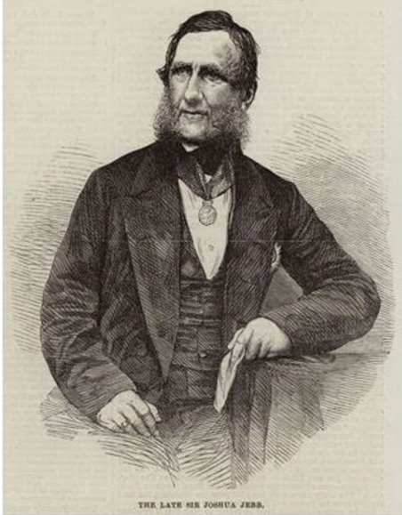
Figure 3 Joshua Jebb, a high-ranking officer in the Royal Engineers and surveyor-general of prisons, became chairman of the Convict Prison Directors in 1850. In this role, he oversaw the replacement of sentences of transportation with penal servitude, and in consequence the construction of new prisons in Britain to accommodate convicts. Jebb continued to believe in the value of reformatory schemes in convict prisons. His sudden death in 1863, while travelling on an omnibus in the Strand, paved the way for the implementation of the more punitive policies in the wake of the 1863 Royal Commission.
View description - Figure 3 Joshua Jebb, a high-ranking officer in the Royal Engineers and surveyor-general ...
View description - Figure 3 Joshua Jebb, a high-ranking officer in the Royal Engineers and surveyor-general ...

In 1850, the management of all convict prisons and hulks came under a new body, the Convict Prison Directors, who were employed by, and reported to, the Home Secretary. The Convict Prison Directors sent instructions on how to run prisons to governors via ‘Standing Orders’. Unless specifically stated otherwise, implementation was mandatory. However, Standing Orders did not entirely eliminate the ability of institutional officials (governors and chaplains) to make key decisions. These officials regularly exploited loopholes and sometimes interpreted instructions in the Standing Orders in different ways.
In 1863, the Convict Prison Directors drafted a series of Standing Orders based on the recommendations of the Commissioners who had been asked to review discipline in convict prisons. These Standing Orders, together with the 1864 Penal Servitude Act, made significant changes to the regime in convict prisons.
Read Standing Order 143, which was sent to the governors of Portland, Portsmouth and Chatham – prisons for men serving their second stage of penal servitude – and Woking and Dartmoor – prisons primarily for invalid men serving their second stage. This Standing Order introduced a system of evening schools into male public works prisons, replacing the former half-day schools (which you looked at in Sessions 2 and 3).
Consider the following questions:
- Which of the regulations in this Standing Order might have had an effect on what was taught in prison schools?
- What regulations (or other text) in this Standing Order suggest that it might have had only a limited effect on schooling in convict prisons?
Note: ‘convict school clerks’ were well-behaved, literate prisoners who spent some of their time doing clerical work – paperwork, looking after library books – to assist the schoolmasters and chaplain.

Standing Order 143
21 July 1864
I transmit herewith, for your information and guidance, a copy of the Regulations with regard to school instruction in the public works prisons which have been approved by the Secretary of State.
To the Governors of Portland, Portsmouth, and Chatham Prisons.
Clauses 5 and 6 to Governors of Woking and Dartmoor Prisons, 5th August 1864.
COPY OF THE REGULATIONS.
- Morning Prayers will for the future be read in the halls by the chaplains and schoolmasters.
- School will hereafter be held in the evenings in the halls.
- The arrangements for instruction to be detailed by the chaplain in concert with the Governor, and submitted for the approval of the Directors with reference to the special circumstances and construction of each prison.
- It is proposed to adopt a system of class instruction in the body of the hall for those uneducated men who most require assistance, and to supply those who are already well or tolerably educated with the means of continuing their studies in their cells.
- Evening Prayers in chapel to be discontinued.
- Convict school clerks to be abolished, and the work hitherto done by them to be done by schoolmasters.
- Library books to be changed and letters to be written once a week on the day when there is no schooling, viz., on Saturday evenings, which are also to be allotted to cleaning, changing clothes, and other necessary prison arrangements as at present.
(Source: Index to the Standing Orders, 1870, SO 143)

Provide your answer...
View discussion - Activity 2 Standing Orders for Convict Prisons

Although Woking and Dartmoor prisons were exempt from the regulations on evening schools and school attendance in Standing Order 143, by 1866 evening schools had been implemented at both institutions. In 1867, attendance at school at Pentonville was also limited to the lowest educational class.
Disillusionment with religion and concerns about ‘over education’ only go so far in explaining the new focus on basic skills in convict prisons. Also of relevance was what was happening outside the prison. The 1862 Revised Code (mentioned above), which made more than half of an elementary school’s funding dependent on the performance of pupils in examinations in reading, writing and arithmetic, both secularised the core curriculum in state-subsidised schools (religious instruction continued to be given but separately and performance was not rewarded) and significantly curtailed teaching in non-examined subjects such as history and geography.
What was taught in prison schools therefore continued to reflect what was taught in mainstream elementary schools. In 1864, the chaplain at Dartmoor Prison declared that ‘writing, reading, and the first four rules of arithmetic [should] be the subjects taught during school hours, seeing that these pursuits are the only ones rewarded by the Government in National and British Schools’ (Directors of Convict Prisons Report, 1865, p. 207).
Similar trends – a focus on basic skills and the elimination of lessons in history and geography – can be found in the local prison sector. At the same time, in the 1865 Prison Act, the rule on the provision of education in local prisons first crafted in 1823 (Session 1) was updated to include instruction in arithmetic alongside reading and writing, reflecting expectations of elementary education in the 1862 Revised Code (Prison Act 1865, Sch I, Reg. 53).

4 Incentives for learning
In Britain, the introduction of sentences of penal servitude in 1853 was accompanied by a system of rewards and privileges which were given to convicts who behaved well and worked hard. Before 1857, these incentives were the only way of encouraging compliance and good conduct across long sentences in the absence of remission (a reduction of the time spent in prison). After 1857, the system provided a mechanism for withholding release on licence – a third stage of penal servitude whereby a portion of the original sentence was served outside of prison – from those who misbehaved.
In Ireland, convicts had to earn a certain number of ‘marks’ in order to claim remission. A convict could earn up to 9 marks each month. These were awarded for: discipline (for their regularity and good behaviour); school (for their attention and diligence, not progress); and industry (for their effort at work).

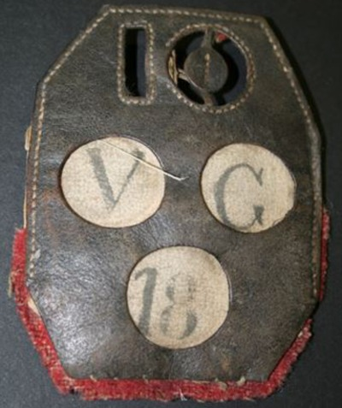
Figure 4 A convict prisoner’s ‘good conduct’ badge.
View description - Figure 4 A convict prisoner’s ‘good conduct’ badge.
View description - Figure 4 A convict prisoner’s ‘good conduct’ badge.

Box 2 Notes on Figure 4
From 1853, the second stage of penal servitude or transportation – associated labour on public works – was sub-divided into a further three stages, the lowest of which was divided into three classes. Convicts advanced through these classes and stages, and received gratuities, badges and other indulgences, according to their conduct and industry. Those who behaved badly, or who were not industrious, could be demoted.
Their progress was recorded in a book, but, in order to impress upon them the fact that they were always under assessment, additions were made to their uniforms (McConville, 1981, p. 401). Rings were worn by convicts on their left arms to indicate the stage they had reached. Good conduct badges, made of leather with an edge of red cloth, were worn by those who had achieved them on their right arms. The top number displayed the length of their sentence – in this example, 10 years. The number at the bottom showed how many months had been completed at the prison. The disks in the middle summarised the convict’s conduct – in this case, the convict had been ‘very good’ (V. G.) for his whole 18 months at the prison. Other possible grades included ‘good’ (G) and ‘ordinary’ (O).

The 1863 Royal Commission on Penal Servitude expressed concern about the system of rewards and privileges in British convict prisons. In particular, they objected to the assumption that convicts were entitled to remission: they lost it only if they misbehaved, and even then they could earn it back again. The Irish marks system provided an attractive alternative, though the Commissioners rejected the practice of awarding marks for diligence at school. They also thought that good conduct should be expected and not rewarded.
Following the Commissioner’s recommendations, in July 1864 a new system of classification based on the awarding of marks was introduced into British male convict prisons (there was no change for Irish prisons). Convicts in their second stage of a penal servitude sentence were divided into five classes: probation, third, second, first and special. Promotion through these classes depended on the number of marks they earned for the labour they performed each day. As convicts progressed through the classes, gratuities (small sums of money given for labour performed) and indulgences increased. Those who earned the maximum number of marks became eligible for release on licence after serving three-quarters of their sentence (McConville, 1981, p. 404).

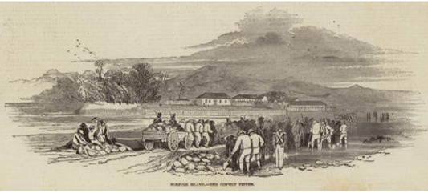
Figure 5 Norfolk Island penal colony, c.1847. Norfolk Island was first used as a penal colony between 1788 and 1814. In 1825 it was revived as a place of banishment for the very worst convicts and gained a reputation for its inhumanity. In 1840, Alexander Maconochie was appointed Commandant and introduced a system of ‘progressive stages’ to regulate and improve the behaviour of the convicts. The men were awarded ‘marks’ for their labour and good behaviour which could then be used to purchase privileges, including scholarly instruction. The progressive stages implemented in British and Irish convict prisons in the 1850s were said to have been influenced by Maconochie’s example.
View description - Figure 5 Norfolk Island penal colony, c.1847. Norfolk Island was first used as a ...
View description - Figure 5 Norfolk Island penal colony, c.1847. Norfolk Island was first used as a ...

Activity 3 The marks system in British convict prisons
Allow approximately 15 minutes for this activity

Have a look at these extracts from Standing Orders 145 and 146 sent to prison governors on 22 July 1864. Standing Order 145 outlined the new system of classification in British convict prisons. Standing Order 146 contained regulations for the awarding of marks. Quite a few of the clauses have been included in each to give you a sense of what the authorities were trying to achieve.
- Can you find clauses which relate to education? How is education being used to regulate promotion between classes and the allocation of privileges and marks?
- How did this differ from the Irish system described above?

[Standing Order] No. 145
22nd July 1864.
SYSTEM OF CLASSIFICATION to be adopted for all CONVICTS received into the PUBLIC WORKS PRISONS on and after the 12th July 1864.
- All stages and classes, as now existing, to be prospectively abolished for all convicts hereafter received into public works prisons.
- A convict during the term of his imprisonment will be required to pass through the following classes, viz.: -
  - Probation Class, 1 year, during which they must earn on public works 720 marks
  - 3rd Class, 1 year, during which they must earn on public works 2,920 marks
  - 2nd Class, 1 year, during which they must earn 2,920 marks
  - After which they will be eligible for promotion to the 1st Class.
- Every convict is thus required to remain in the Probation Class for a minimum period of 1 year, reckoned from the date of conviction, of which 9 months will be passed in separate confinement.
- If his conduct and industry are good he will then be promoted to the 3rd Class, and so on to the 2nd, remaining in each a minimum period of 1 year
[…]
- Prisoners in the 3rd Class will wear the ordinary grey convicts’ dress with black facings.
  - They will be allowed:-
  - 1st. To receive a gratuity of 12s. being at the rate of 1s. per month for 12 months, to be earned by marks during the time spend in this class, and if their conduct shows that they deserve it.
  - 2nd. To receive a visit of 20 minutes duration, once in six months, at such time as the Governor approves, care being taken that the stipulated number is not exceeded, and both to receive and write a letter once in six months, provided their conduct in that class has been good for at least two previous consecutive months.
  - 3rd. They will be allowed one period of exercise during Sundays.
- Prisoners in the 2nd Class will wear the ordinary grey convicts’ dress with yellow facings.
  - They will be allowed:-
  - 1st. To receive a visit of 20 minutes’ duration, and both to receive and write a letter once in four months.
  - 2nd. To receive a gratuity of 18s calculated at 1s 6d., per month for 12 months, to be earned by marks during the time spent in this class, and if their conduct shows that they deserve it.
  - 3rd. To be allowed choice of tea and 2 oz. of additional bread instead of gruel.
  - 4th. To have two periods of exercise during Sundays.
- Prisoners in the 1st class will wear the ordinary grey convicts’ dress with blue facings.
  - They will be allowed:-
  - 1st. To receive a visit of half-an-hour, and both to receive and write a letter once in three months.
  - 2nd. Prisoners in this class will be allowed a gratuity of 30s, being at the rate of 2s 6d. per month for 12 months, to be earned by marks until they have earned 3l. altogether.
  - 3rd. To be eligible, if their conduct and industry are good, and if special circumstances should render it desirable, to be recommended on discharge for a further gratuity not exceeding 3l.
  - 4th. To be allowed the choice of tea and 2 oz. of additional bread instead of gruel, and baked instead of boiled meat.
  - 5th. To be allowed three periods of exercise on Sundays.
  - No convict is to be promoted to the 1st Class until he can read and write, except in special cases, which must be reported to the Director.
- Prisoners in the Special Class will wear a blue dress. They will be eligible to be recommended for an extra remission not exceeding one week.
(Source: Index to the Standing Orders, 1870, SO 145)

[Standing Order] No. 146
REGULATIONS – MARK SYSTEM
- The time which every convict, under sentence of penal servitude, must henceforth pass in prison will be represented by a certain number of marks, which he must earn by actual labour performed before he can be discharged.
- No remission will be granted for conduct. It is only on condition of good conduct and strict obedience that convicts are allowed to earn by their industry a remission of a portion of their sentences.
- If, therefore, their conduct is indifferent, or bad, they will be liable to be fined a certain number of marks, according to the nature and degree of the offence, and will thus forfeit by misconduct the remission they may have earned by their industry.
- The scale of marks is, -
  - 8 marks per [day] for steady hard labour and the full performance of their allotted task
  - 7 [marks per day for] a less degree of industry
  - 6 [marks per day] for a fair but moderate day’s work.
[…]
- Any prisoner reported for idleness or misconduct at school will be liable, in addition to any other punishment, to be fined a number of marks proportionate to his offence.
- Convicts who, by their inattention, do not profit by the instruction given them, and are found to be unable to read and write on emerging from the 3rd Class, will forfeit their gratuity, which cannot be restored to them until they can do so
[…]
(Source: Index to the Standing Orders, 1870, SO 146)

Provide your answer...
View discussion - Activity 3 The marks system in British convict prisons

You could argue that in British prisons illiteracy was made part of the crime for which time had to be served. By these rules, illiterate prisoners could not gain remission unless they obtained special dispensation. Another consequence was that the focus on ‘literacy’ (reading and writing) meant that the achievement of competence in arithmetic became less important.
The new system of classification – or marks – was extended to include female convicts in September 1865. Unlike men, women could begin to earn marks during their first stage of imprisonment. Promotion from third to second class was dependent on time served rather than conduct or industry (Zedner, 1991, pp. 179–81). Like men, illiterate convict women were barred from promotion to the first class and were denied their gratuity on emerging from the third class if they had been inattentive at school. Clearly a change in attitude had taken place, with education now a means of disciplining prisoners.

5 Facilities for self-instruction
In Session 4, you looked at opportunities for education outside the prison school through the provision of books and other reading matter, and increasingly through the prison library. As schools in convict prisons began to exclude men and women with basic competence in reading, writing and arithmetic, facilities for self-instruction became even more important.
From the late 1830s, convicts at Millbank, and then Pentonville, were given a small allocation of ‘schoolbooks’ to aid private study in their cells. From 1850, male convicts arriving at public works prisons for their second stage of punishment were given two schoolbooks in addition to a library book and religious books, as well as a slate and pencil to enable them to study in the evenings. At Portsmouth, for example, the men were allowed to choose two of the following works: ‘arithmetic, mensuration, book-keeping, practical geometry, Chambers’ Mathematics, dictionary, grammar, [and] spelling-book’ (Directors of Convict Prisons Report, 1854, p. 234).

Figure 6 Bound volumes of some of Charles Dickens’ works. Standing Order 118, sent to chaplains on 3 February 1864, ordered them to remove specific books from their libraries. These included, for example: all of Charles Dickens’ books, William Thackeray’s Vanity Fair, The Newcomes, and Pendennis, Anthony Trollope’s Barchester Towers, George Eliot’s Mill on the Floss, and Silas Marner.
View description - Figure 6 Bound volumes of some of Charles Dickens’ works. Standing Order 118, sent ...
View description - Figure 6 Bound volumes of some of Charles Dickens’ works. Standing Order 118, sent ...

Standing Order 143 – which excluded the ‘well’ and ‘tolerably’ educated from schools at public works prisons – instructed governors to supply these men ‘with the means of continuing their studies in their cells’. At Portland and Portsmouth, convicts were permitted to have additional schoolbooks in their cells. The 1863 inquiry on discipline in local prisons recommended the greater provision of artificial light in cells to facilitate evening schools and self-instruction.

Activity 4 Book purges
Allow approximately 10 minutes for this activity

Standing Order 261 was sent to governors of convict prisons on 2 November 1865. Read it now, and try to answer the following questions:
- What are governors and chaplains being asked to do?
- Why do you think they are being asked to do this?
- What consequences do you think this might have for education in the prison?

Standing Order No. 261
2nd November, 1865
PRISON LIBRARIES
The yearly supply of Books for the Libraries of Convict Prisons will, in future, be limited to the replacing of those Books which become unfit for further use during the year.
Governors and Chaplains of Prisons will be good enough to remove from Prison Libraries all Novels, and Tales of an uninstructive character, and will be careful that the periodicals they demand are unobjectionable in this respect.
E. Y. W. HENDERSON [chair of the Convict Prison Directors]
(Source: Index to the Standing Orders, 1870, SO 261)

Provide your answer...
View discussion - Activity 4 Book purges

6 Cellular instruction
As explained in the video for this session, the use of separation – the confinement of prisoners in individual cells and the limitation of their opportunities to be in the company of other prisoners – for reformatory purposes was increasingly challenged after 1850. However, a new generation of penal reformers reacting to the perceived threat of rising criminality and the end of transportation were attracted to the ability of separate confinement to inflict mental suffering on prisoners. Both inquiries on prison discipline in convict and local prisons recommended its use and expansion.
The Commissioners also recommended that in convict prisons, the amount of food given to those in separate confinement should be reduced for the first four months. In addition, the Convict Prison Directors installed fixed wooden beds with small coir mattresses in cells at Millbank and Pentonville, and, to render the discipline ‘still further deterrent’, introduced a system of ‘cellular instruction’ (teaching individuals in cells) to replace the practice of assembling convicts in school classes (Directors of Convict Prisons Report, 1864, p. 8).
Although cellular instruction was already in use at some local prisons before 1863, it became more widespread following the report of the inquiry into discipline in local prisons and the 1865 Prison Act. Despite this, the practice of assembling prisoners in classes for school was never entirely abolished. Male convicts in their second stage of penal servitude also continued to be assembled in classes for school.

Figure 7 Separate cell at Pentonville Prison. The separate cells in model prisons such as Pentonville were designed for long periods of human habitation without damage to health. Prisoners had running water and toilet facilities. A thermometer monitored the temperature, as hot or cold cells could aid the spread of disease. Prisoners slept in hammocks with mattresses which could be rolled away. Reforms to convict and local prison discipline after 1863 were intended to make prisoners uncomfortable. Plank beds were introduced to disrupt sleep and reduced diets made prisoners hungry. At the same time, arcades and galleries designed to circulate air were filled in as the space was used for more accommodation. Built-in toilets were poorly maintained. Cell buckets increasingly resorted to in new separate prisons were unhygienic (Johnston, 2016, p. 50). These conditions would have had an impact on prisoners’ ability to learn in a system of cellular instruction.
View description - Figure 7 Separate cell at Pentonville Prison. The separate cells in model prisons ...
View description - Figure 7 Separate cell at Pentonville Prison. The separate cells in model prisons ...

Activity 5 Evaluating the use of cellular instruction
Allow approximately 15 minutes for this activity

This activity is in two parts.

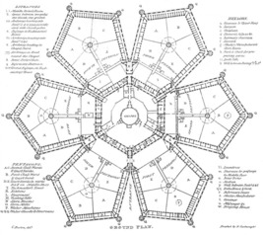
Figure 8 Plan of Millbank Prison. This provides an image of one floor of the building, as if from above, with some details omitted. Although considered revolutionary in prison design when constructed in 1816, successive managers and governors struggled to enforce discipline at Millbank Prison. There were several attempts at substantial alteration, but nothing could be done about the pentagon layout around which the convicts’ cells were situated. A schoolmaster who worked at Millbank in the late 1860s explained that during ‘school’, when the cell doors were opened to allow the teacher access at will, the supervising warders, who had to stand at the angle between the two sides of the pentagon which formed one ward, remained oblivious to the significant amount of prisoner interaction which was carried on. The convicts talked, exchanged library books with each other, and committed a range of petty offences (Sketches of Convict Life, 1881).
View description - Figure 8 Plan of Millbank Prison. This provides an image of one floor of the building, ...
View description - Figure 8 Plan of Millbank Prison. This provides an image of one floor of the building, ...

Part 1

Under the system of cellular instruction at Millbank and Pentonville, male convicts, who had formerly spent between three and six hours in classes each week, now received only fifteen minutes of individual tuition in their cells (though at Millbank, twice a week, where possible).
The following reports were written by the Rev. George de Renzi, chaplain at Millbank, and the Rev. Ambrose Sherwin, chaplain at Pentonville, after one year’s experience of cellular instruction. Although not directly involved in teaching the convicts, the chaplains supervised the schoolmasters and examined the prisoners every six months.
As you read them, consider the following questions:
- What are the advantages of cellular instruction that the two chaplains describe and are these advantages disciplinary or educational?
- Does either chaplain mention any disadvantages?
- Can you think of any disadvantages not listed?

Extract from the Annual Report of the Rev. George de Renzi, chaplain at Millbank Prison, for the year 1864
With reference to the schools, I am glad to be able to report most favourably of the system at present in operation. It is now more than 12 months since the practice, which had prevailed for many years, of assembling the men in a school-room, which has been discontinued, in lieu of which school is now held in the wards, the prisoners remaining in their cells and receiving instruction individually. […] There is no difficulty now in gaining the attention of the men, and they evince a much greater interest in their own improvement, and as a natural consequence an increased success has attended the efforts of the schoolmasters. But the more satisfactory progress of the prisoners is not the only advantage resulting from the change; it has also been attended with considerable gain to the discipline, inasmuch as, from the teaching being carried on in the cells, the evils, inseparable from the bringing together of the prisoners, are proportionately diminished.
(Source: Directors of Convict Prisons Report, 1865, pp. 70–1.

Extract from the Annual Report of the Rev Ambrose Sherwin, chaplain at Pentonville Prison, for the year 1865
The mode of teaching the prisoners separately in their cells, instead of as heretofore in school classes, commenced in January last year. […] [We] are able to say it is better system for adults in a convict prison, for sufficient instruction is imparted in the elementary and more essential parts of secular education, viz: reading, writing and arithmetic; more individual effort on the part of the prisoner is produced, the time of the teacher is apportioned according to the wants of the more ignorant, and superfluous attention to others precluded. Then, in a moral and disciplinary point of view the wholesome effects of intercepted communication are clearly seen. It is a great help to all who really wish to withdraw from evil and to amend, and it is a great preventive of the machinations of evil-disposed men who take pleasure in corrupting others.
The plan pursued is in many ways decidedly restrictive; not only are various subjects formerly taught in the school class now necessarily laid aside, but also a much smaller amount of instruction is given to some classes than had been given; even the means of self teaching are limited, inasmuch as fewer books are allowed in the cells, and the use of paper, pens and ink is entirely superseded, except for the half yearly purpose of writing a letter; all library books of a merely amusing character, and all tales not instructive, are eliminated from the catalogue; there is a parallelising in fact, in the retrenchment of mental redundancies and the reduced scale of dietary.
(Source: Directors of Convict Prisons Report, 1866, p. 30)

Provide your answer...
View discussion - Part 1

Part 2

Now read the following extract from the Rev. Sherwin’s annual report for 1873. The chaplain has changed his mind about cellular instruction. Why? What does he now see as its disadvantages?
(It will be useful to know that between 1864 and 1873, the daily number of prisoners at Pentonville had increased from around 500 to almost 900, and new buildings had been erected to accommodate them.)

Extract from the Annual Report of the Rev. Ambrose Sherwin, chaplain at Pentonville Prison, for the year 1873

When some years ago class teaching was suspended and separate cellular instruction resorted to, the experiment seemed favourable in a disciplinary point of view, but then the prison was not more than half its present size and extent, it was manageable, and sufficient instruction was practicable.
Now, however, there is evidently a considerable loss of schoolmasters’ time in making the tour of the prison, and a waste of teaching power in expending upon one prisoner an amount of teaching which might suffice for the class of twenty.
Again, the effectual supervision by the Chaplain of the schoolmasters while passing from cell to cell is absolutely impossible under existing circumstances.
I would therefore respectfully suggest the expediency of reviving the class teaching of the two lower or more ignorant sections of convicts.
(Source: Directors of Convict Prisons Report, 1874, p. 28)

Provide your answer...
View discussion - Part 2

It is important not to dismiss cellular instruction as a mode of delivery outright. One-to-one tuition given in short irregular bursts was common in working-class communities in the early 1800s and assisted the early spread of literacy in British society. Convicts (and local prisoners) arrived at prison with different levels of attainment, educational experiences and capacities. It could be argued that cellular instruction provided an opportunity to tailor teaching to individual needs, but there is little evidence that this was exploited.
Instead, from the 1860s at least, cellular instruction was a disciplinary tool. It reduced the instruction that prisoners received to an almost negligible – or token – amount. As the Rev. Sherwin acknowledged in a later report, cellular instruction combined with the focus on the acquirement of the basic skills made instruction for many prisoners unpleasant and monotonous (Directors of Convict Prisons Report, 1876, p. 338).

7 This session’s quiz
Well done – you have reached the end of Session 6. You can now check what you’ve learned this session by taking the end-of-session quiz.
Session 6 practice quiz
Open the quiz in a new tab or window by holding down Ctrl (or Cmd on a Mac) when you click on the link. Return here when you have finished.

8 Summary of Session 6
In this session, you explored a significant turning point in UK penal history – the increasing emphasis given to punishment and deterrence in penal policy in the 1860s – and you evaluated its impact on the provision of education in prisons.
Despite disillusionment with reformatory schemes in prisons of the 1840s and 1850s, the growing belief in the existence of an irredeemable criminal class, and the appearance of new legislation and directives aimed at making prisons as punitive as possible, prison schools survived. You learned that the reasons for this most likely lie outside the penal world, in the development of educational policy. Prison schools also continued to reflect the curriculum of mainstream elementary schools.
This does not mean, however, that prison schools were immune from the new emphasis on punishment. Using a series of Standing Orders issued by the Convict Prison Directors, you examined the effects of the change in penal policy on educational provision, including the introduction of evening schools, the use of literacy as a tool for discipline, the removal of entertaining literature from libraries, and the introduction of cellular instruction. All these measures threatened the transformative potential of education in prison.
You should now be able to:
- outline the reasons for a change in penal policy during the 1860s
- explain why education continued to be provided in prisons, and how the desire for a more punitive regime affected its delivery and potential results
- understand the use of Standing Orders in the convict prison sector after 1850
- compare and contrast two primary sources.

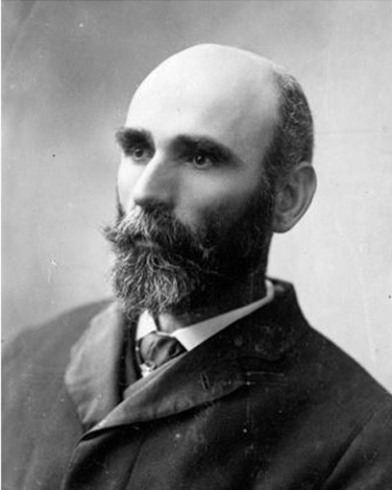
Figure 9 Michael Davitt (1846–1906) was born in Ireland during the Great Famine and moved to England with his family in 1850 when they were evicted from their tenancy for rent arrears. He began work in a cotton mill aged 9, where he lost his right arm in an accident. Davitt joined the Irish Republican Brotherhood in 1865, and in 1870 was convicted for treason-felony and sentenced to fifteen years’ penal servitude. In August 1872, while in prison, he managed to write and send a letter, criticising the penal regime, which was published in several newspapers and led to an inquiry by the Home Secretary. On his release, after seven years, he published a pamphlet and gave evidence to the 1878 Royal Commission on Penal Servitude about the cruelties he had suffered while inside. His disability meant that he was forced to pick oakum with his teeth, cart stones using a harness, and smash bones for fertiliser with one hand.
View description - Figure 9 Michael Davitt (1846–1906) was born in Ireland during the Great Famine and ...
View description - Figure 9 Michael Davitt (1846–1906) was born in Ireland during the Great Famine and ...

In this session, especially through the use of Standing Orders, you have focused mainly on penal policymaking – what MPs and civil servants wanted to happen – rather than on what actually happened inside prisons. The implementation of Standing Orders was mandatory, but there were often loopholes that governors and chaplains could exploit. Some convict prison governors and chaplains delayed bedtime to allow more time for evening schools. Some allowed schoolmasters to visit and assist convicts who were studying alone in their cells. Chaplains got to decide what literature was purely entertaining and what, conceivably, had a moral or instructive purpose. Like its predecessor (the 1823 Gaols Act), the 1865 Prison Act lacked an effective mechanism for enforcement. Local prison administrators and officials could choose to ignore many of the new rules and regulations laid down by the legislation.
Still, penal policy did matter. In 1878, testimonies given by former convicts to a new Royal Commission on penal servitude revealed the brutality of conditions in convict prisons that had evolved since 1863. In the same year, following legislation passed in 1877, local prisons were nationalised, and brought under direct control of the Home Office. This made possible the full implementation of provisions in the 1865 Prison Act and uniformity in prison discipline. In Session 7, you will explore the pursuit of uniformity and its impact on education in convict and local prisons.
You can now go to Session 7.

Session 7: Uniformity in prisons and prison education

Introduction
Uniformity in prison discipline – the idea that the experience of imprisonment should be the same for every prisoner convicted of a similar offence regardless of the prison he or she ends up in – had been an ambition of penal reformers since the beginning of the 1800s. It was, they argued, a question of fairness. Also, they believed that deterrence (discouragement to commit crime) was impossible without it. From the early 1800s through to the 1870s, stories circulated that some criminals deliberately committed their crimes in jurisdictions with prisons in which discipline was ‘soft’ (McConville, 1995b, pp. 126–7).
Because convict prisons were under the control of the Home Office, uniformity was easier to achieve in this sector (though, crucially, it was never absolute). From the early 1850s, the Convict Prison Directors used Standing Orders to enforce, clarify and extend the rules set out for each type of prison or stage of penal servitude. You looked at some of these Standing Orders in Session 6. In this session, you will examine another, Standing Order 309, which aimed to homogenise (make the same) the curriculum and delivery of education across the convict prison sector.
Local prisons were run by local magistrates (county and borough) and paid for, almost entirely, by local rates. Between 1800 and the 1870s, legislation passed by Parliament to achieve greater uniformity in this sector had a limited effect. In 1877, Parliament passed new legislation which transferred control of all UK local prisons to the Home Office and their running costs to the Exchequer (i.e. Treasury).
Nationalisation provided an opportunity to enforce in full prison rules and regulations contained in legislation; for example, in the case of England and Wales, in the 1865 Prison Act. As these rules included the provision of education, by the early 1880s a national system of prison education had been created in Britain (in Ireland it took a little longer). In this session, you will learn how policymakers went about the task of creating a homogenous experience of education in local prisons. Throughout, you will be asked to consider the advantages and disadvantages of the pursuit of uniformity in prison discipline.

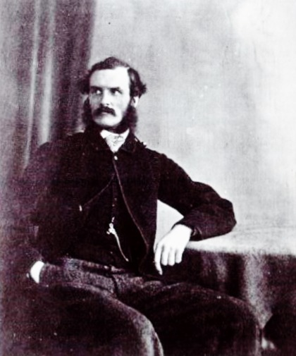
Figure 1 Edmund Frederick Du Cane (1830–1903), an officer in the Royal Engineers with experience of managing convict settlements in Western Australia, became a director of convict prisons in 1863, chair of the Convict Prison Directors in 1869, and chair of the Prison Commission for England and Wales in 1878. Du Cane was committed to the achievement of uniformity in prison discipline and has been credited with creating ‘the most severe system of secondary punishment in English history’ (McConville, 1995a, p. 187).
View description - Figure 1 Edmund Frederick Du Cane (1830–1903), an officer in the Royal Engineers ...
View description - Figure 1 Edmund Frederick Du Cane (1830–1903), an officer in the Royal Engineers ...

By the end of this session, you should be able to:
- assess the extent to which uniformity in prisons was achievable
- outline the impact of the pursuit of uniformity on the content and delivery of prison education
- evaluate the impact of an exclusive focus on the basic skills (reading, writing and arithmetic) on the transformative potential of education in prisons.
Let’s begin by returning to Lincoln Castle Gaol. In this video, Rosalind Crone presents the final chapter in the history of this prison. Why did Lincoln Castle Gaol close in 1878? What happened to the prisoners? What happened to the prison buildings?
Watch the video now and make some brief notes in answer to these questions. You’ll refer back to them later in this session.

Video content is not available in this format.
View transcript - Uncaptioned interactive content

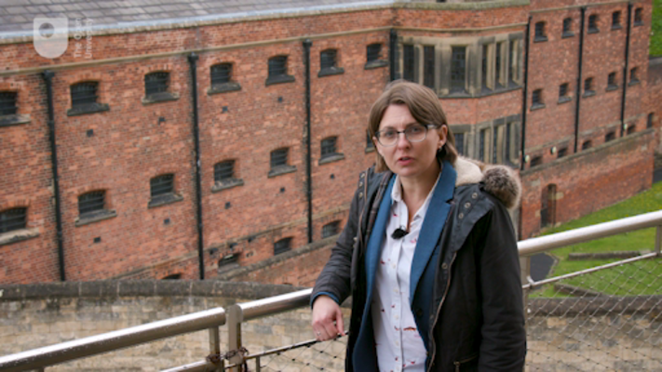

1 The Revised Code in convict prisons
By the late 1860s, some uniformity in the delivery of education in convict prisons had been achieved. Men and women serving their first stage of penal servitude at Millbank and Pentonville were taught individually in their cells. Men in their second stage at public works prisons were taught in classes in the evening.

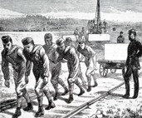
Figure 2 At Chatham Convict Prison, convicts quarried stone to build naval fortifications. The labour was especially brutal, there were many accidents, and some convicts deliberately hurt themselves in order to get some respite. After a day of punishing labour, some convicts were expected to attend evening school. Many were tired and irritable, and their progress in learning suffered as a result.
View description - Figure 2 At Chatham Convict Prison, convicts quarried stone to build naval fortifications. ...
View description - Figure 2 At Chatham Convict Prison, convicts quarried stone to build naval fortifications. ...

However, prison officials retained significant control over what convicts were taught. Different sets of lesson books were used: those of the British and Foreign Schools Society at Millbank and Pentonville, those produced by the Commissioners of Irish National Education at public works prisons, and those published by the Society for the Promotion of Christian Knowledge at Fulham (Women’s) Convict Prison.
Chaplains at public works prisons had been ordered to restrict attendance at school to uneducated men who most required assistance, but they still got to decide what degree of education justified exclusion. Just about all prisoners at Millbank and at the female convict prisons continued to attend school.
These differences in curriculum and attendance mattered, not just for reasons of fairness, but also because convicts were transferred between prisons as they progressed through the stages of their sentence. Moreover, inconsistent educational expectations meant that there was no way of measuring the effectiveness of instruction across the sector. And so, in an effort to homogenise the school curriculum in all convict prisons, on 15 May 1868, Standing Order 309 introduced a new system of examination by Standards. These were the same Standards that had been introduced in state-subsidised elementary schools by the 1862 Revised Code (which you learned about in Session 6).

Activity 1 Examinations by Standards in convict prisons
Allow approximately 10 minutes for this activity

Read Standing Order 309 (link below) and consider the following questions:
- Standing Order 309 introduced examination by Standards. What else did it mandate?
- At each examination, chaplains were asked to record the Standard achieved by the convict as well as the Standard that had been achieved at his or her last examination. What other information were chaplains asked to record in a separate table?
Standing Order 309
Source: Index to the Standing Orders, 1870, SO 309.

Provide your answer...
View discussion - Activity 1 Examinations by Standards in convict prisons

While there were six months between examinations, time spent at school was very limited, and many prisoners did not achieve a new Standard at each examination. Table III was therefore essential to measure whether any progress at all had been achieved.
Perhaps you were surprised by the grade ‘B’ or ‘Gone Back’. Often we think of learning as a linear and mostly progressive experience: that, at least while in education, skills are learned (or not) and then developed (or not). This is a good reminder of the fragility of skills at the most basic level of competence. There are many scenarios in the penal context which might mean that an individual goes backwards in their learning, for example as a result of transfer to a new prison (where less time might be given to lessons), or as a consequence of the mental strain of imprisonment (which might be felt by prisoners in separate confinement, or when performing hard labour).

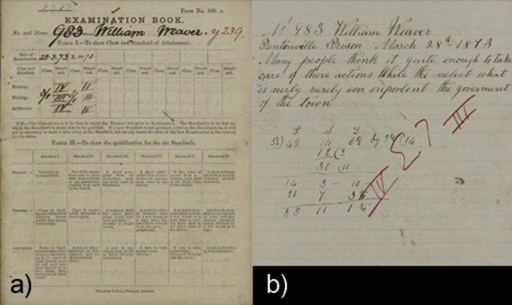
Figure 3 Pages from the Examination Book of William Weaver, which were included with his penal record. Weaver was convicted of stealing five pounds four ounces of bacon at Frome in November 1873 and sentenced to seven years’ penal servitude. He served his sentence in stages at Pentonville, Chatham and Brixton before he was released on licence in December 1879. Few examination books such as this survive.
View description - Figure 3 Pages from the Examination Book of William Weaver, which were included with ...
View description - Figure 3 Pages from the Examination Book of William Weaver, which were included with ...

2 The nationalisation of local prisons
The video you watched at the start of this session explained the reasons behind the decision to nationalise local prisons in 1878. Not all (or even many) local prisons were inefficient or badly run. Nationalisation fulfilled an election promise made by the Conservatives to reduce local rates.
As a result of the 1877 Prison Act, three new national prison systems were created to manage local prisons in the UK: the Prison Commission for England and Wales, the Scottish Prison Commission and the Irish General Prisons Board. Officials for all three reported directly to the Home Secretary.
Nationalisation had an immediate impact on the provision of education in English and Welsh prisons. Prison closures led to overcrowding in some institutions where governors were forced to squeeze up to three men in cells designed for one. At other prisons, major renovations and rebuilding took place to ensure facilities were fit for purpose (McConville, 1995, pp. 196–7). Education was disrupted as a result. Schools were suspended at Bristol and Lewes prisons. ‘[There] have been difficulties in the way of education to which as much attention has not been paid as usual,’ officials at Derby Prison reported to the Commissioners at the end of 1879 (Commissioners of Prisons, Third Annual Report, 1880, p. 24).

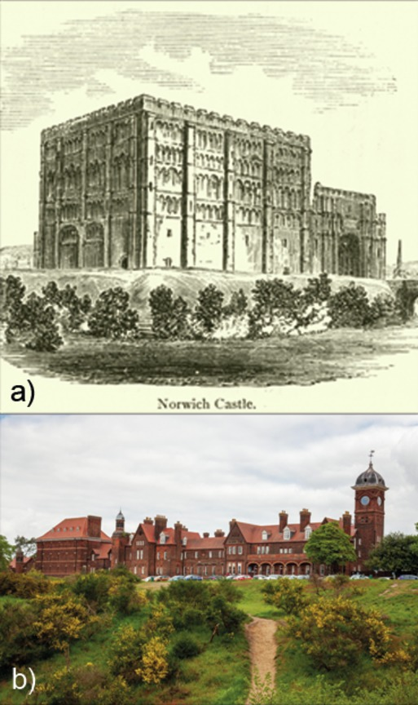
Figure 4 The local prison estate inherited by the Commissioners of Prisons in England and Wales, the Commissioners in Scotland, and by the Prisons Board in Ireland, contained an assortment of buildings, including castles which dated back to the medieval period. The county gaol for Norfolk was located at Norwich Castle from the 1300s. The castle keep was used until a new gaol was constructed inside and around the keep in the 1790s. There were further alterations made in the 1800s. After centralisation, the Prison Commissioners for England and Wales decided it was entirely unsuitable and could not be modified any further. A new prison was constructed at Mousehold Heath, which remains in use today.
View description - Figure 4 The local prison estate inherited by the Commissioners of Prisons in England ...
View description - Figure 4 The local prison estate inherited by the Commissioners of Prisons in England ...

One of the first acts of the Commissioners of Prisons in England and Wales was to introduce a new, uniform system of progressive stages into local prisons. Soon after, the same system was implemented in Scottish local prisons. The inspiration came from the convict prison sector where progressive stages had been introduced in 1864 (in 1854 in Ireland).
By this system, imprisonment in local prisons was served in four stages. Prisoners had to earn 224 marks through good behaviour and industry in order to progress to the next stage. Up to 8 marks could be earned each day. The minimum time that had to be served in the first stage was 28 days but often it was longer.
The first stage was designed to inflict the most severe punishment on prisoners. They were kept in strict separation, subjected to ten hours of hard labour of the first class, six to eight of which had to be performed on the treadwheel, crank or other work of a similar nature, and they were forced to sleep on a plank bed without a mattress. As prisoners progressed through the stages, there was a general ‘lessening’ of pressure, with the gradual introduction of some lighter labour, gratuities for work performed, mattresses, limited association with other prisoners, books, and, in the highest stage, permission to write a letter. Unlike convicts, prisoners serving sentences of imprisonment in local prisons could not earn remission (time off their sentence).

Activity 2 Progressive stages in local prisons
Allow approximately 10 minutes for this activity

Here is a description of the system of progressive stages. Read it now, and consider the following questions:
- At what stage did prisoners become eligible to receive school instruction?
- What effect do you think this might have had on the provision of education in local prisons?
- What other restrictions were placed on access to learning?

SYSTEM OF PROGRESSIVE STAGES
The following instructions will be followed in local prisons, with a view to give effect to Rule 24, made by the Secretary of State, as to the employment of prisoners.
- A prisoner shall be able to earn on each week-day eight, seven or six marks, according to the degree of his industry; and on Sunday he shall be awarded marks according to the degree of his industry during the previous week.
- A prisoner who is idle on any day will be reported, and be liable to punishment.
- There shall be four stages, and every prisoner shall pass through them, or through so much of them as the term of his imprisonment admits.
- He shall commence in the first stage, and shall remain in the first stage until he has earned 28 X 8 or 224 marks; in the second stage until he has earned 224 more marks, or 448 in the whole; in the third stage until he has earned 224 more marks, or 672 in the whole; in the fourth stage during the remainder of his sentence.
- A prisoner whose term of imprisonment is 28 days or less, shall serve the whole of his term in the first stage.
[…]
- A prisoner in the 1st stage will:
  - Be employed 10 hours daily in strict separation on 1st class hard labour, of which six to eight hours will be on crank, treadwheel, or work of a similar nature.
  - Sleep on a plank bed without a mattress.
  - Earn no gratuity.
- A prisoner in the 2nd stage will:
  - Be employed as in the first stage until he has completed one month of imprisonment, and afterwards on hard labour of the second class.
  - Sleep on a plank bed without a mattress two nights weekly, and have a mattress on the other nights.
  - Receive school instruction.
  - Have school books in his cell.
  - Have exercise on Sunday.
  - Be able to earn a gratuity not exceeding 1s.
[…]
- A prisoner in the 3rd stage will:
  - Be employed on 2nd class hard labour.
  - Sleep on a plank bed one night weekly, and have a mattress on the other nights.
  - Receive school instruction.
  - Have school books in his cell.
  - Have library books in his cell.
  - Have exercise on Sunday.
  - Be able to earn a gratuity not exceeding 1s 6d.
[…]
- A prisoner in the 4th stage will:
  - Be eligible for employment of trust in the service of the prison.
  - Sleep on a mattress every night.
  - Receive school instruction.
  - Have school books in his cell.
  - Have library books in his cell.
  - Have exercise on Sunday.
  - Be allowed to receive and write a letter, and receive a visit of 20 minutes, and in every three months afterwards to receive and write a letter, and receive a visit of half-an-hour.
  - Be able to earn a gratuity not exceeding 2s.
(Source: Commissioners of Prisons, First Annual Report, 1878, pp. 39–40)

Provide your answer...
View discussion - Activity 2 Progressive stages in local prisons

The system of progressive stages in local prisons made education – through tuition or self-instruction – a privilege that had to be earned.
Most prisoners in local prisons were sentenced to short periods of imprisonment which did not exceed one month. This scheme narrowed access to education to a small minority. On the one hand, this was a pragmatic policy. You might remember from Session 5 that illiterate prisoners with sentences of less than three months made little progress at school.
On the other hand, prisoners with longer sentences were often repeat offenders or serious offenders. From a reformatory perspective, this intervention came late in the day. It was also too little. Time that could be used for instruction was wasted while prisoners completed their first stage. Many had little time left to serve when they became eligible for instruction.

3 The Fenwick Committee
Nationalisation provided an opportunity to achieve uniformity in prison discipline in local prisons. In England and Wales, uniformity was pursued with a particular ruthlessness by the chair of the Prison Commission, Sir Edmund Du Cane.
The rules and regulations in the 1865 Prison Act were enforced in every prison. Many of these rules were too general, so committees were established to decide on the minutiae of prison discipline. A committee on hard labour decided that prisoners should climb 8,640 feet on the treadwheel each day (the equivalent of climbing the steps to the top of the Shard in London 8 times) to meet the requirements of their sentence. Another committee devised a penal diet that would sustain life but was repulsive enough to deny prisoners any pleasure in eating. Activities had to be quantifiable to enable uniform implementation. As such, uniformity encouraged severity rather than leniency (McConville, 1995b, pp. 130–3).

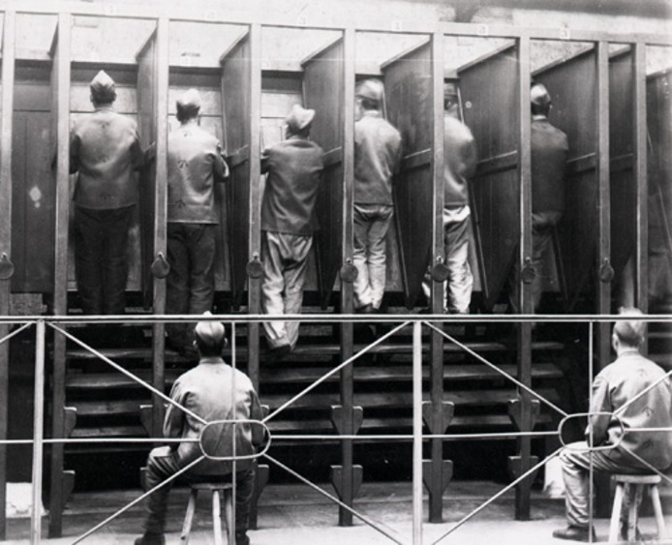
Figure 5 Prisoners on the treadwheel at Pentonville Prison in 1895. The treadwheel – also known as the treadmill or ‘everlasting staircase’ – was invented by William Cubitt in 1818 and first used to employ prisoners at Bury St Edmunds Gaol and Brixton House of Correction. It could be productive – if attached to pumps to draw water or to mills to grind corn – or it could be entirely penal. Treadwheels were used on and off until 1865 when legislation mandated their use – or an alternative, such as the hand crank – in local prisons. The legislation was properly enforced after 1878. Prisoners placed on the treadwheel were expected to climb over 8,000 feet a day using the revolving wooden steps.
View description - Figure 5 Prisoners on the treadwheel at Pentonville Prison in 1895. The treadwheel ...
View description - Figure 5 Prisoners on the treadwheel at Pentonville Prison in 1895. The treadwheel ...

In 1879, the Prison Commissioners for England and Wales recommended the appointment of a departmental committee (a committee initiated within a government department) to devise a uniform scheme for the provision of education in local prisons. Three committee members were appointed: Captain W.H. Fenwick, an inspector employed by the Prison Commission; the Rev. George de Renzi, chaplain at Pentonville Prison; and the Rev. T. W. Sharpe, a senior inspector of schools and inspector of training colleges for schoolmasters.
The committee operated under a tight set of terms determined by the chair of the Prison Commissioners, Sir Edmund Du Cane. Between April and June 1879, committee members visited prisons to obtain details on existing schemes and to observe the teaching of prisoners. On 14 June, they presented a draft scheme to the Home Secretary. It was approved for trial in a select number of prisons. In 1883, the scheme (known as the Fenwick scheme) was rolled out to all remaining local prisons in England and Wales via a Standing Order from the Prison Commissioners.

Activity 3 Educational Instruction of Prisoners in Local Prisons in England and Wales, 1883
Allow approximately 10 minutes for this activity

Below is a summary of the main features of the Fenwick scheme. Read it now and consider the following questions:
- The primary aim of this scheme was to achieve uniformity in the provision of education in local prisons: no prisoner would receive less or more education because of the prison he or she was sent to. Can you see any loopholes which could be exploited by prison officials to expand or contract provision at their institution?
- Was attendance at school voluntary or compulsory in this scheme?
- In Session 3, you learned that the primary aim of prison education during the early 1800s was evangelisation: teaching prisoners to read and write enabled them to engage with the Bible. What was the aim of this scheme?

Summary of the Fenwick Scheme for the Instruction of Prisoners in Local Prisons
- Prisoners sentenced to at least four months imprisonment were to be examined by the chaplain and placed in one of three classes:
  - Class I, those who could not read Standard I of the National Society’s reading book (that is, to read a short paragraph from a book not confined to words of one syllable);
  - Class II, those who could read Standard I, but had not passed Standard II (that is, to read a short paragraph from an elementary reading book);
  - Class III, those who had passed Standard III (that is, to read a short paragraph from a more advanced book).
- Prisoners in Class III should not receive instruction except in writing and arithmetic should they need it. They should, however, be given authorised books and a slate and pencil.
- Prisoners in Class II should receive 15 minutes of individual tuition in their cells twice a week.
- Prisoners in Class I should receive instruction in reading in classes for 30 minutes twice a week, and instruction in writing and arithmetic in their cells for 15 minutes twice a week.
- Prisoners should receive instruction in: reading as far as Standard III inclusive; writing, as far as transcribing a portion of the book read, and reading what has been transcribed; arithmetic, as far as casting simple money accounts, and mental calculation of small money sums.
- Prisoners aged 40 or above should not receive instruction, except in special cases, recommended by the chaplain, and approved by the governor. Prisoners identified by the chaplain as having no capacity for instruction shall be excluded. Prisoners who are idle shall be temporarily excluded. Chaplains should exercise discretion in excluding prisoners with previous convictions.
- Prisoners should not be given library books until they can read Standard II with fluency.
- All juveniles under 16 years of age should receive instruction for one hour daily in class.

Provide your answer...
View discussion - Activity 3 Educational Instruction of Prisoners in Local Prisons in England and Wales, ...

4 Evaluating the Fenwick scheme
The Fenwick scheme offered correctional, rather than transformational, education. In 1870, a national system of elementary schooling was finally introduced in England and Wales. Local authorities were permitted to compel attendance until legislation in 1880 made attendance compulsory for all children aged between 5 and 10 years. The majority of children left school having achieved Standard III or IV at most. The aim of the Fenwick scheme was only to increase the literacy and numeracy of prisoners to the level which the state had mandated that all children achieve in elementary school.

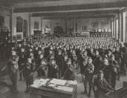
Figure 6 Morning assembly at a Board School. Board schools were the first ‘state schools’ in England, Wales and Scotland. The 1870 Education Act (and the 1872 Act for Scotland) allowed board schools to be built in areas where adequate provision had not already been made by the rival church school societies. Board schools were funded from local rates and provided non-denominational elementary education for girls and boys of the working classes.
View description - Figure 6 Morning assembly at a Board School. Board schools were the first ‘state ...
View description - Figure 6 Morning assembly at a Board School. Board schools were the first ‘state ...

Having said that, basic literacy and numeracy provided a key to other activities which could be transformational, such as reading for pleasure or self-instruction (aiding self-development, reflection and further skills development), writing to friends and family outside the prison (maintaining contacts to aid rehabilitation on release), and religious or moral instruction. The problem with this scheme was establishing the connection between skills and their use (library books, for example, were denied to all who had not passed Standard II), and in nurturing a pleasure of learning.
Furthermore, even after the roll out of this scheme, differences persisted in the provision of education in local prisons. Some chaplains used their discretion to include prisoners aged over 40. Conversely, relatively few prisoners were excluded on the basis of ‘limited capacity’, despite the circulation of ideas about mental and physical degeneracy in criminals (which you looked at in Session 5).
At some prisons, prisoners who had reached Standard III were permitted to remain at school and continue their studies ‘for the sake of the good influence that was being brought upon [them]’ (Mitford Committee, 1896, p. 33). At others, levels of achievement were strictly interpreted or even reduced.
At Pentonville (which became a local prison in 1885), prisoners were passed for writing if they could write a simple sentence such as ‘I had just received your letter’ fairly well – and that did not include the ability to spell the words correctly. Instruction in arithmetic at Pentonville was limited to simple addition (Mitford Committee, 1896, p. 6). While some prisoners received all of the time for tuition set out in the scheme, others received more or less, depending on their abilities and the time the teacher (now also a warder – which you’ll look at in Section 6) was allowed to devote to teaching duties.

5 Uniformity across the UK
In July 1883, the Home Secretary encouraged the Scottish Prison Commissioners to bring the content and delivery of education in Scottish prisons into line with the new regulations for English and Welsh prisons. The Scottish Commissioners agreed to adopt the Fenwick scheme but with two modifications:

- the extension of educational provision to local prisoners with sentences of 2 months or more
- the provision of instruction for female convicts held in Scotland regardless of age
(Prison Commissioners of Scotland, Sixth Annual Report, 1884, p. 9)

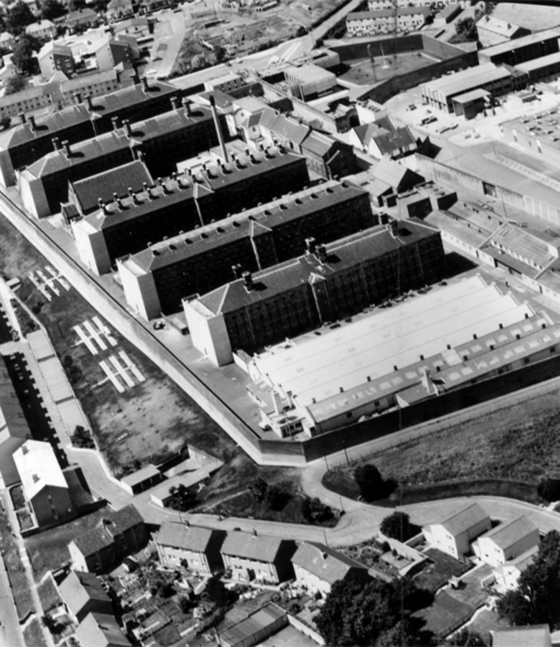
Figure 7 An aerial view of Barlinnie Prison, on the outskirts of Glasgow, Scotland. Barlinnie Prison was built by the Scottish Prison Commission between 1880 and 1894 in order to allow for the closure of inadequate prisons at Campbelltown, Rothesay, Airdrie, Hamilton and Lanark. With cell accommodation for 1000 prisoners, it was intended to serve as a prison for all categories of prisoner. In July 1882, it became a General Prison for Scotland.
View description - Figure 7 An aerial view of Barlinnie Prison, on the outskirts of Glasgow, Scotland. ...
View description - Figure 7 An aerial view of Barlinnie Prison, on the outskirts of Glasgow, Scotland. ...

In Ireland, the achievement of uniformity in prison discipline lagged behind the other nations in part because of political unrest. A Royal Commission established to review the Irish prison system in 1884 delivered a harsh critique of the system of cellular instruction which had become common after 1878, and in which prisoners received just 4 or 5 minutes of tuition each week (Royal Commission on Prisons in Ireland, 1884, p. 36). The Irish Prisons Board agreed that improved arrangements were necessary. In November 1887, new Regulations for the Educational Instruction of Prisoners were circulated to prison governors. They were, in all essentials, a replication of the Fenwick scheme (General Prisons Board (Ireland) Tenth Report, 1888, pp. 25–7).

6 Warders as teachers
In Session 2, you looked at the rise of the prison schoolmaster (and, to a lesser extent, the prison schoolmistress). By the 1850s, qualified schoolmasters and schoolmistresses had been appointed to deliver teaching in all convict institutions (including on hulks). Many large local prisons had also appointed schoolmasters (and some schoolmistresses) who had some teacher training or teaching experience.
Through the 1850s, 1860s and 1870s, there remained a significant number of unqualified teachers and prison officers – warders, wardresses and matrons – in teaching roles. At some institutions, schoolmasters had been forced to take on warder duties when their hours of teaching were reduced (Crone, 2022).

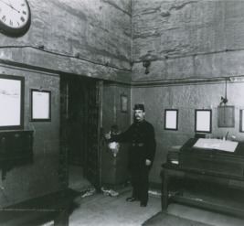
Figure 8 Prison warder standing in the Entrance Hall at Newgate Prison, in the late nineteenth century. Schoolmaster-warders were required to wear the same uniform as ordinary warders. This allowed them to move seamlessly between duties, but could create confusion among prisoners. A prisoner on the school roll at Pentonville Prison, for example, claimed he had never seen the schoolmaster because he thought the schoolmaster was just an ordinary warder (Mitford Committee, 1896, p. 107). Many complained that it was difficult to combine disciplinary and teaching roles in the prison. Prisoners either did not respect them, or were unable to establish effective teacher-student relationships with them.
View description - Figure 8 Prison warder standing in the Entrance Hall at Newgate Prison, in the late ...
View description - Figure 8 Prison warder standing in the Entrance Hall at Newgate Prison, in the late ...

The Fenwick Committee had been asked to consider ‘the class and qualifications of the persons to be engaged as teachers in small or large prisons, and their number and remuneration’ (‘Copy of instructions sent to each member of the Committee’, 1879). Employing an entire staff of qualified schoolmasters across all local prisons, they discovered, would be very expensive. The Home Secretary was reluctant to support such a proposal because he did not believe ‘that the teaching which can be given in short sentence prisons will do much good or will diminish crime in any degree proportionate to its cost.’ Good men, who were strong morally and capable of influencing were needed, he continued, but trained schoolmasters and schoolmistresses were unnecessary when teaching would not extend past basic literacy and numeracy (‘Report on costs of the proposed scheme’, 14 November 1879).
While schoolmasters and schoolmistress appointed before centralisation in 1878 were allowed to keep their titles and pay scales, from 1880 no more qualified teachers were appointed to the local prison service. Instead, warders and wardresses were promoted to the rank of schoolmaster-warder or schoolmistress-wardress on passing an examination under a School Board inspector. These officers were paid as warders and received an additional allowance for their teaching duties (in the case of schoolmaster-warders £12 per annum). Outside the time they were required to teach, they were expected to perform general warder duties.
In the short term, the creation of the schoolmaster-warder and schoolmistress-wardress gave rise to new tensions between teachers appointed after and those appointed before nationalisation, and between teachers in the local prisons and those in the convict prisons. The latter, in both cases, enjoyed better conditions including more pay. Many warders (and wardresses) found that their role as a teacher clashed with their role as a discipline officer, and made prison learners less receptive to their instruction.
In the long term, the use of warders and wardresses in local prisons proved to be the thin end of the wedge. In the late 1890s, the use of warders instead of trained teachers was applied to the convict sector. In the context of the expansion of increasingly specialised training for elementary school teachers in the civil sphere, the use of warders with minimal training as teachers in the penal world widened the gap between education inside and outside the prison even further. It also ensured that instruction in prisons was limited to basic literacy and numeracy (Crone, 2022).

Activity 4 Teaching staff in local prisons
Allow approximately 10 minutes for this activity

Below are two tables which show the daily average number of prisoners (male and female) enrolled in school at prisons in England and Wales in 1895. Given your knowledge of the statistics on prisoner literacy (examined in Session 5), you might be surprised by the small numbers receiving instruction. This was the consequence of the advent of national and compulsory elementary education outside the prison (fewer illiterate prisoners) and the restriction of tuition in prison to those with sentences of 4 months or more.
The tables also show how many teachers (or schoolmaster-warders and schoolmistress-wardresses) were employed at each prison. Look at the tables now and consider the following questions:
- Were there schoolmaster-warders and schoolmistress-wardresses at every prison?
- If not, why not?
- What do you think the consequences were?

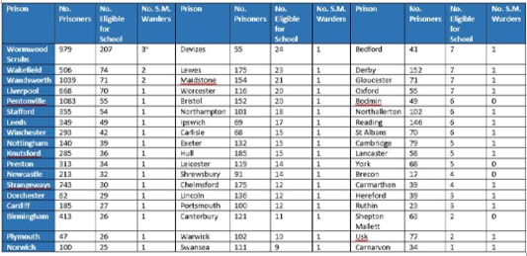
Table 1 The daily average number of male prisoners and male prisoners eligible to attend school as well as the number of schoolmaster-warders at each local prison in 1895.

Access the following link to see a larger version of this table.

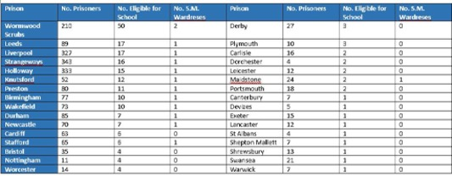
Table 2 The daily average number of female prisoners and female prisoners eligible to attend school as well as the number of schoolmistress-wardresses at each local prison in 1895.

Access the following link to see a larger version of this table.
Source: Mitford Committee (1896) Appendix III, p. 153.

Provide your answer...
View discussion - Activity 4 Teaching staff in local prisons

7 This session’s quiz
Well done – you have reached the end of Session 7. You can now check what you’ve learned this session by taking the end-of-session quiz.
Session 7 practice quiz
Open the quiz in a new tab or window by holding down Ctrl (or Cmd on a Mac) when you click on the link. Return here when you have finished.

8 Summary of Session 7
The standardisation of education for children in mainstream elementary schools through the Revised Code and the nationalisation of local prisons in 1877–78 provided penal administrators with an opportunity: to create a national system of prison education which would tackle illiteracy and innumeracy among the prison population in an equitable manner. No prisoner would receive more education than the honest labourer or than another prisoner in a different prison. Standardisation of the school curriculum in convict prisons – and especially the use of examination books – also reduced disruption to education caused by transfers between prisons.

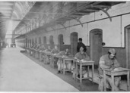
Figure 9 Male prisoners writing letters at Wandsworth Prison, at desks outside their cells, n.d. Letter writing remained a vital means of communication with family and friends outside the prison. At local prisons, it was limited to those who had reached the highest stages through time and good behaviour. Literacy – the ability to read and write – was essential to make use of this privilege.
View description - Figure 9 Male prisoners writing letters at Wandsworth Prison, at desks outside their ...
View description - Figure 9 Male prisoners writing letters at Wandsworth Prison, at desks outside their ...

But there were drawbacks too. While there was, nominally, a school in every UK prison, new eligibility criteria meant that in some prisons there were few, if any, prisoners enrolled in it. Uniformity relied on quantification. In local prisons, each eligible prisoner was meant to receive a set number of minutes of instruction and no more. The adoption of the Revised Code Standards in both the convict and local prison sectors reduced the task of educating prisoners to a tidy checklist of skills that could be ‘ticked off’ when achieved. Progress became more measurable, but the skills or outcomes of education that are easiest to measure are often those that are the least significant. The aim of the prison school was not to transform lives, but, by focusing exclusively on those who had failed to achieve a basic level of competence in literacy and numeracy, to correct educational deficiencies.
However, when assessing the role of prison education at this time, it is important to keep two points in view: first, that there were loopholes in Standing Orders on education which could be exploited, and so uniformity in prisons was never absolute; and second, that while acquiring the skills of reading, writing and arithmetic was not transformative in itself, these were essential tools that could aid rehabilitation if put to good use.
You should now be able to:
- assess the extent to which uniformity in prisons was achievable
- outline the impact of the pursuit of uniformity on the content and delivery of prison education
- evaluate the impact of an exclusive focus on the basic skills (reading, writing and arithmetic) on the transformative potential of education in prisons.
In the early 1890s, uniformity, and the brutal conditions of imprisonment in local and convict prisons came under attack from a new generation of penal reformers concerned about rates of re-offending and the damage that imprisonment caused to individual prisoners. In Session 8, you’ll look at the extent to which this backlash offered a new opportunity for prison education.
You can now go to Session 8.

Session 8: A new era for prison education?

Introduction
In the late 1880s, penal administrators across the British Isles had much to feel satisfied about. Nationalisation had enabled the overhaul of the local prison estate in all four nations. Significant improvements had been made to management procedures, prison buildings and sanitation. Many inefficient prisons had been closed or reconstructed (McConville, 1995b, p. 129). Perhaps most importantly, the prison population began to decline. Between 1879 and 1894, the daily average number of prisoners in local prisons in England and Wales fell by one-third, from 20,833 to 13,850, while the number of convicts halved, from 10,880 to 4,770 (Bailey, 2019, p. 16).
The appearance of an increasingly efficient penal system accompanied by a decline in the prison population suggested that a deterrent and uniform penal regime was working: the late Victorians were winning the war against crime. However, these ‘achievements’ were accompanied by new demands for penal reform. In this final session, you will look at the various factors driving demands for reform, what reforms were being called for, and the impact of these new attitudes towards punishment and prisoners on the provision of education in prisons.
You will also spend some time reflecting on what you have learned about the history of prison education, and whether that knowledge might be used to engage with current debates and to inform practice in the present.

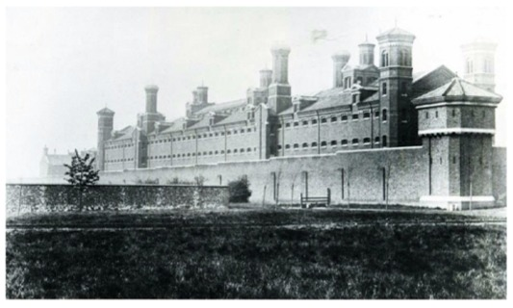
Figure 1 Exterior of Wormwood Scrubs Prison, London. The prison was designed by Edmund Du Cane, chair of the Convict Prison Directors, for convicts serving sentences of penal servitude. It was built between 1874 and 1890 using convict labour. By the early 1880s, the prison was able to accommodate convicts serving their first and second stages of penal servitude. In October 1890, the convict establishment at the prison was broken up, and Wormwood Scrubs became a local prison. Wormwood Scrubs was one of the largest local prisons in England. In 1895, it also had the largest number of male and female prisoners under school instruction.
View description - Figure 1 Exterior of Wormwood Scrubs Prison, London. The prison was designed by Edmund ...
View description - Figure 1 Exterior of Wormwood Scrubs Prison, London. The prison was designed by Edmund ...

By the end of this session, you should be able to:
- outline the reasons for penal reform at end of the 1800s
- assess the extent to which the desire for penal reform resulted in meaningful change, especially for prison education
- understand what is meant by ‘historical perspective’ and reflect on whether knowledge about the history of prison education can usefully inform debate and practice in the present.

1 Behind the prison walls
In Sessions 6 and 7, you learned about the desire of penal reformers and administrators such as Edmund Du Cane to create a uniform and deterrent penal regime in both the convict and local prison sectors. By the late 1870s, the convict prison system had been turned into ‘a huge punishing machine’ (Radzinowicz and Hood, 1990, p. 545). The regime in local prisons after their nationalism in 1878 aimed to deliver a short, sharp shock to those with sentences of imprisonment to dissuade them from returning.

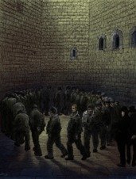
Figure 2 Gustave Dore, Prisoners in the exercise yard at Newgate, c.1872. This illustration appeared in the book, London: A Pilgrimage, by Dore and Blanchard Jerrold, which aimed to show the ‘shadows and sunlight’ of London, and contained many depictions of the lives of the poor and wretched. Dore’s illustration of the exercise yard at Newgate was later copied by Vincent Van Gogh.
View description - Figure 2 Gustave Dore, Prisoners in the exercise yard at Newgate, c.1872. This illustration ...
View description - Figure 2 Gustave Dore, Prisoners in the exercise yard at Newgate, c.1872. This illustration ...

At the same time, the flow of information from prisons to the outside world was dramatically curtailed. By the 1860s, visits from prisoners’ families and friends, charitable ladies and gentlemen and journalists had been greatly restricted. In 1878, the independent prison inspectorate – which had provided Parliament with reports on local prisons in England, Wales and Scotland since 1836 – was abolished. From the 1870s, annual reports from the Convict Prison Directors on convict prisons were reduced in length and contributions from officials such as chaplains were censored (Forsythe, 1987, p. 202). Annual reports produced by the Prison Commissioners on local prisons from 1878 were both short and self-congratulatory. An impression of order and uniformity in both sectors was conveyed.

2 Opposing voices
In Sessions 6 and 7 you learned that uniformity in convict and local prisons was never absolute. There were also some individuals and groups who spoke out against the harsh regime that had been created in prisons. Prison Visiting Committees – groups of local magistrates who, on losing control of local prisons as a result of nationalisation, had been compensated with visiting rights – sometimes protested about certain rules and practices.
For example, at a Visiting Committee conference in 1885, the magistrates complained bitterly about prison officials’ rigid adherence to eligibility criteria for school attendance, the exclusion of eligible women from school in some prisons because of their small numbers, and the inefficiency of cellular instruction. Lord Leigh, chairman of the Warwick Prison Visiting Committee, declared:

What we want in prison now is a good reformatory influence. There was something like a good reformatory influence before the prisons were handed over to the Government. At present there is nothing of the sort. It is all strict discipline that is carried out. Discipline is very good; but we want more than that.
(Report of the Seventh Annual Prison Conference, 1885, p. 30)

From the mid-1870s, former prisoners began to publish accounts of their experiences behind bars especially in convict prisons. Most were either political prisoners (convicted of illegal forms of protest, or acts of terrorism, against the state) or white-collar prisoners (members of the professional classes typically convicted of fraudulent or domestic offences). Their memoirs exposed to the public the brutal conditions to which prisoners were subjected. However, the main thrust of their complaint was that prisoners like themselves had been subjected to the same brutal treatment as, and forced to mix with, hardened, ‘professional’ criminals (Weiner, 1990, pp. 310–13). By striving, through their writing, to separate themselves from the ‘criminal class’, they further embedded damaging stereotypes.

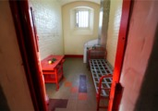
Figure 3 A view inside Oscar Wilde’s cell, C2.2, at Reading Gaol. In 1895, Wilde, a famous poet and playwright, was convicted of homosexual offences and sentenced to two years imprisonment with hard labour. He served his sentence at Pentonville, Wandsworth and, finally, Reading, and suffered greatly as a result of the regime of ‘hard labour, hard board and hard fare’. On release, Wilde wrote of his experiences, including his famous poem, The Ballad of Reading Gaol. His writing help to sustain the penal reform movement in the closing years of the 1800s. Wilde’s cell had a bed and glass in the window. It was light but it may not have been warm or comfortable. It is difficult to get a sense of the noise or the smell. Even when the silent system was in operation, many accounts of prison life refer to the screams and shouting of those people confined to their cells and alone, who had mental breakdowns. Contrast this image with that you saw in Session 1 of Francis Wheatley’s 1787 John Howard Visiting and Relieving the Miseries of Prison. It shows a holding bay for those confined before sentencing, being hanged or being transported to a colony. People, including family, could visit to make sales or offer to represent a prisoner at court. But the staged scenery in the background bears little relation to the architecture of any specific old prison.
View description - Figure 3 A view inside Oscar Wilde’s cell, C2.2, at Reading Gaol. In 1895, Wilde, ...
View description - Figure 3 A view inside Oscar Wilde’s cell, C2.2, at Reading Gaol. In 1895, Wilde, ...

Activity 1 Prison memoirs
Allow approximately 10 minutes for this activity

Prison memoirists of the late 1800s were already literate and numerate before their convictions. Although they complained about the quality and quantity of reading matter available to them during their imprisonment, few had much to say about the prison school because they did not attend lessons.
An exception to this was the ‘Ticket of Leave Man’, a self-proclaimed gentleman who committed a crime in a ‘state of madness’ and was sentenced to penal servitude. He anonymously published his memoir, Convict Life; or, Revelations Concerning Convicts and Convict Prisons, in 1879, basing his pen-name on the system of licensing (or parole) by which well-behaved and industrious convicts served part of their sentence in the community (as you learned in Session 6).
Read his description of the convict prison school and consider the following questions:
- ‘Ticket of Leave Man’ did not attend school in prison. How did he know what went on there?
- According to ‘Ticket of Leave Man’, what was wrong with the prison school?
- This is a very negative portrayal of the prison school. Do you think ‘Ticket of Leave Man’ was supportive of prison education?

An account of the prison school, by ‘Ticket-of-leave Man’
Now, there are thousands of prisoners unable either to read or write their own names, and whose ignorance has been one of the great obstacles to their success in life; there are hundreds of agricultural labourers, who, although they are in prison, are not vicious by nature or inclination; and there are numbers of young boys who have landed in prison in absolute ignorance, and whose presence there is due to the fact that they have been allowed to grow up without any mental or moral training. These classes have now the opportunity of attending school for one hour in a week in the winter time, and for about twenty minutes in a week in summer time!
During these minutes, the boy, the countryman, the novice in crime, sit shoulder to shoulder with old and abandoned thieves. These old thieves have not the most remote intention to learn, even if they had the opportunity, but they attend school as an excuse to get out of their cells, and because they want a change of scene and company.
When prisoners are entitled to write letters to their friends they write them in the school-hour, so that I had frequent opportunities of seeing what went on. Disgusting conversations were indulged in, the prisoners keeping their eyes upon their books to avoid detection, but under pretence of mumbling their lessons aloud they were engaged in ribald chat with their neighbours, and many were making disgusting and licentious drawings on their slates, and showing them to their pals. Classification would remedy this evil, for it is only caused by the habitual-criminal element. The other classes would profit by instruction if they had any opportunity, at present they have no chance given them.
I will describe the educational arrangements at Dartmoor. They reflect precisely the state of things at Portland, and I presume at other public-works prisons. There are five distinct prisons or halls. Once a week, in each hall, in summer for about twenty minutes and in winter for about one hour, the schoolmasters instruct, or pretend to instruct, such prisoners as can neither read nor write; no others are permitted to attend school. An utter ignorance of the history of England, or the geography of the globe, or of the simplest rules of arithmetic, are not considered sufficient reasons to warrant the interference of the schoolmaster.
The very little time allotted for educational purposes is half wasted even in this ‘once a week’ system. When the bell rings for school and the classes have assembled the roll is called, then the schoolmasters (who do everything very leisurely) distribute the copybooks or the spelling-books; then they take another slow walk round with the pens, and by the time a dozen words of one syllable have been spelt, and often before a single line in the copybook has been filled, the bell rings again. The schoolmaster’s work (?) is done, he walks – not leisurely round now, he wants to get home, or to the billiard-room in the village, and he is all in a bustle – “Now, then, hurry up with those books and pens! look sharp!” Then, away rush the “dominies” and the prisoners return to their cells about as wise as they left them. The only thing they have learned, is probably a fresh lesson in vice from their next neighbour, or the latest prison scandal and gossip.
I have certainly met with two or three men who, in spite of difficulties, have after three or four years acquired sufficient knowledge to scribble half-a-dozen ungrammatical lines to their friends; but these cases have been the result of prodigious effort, and are not the consequences of any interest which is taken in their work by the schoolmasters, who are paid very fair salaries, and whose great object seems to be to do as little as possible in return.
(Source: Convict Life, 1879, pp. 174–7)

Provide your answer...
View discussion - Activity 1 Prison memoirs

This was one of the very few accounts of the prison school available to the public in the late 1870s and 1880s. It may be that ‘Ticket of Leave Man’ hoped, that by exposing the problems of prison education, he might convince of the need for improvement. However, there is little evidence in this piece that the provision of education could make a positive difference to prisoners’ lives. ‘Ticket of Leave Man’ also suggested that efforts made to educate habitual criminals were a waste of time. In the past and the present, exclusively negative accounts of prisons and prisoners promote a narrative of failure which can be entirely counterproductive to positive reform.

3 Pressure for reform: the 1895 Gladstone Committee
By the early 1890s, confidence in a uniform and deterrent system of imprisonment that prioritised the punishment of convicted criminals began to wane. New ways of thinking about crime and criminals were becoming more prominent. In Session 5, you looked at the rise of positivist criminology, the proponents of which argued that crime was not caused by the moral failings of individuals, but was the product of environmental and biological factors. As criminals were not responsible for their behaviour, positive criminologists argued that treatment, not punishment, was a more appropriate response (Wiener, 1990, pp. 228–36).
At the same time, humanitarianism – compassion for the weak and infirm – was being promoted by new organisations such as the Humanitarian League (established in 1891). A new generation of civil servants and MPs were attracted to the idea that state policy (and by extension, penal policy) needed to help individuals to become their ‘best selves’ (Bailey, 2019, pp. 33–42; McConville, 1995a, pp. 550, 580, 583). The rise of this new thinking coincided with a souring of relations between Edmund Du Cane and civil servants in the Home Office (McConville, 1995a, pp. 523–42).

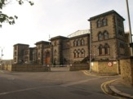
Figure 4 Exterior of Wandsworth Prison, London, opened in 1851. William Douglas Morrison, chaplain at Wandsworth between 1887 and 1898, played a key role in the campaign for prison reform in the 1890s. Originally, historians believed that Morrison was the author of the series of articles on prisons entitled ‘Our Dark Places’ published by the Daily Chronicle in 1894. In that series, Wandsworth Prison was described as ‘By far the best prison in London … One of the least satisfactory is Wormwood Scrubs, which is the proud monument of Sir Edmund Du Cane’s genius…’ (McConville, 1995a, p. 572).
View description - Figure 4 Exterior of Wandsworth Prison, London, opened in 1851. William Douglas Morrison, ...
View description - Figure 4 Exterior of Wandsworth Prison, London, opened in 1851. William Douglas Morrison, ...

Matters came to a head in January 1894 when Henry Massingham, editor of a leading Liberal newspaper, the Daily Chronicle, published a series of articles entitled ‘Our Dark Places’ which exposed and publicly condemned the prison regime in England and Wales. Massingham argued that prisoners who were kept in silence and solitude, given painful, monotonous and unproductive employment, barely kept alive on a subsistence diet, and subjected to few reformatory influences, were debilitated (severely weakened) by their imprisonment. Some suffered severe mental health problems. Others were turned into repeat offenders (McConville, 1995a, pp. 568–76). Official rates of reoffending had increased to about 55% (Bailey, 2019, p. 57; Wiener, 1990, p. 343). According to Massingham, the prison was not the solution to crime; it was one of causes of it.
In response, the Home Secretary, Herbert Henry Asquith, appointed a departmental committee to inquire into the state of prisons in England and Wales. Herbert Gladstone, son of the former Liberal prime minister, William Ewart Gladstone, was asked to chair it. The report of the Gladstone Committee, delivered on 10 April 1895, acknowledged the cruelty and inhumanity that had come to characterise the penal regime of the late 1800s.
The result of a highly centralised and uniform system, the Committee argued, was that ‘the prisoners have been treated too much as a hopeless or worthless element of the community’ (Report from the Departmental Committee on Prisons, 1895, p. 7). They declared that both deterrence and rehabilitation should be pursued as the ‘primary and concurrent’ objects of prison discipline. They proposed, among other things, the abolition of hard labour machines, the reduction of time spent in separate confinement, and the development of education and training opportunities.

4 Reforming prison education
On the eve of the completion of the Gladstone Committee’s report, Edmund Du Cane retired from the chair of the English and Welsh Prison Commission. His departure was convenient, both for him (he avoided the humiliation of an official reprimand or dismissal) and for the Home Office. As Du Cane had become the ‘embodiment of prison severities’, his departure was a change in itself (McConville, 1995a, p. 607). The symbolic ‘change of guard’ was played out in Ireland too. In 1895, Charles Bourke, chair of the Prisons Board, was forced to retire (Smith, 1981, p. 337).

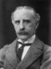
Figure 5 Evelyn Ruggles-Brise, an Oxford graduate and civil servant, was appointed prison commissioner in 1892, and chair of the Prison Commission for England and Wales in 1895. His background meant that he was a contrast to his predecessor, military-man Sir Edmund Du Cane. A cautious administrator and reformer, Ruggles-Brise’s primary innovation was the establishment of ‘Borstal’ prisons for juvenile-adults aged between 16 and 21.
View description - Figure 5 Evelyn Ruggles-Brise, an Oxford graduate and civil servant, was appointed ...
View description - Figure 5 Evelyn Ruggles-Brise, an Oxford graduate and civil servant, was appointed ...

The new chair of the English and Welsh Prison Commission, Evelyn Ruggles-Brise, was given the task of implementing the specific recommendations of the Gladstone Committee. There were 56 in total. Ruggles-Brise proved willing to act on those which removed some of the worst features of Du Cane’s penal regime and on those which provided special treatment for certain categories of prisoners (for example, young adults and alcoholics). He was more reluctant to act on those which increased spending on prisons, or which substantially lessened the penal and deterrent aspects of imprisonment (McConville, 1995a, pp. 660–79).
Four of Gladstone’s recommendations related to the delivery of education in local and convict prisons. These included:
- the replacement of cellular instruction with class teaching
- the extension of scholarly instruction to any ‘who would be the better for it’ including those with sentences of less than four months
- the removal of discipline duties from schoolmaster-warders and schoolmistress-wardresses, and to take them out of uniform
- the more frequent exchange of library books.
Knowing that the implementation of these recommendations would cost money and would require some significant changes to timetables and staffing, Ruggles-Brise proposed the establishment of another departmental committee specifically to consider the provision of instruction and educational facilities in prisons.

Activity 2 The work of the Mitford Committee
Allow approximately 15 minutes for this activity

Between 13 February and 17 April, the Departmental Committee on Education in Local and Convict Prisons (also known as the Mitford Committee, after its chair, Robert Mitford, prison commissioner) heard evidence from 58 witnesses. These included prison chaplains, schoolmaster-warders and schoolmistress-wardresses, governors, an assistant superintendent (female governor) and matron, two educational experts, William Tallack of the Howard Association (predecessor of the Howard League for Penal Reform), as well as five male and two female prisoners. The prisoners were interviewed by members of the Committee at Wormwood Scrubs Prison on 2 March 1896.
Listen to the following extracts from interviews with two male and two female prisoners at Wormwood Scrubs Prison and consider the following questions:
- What reasons did these men and women provide for their illiteracy or poor literacy and numeracy?
- Why might they have wanted to improve their literacy and numeracy while in prison?
- How authentic are these testimonies?

Audio content is not available in this format.
Audio 1
View transcript - Audio 1

Provide your answer...
View discussion - Activity 2 The work of the Mitford Committee

In Session 7, you learned that between 1870 and 1880, a national system of compulsory elementary education for children aged between 5 and 10 was established in England and Wales. However, until 1891, fees still had to be paid. Even after 1891, for poorer families, sending a child to school meant that potential income needed to keep the family afloat was lost. In 1895, nearly 20% of children still did not attend school (Sutherland, 1990, pp. 142–5). Between 1870 and 1892, similar provision – universal, compulsory and free education – was made in Scotland and Ireland. In Ireland in 1900, just 62% of children were attending school regularly (Knox, n.d., pp. 2–3; Walsh, 2016, pp. 16–18).
Universal and compulsory state education did not weaken the case for prison education. If anything, it was strengthened. In their report, the Mitford Committee explained that as the state had taken responsibility for the elementary education of the population, it seemed wholly appropriate and necessary to extend provision to men and women in prison who had failed to reach the minimum educational standard expected of all citizens. However, the Committee also stressed that the provision of education in prisons must not interfere with the penal and deterrent objects of prison discipline.

5 A new scheme for prison education?
The Mitford Committee proposed the following changes to education in prisons:
- the inclusion of prisoners with sentences of 3 months imprisonment
- updates to the curriculum to reflect what was taught in state elementary schools
- a small increase in the amount of time given to teaching prisoners
- a more frequent exchange of library books
- lectures for well-behaved prisoners.
At the same time, the Committee recommended the retention of:
- cellular instruction for all except convicts working in association
- an age limit of 40 years
- the rule requiring local prisoners to complete their first stage of punishment before admission to the school
- the delivery of instruction by schoolmaster-warders and schoolmistress-wardresses.

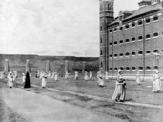
Figure 6 Mothers and babies exercising during their allocated hour together at Wormwood Scrubs Prison, c.1890. Women who were pregnant on conviction and had to give birth while in prison were allowed to keep their new babies with them for a short period. Women sentenced to penal servitude could not take their babies within them to convict prisons.
View description - Figure 6 Mothers and babies exercising during their allocated hour together at Wormwood ...
View description - Figure 6 Mothers and babies exercising during their allocated hour together at Wormwood ...

In July 1897, the English and Welsh Prison Commissioners devised a new scheme for education in local and convict prisons based on these recommendations. The scheme also aimed to assimilate the systems in use at local and convict prisons, because convicts were now completing their first stage of penal servitude – separate confinement – in local prisons. The intention was that eligible convicts would complete their schooling during their first stage of punishment, and that schools in convict prisons would be abolished. This was never achieved in practice.

Activity 3 Evaluating the 1897 scheme for education in local prisons
Allow approximately 10 minutes for this activity

Table 1 summarises the main features of the 1897 scheme alongside those of the Fenwick scheme of 1883 (which you looked at in Session 7).
Have a look at the table now, and consider the following question: how significant were the 1897 reforms to prison education?

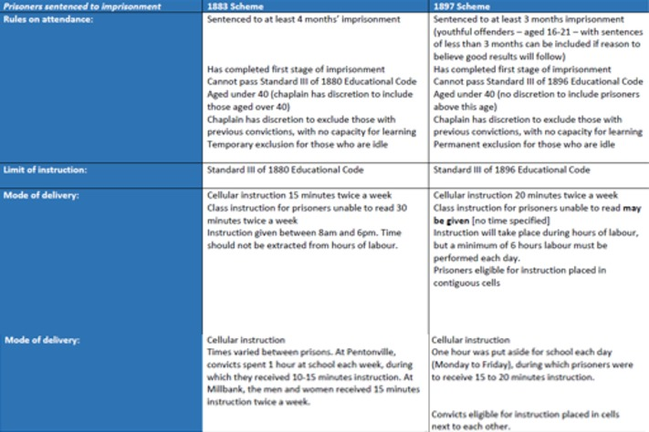
Table 1 Education of Convicts and Prisoners in Local Prisons

Access the following link to see a larger version of this table.

Provide your answer...
View discussion - Activity 3 Evaluating the 1897 scheme for education in local prisons

6 The limits of reform
Criminologist David Garland and historians such as Martin Wiener have argued that the report of the Gladstone Committee was a watershed in penal policymaking. It provided a blueprint for a new age of ‘penal-welfarism’ (Garland, 1985, pp. 4–5; Wiener, 1990, pp. 366–79). The prison was ‘decentred’ within the broader criminal justice system as new custodial options – such as borstals (for young adult offenders), inebriate asylums (for alcoholics), and industrial schools (for children at risk of committing crime) – and non-custodial options – such as fines and probation – were increasingly used as alternatives to imprisonment. What followed was a long period, at least until the end of the Second World War, in which the prison population declined and a significant number of prisons were closed in England and Wales.

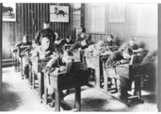
Figure 7 Schoolroom and pupils at the Rochester Borstal in Kent, c.1906. From 1901, Borstals provided separate provision for juvenile-adult prisoners aged between 16 and 21. As well as being subjected to rigorous discipline, military drill and physical exercise, the young men were given training and education, and were supported after their release by middle-class volunteers.
View description - Figure 7 Schoolroom and pupils at the Rochester Borstal in Kent, c.1906. From 1901, ...
View description - Figure 7 Schoolroom and pupils at the Rochester Borstal in Kent, c.1906. From 1901, ...

Other historians, such as Victor Bailey and Seán McConville, have argued that the significance of the Gladstone Committee report, and the changes that followed, have been over-emphasised. They highlight the fact that although some other options for dealing with convicted criminals emerged, there was very little change in the conditions and experience of imprisonment. There was a significant gap between the rhetoric of penal policy – with its emphasis on rehabilitation – and what actually went on inside prisons from the end of the 1800s through the first half of the 1900s (Bailey, 2019; McConville, 1995a, p. 696).
Inertia was also evident in the provision of formal instruction for prisoners, until at least the end of the First World War. The 1897 scheme offered little improvement on the Fenwick scheme of 1880. It applied to England and Wales only. Prisons in Scotland and Ireland retained schemes which had been introduced in 1883 and 1887, both of which had been based on the Fenwick scheme (see Session 7) (Smith, 1981, p. 338).
As the English and Welsh Prison Commissioners explained, to do anything more ambitious would have required more money. To extend formal education for prisoners beyond the basic skills – and beyond that which was available to the poorest, honest, citizen – would have been unpalatable to the public. The basic skills fulfilled a correctional need suggested by the criminal statistics. They made the effect – and therefore value – of prison education easy to measure (Crone, 2022, ch.9).
By the end of the 1800s, as a consequence of penal and educational policy, prison education had become thoroughly embedded in the ‘modern prison’ in Britain and Ireland. Its abolition was now almost impossible. But, at the same time, the chances of its expansion into an ambitious project of social reconstruction had been severely curtailed.

7 Learning from history
Studying the past is, in itself, an enjoyable and useful intellectual activity. Becoming immersed in a different time and place feeds the imagination and stimulates curiosity. The study of a range of sources – primary (of the time) and secondary (what has subsequently been written about events) – provides exposure to different viewpoints. Assessing the value, contribution and biases of primary and secondary sources develops skills of critical analysis. All these things can help us to become more engaged and confident, not to mention more employable, citizens.
There are many who also argue that knowledge and understanding of past events and processes – an historical perspective – can deepen our understanding of particular phenomena or issues in the present and can aid decision making about the future. The society we live in today is a product of the past. It is the outcome of processes which have unfolded over time and which continue to exert influence over our current condition (Tosh, 2008, p. 8).
Take, for example, the criminal justice systems which operate in each of the four nations in the UK today. It is inconceivable that the police forces, prosecution procedures and prisons which we see today could have been invented, entirely from scratch, in the present. Each element has evolved, over time, in response to changing conceptions of crime, new philosophies of punishment and unexpected events.

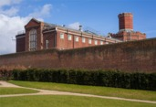
Figure 8 Reading Gaol, built in the mid 1840s and closed in 2014 as part of a government initiative to replace historic prisons with new institutions designed to better meet the aims of imprisonment in the 2000s. But how far have those aims changed? And what should be done with historic prisons, many of which include listed buildings, after their closure?
View description - Figure 8 Reading Gaol, built in the mid 1840s and closed in 2014 as part of a government ...
View description - Figure 8 Reading Gaol, built in the mid 1840s and closed in 2014 as part of a government ...

Studying the past challenges the idea that certain things have always been this way and are therefore impossible to change. Although prisons have a long history as places of confinement, it is only in the very recent past that they have been used as a form of punishment for those convicted of crime in the UK. You might remember from Session 1 that convicted criminals in the 1700s were more commonly sentenced to death or transportation, or endured other bodily punishments, such as branding or whipping. To what extent does this knowledge enable us to conceive of a society without prisons?
Studying the past can also reveal some surprising continuities, thereby challenging the presumed novelty of the present (Lawrence, 2019, p. 495). Perhaps you did not know before studying this course that there were schools in prisons during the 1800s in which accused and convicted criminals were taught reading, writing and arithmetic?
History presents us with ‘a vast reservoir of experience and information’ (Corfield, 2010, p. 2). Historical perspective encourages us to think again about the world around us, to ask different questions about our current circumstances, and to explore alternative solutions to contemporary problems.

Activity 4 Learning from the history of prison education
Allow approximately 10 minutes for this activity

Over the last eight sessions, you have explored the provision of education in prisons during the 1800s. You have looked at the origins of prison education in the UK, the various ways in which education was provided, and its results. You have also looked at the emergence of statistics on prisoner literacy and interrogated some of the data. You have looked at how education in prisons was reshaped (or not) as a result of successive waves of penal reform.
You now have an opportunity to reflect on what you have learned. Here are some questions to guide you through this process:
- Has learning about the history of prison education given you new insights and understanding? Has it also changed how you think about prison education in the present?
- Did you learn anything unexpected in this course?
- Have you acquired any new knowledge or new perspectives on prisons and prison education through this course which could be used to inform debates about or the provision of education in prisons today?
- If you have acquired new knowledge or perspectives, what do you plan to do as a result?

Provide your answer...
View discussion - Activity 4 Learning from the history of prison education

8 Reflection
Before you attempt the quiz you are encouraged to ask yourself three questions about the whole course. The aim is for you to think about your ways of thinking, your values, the challenges you overcame, the insights you gained and if you now understand more about yourself as a learner. We would like you to leave this course confident that you are competent at time management and are well-prepared for further study,
It is recommended that before you write a couple of sentences in response to each question, you read these notes.
What happened?
Was the content interesting? Can you give examples?
Perhaps you found the debates among the reformers of interest. Slowly, evangelical and utilitarian ideas gave way to the desire to isolate and shape the ‘criminal class’. Perhaps you found the voices of the prisoners of most interest. Which aspects of the course have you shared with anybody else?
So what?
What is the value of the knowledge you have acquired? Did you learn or improve a skill?
For example, you will have done a lot of critical reading of a range of written sources including graphs and diagrams as well as listening to a song and looking at some pictures. You have looked for what was not said as well as that which was said. Was this an important idea to understand? How might you apply it once you finish the course?
What next?
How might you apply the skills that you have gained? You have drawn up a study timetable, would it now be easier to draw up a timetable for another activity?
You may well have found that your note-taking improved as you found a system which worked for you. When studying your next course, what sorts of questions might you ask of it, even before you start the course?
In this final session of the course, you examined some aspects of who was taught and what they were taught towards the end of the 1800s. In the preceding seven Sessions, you looked at different approaches to the study of prisoner education, how to assess sources and you were offered some ideas about study skills, timetabling and reflection. You now know where to look to if you wish to refresh your memory as to why, between 1780 and 1840 the penitentiary was conceived and then versions of it were built. You can assess the reasons why prisoners received free education, by law, about half a century before children did.

9 This session’s quiz
It’s now time to complete the Session 8 badged quiz. It is similar to the previous quizzes but this time, instead of answering 3 questions there will be 15, covering Sessions 5–8.
Session 8 compulsory badge quiz
Remember that the quiz counts towards your badge. If you’re not successful the first time, you can attempt the quiz again in 24 hours.
Open the quiz in a new tab or window by holding down Ctrl (or Cmd on a Mac) when you click on the link. Return here when you have finished.

10 Summary of Session 8
In this final session of the course, you have looked at the rise of the penal reform movement of the late 1800s and its consequences for prison education. The Gladstone Committee of 1895 presented an opportunity for doing something meaningful and worthwhile which was largely missed. The 1897 scheme for education in local and convict prisons was evidence of how far ambitions for prison education had receded. You also learned about the concept of ‘historical perspective’ and thought about how an historical perspective on prison education might be valuable for those involved in the provision of prison education today.
You should now be able to:
- outline the reasons for penal reform at end of the 1800s
- assess the extent to which the desire for penal reform resulted in meaningful change, especially for prison education
- understand what is meant by ‘historical perspective’ and reflect on how knowledge about the history of prison education can usefully inform debate and practice in the present.
There remains much that needs to be done to improve the provision of education in prisons and to ensure that prisoners are able to access and make the best use of their learning. Prison education can deliver great benefits to society. A joint study by the Ministry of Justice and the Department for Education published in 2017 showed that prisoners who engaged in any form of learning activity while inside had lower levels of re-offending one year after release; that is, 34% for prisoner learners compared with 43% for prisoner non-learners (‘Exploring the Outcomes of Prisoner Learners’, 2017). Prison education can deliver great benefits to the individual – as Stephen Akpabio-Klementowski’s story shows (see below). Prison education requires courage – from prisoners, who are willing to try, and from the policymakers, who need to invest.
Congratulations, you have now completed this free course. In learning about the history of prison education you have been introduced to some of the fundamental concepts of historical study, and you have developed some important skills which you can use for further study.

A success story

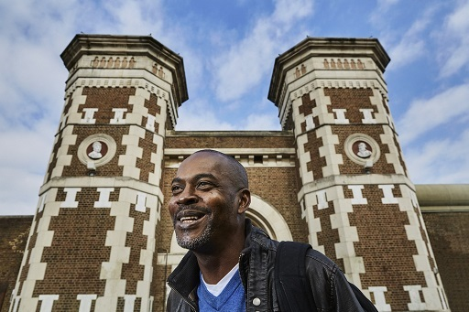
Figure 9 Stephen Akpabio-Klementowski. Stephen’s story shows exactly how life-changing education can be. His journey has taken him from a prisoner, to an OU student and now to an OU member of staff supporting the Students in Secure Environments team.
View description - Figure 9 Stephen Akpabio-Klementowski. Stephen’s story shows exactly how life-changing ...
View description - Figure 9 Stephen Akpabio-Klementowski. Stephen’s story shows exactly how life-changing ...

Read more about Stephen’s story in the following article: From prisoner to OU student and staff member

Where next?
If you’ve enjoyed this course you can find more free resources and courses on OpenLearn.
New to University study? You may be interested in our courses on History.
Making the decision to study can be a big step and The Open University has over 40 years of experience supporting its students through their chosen learning paths. You can find out more about studying with us by visiting our online prospectus.

Tell us what you think
Now you’ve come to the end of the course, we would appreciate a few minutes of your time to complete this short end-of-course survey (you may have already completed this survey at the end of Session 4). We’d like to find out a bit about your experience of studying the course and what you plan to do next. We will use this information to provide better online experiences for all our learners and to share our findings with others. Participation will be completely confidential and we will not pass on your details to others.

References
Butler, R.J. (2016) ‘Rethinking the origins of the British Prisons Act of 1835: Ireland and the development of central-government prison inspection, 1820–1835’, Historical Journal, 59(3), pp. 721–46.
Crone, R. (2022) Illiterate Inmates: Educating Criminals in Nineteenth-Century England. Oxford: Oxford University Press.
Gaols Act, 1823, 4 Geo IV, c.64.
Gatrell, V.A.C. (1994) The Hanging Tree: Execution and the English People 1770–1868. Oxford: Oxford University Press.
Howard, J. (1777) State of the Prisons in England and Wales, with Some Preliminary Observations, and an Account of Some Foreign Prisons. Warrington: William Eyres.
Pole, T. (1816) A History of the Origin and Progress of Adult Schools. 2nd edn, London: C. McDowall & J. Richardson.
Vincent, D. (1989) Literacy and Popular Culture: England, 1750–1914. Cambridge: Cambridge University Press.
Clay, W.L. (1969) The Prison Chaplain: A Memoir of the Rev John Clay, B.D.. Montclair, NJ: Patterson Smith.
Crone, R. (2022) Illiterate Inmates: Educating Criminals in 19th Century England. Oxford: Oxford University Press.
Gaols Act, 1823, 4 Geo IV, c.64.
Inspectors of Prisons of Great Britain II. Northern and Eastern, First Report, (1836), Parliamentary Papers, vol. XXXV.161.
Inspectors of Prisons of Great Britain II. Northern and Eastern, Second Report, (1837), Parliamentary Papers, vol. XXXII.499.
Inspectors of Prisons of Great Britain II. Northern and Eastern, Third Report, (1837–38), Parliamentary Papers, vol. XXXI.1.
Inspectors of Prisons of Great Britain III. Southern and Western, Fourth Report, (1839), Parliamentary Papers, vol. XXII.217.
Jackson’s Oxford Journal, 24 April 1852.
Leicester Chronicle, 9 July 1842.
McConville, S. (1981) A History of English Prison Administration, 1750–1870. London: Routledge.
Regulations for Prisons in England and Wales (1840), London, Her Majesty’s Stationery Office.
Regulations for Prisons in England and Wales (1843), London, Her Majesty’s Stationery Office.
Rogers, H. (2009) ‘The way to Jerusalem: Reading, writing and reform in an early Victorian gaol’, Past & Present, 205(1), pp. 71–104.
Smelser, N.J. (1991) Social Paralysis and Social Change: British Working-Class Education in the Nineteenth Century. Berkeley: California University Press.
Bennett, J. (1981) Oral History and Delinquency: The Rhetoric of Criminology. Chicago: University of Chicago Press.
Clay, J. (1846) Chaplain’s Twenty-Third Report of the Preston House of Correction, Presented to the Magistrates of Lancashire. Preston: L. Clarke.
Crone, R. (2012) ‘The Great “Reading” Experiment: Debates about the role of education in the nineteenth-century gaol’, Crime, Histoire et Sociétés, 16(1), pp. 47–74.
Crone, R. (2022) Illiterate Inmates: Educating Criminals in Nineteenth-Century England. Oxford: Oxford University Press.
Directors of Convict Prisons: Reports on Discipline and Management of Pentonville, Parkhurst, Millbank, Portland, Portsmouth and Dartmoor Prisons, and Hulks, 1852 (1852–53), Parliamentary Papers, vol. LI.385.
Directors of Convict Prisons: Reports on Discipline and Management of Pentonville, Parkhurst, Millbank, Portland, Portsmouth and Dartmoor Prisons, and Hulks, 1859 (1860), Parliamentary Papers, vol. XXX.237.
Field, J. (1848) Prison Discipline and the Advantages of the Separate System of Imprisonment. 2 vols, 2nd edn, London: Longman, Brown, Green and Longmans.
Forsythe, W.J. (1987) The Reform of Prisoners, 1830–1900. New York: St Martin’s Press.
Inspectors of Prisons of Great Britain I. Home District, Fourth Report (1839), Parliamentary Papers, vol. XXI.1.
Inspectors of Prisons of Great Britain II. Northern and Eastern District, Eighth Report (1843) Parliamentary Papers, vol. XXV. & XXVI.249.
Inspectors of Prisons of Great Britain II. Northern and Eastern District, Eleventh Report (1846) Parliamentary Papers, vol. XXI.483.
Inspectors of Prisons of Great Britain I. Home District, Fifteenth Report (1851) Parliamentary Papers, vol. XXVII.1.
Inspectors of Prisons of Great Britain II. Northern and Eastern District, Seventeenth Report (1852–53), Parliamentary Papers, vol. LII.1.
Pentonville Prison, Commissioners’ Visiting Book (1843–1854), The National Archives, PCOM2/ 90.
Reports and Schedules Pursuant to Gaol Acts [i.e. Gaol Act Reports] (1847), Parliamentary Papers, vol. XLVII.297.
‘Second Report on Portland Prison’, Directors of Convict Prisons: Reports on Discipline and Management of Pentonville, Parkhurst, Millbank and Portland Prisons, and Hulks, 1850 (1851), Parliamentary Papers, vol. XXVIII.1.
Vincent, D. (1989) Literacy and Popular Culture: England, 1750–1914. Cambridge: Cambridge University Press.
Crone, R. (2012) ‘The Great “Reading” Experiment: Debates about the role of education in the nineteenth-century gaol’, Crime, Histoire et Sociétés, 16(1), pp. 47–74.
Crone, R. (2022) Illiterate Inmates: Educating Criminals in Nineteenth-Century England. Oxford: Oxford University Press.
Directors of Convict Prisons: Reports on Discipline and Management of Pentonville, Parkhurst, Millbank, Portland, Portsmouth, Dartmoor, and Brixton Prisons, and Hulks, 1856 (1857 Session 2), Parliamentary Papers, vol. XXIII.65.
Field, J. (1848) Prison Discipline and the Advantages of the Separate System of Imprisonment. 2 vols, 2nd edn, London: Longman, Brown, Green and Longmans.
Fyfe, J. (1992) Books Behind Bars: The Role of Books, Reading and Libraries in British Penal Reform, 1701–1911. Westport, Connecticut: Greenwood Press.
Gaols Act, 1823, 4 Geo IV, c.64.
Holford, G. (1828) An Account of the General Penitentiary at Millbank. London: C. & J. Rivington.
Inspectors of Prisons of Great Britain II. Northern and Eastern District, Second Report (1837) Parliamentary Papers, vol. XXXII.499.
Inspectors of Prisons of Great Britain IV. Scotland, Northumberland and Durham, Seventh Report (1842) Parliamentary Papers, vol. XXI.369.
Inspectors of Prisons of Great Britain I. Home District, Tenth Report (1845) Parliamentary Papers, vol. XXIII.1.
Inspectors of Prisons of Great Britain IV. Scotland, Northumberland and Durham, Twelfth Report (1847) Parliamentary Papers, vol. XXIX.381.
Inspectors of Prisons of Great Britain II. Midland and Eastern District, Thirteenth Report (1847–8) Parliamentary Papers, vol. XXXVI.1.
Mayhew, H. (1861) London Labour and the London Poor. Volume I, The London Street-folk (Partial), with a new introduction by Rosenberg, J. D. New York: Dover Publications (this edition 1968).
Prison Act 1839, 2 & 3 Vict. c.56.
Reports and Schedules Pursuant to Gaol Acts [i.e. Gaol Act Reports] (1833) Parliamentary Papers, vol. XXVIII.1.
Reports relating to Parkhurst Prison, 1849 (1849) Parliamentary Papers, vol. XXVI.327.
Select Committee on the Penitentiary at Millbank (1823) Parliamentary Papers, vol. V.403.
Select Committee on Criminal and Destitute Juveniles (1852) Parliamentary Papers, vol. VII.1.
Bailey, V. (2019) The Rise and Fall of the Rehabilitative Ideal, 1895–1970. Abingdon: Routledge.
Commissioners for the Government of Pentonville Prison, Fifth Report (1847) Parliamentary Papers, vol. XXX.481.
Criminal Offenders (England and Wales) 1835 (1836) Parliamentary Papers, vol. XLI.11.
Criminal Offenders (England and Wales) 1838 (1839) Parliamentary Papers, vol. XXXVIII.241.
Crone, R. (2022) Illiterate Inmates: Educating Criminals in Nineteenth-Century England. Oxford: Oxford University Press.
Directors of Convict Prisons: Reports on Discipline and Management of Pentonville, Parkhurst, Millbank, Portland, Portsmouth, Dartmoor, and Brixton Prisons, and Hulks, 1855 (1856) Parliamentary Papers, vol. XXXV.1.
Holford, G. (1828) An Account of the General Penitentiary at Millbank. London, C. & J. Rivington.
‘Home Office circular to keepers of prisons’, 31 October (1834) The National Archives, HO 329/47.
Inspectors of Prisons of Great Britain II. Northern and Eastern District, Eleventh Report (1846) Parliamentary Papers, vol. XXI.483.
Inspectors of Prisons of Great Britain II. Northern and Eastern District, Seventeenth Report (1852–53) Parliamentary Papers, vol. LII.1.
Mayhew, H. and Binny, J. (1862) The Criminal Prisons of London and Scenes of Prison Life. London: Griffin, Bihn & Company.
Morrison, W.D. (1891) Crime and its Causes. London: Swan Sonnenschein & Co.
Regulations for Prisons in England and Wales (1840) London: Her Majesty’s Stationery Office.
Reports and Schedules Pursuant to Gaol Acts [i.e. Gaol Act Reports] (1826) Parliamentary Papers, vol. XXIV.1.
Reports and Schedules Pursuant to Gaol Acts [i.e. Gaol Act Reports] (1845) Parliamentary Papers, vol. XXXVII.417.
Reports and Schedules Pursuant to Gaol Acts [i.e. Gaol Act Reports] (1847) Parliamentary Papers, vol. XLVII.297.
Rules for the Government of the Pentonville Prison (1842) London: Her Majesty’s Stationery Office.
Shoemaker, R. and Ward, R. (2017) ‘Understanding the criminal: record-keeping, statistics and the early history of criminology in England’, British Journal of Criminology, 57(6), pp. 1442–1461.
Symons, J. (1847) A Plea for Schools, which sets forth the dearth of education and the growth of crime. London: James Ridgway.
Vincent, D. (2014) ‘The invention of counting: the statistical measurement of literacy in nineteenth-century England’, Comparative Education, 50(3), pp. 266–81.
Vincent, D. (2020) A History of Solitude. Cambridge: Polity.
Wiener, M.J. (1990) Reconstructing the Criminal: Culture, Law and Policy in England, 1830–1914. Cambridge: Cambridge University Press.
‘Yarmouth Gaol Schoolmaster’s Journal’ (1853–1862), Norfolk Record Office, Y/L2/60.
Davis, J. (1980) ‘The London garroting panic of 1862: a moral panic and the creation of a criminal class in mid-Victorian England’ in Gatrell, V.A.C., Lenman, B. and Parker, G. (eds) Crime and the Law: The social history of crime in Western Europe since 1500. London, Europa, pp. 190–213.
Directors of Convict Prisons: Reports on Discipline and Management of Pentonville, Parkhurst, Millbank, Portland, Portsmouth, Dartmoor, and Brixton Prisons, and Hulks, 1853 (1854) Parliamentary Papers, vol. XXXIII.181.
Directors of Convict Prisons: Reports on Discipline and Management of Pentonville, Parkhurst, Millbank, Portland, Portsmouth, Dartmoor, and Brixton Prisons 1861 (1862) Parliamentary Papers, vol. XXV.331.
Directors of Convict Prisons: Reports on Discipline and Management of Pentonville, Parkhurst, Millbank, Portland, Portsmouth, Dartmoor, and Brixton Prisons, 1863 (1864) Parliamentary Papers, vol. XXVI.209.
Directors of Convict Prisons: Reports on Discipline and Management of Pentonville, Parkhurst, Millbank, Portland, Portsmouth, Dartmoor, and Brixton Prisons, and Criminal Lunatic Asylum at Broadmoor, 1864 (1865) Parliamentary Papers, vol. XXV.1.
Directors of Convict Prisons: Reports on Discipline and Management of Pentonville, Parkhurst, Millbank, Portland, Portsmouth, Dartmoor, and Brixton Prisons, and Criminal Lunatic Asylum at Broadmoor, 1865 (1866) Parliamentary Papers, vol. XXXVIII.1.
Directors of Convict Prisons: Reports on Discipline and Management of Pentonville, Parkhurst, Millbank, Portland, Portsmouth, Dartmoor, and Brixton Prisons, … 1873 (1874) Parliamentary Papers, vol. XXX.55.
Directors of Convict Prisons: Reports on Discipline and Management of Pentonville, Parkhurst, Millbank, Portland, Portsmouth, Dartmoor, and Brixton Prisons, … 1875 (1876) Parliamentary Papers, vol. XXXVII.1.
Goldman, L. (2002) Science , Reform and Politics in Victorian Britain: The Social Science Association, 1857–1886. Cambridge: Cambridge University Press.
Johnston, H. (2016) ‘Architecture and contested space in the development of the modern prison’ in Simon, J., Temple, N. and Tobe, R. (eds) Architecture and Justice: Judicial Meanings in the Public Realm. Abingdon: Routledge, pp. 42–52.
Mayhew, H. (1968 [1861–62]) London Labour and the London Poor. Volume 3, The London Street-folk (Concluded). New York: Dover Publications.
McConville, S. (1981) A History of English Prison Administration, 1750–1870. London: Routledge.
Prison Act, 1865, 28 & 29 Vict., c.126.
Royal Commission on Operation of Acts relating to Transportation and Penal Servitude (1863) Parliamentary Papers, vol. XXI.1, 283.
Sindall, R. (1987) ‘The London garroting panics of 1856 and 1862’, Social History, 12(3), pp. 351–9.
‘Sketches of Convict Life: Compiled from the diary of a convict prison schoolmaster’, Leicester Chronicle, 5 February 1881.
Zedner, L. (1991) Women, Crime and Custody in Victorian England. Oxford: Oxford University Press.
Commissioners of Prisons, First Annual Report (1878) Parliamentary Papers, vol. XLII.1.
Commissioners of Prisons, Third Annual Report (1880) Parliamentary Papers, vol. XXXV.1,73.
‘Copy of instructions sent to each member of the Committee appointed to enquire as to the best mode of providing education for prisoners in Prisons under the Prisons Acts 1865 & 1877’ (1879) The National Archives, HO 45/9574/79667.
Crone, R. (2022) Illiterate Inmates: Educating Criminals in Nineteenth-Century England. Oxford: Oxford University Press.
General Prisons Board (Ireland) Tenth Report (1888) Parliamentary Papers, vol. LVIII.391.
Index to the Standing Orders (1870) London, Printed at HM Convict Prison, Brixton.
McConville, S. (1995a) English Local Prisons, 1860–1900: Next only to death. London: Routledge.
McConville, S. (1995b) ‘The Victorian Prison: England, 1865–1965’, in Morris N. and Rothman, D.J. (eds) The Oxford History of the Prison: The Practice of Punishment in Western Society. Oxford: Oxford University Press, pp. 117–50.
Prison Commissioners of Scotland, Sixth Annual Report (1884) Parliamentary Papers, vol. XLII.849.
‘Report on costs of the proposed scheme, 14 November 1879’ (1879), The National Archives, HO 45/9574/79667.
Reports of Directors of Convict Prisons, 1881–82 (1882) Parliamentary Papers, vol. XXXIV.1
Royal Commission on Prisons in Ireland (1884) Parliamentary Papers, vol. XLII.671
Anon. (1879) Convict Life; or, Revelations Concerning Convicts and Convict Prisons, by a Ticket of Leave Man. London: Wyman and Sons.
Bailey, V. (2019) The Rise and Fall of the Rehabilitative Ideal, 1895–1970. London: Routledge.
Corfield, P. (2010) ‘Historians and the Return of the Diachronic’, in Harlaftis, G., Karapidakis, N., Sbonias, K. and Vaoipoulos, V. (eds) New Ways of History: Developments in Historiography. London and New York: I.B. Taurus.
Crone, R. (2022) Illiterate Inmates: Educating Criminals in Nineteenth-Century England. Oxford: Oxford University Press.
‘Exploring the Outcomes of Prisoner Learners: Analysis of Linked Offender Records from the Police National Computer and Individualised Learner Records’ (Ministry of Justice & Department for Education, 2017).
Forsythe, W.J. (1987) The Reform of Prisoners, 1830–1900, New York: St Martin’s Press.
Garland, D. (1985) Punishment and Welfare: A History of Penal Strategies, Aldershot: Gower.
Knox, W.W. (n.d.) ‘The Scottish Educational System, 1840–1940’ in A History of the Scottish People. Available at: https://www.scran.ac.uk/scotland/pdf/SP2_1Education.pdf) (Accessed 30 September 2021).
Lawrence, P. (2019) ‘Historical criminology and the explanatory power of the past’, Criminology and Criminal Justice, 19(4), pp. 493–511.
McConville, S. (1995a) English Local Prisons, 1860–1900: Next only to death. London: Routledge.
McConville, S. (1995b) ‘The Victorian Prison: England, 1865–1965’, in Morris N. and Rothman, D.J., The Oxford History of the Prison: The Practice of Punishment in Western Society. Oxford: Oxford University Press, pp. 117–50.
Radzinowicz, L. and Hood, R. (1990) The Emergence of Penal Policy in Victorian and Edwardian England. Oxford: Oxford University Press.
Report of the Proceedings at the Joint Meeting of the Seventh Annual Prison Conference and Conference of Discharged Prisons’ Aid Societies (1885) London, Reformatory and Refuge Union.
Report from the Departmental Committee on Prisons (1895), Parliamentary Papers, vol. LVI.1, 55.
Report of the Departmental Committee on Education and Moral Instruction of Prisoners in Local and Convict Prisons (1896) Parliamentary Papers, vol. XLIV.1, 19.
Report of Commissioners of Prisons and Directors of Convict Prisons, 1896–97 (1897) Parliamentary Papers, vol. XL.105.
Smith, B.A. (1981) ‘The Irish Prison System, 1885–1914: Land War to World War’, Irish Jurist, 16(2), pp. 316–49.
Sutherland, G. (1990) ‘Education’, in Thompson, F.M.L. (ed.) The Cambridge Social History of Britain, 1750–1950. Volume 3: Social Agencies and Institutions. Cambridge: Cambridge University Press.
Tosh, J. (2008) Why History Matters. Basingstoke: Palgrave Macmillan.
Walsh, T. (2016) ‘The National System of Education, 1831–2000’ in B. Walsh (ed.) Essays in the History of Irish Education. London: Palgrave Macmillan.
Weiner, M. J. (1990) Reconstructing the Criminal: Culture, Law and Policy in England, 1830–1914. Cambridge: Cambridge University Press.

Further reading
Cameron, J. (1983) Prisons and Punishment in Scotland from the Middle Ages to the Present. Edinburgh: Canongate Publishing.
Cooper, R.A. (1981) ‘Jeremy Bentham, Elizabeth Fry and English prison reform’, Journal of the History of Ideas, 42(4), pp. 675–90.
Crone, R., Hoskins L. and Preston, R. (2018) Guide to the Criminal Prisons of Nineteenth-Century England. London: London Publishing Partnership.
Emsley, C. (1987) Crime and Society in England, 1750–1900. Harlow: Longman.
Forsythe, W.J. (1987) The Reform of Prisoners, 1830–1900. New York: St Martin’s Press.
Harding, C., Hines, B., Ireland, R. and Rawlings, P. (1985) Imprisonment in England and Wales: A Concise History, Beckenham: Croom Helm.
Henriques, U.R.Q. (1979) Before the Welfare State: Social Administration in Early Industrial Britain. London: Longman.
Hilton, B. (2006) A Mad, Bad & Dangerous People? England 1783–1846. Oxford: Oxford University Press.
Johnston, H. (2015) Crime in England, 1815–1880: Experiencing the Criminal Justice System. Abingdon: Routledge.
McConville, S. (1981) A History of English Prison Administration, 1750–1870. London: Routledge.
McGowen, R. (1995) ‘The well-ordered prison: England, 1780–1865’ in Morris, R. and Rothman, D.J. (eds) The Oxford History of the Prison: The Practice of Punishment in Western Society. Oxford: Oxford University Press, pp. 71–99.
Morgan, R. (2004) ‘Howard, John (1726?–1790), philanthropist’, Oxford Dictionary of National Biography.
‘Punishment Sentences at the Old Bailey’, Old Bailey Online. Available at: https://www.oldbaileyonline.org/static/Punishment.jsp (Accessed: 24 January 2022).
Stephens, W.B. (1998) Education in Britain, 1750–1914. Basingstoke: Macmillan Press.
Bartrip, P.W.J. (1982) ‘British government inspection, 1832–1875: some observations’, Historical Journal, 25(3), pp. 605–26.
Forsythe, W.J. (1987) The Reform of Prisoners, 1830–1900. New York: St Martin’s Press.
Henriques, U.R.Q. (1972) ‘The rise and decline of the separate system of prison discipline’, Past & Present, 54(1), pp. 61–93.
Johnston, H. (2015) Crime in England, 1815–1880: Experiencing the Criminal Justice System. Abingdon: Routledge.
McGowen, R. (1995) ‘The well-ordered prison: England, 1780–1865’ in Morris, R. and Rothman, D.J. (eds) The Oxford History of the Prison: The Practice of Punishment in Western Society. Oxford: Oxford University Press, pp. 71–99.
Clay, W.L. (1969) The Prison Chaplain: A Memoir of the Rev John Clay, B.D.. Montclair, NJ: Patterson Smith.
Forsythe, B. (2004) ‘Clay, John (1796–1858), prison chaplain’ Oxford Dictionary of National Biography.
Mayhew, H. and Binny, J. (1862) The Criminal Prisons of London and Scenes of Prison Life. London: Griffin, Bihn & Company.
Clay, W.L. (1969) The Prison Chaplain: A Memoir of the Rev John Clay, B.D.. Montclair, NJ: Patterson Smith.
Hartley, J. (2011) ‘Reading in Gaol’ in Palmer, B. and Buckland, A. (eds) A Return to the Common Reader: Print Culture and the Novel, 1850–1900. Farnham: Ashgate, pp. 87–102.
Mayhew, H. and Binny, J. (1862) The Criminal Prisons of London and Scenes of Prison Life. London: Griffin, Bohn & Company.
Crone, R. (2018), ‘Educating the laboring poor in nineteenth-century Suffolk’, Social History, 43(2), pp. 161–85.
Devereaux, S. (1998) ‘The Criminal Branch of the Home Office 1782–1830’ in Smith, G.T., May, A.N. and Devereaux, S. (eds) Criminal Justice in the Old World and the New: Essays in Honour of J.M. Beattie. Toronto: Centre for Criminology.
Higgs, E. (2004) The Information State in England: The Central Collection of Information on Citizens since 1500. Basingstoke: Palgrave Macmillan.
Crone, R. (2022) Illiterate Inmates: Educating Criminals in Nineteenth-Century England. Oxford: Oxford University Press.
Johnston, H. (2015) Crime in England, 1815–1880: Experiencing the criminal justice system. London: Routledge.
McConville, S. (1995), English Local Prisons, 1860–1900: Next only to death. London: Routledge.
Radzinowicz, L. and Hood, R. (1990) The Emergence of Penal Policy in Victorian and Edwardian England. Oxford: Oxford University Press.
Knox, W.W. (n.d.) ‘The Scottish Educational System, 1840–1940’, in A History of the Scottish People. Available at: https://www.scran.ac.uk/scotland/pdf/SP2_1Education.pdf (Accessed :3 September 2022).
Smith, B.A. (1980) ‘The Irish General Prisons Board, 1877–1885: Efficient deterrence or bureaucratic ineptitude?’, Irish Jurist, 15(1), pp. 122–36.
Sutherland, G. (1990) ‘Education’, in Thompson, F.M.L. (ed.) The Cambridge Social History of Britain, 1750–1950. Volume 3: Social Agencies and Institutions. Cambridge: Cambridge University Press.
Walsh, T. (2016) ‘The National System of Education, 1831–2000’ in B. Walsh (ed.) Essays in the History of Irish Education. London: Palgrave Macmillan.
Cameron, J. (1983) Prisons and Punishment in Scotland from the Middle Ages to the Present. Edinburgh: Canongate Publishing.
Mayhew, H. and Binny, J. (1862) The Criminal Prisons of London and Scenes of Prison Life. London: Griffin, Bihn and Company.

Acknowledgements
This free course was written by Rosalind Crone and Daniel Weinbren.
Except for third party materials and otherwise stated (see terms and conditions), this content is made available under a Creative Commons Attribution-NonCommercial-ShareAlike 4.0 Licence.
The material acknowledged below and within the course is Proprietary and used under licence (not subject to Creative Commons Licence). Grateful acknowledgement is made to the following sources for permission to reproduce material in this free course:

Intro and Guidance
Images
Course image: Chronicle/Alamy Stock Photo
Course badge: © The Open University
Audio-visual
Trailer: © The Open University (2022) with grateful thanks to licensors, including: Bridgeman Images; Rosalind Crone; Getty Images; The National Archives. http://www.nationalarchives.gov.uk; Lincolnshire Archives https://lincolnshire.org/lincolnshire-archives/

Week 1

Figures
Figure 1: Private Collection Look and Learn/Peter Jackson Collection/Bridgeman Images
Figure 2: Battle of Waterloo by William Sadler: public domain https://en.wikipedia.org/wiki/Battle_of_Waterloo#/media/File:Battle_of_Waterloo_1815.PNG
Figure 3: © SZ Photo/Bridgeman Images
Figure 4: National Portrait Gallery, London, UK/Bridgeman Images
Figure 5: Private Collection Look and Learn/Bridgeman Images
Figure 6: Private Collection Look and Learn/Elgar Collection/Bridgeman Images
Figure 7: Hulton Archive/Stringer Via Getty Images
Figure 8: Photo image: Dr Shirin Hirsch, Researcher at People’s History Museum and Lecturer at Manchester Metropolitan University
Figure 9: Private Collection The Stapleton Collection/Bridgeman Images
Figure 10: Left: Jedburgh Castle Jail, Archibald Elliott, 1823 alterations by Thomas Brown, 1847 © Crown Copyright: Historic Environment Scotland. Scotland’s Prisons Research Report 2015. Right: © Sir John Soane’s Museum, London. Photography by Ardon Bar Hama.
Figure 12: Diary of Thomas Lloyd The Diary of Thomas Lloyd kept in Newgate Prison, 1794-1796. ACHS Historic Papers Lloyd Family Digital Library @ Villanova University https://creativecommons.org/licenses/by-sa/4.0/
Figure 13: Extract from the diary of Francis Place describing the pillory, British Library (MS27826) 1829 https://creativecommons.org/licenses/by/4.0/
Prison system in England and Wales (PDF) images:
Lock-up: adapted: Copyright © Chris Andrews. https://creativecommons.org/licenses/by-sa/2.0/
Petty Sessions/Quarter Sessions Assizes: Photo by: Universal History Archive/Universal Images Group via Getty Images
Houses of Correction: From Henry Mayhew and John Binny, The Criminal Prisons of London (London, 1862). Images: Courtesy Rosalind Crone;
Convict Ship: https://en.wikipedia.org/wiki/Convict_ship#/media/File:Convict_ship_Neptune00.jpg;
Gaols: From Henry Mayhew and John Binny, The Criminal Prisons of London (London, 1862). Images: Courtesy Rosalind Crone
Hulks: From Henry Mayhew and John Binny, The Criminal Prisons of London (London, 1862). Images: Courtesy Rosalind Crone;
Millbank Penitentiary: From Henry Mayhew and John Binny, The Criminal Prisons of London (London, 1862). Images: Courtesy Rosalind Crone;
Pentonville Prison: From Henry Mayhew and John Binny, The Criminal Prisons of London (London, 1862). Images: Courtesy Rosalind Crone;
Parkhurst Prison for Juveniles: Illustrated London News, 13 March 1847, p. 164.
Female Convict Prison: From Henry Mayhew and John Binny, The Criminal Prisons of London (London, 1862). Images: Courtesy Rosalind Crone;
Public Works Prisons: image Chatham Prison from ROYAL SAPPERS AND MINERS in Western Australia https://sappers-minerswa.com/sappers-index/sappers-a-f/booler-thomas/ .

Week 2

Images
Figure 1: Photograph: © The Open University
Figure 2: Horsley House of Correction, Registers of prisoners. courtesy Gloucestershire Archives https://www.gloucestershire.gov.uk/archives/
Figure 3: Wymondham Bridewell in Norfolk https://commons.wikimedia.org/wiki/File:Cmglee_Wymondham_Heritage_Museum.jpg https://creativecommons.org/licenses/by-sa/4.0/deed.en
Figure 4: courtesy Preston Digital Archive
Figure 5: Sarah Martin, Private Collection/Bridgeman Images
Figure 6: A separate cell at Pentonville Prison. From Henry Mayhew and John Binny, The Criminal Prisons of London (London, 1862) Image; Courtesy Rosalind Crone
Figure 7: Girls’ schoolroom at Tothill. From Henry Mayhew and John Binny, The Criminal Prisons of London (London, 1862) Image; Courtesy Rosalind Crone
Figure 8: Leicester Chronicle, 9 July 1842. Private Collection / Peter Jackson Collection/Bridgeman Images
Figure 9: advertisement: Jackson’s Oxford Journal, 24 April 1852.
Figure 10: A letter of application from John Sutton Moore. Buckinghamshire Archives archives.buckinghamshire.gov.uk
Figure 11: The chapel on board the Defence prison hulk at Woolwich. From Henry Mayhew and John Binny, The Criminal Prisons of London (London, 1862) Image; Courtesy Rosalind Crone.
Figure 12: The boys’ schoolroom at Tothill Fields. From: Henry Mayhew and John Binny, The Criminal Prisons of London (London, 1862). Image: Courtesy: Rosalind Crone.
Figure 13: Adult School at the Surrey House of Correction, Historical Picture Archive/Contributor/Getty Images
Figure 14: The treadwheel (or treadmill). From: Henry Mayhew and John Binny, The Criminal Prisons of London (London, 1862). Image Courtesy: Rosalind Crone

Audio-visual
Silence and Separation © The Open University (2022) with thanks to licensors, including: Alamy Images; Bridgeman Images; Getty Images; Rosalind Crone.

Week 3

Figures
Figure 1: Mary Evans/Peter Higginbotham Collection.
Figure 2: https://www.bl.uk/collection-items/the-bottle--a-series-of-temperance-themed-illustrations-by-george-cruikshank-with-poetry-by-charles-mackay https://creativecommons.org/publicdomain/mark/1.0 /
Figure 3: Prisoners at exercise at Pentonville Prison in the late 1850s. From: Henry Mayhew and John Binny, The Criminal Prisons of London (London, 1862). Image: Courtesy: Rosalind Crone.
Figure 4:Classrooms at Parkhurst Juvenile Prison in 1847. © Illustrated London News Ltd/Mary Evans.
Figure 5: Pages from the schoolmaster’s journal at Littledean House of Correction, Gloucestershire. Gloucestershire Archives, Schoolmasters’ journals, Littledean House of Correction, Gloucestershire, 1844-1877, Q/Gli/22/2: 1848-1852 https://www.gloucestershire.gov.uk/archives/
Figure 6: Convict life at Portland. Illustration for The Graphic, 31 March 1883. Bridgeman Education
Figures 8 and 9: Mrs Trimmer’s Charity School Spelling Book https://www.bl.uk/collection-items/the-charity-school-spelling-bookhttps://creativecommons.org/publicdomain/mark/1.0/
Figure 10: The new gaol at Reading. Illustration for the Illustrated London News. Private Collection Look and Learn/Illustrated Papers Collection/Bridgeman Images.
Figure 11: Misconduct book from Chester City Gaol. Cheshire Archives, QAG/35 copyright ©Cheshire Archives and Local Studies.
Figure 12: The chapel, on the ‘separate system’ at Pentonville Prison. Photographic image: Granger/Shutterstock.
Figure 13: Women who had given birth shortly before entering prison or who gave birth in prison. From: Henry Mayhew and John Binny, The Criminal Prisons of London (London, 1862). Image: Courtesy: Rosalind Crone.

Audio-visual
Video: Lincoln Castle Gaol: The Prison School: © The Open University (2022) with thanks to licensors including: Rosalind Crone; Parliamentary Papers Gaol Act Reports 1842; Lincolnshire Archives Lincolnshire Archives – About the Lincolnshire Archives - Lincolnshire County Council

Week 4

Images
Figure 1: Prison library at Strangeways, Manchester, 1910: Manchester Libraries Information and Archives https://secure.manchester.gov.uk/terms
Figures 2 and 3: Southgate prison records: Devon Heritage Centre, Southgate Prison book, ECA Book 251 devonarchives@swheritage.org.uk
Figure 4: Surrey House of Correction ‘Crank Labour’: Wellcome Images, a website operated by Wellcome Trust, a global charitable foundation based in the United Kingdom. Creative Commons — Attribution 4.0 International — CC BY 4.0
Figure 5: The dormitory at Coldbath Fields Prison, London. From: Henry Mayhew and John Binny, The Criminal Prisons of London (London, 1862). Image: Courtesy: Rosalind Crone
Figure 6: Frederick Hill: H. Manesse https://www.nationalgalleries.org/ https://creativecommons.org/licenses/by-nc/4.0/
Figure 7: Private Collection © Look and Learn/Bridgeman Images
Figure 9: Front cover of The Saturday Magazine, published by the Society for the Promotion of Christian Knowledge held by British Library.
Figure 10: Separate cell in Brixton. From Henry Mayhew and John Binny, The Criminal Prisons of London (London, 1862). Image: Courtesy: Rosalind Crone.
Figure 11: Image of a small prison: Hulton Archive/Stringer/Getty Images.

Audio-visual
Video: The Library © The Open University (2022) with thanks to licensors including: National Archives http://www.nationalarchives.gov.uk/doc/open-government-licence/version/3/; Private Collection Look and Learn/Bridgeman Images; Alamy Stock images

Week 5

Images
Figure 1: Prisoners were required to surrender their clothes and put on a uniform. From Henry Mayhew and John Binny, The Criminal Prisons of London (London, 1862). Image: courtesy: Rosalind Crone.
Figure 2: Page from the Ilchester County Gaol description book dated January 1822. Photograph taken at: Somerset Archives and Local Studies, Q/AGI/15/1
Figure 3: Cartoon featuring representatives from the four major political groups (not parties). Image: Bridgeman Education
Figure 4: A Criminal Calendar for the County of York. Reproduced from an original held by City of York Council/Explore Libraries and Archives Mutual, York (ref Y/ORD/1/1). Permission to reproduce documents in the custody of City of York Council/Explore Libraries and Archives Mutual, York has been granted.
Figure 5: Industrial Manchester, showing the Irwell River from Blackfriars Bridge. Date: 1876.Chronicle/Alamy Stock Photo
Figure 6: Portraits of German and Italian criminals. Bridgeman Images
Figure 7: Rates of male illiteracy in England and Wales derived from prisoner literacy statistics and the marriage registers, 1839–1899. Digest of Prison Returns. Sources: Digest of Prison Returns, 1836-1854 (Parl. Papers, 1837-1857); Return of Judicial Statistics for England and Wales, 1856-1899 (Parl. Papers, 1857-1901); Registrar General of Births, Deaths and Marriages in England, Annual Reports, 1839-1899 (Parl. Papers, 1840-1899).
Figure 8: Rates of female illiteracy in England and Wales derived from prisoner literacy statistics and the marriage registers, 1839–1899. Digest of Prison Returns. Sources: Digest of Prison Returns, 1836-1854 (Parl. Papers, 1837-1857); Return of Judicial Statistics for England and Wales, 1856-1899 (Parl. Papers, 1857-1901); Registrar General of Births, Deaths and Marriages in England, Annual Reports, 1839-1899 (Parl. Papers, 1840-1899).
Figure 9: Two pages from the journal of the schoolmaster, Thomas Shepherd, at Littledean House of Correction in Gloucestershire. (ref: Q/Gli/22/3) https://www.gloucestershire.gov.uk/archives/
Figure 10: Manchester Borough Gaol, also known as Belle Vue Prison, https://commons.wikimedia.org/wiki/File:Belle_Vue_Prison_1870.jpg PD
Figure 11: Recognising the difficulties faced by released prisoners in gaining employment and accommodation after release. Reproduced with the permission of Glasgow Caledonian University, Research Collections, Heatherbank Museum of Social Work.

Tables
Table 3: The state of education of 198 male prisoners discharged from Manchester Borough Gaol between July and September 1850. Source: Inspectors, Northern & Eastern, 17th Report, 1852–53, p. from Inspectors of Prisons of Great Britain II. Northern and Eastern District, Seventeenth Report (1852-53, LII.1), p. 40
Table 4: Commissioners for the Government of Pentonville Prison, Fifth Report (Parl. Papers, 1847, XXX.481), p. 45

Audio-visual
Video: The Reception Cell: © The Open University (2022) with thanks to licensors, including: Welcome Images. https://wellcomeimages.org/indexplus/obf_images/7e/fd/66c92bea4bb089f97d4892859d0c.jpg; Rosalind Crone; National Archives http://www.nationalarchives.gov.uk/doc/open-government-licence/version/3/; Habitual criminals registers Lincolnshire Archives; Wakefield Archives Wakefield House of Correction Receiving Book, Oct 1842.

Week 6

Images
Figure 1: The illustration shows three ‘ticket-of-leave men’ From: Henry Mayhew and John Binny, The Criminal Prisons of London (London, 1862). Image: Courtesy: Rosalind Crone.
Figure 2: Boys at lessons in the gymnasium. https://www.mylearning.org/stories/leeds-reformatory-schools/985 https://creativecommons.org/licenses/by-nc/2.0/
Figure 3: Joshua Jebb, Illustrated London News, 11 July 1863: Bridgeman Images
Figure 4: A convict prisoner’s ‘good conduct’ badge © Galleries of Justice https://creativecommons.org/licenses/by-nc-sa/3.0/
Figure 5: Norfolk Island penal colony, c.1847. Illustrated London News, 12 June 1847: Image: Bridgeman Education.
Figure 6: Bound volumes of some of Charles Dickens’ works. Photograph: John Keates/Alamy Stock Photo.
Figure 7: separate cell at Pentonville Prison. From: Henry Mayhew and John Binny, The Criminal Prisons of London (London, 1862). Image: Courtesy: Rosalind Crone
Figure 8: Plan of Millbank Prison. Millbank Prison - Wikipedia
Figure 9: Michael Davitt (1846–1906) https://en.wikipedia.org/wiki/Michael_Davitt#/media/File:Michael_Davitt_(Charlie_Farr)_restored.png

Audio-visual
Video: Change and continuity in the 1860s: © The Open University (2022) with thanks to licensors including: Punch Cartoon Library: Topfoto; Rosalind Crone; Look and Learn/Peter Jackson/Bridgeman Images; Peter Newark; Alamy; The National Archives. http://www.nationalarchives.gov.uk/

Week 7

Images
Figure 2: World History Archive/Alamy Stock Photo.
Figure 3(a): Pages from the Examination Book of William Weaver https://alpha.nationalarchives.gov.uk/journey/record/PCOM:3 https://www.nationalarchives.gov.uk/doc/open-government-licence/version/3/
Figure 3(b): Pages from the Examination Book of William TNA, PCOM 3/518: Male Licences, 1880Weaver https://www.nationalarchives.gov.uk/doc/open-government-licence/version/3/
Figure 4(a): Norwich castle: Bridgeman Images.
Figure 4(b): Prison at Mousehold Heath: Alamy.
Figure 5: Prisoners on the treadwheel at Pentonville Prison in 1895. https://www.nationalarchives.gov.uk/education/resources/victorian-prison/source-2a/
Figure 6: Morning assembly at a Board School: Bridgeman Images.
Figure 7: An aerial view of Barlinnie Prison: Photo by Daily Record/Mirrorpix/Getty Images.
Figure 8: Prison warder standing in the Entrance Hall at Newgate Prison: Bridgeman Education.
Figure 9: Male prisoners writing letters at Wandsworth Prison. Chronicle/Alamy Stock Photo.

Week 8

Images
Figure 1: Wormword Scrubs London: © unknown.
Figure 2: Prisoners in the exercise yard at Newgate, c.1872. Lebrecht Music & Arts/Alamy Stock Photo.
Figure 3: A view inside Oscar Wilde’s cell, at Reading Gaol: PA Images/Alamy Stock Photo
Figure 4: Exterior of Wandsworth Prison, London, opened in 1851: Derek Harper Wandsworth Prison - geograph.org.uk - 1030498 - HM Prison Wandsworth - Wikipedia https://creativecommons.org/licenses/by-sa/2.0/
Figure 6: Mothers and babies exercising during their allocated hour together: Hulton Archive/Stringer/Getty Images.
Figure 7: Schoolroom and pupils at the Rochester Borstal in Kent, c.1906: History and Art Collection/Alamy Stock Photo.
Figure 8: Reading Gaol, built in the mid 1840s and closed in 2014: Harry Harrison/Alamy Stock Photo.
Figure 9: Stephen Akpabio-Klementowski: © The Open University
Every effort has been made to contact copyright owners. If any have been inadvertently overlooked, the publishers will be pleased to make the necessary arrangements at the first opportunity.
Don't miss out
If reading this text has inspired you to learn more, you may be interested in joining the millions of people who discover our free learning resources and qualifications by visiting The Open University – www.open.edu/openlearn/free-courses.

Solutions

Activity 1 Assumptions about life in 1800

Discussion
Keep these notes about your impressions of life in 1800. You might want to refer back to them. Over the next few sessions of the course, you will probably find that while some of your assumptions will be challenged, others will be reinforced and developed.
Back to - Activity 1 Assumptions about life in 1800

Activity 2 Mapping the prison system in England and Wales during the 1800s

Discussion
- The other crucial difference between local prisons and convict prisons was the time that prisoners spent in them. Sentences of imprisonment served in local prisons never exceeded two years and most were under three months. Many prisoners were sentenced to just one week. Remand prisoners were rarely held for more than a few months. Prisoners sent to convict prisons before being transported to Australia spent months or sometimes years confined in them. Those who were not transported, or who were sentenced to penal servitude, spent more than two years in convict prisons (including long stretches at individual institutions). The difference is an important one, because learning – and by implication, rehabilitation – takes time. Short sentences limited the effectiveness of prison education.
- All prisoners who ended up in the convict sector first spent time in local prisons waiting for their trial. It is worth noting too, that while local prisons typically accommodated those accused or convicted of crimes committed in the local area (broadly speaking), convict prisons, typically located in London and on the south coast, took prisoners from all over England and Wales. Transfer to the convict sector often took prisoners far away from family and friends.
- Over the course of the 1800s the number of different types of prisons decreased. In the early 1800s, there were many different types of prisons, each of which purported to perform a specialist function in the prison system – for example, gaols for remand prisoners, prison hulks (decommissioned war ships fitted up as prisons) for ‘invalids’ (i.e. men considered too weak to undergo transportation to Australia), Pentonville for ‘promising men’ (i.e. those who showed signs they could be reformed). As the century progressed, the differences between prisons were eroded and the system was streamlined. In 1850, Millbank and Pentonville became prisons for all convicts serving their first stage of punishment in separate confinement. Hulks (in England) disappeared in the late 1850s. The juvenile prison was abolished in 1864. In 1865, all gaols and houses of correction became local prisons. By the 1880s, there were no longer probationary and public works prisons for men, just convict prisons, which often accommodated men in both stages. In the convict sector, the only remaining difference at the end of the century was between male and female prisons.
Back to - Activity 2 Mapping the prison system in England and Wales during the 1800s

Activity 3 What have been the reasons for supporting learning in prison?

Discussion
Reformers in the early 1800s promoted the education of prisoners for the following reasons:
- Crime rates were lower among educated people.
- Reading enabled the personal study of the Bible which led to moral improvement.
- Literacy offered a means of self-improvement, and therefore a solution to poverty.
- Literacy was seen to have a profound impact on the mental and moral character of an individual and therefore on wider society.
Other reasons for providing education in prisons might include:
- Studying can give prisoners self-confidence and a sense of personal achievement.
- Through education prisoners can gain skills which will be useful on release.
- Having evidence of learning might aid a prisoner’s case for parole.
- Educated prisoners are less likely to return to prison.
Back to - Activity 3 What have been the reasons for supporting learning in prison?

Activity 4 Using a source

Part 1

Discussion
Here are some questions, but this is not an exhaustive list. You may have thought of other ones. When you come to look at sources in other sessions you might want to refer back to these questions. Note that a source might be a document or an image or a history book or a novel. You can ask similar questions of any of these.
- When was it written or produced? Knowing this tells us whether the source is a primary source (written at the time) or a secondary source (written later by someone who did not live through the event). Dates on primary sources allow us to gauge how close the author was to events they were describing, and to place the source in the context of other things that were happening.
- Who is the author? This is important because it can help us understand their motivation. For example, knowing that the author was a middle-class female Christian prison visitor might help you to understand some of their presumptions and motives.
- Is there anything in the text which tells you why the author wrote this? What was at stake for this author?
- Is the author making a specific argument, for example, for prison reform, or against the teaching of reading in prisons? Might they have selected evidence to support their case?
- Does the author employ emotive language? Do they use seemingly neutral information?
- How does this text compare to others on the same topic?
- Who is the intended readership of this source?
Back to - Part 1

Part 2

Discussion
In the video three different approaches to the rise of imprisonment are outlined.
- One focused on the roles of reformers who had successfully argued for prison as an alternative to hanging. Although corporal punishment, such as the use of the lash, continued throughout the 1800s, transportation ceased, prisoners were clothed and fed and were not required to pay for their own accommodation.
- Another approach was to see reform not as a triumph of humanity but as a way to promote stability and order, to mould prisoners through disciplining their minds and bodies. Prisoners could be observed, categorised, and controlled through hard labour and the use of Christian observance to promote obedience.
- A third perspective examined the implementation of these ideas at the level at which people lived their lives. Across the UK there was a lack of uniformity and consistency regarding treatment and perspectives. While some politicians and governors focused on keeping order, not all of them achieved this goal or saw it as their main aim. Developments were determined by trial and error and individual passion as well as based on data derived from studying prisoners.
Back to - Part 2

Activity 1 Arrangements for instruction at Preston House of Correction

Discussion
- At Preston House of Correction prisoners were supplied with ‘the necessary books’ (i.e. elementary books) and encouraged to teach each other to read.
- The chaplain seems positive about the arrangements. He says the prisoners are ‘anxious’ to participate. However, we do not know how many learned to read as a consequence.
- There were multiple benefits. Not only was the arrangement voluntary but prisoners were actively engaged in their instruction. Learning from a peer with whom you can identify can be effective and it can foster self-confidence. It was still the common practice outside prisons for children to learn from literate adults or older children. There were benefits for the prison too. Instruction could take place in existing spaces in the prison and during times when prisoners were not working (in this case, Sunday morning). You might have noticed the reference to ‘misdemeanants’ (petty offenders) and ‘felons’ (serious offenders) – these two classes of prisoners were supposed to be kept separate. These arrangements did not interfere with prison classification systems.
- As for drawbacks, these arrangements depended on the existence of prisoners who knew how to read well enough to teach others. This might have been a problem in prisons with smaller populations, or among female prisoners who were often a small group and who had to be kept apart from male prisoners.
Back to - Activity 1 Arrangements for instruction at Preston House of Correction

Activity 2 Silence and separation

Discussion
Under the silent system, although prisoners remained in association, any form of communication between them – verbal, written or physical – was strictly prohibited. Under the separate system, prisoners were locked in solitary cells as much as possible, and were also forbidden to communicate when brought into association for exercise or chapel services.
These rules on contact between prisoners meant that forms of mutual instruction or peer learning were abolished. Prisoners were also no longer able to be appointed as teachers. In some prisons, in consequence of the imposition of silence or separation, prisoners were left without instruction for some time until new arrangements could be made.
At the same time, education in prisons became more important under both the silent and separate systems. The ability to read provided mental relief for prisoners, and could protect at least some from depression and mental illness. Separation in theory relied on prisoners being able to read the Bible, and to understand its messages of Christian salvation, especially when the visits of the chaplain were necessarily short and few and far between.
Back to - Activity 2 Silence and separation

Activity 3 Employing teachers

Discussion
The advertisement for a schoolmaster for Leicester House of Correction calls for someone who is ‘qualified in every respect for tuition’. It’s vague, and does not mention a specific qualification or training. The advertisement for a schoolmaster for the Buckingham County Prison does not even mention teaching qualifications. This was not unusual. Before the 1840s, there were only limited opportunities for teacher training in England and Wales. In 1846, a state-financed pupil-teacher system was established through which certificates were issued to those who completed a teaching apprenticeship, but there remained many elementary school teachers without certificates (Smelser, 1991, pp. 297–300).
Profiles of prison schoolmasters in annual reports and surviving applications for prison schoolmaster posts indicate that men with experience of teaching in elementary schools, and sometimes teacher training, applied and were appointed (see, for example, John Sutton Moore’s letter of application in Figure 10). The prison offered an alternative – and sometimes better paid – career path for male teachers.

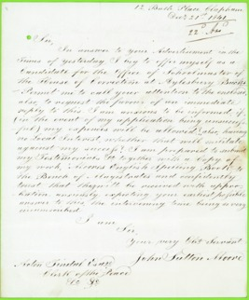
Figure 10 A letter of application from John Sutton Moore for the post of schoolmaster at Buckingham County Gaol in 1841. Moore included evidence of former teaching experience with this letter (including at an adult evening school), and he was eager to show the magistrates in charge of the prison a spelling book he had written. His letter strongly suggests that he wanted the job. Moore was appointed and remained in post until the early 1850s.
View description - Figure 10 A letter of application from John Sutton Moore for the post of schoolmaster ...
View description - Figure 10 A letter of application from John Sutton Moore for the post of schoolmaster ...

The advertisement from Buckingham County Prison does insist that the schoolmaster must be a member of the Church of England. This was a common requirement. Instruction in reading and writing had a religious purpose. Church of England prison chaplains were often deeply suspicious of teachers from other denominations (such as Methodists, Quakers, Independents). This suspicion led to many prison visitors, who tended to be Dissenters rather than Anglicans, being ejected.
You might have noticed that both of these were full-time posts. This was another important trend in the rise of the schoolmaster. Prison officials wanted complete control over those they employed and part-time hours were a hindrance to this. Especially in smaller prisons, time spent not teaching had to be filled with other duties. At Leicester House of Correction, the schoolmaster was required to do clerical work. At some prisons, he was given warder duties.
Both advertisements were for schoolmasters. Not much has been said about schoolmistresses. Their numbers also grew but their rise was far less apparent. Because of the small populations of female prisoners in many prisons, matrons continued to be given schoolmistress duties where possible. Occasionally, a schoolmistress was employed on a part-time basis. Career paths for prison schoolmistresses were only really available in the convict sector where populations of female prisoners were larger and more stable.
Back to - Activity 3 Employing teachers

Activity 4 Designing schoolrooms for prisons

Discussion
The boys’ schoolroom at the Tothill Fields House of Correction looks like a fairly typical elementary school classroom. The boys are seated at desks in rows. The desks are slanted with ink pots. There are various wall hangings, one of which looks like the letters of the alphabet. The only feature which suggests this schoolroom is in a prison are the bars on the windows. You might have also noticed the raised desk of the teacher which allows him to supervise the boys.
The school for adults at Wandsworth Prison – which was held in the chapel – looks completely different. Each prisoner is confined in a separate box in order to prevent any communication. The schoolmaster teaches from a raised platform so that all the prisoners can see him.
Wandsworth is an example of the kind of experimentation in schoolroom design which was encouraged by the separate system. Although the leading proponents of separation believed that prisoners should continue to assemble for school, there was a desire to limit physical contact as much as possible.
From 1837, partitions began to appear in schoolrooms and, after the construction of the model prison, Pentonville, in 1842, in chapels too. For convenience, partitioned chapels were often used as schoolrooms on weekdays. Far from preventing communication, partitions in schoolrooms and chapels encouraged prisoners to redouble their efforts. The boards separating prisoners became covered with graffiti and had to be stripped and cleaned regularly.
Back to - Activity 4 Designing schoolrooms for prisons

Activity 5 Timetabling

Discussion
Here are some examples produced with the help of former prisoner learners and mentors.

Access the following link to get a larger version of the table.
The above timetable is the basic prison core day. Most prisons follow this sort of regime, with some variation on the times. If you are a prisoner you will have to negotiate with the prison staff, and Education Provider’s staff for access to the Open University’s Virtual Campus. If you are a prisoner who is in a double-cell you will also need to negotiate time with your cellmate so that you can study. This is not easy when you share a small room from 1900-0800 each day.

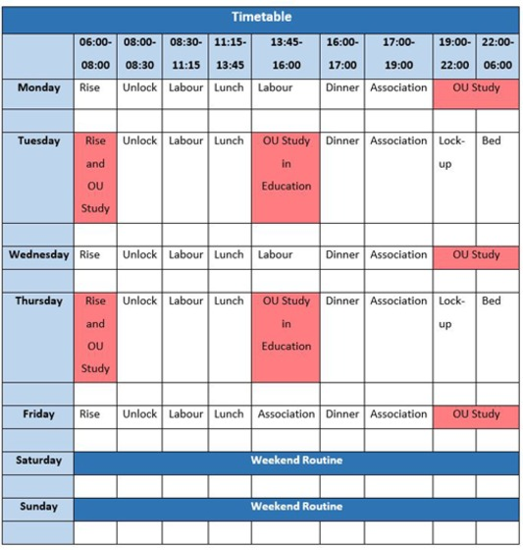

Access the following link to get a larger version of the table.
This timetable was the schedule of a prisoner. He added ‘My early morning study was the time that I used to read material without taking any notes, and then I would type up notes during the afternoons when we had dedicated Distance Learner access to the IT equipment!’ He had to be focused and dedicated.

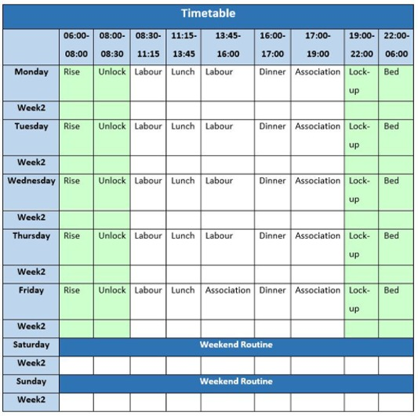

Access the following link to get a larger version of the table.
The ex-prisoner who produced this timetable added:

There is time for most learners in custody to study the basics of the course work within the coloured green time zones. You will see that I have used this single grid to create a two-week timetable – which I think is probably the best route to go down in prison and secure environments. That way the study workload can be spread over a longer period and allowing a more concentrated effort in the time given to study. I have found that prison employers are much more accepting of a timetable over a longer period rather than taking the same time off each week.

You can of course develop your own timetable that works for you, and these examples are not intended to be prescriptive. The aim is to plan your time effectively, and this is a useful and transferable skill which can apply to other activities as well.
Back to - Activity 5 Timetabling

Activity 1 Testimonies of prisoners

Discussion
- In his testimony, J.M. does not mention his own guilt, but instead blames his father for the bad example he set (presumably by drinking too much). J.M. suggests that if he had listened to his mother, and continued to go to Sunday School – that is, a school held after church services on Sunday in which reading, writing, and Christian values were taught – then he might have got a good job rather than ending up in prison.
- J.M.’s overall language is quite formal. He may well have called his parents ‘mother’ and ‘father’, especially when talking to the prison chaplain. The words ‘drunkard’ and ‘honourable situation’ appear more contrived. Perhaps J.M. was echoing terms he had picked up from Clay. The phrase ‘it has learnt me’ sounds odd and unnatural. It looks like an attempt by J.M. to employ the language of another rather than to explain things in his own words.
- You could read this material as evidence of J.M. asserting his right to provide an account of the past. Perhaps you think J.M.’s emotional plea was a hypocritical attempt to win round Clay and gain concessions, such as access to books, a better diet, or time off his sentence. He would have known that these were the right things to say to Clay who was a religious man. There is also a possibility that Clay tailored the material he recorded. In his reports, Clay was very keen to emphasise the negative consequences of alcohol as well as the effects of religious ignorance. In 1848 he wrote ‘Religious ignorance is the chief ingredient in the character of the criminal. This combines with the passion for liquor’ (Bennett, 1981, p. 80). An account like J.M.’s was perfect for proving his point.
Back to - Activity 1 Testimonies of prisoners

Activity 2 Lesson plans

Discussion
You may have been struck by the amount of time – 25 minutes – that was devoted to singing hymns and reading Scriptures at the beginning of the lesson. Considering that convicts had only three hours a week at school, and that they also attended services in the chapel on Sunday and read prayers every day, this was a lot of time to take from teaching other lessons. It shows how important religion was in the school curriculum.
Another 15 minutes at the end of school was taken up with the exchange of library books, again, eating into valuable time for teaching and learning. You will look at prison libraries in Session 4.
Did you notice the term ‘Letters’? Prisoners in convict prisons and in some local prisons were allowed to send letters home at various stages during their imprisonment. In order to supervise their composition, and assist those who could not write, letter writing was done during school time. Although it was another activity which consumed valuable time, it could also be used as a way to teach writing. In 1859, the chaplain at Chatham Convict Prison wrote that although ‘their school exercises are more or less interrupted … by writing letters to their respectable friends … such writing should tend in a measure to improve both their composition and their penmanship’ (Director of Convict Prisons Report, 1860, p. 244).
Another term in the plan which might be unfamiliar is ‘slates’. Slates were essentially mini blackboards. Chalk or pencil was used to write on slates, and anything written on them could be rubbed out. Slates were common in elementary schools in the 1800s because they could be reused and so were cheaper than paper and ink. However, students who learned to write on slates found it difficult to move to paper and ink, as prison teachers and chaplains soon discovered. Despite this, slates persisted in prisons because of the need to limit any form of illicit communication. Paper could be secreted and taken away. Slates could be monitored and any writing easily erased.
Back to - Activity 2 Lesson plans

Activity 3 Case study: Reading Gaol

Discussion
Comparing the exam script and the letter, the first thing you may have noticed was that both contained references to parts of the Bible – that is, specific chapters and verses. This emphasises the importance of the Bible in the instruction given at Reading Gaol. You might have also been impressed that both men were able to recall specific passages to support particular points. This shows how rigorous drilling and memorisation was at Reading Gaol. Both made reference to the sin of drinking alcohol, and its relationship to criminal behaviour. It is clear that Field was attempting to train them to avoid the pub when released from prison.
You may have thought that the main difference between the two texts was that the letter warns that those who do not mend their ways will not only end up in prison (like J.I.) but will ‘suffer the vengeance of eternal fire’. In other words, they will go to hell, unless they repent and believe in Christ.
Were these authentic voices of prisoners? The first was written under exam conditions, and I.N. obviously wanted to show that he had learned something at the prison school. J.I. would have known that his letter would be read by the chaplain before it was sent to his sister. Both prisoners might have hoped that by showing Field they had reformed that they might gain something. Indeed, Field had, in the past, argued for the early release of prisoners who had performed well under his scheme, so this could have motivated the authors of these sources.
Alternatively, you could argue that the methods of instruction used in the prison – drilling, memorisation, writing copies – meant that these prisoners, when given pen and paper, were hardly equipped to write anything else. J.I. in particular would not have wanted to pass up the opportunity to write to his sister. In 1850, when prison inspector Captain Williams interviewed prisoners at Reading Gaol about the instruction they had received, he found they could repeat verses from the Bible perfectly but did not understand the meaning of what they had learned (Inspectors, Home District, 15th Report, 1851, p. 63).
Finally, it is important not to underestimate the message of hope contained in the Bible. Instruction focused on soul-saving. Many of these men would not have wanted to return to prison and they were being told they would not have to if they could live as good Christians. Reality of life outside the prison may have suggested otherwise, but it does not mean these prisoners were not sincere when they wrote these pieces.
Back to - Activity 3 Case study: Reading Gaol

Activity 4 Misconduct records at Pentonville Prison

Discussion
- First, you may have found nine offences described as ‘misconduct in school, and insolence to schoolmasters’. You may have also seen that there were 70 offences described as ‘communicating or attempting to communicate in school or chapel’. Arguably, there are other offences in this table which might be connected with the school. You might have noticed there were a further 17 charges for ‘obscene communications and drawing obscene figures on books, stalls, etc’. The reference to books and stalls – partitions used to separate prisoners in chapel – could mean that some of these offences occurred at school. In any case they relate to the tools of literacy or acts of writing. There were also 66 charges for communicating and attempting to communicate in writing – again, showing prisoners’ use of the writing skill, if these offences did not happen in the schoolroom. Altogether, these add up to a lot of charges – 162 of a total 461.
- The overwhelming number of these school-related offences are attempts to communicate with others, rather than acts which could be interpreted as a protest against the school and the instruction given within it. Assembling prisoners for school offered a golden opportunity for prisoners to attempt to communicate, as did the provision of pens, paper and books. It is a testament to the sociability of humans more than anything else. That leaves just nine instances of misconduct in school. The table does not explain what ‘misconduct’ was.
- 993 prisoners did not commit offences for which they were punished. That is a substantial majority of the total number of prisoners. This, and the nine cases of misconduct, suggest that most prisoners did not object to school.
Back to - Activity 4 Misconduct records at Pentonville Prison

Activity 1 Bible reading at Reading Gaol

Part 1

Discussion
- The prisoners observed by the governor were most likely reading the Bible. You might remember from Session 3 that prisoners arriving at Reading from 1844 were given Bibles to read when they asked for work. Alternatively, some of these prisoners might have been reading other religious books – prayer or hymn books, or maybe tracts. The Rev. John Field liked to give prisoners a copy of an SPCK tract, The Divines of our Blessed Lord, as well as one authored by himself: Friendly Advice to a Prisoner. Secular (non-religious) books were rarely distributed to prisoners at Reading Gaol in the 1840s and 1850s (Crone, 2012).
- According to the governor’s account, 85 of the 97 prisoners appeared to be reading. It is possible that the 12 men who were not reading were taking a break from reading, to warm their hands or to exercise. It is also possible that the 12 men could not read (i.e. they had not yet learned how to read).
- You might have remembered from the activity in Session 3 that Reading Gaol had recently been rebuilt to allow for the separate confinement of prisoners. There was a hint in the extract – the governor observed each man using the ‘inspection slide’. The men spent most of their time in cells by themselves. They might have:
  - felt able to pick up the religious books left for them without having to suffer the jeers of their peers
  - been reading the Bible because there was nothing else to do
  - heard the governor approaching and decided to pretend to read their Bibles in the hope of looking penitent and gaining some kind of reward. The source does not speculate on this, but clearly there are many reasons why the prisoners might have appeared so studious.
Back to - Part 1

Part 2

Discussion
It further illuminates the governor’s report of three years earlier and suggests that prisoners could be reformed through reading the Bible. However, this prisoner’s response has been filtered through the chaplain. We may not be reading exactly what the prisoner said and we cannot tell if the prisoner sounded sincere.
Back to - Part 2

Activity 2 The dangers of reading

Discussion
- In this passage, Henry Mayhew suggests that the reading of tales about thieves had led the boys into a life of crime. Having the ability to read and write was no protection against criminal behaviour. If anything, possession of these skills made the boys vulnerable to the effects of romantic tales about famous thieves such as Jack Sheppard – a burglar who escaped from prison four times before he was hanged at Tyburn in 1724 – and Dick Turpin – a highwayman (or street robber), active in the 1730s, who was hanged outside York Castle Gaol in 1739. The suggestion is that the boys hoped to emulate these famous thieves and lead equally exciting lives. Interestingly, the corrupting influence of such literature was not restricted to those who could read, as others were able to indulge in these stories by being read to.
- Mayhew writes that many boys said they had been encouraged to commit crime through reading about notorious thieves. Perhaps Mayhew had already suggested this idea and the boys readily agreed because it offered an easy way out. Explaining criminal behaviour and the causes of crime is complex and often painful, especially for individuals. When Mayhew asked if they would like to be Jack Sheppard, they said they would if the times were the same now as they were then. This suggests the boys did not take the tales as seriously as Mayhew believed they did.
Back to - Activity 2 The dangers of reading

Activity 3 Accessing books in the library

Discussion
This short passage tells us a surprising amount about access to the library at Lancaster Castle County Gaol. Perhaps the most striking information is that male prisoners could borrow entertaining books, but female prisoners were limited to religious books.
Concern about women of all ranks of society reading fiction was expressed at various points throughout the 1800s. Women were considered intellectually weaker than men and therefore more susceptible to the dangers of tales of romance and fantasy. At the same time, female criminals were regarded as more transgressive, or immoral, than male criminals. Committing a crime was completely opposed to the image of the ideal woman. According to the matron at Lancaster Gaol, the women refused to read the religious books provided for them.
Male prisoners had their books changed once a week. According to the report, they also got to choose from the catalogue, though it is not clear what happened if their choice was not available. The report also gives us an idea of their preferences – entertaining books, history, voyages, and especially The Saturday Magazine. This was an educational magazine published by the Society for the Promotion of Christian Knowledge. It had four pages, cost a penny, and contained short articles on a range of subjects including nature, science, history, geography and technology.
Back to - Activity 3 Accessing books in the library

Activity 1 Recording education in prison registers

Discussion
- Information about a prisoner’s previous education was noted in two columns: ‘Read’ and ‘Write’. If a prisoner was able to read, an ‘R’ was placed in the column headed ‘Read’. If a prisoner was able to write, a ‘W’ was placed in the column headed ‘Write’. In the early 1800s, pupils were often taught to read before they were taught to write. Many working-class children (and adults) left education before they learned to write. Some schools only taught pupils how to read (and not to write). Two prisoners listed on this page of the Ilchester Gaol description book could only read and not write. Sometimes prison officials relied on prisoners to tell them if they could read or read and write. Other times prisoners’ skills were tested, for example, by reading aloud a passage from the Bible or by writing it out.
- There are several types of information collected here that could be used by the state to exert control over the lives of individuals. Information on physical characteristics – height, eye and hair colour, and descriptions of distinguishing marks – could be used to identify these men as former prisoners after their release. Similarly, information on a prisoner’s ‘last place of abode’ could be used by the authorities to track down former prisoners and to keep an eye on them. (However, it should be noted that in the early 1800s there were few agencies able to take advantage of this information either to watch or to identify former prisoners. Policing was reactive and limited in scope. Probation services did not exist (Shoemaker and Ward, 2017, pp. 1442–6).)
- Many types of information collected in the description book could be used to investigate the ‘character of the criminal’ and the causes of crime. Information on age could be used by contemporaries to investigate the extent of youth crime. Information on marital status and progeny (i.e. number of children) could provide similar evidence on either the causes of crime (the need to provide for a family) or on patterns of desistance (that getting married and having children acts as a brake on criminal activity). Place of birth and place of abode could tell contemporaries whether convicted criminals were more likely to come from certain areas. Information on literacy – the ability to read and write – could be used to prove or disprove a link between the lack of education and the commission of crime.
- There may have been a functional reason for the collection of information on prisoners’ literacy. In order to teach prisoners how to read and write prison officials needed to know who could already read, read and write, or do neither. Surviving registers from the period before 1835 suggest that there was a close relationship between the collection of information on prisoner literacy and the existence of a prison school. For example, the introduction of description books at Ilchester Gaol in 1821 which contained columns to collect information on prisoners’ ability to read and write coincided with the provision of instruction in reading and writing at that prison.
Back to - Activity 1 Recording education in prison registers

Activity 2 Literacy in the Criminal Returns for 1835

Discussion
- Strictly speaking, most prisoners sent for trial in 1835 were illiterate. Only 46% of males and 26% of females could read and write. However, it is still significant that well over half of the prisoners could at least read. The ability to read is in itself an important skill. Remember that large numbers of children (and adults) left formal education before they learned to write. That only 33% of male prisoners and 38% of female prisoners could neither read nor write could be regarded as an achievement in the absence of a system of universal, compulsory and free elementary education.
- The spread of the skills among male and female prisoners was uneven. A larger proportion of male prisoners could read and write, while a larger proportion of female prisoners could read only. This matches what we know about education outside the prison: in the early 1800s, girls were more likely to leave school early or to be taught at home, which meant that they were less likely to learn to write.
- The main problem with the categories used here was that they measured the presence of a skill, but not the degree of ability. Included among those who could read and write, for example, were men and women who could just about write their names, who could copy a passage from the Bible, who could write a letter home, and who could compose a critical essay. Similarly, among those who could read were men and women who could barely read words of one syllable, who could read a passage from the Bible but had no idea of its meaning, and who could read Shakespeare with ease.
Back to - Activity 2 Literacy in the Criminal Returns for 1835

Activity 3 Interrogating the statistics

Part 1

Discussion
Morrison’s comparison of data derived from marriage registers with prisoner literacy data could be regarded as based on unreasonable assumptions. A groom or bride was considered literate if he or she could write their name in the marriage register. This does not mean that they could read and write well; it is entirely possible that they could only read and write imperfectly.
Furthermore, the marriage registers provided a snapshot of the literacy of men and women of marital age, overwhelmingly 21 to 30 years. The prison population included males and females from a wider age range and, after 1879, an increasing proportion aged over 30.
Back to - Part 1

Part 2

Discussion
It is notable that in the 1880s and 1890s – following the advent of compulsory education in England and Wales – the proportion of illiterate male prisoners and illiterate female prisoners began to decline at a rate similar to that of illiterate grooms and brides. This finding could be used to challenge Morrison’s conclusions. It suggests that while prisoners might, on average, have been more illiterate than the general population, they were not, on the whole, hopeless causes who – through some inherited or mental deficiency – could not learn to read and write.
Back to - Part 2

Activity 4 Evaluating the results of the prison school

Discussion
- At Manchester Borough Gaol in the early 1850s, prisoners attending school were taught reading, writing and arithmetic. They were also given some religious instruction in the form of learning – or memorising – the Lord’s Prayer, the Creed and the Ten Commandments.
- Overall, the progress made by prisoners during their time at school appears to have been limited, especially in the basic elements of reading, writing and arithmetic.
  - Of the 80 prisoners who were unable to read on admission, 50 still could not read on discharge.
  - Similarly, of the 144 prisoners who could not write, 111 were still unable to write on discharge.
  - Progress in arithmetic looks slightly better. Of the 179 prisoners who could not cipher on admission, 73 acquired some level of proficiency before their discharge. Still, 106 left the prison unable to complete basic sums in addition, subtraction, multiplication and division.
More progress seems to have been made in memorising key Christian texts. For example, very few – only 3 – left the prison unable to recite the Lord’s Prayer.
- According to the table, the biggest single factor which affected the progress of prisoners attending school was time.
  - Very little progress was made by prisoners with sentences of one or two months. For example, only 6 of those who could not read on admission and only 2 of those who could not write on admission learned these skills by the time of their discharge. The 3 prisoners who did not learn to recite the Lord’s Prayer were all incarcerated for one or two months.
  - No prisoner serving a sentence of nine or twelve months left Manchester Borough Gaol unable to read, write or cipher.
Back to - Activity 4 Evaluating the results of the prison school

Activity 1 The causes and effects of change in penal policy

Discussion
- Don’t worry if you found it hard to summarise, especially from a video. You were asked to do this because creating brief summaries (such as bullet-point lists) is a really useful skill, especially as it helps you to remember the important information. Also, you can refer back to it. Here is an example answer:
Causes:
  - Disillusionment with separate prisons – concerns about mental health of prisoners and/or prisoners being too comfortable.
  - Growing uncertainty about ability of religious instruction to reform prisoners.
  - Replacement of transportation with penal servitude (long term imprisonment) – meant convicts had to be released into British society – public fears about these ‘hardened offenders’. (The last of about 164,000 convicts arrived in Western Australia in 1868.)
  - A perceived crime wave fuelled by lots of reports about garrotting (robbery) in the newspapers.
- Changes in penal policy were realised through legislation and (in the case of convict prisons) Standing Orders (mandatory instructions on procedure) issued by the Convict Prison Directors (you will look at these in more detail shortly). A list of key changes might include:
Convict prisons (1864 Penal Servitude Act and Standing Orders):
  - increased the minimum sentence of penal servitude to five years
  - intensified the separation of convicts during their probationary stage
  - reduced the diet
  - curtailed religious facilities available to convicts
  - introduced a system of surveillance for prisoners released on licence.
Local prisons (1865 Prison Act):
  - separate confinement
  - strict performance of truly hard and unproductive labour (such as the treadmill, shot drill, hand crank and stone breaking)
  - reduced diet
  - plank beds.
- Lincoln Castle Gaol was a local prison, so we need to measure the experience of imprisonment there against the rules laid out in the 1865 Prison Act. There was little change at this prison. This was mainly because prisoners held here were on remand (awaiting trial). After conviction, they were transferred to other prisons (primarily convict prisons) to serve sentences of imprisonment, which was when provisions for punishment were meant to be enforced. Still, there were many other local prisons, including those which held convicted prisoners, which did not implement some or many of the new measures promoted by the 1865 Prison Act. This was because local prisons were still under the control of local authorities. Some authorities continued to believe in reformatory regimes while others baulked at the cost of implementing the new rules. Mechanisms for the enforcement of this legislation also remained weak.
Back to - Activity 1 The causes and effects of change in penal policy

Activity 2 Standing Orders for Convict Prisons

Discussion
- Regulation 4 restricted attendance at school to ‘uneducated men who most require assistance’. Those tolerably or well educated were given books to teach themselves alone in their cells. This implies that there was an intention to restrict lessons to instruction in the basic skills – reading, writing and arithmetic – or enough to facilitate self-instruction.
- As well as refraining from specifying exactly what should be taught in schools, you might have noted that the Standing Order was only sent to prisons for convict men serving their second stage, and that Regulations 2 (evening schools) and 4 did not apply to the invalid prisons.
Back to - Activity 2 Standing Orders for Convict Prisons

Activity 3 The marks system in British convict prisons

Discussion
- According to Standing Order 145, no convict was allowed promotion to the first class unless he could read and write (except in special cases). Standing Order 146 states that any convict unable to read and write when emerging from the third class because they were inattentive at school will forfeit (lose) their gratuity. You might have also noticed that Standing Order 146 includes provision for the removal of marks from those who are idle or badly behaved at school.
- The Irish system rewarded convicts who made an effort at school. In contrast, the new system in British prisons didn’t give any marks to convicts who tried, and instead punished those who did not try or who struggled to learn. Illiteracy was therefore something that the authorities thought should be punished.
Back to - Activity 3 The marks system in British convict prisons

Activity 4 Book purges

Discussion
- Convict prison governors and chaplains are being asked to remove all novels and tales of an uninstructive character from the prison library. Also, they are instructed to ensure that the periodicals (journals and magazines) they request do not have uninstructive stories in them.
- The Convict Prison Directors believed that literature which simply entertained convicts was not appropriate.
- One consequence of this Standing Order was to reduce the amount of available reading matter in the prison. Another was to reduce the range of reading matter. The removal of entertaining literature made reading less appealing and so removed incentives for prisoners to learn to read, as well as opportunities to practise and improve reading skills.
Back to - Activity 4 Book purges

Activity 5 Evaluating the use of cellular instruction

Part 1

Discussion
- You might have identified the following advantages:
  - In one-to-one tuition the men were not distracted by others and made more effort. Rev. de Renzi claimed that the prisoners made more progress in learning as a result. (Educational)
  - Communication between prisoners during school time was eliminated. This removed the pleasure of company and the potential for corruption (the bad influence of hardened offenders on others). (Disciplinary)
  - More time could be given by the teacher to those students who needed it. (Educational)
- The Rev. de Renzi does not mention any disadvantages. The Rev. Sherwin, however, highlights the restrictions on books and the ban on paper, pens and ink in cells (prisoners were given slates and pencils instead, which made learning to write more difficult, and limited their ability to use a pen when required). He implies that these restrictions combined with the reduction of the curriculum and prohibitions on entertaining books limited the potential gains of prison education.
- As for additional disadvantages, you might have thought that the reduction of time caused by one-to-one tuition – from six hours to thirty minutes each week – was a disadvantage. Also, the potential for emulation or encouragement from peers was entirely absent in a system of cellular instruction.
Back to - Part 1

Part 2

Discussion
The Rev. Sherwin declared that cellular instruction had become impracticable because the prison had doubled in size. As a result, valuable teaching time was wasted as schoolmasters had to walk between cells to visit those on the school roll. Also, Sherwin claimed that the amount of time spent on one prisoner could have been used to teach a whole class. Finally, Sherwin complained that it was impossible to supervise the teaching of the schoolmasters in a system of cellular instruction.
Back to - Part 2

Activity 1 Examinations by Standards in convict prisons

Discussion
- As well as the use of Standards for the examination of convicts in reading, writing and arithmetic, Standing Order 309 also mandated the use of ‘examination books’. Every convict enrolled in school would be assigned an examination book and the results of each examination would be recorded in it. Examination books travelled with convicts as they moved between prisons. Standing Order 309 also directed chaplains (or assistant chaplains) to act as the Examiner. The chaplain was ordered to use the examination books to describe the progress made by prisoners – in numerical form – in his annual report.
- In a separate table (III), chaplains were asked to record the degree of progress which convicts had made in each subject between examinations using the following abbreviations: G.P. for Great Progress, P for Progress, S for Stationary, and B for Gone Back.
Back to - Activity 1 Examinations by Standards in convict prisons

Activity 2 Progressive stages in local prisons

Discussion
- A prisoner became eligible to receive school instruction in his or her second stage. That meant that a prisoner must have spent at least 28 days in prison (and typically more).
- This rule effectively excluded any prisoners with shorter sentences and only those serving at least one month, likely more, would have benefitted.
- You might have also noticed the restrictions placed on access to books. Prisoners became eligible to have schoolbooks in their cells on reaching the second stage. Library books were reserved for those in their third or fourth stage. Prisoners in their first stage were not left entirely without literature: there were Bibles in their cells which they could read if they were able and willing.
Back to - Activity 2 Progressive stages in local prisons

Activity 3 Educational Instruction of Prisoners in Local Prisons in England and Wales, 1883

Discussion
- You might have noticed that several loopholes existed in the criteria for eligibility. Chaplains and governors were given power to include prisoners aged over 40, and to exclude those who they believed had ‘no capacity’ for instruction. The Standing Order suggested that chaplains might also exclude those with previous convictions.
- This was a compulsory scheme. All prisoners with sentences of at least four months’ imprisonment who could not pass Standard III were enrolled in school, unless they were aged over 40 or were deemed to have no capacity for learning. Prisoners could not get out of school by being idle – those who were idle were only temporarily excluded, so as not to reward their bad behaviour. These rules sat awkwardly beside those of the system of progressive stages – you looked at these above – which positioned schooling as a privilege to be earned.
- The primary aim of this scheme was to raise the literacy and numeracy of prisoners to a basic level of competence.
Back to - Activity 3 Educational Instruction of Prisoners in Local Prisons in England and Wales, 1883

Activity 4 Teaching staff in local prisons

Discussion
- Schoolmaster-warders and schoolmistress-wardresses were not employed at every prison. At 4 prisons with prisoners there were no schoolmaster-warders. At 19 prisons with female prisoners there were no schoolmistress-wardresses.
- There was a relationship between the number of prisoners eligible for school and the employment of a schoolmaster-warder or schoolmistress-wardress. Especially in the case of women, if only a small number were eligible for instruction (i.e. typically 6 or fewer), no schoolmistress-wardress was appointed.
- The consequence was that some prisoners who were eligible for instruction missed out. This was especially so in the case of female prisoners. At prisons without schoolmaster-warders, sometimes the chaplain provided instruction. Rules on chaperoning at female prisons meant that this was often not possible.
Back to - Activity 4 Teaching staff in local prisons

Activity 1 Prison memoirs

Discussion
- ‘Ticket of Leave Man’ observed the goings-on in the schoolroom when he was sent to evening class to write his letters under the supervision of the schoolmaster and warders. Still, he would have only attended a few times each year. Convicts who reached the first class were allowed to write a letter once every three months, while those in the third (or lowest) class could write once every six months. ‘Ticket of Leave Man’ also claimed to have met two or three men who learned to read and write in the prison school.
- ‘Ticket of Leave Man’ identified several problems with the prison school which he suggested limited any beneficial effect of the instruction provided:
  - In lessons, no effort was made to separate first time offenders from habitual criminals. School provided an opportunity for the latter to ‘contaminate’ the former. (Depictions such as these helped to convince penal policymakers to establish a separate class, known as ‘star class’, for convicts of previous good character serving their first sentence.)
  - The time for school was too short: only 20 minutes a week in summer, or one hour a week in winter. (Labour was carried on longer in summer than winter, hence the variable times.)
  - The schoolmasters were uninterested in their work.
  - Instruction was given only to those who could not read or write. Many prisoners who could have benefitted from schooling missed out.
- ‘Ticket of Leave Man’ did support the idea of prison education. He claimed that the illiteracy of thousands of prisoners prevented their success in life and he suggested that the absence of education (mental and moral training) led many to commit crime.
Back to - Activity 1 Prison memoirs

Activity 2 The work of the Mitford Committee

Discussion
- Some of the prisoners had attended school as children but had subsequently forgotten what they had learned. Others did not attend school because they had been required to work to support their families instead.
- Some of the prisoners suggested that improving their literacy and numeracy would help them in the jobs they had before imprisonment, or to obtain a better job on release. Learning to write enabled some to write a letter to loved ones outside. For some, learning to read meant that they could read letters from home and books from the library.
- It is very difficult to say how authentic these testimonies are. As with many other prisoner voices presented in this course, they are mediated through the official record. We do not know how these prisoners were selected for interview. The questions asked were leading and the answers given were short and hardly challenging.
Back to - Activity 2 The work of the Mitford Committee

Activity 3 Evaluating the 1897 scheme for education in local prisons

Discussion
Reforms made to content and delivery of education in local and convict prisons in 1897 were modest and not all were ‘progressive’. Attendance was expanded in local prisons to include prisoners with sentences of three months’ imprisonment, or even shorter sentences in the case of young prisoners who showed promise. However, in practice, this added very few prisoners to the total eligible for instruction as most prisoners continued to receive sentences of less than three months. Prison officials were given no additional resources to provide education to young prisoners with sentences of less than three months and so were discouraged from enrolling them at school. Chaplain’s no longer had discretion to allow prisoners aged over 40 to receive instruction. Valuable time for instruction continued to be wasted as local prisoners had to complete their first stage of imprisonment.
The content of instruction was updated to reflect what was taught in state schools – that is, the 1896 Educational Code. The limitation of instruction to the achievement of Standard III matched the absolute minimum expected from a child on leaving compulsory education. A very small amount of additional tuition time was given to local prisoners; substantially more was given to convicts in separate confinement (as explained above, the aim was to do away with the need to provide education for convicts after their first stage of penal servitude). Cellular instruction was retained. The provision of class teaching for prisoners unable to read became optional, rather than compulsory.
Back to - Activity 3 Evaluating the 1897 scheme for education in local prisons

Activity 4 Learning from the history of prison education

Discussion
Hopefully, your studies have had some impact on your views of the value of prison education. Perhaps this course has strengthened some of your pre-existing beliefs. Maybe you have changed your mind altogether! Or perhaps this course has encouraged you to reflect on a subject – prison education – that you had not thought about before or had taken for granted.
Perhaps you were surprised to learn that there was a history of prison education which stretched back as far as the early 1800s, and that state-funded prison education predated state-funded universal and compulsory elementary education for children. If you are (or were previously) a prisoner, or if you work in the prisons sector, you might have been struck by the appearance of some familiar themes, including the difficulty of accommodating education in the prison timetable alongside other activities such as work, and the disruptions caused to education, for example, by transfers between prisons.
As for the application of new knowledge and new perspectives, you will have your own thoughts, but you might like to reflect on the following points:
- The intersections between different areas of social policymaking. The provision of education in prisons was as much, if not more than, a consequence of educational reform as of penal reform. The relationship between these two departments – or spheres more generally – continues and continues to be complicated. The impress of present-day educational policy continues to be evident in the curriculum nominally available to prisoners, from standard prison education courses (literacy and numeracy to Level 2), to GCSEs, A-Levels, vocational and professional qualifications, to higher education modules and qualifications. Yet, with few exceptions, prison education remains separate from mainstream education (separate providers, specialist staff, distinct communities of learners), and insights revealed by experiences of education within the prison typically don’t feed back into mainstream educational pedagogy and provision. This seems like a missed opportunity, for both mainstream and prison education.
- What is education within the context of the prison? Should it be a privilege or a right? Is it a necessity? Should education specifically aim to be reformative, or should it be restricted to instruction in key skills which prisoners could use, if they choose, to improve their mental and material condition? How can we unlock the transformative potential of education?
- The accommodation of education within the penal environment. This course has shown how education was moulded to fit within the time and space available in prisons. Compromises had to be made, often to the detriment of education. Prisons were (and are) places of punishment. The realities of imprisonment and the prioritisation of discipline ultimately limited access to education and hampered efforts made by prisoners to learn. Similar problems of access and delivery remain in prisons today. Unless these are properly addressed, and the purpose of the prison is reconsidered, education is unlikely to play a central role in the penal regime and to make a significant difference to the lives of more than a small proportion of the prison population.
- The gap between policy and its implementation at the level of the institution, even when prisons are under the control of one authority. This can work both for and against the provision of education in prisons. Even today, there is significant difference in what education prisoners have access to across the penal estate. At the same time, institutional autonomy can give rise to progressive and impactful initiatives.
- How to achieve meaningful reform in prisons. This course has illuminated the growing complexity of forces that have come to determine policy and practice in the penal sector. Legislators, administrators, prison officers, magistrates, lobbyists, social scientists, public opinion – all have a role to play, and because change has to be negotiated at each level, inertia (no change) is often the result.
We have a small favour to ask. We hope to use this OpenLearn course as part of an Impact Case Study for submission to the next Research Excellence Framework (REF) scheduled for 2027. REF provides an opportunity to showcase the work we do as historians at The Open University.
To do this, we need evidence of how your studies on this course might have changed your perspectives on prison education, prisons or the value of historical study more generally. We would be extremely grateful if you could send us your response to Activity 4 using this email address: Prison-Education-BOC@open.ac.uk. You can simply copy and paste the text from the response box into an email. Please also tell us, if you are able and willing, if there is anything you plan to do as a result of your new knowledge and perspectives.
And, at the same time, feel free to give us any other feedback on the course.
Your name, email address and quote will be stored securely and only accessed by the course team. If we use your quote or feedback in the REF submission your name will only be used if you give permission. Your email address will only be used to contact you to ask for that permission. All data not used in the REF submission will be deleted by January 2028. If after emailing us you change your mind and would like to withdraw your feedback you can contact us at the same email address and your data will be deleted.
Many thanks, in advance, for your help. It is much appreciated!
Back to - Activity 4 Learning from the history of prison education

Figure 1 Newgate Gaol in London, sacked by rioters during the Gordon Riots of June 1780. The prison had only just been rebuilt and the repairs took several years to complete.

Description
This is a black and white illustration of a group of rioters setting a building alight. Flames leap from the windows of the brick-faced prison building, and a cloud of smoke rises in front of it. Onlookers in the foreground raise their arms, some of them brandishing weapons.
Back to - Figure 1 Newgate Gaol in London, sacked by rioters during the Gordon Riots of June 1780. The prison had only just been rebuilt and the repairs took several years to complete.

Figure 2 An important event in British national memory is the Battle of Waterloo, fought in 1815 in Belgium, in which a French army under Napoleon Bonaparte was defeated by a coalition of states which included the United Kingdom.

Description
This is a large-scale oil painting of a battle scene. Commanders on horseback in the centre foreground are surrounded by hundreds of red-uniformed foot soldiers. Smoke from cannon-fire darkens the sky.
Back to - Figure 2 An important event in British national memory is the Battle of Waterloo, fought in 1815 in Belgium, in which a French army under Napoleon Bonaparte was defeated by a coalition of states which included the United Kingdom.

Figure 3 Women working on looms in a factory, around 1800.

Description
This black and white illustration depicts two receding lines of looms in a low-ceilinged space. A crouching woman in the centre foreground tends to the mechanism of one of the looms. Other women can be seen standing at their looms in the background.
Back to - Figure 3 Women working on looms in a factory, around 1800.

Figure 4 This painting, commissioned to commemorate the Great Reform Act of 1832, shows the newly reformed House of Commons where laws governing the whole of the United Kingdom (which included Ireland) were made in the 1800s. Some important features in common with the Parliament of 1823 stand out: all the MPs were men; they were also gentlemen who did not need a salary; there were much fewer of them than there are today.

Description
This black and white image depicts ranks of frock-coated men seated facing each other on either side of a large hall. Observers stand on balconies above them, which recede towards three high windows at the far end of the room.
Back to - Figure 4 This painting, commissioned to commemorate the Great Reform Act of 1832, shows the newly reformed House of Commons where laws governing the whole of the United Kingdom (which included Ireland) were made in the 1800s. Some important features in common with the Parliament of 1823 stand out: all the MPs were men; they were also gentlemen who did not need a salary; there were much fewer of them than there are today.

Figure 5 Bristol Newgate Gaol at the end of the eighteenth century, showing the alms box for poor prisoners attached to the prison wall. Passers-by, who felt charitable, could donate coins to help feed and clothe those inside the prison.

Description
This is a black and white illustration of a lone figure walking along a city street. Looming above him in the right foreground is a high stone-built structure, with few windows and a doorway at pavement level. In the background is a timber-framed building that looks like an ale-house.
Back to - Figure 5 Bristol Newgate Gaol at the end of the eighteenth century, showing the alms box for poor prisoners attached to the prison wall. Passers-by, who felt charitable, could donate coins to help feed and clothe those inside the prison.

Figure 6 John Howard visiting an English prison. Originally drawn in the late 1700s by Francis Wheatley. Note the squalor of the prison, the lack of separation between men and women, and the presence of children, imprisoned with their mothers.

Description
This black and white illustration depicts a well-dressed man standing to the right of centre, in a dark, stone-flagged interior. He gestures to the left, where a group of men, women and children cluster around a sack-covered figure reclining on a stone bench. They gaze towards the visitor in apparent despair.
Back to - Figure 6 John Howard visiting an English prison. Originally drawn in the late 1700s by Francis Wheatley. Note the squalor of the prison, the lack of separation between men and women, and the presence of children, imprisoned with their mothers.

Figure 7 Millbank Penitentiary. Built between 1812 and 1816, for male and female convicts sentenced to transportation who would serve a sentence of imprisonment here instead. The geometric design and individual cells indicate the importance attached to routine, discipline and control.

Description
This black and white drawing depicts a symmetrically designed building, viewed from above. At its centre is a round structure within a hexagonal courtyard. Wings of window-lined buildings frame six surrounding pentagonal yards, each of which contains an observation tower.
Back to - Figure 7 Millbank Penitentiary. Built between 1812 and 1816, for male and female convicts sentenced to transportation who would serve a sentence of imprisonment here instead. The geometric design and individual cells indicate the importance attached to routine, discipline and control.

Figure 8 On 16 August 1819, local magistrates ordered the cavalry to charge a crowd of more than 60,000 people who had gathered at St Peter’s Fields, Manchester, to demand parliamentary reform. The event became known as ‘Peterloo’.

Description
This is a colour illustration of mounted soldiers riding into a group of unarmed men, women and children. The soldiers charge from the left, threatening the crowd with unsheathed swords, as the leading horse crushes a child underfoot. A family group in the right foreground cower away from the advancing soldiers.
Back to - Figure 8 On 16 August 1819, local magistrates ordered the cavalry to charge a crowd of more than 60,000 people who had gathered at St Peter’s Fields, Manchester, to demand parliamentary reform. The event became known as ‘Peterloo’.

Figure 9 ‘Mrs Fry Reading to the Prisoners at Newgate in the Year 1816’, by Jerry Barrett. This famous scene was painted in 1860 by an artist who had not been present at the event. It is representative and allegorical rather than accurate. To Fry’s left are several notable prison reformers. Some of the prisoners are flouting Fry’s prison rules by drinking beer and gambling.

Description
This is a black and white image of a well-dressed older woman seated at a central table in a crowded room. She reads aloud to a group of women on the right: some are seated, while two stand supporting each other in the foreground, with children at their feet. A group of visitors observe the scene from the left.
Back to - Figure 9 ‘Mrs Fry Reading to the Prisoners at Newgate in the Year 1816’, by Jerry Barrett. This famous scene was painted in 1860 by an artist who had not been present at the event. It is representative and allegorical rather than accurate. To Fry’s left are several notable prison reformers. Some of the prisoners are flouting Fry’s prison rules by drinking beer and gambling.

Figure 10 (a) and (b) Jedburgh Prison, in Scotland, was built in 1823. Each individual prisoner was in a single cell which was designed to be visible by a single guard concealed in the central tower. This was to be an economic and utilitarian solution to prison design. The design took direct inspiration from Bentham’s proposal. There was also separation of prisoners by class with three accommodation blocks for male or female criminals, male debtors and young prisoners. The aim was to improve the physical and moral health of the prisoners. The jail is now a museum.

Description
(a) This colour photograph of a walled prison complex is taken from above. It depicts a central, rounded structure, with blocks extending from it on three sides. (b) In the centre of this ground plan is a tower in the middle of a semi-circular building. Three further accommodation blocks surround this structure: one on each side and one below it. Individual cells are marked in each block – all of them visible from a central point.
Back to - Figure 10 (a) and (b) Jedburgh Prison, in Scotland, was built in 1823. Each individual prisoner was in a single cell which was designed to be visible by a single guard concealed in the central tower. This was to be an economic and utilitarian solution to prison design. The design took direct inspiration from Bentham’s proposal. There was also separation of prisoners by class with three accommodation blocks for male or female criminals, male debtors and young prisoners. The aim was to improve the physical and moral health of the prisoners. The jail is now a museum.

Figure 11 Frontispiece from Joseph Lancaster, The British system of education: being a complete epitome of the improvements and inventions practised at the Royal Free Schools, Borough Road, Southwark, 1810. The monitor, the boy with the stick, has just given the command ‘Show slates!’ and can see that every pupil has written ‘Long live the King’. Lancaster, J. and Corston, W. (1810) The British System of Education: Being a Complete Epitome of the Improvements and Inventions Practised at the Royal Free Schools, Borough-Road, Southwark, London, Longman & Co.

Description
This is a sketch of a line of ten boys seated on a bench at a long desk. Each of them holds up a slate, chalked with writing. A boy with a stick stands in front of them, inspecting the slates.
Back to - Figure 11 Frontispiece from Joseph Lancaster, The British system of education: being a complete epitome of the improvements and inventions practised at the Royal Free Schools, Borough Road, Southwark, 1810. The monitor, the boy with the stick, has just given the command ‘Show slates!’ and can see that every pupil has written ‘Long live the King’. Lancaster, J. and Corston, W. (1810) The British System of Education: Being a Complete Epitome of the Improvements and Inventions Practised at the Royal Free Schools, Borough-Road, Southwark, London, Longman & Co.

Figure 12 Entry in the Diary of Thomas Lloyd kept in Newgate Prison, 1794–1796. Thomas Lloyd (1756–1827) was an American who was imprisoned in the Fleet Prison London for debt. While in prison, Lloyd posted a ‘declaration of republican principles’ on a chapel door. He was found guilty of seditious libel and fined, sentenced to an hour in the pillory and three years in Newgate Prison.

Description
This is a photograph of two facing handwritten pages, with numbered paragraphs. The script on the right-hand page runs vertically: from bottom to top. The text is hard to read, but references to delivering a packet can be deciphered.
Back to - Figure 12 Entry in the Diary of Thomas Lloyd kept in Newgate Prison, 1794–1796. Thomas Lloyd (1756–1827) was an American who was imprisoned in the Fleet Prison London for debt. While in prison, Lloyd posted a ‘declaration of republican principles’ on a chapel door. He was found guilty of seditious libel and fined, sentenced to an hour in the pillory and three years in Newgate Prison.

Figure 13 An 1829 diary entry by Francis Place, 1771–1854. A radical campaigner for public education and friend of Jeremy Bentham, here he describes the pillory. A person could be locked into this wooden framework. It had holes for the head and hands and was placed in a public location. People could abuse the prisoner and throw things at them. Here is a transcript of the text shown in the figure. The term ‘John Bull’ was first used in 1712. He is a representation of the country.

Description
This is a photograph of a handwritten page, dated Dec. 1829, and headed ‘The Pillory’. The writing is neatly aligned, with occasional words crossed out, and others underlined. The text reads: ‘This barbarous punishment, this disgrace to the laws and to the nation, may be said to exist no longer. So atrocious was the conduct of the mob when a man was “pilloried”, so debased and cruel were they, that those who are now children, will scarcely be able, when grown up, to conceive the existence of such enormities, much less to believe they were permitted and encouraged by lawyers, juries and what are usually termed respectable people. Even the very populace better taught and more humane than their parents will hear with incredulity the tales which may perchance be told of the pillory. The time for standing, or rather walking round, on and in the Pillory, was one hour usually, from 12 to 1 O Clock at noon, the common dining hour of all sorts of persons who earn their livings by the labour of their hands, and consequently the time when the streets were crowded by such people. Formerly every one who was put in the pillory was pelted, the populace would not forgo the “fun”. A human being was stuck up to be “shied at”, and the blackguard John Bull would “have his shy”. There were always on these occasions a sufficiently large number to help one another in countenance and encourage the more debased, to “help up the game”, there was never any want of low lived men and women, boys and girls, thieves and miscreants of every description, and to increase the misery of the wretch put up for their amusement, and to enjoy themselves in the exercise of their villainous propensities.’
Back to - Figure 13 An 1829 diary entry by Francis Place, 1771–1854. A radical campaigner for public education and friend of Jeremy Bentham, here he describes the pillory. A person could be locked into this wooden framework. It had holes for the head and hands and was placed in a public location. People could abuse the prisoner and throw things at them. Here is a transcript of the text shown in the figure. The term ‘John Bull’ was first used in 1712. He is a representation of the country.

Figure 1 Inside the austere chapel at Lincoln Castle County Gaol.

Description
This colour photograph depicts a semi-circle of tiered pews, divided by a central aisle, beneath three windows in a rear wall. Seated boys occupy a few of the pews. They appear to be wearing a grey uniform, and are separated from each other by hinged wooden panels.
Back to - Figure 1 Inside the austere chapel at Lincoln Castle County Gaol.

Figure 2 The back page of the Horsley House of Correction Prison Register. Here you can see the prison clerk summarising personal information collected in the register in preparation for the annual return which had to be submitted to the prison inspector.

Description
This is a photograph of a printed register, with entries filled in by hand. There is a list of names in the left-hand column, with ticks against various categories across the page.
Back to - Figure 2 The back page of the Horsley House of Correction Prison Register. Here you can see the prison clerk summarising personal information collected in the register in preparation for the annual return which had to be submitted to the prison inspector.

Figure 3 Wymondham Bridewell in Norfolk was one of the first female prisons in Britain. Because of their small number and short sentences, the women imprisoned here did not receive any instruction until the late 1840s when the matron began to teach reading and spelling. Before then, prison officials argued that the women were too busy doing the washing to be given any schooling. Wymondham Bridewell is now a heritage museum and open to the public.

Description
This is a colour photograph of the front of a two-storey red brick building. Its central door stands open; it is flanked by a window on each side, with a line of three windows above. A glimpse of what looks like an inner courtyard can be seen beyond the dark central corridor.
Back to - Figure 3 Wymondham Bridewell in Norfolk was one of the first female prisons in Britain. Because of their small number and short sentences, the women imprisoned here did not receive any instruction until the late 1840s when the matron began to teach reading and spelling. Before then, prison officials argued that the women were too busy doing the washing to be given any schooling. Wymondham Bridewell is now a heritage museum and open to the public.

Figure 4 Prisons in the 1800s were often built to look like castles in order to remind local populations of the authority of the law. This is Preston House of Correction, first built in 1789 and substantially rebuilt in the early 1840s. Between 1823 and 1858, the Rev. John Clay was chaplain at Preston.

Description
This is an early photograph of a substantial building in walled grounds, with an urban street in the foreground. A tram and a horse and cart approach from the right. The central part of the building has a castellated façade, featuring battlements flanked by two towers.
Back to - Figure 4 Prisons in the 1800s were often built to look like castles in order to remind local populations of the authority of the law. This is Preston House of Correction, first built in 1789 and substantially rebuilt in the early 1840s. Between 1823 and 1858, the Rev. John Clay was chaplain at Preston.

Figure 5 Sarah Martin, visiting the prisoners at Great Yarmouth Borough Gaol. In this picture, Sarah Martin is reading to men and women as some of them work. She also taught prisoners how to read and write.

Description
In this black and white drawing, a woman wearing a long dress and bonnet sits on the left with a book on her knee. Alongside her sit seven women, some of them occupied with sewing. On the right and in the foreground are a group of men and boys, leaning intently forward.
Back to - Figure 5 Sarah Martin, visiting the prisoners at Great Yarmouth Borough Gaol. In this picture, Sarah Martin is reading to men and women as some of them work. She also taught prisoners how to read and write.

Figure 6 A separate cell at Pentonville Prison. The cells were large enough to enable prisoners to work in them during the day. This one is fitted with a handloom. Others had hand cranks. The cells also had running water, their own toilet facilities and heating, which was highly advanced at the time, but which also meant that there was little need for the prisoner to leave his cell. The sole purpose of the window was to supply natural light. It was deliberately high so that prisoners had no way of seeing out into the world.

Description
This is a drawing of a narrow cell with a curved ceiling and a high window in the rear wall. A narrow bed is slung between the walls in the foreground. A loom behind it fills the bulk of the space. A basin and some printed documents are mounted on the cell walls.
Back to - Figure 6 A separate cell at Pentonville Prison. The cells were large enough to enable prisoners to work in them during the day. This one is fitted with a handloom. Others had hand cranks. The cells also had running water, their own toilet facilities and heating, which was highly advanced at the time, but which also meant that there was little need for the prisoner to leave his cell. The sole purpose of the window was to supply natural light. It was deliberately high so that prisoners had no way of seeing out into the world.

Figure 7 Girls’ schoolroom at Tothill Fields Prison in the late 1850s. By this time, Tothill Fields had become a prison for women and juvenile males. This concentration of female prisoners meant that there were enough to justify the appointment of a schoolmistress. In many other local prisons, the matron took on the duties of the schoolmistress.

Description
This drawing features three rows of young women seated at long desks, with slates in front of them. They face towards the left, where a schoolmistress sits on a raised stool. Two women cross the room with slates in their hands, presumably for inspection by the teacher.
Back to - Figure 7 Girls’ schoolroom at Tothill Fields Prison in the late 1850s. By this time, Tothill Fields had become a prison for women and juvenile males. This concentration of female prisoners meant that there were enough to justify the appointment of a schoolmistress. In many other local prisons, the matron took on the duties of the schoolmistress.

Figure 8 Leicester Chronicle, 9 July 1842.

Description
This is a photograph of a boxed newspaper advertisement, with the printed text aligned to the left and right margins.
Back to - Figure 8 Leicester Chronicle, 9 July 1842.

Figure 9 Jackson’s Oxford Journal, 24 April 1852.

Description
This is a photograph of a boxed newspaper advertisement, with the printed text aligned to the left and right margins.
Back to - Figure 9 Jackson’s Oxford Journal, 24 April 1852.

Figure 10 A letter of application from John Sutton Moore for the post of schoolmaster at Buckingham County Gaol in 1841. Moore included evidence of former teaching experience with this letter (including at an adult evening school), and he was eager to show the magistrates in charge of the prison a spelling book he had written. His letter strongly suggests that he wanted the job. Moore was appointed and remained in post until the early 1850s.

Description
The text of the letter reads: 12 Bath Place, Clapham. Decr. 21st 1841. Sir, In answer to your Advertisement in the Times of yesterday I beg to offer myself as a Candidate for the Office of Schoolmaster of the House of Correction at Aylesbury Bucks. Permit me to call your attention to the enclosed, also, to request the favour of an immediate reply to this. I am anxious to be informed, if, (in the event of my application being unsuccessful) my expenses will be allowed?, also, having no Local Interest, whether that will militate against my success? I am prepared to submit my Testimonials Etc, together with a Copy of my work, ‘Moores English Spelling Book’ to the Bench of Magistrates and confidently trust that they will be received with approbation. anxiously expecting your earliest possible answer to this, the intervening time being so very circumscribed. I am Sir, Your very Obt Servant. John Sutton Moore. Acton Tindal Esqre. Clerk of the Peace Etc, Etc
Back to - Figure 10 A letter of application from John Sutton Moore for the post of schoolmaster at Buckingham County Gaol in 1841. Moore included evidence of former teaching experience with this letter (including at an adult evening school), and he was eager to show the magistrates in charge of the prison a spelling book he had written. His letter strongly suggests that he wanted the job. Moore was appointed and remained in post until the early 1850s.

Figure 11 The chapel on board the Defence prison hulk at Woolwich. From 1847, convicts on hulks were given half a day for school each week and were taught in the chapel. In the body of the chapel, black, slanting desks with inkstand holes were arranged for school.

Description
This black and white illustration depicts rows of boys in uniform, seated in the timbered lower deck of a ship. Wooden stairs on the right lead up to a surrounding balcony, where a man stands in a pulpit and gesticulates as he addresses the boys.
Back to - Figure 11 The chapel on board the Defence prison hulk at Woolwich. From 1847, convicts on hulks were given half a day for school each week and were taught in the chapel. In the body of the chapel, black, slanting desks with inkstand holes were arranged for school.

Figure 12 The boys’ schoolroom at Tothill Fields House of Correction in the 1850s.

Description
This is a black and white illustration of several rows of boys seated close together at desks in a long, narrow schoolroom. Their heads are bent as they write in their notebooks. They are supervised by two schoolmasters: one standing in the left foreground appears to be marking schoolwork; the other reads aloud from an open book.
Back to - Figure 12 The boys’ schoolroom at Tothill Fields House of Correction in the 1850s.

Figure 13 Adult School at the Surrey House of Correction, i.e. Wandsworth Prison, in the late 1850s.

Description
This black and white illustration depicts a lecture hall occupied by rows of men in tiered seating. Each of the men is in a separate cubicle. The schoolmaster addresses them from a raised circular platform, reached by climbing a ladder.
Back to - Figure 13 Adult School at the Surrey House of Correction, i.e. Wandsworth Prison, in the late 1850s.

Figure 14 The treadwheel (or treadmill) and oakum shed at the City of London House of Correction (i.e. Holloway Prison). The image shows two different forms of hard labour – walking the treadwheel and picking oakum. Partitions kept the prisoners separate during labour.

Description
This is a black and white illustration of prisoners at work under supervision in a low-ceilinged room. Along the right-hand wall is a rank of numbered cubicles, in which men are operating treadmills. Other prisoners are lined up in box-like seats, plucking at the fibre on their knees.
Back to - Figure 14 The treadwheel (or treadmill) and oakum shed at the City of London House of Correction (i.e. Holloway Prison). The image shows two different forms of hard labour – walking the treadwheel and picking oakum. Partitions kept the prisoners separate during labour.

Figure 15 While chaplains strove to reform criminals through encouraging them to memorise Biblical passages, prisons remained places in which non-compliance could lead to punishment. Instruction was framed by fear. Durham, opened in 1819, had this collection of items for flogging and fettering inmates.

Description
On the left: This is a black and white drawing of an open-fronted wooden cabinet. Suspended from hooks on its rear wall are a range of metal chains and fetters, with an axe propped behind them. Leather straps hang from the hooks on the side walls. On the right: This is a photograph of a printed rule book, identified as the ‘Rules for the Governance of the Gaol and House of Correction for the County of Durham’.
Back to - Figure 15 While chaplains strove to reform criminals through encouraging them to memorise Biblical passages, prisons remained places in which non-compliance could lead to punishment. Instruction was framed by fear. Durham, opened in 1819, had this collection of items for flogging and fettering inmates.

Figure 1 The schoolroom for boys in the probationary ward at Parkhurst Prison for Juveniles in 1847. Because the boys were undergoing a probationary period, they were accommodated in separate cells and taught in a partitioned schoolroom. Those who behaved well were invited to sit in the open desks at the front of the room.

Description
This black and white illustration depicts a high-ceilinged room, with about forty boys seated in tiered cubicles against the rear wall. In the left foreground stands a schoolmaster, pointing with a stick at a board on an easel. A few more boys are just visible at two rows of open desks along the side walls.
Back to - Figure 1 The schoolroom for boys in the probationary ward at Parkhurst Prison for Juveniles in 1847. Because the boys were undergoing a probationary period, they were accommodated in separate cells and taught in a partitioned schoolroom. Those who behaved well were invited to sit in the open desks at the front of the room.

Figure 2 George Cruikshank, The Bottle. In 1847, the illustrator George Cruikshank published a series of eight plates (drawings) charting the decline of a man and his family as a result of drinking alcohol. The man loses his job and plunges the family into poverty. The sequence ends with his murder of his wife, all as a result of drinking.

Description
This is a black and white drawing of a dramatic scene in a domestic interior. Clinging to the mantel shelf on the right is a dishevelled-looking man; an official in an overcoat and top hat grasps him by the shoulder. A woman’s body lies on the floor in the left foreground, half concealed by a kneeling female figure in front of her. In the left background, women cluster in a doorway, evidently shocked by the scene.
Back to - Figure 2 George Cruikshank, The Bottle. In 1847, the illustrator George Cruikshank published a series of eight plates (drawings) charting the decline of a man and his family as a result of drinking alcohol. The man loses his job and plunges the family into poverty. The sequence ends with his murder of his wife, all as a result of drinking.

Figure 3 Prisoners at exercise at Pentonville Prison in the late 1850s. The men were forced to wear peaked caps to cover their faces and were referred to by number not name. This was, ostensibly, to prevent them from being recognised by other prisoners, though the imposition of anonymity – and with it, the deprivation of agency – was also part of the punishment.

Description
The prisoners in this black and white illustration walk in regimented file up and down an outdoor yard. Each holds onto a long rope, to keep them a fixed distance apart. Their peaked caps are tilted down to cover their faces. They are supervised by a uniformed guard.
Back to - Figure 3 Prisoners at exercise at Pentonville Prison in the late 1850s. The men were forced to wear peaked caps to cover their faces and were referred to by number not name. This was, ostensibly, to prevent them from being recognised by other prisoners, though the imposition of anonymity – and with it, the deprivation of agency – was also part of the punishment.

Figure 4 Classrooms at Parkhurst Juvenile Prison in 1847. Originally, this was one large schoolroom in which all the boys were taught together. With the introduction of the ‘Battersea System’ – a new method of teaching – in 1842, large curtains were used to divide the space into several classrooms.

Description
This is a black and white illustration of a large interior space with a wide alcove at the far end, in which three rows of boys are seated. The left-hand side of the room is concealed behind drawn curtains. A curtain rail indicates that the alcove and the right-hand side of the room can be similarly divided into separate spaces.
Back to - Figure 4 Classrooms at Parkhurst Juvenile Prison in 1847. Originally, this was one large schoolroom in which all the boys were taught together. With the introduction of the ‘Battersea System’ – a new method of teaching – in 1842, large curtains were used to divide the space into several classrooms.

Figure 5 Pages from the schoolmaster’s journal at Littledean House of Correction, Gloucestershire. The schoolmaster recorded attendance and gave an account of what was covered in lessons. The entry for 16 January 1851 reads ‘1st class read in “Davy’s Village Conversations” [a religious text] on the Catechism. 2 class read in East reading in Tablet Lessons. All said their catechism.’

Description
This is a colour photograph of an open record book held up against a screen. Handwritten entries have been made in a series of headed columns.
Back to - Figure 5 Pages from the schoolmaster’s journal at Littledean House of Correction, Gloucestershire. The schoolmaster recorded attendance and gave an account of what was covered in lessons. The entry for 16 January 1851 reads ‘1st class read in “Davy’s Village Conversations” [a religious text] on the Catechism. 2 class read in East reading in Tablet Lessons. All said their catechism.’

Figure 6 Convict life at Portland. Illustration for The Graphic, 31 March 1883. Portland Prison was opened in November 1848 for male convicts who had already served a term of separate confinement. The men were put to hard labour in the Admiralty Quarries breaking stone for the construction of the harbour.

Description
This composite black and white illustration features a range of scenes from Portland life. Framed at upper centre are prisoners threshing in a field. Other scenes show them digging, cleaning, stone-cutting, and returning in formation from their day’s outdoor work.
Back to - Figure 6 Convict life at Portland. Illustration for The Graphic, 31 March 1883. Portland Prison was opened in November 1848 for male convicts who had already served a term of separate confinement. The men were put to hard labour in the Admiralty Quarries breaking stone for the construction of the harbour.

Figure 7 School lesson plan from Portland Convict Prison, 1850 (‘Second report on Portland Prison’, 1851, p. 33).

Description
This simple table illustrates the timing of morning classes at Portland. The day begins at 8:00, with singing hymns and reading scriptures. In the left-hand column of the table are the class times: 8:25 to 9:30; 9:30 to 10:45; 10:45 to 11:00. The middle and right-hand columns show the class subjects for two divisions of prisoners. The longer sessions are for either ‘Writing, Letters and Arithmetic on slates’ or ‘Reading, spelling, geography and mental arithmetic. The short final session is for issuing library books and concluding.
Back to - Figure 7 School lesson plan from Portland Convict Prison, 1850 (‘Second report on Portland Prison’, 1851, p. 33).

Uncaptioned Figure

Description
This is a photograph of two facing pages of a book. On the left-hand page simple sentences are arranged in groups of three, such as: ‘The Man digs well. / The Boy plows well. / The Girl sews fast.’ On the right-hand page are longer moral messages, such as ‘Boys and Girls who will not work when they may, will go in rags all their lives’.
Back to - Uncaptioned Figure

Figures 8 and 9 Mrs Timmer’s Charity School Spelling Book was a frequently used primer. It was designed for children who attended charity schools. There were adapted alphabets for copying, spelling lessons, moral messages told in words of one syllable, and definitions of words found in the Bible and transcripts of prayers.

Description
This is a photograph of two facing pages in an open book. On the left-hand page are lists of the books of the New Testament and the Apocrypha. On the right-hand page is the start of an alphabetical list of words used in the scriptures.
Back to - Figures 8 and 9 Mrs Timmer’s Charity School Spelling Book was a frequently used primer. It was designed for children who attended charity schools. There were adapted alphabets for copying, spelling lessons, moral messages told in words of one syllable, and definitions of words found in the Bible and transcripts of prayers.

Figure 10 The new gaol at Reading. Illustration for the Illustrated London News, 17 February 1844. Built in the neo-gothic style, Reading Gaol was meant to look like an imposing castle, a symbol of authority overlooking the town of Reading. It cost three times the original estimate to build. The architect, Sir Gilbert Scott (1811–1878) was also responsible for the design of the Midland Grand Hotel at St Pancras Station, London.

Description
This is a black and white drawing of an imposing and elaborately designed public building. Its prominent entranceway is framed by a range of castellated towers. A tree-lined stream runs through a field in the foreground, where sheep and cattle are grazing.
Back to - Figure 10 The new gaol at Reading. Illustration for the Illustrated London News, 17 February 1844. Built in the neo-gothic style, Reading Gaol was meant to look like an imposing castle, a symbol of authority overlooking the town of Reading. It cost three times the original estimate to build. The architect, Sir Gilbert Scott (1811–1878) was also responsible for the design of the Midland Grand Hotel at St Pancras Station, London.

Figure 11 Misconduct book from Chester City Gaol. The pages shown include, in November 1852, the following: ‘Jeremiah Kearnes (19), William McCormack (21) and Walter Lambert (18), for riotous and disorderly conduct in the school room and throwing coals at another prisoner. Each to be kept from school for one month.’

Description
This is a photograph of an open notebook, in which handwritten details of dates, names, behaviour and punishments are recorded in a series of columns.
Back to - Figure 11 Misconduct book from Chester City Gaol. The pages shown include, in November 1852, the following: ‘Jeremiah Kearnes (19), William McCormack (21) and Walter Lambert (18), for riotous and disorderly conduct in the school room and throwing coals at another prisoner. Each to be kept from school for one month.’

Figure 12 The chapel, on the ‘separate system’ at Pentonville Prison. The partitions placed between prisoners were meant to prevent communication but soon became covered in graffiti, and had to be stripped and cleaned. Warders placed at inspection points could not prevent prisoners from drawing on the stalls. Sometimes this was because they fell asleep on duty.

Description
The tiered ranks of seating in this black and white drawing of a chapel rise and recede almost to ceiling height. They are filled with seated figures in partitioned cubicles. At the rear of the room is an organ, and two supervisors sit on raised podiums in the left foreground.
Back to - Figure 12 The chapel, on the ‘separate system’ at Pentonville Prison. The partitions placed between prisoners were meant to prevent communication but soon became covered in graffiti, and had to be stripped and cleaned. Warders placed at inspection points could not prevent prisoners from drawing on the stalls. Sometimes this was because they fell asleep on duty.

Figure 13 Women who had given birth shortly before entering prison or who gave birth in prison were permitted to stay with the child. This illustration from the late 1850s is of the ‘nursery’ at Brixton Convict Prison for women which accommodated children up to the age of 4.

Description
The women and children in this black and white drawing are gathered in a bright, sunlit room. The women, wearing aprons, sit on what look like blanket-covered beds against the side walls: some are nursing babies, while others watch toddlers playing on the floor. A metal guard screens a fireplace on the left, and mugs and plates stand on shelves at the rear wall.
Back to - Figure 13 Women who had given birth shortly before entering prison or who gave birth in prison were permitted to stay with the child. This illustration from the late 1850s is of the ‘nursery’ at Brixton Convict Prison for women which accommodated children up to the age of 4.

Figure 1 Prison library at Strangeways, Manchester, 1910.

Description
This is a black and white photograph of a range of tall bookshelves, with a reading lamp in the foreground. The books are neatly arranged, with the larger ones on the lower shelves. All of them have white labels at the base of their spines.
Back to - Figure 1 Prison library at Strangeways, Manchester, 1910.

Uncaptioned Figure

Description
This is a photograph of the facing pages of an open notebook. On the left-hand page are handwritten notes about items received by the Chaplain. And on the right-hand page is a list of names and items borrowed, with the dates issued and returned.
Back to - Uncaptioned Figure

Figures 2 and 3 The ‘Southgate Prison’ book, from Exeter City Gaol, contains a record of loans of religious books from the chaplain to prisoners in 1819.

Description
This is a photograph of the facing pages of an open notebook. On the left-hand page are columns detailing names, items borrowed, and the dates issued and returned. On the right-hand page are various diary notes about named vagrants committed to the Gaol.
Back to - Figures 2 and 3 The ‘Southgate Prison’ book, from Exeter City Gaol, contains a record of loans of religious books from the chaplain to prisoners in 1819.

Figure 4 A prisoner working at ‘crank labour’ in his cell in the Surrey House of Correction, in the late 1850s. The invention of the hand crank allowed hard labour to be brought into prison cells, limiting further opportunities for prisoners to leave their cells. A prisoner would turn the crank until he had completed the number of revolutions set for him by the taskmaster. The resistance of the crank could be tightened to increase the pain. In this image, there is an open book on the table in the cell indicating that the prisoner might have used the opportunity to read during breaks.

Description
This black and white drawing depicts a prisoner in a narrow, stone-walled cell. He stands left of centre, facing the window with his back to the viewer. He puts his weight into turning a handle attached to the machine beside him.
Back to - Figure 4 A prisoner working at ‘crank labour’ in his cell in the Surrey House of Correction, in the late 1850s. The invention of the hand crank allowed hard labour to be brought into prison cells, limiting further opportunities for prisoners to leave their cells. A prisoner would turn the crank until he had completed the number of revolutions set for him by the taskmaster. The resistance of the crank could be tightened to increase the pain. In this image, there is an open book on the table in the cell indicating that the prisoner might have used the opportunity to read during breaks.

Figure 5 The dormitory at Coldbath Fields Prison, London, in the late 1850s. Coldbath Fields operated on the silent system. Prisoners were kept under close surveillance by guards and those who broke the silence were punished, sometimes severely. This engraving shows several prisoners are taking the opportunity to read before lights out.

Description
This is a black and white drawing of a large, open-windowed hall housing three long rows of canvas bunks slung on metal rails. Each bunk is occupied by a man sitting, lounging, or preparing their bedding. They are supervised by uniformed guards seated in the walkway on the right of the room.
Back to - Figure 5 The dormitory at Coldbath Fields Prison, London, in the late 1850s. Coldbath Fields operated on the silent system. Prisoners were kept under close surveillance by guards and those who broke the silence were punished, sometimes severely. This engraving shows several prisoners are taking the opportunity to read before lights out.

Figure 6 Frederic Hill (1803–1896), prison inspector for Scotland (1836–49) and for the North of England (1850–1). Frederic Hill was the son of a schoolmaster, brother of Rowland Hill who established the penny post, and brother of Matthew Davenport Hill who was one of the leaders of the reformatory schools movement. On becoming inspector of prisons for Scotland, Frederic Hill campaigned for the improvement of prison libraries. In 1837 he completed a survey of towns in Scotland which showed that crime was higher in places with poor library facilities. In 1843, he compiled a list of books which should feature in a prison library and sent it to prison governors in his district.

Description
This black and white head and shoulders portrait depicts a bearded male figure. He faces to the left, and wears an open-fronted jacket with a velvet collar. His head is slightly downturned, and his expression thoughtful.
Back to - Figure 6 Frederic Hill (1803–1896), prison inspector for Scotland (1836–49) and for the North of England (1850–1). Frederic Hill was the son of a schoolmaster, brother of Rowland Hill who established the penny post, and brother of Matthew Davenport Hill who was one of the leaders of the reformatory schools movement. On becoming inspector of prisons for Scotland, Frederic Hill campaigned for the improvement of prison libraries. In 1837 he completed a survey of towns in Scotland which showed that crime was higher in places with poor library facilities. In 1843, he compiled a list of books which should feature in a prison library and sent it to prison governors in his district.

Figure 7 Jack Sheppard with Edgeworth Bess escaping from Clerkenwell Prison in London. This is one of the many illustrations of Jack’s exploits which appeared in the novel written by William Harrison Ainsworth, published in instalments between January 1839 and February 1840. The great popularity of the novel meant that cheap, pirated versions quickly appeared in the market.

Description
This dramatic black and white book illustration depicts a woman being lowered down an exterior wall on a rope made of knotted fabric. A man leans through the window cavity above her to control the descent of the rope. The woman looks down anxiously at the metal barbs on top of the wall below her.
Back to - Figure 7 Jack Sheppard with Edgeworth Bess escaping from Clerkenwell Prison in London. This is one of the many illustrations of Jack’s exploits which appeared in the novel written by William Harrison Ainsworth, published in instalments between January 1839 and February 1840. The great popularity of the novel meant that cheap, pirated versions quickly appeared in the market.

Figure 8 The Garden of the Soul; or, A Manual of Spiritual Exercises and Instructions, was given to Roman Catholic convicts, along with The Poor Man’s Catechism, in place of protestant tracts in the early 1850s.

Description
This is a photograph of the title page of The Garden of the Soul. Printed in 1775, the book is intended ‘for CHRISTIANS who (living in the World) aspire to DEVOTION.’
Back to - Figure 8 The Garden of the Soul; or, A Manual of Spiritual Exercises and Instructions, was given to Roman Catholic convicts, along with The Poor Man’s Catechism, in place of protestant tracts in the early 1850s.

Figure 9 Front cover of The Saturday Magazine, published by the Society for the Promotion of Christian Knowledge. From 1832, the SPCK published a range of secular books and magazines. The idea behind The Saturday Magazine was to provide a cheap weekly publication which was full of ‘useful knowledge’ but was also entertaining and engaging. This issue, dated 8 October 1836, featured an article on the Australian platypus.

Description
This photograph of The Saturday Magazine features the issue dated October 8th, 1836. On the front page is an article titled ‘The Duck-Bill’, illustrated with a sketch of five of the animals on the banks of a stream. The article includes a long extract from a piece about the platypus in the Transactions of the Zoological Society of London.
Back to - Figure 9 Front cover of The Saturday Magazine, published by the Society for the Promotion of Christian Knowledge. From 1832, the SPCK published a range of secular books and magazines. The idea behind The Saturday Magazine was to provide a cheap weekly publication which was full of ‘useful knowledge’ but was also entertaining and engaging. This issue, dated 8 October 1836, featured an article on the Australian platypus.

Figure 10 Separate cell in Brixton female convict prison in the late 1850s. On the top shelf is a pile of books. It is impossible to tell if library books are included in the pile, or if it contains just the religious books which were left in cells for prisoners. Female prisoners at Brixton and Fulham convict prisons were given 45 minutes in the evening to read before lights out.

Description
This is a black and white drawing of a prison cell, containing a narrow bed, a stool, and a drop-down table fastened to the wood-panelled side wall. There is a small window above the head of the bed on the right. On two corner shelves at upper left are a plate, two mugs, and a pile of three books.
Back to - Figure 10 Separate cell in Brixton female convict prison in the late 1850s. On the top shelf is a pile of books. It is impossible to tell if library books are included in the pile, or if it contains just the religious books which were left in cells for prisoners. Female prisoners at Brixton and Fulham convict prisons were given 45 minutes in the evening to read before lights out.

Figure 11 This image of a small prison, in which most of the prisoners were debtors, indicates that it was relatively clean and there was a lot of violence. From your studies, do you think this is an accurate portrayal?

Description
This is a black and white illustration of a scene of disorder in a dark room with barred windows. Two men are involved in a fist-fight, while three stand on a table, laughing and tossing a piece of fruit. In the foreground, two guards in top hats struggle to regain control, by breaking up an argument and – in one case – kicking a prisoner.
Back to - Figure 11 This image of a small prison, in which most of the prisoners were debtors, indicates that it was relatively clean and there was a lot of violence. From your studies, do you think this is an accurate portrayal?

Figure 1 On arrival at Coldbath Fields House of Correction, prisoners were required to surrender their clothes and put on a uniform. Their clothes were then fumigated with sulphur, to get rid of any vermin which might be present. Next, they were tied in a bundle, and a wooden label was attached to indicate who owned it. The clothes were returned to prisoners on their release.

Description
In this black and white illustration, a man on the right sorts through bundles of clothes piled up on the floor. In a sunken hearth behind him is a large range, with glowing flames in its open firebox. Above the range is an open-doored metal cabinet, packed with bundles of clothing.
Back to - Figure 1 On arrival at Coldbath Fields House of Correction, prisoners were required to surrender their clothes and put on a uniform. Their clothes were then fumigated with sulphur, to get rid of any vermin which might be present. Next, they were tied in a bundle, and a wooden label was attached to indicate who owned it. The clothes were returned to prisoners on their release.

Figure 2 A page from the Ilchester County Gaol description book dated January 1822.

Description
This is a photograph of the facing pages of an open book. The pages are divided into columns, with handwritten entries. The second column is headed ‘name’, and others record details like age, height, complexion, trade and last place of abode.
Back to - Figure 2 A page from the Ilchester County Gaol description book dated January 1822.

Figure 3 A cartoon featuring representatives from the four major political groups (not parties) in the UK Parliament in the early 1830s. Each gives his (there were no female MPs) view on Reform: a Whig, Charles Grey (1764–1845) says ‘Reform is absolutely necessary to prevent Revolution’; a Tory, the Duke of Wellington (1769–1852) says ‘I do maintain that Reform means nothing else than Revolution’; a Liberal, possibly John Lee Lee (1802–74) says ‘A Leetle Reform is wanting but fiddlededee about Revolution’; a Radical, William Cobbett (1763–1835) brandishing a gridiron says ‘I say if we don’t have a Real Radical Reform we’ll have a Revolution’.

Description
This black and white cartoon features caricatures of four standing male figures. On the left is a Whig, clasping a rolled-up document. Next to him is a Tory, dipping a hand into his pocket. Next is a Liberal, twiddling his thumbs. And on the right is a Radical, ready for action with legs apart and a gridiron raised above his head.
Back to - Figure 3 A cartoon featuring representatives from the four major political groups (not parties) in the UK Parliament in the early 1830s. Each gives his (there were no female MPs) view on Reform: a Whig, Charles Grey (1764–1845) says ‘Reform is absolutely necessary to prevent Revolution’; a Tory, the Duke of Wellington (1769–1852) says ‘I do maintain that Reform means nothing else than Revolution’; a Liberal, possibly John Lee Lee (1802–74) says ‘A Leetle Reform is wanting but fiddlededee about Revolution’; a Radical, William Cobbett (1763–1835) brandishing a gridiron says ‘I say if we don’t have a Real Radical Reform we’ll have a Revolution’.

Figure 4 A Criminal Calendar for the County of York, which features a list of prisoners tried at the York Quarter sessions on 28 March 1835. The literacy of each prisoner is recorded to the left of their name and age. Just under half were found ‘not guilty’ and released.

Description
This is a photograph of a printed document, headed ‘The General Gaol Delivery’. The print is too small to decipher, but information is recorded in several columns, with basic details on the left and longer notes on the right.
Back to - Figure 4 A Criminal Calendar for the County of York, which features a list of prisoners tried at the York Quarter sessions on 28 March 1835. The literacy of each prisoner is recorded to the left of their name and age. Just under half were found ‘not guilty’ and released.

Figure 5 Manchester was so affected by rapid industrialisation and urbanisation that it became known as Britain’s ‘shock city’. Factories poured smoke into the air and pollutants into the water. Many of the workers lived in slum conditions.

Description
This is a black and white newspaper illustration, captioned ‘View from Blackfriars Bridge’, of factories lining the banks of a river. Beyond the bridge in the centre, city buildings and mill chimneys recede into the distance. Dark smoke rises from the chimneys, and liquid pours into the river from a spout in one of the factory walls.
Back to - Figure 5 Manchester was so affected by rapid industrialisation and urbanisation that it became known as Britain’s ‘shock city’. Factories poured smoke into the air and pollutants into the water. Many of the workers lived in slum conditions.

Figure 6 Portraits of German and Italian criminals. Album of photographs gathered by Cesare Lombroso (1835–1909), Italian criminologist, for his book, The criminal man, 1875. Lombroso believed that criminality was hereditary and that criminals could be identified by physical defects. Lombroso’s work lent a scientific basis to the idea of the existence of a ‘criminal class’ and influenced some early criminologists in Britain.

Description
This is a series of small black and white photographic portraits, arranged in eight rows of seven. Most of the subjects are male, and framed in a full-face head and shoulders shot. A few wear a collar and tie, and one has a top hat, while others wear the collarless shirts of workmen.
Back to - Figure 6 Portraits of German and Italian criminals. Album of photographs gathered by Cesare Lombroso (1835–1909), Italian criminologist, for his book, The criminal man, 1875. Lombroso believed that criminality was hereditary and that criminals could be identified by physical defects. Lombroso’s work lent a scientific basis to the idea of the existence of a ‘criminal class’ and influenced some early criminologists in Britain.

Figure 7 Rates of male illiteracy in England and Wales derived from prisoner literacy statistics and the marriage registers, 1839–1899.

Description
This is a line graph with percentages from zero to forty on the vertical axis, and dates in five-year intervals from 1839 to 1899 on the horizontal axis. A blue line representing the marks of grooms descends steadily from 33% to less than 5% in 1899. An orange line representing prisoners descends less smoothly from 37% in 1839 to 16% in 1899 – with the sharpest decline in the 1880s and 1890s.
Back to - Figure 7 Rates of male illiteracy in England and Wales derived from prisoner literacy statistics and the marriage registers, 1839–1899.

Figure 8 Rates of female illiteracy in England and Wales derived from prisoner literacy statistics and the marriage registers, 1839–1899.

Description
This is a line graph with percentages from zero to sixty on the vertical axis, and dates in five-year intervals from 1839 to 1899 on the horizontal axis. A blue line representing the marks of brides descends from just under 50% in 1839 to about 3% in 1899. An orange line representing prisoners descends less noticeably, from 45% in 1839 to 25% in 1899 – with the sharpest decline in the 1880s and 1890s.
Back to - Figure 8 Rates of female illiteracy in England and Wales derived from prisoner literacy statistics and the marriage registers, 1839–1899.

Figure 9 Two pages from the journal of the schoolmaster, Thomas Shepherd, at Littledean House of Correction in Gloucestershire. Shepherd gave an account of the progress being made by prisoners at each lesson, as well as a summary of what was taught (on the days shown here, mainly reading and the Catechism). The journal likely served two purposes: to monitor the progress made by prisoners, and to enable the chaplain to keep an eye on the schoolmaster.

Description
This is a photograph of facing pages in an open notebook. The pages are divided into columns with printed headings, and handwritten notes beneath. Both the print and handwriting are too blurred to decipher in any detail.
Back to - Figure 9 Two pages from the journal of the schoolmaster, Thomas Shepherd, at Littledean House of Correction in Gloucestershire. Shepherd gave an account of the progress being made by prisoners at each lesson, as well as a summary of what was taught (on the days shown here, mainly reading and the Catechism). The journal likely served two purposes: to monitor the progress made by prisoners, and to enable the chaplain to keep an eye on the schoolmaster.

Figure 10 Manchester Borough Gaol, also known as Belle Vue Prison, was opened in 1849. It was a large prison and held, on average, between 420 and 780 prisoners at a time between 1853 and 1883. It was, however, considered largely unfit for purpose. The prison closed in 1887 and was demolished in 1892.

Description
This is an early black and white photograph of an extensive prison complex, sited above a grassy bank, with a bowling green in the foreground. Behind the imposing entrance tower at upper right is a tall, ornamented block with a high circular tower overlooking it. A long wing with small, regularly positioned windows extends to the left.
Back to - Figure 10 Manchester Borough Gaol, also known as Belle Vue Prison, was opened in 1849. It was a large prison and held, on average, between 420 and 780 prisoners at a time between 1853 and 1883. It was, however, considered largely unfit for purpose. The prison closed in 1887 and was demolished in 1892.

Figure 11 Recognising the difficulties faced by released prisoners in gaining employment and accommodation, from the early 1800s philanthropic societies were established to offer support. By the middle of the 1800s these had evolved into more formal Discharged Prisoners’ Aid Societies attached to local prisons, and eventually to districts. They were recognised by statute in 1862. The Glasgow Discharged Prisoners’ Aid Society, pictured here, was established in 1856.

Description
This black and white photograph depicts two men in an office. One of them sits behind a reception desk on the left, and the other stands beside a filing cabinet on the right. There is a wooden partition between them.
Back to - Figure 11 Recognising the difficulties faced by released prisoners in gaining employment and accommodation, from the early 1800s philanthropic societies were established to offer support. By the middle of the 1800s these had evolved into more formal Discharged Prisoners’ Aid Societies attached to local prisons, and eventually to districts. They were recognised by statute in 1862. The Glasgow Discharged Prisoners’ Aid Society, pictured here, was established in 1856.

Figure 1 The illustration shows three ‘ticket-of-leave men’ from the 1850s. Convicts granted release on licence (or parole) were commonly known as ‘ticket-of-leave men’. They could marry, but needed to carry their ‘Ticket of Leave’ with them at all times and were subject to recall to prison to serve the remainder of their sentence if they broke the terms of their licence or were convicted of another crime.

Description
Three men stand shoulder to shoulder in this black and white illustration. All are neatly dressed, with waistcoats under their jackets and topcoats, and knotted scarves at their necks. The man in the centre holds a top hat.
Back to - Figure 1 The illustration shows three ‘ticket-of-leave men’ from the 1850s. Convicts granted release on licence (or parole) were commonly known as ‘ticket-of-leave men’. They could marry, but needed to carry their ‘Ticket of Leave’ with them at all times and were subject to recall to prison to serve the remainder of their sentence if they broke the terms of their licence or were convicted of another crime.

Figure 2 Boys at lessons in the gymnasium at the Leeds Reformatory School for Boys, which opened in 1857 (n.d.). The 1854 Youthful Offenders Act enabled magistrates and justices to sentence criminally convicted boys and girls up to the age of sixteen to a period of between 2 and 5 years in a reformatory school certified by the government. The legislation also required that at least two weeks were spent in prison prior to transfer. Far from removing the education project from prisons, the legislation arguably further entrenched the idea that the ‘criminal class’ were in need of schooling.

Description
In the foreground of this black and white photograph, three boys lie on a gym mat underneath a high-bar frame, studying something in front of them. Several long desks are arranged behind them, with boys sitting on benches at either side. A schoolmaster stands to the right of centre, looking towards the camera.
Back to - Figure 2 Boys at lessons in the gymnasium at the Leeds Reformatory School for Boys, which opened in 1857 (n.d.). The 1854 Youthful Offenders Act enabled magistrates and justices to sentence criminally convicted boys and girls up to the age of sixteen to a period of between 2 and 5 years in a reformatory school certified by the government. The legislation also required that at least two weeks were spent in prison prior to transfer. Far from removing the education project from prisons, the legislation arguably further entrenched the idea that the ‘criminal class’ were in need of schooling.

Figure 3 Joshua Jebb, a high-ranking officer in the Royal Engineers and surveyor-general of prisons, became chairman of the Convict Prison Directors in 1850. In this role, he oversaw the replacement of sentences of transportation with penal servitude, and in consequence the construction of new prisons in Britain to accommodate convicts. Jebb continued to believe in the value of reformatory schemes in convict prisons. His sudden death in 1863, while travelling on an omnibus in the Strand, paved the way for the implementation of the more punitive policies in the wake of the 1863 Royal Commission.

Description
This is a half-length black and white portrait of a man with dark hair and full sideburns. He is formally dressed in jacket and waistcoat over a white shirtfront, and a medal hangs on a ribbon around his neck. His head is angled to the left and his gaze directed upwards.
Back to - Figure 3 Joshua Jebb, a high-ranking officer in the Royal Engineers and surveyor-general of prisons, became chairman of the Convict Prison Directors in 1850. In this role, he oversaw the replacement of sentences of transportation with penal servitude, and in consequence the construction of new prisons in Britain to accommodate convicts. Jebb continued to believe in the value of reformatory schemes in convict prisons. His sudden death in 1863, while travelling on an omnibus in the Strand, paved the way for the implementation of the more punitive policies in the wake of the 1863 Royal Commission.

Figure 4 A convict prisoner’s ‘good conduct’ badge.

Description
This is a colour photograph of a tooled leather badge. The number 10 is cut into the leather at the top, with the letters VG and the number 18 printed in white circles beneath it. The remains of a red fabric border adhere to the bottom of the badge.
Back to - Figure 4 A convict prisoner’s ‘good conduct’ badge.

Figure 5 Norfolk Island penal colony, c.1847. Norfolk Island was first used as a penal colony between 1788 and 1814. In 1825 it was revived as a place of banishment for the very worst convicts and gained a reputation for its inhumanity. In 1840, Alexander Maconochie was appointed Commandant and introduced a system of ‘progressive stages’ to regulate and improve the behaviour of the convicts. The men were awarded ‘marks’ for their labour and good behaviour which could then be used to purchase privileges, including scholarly instruction. The progressive stages implemented in British and Irish convict prisons in the 1850s were said to have been influenced by Maconochie’s example.

Description
This is a black and white sketch of some carts and groups of men crossing a shallow stretch of water. In the background are a range of low buildings, with mountains rising beyond them. The convoy of prisoners is guarded by armed uniformed soldiers.
Back to - Figure 5 Norfolk Island penal colony, c.1847. Norfolk Island was first used as a penal colony between 1788 and 1814. In 1825 it was revived as a place of banishment for the very worst convicts and gained a reputation for its inhumanity. In 1840, Alexander Maconochie was appointed Commandant and introduced a system of ‘progressive stages’ to regulate and improve the behaviour of the convicts. The men were awarded ‘marks’ for their labour and good behaviour which could then be used to purchase privileges, including scholarly instruction. The progressive stages implemented in British and Irish convict prisons in the 1850s were said to have been influenced by Maconochie’s example.

Figure 6 Bound volumes of some of Charles Dickens’ works. Standing Order 118, sent to chaplains on 3 February 1864, ordered them to remove specific books from their libraries. These included, for example: all of Charles Dickens’ books, William Thackeray’s Vanity Fair, The Newcomes, and Pendennis, Anthony Trollope’s Barchester Towers, George Eliot’s Mill on the Floss, and Silas Marner.

Description
This is a colour photograph of five books bound in red leather. Their titles are tooled in gold on the spines, and include Hard Times, A Tale of Two Cities, and Little Dorrit.
Back to - Figure 6 Bound volumes of some of Charles Dickens’ works. Standing Order 118, sent to chaplains on 3 February 1864, ordered them to remove specific books from their libraries. These included, for example: all of Charles Dickens’ books, William Thackeray’s Vanity Fair, The Newcomes, and Pendennis, Anthony Trollope’s Barchester Towers, George Eliot’s Mill on the Floss, and Silas Marner.

Figure 7 Separate cell at Pentonville Prison. The separate cells in model prisons such as Pentonville were designed for long periods of human habitation without damage to health. Prisoners had running water and toilet facilities. A thermometer monitored the temperature, as hot or cold cells could aid the spread of disease. Prisoners slept in hammocks with mattresses which could be rolled away. Reforms to convict and local prison discipline after 1863 were intended to make prisoners uncomfortable. Plank beds were introduced to disrupt sleep and reduced diets made prisoners hungry. At the same time, arcades and galleries designed to circulate air were filled in as the space was used for more accommodation. Built-in toilets were poorly maintained. Cell buckets increasingly resorted to in new separate prisons were unhygienic (Johnston, 2016, p. 50). These conditions would have had an impact on prisoners’ ability to learn in a system of cellular instruction.

Description
This is a drawing of a narrow cell with a curved ceiling and a high window in the rear wall. A narrow bed is slung between the walls in the foreground. A loom behind it fills the bulk of the space. A basin and a number of printed documents are mounted on the cell walls.
Back to - Figure 7 Separate cell at Pentonville Prison. The separate cells in model prisons such as Pentonville were designed for long periods of human habitation without damage to health. Prisoners had running water and toilet facilities. A thermometer monitored the temperature, as hot or cold cells could aid the spread of disease. Prisoners slept in hammocks with mattresses which could be rolled away. Reforms to convict and local prison discipline after 1863 were intended to make prisoners uncomfortable. Plank beds were introduced to disrupt sleep and reduced diets made prisoners hungry. At the same time, arcades and galleries designed to circulate air were filled in as the space was used for more accommodation. Built-in toilets were poorly maintained. Cell buckets increasingly resorted to in new separate prisons were unhygienic (Johnston, 2016, p. 50). These conditions would have had an impact on prisoners’ ability to learn in a system of cellular instruction.

Figure 8 Plan of Millbank Prison. This provides an image of one floor of the building, as if from above, with some details omitted. Although considered revolutionary in prison design when constructed in 1816, successive managers and governors struggled to enforce discipline at Millbank Prison. There were several attempts at substantial alteration, but nothing could be done about the pentagon layout around which the convicts’ cells were situated. A schoolmaster who worked at Millbank in the late 1860s explained that during ‘school’, when the cell doors were opened to allow the teacher access at will, the supervising warders, who had to stand at the angle between the two sides of the pentagon which formed one ward, remained oblivious to the significant amount of prisoner interaction which was carried on. The convicts talked, exchanged library books with each other, and committed a range of petty offences (Sketches of Convict Life, 1881).

Description
This ground plan illustrates the central hexagon and six surrounding pentagonal wings of the prison. The round chapel is in the middle of the hexagon. Details of the building are marked with numbers and letters, and identified in keys at the side. They include service areas like laundries, kitchens and corn mills, along with the offices of the Governor, Matron, Surgeon and Chaplain.
Back to - Figure 8 Plan of Millbank Prison. This provides an image of one floor of the building, as if from above, with some details omitted. Although considered revolutionary in prison design when constructed in 1816, successive managers and governors struggled to enforce discipline at Millbank Prison. There were several attempts at substantial alteration, but nothing could be done about the pentagon layout around which the convicts’ cells were situated. A schoolmaster who worked at Millbank in the late 1860s explained that during ‘school’, when the cell doors were opened to allow the teacher access at will, the supervising warders, who had to stand at the angle between the two sides of the pentagon which formed one ward, remained oblivious to the significant amount of prisoner interaction which was carried on. The convicts talked, exchanged library books with each other, and committed a range of petty offences (Sketches of Convict Life, 1881).

Figure 9 Michael Davitt (1846–1906) was born in Ireland during the Great Famine and moved to England with his family in 1850 when they were evicted from their tenancy for rent arrears. He began work in a cotton mill aged 9, where he lost his right arm in an accident. Davitt joined the Irish Republican Brotherhood in 1865, and in 1870 was convicted for treason-felony and sentenced to fifteen years’ penal servitude. In August 1872, while in prison, he managed to write and send a letter, criticising the penal regime, which was published in several newspapers and led to an inquiry by the Home Secretary. On his release, after seven years, he published a pamphlet and gave evidence to the 1878 Royal Commission on Penal Servitude about the cruelties he had suffered while inside. His disability meant that he was forced to pick oakum with his teeth, cart stones using a harness, and smash bones for fertiliser with one hand.

Description
This is a black and white head and shoulders photograph of a bearded man with a receding hairline. He faces to the left, with a serious expression and a steady gaze. He wears an overcoat buttoned to the collar, over a white shirt and tie.
Back to - Figure 9 Michael Davitt (1846–1906) was born in Ireland during the Great Famine and moved to England with his family in 1850 when they were evicted from their tenancy for rent arrears. He began work in a cotton mill aged 9, where he lost his right arm in an accident. Davitt joined the Irish Republican Brotherhood in 1865, and in 1870 was convicted for treason-felony and sentenced to fifteen years’ penal servitude. In August 1872, while in prison, he managed to write and send a letter, criticising the penal regime, which was published in several newspapers and led to an inquiry by the Home Secretary. On his release, after seven years, he published a pamphlet and gave evidence to the 1878 Royal Commission on Penal Servitude about the cruelties he had suffered while inside. His disability meant that he was forced to pick oakum with his teeth, cart stones using a harness, and smash bones for fertiliser with one hand.

Figure 1 Edmund Frederick Du Cane (1830–1903), an officer in the Royal Engineers with experience of managing convict settlements in Western Australia, became a director of convict prisons in 1863, chair of the Convict Prison Directors in 1869, and chair of the Prison Commission for England and Wales in 1878. Du Cane was committed to the achievement of uniformity in prison discipline and has been credited with creating ‘the most severe system of secondary punishment in English history’ (McConville, 1995a, p. 187).

Description
This black and white photographic portrait features a man seated with one elbow propped on a table. He faces to the right, with his head turned to the left. He has dark hair, a moustache and full sideburns, and wears a velvet jacket over a buttoned waistcoat. A metal implement is fastened to one of his waistcoat buttons.
Back to - Figure 1 Edmund Frederick Du Cane (1830–1903), an officer in the Royal Engineers with experience of managing convict settlements in Western Australia, became a director of convict prisons in 1863, chair of the Convict Prison Directors in 1869, and chair of the Prison Commission for England and Wales in 1878. Du Cane was committed to the achievement of uniformity in prison discipline and has been credited with creating ‘the most severe system of secondary punishment in English history’ (McConville, 1995a, p. 187).

Figure 2 At Chatham Convict Prison, convicts quarried stone to build naval fortifications. The labour was especially brutal, there were many accidents, and some convicts deliberately hurt themselves in order to get some respite. After a day of punishing labour, some convicts were expected to attend evening school. Many were tired and irritable, and their progress in learning suffered as a result.

Description
This is a drawing of six convicts hauling a handcart loaded with a large stone block along metal rails. The men trudge towards the left foreground, leaning forward into the weight of the task. Two more carts are loaded by crane in the background, while a supervisor looks on from the right.
Back to - Figure 2 At Chatham Convict Prison, convicts quarried stone to build naval fortifications. The labour was especially brutal, there were many accidents, and some convicts deliberately hurt themselves in order to get some respite. After a day of punishing labour, some convicts were expected to attend evening school. Many were tired and irritable, and their progress in learning suffered as a result.

Figure 3 Pages from the Examination Book of William Weaver, which were included with his penal record. Weaver was convicted of stealing five pounds four ounces of bacon at Frome in November 1873 and sentenced to seven years’ penal servitude. He served his sentence in stages at Pentonville, Chatham and Brixton before he was released on licence in December 1879. Few examination books such as this survive.

Description
(a) This is a photograph of a printed page of an examination book, with the number 983 and the name William Weaver inserted at the top. What look to be grades in roman numerals have been added to some of the columns. (b) The page of the examination book in this photograph contains some neatly handwritten lines and an arithmetical calculation in pounds, shillings and pence. The page is dated March 28th 1873. Scrawled across the page in a different hand are the roman numeral IV, a Greek sigma, what looks like a figure 7, and the numeral III.
Back to - Figure 3 Pages from the Examination Book of William Weaver, which were included with his penal record. Weaver was convicted of stealing five pounds four ounces of bacon at Frome in November 1873 and sentenced to seven years’ penal servitude. He served his sentence in stages at Pentonville, Chatham and Brixton before he was released on licence in December 1879. Few examination books such as this survive.

Figure 4 The local prison estate inherited by the Commissioners of Prisons in England and Wales, the Commissioners in Scotland, and by the Prisons Board in Ireland, contained an assortment of buildings, including castles which dated back to the medieval period. The county gaol for Norfolk was located at Norwich Castle from the 1300s. The castle keep was used until a new gaol was constructed inside and around the keep in the 1790s. There were further alterations made in the 1800s. After centralisation, the Prison Commissioners for England and Wales decided it was entirely unsuitable and could not be modified any further. A new prison was constructed at Mousehold Heath, which remains in use today.

Description
(a) This is a black and white illustration of an imposing stone-built castle, located on a raised mound. The castle is constructed as a solid square block, with its façades punctuated by regularly spaced projections. A lower extension on the right houses an arched entranceway. (b) This colour photograph features a three-storey red-brick building, with high-pitched roofs and many chimneys. At its right end is a clock tower, and on the left is an extension whose small windows suggest that it houses additional cells. In the foreground is a gorse-covered bank.
Back to - Figure 4 The local prison estate inherited by the Commissioners of Prisons in England and Wales, the Commissioners in Scotland, and by the Prisons Board in Ireland, contained an assortment of buildings, including castles which dated back to the medieval period. The county gaol for Norfolk was located at Norwich Castle from the 1300s. The castle keep was used until a new gaol was constructed inside and around the keep in the 1790s. There were further alterations made in the 1800s. After centralisation, the Prison Commissioners for England and Wales decided it was entirely unsuitable and could not be modified any further. A new prison was constructed at Mousehold Heath, which remains in use today.

Figure 5 Prisoners on the treadwheel at Pentonville Prison in 1895. The treadwheel – also known as the treadmill or ‘everlasting staircase’ – was invented by William Cubitt in 1818 and first used to employ prisoners at Bury St Edmunds Gaol and Brixton House of Correction. It could be productive – if attached to pumps to draw water or to mills to grind corn – or it could be entirely penal. Treadwheels were used on and off until 1865 when legislation mandated their use – or an alternative, such as the hand crank – in local prisons. The legislation was properly enforced after 1878. Prisoners placed on the treadwheel were expected to climb over 8,000 feet a day using the revolving wooden steps.

Description
In this black and white photograph, six men in prison clothing are mounted on a treadmill, with their backs to the viewer. They are separated from each other by wooden partitions. Two other prisoners sit on wooden stools in the foreground, watching the treadmill turn.
Back to - Figure 5 Prisoners on the treadwheel at Pentonville Prison in 1895. The treadwheel – also known as the treadmill or ‘everlasting staircase’ – was invented by William Cubitt in 1818 and first used to employ prisoners at Bury St Edmunds Gaol and Brixton House of Correction. It could be productive – if attached to pumps to draw water or to mills to grind corn – or it could be entirely penal. Treadwheels were used on and off until 1865 when legislation mandated their use – or an alternative, such as the hand crank – in local prisons. The legislation was properly enforced after 1878. Prisoners placed on the treadwheel were expected to climb over 8,000 feet a day using the revolving wooden steps.

Figure 6 Morning assembly at a Board School. Board schools were the first ‘state schools’ in England, Wales and Scotland. The 1870 Education Act (and the 1872 Act for Scotland) allowed board schools to be built in areas where adequate provision had not already been made by the rival church school societies. Board schools were funded from local rates and provided non-denominational elementary education for girls and boys of the working classes.

Description
This is a black and white photograph of a large school hall packed with standing boys, who are supervised by teachers at the sides of the room. A boy sits at a piano in the right foreground, with three rows of schoolfellows behind him forming an orchestra of stringed and wind instruments.
Back to - Figure 6 Morning assembly at a Board School. Board schools were the first ‘state schools’ in England, Wales and Scotland. The 1870 Education Act (and the 1872 Act for Scotland) allowed board schools to be built in areas where adequate provision had not already been made by the rival church school societies. Board schools were funded from local rates and provided non-denominational elementary education for girls and boys of the working classes.

Figure 7 An aerial view of Barlinnie Prison, on the outskirts of Glasgow, Scotland. Barlinnie Prison was built by the Scottish Prison Commission between 1880 and 1894 in order to allow for the closure of inadequate prisons at Campbelltown, Rothesay, Airdrie, Hamilton and Lanark. With cell accommodation for 1000 prisoners, it was intended to serve as a prison for all categories of prisoner. In July 1882, it became a General Prison for Scotland.

Description
This black and white photograph provides an overhead view of a walled prison complex. It consists of five separate four-storey blocks of identical size, with a chapel between two of them at upper left. There are what look like workshops at lower right, and an open yard at upper right.
Back to - Figure 7 An aerial view of Barlinnie Prison, on the outskirts of Glasgow, Scotland. Barlinnie Prison was built by the Scottish Prison Commission between 1880 and 1894 in order to allow for the closure of inadequate prisons at Campbelltown, Rothesay, Airdrie, Hamilton and Lanark. With cell accommodation for 1000 prisoners, it was intended to serve as a prison for all categories of prisoner. In July 1882, it became a General Prison for Scotland.

Figure 8 Prison warder standing in the Entrance Hall at Newgate Prison, in the late nineteenth century. Schoolmaster-warders were required to wear the same uniform as ordinary warders. This allowed them to move seamlessly between duties, but could create confusion among prisoners. A prisoner on the school roll at Pentonville Prison, for example, claimed he had never seen the schoolmaster because he thought the schoolmaster was just an ordinary warder (Mitford Committee, 1896, p. 107). Many complained that it was difficult to combine disciplinary and teaching roles in the prison. Prisoners either did not respect them, or were unable to establish effective teacher-student relationships with them.

Description
This is a black and white photograph of a uniformed man standing beside an open doorway. He is in a high-ceilinged room, whose walls are hung with framed documents. What looks like a visitor book lies open on a desk to the right, and there is a clock on the wall at upper left.
Back to - Figure 8 Prison warder standing in the Entrance Hall at Newgate Prison, in the late nineteenth century. Schoolmaster-warders were required to wear the same uniform as ordinary warders. This allowed them to move seamlessly between duties, but could create confusion among prisoners. A prisoner on the school roll at Pentonville Prison, for example, claimed he had never seen the schoolmaster because he thought the schoolmaster was just an ordinary warder (Mitford Committee, 1896, p. 107). Many complained that it was difficult to combine disciplinary and teaching roles in the prison. Prisoners either did not respect them, or were unable to establish effective teacher-student relationships with them.

Figure 9 Male prisoners writing letters at Wandsworth Prison, at desks outside their cells, n.d. Letter writing remained a vital means of communication with family and friends outside the prison. At local prisons, it was limited to those who had reached the highest stages through time and good behaviour. Literacy – the ability to read and write – was essential to make use of this privilege.

Description
This black and white photograph depicts the interior of an extensive cell block, receding from the right foreground. Outside each cell door sits a man at a wooden desk, their heads bent forward as they write. A warder walks alongside them, supervising the activity.
Back to - Figure 9 Male prisoners writing letters at Wandsworth Prison, at desks outside their cells, n.d. Letter writing remained a vital means of communication with family and friends outside the prison. At local prisons, it was limited to those who had reached the highest stages through time and good behaviour. Literacy – the ability to read and write – was essential to make use of this privilege.

Figure 1 Exterior of Wormwood Scrubs Prison, London. The prison was designed by Edmund Du Cane, chair of the Convict Prison Directors, for convicts serving sentences of penal servitude. It was built between 1874 and 1890 using convict labour. By the early 1880s, the prison was able to accommodate convicts serving their first and second stages of penal servitude. In October 1890, the convict establishment at the prison was broken up, and Wormwood Scrubs became a local prison. Wormwood Scrubs was one of the largest local prisons in England. In 1895, it also had the largest number of male and female prisoners under school instruction.

Description
This is a black and white photograph of a prison building, partly concealed behind a high wall. Cell windows line the upper levels of the building, and massive chimneys rise above its roofs. There are observation towers at each end of the prison’s visible façade.
Back to - Figure 1 Exterior of Wormwood Scrubs Prison, London. The prison was designed by Edmund Du Cane, chair of the Convict Prison Directors, for convicts serving sentences of penal servitude. It was built between 1874 and 1890 using convict labour. By the early 1880s, the prison was able to accommodate convicts serving their first and second stages of penal servitude. In October 1890, the convict establishment at the prison was broken up, and Wormwood Scrubs became a local prison. Wormwood Scrubs was one of the largest local prisons in England. In 1895, it also had the largest number of male and female prisoners under school instruction.

Figure 2 Gustave Dore, Prisoners in the exercise yard at Newgate, c.1872. This illustration appeared in the book, London: A Pilgrimage, by Dore and Blanchard Jerrold, which aimed to show the ‘shadows and sunlight’ of London, and contained many depictions of the lives of the poor and wretched. Dore’s illustration of the exercise yard at Newgate was later copied by Vincent Van Gogh.

Description
This unusually dark engraving depicts a group of about thirty men circling round a confined yard. The walls enclosing the yard are so high that little light reaches ground level. Many of the men are hunched forward, their heads lowered towards the ground.
Back to - Figure 2 Gustave Dore, Prisoners in the exercise yard at Newgate, c.1872. This illustration appeared in the book, London: A Pilgrimage, by Dore and Blanchard Jerrold, which aimed to show the ‘shadows and sunlight’ of London, and contained many depictions of the lives of the poor and wretched. Dore’s illustration of the exercise yard at Newgate was later copied by Vincent Van Gogh.

Figure 3 A view inside Oscar Wilde’s cell, C2.2, at Reading Gaol. In 1895, Wilde, a famous poet and playwright, was convicted of homosexual offences and sentenced to two years imprisonment with hard labour. He served his sentence at Pentonville, Wandsworth and, finally, Reading, and suffered greatly as a result of the regime of ‘hard labour, hard board and hard fare’. On release, Wilde wrote of his experiences, including his famous poem, The Ballad of Reading Gaol. His writing help to sustain the penal reform movement in the closing years of the 1800s. Wilde’s cell had a bed and glass in the window. It was light but it may not have been warm or comfortable. It is difficult to get a sense of the noise or the smell. Even when the silent system was in operation, many accounts of prison life refer to the screams and shouting of those people confined to their cells and alone, who had mental breakdowns. Contrast this image with that you saw in Session 1 of Francis Wheatley’s 1787 John Howard Visiting and Relieving the Miseries of Prison. It shows a holding bay for those confined before sentencing, being hanged or being transported to a colony. People, including family, could visit to make sales or offer to represent a prisoner at court. But the staged scenery in the background bears little relation to the architecture of any specific old prison.

Description
This is a colour photograph of a prison cell, preserved as it was in the past. A metal bunk with a strapped bed-base stands against the right-hand wall, with a red-painted writing desk opposite. The floor of the cell is tiled, and the brick walls painted cream. Light enters the cell through a window at the far end.
Back to - Figure 3 A view inside Oscar Wilde’s cell, C2.2, at Reading Gaol. In 1895, Wilde, a famous poet and playwright, was convicted of homosexual offences and sentenced to two years imprisonment with hard labour. He served his sentence at Pentonville, Wandsworth and, finally, Reading, and suffered greatly as a result of the regime of ‘hard labour, hard board and hard fare’. On release, Wilde wrote of his experiences, including his famous poem, The Ballad of Reading Gaol. His writing help to sustain the penal reform movement in the closing years of the 1800s. Wilde’s cell had a bed and glass in the window. It was light but it may not have been warm or comfortable. It is difficult to get a sense of the noise or the smell. Even when the silent system was in operation, many accounts of prison life refer to the screams and shouting of those people confined to their cells and alone, who had mental breakdowns. Contrast this image with that you saw in Session 1 of Francis Wheatley’s 1787 John Howard Visiting and Relieving the Miseries of Prison. It shows a holding bay for those confined before sentencing, being hanged or being transported to a colony. People, including family, could visit to make sales or offer to represent a prisoner at court. But the staged scenery in the background bears little relation to the architecture of any specific old prison.

Figure 4 Exterior of Wandsworth Prison, London, opened in 1851. William Douglas Morrison, chaplain at Wandsworth between 1887 and 1898, played a key role in the campaign for prison reform in the 1890s. Originally, historians believed that Morrison was the author of the series of articles on prisons entitled ‘Our Dark Places’ published by the Daily Chronicle in 1894. In that series, Wandsworth Prison was described as ‘By far the best prison in London … One of the least satisfactory is Wormwood Scrubs, which is the proud monument of Sir Edmund Du Cane’s genius…’ (McConville, 1995a, p. 572).

Description
This is a colour photograph of the frontage of a stone-built prison. It is flanked by two square four-storey towers, with smaller towers framing a central archway.
Back to - Figure 4 Exterior of Wandsworth Prison, London, opened in 1851. William Douglas Morrison, chaplain at Wandsworth between 1887 and 1898, played a key role in the campaign for prison reform in the 1890s. Originally, historians believed that Morrison was the author of the series of articles on prisons entitled ‘Our Dark Places’ published by the Daily Chronicle in 1894. In that series, Wandsworth Prison was described as ‘By far the best prison in London … One of the least satisfactory is Wormwood Scrubs, which is the proud monument of Sir Edmund Du Cane’s genius…’ (McConville, 1995a, p. 572).

Figure 5 Evelyn Ruggles-Brise, an Oxford graduate and civil servant, was appointed prison commissioner in 1892, and chair of the Prison Commission for England and Wales in 1895. His background meant that he was a contrast to his predecessor, military-man Sir Edmund Du Cane. A cautious administrator and reformer, Ruggles-Brise’s primary innovation was the establishment of ‘Borstal’ prisons for juvenile-adults aged between 16 and 21.

Description
This is a black and white photographic portrait of a man with a bushy moustache. Framed in a head and shoulders view, he wears a heavy wool jacket over a high-collared white shirt, and gazes straight at the camera.
Back to - Figure 5 Evelyn Ruggles-Brise, an Oxford graduate and civil servant, was appointed prison commissioner in 1892, and chair of the Prison Commission for England and Wales in 1895. His background meant that he was a contrast to his predecessor, military-man Sir Edmund Du Cane. A cautious administrator and reformer, Ruggles-Brise’s primary innovation was the establishment of ‘Borstal’ prisons for juvenile-adults aged between 16 and 21.

Figure 6 Mothers and babies exercising during their allocated hour together at Wormwood Scrubs Prison, c.1890. Women who were pregnant on conviction and had to give birth while in prison were allowed to keep their new babies with them for a short period. Women sentenced to penal servitude could not take their babies within them to convict prisons.

Description
This is a black and white photograph of women walking in a prison yard, bordered by a cell block on the right. Each woman walks at a distance from the next, and some are cradling babies in their arms. They wear loose, light-coloured dresses, with white caps covering their hair.
Back to - Figure 6 Mothers and babies exercising during their allocated hour together at Wormwood Scrubs Prison, c.1890. Women who were pregnant on conviction and had to give birth while in prison were allowed to keep their new babies with them for a short period. Women sentenced to penal servitude could not take their babies within them to convict prisons.

Figure 7 Schoolroom and pupils at the Rochester Borstal in Kent, c.1906. From 1901, Borstals provided separate provision for juvenile-adult prisoners aged between 16 and 21. As well as being subjected to rigorous discipline, military drill and physical exercise, the young men were given training and education, and were supported after their release by middle-class volunteers.

Description
A dozen boys are seated at three lines of desks in this black and white photograph. Their heads are bent forward as they apparently copy text from the books propped open in front of them. They are supervised by a teacher wearing what looks like military uniform.
Back to - Figure 7 Schoolroom and pupils at the Rochester Borstal in Kent, c.1906. From 1901, Borstals provided separate provision for juvenile-adult prisoners aged between 16 and 21. As well as being subjected to rigorous discipline, military drill and physical exercise, the young men were given training and education, and were supported after their release by middle-class volunteers.

Figure 8 Reading Gaol, built in the mid 1840s and closed in 2014 as part of a government initiative to replace historic prisons with new institutions designed to better meet the aims of imprisonment in the 2000s. But how far have those aims changed? And what should be done with historic prisons, many of which include listed buildings, after their closure?

Description
This is a colour photograph of a red-brick prison building, mostly concealed by a high exterior wall. Small windows can be seen at the upper level, with a wide octagonal chimney rising above the building on the right.
Back to - Figure 8 Reading Gaol, built in the mid 1840s and closed in 2014 as part of a government initiative to replace historic prisons with new institutions designed to better meet the aims of imprisonment in the 2000s. But how far have those aims changed? And what should be done with historic prisons, many of which include listed buildings, after their closure?

Figure 9 Stephen Akpabio-Klementowski. Stephen’s story shows exactly how life-changing education can be. His journey has taken him from a prisoner, to an OU student and now to an OU member of staff supporting the Students in Secure Environments team.

Description
This is a colour photographic portrait of a smiling man, framed against the elaborately designed frontage of a prison entrance. He faces to the left, and wears a grey denim jacket over a blue t-shirt. The shot is taken from below, so that we see him in a head and shoulders view, with the prison towers outlined against a blue sky.
Back to - Figure 9 Stephen Akpabio-Klementowski. Stephen’s story shows exactly how life-changing education can be. His journey has taken him from a prisoner, to an OU student and now to an OU member of staff supporting the Students in Secure Environments team.

Uncaptioned interactive content

Transcript
[GENTLE MUSIC]
ROSALIND CRONE
This is Lincoln Castle, a fortress built in the wake of the Norman invasion of England in the 11th Century. Its construction included a dungeon just underneath me, where enemies of the crown were imprisoned.
From about the 14th century, a county gaol was located in the grounds of the castle, to hold those who had been accused of crime and were awaiting trial, those who had been convicted of crime and were awaiting punishment, which was not typically imprisonment, and debtors, who couldn't or wouldn't pay their creditors.
The penal reformer John Howard visited the prison in the 1770s and wrote about the conditions he found there. The criminal prisoners were confined in dungeons beneath the debtor's wards. There was some straw on the floor for bedding, but there was no water and no sewer. The smell, he declared, was offensive.
Howard's report led to the construction of a new county gaol, completed in 1788, which meant all prisoners were now accommodated in two wings, each of three storeys, divided into day rooms and sleeping rooms. The new prison was clean and the prisoners were healthy. But by the 1830s, concern began to be expressed about the degree of association that the prisoners had. They occupied the same rooms, day and night, often in idleness, with plenty of opportunity for corruption.
In the mid 1840s, this extension was added to the prison for the accommodation of those awaiting trial and those awaiting punishment, namely hanging or transportation. With its cellular accommodation and separate chapel, Lincoln Castle Gaol was at the cutting edge of prison design.
In just 60 years, Lincoln Castle Gaol, like many other British local prisons, had been transformed from a dungeon into a clean and healthy, and finally, a well-ordered institution.
At the same time, the use of imprisonment as a punishment expanded, replacing bodily punishments such as whipping and branding, and eventually, transportation. Early historians of the prison describe this transformation of the prison as an institution and as a punishment as progress, driven by humanitarian concerns for the welfare of prisoners.
In the 1970s, a new generation of historians argued that it was merely the product of a new form of state power or social domination, a way to control both bodies and minds. More recently, penal historians have highlighted the gap that existed between the intentions of reformers and the reality on the ground. Bringing the provision of education in prisons into play complicates that story even further. But it also offers the real possibility of a deeper understanding of the function and purpose of the modern prison.
So, Lincoln Castle Gaol provides an excellent backdrop for our exploration of the history of the prison, and especially, the history of prison education in the UK.
Back to - Uncaptioned interactive content

Uncaptioned interactive content

Transcript
[GENTLE MUSIC]
ROSALIND CRONE
This is the chapel at Lincoln Castle Gaol, which was constructed in 1848 as part of the renovation and enlargement of the prison. You'll see that it's very different from your typical church or chapel. The pulpit is positioned quite high up, overlooking the tiered pews. And can you see that each row of seats has been divided with partitions, so that each prisoner is encapsulated in his own box, unable to see his neighbours, only the chaplain delivering the sermon? This chapel was designed for the separate system of prison discipline.
The 1830s in Britain was a time of social crisis. Poverty was endemic and crime appeared to be increasing at an alarming rate. Imprisonment was failing to deter would-be criminals or to reform the convicted. Association in prisons, meaning the ability of prisoners to mix and talk, contributed to the problem. And many believed that prisons were schools of vice.
Reformers looked to America for a solution, where two experiments in prison discipline were underway. The first, the silent system, was in practise at two prisons in New York State, Auburn and Sing Sing. Here, prisoners were kept in association, but complete silence was imposed, which was enforced by guards and punishments such as whipping and solitary confinement.
At Eastern State Penitentiary in Philadelphia, they imposed the separate system, whereby prisoners were confined to their cells for the duration of their sentences, their solitude mitigated by practical work such as weaving or shoe making, and by the visits of approved moral agents.
The aim was reformative. Strict isolation would break the hardened resolve of the prisoner, preparing him to receive Christian messages of salvation through repentance. Both systems were imported into British and Irish prisons.
The silent system, which was quick to implement and required no modifications to prison buildings, was used in a number of local prisons, including Coldbath Fields in London. But the government expressed a preference for the separate system, and in 1842, built Pentonville Prison as a model for prisons across the UK.
[GENTLE MUSIC]
Between 1847 and 1848, Lincoln Castle Gaol was extended and remodelled for the implementation of the separate system. 24 cells, like this one, were built for the male prisoners, and nine for the female prisoners. They all had running water, toilets, heating, and ventilation. And all opened onto a landing within a large, vaulted gallery, designed not just for surveillance, but in mimicking a cathedral, to reinforce the power of the Almighty.
Separation at Lincoln, as at many other local prisons in Britain, was never fully realised. There were, at times, problems here with overcrowding. So cells were shared and prisoners continue to be brought together for work and exercise. However, separation and silence had a profound effect on the delivery of education in prisons.
Back to - Uncaptioned interactive content

Uncaptioned interactive content

Transcript
[GENTLE MUSIC]
ROSALIND CRONE
This was a day room, located on the ground floor of the Victorian prison at Lincoln Castle Gaol. In the late 1840s, it was used as a schoolroom. You can see a representation of that behind me here. We have prisoners using slates and pencils to do their work, and the stern figure of the chaplain standing over them.
Schooling wasn't a consequence of the renovations of the Gaol, nor of the imposition of the separate system of prison discipline here. Rather, it was a continuation of what had been going on before.
In the mid 1820s, criminal prisoners in the old Gaol had been encouraged to teach each other how to read and write. And the chaplain had been allowed to supply them with schoolbooks.
In the 1830s, the turnkeys or prison officers began to help the prisoners in their efforts to learn. And by 1837, the matron had begun to teach the female prisoners.
A turnkey interviewed by the home office prison inspector on his first visit to Lincoln Gaol in 1837 explained that some of the prisoners delighted in learning, while others found it a bore. Older prisoners were less inclined to learn and were more difficult to teach. In general, the prisoners were most anxious to learn to write.
In 1841, in his annual report, the chaplain wrote that of all the prisoners committed in the last year, 24 had improved in reading, writing, and the catechism, eight had been taught to read and repeat the catechism, and just four were unwilling to learn anything.
In 1849, the prison authorities advertised for a school master. A Mr Rollins Heron, a 40-year-old Master of a Church of England Elementary School, was employed to teach the prisoners reading, writing, and arithmetic in the newly-built prison. He devoted four hours a day to lessons, and the prisoners made good progress.
But after just three years' service, the school master resigned. The chaplain and the matron took over his duties, and instruction was moved out of the schoolroom and into the cells. This arrangement continued until the closure of the prison in 1878.
This potted history of the school at Lincoln Gaol has been pulled together from a range of official sources. But what's missing are the voices of the prisoners. What was their motivation for learning? Why did some refuse to learn? How did they respond to the religious instruction embedded in lessons? What did the acquisition of literacy, and later, numeracy, mean to them? And crucially, what impact, if any, did prison education have on their future?
Back to - Uncaptioned interactive content

Uncaptioned interactive content

Transcript
[GENTLE MUSIC]
ROSALIND CRONE
As well as a school at Lincoln Castle Gaol, there was also a library where prisoners were able to borrow books. It was established in 1833, when the county authorities purchased a collection of books and tracks from the Society for the Promotion of Christian Knowledge.
The aim was to combat idleness, a particular problem in a prison which held criminal prisoners who were awaiting trial or punishment. By the time of the first home office inspection in 1837, there were 56 titles in the catalogue. Prisoners could select from a list which they were provided. And each time they borrowed a book, a note was made in a special ledger of the date it was sent out, and eventually, the date it was returned.
Prisoners who had been sentenced to transportation and were awaiting their dispatch to Australia generally read Robinson Crusoe, the tale of an explorer who was shipwrecked on an island and made a new life there, while living in solitude, drawing strength from reading the Bible. A deliberate choice? Perhaps, but it was the only novel in the library.
Also popular were John Gay's fables, Defoe's History of the Plague, a book of trades, and several lives of famous men, including Captain Cook, who circumnavigated Australia, and the Duke of Wellington, who defeated the French at Waterloo. Exclusively religious books were rarely requested.
The borrowing record for this prison library sadly doesn't survive. Official journals from the chaplain, the matron, and the governor offer occasional insights into prisoners' interactions with books. On the 15th of April 1854, the Governor John Nicholson wrote that William Messenger had been placed in a dark cell, and on a diet of bread and water for three days for destroying his books.
The surviving evidence fails to communicate the great importance of the library in the 19th century prison. Books provided relief from isolation and boredom. They helped to sustain prisoners' mental health. They were a core component of prison education. Here was a practical application for the skill of reading, which could provide pleasure and expand horizons. Libraries, books, and reading offered one of the best chances for rehabilitation.
Back to - Uncaptioned interactive content

Uncaptioned interactive content

Transcript
[GENTLE MUSIC]
ROSALIND CRONE
This rather empty room was used as a reception cell for criminal prisoners arriving here after 1848. New arrivals were required to bathe if dirty. Convicted prisoners were given uniforms. Those awaiting trial were allowed to stay in their own clothes, or, if necessary, were given a different colour uniform. All were examined by the surgeon. Finally, the personal details of each individual were recorded in the prison register.
Prison registers were ledgers kept by gaolers, keepers, and turnkeys which recorded the details of prisoners who had been delivered into their custody. Before 1780, these and other types of criminal justice records contained very little personal information about prisoners. Often, they were just a list of names with release dates and arrival dates alongside.
But at the end of the 1700s, all this began to change. In 1791, the sheriffs of Middlesex and London invented the Criminal Register, a list of prisoners on remand at Newgate Gaol, which included information about age, birthplace, occupation, previous convictions, height, eye and hair colour of each individual listed therein.
In 1794, the register was taken over by the home office. And it was later expanded to cover the rest of England and Wales. From 1810, information in the Criminal Register was used to produce national criminal statistics.
This pattern continued through to the 1860s. Local officials, magistrates, prison governors, prison chaplains would think of new types of information to collect. Clerks at the home office would recognise the benefits of collection, and then orders would be sent to other jurisdictions to collect the same information. Criminal records, especially prison registers, became increasingly elaborate.
This page from the Register of Convicts from the Sessions, kept by the Lincolnshire authorities between 1838 and 1874, shows details about the crime, trial, and sentence for each convict committed to the Gaol, their physical characteristics and their personal history. The register also tells us whether they could read or write, in other words, the education they had received before they came to prison.
For example, Alec Johnson a 26-year-old, originally from Leicester, who had worked as a brick maker. He was convicted of violently and indecently assaulting one Anne Kiel, and sentenced to seven years penal servitude. He could only read, imperfectly. Johnson's accomplice was 23-year-old chimney sweep John Sugden, who could neither read nor write.
Historians have long debated the reason for this new interest in the lives of criminals. Some have argued that such detailed records were used to facilitate the expansion of state control over the lives of individuals.
Others have pointed to a growing desire among magistrates and prison officials to better understand the criminal and the causes of crime. In other words, they argue that the expansion of criminal records at the end of the 1700s can be regarded as the birth of criminology. Whatever the reason, prison officials became increasingly inventive at recording details for posterity.
Back to - Uncaptioned interactive content

Uncaptioned interactive content

Transcript
[GENTLE MUSIC]
ROSALIND CRONE
In 1854, a prisoner who had been sentenced to transportation managed to escape twice from Lincoln Castle Gaol. The event provided an excuse for an inquiry, and for the dismissal of the Governor John Nicholson. He was replaced by James Foster, who had been the deputy governor at the Wandsworth House of Correction.
Foster made a much more concerted effort to enforce a separate system of prison discipline. However, his efforts coincided with the rise of disillusionment about the separate prisons in Britain. Some feared that sustained periods of seclusion could lead to insanity. Others believed the prisoners, with their warm, ventilated cells, running water, and toilet facilities, generous diet, long hours in bed, and light labour were being pampered.
As recorded crime continued to rise and the prison population grew, many questioned the ability of religious instruction to reform prisoners. At the same time, there was a much wider loss of confidence in the capacity of the churches to lead the fight against social problems.
Other changes were afoot. Between 1853 and 1857, sentences of transportation were replaced with sentences of penal servitude, being long term imprisonment for a minimum of three years or a maximum of life.
Penal servitude was served in three stages, a period of separate confinement, hard labour at public works, or an equivalent for women, and finally, if earned through good behaviour, release on licence, that is, parole, for the remainder of the sentence.
The idea that serious offenders were being released back into British society instead of being transported to Australia caused alarm among the middle and the upper classes. When, in July 1862, a member of parliament was garrotted meaning strangled and robbed, while walking to his club on Pall Mall, the press had a field day. By filling their newspapers with accounts of violent street crime, editors suggested, falsely, that a crime wave caused by men on parole had swept the country.
A major review of criminal justice policy followed. The 1864 Penal Servitude Act, and a raft of standing orders issued by the convict prison directors, increased the minimum sentence of penal servitude to five years, intensified the separation of convicts during their first stage, reduced the diet, curtailed religious facilities, and introduced a system of surveillance of released prisoners.
The 1865 Prisons Act introduced new rules for local prisons, through separate confinement and the strict performance of truly hard and unproductive labour, such as a treadmill, a low diet, and the use of plank beds. Policy makers intended to deliver a sharp shock to short sentenced prisoners in order to dissuade them from returning.
What impact did this have on the experience of imprisonment at Lincoln Castle Gaol? Although it was a local prison, the Gaol continued to hold prisoners on remand, and those who had been convicted and were awaiting punishment, death, or transfer to a convict prison for penal servitude.
There were no instruments of hard labour in use here. The men pumped water for the prison, mowed the castle lawns, or were employed in mapmaking or oakum picking. The women were given sewing and washing.
Yet, a punishing experience in the convict prisons lay before them, as did the stigma of having done time. These prisoners became members of a criminal class, increasingly identifiable through new methods of record keeping, and increasingly, believed to be incapable of rehabilitation, even through education, either inside or outside the prison.
Back to - Uncaptioned interactive content

Uncaptioned interactive content

Transcript
[GENTLE MUSIC]
[DOOR CREAKING]
ROSALIND CRONE
In 1878, Lincoln Castle Gaol was closed. It's true that from about the 1860s, prisoner numbers had been declining. In 1873, there were only, on average, 13 prisoners in occupation at any one time. But the county authorities kept it going. They still believed it had a role to play.
Its closure was a consequence of the nationalisation of local prisons following the 1877 Prison Act. Through that legislation, control for local prisons passed from the county and borough authorities to the home office.
The supporters of nationalisation argued that the management of prisons by local government was inadequate, that deterrence was impossible when the experience of imprisonment was different at each institution, and it gave rise to abuses. But by the 1870s, few local prisons were badly run. Lincoln Castle Gaol certainly wasn't.
Historians now recognise that the nationalisation of prisons was a means of fulfilling an election promise to lower local rates. The financial burden of punishing criminals was transferred to the exchequer. It was accompanied by a plan to close prisons and amalgamate populations, which was deeply flawed. Some prisons became dangerously overcrowded, and the provision of education suffered temporarily.
The prisoners from Lincoln Castle Gaol, as well as those from the city Gaol, were relocated to the county prison on Greetwell Road, which had been built in 1872 and is still in use today. There, they were subjected to a new regime in which the rules contained in the 1865 Prisons Act on hard labour, diet, and separation were strictly enforced. Education was limited to a small number of prisoners under tightly-controlled conditions.
What of the Castle Gaol? Well, its closure in 1878 and the protection that was afforded to it by being within the castle complex meant that we have before us a well-preserved example of a mid 19th century prison, really one of a kind.
The buildings tell us a lot, especially about ideals and intentions. But what I have tried to show over the last few weeks is that it is what went on inside the prison, daily life, that really mattered. Realities did not always fulfil expectations.
I hope that the story of Lincoln Castle Gaol, as a way into the history of imprisonment and prison education, has challenged some of your preconceptions about prisons and prisoners in the 1800s. Over the next two weeks, you'll have an opportunity to reflect on what you have learned, and ways that you can use your new knowledge.
Back to - Uncaptioned interactive content

Audio 1

Transcript
On 2 March 1896, members of the Prisoners’ Education Committee visited Wormwood Scrubs Prison to interview male and female prisoners about their experiences of schooling while serving sentences of imprisonment. Five male and two female prisoners were interviewed. What follows are extracts from the interviews of four of the prisoners, two males (W.P. and A.B.) and two females (M.H. and K.T.).
Although several of the Committee members put questions to the prisoners, in this reconstruction they have been voiced by one person, a member of staff from The Open University. The responses given by W.P., A.B., M.H. and K.T. have been voiced by two former prisoners.
W.P. (male prisoner) called and examined
Robert Mitford (chair): How long have you been here?
W.P. (prisoner): Since 16th December.
Robert Mitford (chair): What is your sentence?
W.P. (prisoner): Eight months.
Robert Mitford (chair): You are under instruction – being taught now?
W.P. (prisoner): Not yet.
Robert Mitford (chair): Does not the schoolmaster instruct you?
W.P. (prisoner): He has come round twice.
Robert Mitford (chair): When does he come to you?
W.P. (prisoner): Thursday and today.
Robert Mitford (chair): Those are the only times?
W.P. (prisoner): Yes.
Robert Mitford (chair): What are you learning now?
W.P. (prisoner): I am trying to do sums.
Robert Mitford (chair): Can you read and write?
W.P. (prisoner): I can read pretty well.
[…]
Major-General Sims: You did not do much schooling?
W.P. (prisoner): No.
Major-General Sims: How much did you do?
W.P. (prisoner): Three months altogether – the death of my mother stopped me going to school.
Mr Merrick: What age were you then?
W.P. (prisoner): Eleven.
Mr Merrick: What standard were you in when you left the school?
W.P. (prisoner): I was in the second, and they put me in the third.
Mr Merrick: Were you short in arithmetic?
W.P. (prisoner): Yes.
Mr Merrick: What use have you made of what you learned in school?
W.P. (prisoner): Forgot it all.
Mr Merrick: You never used it?
W.P. (prisoner): No.
Mr Merrick: What is the advantage of your learning now?
W.P. (prisoner): To help me when I get older.
Mr Merrick: In what way do you think?
W.P. (prisoner): I might go to work, better work.
Mr Merrick: You did not think of that before?
W.P. (prisoner): No.
[…]
Robert Mitford (chair): Have you ever been in prison before?
W.P. (prisoner): Here, last year: went out last June.
Robert Mitford (chair): What sentence did you get last year?
W.P. (prisoner): Six months.
Robert Mitford (chair): Did you learn much then?
W.P. (prisoner): I learned how to do simple multiplication.
Robert Mitford (chair): Did you remember that when you came in this time?
W.P. (prisoner): Yes.
Mr Merrick: Did you make use of it at all while you were out?
W.P. (prisoner): I was obliged to, to reckon up – I was working for the ‘Evening News’.
Mr Merrick: You found what you learned in prison enabled you to do that?
W.P. (prisoner): Yes.
[…]
A.B. (Male Prisoner) called and examined.
Robert Mitford (chair): How long have you been in here?
A.B. (prisoner): Four months.
Robert Mitford (chair): What is your sentence?
A.B. (prisoner): Five months.
Robert Mitford (chair): Are you receiving education from the schoolmaster?
A.B. (prisoner): Yes.
[…]
Robert Mitford (chair): What are you learning here?
A.B. (prisoner): Some sums and writing.
Robert Mitford (chair): What sums are you doing?
A.B. (prisoner): Addition, subtraction and money sums.
Robert Mitford (chair): Do you make any use of this when you are outside?
A.B. (prisoner): Yes, I have to work.
Robert Mitford (chair): What do you work at?
A.B. (prisoner): Costering.
Robert Mitford (chair): You find the calculations useful to you?
A.B. (prisoner): Yes.
[…]
Mr Merrick: Can you write a letter?
A.B. (prisoner): I wrote the first one here.
Major-General Sim: You are a London man?
A.B. (prisoner): Yes.
Major-General Sim: How did you miss going to school?
A.B. (prisoner): My father used to have me work.
Major-General Sim: Did the Board man try to catch you?
A.B. (prisoner): I had to work. I could earn more money at eight years old than I could now.
Mr Merrick: How old are you?
A.B. (prisoner): 24
Mr Merrick: You think what you learn in school has been of service to you?
A.B. (prisoner): Yes.
Mr Merrick: When you say you would like to learn more – what do you mean?
A.B. (prisoner): To read more difficult books.
Mr Merrick: Do you work at it every day when you have the opportunity?
A.B. (prisoner): When I have got a chance I sit down and do a little writing or reading.
Mr Merrick: You like schooling?
A.B. (prisoner): Yes.
M.H. (Female Prisoner) called and examined.
Robert Mitford (chair): How long have you been here?
M.H. (prisoner): Six months.
Robert Mitford (chair): Are you receiving instruction from the schoolmistress?
M.H. (prisoner): Yes.
Robert Mitford (chair): What is she teaching you?
M.H. (prisoner): Reading and writing.
Robert Mitford (chair): Are you doing sums?
M.H. (prisoner): I am learning addition.
Robert Mitford (chair): Did you know anything when you came in here?
M.H. (prisoner): No.
[…]
Mr Merrick: Can you read a letter?
M.H. (prisoner): No.
Mr Merrick: Would you like to read and write?
M.H. (prisoner): Yes.
Robert Mitford (chair): You have letters from your mother?
M.H. (prisoner): Yes; I had one.
Robert Mitford (chair): You could not read it?
M.H. (prisoner): Yes.
Robert Mitford (chair):Could you have done that when you first came in?
M.H. (prisoner): No; nothing when I first came in.
Mr Merrick: Can you understand it when you have read it?
M.H. (prisoner): Yes.
Robert Mitford (chair): Have you written an answer to it?
M.H. (prisoner): No, not yet. I expect to do it one day this week.
Mr Merrick: What age were you when you went to work first?
M.H. (prisoner): 15.
Mr Merrick: Did you not go to school before 15?
M.H. (prisoner): No.
Mr Merrick: Did not your mother send you?
M.H. (prisoner): No.
Mr Merrick: What did you do at home?
M.H. (prisoner): Rag-sorting.
K.T. (Female Prisoner) called and examined.
Robert Mitford (chair): How long have you been in prison?
K.T. (prisoner): Nine months.
Robert Mitford (chair): Are you receiving instruction from the schoolmistress?
K.T. (prisoner): Yes.
Robert Mitford (chair): What standard are you in?
K.T. (prisoner): I could not do anything when I came here; I can read and write now.
Robert Mitford (chair): You could not when you came in?
K.T. (prisoner): No; not at all.
Robert Mitford (chair): Do you belong to London?
K.T. (prisoner): Yes.
Robert Mitford (chair): What part of London?
K.T. (prisoner): City.
Robert Mitford (chair): How was it you never went to school?
K.T. (prisoner): I was married before I was 15, only I put down I was older?
Robert Mitford (chair): Have you ever been in prison before?
K.T. (prisoner): Yes.
Robert Mitford (chair): Were you taught then?
K.T. (prisoner): No.
Robert Mitford (chair): Can you read and write now?
K.T. (prisoner): I can understand for myself.
Robert Mitford (chair): Can you understand what you read?
K.T. (prisoner): I can read a book.
Robert Mitford (chair): Can you write a letter?
K.T. (prisoner): I could to my friends.
Robert Mitford (chair): Are you glad to be taught here?
K.T. (prisoner): Yes.
Robert Mitford (chair): Do you think it will be useful to you?
K.T. (prisoner): Yes.
Robert Mitford (chair): What do you do when you are outside?
K.T. (prisoner): Buying and selling.
Robert Mitford (chair): Do you think it will be useful to you to read and write and do sums?
K.T. (prisoner): Yes.
Robert Mitford (chair): What do you mean by buying and selling?
K.T. (prisoner): In the market place – buying goods and selling.
Mr Merrick: What market?
K.T. (prisoner): Petticoat Lane.
Mr Merrick: Were you able to do that?
K.T. (prisoner): Yes.
Mr Merrick: You knew whether you were being cheated or not?
K.T. (prisoner): Yes.
Mr Merrick: Well, what would five jackets come to at one shilling six pence each?
K.T. (prisoner): (after a slight pause) seven and sixpence.
Mr Merrick: Is it reading and writing you would like to do?
K.T. (prisoner): Yes.
Back to - Audio 1

Figure 1 Newgate Gaol in London, sacked by rioters during the Gordon Riots of June 1780. The prison had only just been rebuilt and the repairs took several years to complete.

Description
This is a black and white illustration of a group of rioters setting a building alight. Flames leap from the windows of the brick-faced prison building, and a cloud of smoke rises in front of it. Onlookers in the foreground raise their arms, some of them brandishing weapons.
Back to - Figure 1 Newgate Gaol in London, sacked by rioters during the Gordon Riots of June 1780. The prison had only just been rebuilt and the repairs took several years to complete.

Figure 2 An important event in British national memory is the Battle of Waterloo, fought in 1815 in Belgium, in which a French army under Napoleon Bonaparte was defeated by a coalition of states which included the United Kingdom.

Description
This is a large-scale oil painting of a battle scene. Commanders on horseback in the centre foreground are surrounded by hundreds of red-uniformed foot soldiers. Smoke from cannon-fire darkens the sky.
Back to - Figure 2 An important event in British national memory is the Battle of Waterloo, fought in 1815 in Belgium, in which a French army under Napoleon Bonaparte was defeated by a coalition of states which included the United Kingdom.

Figure 3 Women working on looms in a factory, around 1800.

Description
This black and white illustration depicts two receding lines of looms in a low-ceilinged space. A crouching woman in the centre foreground tends to the mechanism of one of the looms. Other women can be seen standing at their looms in the background.
Back to - Figure 3 Women working on looms in a factory, around 1800.

Figure 4 This painting, commissioned to commemorate the Great Reform Act of 1832, shows the newly reformed House of Commons where laws governing the whole of the United Kingdom (which included Ireland) were made in the 1800s. Some important features in common with the Parliament of 1823 stand out: all the MPs were men; they were also gentlemen who did not need a salary; there were much fewer of them than there are today.

Description
This black and white image depicts ranks of frock-coated men seated facing each other on either side of a large hall. Observers stand on balconies above them, which recede towards three high windows at the far end of the room.
Back to - Figure 4 This painting, commissioned to commemorate the Great Reform Act of 1832, shows the newly reformed House of Commons where laws governing the whole of the United Kingdom (which included Ireland) were made in the 1800s. Some important features in common with the Parliament of 1823 stand out: all the MPs were men; they were also gentlemen who did not need a salary; there were much fewer of them than there are today.

Figure 5 Bristol Newgate Gaol at the end of the eighteenth century, showing the alms box for poor prisoners attached to the prison wall. Passers-by, who felt charitable, could donate coins to help feed and clothe those inside the prison.

Description
This is a black and white illustration of a lone figure walking along a city street. Looming above him in the right foreground is a high stone-built structure, with few windows and a doorway at pavement level. In the background is a timber-framed building that looks like an ale-house.
Back to - Figure 5 Bristol Newgate Gaol at the end of the eighteenth century, showing the alms box for poor prisoners attached to the prison wall. Passers-by, who felt charitable, could donate coins to help feed and clothe those inside the prison.

Figure 6 John Howard visiting an English prison. Originally drawn in the late 1700s by Francis Wheatley. Note the squalor of the prison, the lack of separation between men and women, and the presence of children, imprisoned with their mothers.

Description
This black and white illustration depicts a well-dressed man standing to the right of centre, in a dark, stone-flagged interior. He gestures to the left, where a group of men, women and children cluster around a sack-covered figure reclining on a stone bench. They gaze towards the visitor in apparent despair.
Back to - Figure 6 John Howard visiting an English prison. Originally drawn in the late 1700s by Francis Wheatley. Note the squalor of the prison, the lack of separation between men and women, and the presence of children, imprisoned with their mothers.

Figure 7 Millbank Penitentiary. Built between 1812 and 1816, for male and female convicts sentenced to transportation who would serve a sentence of imprisonment here instead. The geometric design and individual cells indicate the importance attached to routine, discipline and control.

Description
This black and white drawing depicts a symmetrically designed building, viewed from above. At its centre is a round structure within a hexagonal courtyard. Wings of window-lined buildings frame six surrounding pentagonal yards, each of which contains an observation tower.
Back to - Figure 7 Millbank Penitentiary. Built between 1812 and 1816, for male and female convicts sentenced to transportation who would serve a sentence of imprisonment here instead. The geometric design and individual cells indicate the importance attached to routine, discipline and control.

Figure 8 On 16 August 1819, local magistrates ordered the cavalry to charge a crowd of more than 60,000 people who had gathered at St Peter’s Fields, Manchester, to demand parliamentary reform. The event became known as ‘Peterloo’.

Description
This is a colour illustration of mounted soldiers riding into a group of unarmed men, women and children. The soldiers charge from the left, threatening the crowd with unsheathed swords, as the leading horse crushes a child underfoot. A family group in the right foreground cower away from the advancing soldiers.
Back to - Figure 8 On 16 August 1819, local magistrates ordered the cavalry to charge a crowd of more than 60,000 people who had gathered at St Peter’s Fields, Manchester, to demand parliamentary reform. The event became known as ‘Peterloo’.

Figure 9 ‘Mrs Fry Reading to the Prisoners at Newgate in the Year 1816’, by Jerry Barrett. This famous scene was painted in 1860 by an artist who had not been present at the event. It is representative and allegorical rather than accurate. To Fry’s left are several notable prison reformers. Some of the prisoners are flouting Fry’s prison rules by drinking beer and gambling.

Description
This is a black and white image of a well-dressed older woman seated at a central table in a crowded room. She reads aloud to a group of women on the right: some are seated, while two stand supporting each other in the foreground, with children at their feet. A group of visitors observe the scene from the left.
Back to - Figure 9 ‘Mrs Fry Reading to the Prisoners at Newgate in the Year 1816’, by Jerry Barrett. This famous scene was painted in 1860 by an artist who had not been present at the event. It is representative and allegorical rather than accurate. To Fry’s left are several notable prison reformers. Some of the prisoners are flouting Fry’s prison rules by drinking beer and gambling.

Figure 10 (a) and (b) Jedburgh Prison, in Scotland, was built in 1823. Each individual prisoner was in a single cell which was designed to be visible by a single guard concealed in the central tower. This was to be an economic and utilitarian solution to prison design. The design took direct inspiration from Bentham’s proposal. There was also separation of prisoners by class with three accommodation blocks for male or female criminals, male debtors and young prisoners. The aim was to improve the physical and moral health of the prisoners. The jail is now a museum.

Description
(a) This colour photograph of a walled prison complex is taken from above. It depicts a central, rounded structure, with blocks extending from it on three sides. (b) In the centre of this ground plan is a tower in the middle of a semi-circular building. Three further accommodation blocks surround this structure: one on each side and one below it. Individual cells are marked in each block – all of them visible from a central point.
Back to - Figure 10 (a) and (b) Jedburgh Prison, in Scotland, was built in 1823. Each individual prisoner was in a single cell which was designed to be visible by a single guard concealed in the central tower. This was to be an economic and utilitarian solution to prison design. The design took direct inspiration from Bentham’s proposal. There was also separation of prisoners by class with three accommodation blocks for male or female criminals, male debtors and young prisoners. The aim was to improve the physical and moral health of the prisoners. The jail is now a museum.

Figure 11 Frontispiece from Joseph Lancaster, The British system of education: being a complete epitome of the improvements and inventions practised at the Royal Free Schools, Borough Road, Southwark, 1810. The monitor, the boy with the stick, has just given the command ‘Show slates!’ and can see that every pupil has written ‘Long live the King’. Lancaster, J. and Corston, W. (1810) The British System of Education: Being a Complete Epitome of the Improvements and Inventions Practised at the Royal Free Schools, Borough-Road, Southwark, London, Longman & Co.

Description
This is a sketch of a line of ten boys seated on a bench at a long desk. Each of them holds up a slate, chalked with writing. A boy with a stick stands in front of them, inspecting the slates.
Back to - Figure 11 Frontispiece from Joseph Lancaster, The British system of education: being a complete epitome of the improvements and inventions practised at the Royal Free Schools, Borough Road, Southwark, 1810. The monitor, the boy with the stick, has just given the command ‘Show slates!’ and can see that every pupil has written ‘Long live the King’. Lancaster, J. and Corston, W. (1810) The British System of Education: Being a Complete Epitome of the Improvements and Inventions Practised at the Royal Free Schools, Borough-Road, Southwark, London, Longman & Co.

Figure 12 Entry in the Diary of Thomas Lloyd kept in Newgate Prison, 1794–1796. Thomas Lloyd (1756–1827) was an American who was imprisoned in the Fleet Prison London for debt. While in prison, Lloyd posted a ‘declaration of republican principles’ on a chapel door. He was found guilty of seditious libel and fined, sentenced to an hour in the pillory and three years in Newgate Prison.

Description
This is a photograph of two facing handwritten pages, with numbered paragraphs. The script on the right-hand page runs vertically: from bottom to top. The text is hard to read, but references to delivering a packet can be deciphered.
Back to - Figure 12 Entry in the Diary of Thomas Lloyd kept in Newgate Prison, 1794–1796. Thomas Lloyd (1756–1827) was an American who was imprisoned in the Fleet Prison London for debt. While in prison, Lloyd posted a ‘declaration of republican principles’ on a chapel door. He was found guilty of seditious libel and fined, sentenced to an hour in the pillory and three years in Newgate Prison.

Figure 13 An 1829 diary entry by Francis Place, 1771–1854. A radical campaigner for public education and friend of Jeremy Bentham, here he describes the pillory. A person could be locked into this wooden framework. It had holes for the head and hands and was placed in a public location. People could abuse the prisoner and throw things at them. Here is a transcript of the text shown in the figure. The term ‘John Bull’ was first used in 1712. He is a representation of the country.

Description
This is a photograph of a handwritten page, dated Dec. 1829, and headed ‘The Pillory’. The writing is neatly aligned, with occasional words crossed out, and others underlined. The text reads: ‘This barbarous punishment, this disgrace to the laws and to the nation, may be said to exist no longer. So atrocious was the conduct of the mob when a man was “pilloried”, so debased and cruel were they, that those who are now children, will scarcely be able, when grown up, to conceive the existence of such enormities, much less to believe they were permitted and encouraged by lawyers, juries and what are usually termed respectable people. Even the very populace better taught and more humane than their parents will hear with incredulity the tales which may perchance be told of the pillory. The time for standing, or rather walking round, on and in the Pillory, was one hour usually, from 12 to 1 O Clock at noon, the common dining hour of all sorts of persons who earn their livings by the labour of their hands, and consequently the time when the streets were crowded by such people. Formerly every one who was put in the pillory was pelted, the populace would not forgo the “fun”. A human being was stuck up to be “shied at”, and the blackguard John Bull would “have his shy”. There were always on these occasions a sufficiently large number to help one another in countenance and encourage the more debased, to “help up the game”, there was never any want of low lived men and women, boys and girls, thieves and miscreants of every description, and to increase the misery of the wretch put up for their amusement, and to enjoy themselves in the exercise of their villainous propensities.’
Back to - Figure 13 An 1829 diary entry by Francis Place, 1771–1854. A radical campaigner for public education and friend of Jeremy Bentham, here he describes the pillory. A person could be locked into this wooden framework. It had holes for the head and hands and was placed in a public location. People could abuse the prisoner and throw things at them. Here is a transcript of the text shown in the figure. The term ‘John Bull’ was first used in 1712. He is a representation of the country.

Figure 1 Inside the austere chapel at Lincoln Castle County Gaol.

Description
This colour photograph depicts a semi-circle of tiered pews, divided by a central aisle, beneath three windows in a rear wall. Seated boys occupy a few of the pews. They appear to be wearing a grey uniform, and are separated from each other by hinged wooden panels.
Back to - Figure 1 Inside the austere chapel at Lincoln Castle County Gaol.

Figure 2 The back page of the Horsley House of Correction Prison Register. Here you can see the prison clerk summarising personal information collected in the register in preparation for the annual return which had to be submitted to the prison inspector.

Description
This is a photograph of a printed register, with entries filled in by hand. There is a list of names in the left-hand column, with ticks against various categories across the page.
Back to - Figure 2 The back page of the Horsley House of Correction Prison Register. Here you can see the prison clerk summarising personal information collected in the register in preparation for the annual return which had to be submitted to the prison inspector.

Figure 3 Wymondham Bridewell in Norfolk was one of the first female prisons in Britain. Because of their small number and short sentences, the women imprisoned here did not receive any instruction until the late 1840s when the matron began to teach reading and spelling. Before then, prison officials argued that the women were too busy doing the washing to be given any schooling. Wymondham Bridewell is now a heritage museum and open to the public.

Description
This is a colour photograph of the front of a two-storey red brick building. Its central door stands open; it is flanked by a window on each side, with a line of three windows above. A glimpse of what looks like an inner courtyard can be seen beyond the dark central corridor.
Back to - Figure 3 Wymondham Bridewell in Norfolk was one of the first female prisons in Britain. Because of their small number and short sentences, the women imprisoned here did not receive any instruction until the late 1840s when the matron began to teach reading and spelling. Before then, prison officials argued that the women were too busy doing the washing to be given any schooling. Wymondham Bridewell is now a heritage museum and open to the public.

Figure 4 Prisons in the 1800s were often built to look like castles in order to remind local populations of the authority of the law. This is Preston House of Correction, first built in 1789 and substantially rebuilt in the early 1840s. Between 1823 and 1858, the Rev. John Clay was chaplain at Preston.

Description
This is an early photograph of a substantial building in walled grounds, with an urban street in the foreground. A tram and a horse and cart approach from the right. The central part of the building has a castellated façade, featuring battlements flanked by two towers.
Back to - Figure 4 Prisons in the 1800s were often built to look like castles in order to remind local populations of the authority of the law. This is Preston House of Correction, first built in 1789 and substantially rebuilt in the early 1840s. Between 1823 and 1858, the Rev. John Clay was chaplain at Preston.

Figure 5 Sarah Martin, visiting the prisoners at Great Yarmouth Borough Gaol. In this picture, Sarah Martin is reading to men and women as some of them work. She also taught prisoners how to read and write.

Description
In this black and white drawing, a woman wearing a long dress and bonnet sits on the left with a book on her knee. Alongside her sit seven women, some of them occupied with sewing. On the right and in the foreground are a group of men and boys, leaning intently forward.
Back to - Figure 5 Sarah Martin, visiting the prisoners at Great Yarmouth Borough Gaol. In this picture, Sarah Martin is reading to men and women as some of them work. She also taught prisoners how to read and write.

Figure 6 A separate cell at Pentonville Prison. The cells were large enough to enable prisoners to work in them during the day. This one is fitted with a handloom. Others had hand cranks. The cells also had running water, their own toilet facilities and heating, which was highly advanced at the time, but which also meant that there was little need for the prisoner to leave his cell. The sole purpose of the window was to supply natural light. It was deliberately high so that prisoners had no way of seeing out into the world.

Description
This is a drawing of a narrow cell with a curved ceiling and a high window in the rear wall. A narrow bed is slung between the walls in the foreground. A loom behind it fills the bulk of the space. A basin and some printed documents are mounted on the cell walls.
Back to - Figure 6 A separate cell at Pentonville Prison. The cells were large enough to enable prisoners to work in them during the day. This one is fitted with a handloom. Others had hand cranks. The cells also had running water, their own toilet facilities and heating, which was highly advanced at the time, but which also meant that there was little need for the prisoner to leave his cell. The sole purpose of the window was to supply natural light. It was deliberately high so that prisoners had no way of seeing out into the world.

Figure 7 Girls’ schoolroom at Tothill Fields Prison in the late 1850s. By this time, Tothill Fields had become a prison for women and juvenile males. This concentration of female prisoners meant that there were enough to justify the appointment of a schoolmistress. In many other local prisons, the matron took on the duties of the schoolmistress.

Description
This drawing features three rows of young women seated at long desks, with slates in front of them. They face towards the left, where a schoolmistress sits on a raised stool. Two women cross the room with slates in their hands, presumably for inspection by the teacher.
Back to - Figure 7 Girls’ schoolroom at Tothill Fields Prison in the late 1850s. By this time, Tothill Fields had become a prison for women and juvenile males. This concentration of female prisoners meant that there were enough to justify the appointment of a schoolmistress. In many other local prisons, the matron took on the duties of the schoolmistress.

Figure 8 Leicester Chronicle, 9 July 1842.

Description
This is a photograph of a boxed newspaper advertisement, with the printed text aligned to the left and right margins.
Back to - Figure 8 Leicester Chronicle, 9 July 1842.

Figure 9 Jackson’s Oxford Journal, 24 April 1852.

Description
This is a photograph of a boxed newspaper advertisement, with the printed text aligned to the left and right margins.
Back to - Figure 9 Jackson’s Oxford Journal, 24 April 1852.

Figure 10 A letter of application from John Sutton Moore for the post of schoolmaster at Buckingham County Gaol in 1841. Moore included evidence of former teaching experience with this letter (including at an adult evening school), and he was eager to show the magistrates in charge of the prison a spelling book he had written. His letter strongly suggests that he wanted the job. Moore was appointed and remained in post until the early 1850s.

Description
The text of the letter reads: 12 Bath Place, Clapham. Decr. 21st 1841. Sir, In answer to your Advertisement in the Times of yesterday I beg to offer myself as a Candidate for the Office of Schoolmaster of the House of Correction at Aylesbury Bucks. Permit me to call your attention to the enclosed, also, to request the favour of an immediate reply to this. I am anxious to be informed, if, (in the event of my application being unsuccessful) my expenses will be allowed?, also, having no Local Interest, whether that will militate against my success? I am prepared to submit my Testimonials Etc, together with a Copy of my work, ‘Moores English Spelling Book’ to the Bench of Magistrates and confidently trust that they will be received with approbation. anxiously expecting your earliest possible answer to this, the intervening time being so very circumscribed. I am Sir, Your very Obt Servant. John Sutton Moore. Acton Tindal Esqre. Clerk of the Peace Etc, Etc
Back to - Figure 10 A letter of application from John Sutton Moore for the post of schoolmaster at Buckingham County Gaol in 1841. Moore included evidence of former teaching experience with this letter (including at an adult evening school), and he was eager to show the magistrates in charge of the prison a spelling book he had written. His letter strongly suggests that he wanted the job. Moore was appointed and remained in post until the early 1850s.

Figure 11 The chapel on board the Defence prison hulk at Woolwich. From 1847, convicts on hulks were given half a day for school each week and were taught in the chapel. In the body of the chapel, black, slanting desks with inkstand holes were arranged for school.

Description
This black and white illustration depicts rows of boys in uniform, seated in the timbered lower deck of a ship. Wooden stairs on the right lead up to a surrounding balcony, where a man stands in a pulpit and gesticulates as he addresses the boys.
Back to - Figure 11 The chapel on board the Defence prison hulk at Woolwich. From 1847, convicts on hulks were given half a day for school each week and were taught in the chapel. In the body of the chapel, black, slanting desks with inkstand holes were arranged for school.

Figure 12 The boys’ schoolroom at Tothill Fields House of Correction in the 1850s.

Description
This is a black and white illustration of several rows of boys seated close together at desks in a long, narrow schoolroom. Their heads are bent as they write in their notebooks. They are supervised by two schoolmasters: one standing in the left foreground appears to be marking schoolwork; the other reads aloud from an open book.
Back to - Figure 12 The boys’ schoolroom at Tothill Fields House of Correction in the 1850s.

Figure 13 Adult School at the Surrey House of Correction, i.e. Wandsworth Prison, in the late 1850s.

Description
This black and white illustration depicts a lecture hall occupied by rows of men in tiered seating. Each of the men is in a separate cubicle. The schoolmaster addresses them from a raised circular platform, reached by climbing a ladder.
Back to - Figure 13 Adult School at the Surrey House of Correction, i.e. Wandsworth Prison, in the late 1850s.

Figure 14 The treadwheel (or treadmill) and oakum shed at the City of London House of Correction (i.e. Holloway Prison). The image shows two different forms of hard labour – walking the treadwheel and picking oakum. Partitions kept the prisoners separate during labour.

Description
This is a black and white illustration of prisoners at work under supervision in a low-ceilinged room. Along the right-hand wall is a rank of numbered cubicles, in which men are operating treadmills. Other prisoners are lined up in box-like seats, plucking at the fibre on their knees.
Back to - Figure 14 The treadwheel (or treadmill) and oakum shed at the City of London House of Correction (i.e. Holloway Prison). The image shows two different forms of hard labour – walking the treadwheel and picking oakum. Partitions kept the prisoners separate during labour.

Figure 15 While chaplains strove to reform criminals through encouraging them to memorise Biblical passages, prisons remained places in which non-compliance could lead to punishment. Instruction was framed by fear. Durham, opened in 1819, had this collection of items for flogging and fettering inmates.

Description
On the left: This is a black and white drawing of an open-fronted wooden cabinet. Suspended from hooks on its rear wall are a range of metal chains and fetters, with an axe propped behind them. Leather straps hang from the hooks on the side walls. On the right: This is a photograph of a printed rule book, identified as the ‘Rules for the Governance of the Gaol and House of Correction for the County of Durham’.
Back to - Figure 15 While chaplains strove to reform criminals through encouraging them to memorise Biblical passages, prisons remained places in which non-compliance could lead to punishment. Instruction was framed by fear. Durham, opened in 1819, had this collection of items for flogging and fettering inmates.

Figure 1 The schoolroom for boys in the probationary ward at Parkhurst Prison for Juveniles in 1847. Because the boys were undergoing a probationary period, they were accommodated in separate cells and taught in a partitioned schoolroom. Those who behaved well were invited to sit in the open desks at the front of the room.

Description
This black and white illustration depicts a high-ceilinged room, with about forty boys seated in tiered cubicles against the rear wall. In the left foreground stands a schoolmaster, pointing with a stick at a board on an easel. A few more boys are just visible at two rows of open desks along the side walls.
Back to - Figure 1 The schoolroom for boys in the probationary ward at Parkhurst Prison for Juveniles in 1847. Because the boys were undergoing a probationary period, they were accommodated in separate cells and taught in a partitioned schoolroom. Those who behaved well were invited to sit in the open desks at the front of the room.

Figure 2 George Cruikshank, The Bottle. In 1847, the illustrator George Cruikshank published a series of eight plates (drawings) charting the decline of a man and his family as a result of drinking alcohol. The man loses his job and plunges the family into poverty. The sequence ends with his murder of his wife, all as a result of drinking.

Description
This is a black and white drawing of a dramatic scene in a domestic interior. Clinging to the mantel shelf on the right is a dishevelled-looking man; an official in an overcoat and top hat grasps him by the shoulder. A woman’s body lies on the floor in the left foreground, half concealed by a kneeling female figure in front of her. In the left background, women cluster in a doorway, evidently shocked by the scene.
Back to - Figure 2 George Cruikshank, The Bottle. In 1847, the illustrator George Cruikshank published a series of eight plates (drawings) charting the decline of a man and his family as a result of drinking alcohol. The man loses his job and plunges the family into poverty. The sequence ends with his murder of his wife, all as a result of drinking.

Figure 3 Prisoners at exercise at Pentonville Prison in the late 1850s. The men were forced to wear peaked caps to cover their faces and were referred to by number not name. This was, ostensibly, to prevent them from being recognised by other prisoners, though the imposition of anonymity – and with it, the deprivation of agency – was also part of the punishment.

Description
The prisoners in this black and white illustration walk in regimented file up and down an outdoor yard. Each holds onto a long rope, to keep them a fixed distance apart. Their peaked caps are tilted down to cover their faces. They are supervised by a uniformed guard.
Back to - Figure 3 Prisoners at exercise at Pentonville Prison in the late 1850s. The men were forced to wear peaked caps to cover their faces and were referred to by number not name. This was, ostensibly, to prevent them from being recognised by other prisoners, though the imposition of anonymity – and with it, the deprivation of agency – was also part of the punishment.

Figure 4 Classrooms at Parkhurst Juvenile Prison in 1847. Originally, this was one large schoolroom in which all the boys were taught together. With the introduction of the ‘Battersea System’ – a new method of teaching – in 1842, large curtains were used to divide the space into several classrooms.

Description
This is a black and white illustration of a large interior space with a wide alcove at the far end, in which three rows of boys are seated. The left-hand side of the room is concealed behind drawn curtains. A curtain rail indicates that the alcove and the right-hand side of the room can be similarly divided into separate spaces.
Back to - Figure 4 Classrooms at Parkhurst Juvenile Prison in 1847. Originally, this was one large schoolroom in which all the boys were taught together. With the introduction of the ‘Battersea System’ – a new method of teaching – in 1842, large curtains were used to divide the space into several classrooms.

Figure 5 Pages from the schoolmaster’s journal at Littledean House of Correction, Gloucestershire. The schoolmaster recorded attendance and gave an account of what was covered in lessons. The entry for 16 January 1851 reads ‘1st class read in “Davy’s Village Conversations” [a religious text] on the Catechism. 2 class read in East reading in Tablet Lessons. All said their catechism.’

Description
This is a colour photograph of an open record book held up against a screen. Handwritten entries have been made in a series of headed columns.
Back to - Figure 5 Pages from the schoolmaster’s journal at Littledean House of Correction, Gloucestershire. The schoolmaster recorded attendance and gave an account of what was covered in lessons. The entry for 16 January 1851 reads ‘1st class read in “Davy’s Village Conversations” [a religious text] on the Catechism. 2 class read in East reading in Tablet Lessons. All said their catechism.’

Figure 6 Convict life at Portland. Illustration for The Graphic, 31 March 1883. Portland Prison was opened in November 1848 for male convicts who had already served a term of separate confinement. The men were put to hard labour in the Admiralty Quarries breaking stone for the construction of the harbour.

Description
This composite black and white illustration features a range of scenes from Portland life. Framed at upper centre are prisoners threshing in a field. Other scenes show them digging, cleaning, stone-cutting, and returning in formation from their day’s outdoor work.
Back to - Figure 6 Convict life at Portland. Illustration for The Graphic, 31 March 1883. Portland Prison was opened in November 1848 for male convicts who had already served a term of separate confinement. The men were put to hard labour in the Admiralty Quarries breaking stone for the construction of the harbour.

Figure 7 School lesson plan from Portland Convict Prison, 1850 (‘Second report on Portland Prison’, 1851, p. 33).

Description
This simple table illustrates the timing of morning classes at Portland. The day begins at 8:00, with singing hymns and reading scriptures. In the left-hand column of the table are the class times: 8:25 to 9:30; 9:30 to 10:45; 10:45 to 11:00. The middle and right-hand columns show the class subjects for two divisions of prisoners. The longer sessions are for either ‘Writing, Letters and Arithmetic on slates’ or ‘Reading, spelling, geography and mental arithmetic. The short final session is for issuing library books and concluding.
Back to - Figure 7 School lesson plan from Portland Convict Prison, 1850 (‘Second report on Portland Prison’, 1851, p. 33).

Uncaptioned Figure

Description
This is a photograph of two facing pages of a book. On the left-hand page simple sentences are arranged in groups of three, such as: ‘The Man digs well. / The Boy plows well. / The Girl sews fast.’ On the right-hand page are longer moral messages, such as ‘Boys and Girls who will not work when they may, will go in rags all their lives’.
Back to - Uncaptioned Figure

Figures 8 and 9 Mrs Timmer’s Charity School Spelling Book was a frequently used primer. It was designed for children who attended charity schools. There were adapted alphabets for copying, spelling lessons, moral messages told in words of one syllable, and definitions of words found in the Bible and transcripts of prayers.

Description
This is a photograph of two facing pages in an open book. On the left-hand page are lists of the books of the New Testament and the Apocrypha. On the right-hand page is the start of an alphabetical list of words used in the scriptures.
Back to - Figures 8 and 9 Mrs Timmer’s Charity School Spelling Book was a frequently used primer. It was designed for children who attended charity schools. There were adapted alphabets for copying, spelling lessons, moral messages told in words of one syllable, and definitions of words found in the Bible and transcripts of prayers.

Figure 10 The new gaol at Reading. Illustration for the Illustrated London News, 17 February 1844. Built in the neo-gothic style, Reading Gaol was meant to look like an imposing castle, a symbol of authority overlooking the town of Reading. It cost three times the original estimate to build. The architect, Sir Gilbert Scott (1811–1878) was also responsible for the design of the Midland Grand Hotel at St Pancras Station, London.

Description
This is a black and white drawing of an imposing and elaborately designed public building. Its prominent entranceway is framed by a range of castellated towers. A tree-lined stream runs through a field in the foreground, where sheep and cattle are grazing.
Back to - Figure 10 The new gaol at Reading. Illustration for the Illustrated London News, 17 February 1844. Built in the neo-gothic style, Reading Gaol was meant to look like an imposing castle, a symbol of authority overlooking the town of Reading. It cost three times the original estimate to build. The architect, Sir Gilbert Scott (1811–1878) was also responsible for the design of the Midland Grand Hotel at St Pancras Station, London.

Figure 11 Misconduct book from Chester City Gaol. The pages shown include, in November 1852, the following: ‘Jeremiah Kearnes (19), William McCormack (21) and Walter Lambert (18), for riotous and disorderly conduct in the school room and throwing coals at another prisoner. Each to be kept from school for one month.’

Description
This is a photograph of an open notebook, in which handwritten details of dates, names, behaviour and punishments are recorded in a series of columns.
Back to - Figure 11 Misconduct book from Chester City Gaol. The pages shown include, in November 1852, the following: ‘Jeremiah Kearnes (19), William McCormack (21) and Walter Lambert (18), for riotous and disorderly conduct in the school room and throwing coals at another prisoner. Each to be kept from school for one month.’

Figure 12 The chapel, on the ‘separate system’ at Pentonville Prison. The partitions placed between prisoners were meant to prevent communication but soon became covered in graffiti, and had to be stripped and cleaned. Warders placed at inspection points could not prevent prisoners from drawing on the stalls. Sometimes this was because they fell asleep on duty.

Description
The tiered ranks of seating in this black and white drawing of a chapel rise and recede almost to ceiling height. They are filled with seated figures in partitioned cubicles. At the rear of the room is an organ, and two supervisors sit on raised podiums in the left foreground.
Back to - Figure 12 The chapel, on the ‘separate system’ at Pentonville Prison. The partitions placed between prisoners were meant to prevent communication but soon became covered in graffiti, and had to be stripped and cleaned. Warders placed at inspection points could not prevent prisoners from drawing on the stalls. Sometimes this was because they fell asleep on duty.

Figure 13 Women who had given birth shortly before entering prison or who gave birth in prison were permitted to stay with the child. This illustration from the late 1850s is of the ‘nursery’ at Brixton Convict Prison for women which accommodated children up to the age of 4.

Description
The women and children in this black and white drawing are gathered in a bright, sunlit room. The women, wearing aprons, sit on what look like blanket-covered beds against the side walls: some are nursing babies, while others watch toddlers playing on the floor. A metal guard screens a fireplace on the left, and mugs and plates stand on shelves at the rear wall.
Back to - Figure 13 Women who had given birth shortly before entering prison or who gave birth in prison were permitted to stay with the child. This illustration from the late 1850s is of the ‘nursery’ at Brixton Convict Prison for women which accommodated children up to the age of 4.

Figure 1 Prison library at Strangeways, Manchester, 1910.

Description
This is a black and white photograph of a range of tall bookshelves, with a reading lamp in the foreground. The books are neatly arranged, with the larger ones on the lower shelves. All of them have white labels at the base of their spines.
Back to - Figure 1 Prison library at Strangeways, Manchester, 1910.

Uncaptioned Figure

Description
This is a photograph of the facing pages of an open notebook. On the left-hand page are handwritten notes about items received by the Chaplain. And on the right-hand page is a list of names and items borrowed, with the dates issued and returned.
Back to - Uncaptioned Figure

Figures 2 and 3 The ‘Southgate Prison’ book, from Exeter City Gaol, contains a record of loans of religious books from the chaplain to prisoners in 1819.

Description
This is a photograph of the facing pages of an open notebook. On the left-hand page are columns detailing names, items borrowed, and the dates issued and returned. On the right-hand page are various diary notes about named vagrants committed to the Gaol.
Back to - Figures 2 and 3 The ‘Southgate Prison’ book, from Exeter City Gaol, contains a record of loans of religious books from the chaplain to prisoners in 1819.

Figure 4 A prisoner working at ‘crank labour’ in his cell in the Surrey House of Correction, in the late 1850s. The invention of the hand crank allowed hard labour to be brought into prison cells, limiting further opportunities for prisoners to leave their cells. A prisoner would turn the crank until he had completed the number of revolutions set for him by the taskmaster. The resistance of the crank could be tightened to increase the pain. In this image, there is an open book on the table in the cell indicating that the prisoner might have used the opportunity to read during breaks.

Description
This black and white drawing depicts a prisoner in a narrow, stone-walled cell. He stands left of centre, facing the window with his back to the viewer. He puts his weight into turning a handle attached to the machine beside him.
Back to - Figure 4 A prisoner working at ‘crank labour’ in his cell in the Surrey House of Correction, in the late 1850s. The invention of the hand crank allowed hard labour to be brought into prison cells, limiting further opportunities for prisoners to leave their cells. A prisoner would turn the crank until he had completed the number of revolutions set for him by the taskmaster. The resistance of the crank could be tightened to increase the pain. In this image, there is an open book on the table in the cell indicating that the prisoner might have used the opportunity to read during breaks.

Figure 5 The dormitory at Coldbath Fields Prison, London, in the late 1850s. Coldbath Fields operated on the silent system. Prisoners were kept under close surveillance by guards and those who broke the silence were punished, sometimes severely. This engraving shows several prisoners are taking the opportunity to read before lights out.

Description
This is a black and white drawing of a large, open-windowed hall housing three long rows of canvas bunks slung on metal rails. Each bunk is occupied by a man sitting, lounging, or preparing their bedding. They are supervised by uniformed guards seated in the walkway on the right of the room.
Back to - Figure 5 The dormitory at Coldbath Fields Prison, London, in the late 1850s. Coldbath Fields operated on the silent system. Prisoners were kept under close surveillance by guards and those who broke the silence were punished, sometimes severely. This engraving shows several prisoners are taking the opportunity to read before lights out.

Figure 6 Frederic Hill (1803–1896), prison inspector for Scotland (1836–49) and for the North of England (1850–1). Frederic Hill was the son of a schoolmaster, brother of Rowland Hill who established the penny post, and brother of Matthew Davenport Hill who was one of the leaders of the reformatory schools movement. On becoming inspector of prisons for Scotland, Frederic Hill campaigned for the improvement of prison libraries. In 1837 he completed a survey of towns in Scotland which showed that crime was higher in places with poor library facilities. In 1843, he compiled a list of books which should feature in a prison library and sent it to prison governors in his district.

Description
This black and white head and shoulders portrait depicts a bearded male figure. He faces to the left, and wears an open-fronted jacket with a velvet collar. His head is slightly downturned, and his expression thoughtful.
Back to - Figure 6 Frederic Hill (1803–1896), prison inspector for Scotland (1836–49) and for the North of England (1850–1). Frederic Hill was the son of a schoolmaster, brother of Rowland Hill who established the penny post, and brother of Matthew Davenport Hill who was one of the leaders of the reformatory schools movement. On becoming inspector of prisons for Scotland, Frederic Hill campaigned for the improvement of prison libraries. In 1837 he completed a survey of towns in Scotland which showed that crime was higher in places with poor library facilities. In 1843, he compiled a list of books which should feature in a prison library and sent it to prison governors in his district.

Figure 7 Jack Sheppard with Edgeworth Bess escaping from Clerkenwell Prison in London. This is one of the many illustrations of Jack’s exploits which appeared in the novel written by William Harrison Ainsworth, published in instalments between January 1839 and February 1840. The great popularity of the novel meant that cheap, pirated versions quickly appeared in the market.

Description
This dramatic black and white book illustration depicts a woman being lowered down an exterior wall on a rope made of knotted fabric. A man leans through the window cavity above her to control the descent of the rope. The woman looks down anxiously at the metal barbs on top of the wall below her.
Back to - Figure 7 Jack Sheppard with Edgeworth Bess escaping from Clerkenwell Prison in London. This is one of the many illustrations of Jack’s exploits which appeared in the novel written by William Harrison Ainsworth, published in instalments between January 1839 and February 1840. The great popularity of the novel meant that cheap, pirated versions quickly appeared in the market.

Figure 8 The Garden of the Soul; or, A Manual of Spiritual Exercises and Instructions, was given to Roman Catholic convicts, along with The Poor Man’s Catechism, in place of protestant tracts in the early 1850s.

Description
This is a photograph of the title page of The Garden of the Soul. Printed in 1775, the book is intended ‘for CHRISTIANS who (living in the World) aspire to DEVOTION.’
Back to - Figure 8 The Garden of the Soul; or, A Manual of Spiritual Exercises and Instructions, was given to Roman Catholic convicts, along with The Poor Man’s Catechism, in place of protestant tracts in the early 1850s.

Figure 9 Front cover of The Saturday Magazine, published by the Society for the Promotion of Christian Knowledge. From 1832, the SPCK published a range of secular books and magazines. The idea behind The Saturday Magazine was to provide a cheap weekly publication which was full of ‘useful knowledge’ but was also entertaining and engaging. This issue, dated 8 October 1836, featured an article on the Australian platypus.

Description
This photograph of The Saturday Magazine features the issue dated October 8th, 1836. On the front page is an article titled ‘The Duck-Bill’, illustrated with a sketch of five of the animals on the banks of a stream. The article includes a long extract from a piece about the platypus in the Transactions of the Zoological Society of London.
Back to - Figure 9 Front cover of The Saturday Magazine, published by the Society for the Promotion of Christian Knowledge. From 1832, the SPCK published a range of secular books and magazines. The idea behind The Saturday Magazine was to provide a cheap weekly publication which was full of ‘useful knowledge’ but was also entertaining and engaging. This issue, dated 8 October 1836, featured an article on the Australian platypus.

Figure 10 Separate cell in Brixton female convict prison in the late 1850s. On the top shelf is a pile of books. It is impossible to tell if library books are included in the pile, or if it contains just the religious books which were left in cells for prisoners. Female prisoners at Brixton and Fulham convict prisons were given 45 minutes in the evening to read before lights out.

Description
This is a black and white drawing of a prison cell, containing a narrow bed, a stool, and a drop-down table fastened to the wood-panelled side wall. There is a small window above the head of the bed on the right. On two corner shelves at upper left are a plate, two mugs, and a pile of three books.
Back to - Figure 10 Separate cell in Brixton female convict prison in the late 1850s. On the top shelf is a pile of books. It is impossible to tell if library books are included in the pile, or if it contains just the religious books which were left in cells for prisoners. Female prisoners at Brixton and Fulham convict prisons were given 45 minutes in the evening to read before lights out.

Figure 11 This image of a small prison, in which most of the prisoners were debtors, indicates that it was relatively clean and there was a lot of violence. From your studies, do you think this is an accurate portrayal?

Description
This is a black and white illustration of a scene of disorder in a dark room with barred windows. Two men are involved in a fist-fight, while three stand on a table, laughing and tossing a piece of fruit. In the foreground, two guards in top hats struggle to regain control, by breaking up an argument and – in one case – kicking a prisoner.
Back to - Figure 11 This image of a small prison, in which most of the prisoners were debtors, indicates that it was relatively clean and there was a lot of violence. From your studies, do you think this is an accurate portrayal?

Figure 1 On arrival at Coldbath Fields House of Correction, prisoners were required to surrender their clothes and put on a uniform. Their clothes were then fumigated with sulphur, to get rid of any vermin which might be present. Next, they were tied in a bundle, and a wooden label was attached to indicate who owned it. The clothes were returned to prisoners on their release.

Description
In this black and white illustration, a man on the right sorts through bundles of clothes piled up on the floor. In a sunken hearth behind him is a large range, with glowing flames in its open firebox. Above the range is an open-doored metal cabinet, packed with bundles of clothing.
Back to - Figure 1 On arrival at Coldbath Fields House of Correction, prisoners were required to surrender their clothes and put on a uniform. Their clothes were then fumigated with sulphur, to get rid of any vermin which might be present. Next, they were tied in a bundle, and a wooden label was attached to indicate who owned it. The clothes were returned to prisoners on their release.

Figure 2 A page from the Ilchester County Gaol description book dated January 1822.

Description
This is a photograph of the facing pages of an open book. The pages are divided into columns, with handwritten entries. The second column is headed ‘name’, and others record details like age, height, complexion, trade and last place of abode.
Back to - Figure 2 A page from the Ilchester County Gaol description book dated January 1822.

Figure 3 A cartoon featuring representatives from the four major political groups (not parties) in the UK Parliament in the early 1830s. Each gives his (there were no female MPs) view on Reform: a Whig, Charles Grey (1764–1845) says ‘Reform is absolutely necessary to prevent Revolution’; a Tory, the Duke of Wellington (1769–1852) says ‘I do maintain that Reform means nothing else than Revolution’; a Liberal, possibly John Lee Lee (1802–74) says ‘A Leetle Reform is wanting but fiddlededee about Revolution’; a Radical, William Cobbett (1763–1835) brandishing a gridiron says ‘I say if we don’t have a Real Radical Reform we’ll have a Revolution’.

Description
This black and white cartoon features caricatures of four standing male figures. On the left is a Whig, clasping a rolled-up document. Next to him is a Tory, dipping a hand into his pocket. Next is a Liberal, twiddling his thumbs. And on the right is a Radical, ready for action with legs apart and a gridiron raised above his head.
Back to - Figure 3 A cartoon featuring representatives from the four major political groups (not parties) in the UK Parliament in the early 1830s. Each gives his (there were no female MPs) view on Reform: a Whig, Charles Grey (1764–1845) says ‘Reform is absolutely necessary to prevent Revolution’; a Tory, the Duke of Wellington (1769–1852) says ‘I do maintain that Reform means nothing else than Revolution’; a Liberal, possibly John Lee Lee (1802–74) says ‘A Leetle Reform is wanting but fiddlededee about Revolution’; a Radical, William Cobbett (1763–1835) brandishing a gridiron says ‘I say if we don’t have a Real Radical Reform we’ll have a Revolution’.

Figure 4 A Criminal Calendar for the County of York, which features a list of prisoners tried at the York Quarter sessions on 28 March 1835. The literacy of each prisoner is recorded to the left of their name and age. Just under half were found ‘not guilty’ and released.

Description
This is a photograph of a printed document, headed ‘The General Gaol Delivery’. The print is too small to decipher, but information is recorded in several columns, with basic details on the left and longer notes on the right.
Back to - Figure 4 A Criminal Calendar for the County of York, which features a list of prisoners tried at the York Quarter sessions on 28 March 1835. The literacy of each prisoner is recorded to the left of their name and age. Just under half were found ‘not guilty’ and released.

Figure 5 Manchester was so affected by rapid industrialisation and urbanisation that it became known as Britain’s ‘shock city’. Factories poured smoke into the air and pollutants into the water. Many of the workers lived in slum conditions.

Description
This is a black and white newspaper illustration, captioned ‘View from Blackfriars Bridge’, of factories lining the banks of a river. Beyond the bridge in the centre, city buildings and mill chimneys recede into the distance. Dark smoke rises from the chimneys, and liquid pours into the river from a spout in one of the factory walls.
Back to - Figure 5 Manchester was so affected by rapid industrialisation and urbanisation that it became known as Britain’s ‘shock city’. Factories poured smoke into the air and pollutants into the water. Many of the workers lived in slum conditions.

Figure 6 Portraits of German and Italian criminals. Album of photographs gathered by Cesare Lombroso (1835–1909), Italian criminologist, for his book, The criminal man, 1875. Lombroso believed that criminality was hereditary and that criminals could be identified by physical defects. Lombroso’s work lent a scientific basis to the idea of the existence of a ‘criminal class’ and influenced some early criminologists in Britain.

Description
This is a series of small black and white photographic portraits, arranged in eight rows of seven. Most of the subjects are male, and framed in a full-face head and shoulders shot. A few wear a collar and tie, and one has a top hat, while others wear the collarless shirts of workmen.
Back to - Figure 6 Portraits of German and Italian criminals. Album of photographs gathered by Cesare Lombroso (1835–1909), Italian criminologist, for his book, The criminal man, 1875. Lombroso believed that criminality was hereditary and that criminals could be identified by physical defects. Lombroso’s work lent a scientific basis to the idea of the existence of a ‘criminal class’ and influenced some early criminologists in Britain.

Figure 7 Rates of male illiteracy in England and Wales derived from prisoner literacy statistics and the marriage registers, 1839–1899.

Description
This is a line graph with percentages from zero to forty on the vertical axis, and dates in five-year intervals from 1839 to 1899 on the horizontal axis. A blue line representing the marks of grooms descends steadily from 33% to less than 5% in 1899. An orange line representing prisoners descends less smoothly from 37% in 1839 to 16% in 1899 – with the sharpest decline in the 1880s and 1890s.
Back to - Figure 7 Rates of male illiteracy in England and Wales derived from prisoner literacy statistics and the marriage registers, 1839–1899.

Figure 8 Rates of female illiteracy in England and Wales derived from prisoner literacy statistics and the marriage registers, 1839–1899.

Description
This is a line graph with percentages from zero to sixty on the vertical axis, and dates in five-year intervals from 1839 to 1899 on the horizontal axis. A blue line representing the marks of brides descends from just under 50% in 1839 to about 3% in 1899. An orange line representing prisoners descends less noticeably, from 45% in 1839 to 25% in 1899 – with the sharpest decline in the 1880s and 1890s.
Back to - Figure 8 Rates of female illiteracy in England and Wales derived from prisoner literacy statistics and the marriage registers, 1839–1899.

Figure 9 Two pages from the journal of the schoolmaster, Thomas Shepherd, at Littledean House of Correction in Gloucestershire. Shepherd gave an account of the progress being made by prisoners at each lesson, as well as a summary of what was taught (on the days shown here, mainly reading and the Catechism). The journal likely served two purposes: to monitor the progress made by prisoners, and to enable the chaplain to keep an eye on the schoolmaster.

Description
This is a photograph of facing pages in an open notebook. The pages are divided into columns with printed headings, and handwritten notes beneath. Both the print and handwriting are too blurred to decipher in any detail.
Back to - Figure 9 Two pages from the journal of the schoolmaster, Thomas Shepherd, at Littledean House of Correction in Gloucestershire. Shepherd gave an account of the progress being made by prisoners at each lesson, as well as a summary of what was taught (on the days shown here, mainly reading and the Catechism). The journal likely served two purposes: to monitor the progress made by prisoners, and to enable the chaplain to keep an eye on the schoolmaster.

Figure 10 Manchester Borough Gaol, also known as Belle Vue Prison, was opened in 1849. It was a large prison and held, on average, between 420 and 780 prisoners at a time between 1853 and 1883. It was, however, considered largely unfit for purpose. The prison closed in 1887 and was demolished in 1892.

Description
This is an early black and white photograph of an extensive prison complex, sited above a grassy bank, with a bowling green in the foreground. Behind the imposing entrance tower at upper right is a tall, ornamented block with a high circular tower overlooking it. A long wing with small, regularly positioned windows extends to the left.
Back to - Figure 10 Manchester Borough Gaol, also known as Belle Vue Prison, was opened in 1849. It was a large prison and held, on average, between 420 and 780 prisoners at a time between 1853 and 1883. It was, however, considered largely unfit for purpose. The prison closed in 1887 and was demolished in 1892.

Figure 11 Recognising the difficulties faced by released prisoners in gaining employment and accommodation, from the early 1800s philanthropic societies were established to offer support. By the middle of the 1800s these had evolved into more formal Discharged Prisoners’ Aid Societies attached to local prisons, and eventually to districts. They were recognised by statute in 1862. The Glasgow Discharged Prisoners’ Aid Society, pictured here, was established in 1856.

Description
This black and white photograph depicts two men in an office. One of them sits behind a reception desk on the left, and the other stands beside a filing cabinet on the right. There is a wooden partition between them.
Back to - Figure 11 Recognising the difficulties faced by released prisoners in gaining employment and accommodation, from the early 1800s philanthropic societies were established to offer support. By the middle of the 1800s these had evolved into more formal Discharged Prisoners’ Aid Societies attached to local prisons, and eventually to districts. They were recognised by statute in 1862. The Glasgow Discharged Prisoners’ Aid Society, pictured here, was established in 1856.

Figure 1 The illustration shows three ‘ticket-of-leave men’ from the 1850s. Convicts granted release on licence (or parole) were commonly known as ‘ticket-of-leave men’. They could marry, but needed to carry their ‘Ticket of Leave’ with them at all times and were subject to recall to prison to serve the remainder of their sentence if they broke the terms of their licence or were convicted of another crime.

Description
Three men stand shoulder to shoulder in this black and white illustration. All are neatly dressed, with waistcoats under their jackets and topcoats, and knotted scarves at their necks. The man in the centre holds a top hat.
Back to - Figure 1 The illustration shows three ‘ticket-of-leave men’ from the 1850s. Convicts granted release on licence (or parole) were commonly known as ‘ticket-of-leave men’. They could marry, but needed to carry their ‘Ticket of Leave’ with them at all times and were subject to recall to prison to serve the remainder of their sentence if they broke the terms of their licence or were convicted of another crime.

Figure 2 Boys at lessons in the gymnasium at the Leeds Reformatory School for Boys, which opened in 1857 (n.d.). The 1854 Youthful Offenders Act enabled magistrates and justices to sentence criminally convicted boys and girls up to the age of sixteen to a period of between 2 and 5 years in a reformatory school certified by the government. The legislation also required that at least two weeks were spent in prison prior to transfer. Far from removing the education project from prisons, the legislation arguably further entrenched the idea that the ‘criminal class’ were in need of schooling.

Description
In the foreground of this black and white photograph, three boys lie on a gym mat underneath a high-bar frame, studying something in front of them. Several long desks are arranged behind them, with boys sitting on benches at either side. A schoolmaster stands to the right of centre, looking towards the camera.
Back to - Figure 2 Boys at lessons in the gymnasium at the Leeds Reformatory School for Boys, which opened in 1857 (n.d.). The 1854 Youthful Offenders Act enabled magistrates and justices to sentence criminally convicted boys and girls up to the age of sixteen to a period of between 2 and 5 years in a reformatory school certified by the government. The legislation also required that at least two weeks were spent in prison prior to transfer. Far from removing the education project from prisons, the legislation arguably further entrenched the idea that the ‘criminal class’ were in need of schooling.

Figure 3 Joshua Jebb, a high-ranking officer in the Royal Engineers and surveyor-general of prisons, became chairman of the Convict Prison Directors in 1850. In this role, he oversaw the replacement of sentences of transportation with penal servitude, and in consequence the construction of new prisons in Britain to accommodate convicts. Jebb continued to believe in the value of reformatory schemes in convict prisons. His sudden death in 1863, while travelling on an omnibus in the Strand, paved the way for the implementation of the more punitive policies in the wake of the 1863 Royal Commission.

Description
This is a half-length black and white portrait of a man with dark hair and full sideburns. He is formally dressed in jacket and waistcoat over a white shirtfront, and a medal hangs on a ribbon around his neck. His head is angled to the left and his gaze directed upwards.
Back to - Figure 3 Joshua Jebb, a high-ranking officer in the Royal Engineers and surveyor-general of prisons, became chairman of the Convict Prison Directors in 1850. In this role, he oversaw the replacement of sentences of transportation with penal servitude, and in consequence the construction of new prisons in Britain to accommodate convicts. Jebb continued to believe in the value of reformatory schemes in convict prisons. His sudden death in 1863, while travelling on an omnibus in the Strand, paved the way for the implementation of the more punitive policies in the wake of the 1863 Royal Commission.

Figure 4 A convict prisoner’s ‘good conduct’ badge.

Description
This is a colour photograph of a tooled leather badge. The number 10 is cut into the leather at the top, with the letters VG and the number 18 printed in white circles beneath it. The remains of a red fabric border adhere to the bottom of the badge.
Back to - Figure 4 A convict prisoner’s ‘good conduct’ badge.

Figure 5 Norfolk Island penal colony, c.1847. Norfolk Island was first used as a penal colony between 1788 and 1814. In 1825 it was revived as a place of banishment for the very worst convicts and gained a reputation for its inhumanity. In 1840, Alexander Maconochie was appointed Commandant and introduced a system of ‘progressive stages’ to regulate and improve the behaviour of the convicts. The men were awarded ‘marks’ for their labour and good behaviour which could then be used to purchase privileges, including scholarly instruction. The progressive stages implemented in British and Irish convict prisons in the 1850s were said to have been influenced by Maconochie’s example.

Description
This is a black and white sketch of some carts and groups of men crossing a shallow stretch of water. In the background are a range of low buildings, with mountains rising beyond them. The convoy of prisoners is guarded by armed uniformed soldiers.
Back to - Figure 5 Norfolk Island penal colony, c.1847. Norfolk Island was first used as a penal colony between 1788 and 1814. In 1825 it was revived as a place of banishment for the very worst convicts and gained a reputation for its inhumanity. In 1840, Alexander Maconochie was appointed Commandant and introduced a system of ‘progressive stages’ to regulate and improve the behaviour of the convicts. The men were awarded ‘marks’ for their labour and good behaviour which could then be used to purchase privileges, including scholarly instruction. The progressive stages implemented in British and Irish convict prisons in the 1850s were said to have been influenced by Maconochie’s example.

Figure 6 Bound volumes of some of Charles Dickens’ works. Standing Order 118, sent to chaplains on 3 February 1864, ordered them to remove specific books from their libraries. These included, for example: all of Charles Dickens’ books, William Thackeray’s Vanity Fair, The Newcomes, and Pendennis, Anthony Trollope’s Barchester Towers, George Eliot’s Mill on the Floss, and Silas Marner.

Description
This is a colour photograph of five books bound in red leather. Their titles are tooled in gold on the spines, and include Hard Times, A Tale of Two Cities, and Little Dorrit.
Back to - Figure 6 Bound volumes of some of Charles Dickens’ works. Standing Order 118, sent to chaplains on 3 February 1864, ordered them to remove specific books from their libraries. These included, for example: all of Charles Dickens’ books, William Thackeray’s Vanity Fair, The Newcomes, and Pendennis, Anthony Trollope’s Barchester Towers, George Eliot’s Mill on the Floss, and Silas Marner.

Figure 7 Separate cell at Pentonville Prison. The separate cells in model prisons such as Pentonville were designed for long periods of human habitation without damage to health. Prisoners had running water and toilet facilities. A thermometer monitored the temperature, as hot or cold cells could aid the spread of disease. Prisoners slept in hammocks with mattresses which could be rolled away. Reforms to convict and local prison discipline after 1863 were intended to make prisoners uncomfortable. Plank beds were introduced to disrupt sleep and reduced diets made prisoners hungry. At the same time, arcades and galleries designed to circulate air were filled in as the space was used for more accommodation. Built-in toilets were poorly maintained. Cell buckets increasingly resorted to in new separate prisons were unhygienic (Johnston, 2016, p. 50). These conditions would have had an impact on prisoners’ ability to learn in a system of cellular instruction.

Description
This is a drawing of a narrow cell with a curved ceiling and a high window in the rear wall. A narrow bed is slung between the walls in the foreground. A loom behind it fills the bulk of the space. A basin and a number of printed documents are mounted on the cell walls.
Back to - Figure 7 Separate cell at Pentonville Prison. The separate cells in model prisons such as Pentonville were designed for long periods of human habitation without damage to health. Prisoners had running water and toilet facilities. A thermometer monitored the temperature, as hot or cold cells could aid the spread of disease. Prisoners slept in hammocks with mattresses which could be rolled away. Reforms to convict and local prison discipline after 1863 were intended to make prisoners uncomfortable. Plank beds were introduced to disrupt sleep and reduced diets made prisoners hungry. At the same time, arcades and galleries designed to circulate air were filled in as the space was used for more accommodation. Built-in toilets were poorly maintained. Cell buckets increasingly resorted to in new separate prisons were unhygienic (Johnston, 2016, p. 50). These conditions would have had an impact on prisoners’ ability to learn in a system of cellular instruction.

Figure 8 Plan of Millbank Prison. This provides an image of one floor of the building, as if from above, with some details omitted. Although considered revolutionary in prison design when constructed in 1816, successive managers and governors struggled to enforce discipline at Millbank Prison. There were several attempts at substantial alteration, but nothing could be done about the pentagon layout around which the convicts’ cells were situated. A schoolmaster who worked at Millbank in the late 1860s explained that during ‘school’, when the cell doors were opened to allow the teacher access at will, the supervising warders, who had to stand at the angle between the two sides of the pentagon which formed one ward, remained oblivious to the significant amount of prisoner interaction which was carried on. The convicts talked, exchanged library books with each other, and committed a range of petty offences (Sketches of Convict Life, 1881).

Description
This ground plan illustrates the central hexagon and six surrounding pentagonal wings of the prison. The round chapel is in the middle of the hexagon. Details of the building are marked with numbers and letters, and identified in keys at the side. They include service areas like laundries, kitchens and corn mills, along with the offices of the Governor, Matron, Surgeon and Chaplain.
Back to - Figure 8 Plan of Millbank Prison. This provides an image of one floor of the building, as if from above, with some details omitted. Although considered revolutionary in prison design when constructed in 1816, successive managers and governors struggled to enforce discipline at Millbank Prison. There were several attempts at substantial alteration, but nothing could be done about the pentagon layout around which the convicts’ cells were situated. A schoolmaster who worked at Millbank in the late 1860s explained that during ‘school’, when the cell doors were opened to allow the teacher access at will, the supervising warders, who had to stand at the angle between the two sides of the pentagon which formed one ward, remained oblivious to the significant amount of prisoner interaction which was carried on. The convicts talked, exchanged library books with each other, and committed a range of petty offences (Sketches of Convict Life, 1881).

Figure 9 Michael Davitt (1846–1906) was born in Ireland during the Great Famine and moved to England with his family in 1850 when they were evicted from their tenancy for rent arrears. He began work in a cotton mill aged 9, where he lost his right arm in an accident. Davitt joined the Irish Republican Brotherhood in 1865, and in 1870 was convicted for treason-felony and sentenced to fifteen years’ penal servitude. In August 1872, while in prison, he managed to write and send a letter, criticising the penal regime, which was published in several newspapers and led to an inquiry by the Home Secretary. On his release, after seven years, he published a pamphlet and gave evidence to the 1878 Royal Commission on Penal Servitude about the cruelties he had suffered while inside. His disability meant that he was forced to pick oakum with his teeth, cart stones using a harness, and smash bones for fertiliser with one hand.

Description
This is a black and white head and shoulders photograph of a bearded man with a receding hairline. He faces to the left, with a serious expression and a steady gaze. He wears an overcoat buttoned to the collar, over a white shirt and tie.
Back to - Figure 9 Michael Davitt (1846–1906) was born in Ireland during the Great Famine and moved to England with his family in 1850 when they were evicted from their tenancy for rent arrears. He began work in a cotton mill aged 9, where he lost his right arm in an accident. Davitt joined the Irish Republican Brotherhood in 1865, and in 1870 was convicted for treason-felony and sentenced to fifteen years’ penal servitude. In August 1872, while in prison, he managed to write and send a letter, criticising the penal regime, which was published in several newspapers and led to an inquiry by the Home Secretary. On his release, after seven years, he published a pamphlet and gave evidence to the 1878 Royal Commission on Penal Servitude about the cruelties he had suffered while inside. His disability meant that he was forced to pick oakum with his teeth, cart stones using a harness, and smash bones for fertiliser with one hand.

Figure 1 Edmund Frederick Du Cane (1830–1903), an officer in the Royal Engineers with experience of managing convict settlements in Western Australia, became a director of convict prisons in 1863, chair of the Convict Prison Directors in 1869, and chair of the Prison Commission for England and Wales in 1878. Du Cane was committed to the achievement of uniformity in prison discipline and has been credited with creating ‘the most severe system of secondary punishment in English history’ (McConville, 1995a, p. 187).

Description
This black and white photographic portrait features a man seated with one elbow propped on a table. He faces to the right, with his head turned to the left. He has dark hair, a moustache and full sideburns, and wears a velvet jacket over a buttoned waistcoat. A metal implement is fastened to one of his waistcoat buttons.
Back to - Figure 1 Edmund Frederick Du Cane (1830–1903), an officer in the Royal Engineers with experience of managing convict settlements in Western Australia, became a director of convict prisons in 1863, chair of the Convict Prison Directors in 1869, and chair of the Prison Commission for England and Wales in 1878. Du Cane was committed to the achievement of uniformity in prison discipline and has been credited with creating ‘the most severe system of secondary punishment in English history’ (McConville, 1995a, p. 187).

Figure 2 At Chatham Convict Prison, convicts quarried stone to build naval fortifications. The labour was especially brutal, there were many accidents, and some convicts deliberately hurt themselves in order to get some respite. After a day of punishing labour, some convicts were expected to attend evening school. Many were tired and irritable, and their progress in learning suffered as a result.

Description
This is a drawing of six convicts hauling a handcart loaded with a large stone block along metal rails. The men trudge towards the left foreground, leaning forward into the weight of the task. Two more carts are loaded by crane in the background, while a supervisor looks on from the right.
Back to - Figure 2 At Chatham Convict Prison, convicts quarried stone to build naval fortifications. The labour was especially brutal, there were many accidents, and some convicts deliberately hurt themselves in order to get some respite. After a day of punishing labour, some convicts were expected to attend evening school. Many were tired and irritable, and their progress in learning suffered as a result.

Figure 3 Pages from the Examination Book of William Weaver, which were included with his penal record. Weaver was convicted of stealing five pounds four ounces of bacon at Frome in November 1873 and sentenced to seven years’ penal servitude. He served his sentence in stages at Pentonville, Chatham and Brixton before he was released on licence in December 1879. Few examination books such as this survive.

Description
(a) This is a photograph of a printed page of an examination book, with the number 983 and the name William Weaver inserted at the top. What look to be grades in roman numerals have been added to some of the columns. (b) The page of the examination book in this photograph contains some neatly handwritten lines and an arithmetical calculation in pounds, shillings and pence. The page is dated March 28th 1873. Scrawled across the page in a different hand are the roman numeral IV, a Greek sigma, what looks like a figure 7, and the numeral III.
Back to - Figure 3 Pages from the Examination Book of William Weaver, which were included with his penal record. Weaver was convicted of stealing five pounds four ounces of bacon at Frome in November 1873 and sentenced to seven years’ penal servitude. He served his sentence in stages at Pentonville, Chatham and Brixton before he was released on licence in December 1879. Few examination books such as this survive.

Figure 4 The local prison estate inherited by the Commissioners of Prisons in England and Wales, the Commissioners in Scotland, and by the Prisons Board in Ireland, contained an assortment of buildings, including castles which dated back to the medieval period. The county gaol for Norfolk was located at Norwich Castle from the 1300s. The castle keep was used until a new gaol was constructed inside and around the keep in the 1790s. There were further alterations made in the 1800s. After centralisation, the Prison Commissioners for England and Wales decided it was entirely unsuitable and could not be modified any further. A new prison was constructed at Mousehold Heath, which remains in use today.

Description
(a) This is a black and white illustration of an imposing stone-built castle, located on a raised mound. The castle is constructed as a solid square block, with its façades punctuated by regularly spaced projections. A lower extension on the right houses an arched entranceway. (b) This colour photograph features a three-storey red-brick building, with high-pitched roofs and many chimneys. At its right end is a clock tower, and on the left is an extension whose small windows suggest that it houses additional cells. In the foreground is a gorse-covered bank.
Back to - Figure 4 The local prison estate inherited by the Commissioners of Prisons in England and Wales, the Commissioners in Scotland, and by the Prisons Board in Ireland, contained an assortment of buildings, including castles which dated back to the medieval period. The county gaol for Norfolk was located at Norwich Castle from the 1300s. The castle keep was used until a new gaol was constructed inside and around the keep in the 1790s. There were further alterations made in the 1800s. After centralisation, the Prison Commissioners for England and Wales decided it was entirely unsuitable and could not be modified any further. A new prison was constructed at Mousehold Heath, which remains in use today.

Figure 5 Prisoners on the treadwheel at Pentonville Prison in 1895. The treadwheel – also known as the treadmill or ‘everlasting staircase’ – was invented by William Cubitt in 1818 and first used to employ prisoners at Bury St Edmunds Gaol and Brixton House of Correction. It could be productive – if attached to pumps to draw water or to mills to grind corn – or it could be entirely penal. Treadwheels were used on and off until 1865 when legislation mandated their use – or an alternative, such as the hand crank – in local prisons. The legislation was properly enforced after 1878. Prisoners placed on the treadwheel were expected to climb over 8,000 feet a day using the revolving wooden steps.

Description
In this black and white photograph, six men in prison clothing are mounted on a treadmill, with their backs to the viewer. They are separated from each other by wooden partitions. Two other prisoners sit on wooden stools in the foreground, watching the treadmill turn.
Back to - Figure 5 Prisoners on the treadwheel at Pentonville Prison in 1895. The treadwheel – also known as the treadmill or ‘everlasting staircase’ – was invented by William Cubitt in 1818 and first used to employ prisoners at Bury St Edmunds Gaol and Brixton House of Correction. It could be productive – if attached to pumps to draw water or to mills to grind corn – or it could be entirely penal. Treadwheels were used on and off until 1865 when legislation mandated their use – or an alternative, such as the hand crank – in local prisons. The legislation was properly enforced after 1878. Prisoners placed on the treadwheel were expected to climb over 8,000 feet a day using the revolving wooden steps.

Figure 6 Morning assembly at a Board School. Board schools were the first ‘state schools’ in England, Wales and Scotland. The 1870 Education Act (and the 1872 Act for Scotland) allowed board schools to be built in areas where adequate provision had not already been made by the rival church school societies. Board schools were funded from local rates and provided non-denominational elementary education for girls and boys of the working classes.

Description
This is a black and white photograph of a large school hall packed with standing boys, who are supervised by teachers at the sides of the room. A boy sits at a piano in the right foreground, with three rows of schoolfellows behind him forming an orchestra of stringed and wind instruments.
Back to - Figure 6 Morning assembly at a Board School. Board schools were the first ‘state schools’ in England, Wales and Scotland. The 1870 Education Act (and the 1872 Act for Scotland) allowed board schools to be built in areas where adequate provision had not already been made by the rival church school societies. Board schools were funded from local rates and provided non-denominational elementary education for girls and boys of the working classes.

Figure 7 An aerial view of Barlinnie Prison, on the outskirts of Glasgow, Scotland. Barlinnie Prison was built by the Scottish Prison Commission between 1880 and 1894 in order to allow for the closure of inadequate prisons at Campbelltown, Rothesay, Airdrie, Hamilton and Lanark. With cell accommodation for 1000 prisoners, it was intended to serve as a prison for all categories of prisoner. In July 1882, it became a General Prison for Scotland.

Description
This black and white photograph provides an overhead view of a walled prison complex. It consists of five separate four-storey blocks of identical size, with a chapel between two of them at upper left. There are what look like workshops at lower right, and an open yard at upper right.
Back to - Figure 7 An aerial view of Barlinnie Prison, on the outskirts of Glasgow, Scotland. Barlinnie Prison was built by the Scottish Prison Commission between 1880 and 1894 in order to allow for the closure of inadequate prisons at Campbelltown, Rothesay, Airdrie, Hamilton and Lanark. With cell accommodation for 1000 prisoners, it was intended to serve as a prison for all categories of prisoner. In July 1882, it became a General Prison for Scotland.

Figure 8 Prison warder standing in the Entrance Hall at Newgate Prison, in the late nineteenth century. Schoolmaster-warders were required to wear the same uniform as ordinary warders. This allowed them to move seamlessly between duties, but could create confusion among prisoners. A prisoner on the school roll at Pentonville Prison, for example, claimed he had never seen the schoolmaster because he thought the schoolmaster was just an ordinary warder (Mitford Committee, 1896, p. 107). Many complained that it was difficult to combine disciplinary and teaching roles in the prison. Prisoners either did not respect them, or were unable to establish effective teacher-student relationships with them.

Description
This is a black and white photograph of a uniformed man standing beside an open doorway. He is in a high-ceilinged room, whose walls are hung with framed documents. What looks like a visitor book lies open on a desk to the right, and there is a clock on the wall at upper left.
Back to - Figure 8 Prison warder standing in the Entrance Hall at Newgate Prison, in the late nineteenth century. Schoolmaster-warders were required to wear the same uniform as ordinary warders. This allowed them to move seamlessly between duties, but could create confusion among prisoners. A prisoner on the school roll at Pentonville Prison, for example, claimed he had never seen the schoolmaster because he thought the schoolmaster was just an ordinary warder (Mitford Committee, 1896, p. 107). Many complained that it was difficult to combine disciplinary and teaching roles in the prison. Prisoners either did not respect them, or were unable to establish effective teacher-student relationships with them.

Figure 9 Male prisoners writing letters at Wandsworth Prison, at desks outside their cells, n.d. Letter writing remained a vital means of communication with family and friends outside the prison. At local prisons, it was limited to those who had reached the highest stages through time and good behaviour. Literacy – the ability to read and write – was essential to make use of this privilege.

Description
This black and white photograph depicts the interior of an extensive cell block, receding from the right foreground. Outside each cell door sits a man at a wooden desk, their heads bent forward as they write. A warder walks alongside them, supervising the activity.
Back to - Figure 9 Male prisoners writing letters at Wandsworth Prison, at desks outside their cells, n.d. Letter writing remained a vital means of communication with family and friends outside the prison. At local prisons, it was limited to those who had reached the highest stages through time and good behaviour. Literacy – the ability to read and write – was essential to make use of this privilege.

Figure 1 Exterior of Wormwood Scrubs Prison, London. The prison was designed by Edmund Du Cane, chair of the Convict Prison Directors, for convicts serving sentences of penal servitude. It was built between 1874 and 1890 using convict labour. By the early 1880s, the prison was able to accommodate convicts serving their first and second stages of penal servitude. In October 1890, the convict establishment at the prison was broken up, and Wormwood Scrubs became a local prison. Wormwood Scrubs was one of the largest local prisons in England. In 1895, it also had the largest number of male and female prisoners under school instruction.

Description
This is a black and white photograph of a prison building, partly concealed behind a high wall. Cell windows line the upper levels of the building, and massive chimneys rise above its roofs. There are observation towers at each end of the prison’s visible façade.
Back to - Figure 1 Exterior of Wormwood Scrubs Prison, London. The prison was designed by Edmund Du Cane, chair of the Convict Prison Directors, for convicts serving sentences of penal servitude. It was built between 1874 and 1890 using convict labour. By the early 1880s, the prison was able to accommodate convicts serving their first and second stages of penal servitude. In October 1890, the convict establishment at the prison was broken up, and Wormwood Scrubs became a local prison. Wormwood Scrubs was one of the largest local prisons in England. In 1895, it also had the largest number of male and female prisoners under school instruction.

Figure 2 Gustave Dore, Prisoners in the exercise yard at Newgate, c.1872. This illustration appeared in the book, London: A Pilgrimage, by Dore and Blanchard Jerrold, which aimed to show the ‘shadows and sunlight’ of London, and contained many depictions of the lives of the poor and wretched. Dore’s illustration of the exercise yard at Newgate was later copied by Vincent Van Gogh.

Description
This unusually dark engraving depicts a group of about thirty men circling round a confined yard. The walls enclosing the yard are so high that little light reaches ground level. Many of the men are hunched forward, their heads lowered towards the ground.
Back to - Figure 2 Gustave Dore, Prisoners in the exercise yard at Newgate, c.1872. This illustration appeared in the book, London: A Pilgrimage, by Dore and Blanchard Jerrold, which aimed to show the ‘shadows and sunlight’ of London, and contained many depictions of the lives of the poor and wretched. Dore’s illustration of the exercise yard at Newgate was later copied by Vincent Van Gogh.

Figure 3 A view inside Oscar Wilde’s cell, C2.2, at Reading Gaol. In 1895, Wilde, a famous poet and playwright, was convicted of homosexual offences and sentenced to two years imprisonment with hard labour. He served his sentence at Pentonville, Wandsworth and, finally, Reading, and suffered greatly as a result of the regime of ‘hard labour, hard board and hard fare’. On release, Wilde wrote of his experiences, including his famous poem, The Ballad of Reading Gaol. His writing help to sustain the penal reform movement in the closing years of the 1800s. Wilde’s cell had a bed and glass in the window. It was light but it may not have been warm or comfortable. It is difficult to get a sense of the noise or the smell. Even when the silent system was in operation, many accounts of prison life refer to the screams and shouting of those people confined to their cells and alone, who had mental breakdowns. Contrast this image with that you saw in Session 1 of Francis Wheatley’s 1787 John Howard Visiting and Relieving the Miseries of Prison. It shows a holding bay for those confined before sentencing, being hanged or being transported to a colony. People, including family, could visit to make sales or offer to represent a prisoner at court. But the staged scenery in the background bears little relation to the architecture of any specific old prison.

Description
This is a colour photograph of a prison cell, preserved as it was in the past. A metal bunk with a strapped bed-base stands against the right-hand wall, with a red-painted writing desk opposite. The floor of the cell is tiled, and the brick walls painted cream. Light enters the cell through a window at the far end.
Back to - Figure 3 A view inside Oscar Wilde’s cell, C2.2, at Reading Gaol. In 1895, Wilde, a famous poet and playwright, was convicted of homosexual offences and sentenced to two years imprisonment with hard labour. He served his sentence at Pentonville, Wandsworth and, finally, Reading, and suffered greatly as a result of the regime of ‘hard labour, hard board and hard fare’. On release, Wilde wrote of his experiences, including his famous poem, The Ballad of Reading Gaol. His writing help to sustain the penal reform movement in the closing years of the 1800s. Wilde’s cell had a bed and glass in the window. It was light but it may not have been warm or comfortable. It is difficult to get a sense of the noise or the smell. Even when the silent system was in operation, many accounts of prison life refer to the screams and shouting of those people confined to their cells and alone, who had mental breakdowns. Contrast this image with that you saw in Session 1 of Francis Wheatley’s 1787 John Howard Visiting and Relieving the Miseries of Prison. It shows a holding bay for those confined before sentencing, being hanged or being transported to a colony. People, including family, could visit to make sales or offer to represent a prisoner at court. But the staged scenery in the background bears little relation to the architecture of any specific old prison.

Figure 4 Exterior of Wandsworth Prison, London, opened in 1851. William Douglas Morrison, chaplain at Wandsworth between 1887 and 1898, played a key role in the campaign for prison reform in the 1890s. Originally, historians believed that Morrison was the author of the series of articles on prisons entitled ‘Our Dark Places’ published by the Daily Chronicle in 1894. In that series, Wandsworth Prison was described as ‘By far the best prison in London … One of the least satisfactory is Wormwood Scrubs, which is the proud monument of Sir Edmund Du Cane’s genius…’ (McConville, 1995a, p. 572).

Description
This is a colour photograph of the frontage of a stone-built prison. It is flanked by two square four-storey towers, with smaller towers framing a central archway.
Back to - Figure 4 Exterior of Wandsworth Prison, London, opened in 1851. William Douglas Morrison, chaplain at Wandsworth between 1887 and 1898, played a key role in the campaign for prison reform in the 1890s. Originally, historians believed that Morrison was the author of the series of articles on prisons entitled ‘Our Dark Places’ published by the Daily Chronicle in 1894. In that series, Wandsworth Prison was described as ‘By far the best prison in London … One of the least satisfactory is Wormwood Scrubs, which is the proud monument of Sir Edmund Du Cane’s genius…’ (McConville, 1995a, p. 572).

Figure 5 Evelyn Ruggles-Brise, an Oxford graduate and civil servant, was appointed prison commissioner in 1892, and chair of the Prison Commission for England and Wales in 1895. His background meant that he was a contrast to his predecessor, military-man Sir Edmund Du Cane. A cautious administrator and reformer, Ruggles-Brise’s primary innovation was the establishment of ‘Borstal’ prisons for juvenile-adults aged between 16 and 21.

Description
This is a black and white photographic portrait of a man with a bushy moustache. Framed in a head and shoulders view, he wears a heavy wool jacket over a high-collared white shirt, and gazes straight at the camera.
Back to - Figure 5 Evelyn Ruggles-Brise, an Oxford graduate and civil servant, was appointed prison commissioner in 1892, and chair of the Prison Commission for England and Wales in 1895. His background meant that he was a contrast to his predecessor, military-man Sir Edmund Du Cane. A cautious administrator and reformer, Ruggles-Brise’s primary innovation was the establishment of ‘Borstal’ prisons for juvenile-adults aged between 16 and 21.

Figure 6 Mothers and babies exercising during their allocated hour together at Wormwood Scrubs Prison, c.1890. Women who were pregnant on conviction and had to give birth while in prison were allowed to keep their new babies with them for a short period. Women sentenced to penal servitude could not take their babies within them to convict prisons.

Description
This is a black and white photograph of women walking in a prison yard, bordered by a cell block on the right. Each woman walks at a distance from the next, and some are cradling babies in their arms. They wear loose, light-coloured dresses, with white caps covering their hair.
Back to - Figure 6 Mothers and babies exercising during their allocated hour together at Wormwood Scrubs Prison, c.1890. Women who were pregnant on conviction and had to give birth while in prison were allowed to keep their new babies with them for a short period. Women sentenced to penal servitude could not take their babies within them to convict prisons.

Figure 7 Schoolroom and pupils at the Rochester Borstal in Kent, c.1906. From 1901, Borstals provided separate provision for juvenile-adult prisoners aged between 16 and 21. As well as being subjected to rigorous discipline, military drill and physical exercise, the young men were given training and education, and were supported after their release by middle-class volunteers.

Description
A dozen boys are seated at three lines of desks in this black and white photograph. Their heads are bent forward as they apparently copy text from the books propped open in front of them. They are supervised by a teacher wearing what looks like military uniform.
Back to - Figure 7 Schoolroom and pupils at the Rochester Borstal in Kent, c.1906. From 1901, Borstals provided separate provision for juvenile-adult prisoners aged between 16 and 21. As well as being subjected to rigorous discipline, military drill and physical exercise, the young men were given training and education, and were supported after their release by middle-class volunteers.

Figure 8 Reading Gaol, built in the mid 1840s and closed in 2014 as part of a government initiative to replace historic prisons with new institutions designed to better meet the aims of imprisonment in the 2000s. But how far have those aims changed? And what should be done with historic prisons, many of which include listed buildings, after their closure?

Description
This is a colour photograph of a red-brick prison building, mostly concealed by a high exterior wall. Small windows can be seen at the upper level, with a wide octagonal chimney rising above the building on the right.
Back to - Figure 8 Reading Gaol, built in the mid 1840s and closed in 2014 as part of a government initiative to replace historic prisons with new institutions designed to better meet the aims of imprisonment in the 2000s. But how far have those aims changed? And what should be done with historic prisons, many of which include listed buildings, after their closure?

Figure 9 Stephen Akpabio-Klementowski. Stephen’s story shows exactly how life-changing education can be. His journey has taken him from a prisoner, to an OU student and now to an OU member of staff supporting the Students in Secure Environments team.

Description
This is a colour photographic portrait of a smiling man, framed against the elaborately designed frontage of a prison entrance. He faces to the left, and wears a grey denim jacket over a blue t-shirt. The shot is taken from below, so that we see him in a head and shoulders view, with the prison towers outlined against a blue sky.
Back to - Figure 9 Stephen Akpabio-Klementowski. Stephen’s story shows exactly how life-changing education can be. His journey has taken him from a prisoner, to an OU student and now to an OU member of staff supporting the Students in Secure Environments team.

