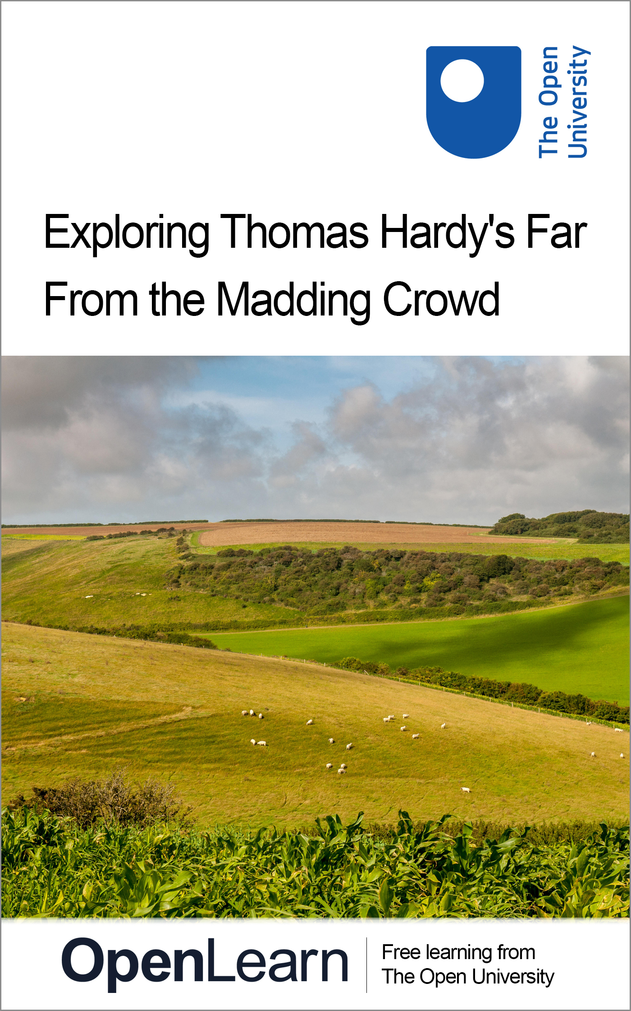

A233_1

Exploring Thomas Hardy's Far From the Madding Crowd
About this free course
This free course is an adapted extract from the Open University course A233 Telling stories: the novel and beyond www.open.ac.uk/courses/modules/a233.
This version of the content may include video, images and interactive content that may not be optimised for your device.
You can experience this free course as it was originally designed on OpenLearn, the home of free learning from The Open University –
www.open.edu/openlearn/history-the-arts/exploring-thomas-hardys-far-the-madding-crowd/content-section-0
There you’ll also be able to track your progress via your activity record, which you can use to demonstrate your learning.
Copyright © 2019 The Open University
Intellectual property
Unless otherwise stated, this resource is released under the terms of the Creative Commons Licence v4.0 http://creativecommons.org/licenses/by-nc-sa/4.0/deed.en_GB. Within that The Open University interprets this licence in the following way: www.open.edu/openlearn/about-openlearn/frequently-asked-questions-on-openlearn. Copyright and rights falling outside the terms of the Creative Commons Licence are retained or controlled by The Open University. Please read the full text before using any of the content.
We believe the primary barrier to accessing high-quality educational experiences is cost, which is why we aim to publish as much free content as possible under an open licence. If it proves difficult to release content under our preferred Creative Commons licence (e.g. because we can’t afford or gain the clearances or find suitable alternatives), we will still release the materials for free under a personal end-user licence.
This is because the learning experience will always be the same high quality offering and that should always be seen as positive – even if at times the licensing is different to Creative Commons.
When using the content you must attribute us (The Open University) (the OU) and any identified author in accordance with the terms of the Creative Commons Licence.
The Acknowledgements section is used to list, amongst other things, third party (Proprietary), licensed content which is not subject to Creative Commons licensing. Proprietary content must be used (retained) intact and in context to the content at all times.
The Acknowledgements section is also used to bring to your attention any other Special Restrictions which may apply to the content. For example there may be times when the Creative Commons Non-Commercial Sharealike licence does not apply to any of the content even if owned by us (The Open University). In these instances, unless stated otherwise, the content may be used for personal and non-commercial use.
We have also identified as Proprietary other material included in the content which is not subject to Creative Commons Licence. These are OU logos, trading names and may extend to certain photographic and video images and sound recordings and any other material as may be brought to your attention.
Unauthorised use of any of the content may constitute a breach of the terms and conditions and/or intellectual property laws.
We reserve the right to alter, amend or bring to an end any terms and conditions provided here without notice.
All rights falling outside the terms of the Creative Commons licence are retained or controlled by The Open University.
Head of Intellectual Property, The Open University

Contents
- Introduction
- Learning outcomes
- 1 Biography and context
- 2 Locations
- 3 Far From the Madding Crowd
- 4 Reading a chapter from Far From the Madding Crowd
  - 4.1 The narrator
  - 4.2 How does the narrator set the scene?
  - 4.3 Style: what kind of writing is this?
  - 4.4 Dialogue
  - 4.5 What motivates Bathsheba to send the card to Boldwood?
- 5 Religion
- Conclusion
- Acknowledgements

Introduction
In this free course, Exploring Thomas Hardy’s Far From the Madding Crowd, you’ll explore one of the richest, most vivid novels in English, written in 1874. First you will discover something about Hardy’s life, and the importance to his writing of the region he grew up in, the South-West of England. You will then read one short chapter from Far From the Madding Crowd and find out about how Hardy uses narration, style and dialogue to create characters and a fictional world that readers can believe in. You will also find out about the important place of religion in Hardy’s work.
This OpenLearn course is an adapted extract from the Open University course A233 Telling stories – the novel and beyond.

Learning outcomes
After studying this course, you should be able to:
- understand the possibilities of third-person narration
- recognise the role of dialogue in creating character
- understand how literary techniques combine to create a story.

1 Biography and context
Thomas Hardy (1840–1928) was a novelist and poet, famous in his own lifetime with a well-deserved reputation that endures into the twenty-first century. He was born in Upper Bockhampton, a small village in Dorset and as a child went to the Church of England school in the next village. As a young man he was articled to an architect in Dorchester, and in 1862 moved to London where for five years he was employed as a draughtsman before returning to Dorset, where he worked restoring churches. He also started writing fiction which he based on the countryside he came from and lived in, and the country people that he knew best.

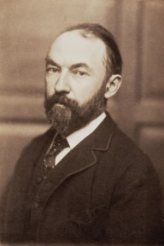
Figure 1 Image of Thomas Hardy in about 1870.
View description - Figure 1 Image of Thomas Hardy in about 1870.

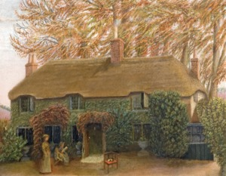
Figure 2 Thomas Hardy’s birthplace in Upper Bockhampton (Dorset).
View description - Figure 2 Thomas Hardy’s birthplace in Upper Bockhampton (Dorset).

Activity 1

Watch this short video now which was filmed in and around the cottage where Hardy was born, and where he wrote Far From the Madding Crowd. As you watch, pay attention to information about the Hardy family, and anything in his background that is discussed here that you think might have contributed to his future career a writer.

Video content is not available in this format.
Video 1
View transcript - Video 1

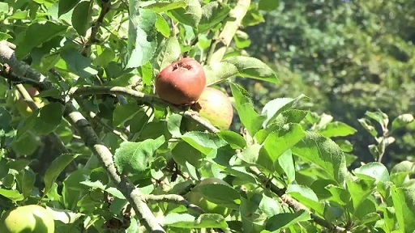

View discussion - Activity 1

2 Locations
Far From the Madding Crowd was serialised in The Cornhill Magazine before it was published in book form. Hardy’s first novel, Under the Greenwood Tree, had come to the attention of the Cornhill’s editor, Leslie Stephen, who wrote to Hardy expressing interest in publishing his next work. Only by good luck did the letter arrive: the postman gave it to some children who carelessly dropped it in the mud. Fortunately a farm labourer found and delivered it: a significant piece of good fortune for Hardy. At the beginning of this next short video when Jonathan Gibson mentions ‘Stephen’ he is referring to Leslie Stephen, the Cornhill editor.

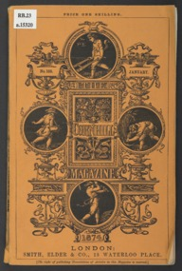
Figure 3 Cover of Cornhill magazine January 1874.
View description - Figure 3 Cover of Cornhill magazine January 1874.

Activity 2

Watch this next film clip now, paying particular attention to the discussion of the importance of the location and setting of Far From the Madding Crowd.

Video content is not available in this format.
Video 2
View transcript - Video 2

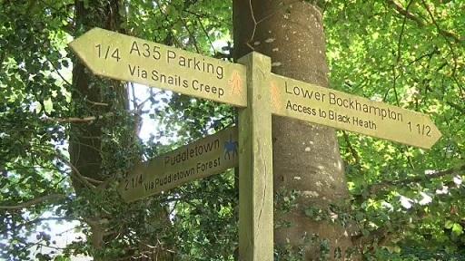

View discussion - Activity 2

3 Far From the Madding Crowd

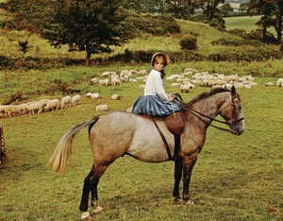
Figure 4 Julie Christie as Bathsheba Everdene in John Schlesinger’s film of Hardy’s novel. In this image Bathsheba is shown as riding side-saddle, whereas in the novel we are told that she often rode astride - one instance of her independent attitude to social conventions for women at the time.
View description - Figure 4 Julie Christie as Bathsheba Everdene in John Schlesinger’s film of Hardy’s ...

The discussion of Far From the Madding Crowd that follows will be most rewarding if you have time to read the novel, either now, or at some point as you work through this course. For those who don’t have time or opportunity right now, a synopsis follows. However, don’t read it if you don’t want to spoil the pleasure of finding out what happens if you plan to read it later.

Box 1 Synopsis of the novel
Far From the Madding Crowd is the story of Bathsheba Everdene, a young woman who attracts the fancy of three very different men: steady, reliable Gabriel Oak, a shepherd; the unreliable Sergeant Troy, and the gentleman-farmer Boldwood. All three propose to her. Bathsheba turns Gabriel down early in the story, but her head is turned by the flashy attractions of Frank Troy and she marries him secretly, unaware that Troy had been about to marry Fanny, a poor servant girl. Confusion over which church their wedding was to take place in leaves Troy feeling humiliated and Fanny distraught and destitute. Bathsheba and Troy’s marriage is disastrous and in the meantime Boldwood has become increasingly obsessed with Bathsheba. When Troy is missing, presumed dead, Boldwood wears Bathsheba down until he extracts a promise of marriage from her. Troy reappears ready to reclaim his wife, Boldwood shoots him, is arrested and sentenced to prison. The story ends with Bathsheba’s marriage to the ever-faithful Gabriel Oak.

4 Reading a chapter from Far From the Madding Crowd
A short chapter has been chosen to use as an example of ways in which Hardy makes us believe in and care about his fictional characters and what happens to them. Chapter XIII comes about a third of the way through the novel. Of course, if you were reading FarFrom the Madding Crowd from the beginning (and hopefully you have, or will want to) you would already be familiar with Bathsheba and her servant Liddy, the characters who feature in this chapter. But if not, even in these few pages Hardy’s use of narrative description and the characters’ dialogue gives us a strong sense of who these women are, what they are like, and a desire to discover what will happen next.
At this point in the story, Bathsheba Everdene, an educated young woman but previously penniless and dependent on an aunt for her home, has inherited the lease of an uncle’s farm. She has left her aunt and moved twenty miles away to Weatherbury to manage it. The local community takes great interest in her independent ways and managerial skills.

Box 2 Chapter XIII
Chapter XIII is called ‘Sortes sanctorum: the valentine’. The Latin words translate as ‘the oracles of the holy scripture’ and refer to using the Bible as a kind of fortune-telling device or as a way to solve problems; opening it and alighting on a verse at random would, it was believed, provide an answer. Names for new-born babies were sometimes chosen in the same way, and as you will see, in this chapter Bathsheba and Liddy engage in a variation of that practice.

Read the chapter (link below) now so that you are familiar with the examples in the discussion that follows. You may like to make notes of any words or references that you might find unfamiliar or difficult to understand. If they are not explained do look them up in a dictionary.
Thomas Hardy, Far From the Madding Crowd Chapter 13

4.1 The narrator
The story teller of Far From the Madding Crowd is what is known as a third-person narrator. That is, someone who knows all there is to know about what happens, knows exactly who the characters are and what motivates them to do what they do. Third-person narrators are often also referred to as omniscient, because they are god-like in their control of their fictional characters and the story that they tell. But they stand outside their stories, sometimes judging or telling us what to think about characters, sometimes leaving readers to decide for themselves, or they may conceal information deliberately in order to build suspense. You will have opportunities to make up your own mind about what kind of third-person narrator Hardy’s is as you read further. As you read Chapter XIII think about what the narrator tells us about Bathsheba, and what we are left to find out for ourselves.
The narrator is not quite one and the same as the author, and that’s worth remembering: there is a gap between Thomas Hardy the writer and the narrator who tells his story.

4.2 How does the narrator set the scene?
Let’s begin with the first paragraph of Chapter XIII, which you may like to read again now. Think about what information the narrator gives us: for example, what do you know at the end of the paragraph that you didn’t know at the beginning? Does the description help us to believe in this fictional story, and if so, how?

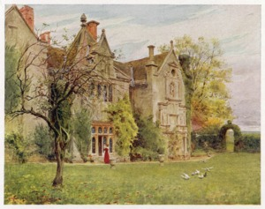
Figure 5 Hardy based Bathsheba’s farm on Waterston Manor. The exterior is described in great detail at the beginning of Chapter IX.
View description - Figure 5 Hardy based Bathsheba’s farm on Waterston Manor. The exterior is described ...

Hardy’s chapters often begin as this one does with some descriptive writing which sets the scene for what follows. This one begins with some of the key elements of a realist novel: the first sentence helpfully informs us of the date, the time, and the location. In this way we are firmly located in the world of the novel, which we can believe in (even though we are aware that we are reading fiction) because dates, times and locations are important features of the real word we inhabit. We may never have set foot in a farmhouse, and we were certainly not alive in the mid-nineteenth century when this story is set – but the description that follows provides enough detail relating to our experiences of the real world to convince us that this is not a fairy story or a fantasy, but realism. The story we are being told is recognisable: using everyday contemporary detail the narrator creates a plausible fictional world peopled with characters we can relate to. It is the day before Valentine’s Day, we are in a farm house and it is Sunday afternoon.

Box 3 Realism
Key elements of realism:
- time: use of convincing time scales for the development of the story; when the story takes place – with accurate historical details
- location: settings, places and situations that are recognisably ‘real’ (even while we know they are fictional)
- characters we find convincing.

Next you will look more closely at the detailed description, thinking too about the style of the writing.

4.3 Style: what kind of writing is this?

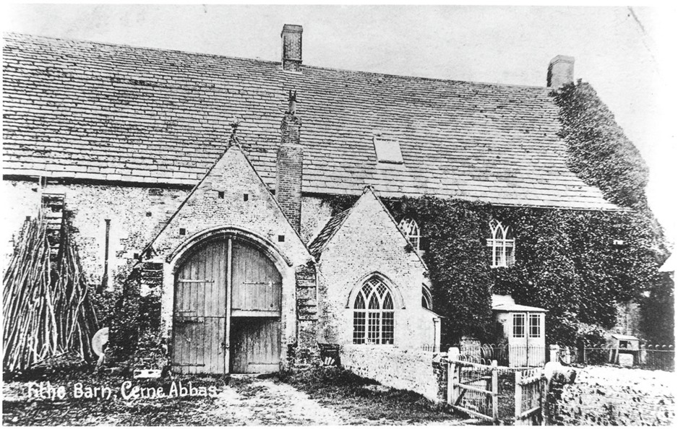
Figure 6 Bathsheba’s barn is based on a real medieval barn in Cerne Abbas, Dorset.
View description - Figure 6 Bathsheba’s barn is based on a real medieval barn in Cerne Abbas, Dorset. ...

Did you notice the length of the sentences in that first paragraph? The first one is short and factual; the second which introduces Bathsheba and Liddy is not much longer. But the third sentence is very long and descriptive. It winds on and on, adding detail upon detail in a succession of subordinate clauses which build to create an impression of a far-from cheerful room. The farmhouse is a ‘mouldy pile’, it is ‘dreary before the candles were lighted and the shutters closed’, and there is no fire, so no warmth. That focus on sensuous detail – the lack of light and heat - allows us to feel as well as see the place in our imaginations. Bathsheba’s piano may be second-hand but it is still a status symbol, nevertheless in this unwelcoming and dilapidated space it appears to be ‘sloping and out of level on the warped floor’. Neither the room nor the piano look anything but ramshackle in this description.
Then the narrator comments on Liddy, describing her as ‘like a little brook’ which is shallow, but ‘always rippling’. That comparison provides us with a lovely image of Liddy, making her sound interesting and lively in contrast to the dreary room. If you find the rest of the sentence slightly puzzling, think back to the image of the shallow rippling brook to help make sense of it. Her ‘presence had not so much weight as to task thought, and yet enough to exercise it’. Liddy is, in other words, not a complex character with a great intellect (she’s not going to make anyone think hard) but she might well provoke ideas. Which is exactly what she goes on to do in conversation with Bathsheba. Re-read the first passage of dialogue between them now.

4.4 Dialogue
The conversation between the two women and the way they talk to each other says a great deal about their characters and their relationship: they may be mistress and servant, but they are easy and comfortable in each other’s company. Liddy is clearly superstitious, and her superstitions extend to what ought, and ought not, to take place on a Sunday. Bathsheba thinks that is nonsense, and is also dismissive about Sunday observance ‘what’s right week days is right Sundays’.

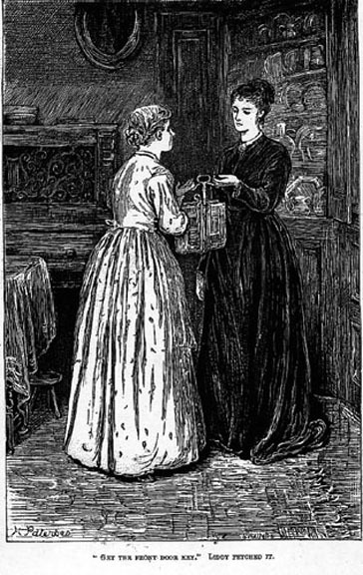
Figure 7 This illustration from the Cornhill magazine’s serialisation of Far From the Madding Crowd shows the social status of the two women. Bathsheba is taller and more elegant then her servant Liddy. We see Bathsheba’s lovely face clearly, and only a side view of Liddy’s. Notice that the illustrator has included some of the detail from Hardy’s description of the room: Bathsheba’s piano is visible on the left. Apart from the brightness of Liddy’s dress, the setting is dark and rather sombre.
View description - Figure 7 This illustration from the Cornhill magazine’s serialisation of Far From ...

Liddy very properly addresses Bathsheba as ‘Miss’ indicating her subservient position, but the question she asks simply suggests one young woman gossiping and chatting to another: ‘Did you ever find out, Miss, who you are going to marry by means of the Bible and key?’ The question doesn’t come across as impertinent, nor does Bathsheba take it in that way: ‘Don’t be so foolish Liddy. As if such things could be.’ Her education as well as her social status is superior to Liddy’s and she is not given to such superstitious nonsense, but Liddy is not afraid to stand up for her own beliefs: ‘it makes your heart fearful!’ she says, and while some people believe in it, and others don’t, ‘I do’ she declares. Rather than dismissing the idea, she sends Liddy to find the front door key so they can try out the superstition for themselves. Rather than simply ridiculing the ‘foolish’ practice, Bathsheba appears to take it seriously. Notice that she blushes as the Bible turns, which suggests that, whatever the intentions, she has entered into the spirit of the fortune-telling. She is full of contradictions like this which make her character more complex and – you may decide – more interesting and convincing.
Her blushes prompt Liddy to ask ‘Who did you try?’ and when Bathsheba refuses to tell her, Liddy, that ever-rippling shallow little brook, picks up on an unspoken association of ideas and teasingly plays with it. She asks first if her mistress noticed what Boldwood did in church that morning. Which turns out to be nothing at all: unlike the rest of the congregation, he failed to even glance at Bathsheba. ‘Rich and gentlemanly, what does he care?’ Liddy remarks. And then Bathsheba’s unspoken thought processes turn to the ‘gorgeously illuminated and embossed’ valentine she bought in Casterbridge the day before to give to a little boy called Teddy Coggan as a ‘pretty surprise’ for him. But the card is destined for a different recipient.

4.5 What motivates Bathsheba to send the card to Boldwood?
Between naughty Liddy’s sense of mischief and Bathsheba feeling her nose out of joint (‘it was faintly depressing that the most valuable and dignified man in the parish should withhold his eyes’), the card is sent to Boldwood. But do you think that was in her mind from the moment that she remembered she’d bought the card, or does the decision come later? She writes the ‘rose is red’ verse on the card, gives a definitive ‘no’ to Liddy’s repeated suggestion that she send it to Boldwood, before she begins to question out loud whether Teddy really deserves it: ‘he’s rather a naughty child sometimes’. Has she been thinking of Boldwood from the moment the Bible turns, in spite of what she says to Liddy? Instead of giving readers an answer, the narrator leaves us to decipher Bathsheba’s thoughts, which are deeper and less transparent that Liddy’s. Unable to decide who to send it to, Bathsheba decides to do ‘as men do’, by tossing for it – and the book she tosses comes down shut, in Boldwood’s favour.
You might think that he narrator’s next description is very telling. Bathsheba yawns, and with ‘off-hand serenity’ addresses the valentine to Boldwood. Her attitude is designed to convey that she’s not at all bothered by what she’s doing, and what she says next is equally off-hand. But notice how she uses ‘we’ rather than ‘I’ in the speech which follows: ‘which seal shall we use? …. We’ll try this, and if it doesn’t do we’ll have another’. Although the choice of seal is entirely her own, Bathsheba manages to imply that Liddy shares responsibility. The narrator is silent about Liddy’s reaction when she reads ‘MARRY ME’, but comments directly on how ‘very idly and unreflectingly was this deed done. Of love as a spectacle Bathsheba had a fair knowledge, but of love subjectively she knew nothing’. In fact, Bathsheba seems to have reflected quite a lot on whether she should or shouldn’t send the valentine to Boldwood, but she is aware that it is a mischievous thing to do. Her pique at being ignored is the real reason, but as she does not know the man she has no idea of the effect it will have on him. The narrator’s comment ‘So very idly and unreflectingly the deed was done’ hints at the devastating chain of events that it will set in motion, while the words ‘idly and unreflectingly’ strike an unusually moral tone.
Bathsheba was right earlier in the chapter when she said she wouldn’t send the card to Boldwood as ‘He wouldn’t see any humour in it’. Liddy’s reply ‘He wouldn’t. He’d worry to death’ is a common enough exaggeration – an insignificant throw-away remark readers barely register. But if you were to re-read the novel, you might see that common turn-of-phrase exaggeration in a very different light.
The chapter ends on the narrator’s note of warning and suspense and you would have to read the Chapter XIV ‘Effect of the Letter: Sunrise’ to find out how it is received.

5 Religion
Thomas Hardy was a religious sceptic, but Far From the Madding Crowd has references to the Bible on practically every page. That is because of the influence the church had at the time. While such references might seem esoteric now and have many of us modern readers turning to notes in the backs of our editions for explanations, they would have been familiar to the church-going rural society Hardy writes about, and to his contemporary readers. Interestingly such references don’t signify piety or religious devotion, but instead testify to the community’s shared heritage.
Chapter XIII is no exception. We have already considered the title ‘Sortes sanctorum’, using the Holy Scriptures for fortune telling. The ‘old quarto Bible, bound in leather’ that Liddy and Bathsheba use is fundamental to the action in this chapter, and the use the bible is put to is far from spiritual! The narrator describes its pages as ‘drab with age’, and comments that in places it is ‘quite worn away at much-read verses by the forefingers of unpractised readers in former days where they were moved along under the line as an aid to vision’. That description conveys a hazy impression of those who owned the book in the past; it has been handed down through generations, not of scholars but ordinary people, not all of whom were fluent readers.

Box 4 The Bible as a ‘quarto’
The description of the Bible as ‘quarto’ is a reference to the number of times the pages were folded: it indicates the size of the book. Later the valentine is described as a ‘gorgeously illuminated and embossed design in post octavo’. Again, this refers to the way the paper has been folded and thus the size of the card.

There’s something touching about the way their marks are inscribed on the pages, reminding us of their existence. And when Bathsheba finds a rusty mark in the place she’s looking for, she knows and we know that she is not the first to use an old key to find out who she will marry. In this way narrator conveys a sense of history and tradition to using the bible in this way.

Box 5 Focalisation
‘… a species of Daniel’ is a Biblical reference. Bathsheba is piqued because unlike everyone else in church, Boldwood has not even glanced at her. So the narrator compares him to the Biblical Daniel in the Old Testament (Daniel, chap. 6 v.16): who refused to observe King Darius’s decree and insisted on facing Jerusalem when he prayed. In church, Boldwood continues to face east and the altar, ‘when reason and common sense said that he might just as well follow suit with the rest and afford [Bathsheba] the official glance of admiration’. This is not what the narrator really thinks, but is a way of expressing Bathsheba’s annoyance at Boldwood ignoring her. The technique is known as ‘focalisation’ and it happens when a third-person narrator goes into a character’s mind to tell us what they think, without explicitly saying that’s what they’re doing. We have to read carefully to notice shifts like this one.

Hardy expects his readers to know exactly which verse he means when he tells us Bathsheba searches for the ‘special verse’ whereas you might have had to look it up: the ‘sublime words’ that she reads are from the Book of Ruth chap. 1, verse 16. Interestingly enough, Ruth is speaking to her future mother-in-law, not Boaz whom she is to marry: ‘Intreat me not to leave thee, or to return from following after thee: for whither thou goest, I will go: and where thou lodgest, I will lodge: thy people shall be my people, and thy God my God’. Nevertheless, the verses are about love, and they convey absolute sincerity.
The narrator uses an image from the Book of Daniel to describe the ‘troublesome image’ Boldwood ignoring her presents to Bathsheba, but did you notice just how many other references there are to religion or religious observances in this short chapter? First, the action takes place on a Sunday, so certain practices are frowned upon. Liddy is anxious that indulging in Biblical fortune-telling is wrong on a Sunday. Bathsheba, capable of independent practical thought dismisses it: ‘What’s right week days is right Sundays’.
Boldwood has ignored Bathsheba in church, throughout the whole service. We can infer that everyone goes to church because ‘everybody else’ does notice her. That she attracts interest is inevitable, she is new to the village of Weatherbury, she is unusual in that she is a woman who has taken over management of a farm, and she is also single and very attractive. Church on Sunday then serves as an opportunity for the community to give her a once-over; an instance of religious observance used as a social, rather than (or possibly as well as) a spiritual event.
From the evidence of this chapter it can be suggested that, although we know that Hardy himself had little or no religious faith, his fiction reflects the influence of the Church on the daily lives of the community he depicts.

Conclusion
You have spent quite a long time reading and analysing just one short chapter of Hardy’s comparatively long novel. If you were reading the whole book, how long do you think you would spend on that chapter? You may think that you would probably have finished it in about five or ten minutes – it’s only four pages long after all, and you might be keen to find out what happens next. But you have read ‘A Valentine’ slowly and analytically, paying close attention to the details and subtle nuances of narrative, and the way the character’s voices interact with each other.
Bathsheba’s reason for sending the valentine is mainly because she’s piqued at being ignored by Boldwood, but the chapter’s opening description of how dreary her house is on a winter Sunday afternoon also plays its part. The sense of boredom, of having nothing to do and only Liddy to entertain her helps to account for Bathsheba’s reckless act. Important though the descriptive detail is, if we are reading just to find out what happens next, we probably don’t really pay it a great deal of attention. But Hardy’s descriptions are worth close attention for they always contribute in various ways to the drama of the action. Novels like this really do one repay time invested in careful reading.
The idea of telling a story sounds quite straightforward, but a great deal depends on exactly how that story is told!
This OpenLearn course is an adapted extract from the Open University course A233 Telling stories – the novel and beyond.

Acknowledgements
This free course was written by Sue Asbee. It was first published in July 2019.
Except for third party materials and otherwise stated (see terms and conditions), this content is made available under a Creative Commons Attribution-NonCommercial-ShareAlike 4.0 Licence.
The material acknowledged below is Proprietary and used under licence (not subject to Creative Commons Licence). Grateful acknowledgement is made to the following sources for permission to reproduce material in this free course:

Images
Course image: Photo: Joe Dunckley/Alamy
Figure 1: Photo: Heritage Image Partnership Ltd/Alamy
Figure 2: Photo: Courtesy of Dorset County Museum
Figure 3: Photo: © British Library Board. All Rights Reserved/Bridgeman Images
Figure 4: Photo: Vic/Appia/Kobal/Shutterstock
Figure 5: Photo: Chronicle/Alamy
Figure 6: Used with permission from Cerne Abbas Historical Society
Figure 7: Photo: The Victorian Web. This image may not be used without prior permission for any scholarly or educational purpose http://www.victorianweb.org/art/illustration/allingham/1b.html
Images within videos: John Frost Newspapers/Alamy Stock Photo; Pictorial Press/Alamy Stock Photo; Historic Collection/Alamy Stock Photo; The National Trust/Simon Harris; Classic Collection 3/Alamy Stock Photo; Science History Images/Alamy Stock Photo; World History Archive/Alamy Stock Photo; Lebrecht Music and Arts/Alamy Stock Photo; James Brittain-VIEW/Alamy Stock Photo
Every effort has been made to contact copyright owners. If any have been inadvertently overlooked, the publishers will be pleased to make the necessary arrangements at the first opportunity.
Don't miss out
If reading this text has inspired you to learn more, you may be interested in joining the millions of people who discover our free learning resources and qualifications by visiting The Open University – www.open.edu/openlearn/free-courses.

Activity 1

Discussion
There are several interesting pieces of information in that film clip that might be significant in fostering Hardy’s interest in writing. First, his mother Jemima had been a servant, but unusually seems to have been allowed access to the family’s library where she was in service. She read works by Dr Johnson, Sir Walter Scott and Lord Byron, and it seems likely that she passed on her love of reading to her son. His father was a builder with his own yard employing other working men, which put the Hardy family’s social standing a cut above that of other labouring families. The parents may well have encouraged aspirations in their children and clearly Thomas had a sound education, after working in London he returned to the family home. That father and son worked their cider press together suggests one way in which the family was steeped in local tradition, and Hardy’s interest in the community is evident when we learn that he took jobs and names of country people from churchyards in the area, using them as inspiration for his fiction.
Back to Session 1 Activity 1

Activity 2

Discussion
That clip emphasises the significance for Hardy of the district he lived in and fictionalised. The miles that his characters walk across the heathland, and the pattern that the movement of those walks makes, helps to provide a structure for the novel and reminds us of the time it takes for the characters to travels from one location to another.
Back to Session 2 Activity 1

Figure 1 Image of Thomas Hardy in about 1870.

Description
This is a black-and-white photograph of Thomas Hardy.
Back to Session 1 Figure 1

Figure 2 Thomas Hardy’s birthplace in Upper Bockhampton (Dorset).

Description
This is an illustration of a house.
Back to Session 1 Figure 2

Figure 3 Cover of Cornhill magazine January 1874.

Description
This image shows the cover of Cornhill magazine.
Back to Session 2 Figure 1

Figure 4 Julie Christie as Bathsheba Everdene in John Schlesinger’s film of Hardy’s novel. In this image Bathsheba is shown as riding side-saddle, whereas in the novel we are told that she often rode astride - one instance of her independent attitude to social conventions for women at the time.

Description
This is a photograph of the actress Julie Christie sitting on a horse.
Back to Session 3 Figure 1

Figure 5 Hardy based Bathsheba’s farm on Waterston Manor. The exterior is described in great detail at the beginning of Chapter IX.

Description
This is an illustration of Waterston Manor.
Back to Session 4 Figure 1

Figure 6 Bathsheba’s barn is based on a real medieval barn in Cerne Abbas, Dorset.

Description
This is an illustration of Cerne Abbas barn.
Back to Session 4 Figure 2

Figure 7 This illustration from the Cornhill magazine’s serialisation of Far From the Madding Crowd shows the social status of the two women. Bathsheba is taller and more elegant then her servant Liddy. We see Bathsheba’s lovely face clearly, and only a side view of Liddy’s. Notice that the illustrator has included some of the detail from Hardy’s description of the room: Bathsheba’s piano is visible on the left. Apart from the brightness of Liddy’s dress, the setting is dark and rather sombre.

Description
This is an illustration of Bathsheba and Liddy.
Back to Session 4 Figure 3

Video 1

Transcript
CHARLOTTE LILLEY
So we're at Hardy's Cottage, the home of the novelist Thomas Hardy. And it was where he was born. So he lived in a very small country cottage with his family, his four siblings and his mother and father. And he lived here from 1840 when he was born until the age of 34 when he had finally gotten money from his novel to marry his first wife Emma. So the original cottage was actually a simple two-up, two-down cob building. And in 1857 it was passed on to Thomas Hardy's father. And a separate cottage was built next door for his grandmother Mary. That was up for about 20 years as two individual cottages until 1857 when it was knocked through when she passed away and made into the one cottage that we have today.
[MUSIC PLAYING]
NARRATOR
Hardy's father was a builder who employed workmen of his own and was thus in social status a cut above the labourers who worked for Bathsheba in Far from the Madding Crowd. Hardy's mother had been a maid servant. She was a great reader who enjoyed Sir Walter Scott's and Byron's poetry and had been allowed to read books in her employer's library.
CHARLOTTE LILLEY
When Hardy was 22 years of age he got an architectural job up in London.
NARRATOR
Over the next decade, Hardy went on to write four novels, three of which were published, before writing the book that would make him famous, Far from the Madding Crowd. Although he'd moved to London, Hardy kept returning to Higher Bockhampton. He wrote Far from the Madding Crowd here, eating meals cooked by his mother and helping his father with the cider making. His room looked down on what's now the front garden but was then his father's building yard. For Hardy, writing this book was a return to Dorset, to Higher Bockhampton and the world of his childhood after his years in London.
CHARLOTTE LILLEY
He wrote Far from the Madding Crowd up in his room upstairs. He shared this room with his brother Henry. But he would go up there, sit at his desk, take inspiration from the surroundings, the people. There's a lovely story where for his novels he'd go round church yards and pick out names of country people from the tombstones that had a direct relation to the area. And he'd use their jobs for inspiration, names. So this place for him was his ultimate area. It's what he could write about. He knew the place inside out, the people, their roles, the rural life.
Back to Session 1 MediaContent 1

Video 2

Transcript
NARRATOR 1
There's a close relationship between Far from the Madding Crowd and the area around this cottage. Hardy himself explained to Stephen that his home was within a walk of the district in which the incidents in the book are supposed to occur. Hardy's cottage is, in fact, halfway between the two major destinations in the book, the two places that people walk towards or away from along what is now the A35. Casterbridge or Dorchester is just under three miles away to the southwest and Weatherbury, or Puddletown, where Bathsheba's farm was located, a little less in the opposite direction. Much of the landscape here looks very different from how it did in Hardy's time. Much of what was originally bleak heathland has been planted with conifers. Behind Hardy's cottage, however, there is one part that has been restored to be more like the original heath. Hardy was a great walker. And there are many walks in Far from the Madding Crowd. These walks fall into a rough overall pattern. First of all, we get a movement from east to west. Then at the end, a movement back again, back to the east. The novel opens way over to the northwest in a quite different part of Dorset, near Beaminster or in Hardy's name for it, Emminster, where Gabriel keeps his sheep farm. Gabriel travels to the great county town, the great public centre, Casterbridge, to try to get a job at the hiring fair. Then he walks from Casterbridge towards the location of the next hiring fair but ends up instead in Weatherbury. At the end of the novel, there are two important bleak walks in the opposite direction, from Weatherbury, the little world of the novel, to the public institutional world of Casterbridge, as Fanny's agonising trek to the union workhouse and Boldwood's walk to the prison.
NARRATOR 2
Far from the Madding Crowd has its grim or despairing moments. Fanny's death is a good example. But in comparison to some of his later and more controversial novels, it is overall an optimistic and cheerful work. Hardy continued to write novels for more than 20 years until, following the hostile reception of Jude the Obscure, he turned to writing poetry instead, revising his novels as they were reprinted. When Hardy died in 1928 at Max Gate, the house in Dorchester he'd designed for himself and where he was living very privately with his second wife Florence, he was perhaps the most eminent writer in the country. He wanted to be buried at the church he had gone to as a boy, at Stinsford alongside his parents, grandparents, and first wife Emma. And his heart is buried here. Although bizarrely, the rest of his body is buried in Westminster Abbey. Although Hardy was a religious sceptic, the church and the peaceful country churchyard represented continuity and a sense of belonging which was of great importance to him.
Back to Session 2 MediaContent 1

