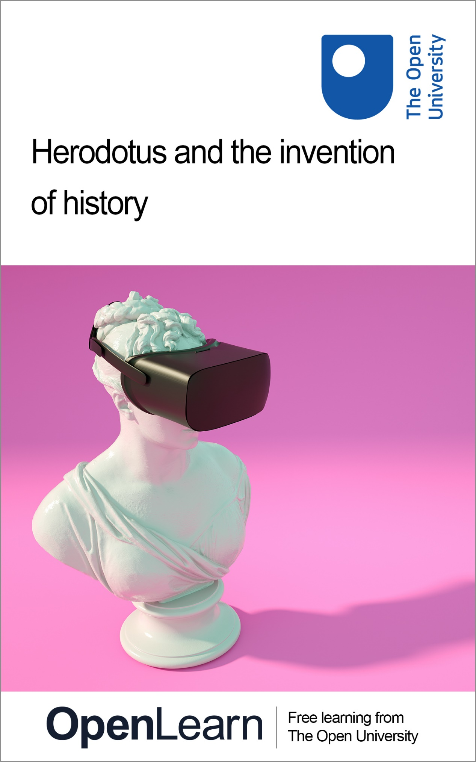

HDS_4

Herodotus and the invention of history

About this free course
Find out more about The Open University’s Classical Studies courses and qualifications: www.open.ac.uk/courses/arts/degrees/ba-arts-humanities-classical-studies-r14-cs.
This version of the content may include video, images and interactive content that may not be optimised for your device.
You can experience this free course as it was originally designed on OpenLearn, the home of free learning from The Open University –
www.open.edu/openlearn/history-the-arts/herodotus-and-the-invention-history/content-section-0
There you’ll also be able to track your progress via your activity record, which you can use to demonstrate your learning.
First published 2023.
Unless otherwise stated, copyright © 2024 The Open University, all rights reserved.
Intellectual property
Unless otherwise stated, this resource is released under the terms of the Creative Commons Licence v4.0 https://creativecommons.org/licenses/by-nc-sa/4.0/deed.en. Within that The Open University interprets this licence in the following way: www.open.edu/openlearn/about-openlearn/frequently-asked-questions-on-openlearn. Copyright and rights falling outside the terms of the Creative Commons Licence are retained or controlled by The Open University. Please read the full text before using any of the content.
We believe the primary barrier to accessing high-quality educational experiences is cost, which is why we aim to publish as much free content as possible under an open licence. If it proves difficult to release content under our preferred Creative Commons licence (e.g. because we can’t afford or gain the clearances or find suitable alternatives), we will still release the materials for free under a personal end-user licence.
This is because the learning experience will always be the same high quality offering and that should always be seen as positive – even if at times the licensing is different to Creative Commons.
When using the content you must attribute us (The Open University) (the OU) and any identified author in accordance with the terms of the Creative Commons Licence.
The Acknowledgements section is used to list, amongst other things, third party (Proprietary), licensed content which is not subject to Creative Commons licensing. Proprietary content must be used (retained) intact and in context to the content at all times.
The Acknowledgements section is also used to bring to your attention any other Special Restrictions which may apply to the content. For example there may be times when the Creative Commons Non-Commercial Sharealike licence does not apply to any of the content even if owned by us (The Open University). In these instances, unless stated otherwise, the content may be used for personal and non-commercial use.
We have also identified as Proprietary other material included in the content which is not subject to Creative Commons Licence. These are OU logos, trading names and may extend to certain photographic and video images and sound recordings and any other material as may be brought to your attention.
Unauthorised use of any of the content may constitute a breach of the terms and conditions and/or intellectual property laws.
We reserve the right to alter, amend or bring to an end any terms and conditions provided here without notice.
All rights falling outside the terms of the Creative Commons licence are retained or controlled by The Open University.
Head of Intellectual Property, The Open University

Contents
- Introduction
- 1 Introducing Herodotus: thinking historically
  - 1.1 How do we know what we know?
  - 1.2 Herodotus’ opening pitch (1.1.1)
  - 1.3 The first account (1.1.1–1.5.4)
  - 1.4 Re-reading the first account (1.1.1–1.5.4)
  - 1.5 Thinking historically
- 2 Constructing the Histories: writing historically
  - 2.1 Beginning with Croesus
  - 2.2 Candaules’s wife
  - 2.3 Reading historically
- 3 Looking to the end: reading historically
  - 3.1 The oracle at Delphi
  - 3.2 Croesus tests the oracles
  - 3.3 Putting two and two together
  - 3.4 Croesus on the pyre
- Conclusion: writing historically
- Taking it further
- Pronunciation guide
- Tell us what you think
- References
- Acknowledgements
- Glossary
- Solutions
- Descriptions

Introduction
With the information explosion online, how can you tell fake news from the real thing, or be more sensitive to how information can be weaponised? In the fifth century BCE, a Greek by the name of Herodotus faced a similar challenge when he set out to examine why his people, the Greeks, and the Persians went to war with each other. Chief among his tasks was deciding what and whom to believe, as he pieced together the events of the past. His response was to produce an enquiry (in Greek: historiē, which is where the English word ‘history’ comes from). Explore how Herodotus puts together his enquiry and learn how he makes the problem of finding out what happened to ours too.
After studying this course you will be able to:
- identify the context in which Herodotus was writing and the subject matter of his Histories, as well as key episodes, themes and issues
- analyse passages of Herodotus’ text in order to learn how he presents his material and his methods as a historian
- evaluate sources (including Herodotus’ writing as well as modern-day material) as you assess their reliability and significance
- discuss aspects of identity in the ancient Greek world, especially the opposition between Greeks and non-Greeks
- reflect on personal experiences as an informed critical reader.
Before you get started we would really appreciate a few minutes of your time to tell us about yourself and your expectations for this course, in our optional start-of-course survey. Participation will be completely confidential and we will not pass on your details to others.

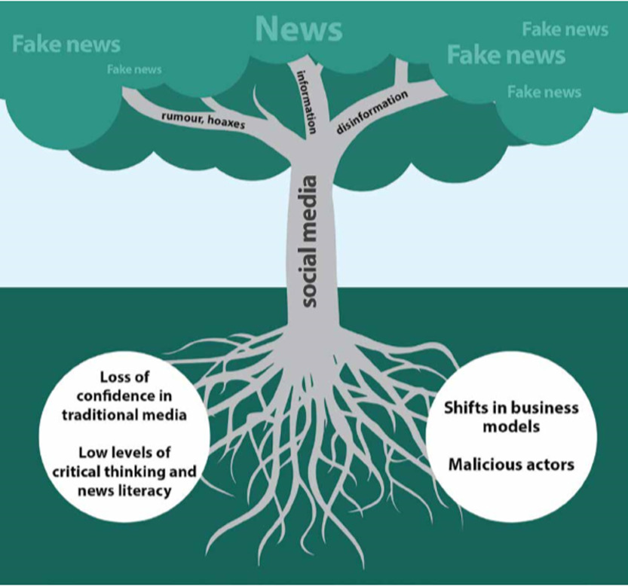
Figure 1 The roots of ‘fake news’, from UNESCO’s 2017/2018 Report into World Trends in Freedom of Expression and Media Development Global.
View description - Figure 1 The roots of ‘fake news’, from UNESCO’s 2017/2018 Report into World Trends ...
View alternative description - Figure 1 The roots of ‘fake news’, from UNESCO’s 2017/2018 Report into World Trends ...

Study note: a note on names
In this course, you will come across a number of names of places and people from the ancient Mediterranean world that may be unfamiliar to you. We have given you a guide to the standard pronunciation of some of the more commonly occurring ones, but do bear in mind that you will often hear ancient names, places and words pronounced in slightly different ways. The key here is not to worry too much about getting it ‘right’ and to be open to the fact that there are different conventions in operation.

1 Introducing Herodotus: thinking historically
In this section, you are going to learn about Herodotus, his context, what he sets out to do, and why that’s important. But first, take a minute to reflect on how we (think we) know things.

Figure 2 Communication concept.
View description - Figure 2 Communication concept.
View alternative description - Figure 2 Communication concept.

Study note: a note on dates
You will notice that this course uses the abbreviations ‘BCE’ and ‘CE’ when dating events, texts and objects. These abbreviations stand for ‘Before the Common Era’ and ‘Common Era’. You may be familiar with an alternative method of referring to dates as ‘BC’ (‘before Christ’) and ‘AD’ (Anno Domini, Latin for ‘in the year of our Lord’), and you may find that the authors of other things you read on the topics discussed here use instead BC and AD instead of BCE and CE. Remember that BCE years count backwards – therefore the sixth century BCE is earlier than the fifth century BCE.

1.1 How do we know what we know?
If you wanted to know about a specific topic, what would you do?

Activity 1
Allow approximately 5 minutes for this activity

Using Herodotus as an example, think about what you would do to find out who he is. Jot down two or three sources where you’d look to find out this information.

Provide your answer...
View discussion - Activity 1

All of these possibilities are fine, but can we trust them? Or, to put that slightly differently, how can we trust them? What kinds of elements do we look out for? Let’s take one particular popular internet source for information: Wikipedia and its entry for Herodotus.

Study note: a note on Wikipedia
Wikipedia is a free online encyclopaedia. Maintained and updated by community contributions, it allows multiple users (known as Wikipedia editors) to create and edit content. As such, it is a powerful means of gathering and sharing knowledge. When you perform a search online using Google or another search engine, it’s likely that one of the highest-ranked results that you’ll see will be a Wikipedia article. Because of the collaborative way it is compiled, Wikipedia pages change often. The text that appears in the activity below is what the page on Herodotus looked like when accessed in March 2024. It may look different if you search for it yourself now.

Activity 2
Allow approximately 20 minutes for this activity

Read the first three paragraphs of the Wikipedia entry on Herodotus reproduced below (see also Figure 3 below). You may well encounter names of people, places and events that are unfamiliar to you, as well as some technical words. Try not to get too bogged down in these details for now, but rather focus on the following tasks.
- First, identify one bit of information about Herodotus from each paragraph.
- Second, jot down how you think any of this is known.

Herodotus^{[1]} (c.484 – c.425 BCE) was a Greek historian and geographer from the Greek city of Halicarnassus, part of the Persian Empire (now Bodrum, Turkey) and a later citizen of Thurii in modern Calabria (Italy). He is known for having written the Histories – a detailed account of the Greco-Persian Wars. Herodotus was the first writer to perform systematic investigation of historical events. He is referred to as ‘The Father of History’, a title conferred on him by the ancient Roman orator Cicero.^{[2] [3]}
The Histories primarily cover the lives of prominent kings and famous battles such as Marathon, Thermopylae, Artemisium, Salamis, Plataea, and Mycale. His work deviates from the main topics to provide a cultural, ethnographical, geographical, and historiographical background that forms an essential part of the narrative and provides readers with a wellspring of additional information.
Herodotus has been criticized for his inclusion of ‘legends and fanciful accounts’ in his work. The contemporaneous historian Thucydides accused him of making up stories for entertainment. However, Herodotus explained that he reported what he could see and was told.^{[4]} A sizable portion of the Histories has since been confirmed by modern historians and archaeologists.
[1] ‘Herodotus’. Dictionary.com Unabridged (Online). n.d.
[2] Luce, T. James (2002). The Greek Historians. p. 26.
[3] ‘Herodotus’. Encyclopædia Britannica. Archived from the original on 4 April 2021. Retrieved 30 March 2021.
[4] Hornblower, Simon; Spawforth, Antony; Eidinow, Esther (11 September 2014). The Oxford Companion to Classical Civilization. OUP Oxford. p. 372.

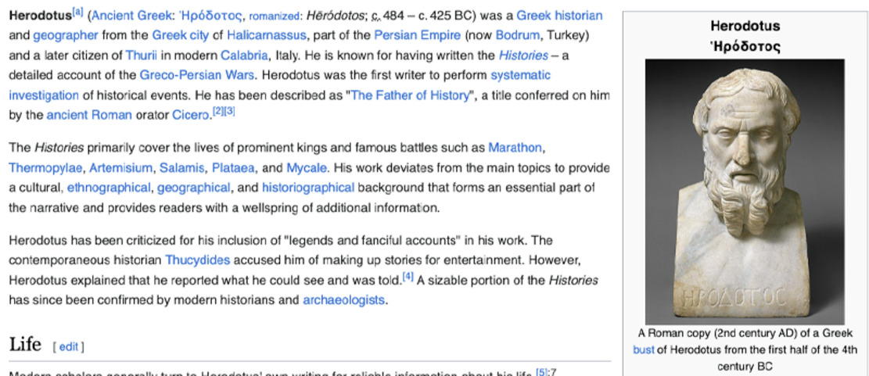
Figure 3 Screenshot of the Wikipedia entry on Herodotus, taken 1 March 2024.
View description - Figure 3 Screenshot of the Wikipedia entry on Herodotus, taken 1 March 2024.
View alternative description - Figure 3 Screenshot of the Wikipedia entry on Herodotus, taken 1 March 2024.

Provide your answer...
View discussion - Activity 2

Wikipedia, then, is a useful resource for supplying a quick answer to our question, ‘Who is Herodotus?’, including information about why he’s important – for example, that he is the author who records the battle of Thermopylae, which was famous for being the last stand of the 300 Spartans. At the same time, you may have noticed a structure to this entry that is shared with many Wikipedia entries on people: who (someone is), where (they’re from), what (they did). Underpinning this common structure is a concern to evidence each claim – not just with footnotes (including references to more traditional encyclopaedias) but also with the use of the modern-day name for the ancient place of Herodotus’ birth. This kind of information provides the entry with authority. It encourages us to believe it.
By the same token, a comment that is not referenced can, and perhaps should, strike us as being less persuasive. Ironically, no reference is provided for the criticism of Herodotus for including ‘legends and fanciful accounts’, though the quotation marks suggest that a source is being cited. Similarly, the claim that ‘Herodotus explained that he reported what he could see and was told’, is supported by a reference to a work of scholarship, not to the Histories themselves. Yet, what Herodotus actually says is: ‘While I am obliged to say what was said, I'm in no way obliged to believe it’ (Herodotus 7.152.3). Perhaps this warning does a better job than the Wikipedia article in rebutting that criticism of Herodotus for including ‘legends and fanciful accounts’: Herodotus himself is aware that many of the accounts he relates may be fanciful, but he includes them nonetheless because they are important for some reason. As you will find out, Herodotus is keenly alert to the problem of sources.
This course will shine a light on the process of information gathering. You will learn about the kinds of challenges that Herodotus faced when wanting to find out about past events and, critically, why they happened. And, just as importantly, you’re going to learn what Herodotus does in response – how he constructs history as an active enquiry (historiē) into whom and what to believe. In short, you’re going to learn how to think historically.

Study note: how to refer to the Histories
The conventional way of referring to a section of the text of the Histories of Herodotus is to provide the book, chapter and paragraph numbers. So the reference ‘Herodotus 7.152.3’ refers to Book 7, chapter 152, paragraph 3 of the Histories. You may also sometimes see ‘Herodotus’ abbreviated to ‘Hdt.’.

1.2 Herodotus’ opening pitch (1.1.1)
The Wikipedia entry which you read in Activity 2 informed us that Herodotus is known as ‘the first writer to perform systematic investigation of historical events’. You’ll begin by examining this claim, by thinking about what kind of (ancient Greek) literature came before Herodotus. To better understand what Herodotus is doing, you’re going to compare Herodotus’ introduction to the beginning of Homer’s Iliad.
Homer’s Iliad is a poem on an epic scale (it is 15,693 lines long!). One of the first complete works of ancient Greek literature to have come down to us, in fact the Iliad stands at the end of a long oral tradition of song stretching back centuries. These songs star a mythical generation of hero men and preserve their exploits for future fame (kleos). At the same time, epic poetry provided Greek audiences with a shared past and a sense of how their current world came into being.
From around a generation before Herodotus (i.e. some time in the sixth century BCE), two of these epics, Homer’s Iliad and Odyssey, became incorporated into the repertoire of an important panhellenic (‘all Greek’) festival put on by the Athenians every four years: the Great Panathenaia – an ‘all Athenian’ cultural festival of sport, dance, drama and poetry. Soon after, both Homeric poems become fixed in form and content by being written down, which is why they have survived and other epic poems have not. With the advent of writing, there was an information explosion in the Greek world, as a new wave of thinkers took to recording in prose all kinds of things: how the natural world worked; how and why people got ill; what different lands and peoples looked like, etc. Among this group of radical thinkers is Herodotus.

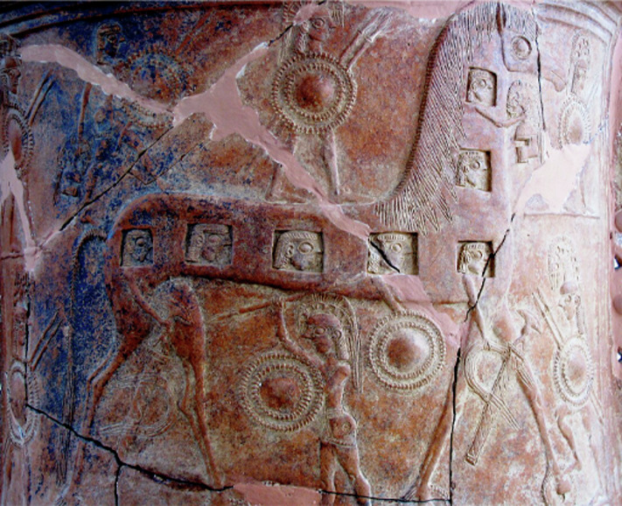
Figure 4 The Trojan Horse. Pithos (a large storage container) found at Mykonos, about 670 BCE, Archaeological Museum of Mykonos, ID: 2240.
View description - Figure 4 The Trojan Horse. Pithos (a large storage container) found at Mykonos, about ...
View alternative description - Figure 4 The Trojan Horse. Pithos (a large storage container) found at Mykonos, about ...

In the next activity you will read a short passage from the Iliad. There are many aspects that may well appear odd or confusing. For example, Homer refers to several gods worshipped by the ancient Greeks – Hades, the god of the underworld; Zeus, the leader of the gods; and Apollo (‘the son of Leto and Zeus’). Homer also uses unfamiliar terms – labels such as ‘the Achaeans’ to mean the Greeks who fought at Troy or the ‘son of Atreus’ to mean Agamemnon.Try not to let these unfamiliar aspects put you off: your task is about extracting specific information.

Activity 3
Allow approximately 20 minutes for this activity

Compare the opening lines of Herodotus’ Histories and the Iliad. Reading them as many times as you need, answer the questions in the table below, jotting down a short sentence or phrase to sum up your thoughts.

Question | Homer’s Iliad | Herodotus’ Histories
What do we learn about the author of each work? | Provide your answer... | Provide your answer...
What will the work be about? Try to find three things. | Provide your answer... | Provide your answer...

Homer, Iliad 1.1-8 [Book 1, lines 1-8]
About the wrath of Peleus’s son Achilles, sing goddess,
a destructive wrath that put a myriad of hurt on the Achaeans,
and sent into Hades the many mighty souls
of heroes, and made them food for all kinds of dogs
and birds; and the will of Zeus was being accomplished,
from that time when the two of them first stood apart in strife,
Son of Atreus, lord of men, and godlike Achilles,
Which one of the gods brought them together in strife?
The son of Leto and Zeus: for he was angry with the king...

Herodotus, Histories 1.1.1
This is the display of the enquiry (historiē) of Herodotus the Halicarnassian – an enquiry made so that the things people have done don’t get lost over time, and that the great and astounding actions of both Greeks and barbarians (barbaroi) alike don’t lose their glory (kleos). And especially it’s an enquiry into the cause of why they went to war with each other.
Men skilled in argument among the Persians say that the Phoenicians were the cause of the division...

View discussion - Activity 3

Study note: a note on Greek terms
historiē is the English transliteration of the Greek ἱστορίη. Similarly, barbaroi renders βαρβάροι, kleos κλέος, and aitia αἰτία. If you would like to learn more about the language in which Herodotus wrote, you can try the free OpenLearn course, Getting started on Ancient Greek.

Don’t worry if you didn’t get all of these points or found different ones. The beginning of the Iliad in particular is quite a challenge. (Who are these people?, you might be asking. If you’d like to learn more, see the ‘Taking it further’ section of this course.) Perhaps the most striking thing of note is the lack of any author: there’s no name (no Homer!) and no place associated with them. Instead, there’s an appeal to the ‘goddess’. Contrast this to the Histories, where we learn not only who has put this together (Herodotus) but also where they’re from (Halicarnassus). Yet, you may also have noticed some points of correspondence. Both beginnings describe a conflict and set out to provide the origins for it.
By placing himself at the beginning of his account – in the Greek, ‘Herodotus’ is literally the first word – Herodotus was doing something new and radically different from poets like Homer who had gone before him. At the beginning of the Iliad, the poet appeals to a ‘goddess’ (the Muse) for information about the Troy story (the war between the Greeks and Trojans over Helen of Sparta). Herodotus’ opening gambit is revolutionary because he takes ownership of the account that we are about to read. His authority doesn’t come from an external source; he’s going to be personally responsible for this account.
Equally, however, you may also have noticed aspects of Herodotus’ preparatory remarks that are what we might call ‘epic adjacent’, meaning that Herodotus draws on epic, even as he marks his departure from it. So, for example, when Herodotous writes that he’s keen that important actions don’t lose their recognition, he uses the epic term kleos (glory or fame), while, like Homer, he too ends with a question and, specifically, an interest in the cause of conflict. That is to say, right from the outset, Herodotus is also making the claim that his ‘enquiry’ will have similarities with epic: it is grand in scale and importance; it recounts famous past actions; and, fundamentally, it is interested in finding out why a particular conflict happened. Doing history is moving on to the ground that had previously been occupied by poems like the Iliad.

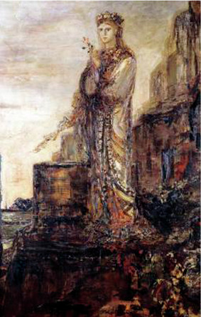
Figure 5 Helen on the Ramparts of Troy. Oil on canvas, by Gustave Moreau, late nineteenth century. Musee Gustave Moreau, Paris, France.
View description - Figure 5 Helen on the Ramparts of Troy. Oil on canvas, by Gustave Moreau, late nineteenth ...
View alternative description - Figure 5 Helen on the Ramparts of Troy. Oil on canvas, by Gustave Moreau, late nineteenth ...

Study note: a note on transliterating Greek names
Greek names frequently have more than one English spelling. For instance, Achaeans may be spelled as Achaians or even as Akhaians, Achilles as Achilleus (or Akhilleus), Herodotus as Herodotos, and so on. The reason is that there are different conventions for transliterating words from Greek into the English alphabet: the Greek κ can be rendered as 'k’ or ‘c’, αι as ‘ai’ or ‘ae’, ος as ‘os’ or ‘us’. This course generally uses the Latinised spellings of the more familiar names – Herodotus (not Herodotos) and Achilles (not Akhilleus), as well as Croesus (Kroisos) and Candaules (Kandaules).

1.3 The first account (1.1.1–1.5.4)
As you have just seen from his trailer, Herodotus’ primary aim is to answer the question why two sides came into conflict – which is the question posed at the beginning of the Iliad too. In the Iliad we receive an immediate answer: the god Apollo (referred to in the poem as ‘the son of Leto and Zeus’) was the cause of the quarrel between the heroes Agamemnon and Achilles. In Herodotus, the reader is similarly given an immediate answer, though in a way that makes us pause. In the next activity you will find out how hard that ‘in a way’ is working in the last sentence, and how Herodotus’ first account prepares us for thinking historically.

Study note: terminology for non-Greeks
In his opening pitch Herodotus writes that he will preserve the deeds done by Greeks and non-Greeks. The term he uses for non-Greeks is barbaroi (singular barbaros). This term derives from the Greek view that to their ears other peoples spoke gibberish, i.e. ‘bar bar’ (like the English ‘blah blah’). How much other baggage to attach to term ‘barbaros’, namely whether or to what extent these foreigners are, or should be seen as, different from Greeks (i.e. as ‘barbarians’), is a question that this course will get you to ponder.

The first episode of the Histories (1.1.1–1.5.4) throws us straight into a story that is supposed to answer why the two groups, Greeks and barbarians, came into conflict. It includes a lot of to-ing and fro-ing between various places and peoples. Since it can be rather bewildering, a map of those places and peoples, colour-coded according to whether they are Greeks or non-Greeks is provided (see Figure 6). While this episode is short on detail, the thematic thread linking the various movements concerns the abduction of women. If you are likely to find this section distressing, please consider carefully when and how you might want to engage with it. You can find suggestions in the Guidance on studying emotive topics and developing emotional resilience, from The Open University.

Activity 4
Allow approximately 30 minutes for this activity

First, using the text supplied, skim read Herodotus 1.1.1–1.5.4 to get a sense of what’s going on. Then, using both the map and the text, jot down some notes in answer to the following questions:
- Where does the first event (1.1.1–1.1.4) take place? Who is involved and what happens?
- Where does the second event (1.2.1) take place? Who is involved and what happens?
- Where does the third event (1.2.2–1.2.3) take place? Who is involved and what happens?
- What is the pattern that’s emerging?
- What is different about the fourth event (1.3.1–2)?

Herodotus, The Histories, Book 1 Sections 1–5
1.1
(1) Men skilled in arguments among the Persians say that the Phoenicians were the cause of the division. For these men (the Persians say) came from what’s called the Red Sea to our sea [the Mediterranean], and, once they had settled in the land in which they live to this day, they immediately began to embark on long voyages. They carried their Egyptian and Assyrian merchandise to many places before arriving in Argos. (2) Argos at this time was preeminent in every way in the land now called Hellas [Greece]. Arriving in Argos, (the Persians say) the Phoenicians set out their wares. (3) On the fifth or sixth day after they had arrived, when nearly all had been sold, there came to the seashore many women, chief among them the daughter of the king. Her name — and on this the Greeks say the same — was Io, daughter of Inachos. (4) As these women stood about the stern of the ship, bargaining for the wares that they had set their hearts on, (the Persians say) the Phoenicians incited one another to assault them. Most of the women escaped, but Io, along with some others, was abducted. Throwing her into the ship, the Phoenicians sailed off to Egypt.
1.2
(1) In this way, Io arrived in Egypt say the Persians (though not the Greeks), and that this was the first injustice done. After this, they say that some Greeks (the Persians aren’t able to recount the name) landed at Tyre in Phoenicia and abducted the king’s daughter Europa. (These Greeks would have been Cretans.) Up until now it had been like for like; but after this point it was the Greeks (the Persians say) who were guilty of the second injustice. (2) For Greeks sailed in a long ship down to Aea in Colchis and to the river Phasis; then, once they had completed the business on account of which they had come, (the Persians say) they abducted the king’s daughter Medea. (3) The king of the Colchians sent a herald to Greece to demand both a penalty for the abduction and his daughter back. But the Greeks (the Persians say) replied that, since those other men hadn’t paid any penalty for the abduction of Argive Io, nor would they pay a penalty to the Colchians.
1.3
(1) In the second generation after this, they say, Alexandros, the son of Priam, got to hear about these events and decided to get himself a wife by abducting one from Greece. He was completely convinced that he wouldn’t have to pay any penalty, since the others hadn’t. (2) So, he abducted Helen. The Greeks first resolved to send messengers to demand both Helen back and a penalty for the abduction. But, when these measures were proposed, they (the Trojans) brought up the abduction of Medea and the fact that they (the Greeks) wanted justice from others, though they had not paid any penalty or given up what had been demanded of them.
1.4
(1) Up until this point it was a matter only of abduction on both sides. But after this the Greeks (the Persians say) were the cause of an escalation: for the Greeks first launched an invasion against Asia before they launched one against Europe. (2) The Persians consider abducting women an action of unjust men, but to be out for revenge when an abduction has happened nonsensical. Level-headed people have no concern for abductions, for (the Persians say) it is clear that the women wouldn't have been abducted, had they not wanted it themselves. (3) The Persians say that for their part they made no account of the abductions of women. But the Greeks, on account of a single woman from Lacedaemonia, gathered a massive army, came to Asia, and tore down the power of Priam. (4) Ever since then the Persians have considered the Greek to be an enemy. For the Persians think of Asia and the foreign peoples living there as their own, but Europe and the Greek people they consider separate from themselves.
1.5
(1) This is what the Persians say happened. And they trace the beginning of their hatred of the Greeks to the sack of Troy. (2) About Io, though, the Phoenicians do not agree with the Persians. For they say that they did not use force to carry her off to Egypt. Rather, she had sex with the captain of the ship while still in Argos. When she learned that she was pregnant, she was ashamed for her parents, and so she willingly sailed off with the Phoenicians before her shame became visible. (3) These are the things that the Persians and Phoenicians say. For my part, I’m not going to say whether these things happened in this or some other way. Rather, I’ll identify and speak about the person who I know first wronged the Greeks, as I march on farther into my account, going through both small and great cities alike. (4) For those cities that were once great have now become small, while those that were great in my time were before small. Knowing that human happiness doesn’t stay in the same place, I’ll mention both alike.

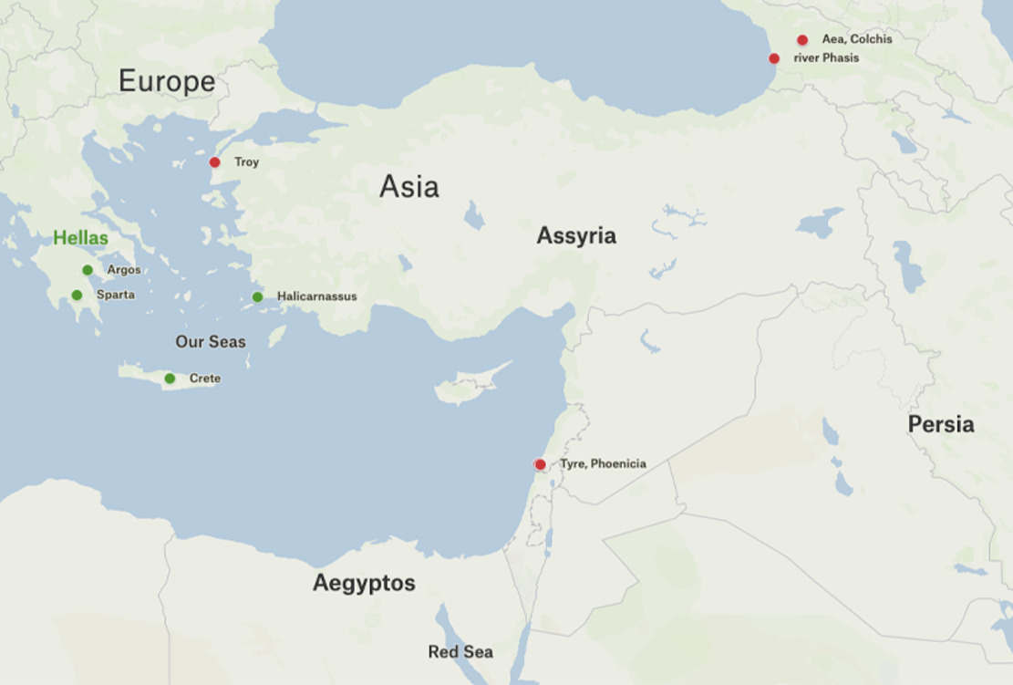
Figure 6 A map of the places and peoples mentioned in Herodotus 1.1.1–1.5.4, with the settlements of Greeks or Greek majority populations in green.
View description - Figure 6 A map of the places and peoples mentioned in Herodotus 1.1.1–1.5.4, with ...
View alternative description - Figure 6 A map of the places and peoples mentioned in Herodotus 1.1.1–1.5.4, with ...

Provide your answer...
View discussion - Activity 4

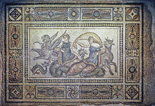
Figure 7 The Kidnapping of Europa. Mosaic, between first and second centuries CE. Zeugma Mosaic Museum, Gaziantep, Türkiye.
View description - Figure 7 The Kidnapping of Europa. Mosaic, between first and second centuries CE. ...
View alternative description - Figure 7 The Kidnapping of Europa. Mosaic, between first and second centuries CE. ...

In fact, Alexander uses the evidence from the other episodes to suppose that he too can abduct a woman (in this case, Helen) without facing any consequences. But he’s wrong and the Greeks send an army against Troy to get her back. In this way, this opening account acts as both the context for Homer’s Iliad and a kind of precedent for the war between Greeks and ‘foreigners’ that is the focus of Herodotus’ enquiry. Or to put that differently: Herodotus here provides a brief sketch of how events from the past (including those represented in the Iliad) could be seen to have led to the war between the Greeks and the Persians of his lifetime.

1.4 Re-reading the first account (1.1.1–1.5.4)
Reading this first account, however, is more complicated than that. Next you’ll dig into it further to analyse how Herodotus presents the information.

Activity 5
Allow approximately 15 minutes for this activity

Re-read the account with one simple question in mind: What does Herodotus tell us about where he got his information? Picking out phrases from each section (1–5), make a list of all the indications where a point of view is identified.

Herodotus, The Histories, Book 1 Sections 1–5
1.1
(1) Men skilled in arguments among the Persians say that the Phoenicians were the cause of the division. For these men (the Persians say) came from what’s called the Red Sea to our sea [the Mediterranean], and, once they had settled in the land in which they live to this day, they immediately began to embark on long voyages. They carried their Egyptian and Assyrian merchandise to many places before arriving in Argos. (2) Argos at this time was preeminent in every way in the land now called Hellas [Greece]. Arriving in Argos, (the Persians say) the Phoenicians set out their wares. (3) On the fifth or sixth day after they had arrived, when nearly all had been sold, there came to the seashore many women, chief among them the daughter of the king. Her name — and on this the Greeks say the same — was Io, daughter of Inachos. (4) As these women stood about the stern of the ship, bargaining for the wares that they had set their hearts on, (the Persians say) the Phoenicians incited one another to assault them. Most of the women escaped, but Io, along with some others, was abducted. Throwing her into the ship, the Phoenicians sailed off to Egypt.
1.2
(1) In this way Io arrived in Egypt, say the Persians (though not the Greeks), and that this was the first injustice done. After this, they say that some Greeks (the Persians aren’t able to recount the name) landed at Tyre in Phoenicia and abducted the king’s daughter Europa. (These Greeks would have been Cretans.) Up until now it had been like for like; but after this point it was the Greeks (the Persians say) who were guilty of the second injustice. (2) For Greeks sailed in a long ship down to Aea in Colchis and to the river Phasis; then, once they had completed the business on account of which they had come, (the Persians say) they abducted the king’s daughter Medea. (3) The king of the Colchians sent a herald to Greece to demand both a penalty for the abduction and his daughter back. But the Greeks (the Persians say) replied that, since those other men hadn’t paid any penalty for the abduction of Argive Io, nor would they pay a penalty to the Colchians.
1.3
(1) In the second generation after this, they say, Alexandros, the son of Priam, got to hear about these events and decided to get himself a wife by abducting one from Greece. He was completely convinced that he wouldn’t have to pay any penalty, since the others hadn’t. (2) So, he abducted Helen. The Greeks first resolved to send messengers to demand both Helen back and a penalty for the abduction. But, when these measures were proposed, they (the Trojans) brought up the abduction of Medea and the fact that they (the Greeks) wanted justice from others, though they had not paid any penalty or given up what had been demanded of them.
1.4
(1) Up until this point it was a matter only of abduction on both sides. But after this the Greeks (the Persians say) were the cause of an escalation: for the Greeks first launched an invasion against Asia before they launched one against Europe. (2) The Persians consider abducting women to be the act of unjust men, but seeking revenge, when an abduction has already happened, to be nonsensical. Level-headed people have no concern for abductions, for (the Persians say) it is clear that the women wouldn't have been abducted, had they not wanted it themselves. (3) The Persians say that for their part they made no account of the abductions of women. But the Greeks, on account of a single woman from Lacedaemonia [i.e. Helen of Sparta], gathered a massive army, came to Asia, and tore down the power of Priam. (4) Ever since then the Persians have considered the Greek to be an enemy. For the Persians think of Asia and the foreign peoples living there as their own, but Europe and the Greek people they consider separate from themselves.
1.5
(1) This is what the Persians say happened. And they trace the beginning of their hatred of the Greeks to the sack of Troy. (2) About Io, though, the Phoenicians do not agree with the Persians. For they say that they did not use force to carry her off to Egypt. Rather, she had sex with the captain of the ship while still in Argos. When she learned that she was pregnant, she was ashamed for her parents, and so she willingly sailed off with the Phoenicians before her shame became visible. (3) These are the things that the Persians and Phoenicians say. For my part, I’m not going to say whether these things happened in this or some other way. Rather, I’ll identify and speak about the person who I know first wronged the Greeks, as I march on farther into my account, going through both small and great cities alike. (4) For those cities that were once great have now become small, while those that were great in my time were before small. Knowing that human happiness doesn’t stay in the same place, I’ll mention both alike.

Provide your answer...
View discussion - Activity 5

Again, don’t worry if you didn’t catch all these instances. The important point to note is that this opening account is mostly assigned to the Persians. You’re now going to consider the significance of this point for our reading of the text.

Activity 6
Allow approximately 5 minutes for this activity

Think about two follow-up questions:
- What difference does it make that Herodotus represents his opening account as largely described from the perspective of another group (i.e. the Persians) rather than the Greeks?
- What other voices (aside from the Persians) are heard in the text and what difference do they make?
In both cases jot down in your own words the impact that identifying perspective has on your understanding of what’s going on.

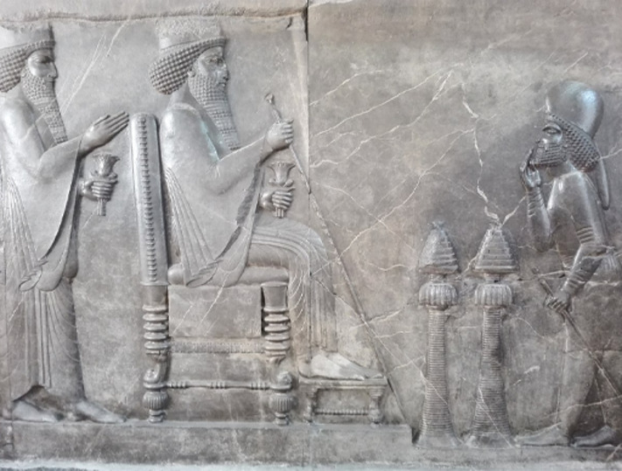
Figure 8 Audience scene of Darius (or Xerxes I). Stone relief. Iran National Museum, Tehran, ID: 1765.
View description - Figure 8 Audience scene of Darius (or Xerxes I). Stone relief. Iran National Museum, ...
View alternative description - Figure 8 Audience scene of Darius (or Xerxes I). Stone relief. Iran National Museum, ...

Provide your answer...
View discussion - Activity 6

Different voices characterise this opening section of the Histories and invite different ways of responding to the events recorded. So, for example, when Herodotus observes that the Greeks agree on the name of Io (1.1.3), this passing note lends authority to the ongoing Persian account. It subtly shows that the ‘men skilled in arguments among the Persians’ have done their homework and attempted to align their thinking with Greek sources. Not that it makes it right. Capping this account, Herodotus pithily remarks: ‘In this way Io arrived in Egypt, say the Persians (though not the Greeks)’. The parenthesis equally subtly introduces a note of dissent. The Greeks have their own version of how Io ended up in Phoenicia, which is far more fantastical (see the Glossary entry for Io). At the end of the first episode as a whole, Herodotus introduces yet another account: the Phoenicians maintain that Io left of her own accord (1.5.2)! This new information contradicts the Persian account (not to mention the Greek version) and further complicates our reading of Io’s journey to Egypt. Which account do we agree with?

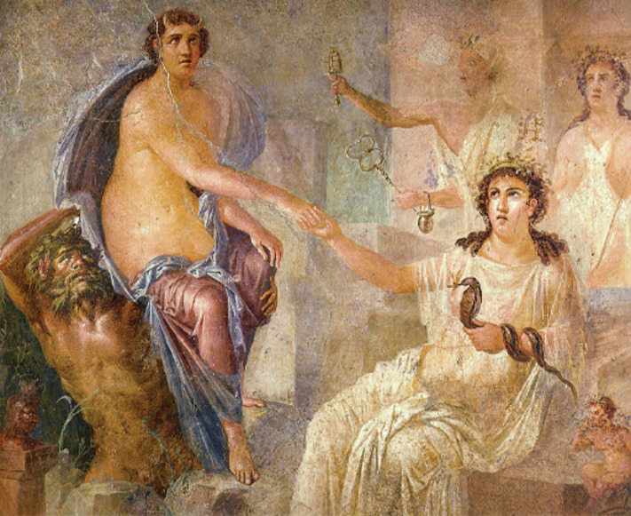
Figure 9 Io (on the left, with horns) is welcomed in Egypt by Isis (sitting, holding a snake and with a crocodile at her feet). Roman fresco from the temple of Isis in Pompeii. Museo Archeologico Nazionale, Naples, ID: 9558.
View description - Figure 9 Io (on the left, with horns) is welcomed in Egypt by Isis (sitting, holding ...
View alternative description - Figure 9 Io (on the left, with horns) is welcomed in Egypt by Isis (sitting, holding ...

1.5 Thinking historically
There are three key points worth taking from what has been discussed so far.
First, according to the Phoenicians, Io went willingly with their ship’s captain. But the earlier account related that she had been abducted. By recording different accounts, assigning them each a source, and juxtaposing them, Herodotus puts us on guard about where information comes from, precisely what information is communicated, and how information is used. This is important because, as the Phoenician example shows, sources invariably present versions of events from their point of view or to cast themselves in the best light. Taking a critical stance like this can come in useful not just when we’re thinking about an ancient writer's account of historical events, but when we’re reading contemporary news articles or posts on social media.
Second, being alert to sources can help us better understand the content of this opening account and how it’s being presented. Right at the beginning, Herodotus assigns this account to ‘men skilled in arguments among the Persians’ (1.1.1). It is they who identify the Phoenicians as beginning all the troubles, and who identify the Greek response to Alexander’s seizure of Helen as marking the critical escalation in hostilities. They (they say) are not to blame; on the contrary, they are so fair-minded as to acknowledge that Europe belongs to the Greeks – so long as they (the Persians) have power over all the communities, Greek and otherwise, in Asia. Being alert to the source, then, can help reveal why things are presented in a particular way.
Third, what does Herodotus think about all of this? At the end of this episode he simply notes: ‘These are the things that the Persians and Phoenicians say. For my part, I’m not going to say whether these things happened in this way or some other way’ (1.5.3). The fact that Herodotus not only withholds judgement but explicitly tells us that he is withholding judgement is important to his self-representation as an author. We see him impartially weighing the evidence, struggling to come down on either side, and showing the value of doing that weighing and struggling. By being so blunt about what he cannot record, paradoxically he encourages us to believe in what he can and does record.

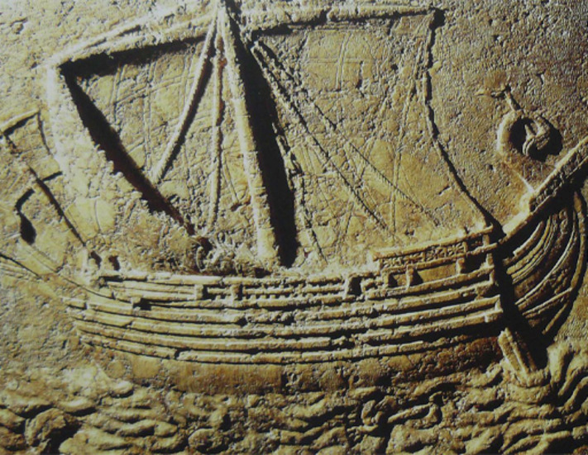
Figure 10 Phoenicians ship carved on the face of a sarcophagus, second century CE.
View description - Figure 10 Phoenicians ship carved on the face of a sarcophagus, second century C ...
View alternative description - Figure 10 Phoenicians ship carved on the face of a sarcophagus, second century C ...

The clearest limitations in this account, as Herodotus has shown, is the need to rely on what others say. The people involved in these events are lost to time. All these women – Io, Europa, Medea, Helen – are from a world that we now recognise as myth. In fact, it is Herodotus who here first draws a distinction between myth and history. The point is not that these events didn’t happen, but rather that there is no way of knowing whether they did or not, and, even if they did, whether they happened in this or some other way. Their truths cannot be questioned or determined.
Included in this world of untestable testimony is Homer’s Troy story, which the Persians bring to mind when they assert that it was the Greeks who were to blame for sending an army to get Helen back. The lesson is that such stories, while familiar and perhaps even comforting (in that they conform to preconceived ideas), cannot be verified and are just as likely to mislead our understanding of more recent events than not.
If this, then, is a ‘false start’, where, and how, does Herododus begin his writing of history? This is the question which you’ll now consider.

2 Constructing the Histories: writing historically
In Section 1 you learned what Herodotus doesn’t think can count as history (even if it makes a good story), namely a past that is so distant that it cannot be examined. Just as importantly, you also learned that sources are not impartial. People provide accounts that are influenced by their own perspective and experience. In this section you will investigate what Herodotus does think counts as history, and how he goes about writing it in such as way as to alert us to the stakes involved.

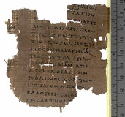
Figure 11 Fragment from Herodotus’ Histories, Book 8. Papyrus, early second century CE. Sackler Library, Oxford, Papyrus Oxyrhynchus 2099.
View description - Figure 11 Fragment from Herodotus’ Histories, Book 8. Papyrus, early second century ...
View alternative description - Figure 11 Fragment from Herodotus’ Histories, Book 8. Papyrus, early second century ...

2.1 Beginning with Croesus
Directly after his refusal to comment on the accounts given by the Persians and Phoenicians, Herodotus states that he will start from the person ‘who I know first did wrong against the Greeks’ (1.5.3). This someone isn’t a Persian at all but a Lydian – Croesus, who was ‘leader of all the nations inside the river Halys, which flows from the noon sun between Syria and Paphlagonia and empties towards the north into the Euxine Sea’ (1.6.1). These next activities will ask you to explore the account Herodotus gives about Croesus, starting with why he begins his history proper with this figure.

Activity 7
Allow approximately 5 minutes for this activity

Read the passage below. Then, using the map as an aid, answer the following questions, jotting down your thoughts in a sentence or two:
- Why does Herodotus start his history with Croesus?
- What relations does Croesus have with the Greeks?
- What territories do the Greek communities mentioned occupy?

Herodotus 1.6.2
This Croesus was the first of the foreigners [barbaroi, plural of barbaros] who we know rolled over [i.e. conquered] some Greeks and took tribute from them, and made friends with others. He rolled over the Ionians, the Aeolians and the Dorians of Asia, and made friends with the Lacedaemonians [also known as Spartans].

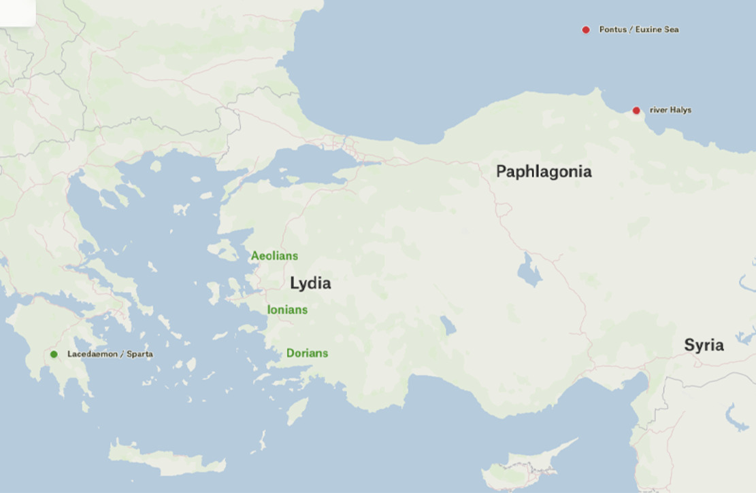
Figure 12 A map showing Lydia and the Greek communities (in green) along the Asia Minor (Anatolia) coast.
View description - Figure 12 A map showing Lydia and the Greek communities (in green) along the Asia ...
View alternative description - Figure 12 A map showing Lydia and the Greek communities (in green) along the Asia ...

Provide your answer...
View discussion - Activity 7

Three important points follow these observations. First, Herodotus starts with Croesus because, unlike the previous accounts (discussed in Section 1), he is a figure to whom knowledge can be attached. He’s known because of what he did to the Greeks: he conquered and ruled over those who lived along the Asia Minor coast. Second, Herodotus also notes that Croesus made friends with other Greeks, namely the Spartans. That is to say, Croesus is not an exclusively enemy figure, which should make us wary of conflating the term ‘barbaros’ with modern notions of ‘the barbarian’. He’s not all bad and, indeed, shares many things in common with the Greeks, as you shall see. Third, and related, an additional complexity emerges if we map the Greeks whom Herodotus mentions here. Figure 10 is an apt demonstration that the Greek world of antiquity was not limited to the mainland and islands of the Aegean that is now known as modern nation-state of ‘Greece’. There were Greek communities across the Mediterranean, as well as all around the Black Sea (otherwise known as the Pontus or Euxine).
As you have just seen, Herodotus starts with Croesus because, apparently, he is the first foreigner ‘who we know’ (1.6.2) conquered Greeks. But what might an ancient reader of Herodotus’ text already have known about Croesus? To answer this question, we can look at evidence from material culture – that is, physical objects which were produced in the ancient world. Figures 13 and 14 below are images of two pieces of material culture associated with Croesus. These pre-date Herodotus’ Histories, and can therefore help us to fill out the picture Herodotus’ contemporary reader might indeed have known. Interpreting visual sources like these requires analytical skills which are different from those which we use when we read an ancient text. A short audio discussion will help to guide your own analysis of these images.

Activity 8
Allow approximately 30 minutes for this activity

As you study Figures 13 and 14, listen to the accompanying discussion.
Note: In the audio you will hear the speakers refer to Sardis, which is the capital of Lydia and the seat of Croesus’s power, and the god Apollo, with whom Croesus seems to enjoy a special relationship.
Using the audio discussion and the images, answer the following questions:
- What are the two types of evidence that are explored in the audio discussion?
- What does the decoration on each source depict?
- What did you learn about Croesus? Try to note at least one thing using each source.

Video content is not available in this format.
View transcript - Uncaptioned interactive content

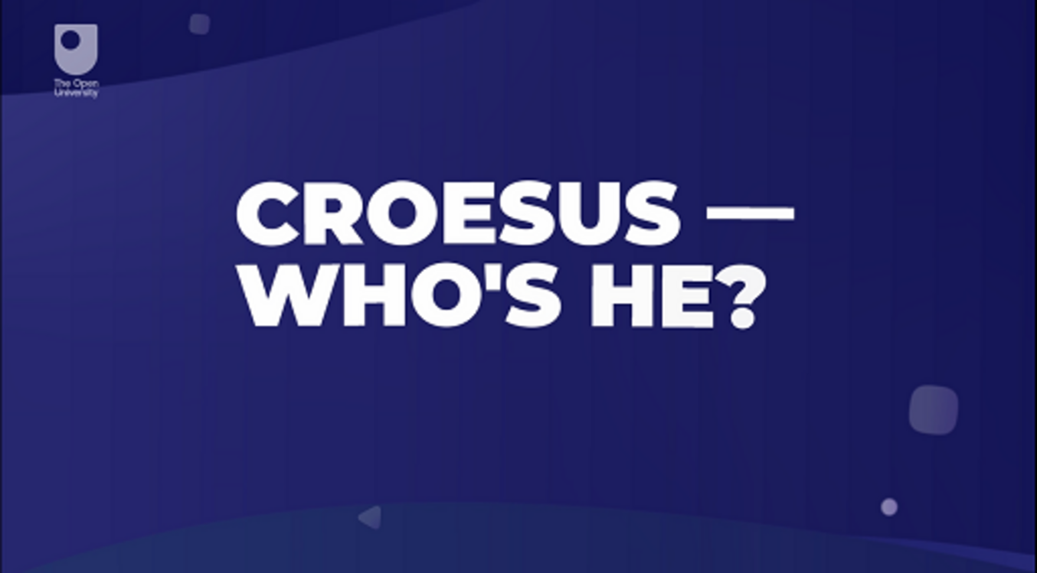

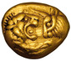
Figure 13 Gold Stater (a type of coin) from the mint at Sardis, 561–546 BCE. American Numismatic Society ID: 1997.9.143.

Figure 14 Amphora (a large jar for storing wine), attributed to the Athenian Myson, c.500–475 BCE, found in Vulci, Southern Italy. The Louvre, Paris, ID: G197.

Provide your answer...
View discussion - Activity 8

Both sources, then, help us build up a picture of a Croesus the Greeks of Herodotus’ time would have known. Croesus is rich. So wealthy, in fact, that his name has become synonymous with wealth. (You may even have heard the expression ‘as rich as Croesus’.) One aspect of his wealth is the fact that he mints gold coins. Herodotus is alert to the importance of this, when he writes: ‘So far as we have any knowledge, they [the Lydians] were the first people to introduce the use of gold and silver coins, and the first who sold goods by retail’ (1.94.1). Minting coins is important: they literally demonstrate the circulation of power. Yet the other source provides a rather different picture. He’s still the regal figure seated on a throne, but that throne is on top of a pyre that is about to be set on fire! There’s a story here about the downfall of a king in spite of all his wealth. Moreover, it is a story well known enough to make sense to a Greek audience from as far apart as Athens and Vulci (a Greek community in what is now southern Italy) with very little help apart from the situation (a pyre) and a name (Croesus).

2.2 Candaules’s wife
Having introduced Croesus, Herodotus springs another surprise that sheds light on his way of writing historically. He takes another step back to explain how it was that Croesus’s family held power in Lydia in the first place (1.7.1). Croesus may have been ‘known’ to Herodotus’ reader, but now the author promises special insight by exploring the origins of his power. Incidentally, by doing this, Herodotus also demonstrates that the question of cause – or origins or blame: the Greek aitia (Herodotus 1.1.1) captures all of these senses – can always be pushed back further into the past. In this case Herodotus traces the question of why Croesus’ family held power in Lydia back to a certain Candaules.

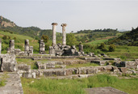
Figure 15 The Temple of Artemis outside Sart (ancient Sardis), Türkiye.
View description - Figure 15 The Temple of Artemis outside Sart (ancient Sardis), Türkiye.
View alternative description - Figure 15 The Temple of Artemis outside Sart (ancient Sardis), Türkiye.

Activity 9
Allow approximately 20 minutes for this activity

Below are extracts from the beginning of Herodotus’ account of Candaules, who some five generations before Croesus was ruler of the kingdom of Lydia, whose capital city was Sardis. Read the following extracts from Herodotus at least once, and then answer the following questions:
- What background information to Candaules does Herodotus provide?
- What is the core feature of this account?
- What action does Candaules decide upon?
- In what ways does Herodotus get his reader to believe this account?

Herodotus 1.7.2, 4
Candaules, whom the Greeks call Myrsilos, was the ruler of Sardis and a descendant of Alkaios the son of Heracles....The descendants of Heracles, the Heraklidai, ruled for twenty-two generations or five hundred and five years, with the son receiving the rule from the father, until Candaules the son of Myrsos.

Herodotus 1.8.1–2
This Candaules was in love with his own wife, and, because he loved her, he thought that she was by far the most beautiful woman in the world. And, because he was thinking this, he kept praising his wife’s appearance to his favourite personal guard, Gyges the son of Daskylos. For it was with this Gyges that Candaules used to discuss his most important affairs. After a little while had passed (for things with Candaules were destined to end badly), he said to Gyges such things as these: ‘Gyges, I don’t think that you believe me when I tell you about my wife’s looks – and it’s true that people tend to believe their ears less than their eyes. So, you must find a way to see her naked.’

Provide your answer...
View discussion - Activity 9

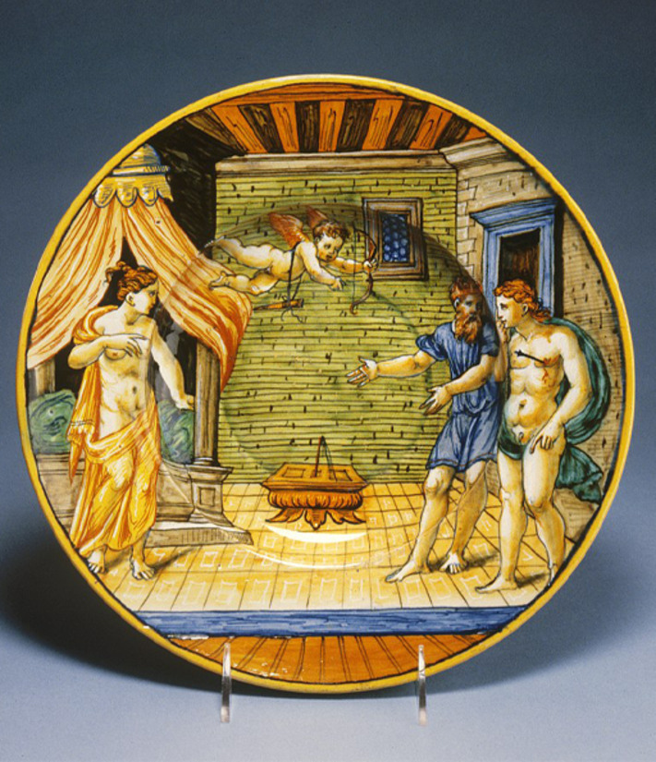
Figure 16 Dish with King Candaules exhibiting his wife Nyssia to Gyges. Earthenware with tin glaze, between around 1540–1550 CE, Urbino, Italy. Walters Art Museum, Baltimore. ID: 48.2031.
View description - Figure 16 Dish with King Candaules exhibiting his wife Nyssia to Gyges. Earthenware ...
View alternative description - Figure 16 Dish with King Candaules exhibiting his wife Nyssia to Gyges. Earthenware ...

This use of direct speech is another feature that Herodotus takes from Homeric epic, since he couldn’t possibly have known the precise words that were spoken. It allows him to bring the story to life, as if we were there eavesdropping on this intimate exchange. It also allows the character of individuals to be revealed through what they say and how they say it, rather than simply through a narrator’s description. But the use of direct speech additionally introduces other voices into the narrative: these aren’t the words of Herodotus (as the narrator) but of a figure in his narrative. Like our earlier observation on sources, this is another strategy for demanding that we read carefully and not simply accept what is being told to us.
You may also have noticed the rather odd-sounding expression with which Herodotus introduces the key idea motivating this episode: that ‘Candaules was in love with his own wife’. A clue to how to think about it comes in the next sentence when Herodotus writes that Candaules used to discuss his most important affairs with Gyges, especially his wife’s appearance. Candaules’ desire, even if it’s for his own wife, is a problem because it dominates his thinking: when he should be ruling, he’s instead singing her praises. This is a story about power. So much becomes clear as the episode continues. First, Candaules succeeds in forcing Gyges to spy on his wife. Then, because she notices him spying on her, she later confronts Gyges and gives him a stark choice: either he must kill Candaules, or be killed himself for seeing what he ought not have (Herodotus 1.11.2). Unsurprisingly, Gyges opts for the former and kills his master. Through this story we learn how the throne of Lydia came into the possession of the family of Croesus.

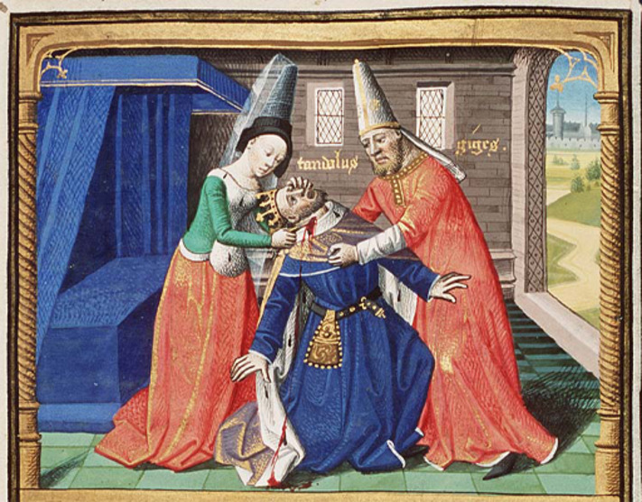
Figure 17 Gyges kills King Candaules at the queen’s order. Illuminated manuscript of Cité de Dieu by Maître François, between 1475 and 1480 CE.
View description - Figure 17 Gyges kills King Candaules at the queen’s order. Illuminated manuscript ...
View alternative description - Figure 17 Gyges kills King Candaules at the queen’s order. Illuminated manuscript ...

That is not all. This is also a story about Herodotus’ brand of history. At first glance, this episode, on which Herodotus leads on seems curiously trivial, even gossipy. Yet by taking us into the bedroom Herodotus promises insight into power dynamics that have repercussions for an entire kingdom and beyond. Much is at stake, and the switch to direct speech marks a key moment. Candaules’s description that ‘people tend to trust their ears less than their eyes’ (1.8.2) – or, as we might put it in English, seeing is believing – resonates strongly with Herodotus’ conception of history as enquiry, in which he actively hunts out eyewitnesses of an event or describes what he himself sees. But there is also a danger in taking a position from which to view events, as you will explore now.
In the passages below you’ll learn about what happens next and what’s important about it. Where before you’ve concentrated on reading in a way that captures the gist or identifies key features, with this activity you will be focusing on close reading.

Activity 10
Allow approximately 20 minutes for this activity

Compare and contrast two passages: Candaules’s instructions to Gyges; and Herodotus’ narration of what actually happens. First, read each passage to get a sense of what is going on. Then re-read them, this time comparing them to each other, by:
- underlining at least three differences that you notice in the second text (the narration)
- providing a one-line summary that explains the differences that you’ve noted
- giving an example of the point that you have observed.

Herodotus 1.9.2–3 (Candaules instructs Gyges how he can spy on his wife without being seen)
I will stand you in the room in which we sleep, behind the open door. After I have entered, my wife will also be there for bed. There is a chair near the entrance. On this chair she will place her clothes as she slips them off, one by one, and you will be able to see her quite at ease. But, when she walks away from the chair to the bed, and you are behind her back, then take care that she doesn't see you as you go out the door.

Herodotus 1.10.1–2 (Herodotus narrates what actually happens when Gyges spies on Candaules's wife)
When he thought it was time for bed, Candaules led Gyges to the room, and directly afterwards his wife was there. Gyges saw her come in and set down her clothes. When he was behind the back of the woman as she was going to the bed, he withdrew, slipping out. But the woman saw him leaving.
(Translations are from Purves, 2014)

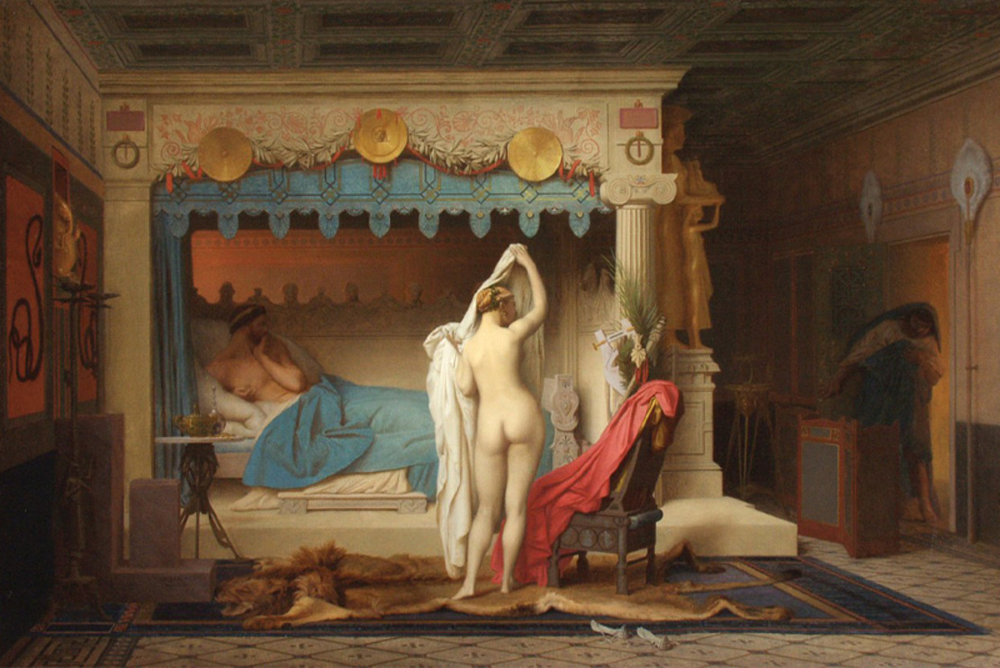
Figure 18 Le roi Candaules (King Candaules). Oil on canvas, by Jean-Léon Gérôme, 1859. Museo de Arte de Ponce, Puerto Rico
View description - Figure 18 Le roi Candaules (King Candaules). Oil on canvas, by Jean-Léon Gérôme, ...
View alternative description - Figure 18 Le roi Candaules (King Candaules). Oil on canvas, by Jean-Léon Gérôme, ...

Provide your answer...
View discussion - Activity 10

In this translation of speech into narration, you may also have noted two other differences. First, the future tense verbs become past tense verbs when the episode is recounted: ‘I will stand you’ becomes ‘Candaules led Gyges’; ‘my wife will be there’ becomes ‘his wife was there’; and so on. Second, the speed of the narration varies. It’s quicker. In this way, even though Herodotus’ description essentially replays Candaules’ instructions – Gyges takes his place; the wife comes in; Gyges spies her; when she turns her back, he leaves – it’s not simple repetition. The narration feels different, more urgent somehow, and more tense.
It’s worth pondering what’s at stake in this shift. Candaules’ instructions map out the coordinates of his bedroom in some detail, mainly through the use of prepositions – behind, near to, on, away, towards, behind, through. Everything is neatly ordered, highly controlled. This is the master’s gaze. By contrast, in his narration of what happens, Herodotus homes in on a single idea: how Gyges gets in and gets out of the room. The description mirrors Gyges’ anxiety, as if we experience the scene through his eyes, and feel his desperation to leave, as if he’s the one under scrutiny.
And indeed he is, because the wife notices Gyges as he exits. This is the biggest difference between the two passages, and reveals the gap between expectation and outcome even in the best laid plans. Herodotus marks this concisely and effectively in the phrases that were italicised above: the wife ‘slips off’ her clothes; Gyges ‘slips out’ of the room – the same word (ekduō, in the Greek) is used in both cases. Where Candaules had emphasised the spectacle of Gyges seeing the wife ‘slipping out’ of her clothes, Herodotus highlights instead the critical moment when the wife sees Gyges ‘slipping out’.

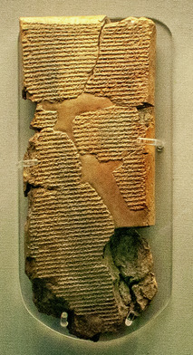
Figure 19 Account of the Egyptian campaigns of Ashurbanipal, king of Assyria, and his reception of an embassy from Gyges, king of Lydia, Neo-Assyrian clay tablet with cuneiform script, c. 660 BCE, British Museum, ID: ME K2675
View description - Figure 19 Account of the Egyptian campaigns of Ashurbanipal, king of Assyria, and ...
View alternative description - Figure 19 Account of the Egyptian campaigns of Ashurbanipal, king of Assyria, and ...

2.3 Reading historically
Now you’ll think about what lessons we can learn about reading history from the way Herodotus begins his account here. You may have noticed that in all of these passages the woman remains anonymous: she’s simply described in relation to her man. This may suggest the difficulty of precisely naming all the figures who were involved in past events, particularly those in the background. More pointedly, it may also reflect the subordinate role of women in cultures where the king is preeminent.
We should, however, note that the woman here has some agency. It’s she who takes control. When Candaules’ wife spies Gyges, she not only inverts the hierarchy of who’s looking (she, not Gyges) and who’s being seen (Gyges, not her); through this act she also subverts the power dynamics of the episode. Instead of the anticipated scenario of the stage manager (Candaules), where his ideal spectator (Gyges) is able to freely observe an actor performing an assigned role (the wife), it is the wife who both observes and takes control. It is particularly striking that she instantly realises what has occurred, recognises that her husband has betrayed her faith, and demands (and secures) instant payback.

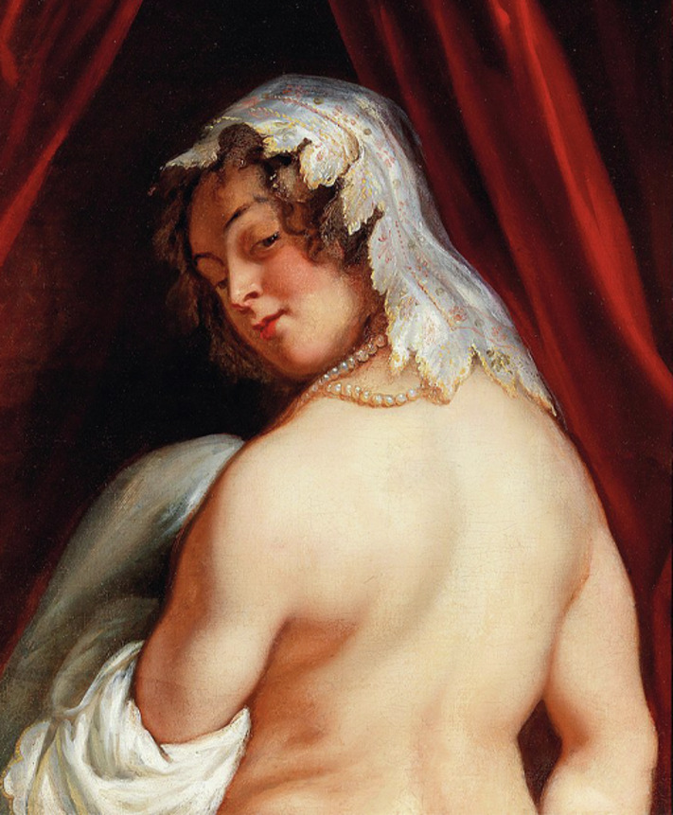
Figure 20 Close up of King Candaules of Lydia Showing his Wife to Gyges. Oil on canvas, by Jacob Jordaens, 1646, Nationalmuseum Sweden, ID: NM 1159
View description - Figure 20 Close up of King Candaules of Lydia Showing his Wife to Gyges. Oil on canvas, ...
View alternative description - Figure 20 Close up of King Candaules of Lydia Showing his Wife to Gyges. Oil on canvas, ...

Equally, however, she turns the problem of viewing back on the spectator. Most obviously, the spectator implicated in what they’re viewing is Gyges, who quickly finds that he cannot escape from the scene unscathed. He has to get involved in the power struggle. But potentially too the reader is implicated. Herodotus also stands us in a scene of great intimacy to witness what goes on behind closed doors; we too may feel the wife’s gaze. Of course, unlike Gyges, we’re able to escape from the power struggle in the bedroom. We’re not in any physical danger! And yet the story demonstrates that there is no ideal or stable position from which to view an event. The onlooker becomes implicated in events simply by virtue of looking on. This bedroom drama is not only the first episode of the Histories; it enacts the problem of doing history. Herodotus makes his writing of history a problem for reading historically.

3 Looking to the end: reading historically
In Section 2 you scrutinsed Herodotus’ writing of history and learned the importance of reading closely. What began as a question of authorship and authority (‘This is the enquiry of Herodotus the Halicarnassian’) turns out to be a challenge for reading. In this final section you’ll consider one way in which Herodotus sets his reader up to continually reflect on their own position when processing the events being represented: when he depicts historical people consulting the oracle at Delphi.

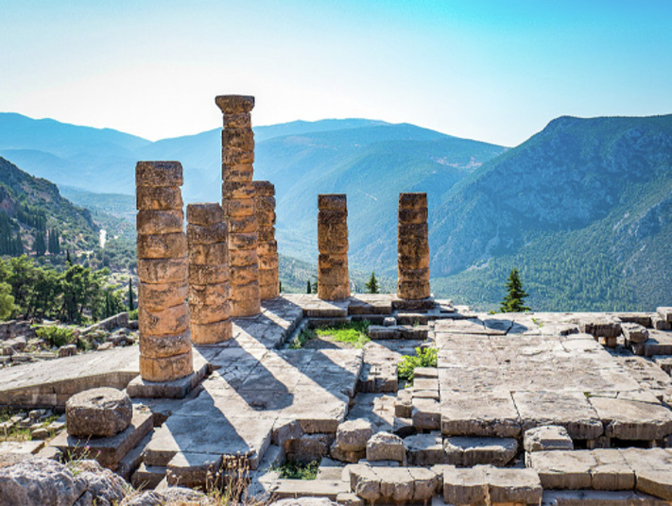
Figure 21 Ruins of the ancient Temple of Apollo at Delphi (the site of the oracle), overlooking the valley of Phocis.
View description - Figure 21 Ruins of the ancient Temple of Apollo at Delphi (the site of the oracle), ...
View alternative description - Figure 21 Ruins of the ancient Temple of Apollo at Delphi (the site of the oracle), ...

3.1 The oracle at Delphi
After describing the transfer of power from Candaules to Gyges, Herodotus turns to an oracle to underline the importance of this opening episode for thinking about Croesus. This is the oracle at Delphi, which once prophesied, according to Herodotus, that ‘vengeance would come to the Heraklidai [the sons of Heracles and ancestors of Candaules] in the fifth generation after Gyges. Yet, as Herodotus adds, ‘This utterance the Lydians and their kings took no notice of (poieōlogon oudena), until it was fulfilled’ (1.13.2). In his sideways manner, Herodotus sets up Croesus’ downfall from the start: it is because his ancestor, Gyges, was a usurper to the throne of Lydia that he, Croesus, will in turn be overthrown.
It is significant that Herodotus uses an oracle to make the connection. Oracles were a kind of intelligence community for the ancient world that provided assistance in making plans for the future. Typically, they are associated with Apollo who, among other things, was considered the god of prophecy. One such oracle was this one at Delphi, where the chief priestess of Apollo (who was sometimes known as the Pythia) would answer questions about the future, as if the god himself could speak through her. References to, and representations of, people consulting the oracle at Delphi occur consistently through the Histories. Why that should be so, and how these oracles function within the Histories, you are going to explore by accompanying Croesus on his consultations at Delphi.

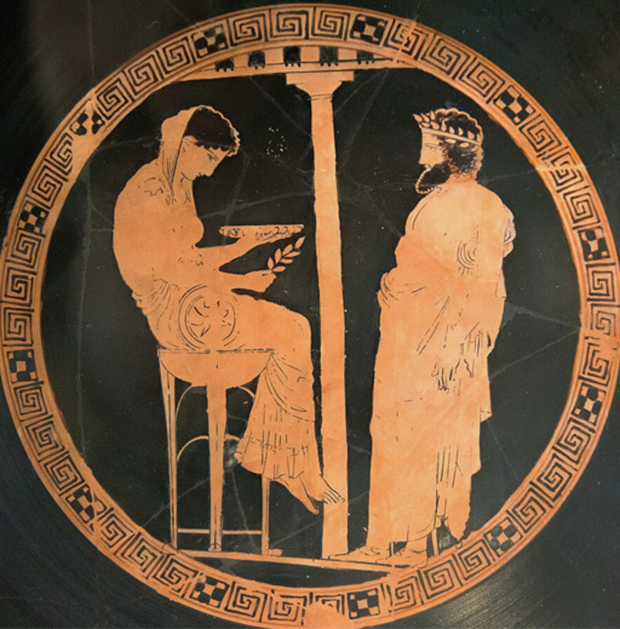
Figure 22 The mythical king of Athens, Aigeus, receiving an oracle from the Pythia at Delphi. Attic red-figure kylix (a cup for drinking wine), ascribed to the ‘Kodros Painter’, 440–430 BCE, found in Vulci (Italy). Altes Museum, Berlin, ID: F 2538.
View description - Figure 22 The mythical king of Athens, Aigeus, receiving an oracle from the Pythia ...
View alternative description - Figure 22 The mythical king of Athens, Aigeus, receiving an oracle from the Pythia ...

3.2 Croesus tests the oracles
Herodotus begins his account of Croesus by recording a visit to his palace at Sardis by the Athenian, Solon (1.29). Both a poet and a leading figure in the political affairs of Athens, Solon was known for his wisdom. Later Athenians attributed to him the founding principles of their democracy. After showing him around his treasury, Croesus eagerly asks Solon, of all the people he knows ‘who is the happiest of them all?’ (1.30.2). Croesus asks this question fully expecting Solon to name him: how could someone so wealthy not be the happiest person alive? When Solon not only doesn’t name him but instead urges him to ‘look to the end’ in all things, Croesus sends him away ‘considering him to be a nobody’ (1.33.1, using that same phrase as in 1.13.2: poieō logon oudena). Soon after, wary of a growing power to the east of his kingdom (Persia), Croesus ponders whether to launch a pre-emptive strike. To help him decide, he tests various oracles by setting them a puzzle.

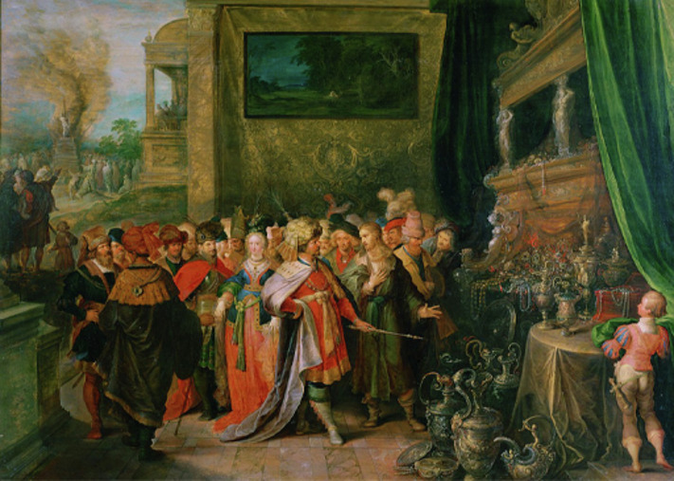
Figure 23 Krösus zeigt Solon seine Schätze (Croesus displays his treasures to Solon). Colour on oak wood, by Frans Francken the Younger, about 1620; Kunsthistorisches Museum, Vienna, ID: GG_1049.
View description - Figure 23 Krösus zeigt Solon seine Schätze (Croesus displays his treasures to Solon). ...
View alternative description - Figure 23 Krösus zeigt Solon seine Schätze (Croesus displays his treasures to Solon). ...

Activity 11
Allow approximately 25 minutes for this activity

Read Herodotus’ description of Croesus’ first consultation of the oracles. What are the different stages of the process? You will need to read the episode at least twice in order to work out what’s going on. In your answer, pick out (at least) three stages as they are revealed to us.
Note: Remember that the Pythia, as referred to in this text, is another name for the priestess at Delphi who conveyed oracular messages to enquirers.

Herodotus 1.46.3–1.48.2
Croesus sent out messengers to test the oracles for what they knew. He did this so that, should he discover that they knew the truth, he might then enquire of them again to find out whether he should launch a military expedition against the Persians.
When he sent to test the oracles, he gave the Lydians these instructions: they were to keep track of the time from the day they left Sardis, and on the hundredth day enquire of the oracles what Croesus, king of the Lydians, was doing. Then they were to write down whatever divine utterance each oracle made and bring it to him.
What the other oracles prophesied is not said, but at Delphi, as soon as the Lydians had entered the hall to consult the god and ask what they had been instructed, the Pythia spoke these words in hexameter verses:
‘I know the number of the sands and the measures of the sea;
I understand the dumb; I hear who does not speak.
A smell comes to my senses of a mightily armoured tortoise
Being boiled in bronze together with lamb meat.
Bronze lies underneath, and bronze lies above.’
After they had written down the Pythia’s divine utterance, the Lydians went back to Sardis. When those who had been sent to other places came bringing their oracles, Croesus unfolded each and read what had been written. In what they had to say nothing pleased him. But, when he heard the oracle from Delphi, immediately he proclaimed it and accepted it, considering the only place of divination to be the one in Delphi, because it had discovered what he had been doing.
For, after he had sent his envoys to the oracles, he had waited for the appointed day and devised this cunning plan – something that would be impossible to discover or to imagine: he cut up a tortoise and a lamb, and then boiled them together in a bronze pot with a bronze lid on top.

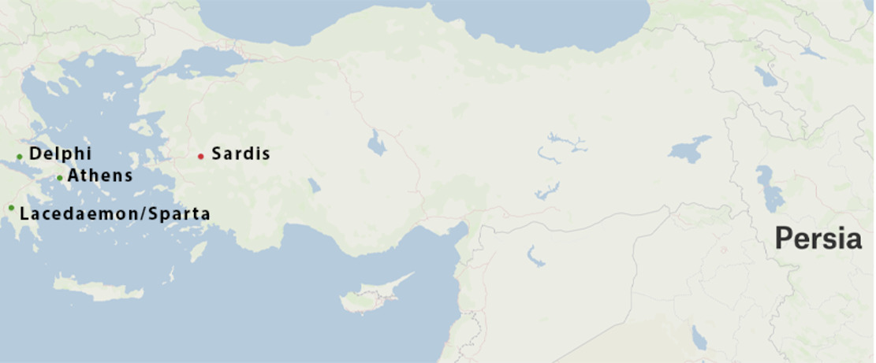
Figure 24 A map showing the key places mentioned in the narrative of Croesus consulting the oracles: Sardis, Delphi, Persia, Athens and Sparta.
View description - Figure 24 A map showing the key places mentioned in the narrative of Croesus consulting ...
View alternative description - Figure 24 A map showing the key places mentioned in the narrative of Croesus consulting ...

Provide your answer...
View discussion - Activity 11

Did you notice that this oracular consultation isn’t really an enquiry into what will happen? Croesus asks the oracles to determine, when the appointed time arrives (‘the hundredth day’), what he’s doing at that very moment. This oracle isn’t about what was going to happen but what was actually happening. In fact, the person making the enquiry knows the answer already. This is a clear case of someone reading into the oracle’s intelligence report what they already have in mind.
In the next activity you will reflect on the potential ramifications of this way of reading the oracles by examining Croesus’s next move. Having discovered the truth of the oracle at Delphi, Croesus sends his Lydian messengers back to it to so that he can determine what to do about that growing power of Persia.

Figure 25 The Oracle. Oil on canvas, by Camillo Miola, 1880. Getty Center, ID 72.PA.32.
View description - Figure 25 The Oracle. Oil on canvas, by Camillo Miola, 1880. Getty Center, ID 72 ...
View alternative description - Figure 25 The Oracle. Oil on canvas, by Camillo Miola, 1880. Getty Center, ID 72 ...

Activity 12
Allow approximately 20 minutes for this activity

As you read the following description, consider the following questions and write a sentence or two in your own words to answer each:
- What is the specific question that he asks?
- What is the answer that he receives?
- How does Croesus interpret the oracle’s answer?
- What might an alternative interpretation be?

Herodotus 1.53.2–54.1–2
When they arrived at Delphi, the Lydians dedicated offerings before consulting the oracle in the following manner: ‘Croesus, king of Lydia and other nations, considers you the only place of divination among mortals, and gives you gifts worthy of your discoveries. Now he asks you whether he should send an army against the Persians, and whether he should take allies.’ This is what they enquired about. The judgement given to Croesus proclaimed that, if he sent an army against the Persians he would destroy a great empire; and that he should discover the most powerful of the Greeks and make them his friends.
When the divine answer had been brought back and Croesus learned of it, he was overjoyed with the oracle. Since he was in no doubt that he would destroy the kingdom of Cyrus [king of the Persians], he sent once again to the Pythia and gave to the Delphians, whose number he had learned, two gold coins for each man. The Delphians in return gave Croesus and all Lydians the right to consult the oracle first, free of charge, the front seats at festivals, and, to whoever wanted it, the right of Delphian citizenship for all time.

Provide your answer...
View discussion - Activity 12

Croesus is pondering whether he should launch a pre-emptive strike against Lydia’s main rival, Persia. When he learns that, if he does this, a great power will fall, he thinks that this means he will succeed in defeating the Persians and removing them as a threat. But, as we’ll soon learn, he’s wrong. He’s failed to see that the oracle is ambiguous: that is to say, that it can be read in more than one way. And so he fails to ask the follow-up question: which power does the oracle mean, when it says that a power will fall?
You may wonder whether Croesus’ response here relates back to that first test that he set for the oracles, when he already knew the answer? This is because Croesus also reads this second oracle as confirming his own expectations and desires. Herodotus describes him as being ‘overjoyed’ at the oracle, which seems a subtle criticism of the lack of consideration he gives to its response.
If Herodotus is implying subtle criticism of Croesus, however, it is because of what he does – or, in this case, doesn’t do, since he doesn’t ask the follow up question – and not because of who he is. That is to say, there is no indication that Croesus gets things wrong because he’s one of those foreigners (barbaroi). On the contrary, Herodotus is at pains to show the high regard in which Croesus holds Delphi – a Greek community – and the mutual respect between them. The Delphians even make him a citizen owing to his generosity in showering them with gifts – a story that Herodotus backs with his own eye-witness account of those dedications (1.51.1–5). There’s nothing inherently bad about Croesus.

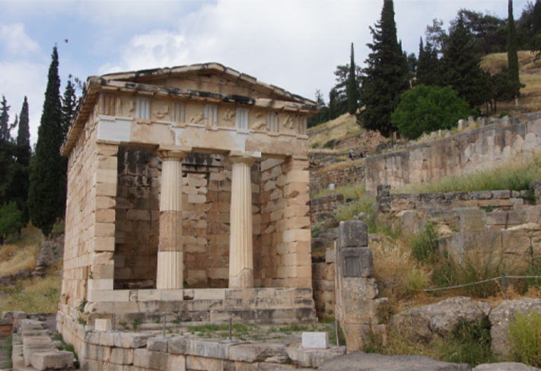
Figure 26 The Athenian Treasury, Delphi.
View description - Figure 26 The Athenian Treasury, Delphi.
View alternative description - Figure 26 The Athenian Treasury, Delphi.

Still, the episode shows the importance of being open-minded to information and Croesus’ position as an all-powerful monarch doesn’t help, since there’s no one to contest his interpretation. Our second example explores the importance of reading closely more fully.

3.3 Putting two and two together
While being overjoyed with the oracle’s response, Croesus does follow up on the practical advice that he receives, namely to identify the most powerful Greeks of the time and make them his allies. His search takes him to the newly powerful city of Sparta. How the Spartans attained supremacy over their neighbours is also explored through a pair of oracles. Like Croesus, the Spartans want to launch an attack against a neighbouring power (the city of Tegea); like Croesus, they consult the oracle at Delphi; and like Croesus, they receive the answer they want to hear: the oracle promises them ‘Tegea to dance on with stamping feet and its plain to measure out with rope’ (1.66.2). So, they rush into battle … only to be defeated. As a result, they are forced to measure out the plain of Tegea bound as slaves. Like Croesus, they have failed to discern the oracle’s critical ambiguity and consequently suffer a major reverse.

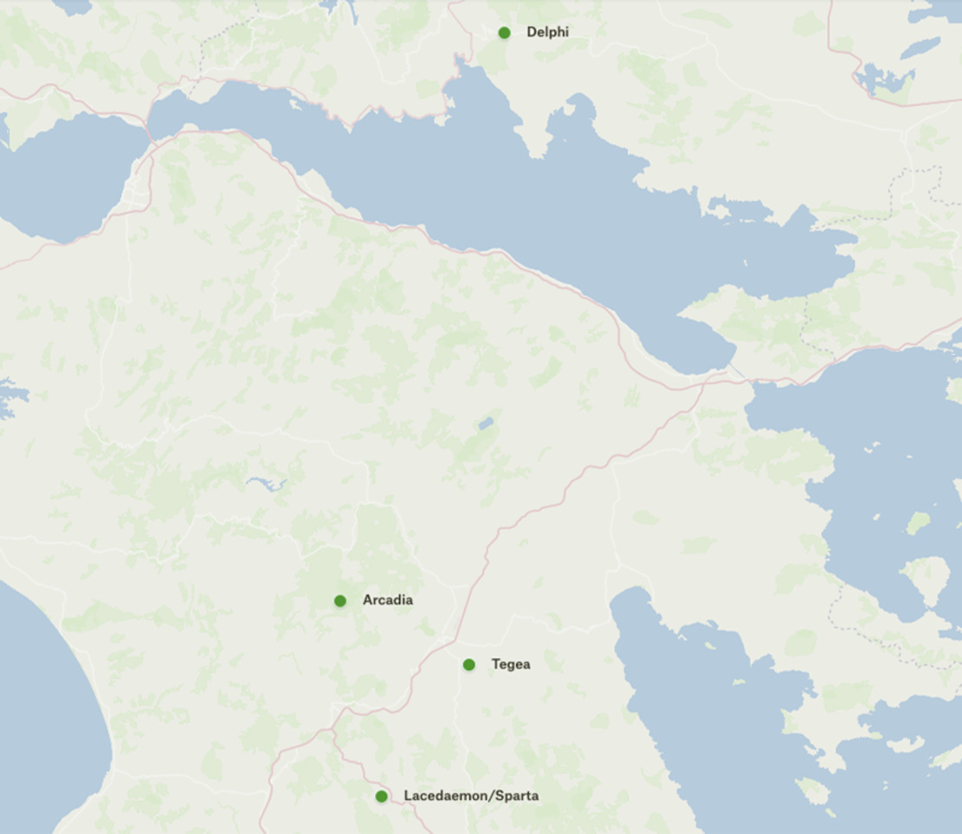
Figure 27 A map showing Sparta and its neighbours, Tegea and Arcadia.
View description - Figure 27 A map showing Sparta and its neighbours, Tegea and Arcadia.
View alternative description - Figure 27 A map showing Sparta and its neighbours, Tegea and Arcadia.

It’s the second oracle at 1.67.4 that you will focus on, since the way Herodotus puts it to use sheds light on how he constructs his narrative. In it, the Spartans learn that they will be victorious only if they manage to retrieve the bones of Orestes, the son of the legendary Trojan War hero, Agamemnon (who was headlined in that passage from Homer which you looked at earlier). The Spartans send out special agents into Tegea to try to locate the site of Orestes’ burial. One of them, a certain Lichas, meets a blacksmith who tells him of a wondrous discovery he’s made – a massive coffin containing an equally massive skeleton of a man (1.68.3).

Activity 13
Allow approximately 20 minutes for this activity

This activity puts you in the position of Lichas, who, as he hears about this wondrous discovery, has knowledge of the oracle that has been given to his fellow Spartans. Your task will be to read that oracle for yourselves and to try to work out how it relates to the information Lichas learns from the blacksmith. To help guide your reading, answer the following questions, jotting down some notes to each:
- How does the oracle pinpoint the location of Orestes’ burial?
- In what terms is the precise location described?
- Thinking about the occupation of the person whom Lichas has met, what kind of place do you think the oracle is describing?
- If you were Lichas with all this information, what do you think has been unearthed?

Herodotus 1.67.4
There is on the level plain of Arcadia in Tegea a place
Where two winds puff under strong compulsion.
Blow upon blow, woe lies on woe.
There the life-giving earth holds the son of Agamemnon.
Bring him back, and you will be the defender of Tegea.

Provide your answer...
View discussion - Activity 13

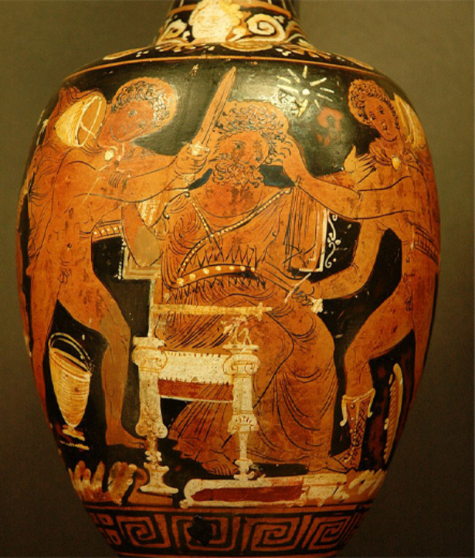
Figure 28 Aegisthus murdered by Orestes and Pylades. Red-figure Apulian oinochoe (wine jug), about 430–400 BCE. Louvre, Paris, ID: K320.
View description - Figure 28 Aegisthus murdered by Orestes and Pylades. Red-figure Apulian oinochoe ...
View alternative description - Figure 28 Aegisthus murdered by Orestes and Pylades. Red-figure Apulian oinochoe ...

Don’t worry if you found this task tough or if you didn’t get all these answers. This is an oracle and reading them, as you are learning, is meant to be difficult. Those middle two lines of the oracle, describing a place in Tegea ‘where two winds blow … and woe lies on woe’, are particularly vague and ambiguous – typically oracular in fact. But Herodotus’ subsequent description of Lichas meeting a blacksmith helped me work out that these lines indicate a blacksmith's place of work: the smithy, where a blacksmith would use bellows to stoke the fire (‘two winds puff under strong compulsion’) to such a point of intensity that he could hammer metal into shape (‘blow upon blow, woe lies on woe’). You may have then made the connection to Orestes because of the blacksmith’s discovery of the bones. The skeleton is massive because these are the bones of a hero from a bygone era when (it was imagined) people were bigger and stronger than they are today.
In case we have struggled to make these connections ourselves, Herodotus straightaway spells it out for us:

Herodotus 1.68.3–5
Taking in mind what was said, Lichas made the connection (sumballesthai) to the oracle that this was Orestes. He put things together (sumballesthai) in the following way. He worked out that the ‘winds’ were the blacksmith’s two pairs of bellows; the ‘smiting and counter-smiting’ the hammer and anvil; and the ‘woe on woe’ was the drawn-out iron – inferring that iron’s discovery had been an evil for humankind. Putting things together (sumballesthai) in this way, he went back to Sparta where he declared the whole thing to the Spartans.

The reader here is led through a process of ‘putting together’ (the Greek word sumballesthai is used three times in this passage) the different parts of the jigsaw. When Herodotus related the episode of Croesus testing the oracles, he quoted the Delphi oracle in full, providing not only the answer that Croesus had been looking for but also a two-line summary of its claim to knowledge (1.47.3):

‘I know the number of the sands and the measures of the sea;
I understand the dumb; I hear who does not speak.’

Knowing the number of the sands; hearing those who cannot speak – these ideas point to an excess of meaning in the oracle’s response that Croesus blithely ignores. As you learned, his inability to comprehend oracular polysemy (something that can mean more than one thing) leads to his downfall. Now, with this oracle given to the Spartans, Herodotus very carefully guides his readers through the analysis of the oracular text – so very carefully in fact as to render the act of interpretation transparent. Herodotus thus uses the ambiguity of oracular discourse to train his reader to read carefully, particularly when it comes to considering issues of power and identity.

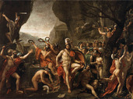
Figure 29 Léonidas aux Thermopyles (Leonidas at Thermopylae), Jacques-Louis_David, 1814; Louvre, Paris, ID: INV 3690
View description - Figure 29 Léonidas aux Thermopyles (Leonidas at Thermopylae), Jacques-Louis_David, ...
View alternative description - Figure 29 Léonidas aux Thermopyles (Leonidas at Thermopylae), Jacques-Louis_David, ...

3.4 Croesus on the pyre
In spite of gaining the Spartans as an ally, when Croesus launches his pre-emptive strike against the Persians, he’s the one to lose his empire. The reversal of fortune which the massively wealthy Croesus suffers culminates with that scene of him on the pyre (see Figure 12: the wine amphora.) In Herodotus we learn more about the context. After his victory, the Persian king, Cyrus, puts Croesus on the pyre, at which point Herodotus takes us through his reasoning: ‘perhaps he had in mind to dedicate Croesus as a victory-offering to some god, or he wished to fulfill a vow, or perhaps he had learned that Croesus was god-fearing and put him on the pyre to find out whether some divinity would save him from being burned alive’ (1.86.2). That third option is particularly striking, because in a poem by a Greek author called Bacchylides, who was active a generation before Herodotus, Apollo does indeed intervene to save Croesus, by sending a rainstorm to put out the fire. Indeed, it may because of its association with divine intervention that the scene of Croesus on the pyre was so attractive to the amphora painter. Herodotus, however, humanises the story. When Cyrus hears Croesus cry out ‘Solon’, and learns about his reflections on the instability of human fortune, Cyrus steps in and puts out the fire himself.
In Herodotus’ hands, the scene on the pyre takes us back to the beginning of his account of Croesus and delivers a memorable pay-off, where Croesus finally grasps the truth of Solon’s remarks: you really can’t call someone happy until the end. But this isn’t quite the end of Croesus’ story. For, once Cyrus saves him from the pyre, Croesus sends his Lydians to make one last enquiry of the oracle at Delphi, angry that the god (Apollo) had deceived him. The oracle’s answer contains lessons for the reader too.

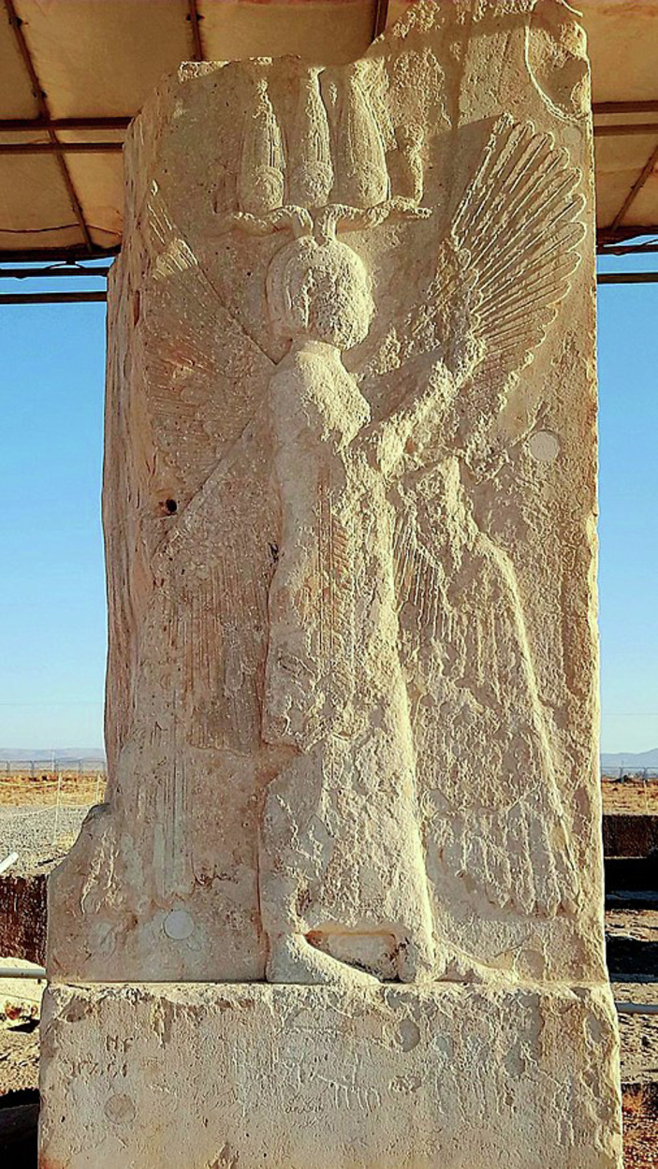
Figure 30 Cyrus the Great with a Hemhem crown, or four-winged Cherub tutelary divinity, from a relief in the residence of Cyrus in Pasargadae, near Persepolis (present-day Fars province, Iran).
View description - Figure 30 Cyrus the Great with a Hemhem crown, or four-winged Cherub tutelary divinity, ...
View alternative description - Figure 30 Cyrus the Great with a Hemhem crown, or four-winged Cherub tutelary divinity, ...

Activity 14
Allow approximately 15 minutes for this activity

Read the passage below. Then consider the following question, writing a sentence or two in your own words in answer: What two things does Croesus learn?

Herodotus 1.91.1, 3–4, 6
When the Lydians [who had been sent by Croesus] arrived and enquired of the oracle as they had been instructed, the Pythia (it is said) said this: ‘No one is able to escape their allotted fate, not even a god. Croesus has fulfilled the error of his ancestor that goes back five generations – Gyges, who, though he was a bodyguard for the Heraklidai, followed a woman’s deception to murder his master and take that man’s office, to which he had no right … Besides Apollo saved Croesus from being burned alive.
As for the oracle that occurred: Croesus has no right to cast blame. For Apollo declared to him that, should he lead an army against the Persians, he would destroy a great power. Given this response, had he wanted to plan well, he should have sent and enquired again whether the god meant his own power or Cyrus’s. Since he didn’t put together (sullambanō) what was said and he didn’t make further enquiries, he should acknowledge that he was the cause (aitia) of his own downfall.’
This was the answer of the priestess. The Lydians carried the message back to Croesus and informed him of it. When he heard it, he agreed that the error was his own, not the god’s.

Provide your answer...
View discussion - Activity 14

There are several significant points about this final oracular consultation that serve as a useful summary for how Herodotus can help us read historically. First, it’s again a rather strange oracle: Croesus isn’t enquiring into what will happen but rather what has happened. In this sense, this oracular consultation is about how to read the past. Through this final oracle, Herodotus spells out the lesson for Croesus and, by extension, us, the readers. The answer Croesus had received was ambiguous. He should have followed it up with further enquiries.

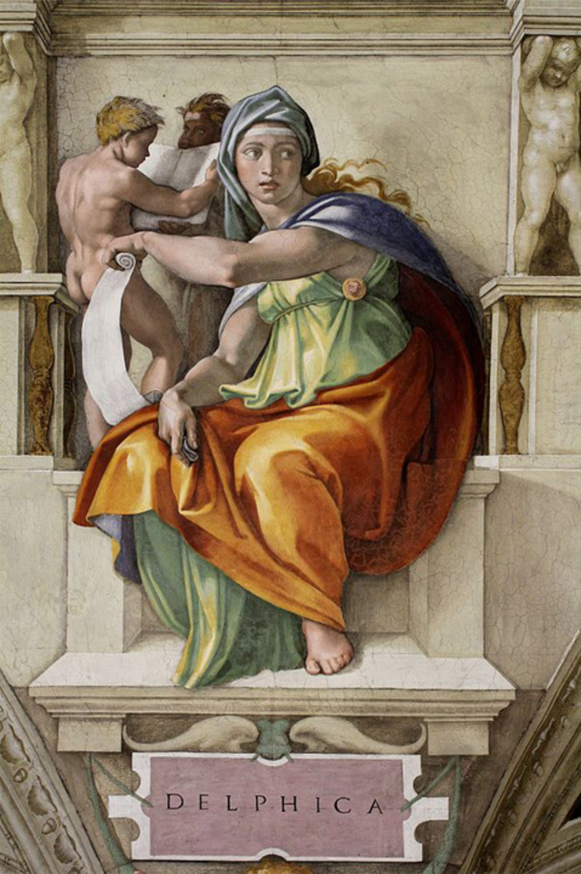
Figure 31 Delphic Sibyl. Fresco, by Michelangelo (1475–1564). Sistine Chapel Ceiling (1508–1512). Vatican, Rome.
View description - Figure 31 Delphic Sibyl. Fresco, by Michelangelo (1475–1564). Sistine Chapel Ceiling ...
View alternative description - Figure 31 Delphic Sibyl. Fresco, by Michelangelo (1475–1564). Sistine Chapel Ceiling ...

In addition, the oracle adds a critical idea: Croesus had been fated to come to a bad end and lose his throne, because of the actions of his ancestor. The notion of inherited guilt is another common theme in ancient Greek literature. It’s a way of explaining why people who do bad things often seem to get away with it; they may, but their descendants won’t. But note how it’s repurposed by Herodotus to get us to think about our own reading practices. Did you remember that Herodotus, at end of his account of Candaules, had mentioned an oracle that foretold that punishment would be visited on Gyges’ family in the fifth generation, adding that at the time people didn’t make anything of it – just as Croesus hadn’t initially made anything of Solon (poieō logon oudena, 1.13.2; 1.33.1)? It would be easy not to have made anything of this, given everything that has passed since. But here, right at the end of Croesus’ story, we are reminded that we should, in the end, pay attention to the details.
This is a lesson in reading. Namely, we learn about the importance of putting things together (sumballesthai in Greek), just as Croesus had failed to do so. The way Herodotus ‘displays his enquiry’ (1.1.1) invites readers to get involved in the enquiry for themselves, to put all these things together, to be alert to ambiguity and nuance, to read to the end. Understanding is not a one-off moment but a process of continual self-reflection about the positions that we take and the views we adopt. Thinking historically is to read, and write, self-critically.

Conclusion: writing historically
In this course you have gained an understanding of the overall concept of Herodotus’ Histories, as well as of the particular structure and thematic content of the first episode, which is dedicated to Croesus. You have identified some of the ways in which Herodotus elicits trust for his account, and you have examined his repurposing of oracles in ways that encourage reflection on the act of reading historically. You have also learned several useful strategies for better navigating online information and fake news in particular, such as the importance: of identifying who’s speaking and thinking hard about what agenda they hold or promote; of reading closely for inconsistencies in accounts and for ambiguity in the evidence; and above all of acknowledging that there is complexity in the answers that we seek.

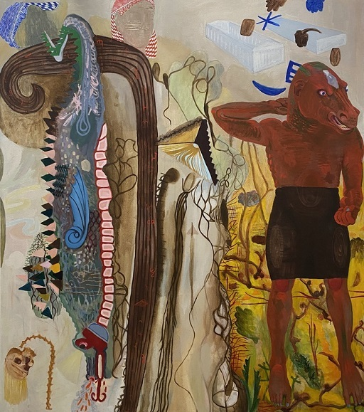
Figure 32 Herodotus. Oil on canvas, by Charles Garabedian, 1995–1996. Orange County Museum of Art, California.
View description - Figure 32 Herodotus. Oil on canvas, by Charles Garabedian, 1995–1996. Orange County ...
View alternative description - Figure 32 Herodotus. Oil on canvas, by Charles Garabedian, 1995–1996. Orange County ...

Now that you have developed some of the key skills required for close reading the Histories, you might consider reading more of Herodotus’ work in a translation of your choice. You may also wish to explore more ancient texts. If you would like to expand your skills and knowledge further, follow up some of the suggestions in the ‘Taking it further’ section.

Taking it further
If you liked these snippets of Herodotus:
- Tom Holland’s Persian Fire (Little, 2005) is a lively and accessible modern retelling of the Histories that draws upon contemporary frames of reference (from Churchill’s Second World War speeches to the US-UK led invasion of Iraq).
- Holland has also published a translation of The Histories (Penguin, 2015). Other popular English translations include those by Robin Waterfield (Oxford World Classics, 2008) and Andrea Purvis (the Landmark Herodotus, Anchor Books, 2009).
- Alternatively, the Histories of Herodotus is freely available online (in both English and Greek) via the Perseus Classical Library.
If you want to find out more about Herodotus:
- Melvyn Bragg’s long-running Radio4 show In Our Time has an episode dedicated to Herodotus, with a roundtable discussion among Herodotean specialists, Tom Harrison (formerly Professor of Ancient History at the University of St Andrews), Esther Eidinow (Professor of Ancient History at the University of Bristol), and Paul Cartledge (A. G. Leventis Senior Research Fellow at Clare College, University of Cambridge).
- For the Radio4 show Great Lives presented by Matthew Parris, writer Justin Marozzi argues for his choice of Herodotus, with Professor Edith Hall as an expert witness.
- In an episode of the joint BBC/British Museum production A History of the World in 100 Objects, former British Museum director Neil MacGregor examines a gold coin of Croesus, assisted by scientist Paul Craddock and curator Amelia Dowler.
- A TEDEd animation addresses the question Why is Herodotus called “The Father of History”?, presented by Mark Robinson.
- A map of all the places mentioned in the Histories is provided by the course author, using the free open-source annotation tool, Recogito, and the English text provided by Perseus.
If you’d like to know more about Homer:
- Dr Emma Bridges of The Open University has written a free companion course on Homer, Exploring Homer’s Odyssey.
- Dr Christine Plastow and Professor Elton Barker of The Open University have written a free OpenLearn course Introducing Homer’s Iliad (adapting materials from the Open University course A229 Introducing the Classical World).
- The Open University has produced two short animations on Homer’s Troy Story, the Iliad and Odyssey, with a helpful Who’s Who guide by Dr Emma Bridges.
- Professors Elton Barker (The Open University) and Joel Christensen (Brandeis) have written a short, lively and accessible Beginner'’ Guide to Homer (OneWorld, 2010).
This course is part of a series of courses under the title HeadStart Classical Studies. You can find details about this series as well as links to its other courses on this page.

Pronunciation guide

Audio content is not available in this format.
Achaeans

Audio content is not available in this format.
Achilleus

Audio content is not available in this format.
Aeolians

Audio content is not available in this format.
Agamemnon

Audio content is not available in this format.
aitia

Audio content is not available in this format.
Alkaios

Audio content is not available in this format.
amphora

Audio content is not available in this format.
Apollo

Audio content is not available in this format.
Artemisium

Audio content is not available in this format.
Atreus

Audio content is not available in this format.
Bacchylides

Audio content is not available in this format.
barbaroi

Audio content is not available in this format.
Candaules

Audio content is not available in this format.
Colchis

Audio content is not available in this format.
Croesus

Audio content is not available in this format.
Cyrus

Audio content is not available in this format.
Daskylos

Audio content is not available in this format.
Delphi

Audio content is not available in this format.
ekduō

Audio content is not available in this format.
Euxine

Audio content is not available in this format.
Great Panathenaia

Audio content is not available in this format.
Gyges

Audio content is not available in this format.
Hades

Audio content is not available in this format.
Halicarnassus

Audio content is not available in this format.
Halys

Audio content is not available in this format.
Heracles

Audio content is not available in this format.
the Heraklidai

Audio content is not available in this format.
Herodotus

Audio content is not available in this format.
Hexameter

Audio content is not available in this format.
historiē

Audio content is not available in this format.
Iliad

Audio content is not available in this format.
Io

Audio content is not available in this format.
Ionians

Audio content is not available in this format.
kleos

Audio content is not available in this format.
Lacedaemonians

Audio content is not available in this format.
Lichas

Audio content is not available in this format.
Leto

Audio content is not available in this format.
Lydian

Audio content is not available in this format.
Medea

Audio content is not available in this format.
Mycale

Audio content is not available in this format.
Myrsilos

Audio content is not available in this format.
Myson

Audio content is not available in this format.
Myrsos

Audio content is not available in this format.
Odyssey

Audio content is not available in this format.
Orestes

Audio content is not available in this format.
Paphlagonia

Audio content is not available in this format.
Peleus

Audio content is not available in this format.
Phoenicians

Audio content is not available in this format.
pithos

Audio content is not available in this format.
Plataea

Audio content is not available in this format.
poieō logon oudena

Audio content is not available in this format.
Pythia

Audio content is not available in this format.
Salamis

Audio content is not available in this format.
Solon

Audio content is not available in this format.
stater

Audio content is not available in this format.
sumballesthai

Audio content is not available in this format.
Tegea

Audio content is not available in this format.
Thermopylae

Audio content is not available in this format.
Tyre

Audio content is not available in this format.
Vulci

Audio content is not available in this format.
Zeus

Tell us what you think
Now you’ve come to the end of the course, we would appreciate a few minutes of your time to complete this short end-of-course survey. We’d like to find out a bit about your experience of studying the course and what you plan to do next. We will use this information to provide better online experiences for all our learners and to share our findings with others. Participation will be completely confidential and we will not pass on your details to others.

References
Purves, A. (2014) ‘In the bedroom: interior space in Herodotus’ “Histories”’, in K. Gilhuly and N. Worman (eds) Space, Place, and Landscape in Ancient Greek Literature and Culture, Cambridge: Cambridge University Press, pp. 94–129.

Acknowledgements
This free course was written by Elton Barker. Many thanks to Danny Pucknell for his feedback on the content.
Note: Section 1 is inspired by Cathryn Dewald’s 1987 article: ‘Narrative surface and authorial voice in Herodotus’ Histories,’, Arethusa, 20, pp. 147–70.
Section 2 draws heavily on Alex Purves’s chapter: ‘In the bedroom: interior space in Herodotus’ Histories’, in K. Gilhuly and N. Worman (eds) Space, Place, and Landscape in Ancient Greek Literature and Culture, Cambridge: Cambridge University Press, 2014, pp. 94–129.
Section 3 is largely derived from Elton Barker (2006) ‘Paging the oracle: interpretation, identity, and performance in Herodotus’ History’, Greece&Rome, 58, pp.1–28.
All translations are the author’s, except where noted.
Except for third party materials and otherwise stated (see terms and conditions), this content is made available under a Creative Commons Attribution-NonCommercial-ShareAlike 4.0 Licence.
The material acknowledged below is Proprietary and used under licence (not subject to Creative Commons Licence). Grateful acknowledgement is made to the following sources for permission to reproduce material in this free course:
Images
Course image: akinbostanci; Getty Images
Figure 1: UNESCO; https://creativecommons.org/licenses/by-sa/3.0/igo/deed.en
Figure 2: Creative-Touch; Getty Images
Figure 3: taken from: https://web.archive.org/web/20230503065234/https:/en.wikipedia.org/wiki/Herodotus
Figure 4: Travelling Runes; https://creativecommons.org/licenses/by-sa/2.0/deed.en
Figure 5: Gustave Moreau - World Gallery; see also Maguire, Helen of Troy, 41, Public Domain, https://commons.wikimedia.org/w/index.php?curid=7290580
Figures 6, 12, 24 and 27: The Open University
Figure 7: Bernard Gagnon; CC BY-SA 3.0
Figure 8: Mohammad Vahidi; https://creativecommons.org/licenses/by-sa/4.0/deed.en
Figure 9: WolfgangRieger - Filippo Coarelli (ed.): Pompeji. Hirmer, München 2002, ISBN 3-7774-9530-1, p. 99., Public Domain, https://commons.wikimedia.org/w/index.php?curid=6229018
Figure 10: NMB; https://creativecommons.org/licenses/by-sa/3.0/deed.en
Figure 11: ©Unknown - Papyrology Rooms, Sackler Library, Oxford;
Figure 13: American Numismatic Society
Figure 14: M.Tiverios, Elliniki Techni; The Classical Art Research Centre
Figure 15: SeptemberWoman; https://creativecommons.org/licenses/by-sa/2.0/
Figure 16: taken from; https://commons.wikimedia.org/wiki/Category:Gyges_in_the_bedchamber_of_King_Candaules#/media/File:Italian_-_Dish_with_King_Candaules_Exhibiting_His_Wife_Nyssia_to_Gyges_-_Walters_482031.jpg
Figure 17: Maître François - http://katoliki.livejournal.com/660816.html, Public Domain, https://commons.wikimedia.org/w/index.php?curid=50963919
Figure18: Jean-Léon Gérôme - Museo de Arte de Ponce; https://commons.wikimedia.org/wiki/Category:Gyges_in_the_bedchamber_of_King_Candaules#/media/File:Jean-L%C3%A9on_G%C3%A9r%C3%B4me_-_El_rey_Candaules.jpg
Figure 19: Unknown artist - Own work, Photo by Szilas in the British Museum, 2010-08-03, CC BY-SA 4.0, https://commons.wikimedia.org/w/index.php?curid=129782824
Figure 20: Dorotheum; https://commons.wikimedia.org/wiki/File:Jacob_Jordaens_-_The_wife_of_King_Candaules.jpg
Figure 21: Skyring - Own work, CC BY-SA 4.0, https://commons.wikimedia.org/w/index.php?curid=64170779
Figure 22: Zde; https://creativecommons.org/licenses/by-sa/4.0/deed.en
Figure 23: Kunsthistorisches Museum Wien, Bilddatenbank.
Figure 25: Camillo Miola (Biacca) - J. Paul Getty Museum, Public Domain, https://commons.wikimedia.org/w/index.php?curid=48328126
Figure 26: rob Stoeltje from Loenen, Netherlands - GRIEKENLAND 014, https://creativecommons.org/licenses/by/2.0/
Figure 28: Wind Group - Jastrow (2006), Public Domain, https://commons.wikimedia.org/w/index.php?curid=688179
Figure 29: Jacques-Louis David - Web Gallery of Art: Image Info about artwork, Public Domain, https://commons.wikimedia.org/w/index.php?curid=15387269
Figure 30: Surenae; https://creativecommons.org/licenses/by-sa/4.0/deed.en
Figure 31: Jörg Bittner Unna; https://creativecommons.org/licenses/by/3.0/deed.en
Figure 32: Estate of Charles Garabedian
Text
Herodotus, The Histories, Book 1 Sections 1 -5, translated by Elton Barker, 2023
Audio/Visual
Activity 8 Audio: The Open University
Every effort has been made to contact copyright owners. If any have been inadvertently overlooked, the publishers will be pleased to make the necessary arrangements at the first opportunity.
Don't miss out
If reading this text has inspired you to learn more, you may be interested in joining the millions of people who discover our free learning resources and qualifications by visiting The Open University – www.open.edu/openlearn/free-courses.

Glossary
Achaeans
one of the terms that Homer uses to refer to the Greek army in the Iliad.
Achilles
son of Peleus and the goddess Thetis and star of Homer’s Iliad. The greatest of the Greek heroes at Troy.
Agamemnon
brother of Menelaos and leader of the Greek coalition at Troy.
aitia
Greek term meaning ‘cause’, ‘reason’ or ‘origin’.
Alexander
the son of Priam, king of Troy. Also known as Paris, his abduction of Helen leads to the Trojan War.
amphora
a two-handled storage jar (typically for wine) with a neck narrower than the body.
Apollo
son of Zeus and Hera, and god of prophecy and healing. His main site of divination was at Delphi.
Athens
a growing power at the time of Herodotus’ Histories (sixth–fifth century BCE), which Herodotus himself puts down to their new-found equality under democracy (5.78.1).
Bacchylides
a Greek poet of the generation before Herodotus (c. 518–c. 451 BCE).
barbaroi
Greek term meaning ‘foreigner’. This term derives from the Greek view that to their ears other peoples spoke gibberish, i.e. ‘bar bar’ (like the English ‘blah blah’)
Candaules
also known as Myrsilos, a king of the ancient Kingdom of Lydia in the early years of the seventh century BCE (c. 680 BCE). The last of the Heraklidai dynasty.
Croesus
last of the Mermnad kings of Lydia. Reigns c. 585–c. 546 BCE until defeated by the Persians under Cyrus.
Cyrus
founder of the Persian Achaemenid Empire. Reigns c. 600–530 BCE.
divination
the practice of seeking knowledge of the future or the unknown by supernatural means.
epic
poetry that focuses either on the stories of the semi-divine heroes (‘heroic epic’, as in Homer’s Iliad and Odyssey) or on the cosmos and how gods and humans fit in with it (in Hesiod’s Theogony and Works and Days respectively).
Europa
daughter of the king of Tyre in Phoenicia. Zeus abducts her by taking the form of a bull and carries her to Crete.
Euxine
another term for the Black Sea or Pontus.
Gyges
favourite bodyguard of Candaules who usurps the throne and establishes the Mermnad dynasty of Lydian kings. Reigns c. 680–644 BCE
Hades
the god of the underworld.
Halicarnassus
the hometown of Herodotus, with a mixed population of Greeks and Carians. Now Bodrum (Turkey).
Helen
wife of Menelaos of Sparta (brother of Agamemnon). Her abduction by (or elopement with) Alexander is the cause of the Trojan War.
Heraklidai
the descendants of the Greek hero, Heracles (in Latin, Hercules).
hero
a legendary figure who, living a generation before people like our own, still consorted with the gods and fought cataclysmic wars, such as the one at Troy.
hexameter
the poetic metre used by Homer, comprising six metrical feet in each line and consisting of a combination of short and long syllables. It is also the metre used for the oracles of Delphi which Herodotus quotes
historiē
Greek term meaning ‘enquiry’, used by Herodotus to describe his narrative. It is from Herodotus’ use that we get the word ‘history’.
Io
daughter of Inachos, first king of Argos. Desired by Zeus, Io is turned into a cow (either by Zeus or by his jealous wife, Hera). In this form, and driven mad by a gadfly, she wanders the earth until she finds her way to Egypt. There she is changed into human form by Zeus and gives birth to his son, Epaphos.
Ionians
Greeks living on the Eastern Mediterranean shore (modern-day Turkey), who are the first Greeks conquered (by Croesus). This area was the birthplace of the Greek revolution in scientific thinking, out of which Herodotus emerges.
kleos
Greek term meaning ‘glory’ or ‘fame’.
Lacedaemonia
another name for Spartans.
Lydian
a term applied to describe the people living in Lydia, a region of western Anatolia (the present-day east Aegean coastline of Turkey). Its capital was Sardis.
Medea
daughter of King Aeëtes of Colchis and the granddaughter of the sun god Helios. She uses magic to help Jason get the golden fleece (which is the reason why he and the Argonauts sail to Colchis) and punishes him when he betrays her.
oracle
a site of divine prophecy, or the prophecy itself. The most well-known oracle from the Greek world is that located at the shrine to Apollo at Delphi.
oral tradition
poetry composed without the use of writing, including Homer’s epic poems, the Iliad and the Odyssey. These poems were composed in performance, where myth was continually reworked and re-purposed to address present concerns.
panhellenic
relating to the whole of Greece (from the Greek word pan, ‘all’, and ‘Hellenic’, derived from Hellas, the Greek name for Greece).
Paris
the son of Priam, king of Troy. Also known as Alexander, his abduction of Helen leads to the Trojan War.
Phoenicians
a Semitic people of the Mediterranean, known for their sailing prowess. Tyre (in modern-day Lebanon) was one of their strongholds.
prose
at the time of Herodotus, a radical new kind of composition, without metre and with the aid of writing. Generally the choice of medium for the new scientific thinkers of the sixth and fifth century BCE.
Sardis
the capital of the kingdom of Lydia.
Solon
c. 630–c. 560 BCE, Athenian statesman, constitutional lawmaker and poet, later credited with having laid the foundations for Athenian democracy.
Spartans
the main power in the area of mainland Greece known as the Peloponnese. Their culture was founded on military power. See also Lacedaemonia.
stater
a type of coin used in Greek and non-Greek territories.
the Muse
a goddess, who is the source of inspiration, authority and knowledge for the poets of the oral epic tradition.
Zeus
the father of gods and men. He overthrew his father Cronos to free his siblings and take control of the cosmos.

Solutions

Activity 1

Discussion
There are many different ways you may have answered this question. Perhaps you know someone who you think will know the answer, and you asked them. Perhaps you looked the answer up in a book you have to hand. Or perhaps you typed ‘Herodotus’ into Google.
Back to - Activity 1

Activity 2

Discussion
You may have noted the following points:
- In paragraph 1 we’re told where Herodotus comes from, or what he’s known for, or how he’s been thought about.
- In paragraph 2 we learn a little bit about his work: the main battles of the war, or alternatively his broad range of interests from ethnography (‘the study of peoples’) to history.
- In paragraph 3 we’re introduced to the question of how he’s assessed as a historian, whether critically or more positively.
- As for the question, ‘How is this known?’, perhaps you noticed some references — notes letting us know where the information comes from.
Back to - Activity 2

Activity 3

Discussion
Here is an example table of responses:

Question | Homer’s Iliad | Herodotus’ Histories
What do we learn about the author of each work? | nothing | The author’s name and the place he’s from
What will the work be about? Try to find at least three things. | the anger of Achilles  Zeus’s plan  the strife between Achilles and Agamemnon  why they came into strife | the display of an enquiry  things done by people  the great and astounding actions of Greeks and barbarians  why they went to war

Back to - Activity 3

Activity 4

Discussion
These are some points you may have noted:
- The first event takes place in Argos, when some Phoenicians abduct Io, the daughter of the king, and take her back to Egpyt.
- The second event takes place in Tyre, when some Greeks abduct Europa, the daughter of the Phoenician king.
- The third event takes place in Colchis, when some Greeks abduct Medea, the king’s daughter.
- The common element in each episode is the abduction of a woman by outsiders (both Greeks and non-Greeks).
- The fourth episode is different because we are given an insight into the thinking of the aggressor, Alexander (otherwise known as Paris), before he carries out an abduction.
Back to - Activity 4

Activity 5

Discussion
You may have come up with something like the following list:
1.1
- Men skilled in arguments among the Persians say that
- (the Persians say)
- (the Persians say)
- — and on this the Greeks say the same —
- (the Persians say)
1.2
- say the Persians (though not the Greeks)
- they say
- (the Persians aren't able to recount the name)
- (These Greeks would have been Cretans.)
- (the Persians say)
- (the Persians say)
- (the Persians say)
1.3
- they say
1.4
- (the Persians say)
- The Persians consider
- (the Persians say)
- The Persians say that
- the Persians think
- they consider
1.5
- This is what the Persians say happened
- the Phoenicians do not agree with the Persians
- These are the things that the Persians and Phoenicians say
- For my part, I’m not going to say
- I’ll identify the man whom I know
- I'll mention
Back to - Activity 5

Activity 6

Discussion
These are the points you may have observed:
- Knowing that this account derives from one group’s point-of-view affects what is recorded. We are being given a particular angle on the events, namely what the Persians think.
- Herodotus also records, at specific moments, the perspectives of others (the Greeks and the Phoenicians). Providing different points of view sets in relief the Persian line of thinking, particularly when those other accounts are said to be in disagreement (as with the Greeks at 1.2.1 or the Phoenicians at 1.5.2).
Back to - Activity 6

Activity 7

Discussion
You may have made some notes along the following lines:
- Herodotus starts with Croesus because he’s the first figure the Greeks know who conquered and ruled over them.
- Croesus conquered some Greeks but he also made friends with others.
- The Greek communities mentioned are on both mainland Greece and along the Asia Minor coast.
Back to - Activity 7

Activity 8

Discussion
You may have noted down the following points from the discussion:
- One source is a gold coin. The other piece of evidence is a storage jar (for wine).
- The coin represents a lion and a bull facing each other, which is a mark of Croesus’s royal mint. The storage jar shows a finely dressed character seated on a throne on top of a pyre that is about to be lit by another figure. The figure on the throne is identified by writing alongside it spelling out Croesus’ name in Greek letters.
- We learn from the coin that Croesus was a rich Eastern monarch who had the power to mint gold currency. We learn from the amphora that Croesus was going to be burned alive.
Back to - Activity 8

Activity 9

Discussion
As usual with reading Herodotus, there’s a lot going on! You may have jotted down the following points:
- Herodotus provides a genealogy going back to the Greek hero, Heracles, that establishes Candaules as the legitimate ruler of Sardis.
- Candaules thinks his wife is so beautiful that he wants his bodyguard, Gyges, to recognise her beauty too.
- Candaules decides that Gyges should spy on his wife.
- There are various ways in which Herodotus invites his reader to believe his account. He includes Candaules’s alternative Greek name, as if to demonstrate to his Greek reader his superior knowledge. Similarly, his very specific identification of the length of time is designed to gain trust. He also uses direct speech, as if he were there to record Candaules’s conversation!
Back to - Activity 9

Activity 10

Discussion
These are points of comparison that you may have noted:
- Candaules, when it was time for bed, led Gyges to the room, and quickly afterwards his wife entered. Gyges watched her come in and set down her clothes. When he was behind the back of the woman as she went towards the bed, he departed, slipping out. But the woman saw him going.
- Most of the differences result from the translation of a (first-person) speech into (third-person) narration.
- So, ‘Candaules’ replaces the ‘I’ in the first passage, and ‘Gyges’ the ‘you’.
Back to - Activity 10

Activity 11

Discussion
These are the stages of the process which you may have picked out:
- Croesus sends out messengers to the oracles.
- He instructs the Lydians to keep track of the time and to write down whatever divine utterance they receive and bring it to him.
- At Delphi they receive an oracle as soon as they walk in the door.
- They write it down and take it back to Sardis.
- Croesus reads each oracle and immediately proclaims Delphi as the one true oracle.
- Only then does Herodotus narrate what Croesus had done.
Back to - Activity 11

Activity 12

Discussion
These are the points you may have picked out:
- Croesus wants to know whether he should attack Persia.
- He receives the answer that, if he attacks, he will destroy a great power.
- Croesus interprets this to mean that, if he attacks, he will destroy Persia, and he’s very happy about that!
- However, the oracle doesn’t spell out which power he will destroy. It’s equally possible that his own power is meant.
Back to - Activity 12

Activity 13

Discussion
You may have noted the following points:
- The oracle cites three locations as it homes in on the burial site: the level plain of Arcadia, Tegea, and an unspecified place (‘where’).
- This nameless place is described in elusive terms – it’s where winds puff, blows are handed out, and suffering is caused.
- A blacksmith’s place of work.
- The bones of Orestes.
Back to - Activity 13

Activity 14

Discussion
You may noted these two things that Croesus learns:
- He learns that he was in the wrong, not the god: Apollo hadn’t specified which empire would fall.
- Croesus also learns that his downfall was fated. His fate can be traced back to Gyges.
Back to - Activity 14

Descriptions

Figure 1 The roots of ‘fake news’, from UNESCO’s 2017/2018 Report into World Trends in Freedom of Expression and Media Development Global.
A drawing of a tree. In the leaves of the tree are the words ‘Fake news’. In its branches are written ‘rumour, hoaxes’, ‘information’, and ‘disinformation’; its trunk has ‘social media’. Its roots point to two word bubbles, in which are written: ‘Loss of confidence in traditional media’ and ‘Low levels of critical thinking and news literacy’ on the left; and on the right, ‘Shifts in business models’ and ‘Malicious actors’.
Back to - Figure 1 The roots of ‘fake news’, from UNESCO’s 2017/2018 Report into World Trends in Freedom of Expression and Media Development Global.

Figure 1 The roots of ‘fake news’, from UNESCO’s 2017/2018 Report into World Trends in Freedom of Expression and Media Development Global.
A drawing of a tree. In the leaves of the tree are the words ‘Fake news’. In its branches are written ‘rumour, hoaxes’, ‘information’, and ‘disinformation’; its trunk has ‘social media’. Its roots point to two word bubbles, in which are written: ‘Loss of confidence in traditional media’ and ‘Low levels of critical thinking and news literacy’ on the left; and on the right, ‘Shifts in business models’ and ‘Malicious actors’.
Back to - Figure 1 The roots of ‘fake news’, from UNESCO’s 2017/2018 Report into World Trends in Freedom of Expression and Media Development Global.

Figure 2 Communication concept.
A diagram of two heads facing each other. Out of the heads come a series of gears and cogs which connect the two figures. The diagram tries to represent the communication concept.
Back to - Figure 2 Communication concept.

Figure 2 Communication concept.
A diagram of two heads facing each other. Out of the heads come a series of gears and cogs which connect the two figures. The diagram tries to represent the communication concept.
Back to - Figure 2 Communication concept.

Figure 3 Screenshot of the Wikipedia entry on Herodotus, taken 1 March 2024.
A screenshot of the Wikipedia entry for Herodotus, with the text on the left and the image of a bust of Herodotus on the right. The text has a series of words in blue (indicating hyperlinks to other Wikipedia entries), as well as footnote references.
Back to - Figure 3 Screenshot of the Wikipedia entry on Herodotus, taken 1 March 2024.

Figure 3 Screenshot of the Wikipedia entry on Herodotus, taken 1 March 2024.
A screenshot of the Wikipedia entry for Herodotus, with the text on the left and the image of a bust of Herodotus on the right. The text has a series of words in blue (indicating hyperlinks to other Wikipedia entries), as well as footnote references.
Back to - Figure 3 Screenshot of the Wikipedia entry on Herodotus, taken 1 March 2024.

Figure 4 The Trojan Horse. Pithos (a large storage container) found at Mykonos, about 670 BCE, Archaeological Museum of Mykonos, ID: 2240.
Close up of the clay storage container (dark red in colour), which has been pieced back together. The image shows a large horse, in which there are seven windows, revealing (Greek) fighters inside, carrying arms (helmets, shields, and swords). Around the horse are at least six other warriors (Trojans), appearing to lead the horse (into the city).
Back to - Figure 4 The Trojan Horse. Pithos (a large storage container) found at Mykonos, about 670 BCE, Archaeological Museum of Mykonos, ID: 2240.

Figure 4 The Trojan Horse. Pithos (a large storage container) found at Mykonos, about 670 BCE, Archaeological Museum of Mykonos, ID: 2240.
Close up of the clay storage container (dark red in colour), which has been pieced back together. The image shows a large horse, in which there are seven windows, revealing (Greek) fighters inside, carrying arms (helmets, shields, and swords). Around the horse are at least six other warriors (Trojans), appearing to lead the horse (into the city).
Back to - Figure 4 The Trojan Horse. Pithos (a large storage container) found at Mykonos, about 670 BCE, Archaeological Museum of Mykonos, ID: 2240.

Figure 5 Helen on the Ramparts of Troy. Oil on canvas, by Gustave Moreau, late nineteenth century. Musee Gustave Moreau, Paris, France.
A portrait representation of a richly attired woman. With a blank expression on her face, the woman holds a flower in her crossed arms as she gazes into the distance. Her pale face (matching the pale sky behind) contrasts with the detail of her brightly coloured patterned robes, which cover her from her head down to the floor.
Back to - Figure 5 Helen on the Ramparts of Troy. Oil on canvas, by Gustave Moreau, late nineteenth century. Musee Gustave Moreau, Paris, France.

Figure 5 Helen on the Ramparts of Troy. Oil on canvas, by Gustave Moreau, late nineteenth century. Musee Gustave Moreau, Paris, France.
A portrait representation of a richly attired woman. With a blank expression on her face, the woman holds a flower in her crossed arms as she gazes into the distance. Her pale face (matching the pale sky behind) contrasts with the detail of her brightly coloured patterned robes, which cover her from her head down to the floor.
Back to - Figure 5 Helen on the Ramparts of Troy. Oil on canvas, by Gustave Moreau, late nineteenth century. Musee Gustave Moreau, Paris, France.

Figure 6 A map of the places and peoples mentioned in Herodotus 1.1.1–1.5.4, with the settlements of Greeks or Greek majority populations in green.
The map shows the eastern part of the Mediterranean and the Black Sea. The largest fonts read ‘Europe’ (on the land above the Aegean Sea) and ‘Asia’ (below the Black Sea). Words in smaller font indicate ‘Hellas’ (in green, where modern-day Greece is located), ‘Assyria’ (north-east of Cyprus), ‘Persia’ (modern-day Iran), and ‘Aegyptos’ (the Nile Delta). There are four places marked in green (Argos, Sparta, Crete, and Halicarnassus), and four in red (Troy, Colchis, the river Phasis, and Tyre). Troy and Halicarnassus are located on the same Ionian coastline (now modern-day Türkiye).
Back to - Figure 6 A map of the places and peoples mentioned in Herodotus 1.1.1–1.5.4, with the settlements of Greeks or Greek majority populations in green.

Figure 6 A map of the places and peoples mentioned in Herodotus 1.1.1–1.5.4, with the settlements of Greeks or Greek majority populations in green.
The map shows the eastern part of the Mediterranean and the Black Sea. The largest fonts read ‘Europe’ (on the land above the Aegean Sea) and ‘Asia’ (below the Black Sea). Words in smaller font indicate ‘Hellas’ (in green, where modern-day Greece is located), ‘Assyria’ (north-east of Cyprus), ‘Persia’ (modern-day Iran), and ‘Aegyptos’ (the Nile Delta). There are four places marked in green (Argos, Sparta, Crete, and Halicarnassus), and four in red (Troy, Colchis, the river Phasis, and Tyre). Troy and Halicarnassus are located on the same Ionian coastline (now modern-day Türkiye).
Back to - Figure 6 A map of the places and peoples mentioned in Herodotus 1.1.1–1.5.4, with the settlements of Greeks or Greek majority populations in green.

Figure 7 The Kidnapping of Europa. Mosaic, between first and second centuries CE. Zeugma Mosaic Museum, Gaziantep, Türkiye.
Photograph of a rectangular mosaic floor. The central panel shows a scene from mythology, as the young woman Europa is carried off on the back of a bull (the god Zeus in disguise) across the sea (represented by fish). Geometric patterns frame the scene.
Back to - Figure 7 The Kidnapping of Europa. Mosaic, between first and second centuries CE. Zeugma Mosaic Museum, Gaziantep, Türkiye.

Figure 7 The Kidnapping of Europa. Mosaic, between first and second centuries CE. Zeugma Mosaic Museum, Gaziantep, Türkiye.
Photograph of a rectangular mosaic floor. The central panel shows a scene from mythology, as the young woman Europa is carried off on the back of a bull (the god Zeus in disguise) across the sea (represented by fish). Geometric patterns frame the scene.
Back to - Figure 7 The Kidnapping of Europa. Mosaic, between first and second centuries CE. Zeugma Mosaic Museum, Gaziantep, Türkiye.

Figure 8 Audience scene of Darius (or Xerxes I). Stone relief. Iran National Museum, Tehran, ID: 1765.
Stone carving showing three figures. One (with a neat, but long beard) is seated on a throne. He holds a staff in his right hand, which reaches to the ground; in his left hand he carries a cup; his feet are rested on a footstall. Behind him, also bearded, stands a man who is the same height as the seated figure. He also carries a cup in his left hand, and holds his right hand out straight in from of him. Before them stands a third bearded figure, much smaller, carrying a staff in his left hand, while with his right he touches his lips, as he looks up to the figure seated in front of him.
Back to - Figure 8 Audience scene of Darius (or Xerxes I). Stone relief. Iran National Museum, Tehran, ID: 1765.

Figure 8 Audience scene of Darius (or Xerxes I). Stone relief. Iran National Museum, Tehran, ID: 1765.
Stone carving showing three figures. One (with a neat, but long beard) is seated on a throne. He holds a staff in his right hand, which reaches to the ground; in his left hand he carries a cup; his feet are rested on a footstall. Behind him, also bearded, stands a man who is the same height as the seated figure. He also carries a cup in his left hand, and holds his right hand out straight in from of him. Before them stands a third bearded figure, much smaller, carrying a staff in his left hand, while with his right he touches his lips, as he looks up to the figure seated in front of him.
Back to - Figure 8 Audience scene of Darius (or Xerxes I). Stone relief. Iran National Museum, Tehran, ID: 1765.

Figure 9 Io (on the left, with horns) is welcomed in Egypt by Isis (sitting, holding a snake and with a crocodile at her feet). Roman fresco from the temple of Isis in Pompeii. Museo Archeologico Nazionale, Naples, ID: 9558.
A wall painting. Two central figures (both women) clasp hands. The one on the left, as the viewer sees it, is naked to the waist. She has two small horns in her head and looks up; she is higher because she is being carried on the shoulders of a bronzed and bearded figure. Below her, to the right, is the second woman. Clothed simply in a white dress, and crowned, she holds a snake in her left hand, which is wrapped around her wrist. A tiny figure sits to her left. In the background are another pair (faint, possibly a man and a woman), holding accruements.
Back to - Figure 9 Io (on the left, with horns) is welcomed in Egypt by Isis (sitting, holding a snake and with a crocodile at her feet). Roman fresco from the temple of Isis in Pompeii. Museo Archeologico Nazionale, Naples, ID: 9558.

Figure 9 Io (on the left, with horns) is welcomed in Egypt by Isis (sitting, holding a snake and with a crocodile at her feet). Roman fresco from the temple of Isis in Pompeii. Museo Archeologico Nazionale, Naples, ID: 9558.
A wall painting. Two central figures (both women) clasp hands. The one on the left, as the viewer sees it, is naked to the waist. She has two small horns in her head and looks up; she is higher because she is being carried on the shoulders of a bronzed and bearded figure. Below her, to the right, is the second woman. Clothed simply in a white dress, and crowned, she holds a snake in her left hand, which is wrapped around her wrist. A tiny figure sits to her left. In the background are another pair (faint, possibly a man and a woman), holding accruements.
Back to - Figure 9 Io (on the left, with horns) is welcomed in Egypt by Isis (sitting, holding a snake and with a crocodile at her feet). Roman fresco from the temple of Isis in Pompeii. Museo Archeologico Nazionale, Naples, ID: 9558.

Figure 10 Phoenicians ship carved on the face of a sarcophagus, second century CE.
A picture of a ship on the sea. The hull is curved and lined (suggesting a wooden construction), with a curved bow to the right, as the viewer sees it. A central mast carries a massive sail which spans almost the length of the ship.
Back to - Figure 10 Phoenicians ship carved on the face of a sarcophagus, second century CE.

Figure 10 Phoenicians ship carved on the face of a sarcophagus, second century CE.
A picture of a ship on the sea. The hull is curved and lined (suggesting a wooden construction), with a curved bow to the right, as the viewer sees it. A central mast carries a massive sail which spans almost the length of the ship.
Back to - Figure 10 Phoenicians ship carved on the face of a sarcophagus, second century CE.

Figure 11 Fragment from Herodotus’ Histories, Book 8. Papyrus, early second century CE. Sackler Library, Oxford, Papyrus Oxyrhynchus 2099.
A picture of a fragment of papyrus. The piece of papyrus is roughly square in form and clearly torn. The writing on it in Greek capitals is neat and runs in a single column down the centre of the papyrus roll. A ruler on the right indicates that the size of the fragment is roughly 9 cm in length.
Back to - Figure 11 Fragment from Herodotus’ Histories, Book 8. Papyrus, early second century CE. Sackler Library, Oxford, Papyrus Oxyrhynchus 2099.

Figure 11 Fragment from Herodotus’ Histories, Book 8. Papyrus, early second century CE. Sackler Library, Oxford, Papyrus Oxyrhynchus 2099.
A picture of a fragment of papyrus. The piece of papyrus is roughly square in form and clearly torn. The writing on it in Greek capitals is neat and runs in a single column down the centre of the papyrus roll. A ruler on the right indicates that the size of the fragment is roughly 9 cm in length.
Back to - Figure 11 Fragment from Herodotus’ Histories, Book 8. Papyrus, early second century CE. Sackler Library, Oxford, Papyrus Oxyrhynchus 2099.

Figure 12 A map showing Lydia and the Greek communities (in green) along the Asia Minor (Anatolia) coast.
The map shows the eastern part of the Mediterranean and the Black Sea. Three regions are marked out in bigger font: Lydia (in the middle of the Asia Minor (Anatolian) coast next to the Aegean Sea); Paphlagonia (just under the Black Sea); and Syria (in line with the island of Cyprus). In smaller (green) font are three Greek communities along the Asia Minor coast: Aeolians at the top, Ionians in the middle, and Dorians at the bottom. The settlement of Sparta (Lacedaemon) is marked out (also in green) on the Greek mainland, in the middle of the Peloponnese; the Pontus and the river Halys are both indicated in red.
Back to - Figure 12 A map showing Lydia and the Greek communities (in green) along the Asia Minor (Anatolia) coast.

Figure 12 A map showing Lydia and the Greek communities (in green) along the Asia Minor (Anatolia) coast.
The map shows the eastern part of the Mediterranean and the Black Sea. Three regions are marked out in bigger font: Lydia (in the middle of the Asia Minor (Anatolian) coast next to the Aegean Sea); Paphlagonia (just under the Black Sea); and Syria (in line with the island of Cyprus). In smaller (green) font are three Greek communities along the Asia Minor coast: Aeolians at the top, Ionians in the middle, and Dorians at the bottom. The settlement of Sparta (Lacedaemon) is marked out (also in green) on the Greek mainland, in the middle of the Peloponnese; the Pontus and the river Halys are both indicated in red.
Back to - Figure 12 A map showing Lydia and the Greek communities (in green) along the Asia Minor (Anatolia) coast.

Figure 15 The Temple of Artemis outside Sart (ancient Sardis), Türkiye.
The photograph depicts oblong ruins in the foreground, made up of very large stone blocks. At the crest of a low hill stand six columns, two of which stand at their full height, each capped by a volute (a stone that looks like a scroll or the curved horns of a goat). In the background are wooded hills and some terracing.
Back to - Figure 15 The Temple of Artemis outside Sart (ancient Sardis), Türkiye.

Figure 15 The Temple of Artemis outside Sart (ancient Sardis), Türkiye.
The photograph depicts oblong ruins in the foreground, made up of very large stone blocks. At the crest of a low hill stand six columns, two of which stand at their full height, each capped by a volute (a stone that looks like a scroll or the curved horns of a goat). In the background are wooded hills and some terracing.
Back to - Figure 15 The Temple of Artemis outside Sart (ancient Sardis), Türkiye.

Figure 16 Dish with King Candaules exhibiting his wife Nyssia to Gyges. Earthenware with tin glaze, between around 1540–1550 CE, Urbino, Italy. Walters Art Museum, Baltimore. ID: 48.2031.
This decorative plate is fully coloured and glazed. It depicts the interior of a house, with a tiled floor, a back wall of bricks and a window, a wall to the right as the viewer looks at it, made of slightly larger bricks and a bigger window, and wooden beams for a ceiling. On the left is a four-poster bed, with drapery. Standing beside the bed is a woman half-dressed in a saffron coloured robe (wrapped around her waist and flowing to the floor); she is looking directly at a pair of men on the opposite side of the room. The one, dressed in a short blue robe which covers his chest and loins, is talking to a second man while gesturing with both of his hands towards the woman. The second man is naked, except for a covering over his groin area. He is looking at the woman and has an arrow in his left breast, shot by a cupid figure hovering in the centre of the plate.
Back to - Figure 16 Dish with King Candaules exhibiting his wife Nyssia to Gyges. Earthenware with tin glaze, between around 1540–1550 CE, Urbino, Italy. Walters Art Museum, Baltimore. ID: 48.2031.

Figure 16 Dish with King Candaules exhibiting his wife Nyssia to Gyges. Earthenware with tin glaze, between around 1540–1550 CE, Urbino, Italy. Walters Art Museum, Baltimore. ID: 48.2031.
This decorative plate is fully coloured and glazed. It depicts the interior of a house, with a tiled floor, a back wall of bricks and a window, a wall to the right as the viewer looks at it, made of slightly larger bricks and a bigger window, and wooden beams for a ceiling. On the left is a four-poster bed, with drapery. Standing beside the bed is a woman half-dressed in a saffron coloured robe (wrapped around her waist and flowing to the floor); she is looking directly at a pair of men on the opposite side of the room. The one, dressed in a short blue robe which covers his chest and loins, is talking to a second man while gesturing with both of his hands towards the woman. The second man is naked, except for a covering over his groin area. He is looking at the woman and has an arrow in his left breast, shot by a cupid figure hovering in the centre of the plate.
Back to - Figure 16 Dish with King Candaules exhibiting his wife Nyssia to Gyges. Earthenware with tin glaze, between around 1540–1550 CE, Urbino, Italy. Walters Art Museum, Baltimore. ID: 48.2031.

Figure 17 Gyges kills King Candaules at the queen’s order. Illuminated manuscript of Cité de Dieu by Maître François, between 1475 and 1480 CE.
Three figures occupy the centre of this scene. To the left, as the viewer sees it, is a pale-faced woman, dressed simply but elegantly in a tall peaked black hat (with a veil falling down the back), a pale green top with an egg-white middle, and a pale red folded skirt that flows out to the floor. She is looking down at, and holding onto the head and shoulder, of a man. He is slightly lower and holds his hands out on either side in a gesture of defence. He is dressed in royal blue robes, with an embroidered cloak over his shoulders, and wears a golden crown on his head and a golden pouch around his waist. His mouth and eyes are wide open, as his head is being pulled back by the woman to expose his neck. A second man, dressed in the same-coloured pale red robe as the woman, and wearing a similarly shaped hat (this time egg-white with a golden cross), stabs the central figure in the neck with a knife held in his left hand. A four-poster bed, in the same royal blue as the robes of the central figure, is to the left of the group and a door on the right, which opens out to an outdoor scene with a city and its walls in the far distance.
Back to - Figure 17 Gyges kills King Candaules at the queen’s order. Illuminated manuscript of Cité de Dieu by Maître François, between 1475 and 1480 CE.

Figure 17 Gyges kills King Candaules at the queen’s order. Illuminated manuscript of Cité de Dieu by Maître François, between 1475 and 1480 CE.
Three figures occupy the centre of this scene. To the left, as the viewer sees it, is a pale-faced woman, dressed simply but elegantly in a tall peaked black hat (with a veil falling down the back), a pale green top with an egg-white middle, and a pale red folded skirt that flows out to the floor. She is looking down at, and holding onto the head and shoulder, of a man. He is slightly lower and holds his hands out on either side in a gesture of defence. He is dressed in royal blue robes, with an embroidered cloak over his shoulders, and wears a golden crown on his head and a golden pouch around his waist. His mouth and eyes are wide open, as his head is being pulled back by the woman to expose his neck. A second man, dressed in the same-coloured pale red robe as the woman, and wearing a similarly shaped hat (this time egg-white with a golden cross), stabs the central figure in the neck with a knife held in his left hand. A four-poster bed, in the same royal blue as the robes of the central figure, is to the left of the group and a door on the right, which opens out to an outdoor scene with a city and its walls in the far distance.
Back to - Figure 17 Gyges kills King Candaules at the queen’s order. Illuminated manuscript of Cité de Dieu by Maître François, between 1475 and 1480 CE.

Figure 18 Le roi Candaules (King Candaules). Oil on canvas, by Jean-Léon Gérôme, 1859. Museo de Arte de Ponce, Puerto Rico
Richly detailed interior scene, full of warm colours. At the centre is a naked woman with her back to the viewer, in the process of lifting off her nightdress; her red robe lies on a chair next to her. Her head is slightly tilted towards the right: in line with the inclination of her head is a dimly lit, hooded figure, slipping out of the door. In front of the woman is a grandly decorated four-posted bed, in which lies a man, naked to the chest, also looking towards the open door.
Back to - Figure 18 Le roi Candaules (King Candaules). Oil on canvas, by Jean-Léon Gérôme, 1859. Museo de Arte de Ponce, Puerto Rico

Figure 18 Le roi Candaules (King Candaules). Oil on canvas, by Jean-Léon Gérôme, 1859. Museo de Arte de Ponce, Puerto Rico
Richly detailed interior scene, full of warm colours. At the centre is a naked woman with her back to the viewer, in the process of lifting off her nightdress; her red robe lies on a chair next to her. Her head is slightly tilted towards the right: in line with the inclination of her head is a dimly lit, hooded figure, slipping out of the door. In front of the woman is a grandly decorated four-posted bed, in which lies a man, naked to the chest, also looking towards the open door.
Back to - Figure 18 Le roi Candaules (King Candaules). Oil on canvas, by Jean-Léon Gérôme, 1859. Museo de Arte de Ponce, Puerto Rico

Figure 19 Account of the Egyptian campaigns of Ashurbanipal, king of Assyria, and his reception of an embassy from Gyges, king of Lydia, Neo-Assyrian clay tablet with cuneiform script, c. 660 BCE, British Museum, ID: ME K2675
An oblong clay tablet, standing upright in a portrait view. The tablet has been put together from at least 3 separate pieces. Lines run across these fragments, full of dense, tiny inscriptions.
Back to - Figure 19 Account of the Egyptian campaigns of Ashurbanipal, king of Assyria, and his reception of an embassy from Gyges, king of Lydia, Neo-Assyrian clay tablet with cuneiform script, c. 660 BCE, British Museum, ID: ME K2675

Figure 19 Account of the Egyptian campaigns of Ashurbanipal, king of Assyria, and his reception of an embassy from Gyges, king of Lydia, Neo-Assyrian clay tablet with cuneiform script, c. 660 BCE, British Museum, ID: ME K2675
An oblong clay tablet, standing upright in a portrait view. The tablet has been put together from at least 3 separate pieces. Lines run across these fragments, full of dense, tiny inscriptions.
Back to - Figure 19 Account of the Egyptian campaigns of Ashurbanipal, king of Assyria, and his reception of an embassy from Gyges, king of Lydia, Neo-Assyrian clay tablet with cuneiform script, c. 660 BCE, British Museum, ID: ME K2675

Figure 20 Close up of King Candaules of Lydia Showing his Wife to Gyges. Oil on canvas, by Jacob Jordaens, 1646, Nationalmuseum Sweden, ID: NM 1159
Close up of a woman. She is naked to the waist, with her back to the viewer, though her head is turning back to look over her shoulder towards the viewer. Her eyes are half open and there seems to be a slight smile on her face. Her hair is mainly covered by a richly embroidered night cap that falls down to her shoulders. She also wears a pearl necklace. The background is made up of the folds of rich red draperies.
Back to - Figure 20 Close up of King Candaules of Lydia Showing his Wife to Gyges. Oil on canvas, by Jacob Jordaens, 1646, Nationalmuseum Sweden, ID: NM 1159

Figure 20 Close up of King Candaules of Lydia Showing his Wife to Gyges. Oil on canvas, by Jacob Jordaens, 1646, Nationalmuseum Sweden, ID: NM 1159
Close up of a woman. She is naked to the waist, with her back to the viewer, though her head is turning back to look over her shoulder towards the viewer. Her eyes are half open and there seems to be a slight smile on her face. Her hair is mainly covered by a richly embroidered night cap that falls down to her shoulders. She also wears a pearl necklace. The background is made up of the folds of rich red draperies.
Back to - Figure 20 Close up of King Candaules of Lydia Showing his Wife to Gyges. Oil on canvas, by Jacob Jordaens, 1646, Nationalmuseum Sweden, ID: NM 1159

Figure 21 Ruins of the ancient Temple of Apollo at Delphi (the site of the oracle), overlooking the valley of Phocis.
In the foreground of the picture are the ruins of a temple, marked by an almost complete floor of large square stone slabs and six half-length columns running around the top left corner of the building as the viewer sees it. A valley is visible in the background at some distance away and much lower. The indication is of a temple on the side of a steep incline with a panoramic view of the entire valley below.
Back to - Figure 21 Ruins of the ancient Temple of Apollo at Delphi (the site of the oracle), overlooking the valley of Phocis.

Figure 21 Ruins of the ancient Temple of Apollo at Delphi (the site of the oracle), overlooking the valley of Phocis.
In the foreground of the picture are the ruins of a temple, marked by an almost complete floor of large square stone slabs and six half-length columns running around the top left corner of the building as the viewer sees it. A valley is visible in the background at some distance away and much lower. The indication is of a temple on the side of a steep incline with a panoramic view of the entire valley below.
Back to - Figure 21 Ruins of the ancient Temple of Apollo at Delphi (the site of the oracle), overlooking the valley of Phocis.

Figure 22 The mythical king of Athens, Aigeus, receiving an oracle from the Pythia at Delphi. Attic red-figure kylix (a cup for drinking wine), ascribed to the ‘Kodros Painter’, 440–430 BCE, found in Vulci (Italy). Altes Museum, Berlin, ID: F 2538.
Two figures are presented in profile, bordered by a Greek keys pattern that creates a circular outside frame. One figure, a bearded male, naked to the waist, stands facing to the left (as the viewer sees it), wearing a full-length robe, sandals, and a laurel-leaf crown on his head. His arms hang by his side, in a waiting pose. A second figure sits opposite him on a high stool, wearing a robe that entirely covers her body. Her partially veiled head is bent forward, as she studies a bowl that she has in her left hand. In her right hand she holds a laurel branch. Her feet are naked.
Back to - Figure 22 The mythical king of Athens, Aigeus, receiving an oracle from the Pythia at Delphi. Attic red-figure kylix (a cup for drinking wine), ascribed to the ‘Kodros Painter’, 440–430 BCE, found in Vulci (Italy). Altes Museum, Berlin, ID: F 2538.

Figure 22 The mythical king of Athens, Aigeus, receiving an oracle from the Pythia at Delphi. Attic red-figure kylix (a cup for drinking wine), ascribed to the ‘Kodros Painter’, 440–430 BCE, found in Vulci (Italy). Altes Museum, Berlin, ID: F 2538.
Two figures are presented in profile, bordered by a Greek keys pattern that creates a circular outside frame. One figure, a bearded male, naked to the waist, stands facing to the left (as the viewer sees it), wearing a full-length robe, sandals, and a laurel-leaf crown on his head. His arms hang by his side, in a waiting pose. A second figure sits opposite him on a high stool, wearing a robe that entirely covers her body. Her partially veiled head is bent forward, as she studies a bowl that she has in her left hand. In her right hand she holds a laurel branch. Her feet are naked.
Back to - Figure 22 The mythical king of Athens, Aigeus, receiving an oracle from the Pythia at Delphi. Attic red-figure kylix (a cup for drinking wine), ascribed to the ‘Kodros Painter’, 440–430 BCE, found in Vulci (Italy). Altes Museum, Berlin, ID: F 2538.

Figure 23 Krösus zeigt Solon seine Schätze (Croesus displays his treasures to Solon). Colour on oak wood, by Frans Francken the Younger, about 1620; Kunsthistorisches Museum, Vienna, ID: GG_1049.
A detailed crowd scene. In the centre foreground stands a regal figure, wearing a rich red robe, a golden scarf around his waist, an ermine cloak that flows to the floor, knee-high ivory-coloured boots, and a gold-coloured hat with a dark-green plume. He poses with his right arm on his waist; in his left hand, he holds a golden rod that points towards a mass of treasures — wine jars of all shapes and sizes, jewellery, gold bowls — spilling over carefully laid tables on to the floor, such is their number. Next to him stands a man, much more simply dressed in a dark green robe and walking boots, who appears to be animated conversation with him. To the left of the central figure stands a woman, as regally dressed as he is, with a golden red dress that billows out, and a royal blue bejewelled top that opens at the waist; she too wears an elaborate plumed hat. Milling around them are an array of finely drawn characters, around twenty in number. Behind them is a wall with a large landscape painting at its centre, and further off to the left (as the viewer sees it) is an outdoor scene with a temple-like building and trees.
Back to - Figure 23 Krösus zeigt Solon seine Schätze (Croesus displays his treasures to Solon). Colour on oak wood, by Frans Francken the Younger, about 1620; Kunsthistorisches Museum, Vienna, ID: GG_1049.

Figure 23 Krösus zeigt Solon seine Schätze (Croesus displays his treasures to Solon). Colour on oak wood, by Frans Francken the Younger, about 1620; Kunsthistorisches Museum, Vienna, ID: GG_1049.
A detailed crowd scene. In the centre foreground stands a regal figure, wearing a rich red robe, a golden scarf around his waist, an ermine cloak that flows to the floor, knee-high ivory-coloured boots, and a gold-coloured hat with a dark-green plume. He poses with his right arm on his waist; in his left hand, he holds a golden rod that points towards a mass of treasures — wine jars of all shapes and sizes, jewellery, gold bowls — spilling over carefully laid tables on to the floor, such is their number. Next to him stands a man, much more simply dressed in a dark green robe and walking boots, who appears to be animated conversation with him. To the left of the central figure stands a woman, as regally dressed as he is, with a golden red dress that billows out, and a royal blue bejewelled top that opens at the waist; she too wears an elaborate plumed hat. Milling around them are an array of finely drawn characters, around twenty in number. Behind them is a wall with a large landscape painting at its centre, and further off to the left (as the viewer sees it) is an outdoor scene with a temple-like building and trees.
Back to - Figure 23 Krösus zeigt Solon seine Schätze (Croesus displays his treasures to Solon). Colour on oak wood, by Frans Francken the Younger, about 1620; Kunsthistorisches Museum, Vienna, ID: GG_1049.

Figure 24 A map showing the key places mentioned in the narrative of Croesus consulting the oracles: Sardis, Delphi, Persia, Athens and Sparta.
The map shows the eastern part of the Mediterranean and the Black Sea. Four locations are marked: on the Greek mainland are — from top to bottom — Delphi, Athens, and Sparta (or Lacedaemon); in Anatolia is Sardis. Far off to the east is the region of Persia.
Back to - Figure 24 A map showing the key places mentioned in the narrative of Croesus consulting the oracles: Sardis, Delphi, Persia, Athens and Sparta.

Figure 24 A map showing the key places mentioned in the narrative of Croesus consulting the oracles: Sardis, Delphi, Persia, Athens and Sparta.
The map shows the eastern part of the Mediterranean and the Black Sea. Four locations are marked: on the Greek mainland are — from top to bottom — Delphi, Athens, and Sparta (or Lacedaemon); in Anatolia is Sardis. Far off to the east is the region of Persia.
Back to - Figure 24 A map showing the key places mentioned in the narrative of Croesus consulting the oracles: Sardis, Delphi, Persia, Athens and Sparta.

Figure 25 The Oracle. Oil on canvas, by Camillo Miola, 1880. Getty Center, ID 72.PA.32.
A richly painted scene. A woman sits on a stool, like that depicted in the Attic red-figure kylix (Figure 22), head forward and eyes looking up, as if in a trance. She has thick black hair that runs down her back, and wears a white robe, a band of golden necklaces, and an embroidered scarf. Around her are four elderly, bearded men, all dressed in simple white robes with a white band around their heads. One, in profile, looks intently at her; another — whom the viewer sees from behind — holds his arms out straight in front of him; a third stands behind her, looking up; the fourth holds a scroll in his left hand and a writing instrument in his right. All five figures are in a special sanctuary, set off from the immediate foreground of the painting. A dark red wall provides the background to the sanctuary; there is also a laurel tree (and many laurel leaves strewn all over the floor), while high up on the wall on the right are hung various votive objects. Before them, and in front of the sanctuary, two figures kneel, with their heads bent and right arms raised. There appear to be twirls of smoke coming from somewhere.
Back to - Figure 25 The Oracle. Oil on canvas, by Camillo Miola, 1880. Getty Center, ID 72.PA.32.

Figure 25 The Oracle. Oil on canvas, by Camillo Miola, 1880. Getty Center, ID 72.PA.32.
A richly painted scene. A woman sits on a stool, like that depicted in the Attic red-figure kylix (Figure 22), head forward and eyes looking up, as if in a trance. She has thick black hair that runs down her back, and wears a white robe, a band of golden necklaces, and an embroidered scarf. Around her are four elderly, bearded men, all dressed in simple white robes with a white band around their heads. One, in profile, looks intently at her; another — whom the viewer sees from behind — holds his arms out straight in front of him; a third stands behind her, looking up; the fourth holds a scroll in his left hand and a writing instrument in his right. All five figures are in a special sanctuary, set off from the immediate foreground of the painting. A dark red wall provides the background to the sanctuary; there is also a laurel tree (and many laurel leaves strewn all over the floor), while high up on the wall on the right are hung various votive objects. Before them, and in front of the sanctuary, two figures kneel, with their heads bent and right arms raised. There appear to be twirls of smoke coming from somewhere.
Back to - Figure 25 The Oracle. Oil on canvas, by Camillo Miola, 1880. Getty Center, ID 72.PA.32.

Figure 26 The Athenian Treasury, Delphi.
The photo depicts an almost intact temple, which is bricked all around with the exception of its open front where stand two columns. The simple building is capped by a triangular pediment. It stands on the side of a hill, which rises quite dramatically behind it. In the background stand a number of tall cypress trees.
Back to - Figure 26 The Athenian Treasury, Delphi.

Figure 26 The Athenian Treasury, Delphi.
The photo depicts an almost intact temple, which is bricked all around with the exception of its open front where stand two columns. The simple building is capped by a triangular pediment. It stands on the side of a hill, which rises quite dramatically behind it. In the background stand a number of tall cypress trees.
Back to - Figure 26 The Athenian Treasury, Delphi.

Figure 27 A map showing Sparta and its neighbours, Tegea and Arcadia.
This map focuses on the Peloponnese area of mainland Greece. In the centre are three settlements close to each other, running north to south in the following order: Arcadia, Tegea, and Sparta/Lacedaemon. To the north, just the other side of the Isthmus of Corinth, is Delphi.
Back to - Figure 27 A map showing Sparta and its neighbours, Tegea and Arcadia.

Figure 27 A map showing Sparta and its neighbours, Tegea and Arcadia.
This map focuses on the Peloponnese area of mainland Greece. In the centre are three settlements close to each other, running north to south in the following order: Arcadia, Tegea, and Sparta/Lacedaemon. To the north, just the other side of the Isthmus of Corinth, is Delphi.
Back to - Figure 27 A map showing Sparta and its neighbours, Tegea and Arcadia.

Figure 28 Aegisthus murdered by Orestes and Pylades. Red-figure Apulian oinochoe (wine jug), about 430–400 BCE. Louvre, Paris, ID: K320.
The picture shows a close up of an ancient Greek oinochoe, which has the shape of a vase. On the main bit of its body are three figures, which stands out as reddish-brown figures against the black glaze of the ceramic. A central seated figure is being attacked on either side by two young men, both wielding swords. The figure on the right (as the viewer sees it) has sunk his sword into the chest of the seated man, who holds his hands out in a vain appeal to stop his assailants.
Back to - Figure 28 Aegisthus murdered by Orestes and Pylades. Red-figure Apulian oinochoe (wine jug), about 430–400 BCE. Louvre, Paris, ID: K320.

Figure 28 Aegisthus murdered by Orestes and Pylades. Red-figure Apulian oinochoe (wine jug), about 430–400 BCE. Louvre, Paris, ID: K320.
The picture shows a close up of an ancient Greek oinochoe, which has the shape of a vase. On the main bit of its body are three figures, which stands out as reddish-brown figures against the black glaze of the ceramic. A central seated figure is being attacked on either side by two young men, both wielding swords. The figure on the right (as the viewer sees it) has sunk his sword into the chest of the seated man, who holds his hands out in a vain appeal to stop his assailants.
Back to - Figure 28 Aegisthus murdered by Orestes and Pylades. Red-figure Apulian oinochoe (wine jug), about 430–400 BCE. Louvre, Paris, ID: K320.

Figure 29 Léonidas aux Thermopyles (Leonidas at Thermopylae), Jacques-Louis_David, 1814; Louvre, Paris, ID: INV 3690
A highly stylised military set piece, depicting naked warriors, wearing nothing but helmets, red robes, and sandals, in the setting of a mountain pass. At the centre is a warrior, looking directly at us, with a sword in his right hand and a large shield in his left hand, which frames his pose. Three figures behind him hold out laurels in their left hand to a warrior climbing the rocks on the left of the painting, with a sword in his right hand. Below him a warrior poses with his left arm outstretched and a spear in his right arm. To the right of the central figure is a mass of similarly unclothed warriors, with two trumpeters framing the scene — their long trumpets pointing left over the shoulder of the central figure. In the background, the mountain sides open up to reveal a simple Greek temple (with four front columns and a triangular pediment), a distant valley, and a darkening sky.
Back to - Figure 29 Léonidas aux Thermopyles (Leonidas at Thermopylae), Jacques-Louis_David, 1814; Louvre, Paris, ID: INV 3690

Figure 29 Léonidas aux Thermopyles (Leonidas at Thermopylae), Jacques-Louis_David, 1814; Louvre, Paris, ID: INV 3690
A highly stylised military set piece, depicting naked warriors, wearing nothing but helmets, red robes, and sandals, in the setting of a mountain pass. At the centre is a warrior, looking directly at us, with a sword in his right hand and a large shield in his left hand, which frames his pose. Three figures behind him hold out laurels in their left hand to a warrior climbing the rocks on the left of the painting, with a sword in his right hand. Below him a warrior poses with his left arm outstretched and a spear in his right arm. To the right of the central figure is a mass of similarly unclothed warriors, with two trumpeters framing the scene — their long trumpets pointing left over the shoulder of the central figure. In the background, the mountain sides open up to reveal a simple Greek temple (with four front columns and a triangular pediment), a distant valley, and a darkening sky.
Back to - Figure 29 Léonidas aux Thermopyles (Leonidas at Thermopylae), Jacques-Louis_David, 1814; Louvre, Paris, ID: INV 3690

Figure 30 Cyrus the Great with a Hemhem crown, or four-winged Cherub tutelary divinity, from a relief in the residence of Cyrus in Pasargadae, near Persepolis (present-day Fars province, Iran).
A large sand-coloured stone showing a single figure standing in profile. The figure is looking to the right (as the viewer sees it), with his hands in front. He wears a highly elaborate headpiece and a long robe. He appears to be winged — a pair of wings, which cover the entire block of stone, provide a background to the figure.
Back to - Figure 30 Cyrus the Great with a Hemhem crown, or four-winged Cherub tutelary divinity, from a relief in the residence of Cyrus in Pasargadae, near Persepolis (present-day Fars province, Iran).

Figure 30 Cyrus the Great with a Hemhem crown, or four-winged Cherub tutelary divinity, from a relief in the residence of Cyrus in Pasargadae, near Persepolis (present-day Fars province, Iran).
A large sand-coloured stone showing a single figure standing in profile. The figure is looking to the right (as the viewer sees it), with his hands in front. He wears a highly elaborate headpiece and a long robe. He appears to be winged — a pair of wings, which cover the entire block of stone, provide a background to the figure.
Back to - Figure 30 Cyrus the Great with a Hemhem crown, or four-winged Cherub tutelary divinity, from a relief in the residence of Cyrus in Pasargadae, near Persepolis (present-day Fars province, Iran).

Figure 31 Delphic Sibyl. Fresco, by Michelangelo (1475–1564). Sistine Chapel Ceiling (1508–1512). Vatican, Rome.
Close up of a female figure, sitting on a ledge. She is looking slightly to her left (the viewer's right). In her left hand she holds a scroll, turned towards her as if she had been reading from it before looking up; in her right, she holds a small, black object. She wears a metallic blue head dress that also covers her shoulders; a metallic green underdress, fastened under her left arm with a gold pin; and a metallic orange robe, which, along with the green dress, flows to her feet. Only her left foot can be seen. Underneath is written the legend "DELPHICA". Behind her to her left (as the viewer sees it) are two small boys: one holds an open book, which he appears to be reading; the other faces him, peering over it.
Back to - Figure 31 Delphic Sibyl. Fresco, by Michelangelo (1475–1564). Sistine Chapel Ceiling (1508–1512). Vatican, Rome.

Figure 31 Delphic Sibyl. Fresco, by Michelangelo (1475–1564). Sistine Chapel Ceiling (1508–1512). Vatican, Rome.
Close up of a female figure, sitting on a ledge. She is looking slightly to her left (the viewer's right). In her left hand she holds a scroll, turned towards her as if she had been reading from it before looking up; in her right, she holds a small, black object. She wears a metallic blue head dress that also covers her shoulders; a metallic green underdress, fastened under her left arm with a gold pin; and a metallic orange robe, which, along with the green dress, flows to her feet. Only her left foot can be seen. Underneath is written the legend "DELPHICA". Behind her to her left (as the viewer sees it) are two small boys: one holds an open book, which he appears to be reading; the other faces him, peering over it.
Back to - Figure 31 Delphic Sibyl. Fresco, by Michelangelo (1475–1564). Sistine Chapel Ceiling (1508–1512). Vatican, Rome.

Figure 32 Herodotus. Oil on canvas, by Charles Garabedian, 1995–1996. Orange County Museum of Art, California.
An abstract picture, painted with bright, vivid colours. To the right (as the viewer sees it) stands a bronzed figure with a horse's head, with a black covering wrapped around its midriff, its right hand bent behind its head, and its left arm down by its side. On the left is a green-blue coloured crocodile, the same length as the man-horse figure, with its head pointing down to the ground. Above the man-horse are two white blocks, one of which is clearly a Greek temple, with around 12 columns along both of its lengths and 6 more at the front, which is capped by a triangular pediment. There appears to be an Egyptian head with a red and white headpiece, along with various plants, branches, and roots.
Back to - Figure 32 Herodotus. Oil on canvas, by Charles Garabedian, 1995–1996. Orange County Museum of Art, California.

Figure 32 Herodotus. Oil on canvas, by Charles Garabedian, 1995–1996. Orange County Museum of Art, California.
An abstract picture, painted with bright, vivid colours. To the right (as the viewer sees it) stands a bronzed figure with a horse's head, with a black covering wrapped around its midriff, its right hand bent behind its head, and its left arm down by its side. On the left is a green-blue coloured crocodile, the same length as the man-horse figure, with its head pointing down to the ground. Above the man-horse are two white blocks, one of which is clearly a Greek temple, with around 12 columns along both of its lengths and 6 more at the front, which is capped by a triangular pediment. There appears to be an Egyptian head with a red and white headpiece, along with various plants, branches, and roots.
Back to - Figure 32 Herodotus. Oil on canvas, by Charles Garabedian, 1995–1996. Orange County Museum of Art, California.

Uncaptioned interactive content

Transcript
ELTON BARKER: Hello, my name is Elton Barker. I'm a professor in Greek literature and culture at The Open University. And I'm joined here today with my colleague Emma.
EMMA BRIDGES: Hello, Elton. Thanks for having me. I'm also in the Department of Classical Studies at The Open University, where I'm a senior lecturer.
ELTON BARKER: And we're going to be using the short audio discussion today to address what a reader might have known about Croesus. To answer this question, we're going to be exploring two objects from the period.
So let's take a look at this first object. Emma, do you think you can describe it for us and just to give a give a sense of what it is that we're looking at here?
EMMA BRIDGES: It's sort of not quite round. It looks like it's made of some kind of shiny metal. I guess I would say it looks like it's made of gold. It's got quite fine detail on it as well. But I'd like to know ideally how big it is before I speculate on what it actually is.
ELTON BARKER: So the diameter, you'll be interested to know, is only 16 millimetres. So this is really quite a tiny object. And its weight is 8 grams.
EMMA BRIDGES: Yes, so that gives us a real clue, doesn't it, as to what this might be used for? And given the shape and the fact that it seems to be made of metal, I would ordinarily guess that something of that size might be quite likely to be a coin?
ELTON BARKER: Yeah, I think that's right. It's definitely going to be something in your hand, something you could easily fit into a pocket, let's say. And I think you're also really spot on to say-- I mean, particularly given now that we've realised that this is a very small object that we're looking at, the fine craftsmanship on it. And I want us to home in on that for a second now. What can you see here?
EMMA BRIDGES: So it's not immediately obvious until you start to look more closely at what exactly we can see on the image. But there's an image of two animals facing one another in profile. One of those animals is a lion. We can see it with its jaw wide open. And the animal on the other side, I would guess, with the horns, is perhaps a bull. The lion in particular, I'm aware, is associated with royalty in this context. And so that might tell us something about the provenance of the coin, where it came from and who produced it.
ELTON BARKER: And that is something I think, again, I want to just to dig into a bit more detail. And for that, let's turn the coin over. If we think of modern-day coins, for example, you'd often have the figure of the-- a representation of the person or the institution who is minting the coin. And then on the other side, you have some kind of writing.
EMMA BRIDGES: It's notable, to start with, that there isn't any actual writing that I can see on here. And actually, what the writing on a modern coin does sometimes is it tells us the value of that coin. So this leads me to think that this is actually some kind of stamp perhaps, which perhaps indicates maybe the consistent weight of a coin or perhaps the purity of the metal or maybe both of those things.
ELTON BARKER: That's a really good point. So we have here the guarantee of the coin's value, essentially. This implies, I think, of a very sophisticated state machinery.
EMMA BRIDGES: So I think we're getting to the kind of sense here that this is a coin from the mint of Croesus. It was actually minted in Sardis, which was the capital of Lydia, where Croesus ruled. And it dates from around the middle of the sixth century. So it's actually a piece of evidence, an object, a piece of what we would call material culture that is contemporaneous with when Croesus was actually on the throne.
ELTON BARKER: I think that's a really important point, that this is evidence that Croesus as a historical figure and shows the kind of figure that Croesus was and what he was known for. And on that subject, I was wondering if we could move on to the second object and use this as a point of comparison with the coin that we've just been discussing.
EMMA BRIDGES: Absolutely. So what I'm seeing here is a large two-handled vessel, a painted pot, which looks like it would be made of terracotta. And it's decorated with black paint work over the top of that and very fine detailed decoration. A two-handled pots like this is known as an amphora. This is the sort of object that would be used for storing and transporting liquids like maybe olive oil or wine.
The other interesting thing about this is the level of detail and the decoration. It's very finely decorated with a detailed image showing two figures. And I wonder if, Elton, I could hand over to you to talk a bit more about who those figures might be or what they're doing in the image.
ELTON BARKER: Thanks, yeah. You've set me a good challenge there. I see two figures. One figure is seated and is on top of some kind of construction and looking a bit more closely, it looks like a wooden construction. I'm seeing logs. I'm seeing layers of wood.
And then I see another figure bended in front of that seated person with a couple of sticks that are connected to this wooden structure. That second figure I just talked about, the one bending down in front, is naked to the waist, is barefoot, and very simply dressed.
The contrast couldn't be greater with the other figure. The seated figure is very finely dressed. He's holding a staff. He's seated on a throne. This looks to be like a king. In his other hand, he seems to be turning something over above the head of the figure in front of him.
EMMA BRIDGES: If we look a bit more closely, we can identify that there's also some writing on this pot. It's quite hard to see from the coloured images, but we do have it rendered in black and white, which actually gives a clearer sense of what that writing might say. And if we look closely at the writing to the side of the seated figure, well, that actually says Croesus' name in Greek capital letters.
ELTON BARKER: That's brilliant. Yes, I hadn't seen that before from that first image, but you're quite right. Once you almost turn the pot around in your hands and particularly once it's rendered in black and white and you get rid of the colour and the shine, you can clearly see those etchings. What's going on there? What is this moment in Croesus's life?
EMMA BRIDGES: This is the point at which Croesus is sent to die on the pyre. And actually, again, we can see from the black and white image that what seems to be happening with the figure who's bending over is that perhaps he's got some objects in his hand, which looks like he's probably lighting the pyre.
I'm seeing a laurel crown on the head of the seated figure. And he's also got something in his hand, which he seems perhaps to be pouring over either the pyre or the figure in front. And I wondered what you think might be going on there, Elton.
ELTON BARKER: It's quite clear that something seems to be pouring down from that object in his right hand, some kind of libation perhaps. It certainly seems to be contrasting with what you might expect that figure to be experiencing. I mean, he's seated on top of this wooden construction that's about to be set on fire, and yet he's seated there very calm, making this libation.
And I think that's interesting here because you mentioned this crown or this wreath that that figure has around his head. And I think, knowing that Apollo is in the scene here, we can easily see that as one of Apollo's key artifacts. We have this image of serenity and a real sense that the gods are going to look after him, that Apollo is going to intervene.
And that is one of the myths that Herodotus will be dealing with when he comes to his own narration of the Croesus episode. And you'll see in that narration how Herodotus provides a rather different spin on that episode.
EMMA BRIDGES: That's actually really interesting that even not long after his own lifetime, there were these different versions of Croesus' story and that this was being sort of visualised and later written about in different contexts, almost as though this historical figure had become a mythical version of himself, with different people creating different stories about him.
ELTON BARKER: That's a really interesting point, Emma. And in fact, that's what I was going to ask next actually. Can we date this image?
EMMA BRIDGES: This pot was found in Vulci, in what we now know as southern Italy. But we know it was made in Athens. And it dates to the first quarter of the fifth century BCE, so sometime between 500 and 475 BCE. So we can date it relatively precisely.
Now what's interesting about that is that, in comparison with the coin that we looked at earlier, which was from a period contemporary with Croesus himself, this is from a later date and from a very different location. So we're getting that sense already that Croesus and his story have already begun to travel through space and through time. And Herodotus, of course, is also part of that storytelling and that reversioning of Croesus' story.
ELTON BARKER: That's brilliant. I really like-- really love that idea that we have here essentially a foreign king who is being represented on a pot that's produced in Athens, and yet that pot is then found in an entirely different community in what is now southern Italy. I think you're absolutely right that here we get a real sense of the currency of the story of Croesus, one version of which we're going to learn more about in Herodotus.
Thank you so much, Emma, for leading me through these images. I learnt a lot. And I think it really shows the value of taking some time to look through the material cultural evidence more closely and in dialogue with the textual evidence.
EMMA BRIDGES: Absolutely. Thank you very much, Elton.
Back to - Uncaptioned interactive content

