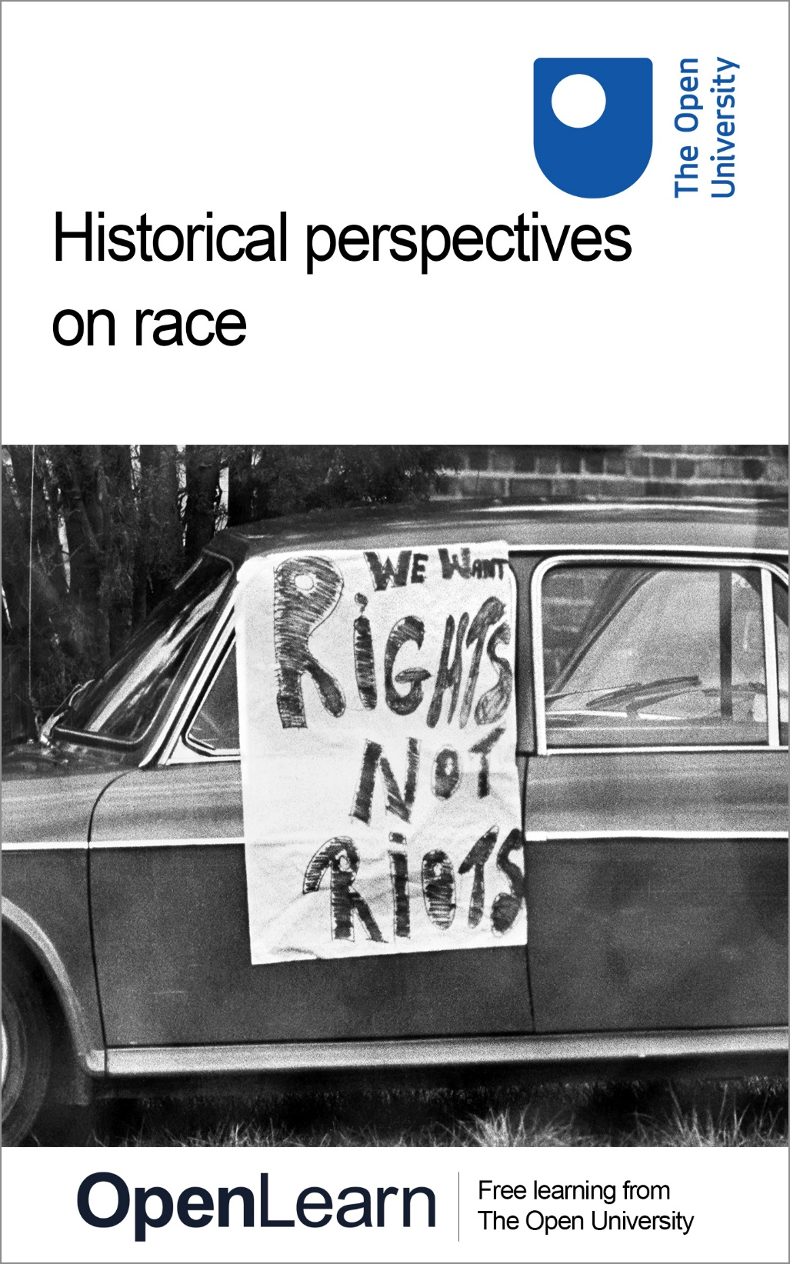

ALT_1

Historical perspectives on race

About this free course
This free course is an adapted extract from the Open University course .
This version of the content may include video, images and interactive content that may not be optimised for your device.
You can experience this free course as it was originally designed on OpenLearn, the home of free learning from The Open University –
There you’ll also be able to track your progress via your activity record, which you can use to demonstrate your learning.
Copyright © 2015 The Open University
Intellectual property
Unless otherwise stated, this resource is released under the terms of the Creative Commons Licence v4.0 http://creativecommons.org/licenses/by-nc-sa/4.0/deed.en_GB. Within that The Open University interprets this licence in the following way: www.open.edu/openlearn/about-openlearn/frequently-asked-questions-on-openlearn. Copyright and rights falling outside the terms of the Creative Commons Licence are retained or controlled by The Open University. Please read the full text before using any of the content.
We believe the primary barrier to accessing high-quality educational experiences is cost, which is why we aim to publish as much free content as possible under an open licence. If it proves difficult to release content under our preferred Creative Commons licence (e.g. because we can’t afford or gain the clearances or find suitable alternatives), we will still release the materials for free under a personal end-user licence.
This is because the learning experience will always be the same high quality offering and that should always be seen as positive – even if at times the licensing is different to Creative Commons.
When using the content you must attribute us (The Open University) (the OU) and any identified author in accordance with the terms of the Creative Commons Licence.
The Acknowledgements section is used to list, amongst other things, third party (Proprietary), licensed content which is not subject to Creative Commons licensing. Proprietary content must be used (retained) intact and in context to the content at all times.
The Acknowledgements section is also used to bring to your attention any other Special Restrictions which may apply to the content. For example there may be times when the Creative Commons Non-Commercial Sharealike licence does not apply to any of the content even if owned by us (The Open University). In these instances, unless stated otherwise, the content may be used for personal and non-commercial use.
We have also identified as Proprietary other material included in the content which is not subject to Creative Commons Licence. These are OU logos, trading names and may extend to certain photographic and video images and sound recordings and any other material as may be brought to your attention.
Unauthorised use of any of the content may constitute a breach of the terms and conditions and/or intellectual property laws.
We reserve the right to alter, amend or bring to an end any terms and conditions provided here without notice.
All rights falling outside the terms of the Creative Commons licence are retained or controlled by The Open University.
Head of Intellectual Property, The Open University

Contents
- Course introduction
  - 1 Introduction
  - 2 Key questions
    - 2.1 What do we mean when we talk about ‘race’ in the past?
    - 2.2 How was the concept of ‘race’ invented?
    - 2.3 How did ideas of ‘race’ operate in political, legal and economic terms?
    - 2.4 What are the challenges we face in describing ‘race’ in our study of the past?
  - 3 Summary of Course introduction
- Session 1: The Haitian Revolution
  - 1 Introduction
  - 2 The impact of the French Revolution
  - 3 The great slave rebellion of 1791
  - 4 Fighting for and against France
  - 5 Summary of Session 1
- Session 2: Human ‘zoos’ in the nineteenth century
  - 1 Introduction
  - 2 Sarah Baartman, the ‘Hottentot Venus’
  - 3 Reinforcing colonial stereotypes about Africa: Savage South Africa
  - 4 Summary of Session 2
- Session 3: Gandhi’s train journey in colonial South Africa
  - 1 Introduction
  - 2 Racial discrimination in colonial South Africa
  - 3 Gandhi’s train journey in South Africa
  - 4 Summary of Session 3
- Session 4: Yemeni Muslim sailors in Cardiff
  - 1 Introduction
  - 2 How did Yemeni sailors come to live in Cardiff?
  - 3 What was community life like for Yemenis in Cardiff?
  - 4 Marriages with Welsh women
  - 5 Local backlash: Cardiff ‘race riots’
  - 6 Summary of Session 4
- Session 5: Algerian Harkis in France in the 1960s and 1970s
  - 1 Introduction
  - 2 Harkis and the Algerian War
  - 3 Harkis and Pieds-Noirs: Comparing their reception in France
  - 4 Summary of Session 5
  - 5 Course conclusion
- References
- Acknowledgements
- Solutions

Course introduction

1 Introduction

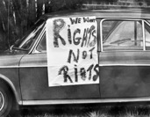
Figure 1 Anti-apartheid sign on a car in Cape Town, South Africa (1976). You will learn more about early resistance to apartheid in Session 3.
View description - Figure 1 Anti-apartheid sign on a car in Cape Town, South Africa (1976). You will ...
View description - Figure 1 Anti-apartheid sign on a car in Cape Town, South Africa (1976). You will ...

This short course will introduce you to the development of the social construction of ‘race’ in the past. The course draws from some of the materials that you can study in the History degree at The Open University.
Through a number of case studies, you will learn about the experiences of groups of people and individuals who were considered different to others, within their own environments, as a result of perceptions of their ‘race’. In addition to this introduction the course is divided into 5 sessions. The sessions cover the following examples:
- Black self-liberated revolutionaries in Haiti winning independence from France in 1804
- the controversial practice of exhibiting humans in ‘zoos’ in Europe in the late nineteenth century
- how a racist incident on a train in South Africa in 1893 sparked the anti-racist activism of M.K. Gandhi
- the establishment of Arab communities in Wales in the nineteenth century, and the racism they combatted into the 1900s
- the experience of Algerian Muslim French army veterans, who faced racism in France after Algerian independence in the 1960s.
These examples cover a wide geographical scope, over a time span of about 200 years. The aims of the course are:
- to introduce you to stories of the past that you might be unfamiliar with
- to encourage you to think about the experiences of different groups of people in the past and to understand how historians use textual and visual sources to uncover diverse histories
- to help you think about how racist structures operated in the past, and how these structures often rested on perceptions of difference based on race, ethnicity and religious expression
- to help you recognise how groups of people resisted racism in the past and also resisted the idea that one particular ‘race’ was superior
- to give you a taster of some of the undergraduate degree offer at The Open University.
Moving around the course
In the ‘Summary’ at the end of each session, you will find a link to the next session. If at any time you want to return to the start of the course, click on ‘Full course description’. From here you can navigate to any part of the course.
It’s also good practice, if you access a link from within a course page, to open it in a new window or tab. That way you can easily return to where you’ve come from without having to use the back button on your browser.

2 Key questions
In this introduction, you will be guided by the following questions:
- What do we mean when we talk about ‘race’ in the past?
- How was the concept of ‘race’ invented?
- How did ideas of ‘race’ operate in political, social, legal and economic terms?
- What are the challenges we face in describing ‘race’ in our study of the past?
Please be aware, this course includes descriptions and depictions of violence, slavery and racist language. If you are likely to find this distressing, please consider carefully how you might want to engage with this.

OpenLearn’s Race and Ethnicity Hub
This course is part of OpenLearn’s Race and Ethnicity Hub, a dedicated space for free resources focusing on race, racism and ethnicity.

2.1 What do we mean when we talk about ‘race’ in the past?
We often think of race as a historical or biological fact: that humans have always grouped people into what we term races, and that there is a biological basis to race that is fixed in time and space. But this is not the case. The concept of ‘five races’ only dates from the eighteenth century, when European scientists divided the world’s people into racial categories generally aligned to African, Asian, European, Native American and Australasian. The belief that race is somehow a fixed category underpins a false construction of white superiority. Crucially, recent advances in genetic mapping have uncovered that there are only tiny variations in DNA among humans across the globe.
Race is not a scientific category. Race is a social, political and legal construction. Our understanding of race has changed over time. But definitions of race have great consequence: these definitions continue to shape the experiences of people in the past and the present, and in different geographical, social, economic, political and legal contexts.

2.2 How was the concept of ‘race’ invented?
Prior to the 1600s, the term ‘race’ was used infrequently in Europe. For example, in Shakespeare’s England, the word race was normally used in the context of family origin or lineage, for example in describing a royal ‘race’. Even in this usage, it was a socially constructed term designed to reinforce hierarchies of power: it referred loosely to what we might now consider genetic or geographical heritage, but without any scientific or biological basis. However, by the seventeenth century, the word ‘race’ started to acquire a different meaning: in Britain, for example, it began to be used to define those who held power as ‘white’. Those who were not considered ‘white’ often experienced discrimination – no matter what the colour of their skin was. This racialisation has proved to be enduring. You can see an example of this in the treatment of M.K. Gandhi at Pietermaritzburg station in South Africa in 1893 (see Session 3), and in the ways that the Yemeni population was racialised in Cardiff during the 1919 race riots (see Session 4).

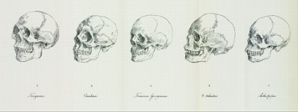
Figure 2 German scientist Johann Friedrich Blumenbach, in his book On the Natural Variety of Mankind (1776), classified humans into (l–r) Mongolian, (Native) American, Caucasian, Tahitian, Ethiopian. At the centre of his diagram was what he called the ‘most beautiful skull’, that of a woman from Georgia in the Caucasus – giving rise to the term ‘Caucasian’.
View description - Figure 2 German scientist Johann Friedrich Blumenbach, in his book On the Natural ...
View description - Figure 2 German scientist Johann Friedrich Blumenbach, in his book On the Natural ...

Several factors contributed to the modern construction of ‘race’, including:
- The Christianisation of Europe and the end of the Wars of Religion (1520s–1710s). After prolonged religious conflict, a period of relative harmony allowed Christian Europeans to think of themselves as superior to those who weren’t Christian in Africa and Asia. Eventually, Europeans would use their own religious and cultural standards as a key measurement of defining what, and whom, was ‘civilised’ or not to them.
- Systems of categorisation and taxonomy developed in the seventeenth and eighteenth centuries: for example, in the 1770s the German scientist Johann Friedrich Blumenbach sought to explain the diversity of humans by dividing them into ‘types’ or ‘species’ according to the design of their skulls (see Figure 2 above). This kind of early scientific categorisation would become an important tool in the development of eugenics and racist thinking, and was later linked with Charles Darwin’s evolutionary theories and the racial hierarchies of social Darwinism.
- The growth of nationalism, and the early emergence of the nation state during the seventeenth and eighteenth centuries in Europe. Increasingly, matters of political and personal identity developed around belonging to a region or a nation, separating people according to perceived differences connected to a supposed land of origin. This also created narratives of the ‘other’; for example, when English settlers established political control over Ireland in the seventeenth century, they created social and legal systems that designated the Irish as ‘uncivilised’ and therefore, in English eyes, as inferior.

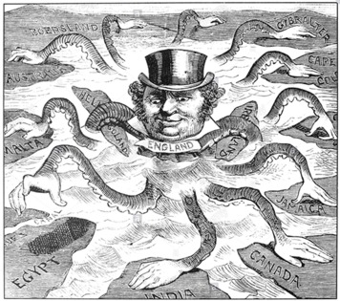
Figure 3 ‘The Devilfish in Egyptian Waters’, 1882. An American cartoon depicting John Bull (England) as the octopus of imperialism, grabbing land on every continent.
View description - Figure 3 ‘The Devilfish in Egyptian Waters’, 1882. An American cartoon depicting ...
View description - Figure 3 ‘The Devilfish in Egyptian Waters’, 1882. An American cartoon depicting ...

- The global expansion of European empires. The expansion of the British empire through conquest and annexation from the seventeenth century codified certain assumptions about race into legal, economic and political systems. Private companies like the British East India Company (1600–1874) oversaw a substantial shift in power in India from Indian elites to British colonial agents. The colonial occupation of the Indian sub-continent was almost always justified in racialised terms: Indians were deemed incapable of governing themselves. Even though British India included many Indian officials in its bureaucracy, the highest echelons of the Indian Civil Service and political power remained in the hands of British officials and reinforced racialised hierarchies.
- The development of the Atlantic Slave Trade. As the Portuguese, Spanish, Dutch and English extended their global economic influence through the conquest of lands in the Americas, they developed specific attitudes to justify their treatment of Indigenous peoples as forced labour after conquest. These attitudes extended towards men, women and children captured or sold into slavery in Africa, and transported across the Atlantic to work on farms, plantations and industries in the Americas. Between the mid-sixteenth and the mid-nineteenth centuries, over 12 million Africans were forcibly displaced from Africa to the Americas. You can find estimates and more information about the Trans-Atlantic slave trade through the Slave Voyages database. In particular, it is in the early European colonisation of the Americas that we see the conflation of skin colour with political and social status, resulting in complex systems of discrimination, especially against peoples of African origin. More than any other factor, the horrifically enormous scale of the enslavement of people from Africa was justified by racist thinking, and informed the development of complex systems of racial hierarchies.
- Chattel slavery. Perceived difference based on skin colour became more pronounced with the development of chattel slavery systems from the mid-seventeenth century. Chattel slavery refers to types of slavery common in parts of the Americas (especially in Brazil, the Caribbean and what became the United States of America) where enslavement was an inherited condition passed through generations, usually removing political and economic freedom from peoples of African origin. Through this form of slavery, skin colour and inferior status were inextricably linked in the minds of those who considered themselves white. The endurance of this kind of slavery was based on beliefs of white supremacy, which were used to justify ownership of other people. Not all people of African origin were enslaved, but many ’white’ Europeans and Americans believed there was a link between skin colour and political and social inferiority. The impact of chattel, or hereditary, slavery on societies in the Caribbean, and parts of North and South America was devastating and long-lasting.

2.3 How did ideas of ‘race’ operate in political, legal and economic terms?
Systems of exploitation pre-existed the development of chattel slavery and the European empires. But modern ideas of race developed for the most part as a convenient tool to explain and justify systems of exploitation of people who did not live in Europe, especially people of African origin, where such exploitation was hugely beneficial economically to wealthy European elites. For example, historians have drawn clear links between wealth generated through slavery and the growth of capitalism during the British industrial revolution.
In Britain, Europe and the United States, elites tended to connect their ‘whiteness’ with national, personal, moral and economic supremacy. ‘Blackness’ or ‘brownness’ became synonymous with wholescale inferiority, inability to thrive economically, and being unfit for political autonomy and other types of independent agency. It is important to remember that the term ‘white’ also developed a specific kind of meaning in politics and society: ‘white’ didn’t really describe skin colour, but became associated with a particular kind of political and social power. In the US state of Virginia, for example, the Racial Integrity Act of 1924 defined race according to ‘blood’. This highly discriminatory law defined white as anyone ‘who has no trace whatsoever [not one drop] of any blood other than Caucasian’. This racist view was controversial at the time; it indicated an official position that race could not be determined by physical skin colour, but would be defined by state officials intent on preserving established systems of power based on white supremacy.

2.4 What are the challenges we face in describing ‘race’ in our study of the past?
As discussed earlier, race is something that is not fixed in meaning, and so it can be challenging to accurately use language to describe racialised differences. Some of the primary sources you will read during this course will use derogatory and racist language to describe people’s race and ethnicity. It is important to acknowledge that these words were used in historical documentation – often by governments, police forces, newspapers, employers, among many others – to reinforce systems of discrimination.
Historians try to use language accurately to ensure we understand the past in context, but avoid replicating the systems of discrimination we study. For example, when writing about slavery, we usually talk about ‘enslaved people’ rather than slaves. This language is important because it acknowledges the humanity of enslaved people, instead of using the description forced on them by their enslavers.
This course also uses language that accurately describes people’s experiences and complex identities within their own political and social environment. So, in their session on the Haitian revolution, Dr Anna Plassart and Dr Robin Mackie use the terms ‘Black’ to describe some people and ‘mixed race’ (gens de couleur) to describe others: this reflects the different contemporary social and political experiences of the people they discuss. In the session on human ‘zoos’, Dr Suki Haider describes Sarah Baartman as Khoikhoi – a term to describe one of the Khoe-speaking polities in South Africa, and much more accurate than the pejorative colonial designation of ‘Hottentot’ that was used by Baartman’s contemporaries to describe her origins.
Different words have different meanings in specific contexts, and they often acquire different meanings over time: it is important to pay attention to the words we use to describe people in the past and present. A good example of this is the adoption of the word ‘Negro’ as a very positive term by Black activists like W.E.B. Du Bois in the USA during the early twentieth century; this term is no longer seen as a positive description of identity.

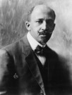
Figure 4 W.E.B. Du Bois (1868-1963), sociologist, activist and author of The Souls of Black Folk.
View description - Figure 4 W.E.B. Du Bois (1868-1963), sociologist, activist and author of The Souls ...
View description - Figure 4 W.E.B. Du Bois (1868-1963), sociologist, activist and author of The Souls ...

Activity 1
Allow around 30 minutes for this activity

Read the extract below from W.E.B. Du Bois, The Souls of Black Folk and look at the way Du Bois describes racial differences. Consider the following questions and make notes in the box below.
- How does Du Bois describe the tensions between being Black and American?
- What does this tell you about the difficulties faced by Black Americans in the early twentieth century?
- What is the significance of the word ‘Negro’ as a capitalised description of race?
- Pay attention to the lyrical language Du Bois uses. Why might this be important?

…After the Egyptian and Indian, the Greek and Roman, the Teuton and Mongolian, the Negro is a sort of seventh son, born with a veil, and gifted with second-sight in this American world,—a world which yields him no true self-consciousness, but only lets him see himself through the revelation of the other world. It is a peculiar sensation, this double-consciousness, this sense of always looking at one’s self through the eyes of others, of measuring one’s soul by the tape of a world that looks on in amused contempt and pity. One ever feels his twoness,—an American, a Negro; two souls, two thoughts, two unreconciled strivings; two warring ideals in one dark body, whose dogged strength alone keeps it from being torn asunder.
The history of the American Negro is the history of this strife,—this longing to attain self-conscious manhood, to merge his double self into a better and truer self. In this merging he wishes neither of the older selves to be lost. He would not Africanize America, for America has too much to teach the world and Africa. He would not bleach his Negro soul in a flood of white Americanism, for he knows that Negro blood has a message for the world. He simply wishes to make it possible for a man to be both a Negro and an American, without being cursed and spit upon by his fellows, without having the doors of Opportunity closed roughly in his face.
(Du Bois, 1903)

Provide your answer...
View discussion - Activity 1

3 Summary of Course introduction
You now have some ideas to think about as you start to explore the sessions in this course. Remember that these are stories of people’s experiences in particular times and places in the past. These are not exhaustive or comprehensive examples. Yet by the end of the course you should be able to think more critically about the ways that difference was constructed according to the interplay between race and ethnicity, and sometimes also religion, to have a real impact on people’s lives. You will also have some understanding of how people resisted racism locally and globally.

Explore further
A free OpenLearn article: W.E.B. Du Bois: A man for all times?
A free OpenLearn course: The American civil rights movement
You can now go to Session 1.

Session 1: The Haitian Revolution

1 Introduction
This session was written by Dr Anna Plassart and Dr Robin Mackie

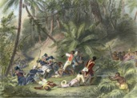
Figure 1 Illustration depicting Francois Dominique Toussaint L’Ouverture participating in the successful revolt against French power in Saint-Dominigue (Haiti). Hand-coloured engraving, 1900.
View description - Figure 1 Illustration depicting Francois Dominique Toussaint L’Ouverture participating ...
View description - Figure 1 Illustration depicting Francois Dominique Toussaint L’Ouverture participating ...

When the French Revolution broke out in 1789, France possessed a number of colonies in the Caribbean. The largest and most prosperous of these was Saint-Domingue, now known as Haiti. Black enslaved people formed the majority of the population – almost 90 per cent, of whom almost two-thirds had been born in Africa (Dubois and Garrigus, 2006, p. 13).
A small elite of white plantation owners controlled the colony. In addition, there was a population of poorer white people referred to as the petits blancs (the small whites). A larger group of non-enslaved peoples, who were known as gens de couleur (directly translates as ‘people of colour’), included both people of mixed race and a small number of free Black people. Saint-Domingue was therefore a fractured society, divided by wealth and class, as well as by race and servitude.
This session will examine the successful revolt by self-liberated formerly enslaved people in Saint-Domingue, and their fight for independence from France.

2 The impact of the French Revolution
The French Revolution soon exacerbated existing divisions within colonial society. The gens de couleur, with some backing from reformers in Paris, argued that the Declaration of the Rights of Man and of the Citizen of 1789 meant all free men should enjoy equal rights. These demands aroused the fury of many white colonists, and particularly that of the petits blancs, some of whom saw their status as under threat.

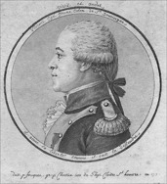
Figure 2 A portrait of Vincent Ogé.
View description - Figure 2 A portrait of Vincent Ogé.
View description - Figure 2 A portrait of Vincent Ogé.

Tensions broke out in the colony: a revolt led by one of the leaders of the gens de couleur, Vincent Ogé, was defeated in February 1791 and Ogé was tortured and executed. Later in 1791, following a decision by the French National Assembly to grant citizenship to free men of colour, open fighting started between armed groups of white and mixed-race people.

3 The great slave rebellion of 1791

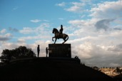
Figure 3 People stand under a statue of Jean-Jacques Dessalines, a leader of the Haitian Revolution and the first ruler of an independent Haiti, in Port au Prince on February 10, 2018 in Port-au-Prince, Haiti.
View description - Figure 3 People stand under a statue of Jean-Jacques Dessalines, a leader of the ...
View description - Figure 3 People stand under a statue of Jean-Jacques Dessalines, a leader of the ...

The conflicts between different groups of white and mixed-race settlers in Saint-Domingue were not primarily about the question of slavery. Yet they formed the background to the great slave rebellion which swept the Northern Plain – the richest part of the colony – on 22 August 1791. The anti-slavery uprising spread rapidly, destroying hundreds of sugar and coffee plantations. Many white colonists were killed, while others fled to the towns. The rebels were at first only around 1,000 strong, but by the end of September they numbered between 10,000 and 20,000 and were well armed and organised (Dubois and Garrigus, 2006, pp. 24–5).

4 Fighting for and against France

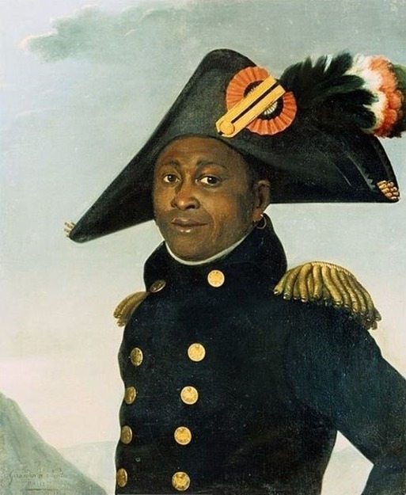
Figure 4 Alexandre Francois Louis, Comte de Girardin, A Portrait of Toussaint Louverture, c.1804.
View description - Figure 4 Alexandre Francois Louis, Comte de Girardin, A Portrait of Toussaint Louverture, ...
View description - Figure 4 Alexandre Francois Louis, Comte de Girardin, A Portrait of Toussaint Louverture, ...

Over time, the slave rebellion developed into a disciplined force led by a former enslaved person, Toussaint Louverture (c.1743–1803).
Under Louverture’s command, the Black insurgents allied with republican France to fight off a Spanish invasion. In 1796 Louverture was made deputy governor of the colony, and in 1797 commander-in-chief of the French forces in the colony.
By 1802, Napoleon Bonaparte (by then First Consul of the French Republic) decided to reassert Parisian control of Saint-Domingue, and he sent a large army there under the command of General Charles Victor-Emmanuel Leclerc. But Black Haitians suspected that France’s real aim was to restore slavery and the plantation system to the colony. Relations with Leclerc were poor from the start and soon deteriorated into open conflict. Leclerc promised Louverture immunity if he retired, but instead had him arrested and sent to France, where he died as a prisoner in 1803.
Meanwhile, French power in Saint-Domingue was disintegrating, despite brutal attempts to maintain control (represented artistically in Figure 5). Leclerc’s army was ravaged by Yellow Fever, while uprisings of the freed Black slaves and their supporters multiplied. Black and mixed-race forces united against the French, under the command of Louverture’s former main lieutenant, Jean-Jacques Dessalines (1758–1806). Many Black women took up arms against the French, most famously Marie-Jeanne Lamartiniere who fought fearlessly at the Battle of Crete-a-Pierrot in 1802 (Girard, 2009).

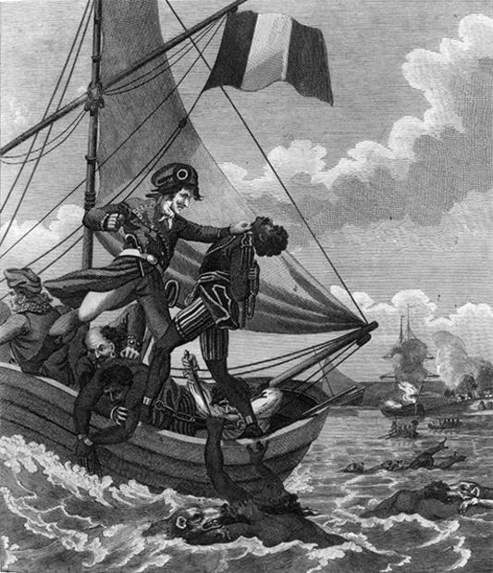
Figure 5 ‘The Mode of exterminating the Black Army, as practised by the French’. From Marcus Rainsford, An Historical Account of the Black Empire of Hayti, 1805.
View description - Figure 5 ‘The Mode of exterminating the Black Army, as practised by the French’. ...
View description - Figure 5 ‘The Mode of exterminating the Black Army, as practised by the French’. ...

Fighting was extremely brutal, but by November 1803 the remainder of the French forces had been evacuated. On 1 January 1804 Dessalines proclaimed the independent state of Haiti, stating that ‘we must live independent or die’. In the following months, his army massacred thousands of remaining white settlers, and he was crowned Emperor of Haiti.

Activity 1
Allow around 25 minutes for this activity

This painting below, Figure 6, represents the 1802 alliance of two leaders of the Haitian Revolution against Napoleon’s army: Alexandre Pétion, a prominent leader of the gens de couleur (left), and Jean-Jacques Dessalines, leader of the Black insurgents (right). It was painted in honour of the Haitian Revolution by a well-known French mixed-race painter, Guillaume Guillon-Lethière.
Take a few minutes to look carefully at Figure 6, focusing particularly on the three main characters. Don’t forget to also read the image caption. Then answer the following question:
- How does the painting represent the influence of France on the Haitian Revolution?

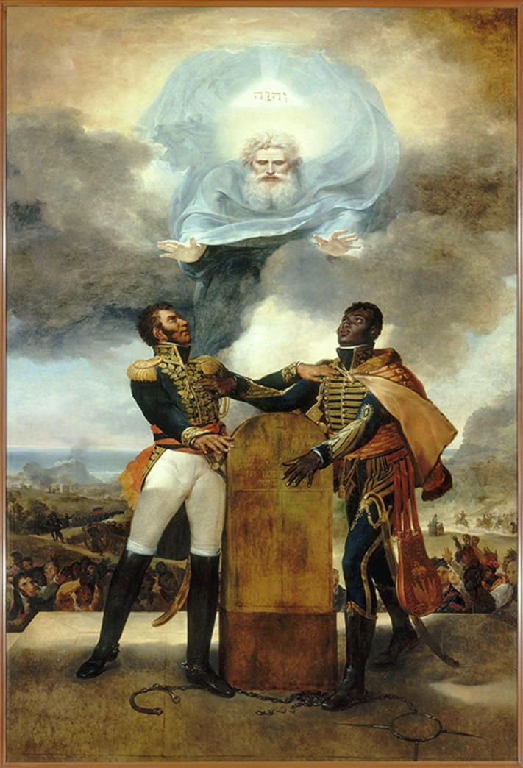
Figure 6 Guillaume Guillon-Lethière, Serment des ancêtres (Oath of the Ancestors), 1822. The stone altar’s engraving reads: ‘L’union fait la force / Vivre libre ou mourir / Il n’y a de véritable liberté qu’avec la religion, les loix … constitution’ (’Unity is strength / Live free or die / There is no true liberty without religion, laws … constitution’).
View description - Figure 6 Guillaume Guillon-Lethière, Serment des ancêtres (Oath of the Ancestors), ...
View description - Figure 6 Guillaume Guillon-Lethière, Serment des ancêtres (Oath of the Ancestors), ...

Provide your answer...
View discussion - Activity 1

It is important to note, however, that the Haitian Revolution was equally shaped by a number of other influences, especially the Creole language and culture that had developed from contacts between West African enslaved peoples and European settlers.

5 Summary of Session 1
The Haitian Revolution remains one of history’s very few successful slave revolts. Haitian independence challenged the interests of many Frenchmen, and the French State tried hard to overturn and, later, to contain Haiti (as did other European powers and the United States of America). This meant that Haiti long remained isolated from the international community.
By the mid-twentieth century, however, European empires were being defeated and dismantled. While Haiti might have been an isolated exception in the 1800s, it was a pioneer for the many post-colonial states that exist today.
In the next session, you’ll explore the ways that colonialism and racist ideas led to the fetishisation of Black bodies in what were called human ‘zoos’ in Europe.

Explore further
You can study more about the Haitian Revolution in Unit 3 of the OU course A113 Revolutions.
You can now go to Session 2.

Session 2: Human ‘zoos’ in the nineteenth century

1 Introduction
This session was written by Dr Suki Haider

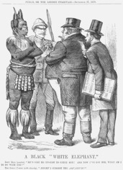
Figure 1 ‘A Black “White Elephant”’, 1879. Artist: Joseph Swain.
View description - Figure 1 ‘A Black “White Elephant”’, 1879. Artist: Joseph Swain.
View description - Figure 1 ‘A Black “White Elephant”’, 1879. Artist: Joseph Swain.

Text below illustration in Figure 1
John Bull (puzzled). “HE’S COST ME ENOUGH TO CATCH HIM! AND NOW I’VE GOT HIM, WHAT AM I TO DO WITH HIM?”
The Great F-RINI (with alacrity). “MIGHT I SUGGEST THE AQUARIUM?”

The satirical cartoon in Figure 1 shows the Zulu Chief Cetewayo (c.1826–1884) who had recently been captured by colonists. John Bull, the caricature representative of the British people, wonders what to do with him, while the man at the right of the cartoon is a showman who displayed African people in human ‘zoos’. From the weekly magazine Punch, or the London Charivari, 27 September 1879.
Living Indigenous people, from parts of the world colonised or under the influence of European colonisers, were exhibited throughout Europe and North America in the nineteenth century. Initially, the voyeuristic shows took place in private houses. By the end of the nineteenth century Africans, contracted to perform as ‘savages’ in re-enactments of recent battles, were a feature of the mass entertainment offered at the international fairs that toured Europe. The complex history of so-called human ‘zoos’ reflects the changing viewing context and evolving relationships between audiences, agents and human exhibits. As the leading historian of this phenomena Dr Sadiah Qureshi explains, some spectators were disgusted, others talked to, gave gifts to, shook hands with, danced with and had relationships with the exhibited people (Qureshi, 2011, p. 278).
Throughout the century promoters appealed to white spectators’ curiosity. They were keen to distinguish their ‘exotic’ exhibits from Britain’s resident ethnic minority populations. There was also fascination with foreign peoples as natural history specimens and the shows enabled the public to engage in the then current social Darwinist debates about human difference. In Britain, many professional anthropologists had close associations with live human exhibitions until the early twentieth century, when scholarship demanded that research of Indigenous peoples was carried out in their own environment. In this session, you will consider two contrasting examples of human exhibitions.

2 Sarah Baartman, the ‘Hottentot Venus’

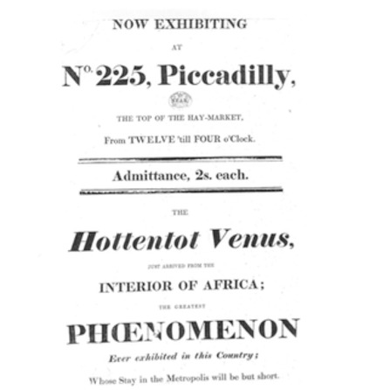
Figure 2 A promotional poster for the exhibition of Sarah Baartman, London, 1810. She is described by historians as the ‘the first foreign celebrity exhibit of the century’ (in Qureshi, 2011, p. 130).
View description - Figure 2 A promotional poster for the exhibition of Sarah Baartman, London, 1810. ...
View description - Figure 2 A promotional poster for the exhibition of Sarah Baartman, London, 1810. ...

Saartjie Baartman (c.1775–1815), a member of the Indigenous Khoikhoi people of South Africa, had been sold into slavery and was brought to London by a Scotsman who procured people for display. Given the European name ‘Sarah’, she became widely known by the pejorative term ‘Hottentot Venus’ (European settlers used the name Hottentot to describe nomadic peoples like the Khoikhoi in South Africa). Satirist illustrators focused on her physique, especially the perceived enormity of her buttocks. In 1801, she was exhibited almost naked at No. 225 Piccadilly, London, before spectators who paid two shillings (see Figure 2). According to the evidence, she was ‘led by her keeper, and exhibited like a wild beast’ and the spectators were encouraged to prod her (Qureshi, 2011, p. 146).
The term ‘keeper’ is notable, as she was then sold to an animal trainer and exhibited in Paris. Accounts record she was a degraded and unwilling participant, hitting her minders when she could. She refused to give the anatomists, who studied her, permission to conduct an intimate examination. Throughout the century displayed people often resisted being used as specimens of scientific study, for example refusing to be measured or to pose naked for photographs. Members of Britain’s slavery abolition movement also tried to resist her exploitation through a newspaper campaign and a failed legal action to halt the exhibition.
But even in death, the exploitation continued. Her body was dissected, and her skeleton and a plaster replica of her body were displayed in Paris. They were removed in 1970, following feminist protests at the violation of her dignity. In 2002 her remains were returned to Africa, after an eight-year restitution campaign instigated by South African President Nelson Mandela. At her funeral, Mandela’s successor, President Thabo Mbeki, said her story was emblematic of the colonial abuse of the African continent. Today a sculpture of Baartman, at the University of Cape Town, provokes debate about the colonial abuse of women and how racism was legitimised by science, as shown in Figure 3.

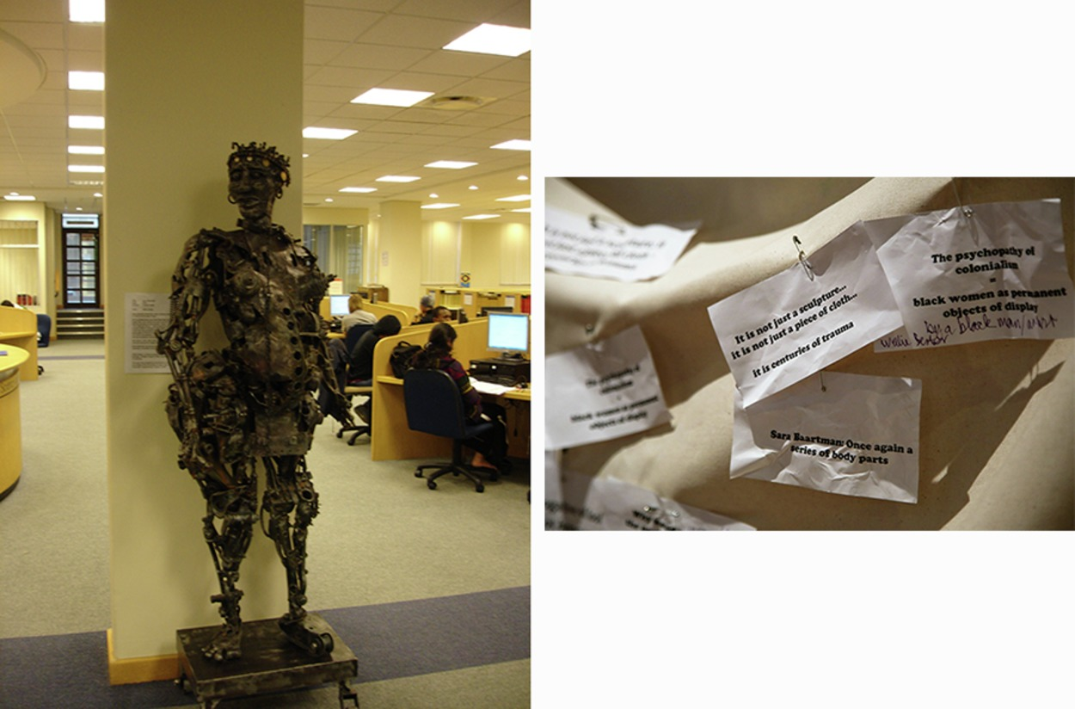
Figure 3 Left, a sculpture of Baartman at the University of Cape Town. Students have demanded the statue be ‘dignified’ and have covered it with cloth, and right, pinned notes of protest.
View description - Figure 3 Left, a sculpture of Baartman at the University of Cape Town. Students have ...
View description - Figure 3 Left, a sculpture of Baartman at the University of Cape Town. Students have ...

For most of the nineteenth century it was common for individuals to be exhibited for public entertainment and ‘education’. Other Khoikhoi were displayed in exploitative exhibitions, prompting complaints from the Aborigines’ Protection Society. By the end of the century whole groups of people were displayed. They were often paid professionals, supported by recruiting officers who negotiated their permission to travel and work.

3 Reinforcing colonial stereotypes about Africa: Savage South Africa
Savage South Africa was a human exhibition in London’s Earl’s Court exhibition centre from 1899–1900. It was typical of the lavish entertainment designed to celebrate the triumph of European empires. By 1900 Europeans controlled 90% of the African continent and 1 in 3 Africans were British colonial subjects (Olusoga, 2016, p. 401). Produced by South African circus owner Frank Fillis, the ‘Horde of Savages’ show was advertised as the chance to see ‘Africa’ and dramatic re-enactments of the 1893–1894 Anglo-Ndebele War that had been fought in Matabeleland and Mashonaland (Qureshi, 2011, p. 250). These territories became part of Rhodesia and today are regions of Zimbabwe.
Twice a day, amid the tightrope and equestrian acts, seated spectators were reminded of European superiority as 200 Africans, armed with shields and spears, were outmatched by 20 British South Africa Company soldiers with guns, who were played by the Boers (Dutch settler colonialists) in the troupe. In between the performances spectators watched, from behind fences, ‘native’ life in the mock African village (see Figure 4). The Black human exhibits, wearing costumes Fillis designed, performing the ceremonies he instructed and eating the food he prescribed, were constantly supervised.
When frustration on the part of the British ‘exhibits’ led to overt resistance and violence, the human ‘exhibits’ were granted limited freedom to walk around the show grounds. The Aborigines’ Protection Society protests against the exploitative blurring of the performers’ working and living conditions received little public sympathy. The exhibits were hugely popular with Victorians keen to view the latest enemy in the European Partition of Africa.

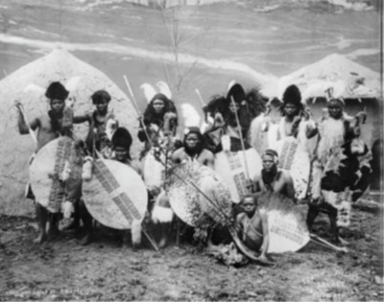
Figure 4 11 of the 200 Black performers from Savage South Africa. Behind them are the huts and one of the several painted backdrops used to fabricate the African village at the Earl’s Court showground. The photograph bears Frank Fillis’ stamp and records a ‘chief and group of Swazies’, 1899.
View description - Figure 4 11 of the 200 Black performers from Savage South Africa. Behind them are ...
View description - Figure 4 11 of the 200 Black performers from Savage South Africa. Behind them are ...

The demise of the Savage South Africa show was partly due to the mistaken belief in racial biological difference and racial hierarchy. The thought of racial mixing horrified most Victorians. The international press was initially scandalised by the rumoured sexual relations between white women and Black men who were part of the human exhibit, and this led to a ban of female visitors to the mock village. The show closed following damning reports of the marriage of a Black performer (said to be Peter Lobengula, the son of the defeated Ndebele king) and an English woman – Kitty Jewell. They soon divorced and, in 1902, Peter married the Irish woman Lily Magowan. They settled in Lancashire, and had five children before Peter died in 1913.
In 1900 Fillis took the show on a national tour, but its re-enactments no longer interested a public gripped by Britain’s war with the Boers in South Africa (1899–1902).

Activity 1
Allow around 20 minutes for this activity

Visual images are a valuable source of historical evidence and historical context is important to their interpretation. Examine Figure 5 closely, consider the information in the caption, then answer the following question:
- Drawing on the historical context provided above, how does the image in Figure 5 contribute to the study of nineteenth-century human exhibitions?
It is helpful to begin your answer by identifying what you can see.

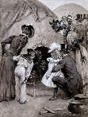
Figure 5 ‘A Peep at the Natives’, Graphic, 4 June 1899. The image appears to show a middle-class Victorian family attending the Savage South Africa exhibition. The Graphic was a British weekly illustrated newspaper.
View description - Figure 5 ‘A Peep at the Natives’, Graphic, 4 June 1899. The image appears to show ...
View description - Figure 5 ‘A Peep at the Natives’, Graphic, 4 June 1899. The image appears to show ...

Provide your answer...
View discussion - Activity 1

4 Summary of Session 2
Human ‘zoos’ have been described as ‘a racist theme park for Europe’s colonialists’. This is a description that is supported by the cartoon from the satirical magazine Punch, in 1879 (see Figure 1). The exhibitions were, for the most part, the primary encounter most Europeans had with Africa. In Britain, exhibited Africans were presented as exceptional, to set them apart from Black members of the resident population. The exhibition of living people as objects of inspection and entertainment supported the scientific debates about human evolution, and reinforced the belief that white people were the superior race. In Europe, displays remained popular in the twentieth century. 34 million people visited the Paris colonial exhibition in 1931, viewing mock villages and human beings in cages. As late as 1958, Belgium exhibited Congolese men, women and children in ‘native conditions’, behind a fence, at their world fair. Congo became an independent republic in 1960. In 2018, the University of Cape Town renamed the hall at the centre of its campus Sarah Baartman Hall, ‘to honour her memory and to restore to her name the dignity that was so brutally stolen from her in the 19th century’ (Pityana and Phateng, 2018).
In the next session, you will learn more about perceptions of race in South Africa and efforts to resist racist social and political structures.

Explore further
Registered Open University students can access academic scholarship on Baartman and the racist practice of human exhibition through the OU University Library’s catalogue.
For more on Baartman, see the website South African History Online.
You can now go to Session 3.

Session 3: Gandhi’s train journey in colonial South Africa

1 Introduction
This session was written by Dr John Slight

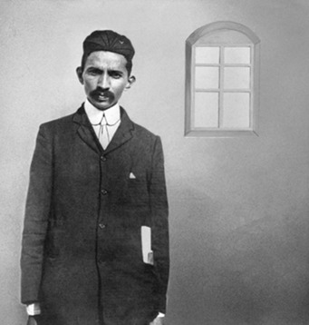
Figure 1 Gandhi in Johannesburg, 1900, where he was working as a solicitor for an Indian businessman.
View description - Figure 1 Gandhi in Johannesburg, 1900, where he was working as a solicitor for an ...
View description - Figure 1 Gandhi in Johannesburg, 1900, where he was working as a solicitor for an ...

M.K. Gandhi (1869–1948) was one of the leading figures in India’s independence struggle against British colonial rule. His activism inspired people living across the world to fight against the injustices of colonialism and racism. Where did Gandhi’s journey from a successful attorney to figure of global importance begin? Many scholars of Gandhi have pinpointed one key event that changed the trajectory of his life: in 1893, when he was ejected from a First-class train compartment in colonial South Africa because he was not white. Since the mid-seventeenth century, Black people were treated as second-class citizens in their own land by Dutch and British colonial rulers and then white-nationalist Afrikaners, which is a direct consequence of the social construction of race. South Africa transitioned from the apartheid system of racial segregation to Black majority rule in 1994 when Nelson Mandela was elected president.
This session explores the racist incident with Gandhi on the train, placing it in the context of structural racism in South Africa and the wider British empire, and drawing on Gandhi’s own account of the incident.

2 Racial discrimination in colonial South Africa

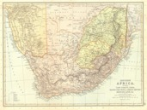
Figure 2 A map of Southern Africa, 1893.
View description - Figure 2 A map of Southern Africa, 1893.
View description - Figure 2 A map of Southern Africa, 1893.

The state now called South Africa was colonised by white settlers from the Netherlands from the seventeenth century (known as Boers) who were subsequently followed by white settlers from Britain from the early nineteenth century. The settlers forcibly dispossessed the existing Black population from lands that were coveted by the settlers for agriculture and mineral extraction. British forces occupied Cape Town from 1795 to 1803 to stop the strategically important territory being occupied by the French, with whom they were at war. From 1806, British forces again occupied Cape Town. After the end of the Napoleonic Wars in 1815, South Africa became part of the British empire.
Like other British colonies in Africa, British colonial subjects from India migrated to South Africa to seek work. Some of this migration was coerced, and these migrants were known as indentured labourers. This was a system of bonded labour introduced after the abolition of slavery in the British empire in 1833. Labourers were recruited from South Asia (as well as China) and signed a contract to work overseas for five years and sometimes more. The contract promised certain things in return for their labour, such as wages and land but, in reality, conditions of work and wages were very poor. This sort of bonded labour was enslavement in all but name.
The constituent territories that made up colonial South Africa had a wide variety of laws and regulations to racially discriminate between Black, South Asian (called ‘coloured’ people in nineteenth-century South Africa) and white people. These categories were politically created, and reflected contemporary racist attitudes based on white supremacy. The categorisation of people by skin colour and heritage (including religion) formed one of the bases of the racist apartheid system in South Africa after the Second World War. Apartheid, which means ‘apartness’ in Afrikaner, was a complex system of racial segregation that invaded many areas of Black South Africans’ lives, for example, where they could live, what pavements they could walk on, and what shops they could enter. What this racial discrimination meant on a daily basis was that if you were not legally classified as white, you were excluded from full equality and social and economic participation. Being defined as not white would lead to exclusion from full citizenship, exclusion from certain educational establishments, and certain kinds of jobs. Exclusion also extended to public and private places.
One example of this racial discrimination was about who could, and could not, sit in First-class train carriages. The segregation of train travel was because people of all socio-economic classes used the railways; many white people did not want to share their space in carriages with people who were Black Africans, and Indians, whom they believed to be inferior to them. Across the world, train travel was one of the most important areas of public transportation in the late nineteenth century. For the most part, it was relatively cheap for passengers and enabled people to travel relatively swiftly across short and long distances – in more comfort and more quickly than using roads or transport on water. This type of racist regulation of public transportation was common throughout the British empire, and was replicated in the racial segregation on buses and trains in parts of the United States until the mid-twentieth century.

3 Gandhi’s train journey in South Africa

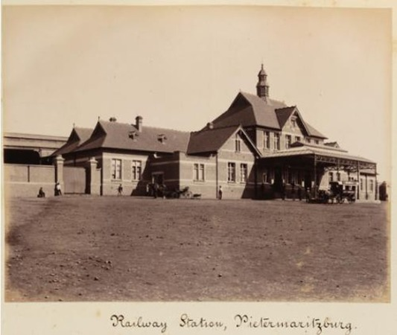
Figure 3 Pietermaritzburg train station, where the racist treatment of Gandhi described below happened in 1893.
View description - Figure 3 Pietermaritzburg train station, where the racist treatment of Gandhi described ...
View description - Figure 3 Pietermaritzburg train station, where the racist treatment of Gandhi described ...

Gandhi gained his law degree in England in 1891. After this he returned to India to practice law but soon found work as an attorney for the Indian merchant Dada Abdulla in Durban, South Africa. He arrived in South Africa in April 1893, at the age of 23. In June 1893, Abdulla asked him to travel to Pretoria for work, and a First-class train ticket was purchased for him. One of the stops on the way was Pietermaritzburg. Gandhi wrote about what happened to him there in his autobiography, first published as a serial in the Indian magazine Navijan in 1925–1928.

Activity 1
Allow around 30 minutes for this activity

Read this primary source extract from Gandhi’s autobiography below, thinking about the following questions:
- How reliable do you think Gandhi’s account of the incident is?
- What does this tell us about why Gandhi decided his duty was to resist racism?

The train reached Maritzburg, the capital of Natal, at about 9 p.m. Beddings used to be provided at this station. A railway servant came and asked me if I wanted one. ‘No,’ said I, ‘I have one with me.’ He went away. But a passenger came next, and looked me up and down. He saw that I was a ‘coloured’ man. This disturbed him. Out he went and came in again with one or two officials. They all kept quiet, when another official came to me and said, ‘Come along, you must go to the van compartment.’
‘But I have a first class ticket,’ said I.
‘That doesn't matter,’ rejoined the other. ‘I tell you, you must go to the van compartment.’
‘I tell you, I was permitted to travel in this compartment at Durban, and I insist on going on in it.’
‘No, you won’t,’ said the official. ‘You must leave this compartment, or else I shall have to call a police constable to push you out.’
‘Yes, you may. I refuse to get out voluntarily.’
The constable came. He took me by the hand and pushed me out. My luggage was also taken out. I refused to go to the other compartment and the train steamed away. I went and sat in the waiting room, keeping my hand-bag with me, and leaving the other luggage where it was. The railway authorities had taken charge of it.
It was winter, and winter in the higher regions of South Africa is severely cold. Maritzburg being at a high altitude, the cold was extremely bitter. My over-coat was in my luggage, but I did not dare to ask for it lest I should be insulted again, so I sat and shivered. There was no light in the room. A passenger came in at about midnight and possibly wanted to talk to me. But I was in no mood to talk.
I began to think of my duty. Should I fight for my rights or go back to India, or should I go on to Pretoria without minding the insults, and return to India after finishing the case? It would be cowardice to run back to India without fulfilling my obligation. The hardship to which I was subjected was superficial – only a symptom of the deep disease of colour prejudice. I should try, if possible, to root out the disease and suffer hardships in the process. Redress for wrongs I should seek only to the extent that would be necessary for the removal of the colour prejudice.
So I decided to take the next available train to Pretoria.
The following morning I sent a long telegram to the General Manager of the Railway and also informed Abdulla Sheth, who immediately met the General Manager. The Manager justified the conduct of the railway authorities, but informed him that he had already instructed the Station Master to see that I reached my destination safely. Abdulla Sheth wired to the Indian merchants in Maritzburg and to friends in other places to meet me and look after me. The merchants came to see me at the station and tried to comfort me by narrating their own hardships and explaining that what had happened to me was nothing unusual. They also said that Indians traveling first or second class had to expect trouble from railway officials and white passengers. The day was thus spent in listening to these tales of woe.
(Gandhi, 1925–28)

Provide your answer...
View discussion - Activity 1

4 Summary of Session 3

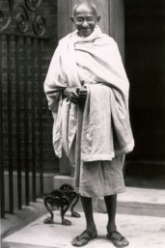
Figure 4 Gandhi outside 10 Downing Street, London, 3 November 1931, during talks with the British government about the future status of India.
View description - Figure 4 Gandhi outside 10 Downing Street, London, 3 November 1931, during talks ...
View description - Figure 4 Gandhi outside 10 Downing Street, London, 3 November 1931, during talks ...

This traumatic event made Gandhi aware of racism and the inequalities people are subjected to because of the colour of their skin. Gandhi’s response to this had huge consequences in world history, as he moved from being a lawyer to an activist. He helped found the Natal Indian Congress in 1894 (named after a former province in South Africa, and modelled on the Indian National Congress organisation in India). In 1906, the government of the South African province of Transvaal passed an act that required the compulsory registration of Indian and Chinese residents. At a protest meeting in Johannesburg in the same year, Gandhi urged Indians to defy this act in a non-violent way. This was one of the beginnings of Gandhi’s activist strategy, which he called satyagraha: a combination of non-violent protests, articulate persuasion, and skilful public relations management. Gandhi continued to contest racial discrimination in South Africa until he returned to India in 1915, where he continued his activism.
Gandhi’s anti-colonial activism from the 1910s played a very important part in ending British colonial rule in India. His tireless work for this cause inspired many other people to fight for independence in colonies across the world, and helped change the global political order from being empire-based to nation-state based. Gandhi’s example also inspired others to fight against racism and racial discrimination, such as the important civil rights activist Martin Luther King, in the USA. In South Africa, the Black population resisted racism, and one of the most important groups in this struggle was the African National Congress. Nelson Mandela, the first Black President of South Africa and leading figure in the African National Congress, took inspiration from Gandhi’s activism and saw Gandhi as his role model. Mandela was known as ‘the Gandhi of South Africa’. Three years after the fall of apartheid South Africa in 1994, President Nelson Mandela held a ceremony at Pietermaritzburg railway station. Mandela posthumously conferred the Freedom of Pietermaritzburg on Gandhi, and recalled Gandhi’s ‘magnificent example of personal sacrifice and dedication in the face of oppression’. Racism and racist discrimination is a global phenomenon: Gandhi showed how countering these iniquities could also be a global project.
In the next session, you will learn about a community of Yemeni Muslims in Cardiff, who also had to deal with racist attitudes as they lived and worked in the Welsh capital’s docks.

Explore further
Find out more about the History of Empires by studying the OU course A326 Empire: 1492–1975.
You can now go to Error! Hyperlink reference not valid..

Session 4: Yemeni Muslim sailors in Cardiff

1 Introduction
This session was written by Dr Sinead McEneaney

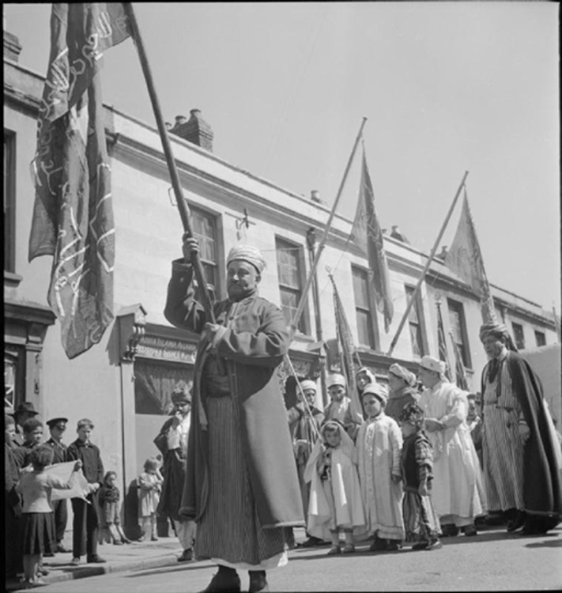
Figure 1 Procession to celebrate the opening of the new mosque, Butetown, Cardiff, Wales in 1943.
View description - Figure 1 Procession to celebrate the opening of the new mosque, Butetown, Cardiff, ...
View description - Figure 1 Procession to celebrate the opening of the new mosque, Butetown, Cardiff, ...

Butetown, a district and community in southern Cardiff in Wales, has one of the longest established Muslim communities in the UK. The opening of the West Bute dock in 1839 increased international trade connections, especially with shipping routed through Singapore, India, Suez and the Mediterranean. Groups of Yemeni and Somali seafarers made their home in Butetown, which became an important local centre of Muslim culture. By the late 1930s, an Islamic cultural and worship centre was established on Peel Street, and on 11 November 1938, approval was given to build the first purpose-built mosque in Wales. Despite some setbacks during the Second World War, the new Noor el-Islam mosque was opened in a temporary structure in July 1943 to much celebration (see Figure 1 above) and was developed into a permanent site several years later.
This session will focus on the origins and community of Muslims in Cardiff. The importance of these Muslim communities is an aspect of Cardiff’s history, and Welsh history, that rarely appears in general histories of Wales, although they feature in recent histories such as Mohammed Siddique Seddon’s Last of the Lascars (2014) and Humayun Ansari’s TheInfidel Within: Muslims in Britain since 1800 (2018).

2 How did Yemeni sailors come to live in Cardiff?
Yemeni, Somali and other Arab and Indian sailors worked on British registered merchant ships from the 1760s onwards, usually as cheaper labour on ships returning from India. The term ‘lascars’ was used to distinguish them – and other non-Europeans – from white British sailors. The word lascar originally comes from the Portuguese lascarim, which means Asian seaman. The term as used on British ships carried racialised meaning. While not all lascars were Muslim, the term also indicated religious difference from the mostly Christian British sailors.
As steam-powered shipping grew rapidly from the mid-nineteenth century, the importance of the lascars to the wealth and power of the British maritime economy grew. By the 1850s, approximately ten thousand lascars were employed on British merchant ships, and still thousands more on American- and European-registered vessels. Historians Dr Florian Stadtler and Rozina Visram estimate that by the start of the First World War in 1914, the number of lascars on British ships had risen to over 50,000.
Lascars primarily worked in the engine rooms, stoking the fires that powered steam ships. Stereotypes emerged that lascars were pre-disposed to this work, because they were used to hot climates. But their work went beyond the furnace: they were also believed to have natural abilities suited to being stewards, cooks and other menial work usually associated with women. Perceptions of effeminacy (seen as a negative trait in seamen) were rooted in racist stereotyping. These stereotypes also meant that they were treated as second-class workers compared to white British seafarers. Their contracts were much more exploitative than those of white sailors, they were paid less, the main unions refused them permission to join, and the legislation that improved the working lives of white British sailors through the nineteenth and early twentieth centuries often did not apply to lascars.
When these sailors arrived at British ports, they often had to wait months before they got work on return vessels. So, over the course of the nineteenth and early twentieth centuries, communities of lascars settled in the ports where they landed: Cardiff, London, Liverpool, South Shields, Glasgow, and later in Hull and Manchester.

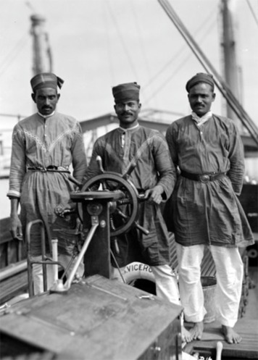
Figure 2 Three lascars on RMS Viceroy of India, c.1930s.
View description - Figure 2 Three lascars on RMS Viceroy of India, c.1930s.
View description - Figure 2 Three lascars on RMS Viceroy of India, c.1930s.

3 What was community life like for Yemenis in Cardiff?
Before 1914, the estimated Yemeni population of Cardiff was around 700 people – mostly men – concentrated in the Butetown area of the city. As a community, they regularly held colourful religious processions through the city streets to celebrate Eid and other major Muslim religious occasions. Lascar funerals often attracted public attention because of their traditional dress and rituals unfamiliar to many Cardiff residents. The vibrancy of religious worship increased with the arrival in the late 1930s of a prominent Yemeni Sufi leader and entrepreneur Shaykh Abdullah Ali al-Hakimi. Islam was a defining element of community life, but the mosques they built for worship were not their only meeting places.
High rates of illiteracy among lascars meant they were often unable to get onshore work when they arrived in Cardiff. Many men opened cafés, restaurants and boarding houses for other Arab seamen docking at Cardiff. These Yemeni-run cafés provided alcohol-free venues to meet, play cards and eat Yemeni dishes. Cafés were de facto community centres, but were also frequented by white Welsh people, and so acted as a bridge between the immigrant Yemeni and the existing Welsh communities. They were also important places for white Welsh women to meet Yemeni men.

4 Marriages with Welsh women
Before 1914, the majority of Yemeni settlers in Cardiff were men. Because of their work in the docks, and through running cafés and lodging houses, they became connected within certain levels of Welsh society. Intermarriage with Welsh, English and Irish women was quite common. According to Seddon, Yemeni men in Cardiff were much more likely to marry local Welsh women than were men from Southeast Asia, who preferred to remain single or bring wives from their country of origin (Seddon, 2014, p. 165). Marriages were preferably conducted under Muslim rites, although these often lacked official legal recognition and were therefore less secure for the wives (who often converted to Islam) and their children. Women who married Yemeni seafarers found they had more autonomy because their husbands were away for long periods of time, but they also bore huge responsibility for childcare and religious teaching.
Marriage to Welsh women offered one route towards social integration for Yemeni immigrants. However, unions between Muslim men and non-Muslim women often met with disapproval from each community, and provoked jealousy among Welsh men. In 1919, the Chief Constable of Cardiff, James A. Wilson, called for legislation to make sexual relations between Muslim sailors and white women a criminal offence. This was one of the local measures that would influence the racially discriminatory Special Restriction (Coloured Alien Seamen) Order issued by the Home Office Aliens Department in 1925.

5 Local backlash: Cardiff ‘race riots’

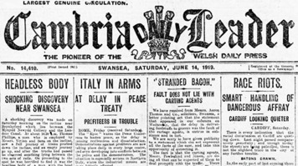
Figure 3 Front page of the Cambria Daily Leader, 14 June 1919. The headline on the right column describes some of the ‘race riots’ in June 1919. This paper was one of the most widely circulated local papers in Wales.
View description - Figure 3 Front page of the Cambria Daily Leader, 14 June 1919. The headline on the ...
View description - Figure 3 Front page of the Cambria Daily Leader, 14 June 1919. The headline on the ...

Sexual jealousy, a lack of understanding about Islam, and tensions over racist ‘Whites First’ employment practices in the economic depression following the First World War all contributed to the explosion of what were termed ‘race riots’ in Cardiff on 11 June 1919. Discriminatory housing policy, alongside a desire for community cohesion, meant that the Arab community was largely confined to Butetown. As a result, they were easily targeted. Over several nights, mobs attacked Arab lodging houses, businesses and homes. Several people were hospitalised, others were arrested, and three men died as a result of the rioting.
Newspaper coverage of the riots reveals contemporary racist attitudes.

Activity 1
Allow around 20 minutes for this activity

Read the following article from the Manchester Guardian covering the riots in Cardiff and answer the following questions:
- Look at the language used to describe the people targeted by the rioters. What kinds of racial assumptions does the correspondent make in his descriptions?
- What sense do you get of the tension between coal miners, sailors and soldiers? Can you explain this?

BATON CHARGE BY THE POLICE
(From our correspondent)
Strong precautions were taken last night to prevent a recurrence of the colour trouble, for thousands of young miners came down to the city from the colliery villages, bend on fun. The police formed a strong cordon around the approach to the negro town, and no one was permitted to go to the docks district unless he or she resided there or was on business bent. Coloured men moved freely about in the encircled area and gave no trouble, though they congregated in large crowds to discuss the situation.
Just at dusk a solitary Malay sailor ventured into the city, and his appearance was the immediate cause of a riot. A soldier in khaki was the first to notice him, and rushed upon him, followed by an angry crowd. The police, mounted and on foot, rushed to the rescue and succeeded in scattering the mob and in arresting both the soldier and the Malay. They took them through some by-streets to the central police station, but as they emerged again into the main street the crowd, sympathising with the soldier under arrest, made an attempt at rescue. An ugly rush took place, and at one time it appeared as if the police would be over-powered. Just then reinforcements arrived under Superintendent Charles Jones, placed themselves between the crowd and the prisoner, and in self-defence the order to charge was given. The police, with truncheons drawn, lay about with vigour, and the disturbance was eventually quelled, but several of the crowd were taken to the infirmary.
There were further signs of unrest later in the evening, and at eleven o’clock the order came to clear the streets, and this the police did most effectually.
There was trouble also, at the colliery village of Taffs Well, some miles from Cardiff, where a coloured collier resided with his white wife. A threatening crowd congregated in front of his house and insisted that he should leave the village. It appeared at one time as if a riot would develop, but the police intervened, and eventually the negro and his wife took a taxi-cab and drove into Cardiff, where all the coloured races of the district are now gathered within a prescribed area.
(Manchester Guardian, 1919, p. 9. Note: the Manchester Guardian changed its name in 1959 to The Guardian.)

Provide your answer...
View discussion - Activity 1

6 Summary of Session 4
By the 1920s, the British government tried to encourage Asian and Black immigrant workers in the United Kingdom to return to their places of origin. They even offered to make payments to encourage repatriation. However, despite facing racism in the city, the Yemeni community in Cardiff continued to thrive. Butetown remains one of Britain’s longest established Muslim communities. Subsequent immigration in the post-1945 period increased the number of Yemeni families in the city, and we also see the emergence of hybrid identities within the second and third generation diasporic community: British-Yemeni, or Welsh-Yemeni. As Ansari tells us: ‘Muslims living in the beginning of twenty-first-century [Britain] are creating a range of identities that combine their consciousness of the global [community]... with their British citizenship.’ (Ansari, 2018, p. 421).
In the next session, you will learn about how a group of Algerians grappled with questions of identity and loyalty to the French state after the end of the Algerian war of independence in 1962.

Explore further
The Lascars: Britain’s colonial sailors
From Cardiff to the Caribbean: the 1919 Race Riots
The Open University History degree offers students further opportunities to study Welsh history through the course A329 The making of Welsh history.
You can now go to Session 5.

Session 5: Algerian Harkis in France in the 1960s and 1970s

1 Introduction
This session was written by Lynn Berry

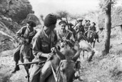
Figure 1 Harki soldiers on patrol during the war in Algeria (1954–1962).
View description - Figure 1 Harki soldiers on patrol during the war in Algeria (1954–1962).
View description - Figure 1 Harki soldiers on patrol during the war in Algeria (1954–1962).

In July 1962, after almost eight years of bitter war, Algeria officially became independent from the French empire. The conflict had pitched France and its supporters from settler and pro-French Indigenous communities, against the majority of Indigenous Algerians, who demanded self-determination after more than 130 years of French control. It was a complex and costly armed struggle with stunning brutality shown on both sides. It ended by the decision of two referenda in 1962, one in France on 8 April and one in Algeria on 1 July, in which the war-weary majority polled in both countries endorsed Algerian independence.
Formal decolonisation is a long and complex chain of events by which colonies became sovereign nations; you saw a good example of this earlier in the course, when the French fought to preserve their control of Haiti. Decolonisation remained a difficult process through the mid-twentieth century. The British empire had surrendered most of its colonies by 1960. France lost French Indochina in 1954, relinquished Tunisia and Morocco in 1956, and Algeria in 1962. Such losses often led to the ‘repatriation’ of French colonists who did not wish to remain in these newly independent nation-states. Some Indigenous peoples who had supported imperial rule also sought refuge in France, after threats by Indigenous nationalists from their homeland, who denounced them as collaborators.
This type of migration from the colonies to France brought issues of racial discrimination into the lives of Asian and African immigrants who had been forced to move to an unwelcoming metropole. This session will consider the experience of the Harkis, Muslim Algerian auxiliaries to the French army, who were compelled to emigrate to France at the end of the Algerian War, and faced racial prejudice there despite their military service. This example demonstrates the complex ways that race, ethnicity and religion intersected to produce negative outcomes for a group of people who had been colonised. It is important to remember here that ‘Harki’ was a name given to a group of Algerian men who were auxiliaries in the French armed forces, and who were understood to be loyal to the empire. But this loyalty became irrelevant in the process of decolonisation, and you will see by the end of this session how racist attitudes negatively affected the lives of these men and their families.

2 Harkis and the Algerian War
Unlike other French territories in North Africa, Algeria was not technically a colony. It was officially an extension of France across the Mediterranean. This helps explain the vigorous French military response to the guerrilla war unleashed by the militant National Liberation Front (FLN) in 1954 in their quest for independence. At the peak of the conflict, over 400,000 French troops were stationed in Algeria, responding to the terror attacks of the FLN with equally brutal tactics.
Harkis were an essential part of French military strategy. Approximately 58,000 Algerian Muslims of Arab or Berber descent were Harkis, contracted to support the French armed forces. (The name Harki came from the Arabic for ‘movement’ and referred to the use of auxiliaries in harkas or mobile units.) The term later came to be used more broadly for any of the more than 200,000 Indigenous Algerians who served with the French army, police or civil service. As such, the name denotes ethnic and religious difference, and became associated with perceptions of racial difference. Some became Harkis because their communities had suffered from the ruthless tactics of the FLN. Others were coerced into joining by French commanders who needed to expand their Harki units. Many were poor and illiterate and were compelled to accept any income in rural regions impoverished by the structural inequities of French rule.
The Harkis paid a considerable price for their support of the French. They and their families were subject to FLN retribution during the war. When the war was over, despite promises of reconciliation, they were the targets of severe reprisals. While almost a million colonists of European descent escaped to France after the war, Harkis were essentially left in Algeria by the French government to fend for themselves. Tens of thousands were tortured and murdered as traitors by the triumphant FLN. However, as many as 88,000 Harkis and their families fled to France with help from members of the French army or through other semi-clandestine methods.

3 Harkis and Pieds-Noirs: Comparing their reception in France
The European-Algerian colonists, popularly known as Pieds-Noirs (literally, ‘black feet’), who had reluctantly left for France, were designated by the government as ‘rapatriés’, repatriated French citizens or returnees, even though most had never been to France before. Such a massive migration, channelled mostly through the port city of Marseilles, overwhelmed administrators. Local residents initially reacted with animosity to these new arrivals. Nonetheless, the integration of the Pieds-Noirs (who were mostly Christian and Jewish), classified specifically as ‘European repatriates’, was prioritised by the government, which provided temporary housing in requisitioned hotels or other urban settings.

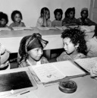
Figure 2 The children of Harki soldiers in a temporary school in Algeria, before being sent to France with their families. 1960s.
View description - Figure 2 The children of Harki soldiers in a temporary school in Algeria, before ...
View description - Figure 2 The children of Harki soldiers in a temporary school in Algeria, before ...

The Harkis were also categorised as ‘returning’ French nationals, but their housing needs were considered secondary by the Ministry of Repatriates and were often sub-standard, the most notorious being the rural transit camp. Almost half of Harkisrelied on kin networks to find their own accommodation in France, but more than 40,000 passed through designated transit camps from 1962 to 1964. Some remained in camps for years. The facilities that were provided were noticeably poorer than accommodation offered to Pieds-Noirs. The Harki camp at Bias, southeast of Bordeaux, for example, was a former refugee and prisoner of war camp isolated from nearby towns. Harki families were given small rooms in rows of dingy barracks within a fenced perimeter. A supervised gate controlled the entrance and exit of residents, and a 10 p.m. curfew was enforced. Cockroaches and rats were a persistent problem at Bias. With limited washing facilities, conditions were often unhygienic. Basic schooling was provided at the camp itself, so that the children of Harkis, like their parents, remained segregated from local French communities. Finding employment was difficult and Harki wives, who tended to speak less French than their husbands, were even further isolated. Similar conditions, and sometimes worse, were experienced at many of the transit camps to which Harkis were assigned.
For the Harkis, the most plausible explanation for their comparatively poor treatment was racial discrimination, compounded by growing anti-Muslim sentiment. The fact that the Harkis fought to preserve French imperial control over Algeria was ignored once they arrived in mainland France. Traumatised by war and exile, and demoralised by the condescension and paternalism of camp administrators, some of whom were Pieds-Noirs French Algerians, many Harkis withdrew into stoic silence. However, their children who grew up in the transit camps, the forestry work camps or the urban estates designated for the more ‘advanced’ Harkis, became increasingly vocal about their rights and those of their parents as French citizens.

Activity 1
Allow around 30 minutes for this activity

Consider the image in Figure 3 below of the middle-aged Harki man in his single room in the barracks of the reception camp at Bias. The picture was taken by a photographer for a French press agency in 1975. This was the year that protests broke out at the Bias camp, when the adult children of Harki parents demanded an end to their marginalised status.

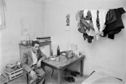
Figure 3 A Harki resident of the transit camp at Bias, France, August 1975.
View description - Figure 3 A Harki resident of the transit camp at Bias, France, August 1975.
View description - Figure 3 A Harki resident of the transit camp at Bias, France, August 1975.

Answer the following questions:
- Based on close observation of the photograph, what might you expect were some of the main concerns that the Harki protestors had about their lives in the camp?
- Considering the date of the image in relation to the end of the Algerian war, how would you estimate the success of the repatriation scheme for Harki integration?
- What do you think might be some concerns that should be kept in mind when using a photograph as a historical source for an issue such as racism?

Provide your answer...
View discussion - Activity 1

4 Summary of Session 5
The repatriated settlers of European heritage and the Muslim Harkis, shared many similar experiences:
- the shock of colonial conflict
- unwilling exile from their lives in Algeria
- the struggle to begin a new life in a new country
- a sense that their sacrifice was unappreciated by the metropolitan French who wished to move on from an unpopular and costly colonial war.
Racism, however, added to the burdens of the Harkis in France, even more so during the economic recession of the early 1970s, when the rise of anti-immigrant and anti-Algerian sentiment in France affected their daily lives. They expected to receive loyalty from the French state due to their military service: they did not receive it, because they were ethnically Algerian and adhered to the Muslim faith. Both of these things marked them as different and unequal in a France still rebuilding its sense of identity in the aftermath of the second world war and the loss of imperial territory. That identity did not include the Harkis.
Lobbying in the 1970s and 1980s by the second generation of Harkis for political and social recognition of their parents’ contributions to French Algeria highlighted the racial discrimination that their communities confronted, and continue to confront to the present day. In 2016, then President of France Francois Hollande accepted ‘the responsibilities of French governments in the abandonment of the Harkis’. In September 2021, his successor Emmanuel Macron held a ceremony at the Elysee Palace to apologise for the failure of the French state in its ‘duty towards the Harkis, their wives, their children’. But the continued social exclusion of the Harkis is an example of the pervasive legacy of racialised colonial thinking.

Explore further
Buettner, E. (2016) Europe after Empire. Decolonization, Society, and Culture. Cambridge: Cambridge University Press.
Moumen, A. (2012) ‘Housing the Harkis: long-term segregation’, Metropolitics. Available at: https://metropolitics.org/Housing-the-Harkis-long-term.html (Accessed: 26 October 2021).
Sims, L.J. (2018) ‘Memories of a French Migration Crisis: The Harkis’, in Menjívar, C., Ruiz. M. and Ness, I. (eds) The Oxford Handbook of Migration Crises. Oxford: Oxford University Press.
Smith, A.L. (ed.) (2003) Europe’s Invisible Migrants. Amsterdam: Amsterdam University Press. Available at: https://library.oapen.org/handle/20.500.12657/35104 (Accessed: 26 October 2021).

5 Course conclusion
This course has provided you with some examples of stories of the past that you might have been unfamiliar with.
We hope that during this course you have enjoyed learning about the case studies that explored Haiti, France, South Africa and Britain. These selected examples give some perspectives on how people’s experiences in the past have been affected by contemporary ideas of race, and the political, legal and social implications of racial categorisation. You have seen how people of colour resisted racism and discrimination throughout history. This is an area of scholarship where important research is underway, because these stories have often been missing from the traditional, and colonial, narratives of the past.
Through the activities in each session, you have examined a range of sources that historians use regularly in order to piece together our understanding of the past, including
- images
- newspaper reports
- memoirs.
These activities, alongside the links to further resources, were designed to help you develop your approach to learning at a distance, and to improve your confidence as an independent learner.
This course draws from some of the materials that you can study in the History degree at the Open University.

OpenLearn’s Race and Ethnicity Hub
This course is part of OpenLearn’s Race and Ethnicity Hub, a dedicated space for free resources focusing on race, racism and ethnicity.

References
Du Bois, W.E.B. (1903) The Souls of Black Folk. Chicago: A.C. McClurg & Co. Also available online: https://www.gutenberg.org/files/408/408-h/408-h.htm#chap01 (Accessed: 4 November 2021).
Dubois, L. and Garrigus, J.D. (2006) Slave Revolution in the Caribbean 1789–1804: A Brief History with Documents. Boston, MA: Bedford/St Martin’s.
Girard, P. (2009) ‘Rebelles with a Cause: Women in the Haitian War of Independence, 1802–1804’. Gender and History. 21(1), pp. 60–85.
Olusoga, D. (2016) Black and British: A Forgotten History. London: Pan Books.
Pityana, S.M. and Phateng, M. (2018) ‘Renaming Memorial Hall Sarah Baartman Hall’. Available at: https://www.news.uct.ac.za/article/-2018-12-13-renaming-memorial-hall-sarah-baartman-hall (Accessed: 5 October 2021).
Qureshi, S. (2011) Peoples on Parade: Exhibitions, Empire and Anthropology in Nineteenth-Century Britain. Chicago and London: University of Chicago Press.
Gandhi, M.K. (1925–8) An Autobiography: The Story of my Experiments with Truth (1925–8). Ahmedabad, India: Navajivan Publishing House. Also available online at: https://www.gandhiashramsevagram.org/autobiography/chapter-32.php (Accessed: 26 October 2021).
Ansari, H. (2018) The Infidel Within: Muslims in Britain since 1800. New York & Oxford: Oxford University Press.
Manchester Guardian (1919) ‘Baton charge by the police’, Manchester Guardian, 16 June, p. 9.
Seddon, M.S. (2014) Last of the Lascars: Yemeni Muslims in Britain, 1836–2012. Leicestershire: Kube Publishing.
Eldridge, C. (2009) ‘“We’ve never had a voice”: memory construction and the children of the Harkis (1962–1991)’, French History, 23(1), pp. 88–107. Available at: https://academic.oup.com/fh/article/23/1/88/668266 (Accessed: 26 October 2021).

Acknowledgements
This free course was conceived and led by Dr Sinead McEneaney and Dr John Slight, and written by Dr Sinead McEneaney, Dr John Slight, Dr Suki Haider, Dr Robin Mackie, Dr Anna Plassart and Lynn Berry.
Except for third party materials and otherwise stated (see terms and conditions), this content is made available under a Creative Commons Attribution-NonCommercial-ShareAlike 4.0 Licence.
The material acknowledged below is Proprietary and used under licence (not subject to Creative Commons Licence). Grateful acknowledgement is made to the following sources for permission to reproduce material in this free course:

Images
Course introduction
Course image and Figure 1: © Granger Historical Picture Archive/Alamy Stock Photo
Figure 2: taken from: https://en.wikipedia.org/wiki/Johann_Friedrich_Blumenbach#/media/File:Blumenbach's_five_races.JPG
Figure 3: © Granger Historical Picture Archive/Alamy Stock Photo
Figure 4: Photographer: Cornelius Marion Battey
Session 1
Figure 1: © Bettmann/Contributor; Getty Images
Figure 2: © Gerald Bloncourt/Bridgeman Images
Figure 3: © Spencer Platt/Staff; Getty Images
Figure 4: taken from: https://commons.wikimedia.org/wiki/File:Toussaint_Louverture_-_Girardin.jpg
Figure 5: ‘The Mode of exterminating the Black Army, as practised by the French’. From Marcus Rainsford, An Historical Account of the Black Empire of Hayti, 1805., taken from: https://commons.wikimedia.org/wiki/File:The_Mode_of_exterminating_the_Black_Army
Figure 6: taken from: https://fr.wikipedia.org/wiki/Fichier:Le_serment_des_Anc%C3%AAtres.jpg
Session 2
Figure 1: © Print Collector/Contributor; Getty Images
Figure 2: taken from: https://upload.wikimedia.org/wikipedia/en/d/db/Hottentot_Venus_Poster.png
Figure 3: (left) Alan Cordle Villegas; https://creativecommons.org/licenses/by-nc-sa/2.0/; Right: University of Capetown; https://www.news.uct.ac.za/images/userfiles/images/news/2018/2018-09-21_SarahBaartman_02.jpg
Figure 4: Peoples on Parade: Exhibitions, Empire, and Anthropology in Nineteenth-Century Britain, Qureshi, Sadiah (author), 2011.
Figure 5: ‘A Peek at the Natives’, Savage South Africa at Earl's Court, 1899 (pen and washes on paper); Maud, William T. (1865-1903); photograph © Michael Graham-Stewart/Bridgeman Images.
Session 3
Figure 1: © Archive PL/Alamy Stock Photo
Figure 2: Antiqua Print Gallery; Alamy Stock Photo
Figure 3: taken from: Melville J. Herskovits Library of African Studies, Northwestern University, Evanston 6-13-1, The Humphrey Winterton Collection of East African Photographs: 1860-1960: https://commons.wikimedia.org/wiki/File:Railway_station_Pietermaritzburg,_South_Africa_-_Winterton_Collection_of_East_African_Photographs_6-13-1.jpg
Figure 4: © Pictorial Press Ltd; Alamy Stock Photo
Session 4
Figure 1: photographer Richard Stone: © Crown Copyright: IWM
Figure 2: Three lascars of the ‘Viceroy of India’, standing behind the wheel of one of the ship's tenders: National Maritime Museum from Greenwich, United Kingdom
Figure 3: taken from: https://newspapers.library.wales/view/4427229/4427230/33/
Session 5
Figure 1: © Jean-Louis SWINERS/Contributor; Getty Images
Figure 2: © Tallandier; Bridgeman Images
Figure 3: © Jean-Pierre TARTRAT/Contributor; Getty Images

Text
Course introduction
Activity 1: Du Bois, W.E.B. (1903) The Souls of Black Folk, Chicago: A.C. McClurg & Co.
Session 3
Activity 1: Gandhi, M.K. (1925-28) An Autobiography: the story of my experiments with Truth (1925-28). Navajivan Publishing House, Ahmedabad, India
Session 4
Activity 1: Manchester Guardian (1919) ‘Baton charge by the police’, Manchester Guardian, 16 June 1919, p. 9.
Every effort has been made to contact copyright owners. If any have been inadvertently overlooked, the publishers will be pleased to make the necessary arrangements at the first opportunity.
Don't miss out
If reading this text has inspired you to learn more, you may be interested in joining the millions of people who discover our free learning resources and qualifications by visiting The Open University – www.open.edu/openlearn/free-courses.

Solutions

Activity 1

Discussion
W.E.B. Du Bois (1868–1963) was an American sociologist, who argued that education would be a key factor in gaining political and civil equality for African Americans. Writing in the early twentieth century, at a time when Black Americans were subjected to severe social, economic and political discrimination, Du Bois explored what he called the ‘double consciousness’ of African Americans: how could they embrace both American and Black identities in such a discriminatory society? Like most of his contemporaries, Du Bois used the term ‘Negro’ to designate a political and social identity. In doing so, he sought to reclaim a word that had more often been used as a racial slur, and to make common cause with people of African origin across the globe – the pan-African movement.
Du Bois deliberately uses poetic language to challenge racist assumptions that Black Americans were not considered human. He was writing at the same time as Black people were being put on display for entertainment (see Session 2 on human ‘zoos’), and when the murder of African Americans by lynching was widespread across the United States. Du Bois’ lyricism underscores the humanity, the soul of Black Americans in the face of this violence.
Back to - Activity 1

Activity 1

Discussion
This painting seeks to immortalise the union of Black and mixed-race slaves that allowed Haiti to defeat the French Republic and paved the way for Haitian Independence in 1804. But it also illustrates Haiti’s complex relationship with French and European culture: the oath of alliance is witnessed by a white Judaeo-Christian god, the two leaders’ elaborate uniforms are influenced by European standards of dress, and the altar inscription repeats the French revolutionary slogan vivre libre ou mourir (‘liberty or death’).
Back to - Activity 1

Activity 1

Discussion
The image appears to depict a Victorian family touring the Savage South Africa mock village at Earl’s Court, London in June 1899. The family members lean towards a mock African hut and meet the gaze of three Africans. In the background stand men in top hats, apparently conversing with a Black person who was part of the human exhibit.
The image is from the Graphic newspaper. It was published the year the show opened, and was likely produced for promotional purposes. It suggests the exhibition was the opportunity for spectators to ‘peep at the natives’ in authentic surroundings. The hinted conversation, top right, suggests visitors with an interest in anthropology may also meet the exhibits. The African’s headgear is reminiscent of the costumes in Figure 4. It is valuable to cross-reference the image with the photograph in Figure 4, also from 1899. In neither image are the full troupe of 200 African performers shown, and the 20 Boers are also missing. Perhaps this reflects the draw of a personal encounter with an African ‘native’.
The image strongly captures the erroneous racial stereotypes that informed and drove imperial expansion in the late nineteenth century. The portrayal of Black people in the hut reflects contemporary Victorian stereotypes of Africans, with their childlike expressions. The British family is well dressed, symbolic of the power and supposed superiority of Europeans over the ‘savages’ crouching, presumed naked, in the darkness. Africa was routinely referred to as the ‘Dark Continent’ at this time.
The image does not fully convey the exhibition’s racialised structures. The fences limiting interaction between the Africans and spectators are absent. Nor are there clues of the strict supervision of Black performers.
It is worth considering how language can be used to describe humans in exhibitions. ‘Performer’ recognises their status as paid re-enactors. ‘Exhibit’ more accurately reflects their lack of agency.
Back to - Activity 1

Activity 1

Discussion
As with any memoir or other record written many years after the event, it is inevitable that it will never be completely accurate. In this case, over thirty years had passed. It’s also important to note that when Gandhi published his autobiography he was a very famous figure in India as one of the leaders of the Independence struggle, which may have affected the way in which he wrote about this incident. Gandhi was ejected from that First-class carriage because he was not white: it had a crucial effect on him and his future path in life. One of his goals after the incident, as he states in the account, was to ‘seek [redress for wrongs] only to the extent that would be necessary for the removal of the colour prejudice’.
Back to - Activity 1

Activity 1

Discussion
Contemporaries, including the media and the police, often were imprecise in their description of ethnicity. They often relied on racialised stereotyping, generic assumptions about national origins, and language that we would find unacceptable today (e.g. ‘coloured’) to describe people who were viewed as ethnically or racially different to the white Welsh population.
It is not a coincidence that tensions arose between lascar sailors, miners and soldiers. Soldiers returning to Wales after demobilisation often found themselves dislocated from life and work which had continued without them during the First World War. Competition in employment, and the tendency to underpay Arab workers, contributed to the perception that work, housing and other resources were being unfairly taken by ‘foreign’ men. This was not peculiar to Cardiff: in the summer of 1919, a series of riots broke out in the United Kingdom and the USA where race and racism were central causal factors.
Often the response of the authorities, namely the police and government, was to blame the ‘foreign’ community. In this case, you can see that the solution was to cordon off Butetown and ensure that the population was not able to mix with residents in other parts of Cardiff. This segregation often served to further separate the different ethnic populations of a city. Again, the Chief Constable of Cardiff was not alone in proposing this response to the riots; segregation was replicated in other cities that had experienced similar types of rioting.
Back to - Activity 1

Activity 1

Discussion
- Based on the photograph, it is likely that the protests included concerns about living conditions and poverty. The solitary Harki man in his humble room lacks space and any home comforts beyond the bare essentials of a table, chairs and sideboard. He has nowhere for his clothing besides a wire strung across the room and some of the bare walls appear spotted with mould. His stooped posture and weary expression also suggest the possibility that protesters spoke out about the mental and social isolation that Harki elders were experiencing in the camps.
- Transit camps such as Bias were opened in 1962 to temporarily house Harkis and their families until they could be integrated into French communities. The image was taken in 1975, however, indicating that some Harkis were still living in sparse and isolated accommodation more than a decade after the end of the Algerian War, long after most Pieds-Noirs had been housed and were well-integrated into communities across France. The impact of racial stereotyping on individual lives is complex and multi-faceted, but a photograph is only a single snapshot of a moment in time. We do not know if the French press photographer framed the image of his apparently pensive and isolated subject to match the aim of an accompanying article, or whether he accurately captured the Harki man’s reality. One of the residents of the camp at Bias later complained, for example, that the dominant image of the Harki at that time was that of the ‘eternal submissive auxiliary, docile and faithful’ (Eldridge, 2009, p. 104), rather than one which recognised their perseverance and fortitude in the face of trauma and discrimination.
Back to - Activity 1

Figure 1 Anti-apartheid sign on a car in Cape Town, South Africa (1976). You will learn more about early resistance to apartheid in Session 3.

Description
A photograph of a sign attached to a car which says ‘We want rights not riots’.
Back to - Figure 1 Anti-apartheid sign on a car in Cape Town, South Africa (1976). You will learn more about early resistance to apartheid in Session 3.

Figure 2 German scientist Johann Friedrich Blumenbach, in his book On the Natural Variety of Mankind (1776), classified humans into (l–r) Mongolian, (Native) American, Caucasian, Tahitian, Ethiopian. At the centre of his diagram was what he called the ‘most beautiful skull’, that of a woman from Georgia in the Caucasus – giving rise to the term ‘Caucasian’.

Description
This features five illustrations of slightly different looking skulls.
Back to - Figure 2 German scientist Johann Friedrich Blumenbach, in his book On the Natural Variety of Mankind (1776), classified humans into (l–r) Mongolian, (Native) American, Caucasian, Tahitian, Ethiopian. At the centre of his diagram was what he called the ‘most beautiful skull’, that of a woman from Georgia in the Caucasus – giving rise to the term ‘Caucasian’.

Figure 3 ‘The Devilfish in Egyptian Waters’, 1882. An American cartoon depicting John Bull (England) as the octopus of imperialism, grabbing land on every continent.

Description
An illustration of an octopus with human hands and a human head. The octopus is labelled ‘England’ and its hands are ‘grabbing’ different countries, including Canada, India and Egypt.
Back to - Figure 3 ‘The Devilfish in Egyptian Waters’, 1882. An American cartoon depicting John Bull (England) as the octopus of imperialism, grabbing land on every continent.

Figure 4 W.E.B. Du Bois (1868-1963), sociologist, activist and author of The Souls of Black Folk.

Description
A photograph of W.E.B. Du Bois.
Back to - Figure 4 W.E.B. Du Bois (1868-1963), sociologist, activist and author of The Souls of Black Folk.

Figure 1 Illustration depicting Francois Dominique Toussaint L’Ouverture participating in the successful revolt against French power in Saint-Dominigue (Haiti). Hand-coloured engraving, 1900.

Description
An illustration of two sets of people fighting, surrounded by trees.
Back to - Figure 1 Illustration depicting Francois Dominique Toussaint L’Ouverture participating in the successful revolt against French power in Saint-Dominigue (Haiti). Hand-coloured engraving, 1900.

Figure 2 A portrait of Vincent Ogé.

Description
This is an illustration of Vincent Ogé.
Back to - Figure 2 A portrait of Vincent Ogé.

Figure 3 People stand under a statue of Jean-Jacques Dessalines, a leader of the Haitian Revolution and the first ruler of an independent Haiti, in Port au Prince on February 10, 2018 in Port-au-Prince, Haiti.

Description
A photograph of a statue featuring a man on a horse, situated on a hill.
Back to - Figure 3 People stand under a statue of Jean-Jacques Dessalines, a leader of the Haitian Revolution and the first ruler of an independent Haiti, in Port au Prince on February 10, 2018 in Port-au-Prince, Haiti.

Figure 4 Alexandre Francois Louis, Comte de Girardin, A Portrait of Toussaint Louverture, c.1804.

Description
An illustration of Toussaint Louverture.
Back to - Figure 4 Alexandre Francois Louis, Comte de Girardin, A Portrait of Toussaint Louverture, c.1804.

Figure 5 ‘The Mode of exterminating the Black Army, as practised by the French’. From Marcus Rainsford, An Historical Account of the Black Empire of Hayti, 1805.

Description
An illustration of a White Man holding a Black man by his neck, on a boat at sea.
Back to - Figure 5 ‘The Mode of exterminating the Black Army, as practised by the French’. From Marcus Rainsford, An Historical Account of the Black Empire of Hayti, 1805.

Figure 6 Guillaume Guillon-Lethière, Serment des ancêtres (Oath of the Ancestors), 1822. The stone altar’s engraving reads: ‘L’union fait la force / Vivre libre ou mourir / Il n’y a de véritable liberté qu’avec la religion, les loix … constitution’ (’Unity is strength / Live free or die / There is no true liberty without religion, laws … constitution’).

Description
An illustration showing a Black man and a mixed-race man touching a stone alter with a depiction of God above them.
Back to - Figure 6 Guillaume Guillon-Lethière, Serment des ancêtres (Oath of the Ancestors), 1822. The stone altar’s engraving reads: ‘L’union fait la force / Vivre libre ou mourir / Il n’y a de véritable liberté qu’avec la religion, les loix … constitution’ (’Unity is strength / Live free or die / There is no true liberty without religion, laws … constitution’).

Figure 1 ‘A Black “White Elephant”’, 1879. Artist: Joseph Swain.

Description
A black-and-white illustration of three White men surrounding a Black man.
Back to - Figure 1 ‘A Black “White Elephant”’, 1879. Artist: Joseph Swain.

Figure 2 A promotional poster for the exhibition of Sarah Baartman, London, 1810. She is described by historians as the ‘the first foreign celebrity exhibit of the century’ (in Qureshi, 2011, p. 130).

Description
A promotional poster which reads: ‘Now exhibiting at No. 225, Piccadilly, the top of the Hay-Market, from twelve til four o’clock. Admittance, 2s. each. The Hottentot Venus … The greatest phenomenon ever exhibited in this country’.
Back to - Figure 2 A promotional poster for the exhibition of Sarah Baartman, London, 1810. She is described by historians as the ‘the first foreign celebrity exhibit of the century’ (in Qureshi, 2011, p. 130).

Figure 3 Left, a sculpture of Baartman at the University of Cape Town. Students have demanded the statue be ‘dignified’ and have covered it with cloth, and right, pinned notes of protest.

Description
On the left is a photograph of a sculpture of Baartman. On the right is a photograph of the notes of protest.
Back to - Figure 3 Left, a sculpture of Baartman at the University of Cape Town. Students have demanded the statue be ‘dignified’ and have covered it with cloth, and right, pinned notes of protest.

Figure 4 11 of the 200 Black performers from Savage South Africa. Behind them are the huts and one of the several painted backdrops used to fabricate the African village at the Earl’s Court showground. The photograph bears Frank Fillis’ stamp and records a ‘chief and group of Swazies’, 1899.

Description
A black-and-white photograph of the performers from Savage South Africa.
Back to - Figure 4 11 of the 200 Black performers from Savage South Africa. Behind them are the huts and one of the several painted backdrops used to fabricate the African village at the Earl’s Court showground. The photograph bears Frank Fillis’ stamp and records a ‘chief and group of Swazies’, 1899.

Figure 5 ‘A Peep at the Natives’, Graphic, 4 June 1899. The image appears to show a middle-class Victorian family attending the Savage South Africa exhibition. The Graphic was a British weekly illustrated newspaper.

Description
This is a black-and-white illustration of a white family peering to look at a group of Black people.
Back to - Figure 5 ‘A Peep at the Natives’, Graphic, 4 June 1899. The image appears to show a middle-class Victorian family attending the Savage South Africa exhibition. The Graphic was a British weekly illustrated newspaper.

Figure 1 Gandhi in Johannesburg, 1900, where he was working as a solicitor for an Indian businessman.

Description
A black-and-white photograph of Gandhi.
Back to - Figure 1 Gandhi in Johannesburg, 1900, where he was working as a solicitor for an Indian businessman.

Figure 2 A map of Southern Africa, 1893.

Description
A map of Southern Africa in 1893.
Back to - Figure 2 A map of Southern Africa, 1893.

Figure 3 Pietermaritzburg train station, where the racist treatment of Gandhi described below happened in 1893.

Description
An image of Pietermaritzburg train station.
Back to - Figure 3 Pietermaritzburg train station, where the racist treatment of Gandhi described below happened in 1893.

Figure 4 Gandhi outside 10 Downing Street, London, 3 November 1931, during talks with the British government about the future status of India.

Description
A black-and-white photo of Gandhi.
Back to - Figure 4 Gandhi outside 10 Downing Street, London, 3 November 1931, during talks with the British government about the future status of India.

Figure 1 Procession to celebrate the opening of the new mosque, Butetown, Cardiff, Wales in 1943.

Description
A black-and-white photograph of a procession.
Back to - Figure 1 Procession to celebrate the opening of the new mosque, Butetown, Cardiff, Wales in 1943.

Figure 2 Three lascars on RMS Viceroy of India, c.1930s.

Description
A black-and-white image of three men on a ship.
Back to - Figure 2 Three lascars on RMS Viceroy of India, c.1930s.

Figure 3 Front page of the Cambria Daily Leader, 14 June 1919. The headline on the right column describes some of the ‘race riots’ in June 1919. This paper was one of the most widely circulated local papers in Wales.

Description
An image of the front page of the ‘Cumbria Daily Leader’. It includes a headline which reads: ‘Race riots’.
Back to - Figure 3 Front page of the Cambria Daily Leader, 14 June 1919. The headline on the right column describes some of the ‘race riots’ in June 1919. This paper was one of the most widely circulated local papers in Wales.

Figure 1 Harki soldiers on patrol during the war in Algeria (1954–1962).

Description
A black-and-white photograph of a number of soldiers on horseback.
Back to - Figure 1 Harki soldiers on patrol during the war in Algeria (1954–1962).

Figure 2 The children of Harki soldiers in a temporary school in Algeria, before being sent to France with their families. 1960s.

Description
A black-and-white photograph of a group of children learning in a school setting.
Back to - Figure 2 The children of Harki soldiers in a temporary school in Algeria, before being sent to France with their families. 1960s.

Figure 3 A Harki resident of the transit camp at Bias, France, August 1975.

Description
A black-and-white photograph of a man sitting at a table.
Back to - Figure 3 A Harki resident of the transit camp at Bias, France, August 1975.

Figure 1 Anti-apartheid sign on a car in Cape Town, South Africa (1976). You will learn more about early resistance to apartheid in Session 3.

Description
A photograph of a sign attached to a car which says ‘We want rights not riots’.
Back to - Figure 1 Anti-apartheid sign on a car in Cape Town, South Africa (1976). You will learn more about early resistance to apartheid in Session 3.

Figure 2 German scientist Johann Friedrich Blumenbach, in his book On the Natural Variety of Mankind (1776), classified humans into (l–r) Mongolian, (Native) American, Caucasian, Tahitian, Ethiopian. At the centre of his diagram was what he called the ‘most beautiful skull’, that of a woman from Georgia in the Caucasus – giving rise to the term ‘Caucasian’.

Description
This features five illustrations of slightly different looking skulls.
Back to - Figure 2 German scientist Johann Friedrich Blumenbach, in his book On the Natural Variety of Mankind (1776), classified humans into (l–r) Mongolian, (Native) American, Caucasian, Tahitian, Ethiopian. At the centre of his diagram was what he called the ‘most beautiful skull’, that of a woman from Georgia in the Caucasus – giving rise to the term ‘Caucasian’.

Figure 3 ‘The Devilfish in Egyptian Waters’, 1882. An American cartoon depicting John Bull (England) as the octopus of imperialism, grabbing land on every continent.

Description
An illustration of an octopus with human hands and a human head. The octopus is labelled ‘England’ and its hands are ‘grabbing’ different countries, including Canada, India and Egypt.
Back to - Figure 3 ‘The Devilfish in Egyptian Waters’, 1882. An American cartoon depicting John Bull (England) as the octopus of imperialism, grabbing land on every continent.

Figure 4 W.E.B. Du Bois (1868-1963), sociologist, activist and author of The Souls of Black Folk.

Description
A photograph of W.E.B. Du Bois.
Back to - Figure 4 W.E.B. Du Bois (1868-1963), sociologist, activist and author of The Souls of Black Folk.

Figure 1 Illustration depicting Francois Dominique Toussaint L’Ouverture participating in the successful revolt against French power in Saint-Dominigue (Haiti). Hand-coloured engraving, 1900.

Description
An illustration of two sets of people fighting, surrounded by trees.
Back to - Figure 1 Illustration depicting Francois Dominique Toussaint L’Ouverture participating in the successful revolt against French power in Saint-Dominigue (Haiti). Hand-coloured engraving, 1900.

Figure 2 A portrait of Vincent Ogé.

Description
This is an illustration of Vincent Ogé.
Back to - Figure 2 A portrait of Vincent Ogé.

Figure 3 People stand under a statue of Jean-Jacques Dessalines, a leader of the Haitian Revolution and the first ruler of an independent Haiti, in Port au Prince on February 10, 2018 in Port-au-Prince, Haiti.

Description
A photograph of a statue featuring a man on a horse, situated on a hill.
Back to - Figure 3 People stand under a statue of Jean-Jacques Dessalines, a leader of the Haitian Revolution and the first ruler of an independent Haiti, in Port au Prince on February 10, 2018 in Port-au-Prince, Haiti.

Figure 4 Alexandre Francois Louis, Comte de Girardin, A Portrait of Toussaint Louverture, c.1804.

Description
An illustration of Toussaint Louverture.
Back to - Figure 4 Alexandre Francois Louis, Comte de Girardin, A Portrait of Toussaint Louverture, c.1804.

Figure 5 ‘The Mode of exterminating the Black Army, as practised by the French’. From Marcus Rainsford, An Historical Account of the Black Empire of Hayti, 1805.

Description
An illustration of a White Man holding a Black man by his neck, on a boat at sea.
Back to - Figure 5 ‘The Mode of exterminating the Black Army, as practised by the French’. From Marcus Rainsford, An Historical Account of the Black Empire of Hayti, 1805.

Figure 6 Guillaume Guillon-Lethière, Serment des ancêtres (Oath of the Ancestors), 1822. The stone altar’s engraving reads: ‘L’union fait la force / Vivre libre ou mourir / Il n’y a de véritable liberté qu’avec la religion, les loix … constitution’ (’Unity is strength / Live free or die / There is no true liberty without religion, laws … constitution’).

Description
An illustration showing a Black man and a mixed-race man touching a stone alter with a depiction of God above them.
Back to - Figure 6 Guillaume Guillon-Lethière, Serment des ancêtres (Oath of the Ancestors), 1822. The stone altar’s engraving reads: ‘L’union fait la force / Vivre libre ou mourir / Il n’y a de véritable liberté qu’avec la religion, les loix … constitution’ (’Unity is strength / Live free or die / There is no true liberty without religion, laws … constitution’).

Figure 1 ‘A Black “White Elephant”’, 1879. Artist: Joseph Swain.

Description
A black-and-white illustration of three White men surrounding a Black man.
Back to - Figure 1 ‘A Black “White Elephant”’, 1879. Artist: Joseph Swain.

Figure 2 A promotional poster for the exhibition of Sarah Baartman, London, 1810. She is described by historians as the ‘the first foreign celebrity exhibit of the century’ (in Qureshi, 2011, p. 130).

Description
A promotional poster which reads: ‘Now exhibiting at No. 225, Piccadilly, the top of the Hay-Market, from twelve til four o’clock. Admittance, 2s. each. The Hottentot Venus … The greatest phenomenon ever exhibited in this country’.
Back to - Figure 2 A promotional poster for the exhibition of Sarah Baartman, London, 1810. She is described by historians as the ‘the first foreign celebrity exhibit of the century’ (in Qureshi, 2011, p. 130).

Figure 3 Left, a sculpture of Baartman at the University of Cape Town. Students have demanded the statue be ‘dignified’ and have covered it with cloth, and right, pinned notes of protest.

Description
On the left is a photograph of a sculpture of Baartman. On the right is a photograph of the notes of protest.
Back to - Figure 3 Left, a sculpture of Baartman at the University of Cape Town. Students have demanded the statue be ‘dignified’ and have covered it with cloth, and right, pinned notes of protest.

Figure 4 11 of the 200 Black performers from Savage South Africa. Behind them are the huts and one of the several painted backdrops used to fabricate the African village at the Earl’s Court showground. The photograph bears Frank Fillis’ stamp and records a ‘chief and group of Swazies’, 1899.

Description
A black-and-white photograph of the performers from Savage South Africa.
Back to - Figure 4 11 of the 200 Black performers from Savage South Africa. Behind them are the huts and one of the several painted backdrops used to fabricate the African village at the Earl’s Court showground. The photograph bears Frank Fillis’ stamp and records a ‘chief and group of Swazies’, 1899.

Figure 5 ‘A Peep at the Natives’, Graphic, 4 June 1899. The image appears to show a middle-class Victorian family attending the Savage South Africa exhibition. The Graphic was a British weekly illustrated newspaper.

Description
This is a black-and-white illustration of a white family peering to look at a group of Black people.
Back to - Figure 5 ‘A Peep at the Natives’, Graphic, 4 June 1899. The image appears to show a middle-class Victorian family attending the Savage South Africa exhibition. The Graphic was a British weekly illustrated newspaper.

Figure 1 Gandhi in Johannesburg, 1900, where he was working as a solicitor for an Indian businessman.

Description
A black-and-white photograph of Gandhi.
Back to - Figure 1 Gandhi in Johannesburg, 1900, where he was working as a solicitor for an Indian businessman.

Figure 2 A map of Southern Africa, 1893.

Description
A map of Southern Africa in 1893.
Back to - Figure 2 A map of Southern Africa, 1893.

Figure 3 Pietermaritzburg train station, where the racist treatment of Gandhi described below happened in 1893.

Description
An image of Pietermaritzburg train station.
Back to - Figure 3 Pietermaritzburg train station, where the racist treatment of Gandhi described below happened in 1893.

Figure 4 Gandhi outside 10 Downing Street, London, 3 November 1931, during talks with the British government about the future status of India.

Description
A black-and-white photo of Gandhi.
Back to - Figure 4 Gandhi outside 10 Downing Street, London, 3 November 1931, during talks with the British government about the future status of India.

Figure 1 Procession to celebrate the opening of the new mosque, Butetown, Cardiff, Wales in 1943.

Description
A black-and-white photograph of a procession.
Back to - Figure 1 Procession to celebrate the opening of the new mosque, Butetown, Cardiff, Wales in 1943.

Figure 2 Three lascars on RMS Viceroy of India, c.1930s.

Description
A black-and-white image of three men on a ship.
Back to - Figure 2 Three lascars on RMS Viceroy of India, c.1930s.

Figure 3 Front page of the Cambria Daily Leader, 14 June 1919. The headline on the right column describes some of the ‘race riots’ in June 1919. This paper was one of the most widely circulated local papers in Wales.

Description
An image of the front page of the ‘Cumbria Daily Leader’. It includes a headline which reads: ‘Race riots’.
Back to - Figure 3 Front page of the Cambria Daily Leader, 14 June 1919. The headline on the right column describes some of the ‘race riots’ in June 1919. This paper was one of the most widely circulated local papers in Wales.

Figure 1 Harki soldiers on patrol during the war in Algeria (1954–1962).

Description
A black-and-white photograph of a number of soldiers on horseback.
Back to - Figure 1 Harki soldiers on patrol during the war in Algeria (1954–1962).

Figure 2 The children of Harki soldiers in a temporary school in Algeria, before being sent to France with their families. 1960s.

Description
A black-and-white photograph of a group of children learning in a school setting.
Back to - Figure 2 The children of Harki soldiers in a temporary school in Algeria, before being sent to France with their families. 1960s.

Figure 3 A Harki resident of the transit camp at Bias, France, August 1975.

Description
A black-and-white photograph of a man sitting at a table.
Back to - Figure 3 A Harki resident of the transit camp at Bias, France, August 1975.

