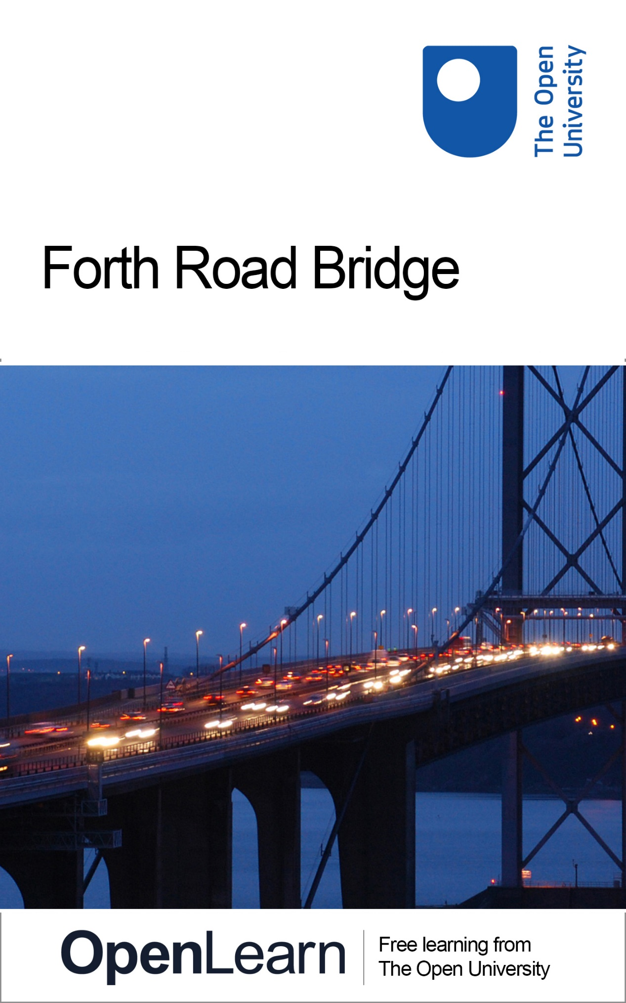

4ROAD_1

Forth Road Bridge

About this free course
This OpenLearn course provides a sample of Level 1 study in Technology http://www.open.ac.uk/courses/find/technology
This version of the content may include video, images and interactive content that may not be optimised for your device.
You can experience this free course as it was originally designed on OpenLearn, the home of free learning from The Open University –www.open.edu/openlearn/history-the-arts/forth-road-bridge/content-section-0
There you’ll also be able to track your progress via your activity record, which you can use to demonstrate your learning.
Copyright © 2016 The Open University
Intellectual property
Unless otherwise stated, this resource is released under the terms of the Creative Commons Licence v4.0 http://creativecommons.org/licenses/by-nc-sa/4.0/deed.en_GB. Within that The Open University interprets this licence in the following way: www.open.edu/openlearn/about-openlearn/frequently-asked-questions-on-openlearn. Copyright and rights falling outside the terms of the Creative Commons Licence are retained or controlled by The Open University. Please read the full text before using any of the content.
We believe the primary barrier to accessing high-quality educational experiences is cost, which is why we aim to publish as much free content as possible under an open licence. If it proves difficult to release content under our preferred Creative Commons licence (e.g. because we can’t afford or gain the clearances or find suitable alternatives), we will still release the materials for free under a personal end-user licence.
This is because the learning experience will always be the same high quality offering and that should always be seen as positive – even if at times the licensing is different to Creative Commons.
When using the content you must attribute us (The Open University) (the OU) and any identified author in accordance with the terms of the Creative Commons Licence.
The Acknowledgements section is used to list, amongst other things, third party (Proprietary), licensed content which is not subject to Creative Commons licensing. Proprietary content must be used (retained) intact and in context to the content at all times.
The Acknowledgements section is also used to bring to your attention any other Special Restrictions which may apply to the content. For example there may be times when the Creative Commons Non-Commercial Sharealike licence does not apply to any of the content even if owned by us (The Open University). In these instances, unless stated otherwise, the content may be used for personal and non-commercial use.
We have also identified as Proprietary other material included in the content which is not subject to Creative Commons Licence. These are OU logos, trading names and may extend to certain photographic and video images and sound recordings and any other material as may be brought to your attention.
Unauthorised use of any of the content may constitute a breach of the terms and conditions and/or intellectual property laws.
We reserve the right to alter, amend or bring to an end any terms and conditions provided here without notice.
All rights falling outside the terms of the Creative Commons licence are retained or controlled by The Open University.
Head of Intellectual Property, The Open University
978-1-4730-1394-0 (.kdl)
978-1-4730-0626-3 (.epub)

Contents
- Introduction
- Learning outcomes
- 1 The Forth Road Bridge
- 2 Conclusion
- Acknowledgements

Introduction
This unit focuses on the Forth Road Bridge that connects Edinburgh with Fife. This suspension bridge continues to face a number of problems regarding its deteriorating condition. The short video included in this unit illustrates some of the major structural issues facing bridges and examines some of the proposed changes to the use of the Forth Road Bridge to help increase its lifespan.
This OpenLearn course provides a sample of Level 1 study in Technology

Learning outcomes
After studying this course, you should be able to:
- understand the basic structural issues of the Forth Road Bridge
- give examples of how engineers are trying to alleviate the wear and tear on the bridge.

1 The Forth Road Bridge
Edinburgh reaches over the Firth of Forth with two great bridges – the photogenic Victorian Forth Rail Bridge and the slender 1960s Forth Road Bridge. The latter suspends the road from cables, but it is being threatened by rust. Water has found its way inside the cables, causing them to rust and weaken. It is predicted that in 2014 they may have to stop heavy goods vehicles using it and possibly close it altogether in 2019.
The following video, an extract from BBC's Coast Series 3, examines many of the issues facing the Forth Road Bridge.

Activity
0 hours 30 minutes

The deteriorating condition of the Forth Road Bridge has led to the Scottish Government recommending the development of a new cable-stayed bridge to the west of the existing Forth Road Bridge. There is some opposition to the construction of a second crossing rather than a replacement bridge because it is felt that this will lead to an increase in road traffic.
Watch the video extract from Coast, linked below, and consider:
- the risks associated with an increase in road traffic (for example pollution and congestion on arterial routes);
- the effect on local communities of building a new bridge;
- what measures could be taken to reduce road traffic over the Forth, for example, investment in public transport alternatives and reducing the number of single occupancy cars and HGVs.
You may wish to share these thoughts with fellow learners by posting your ideas in the Comments section below.
Click to view the video extract (8 minutes).

Video content is not available in this format.
Forth road bridge
View transcript - Forth road bridge

2 Conclusion
The Forth Road Bridge, connecting Edinburgh with Fife, continues to face a number of problems regarding its deteriorating condition. Both structural issues and the increasing wear and tear of the traffic upon the bridge are causes of concern for the engineers who maintain it.

Acknowledgements
Except for third party materials and otherwise stated (see terms and conditions), this content is made available under a Creative Commons Attribution-NonCommercial-ShareAlike 4.0 Licence.
The material acknowledged below is Proprietary and used under licence (not subject to Creative Commons Licence). Grateful acknowledgement is made to the following sources for permission to reproduce material in this free course:
Course image Lauren in Flickr made available under Creative Commons Attribution 2.0 Licence.
This video extract is from Coast Series 3, Programme 5 © Copyright BBC 2007.
Every effort has been made to contact copyright owners. If any have been inadvertently overlooked, the publishers will be pleased to make the necessary arrangements at the first opportunity.
Don't miss out
If reading this text has inspired you to learn more, you may be interested in joining the millions of people who discover our free learning resources and qualifications by visiting The Open University – www.open.edu/openlearn/free-courses.

Forth road bridge

Transcript
NEIL OLIVER
Edinburgh reaches over the Firth of Forth with two great bridges. While the famously robust Victorian rail bridge is the more photographed, the slender sweep of the 1960s road bridge behind it carries hundreds of thousands more people across the water. But there could be a ticking timebomb in the design of this suspension bridge and others like it around our coast.
Alice Roberts discovers the Forth Road Bridge’s hidden weakness.
ALICE ROBERTS
The most important parts of any suspension bridge are the cables that suspend it. And here they are. These ones are sixty-one centimetres in diameter and they stretch all the way from one end of the bridge to the other, and the roadway down there is literally suspended from them. It's a brilliantly simple idea but it may have a fatal flaw, and these cables are causing serious concern.
(Radio traffic broadcast) Inside Queen Street there’s queuing traffic heading towards the Forth Road Bridge, drivers should expect major delays.
ALICE ROBERTS
The cables that hold up the roadway are gradually corroding. Twenty-four million vehicles a year use this bridge. The nearest alternative crossing means a forty mile diversion. If you took away this bridge tomorrow, it’d be an economic disaster for the entire region.
Forth Road Bridge Master, Alastair Andrew, is trying to keep the bridge going.
ALICE ROBERTS
The traffic across the bridge is pretty relentless.
ALASTAIR ANDREW
This is one of our quietest days, believe it or not.
ALICE ROBERTS
Really?
ALASTAIR ANDREW
Yes.
ALICE ROBERTS
So, Alastair, what is the problem with these cables?
ALASTAIR ANDREW
Well, the problem is that water has found its way into the cable and has allowed rust to take hold inside the cable.
ALICE ROBERTS
But surely you waterproof them, they’re outside all day?
ALASTAIR ANDREW
Of course. There are several layers of protection and that’s why we’re so surprised because that waterproofing hasn’t worked.
ALICE ROBERTS
If you’ve got corrosion inside the cable, that’s weakening it from the inside?
ALASTAIR ANDREW
It is weakening the cable but the cable is perfectly safe at the moment. But, if we cannot stop that corrosion, the predictions are that we will have to stop heavy goods vehicles using the bridge in 2014 and, ultimately, close the bridge by 2019.
ALICE ROBERTS
So you’re in a bit of a race against time then to stop this corrosion?
ALASTAIR ANDREW
It's very much a race against time now.
ALICE ROBERTS
To see why the cables are so vulnerable, I'm going into the very innards of the bridge with Keith Perryman who was Inspector here for nine years.
ALICE ROBERTS
So Keith, there’s thousands of tons of roadway suspended up there?
KEITH PERRYMAN
Yeah, and in order to suspend that steelwork, we need two cables across four towers, anchored at both sides of the estuary into good, firm, solid rock, which is where the cable comes down into the anchor chamber over here.
ALICE ROBERTS
Following the cable inside reveals what it's really made of.
KEITH PERRYMAN
This is where we see the cables for what they really are and that’s loads and loads and loads and loads of wires.
ALICE ROBERTS
There must be thousands?
KEITH PERRYMAN
There’s in excess of eleven and half thousand wires.
ALICE ROBERTS
Wow! And each of these wires is actually quite slender. I mean it's about five millimetres in diameter.
KEITH PERRYMAN
Yeah, just under five millimetre in diameter.
ALICE ROBERTS
This is what’s holding the bridge up?
KEITH PERRYMAN
Yes, without the wires, no cable, without a cable, no bridge - this is it.
ALICE ROBERTS
A corroded or rusty wire is weak. Any one of the 11,500 wires in each cable is liable to snap at any time anywhere along the whole length of the bridge. The corrosion of the wires is a slow death sentence.
ALICE ROBERTS
Well, down here underneath the roadway, you get a really good idea of what it is that’s suspended from those cables; the sheer weight of all this steel and the roadways themselves and this traffic thundering past.
Wow! Every time a lorry goes by, the entire thing shakes, and all of this is suspended in mid air, sixty metre above the waters of the Forth.
So is there a solution to the corroding cables holding all of this up? Without knowing how fast it's weakening, the bridge team’s working blind. Somehow, Bridgemaster Alastair Andrew needs to get to the heart of the problem.
ALICE ROBERTS
But, Alastair, how can you know what’s going on inside those cables because presumably you can’t open them up?
KEITH PERRYMAN
No, absolutely, we can’t open up the whole length of the cable. The only way to do this is to actually listen to the cable. And what we have here are microphones which are attached to the cable.
ALICE ROBERTS
Which are there?
KEITH PERRYMAN
That’s the microphones there and they’re listening for any wire breaks that may occur inside the cable.
ALICE ROBERTS
So that’s like a stethoscope listening out to the health of the cables?
KEITH PERRYMAN
Exactly, the difference being that we have fifteen microphones placed over the entire length of each cable and we’re listening all the time.
ALICE ROBERTS
Continuously, twenty-four hours?
KEITH PERRYMAN
Absolutely.
ALICE ROBERTS
The microphones began their round-the-clock vigil in August 2006, and straightaway the computers began to pick up strange sounds hidden in the background noise from the traffic.
(Clicking sound)
These innocuous sounding clicks are actual wires snapping. So far the bridge has lost around ten percent of its strength. At that rate, the bridge has only got thirteen years left.
But there might be a way to save the bridge. The plan is to inject dry air into the cables to stop the corrosion. It’ll be the first time in the world it's been attempted, and there’s a big dilemma. By the time they find out if the dry air’s worked, it’ll be too late to build a new bridge. There’s a lot at stake.
KEITH PERRYMAN
Given that we’re handling twenty-four million vehicles a year, it's quite impractical to consider that traffic diverting on a mile detour. So it will have a major impact if a new bridge is not provided before we have to consider closing this one.
ALICE ROBERTS
And people around the world face the same prospect. Cable corrosion is affecting bridges in the US and Europe. But closer to home, it's even more severe, the old Severn Bridge is urgently having to tackle the same problem, and others may follow. We may soon have to rebuild bridges across the coastal barriers we thought we'd conquered.
Back to - Forth road bridge

