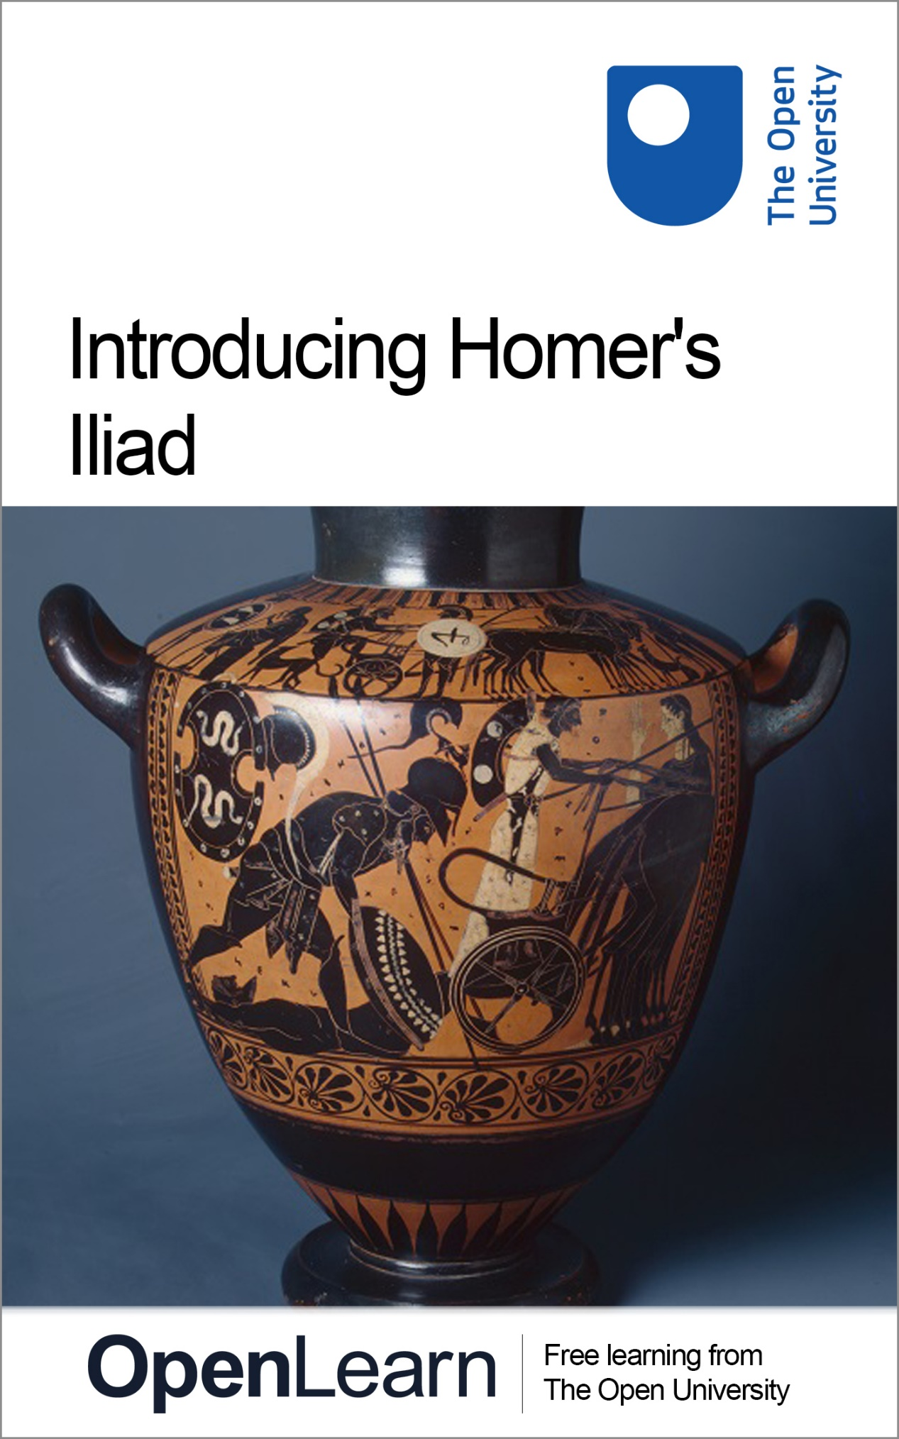

A229_1 Introducing Homer's Iliad

Introducing Homer's Iliad

About this free course
This free course is an adapted extract from the Open University course A229 Introducing the Classical World: www.open.ac.uk/courses/qualifications/details/a229 .
This version of the content may include video, images and interactive content that may not be optimised for your device.
You can experience this free course as it was originally designed on OpenLearn, the home of free learning from The Open University –
www.open.edu/openlearn/history-the-arts/introducing-homers-iliad/content-section-0
There you’ll also be able to track your progress via your activity record, which you can use to demonstrate your learning.
First published 2018.
Unless otherwise stated, copyright © 2024 The Open University, all rights reserved.
Intellectual property
Unless otherwise stated, this resource is released under the terms of the Creative Commons Licence v4.0 http://creativecommons.org/licenses/by-nc-sa/4.0/deed.en_GB. Within that The Open University interprets this licence in the following way: www.open.edu/openlearn/about-openlearn/frequently-asked-questions-on-openlearn. Copyright and rights falling outside the terms of the Creative Commons Licence are retained or controlled by The Open University. Please read the full text before using any of the content.
We believe the primary barrier to accessing high-quality educational experiences is cost, which is why we aim to publish as much free content as possible under an open licence. If it proves difficult to release content under our preferred Creative Commons licence (e.g. because we can’t afford or gain the clearances or find suitable alternatives), we will still release the materials for free under a personal end-user licence.
This is because the learning experience will always be the same high quality offering and that should always be seen as positive – even if at times the licensing is different to Creative Commons.
When using the content you must attribute us (The Open University) (the OU) and any identified author in accordance with the terms of the Creative Commons Licence.
The Acknowledgements section is used to list, amongst other things, third party (Proprietary), licensed content which is not subject to Creative Commons licensing. Proprietary content must be used (retained) intact and in context to the content at all times.
The Acknowledgements section is also used to bring to your attention any other Special Restrictions which may apply to the content. For example there may be times when the Creative Commons Non-Commercial Sharealike licence does not apply to any of the content even if owned by us (The Open University). In these instances, unless stated otherwise, the content may be used for personal and non-commercial use.
We have also identified as Proprietary other material included in the content which is not subject to Creative Commons Licence. These are OU logos, trading names and may extend to certain photographic and video images and sound recordings and any other material as may be brought to your attention.
Unauthorised use of any of the content may constitute a breach of the terms and conditions and/or intellectual property laws.
We reserve the right to alter, amend or bring to an end any terms and conditions provided here without notice.
All rights falling outside the terms of the Creative Commons licence are retained or controlled by The Open University.
Head of Intellectual Property, The Open University

Contents
- Introduction
- Learning outcomes
- 1 The Troy story
  - 1.1 The catalyst for the Trojan War
  - 1.2 Sources for the Trojan War
- 2 Homer’s Iliad
- 3 Homer’s oral art I
  - 3.1 Meter and word order
  - 3.2 Epithets
  - 3.3 Homeric music
- 4 Homer’s oral art II
  - 4.1 Insightful similes
- Conclusion
- Images
- References
- Solutions

Introduction
The Iliad and the Odyssey, the two epic ancient Greek poems attributed to Homer, are widely considered to be foundational texts in Western literature. Yet, the poems contain many features that seem unusual or just plain weird to the modern reader. In order for you to be able to read and better understand the poems, you will be introduced to some of the major characteristics of Homeric poetry.
This free course, Introducing Homer’s Iliad, will focus on the first of the two poems, which tells the story of the Trojan War. You will begin by learning about the wider cycle of myths of which the narrative of the Iliad was a part. You’ll then look more closely at the story of the poem itself and its major theme of the anger of Achilles, in particular in the opening of the poem. Using this opening, you’ll examine some of the characteristic features of the text: metre, word order (and its effects on translation), and epithets. Finally, you’ll learn about one of the key features of Homer’s poetry, the simile. This should prepare you to read the Iliad, as well as the Odyssey, on your own with greater ease and interest.
This OpenLearn course is an adapted extract from the Open University course A229 Introducing the Classical World.

Learning outcomes
After studying this course, you should be able to:
- understand the plot of the Iliad and the wider cycle of myths of which it was a part
- identify characteristic features that show how the Iliad was composed orally
- use these features to think about and interpret the poem.

1 The Troy story
Homer’s two poems – the Iliad and the Odyssey – together tell the story of a war between Greeks and Trojans at a place called Troy (or Ilium, to give it its Latinised name – hence the Iliad), and the return home of one of the heroes, Odysseus (hence the Odyssey). Even if you think you don’t know anything about the Trojan War, perhaps you’ve heard the phrases ‘Achilles’ heel’, ‘Trojan horse’, or ‘the face that launched a thousand ships’? Or you may have seen a film, watched a TV programme, or read a novel based on the story of Troy. For many people, these stories are a gateway into the classical world.
Since Homer’s poems are part of the Trojan War story, it is a good idea first to provide a summary of the siege of Troy: why it began, what happened there, and how it ended. Although there’s a considerable cast of characters, both divine and mortal, you don’t need to know them all: the course will help guide you through all details that are important. It’s also worth highlighting two features of this account. First, this summary has been stitched together from a wide range of sources. Versions of the Troy story don’t just appear in Homer: we have other literary sources, including fragments of rival epic poems about the war (one called the Cypria narrated its beginning, another called the Sack of Troy its end); a poem about the origins of the cosmos under Zeus’ rule (Hesiod’s Theogony); and a collection of thirty-three poems honouring the gods (the Homeric Hymns), while the backstory to Achilles’ mother, Thetis, is preserved in the much later fifth-century poem Isthmian 8 by Pindar. Extracts from the Trojan story also appear in other media, notably depictions on ceramics and temple friezes. There is never any one canonical version of the Trojan War, nor any one version that tells the whole story. Second, what we see here is myth in action: the Troy story isn’t historical fact but a traditional story for thinking about the past, involving supernatural beings (gods and heroes), and continually retold and reworked from the standpoint of each successive generation.

Please note: Though we call the poet of the Iliad and the Odyssey ‘Homer’, in fact very little is known about who wrote them. This question of authorship will be discussed in more detail later in this course.

1.1 The catalyst for the Trojan War

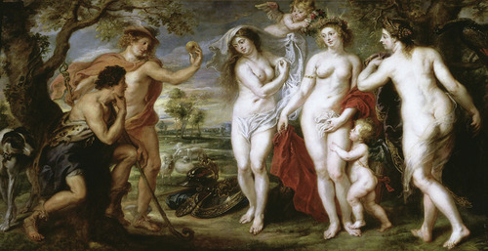
Figure 1 Peter Paul Rubens, The Judgement of Paris, c.1638, oil on canvas, 199 x 381 cm. Prado Museum, Madrid. Hermes holds up the golden apple, while Paris surveys the beauty of the three goddesses Hera, Athena and Aphrodite.

The catalyst for the Trojan War occurred when, at the wedding of the hero Peleus and the immortal nymph Thetis, Eris, the goddess of strife, rolled an apple marked ‘for the fairest’ down the aisle. In the resulting fallout – as the goddesses Hera, Athena, and Aphrodite quarrelled over who should receive this title – Zeus entrusted the decision to the judgement of a mortal, Paris, a prince of Troy. All three goddesses attempted to influence Paris: Hera offered him political dominion, Athena strategic success in war; but Paris chose Aphrodite, who offered him the most beautiful of all women, Helen. Unfortunately, Helen was already married to a Greek hero by the name of Menelaus: when she eloped with Paris to Troy, Menelaus’ brother, Agamemnon, raised a coalition of Greek forces to besiege Troy and secure Helen’s return. For ten years the two sides fought at Troy, along with their allies – the Trojans were supported at various times by Amazons (a mythical tribe of warrior women) and Ethiopians, making this something of an ancient world war. Achilles defeated all the main heroes, including the Amazon Penthesilea, the Ethiopian Memnon, and Troilus, the youngest son of the elderly king Priam, as well as the Trojan champion, Hector, whose body he dragged behind his chariot around the walls of Troy three times. Achilles too died, killed at the hands of Paris, who brought him low with an arrow through his heel. His body was rescued for burial by Ajax. Eventually, the city fell to Odysseus’ ruse of the Trojan Horse. Once inside the city, the Greeks massacred the population (except for some women and children whom they enslaved), and committed numerous atrocities, notorious among which was Neoptolemus, Achilles’ son, killing Priam at the altar of Athena. With these actions the Greeks incurred the wrath of the gods, and few returned safely to their homelands: many were lost at sea, others founded colonies in distant lands, and those that did make it back found trouble waiting for them at home (Agamemnon was murdered by his wife, Clytemnestra and her lover; Odysseus found his palace overrun with suitors for his wife).

1.2 Sources for the Trojan War
It’s important to remember that there are variations on this story, and that the narrative is not fixed in one version; for example, some ancient authors wrote that Helen did not actually go to Troy, but rather a ‘phantom’ version of her created by Aphrodite did, while the real Helen was concealed in Egypt. The Iliad, too, is only a version of the story. We can see multiple versions in a variety of sources – and, crucially, not all of these sources are textual.

Activity 1

Another source for the Trojan story is Greek pottery. Look at the images below. Can you identify from the summary of the Trojan War which part of the story each of the images relates to?

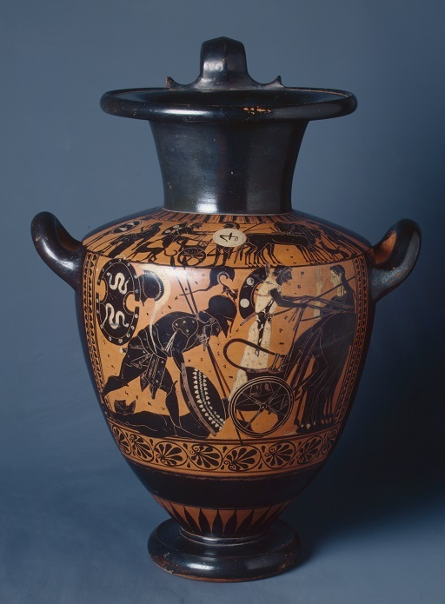
Figure 2

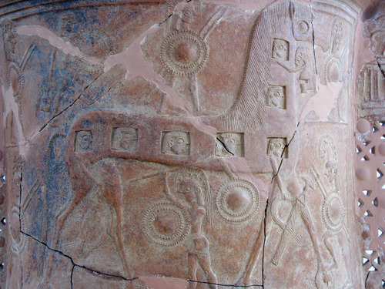
Figure 3

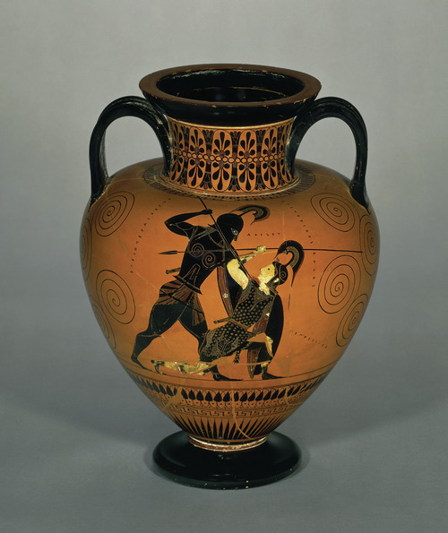
Figure 4

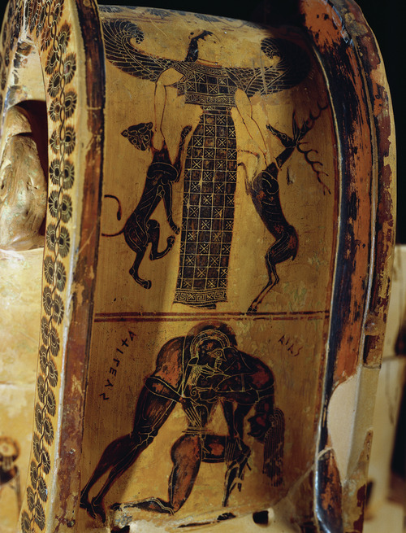
Figure 5

View discussion - Activity 1

Out of these four images, only that in Figure 2 is narrated by the Iliad. From this fact, we can learn two things. Firstly, the narrative of the Iliad is only one part of a much wider mythical tapestry of the Troy story. The story extends on either side of the narrative, and even events that do occur in the poem could be told in different ways: for example, the scene in Figure 2 is not exactly what we ‘see’ in Homer, though it addresses the same moment in the narrative. Secondly, the numerous scenes from the Troy story that appear on Greek ceramics and other visual sources from the Greek world are almost certainly not illustrations of the Iliad itself, but rather of the wider myth. Homer’s Iliad, then, is simply one version of a part of the Troy story.
You now have a sense of the Trojan War and what happened in it. In this next activity you will learn about Homer’s take on the tradition.

Activity 2

Watch this short animation, ‘Troy Story I’, which summarises the narrative of Homer’s Iliad. Then reread the summary of the Trojan War story in Section 1. How does the plot of the animation compare to it?

Video content is not available in this format.
Video 1 Troy Story I: the Iliad
View transcript - Video 1 Troy Story I: the Iliad

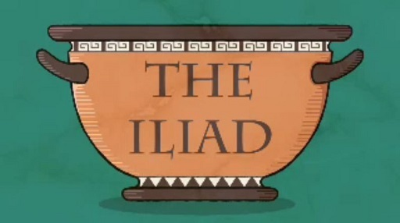

View discussion - Part

Optional activity

Although the Odyssey won’t be discussed in detail in this course, you might enjoy watching this second Troy Story animation, which explains the plot of this poem about Odysseus’ arduous journey home from Troy to Ithaca and the problems he encountered once he arrived there. The skills you learn in this OpenLearn course should prepare you to read both poems, as they employ similar techniques of oral poetry.

Video content is not available in this format.
Video 2 Troy Story II: the Odyssey
View transcript - Video 2 Troy Story II: the Odyssey

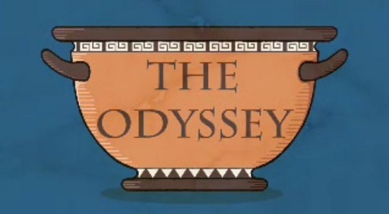

Despite the fact that the Iliad is a (very) long poem, Homer is remarkably concentrated on a single, fleeting episode in a much longer conflict. At the same time, he still manages to evoke the war as a whole. To take one example: Homer relates that, when news of the Trojan hero Hector’s death reached the Trojans holed up in the city, they wailed ‘as if the whole of jutting Ilium was now smouldering / with fire all the way from its top to its bottom’ (Iliad 22.410–411). Homer doesn’t need to narrate the fall of Troy because: (i) his ancient audience knew the broader outline of the Troy story; and (ii) he has shown by this point in the narrative that, with the death of Hector, Troy is doomed to fall.
It’s clear already, then, that the Iliad doesn’t tell the whole story of the Trojan War. In what follows you’ll start to think about what Homer does focus on.

2 Homer’s Iliad
In the last section you discovered how the Trojan War begins and ends in the mythical narratives, and you learned that the Iliad doesn’t deal directly with either: in spite of its length, its story is focused on a handful of days in a 10-year conflict. In this section and the next, you will spend most of your time looking at the opening, or proem, of the poem – more specifically, the first seven lines. Although this is a very short extract of the text, it actually contains a large amount of useful material that you can tease out for thinking about the Iliad as a whole. You might be surprised to see how much you can learn from just these few lines! You’ll start by finding out how the poet signals his version of the narrative for an audience who knew (at least roughly) the basic trajectory of the war and the key characters involved.

Activity 3

The first seven lines of the Iliad function in some ways like the preface to a novel or a trailer for a film in that it gives the audience an insight into what is to come in the rest of the poem. In this version, translated by Anthony Verity, some words and phrases that may be unfamiliar to you have been glossed underneath the text. Read this text now.

Sing, goddess, the anger of Achilles, Peleus’ son,
the accursed anger which brought the Achaeans countless
agonies and hurled many mighty shades of heroes into Hades,
causing them to become the prey of dogs and
all kinds of birds; and the plan of Zeus was fulfilled.
Sing from the time the two men were first divided in strife—
Atreus’ son, lord of men, and glorious Achilles.

Glossary
Achaeans: one of the words used by Homer to describe the Greeks.
Hades: the Underworld; also used of the god of the Underworld.
Atreus’ son: Agamemnon, leader of the Achaeans.
What information can you identify that relates to the story of the Trojan War outlined in my synopsis in the previous section? What is the audience not told? Does it seem like the poet is assuming anything of his audience?

Provide your answer...
View discussion - Part

You’ll come back to the unnamed goddess, Zeus, and ‘Atreus’ son’ shortly. Before doing so, read the passage again, focusing on Achilles, the central character of the epic. What do we learn about him? Does anything seem surprising?

Provide your answer...
View discussion - Part

Please note: Homer uses three names for the Greek army: they are Achaeans, Danaans or Argives. Although the term ‘Greeks’ is used in this course, he never uses the term in this collective sense. (In Homer ‘Hellas’ (Greece) denotes a northern region in the Greek mainland.)

From this opening, then, you have seen how Homer positions his particular poem about the Trojan War in and against the story tradition relating to this conflict. Why do we talk about ‘Homer’ though, when, as you have seen, no mention of an author is given in the opening lines? The simple truth is that we don’t know anything about Homer. The Iliad and Odyssey are oral poems that were composed in performance, meaning that they were crafted in the process of being sung, rather than being created in advance and recited or rehearsed as we might expect from a poetic recital. Because of this ‘composition in performance’ element, whoever the poet (poetēs comes from the Greek meaning the ‘one who makes’) was would have been clear for all members of that audience to see. By the same token, since there is no eye-witness account of the Iliad or Odyssey being composed, we have no information about their poet or whether indeed the same poet composed both epics. It was when these two poems came to be written down and re-performed at an Athenian festival held every four years in honour of Athena called the Great Panatheneia, around 550 BCE or so, that the name of ‘Homer’ appeared in conjunction with them. Indeed, at this early point, Homer’s name was also attached to other poems about the Trojan War, as if the name was shorthand to describe the genre of these poems, heroic epic. However, by the time of Aristotle (384–322 BCE), to talk of Homer’s poems meant the Iliad and Odyssey. Only these two orally composed heroic epics have survived the test of time (apparently) complete.

Please note: heroic epic is a genre of poetry that focuses on the stories of heroes (as in Homer’s Iliad and Odyssey) to be distinguished from the epic poetry of Hesiod (in the same hexameter verse) that focuses on gods (Theogony) or men (the Works and Days).

3 Homer’s oral art I
The fact that the Iliad was composed orally means that it has a number of features that are specific to this type of poetry. Even though all we have is a written version of the text, we can still identify a number of these oral features.

Activity 4

Read through the opening seven lines of the Iliad again. What stylistic features of this kind of poetry do you find striking or odd, or would like to know more about?

Sing, goddess, the anger of Achilles, Peleus’ son,
the accursed anger which brought the Achaeans countless
agonies and hurled many mighty shades of heroes into Hades,
causing them to become the prey of dogs and
all kinds of birds; and the plan of Zeus was fulfilled.
Sing from the time the two men were first divided in strife—
Atreus’ son, lord of men, and glorious Achilles.

View discussion - Activity 4

The first of these features, the address to the goddess, is not distinctive to oral poetry, but is something that appears in a lot of ancient poetry. The goddess in question is one of the Muses, a group of goddesses who were said to inspire all creative endeavours. So here, the poet is asking the Muse to tell the story of Achilles’ anger through him, suggesting that he is a vessel for divine inspiration.
The other two features highlighted – singing and the descriptions of the heroes, which we call ‘epithets’ – are closely linked to the oral nature of the Iliad. While we read Homer in a book, and are able to because of a long manuscript tradition going back centuries of copying his poems (see Figure 6), Homer’s early audiences would have received his poems by listening to them being performed orally. Each of Homer’s poems would take some 3 days to perform, and would likely be performed in a public festival setting, like the Athenian Great Panathenaia festival mentioned above. If we remember that these poems were usually composed in performance, we can begin to understand some of the distinctive features of Homeric poetry, including ones that don’t translate well into English but are very effective in the original ancient Greek.

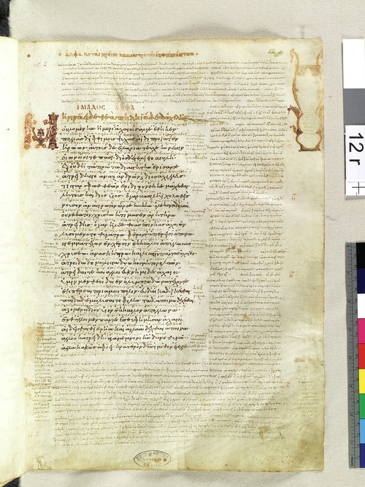
Figure 6 Iliad 1-1.25, Biblioteca Nazionale Marciana, Venice, Venetus A: Marcianus Graecus Z. 454 (= 822), folio 12, recto.

3.1 Meter and word order
The sung nature of oral poetry is particularly apparent from the fact that there is a strong metrical structure, or rhythm, to the poetry in the ancient Greek. Various metrical structures can be seen in more modern poetry; for example, Shakespeare’s sonnets make use of iambic pentameter (five metrical ‘feet’ of two syllables each, one unstressed and one stressed: da-DUM). The poetic genre of the Iliad – heroic epic – has, in the original Greek text, a very strict metrical structure. For each line of verse, in the Greek there are six metrical feet – hence the full name of Homer’s poetry: hexameter – composed of a combination of short and long syllables. You don’t need to recognise the precise structure of the hexameter metrical line, but it is important to know this is the fundamental basis for how the poetry works.

Activity 5

Listen to the first audio, which is a recording of the English translation of the first seven lines of the Iliad. Then listen to the second audio, which is a recording of the first seven lines of the Iliad being recited in ancient Greek, in order to hear the rhythm. Finally, listen to the third audio, which discusses the metrical structure of these lines.

Audio content is not available in this format.
Audio 1 Reading of lines 1–7 of the Iliad in translation
View transcript - Audio 1 Reading of lines 1–7 of the Iliad in translation

Audio content is not available in this format.
Audio 2 Lucy Jackson reads lines 1–7 of the Iliad in Greek

Audio content is not available in this format.
Audio 3 A discussion of meter in these lines
View transcript - Audio 3 A discussion of meter in these lines

As you heard, the metrical structure of the Iliad is particularly strict. You might expect that this would affect how creative the poet could be in his choice of words and phrases. Although the meter did in some ways constrain the poetry, in fact the poet was able to use the form to great effect by exploiting the flexibility of Greek word order.

Activity 6

Now return to those first seven lines, but this time you’re going to look at the order of the words in Greek, and how they’ve been translated into English. You are not expected to be able to read the Greek here (though if you’ve studied ancient Greek before, you may be able to recognise some words); a literal translation to illustrate the original word order is provided. For each line, you are given the Greek text, then the transliteration (the Greek text rendered in English letters), then the literal word order in English and finally the good English translation. Take a few minutes to study each line and see how the English translation relates to the original Greek word order. Then look more closely at the Greek word order, and see if you can spot any interesting effects.
Line 1
μῆνιν ἄειδε θεὰ Πηληϊάδεω Ἀχιλῆος
menin aeide thea Peleiadeo Achileos
anger sing goddess son-of-Peleus Achilles
Sing, goddess, the anger of Achilles, Peleus' son,

Line 2
οὐλομένην, ἣ μυρί᾽ Ἀχαιοῖς ἄλγε᾽ ἔθηκε,
oulomenen, he myri’ Achaiois alge’ etheke,
accursed, that countless to-the-Achaeans agonies brought
the accursed anger which brought the Achaeans countless

Line 3
πολλὰς δ᾽ ἰφθίμους ψυχὰς Ἄϊδι προΐαψεν
pollas d’ iphthimous psychas Aidi proiapsen
many and mighty shades into-Hades hurled
agonies and hurled many mighty shades of heroes into Hades,

Line 4
ἡρώων, αὐτοὺς δὲ ἑλώρια τεῦχε κύνεσσιν
heroon, autous de heloria teuche kynessin
of-heroes, them and prey causing-them-to-become of-dogs
causing them to become the prey of dogs and

Line 5
οἰωνοῖσί τε πᾶσι, Διὸς δ᾽ ἐτελείετο βουλή,
oionoisi te pasi, Dios d’ eteleieto boule,
of-birds and all-kinds, of-Zeus and was-fulfilled plan.
all kinds of birds; and the plan of Zeus was fulfilled.

Line 6
ἐξ οὗ δὴ τὰ πρῶτα διαστήτην ἐρίσαντε
ex hou de ta prota diasteten erisante
from when indeed the first in-strife were-divided
Sing from the time the two men were first divided in strife—

Line 7
Ἀτρεΐδης τε ἄναξ ἀνδρῶν καὶ δῖος Ἀχιλλεύς.
Atreides te anax andron kai dios Achilleus.
Son-of-Atreus both lord of-men and glorious Achilles.
Atreus' son, lord of men, and glorious Achilles.

View discussion - Activity 6

3.2 Epithets
Besides the creative use of word order, there were other ways for the poet to work with the strict metrical form of heroic epic poetry. One was the regular use of stock phrases, called formulae, which act as ‘ready-made building blocks’ to fit the metrical structure, often finishing off a line. One particular type of formula is the epithet, a way of referring to characters by different attributes. You’ve already encountered one example that occurs in the very first line: Peleus’ son, which is used to refer to Achilles.

Activity 7

Read the first seven lines again, and see how many more epithets you can spot.

Sing, goddess, the anger of Achilles, Peleus’ son,
the accursed anger which brought the Achaeans countless
agonies and hurled many mighty shades of heroes into Hades,
causing them to become the prey of dogs and
all kinds of birds; and the plan of Zeus was fulfilled.
Sing from the time the two men were first divided in strife—
Atreus’ son, lord of men, and glorious Achilles.

View discussion - Activity 7

Epithets serve as a kind of shorthand to immediately identify the hero or thing being described: so Agamemnon can be described in terms of his birth right (‘son of Atreus’) or his role (‘lord of men’). Other repeated phrases can be longer in form, as in ‘the plan of Zeus was fulfilled’ (Iliad 1.5).

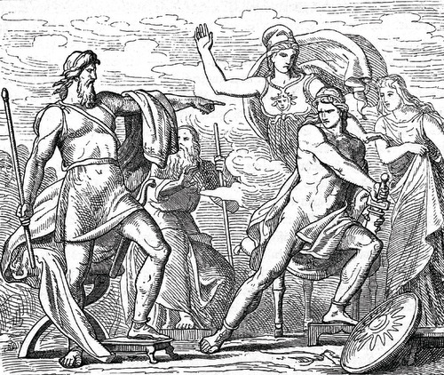
Figure 7 Achilles and Agamemnon arguing; the subject of the first book of the Iliad, and the catalyst for its whole narrative.

You’ve already seen how frequently epithets appear even just in the first few lines. In fact, they occur in almost every line, and are a characteristic feature of Homer’s poems. Importantly, the epithets themselves show both repetition and variation; for example, Achilles is often called ‘swift-footed’, but also ‘glorious’ and ‘glorious swift-footed’. This allows them to fit into different sections of the metrical structure, allowing the poet to compose in performance more easily.
Arguably the closest modern comparison for how this poetry works is rap – a musical genre that similarly possesses a similar set of stock scenarios, images and language, with a strong metrical basis (which must aid memory and recall for poet and audience alike).

Activity 8

The idea that heroic epic poems draw on a vast repertoire of epithets and repeated phrases – and even entire story patterns, like the ‘destruction of a city’ or the ‘homecoming’ – might give the impression of a ‘poetry-by-numbers’ kind of literature. For an example, consider the first instance when Achilles is called ‘swift-footed’ in the Iliad:

So when they had assembled and were gathered together,
swift-footed Achilles rose and spoke among them.
(Homer, Iliad 1.57–8)

What’s the problem here with the epithet ‘swift-footed’? With the idea of oral composition in mind, can you explain its use here?

Provide your answer...
View discussion - Activity 8

This explanation is fine, but doesn't seem to do justice to the skill of the poet. There is another invaluable function that the epithets provide. As you noted before, well-known characters can be introduced without even being named. This is because the ancient audience would be familiar with both the characters and their epithet descriptions. In turn, this is because they are ‘ready-made building blocks’ that had been used before in other poems and other contexts. That seems to be the point here. The epithet ‘swift-footed’ points to one essential aspect (there are others, such as ‘son of Peleus’) of who Achilles is in the tradition of epic song about the Trojan War. To put that another way: in the tradition Achilles is usually ‘swift-footed’, presumably because this was an important asset in fighting. Here, however, the context is precisely at odds with what Achilles is famed for. Indeed, for the most part of the Iliad, Achilles doesn’t move: he sits out the war in his hut by the ships. This tension between his traditional description and what he actually does draws attention to a disjunction between what is expected of Achilles in traditional storytelling and the (new, perhaps even radical) version that Homer sings.

3.3 Homeric music
You’ve now completed a close reading of the first seven lines of the Iliad, thinking about the effects of metre, word order, epithets, and the audience’s knowledge of the Trojan story. The only thing that is still missing from the whole experience of the Iliad is the music. As you now know, the Iliad would not have simply been recited, but sung with instrumental accompaniment. This may be one of the most difficult aspects of the original performance context to recreate, but it’s not impossible. A researcher named Stefan Hagel has been working for 35 years on creating a reconstruction of Homeric singing and music.

Activity 9

First, read this explanation of Stefan Hagel’s research method in recreating Homeric music:

Most scholars are convinced that Homer stood in a tradition of lyre-accompanied epic song, just as depicted in both the Iliad and the Odyssey. The melodies, which would have been improvised along with the text, are of course lost, the first Greek notated musical documents surviving only from about 400 years later. However, computer-aided statistics of word accents in the epics have shown that these were not distributed randomly; especially word-final accents accumulate in certain places, in a way that can only be explained as governed by melodic preferences. Patterns emerge that align melodic contours with metrical and grammatical units, even across verses.
On the basis of these patterns and the conventions of Homeric versification it becomes possible to improvise a melody for any piece of archaic hexameter poetry, adjusting the broader contours to the demands of individual word accents, so that the melody becomes a stylised representation of Greek speech – just as it is observed in notated music from the Hellenistic period (after 323 BCE) on. In the audio example below, the re-envisaged Homeric melody is accompanied on a seven-stringed lyre, the typical instrument of the early poets, tuned to what may have been the archaic version of ‘Aeolian’ – probably the closest we may get to a seventh-century BCE tuning, and in good geographic accord with the history of the epic language.

Now listen to this audio, in which Stefan Hagel performs an improvisation on the lyre and sings the opening lines of the Iliad.

Audio content is not available in this format.

Audio 4 A performance by Stefan Hagel

4 Homer’s oral art II
Another characteristic feature of Homer’s oral poetry is the simile. In similes, the poet compares one thing to another: so and so is ‘like’ x. For example, at Iliad 21.461–7, Apollo backs out of fighting with his uncle Poseidon, the earth-shaker, ‘for the sake of mortals’ because they are:

wretched creatures, who like leaves at one time flourish in a
blaze of glory, feeding on the fruits of the tilled earth, and
at another wither spiritlessly away.

Apollo’s contention is that the gods should not fight among themselves on behalf of men, because men die. He compares mortals to leaves on a tree, since, in comparison to the gods, mortals live their lives in the seasonal cycle of one year, flourishing at one moment, at the next withering and dying away. In this way, similes are exemplary for demonstrating the ways in which Homer relates his story of an epic universe of heroes to the people of his day.
Homer’s similes most often use scenes from nature or domestic life in their imagery. These would have had various powerful effects on the audience listening to the poem, which we can explore by looking at some of the similes more closely.

Activity 10

Read the two sections of similes below, and look at the images that accompany them. Then, list 3–5 adjectives that describe the scenes in these two similes. Can you guess what they might be comparing the scene to?

Figure 8 Cranes flying

[they] advanced, screeching and shouting like birds;
as when the screech of cranes is heard in the high sky,
when they have fled from winter’s onset and prodigious rain,
and screaming fly towards the streams of Ocean…
(Iliad 3.2–5)

Figure 9 A family of leaves

As is the family of leaves, so it is also with men:
the wind scatters the leaves on the ground, but the forest breaks
into bud and makes more when the spring season comes round.
(Iliad 6.146–8)

View discussion - Activity 10

When you read these similes, were you struck by how vivid the imagery was? The ancient audience would have experienced the same effect. This is a literary feature called enargeia, meaning a description vivid enough for a listener (or reader) to be able to visualise it in their mind’s eye. This would have been a particularly effective aspect of the performance of the poem, not just in the vivid descriptions in the similes, but in similar descriptions of scenes of battle or assembly.
Another advantage of these kinds of images in the similes is that they would have been familiar to a majority of the audience. Although it’s likely that most of the audience would have experienced war at some point, the epic aspect of this narrative – that is, the momentous, world-changing nature of this particular war – would have created distance between the audience and the story. In this way, the ancient epic genre is a bit like the modern genre of science fiction, which often examines deeply human issues in an alternative setting unlike our modern reality, or perhaps even better the Western, which explores issues of the foundation of society in a sort of ‘heroic’ past, much like the Iliad. These similes bridge the two worlds by specifically relating the epic past to the audience’s present, using recognisable natural phenomena. This same effect was perhaps achieved even more easily in those similes that use scenes from everyday life for their comparisons.

Activity 11

Now read these two similes, where comparisons are made with domestic or everyday scenes. Which scene feels more familiar to you? Why?

In this simile, the Greek and Trojan armies are clashing over the ramparts that the Greeks have built, and neither side can push the other back.
Like two men who are in dispute over boundary-stones,
on common ploughland, holding measuring-rods in their hands,
and quarrelling over the fair division of a narrow patch of earth,
so the battlements separated these men…
(Iliad 12.421–4)

In this simile, Patroclus has approached Achilles crying about the heavy losses that the Greeks are suffering; Achilles questions Patroclus about his tears.

Patroclus, why are you weeping like a little girl who
runs at her mother’s side and demands to be carried,
clutching at her dress, tugging her back as she tries to hurry,
and tearfully looking up at her until she is picked up?
That is what you are like, Patroclus, weeping soft tears.
(Iliad 16.7–11)

Provide your answer...
View discussion - Activity 11

For the original audience, however, these scenes might have seemed equally familiar. Many people would have led lives centred on agriculture, and so issues of land management would have been a part of everyday life. Passages like this in the Iliad are interesting not only for their poetic effect, but for the historical information that they can provide us about life in early Greece. (Of course, in order to build a fuller picture of early Greek life, we need to combine the evidence of the poems with the evidence of other texts and pieces of material culture.)
Similes from nature and from domestic life provide a level of universality to a narrative made distant by its epic nature. They allow listeners to connect scenes and ideas unfamiliar in their magnitude to images that they may have witnessed for themselves, and thus can easily picture in their mind’s eye. This heightened vividness and relatability will have made the poem even more engaging in performance.
The domestic, everyday nature of these scenes, though, will also have had a powerful effect on the major theme of war in the poem. Scenes such as a mother and child or new leaves growing in the spring seem a world away from the violence and bloodshed of the epic battlefield. Such everyday similes emphasise that the Trojan War was not an everyday event, but a time of extreme disruption to the lives of those affected. This, in turn, situates the war in a ‘real world’ setting; these are not merely distant, heroic events, but things that can actually happen. In this way, the poem seems to reduce the possibility for the glorification of war.

4.1 Insightful similes
But the similes in the Iliad are not only interesting for their vividness, universality, and for reflecting on the greater theme of war. By deploying similes at key points in his story, Homer reveals important insights into not only the world of his audience, but also his characters.

Activity 12

Read these two similes, which both describe Agamemnon. What sort of characteristics do they suggest about him in each instance?
First simile:

When the Trojans reached the Scaean gates and the oak tree,
there they halted and stood, waiting for one another;
many were still fleeing in panic over the mid-plain, like cattle
stampeded by a lion that has come on them in the dead of night;
the rest have scattered, and one alone faces sheer death, and
first the lion seizes the neck in its powerful jaws and breaks it,
and then greedily gulps down its blood and all its entrails.
So lord Agamemnon, son of Atreus, pursued the Trojans,
all the time killing the hindmost; and they fled in panic.
(Iliad 11.170–178)

Second simile:

Now the son of Atreus, so long as the blood welled up warm
from his wound, went up and down the Trojan ranks,
attacking them with spear and sword and great stones;
but when the wound began to dry, and the blood stopped flowing,
then sharp pains began to assail the fury of Atreus’ son.
As when a sharp spasm seizes a woman in labour, a piercing
pang, sent by the Eilythyiae, goddesses of painful birth,
bringers of bitter suffering and daughters of Hera,
so sharp pains began to assail the fury of Atreus’ son.
(Iliad 11.264–272)

Provide your answer...
View discussion - Activity 12

It’s particularly interesting to note that these two similes appear in close proximity to each other in book 11. The difference between the two similes marks a change in Agamemnon’s role on the battlefield during this episode, from an aggressive and powerful warrior to a wounded and weakened figure. From a modern perspective, we might not see the comparison with a woman in labour as particularly detrimental to Agamemnon’s character, but for the ancient audience this might have had a different resonance, as men and women occupied very different spheres. To compare him to a woman may have, at the very least, had the effect of showing that his wound has prevented him from fulfilling his duty as a male warrior, and could also serve as an ironic commentary on his self-styled misogyny elsewhere in the poem.
The simile comparing Patroclus and a little girl from Activity 11 also gives an interesting perspective on character. In spite of the fact that Achilles makes a comparison which could be seen as diminishing Patroclus’ status as a warrior, and which seems to mock Patroclus to some extent, Achilles stillreluctantly agrees to let Patroclus fight in his stead. The humble simile helps to humanise Achilles at this critical moment (one that will have devastating consequences) and allows us a way into his mind-set. Ironically, the heroic world has to be supplemented by images from the real world in order to convey its magnitude.
This section has examined just a few of the many similes that appear in the Iliad, and which are a distinctive part of the poem’s style. Many of their effects would have been particularly potent in oral performance – especially the creation of enargeia for the listeners – but others, such as reflections on characters and themes, are equally effective in the written format in which most people experience the poem today.

Conclusion
In this free course, Introducing Homer’s Iliad, you have begun to get to know the Iliad, the ancient Greek epic poem of the Trojan War attributed to Homer. You have also learned some of the main features of oral poetry that survive in the written text that exists today.
You have looked in some detail at the myth of the Trojan War as it can be compiled from a range of extant sources, including texts and material artefacts. You have then examined more closely the plot of the Iliad, which covers only a short period of 51 days during the 10-year Trojan War and focuses on the anger of Achilles, his quarrel with Agamemnon, and the consequences of their disagreement. Studying the first seven lines of the poem, both in Greek and English, text and audio, allowed you to notice several distinctive features: the hexameter of the poetry in Greek; the fact that the poem would have been sung to music; the use of word order to highlight the theme of anger; and the use of formulaic phrases, particularly epithets. A closer look at later sections of the text also introduced the extensive use of similes in the poem, which often refer to the natural world or domestic life far from the battlefield, in order to minimise the epic distance of the setting of the Iliad’s narrative, as well as to reflect on the major theme of war.
Hopefully this course has given you a greater sense of how the Iliad works, and has prepared you to some extent to read the poem in its entirety, if you want to. The features of oral poetry highlighted in this course also apply to the Odyssey, the other existing example of heroic epic poetry that uses the myth of the Trojan War as source material. Although the plot of the Odyssey wasn’t covered in detail, you can watch our ‘Troy Story II’ animation (included as an optional activity in this course) to get a sense of the narrative. So you might also feel ready to read that poem, too.
This OpenLearn course is an adapted extract from the Open University course A229 Introducing the Classical World.

A level Classical Civilisation with the NEC

The ancient Greeks and Romans created a legacy that has shaped the literature, language, arts, politics and philosophy of the western world. NEC's A level Classical Civilisation online course invites you to step back in time to develop a critical approach to literature and culture of this fascinating period in history.
Step back in time to explore the ancient Greco-Roman world through the eyes of Homer, Virgil and Sophocles in this online A level Classical Civilisation course from the National Extension College (NEC).
Enrol from £750.
Find out more about A level Classical Civilisation here.

Images
This free course was written by Elton Barker and Christine Plastow.
Except for third party materials and otherwise stated (see terms and conditions), this content is made available under a Creative Commons Attribution-NonCommercial-ShareAlike 4.0 Licence.
The material acknowledged below is Proprietary and used under licence (not subject to Creative Commons Licence). Grateful acknowledgement is made to the following sources for permission to reproduce material in this free course:
Figure 1: Photo: © Masterpics / Alamy
Figure 2 and course image: Photograph © The State Hermitage Museum. Photo by Vladimir Terebenin.
Figure 3: Photo: Paul. Used under this licence: https://creativecommons.org/licenses/by-sa/2.0/
Figure 4: Photo: © The Trustees of the British Museum
Figure 5: © Museo Archeologico, Florence, Italy / De Agostini Picture Library / G. Dagli Orti / Bridgeman Images
Figure 6: Photo: © 2007, Biblioteca Nazionale Marciana, Venice, Italy. The derivative images are © 2010, Center for Hellenic Studies. All original and derivative images are licensed under the Creative Commons Attribution-Noncommercial-Share Alike 3.0 License. https://creativecommons.org/licenses/by-nc-sa/3.0/. The CHS/Marciana Imaging Project was directed by David Jacobs of the British Library.
Figure 7: Photo: © INTERFOTO / Alamy
Figure 8: © Philip Mugridge / Alamy
Figure 9: © Pam Biddle / Alamy
Every effort has been made to contact copyright owners. If any have been inadvertently overlooked, the publishers will be pleased to make the necessary arrangements at the first opportunity.
Don't miss out
If reading this text has inspired you to learn more, you may be interested in joining the millions of people who discover our free learning resources and qualifications by visiting The Open University – www.open.edu/openlearn/free-courses.

References
Barker, E. T. E. and Christensen, J. (2013) Homer: A Beginner’s Guide, London, Oneworld.
Foley, J. M. (ed.) (2005) A Companion to Ancient Epic, Oxford, Blackwell.
Fowler, R. (ed.) (2004) The Cambridge Companion to Homer, Cambridge, Cambridge University Press.
Graziosi, B. (2016) Homer, Oxford, Oxford University Press.
Homer, The Iliad, trans. A. Verity (2012), Oxford, Oxford University Press.
Raaflaub, K. A. and Wees, H. van (eds) (2009) A Companion to Archaic Greece, Oxford, Blackwell.

Solutions

Activity 1

Discussion
- Figure 2 depicts Achilles tying the body of Hector onto his chariot, in order to drag it around the walls of Troy three times in revenge for the killing of Patroclus.
- Figure 3 depicts the Trojan Horse, the famous ruse by which the Greeks were able to enter Troy and bring about the sack of the city.
- Figure 4 depicts Achilles and the Amazon Queen Penthesilea. Achilles is portrayed as obviously dominant, towering over Penthesilea, seemingly about to deliver the deathblow. We know that the figure of Penthesilea is female because she is painted in white and depicted with fewer muscles than Achilles.
- Figure 5 is from another ancient Greek pot that depicts Ajax rescuing the body of Achilles from the battlefield for burial. Two inscriptions (in Greek) mark the characters involved.
Back to - Activity 1

Activity 2

Part

Discussion
The main theme of the Iliad is Achilles’ anger. To summarise: The poem begins with Achilles getting angry with Agamemnon, for taking the woman he had been awarded as a prize, Briseis; it ends with the burial of Hector, the Trojans’ greatest fighter, killed by Achilles, angry with Hector for having killed his best friend, Patroclus. Did you notice what the Iliad doesn’t narrate? It doesn’t tell us how the Trojan War started, or how it will end. In fact the whole of the Iliad covers only about 51 days in a 10-year war, and even then the main chunk of the text only really concerns a mere 3 days of fighting!
Back to - Part

Activity 3

Part

Discussion
Homer mentions four characters: an unnamed goddess, Achilles, Zeus, and ‘Atreus’ son’. But he doesn’t introduce them as characters: or, at any rate, he only provides the most minimal of details. Agamemnon isn’t even named: he’s ‘Atreus’ son’ and ‘lord of men’ (Iliad 1.7). (You probably found that you needed to use the glossary in order to understand that these phrases referred to Agamemnon.) Note, we’re also not told that Achilles and Agamemnon are Greeks (or Achaeans) or that they’re at Troy. Homer seems to assume that his audience will know who and where these characters are and what they’re doing there already.
Back to - Part

Part

Discussion
Rather than saying that his poem will sing of the Trojan War, Homer chooses to focus on a specific episode within the Trojan War: the anger of Achilles. Given this background information about Achilles being an Achaean, did you notice something striking about his anger? Homer tells us that Achilles’ anger ‘brought the Achaeans countless / agonies’ (Iliad1.2–3). This Achaean hero causes death and destruction for his own side. Moreover, it comes about because he was ‘divided in strife’ (Iliad1.6) with the ‘lord of men’ (Iliad1.7). Instead of a promise of war between the Achaeans and Trojans, Homer trails a conflict between two of the Achaeans’ primary heroes – the leader of the expedition and their best warrior. This should make us sit up and take notice, even if we are a seasoned audience of epic song.
Back to - Part

Activity 4

Discussion
There are several features that might have stood out to you. You might have noticed the address to the goddess, the mention of singing, and the way the heroes are described – for example, Achilles as ‘Peleus’ son’ in the first line.
Back to - Activity 4

Activity 6

Discussion
You might have noticed that the translator tries to keep the same words on the same line in his translation, even though he cannot keep the same word order; it appears that the only major deviation is the word ‘agonies’, which he moves from the second line to the third line. Similarly, he tries not to add in any more extra words than are necessary to make sense of the Greek grammar, with the exception of the repetition of the word ‘sing’ on line 6.
You might have also noted that the first word in Greek is ‘anger’, which as you saw in the Troy Story I animation is the theme of the whole poem – the anger of Achilles. This is an intentional use of the flexibility of ancient Greek word order, to have the effect of highlighting the theme of the poem from the very beginning for the listening audience. It is difficult, however, to translate this into English in a way that maintains this effect, and so many translators choose to start with the imperative ‘sing’, directed towards the Muse.
You might have spotted a similar effect in the Greek on lines two and four, where the first word of each line is part of a phrase that runs over from the previous line: ‘accursed’ on line two, and ‘heroes’ on line four (this poetic technique of running a sentence over two lines to emphasise certain words is called enjambement). Thus, like anger, these words are highlighted and their force emphasised; we learn that Achilles’ anger will be terrible and destructive, and meet for the first time the heroes who will play such major roles in the epic.
However, it’s possible to draw out another interesting point from the introduction of the heroes here. You might have been surprised by the fact that the first thing we hear about the heroes is that their souls are being hurled into Hades. This sombre, reflective tone and focus on death contains no suggestion of a celebration of heroic activity. We can see from the very start, then, that the Iliad is not a poem that glorifies war, or even necessarily the heroic way of life; although the heroes are obviously set apart from ‘normal’ people (both at the time of the poem’s original performance and in the present day) by their strength, courage, and honour, they are still victims of the fighting and subject to their own mortality.
Back to - Activity 6

Activity 7

Discussion
There are three more epithets used in the passage, all in line 7. ‘Atreus’ son’ and ‘lord of men’ both refer to Agamemnon, and Achilles is called ‘glorious’.
Back to - Activity 7

Activity 8

Discussion
There seems to be a disjunction between the act being described and the epithet chosen to describe it. Achilles is standing to speak – but then he's described as ‘swift footed’. Oral theory provides one answer, namely that the use of the epithet ‘swift footed’ is determined by metrical need. That is to say, Homer, who has several other epithets for Achilles such as ‘godlike’ or ‘son of Peleus’, uses ‘swift footed’ here because that phrase fits the metrical demands of the Greek hexameter line.
Back to - Activity 8

Activity 10

Discussion
For the first simile, you might have chosen words like ‘noisy’, ‘chaotic’, ‘overwhelming’, ‘unified’, and ‘dramatic’. You may have guessed that this simile was evoking a mass movement of people, perhaps troops gathering for an attack. In fact, in this scene, the Trojan army are being compared to the loud flock of cranes, because they are massed together in front of Troy, shouting in order to intimidate the Greeks.
For the second simile, you might have come up with words like ‘peaceful’, ‘cyclical’, ‘biological’, ‘seasonal’, and ‘unending’. You may have guessed that this simile was evoking the cyclical nature of human life, with the processes of death and birth always ensuring the continuation of humanity. In fact, in this scene, the Trojan warrior Glaucus is answering the Greek warrior Diomedes’ question about his parentage. Glaucus answers that his genealogy does not matter, because the generations of humanity are like generations of leaves; he says ‘one generation of men will grow while another dies.’
Back to - Activity 10

Activity 11

Discussion
You might have found the simile about the crying little girl to be the more familiar of the two. It feels like a universal idea that a young child would seek comfort from her mother, even when her mother is busy. By contrast, you might never have had a dispute over the boundaries of a piece of land (though perhaps you have!).
Back to - Activity 11

Activity 12

Discussion
The first simile compares Agamemnon to a lion pursuing a herd of cattle (the Trojans). He appears to be a powerful and terrifying figure, and an obvious predator to the prey of the Trojan army. He seems to cause death and destruction easily, particularly for any Trojans who lag behind. This is Agamemnon portrayed as an unstoppable, intimidating fighting force.
By contrast, the second simile compares Agamemnon after he has been wounded to a woman in childbirth. Agamemnon appears to be in great pain here, and perhaps in a state of vulnerability. The comparison with a woman could be seen as a slight to a warrior of Agamemnon’s calibre.
Back to - Activity 12

Video 1 Troy Story I: the Iliad

Transcript
[MUSIC PLAYING]
NARRATOR
The Iliad, an epic tale of gods and heroes set at Troy over 3,000 years ago. At its heart, the story of a great warrior afflicted by terrible rages-- Achilles, son of the sea nymph Thetis and a mortal named Peleus.
The setting-- the war began almost 10 years ago when Helen of Sparta was stolen away by the Trojan prince Paris, a war manipulated by gods who take opposing sides. Total war, ancient style.
We begin at Troy, the seize by King Agamemnon and his Greek army. The stubborn king offends Achilles, the Greeks' best warrior, by claiming his spoil of war with the maiden Briseis. Achilles leaves the battlefield, honour affronted. So Achilles's mother, Thetis, asks Zeus to let the Trojans have the upper hand to show the Greeks they need her sign.
For now, there's a truce, although Paris-- a lover, not a warrior-- is almost killed in a duel with Helen's husband. Heading into battle, Trojan champion Hector says an emotional goodbye to his wife and child.
The fighting resumes, spurred on by the gods, and the Trojans are winning. Achilles still refuses to fight. But the Greeks know their foes fear him. So his best friend Patroclus, tries to fool the Trojans by wearing Achilles's armour. He is killed in battle by Hector.
Enraged, Achilles vows revenge. Wearing armour newly fashioned fashioned by Hephaestus, the blacksmith god, he re-enters the battle and slays Hector. Still incensed, Achilles defiles Hector's corpse. This angers Zeus. He helps Hector's father, Priam, find Achilles and beg for Hector's body.
Priam reminds Achilles of his own father, and the two weep together, lamenting the vagaries of war. And our story ends with Hector's funeral and mourning at Troy.
Back to - Video 1 Troy Story I: the Iliad

Video 2 Troy Story II: the Odyssey

Transcript
[MUSIC PLAYING]
NARRATOR
Our tale, the Odyssey, starts with a nymph, a king and the aftermath of war at Troy. It's a decade since Odysseus left for his home, Ithaca, after the Trojan War. For seven years, he's been ensnared by the nymph Calypso. But he's pining for his wife Penelope and son Telemachus.
The goddess Athena is rather a fan of Odysseus. She persuades her father Zeus to compel Calypso to free him. He's been gone 20 years, feared dead, and Penelope's fending off 108 suitors. She says she'll marry one when she finishes her weaving. Sneaky.
Telemachus searches for news. But meanwhile, a higher power plots his father's downfall. The sea god Poseidon really dislikes Odysseus. Well, he did blind his cyclops son. On a Mediterranean cruise, that's unfortunate, and Odysseus is left stranded once more.
But Odysseus entrances his hosts, the Phaeacians, with tales of his odyssey and his many escapes from, among others, the cyclops, Polyphemus, the sorceress, Circe, the sirens, the supernatural Scylla, and the whirlpool of Charybdis. His reward for this stirring story? Home.
But Odysseus needs to stay incognito. Ever helpful Athena turns him into a beggar. And reunited with his son, they celebrate by agreeing Penelope's suitors must die. The fair Penelope arranges a competition. She'll marry whoever can string Odysseus's huge bow. The suitors lose more than the contest.
Odysseus is home, and Ithaca's his again. Athena celebrates. Poseidon doesn't. The suitors families are angry, too. But they'll get over it with Athena's help. Odysseus is in the clear and ready for life with Penelope, or another adventure.
[MUSIC PLAYING]
Back to - Video 2 Troy Story II: the Odyssey

Audio 1 Reading of lines 1–7 of the Iliad in translation

Transcript
Sing, goddess, the anger of Achilles, Peleus' son,
the accursed anger which brought the Achaeans countless
agonies and hurled many mighty shades of heroes into Hades,
causing them to become the prey of dogs and
all kinds of birds; and the plan of Zeus was fulfilled.
Sing from the time the two men were first divided in strife—
Atreus' son, lord of men, and glorious Achilles.
Back to - Audio 1 Reading of lines 1–7 of the Iliad in translation

Audio 3 A discussion of meter in these lines

Transcript
CHRISTINE PLASTOW
Meter can be quite a complicated idea to get your head around, especially if you’re not used to reading a lot of poetry. For English speakers, the most familiar meter is probably iambic pentameter. ‘Pentameter’ refers to the number of metrons, more commonly called feet, which are the individual units of the meter; in this case, there are five feet (as the ‘pent’ part of ‘pentameter’ indicates.) ‘Iambic’ refers to the type of foot – in the case of English, an iamb is constructed of one unstressed and one stressed syllable, ‘da-DUM’ as in ‘above’ or ‘delay’. The meter can be noticed particularly clearly in Shakespeare’s sonnets, for example: Shall I compare thee to a summer’s day? or My mistress’ eyes are nothing like the sun. As I recite those lines, you can hopefully hear that every other syllable is stressed, in a pattern of five feet. This stressed and unstressed form of meter is called accentual meter.
Meter in ancient Greek is slightly different, because it uses long and short syllables, rather than stressed and unstressed syllables. So in Greek poetry, an iamb would be one short and one long syllable. This is called quantitative meter. The metrical system of the Iliad, and indeed of all heroic epic poetry, is called dactylic hexameter. You may be able to deduce that the word ‘hexameter’ indicates that there are six feet to a line. ‘Dactylic’ refers to the type of foot, which is constructed of one long and two short syllables, ‘dum-diddle’. The name comes from the Greek word ‘daktylos’, meaning finger, because the finger from the knuckle to the tip is composed of one long and two short bones. Dactylic hexameter is often considered to be the most grandiose and formal type of meter, though its success as a meter for epic is because of the way it seems to drive the narrative along and create a flowing style.
In dactylic hexameter, the first five feet are usually dactyls, while the sixth foot has only two syllables, often one long and one short, called a trochee, or two long, called a spondee. Classical dactylic hexameter is quite a flexible meter, though, and any of the first four dactyls can be freely replaced with a spondee. The fifth dactyl can occasionally be replaced with a spondee, though in Homer, the fifth foot remains a dactyl 95% of the time.
In Homeric poetry, word breaks often occur in the middle of feet. So the first two words of the Iliad, menin aeide, take up one and a half feet. If I recite the first line of the Iliad slowly, hopefully you can hear the distinction between the feet: ME nin a / EI de the / A PE / LE i a / DEO akh i / LE OS. You might have been able to hear that there was a change in the middle of the line. The third foot has been replaced with a spondee. So in the first line of the Iliad, we have two dactyls: Menin aeide the-. One spondee: -A pe-. Two more dactyls: -leia deo akhi-. And a final spondee: -leos. If you go back and listen to the Greek recording again now, you may be able to begin to hear the meter in the opening of the Iliad.
Back to - Audio 3 A discussion of meter in these lines

