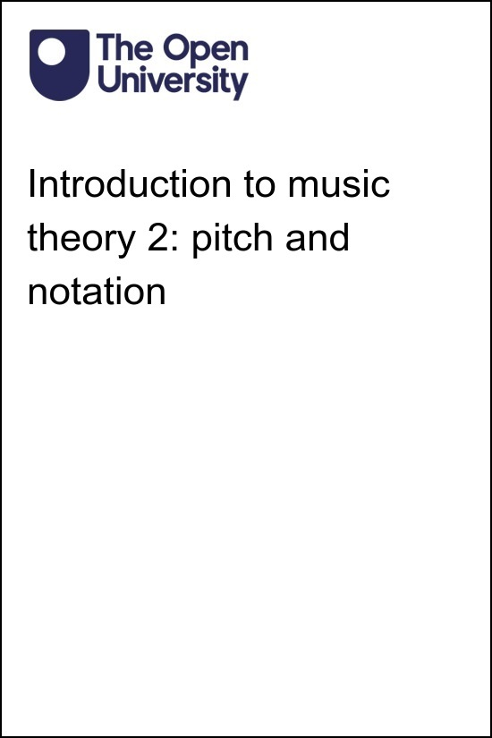

MUS_2

Introduction to music theory 2: pitch and notation

About this free course
This free course is an adapted extract from the Open University course A234 Understanding Music.
This version of the content may include video, images and interactive content that may not be optimised for your device.
You can experience this free course as it was originally designed on OpenLearn, the home of free learning from The Open University – https://www.open.edu/openlearn/history-the-arts/music/introduction-music-theory-2-pitch-and-notation/content-section-0
There you’ll also be able to track your progress via your activity record, which you can use to demonstrate your learning.
Unless otherwise stated, copyright © 2024 The Open University, all rights reserved.
Intellectual property
Unless otherwise stated, this resource is released under the terms of the Creative Commons Licence v4.0 http://creativecommons.org/licenses/by-nc-sa/4.0/deed.en_GB. Within that The Open University interprets this licence in the following way: www.open.edu/openlearn/about-openlearn/frequently-asked-questions-on-openlearn. Copyright and rights falling outside the terms of the Creative Commons Licence are retained or controlled by The Open University. Please read the full text before using any of the content.
We believe the primary barrier to accessing high-quality educational experiences is cost, which is why we aim to publish as much free content as possible under an open licence. If it proves difficult to release content under our preferred Creative Commons licence (e.g. because we can’t afford or gain the clearances or find suitable alternatives), we will still release the materials for free under a personal end-user licence.
This is because the learning experience will always be the same high quality offering and that should always be seen as positive – even if at times the licensing is different to Creative Commons.
When using the content you must attribute us (The Open University) (the OU) and any identified author in accordance with the terms of the Creative Commons Licence.
The Acknowledgements section is used to list, amongst other things, third party (Proprietary), licensed content which is not subject to Creative Commons licensing. Proprietary content must be used (retained) intact and in context to the content at all times.
The Acknowledgements section is also used to bring to your attention any other Special Restrictions which may apply to the content. For example there may be times when the Creative Commons Non-Commercial Sharealike licence does not apply to any of the content even if owned by us (The Open University). In these instances, unless stated otherwise, the content may be used for personal and non-commercial use.
We have also identified as Proprietary other material included in the content which is not subject to Creative Commons Licence. These are OU logos, trading names and may extend to certain photographic and video images and sound recordings and any other material as may be brought to your attention.
Unauthorised use of any of the content may constitute a breach of the terms and conditions and/or intellectual property laws.
We reserve the right to alter, amend or bring to an end any terms and conditions provided here without notice.
All rights falling outside the terms of the Creative Commons licence are retained or controlled by The Open University.
Head of Intellectual Property, The Open University

Contents
- Introduction
- Learning outcomes
- 1 Pitch in Western music
  - 1.1 The 7-note gamut
  - 1.2 The 7-note gamut and staff notation
- 2 Realising notation as sound
- 3 The black keys
  - 3.1 The natural sign
  - 3.2 Other accidentals
- 4 Intervals
- 5 Revisiting key concepts
- 6 Frequency and note identity
- 7 A broader understanding of pitch systems
  - 7.1 A pentatonic pitch system in Sunda
  - 7.2 Distances between notes
- 8 Distances between notes in Arab classical music
  - 8.1 Notating and hearing quarter tones
  - 8.2 Taqsīm and composition
  - 8.3 Intervals in Maqām bayātī
- 9 Notating pitch using numbers
- 10 How wide is an interval?
- Conclusion
- Acknowledgements
- References
- Glossary
- Solutions
- Descriptions

Introduction
This free course explores pitch, considering how musical sounds are differentiated as notes and as systems of notes. It introduces the Western pitch system, then explores how pitch is organised in some other world traditions, including Aka singing from Central Africa, Sundanese gamelan music from Indonesia, and Arab classical music from Syria.
The course explores how notes are represented through words and symbols, devoting special attention to Western staff notation while also considering Arab and Sundanese notation. You will have opportunities to read and write notes and to sing and play short musical extracts with the help of staff notation.
You will get the most out of this course if you can study it with the help of a keyboard instrument. Even a basic 49-key electronic keyboard will allow you to undertake all of the activities. If you cannot get access to an actual instrument, the second-best option is to find an app or website that incorporates a sound-producing keyboard. This should allow you to complete the majority of the activities.
This OpenLearn course is the second in a planned sequence of music theory courses. It draws in part on material created for A234 Understanding music by Byron Dueck, Alex Kolassa, and Helen Coffey.

Learning outcomes
After studying this course, you should be able to:
- understand how pitch and interval are conceptualised in several musical traditions
- perceive differences of pitch and interval
- understand how pitch can be represented visually, including through staff notation
- read and write notes using staff notation
- play and sing short musical examples transmitted through music notation.
You will need:
- a keyboard instrument, or an app to approximate one
- the ability to print out a sheet of exercises, as well as a pencil and eraser to complete the exercises.

1 Pitch in Western music
A note is a musical sound of fixed pitch. A pitch is perceived when a voice or an instrument produces a sound at a steady frequency, or rate of vibration.
Musicians in many traditions understand the music they play to be made up of notes that sound different from one another. The differences between these notes can be described in two ways: in terms of pitch and of frequency. The term ‘pitch’ focuses on the listener’s perception of a note, as higher or lower in relation to other notes. The word ‘frequency’ focuses on the objective measurement of a note, in terms of vibrations per second.
In this first activity, you’ll begin by familiarising yourself with the relationship between the frequency of a sound and its pitch.

Activity 1
Allow around 5 minutes

Visit the Online Tone Generator website (open the link in a new tab/window so you can easily return here). Make sure that your speakers or headphones are set at a moderate volume, read the warning on the page, and then press ‘play’.
Move the slider a centimetre or so to the right and then a centimetre or so to the left of its starting position. Observe how the pitch changes when you move the slider. It gets higher when you move the slider to the right and lower when you move it to the left. Similarly, the number indicating the frequency of vibration (the number with ‘Hz’ after it just below the slider bar) gets higher when you move the slider to the right and lower when you move it to the left.

The Online Tone Generator’s slider feature reveals how the pitch you perceive changes in a continuous way, gradually increasing as the frequency gets higher or lower. In many musical traditions, however, pitch is understood less as a continuum than as a series of discrete notes. (In fact, the word ‘pitch’ is often used as a synonym for ‘note’.) In this course, the terms gamut and pitch system will be used to refer to collections of notes.
Pitch systems are learned, cultural structures. They shape how music is made and how it is heard, and they help determine how instruments are constructed. Although the parts of pitch systems are often quantified using numbers and ratios (for example, with reference to frequency), they are primarily cultural systems that vary over time and from community to community.

1.1 The 7-note gamut
The great majority of Western music makes use of a pitch system comprising twelve more or less equally spaced notes. Musicians began to consolidate the system in Italy during the second half of the sixteenth century (Dyson and Drabkin, 2001). The 12-note pitch system contains within it an older, 7-note pitch system that was first described by theorists of music in ancient Greece. (The 7- and 12-note gamuts represent only two of many pitch systems that exist in the world. Others will be discussed later in the course.)
The 7- and 12-note pitch systems are laid out in an especially clear way on Western keyboard instruments such as the piano, organ, harmonium and synthesiser, which produce sounds when musicians press keys down with their fingers. Keyboard instruments began to emerge in Western Europe in the medieval era and eventually adopted a pattern of black and white keys (Figure 1) that embeds both the 7- and 12-note pitch systems.

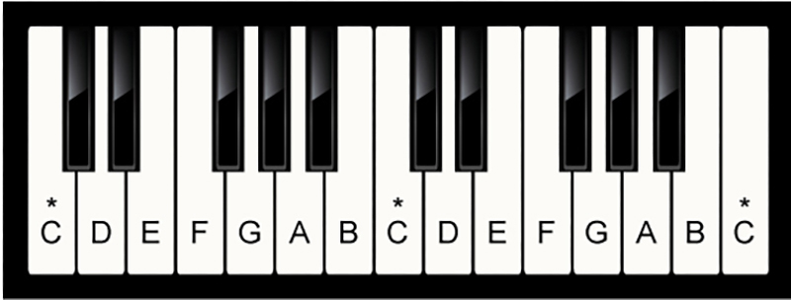
Figure 1 Keyboard showing black and white notes, with white notes named (two octaves)
View description - Figure 1 Keyboard showing black and white notes, with white notes named (two oct ...

The 7-note pitch system organises the white keys – labelled with letters in Figure 1 – and the 12-note system organises the black and white keys together. In this way, the two gamuts are built right into the instrument.
When teaching Western music theory, it is typical to start with the 7-note pitch system, whose notes have the names A, B, C, D, E, F and G in English. On many keyboards, including the one shown in Figure 1, the 7-note sequence begins on C rather than A. In that figure, the keys move from left to right through two rotations of the pattern as follows:
C, D, E, F, G, A, B, C, D, E, F, G, A, B, C
The C on the leftmost side of the figure is the lowest pitch, and the C on the rightmost side is the highest.
A single iteration of the pattern, starting and ending on notes of the same name, is called an octave (so named because that span contains eight notes, at least in the 7-note Western pitch system). For example, the C in the middle of Figure 1 is an octave above the leftmost C, and it is an octave below the rightmost C (all three Cs are marked by asterisks in the image). Similarly, the two Ds, the two Es, the two Fs, and so on are all an octave apart.

Activity 2
Allow around 45 minutes

Part 1

Watch Video 1, which explains how the white notes of the keyboard are organised and how to recognise them.

Video content is not available in this format.
Video 1 Getting familiar with the keyboard
View transcript - Video 1 Getting familiar with the keyboard

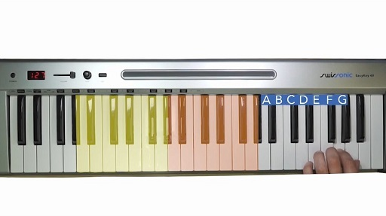

Part 2

Next, use a keyboard or an app to undertake the following exercises. They will help you internalise the note names as well as the geography of the keyboard. Check your progress against Figure 1 when necessary. If note names are new to you, come back to this exercise several times this week.

Figure 1 (repeated) Keyboard showing black and white notes, with white notes named (two octaves)
View description - Figure 1 (repeated) Keyboard showing black and white notes, with white notes named ...

Note that step 5 instructs you to sing in a vocal range that is comfortable for you. As mentioned earlier, the sequence of notes (C, D, E etc.) is repeated in higher and lower octaves, which means that you can sing in a higher or lower octave than the one in which you play, depending on what best suits your vocal range.
- Observe the regular patterning of the black keys on the keyboard, which occurs in groups of two and three. This pattern will help you orient yourself when you look for specific notes.
- With the help of Figure 1, find a C in the middle of your keyboard and play it. The C will have a single white key immediately to the left of it and a group of two black keys immediately to the right of it.
- Now find all the other Cs on the instrument and play them (the lowest and highest Cs on the keyboard may not possess the keys below or above them, respectively). All of the Cs sound like the same note, although some are higher and some lower.
- Do the same thing with F, which is the note that’s easiest to confuse with C. There is again a single white key immediately to the left of F, but a group of three black keys immediately to the right of it. Find one F, and then all of the Fs on the keyboard.
- Next, using the index finger of your right hand, play each of the white keys on your keyboard in succession, starting with the lowest (at the far left side of the keyboard) and continuing to the highest. Sing the name of each note as you play, using a vocal range that is comfortable for you.
- Then reverse the pattern, starting with the highest key of your keyboard and moving downwards, playing with the index finger of your left hand. Practise this until you can sing the note names in a slow, steady rhythm without errors.
- Finally, create a more complex sequence of movements on the keyboard and sing the note names as you move through them.
For example, you could start with the pattern ‘up two, down one’. Starting on C, you would play and sing C–E, D–F, E–G, F–A, G–B, A–C, B–D, C.
You could also try ‘down two, down two, up three’. Starting on C, you would play and sing C–A–F, B–G–E, A–F–D, G–E–C, F–D–B, E–C–A, D–B–G, C.

View discussion - Part 2

1.2 The 7-note gamut and staff notation
Up to this point, the 7-note gamut has been discussed with the help of letter names, but this information is also conveyed using staff notation. Staff notation is one of the many different ways that musicians around the world have developed to represent sound visually. It emerged relatively recently compared to other systems – in Italy in the early eleventh century – and is generally credited to a musician named Guido of Arezzo (Palisca and Pesce, 2009; Bent et al., 2014). The city of Arezzo can be seen to the southeast of Florence in the map of Italy in Figure 2.


Figure 2 Detail of Italy, showing Arezzo southeast of Florence
View description - Figure 2 Detail of Italy, showing Arezzo southeast of Florence

One of the advantages of staff notation is its ability to communicate the octave in which a note is located. Remember that each named note on the keyboard appears in more than one octave: staff notation allows you to specify exactly where a note is located. (You will see later that other notation systems, for instance Sundanese numerical notation, can convey information about the octave in other ways.)
The lower portion of Figure 3 introduces several elements of staff notation. There are two staves (sing. staff, stave), each made up of five horizontal lines and the spaces between them. The staves are joined by a curved bracket in the left-hand margin, indicating that they are to be read together. The bracketed pair of staves is called the grand staff and is widely used in notating music for keyboard instruments.

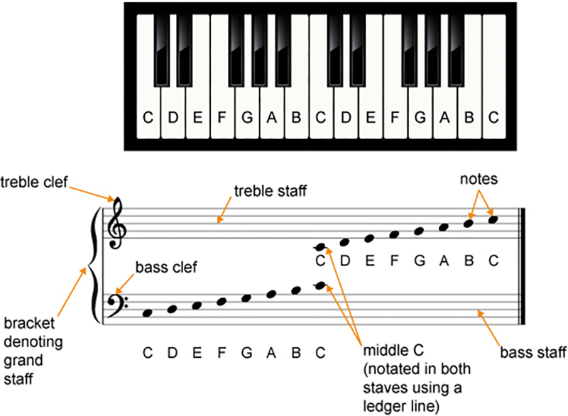
Figure 3 Keyboard and corresponding notes on a grand staff (two octaves)
View description - Figure 3 Keyboard and corresponding notes on a grand staff (two octaves)

Each line and each space on the grand staff represents a note that sounds when you play a white key on a keyboard instrument. In this notational system, lower lines and spaces represent keys on the left-hand side of the keyboard and higher ones represent keys on the right. Musicians place oval shapes called noteheads or notes on lines and in spaces to indicate the pitches to be sung or played. Figure 3 contains an ascending series of noteheads, each corresponding to the sound produced by the white key directly above it on the keyboard in the diagram.
The C in the centre of the keyboard in Figure 3 represents middle C, a note near the middle of most keyboard instruments. Observe that it has been notated twice in staff notation, once in the upper staff and once in the lower one. It has been written in both staves using a ledger line, a short line that allows you to incorporate notes that are placed higher or lower than the staff.
The lower of the two staves in the grand staff is the bass staff and is designated as such by the symbol called the bass clef on the left-hand side of the staff. The clef marks the line for the F below middle C (notice the dots on either side of that line). The higher of the two staves is the treble staff; it is designated as such by the symbol called the treble clef on the left-hand side of the staff. This clef marks the line for the G above middle C (notice how the central curl of the clef encircles that line).
Keyboards often extend beyond two octaves, and Figure 4 gives you an even broader picture of the relationship between the keyboard, the notes it produces, and the staff. Notice the more extensive use of ledger lines both above and below the staff.

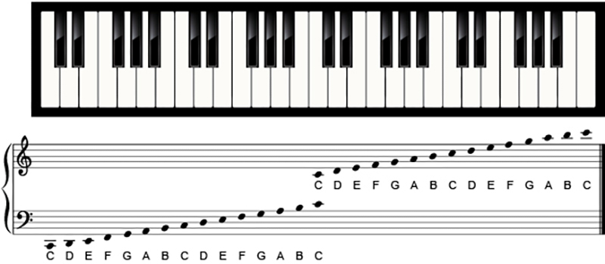
Figure 4 Keyboard and corresponding notes on staff (four octaves)
View description - Figure 4 Keyboard and corresponding notes on staff (four octaves)

Many new terms and symbols have been introduced in this section, so you may need to revisit it from time to time if you are new to staff notation. The next activity will help to reinforce some of these new terms.

Activity 3
Allow around 10 minutes

Watch Video 2, which will help to consolidate your understanding of the terms and symbols that have been introduced so far.

Video content is not available in this format.
Video 2 Notating pitch on the grand staff
View transcript - Video 2 Notating pitch on the grand staff

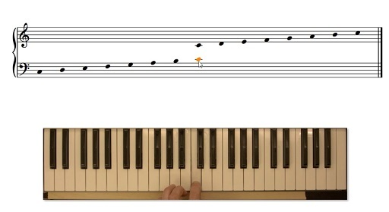

2 Realising notation as sound
Reading staff notation involves not only associating notes on the staff with their names, of course, but also realising these as sounds. The following activity will develop this skill through the use of a keyboard instrument. Its goal is to help you to internalise staff notation through a form of learning that connects concepts, symbols, sounds, and physical actions.
You are welcome to find creative ways to adapt these exercises to use with a keyboard app or with another instrument. The advantage of working with a keyboard instrument here is that the keyboard presents all of the notes of the Western gamut in a simple sequence: there is a clear correspondence between the layout of the instrument and how the notation looks.

Activity 4
Allow around 60 minutes

Examples 1 and 2 present basic patterns on the white keys of the keyboard. Play the notes in the bass clef with your left hand (LH) and the notes in the treble clef with your right hand (RH). Then play the exercises again, this time saying or singing the note names as you do so.
Audio demonstrations are provided beneath each example. You might find these to be a useful guide as you play.
The numbers accompanying the notes indicate which fingers to use; as Figure 5 shows, 1 designates the thumb, 2 the index finger, 3 the middle finger, and so on.

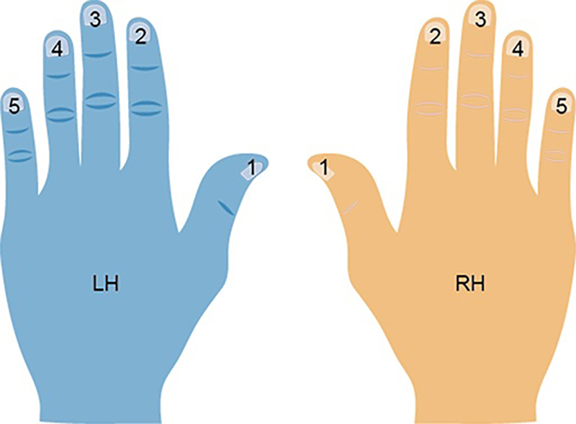
Figure 5 Finger numbers for keyboard instruments
View description - Figure 5 Finger numbers for keyboard instruments

Work towards being able to realise the exercises at a steady, even pace, such that each note is equal in duration. Don’t worry if this means you end up playing very slowly, or if you don’t make much apparent progress in an hour, especially if you are new to the keyboard. You can always revisit these exercises later for further practice.
In Example 2, there is a symbol that looks a little like a bird’s eye above every seventh right-hand note. It is a fermata, and indicates that you should hold that note a little longer than the others.

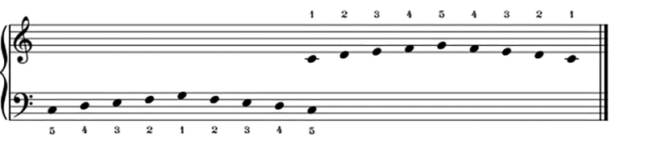
Example 1 Short keyboard exercise for left and right hands
View description - Example 1 Short keyboard exercise for left and right hands

Audio content is not available in this format.
Example 1 (audio) Short keyboard exercise for left and right hands

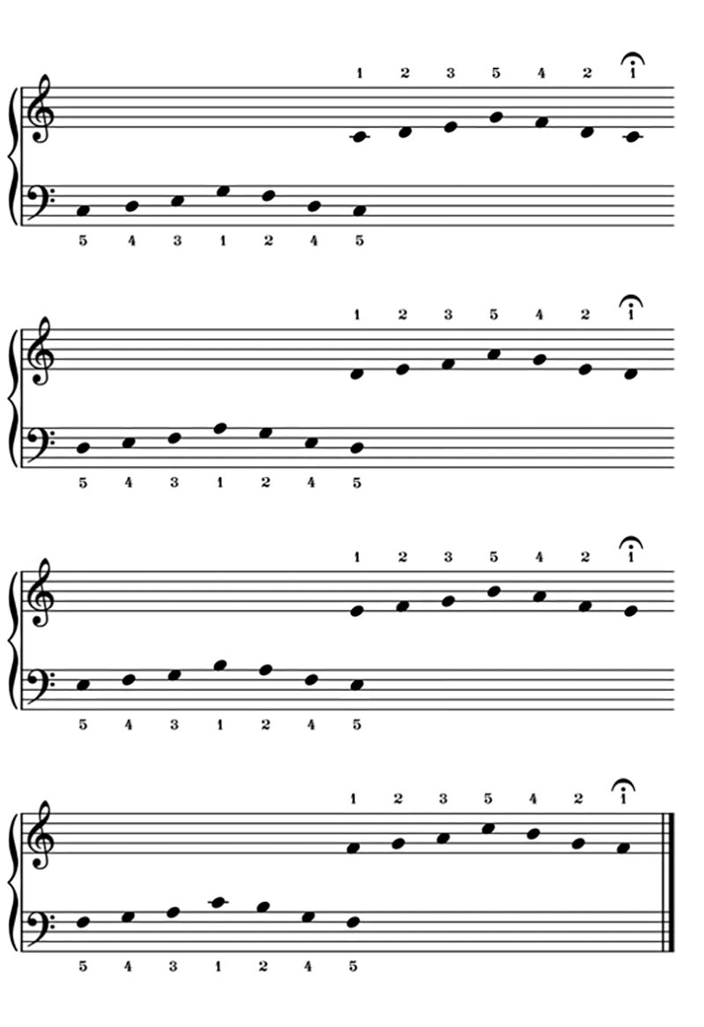
Example 2 Longer keyboard exercise for left and right hands
View description - Example 2 Longer keyboard exercise for left and right hands

Audio content is not available in this format.
Example 2 (audio) Longer keyboard exercise for left and right hands

3 The black keys
As mentioned earlier, the white notes on keyboard instruments comprise a 7-note pitch system that is part of a larger 12-note one. You can reconfirm this by looking at Figure 6, which shows a single octave of a keyboard. The seven white keys (C, D, E, F, G, A and B) and five black keys together make a twelve-note collection. (Note the repetition of the C isn’t included in this count.)
Each of the black notes has two names: one ending in the word sharp and the other in the word flat. Black notes are sometimes named with reference to the white notes immediately below (to the left of) them. Following this logic, the black key with C immediately below it is C sharp (C♯), and the black key with D immediately below it is D sharp (D♯). These designations – including F sharp, G sharp and A sharp – constitute one of the sets of labels on the black keys in Figure 6.
One way to remember the meaning of the word ‘sharp’ is to think of C sharp as ‘higher’ or ‘brighter’ than C.

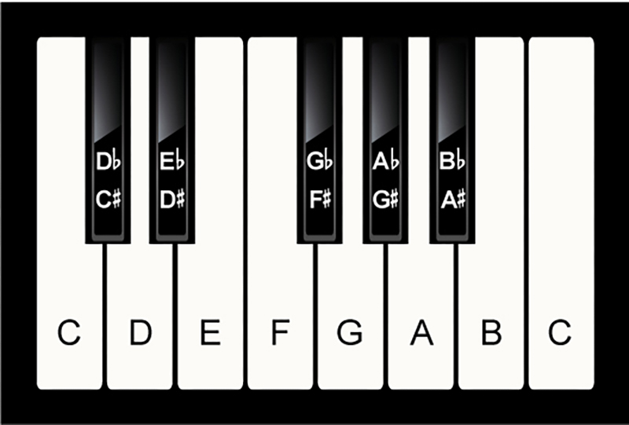
Figure 6 The black keys, labelled with both sharps and flats
View description - Figure 6 The black keys, labelled with both sharps and flats

The black notes are also named with reference to the white keys immediately above (to the right of) them. Thus, the black key with D immediately above it is named D flat (D♭), the black key with E immediately above it is named E flat (E♭) and so on (G flat, A flat and B flat). These designations constitute the other set of labels on the black keys in Figure 6. Which designation gets used for a given note – F♯ or G♭, for instance – depends on the musical context.
One way to remember the meaning of the word ‘flat’ is to think of D flat as ‘lower’ or more ‘dispirited’ than D.
In staff notation, a sharp sign (♯) immediately to the left of a note indicates that the note should be raised: it turns C into C sharp, F into F sharp and so on. Similarly, a flat sign (♭) immediately to the left of a note indicates that the note should be lowered: it turns D into D flat, A into A flat and so on. The sharp and flat signs are called accidentals. The next activity connects these terms and symbols to sounds and the ability to make them.

Activity 5
Allow around 60 minutes

Play the patterns outlined in Examples 3 and 4, using your right hand to play the notes in the treble clef and your left hand to play the ones in the bass clef. Then play each pattern while saying or singing the relevant note names out loud. Don’t forget to include the word ‘sharp’ or ‘flat’ where appropriate.
Work towards realising the exercises at a steady, even pace, but don’t worry if you don’t get to this point within the allotted time. As with other activities, it may be helpful to come back to this one more than once.

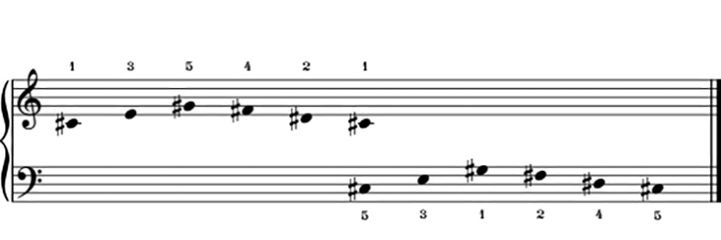
Example 3 Exercise for left and right hands using sharps
View description - Example 3 Exercise for left and right hands using sharps

Audio content is not available in this format.
Example 3 (audio) Exercise for left and right hands using sharps

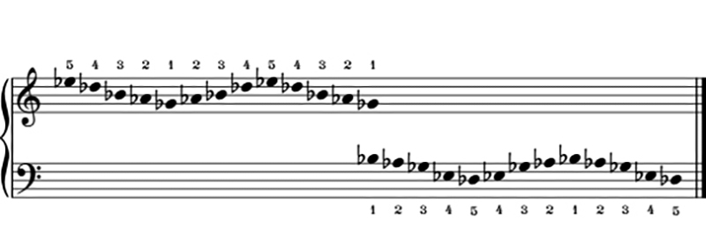
Example 4 Longer exercise for left and right hands using flats
View description - Example 4 Longer exercise for left and right hands using flats

Audio content is not available in this format.
Example 4 (audio) Longer exercise for left and right hands using flats

View discussion - Activity 5

3.1 The natural sign
A third accidental is the natural, ♮, which cancels out a preceding sharp or flat. Example 5 contains four notes. The second of these is an F with a sharp next to it, designating a raised F; namely, the black key to the right of F on the keyboard. The fourth note is an F with a natural sign next to it, designating F natural, the white note.

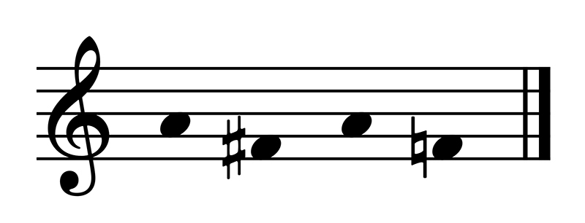
Example 5 A natural sign cancelling a sharp. This example is presented on a solitary treble staff rather than on a grand staff, since all of the music is in the treble clef
View description - Example 5 A natural sign cancelling a sharp. This example is presented on a solitary ...

In staff notation, the modification introduced by an accidental is generally valid for the length of a bar, a segment of music delineated by the vertical lines that cross the staff, as shown in Example 6. There are three bars in the example. In the first bar, the second note has a flat next to it, so it is a B flat. This flat sign remains active until the next bar line unless a natural sign is introduced, so the fourth note is also a B flat, even though there is no flat sign next to it. The sixth note in the bar, also a kind of B, has a natural sign next to it. This cancels the preceding flat and makes the sixth note a B natural.
The second and third bars of the example also contain Bs. In the second bar, the first B has no accidental next to it, so it is a B natural. The fifth note, however, has a flat next to it, so it is a B flat. That B flat gets cancelled by the bar line that soon follows, so the first note in bar three needs a flat next to it to make it a B flat, too.

Example 6 A passage of notated music featuring bar lines and accidentals
View description - Example 6 A passage of notated music featuring bar lines and accidentals

Activity 6
Allow around 20 minutes

Listen two or three times to Audio 1 while following the notation in Example 6, and focus on hearing the differences in pitch.

Audio content is not available in this format.
Audio 1 Realisation of Example 6, a passage of notated music featuring bar lines and accidentals

Now sing along with the recording in a range that is comfortable to you, pronouncing the note names (including accidentals) as you do so.
Finally, try to sing the note names (including accidentals) without the recording, using the notation as a guide. If you have difficulty with this, don’t worry – return to the previous step and replay the audio to get the sounds back in your ears.

View discussion - Part

3.2 Other accidentals
Note that there are some occasions when a white note on the keyboard can be a sharp or a flat. This may seem confusing, since sharps and flats have been introduced with reference to the black keys. However, a sharp raises any note, just as a flat lowers any note.

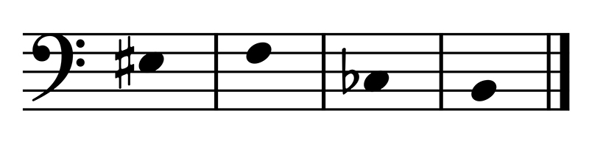
Example 7 Notating E sharp and C flat. All of the notes in this example are below middle C, so they are notated in the bass staff rather than on the grand staff
View description - Example 7 Notating E sharp and C flat. All of the notes in this example are below ...

Consider the E sharp notated in the first bar of Example 7. The note immediately to the right of E on the keyboard is a white key that more usually goes by the name of F – but it can also be called E sharp (see Figure 7 for a depiction of this that uses a keyboard for greater clarity). Similarly, the note in the third bar of Example 7 is a C flat. The key immediately to the left of C is the white key usually known as B, but it can also be called C flat.
You can confirm this by playing Audio 2, in which you will hear the four notes in Example 7 in succession: E♯, F, C♭ and B. As you will hear, E♯ and F are the same note, and so are C♭ and B.

Audio content is not available in this format.
Audio 2 Comparison between E sharp and F and between C flat and B

Again, E sharp and C flat may seem like strange possibilities, but you have already seen that black keys can have more than one name. The same is true of white keys.
Two final accidentals are the double sharp and the double flat: 𝄪 and 𝄫, respectively. These appear much less often than regular sharps and flats, but it is worth knowing about them so that you can identify them when you see them. A double sharp indicates that a note is raised not once but twice. The note F modified by the 𝄪 symbol would have the same sound as the note G (see Figure 7). Similarly, a double flat indicates that a note is lowered twice. The note B modified by the 𝄫 symbol would have the same sound as the note A.

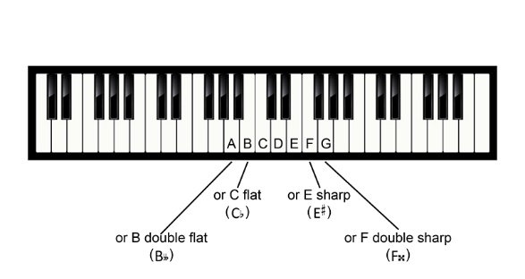
Figure 7 Keyboard demonstrating relationship between A and B double flat, between B and C flat, between F and E sharp, and between G and F double sharp
View description - Figure 7 Keyboard demonstrating relationship between A and B double flat, between ...

4 Intervals
Just as some keys are physically closer to or farther away from one another on the keyboard, so too are the notes those keys generate. The distance between any two notes, smaller or larger, is called an interval.
You have already seen how some white notes are closer to one another than others. C and D are separated by a black key, as are D and E, but B and C are right next to one another, as are E and F. You can confirm this with the help of Figure 8.
(The names of the notes are not written on the keyboard in Figure 8; this is to encourage you to memorise the pattern and names of the notes. You are welcome to open Figure 6 in a separate tab/window if you need a reminder.)

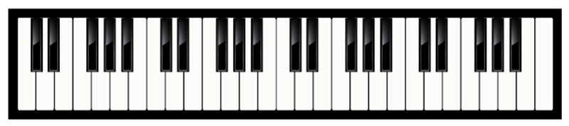
Figure 8 Keyboard (4 octaves)
View description - Figure 8 Keyboard (4 octaves)

This section focuses on three intervals. The first is the octave, which arrives each time the cycle of twelve white and black notes repeats. For example, the F♯ above middle C is an octave away from the F♯ below middle C.
The second interval is called a half step or semitone and is found between any two notes that are directly adjacent (right beside one another). C and C♯ are a semitone apart, as are E♭ and E♮. E and F, and B and C, mentioned earlier, are also a semitone apart.
The third interval is twice as large as a semitone and is called a step or tone. This interval exists between any two notes, black or white, that are separated by one other note. Thus, C and D are a tone apart, as are A and B, G♭ and A♭, and E and F♯.

Activity 7
Allow around 45 minutes

In this three-part activity, you will familiarise yourself with the sounds of the semitone, the tone, and the octave. You will also practise identifying and writing these intervals.

Part 1

Each bar in Example 8 contains a pair of notes separated by an interval. Some of the intervals are semitones, some are tones, and some are octaves.
Start by getting familiar with the sounds of these intervals. Using your keyboard, play the first, then the second note in each pair so that you hear one going to the other. Then play each pair of notes simultaneously.

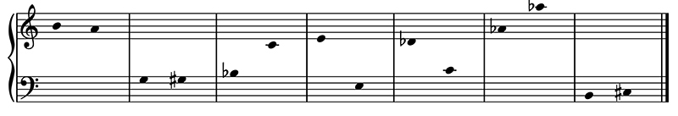
Example 8 Semitones, tones and octaves
View description - Example 8 Semitones, tones and octaves

Next, using the text box below, provide the following information for each of the intervals in Example 8:
- the two note names
- the interval
- the direction of the interval (ascending or descending)
The first interval has been completed for you.

(1) B to A, tone, descending
(2)
(3)
(4)
(5)
(6)
(7)
View discussion - Part

Part 2

Now play the intervals in Example 8 again, this time singing the note names as you play. Sing in a range that is comfortable for you, and don’t forget to name the relevant accidentals.
Finally, try to realise the intervals yourself. Play and sing the first note in each interval, then try to sing the second note without playing it. Pay attention especially to the subtle difference between semitones and tones.

Part 3

Print out Example 9 – downloadable here as a PDF – and work through the exercises that follow. Example 9 is similar to Example 8, except that (aside from the first bar) only the first note in each interval is given.

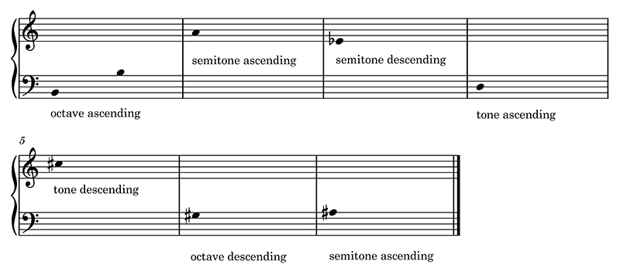
Example 9 Intervals to be completed
View description - Example 9 Intervals to be completed

- Use your keyboard (or keyboard app) to find and play the first note in each bar. Then use the information given about the interval to work out the note that should follow.
- Write each missing note onto the appropriate line or space on the paper. Be sure to include any necessary accidentals.
- Now play the completed intervals, singing the note names as you play. Sing in a range that is comfortable for you, and don’t forget to name the relevant accidentals.
- Next, try to realise the intervals yourself. Play and sing the first note in each interval, then try to sing the second note without playing it.

View discussion - Part 3

A fourth interval, mentioned a few times in the remainder of this course, is the unison. Musicians are in unison when they sing or play the same notes in the same octave and at the same time.

5 Revisiting key concepts
You have now considered the constituent notes of the Western pitch system and how these are represented – on the one hand by the keys of keyboard instruments, and on the other by notes placed on the staff. You have also practised writing and performing notes with the help of staff notation.
The Western pitch system you have been studying, like many others, is made up of a series of discrete notes that are organised into a system. These notes resonate at different frequencies and thus sound distinct from one another.
Some notes within the system have a relationship of similarity rather than difference because they are octaves of one another. Octaves can be understood as higher or lower instances of the same note. This allows you to sing along with notes on a keyboard that are higher or lower than is possible for your actual singing voice (something you were asked to do in some of the preceding activities). This phenomenon also makes it possible for people with high and low voices to sing the same thing together, but in ranges that are comfortable for everyone.
The octave is an interval: a distance between notes. Attuned listeners can not only distinguish notes from one another, but also intervals. To the practised ear, semitones sound like semitones, tones sound like tones, and octaves sound like octaves, no matter which notes are involved.

Activity 8
Allow around 5 minutes

Using your keyboard, play C and the D♭ next to it simultaneously, noticing the ‘crunch’ of the semitone. Next, play D and E simultaneously, noticing how this interval also crunches, but not quite as sharply. Finally, play any two Gs together, and notice the relative smoothness or similarity of the two sounds.

View discussion - Activity 8

The following sections expand on concepts introduced earlier, including pitch, pitch system, octave, interval and frequency. These provide a starting point for thinking about how pitch systems are organised more globally.

6 Frequency and note identity
Western musicians often assign specific frequencies to the notes of the gamut. In the most widely used system for allocating frequencies, the A below middle C vibrates at 220 hertz, or 220 vibrations per second. Table 1 lays out the frequencies conventionally associated with the twelve notes above that note (called A220 in the table and located in the lowest row).

Table 1 Frequencies for A below middle C and the twelve notes above it (after Suits, 1998)
Note name | Frequency in hertz | Distance from A220 in hertz | Distance from the note below in hertz | Distance from A220 in cents | Distance from the note below in cents
A440 | 440 | 220 | 25 | 1200 | 100
G♯/A♭ | 415 | 195 | 23 | 1100 | 100
G | 392 | 172 | 22 | 1000 | 100
F♯/G♭ | 370 | 150 | 21 | 900 | 100
F | 349 | 129 | 19 | 800 | 100
E | 330 | 110 | 19 | 700 | 100
D♯/E♭ | 311 | 91 | 17 | 600 | 100
D | 294 | 74 | 17 | 500 | 100
C♯/D♭ | 277 | 57 | 15 | 400 | 100
C | 262 | 42 | 15 | 300 | 100
B | 247 | 27 | 14 | 200 | 100
A♯/B♭ | 233 | 13 | 13 | 100 | 100
A220 | 220 | 0 | — | 0 | —

Two important points emerge from this table. The first involves the octave relationship. Notice that the frequency (the number of vibrations per second) of A440 is exactly double the frequency of A220. This doubling is evident in all octaves. The A below A220 has a frequency of 110 hertz and the A above A440 has a frequency of 880 hertz. Similarly, the G below G392 has a frequency of 196 hertz and the G above it has a frequency of 784 hertz. (A110, A880, G196, and G784 are not shown in the table.)
This helps explain why notes in an octave relationship sound like the same note: their respective rates of vibration exist in simple ratios such as 2:1.
A second point, related to the exponential octave relationship (110, 220, 440, 880, 1760, etc.), is that some semitones are further apart than others, at least in terms of vibrations per second. As the fourth column in Table 1 shows, the number of vibrations per second increases as notes get higher and higher. A220 and A#233 are 13 hertz apart, but G#415 and A440 are 25 hertz apart. At the same time, to the ear, these intervals sound like they are of the same size.
Because the figures involved when discussing frequency can jar with the musical experience of hearing intervals, intervals are often discussed in terms of ‘cents’ instead. The cent is a unit of perceived intervallic distance, first proposed in an article by Alexander J. Ellis (1885). In Ellis’s measurement system, an octave is made up of 1200 equal cents, such that each Western semitone comprises 100 cents and each Western tone comprises 200 cents. This measurement system accords a little better with musical perceptions of intervals, in which tones sound like tones and octaves sound like octaves, no matter how many vibrations per second are involved.
The fifth and sixth columns of Table 1 give the breakdown of the twelve notes/intervals above A220 in terms of cents. The remainder of this course’s discussions will employ Ellis’s 1200-part measuring system.

Intervals and ratios
Intervals have been described here in terms of hertz and cents, but in many music cultures, intervals are understood in terms of ratios. For example, the octave is widely associated with the ratio 2:1. This is consistent with what you learned in the discussion of frequency: A440 vibrates twice as fast as the note an octave below it, A220. Similarly, a plucked string sounds an octave higher when you shorten its length by half. Meanwhile, the Western tone or whole step has sometimes been associated with the ratio 9:8 because a string sounds a tone higher when you shorten its length by a ninth.

7 A broader understanding of pitch systems
So far, you have focused on the notes and intervals of the Western gamut and how these are represented with the help of staff notation. This is in keeping with one of the overall goals of this suite of courses: teaching the basics of Western music theory and staff notation. In the remaining sections of this course, you will look at how pitch is organised and represented in other musical traditions. As will become apparent, Western music theory does not even begin to account for the diverse range of musics in the world. Nevertheless, certain broad similarities are shared by many of these musics, including the existence of pitch systems and intervals. This section and those that follow consider the number of pitches in various pitch systems, then the intervals between those pitches, and finally the stability of those pitches and intervals.
There are many pitch systems beyond the 7- and 12-note ones you have studied so far. For example, the Aka people from the Central African Republic and the Republic of the Congo (see Figure 9) make use of a pentatonic (5-note) pitch system.

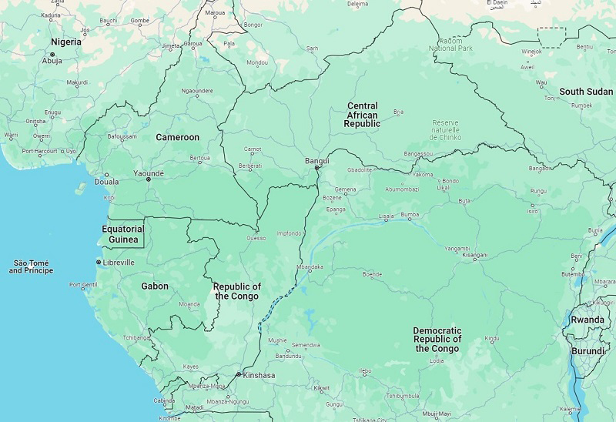
Figure 9 Map showing the Central African Republic and the Republic of the Congo (to be distinguished from the Democratic Republic of the Congo to the south and east of it)
View description - Figure 9 Map showing the Central African Republic and the Republic of the Congo (to ...

The piece in Video 3 is an Aka lullaby called Mo boma sung by two girls (Arom, 1978, p. 30). The performers sing distinct but complementary melodies that together present the five notes of the pentatonic pitch system. (Traditional Aka music is polyphonic, meaning that two or more distinct melodies are sung simultaneously).

Activity 9
Allow around 5 minutes

Listen to Mo boma and try to make out the notes that comprise the pentatonic pitch system.
Video 3 Mo boma (make sure to open the link in a new tab/window)
If you listen closely, you may be able to hear that there are six distinct notes in play. However, the lowest one stands in an octave relationship with the highest one, so the system is a pentatonic one overall.

7.1 A pentatonic pitch system in Sunda
Much of the music in Sunda, the mountainous western part of the Island of Java in Indonesia, also employs pentatonic pitch systems (Cook, 2014). You can hear an example of this music in Audio 3, an extract from a performance of a piece called Bendrong, performed by the Gamelan Galura ensemble. The ensemble is an orchestra incorporating a range of instruments, including gongs, gong-chimes (smaller pot-shaped gongs), xylophone-like instruments, drums, and a kind of fiddle called a rebab.

Activity 10
Allow around 5 minutes

Listen to the extract from Bendrong in Audio 3 to hear an example of music using another 5-note pitch system. As in the previous activity, two or more of the notes of the 5-note pitch system may sometimes be in play simultaneously.

Audio content is not available in this format.
Audio 3 Bendrong performed by the Gamelan Galura ensemble (Pa Otong Rasta, music director)

The ensemble you have just heard is a Gamelan Saléndro ensemble, so named because it makes use of a pitch system called saléndro. This system is forged into several of the instruments that play as part of the gamelan, including gongs, gong-chimes, and xylophones. Figure 10 is a picture of a saron, whose tuned metal bars produce distinct notes when struck. If you look very closely, you may be able to see that the keys have been numbered 4, 5, 1, 2, 3, 4, 5 from left to right, indicating the 5 notes of the pitch collection (keep in mind however that most of the numbers are upside down in the photo).

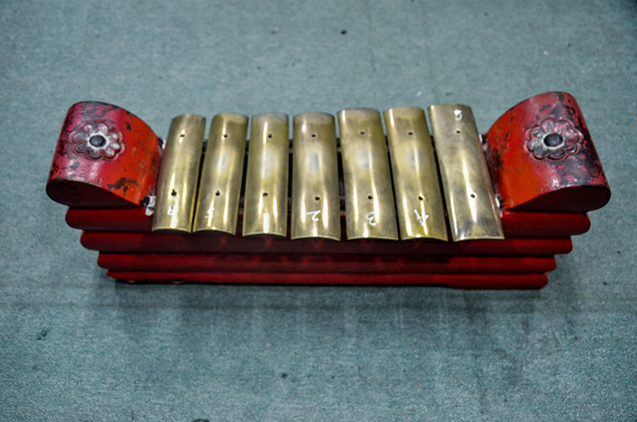
Figure 10 Sundanese saron
View description - Figure 10 Sundanese saron

Simon Cook (1992) explains that each of the five pitches in the version of saléndro used in music played by the Gamelan Saléndro ensemble is associated with a name (or names) and a number. With the lowest on the bottom left and the highest on the top right, this is as follows:

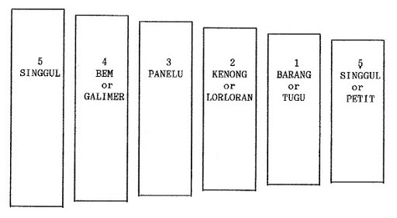
Figure 11 Five pitches as played by the Gamelan Saléndro ensemble
View description - Figure 11 Five pitches as played by the Gamelan Saléndro ensemble

Notice how in this system, the lowest pitch is accorded the highest number. This is the reverse of how notes are numbered in the Western gamut, where, if C is 1, D is 2, E is 3, and so on. In fact, in Sunda, many musicians use the word ‘low’ to describe what Western – and many other Indonesian – musicians call ‘high’ notes and vice versa (see Cook, 1992, p. 3–4, and note several caveats). To avoid confusion, these course materials will always use the terms ‘low’ and ‘high’ in the conventional Western sense.
Three broader points become evident in considering the examples of Aka and Sundanese music. First, the number of notes within an octave can vary from pitch system to pitch system. Second, notes within these systems may be named and numbered in culturally specific ways. Third, just as 7-note and 12-note gamuts are built into the piano, so too are pitch systems such as Sundanese saléndro built into instruments such as the saron.

7.2 Distances between notes
It is not simply the number of notes that varies from pitch system to pitch system, but also the size of the intervals between those notes. You may remember that in Western music, each note in the 12-note pitch system stands 100 cents away from its immediate neighbours. This distance is anything but universal. In the pentatonic music from Sunda you have just heard, each note is around 240 cents away from its neighbours (Cook, 2014).
The relationship between notes is set out in Table 2, which lists the notes introduced on the preceding page as well as their approximate distance from one another in cents. Note that actual distances often depart from the average given here.
The lowest note, in Western terms, is at the bottom of the table and the highest is at the top.

Table 2 Structure of saléndro pitch system
Number | Name | Distance from singgul in cents | Distance from previous note in cents
5̣ | Singgul or petit | 1200 | 240
1 | Barang or tugu | 960 | 240
2 | Kenong or lorloran | 720 | 240
3 | Panelu | 480 | 240
4 | Bem or galimer | 240 | 240
5 | Singgul | — | —

Activity 11
Allow around 5 minutes

Listen to Audio 4, which presents a simplified version of the 5-note Sundanese saléndro pitch system, moving from low to high and then back down again. It was generated using the Leimma music environment, a browser-based resource created by Khyam Allami for creating, hearing and playing pitch systems.

Audio content is not available in this format.
Audio 4 Simplified representation of the notes of the Sundanese saléndro pitch system

Creating room for a wider range of pitch systems
Khyam Allami’s music environment is a response to a widespread absence of readily available electronic instruments, applications, and programs that accommodate pitch systems other than the Western one (for example, pitch systems where notes are 240 cents apart instead of 100 or 200). At the time of writing, it is easy to find online interfaces that emulate the piano, but much more difficult to find ones that replicate instruments or ensembles structured by alternative pitch systems.

8 Distances between notes in Arab classical music
In Arab music theory, the gamut is sometimes said to consist of 24 equally spaced notes – double the number of notes in the Western pitch system, which has 12. An octave of the Arab system is shown in Table 3, which draws on work by the Lebanese music theorist Mīkhā’īl Mushāqa (c.1840) and the US ethnomusicologist Scott Marcus (1989).
The first column of the table gives the note names in Arabic and the second in English. As you can see from the third and fourth columns, each note is approximately 50 cents away from its immediate neighbours. 50 cents is half of a semitone and thus a quarter tone (also called a quarter step).
As will be explained a little later, distances between notes often vary significantly from the ones shown here in actual music making. For deliberate aesthetic reasons, musicians will play them sharper or flatter. However, the table is a good initial introduction to the pitch system.
The notes marked in bold in the table are understood to be more important or fundamental than the others, and they are thus highlighted. The lowest note is at the bottom of the table and the highest is at the top.

Table 3 First octave of modern Arab pitch system (Marcus, 1989, p. 99, pp. 810–11; see also Davis, 2001; Mashāqah c.1840, plate 1)
Arabic name for note | English name for note | Distance from lowest note in cents | Distance from previous note in cents
Nawā | G | 1200 | 50
tīk Ḥijāz | G half flat | 1150 | 50
Ḥijāz | F sharp | 1100 | 50
nīm Ḥijāz | F half sharp | 1050 | 50
Jahārkāh | F | 1000 | 50
tīk Būsalik | E half sharp | 950 | 50
Būsalik | E | 900 | 50
Sīkāh | E half flat | 850 | 50
Kurd | E flat | 800 | 50
nīm Kurd | D half sharp | 750 | 50
Dūkāh | D | 700 | 50
tīk Zirkūlāh | D half flat | 650 | 50
Zirkūlāh | D flat | 600 | 50
nīm Zirkūlāh | C half sharp | 550 | 50
Rāst | C | 500 | 50
tīk Kawasht | B half sharp | 450 | 50
Kawasht | B | 400 | 50
‘Irāq | B half flat | 350 | 50
‘Ajam ‘Ushayrān | B flat | 300 | 50
nīm ‘Ajam ‘Ushayrān | A half sharp | 250 | 50
‘Ushayrān | A | 200 | 50
qarār tīk Ḥiṣār | A half flat | 150 | 50
qarār Ḥiṣār | A flat | 100 | 50
qarār nīm Ḥiṣār | G half sharp | 50 | 50
Yakāh | G | — | —

The key point is that there are not only tones and semitones in Arab music theory, but also quarter tones and three-quarter tones.

8.1 Notating and hearing quarter tones
Since the 1930s and 1940s, Arab musicians and theorists have used Western-style staff notation to transmit music (Marcus, 1993, p. 52). There are a number of specialist symbols representing musical elements employed in the Arab music tradition. For example, the half flat symbol indicates that a note is approximately a quarter of a tone flatter than the given note.
The symbol is used three times in Example 10; see the second, tenth and fourteenth notes. You can distinguish the half flat from the flat because its ‘belly’ faces left rather than right. The half flat symbol indicates that the note is higher or ‘less flat’ than a flat: it is (approximately) a quarter step rather than a half step below the modified note.

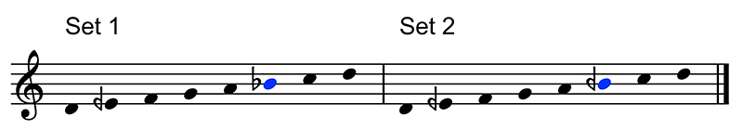
Example 10 Pitches used in the opening 01:32 of the performance of Samai Bayātī: Set 1 contains B flat and Set 2 contains B half flat
View description - Example 10 Pitches used in the opening 01:32 of the performance of Samai Bayātī: ...

Performances of Arab music rarely make use of all 24 notes of the gamut, and in any given section of music it is not unusual for only seven or eight notes to be in play.
Video 4 is a performance of Arab music by the Classical Arabic Orchestra of Aleppo. It comprises a composition and two improvisations. The composition is Samai Bayati (also spelled Sama‘ī Bayyātī) by the Egyptian composer Ibrahim al-‘Uryān. The opening of this performance – the material from 00:00 to 01:32 – makes use of eight of the 24 notes of the overall pitch system shown in Table 3 on the previous page.
Video 4 Samai Bayati performed by the Classical Arabic Orchestra of Aleppo (make sure to open the link in a new tab/window)
These notes are presented across the two halves of Example 10, comprising two sets of notes that differ in only one respect: in the first set the sixth note (marked in blue) is a B flat and in the second set it is a B half flat. The notes are separated into two sets because the improvising musician uses B flat in some parts of the opening and B half flat in others, but does not use them in close proximity to one another.
The pitches have been notated within a single octave for the sake of simplicity, but they appear in more than one octave in the performance.

Activity 12
Allow around 30 minutes

Part 1

Listen five or six times to Audio 5, a representation of the notes in Example 10. Start by listening for the second note, E half flat. To musicians familiar with the Western gamut, this will probably sound lower than E but higher than E flat. Next, listen for the sixth note in each half of the example, and notice how this changes slightly from the first set of notes to the second. The note in blue is slightly higher in the second set of notes.

Audio content is not available in this format.
Audio 5 Simplified representation of the two collections of notes heard at the beginning of the performance (00:00–01:32)

Part 2

In this next part of the activity, you will listen to short extracts from the opening of the performance of Samai Bayātī to get a better sense of how the notes of the pitch system may be used.
First, listen closely to 00:00–00:53 of the recording of Samai Bayati in Video 4. You will hear the beginning of an improvisation, called a taqsīm, played on a plucked stringed instrument called an ‘ūd (see Figure 12). During this first part of the improvisation, the musician uses the notes shown in Example 11 below. Some of the notes are below D and some are above it, and these groups of notes are distinguished with the help of curved lines called slurs.
Video 4 Samai Bayati performed by the Classical Arabic Orchestra of Aleppo (make sure to open the link in a new tab/window)

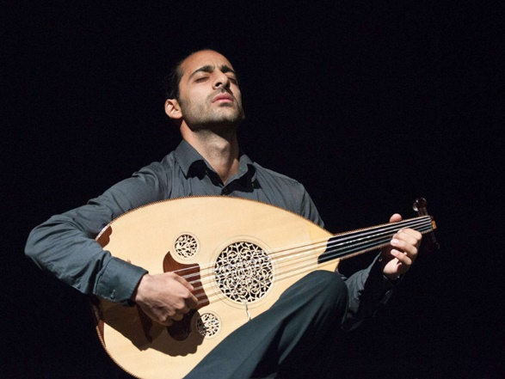
Figure 12 Samir Joubran from Le Trio Joubran playing an ‘ūd, a short-necked lute (guitar-like instrument) whose strings are plucked
View description - Figure 12 Samir Joubran from Le Trio Joubran playing an ‘ūd, a short-necked lute ...

Comparing Example 11 with Example 10 reveals that the ‘ūd player is using notes from Set 2, the group of notes containing B half flat. However, several of these notes are in a lower octave than in Example 10. You will need to count down several ledger lines to verify the identity of the lowest ones.

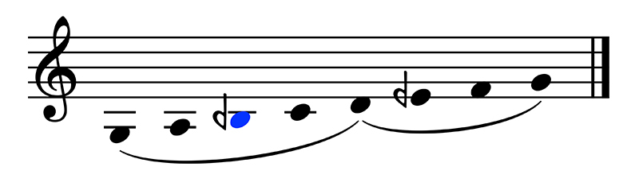
Example 11 Notes from the ‘ūd taqsīm from 00:00–00:53. All of the notes can be found in Example 10, Set 2, although some are in a higher octave
View description - Example 11 Notes from the ‘ūd taqsīm from 00:00–00:53. All of the notes can be ...

Next, listen to 00:53–01:26. The player of the solo ‘ūd continues the taqsīm here, this time using the notes in Example 12. As the slurs indicate, all but one of the notes are above the lower D. Further, as comparison with Example 10 reveals, all of the notes belong to Set 1, the group of notes containing B flat.

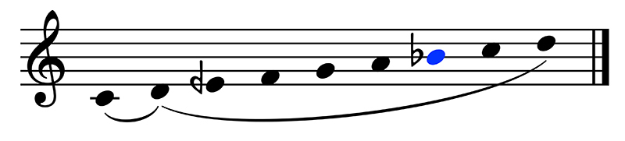
Example 12 Notes from the ‘ūd taqsīm from 00:53–01:26. All of the notes can be found in Example 10, Set 1
View description - Example 12 Notes from the ‘ūd taqsīm from 00:53–01:26. All of the notes can be ...

Finally, listen to 01:26–01:32. This contains the notes shown in Example 13. They correspond exactly to the notes in Set 2.

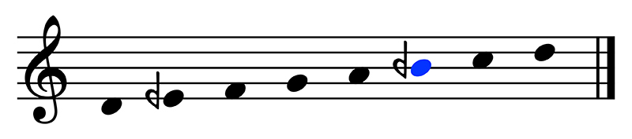
Example 13 Notes from the ‘ūd taqsīm from 01:26–01:32. The notes correspond with those in Example 10, Set 2
View description - Example 13 Notes from the ‘ūd taqsīm from 01:26–01:32. The notes correspond with ...

The preceding activity demonstrates how an improvising musician makes use of the possibilities of the 24-note Arab gamut. In this case, the musician employs two collections of notes that are alike except for one difference. In the first set, heard in 00:00–00:53 and 01:26–01:32 of the performance, the accidentals are E half flat and B half flat. In the second set, heard in 00:53–01:26, they are E half flat and B flat. It is a subtle difference, but one that is significant to musicians and to those who love the music.

8.2 Taqsīm and composition
The performance you have been listening to alternates episodes of taqsīm, or improvisation, with sections from Samai Bayati, the composition being performed. As you have heard, the performance starts with a taqsīm (played on the ‘ūd) that makes use of a collection of notes that sometimes includes B half flat and sometimes B flat.
Table 4 outlines the entire performance, including parts not yet discussed. Three sections follow the opening improvisation. The full orchestra comes in at 01:32, introducing the composition Samai Bayati per se. At 03:29, there is another taqsīm, this time performed on the qānūn, an instrument whose plucked strings are laid out across a sounding board (see Figure 13). Then at 06:11, the orchestra enters again and plays the remainder of the composition.

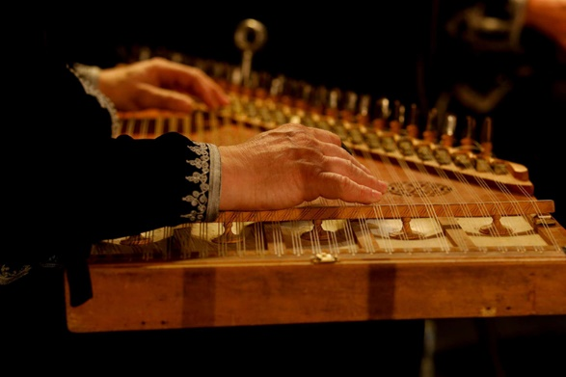
Figure 13 The qānūn, an instrument whose plucked strings are laid out across a sounding board
View description - Figure 13 The qānūn, an instrument whose plucked strings are laid out across a sounding ...

Activity 13
Allow around 20 minutes

Read through Table 4, then listen to the full performance (repeated below) while following the table.

Table 4 Sections and note sets in play in Samai Bayati
Time code | Instrument | Observations | Note set
00:00 | Solo ‘ūd (taqsīm) | The solo begins, using the set of notes with B half flat (see Example 11 on previous page). | Set 2
00:53 | Solo ‘ūd (taqsīm) | The solo continues, now using the set of notes with B flat (see Example 12 on previous page). | Set 1
01.26 | Solo ‘ūd (taqsīm) | Solo ‘ūd returns to the set of notes with B half flat (see Example 13 on previous page). | Set 2
01:32 | Full orchestra (composition) | The orchestra enters with the opening melody of the composition. | –
02:03 | Full orchestra (composition) | The orchestra introduces a melody that recurs several times. This is melody R, and it makes use of Set 1. | Set 1
02:32 | Full orchestra (composition) | The orchestra plays a contrasting melody. | –
03:01 | Full orchestra (composition) | The orchestra plays melody R again. | Set 1
03:29 | Solo qānūn (taqsīm) | A soloist plays a taqsīm on the qānūn. | –
06:11 | Full orchestra (composition) | The orchestra enters again. | –
06:39 | Full orchestra (composition) | The orchestra plays melody R again. | Set 1
07:07 | Full orchestra (composition) | The music speeds up slightly and takes on a new rhythm. Sections of the orchestra now play in alternation. | –
08:01 | Full orchestra (composition) | The orchestra slows down slightly, returns to the original rhythm, and plays melody R one last time. | Set 1

Listen especially for (a) the alternation between taqsīm and composition and (b) a recurring melody, heard four times: at 02:03, 03:01, 06:39 and 08:01.
Video 4 Samai Bayati performed by the Classical Arabic Orchestra of Aleppo (make sure to open the link in a new tab/window)
If you have time (either now or later), work through Activities 12 and 13 again to help internalise the sounds and structures of the music.

As you have learned, Arab music theory divides the octave into 24 notes. However, performers typically only use a subset of these notes in any given performance or section of a performance. (This is also true of other traditions. In many pieces and passages of Western music, for example, musicians only use seven of the twelve notes available to them.)
While following Table 4 in the previous activity, you may have noticed that from 01:32 onwards the column entitled ‘Note set’ occasionally contained a dash rather than the name of a note set. This is because, while the recurring melody at 02:03, 03:01, 06:39 and 08:01 makes unambiguous use of the collection identified as Set 1, the pitch content of the other sections is more complicated.
For example, the material from 01:32 to 02:03 employs both B half flat and B flat (albeit in different octaves). From 02:32 to 03:03, the music also uses the two versions of the B (this time in the same octave) as well as F half sharp and E natural. The qānūn taqsīm introduces some new notes, too.
Don’t feel daunted if you find it difficult to hear such details; the key thing is to be able to hear something of the use of E half flat, B flat, and B half flat in the opening minute and a half of the performance. It may be an encouragement to know that the author of these teaching materials needed to draw on the guidance of an expert (Saeid Kordmafi) to be able to point out certain nuances of the performance!

8.3 Intervals in Maqām bayātī
Example 10 is shown again here, presenting the notes used in the opening of this performance of Samai Bayati. Some of the notes are a step (200 cents) apart, for example the third and fourth notes, F and G. Another pair of notes is a half step apart, namely the fifth and sixth notes, A and B flat. However, the use of a half flat creates other intervals. E half flat is 50 cents below E, which stands 200 cents above D and 100 cents below F. E half flat is therefore midway between D and F; it is 150 cents above D and 150 cents below F.
Table 5 summarises the intervals between the first four notes of Set 1 and Set 2. The lowest note is at the bottom of the table and the highest is at the top.

Example 10 (repeated) Pitches used in the opening of Samai Bayātī
View description - Example 10 (repeated) Pitches used in the opening of Samai Bayātī

Table 5 Intervals between the first four notes of Set 1 and Set 2
Arabic note name | English note name | Distance from lowest note in cents | Distance from previous note in cents
Nawā | G | 500 | 200
Jahārkāh | F | 300 | 150
Sīkāh | E half flat | 150 | 150
Dūkāh | D | — | —

Keep in mind that the measurements provided so far – 100 cents for semitones, 150 cents for three-quarter tones, and 200 cents for tones – are approximations only. Arab musicians often deliberately play pitches a little sharper or flatter than the numbers given here.
In fact, there exists a rich set of discourses about whether, when and to what degree certain notes should be performed higher or lower than in the theoretical model presented here (see Marcus, 1993). To give one example, some musicians argue that the E half flat used in Samai Bayātī and other music like it should be played slightly lower than the E half flat used in other pitch collections (Marcus, 1993, p. 45).

9 Notating pitch using numbers
As noted earlier, there are many kinds of notation in the world, several of which existed long before staff notation. Many of these use written characters to designate notes. For instance, Indonesian gamelan music such as the Sundanese piece (Bendrong) you heard in Section 7.1 is often notated using numbers.
Example 14 below is an instance of notation for Gamelan Saléndro, the ensemble that uses the Sundanese saléndro pitch system introduced earlier. It comes from an introductory guide to Sundanese gamelan by Simon Cook (1992). It demonstrates an interlocking pattern of the kind that might be played by two different sarons, in which saron II plays a note, then saron I, then saron II, then saron I, and so on.
This alternation is represented in the example by means of a kind of sawtooth pattern, with a line in the saron I part when the saron II part has a number, and a dot in the saron II part when the saron I part has a number. The very final note, 4, aligns vertically between the two parts, indicating that the musicians play it together. The example makes use of cipher notation: notation that uses numbers to indicate pitches.

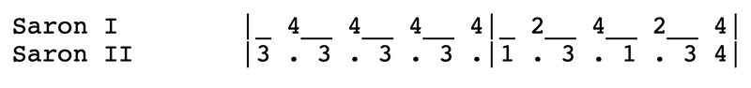
Example 14 Music for two sarons, written using cipher notation (after Cook, 1992, p. 27)
View description - Example 14 Music for two sarons, written using cipher notation (after Cook, 1992, ...

Table 2 (repeated) Structure of saléndro pitch system
Number | Name | Distance from singgul in cents | Distance from previous note in cents
5̣ | Singgul or petit | 1200 | 240
1 | Barang or tugu | 960 | 240
2 | Kenong or lorloran | 720 | 240
3 | Panelu | 480 | 240
4 | Bem or galimer | 240 | 240
5 | Singgul | — | —

Table 2 was introduced earlier in Section 7.2. It outlines the names of the notes in the saléndro pitch system as well as the numbers given to them in cipher notation (Cook, 1992). The lowest note (in Western terms) is at the bottom of the table and the highest is at the top.
(You may wonder about the uppermost 5̣ in the table, which features a dot below the number. This symbol represents the note an octave above the lowest 5 in the table. There is a dot below the symbol to indicate that this is a ‘lower’ 5, which is to say one that sounds higher from a Western perspective. The use of dots above or below the numbers in cipher notation allows musicians to represent notes in up to three octaves. For example, they would look like: .)
With the help of the table, you can see that in Example 14 the player of saron II plays panelu, then the player of saron I plays bem, then the player of saron II plays panelu again, and so on. Audio 6 contains an approximate electronic representation of the passage.

Audio content is not available in this format.
Audio 6 Realisation of saron pattern in Example 14

Cipher notation can also be found in other music cultures: the Cameroonian ethnomusicologist Pie-Claude Ngumu devised a system of cipher notation to represent xylophone music from the Centre Region of his country (see Ngumu, 1976; 1980). Cipher notation is easier to grasp than staff notation, so musicians use it in contexts where staff notation would be needlessly complicated.
This is not to say that complicated forms of music take complicated forms of notation and simple forms of music require simple forms of notation. There are plenty of complexities in gamelan music and Cameroonian xylophone music! Rather, it is a matter of numbers being the most efficient and accessible way to designate pitch to musicians working in certain traditions.

10 How wide is an interval?
This course has so far employed exact numbers when discussing pitches and intervals, speaking for instance of 220 hertz or 240 cents. But this presents a misleading picture of how these phenomena exist in most actual musical practice.
First, there is a degree of tolerance around what is considered a note or an interval, even in relatively ‘strict’ traditions of music making. For example, Eric Prame’s 1997 study of pitch in 10 commercial recordings of a piece of Western classical music (Schubert’s Ave Maria) indicated that sung notes could be over 40 cents sharp or flat of the ideal – nearly a quarter tone. Evidently, professional singers and recording engineers didn’t find such inaccuracies worrisome enough to withhold them from public circulation. Thus, performances may stray significantly from an ideal without seeming to be out of tune (that is, too sharp or too flat), even to insider experts.
Second, instrument makers in some traditions deliberately manipulate octaves and/or unisons to be slightly and pleasingly out of tune. Builders of gamelan ensembles in central Java, the most populous island in Indonesia, deliberately stretch or compress octaves across the various instruments of an ensemble when tuning them (Vetter, 1989 [citing Hood, 1966]; Brinner 2001). Put another way, they deliberately tune octaves so that they are slightly larger or slightly smaller than the 2:1 relationship discussed earlier in this course. This approach helps produce the characteristic ‘shimmering’ sound of the ensemble. (If you are interested, you can hear the shimmer in this video, a compilation of gamelan music from the Royal Palace of Yogyakarta in central Java, for example from 08:00–13:20.)
A similar approach to tuning is evident in flute traditions from the Andes (the mountains along the western side of South America), where inexact tuning of instruments to one another helps the music project across outdoor spaces and creates a rich musical analogue for cultural concepts of ‘abundance and social harmony’ (Stobart, 2013, p. 27). Thomas Turino, writing of the flute music in an Aymara Indigenous community in southern Peru, describes a ‘dense unison’ in which some musicians play slightly sharp or slightly flat of one another (1989, p. 12). The result is musical notes that have ‘a “fuzzy” aura … in contrast to a “clear” or “sharp” sound’ (1989, p. 13).
Third, pitch systems do not always have fixed or stable components. The positions of notes and the intervals between them may vary. This is true even in some traditions where instrument-makers build the pitch system into the instruments. Central Java in Indonesia is a good example. The pitch systems sléndro and pélog are used in many different ensembles in that part of the country. However, instrument-makers interpret these pitch systems in a range of ways (Vetter, 1989, pp. 217–8), and as a result the size of the intervals between notes varies noticeably from ensemble to ensemble and from community to community (Brinner, 2001).

Conclusion
This course has considered pitch and interval in Western, Arab, Aka and Sundanese musics. It has explored the relationships between the notes that comprise pitch systems and how these relationships are presented spatially and visually. For example, the Western gamut can be laid out as the pattern of white and black keys that comprise a keyboard instrument, or as a series of noteheads placed on the lines and spaces of a staff. Similarly, the Sundanese saléndro system can be presented as a set of keys on a xylophone or a series of numbers in cipher notation.
The course has also incorporated some practical training in the use of staff notation. You have learned to identify the symbols for notes and accidentals, and to realise notated pitches with the help of a keyboard instrument. If you are new to reading and writing music, it can take some time to internalise these skills, so it may be helpful to return to parts of this course over the coming weeks, or to work through certain activities more than once. With continued exposure and engagement, identifying notes on the staff will come more naturally.
The later sections of this course introduced three ways of organising pitch outside of the Western system. You have considered 5-note pitch systems from central Africa and Sunda, as well as the pitch system used in Arab music, with 24 possible pitches. You have seen how it is not only the number of pitches that varies from system to system, but also the size of the intervals between notes. In the 12-note Western gamut, adjacent notes are 100 cents apart, but in the Sundanese saléndro pitch system, notes are approximately 240 cents apart, and in the Arab pitch system, the idealised distance is 50 cents.
Finally, the course has explored how, although notes and intervals are discussed with reference to ideal numbers and ratios, actual practice is less straightforward. For example, singers and instrumentalists regularly perform sharp or flat of abstract ideals, and some degree of tolerance for supposed out-of-tune-ness seems built into all kinds of musical traditions. Further, some musical practices make calculated use of discrepancies in tuning to produce special musical effects; for example, the shimmering sound of gamelan music or the dense unison of Andean flute music. In fact, in some musical traditions, intervals ‘float’: they may be larger or smaller depending on the ensemble or the community. As this suggests, pitch and tuning in actual music making are anything but straightforward!

Acknowledgements
This free course was written by Byron Dueck, with thanks to Maiko Kawabata, Saeid Kordmafi (section on Arab music), Eshantha Peiris, and Lilian Simones for their comments and criticism. Any errors or omissions are the responsibility of the author. If you have a concern or notice an error, please contact the author at byron.dueck@open.ac.uk
Except for third party materials and otherwise stated (see terms and conditions), this content is made available under a Creative Commons Attribution-NonCommercial-ShareAlike 4.0 Licence.
The material acknowledged below is Proprietary and used under licence (not subject to Creative Commons Licence). Grateful acknowledgement is made to the following sources for permission to reproduce material in this free course:
Images
Course image: © Paul Tomlins. All rights reserved. 2024/Bridgeman Images
Figure 2: Google Maps Screenshot: Map data © 2024 Google. geoBasis DE/BKG (2009). Inst Geogr National
Figure 9: Map showing the Central African Republic and the Republic of the Congo (to be distinguished from the Democratic Republic of the Congo to the south and east of it) Map data © 2024 Google
Figure 10: Sundanese saron https://su.wikipedia.org/wiki/Gambar:Saron_laras_Pelog_dan_Salendro_koleksi_Jurusan_Karawitan_ISBI_Bandung.jpg Deed - Attribution-ShareAlike 4.0 International - Creative Commons
Figure 11: Five pitches as played by the Gamelan Saléndro ensemble https://archive.org/details/GuideToSundaneseMusic/page/n9/mode/2up https://creativecommons.org/publicdomain/
Figure 12: Samir Joubran from Le Trio Joubran playing an ‘ūd © Paul Tomlins. All rights reserved. 2024/Bridgeman Images
Figure 13: The qānūn © Philippe Lissac/Godong/Bridgeman Images
Every effort has been made to contact copyright owners. If any have been inadvertently overlooked, the publishers will be pleased to make the necessary arrangements at the first opportunity.
Don't miss out
If reading this text has inspired you to learn more, you may be interested in joining the millions of people who discover our free learning resources and qualifications by visiting The Open University – www.open.edu/openlearn/free-courses.

References
Arom, S. (1987 [1978]) Untitled CD liner notes. In Pygmées Aka: Centrafrique: Anthologie de la Musique des Pygmées Aka [CD liner notes]. Translated from the French by D. Stevens. Paris: Ocora C559012 13.
Bent, I.D., Hughes, D.W., Provine, R.C., Rastall, R., Kilmer, A., Hiley, D., Szendrei, J., Payne, T.B., Bent, M., and Chew, G. (2014) ‘Notation’, Grove Music Online. Available at: https://www-oxfordmusiconline-com.libezproxy.open.ac.uk/grovemusic/view/10.1093/gmo/9781561592630.001.0001/omo-9781561592630-e-0000020114 (Accessed: 23 July 2024).
Besouw, R.M.V., Brereton, J.S. and Howard, D.M. (2008) ‘Range of Tuning for Tones with and Without Vibrato’, Music Perception, 26(2), pp. 145–155.
Brinner, B. (2001) ‘Central Java’ in P. Yampolsky et al., ‘Indonesia (Bahasa Indon. Republik Indonesia)’, Grove Music Online. Available at: https://www-oxfordmusiconline-com.libezproxy.open.ac.uk/grovemusic/view/10.1093/gmo/9781561592630.001.0001/omo-9781561592630-e-0000042890?rskey=jeNWaj#omo-9781561592630-e-0000042890-div1-0000042890.1 (Accessed: 23 July 2024).
Cook, S. (1992) Guide to Sundanese Music: A Practical Introduction to Gamelan Saléndro/Pélog, Gamelan Degung, Panambih Tembang Sunda. Bandung: self-published. Available at: https://archive.org/details/GuideToSundaneseMusic/page/n9/mode/2up (Accessed: 18 July 2024).
Cook, S. (2014) ‘West Java’, in P. Yampolsky et al., ‘Indonesia’, Grove Music Online. Available at: https://www-oxfordmusiconline-com.libezproxy.open.ac.uk/grovemusic/view/10.1093/gmo/9781561592630.001.0001/omo-9781561592630-e-0000042890 (Accessed: 23 July 2024).
Davis, R. (2001) ‘Middle East and Central Asia: ‘”Maqām”, “Makom”’, in H.S. Powers et al., ‘Mode’, Grove Music Online. Available at: https://www-oxfordmusiconline-com.libezproxy.open.ac.uk/grovemusic/view/10.1093/gmo/9781561592630.001.0001/omo-9781561592630-e-0000043718 (Accessed: 23 July 2024).
Dyson, G. and Drabkin, W. (2001) ‘Chromatic’, Grove Music Online. Available at: https://www-oxfordmusiconline-com.libezproxy.open.ac.uk/grovemusic/view/10.1093/gmo/9781561592630.001.0001/omo-9781561592630-e-0000005718 (Accessed: 23 July 2024).
Ellis, A.J. (1885) ‘On the musical scales of various nations’, Journal of the Society of Arts, 33(1688), pp. 485–527. Available at: https://soundandscience.de/text/musical-scales-various-nations (Accessed: 23 July 2024).
Fürniss, S. (2000) ‘Cadres de quartes, fluctuations d'intervalles et mutations pentatoniques dans la polyphonie vocale aka’, Musicae Scientiae, 5 (1_suppl), pp. 65–72.
Hood, M. (1966) ‘Slendro and pelog redefined, with a note on laboratory methods by Max Harrell’, Selected Reports in Ethnomusicology, 1(1), pp. 28–48.
Marcus, S. (1989) Arab Music Theory in the Modern Period. Unpublished PhD thesis. University of California, Los Angeles.
Marcus, S. (1993) ‘The Interface between theory and practice: Intonation in Arab music’, Asian Music, 24(2), pp. 39–58.
Mushāqa, M. (1913 [c.1840]) ‘Un traité de musique arabe moderne’ (Al risālah al-Shihābiyyah fī al-sināh’ah al-mūsīqiyyah [The Shihabi treatise of the musical art]), Mélanges de la Faculté orientale, Université Saint-Joseph, Beirut, 6, pp. 1–120. Edited and translated from the Arabic into the French with commentary by P. Ronzevalle. Available at: https://www.persee.fr/doc/mefao_0256-5587_1913_num_6_1_945 (Accessed: 23 July 2024).
Ngumu, P-C. (1976) Les Mendzaŋ des Chanteurs de Yaoundé: Histoire--Organologie--Fabrication--Système de transcription. Acta Ethnologica et Linguistica 34, Series Musicologica 2. Vienna: Elisabeth Stiglmayr.
Ngumu, P-C. (1980) ‘Modèle standard de rangées de carreaux pour transcrire les traditions musicales africaines du Cameroun’, Journal of the International Library of African Music, 6(1), pp. 52–58.
Palisca, C. V. and Pesce, D. (2009) ‘Guido of Arezzo’, Grove Music Online. Available at: https://www-oxfordmusiconline-com.libezproxy.open.ac.uk/grovemusic/view/10.1093/gmo/9781561592630.001.0001/omo-9781561592630-e-0000011968 (Accessed: 23 July 2024).
Prame, E. (1997) ‘Vibrato extent and intonation in professional Western lyric singing’, The Journal of the Acoustical Society of America, 102(1), pp. 616–621.
Rahn, J. (1978) ‘Javanese pélog tunings reconsidered’, Yearbook of the International Folk Music Council, 10, pp. 69–82.
Stobart, H. (2013) ‘Staging sound: Acoustic reflections on Inca music, architecture and performance spaces’, in M. Stöckli and A.A. Both (eds) Flower World: Music Archaeology of the Americas / Mundo Florido: Arqueomusicología de las Américas, Vol. 2. Berlin: Ekho Verlag, pp. 11–35.
Suits, B.H. (1998) ‘Tuning: Frequencies for Equal-Tempered Scale, A₄=440 Hz’, Physics of Music – Notes. Available at: https://pages.mtu.edu/~suits/notefreqs.html (Accessed: 23 July 2024).
Turino, T. (1989) ‘The coherence of social style and musical creation among the Aymara in southern Peru’, Ethnomusicology 33(1), pp. 1–30.
Vetter, R. (1989) ‘A retrospect on a century of gamelan tone measurements’, Ethnomusicology, 33(2), pp. 217–227.

Glossary
accidental
A category including sharps, flats, naturals, double sharps and double flats. These words or symbols indicate that a note is to be raised or lowered, depending on the context.
bass clef
F clef; a symbol that indicates that the second highest line of a staff represents the F below middle C.
bass staff
A staff written in the bass clef.
cent
A unit of perceived intervallic distance; there are 1200 equal cents in an octave.
cipher notation
Indonesian notation system using numbers to designate pitches, with dots above or below the numbers designating pitches in higher or lower octaves.
courtesy accidental
A discretionary accidental that clarifies which version of a note (sharp, flat, natural, etc.) is in play. A courtesy accidental is a helpful reminder rather than a symbol modifying a note.
double flat
A word or symbol (resembling two flats side by side) indicating a note lowered by two semitones.
double sharp
A word or symbol (𝄪) indicating a note raised by two semitones.
fermata
A sign, typically placed above or below a note, to indicate a pause.
flat
A word or symbol (♭) indicating a note lowered by one semitone.
frequency
rate of vibration, typically measured in hertz.
gamut
A collection of notes that stand in a culturally determined intervallic relationship to one another; pitch system.
gong-chimes
Pot-shaped gongs.
grand staff
A pair of staves, typically with the upper in the treble clef and the lower in the bass clef, joined together by a brace. The grand staff is often used to notate piano music.
half step
The smallest interval conventionally used in Western music. A semitone can be found between any two adjacent notes on a keyboard instrument. Also called a semitone.
hertz
Vibrations per second, sometimes abbreviated Hz.
interval
The distance between two pitches, often measured in cents or hertz.
intervallic
Involving or related to intervals.
keyboard instrument
A mechanism that produces musical sound when its keys are pressed down. Keyboard instruments include the organ, piano, harmonium and synthesiser. Most keyboards are organised in a repeating pattern of dark- and light-coloured keys and embed the 7- and 12-note Western pitch collections.
ledger line
A short line used in notating pitches that are higher or lower than the staff. Also spelled as ‘leger’.
maqa̅m
In Arab music theory, (a) the complete gamut, comprising 24 equally spaced notes per octave; (b) smaller pitch collections such as Maqām bayātī, derived from the larger gamut.
middle C
Typically the C found closest to the centre of a keyboard instrument.
natural
A word or symbol (♮) that cancels a sharp or flat.
note
(a) A musical sound of fixed pitch, typically belonging to a pitch collection; (b) the elliptical shape used to represent this sound in staff notation.
notehead
The elliptical part of a musical note, distinct from the stem.
octave
(a) In Western music, the distance between a note and the closest note above or below it to share the same note name; (b) an interval in which the higher of the two notes vibrates at twice the speed of the lower.
out of tune
Too sharp or too flat.
pélog
A pitch system from Sunda in western Java comprising seven pitches, used in music played by a kind of ensemble called Gamelan Pélog. Note that there is also a 5-note version of pélog in Sunda, used by an ensemble called Gamelan Degung, and that different pitch collections called pélog exist in other parts of Java.
pentatonic
Of a pitch system or scale: having five distinct pitches.
pitch
(a) The perception of the frequency of a sound or of its highness or lowness; (b) a note.
pitch collection
(a) A group of pitches or notes; (b) (rarer) a pitch system.
pitch system
A collection of notes (also called pitches) that stand in a culturally determined intervallic relationship to one another; gamut.
polyphonic
(n. polyphony) Music in which two or more distinct parts are heard simultaneously
qānūn
An instrument whose plucked strings are laid out across a sounding board.
quarter step
See quarter tone.
quarter tone
The smallest interval conventionally identified in Arab music theory. Two quarter tones comprise a semitone and four quarter tones comprise a tone. Also called a quarter step.
rebab
Stringed instrument played with a bow and used in Indonesian gamelan performance.
saléndro
A pitch system from Sunda in western Java, comprising five approximately equidistant pitches and used in music played by an ensemble called Gamelan Saléndro. Note that different pitch systems called sléndro (a slightly different pronunciation) exist elsewhere in Java.
sléndro
A pitch system used in central Java and comprising five pitches. Note that a different pitch system called saléndro (a slightly different pronunciation) exists in western Java.
saron
A xylophone used in Sundanese gamelan performance.
semitone
The smallest interval conventionally used in Western music. A semitone can be found between any two adjacent notes on a keyboard instrument. Also called a half step.
sharp
A word or symbol (♯) indicating a note raised by one semitone.
slur
In staff notation, a curved line placed above or below a succession of notes. This can indicate that the notes are played smoothly. In music theory, a slur can also be used to group notes together for analytical or demonstrative purposes.
staff
(pl. ‘staves’) A set of lines on which notes are written in staff notation. A five-line staff is usual in contemporary Western and Arab musical notation.
staff notation
A method for representing music visually in which notes designating sounds of fixed pitch are arranged on staves.
step
A step comprises two half steps. Also called a tone.
taqsīm
An improvised section in a performance of Arab music.
tone
A tone is equal to the sum of two semitones. Also called a step.
treble clef
G clef; a symbol that indicates that the second lowest line of the staff represents G above middle C.
treble staff
A staff written in the treble clef.
‘ūd
A short-necked lute (a guitar-like instrument) whose strings are plucked.
unison
Musicians perform in unison when they sing or play the same pitches in the same octave at the same time.

Solutions

Activity 2

Part 2

Discussion
Exercises such as those in number 7 can be a challenge if you are not yet used to note names, but they will help you learn them more quickly. Don’t worry if you aren’t able to say the names fluently right away – try repeating these exercises on different days to help internalise them.
Back to - Part 2

Activity 5

Discussion
You should be able to determine the notes above with the help of the figures or mnemonics introduced earlier in the chapter. You may also want to check against the following lists. As you get better at reading staff notation, you will find it easier to read the notation than the lists of notes given below.
Example 3 RH: C♯, E, G♯, F♯, D♯, C♯; LH: C♯, E, G♯, F♯, D♯, C♯.
Example 4 RH: E♭, D♭, B♭, A♭, G♭, A♭, B♭, D♭, E♭, D♭, B♭, A♭, G♭ LH: B♭, A♭, G♭, E♭, D♭, E♭, G♭, A♭, B♭, A♭, G♭, E♭, D♭
Back to - Activity 5

Activity 6

Part

Discussion
Hopefully you were able to sing the note names without the recording after a few tries. These are:
C, B♭, A, B♭, A, B♮, C | B, C, D, C, B♭, A, G | B♭, A, G, A, G, G, F |
This is not a particularly easy exercise if you are new to singing from notation, so don’t worry if you weren’t able to accomplish it right away. If you struggled, come back to this activity a couple more times during the week.
Back to - Part

Activity 7

Part

Discussion
Here are the answers:
- B to A: tone, descending
- G to G♯: semitone, ascending
- B♭ to C: tone, ascending
- E to E: octave, descending
- D♭ to C: semitone, descending
- A♭ to A♭: octave, ascending
- B to C♯: tone, ascending

Example 8 (repeated) Semitones, tones and octaves
View description - Example 8 (repeated) Semitones, tones and octaves

Back to - Part

Part 3

Discussion
The answers are shown below in a completed version of Example 9. Keep in mind that there may be more than one correct answer in at least one case. For example, it would be fine to write A sharp rather than B flat in the second bar.
You may notice that there is a natural sign beside the E in bar 4. This is called a courtesy accidental, and it reminds a musician that the E flat in bar 3 no longer holds.

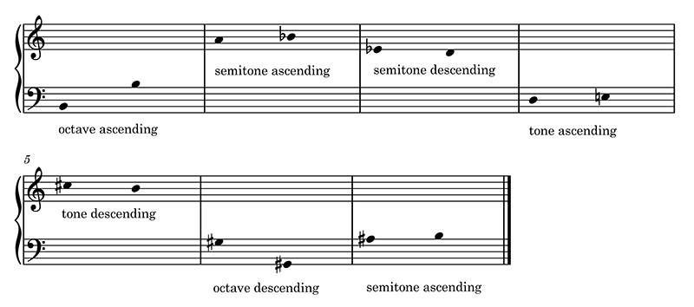
Example 9 Completed intervals
View description - Example 9 Completed intervals

Back to - Part 3

Activity 8

Discussion
What you heard were the distinct characteristics of three different intervals. Many trained musicians can identify the quality of an interval (e.g., whether they are hearing a tone or a semitone) by ear, without being told which notes are in play. You too can learn to do this with practice!
Back to - Activity 8

Descriptions

Figure 1 Keyboard showing black and white notes, with white notes named (two octaves)
This figure shows the keys of a keyboard labelled with the white-note names starting on a C and ending on a C two octaves above it. From left to right (lowest to highest) these are C, D, E, F, G, A, B, C, D, E, F, G, A, B and C. The first, eighth and last white keys – all of which are Cs – are marked with an asterisk.
Back to - Figure 1 Keyboard showing black and white notes, with white notes named (two octaves)

Figure 1 (repeated) Keyboard showing black and white notes, with white notes named (two octaves)
This figure shows the keys of a keyboard labelled with the white-note names starting on a C and ending on a C two octaves above it. From left to right (lowest to highest) these are C, D, E, F, G, A, B, C, D, E, F, G, A, B and C. The first, eighth and last white keys – all of which are Cs – are marked with an asterisk.
Back to - Figure 1 (repeated) Keyboard showing black and white notes, with white notes named (two octaves)

Figure 2 Detail of Italy, showing Arezzo southeast of Florence
This is a screenshot from Google Maps, showing northern and central Italy and parts of the surrounding countries.
Back to - Figure 2 Detail of Italy, showing Arezzo southeast of Florence

Figure 3 Keyboard and corresponding notes on a grand staff (two octaves)
This figure contains two images. The first shows the keys of a keyboard (two octaves, from C to C, as in Figure 1). The second shows the corresponding notes on a pair of staves joined by a bracket in the left-hand margin (the grand staff). There are eight notes on the lower staff, ascending from one C to another C (identified as ‘middle C’) an octave above it. There are also eight notes in the upper staff, ascending from a C identified as ‘middle C’ to another C an octave above it. The top staff is labelled ‘treble staff’ and begins with a treble clef symbol. The bottom staff is labelled ‘bass staff’ and begins with a bass clef symbol. As noted, a bracket joins the two staves. Middle C is labelled on both staves where it appears, as are the ledger lines used to notate it.
Back to - Figure 3 Keyboard and corresponding notes on a grand staff (two octaves)

Figure 4 Keyboard and corresponding notes on staff (four octaves)
This figure contains two images. The first shows the keys of a keyboard (four octaves, from the C two octaves below middle C to the C two octaves above it). The notes that correspond to the white keys in the first image are shown on a grand staff in the second image, ascending left to right (low to high) in the pattern C, D, E, F, G etc.
Back to - Figure 4 Keyboard and corresponding notes on staff (four octaves)

Figure 5 Finger numbers for keyboard instruments
This figure is an image of the left and right hands, with numbers at the end of each digit (the number 1 designates the thumbs, 2 the index fingers, 3 the middle fingers, and so on).
Back to - Figure 5 Finger numbers for keyboard instruments

Example 1 Short keyboard exercise for left and right hands
This example shows a short keyboard exercise for left and right hands. Notated on a grand staff, there is a rising and falling pattern for each hand. For the left hand, the pattern moves from the C below middle C to the G above it and back down to the initial C, using only the white notes. The fingering is provided for each note, starting and ending on 5 (the little finger). The pattern is then repeated in the right hand, which moves from middle C to the G above it and back down to the initial C. The fingering is again provided for each note, starting and ending on 1 (the thumb).
Back to - Example 1 Short keyboard exercise for left and right hands

Example 2 Longer keyboard exercise for left and right hands
This example shows a longer keyboard exercise for left and right hands. The exercise begins in the left hand, starting on the C below middle C, ascending through D and E to G, then descending through F and D to the initial C. The right hand then plays the same melody, but starting on middle C. The fingering reads 5, 4, 3, 1, 2, 4, 5 (for the left hand) and 1, 2, 3, 5, 4, 2, 1 (for the right hand). This entire 14-note pattern is then repeated four times, in each instance starting one note higher than the last (first on D, then E, then F). The fingering of each repetition is the same.
Back to - Example 2 Longer keyboard exercise for left and right hands

Figure 6 The black keys, labelled with both sharps and flats
This figure shows the keys of the keyboard (from one C to another an octave above it). All the keys are identified. The white keys are labelled in ascending order as C, D, E, F, G, A, B and C. Each of the black keys is labelled with two names: in ascending order, the first is C sharp and D flat, the second is D sharp and E flat, the third is F sharp and G flat, the fourth is G sharp and A flat, and the fifth is A sharp and B flat.
Back to - Figure 6 The black keys, labelled with both sharps and flats

Example 3 Exercise for left and right hands using sharps
This example shows a six-note pattern that is first played by the right hand, starting on the C sharp above middle C, and then by the left hand an octave lower. The notes are C sharp, E, G sharp, F sharp, D sharp, and C sharp. The right-hand fingering is 1, 3, 5, 4, 2, 1. The left-hand fingering is 5, 3, 1, 2, 4, 5.
Back to - Example 3 Exercise for left and right hands using sharps

Example 4 Longer exercise for left and right hands using flats
This example shows an undulating thirteen-note pattern for the right hand, followed by a similar pattern for the left hand. The right-hand pattern begins on the second E flat above middle C and is as follows: E flat, D flat, B flat, A flat, G flat, A flat, B flat, D flat, E flat, D flat, B flat, A flat, G flat. The fingering is 5, 4, 3, 2, 1, 2, 3, 4, 5, 4, 3, 2, 1. The left-hand pattern begins on the B flat below middle C and is as follows: B flat, A flat, G flat, E flat, D flat, E flat, G flat, A flat, B flat, A flat, G flat, E flat D flat. The fingering is 1, 2, 3, 4, 5, 4, 3, 2, 1, 2, 3, 4, 5.
Back to - Example 4 Longer exercise for left and right hands using flats

Example 5 A natural sign cancelling a sharp. This example is presented on a solitary treble staff rather than on a grand staff, since all of the music is in the treble clef
This example comprises a single bar of music in the treble clef. There are four notes in the bar: A, F sharp, A, and F natural. A sharp symbol indicates the F sharp and a natural symbol indicates the F natural.
Back to - Example 5 A natural sign cancelling a sharp. This example is presented on a solitary treble staff rather than on a grand staff, since all of the music is in the treble clef

Example 6 A passage of notated music featuring bar lines and accidentals
This example comprises three bars of music in the treble clef. Each bar has seven notes in it, and there is a pause symbol above the seventh note in each bar. The first bar contains the notes C, B flat, A, B flat, A, B natural, and C. A flat symbol indicates the first B flat and a natural symbol indicates the B natural. The second bar contains the notes B, C, D, C, B flat, A, and G. A flat symbol indicates the B flat. The third bar contains the notes B flat, A, G, A, G, G, and F. A flat symbol indicates the B flat.
Back to - Example 6 A passage of notated music featuring bar lines and accidentals

Example 7 Notating E sharp and C flat. All of the notes in this example are below middle C, so they are notated in the bass staff rather than on the grand staff
This example comprises four bars of music, each of which contains one note. The notes are E sharp, F, C flat, and B. A sharp symbol indicates the E sharp and a flat symbol indicates the C flat.
Back to - Example 7 Notating E sharp and C flat. All of the notes in this example are below middle C, so they are notated in the bass staff rather than on the grand staff

Figure 7 Keyboard demonstrating relationship between A and B double flat, between B and C flat, between F and E sharp, and between G and F double sharp
This figure shows the keys of a keyboard (four octaves, from C to another C four octaves above it). Seven of the white keys are labelled with note names, ascending from A to G. Notes indicate that A can also be understood as B double flat, that B can also be understood as C flat, that F can also be understood as E sharp, and that G can also be understood as G double sharp.
Back to - Figure 7 Keyboard demonstrating relationship between A and B double flat, between B and C flat, between F and E sharp, and between G and F double sharp

Figure 8 Keyboard (4 octaves)
This figure shows the keys of a keyboard (four octaves, from C to another C four octaves above it).
Back to - Figure 8 Keyboard (4 octaves)

Example 8 Semitones, tones and octaves
This example comprises seven bars of music in the treble and bass clefs. There are two notes in each bar. In bar 1, there is a note on the middle line of the treble staff followed by a note in the second lowest space of the treble staff. In bar 2, there is a note in the top space of the bass staff followed by the same note with a sharp symbol beside it. In bar 3, there is a note with a flat symbol beside it in the space above the top line of bass staff; this is followed by a note on the first ledger line below the bottom line of the treble staff. In bar 4, there is a note on the bottom line of the treble staff, followed by a note in the second highest space of the bass staff. In bar 5, there is a note with a flat symbol beside it in the space below the lowest line of the treble staff; it is followed by a note on a ledger line above the highest line in the bass staff. In bar 6, there is a note with a flat symbol beside it in the second lowest space of the treble staff; it is followed by a note with a flat symbol beside it on the first ledger line above the highest line of the treble staff. In bar 7, there is a note on the second lowest line of the bass staff, followed by a note with a sharp sign beside it in the second lowest space of the bass staff.
Back to - Example 8 Semitones, tones and octaves

Example 8 (repeated) Semitones, tones and octaves
This example comprises seven bars of music in the treble and bass clefs. There are two notes in each bar. In bar 1, there is a note on the middle line of the treble staff followed by a note in the second lowest space of the treble staff. In bar 2, there is a note in the top space of the bass staff followed by the same note with a sharp symbol beside it. In bar 3, there is a note with a flat symbol beside it in the space above the top line of bass staff; this is followed by a note on the first ledger line below the bottom line of the treble staff. In bar 4, there is a note on the bottom line of the treble staff, followed by a note in the second highest space of the bass staff. In bar 5, there is a note with a flat symbol beside it in the space below the lowest line of the treble staff; it is followed by a note on a ledger line above the highest line in the bass staff. In bar 6, there is a note with a flat symbol beside it in the second lowest space of the treble staff; it is followed by a note with a flat symbol beside it on the first ledger line above the highest line of the treble staff. In bar 7, there is a note on the second lowest line of the bass staff, followed by a note with a sharp sign beside it in the second lowest space of the bass staff.
Back to - Example 8 (repeated) Semitones, tones and octaves

Example 9 Intervals to be completed
This example comprises seven bars of music in the treble and bass clefs. There is an instruction in each bar. Bar 1 contains two notes and the other bars contain a single note each. Bar 1 contains the instruction ‘octave ascending’; there is a note on the second lowest line of the bass staff followed by a note in the space above the highest line of the bass staff. Bar 2 contains the instruction ‘semitone ascending’; there is a note in the second lowest space of the treble staff. Bar 3 contains the instruction ‘semitone descending’; there is a note with a flat symbol beside it on the second lowest line of the treble staff. Bar 4 contains the instruction ‘tone ascending’; there is a note on the middle line of the bass staff. Bar 5 contains the instruction ‘tone descending’; there is a note with a sharp sign next to it in the second highest space of the treble staff. Bar 6 contains the instruction ‘octave descending’; there is a note with a sharp sign next to it in the highest space of the bass staff. Bar 7 contains the instruction ‘semitone ascending’; there is a note with a sharp sign next to it on the highest line of the bass staff.
Back to - Example 9 Intervals to be completed

Example 9 Completed intervals
This example comprises seven bars of music in the treble and bass clefs. Each bar contains two notes and an instruction. Bar 1 contains the instruction ‘octave ascending’; there is a note on the second lowest line of the bass staff followed by a note in the space above the highest line of the bass staff. Bar 2 contains the instruction ‘semitone ascending’; there is a note in the second lowest space of the treble staff followed by a note with a flat symbol next to it on the middle line of the treble staff. Bar 3 contains the instruction ‘semitone descending’; there is a note with a flat symbol beside it on the second lowest line of the treble staff followed by a note in the space below the lowest line of the treble staff. Bar 4 contains the instruction ‘tone ascending’; there is a note on the middle line of the bass staff followed by a note in the second lowest space of the bass staff. Bar 5 contains the instruction ‘tone descending’; there is a note with a sharp sign next to it in the second highest space of the treble staff followed by a note on the middle line of the treble staff. Bar 6 contains the instruction ‘octave descending’; there is a note with a sharp sign next to it in the highest space of the bass staff followed by a note with a sharp sign next to it on the lowest line of the bass staff. Bar 7 contains the instruction ‘semitone ascending’; there is a note with a sharp sign next to it on the highest line of the bass staff followed by a note in the space above the highest line of the bass staff.
Back to - Example 9 Completed intervals

Figure 9 Map showing the Central African Republic and the Republic of the Congo (to be distinguished from the Democratic Republic of the Congo to the south and east of it)
This figure shows a map of a number of the countries in Central Africa, as well as their neighbours in West and East Africa. Across the top of the map, from westernmost to easternmost, are Nigeria, Cameroon, Central African Republic, and South Sudan. Across the bottom of the image, from westernmost to easternmost, are Equatorial Guinea, Gabon, Republic of the Congo, and Democratic Republic of the Congo. In the bottom right-hand corner, bordering the Democratic Republic of the Congo, are Rwanda and Burundi.
Back to - Figure 9 Map showing the Central African Republic and the Republic of the Congo (to be distinguished from the Democratic Republic of the Congo to the south and east of it)

Figure 10 Sundanese saron
This figure shows a saron, a metal xylophone. It has seven keys, which grow longer from left to right. From left to right, the keys are numbered 4, 5, 1, 2, 3, 4, 5. Because of the angle from which the photograph has been taken, most of the numbers are upside down.
Back to - Figure 10 Sundanese saron

Figure 11 Five pitches as played by the Gamelan Saléndro ensemble
This figure shows representations of six xylophone keys, each of which is labelled. The keys descend in size from left to right. From left to right they are labelled ‘Five, Singgul’, ‘Four, Bem or Galimer’, ‘Three, Panelu’, ‘Two, Kenong or Lorloran’, ‘One, Barang or Tugu’, and ‘Five, Singgul or Petit’. The number five on the smallest, rightmost key has a small dot beneath it.
Back to - Figure 11 Five pitches as played by the Gamelan Saléndro ensemble

Example 10 Pitches used in the opening 01:32 of the performance of Samai Bayātī: Set 1 contains B flat and Set 2 contains B half flat
This example comprises two bars in the treble staff. Both bars contain eight notes. The rubric ‘Set 1’ sits above bar 1 and the rubric ‘Set 2’ sits above bar 2. Bar 1 contains the ascending scale D, E half flat, F, G, A, B flat, C, and D. E half flat is marked by a half flat symbol and B flat by a flat symbol. Bar 2 contains the ascending scale D, E half flat, F, G, A, B half flat, C and D. E half flat and B half flat are marked by half flat symbols.
Back to - Example 10 Pitches used in the opening 01:32 of the performance of Samai Bayātī: Set 1 contains B flat and Set 2 contains B half flat

Figure 12 Samir Joubran from Le Trio Joubran playing an ‘ūd, a short-necked lute (guitar-like instrument) whose strings are plucked
This photograph shows a man playing the ‘ūd. His eyes are nearly closed. His right hand plucks the strings (probably with a plectrum that is out of view) while his right hand presses some of the strings against the neck of the instrument.
Back to - Figure 12 Samir Joubran from Le Trio Joubran playing an ‘ūd, a short-necked lute (guitar-like instrument) whose strings are plucked

Example 11 Notes from the ‘ūd taqsīm from 00:00–00:53. All of the notes can be found in Example 10, Set 2, although some are in a higher octave
This example comprises a single bar in the treble clef. It contains eight notes comprising the ascending scale G, A, B half flat, C, D, E half flat, F, and G. Notes 1 to 5 (G to D) are slurred together and notes 5 to 8 (D to G) are slurred together. B half flat and E half flat are marked by half flat symbols.
Back to - Example 11 Notes from the ‘ūd taqsīm from 00:00–00:53. All of the notes can be found in Example 10, Set 2, although some are in a higher octave

Example 12 Notes from the ‘ūd taqsīm from 00:53–01:26. All of the notes can be found in Example 10, Set 1
This example comprises a single bar in the treble clef. It contains eight notes comprising the ascending scale C, D, E half flat, F, G, A, B flat, and C. Notes 1 and 2 (C and D) are slurred together and notes 2 to 8 (D to C) are slurred together. E half flat is marked by a half flat symbol and B flat is marked by a flat symbol.
Back to - Example 12 Notes from the ‘ūd taqsīm from 00:53–01:26. All of the notes can be found in Example 10, Set 1

Example 13 Notes from the ‘ūd taqsīm from 01:26–01:32. The notes correspond with those in Example 10, Set 2
This example comprises one bar in the treble staff. It contains eight notes comprising the ascending scale D, E half flat, F, G, A, B half flat, C and D. E half flat and B half flat are marked by half flat symbols.
Back to - Example 13 Notes from the ‘ūd taqsīm from 01:26–01:32. The notes correspond with those in Example 10, Set 2

Figure 13 The qānūn, an instrument whose plucked strings are laid out across a sounding board
This photograph shows the hands of a musician playing the qānūn. The musician is plucking the strings of the instrument with their fingers. The strings of the instrument are arranged in courses, which means that there is more than one string for each note (three for the most part on this instrument).
Back to - Figure 13 The qānūn, an instrument whose plucked strings are laid out across a sounding board

Example 10 (repeated) Pitches used in the opening of Samai Bayātī
This example comprises two bars in the treble staff. Both bars contain eight notes. The rubric ‘Set 1’ sits above bar 1 and the rubric ‘Set 2’ sits above bar 2. Bar 1 contains the ascending scale D, E half flat, F, G, A, B flat, C, and D. E half flat is marked by a half flat symbol and B flat by a flat symbol. Bar 2 contains the ascending scale D, E half flat, F, G, A, B half flat, C and D. E half flat and B half flat are marked by half flat symbols.
Back to - Example 10 (repeated) Pitches used in the opening of Samai Bayātī

Example 14 Music for two sarons, written using cipher notation (after Cook, 1992, p. 27)
Example 14 comprises two bars of music in cipher notation. There are two lines of music, one labelled ‘Saron 1’ and the other labelled ‘Saron 2’. The notation consists of a mixture of numbers (these are the so-called ciphers) and symbols. Bar 1 of the Saron 1 line contains a dash, the number four, a dash, the number four, a dash, the number four, a dash, and the number four. Bar 2 of the Saron 1 line contains a dash, the number two, a dash, the number four, a dash, the number two, a dash, and the number four. Bar 1 of the Saron 2 line contains the number three, a dot, the number three, a dot, the number three, a dot, the number three, and a dot. Bar 2 of the Saron 2 line contains the number one, a dot, the number three, a dot, the number one, a dot, the number three, and the number four.
Back to - Example 14 Music for two sarons, written using cipher notation (after Cook, 1992, p. 27)

Video 1 Getting familiar with the keyboard

Transcript
BYRON DUECK
The keyboard is made up of seven recurring white notes, or white keys. And these are named after the letters of the alphabet: A, B, C, D, E, F, and G. And that sequence of note names recurs across the keyboard, so you can find it down here: A, B, C, D, E, F, G, followed by: A, B, C, D, E, F, G, and then again: A, B, C, D, E, F, G, A.
Most keyboards like this electronic one don’t begin and end on A. Instead they begin and end on C. So on this keyboard the lowest note is C, and the highest note is C. And in between those notes you have several other Cs. Here too the sequence is simply continuous: C, D, E, F, G, A, B, C, D, E, F, G, A, B, C.
Having introduced that, let me help you orient yourself to the MIDI keyboard by finding two different notes. One is the note C. You can find C by locating the two black keys that are close to one another. You can see that the MIDI keyboard is made up of a recurring series of black keys as well. Two black keys, three, two, three, and two. To find the Cs, you find the pair of black keys, and the note immediately to the left of those two is C. So here again, two black keys, C is close, there, and two black keys here, and there’s the C.
The note that is easy to confuse with C is F. F is found immediately to the left of the three black keys on the MIDI keyboard. So wherever you have three black keys, immediately to the left of that is the note F. Three black keys, F. Three black keys, F.
Once you know where C and F are, it’s relatively easy to find any other note that you might want to look at. So for instance, if you’re looking for B, you find note C first. C is located to the left of the two black keys, and B is the note immediately below it. Similarly, if you’re looking for the note E, you can find that one of two ways. Either you can find C next to the two black keys, and go up two notes: C, D, E. Or alternatively, you can find the F next to the three black keys and descend by one note: F, E, and you’ve located the E.
So, once you have these basic anchoring keys in mind, it should be possible to find any note. You should now be able to identify the white keys on the piano by their alphabetic names, and to distinguish two frequently confused keys, C and F.
Back to - Video 1 Getting familiar with the keyboard

Video 2 Notating pitch on the grand staff

Transcript
BYRON DUECK
In this video, I’m going to review how the note names you’ve learned are represented using staff notation, as well as a number of key terms used to designate elements of that notation. When you look at a musical score, or this one in particular, you’ll see two grille-like objects, one above and one below, each made up of five lines and four spaces between them. These are called staves – the singular is staff or stave. You’ll see that in this example the two staves are bracketed together here in the margin. This is an example of music written for a keyboard instrument, and this bracket turns it into a grand staff.
Each of the lines and each of the spaces represents a particular note. When an oval shape like this one is placed on a line or a space, it indicates that the note in question is to be played. So, for instance, this note here is middle C, and it designates this note on the piano or MIDI keyboard.
You read the staff from left to right. The sequence of notes represents their sequence in time. So, starting here, I would play: C, D, E, F, G, A, B, C, D, E, F, G, A, B, C.
Just which notes are represented on the staves is determined by the clef in the margin. Here you have one clef and here you have another. This one at the top is often called the treble clef, or the G clef. It designates where the line representing G – the G above middle C – appears. So, here’s middle C and here’s G. And as you can see, the treble clef circles around that particular G.
Similarly, this clef is called the bass clef, or sometimes the F clef, and it shows you where the line representing F occurs in relation to middle C. That is the line representing F below middle C, this particular F. So again, here’s middle C, the treble clef shows you where the G above middle C is, and the bass clef shows you where the F below middle C is.
Much keyboard music is notated on a grand staff made up of two staves, with the top staff written in the treble clef and the bottom staff written in the bass clef, just like here. But this isn’t always the case. You’ll find some keyboard music that’s written on three staves, maybe even four. And sometimes you’ll find music written in two staves, where both staves are in the treble clef or both are in the bass clef. So it’s worthwhile every time you see some keyboard music, having a good look to see what clef it’s actually written in.
If you aren’t familiar with staff notation, it will be important to get familiar with it quickly. One way to do this is to get familiar with some of the mnemonics that have been created to help identify the lines and spaces on the staff. For instance, in the treble clef, you have the lines E, G, B, D, and F, which stands for – according to some – ‘Every Good Boy Deserves Fudge’. The spaces, meanwhile, are named F, A, C, E, which creates the word ‘FACE’.
So far, I haven’t said much about this particular note, and the fact that it’s on a tiny line. And in that respect, it’s different from the other lines and spaces. Well, whether it’s on a line or a ledger line, as this is called, the same way of counting holds true. You count up from middle C in sequence: C, D, E, F, G, A, B, C. And when you see a note on a ledger line, it simply continues the overall sequence of note names that you use when moving up and down the staff. For instance, if I have a note that is up on a high ledger line like this, I know that the top line of the treble clef is F. So, the space above that will be G. The ledger line above that space is A. The space above that is B. And the second ledger line is going to be C. You can do this whenever you find notes notated on ledger lines.
If you’re new to notation it will be important to get familiar with it just as quickly as you can. One of the better ways to do this is to test yourself. Pick a note out and see if you can identify it, first simply by looking at it. And then to confirm that you’ve got it right, check it with respect to the G line here, the F line here, or middle C here. Or of course to one of the mnemonics that you’ve learned.
You should now have a good sense of some of the terms used to designate basic elements of staff notation, as well as how the lines and spaces of this notation designate particular notes.
Back to - Video 2 Notating pitch on the grand staff

