

AA314_2 Studies in music 1750–2000: interpretation and analysis

Voice-leading analysis of music 2: the middleground

About this free course
This free course provides a sample of Level 3 study in Arts and Humanities: http://www.open.ac.uk/courses/find/arts-and-humanities.
This version of the content may include video, images and interactive content that may not be optimised for your device.
You can experience this free course as it was originally designed on OpenLearn, the home of free learning from The Open University - www.open.edu/openlearn/history-the-arts/culture/music/voice-leading-analysis-music-2-the-middleground/content-section-0.
There you’ll also be able to track your progress via your activity record, which you can use to demonstrate your learning.
The Open University Walton Hall, Milton Keynes MK7 6AA
Copyright © 2016 The Open University
Intellectual property
Unless otherwise stated, this resource is released under the terms of the Creative Commons Licence v4.0 http://creativecommons.org/licenses/by-nc-sa/4.0/deed.en_GB. Within that The Open University interprets this licence in the following way: www.open.edu/openlearn/about-openlearn/frequently-asked-questions-on-openlearn. Copyright and rights falling outside the terms of the Creative Commons Licence are retained or controlled by The Open University. Please read the full text before using any of the content.
We believe the primary barrier to accessing high-quality educational experiences is cost, which is why we aim to publish as much free content as possible under an open licence. If it proves difficult to release content under our preferred Creative Commons licence (e.g. because we can’t afford or gain the clearances or find suitable alternatives), we will still release the materials for free under a personal end-user licence.
This is because the learning experience will always be the same high quality offering and that should always be seen as positive – even if at times the licensing is different to Creative Commons.
When using the content you must attribute us (The Open University) (the OU) and any identified author in accordance with the terms of the Creative Commons Licence.
The Acknowledgements section is used to list, amongst other things, third party (Proprietary), licensed content which is not subject to Creative Commons licensing. Proprietary content must be used (retained) intact and in context to the content at all times.
The Acknowledgements section is also used to bring to your attention any other Special Restrictions which may apply to the content. For example there may be times when the Creative Commons Non-Commercial Sharealike licence does not apply to any of the content even if owned by us (The Open University). In these instances, unless stated otherwise, the content may be used for personal and non-commercial use.
We have also identified as Proprietary other material included in the content which is not subject to Creative Commons Licence. These are OU logos, trading names and may extend to certain photographic and video images and sound recordings and any other material as may be brought to your attention.
Unauthorised use of any of the content may constitute a breach of the terms and conditions and/or intellectual property laws.
We reserve the right to alter, amend or bring to an end any terms and conditions provided here without notice.
All rights falling outside the terms of the Creative Commons licence are retained or controlled by The Open University.
Head of Intellectual Property, The Open University
The Open University
The Alden Group, Oxford.
978-1-4730-1079-6 (.epub)
978-1-4730-1847-1 (.kdl)

Contents
- Introduction
- Learning outcomes
- 1 Introduction
  - 1.1 Voice-leading concepts
  - 1.2 Moving beyond the foreground
- 2 Melodies within melodies
- 3 Unfolding
  - 3.1 Unfolding in Mozart
  - 3.2 Identifying unfoldings
  - 3.3 Unfolding: a summary
- 4 Self-contained musical structures
- 5 Interruption
  - 5.1 Interruption as a structural device
  - 5.2 Identifying an interrupted structure
  - 5.3 Interrupted structure and typical features of the style
  - 5.4 Different analyses of a single theme
  - 5.5 Interruption: a summary
- 6 Towards a deeper level of structure
  - 6.1 Considering patterns on a larger scale
  - 6.2 The idea of the background, and course summary
- Conclusion
- References
- Acknowledgements
- Solutions

Introduction
This is the second of three courses. It continues on from the discussion of voice-leading analysis begun in AA314_1 Voice-leading analysis of music 1: the foreground and which will continue in AA314_3 Voice-leading analysis of music 3: the background. This course returns to the study of Mozart's harmonic style that was begun in AA314_1. Once again, we will analyse the voice leading of extracts chosen from the piano sonatas. At the end of AA314_1, you saw that analysing the ‘foreground’ of the music – that is, the structure outlined by the consonances in the harmony – leads on to the discovery of deeper levels of structure. These deeper levels of harmony are what you are going to study here. The term used for this larger-scale structuring is the ‘middleground’ . However, the basic techniques used to describe it are just the same as those introduced in AA314_1 which analyse the foreground.
Before you begin, you may wish to revise the ideas that were introduced in AA314_1, especially familiarising yourself with the terms analytical notation, arpeggiation, background, consonance, consonant skip, diminution, dissonance, foreground, middleground, neighbour note, passing note, prolongation, reduction, register transfer, resolution and suspension, which are listed in the glossary for this course. In this course you will be meeting extracts from all the complete sonata movements to which you listened at the beginning of AA314_1, so you may wish to listen to these whole movements again. In Section 3 of this course you will need a pencil and some manuscript paper in order to complete the activities.
The aims of this course are:
- to develop voice-leading analysis;
- to introduce the concept of the ‘middleground’ of harmonic structure.
The materials upon which this course is based have been jointly authored by Robert Samuels and Howard Wilde.
This OpenLearn course provides a sample of Level 3 study in Arts and Humanities.

Learning outcomes
After studying this course, you should be able to:
- understand more deeply the complete movements from Mozart's sonatas, studied both here and in the course 'Voice-leading analysis of music 1: the foreground'
- recognise extracts from other Mozart piano sonatas
- recognise typical techniques used by Mozart to organise the harmony of complete short sections within musical works
- understand the use of symbols in voice-leading graphs of the middleground of harmonic structure
- relate this sort of graph to the score of the music it analyses.

1 Introduction

1.1 Voice-leading concepts
Here are some ideas to explain why analysis of voice leading can help our understanding of Mozart's music.
- Ordinary chord-function analysis (using roman numerals) is not able, on its own, to explain the sense of logical continuity in Mozart's music.
- Order and coherence are, in part, produced in Mozart's style by smooth linear patterns of notes, hidden within the individual parts (or ‘voices’) of the music.
- These smooth lines can be identified at several different levels: in the music as the composer wrote it (that is, the ‘surface’ or ‘foreground’); in the underlying ‘skeleton’ of the harmony; and at a number of levels in between.
- Each of these levels obeys the basic rules of counterpoint, in which dissonances must resolve – as passing notes, neighbour notes or suspensions – to consonances.
- Analytical notation can be used to show the relationships between these levels, by representing them using noteheads, stems and slurs.
In this course you are going to look in more detail at these deeper levels of the structure. In AA314_1, you saw that analysing the voice leading of a passage can often reveal connections we would otherwise miss – you may remember, for instance, that bars 3–4 and 5–8 of Mozart's Sonata in C, K545 have the same underlying structure, despite being completely different on the surface (see AA314_1, Example 14). These connections become more visible when we look at deeper levels of harmonic organisation.

1.2 Moving beyond the foreground
As you know, the essence of analysing the foreground of a piece of music lies in distinguishing between consonant and dissonant notes. Dissonant notes, whether passing notes, neighbour notes or suspensions, are all subsidiary to the consonant note to which they resolve. The same goes for arpeggiations, where the subsidiary notes are consonant. In all of these cases, we can say that the subsidiary notes elaborate the main (consonant) note.
The big difference, when we look deeper into the structure of the music, is that we discover that some consonant harmonies (notes or chords) elaborate, or are subsidiary to, the main harmonies. This is what defines the ‘middleground’. You may have noticed that this was the case when we analysed the opening of the last movement of Mozart's Sonata in B flat, K570, in the video clips in AA314_1.

Activity 1

Example 1 is the score of bars 1–4 of the third movement of K570 and Examples 2 and 3 show part of the multi-layered analysis built up in the video clips. Listen to the extract below, and then listen through three more times, first following the score (Example 1), then Level 4 (Example 3), then Level 2 (Example 2). Why does Level 2 omit some of the notes found in Level 4?
Click to listen to Extract 1

Audio content is not available in this format.

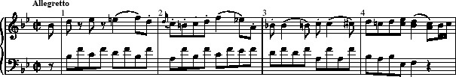
Example 1 Sonata in B flat, K570, third movement, bars 1–4

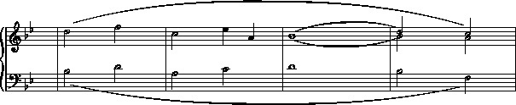
Example 2 Sonata in B flat, K570, third movement, bars 1–4: Level 2

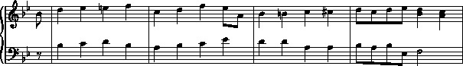
Example 3 Sonata in B flat, K570, third movement, bars 1–4: Level 4

View discussion - Activity 1

Throughout this course, you will be making distinctions between main harmonies and the subsidiary harmonies that prolong them. Just as in AA314_1, the most important consideration in doing this is to trust what your ear tells you about the music. Analysis is not a mechanical or abstract activity; it is rooted in careful listening. Always ask yourself exactly what you hear in any individual passage, and then how this can be expressed using analytical language or notation. Some new techniques will be needed to analyse middleground harmonic structures, but we will still be dealing in this course with relatively short extracts from Mozart's piano sonatas. Although I want to show how Mozart organises whole self-contained phrases, those I have chosen are no longer than eight bars. The techniques you will learn here, however, can be applied to much longer stretches of music. Do not worry, though, that you will be expected to produce complicated analytical graphs yourself. The aim of all the AA314 courses presenting voice-leading theory is to enable you to understand what an analytical graph says about the music. The analytical activities you are asked to do yourself are all directed towards this end, and as a result, there is much more emphasis on reading graphs presented to you rather than writing or annotating your own.

2 Melodies within melodies
In this course we introduce two new concepts that are central to voice-leading theory: unfolding and interruption. These, especially the latter, tend to occur at a level beyond the musical surface, in what I have called the middleground. They both involve processes that extend over a longer span of time than the foreground features studied in AA314_1. This course will involve listening especially for musical lines that underpin entire phrases.
You probably think of melody as a single strand of music, maybe moving over a harmonic accompaniment. While this is obviously true in one sense, you may know from the start of AA314_1 that the treble and bass lines also have to make sense as a piece of counterpoint. Dissonances, for instance, are normally treated according to particular rules (a suspension, for example, should resolve downwards by step). Instead of thinking of the opening theme from Mozart's Piano Sonata in B flat, K333 as a tune with supporting chords, I asked you to think of it in terms of voices moving against one another, outlining large-scale lines.
This idea can be taken a step further. In some cases, there is not just one voice, but more than one, within a single treble melody. This idea, that two or more separate lines may be expressed in a single melodic part, is one of the most important aspects of voice-leading theory.
The clearest examples of this device, which is sometimes called ‘pseudo-polyphony’, are found in music of the late Baroque. We are going to look briefly at an extract by Vivaldi in order to see this at work.

Activity 2

Listen to Extract 2, from a flute concerto by Vivaldi, following the score given in Example 4. How many strands can you hear in the flute's melody line?
Click to listen to Extract 2

Audio content is not available in this format.

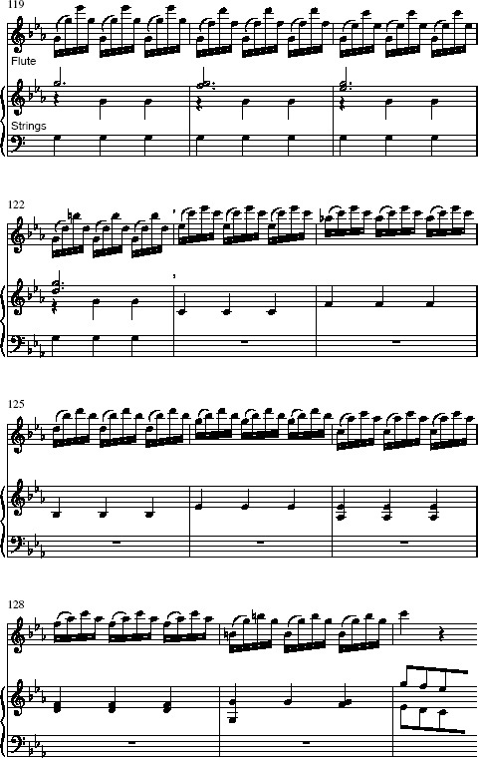
Example 4 Vivaldi, Concerto for Flute and Strings in C minor, RV441, third movement, bars 119–30

View discussion - Activity 2

J.S. Bach, in particular, exploited this device to its fullest potential. It enabled him to write three-part fugues and other ‘polyphonic’ music for a single melody instrument (the fugues from the three sonatas for solo violin being perhaps the most sublime examples). While the music may contain large leaps at the surface level, the leaps are between different strands which move against one another according to the rules of counterpoint.
Example 6a shows a cadence typical of Bach's practice, slightly adapted from the Sarabande of the Second Suite for solo cello. On paper, the cello part looks almost bizarre: the melody leaps downwards by a fourth, then upwards by a fifth and a seventh. Yet, as always in Bach, the aural effect is supremely logical, since the D resolving to C# in the upper register is supported by A in the bass and E in the tenor: a simple cadential 4–3 suspension.

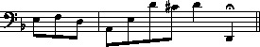
Example 6a Adapted from J.S.Bach, suite for solo cello in D minor BWV 1 008, Sarabande

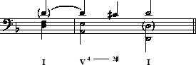
Example 6b ‘Aligned’ version

Activity 3

Listen first to Example 6a, then to the ‘aligned’ reduction shown in Example 6b (E).
Click to listen to Extract 4

Audio content is not available in this format.

Click to listen to Extract 5

Audio content is not available in this format.

This technique is a ‘spreading-out’, through time, of a simpler progression in which the pitches of two or more independent lines actually belong together harmonically. This process, of taking two or more voices and separating them out so as to present them in a single melodic part, is known technically as ‘unfolding’.
This is actually an idea that you have met already. At the end of AA314_1, you made an analysis of the opening of Mozart's Sonata in C, K545. Let's look at this once again.

Activity 4

Listen to bars 1–8 of the Sonata in C, K545 (Extract 6), which are shown in Example 7 below, once following the score (Example 7), then again following the analytical graph in Example 8. What does this analysis say about the melody line of bars 5–8?
Click to listen to Extract 6

Audio content is not available in this format.

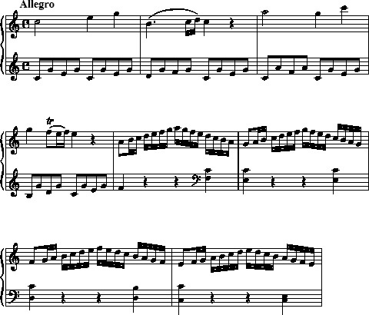
Example 7 Mozart, Sonata in C, K545, first movement, bars 1–8

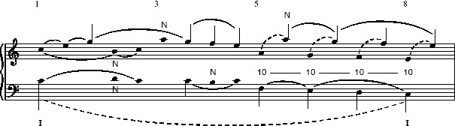
Example 8 Mozart, Sonata in C, K545, first movement, bars 1–8: analytical graph

View discussion - Activity 4

I hope that you were able to hear two lines (A–G–F–E) moving in parallel in these bars. The semiquaver runs that connect each pair of notes can be called miniature ‘octave progressions’, or ‘8-prg.’ for short. We might call these lines a sort of ‘treble’ and a sort of ‘alto’. This would not really be quite right here, though, because rather than moving in counterpoint like the earlier examples from Vivaldi and Bach, these lines are merely a doubling of a single voice at the octave. This technique is quite common in Mozart's sonatas. It is not an example of contrapuntally incorrect ‘consecutive octaves’ but a good (if simple) example of how two or more voices can exist within a single melodic line.

3 Unfolding

3.1 Unfolding in Mozart
We are now going to look at cases where Mozart creates a single melodic line which contains more than one part, as in the last example in Section 2, but where these voices work in counterpoint, more in the fashion of the examples from Vivaldi and Bach. This section is presented in conjunction with several video clips. To follow these, you will need a pencil and some manuscript paper. Some of the examples are reproduced here as an aid to following the process of analysis, and the videos will ask you to return to the course text at certain points.

Activity 5

When you are ready, play the video clip below and follow the activities described there.

Video content is not available in this format.
Unfolding in Mozart
View transcript - Unfolding in Mozart

Activity 6

You are going to start to make an analytical graph of the bars that we've been looking at on the video, using the symbols that you are already familiar with. For this activity you will need Examples 9 and 10 below.

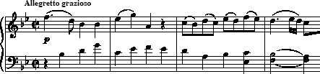
Example 9 Mozart, Sonata in B flat, K333, third movement, bars 1–4

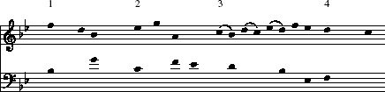
Example 10 Mozart, Sonata in B flat, K333, third movement, bars 1–4: graph with noteheads and guidance symbols only

Example 9 shows you the bars of Mozart's score. Example 10 is a version of these four bars which gives all the notes just as noteheads, with the bar numbers indicated above. A few changes have been made in the alignment to show where the melody harmonises with the bass. Three slurs have already been put in to show where the appoggiaturas are. You should follow the instructions below to continue drawing the graph. There are five things to do. A pdf of Example 10 is provided below for you to print out for marking up.
Click to download pdf version of Example 10 bar graph.
- Put stems going upwards on the main notes of the top voice.
- Put stems going downwards on the notes which make the ‘structural alto’ voice.
- Put stems, also going downwards, on the main harmony notes of the bass voice.
- Put a slur to show where there is a passing note in the melody line.
- Finally, put a slur to show how each remaining notehead belongs to one of the notes with a stem.

Activity 7

Video content is not available in this format.
Making an analytical graph
View transcript - Making an analytical graph

To help you compare your graph with mine, my solution is reprinted here as Example 11. You will also see three new notational symbols added. The final completed graph is printed below as Example 12.

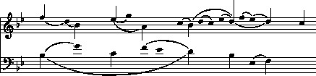
Example 11 Mozart, Sonata in B flat, K333, third movement, bars 1–4: intermediate stage

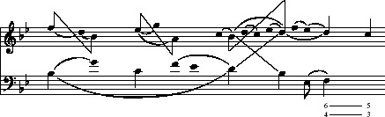
Example 12 Mozart, Sonata in B flat, K333, third movement, bars 1–4: completed graph

Activity 8

As in the previous activity, you're going to start to make an analytical graph, this time of the first four bars of the first movement of K333. As before, you will find below a version of the score (Example 13) and a version of these four bars which gives all the notes just as noteheads (Example 14). A few changes have been made in the alignment to show where the melody harmonises with the bass. As before, you should add stems and slurs to these noteheads. This time, I don't want you to make such a detailed analysis.

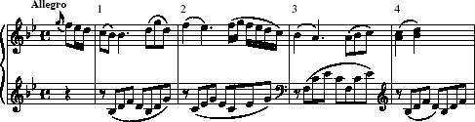
Example 13 Mozart, Sonata in B flat, K333, first movement, bars 1–4

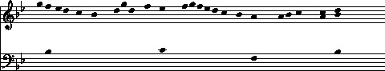
Example 14 Mozart, Sonata in B flat, K333, first movement, bars 1–4: noteheads

Click to download pdf version of Example 14 bar graph
Follow the five instructions below.
- Identify unfolded intervals in the melody line.
- Place upward stems on the notes of the ‘structural treble’.
- Place downward stems on the notes of the ‘structural alto’.
- Connect the stems with diagonal beams to show the unfoldings.
- Add slurs to show how the noteheads between the notes with stems are related to them.

View discussion - Activity 8

3.2 Identifying unfoldings
For the next example of unfolded intervals at work we return to the Sonata in C, K545. This time we are going to look at a passage from the second-subject group, which acts as a transition between the second-subject theme and the codetta theme.

Activity 9

Listen several times to Extract 7 following the score given as Example 17.
Click to listen to Extract 7

Audio content is not available in this format.

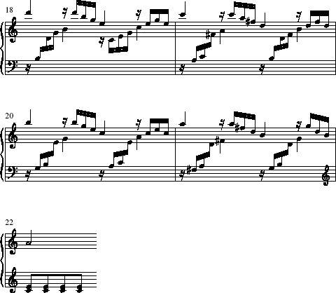
Example 17 Mozart, Sonata in C, K545, first movement, bars 18–22

Then, on some manuscript paper, make your own analytical graph of these bars by following the steps listed below.
Click to open blank manuscript paper.
- Make a simple reduction of the passage by removing the semiquaver figuration and instead writing two minims per bar in each stave. The only exception to this comes in bar 21, where you should write a minim and two crotchets in the right hand.
This should produce the logical piece of two-part counterpoint shown below in Example 18.
- Look at the right-hand melody of your reduction. You should be able to discover two distinct lines in this part. Overall, in other words, the passage contains a logical piece of three-part harmony.
- On a fresh pair of staves, but without bar lines, write out the notes of your reduction again as noteheads without stems. To make the harmony easier to read, transpose the left-hand notes down an octave and write them in the bass clef. Add the first and last bar numbers above the stave to help guide your eye.
- Now turn this version into an analytical graph by adding upward stems to the notes of the upper line within the melody, and downward stems to the notes of the lower line within the right-hand melody, then add downward stems to the main harmony notes of the left hand.
- Add slurs to show the unfolded intervals, by connecting each note in the lower line to the note with which it harmonises in the upper line of the right-hand melody. Finally, add slurs to each of the three lines (two in the right-hand melody, one in the left-hand) to show the large linear movement.

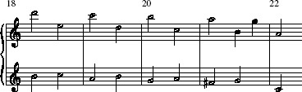
Example 18 Preliminary reduction of Example 17

When you have completed your graph, look at my suggested solution given below as Example 19, along with the discussion that follows it.

View discussion - Activity 9

The ‘alto’ voice in the right hand is especially interesting here. It outlines a motive of four descending notes, E–D–C–B. This is the same shape that I called motive ‘X’ in the analysis of the first subject in the same sonata movement (see AA314_1, Example 14). Here the motive is transposed to the key of G major, rather than C major, since the music has modulated to the dominant. What defines this motive is not just that it is made up of four descending notes, but that these are notes 6–5–4–3 of the new G major scale, and that they are harmonised similarly, with notes 5 and 3 as part of the local tonic chord (C major at the opening of the movement, G major in this transitional passage).
Thus the transition passage of the movement might be said to grow out of the same motivic shape as the first subject (bars 1–4) and its development (bars 5–8). Again, it is an example of a hidden motivic link between material that looks quite different at the surface. Furthermore, the last note (the mediant) comes in each of these three occurrences at the end of a phrase in the music. Look at Examples 19 and 17 to see what I mean. This is an instance of a motive which is partially defined by rhythm, but which is only brought to light by a voice-leading analysis, despite the fact that this form of analysis is often accused of ignoring the role of rhythm.
When you are sure that you understand the features of the music that led me to make my analytical judgements, continue with the next section.

3.3 Unfolding: a summary
Let's recap. An unfolding occurs when two structural voices, which belong together as part of the same harmony, are separated out through time, and are presented as a single melodic part. Both voices must behave according to the rules of good counterpoint (for instance, the seventh of a chord must fall downwards by step and a leading note will nearly always rise). For this reason, you should be careful not to identify unfoldings where the parts are dissonant with one another (for instance, the leaping downward intervals in Example 19 are not unfolded sevenths, which would produce a dissonant and ungrammatical effect). In terms of notation, as you have seen, the outer and inner voices are usually shown with stems pointing in different directions to signify that they belong to different strands of counterpoint. The notes of each unfolded interval may be connected by slurs (as in Example 19), or the stems may be connected by diagonal beams (as has been seen in the video analyses) – the latter are used especially when there are several notes in between the notes of the unfolded interval. Unfoldings are especially common in Mozart's music (indeed, it is rare to find a passage which does not feature them in some guise or other) and they are one reason for the richness of his melodic language.

4 Self-contained musical structures
Most of the preceding examples, both here and in AA314_1, have been very brief and fragmentary. Now is the time to begin to deal with complete phrases. By ‘complete’ I mean phrases or passages which begin and end in the tonic, and are finished off with a perfect cadence. In other words, they could conceivably pass for entire pieces. The following examples share some basic patterns of voice leading, which will emerge as we analyse them: in particular, the pattern of a linear descent in the treble towards a perfect cadence in the tonic.
For our first example of a self-contained passage, we are going to look at the opening movement of the Sonata in C, K309. In AA314_1 we looked at a passage from the development section of this movement. Now we are going to consider the first subject, presented in the opening bars.

Activity 10

Listen to Extract 8, whilst following the score given in Example 20. How would you describe the structure of the melody line?
Click to listen to Extract 8

Audio content is not available in this format.

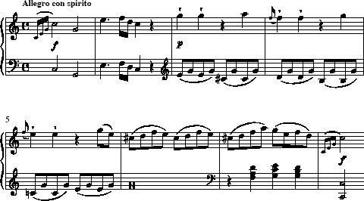
Example 20 Mozart, Sonata in C, K309, first movement, bars 1–8

View discussion - Activity 10

To make these observations clear, Example 21 gives a simplified form of the passage, in which I have removed the inner parts, dissonances and local arpeggiations. I hope you agree that this is a fair representation of the skeleton of the melodic line.

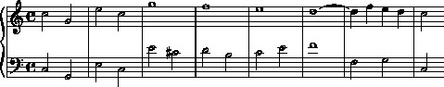
Example 21 Reduction of Example 20

The linear descent in the treble (bars 3–8) should be clear from this version; you will also notice that Mozart delays the arrival of the cadence by prolonging the iib chord (a first inversion D minor chord) for the whole of bar 6. This emphasises the stock iib–V–I cadence.
Now I want to produce an analytical graph based on the reduction given in Example 21. I have two main purposes in mind: first, to show the large middleground line; secondly, to illustrate how this basic outline is fleshed out to produce the finished theme. Example 22 is my attempt to do these things.

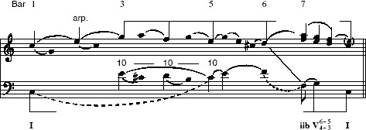
Example 22 Analytical graph based on Example 21

Activity 11

Compare the graph in Example 22 with the reduction in Example 21, and the score extract in Example 20. How has the melodic structure apparent in Example 21 been shown in the analytical graph?

View discussion - Activity 11

This combination of treble and bass movement is a general feature of virtually all eighteenth-century pieces. While the descent to the tonic in the treble gives the entire phrase its overall contour, the bass, driving to a perfect cadence, affirms the tonal centre and gives the passage a feeling of completeness.
Example 22 has introduced a couple of new notational features. The beam connecting together the notes of the linear descent in the treble is a more effective way of indicating this sort of middleground line than simply using a large slur. The same goes for the beam showing the I–V–I progression in the bass. Beams are usually kept for exactly these situations: large-scale descending lines in the upper parts which aim towards the tonic, or large-scale progressions, also aiming towards a perfect cadence in the tonic, in the bass line.
There is also one new technical term which describes an important aspect of this middleground line in the top voice. The top G at bar 3 is termed the primary tone or head-note of the structure. This term simply means the first note of the main structural line (sometimes the highest note of the piece, but by no means always). In Mozart's works, as in all tonal music, the primary tone will always be consonant with the tonic chord. Here, the A that follows it (the highest note of the extract) is subsidiary, since it is not part of the C major harmony. Indeed, which notes occupy which level of structure depends on the tonality of the extract. Ultimately, the deepest level is based around the tonic chord, precisely because it is the tonic.

Activity 12

Listen again to Extract 8, this time following the graph in Example 22. Can you hear the middleground lines indicated by the beamed notes?
Click to listen to Extract 8

Audio content is not available in this format.

View discussion - Activity 12

It is worth pointing out here that the events of the basic framework have been picked out not because they are necessarily the most interesting, or even the most important things in the music, but because they are the most generalised aspects. All works in the Viennese Classical style tend to drive towards perfect cadences in the tonic, and to move through some sort of linear descent in the upper voice. We saw numerous examples of this in AA314_1. The interesting features which are specific to Mozart lie not in the framework itself but in the prolongational processes between framework and surface, which transform the abstract model into the complete musical artwork.
Before we leave Example 22, I want to look at some features associated with foreground detail.

Activity 13

Compare the graph in Example 22 again with the reduction in Example 21 and the score extract given in Example 20. What aspects of the analytical notation indicate foreground structures?

View discussion - Activity 13

To spell out how the graph analyses bars 3–5: the sequential descent in the treble is supported by a bass line moving downwards in parallel tenths (E–D–C). At the surface of the music, however, the notes D and C are preceded by their respective leading notes (C# and B).
The changes of register in the bass consist first of a prolongation of the initial tonic, C, via a progression to the C an octave above, and secondly of a straightforward leap from the F in the bass of bar 6 to the F an octave below in bar 7 (the note analysed with a flagged stem). This has the effect of making the cadence take place in the octave in which the bass line began. This octave is called the ‘main register’. To show that the D in the middleground descending line belongs harmonically with this F, I have connected them together with a straight diagonal line. Many pieces establish a main register for the bass line near the beginning, and return to it at the final cadence, an effect which reinforces the sense of return and closure. In these cases, the register is sometimes called the ‘obligatory register’. These terms belong to rather abstract voice-leading theory, however, and are not really our concern in this course.
The flagged note F in the bass (bar 7) denotes a pitch that is not actually part of the middleground framework. It is not strictly necessary to support the second degree of the scale by this iib harmony; Mozart could have gone straight to V. We noted the prominence of this chord earlier, however. It has the special function of driving to the dominant while supporting the D in the upper line. This kind of formula is extremely common in Mozart and is worth committing to memory. [Always remember that the flagged pitch is not a quaver! Here the flag denotes an important event, and it actually occupies a deeper level than the stemmed notes (which look like crotchets).]
You may wonder why I have shown two voices on the upper stave in my analysis of bar 7. In fact, these are miniature, foreground-level unfoldings. My graph states that these voices belong together as ‘treble’ and ‘alto’, although they are presented as a single melodic part. By aligning them in this way, I have clarified the basic harmonic pattern of this bar, the chord progression iib–Ic–V⁷–I. In order to show that these ‘hidden’ descending thirds imply a resolution to a subsidiary E above the final C, I have placed this note in the graph in brackets. In fact, this note does occur in the music almost immediately after the close of this phrase, as part of the repeat of the initial motive.
It is worth pausing to discuss the chord I have just called ‘Ic’ (bar 7³ ). You will notice that I have not called it Ic on the graph itself, and there is good reason for this. While beginners’ books on harmony will often call this Ic, signifying a second inversion of the tonic chord, in fact it contains a fourth above the bass, which is treated as a dissonance. In most tonal music, and almost always in Mozart, this chord (more properly called the cadential 6/4) is expected to resolve to the dominant 5/3 chord (Va). This explains why my sketch shows this progression as a dominant chord with a double suspension (6/4 resolving to 5/3). In other words, the 6/4 chord is not really a tonic chord at all: it is a decoration of the dominant. This extremely common formula has occurred already (it was a feature of both Example 3 and Example 9), and will crop up again in later examples.

5 Interruption

5.1 Interruption as a structural device
Now that we have seen how a middleground linear descent can organise the structure of a whole phrase, the next main topic of this course is to consider cases where this descent stops short of reaching the tonic note. This is called an interrupted structure. While the following examples are quite short and relatively simple, the principle of interruption has a far-reaching influence which can affect the overall form of entire movements, particularly those in sonata form.
We are going to look at three case studies of ‘interrupted form’, one from a sonata you have already done a lot of work with, and two from sonatas new to this course. You may find it helpful to make your own attempt at an analytical graph of each extract before looking at mine; but in each case the most important aim is to hear the main shapes and patterns shown in my graphs.
I recommend that you listen to each of the recordings several times as you work through the three case studies. To begin with, I will give quite a lot of detailed discussion of the graphs in order to explain my analytical decisions, but as we proceed I hope that you will find them increasingly self-explanatory.

5.2 Identifying an interrupted structure
We are going to begin our case studies by considering the whole eight-bar opening theme of the third movement of Mozart's Sonata in B flat, K333.

Activity 14

Listen to Extract 9, following the score given as Example 23. In the most general terms, how would you describe the phrase structure of this theme?
Click to listen to Extract 9

Audio content is not available in this format.

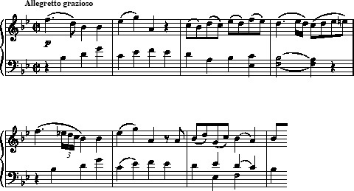
Example 23 Mozart, Sonata in B flat, K333, third movement, bars 1–8

View discussion - Activity 14

Let's look more closely at this theme. The melodic content of the two halves is actually very similar. There is one obvious difference: whereas the first half outlines a large linear motion to the second degree of the scale (C), the second half moves downwards all the way to the tonic (B♭).
Now look at my analysis of this theme, summarised as a graph in Example 24.

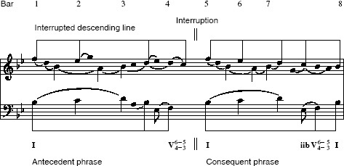
Example 24 Analysis of Example 23

Activity 15

Compare the graph in Example 24 with the score extract in Example 23. How does the graph analyse the phrase structure I have just described?

View discussion - Activity 15

This theme is an example of an interruption of the main structural line, one of the commonest and most important forms of middleground prolongation in Classical music. Instead of going straight to a perfect cadence in the tonic, the music comes to rest on a dominant chord (an imperfect cadence) at the halfway point (this is called a dividing dominant because it cuts the structure into two halves). Not only is the bass line interrupted by chord V, but the top line is interrupted as well. You can see that the treble descends as far as the second degree (the supertonic, C), supported by the dominant, in the first half of the theme. It then returns to the primary tone (F) at the start of the second, and finally descends to form a perfect cadence in the tonic.
I will not go into great detail concerning this graph because we have already spent some time with the first half of the theme in AA314_1, but it is worth mentioning the treatment of the cadential 6/4 chords in this example (bars 4 and 7). In both cases, the 6/4 chord is analysed as a dissonance, for the reasons we discussed just now in relation to the extract from K309. At the end of the first half here, the true structural note over the dividing dominant is C rather than D (the D is analysed, as before, as a sort of suspension). Likewise, at the final cadence, the true structural degree is the tonic B♭ supported by Ia in bar 8, not the B♭ on the last beat of bar 7, which is supported by a 6/4 chord. This again is a suspension, and serves to prolong the dominant harmony. The acid test for such decisions is to stop the music on the 6/4 chord; if it does not sound complete, it cannot be the true termination of the structural line.

5.3 Interrupted structure and typical features of the style
The next extract is from the last movement of an earlier sonata, K281, in the same key, B flat major. The theme is very different in rhythm and contour from that in K333, but a look at the voice leading reveals similarities.

Activity 16

Listen to the extract given as Example 25 (Extract 10). What similarities can you find between this theme and that of the third movement of K333 (Example 23)?
Click to listen to Extract 10

Audio content is not available in this format.

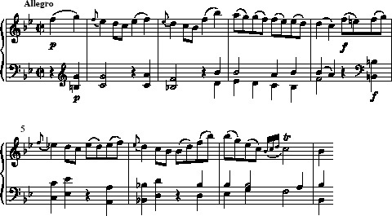
Example 25 Mozart, Sonata in B flat, K281, third movement, bars 1–8

View discussion - Activity 16

Activity 17

Compare the analytical graph in Example 26 with the score extract given as Example 25. What features can you identify in the graph which have occurred in previous examples you have studied?

View discussion - Activity 17

While Example 26 should be quite self-explanatory after all the work you have done on analytical notation, there are two points worth lingering over.
The first is the rather strange opening, in which the tonic chord is missing. Instead of beginning with a clear-cut tonic, Mozart begins on the dominant of chord ii, moving sequentially through a cycle of fifths to reach the tonic at bar 3. Nevertheless, I have analysed the note F (the first note) as the primary tone (or head-note), beginning the structural descending line. In other words, I think that, at the middleground level of the harmony, this F belongs with the B♭ in the bass of bar 2. The technical term for this feature is elision, and this is shown by the diagonal straight line. Structurally, we would say that the primary tone belongs to the tonic chord, but that here it has been separated from its true bass support by one and a half bars. [Mozart is not the only Classical composer to perform this sort of sleight of hand; a very similar device is used, for example, by Haydn in the opening Allegro of Symphony No.94.]
The second point concerns the music in the high register at bars 2–3. You might have been tempted to think of the top B♭ as the primary tone of a large line, descending through all the notes of the scale. After all, it is the highest note of the passage and part of the tonic chord. However, a closer hearing of bar 3 proves this to be illusory. The A on the first quaver is dissonant, and therefore only an appoggiatura to the following G. In addition, this line is not repeated by the second half of the theme. There, the upper B♭ in bars 6–7 occurs as an arpeggiation, first of tonic harmony (Ib), then of a iib chord: it does not form part of a large structural line.

5.4 Different analyses of a single theme
There is one question that always arises when beginning an analysis of this sort: ‘Which is the primary tone of the structure?’ Sometimes, as in the preceding example, the melody will contain several pitches that are consonant with the tonic chord. Often it is fairly clear which of these begins a large-scale structural line towards the cadence. Occasionally, though, there are situations where either of two lines is plausible. The thing to remember about all analytical decisions is that there are no hard and fast rights and wrongs, provided that the reduction makes sense as a piece of counterpoint. Experienced analysts can disagree about these things, and their disagreements often suggest that the music itself is rich in different interpretative possibilities.
We will now look at an example which has provoked just such disagreements. In fact, it is one of the most frequently analysed extracts in the whole of the tonal repertoire, perhaps because its apparent simplicity allows analysts the chance to use the piece as a testing-ground for their different analytical formulations.

Activity 18

Listen to the opening theme from the first movement of Mozart's Sonata in A, K331 (Extract 11), following the score extract given as Example 27. How would you describe the structure of this theme?
Click to listen to Extract 11

Audio content is not available in this format.

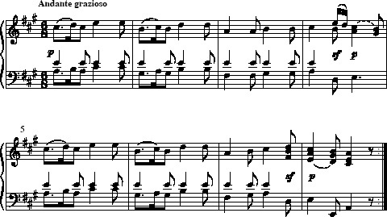
Example 27 Mozart, Sonata in A, K331, first movement, bars 1–8

View discussion - Activity 18

The sequential patterns of the musical surface certainly encourage us to hear a descending linear shape. But which line should be identified as the middleground framework?
The first note of the piece (C#) is the beginning of a downward line, moving at one bar's duration: C# (bar 1) – B (bar 2) – A (bar 3). This line gains emphasis by beginning on the first beat of each bar. However, there is another linear shape running in parallel thirds above this: E (bar 1) – D (bar 2) – C# (bar 3). This also has claims to be the main middleground line, since it is higher, and therefore more prominent, than the inner line. In fact, the two lines can be analysed as two unfolded voices, a ‘treble’ and an ‘alto’, running in parallel.
I don't think it really matters which of these descriptions of the structure you prefer; there are merits to each. Any analysis, of course, must, however, be consistent. We are going to look at graphs which show three equally legitimate possibilities.

Activity 19

Compare each of the three graphs in Examples 28, 29 and 30 in turn with the score extract (Example 27). Listen to the theme again (Extract 11) as you work through them. What aspects of the theme does each graph emphasise in its analysis of the structure of the extract?
Click to listen to Extract 11

Audio content is not available in this format.

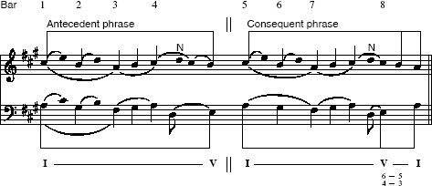
Example 28 Possible analysis of Example 27

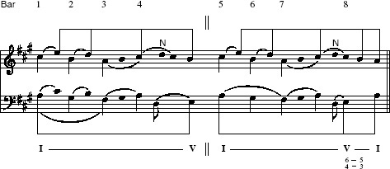
Example 29 Possible analysis of Example 27

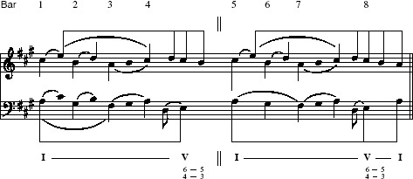
Example 30 Possible analysis of Example 27

View discussion - Activity 19

Example 29 reduces away the 6/4 chord on the second beat of bar 4, adhering to the principle that this sort of harmony is not truly a version of the tonic chord, but rather needs to resolve to the dominant 5/3. It is therefore less important, structurally, than the dominant (the B over chord V at the end of bar 4). Example 30, on the other hand, places a main note of the descending line (the C#) over a 6/4 chord. This is arguably acceptable, however, since the 6/4 chord still resolves to this following 5/3 chord.
It probably won't surprise you to learn that all three of these graphs have been adapted from published analyses by different experts. The seemingly curious placing of a structural note over a 6/4 harmony was, in fact, the version preferred by Schenker himself. [Example 28 corresponds in most respects to an analysis by the American scholars Lerdahl and Jackendoff (1983) and Example 29 follows the view of structural movement taken by Forte and Gilbert (1982). Example 30 follows Schenker's own analysis (1979).] But again it has to be emphasised that we are in the domain of personal taste, and that you should always let your hearing be the judge in such cases.

5.5 Interruption: a summary
As I have already stated, the principle of interruption is extremely important in music of the Classical period. This kind of antecedent–consequent phrase, with a balanced I–V ∥ I–V–I harmonic scheme, is found many times over in Mozart. It can be expanded to produce a simple binary form, and expanded further to produce what we call sonata form. In fact there are very few movements by Mozart which do not feature interruptions at some level or other.
I hope you have seen how discussing Mozart's harmonic language from the perspective of features beyond the immediate surface of the music – linear formations and motivic shapes – allows us to consider aspects of Mozart's musical designs that lie beyond the scope of traditional harmonic analysis. This course is going to end with a discussion of how the principles we have observed in the short extracts used so far can address issues of large-scale structure, even across the span of entire movements.

6 Towards a deeper level of structure

6.1 Considering patterns on a larger scale
So far I have introduced some fairly sophisticated and difficult ideas in this course, but on a very small scale. In AA314_3, you will look at two entire movements taken from Beethoven's Eighth Symphony. This will mean dealing with issues such as modulation and overall form, which have been outside the scope of this course. In preparation for such large-scale analysis, I would now like you to listen to a more extended passage from one of the Mozart piano sonatas you have been studying, so that we can consider some patterns of tension and resolution on a larger scale than we have seen so far.
If you recall the rondo theme from K333 (Example 23), you will remember that it has an interrupted structure, ending on V at the halfway point. If we were to stop the music at this point, it would feel incomplete; only at bar 8 does the theme reach its closure. To put it another way, bars 1–4 form only an incomplete musical ‘sentence’; we must wait until bar 8 before the sense of the passage is completed.
Sometimes, especially in more extended musical structures, the point of arrival may be delayed, producing a prolonged sense of expectation. When this happens, the moment of arrival at the tonic, which in Mozart always seems inevitable, feels all the more satisfying and complete. Our last example is taken from the end of this same movement, and is a glorious instance of delaying closure on a much greater scale.

Activity 20

Turn to the score of the last movement of the Sonata in B flat, K333 and look at the beginning of the final section at bar 148. The theme that begins in bar 148 is, in fact, the second subject of this sonata-rondo movement, recapitulated here in the tonic key (B flat). Listen carefully from this point to the end of the movement (Extract 12), whilst following the score. You may wish to listen through more than once. This is a rare and wonderful example of a true cadenza in a piano sonata. Traditionally, the cadenza belongs in the genre of the concerto, where the soloist has a final flourish before the orchestra returns to wrap things up; here, Mozart creates this effect using the keyboard alone. When you have familiarised yourself with the passage, write notes in answer to the following questions.
- At which point do you feel that the music achieves its closure, and why?
- Here we have no textural contrast as between soloist and orchestra, and yet the passage sounds unequivocally like a cadenza. Why is this?
Click to listen to Extract 12

Audio content is not available in this format.

Click to view W. A. Mozart, Sonata in B flat, K333, third movement

View discussion - Activity 20

So, where did you locate the closure? It is unlikely that you located it at this emphasised pause in bar 171. Although in conventional harmonic terms this is a tonic chord, here in second inversion (Ic), it does not sound complete. This is because, as we have seen several times now, the second inversion chord is actually a dissonance: the interval of a fourth over the bass is dissonant. So this 6/4 chord is expected to resolve to a dominant chord in root position (6/4 resolving to 5/3).
Yet this resolution does not immediately happen. Although our rondo theme returns in bar 173, there is a crucial difference. The bass note F continues through the texture, giving us the 6/4 chord again. We then pass through a series of seemingly remote areas, including the tonic minor (bar 175), and a chord of G flat major (bar 177). Even these strangely Romantic colourings, though, are underpinned by a logical process of voice leading in the bass. The dominant, F, moves upwards to its chromatic neighbour, G♭ (bar 177), returning by means of a German sixth chord (bar 178) to the dominant chord (bar 179). This dominant chord is prolonged still further until the end of bar 185. I will gloss over the details of this intervening passage, which is rather complex, except to say that the music still ‘feels’ as though the dominant chord is in operation. The big dominant seventh at bar 199 finally suggests the possibility of a closure, and the cadenza comes to an end with the return of the rondo theme (this time properly supported by a tonic) in bar 200.
But even now, this is not the end of the piece; and to me, it does not feel like true closure (try stopping the music at the start of bar 200). This is because the C in the right hand, with its characteristic trill (bar 199), does not fall to a B♭ as we might expect but instead rises to the F, which begins the rondo theme, giving the feeling of a new beginning rather than a close. In the concluding section, Mozart cleverly delays the sense of closure several times. At bars 206–7 and 209–10, he leads us to expect a full close on the tonic, only to weaken the closure by the use of the first inversion. Only at bar 214 do we finally have a full-scale perfect cadence, with the second degree of the scale (the trill on C) falling to the tonic in the treble, over a root-position V–I in the bass. The rest of the movement is therefore post-closural, and we would probably call it a coda.
This example shows how Mozart's language is based on the listener's large-scale expectations of closure, in which the surface complexities are regulated by a long-range drive towards a perfect cadence. ‘Perfect cadence’ here requires definition. You will probably understand the term to mean a progression from V to I (which is partly true), but a perfect cadence must fulfil other conditions: one voice should normally contain a falling motion from the second degree of the scale to the tonic, while the bass should normally have V and I chords in root position (we saw in the above example how the music did not sound quite complete if one or more of these conditions was not met).

6.2 The idea of the background, and course summary
Mozart's music, as we have already seen, achieves its sense of coherence through a series of tensions followed by resolutions: dissonances imply resolution to consonances, and dominant chords imply resolution onto tonic chords, giving a sense of finality and order to the music. Mozart's music, like nearly all tonal music, sounds ‘goal-directed’: we expect harmonic progressions, however complex, to resolve onto the home tonic, and this arrival at the tonic provides a satisfying sense of completeness.
All the extracts studied in this course have shown the importance of the drive towards a perfect cadence; this is one of the defining characteristics of Mozart's musical language. When a perfect cadence is delayed, this has the effect of incompleteness, while the cadence itself tends to signify closure or arrival. It is this basic premise that underlies the concept of ‘background’, pioneered in the late works of Schenker.
The background itself will be introduced properly in AA314_3. It is a theoretical formulation which can sometimes seem rather abstract, or seem to deny the uniqueness of individual works, since all background structures are very similar. Indeed, the theory has always had its share of fierce opposition. In essence, it is based on four main observations about large-scale structures in tonal music.
- They tend to express underlying linear shapes.
- They conform to the rules of dissonance treatment and counterpoint in the way that voices move against one another.
- They tend to begin by establishing a tonic chord.
- They drive towards closure, defined by a perfect cadence in the tonic.
I have already tried to show how Mozart's melodic and harmonic language can be seen to grow out of a limited number of basic deep-level shapes (particularly the descending line through a third or a fifth, supported by a tonic–dominant–tonic pattern in the bass), with the foregrounds and musical surfaces acting as elaborations of this deeper structural logic.
You may be tempted to think of voice-leading theory as reductionist: a process of stripping away successive layers of beautiful and distinctive music to arrive at some abstract generative model. In fact, this is only half of the story, and I hope that, when reducing musical surfaces, we have done so as a means to an end. When analysing Mozart's music you should bear in mind that the deeper-level models are artistically worthless in themselves: it is not the abstract structure itself, nor the identification of the notes of the structure in a piece of music, that is analytically interesting; rather, analysts are more interested in the process by which the large-scale drive towards the tonic is prolonged, delayed, embellished and decorated, to produce the middleground, the foreground and ultimately the musical work itself.
You will perhaps already have a view of the value, as well as the limitations, of the methods I have employed in this course. Voice-leading theory can be extremely useful if it allows us to make observations about style which simple chordal analysis cannot explain, if it can show hidden features such as linear part-movement we hear but cannot otherwise show analytically and if it reveals motivic connections between fragments of music that seem unrelated on the surface.
Conversely, voice-leading theory is not in any way intended to supersede the more traditional approaches such as analysis of chordal harmony, rhythm or form (the last two, for instance, have not been considered very much in this course). Instead, this approach is intended to run in parallel with these other methods; in particular, large-scale voice-leading processes can (and often do) interact with the patterns of musical forms as defined through thematic identity.
Once you have completed this course, you can move on to the third of the three courses on harmonic analysis, Voice-leading analysis of music 3: the background (AA314_3).

Conclusion
This free course provided an introduction to studying the arts and humanities. It took you through a series of exercises designed to develop your approach to study and learning at a distance and helped to improve your confidence as an independent learner.

References
Forte, A. and Gilbert, S. (1982) An Introduction to Schenkerian Analysis, New York, W.W. Norton.
Lerdahl, F. and Jackendoff, R. (1983) A Generative Theory of Tonal Music, Cambridge, MA, MIT Press.
Schenker, H. ([1935] 1979) Free Composition (DerFreie Satz), trans. and ed. by E. Oster, 2 vols, New York, Longman.

Acknowledgements
Except for third party materials and otherwise stated (see terms and conditions), this content is made available under a Creative Commons Attribution-NonCommercial-ShareAlike 4.0 Licence
Grateful acknowledgement is made to the following sources for permission to reproduce material in this course:
Course image: Paul Hudson in Flickr made available under Creative Commons Attribution 2.0 Licence.
All video extracts and the audio extracts taken from the original tracks 16–26 of CDA 5085 are taken from AA314 Studies in Music 1750–2000: Intrepretation and Analysis. Produced by the BBC on behalf of the Open University © 2001 The Open University.
Don't miss out:
If reading this text has inspired you to learn more, you may be interested in joining the millions of people who discover our free learning resources and qualifications by visiting The Open University - www.open.edu/openlearn/free-courses

Solutions

Activity 1

Discussion
As was explained in the video clips, the notes that have been removed from Level 4 to give Level 2 are passing notes, which lead in each case between different versions of the same chord. Even though these ‘passing harmonies’ are consonant within the score (at the foreground), we might say that these notes are dissonant at the deeper level. Strictly speaking, this means that Level 2 is a middleground structure, whilst Level 4 is a foreground structure.
Back to - Activity 1

Activity 2

Discussion
The giant leaps in the flute part clearly suggest that a multi-voiced melody is at work. In fact, the melody is in three strands. When we hear the passage, the ear tends to connect the upper pitches and hear them as a single line; likewise the lower and middle pitches. These strands are harmonic voices: they move in counterpoint with one another, obeying the basic principles of dissonance treatment. So overall, Vivaldi makes his extremely virtuosic solo line do the job of three lines of counterpoint. If we make a reduction of the flute line, we can see how, on its own, it expresses three contrapuntal parts. The reduction is given as Example 5.
Listen to Extract 3.
Click to listen to Extract 3

Audio content is not available in this format.

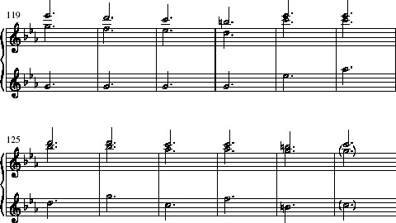
Example 5 Analytical reduction of Example 4

Back to - Activity 2

Activity 4

Discussion
You may recall that in AA314_1, we described bars 5–8 as presenting the descending line A–G–F–E. The graph shows this as two parts moving in consecutive octaves with one another within a single melodic line in the right hand. This is why I said in AA314_1 that it did not matter very much whether you give stems to the notes in the lower or the higher octave. The interval of an octave between each pair of notes is unfolded in the music.
Back to - Activity 4

Activity 8

Discussion
Now check your graph against Example 15.

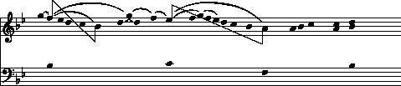
Example 15 Mozart, Sonata in B flat, K333, first movement, bars 1–4: intermediate stage

When you have done this, turn to the next video clip, and watch how the graph is completed. My final version is printed below as Example 16.

Video content is not available in this format.
Completing the graph
View transcript - Completing the graph

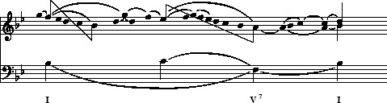
Example 16 Mozart, Sonata in B flat, K333, first movement, bars 1–4: completed graph

Back to - Activity 8

Activity 9

Discussion

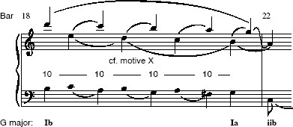
Example 19 Voice-leading graph of Example 17

I hope you were able to hear the two large descending lines in the ‘treble’ and ‘alto’ voices, both in the right hand, joined together by arpeggios.
There are several ways in which this passage can be analysed, and the exact details of analytical notation are relatively unimportant. For instance, I asked you to show the unfolded intervals by means of slurs rather than the diagonal beams that were used in Video 1, Band 3; this is purely to make the final graph easier to read. Nevertheless, I hope that your graph looks roughly like mine. What matters is that the graph is able to communicate the way in which you hear the processes and shapes.
Example 19 analyses the unfolded intervals as a set of consecutive sixths. The ‘treble’ and ‘alto’ cannot be moving as parallel sevenths, as this would be bad counterpoint. What happens is that the intervals are staggered across the bar lines to produce the effect of 7–6 suspensions between the two upper voices. As with the graphs built up during Video 1, Band 3, the stem directions clarify the two distinct lines that we hear in the melody. As in some previous examples from AA314_1, the bass runs in parallel tenths with the upper voice, and I have indicated this on the graph.
Back to - Activity 9

Activity 10

Discussion
This opening melody has two main components: a striking, initial motive doubled at two octaves’ distance (bars 1–2), and a more lyrical continuation leading to a perfect cadence (bars 3–8). The initial motive, coupled with the first note (G) of bar 3, outlines an ascending broken chord of the tonic (to use the terminology introduced in AA314_1, this is called an arpeggiation of the tonic chord). Having arrived at this top G, the melody then moves in a descending sequence, similar to the ones you met in earlier examples, arriving at the tonic note, C, in bar 8.
Back to - Activity 10

Activity 11

Discussion
The melodic structure revealed by the reduction has been analysed as two main processes. First, the ascending arpeggiation to the top G (the fifth degree of the scale) is shown via two levels of slurs. Secondly, the subsequent descent from G to C is shown by a beam connecting together the stems of the notes involved. A similar beam shows the overall bass progression, which begins on chord I and moves to a perfect cadence, V–I. The beams connecting these notes together have had to be broken to improve the clarity of the graph – this is solely for ease of reading.
Back to - Activity 11

Activity 12

Discussion
In fact, Mozart's sequential pattern in bars 3–5 makes it very easy to hear the underlying descending shape. I hope that you can hear how the whole extract is organised around the drive to the tonic cadence.
Back to - Activity 12

Activity 13

Discussion
You should by now be fairly conversant with the notation used in this graph. Here are the main elements.
- Unstemmed noteheads indicate subsidiary notes, connected to the stemmed noteheads by slurs.
- The figures ‘10–10–10’ indicate an interval progression.
- The dotted slurs in the bass indicate register transfers.
- The flagged notehead (which looks like a quaver) indicates a preparation of the dominant chord.
- The treble notes in bar 7 have been shown as a series of aligned thirds rather than successions.
Back to - Activity 13

Activity 14

Discussion
This eight-bar phrase is typical of Mozart's style. It sounds self-contained by virtue of its final cadence in the tonic. It also falls neatly into two halves: an antecedent phrase ending on the dominant (bars 1–4), and a consequent phrase ending on the tonic (bars 5–8).This sort of regular ‘question-and-answer’ phrasing is very characteristic of Viennese Classicism, although you will also have come across it in many other tunes (Greensleeves, for example).
Back to - Activity 14

Activity 15

Discussion
The graph shows the whole theme as governed by a large line moving downwards through a fifth to the tonic (like my previous example from K309). However, in this case the line does not move straight to its closure, but is instead broken off at the halfway point. It is then repeated in the second half, this time reaching its goal, the tonic, at the end. In the bass, the binary nature of the phrase is emphasised by the dominant chord at the halfway point.
Back to - Activity 15

Activity 16

Discussion
There are several features shared by this example and the previous one. Again, it clearly falls into two sections with the harmonic framework I–V ∥ I–V–I. It also has a strong sense of a linear outline in the upper voice, moving to the second degree of the scale (C) at the end of the first half and to the tonic (B♭) at the end. It is not surprising, then, that it fits the model of the interrupted structure outlined in the previous example.
Example 26 shows my analysis of the structure of these bars.

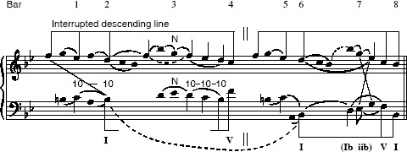
Example 26 Analysis of Example 25

Back to - Activity 16

Activity 17

Discussion
In its local details, there are many connections between Example 26 and some of our earlier examples. For instance, the main pitches of the upper linear shape are supported in parallel tenths in the bass (bars 2 and 3); these bass supports are in turn preceded by lower neighbour notes just as they were in the example from K309 (Example 20).The way in which the bass drives towards the final cadence is also very similar: it outlines a I–Ib–iib–V–I motion, a feature also shared by the extract from K333. These similarities show just how useful voice-leading theory can be in pinpointing some of the defining aspects of Mozart's harmonic and melodic style.
Back to - Activity 17

Activity 18

Discussion
This sonata is famous for its quirkiness. The first movement is a set of variations on the theme whose first half is given in Example 27, rather than the usual sonata-form Allegro; and the last movement is the celebrated Rondo alla Turca. Once again, though, Example 27 is a clear-cut instance of an interrupted structure (I–V in the first phrase, I–V–I in the second).
Back to - Activity 18

Activity 19

Discussion
The first graph (Example 28) brings out the third degree of the scale (C#) as the primary tone of a large interrupted line. Arguably, though, it does not really do justice to the upper pattern E–D–C#.
The graphs in Examples 29 and 30 give more weight to the upper line, but locate the main structural notes in different places. Example 29 gives more emphasis to the first descending pattern in bar 1–3. Example 30, on the other hand, analyses this pattern as belonging to a subsidiary level, nesting inside the most important middleground line E–D–C#–B, that comes to rest on an imperfect cadence at the end of bar 4.
Back to - Activity 19

Activity 20

Discussion
This is rather different in style from the previous exercises, because in issues of large-scale structure, the analytical process is not mechanistic or rule-bound, but based much more on hearing, intuition and (to an extent) subjective judgement. There are two places in the early part of the extract where there is a perfect cadence on to a tonic B flat chord: bars 155–6, and bars 163–4. But at neither of these points does the music really rest, but rushes onwards with a gathering sense of excitement. So it is unlikely that you heard the decisive closure of the passage as happening before the big pause on the first beat of bar 171.
Back to - Activity 20

Unfolding in Mozart

Transcript
Robert Samuels
You've just been looking at how we can analyse melodies which actually contain two or more different harmonic voices within a single melodic line. This is a common feature of the sort of baroque figuration used by Bach or Vivaldi, and you might think that this sort of harmony is only found in baroque music. But in this video section we're going to look at examples where Mozart constructs a melody which contains two separate harmonic lines, despite the much less contrapuntal style of Classical period music, which is normally a theme and an accompaniment.
This sort of voice-leading process is called ‘unfolding’. This means that two notes which harmonise with each other are ‘unfolded’ as an interval within the melodic line. Sometimes the two notes of the unfolding come one after another, as was the case in the baroque examples; but sometimes the unfolded interval is filled in with passing notes or neighbour notes.
The first extract which we are going to analyse is the little four-bar section which we looked at right at the beginning of Unit 3:
You remember that we saw how the smooth elegance of this rondo melody comes from the downwards line from F natural to C natural. [play F–E flat–D–C] [play melody through emphasising downwards line]. It is this that gives the extract its shape. Now let’s look a bit more closely at how this line fits into the rest of the melody.
The most striking feature of this opening is the interval of a downward seventh between the last two notes. (Plays downward 7th) So what is it that makes this surprising leap sound part of a balanced melody? The answer lies in an overall harmonic line – that is, a harmonic voice. But this isn't the F to E flat line we have analysed already at the top of the harmony, but a second, lower voice. The melody of the first bar outlines an arpeggio of B flat – the tonic chord – and, just as the top note, the F (plays), falls to the E flat at the beginning of bar two, so the lower note, the B flat (plays), falls to the A natural which is the lower note in that leap of a seventh [graphic for this]. In other words, this melody [play bb. 1–2] outlines these two intervals [play F/B flat–E flat/A: graphic for this].
Now let’s look at bar three. You'll remember that the foreground of the music is a string of appoggiaturas, or accented neighbour-notes [play b. 3 melody], so that the harmonic line is this [play B flat–C–D–E flat]. The elegance and balance of the melody comes from this structure which our analysis uncovers as being made up of two parts: a structural upper voice and a structural alto voice – that is, two voices in which each note leads to the next. That is where voice-leading analysis gets its name from.
So, let’s recap. Our analysis is saying that Mozart’s melody is based on a harmonic progression which is in two parts, made up of these three intervals: [play the three intervals – graphic]. These intervals are ‘unfolded’ like this [play F–B flat–E flat–A–B flat–D – graphic of these], and then they’re filled in with an arpeggiation [fill in b. 1], a consonant skip [fill in b. 2], and a passing note [fill in b.2 passing note] with appoggiaturas as ornamentation [fill in appoggiaturas: play bb. 1–3].
One final comment about the harmony here. You may be wondering how we can claim that the E flat in bar two (plays) harmonises with the A natural later in the bar, because the G natural shows that this E flat is part of a C minor chord, (plays) and not the dominant seventh chord on F [highlight these notes]. Well, this is quite true; and in fact, the B flat at the end of bar one is also harmonised differently from the F at the beginning, with a G minor chord (plays) following the tonic B flat chord [highlight & play these notes]. We haven’t ignored these harmonies; what our analysis says is that these chords – G minor and C minor – are subsidiary to the B flat and F chords. The idea of subsidiary harmonies is what makes this a middleground analysis and not a foreground one.
Back to - Unfolding in Mozart

Making an analytical graph

Transcript
Robert Samuels
Now compare your graph with my analysis of these bars. Here's the score [graphic of score]. And now, we take out the rhythmic notation and the bar lines, and re-align the treble and bass slightly to make the consonances clear [graphic melts to analytical graph]. If we add the slurs to show the appoggiaturas in bar three, this is what you started with [add slurs].
Robert Samuels
and finally C [add stems]. Next, we show the B flat to A to B flat (plays) shape of the inner voice with downward stems [add stems]. Now we add stems to the main bass notes, which show a sort of contrary motion to the top voice, moving from B flat to C, D, and back to B flat (plays) before ending on the dominant, F [add stems]. The point where the melody moves via a passing note is in bar three (plays), where each note is also decorated by an appoggiatura. So we show this with a slur [add slur]. Now we use slurs to show the arpeggiation in bar one [plays & adds slurs], the subsidiary note and the harmonic interval in bar two [add slurs], and the way that the last appoggiatura in bar three is a neighbour note to the D [add slurs]. Finally, the notes in the bass form consonant skips [add slurs], this descending passing note feature [add slur], a larger-scale ascending passing note feature and a neighbour note to the final dominant harmony [add slur].
Now we are going to add three new notational symbols to make some middleground features even clearer. First of all, we are going to show which note in the top voice harmonises with which note of the structural alto voice in the three unfoldings. We do this by connecting together the stems with beams, which go diagonally like this [add diagonal beams]. Secondly, we indicate the voice exchange by straight lines crossing over to show the notes involved [add voice exchange lines]. Thirdly, the dominant chord at the imperfect cadence is emphasised in two ways which are also typical of the Classical style. It is ornamented by a 6/4–5/3 suspension, and it is has a prominent subsidiary harmony leading up to it over the E flat in the bass (plays). We show the suspension by using figures [add figures], and the subsidiary harmony, which we call a supporting harmony in this case, by adding a stem with a flag to the bass note.
Robert Samuels
This looks like a quaver, although it’s nothing to do with rhythm, but only with the function of the harmony [add flagged stem].
Now our graph is complete.
I hope that you feel you now understand how Mozart’s harmony works a little better. This is one of the main reasons for doing analysis, after all. But another thing that analysis can do is point out connections between different passages of music which we wouldn’t be able to describe otherwise. To show this at work, we are going to look at another four-bar extract from this Mozart sonata. But this isn’t from the same movement, but instead comes from the first movement. In fact, it’s the opening of the whole piece.
This is a very different melody in many ways from that of the last movement which we’ve just been analysing. It begins on an off-beat, it has very prominent appoggiaturas on the first crotchet of each bar, and it ends on the tonic rather than the dominant. But I want you to look now to see if you can identify any unfolded intervals in the melody.
Back to - Making an analytical graph

Completing the graph

Transcript
Robert Samuels
Here is my analysis of these bars [Show graph with just noteheads]. The first harmony note in the melody is the top F (plays). Mozart’s own notation shows that the initial G is an appoggiatura or neighbour note to this F. This runs down the scale to a B flat at the beginning of bar one (plays), unfolding this interval of a fifth. So we place an upward stem on the F and a downward stem on the B flat, and we analyse the other notes with slurs, and show the unfolding with a beam [add stems, slurs and beam; play b. 1 i–ii]. The melody then moves up via neighbour notes and arpeggio notes to an E flat over the C minor chord in bar two [add slurs; play bb. 1 iii–2 ii], before another run down the scale leads to an A over the F in the bass in bar three.
This unfolds another interval, this time of a diminished fifth [add stems, slurs and beam; play bb. 2 iii–3 ii]. We would expect the E flat at the top to fall to a D (plays), and the leading note A to rise to a B flat (plays).
And indeed, this is what Mozart does, writing the two parts together at bar four (plays). So we can add stems to the D and the B flat [add stems], and show the passing notes with another slur [add slur; play bb. 3 iii–4 ii].
To complete this graph, we should analyse how the bass makes sense. It moves from tonic to dominant [add slur, I and V7] and back again [add slur and I], and the C minor chord is subsidiary to, or leading up to, the dominant [add slur].
I hope that you saw how these intervals are unfolded in this melody. If you found this difficult, you may wish to rewind and look again at how I reached my analysis. Let’s hear these bars again [play bb. 1–4].
You may already have seen the conclusion that I am going to draw from these analyses. The main theme of Mozart’s first movement, and the main theme of his last movement, have exactly the same structure at this level of the harmony. The same three intervals are unfolded to make the melody in each case. Here is the structural progression which gives rise to both melodies.
[Play three intervals; graphic score for this and the following]
In the first movement, they unfold like this:
[Play unfolded intervals]
And are ornamented like this:
[Play K.333/I bb. 1–4]
In the last movement, the same three intervals [Play three intervals]
Are unfolded like this, with an imperfect cadence added:
[Play unfolded intervals]
And are ornamented like this
Our analysis has shown how these two themes, so different on the surface, share the same structure at a deeper, middleground level. The similarity is clearly there in the harmony, and can be seen from a comparison of the voice-leading graphs which we have drawn. This is a very subtle sort of connection between the themes, not evident at a first hearing. But once we’ve noticed it, other details strengthen the family resemblance between the themes. The prominent use of the sixth degree of the scale, G natural, as a neighbour note to the F natural at the beginning of the upper voice is one such feature. In both themes, indeed, it’s harmonised by a subsidiary G minor harmony at the end of the first bar.
This illustrates one use of analysis, which is to reveal an aesthetic feature of the music. The hidden connections between these two themes accounts for the feeling of coherence and unity between the different movements of the sonata. Mozart is one of the earliest composers to create this sort of integrated approach to form, something which was to develop greatly during the 19th century. It’s really an idea associated with Romanticism, and many later works are genuinely a cycle of interconnected movements. You will be meeting some of these works later in the course. Here, this approach to composition is not as explicit as subsequent composers made it. But its subliminal effect is still telling, and it can be identified and made clear by the use of voice- leading analysis.
Back to - Completing the graph

