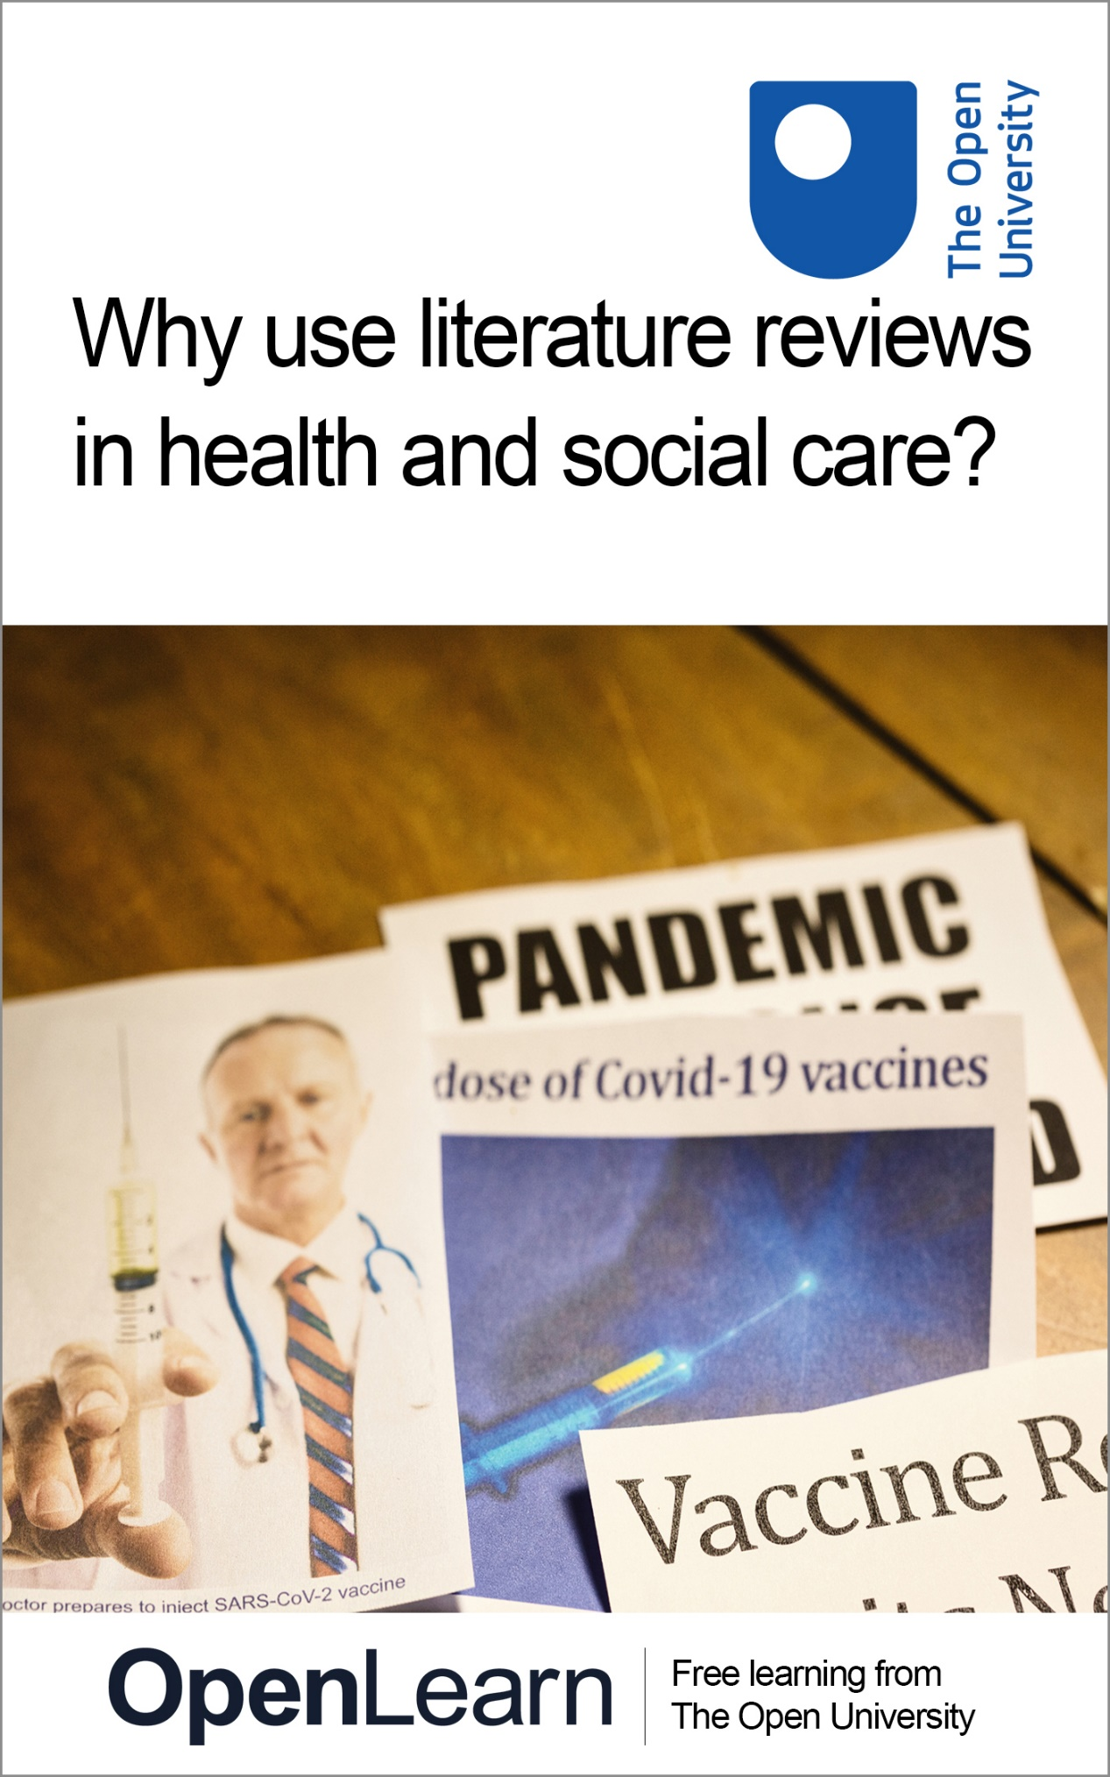

CEN_1

Census stories: Bringing statistics to life in Milton Keynes

About this free course
This version of the content may include video, images and interactive content that may not be optimised for your device.
You can experience this free course as it was originally designed on OpenLearn, the home of free learning from The Open University –
https://www.open.edu/openlearn/society-politics-law/census-stories/content-section-0
There you’ll also be able to track your progress via your activity record, which you can use to demonstrate your learning.
Copyright © 2021 The Open University
Intellectual property
Unless otherwise stated, this resource is released under the terms of the Creative Commons Licence v4.0 http://creativecommons.org/licenses/by-nc-sa/4.0/deed.en_GB. Within that The Open University interprets this licence in the following way: www.open.edu/openlearn/about-openlearn/frequently-asked-questions-on-openlearn. Copyright and rights falling outside the terms of the Creative Commons Licence are retained or controlled by The Open University. Please read the full text before using any of the content.
We believe the primary barrier to accessing high-quality educational experiences is cost, which is why we aim to publish as much free content as possible under an open licence. If it proves difficult to release content under our preferred Creative Commons licence (e.g. because we can’t afford or gain the clearances or find suitable alternatives), we will still release the materials for free under a personal end-user licence.
This is because the learning experience will always be the same high quality offering and that should always be seen as positive – even if at times the licensing is different to Creative Commons.
When using the content you must attribute us (The Open University) (the OU) and any identified author in accordance with the terms of the Creative Commons Licence.
The Acknowledgements section is used to list, amongst other things, third party (Proprietary), licensed content which is not subject to Creative Commons licensing. Proprietary content must be used (retained) intact and in context to the content at all times.
The Acknowledgements section is also used to bring to your attention any other Special Restrictions which may apply to the content. For example there may be times when the Creative Commons Non-Commercial Sharealike licence does not apply to any of the content even if owned by us (The Open University). In these instances, unless stated otherwise, the content may be used for personal and non-commercial use.
We have also identified as Proprietary other material included in the content which is not subject to Creative Commons Licence. These are OU logos, trading names and may extend to certain photographic and video images and sound recordings and any other material as may be brought to your attention.
Unauthorised use of any of the content may constitute a breach of the terms and conditions and/or intellectual property laws.
We reserve the right to alter, amend or bring to an end any terms and conditions provided here without notice.
All rights falling outside the terms of the Creative Commons licence are retained or controlled by The Open University.
Head of Intellectual Property, The Open University

Contents
- Introduction
- Learning outcomes
- 1 What can the census tell us about religion?
- 2 Census data discussion
- 3 A closer look at Milton Keynes and its religious diversity
- 4 Survey activity
- 5 Who am I?
- 6 What do I do?
- 7 Where do I belong?
- Conclusion
- Further stories
- References
- Acknowledgements

Introduction
This free course, Census stories: Bringing statistics to life in Milton Keynes, aims to provide you with opportunities to reflect on contemporary religious identities, as well as the role of religious and secular communities in providing a sense of belonging, in our increasingly global, urban and multifaith society. During this course you will compare data from the UK national census, particularly statistical evidence on religion and ethnicity, with people’s own stories. These stories include themes of identity, belonging and the sorts of practices (be these religious, spiritual or secular ritual practices) they engage in to celebrate life’s big events, such as births and funerals.
The UK national census seems to confirm some scholarly predictions that we are witnessing a continuous and persistent decline in religious identity over time, a process which is known as secularisation. The 2001 census indicated that 72% of the population of the UK identified as Christian, yet the 2011 census showed that only 59.3% still identify as Christians. There has also been a corresponding growth in people who identify as ‘not religious’.
But what does this mean? Are people in the ‘no religion’ category Christians who no longer practise, or people who practise but do not believe in God? Are they indifferent to religion altogether, or perhaps they are ‘spiritual but not religious’ – a category that is increasingly used by people to describe their religious identity, but is not captured by the census.
Of course, census data, like other types of quantitative survey data, cannot tell us the entire story – but they can provide us with very interesting perspectives over a longer time span, such as the past two decades since the UK census has begun to ask questions about religious identity.
This course will try to augment – and animate – the data, exploring people’s experiences of religion, ethnicity, and migration in a diverse British city. Milton Keynes is a large multicultural town in South East England, a commuter hub for London, where multicultural communities are the norm. As a result, the town presents a great case study for the religious changes that have marked British society since the late 1960s – when Milton Keynes was officially established.

The structure of this course: three key questions
Many scholars preoccupied with religion claim that there is convincing evidence that religion in Britain is in fact finding new channels of expression, such as through a growing, global, and increasingly digital, contemporary spirituality for example. Thus, in order to go beyond the labels that people use to describe their religious or secular identities, this course will present people's personal accounts as a lens for considering three key questions:
- Who am I?
- Where do I belong?
- What do I do?

Learning outcomes
After studying this course, you should be able to:
- understand the major recent demographic changes in religion and ethnicity in the UK as revealed in the national census
- understand the overlaps and complexities of religious and non-religious identities
- appreciate hearing a variety of perspectives and stories from people with very different life experiences
- confidently tell personally meaningful stories in relationship to larger social issues.

1 What can the census tell us about religion?
Before you start thinking through the course's key questions in more depth, watch this short film explaining how the census data can help us understand religious identity in Milton Keynes:

Video content is not available in this format.
Video 1 What can the census tell us about religion?
View transcript - Video 1 What can the census tell us about religion?

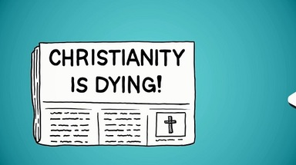

2 Census data discussion
Figures 1 and 2 compare the reduction in the number of people across England and Wales identifying as Christian, with the same statistic specifically in Milton Keynes.
The census data shows that the number of people who identify as Christians dropped by 12.4% between 2001 and 2011, nationwide. Those identifying as not religious increased by 10.3%, while the Muslim population increased from 3% to 4.8%.

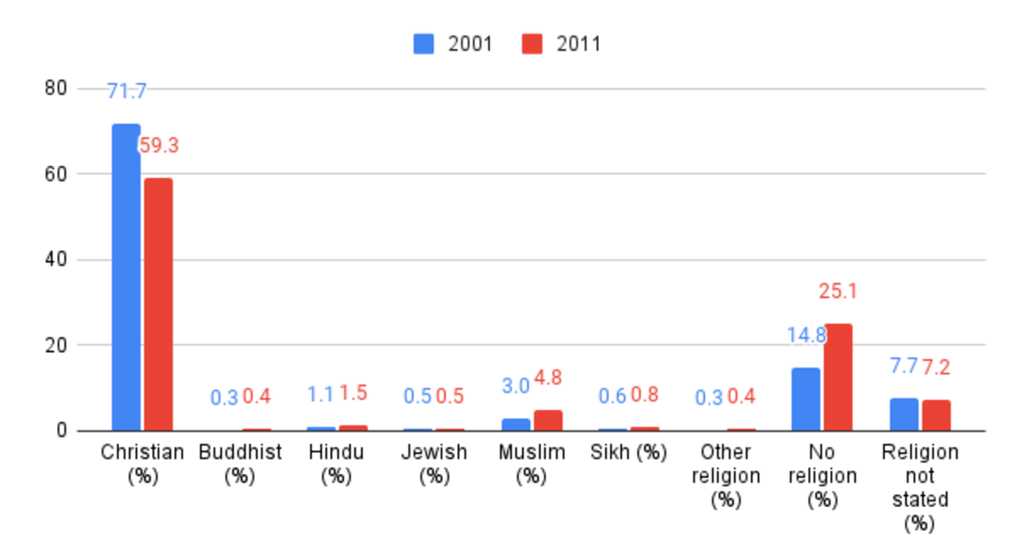
Figure 1 Religion in England and Wales
View description - Figure 1 Religion in England and Wales

Milton Keynes is the largest town in Buckinghamshire and according to the 2011 census, the town has an average population of 230,000. Later statistics place the total number of Milton Keynes residents around 245,000.
Figure 2 shows that Milton Keynes largely follows national trends across England and Wales, with a slightly larger increase in those identifying as not religious.
Today, Milton Keynes has 6.5% fewer identifying as Christian than the national average, and 6.2% more non-religious. Yet the Jewish and Sikh communities are also smaller than the average.

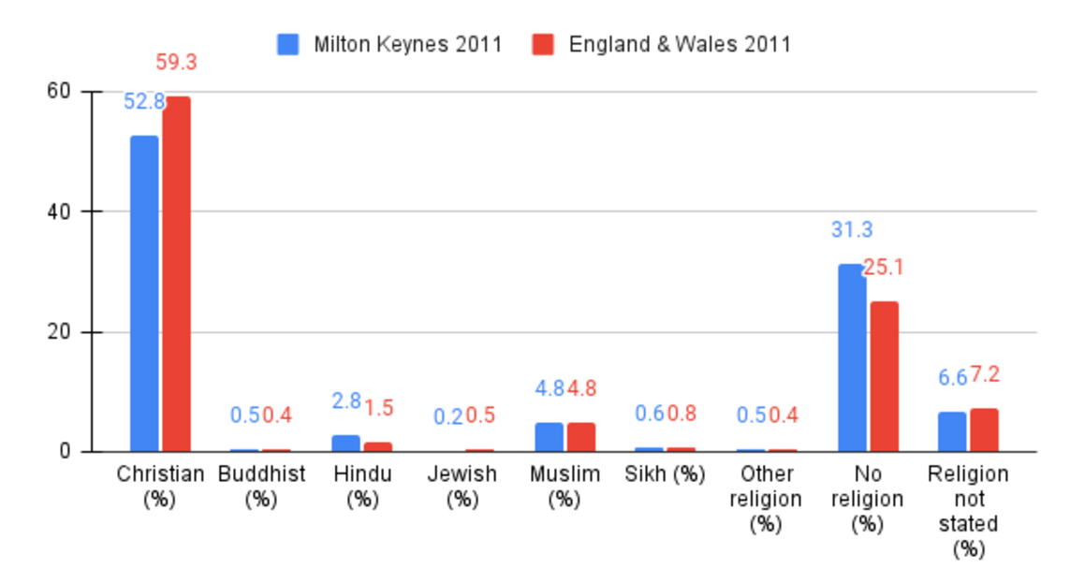
Figure 2 Religion in Milton Keynes and England & Wales, 2011
View description - Figure 2 Religion in Milton Keynes and England & Wales, 2011

Milton Keynes in 2011 is less white than the national average. However, it is also less black. Asian and mixed ethnicity groups make up the difference, being higher than the national average.

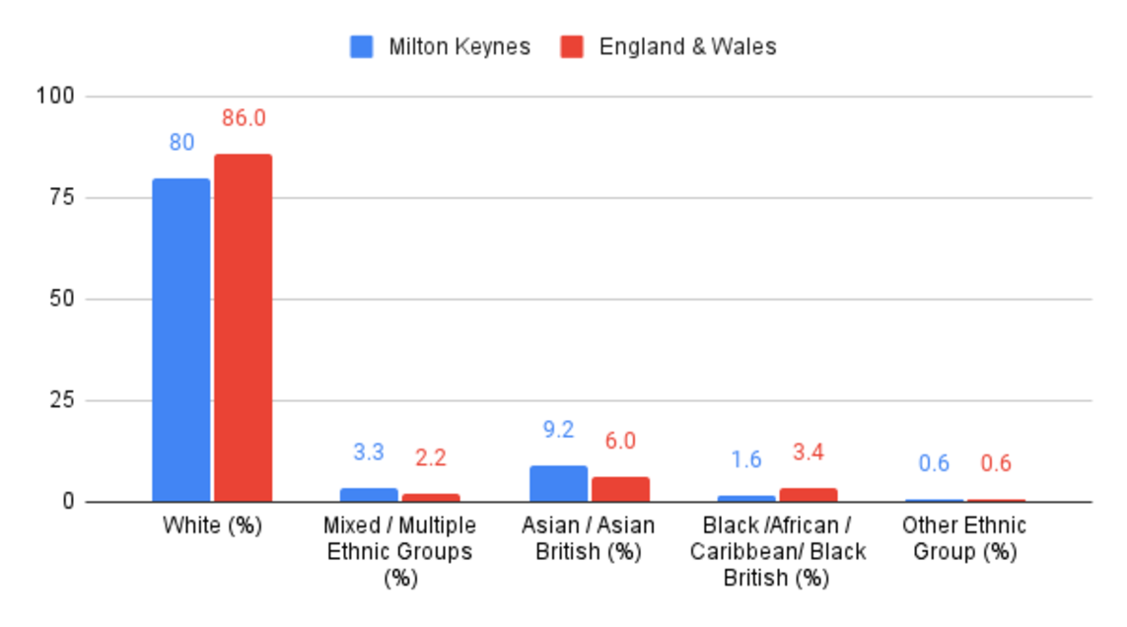
Figure 3 Ethnicity in Milton Keynes and England & Wales, 2011
View description - Figure 3 Ethnicity in Milton Keynes and England & Wales, 2011

The percentage of the population marrying has dropped steadily since the early 1970s, but this has actually started to level out since the last census.

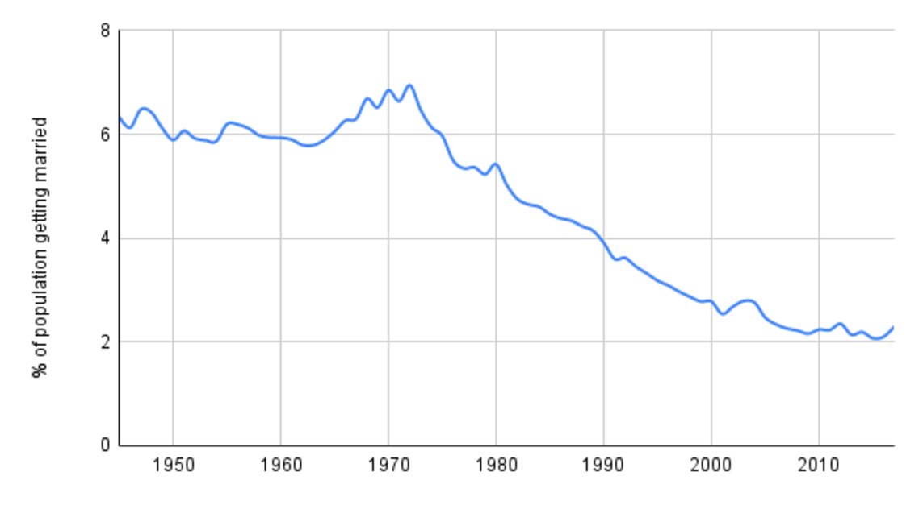
Figure 4 Marriages in England & Wales, 1945-2019
View description - Figure 4 Marriages in England & Wales, 1945-2019

Around the same time, nationwide, cremations overtook burials as the preferred form of final disposition. Today, the proportion is almost the reverse of what it was in 1950.

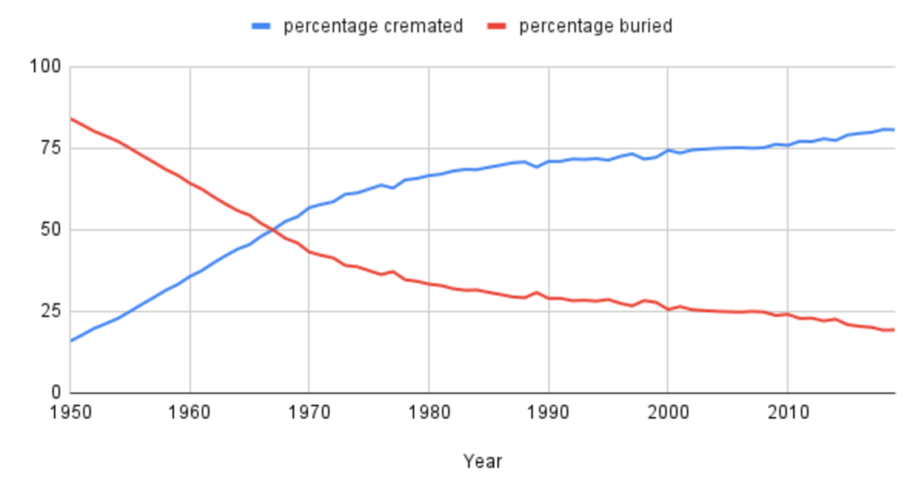
Figure 5 Burial and cremation in England & Wales, 1950-2019
View description - Figure 5 Burial and cremation in England & Wales, 1950-2019

The population of Milton Keynes has grown steadily. The high proportion of working age people suggests that a higher-than-typical proportion of the population are ‘economic migrants’ to the city.

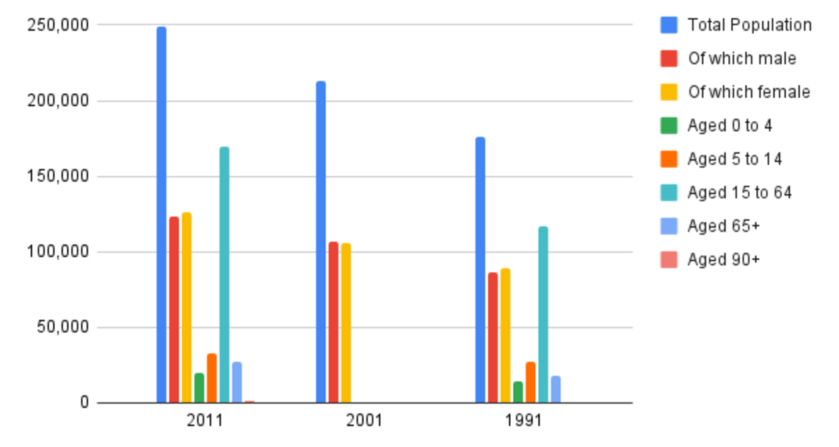
Figure 6 Population in Milton Keynes (please note: the age breakdown was missing from the 2001 census data)
View description - Figure 6 Population in Milton Keynes (please note: the age breakdown was missing ...

The South East of England has the second-highest proportion of the population born outside the UK, taking over from the West Midlands during the 1990s. However, it is still below the average for England and Wales.

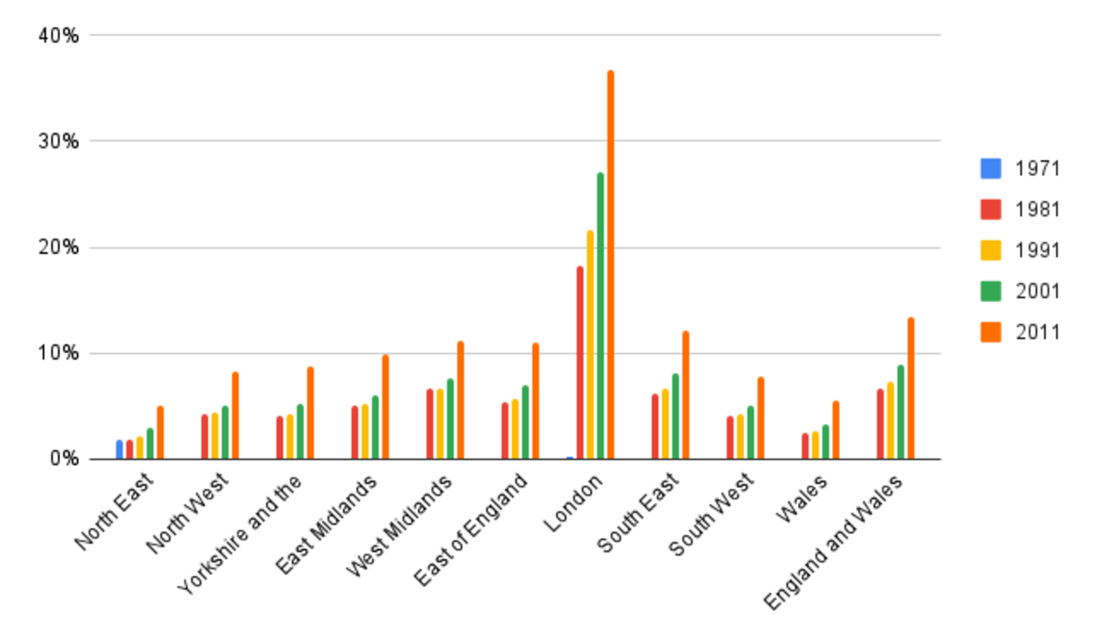
Figure 7 Resident population born outside the UK, 1971-2011
View description - Figure 7 Resident population born outside the UK, 1971-2011

3 A closer look at Milton Keynes and its religious diversity
The new town of Milton Keynes was established in 1967 and brought together the existing smaller towns (Bletchley, Fenny Stratford, Wolverton and Stony Stratford) and villages in the area. The town incorporated more traditional elements as well as new urban design. For example, it was organised around a grid of roads that would allow for the flow of traffic, yet town planners rejected the tower blocks that had become the most visible structures in modern cities, instead setting a height limit for buildings both inside and outside the town centre. Milton Keynes has plenty of wild areas, grasslands, forests, lakes and an impressive river, the River Great Ouse, which forms its Northern border – although as a large urban jungle, Milton Keynes’ biodiversity is reduced and further under threat due to the present ecological and climate crisis. In terms of its socio-economic profile, Milton Keynes was depicted by a 2016 community report as a ‘tale of two cities’ – this is because the town showed one of the starkest contrasts between affluent and deprived communities in the UK (Milton Keynes Community Foundation, 2016).

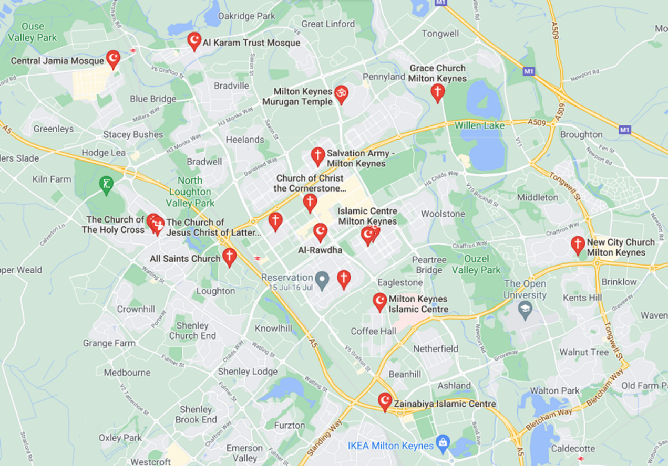
Figure 8 Religious buildings in Milton Keynes
View description - Figure 8 Religious buildings in Milton Keynes

As a town established in the 1960s, Milton Keynes reflects wider trends of religious diversity in the UK; the town has eight Islamic mosques, three Hindu temples, one Sikh Gurdwara and a Buddhist Centre, alongside its twenty or so Christian churches.
The diversity of church traditions reflects the internal diversity of Christianity; however, this also indicates something of the ethnic transformation of British Christianity since the 1950s through migration. There are, for example, various congregations which might be designated ‘black majority’ churches.
It was particularly after the 1960s that South Asians from India, Pakistan, Bangladesh and Sri Lanka began to arrive in significant numbers in the UK, as well as Europe and the US. By the 1990s there were hundreds of Hindu, Sikh and Buddhist temples in the UK, as well as Islamic mosques. Many South Asian immigrants understood the West to be secular. They often guarded against aspects of Western culture or, in some cases, tried to attract new converts. In this context immigration to the UK gave rise to the growth of diaspora religions, which are understood as ‘groups that have a sense of being a minority, sometimes an oppressed minority, living in an alien culture at a distance from the old country’ (Hinnells, 1996, p.11).

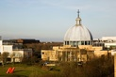
Figure 9 Church of Christ the Cornerstone, Milton Keynes
View description - Figure 9 Church of Christ the Cornerstone, Milton Keynes

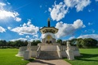
Figure 10 Peace Pagoda, Milton Keynes
View description - Figure 10 Peace Pagoda, Milton Keynes

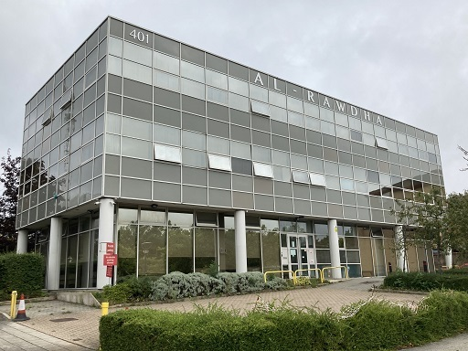
Figure 11 Al-Rawdha Mosque, Milton Keynes
View description - Figure 11 Al-Rawdha Mosque, Milton Keynes

Around this time in the 1960s and 70s, many other traditions started to become established in Britain, often with direct links to immigrant communities from South Asia and Commonwealth countries, or influenced by Eastern beliefs and practices, such as yoga, meditation, reincarnation or karma. The New Age movement, which also experienced a rapid growth around this time, abounds in Eastern beliefs and practices, as well as eclectic influences from a great variety of ideas from around the world (for example, belief in ‘ley lines’ as some sort of spiritually charged network of arteries across the Earth, believed to have been recognised by ancient and pre-modern people as links between important constructions, from ancient megalith structures to medieval cathedrals). It is no wonder that, being planned in the late 1960s, Milton Keynes shows this New Age influence too, as the town grid was designed so that, at sunrise on the day of the Solstice, the sun is directly aligned with the main boulevard in Milton Keynes: Midsummer Boulevard!
Religious diversity has many distinct aspects; not only are there many religious traditions that have arrived in Britain through increased immigration, but there's also been cross-fertilisation among religious traditions through living in close proximity with each other, often in newly established cosmopolitan urban areas, like Milton Keynes. Today, contemporary spirituality and a great diversity of newer religious traditions show some of the influences of the changes seen since the 1960s. The next activity is designed to help you reflect on this great contemporary diversity of religious identities, and the complexity of an individual’s religiosity or non-religiosity.

4 Survey activity
The following activity aims to provide you with the opportunity to reflect on your own identity as well as the intricate nature of religious identities more broadly. The link below will take you to a short survey about your personal religious identity. Your answers will not be recorded or shared, and there are no judgements. It’s a reflective exercise, designed to help you to think about religious identity in a different way.
If you don’t feel comfortable doing this activity, it's fine to skip it and move on to the next section instead. But we think you’ll find it interesting, and maybe even fun!
Click the following link to be taken to the activity. There will be a link back to the course at the end of the survey.
Link to activity

5 Who am I?
The census data gives us some important information about changing societal trends in religious identity, yet these numbers cannot always capture the in-between categories, and the ways individuals are likely to create their sense of identity and values, which result in the individualisation (e.g. personal spiritual practice) and pluralisation (e.g. Christian – Buddhist – Spiritual) that are taking place, particularly in a Western European context (Müller et al., 2012). Some scholars claim that religion is becoming more private or privatised as a result of our consumer society, in which the individual practitioner is encouraged to customise their spiritual experience by picking and mixing elements that make sense to them, rather than follow a religious path or belong to one religious community.
So, what kind of religious practices and rituals do modern, urban, plural, secularised individuals and communities engage in? As the census data shows, the ways in which we celebrate life and commemorate death are radically changing. Scholars sometimes refer to the rituals that accompany such big changes as ‘rites of passage’, given that in ancient and traditional societies rituals often involved crossing a boundary (the tribal or village boundary for instance) and the rituals were constructed and envisaged as a journey. This is particularly relevant in the case of funerary rites, which have been noted for their depletion and shrinkage with the transition to modern, urban societies. This does not mean that we modern humans care less about our departed loved ones. Philippe Ariès, a French historian, famously claimed that this reduction in the rituals that used to surround death in traditional communities is caused by, and implicitly is causing, an inability to deal with the death of our loved ones. So, what do we modern humans do about life’s big transitions, and what does this mean?

Video content is not available in this format.
Video 2 Who am I?
View transcript - Video 2 Who am I?

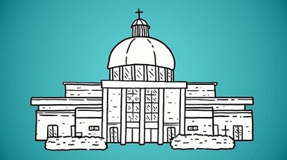

Steve’s reflection on his religious identity does seem to confirm scholarly views that traditional religious identities are not being ‘transmitted’ from the older to the younger generations. While Steve was raised as a Catholic, he is not too sure about his own religious identity, and we can see his dilemma between maintaining a traditional Christian practice in his son’s Christening, or adopting a more secular celebration of birth. Identity – ‘who am I?’ – is of course very much related to ‘what do we do?’, as will be seen in the next section.

6 What do I do?
One category in the study of religion is ‘lived religion’ with some scholars attempting to understand what exactly religious people actually ‘do’ (not what we imagine they ‘should’ do), and how they live out and ritualise their religious identities. What do they do which makes them identify as Christians or Muslims? Or identify as ‘not religious’?
In traditional communities this question may be easier to answer, because traditional religious practices would punctuate every aspect of one’s life. For example, for a Muslim praying five times a day and going to their local mosque every Friday, their religious practice is very much a central part of their lifestyle. Reflect now on this topic of people being religious by virtue of the things they do, with a story from the first half of the 20th century, in Stony Stratford, a village that would later become part of Milton Keynes.

Video content is not available in this format.
Video 3 What do I do?
View transcript - Video 3 What do I do?

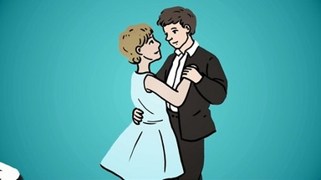

As you can see from Cecil’s story, the church was not just a place where people would come to christen their children, but an integral part of the community life. It was a place where Cecil spent a lot of his time, whether to serve as an altar boy, or socialise, even ballroom dance! His identity as a ‘churchman’ is linked to him spending a lot of his time being part of a church community and doing things with this community. Do you think it is likely that Cecil’s children, whether they might have continued to live in Milton Keynes or not, could have such an intimate relationship with their church or religious communities? What other communities may have arrived in Milton Keynes as times changed after the 1960s? You will reflect further on this question of belonging to a community in the next section.

7 Where do I belong?
Many would probably agree that having a feeling of belonging to a community is important. But what ‘belonging’ and being part of a community would have meant in more rural and local community settings has shifted significantly in our contemporary, globalised, mobile, digital, urban world. In our fast-paced society, we no longer belong to one local community only – a so-called ‘community of place’, perhaps embodied by the local church. Rather we belong to many ‘communities of choice’, or interest groups which are becoming increasingly detached from place and far more mobile, like online interest groups, or large international festival communities, such as Burning Man. However, research shows that having a sense of belonging is really important for people to become socially and politically involved. This is even more important among minority groups and new migrant groups, either living or arriving in large urban centres, as is the case with Milton Keynes in our case study.

Video content is not available in this format.
Video 4 Where do I belong?
View transcript - Video 4 Where do I belong?

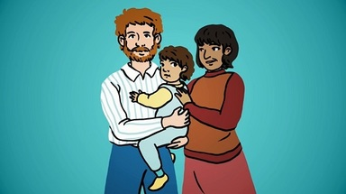

Anita’s story is also a story about different generations and their ethnic and religious identities. Anita’s mother came from India, yet her parents were part of the Jehovah’s Witnesses (JW), a religion which grew out of 19th century Christian movements in the United States. Anita’s story shows that belonging to a group can expose one to exclusion from other groups. Being a Jehovah's Witness, Anita tells us, attracted some prejudiced views from people who disagreed with followers’ beliefs and practices. Yet for Anita, the JWs offered a strong sense of community and belonging, support and hospitality.

Conclusion
In this course you have looked at two kinds of sources that help us to understand religious and non-religious change: the census data and stories. You have seen how these two kinds of data can complement each other, helping us to understand both better.
The census data gives us a ‘big’ story. It shows us, for example, that religious identity has been changing rapidly in our increasingly globalised society, particularly in fast-developing multicultural urban environments like Milton Keynes, where we find a high influx of newcomers and migrant populations. Indeed, Milton Keynes makes a fascinating case study of changing trends in religious identity and belonging in Britain, because this town shows the accelerated changes in the British religious and ethnic landscape since the 1960s, coinciding with the creation of this new town in 1967.
The census data shows the rise in ethnic and religious diversity in Milton Keynes. This includes diversity within Christianity, for example, the black majority churches. There is also the expansion of minority religious traditions, which is evident also in the town’s rich religious architecture, with its many Islamic mosques and Hindu temples. Islam and Hinduism are two of the biggest minority religions in the UK, also according to census data nationwide. Alongside the growth of these larger minority religions, new religions have also been observed, as well as a rise of ‘non-religion’, which is perhaps the most statistically significant development of its type in recent decades.
We can both illustrate and complicate the ‘big story’ drawn from census data by listening to the individual stories of people (after all, the ‘big story’ of the census is ultimately a reflection – in some ways very helpful, but in some ways limited – of many hundreds of thousands of personal stories). This course's short animated stories provide a glimpse into the complicated issues of identity and belonging we, modern humans, must grapple with.
To complete the course, please take a few minutes to reflect on the following questions, brought to light by the census data, as well as Anita, Steve and Cecil’s stories:

What kind of changes in religious identities can we see in modern, increasingly global, multicultural and multifaith societies, like Britain? How are religious and ethnic identities shaped by growing up between two or more cultures?
What might have been some of the challenges and opportunities encountered by children and young people from different backgrounds growing up in Britain since the 1960s, given the rapid growth of multicultural towns and cities? (You might consider, for example, young people growing up in diaspora religious communities, whose school friends might have known very little about their religion and culture.)
How does living in a plural, increasingly individualistic, multicultural society impact how people celebrate life’s major events, like birth, marriage and death?

Congratulations on completing the course!

Optional stories
You have now completed the course and earned your Statement of Participation. But if you would like to listen to a couple of optional, extended stories portraying religious identities from Milton Keynes, go to the next page.

Further stories
This is optional study material – three stories to help deepen your understanding of the wide variety of religious identities to be found (in Milton Keynes and everywhere else).

Audio content is not available in this format.
Optional story 1 Eileen
View transcript - Optional story 1 Eileen

Audio content is not available in this format.
Optional story 2 Pushpa
View transcript - Optional story 2 Pushpa

Audio content is not available in this format.
Optional story 3 Irini
View transcript - Optional story 3 Irini

References
Hinnells, J.R. (1996) A New Dictionary of Religions. London: Wiley.
Milton Keynes Community Foundation (2016) Vital Signs. Available at https://www.mkcommunityfoundation.co.uk/files/4514/7819/4217/LONG_REPORT_Vital_Signs_MK2016.pdf (Accessed: 16 September 2021).
Müller, O., Pollack, D., and Pickel, G. (2012) The Social Significance of Religion in the Enlarged Europe. London: Routledge.

Acknowledgements
This free course was written by John Maiden, Maria Nita and David Robertson, with contributions from Suzanne Newcombe and Sas Amoah.
The Open University and Census stories: Bringing statistics to life in Milton Keynes course team would like to thank the following organisations for their support in developing the course:

Living Archive Milton Keynes
Living Archive’s creative community projects record, archive and celebrate the unique history and heritage of Milton Keynes. Their work collects, preserves and shares the stories of residents’ lives, building a sense of place and using old memories to create new ones and bring communities together.
https://www.livingarchive.org.uk

Milton Keynes Community Foundation
Milton Keynes Community Foundation is an independent charity working for and at the heart of Milton Keynes. The charity connects people and resources to projects and ideas to create a positive impact and enduring solutions for our communities within Milton Keynes.
https://www.mkcommunityfoundation.co.uk

Except for third party materials and otherwise stated (see terms and conditions), this content is made available under a Creative Commons Attribution-NonCommercial-ShareAlike 4.0 Licence.
The material acknowledged below is Proprietary and used under licence (not subject to Creative Commons Licence). Grateful acknowledgement is made to the following sources for permission to reproduce material in this free course:

Images
Course image: Pajor Pawel; Shutterstock.com
Figure 8: Google; Google search showing local religious buildings
Figure 9: David Wheeldon; Alamy Stock Photo
Figure 10: Pajor Pawel; Shutterstock.com
Figure 11: courtesy of James Puddephatt
Every effort has been made to contact copyright owners. If any have been inadvertently overlooked, the publishers will be pleased to make the necessary arrangements at the first opportunity.
Don't miss out
If reading this text has inspired you to learn more, you may be interested in joining the millions of people who discover our free learning resources and qualifications by visiting The Open University – www.open.edu/openlearn/free-courses.

Figure 1 Religion in England and Wales

Description
This bar chart compares the 2001 and 2011 census statistics for religion in England and Wales. The numbers, in percentages, are as follows: Christian – 71.7% in 2001, 59.3% in 2011. Buddhist – 0.3% in 2001, 0.4% in 2011. Hindu – 1.1% in 2001, 1.5% in 2011. Jewish – 0.5% in 2001, 0.5% in 2011. Muslim – 3.0% in 2001, 4.8% in 2011. Sikh – 0.6% in 2001, 0.8% in 2011. Other religion – 0.3% in 2001, 0.4% in 2011. No religion – 14.8% in 2001, 25.1% in 2011. Religion not stated – 7.7% in 2001, 7.2% in 2011.
Back to - Figure 1 Religion in England and Wales

Figure 2 Religion in Milton Keynes and England & Wales, 2011

Description
This bar chart compares the 2011 census statistics for religion in Milton Keynes, and England & Wales more broadly. The numbers, in percentages, are as follows: Christian – 52.8% in Milton Keynes, 59.3% in England & Wales. Buddhist – 0.5% in Milton Keynes, 0.4% in England & Wales. Hindu – 2.8% in Milton Keynes, 1.5% in England & Wales. Jewish – 0.2% in Milton Keynes, 0.5% in England & Wales. Muslim – 4.8% in Milton Keynes, 4.8% in England & Wales. Sikh – 0.6% in Milton Keynes, 0.8% in England & Wales. Other religion – 0.5% in Milton Keynes, 0.4% in England & Wales. No religion – 31.3% in Milton Keynes, 25.1% in England & Wales. Religion not stated – 6.6% in Milton Keynes, 7.2% in England & Wales.
Back to - Figure 2 Religion in Milton Keynes and England & Wales, 2011

Figure 3 Ethnicity in Milton Keynes and England & Wales, 2011

Description
This bar chart compares the 2011 census statistics for ethnicity in Milton Keynes, and England & Wales more broadly. The numbers, in percentages, are as follows: White – 80.0% in Milton Keynes, 86.0% in England & Wales. Mixed / Multiple Ethnic Groups – 3.3% in Milton Keynes, 2.2% in England & Wales. Asian / Asian British – 9.2% in Milton Keynes, 6.0% in England & Wales. Black / African / Caribbean / Black British – 1.6% in Milton Keynes, 3.4% in England & Wales. Other Ethnic Group – 0.6% in Milton Keynes, 0.6% in England & Wales.
Back to - Figure 3 Ethnicity in Milton Keynes and England & Wales, 2011

Figure 4 Marriages in England & Wales, 1945-2019

Description
This line chart shows the percentage of the population marrying between 1945 and 2019. There are many slight rises and falls each year, but the numbers remain broadly around 6% in the 1950s and 1960s, and peak around 7% in the early 1970s. The percentage then drops gradually, by roughly 1% each decade. It reaches 2% in the 2010s, at which it appears to remain level.
Back to - Figure 4 Marriages in England & Wales, 1945-2019

Figure 5 Burial and cremation in England & Wales, 1950-2019

Description
This line chart plots two simultaneous lines, ‘percentage cremated’ and ‘percentage buried’ in England & Wales between 1950 and 2019. In 1950, burials were at around 80%, and cremations around 20%. This gap closed sharply over the following years, with both hitting 50% by approximately 1967. Cremation then overtook burial as the preferred form of final disposition. ‘Percentage cremated’ continued to rise over the following decades, though more slowly than the change seen in the 1950s/1960s. In the 2010s cremations reached approximately 80%, and burials around 20%.
Back to - Figure 5 Burial and cremation in England & Wales, 1950-2019

Figure 6 Population in Milton Keynes (please note: the age breakdown was missing from the 2001 census data)

Description
This bar chart shows population figures and how they break down from the 1991, 2001 and 2011 censuses. The bars break down sex and age. The 1991 statistics show a population around 175,000. The female proportion is slightly higher than the male. By age, the lowest proportion is aged 0-4 (approximately 15,000), then 65+ (approximately 20,000), then 5-14 (approximately 25,000-30,000), and the largest group is aged 15-64 (approximately 115,000-120,000). The 2001 statistics show a population around 210,000. The male proportion is slightly higher than the female. The age statistics are not shown for this year. The 2011 statistics show a population just under 250,000. The female proportion is slightly higher than the male. By age, the lowest proportion is aged 90+ (a very small group not visibly listed for previous years, approximately 1,000), then 0-4 (approximately 20,000), then 65+ (approximately 25,000-30,000), then 5-14 (approximately 35,000), and the largest group is aged 15-64 (approximately 170,000).
Back to - Figure 6 Population in Milton Keynes (please note: the age breakdown was missing from the 2001 census data)

Figure 7 Resident population born outside the UK, 1971-2011

Description
This bar chart shows the resident population born outside the UK (shown as a percentage) across nine regions of England, as well as Wales, and England & Wales as a whole. Each area has the statistics listed for censuses in 1981, 1991, 2001 and 2011 (most areas don’t show any 1971 figures). In all areas, the percentage has risen with every census. In England and Wales as a whole, the figure is around 7% for 1981 and 1991, around 9% in 2001, and 13-14% in 2011. In all areas besides London, the numbers are lower than this average, but follow the same growth trajectory. The lowest numbers are seen in the North East, and Wales, which both reach around 5% in 2011. Then the South West, North West, and Yorkshire and the Humber, which reach around 8-9% in 2011. Then the East Midlands, which reaches around 10% in 2011. Then the East of England, West Midlands, and South East, which reach around 11-12% in 2011. London has the highest numbers, around 18% in 1981, 21% in 1991, 27% in 2001, and 37% in 2011.
Back to - Figure 7 Resident population born outside the UK, 1971-2011

Figure 8 Religious buildings in Milton Keynes

Description
This is a screenshot from Google Maps, showing the locations of various religious buildings across Milton Keynes. There are about a dozen locations listed, of various faiths, spread across the town.
Back to - Figure 8 Religious buildings in Milton Keynes

Figure 9 Church of Christ the Cornerstone, Milton Keynes

Description
This is a photograph of the Church of Christ the Cornerstone in Central Milton Keynes.
Back to - Figure 9 Church of Christ the Cornerstone, Milton Keynes

Figure 10 Peace Pagoda, Milton Keynes

Description
This is a photograph of the Peace Pagoda at Willen Lake, Milton Keynes.
Back to - Figure 10 Peace Pagoda, Milton Keynes

Figure 11 Al-Rawdha Mosque, Milton Keynes

Description
This is a photograph of the Al-Rawdha Mosque in Central Milton Keynes.
Back to - Figure 11 Al-Rawdha Mosque, Milton Keynes

Video 1 What can the census tell us about religion?

Transcript
NARRATOR
Are we getting less religious? Every ten years in the UK we have a national census, giving us data about the way we live – and since 2001 that’s included our religious identification. What story does this data tell us about religion – and non-religion – in the 21st century?
In the media, the big headline has been ‘Christianity is dying’. The number of people ticking the ‘Christian’ box dropped by 12.4%, to 59.3%, between 2001 and 2011. If this pattern is continued, then the UK will no longer be a Christian-majority country. But this isn’t a simple story: the number of Christians from some minority ethnic backgrounds has been increasing, and equally, someone might tick ‘Christian’, but not have attended church for years.
The broader trend of falling numbers of Christians isn’t due to immigration: Muslims still only make up 4.8% of the population, a rise of less than 2%. Nor is it due to a rise in new religions like Jedis or Scientology. The biggest increase – 10.3% – was ‘no religion’.
But this is where census data gets tricky – who ticks the ‘no religion’ box? It could be a confirmed atheist, or someone agnostic or undecided, or even someone who is ‘spiritual’, perhaps enjoying a yoga class or aromatherapy, but less keen on organised religion. In fact, many are probably just indifferent – religion is just not particularly relevant to their lives. So ‘no religion’ doesn’t necessarily equate with ‘goodbye religion’.
In fact, when we dig down, religious identity, commitment and practice are complex. Someone might tick a box in the census, but their own story – like millions of others – is unique. Are we getting less religious? Perhaps the best answer is: it’s complicated.
Back to - Video 1 What can the census tell us about religion?

Video 2 Who am I?

Transcript
STEVE
I was raised a Catholic, I now put in the census that I'm Christian, although I haven't been to church for a while. But yes, I was raised a Catholic and I went to Catholic Primary school and Secondary school and all that. But when it came to our child’s christening, we were in a real difficult place because my father's family, as I said, were keen for a Catholic baptism. My wife's family are not religious at all. It took us a long time to decide what to do.
It wasn’t until my son was one that we ended up finding, eventually, the Christchurch Cornerstone, which is an ecumenical church, and we met with the pastor at that time. And we finally had a place where we felt that we could have a celebration of birth, but without it being too religious, if you see what I mean. I consider myself Christian, but I don't really know what faith I am. I have faith, but I don't really have a religion, I suppose.
Back to - Video 2 Who am I?

Video 3 What do I do?

Transcript
NARRATOR
Cecil Palmer was a working-class man born in 1901 in Stony Stratford, on the edge of what is now Milton Keynes. Cecil was an altar boy at Saint Mary and Saint Giles church. After starting work at fourteen, he continued as an altar server, and went to what he called ‘church dues’, where ballroom dancing continued till late evening. As he danced, Cecil would feel the eyes of the two chaperones on him: the Vicar's wife, and another lady, on the lookout for inappropriateness. In old age, he no longer attended much due to his wife's health, but he still referred to himself as a ‘churchman’. He brought his daughters up as churchgoers. ‘Our children,’ he said, ‘had to do what they were told until they left, but well, that's up to them now’, and he doesn't say whether they did continue his relationship with the church.
Back to - Video 3 What do I do?

Video 4 Where do I belong?

Transcript
ANITA
My mum was born in India, but she comes from mixed-race parents. She came here when she was seventeen, and there’s a whole life that we don’t really discuss. I remember things happening when we were younger. So, when we moved to our new estate, and my dad being white, and my mom being mixed-race as well, I remember having a swastika sprayed on our garage. But it wasn't a big thing – my parents never showed their emotions about it in front of people.
You know, being a Jehovah’s Witness has some very strong views from other people. You don't want someone to say ‘you've just been brainwashed’, or ‘you just follow a religion because your parents do’. But for me, the religion growing up has always been a sense of community, the whole nature is that you offer hospitality and you be sociable, and you support one another. Even to this day, I would like to feel myself as sociable within those Christian morals and guidance of being kind to people.
Back to - Video 4 Where do I belong?

Optional story 1 Eileen

Transcript
EILEEN
So, I'm second generation Irish, so both of my parents are Irish Catholics, very religious – sadly no longer with us, but they had me very late in life, so they were forty-three when they had me. But I was brought up strict Roman Catholic. And I think when you're brought up in that atmosphere, I think it goes either of two ways, doesn't it? You either embrace it as an adult or you move away from it. And I certainly moved away from it. I didn't get married in a church, I got married in a registry office. I was estranged from my parents at that stage, so they didn't come to the wedding. I was married for nearly 20 years, and then I gave up that life completely when I was 40 in order to fulfil my dream of having a child, and I moved away from where I was living. So, I completely gave up everything to come to Stony Stratford. So, I had no sense of belonging, really. I came here knowing one person. I had a job in Milton Keynes, at Santander, so I worked for them for 20 years.
I then joined the Local Baptist Church in Stony Stratford, which is now called a community church. A very strong sense of belonging. And I immediately felt at home, immediately felt included, and particularly the emphasis on women, you know, getting involved in the various groups and helping to run some of them. So, a very strong sense of belonging, and that followed through into the school as well. So, when my son came along in 2008, and I was a single parent from when he was born, sadly, obviously a lot going on at the school, a lot to get involved in. So, there was another sense of belonging, but there were two distinct belongings. There was the school and everything that went on there, which was quite rigid, is..., well, was quite rigid. And then there was the church, which was so different. And even my son noticed it, as young as he was. The only slight tension was that my son, who was attending at St Mary and St Giles school, which is obviously a Christian school… there was some conflict at the school, and I won't go into any details, it's well known, it's out there. There were some irregularities, shall we say, and a lot of change happened at the school as a result of what was going on at the church. So, a number of parents took their children out. I didn't. I chose to stay. My son was very happy there. And so, he was attending school activities at the church. But we were going as mother and son to the local community church, which was entirely different, and, I have to say, absolutely fascinating. The things that we got involved in, all of the worship is all part of a-- you have a band, a very lively, very inclusive, lovely, lovely atmosphere, and lots of groups that you can take part in. So I was part of a group of ladies, and the whole idea of the group was that if a lady, any of us, if we were struggling or we needed help, then the others would support you, and pick you up. So very, very inclusive. And we'd meet weekly in each other's houses, lots of different activities with the children. And I then became part of the family fund group where each week we'd have a collection. There'd be two bags, one would be the general collection, and one would be any money that you wanted to give to the family fund, which was specifically for people in our church who may need some support. And it was very private, very respectful. But if you became aware that somebody might be in need, you could make it known to the relevant people and those people would receive some funds completely privately through their front door. They'd have a little envelope. They wouldn't know who it was from necessarily. They just knew it was the family fund, and they would be asked to sort of keep it to themselves type of thing, but it was lovely that you knew that there were people who were in need, who could be helped. So, yeah, absolutely fascinating time.
And then as a result of some experiences that I had, I'm now no longer a member of the church. I have much, much respect and love for the church community. But I'm now a spiritualist and I actually take part in providing reedings to people. It's a bit difficult to explain in a few minutes, but I had some quite prominent and extreme dreams about people, some of them which I knew... And I took the opportunity to contact one of them and say to her, I know this sounds really weird, I know you're going to think I'm mad. I've had this dream about you, I do these readings, would you like one is free of charge, absolutely not offended if you say no, blah, blah, blah. Long and the short was she said yes, she came to see me. It was all true, what I dreamed, and I've enabled her in some ways to fulfil a desire that she had, and it's gone from there. So, I do reedings for people, I often don't charge, and I don't advertise. I don't feel the need to, it is usually word of mouth, it's usually people that come back to me. But yeah, it's a fascinating part of my life and I'm very happy with it. So, yeah, quite a multifaceted religious experience, but yeah, that's me.
Back to - Optional story 1 Eileen

Optional story 2 Pushpa

Transcript
INTERVIEWER:
When did you come to Milton Keynes?
PUSHPA:
Milton Keynes, like in 1980, December. And originally from Kenya, Nairobi. Got married in October, 1970, October.
INTERVIEWER:
So, you came after getting married?
PUSHPA:
No, I came to England, and then got married.
INTERVIEWER:
Oh, I see. Coming to Milton Keynes in 1980, you know there have been a lot of changes, now it is almost over twenty years. So how did you find the place? Was it welcoming? How were the people?
PUSHPA:
I think we used to meet very few people. Actually, we used to call this town, a ghostly town. In the evenings we won't see anyone around. And there were very few Indian people, so we were very lonely. I didn't like this place for a long time. First, I broke my bones. And the second thing, it was hard to accept the new city. Because Milton Keynes is like another Bombay. I mean, Leicester is like another place in India. But Milton Keynes was very deserted. We had to go and buy Indian vegetarian food from Leicester or London. No Indian shops. And it was hard for us. You know, when we hear the news on wireless or television, then we would say, ‘why are we treated like this?’ Then, you know, young girls or boys would say, ‘why are you in England then, huh?’ And I said, ‘it's you people have brought us, because you ruled our country for 200 years and we are entitled to be in this country’.
INTERVIEWER:
Interviewer: All right.
PUSHPA:
Maybe we are not we are not very fond of this country because it's cold. The cold hits us the hardest. But we have all the right to be in this country, if we have British citizenship. So, they couldn't say much... one thing I noticed that many English people don't know their own history. They didn't know that the English, I mean the British were in India for so many years. They don't know.
INTERVIEWER:
So that that was in the 1980s. Now, how do you find the atmosphere now, in 2000?
PUSHPA:
Actually, my son has married a white girl. He was seeing this girl behind my back. So, when I said, ‘you have to get married, whoever...’ I didn't know there was a girl behind my back. So, I said, ‘it's high time we look for a girl, genuine girl, and you get married’. And I found one of his photos is the girl. And I showed him the photo. Is this the girl? He said, ‘yes’. I said, ‘bring the girl here, if I like her...’ He liked her alright, but ‘if I like her, you'll have the Indian wedding, I'll accept the girl is my daughter-in-law and she'll be one of the family members’. He brought the girl home and we talked, and I think the girl is alright. Then we ask her and her to bring her parents. The first thing the parents asked, 'I would not like my daughter to be converted'. I said ‘we Hindus don't convert anyone. Is the Christian people or Muslims who convert.’ I said openly. I said if she respects our religion, that's all right. If she doesn't, there is no force. And the girl has taken me, my family, very well. She is getting very fond of vegetarian food, and in fact, we are starting an 'Indian snacks-away' delivered to homes. Right. Well, she has the idea of delivering food stuff at people's homes. I have different idea, I said we should have a restaurant. They've said not yet. But she's very interested in Indian culture, Indian way of life. And luckily, we have compromised with each other that we will never hate me being Indian or her being English. And we are the happiest family.
INTERVIEWER:
You’re getting on…
PUSHPA:
We are getting on very well. Three times a week they come home and eat with me. You know what happened, my son, we had an extra house given on rent, because my son was alone, he didn't have a father, he didn't have a brother. I said ‘we need something, as an asset’. So, we had a house, it was on rent, and she had a big house. She was living in it. Now she says the boy should go to her house. I say ‘that's not Indian way of life’. ‘Either you come and live with me or you buy another house’. Because the house we had was a smaller one.
Back to - Optional story 2 Pushpa

Optional story 3 Irini

Transcript
IRINI:
My story starts with my father. He was born of Greek parents in Wales and went to Cyprus with a colonial servant's service to work. He met my mother, who was a Greek Cypriot, a native as the colonial service would call it the time, and fell in love, married and had a family, as it were. However, we were really not entirely accepted by the British contingent because my father had married a native. But equally, we weren't entirely fitting into the Greek Cypriot bit with my Greek Cypriot mother because of the language and the language problem was around whether we spoke English or Greek. My father absolutely insisted that we speak English at home because he wanted us to be bilingual. And even though my Greek mother was entirely Greek at that point, she had to learn English along with us, and we were simply not allowed to speak any Greek at all at home. And if we did, we would get a slap across the mouth with the back of his hand, which was actually quite painful. Also, so we learnt to speak English to him and at home all the time. And we were christened in the Greek Orthodox Church, and we did attend Christmas and Easter services at that point. And, you know, the culture was there, but we were still one step outside everybody else.
When I was 17 the troubles in Cyprus finished with Cyprus becoming independent, but that meant that my father lost his job. He was chief education officer at the time, and we packed our bags as a family and arrived in London, and it was really, I guess, in a way, a surprise and not a surprise that we were on the outside again, because now we were Greeks in London and we were, again, not quite belonging to anywhere. And there was racist abuse. It was after the fight for independence and all those troubles. And there was a fair amount of prejudice and racial tension there. And I went off to become a physio and I have found a lot of racism amongst my peers. I still remember the old boy, Mr Hawkins, his name was, who told me that he did not want to be treated by a dirty 'Cyp' like me, all of which, you know, was not entirely comfortable. And at that point, I fell in love with my husband, an Englishman. Of course, that was the wrong side of the dividewasn't it, it was the fight against the Brits and in Cyprus, and here I was falling in love with an Englishman.
My father interviewed my husband, he also interviewed his parents to establish quite what they thought of their son marrying a foreigner. And it was my lucky day when they actually said, I don't know, I think something like we hadn't even noticed, which probably wasn't true, but it was enough for my dad to accept that it was OK. And we got married and we have been married for quite a long time, quite happily, actually. So it did work out, even though my parents did not think it was going to be anything but a disaster. We have two children, and right from the start, I felt that I'd married an Englishman, I's settled in England, my children were going to be growing up in England, and whatever happened, I did not want them to have the same kind of issues and problems that I had had, and my siblings as well, about where we belonged, what we were and how we were going to fit in. So in a way, we kind of tried to adjust everything that we did so that we fitted in with the Britishness of the situation.
So my daughter is called Anna, which is an English of the Greek name, and also my mother-in- law's name. So that was following a Greek tradition. The Greek tradition also is that my son would be called after my father, my father was Christoph, so my son was Chris, and so that also worked out quite nicely. But it really was always just a little bit of a balancing act between the Greek and the English, with the English coming up uppermost. We've been married in an English church and now the children are christened the English way in an Anglican church. So, you know, that was the all the time the kind of balancing act, making sure that they were OK and that they were fitting in.
At the same time I think it would be fair to say that we have managed to instill in our children a love of Greek things, Greek culture. We've taken them and the grandchildren to visit monuments and things and kept the myths and talked about things. So they love it. I mean, they are perfectly comfortable. The grandchildren are in a kind of way even more comfortable with where they are. They are a quarter Greek, and they are very happy to be entirely English as far as they're concerned. But they love the food, and they love the family and they love the culture. And when they come to visit, they are always asking for their special dishes to be prepared, and their special things to be done, and the Greek Easter eggs to be dyed, all the traditions that that I've tried to keep going with my children, and we've managed to keep going with the grandchildren. And they are even more comfortable, I would say, with that all than my children are. My children didn't feel quite as comfortable with with all of this. If if we had their friends to tea or birthday parties, they would always request that I didn't do any of my funny things, any of my funny foods or whatever. They did want baked potatoes, baked beans and sausages. 'Please, mother, don't make it any of your fancy silly things because they just won't understand what you're about'. And it a bit sad that things do become diluted down the road of the generations because actually all the time it's my my half of of my children which is being washed out and a quarter of my grandchildren now. And by the time they have grandchildren as well, there won't be any of me left at all.
When the census came, it simply seemed to be just a question of ticking the boxes. And my husband Ewan was doing it for me, and he was asking me the questions and I was giving straight answers. And he comes to the bit about religion. And my reply immediately was, I'm Greek Orthodox. And, you know, no hesitation, no problem at all. I asked myself the question, am I really Greek Orthodox? Because I'm not religious, I'm not... I have values and I have beliefs, but they're not necessarily even Christian, they're my beliefs and the ways that I want to behave and the ways that I think one should behave. And it becomes became really quite a question in my head about why, when there is no rationality to all of this, I still feel that I am a Greek Orthodox. And yet when it came to it, I helped to set up a Greek Orthodox church in Milton Keynes and, you know, I got involved in all of that because I guess it's, I guess it's the culture. A friend of mine was very, very keen to start a church in Milton Keynes. And I thought it would be good for the community rather than the religious side of things. And we worked together, and other people, lots of people were involved. And it was a small community to begin with, mostly Greek Cypriots, which grew gradually, and of course, young Greeks come along later, and they have children, and the children have to be baptised and all the children get married and they also need to go to school. So, there is a Saturday and an evening Greek school for the children. And we have Greek dancing, and we have Greek food nights, and we have huge celebrations at Easter, with all the traditional lambs on spits in, would you believe, Stony Stratford, with everything happening and people walking by and invited to come in. And it's actually an absolutely buzzing, lively, helpful community, which gives people a huge amount of support and I think comfort in being living abroad amongst other people. And where we are at the end of the day, foreigners. But that's the community that belongs together. And the church is very much at the centre of all of that. The really significant thing for me was that my mother, who came to England two or three years at the end of her life, was given a Greek funeral. And it's absolutely wonderful for all of us that she was able to have that because somehow these big events in one's life, you need to go back to your traditions and to your, I think, roots. And the language is also so important in all of that. And it was really super to do that. I'm really, really pleased about that.
Back to - Optional story 3 Irini

