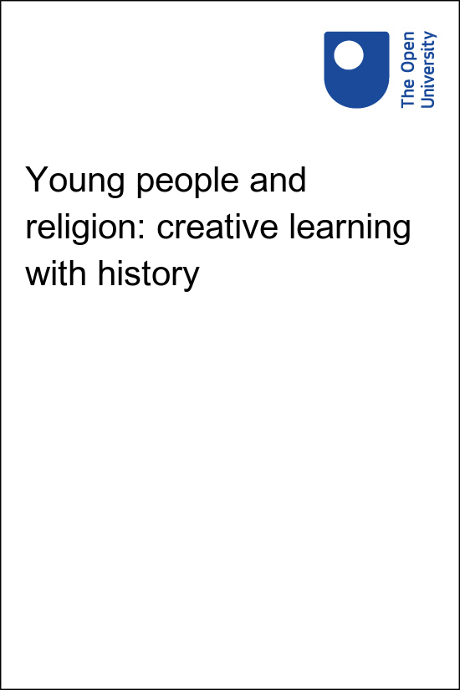

RTP_1 Young people and religion: creative learning with history

Young people and religion: creative learning with history

About this free course
This free course is an adapted extract from the Open University course .
This version of the content may include video, images and interactive content that may not be optimised for your device.
You can experience this free course as it was originally designed on OpenLearn, the home of free learning from The Open University –
There you’ll also be able to track your progress via your activity record, which you can use to demonstrate your learning.
Copyright © 2022 The Open University
Intellectual property
Unless otherwise stated, this resource is released under the terms of the Creative Commons Licence v4.0 http://creativecommons.org/licenses/by-nc-sa/4.0/deed.en_GB. Within that The Open University interprets this licence in the following way: www.open.edu/openlearn/about-openlearn/frequently-asked-questions-on-openlearn. Copyright and rights falling outside the terms of the Creative Commons Licence are retained or controlled by The Open University. Please read the full text before using any of the content.
We believe the primary barrier to accessing high-quality educational experiences is cost, which is why we aim to publish as much free content as possible under an open licence. If it proves difficult to release content under our preferred Creative Commons licence (e.g. because we can’t afford or gain the clearances or find suitable alternatives), we will still release the materials for free under a personal end-user licence.
This is because the learning experience will always be the same high quality offering and that should always be seen as positive – even if at times the licensing is different to Creative Commons.
When using the content you must attribute us (The Open University) (the OU) and any identified author in accordance with the terms of the Creative Commons Licence.
The Acknowledgements section is used to list, amongst other things, third party (Proprietary), licensed content which is not subject to Creative Commons licensing. Proprietary content must be used (retained) intact and in context to the content at all times.
The Acknowledgements section is also used to bring to your attention any other Special Restrictions which may apply to the content. For example there may be times when the Creative Commons Non-Commercial Sharealike licence does not apply to any of the content even if owned by us (The Open University). In these instances, unless stated otherwise, the content may be used for personal and non-commercial use.
We have also identified as Proprietary other material included in the content which is not subject to Creative Commons Licence. These are OU logos, trading names and may extend to certain photographic and video images and sound recordings and any other material as may be brought to your attention.
Unauthorised use of any of the content may constitute a breach of the terms and conditions and/or intellectual property laws.
We reserve the right to alter, amend or bring to an end any terms and conditions provided here without notice.
All rights falling outside the terms of the Creative Commons licence are retained or controlled by The Open University.
Head of Intellectual Property, The Open University
978-1-4730-3676-5 (.kdl) 978-1-4730-3677-2 (.epub)

Contents
- Young people and religion: creative learning with history
  - Introduction
  - What is a badged course?
    - How to get a badge
  - Course structure
  - Resourcing your workshop
- Session 1 Engage – exploring religious diversity
  - Introduction
  - 1 Religious diversity in Europe
  - 2 Young people’s views on religion, toleration and history
    - 2.1 Exploring religious views in your group
  - 3 The RETOPEA clippings collection
  - 4 Using the clippings to teach about religious toleration and peace
    - 4.1 Helping young people navigate and use the collection
  - 5 Session 1 quiz
- Session 2: Plan – preparing to create your docutube
  - Introduction
  - 1 Types of documentary film
  - 2 Communicating key messages through docutubes
  - 3 Connecting past and present
    - 3.1 Beginning the planning phase
  - 4 The ingredients of a docutube
    - 4.1 Ingredients of a docutube: who, what and where
    - 4.2 Ingredients of a docutube: making a ‘shooting script’
    - 4.3 A filmmakers perspective
    - 4.4 The teacher’s role
  - 5 Session 2 quiz
  - 6 Summary of Session 2
- Session 3: Create – filming and editing
  - Introduction
  - 1 Working together as a team
  - 2 Ethical considerations
  - 3 A teacher’s perspective
  - 4 Filming: some tips and tricks from a professional filmmaker
  - 5 Editing: bringing it all together
    - 5.1 The principles of video editing
    - 5.2 Developing the edit
  - 6 Session 3 quiz
  - 7 Summary of Session 3
- Session 4 Reflect – deepening the learning experience
  - Introduction
  - 1 The finished product: examples of docutubes
  - 2 Rolling out the red carpet
  - 3 Findings from the evaluation of the pilot workshops
  - 4 Session 4 quiz
  - 5 Summary of Session 4
  - Where next?
- References
- Acknowledgements
- Solutions

Young people and religion: creative learning with history

Introduction
This free course is intended for teachers and other educators and leaders working with young people in both formal and informal educational settings. The course will provide practical guidance and resources for running workshops for young people between the ages of 13 and 18 to stimulate reflection on religious diversity.
Young people and religion: creative learning with history presents conclusions from a major European project on Religious Toleration and Peace (RETOPEA). This project explored historical and contemporary examples of religious diversity to provide an informed basis for thinking about how to make contemporary society more harmonious. Using the findings, this course will enable you to engage young people with a collection of short texts, images and videos (which will be referred to as ‘clippings’) to broaden their understanding of the subject and make their own short films (which will be referred to as ‘docutubes’) to share their ideas and experiences. Some of the concepts explored and learning activities suggested can also be pursued independently of the filmmaking exercise.

Figure 1 Young people filming their docutube during a workshop in Granada, Spain
View description - Figure 1 Young people filming their docutube during a workshop in Granada, Spai ...

The docutube workshops are based on a pedagogic approach that encourages young people to be active, creative, express their voice and ‘make and do’, rather than ‘sit back and be told’ or simply recall facts. The workshops aim to inspire a ‘hands-on approach to learning, and a spirit of enquiry and questioning’ (Gauntlett, 2011, p. 12). It has been found that the creative process of making short films can be a good way of encouraging young people to actively engage with and reflect on issues relevant to religious toleration and peace in the past and present. This awareness enriches their perspectives on their present-day situation which they are then able to articulate in films. The process can also support the development of a range of other important skills, such as successful team working, inspiring young people to connect with each other, whilst stimulating their curiosity and imagination.
The course has been developed through a series of pilot workshops with young people in eight European countries (Belgium, Estonia, Finland, Germany, Poland, North Macedonia, Spain and the UK). A large majority (83%) of the 65 young people that completed anonymous questionnaires as part of the evaluation of our pilot workshops told us that the RETOPEA project helped them think of religious toleration and peace in new ways, saying, for example, that ‘It has made me realise and think about religious peace and how my actions can help keep peace’. 80% felt that making a docutube film helped them learn about religious peace and toleration. 92% said that they enjoyed making their docutubes, telling us, for instance, that they liked that the workshop involved ‘practical learning, not just reading books’, working ‘with your hands and your brains’ as well as ‘communicating with other people and learning about their opinion’.
During the course you will view a series of short films giving you a flavour of what happens at a RETOPEA workshop. To begin the course watch this first short film.

Video content is not available in this format.
Video 1
View transcript - Video 1

View description - Uncaptioned Figure

You can work through the course at your own pace. You will be able to test your understanding of the course through the interactive quizzes at the end of each session. The Session 4 quiz will provide you with an opportunity to earn a digital badge to demonstrate your new skills. You can read more on how to study the course and about badges in the next sections.
After studying this course, you should be able to:
- demonstrate awareness of the attitudes of young people to matters of religious toleration and peace both in a local context and in wider European perspective
- help young people articulate and reflect on their own ideas and attitudes regarding religion and religious diversity
- find online resources designed to stimulate and inform young people’s thinking about religion through increased awareness of its role in history and in present-day politics, media and culture
- confidently lead a group of young people in planning and making short films to put forward their own ideas about religious toleration and peace
- reflect critically with the workshop participants on what everyone has learned from the experience.

Moving around the course
In the ‘Summary’ at the end of each section, you will find a link to the next section. If at any time you want to return to the start of the course, click on ‘Full course description’. From here you can navigate to any part of the course.
It’s also good practice, if you access a link from within a course page (including links to the quizzes), to open it in a new window or tab. That way you can easily return to where you’ve come from without having to use the back button on your browser.

What is a badged course?
While studying this course you have the option to work towards gaining a digital badge.
Badged courses are a key part of The Open University’s mission to promote the educational well-being of the community. The courses also provide another way of helping you to progress from informal to formal learning.
Badged courses are available on The Open University’s OpenLearn website and do not cost anything to study. You do not receive support from a tutor, but you do get useful feedback from the interactive quizzes.

What is a badge?
Digital badges are a new way of demonstrating online that you have gained a skill. Colleges and universities are working with employers and other organisations to develop open badges that help learners gain recognition for their skills, and support employers to identify the right candidate for a job.
Badges demonstrate your work and achievement on the course. You can share your achievement with friends, family and employers, and on social media. Badges are a great motivation, helping you to reach the end of the course. Gaining a badge often boosts confidence in the skills and abilities that underpin successful study. So, completing this course could encourage you to think about taking other courses.

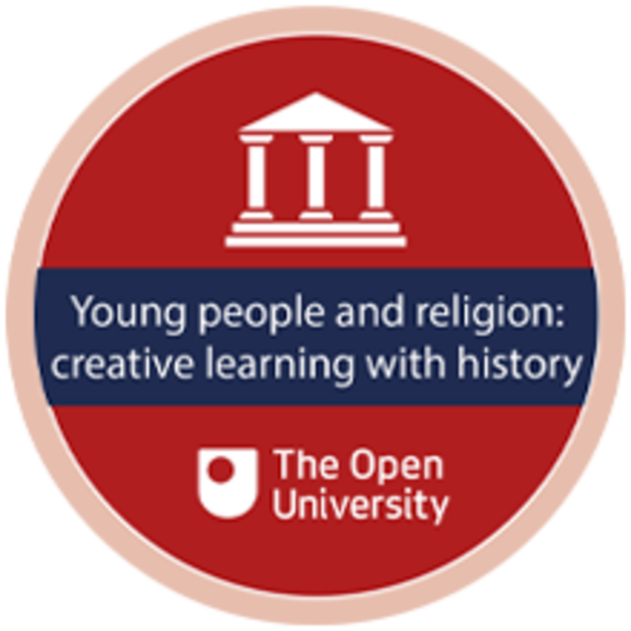
View description - Uncaptioned Figure

How to get a badge
Getting a badge is straightforward! Here’s what you have to do:
- read all sections of the course
- score 50% or more in the badge quiz in Session 4 (if you’re not successful in getting 50% the first time, after 24 hours you can attempt the whole quiz again and come back as many times as you like).
For all the quizzes, you can have three attempts at most of the questions (for true or false type questions you usually only get one attempt). If you get the answer right first time you will get more marks than for a correct answer the second or third time. Therefore, please be aware that for the badge quiz at the end of Session 4 it is possible to get all the questions right but not score 50% and be eligible for the badge on that attempt. If one of your answers is incorrect you will often receive helpful feedback and suggestions about how to work out the correct answer.
We hope that as many people as possible will gain an Open University badge – so you should see getting a badge as an opportunity to reflect on what you have learned rather than as a test.
If you need more guidance on getting a badge and what you can do with it, take a look at the OpenLearn FAQs. When you gain your badge you will receive an email to notify you and you will be able to view and manage all your badges in My OpenLearn within 24 hours of completing the criteria to gain a badge.

Course structure
The course is divided into four sessions:
- Session 1: Engage
This session explores the theme of religious diversity in Europe and the attitudes of young people towards it. It suggests an approach to gathering initial insights into the ideas of your participating young people. It then introduces the RETOPEA ‘clippings’ collection of online resources and provides guidance on its use in teaching and discussion.
You should allow 3 hours study time for this session.
- Session 2: Plan
This session focuses on supporting young people in planning their films. You will view examples of films that have already been made in pilot workshops and consider different styles of documentary film-making. You will think about how to help young people turn an initial concept into a viable series of sequences and script for a film.
You should allow 3 hours study time for this session.
- Session 3: Create
Session 3 emphasises how the purpose of the exercise is to stimulate consideration of matters of religious toleration and peace. In that context, it provides practical advice on organisational, creative and technical aspects of supporting young people to make films. You are advised on the basic ethical and safety awareness you will need to instil in your participating young people.
You should allow 3 hours study time for this session.
- Session 4: Reflect
This session emphasises the importance of feedback and discussion if participants are to gain full benefit from the experience. It summarises the experience of the RETOPEA project team in running pilot workshops and then suggests approaches to facilitating reflection in your own group of young people.
You should allow 2 hours study time for this session.
Note that there is no need to complete a session in one sitting. The four sessions are used to organise the learning material and the associated quizzes and you should feel entirely free to pause part way through a session and resume later if that best suits your own schedule.
The course includes practical resources, marked ‘IN PRACTICE’. These are highlighted on the relevant pages and should be revisited when you are ready to run your own workshop. A downloadable summary sheet for quick reference will also be provided.
Each session will include short films of young people at the four different stages of the project: engage, plan and create and reflect. These films are also designed to be a stimulating resource for you to show young people in your own RETOPEA workshop.

Activity 1

RETOPEA has created an animation to explain the concept of the docutube and engage the interest of young people right from the outset. Watch the film yourself, and as you watch consider how you might use it with your own group of young people. Use the note-taking box to write down your ideas.

Video content is not available in this format.
Video 2
View transcript - Video 2

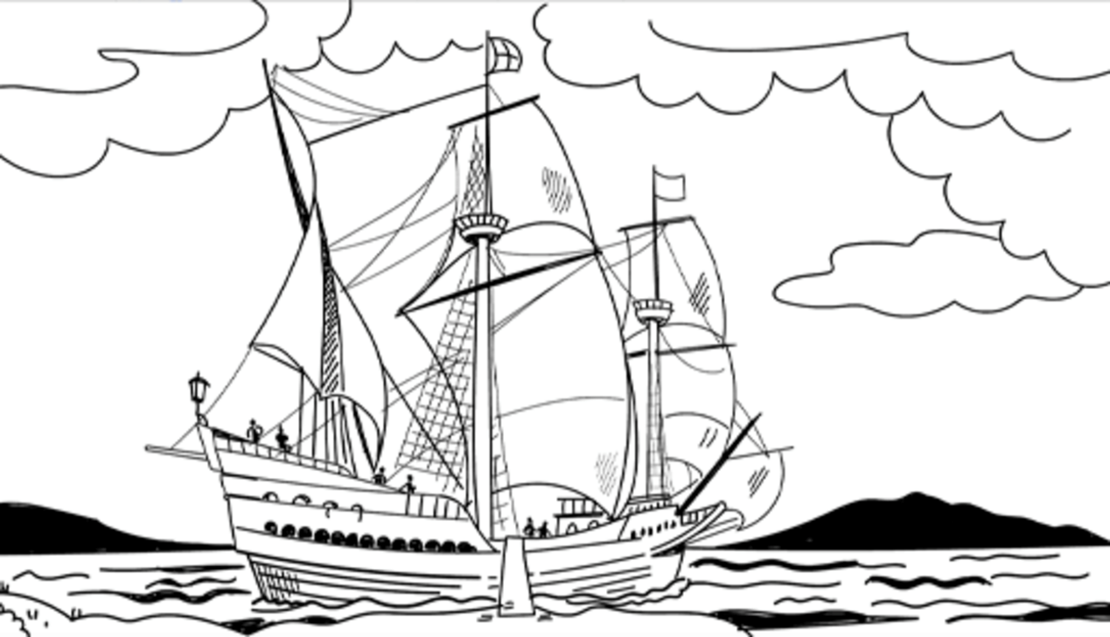
View description - Uncaptioned Figure

Provide your answer...

Resourcing your workshop
The course will provide detailed guidance on the content and management of a workshop, but even at this early stage you are likely to be wondering how much time should be allowed for it, and what equipment and other resources will be required. The following ‘IN PRACTICE’ activity provides some recommendations around this.

IN PRACTICE: Resourcing your workshop

Time
If the workshop is to be delivered in an intensive manner, we recommend setting aside three full days, although with good management and tight timetabling, it will be possible to deliver it in two days. It would therefore be suitable for inclusion in an activity week, such as those run by some schools in periods following exams when there is a natural break in delivering the core syllabus. A museum or public library might offer the workshop as part of a school holiday programme. A youth group might include the workshop over a weekend or as part of a residential week away, provided necessary equipment and possibilities for filming are available at the chosen location.
An alternative model, which has also proved successful, is to run the workshop as a course of several shorter sessions spread over several weeks. If this approach is adopted, a corresponding total amount of contact time (15–20 hours) is advised. If that format is adopted, it will probably be necessary to include at least one extended session in order to facilitate filming especially if this is to be done in locations away from the usual base.

Equipment
Ideally, if budgets allow, the use of small GoPro cameras or similar is recommended. These are easy to use and provide satisfyingly good quality results. The guidance in subsequent sections of the course reflects the RETOPEA project’s own experience with these cameras.

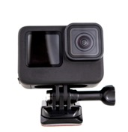
Figure 2 A GoPro camera or similar is recommended for this project
View description - Figure 2 A GoPro camera or similar is recommended for this project

Realistically, however, many participants will use their own mobile phones, tablet or other device provided by the organisers. The quality of the resulting films is unlikely to be as good as when using a camera such as a GoPro, but the underlying learning experience will be similar. If personal mobile phones are used, the ethical risks, particularly of inappropriate sharing of sensitive material, will need to be acknowledged and mitigated. Further advice is provided in Session 3: Create.
If a GoPro camera is used, films will need to be edited on a laptop or PC using whatever basic editing software package is readily available. If filming has been done using a phone or tablet, then an editing app can be downloaded to the device. To ensure the smooth running of the edit, you are strongly advised to consult someone in your community with IT skills in the early stages of planning the workshop and for them to be available on call while participants are editing their films.

You can now go to Session 1.

Session 1 Engage – exploring religious diversity

Introduction

‘You have to stand proudly for the national anthem or you shouldn’t be playing, you shouldn’t be there, maybe you shouldn’t be in the country’ – Former US President, Donald Trump (Carpenter, 2018)

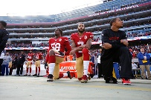
Figure 1 American footballers Eli Harold, Colin Kaepernick and Eric Reid take the knee during the American national anthem ahead of a game.
View description - Figure 1 American footballers Eli Harold, Colin Kaepernick and Eric Reid take the ...
View description - Figure 1 American footballers Eli Harold, Colin Kaepernick and Eric Reid take the ...

Despite the common cliché that sport and politics should not mix, sport has consistently demonstrated itself to be a breeding ground for political endeavours. The argument that sport and politics should remain independent of one another is perhaps most prevalent when it comes to athletes voicing political opinions (Butterworth, 2016). Politicians themselves project similar viewpoints across sport as emphasised by the quote from Donald Trump above when responding to the national anthem protests that have spread across the United States since 2016.
This first session is designed to give a broad introduction to sport and politics, before delving into football and the World Cup more specifically in subsequent sessions.
First, take a brief moment before you get started by putting the term politics into some context. Politics has been described as a series of activities through which it is decided, often by negotiation but frequently by force, who should get what, where and how (Bairner et al., 2016), and can be explained by the use of a lower case and capital letter:
- Small ‘p’ politics refers to any form of social organisation where matters are concerned with getting or using power within a particular group e.g., there is plenty of ‘office’ politics within, and often between, sports organisations.
- Big ‘P’ Politics often focuses on governmental decision making, world trade agreements and global affairs. The Politics in Europe does not often address sport.
Throughout this course you will see examples of both and within the next section you will be introduced to how sport often has political dimensions.

1 Religious diversity in Europe
Europe is a religiously diverse continent. Although some East Asian and African countries have higher levels of religious diversity, many European countries have obtained high Religious Diversity Index scores as calculated by the Pew Research Center. In 2010, the European countries in the top quarter of religious diversity scores included (in descending order) the Netherlands, Bosnia-Herzegovina, France, Belgium, Latvia, North Macedonia, Estonia, Sweden, Germany and the United Kingdom (Pew Research Center, 2014).

Activity 1
Allow about 15 minutes for this activity

Take a look now at the full table showing Religious Diversity Index Scores by Country by the Pew Research Center.
The table initially displays in alphabetical order of country, but by clicking on the headers you can make it display in order of Diversity Index (RDI), or in the order of percentages of a particular religion. Explore the table and note down your thoughts as to why the European countries listed above scored highly on this measure of diversity? Can you think of ways in which their various pasts have shaped their present-day diversity?

Provide your answer...
View discussion - Activity 1

Europeans have a mixed record in managing religious diversity, even diversity within the continent’s historically dominant religion, Christianity. Examples of intolerance are numerous: the expulsion of Muslims from Spain at the end of the fifteenth century; the ‘wars of religion’ of the sixteenth century; the Catholic French King Louis XIV’s withdrawal in 1685 of the toleration of Protestants granted by his grandfather Henry IV in 1598; and the repression of all religions in the Soviet Union and its satellite states during the twentieth century. Most extreme of all was the genocide of the majority of European Jews in the Holocaust of the 1940s.
Nevertheless, the RETOPEA project (and so this course) starts from the assumption that informed engagement with the past of both European and non-European countries can also offer us positive ideas of religious toleration. For example, the ancient Indian Emperor Ashoka desired ‘that in all places should reside people of diverse religious sects’ (quoted in Mukherjee, 1928, pp. 149–50); the sixteenth-century Polish King Stephen sought to preserve religious peace by saying he ‘did not want to rule consciences’ (Keckermannus, 1610); and the Charter of Fundamental Rights of the European Union, proclaimed in the year 2000, prohibits discrimination on grounds of ‘religion or belief’ (European Union Agency for Fundamental Rights, 2000), among other things.

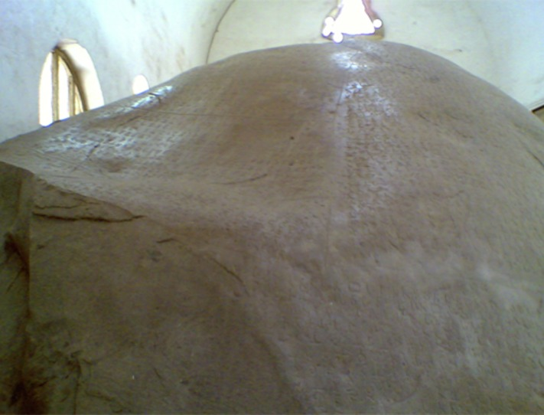
Figure 1 The Mansehra rock in Pakistan inscribed with the Emperor Ashoka’s edicts, including his requirement to accept religious diversity
View description - Figure 1 The Mansehra rock in Pakistan inscribed with the Emperor Ashoka’s edicts, ...

As important as these formal statements by political leaders, however, was the widespread ‘on the ground’ ability of people of different religions to live peacefully alongside each other, whatever their leaders’ aspirations for toleration. In many countries, although such co-existence can break down, sometimes with tragic consequences, historical periods have shown that peace and cooperation is a more enduring reality than conflict and persecution.
In 2018, the then German Chancellor Angela Merkel declared that ‘tolerance is the soul of Europe’ (quoted in European Parliament, 2018). The historical reality is more complex, but if her assertion is to become a reality for the future, young people need to understand and engage with the legacies of the past and be equipped to challenge misuses of the past that can fuel intolerance.

2 Young people’s views on religion, toleration and history
Before you begin thinking about how to engage young people with the issues of religion and toleration, it is worth pausing to look at what is already known about their attitudes towards religious diversity. Ongoing research (see: Maiden, Salmesvuori, Sinclair, Van Nieuwenhuyse and Wolffe, 2022) has led to the following insights:
- Young people value religious diversity and are usually more positive about it than older people (in theory, at least). However, some of them still hold significant prejudices, for example against the building of mosques, in Germany.
- Numerous ‘concentric circles’ of influence shape young people’s views, with family the most important, followed by friends and school, and only then their own faith community (if indeed they belong to one).
- Local context is important. For example, RETOPEA project researchers found significant contrasts between young people in schools in London situated in highly diverse multi-faith areas and those in a school in a town in the north-west of England with a majority white population. Frequent meaningful contact with people of other religions, especially in school, leads to greater tolerance and acceptance.
- Broadcast media has limited impact. While stereotypes are propagated by both news and dramas – for example, of Muslim extremists or Catholic paedophiles – young people have a critical approach to such material and would like to see the media being more nuanced and balanced in its treatment of religion. Their own views are increasingly likely to be influenced by YouTube and social media as well as by more traditional media. Although social media is not subject to traditional ‘gatekeepers’ and can therefore promote fake news such as conspiracy theories, it can have positive impacts too. However, it is vitally important to promote visual and media literacy so that young people are equipped to make sound judgements.
- Young people often have a limited ‘presentist’ understanding of the past which often reflects their limited knowledge. They tend to seize on episodes such as the Holocaust or so-called ‘wars of religion’ as evidence that things were ‘worse’ in the past than in the present or impose anachronistic moral judgements without awareness of the complexities of historical contexts. A central objective of the RETOPEA project is to provide resources and encouragement to challenge this view of the past, and to help young people to see it as a source of ideas to think creatively about their present-day situation instead.

Activity 2
Allow about 15 minutes for this activity

Before you read on, pause to consider to what extent these broad generalisations are true of the young people you are working with, bearing in mind your specific local and organisational context. You may find it helpful to make some notes below.

Provide your answer...

2.1 Exploring religious views in your group
The IN PRACTICE activity below should be completed at your first workshop and will help to give you an idea of your young participants’ views on religion.

IN PRACTICE: Exploring views in your group
As an initial step we recommend using a simple questionnaire and discussion both to inform yourself further on the views of the young people you work with, and to stimulate them to begin to think more about the issues for themselves. You should consider in your context whether, in view of potential sensitivities, you should make participation voluntary, and in any case avoid forcing contributions from individuals who may feel uncomfortable. The RETOPEA project team’s experience, however, has been that young people are usually very willing to participate and indeed welcome the opportunity to discuss these issues.

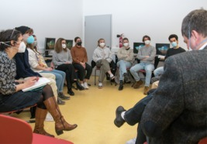
Figure 2 A group discussion at a docutube workshop at a school in Germany
View description - Figure 2 A group discussion at a docutube workshop at a school in Germany

First, ask participants to spend five to ten minutes to quietly and anonymously complete a short written questionnaire on the following lines:
- How important (if at all) is religion to your life?
Please circle a score between 1 (not important at all) and 5 (of great importance).
- Have you ever observed prejudice or bias against religion in the area where you live?
Please circle one of the following answers: Yes – No – Not sure.
- Have you ever experienced bias against your religious or non-religious beliefs?
Please circle one of the following answers: Yes frequently – Yes sometimes – Hardly ever – No – Not sure.
You should also allow space for open comments and explanations. The questionnaire should prompt useful initial thinking that then leads into subsequent lively discussion.
Click here for a downloadable version of the questionnaire which you can adapt to suit your own circumstances.
Once you have collected the questionnaires you should then lead a discussion. The ideal seating plan is a circular arrangement of chairs, with teachers and facilitators also part of the circle, so as to encourage discussion amongst the young people. Remember that the point of the group interviews is to give as much agency as possible to the young people to share and respond to views.
The discussion should cover the following themes:
- Representations of religion and religious diversity in the media (including questions, such as ‘How accurate or inaccurate, fair or unfair, do you think different types of media are when they discuss different religious groups?’)
- Religious diversity in the past (e.g. ‘Historically, how religiously diverse do you think your city/town/country/Europe has been? Are there any particular ‘turning points’ when your city/town/country/Europe became more or less religiously diverse?’)
- Religious diversity in present-day society (e.g. ‘In the present day, to what extent do you think religious diversity offers benefits or challenges to society?’)
- Potential connections between approaches to religious diversity in the past and present (e.g. ‘Are there ways in which we can learn from history?’)
- The nature of religious tolerance – what does it mean in practice?
It is recommended that you allow up to one hour for the discussion. The aim is to trigger conversation. It can be a good idea to invite participants initially to discuss in pairs before sharing with the larger group. Use your professional skills to facilitate the conversation by:
- giving participants time to think even if this means the occasional awkward silence
- allowing young people their voice but steering the conversation back if they get stuck on irrelevancies
- affirming healthy differences of opinion or experience but managing conflict or aggression firmly.
- allowing time for each question, though if particular questions have triggered good discussion, allow this to run.
Make some notes to record your impressions of their reactions and ideas. These will help to inform your subsequent guidance of the docutubes process.

3 The RETOPEA clippings collection
The approach which RETOPEA has taken to engaging young people with issues around religious toleration is based on using what have been called ‘clippings’. Between 2018 and 2020, the RETOPEA project team curated a collection of around 400 clippings — short text extracts, images and videos. They cover a wide range of national and regional contexts, and historical periods, including contemporary material. Each clipping aims to provide some context for the source in question, and also some questions to stimulate reflection and discussion. To make navigation of the collection easier, the clippings are grouped into twelve themes, each of which has its own short introduction.

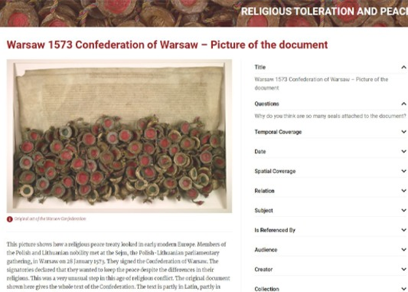
Figure 3 An example clipping about the 1573 Confederation of Warsaw
View description - Figure 3 An example clipping about the 1573 Confederation of Warsaw
View description - Figure 3 An example clipping about the 1573 Confederation of Warsaw

The primary purpose of the clippings is not to teach young people about history in the conventional way, but rather to stimulate them to think about the past for themselves. They are not overloaded with detailed background information, as instead they should be used as a resource of potential new ideas relevant to the challenges and opportunities presented by religious diversity in the present.

Activity 3
Allow about 30 minutes for this activity

Now spend some time – up to 30 minutes – browsing the Religious Toleration and Peace clippings collection, and familiarising yourself with the various themes and some of the individual clippings that attract your interest. You might like to try searching for clippings that relate to a religion you are particularly interested in, one of the twelve themes that engages your attention, a specific time period, or your own country, city or region.
Identify and note in the text box below up to five clippings that you think will be of interest to your group. In the next section you will consider further how best to present them to young people.
Religious Toleration and Peace clippings
To avoid losing your place in the course, you should open the link in a new tab or window by holding down Ctrl (or Cmd on a Mac) when you click on it. If you are studying on a mobile device hold down the link and select to ‘Open in New Tab’. Return here when you have finished.

Provide your answer...

4 Using the clippings to teach about religious toleration and peace
You will now look more closely at some clippings in order to explore how these can effectively be used in teaching and discussion. You will begin with an historical example in Activity 4.

Activity 4
Allow about 20 minutes for this activity

The clippings collection is intended to stimulate innovative ways of thinking about the past and its relationship to the present. In this activity, you will look at an extract from the writings of Roger Williams, the seventeenth-century Puritan founder of the state of Rhode Island, who you met in the animation earlier in the course. Look at this clipping now and think about how you might help young people to engage with it and be inspired by it. If you see challenges in doing so, how would you hope to overcome them? Make some notes in response to these questions in the text box below.
Roger Williams and society as a ship clipping

Provide your answer...
View discussion - Activity 4

The collection also includes a substantial proportion of clippings that relate to contemporary and near-contemporary contexts. You will look at examples of this next in Activity 5.

Activity 5
Allow about 25 minutes for this activity

You are now going to take two clippings that reflect strongly contrasting views of Islam. The first is the hostile propaganda of the German right-wing party Alternative für Deutschland (AfD) (which of course in no way reflects the views of OpenLearn nor the RETOPEA team) and the second is a video about the Liverpool football star Mo Salah, whose Muslim faith has proved no obstacle to his popularity in his adopted city.
Look at these clippings and then spend some time thinking about how you might use them to stimulate constructive discussion and reflection among both Muslim and non-Muslim young people. How would you handle polarised reactions of agreement or outrage at the poster? What are the advantages and risks of drawing contrasts between the two clippings? In what ways is history still relevant to this contemporary material? Make some notes in the box below.

Provide your answer...
View discussion - Activity 5

4.1 Helping young people navigate and use the collection
The following IN PRACTICE activity offers suggestions on how to introduce the clippings to your young participants in the workshop and encourage them to engage with them.

IN PRACTICE: Helping young people navigate and use the collection
Approaches to the clippings collection are likely to be determined by two key considerations:
- The age and ability of the group.
- The amount of time available for the workshop or course.
If your time is limited or if the participants are younger and/or of lower ability, it may well be best for you, the teacher or leader, to make your own preliminary section of between three and six clippings and to introduce them to the group. Especially for younger teenagers, three may well be sufficient; with an older group you might make a somewhat larger selection and assign two clippings each to subgroups who would then discuss them and report back to a plenary session. Especially for clippings that include text from historic documents, some explanation and clarification of unfamiliar language may be helpful.
The website also includes (in the ‘Narratives’ section) examples of selections made for pilot workshops, which illustrate some of the thematic linkages that might be made, and how the clippings can be related to participants’ own experience. One of these selections could be adopted as a ‘package’ or, preferably, modified and developed to accommodate the situation and interests of the group. This approach requires a session of 1.5 to 2 hours in order to ensure participants understand the selected clippings and are engaging thoughtfully with them. Participants should be encouraged to consider the questions on the website associated with each clipping and might be given a printed question-sheet (as illustrated in Video 1) to prompt additional thinking and ideas.

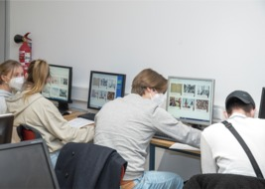
Figure 4 Young people in Germany working with the RETOPEA clippings collection
View description - Figure 4 Young people in Germany working with the RETOPEA clippings collection

Ideally though, you should encourage older (16+) young people to work in small groups of three or four, to browse the collection for themselves with a view to making a selection of up to five clippings that particularly engage their interest, and that they would like to study and discuss further. They could start with one of the themes identified on the website and/or use the search facility to look for clippings on a particular topic, religion, period of history, or country that interests them. Participants should be encouraged to feel free to make their own choices, while also thinking about ways in which their choices can be linked with each other and related to their own situation and experience. Young people will need sufficient time to carry out such a process effectively and to their own satisfaction. A session of at least 1.5 to 2 hours is therefore recommended for that purpose.

Activity 6
Allow about 20 minutes for this activity

Throughout this course, you will see videos of practitioners giving advice about aspects of running a workshop. The first of these is from Professor Karel Van Nieuwenhuyse of KU Leuven, a teacher educator and member of the RETOPEA team. He discusses how to get the best educational value from the clippings, and ensure that learners engage with them in different European settings. As you watch, make notes on how you might apply his suggestions in your own situation.

Video content is not available in this format.
Video 3
View transcript - Video 3

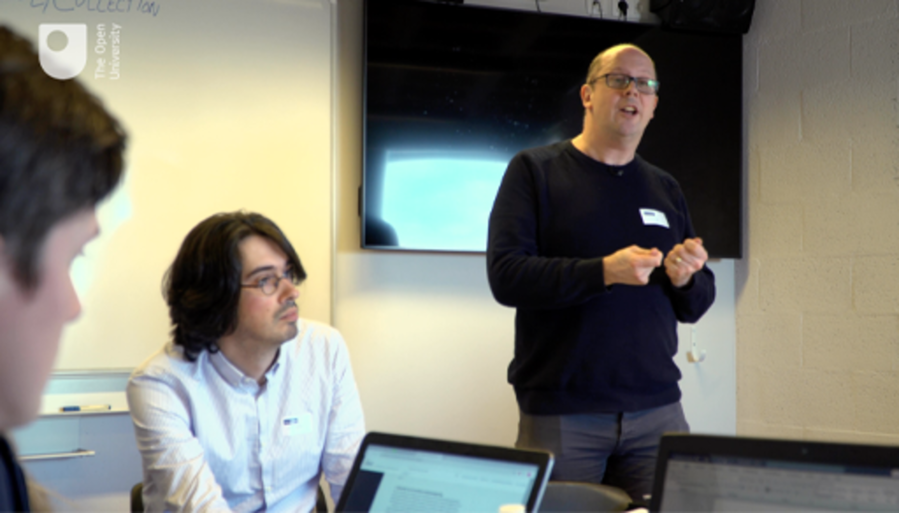
View description - Uncaptioned Figure

Provide your answer...
View discussion - Part

The next perspective is from Annie Powell, a teacher at the east London school mentioned in Activity 4. As well as giving advice on how to approach the clippings, Annie considers the practicalities of running a workshop in a formal educational setting. Even if you work in a less formal setting, Annie’s advice could still be relevant to you. As you watch make notes on the people or skills you could enlist to support your own workshop.

Video content is not available in this format.
Video 4
View transcript - Video 4

View description - Uncaptioned Figure

Provide your answer...
View discussion - Part

Whatever approach to the clippings is adopted, it is important to keep in mind that the primary purpose of the workshop is to stimulate new thinking about religious toleration and peace in the present-day. Hence participants should be encouraged to draw on the clippings as a source of ideas, perhaps challenging some of their previous assumptions about the past, and not to be diverted into questions about historical and other contexts that are not addressed on the website itself.

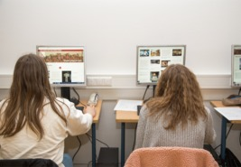
Figure 5 Young people in Germany working with the RETOPEA clippings collection
View description - Figure 5 Young people in Germany working with the RETOPEA clippings collection

5 Session 1 quiz
You can now check what you’ve learned in this section by taking the end-of-session quiz. Before you do so you will find it useful to refresh your memory and consolidate your learning so far, by rewatching the Engage video (Video 1).

Video content is not available in this format.
Video 1 (repeated)
View transcript - Video 1 (repeated)

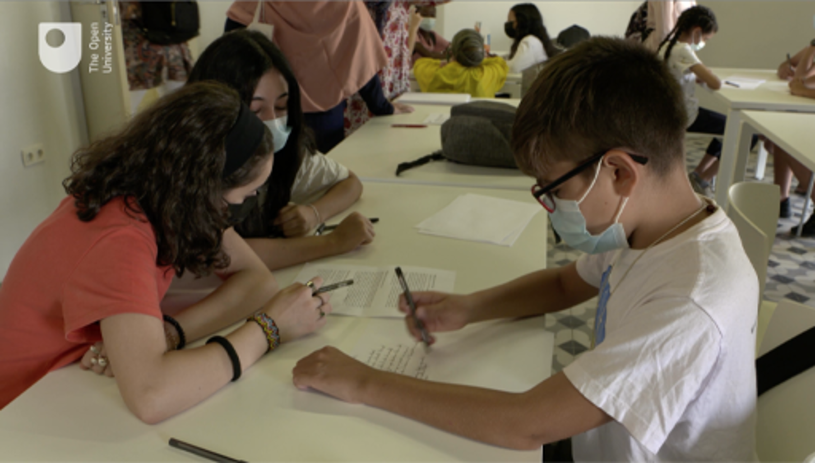
View description - Uncaptioned Figure

Open the quiz in a new tab or window by holding down Ctrl (or Cmd on a Mac) when you click on the link. Return here when you have finished.
Session 1 practice quiz

Session 2: Plan – preparing to create your docutube

Introduction
In this session you will think about helping young people creatively plan their docutubes, the short, creative films which they can produce to explore issues of religious toleration and peace. How can you help them to ‘tell a story’? Specifically, you will:
- consider different types of documentary filmmaking
- learn how to help young people decide on the key ‘message’ of their film
- think about the intellectual and visual ingredients of a docutube, and how to bring these together in a ‘shooting script’.
Before you learn about the Plan phase, watch Video 1 which will give you a sense of what it involves. The video follows young people working on their docutube plans in Granada, Leuven and London.
You will watch this video again in greater detail later, so this time, just enjoy viewing it and at the end jot down a sentence about your understanding of what the Plan phase of making a docutube is trying to accomplish.

Video content is not available in this format.
Video 1
View transcript - Video 1

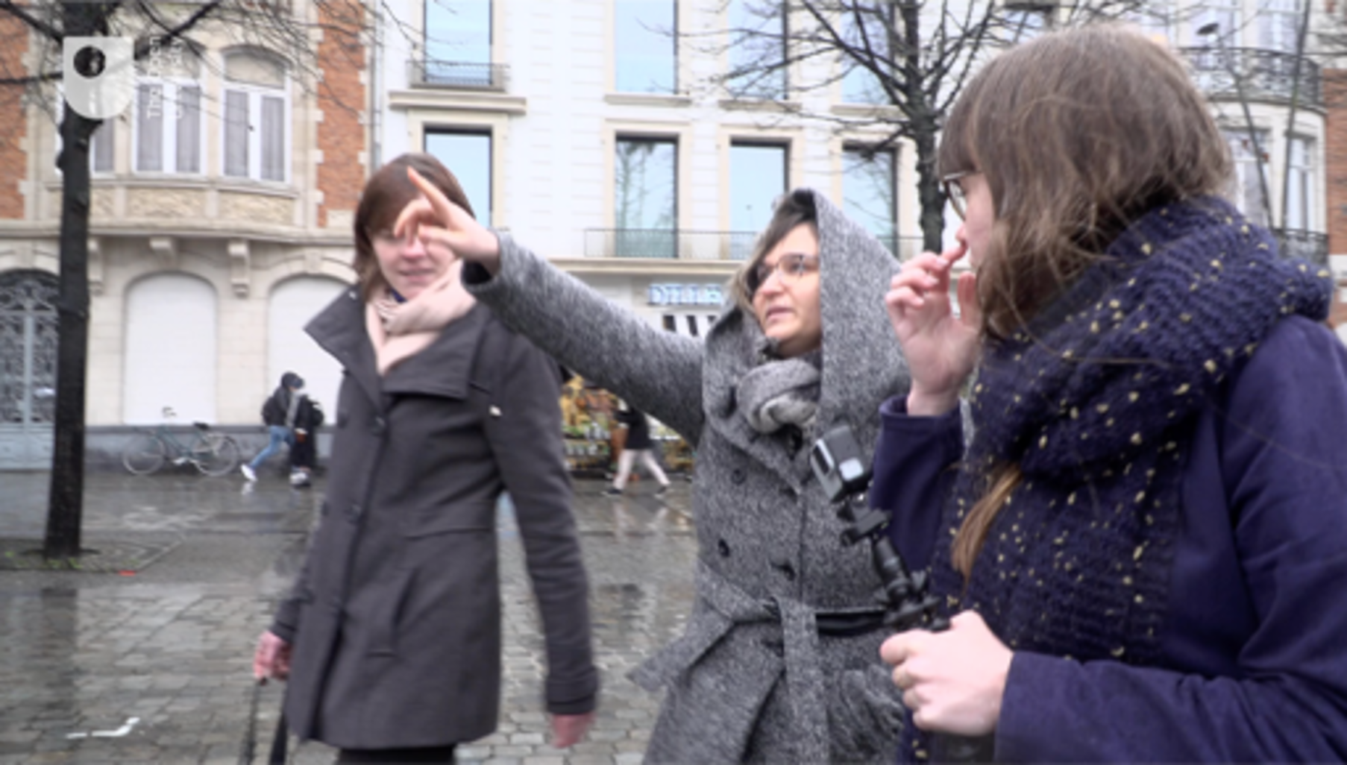
View description - Uncaptioned Figure

What is the Plan phase trying to accomplish?

Provide your answer...
View discussion - SAQ

1 Types of documentary film
The pedagogical purpose of docutubes is not to help young people become the next Steven Spielberg (although if one does, perhaps that is a welcome bonus!) – rather, the point is the learning and creative process. The aim of docutube-making is to help participants develop their ideas about religious diversity and toleration by going through a process of thinking, planning and creating in order to communicate a message to others. Docutubes, in pedagogical terms, are a means of ‘active learning’ or ‘creative analytic practice’ (Parry and Johnson, 2007; Gauntlett, 2011). As an educator, you will need to help the young people keep in mind that a docutube project is not a course in filmmaking. Perfection is not required!
Having said this, to develop and express their ideas, and to enjoy the experience, young people will benefit from having some of the basic tools to turn their ideas into a visual message. This is the goal of the planning phase.
For a moment, you will put to one side the theme of religious toleration and think about different documentary genres. Nichols (2001) suggests there are six types of documentary film. The three mentioned below are particularly relevant to docutubes:
- Expository: essentially a voiceover (‘voice of God’) approach, whereby one or more participants narrate a discussion of a range of images (objects, places etc.).
- Participatory: here, the filmmakers’ interactions with the subjects and material become the focus of the documentary.
- Performative: one in which the filmmaker(s) is actively involved in the action, perhaps even becoming the subject.

Activity 1
Allow about 10 minutes for this activity

Think about the three documentary ‘types’ and try to think of an example of each from documentaries you have seen. Write your example in the text box below. If you can’t think of an example for some, just do the ones you can.

Provide your answer...
View discussion - Activity 1

2 Communicating key messages through docutubes
The aim of docutubes is to help young people make connections between the past and present in thinking about religious diversity. Rather than viewing the past through the lens of present-day experiences, the challenge to the young people is to tell a story about the past which speaks to the present. This neatly sums up the aim of a docutube – and indeed the vision of the RETOPEA project.

Activity 2
Allow about 15 minutes for this activity

Now watch again the short animation which explains the purpose of docutubes and challenges young people to make one. This video is also available in the Resources section and can be used to promote RETOPEA to your young people. You can find the Resources section at bottom of the contents list for each session.
Pay particular attention to the central part of the animation which focuses on Roger Williams, the historical figure you encountered in Session 1. As you watch, make some notes on how the example story makes a link between past and present (you can pause the video if necessary). Then, summarise in no more than 100 words what you understand the central message of this story to be.

Video content is not available in this format.
Video 2
View transcript - Video 2

View description - Uncaptioned Figure

Provide your answer...
View discussion - Activity 2

People often talk about young people ‘finding their voice’. This requires speaking with clarity and conviction to communicate a key message. In the animation in Activity 2, the central message was about the possibility of religious freedom in a diverse society.

Activity 3
Allow about 15 minutes for this activity

A big part of the docutube Plan stage involves helping your young people decide what is the main thing they want to convey. It is now time to watch another actual docutube, produced by a group of students in Warsaw, Poland, to help you think about communicating a key message. Please note, that this docutube has been filmed in Polish; an Enlgish translation is available in the transcript.
(It is worth noting that this example is one of our longer docutubes, and it took the young people a lot of planning, filming and editing to achieve. Most docutubes will be shorter, especially if less scheduled time is available.)
In the text box below, try to summarise, in a couple of sentences, what you think the key message of the film is.

Video content is not available in this format.
Video 3 (a translation of this video is available in the transcript)
View transcript - Video 3 (a translation of this video is available in the transcript)

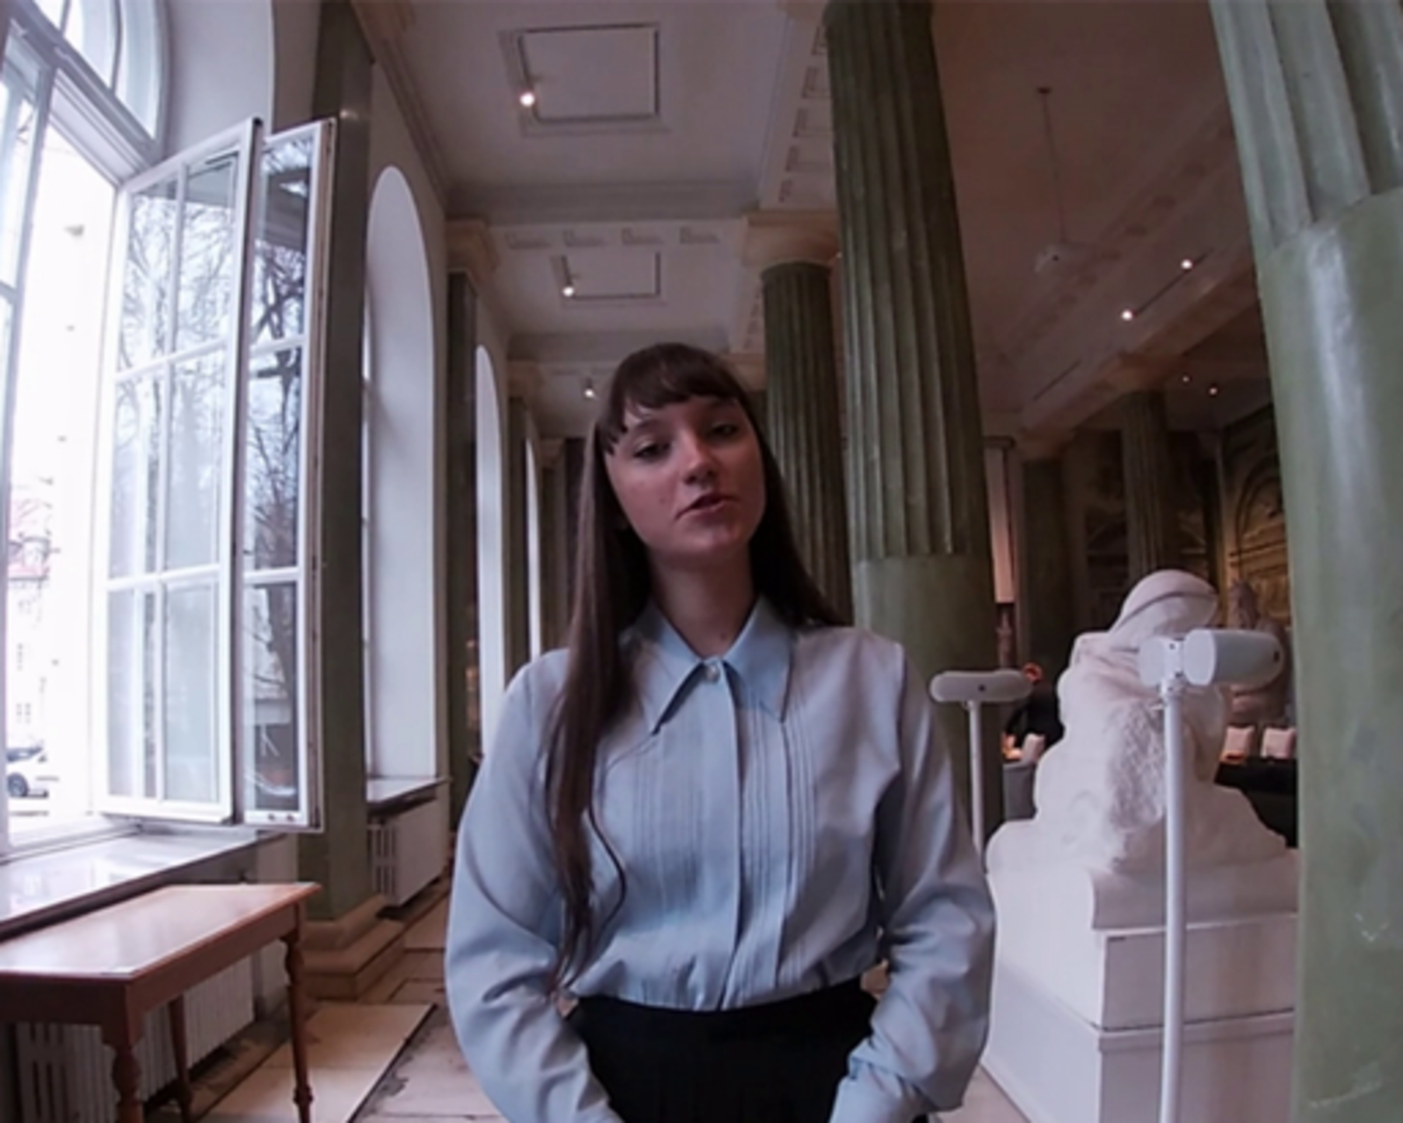
View description - Uncaptioned Figure

Provide your answer...
View discussion - Activity 3

3 Connecting past and present
The two videos you watched in the previous section both made connections between past and present. How did they do so?
- The animation about Roger Williams (Video 2) showed how ideas of religious toleration in society have a long history, and that these remain relevant for today.
- The docutube by students in Warsaw (Video 3) discussed how historic migration and place-making by religious minorities can shape attitudes of the same issues today.
The next activity will help you to think about how the RETOPEA clipping database can help you make connections between past and present.

Activity 4
Allow about 15 minutes for this activity

You are now going to take a step back and look at one of the clippings which inspired the docutube created by the Warsaw students you saw in Video 3. This will help you think about how a clipping can be used to help young peoples’ creative planning.
The clipping, which is taken from POLIN Museum of the History of the Polish Jews in Warsaw, is a seventeenth century etching of a panorama of Troki, a city which was part of the Polish–Lithuanian Commonwealth. Look at the clipping and then write in the text box below how you think it may have inspired the students’ docutube. Note the text in the figure has been reproduced below.

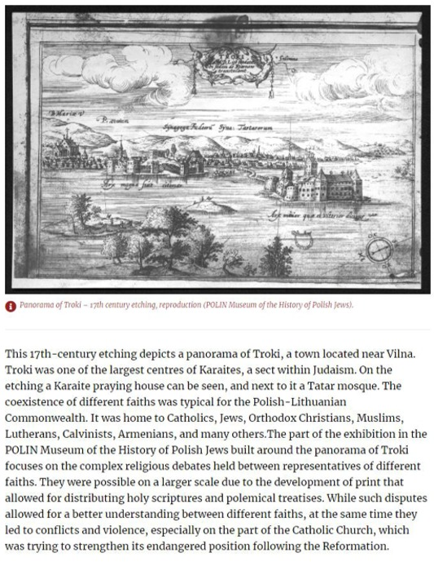
Figure 1 Clipping taken from the POLIN Museum of the History of Polish Jews
View description - Figure 1 Clipping taken from the POLIN Museum of the History of Polish Jews
View description - Figure 1 Clipping taken from the POLIN Museum of the History of Polish Jews

Text in clipping
This 17th-century etching depicts a panorama of Troki, a town located near Vilna. Troki was one of the largest centres in of Karaites, a sect within Judaism. On the etching a Karaite praying house can be seen, and next to it a Tatar mosque. The coexistence of different faiths was typical for the Polish–Lithuanian Commonwealth. It was home to Catholic, Jews, Orthodox Christians, Muslims, Lutherans, Calvanists, Armenians, and many others. The part of the exhibition in the POLIN Museum of the History of Polish Jews built around the panorama of Troki focuses on the complex religious debates held between representatives of different faiths. They were possible on a larger scale due to the development of print that allowed for distributing holy scriptures and polemical treatises. While such disputes allowed for a better understanding between different faiths, at the same time they led to conflicts and violence, especially on the part of the Catholic Church, which was trying to strengthen its endangered position following the Reformation.

Provide your answer...
View discussion - Activity 4

Although the students were inspired by this seventeenth century source, they were able to make specific, powerful links to the present. There were a number of ways in which they did this.
First, to show the importance of remembering the significant Jewish community that had existed in Warsaw before the Holocaust, they included footage of a modern artwork installation in the city called ‘Greetings from Jerusalem Avenue’. The palm tree (of the kind which is common in the city of Jerusalem), stands as a reminder of the historic Jewish community in the city.

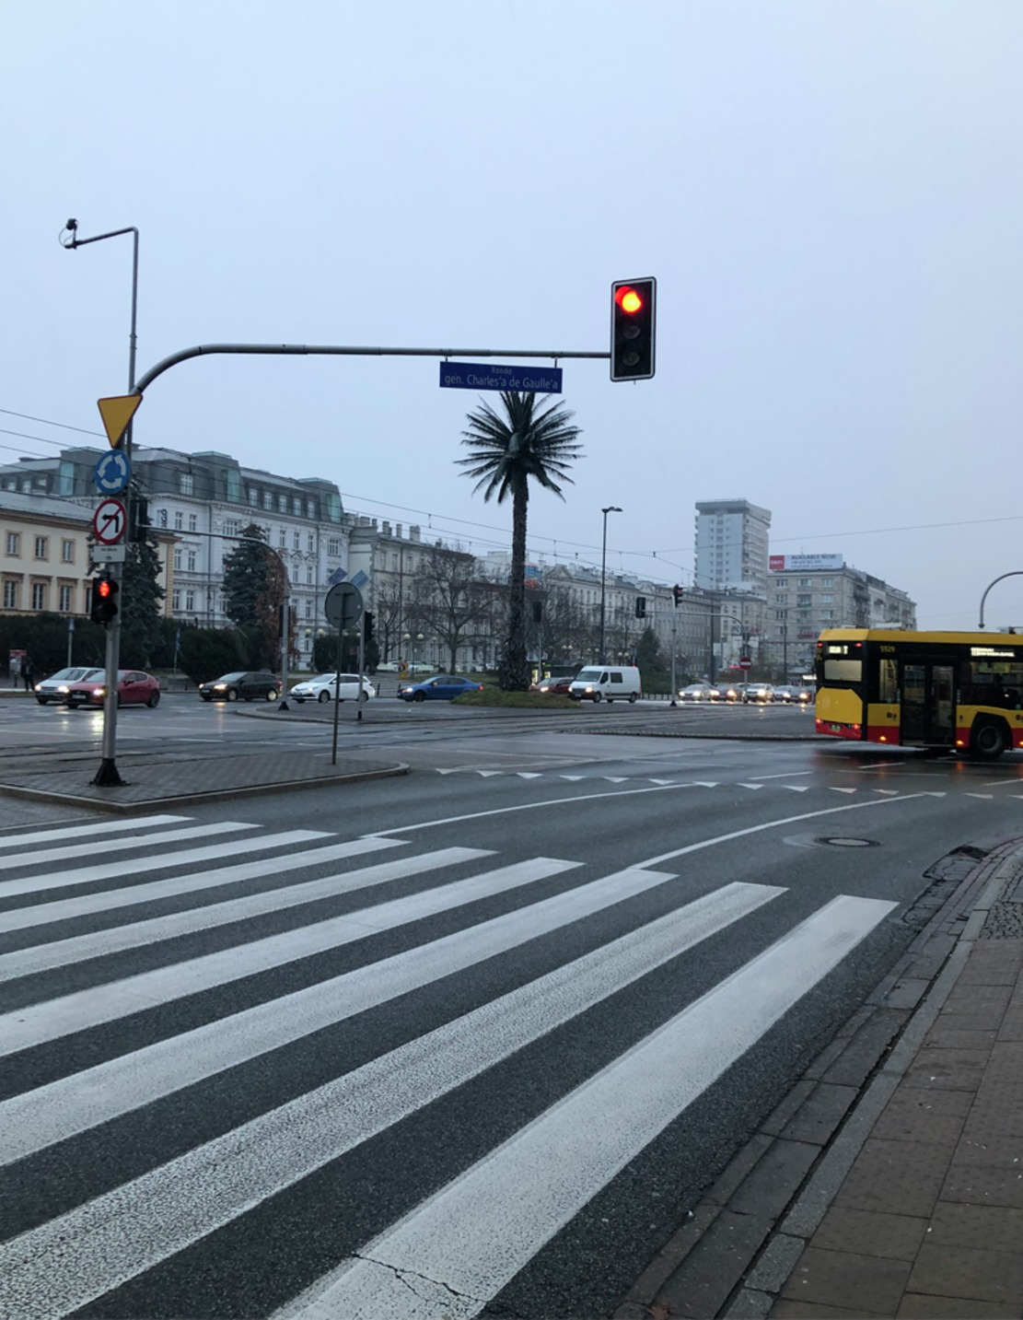
Figure 2 ‘Greetings from Jerusalem Avenue’ installation in central Warsaw
View description - Figure 2 ‘Greetings from Jerusalem Avenue’ installation in central Warsaw

The docutube included a second powerful link with the present. At the beginning of the film, the voiceover said: ‘Migrations are now often considered as something negative, especially for the countries that are welcoming migrants.’ This was a reference to a very current issue for the young people in Poland in late 2021 as there was a great deal of political and media controversy about the efforts of migrants, often from war-torn Muslim-majority countries in the Middle East, migrating to Poland, via Belarus. At the time the students were making their docutube, many migrants were waiting on the border of Poland, unable to gain entry but unwelcome in Belarus. The film thus makes a powerful connection between historic and contemporary issues of migration.

3.1 Beginning the planning phase
The IN PRACTICE activity below will encourage your young participants to consider how the clipping(s) they have chosen can help demonstrate the key message they want to convey in their docutube.

IN PRACTICE: Planning with the clippings
It will be important to allow the young people to spend plenty of time discussing their ideas about religious diversity and toleration, past and present. They may have already developed ideas during the Engage phase, but the Plan phase is about crystalising those ideas. To do this, you will want to divide them into the groups of 2–4 that they will be working in.
You can then follow the process outlined below.
- Get each group to focus on one or two clippings. You might want to ask them to discuss the question: ‘Which clipping(s) surprised or interested you the most, and why?’
- Now ask why they think the historic clipping(s) they have chosen is relevant to present-day issues of religious diversity and toleration. You could ask questions like:
  - Is it relevant to your own experiences of religious diversity and toleration?
  - Is it relevant to something you have heard about in the news?
- Now ask them to summarise in each group what their ‘key message’ might be in a docutube, which relates past and present.
Once the young people have done the groundwork, they will be ready to start planning their docutube in detail.

4 The ingredients of a docutube
Let’s imagine that your young people have made an intellectual link between past and present and decided the central message they want their docutube to convey. They are making good progress: they now have the intellectual foundation for their docutube. It is now time to help your young people think about how they will convert their idea into audio-visual film.

Activity 5
Allow about 15–20 minutes for this activity

You are now going to watch again the short film about the ‘Planning’ phase which was at the start of this session. This film follows young people through the process of planning in Granada, Spain; Leuven, Belgium; and London, United Kingdom. As you watch the video, in the box below note down any specific advice which is shared about planning a docutube.
You will then explore some of these issues in more depth.

Video content is not available in this format.
Video 1 (repeated)
View transcript - Video 1 (repeated)

View description - Uncaptioned Figure

Provide your answer...
View discussion - Activity 5

Keeping the narrative straightforward
As one of the young people said: three minutes is not a long time! You will be surprised how quickly three minutes are filled up. Therefore, you will need to keep bringing the young people back to their central message. What is the essence of what they are trying to convey? How can their narrative clearly and concisely present this message?
From the video, you will have got the message that careful planning is essential to the docutube process. You will now go into more detail about different aspects of this.

4.1 Ingredients of a docutube: who, what and where
As one of the RETOPEA project team said in Video 1, the docutube planning phase is about translating young peoples’ ideas into a visual format. To do this, it might be helpful ask your young people to think about the ‘who’, ‘what’ and ‘where’ of their film.

Who will be in the film?
Think back to the expository, participatory and performative types of documentaries. Will there only be a voiceover or will the young people also participate in the film? Do they want to interview other people? Remember that not everyone in a group needs to ‘star’ in the docutube – you may well find that some would prefer only to be involved on the technical/practical side, e.g. using the camera.

What will you shoot?
If the young people are planning to interview other people, they will need to decide who and how many. The film talked about using props – an example which you saw was the map of Leuven. There are all kinds of different props you might use in a docutube. Be creative! Here are some examples of props that have been used in docutubes:
- a quote from a RETOPEA clipping written on a whiteboard
- a close-up image of a RETOPEA clipping
- artwork, photographs or animation by members of the group
- a historic costume for a young person to wear
- sticky notes with key words.

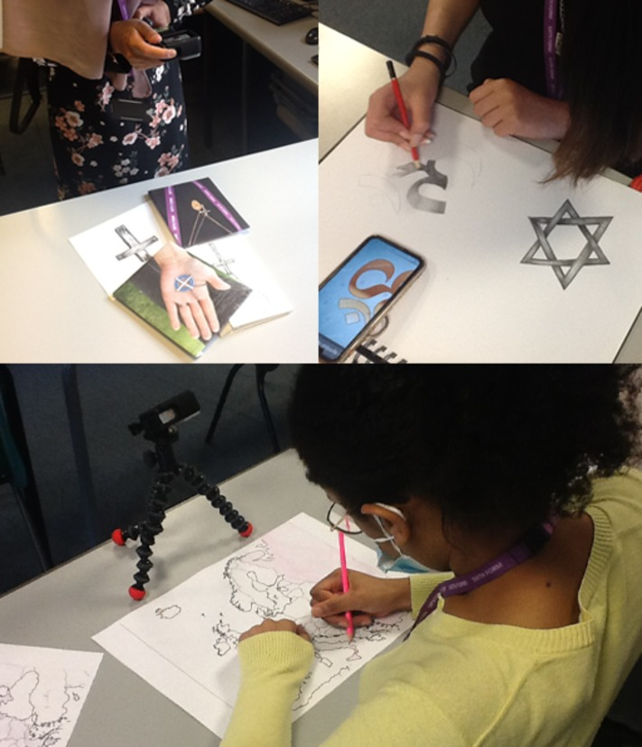
Figure 3 Young people working on their docutubes
View description - Figure 3 Young people working on their docutubes
View description - Figure 3 Young people working on their docutubes

The vlog style – speaking directly to the camera in a diary style – which your young people will be very familiar with from platforms such as YouTube – can be effective and convenient, though limited. If this style is chosen, it will probably need to be mixed with other footage – images from the clippings, on-location shooting in TV News style, or other visual tricks such as using drawings or text.

Where will you shoot?
It might be that the docutube lends itself to being filmed in a classroom. However, you might want to shoot in a particular place that is relevant to the message of the film, perhaps elsewhere on the school property or even ‘on location’ – for example, in a place of worship, a museum, or at a historic site.
It is important to mention that the who, what and where ingredients of a docutube each have ethical implications. You will think through these ethical issues in more detail in the Create session (Session 3).

IN PRACTICE: Getting your group to pitch their film
As you saw in Video 1, it can really focus the minds of the young people if they know they will be ‘pitching’ their film to either their teacher or peers (or both). Give your group a definite time when they will need to be ready to do this. The response to the pitch should be both encouraging and constructively critical. You can give your groups a chance to go back, if necessary, and refine their plans.
You might want to ask the groups questions like?
- What is your key message?
- Who, where and what are you filming?
- What roles will the different people in your group have?
- Have you thought about safety, ethics and copyright (see Session 3)?

4.2 Ingredients of a docutube: making a ‘shooting script’
Once your young people have been able to ‘pitch’ their film and had some helpful feedback, they will really benefit from getting their plan on paper in greater detail. A good way to do this is to devise a shooting script. Table 1 is an example of a simple form for making a shooting script. You can also print off a blank form to use in the classroom in the Resources section.

Table 1 An example shooting script
Visuals | Words
Title says ‘Jewish migration to Warsaw’
Presenter introduces the film inside building | Migrations are often now considered as something negative, especially for countries that are welcoming migrants. We are now in Warsaw, the capital of Poland, a city historically regarded as an asylum for religious immigrants, Jews in particular.
Camera pans over and shot changes to new angle | Presenter: But are peoples’ attitudes towards other religions still positive now?
New shot of presenter outside. Camera pans up from feet. | Presenter: We will ask students and people on the streets of Warsaw what they think about religious immigrants and if they could find refuge in Warsaw.
New shot, also outside (use garden area?). Presenter speaking to interviewee. | Hello, I would like to ask you a few questions. What would you think if new synagogues were built in Warsaw?
 | Interviewee responds with answer.

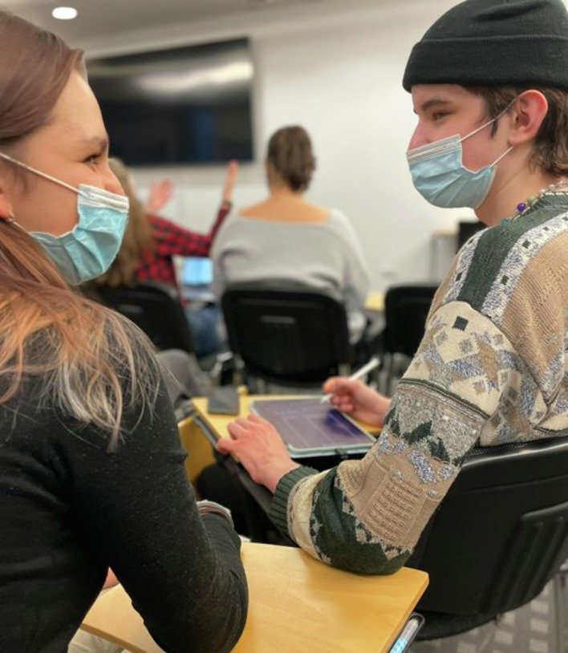
Figure 4 Students in Warsaw developing a shooting script
View description - Figure 4 Students in Warsaw developing a shooting script

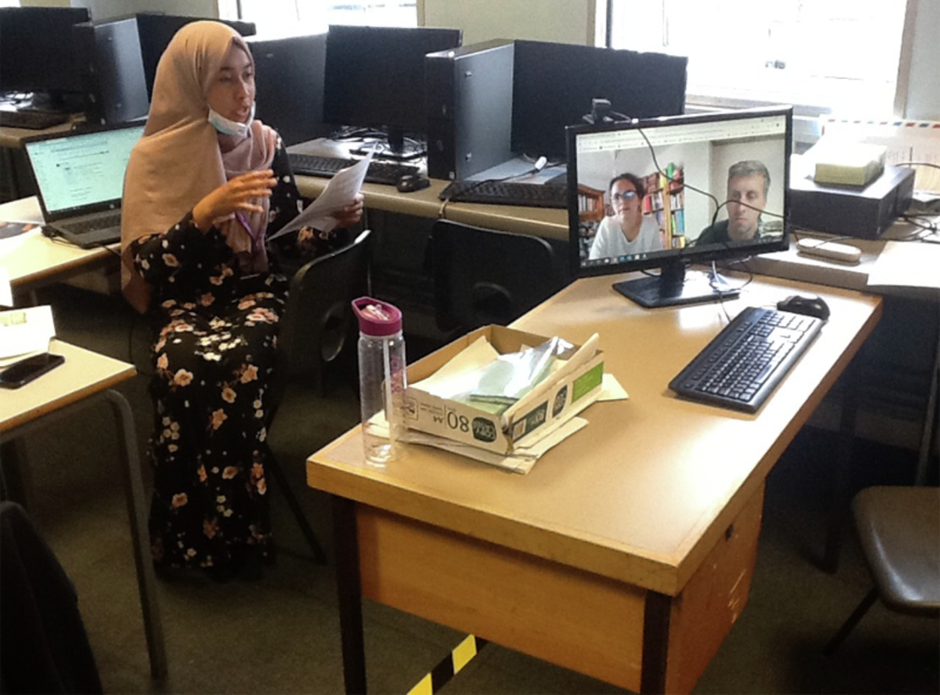
Figure 5 A young person in London ‘pitching’ their docutube plan to the (remote) RETOPEA team
View description - Figure 5 A young person in London ‘pitching’ their docutube plan to the (remote) ...

4.3 A filmmakers perspective
As discussed at the beginning of this Plan session, the emphasis of docutubes is the means (thinking and being creative) rather than the end (a high-quality documentary). A group of young people could make a very low standard docutube, from the point of its visual quality, but still benefit enormously from the intellectual and creative process of making it. However, obviously the better the film the more satisfaction young people will take from the whole experience. So, in Activity 6, you will hear the experience of a filmmaker who was involved in some of the pilot docutubes, and look again at some of the techniques which young people might consider when they are planning their films.

Activity 6
Allow about 10 minutes for this activity

Watch the film below of filmmaker Gail Block talking about some of the techniques which young people might plan to use. As you watch, write down some of the techniques which are mentioned.

Video content is not available in this format.
Video 4
View transcript - Video 4

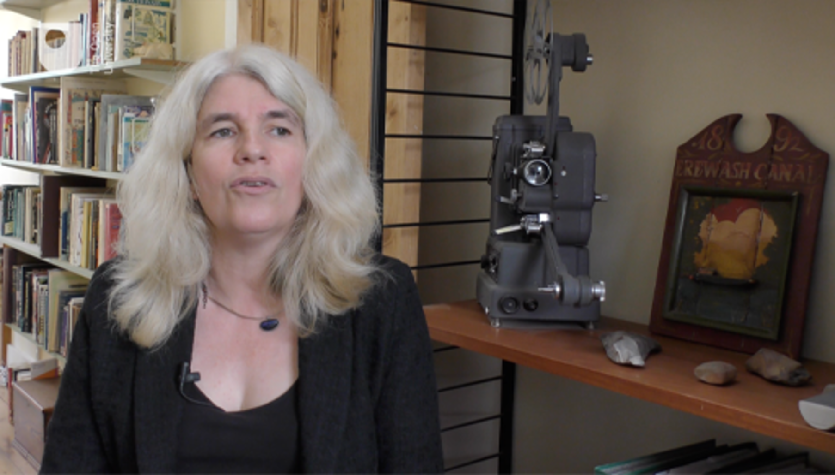
View description - Uncaptioned Figure

Provide your answer...
View discussion - Activity 6

4.4 The teacher’s role
You’ll now move on to think about the planning stage and the place of the teacher in facilitating this.

Activity 7
Allow about 10 minutes for this activity

You are now going to watch a film where Dr Nadia Hindi, an academic at the University of Granada, Spain, discusses the role of the teacher or youth leader in the docutube process. After watching the film, note down the main points you took from her reflections on the planning process.

Video content is not available in this format.
Video 5
View transcript - Video 5

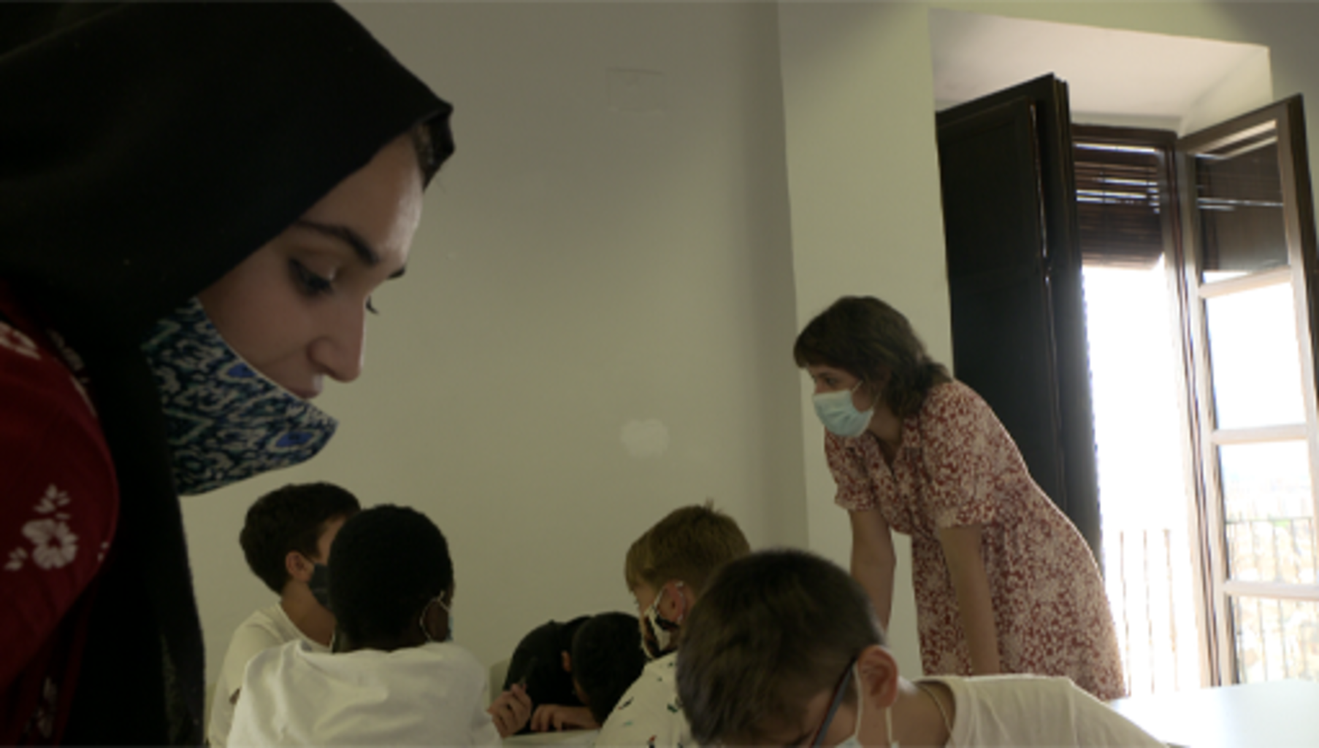
View description - Uncaptioned Figure

Provide your answer...
View discussion - Activity 7

5 Session 2 quiz
You can now check what you’ve learned this section by taking the end-of-session quiz.
Open the quiz in a new tab or window by holding down Ctrl (or Cmd on a Mac) when you click on the link. Return here when you have finished.
Session 2 practice quiz.

6 Summary of Session 2
You’ve covered a lot of ground in Session 2. You have explored the creative process of discussing and planning ideas and have been shown how to use the clippings to generate content which relates clearly to religious peace and toleration – the backbone of a good docutube.
This session has emphasised the importance of focussing on the process, rather than the result. As Karel van Nieuwenhuyse said in Video 1, by the end of this stage, the young people should have learned a lot about each other’s point of view. In the next session, you will learn how to support your group as they bring their docutubes to fruition.
You can now go to Session 3.

Session 3: Create – filming and editing

Introduction
This session of the course is very much focused on practical advice on how to support young people in the creation of their short films. Specifically, you will learn how to:
- support young people in the process of filming and editing their docutubes
- facilitate teamwork in this creative process
- anticipate and approach ethical concerns.

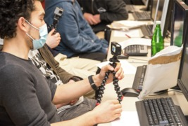
Figure 1 Young people working with cameras at a docutube workshop at a school in Germany
View description - Figure 1 Young people working with cameras at a docutube workshop at a school in ...

Watch Video 1 which introduces you to the ‘Create’ phase of the docutube workshops where young people film and edit their films. It provides an overview of both the filming and editing processes, as the RETOPEA project team experienced them in the context of the docutube workshops piloted in different countries between 2020 and 2022. As you watch, make some notes in the box below on what the ‘Create’ phase of the docutube workshops entails. (Note that this is also a film you can show to your group before they start to film and edit their docutubes.)

Video content is not available in this format.
Video 1
View transcript - Video 1

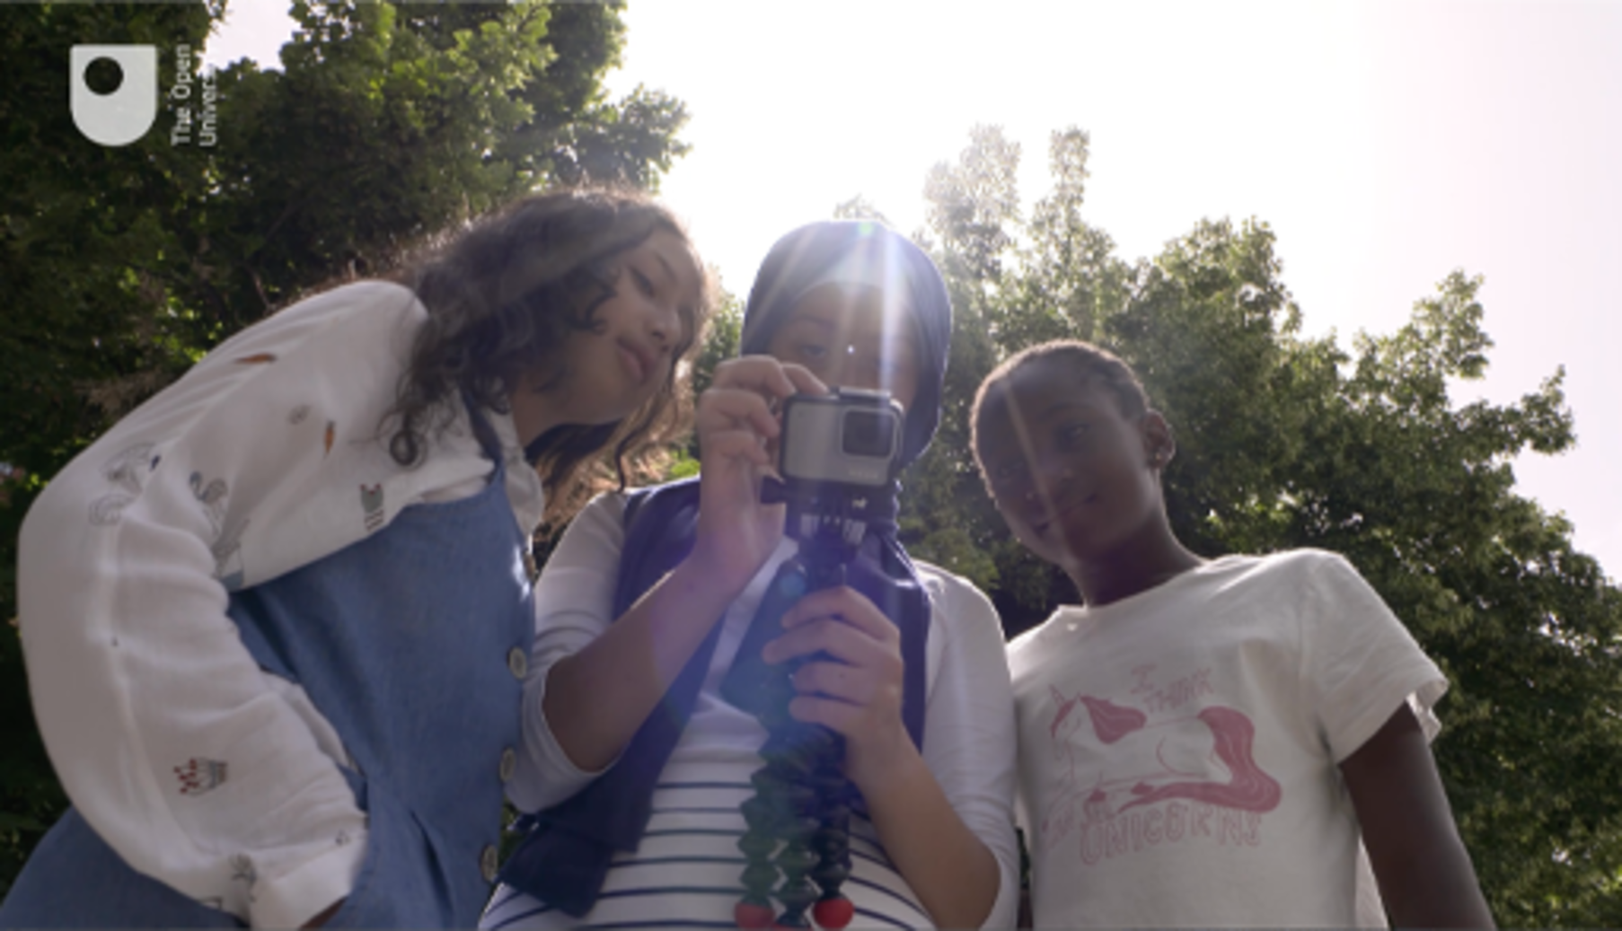
View description - Uncaptioned Figure

What is involved in the ‘Create’ phase of the docutube workshops?

Provide your answer...
View discussion - SAQ

1 Working together as a team
A real strength of the RETOPEA approach is that through the process of filmmaking, participants actively engage with issues related to religious toleration and peace in the past and present. This is not only due to the capacity that filmmaking can have in facilitating creative, multisensory engagement with these ideas — the fact that young people have to find ways of working together as a team to make a film helps to deepen and enhance the learning experience. So, the process of creating the film is just as important – if not more so – than the finished product.

IN PRACTICE: Familiarising your group with the filmmaking process
It is recommended that you give participants the opportunity to ‘warm up’ and familiarise themselves with being behind and in front of the camera. This can simply involve them taking turns in filming each other, briefly saying their name or talking about what they had for breakfast.
Alternatively, if you have a little more time, you could ask them to film each other responding to either or both of the following two questions:
- What does religious toleration mean to you?
- How can history help you think about religious diversity and toleration today?
Answering these two questions provides the opportunity for young people to experience what it is like to have to answer a complex question in a concise way in front of a camera.
This is not footage that needs to be included in the docutube (though it could be, should a group wish to). The main purpose of this activity is to help participants familiarise themselves with the filmmaking process and with the equipment, giving them the opportunity to check both video and sound. This activity can also help to establish what roles the different team members might like to focus on in the creation of the docutube in their small group. Some young people might find that they feel more comfortable behind the camera, others might prefer to speak to the camera as a presenter or actor.

There are good reasons for working in small groups of three or four, given that there are a number of different tasks and roles that need to be covered to make a film. A group of three people can, for example, involve one person being filmed speaking to the camera (either presenting, acting or interviewing), another filming and a third directing. If you have separate sound equipment (which is not required, but will provide you with better sound quality), handling this equipment can be another important role for a member of the film crew to take on. As far as possible, you should encourage members of each group to take turns with these different tasks.

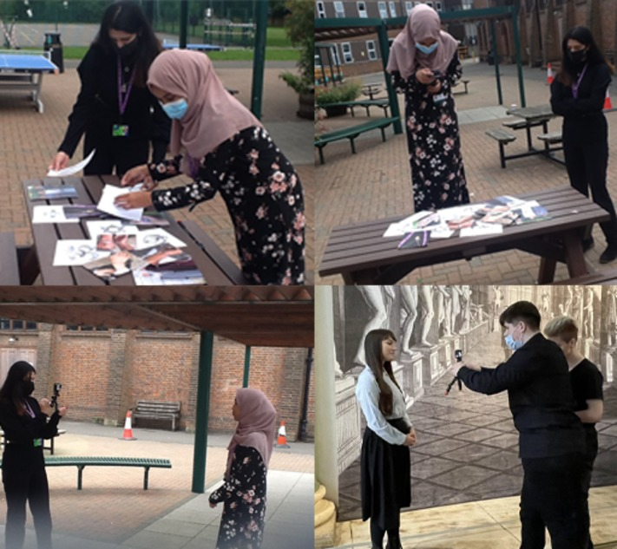
Figure 2 Young people working together in the filmmaking process
View description - Figure 2 Young people working together in the filmmaking process

IN PRACTICE: Deciding on roles in the group
To avoid any disagreements between different members of the group in the process of taking turns, it might be helpful for participants to draw lots or toss a coin. One group that worked particularly well together played ‘Rock, Paper, Scissors’ to decide whose turn it was for different tasks.

2 Ethical considerations
Religious toleration and peace can be a sensitive and sometimes controversial topic. You should remind participants of the importance of being considerate and respectful of each other’s views, as well as of anyone they are planning to involve in the film.

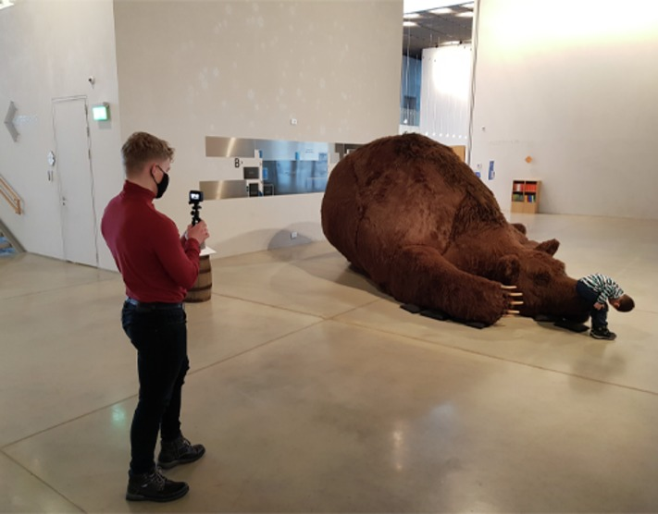
Figure 3 A student filming an exhibit displayed in the Estonian National Museum in Tartu
View description - Figure 3 A student filming an exhibit displayed in the Estonian National Museum in ...

If the young people plan to film or interview anyone for their docutube who is not part of their group, they will need to gain informed consent from them. This means that they will need to explain to them what their film is about, what it is for and make sure that everyone who is filmed (including members of their own group) is happy with the footage that is included in the docutube.
While being filmed, participants or interviewees might make some remarks about potentially sensitive topics that, on reflection, they might quickly regret or not like to be shared more widely. This is why you will need to stress that it is important for ethical and legal reasons that your groups do not publicly to share any ‘raw’ film footage. They need to agree to only share the final edit of the docutube, i.e. footage that has been approved by you and everyone in the group, and that any further footage will need to be deleted once the workshop is completed.
Here is an example of an information sheet and consent form that groups can use for people they would like to interview for their docutubes.
One reason why the RETOPEA team used GoPro cameras when they piloted the docutube workshops was because these cameras cannot be directly connected to the Internet. This allowed the team to maintain tighter control over where and how footage was shared. GoPro cameras might not be an option for you, in which case it is all the more important that you stress to young people to be mindful of these ethical concerns.
Remind young people that they might also need to ask for permission to film in particular locations, such as museums, galleries or other buildings. If in doubt, it’s best to ask for permission before starting to film.

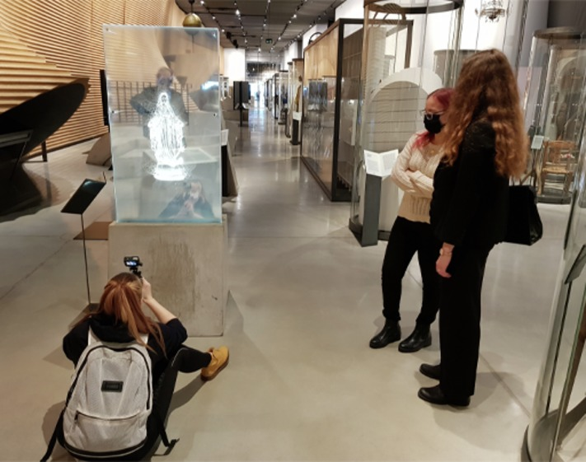
Figure 4 Students filming exhibits displayed in the Estonian National Museum in Tartu
View description - Figure 4 Students filming exhibits displayed in the Estonian National Museum in ...

Finally, make sure you are aware of relevant policies at your school, youth group, museum etc. regarding taking pictures or filming other people and gain parental consent, where appropriate. You can reassure members of your group that they do not have to appear on camera if they do not feel comfortable with it – as has been mentioned there are plenty of other roles they can take on behind (rather than in front of) the camera.

3 A teacher’s perspective
You are now going to focus on the advice of a teacher who supported the ‘Create’ phase of a docutube workshop in London.

Activity 1
Allow about 10 minutes for this activity

Watch Video 2 where teacher Annie Powell talks about her experience of managing the filming and editing process of a docutube workshop. While you are watching the video, make notes in the text box below on what Annie Powell says about the kind of practical concerns that educators might need to bear in mind when supporting young people in the filming and editing process of the docutube workshops. In particular, focus on aspects that might be of special relevance to your own educational setting.

Video content is not available in this format.
Video 2
View transcript - Video 2

View description - Uncaptioned Figure

Provide your answer...
View discussion - Activity 1

As teacher Annie Powell explains in Video 2, it is important to find effective ways of keeping track of where your young people are and to make sure they have a way of contacting you when they are out and about (for example, by giving them your mobile phone number). Even if they are not planning to film outside the room where you are holding the workshop, it is likely that some groups will need to leave the room to avoid sound interferences with other groups.

IN PRACTICE: Filming locations and timing
Ideally, you should book several rooms that groups can use for filming. You might need to weigh up whether you are prepared to let your groups leave the premises (if so, make sure you gain parental consent, if required). You could also consider linking the workshop to a visit to a museum or gallery.
Depending on the overall amount of time you can give to the workshop, give a realistic deadline for completing the filming. We would recommend two hours at a minimum, though more time would be preferable, and will probably be essential if travel to a museum or other location is involved.

In advance of the workshop, you will need to establish what kind of computers or laptops are available to you. If possible, avoid a scenario where participants use their own laptops or phones as this makes it harder for you to supervise the process and prevent footage from being shared in the public sphere prematurely or inappropriately.

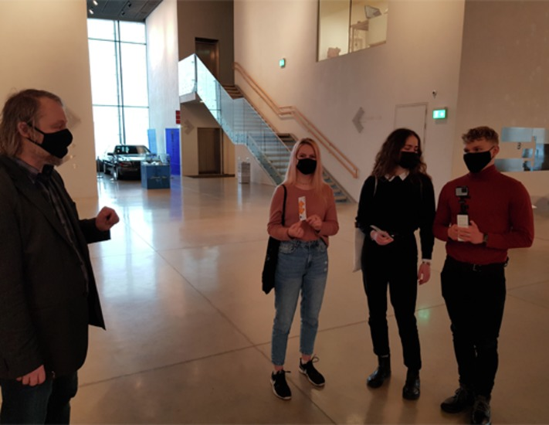
Figure 5 A teacher checking in with his students at a docutube workshop in Tartu, Estonia
View description - Figure 5 A teacher checking in with his students at a docutube workshop in Tartu, ...

Most computers will already have some form of video editing software installed, so it is ok to go with whatever editing software is already available to you. Indeed, the simpler the software, the less temptation to spend too long trying to achieve effects during editing. If you are not sure which software to use, the RETOPEA team recommend OpenShot, which is a freely available software that is relatively user-friendly and compatible with different systems.
You should also check whether there is any further hardware available that might be needed – such as adaptors for connecting memory cards from the cameras into laptops, or USB sticks for moving finished docutubes.
As Annie Powell explains in Video 2, if you don’t have filmmaking experience, it is important to find out whether there is someone in your community who can assist and offer technical support, particularly with the practicalities of using the editing software, transferring footage from the cameras to the computers, editing, downloading and securely storing the finished films. Make sure you reach out to them well in advance of the session, especially if these are aspects you are inexperienced with.
If suitable cameras and computer hardware are not available, participants may be working with tablets or their own phones and editing their films using apps that can be easily downloaded onto such devices. The quality, however, is unlikely to be as good as with films made with cameras and then edited on PCs. If young people use their own devices to film and/or edit their docutube, it is especially important to reiterate messages about the importance of not sharing material inappropriately. Participants themselves might later regret putting on the Internet footage that might be ill-considered, offend someone or be subject to ridicule or harsh public criticism. Indeed, in light of these challenges, consider very carefully what footage, if indeed any, should be shared beyond the workshop.

4 Filming: some tips and tricks from a professional filmmaker
You are now going to focus on the technical aspects of the filmmaking process.

Activity 2
Allow about 10 minutes for this activity

Watch Video 3, where professional filmmaker Gail Block shares some tricks of the filmmaking trade. Make some notes in the text box below on the kind of advice that you could pass on to young people for filming their docutubes. (Note that this is also a film you can show to your group before they start to film their docutubes.)

Video content is not available in this format.
Video 3
View transcript - Video 3

View description - Uncaptioned Figure

Provide your answer...
View discussion - Activity 2

IN PRACTICE: Encouraging good filmmaking practices
Remind the groups to film a variety of shots and keep them short, working through the script they have developed in the ‘Plan’ phase of the workshop.
Advise them to delete obviously unsuccessful shots immediately from the camera, so as not to clutter the edit unnecessarily.

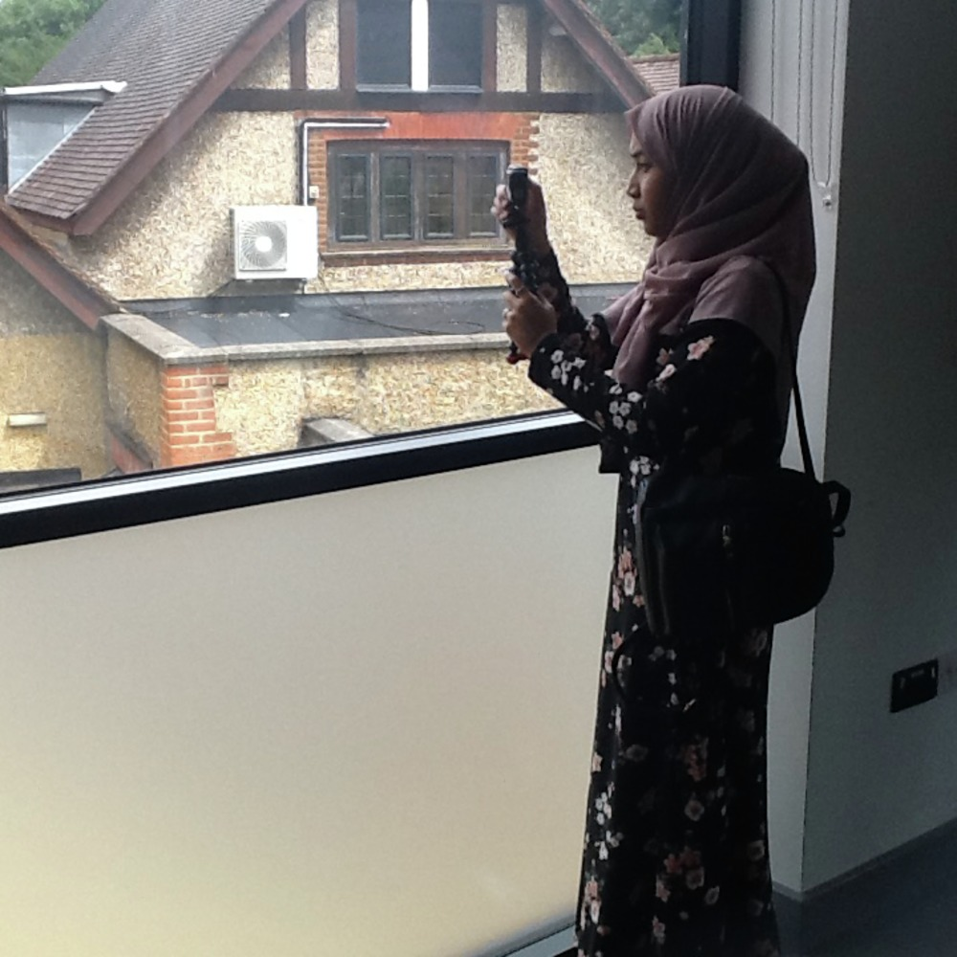
Figure 6 A student in London trying out different shots for their docutube.
View description - Figure 6 A student in London trying out different shots for their docutube.

Here is some further advice from filmmaker Gail Block on what makes a good film shot:
- Composition: think about how you are framing what you are shooting in the frame – do you want a wide shot, showing context, or a closer shot showing the speaker’s facial expressions?
- Camera angle: consider using a tripod for stability.
- Sound: holding the camera close to the speaker also ensures sound is clear and the audience can hear what the speaker says. If a microphone can be connected to the camera, this can also help to give a more professional end result.
- Lighting: this can really bring a shot to life. You want to have what you are filming reflecting as much light as possible – point your light source at your subject, not at your camera (or move your subject into the light). Avoid filming against a window, the contrast in light levels means the speaker will be in silhouette.

5 Editing: bringing it all together
Allow as much time for editing as possible. Editing often takes a lot longer than expected – in fact, it tends to take a lot longer than the process of filming the footage. While there is no expectation for the docutubes to be any longer than 3 minutes, professionals would spend days editing a three-minute film. This is why some young people who participate in educational film projects can be disappointed by what they can achieve in the relatively limited time available. However, you should again remind them that the purpose of their docutube is not to make a technically perfect movie, but to communicate ideas about religious peace and toleration in the past and present. So, what is most important in the process of editing their docutubes is to focus on the argument or story that they aim to convey.

Activity 3
Allow about 5 minutes for this activity

Watch Video 3 again, but this time focus on the advice that professional filmmaker Gail Block gives on editing short films. (Note that this is also a film you can show to your group before they start to film and edit their docutubes.)
This is only a taster, since the editor’s art is complex and deserves an entire course of its own. Make sure you take the advice of anyone you know who has these skills and is willing to support the editing session.

Video content is not available in this format.
Video 3 (repeated)
View transcript - Video 3 (repeated)

View description - Uncaptioned Figure

Provide your answer...
View discussion - Activity 3

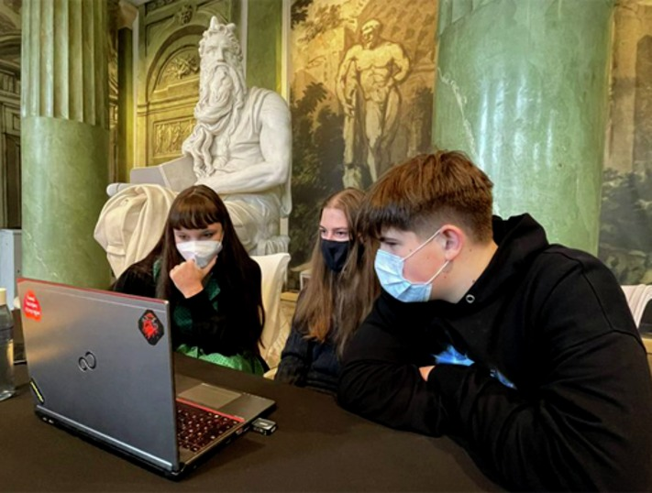
Figure 7 A small group of young people in Warsaw working together to edit their docutube
View description - Figure 7 A small group of young people in Warsaw working together to edit their ...

Just as there are different roles team members can take on in the filming process, each group member can also take on a different role in the process of editing the film. For instance, in a small group, one person might work with the software (the ‘editor’), another might select the shots (the ‘producer’) and a third member of the group might further develop the script to strengthen the narrative in light of the available footage. Another way of sharing the work in the editing process is to split the film into different sections, with each group member focusing on editing a different section of the film.

5.1 The principles of video editing
The IN PRACTICE activity below shows a tutorial that you might like to share with your groups to help them familiarise themselves with some of the main principles of video editing.

IN PRACTICE: Introducing the principles of video editing
A good way of introducing the principles of video editing is to illustrate the idea of a video cut by ‘splicing’ together two pieces of till roll with scotch tape, where one piece of till roll represents a wide shot of a garden, the other a close-up of a person.
Show the same process on OpenShot (or whichever editing software you are using) by dragging a shot onto the timeline, bringing another next to it, and playing the resulting edit.
There are online tutorials to help you get to grips with the technical aspects of editing with software like OpenShot. The video below is one example you might find helpful.

Video content is not available in this format.
Video 4
View transcript - Video 4

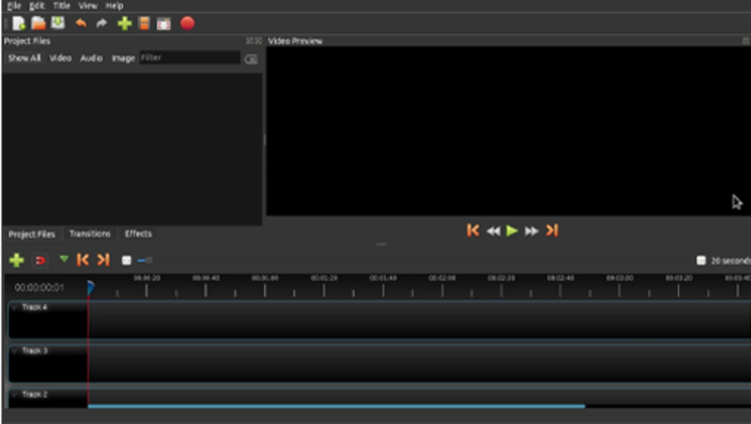
View description - Uncaptioned Figure

Video editing software has a timeline with tracks for sound and visuals, a play-head, which allows you to scroll manually over the shots, and a window in which you can preview the video you are making. The timeline allows you to slide one shot next to another and add layers of sound and pictures. If you have multiple video tracks, the play-head only ‘sees’ the topmost one, so only one shot will show at any one time. As it develops, a timeline starts to look like a chequerboard.

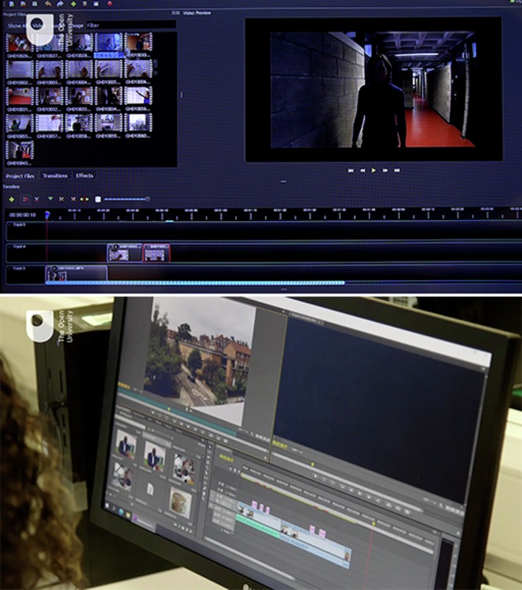
Figure 8 (top) Frame-grab of what OpenShot editing software looks like on the screen; (bottom) Adobe Premiere timeline source and record windows
View description - Figure 8 (top) Frame-grab of what OpenShot editing software looks like on the screen; ...
View description - Figure 8 (top) Frame-grab of what OpenShot editing software looks like on the screen; ...

In the editing process, young people will be working with the shooting script they developed earlier in the workshop. This will help them decide which content to include, and in what order. A good way to start is by creating an ‘assembly’ – placing all the footage they’ve created roughly in order, without worrying about style. This will let them make decisions about which take to use, or if a scene needs to be moved. Importantly, it will let them know quickly if there is a technical problem that means a shot can’t be used, like noise or bad focus, or if something is missing altogether.

5.2 Developing the edit
If the young participants did not manage to get all the film shots that they had hoped for, or if they would like to include additional or different materials than originally planned, they will need to work together to find solutions (see IN PRACTICE, below). Making these structural decisions early in the editing process means that the group will be free to use the remaining time to work on the details of the edit without the risk of producing an unfinished docutube that doesn’t quite make sense.

IN PRACTICE: Creative solutions
A docutube is not long – nevertheless, accidents and issues do happen on film shoots and edits, and it is not unusual to find that something a group planned to use to make their docutube work isn’t available, or is unusable for some unexpected reason. Here are some practical suggestions for what to do if this happens:
- A voice-over is an easy way to add missing information, or to connect sections together. This can usually be recorded straight onto the video at the editing stage.
- Sound and vision do not need to come from the same source – if a location shot has too much wind noise, for example, you can take that audio off and replace with music or a voice over. And you can cut away from a talking head to show a location shot, but keep the audio as a voice over.
- Consider using still photographs or images from the clippings to illustrate what is being talked about – this can be very effective!
- Members of the team can still shoot extra ‘pick up’ shots while others are editing, to fill any gaps – for example, talking heads, shots of their fellow participants at work, or even drawings or props.

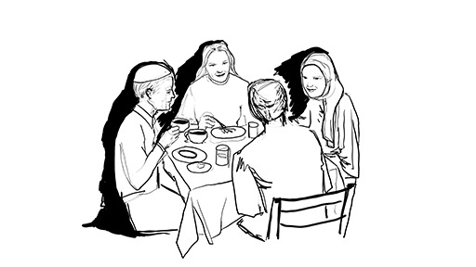
Figure 9 A drawing can be a substitute for a shot that went wrong or when people do not want to appear on film
View description - Figure 9 A drawing can be a substitute for a shot that went wrong or when people ...

Remember that the main aim of a docutube is to communicate effectively and provide evidence of learning about religious peace and toleration. Encourage your groups to put together the materials in a way that gets across an argument or a key message and builds a clear and concise narrative or story. The way in which a film is introduced and concluded can be quite important here. A good way of introducing a docutube can be to pose a question at the start of the film and then come back to it at the end of the film. Young people could also consider recording a voiceover that can weave a clear narrative through their docutube.
In order to link their docutubes to a specific RETOPEA clipping, groups could consider integrating screen shots of the relevant clipping on the RETOPEA website into their film. They can also use captions (if available in the editing software they are using) to explain what the viewer is looking at, or to introduce a new section. Images of handwritten text or (sped-up) film footage of someone writing key questions, statements or section headings on a piece of paper or on sticky notes can also be quite effective (see Figure 9).

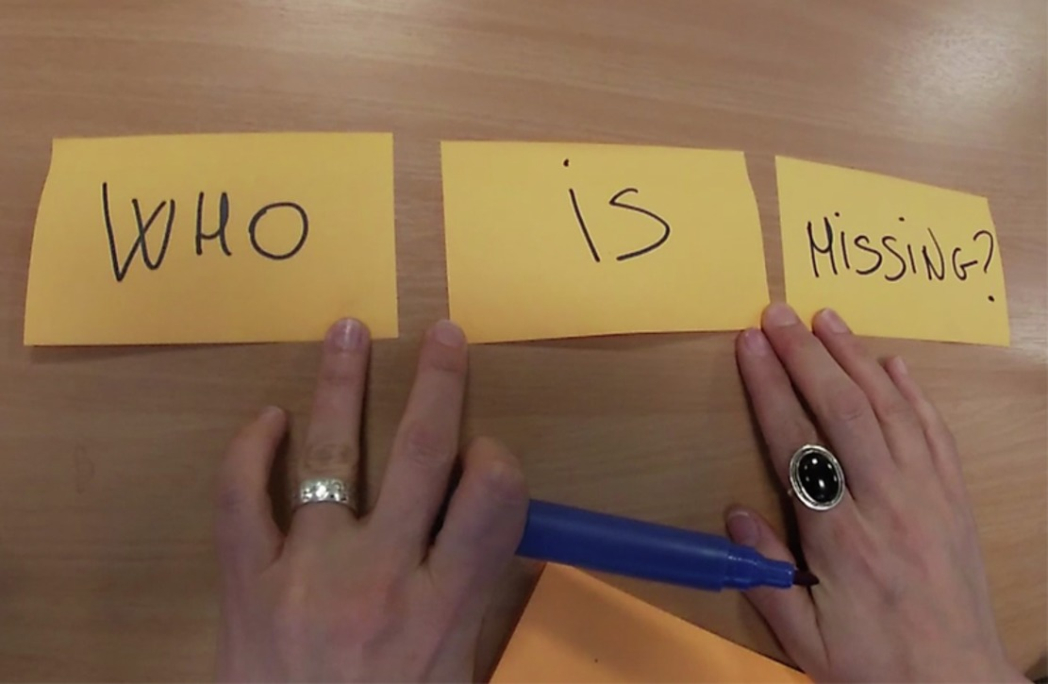
Figure 10 Key questions can be written on sticky notes
View description - Figure 10 Key questions can be written on sticky notes

It is important that you remind groups to save their work regularly as they go along, so their work is not accidentally lost.
Once the edit is completed – or you have run out of time! – the video should be ‘rendered’, that is, exported as a self-contained, playable video. Bear in mind that rendering the edited docutubes might need some time as the files will be quite big. It is recommended that they are exported at 1920 x 1080 in .mp4 format, if possible, for maximum compatibility.

6 Session 3 quiz
You can now check what you’ve learned this section by taking the end-of-session quiz.
Open the quiz in a new tab or window by holding down Ctrl (or Cmd on a Mac) when you click on the link. Return here when you have finished.
Session 3 practice quiz

7 Summary of Session 3
Session 3: Create has provided you with guidance on how young people can be supported in the creative process of filming and editing their docutubes. Again, it should be emphasised that the hands-on, collaborative process of making a docutube is more important than the end result.
While the young people will need to work with the plans they developed for their docutube in the earlier ‘Planning’ phase of the workshop, the reality of the filming and editing process does involve an element of trial and error. It is important that they are given the opportunity to explore and experiment. Try to create a safe, relaxed space, where participants are put at ease (Borg and Grech, 2017) and encouraged to be creative, investigate, express their views and work with others, bearing in mind relevant ethical considerations.
The fact that the filming and editing process very much relies on collaboration within each ‘film crew’ forms a key part of the workshop. It requires young people to interact and connect with each other and negotiate ways of working together. This process does not only give them the opportunity to practise and develop their team working skills – or indeed their filming and editing skills – it can also help build their resilience and their ability to creatively deal with a range of challenges, working with others to ask questions as well as discuss and develop ideas.
Rather than aiming for a sleek, technically perfect film, it is more important that participants actively engage with issues related to religious toleration and peace in the past and present through the process of making a docutube together. The final session of this course focuses on how educators can support young people in making the most of the opportunities this process provides for reflection.
You can now go to Session 4.

Session 4 Reflect – deepening the learning experience

Introduction
In this session of the course, you will think about how to support young people in the process of reflecting on what they have learned during the workshop. Specifically, you will learn how to support young people in the process of reflecting on:
- the process of making the docutube
- what they learned about religious toleration and peace in the past and present.

1 The finished product: examples of docutubes
There are a wide range of approaches young people can take in their docutubes. In the ‘Plan’ session of this course, you saw examples of docutubes made by young people in Warsaw and London. You are now going to see some further examples of docutubes that young people have made in the context of the RETOPEA pilot workshops. These will help to give you a clearer idea of what docutubes could look like. It is important to stress, though, that there is no such thing as an ‘ideal’ or ‘perfect’ docutube, so these examples shouldn’t be regarded as blueprints.

Activity 1
Allow about 45 minutes for this activity

Watch the following three examples of docutubes, which illustrate the wide variety of different approaches that young people who have taken part in the pilot workshops have adopted. As you watch, make notes in the text box below on the differences and similarities between these docutubes, bearing in mind the following questions:
- How do these docutubes engage with issues of religious toleration and peace in the past and present?
- How do these docutubes reflect the participants’ different local environments and experiences?

Video content is not available in this format.
Video 1
View transcript - Video 1

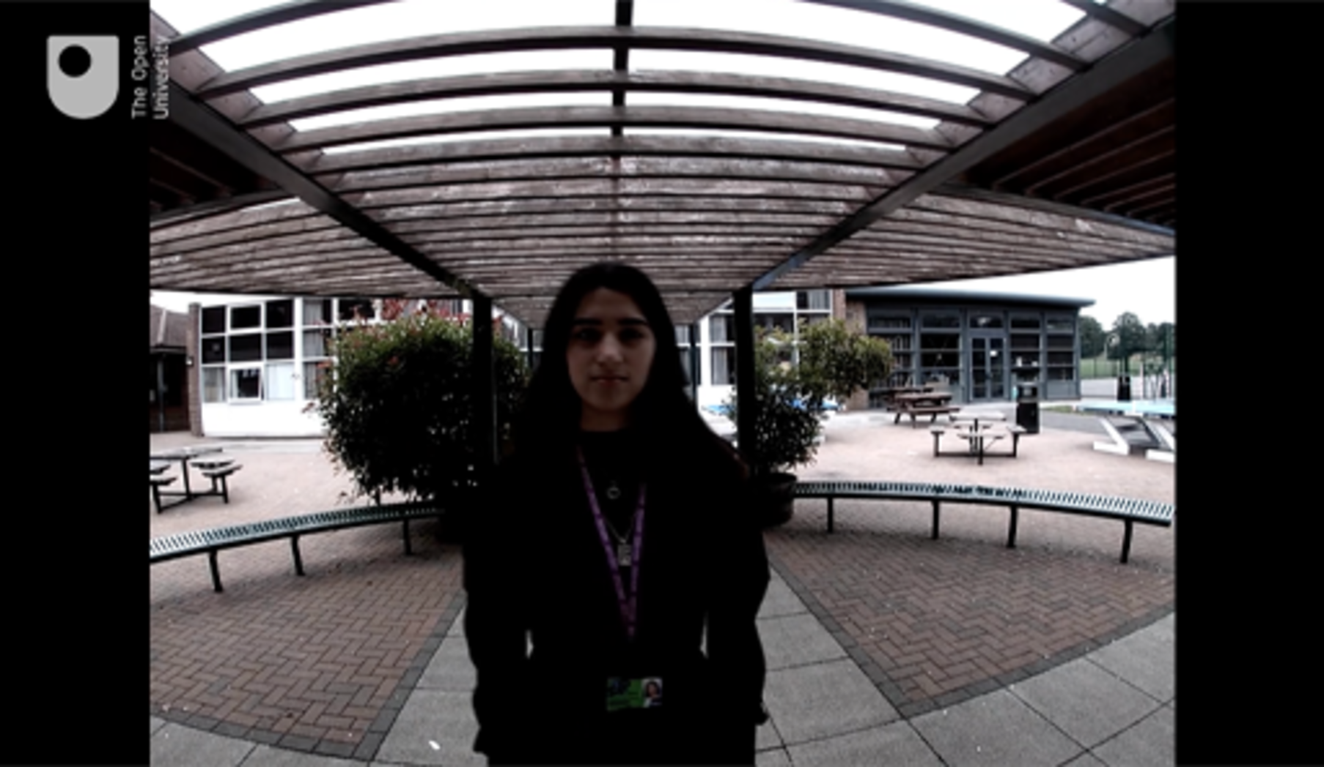
View description - Uncaptioned Figure

Video content is not available in this format.
Video 2 (a translation of this video is available in the transcript)
View transcript - Video 2 (a translation of this video is available in the transcript)

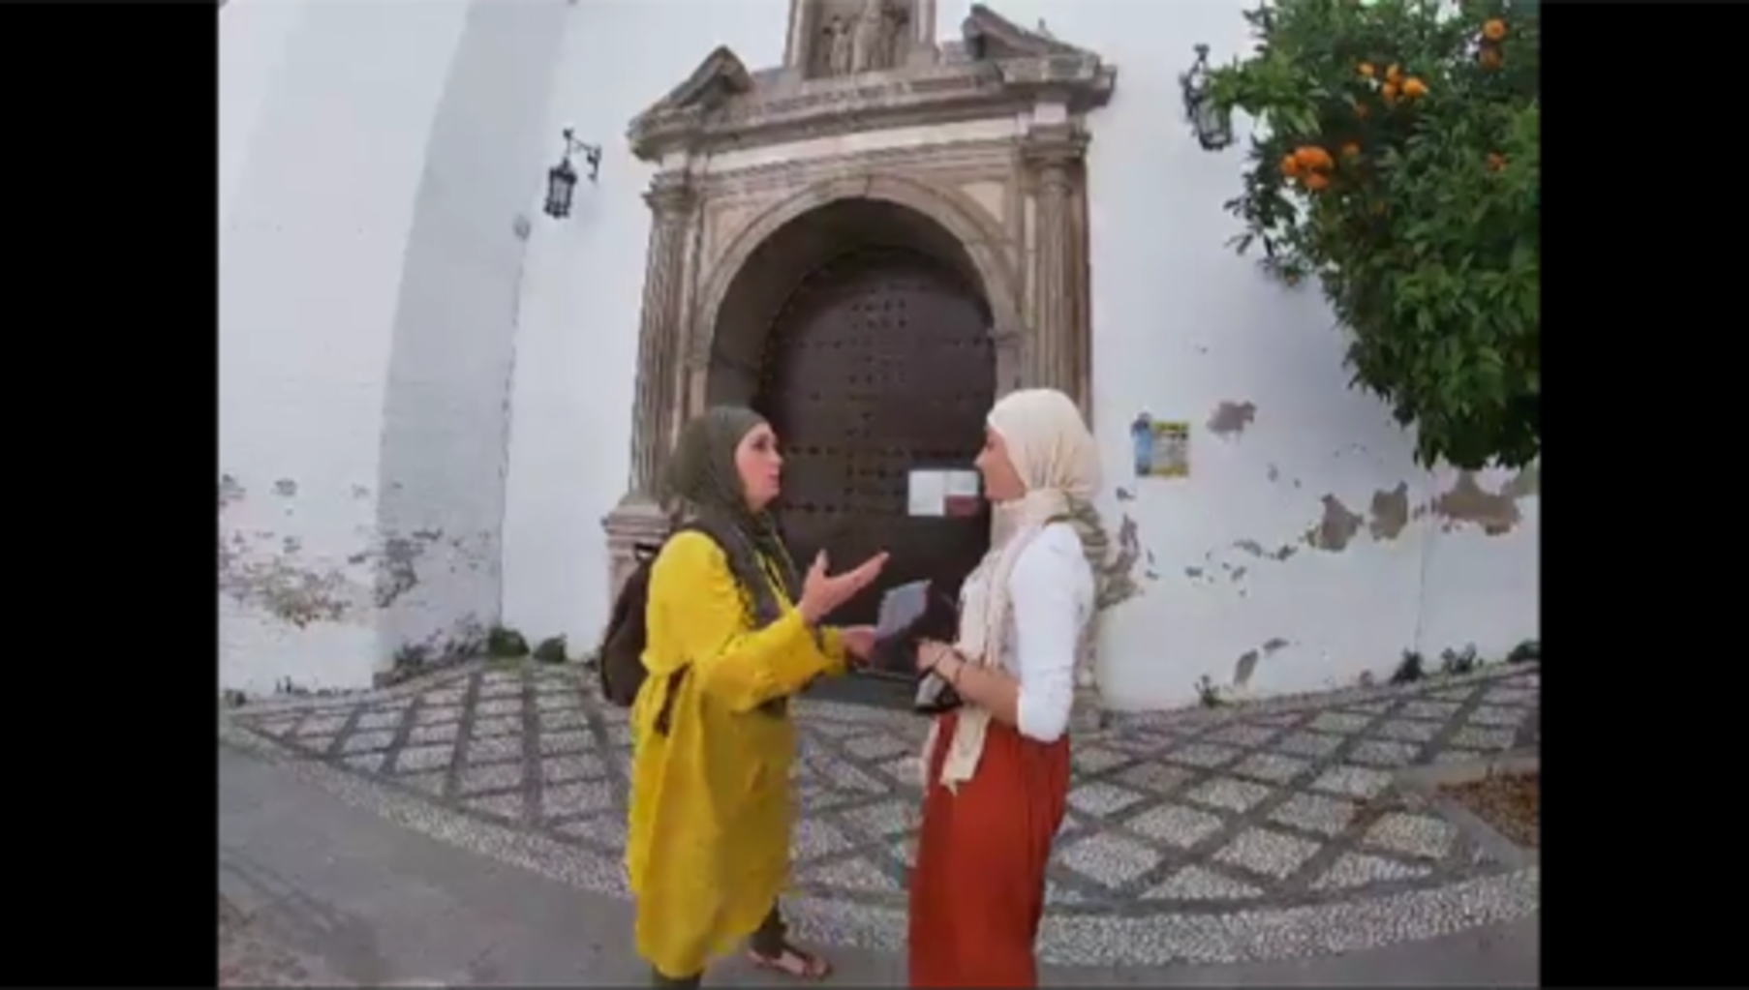
View description - Uncaptioned Figure

Video content is not available in this format.
Video 3
View transcript - Video 3

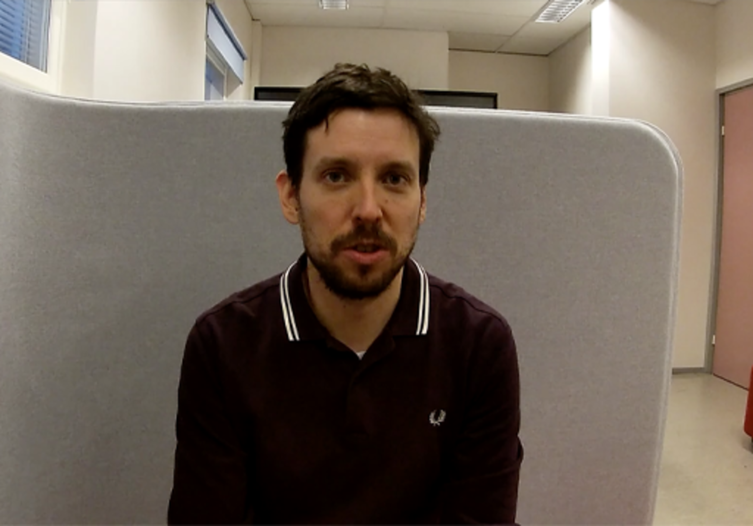
View description - Uncaptioned Figure

Provide your answer...
View discussion - Activity 1

2 Rolling out the red carpet
Once your groups have completed their docutubes, it is important to leave enough time to present their finished film to you and the other groups. Sharing their creations offers a great opportunity for further reflection and discussion to deepen the learning experience.

Activity 2
Allow about 10 minutes for this activity

Watch Video 4 where Karel Van Nieuwenhuyse, a member of the RETOPEA team at the University of Leuven in Belgium, offers some suggestions on how teachers and youth leaders can promote learning through reflection at the end of a RETOPEA workshop. As you watch the film, make notes in the text box below on the kind of questions you could ask your group to encourage them to reflect on the process of making a docutube.

Video content is not available in this format.
Video 4
View transcript - Video 4

View description - Uncaptioned Figure

Provide your answer...
View discussion - Activity 2

IN PRACTICE: Guiding the reflection
When watching the docutubes together, ask each group what worked well, and what they would improve if they were to do it again. Reassure them that video production is a complex skill. Try to keep the focus on content that is not technical (e.g. ‘I found it really interesting when you said X – can you tell us more about that?’). And – importantly – encourage participants to reflect on what they learned about religious toleration and peace in the past and present when making their docutube.
Ask them to reflect on what they have learned from working with the RETOPEA clippings, including the need to engage with information in a critical way, as well as the value of considering different kind of sources and multiple perspectives. Also encourage participants to reflect on the experience of working with other young people to make their docutube (for example, in terms of listening to each other, understanding each other’s point of view, sharing tasks and finding solutions together).

3 Findings from the evaluation of the pilot workshops
In order to evaluate the pilot workshops conducted in Belgium, Estonia, Finland, Germany, Poland, Spain, North Macedonia and the UK between 2020 and 2022, the RETOPEA team asked participating young people to give feedback, both in the form of anonymous questionnaires, as well as in the context of semi-structured focus-group interviews.
The vast majority of young people who took part in the evaluation of these workshops said they enjoyed the process of making a docutube and felt they learned a lot from it. They liked, for example, that filmmaking is a very hands-on process and enjoyed learning about other people’s opinions and expressing their own views. They fed back that they really appreciated the opportunity the workshops gave them to form and express their own opinions and that they felt inspired to think more about the role of religion in society in the past and present. Many said that it was important to them to work with others in a relaxed, but respectful atmosphere, and that they appreciated and enjoyed the fact that the workshops ‘created a sort of safe space to speak out’.
Findings from the evaluation of the workshops also indicate that far from being a distraction, the filmmaking process can stimulate deeper learning and reflection compared to conventional classroom discussion as it involves hands-on and creative engagement with the learning materials. Some docutubes that were made in the context of the pilot workshops did not explicitly refer to the RETOPEA clippings. However, in their feedback, many young people said that working with the clippings had inspired them to think about how religious diversity is represented and reflected in their own environment, their own school, their own community group or their own city.

4 Session 4 quiz
It’s now time to complete the Session 4 badged quiz. It is similar to the previous quizzes, but this time, instead of answering 5 questions there will be 15, covering all four sessions.
Remember that the quiz counts towards your badge. If you’re not successful the first time, you can attempt the quiz again in 24 hours.
Open the quiz in a new or window and come back here when you have finished.
Session 4 compulsory badge quiz

5 Summary of Session 4
We hope that you have enjoyed studying this course and that it has inspired you to work with young people in your own context to enable them to produce docutubes. This project is grounded in an awareness of the heightened religious diversity of present-day Europe and the need for tolerance and mutual respect. There are real challenges here, but also opportunities for enrichment and deep learning, which can be further enhanced by drawing on the past historic experience of the continent as mediated through the RETOPEA clippings collection.
The course has provided advice on managing discussion of sometimes sensitive issues and on the practicalities of planning and making films. If as an adult leader you remain unsure of your capacity to support the technical side of things, it is worth emphasising that the experience during the pilot workshops was that young people who – unlike their elders – are ‘digital natives’ pick this up very quickly. On the other hand, they will need adult support in understanding and exploring the conceptual and societal issues raised. Remember above all that the filming is a means to this wider end so ensure that you allow time and opportunity for discussion and reflection on these lines.
If you are planning to run a docutube workshop or have already done so, the RETOPEA team would like to hear from you. Please get in touch by emailing: retopea@open.ac.uk. By emailing you are consenting to being contacted by The Open University for research and promotional purposes relating to the RETOPEA project.

Where next?
If you’ve enjoyed this course you can find more free resources and courses on OpenLearn. In particular, you may be interested in the following resources:
- OpenLearn course:Religious diversity: rethinking religion
- Religious toleration and peace (RETOPEA) webiste
New to University study? You may be interested in our courses on religious studies. Alternatively you might be interested in our BA/BSc (hons) Open degree.
Making the decision to study can be a big step and The Open University has over 50 years of experience supporting its students through their chosen learning paths. You can find out more about studying with us by visiting our online prospectus.

References
Introduction
Gauntlett, D. (2011) Making is Connecting: The social meaning of creativity, from DIY and knitting to YouTube and Web 2.0. Cambridge/Malden: Polity.
Session 1
European Parliament (2018) ‘Merkel: Nationalism and egoism must never have a chance again in Europe’, 13 November [Press release]. Available at: https://www.europarl.europa.eu/news/en/press-room/20181106IPR18316/merkel-nationalism-and-egoism-must-never-have-a-chance-again-in-europe (Accessed: 4 May 2022).
European Union Agency for Fundamental Rights (2000) Charter of Fundamental Rights of the European Union. Available at: https://www.europarl.europa.eu/charter/pdf/text_en.pdf (Accessed: 21 March 2022).
Keckermannus, B. (1610) Systema Disciplinae Politicae.
Maiden, J., Salmesvuori, P., Sinclair, S., Van Nieuwenhuyse, K. and Wolffe, J. (2022) ‘Views of the young: Reflections on the basis of European pilot studies’, in R. Altnurme, E. Arigita and P. Pasture (eds) Religious Diversity in Europe Mediating the Past to the Young. London: Bloomsbury Academic, pp. 33–49.
Mukherjee, R. K. (1928) Asoka. New York: MacMillan.
Pew Research Centre (2014) Table: Religious Diversity Index Scores by Country. Available at: https://www.pewforum.org/2014/04/04/religious-diversity-index-scores-by-country/ (Accessed: 24 February 2022).
Sesson 2
Gauntlett, D. (2011) Making is Connecting: The social meaning of creativity, from DIY and knitting to YouTube and Web 2.0. Cambridge/Malden: Polity.
Nichols, B. (2001) Introduction to documentary. Bloomington: Indiana University Press.
Parry, D. C. and Johnson, C. W. (2007) ‘Contextualizing Leisure Research to Encompass Complexity in Lived Leisure Experience: The Need for Creative Analytic Practice’, Leisure Sciences, 29(2), pp. 119–130.
Session 3
Borg, C. and Grech, M, (2017) ‘Epilogue’ in C. Borg and M. Grech (eds) Pedagogy, Politics and Philosophy: Interrogating Peace and Peacemaking. London/New York/Oxford New Delhi/Sydney: Bloomsbury, pp. 217–242.

Acknowledgements
This free course was written by John Maiden, David Robertson, Stefanie Sinclair and John Wolffe. It was first published in May 2022.
Except for third party materials and otherwise stated (see terms and conditions), this content is made available under a Creative Commons — Attribution-NonCommercial-NoDerivatives 4.0 International — CC BY-NC-ND 4.0. You agree not to distribute any of this course without the prior written permission of The Open University.
The material acknowledged below is Proprietary and used under licence (not subject to Creative Commons Licence). Grateful acknowledgement is made to the following sources for permission to reproduce material in this free course:

Images
Course Badge: ©The Open University
Course image: Used with permission from RETOPEA workshop participants. http://www.retopea.eu/s/start/page/home
Figure 1: Used with permission from RETOPEA workshop participants ©The Open University for the RETOPEA project http://www.retopea.eu/s/start/page/home
Figure 2: Maria Argutinskaya/Getty Images

Videos
Video 1: excerpt from RETOPEA workshop: ©The Open University for the RETOPEA project http://www.retopea.eu/s/start/page/home
Video 2: ©The Open University for the RETOPEA project http://www.retopea.eu/s/start/page/home
Course Badge: ©The Open University
Course image: Used with permission from RETOPEA workshop participants. http://www.retopea.eu/s/start/page/home
Figure 1: Mansehra rock in Pakistan Faysal Elahi https://commons.wikimedia.org/wiki/File:Ashoka_Rock_Edict_at_Junagadh.jpg Creative Commons — Attribution-ShareAlike 2.0 Generic — CC BY-SA 2.0
Figure 2: photographer: Henning Jurgens for ©The Open University 2022
Figure 3: from Charter of Fundamental Rights of the European Union – cultural diversity http://retopea.eu/s/en/item/7612
Figure 4: photograph: Henning Jurgens for ©The Open University 2022
Figure 5: photograph Henning Jurgens for ©The Open University 2022

Videos
Video 1: Compiled by The Open University for this course with thanks to: young people on RETOPEA workshops in the Green School, Urswick School, London; Leuven, Belgium; Granada, Spain.
Video 2: © The Open University
Video 3: The Open University for RETOPEA project. http://www.retopea.eu/s/start/page/home
Video 4: The Open University for RETOPEA project http://www.retopea.eu/s/start/page/home

Images
Course Badge: ©The Open University
Course image: Used with permission from RETOPEA workshop participants. http://www.retopea.eu/s/start/page/home
Figure 1: Panorama of Troki – 17th century etching, reproduction (POLIN Museum of the History of Polish Jews). http://retopea.eu/s/en/media/8146
Figure 2: photograph: John Maiden ©The Open University
Figure 3: young people working on their docutubes for RETOPEA project http://www.retopea.eu/s/start/page/home
Figure 4: Photograph: Albert Kozik for ©The Open University
Figure 5: photograph: Amy Popple for ©The Open University

Videos
Video 1: ©The Open University for the RETOPEA project http://www.retopea.eu/s/start/page/home
Video 2: ©The Open University for the RETOPEA project http://www.retopea.eu/s/start/page/home
Video 3: docutube, produced by a group of students in Warsaw for RETOPEA Project, Poland http://www.retopea.eu/s/start/page/home
Video 4: ©The Open University for the RETOPEA project http://www.retopea.eu/s/start/page/home
Video 5: ©The Open University for the RETOPEA project http://www.retopea.eu/s/start/page/home

Images
Course Badge: ©The Open University
Course image: Used with permission from RETOPEA workshop participants. http://www.retopea.eu/s/start/page/home
Figure 1: photograph: Henning Jürgens ©The Open University
Figure 2: photographs: Albert Kozik, Amy Popple © The Open University
Figure 3: photographed by students at Estonian National Museum in Tartu for RETOPEA project http://www.retopea.eu/s/start/page/home
Figure 4: photographed by students at Estonian National Museum in Tartu for RETOPEA project http://www.retopea.eu/s/start/page/home
Figure 5: photographed by students at Estonian National Museum in Tartu for RETOPEA project http://www.retopea.eu/s/start/page/home
Figure 6: photograph: Amy Popple ©The Open University
Figure 7: photograph: Albert Kozik ©The Open University
Figure 8: photograph: Top: what OpenShot editing software looks like on the screen; (bottom) Adobe Premiere timeline source and record. Openshot is a free software you can redistribute and/or modify it under the terms of the GNU General Public Licence as published by the Free Software Foundation. https://www.openshot.org
Figure 9: courtesy: Joana Suklevska
Figure 10: Photographer: Stefanie Sinclair ©The Open University

Videos
Video 1: The Open University for RETOPEA project http://www.retopea.eu/s/start/page/home
Video 2: The Open University for RETOPEA project http://www.retopea.eu/s/start/page/home
Video 3: The Open University for RETOPEA project http://www.retopea.eu/s/start/page/home
Video 4: OpenShot Video Editing Beginner Tutorial https://www.youtube.com/watch?v=0a_B4LxTy3Yhttps://www.openshot.org

Videos
Video 1: The Open University and docutube students for the RETOPEA project. http://www.retopea.eu/s/start/page/home
Video 2: docutube produced by students in Granada for RETOPEA Project. http://www.retopea.eu/s/start/page/home
Video 3: docutube produced by students in Finland for RETOPEA project. http://www.retopea.eu/s/start/page/home
Video 4: The Open University for the RETOPEA project http://www.retopea.eu/s/start/page/home
Every effort has been made to contact copyright owners. If any have been inadvertently overlooked, the publishers will be pleased to make the necessary arrangements at the first opportunity.
Don't miss out
If reading this text has inspired you to learn more, you may be interested in joining the millions of people who discover our free learning resources and qualifications by visiting The Open University – www.open.edu/openlearn/free-courses.

Solutions

Activity 1

Discussion
Religious diversity takes different forms, which reflects the histories of the various regions of the continent. For example, under the Ottoman Empire between the fourteenth and nineteenth centuries, Muslims settled in the Balkans, meaning that Bosnia and North Macedonia have substantial longstanding Muslim minorities. Much more recently, in the mid to late twentieth century, numerous Muslims migrated to Western European countries from South Asia, the Middle East and North Africa. Pattens of migrations were often shaped by historic colonial connections, for example from South Asia to Britain and from North Africa to France.
There are also smaller but significant minorities of other religions, notably Hindus in the United Kingdom and the Netherlands, and Jews in the UK and France. The high scores obtained by the former Soviet Union countries of Estonia and Latvia illustrates a further important dimension – the widespread presence of people who do not identify with any religion (unaffiliated), which is also a rising trend in Western Europe.
Back to - Activity 1

Activity 4

Discussion
It may well be that you have little knowledge of the seventeenth-century background and unless the young people you are working with have chanced to study that period of English and American history, they may also know nothing about it. For your purposes here, however, that should not be a problem.
The commentary on the website provides some essential context, particularly in pointing out that Williams’s ideas were unusual for his time and contrasting them with the then dominant ‘old European’ way of close identification between church and state. A historian might instinctively want to focus more on the context of English Puritanism and the early settlement of North America, but one does not need to know about this background to appreciate Williams’s vivid image of society as a ship.
When introducing this clipping to 16-year-old students in a London school the RETOPEA project team did find, however, that they needed some help in understanding the seventeenth-century language and that a ‘translation’ into a more contemporary style was helpful to them. Once that was done, they became excited by the idea, and started to apply it to their own highly diverse context as you saw in Video 1 at the start of this session.
The questions included with the clipping suggest some other possible directions for discussion. The participants in richly multi-cultural London took it for granted that religious diversity is ‘a good thing’, but it is possible that young people living in regions where one religion still dominates, or in a divided society such as Northern Ireland or North Macedonia, might take a rather different view. The hope is that the clipping, precisely because it comes from a historical context remote from their own experience, will be an inspiring stimulus to open discussion of different views. The question raising the very topical issue of the public wearing of headscarves seeks to suggest another route to explore the enduring contemporary relevance of Williams’s ideas.
This approach to historical texts might be criticised as liable to lead to anachronisms. It is of course no substitute for more systematic historical study. It is, however, designed to prompt young people to think differently about the past, challenging their often one-sided and limited perception of religious diversity in history. In this way, the past becomes a potential inspiration for thinking and action in the present rather than assuming its irrelevance and inferiority. By offering them short ‘clippings’ accessible online – some of which are visual as well as textual – rather than extended conventional textbooks, the aim is to accommodate for limited attention spans.
Now watch Video 2 about this clipping, which was made by the young people at the school in east London mentioned above. As you watch, notice how they have applied ideas in the clipping to their own school and community context.

Video content is not available in this format.
Video 2
View transcript - Video 2

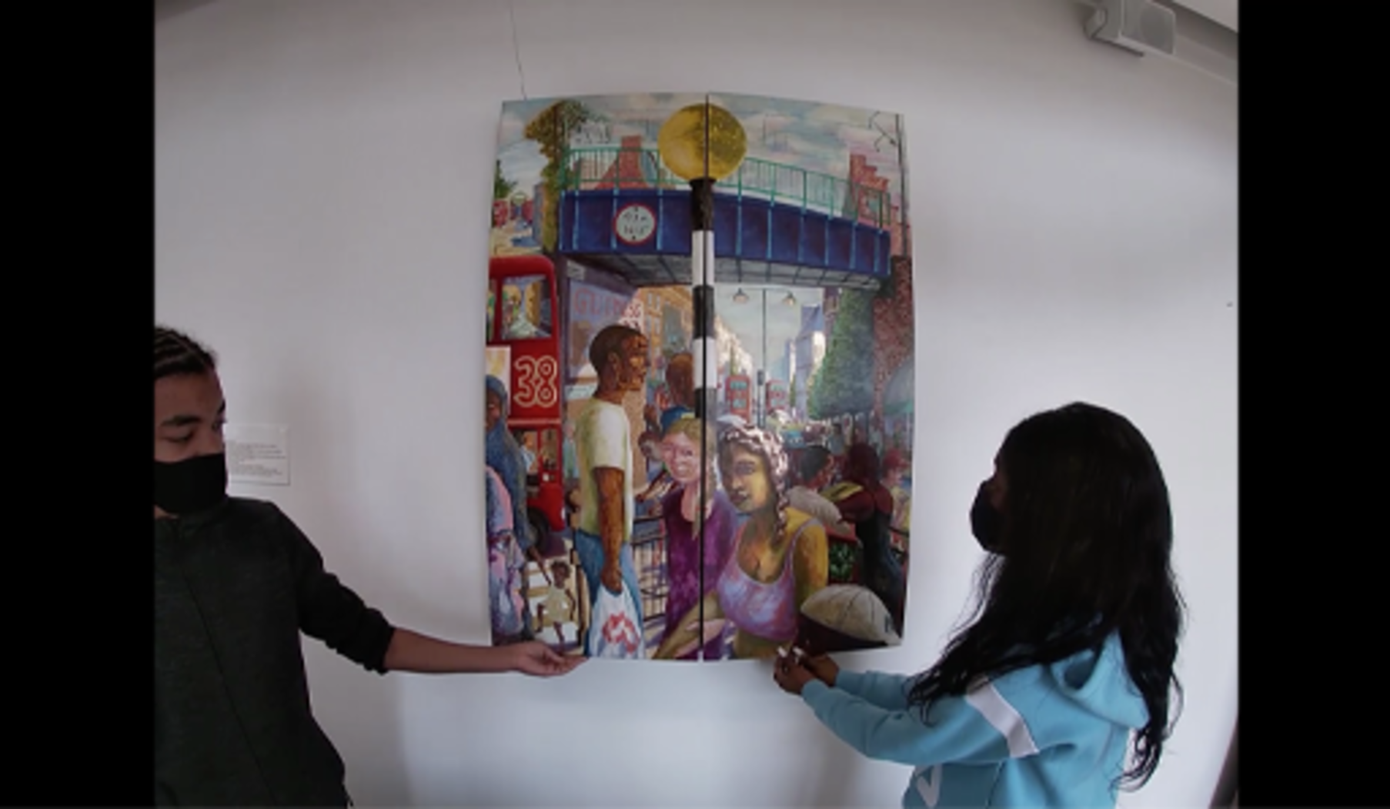
View description - Uncaptioned Figure

Back to - Activity 4

Activity 5

Discussion
Islamophobia is a sensitive topic, but one that must be engaged with if young people are to move beyond the natural tendency of Muslims to feel threatened and offended, and the tendency of non-Muslims to be too easily swayed by images such as the AfD poster. In managing such a conversation, it is essential to step back from inevitably polarised positions of ‘agreement’ or ‘disagreement’ with the image to discussion that probes its assumptions on the lines indicated in the questions that accompany the clipping. For example, participants might be prompted to discuss whether ‘Christian’ and ‘Islamic’ values are really polarised in the way that the poster implies. Both may in fact be challenged in similar ways by the increasing dominance of secular values and policies.
The alternative perspective presented by the Mo Salah video is also important to bring into the conversation, as it is compelling evidence that hostility to Muslims can be overcome by positive encounters and role models. On the other hand, superficial assumptions, such as that north-west England is somehow a more ‘tolerant’ region than southern Germany will need to be challenged.
While these clippings are contemporary in their content, they also have a historical dimension. The AfD poster makes implicit (and contentious) assumptions about the German past; the Mo Salah video alludes to the longstanding presence of Islam in Liverpool, as one of the earliest Muslim communities in the UK. These clippings, like many other contemporary ones, also provide a prompt for discussion of how the past is viewed and whether the ‘presentist’ assumptions that are widespread among young people are valid.
Back to - Activity 5

Activity 6

Part

Discussion
Your response will depend on your own circumstances, but three message you may have picked up include:
- Select clippings likely to be most relevant to your young people.
- Allow plenty of time for discussion.
- Create a safe environment.
Back to - Part

Part

Discussion
Annie emphasises particularly the importance of making a selection of clippings that is customised to your own setting and the aptitudes of your young people. The clippings will need to be introduced in a manner that engages the group and overcomes any initial difficulties of comprehension. She also stresses the importance of having effective support. In a school setting, this is likely to come from management; in a community group it might come from trustees, parents and volunteers.
Back to - Part

SAQ

Discussion
The Plan phase is about enabling the young people to think about how they will turn their ideas, developed during the Engage phase, into something visual and creative and with a focused message.
Back to - SAQ

Activity 1

Discussion
As an example:
- Expository: Planet Earth (2006). This is ‘driven’ by a single narration, by David Attenborough, describing (‘expositing’) the footage of nature.
- Participatory: Louis Theroux: The City Addicted to Crystal Meth (2009). In fact, any of Louis Theroux’s work falls into this category: he is always on screen, interacting with his subjects.
- Performative: Super Size Me (2004). This documentary is ‘performative’ because the director is himself the subject, eating only McDonald’s food for 30 days.
Back to - Activity 1

Activity 2

Discussion
The voiceover makes the claim at the beginning that this story from the past is relevant to streets, communities, sports and hobbies etc., today. The story makes links between past and present by looking at the ways in which Roger Williams thought about religious and non-religious diversity, and in particular his metaphor of society as a ship, one of diversity, justice and fairness. The animation gives the story a contemporary relevance by placing the young person on the ship.
The central message of the narrative is that the past – in the case the story of Roger Williams – can give you unique and relevant insights (though not necessarily straightforward answers) to religious freedom in diverse societies.
Back to - Activity 2

Activity 3

Discussion
The core message of the docutube is that the migration of religious minorities and place-making (e.g. the building of synagogues) has long been a part of Warsaw’s history, and that this is an important consideration when issues of migration and diversity are discussed today.
Back to - Activity 3

Activity 4

Discussion
Although the panoramic image is of Troki in the Polish–Lithuanian Commonwealth (which is in present-day Lithuania but still called by its Polish name), not of Warsaw, it got the students thinking about what cityscapes – either those presented in historical images or what they see now when they look out of the window – might tell us about religious diversity, and the presence of minorities, past and present.
The religious architecture of a city today might not reflect its diversity in the past; and as religious diversity changes in the present, new places of worship may appear. The religious diversity and architecture of a city is constantly changing; and many cities have a long tradition of place-making by religious minorities – in the case of this docutube, the Jewish community in Warsaw.
(If you would like to know more about this clipping, you can find the complete version on the RETOPEA website.)
Back to - Activity 4

Activity 5

Discussion
Here are some of the pieces of advice which might have stood out to you. You might have thought of others.
- Think about how to tell your story visually.
- Ask yourself what is the message, what is the topic?
- You can’t do everything in a film – 3 minutes is not a long time.
- Get your ideas down on paper first.
- Keep it simple.
Back to - Activity 5

Activity 6

Discussion
As a practicing filmmaker, Gail takes a real-world approach, translating the performative, participatory and expository styles you’ve looked at into practical tools in a film practitioner’s toolbox: drama, interview, graphics, locations. She emphasises argument over technical finesse, and advises how much content you can fit into a short film.
Back to - Activity 6

Activity 7

Discussion
There are various points made in the film, but perhaps one of the most important is to allow the young people to be creative, to take the lead in the process and to be open to them making connections to their own experiences.
Back to - Activity 7

SAQ

Discussion
The film sets out the purpose of making docutubes, which is for young people to:
- reflect thoroughly on issues of religious diversity
- actively engage with ideas, problems and solutions of the past
- present their opinions that that they have formed on these issues in an appealing audio-visual way.
It highlights the importance of teamwork in the process of filming and editing the docutubes. The film also gives examples of different filmmaking techniques that have been tried out by the different groups of young people that the RETOPEA team has been working with.
The film recommends encouraging young people to focus on the development of a strong narrative and building on the RETOPEA materials (the ‘clippings’), rather than aiming for technical perfection when filming and editing their docutubes.
Back to - SAQ

Activity 1

Discussion
The teacher makes the following suggestions:
- Make sure that not all the groups film in the same place at the same time to give each other space and to avoid sound interference.
- In order to keep track of where groups are, write down where they are planning to film and when. Consider giving them time slots.
- Encourage groups to focus on the story they are telling, rather than aim for a technically perfect film.
- Ask other colleagues to assist you in the delivery of the workshop, for example by providing technical support.
Back to - Activity 1

Activity 2

Discussion
In this film, Gail Block talks about a wide range of filming techniques including the following:
- Rehearse: encourage young people to rehearse first to find out what camera angle might work best and to rehearse any spoken words.
- Encourage them to film a number of different shots of the same scene/object, but from different angles.
- Encourage participants to try out a range of different filming techniques, including:
  - Close-up shots where objects or people are filmed close to the camera, with focus on small details
  - Establishing shots of landscapes, buildings, street names etc., to set the scene or give context
  - Moving shots where the camera moves. This can convey a sense of dynamism.
- If interviews are included, film both the interviewee and the interviewer. If you only have one camera, you can always film the interviewer separately afterwards – edited together, no one will ever know the difference!
- Encourage participants to draw maps, charts, people or costumes that can be included in their films.
Back to - Activity 2

Activity 3

Discussion
In this film, Gail Block talks about some of the main principles of editing short films, including the following:
- Give the editing phase as much time as possible as it often takes more time than expected.
- Encourage young people to focus on the story they intend to tell when editing their film and concentrate first on the (1) the story as a soundtrack and then on the (2) visuals. Finally, if there is more time, they can also add (3) captions and (4) music.
Back to - Activity 3

Activity 1

Discussion
You might have picked up on a wide range of things, as these docutubes are quite different from one another! Here are a couple of things you might have noted:

Some of these differences are due to the fact that the young people who made these films have related the ideas they encountered in the RETOPEA materials to their own local environment in a range of different ways. Some consider wider social and legal issues, for example in relation to the display of religious symbols – or re-enact historical situations, illustrating examples of religious toleration or intolerance. In some examples, the link between the past and present is explored more explicitly, and others highlight issues relevant to religious toleration and peace more clearly.
This first docutube, made by a group of young people in London, engages with a number of RETOPEA clippings, including a clipping based on the European Convention of Human Rights as well as a clipping about clothing rules for Muslims and Christians issued by Caliph Umar. The students have used a wide variety of different filming techniques and props, including drawings, photos and voice recordings, to highlight different issues related to the right of religious expression, and the display of religious symbols through clothing and jewellery in particular. This film begins with some brief references to the historical and legal context, but focuses mainly on how these issues are relevant to contemporary society.
In the second docutube, young people from a community group engage very much with their local religious history in the Spanish city of Granada. This film involves a combination of different techniques, including expository (presenting a number of different local places and historical facts), participatory (for example, with one of the filmmakers trying on a hijab), as well as performative (with some filmmakers acting, for instance, like they are looking for a mosque or burning books). The starting point for these young people was the RETOPEA clipping about the Reconquista. While the key message is perhaps not wholly clear, this docutube works well visually, taking advantage of the location.
The third docutube was made by a group of teenagers in Tampere, Finland. This is based on a set of interviews with a teacher and students at their school. This film does not directly refer to a specific RETOPEA clipping but focuses on the interviewees’ perception of religious toleration and peace in contemporary Finland.

Back to - Activity 1

Activity 2

Discussion
Karel Van Nieuwenhuyse suggests a number of questions that you could use for a discussion with your group at the end of the workshop. These include:
- What were your initial thoughts on religious toleration?
- How did you engage with the new information from the RETOPEA clippings?
- To what extent did the RETOPEA clippings or the process of making a docutube change your thinking?
- What were the three most important things you learned?
- What can we do to shape the society we live in?
Back to - Activity 2

Figure 1 American footballers Eli Harold, Colin Kaepernick and Eric Reid take the knee during the American national anthem ahead of a game.

Description
A photograph of three American footballers taking the knee in a stadium.
Back to - Figure 1 American footballers Eli Harold, Colin Kaepernick and Eric Reid take the knee during the American national anthem ahead of a game.

Figure 3 An example clipping about the 1573 Confederation of Warsaw

Description
An example clipping taken from the RETOPEA website. It shows and image and text about the 1573 Confederation of Warsaw. The image is a screenshot so the majority of the text cannot be seen clearly.
Back to - Figure 3 An example clipping about the 1573 Confederation of Warsaw

Figure 1 Clipping taken from the POLIN Museum of the History of Polish Jews

Description
Screenshot from the RETOPEA website showing a clipping of a 17th century etching of a panorama of Troki. Text displayed in image reproduced underneath image.
Back to - Figure 1 Clipping taken from the POLIN Museum of the History of Polish Jews

Figure 3 Young people working on their docutubes

Description
Three photos showing a young person filming drawings and photographs; a young person creating artwork for a; and a young person working on map for a docutube.
Back to - Figure 3 Young people working on their docutubes

Figure 8 (top) Frame-grab of what OpenShot editing software looks like on the screen; (bottom) Adobe Premiere timeline source and record windows

Description
The top image shows what OpenShot editing software looks like on the screen. The bottom image showing someone using Adobe Premiere timeline source and record windows.
Back to - Figure 8 (top) Frame-grab of what OpenShot editing software looks like on the screen; (bottom) Adobe Premiere timeline source and record windows

Video 1

Transcript
[MUSIC PLAYING]
[BELL TOLLS]
NARRATOR:
Five cities, one resource, the RETOPEA method has been developed in workshops all over Europe.
KAREL VAN NIEUWENHUYSE:
If you look at the media, a lot of religious issues emerge.
NARRATOR:
It provides a rich educational experience for young people of different ages, backgrounds, and abilities.
STUDENT 1:
We've started educating ourselves about religious tolerance.
NARRATOR:
RETOPEA's unique approach engages learners with ideas about religious toleration.
TEACHER 1:
We show respect for other faiths and people of no faith.
NARRATOR:
Empowering to make short, creative films.
STUDENT 2:
Welcome to the reflection room.
STUDENT 3:
We are going to interview some business employers.
STUDENT 4:
We did make a timelapse for a couple of shots.
NARRATOR:
Whether you're involved in education or youth work, this online course will support you to offer young people the benefits of taking part in RETOPEA.
STUDENT 5:
I didn't know that there was people like that back then. So, yeah, that was really interesting.
NARRATOR:
The course will break the journey down into manageable chunks. You will be given practical advice about how to deliver the sessions.
NADIA HINDI:
What is the message? What is the topic they want to transmit?
NARRATOR:
And hear the experience of other educators.
KAREL VAN NIEUWENHUYSE:
Pitch your story to me. What kind of story do I want to tell?
NARRATOR:
By the end of the course, you too will be ready to roll out a RETOPEA workshop in your own setting and support your young people to learn about religious peace and tolerance.
[MUSIC PLAYING]
STUDENT 2:
Coming slowly!
[MUSIC PLAYING]
Back to - Video 1

Video 2

Transcript
[MUSIC PLAYING]
NARRATOR:
Can you tell a story about the past that speaks to the present? I hear you asking, why would I do that? Let me explain by telling you a true story, a story from the past that has something to say about your streets, your community, your sports, or your hobbies. A story about diversity, people who are different, and a man with a passion for the values of religious toleration. The story takes you back in time 400 years ago to a place called Massachusetts on the East Coast of America. The people here have recently arrived from England.
[MUSIC PLAYING]
They're known as Puritans. They want to establish what they see as an ideal Christian society. But in building their ideal pure society, they're intolerant towards people who don't share their religious beliefs and practices. One person who disagrees with this is Roger Williams.
By winter 1636, Roger Williams is no longer welcome. He's facing arrest. He needs to escape. It's a long journey through the deep snow and harsh cold.
Eventually, thanks to some friendly Indigenous people, Roger got the chance to start a new settlement. It would become the colony of Rhode Island. Roger wanted this new colony to be different, different from Massachusetts, different from the Old World in Europe, a society where there is freedom of conscience. Roger Williams thought of this new society as a ship.
On this ship, in theory, there could be people of different religions, different types of Christians, Muslims, atheists, Jews. They were all welcome. They shared the ship. It was a ship where there was justice and fairness. Everyone had a choice about when they prayed and who they prayed to.
The captain of the ship could belong to any religion. In the 17th century, very few people believed a society could be like this. But Roger Williams did. And he pioneered a new approach to religious freedom.
There. I've told you a story, a story about diversity and toleration and what society might be like. What does that story trigger your thinking about? Why not make a film about it?
In this project, you will relay ideas from history to your streets, your community, your sports, or your hobbies? You'll become a historian, a film maker, and a blogger all in one. All it takes is a little imagination.
Like Roger Williams, you, too, will go on a voyage of discovery. Go to retopea.eu. It has all the tools you'll need to think about history in a new way and make your film. Bon voyage.
[MUSIC PLAYING]
Back to - Video 2

Video 2

Transcript
SPEAKER 1:
Roger Williams uses the metaphor of a ship to convey his beliefs about an ideal world. He talks about how every man, woman, child is equal in spite of their faiths, beliefs, and God. Today we're going to explore how far us as a society has come to his version of an ideal world.
SPEAKER 2:
It happens sometimes that both Catholics, Protestants, Jews, and Muslims may be traveling on one ship. In that case, I tell you the tool the freedom of conscience I have ever asked for depends upon these two things, that none of them is forced to come to the ships' prayers of worship and that none of them is stopped from worshipping in their own way if they pray at all.
SPEAKER 3:
In Hackney, I think we have the same challenges as all other communities in the country. And I think that what's actually happening is that you have two sides of a coin. On one side, you see great strides in terms of communities getting along better, being more respectful of each other, and getting to know each other's cultures better. And I think that this school that we're in exemplifies that.
[MUSIC PLAYING]
SPEAKER 4:
And I think the call is really important for us to seek out people of all faiths and none and look for good, the common good, that guides us all. And the more we get to talk about things like how the golden rule, love your neighbour, exists in every religious culture and every non-religious culture throughout history, the more we get to encourage people that we all have exactly the same standards. Treat other people the way you want to be treated, the better it is for all of us.
SPEAKER 3:
However, on the other side, I must caution that incidents of religious hatred, lack of tolerance still exist in society, still exist in the local community. But I think that when they do happen, the moral majority are more empowered to gather together and condemn those actions with our words and our deeds to show that we are better together and stronger together than being divided.
Back to - Video 2

Video 3

Transcript
[MUSIC PLAYING]
KAREL VAN NIEUWENHUYSE:
My advice to educators about relating learning from RETOPEA to their immediate settings-- first, I would advise them to ensure the significance for the participants. What is meaningful for the learners? This is particularly important with regard to the selection of the clippings. Think carefully about the good and meaningful selection in the light of your specific target audience-- in terms of age, gender, interest, reading capabilities, religious and other backgrounds, and so on.
Take your time to engage with the topic. Because listening to each other, talking with each other, reflecting on such complex issues forming your own opinion-- all this takes a lot of time. So if we mean it seriously with this topic, if we consider it important in the development of young people, then we really need to take the necessary time for it, and not on one occasion but on several occasions.
Create a safe environment because issues regarding religion and religious diversity are very sensitive. They often touch upon young people's personal and social identities. And therefore, we really need to ensure them that all conversation will happen in a safe and respectful way.
Think about apt questions that encourage to draw analogies between past and present. The past never offers ready-made recipes for today and for tomorrow. Because after all, historical context differ and human behaviour does not follow fixed laws.
Mark Twain once said, history never repeats itself, but it does often rhyme. And I think that is precisely what is important for this project. What rhymes, so to speak, do young people recognise today in those clippings about the past? How were things done in the past? What were the consequences of actions in the past? And in this way, their thinking about today and tomorrow will be challenged.
Back to - Video 3

Video 4

Transcript
[MUSIC PLAYING]
ANNIE POWELL:
My top tips for educators considering doing RETOPEA is, yes, I would do it. Definitely, go for it. Really, you can't do it unless you've got really good support from your senior management because the senior management can help you to make things happen.
I think it's thinking about the timing and how you structure each session, running the actual ENGAGE session would be quite straightforward, particularly for someone who's used to teaching history or RE.
Getting lots of people on board. So we had lots of goodwill. We had students coming to help. We had other teachers coming in to help. And all of them enjoyed it, felt they were doing something positive. And obviously, thinking about maybe the ethos and the ideas within your own school. Make it relatable to the things which are important themes where you are. And then I think it will work really well.
If I was advising a new teacher coming to the process, and certainly if I was going to do it again, I would definitely edit down the clippings a little bit. I did do a slightly modern language version of one of the sources. And I think I would edit it a little bit even more.
I think the methods of using the clippings and then having them discuss them in their groups, that was quite a challenge to them. And we did have to slightly rethink and break it down a little bit to make it more accessible for them. But it worked, really, once we did that, it really was sort of light bulb moment for them. It sort of made sense and even one of the sources they found really difficult to begin with was actually the one that all of them really identified with and recognised and wanted to employ it as one of the key things in their videos, their stories. So that was sort of very rewarding to see them do that.
Back to - Video 4

Video 1 (repeated)

Transcript
[MUSIC PLAYING]
NARRATOR:
From the sunny south to the frozen north of Europe, young people are engaging with the new educational project.
KAREL VAN NIEUWENHUYSE:
It aims to examine how people deal with religious diversity in the past.
NADIA HINDI:
Normally, there's a negative view of religions in the past, considering the religion as an inherent source of conflicts.
KAREL VAN NIEUWENHUYSE:
The idea is to inform and enrich particularly young peoples' thinking and to inspire ways forwards towards peaceful religious coexistence.
NARRATOR:
In Granada in the south of Spain, a community based youth group is taking up the challenge.
NADIA HINDI:
We provide them educational materials in order for them to reflect in a way that they can connect the past with the present and with their own experience.
KAREL VAN NIEUWENHUYSE:
The idea is not to impose what young people should think, but really to inspire their reflection on issues about religious diversity.
NARRATOR:
These 16-year-olds are based in a city center school in London, England.
ANNIE POWELL:
I think our young people really benefited. They were quite daunted initially by the sources that they were working with. But once they got their confidence up there, they started to have some ideas.
STUDENT 1:
I learned an incredible story about Roger Williams and how he created this incredible society where Christians, Muslims, Jews were all welcome.
STUDENT 2:
He's an example of progressive attitudes back in the past. And I didn't know that there was people like that back then. So yeah, that was really interesting.
NARRATOR:
The project website provides essential resources called clippings.
NADIA HINDI:
The information is presented in the clippings could be a text, could be a video, or could be an image. A very important thing is that it comes with a context.
NARRATOR:
The clippings are deliberately thought provoking, designed to stimulate discussion on the theme of religious toleration and peace. In Leuven, Belgium, this group of students are inspecting these resources.
INSTRUCTOR 4:
So this main text here, on the page, that is the actual clipping text.
STUDENT 3:
This morning, we started educating ourselves about religious tolerance and what it means to deal with that. And we basically started by going to the website and looking at different clippings.
NADIA HINDI:
We always give them a question in order to encourage critical thinking.
STUDENT 3:
There's one set of values, another set of values. When you're in a country, and they all come together, it's finding a way to make them fit.
NADIA HINDI:
And then always try to narrow down and think and reflect about what they can learn and how this relates to their present.
NARRATOR:
The questions are a stimulus for lively debate.
INSTRUCTOR 4:
It's easier to say, well, you can believe whatever you want. That's easy. But it's way more difficult to say, well, you can show your belief to whoever you want. You can manifest your belief.
STUDENT 4:
Yeah, because it's something very personal. But people also take offense to that in a personal matter. So there's always two sides.
KAREL VAN NIEUWENHUYSE:
We share collective memories in different communities and so on. So experiences from the past help to shape our present and how we look at the present. And this is why we need to engage with that past.
NARRATOR:
Teachers and group leaders often draw their inspiration from the area around them.
NADIA HINDI:
In Granada, we are very lucky because it's very obvious when you go into the streets. There's many churches. And these churches also used to be mosques. So one of these places, the tower is a minaret and reflects the mixing culture in Granada.
STUDENT 4:
One of us mentioned, in Leuven, there's a lot of religious buildings. And we got thinking buildings, streets as well. And we were thinking about what is a street name.
NARRATOR:
Some students find inspiration in events from the past.
STUDENT 3:
We started with the clipping about the Kindertransport during World War II in Britain. And then we're thinking about, OK, how do people think about religion? What can you say or what can you not say?
NARRATOR:
While others find parallels with their own community.
STUDENT 5:
In the clipping, it talks about different faiths and those who don't have a faith. And our school's very much like that.
ANNIE POWELL:
Using a historical source, sometimes it can feel a bit distant. But in fact, once we then linked it into their community, their experience, it made so much more sense to them.
NARRATOR:
It's all about overcoming barriers to understanding.
NADIA HINDI:
There's an obstacle, and that is presentism. Presentism is the way they present the past by dominant ideas of the present. This way we get to biased conclusions or stereotypes.
KAREL VAN NIEUWENHUYSE:
If you look at history education, the impression arises there that only political leaders, military leaders, kings, white males, have the ability to make changes in society, which is, of course, not true.
NADIA HINDI:
A way to avoid simplistic views and opinions is through studying the context. And this helps us to have more deeper understanding.
NARRATOR:
As the young people work through this stage, they are invited to develop a more critical line of inquiry.
STUDENT 4:
I think my ideas about religious peace and tolerance it change a bit.
STUDENT 1:
We all had good ideas, and we started off really good.
STUDENT 2:
I thought it was really interesting.
KAREL VAN NIEUWENHUYSE:
If we look at changes during the past, many changes stem from actions of common individuals, common groups. And this is an important benefit from the RETOPEA project.
INSTRUCTOR 5:
We show respect for other faiths and people of no faith.
KAREL VAN NIEUWENHUYSE:
You show young people how all of us have the ability to change the world we live in into a better place.
Back to - Video 1 (repeated)

Video 1

Transcript
STUDENT 1:
The thing I found most surprising is how much planning there has to be, how much you have to think about what you're doing and the work that goes into it before even starting.
STUDENT 2:
We're just trying to keep it simple, not go into too much detail.
STUDENT 3:
Plan out everything because three minutes isn't a long time.
NARRATOR:
In Granada, the students have already decided on their line of inquiry. Now they must work out how to turn it into a film.
NADIA HINDI:
I think that learning about the past and the present through making videos is very powerful because it makes them actively engaged in the process, in the whole process.
NARRATOR:
In Leuven, the students are learning how important it is to consider the messages in pictures as well as words.
INSTRUCTOR 1:
First thing I'm going to start with is we're going to talk a little bit about vloggers and vlogging, OK?
KAREL VAN NIEUWENHUYSE:
RETOPEA chose vlogging in the plan phase because in this 21st century, we no longer live in a verbal culture, but we live in a visual culture. We live in a world of images. And moreover, the medium of vlogging forces young people to develop very clear and very articulate opinion.
NADIA HINDI:
We have to think clearly what is the message, what is the topic they want to transmit through the clippings, and only in three minutes. So they really have to be clear about their ideas.
STUDENT 4:
I think we should do both perspectives.
GAIL BLOCK:
Young people have to think really hard about the ingredients of the film. So that's the location-- where are they going to be filming? The people-- who are they going to point the camera at? Props-- do they need any props?
NARRATOR:
In London, they're thinking about the practicalities of who, what, and where they can film.
ANNIE POWELL:
It's not raining. You can go outside. You can go into the playground. You can use the breakout areas.
All I needed to do really was give them those ideas of where they might film. They then brought in their ideas of how they were going to tell their story. And in fact, they were trying to cram lots in. But they were quite disciplined about it. They recognised early on that they couldn't do everything.
STUDENT 5:
While we've done that scene and we're about to go to the chapel, we should film ourselves going there.
STUDENT 6:
Yeah, but before they have to-- we have to see what we're doing.
STUDENT 5:
Oh.
[LAUGHTER]
NARRATOR:
Sometimes it helps to get your ideas down on paper.
INSTRUCTOR 1:
What I'd like you to do is to start putting together this simple shooting script. So on this side, we're going to see what the shots are. On this side, we're going to have the audio. What this gives you is some sort of plan.
STUDENT 7:
You have to visually already know what kind of story you want to tell, select images you want to film even before you're actually doing it. So it is mentally a task as well.
STUDENT 8:
I think we have all very different ideas, and to bring all these ideas together, I think it's difficult. We don't have any experience, and the ideas are really abstract. So we are looking for something more concrete, and we think we found it now.
NARRATOR:
Conversations range widely. But in the end, the groups must find something they can point a camera at. It's a process of refining and looking for the essence of what they want to say.
STUDENT 2:
I would say, keep it simple, definitely, because as soon as you try to overcomplicate things, you're just going to get stuck.
ANNIE POWELL:
They had to keep it very, very focused, and they had to focus on what the story was that they were telling. And that was really important to keep it very, very tight.
NARRATOR:
At the culmination of the plan stage, the young people are asked to pitch their ideas.
KAREL VAN NIEUWENHUYSE:
In order to facilitate your thinking, I am going to ask you to pitch your story to me. The main worry should be what kind of story do I want to tell.
NARRATOR:
During the pitch, educators are looking for a well-structured story that uses pictures as well as words.
STUDENT 7:
We were thinking about Leuven, the setting we were in. And there are a lot of religious buildings and street names, which got us thinking, why are certain symbols of religion a problem and certain symbols are not?
KAREL VAN NIEUWENHUYSE:
And that's a very nice, surprising angle. We all know the street names. And all of the sudden, you start to think about it and reflect about it. So, great, yeah.
ANNIE POWELL:
That sense of pressure that they've got to get it ready and there's going to be a pitch, it builds the excitement, but it really focuses their minds.
STUDENT 9:
It questions our society as a whole. Why haven't we reached a point where everyone can live in peace?
GAIL BLOCK:
Intellectually, it's really making them think about ideas as translating them into a visual format.
NADIA HINDI:
They have to think about not only the message that they want to transmit, but also how to make it original, creative.
NARRATOR:
By the time they are issued with cameras, the young people have learned a lot about each other's points of view.
KAREL VAN NIEUWENHUYSE:
It is very important that young people learn to listen to each other-- to, well, to take someone else's perspective and to really try to understand because only then, only when we try to understand one another, we can move forward and try to come to more shared opinions or peaceful coexistence.
Back to - Video 1

Video 2

Transcript
[MUSIC PLAYING]
NARRATOR:
Can you tell a story about the past that speaks to the present? I hear you asking, why would I do that? Let me explain by telling you a true story, a story from the past that has something to say about your streets, your community, your sports, or your hobbies. A story about diversity, people who are different, and a man with a passion for the values of religious toleration. The story takes you back in time 400 years ago to a place called Massachusetts on the East Coast of America. The people here have recently arrived from England.
[MUSIC PLAYING]
They're known as Puritans. They want to establish what they see as an ideal Christian society. But in building their ideal pure society, they're intolerant towards people who don't share their religious beliefs and practices. One person who disagrees with this is Roger Williams.
By winter 1636, Roger Williams is no longer welcome. He's facing arrest. He needs to escape. It's a long journey through the deep snow and harsh cold.
Eventually, thanks to some friendly Indigenous people, Roger got the chance to start a new settlement. It would become the colony of Rhode Island. Roger wanted this new colony to be different, different from Massachusetts, different from the Old World in Europe, a society where there is freedom of conscience. Roger Williams thought of this new society as a ship.
On this ship, in theory, there could be people of different religions, different types of Christians, Muslims, atheists, Jews. They were all welcome. They shared the ship. It was a ship where there was justice and fairness. Everyone had a choice about when they prayed and who they prayed to.
The captain of the ship could belong to any religion. In the 17th century, very few people believed a society could be like this. But Roger Williams did. And he pioneered a new approach to religious freedom.
There. I've told you a story, a story about diversity and toleration and what society might be like. What does that story trigger your thinking about? Why not make a film about it?
In this project, you will relay ideas from history to your streets, your community, your sports, or your hobbies? You'll become a historian, a film maker, and a blogger all in one. All it takes is a little imagination.
Like Roger Williams, you, too, will go on a voyage of discovery. Go to retopea.eu. It has all the tools you'll need to think about history in a new way and make your film. Bon voyage.
[MUSIC PLAYING]
Back to - Video 2

Video 3 (a translation of this video is available in the transcript)

Transcript
[TEXT ON SCREEN: Jewish migrations to Warsaw.]
SPEAKER 1:
Migrations are now often considered as something negative, especially for the countries that are welcoming migrants. We are now in Warsaw, the capital of Poland, a city historically regarded as an asylum for religious immigrants, Jews in particular.
But is people’s attitude towards other religions still positive now?
We’ll ask students and people on the streets of Warsaw what they think about religious immigrants and if they could find refuge in Warsaw.
Hello.
INTERVIEWEE 1:
Hello.
SPEAKER 1:
I would like to ask you a few questions. What would you think if new synagogues were built in Warsaw?
INTERVIEWEE 1:
I think it’s a very good idea, because then the Jewish community could practise their religion freely and feel more at home both in Warsaw, and in Polish society as such.
INTERVIEWEE 2:
I certainly wouldn’t be opposed! As a multicultural city, Warsaw has a lot of space where all cultures and religions should have the right to establish their own religious and cultural spheres, and to cover them with their own artefacts. This should all be possible for respecting religious diversity and heterogeneity.
INTERVIEWEE 3:
It wouldn’t be a problem at all. Especially because there aren’t enough synagogues in Warsaw compared to the number of Catholic churches.
SPEAKER 2:
All respondents wouldn’t oppose new synagogues in Warsaw. Over centuries, religious migrations were a common phenomenon. Many Jewish immigrants came to Poland, at that time considered an asylum for people of diverse religious beliefs, and established new synagogues.
SPEAKER 1:
Are you aware of how many synagogues there are in Warsaw now and how many there were in the past?
INTERVIEWEE 4:
Honestly, I have no idea because…
SPEAKER 1:
You have never thought about it?
INTERVIEWEE 4:
I haven’t.
SPEAKER 1:
Right, I see.
INTERVIEWEE 3:
Well, yes, there were of course much more synagogues in the past, for historical reasons. Now these remaining buildings are not enough to accommodate the needs of the Jewish community, which exists in Warsaw and is prospering.
INTERVIEWEE 2:
I could certainly say more about the past, because I haven’t studied this topic now. I know that a synagogue is about to be built in Warsaw and that there are plans for another one. The architecture changes, but I believe this would be a place every resident of Warsaw should see. Not only churches, but also synagogues because these are monuments of our common culture, culture of Warsaw.
SPEAKER 2:
In the past, there were 440 synagogues and Jewish houses of prayer in Warsaw. There are 20 of them in Warsaw today, with only one still in operation. It is the Nozyk synagogue, which survived World War Two.
The palm located at the Jerusalem Avenue in Warsaw reminds us of the city’s Jewish history. It commemorates a Jewish settlement called the New Jerusalem, connected with the city through the Jerusalem Avenue.
SPEAKER 1:
What do you think about the level of religious toleration in Warsaw?
INTERVIEWEE 3:
It is really, really low, which you can experience when you, for example, wrap a scarf around your head to warm yourself up. And you immediately hear different comments on the street, which only tells you how much prejudice there is towards people who look even slightly different. People immediately think that this person is Muslim.
SPEAKER 1:
And therefore, a terrorist for example?
INTERVIEWEE 3:
Yes, for example. And if someone’s wearing a kippa, you will see people mocking them with weird gestures. Not to mention the situation when someone’s wearing payot.
SPEAKER 1:
I see.
INTERVIEWEE 1:
I think that there is certainly some religious toleration in Warsaw, but how high is it? I would have to think more about it, but I don’t believe it’s very high. People should get more tolerant, especially in Poland.
INTERVIEWEE 4:
I think the situation is mediocre, but Polish schools could certainly get more tolerant.
[TEXT ON SCREEN: How to increase religious toleration?]
SPEAKER 2:
As you can see, almost all interviewees believe that Warsaw could be more tolerant. We can draw inspiration from the past. For example, the Statue of Kalisz issued in 1263 granted religious privileges to the Jewish community. It was later confirmed by, amongst others, the kings Casimir III the Great and Stanislaw II August. It exempted Jews from taxes and made hurting Jews punishable under law.
SPEAKER 1:
Religious migrations are not a new phenomenon, and centuries-old vestiges of religious diversity can be easily observed in the cityscape of Warsaw. We shouldn’t oppose a similar situation now and we should be open to the Jewish community as it has been present in Warsaw for centuries.
Back to - Video 3 (a translation of this video is available in the transcript)

Video 1 (repeated)

Transcript
STUDENT 1:
The thing I found most surprising is how much planning there has to be, how much you have to think about what you're doing and the work that goes into it before even starting.
STUDENT 2:
We're just trying to keep it simple, not go into too much detail.
STUDENT 3:
Plan out everything because three minutes isn't a long time.
NARRATOR:
In Granada, the students have already decided on their line of inquiry. Now they must work out how to turn it into a film.
NADIA HINDI:
I think that learning about the past and the present through making videos is very powerful because it makes them actively engaged in the process, in the whole process.
NARRATOR:
In Leuven, the students are learning how important it is to consider the messages in pictures as well as words.
INSTRUCTOR 1:
First thing I'm going to start with is we're going to talk a little bit about vloggers and vlogging, OK?
KAREL VAN NIEUWENHUYSE:
RETOPEA chose vlogging in the plan phase because in this 21st century, we no longer live in a verbal culture, but we live in a visual culture. We live in a world of images. And moreover, the medium of vlogging forces young people to develop very clear and very articulate opinion.
NADIA HINDI:
We have to think clearly what is the message, what is the topic they want to transmit through the clippings, and only in three minutes. So they really have to be clear about their ideas.
STUDENT 4:
I think we should do both perspectives.
GAIL BLOCK:
Young people have to think really hard about the ingredients of the film. So that's the location-- where are they going to be filming? The people-- who are they going to point the camera at? Props-- do they need any props?
NARRATOR:
In London, they're thinking about the practicalities of who, what, and where they can film.
ANNIE POWELL:
It's not raining. You can go outside. You can go into the playground. You can use the breakout areas.
All I needed to do really was give them those ideas of where they might film. They then brought in their ideas of how they were going to tell their story. And in fact, they were trying to cram lots in. But they were quite disciplined about it. They recognised early on that they couldn't do everything.
STUDENT 5:
While we've done that scene and we're about to go to the chapel, we should film ourselves going there.
STUDENT 6:
Yeah, but before they have to-- we have to see what we're doing.
STUDENT 5:
Oh.
[LAUGHTER]
NARRATOR:
Sometimes it helps to get your ideas down on paper.
INSTRUCTOR 1:
What I'd like you to do is to start putting together this simple shooting script. So on this side, we're going to see what the shots are. On this side, we're going to have the audio. What this gives you is some sort of plan.
STUDENT 7:
You have to visually already know what kind of story you want to tell, select images you want to film even before you're actually doing it. So it is mentally a task as well.
STUDENT 8:
I think we have all very different ideas, and to bring all these ideas together, I think it's difficult. We don't have any experience, and the ideas are really abstract. So we are looking for something more concrete, and we think we found it now.
NARRATOR:
Conversations range widely. But in the end, the groups must find something they can point a camera at. It's a process of refining and looking for the essence of what they want to say.
STUDENT 2:
I would say, keep it simple, definitely, because as soon as you try to overcomplicate things, you're just going to get stuck.
ANNIE POWELL:
They had to keep it very, very focused, and they had to focus on what the story was that they were telling. And that was really important to keep it very, very tight.
NARRATOR:
At the culmination of the plan stage, the young people are asked to pitch their ideas.
KAREL VAN NIEUWENHUYSE:
In order to facilitate your thinking, I am going to ask you to pitch your story to me. The main worry should be what kind of story do I want to tell.
NARRATOR:
During the pitch, educators are looking for a well-structured story that uses pictures as well as words.
STUDENT 7:
We were thinking about Leuven, the setting we were in. And there are a lot of religious buildings and street names, which got us thinking, why are certain symbols of religion a problem and certain symbols are not?
KAREL VAN NIEUWENHUYSE:
And that's a very nice, surprising angle. We all know the street names. And all of the sudden, you start to think about it and reflect about it. So, great, yeah.
ANNIE POWELL:
That sense of pressure that they've got to get it ready and there's going to be a pitch, it builds the excitement, but it really focuses their minds.
STUDENT 9:
It questions our society as a whole. Why haven't we reached a point where everyone can live in peace?
GAIL BLOCK:
Intellectually, it's really making them think about ideas as translating them into a visual format.
NADIA HINDI:
They have to think about not only the message that they want to transmit, but also how to make it original, creative.
NARRATOR:
By the time they are issued with cameras, the young people have learned a lot about each other's points of view.
KAREL VAN NIEUWENHUYSE:
It is very important that young people learn to listen to each other-- to, well, to take someone else's perspective and to really try to understand because only then, only when we try to understand one another, we can move forward and try to come to more shared opinions or peaceful coexistence.
Back to - Video 1 (repeated)

Video 4

Transcript
[MUSIC PLAYING]
GAIL BLOCK:
My advice for teachers and young people when they're trying to translate an abstract academic historical idea into something that you can film is to think very hard about what in the real world you can point that camera at. So, can you reconstruct a historical event? Or can you interview someone?
If you're going to interview someone, what questions would you like to ask them? Can you draw something on paper and create a little graphic sequence? Or are there any objects or buildings or places in your local area that really exemplify this idea?
A good idea for a three-minute film is actually quite simple. You don't want to cram a whole load of detail in there. I was always told you have to have something that you can write down on a post-it note. It also has to have a strong argument, a strong intellectual idea in the way that you would probably look for in an essay.
We are really interested in what the young people themselves have to say so it's not just, oh, we went out and we interviewed people to find out what they think. We would love to see a beginning, a middle, and an end. And at the end we would love to see a synthesis of what the young people themselves have decided about this matter.
When professionals make a film we have quite a long time to do it and that's not a luxury that your young people are ever going to have. So it's really important not to set too high expectations. They're not going to make a Hollywood movie. And actually that's not the point. The point is for them to be able to express their ideas, so they should be thinking about what they really most want to say.
[MUSIC PLAYING]
Back to - Video 4

Video 5

Transcript
[MUSIC PLAYING]
NADIA HINDI:
My advice to a teacher or youth leader would be let the young people lead the process and support their ideas. It's just like facilitating and leaving the room for the students to discuss and get to the points they want to get. Also, I would tell them to think about how it relates to their normal life, the life in the neighborhood, the knowledge they have previously about the world or the history of their families.
This group of Granada is a group of quite young people from 12 to 15-years-old. And not all of them, but the majority of them are Muslims for different backgrounds. The group picked up the idea of tolerance and acceptance of the other in the past in the present in Spain.
There are many evidence of this coexistence and many cities. In Granada, we are very lucky because it's very obvious when you go into the streets. Eight centuries of Islamic presence. People were born there and lived there are Muslims. The young people in Granada, they find quite original ways. They can even relate the idea of water with tolerance. Asking themselves what's the relation between water and tolerance. So one of them thought, they answered and said, OK, the man that deliver water in the past, they have to give water to everybody, regardless of religion.
I will advise the teachers and youth leaders to think about different skills that they will really need. Not only knowledge, but also technical skills and human support.
Also, you need to find that support by people that can go with the groups and to street. Many different roles that we can play in order to make this thing happen.
[MUSIC PLAYING]
Back to - Video 5

Video 1

Transcript
[MUSIC PLAYING]
STUDENT 1:
After you've planned all the shots, seeing them develop, seeing them even on the little screen, seeing a plan come to fruition in an image was really nice. Yeah.
STUDENT 2:
We tried some things, and if it didn't work, then we tried again, and then it would work better. So yeah, that's basically trial through error, I guess that's what you would say.
STUDENT 3:
We all had good ideas-- welcome to the reflection room, hoping that all turns out really good at the end.
NARRATOR:
In the Create Stage, the students develop a message about religious, peace, and toleration, shot by shot.
KAREL VAN NIEUWENHUSE:
Making docutubes combines several purposes. The most important one is to reflect thoroughly on issues of religious diversity.
NADIA HINDI:
Young people learn a different way of looking to the past, more contextualised, more critical and more complex.
KAREL VAN NIEUWENHUSE:
A secondary purpose is then to present this opinion that they formed in an appealing audiovisual way via docutubes.
NARRATOR:
In Leuven, the students are investigating how religious coexistence in the past affects everyday life in the present.
STUDENT 1:
We started thinking from the clipping French laicité, in France, the separation of church and state, and then we found ourselves asking how far does that go?
NARRATOR:
The streets of Leuven offer many ways to depict the passage of time.
STUDENT 1:
One thing we did was make a time lapse for a couple of shots.
[MUSIC PLAYING]
We took shots of street names to edit together.
KAREL VAN NIEUWENHUSE:
They should think about the relationship and the connections between past and present.
NARRATOR:
A pen and paper is all you need to create your own graphics.
STUDENT 1:
And we also filmed a bit of moving around so just holding the camera to ourselves while we were walking.
STUDENT 4:
What we really want to know is do they work in practice?
KAREL VAN NIEUWENHUSE:
It's important to remind young people that they should engage with the clippings, that they should give them the space in their docutube.
[MUSIC PLAYING]
NARRATOR:
In London, the students found parallels between ideas in the clippings and ideas in their own school.
ANNIE POWELL:
I think as a Church of England School, we're very inclusive. As the students mentioned a lot in their videos, we are a Christian School, but we're not a school for Christians, we're a school for everyone.
STUDENT 5:
Do you think we need to embody Williams' metaphor of society as a ship? We wanted to look at Roger Williams, his metaphor of society as a ship, and how Urswick embodies this.
INSTRUCTOR 1:
That's why this chapel door, you've got a display of the Lord's Prayer translated into over 40 different languages. Those are the first languages of everyone who speaks at this school.
STUDENT 3:
Our school is like a society in the ship, and we're here to prove it by the testimony of two teachers.
NARRATOR:
When interviewing the head teacher, it's important to get your questions straight.
STUDENT 3:
So as a Muslim, do you think the school is promoting religious toleration to help unify all students?
NARRATOR:
I don't think it, I know it.
ANNIE POWELL:
They had to keep it very, very focused, and they had to focus on what the story was that they were telling.
NARRATOR:
In Granada, many students were inspired by Spain's multicultural past.
NADIA HINDI:
We tackle different things related to Granada, to the history of Granada, about the relation between Christians or non-Muslims with Muslims in the city.
NARRATOR:
These students are using drama to reconstruct the religious intolerance that happened on this spot.
NADIA HINDI:
Some of them were interested by Reconquista, for example. Reconquista refers to the battle between the Christians and the Muslims from the Christian perspective. Some of them was very keen to take this topic and take it to the street and interview people.
INTERVIEWEE:
So this street here is bizarre, and you can see that Granada is very tolerant.
NADIA HINDI:
They was really engaged with the process.
NARRATOR:
The next stage of the process will test the students teamwork even further.
STUDENT 2:
We are currently making the movie, so they're actually editing things which means that we're choosing which fragments to use, what are we leaving out, what do we put in.
GAIL BLOCK:
Editing is in fact, what makes the film. So when you've been out filming, it's only in the edit that the story really comes together when you're deciding what order to put those shots in, what to emphasise, what to leave out.
NARRATOR:
With some technical support, the footage is loaded and the edit set up.
INSTRUCTOR 2:
Once they're into your project window, they'll look a bit like this.
NADIA HINDI:
It's really a team that's behind supporting the young group. We have the historical skills, the knowledge, and we have also the technical skills.
STUDENT 5:
Just the little end bit?
STUDENT 6:
Yes, the just the little end bit.
STUDENT 5:
This one or this one?
STUDENT 6:
I think that one.
STUDENT 7:
That one because it have better angle in it.
STUDENT 6:
Yeah.
NARRATOR:
Editing forces the students to clarify their ideas about religious, peace, and toleration.
GAIL BLOCK:
It's a really good idea to first of all concentrate on your sound and lay down the story in terms of interview, in terms of commentary, because that's the backbone of a good film.
STUDENT 8:
[INAUDIBLE] We are struggling a little bit with working with the audio tracks.
STUDENT 9:
I mean, It's not that bad.
STUDENT 8:
No, no, no, but the way it cuts it.
ANNIE POWELL:
There were some moments of despair when they realised they hadn't quite filmed what they wanted to-- and they couldn't make it look quite like a sort of million pound Hollywood movie.
STUDENT 10:
What is that?
INSTRUCTOR 3:
Any surprises?
STUDENT 11:
A little bit. There's a bit of malfunction, but we're working through it. Yeah.
NARRATOR:
History, not technology is the key to success. So just a little technical know how is all the students need.
STUDENT 4:
Ambitious, tolerance, and constitutions and moderation of lives.
STUDENT 1:
What I enjoyed most about editing is how putting all the separate bits together, all those different little clips become one movie, one story. So that's it's nice to see that come together.
NARRATOR:
After the edit, the students watch each other's films. In London, they'll be judged by Professor John Wolffe from the RETOPEA.
JOHN WOLFFE:
I think you've all showed a very strong, creative narrative, but also building very much on the RETOPEA materials. So thank you, I think you've all done a brilliant job.
NARRATOR:
Elsewhere, the young people have also been thinking hard about the aims of the project.
KAREL VAN NIEUWENHUSE:
RETOPEA wants to promote among young people and in society at large, active engagement with ideas, problems, solutions, and processes from the past.
STUDENT 12:
Hey, today, we're at the University of Leuven and we're going to take a look at some examples of tolerance in the past.
STUDENT 1:
When I go out in the streets, after tomorrow, I'll have a look at some things differently.
NADIA HINDI:
At the end, we always try to encourage them to connect with the things they know, the things that they experience in their lives and their normal lives, so this is the way they learn.
STUDENT 5:
It was fun, Yeah. It was fun to do.
STUDENT 13:
Well, it feels very professional although we're not professionals. So it's a nice feeling actually.
Back to - Video 1

Video 2

Transcript
[MUSIC PLAYING]
ANNIE POWELL:
I think one of the key things that we did was just before we sent them off to film we actually asked them to write down exactly where they were going. I gave them time slots for where they needed to be to interview one of the particular colleagues. And then they had to write down the order in which they were going to go to certain places.
I think the students very quickly realised it was very important not to be all in the same area filming at the same time because they couldn't get the sound to work. There was too much noise and so they would be interviewing someone but there would be noises off of someone else being interviewed. They went off and it was slightly alarming at one point because I couldn't see where anyone was. In fact, there was one group on our roof garden and there was one group down in the museum, another group interviewing someone else that I hadn't even expected. So they were really very focused and very efficient in their filming.
We had lots of goodwill. We had students coming to help. We had other teachers coming in to help and all of them enjoyed it, felt they were doing something positive.
And the editing phase required all sorts of other skills like we got assistance from some of our colleagues. The head of ICT kindly came in to help the students get started. They had to download their film footage and then open up the package which we have on the school system, which they were not familiar with. They'd not actually used it before and they then had to start putting together their cut of their docutube.
The students found that quite a challenge. They wanted to do everything. They wanted to make their docutubes look like sort of million-dollar films if they could. I think it was interesting that there were moments of kind of despair as things didn't work in the way that they'd wanted to and they were briefly despondent when they realised that they hadn't quite filmed the thing that they thought they'd filmed.
The fact that they had such a short amount of time we emphasised that it wouldn't be perfect. The point is to try and tell their story and focus on the story they're telling. And that was really useful, actually, because they accepted very quickly that they couldn't quite do the most perfect film but they could tell their story. And they turned out to be very resilient.
Back to - Video 2

Video 3

Transcript
[MUSIC PLAYING]
GAIL BLOCK:
I think when people are new to camera work, they just go out and they take one shot that's quite a wide shot. But one of the key ways of making your work look really professional is to get up close to the thing that you're filming. And also film lots of different shots of the same thing.
A lot of young people like to film each other presenting. And the best way of getting a good presentation is to rehearse first. You might want to rehearse what camera angle you want. And I'm sure the presenter will want to rehearse their words so that they're really confident.
When you're filming an interview, what the professionals do is that they film the interviewee, but then they may well also film the interviewer asking the questions. That makes it easier to edit.
A lot of visual variety will make a better film, so why not do some drawing? You might want to draw maps, you might want to draw charts. If you have somebody artistic in the team, you could draw people and costumes. Challenge your young people to go out and film shots that will take different roles in the final film.
Landscapes can be really useful to give context to your argument. We call those establishing shots.
Small details like little street signs or works of art can really push forward the argument. Moving shots can give more of a sense of geography, can take us from one part of the argument to another, and can give a sense of dynamism to the final film.
[MUSIC PLAYING]
Give the edit as much time as you can afford to. Given the realities that there's not going to be as much time as professionals have, it's a really good idea to start off by concentrating on the story as a soundtrack. And then, if there's enough time, you can layer over the visuals. And if there's even more time you can add captions and even music.
Back to - Video 3

Video 3 (repeated)

Transcript
[MUSIC PLAYING]
GAIL BLOCK:
I think when people are new to camera work, they just go out and they take one shot that's quite a wide shot. But one of the key ways of making your work look really professional is to get up close to the thing that you're filming. And also film lots of different shots of the same thing.
A lot of young people like to film each other presenting. And the best way of getting a good presentation is to rehearse first. You might want to rehearse what camera angle you want. And I'm sure the presenter will want to rehearse their words so that they're really confident.
When you're filming an interview, what the professionals do is that they film the interviewee, but then they may well also film the interviewer asking the questions. That makes it easier to edit.
A lot of visual variety will make a better film, so why not do some drawing? You might want to draw maps, you might want to draw charts. If you have somebody artistic in the team, you could draw people and costumes. Challenge your young people to go out and film shots that will take different roles in the final film.
Landscapes can be really useful to give context to your argument. We call those establishing shots.
Small details like little street signs or works of art can really push forward the argument. Moving shots can give more of a sense of geography, can take us from one part of the argument to another, and can give a sense of dynamism to the final film.
[MUSIC PLAYING]
Give the edit as much time as you can afford to. Given the realities that there's not going to be as much time as professionals have, it's a really good idea to start off by concentrating on the story as a soundtrack. And then, if there's enough time, you can layer over the visuals. And if there's even more time you can add captions and even music.
Back to - Video 3 (repeated)

Video 4

Transcript
SPEAKER:
Hello, and welcome to my beginner OpenShot tutorial. I prepared some short video files and music file and a watermark image. And we're going to make a little video out of them. Before we add the files, let's make sure we have a right profile.
I'm going to use the standard resolution HD 720p 30 fps one. You can pick any other. If you don't know what I'm talking about, I think this is a good start. Now I'm just going to drag the files I want to use in this project. And because I have a bit too many tracks, I'm just going to remove some of them. Here I think three is good. Let's make a little bit more space. And we are going to start with the signing video.
We can zoom in with this slide bar or with the Control button and scroll wheel of our mouse. And we can always play back our track using space and also pause it. So now I'm going to add another video right behind it.
And now I want to-- I can't zoom any further, but I want to split this video right before the people start clapping. But to do that, we're actually going to have to do something else. We're going to have to copy it. Copy the clip. Paste it somewhere else. Put it on top of the other clip.
And we're going to have to move this one, the left edge to the right. And whoops. And here we're going to have to move the right edge to the left. And then I want this to appear in between them. And then I want it to continue.
And we can actually drag it on top of each other to create crossfades. Let's see what it looks like. Unfortunately, my computer is quite slow.
[APPLAUSE]
OK. So this is a weird issue with the audio playing strangely but hopefully that'll be resolved. All right, now I would like to add a watermark. So I'm just going to drag the image which I already prepared. And I'm going to stretch it to the length of the whole video. And there we go.
Let's give our clips some more space. If we right-click them, we can go to Properties where we can do things like disable the audio, for example. And now that we removed the audio, I would like to replace it by dragging a music clip to another track. And I want to shorten it so it fits the video clips.
So now let's just try to export it. I'm going to press the Export button, going to call it OpenShot test. And we want the h.264 encoder. We want 720p 30 fps, high quality. And let's just stick with the defaults and export. Now that the exported video is ready, let's take a look.
[MUSIC PLAYING]
All right. Even though there were some issues in the interface with the audio not stopping, it seems to work in the end product. Unfortunately, it's a bit hard to get the exact length of clips. But if you really need to be exact, you can always go to Properties and set the end value, for example. In this case, you would have to calculate them exactly though so that we can coordinate all three tracks exactly since the zoom level is limited.
There are also other transition effects and video effects you can use, quite a lot of transitions actually. And there are some very cool features like animated titles which get rendered in Blender for you. Unfortunately, the previews don't work for me. But when I try to render them, they actually do work. So this is quite cool. As a bonus, let's take a look at the bright color theme of OpenShot. Here it is. The timeline stays dark, but the rest of the UI is bright.
So I hope this tutorial helps you getting started. Please like and subscribe. Let me know in the comments if you have any questions. And see you in the next video. Ciao.
Back to - Video 4

Video 1

Transcript
[MUSIC PLAYING]
[TEXT ON SCREEN: Are we becoming less tolerant of people wearing religious symbols?]
SPEAKER 1:
When Christianity first entered Europe in 380 AD, the religion was homogeneous until the Great Schism of 1053. In the wake of the split, persecution between the opposing Catholic and Orthodox churches began.
[MUSIC PLAYING]
During this, Christians have been pushing back against the rising influence of Islam in Europe. In the Islamic world, Caliph Umar required Christians and Muslims to dress differently so they could be discerned from each other.
SPEAKER 2:
In today's globalised society, we've become familiar with many religious symbols, so it's not abnormal for a person to meet someone wearing various external symbols like a hijab, another wearing a cross, a kippah, a kara and a turban all in one lifetime.
SPEAKER 3:
Everyone has the right to freedom of thoughts, conscience, and belief, and they have the right to manifest their belief in observance, in teaching, in worship, and in practice. But what exactly does that mean? Article 9 of the European Convention of Human Rights defends a person's right to hold a belief, but the question of manifestation is not absolute.
SPEAKER 1:
Shirley Chaplin was a NHS nurse who had been wearing the crucifix on duty for 30 years. In 2010, she was asked to remove it. She then took the incident to court as a violation to her rights of religious expression. She lost her case against the European Court of Human Rights, and the Court ruled that her rights had not been violated under the ECHR.
[MUSIC PLAYING]
[TEXT ON SCREEN:Shirley Chaplin lost her case against the European Court of Human Rights. The court ruled that her rights had not been violated under the ECHR.]
[TEXT ON SCREEN: Who decides what religious symbols and expressions are acceptable?]
SPEAKER 4:
One time my mom was telling me a story about how she was racially abused in a car park because she was wearing a sari.
SPEAKER 5:
I was called towel-head because of my Sikh turban at the last school I attended.
SPEAKER 6:
I was discriminated against by the head teacher of the school I was working in simply because I wore my hijab.
SPEAKER 7:
The school I had attended had discriminated against me due to my religion, and it had reached the extent of the IRU at MEND Islamophobia Response Unit becoming involved.
SPEAKER 8:
During a job interview, I was advised not to wear my hijab, and the Muslims who were currently working there had taken their hijabs off during their working hours in order to keep their jobs. After their shift, they'd put the hijab back on.
[MUSIC PLAYING]
[TEXT ON SCREEN: How would you feel if you had experienced any religious discrimination. What would you do about it?]
Back to - Video 1

Video 2 (a translation of this video is available in the transcript)

Transcript
[TEXT ON SCREEN: ¿Dónde está la Meca?]
[TEXT ON SCREEN: Where is Mecca?]
AMINA:
Y aquí estamos delante en una iglesia, lo que antiguamente era una mezquita. ¿Cómo sé yo eso? Lo sé por la dirección en la que está construido. Está construida hacia el sureste, es decir hasta la Meca. A esto se llama Quibla.
And here we are in front of a church, what used to be a mosque. How do I know this? I know this from the direction in which it is built. It is built towards the southeast, that is to say, up to Mecca. This is called Quibla.
MUJER:
Ahora vamos a un sitio donde se vea la Alhambra. Y vamos a grabar la parte de la Alhambra.
Now we go to a place where we can see the Alhambra. And we are going to record the part of the Alhambra.
MARYAM:
Y aquí estamos en el Reino Nazarí de Granada, es decir, Alhambra. Esta fue la última ciudad en la que estuvieron los moriscos, conviviendo con otras religiones.
And here we are in the Nasrid kingdom of Granada, that is, the Alhambra. This was the last city where the Moors were, coexisting with other religions.
AMINA:
Para conocer más el Islam, una de las cosas que más sobresale es el hiyab, o el velo, que es una decisión personal y voluntaria que toman las mujeres.
To learn more about Islam, one of the things that stands out the most is the hijab, or the veil, which is a personal and voluntary decision made by women.
MARDÍA:
Hola. ¿Te podemos probar el pañuelo a ver como te queda?
Hello, can we try the veil with you? Let's see how it looks?
MUJER:
Vale.
Ok!
AMINA:
Qué guapa.
How beautiful!
(TODAS) ¡Salam!
Salam! (Peace in arabic)
AMINA:
Y por aquí estamos en la Plaza de las Pasiegas, y aquí está la Catedral de Granada, muy famosa, muy grande. ¿Algo que decir, Maryam?
And here we are in the Plaza de las Pasiegas, and here is the cathedral of Granada, very famous, very big. Something to say Maryam?
MARYAM:
No.
No
MARDÍA:
Esta es La Plaza Bib-Rambla. Aunque mucha gente no sepa que aquí el cardenal Cisneros ordenó quemar una de las bibliotecas más grandes de Europa, La Madraza. Se quemaron muchos libros, se quemaron muchos libros. ¿Imagina eso?
This is the Bib-rambla square. Although many people do not know that here Cardinal Cisneros ordered the burning of one of the largest libraries in Europe: the Madrasa. Many books were burned. Can you imagine that?
MARYAM:
Y aquí estamos en Mirador. ¿Qué tenía que decir?
And here we are on the lookout ... What did I have to say?
HOMBRE:
Es gratis.
AMINA:
Y aquí estamos en una iglesia. Que me ha salido, mira.
And here we are in a church ...
Back to - Video 2 (a translation of this video is available in the transcript)

Video 3

Transcript
[TEXT ON SCREEN: We wanted to find out what Finnish people think about religious tolerance. How do you think different religions are treated in Finland?]
SPEAKER 1:
Well I think well Finland, first of all, is very homogeneous country when it comes to religion. It's very dominantly, predominantly Christian, and becoming more secular and secular all the time. So I think that is the main feature in Finnish attitudes towards religion. A lot of things are not that religious. And then I don't think, it's not indifferent, but the idea of religion, it's not too fundamental to any direction. But when it comes to, and obviously, the we have the state church, so Christianity, obviously, is accepted as part of our history and tradition and culture. But when it comes to other religions, I think Finns are fairly tolerant. There are always these opinions that attach certain characteristics to one specific religion. There is Islamophobia and that sort of attitudes towards, for example, Islam. But I think, overall, the overall secular attitude that most Finns have, I think, it's a fairly, it gives a fairly balanced and fairly tolerant approach to different religions.
SPEAKER 2:
I think mostly Finnish people are open about religions. And they think it's a positive thing. But some older people might have something against religion. But mostly, I think it's only positive vibes in Finland.
[TEXT ON SCREEN: Do you believe that religion, peace and tolerance fit together?]
SPEAKER 3:
They can be together if they aren't extreme, extreme point of view, no extreme point of views. And there is the extreme point of view in every religion, like extreme Christianity, or ISIS, or something like that. So it would be best if all can fit together if they want to.
SPEAKER 4:
As for this question, yes. My resounding yes is my answer. In any case, when it comes to world views, and religions, and different opinions, my approach and my belief is that people should always start from the things that they have in common. Start from common ground. Find that common ground and this way, you can start seeing yourself in other people, and other people will start to see you in themselves.
And that is true, it is true that people also have opinions that differ and divide them. And of course, that is something that, in any discussion will, unavoidably, take that path of discussion. But surely, even the things that divide us and that we don't have in common, we can still behave like adults, and constructively discuss those things, and find answers that might not be perfect, but might leave all of us content, if not happy. Thank you.
[TEXT ON SCREEN: Thank you for all participants and thank you for watching.]
Back to - Video 3

Video 4

Transcript
[MUSIC PLAYING]
KAREL VAN NIEUWENHUYSE:
It is important that teachers and youth workers encourage learners to reflect at the end of the project. Because in every learning process, whether it is installing a new laptop or thinking about religious diversity in the past, it is important to take a step back and think about what you've been doing, how you've been doing it, and why you've been doing it.
So in the RETOPEA process, we should really encourage learners to think about, for instance, what was our initial thought about religious diversity? How did we engage with the new information from the clippings? Were we open for it? Yes or no? To what extent did we change our own ideas? And so learners should really reflect on the process they went through because it is only via reflection at the end that they will be able to build on this experience for future endeavours.
Educators can promote learning via very different ways, but I will explore one of them. In Flanders, Belgium, there's a television cook who comes to the rescue with people at their homes when they fail to cook a particular dish. And in the television program, he helps them through the cooking process. And at the end, he asks the participants, what are the three most important things that you learnt today?
And in my opinion, teachers might adopt the same strategy. They might ask learners to individually come to three points learned. But it is equally possible to determine three points in small groups or during a whole class debate.
Youth leaders and educators should draw the attention of young people to their possible civic engagements. And what do I mean with that? Well, I mean that if we look at the clippings that we offer young people, they are all about common people giving shape to the world they live in. And this is a very important idea to reflect upon, together with young people, together with learners. What can we do to build our society we live in?
Back to - Video 4

Figure 1 Young people filming their docutube during a workshop in Granada, Spain

Description
Young people interviewing two adults on the streets in Granada
Back to - Figure 1 Young people filming their docutube during a workshop in Granada, Spain

Uncaptioned Figure

Description
Back to - Uncaptioned Figure

Uncaptioned Figure

Description
OpenLearn badge for the course Young people and religion: creative learning with history.
Back to - Uncaptioned Figure

Uncaptioned Figure

Description
Back to - Uncaptioned Figure

Figure 2 A GoPro camera or similar is recommended for this project

Description
A GoPro camera
Back to - Figure 2 A GoPro camera or similar is recommended for this project

Figure 1 American footballers Eli Harold, Colin Kaepernick and Eric Reid take the knee during the American national anthem ahead of a game.

Description
A photograph of three American footballers taking the knee in a stadium.
Back to - Figure 1 American footballers Eli Harold, Colin Kaepernick and Eric Reid take the knee during the American national anthem ahead of a game.

Figure 1 The Mansehra rock in Pakistan inscribed with the Emperor Ashoka’s edicts, including his requirement to accept religious diversity

Description
The Mansehra rock in Pakistan
Back to - Figure 1 The Mansehra rock in Pakistan inscribed with the Emperor Ashoka’s edicts, including his requirement to accept religious diversity

Figure 2 A group discussion at a docutube workshop at a school in Germany

Description
A group of young people sat on chairs in a circle with a teacher.
Back to - Figure 2 A group discussion at a docutube workshop at a school in Germany

Figure 3 An example clipping about the 1573 Confederation of Warsaw

Description
Screenshot from the RETOPEA website showing a clipping about the 1573 Confederation of Warsaw
Back to - Figure 3 An example clipping about the 1573 Confederation of Warsaw

Uncaptioned Figure

Description
Back to - Uncaptioned Figure

Figure 4 Young people in Germany working with the RETOPEA clippings collection

Description
Students sat at desks with computers looking at the RETOPEA website.
Back to - Figure 4 Young people in Germany working with the RETOPEA clippings collection

Uncaptioned Figure

Description
Back to - Uncaptioned Figure

Uncaptioned Figure

Description
Back to - Uncaptioned Figure

Figure 5 Young people in Germany working with the RETOPEA clippings collection

Description
The back of two students who are sat at desks with computers looking at the RETOPEA website.
Back to - Figure 5 Young people in Germany working with the RETOPEA clippings collection

Uncaptioned Figure

Description
Back to - Uncaptioned Figure

Uncaptioned Figure

Description
Back to - Uncaptioned Figure

Uncaptioned Figure

Description
Back to - Uncaptioned Figure

Uncaptioned Figure

Description
Back to - Uncaptioned Figure

Figure 1 Clipping taken from the POLIN Museum of the History of Polish Jews

Description
Screenshot from the RETOPEA website showing a clipping of a 17th century etching of a panorama of Troki
Back to - Figure 1 Clipping taken from the POLIN Museum of the History of Polish Jews

Figure 2 ‘Greetings from Jerusalem Avenue’ installation in central Warsaw

Description
A photo of a road and pedestrian crossing in Warsaw.
Back to - Figure 2 ‘Greetings from Jerusalem Avenue’ installation in central Warsaw

Uncaptioned Figure

Description
Back to - Uncaptioned Figure

Figure 3 Young people working on their docutubes

Description
Three photos showing young people creating props for their docutubes
Back to - Figure 3 Young people working on their docutubes

Figure 4 Students in Warsaw developing a shooting script

Description
Two students looking at each other whilst sat at individual desks
Back to - Figure 4 Students in Warsaw developing a shooting script

Figure 5 A young person in London ‘pitching’ their docutube plan to the (remote) RETOPEA team

Description
A young person sitting in front of a desk with a camera on it presenting/pitching remotely to the RETOPEA team.
Back to - Figure 5 A young person in London ‘pitching’ their docutube plan to the (remote) RETOPEA team

Uncaptioned Figure

Description
Back to - Uncaptioned Figure

Uncaptioned Figure

Description
Back to - Uncaptioned Figure

Figure 1 Young people working with cameras at a docutube workshop at a school in Germany

Description
A student looking at the screen of a GoPro camera whilst sitting at a desk
Back to - Figure 1 Young people working with cameras at a docutube workshop at a school in Germany

Uncaptioned Figure

Description
Back to - Uncaptioned Figure

Figure 2 Young people working together in the filmmaking process

Description
Images 1, 2, 3: Young people in London filming for their docutube. Image 4: three students filming their docutube in Warsaw
Back to - Figure 2 Young people working together in the filmmaking process

Figure 3 A student filming an exhibit displayed in the Estonian National Museum in Tartu

Description
A student filming an exhibit in the Estonian National Museum
Back to - Figure 3 A student filming an exhibit displayed in the Estonian National Museum in Tartu

Figure 4 Students filming exhibits displayed in the Estonian National Museum in Tartu

Description
A student filming an exhibit in the Estonian National Museum while two other students look on
Back to - Figure 4 Students filming exhibits displayed in the Estonian National Museum in Tartu

Uncaptioned Figure

Description
Back to - Uncaptioned Figure

Figure 5 A teacher checking in with his students at a docutube workshop in Tartu, Estonia

Description
A teacher speaking to three students in a museum
Back to - Figure 5 A teacher checking in with his students at a docutube workshop in Tartu, Estonia

Uncaptioned Figure

Description
Back to - Uncaptioned Figure

Figure 6 A student in London trying out different shots for their docutube.

Description
A student taking a photo/video of out of a window
Back to - Figure 6 A student in London trying out different shots for their docutube.

Uncaptioned Figure

Description
Back to - Uncaptioned Figure

Figure 7 A small group of young people in Warsaw working together to edit their docutube

Description
Three students sat at a table looking at a laptop screen
Back to - Figure 7 A small group of young people in Warsaw working together to edit their docutube

Uncaptioned Figure

Description
Back to - Uncaptioned Figure

Figure 8 (top) Frame-grab of what OpenShot editing software looks like on the screen; (bottom) Adobe Premiere timeline source and record windows

Description
Two images. One shows OpenShot editing software on screen. The other of Adobe Premiere timeline source
Back to - Figure 8 (top) Frame-grab of what OpenShot editing software looks like on the screen; (bottom) Adobe Premiere timeline source and record windows

Figure 9 A drawing can be a substitute for a shot that went wrong or when people do not want to appear on film

Description
A sketch/drawing of four people sat around a table eating and drinking
Back to - Figure 9 A drawing can be a substitute for a shot that went wrong or when people do not want to appear on film

Figure 10 Key questions can be written on sticky notes

Description
Three sticky notes with one word written on each: Who is missing?
Back to - Figure 10 Key questions can be written on sticky notes

Uncaptioned Figure

Description
Back to - Uncaptioned Figure

Uncaptioned Figure

Description
Back to - Uncaptioned Figure

Uncaptioned Figure

Description
Back to - Uncaptioned Figure

Uncaptioned Figure

Description
Back to - Uncaptioned Figure

