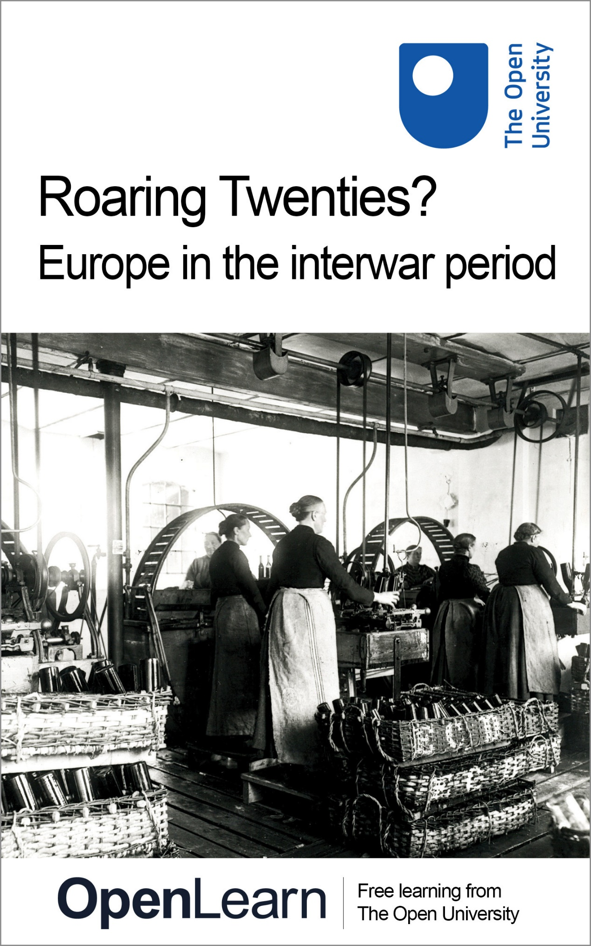

A327_1

Roaring Twenties? Europe in the interwar period

About this free course
This free course is an adapted extract from the Open University course A327 Europe 1914-1989: war, peace, modernity: http://www.open.ac.uk/courses/modules/a327.
This version of the content may include video, images and interactive content that may not be optimised for your device.
You can experience this free course as it was originally designed on OpenLearn, the home of free learning from The Open University – http://www.open.edu/openlearn/history-the-arts/roaring-twenties-europe-the-interwar-period/content-section-0.
There you’ll also be able to track your progress via your activity record, which you can use to demonstrate your learning.
Copyright © 2016 The Open University
Intellectual property
Unless otherwise stated, this resource is released under the terms of the Creative Commons Licence v4.0 http://creativecommons.org/licenses/by-nc-sa/4.0/deed.en_GB. Within that The Open University interprets this licence in the following way: www.open.edu/openlearn/about-openlearn/frequently-asked-questions-on-openlearn. Copyright and rights falling outside the terms of the Creative Commons Licence are retained or controlled by The Open University. Please read the full text before using any of the content.
We believe the primary barrier to accessing high-quality educational experiences is cost, which is why we aim to publish as much free content as possible under an open licence. If it proves difficult to release content under our preferred Creative Commons licence (e.g. because we can’t afford or gain the clearances or find suitable alternatives), we will still release the materials for free under a personal end-user licence.
This is because the learning experience will always be the same high quality offering and that should always be seen as positive – even if at times the licensing is different to Creative Commons.
When using the content you must attribute us (The Open University) (the OU) and any identified author in accordance with the terms of the Creative Commons Licence.
The Acknowledgements section is used to list, amongst other things, third party (Proprietary), licensed content which is not subject to Creative Commons licensing. Proprietary content must be used (retained) intact and in context to the content at all times.
The Acknowledgements section is also used to bring to your attention any other Special Restrictions which may apply to the content. For example there may be times when the Creative Commons Non-Commercial Sharealike licence does not apply to any of the content even if owned by us (The Open University). In these instances, unless stated otherwise, the content may be used for personal and non-commercial use.
We have also identified as Proprietary other material included in the content which is not subject to Creative Commons Licence. These are OU logos, trading names and may extend to certain photographic and video images and sound recordings and any other material as may be brought to your attention.
Unauthorised use of any of the content may constitute a breach of the terms and conditions and/or intellectual property laws.
We reserve the right to alter, amend or bring to an end any terms and conditions provided here without notice.
All rights falling outside the terms of the Creative Commons licence are retained or controlled by The Open University.
Head of Intellectual Property, The Open University
978-1-4730-1249-3 (.kdl)
978-1-4730-0481-8 (.epub)

Contents
- Introduction
- Learning outcomes
- 1 Modernism
- 2 Modern populations
- 3 The interwar city as a site of modernity
  - Exploring interwar Berlin
- 4 Mass media and the transformation of popular culture
  - The politics of production
  - Content
  - Reception
- 5 The ‘New Woman’ – myth or reality?
  - Modern fashion in the making of modern women
- 6 Governments and populations
  - Infant welfare
  - Social medicine
- Conclusion
- References
- Further reading
- Acknowledgements
- Glossary
- Solutions
- Descriptions

Introduction

It’s rather sad, to belong as we do, to a lost generation. I’m sure in history the two wars will count as one war, and that we shall be squashed out of it altogether, and people will forget we ever existed.
(Mitford, 1949 [1945], pp. 186–7)

So said Linda, chief protagonist in Nancy Mitford’s bestselling and semi-autobiographical novel The Pursuit of Love, published at the end of the Second World War in 1945. It is likely that Linda’s reflections, made while taking shelter from the war on her family’s estate, matched the ponderings of the author. Like Linda, Mitford and her five sisters were Bright Young Things of the 1920s (men and women of the upper and upper-middle classes who came of age during or just after the First World War and enjoyed a bohemian and carefree lifestyle), who subsequently became deeply embroiled in the political polarisations of the 1930s. One sister, Diana, eloped with and married Oswald Mosley, leader of the British Union of Fascists, at the home of Nazi propaganda minister Joseph Goebbels, while another, Jessica, eloped with the socialist journalist Esmond Romilly, and together they travelled to Spain to assist in the war against General Franco. Of course the Mitford sisters and other Bright Young Things did not become a lost generation – instead they rose to prominence in the popular memory of the ‘Roaring Twenties’.
However, the Mitford quote captures a second, important element in our understanding of the interwar years in Europe: the way in which war has hung so heavily over the period, as even the term, ‘interwar’, so commonly used by historians, implies. And because of this, in the literature on interwar society, we are often presented with two competing narratives: one of hedonism and frivolity, as a new generation, having been exposed to the horrors of modern war, threw off the shackles of tradition to embrace new pleasures in an almost apocalyptic manner; and one of pessimism, in which European civilisation was perceived to be in crisis, as society was plagued by discontent and political extremism, and war seemed perpetually on the horizon. The long hold of these narratives is demonstrated by the publication only eighteen months apart of two books on British society in the interwar period: Martin Pugh’s We Danced All Night (first published in 2008) and Richard Overy’s The Morbid Age (first published in 2009).
At the heart of both of these narratives is an attempt to explain the experience of modernity in Europe during the interwar years. You will recognise some features of modernity in this course – for example, the increasing visibility of, and new rights granted to, women, and the promotion of emerging technologies – as well as some of the tensions which modern life spawned.
This OpenLearn course is an adapted extract from the Open University course A327 Europe 1914-1989: war, peace, modernity.

Learning outcomes
After studying this course, you should be able to:
- understand ‘modernisation’, ‘modernity’ and ‘modernism’ and how they relate to each other
- understand modernity in interwar Europe
- understand the main historical debates about society and culture in interwar Europe, in particular a sense of the patterns of change and continuity, and the extent to which any change can be attributed to the First World War
- interpret visual sources, use data in tables to construct arguments, and summarise historiographical review articles.

1 Modernism
It is worth spending a moment now to untangle some of the terms that will be used explicitly in this course and that you will regularly encounter in readings on interwar society.
First, ‘modernisation’, which is a process of evolution, by which early modern and pre-industrial societies are transformed into modern societies through industrialisation, urbanisation, rationalisation, secularisation and the widening of the political community. Most historians suggest that modernisation began in Europe during the eighteenth century (Cocks, 2007, pp. 27–8), continued throughout the nineteenth and reached maturity in the twentieth.
Second, ‘modernity’, which is the experience of modernisation, an articulation of feeling modern or a sense that a break with the past has occurred, which is expressed in either positive or negative terms (or even both simultaneously). Historians have argued that there is no one moment of modernity in the 200-year period from c.1750 to c.1950; instead, there are multiple moments of modernity, which often occur in particular sites. However, a number of historians have highlighted the period 1880–1940 as a particularly important moment of modernity across Europe (Rieger and Daunton, 2001, pp. 1–4).
Third, ‘modernism’, an artistic movement that flourished in Europe from the late nineteenth century through to the interwar years. Many historians have argued that, as a narrative of change produced by an artistic elite or avant-garde, modernism had little to do with wider social change. However, modernism permeated European society more generally through the modernist architecture of new social housing projects, and the use of modern art and design by a range of political movements on the right and left (including the Republican government in Spain and the Fascists in Italy). If ordinary people were not conversant with modernism, many, especially in urban environments, were aware of it. We will not look at modernist art in any great depth in this course; however, we will touch upon it as part of the broader experience of modernity.
We will look at a number of specific features that suggest that the interwar period was a distinctive and important moment of modernity: shifts in demographics; the character of modern urban life; new forms of mass media; changing lifestyles of women; and the increasingly interventionist approaches to managing the health and welfare of modern populations. The way in which we have separated these features is artificial. For example, shifts in demographics and changes in the lives of women shaped health and welfare policies; the mass media was a vehicle through which to debate change, but also a tool to promote it; and the experience of all these features of modern life was arguably most intense within the urban environment. Two issues, derived from the historiography, will shape our assessment of these features:
- The role of the First World War in the experience of modernity – was war an agent of social change? Or did it represent an interruption to a set of inevitable developments?
- The tensions inherent in the experience of modernity – were these felt more keenly in some sites as opposed to others? How did pro- and anti-modern discourses relate to each other?

2 Modern populations
Rosalind Crone
Not everyone in Europe would have experienced the interwar period as a time of great social change, or ‘modernity’. This is particularly evident when we look at some broad demographic data from across the continent.

Table 1 Populations of Europe (in thousands)
State | 1900/01 | 1910/11 | 1920/21 | 1930/31
Austria | n/a | 6648¹ | 6426 | 6672
% in major cities | n/a | n/a | 29 | 28.1
Belgium | 6694 | 7424 | 7406 | 8092
% in major cities | n/a | 13.8 | 13.8 | 17.5
Bulgaria | 4338 | 4338² | 4847 | 6305
% in major cities | n/a | 2.4 | 3.2 | 4.6
Czechoslovakia | n/a | 13599 | 13612 | 14730
% in major cities | n/a | 1.6 | 5 | 5.8
Denmark | 2450 | 2757 | 3104³ | 3551
% in major cities | n/a | 20.3 | 18.1 | 21.7
Estonia | n/a | n/a | 1105 | 1122
% in major cities | n/a | n/a | n/a | n/a
Finland | 2656 | 2943 | 3148 | 3463
% in major cities | n/a | 5 | 6 | 7
France | 38451 | 39192 | 38798 | 41228
% in major cities | n/a | 12.2 | 12.6 | 11.9
Germany | 56367 | 64926⁴ | 63181 | 66030
% in major cities | n/a | 14.3 | 18.3 | 21.4
Greece | 2434 | 2632 | 5017 | 7201
% in major cities | n/a | 12.3 | 9.4 | 9.6
Hungary⁵ | n/a | 7615 | 7990 | 8688
% in major cities | n/a | 11.6 | 14.8 | 11.6
Ireland | 4459 | 4390 | 2972⁶ | 2963
% in major cities | n/a | 6.9 | 13.4 | 14.1
Italy | 32475 | 34671 | 36406⁷ | 41177
% in major cities | n/a | 10 | 11.3 | 12.7
Latvia | n/a | n/a | 1596 | 1951
% in major cities | n/a | n/a | 17.9 | 19.4
Lithuania | n/a | n/a | 2116 | 2597
% in major cities | n/a | n/a | n/a | n/a
Luxembourg | 236 | 260 | 261 | 300
% in major cities | n/a | n/a | n/a | n/a
Netherlands | 5104 | 5858 | 6865 | 7936
% in major cities | n/a | 21.9 | 21.9 | 22.3
Norway | 2240 | 2392 | 2650 | 2814
% in major cities | n/a | 10.2 | 9.7 | 9
Poland | n/a | n/a | 27177 | 32107
% in major cities | n/a | n/a | 5.8 | 6.2
Portugal | 5423 | 5958 | 6087 | 6826
% in major cities | n/a | 7.3 | 8 | 8.7
Romania⁸ | 5957 | 7235 | 15635 | 18057
% in major cities | n/a | 4.7 | 2 | 3.5
Russia/USSR | 126367⁹ | n/a | 136900 | 170467
% in major cities | n/a | n/a | 3.5 | 4.5
Spain | 18594 | 19927 | 21303 | 23564
% in major cities | n/a | 7.9 | 9 | 9
Sweden | 5,137 | 5522 | 5905 | 6142
% in major cities | n/a | 9.2 | 10.5 | 12.1
Switzerland | 2315 | 3753 | 3880 | 4006
% in major cities | n/a | 6.6 | 6.8 | 9.3
Great Britain (excl. Ireland) | 37000 | 40831 | 42769 | 44795
% in major cities | n/a | 30.7 | 30.4 | 31.4
Yugoslavia | n/a | n/a | 11985 | 13934
% in major cities | n/a | n/a | 1.8 | 3.3
Note: Not all countries held a census in 1900 or 1901, and in this case data is taken from the closest census to these years. Also, in the case of Russia, there was no census taken at or near 1910/11.
¹ This is the population of the geographical area which would be the Austrian Republic after the First World War.
² Between 1910 and 1920, there were several boundary changes, including the loss of Southern Dobrudja to Romania and the gain of rather larger territories from Turkey.
³ In 1921, part of Schleswig was acquired from Germany. This is not counted in the data for 1920/21 but is counted in the data for 1930/31.
⁴ Territory ceded after the First World War is included in the data for 1910/11 but not for 1920/21.
⁵ Only population in territory that constituted the post-Trianon state (that is, after territorial adjustments made in the Paris Peace Settlement) is counted.
⁶ Post-partition population, so not including Northern Ireland.
⁷ Not including territory gained as a result of the First World War. Figure for 1930/31 does include this territory.
⁸ Romania acquired territory as a result of the Balkan wars and the First World War, which is counted in the relevant figures.
⁹ The population of the areas of the former empire excluded from the USSR was 21,734 in 1897 (excluding Finland).
(Sources: compiled from data in Kirk, 1969, p. 24 and Mitchell, 1998, pp. 3–8)

Activity 1

Look at Table 1 and answer the following questions:
- Can you see any broad trends in the data on the populations of individual countries across Europe?
- What impact might the First World War have had on the presence or absence of any trends?

View answer - Activity 1
View discussion - Activity 1

Table 2 Populations of major cities of Europe (in thousands)
State | City | 1910/11 | 1920/21 | 1930/31
Austria | Vienna | 2031 | 1866 | 1874
Czechoslovakia | Prague | 224 | 677 | 849
Germany | Berlin | 2071 | 3801 | 4243
Belgium | Brussels | 720 | 685 | 840
Bulgaria | Sofia | 103 | 154 | 287
Greece | Athens | 167 | 301 | 453
Russia | Moscow | 1533 | 1050 | 2029
Yugoslavia | Belgrade | 91 | 112 | 267
Poland | Warsaw | 872 | 931 | 1179
Italy | Rome | 542 | 692 | 1008
Netherlands | Amsterdam | 574 | 642 | 752
Hungary | Budapest | 880 | 1185 | 1006
France | Paris | 2888 | 2907 | 2891
Great Britain | London | 7256 | 7488 | 8216
Denmark | Copenhagen | 559 | 561 | 771
Note: Warsaw was part of the Russian empire before the 1920s, and Belgrade was part of Serbia before the 1920s.
(Source: Mitchell, 1998, pp. 74–7)

Activity 2

Look at Tables 1 and 2 and answer the following questions:
- Looking at the populations of the major European cities, can you see any notable trends? Did the First World War have any impact on these cities?
- From the data in the tables, do any countries stand out as being more urbanised than others? Are there any notable trends to discuss?

View answer - Activity 2

It is important not to equate the process of urbanisation with industrialisation. A large number of those states in eastern Europe had expanding urban populations in the interwar years yet were not industrialising at any significant pace. In the 1930s, when the agricultural labour force in Britain had shrunk to 5 per cent of the population, and in Germany, France and much of Scandinavia to around 20 to 30 per cent, in eastern Europe, and particularly in the Balkans, agriculture continued to dominate, employing between 50 and 75 per cent of the populations (Wasserstein, 2009, p. 213). Derek Aldcroft has described the periphery of states stretching from eastern Europe around the rim of the Mediterranean (for example, Greece, Spain and Portugal) as Europe’s ‘third world’ during the interwar years. These states tended to be dominated by an antiquated and inefficient agrarian sector based on peasant self-sufficiency, smallholdings, overpopulation on the land, primitive farming techniques, lack of capital investment and poor education. The general poverty of the countryside meant that the market for industrial goods was small and growth discouraged. For example, 40 per cent of Hungarians were poor peasants who lived at a minimum level of subsistence and considered the most basic items such as shoes and clothes a luxury (Aldcroft, 2006, pp. 175–7). R.J. Crampton adds that often any surplus money was spent on family, religious or community festivals, and not reinvested in agriculture or used to purchase modern industrial goods (1994, p. 35). Thus it would seem that we could hardly describe society in these countries as ‘modern’ (see Figure 1).

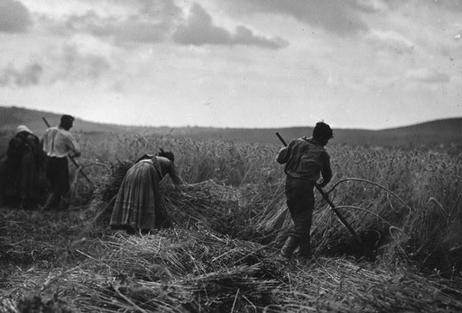
Figure 1 Harvesting in Hungary, 1935. Photographer unknown. Photo: Fox Photos/Getty. Note the traditional dress worn by the workers. It is worth bearing this in mind when we turn to consider changing fashions in women’s dress during the interwar years later in this course.
View description - Figure 1 Harvesting in Hungary, 1935. Photographer unknown. Photo: Fox Photos/Getty. ...

However, some historians have argued that the backwardness of life in these states has been overplayed. For instance, Robert Bideleux and Ian Jeffries caution us not to paint too bleak a picture of interwar eastern Europe, quoting the observations of Hubert Hessell Tiltman in his Peasant Europe, published in 1934:

The Bulgarian people have been ‘lifted off the floor’ … The poorest Bulgarian peasant today generally has his land, his house, some pieces of furniture and his self-respect … And with this psychological transformation the health of the people has improved. The death rate, though still high, is falling … The peasantry live in modern two-roomed dwellings, often built of designs supplied by the state, and their animals are housed separately. The earth floors have been replaced by brick and wood. There are windows that open … Many … now sleep on beds and eat sitting at tables. Separate plates for each person have replaced the old communal bowl. Electric light, even, has come to some of the villages.
(Quoted in Bideleux and Jeffries, 1998, pp. 451–2)

This source is a helpful reminder that the process of modernisation or experience of modernity was uneven, that we cannot necessarily divide Europe into those countries which were modern and those which were ‘backward’. Prague and Krakow became vibrant hubs of modernist culture during the 1920s, attracting intellectuals from the east and exporting new ideas in photography to the west (Fischer, 2010, p. 193). Conversely, Martin Pugh states that life in rural Britain demonstrated greater continuity than change in the interwar years (2009, pp. 260–1).

3 The interwar city as a site of modernity
Rosalind Crone
In the previous section I established that while the majority of Europeans in the interwar period were not urban dwellers (though in some countries, especially in the north-west, the majority were), the process of urbanisation, already underway in most countries before the First World War, gathered pace during the 1920s. This was in part linked to economics: as Paul Lawrence has written, ‘unlike the factory industrialization of the nineteenth century [...] which had concentrated people near coalfields and water sources, the capitalism of the twentieth century favored large capital cities and commercial centers’ (Lawrence, 2005). Thus, the first half of the twentieth century witnessed the rise of the ‘metropolis’.
Many features of the modern metropolis were visible before the First World War. Electricity, urban transport networks including underground railways, large department stores and mass entertainment venues such as music halls were all visible in cities such as London, Paris and Berlin. However, after the war, electricity supply was expanded (including into the domestic environment) and rationalised (for instance, through initiatives such as the National Grid in England and Wales); music halls were joined and subsequently replaced by cinemas, dance halls and jazz clubs; existing urban transport networks were extended and new ones built to service growing numbers of commuters living in emerging suburbs; new forms of transport, notably cars, raised the tempo of city life; and the increase of white-collar employment, for women as well as men, swelled the ranks of the middle class and fuelled new levels and forms of consumerism. While municipal authorities began to focus on ‘town planning’, urbanisation and changing demographics collided with the artistic movement of modernism, generating new designs for urban living that promoted functionalism and hygiene. Finally, the city began to acquire a new dominance over rural life in many countries: it sucked in immigrants from the countryside who were in search of new employment opportunities; and new communications networks, often emanating from the city, promoted urban life and culture.
Despite the pleasures and conveniences offered by the metropolis, modern urban life was not always viewed in a positive light. In the first place this was because change was uneven – for instance, in all cities overcrowded slum neighbourhoods persisted alongside new social housing. But it was also because the experience of modernity could produce a longing for the stability associated with tradition and a lost rural idyll. As Bernhard Rieger and Martin Daunton have argued, this negativity was most strongly articulated in those cities in which the break with the past had been rapid and intense (2001, pp. 9–11). For example, cities in Germany, Italy and Russia were not only subject to rapid expansion and modernisation after 1918, but also became sites for political extremism and violence (Jerram, 2011, p. 33).

Exploring interwar Berlin
In order to get a sense of the change and continuity present in the modern metropolis, as well as the tensions created by the sense of modernity, let’s take a look at one city in more detail: Berlin.
Although Berlin was not necessarily representative of other European cities, contemporaries often wrote that that the city was representative of the experience of modernity. In the early twentieth century, Berlin had only recently emerged as a major European city. Prussian power in the process of unification had ensured that Berlin became the new German capital after 1871, and this, combined with rapid industrialisation, meant that the city already had a modern look and feel before the outbreak of the First World War. Its population had also begun to grow: it more than doubled between 1910 and 1930. Moreover, the Greater Berlin Act of 1920 recognised the sheer physical expansion of the city as a number of outlying ‘towns’ and other communities now surrounded by the urban spread were officially incorporated into the city. However, it was during the interwar years, under the shadow of defeat and the instability of the democratic experiment that Berliners experienced modernity most intensely. This modernity was viewed both positively and negatively by different groups, within and outside Germany: for some the new attractions of the city were exciting and liberating, but for others the city’s modernity was horrific, and Berlin became a symbol of modern decay.
In the following activity you will explore the U-bahn system as it operated in Berlin in 1930. The ‘Untergrundbahn’ or ‘U-bahn’ was in fact an invention of the period before the First World War. Its construction began in 1897, some three decades after the London Underground but around the same time as the Parisian Métro. By the outbreak of war two lines had already opened: U1, connecting the east of the city with the west, and U2, connecting the north with the west. However the interwar years witnessed the great expansion of this network, as both U1 and U2 were extended and new lines were constructed, making journeys within the city easier, and providing more transport options for those commuting from the suburbs. (If you are particularly interested in the development of the U-Bahn network, and its relationship to other transit systems in Berlin, such as the Stadt-bahn, or S-bahn, you can take a look at the historic maps on this German transport website.)

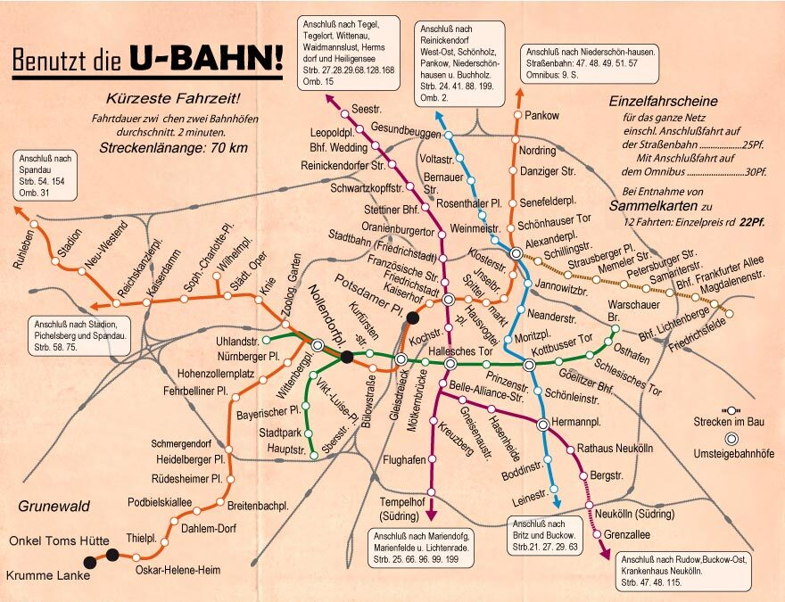
A map of the U-Bahn.

Your first stop will be Potsdamer Platz.

Station 1: Potsdamer Platz
Watch the following film (please note that this film is mute).

Video content is not available in this format.
Potsdamer Platz
View transcript - Potsdamer Platz

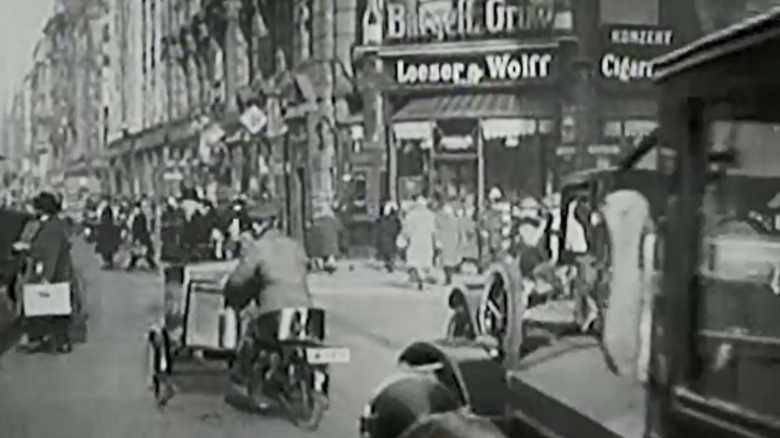

Potsdamer Platz, the meeting point of five major roads making it one of Europe’s busiest traffic intersections, has often been held up as iconic of 1920s Berlin; though many of its physical indicators of ‘modernity’ in fact predated the First World War. For example, the most famous buildings associated with the Platz had been constructed in the late nineteenth century, including the magnificent Wertheim department store (1897), Café Josty (1880), and the food emporium, Haus Vaterland (1912). However, during the 1920s the use of these buildings came to be representative of Weimar social life and culture. Café Josty (which you saw at the end of the film) became an important meeting place for artists and intellectuals. Haus Vaterland underwent substantial renovations in 1928, and was transformed into a palace of entertainments, complete with illuminated dome. And in the early 1930s, a symbol of the modernist age, Erich Mendelsohn’s Columbus House, was added to complete the set.

Activity 3

The footage you have just seen includes scenes of not just Potsdamer Platz, but also some of the surrounding main thoroughfares.
Can you identify any indicators of modernity in these scenes that are particular to the interwar years?

View answer - Activity 3

Next, you will go to the station Onkel Toms Hütte. On arrival there, you will be joined by your tour guide, Matt Frei.

Station 2: Onkel Toms Hütte
Watch the following film.

Video content is not available in this format.
Onkel Toms Hütte
View transcript - Onkel Toms Hütte

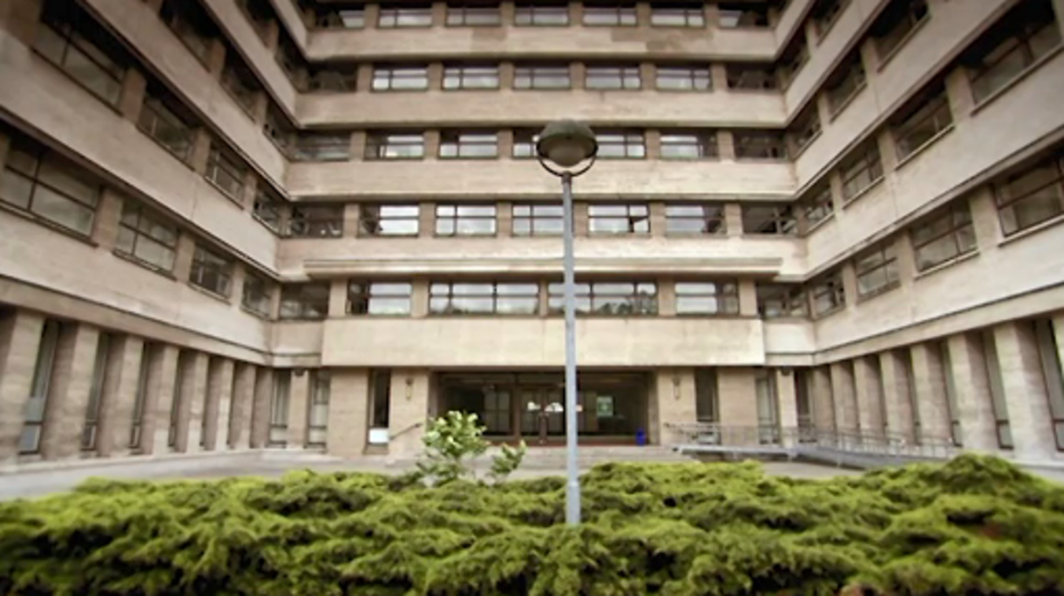

You might have noticed the peculiar name of this U-bahn station, Onkel Toms Hütte, which, directly translated, means Uncle Tom’s Cabin. In the late nineteenth century, a pub landlord named Thomas constructed small huts or cabins in his beer garden for customers to shelter in when it rained. This, combined with the popularity of Harriet Beecher Stowe’s novel, made the play on the name irresistible. Between 1925 and 1932, the site was redeveloped, allowing for the construction of a large housing estate designed by GEHAG, a team of architects led by the famous modernist architect, Bruno Taut. Taut and GEHAG were also responsible for some of the other large housing estates you saw in the film – for example, the famous Horseshoe Estate (Hufeisensiedlung) in Britz, on the southern edge of the city.

Activity 4

To get an idea of what it was like inside these new, modern, living quarters, read Source 1, Otto Steinicke’s ‘Visit to a new apartment’, and answer the accompanying questions.
- What is the general tone of the article?
- Can you identify some of the features of ‘modern living’ which Steinicke draws to the reader’s attention?
- Given the layout of the new apartment he describes, who was expected to occupy it?

View answer - Activity 4
View discussion - Activity 4

Before we head back into the centre of Berlin, we will make one brief stop further down the line at Krumme Lanke, another housing estate constructed in the 1930s, which will expose you to some of the tensions of modernity.

Station 3: Krumme Lanke
Watch the following film.

Video content is not available in this format.
Krumme Lanke
View transcript - Krumme Lanke

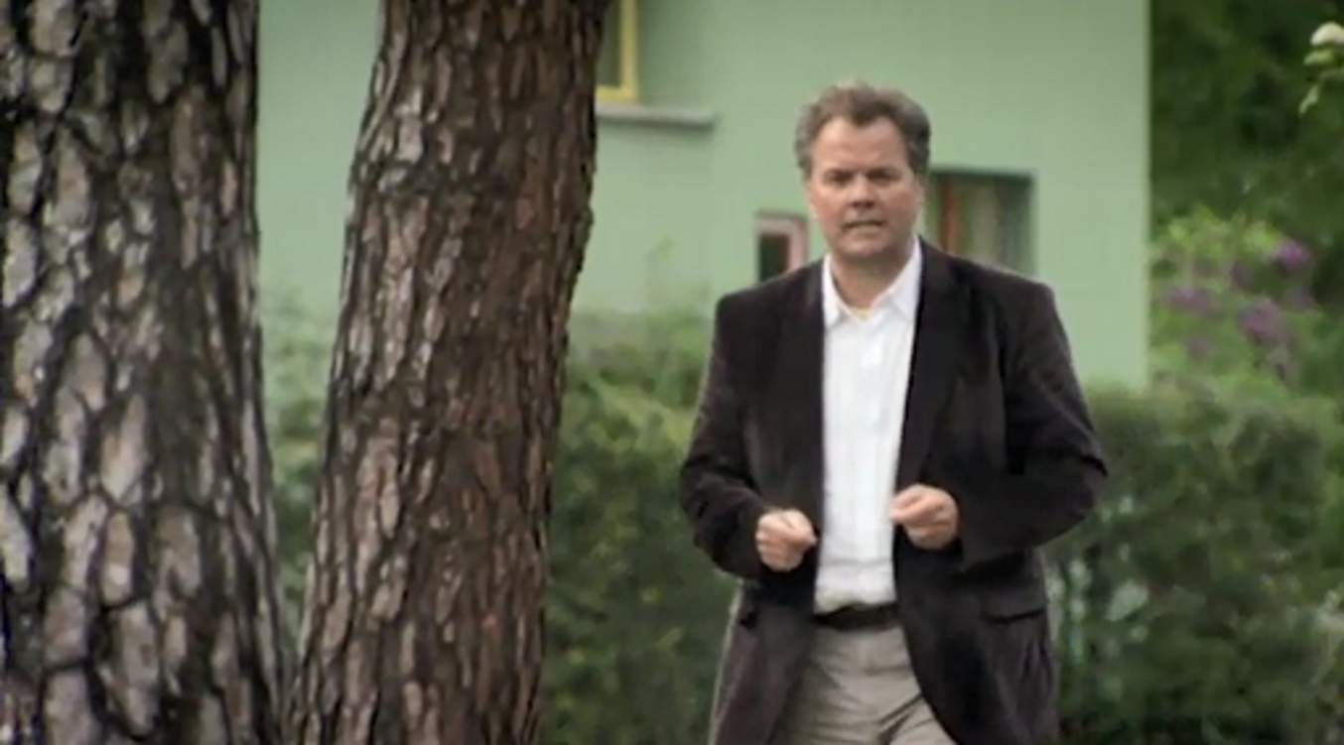

You will explore the competing versions of modernity offered by authoritarian right-wing regimes in more depth later in this course. However, you might like to bear in mind some of the comments made about the ‘idyll’ that the Nazis were attempting to create with this housing estate as we move on to our final stop on this tour, Nollendorfplatz. Matt Frei will make some comments about the character of Berlin’s west end in the late 1920s, after which you will be shown some footage of Berlin nightlife from Ruttman’s Sinphonie.

Station 4: Nollendorfplatz
Watch the following film.

Video content is not available in this format.
Nollendorfplatz
View transcript - Nollendorfplatz

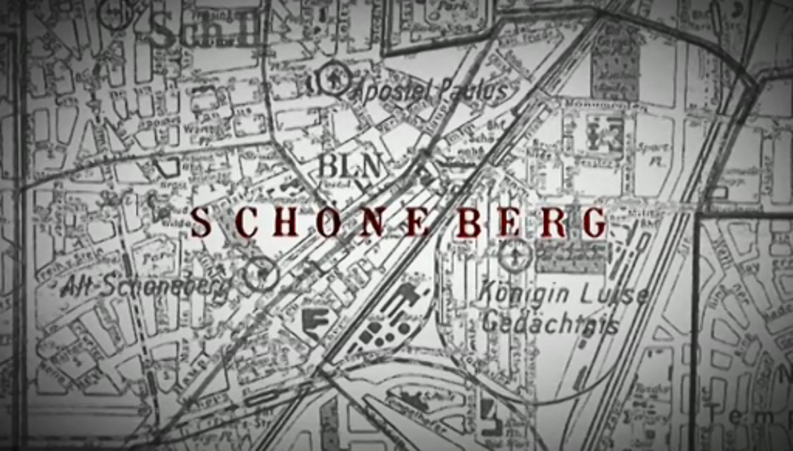

Activity 5

- Make a list of the key features of urban leisure in 1920s Berlin.
- What theme links Frei’s commentary with Ruttman’s film?

View answer - Activity 5
View discussion - Activity 5

Activity 6

Read the Source 3.
- Can you identify the author of this article?
- What are the problems of modernity that concern the author?

View answer - Activity 6

Activity 7

For now, I want to end this tour with a hint of what was to happen next, through a little case study of the famous erotic dancer of 1920s Berlin. Watch the following film:

Video content is not available in this format.
Berlin nightlife
View transcript - Berlin nightlife

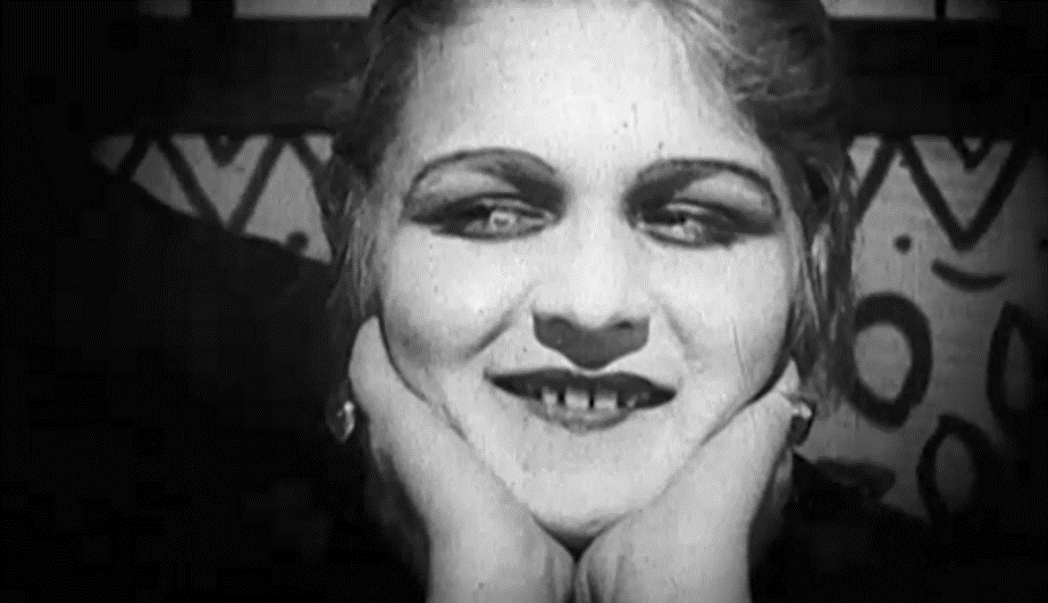

4 Mass media and the transformation of popular culture
Rosalind Crone
Those living in the city, and increasingly those living outside the city, were exposed to new forms of mass media in the interwar period, which sparked a transformation in popular culture. Given that cinema and radio were regarded by many as forms of entertainment, you might well ask why I have applied the label ‘popular culture’ rather than ‘leisure’. First, this is because the term ‘leisure’, and its use by historians, suggests that people in the past neatly divided their time into periods spent in work and in relaxation. Work hours became shorter and more regulated for many (for example, those in industrial and white-collar employment) across Europe in the first decades of the twentieth century, but there were several groups for whom the segregation of work and leisure time did not apply, including women and the unemployed. Second, the term ‘popular culture’ highlights the relationship between these phenomena and the way in which its consumers saw the world around them. Third, it is necessary to distinguish between these popular entertainments, which were available and often patronised by all, and the cultural products of the intelligentsia, often referred to as ‘high culture’ and typically inaccessible to many ordinary people because of their price or their form. (For instance, we could group a substantial amount of the output from the artistic movement of modernism, referred to earlier in this course, in this category.) However, we would do well to remember too that the participation of ‘cultural elites’ in popular culture meant that these entertainments and the themes or messages that they promoted had some impact on the creativity of the avant-garde.
In what ways was popular culture transformed during the interwar years? First, and most obviously, it was transformed by technology, so that it is possible to refer to a process of modernisation at work in the entertainments enjoyed by the people. Radio was a new invention; film had existed before the First World War but took off dramatically after 1918, and the introduction of sound further increased its appeal in many countries during the 1930s. Popular culture was thus experienced in new ways. But be aware that the new media did not always replace older entertainments that survived from the nineteenth century. Second, the growth of the middle class, combined with an increase in the spending power of many urban workers and changing methods of production and dissemination, which drove down prices and increased the ability to cater for large audiences, led to the emergence of ‘mass’ audiences for many phenomena. The 1920s and 1930s formed a key moment in the development of mass culture – entertainment made for the people but not by the people. However, as you will see below, you should be wary of the term ‘mass culture’ because audiences often continued to be fragmented in various ways by age, class and gender, and audiences, as paying consumers, continued to have some role in the creation of popular culture. The authenticity of popular culture was challenged but not eradicated. Similarly, it is worth noting the impact of the rise of modern totalitarian regimes, especially those that publicly decried modern forms of leisure and promoted traditional lifestyles. As was evident in the material on modern Berlin that you explored in Activity 3, there was no clear anti-modern rhetoric: instead, regimes such as Nazi Germany, Fascist Italy and Soviet Russia recognised the possibilities offered by mass media in their pursuit of mass politics, particularly for propaganda purposes.

The politics of production
The medium of film came into existence in the late nineteenth century and by 1914 had developed from a fairground attraction into a popular, if often low-brow, entertainment housed in purpose-built cinemas. But it had found commercial success, becoming a huge international undertaking. Before the outbreak of hostilities in 1914, international production and distribution were dominated by the French, British and Italian film companies (Chapman, 2001, p. 174). Although war disrupted trade across Europe, its effects on each local film industry varied greatly. In Britain and France, film production declined rapidly during the war years, and those cinemas that remained open to the public filled their programmes with Hollywood imports. In contrast, the isolation of Germany and Russia encouraged growth in local film production. In Russia, the vibrancy of local production was relatively short-lived, as it was interrupted by revolution in 1917 and failed to attract the necessary audiences during the 1920s. However, during the 1920s, Germany became the largest European film producer: in terms of its local market, German film companies produced at least as many films as were imported (Laqueur, 1974, p. 230). During the interwar years, as the dominance of Hollywood productions in Europe increased, some governments attempted to promote their national film industry: while the British government introduced a quota forcing cinemas to show a set number of local films, in Germany and France the importation of foreign films was limited in 1925 and 1931 respectively, and in the Soviet Union film imports were stopped altogether in 1929.
While film production was conducted by private companies on an international scale, radio broadcasting, by contrast, was typically national and controlled by the government. Wireless telegraphy and telephony had advanced significantly during the two decades before the outbreak of war; during the war, radio-telephony was used as a method of communication on the battlefield and amateur wireless activities were, as far as possible, brought under state control (Briggs, 1961, p. 39). Even if war had helped to develop wireless technology and increase the power of the state, broadcasting was predominantly a new feature of interwar society in Europe. With their established monopoly over the airwaves through licensing systems governments across the continent had the power to determine who broadcast signals as well as who received them. By 1938, ‘of the thirty European national broadcasting systems in existence, thirteen were state owned and run, nine were government monopolies, four were directly operated by governments, and only three were privately-owned’ (Aldgate, 2001, p. 167).

Content
The politics of production shaped the content of the new mass media. The rise of American imports across Europe, facilitated in the 1920s by the fact that film was ‘silent’ (that is, in terms of dialogue, but music was typically added at viewing venues), did much to determine popular taste. The popularity of American films in Poland soared during the 1920s – by 1926 they constituted 70.6 per cent of all films shown. However, the introduction of sound led to a 30 per cent decrease in cinema attendance – Polish audiences wanted films in their own language but local production remained limited (Haltof, 2002, pp. 10, 24). Glamorous Hollywood feature films offered escapism, which many viewers desired but which many local production companies eschewed, especially those employed by the state to peddle propaganda. Thus, in France, where the Ministry of Agriculture attempted to use film to educate French farmers on progressive farming techniques, the only way to attract audiences to the village halls, bars and cafes where film projectors had been installed to deliver these messages was to include in the package of reels purely entertaining material such as comedies donated by commercial companies (Levine, 2004). Anti-censorship laws in Weimar Germany encouraged a healthy degree of experimentalism in the production of local films, though much of this proved to be apolitical, perhaps because producers were aware of the need to make money (Laqueur, 1974, p. 181). In Britain, where large picture palaces owned by three companies – Odeon, Gaumont-British and Associated British Cinemas – dominated the market by the 1930s and treated viewers to a near-exclusive diet of American blockbusters, concerns were raised by cultural elites that these films engendered apathy among the working classes while corrupting English speech and promoting gangster life (Beaven, 2005, pp. 187–90).
Perhaps it is little wonder then that when governments had the ability to control mass media they took to the task with great energy, as was the case with radio broadcasting. In Germany, radio broadcasting was ‘to be above party politics – unlike so many of Germany’s great and influential newspapers and other printed periodicals – and it was not to be subject to the kind of international influence that challenged the independence of the German motion picture industry throughout the 1920s’ (Führer, 1997, p. 724). In Britain, Germany and even Russia the radio was regarded as a tool for the education and enculturation of the masses. During the late 1920s, Soviet radio experimented with the establishment of a ‘university of the air’, transmitting educational broadcasts to around 80,000 pupils (Stites, 1992, p. 83). However, in Britain the insistence of John Reith, director general of the BBC, on a schedule dominated by discussion programmes, lectures, plays and classical concerts encouraged many, and especially working-class, listeners to tune in to the new commercial stations broadcast from the continent in the early 1930s – Radio Normandie (1931) and Radio Luxembourg (1933) – which satisfied the desire for popular music. The BBC’s attempt at compromise, scheduling ‘hot music’ every night from 10.30 pm until midnight, did not please everyone, as this letter from Beryl Heitland to the editor of the Musical Times in September 1933, demonstrates:

As things are, it is surely time that the official B.B.C. heard a Neighbour’s Radio Concert in a big block of modern flats on a warm evening, or in a reasonably crowded street of suburban gardens. Now, are we all to be content to be plagued till midnight, night after night, by the thrum-thrum, and unutterably dreary whine and moan of the jazz band through walls and windows – because it pleases the proletariat? Who will invent for us some device which will keep us sacrosanct from other people’s choices in radio? Please tell us that, Messrs. B.B.C., and till then, marvel not that lovers of music and of a modicum of plain silence lift up their standard against the arch-fiend, noise.
(Quoted in Jerram, 2011, p. 215)

Reception

Activity 8

Compare Beryl Heitland’s letter to the Musical Times in 1933 (quoted at the end of the previous section) with the extract below, from an autobiography written by two sisters describing their childhood in a working-class district of Lincoln. What are the major differences in the experience of listening to the radio which each source describes?

It is not easy now to remember what life was like before radio and television and, certainly, the coming of the wireless made a great deal of difference to us. It was not just the listening that mattered it was also the talking about it afterwards.
[…]
Mother looked down her nose at those ‘who had it on all day’ and we were encouraged to choose our programmes and none was allowed to be switched on while homework was in progress. Mother always listened to the Morning Service and we all kept quiet during Children’s Hour and the News. We sometimes listened to plays and nearly always to Variety programmes of the Music Hall kind.
[…]
We listened of course to all the outside broadcasts of the great events and Mother loved listening to Howard Marshall’s cricket commentaries; a taste she never lost. We were never much interested in racing apart from the commentaries on the Grand National and the Derby but we did listen to Wimbledon in the heady days of Fred Perry and Bunny Austin and Dorothy Round. And sometimes we listened to football and rugby on the radio. These last were best done with a Radio Times picture of the pitch divided into numbered squares to help the listeners to know just where the action was taking place. Over the hubbub of the cheers and shouting and the excited account of the commentator would come a calm and clinical voice saying ‘Square One’ or ‘Square Four’ and you knew just where you were!
(Skinner and Purchase, 1989, pp. 169–71)

View answer - Activity 8
View discussion - Activity 8

Let’s tease these issues out a little more to gain a full appreciation of the experience of the radio during the interwar years. Patterns and practices of listening varied between and within social classes and they varied over time. Broadcasts at the start of the 1920s were most often received on crystal sets through a single pair of headphones when the listener was within a relatively short distance – i.e. about 15 kilometres – from the transmission tower. Over the next few years, valve sets (such as that in the photograph), which could be plugged in to the mains supply of electricity, emerged and eventually, by the end of the decade, these came with loudspeakers. As these valve sets were more sensitive, the geographical reach of broadcasting was extended. They were also expensive, at least in the early years, and those who wanted to listen were also required to purchase an annual licence.
But these financial considerations did not prevent the working classes, or those based in more rural locations, from tuning in. The licensing statistics tend to obscure the sheer numbers of those with access to radio. Although in both Russia and Italy private ownership rates were low, many people listened to broadcasts in public spaces: in Russia programmes were broadcast over loudspeakers, while in Italy radios were commonplace in cafes and factories (Wasserstein, 2009, p. 235). In contrast, Britain and Germany boasted higher rates of private ownership – in 1932, 4.3 million licences were issued in Germany and 5.2 million in the United Kingdom – but especially in the 1920s, when costs were still significant, these figures failed to capture a large number of people listening in ‘illegally’ (Führer, 1997, p. 731; Pegg, 1983, p. 7). Crystal sets, for example, could be bought as kits and constructed at home. One woman from Warrington in north-west England, interviewed as part of a local history project, remembered that she used to buy radio parts for her husband:

When it was his birthday, or when Christmas came, I used to give him parts for his wireless, d’you see. I’d put fourpence away every week to save up to get him the bits he was after. All the family – not just me – bought him these different parts for it and he built it up himself.
(Quoted in Moores, 1988, p. 28)

As suggested by the interviewee, men and women could experience radio differently. One British social commentator remarked that ‘it seems to women that the last thing men want to do with their wireless set is to listen in. They want to play with it, fiddle with it incessantly’ (quoted in Beaven, 2005, p. 203). Especially with the addition of loudspeakers on receivers, listening was the primary experience of women, many of whom tuned in while completing household tasks, challenging the boundaries between work and leisure time. Some have argued that this use of the radio, as background noise, was also distinctively working class; in contrast, the middle-class family would tune in at specific times and listen attentively.
Age, gender, class and geographical location similarly fragmented the superficially homogenous cinema audiences. In many countries across Europe, cinema-going reached its heyday during the interwar period. Yet the statistics often bear this out in an unexpected way. If we take Britain as our example, which was said to have the highest rate of cinema attendance, there were approximately 1,600 cinemas in 1910, around 4,000 in 1921 and just under 5,000 in 1939 (Jancovich et al., 2003, p. 85; Pugh, 2009, p. 229). On the surface, these statistics suggest that, if anything, the cinema craze slowed down during the interwar years. But what they don’t tell us is that cinema construction had changed: in 1912 the average cinema had 600 seats; by the late 1920s and 1930s, new cinemas with 2–3,000 seats were being built. We might expect that patronage by the majority of the large cinemas that were under the management of three companies would have homogenised the cinema-going experience, but historians have shown that this was not the case. At least three different types of cinema, which attracted different clienteles, existed in British cities: prestigious city-centre cinemas, which showed first-run films and were expensive; new, luxurious suburban cinemas, attracting the local middle-class and skilled working-class families; and cheap, inner-city cinemas, located in older working-class neighbourhoods and often referred to as ‘fleapits’ (Jancovich et al., 2003, p. 87). Moreover, even in those cinemas that boasted a socially mixed clientele, ticket-pricing strategies ensured that audiences were segregated by class (Richards, 1984, p. 15).
Corey Ross has argued that similar distinctions existed in the cinema audiences of interwar Germany. Middle- and working-class Germans not only patronised different cinemas, but their behaviour within these establishments represented a great contrast: working-class patrons ‘came and went at any time during the screening, frequently ate, smoked and drank as if they were at home’, and shouted, laughed and roared through the films (Ross, 2006, p. 170). The cinema also offered different experiences for the young and more mature: while many youths found in the cinema a convenient location to pursue courtship, for many married women the cinema expanded available leisure opportunities as, unlike the public house, this was a venue she could respectably attend with her husband or even alone (Beaven, 2005, p. 193). Finally, the location of cinemas, primarily in urban centres, did limit the extent of the experience of modern cinema-going. Levine (2004) has shown how cinema could be exported to the countryside of France. In contrast, Ross has argued that, as only 1,462 of the 63,507 towns with populations under 10,000, in which over half of all Germans lived, had any cinema at all, this medium could in fact widen the cultural gap that existed between urban and rural populations (2006, p. 162).

5 The ‘New Woman’ – myth or reality?
Rosalind Crone
For contemporaries, both the experience and challenge of modernity was prominently encapsulated in the motif of the ‘New Woman’. By the 1920s, women in many countries had not only won the right to vote, but were also moving into new occupations and choosing to wear ‘rational’, or at least much less restricted, garments. These developments seemed to pose a challenge to the traditional role of women as homemakers in the private sphere, especially at a time when anxiety about population growth and birth rates was rife. For historians writing since the rise of women’s history in the 1960s, debate has focused on whether or not the New Woman actually existed. In their discussions, the First World War has acquired a central place. Discussions have referred to the range of occupations that women entered during the war, as well as the challenges that war presented to traditional conceptions of both masculinity and femininity. However, the extent to which war generated lasting change has been disputed by successive generations of historians.

Activity 9

Read Source 4, Adrian Bingham’s article ‘“An era of domesticity?” Histories of women and gender in interwar Britain’. Try to summarise the main trends in the historiography on the New Woman, or, in other words, to isolate the main groups of historians and identify their primary contribution to the debate about the New Woman.

View answer - Activity 9
View discussion - Activity 9

Modern fashion in the making of modern women
As you might have picked out from Bingham’s article, early feminist historians tended to seek indicators of change that they recognised from their own experiences of campaigning for women’s liberation, including employment opportunities, shrinking wage differentials, enhanced legal status and sexual freedom (Roberts, 1994, p. 6). Perhaps unsurprisingly, they were often disappointed. In few European countries did the interwar period show significant change in these categories for women. Female enfranchisement achieved in some states was often granted at the same time as universal suffrage for men and, if anything, feminist activism in the political sphere seemed to be in decline. In most states, too, the number of employed women after the First World War was roughly comparable to the number employed before the First World War; and even if general employment statistics have disguised changes in the types of work women did (e.g. an increase in white-collar and factory employment in some countries at the expense of domestic service and agricultural labour) and a growth in the employment of young women, neither of these trends had any impact on marital rates, which remained high. Also, despite provisions made in some new constitutions (e.g. in the Weimar Constitution), women continued to be paid at rates below that of men. And, finally, any new degree of sexual freedom tended to be limited to a small minority.
However, as some historians have suggested, an alternative indicator of change can be found in new fashions that emerged for women during the interwar years. Fashion could be representative of change as well as an initiator of change. Wearing new fashions could also be a way of experiencing change. Hence fashion played an important role in the making of the modern woman. At the same time, changes in women’s fashion further expose the contradictions inherent in the discourses of modernity.

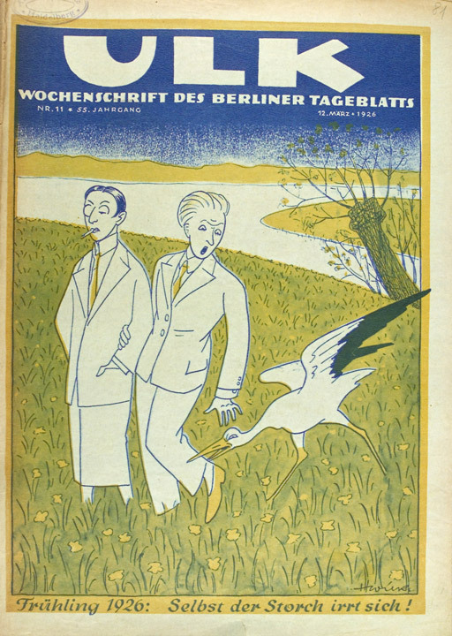
Figure 2 ‘Spring 1926: Even the stork is confused!’, cartoon from German weekly periodical ULK, vol. 55, no. 11, 12 March 1926. Photo: © Universit ätsbibliothek Heidelberg.
View description - Figure 2 ‘Spring 1926: Even the stork is confused!’, cartoon from German weekly ...

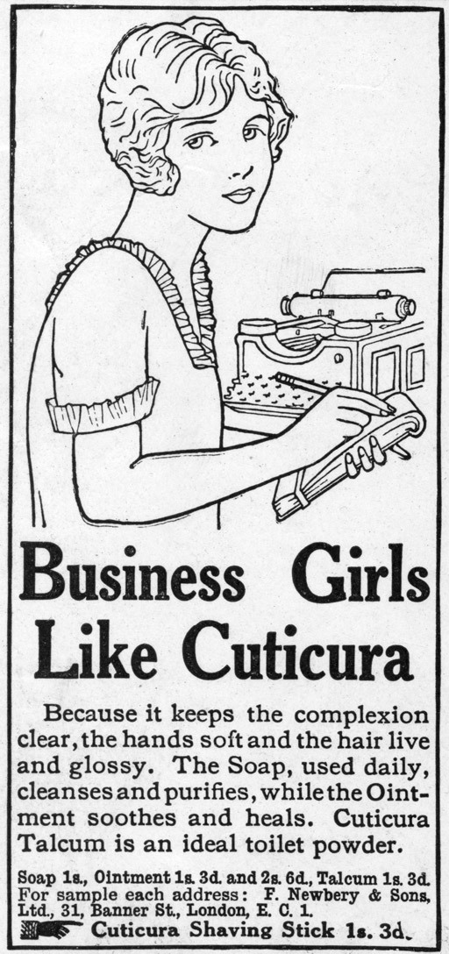
Figure 3 ‘Business girls like Cuticura’, cartoon from Illustrated London News, 11 July 1925, p. 96. Photo: © Illustrated London News Ltd/Mary Evans.
View description - Figure 3 ‘Business girls like Cuticura’, cartoon from Illustrated London News, 11 ...

Activity 10

Look at the two images of women in Figures 2 and 3 and answer the following questions:
- The two images are different types of primary source – can you identify these?
- In what light is women’s fashion presented in both of these images? Can you spot the similarities and/or differences in the portrayal of women’s fashion?

View answer - Activity 10
View discussion - Activity 10

Few would deny that women’s fashion changed dramatically at the end of the First World War: skirts were shortened (to above the knee, for the first time in history, by 1924) and rigidly shaped garments replaced with looser-fitting clothes, hair was shaped into bob styles, and cosmetics and other beauty products were both widely accepted and used to enhance features. As Mila Ganeva has written, ‘it was during the 1920s that women began … to dress in a way that we can identify with today’ (Ganeva, 2008, p. 3). Historians such as Martin Pugh have argued that these changes were rooted in wartime experiences: in Britain at least, as a sign of patriotism, women shortened their skirts to economise on material (Pugh, 2009, p. 171). However, others have pointed to the influence of trends in the major Parisian fashion houses on the eve of war (McElligott, 2001, p. 201; Søland, 2000, pp. 22–3), as well as state- and market-driven changes in clothes production that favoured mass-produced ready-to-wear garments over traditional artisanal creations (De Grazia, 1992, p. 221). I could also point to the impact of new employment opportunities for women in the white-collar sector as clerks and sales assistants, which sparked demand for more rational and functional clothes.
Whereas previously the affluent would have ordered clothes from a fashion house, while those at the lower end of the social hierarchy would have relied on a few garments sewn by local artisans or themselves and often passed between family members, the new simple styles allowed for the tremendous expansion of the ready-to-wear market across Europe. By the mid-1920s, Konfektion (ready-to-wear) had become an essential branch of the German economy, and by 1927 there were 800 firms located in Berlin alone employing more than one-third of the city’s workforce (Ganeva, 2008, p. 4). The industry increased the choice that was available to women seeking employment. Elizabeth Bright Jones has shown how female agricultural workers in rural Saxony actively sought alternative employment in these and other factories, and a range of surveys of German schoolgirls highlighted changing aspirations for future employment, some of which had been initiated by changes in the fashion industry (Jones, 2001; McElligott, 2001, pp. 198–200). Moreover, at least a portion of the wages that these young single women earned fed back into supporting the fashion industry, as they became important consumers not just of ready-to-wear but also of cheap cosmetics (Todd, 2005, p. 803).
Even if the common image projected across Europe was one of the urbane, fashionable New Woman, the reach of fashion, and its potential to generate change, stretched much further than this. A number of historians have pointed to the democratisation of fashion during the 1920s. The latest trends thought up in the haute couture fashion houses of Paris were now rapidly copied by the ready-to-wear factories and put on sale in the department stores for the middle classes. Moreover, those working women who could not afford the rack prices were able to sew their own as a result of a booming pattern market and the availability of cheap fabrics (Stewart, 2008). Ease of copying also helped to break down traditional urban–rural divides. Victoria De Grazia has suggested that the village girls in Italy ‘wore the same bright colors, “autarchic” silks, hiked-up skirts, and shorter hairstyles as urban working girls’ (De Grazia, 1992, p. 221). Age, however, continued at least in some areas to be an important differential, as some women of the older generations refused to adopt the new styles (Søland, 2000, p. 1). Figure 1 also suggests that peasant women of central Europe found new fashions inaccessible or impractical.
The introduction of new fashions for women was not always a smooth process. Roberts has described in detail the tensions and rifts that erupted in French families: ‘Throughout the [1920s], newspapers recorded lurid tales, including one husband in the provinces who sequestered his wife for bobbing her hair and another father who reportedly killed his daughter for the same reason’ (Roberts, 1993, pp. 657–8). You have already examined a negative portrayal of masculine fashions that appeared in print culture. However, these must be balanced against evidence that changing fashions were fairly rapidly accepted. Contemporary surveys of German men suggest that many were finding it easier to accept changes in the appearance of women than is sometimes believed (McElligott, 2001, p. 205). Finally, new fashions were central to the sense of modernity that characterised the identity of the postwar generation. Evidence from autobiographies and oral history interviews has led Birgitte Søland to argue that young Danish women used new fashions to set themselves apart from older generations. One interviewee, Charlotte Hensen, explained that: ‘Our generation was different. We were not content to just sit still and do nothing. Corsets and stays, that was not for us. We did not want to wear all those heavy clothes. They just did not fit us’ (Søland, 2000, p. 41). Yet, even if new garments, hairstyles and cosmetics made young women feel modern, they did not necessarily offer liberation, nor was it sought. New fashions demanded as much time and upkeep as previous fashions, and the majority of young women, even those fortunate enough to have some disposable income from their employment, continued to marry and enter the domestic sphere.

6 Governments and populations
Deborah Brunton
Another of the key features of modernisation in twentieth-century Europe was the changing relationship between ordinary people and the state. In the nineteenth century, the state would have impinged very little on the lives of peasant farmers or industrial workers; in the early twentieth century, local and central governments increasingly regulated their behaviour and supported them through periods of crisis. State support for the sick, the old and the young began in the 1880s in Germany, when the first old-age pensions and sickness and unemployment insurance were established. Other countries followed suit. For example, Britain introduced state pensions in 1908 and a range of benefits under the 1911 National Insurance Act, and Sweden introduced pensions in 1913. In addition, governments began to offer a range of health and welfare services.
Historians have traditionally seen the state provision of health services as a rational response to disease, initiated and shaped by medical experts and bureaucrats. However, more recently, many historians of public policy and medicine have argued that health services were fundamentally shaped by broader social, political and moral ideas. Policy was driven not only by central government but also by charities, political groups, dedicated campaigning associations and local government, many of whom were active in providing services. Putting policy into practice involved a range of experts – doctors, nurses and health visitors. As a result, welfare policies varied from country to country, reflecting particular social and political contexts.
Behind the drive to introduce new forms of welfare and of health provision in the early twentieth century was a concern about the strength of populations. As you have seen, the growth rate of populations was slowing before the First World War and remained low after 1918. In the 1930s, statisticians produced alarming projections of the size of national populations: the population of Britain would be just 28 million by 1976 and 17 million by the year 2000 (Glass, 1967, p. 84). The population of France was predicted to fall from 41 million in 1931 to 29 million in 1980. Towns would be deserted, and factories would lie idle for lack of workers. As well as worrying about the size of the populations, commentators were also concerned about the health and strength of individuals. Wartime recruitment had shown that many of the poorer classes were small or weak, or had defective teeth or eyesight. The size of population and the fitness of its men mattered: at a time of intense national rivalries, ‘population was power’ (Davin, 1978, p. 10). A small, weak population could not provide workers to support industries or manpower to supply the armed forces. As one British MP remarked: ‘The empire cannot be built on rickety or flat-chested citizens’ (Davin, 1978, p. 17). All over Europe, governments made unfavourable comparisons between their own populations and those of their competitor states. Medicine offered possible solutions: encouraging healthy parents to have more children, ensuring that infants received a good start in life and controlling diseases that weakened the adult population.

Infant welfare
In the early twentieth century, children became a ‘national asset’ on whose health the future of nations depended. Every life was precious, and governments felt they had an urgent duty to tackle the problems of low birth rates and high infant mortality. However, states were hesitant to deal with birth rates, which required governments to intervene in the most intimate area of family life. Some governments – mostly those on the political right – tinkered with policies to increase family size. They discouraged the use of contraception and outlawed abortion. They imposed financial disincentives for those who failed to marry: single men and women in France and bachelors in Italy were required to pay extra income tax. Women who had large families were rewarded with medals and commendations. None of this had much impact on birth rates (Quine, 1996).
Governments and voluntary organisations were much more comfortable with policies aimed at saving the lives and improving the health of infants. There was remarkably wide support for such policies, from thinkers of all political persuasions. Imperialists were in favour of improving the health of children as a way of ensuring recruits to help maintain overseas interests. Socialist thinkers wanted the state to help poor families to bring up future citizens and to recognise the value of the women’s labour in rearing the next generation, while those on the right saw support for infants as a means of strengthening the family as a whole. Eugenicists, concerned with the future of races and peoples, advocated positive eugenic policies, encouraging healthy, hardworking parents to have children, and support to ensure that infants grew to be strong and healthy (Bock and Thane, 1991; Davin, 1978). In recent years, historians have pointed to the key role played by middle-class women in campaigning for, organising and staffing welfare schemes, one of the first arenas where women claimed a political voice. Women had traditionally provided charitable aid to the poor, and they readily took up the challenge of dealing with infant mortality, which was closely associated with urban poverty. What bound these often quite disparate groups of women was ‘maternalism’: a set of political ideas and actions that shifted motherhood and bringing up children from being a private responsibility to a matter of public policy (Koven and Michel, 1993).
There was also broad agreement on the target for welfare schemes – poor childrearing skills among mothers, rather than environmental conditions, such as poor housing or poverty (see Figure 4). In part, this was a matter of economics – wholesale improvements of poor housing stock in rapidly growing cities would be expensive – but it also reflected the strong ideology of motherhood found throughout Europe in the early twentieth century. It was seen as the duty and destiny of a woman to marry and to have children and her key domestic role was to rear children.

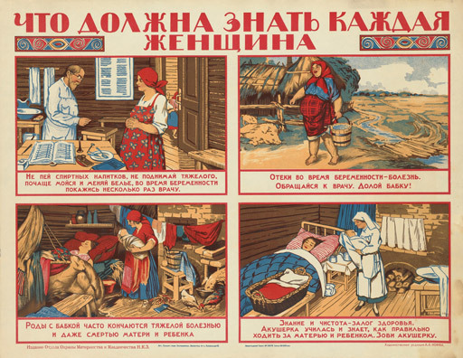
Figure 4 Russian poster giving advice to expectant mothers on healthy practices during pregnancy and at the birth, 1925, lithograph, printed in colours on paper, 51 × 66 cm. Photo: © Wellcome Library, London. The poster shows images of good and bad practices for mothers. Bad practice includes lifting heavy weights, swaddling the baby and having animals in the room. Good mothers listen to the advice of doctors and nurses.
View description - Figure 4 Russian poster giving advice to expectant mothers on healthy practices ...

Infant welfare schemes were set up across Europe in the early decades of the century and the war simply gave an additional impetus to their work. In Britain, the number of welfare centres increased from 842 in 1914 to almost 1,300 by 1918. These programmes took different forms in different countries. In France, centres called ‘Consultations de Nourissons’ and ‘Gouttes de lait’ were set up from the 1890s to encourage mothers to breastfeed their children and to provide free milk to those who were unable to do so. Staff at the centres monitored the development of babies receiving milk, and provided free medical care and advice on childrearing. Some facilities also offered free meals to breastfeeding mothers. At the same time, local authorities offered mothers a wide range of support – free midwifery care at the birth, registered nurses to look after infants, and small payments to stay in bed after the delivery and to help support the child in its first year. By contrast, British infant welfare schemes focused on maternal education rather than material help. Infant welfare centres (some of which were called ‘Schools for Mothers’) offered classes in how to cook, sew baby clothes, bath and feed infants. Babies were regularly weighed and inspected to ensure that they were developing normally. However, if any medical problems were uncovered, staff could only advise mothers to take their infants to a local doctor, who would charge for any treatment provided (Dwork, 1987).
The different approaches to infant welfare on each side of the English Channel grew out of a set of particular social conditions. In France, fears of a declining population were much stronger than in Britain, so government and voluntary associations were prepared to make more radical interventions to help save infant lives, and to invest more in helping mothers. Welfare also reflected patterns of female employment. Far more married women went out to work in France, placing their infants in the care of other women, from whom they received supplementary feeding. British associations were, in general, reluctant to provide direct forms of help, which might lead to welfare ‘dependency’. In Britain, the majority of working women were young and single. They moved out of the workplace when they married and were supported by their husbands. As a result, British welfare schemes were much more concerned not to interfere with the father’s responsibility to support his family.
At the time, these schemes were applauded for reducing infant mortality. The number of infant deaths fell from 140 per thousand births in 1900 to just 63 in 1930. Writing in 1939, George Newman (former medical officer to the Ministry of Health) reported that, through education, mothers had become more ‘child conscious’ and aware of the need for good childrearing practices (quoted in Dwork, 1987, p. 216). Historians have been more critical of infant welfare schemes, arguing that advice given by middle-class staff to poor mothers on the need to feed babies on expensive milk substitutes or take them to the doctor was at best useless and at worst actually increased the anxiety of mothers and the strain on family budgets (Ross, 1993). However, letters from mothers suggested that they had a positive view of infant welfare schemes. Using letters written at the time, Deborah Dwork concluded:

It is clear that these women wanted education, help, advice, and proper nutrition. … A woman … wrote: ‘… my feeling is that if it were possible to get Maternity Centres or schools for expectant mothers, it would be a godsend to many a woman; and also to get some little help in nourishing the body, such as a small quantity of fresh milk.’ Lack of education was specifically mentioned over and over again. They wanted, they said, instruction with regard to sex, contraception, hygiene, and child-rearing. ‘I think ignorance has more to do with suffering than anything,’ one woman contended, and she recommended that physicians give lectures to maternity groups. Another claimed that ‘from the advice that mothers have been able to get at the “Baby Welcome” here, many babies’ lives have been saved’. There is a ‘great need for a place where a young mother could go and get advice and, if necessary, nourishment’, a third concluded.
(Dwork, 1987, p. 165)

Social medicine
Infants were not the only targets of public concern: across Europe, governments set up schemes to tackle a range of diseases among the adult population. In the late nineteenth century, the pattern of disease was changing. Overall, life expectancy increased as the number of deaths from epidemic diseases such as cholera, typhus and typhoid fever declined. Instead, chronic illnesses – heart diseases, tuberculosis (TB) and cancer – emerged as significant causes of death. A new form of medicine emerged called ‘social medicine’. Whereas infectious diseases had been brought under control by cleaning up the environment and isolating patients, social medicine dealt with disease through social interventions, improving housing, diet and working conditions by educating people to live in ways that would improve their health and stop the spread of disease. In the case of TB, this meant isolating patients in their own homes. TB patients were taught to sleep separately from other family members, not to share plates and cutlery, and to spend as much time as possible in the open air (Smith, 1988). People were taught about the dangers of cancer, were encouraged to watch for early symptoms and to follow a healthy lifestyle, taking exercise in the opening air, avoiding alcohol and tobacco, and eating ‘natural’ foods (Proctor, 1999).
Governments put a lot of effort into tackling venereal diseases (VD). Although it is hard to arrive at accurate statistics of the levels of infection, it was clear that the incidence of VD was increasing. Over 24,000 cases were reported in Sweden in 1918, compared with just 3,681 in 1900 (Davidson and Hall, 2001, p. 30). Some estimates suggested that 10 per cent or more of the population were infected. Both syphilis and gonorrhoea had serious consequences: untreated syphilis could end in insanity and death while babies born to women suffering from gonorrhoea could be left blind. As well as a threat to individuals, VD was singled out as a danger to society (see Figure 5). It was ‘one of the greatest public evils – a chief cause of premature death, of untold suffering, of racial degeneration, of blindness, of deafness, of ugliness, of everything that is hateful’ (The Times, 1913, p. 6). VD was linked with ‘modern’ lifestyles and moral decline. In the postwar period, a loosening of moral codes, a loss of influence among the churches, which could no longer regulate behaviour, and greater sexual freedom for women were all blamed for a rise in rates of VD.

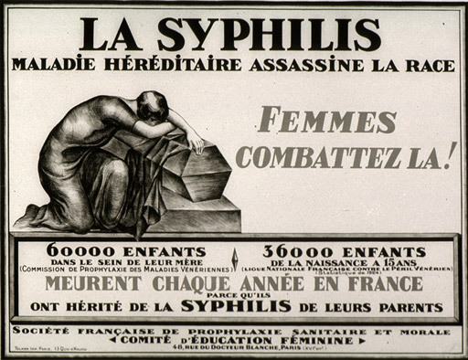
Figure 5 La syphilis maladie héréditaire assassine la race, 1920, France, lithograph on paper, 62 × 81 cm. Photo: U.S. National Library of Medicine, History of Medicine Division, USA. Notice how syphilis is linked to the New Woman, with her short hair and glamorous appearance.
View description - Figure 5 La syphilis maladie héréditaire assassine la race, ...

Broadly speaking, there were two possible approaches. The first, supported by churches and social purity campaigners, argued that VD could be controlled by changing moral standards and patterns of behaviour. Young people should abstain from sex until marriage, and then remain faithful to their partners. Alternatively, a more pragmatic approach suggested that such high moral standards were unattainable: sex outside marriage was a fact of life and it was the responsibility of the state to ensure that the results of this behaviour should not be life-threatening by offering free VD treatment. By 1918, medical practitioners had a good understanding of both diseases. The bacteria responsible for syphilis and gonorrhoea had been identified in 1902 and from 1910 there was an effective treatment for syphilis – Salvarsan, one of the first ‘magic bullet’ drugs, which targeted the infective agent. It still had unpleasant side effects and required long periods of treatment.
European states adopted a variety of strategies to deal with VD. A number of countries, including Spain and Italy, maintained nineteenth-century policies that targeted only prostitutes, who were required to submit to regular medical inspections, and were compelled to undergo medical treatment if found to have VD. Other states extended such policies to the whole population. In Germany and Sweden, the authorities had to be notified of any cases of VD and sufferers were compelled to undergo treatment. Anyone who failed to complete the treatment, or continued to be sexually active while infected, could be sent to prison for up to three years. In practice, it was very difficult to prove such cases and such regulations functioned as a deterrent (Davidson and Hall, 2001, pp. 39–40). An alternative strategy, adopted in Britain through legislation in 1916, was aimed at encouraging sufferers to come forward for treatment. There was no mandatory notification of VD cases, and free, confidential treatment was offered through local authority clinics. By 1919, over a million patients were seen by the clinics and deaths from syphilis declined. While British VD policy was pragmatic in the sense that it accepted a certain level of sexual freedom, it still had a moral dimension, which can be seen in approaches to dealing with different social groups.

Conclusion
As this course has demonstrated, the interwar period was one of fundamental social change. Many of the developments fit with notions of modernisation. Many cities acquired a new and exciting character as centres of modern life. Radio and film brought about transformations in popular culture, bringing new forms of entertainment and new ideas to whole populations. State governments accepted responsibility to help support the most vulnerable members of society, but their policies also created new expectations of how individuals should look after their own health.
While it is easy to see change, it is harder to pin down the exact motors of it, and especially the role played by the First World War in setting such developments in train. For example, with respect to women, it is true that for many war brought new employment opportunities and greater freedom in behaviour, and some historians have even argued that enfranchisement was awarded to women in some countries in recognition of their service during the conflict. At the same time, many historians have argued that such developments were part of a longer, more gradual process, the effects of which became more visible in the 1920s. Similarly, in other ways, the war had little impact on the progress of fundamental social change. Urbanisation, and greater state responsibility for the health and welfare of populations, had begun long before 1914, and continued through the 1920s and 1930s.
The uneven influence of war on social change serves as a reminder that the experience of change also varied hugely across Europe. Rural life in eastern Europe was largely untouched by film, radio, new modes of transport or new fashions. Even in rural Britain, while people may have been aware of these innovations, they may have had little direct contact with them. Finally, change was not always viewed positively: for contemporaries, Berlin was both an exciting tourist attraction and a symbol of moral decay, and the new fashions and perceived freedoms of women sparked moral panics. To complicate matters further, we cannot view contemporary attitudes as diametrically pro- and anti-modern – those who promoted more traditional ways of life harnessed modern media to project their message. Take, for example, the dictatorships of the Italian Fascists and German National Socialists. Both were modern, mass political movements, whose glorification of the past was in fact used to promote a ‘futurist’ vision of a new society, captured in their ambitious urban redevelopment projects, the Piazza Augusto Imperatore in Rome, and Germania in Berlin.

References
Aldcroft, D.H. (2006) Europe’s Third World: The European Periphery in the Interwar Years, Aldershot, Ashgate.
Aldgate, T. (2001) ‘Film and radio in the interwar period’ in Between Two Wars, AA312 Book 3, Milton Keynes, The Open University, pp. 153–88.
Ambrosius, G. and Hubbard, W.H. (1989) A Social and Economic History of Twentieth-Century Europe, Cambridge, MA, Harvard University Press.
Beaven, B. (2005) Leisure, Citizenship and Working-Class Men in Britain, 1850–1945, Manchester, Manchester University Press.
Bideleux, R. and Jeffries, I. (1998) A History of Eastern Europe: Crisis and Change, London, Routledge.
Bock, G. and Thane, P. (eds) (1991) Maternity and Gender Policies: Women and the Rise of European Welfare States, 1880s–1950s, London, Routledge.
Briggs, A. (1961) The History of Broadcasting in the United Kingdom, vol. I: The Birth of Broadcasting, London, Oxford University Press.
Chapman, J. (2001) ‘Film and the First World War’ in The Impact of World War I, AA312 Book 2, Milton Keynes, The Open University, pp. 174–92.
Cocks, H. (2007) ‘Modernity and modernism’ in Carnevali, F. and Strange, J.M. (eds) Twentieth Century Britain: Economic, Cultural and Social Change, 2nd edn, Harlow, Pearson, pp. 26–41.
Crampton, R.J. (1994) Eastern Europe in the Twentieth Century, London, Routledge.
Davidson, R. and Hall, L. (eds) (2001) Sex, Sin and Suffering: Venereal Disease and European Society since 1870, London, Routledge.
Davin, A. (1978) ‘Imperialism and motherhood’, History Workshop Journal, vol. 5, no. 1, pp. 9–65.
De Grazia, V. (1992) How Fascism Ruled Women: Italy, 1922–1945, Berkeley, CA, University of California Press.
Dwork, D. (1987) War Is Good for Babies and Other Young Children, London, Tavistock.
Fischer, C. (2010) Europe between Democracy and Dictatorship, 1900–1945, Oxford, Wiley-Blackwell.
Führer, K.C. (1997) ‘A medium of modernity? Broadcasting in Weimar Germany, 1923–1932’, Journal of Modern History, vol. 69, no. 4, pp. 722–53.
Ganeva, M. (2008) Women in Weimar Fashion: Discourses and Displays in German Culture, 1918–1933, New York, Camden House.
Glass, D. (1967) Population: Policies and Movements in Europe, London, Frank Cass.
Haltof, M. (2002) Polish National Cinema, New York, Berghahn.
Jancovich, M., Faire, L. and Stubbings, S. (2003) The Place of the Audience: Cultural Geographies of Film Consumption, London, British Film Institute.
Jerram, L. (2011) Streetlife: The Untold History of Europe’s Twentieth Century, Oxford, Oxford University Press.
Jones, E.B. (2001) ‘A new stage of life? Young women’s changing expectations and aspirations about work in Weimar Saxony’, German History, vol. 19, no. 4, pp. 549–70.
Kirk, D. (1969) Europe’s Population in the Interwar Years, New York, Gordon & Breach.
Koven, S. and Michel, S. (1993) Mothers of a New World: Maternalist Politics and the Origins of Welfare States, London, Routledge.
Laqueur, W. (1974) Weimar: A Cultural History, New York, G.P. Putnam’s Sons.
Lawrence, P. (2005) ‘Urbanization, poverty and crime’ in Martel, G. (ed.) A Companion to Europe 1900–1945, Oxford, Blackwell, also available online at http://www.blackwellParagraph.com/subscriber/tocnode?id=g9781405106641_chunk_g97814051066415 (accessed 1 April 2012).
Levine, A.M. (2004) ‘Projections of rural life: the agricultural film initiative in France, 1919–1939’, Cinema Journal, vol. 43, no. 4, pp. 76–95.
McElligott, A. (2001) The German Urban Experience, 1900–1945: Modernity and Crisis, London, Routledge.
Mitchell, B.R. (1998) International Historical Statistics: Europe, 1750–1993, 4th edn, Basingstoke, Macmillan.
Mitford, N. (1949 [1945]) The Pursuit of Love, London, Penguin.
Moores, S. (1988) ‘“The box on the dresser”: memories of early radio and everyday life’, Media, Culture and Society, vol. 10, no. 4, pp. 23–40.
Overy, R. (2010) The Morbid Age: Britain and the Crisis of Civilisation, London, Penguin.
Pegg, M. (1983) Broadcasting and Society, 1918–1939, Beckenham, Croom Helm.
Proctor, R.N. (1999) The Nazi War on Cancer, Princeton, NJ, Princeton University Press.
Pugh, M. (2009) We Danced All Night: A Social History of Britain between the Wars, London, Vintage.
Quine, M.S. (1996) Population Politics in Twentieth-Century Europe: Fascist Dictatorships and Liberal Democracies, London, Routledge.
Richards, J. (1984) The Age of the Dream Palace: Cinema and Society in Britain, 1930–1939, London, Routledge.
Rieger, B. and Daunton, M.J. (2001) ‘Introduction’ in Daunton, M.J. and Rieger, B. (eds) Meanings of Modernity: Britain from the late-Victorian Era to World War II, Oxford, Berg, pp. 1–14.
Roberts, M.L. (1993) ‘Samson and Delilah revisited: the politics of women’s fashion in 1920s France’, American Historical Review, vol. 98, no. 3, pp. 657–84.
Roberts, M.L. (1994) Civilisation without Sexes: Reconstructing Gender in Postwar France, 1917–1927, Chicago, IL, University of Chicago Press.
Ross, C. (2006) ‘Mass culture and divided audiences: cinema and social change in interwar Germany’, Past and Present, no. 193, pp. 157–95.
Ross, E. (1993) Love and Toil: Motherhood in Outcast London, 1870–1918, Oxford, Oxford University Press.
Saunders, T.J. (2005) ‘The Jazz Age’ in Martel, G. (ed.) A Companion to Europe 1900–1945, Oxford, Blackwell, also available online at http://www.blackwellParagraph.com/subscriber/tocnode?id=g9781405106641_chunk_g978140510664126 (accessed 1 April 2012).
Skinner, J. and Purchase, E. (1989) Growing Up Downhill: Growing up in Lincoln between the Wars, a Book for Claire, Boston, Richard Kay.
Smith, F.B. (1988) The Retreat of Tuberculosis 1850–1950, London, Croom Helm.
Søland, B. (2000) Becoming Modern: Young Women and the Reconstruction of Womanhood in the 1920s, Princeton, NJ, Princeton University Press.
Stewart, M.L. (2008) Dressing Modern Frenchwomen: Marketing Haute Couture, 1919–1939, Baltimore, MD, Johns Hopkins University Press.
Stites, R. (1992) Russian Popular Culture: Entertainment and Society since 1900, Cambridge, Cambridge University Press.
The Times (1913) ‘Venereal Disease: A royal commission’, 6 October, p. 6.
Todd, S. (2005) ‘Young women, work and leisure in interwar England’, Historical Journal, vol. 48, no. 3, pp. 789–809.
Usborne, C. (1992) The Politics of the Body in Weimar Germany: Women’s Reproductive Rights and Duties, Basingstoke, Macmillan.
Wasserstein, B. (2009) Barbarism and Civilisation: A History of Europe in Our Time, Oxford, Oxford University Press

Further reading
Davin, A. (1978) ‘Imperialism and motherhood’, History Workshop Journal, vol. 5, no. 1, pp. 9–65.
Lawrence, P. (2005) ‘Urbanisation, poverty, and crime’ in Gordon Martel (ed.) A Companion to Europe, 1900–1945, Oxford, Blackwell.
Pugh, M. (2009) We Danced All Night: A Social History of Britain between the Wars, London, Vintage.
Roberts, M.L. (1994) Civilisation without Sexes: Reconstructing Gender in Post war France, Chicago, Chicago University Press.
Ross, C. (2006) ‘Mass culture and divided audiences: cinema and social change in interwar Germany’, Past & Present, no. 193, pp. 157–95.
Søland, B. (2000) Becoming Modern: Young Women and the Reconstruction of Womanhood in the 1920s, Princeton, NJ, Princeton University Press.

Acknowledgements
Except for third party materials and otherwise stated (see terms and conditions), this content is made available under a Creative Commons Attribution-NonCommercial-ShareAlike 4.0 Licence.
The material acknowledged below is Proprietary and used under licence (not subject to Creative Commons Licence). Grateful acknowledgement is made to the following sources for permission to reproduce material in this free course:
Every effort has been made to contact copyright owners. If any have been inadvertently overlooked, the publishers will be pleased to make the necessary arrangements at the first opportunity.
Course image Municipal Archives of Trondheim in Flickr made available under Creative Commons Attribution 2.0 Licence.
Source 1: Steinicke, O. ‘A visit to a new apartment’: Steinicke, O. (1929) ‘Besuch in einer Newbauwohnung’ (‘A visit to a new apartment’), Magazin für Alle, vol. 4, no. 7 pp. 22–3 (July 1929).
Source 3: Joseph Goebbels (1928) ‘Rund um die Gedächtniskirche’ (‘Around the Gedächtniskirche’), Der Angriff, 23 January.
Source 4: Bingham, A. (2004) ‘“An era of domesticity?”: Histories of women and gender in interwar Britain’, Social and Cultural History, vol. 1, no.2, pp. 225–33, Berg Publishers.
Figure 1: Photographer unknown. Fox Photos/Getty Images
Figure 2: ‘Spring 1926: Even the stork is confused!’, cartoon from German weekly periodical ULK, vol. 55, no. 11, 12 March 1926. Photo: © Universit ätsbibliothek Heidelberg.
Figure 3: ‘Business girls like Cuticura’, cartoon from Illustrated London News, 11 July 1925, p. 96. Photo: © Illustrated London News Ltd/Mary Evans.
Figure 4: Russian poster giving advice to expectant mothers on healthy practices during pregnancy and at the birth, 1925, lithograph, printed in colours on paper, 51 × 66 cm. Photo: © Wellcome Library, London.
Figure 5: La syphilis maladie héréditaire assassine la race, 1920, France, lithograph on paper, 62 × 81 cm. Photo: U.S. National Library of Medicine, History of Medicine Division, USA.
Potsdamer Platz Walter Rutman, Berlin: Die Sinfonie der Grosstadt (public domain)
Onkel Toms Hutte: Matt Frei Berlin © BBC (2009)
Krumme Lanke: Matt Frei Berlin © BBC (2009)
Nollendorfplatz: Matt Frei Berlin © BBC (2009)
Berlin nightlife: Matt Frie Berlin © BBC (2009). Includes: Image: Anita Berber in der Tanschoepfung ‘Cocain’ – ÖNB/Wien. Image: Anita Berber mit Hose – ÖNB/Wien.
Don't miss out
If reading this text has inspired you to learn more, you may be interested in joining the millions of people who discover our free learning resources and qualifications by visiting The Open University – www.open.edu/openlearn/free-courses.

Glossary
Germania
The new name given to Berlin in Adolf Hitler’s and Albert Speer’s plans to transform the city into a monumental capital city at the heart of a greater German world empire. In 1937 Speer (the Nazi Party architect) was commissioned by Hitler to produce designs for the transformation of the city, which were released to the public in January 1938. The designs for the buildings and accompanying transport system were undoubtedly modern, though with classic overtones. Speer’s plans included two grand processional boulevards on a north-south and east-west axis, a Great Hall at the very centre of Berlin with a dome 16 times larger than St Peter’s in Rome, a massive Arch of Triumph, modern housing stock, ring roads and vehicle underpasses. Although work began almost immediately, the demands of waging war soon diverted attention away from the project.
high culture
Cultural traditions and phenomena predominantly created by and patronised by the higher classes or intellectuals in a society. The conditions in which such phenomena are created and disseminated often inhibit the participation of the ‘many’ (or lower social classes) in these cultural traditions.
mass culture
Primarily cultural phenomena that appeal to the ‘many’, or mass audiences, often cutting across class, gender and age boundaries. Mass culture is seen as distinct from popular culture, or as a modern development of popular culture. Where popular culture is associated with folk traditions, and seen as being made for the people by the people, mass culture is created for the people, but not by the people. Mass culture is also linked to the industrial and urban environment, as opposed to popular culture, the roots of which are said to be found in rural and community life. However, such distinctions often blur in reality, especially as mass culture is not devoid of authenticity and popular culture can be remade and re-emerge in new environments.
Piazza Augusto Imperatore
Directly translated as Emperor Augustus Square, the Piazza Augusto Imperatore was one of the great construction projects of Benito Mussolini, designed by fascist architect Vittorio Ballio Morpurgo in 1936 and built for the 1938 celebration of the 2000th anniversary of Augustus’ birth. It is an ideal example of the way in which Italian fascism made use of the grandeur of the Roman Empire as part of its futurist planning.
positive eugenic policies
Designed to encourage healthy parents to have children and pass on their good physique to the next generation. Negative eugenic policies aimed to discourage the physically and mentally weak from having children.
totalitarian
The OED defines totalitarian as the following: ‘A system of government which tolerates only one political party, to which all other institutions are subordinated, and which demands the complete subservience of the individual to the State.’
Trianon state
This refers to the new states of Austria and Hungary after the signing of the Treaty of Trianon, signed by the Allies and the new state of Hungary on 4 June 1920 as part of the Paris Peace Settlement, which dissolved the former Austro-Hungarian empire.

Solutions

Activity 1

Specimen answer
- It is apparent that not every country has population data from the period before the First World War. Mostly this is because these countries only came into existence as separate states as a result of the Paris Peace Settlement. In all those countries for which data is available (with the exception of Ireland, whose population fell in the 1920s and 1930s as a result of partition and high emigration), the population grew over the period 1900–30.
- The impact of the First World War is noticeable in some cases. For example, the populations of Austria, Germany and France all experienced a slight decline (in the case of Austria, this is a real decline as the pre-1920/21 population is only that of regions that formed the postwar, or Trianon state; also, it is important to note that Germany lost territory at the end of the war, which is not allowed for here). However, all three countries had recovered and exceeded prewar population levels by the 1930s.
Back to - Activity 1

Discussion
Even though the population of Europe continued to increase after the First World War, you might have noticed that the rate of growth was much higher in some countries and regions than in others. Generally speaking, populations of countries in the east and south of Europe tended to grow at a faster rate than those of the north-west. The slow growth of the latter is indicative of a decline in the birth rate in those countries, due in large part to the active limitation of family size. Starting with the upper classes and moving slowly down the social scale, parents chose to limit the numbers of their children. Whereas large families with four or more children were common across Europe at the turn of the century, in the interwar years the presence of such families declined in western Europe (for example, the average number of children born per marriage in Germany dropped from 4.7 before 1905 to 2 in 1925–29), a trend that both intensified and spread to southern and eastern Europe after 1945 (Ambrosius and Hubbard, 1989, p. 23; Usborne, 1992, p. 33). Anxieties about population growth before 1914 were exacerbated by losses of the First World War – around 1.3 million French, 2 million German and 750,000 British soldiers died in the conflict. Not only was there a sharp decline in the birth rate during the war, but recovering birth rates in the interwar years never again reached levels seen in the nineteenth century. However, some historians have argued that images of a postwar cohort of spinsters in western European countries were often the products of population panics and did not necessarily reflect reality (Pugh, 2009, pp. 124–7).
Back to - Activity 1

Activity 2

Specimen answer
- In almost every city listed in Table 2, the population increased over the period 1910–30. However, Paris, Budapest and Vienna are the exceptions to this trend: in Paris the population declined each decade, but the small extent of that decrease suggests a fairly stable population; Budapest grew between 1910 and 1920, but then experienced a small decrease by 1930. These figures also suggest that the greatest increases in population happened during the 1920s. For the most part, the impact of the First World War was marginal: some cities in countries with a direct experience of combat found their populations decreasing slightly, but this was more than made up for after the war. However, Vienna’s population decline could be said to have been directly related to the war, as the city suffered in the 1920s because it lost its status as the capital of the Austro-Hungarian empire.
- Even if the general trend was towards urban expansion in the interwar period, urbanisation was not the dominant experience in all European countries. The data in Table 1 on the populations of the major cities for each country show that European states with larger urban populations tended to be located in north-west Europe.
Back to - Activity 2

Activity 3

Specimen answer
Ruttman’s Sinphonie is a celebration of the modern city, and it can be difficult to untangle those features in the film which are particular to the interwar years. However, I picked out two primary indicators. First, transport; specifically the appearance of cars on the city streets, and the problems that these new vehicles created for urban order. You might have noticed the policeman on the streets directing the traffic. Also, you might have noticed the continued presence of more traditional modes of transport, especially the large number of horses with carts attached. The second indicator I identified was the presence of women in the public sphere – not just the fact that there are quite a lot of women in the film walking the city streets, but that they do so unchaperoned and often with a sense of purpose. This perhaps suggests that they are on their way to work. I also took note of the fashions that many of these women were wearing, a contrast to images of women in the prewar period.
Back to - Activity 3

Activity 4

Specimen answer
- The tone of Steinicke’s article is overwhelmingly positive. He emphasises all the attractions of modern apartments compared with former city housing.
- Steinicke lists a number of features of modern urban living. Electricity and central heating are perhaps the most obvious. He also places great emphasis on improvements in hygiene. Similarly, he stresses the tidiness of the new apartments – although some residents had brought some of their old furniture with them, many had dispensed with items that tended to clutter their former living quarters, for example, knick-knacks and other superfluous and cheap ornaments.
- Steinicke describes a two-and-a-half room modern apartment. In practice, this consists of a main room (including a kitchen), a bedroom, a child’s bedroom, and a bathroom. Steinicke also tells us that there is a double bed and two small children’s beds in the apartment. It is clear that the designers intended these apartments to be occupied by a nuclear family, ideally two adults and two children. These expectations fit with what we know about demographic patterns in Europe during the interwar years.
Back to - Activity 4

Discussion
Also of note in this article is Steinicke’s description of the tortuous process by which the Müller family obtained their modern apartment. Although around 2.5 million modern apartments such as these were constructed during the Weimar period, the majority were occupied by the middle classes, despite the great need for housing for the lower classes identified by the Weimar government. Moreover, the 1925 census revealed that more than 117,000 people were homeless in Berlin (Wasserstein, 2009, p. 214). Throughout the 1920s and 1930s, famous districts such as Wedding, to the north east, and Hallesches Tor, within a short walk of the glittering Potsdamer Platz, remained representative of the slum-like conditions that many of the unskilled and semi-skilled urban labourers continued to live in: families were often crowded into damp and unhygienic tenements that had been rapidly put up in the late-nineteenth century to house a growing industrial workforce. The persistence of similar slums in most European cities has led historian Leif Jerram to question the apparent ‘liberty’ that urban life offered to former agricultural labourers, especially women (Jerram, 2011, p. 103). For an alternative description of living quarters in interwar Berlin, you might like to read Source 2, Christopher Isherwood’s description of the Nowaks’ house in Wassertorstrasse.
Back to - Activity 4

Activity 5

Specimen answer
- Cinema; illuminated shop windows and flashing neon lights; cabaret-style entertainment (or variety theatre) including dancing girls, acrobatic tricks, music, and other circus acts; cocktail bars; night clubs with dancing, live bands and casino entertainments; sexual freedom (including homosexuality).
- Hedonism. This is first apparent in Frei’s description of the deliberate ignorance of street violence in favour of drinking and partying. Ruttman’s pleasure-seekers also seem oblivious to all but enjoyment – most obviously, the couple getting into the cab: the sexual frisson between the two is evident by the way the man places his hand on the woman’s arm, and both ignore the plight of the poor begging boy.
Back to - Activity 5

Discussion
Dance halls pushing popular music, nightclubs with resident jazz bands and cinemas could be found in cities across Europe in the 1920s, but it is worth noting that in Berlin transformations in popular culture seemed to be much more extreme than elsewhere, the result of a combination of political freedom (ie, the absence of censorship legislation) and a deep sense of instability. At the same time though, those extremes were often experienced by a small minority – elements of the intelligentsia, or even tourists to the city intent on seeking out pleasures for which Berlin had acquired a reputation. As the British diplomat Harold Nicholson later wrote, ‘it was not the Berliners themselves who most frequented these palaces of delight; it was the tourists and the businessmen from Dortmund or Breslau’. Yet the perception of cultural extremity can be just as important as the reality.
Back to - Activity 5

Activity 6

Specimen answer
- The author is Joseph Goebbels. You might already be familiar with the name, and know him as the propaganda minister under the Nazi government from 1933. In 1926, Goebbels had become the Gauleiter (regional head) of the Nazi Party in Berlin-Brandenburg.
- For Goebbels, several features of modernity – cosmopolitanism, cultural openness and the rise of the political left – have led to great moral decay.
Back to - Activity 6

Activity 8

Specimen answer
The first major difference that I could spot was the family- and home-centred experience of listening in the autobiography, compared with the (unwanted) communal experience in Heitland’s letter. For Heitland the radio was background music, but for the Skinners radio programmes captured the household’s full attention, and were events to be talked about or even sometimes part of a multi-media experience involving the Radio Times. Heitland was implying that the dance music was put on solely to appeal to working-class people (‘the proletariat’): the Skinner family enjoyed the ‘improving’ elements of radio output as well as the ‘Music Hall’. Mrs Skinner did seem to share some of Heitland’s snobbery though – feeling superior to ‘those who had it on all day’.
Back to - Activity 8

Discussion
It’s easy to find evidence of class-based prejudices like Heitland’s about the social impact of ‘working-class’ culture – but we mustn’t forget that within social classes, people like Mrs Skinner also had opinions about what was the proper way to live. Notions of respectability and appropriateness could cut across class boundaries, and they were often linked to opinions about which forms of popular culture were the most acceptable.
Back to - Activity 8

Activity 9

Specimen answer
When I read this article I identified three main trends in the literature on the New Woman since the 1960s:
- During the 1960s and 1970s, a group of historians (including Arthur Marwick and David Mitchell) championed the notion that the First World War had ushered in significant changes to the lives of women, predominantly in the form of enfranchisement and widening employment prospects.
- However, during the 1980s another group of historians – Gail Braybon, Dierdre Beddoe, Harold Smith and Susan Kent – challenged this by presenting evidence of a backlash against women. Even if women had enjoyed limited freedoms in work and social life during wartime, these were quickly removed once war had ended, under a ‘prevailing atmosphere of domesticity’.
- By the late 1990s, a third group of historians had emerged (e.g. Cheryl Law, Caitriona Beaumont, Claire Langhamer and Birgitte Søland) whose research into other aspects of social activity revealed substantial limits to the backlash thesis of the 1980s. These historians argued that the 1920s formed an important moment of modernity, marked by changing expectations and greater opportunities for young women (note that they introduce an important differential here, which I will refer to again below). Moreover, they placed great weight on the importance of cultural representations of femininity, or the proliferation of images of the New Woman, which, even if not a strict reflection of reality, had significance as a way of asserting change.
Back to - Activity 9

Discussion
Although it is not made explicit in this article, it is important to note that the last group of historians that Bingham identified (and of which he is a member) have largely shifted their focus away from debating the impact of the First World War on the lives of women. Let’s take a moment to consider this further. It could be argued that the second group of historians saw the First World War as a blip, an interruption to patterns of continuity in women’s lives as wives and mothers; after the war, things went back to normal. By sidelining the First World War, the third group of historians also suggest that the event might have been a blip, but one that interrupted a series of gradual changes present in the decades leading up to war and gathering pace in the early 1920s. This is especially noticeable in the use of the term ‘New Woman’. It is a useful shorthand to describe a process occurring across Europe in the interwar period. However, in France and Britain the term ‘New Woman’ has a much longer pedigree. It was used from the late nineteenth century to describe a small minority of mostly wealthy women who were able to live with some independence, dabble in careers that shocked their families, and experiment with some new fashions of rational dress. These ‘New Women’ were both related to and distinct from the ‘flapper’ and ‘garçonne’, or ‘Femme Moderne’ of 1920s’ Britain and France, as well as the ‘Neue Frau’ of interwar Germany. In other words, it is important to try to untangle changes that occurred as a result of war from developments that had begun before it.
Back to - Activity 9

Activity 10

Specimen answer
- Both of these images appear in contemporary newspapers. However, the first image is a satirical cartoon published in a German weekly periodical, ULK (which means ‘joke’ or ‘fun’ in German) and the second image is an advertisement published in the Illustrated London News, a weekly British newspaper. The images probably have different audiences, the first intended to amuse (at least predominantly) male readers and the second aimed at female consumers.
- Both images contain a representation of the ‘New Woman’ – that is, an (at least superficially) independent woman clothed in the new rational fashions. However, there are some important differences. In Figure 2, women’s fashion is presented in a negative light. The implication is that women’s fashion has become so masculinised that even the stork cannot tell who is the man and who is the woman. (In German folklore, if a stork bites a woman she will have a baby – in the cartoon, the stork has bitten the man by accident.) In Figure 3, fashion is presented in a positive light. The woman is wearing the current fashion and purchasing new beauty products, but here that serves to enhance her femininity, despite the fact that she is outside the domestic sphere (and the test of the advertisement implies that these products help this woman to do her job).
Back to - Activity 10

Discussion
These images capture the two competing narratives encapsulated in the image of the ‘New Woman’: that of ‘archetype’ and that of ‘consumer’ (Saunders, 2005). On the one hand, the archetypal ‘New Woman’ – employed (and hence independent), single and in pursuit of pleasure – was viewed by many contemporaries, especially at a time of declining birth rates, with scorn. Her modern or masculinised clothes were symbolic of the challenge she presented to traditional male roles and authority, fuelling a crisis of masculinity. As Mary Louise Roberts has written: ‘The blurring of the boundaries between “male” and “female” – a civilisation without sexes – served as a primary referent for the ruin of civilization itself’ (1994, p. 4). In Source 4, Bingham mentions several historians (in particular Beddoe and Melman) who have emphasised the role played by the interwar press in Britain in the ‘backlash’ against perceived new freedoms for women, presenting hostile images of the ‘New Woman’ while reasserting the role of women in the domestic sphere through advertising and special features.
On the other hand, the ‘New Woman’, with her disposable income, was also seen as a consumer. This happened to coincide with the expansion of the mass media. Hence new fashions and beauty products were promoted by newspapers, sometimes in advertisements boasting domestic scenes and sometimes in advertisements displaying women in the public sphere. Crucially, the vast majority emphasised the femininity of women and the importance of beauty products in enhancing female elegance, while offering little challenge to male authority (you might note that the woman in Figure 3, sitting by the typewriter, is employed in a secretarial role and hardly a challenge for the male executives she works for). At the same time, though, you should note the aspirational value of the advertisement.
Back to - Activity 10

Descriptions

Figure 1 Harvesting in Hungary, 1935. Photographer unknown. Photo: Fox Photos/Getty. Note the traditional dress worn by the workers. It is worth bearing this in mind when we turn to consider changing fashions in women’s dress during the interwar years later in this course.
This photograph shows four people, two men and two women, harvesting wheat in a field in Hungary. All four people have their backs to the camera, the wheat stands tall in front of them, and harvested wheat lies behind them. Their arrangement is as follows, from left to right: woman, man, woman, man. Both men, standing tall, are using scythes to cut the wheat, while both women, bent over, are collecting the cut wheat. There are no other agricultural tools or machinery in the photograph. The people are all dressed in peasant attire. In particular, the women wear long, ankle-length skirts and long head scarves.
Back to - Figure 1 Harvesting in Hungary, 1935. Photographer unknown. Photo: Fox Photos/Getty. Note the traditional dress worn by the workers. It is worth bearing this in mind when we turn to consider changing fashions in women’s dress during the interwar years later in this course.

Figure 2 ‘Spring 1926: Even the stork is confused!’, cartoon from German weekly periodical ULK, vol. 55, no. 11, 12 March 1926. Photo: © Universit ätsbibliothek Heidelberg.
This is the front cover of the German weekly periodical, ULK. This title means ‘joke’ or ‘fun’ in German. ‘ULK’ is in capital letters across the top of the page. Directly underneath is the subtitle, also in capital letters, ‘Wochenschrift des Berliner Tageblatts’ (‘weekly magazine of the Berliner Tageblatt’ – a daily German newspaper. Underneath that is the issue number (NR. 11), 55. Jahrgang (55th year) and the date of publication (11 March 1926). Most of the cover is taken up with a drawing. It shows a man and woman walking in a green field with yellow flowers. A winding grey river is behind them. There is a short tree on the river bank on the right-hand side. New leaves are growing from its sparse branches suggesting the start of spring. In the distance, across the back of the picture, is a row of mountains, and the sky above them is a dark blue. The pose of the man and woman suggests that they are couple: the man on the right holds on to the arm of the woman on the left, who has her hand in her jacket pocket. Their dress is remarkably similar: each wears a white jacket, a yellow tie, and a white shirt. The man wears trousers, while the woman wears a long skirt or possibly three-quarter length trousers. The man has short, combed-back blonde hair. The woman has short, centrally parted dark hair. She also wears a monocle and is smoking a cigarette. To the right of the man is a large stork, who is biting his raised ankle, to which he responds with some shock. The caption below the picture, at the bottom of the cover, reads ‘Frühling 1926: Selbst der Storch irrt sich!’, which means, ‘Spring 1926: Even the stork is confused!’. This refers to the fact that in German folklore, a pregnant women is said to have been bitten by a stork. In this case, man and woman look so similar that the stork accidentally bites the wrong person.
Back to - Figure 2 ‘Spring 1926: Even the stork is confused!’, cartoon from German weekly periodical ULK, vol. 55, no. 11, 12 March 1926. Photo: © Universit ätsbibliothek Heidelberg.

Figure 3 ‘Business girls like Cuticura’, cartoon from Illustrated London News, 11 July 1925, p. 96. Photo: © Illustrated London News Ltd/Mary Evans.
This black-and-white advertisement from the Illustrated London News shows a young woman with short hair, wearing a short-sleeved top with a ruffled v-shaped neckline, holding a pencil and notepad with her neatly manicured hands. She gazes sweetly at the reader. Behind her and slightly to her right is a typewriter which, together with her notepad, suggests that she is an administrative assistant. The caption for the advertisement reads ‘Business girls like Cuticura’, and a short blurb below explains the beauty products being advertised – soap, ointment and talcum powder – together with the current retail prices.
Back to - Figure 3 ‘Business girls like Cuticura’, cartoon from Illustrated London News, 11 July 1925, p. 96. Photo: © Illustrated London News Ltd/Mary Evans.

Figure 4 Russian poster giving advice to expectant mothers on healthy practices during pregnancy and at the birth, 1925, lithograph, printed in colours on paper, 51 × 66 cm. Photo: © Wellcome Library, London. The poster shows images of good and bad practices for mothers. Bad practice includes lifting heavy weights, swaddling the baby and having animals in the room. Good mothers listen to the advice of doctors and nurses.
A large textual legend (in Russian) runs along the top of this brightly coloured poster. Below it, the poster is divided into four boxes, each containing a different pictorial scene relating to the actions of women in pregnancy and childbirth. Beneath each box is a strip of text giving instructions (in Russian). The box on the top left shows a woman dressed in peasant clothes (red pinafore and red head scarf) visiting a doctor’s surgery. The woman stands to the right of the doctor, beside a table, and looks at the doctor intently, suggesting that she is concentrating on what he has to say. The doctor to her left is a man in a white coat. He stands behind the table and looks at the woman sternly. The table in front of him (and to the left of the woman) has a number of medical instruments on it. Along the back wall of his surgery is a table with a jug and basin (to the left) and a large chart (to his right). Behind the woman and to her right is a partially open door which reveals a waiting room. The second box on the top right is a pastoral scene. There is a flat field with a stream running through its centre. To the left of the stream is a hut with a straw roof. In front of the hut is a woman, heavily pregnant, and dressed in peasant clothes with bare feet. She is carrying a large bucket of water in her right hand. To her left is an animal. The third box on the bottom left shows a scene inside a peasant’s hut. On the left is a bed with a woman asleep in it. The bed clothes are made up of a range of materials, and straw pokes out of the mattress. Along the back wall of the dwelling is a clothes line with rags hanging from it. In front of the clothes line and to the right of the bed is a woman, dressed in peasant clothes, cradling a baby who is wrapped in swaddling blankets. To her right, in the right hand corner of the image, there is an axe on the floor of the hut, two chickens, and a goat drinking from a bucket. The fourth box on the bottom right is another scene in a dwelling. On the left a woman lies asleep in a bed which has neat and clean linen. At the foot of the bed is a baby’s basinet. Beside the bed, parallel with the woman’s head is a small table with a cup and jug. Standing to the right of the bed, and in the centre of the picture, is a woman dressed as a nurse in clean white cotton robes. She is cradling a baby wrapped in clean white cotton. On her right is another table with a basin and a clean white sheet.
Back to - Figure 4 Russian poster giving advice to expectant mothers on healthy practices during pregnancy and at the birth, 1925, lithograph, printed in colours on paper, 51 × 66 cm. Photo: © Wellcome Library, London. The poster shows images of good and bad practices for mothers. Bad practice includes lifting heavy weights, swaddling the baby and having animals in the room. Good mothers listen to the advice of doctors and nurses.

Figure 5 La syphilis maladie héréditaire assassine la race, 1920, France, lithograph on paper, 62 × 81 cm. Photo: U.S. National Library of Medicine, History of Medicine Division, USA. Notice how syphilis is linked to the New Woman, with her short hair and glamorous appearance.
This black and white lithograph is divided into three panels. The first panel, at the top and taking up two thirds of the lithograph, shows a woman, on the left, slumped over a small coffin. She is wearing a long gown, and her hair is cut short. The large text at the top of this panel reads ‘Syphillis. Hereditary disease killing the race’. To the left of the woman, in large type, is the statement, ‘Women, Fight it’. The second panel below contains more text. It reads: ‘60,000 children in the womb of their mother, 36,000 children from birth to 15 years, die each year in France because they have inherited Syphilis from their parents’. The viewer is also given the source of these statistics. The third panel, at the bottom of the lithograph is the smallest. It provides the details of the publisher of this lithograph, namely, the French Society of Preventative Health and Morals.
Back to - Figure 5 La syphilis maladie héréditaire assassine la race, 1920, France, lithograph on paper, 62 × 81 cm. Photo: U.S. National Library of Medicine, History of Medicine Division, USA. Notice how syphilis is linked to the New Woman, with her short hair and glamorous appearance.

Potsdamer Platz

Transcript
[TRAIN NOISE]
Back to - Potsdamer Platz

Onkel Toms Hütte

Transcript
NARRATOR
By the 1920s, across the city, new visions of living and working were springing up. Berlin had become a cauldron of creativity. On its edges, pioneering architects were commissioned to come up with new homes to take the masses out of the overcrowded city. The Hufeisensiedlung, or Horseshoe Estate, designed by Bruno Taut, had more than 1,000 residences. Onkel Toms Siedlung, built five years later, would accommodate twice as many again. These estates were like garden cities, boldly colourful, the fruits of a society that celebrated the new.
Back to - Onkel Toms Hütte

Krumme Lanke

Transcript
[TRAIN RUMBLING]
NARRATOR: Modernism now led, and where Berlin led the rest of the world followed. Or so it seemed.
[SINISTER MARCH MUSIC]
NARRATOR: From 1933, Berlin became Hitler's city. The rise to power of the Nazi Party spelled the end of modernism, condemned by them as cosmopolitan rubbish.
This estate was mainly home to communists. The emerging Nazi Party regarded them, as well as the style of the buildings they lived in, as their enemies. Modernism itself was now in the firing line.
[HARSH SOUND]
[BIRDS TWITTERING]
NARRATOR: But the Nazis were to take on their opponents with more than just jackboots. Just around the corner, a very different vision of Germanic identity was being built. The Nazis armed themselves with pitched roofs to combat the flat ones of modernism. It would be dubbed the Battle of the Roofs.
The perfect chocolate box village, straight out of a Grimm fairy tale with the pitched roofs and the folkish style, this place looks idyllic. But guess what? It was built in the late 1930s specifically for the SS as a model community.
Today this neighbourhood, originally known as the SS Comradeship Estate, is once again very desirable. But whether it has managed to shake off its connection with Hitler's infamous security force is less clear.
FRIEDRICH HAGELE (SUBTITLES)
These houses look straight from the Black Forest, don’t they?
MATT FREI (SUBTITLES)
The SS would never have lived under a flat roof.
FRIEDRICH HAGELE (SUBTITLES)
Exactly.
MATT FREI (SUBTITLES)
If you try and imagine SS workers living here with their families, that must seem really odd.
FRIEDRICH HAGELE (SUBTITLES)
But now we’re living in different times of course.
MATT FREI (SUBTITLES)
But this is the past which is always swirling around in Berlin.
FRIEDRICH HAGELE (SUBTITLES)
We felt at home here very quickly and we have wonderful neighbours. There really are no problems. There is a real sense of community.
MATT FREI (SUBTITLES)
So a very happy community of Berliners live here?
FRIEDRICH HAGELE (SUBTITLES)
Yes that’s true.
MATT FREI (SUBTITLES)
The ghosts are rattling.
FRIEDRICH HAGELE (SUBTITLES)
Yes but at the height of summer, in five minutes we can be swimming in the nearby lake. It’s really dreamy.
MATT FREI (SUBTITLES)
Wonderful, an idyll.
[MUSIC PLAYING]
Back to - Krumme Lanke

Nollendorfplatz

Transcript
[TRAIN RUMBLING]
NARRATOR: Many of those drawn to Berlin during the 1920s made a beeline for Schoeneberg, then, as now, the gay centre of the city. One was a young Englishman named Christopher Isherwood. He lived at Number 17 Nollendorfstrasse, and it was here that he wrote the tales of his experiences. Published in the book Goodbye to Berlin, they later became the film Cabaret.
So this was the flat, second floor on the left-hand side, and all the characters here, all the tenants, immortalised in Cabaret. Sally Bowles in this room, Fraulein Schneider, the German landlady, over there, Fraulein Kost, the German prostitute, over there. And here, Christopher Isherwood.
READER: From my window, the deep, solemn, massive street. Cellar shops where lamps burn all day, under the shadow of top-heavy balconied facades. The whole district is like this -- street leading into street of houses like shabby monumental safes crammed with the tarnished valuables and secondhand furniture of a bankrupt middle class.
NARRATOR: Isherwood saw Berlin as a powder keg waiting to explode. Hyperinflation had bankrupted the city, creating a population of destitute millionaires. Goebbels's Nazi militias were on the up and up, out on the streets, openly picking fights with communist gangs. As Isherwood and his friends drank and danced the night away:
READER: Berlin was in a state of civil war. Hate exploded suddenly, without warning, out of nowhere. Knives were whipped out. Blows were dealt with spiked rings, beer mugs, chair legs, or leaded clubs. Bullets slashed the advertisements on the poster columns, rebounded from the iron roofs of latrines. In the middle of a crowded street, a young man would be attacked, stripped, thrashed, and left bleeding on the pavement. In 15 seconds it was all over, and the assailants had disappeared.
[SHOUTING]
Back to - Nollendorfplatz

Berlin nightlife

Transcript
Matt Frei
The woman’s name was Anita Berber. She was a movie actress and a dancer, famed for her erotic modern dance numbers. She danced at the notorious Eldorado club. In what is now an organic supermarket, people would once sit in sweaty thrall to Berber’s gyrations.
[MUSIC]
Berber was a bisexual, addicted to cocaine, morphine and heroin.
[MUSIC]
Someone who wouldn’t shy at stooping to prostitution to fund her habits. Hard to believe, but this place was once the centre of Berlin’s creative scene.
[MUSIC]
Another artist, Otto Dix, captured the mood in a stunning portrait of Berber.
[MUSIC]
And his rendering of the club’s transvestite clientele. The sexual underworld of Berlin in the 1920s represented not just a way of life, or, for that matter, a good night out. Like everything else in this city at that time, it embodied a political idea. The Eldorado club was closed down. Soon it would be a Nazi Party local office.
Back to - Berlin nightlife

