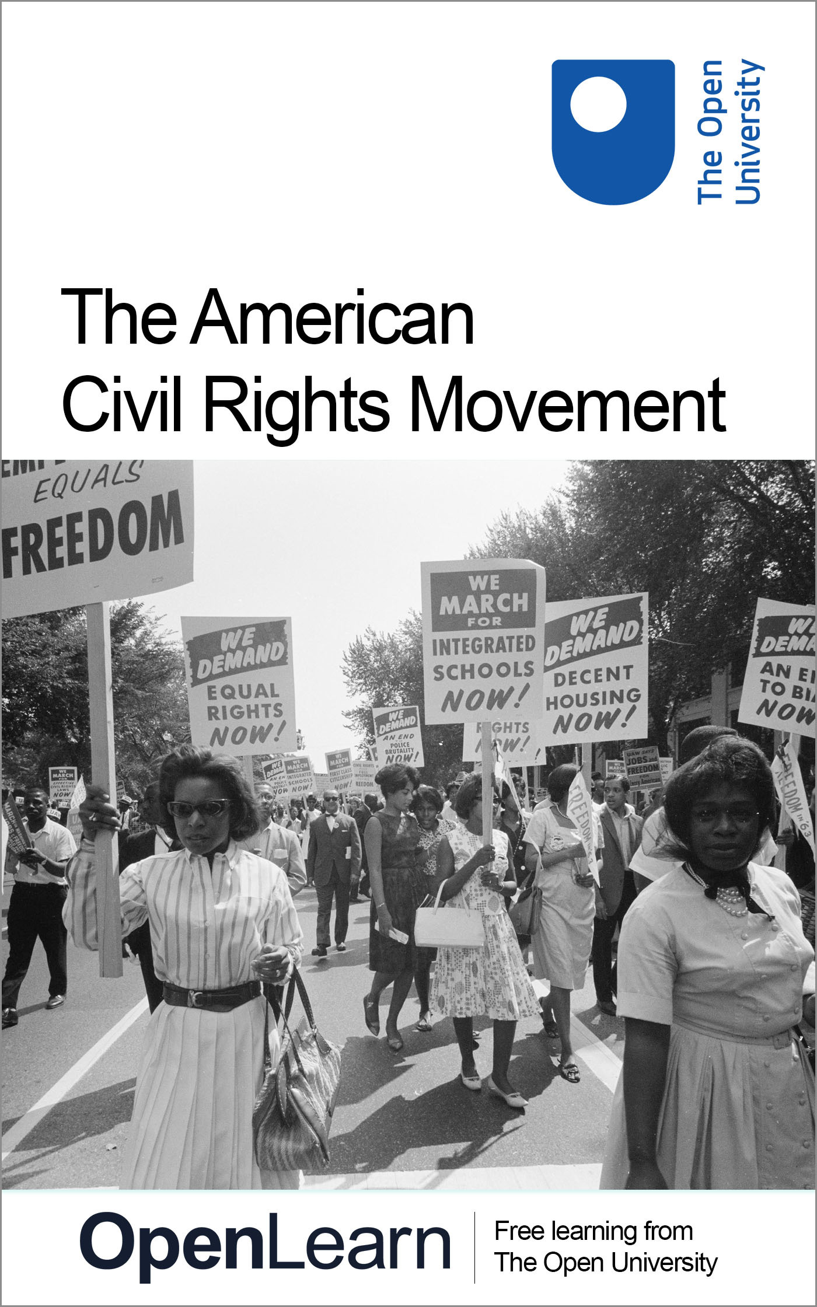

a113_1

The American Civil Rights Movement

About this free course
This free course is an adapted extract from the Open University course A113 Revolutions http://www.open.ac.uk/courses/modules/a113.
This version of the content may include video, images and interactive content that may not be optimised for your device.
You can experience this free course as it was originally designed on OpenLearn, the home of free learning from The Open University – https://www.open.edu/openlearn/history-the-arts/the-american-civil-rights-movement/content-section-0
There you’ll also be able to track your progress via your activity record, which you can use to demonstrate your learning.
Copyright © 2020 The Open University
Intellectual property
Unless otherwise stated, this resource is released under the terms of the Creative Commons Licence v4.0 http://creativecommons.org/licenses/by-nc-sa/4.0/deed.en_GB. Within that The Open University interprets this licence in the following way: www.open.edu/openlearn/about-openlearn/frequently-asked-questions-on-openlearn. Copyright and rights falling outside the terms of the Creative Commons Licence are retained or controlled by The Open University. Please read the full text before using any of the content.
We believe the primary barrier to accessing high-quality educational experiences is cost, which is why we aim to publish as much free content as possible under an open licence. If it proves difficult to release content under our preferred Creative Commons licence (e.g. because we can’t afford or gain the clearances or find suitable alternatives), we will still release the materials for free under a personal end-user licence.
This is because the learning experience will always be the same high quality offering and that should always be seen as positive – even if at times the licensing is different to Creative Commons.
When using the content you must attribute us (The Open University) (the OU) and any identified author in accordance with the terms of the Creative Commons Licence.
The Acknowledgements section is used to list, amongst other things, third party (Proprietary), licensed content which is not subject to Creative Commons licensing. Proprietary content must be used (retained) intact and in context to the content at all times.
The Acknowledgements section is also used to bring to your attention any other Special Restrictions which may apply to the content. For example there may be times when the Creative Commons Non-Commercial Sharealike licence does not apply to any of the content even if owned by us (The Open University). In these instances, unless stated otherwise, the content may be used for personal and non-commercial use.
We have also identified as Proprietary other material included in the content which is not subject to Creative Commons Licence. These are OU logos, trading names and may extend to certain photographic and video images and sound recordings and any other material as may be brought to your attention.
Unauthorised use of any of the content may constitute a breach of the terms and conditions and/or intellectual property laws.
We reserve the right to alter, amend or bring to an end any terms and conditions provided here without notice.
All rights falling outside the terms of the Creative Commons licence are retained or controlled by The Open University.
Head of Intellectual Property, The Open University

Contents
- Introduction
- Learning outcomes
- 1 Jim Crow
- 2 The 1950s
- 3 Sit-ins
- 4 The ‘Freedom Rides’
- 5 The year 1963
- 6 The Civil Rights Act
- 7 The Voting Rights Act
- 8 Urban riots
- 9 ‘Black Power’
- 10 The Black Panthers
- Conclusion
- Glossary
- References
- Acknowledgements
- Solutions

Introduction
In the mid-1950s a mass movement developed in opposition to racial discrimination in the United States. This struggle reached its zenith in the early 1960s, when a series of non-violent demonstrations forced the federal government to enact legislation, overturning a deeply entrenched system of racial segregation across the southern states of the USA. The protests of the civil rights movement, and the inspiring words of its leaders, attracted widespread media attention and captured the public imagination. Together with the anti-Vietnam War movement and the counterculture, the civil rights movement has become part of the popular memory of the 1960s, helping to characterise the decade as a period of rapid transformation and upheaval. But how successful, ultimately, was this struggle for racial equality? Was it a radical, revolutionary movement, or something more moderate? In this course, you’ll explore these questions and examine the key events which defined this critical juncture in American history.

Use of racial language and terms
This course deals with topics involving racial issues. Since the societies being studied were characterised by deeply-held and widespread racist views, this course contains language that is also racist. Although these may provoke a strong personal response, we believe it is necessary to engage with such attitudes to reach a clear understanding of the past.

This free course is an adapted extract from the Open University course A113 Revolutions. It is one of four OpenLearn courses exploring the notion of the Sixties as a ‘revolutionary’ period. Learn more about these OpenLearn courses here.

Learning outcomes
After studying this course, you should be able to:
- understand some of the key events in the history of the civil rights movement
- understand the movement’s achievements and shortcomings
- assess how ‘revolutionary’ the civil rights movement was
- interpret a range of relevant primary sources, including interviews, speeches and letters.

1 Jim Crow
Following the end of the American Civil War and the abolition of slavery in 1865, Black people had been granted equal constitutional rights. Slavery had previously been permitted across the southern states of the United States, but now Black Americans were free to vote, stand for office and, in theory, enjoy many of the same freedoms as White Americans. Gradually, however, many states across the South began to introduce legislation – often known as ‘Jim Crow’ laws – which enforced racial segregation. These laws meant that Black and White people were separated in public spaces, with Black people prevented from accessing schools, restaurants, and housing reserved for White people. In order to disenfranchise Black people, Southern states also enacted various measures, such as literacy tests, which disproportionately prevented Black people from voting. In the first half of the twentieth century activists established a number of organisations – such as the National Association for the Advancement of Colored People (NAACP, formed in 1909) and the Congress of Racial Equality (CORE, formed 1942) – to advance their rights, but racial discrimination and segregation were still firmly in place by the 1950s.

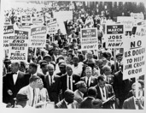
Figure 1: A major NAACP march in Washington D.C., 1963.

Activity 1
Allow approximately 15 minutes.

To gain a greater sense of how these laws affected many Americans, watch the following interview with Martin Luther King Jr., who became a major leader of the civil rights movement. You’ll learn more about King’s role in this struggle later in this course, but here you’ll focus on a section of the interview in which King discusses his experiences of racial discrimination when growing up in Atlanta, Georgia. King was thirty-two when this interview was conducted in 1961.
While you’re watching the video, consider the question below.
What forms of racial discrimination and segregation does King discuss in this video?

Video content is not available in this format.
Video 1: Martin Luther King: Face to face
View transcript - Video 1: Martin Luther King: Face to face

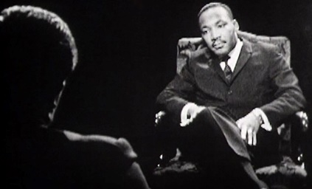

View discussion - Activity 1

King’s recollections provide us with a clear sense of the injustices and prejudices that many Black Americans faced in the United States in the first half of the twentieth century. During the 1950s and 1960s, the civil rights movement worked to overturn this system of racial segregation.

2 The 1950s
In 1954, in a court case called Brown v. The Board of Education, the United States Supreme Court officially ruled that segregated educational facilities were unconstitutional and ‘inherently unequal’ (quoted in Reynolds, 2010, p. 410). A Black lawyer, Thurgood Marshall, who worked for the NAACP, helped bring this case to the Supreme Court. But while it paved the way for an end to educational segregation, this court ruling alone did not immediately lead to change. President Dwight Eisenhower was reluctant to act, and the court did not actually set a timeframe in which schools would have to be desegregated.

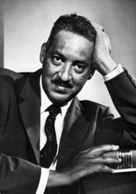
Figure 2: Portrait of Thurgood Marshall in the 1950s.

The Supreme Court’s decision, however, did provide further impetus for Black people across the American South, encouraging many to resist racial discrimination. This resistance was not entirely new, but the language of rights and freedom espoused by the United States during the Cold War meant that it became more difficult for states to continue to refuse equality to Black citizens in key areas of education, transport, employment and housing. Continued violence by White people against African Americans – including the brutal murder of the fourteen-year-old schoolboy Emmett Till in Mississippi in 1955 – also galvanised the civil rights movement.
One of the most famous early examples of protest occurred in Montgomery, Alabama, on 1 December 1955. Across the South, Black people were usually required to move to the back of buses in order to allow White people to sit at the front. That day a Black woman, Rosa Parks, refused to move to the back, despite the protestations of the bus driver. She is now often remembered solely for this, but Parks was in fact a seasoned NAACP activist, who had been involved in over two decades of civil rights activism prior to this act of defiance (Theoharis, 2009, p. 116). Parks was arrested and taken to jail, but her actions encouraged Black leaders, including Jo Ann Robinson, who headed the Women’s Political Council, to organise a city-wide boycott of buses in Montgomery. These activists turned to a young Baptist minister, Martin Luther King Jr., to help lead the boycott. A firm believer in non-violent protest, King proved himself to be a capable leader and an inspiring orator. The boycott was successful, forcing the Supreme Court to rule that Montgomery’s policy of bus segregation was unconstitutional. The city eventually agreed to integrate its buses by the end of 1956.

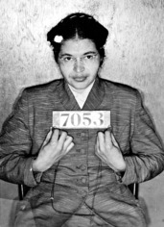
Figure 3: Rosa Parks’ photograph taken at the time of her arrest for refusing to give up her seat on a bus to a White passenger, Alabama, 1955.

The following year, King and other Black Christian ministers across the South formed the Southern Christian Leadership Conference (SCLC), which would go on to play a major role in further civil rights activism. Despite its recent gains, however, the movement faced considerable resistance from White leaders in the South, and change was slow to happen. By 1957 fewer than 20 percent of schools had been integrated, and various forms of segregation remained a fact of life for many Black people (Greene, 2010, p. 7).

3 Sit-ins
From 1960 onwards, the civil rights movement gained serious momentum, attracting nationwide attention. Young activists, and especially students, were instrumental in these developments. In 1960 groups of college students began to organise ‘sit-ins’ at lunch counters which refused to serve Black customers. The most high-profile of these occurred in Greensboro, North Carolina. Four Black students asked to be served at a segregated lunch counter at the Woolworth’s department store. When they were asked to leave, they refused to move and stayed there until the end of the day. They returned the next day, bringing more protestors with them. 400 students had joined them by the end of the week (Lepore, 2018, p. 596).

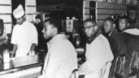
Figure 4: Four students, Joseph McNeil, Franklin McCain, Billy Smith and Clarence Henderson sit-in at Woolworth’s lunch counter, Greensboro, North Carolina, 1960.

The sit-ins soon spread to other states across the South, with an estimated 50,000 students participating (Lepore, 2018, p. 596). The protests were informed by the philosophy of non-violent direct action: the students were often attacked by White people and were victimised and arrested by police, but they refused to retaliate. Images of these injustices were broadcast across the nation and abroad, attracting sympathy for the students and the wider civil rights cause.

Activity 2
Allow approximately 15 minutes.

In this short clip from the BBC documentary Icons, Bryan Stevenson, a lawyer and social justice activist, explains why Martin Luther King and other civil rights leaders espoused a philosophy of non-violence. While you’re watching the clip, consider the following questions:

Video content is not available in this format.
Video 2: Icons
View transcript - Video 2: Icons

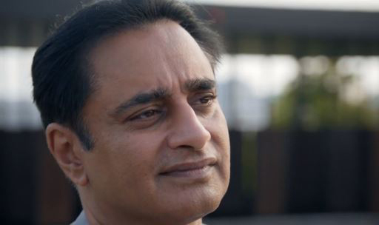

- Why did King and other civil rights activists avoid violent protest?
- Which activist from outside the United States was an influence on King and why?

View discussion - Activity 2

Following the sit-ins, some civil rights leaders began to recognise the potential value of the students to the movement. Particularly influential here was the SCLC’s acting director, Ella Baker, who had played a major role in civil rights campaigning since joining the NAACP in 1941. Rather than placing her faith solely in charismatic leaders like King, Baker was a firm believer in grass-roots activism, helping the students to form their own organisation – the Student Nonviolent Coordinating Committee (SNCC). Over the subsequent years the SNCC rose to become one of the most significant organisations in the civil rights movement.

4 The ‘Freedom Rides’
In 1961, civil rights activists once again captured national attention with what became known as the ‘Freedom Rides’. Segregation on interstate buses and at bus terminals had also been deemed unconstitutional by the Supreme Court, but the practice persisted in spite of this. In the first ‘Freedom Ride’, which began on 4 May 1961, groups of volunteers, organised by the Congress of Racial Equality (CORE), decided to protest against this by boarding buses in Washington D.C. and travelling through the South, bound for New Orleans, Louisiana. They sat wherever they wanted on the buses and attempted to use facilities that were reserved for White people. On 14 May, in Anniston, Alabama, White racists responded in brutal fashion, attacking the ‘Freedom Riders’ and firebombing one of the buses. The Alabama state police, meanwhile, failed to protect the activists. The violence attracted the attention of President John F. Kennedy, who thus far had been slow to act on civil rights issues. With the hope of quelling the unrest, Kennedy’s brother, Attorney General Robert F. Kennedy arranged for the riders to be escorted safely to Montgomery, Alabama. With further threats of violence, however, the riders eventually abandoned their journeys.
Following this, on 17 May 1961, the SNCC helped to revive the Freedom Rides, organising a new series of interstate bus journeys across the South. On 22 May, the Kennedy administration again had to intervene to ensure the safe passage of the riders to Jackson, Mississippi, where they were thrown in jail. Activists continued to travel on buses to Jackson over the subsequent days, and the jails began to overflow. Pressure from the Kennedy administration, and further Freedom Rides over the subsequent months, eventually forced the Interstate Commerce Commission (which regulated interstate bus transport) to enforce the desegregation of all interstate bus routes in September 1961.
The ‘Freedom Rides’ also succeeded in gaining widespread sympathy for the civil rights movement. As the historian M. J. Heale has explained, ‘the rides exposed the viciousness of southern white racism before the whole nation and seared the conscience of many citizens’ (Heale, 2001, p. 116). The vast majority of US households had televisions by 1960, and graphic images of racial brutality were beamed directly into American living rooms. Provoking violence and capturing media attention was therefore an important strategy for the civil rights activists. Television also added a global dimension to the civil rights protest, inspiring activists in other countries, including the United Kingdom.

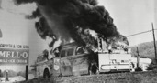
Figure 5: A firebombed Freedom Rider bus, Alabama, 1961.

5 The year 1963
As the struggle against racial inequality continued, in 1963 Martin Luther King Jr. organised a series of protests and sit-ins in Birmingham, Alabama, a city which had been plagued by racist violence against the Black population. Many activists were imprisoned as part of King’s ‘Jail, no bail’ strategy to fill the city prisons with activists, thus creating problems for city policing. Following his arrest for protesting in the city, King wrote a letter on 16 April responding to White clergymen who had denounced his actions. The letter, now often known as the ‘Letter from Birmingham Jail’, provides us with an important insight into King’s motivations and his role within the civil rights movement.

Activity 3
Allow approximately 15 minutes.

Read this extract from the ‘Letter from Birmingham Jail’ and answer the questions below:

I think I should indicate why I am here in Birmingham … Birmingham is the most thoroughly segregated city in the United States … There have been more unsolved bombings of Negro homes and churches in Birmingham than in any other city in the nation. These are the hard, brutal facts. On the basis of these conditions, Negro leaders sought to negotiate with the city fathers. But the latter consistently refused to engage in good-faith negotiation …
As in so many past experiences, our hope had been blasted, and the shadow of deep disappointment settled upon us. We had no option except to prepare for direct action, whereby we would present our very bodies as a means of laying our case before the conscience of the local and national community.
You may well ask: “Why direct action? Long sit-ins, marches and so forth? Isn’t negotiation a better path?” You are quite right in calling for negotiation. Indeed, this is the very purpose of direct action. Non-violent direct action seeks to create such a crisis and foster such a tension that a community which has constantly refused to negotiate is forced to confront the issue’.
Source: https://www.africa.upenn.edu/Articles_Gen/Letter_Birmingham.html

- Why did King choose to target Birmingham, Alabama?
- What was the ultimate goal of the campaign of non-violent direct action in Birmingham?
- Do you think that King’s aims and actions could be described as ‘revolutionary’?

View discussion - Activity 3

Following his release from jail, King helped to organise another protest in Birmingham on 2 May, this one involving children and high school students. King hoped to provoke a reaction that would play into the hands of the civil rights movement. He succeeded. The Birmingham police led by Eugene ‘Bull’ Connor – known by reputation to be virulently racist – responded aggressively, blasting protestors with water cannons and unleashing dogs upon them. Images of small children being treated so brutally were beamed across the nation, driving home the realities of racial discrimination and encouraging further sympathy for the civil rights cause. This forced the Attorney General Robert Kennedy to step in. He threatened the intervention of federal troops to protect the protestors at the next march, scheduled for 7 May. As King had hoped, this led to negotiation and a deal to desegregate the city.

6 The Civil Rights Act
This was followed by another victory for the civil rights movement the following month. Despite the personal resistance of the Alabama Governor George Wallace, two Black students – supported by the National Guard – were finally admitted to the University of Alabama, an institution that had previously been reserved only for White students. That evening, President Kennedy took a firm stance, delivering a speech on live television that denounced segregation and promised to take legislative action:

it ought to be possible … for American students of any color to attend any public institution they select without having to be backed up by troops. It ought to be possible for consumers of any color to receive equal service in places of public accommodation, such as hotels and restaurants and theaters and retail stores, without being forced to resort to demonstrations in the street, and it ought to be possible for American citizens of any color to register and vote in free elections without interference or fear of reprisal.
(quoted in Marwick, 1998, p. 217)

You can watch a video of the entire speech at YouTube.com.
In order to fulfil this promise, the Kennedy administration began working on legislation that would end racial segregation and discrimination. The following month, on 28 August, Martin Luther King Jr. delivered what is considered one of the most famous speeches in the civil rights movement during a major civil rights march in Washington, D.C.:

I say to you today, my friends, so even though we face the difficulties of today and tomorrow, I still have a dream. It is a dream deeply rooted in the American dream. I have a dream that one day this nation will rise up and live out the true meaning of its creed: “We hold these truths to be self-evident, that all men are created equal”. I have a dream that one day on the red hills of Georgia, the sons of former slaves and the sons of former slave-owners will be able to sit down together at the table of brotherhood.
(quoted in Sundquist, 2009, p. 232)

You can watch part of the speech in the video below:

Video content is not available in this format.
Video 3
View transcript - Video 3

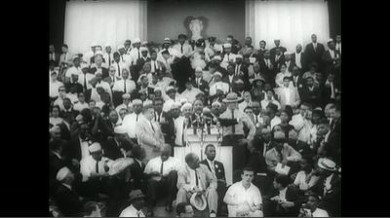

When King asserted that ‘we hold these truths to be self-evident, that all men are created equal’, he was consciously echoing the words of the 1776 Declaration of Independence, the adoption of which was a key moment in the American Revolution and the founding of the United States. In this sense, King was employing ‘revolutionary’ language, and it might be argued that he was indeed proposing a ‘revolution’ in race relations. King’s speech, like Kennedy’s television address, is now rightly seen as a significant moment in the civil rights movement. However, while it was an inspiring and powerful speech, it must be remembered that only limited progress had been made by this point. Despite small successes on a local level, attitudes on race remained largely unchanged, and substantial legislation to enforce racial integration had not yet been passed. Only three months after King’s speech, Kennedy was assassinated, before he could pass the civil rights bill through Congress.
Kennedy’s successor, Lyndon Johnson, was determined to finish his predecessor’s work and made passing the bill a priority. A significant number of southern senators, in particular, fiercely opposed the legislation, but in July 1964, after considerable debate in Congress, Johnson secured the passage of the Civil Rights Act. The Act outlawed race and colour discrimination, in addition to discrimination based on sex, religion or national origin. How radical was this legislation? In theory, the Act put an end to all forms of discrimination and segregation, but in reality, it did not do enough on its own to ensure this. As the historian John Robert Greene has stressed, ‘It was a landmark piece of legislation, but it was hardly the death-knell for either discrimination or segregation in the nation. It was, in short, a bill that Johnson could get passed’ (Greene, 2010, p. 56). For instance, although the Act outlawed school segregation, it did not guarantee that buses would be provided to transport Black students to schools previously reserved for White people, and it did not resolve discrimination in housing provision.

Figure 6: President Lyndon Johnson signing the Civil Rights Act, 2 July 1964. Martin Luther King Jr. can be seen in the background.

7 The Voting Rights Act
Perhaps most significantly, the Civil Rights Act did not do enough to address the problem of Black disenfranchisement in the South. Although Black people had not been entirely barred from registering to vote, many states in the South made the process of registering to vote intentionally convoluted and complex for Black people in order to prevent them from doing so. The Civil Rights Act ensured that these discriminatory practices were outlawed, but it did not eliminate literacy tests, which were still often used to determine whether a person was eligible to vote. This disproportionately disenfranchised poorer Black Americans, who had often not had the same educational opportunities as their White counterparts.
Voter registration therefore became a key focal point for many civil rights activists throughout 1964 and 1965. In the summer of 1964, SNCC organised what became known as ‘Freedom Summer’, during which young activists, Black and White, travelled from northern universities to Mississippi in order to assist voter registration in Black communities. The following March, civil rights activists, including prominent members of the SCLC and SNCC, organised a series of marches in Alabama from Selma to Montgomery. Once more, brutally repressive policing captured worldwide media attention, forcing President Lyndon Johnson to act. For the third march, the president arranged for the National Guard to escort the protestors, protecting them from local police and violent mobs.

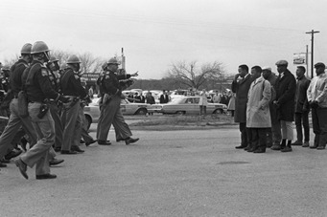
Figure 7: Still from documentary film, I Am Not Your Negro, showing marchers facing a line of state troopers in Selma moments before police beat the protestors on 7 March 1965 in an event that became known as ‘Bloody Sunday’.

The protests were successful in achieving their immediate goal. Johnson called on Congress to introduce a Voting Rights Act, which he signed into law in August 1965. The Act eliminated literacy tests and permitted federal examiners to police the voter registration process. The Act quickly helped to address the problem of disenfranchisement: in Alabama and Mississippi, for example, fewer than 10 percent of Black people of voting age were registered to vote at the beginning of the 1960s; by 1968 this had risen to 60 percent (Reynolds, 2009, pp. 419–421).

Activity 4
Allow approximately 15 minutes.

Reflecting on what you have read above, why do you think the issue of voting rights was so important for civil rights activists? And in what ways might the Voting Rights Act have helped to advance the interests of Black Americans?

View discussion - Activity 4

8 Urban riots
Despite these legislative advancements, however, racial inequalities had not been eliminated. Because of legal codes of segregation, civil rights activism had largely focused its attentions on the South, but as the 1960s progressed, it became increasingly apparent that discrimination was by no means restricted to that area. Although Black people were not subjected to formal segregation outside the South, northern cities were also beset with racial tensions. Black Americans across the United States were often discriminated against when looking for jobs and housing, and they were less likely to be promoted at work. Poverty and unemployment were also common within the black neighbourhoods of northern cities (often known as ghettos).
These sources of discontent provoked a backlash in the form of urban riots that engulfed many cities throughout the 1960s. Between 1963 and 1972, there were over 750 urban revolts across the United States. These riots – described by the historian Peter Levy as ‘the Great Uprising’ – largely involved young Black men, occurred in black neighbourhoods, and affected every city in the United States with a black population of more than 50,000 (Levy, 2018, p. 1). One of the most dramatic of these occurred in the Watts neighbourhood of Los Angeles, during the summer of 1965, in response to an incident of alleged police brutality. Rioters burned down white businesses and shops, while clashes with the police and the National Guard resulted in the deaths of 34 Black men.
Many of the moderate leaders of the civil rights movement were shocked by these events and turned their attentions to the northern cities where poverty and racial discrimination intersected. King, for example, began campaigning against housing discrimination in Chicago in 1966. He organised marches through the white suburbs and witnessed first-hand the appalling racism that existed there. In 1968, he established the Poor People’s Campaign, which focused on tackling economic injustice. That year, while campaigning on behalf of striking sanitation workers in Memphis, Tennessee, King was assassinated, sparking another wave of urban riots across the country. There were uprisings in over a hundred cities, including Washington D.C., New York City, Detroit and Chicago.

9 ‘Black Power’
By this stage, the civil rights movement had begun to splinter. Since the early 1960s, tensions had been growing between some of the younger, more radical members of the SNCC and the older, more moderate leaders of the civil rights movement. Meanwhile, other Black rights activists – such as Malcolm X, a spokesman for the Nation of Islam – had denounced King’s message of racial integration. Despite the legislative gains of 1964 and 1965, many activists also lamented that change had been slow, while racial inequalities persisted. Some SNCC members began to abandon their belief in non-violence, adopting more revolutionary language, especially after Stokely Carmichael became their leader in 1966.

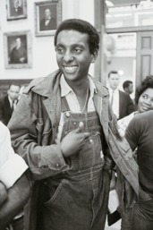
Figure 8: Stokely Carmichael, chairman of the Student Nonviolent Coordinating Committee, speaks to reporters in Atlanta, Georgia, 1966.

Carmichael was a longstanding SNCC activist who had participated in the Freedom Rides and the march on Selma. His beliefs by this stage were encapsulated by the slogan ‘Black Power’, which he had popularised amongst young SNCC activists. When campaigning in Mississippi in 1966, he addressed a rally, exclaiming that ‘The only way we gonna stop them White men from whuppin’ us is to take over. What we gonna start saying now is Black Power!’ (cited in Joseph, 2006, p. 2). ‘Black Power’ became a rallying cry for many Black rights activists across the country, and marked a significant departure from the emphasis on interracial cooperation that had characterised the earlier civil rights movement. From here on, the influence of the older civil rights leaders began to wane.

10 The Black Panthers
In 1966, a new black rights movement known as the Black Panthers was established by Huey P. Newton and Bobby Seale in Oakland, California. Initially known as the ‘Black Panther Party for Self-Defense’, the organisation explicitly differentiated itself from the non-violent civil rights groups, and its members styled themselves deliberately along the lines of contemporary anti-colonial revolutionaries in Africa and Latin America. The Black Panthers’ primary goals and philosophies are evident in the party’s ‘Ten-Point Program’, first published in 1966.

Activity 5
Allow approximately 15 minutes.

Read this extract from the ‘Ten-Point Program’ before answering the questions below:

‘We believe that Black People will not be free until we are able to determine our own destiny …
We believe that the federal government is responsible and obligated to give every man employment or a guaranteed income. We believe that if the White American businessmen will not give full employment, the means of production should be taken from the businessmen and placed in the community so that the people of the community can organize and employ all of its people and give a high standard of living. …
We believe that if the White landlords will not give decent housing to our Black community, then the housing and the land should be made into cooperatives so that our community, with government aid, can build and make a decent housing for its people. …
We believe we can end police brutality in our Black community by organizing Black self-defense groups that are dedicated to defending our Black community from racist police oppression and brutality. The Second Amendment to the Constitution of the United States gives the right to bear arms. We therefore believe that all Black people should arm themselves for self-defense’.
Source: https://archive.org/details/Blackpntrs10Pnt.66

- To what extent does this strike you as a ‘revolutionary’ document?
- In what ways do the Black Panthers’ beliefs differ from those of the civil rights activists of the early 1960s?

View discussion - Activity 5

In the context of the Cold War, this approach made the Panthers appear to be much closer to left-wing revolutionaries in other parts of the Americas, such as Fidel Castro in Cuba. Their style of revolution appeared rather different – and considerably more dangerous – from that of the early civil rights movement. As Alex Zamalin has argued, many ‘White liberals … shook with horror at the scenes of armed Black men in paramilitary gear walking the streets of Oakland’ (Zamalin, 2017, p. 88).

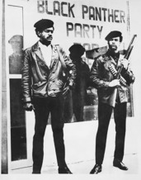
Figure 9: Poster showing Huey P. Newton and Bobby Seale standing in front of the local Black Panther Party headquarters, Harlem, New York, USA, 1968.

The Black Panther party was initially popular, spreading swiftly across the country and establishing new chapters in major American cities. The organisation worked in inner city ‘ghettos’, providing free meals and classes for local children, but it was also involved in violent clashes with the police. A number of members were charged with murder and arrested for criminal activities. Despite being deemed by J. Edgar Hoover, the Director of the FBI, as ‘the greatest threat to the internal security of the country’ (quoted in Murch, 2010, p. 184) in 1969, the Black Panther Party was only ever a fringe movement, and its influence began to wane after 1970, before the organisation could successfully implement its revolutionary goals.

Conclusion
In many respects, the civil rights movement was a great success. Successive, targeted campaigns of non-violent direct action chipped away at the racist power structures that proliferated across the southern United States. Newsworthy protests captured media attention and elicited sympathy across the nation. Though Martin Luther King Jr.’s charismatic leadership was important, we should not forget that the civil rights cause depended on a mass movement. As the former SNCC member Diane Nash recalled, it was a ‘people’s movement’, fuelled by grass-roots activism (Nash, 1985). Recognising a change in the public mood, Lyndon Johnson swiftly addressed many of the racial inequalities highlighted by the civil rights movement. The Civil Rights Act of 1964 and the Voting Rights Act of 1965 led to meaningful change in the lives of many Black Americans, dismantling systems of segregation and black disenfranchisement.
In other respects, the civil rights movement was less revolutionary. It did not fundamentally restructure American society, nor did it end racial discrimination. In the economic sphere, in particular, there was still much work to be done. Across the nation, and especially in northern cities, stark racial inequalities were commonplace, especially in terms of access to jobs and housing. As civil rights activists became frustrated by their lack of progress in these areas, the movement began to splinter towards the end of the 1960s, with many Black activists embracing violent methods. Over the subsequent decades, racial inequalities have persisted, and in recent years police brutality against Black Americans, in particular, has become an urgent issue. As the protests triggered by the murder of George Floyd in May 2020 have demonstrated, many of the battles of the 1960s are still being fought.
Though King and other members of the civil rights movement failed to achieve their broader goals, there can be no doubting their radical ambitions. As Wornie Reed, who worked on the Poor People’s Campaign, explains in this interview, King was undoubtedly a ‘radical’ activist, even if the civil rights movement itself never resulted in a far-reaching social revolution.

Video content is not available in this format.
Video 4: Wornie Reed
View transcript - Video 4: Wornie Reed

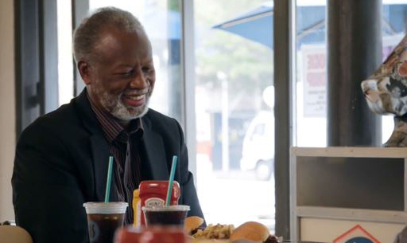

This free course is an adapted extract from the Open University course A113 Revolutions. It is one of four OpenLearn courses exploring the notion of the Sixties as a ‘revolutionary’ period. Learn more about these OpenLearn courses here.

Glossary
Attorney General
The head of the United States Department of Justice and the chief lawyer of the federal government.
Chapter
A North American term for a local branch of a society or organisation. The Black Panthers, for example, had chapters spread across the United States.
Civil rights movement
Civil rights are the political, social and economic rights that a person is guaranteed by the law. The ‘civil rights movement’ usually refers to the efforts of Black Americans to abolish racial discrimination and improve their civil rights during the 1950s and 1960s.
CORE
The Congress of Racial Equality, a major African American civil rights organisation, formed in 1942.
Direct action
Direct action is a form of political activism in which groups attempt to achieve their goals through methods other than negotiation. It may or may not involve violence, but early civil rights leaders like King insisted on using non-violent methods.
Disenfranchise
The franchise, or suffrage, is the right to vote. Disenfranchisement means being deprived of the right to vote.
Jim Crow
Jim Crow laws were various state and local laws that enforced racial segregation in the American South between the late nineteenth century and the 1960s. The name comes from a minstrel routine – a form of entertainment in which White performers depicted Black characters in a derogatory fashion.
NAACP
The National Association for the Advancement of Colored People, the oldest and largest civil rights organisation in the United States, formed in 1909.
National Guard
A reserve component of the United States Armed Forces. Each state in the USA has its own National Guard force that can be called upon in emergencies.
Nation of Islam
An African-American political and religious organisation founded in 1930. It opposed racial integration and grew significantly during the 1960s after Malcolm X became a major spokesman for the group.
SCLC
The Southern Christian Leadership Conference. A civil rights organisation formed in 1957.
SNCC
The Student Nonviolent Coordinating Committee. A civil rights organisation led by students and formed in 1960.

References
Greene, J.R. (2010) America in the Sixties. Syracuse: Syracuse University Press.
Heale, M.J. (2001) The Sixties in America: History, Politics and Protest. Edinburgh: Edinburgh University Press.
Joseph, P. E. (2006), ‘Introduction: Towards a Historiography of the Black Power Movement’, in Joseph, P.E. (ed.), The Black Power Movement: Rethinking the Civil Rights-Black Power Era, New York, Routledge, 2006, pp. 1-26.
Lepore, J. (2018) These Truths: A History of the United States. New York: W. W. Norton and Company.
Levy, P. (2018) The Great Uprising: Race Riots in Urban America during the 1960s. Cambridge: Cambridge University Press.
Marwick, A. (1998) The Sixties: Cultural Revolution in Britain, France, Italy and the United States, c.1958 – c.1974. Oxford: Oxford University Press.
Murch, D.J. (2010) Living for the city: migration, education, and the rise of the Black Panther Party in Oakland, California. Chapel Hill, NC: University of North Carolina Press.
Nash, D. (1985). ‘Eyes on the Prize’ interview, 12 November 1985. Available at: http://repository.wustl.edu/concern/videos/qf85nd261 (Accessed: 29 September 2020)
Reynolds, D. (2010) America: Empire of Liberty. London: Penguin.
Sundquist, E.J. (2009) King’s dream: The legacy of Martin Luther King’s I Have a Dream speech. New Haven, CT: Yale University Press.
Theoharis, J. (2009), ‘“A Life History of Being Rebellious”: The Radicalism of Rosa Parks’, in Theoharis, J., Woodward, K. and Gore, D.F. (eds), Want to Start a Revolution? Radical Women in the Black Freedom Struggle. New York, New York University Press, pp. 115-137.
Zamalin, A. (2017) Struggle on Their Minds: The Political Thought of African American Resistance. New York, Columbia University Press.

Acknowledgements
This free course was written by Vincent Trott.
Except for third party materials and otherwise stated (see terms and conditions), this content is made available under a Creative Commons Attribution-NonCommercial-ShareAlike 4.0 Licence.
The material acknowledged below is Proprietary and used under licence (not subject to Creative Commons Licence). Grateful acknowledgement is made to the following sources for permission to reproduce material in this free course:
Course image: American Photo Archive / Alamy
Figure 1: Library of Congress / Getty Images
Figure 2: Keystone / Getty images
Figure 3: UniversalImagesGroup / Getty
Figure 4: Granger Historical Picture Archive / Alamy
Figure 5: AP / Shutterstock
Figure 6: Cecil Stoughton, White House Press Office (WHPO) / Lyndon Johnson signing Civil Rights Act, July 2, 1964. This file is licensed under the Creative Commons Public Domain Dedication https://creativecommons.org/publicdomain/zero/1.0/
Figure 7: Lifestyle pictures / Alamy
Figure 8: Bettmann / Getty
Figure 9: Science History Images / Alamy
Video 2: Icons (2019), Produced by 72 Films, © BBC made in partnership with The Open University
Video 4: Icons (2019), Produced by 72 Films, © BBC made in partnership with The Open University
Every effort has been made to contact copyright owners. If any have been inadvertently overlooked, the publishers will be pleased to make the necessary arrangements at the first opportunity.
Don't miss out
If reading this text has inspired you to learn more, you may be interested in joining the millions of people who discover our free learning resources and qualifications by visiting The Open University – www.open.edu/openlearn/free-courses.

Solutions

Activity 1

Discussion
King discusses the various forms of segregation that were enforced in Atlanta. He notes that Black people were unable to use white parks, swimming pools or cinemas, and explains that the facilities available to Black people were inferior to those reserved for White people. There was only one black high school in the city, for example, despite a black population of around 200,000.
Back to - Activity 1

Activity 2

Discussion
- Stevenson suggests that civil rights leaders like King were committed to non-violence for moral reasons. The civil rights leaders had argued that justice would prevail and did not want to concede moral superiority by resorting to violence themselves. In order to prove that violence was wrong, King was determined not to fight violence with more violence.
- Stevenson suggests that King was inspired by the teachings of Mahatma Gandhi, who had also preached non-violence. He suggests that Gandhi’s philosophies gave King hope that justice would eventually prevail.
Back to - Activity 2

Activity 3

Discussion
King and other SCLC leaders targeted Birmingham because racial discrimination and segregation were particularly severe within the city. As King notes, the Black community had also been subjected to significant levels of racial violence, including the bombing of churches and homes.
King explains that his ultimate goal is to seek negotiation that will end racial segregation in Birmingham. The campaigns of direct action are intended to be sufficiently disruptive to force local government into negotiation – something that it had previously been unwilling to consider.
It is debatable whether King’s goals and methods can be considered revolutionary. King was not seeking to seize power for the Black community, and he was not advocating an overthrow of the existing regime in this letter. He was merely seeking negotiation and employing non-violent methods to achieve this. In this sense, his goals were relatively moderate; as you will see, many other Black activists began to propose more radical methods as the 1960s progressed. But we should not downplay the potential significance of these actions for the lives of Black people. King and other civil rights leaders were seeking to bring about a fundamental change in race relations in the South, with the hope of overturning deep-seated racial prejudices – this was certainly a radical ambition. White people held all significant positions of power in the South and did not want to see their authority challenged. King and other civil rights activists threatened this system of power. As you’ll see, continued activism did soon result in concrete changes that helped to dismantle many Jim Crow laws and customs.
Back to - Activity 3

Activity 4

Discussion
Black enfranchisement had the potential to advance the interests and concerns of Black people in ways that were impossible before. There was now a greater need for politicians to consider the views and concerns of Black people, while Black voters had the opportunity to vote for politicians, including Black politicians, who might represent their interests at both a state and federal level.
Back to - Activity 4

Activity 5

Discussion
In many respects, this is a revolutionary document which makes radical demands. Some of the points, in fact, explicitly use the language of Marxism. For example, the Black Panthers propose seizing ‘the means of production’ and advocate the redistribution of land and housing amongst the black community.
The Black Panthers’ beliefs differ considerably from those of civil rights leaders like Martin Luther King Jr. Whereas King emphasised integration and non-violence, the Black Panthers proposed a black separatist vision in which Black people ‘are free to determine our own destiny’. In this sense, their views were similar to those of Malcolm X. Perhaps most significantly, the Black Panthers differ from groups like the SCLC and SNCC in their willingness to use violence. They highlight their right to bear arms and their desire to retaliate in the face of police brutality.
Back to - Activity 5

Video 1: Martin Luther King: Face to face

Transcript
Interviewer
What were you really prevented from doing as a child that a white child might have done?
Martin Luther King Jr
Well, in my days in Atlanta as a child, there was a pretty strict system of segregation. For instance, I could not use the swimming pool. So that for a long, long time, I could not go and swim in, until the YMCA was built, Negro YMCA, and they had a swimming pool there. But certainly, a Negro child in Atlanta could not go to any public park.
I could not go to the so-called white schools, that was separate schools. And I attended a high school in Atlanta, which was the only high school for Negroes in the city. And this was a real problem because in Atlanta there are more than 200,000 Negroes. In many of the stores downtown, to take another example, I could not go to a lunch counter to buy a hamburger, or a cup of coffee, or something like that.
I could not attend any of the theatres, only, there were one or two Negro theatres. They were very small. But they did not get the main pictures, if they got them, they were two years later, three years late. So that by and large that was a very strict system of segregation. And there was nothing called racial integration at that time in Atlanta.
Back to - Video 1: Martin Luther King: Face to face

Video 2: Icons

Transcript
SANJEEV BHASKAR
What was it that made Dr. King choose non-violence?
BRYAN STEVENSON
Dr. King and those who had lived through this knew that if they gave away the most precious commodity we had, which was this understanding that justice can prevail. To give that away would be to give away the power, and so he said, we can't do that, we can't be violent, we can't react to violence with violence, we can't hate.
SANJEEV BHASKAR
But I understand he went to India in the 1950s. And he met with Gandhi's relatives I think, how much of an impact was that on what he was doing?
BRYAN STEVENSON
He understood that the power of overcoming injustice was rooted in a hopefulness, he just didn't know how you implement it. And I think what Gandhi did was very influential, in creating a consciousness that, that was achievable in the face of great oppression in the face of great might, and power that might be utilised to destroy what you're trying to do.
Back to - Video 2: Icons

Video 3

Transcript
[MUSIC PLAYING]
NARRATOR: The theme, the keynote, the thought uppermost in minds of all here today is best set forth by Dr. King. He sums up a day the capital will long remember.
DR MARTIN LUTHER KING: I have a dream that one day this nation will rise up, live out the true meaning of its creed. We hold these truths to be self-evident that all men are created equal.
I have a dream that one day on the red hills of Georgia sons of former slaves and the sons of former slave owners, will they be able to sit down together at the table of brotherhood. I have a dream.
NARRATOR: Washington, D.C. 1963. Democracy speaks in a mighty voice.
Back to - Video 3

Video 4: Wornie Reed

Transcript
WORNIE REED
We were demonstrating to open restaurants and so on. And they were restaurants that I can't afford to go to, [LAUGHS] so we need to work out economics, as well as integration.
SANJEEV BHASKAR
What is the point of being able to sit at a lunch counter?
WORNIE REED
If you can't pay for the sandwich.
SANJEEV BHASKAR
Right, [CHUCKLES]
WORNIE REED
It was wider than just advocating for African-Americans, it was clearly for all poor people.
SANJEEV BHASKAR
Would you describe him as radical?
WORNIE REED
Yes.
SANJEEV BHASKAR
How would you define his radicalism?
WORNIE REED
Well, because he wanted to change current situations, he was talking about a restructuring of society. That's radical.
Back to - Video 4: Wornie Reed

