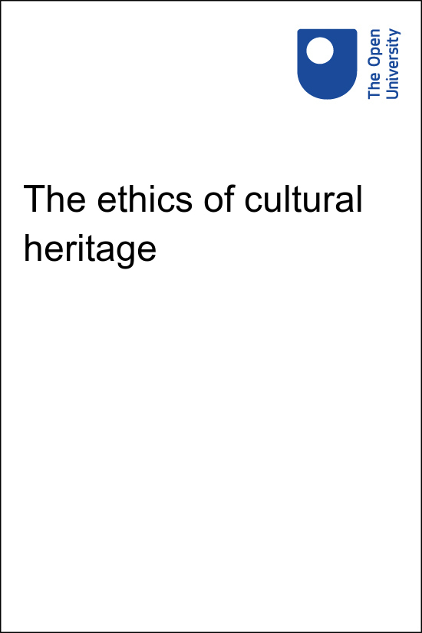

HIW_1

The ethics of cultural heritage

About this free course
This version of the content may include video, images and interactive content that may not be optimised for your device.
You can experience this free course as it was originally designed on OpenLearn, the home of free learning from The Open University –
www.open.edu/openlearn/history-the-arts/the-ethics-cultural-heritage/content-section-overview?utm_source=openlearn&amp;utm_campaign=ol&amp;utm_medium=ebook
There you’ll also be able to track your progress via your activity record, which you can use to demonstrate your learning.
Copyright © 2020 The Open University
Intellectual property
Unless otherwise stated, this resource is released under the terms of the Creative Commons Licence v4.0 http://creativecommons.org/licenses/by-nc-sa/4.0/deed.en_GB. Within that The Open University interprets this licence in the following way: www.open.edu/openlearn/about-openlearn/frequently-asked-questions-on-openlearn. Copyright and rights falling outside the terms of the Creative Commons Licence are retained or controlled by The Open University. Please read the full text before using any of the content.
We believe the primary barrier to accessing high-quality educational experiences is cost, which is why we aim to publish as much free content as possible under an open licence. If it proves difficult to release content under our preferred Creative Commons licence (e.g. because we can’t afford or gain the clearances or find suitable alternatives), we will still release the materials for free under a personal end-user licence.
This is because the learning experience will always be the same high quality offering and that should always be seen as positive – even if at times the licensing is different to Creative Commons.
When using the content you must attribute us (The Open University) (the OU) and any identified author in accordance with the terms of the Creative Commons Licence.
The Acknowledgements section is used to list, amongst other things, third party (Proprietary), licensed content which is not subject to Creative Commons licensing. Proprietary content must be used (retained) intact and in context to the content at all times.
The Acknowledgements section is also used to bring to your attention any other Special Restrictions which may apply to the content. For example there may be times when the Creative Commons Non-Commercial Sharealike licence does not apply to any of the content even if owned by us (The Open University). In these instances, unless stated otherwise, the content may be used for personal and non-commercial use.
We have also identified as Proprietary other material included in the content which is not subject to Creative Commons Licence. These are OU logos, trading names and may extend to certain photographic and video images and sound recordings and any other material as may be brought to your attention.
Unauthorised use of any of the content may constitute a breach of the terms and conditions and/or intellectual property laws.
We reserve the right to alter, amend or bring to an end any terms and conditions provided here without notice.
All rights falling outside the terms of the Creative Commons licence are retained or controlled by The Open University.
Head of Intellectual Property, The Open University

Contents
- Introduction
- Learning outcomes
- Week 1: Notre-Dame and the ethics of heritage preservation
  - Introduction
  - Learning outcomes
  - 1 Notre-Dame Cathedral
    - 1.1 The Notre-Dame fire
    - 1.2 The day after the fire
    - 1.3 Response to the fire
    - 1.4 Charitable donations to the restoration project
  - 2 The debate about rebuilding Notre-Dame
    - 2.1 The ‘It’s my money’ response (part 1)
    - 2.2 The ‘It’s my money’ response (part 2)
    - 2.3 The economic justification for rebuilding
    - 2.4 The heritage value justification for rebuilding
    - 2.5 Can heritage values outweigh the value of human lives?
  - 3 This week’s quiz
  - 4 Week 1 summary
- Week 2: Cultural heritage in war
  - Introduction
  - Learning outcomes
  - 1 Introduction to the basic dilemma in war
  - 2 Monte Cassino Abbey
    - 2.1 The destruction of Monte Cassino
  - 3 The Hague Convention (1954)
    - 3.1 Applying Hague Convention Guidelines
    - 3.2 The Hague Convention in practice
  - 4 Arguments for and against protecting cultural property in war
    - 4.1 The humanitarian position
    - 4.2 The force-multiplier argument
    - 4.3 The heritage value justification (again)
  - 5 This week’s quiz
  - 6 Week 2 summary
- Week 3: Weighing heritage against lives
  - Introduction
  - Learning outcomes
  - 1 The inseparability thesis
    - 1.1 The evidential reading
    - 1.2 The strategic reading
    - 1.3 The constitutive reading
    - 1.4 The constitutive reading (continued)
    - 1.5 Problems with the constitutive reading
    - 1.6 Section conclusion
  - 2 Difficulties weighing the values of heritage and human lives
    - 2.1 Incommensurable values
    - 2.2 Incomparable values
    - 2.3 The aggregation problem
    - 2.4 Cultural heritage and the aggregation problem
  - 3 This week’s quiz
  - 4 Week 3 summary
  - End-of-course summary
  - Where next?
- Acknowledgements
- Solutions

Introduction
How much should we pay to restore the cathedral of Notre-Dame in Paris? Is it morally right to donate money to this project when there are humanitarian crises happening in other parts of the world? In wartime, how should soldiers make decisions when they are forced to choose between protecting cultural heritage and protecting human beings?
In this free course, The ethics of cultural heritage, you will explore some of the most pressing ethical questions surrounding our treatment of cultural heritage. At the core of these questions is a single puzzle: how can we compare the value of cultural heritage with the value of human life?
Throughout the course, you will interrogate this problem from many vantage points and within many contexts. Is it right for governments to spend their resources on heritage conservation or restoration instead of health care or welfare? Is it right for armies to use or destroy cultural heritage sites if that makes their military objectives easier to achieve? You will discover the complexities of such problems and evaluate the philosophical arguments which have been given in favour of various answers or solutions.
You will be guided through several fascinating case studies, allowing you to ground these theoretical questions in real-world examples. These range from the fire in 2019 which destroyed Notre-Dame Cathedral to the bombing of Monte Cassino Abbey during the Second World War.
By enrolling on this course, you can track your progress and gain a Statement of Participation upon completion. You will also be able to test your knowledge in end-of-week quizzes, and share your own perspective in the opinion polls.

Learning outcomes
After studying this course, you should be able to:
- understand the role which cultural heritage plays in our society, and some of the ways in which it can be beneficial or important to us
- examine and apply the rules of the Hague Convention of 1954 (on protecting heritage in war) in both real and hypothetical examples
- recognise occasions where we might face a dilemma between preventing damage to heritage and preventing harm to human beings and explore the challenges involved in comparing these competing priorities
- analyse some of the key arguments given for and against heritage protection in such circumstances
- connect these arguments to case studies, such as the Notre-Dame fire in 2019, the destruction of Palmyra in 2015, and the bombing of Monte Cassino in the Second World War.

Week 1: Notre-Dame and the ethics of heritage preservation

Introduction
Cultural heritage – for example, ancient ruins or artefacts and works of art or architecture – can be very important to society. They can be valued for their beauty, their historic significance, and their religious or cultural associations.
We try to protect important heritage, if we can. However, what if we had to choose between protecting heritage and saving human lives? When these goals compete, how should we proceed?
In the first week of this course, you will examine Notre-Dame as a case study exemplifying this dilemma. You will explore the plans to restore the cathedral after the fire in 2019 and their extraordinary cost. You will also assess some of the arguments given both for and against this restoration.

Learning outcomes
By the end of this week, you should be able to:
- explain the significance of Notre-Dame Cathedral and the damage done by the fire in 2019
- understand the cost of its proposed restoration and the alternative causes that could benefit from these funds
- recognise and assess arguments given for and against funding such an expensive restoration project.

1 Notre-Dame Cathedral

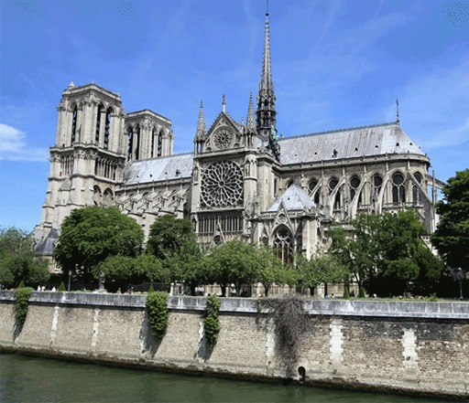
Figure 1 View of Notre-Dame Cathedral in Paris from the River Seine
View description - Figure 1 View of Notre-Dame Cathedral in Paris from the River Seine
View description - Figure 1 View of Notre-Dame Cathedral in Paris from the River Seine

Notre-Dame is a medieval Catholic cathedral in Paris, sitting on an island in the River Seine known as the Île de la Cité (Figure 1). Construction began in 1163 and was not finished until 1345, a total of 182 years.
It is one of the best examples of Gothic architecture in the world. Particularly outstanding are its flying buttresses (the external stone arches supporting the main body of the church), its large and brightly coloured stained-glass rose windows, and its famous gargoyles (demonic sculptured figures, originally designed to divert rainwater away from the building – see Figure 2).

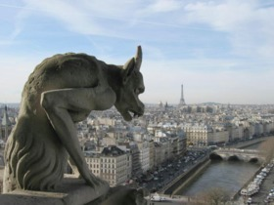
Figure 2 One of Notre-Dame’s gargoyles
View description - Figure 2 One of Notre-Dame’s gargoyles
View description - Figure 2 One of Notre-Dame’s gargoyles

In 1991, because of its unique and valuable features, Notre-Dame was recognised as a UNESCO World Heritage Site (among other nearby architectural wonders, including the Eiffel Tower). It is one of the most well known and frequently visited sites in the world, attracting 12 million tourists every year (Figure 3). Owing to its fame, it has become a symbol of Paris and has inspired artists and writers for many generations.

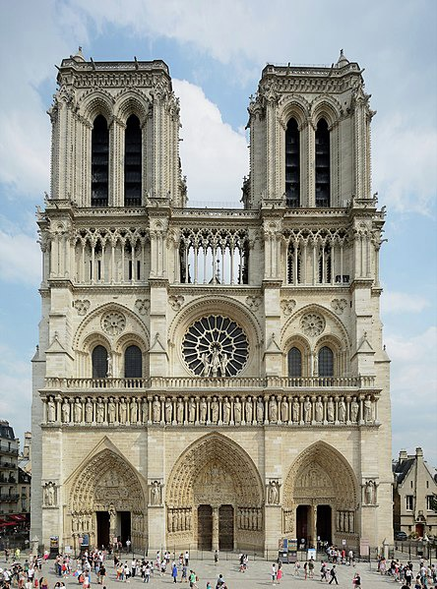
Figure 3 Western view of Notre-Dame, showing its 69-metre-high belfries
View description - Figure 3 Western view of Notre-Dame, showing its 69-metre-high belfri ...
View description - Figure 3 Western view of Notre-Dame, showing its 69-metre-high belfri ...

1.1 The Notre-Dame fire

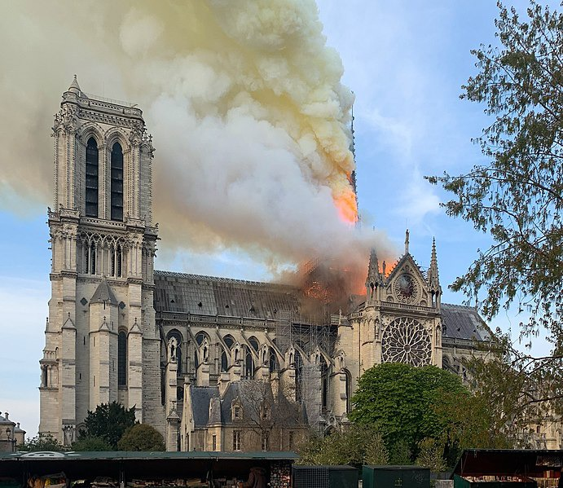
Figure 4 Notre-Dame on 15 April 2019 at 19:00, from the Quai de Montebello
View description - Figure 4 Notre-Dame on 15 April 2019 at 19:00, from the Quai de Mon ...
View description - Figure 4 Notre-Dame on 15 April 2019 at 19:00, from the Quai de Mon ...

On 15 April 2019, tragedy struck. A fire broke out in the attic beneath the roof of Notre-Dame (Figure 4). It is not known what caused the fire – it may have been by a dropped cigarette or faulty electrical equipment but nothing has ever been confirmed. The alarm was first sounded at 18:20 but, by the time the source of the fire was discovered, it was too advanced to be easily extinguished.
TheÎle de la Cité on which Notre-Dame stands was quickly evacuated, while more than 400 firefighters tried to prevent the fire from spreading across the cathedral’s roof. Simultaneously, teams of other municipal workers formed human chains to evacuate various precious objects and relics from the cathedral.
Initially, much of the efforts to put out the blaze were carried out from inside Notre-Dame itself, a choice which allowed the fire to be fought more effectively. But it increased the danger for the personnel involved, given the weakening roof, smoke and molten lead dripping from the stained-glass windows.
At 19:50 the 91-metre-high central spire of the cathedral, which had been engulfed in flames, collapsed (Figure 5). This created a hole in the ceiling below, forcing the firefighters to retreat from the attic.

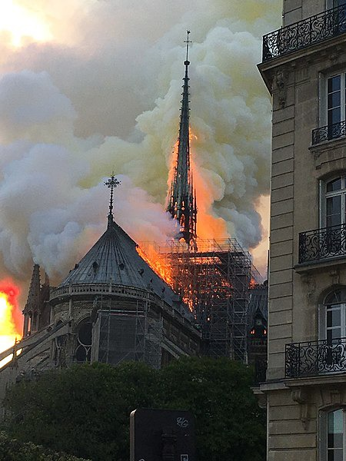
Figure 5 Notre-Dame Cathedral’s spire on fire, 15 April 2019
View description - Figure 5 Notre-Dame Cathedral’s spire on fire, 15 April 2019
View description - Figure 5 Notre-Dame Cathedral’s spire on fire, 15 April 2019

Shortly after the spire was lost, the fire also began to threaten the northern belfry (Figure 6). If the eight immense bells inside had fallen, they could have caused a chain reaction, destroying the base of the towers and eventually pulling down the whole cathedral.

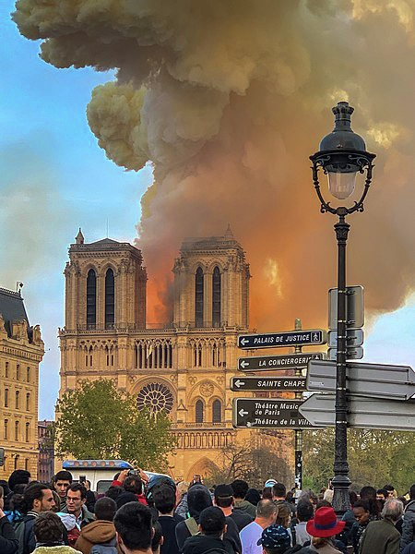
Figure 6 The west end of Notre-Dame Cathedral
View description - Figure 6 The west end of Notre-Dame Cathedral
View description - Figure 6 The west end of Notre-Dame Cathedral

Fortunately, the firefighters were able to focus their efforts and prevent the towers from collapsing. By 21:45, the fire had been reduced to a manageable size and the worst of the danger had passed. The last remnants of the fire were extinguished in the early hours of the morning.

1.2 The day after the fire
This video shows the fire and its immediate aftermath.

Video content is not available in this format.
Video 1
View transcript - Video 1

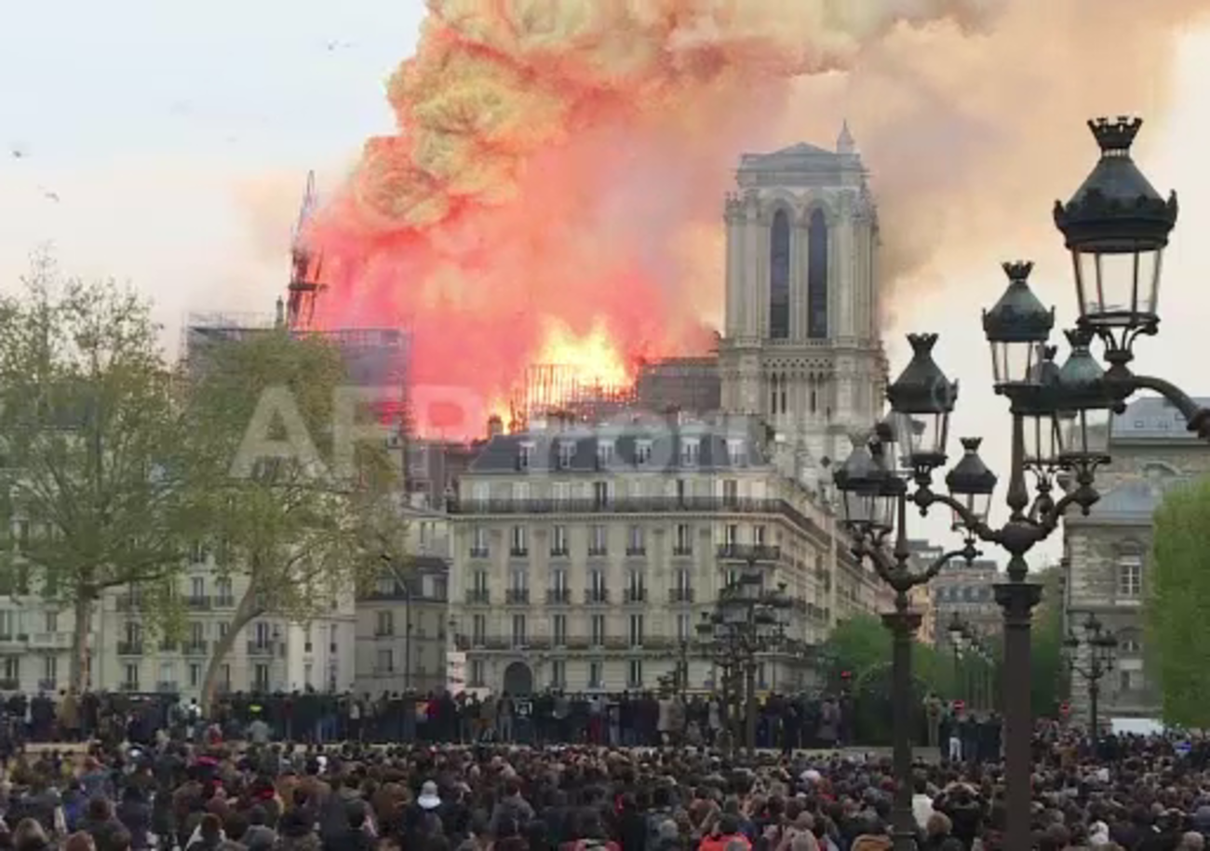

An assessment of the damage caused by the fire began the next day. Along with losing the central spire, most of the roof had been destroyed.

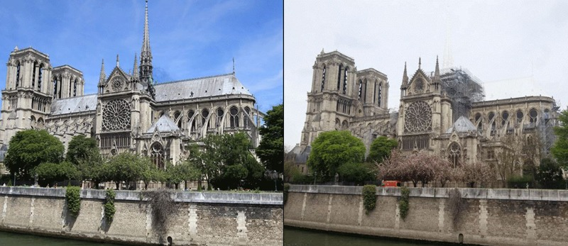
Figure 7 Before and after the Notre-Dame fire in 2019
View description - Figure 7 Before and after the Notre-Dame fire in 2019
View description - Figure 7 Before and after the Notre-Dame fire in 2019

Activity 1 Reflecting on personally valued heritage
Allow about 5 minutes

Think about Notre-Dame, or another historical building, or a piece of heritage in your hometown which is important to you. Then try to answer the following questions.

- Why do you consider the heritage to be important?

Provide your answer...

- How would you feel to see it being destroyed?

Provide your answer...

- What would you want to happen to the site afterwards? Would you want the heritage rebuilt?

Provide your answer...

View discussion - Part

1.3 Response to the fire
Sometimes when buildings are damaged or destroyed, they are simply ignored, leaving a pile of rubble as a reminder of what had occurred. On other occasions, the remnants may be demolished and removed to make way for brand new developments or replacements of the old building.
However, this was not the case with Notre-Dame. On the night of the fire, French President Emmanuel Macron publicly proclaimed that the cathedral would be rebuilt. Calling on talented people throughout the world to contribute to the project, Macron pledged that Notre-Dame would rise again, adding ‘It’s what the French expect. This is what our history deserves. This is our deep destiny.’
View Macron’s press conference(make sure to open this link in a new tab/window so you can easily return to this page).After clicking through, scroll down to the video towards the bottom of the page.
Within a week of the fire, donations from all over the globe, totalling over €1 billion, were offered for the cathedral’s restoration. Some individual donations from wealthy families and corporations were over €10 million each, but a large number of smaller donations were also received.
Once the decision to rebuild was announced, the French Prime Minister Édouard Philippe called for a competition to be held to select the best architectural design for Notre-Dame’s new roof and spire. Suggestions and computer-generated mock-ups were quickly published, ranging from fairly traditional and modest plans to those which were rather more adventurous or bold. Among the latter group were proposals to build the entire roof out of crystal or stained glass, and to turn it into a greenhouse or a swimming pool.

Activity 2 Designing the new Notre-Dame
Allow about 5 minutes

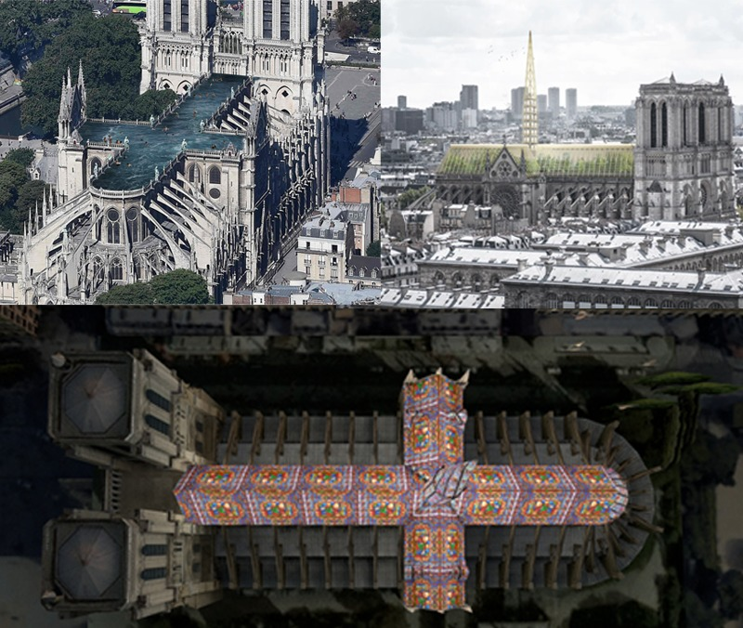
Figure 8 Designs submitted for the restoration
View description - Figure 8 Designs submitted for the restoration ...
View description - Figure 8 Designs submitted for the restoration ...

Interactive content is not available in this format.

View discussion - Activity 2 Designing the new Notre-Dame

1.4 Charitable donations to the restoration project
As noted in Section 1.3, over €1 billion of public donations were pledged for Notre-Dame’s restoration. This figure did not exceed the equivalent amount of donations collected for massive humanitarian catastrophes such as Hurricane Katrina in 2005 (US$4.65 billion raised), the Haitian earthquake in 2010 (US$3.75 billion raised), or the Indian Ocean tsunami in 2014 (US$3.1 billion raised).
However, the money offered by private individuals and corporations to help rebuild Notre-Dame did greatly outweigh offerings for many other globally publicised charity appeals, as Figure 9 shows.

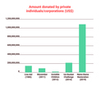
Figure 9 Comparison of the amount of public funds donated to previous global charity appeals and the amount pledged for Notre-Dame’s restoration
View description - Figure 9 Comparison of the amount of public funds donated to previous ...
View description - Figure 9 Comparison of the amount of public funds donated to previous ...

These other examples of global charity appeals were all aimed at relieving human suffering in some way, through tackling famine or child exploitation, or funding medical research and awareness. Despite this, they did not attract as much public support (in the form of financial giving) as the repair and restoration of a cathedral.
Many commentators saw this as unacceptable, revealing a serious moral flaw in our society. Although individuals had donated money to a good cause, the higher degree of concern shown for Notre-Dame compared with other causes was seen by many people as evidence of a failure to properly empathise with the plight of human beings in need.
One common argumentative strategy used here was to point out the kind of benefits that the money pledged to Notre-Dame could have delivered had it been donated to other charities. It was said that €1 billion could have been used to better effect had it been more thoughtfully given.
The animation in the activity below recaps the situation we find ourselves in. It also outlines some specific alternative uses of the funds, showing just how far the money could go.

Activity 3 The ethics of charitable donations
Allow about 10 minutes

Watch the following video comparing the value of donations to Notre-Dame’s restoration to other charitable causes. Afterwards, complete the rest of the activity below.

Video content is not available in this format.
View transcript - Uncaptioned interactive content

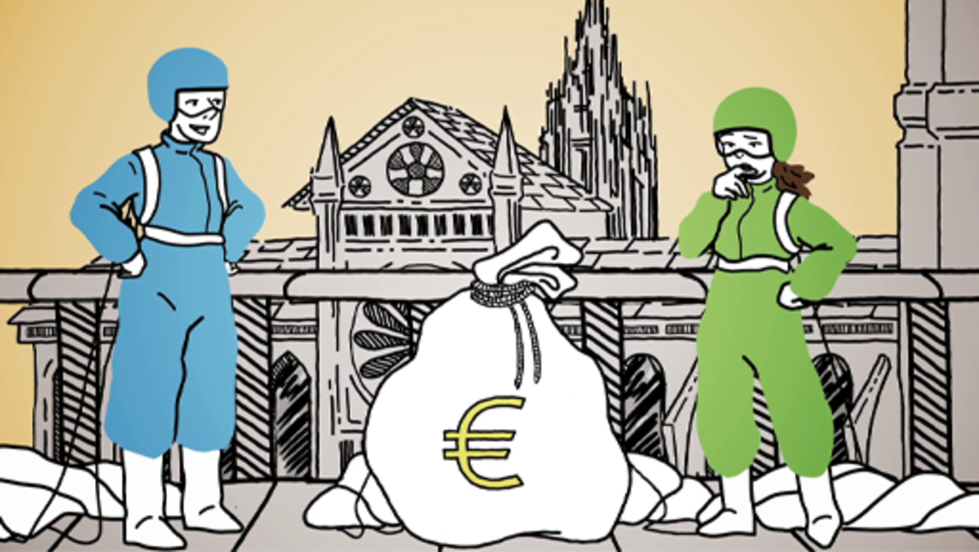
Video 2 Comparing the cost of Notre-Dame restoration to Charitable causes

Interactive content is not available in this format.

Interactive content is not available in this format.

View discussion - Part

As you have seen, some people criticised the level of donations received by Notre-Dame. Their general motivation for doing so was outlined above. In the following sections you will see some more concrete arguments they might make, and possible defences or responses to those arguments.

2 The debate about rebuilding Notre-Dame
Considering the massive cost of repairs for the damage to Notre-Dame (Figure 10), many people have suggested that donating money to restore Notre-Dame is downright immoral. There are two arguments which could motivate this claim:
- Cost-effectiveness argument.
- Humanitarian argument.

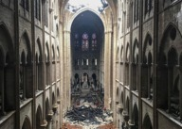
Figure 10 Notre-Dame on Easter morning, 19 April 2019
View description - Figure 10 Notre-Dame on Easter morning, ...
View description - Figure 10 Notre-Dame on Easter morning, ...

Cost-effectiveness argument
This first argument is that restoring Notre-Dame to its former appearance is simply too expensive, and that our funds should not be spent on such extravagant goals. Someone who advocates this argument might still believe that Notre-Dame is valuable and that fixing it would be a good thing. Yet this project is not cost-effective in their view; for them, restoring Notre-Dame is just not worth the money.
To strengthen this argument, we could also point out that the damage done by the fire was quite minimal. The spire and the roof are gone but the spire was a relatively recent addition and the roof was not one of the cathedral’s most outstanding features. The features for which we most admire Notre-Dame all escaped relatively unharmed – its flying buttresses, giant rose-windows, gargoyles and imposing belfries. Therefore, we would keep much of the value of the historic building by merely preserving it as it is. Once again, restoring Notre-Dame would be a noble aim but the cost is just too high.

Humanitarian argument or ‘stones versus lives’
The second argument is less concerned with the cost-effectiveness of Notre-Dame’s restoration but more with the fact that this project competes for our time and resources against other more worthy projects. Specifically, we might argue that our priority should always be to help human beings first – for example, by curing diseases or combating famine. Projects such as restoring historic buildings should come second.
The general idea is that a human being has a certain moral worth, or perhaps right to life, that is not and cannot be outweighed by something like the worth of a historic building. While both are precious, human beings exist in a class of their own. Hence, given that our opportunities for charitable spending seem to pit restoring Notre-Dame against helping human beings, morally we ought to favour the second option. Even if our money can only save one life, that is still better than spending it on Notre-Dame.
Unlike the cost-effectiveness argument, the conclusion of the humanitarian argument would be unaffected even if Notre-Dame could be restored for little money. When we weigh mere ‘stones’ against human lives, our focus should always be on saving lives. In effect, we could only permissibly repair Notre-Dame (or similar projects) once all humanitarian crises were solved.

2.1 The ‘It’s my money’ response (part 1)
Some people believe that others should not have donated their money to the Notre-Dame restoration fund. On the previous page, you read about two arguments in favour of this conclusion.
The first ‘cost-effectiveness argument’ is that restoring the cathedral is simply not worth the money: the cost of the project is greater than the value we might expect to produce. The second ‘humanitarian argument’ is that the value of Notre-Dame can never outweigh the value of human lives. Thus, given that there are human beings in need, our charitable donations should always go towards helping them before being spent on projects such as heritage-restoration (Figure 11).

Figure 11 Arguments against rebuilding Notre-Dame
View description - Figure 11 Arguments against ...
View description - Figure 11 Arguments against ...

And yet, people may disagree with the above argument. Even if donating money to Notre-Dame’s restoration is not morally ideal, arguably it is still permissible. In other words, we would not be breaking any moral rules or obligations by donating to the Notre-Dame appeal, even though there are other options which would be better, ethically speaking.

Activity 4 Defending donations to Notre-Dame
Allow about 15 minutes

Think about the idea that donating to the restoration project is morally acceptable, even if it is not the best choice from an impartial, ethical perspective. What are some of the reasons or motivations you could give to support this claim?

View discussion - Activity 4 Defending donations to Notre-Dame

Assuming that it would be overdemanding to expect people to donate all of their excess income to humanitarian charities, we seem to be left with some degree of freedom. This freedom may well grant us permission to donate to causes such as Notre-Dame without having done something morally impermissible or unacceptable.

2.2 The ‘It’s my money’ response (part 2)
The points made in Section 2.1 support people’s right to spend their money on the restoration of Notre-Dame if they choose. Yet the core premises of both the cost-effectiveness and the humanitarian arguments could still be true. What the arguments in Section 2.1 claim is that even if Notre-Dame’s restoration is not a cost-effective use of money, and even if a human life is worth more than preserving a historic building, people might still be entitled to donate their money to Notre-Dame.
The central claim and its supporting points assert people’s right to donate to non-ideal charitable causes (Figure 12). Some of these assertions are somewhat controversial in philosophy. However, if successful, these moves may provide a moral defence for the choice to donate to Notre-Dame instead of helping human beings.

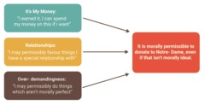
Figure 12 The ‘It’s my money’ response to making private donations to Notre-Dame’s restoration
View description - Figure 12 The ‘It’s my money’ ...
View description - Figure 12 The ‘It’s my money’ ...

The French government
Perhaps private citizens are relieved of responsibility if we agree with the points on the previous page. And yet much of the cost of restoring Notre-Dame (perhaps most of it, depending on how expensive it becomes) will be borne by the French government, and other states may be unable to use the arguments just presented. For instance, states do not obviously have a right to spend their funds however they see fit. Since those funds are collected from the people through taxes and other means, it seems reasonable to expect that they should be spent only in ways that effectively benefit those people. Also, it is not overly demanding to expect a state to strive to do what is morally best for its people.
The ‘relationships’ point raised earlier may apply to states to some degree, if we believe that they are entitled to have greater concern for the wellbeing of their own citizens than those of other nations. Given this, a state may be morally permitted to spend its funds meeting the needs of its own people, even when there are needier people elsewhere.
However, even accepting this, the French state is still faced with an ethical dilemma. France, like any other nation, has humanitarian problems within its own borders, such as poverty, disease and homelessness. Therefore, it is still vulnerable to the cost-effectiveness and humanitarian arguments (Figure 13).

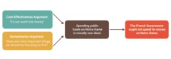
Figure 13 The effect of the cost-effectiveness and humanitarian arguments on the French government
View description - Figure 13 The effect ...
View description - Figure 13 The effect ...

Assuming that the full cost of Notre-Dame’s restoration reaches billions of euros, and will only accomplish a moderate gain in value, shouldn’t the French government spend tax funds in a more cost-effective way? Since there are people in France who lack access to housing, education or medical treatment, does the French government have a moral duty to help them before repairing historical buildings?

2.3 The economic justification for rebuilding
There are two responses that could be made on behalf of the French government. The first focuses on the economic benefits of conserving and restoring heritage. The second, which you will read about in the next section, focuses on ‘heritage values’.
This first response is fairly simple and can be used as a reply to the cost-effectiveness and humanitarian arguments. It goes as follows.
In the long term, the project of restoring Notre-Dame will pay for itself. Through various economic factors, rebuilding Notre-Dame will bring in more income for France than it would cost to carry out. Therefore, it cannot fail to be a cost-effective way of spending funds. Also, it might be the most cost-effective option, bringing in more money than any other project. Thus, ultimately, it would allow for the state to make the greatest investment in the humanitarian causes that are, according to the humanitarian argument, more important.

Activity 5 The economic benefits of Notre-Dame’s restoration
Allow about 2 minutes

In what ways do you think restoring Notre-Dame could generate economic benefits for the people of France?
Think specifically about the work that would be involved and the achievement that would result.

View discussion - Activity 5 The economic benefits of Notre-Dame’s restoration

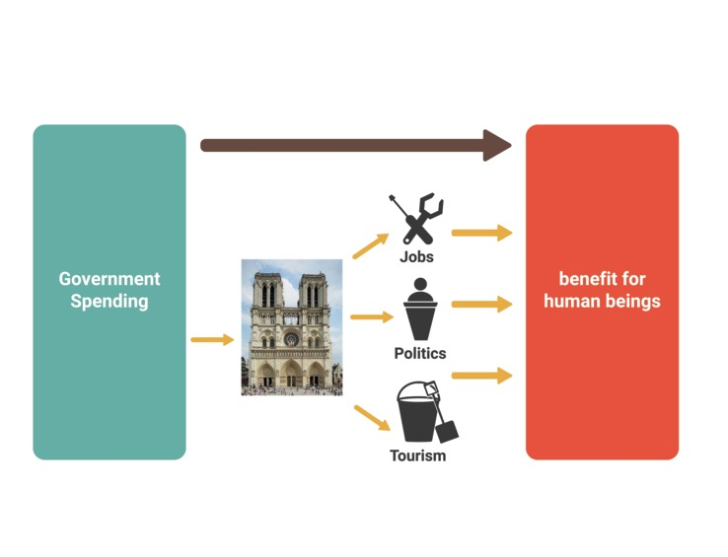
Figure 14 The economic justification for rebuilding
View description - Figure 14 The economic justification ...
View description - Figure 14 The economic justification ...

Figure 14 summarises the economic justification for rebuilding. The upshot of this is that spending on cultural heritage could be an investment that pays back more than was put in. Hence, it will be cost-effective. Also, it may provide greater benefits and economic returns than any other option. In this case, even if the explicit goal is to help people, it may be better to spend money on restoring Notre-Dame than on anything else. Overall, the various advantages that come from such heritage investment would produce the greatest benefit for human beings, so that is what should be done.
And yet, a crucial feature of the economic justification is that it predicts the likely consequences of spending money on restoring Notre-Dame. The success or failure of this argument rests entirely on whether such predictions are true.
It is conceivable that the predictions it makes are accurate, and that heritage-spending could produce a net benefit overall. On the other hand, it is also conceivable that there are other projects which would produce even more of a net benefit, such as investment in transport infrastructure, or even building a new sport stadium. If so, while the restoration would still be cost-effective, tax funds would be better spent elsewhere.
In addition, Notre-Dame’s restoration might not even be cost-effective. It could produce some advantages but they would not outweigh the cost of the project. If this were true, the cost-effectiveness argument would collapse. Therefore, if this justification is deployed, it is critically important that its predictions are tested and assessed for their accuracy.

2.4 The heritage value justification for rebuilding
The economic justification for rebuilding does not challenge the claim that human beings’ value should always take priority over the value of cultural heritage. Rather, it tries to show how acting to benefit cultural heritage could be the best way to help human beings, given the potential effects it could have on tourism and employment, and the collection of additional tax revenue.
However, some people might believe that the economic justification demonstrates a limited understanding of the true worth of cultural heritage. Although it can produce many economic benefits, to think that cultural heritage is only valuable in these ways would be narrow-minded.
Many varieties of heritage value have been identified in cultural heritage sites such as Notre-Dame, including:
- aesthetic value – its beauty or visual appeal
- commemorative value – its role as evidence or as a memorial to a person or an event
- historical value – the information it contains about important historic events or time periods
- scientific value – its capacity to produce new knowledge for scientists or other scholars
- moral value – derived through ethical relationships (e.g. it may deserve protection as the culmination of many lives’ work or teach us an important lesson – a warning against repeating past mistakes)
- associative/symbolic value – derived through symbolic connection to certain ideals or concepts
- spiritual value – its significance as a religious site or artefact; the role it plays in spiritual practices.
We can now develop and enrich Figure 14 (on the previous page) to get Figure 15. When calculating the value that could be gained by restoring Notre-Dame, we should broaden our scope to include these heritage values, as well as the economic benefits acknowledged previously.

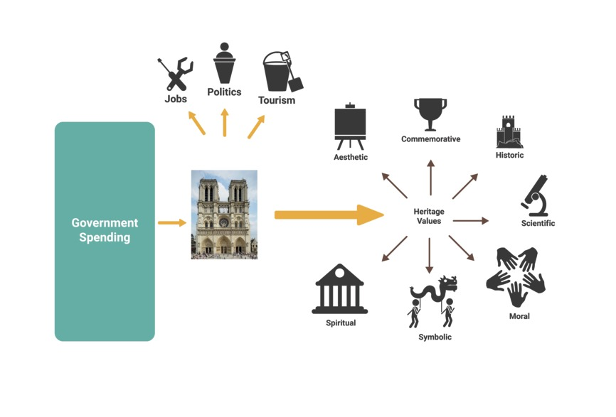
Figure 15 Heritage values
View description - Figure 15 Heritage values
View description - Figure 15 Heritage values

The existence of these valuable features provides another potential justification for rebuilding Notre-Dame. These heritage values are significant, at least in Notre-Dame’s case. Therefore, we should spend money to repair the cathedral because it would be a good thing in itself, independently of the economic benefits that might also be produced.
Indeed, this justification is perhaps what President Macron had in mind when he asserted that the project would go ahead because it is ‘what our history deserves’. Notre-Dame holds a massive amount of value in its own right, and that heritage value alone is enough to justify the expense involved in its repair.

2.5 Can heritage values outweigh the value of human lives?
When assessing the heritage value justification for rebuilding, the most important question is:

Can heritage values (such as beauty, historic significance, commemorative and spiritual value) be counted equally alongside the value of human life or should we give the interests of human beings priority?

The humanitarian argument says we should focus on promoting value for human beings. The heritage value justification says we should promote all kinds of value, both humanitarian and heritage, without giving either absolute priority.
Solving this disagreement is especially urgent if the economic justification for rebuilding Notre-Dame turns out to be based on inaccurate predictions. In that case, if Notre-Dame’s restoration will not pay for itself, we will face a dilemma:

When we have limited resources and the option to spend them either on supporting the welfare of human beings or on cultural heritage, what should we do?

If we decide that objects sometimes have enough heritage value to take priority, we appear to be concluding that some lives are worth less than mere bricks and mortar. We are also faced with the future problem of how to go about weighing the relative value of heritage and human lives. How many lives is Notre-Dame worth?
Yet, if we decide that human beings should always be our priority, we may be unable to justify any spending of public money on cultural heritage or the arts. A nation run according to such a doctrine would channel all of its money into basic education, housing and health care. But it would be left with no state-funded galleries and museums and the inevitable degradation and loss of all public cultural heritage. The population would be as healthy as possible but buildings such as Notre-Dame would be left to crumble and disappear for ever.
To many people, neither option is desirable, and even making the choice is unpalatable. And yet, all states (not just France) must make this choice every year when drawing up their budgets.
This basic dilemma will return in different forms throughout the rest of the course. Next week, you will see how it arises, even more urgently and dramatically, within the context of armed conflict.
To complete this week’s study, do the final activity and then test your understanding by doing this week’s quiz.

Activity 6 The ethics of spending money on heritage

Interactive content is not available in this format.

View discussion - Activity 6 The ethics of spending money on heritage

The next section of this course will get you to reflect on what you have learned by answering five short questions.

3 This week’s quiz
You have completed the first week of the course. Now try these five questions which will test what you have learned:
Week 1 quiz
Open the quiz in a new tab or window and come back here when you’ve finished.

4 Week 1 summary
Congratulations on finishing Week 1! This week you have:
- learned about the history and significance of Notre-Dame Cathedral and the economic and heritage values which arise from such buildings
- learned about the serious damage caused by the fire in 2019 and the extraordinary cost of repairing it
- discovered and analysed some of the arguments given for and against spending our money and resources to restore the cathedral
- reflected on your own attitudes about the morality of this project.
The basic philosophical problem considered this week was how to weigh the value of cultural heritage against human lives and wellbeing. This dilemma will return in different forms throughout the rest of the course. In Week 2, you will see how it arises, even more urgently and dramatically, within the context of armed conflict.
You can now go to Week 2.

Week 2: Cultural heritage in war

Introduction
In Week 1 you studied the Notre-Dame fire and explored some arguments both for and against the plans to restore it. One argument tried to justify the restoration on the basis of the economic benefits that might be produced. Another argument attempted to justify the project with reference to the heritage values of Notre-Dame which would be saved.
Whether it is worth spending our time and resources on heritage values – at the expense of other causes which are directly aimed at saving lives or reducing human suffering – depends at least partly on whether the value of cultural heritage could ever be a higher priority than the value of human life. This is a contentious issue which we did not find a solution to in Week 1.
In addition, if the value of heritage can be weighed up against the value of human lives, exactly what weighting should we give it? How many lives (if any) is a building such as Notre-Dame worth? Questions such as these are not purely theoretical. Governments make such decisions on a regular basis, whenever they draw up budgets and divide funding between the arts and other services such as health care or housing.
Similarly, this week you will see how such decisions can be presented to agents in even more urgent and stressful scenarios. Specifically, when soldiers have to make difficult decisions about the treatment of cultural heritage in wars.

Learning outcomes
By the end of this week, you should be able to:
- explain the events that led to the bombing of Monte Cassino Abbey in the Second World War
- examine and apply the rules of the Hague Convention (on protecting heritage in war) in both real and hypothetical examples
- understand the military concept of a ‘force-multiplier’
- recognise and assess the arguments for and against protecting cultural heritage during armed conflict.

1 Introduction to the basic dilemma in war
- What would you do if you had the power to decide whether Notre-Dame will be destroyed or whether numerous lives are put at risk?
- What would you do if you had to choose between saving the lives of a group of civilians or protecting a museum full of priceless paintings and artefacts?
These questions might seem far-fetched but these situations do arise in the context of armed conflict. Military commanders need to make difficult decisions, weighing up the costs associated with various plans of action to determine the best way forward. Typically, these costs take the form of increased risks or harm to civilians or soldiers. However, sometimes commanders are also expected to consider the value of cultural heritage in their strategic decision-making.

Activity 1 Military dilemmas involving heritage
Allow about 5 minutes

Watch the following video and think about how you would respond as a commanding officer in each of the given examples.

Video content is not available in this format.
Video 1 Example military dilemmas involving heritage
View transcript - Video 1 Example military dilemmas involving heritage

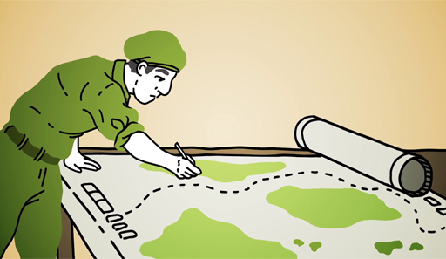

View discussion - Activity 1 Military dilemmas involving heritage

2 Monte Cassino Abbey
Before outlining the case study of Monte Cassino, you should note that, because of constraints, the account you will read is a simplification of the truth. In reality, events were more complex than this description suggests. In addition, the decisions you will examine were made under extremely high pressure, with incomplete and conflicting information, and from a historic perspective which we may not share today. Given this, remind yourself not to draw conclusions or make judgements too hastily or harshly.

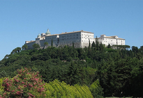
Figure 1 View of Monte Cassino Abbey from the Polish cemetery (2007)
View description - Figure 1 View of Monte Cassino Abbey from the Polish cemetery (2007)
View description - Figure 1 View of Monte Cassino Abbey from the Polish cemetery (2007)

Monte Cassino Abbey is a Benedictine monastery which stands on top of a rocky hill near the town of Cassino in Italy (about 80 miles southeast of Rome). The abbey has a long and significant history, with three of Monte Cassino’s monks going on to become Popes in later life. The first buildings were established nearly 1500 years ago, although the abbey, as it stands today, has been destroyed and rebuilt several times over (Figure 1).
The most recent destruction of the abbey was by the Allied forces in February 1944, during the Second World War (Figure 2). At the start of the year, the Allied armies had been pushing north towards Rome. However, overtaking the German defensive lines proved more challenging than expected. In particular, the Allied forces faced the difficult task of capturing or circumventing Cassino as they attempted to move up the Liri Valley.

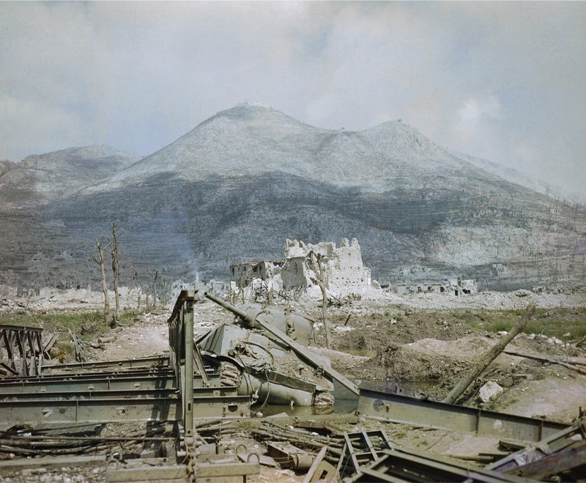
Figure 2 The ruins of Cassino in May 1944: a wrecked Sherman tank and Bailey bridge lie in the foreground, with Monastery Ridge and Castle Hill in the background
View description - Figure 2 The ruins of Cassino in May 1944: a wrecked Sherman tank and ...
View description - Figure 2 The ruins of Cassino in May 1944: a wrecked Sherman tank and ...

The high mountain peaks around Cassino gave the German army advantageous positions to observe the Allied soldiers’ movements, allowing them to carry out accurate artillery strikes. The destructiveness of these attacks effectively halted the Allied forces’ advance northward.
Between 20 and 22 January, the Allied forces made several unsuccessful attacks on the German lines, with heavy casualties. Although further attempts made throughout the rest of January were more successful, gaining control of the abbey itself proved impossible. Attempted advances were repelled with heavy machine-gun fire from the surrounding slopes.
At this point, there were varying opinions among the Allied forces about whether the abbey itself was occupied by the German military. Some reasoned that, given the accuracy of the German artillery fire, they were probably using it as an observation point. Indeed, some pilots reported seeing evidence of a German presence during flyovers (although others disagreed). It was also argued that, even if the German forces weren’t using the abbey, they could start occupying it at any point. So, destroying the building would still be a valuable military goal.
On the other hand, following a special request from the Vatican, the German army had informed the Allied forces that they would not be including the abbey in their defensive line. In addition, the abbey itself was recorded by the Allied forces as one of Italy’s most important monuments and was given a two-star rating (on a scale of one to three).
Despite these factors, the pressure was building for the Allied forces to bomb the abbey. Both American and British newspapers, such as the New York Times and Daily Mail, ran stories claiming that German soldiers were occupying the abbey. Also, army commanders received letters imploring them to save their soldiers’ lives by destroying the building. In addition, Allied commanders were advised that the abbey had previously been demolished and rebuilt, most recently in the seventeenth century. And, on studying the architecture of the building, they decided that further ground infantry attacks would be impractical.
After a period of deliberation, the decision was taken by General Alexander to bomb the abbey.

2.1 The destruction of Monte Cassino

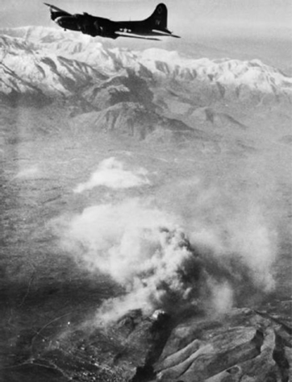
Figure 3 A Flying Fortress aeroplane over Monte Cassino in 1944
View description - Figure 3 A Flying Fortress aeroplane over Monte Cassino in 1944
View description - Figure 3 A Flying Fortress aeroplane over Monte Cassino in 1944

On 15 February 1944, more than 100 aircraft dropped 1150 tons of explosives on the peak of the hill where the abbey stood (Figure 3), as shown in the video linked below. The attack was supplemented with artillery fire from the ground. The building was reduced to rubble (Figure 4).
Bombing of Monte Cassino video (make sure to open this link in a new tab/window so you can easily return to this page).
No evidence was found that these attacks killed a single German soldier in or around the abbey. Tragically, however, the bombing raid killed more than 200 Italian civilians who were sheltering in the abbey.

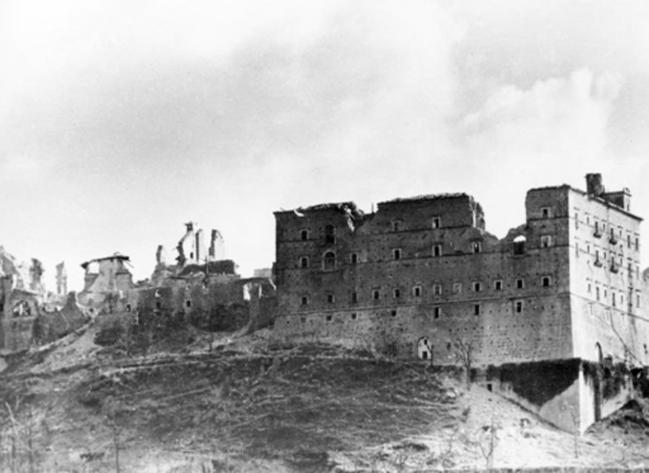
Figure 4 Monte Cassino Abbey after the bombing in 1944
View description - Figure 4 Monte Cassino Abbey after the bombing in 1944
View description - Figure 4 Monte Cassino Abbey after the bombing in 1944

It is now believed that the abbey buildings were unoccupied by German forces both at the start of the conflict and at the time of the bombing. Although they had taken up positions close by, in the surrounding hills, the German Commander-in-Chief in Italy, Albert Kesselring, had left the abbey out of their defensive line.
Yet, after the bombing raid, a division of German paratroopers moved into the ruins of the abbey. Despite prior suggestions that the destroyed abbey would be of little value to the German defence, these soldiers used it effectively as a fortress and an observation point.
Ground assaults by Allied soldiers during the following weeks were all defeated. The Allies then spent the next two months reinforcing their numbers and discreetly manoeuvring new divisions of soldiers into strategic positions in preparation for the next offensive.
By 11 March, when the assault began, the Allied forces had doubled their ranks, completely unknown to German intelligence. Their superior numbers allowed the Allied forces to capture key locations in the hills around Cassino and the German forces, realising they would soon be defeated, chose to retreat. A group of Polish soldiers then finally captured the abbey.
After this victory, the Allied forces were able to continue pushing northward, and by 4 June, they had successfully captured Rome. And yet the Monte Cassino campaign was an incredibly costly series of battles. Along with the destruction of the town of Cassino and the abbey, as well as the deaths of the civilians hiding there, more than 50,000 Allied soldiers were killed or wounded as well as 20,000 German casualties.
The abbey was eventually rebuilt, with the help of the surviving monks, although it took many years to complete. The building was finally reconsecrated on 24 October 1964. It still stands today.

Activity 2 The morality of the Monte Cassino bombing
Allow about 5 minutes

Imagine you were commanding the Allied forces at Monte Cassino.
- What would you have done? Would you have chosen to bomb the abbey or continue with ground assaults?
- Would you have acted earlier or waited to gather more intelligence?

View discussion - Activity 2 The morality of the Monte Cassino bombing

Partly as a result of events like the bombing of Monte Cassino, many international laws and conventions have been drawn up to try and protect heritage from this sort of destruction. In the next pages you will learn about one of the main treaties with this aim.

3 The Hague Convention (1954)
Cultural heritage often plays an important role in armed conflicts. Heritage buildings can be used as fortresses or observation points. Heritage can also be looted as spoils of war or deliberately destroyed in acts of iconoclasm or cultural cleansing.
Yet there have been calls to constrain the treatment of cultural heritage in war. For instance, Sun Tzu in the 6th century BCE argued that cultural heritage should not be punitively destroyed in conflicts. More recently, rules regarding the treatment of cultural heritage in war have begun to be codified into law. Perhaps the most significant international treaty is the 1954 Hague Convention for the Protection of Cultural Property in the Event of Armed Conflict (1954), which can be shortened to the 1954 Hague Convention.
The Convention was developed after the Second World War. In the war a huge amount of cultural property was destroyed and stolen. From the Nazis’ organised looting of European art, to their bombing of historic landmarks, such as England’s Coventry Cathedral (Figure 5). The Allied forces were also responsible for many serious acts of cultural devastation, including bombing Monte Cassino Abbey in Italy, and destroying the Frauenkirche (as well as 90% of the other city-centre buildings) during the air raids on Dresden in Germany (Figure 6).

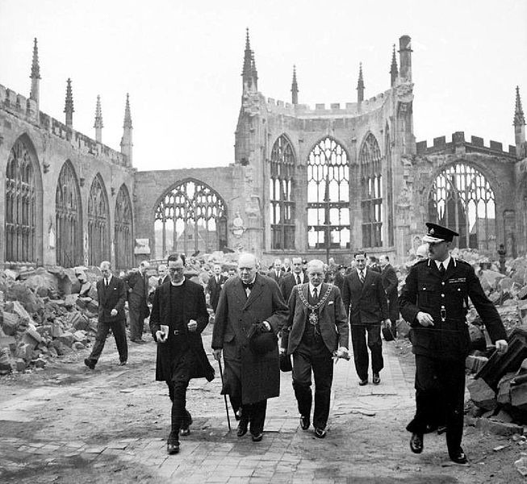
Figure 5 Prime Minister Winston Churchill walking through the ruined nave of Coventry Cathedral in England. It was severely damaged in the Coventry Blitz of 14–15 November 1940
View description - Figure 5 Prime Minister Winston Churchill walking through the ruined nave ...
View description - Figure 5 Prime Minister Winston Churchill walking through the ruined nave ...

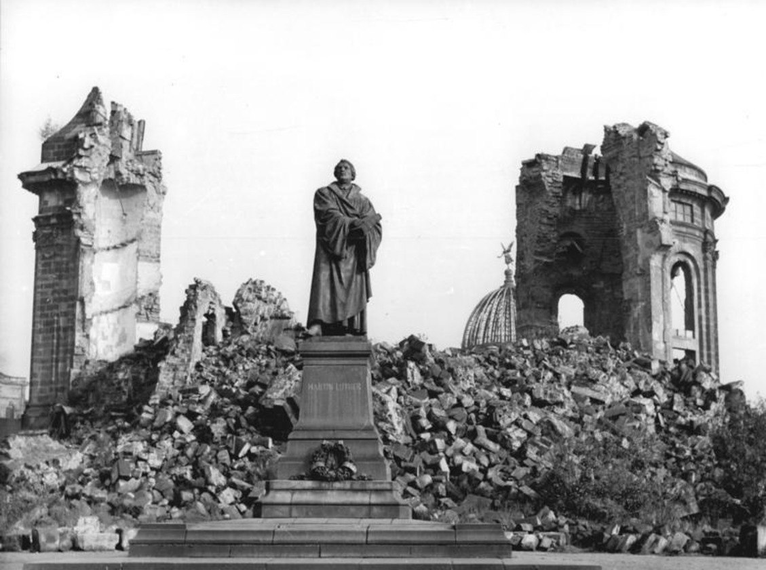
Figure 6 The destroyed Frauenkirche in Dresden, Germany
View description - Figure 6 The destroyed Frauenkirche in Dresden, Germany
View description - Figure 6 The destroyed Frauenkirche in Dresden, Germany

The Hague Convention was drafted by 56 states with the aim of preventing the similar mistreatment and destruction of heritage from happening again. The Convention covers both movable heritage, such as books, paintings, statues and archaeological objects, and immovable heritage, such as cathedrals, temples, museums and ruins. It lays out a series of constraints which forbid the theft of cultural property and limit the circumstances under which it may be used or attacked for military purposes.
The following video clip from UNESCO outlines their understanding of the Convention’s significance. It also outlines the scope of the legislation by offering examples of the kinds of objects and sites it covers.

Video content is not available in this format.
Video 2
View transcript - Video 2

In the next section, you will learn more about the specific rules set out in the 1954 Hague Convention.

3.1 Applying Hague Convention Guidelines
The animation below gives an overview of the structure of the 1954 Hague Convention and the various methods through which it promotes respect for cultural heritage.

Video content is not available in this format.
Video 3
View transcript - Video 3

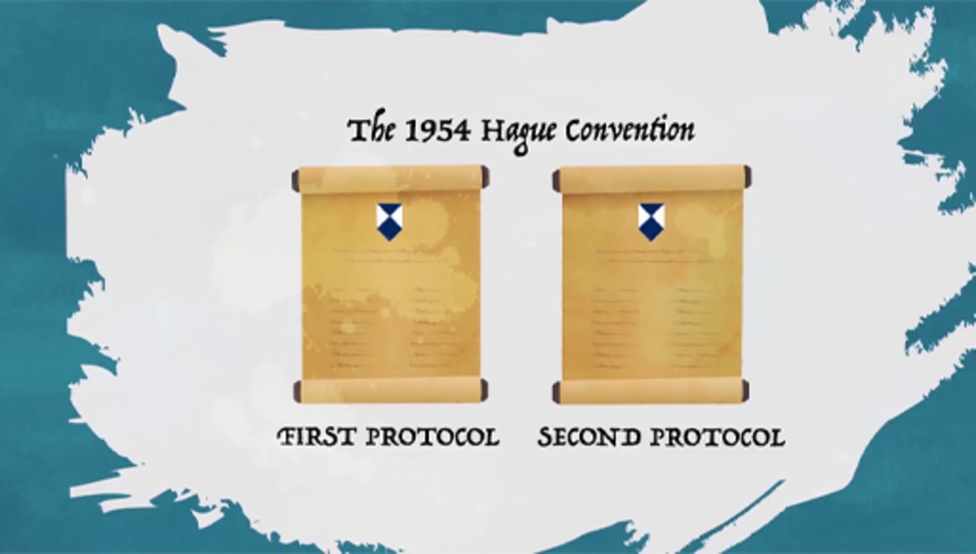

As indicated in the above video, the Convention is complex, and sets out a number of different obligations for the states which have signed up to it. For instance, during peacetime, states are expected to make necessary preparations to ensure that the significant cultural heritage in their territory can be safeguarded. This includes creating inventories listing all significant heritage and plans for the emergency protection of that heritage.
The Convention also includes details of how states can register their heritage and how it should be marked. The lowest level of protection is offered to heritage of ‘great importance’ to the people and should be labelled with the Blue Shield (Figure 7). The middle level of protection is offered only to heritage of ‘very great importance’ to the people and should be labelled with three Blue Shield emblems arranged in a triangle. Finally, the highest level of protection is offered only to heritage which is of ‘greatest importance to humanity’ and should be labelled with the Blue Shield outlined in red (Figure 8).

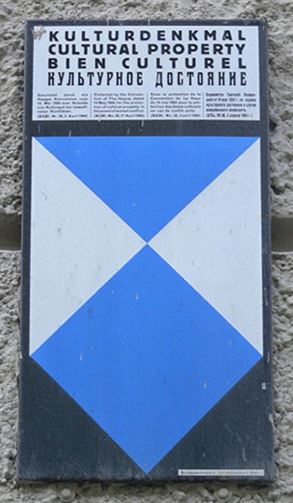
Figure 7 A Blue Shield emblem in Salzburg, Austria
View description - Figure 7 A Blue Shield emblem in Salzburg, Austria
View description - Figure 7 A Blue Shield emblem in Salzburg, Austria

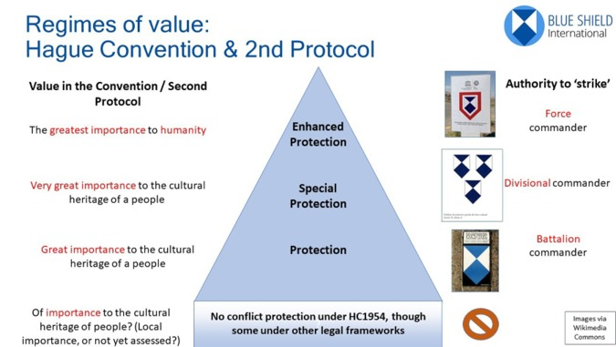
Figure 8 Structure of the Hague Convention regulations called Blue Shield International
View description - Figure 8 Structure of the Hague Convention regulations called Blue Shield ...
View description - Figure 8 Structure of the Hague Convention regulations called Blue Shield ...

During wartime, the primary and main directive of the Convention is that state parties must refrain from directing any hostile attack towards cultural heritage protected by the treaty. It is impermissible to deliberately fire on, assault or damage cultural heritage. However, the Convention stipulates that such action may become permissible in cases of ‘imperative military necessity’. More specifically, some cultural sites or buildings may be directly targeted as long as:
- That property has been made into a military objective. This means that the heritage is effectively contributing to the enemy’s military activities and attacking it would grant the attacking force a military advantage. For instance, if the enemy are using the building to store their weapons, or have stationed a sniper in a tower.
- There is no feasible way of achieving the same military advantage without attacking the heritage.
- The enemy have been warned that the attack is imminent, so that they have the opportunity to stop using the cultural heritage, if possible.
- The attack has been authorised by an appropriately high-ranking commander, if circumstances permit. (This must be at least a Battalion Commander for heritage under regular protection, a Divisional Commander for heritage under Special Protection, and a Force Commander for heritage under Enhanced Protection.)
If hostile action is taken towards cultural heritage, in line with the above waiver, the Convention requires that everything feasible is done to limit harm to the heritage. This means methods of attack which aim to minimise damage must be chosen (such as using light weaponry instead of a heavy aerial bombardment). In addition, the attack should be called off if it appears likely to cause damage which is excessive in relation to the military advantage it would secure.
States are also forbidden from using cultural heritage in any way that is likely to expose it to destruction or damage. However, this obligation can also be waived in cases of imperative military necessity, as described above. For example, a military unit could occupy an ancient fort, provided it was the only feasible way of defending themselves from an enemy attack, and the foreseen damage to the fort would not be disproportionate to the advantage gained.
You can now test your understanding of the Hague Convention by considering the following scenarios.

Activity 3 Choosing the correct action
Allow about 15 minutes

Use the rules set out by the Hague Convention to decide whether the following actions would be permissible or impermissible.

- The soldiers in a military unit have been ordered to await reinforcements in an abandoned village. So that they are not sitting idly, they start shooting out the stained-glass windows of a nearby church for target practice.

impermissible
permissible
View answer - Part

- An officer is put in charge of storing spare ammunition in an occupied town. There are several empty buildings among which it could be shared. But, for convenience, they decide to place all of the ammunition in one place – the basement of a library.

impermissible
permissible
View answer - Part

- The members of a squad are cut off from the rest of their battalion and their communication equipment has been damaged. They urgently need to get an important message to their commanding officer about an impending ambush. However, they are pinned down by a group of enemies shooting at them from the cover of an ancient market, which they know is a heritage site. They choose to engage the enemy, knowing that their own gunfire will cause some minor damage to the market.

impermissible
permissible
View answer - Part

- A small team of soldiers, led by a corporal, are tracking the movement of a convoy of enemy tanks. They gather intelligence that the enemy plan to use a historic stone bridge under Special Protection to cross a river and attack the civilians of a nearby town. Although they have a few hours until the enemy will reach the bridge, the corporal orders her team to demolish the bridge immediately in order to protect the townspeople.

impermissible
permissible
View answer - Part

- An artillery unit has been tasked with destroying an enemy communications post located in some archaeological ruins. The Battalion Commander judges that eliminating the communications post would give them a great military advantage which could not be accomplished without capturing or destroying the enemy’s equipment. A warning is issued to the enemy soldiers that an attack is incoming, which is ignored. Then the Commander authorises a severe airstrike which is likely to destroy both the enemy communications post and the ruins in their entirety.

impermissible
permissible
View answer - Part

3.2 The Hague Convention in practice
The basic strength of the Convention is that it grants all significant heritage at least some immunity from destruction. Even if this immunity can be waived in specific circumstances, it is necessary to justify precisely why the immunity was waived. Cultural heritage can never be freely attacked without a legitimate military reason vindicating the decision.
Yet, applying the Hague Convention is not always as straightforward as it was in Activity 3. Many of its key terms are ambiguous or imprecise, which allows for different interpretations of the text and, therefore, different judgements about the permissibility of certain actions.
Here are some potential points of confusion or disagreement.
- Ranking or categorising heritage. Different levels of protection are offered to heritage sites based on certain criteria (specifically, varying levels of importance to people). However, there is room for disagreement about the extent to which any particular piece of heritage fulfils these criteria. In addition, people might object to the criteria themselves, and believe that the requirements for Special or Enhanced protection, say, ought to be different.
- Identifying heritage on the ground. The Blue Shield emblem is not generally used to identify important heritage. Hence, soldiers face difficulties recognising which buildings are cultural heritage and which are not.
- Assessing military objectives. For something to count as a military objective, it must make an effective contribution to the opponent’s efforts and attacking it must provide an advantage to your own forces. But sometimes these factors can be unclear, especially in the absence of sufficient information.
- Assessing ‘feasibility’. For an attack on heritage to be permitted on the grounds that it provides a military advantage, there must have been no other ‘feasible’ alternative for securing that advantage. Yet, the word ‘feasible’ can be interpreted in different ways. In addition, even if people agree on the meaning of the word, they could disagree on its application in various cases. Would additional deaths make an alternative course of action unfeasible? What about achieving your objective a week late, or using twice the resources?

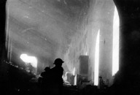
Figure 9 Polish soldiers inside the ruined Monte Cassino Abbey, 18 May 1944
View description - Figure 9 Polish soldiers inside the ruined Monte Cassino Abbey, 18 May ...
View description - Figure 9 Polish soldiers inside the ruined Monte Cassino Abbey, 18 May ...

The Hague Convention did not exist at the time of the bombing of Monte Cassino. The decision to carry out the air raid was taken according to prevailing historic standards which differ from our own. Yet, as a case study, we can wonder whether the bombing would have been ruled as impermissible or permissible according to the Hague Convention.
Remember, for the attack to have been permissible, the abbey would have to be (1) making an effective contribution to the German military effort and (2) attacking it would have to have secured an advantage for the Allied forces which no feasible alternative could have secured. In addition, if the circumstances permitted, the assault would have to be (3) approved by a sufficiently high-ranking authority, (4) carried out after a warning and (5) using means that would do minimal damage to the heritage. Did the attack satisfy these requirements?
- The Allied troops falsely assumed that the Germans were using the abbey as an observation post, based on the intelligence they had gathered. This means, from the Allies perspective, the abbey was contributing to the German’s military effort. However, whether the Allies were reasonable or justified in making this assumption is debatable.
- Bombing the abbey did not secure a military advantage in actuality. The Germans were not using it at the time of the bombing, nor did the bombing prevent them using it later on. Nevertheless, was it unreasonable for the Allies to believe the bombing would produce these benefits? This is an important question, but it is also debatable.
- The decision to bomb the abbey was made by General Alexander, so this requirement appears to be satisfied.
- A warning was offered to the Germans. On the day before the bombing, the Allied forces dropped flyers over the German positions informing them that ‘with very heavy hearts we are going to have to turn our weapons on the abbey’.
- Could the Allied troops have captured the abbey from the Germans without utterly destroying it with bombs? Allied commanders looked for alternative means of attack and determined that further ground assaults would have been fruitless given the solid construction of the building. Yet, the abbey was eventually taken by soldiers attacking on foot, months after the bombing, although with a high cost of life. Perhaps the additional reinforcements which arrived through April and May would have been successful even if the abbey was still intact?
The fundamental question is whether or not imperative military necessity demanded the bombing of Monte Cassino. This is unclear on several grounds. The Hague Convention is far from decisive here – and is similarly indecisive in many other real-world scenarios. That said, it does provide a framework to aid our thinking. The five points above help identify some of the key questions that need to be answered to assess the permissibility of military attacks on cultural heritage.
A large part of the problem at Monte Cassino was that the Allied forces were unable to gather comprehensive information about the situation they were in: whether the Germans occupied the abbey, whether attacking it would assist their mission, whether less damaging means of attacking it could have been effective, etc. However, as you will see in Section 4, even with complete information, the justifiability of some military decisions regarding cultural heritage can still be profoundly uncertain.

Activity 4 The legality of the Monte Cassino bombing

Interactive content is not available in this format.

View discussion - Activity 4 The legality of the Monte Cassino bombing

4 Arguments for and against protecting cultural property in war
How can we weigh up harm to cultural heritage against harm to human life? When heritage is on the battlefield, a military officer may be presented with a range of choices. Some of them may result in additional damage or threat to the heritage; others may harm their soldiers or nearby civilians. In the case of Monte Cassino, a decision was made to try to end the ground battle (and thereby preserve the lives of more Allied soldiers) by totally obliterating a significant historical building.
The Hague Convention officially permits acts which damage cultural heritage if certain conditions are met. For instance, that the heritage has been made into a ‘military objective’, and attacks on it would confer an advantage which could not be acquired through any ‘feasible’ alternative. But would continuing the ground battle have been ‘unfeasible’ if it would have resulted in many more deaths than bombing the abbey? Our answer to this question depends on our understanding of the word ‘feasible’, but a range of interpretations is possible, as follows.

4.1 The humanitarian position
One perspective is that any option which raises the chances of harm to humans is ‘unfeasible’. Given this, the Hague Convention would essentially be commanding: ‘do everything you can to protect cultural heritage unless this is likely to put human beings in danger, in which case you may use/attack the heritage in whatever way is necessary (assuming the other conditions for such an act are met)’. In practice, since many opportunities for preserving heritage in war are likely to add at least some additional risk to soldiers or civilians, the protection of heritage under this interpretation of the Convention would be quite limited.
For instance, this position would likely recommend destroying Monte Cassino Abbey provided doing so was expected to end the battle earlier with fewer casualties (Figure 10).

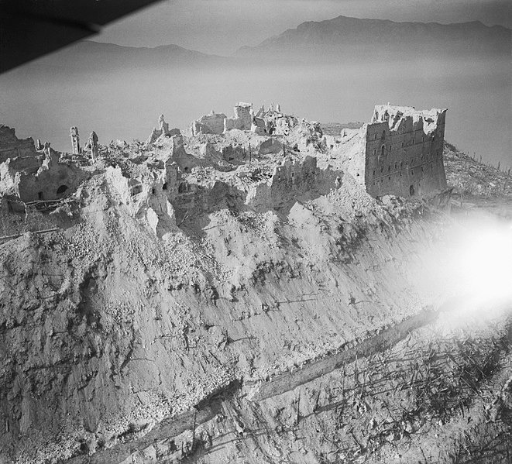
Figure 10 The Battle of Cassino, January–May 1944
View description - Figure 10 The Battle of Cassino, January–May 1944
View description - Figure 10 The Battle of Cassino, January–May 1944

This position runs parallel to the humanitarian position outlined in Week 1, Section 2 (also known as ‘stones versus lives’). This states it is not permissible to spend money on heritage projects such as repairing Notre-Dame when it could be spent on humanitarian charities. Similarly, the humanitarian position here holds that, when choosing between allowing damage to heritage or harm to human beings, we can never permissibly pick the second. Our priority should be to help as many humans as possible. Only then may we consider how to minimise damage to heritage.

Activity 5 Humanitarian or heritage?

Do you agree or disagree with the humanitarian position?

Interactive content is not available in this format.

View discussion - Activity 5 Humanitarian or heritage?

4.2 The force-multiplier argument
The humanitarian position described in Section 4.1 is that people should always have priority over heritage. A simple understanding of this is that human lives should never be sacrificed, or even put in danger, to protect heritage.
Yet, protecting heritage can sometimes provide powerful instrumental military benefits for human beings. For instance, if a military force is occupying or at war in another country:
- Protecting heritage could provide a psychological boost to the local population. Allowing it to be damaged could cause disruption, anxiety and, in the worst cases, an increase in violence among communities. For instance, in 2006, the bombing of the Al-Askari Mosque in Iraq led to a significant increase in aggressive reprisals and deaths (Figure 11).
- Protecting heritage could also benefit the relationship between civilians and the military. If the conflict causes damage to treasured monuments or sites, the local population may become hostile. Alternatively, a force which prevents such damage conveys a respect for the people and may succeed in winning their hearts and minds.
- Defending important monuments and buildings may also provide a morale boost for the troops themselves, as well as their supporters in their home countries.
- Finally, heritage can be important for post-conflict peace-building. It may be instrumental in re-forming broken communal identities. It can also provide an economic boost to their recovery through added tourism and employment.

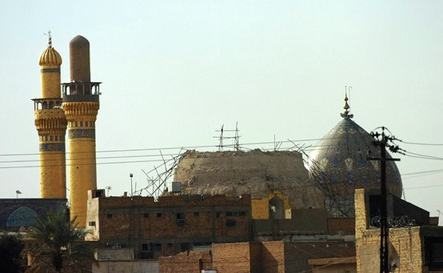
Figure 11 The Golden Mosque (Al-Askari) in Samarra, Iraq, days after anti-Iraqi forces bombed the national landmark in 2006
View description - Figure 11 The Golden Mosque (Al-Askari) in Samarra, Iraq, days after ...
View description - Figure 11 The Golden Mosque (Al-Askari) in Samarra, Iraq, days after ...

These kinds of benefit are called ‘force-multipliers’ in the military – factors which make military goals easier to accomplish (Figure 12). All of the force-multiplier benefits mentioned mean that saving cultural heritage can have a positive impact on limiting and avoiding human suffering and even deaths. Where the benefits of heritage are present, wars could potentially be ended sooner and with less bloodshed.
Therefore, even if we believe human beings are always more important than heritage, sometimes our goals are going to be best served by actions which superficially appear to put heritage first. For example, you may risk ten soldiers’ lives by telling them to guard a religious site. But if you predict the site’s destruction would cause an eruption of aggression and fighting, and perhaps a hundred extra deaths, then protecting the site appears to be the best course of action.

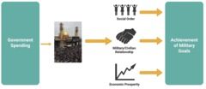
Figure 12 The force-multiplier argument
View description - Figure 12 The force-multiplier argument
View description - Figure 12 The force-multiplier argument

This force-multiplier argument parallels the economic justification for rebuilding Notre-Dame mentioned in Week 1, Section 2.3. Both arguments hang on the observation that sometimes, if we want to help human beings, the best thing we can do is to protect heritage and the benefits it provides. In the case of Notre-Dame, the benefits were primarily economic and political. In these force-multiplier cases, the benefits are primarily the avoidance of future violence and social disorder.
If either of these economic or force-multiplier benefits are sufficiently weighty, they can sometimes justify the imposition of a lesser risk of harm to human beings in order to secure those benefits. Whether we are talking about spending money on a restoration project or putting soldiers in harm’s way to avoid damage to an ancient temple, these smaller human costs can sometimes be worth paying to receive an even more valuable humanitarian result.

4.3 The heritage value justification (again)
The force-multiplier argument in Section 4.2 says that we may put lives in danger, or perhaps even kill, in order to protect heritage because doing so may allow us to save more lives in the long run.
However, a position which attempts to justify sacrificing human lives to protect heritage only in virtue of its force-multiplier benefits could be criticised as narrow-minded. Just as with the original economic justification for rebuilding Notre-Dame, we might insist that these economic/force-multiplier arguments neglect to acknowledge the full range of heritage values.
To remind you about Week 1, heritage values include:
- aesthetic value – its beauty or visual appeal
- commemorative value – its role as evidence or as a memorial to a person or an event
- historical value – the information it contains about important historic events or time periods
- scientific value – its capacity to produce new knowledge for scientists or other scholars
- moral value – derived through ethical relationships (e.g. it may deserve protection as the culmination of many lives’ work or teach us an important lesson – a warning against repeating past mistakes)
- associative/symbolic value – derived through symbolic connection to certain ideals or concepts
- spiritual value – its significance as a religious site or artefact, the role it plays in spiritual practices (Figure 13).

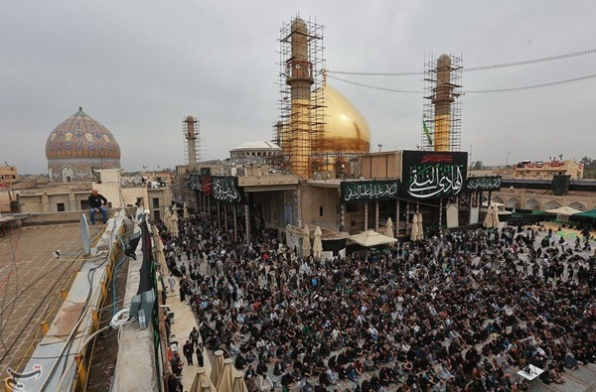
Figure 13 Al-Askari Mosque in 2017, after the reconstruction of its dome
View description - Figure 13 Al-Askari Mosque in 2017, after the reconstruction of its ...
View description - Figure 13 Al-Askari Mosque in 2017, after the reconstruction of its ...

Importantly, a proponent of the heritage value justification might argue that not only do these values matter (which is consistent with the humanitarian position), but also they sometimes matter as much, or more than, human lives. Hence, this position holds that it could sometimes be worth protecting heritage, even if doing so would only impose risks or harms on human beings and there were no force-multiplier benefits whatsoever.
In other words, it could be permissible to sacrifice a few soldiers’ lives to protect an ancient archaeological site, not because it would help end the war faster, or benefit the economy of the society post-conflict. Rather, because it is beautiful, or spiritually important, or contains valuable information about our shared history.
Once again, we face a philosophical puzzle.
- How can historical, commemorative or associative values be compared against the avoidance of suffering, or the saving of a life?
- Can the valuable features of heritage really be so valuable that protecting them is more important than protecting people?
These questions, and the difficulties involved in answering them, are considered again in the final week of the course.
The next section of this course will get you to reflect on what you have learned by answering five short questions.

5 This week’s quiz
You have completed the second week of the course. Now try these five questions which will test what you have learned.
Week 2 quiz
Open the quiz in a new tab or window and come back here when you’ve finished.

6 Week 2 summary
This week you have:
- learned about the events that led to the bombing of Monte Cassino Abbey in the Second World War
- examined the history and content of the Hague Convention (1954) and its uncertainties, and applied its rules in both hypothetical and real cases
- learned about the military concept of a ‘force-multiplier’
- analysed arguments given for and against protecting cultural heritage during conflict
- reflected on your own attitudes about the morality of risking lives to protect heritage.
You can now go to Week 3.

Week 3: Weighing heritage against lives

Introduction
In Weeks 1 and 2 you looked at some of the ways in which the protection of cultural heritage can conflict with the protection of people, in both peace and wartime. For example, you saw that France, with limited resources, must choose whether to spend its money on restoring Notre-Dame Cathedral or on public services such as health care. You also considered the case of Monte Cassino in the Second World War, where Allied forces decided to destroy a historic abbey in an attempt to end a particularly bloody battle.
Dilemmas such as these, which pit human beings against heritage, are difficult to navigate. Some people believe that the defence of heritage could potentially justify allowing harm to human beings. Others disagree, arguing instead that the welfare of people should always take priority over the welfare of buildings. And yet, this position is complicated further by the existence of economic or ‘force-multiplier’ benefits that arise from heritage. These effectively mean that, sometimes, the best way to help humans is to help heritage first.
However, the central puzzle is this:
- Can heritage values ever outweigh the value of human lives?
- Is it true that, in a competition between lives and mere stones, sometimes the stones can win?
In this final week, you will explore some of the challenges involved in answering these questions. But first, you will examine an alternative – and surprisingly popular – response: to simply deny that this question needs answering at all.

Learning outcomes
By the end of this week, you should be able to:
- understand the context and motivation behind assertions of the ‘inseparability thesis’
- analyse different interpretations of the inseparability thesis and identify their flaws
- explore some of the challenges we face in comparing the value of heritage against other values, such as the value of human lives.

1 The inseparability thesis
In recent years, the world has seen some high-profile acts of destruction taken against cultural heritage. Most recently, in 2015 in Syria, ISIS attacked and seriously damaged several important sites in Palmyra, including the Monumental Arch, the Temple of Bel and the Temple of Baalshamin.

Activity 1 Map of Palmyra
Allow 15 minutes

The map accessed via the link below shows the site of the ancient city of Palmyra, just southwest of the modern city of Tadmur. Palmyra was valued as one of the best-preserved ancient cities in the geographic area and was sometimes called ‘the pearl of the desert’. Highlighted are three of the most significant monuments attacked by ISIS. Click the icons and follow the ‘Explore’ links to see an interactive 3D image of each site before it was destroyed.
Map of Palmyra (make sure to open this link in a new tab/window so you can easily return to this page).

View discussion - Activity 1 Map of Palmyra

The international community reacted to Palmyra’s destruction with horror. Many writers and organisations argued that more should be done to protect heritage from such attacks.
At the same time, other commentators pointed out that the war in Syria was also producing a massive human cost: deaths, injuries and displacement of people on a vast scale. They asked:
- Was this reaction to the destruction of a few ancient structures not out of proportion?
- Should we not be more concerned about the loss of human life than the loss of these pieces of cultural property?
- Why direct troops to protect mere monuments when there are people who need protecting elsewhere?
In response to this criticism, several spokespeople defended themselves by asserting what can be called ‘the inseparability thesis’. For example:
- President Hollande of France: ‘Should we be concerned about the patrimony? What is more important, saving lives or saving stones? In reality, these two are inseparable’ (Simons, 2016).
- Irina Bokova, UNESCO’s Director-General: ‘Defending cultural heritage is more than a cultural issue – it is a security imperative, inseparable from that of defending human lives’ (UNESCO, 2017).
- Thomas Weiss and Nina Connelly: ‘The protection of people and the protection of heritage are inseparable … [T]here is no need for a hierarchy of protection because the choice between the two is false, just as a choice between people and the natural environment is false. Air, water, and culture are essential for life’ (Weiss and Connelly, 2017).
The inseparability thesis essentially claims that protecting cultural property and protecting human beings are, in important respects, indistinguishable. Therefore, no one can be criticised for being more concerned about cultural heritage than human beings, or for recommending intervention on behalf of heritage at the expense of people’s lives. This is because the projects of protecting heritage and protecting people are inextricably and intimately connected in such a way that they cannot be disentangled.
The inseparability thesis denies the existence of the puzzle which this course has been circling: that sometimes the protection of human lives and the protection of cultural heritage come into genuine competition. And that we must work out how to compare and weigh up the value of these two goals in order to make decisions about such conflicts.
Instead, the inseparability thesis holds that there is no real need to weigh up the value of heritage against the value of human life. Given that the protection of heritage and the protection of life are inseparable, it makes no sense to worry about comparing one against the other. In practice, the defence of heritage and the defence of people are one and the same.
There is something quite odd about the inseparability thesis if you take it literally. How can the protection of heritage be the same as the protection of human lives? In an attempt to understand it, Erich Hatala Matthes (2019)has provided several different interpretations or ‘readings’ of the thesis which you can consider next.

1.1 The evidential reading
The evidential reading of the inseparability thesis is that, whenever cultural heritage is deliberately attacked, that is good evidence that attacks on people are imminent or already happening.
Weiss and Connelly (2017) argue that attacks on heritage are a kind of ‘alarm bell’, warning us that attacks on human beings are impending. Raphael Lemkin, who constructed the concept of genocide, once asserted that ‘burning books is not the same as burning bodies, but when one intervenes in time against mass destruction of churches and books one arrives just in time to prevent the burning of bodies’(Lemkin, 1948).
Indeed, Lemkin’s chosen example evokes well-known real events. During World War Two, the Nazis were responsible for the genocide of approximately 6 million Jews. Prior to the start of the war, however, they were also responsible for provoking antagonism against groups seen as un-German. One practice in particular was that of book burning, as the video below highlights.

Video content is not available in this format.
Video 6
View transcript - Video 6

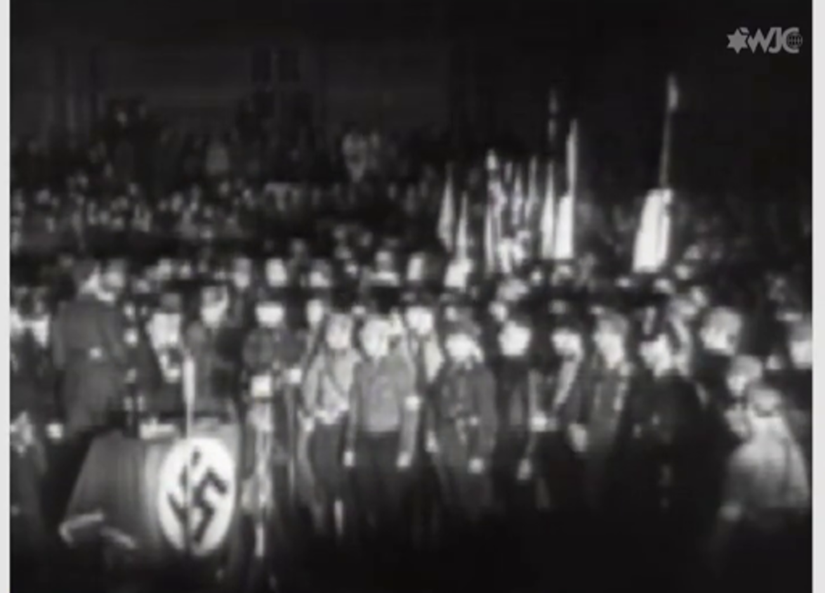

The idea behind the evidential reading is that practices such as book burning warn us that more serious crimes against humans are likely to follow.

Problems with the evidential reading
Unfortunately, the evidential reading of the inseparability thesis is probably false. Attacks on heritage are not always good evidence that attacks on people are imminent. While many genocidal acts are preceded by heritage destruction, there are countless cases of heritage destruction which did not lead to any direct harm to humans.
In addition, even if attacks on heritage were always good evidence that attacks on humans were inevitable, that would not dictate how we should respond in situations where both heritage and humans are under threat. Presumably our primary motivation would be to protect the people who were in danger. Yet, should we also intervene to protect the cultural heritage as well? In such cases, questions about the balance between protecting heritage and protecting people would still arise.
Answering these questions requires us to compare the relative values and costs of pursuing each goal. This means that protecting heritage and protecting humans are not ‘inseparable’ projects in the relevant sense – the evidential reading of the thesis does not work.

1.2 The strategic reading
The strategic reading of the inseparability thesis does not claim that attacks on heritage are mere evidence that attacks on humans are imminent. Rather, it holds that defending heritage against such attacks will always effectively assist in the defence of human beings. Therefore, if we want to protect humans, protecting heritage should be an inseparable element of our military strategy.
This specific claim is similar to the force-multiplier justification for protecting heritage which you considered in Week 2. There, you saw various ways in which the successful defence of heritage could aid a military effort (for example, by preventing the breakdown of social order, boosting the morale of the army, and increasing support for them among local people).
For instance, in 1917 Field Marshal Allenby was leader of the British Empire’s Egyptian Expeditionary Force which was occupying Jerusalem (Figure 1). He used Muslim troops under his command to guard the Mosque of Omar. This showed concern for Jerusalem’s heritage and ways of life. Without this choice, and other gestures such as entering the city on foot rather than on horseback, the people of Jerusalem may have been more hostile to the British forces.

Figure 1 General Sir Edmund Allenby entering the Holy City of Jerusalem on foot in 1917, to show respect for the holy place
View description - Figure 1 General Sir Edmund Allenby entering ...
View description - Figure 1 General Sir Edmund Allenby entering ...

The strategic reading, if true, reveals that attempts to defend human beings in conflicts should, where possible, be allied with attempts to conserve heritage. Hence, there would be a kind of inseparability between the two concerns. Protecting cultural heritage would be similar to protecting power plants, water sources or other things which are important for our survival. Given this, it might seem strange to accuse someone of prioritising the protection of cultural heritage at the expense of human lives since protecting heritage helps us protect lives.

Problems with the strategic reading
Unfortunately, the strategic reading of the inseparability thesis is probably false as well. As noted in Section 1.1, there are many occasions when heritage was attacked and even destroyed without any accompanying violence aimed at human beings. Therefore, it is incorrect to claim that defending heritage always helps us to avoid harming people.
Even in wartime, the defence of heritage is not always a force-multiplier and can sometimes be an obstacle to a mission’s success. This is precisely why the Hague Convention, which you examined in Week 2, has a waiver allowing heritage to be sacrificed in cases where doing so is imperative to achieving a military goal. If protecting heritage and protecting lives never came into conflict, as the strategic reading suggests, there would be no need to offer this waiver. However, it is a matter of fact that such conflicts do occur, so the strategic reading is wrong.
In addition, the strategic reading portrays the value of cultural heritage in precisely the same way as we would calculate the value of a purely instrumental structure such as a bridge or a power plant. Yet, this ignores the heritage values which we have previously acknowledged (for example, beauty or historic value). Therefore, to the extent that individuals were criticised for being overly concerned with the loss of these valuable features at the expense of human tragedies, the strategic reading offers no defence. There is still a deep dilemma about whether human lives can ever be worth paying to preserve the heritage values of certain buildings or sites.
In the rest of this section you will assess one final reading of the inseparability thesis which does not neglect heritage values. Instead, it denies the existence of the previously mentioneddilemma by collapsing all the values of heritage and of human lives into one single category.

1.3 The constitutive reading
The constitutive reading of the inseparability thesis does not claim that attacks on heritage are evidence of attacks on people, or that protecting heritage will strategically prevent attacks on people. Rather, it holds that attacks on heritage are attacks on people. Thus, the causes of defending humans and defending heritage are inseparable because, in certain respects, they both do the same thing.
However, the constitutive reading requires further clarification, otherwise it risks coming across as incoherent.
One way of understanding this reading is to see it as operating on the level of cultural groups. To destroy a cultural group, we might carry out mass killings. Alternatively, we might try to wipe out its heritage, thereby leading to the ‘death’ of the culture even if the members physically survive. Given this, the true defence of the cultural group would require the protection of both people’s lives and their heritage as inseparable elements (Figure 2).

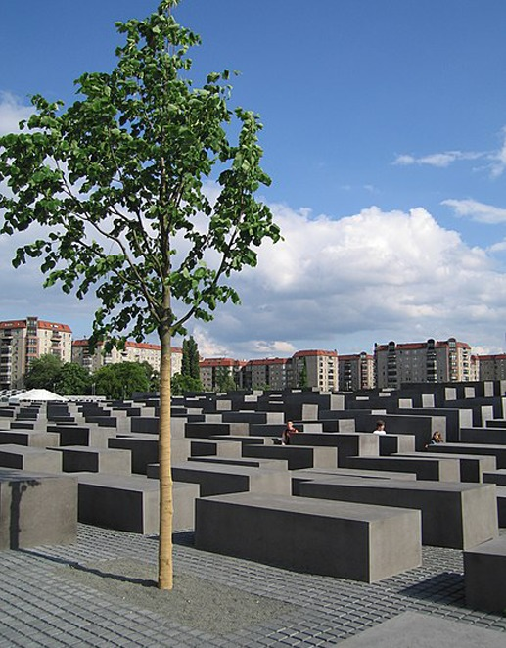
Figure 2 The memorial in Berlin for the people murdered during the Holocaust
View description - Figure 2 The memorial in Berlin for the ...
View description - Figure 2 The memorial in Berlin for the ...

Yet, by focusing only on cultural groups, this interpretation fails to address the cases covered in this course. That is, where agents are forced to make choices between saving individual people and individual pieces of heritage. So we must look further.
Another way to understand the constitutive reading, which does speak to such dilemmas, is: although human beings and cultural heritage are very different things, the value they possess, or the ultimate reason we should value them, is the same in each case.
If human beings and heritage are valuable in the same way, it follows that attacks against humans and attacks against heritage ultimately do the same sort of harm. That is, killing humans and damaging heritage are bad for the same reason. Similarly, protecting humans and protecting heritage would be aimed at protecting the same thing: the single final value that each thing possesses or produces.
What could this be? What sort of value could possibly constitute the entire worth of both human lives and cultural heritage? Again, the answer is not clear, but perhaps the most plausible suggestion is flourishing.

The value of a flourishing life
A flourishing life is a commonly invoked philosophical concept which dates at least as far back as Aristotle (384–322 BCE) (who used the term ‘eudaimonia’). It refers to the best kind of life a being can live. A flourishing life for a human involves the highest wellbeing possible and the optimum range of experiences, opportunities and functioning. Precisely what constitutes a ‘flourishing’ life is a matter of debate. However, most people will agree that, for instance, autonomy, freedom from physical pain, and psychological health are all elements of a flourishing life, and that slavery, physical suffering, and serious psychological conditions such as depression or anxiety are not.

1.4 The constitutive reading (continued)
To clarify, you can think of the constitutive reading as comprising two broad claims. First, the only reason that biological lives are valuable is because we need to be alive in order to flourish. After all, a life is not worth anything if the person leading it cannot experience any flourishing (e.g. a life of nothing but torture would not be valuable for anyone). Therefore, the point of saving human lives is that those individuals have the opportunity to flourish. If there is no chance of this, there is no value and no point in saving the lives.
Second, cultural heritage is valuable for the same reason and only that reason: the worth of cultural heritage, and the point of retaining it, is because it helps humans to flourish. For instance, the beauty of a building, the connection it offers to the past, and its usefulness as a source of information – all of these things are worth preserving only because they contribute to our flourishing. If they did not, there would be no point in saving them.
If both claims are true – that biological life is only valuable as one essential condition for human flourishing and that cultural heritage is only valuable in that it also supports human flourishing – then you can see that the point of protecting heritage is indistinguishable from the point of protecting life. The goal of each claim is to maximise the amount of human flourishing in the world, so there is no genuine dilemma here. In that sense, the two projects are, allegedly, ‘inseparable’ (Figure 3).

Figure 3 The constitutive reading of the inseparability thesis
View description - Figure 3 The constitutive reading of the ...
View description - Figure 3 The constitutive reading of the ...

This version of the constitutive reading aligns with many descriptions of cultural heritage. For instance, when Weiss and Connelly (2017) said ‘Air, water, and culture are essential for life’, they probably did not mean biological life but, rather, flourishing life. Similarly, when Vernon Rapley, Director of Cultural Heritage Protection and Security at the Victoria & Albert Museum, said heritage ‘makes the difference between living and life’, he presumably also meant to distinguish mere existing from valuable, flourishing life (Rapley, 2018).
This constitutive reading is better at incorporating the full range of values which are normally attributed to heritage, unlike the strategic reading which focuses only on the economic/force-multiplier benefits of heritage. It also provides a way to deny that saving heritage and saving lives can ever truly be in competition. Because the ultimate value of biological life and cultural heritage are identical, there is no need to make any philosophically difficult comparisons between the worth of each option. We simply make whichever choice would lead to the greater amount of human flourishing overall.

1.5 Problems with the constitutive reading
While the constitutive reading of the inseparability thesis outlined in Sections 1.3 and 1.4 perhaps comes closest to achieving what its proponents intend, it still has some major drawbacks.
First, when faced with a choice between saving lives or heritage, it could be very challenging to determine which option would maximise human flourishing overall. We would need to predict the long-term consequences of our actions precisely, but this can be incredibly difficult, perhaps even impossible.
For example, would saving this temple preserve more flourishing than saving these biological lives? It is not obvious how to fill in the numbers for this calculation. Given the constitutive reading, there would be no deep conflict between the value of each option, since they would both be measured in terms of flourishing. Yet, in the absence of perfect knowledge about the future, we would still face a dilemma when presented with any particular conflict between the protection of heritage and the protection of humans. In addition, people who choose to protect heritage at the expense of humans would still be vulnerable to the criticism that they had got things wrong – that, in this case, they were overly concerned with the heritage and overestimated its value.
Ultimately, the constitutive reading is unhelpful when applied to specific cases. It may be generally true that heritage is valuable for promoting human flourishing. But that alone does not tell us whether it is worth trading these particular lives for this particular piece of heritage. When the Temple of Baalshamin in Syria was destroyed by ISIS, a potential source of enrichment and flourishing was taken from the world (Figure 4). But how many people’s lives are actually flourishing less well as a result, and by how much? It is incredibly difficult to calculate.

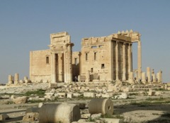
Figure 4 The Temple of Baalshamin
View description - Figure 4 The Temple of Baal ...
View description - Figure 4 The Temple of Baal ...

Second, while the constitutive reading highlights that biological lives and heritage are both connected to the value of human flourishing, it does not entail that the destruction of heritage and the killing of people are entirely equivalent.
To explain: when a cultural heritage site is destroyed, something is removed from the world which could have continued to contribute to human flourishing. It may also reduce the total amount of flourishing going on if people cannot find anything to replace it.
Yet, when a human is killed, two things happen. First, the overall amount of flourishing in the world will go down because that life, which probably would have contained more flourishing in the future, has been cut short. Second, it deprives that specific person of the opportunity to continue flourishing and it also deprives them of their life. Thus, it appears as though the harm of a person’s death is different from the harm of heritage destruction, and in quite significant ways.
The constitutive reading under discussion here is true only if the values of both cultural heritage and human lives are entirely identical. Hence, human life warrants our moral concern only as a sort of container for flourishing, since supporting flourishing is also our primary reason for valuing cultural heritage.
Yet, this seems false. A person for whom flourishing is impossible might still have a right to life or a valuable life, for example. Similarly, we would find it unjustifiable to kill one person merely because that could double the flourishing in someone else’s life. This means that human lives very plausibly possess a kind of independent value or moral significance, which is distinct from their value as mere containers for flourishing.
Thus, the projects of defending heritage and defending lives would have at least partly distinct goals and so could come into genuine competition. Some of the value or benefit of saving lives would be separable from the benefits of saving heritage. Therefore, the constitutive reading of the inseparability thesis is incorrect.
It is true that heritage can promote flourishing in human lives. However, it is still unclear, in any specific case, whether we are morally permitted to sacrifice these lives and their flourishing in order to protect a particular piece of heritage and thereby promote more flourishing for other people in the future. Again, uncertainty about the amount of flourishing which the heritage would produce, and the presence of independent value or moral significance attached to the human lives, mean we would face a genuine dilemma here.

Activity 2 Flourishing human lives

Interactive content is not available in this format.

1.6 Section conclusion
The inseparability thesis may seem plausible because it trades on the notion that cultural heritage is protected at least partly for the sake of people who care about the heritage. Indeed, saving heritage can often serve people’s interests and increase their wellbeing.
Yet, to suggest there can never be serious competition between the projects of saving heritage and helping humans is to take an implausibly narrow view of the value of human life (and perhaps also of heritage). For instance, a human life may have a kind of moral significance beyond its value as a container for flourishing. If so, it follows that a person’s death cannot be entirely compensated for by saving heritage and thereby enhancing the flourishing in other people’s lives.
A profound philosophical problem remains: the value of heritage does seem separable from the value of human lives after all. States and military organisations (and individuals donating to charity) are all faced with genuine dilemmas when humanitarian priorities compete with cultural heritage. And yet we still do not have any clear or systematic way of determining the best moral course of action in these circumstances.
In the next section you will consider some of the problems we face when trying to weigh up the value of heritage against the value of human lives.

2 Difficulties weighing the values of heritage and human lives
How can the values of cultural heritage be weighed up against the value of human lives? If you had to choose between letting a significant heritage building be destroyed or letting a human being be harmed, how would you make that decision?
In this section you will consider some of the problems of trying to weigh up the value of heritage against the value of human lives.

2.1 Incommensurable values
When making everyday decisions – say, what film to watch or what to have for dinner – you might simply weigh up the values of each option and choose the better one. However, in cases which pit cultural heritage against human lives, this is not so easy. One reason for this difficulty is that the forms of value held by heritage and lives appear to be incommensurable.
Two values, ratings or measurements are said to be commensurable when they can be precisely compared on the same scale. For instance, it is possible to determine, with perfect clarity, whether 100 euros is worth more, less or the same as 100 US dollars because these values can both be translated into, say, British pounds. They have a common measure, so they are commensurable. The same goes for temperatures given in Fahrenheit and Celsius, or weights given in kilograms and pounds.
On the other hand, two values are incommensurable when there is no way for them to be translated into one scale. For instance, if you were asked to compare the value of US$100 with that of a family heirloom, you might find this impossible because the value of money and the sentimental value of the heirloom are too different to be evaluated on the same terms. Thus, there is no precise way of determining the relative worth of the heirloom and the US$100 – they have incommensurable values.

Activity 3Commensurability
Allow about 10 minutes

Rank the following items from the list below in order of their value to you (you could type each one into an area on the grid, and make a list or lists to sort, if you wish). If an item does not fit precisely into one of your existing ranked lists, start a new ranked list in the next column.
Items:
- A tasty packed lunch
- A bag of crisps
- A slice of burnt toast
- Taking a free online course in a subject you enjoy
- Learning an interesting fact
- Watching a funny video on your smartphone
- A gourmet five-course meal
- Meeting the love of your life
- Completing a higher degree in a subject you enjoy
- Watching a fantastic comedy at the cinema
- Finding a pair of jeans that really suits you

List 1 | List 2 | List 3 | List 4 | List 5
Provide your answer... | Provide your answer... | Provide your answer... | Provide your answer... | Provide your answer...
Provide your answer... | Provide your answer... | Provide your answer... | Provide your answer... | Provide your answer...
Provide your answer... | Provide your answer... | Provide your answer... | Provide your answer... | Provide your answer...
Provide your answer... | Provide your answer... | Provide your answer... | Provide your answer... | Provide your answer...
Provide your answer... | Provide your answer... | Provide your answer... | Provide your answer... | Provide your answer...
Provide your answer... | Provide your answer... | Provide your answer... | Provide your answer... | Provide your answer...
Provide your answer... | Provide your answer... | Provide your answer... | Provide your answer... | Provide your answer...

View discussion - Activity 3Commensurability

Do heritage and human lives have commensurable values? It appears that they do not.
According to the constitutive reading from Section 1, the value of both heritage and human lives was commensurable because it could be evaluated purely in terms of flourishing. Yet, as you saw in Section 1.5, this claim turned out to be implausible. Human lives have a moral worth or value independent of their relationship to flourishing.
In addition, any other attempt to reduce the value of human lives to values only shared by cultural heritage seems likely to fail. As with the example of the heirloom and the US$100, there seems to be no systematic method for translating both sorts of value into one shared measure. The values of human lives and heritage are just too different.
This already makes evaluating trade-offs between them difficult, since there is no precise way of determining whether some particular heritage is worth the lives it would cost to save it. Yet, the problem may run even deeper than this. Arguably, the values of heritage and lives are not just incommensurable but also incomparable.

2.2 Incomparable values
Incommensurability means there is no common measurement on which to precisely compare two values. Incomparability means any comparative judgement about two values is impossible.
For example, you saw that the values of an heirloom and US$100 were incommensurable, yet they may not necessarily be incomparable. Even if there is no systematic way of measuring the values on the same scale, a person could still potentially assess which of the two was preferable. Similarly, US$100 is also incommensurable with, say, finding your dream job or learning the meaning of life, and yet the latter options may seem obviously better. To be truly incomparable, this must be impossible. There must be no way of determining which option is superior.
Is anything truly incomparable in this way? Plausibly. Imagine you are sharing out a birthday cake and must decide whether every child gets an equal slice, or a slice which is as large as they deserve based on their behaviour. Which is better? To answer you must compare the value of a distribution that delivers equality against one that delivers justice. Yet doing so may seem impossible. Both are noble goals and there may be no apparent strategy for measuring them to see which is more noble, even imprecisely.
The important question for this course is whether the values of human lives and heritage are merely incommensurable, like the heirloom and US$100, or incomparable like cake distributions governed by equality or by justice.
The incommensurability of heritage and lives would prevent us from making systematic judgements about the moral permissibility of certain trade-offs. However, unless they are also incomparable, it may still be possible to determine whether, say, sacrificing one person’s life is approximately proportionate or justifiable in order to preserve some particular heritage site.
The problem is, heritage and lives do appear incomparable to many people. The question ‘How many lives are worth sacrificing to save Notre-Dame Cathedral?’ may be one which you find impossible to answer. Indeed, you may not even know where to start. In addition, any concrete response (for example, Notre-Dame is worth approximately ten to twenty lives) risks sounding absurd.
Yet, such a question must be implicitly answered by the French state when they allocate their restoration budget. Therefore, discovering a solution to the problem of incomparable values is an imperative. Until we succeed, we risk committing significant moral wrongs through ignorance.

Activity 4Incomparability of heritage and lives

Interactive content is not available in this format.

View discussion - Activity 4Incomparability of heritage and lives

2.3 The aggregation problem
As you know from Sections 2.1 and 2.2, comparing the value of heritage and lives is made difficult by their apparent incomparability.
Of course, we might argue that heritage and lives are not always incomparable in every case. For instance, imagine we were weighing up one life against a heritage site beloved by billions of people. Because the heritage is appreciated to such an extent by such a vast number of people, this might indicate to some people that it is more morally significant than a single life.
Yet, this sort of claim is potentially complicated by what we can call the aggregation problem. You can learn more about the basic problem in the next activity by considering the football technician scenario by Tim Scanlon (1998).

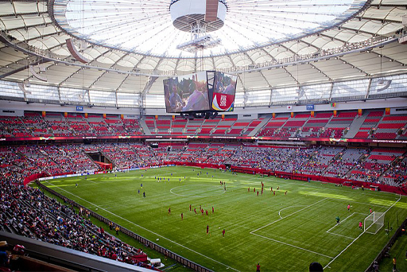
Figure 5 BC Place is a stadium located in Vancouver, British Columbia, Canada
View description - Figure 5 BC Place is a stadium ...
View description - Figure 5 BC Place is a stadium ...

Activity 5Football technician dilemma
Allow about 5 minutes

Imagine that the final match of the football World Cup is being broadcast on television to billions of fans all over the world (Figure 5). Suddenly and unexpectedly, a piece of equipment falls on one of the television technicians, pinning him to the floor. The technician is not in any danger but if he is not rescued soon he will suffer serious pain and injury. The other workers are faced with a dilemma. The technician can be rescued immediately, but this would require the broadcast to be switched off and the viewers around the world would miss the remainder of the game. Alternatively, the technician could be rescued after the game is over, but he would suffer much more.

Interactive content is not available in this format.

View discussion - Activity 5Football technician dilemma

2.4 Cultural heritage and the aggregation problem
The important question for this course is: does the aggregation problem apply to the value of heritage and human lives?
Some believe it does. The video below recaps the aggregation problem and outlines one way it might be relevant to the topic at hand.

Video content is not available in this format.
Video 7
View transcript - Video 7

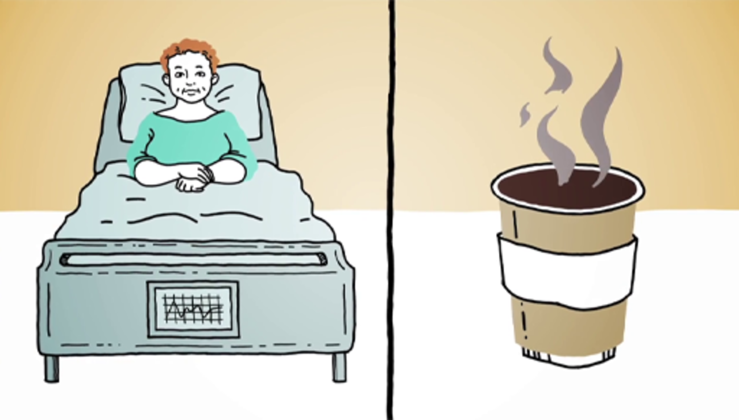

You have seen that heritage can be good in a variety of ways: pleasing us with its beauty; teaching us about the past; and commemorating or reminding us of historic individuals or events, etc. Yet, arguably, each of these benefits is rather small for each individual who enjoys them. Thus, while a single piece of heritage might provide millions of people with these minor goods, it is not clear that we would be justified in allowing even one death to save it.
Aggregating across the millions of people who benefit from the heritage, its overall value seems to be huge. Yet, perhaps these benefits are too trivial to add up in the way they would need to in order to make a human life a permissible trade? If we couldn’t ethically sacrifice someone to guarantee the World Cup stayed on air, why think we could sacrifice someone to keep Notre-Dame standing?
If the benefits of heritage are indeed too minor to be added up and counted as something significant, as the aggregation problem indicates, we may never forfeit lives for the protection of heritage. Both in terms of military decisions and government and charitable spending, heritage must always be abandoned if that is necessary to save even a single person.

Activity 6Aggregating the value of cultural heritage’s benefits
Allow about 5 minutes

Interactive content is not available in this format.

View discussion - Part

Interactive content is not available in this format.

View discussion - Part

The next section of this course will get you to reflect on what you have learned by answering five short questions.

3 This week’s quiz
You have completed the third and final week of the course. Now try these five questions which will test what you have learned.
Week 3 quiz
Open the quiz in a new tab or window and come back here when you’ve finished.

4 Week 3 summary
This week you have:
- explored the context and motivation behind assertions of the ‘inseparability thesis’
- analysed different interpretations of the inseparability thesis and identified their flaws
- reviewed some of the challenges faced in comparing the value of heritage against other values, such as the value of human lives.

End-of-course summary
Congratulations! You have now reached the end of the course. We hope you have enjoyed it.
Throughout this course, you have explored many ethical issues surrounding the conservation of heritage, in both peacetime and wartime. You have examined several case studies, including the restoration of Notre-Dame Cathedral, the bombing of Monte Cassino Abbey, and the destruction of Palmyra. You have also assessed many of the arguments given for and against protecting heritage in such circumstances.
The core dilemma we face is that, sometimes, protecting heritage means neglecting the needs of human beings, or vice versa, and we currently have no principled way of solving this problem.
In Week 3 you learned about some of the philosophical challenges any solution would have to overcome, including the problems of incommensurability, incomparability and aggregation. You have also explored the context and motivation behind assertions of the ‘inseparability thesis’. That is, the attempt to deny the existence of the core dilemma by claiming that heritage protection and the defence of humans are somehow ‘inseparable’.
After examining various readings of this thesis, you have seen that there is no workable interpretation. It is true that heritage defence sometimes has positive force-multiplier effects for humans, and can enhance their ‘flourishing’. However, it is overly simplistic to assume that heritage and lives do not have any independent value and can never be in competition.
We are left in a difficult position: we want to protect both heritage and human lives but, sometimes, we cannot do both. How should we proceed? Any extreme principle seems unappealing: for example,. always sacrificing lives to protect heritage; or never sacrificing any human interests to protect heritage. The first option appears to undervalue human lives, while the second would effectively abandon our world’s heritage to crumble and disappear entirely.
Yet, maintaining the status quo is also problematic. Today, the decisions of states and militaries are largely governed by factors such as political pressure, customary international humanitarian law, and traditional spending habits. It is unclear whether these forces will always produce the ethically correct decisions. This is a problem, especially given that mistakes here could result in abhorrent and ethically unjustified losses of human life.
What we need is a principled way of resolving the dilemma of ‘stones versus lives’. This will involve thinking through what should be done when things we deeply value conflict with each other, even if doing so is not always comfortable. Until we succeed, we will be perpetually at risk of committing serious moral wrongs.

Where next?
You may be interested in the following:
Heritage In War – An AHRC-funded project on protecting cultural heritage in war
Should we risk lives to protect history?
Heritage in war
To restore or not to restore?
You can find more free resources and courses on OpenLearn.
New to University study? You may be interested in our courses on Philosophy, including:
BA (Honours) Arts and Humanities (Philosophy)
BA (Honours) Religion, Philosophy and Ethics
Making the decision to study can be a big step and The Open University has over 40 years of experience supporting its students through their chosen learning paths. You can find out more about studying with us by visiting our online prospectus.

Acknowledgements
This free course was written by Joshua Thomas. It was first published in August 2020.
Except for third party materials and otherwise stated (see terms and conditions), this content is made available under a Creative Commons Attribution-NonCommercial-ShareAlike 4.0 Licence.
The material acknowledged below is Proprietary and used under licence (not subject to Creative Commons Licence). Grateful acknowledgement is made to the following sources for permission to reproduce material in this free course:
Image
Course image: Bernard Gagnon; https://creativecommons.org/licenses/by-sa/3.0/deed.en
Every effort has been made to contact copyright owners. If any have been inadvertently overlooked, the publishers will be pleased to make the necessary arrangements at the first opportunity.
Don't miss out
If reading this text has inspired you to learn more, you may be interested in joining the millions of people who discover our free learning resources and qualifications by visiting The Open University – www.open.edu/openlearn/free-courses.

Solutions

Activity 1 Reflecting on personally valued heritage

Part

Discussion
For many individuals the built environment can be incredibly significant. In Paris, groups of people stood vigil all night over Notre-Dame as the fires were put out, singing and praying, and the news of its destruction was reported all over the world. Buildings such as these can be meaningful to people for cultural, religious or personal reasons and, when they are damaged, it can provoke feelings of intense grief. Some people even describe the destruction of a treasured place as being like the death of a loved one.
And yet you might not see the loss of buildings such as Notre-Dame as quite as serious as the deaths of human beings. One reason for thinking so, among others, is that buildings can be rebuilt. As you will see in the next section, the prospect of rebuilding is an attractive proposal for many people, even when it comes at a great cost.
Back to - Part

Activity 2 Designing the new Notre-Dame

Discussion
Despite its popularity with architects, the competition was cut short due to mounting criticism from the international community and France itself. On 19 July 2019, the French Parliament passed a new bill requiring Notre-Dame’s restoration to mimic its exact appearance before the fire.
This restoration work is estimated to be an incredibly difficult and long-running project. This is because the newly built sections need to be made from material which matches the original building and must mesh with the existing structure without damaging or unbalancing it further.
Initially, President Macron promised that the project would be finished within five years. However, some architects have suggested that it could take 20 to 40 years to complete. In addition, some art insurers have predicted that the overall cost of restoring Notre-Dame will be around €7 billion.
Back to - Activity 2 Designing the new Notre-Dame

Activity 3 The ethics of charitable donations

Part

Discussion
You may agree that there are better uses of our money than restoring the cathedral. However, even if that is true, you might still think it’s morally okay or even praiseworthy to donate money to Notre-Dame. These questions are centred on a complex ethical problem which it is difficult to solve. We need to think about the worth of heritage, but also what freedoms people have to spend their money, and what kind of moral standards we can hold each other to.
Back to - Part

Activity 4 Defending donations to Notre-Dame

Discussion
There are a few points which could support the claim. Here are a few you might have considered (although you probably thought of others too).
‘It’s my money’
Arguably, we each have a right to spend our money however we see fit, provided that it is legal and doesn’t do actual harm. Assuming that we have acquired our money through just means, it is our rightful property and, within certain constraints, we should be allowed to dispose of it how we like. This means that you could donate it to a humanitarian charity or to the restoration of Notre-Dame, and either option would be morally permissible.
Relationships
Many people believe that we have a right to offer special treatment or concern to people, causes or things when we have a special relationship to them which others may not share. For instance, you may have a right to protect your own children rather than someone else’s, given the relationship you have with them as their parent. You may also have a right to help your friends above helping strangers.
Extending this, arguably, we are each entitled to live our lives in a way that respects our unique history and the special relationships we have with other people. But sometimes this can involve doing things which aren’t optimal in terms of impartial morality. Hence, if you feel you have a special connection to Notre-Dame – perhaps the building is meaningful to you because of certain personal experiences – then you have a right to donate money to its restoration, even at the expense of ignoring the needs of less fortunate human beings.
Overdemandingness
It has been argued that it is simply too demanding to expect people to always act in a way that is morally perfect or maximises moral goodness. Perhaps it is impossible for a human being to behave in this way, perhaps not (it depends on your theory of morality). But it would simply be too taxing if people had to live as absolute moral saints. Sometimes people are entitled to be held to less-than-perfect standards, or even to be a little selfish.
More specifically, assume that we did have a strict duty to live as moral saints. This would not only require us to select efficient humanitarian charities rather than historic-building restoration when we donate. It would also require us to donate all of our money to such charities – or as much as we can spare. It would be less-than-perfect, morally speaking, to donate to Notre-Dame. Similarly, it would be less-than-perfect to spend that money on a pint of beer or a cinema ticket for ourselves. Ultimately, we would have to live our lives on the poverty line, giving away all but the money we absolutely require for the most minimal form of subsistence living.
Back to - Activity 4 Defending donations to Notre-Dame

Activity 5 The economic benefits of Notre-Dame’s restoration

Discussion
There are a few ways in which the restoration could end up paying for itself. Here are three (you may have thought of others).
- First, the project will be very effort-intensive, requiring many workers, from architects and designers to craftsmen, joiners, and all kinds of administrative and managerial roles. In short, the project will create numerous jobs. And these jobs will have various knock-on benefits, reducing the strain on welfare and, as the workers spend their wages, stimulating the economy and creating further tax revenue.
- Second, the restoration of Notre-Dame will bring in a lot of revenue by attracting tourists who will spend money in local restaurants, hotels and businesses. This adds to the income of the French government through both taxes and the invigorating impact of tourism on the local economy. Without Notre-Dame, fewer tourists would travel to Paris or spend less time (and money) there. Preserving and eventually restoring the cathedral to its former glory would presumably retain these tourists and potentially attract even more.
- Third, the state’s commitment to the project, and the final outcome of a fully restored Notre-Dame, may also serve valuable political ends. It is reasonable to suppose that France owes at least some small portion of the respect it receives to its impressive store of cultural heritage, of which Notre-Dame is a key element. Hence, the reconstruction may succeed in enhancing France’s image on the global stage and even promote the self-esteem of French citizens. Such consequences would probably bring economic benefits, even if they are hard to quantify precisely.
Back to - Activity 5 The economic benefits of Notre-Dame’s restoration

Activity 6 The ethics of spending money on heritage

Discussion
There is no consensus yet, but this question is important to keep thinking about. You may have decided based on your own moral intuition, or perhaps you based your choice on one of the arguments covered in this week’s content. Either way, it is worth stressing that there are good reasons supporting both positions.
Back to - Activity 6 The ethics of spending money on heritage

Activity 1 Military dilemmas involving heritage

Discussion
These examples are fictional but realistic. In each one the commanding officer has to decide between courses of action. Some of these involve greater risks of harm to cultural heritage; others involve greater risks of harm to civilians or military personnel. Selecting one option instead of another appears to demand that the commanders compare and weigh up the value of heritage against the value of human life.
Given this, identifying the best choice is not easy. As you saw in Week 1, these kinds of decision can be philosophically challenging, even outside the context of an ongoing battle. And yet, soldiers and officers are faced with such decisions, and must often choose with imperfect knowledge of their circumstances. The destruction of the Monte Cassino Abbey during the Second World War is a real-life case which exemplifies this problem.
Back to - Activity 1 Military dilemmas involving heritage

Activity 2 The morality of the Monte Cassino bombing

Discussion
Our best analysis suggests that bombing the abbey was unhelpful to the Allied war effort. It also caused much death and destruction. Yet, given the rising pressure and lack of military intelligence available to the commanders, perhaps you thought the decision was permissible at the time? Alternatively, maybe you believe the commanders acted too quickly, or failed to show appropriate respect for the historic abbey. There is no clear answer here. Indeed, the morality of the decision to bomb is still being debated today.
Back to - Activity 2 The morality of the Monte Cassino bombing

Activity 3 Choosing the correct action

Part

Answer
Right:
impermissible
Wrong:
permissible
Impermissible: this constitutes a direct attack on cultural heritage which has not been made into a legitimate military objective.
Back to - Part

Part

Answer
Right:
impermissible
Wrong:
permissible
Impermissible: this is using a building containing cultural heritage in a way that attracts the risk of attack.
Back to - Part

Part

Answer
Right:
permissible
Wrong:
impermissible
Permissible: the military advantage to be gained from the attack (getting the message to their commanding officer) is proportional to the damage they foresee causing to the heritage site. Also, there is no feasible alternative to this course of action which would provide the same advantage. In addition, they could not have feasibly warned the enemy combatants, nor sought approval for their own attack from their commanding officer, so they are released from these duties.
Back to - Part

Part

Answer
Right:
impermissible
Wrong:
permissible
Impermissible: although there is a military justification for destroying the bridge, the corporal neglected to get approval for the attack from the Division Commander, which would have been possible given the timescale. She also failed to consider alternative courses of action which could have protected the townspeople without destroying the bridge.
Back to - Part

Part

Answer
Right:
impermissible
Wrong:
permissible
Impermissible: although the archaeological ruins have become a legitimate military objective, and the Battalion Commander remembered to issue a warning, in selecting the means of attack, they neglected to consider alternatives to an airstrike which would have inflicted lesser harm on the heritage. For instance, an assault with lighter weaponry could have succeeded in driving out the enemy and capturing the base without completely obliterating the ruins.
Back to - Part

Activity 4 The legality of the Monte Cassino bombing

Discussion
As noted above, whether or not the bombing would have satisfied the requirements of the 1954 Hague Convention is unclear. It depends on how one interprets the military scenario in several key respects. Additionally, it is once again worth stressing that the account you have read is limited and cannot possibly portray the full picture of the events surrounding Monte Cassino. Decisions were made in a stressful and complex environment and we are applying guidelines here which were not yet created at that time. We should not make judgements too hastily or harshly.
Back to - Activity 4 The legality of the Monte Cassino bombing

Activity 5 Humanitarian or heritage?

Discussion
This poll is similar to one from Week 1: ‘Do you think it is morally impermissible for states to spend money on heritage like Notre-Dame instead of humanitarian causes?’ (Activity 6 in Section 2.5).
In both cases, we are considering whether or not we should always prioritise human lives over saving heritage. Last week’s example was about how to spend money, whereas this example is about military decision-making. Did you give similar answers in each poll? If you gave different answers, you may have simply changed your mind, or you might have different beliefs about the different contexts. Either way, think about what might be affecting your opinions in each case. For instance, is it relevant that military personnel adopt a particular role?
In the next section you will see some additional considerations which weigh in favour of protecting heritage, and are particularly relevant to military decision-making.
Back to - Activity 5 Humanitarian or heritage?

Activity 1 Map of Palmyra

Discussion
These structures all date back to the 1st or 2nd Centuries CE. At that time Palmyra was a bustling trading hub, owing to its prime location for merchants. The wealth of the city was what allowed it to create such impressive feats of architecture. Besides their age and size, the buildings were also considered especially valuable because they expressed both Roman and Eastern influences. For instance, you may have noticed the Roman-style columns on both the temples and the colonnade following the arch. Sadly, however, what remains of these buildings are three piles of rubble.
Back to - Activity 1 Map of Palmyra

Activity 3Commensurability

Discussion

A gourmet five-course meal | Meeting the love of your life | Completing a higher degree in a subject you enjoy | Watching a fantastic comedy at the cinema | Finding a pair of jeans that really suits you
A tasty packed lunch |  | Taking a free online course in a subject you enjoy | Watching a funny video on your smartphone
A bag of crisps |  | Learning an interesting fact
A slice of burnt toast

Your table might resemble the one above but don’t worry if it doesn’t. There is plenty of room for differences of opinion here.
This activity was designed to demonstrate the concepts of commensurability and incommensurability. You might have felt that some items are commensurable, and thus easily ranked in the same column. For instance, the food items could all be ranked in terms of tastiness, and the educational items could all be ranked in terms of the quantity of knowledge you gained.
However, other items may have been difficult to integrate into these ranked lists, so you put them in a different column. For instance, you might have felt that meeting the love of your life could not be weighed on the same scale as the food items. This means that the value of the food items were incommensurable with the value of meeting the love of your life.
Back to - Activity 3Commensurability

Activity 4Incomparability of heritage and lives

Discussion
As with many questions addressed so far in the course, this one does not have a clear answer. There is still an ongoing debate amongst philosophers about the value of life and the ways it can or cannot be compared to other things. Yet, it is fundamental that we find an answer to this question in order to navigate the more practical decisions we face surrounding heritage conservation.
Back to - Activity 4Incomparability of heritage and lives

Activity 5Football technician dilemma

Discussion
Here’s one way in which you might have developed your answer: start by adding up or ‘aggregating’ the pleasure which would be felt by the fans if the game continued to be broadcast and see if that outweighs the pain which the technician would feel. If it does, the best option is to leave him trapped. If not, he should be freed immediately.
Yet, other people might feel differently, arguing that the fans’ pleasure is not enough to outweigh the technician’s pain. Indeed, you might feel that this would be true no matter how many people were enjoying the match – even trillions of nice experiences could not justify the technician’s suffering.
There is a general principle which supports the second position: that some pleasures are so insignificant that they can never be ‘aggregated’ in such a way that they become significant. Perhaps a major evil could be justified if it brought about a major benefit, but it could never be justified by minor benefits, no matter how many there were.
Back to - Activity 5Football technician dilemma

Activity 6Aggregating the value of cultural heritage’s benefits

Part

Discussion
If you answered ‘yes’, you may disagree with the aggregation problem or believe that it does not apply to heritage vs lives dilemmas. On the other hand, if you answered ‘no’, you may believe the aggregation problem is indeed serious and does apply to heritage vs lives dilemmas. Either way, the next poll allows you to test your intuitions by setting (or refusing to set) a precise threshold at which a trade-off between human life and heritage becomes morally permissible.
Back to - Part

Part

Discussion
There are many reasons you may have struggled to choose any of the precise figures as answers to this poll. One is that you believe in the aggregation problem, and so don’t believe any number of heritage fans would make sacrificing the life permissible. Alternatively, perhaps you believe a calculation is possible here, but more information is necessary to give a concrete answer, or that no concrete answer is possible because this is a morally vague area.
These sorts of questions are incredibly challenging and so we sometimes try to avoid answering them. Nevertheless, it is worth stressing that militaries, governments, and individuals who donate to charity often implicitly provide answers to questions like these with their actions, whether they acknowledge this or not. For instance, a government which divides its spending between heritage conservation and healthcare is implicitly favouring a certain balance between protecting heritage and saving lives.
Back to - Part

Figure 1 View of Notre-Dame Cathedral in Paris from the River Seine

Description
This is a colour photograph of Notre-Dame Cathedral, taken from the river to the south. Prominently visible in the centre of the photograph are the spire of the church and the large stained-glass rose window. The sky is bright blue and there are several green leafy trees in the foreground.
Back to - Figure 1 View of Notre-Dame Cathedral in Paris from the River Seine

Figure 2 One of Notre-Dame’s gargoyles

Description
This is a colour photograph of one of Notre-Dame’s gargoyles. It is taken from the roof, looking out over the Parisian skyline, with the Eiffel Tower visible in the distance. The gargoyle is a hunched-over creature, with horns, fangs and slender arms.
Back to - Figure 2 One of Notre-Dame’s gargoyles

Figure 3 Western view of Notre-Dame, showing its 69-metre-high belfries

Description
This is a colour photograph of Notre-Dame Cathedral from the public square to the west. Notable features of the cathedral include the two large square belfries on each corner, a large stained-glass rose window, and three large arches on the ground each containing the doors to the cathedral. In the foreground there are many people in the square who are probably tourists.
Back to - Figure 3 Western view of Notre-Dame, showing its 69-metre-high belfries

Figure 4 Notre-Dame on 15 April 2019 at 19:00, from the Quai de Montebello

Description
This is a colour photo taken of Notre-Dame Cathedral from the south. On the left is one of the large square belfries. To the right of centre, the roof above a stained-glass rose window is covered in bright orange flame. The flame has also spread part way up the spire behind the window and is producing plumes of smoke which fill the sky.
Back to - Figure 4 Notre-Dame on 15 April 2019 at 19:00, from the Quai de Montebello

Figure 5 Notre-Dame Cathedral’s spire on fire, 15 April 2019

Description
This is a colour photo of Notre-Dame cathedral taken from the north-east. The fire on the roof of the church has completely overtaken the spire and some scaffolding arranged around it. The beams of the spire are visible through the smoke and flames.
Back to - Figure 5 Notre-Dame Cathedral’s spire on fire, 15 April 2019

Figure 6 The west end of Notre-Dame Cathedral

Description
This is a colour photo of Notre-Dame from the west. It shows the two square belfries of the cathedral with huge amounts of flame and smoke rising up from the roof behind them. In the foreground, a large crowd of people, standing around a lamp post, look on.
Back to - Figure 6 The west end of Notre-Dame Cathedral

Figure 7 Before and after the Notre-Dame fire in 2019

Description
This is two colour photographs showing the before and after of Notre-Dame, both taken from the south, with the river in the foreground. It shows the roof and spire intact, along with the cathedral’s stained-glass windows and belfries. The second image shows Notre-Dame taken after the fire. This photo shows that the spire has totally disappeared and the roof has also entirely burned away.
Inside the cathedral, rubble and wreckage cover the floor, having fallen through the holes in the vault’s stone ceiling. Many of the pews were destroyed, and some of the artworks and stained-glass windows were badly damaged. Overall the harm done was significant although, with the cathedral still standing, it could have been much worse.
Back to - Figure 7 Before and after the Notre-Dame fire in 2019

Figure 8 Designs submitted for the restoration

Description
Three designs which were submitted for the Notre-Dame restoration are shown. One has large stained-glass windows covering the roof. Another shows the roof rebuilt using greenhouse glass, with plant life visible within, and a tall apiary standing in place of the spire. The third shows the roof replaced with a large outdoor swimming pool.
Back to - Figure 8 Designs submitted for the restoration

Figure 9 Comparison of the amount of public funds donated to previous global charity appeals and the amount pledged for Notre-Dame’s restoration

Description
This is a bar chart titled ‘Amount donated by private individuals/corporations in US dollars’. The vertical axis starts at zero and rises to one billion and two hundred million in intervals of two hundred million. The horizontal axis shows five charitable causes, Live Aid in nineteen eighty-five, Movember in two thousand and eleven, Invisible Children in two thousand and twelve, the Ice Bucket Challenge in two thousand and fourteen and, finally, Notre-Dame restoration in two thousand and nineteen. Each label corresponds to a blue bar designating the amount of money it attracted. The first four charitable causes received donations approximating two hundred million US dollars or lower. The final bar, for the Notre-Dame restoration, received donations of over one billion US dollars.
Back to - Figure 9 Comparison of the amount of public funds donated to previous global charity appeals and the amount pledged for Notre-Dame’s restoration

Figure 10 Notre-Dame on Easter morning, 19 April 2019

Description
This is a colour photograph taken from inside Notre-Dame Cathedral, near the entrance. It looks east and upward, showing two large holes in the roof of the high vaulted ceiling. Sunlight pours through these holes, illuminating the floor of the church, which is covered with wooden pews and rubble. Along the side of the hall are three floors of ornate stone arches and three stained-glass windows can be seen near the top of the far east wall.
Back to - Figure 10 Notre-Dame on Easter morning, 19 April 2019

Figure 11 Arguments against rebuilding Notre-Dame

Description
This is a flow diagram. The two boxes to the left are titled Cost-Effectiveness Argument and Humanitarian Argument. Each has an arrow leading to a central box which reads: Donating money to Notre-Dame is morally non-ideal. This box leads to a final box which reads: We ought not donate our money to the Notre-Dame.
Back to - Figure 11 Arguments against rebuilding Notre-Dame

Figure 12 The ‘It’s my money’ response to making private donations to Notre-Dame’s restoration

Description
This is a flow diagram with three blocks on the left-hand side stacked one above each other. The top box is titled:It’s my money. The middle box: Relationships. Bottom box: Over-demandingness. Each has an arrow which points to a box which reads: It is morally permissible to donate to Notre-Dame, even if that isn’t morally ideal.
Back to - Figure 12 The ‘It’s my money’ response to making private donations to Notre-Dame’s restoration

Figure 13 The effect of the cost-effectiveness and humanitarian arguments on the French government

Description
This is a flow diagram. There are two boxes on the left; one labelled Cost-Effectiveness Argument and the other Humanitarian Argument. Both have an arrow leading into a central box which reads: Spending public funds on Notre-Dame is morally non-ideal. This box has an arrow which leads into a box that reads: The French Government ought not spend its money on Notre-Dame.
Back to - Figure 13 The effect of the cost-effectiveness and humanitarian arguments on the French government

Figure 14 The economic justification for rebuilding

Description
This diagram has a large block on the left which is labelled ‘Government Spending’, and a block of equal size on the right labelled ‘benefit for human beings’. Centrally, there is an image of Notre-Dame, and three icons showing ‘jobs’, ‘politics’ and ‘tourism’. Flow arrows lead from the large left block, through the icons in the middle, to the right block, demonstrating their cause-and-effect relationship.
Back to - Figure 14 The economic justification for rebuilding

Figure 15 Heritage values

Description
This is a flow diagram. On the left is a large block labelled ‘Government Spending’. An arrow leads from this into a picture of Notre-Dame. Further arrows flow out of the image of Notre-Dame to ‘Jobs’, ‘Politics’ and ‘Tourism’ icons. Another larger arrow flows to text reading ‘Heritage Values’, from which numerous smaller arrows lead to ‘Aesthetic’, ‘Commemorative’, ‘Historic’, ‘Scientific’, ‘Moral’, ‘Symbolic’, and ‘Spiritual’ icons.
Back to - Figure 15 Heritage values

Figure 1 View of Monte Cassino Abbey from the Polish cemetery (2007)

Description
This is a colour photograph of Monte Cassino Abbey taken from a nearby hill in two thousand and seven. In the foreground there is a small forest, covering a steep incline. The Abbey rises from the trees in the centre of the photo. It is a large white building made of several cuboid buildings connected together with many small rectangular windows. Towards the left of the complex there are two small bluish domes on the roof.
Back to - Figure 1 View of Monte Cassino Abbey from the Polish cemetery (2007)

Figure 2 The ruins of Cassino in May 1944: a wrecked Sherman tank and Bailey bridge lie in the foreground, with Monastery Ridge and Castle Hill in the background

Description
This is a colour photograph taken in nineteen forty-four. In the foreground there is a pile of metal wreckage and a broken-down green Sherman tank. In the mid-ground there is a churned-up field before a large area of bombed white buildings, standing entirely in ruins. In the distance there is a large forested hill, with Monte Cassino Abbey on top of the peak.
Back to - Figure 2 The ruins of Cassino in May 1944: a wrecked Sherman tank and Bailey bridge lie in the foreground, with Monastery Ridge and Castle Hill in the background

Figure 3 A Flying Fortress aeroplane over Monte Cassino in 1944

Description
This is a black-and-white aerial photograph taken in nineteen forty-four. At the top there is a Boeing B-17 aeroplane (Flying Fortress) silhouetted against a snow-capped mountain range in the distance. The bottom of the photo shows an aerial perspective of the town of Cassino and the hill on which the abbey stands. The peak of the hill is obscured by a huge cloud of smoke – the result of a recent bombardment.
Back to - Figure 3 A Flying Fortress aeroplane over Monte Cassino in 1944

Figure 4 Monte Cassino Abbey after the bombing in 1944

Description
This is a black-and-white photograph taken in nineteen forty-four. It shows Monte Cassino Abbey after the bombing. On the right there is a square building which has several large craters in its roof and walls. To the left there is another connected building which is almost entirely ruined. All that remains are a few walls rising unsupported from the rubble.
Back to - Figure 4 Monte Cassino Abbey after the bombing in 1944

Figure 5 Prime Minister Winston Churchill walking through the ruined nave of Coventry Cathedral in England. It was severely damaged in the Coventry Blitz of 14–15 November 1940

Description
This is a black-and-white photograph taken in nineteen forty. It shows the ruins of Coventry Cathedral from the inside. The entire roof is missing and all of its windows have been broken. Piles of rubble have been moved to the sides of the space by the walls. In the centre, the Prime Minister, Winston Churchill, is walking towards the camera, guided by a policeman and a vicar, with several other suit-wearing men following behind him.
Back to - Figure 5 Prime Minister Winston Churchill walking through the ruined nave of Coventry Cathedral in England. It was severely damaged in the Coventry Blitz of 14–15 November 1940

Figure 6 The destroyed Frauenkirche in Dresden, Germany

Description
This is a black-and-white photograph taken shortly after the bombing of Dresden in the Second World War. It shows a statue of Martin Luther, made of black marble, standing on a stone plinth. Behind the statue there is a huge pile of rubble and two unsupported sections of wall belonging to the now-destroyed Frauenkirche.
Back to - Figure 6 The destroyed Frauenkirche in Dresden, Germany

Figure 7 A Blue Shield emblem in Salzburg, Austria

Description
This is a colour photo of the Blue Shield emblem. It shows the emblem attached to a stone wall and labelled in German. The logo takes the shape of a pointed shield divided by two intersecting diagonal lines, which create three triangles at the top of the shield and a single square at the bottom. The square and top triangle are light blue, while the two side triangles are white.
Back to - Figure 7 A Blue Shield emblem in Salzburg, Austria

Figure 8 Structure of the Hague Convention regulations called Blue Shield International

Description
This is a graphical representation, titled Regimes of value: Hague Convention & 2nd Protocol. A main central triangle has ‘Enhanced Protection’ at the top, ‘Special Protection’ located centrally, and ‘Protection’ at the bottom. There is a rectangle at the base of the triangle which reads ‘No conflict protection under HC1954, though some under other legal frameworks. On the right-hand side of the diagram are the Blue Shield International categories. On the left are the Value in the Convention/Second Protocol groupings.
Back to - Figure 8 Structure of the Hague Convention regulations called Blue Shield International

Figure 9 Polish soldiers inside the ruined Monte Cassino Abbey, 18 May 1944

Description
This is a black-and-white photograph taken in nineteen forty-four. It shows the interior of one of the bombed sections of building at Monte Cassino Abbey. Light streams into a long corridor from the left-hand side. In the foreground, a Polish soldier is silhouetted against the rubble behind him.
Back to - Figure 9 Polish soldiers inside the ruined Monte Cassino Abbey, 18 May 1944

Figure 10 The Battle of Cassino, January–May 1944

Description
This is a black-and-white aerial photograph taken in nineteen forty-four. It shows the ruins of Monte Cassino Abbey from above. The building complex is set into the peak of a hill, which looks entirely bare due to the bombing. The buildings lie in almost complete ruins. No roofs remain; only scattered sections of walls stand above the rubble.
Back to - Figure 10 The Battle of Cassino, January–May 1944

Figure 11 The Golden Mosque (Al-Askari) in Samarra, Iraq, days after anti-Iraqi forces bombed the national landmark in 2006

Description
This is a colour photograph of the Al-Askari Mosque in Iraq, taken in two thousand and six. On the left it shows two golden minarets of the mosque rising above some buildings in the foreground. In the centre are the remains of the mosque’s dome, now missing its top half and covered in broken metal bars.
Back to - Figure 11 The Golden Mosque (Al-Askari) in Samarra, Iraq, days after anti-Iraqi forces bombed the national landmark in 2006

Figure 12 The force-multiplier argument

Description
This is a flow diagram. A block on the left is labelled ‘Government Spending’. An arrow then leads into an image of Al-Askari Mosque. Another arrow from Al-Askari Mosque points to icons showing ‘Social Order’, ‘Military/Civilian Relationship’ and ‘Economic Prosperity’. Each of these leads onto ‘Achievement of Military Goals’.
Back to - Figure 12 The force-multiplier argument

Figure 13 Al-Askari Mosque in 2017, after the reconstruction of its dome

Description
This is a colour photograph of the Al-Askari Mosque, taken in 2017. In front of the mosque there is a large gathering of people. The mosque’s two minarets are covered in scaffolding. Behind them the mosque’s large and shiny golden dome has been repaired. The building is draped with black banners decorated with white text in Arabic.
Back to - Figure 13 Al-Askari Mosque in 2017, after the reconstruction of its dome

Figure 1 General Sir Edmund Allenby entering the Holy City of Jerusalem on foot in 1917, to show respect for the holy place

Description
This is a black-and-white photograph taken in nineteen seventeen. It shows a large stone archway in Jerusalem, with an attached clock tower. In the foreground there is a street with a crowd of people and soldiers. Walking down the street towards the camera and from the archway is a group of soldiers with General Allenby at the front.
Back to - Figure 1 General Sir Edmund Allenby entering the Holy City of Jerusalem on foot in 1917, to show respect for the holy place

Figure 2 The memorial in Berlin for the people murdered during the Holocaust

Description
This is a colour photograph of the Holocaust memorial in Berlin. Countless grey concrete cuboids are arranged in rows, stretching off into the distance. The cubes are each about a metre wide and two or three metres long but varying in height. Some are close to the ground, while others are taller than head-height. In the distance there are some apartment buildings and in the foreground a single tree with green leaves.
Back to - Figure 2 The memorial in Berlin for the people murdered during the Holocaust

Figure 3 The constitutive reading of the inseparability thesis

Description
This is a flow diagram. On the left is a block labelled ‘Military/State Efforts and Resources’, which points to two icons labelled ‘Saving Lives (Necessary for...)’, and ‘Saving Heritage (Contributes to...)’. Arrows then flow from both of these to an icon indicating ‘Flourishing’.
Back to - Figure 3 The constitutive reading of the inseparability thesis

Figure 4 The Temple of Baalshamin

Description
The Temple of Baalshamin in Syria before it was destroyed. The temple pictured here shows the dominant columns stretching from the ground upwards, and the main central structure.
Back to - Figure 4 The Temple of Baalshamin

Figure 5 BC Place is a stadium located in Vancouver, British Columbia, Canada

Description
This is a colour photograph of a football stadium. From the perspective of a seat high-up in one of the corners, it shows a large curved section of red seating wrapped around a rectangular grass football pitch. Above the pitch there is a white translucent roof and a large set of screens hanging in the centre. On the pitch, two teams of women footballers are warming up.
Back to - Figure 5 BC Place is a stadium located in Vancouver, British Columbia, Canada

Video 1

Transcript
[note: there is no speech in this video]
Back to - Video 1

Uncaptioned interactive content

Transcript
[MUSIC PLAYING]
NARRATOR
In 2019, a fire severely damaged Notre Dame Cathedral. Shortly after, a variety of private citizens and companies pledged over one billion euros to pay for its restoration. Some saw the donations as incredibly generous. Others questioned whether repairing Notre Dame was really the best use of these funds.
At today's prices, 1 billion euros could buy 246 million mosquito nets to reduce preventable deaths caused by malaria, 7.1 billion bowls of rice to feed the hungry, a month of emergency housing for 2.7 million homeless people, 684,000 newly built libraries for impoverished villages or schools.
Is saving Notre Dame as valuable as these alternatives? Is it morally praiseworthy or even permissible to donate to Notre Dame when these other options are available? These are questions which both philosophers and philanthropists must ask themselves.
Back to - Uncaptioned interactive content

Video 1 Example military dilemmas involving heritage

Transcript
[MUSIC PLAYING]
NARRATOR
Military commanders face difficult choices. They must work out the best plan of action by weighing the costs and rewards of various alternatives. Typically, these factors involve military objectives and risks to civilians or soldiers. But sometimes, the value of cultural heritage also plays a role.
Imagine you have been deployed to help protect civilians against extremist insurgents. Your task is to defend a major religious site, as well as its staff and worshippers. The local population are adamant that the site should remain open. However, closing it would make it easier to defend and reduce the danger to civilians and your own soldiers. What would you do?
Now, imagine you were deciding where to position a temporary military base. Your logistics branch informs you of two possible sites. One is an open area, the other, near some ancient ruins. The second option would give you a better defensive position. Yet if the site was attacked, the archaeological remains could be damaged. Where do you build your base?
Finally, imagine a sniper is firing upon your unit from the tower of a temple. You could eliminate the sniper by shelling the tower. However, this would seriously damage the building and increase unrest amongst the local population. Alternatively, you could attempt to move onwards without returning fire, but this would put your unit in harm's way. What is the best strategy?
In each of these cases, military objectives must be weighed against the value of cultural heritage and the consequences of its destruction. There are no easy solutions.
Back to - Video 1 Example military dilemmas involving heritage

Video 2

Transcript
[MUSIC PLAYING]
NARRATOR
For millennia, sociocultural evolution has been expressed through creating and building. Whether it be temples, theatres, monuments, sculptures, or any other work of art, these masterpieces help to shape our identity. And yet, they're often damaged or even destroyed as a result of armed conflict.
This destruction can have catastrophic consequences for current and future generations. In 1954, in the aftermath of the massive destruction of cultural property in the second world war, the international community unanimously recognised the importance of protecting cultural properties from irreversible damage. And in the spirit of universal responsibility, the Convention for the Protection of Cultural Property in the Event of Armed Conflict was born.
Now broadly referred to as the 1954 Hague Convention, it is the first international treaty with a worldwide vocation, focusing on the protection of cultural heritage in the event of an armed conflict. The Convention protects movable or immovable property of great importance to international cultural heritage, such as monuments and architecture, archaeological sites, buildings of historical or artistic interest, buildings dedicated to religion, manuscripts, books, and other objects of artistic, historical, or archaeological value, as well as scientific connections and important collections of archives.
Back to - Video 2

Video 3

Transcript
NARRATOR
The 1954 Hague Convention explicitly prohibits the use of cultural property for purposes which are likely to expose it to destruction or damage in the event of armed conflict and requires all States Parties to refrain from any act of hostility directed against such property.
The convention also requires States Parties to foster, within their armed forces, a spirit of respect for the cultural property of all peoples. A distinctive emblem is used as a symbol to identify and distinguish cultural property during armed conflict. In addition to this, the 1954 Hague Convention has two protocols.
The First Protocol, among other things, prevents the exportation of cultural property from an occupied territory during hostilities and requires cultural property that has been unlawfully exported to be returned to its original territory.
The Second Protocol, which was adopted in 1999, strengthens the convention and enhances the protection of cultural heritage in the following ways-- It elaborates further on certain terms such as military necessity and preparatory measures and establishes an enhanced level of protection for cultural property that is of the highest importance for humankind. The protocol also requires States Parties to criminalise the deliberate destruction of any cultural property.
Furthermore, the 1999 Second Protocol establishes a special fund for the protection of cultural property in the event of armed conflict. This provides emergency assistance to states in their efforts to take preparatory or emergency measures to protect their cultural property. Finally, the Second Protocol establishes a 12-member intergovernmental committee for the protection of cultural property in the event of armed conflict, which is responsible for monitoring the implementation of the protocol.
Back to - Video 3

Video 6

Transcript
ON-SCREEN TEXT
Burning books in Nazi Germany.
Beginning in May 1933, the Nazis carried out public burnings of books which they deemed were "un-German". The works of Jewish, liberal, and politically-left writers and thinkers were burned in large bonfires. The book burnings were carried out by Nazi-led student groups and took place in 34 cities and university towns across Germany. In Berlin, 40,000 people gathered for the book burning to listen to an address by Nazi propaganda minister Joseph Goebbels. The book burnings were part of a Nazi effort to 'purify' Germany by promoting 'Aryan' culture and suppressing other artistic and ideological productions. It symbolically marked the censorship, intolerance, and terror of the Nazi regime.
Back to - Video 6

Video 7

Transcript
NARRATOR
If you could choose between saving someone's life or giving 1,000 strangers a free cup of coffee, what would you pick? Assuming each coffee has a small amount of value, 1,000 coffees would have a large amount of value. We just need to add them together.
Of course, a life is still more valuable. But what if we kept adding more-- a million coffees, a trillion? Surely there comes a point when the coffees would be more valuable than saving a life. Yet most of us would never trade a person's life for any number of free coffees.
This example illustrates the aggregation problem. If we agree that minor benefits like coffees can be added up or aggregated, then we are seemingly forced to agree to some unappealing hypothetical trades. The aggregation problem can arise in many areas, including the conservation of cultural heritage. To explain, the benefit of visiting a heritage site is typically rather minor but enjoyed by large numbers of people.
[CAMERA CLICKING]
Say a government had to choose between giving a pot of funding to health care or heritage conservation. The first would save one additional life. The second would save one important heritage site. Assume the heritage site is enjoyed by millions. Can these minor benefits be added up? If so, saving the site could be incredibly valuable, perhaps even more than saving a life.
Yet if we cannot add up the minor benefits of heritage, then funding health care would be better in this case. In fact, while hospitals and lifesaving charities could still use additional funds, it would be difficult to justify any spending on heritage at all.
Back to - Video 7

Figure 1 View of Notre-Dame Cathedral in Paris from the River Seine

Description
This is a colour photograph of Notre-Dame Cathedral, taken from the river to the south. Prominently visible in the centre of the photograph are the spire of the church and the large stained-glass rose window. The sky is bright blue and there are several green leafy trees in the foreground.
Back to - Figure 1 View of Notre-Dame Cathedral in Paris from the River Seine

Figure 2 One of Notre-Dame’s gargoyles

Description
This is a colour photograph of one of Notre-Dame’s gargoyles. It is taken from the roof, looking out over the Parisian skyline, with the Eiffel Tower visible in the distance. The gargoyle is a hunched-over creature, with horns, fangs and slender arms.
Back to - Figure 2 One of Notre-Dame’s gargoyles

Figure 3 Western view of Notre-Dame, showing its 69-metre-high belfries

Description
This is a colour photograph of Notre-Dame Cathedral from the public square to the west. Notable features of the cathedral include the two large square belfries on each corner, a large stained-glass rose window, and three large arches on the ground each containing the doors to the cathedral. In the foreground there are many people in the square who are probably tourists.
Back to - Figure 3 Western view of Notre-Dame, showing its 69-metre-high belfries

Figure 4 Notre-Dame on 15 April 2019 at 19:00, from the Quai de Montebello

Description
This is a colour photo taken of Notre-Dame Cathedral from the south. On the left is one of the large square belfries. To the right of centre, the roof above a stained-glass rose window is covered in bright orange flame. The flame has also spread part way up the spire behind the window and is producing plumes of smoke which fill the sky.
Back to - Figure 4 Notre-Dame on 15 April 2019 at 19:00, from the Quai de Montebello

Figure 5 Notre-Dame Cathedral’s spire on fire, 15 April 2019

Description
This is a colour photo of Notre-Dame cathedral taken from the north-east. The fire on the roof of the church has completely overtaken the spire and some scaffolding arranged around it. The beams of the spire are visible through the smoke and flames.
Back to - Figure 5 Notre-Dame Cathedral’s spire on fire, 15 April 2019

Figure 6 The west end of Notre-Dame Cathedral

Description
This is a colour photo of Notre-Dame from the west. It shows the two square belfries of the cathedral with huge amounts of flame and smoke rising up from the roof behind them. In the foreground, a large crowd of people, standing around a lamp post, look on.
Back to - Figure 6 The west end of Notre-Dame Cathedral

Figure 7 Before and after the Notre-Dame fire in 2019

Description
This is two colour photographs showing the before and after of Notre-Dame, both taken from the south, with the river in the foreground. It shows the roof and spire intact, along with the cathedral’s stained-glass windows and belfries. The second image shows Notre-Dame taken after the fire. This photo shows that the spire has totally disappeared and the roof has also entirely burned away.
Back to - Figure 7 Before and after the Notre-Dame fire in 2019

Figure 8 Designs submitted for the restoration

Description
Three designs which were submitted for the Notre-Dame restoration are shown. One has large stained-glass windows covering the roof. Another shows the roof rebuilt using greenhouse glass, with plant life visible within, and a tall apiary standing in place of the spire. The third shows the roof replaced with a large outdoor swimming pool.
Back to - Figure 8 Designs submitted for the restoration

Figure 9 Comparison of the amount of public funds donated to previous global charity appeals and the amount pledged for Notre-Dame’s restoration

Description
This is a bar chart titled ‘Amount donated by private individuals/corporations in US dollars’. The vertical axis starts at zero and rises to one billion and two hundred million in intervals of two hundred million. The horizontal axis shows five charitable causes, Live Aid in nineteen eighty-five, Movember in two thousand and eleven, Invisible Children in two thousand and twelve, the Ice Bucket Challenge in two thousand and fourteen and, finally, Notre-Dame restoration in two thousand and nineteen. Each label corresponds to a blue bar designating the amount of money it attracted. The first four charitable causes received donations approximating two hundred million US dollars or lower. The final bar, for the Notre-Dame restoration, received donations of over one billion US dollars.
Back to - Figure 9 Comparison of the amount of public funds donated to previous global charity appeals and the amount pledged for Notre-Dame’s restoration

Figure 10 Notre-Dame on Easter morning, 19 April 2019

Description
This is a colour photograph taken from inside Notre-Dame Cathedral, near the entrance. It looks east and upward, showing two large holes in the roof of the high vaulted ceiling. Sunlight pours through these holes, illuminating the floor of the church, which is covered with wooden pews and rubble. Along the side of the hall are three floors of ornate stone arches and three stained-glass windows can be seen near the top of the far east wall.
Back to - Figure 10 Notre-Dame on Easter morning, 19 April 2019

Figure 11 Arguments against rebuilding Notre-Dame

Description
This is a flow diagram. The two boxes to the left are titled Cost-Effectiveness Argument and Humanitarian Argument. Each has an arrow leading to a central box which reads: Donating money to Notre-Dame is morally non-ideal. This box leads to a final box which reads: We ought not donate our money to the Notre-Dame.
Back to - Figure 11 Arguments against rebuilding Notre-Dame

Figure 12 The ‘It’s my money’ response to making private donations to Notre-Dame’s restoration

Description
This is a flow diagram with three blocks on the left-hand side stacked one above each other. The top box is titled: It’s my money. The middle box: Relationships. Bottom box: Over-demandingness. Each has an arrow which points to a box which reads: It is morally permissible to donate to Notre-Dame, even if that isn’t morally ideal.
Back to - Figure 12 The ‘It’s my money’ response to making private donations to Notre-Dame’s restoration

Figure 13 The effect of the cost-effectiveness and humanitarian arguments on the French government

Description
This is a flow diagram. There are two boxes on the left; one labelled Cost-Effectiveness Argument and the other Humanitarian Argument. Both have an arrow leading into a central box which reads: Spending public funds on Notre-Dame is morally non-ideal. This box has an arrow which leads into a box that reads: The French Government ought not spend its money on Notre-Dame.
Back to - Figure 13 The effect of the cost-effectiveness and humanitarian arguments on the French government

Figure 14 The economic justification for rebuilding

Description
This diagram has a large block on the left which is labelled ‘Government Spending’, and a block of equal size on the right labelled ‘benefit for human beings’. Centrally, there is an image of Notre-Dame, and three icons showing ‘jobs’, ‘politics’ and ‘tourism’. Flow arrows lead from the large left block, through the icons in the middle, to the right block, demonstrating their cause-and-effect relationship.
Back to - Figure 14 The economic justification for rebuilding

Figure 15 Heritage values

Description
This is a flow diagram. On the left is a large block labelled ‘Government Spending’. An arrow leads from this into a picture of Notre-Dame. Further arrows flow out of the image of Notre-Dame to ‘Jobs’, ‘Politics’ and ‘Tourism’ icons. Another larger arrow flows to text reading ‘Heritage Values’, from which numerous smaller arrows lead to ‘Aesthetic’, ‘Commemorative’, ‘Historic’, ‘Scientific’, ‘Moral’, ‘Symbolic’, and ‘Spiritual’ icons.
Back to - Figure 15 Heritage values

Figure 1 View of Monte Cassino Abbey from the Polish cemetery (2007)

Description
This is a colour photograph of Monte Cassino Abbey taken from a nearby hill in two thousand and seven. In the foreground there is a small forest, covering a steep incline. The Abbey rises from the trees in the centre of the photo. It is a large white building made of several cuboid buildings connected together with many small rectangular windows. Towards the left of the complex there are two small bluish domes on the roof.
Back to - Figure 1 View of Monte Cassino Abbey from the Polish cemetery (2007)

Figure 2 The ruins of Cassino in May 1944: a wrecked Sherman tank and Bailey bridge lie in the foreground, with Monastery Ridge and Castle Hill in the background

Description
This is a colour photograph taken in nineteen forty-four. In the foreground there is a pile of metal wreckage and a broken-down green Sherman tank. In the mid-ground there is a churned-up field before a large area of bombed white buildings, standing entirely in ruins. In the distance there is a large forested hill, with Monte Cassino Abbey on top of the peak.
Back to - Figure 2 The ruins of Cassino in May 1944: a wrecked Sherman tank and Bailey bridge lie in the foreground, with Monastery Ridge and Castle Hill in the background

Figure 3 A Flying Fortress aeroplane over Monte Cassino in 1944

Description
This is a black-and-white aerial photograph taken in nineteen forty-four. At the top there is a Boeing B-17 aeroplane (Flying Fortress) silhouetted against a snow-capped mountain range in the distance. The bottom of the photo shows an aerial perspective of the town of Cassino and the hill on which the abbey stands. The peak of the hill is obscured by a huge cloud of smoke – the result of a recent bombardment.
Back to - Figure 3 A Flying Fortress aeroplane over Monte Cassino in 1944

Figure 4 Monte Cassino Abbey after the bombing in 1944

Description
This is a black-and-white photograph taken in nineteen forty-four. It shows Monte Cassino Abbey after the bombing. On the right there is a square building which has several large craters in its roof and walls. To the left there is another connected building which is almost entirely ruined. All that remains are a few walls rising unsupported from the rubble.
Back to - Figure 4 Monte Cassino Abbey after the bombing in 1944

Figure 5 Prime Minister Winston Churchill walking through the ruined nave of Coventry Cathedral in England. It was severely damaged in the Coventry Blitz of 14–15 November 1940

Description
This is a black-and-white photograph taken in nineteen forty. It shows the ruins of Coventry Cathedral from the inside. The entire roof is missing and all of its windows have been broken. Piles of rubble have been moved to the sides of the space by the walls. In the centre, the Prime Minister, Winston Churchill, is walking towards the camera, guided by a policeman and a vicar, with several other suit-wearing men following behind him.
Back to - Figure 5 Prime Minister Winston Churchill walking through the ruined nave of Coventry Cathedral in England. It was severely damaged in the Coventry Blitz of 14–15 November 1940

Figure 6 The destroyed Frauenkirche in Dresden, Germany

Description
This is a black-and-white photograph taken shortly after the bombing of Dresden in the Second World War. It shows a statue of Martin Luther, made of black marble, standing on a stone plinth. Behind the statue there is a huge pile of rubble and two unsupported sections of wall belonging to the now-destroyed Frauenkirche.
Back to - Figure 6 The destroyed Frauenkirche in Dresden, Germany

Figure 7 A Blue Shield emblem in Salzburg, Austria

Description
This is a colour photo of the Blue Shield emblem. It shows the emblem attached to a stone wall and labelled in German. The logo takes the shape of a pointed shield divided by two intersecting diagonal lines, which create three triangles at the top of the shield and a single square at the bottom. The square and top triangle are light blue, while the two side triangles are white.
Back to - Figure 7 A Blue Shield emblem in Salzburg, Austria

Figure 8 Structure of the Hague Convention regulations called Blue Shield International

Description
This is a graphical representation, titled Regimes of value: Hague Convention & 2nd Protocol. A main central triangle has ‘Enhanced Protection’ at the top, ‘Special Protection’ located centrally, and ‘Protection’ at the bottom. There is a rectangle at the base of the triangle which reads ‘No conflict protection under HC1954, though some under other legal frameworks. On the right-hand side of the diagram are the Blue Shield International categories. On the left are the Value in the Convention/Second Protocol groupings.
Back to - Figure 8 Structure of the Hague Convention regulations called Blue Shield International

Figure 9 Polish soldiers inside the ruined Monte Cassino Abbey, 18 May 1944

Description
This is a black-and-white photograph taken in nineteen forty-four. It shows the interior of one of the bombed sections of building at Monte Cassino Abbey. Light streams into a long corridor from the left-hand side. In the foreground, a Polish soldier is silhouetted against the rubble behind him.
Back to - Figure 9 Polish soldiers inside the ruined Monte Cassino Abbey, 18 May 1944

Figure 10 The Battle of Cassino, January–May 1944

Description
This is a black-and-white aerial photograph taken in nineteen forty-four. It shows the ruins of Monte Cassino Abbey from above. The building complex is set into the peak of a hill, which looks entirely bare due to the bombing. The buildings lie in almost complete ruins. No roofs remain; only scattered sections of walls stand above the rubble.
Back to - Figure 10 The Battle of Cassino, January–May 1944

Figure 11 The Golden Mosque (Al-Askari) in Samarra, Iraq, days after anti-Iraqi forces bombed the national landmark in 2006

Description
This is a colour photograph of the Al-Askari Mosque in Iraq, taken in two thousand and six. On the left it shows two golden minarets of the mosque rising above some buildings in the foreground. In the centre are the remains of the mosque’s dome, now missing its top half and covered in broken metal bars.
Back to - Figure 11 The Golden Mosque (Al-Askari) in Samarra, Iraq, days after anti-Iraqi forces bombed the national landmark in 2006

Figure 12 The force-multiplier argument

Description
This is a flow diagram. A block on the left is labelled ‘Government Spending’. An arrow then leads into an image of Al-Askari Mosque. Another arrow from Al-Askari Mosque points to icons showing ‘Social Order’, ‘Military/Civilian Relationship’ and ‘Economic Prosperity’. Each of these leads onto ‘Achievement of Military Goals’.
Back to - Figure 12 The force-multiplier argument

Figure 13 Al-Askari Mosque in 2017, after the reconstruction of its dome

Description
This is a colour photograph of the Al-Askari Mosque, taken in 2017. In front of the mosque there is a large gathering of people. The mosque’s two minarets are covered in scaffolding. Behind them the mosque’s large and shiny golden dome has been repaired. The building is draped with black banners decorated with white text in Arabic.
Back to - Figure 13 Al-Askari Mosque in 2017, after the reconstruction of its dome

Figure 1 General Sir Edmund Allenby entering the Holy City of Jerusalem on foot in 1917, to show respect for the holy place

Description
This is a black-and-white photograph taken in nineteen seventeen. It shows a large stone archway in Jerusalem, with an attached clock tower. In the foreground there is a street with a crowd of people and soldiers. Walking down the street towards the camera and from the archway is a group of soldiers with General Allenby at the front.
Back to - Figure 1 General Sir Edmund Allenby entering the Holy City of Jerusalem on foot in 1917, to show respect for the holy place

Figure 2 The memorial in Berlin for the people murdered during the Holocaust

Description
This is a colour photograph of the Holocaust memorial in Berlin. Countless grey concrete cuboids are arranged in rows, stretching off into the distance. The cubes are each about a metre wide and two or three metres long but varying in height. Some are close to the ground, while others are taller than head-height. In the distance there are some apartment buildings and in the foreground a single tree with green leaves.
Back to - Figure 2 The memorial in Berlin for the people murdered during the Holocaust

Figure 3 The constitutive reading of the inseparability thesis

Description
This is a flow diagram. On the left is a block labelled ‘Military/State Efforts and Resources’, which points to two icons labelled ‘Saving Lives (Necessary for...)’, and ‘Saving Heritage (Contributes to...)’. Arrows then flow from both of these to an icon indicating ‘Flourishing’.
Back to - Figure 3 The constitutive reading of the inseparability thesis

Figure 4 The Temple of Baalshamin

Description
The Temple of Baalshamin in Syria before it was destroyed. The temple pictured here shows the dominant columns stretching from the ground upwards, and the main central structure.
Back to - Figure 4 The Temple of Baalshamin

Figure 5 BC Place is a stadium located in Vancouver, British Columbia, Canada

Description
This is a colour photograph of a football stadium. From the perspective of a seat high-up in one of the corners, it shows a large curved section of red seating wrapped around a rectangular grass football pitch. Above the pitch there is a white translucent roof and a large set of screens hanging in the centre. On the pitch, two teams of women footballers are warming up.
Back to - Figure 5 BC Place is a stadium located in Vancouver, British Columbia, Canada

