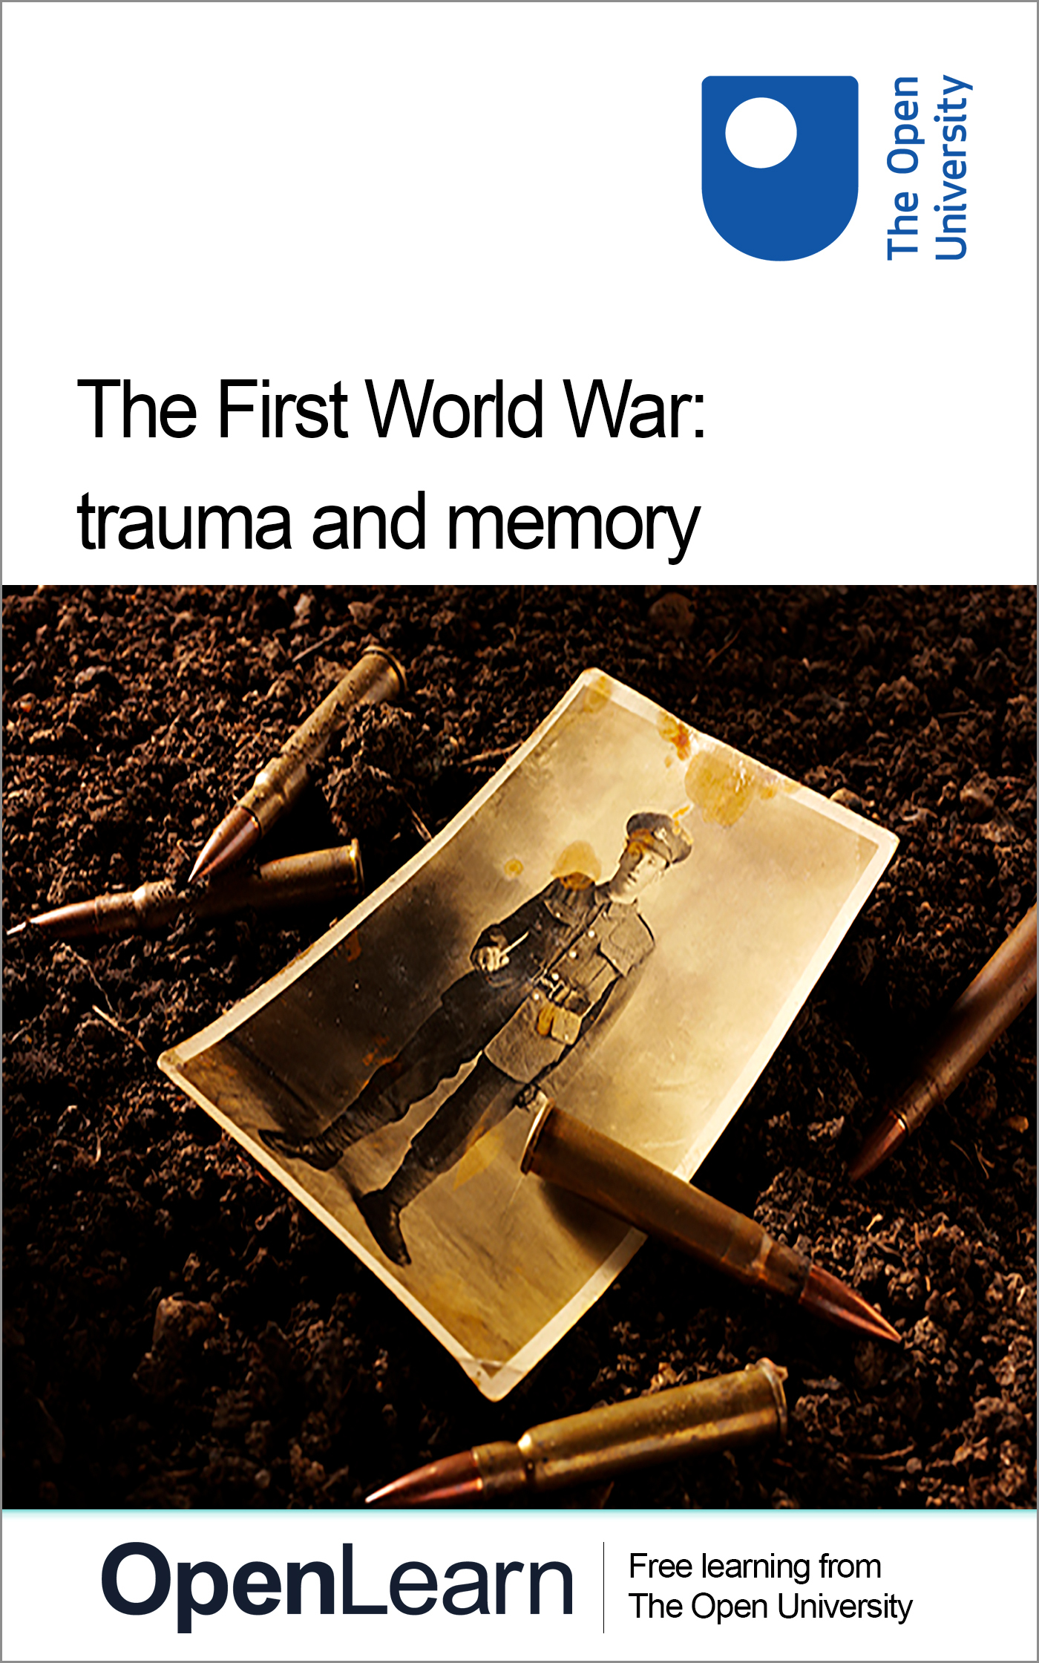

OUFL_14 The First World War: trauma and memory

The First World War: trauma and memory
About this free course
This free course is an adapted extract from the Open University course : .
This version of the content may include video, images and interactive content that may not be optimised for your device.
You can experience this free course as it was originally designed on OpenLearn, the home of free learning from The Open University -
There you’ll also be able to track your progress via your activity record, which you can use to demonstrate your learning.
Copyright © 2016 The Open University
Intellectual property
Unless otherwise stated, this resource is released under the terms of the Creative Commons Licence v4.0 http://creativecommons.org/licenses/by-nc-sa/4.0/deed.en_GB. Within that The Open University interprets this licence in the following way: www.open.edu/openlearn/about-openlearn/frequently-asked-questions-on-openlearn. Copyright and rights falling outside the terms of the Creative Commons Licence are retained or controlled by The Open University. Please read the full text before using any of the content.
We believe the primary barrier to accessing high-quality educational experiences is cost, which is why we aim to publish as much free content as possible under an open licence. If it proves difficult to release content under our preferred Creative Commons licence (e.g. because we can’t afford or gain the clearances or find suitable alternatives), we will still release the materials for free under a personal end-user licence.
This is because the learning experience will always be the same high quality offering and that should always be seen as positive – even if at times the licensing is different to Creative Commons.
When using the content you must attribute us (The Open University) (the OU) and any identified author in accordance with the terms of the Creative Commons Licence.
The Acknowledgements section is used to list, amongst other things, third party (Proprietary), licensed content which is not subject to Creative Commons licensing. Proprietary content must be used (retained) intact and in context to the content at all times.
The Acknowledgements section is also used to bring to your attention any other Special Restrictions which may apply to the content. For example there may be times when the Creative Commons Non-Commercial Sharealike licence does not apply to any of the content even if owned by us (The Open University). In these instances, unless stated otherwise, the content may be used for personal and non-commercial use.
We have also identified as Proprietary other material included in the content which is not subject to Creative Commons Licence. These are OU logos, trading names and may extend to certain photographic and video images and sound recordings and any other material as may be brought to your attention.
Unauthorised use of any of the content may constitute a breach of the terms and conditions and/or intellectual property laws.
We reserve the right to alter, amend or bring to an end any terms and conditions provided here without notice.
All rights falling outside the terms of the Creative Commons licence are retained or controlled by The Open University.
Head of Intellectual Property, The Open University
978-1-4730-2840-1 978-1-4730-2841-8

Contents
- Week 1: Physical and mental casualties
  - Introduction
  - 1.1 Injuries of the First World War
    - 1.1.1 Physical injuries
    - 1.1.2 Finding and interrogating historical data
    - 1.1.3 Search for yourself
    - 1.1.4 Casualties summary
  - 1.2 Introducing shell shock
    - 1.2.1 Interview with Dr Fiona Reid
    - 1.2.2 Treatment of shell shock
    - 1.2.3 Discussing shell shock
  - 1.3 Week 1 summary
- Week 2: Civilian war experiences
  - Introduction
  - 2.1 Atrocities against civilians
    - 2.1.1 The experience of invasion and occupation
    - 2.1.2 The war from the air
    - 2.1.3 The bombing of Hartlepool
    - 2.1.4 Atrocities committed by other armies
    - 2.1.5 Propaganda
  - 2.2 Hunger
    - 2.2.1 Turnips
    - 2.2.2 Hunger: a child’s perspective
    - 2.2.3 The global consequences of the war: the ‘Spanish Flu’
  - 2.3 Week 2 summary
- Week 3: Trauma, grief and bereavement
  - Introduction
  - 3.1 Mourning the dead
    - 3.1.1 Grief and mourning in literature and art
    - 3.1.2 Vera Brittain
    - 3.1.3 Awaiting a telegram
    - 3.1.4 Reactions: trauma, grief and disgust in art
    - 3.1.5 Siegfried Sassoon and shell shock
    - 3.1.6 Great War poets and shell shock
    - 3.1.7 War poetry in the twentieth century
    - 3.1.8 Shell shock in fiction: the example of Pat Barker
  - 3.2 Developing medical attitudes to shell shock after the war
    - 3.2.1 Shell shock since the First World War
    - 3.2.2 Fiona Reid: shell shock
    - 3.2.3 War neurosis and post-traumatic stress disorder
  - 3.3 Summary
  - Where next?
- References
- Further reading
- Acknowledgements

Week 1: Physical and mental casualties

Introduction
Welcome to this free course, First World War: trauma and memory. To start, watch the following video in which Annika Mombauer of The Open University introduces this week.

Video content is not available in this format.
View transcript - Uncaptioned interactive content

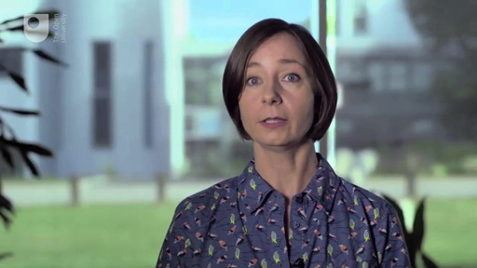

After more than four years of fighting in the First World War, the enormous numbers of dead soldiers and civilians couldn’t be counted accurately. It was even more difficult to account for the many millions of injured, maimed and disfigured soldiers.
During the war, armies and medical professionals were pushed to their limits by the sheer scale of suffering. The types of injuries were not necessarily new, but they occurred on an unprecedented scale. New medical treatments became necessary to deal with wounds to bodies and minds. We often tend to reflect much more on those who died than on those who survived the fighting, but the survivors often had to contend with terrible and long-lasting injuries that continued to haunt them long after the fighting had finally ceased in November 1918. For millions, the suffering did not end with the armistice.
Before you continue reading, you might want to try to guess how many soldiers you think were wounded and killed in the First World War. Jot down your estimate of how many soldiers from the UK, Germany and Russia died. Could you speculate on which country may have had the highest numbers of casualties? Where do you think the highest numbers of civilian losses were sustained? You will look at the answers to these questions, and much more besides, as you explore the trauma and memory of the First World War.
The course is designed to run on desktops, tablets and mobile devices; however, some of the material is quite detailed and using a larger screen will enhance your experience. Materials are best viewed running the most up-to-date software available for your device and using the most recent version of the web browser.

Graphic content
Please be warned that this course contains graphic images of injuries sustained by victims of war.

1.1 Injuries of the First World War
Start by watching a short video in which a historian of the medical history of the war explains the kinds of injuries a soldier might have sustained and the treatments available at the time. As you watch, note if there’s anything unexpected or surprising in what is being discussed.

Video content is not available in this format.
View transcript - Uncaptioned interactive content

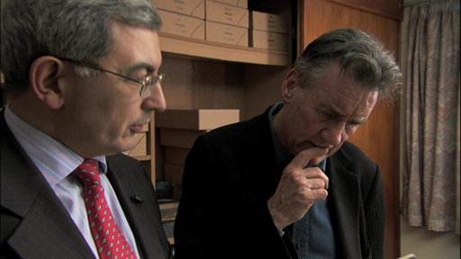

Discussion of the First World War often highlights the appalling death toll. But there were many casualties, often horribly disfigured. Many of them led very reduced lives after the war and plastic surgery to make them look presentable was a process that could take years.
Even once the treatment was finished, the outcome was far from perfect. It is easy to understand why so many facially disfigured soldiers never lived a full life in society again, preferring to hide away with other similarly injured men.

1.1.1 Physical injuries
Figure 1 is a powerful reminder of the terrible injuries that soldiers could sustain.

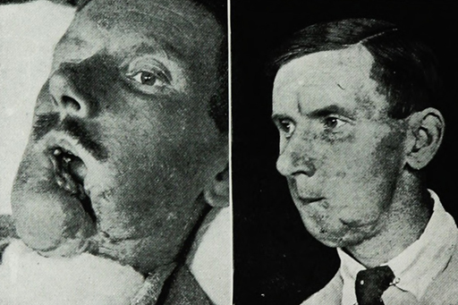
Figure 1 Before and after: facial reconstruction of a wounded soldier
View description - Figure 1 Before and after: facial reconstruction of a wounded soldier

Innovations such as the steel helmet, which one might consider a useful device for safeguarding soldiers, actually made such facial injuries more likely. As the war progressed, survival rates increased due to better protection, but at a terrible price. It is not surprising that at the peace negotiations in Paris in 1919, the French presented the German delegation with a small number of severely disfigured men, so-called gueules cassées (broken faces), to deliver the message that untold harm had been caused by those they considered responsible for starting the war.
Soldiers lost limbs from shell explosions and machine gun attacks in unprecedented numbers. In Germany, for example, around 67,000 men had lost limbs by the end of the war, and this put pressure on the medical establishment to improve the design and functionality of prostheses. If men could not be returned to the front, it was hoped that they could at least return to the workplace – doctors therefore developed a variety of artificial limbs that would allow injured men to undertake various forms of industrial labour. These limbs, however, were often little more than specialised industrial tools, and they were in no way designed to hide a veteran’s disability.

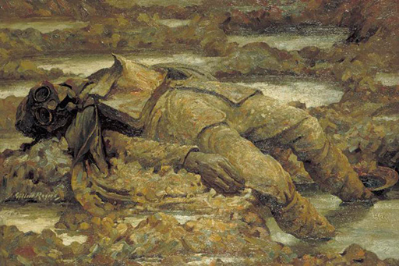
Figure 2 Gassed. ‘In Arduis Fidelis’, Gilbert Rogers (MBE)
View description - Figure 2 Gassed. ‘In Arduis Fidelis’, Gilbert Rogers (MBE)

Soldiers were also blinded and choked by a new and terrifying weapon: gas. This painting, Gassed, by the British artist Gilbert Rogers (Figure 2), depicts in gruesome detail the horrific wounds caused by this most modern of weapons. Soldiers would suffer for many years from the effects of gas, and many would die after the war from injuries sustained during gas attacks.

1.1.2 Finding and interrogating historical data
In the following video, Open University historians Annika Mombauer and Vincent Trott do some ‘desk research’. Their task is to find out how many people died in the First World War.
As you watch, you might want to make a note of some of the ways in which you can find out for yourself about casualty rates, and think about some of the problems that you might face when doing this research.
PDF copies of the casualty tables featured in the video are available here:
Casualty table from Brill’s Encyclopedia of the First World War
Casualty table from The Cambridge History of the First World War

Video content is not available in this format.
View transcript - Uncaptioned interactive content

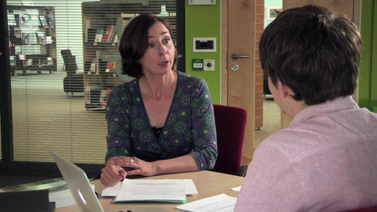

Books consulted in the video:
Gerhard Hirschfeld, Gerd Krumeich and Irina Renz (eds) (2012) Brill’s Encyclopedia of the First World War, volume 2, Leiden, Brill.
Jay Winter (ed.) (2014) The Cambridge History of the First World War, volume 3, Cambridge, Cambridge University Press.

1.1.3 Search for yourself

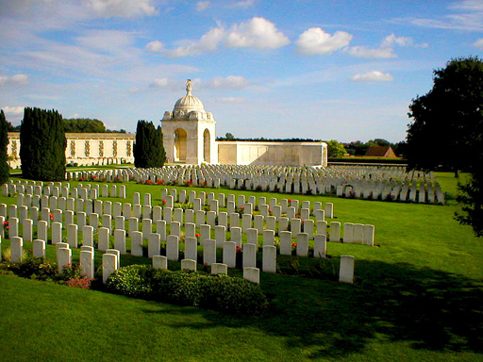
Figure 3 The Tyne Cot memorial to the missing and the cemetery of the dead of the First World War, Passchendaele, Flanders, Belgium.
View description - Figure 3 The Tyne Cot memorial to the missing and the cemetery of the dead of the ...

As you’ve just seen, finding accurate casualty figures is no easy task. Estimates are that around ten million soldiers and up to six million civilians died as a result of the war. You have seen that it is impossible to get exact figures for the casualties of the First World War – many soldiers may have died in captivity or after being discharged from the army, and would not have been included in official estimates. We therefore need to be cautious when approaching statistics of this kind.
Now that you’ve seen historians carry out this research, you could try to do your own historical research, and learn how to find and interrogate historical data. You could do your own internet search for casualty rates of the First World War, using a search engine, just like Vincent did in the video. Most likely, your query will bring up Wikipedia as one of the first hits. As you have just seen, that’s fine as a starting point, so make a note of the casualty rates for a number of other countries, including Germany, Russia, France and Serbia. Choose additional ones if you like. Which countries suffered the highest losses among civilians? Who lost the most soldiers in the war?
Now compare these numbers with some different sources, like the History Learning site or those featured in the previous section. An excellent resource is 1914–1918 Online, an authorative online encyclopedia of the First World War. It includes a thoughtful article on war losses.
In Table 1 are the figures found for Germany, Russia, France and Serbia.

Table 1 Casualty rates for the First World War
Country | Military Deaths | Percentage of Men Mobilised | Civilian Deaths
France | 1,327,000 | 16% | 40,000–600,00
German Empire | 2,037,000 | 15% | 426,000–700,000
Russia | 1,997,500 | 11% | 1,500,000–2,000,000
Serbia | 278,000 | 33% | 300,000–650,000

The military casualty figures are the most recent estimates taken from Jay Winter, The Cambridge History of the First World War, volume 3.
The civilian casualty figures have been taken from 1914–1918 Online. The estimates vary depending on whether you include victims of the Spanish flu or civilians dying of starvation after the war.

1.1.4 Casualties summary

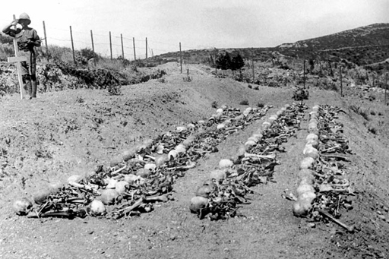
Figure 4 Rows of bones gathered following the Battle of Chunuck Bair, Gallipoli.
View description - Figure 4 Rows of bones gathered following the Battle of Chunuck Bair, Gallipoli.

In this first part of the course, you have considered some of the physical injuries suffered by soldiers of the First World War, and some of the treatments that were developed by the medical profession to deal with huge numbers of casualties.
You’ve also learned why casualty figures can vary greatly from source to source, and thought about how historians have been revising casualty figures over the last few years. The true extent of the losses will never be fully known, but it is clear that casualties were even higher than was previously suspected. Statistically speaking, recent estimates suggest that around 6,000 soldiers died per day during the First World War.
You will now move on to another aspect of considering casualties in the First World War: ‘shell shock’ and mental trauma.

1.2 Introducing shell shock
Watch the following video on shell shock.

Video content is not available in this format.
Please note that there is no sound in this video.

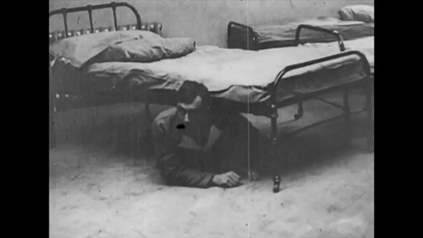

The term ‘shell shock’ is particularly associated with the First World War. It was used in Britain to describe the various forms of psychological trauma suffered by men as a result of combat. A wide range of symptoms were associated with the condition, as the video above demonstrates. Mental trauma among combatants was nothing new, nor was it particular to British soldiers or the First World War, but the term was not used in other countries or in subsequent wars. In this sense, ‘shell shock’ remains culturally and historically specific.
The first psychological casualties of the war were identified in 1914, but the term shell shock first appeared in a medical context in early 1915, when the military doctor, Sir Charles Myers, used the term in the medical journal The Lancet. The choice of words is telling: nervous breakdown was at first seen to be a consequence of concussion caused by exploding shells, and reflected a general belief that shell shock had physical rather than psychological origins. This diagnosis was partly a consequence of a general stigma attached to mental illnesses that had persisted since Victorian times. Nervous breakdowns were often dismissed as hysteria, and were associated with degeneracy, cowardice and a lack of fortitude in men. Such a condition was therefore entirely at odds with the ideals of masculine behaviour that soldiers were expected to exhibit, and mental breakdown was accordingly seen by many to be a shameful, unmanly condition. By maintaining that shell shock was ultimately a physical disorder, doctors therefore ensured that the illness retained a modicum of respectability.
The military authorities, however, were reluctant to recognise shell shock as a legitimate condition. Nervous disorders were frequently viewed from a disciplinary perspective, and men who broke down with fear were often accused of being cowards or malingerers. Nevertheless, by 1915 it was clear that mental breakdown was becoming a potential threat to military manpower, and a large treatment network was established in order to address this problem. This included military hospitals dedicated to mental disorders, such as Craiglockhart near Edinburgh, Maghull near Liverpool and Queen Square in London. In addition to these institutions, specialist wards were opened in other hospitals across the country. However, the doctors working in these hospitals were often torn between their duty to care for their patients and the need to pass men as fit so that they could return to the front as quickly as possible.
The way shell shock was understood and treated was also dependent on the class and rank of the patients. During the First World War, Britain remained a society deeply divided by class and these divisions were reflected in the structure of the army, with officers being primarily drawn from the upper-class elite at the beginning of the war. Men from these more ‘respectable’ backgrounds were therefore often treated more sympathetically. They were less likely to be associated with the degenerate characteristics that were sometimes attributed to soldiers from lower-class backgrounds. As upper-class men were seen to be from ‘better stock’, their condition was more likely to be treated as a genuine illness. The terminology used to classify the symptoms exhibited by soldiers from different backgrounds varied too: officers were more likely to be diagnosed with ‘neurasthenia’, while soldiers from lower-class backgrounds were frequently labelled as ‘hysterical’ – a term which was loaded with negative connotations.

1.2.1 Interview with Dr Fiona Reid
In the following video, Dr Fiona Reid, an expert on shell shock, describes what shell shock was, how it was treated and how it was regarded by contemporaries. She also explores the specific British connotations of the term, and the way we associate it with the First World War in particular.
As you watch, you could make a note of how Fiona describes the condition and try to answer the following questions:
- What was shell shock?
- How was it treated?
- Why is the term imprecise?
- What is the importance of class and age for the condition?

Video content is not available in this format.
View transcript - Uncaptioned interactive content

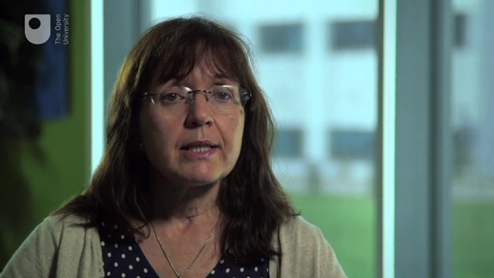

Later, you will explore how attitudes towards the condition changed after the fighting had finished.

1.2.2 Treatment of shell shock
Next, Fiona Reid discusses the various methods that were used to treat shell shock. These might include rest and distraction, or could entail more extreme treatments, such as electric shock therapy (faradism).
Modern forms of psychoanalysis were relatively rare at this stage, although some doctors, such as the famous W.H.R. Rivers, did encourage the ‘talking cure’.

Video content is not available in this format.
View transcript - Uncaptioned interactive content

1.2.3 Discussing shell shock

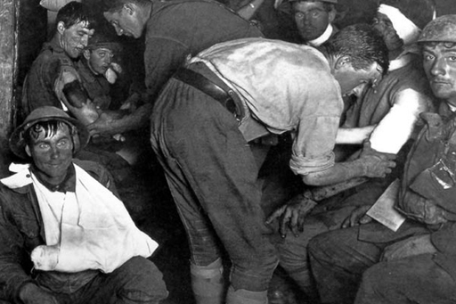
Figure 5 An Australian Advanced Dressing Station near Ypres in 1917. The wounded soldier in the lower left of the photo has a dazed, thousand-yard stare – a frequent symptom of shell-shock.
View description - Figure 5 An Australian Advanced Dressing Station near Ypres in 1917. The wounded ...

In the video in the previous section, Fiona Reid explained that ‘shell shock’ was an imprecise term used during the First World War to describe a variety of symptoms, ranging from stammering and tremors through to more serious forms of mental breakdown. Due to this imprecision, the medical authorities were keen to ban the term, but the phrase endured because it made sense to people.
Reid also noted how shell shock could be associated with a loss of masculinity – men were expected to keep control of their nerves – but this did not necessarily mean that they were treated unsympathetically, particularly if they had previously shown bravery in battle. Shell shock was also frequently associated with very young men, and public attitudes were often more understanding in these instances.
We have not really talked about women here, but you might want to reflect on how women might have been affected by shell shock? Certainly, caring for mentally damaged men was often the role that fell to women, and they would have had to learn how to deal with shell-shocked loved ones. But they may of course also have suffered similar illnesses, for example if exposed to bombing on the home front, after serving as nurses on the front, or after having suffered atrocities at the hands of soldiers.

1.3 Week 1 summary

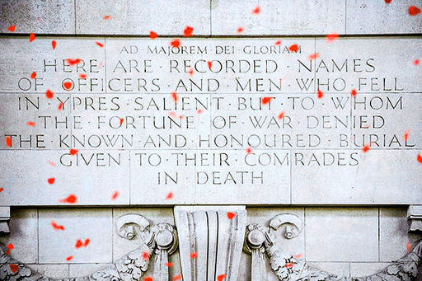
Figure 6 Poppies falling from the top of the Menin Gate in Ypres, Belgium.

You’ve now encountered some of the physical and mental trauma suffered by those who fought in the First World War, and have also considered the overall casualty rates for some of the main combatant nations.
It is certainly worth remembering that while the numbers of dead are shocking and deplorable, and we rightly remember them even today, we should also remember the many more who were casualties of this war, but who survived the slaughter. Indeed, Dr Bamji’s plea (in the first video you watched) to consider this suffering was very compelling. There were some 20 million wounded in the First World War and for many of them, the war was not over when the armistice was declared.
But of course, the war also affected non-combatants. In next week, you’ll examine how the First World War affected civilians.

Week 2: Civilian war experiences

Introduction
First, watch this video in which Annika explains what you’ll be studying this week.

Video content is not available in this format.
View transcript - Uncaptioned interactive content

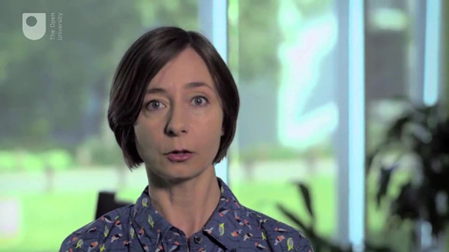

Last week, you looked at some of the devastating physical and psychological effects of the First World War upon combatants. This week, you will reflect on the traumatic experiences of civilians in wartime.
First, you will examine some of the excesses of war committed by invading and occupying armies. Then you will focus on an experience common to most civilians during the war: hunger. This affected everyone on the home front, and one of the examples here focuses on the experience of children at war who were the innocent victims of this conflict.

2.1 Atrocities against civilians

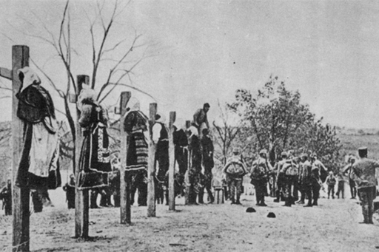
Figure 1 Austria-Hungarian soldiers executing Serbian women, 1916.
View description - Figure 1 Austria-Hungarian soldiers executing Serbian women, 1916.

Mistreatment of civilians was not an entirely new phenomenon in the First World War. Armies had always been bad news for civilians who encountered them. Early twentieth century examples of modern warfare had already given an insight into what was to come: the first aerial bombardments were executed in Italy’s war against Libya in 1911, and the Second Balkan War of 1913 had seen atrocities committed against civilians, including the destruction of villages and the murders of their inhabitants.
However, these crimes seemed to be explicable to many onlookers with the ethnic tensions that existed in the Balkans. News of such atrocities aroused international condemnation, but also a sense that such acts would not be possible among the larger, ‘civilised’ nations. However, that civilised façade broke down almost as soon as war had broken out in August 1914.
From 1914 onwards, new military technology exposed civilians to greater risks than ever before. War at land, at sea and from the air turned civilians, including women and children, into targets. The blurring of distinctions was particularly apparent in smaller states like Belgium, which relied on a citizens’ militia for its defence, making it harder for the invading German army to distinguish between soldiers, armed civilians and innocent bystanders. As you saw when you looked at casualty figures, this new type of warfare led to civilian deaths and injuries on an unprecedented scale.

2.1.1 The experience of invasion and occupation

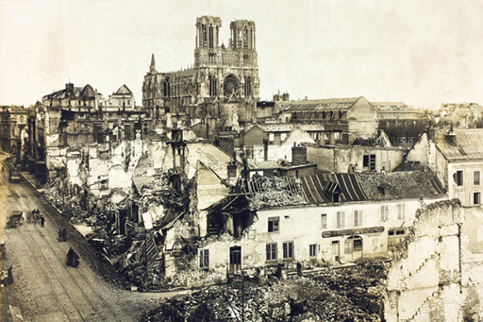
Figure 2 The city of Reims after its destruction in 1914.
View description - Figure 2 The city of Reims after its destruction in 1914.

During the First World War, some traumatic acts of reprisal occurred against civilians in neutral and occupied countries on a scale which was shocking to contemporaries.
The atrocities committed by German soldiers in Belgium and France in 1914 provide some of the most prominent examples of the war’s impact upon civilian populations, though atrocities were also committed by other armies and in other contexts. In the Belgian and French examples, such acts were partly motivated by the memory of previous wars. The so-called franc-tireurs of the Franco-Prussian war of 1870–71 had instilled a deep-rooted fear of partisans in German soldiers. A stray bullet, the news of an alleged poisoned well, or other acts of real or imagined resistance could be seen as evidence of such action and lead to the punishment of scores of suspected partisans and innocent civilians. Cultural differences, including antipathy towards the local Catholic population, also inspired the violence. What is clear, however, is that these atrocities were not part of a premeditated military strategy; rather, they developed as part of the frightening reality in which soldiers and civilians found themselves.

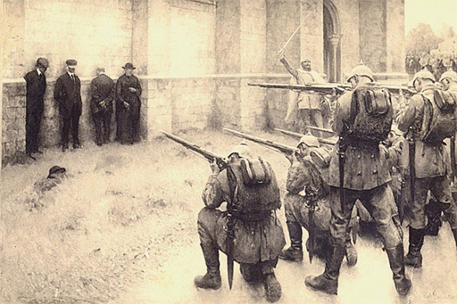
Figure 3 L’exécution des notables de Blégny 1914, by Evariste Carpentier, 1918.
View description - Figure 3 L’exécution des notables de Blégny 1914, by Evariste Carpentier, 1918.

In 1915, the Austrian psychologist Sigmund Freud commented that the violence against civilians

disregards all the restrictions known as International Law which in peacetime the states had bound themselves to observe; ignores the prerogatives of the wounded and the medical service [and] the distinction between the civil and military sections of the population … The civilized nations know and understand one another so little that one can turn against the other with hate and loathing. Indeed, one of the great civilized nations is so universally unpopular that the attempt can actually be made to exclude it from the civilized community as ‘barbaric’.
(cited in Horne, 2014, p. 565)

Such acts of barbarism were attributed to the German army by its enemies. Following the German invasion of Belgium in August 1914, the German army swept through towns and villages, with little regard for the local inhabitants. Having already killed 640 civilians in the area around Liège, the German army invaded the city of Louvain on 19 August. Over a period of five days, beginning on 23 August, the invaders attacked civilians and burnt down buildings. The university library, for example, which housed numerous ancient manuscripts, was burnt to the ground – this act of wanton violence would become a powerful symbol for the barbarism of the German army in Belgium. Pillaging was rife, and it is estimated that around 248 civilians were deliberately murdered in Louvain. Similar atrocities were committed elsewhere in Belgium and northern France.

2.1.2 The war from the air
At 11.30am on 17 June 1917, German aircraft carried out a daylight raid on London, dropping 72 bombs, which killed 162 civilians. One bomb hit Upper North Street School in Poplar in the East End, killing 18 children.
The use of zeppelins and aeroplanes turned civilians on the home front into targets of war, and the bombing of towns and cities claimed countless victims. German aircraft attacked southern English towns and cities, including London, causing casualties and, of course, instilling fear.
It is clear that the killing of innocent civilians had a profound impact on public attitudes in Britain. The bombing of the school in East London provided further evidence for many of Germany’s barbaric aggression, as the following extract from The Times indicates:

A hard life has not hardened the dwellers in dockland. Behind the dingy and often squalid exterior of the East End there lies a rich fount of human emotion. Sometimes it wells up and makes one marvel at the great heart of the toilers in these mean crowded streets. Yesterday all Poplar and the neighbouring borough were charged with an overflowing sympathy for the mothers and fathers whose children have been slaughtered on the altar of German ruthlessness.
(The Times, 21 June 1917)

When reading this quotation, you might want to consider how this newspaper portrayed the character of the inhabitants of the local area, and how it represented the enemy? It’s easy to see how newspaper articles like this might have impacted on public opinion.

2.1.3 The bombing of Hartlepool
Civilians were also bombed from ships at sea, a terrifying experience as there was little warning and no visible enemy. A famous example was the bombing of Hartlepool, Scarborough and Whitby on 16 December 1914. This surprise bombardment by German ships killed 137 people. Three German warships fired more than 1,000 shells during the bombardment. The coastal defence batteries inflicted some damage on the warship Blücher, but found themselves outgunned. The raids were used in recruitment drives by the British military. Posters were produced with the headings ‘Remember Scarborough! Enlist now’ and ‘Men of Britain! Will you stand this?’

2.1.4 Atrocities committed by other armies

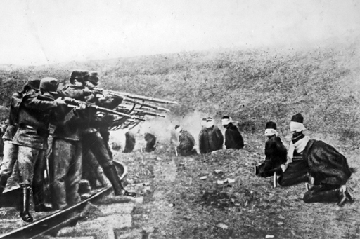
Figure 4 Austrian soldiers executing Serbs, 1917.
View description - Figure 4 Austrian soldiers executing Serbs, 1917.

Of course, Germany did not have a monopoly on violence against civilians. In June 1915, for example, French planes killed 30 civilians and wounded 68 more in just one attack in the southern German town of Karlsruhe. In total, 740 civilians died in Germany from allied bomb attacks during the war, while 1900 were injured.
Both sides wished to undermine their enemy’s morale by targeting civilians who had to get used to living with air raid sirens, blackouts and air raid shelters as the distinctions between combatants and non-combatants were removed. It is important to note that French and British armies never faced enemy civilians on enemy territory and thus we cannot compare their behaviour with that of Germany.
Where armies met civilians, acts of violence against them were commonplace. For example, atrocities were committed by the Austro-Hungarian army during its occupation of Serbian territory. In order to seek revenge for the murder of Archduke Franz Ferdinand, whose assassination at the hands of a Bosnian Serb had been the trigger for the events that led to war, reprisals against Serbs were widespread. It is estimated that as many as 650,000 Serbian civilians died in the war (though this figure also includes those who perished from diseases and malnutrition).

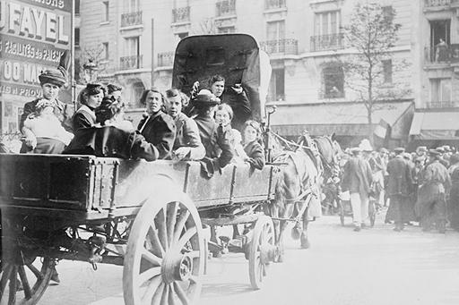
Figure 5 Belgian refugees arriving in Paris, 1914.
View description - Figure 5 Belgian refugees arriving in Paris, 1914.

All occupied territories saw greater or lesser degrees of forced labour, deportation and internment of civilians, including some 70,000 Serbs by 1916, and some 100,000 French and Belgians between 1914 and 1918. Russia, one of the Allied Powers, did occupy enemy territory, and Russian troops also committed atrocities against civilians there. About 100,000 Germans were interned by Russia. Both sides used techniques of modern warfare against civilians, including aerial bombardments and naval warfare (which led to the sinking of passenger ships), thus transforming the civilian experience of war once and for all.
The war also allowed states to commit atrocities against minorities within their own borders. A tragic example of this is the fate of the Armenians in the Ottoman Empire, up to one million of whom are believed to have perished due to mistreatment and murder. You will find these figures reflected in the casualty statistics that you consulted last week. Russian troops mistreated civilians during their retreats from Galicia and Bukovina in 1915 and deported some three million inhabitants, while the German retreat of four armies in France in 1917 led to the evacuation of 160,000 civilians and the complete destruction of the territory they left behind.

2.1.5 Propaganda
Acts of brutality against civilians, both real and imagined, were a perfect vehicle for propaganda against the enemy. Allied propagandists, particularly in Britain, exploited stories of Germany’s ruthless behaviour to provide a moral justification for the war effort. These posters are examples of this. All of these images and others can also be found at the Europeana collections website.

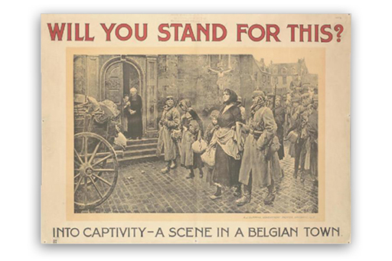
Figure 6 View on the Imperial War Museum website.
View description - Figure 6 View on the Imperial War Museum website.

This recruitment poster was made in Brisbane, Australia (no date is given). Australia was a British dominion during the First World War, and Australian men – many of whom had been born in Britain – voluntarily enlisted in large numbers to fight on behalf of the British Empire. Recruitment posters like these highlighted German atrocities against civilians in Belgium and fostered moral outrage in order to promote enlistment. This poster uses a photograph of German soldiers rounding up Belgian civilians and allegedly leading them into captivity.

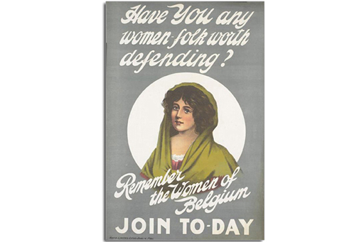
Figure 7 View on the Imperial War Museum website.
View description - Figure 7 View on the Imperial War Museum website.

Many recruitment posters, like this one – made in Dublin, Ireland in 1915 – encouraged enlistment by alluding to the atrocities committed against women. It is implied here that by joining up to fight, men would not only come to the rescue of innocent female victims abroad, but would also be protecting their wives back home.

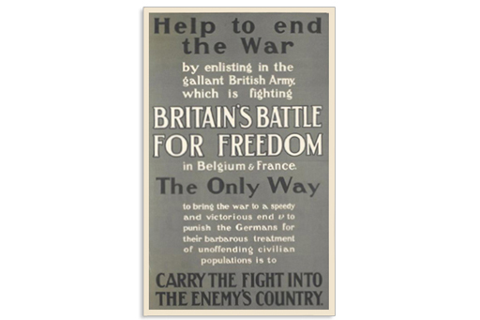
Figure 8 View on the Imperial War Museum website.
View description - Figure 8 View on the Imperial War Museum website.

This English recruitment poster – made in Harrow, Middlesex in 1915 – makes specific reference to German atrocities, portraying the war as a moral crusade and an opportunity to ‘punish’ the Germans for their actions.

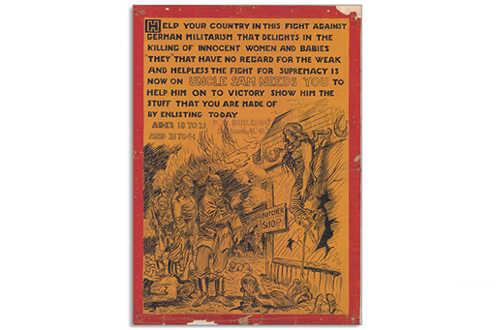
Figure 9 View on the North Carolina Digital Collections website.
View description - Figure 9 View on the North Carolina Digital Collections website.

Although the USA didn’t join the war until 1917, American propagandists also highlighted German atrocities in order to encourage enlistment. This poster – made in Durham, North Carolina in 1918 – employs a particularly vivid sketch of a woman being shot while hanging from a meathook.

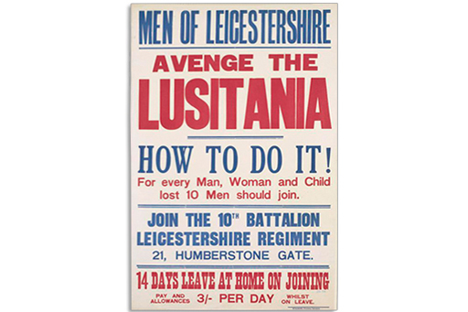
Figure 10 View on the Imperial War Museum website.
View description - Figure 10 View on the Imperial War Museum website.

This English recruitment poster – made in Leicester in 1915 – draws attention to the German sinking of the Lusitania in May 1915, a passenger ship that was carrying numerous civilians between New York and Liverpool. The poster encourages men to avenge the sinking, while also highlighting the benefits of enlisting.

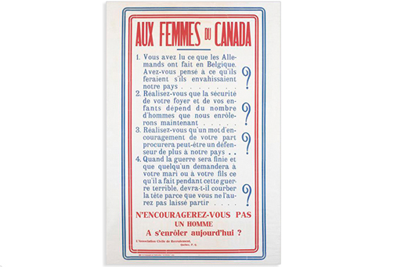
Figure 11 View on the Imperial War Museum website.
View description - Figure 11 View on the Imperial War Museum website.

Like Australia, Canada was a British dominion during the war, and Canadian men were encouraged to enlist in large numbers. This poster, made in Quebec, appeals to French-Canadian women, urging them to encourage their menfolk to enlist. Again, a reference to German atrocities is used to inspire moral outrage. It reads as follows:

- You’ve read about what the Germans did in Belgium. Have you thought about what they would do if they invaded our country … ?
- Do you realise that the safety of your home and your children depends on the number of men we enlist now … ?
- Do you realise that a word of encouragement from you will perhaps procure one more defender for our country … ?
- When the war is over and someone asks your husband or your son what he did during this terrible war, will he have to hang his head because you didn’t let him go…?
Won’t you encourage a man to enlist today?

2.2 Hunger
As the war dragged on, civilians increasingly began to be affected by shortages resulting from blockades and from the demands the war machine placed upon the combatants’ economies.
Germans claimed after the war that 750,000 civilians had died as a result of the British blockade of Germany, which wartime chancellor, Theobald von Bethmann Hollweg, described as a ‘barbaric way of waging war’.

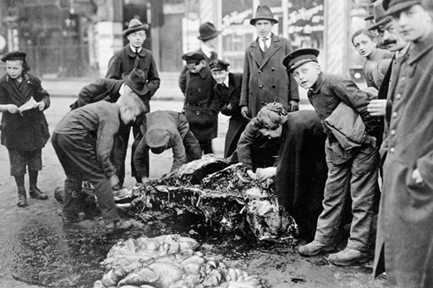
Figure 12 Civilians carving up a horse carcass on the streets of Berlin, c.1917.
View description - Figure 12 Civilians carving up a horse carcass on the streets of Berlin, c.1917.

Hunger was an experience familiar to many during the four long years of war. Most of the estimated 700,000 or more civilian casualties in Germany died from the consequences of hunger during the war. This figure does not include all the victims of the Spanish influenza epidemic, which struck at the end of the war and claimed as many as 350,000 victims in Germany, many of whom had been weakened by malnourishment.
Astonishingly, these staggering figures have hardly been remembered in Germany, where the civilian losses of the Second World War have featured much more prominently in public memory. Estimates for these losses are also imprecise, but are thought to be between 500,000 and 600,000 civilians, many of them lost in Allied bombing raids on German cities. Not many Germans know that twice as many civilians were mourned as a result of the First World War.
Throughout the war, Britain used its naval superiority to enforce a blockade on Germany, inhibiting the supply of crucial raw materials and foodstuffs. This was a factor in creating food shortages in Germany, although historians now believe that the effect of the blockade has been exaggerated, and that shortages were also a result of mismanagement of resources and supplies. The fact remains, however, that during the First World War (and in the months that followed the Armistice, when the British blockade continued), many civilians went hungry and suffered from cold. For the German government, it was easy to blame the British blockade for the deprivation its people experienced, even though the reality was more complicated.
German agriculture was severely affected by shortages of grain, fodder and fertilisers, and this was further exacerbated by a poor potato and wheat harvest in 1916. As a consequence, turnips, which were neither appetising nor nutritious and had previously been mainly used as animal fodder, were widely used as a substitute foodstuff, resulting in the so-called ‘Turnip Winter’ of 1916/17.
Shortages also encouraged a flourishing black market, exorbitant food prices and tensions between communities when it was felt that food was not being distributed equitably. These factors all contributed to declining morale and increasing unrest on the German home front – both of which would severely undermine the German war effort and contribute to its ultimate demise. Before the German army was defeated, Germany had arguably already been defeated economically – starvation had made the population weary of war and unwilling to contemplate yet another winter at war.

2.2.1 Turnips

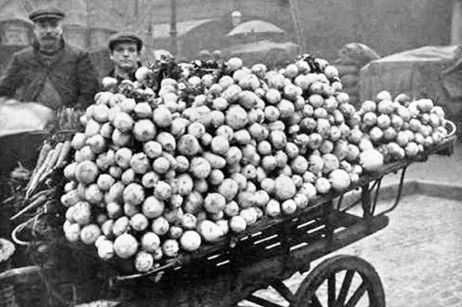
Figure 13 A German turnip cart. The turnips are infested with maggots of Gall Weevil.
View description - Figure 13 A German turnip cart. The turnips are infested with maggots of Gall We ...

During the winter of 1916/17, rations were reduced further, to 1000 calories per day, half of what was needed by an adult. A daily menu might have consisted of swede soup for breakfast, swede ‘chops’ for lunch, and swede cake for dinner. Even coffee was made of dried ground swedes or turnips.

A note on terminology – the German term for the root vegetable consumed in huge quantities is ‘Steckrübe’. This is a yellow root vegetable and in the UK more commonly known as a swede, though confusingly in Scotland a ‘neep’, as in turnip, is the term used for a swede (or Swedish turnip). It is the term ‘turnip winter’ that is used as translation for the German ‘Steckrübenwinter’, and whether turnip or swede, arguably neither would make for a very varied and healthy diet.

2.2.2 Hunger: a child’s perspective

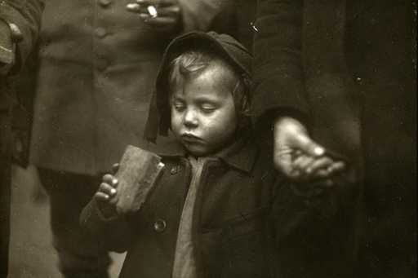
Figure 14 The struggle to survive.
View description - Figure 14 The struggle to survive.

Look at this account of the experience of hunger. Although it is a fictional account, it is likely to have been autobiographical to some extent. The author and his character share the same year of birth (1902), and would therefore have been too young to fight in the war, but old enough to experience and remember the deprivations on the home front.

‘This is going to be a hard winter,’ sighed my mother on one of those days, as Kathinka put the meal on the table. The meal consisted of a couple of slices of fat-free sausage, daintily cut-up turnips, which were held together by a thin sauce, and three potatoes per person. The bread could well have been used to make models of small men. It was like clay. We sat waiting, almost praying, in front of this meal. Perhaps, we thought, it would change miraculously to match our desires. While I was opening my napkin apathetically and lethargically – for we had been eating the same thing almost daily for months – my mother put her hand on the back of my neck, ran her hand almost fearfully through my hair and said softly and indistinctly: ‘I can’t do anything about it … tomorrow perhaps I can get a couple of eggs and some meat … don’t be so sad … perhaps I can also get some white flour …’ She wept. ‘But mother,’ I lied, ‘this tastes very good, although of course the other things would be even better.’ I picked up my spoon and dug enthusiastically into the pale turnips. Then Kathinka, who has been allowed to eat at our table since the beginning of the war, stopped me, gave me a reproaching look, and folded her hands. We sat stiffly in the chairs, and as a company of new recruits marched through the street to the firing ranges, singing songs as ordered, I prayed loudly and defiantly, ‘Dear Lord Jesus, be our guest and bless what you have given us.’ From the bread plate the slogan of the year glowed in red letters: ‘Better war-bread than no bread.’
Then we bowed our heads quietly over the meal. Kathinka gave me her potatoes; my mother gave me two slices of sausage. Afterwards I had to lie down so the meal would settle. Kathinka, however, was asked to go next Sunday to her parents, who live on a farm in Upper Franconia, and to get some butter. My mother gave her one of her prettiest blouses and, for her old father who liked to read books, three volumes of Felix Dahn’s The Struggle for Rome. ‘Thank you,’ said Kathinka and wiped her hands with joy on her apron, the pocket of which was embroidered with a small black, red and white flag. ‘Ha, I’ll bring butter rolls back – they won’t catch me. . .!’ She meant the military police, who for the last month have been posted at the train stations, checking every arriving passenger for forbidden foodstuffs. We trusted Kathinka, because we knew where she hid the butter rolls. In her woolen bloomers. The shamelessness of the war had not yet reached the point where the police were allowed to search there.
(Gläser, 1928, pp. 290–3)

Hunger, as well as the fear of enemy action, made for traumatic childhood experiences. We think of shell shock affecting soldiers, but even children could be affected by trauma. It is likely that we will never know the long-term effects of such suffering, and of course, for many it was only to be exacerbated by the even more horrific treatment of civilians and soldiers in the Second World War.

2.2.3 The global consequences of the war: the ‘Spanish Flu’

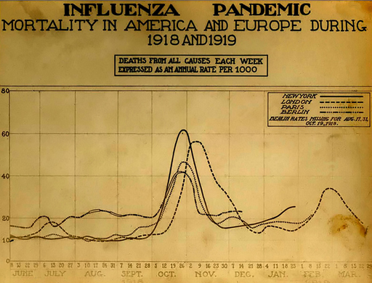
Figure 15 Chart showing mortality from the 1918 influenza pandemic in the US and Europe. Courtesy of the National Museum of Health and Medicine, Armed Forces Institute of Pathology, Washington, D.C., United States.
View description - Figure 15 Chart showing mortality from the 1918 influenza pandemic in the US and ...

Food shortages, of course, were not peculiar to Germany. The reallocation of resources and manpower towards the war effort restricted the supply of food in all countries.
In Russia, on the eve of revolution, bread was the first demand voiced by demonstrating women. In Britain, rationing was introduced in 1918, though crucially never for bread (something that the Russian authorities might have been well advised to copy). Malnutrition, and an increased susceptibility to diseases such as scurvy and tuberculosis, became a serious problem as the war went on.
Similarly, the Spanish flu, which had touched almost every corner of the earth by the end of the war, would claim millions of victims among civilians and soldiers already weakened by hunger. Despite its name, the flu did not originate in Spain. A number of theories have been put forward, but evidence suggests that the disease may have originated in the American Midwest in early spring 1918, where it was spread between troops in military training camps. About half of the military deaths recorded by the US army were due to influenza.
By April 1918, the flu had been carried to various parts of Europe, including Spain, which initially led health authorities to believe that this was where it had originated. Three successive waves of the disease spread between spring 1918 and spring 1919, affecting nearly every inhabited area of the world. Highly contagious, the pandemic peaked towards the end of the war. It was easily transmitted by the movement of troops through densely packed areas of the front and major cities. Overall, it is estimated that around 2.5 to 5 per cent of the world’s population – somewhere between 50 and 100 million people – died as a result of the disease.

2.3 Week 2 summary

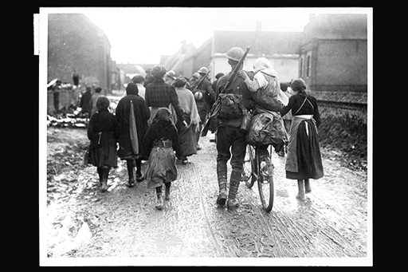
Figure 16 British soldiers entering a village in France.
View description - Figure 16 British soldiers entering a village in France.

In this week’s study, you have learned about the varying ways in which the war affected civilians, both mentally and physically, on the home fronts of Europe. Wars in the twentieth century no longer spared civilians. They were victims of atrocities, hunger and disease. Casualties among combatant populations reached unprecedented numbers as states mobilised every last resource in order to win this war.
In the final week of this course, you will be looking at representations of trauma and grief in art and literature, and you will also explore how trauma continues to affect combatants and non-combatants in conflicts in the twenty-first century.

Week 3: Trauma, grief and bereavement

Introduction
Watch the video in which Annika talks about the subject of this week.

Video content is not available in this format.
View transcript - Uncaptioned interactive content

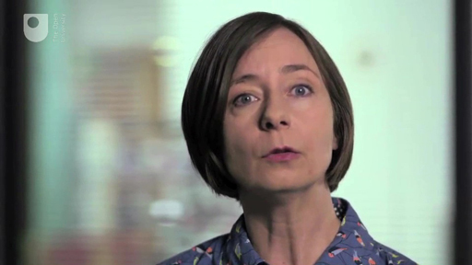

In this final week of the course, you will be taking a closer look at grief and grieving during and after the war, and the different expressions that this could take − from private and public grief, to the way such emotions were explored by artists and authors in art and literature.
You will also find out how attitudes to shell shock developed after the war. You will study examples of how this topic was represented in art and literature, and you’ll consider how the condition was treated and regarded at different times in the twentieth century.

3.1 Mourning the dead
The nature of death during the First World War severely disrupted traditional mourning practices.

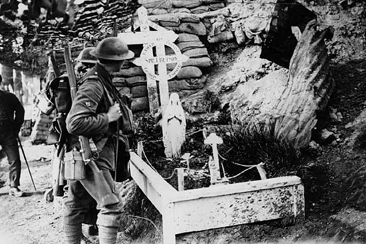
Figure 1 The grave of sapper Ivor Beynon of the Canadian Engineers, near the front line in the Ypres salient, 1918.
View description - Figure 1 The grave of sapper Ivor Beynon of the Canadian Engineers, near the front ...

Outside of wartime, mourning would usually take place at burial sites and focus on the body of the deceased, but during the war this was frequently impossible. The bodies of many soldiers who died at the front could not be identified due to the horrific injuries they had sustained. During periods of intense fighting it was not always possible for bodies to be gathered up and given a proper burial, and those soldiers who could be identified were usually buried in makeshift graves near where they had fallen. Many were never found. Bereaved relatives and loved ones on the home front were therefore often deprived of a body or a grave at which they could mourn, and, where graves existed, they were often too far away to visit. This hindered closure, and often intensified personal trauma.
As a result, new funerary customs and mourning practices developed. Some bereaved families would adopt other bodies as a focus of their mourning, following the funeral cortèges of soldiers unknown to them. This notion that one dead soldier could symbolise all those who had died gave rise to the Tombs of the Unknown Soldier in London and Paris, both of which were established in 1920. In London, the body of an unidentified soldier, who had initially been buried on the Western Front, was entombed at Westminster Abbey. In Paris, the same was done at the Arc de Triomphe.

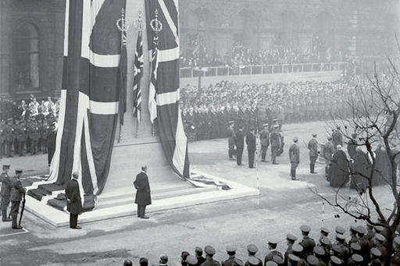
Figure 2 The unveiling of the cenotaph in Whitehall, 1920.
View description - Figure 2 The unveiling of the cenotaph in Whitehall, 1920.

In London, a cenotaph – which literally means ‘empty tomb’ – was also established in 1919. This was initially a temporary structure, but due to its popularity a permanent tomb was built and unveiled in 1920. Symbolically significant sites such as these, along with countless war memorials across the belligerent countries, proved popular focal points for mourning and continue to serve as commemorative sites to this day.
Historians have produced detailed studies of the effect of the war on specific towns and cities. One example is Osnabrück in Germany, a town of around 80,000 inhabitants in 1914. Between August 1914 and the end of 1919, around 2,200 soldiers from the town lost their lives. Statistically, that amounted to news of a death being received every 16 hours. In this town, 15 to 20 per cent of families suffered the loss of one soldier, with some losing as many as four relatives in the war. Assuming a wider ‘circle of mourning’ which extended beyond immediate relatives, it can be estimated that between 25 and 75 per cent of the town’s population were directly or indirectly affected by a war-related death.

3.1.1 Grief and mourning in literature and art

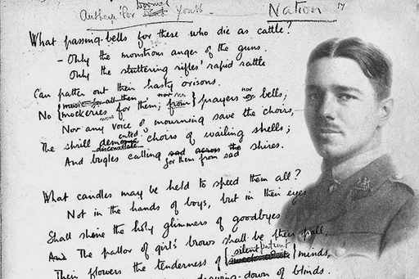
Figure 3 Wilfred Owen, 1893−1918. The text is part of a draft of his famous poem ‘Anthem for Doomed Youth’.
View description - Figure 3 Wilfred Owen, 1893−1918. The text is part of a draft of his famous poem ...

Given the scale of the casualities, the psychological damage of the war extended beyond the battlefields. On the home front, many families, friends and fiancés never saw their loved ones return. Sometimes there were considerable delays before families learnt of a death. On 4 November 1918 the now-famous poet Wilfred Owen died while crossing the Sambre-Oise Canal in northern France. This was a successful operation for the British and victory was in sight, but it was not until the armistice that Owen’s mother discovered the news of her son’s death. For every well-known casualty, like Owen, there are dozens of victims whose names we have now forgotten, but whose loss was equally mourned at the time.
The bereaved developed a variety of methods for coping with their grief. To console themselves they often sought to attribute meaning to the deaths of their loved-ones. The notion that the dead had died for a valid cause offered solace for many, but this could lead to conflicting emotions, as the example in the next section demonstrates.
Grief was a recurring theme in art and literature, both during and after the war. Like everyone else, artists and writers struggled to make sense of the losses around them, and in many cases they also mourned their own personal losses and dealt with their own grief in their work. Next, you will look at some case studies, starting with the example of Vera Brittain.

3.1.2 Vera Brittain

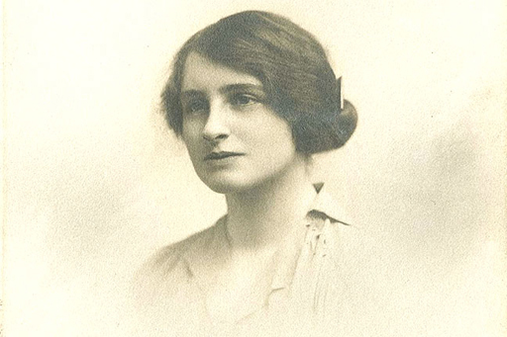
Figure 4 Vera Brittain, 1893−1970. This photograph was taken in 1918.
View description - Figure 4 Vera Brittain, 1893−1970. This photograph was taken in 1918.

The British writer Vera Brittain served as a nurse during the war, and lost her fiancé, brother and two close friends in the war. She was appalled by the horrific injuries she witnessed, and through her multiple bereavements became increasingly disillusioned with the validity of the war. Yet, despite her developing disillusionment, Brittain’s wartime letters and diaries reveal that she clung to many of the romantic and patriotic ideals that legitimised the conflict. By doing so, she reassured herself that those she loved had not died in vain. This ambivalent attitude was by no means uncommon. After the war, Brittain published her autobiography Testament of Youth (1933), which poignantly recalled her bereavements and vehemently denounced the war. Yet even in this text the ambivalence remains.

3.1.3 Awaiting a telegram

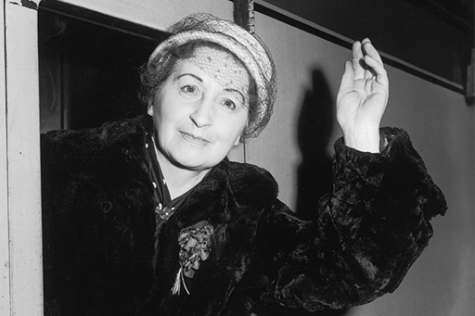
Figure 5 Vera Brittain, 38 years later in 1956
View description - Figure 5 Vera Brittain, 38 years later in 1956

Read or listen to the following passage from Testament of Youth, read by an actress. In it, Vera Brittain describes her anxious wait to hear news of her brother Edward, before she finally receives a telegram announcing his death.

Audio content is not available in this format.

By the following Saturday we had still heard nothing of Edward. The interval usually allowed for news of casualties after a battle was seldom as long as this, and I began, with an artificial sense of lightness unaccompanied by real conviction, to think that there was perhaps, after all, no news to come. I had just announced to my father, as we sat over tea in the dining room, that I must really do up Edward’s papers and take them to the post office before it closed for the weekend, when there came the sudden loud clattering at the front-door knocker that always meant a telegram.
For a moment I felt that my legs would not carry me, but they behaved quite normally as I got up and went to the door. I knew what was in the telegram – I had known for a week – but because the persistent hopefulness of the human heart refuses to allow intuitive certainty to persuade the reason of that which it knows, I opened and read it in a tearing anguish of suspense.
- ‘Regret to inform you Captain E. H. Brittain M.C. killed in action Italy June 15’
“”‘No answer’, I told the boy mechanically, and handed the telegram to my father, who had followed me into the hall. As we went back into the dining room I saw, as though I had never seen them before, the bowl of blue delphiniums on the table; their intense colour, vivid, ethereal, seemed too radiant for earthly flowers. […]
Long after the family had gone to bed and the world had grown silent, I crept into the dining-room to be alone with Edward’s portrait. Carefully closing the door, I turned on the light and looked at the pale, pictured face, so dignified, so steadfast, so tragically mature. He had been through so much – far, far more than those beloved friends who had died at an earlier stage of the interminable War, leaving him alone to mourn their loss. Fate might have allowed him the sorry compensation of survival, the chance to make his lovely music in honour of their memory. It seemed indeed the last irony that he should have been killed by the countrymen of Fritz Keisler, the violinist whom of all others he had most greatly admired.
And suddenly, as I remembered all the dear afternoons and evenings when I had followed him on the piano as he played his violin, the sad searching eyes of the portrait were more than I could bear, and falling on my knees before it I began to cry ‘Edward! Oh, Edward!’ in dazed repetition, as though my persistent crying and calling would somehow bring him back.
(Brittain, 2004 [1933], pp. 437–9)

3.1.4 Reactions: trauma, grief and disgust in art
Grief was also a frequent motif for artists.

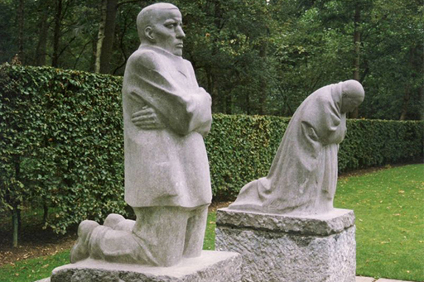
Figure 6 ‘The Grieving Parents’, Käthe Kollwitz, 1932
View description - Figure 6 ‘The Grieving Parents’, Käthe Kollwitz, 1932

The German artist Käthe Kollwitz lost her only son in 1917, and was subsumed by grief, which poured out in her sculptures, drawings and paintings. Her sculpture, ‘The Grieving Parents’, can be found in Vladslo German war cemetery in Belgium. Grief was a recurring theme in her artwork, and it expressed the suffering of millions of parents in Germany.

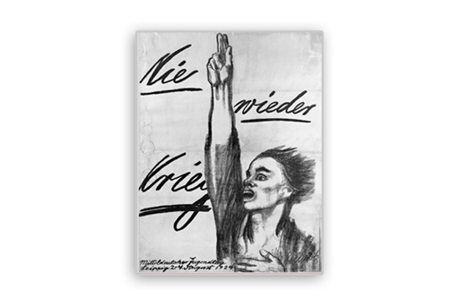
Figure 7 Nie wieder Krieg, Käthe Kollwitz, 1924
View description - Figure 7 Nie wieder Krieg, Käthe Kollwitz, 1924

Kollwitz’s strong anti-war message has had an enduring quality and it is not surprising that, in 2014, to commemorate the centenary of the outbreak of the war, the German post office commissioned just one stamp depicting a Käthe Kollwitz image, with the caption: ‘Nie wieder Krieg’ – never again war.

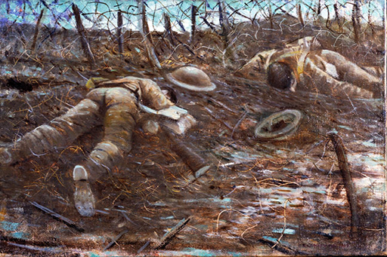
Figure 8 Paths of Glory, C. R. W. Nevinson, 1917
View description - Figure 8 Paths of Glory, C. R. W. Nevinson, 1917

Other artists also took the trauma of war as their recurring motifs. The British painter, C. R. W. Nevinson, despite being commissioned as an official war artist, did not flinch from depicting the carnage of the battlefield.
Similarly, the German painter Otto Dix produced startling images detailing the horrors of war. He also dealt with the aftermath of the war, and his paintings featured physically and mentally damaged soldiers in stark, often ridiculous, poses and situations, as a critique of post-war attitudes towards the suffering of former soldiers. His painting The Match Seller (below), for example, illustrates the pitiful fate that many veterans were subjected to after the war.

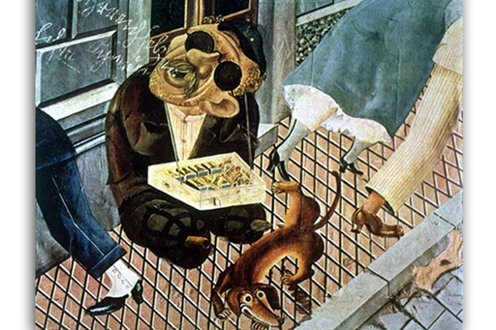
Figure 9 The Match Seller, Otto Dix, 1920
View description - Figure 9 The Match Seller, Otto Dix, 1920

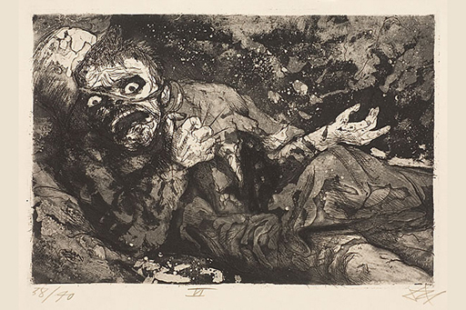
Figure 10 Wounded Man (Autumn 1916, Bapaume), Otto Dix, 1924
View description - Figure 10 Wounded Man (Autumn 1916, Bapaume), Otto Dix, 1924

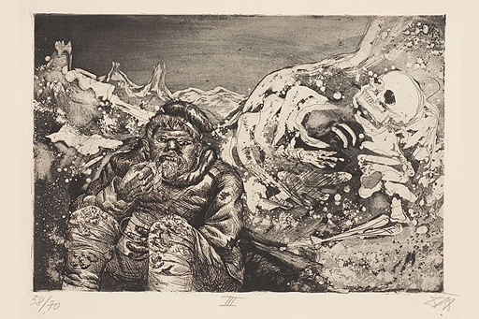
Figure 11 Mealtime in the Trench (Loretto Heights), Otto Dix, 1924
View description - Figure 11 Mealtime in the Trench (Loretto Heights), Otto Dix, 1924

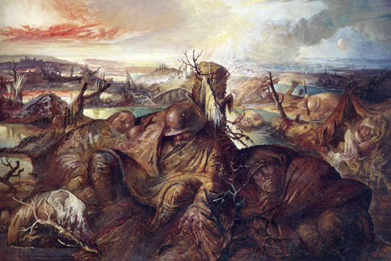
Figure 12 Flanders, Otto Dix, 1936
View description - Figure 12 Flanders, Otto Dix, 1936

After the Nazi seizure of power in 1933, images such as these were considered unpatriotic and labelled ‘degenerate art’.

3.1.5 Siegfried Sassoon and shell shock

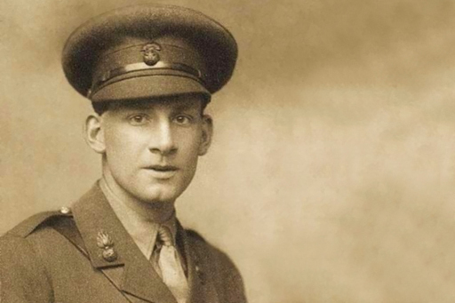
Figure 13 Siegfried Sassoon, 1886−1967. This photograph was taken in 1915
View description - Figure 13 Siegfried Sassoon, 1886−1967. This photograph was taken in 1915

In Britain, shell shock has an iconic cultural status as a symbol of the destructive potential of modern war, and serves almost as a shorthand for soldiers’ suffering in the First World War. This is not least because shell shock has frequently been a subject for literature, with many of the canonical poets and writers of the First World War known to have been treated for the condition themselves.
Siegfried Sassoon, for example, is today one of the most celebrated poets and memoirists of the First World War in Britain. Initially a zealous and committed infantry officer, Sassoon fought with distinction in the Royal Welch Fusiliers on the Western Front. By 1917, appalled by the horrors he had witnessed, and alienated by what he saw as the fatuous jingoism of civilians on the home front, Sassoon became increasingly disillusioned with the war effort. Sassoon consequently wrote an official protest against the war, which he forwarded to his commanding officer and which was eventually read out in the Houses of Parliament by Hastings Lees-Smith, a sympathetic Liberal MP:

I am making this statement as an act of wilful defiance of military authority because I believe that the war is being deliberately prolonged by those who have the power to end it. I am a soldier, convinced that I am acting on behalf of soldiers. I believe that this war upon which I entered as a war of defence and liberation has now become a war of aggression [sic] and conquest. I believe that the purposes for which I and my fellow soldiers entered upon this war should have been so clearly stated as to have made it impossible to change them and that had this been done the objects which actuated us would now be attainable by negotiation.
I have seen and endured the sufferings of the troops and I can no longer be a party to prolong these sufferings for ends which I believe to be evil and unjust. I am not protesting against the conduct of the war, but against the political errors and insincerities for which the fighting men are being sacrificed.
On behalf of those who are suffering now, I make this protest against the deception which is being practised upon them; also I believe it may help to destroy the callous complacency with which the majority of those at home regard the continuance of agonies which they do not share and which they have not enough imagination to realise.

Such an act of defiance placed Sassoon at risk of a court martial, but he was instead deemed as mentally unfit for military service, diagnosed with ‘neurasthenia’, and sent to Craiglockhart hospital. Whether or not Sassoon was actually suffering from shell shock has been debated, but it is interesting to see how this diagnosis could be used to explain away his uncomfortable critique. Regardless, his visit to the hospital was of great significance, as it was here that he met fellow patient and poet, Wilfred Owen. Both Sassoon and Owen would write poetry while in Craiglockhart, with Sassoon in particular offering advice and guidance to his younger friend. Some of this poetry was directly inspired by the mental trauma exhibited by other patients. Sassoon’s poem ‘Survivors’ and Owen’s poem ‘Mental Cases’, for example, were both written in Craiglockhart and hauntingly depict the debilitating mental strains of the war on the other patients they encountered.

3.1.6 Great War poets and shell shock

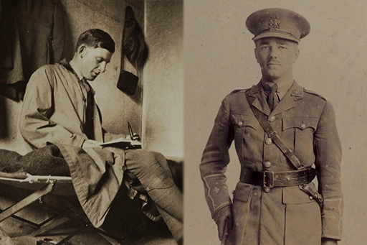
Figure 14 Siegfried Sassoon (Left) and Wilfred Owen (Right)
View description - Figure 14 Siegfried Sassoon (Left) and Wilfred Owen (Right)

Below are two iconic poems by Siegfried Sassoon and Wilfred Owen on the subject of shell shock.

Sassoon: Survivors (1917)

No doubt they’ll soon get well; the shock and strain
Have caused their stammering, disconnected talk.
Of course they’re ‘longing to go out again,’—
These boys with old, scared faces, learning to walk
They’ll soon forget their haunted nights; their cowed
Subjection to the ghosts of friends who died,—
Their dreams that drip with murder; and they’ll be proud
Of glorious war that shatter’d all their pride…
Men who went out to battle, grim and glad;
Children, with eyes that hate you, broken and mad.

Wilfred Owen: Mental Cases (1917)

Who are these? Why sit they here in twilight?
Wherefore rock they, purgatorial shadows,
Drooping tongues from jaws that slob their relish,
Baring teeth that leer like skulls’ teeth wicked?
Stroke on stroke of pain, — but what slow panic,
Gouged these chasms round their fretted sockets?
Ever from their hair and through their hand's palms
Misery swelters. Surely we have perished
Sleeping, and walk hell; but who these hellish?
—These are men whose minds the Dead have ravished.
Memory fingers in their hair of murders,
Multitudinous murders they once witnessed.
Wading sloughs of flesh these helpless wander,
Treading blood from lungs that had loved laughter.
Always they must see these things and hear them,
Batter of guns and shatter of flying muscles,
Carnage incomparable and human squander
Rucked too thick for these men’s extrication.
Therefore still their eyeballs shrink tormented
Back into their brains, because on their sense
Sunlight seems a bloodsmear; night comes blood-black;
Dawn breaks open like a wound that bleeds afresh
— Thus their heads wear this hilarious, hideous,
Awful falseness of set-smiling corpses.
— Thus their hands are plucking at each other;
Picking at the rope-knouts of their scourging;
Snatching after us who smote them, brother,
Pawing us who dealt them war and madness.

Think about the following questions:
- In what ways do these two poems differ? Is there a difference in tone?
- Cast your mind back to some of the themes touched on in the discussion of shell shock in Week 1. What do these poems tell us about the impact of shell shock on ideas about masculinity?
- To whom do you think Sassoon and Owen might be directing these poems?

3.1.7 War poetry in the twentieth century
The futility of the First World War, and the waste and destruction it caused, hold an important place in British memory. These bleak and harrowing wartime portrayals of shell shock did not immediately reach large numbers of the public, however.
Although Owen is one of the best-known poets of the war in Britain today, his work was not widely known during the war and did not begin to achieve widespread acclaim until the 1930s. His work became part of the school national curriculum in the 1960s, and generations since have been raised on this poetry.

3.1.8 Shell shock in fiction: the example of Pat Barker
In more recent years, shell shock has continued to be a theme for literature.
Perhaps most famously, Pat Barker explored the issue in depth in her best-selling Regeneration trilogy (1991–94). The first novel in the trilogy was made into a film in 1997, and formed the basis of a stage adaptation, which premiered in Northampton in August 2014. In these novels, Barker depicted historical characters – including Sassoon, Owen, Graves and the physician W. H. R. Rivers – alongside a shell-shocked fictional protagonist, Billy Prior. Influenced by academic literature on war neurosis, Barker explored the links between masculinity, class and the treatment of shell shock, and further cemented the centrality of shell shock within the popular memory of the First World War in Britain.

3.2 Developing medical attitudes to shell shock after the war

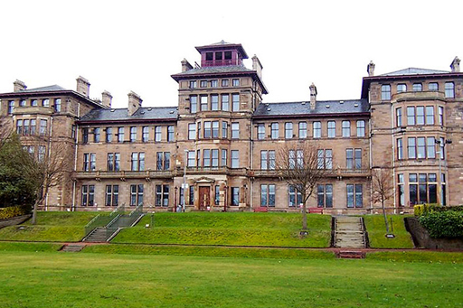
Figure 15 Craiglockhart hospital today, now part of the Edinburgh Napier University campus
View description - Figure 15 Craiglockhart hospital today, now part of the Edinburgh Napier University ...

As you have learned, during the First World War shell shock had developed from being a condition of questionable legitimacy to a recognised problem that had threatened severely to undermine the efficiency of the army. After the war, however, there was still no consensus within the medical profession regarding the causes, diagnosis and treatment of the illness. Shell shock remained a contentious issue. In Britain, many veterans continued to suffer from the debilitating effects of mental trauma, and the government was faced with the task of meting out disability pensions to those they deemed deserving.
A government commission of enquiry into shell shock was established in 1920 and ran until 1922. One of the first decisions made by the committee was to discontinue the use of the term ‘shell shock’ in official language. Due to its imprecise and contentious nature, the commission felt that the term should be avoided. The Commission was also keen to ensure that shell-shocked men were not simply treated as lunatics and sent to asylums; nevertheless, certain preconceptions about the illness remained. Shell shock was still associated by many with hysteria and degeneracy, and it was still generally agreed that the condition tended to affect men with a weak constitution and predisposition to mental illness. Whilst some doctors saw the illness as a genuine psychological reaction to the potentially intolerable fear of combat, others still tended to see it as a form of cowardice or malingering. Despite this, the commission recognised that the condition had affected men who had otherwise fought with distinction and courage. It was these men who were deemed worthy of financial compensation. Others, who had exhibited signs of mental trauma but had demonstrated less willpower during active combat, were often treated less sympathetically. These men would often struggle to find work after the war, but had to survive without pensions or other forms of state support. The historian Jay Winter discusses these uncomfortable legacies of shell shock in more detail later this week.

3.2.1 Shell shock since the First World War

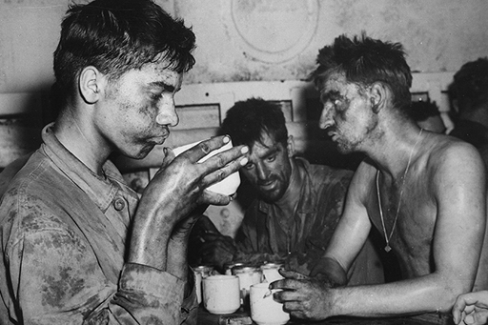
Figure 16 US marines recuperating after surviving the two-day fight for Engebi in Eniwetok Atoll, 19 February 1944.
View description - Figure 16 US marines recuperating after surviving the two-day fight for Engebi in ...

By 1939, with the prospect of another war on the horizon, the issue of war trauma resurfaced. Again the payment of pensions was a major cause for concern, but the general attitude to nervous complaints had not changed hugely: the belief in the supposed links between shell shock and cowardice persisted. In 1939, Dr Francis Prideaux, the British Ministry of Pensions psychiatric expert, suggested that only those soldiers who had demonstrated bravery in battle and had been through genuinely disturbing events were deserving of pensions. It was believed that many men allowed themselves to break down because they felt it was the easy way out. The issue of predisposition also remained a source of contention.
The Second World War ultimately did not bring about anywhere near as many psychiatric casualties in the British army as the First World War, partly due to improved medical practices. Soldiers were more effectively screened before they entered the army to ensure that those already suffering from psychological problems were not admitted. Cases of mental breakdown were addressed more swiftly, closer to the front line. Military training and leadership had also greatly improved since the First World War. Perhaps most significantly, however, the nature of combat during the Second World War may also have helped to reduce the frequency of psychological breakdowns. Whereas the First World War, with the static and degrading conditions of trench warfare, could engender a sense of powerlessness, the Second World War was largely a war of movement, during which soldiers felt they had more control over their own destiny.
Despite this, the Second World War did of course give rise to psychological casualties. For the US Army, for example, the Second World War was far more costly than the previous conflict (as you will remember from our enquiry into casualty figures in Week 1), and the psychological toll was a major cause for concern. The Americans, however, took a more sympathetic approach than the British, removing the stigma from war neurosis. Rather than associating the condition with cowardice, American military and medical experts suggested that in fact every man had his breaking point, and that even the bravest man would eventually break down if exposed to sufficiently traumatic incidents. Rather than the term ‘shell shock’, the terms ‘combat exhaustion’ or ‘combat fatigue’ were more frequently used.

3.2.2 Fiona Reid: shell shock
Watch this interview with the historian Fiona Reid, in which she talks about developing attitudes to shell shock after the war. As you watch, ask yourself – is there still a stigma attached to mental breakdown today?

Video content is not available in this format.
View transcript - Uncaptioned interactive content

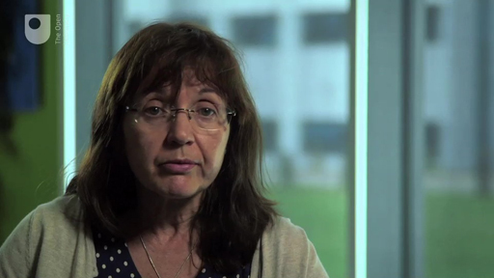

3.2.3 War neurosis and post-traumatic stress disorder

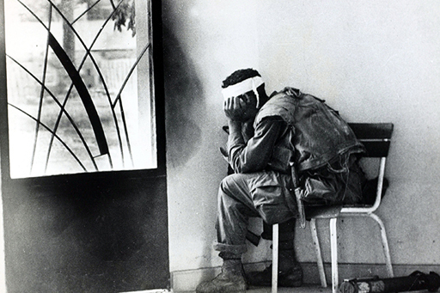
Figure 17 A wounded Vietnam veteran
View description - Figure 17 A wounded Vietnam veteran

War neurosis continued to pose a problem for the US Army, particularly in the wake of the horrors of the Vietnam War.
The term ‘post-Vietnam syndrome’ was developed to describe the psychological aftermath of this conflict, during which many soldiers had witnessed exceptionally brutal combat conditions. Vietnam also helped give rise to modern medical understandings of traumatic neurosis. It was shortly after the conflict that the term ‘post-traumatic stress disorder’ (PTSD) was developed to describe the psychological disorders brought about by exceptionally traumatic events. Unlike labels such as shell shock, the term was not purely limited to trauma resulting from combat, and was applied in a wide variety of contexts.

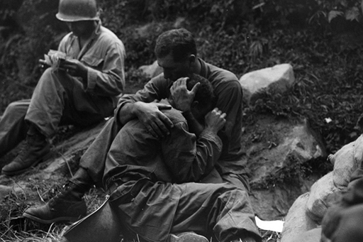
Figure 18 Grief-stricken American soldiers during the Korean war
View description - Figure 18 Grief-stricken American soldiers during the Korean war

Today, the term continues to be used to diagnose psychological casualties of war, and despite vast improvements in psychiatry, post-traumatic stress remains a pressing issue in the wake of recent wars in Iraq and Afghanistan.

3.3 Summary

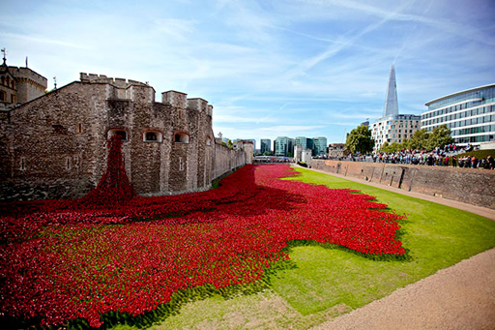
Figure 19 Blood Swept Lands and Seas of Red, created by ceramic artist Paul Cummins at the Tower of London in 2014.
View description - Figure 19 Blood Swept Lands and Seas of Red, created by ceramic artist Paul Cummins ...

This brings you to the end of this course on trauma and memory in the First World War. You have learned about:
- the various forms of physical and mental trauma suffered by those who fought in the First World War
- how to conduct your own research into First World War casualty statistics, and why these statistics continue to pose challenges for historians
- the traumatic experiences of civilians in wartime caused by enemy atrocities, aerial bombing, hunger and disease
- the expression of grief and trauma during and after the war through art and literature
- how attitudes to shell shock have developed after the war and how mental trauma has been treated at different times in the twentieth century.
With the centenary commemorations of the First World War coming to an end, and as we commemorate the end of the war, it is timely to study the conflict. Whatever your previous knowledge of the war, hopefully this course has developed your understanding of a period of history that continues to inspire debate among historians.

Where next?
If you’ve enjoyed this course you can find more free resources and courses on OpenLearn.
New to University study? You may be interested in our courses on history.
Making the decision to study can be a big step and The Open University has over 40 years of experience supporting its students through their chosen learning paths. You can find out more about studying with us by visiting our online prospectus.

References
Week 2
Horne, J. (2014) ‘Atrocities and war crimes’ in Winter, J. (ed.) The Cambridge History of the First World War, Cambridge, Cambridge University Press, pp. 561–84.
Gläser, E. (1928) Jahrgang 1902 [Born in 1902]. Berlin, pp. 290–3.
Week 3

Further reading
Week 1
1914–1918 Online
BBC - iWonder - Does the peace that ended WW1 haunt us today? Bridget Kendall explores how the First World War redrew the map of Europe. (Some of this content is only available in the UK.)
War Neuroses Version B Reel 2 For more footage of shell shock victims, visit British Pathé on YouTube.
BBC - iWonder - Did shell shock make us take mental health seriously? Sian Williams – herself a witness to traumatic news events – explores our understanding of trauma. (Some of this content is only available in the UK.)
Week 2
BBC - Great War Interviews Katie Morter, a civilian in Manchester, recalls a letter that broke her heart. (Some of this content is only available in the UK.)
BBC - iWonder - Was World War One propaganda the birth of spin? In the first total war, the British government had to learn to talk to the people in a new way. (Some of this content is only available in the UK.)
Week 3
BBC - iWonder - Did the trauma of World War One lead to great creativity? Vera Brittain’s daughter, Baroness Shirley Williams, remembers her mother, and reflects on the trauma of the First World War. (Some of this content is only available in the UK.)
BBC - Your Paintings - Christopher Nevinson See more paintings by Christopher Nevinson, and explore the nation’s art collection.
BBC - iWonder - Has poetry distorted our view of mental health? Poet Ian McMillan asks why only certain war poets tend to be remembered and taught. (Some of this content is only available in the UK.)
Blackadder Of course, the topic of shell shock has not escaped iconic treatment by comedians. In the 1980s BBC series Blackadder Goes Forth, the hero of the series, Captain Blackadder, hopes to get out of having to continue fighting by pretending to be suffering from shell shock. This is a fictional account that plays with our prior knowledge of the condition and revisits many of the common assumptions that we have about shell shock, and about the First World War from a British perspective.
BBC - iWonder - Did Craiglockhart hospital revolutionise mental health? Claudia Hammond explores the variety of treatments available at the famous First World War hospital. (Some of this content is only available in the UK.)

Acknowledgements
Week 1
This free course was written by Annika Mombauer and Vincent Trott. It was first published in October 2018.
Course image © wragg (via iStockPhoto.com)
Figure 1 Out of copyright https://www.flickr.com/photos/internetarchivebookimages/14779263271
Figure 2 © Imperial War Museum, Art.IWM ART 3819, http://www.iwm.org.uk/corporate/privacy-copyright/licence
Figure 3 Johan http://creativecommons.org/licenses/by-sa/3.0/deed.en; http://en.wikipedia.org/wiki/File:Tyne_Cot_%287%29.JPG
Figure 4 © Imperial War Museum, Q 14340, http://www.iwm.org.uk/corporate/privacy-copyright/licence
Figure 5 Out of copyright http://commons.wikimedia.org/wiki/File:Shellshock2.jpg
Figure 6 © Ministry of Defence http://www.nationalarchives.gov.uk/doc/open-government-licence/version/2/; http://commons.wikimedia.org/wiki/File:Poppies_falling_from_the_roof_at_the_Menin_Gate_in_Ypres.jpg
Week 2
Figure 1 Out of copyright http://en.wikipedia.org/wiki/File:Hromadn%C3%A1_poprava_srbsk%C3%A9ho_obyvatelstva.jpg
Figure 2 Public domain: https://www.flickr.com/photos/sdasmarchives/8091836534
Figure 3 Public domain http://goo.gl/1XRZId
Figure 4 Public domain http://research.archives.gov/description/533647
Figure 5 Public domain: The Library of Congress (USA) in Flickr
Figure 6 © Imperial War Museum, Art.IWM PST 0886, http://www.iwm.org.uk/corporate/privacy-copyright/licence
Figure 7 © Imperial War Museum, Art.IWM PST 13625, http://www.iwm.org.uk/corporate/privacy-copyright/licence
Figure 8 © Imperial War Museum, Art.IWM PST 11617, http://www.iwm.org.uk/corporate/privacy-copyright/licence
Figure 9 Public domain http://digital.ncdcr.gov/cdm/ref/collection/p15012coll10/id/1725
Figure 10 © Imperial War Museum, Art.IWM PST 6060, http://www.iwm.org.uk/corporate/privacy-copyright/licence
Figure 11 © Imperial War Museum, Art.IWM PST 12444, http://www.iwm.org.uk/corporate/privacy-copyright/licence
Figure 12 © Imperial War Museum Q 110883, http://www.iwm.org.uk/corporate/privacy-copyright/licence
Figure 13 Public domain
Figure 14 Public domain
Figure 15 Courtesy of the National Museum of Health and Medicine, Armed Forces Institute of Pathology, Washington, D.C., United States
Figure 16 Public domain
Week 3
Figure 1 National Library of Scotland (Public domain https://www.flickr.com/photos/nlscotland/4700232268.
Figure 2 Photograph: Horace Nicolls (Public domain)
Figure 3 Poem by Wilfrid Owen and Photograph in Public domain https://archive.org/details/poemsowenwil00owenrich
Figure 4 This item is from The First World War Poetry Digital Archive, University of Oxford (www.oucs.ox.ac.uk/ww1lit); © University of Oxford
Figure 5 Central Press/Stringer/Getty Images
Figure 6 Photograph: © Nick https://www.flickr.com/photos/34517490@N00/3085743748/ Sculpture by Kathe Kollwitz
Figure 7 Nie Wieder Krieg (Never Again War), 1924 - sketch by Käthe Kollwitz
Figure 8 © Imperial War Museum.IWM ART 518, http://www.iwm.org.uk/corporate/privacy-copyright/licence
Figure 9 THE MATCH SELLER, 1920 by Otto Dix © DACS 2014
Figure 10 THE WOUNDED MAN (Autumn 1916, Bapaume),1924 by Otto Dix © DACS 2014
Figure 11 MEALTIME IN THE TRENCH (Loretto Heights), Otto Dix, 1924 © DACS 2014
Figure 12 FLANDERS, Otto Dix, 1936 © DACS 2014
Figure 13 Photograph by George Charles Beresford (Pubic domain)
Figure 14 Left: Siegfried Sassoon reading, Cambridge University Library/The Siegfried Sassoon Literary Estate via First World War Poetry Digital Archive, accessed September 27, 2016, http://www.oucs.ox.ac.uk/ww1lit/collections/item/9672. Right: This item is from The First World War Poetry Digital Archive, University of Oxford (www.oucs.ox.ac.uk/ww1lit); © University of Oxford
Figure 15 © Brideshead http://en.wikipedia.org/wiki/File:Craiglockhart_Hydropathic_main_view.JPG.
Figure 16 National Archives at College Park - Still Pictures (RDSS) https://research.archives.gov/id/513200 Public Domain
Figure 17 © Rolls Press/Popperfoton/Getty Images
Figure 18 © unknown
Figure 19 © photograph: Aurelien Guichard in Flickr https://creativecommons.org/licenses/by-sa/2.0/
Except for third party materials and otherwise stated (see terms and conditions), this content is made available under a Creative Commons Attribution-NonCommercial-ShareAlike 4.0 Licence.
The material acknowledged below is Proprietary and used under licence (not subject to Creative Commons Licence). Grateful acknowledgement is made to the following sources for permission to reproduce material in this free course:

Audio visual
Week 1
1.1 Injuries of the First World War: © BBC
1.1.2 Finding and interrogating historical data © The Open University
1.2 Introducing shell shock © Courtesy of the Wellcome Trust
1.2.1 Interview with Dr Fiona Reid: © The Open University
1.2.2 Treatment of shellshock © The Open University
Week 2
2.2.2: Extract from: Gläser, E. (1928) Jahrgang 1902 , Berlin, pp. 290–3.
Week 3
3.1.3: passage from Testament of Youth (Brittain) BBC for The Open University © BBC
3.2.2: Fiona Reid: Shell shock © The Open University
Extract from: Brittain, V. (2004 [1933]) Testament of Youth, London, Penguin, pp 437–9.
Every effort has been made to contact copyright owners. If any have been inadvertently overlooked, the publishers will be pleased to make the necessary arrangements at the first opportunity.
Don’t miss out
If reading this text has inspired you to learn more, you may be interested in joining the millions of people who discover our free learning resources and qualifications by visiting The Open University – www.open.edu/openlearn/free-courses.

Figure 1 Before and after: facial reconstruction of a wounded soldier

Description
This image shows a soldier’s face before and after facial reconstruction.
Back to Unit 1 Session 1 Figure 2

Figure 2 Gassed. ‘In Arduis Fidelis’, Gilbert Rogers (MBE)

Description
The body of a dead soldier lying on his back on a battlefield. The body rests rigidly on a thick mound of mud, the feet hanging into small rain-filled crater. These craters bordered by walls of mud dominate the background. The head is turned out towards the viewer, a gas mask still in place over the face.
Back to Unit 1 Session 1 Figure 3

Figure 3 The Tyne Cot memorial to the missing and the cemetery of the dead of the First World War, Passchendaele, Flanders, Belgium.

Description
This is a photograph of Tyne Cot memorial and cemetery.
Back to Unit 1 Session 1 Figure 5

Figure 4 Rows of bones gathered following the Battle of Chunuck Bair, Gallipoli.

Description
This image depicts rows of human bones following the battle of Chunuck Bair, Gallipoli.
Back to Unit 1 Session 1 Figure 6

Figure 5 An Australian Advanced Dressing Station near Ypres in 1917. The wounded soldier in the lower left of the photo has a dazed, thousand-yard stare – a frequent symptom of shell-shock.

Description
This image shows soldiers in a wound dressing station. There is a wounded soldier in the lower left of the photo who has a dazed “thousand-yard stare” – a frequent symptom of “shell-shock”.
Back to Unit 1 Session 2 Figure 4

Figure 1 Austria-Hungarian soldiers executing Serbian women, 1916.

Description
This image shows a row of Serbian women being hung from posts.
Back to Unit 2 Session 1 Figure 1

Figure 2 The city of Reims after its destruction in 1914.

Description
The ruins of Reims cathedral
Back to Unit 2 Session 1 Figure 2

Figure 3 L’exécution des notables de Blégny 1914, by Evariste Carpentier, 1918.

Description
A line of soldiers take aim at a group of unarmed Belgian civilians, preparing to fire
Back to Unit 2 Session 1 Figure 3

Figure 4 Austrian soldiers executing Serbs, 1917.

Description
This image depicts an Austrian firing squad ready to execute some Serbian civilians.
Back to Unit 2 Session 1 Figure 4

Figure 5 Belgian refugees arriving in Paris, 1914.

Description
This photograph shows a horse-drawn cart carrying Belgian refugees into Paris.
Back to Unit 2 Session 1 Figure 5

Figure 6 View on the Imperial War Museum website.

Description
Belgian women and children carry bundles of their possessions through the streets of a Belgian town as they are led away by German soldiers. One of their number, a young boy, kisses his mother goodbye as the procession passes a church. text: ISSUED BY THE QUEENSLAND RECRUITING COMMITTEE. WILL YOU STAND FOR THIS? INTO CAPTIVITY –A SCENE IN A BELGIAN TOWN.
Back to Unit 2 Session 1 Figure 6

Figure 7 View on the Imperial War Museum website.

Description
A portrait-length depiction of a woman wearing a green shawl over her head. text: Have you any women-folk worth defending? Remember the Women of Belgium JOIN TO-DAY
Back to Unit 2 Session 1 Figure 7

Figure 8 View on the Imperial War Museum website.

Description
Text: Help to end the War by enlisting in the gallant British Army, which is fighting BRITAIN’S BATTLE FOR FREEDOM in Belgium and France. The Only Way to bring the War to a speedy and victorious end and to punish the Germans for their barbarous treatment of unoffending civilian populations is to CARRY THE FIGHT INTO THE ENEMY’S COUNTRY
Back to Unit 2 Session 1 Figure 8

Figure 9 View on the North Carolina Digital Collections website.

Description
Drawing depicts German soldiers shooting a woman hanging on a meat hook outside a butcher’s shop; fallen babies and children are in the foreground. Text urges men to enlist and help Uncle Sam defeat German Militarism. Front of poster has a faded ink stamp: ‘P. O. Building Durham, N.C.’
Back to Unit 2 Session 1 Figure 9

Figure 10 View on the Imperial War Museum website.

Description
Text: MEN OF LEICESTERSHIRE AVENGE THE LUSITANIA HOW TO DO IT! For every Man, Woman and Child lost 10 Men should join. JOIN THE 10TH BATTALION LEICESTERSHIRE REGIMENT 21, HUMBERSTONE GATE. 14 DAYS LEAVE AT HOME ON JOINING PAY AND ALLOWANCES 3/- PER DAY WHILST ON LEAVE.
Back to Unit 2 Session 1 Figure 10

Figure 11 View on the Imperial War Museum website.

Description
Text: AUX FEMMES DU CANADA 1. Vous avez lu ce que les Allemands ont fait en Belgique. Avez-vous pensé à ce qu’ils feraient s’ils envahissaient notre pays ....... ? 2. Réalisez-vous que la sécurité de votre foyer et de vos enfants dépend du nombre d’hommes que nous enrôlerons maintenant . . . . . ? 3. Réalisez-vous qu’un mot d’encouragement de votre part procurera peut-être un défenseur de plus à notre pays . . ? 4. Quand la guerre sera finie et que quelqu’un demandera à votre mari ou à votre fils ce qu’il a fait pendant cette guerre terrible, devra- t-il courber la tête parce que vous ne l’aurez pas laissé partir . . . . ? N’ENCOURAGEREZ-VOUS PAS UN HOMME A s’enrôler aujourd’hui? L’Association Civile de Recrutement, Québec, P. Q. La Compagnie de Publication ‘LE SOLEIL’, Ltée
Back to Unit 2 Session 1 Figure 11

Figure 12 Civilians carving up a horse carcass on the streets of Berlin, c.1917.

Description
This photograph shows civilians carving up a horse carcass on the streets of Berlin.
Back to Unit 2 Session 2 Figure 1

Figure 13 A German turnip cart. The turnips are infested with maggots of Gall Weevil.

Description
This photograph shows a German turnip cart. The turnips are infested with maggots.
Back to Unit 2 Session 2 Figure 2

Figure 14 The struggle to survive.

Description
This photograph shows a child wearing a coat, looking at food held in his hand.
Back to Unit 2 Session 2 Figure 3

Figure 15 Chart showing mortality from the 1918 influenza pandemic in the US and Europe. Courtesy of the National Museum of Health and Medicine, Armed Forces Institute of Pathology, Washington, D.C., United States.

Description
This is a graph titled ‘Influenza pandemic: mortality in America and Europe during 1918 and 1919’. The graph peaks around October and November.
Back to Unit 2 Session 2 Figure 4

Figure 16 British soldiers entering a village in France.

Description
This photograph shows British soldiers entering a village in France.
Back to Unit 2 Session 3 Figure 1

Figure 1 The grave of sapper Ivor Beynon of the Canadian Engineers, near the front line in the Ypres salient, 1918.

Description
The grave of sapper Ivor Beynon of the Canadian Engineers, near the front line in the Ypres salient, 1918.
Back to Unit 3 Session 1 Figure 1

Figure 2 The unveiling of the cenotaph in Whitehall, 1920.

Description
The unveiling of the cenotaph in Whitehall, 1920
Back to Unit 3 Session 1 Figure 2

Figure 3 Wilfred Owen, 1893−1918. The text is part of a draft of his famous poem ‘Anthem for Doomed Youth’.

Description
This image shows a portrait of Wilfred Owen alongside a draft of his famous poem ‘Anthem for Doomed Youth’.
Back to Unit 3 Session 1 Figure 3

Figure 4 Vera Brittain, 1893−1970. This photograph was taken in 1918.

Description
This is a photograph of Vera Brittain.
Back to Unit 3 Session 1 Figure 4

Figure 5 Vera Brittain, 38 years later in 1956

Description
This is a photograph of Vera Brittain, taken in 1956.
Back to Unit 3 Session 1 Figure 5

Figure 6 ‘The Grieving Parents’, Käthe Kollwitz, 1932

Description
This a photograph of The Grieving Parents sculpture
Back to Unit 3 Session 1 Figure 6

Figure 7 Nie wieder Krieg, Käthe Kollwitz, 1924

Description
This is the stamp of Kollwitz’s ‘Nie wieder Krieg’
Back to Unit 3 Session 1 Figure 7

Figure 8 Paths of Glory, C. R. W. Nevinson, 1917

Description
The corpses of two dead British soldiers lying face down in the mud among barbed wire. Their helmets and rifles lie in the mud next to them.
Back to Unit 3 Session 1 Figure 8

Figure 9 The Match Seller, Otto Dix, 1920

Description
This is Dix’s painting, ‘The Match Seller’
Back to Unit 3 Session 1 Figure 9

Figure 10 Wounded Man (Autumn 1916, Bapaume), Otto Dix, 1924

Description
This is Dix’s painting, ‘Wounded Man’
Back to Unit 3 Session 1 Figure 10

Figure 11 Mealtime in the Trench (Loretto Heights), Otto Dix, 1924

Description
This is Dix’s painting, ‘Mealtime in the Trench’
Back to Unit 3 Session 1 Figure 11

Figure 12 Flanders, Otto Dix, 1936

Description
This is Dix’s painting, ‘Flanders’
Back to Unit 3 Session 1 Figure 12

Figure 13 Siegfried Sassoon, 1886−1967. This photograph was taken in 1915

Description
This is a photograph of Siegfried Sassoon taken in 1915.
Back to Unit 3 Session 1 Figure 13

Figure 14 Siegfried Sassoon (Left) and Wilfred Owen (Right)

Description
This image is made up of a photograph of Siegfried Sassoon on the left, and a photograph of Wilfred Owen on the right.
Back to Unit 3 Session 1 Figure 14

Figure 15 Craiglockhart hospital today, now part of the Edinburgh Napier University campus

Description
A photograph of Craiglockhart hospital today, now part of the Edinburgh Napier University campus.
Back to Unit 3 Session 2 Figure 1

Figure 16 US marines recuperating after surviving the two-day fight for Engebi in Eniwetok Atoll, 19 February 1944.

Description
This is a photo of US marines recuperating after surviving the two-day fight for Engebi in Eniwetok Atoll.
Back to Unit 3 Session 2 Figure 2

Figure 17 A wounded Vietnam veteran

Description
A soldier holds his bandaged head in his hands as he sits in front of a window.
Back to Unit 3 Session 2 Figure 4

Figure 18 Grief-stricken American soldiers during the Korean war

Description
One soldier holds another as he cries.
Back to Unit 3 Session 2 Figure 5

Figure 19 Blood Swept Lands and Seas of Red, created by ceramic artist Paul Cummins at the Tower of London in 2014.

Description
This is a photograph of Blood Swept Lands and Seas of Red, created by ceramic artist Paul Cummins at the Tower of London in 2014
Back to Unit 3 Session 3 Figure 1

Uncaptioned interactive content

Transcript
ANNIKA MOMBAUER
Welcome to World War I, Trauma and Memory. I’m Annika Mombauer, Senior Lecturer in Modern European History at the Open University. And I’ll be your guide over the next three weeks. The First World War was a war of unprecedented scale and brutality. Over the next three weeks, you will discover just how devastating the effects of the war were. You’re going to study the subject of physical and mental trauma, such as shell shock, who was affected by it, and how was it treated. You will also examine the effect this had on civilian populations and how trauma has been represented in art and literature since. This week you will focus on physical and mental casualties of the war.
First of all, you will learn about physical casualties by looking at the death rates and overall casualty rates across the combatant nations. You will also consider issues such as facial disfigurement and loss of limbs, which were encountered on an unprecedented and unexpected scale and posed new challenges to medical professionals.
Back to Unit 1MediaContent 1

Uncaptioned interactive content

Transcript
[MUSIC PLAYING]
MICHAEL PALIN
What sort of injuries were you seeing coming into Queen Mary’s at the very end of the war, the armistice time?
DR ANDREW BAMJI
I’ve got a set of notes here of a chap who was admitted here just before the armistice, in fact. And his name is Thomas, of the First Cheshires. And you can see that the whole of the side of the face has been literally just taken off.
MICHAEL PALIN
Just ripped out.
DR ANDREW BAMJI
Yes,
MICHAEL PALIN
And yet he was alive and conscious.
DR ANDREW BAMJI
He was still alive and conscious.
MICHAEL PALIN
I wouldn’t have thought that was possible, both alive and conscious.
DR ANDREW BAMJI
Well as long as it doesn’t take off a major artery, then he’s not going to bleed to death.
MICHAEL PALIN
When were these pictures taken? How soon after the injury?
DR ANDREW BAMJI
This was taken about two weeks after the injury. And this is actually dated the 6th of November. And so we knew he would have been here at the time of the armistice itself. And as you go through, looking at the reconstructions, then just watch the dates. We’re now in 1921. And a whole series of tubes and flaps are being raised. And then when we get to August 1922, we’ve recreated the upper lip, and then you bring down a last flap to recreate the nose. And the very end. This is what you end up with. Our guy is now presentable.
MICHAEL PALIN
Push his face back, right? It’s just …
[MUSIC PLAYING]
MICHAEL PALIN
What do you feel about the way the wounded and that side of the war is seen?
DR ANDREW BAMJI
It’s neglected. Perhaps one of the things that really bothers me about the way that we look at war, and perhaps even the First World War in particular, is we only focus on the glorious dead. And in a sense, we’re not allowed to see the people who have been disfigured in the way that Private Thomas was disfigured. And if we don’t look at that sort of thing, how can we possible understand what war was really about?
Back to Unit 1 Session 1 MediaContent 1

Uncaptioned interactive content

Transcript
ANNIKA
So Vince, our task today is to try and find out just how many people died in the First World War. That’s not an easy task, is it?
VINCENT
It’s not an easy task because first of all, we have to be careful how we define our terms. We’re talking about casualty statistics here today, but “casualties” doesn’t just mean those who died in the war. It means all men who weren’t fit to fight, so we need to take into account injuries, men who were maybe taken prisoner, and those who went missing. So we need to be careful not to confuse casualties with simply deaths.
ANNIKA
So here you’re talking about military casualties, then, but what about civilian casualties? Are they included in the statistics that we have?
VINCENT
Well, often they’re not. That’s the problem. Of course, civilians were affected by the war as well, but it’s quite difficult to get accurate figures for civilian casualties because we need to think about whether these civilians were directly affected by the war, perhaps by bombing or so on, or whether they were maybe indirectly affected by starvation because of lack of food as a result of the war, for example.
ANNIKA
And I guess also giving statistics for different countries must be difficult for all sorts of reasons. For example, borders changed between the beginning of the war and after the end of the war, so a country with its borders of 1914 might have different borders in 1918. For example, Austria Hungary, which has a unified army consisting of several different nationalities, but in order to understand how many Czech soldiers, say, died, or how many Hungarian soldiers died, it’s very difficult. So best to look at armies rather than nations, and then the records that armies keep, how reliable are they?
VINCENT
Well, this is the other problem. Obviously, armies did keep records, and these are very useful to historians, but the main problem that we have is, of course, armies weren’t so concerned with exactly how many men had died. Obviously, armies were mainly concerned with how many men would be available to fight the next battle. Some soldiers might have died of illness or disease and so on, which again, might not be counted by the army as a death in battle, for example.
Another thing to bear in mind is that if soldiers were severely injured, they might be discharged from the army. Of course, they may have died of very severe wounds a year or two afterwards when they were no longer in the army, and these men would not be included in the death statistics.
ANNIKA
Historians over the years have really come to revise the figures that we’ve all taken for granted, and it seems that there really was serious underestimates, and that the casualty rates were even higher than previously suspected.
VINCENT
Absolutely, yeah.
ANNIKA
So if we wanted to find out, for example, about British casualties, how would we go about finding out how many British soldiers died?
VINCENT
Well, a natural starting point, of course, is to go on the internet, and if we type in to a search engine, “First World War casualties,” we can see what the first few matches are. Of course, one of the many sites that we can look at is Wikipedia, for example.
ANNIKA
And so what does it say, then, for the United Kingdom?
VINCENT
The first major statistic that we see is that of military deaths. We can see that those was a range between nearly 703,000 through to about 888,000.
ANNIKA
That’s a very large discrepancy there, isn’t it? Does that refer to what we just talked about, that the estimates used to be lower and now they are higher?
VINCENT
It does, yeah. The fact that there’s clearly a range here alerts us to the fact that we can’t get an accurate figure. If we take into account the entire British Empire, we’ve got figures for Australia, Canada, India, New Zealand, Newfoundland, and South Africa as well, and if they’re added to the United Kingdom, we get a subtotal, which is between around 908,000 and 1.1 million.
ANNIKA
These are the military deaths as opposed to overall casualties.
VINCENT
These are just the military deaths listed here, yeah. Every statistic here has a footnote, and if we click down, we see that it usually references a book. So we know that these things haven’t just been plucked out of thin air. Ideally, they do relate to some academic work somewhere. So this looks like a fairly good starting point.
ANNIKA
And actually looking at those footnotes, I recognise a lot of names from very reputable First World War experts, so that would be another clue that this is a reliable source.
VINCENT
Exactly. If we go to another one of our hits from the search engine, and we look at this website here, which is PBS.org.
ANNIKA
Is that the American public broadcaster?
VINCENT
It is, yes. This is a table, obviously, that originates from America. If we try and look up British deaths during the war, that figure isn’t listed. What we have here is the figure for the British Empire.
ANNIKA
So where does the information on PBS come from? Do we know?
VINCENT
Well, there isn’t actually any reference listed here. There’s no footnotes. There’s no reference to any actual other sources, any history books or anything. We do need to be careful when using a site like this to make sure that we know where these figures are coming from.
ANNIKA
So this would be useful for cross referencing, but you wouldn’t necessarily use it as your only source of information.
VINCENT
Exactly. I’d be wary of just looking at one table like this without any references and then going away and not looking at other sites.
ANNIKA
Is there another website we can look at?
VINCENT
Sure. One other website I looked up was the Western Front Association website. As the name suggests, the focus here is only on British soldiers who died on the Western Front. Of course, the vast majority of soldiers who served in the First World War for Britain did fight on the Western Front. Of course, not all of them did. Some of them fought in the Middle East and some of them fought in Africa, for example. So figures we get here are slightly different to those that we’ve been looking at on other sites like Wikipedia, for example.
ANNIKA
Yeah. These figures are right, but they’re only giving you a little snapshot.
VINCENT
Exactly. We can’t always compare like for like. These are some useful statistics, but we can’t compare this table to the table we’ve just been looking at because we’re comparing two different things here.
ANNIKA
What about other sources? Historians like printed sources. We like books.
VINCENT
Books would certainly be useful, and I think that’s the perfect next step after looking at the internet, yes.
ANNIKA
Right. Should we go and find some?
VINCENT
Let’s go and have a look.
ANNIKA
Well, there’s no shortage of books on the First World War, is there? I picked up this one, which is an encyclopaedia of the First World War, and it’s a relatively recent one, so let’s have a look.
VINCENT
Great Britain and Ireland.
ANNIKA
Military deaths, 750,000, so a little bit higher than what we found earlier, I think. And British colonies are listed separately, 180,000, so the total is 930,000, which is, again, slightly higher than what we found before.
VINCENT
Slightly higher than the lower range given, but within the range that we saw on Wikipedia, for example.
ANNIKA
We also have figures here for civilian deaths. It’s quite difficult to get at those, and I think you can see that from these figures because they’re so rounded – 300,000, 700,000. Lots of question marks as well, which show you that we just simply do not have the information.
If I were to direct somebody to a very recent publication on the First World War that might include some of this information, I’d probably send them to Jay Winter’s Cambridge History of the First World War, and I’ve got here the table that’s included in that book. What’s useful about this one is that it compares what different authors have given as casualty figures over the years, starting in 1972 and ending with an up to date estimate.
VINCENT
This is really interesting because we gain a sense of just how difficult it is to give accurate figures, and just how estimates can vary.
ANNIKA
It lists 761,000 for the losses for Great Britain, which is higher than what we’ve encountered. And what about the empire?
VINCENT
And again, we see we’ve got a breakdown of the empire here, and it gives us a total figure, which is 959,000 listed there. So again, slightly higher than some of the figures we’ve seen on the internet.
ANNIKA
Yes, absolutely. So would you say, then, in conclusion that it’s better to use books, it’s better to use the internet? What is the best way to try and do this sort of research?
VINCENT
Well, that’s a tricky question. I mean, I think it’s good to use a variety of sources. Of course, with a book, it’s had to go through the publishing process, so that means it’s usually been peer reviewed, which means other historians have checked the facts and figures and so on. So generally, books are likely to be more reliable than a site plucked off the internet, but that doesn’t mean to say that the internet can’t be useful for doing this research. I think the key thing is to use a variety of sources, look at a variety of websites, and preferably look at some printed books as well.
ANNIKA
It’s just overwhelming how vast these figures are. I mean, we looked today mainly at British casualties, but some 10 million soldiers, it is estimated, died, and some six million civilians were victims of this war. I think these numbers are so vast, it’s almost impossible to comprehend.
VINCENT
Exactly. I think sometimes looking at all these figures and statistics, we can become a little bit numb to the actual real pain and suffering that just one of these deaths might have caused.
ANNIKA
Absolutely. And I also think it’s pretty much incomprehensible that we simply do not know just how many people died.
VINCENT
Absolutely, yeah. But I think hopefully today, we’ve proven that we can get a little bit closer to getting some idea of maybe just how many people were affected by the First World War.
ANNIKA
Well, thanks for doing this research with me.
VINCENT
Thank you very much.
Back to Unit 1 Session 1 MediaContent 2

Uncaptioned interactive content

Transcript
DR. FIONA REID
Shell shock is a catch-all term. It’s a descriptor used to describe the symptoms suffered by men fighting in the First World War. It can cover anything from stammering to full blown nervous breakdown. It can cover nervousness and irritability. And at the same time also functional neurosis, such as hysterical deafness, or hysterical blindness.
So it’s not, medically, a helpful term as people recognised at the time. But it was an emotionally important term. It made sense to people.
We suspect that men were using the term shell shock right at the beginning of the First World War. It’s not in evidence, it’s not in print until February 1915, when Charles Myers, the consulting psychologist of the British Expeditionary Force, referred to it in an article in the Lancet. And after that point, the term shell shock was very widely used.
It makes sense because it creates a very graphic illustration of the battlefield. It creates a strong link between the exploding shell and the shock in the man. Also, it’s tied into a sort of old soldier’s lore. Before the First World War, soldiers used to talk about the wind of the shell. That a man very, very close to an exploding shell, or if a man for example had a bullet whiz past his ear, he could after that point become mentally disturbed in some way. Because the changing air pressure had affected the fluid in the brain.
And this is why old soldiers talked about being ‘windy’, or having the ‘wind up’ if they were excessively afraid. So the term shell shock has some kind of a connection to this old soldier’s belief in the wind of the shell. And it simply made sense to so many people that despite military authorities trying to outlaw it people continue to use it. And continued to use it throughout the war and afterwards.
Because it’s medically imprecise, someone who’s suffering from, for example, hysterical deafness, is really not suffering in the same way as someone who is suffering from amnesia or someone suffering from stammering.
It’s also medically imprecise in that men did not necessarily suffer mental complaints because of a direct contact with an exploding shell. It might be weeks and weeks of cold and anxiety and hunger. It might be the conditions of trench life. It might be extreme fear. There’s so many different reasons behind a man’s breakdown that to attribute the break down to the shock of a shell, is simply too simplistic.
Shell shock is tied up with masculinity. Because to be a man, to be essentially masculine, whether you’re working class or whether you’re from one of the elite classes, the central tenet of masculinity is to control your emotions. And clearly, shell shock men were not controlling their emotions.
And so there’s a loss of masculinity implied in shell shock. But, if you had been a good soldier, if you had shown bravery, your mental collapse was not seen as shameful. And diaries of soldiers indicate that they did care for their friends. They nurtured them. If they thought they were showing the symptoms of incipient breakdown, they would go out of their way to protect them. So shell shock, in some cases, could be seen as a respectable war wound.
For many of the contemporaries trying to understand shell shock, they were of course dealing with young men. And a lot of the publicity surrounding the early shell shock dealt with boys. So if you look into newspaper accounts you we can read tales of poor, trembling boys. And this was used during the war to attract sympathy for those sufferers.
And what it’s done, is it’s given us a rather skewed understanding of shell shock. In that we tend to assume it is associated with a very young boy who can’t fight. But some men became extremely aggressive and violent when they suffered from shell shock.
After the war, you tended to get more stories about these very negative perceptions of shell shocked men. Some sort of change takes place after the war as there was less sympathy for wounded men, generally. Whereas the poor, nerve-wracked boy is a sympathetic figure, a mentally disturbed man is a frightening one.
Back to Unit 1 Session 2 MediaContent 2

Uncaptioned interactive content

Transcript
DR. FIONA REID
First of all, there’s simply rest. And soldiers often tried to do this amongst themselves. Hide someone, let them sleep for a few days, maybe they’ll be OK. The men were kept quite close to the front lines, and the belief is that the man will get better.
This is really the basis for forward treatment today based on the principles of PIE, proximity, immediacy, and expectancy. And that’s really what was developed in the First World War. Psychological casualties are treated close to the front and very quickly, with the expectation that they will recover. If men did not recover quickly that was when they were then shipped back to Britain.
In terms of treatments, we’re really not talking about any major drug treatments. It’s too early for that. We’re talking about suggestion, which could mean hypnotism. Now, hypnotism in this period was not considered to be wacky. What it simply meant was someone was put into a sleep. A state of deep relaxation, rather. And then the doctor might suggest to them – you will recover your hearing; you will be able to use your right arm again.
Also distraction. Tasks were very good for men from the ranks. The workshops and so forth. And re-education. The man who was stammering might, for example, be sent for singing lessons. There’s very little psychoanalysis going on. This was not a society in which men were encouraged to talk about their emotions. Not a society like our own where we are used to the idea of counselling. Where we’re used to talking about feelings.
Men were very anxious when asked to talk about their dreams and naturally suspicious. The concern being that you might tell your dream to a medical doctor, and he might say, oh, actually, that indicates that you’re fine. You can go back to the front now. And that raises an important point. Of course, we’re talking about treatment regimes, but we’re also talking about a military hierarchy, and doctors on the whole were committed to the war. And they did want to heal men, but they also wanted to ensure that the British army did not suffer too much wastage. So there’s a conflict in the doctor’s role there.
Craiglockhart Rivers did institute what was known as the talking cure. What he was trying to do was to recognise that some events are so terrible that you cannot forget about them. But what you can do is you can try to turn that memory into something that you can live with. So if your friend is blown to pieces besides you, you can try to think, well, at least he died quickly. At least he didn’t suffer any great pain. It was a recognition that one had to do something a bit more complex with memory than simply try to blot out the unpleasant aspects of it.
But this is not something that was widely carried out by any degree at all. Most men had a sort of mixture of treatments. And some doctors even said, actually, we shouldn’t bother doing anything because you just really have to wait until they get better.
Back to Unit 1 Session 2 MediaContent 3

Uncaptioned interactive content

Transcript
ANNIKA MOMBAUER
Hello, and welcome back to Week two. Last week you studied some of the devastating physical and psychological effects of the First World War on combatants. You saw that some 10 million soldiers died during the conflict, but they weren’t the only casualties of war. The First World War is often referred to as a total war, because it engaged and impacted on the entire populations of all the belligerent nations. As a consequence, non-combatants did not always escape the physical and psychological devastation wrought by the conflict. So this week you will be learning about two aspects of civilian war experiences, atrocities committed against civilians and the experience of hunger on the home front.
The effects of wars on children have only recently been studied by historians in any detail. As you study the material for this week, you might want to reflect on the trauma inflicted on children and other non-combatants and how it affected the rebuilding of societies after the fighting had finished.
Back to Unit 2MediaContent 1

Uncaptioned interactive content

Transcript
ANNIKA MOMBAUER
Hello and welcome to Week 3, the final week of the course. Over the last two weeks you’ve looked at the physical and mental casualties of trauma, and you’ve explored some aspects of civilian life during the First World War. In this final week you’re going to turn your attention to the different ways in which shell shock and trauma have been represented in art and literature. You will encounter some authors who may be familiar to you, such as Siegfried Sassoon, but you will also examine other artistic representations of trauma. For example, you will be introduced to the works of German artists, Otto Dix, and Käthe Kollwitz, who addressed grief and trauma in their works.
Finally, you will explore how attitudes to trauma have developed over the twentieth century, and how psychological casualties have been treated in more recent conflicts, right up to the present day by exploring the connection between shell shock and our modern understanding of post-traumatic stress disorder. To conclude the week, you’ll get a chance to test your understanding of what you have learned with the end-of-course test and discover how you can learn more about this, and other periods of history.
Back to Unit 3MediaContent 1

Uncaptioned interactive content

Transcript
[MUSIC PLAYING]
FIONA REID
Once men returned home they of course faced all the problems of relationships, of families, of sometimes unemployment. And some men found that transition very difficult to cope with. So you have some men who come home and suffer some kind of a breakdown after they’ve come home. You had some men who came home, appeared to get better, but then suffered relapses in later years. And on the whole there was a level of support for men. But it’s a very, very limited level. The government had accepted in 1915 that they simply could not conscript men, send them out into the trenches, and then not support them in any way at all. So there was a statutory pension scheme. And men did claim and were awarded pensions for shell shock. And in 1921, 65,000 men were receiving pensions for shell shock and neurasthenia.
The system was that a man had to go to a board, he had to explain his symptoms, and he would then be awarded a percentage. And he would be told, come back in three months. And sometimes men went on doing that for years. And people found that very stressful. People with mental health problems found that extremely stressful. And then at the end of it you might be told, well you are categorised as having 20 per cent disability, so you get a small pension to supplement your earnings. And so there was a pension system but men felt that it was complicated, it was stressful, and it was also paltry.
Whilst it was possible to be shell shocked and to be considered as respectably wounded, there was a harsher judgement applied to shell shocked men as the 1920s progressed, and it became less respectable. So I think that during the war it was possible to make a stronger distinction between shell shocked men and lunatics, after the war it became much more difficult. The Ex-Services Welfare Society actually insisted that shell shocked men were of a higher status. There was a strong sense that these men ought to be treated properly. But at the same time, on a day-to-day level there was still stigma associated with them.
[MUSIC PLAYING]
There obviously has been a change. But I think that change is largely tied to what we think about the war. So the First World War in Britain is largely seen as the futile war. We have all studied the war poets at school. We have all seen documentaries about men shot at dawn. We all know that 10 million men died in the First World War and that 20 years later we had the Second World War. In AJP Taylor’s famous phrase, this was the bad war, the war we shouldn’t have had. And for that reason, shell shock is the perfect symbol for this mad war. We have this mad man as a symbol. It’s quite different after the Second World War, where despite the Horder Committee, there were people medicalised with psychological problems. But they don’t become emblematic of the war in the same way, because the war is viewed differently. So our responses to men who come home are very much tied to the wars they have been in. We’re not talking about objective medical categories here.
[MUSIC PLAYING]
It’s difficult to say why shell shock has become so culturally important in Britain when it is not in France and Germany, because those countries suffered similarly. Jay Winter has argued – I think quite effectively – that shell shock has become so important to Britain because class is really important in Britain. This is something that affected young, elite males. And so the story of their war became everyone’s story, because class prejudice is so entrenched in Britain. I think there is something in that. We are much more likely to take on board the story of Siegfried Sassoon, for example, than anyone else. But I also think these empirical explanation, the ones to do with context and contingency, are important too. For political reasons, shell shock mattered in the early 1920s. And so it became embedded in literature, in politics, and in popular memory.
[MUSIC PLAYING]
We don’t use the term shell shock to medicalise people who are suffering from war-related conditions. We haven’t done, really, since the beginning of the Second World War. Old soldiers in the First World War might still have been referred to as shell shocked. But soldiers in the Second World War were not referred to as shell shocked and haven’t been since. Shell shock has entered British life as something very much tied to the First World War and something which is now used in a sort of colloquial sense. When Brazil lost to Germany 7-2. we hear that the Brazilian nation is shell shocked. We use it almost in a sort of flippant way to mean extreme and unpleasant surprise. So the term is still there. It’s still within our language as a living remnant of the First World War. But its meaning has mutated in that we don’t use it to describe anything serious and medical now.
[MUSIC PLAYING]
There is a clear link between shell shock and post-traumatic stress disorder. But it is not the case that shell shock is undiagnosed post-traumatic stress disorder or that post-traumatic stress disorder is what we now call shell shock. Shell shock, as I’ve said, is this huge basket of categories. Post-traumatic stress disorder is much more defined. Also, shell shock diagnoses were largely framed on the understanding that ‘this man has broken down’ for one reason or another. It may be his fault, it may not be his fault. But he has broken down. He has demonstrated weakness. Post-traumatic stress disorder is predicated on the belief that whatever it was that produced the trauma it was so extreme that it would produce the trauma in almost anyone. And so the fault lies not in the man but in the war.
Back to Unit 3 Session 2 MediaContent 1

