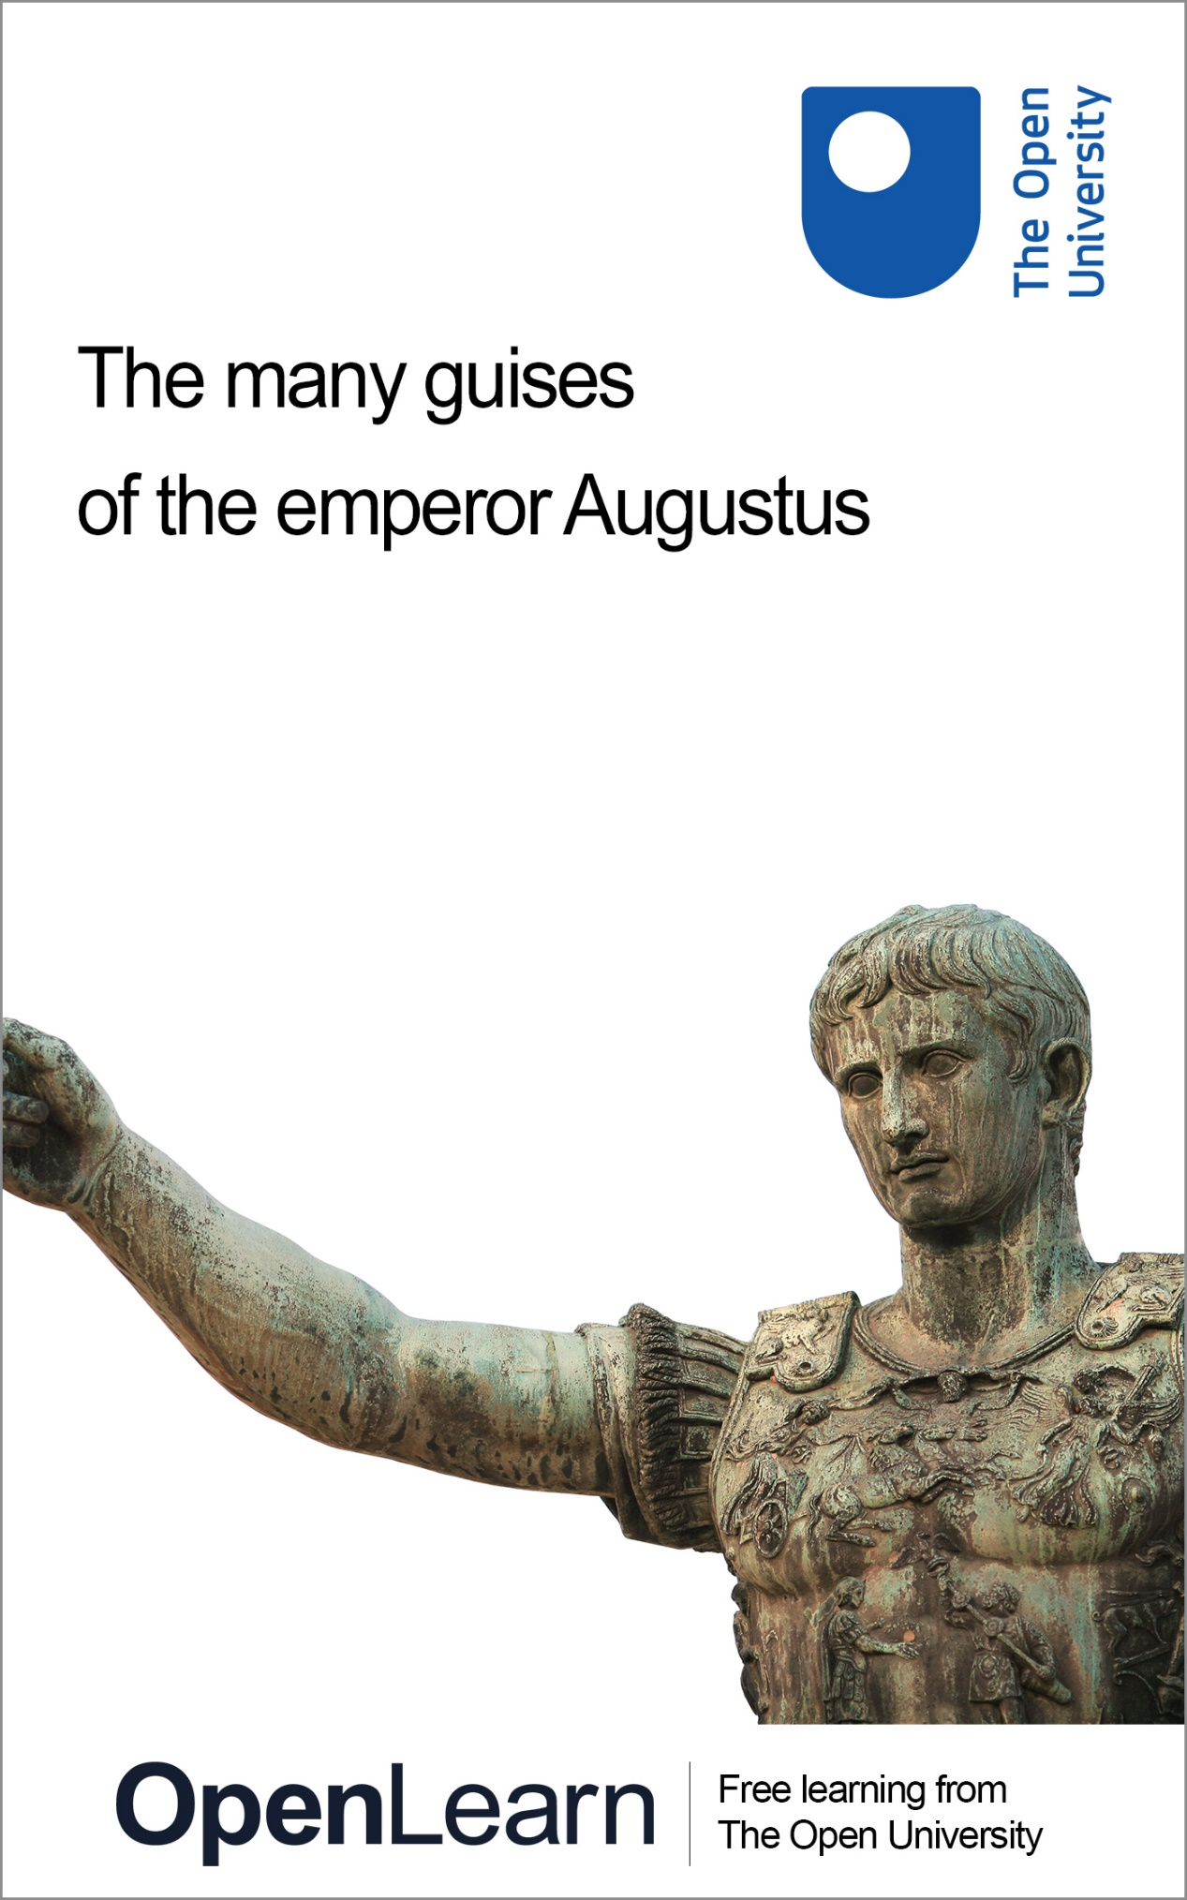

HDS_3

The many guises of the emperor Augustus

About this free course
Find out more about The Open University’s Classical Studies courses and qualifications: www.open.ac.uk/courses/arts/degrees/ba-arts-humanities-classical-studies-r14-cs.
This version of the content may include video, images and interactive content that may not be optimised for your device.
You can experience this free course as it was originally designed on OpenLearn, the home of free learning from The Open University –
www.open.edu/openlearn/history-the-arts/the-many-guises-the-emperor-augustus/content-section-0
There you’ll also be able to track your progress via your activity record, which you can use to demonstrate your learning.
Unless otherwise stated, copyright © 2024 The Open University, all rights reserved.
Intellectual property
Unless otherwise stated, this resource is released under the terms of the Creative Commons Licence v4.0 https://creativecommons.org/licenses/by-nc-sa/4.0/deed.en. Within that The Open University interprets this licence in the following way: www.open.edu/openlearn/about-openlearn/frequently-asked-questions-on-openlearn. Copyright and rights falling outside the terms of the Creative Commons Licence are retained or controlled by The Open University. Please read the full text before using any of the content.
We believe the primary barrier to accessing high-quality educational experiences is cost, which is why we aim to publish as much free content as possible under an open licence. If it proves difficult to release content under our preferred Creative Commons licence (e.g. because we can’t afford or gain the clearances or find suitable alternatives), we will still release the materials for free under a personal end-user licence.
This is because the learning experience will always be the same high quality offering and that should always be seen as positive – even if at times the licensing is different to Creative Commons.
When using the content you must attribute us (The Open University) (the OU) and any identified author in accordance with the terms of the Creative Commons Licence.
The Acknowledgements section is used to list, amongst other things, third party (Proprietary), licensed content which is not subject to Creative Commons licensing. Proprietary content must be used (retained) intact and in context to the content at all times.
The Acknowledgements section is also used to bring to your attention any other Special Restrictions which may apply to the content. For example there may be times when the Creative Commons Non-Commercial Sharealike licence does not apply to any of the content even if owned by us (The Open University). In these instances, unless stated otherwise, the content may be used for personal and non-commercial use.
We have also identified as Proprietary other material included in the content which is not subject to Creative Commons Licence. These are OU logos, trading names and may extend to certain photographic and video images and sound recordings and any other material as may be brought to your attention.
Unauthorised use of any of the content may constitute a breach of the terms and conditions and/or intellectual property laws.
We reserve the right to alter, amend or bring to an end any terms and conditions provided here without notice.
All rights falling outside the terms of the Creative Commons licence are retained or controlled by The Open University.
Head of Intellectual Property, The Open University

Contents
- Introduction
- Learning outcomes
- 1 Rome: republic to empire
- 2 King Abdullah II of Jordan
- 3 Roman male dress
  - 3.1 The toga: how it looked
  - 3.2 The toga in Roman culture
  - 3.3 The Augustan toga
  - 3.4 Capite velato
  - 3.5 Roman military dress
  - 3.6 The corona civica
- 4 The many guises of Augustus
  - 4.1 Augustus’ titles
  - 4.2 Augustus’ outfits
  - 4.3 Augustus’ autobiography
- Conclusion
- Taking it further
- Pronunciation guide
- Tell us what you think
- Acknowledgements
- Glossary
- Solutions
- Descriptions

Introduction
This free course focuses on Rome’s first emperor, Augustus, who lived from 63 BCE to 14 CE. The rule of Augustus marked a significant political change in Rome, and Augustus’ position as emperor was initially fragile and controversial. Key to his success in holding onto power was his masterful use of visual propaganda to cement his position and underline his legitimacy. The course examines the various roles Augustus constructed in an attempt to appeal to as many people as possible, and highlights the central importance of dress in Augustus’ imagery. To illustrate this, the course will also look at Abdullah II, who became king of Jordan in 1999, and who applies a similar principle to his portraiture.

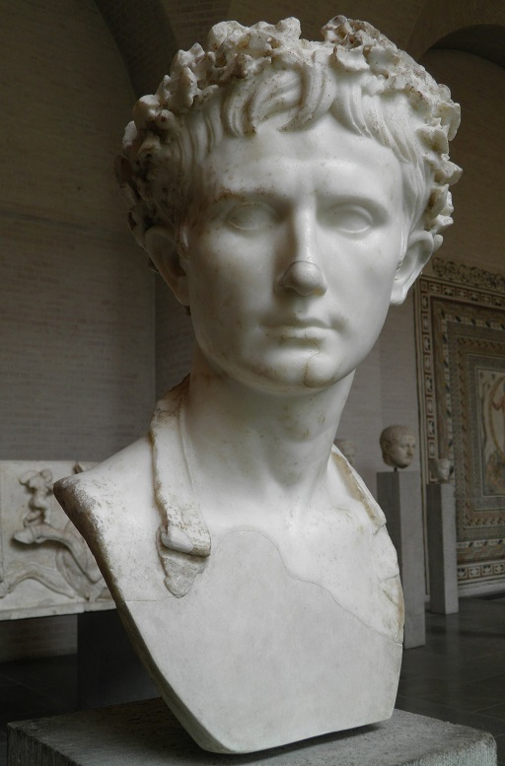
Figure 1 Bust of Augustus, Augustan period. Munich: Glyptothek.
View description - Figure 1 Bust of Augustus, Augustan period. Munich: Glyptothek.
View alternative description - Figure 1 Bust of Augustus, Augustan period. Munich: Glyptothek.

Before you get started we would really appreciate a few minutes of your time to tell us about yourself and your expectations for this course, in our optional start-of-course survey. Participation will be completely confidential and we will not pass on your details to others.

Learning outcomes
After studying this course, you should be able to:
- understand how political leaders can construct various different roles to appeal to as many people as possible
- understand the key role that visual representation and dress plays in these roles
- show knowledge about the personality and history of Rome’s first emperor Augustus, and some of the ways in which he consolidated his power
- analyse images and source texts, and compare them to one another.

1 Rome: republic to empire
Rome’s first emperor, Augustus, was a king in all but name. This may seem unsurprising; after all, one of the things people often associate with Rome is powerful rulers with extravagant tastes, control over a mighty army, and power of life and death over their subjects. But in reality, it was a lot more complicated than this, and the history of Rome’s first emperor illustrates why. Before Augustus came to power, Rome had been a republic (i.e. governed by the people rather than a king) for roughly 500 years, with power carefully balanced in a mixed constitution combining a people’s assembly, a senate and elected magistrates with fixed terms of office. By the mid-first century BCE, however, the system was breaking apart and Rome was plunged into two bitter civil wars between powerful political and military figures, such as Julius Caesar and Mark Antony, one after the other. Augustus – at this stage still called Octavian – was the last man standing after the second civil war, and this is how he came to be in control of the Roman state.

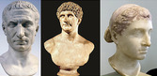
Figure 2 The Chiaramonti bust of Julius Caesar, Rome: Museo Pio-Clementino, Vatican Museums; Figure 3 Bust of Marcus Antonius, Rome: Vatican Museums, Chiaramonti Museum; Figure 4 Bust of Cleopatra, Berlin: Altes Museum, Antikensammlung.
View description - Figure 2 The Chiaramonti bust of Julius Caesar, Rome: Museo Pio-Clementino, Vatican ...
View alternative description - Figure 2 The Chiaramonti bust of Julius Caesar, Rome: Museo Pio-Clementino, Vatican ...

The civil war period (49–31 BCE) was a highly traumatic experience for the Roman people as a whole and counted a number of its most colourful figures as its victims. From this tender political situation emerged Augustus as the undisputed leader of Rome. In principle, he was just one more power-hungry young Roman aristocrat who got caught up in the storm of power-wrangling at end of Republic: even after emerging victorious over Mark Antony and Cleopatra in 31 BCE at the Battle of Actium (the final battle of the second civil war), it was by no means a given that he would be able to maintain his position of control over the Roman state and avoid the violent fate of his rivals and peers. Augustus managed, first, to stay alive and, more importantly, bridge the bitter gap between political ideals while maintaining absolute control.

View description - Uncaptioned Figure
View alternative description - Uncaptioned Figure

Augustus’ ability to maintain power was largely down to his genius for public relations, in which portraiture and imagery played a key role. This allowed him to represent himself in a range of guises to appeal to as many people as possible. Dress can be an important tool for portraying oneself in a particular way, in the Roman period just as it is now, and it is largely through dress that Augustus was able to create his various guises. He was not the first ruler to use dress to project a particular public image, however, nor would he be the last. So, before we look at Augustus, let’s explore this in a more modern setting in the form of the king of Jordan, Abdullah II.

Study note: a note on dates
You will notice that this course uses the abbreviations ‘BCE’ and ‘CE’ when dating events, texts and objects. These abbreviations stand for ‘Before the Common Era’ and ‘Common Era’. You may be familiar with an alternative method of referring to dates as ‘BC’ (‘before Christ’) and ‘AD’ (Anno Domini, Latin for ‘in the year of our Lord’), and you may find that the authors of other things you read on the topics discussed here use instead BC and AD instead of BCE and CE. Remember that BCE years count backwards – therefore the eighth century BCE is earlier than the seventh century BCE.

2 King Abdullah II of Jordan
Abdullah II bin Al-Hussein became king of Jordan, in the Middle East, in 1999, after the death of his father, Hussein. King Hussein had been an exceptionally popular leader, and Abdullah clearly had very large shoes to fill. Jordan is a constitutional monarchy, meaning that the king’s powers are limited by a constitution, but while the king has a great deal of power, he is also very keen to appeal to his subjects. As a result of both these things, Abdullah has developed a public image that involves portraying himself in an array of different guises. In this context, clothing plays a key role.

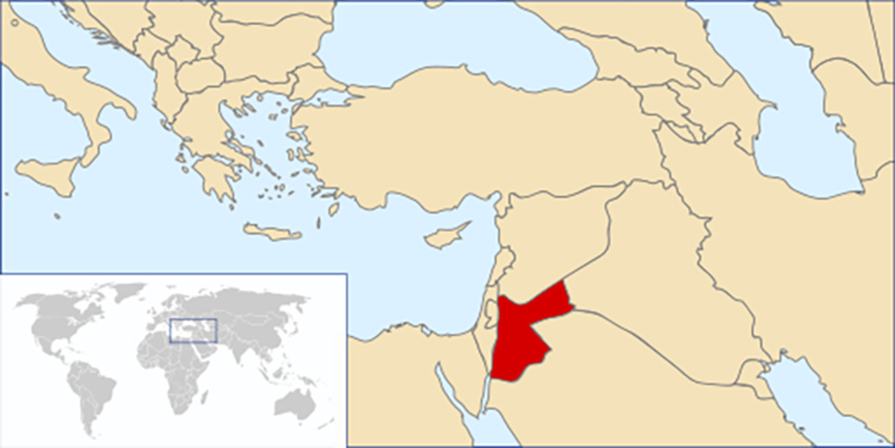
Map 1 Map of the eastern Mediterranean Sea, showing the location of Jordan.
View description - Map 1 Map of the eastern Mediterranean Sea, showing the location of Jordan.
View alternative description - Map 1 Map of the eastern Mediterranean Sea, showing the location of Jordan.

Activity 1
Allow around 25 minutes for this activity

Have a look at the following images of King Abdullah II, also paying attention to the information in the captions. Then fill in the table below with key details with a row for each image: note form is fine. The first one has been done for you.

Figure number | Description of image, especially clothing | Location of image (if known) | What is the image trying to convey/who might it especially appeal to?
5 | The king in military uniform with lots of medals, in front of a Jordanian flag | Outside a military installation | The king as soldier and military commander. Serious face. Looks like someone who is militarily capable/experienced and willing to lead from the front in the event of war. Likely to appeal to military personnel (‘I am one of you’) as well as citizens wanting to know their country is in safe hands.
6 | Provide your answer... | Provide your answer... | Provide your answer...
7 | Provide your answer... | Provide your answer... | Provide your answer...
8 | Provide your answer... | Provide your answer... | Provide your answer...
9 | Provide your answer... | Provide your answer... | Provide your answer...
10 | Provide your answer... | Provide your answer... | Provide your answer...

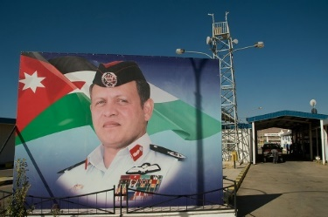
Figure 5 Portrait of King Abdullah outside the military installation on the border with Israel near Aqaba.
View description - Figure 5 Portrait of King Abdullah outside the military installation on the border ...
View alternative description - Figure 5 Portrait of King Abdullah outside the military installation on the border ...

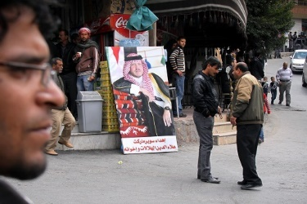
Figure 6 Portrait of King Abdullah outside the bazaar in Wadi Musa in southern Jordan.
View description - Figure 6 Portrait of King Abdullah outside the bazaar in Wadi Musa in southern J ...
View alternative description - Figure 6 Portrait of King Abdullah outside the bazaar in Wadi Musa in southern J ...

Study note: Bedouins
Bedouins are nomadic people who are the traditional inhabitants of large parts of the Middle East. In Jordan most live in the south of the country. Their traditional lifestyle includes herding sheep and goats, living in large tents and distinctive dress, which for men includes a red-and-white headscarf held down with a black band. The Bedouins of Jordan see King Abdullah as their leader.

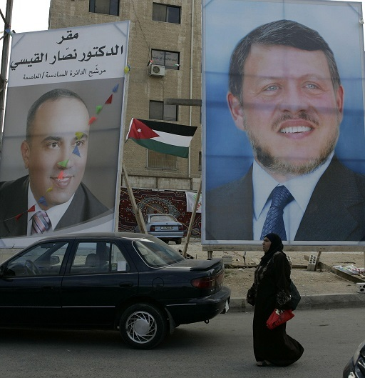
Figure 7 Poster of King Abdullah in the commercial centre of the Jordanian capital, Amman.
View description - Figure 7 Poster of King Abdullah in the commercial centre of the Jordanian capital, ...
View alternative description - Figure 7 Poster of King Abdullah in the commercial centre of the Jordanian capital, ...

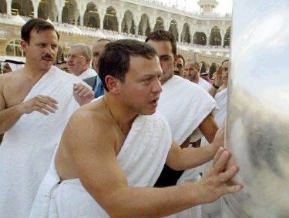
Figure 8 King Abdullah participates in an Umra pilgrimage with his brother Prince Ali Mecca (the key Muslim pilgrimage site in Saudi Arabia) wearing the rida (sash) and izar (loincloth) of pilgrims.
View description - Figure 8 King Abdullah participates in an Umra pilgrimage with his brother Prince ...
View alternative description - Figure 8 King Abdullah participates in an Umra pilgrimage with his brother Prince ...

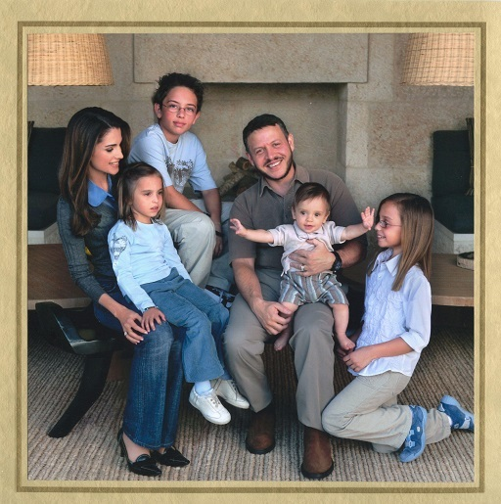
Figure 9 King Abdullah and his family inside their home, posing for a New Year’s Eve card.
View description - Figure 9 King Abdullah and his family inside their home, posing for a New Year’s ...
View alternative description - Figure 9 King Abdullah and his family inside their home, posing for a New Year’s ...

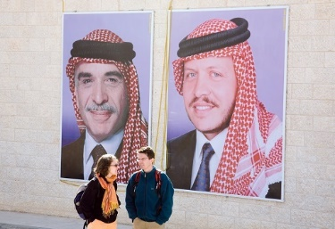
Figure 10 Portraits of King Abdullah (r.) and his father King Hussein (l.) in Petra, southern Jordan.
View description - Figure 10 Portraits of King Abdullah (r.) and his father King Hussein (l.) in Petra, ...
View alternative description - Figure 10 Portraits of King Abdullah (r.) and his father King Hussein (l.) in Petra, ...

View discussion - Activity 1

3 Roman male dress
‘He always had clothes and shoes, fit to appear in public, ready in his bedroom for any sudden occasion.’ So recounts the Roman writer Suetonius (circa 69–122 CE) in chapter 73 of his biography of Augustus, showing that Rome’s first emperor was fully aware of the importance of appearance for someone in his position. In this section, you are going to look at different styles of male Roman dress and their meaning, with a view to being able to understand the symbolism of a number of images of Augustus you will encounter later on. Clothing had a special importance in the ancient world because textiles were hand-woven on looms, so they were time-consuming to produce and therefore expensive. For some people, their clothing will have been the most expensive thing they owned; therefore, it was one of the main ways in which a person could show identity and status.
So, what kinds of clothing did an elite Roman man like Augustus have at his disposal?

3.1 The toga: how it looked
The main garment we tend to associate with Rome today is the toga, and indeed it was the most important symbolic garment of the Roman man. The toga was essentially a huge cloak that was wrapped around the body, usually over a knee-length tunic. It was semi-circular in shape, which gave it a characteristic round hem (setting it apart from other ancient cloaks). By the time of Augustus, it was worn almost exclusively by men. It was very important that the toga was draped correctly, and the styles of draping changed over time.

Activity 2
Allow around 25 minutes for this activity

First, watch the following video on how to drape a toga, taking note of how it is put on and worn. This is a reconstructed toga from the period of Augustus with the draping style of that period (you’ll come back to this shortly).

Video content is not available in this format.

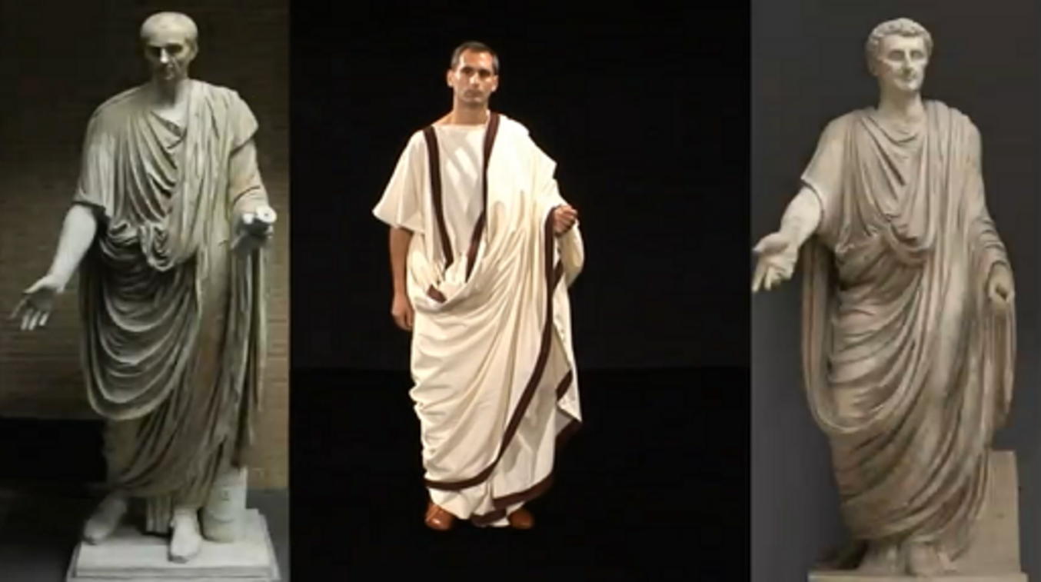

Then watch the video again, this time making notes to answer the following questions:
- Roughly how big is the toga in the video? What effect do you think this had on what it cost? Can you imagine what a cheaper toga might have looked like?
- How is the toga kept on the body? What kinds of things would you not have been able to do while wearing it?

Provide your answer...
View discussion - Activity 2

As a result of its special properties, the toga was, then, the garment worn on an everyday basis only by men who were not involved in manual labour: politicians, lawyers, clerks and businessmen, for example. As it required someone to help put it on, people who wore it on a regular basis would also have normally had household slaves to do this – another expense. Because of its formality, however, it was also the required dress for important formal occasions, like weddings, funerals, court hearings and religious ceremonies. As a result, many artisans and manual labourers will have had a toga stored away for these kinds of events, like many people today have an outfit that they only wear for special occasions.

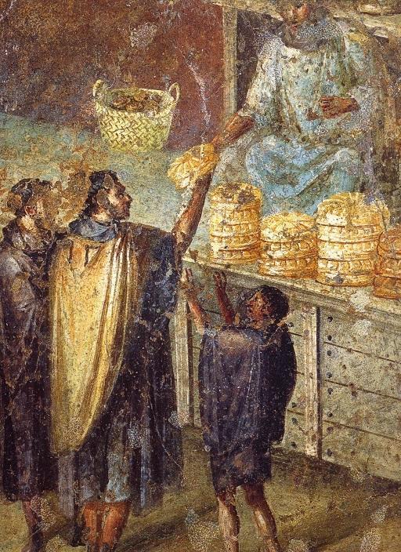
Figure 11 Fresco from Pompeii showing a magistrate in a tunic and toga (top right) handing out free bread to poor people wearing dark tunics and hooded capes, first century CE.
View description - Figure 11 Fresco from Pompeii showing a magistrate in a tunic and toga (top right) ...
View alternative description - Figure 11 Fresco from Pompeii showing a magistrate in a tunic and toga (top right) ...

3.2 The toga in Roman culture
But why would a man bother with the expense of a toga at all? The answer lies in what the toga symbolised.
First, it signified Roman citizenship. From the first century BCE onward, with the exception of enslaved people, most residents of Italy and especially the city of Rome will have held Roman citizenship status, which gave them, e.g., the right to vote and participate in Roman government, to marry and bequeath property and certain tax breaks. Citizenship could be acquired by people in the provinces (the areas Rome conquered: see Map 2) if they fulfilled certain criteria, but the further away one went from Rome, the fewer people will have had it. As a result, it was something of a privilege. If you did not possess Roman citizenship status, you were forbidden from wearing the toga, so it served as a kind of clothing passport.

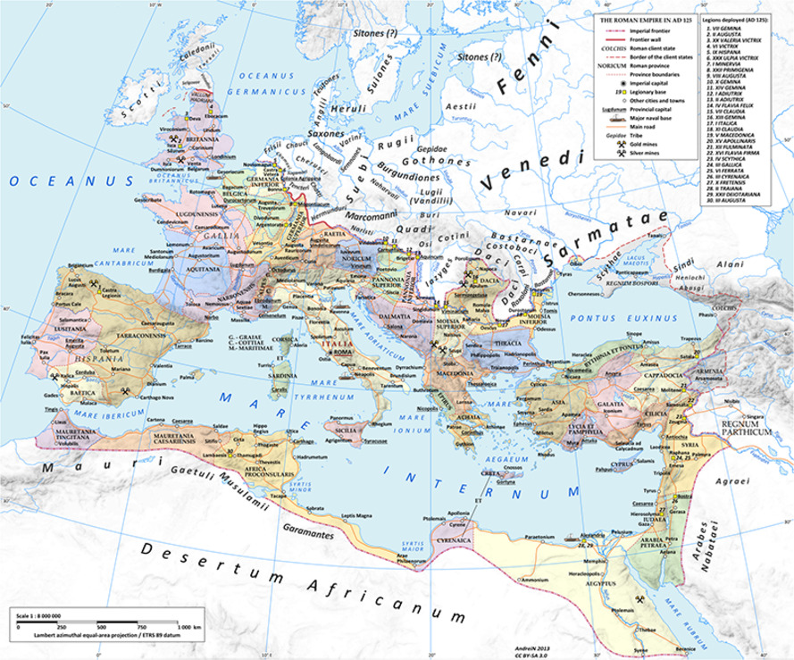
Map 2 Map of the Roman Empire in c. 120 CE showing the location of different provinces.
View description - Map 2 Map of the Roman Empire in c. 120 CE showing the location of different pro ...
View alternative description - Map 2 Map of the Roman Empire in c. 120 CE showing the location of different pro ...

Second, as it symbolised specifically Roman citizenship, the toga was, at the same time, a key emblem of Roman identity, a bit like the kilt for the Scots or the kimono for the Japanese today. This is why the poet Virgil called the Romans ‘the masters of the world, the toga-clad race (gens togata)’ (Aeneid 1.281–2).
Third, the toga symbolised civic duty and Republican egalitarianism. During the Republic, all Roman citizens, rich or poor, were theoretically equal in the eyes of the law. (No matter that in reality the rich found ways to have greater power!) All male Roman citizens were expected to participate in public and political life, e.g. as voters, participants in key state ceremonies, and, if they could afford it, as magistrates and/or senators. Not all inhabitants of Rome will have been Roman citizens: there will have been many enslaved people and immigrants excluded from citizenship, but the principle of the Republic was nonetheless more inclusive than most other pre-modern political system. The relative egalitarianism of the Republic is what set it apart from other ancient societies, where most people were passive subjects of powerful rulers, rather than active citizens with rights and responsibilities.
Fourth, the toga symbolised peace. It was the dress of civic life and civilised political discourse, which for the Romans were the polar opposite of war. In fact, military clothing and weapons were forbidden inside the walls of Rome. The historian Livy (59 BCE–17 CE), in his account of origins and history of Rome, used the phrase ‘while they were still in the toga’ (dum togati sint) to describe generals who had not yet left on military campaign (3.10) and the politician and prolific writer Cicero (106–43 BCE) praised the first-century-BCE general and statesman Julius Caesar for being ‘clarus in toga’ – ‘distinguished’ (clarus) in civilian (as opposed to military) life (Letters to Friends 6.6.5).
Yet there were different types of toga and different ways of wearing it. You will turn to some of them now.

3.3 The Augustan toga
In his Life of Augustus, the historian Suetonius makes the following comment about Augustus:

He desired also to revive the traditional fashion of dress, and once when he saw in an assembly a group of men in dark cloaks, he cried out indignantly, ‘Behold them, Romans, masters of the world, the toga-clad race!’ (gens togata) and he directed the officers never again to allow anyone to appear in the Forum or its neighbourhood except in the toga.
(Suetonius, Augustus 40)

In this passage, Augustus is observed sarcastically quoting the lines from the Aeneid mentioned in the previous section to bewail the sight of men in central Rome wearing dark cloaks instead of togas. For him, this was a sign of the degree to which standards of propriety and patriotism had slipped over the course of the late Republic, and he was determined to do something about it. First, as the passage says, he made the toga compulsory in the civic heart of Rome. Second, he invented a new type of toga.
The Republican toga had consisted of a simple semi-circle of cloth draped diagonally around the body with the straight edge (balteus) at the top and the curved hem at the bottom. Augustus’s toga had an added semicircle of cloth called a sinus that formed a second layer with a higher hem. It was also draped in a more complex way, with a pocket of cloth (umbo) pulled out over the balteus (see Figures 12 and 13). (NB: the toga you saw in the video in the previous section was an Augustan toga!)

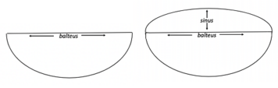
Figure 12 Outline of the earlier Republican toga (left) vs the Augustan toga (right).
View description - Figure 12 Outline of the earlier Republican toga (left) vs the Augustan toga (right). ...
View alternative description - Figure 12 Outline of the earlier Republican toga (left) vs the Augustan toga (right). ...

Figure 13 Draping of the Republican toga (top row) vs the Augustan toga (bottom row). The fully draped Republican toga is D, the fully draped Augustan toga is G. Parts of the toga: 1. lacinia 2. balteus 3. sinus 4. umbo.
View description - Figure 13 Draping of the Republican toga (top row) vs the Augustan toga (bottom row). ...
View alternative description - Figure 13 Draping of the Republican toga (top row) vs the Augustan toga (bottom row). ...

Activity 3
Allow around 15 minutes for this activity

Scholars have speculated on the meaning of the imperial toga. Why do you think Augustus thought it a good idea to introduce a new style of toga?

Provide your answer...
View discussion - Activity 3

3.4 Capite velato
It wasn’t just the form of the toga that was important, but also its drapery, as the previous section showed. Another important toga draping style throughout Roman history was so-called ‘capite velato’ or ‘covering the head’, in which the back part of the balteus – or in the case of the Augustan toga the sinus (see image H in Figure 13 in the previous section) – was pulled up over the back of the head. This was a sign of respect for the gods and was used during religious ceremonies such as sacrifices. When men chose to have themselves portrayed in the toga capite velato, it showed they wanted to be seen as pious, modest and respectful of the gods. Figure 14 is an illustration of how it looked.

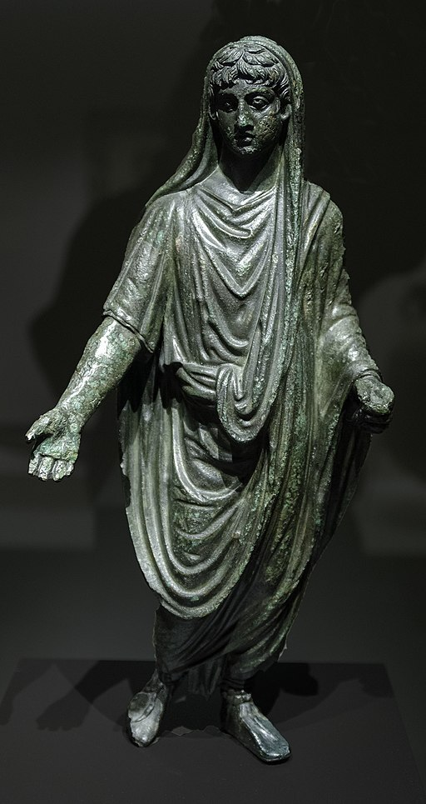
Figure 14 Bronze figurine of a man from Puente Púñide, La Coruña, Spain, first century CE, Museo Arqueológico Nacional de España.
View description - Figure 14 Bronze figurine of a man from Puente Púñide, La Coruña, Spain, first century ...
View alternative description - Figure 14 Bronze figurine of a man from Puente Púñide, La Coruña, Spain, first century ...

3.5 Roman military dress
At the opposite end of the scale to the toga, which signalled civilian life, was military dress.

Activity 4
Allow around 5 minutes for this activity

How might you know someone is a member of the military today?

Provide your answer...
View discussion - Activity 4

In the Roman army there was no uniform as such: military personnel tended to buy their own clothes, and as far as we know there was very little in the way of regulation here. As a result, there are too many variations of clothing used by Roman soldiers to go into them all here. But there were certain elements of clothing that tended to be worn by soldiers, and they themselves often wanted to signal to others that they belonged to the military. This section will outline these main components.

Activity 5
Allow around 15 minutes for this activity

Take a careful look at the following set of images.
- The first shows the basic clothing of the Roman soldier in the time of Augustus. Jot down a few bullet points describing what it consists of.
- The second image shows the dress of a Roman commander. Again, jot down some bullet points describing what it consists of, making note of the main differences between the two.
(NB: Take special care to describe the two figures’ cloaks and how they are worn.)

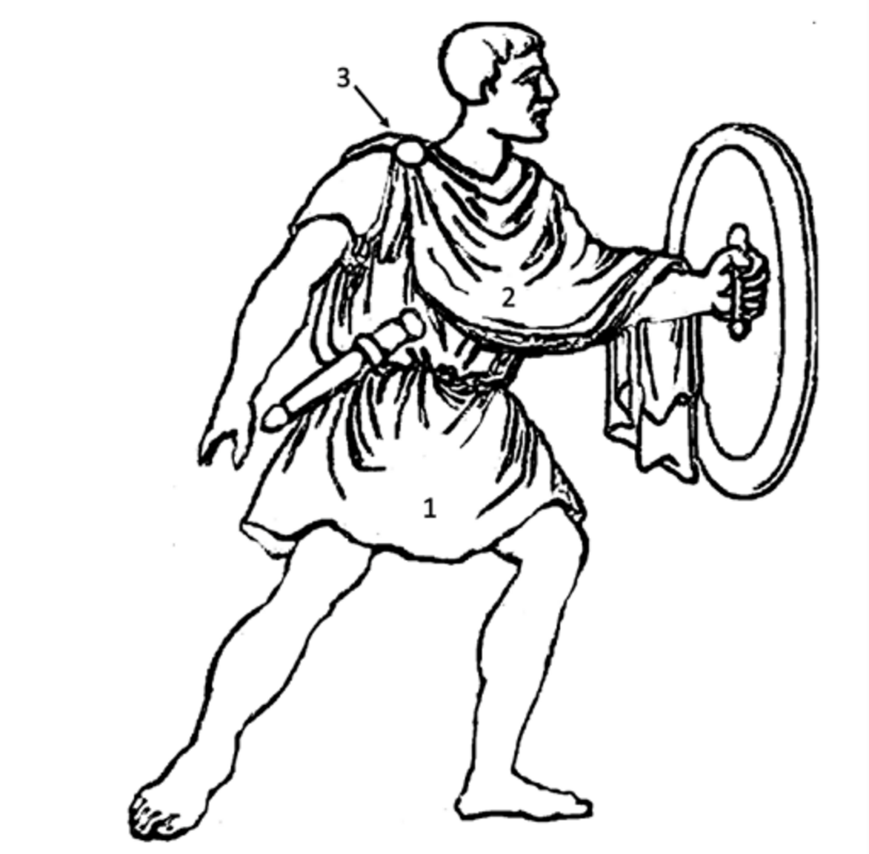
Figure 15 Drawing of a Roman soldier wearing a tunic (1) and sagum (2) fastened with a brooch (3).
View description - Figure 15 Drawing of a Roman soldier wearing a tunic (1) and sagum (2) fastened with ...
View alternative description - Figure 15 Drawing of a Roman soldier wearing a tunic (1) and sagum (2) fastened with ...

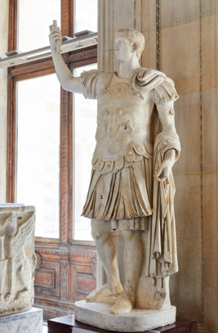
Figure 16 Marble statue of a Roman general wearing a pleated tunic (1), decorated breastplate (cuirass) (2) and large draped cloak (paludamentum: (3) from Gabies, Italy, 69–96 CE (Musée du Louvre, Paris).
View description - Figure 16 Marble statue of a Roman general wearing a pleated tunic (1), decorated ...
View alternative description - Figure 16 Marble statue of a Roman general wearing a pleated tunic (1), decorated ...

Provide your answer...
View discussion - Activity 5

3.6 The corona civica
Decorated breastplates showing images like submissive enemies and war trophies were one way, but there were also other ways of showing off your achievements. For example, one of the highest honours was being awarded the so-called corona civica (literally ‘civic crown’), a wreath made of oak leaves worn on the head and/or hung outside the house that was bestowed on Roman citizens who had saved the lives of other Roman citizens.

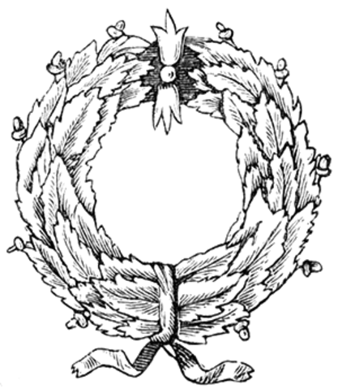
Figure 17 Drawing of a corona civica.
View description - Figure 17 Drawing of a corona civica.
View alternative description - Figure 17 Drawing of a corona civica.

4 The many guises of Augustus
As outlined in the Introduction to this course, Augustus became sole ruler of Rome after a series of bloody civil wars that ended in him defeating all his rivals. These civil wars were characterised by a fundamental battle not only between different powerful figures, but also between the political principles of Republicanism on the one hand, and the realities of personal ambition and the need to control an empire and colossal army on the other. As a result, Augustus’ position at the start of his rule was very precarious. In the way that he presented himself to the people of Rome and the empire, he managed to tread a very fine line between two seemingly contradictory principles – ones that represented the conflicting sides of Rome’s civil wars.
- On the one hand, monarchy was a taboo concept in Rome. Kings hadn’t ruled Rome since they were chased out 500 years earlier and The (Roman) Republic was established. Rome prided itself on its constitution based on a collective duty to be politically involved and saw monarchy as barbaric and immoral. Consequently, and because his adoptive father Julius Caesar had been assassinated for his monarchic ambitions, Augustus had to present himself as the ‘first among equals’, returning Rome to its republican roots, restoring peace and stability, and fostering the so-called mos maiorum, or ‘custom/ways of one’s ancestors’ of the old days of the Republic. Instead of calling himself king, Augustus assumed political offices that had already existed in the Republic. However, instead of sharing them out, his power stemmed from the fact that he held most of the key positions at once!
- On the other hand, the exceptional extent of Augustus’ power couldn’t be completely hidden. As a result, this power had to be justified to the people. Augustus did this by portraying himself as extraordinarily virtuous and capable person, possessing in abundance the qualities expected by the Roman people of one of their leaders, such as piety and modesty. In this way, he could assert that the exceptional power he held was down to his exceptional personal qualities.

4.1 Augustus’ titles
While the position of Roman ruler became an institution that continued, usually passed on from father to son, for many centuries, at this stage one could say that Augustus’ official role was a bit of a fudge. We use the word ‘emperor’ now, but neither this word, nor the concept behind it, existed in the Roman period. (Our word ‘emperor’ comes from the Latin word ‘imperator’, meaning ‘military commander’.) The ancient world only had the concept of the king (‘rex’), and Augustus certainly could not call himself that! Instead, he acquired (i.e. leant on the Roman senate to give him) a series of honorific titles over the course of his rule that meant different things, and these corresponded to the different qualities Augustus tried to emphasise in his written and visual publicity.

Activity 6
Allow around 15 minutes for this activity

Below is a list of the main honorific titles Augustus was given with a translation of what each means. Match up the title and definition with the further details (copying and pasting from the options below into the table). The first one has been done for you.

Honorific title and translation | Further details
Augustus: ‘sacred, solemn, dignified’ | We see this as his name, and indeed this is what it became, but originally he was called Octavian. This honorific title was one he acquired four years into his rule and it denoted religious, rather than political, authority, and showed him as pious, dutiful and respectful of the gods. Tied up with this title was the fact that Augustus acted as priest in several important cults, including as pontifex maximus, chief priest of Rome.
Imperator: ‘military commander’ or ‘commander in chief’ | Provide your answer...
Pater patriae: ‘father of the fatherland’ | Provide your answer...
Divi filius: ‘son of a god’ | Provide your answer...

Option A
Like a father in a Roman family, who was the head of the household, Augustus’ job was both to ensure the wellbeing of his people, and to keep an eye on their behaviour in terms of morality (e.g. taking steps against things like adultery, extravagance and impiety). Augustus used his own family as a model for the Roman people to follow and was the first Roman statesman to portray not just himself but also his family members in public art. Being a family man, along with the title ‘pater patriae’, suggested simplicity, wholesomeness and tradition (in contrast to the egotism and depravity of the civil wars).
Option B
Augustus had been adopted by the famous general Julius Caesar during his lifetime. (Romans often did this: it was a way of being able to choose someone to inherit from you if you either didn’t have children or you felt that the ones you did have weren’t capable of stepping into your shoes.) Although Caesar was eventually assassinated on the Ides of March in 44 BCE by a group of senators who were unhappy with his increasing control of the Roman state, he had been extremely popular with the general populace, and was deified (i.e. declared a god) after his death. The connection to Caesar was a mixed blessing for Augustus. On the one hand, he didn’t want to appear to have monarchical ambitions like Caesar; but on the other, he could benefit from Caesar’s popularity with ordinary people, and especially, as this title shows, from the fact that he could claim divine connections! The fact that he became Caesar’s son meant that he also took on his name and became ‘Caesar Augustus’.
Option C
This is where we get the word ‘emperor’ from. While Augustus was keen to downplay his more aggressive side and his role in the civil wars, there was still a lot of respect to be gained from being a skilled military commander, capable of not only defending the empire from external threat, but also expanding it to increase Rome’s glory. (Remember the mindset revealed by the Virgil quote you read in Section 3.1: the Romans saw themselves as the ‘masters of the world’!)

View discussion - Activity 6

4.2 Augustus’ outfits
It is now time to turn at last to Augustus’ visual propaganda. In this section, you will be introduced to some examples of Augustus’ official portraits (that is to say images that were either devised by Augustus, or had at least been sanctioned by him). These have been chosen because they represent key types in his ‘portfolio’ of publicity images. They are all from Italy, but they also served as models that were replicated throughout the different provinces in Rome’s empire. In the next activity, you will be asked to match the symbolism of the imagery with the honorific titles you learned about in the previous section, so that you can start to see how joined up and clever Augustus’ propaganda programme was.

Activity 7
Allow around 30 minutes for this activity

- Take a close look at the images below the table, as well as the captions, and then fill in the first two blank columns in the table. You may wish to revisit Section 3 to refresh your memory of the dress styles. A sentence or two or 2–3 bullet points is fine for each.
- In the third blank column, insert the honorific title (Augustus, imperator, pater patriae, divi filius) you think matches the image, or, in other words: which of Augustus’ roles is the image conveying? There may be more than one in some cases.
Again, the first has been done for you. Remember to consult the glossary if there are any words that are unfamiliar to you.

Image | Description of image, esp. dress | What is the image trying to convey? | Corresponding title
Louvre bust (Figure 18) | Augustus wearing a sagum with a brooch at the shoulder (i.e. soldiers’ dress) and the oak wreath (corona civica) | Augustus as soldier, but also as someone who saved the lives of fellow Roman citizens, perhaps by ending the civil war? | Either imperator (because military man) or pater patriae (because protecting citizens)
Prima Porta statue (Figure 19) | Provide your answer... | Provide your answer... | Provide your answer...
Via Labicana statue (Figure 20) | Provide your answer... | Provide your answer... | Provide your answer...
Ara Pacis frieze (Figure 21) | Provide your answer... | Provide your answer... | Provide your answer...
Julius Caesar coin (Figure 22) | Provide your answer... | Provide your answer... | Provide your answer...

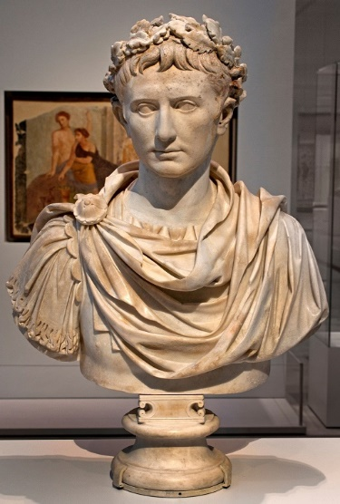
Figure 18 Bust of Augustus from an unknown location in Italy, now in the Louvre, Paris.
View description - Figure 18 Bust of Augustus from an unknown location in Italy, now in the Louvre, ...
View alternative description - Figure 18 Bust of Augustus from an unknown location in Italy, now in the Louvre, ...

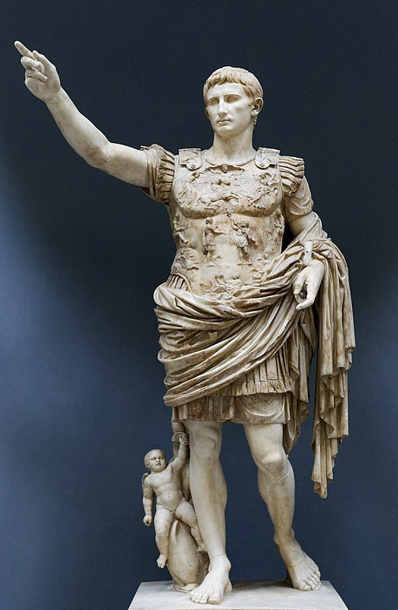
Figure 19 Statue of Augustus from Prima Porta in Rome, now in the Vatican Museums.
View description - Figure 19 Statue of Augustus from Prima Porta in Rome, now in the Vatican Museums. ...
View alternative description - Figure 19 Statue of Augustus from Prima Porta in Rome, now in the Vatican Museums. ...

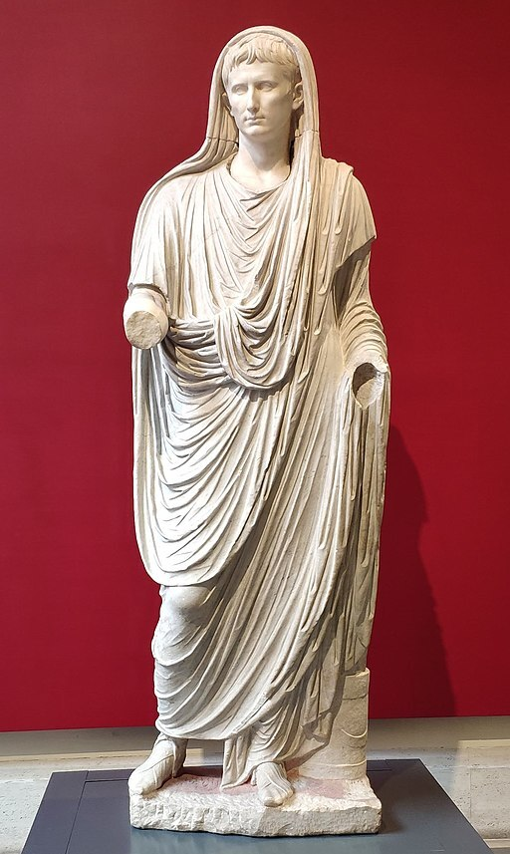
Figure 20 Statue of Augustus from the Via Labicana, Rome, now in the Palazzo Massimo, Rome.
View description - Figure 20 Statue of Augustus from the Via Labicana, Rome, now in the Palazzo Massimo, ...
View alternative description - Figure 20 Statue of Augustus from the Via Labicana, Rome, now in the Palazzo Massimo, ...

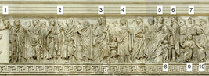
Figure 21 Relief showing a religious procession on the south side of the Ara Pacis (‘Altar to Peace’ or ‘Altar to the Pax Augusta’), a large monument built for Augustus in Rome to celebrate the peace following the civil wars. Key figures in this scene: 1. Augustus (damaged), 2. a group of priests, 3. Agrippa (Augustus’ son-in-law), 4. Julia (Augustus’ daughter), 5. Antonia Minor (Augustus’ niece), 6. Drusus (Augustus’ stepson), 7. Antonia Maior (another niece), 8. Germanicus, 9. Ahenobarbus, 10. Domitia (Augustus’ grandnephews/nieces). NB: please take note of the entire image in terms of what it means for Augustus to be depicted in this scene with his family members and, as far as you can identify it, what dress is worn by Augustus and his relatives.
View description - Figure 21 Relief showing a religious procession on the south side of the Ara Pacis ...
View alternative description - Figure 21 Relief showing a religious procession on the south side of the Ara Pacis ...

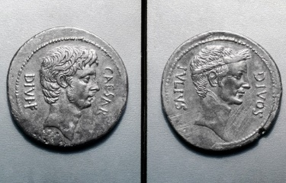
Figure 22 Bronze Roman coin with the head of Augustus and the words ‘CAESAR DIVI F(ILIUS)’ (‘son of Caesar, son of a god’) on one side, and the head of Julius Caesar with the words ‘DIVOS IULIUS’ (the divine Julius’) on the other.
View description - Figure 22 Bronze Roman coin with the head of Augustus and the words ‘CAESAR DIVI ...
View alternative description - Figure 22 Bronze Roman coin with the head of Augustus and the words ‘CAESAR DIVI ...

View discussion - Activity 7

This section has shown you how, by using different types of images, and especially different styles of dress, for his portraits and other public images, Augustus was able to appear in an array of guises that roughly corresponded to the formal titles he was bestowed with over time. In this way, he could try to appeal to as many different types of people as possible, and in so doing secure his reign.

4.3 Augustus’ autobiography
In the previous section you saw how Augustus used special portrait types to portray himself in different roles to appeal to as many people as possible. He seems to have been very keen to have full control of how people saw him. In fact, he was so keen to control his public image that he even wrote his own biography! The latter takes the form of a long list of achievements that were inscribed into stone or bronze tablets and set up in different places across the empire, including outside his tomb (the Mausoleum of Augustus) in Rome. This text is called the Res Gestae Divi Augusti (the ‘Great Deeds of the Divine Augustus’) or Res Gestae for short, and it records for posterity what he considered to be his most important achievements. The version we have today was found in Ankara in Türkiye and a section of it is shown in Figure 23.

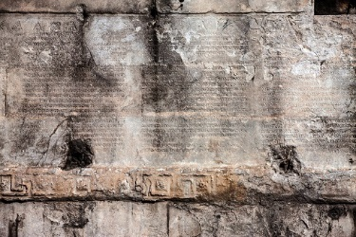
Figure 23 Part of the Res Gestae mounted on the wall of the Temple of Augustus in Ankara, Türkiye.
View description - Figure 23 Part of the Res Gestae mounted on the wall of the Temple of Augustus in ...
View alternative description - Figure 23 Part of the Res Gestae mounted on the wall of the Temple of Augustus in ...

The Res Gestae is really valuable to us, because it means we do not just have the images of Augustus to show us how he wanted to be seen, but also his own words on what he considered to be important. In fact, there is a good deal of consistency across Augustus’ autobiography, his titles, and his visual propaganda.

Activity 8
Allow around 25 minutes for this activity

Read the passages below from the Res Gestae carefully, thinking about what kind of image of himself Augustus is trying to convey in each passage. (Maps 3 and 4 will help you if you are keen to locate the places mentioned in the texts, but don’t worry if you don’t understand all the words in the passages: just try to get the gist of what Augustus is saying.) Then, fill in the final column of the table below by putting in which passage(s) you think best match the image and honorific title you’ve already put in. (NB: The same passage may apply to several of the images, and one image may match up to several passages!) The numbers given for the passages are the section numbers of the original document. Please use these numbers when you are filling in the table. Again, the first one has been done for you. You may come up with slightly different answers, depending on how you interpret the intended message in each passage.

Image | Corresponding title | Corresponding passages of the Res Gestae
Louvre bust (Figure 18) | Perhaps both imperator (because military man) or pater patriae (because protecting citizens) | 26, 34
Prima Porta statue (Figure 19) | Imperator (‘military commander’ or ‘commander in chief’) | Provide your answer...
Via Labicana statue (Figure 20) | Augustus (‘sacred, solemn, dignified’) | Provide your answer...
Ara Pacis frieze (Figure 21) | Pater patriae (‘father of the fatherland’) | Provide your answer...
Julius Caesar coin (Figure 22) | Divi filius (‘son of a god’) | Provide your answer...

Res Gestae 2: ‘I drove the men who slaughtered my father into exile with a legal order, punishing their crime, and afterwards, when they waged war on the state, I conquered them in two battles.’
Res Gestae 6: ‘[W]hen the Senate and the Roman people unanimously agreed that I should be elected overseer of laws and morals, without a colleague and with the fullest power, I refused to accept any power offered me which was contrary to the traditions of our ancestors.’
Res Gestae7: ‘I have been pontifex maximus, augur, a member of the fifteen commissioners for performing sacred rites, one of the seven for sacred feasts, an arval brother, a sodalis Titius, a fetial priest’ (all of these are specific Roman priesthoods).
Res Gestae8: ‘By the passage of new laws I restored many traditions of our ancestors which were then falling into disuse, and I myself set precedents in many things for posterity to imitate.’
Res Gestae15: ‘To the Roman plebs I paid out three hundred sesterces per man in accordance with the will of my father, and in my own name … I gave four hundred sesterces apiece from the spoils of war.’
Res Gestae17: ‘Four times I aided the public treasury with my own money, paying out in this manner to those in charge of the treasury one hundred and fifty million sesterces.’
Res Gestae20a: ‘The Capitolium and the theatre of Pompey, both works involving great expense, I rebuilt without any inscription of my own name.”
Res Gestae20b: ‘I rebuilt in the city eighty-two temples of the gods, omitting none which at that time stood in need of repair.’
Res Gestae26: ‘I extended the boundaries of all the provinces which were bordered by races not yet subject to our empire. The provinces of the Gauls, the Spains, and Germany… I reduced to a state of peace. The Alps, from the region which lies nearest to the Adriatic as far as the Tuscan Sea, I brought to a state of peace without waging on any tribe an unjust war.’
Res Gestae34: ‘[W]hen I had extinguished the flames of civil war, after receiving by universal consent the absolute control of affairs, I transferred the republic from my own control to the will of the senate and the Roman people. For this service on my part I was given the title of Augustus by decree of the senate, and … a civic crown [corona civica] was fixed above my door … . After that time I took precedence of all in rank, but of power I possessed no more than those who were my colleagues in any magistracy.’
Res Gestae35: ‘[T]he senate and the equestrian order and the entire Roman people gave me the title of Father of my Country (Pater Patriae), and decreed that this title should be inscribed upon the vestibule of my house … .’

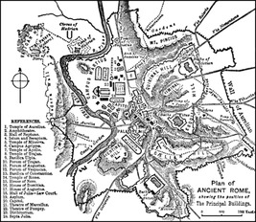
Map 3 Map of ancient Rome showing the location of the key regions and buildings
View description - Map 3 Map of ancient Rome showing the location of the key regions and buildings
View alternative description - Map 3 Map of ancient Rome showing the location of the key regions and buildings

Map 4 Map of the Roman Empire in c. 120 CE showing the location of different provinces.
View description - Map 4 Map of the Roman Empire in c. 120 CE showing the location of different pro ...
View alternative description - Map 4 Map of the Roman Empire in c. 120 CE showing the location of different pro ...

View discussion - Activity 8

Conclusion
Hopefully you now have some insight into the ways in which Rome’s first emperor used imagery, as well as written propaganda, to secure his place at the head of the state.
Augustus was keen to characterise his rule as a return, after the decadence, violence and vanity of the civil wars, to the morally upright values and system of the Republic. At the same time, he was, as everyone could see, in control of the state. Augustus had to convince the Roman people that this power had been given to him by the senate and the people because only he possessed the extraordinary qualities needed to save the state from collapse once again. In other words, in order to legitimise his power, Augustus had to play an interesting double-act of both downplaying the extent of his power, and emphasising his outstanding qualities and achievements. He did this, among other things, by inhabiting a range of different guises which corresponded largely to his honorary titles. Each of these guises was signalled using specific clothing that ‘told’ the viewer how to read the image. In this way, just as for King Abdullah of Jordan, dress could be used as a tool to present an array of different roles and characteristics to the Roman people, and in so doing try to be all things to all people.
Why does all this matter? Well, for one thing, the portraits created by Augustus, as well as the values and roles they represented, became the blueprint for Roman emperors for the rest of Roman history. Centuries later, Roman emperors were still being portrayed in almost exactly the same ways, and aspiring to rule in the way that Augustus did. For another, the examples of Augustus and King Abdullah show that using clothing to carefully construct public images is something common to political leaders across space and time.

Taking it further
If you enjoyed this short course on Augustus, dress and visual propaganda, you may also enjoy the following resources.
For more on the way that Romans and Greeks viewed and used their bodies, over and above as a place to display clothing, try this free OpenLearn course: The body in antiquity.
For more on Roman emperors, try the free OpenLearn course The repute and reality of being a Roman Emperor or follow the emperor Hadrian around the empire in the interactive game The roamin’ Emperor.
If you’re interested in Roman history and culture more generally, you might enjoy one of these free online courses:
- Introducing the Classical World.
- The Roman Empire: introducing some key terms.
- Getting started on Classical Latin.
To learn more about Roman dress, and to ask questions of a Roman dress expert, visit the Dr Toga website.
For a humorous interview on Radio 1 about the toga, go to the BBC website (minutes 7.28 to 14.23).
This course is part of a series of courses under the title HeadStart Classical Studies. You can find details about this series as well as links to its other courses on this page.

Pronunciation guide

Audio content is not available in this format.
augur

Audio content is not available in this format.
balteus

Audio content is not available in this format.
capite velato

Audio content is not available in this format.
corona civica

Audio content is not available in this format.
divi filius

Audio content is not available in this format.
imperator

Audio content is not available in this format.
lacinia

Audio content is not available in this format.
mos maiorum

Audio content is not available in this format.
paludamentum

Audio content is not available in this format.
pater patriae

Audio content is not available in this format.
Pax Augusta

Audio content is not available in this format.
pontifex maximus

Audio content is not available in this format.
Res Gestae Divi Augusti

Audio content is not available in this format.
sagum

Audio content is not available in this format.
sesterces

Audio content is not available in this format.
sinus

Audio content is not available in this format.
Suetonius

Tell us what you think
Now you’ve come to the end of the course, we would appreciate a few minutes of your time to complete this short end-of-course survey. We’d like to find out a bit about your experience of studying the course and what you plan to do next. We will use this information to provide better online experiences for all our learners and to share our findings with others. Participation will be completely confidential and we will not pass on your details to others.

Acknowledgements
This free course was written by Ursula Rothe.
Except for third party materials and otherwise stated (see terms and conditions), this content is made available under a Creative Commons Attribution-NonCommercial-ShareAlike 4.0 Licence.
The material acknowledged below is Proprietary and used under licence (not subject to Creative Commons Licence). Grateful acknowledgement is made to the following sources for permission to reproduce material in this free course:
Images
Course image: ROMAOSLO; Getty Images
Figure 1: Carole Raddato on Flickr; https://creativecommons.org/licenses/by-sa/2.0/
Figure 2: photographer unknown; taken from https://commons.wikimedia.org/wiki/File:Gaius_Iulius_Caesar_(Vatican_Museum).jpg; Figure 3: photographer unknown; taken from https://commons.wikimedia.org/wiki/File:Marble_bust_of_Mark_Antony_(Vatican_Museums).jpg; Figure 4; Louis le Grand; https://commons.wikimedia.org/wiki/File:Kleopatra-VII.-Altes-Museum-Berlin1.jpg
Figure 5: Eddie Gerald; Alamy Stock Photo
Figure 6: Pascal Mannaerts; Alamy Stock Photo
Figure 7: NADER DAOUD, STR; Associated Press; Alamy Stock Photo
Figure 8: Handout; Getty Images
Figure 9: Abaca Press; Alamy Stock Photo
Figure 10: Kumar Sriskandan; Alamy Stock Photo
Figure 11: The History Collection; Alamy Stock Photo
Figures 12, 13 and 15: The Open University
Figure 14: Ángel M. Felicísimo; https://creativecommons.org/licenses/by-sa/4.0/deed.en
Figure 16: agefotostock; Alamy Stock Photo
Figure 17: (c) unknown; taken from https://commons.wikimedia.org/wiki/File:Dona2_(RDCA).gif
Figure 18: Peter Horree; Alamy Stock Photo
Figure 19: Andreas Wahra (original), new version by Till Niermann; https://creativecommons.org/licenses/by-sa/4.0deed.en
Figure 20: Kaga tau; https://creativecommons.org/licenses/by-sa/4.0/deed.en
Figure 21: © Charles S. Rhyne
Figure 22: GRANGER - Historical Picture Archive; Alamy Stock Photo
Figure 23: YAY Media AS; Alamy Stock Photo
Map 1: Vardion; Multi-license with GFDL and Creative Commons CC-BY-SA-2.5 and older versions (2.0 and 1.0)
Map 2/4: taken from https://upload.wikimedia.org/wikipedia/commons/4/4e/Roman_Empire_125_political_map.png
Map 3: taken from https://commons.wikimedia.org/wiki/File:NSRW_Plan_of_Ancient_Rome.png
Audio/Visual
Activity 2 Video: courtesy of Ursula Rothe
Every effort has been made to contact copyright owners. If any have been inadvertently overlooked, the publishers will be pleased to make the necessary arrangements at the first opportunity.
Don't miss out
If reading this text has inspired you to learn more, you may be interested in joining the millions of people who discover our free learning resources and qualifications by visiting The Open University – www.open.edu/openlearn/free-courses.

Glossary
augur
religious official who observed natural signs, such as the behaviour of birds, and interpreted these in terms of indicating the will of the gods
balteus
the straight edge of the toga; in the Augustan toga it was the edge that was folded
Capitolium
a hill in central Rome that housed central Roman institutions, including the Temple of Jupiter
civil war
war between factions within a country, rather than between countries
Cleopatra
queen of Egypt from 51 to 30 BCE
constitution
the set of principles and rules by which a country is organised and governed; often written down in a document (e.g. USA)
constitutional monarchy
a country that has a king or queen, but their role is limited in a constitution, allowing for other governing bodies as well, like a parliament (e.g. UK).
egalitarianism
the idea that all people are equal in the eyes of the law and deserve equal rights.
equestrians
members of the equestrian order; the equestrian order or ordo equester, was an official rank in Roman society above the plebs but below the senatorial order. You had to have a certain amount of money/property to enter it.
the Gauls
(Latin: Gallia) a region of the Roman Empire roughly equivalent to modern France and made up of several provinces: Gallia Narbonensis, Gallia Lugdunensis, Gallia Aquitania and Gallia Belgica
Julius Caesar
a statesman of the late Republic who was popular with the Roman people but who fell out with the senate for seizing ever more dominance and ignoring the balance of power in the Roman Republic. He was assassinated by a group of senators in 44 BCE.
licinia
the two corners of the toga where the curved hem meets the balteus
magistrates
magistrates were Roman officials of the senatorial order who were elected by the people’s assembly for a set period of time and charged with a certain field of activity (e.g. finances, infrastructure). The job was called a magistracy. There is some resemblance to ministers or secretaries of state in modern Britain.
Mark Antony
Roman politician, general and ally of Julius Caesar who ended up being defeated, along with his lover Cleopatra, by Augustus at the Battle of Actium in 31 BCE
monarchy
a country where a king or queen is head of state
mos maiorum
the ‘ways of the ancestors’; what people considered to be the traditions of Rome’s forefathers, such as modesty, civil duty, courage, simplicity etc. These were held in high esteem by large sections of the Roman population.
paludamentum
the cloak of Roman generals – large, rectangular, of thinner fabric than the sagum and draped around the body rather than fastened with a brooch
Pax Augusta
the peace brought by the rule of Augustus; a reference to Augustus ending the civil wars, but also eventually extended to mean the peace brought to places conquered by Rome (not that those who were conquered would necessarily have seen it that way!)
people’s assembly
a general assembly of citizens for discussion and decision-making, often by vote. In the Roman Republic, the people’s assembly could be attended by any adult male who was a full Roman citizen.
plebs
the general body of free Roman citizens who were not equestrians or senators, similar to ‘commoners‘ in modern Britain
pontifex maximus
‘supreme priest’; the chief high priest in ancient Rome
provinces
region conquered by Rome and turned into administrative units with their own governor and capital city.
republic
a state in which supreme power is held by the people and their elected representatives, rather than a monarch
The (Roman) Republic
a form of government of Rome in which it was run through a constitution consisting of a senate, a people’s assembly and a set of magistracies. It is also the name given to the period of Roman history in which this form of government held sway.
Republican
someone who is in favour of a republic as a form of government
sagum
the rectangular cloak of the ordinary Roman soldier, usually draped around the shoulders and fastened on the left shoulder with a brooch
senate
an assembly of political representatives
The (Roman) senate
the assembly of Roman aristocrats (senators) which discussed and decided on matters of state
senators
members of the senatorial order; the senatorial order or ordo senatorius, was the highest official rank in Roman society; it came above the equestrian order, and you had to have even more money/property to enter it than the equestrian order. Only people in this group were allowed to attend the senate.
sesterces
(Latin: sestertius) an ancient Roman coin and monetary unit
the Spains
(Latin: Hispaniae) a region of the Roman Empire roughly equivalent to modern Spain and made up of several provinces: Hispania Baetica, Hispania Lusitania and Hispania Tarraconensis
subjects
people who are ruled by a monarch (i.e. king or queen)
theatre of Pompey
the first stone-built theatre in central Rome built by Pompey in 55 BCE
umbo
the part of the toga pulled up over the balteus on the Augustan toga to form a small pouch
vestibule
(Latin: atrium )entrance hall of a house

Solutions

Activity 1

Discussion
This table may look different from yours: perhaps you spotted fewer details, or perhaps you spotted more!

Figure number | Description of image, esp. dress | Location of image (if known) | What is the image trying to convey?  Who might it especially appeal to?
5 | The king in military uniform with lots of medals, in front of a Jordanian flag | Outside a military installation | The king as soldier and military commander. Serious face. Looks like someone who is militarily capable/experienced and willing to lead from the front in the event of war. Likely to appeal to military personnel (‘I am one of you’) as well as citizens wanting to know their country is in safe hands.
6 | Traditional Bedouin dress | Outside a bazaar in southern Jordan | The king as Bedouin leader. Likely to appeal to Bedouin locals. (Also, he is leaning against a pile of cushions of the kind sold in Jordanian bazaars, so this might appeal to tradespeople working in the bazaar?)
7 | Business suit | Commercial centre of Amman | The king as capable businessman. Likely to appeal to Jordanian businesspeople, businesspeople visiting Jordan and Jordanian citizens who place importance on Jordan’s commercial success. All of these people are likely to predominantly operate in central Amman.
8 | Rida and izar of pilgrims | Mecca (Muslim pilgrimage site) | The king as pious Muslim. Likely to appeal to devout Muslims and those who want their leader to be a religious man.
9 | Casual clothes | Family home | The king as family man. Likely to appeal to ordinary people, people who place importance on family and those who feel their leader should be a loving family man. Also: the king is supplying male children to take his place, so he is securing the dynasty and, as a result, the stability of the country.
10 | Bedouin clothes | Petra, southern Jordan | Bedouin dress likely to appeal to local people, but worn with a suit to appeal to non-Bedouins as well? Also: portrayed next to Hussein. Abdullah benefitting from his connection to his father, who was popular and well-loved. This is also maybe showing political stability/continuity and family honour.

Hopefully this brief discussion has shown how, even today, imagery can be key to a political leader’s public relations and how a prominent figure such as a king can use different forms of carefully chosen imagery to enhance their appeal with their people. Hopefully you also saw how clothing can play a key role here. Clearly, there are many differences between King Abdullah and Augustus: ancient Rome and modern Jordan are two entirely different types of state with very different cultures, different dress codes and different possibilities for portrait production. (As you will discover later in this course, ancient Romans could use coins, statues and a range of other options for portraits.) However, the decisions King Abdullah of Jordan has made in his image construction provide us with a more modern example of the visual framework constructed by Augustus as we turn back to Augustus and his use of portraits for political ends.
Back to - Activity 1

Activity 2

Discussion
- As you can see in the video, the toga was a massive garment, which would have made it expensive. A toga that was somewhat smaller in size and did not have the second layer of cloth of the toga in this video would have been substantially cheaper, but it still had to be big enough to wrap around the body, and as such will still have been fairly costly. In addition, in order to get the toga onto your body and drape it in the correct way, you needed at least two people to help you.
- The toga is entirely draped: there are no pins, buttons or other fastening aids. As a result, it could easily fall off if its wearer did not sit, walk and gesticulate in certain ways. You could certainly not do anything physically demanding in it, such as manual labour or armed combat.
Back to - Activity 2

Activity 3

Discussion
It is hard to pin down what this change meant in concrete terms: the new, Augustan toga would definitely have been more expensive, and would thus have provided a means for status distinction. (That is to say, only very rich citizens would have easily afforded one.) A new type of toga could also have been intended to symbolise the dawn of a new era. On the other hand, because it is so large and elaborate, it could be seen to symbolise an exaggerated adherence to all of the traditional values tied up in the toga as described in the previous section, such as peace, patriotism and civic duty. Perhaps it was a mixture of all of these!
Back to - Activity 3

Activity 4

Discussion
A uniform would be a clear sign of a military person today, of course. There might also be certain hairstyles or kit that might signal to you that someone is a soldier of some kind, even if they were not in uniform.
Back to - Activity 4

Activity 5

Discussion
- The general clothing of Roman soldiers in the time of Augustus as illustrated in Figure 15 consisted of a short-sleeved, knee-length tunic that was belted at the waist. The image also shows that the belt could be used to hang weaponry from. Over the tunic, soldiers wore a rectangular cloak called a sagum that was fastened at the right shoulder with a brooch.
- A Roman commander had a more elaborate pleated tunic over his basic tunic, and could wear a breastplate. The breastplate armour worn by army generals could, depending on their rank and achievements, be elaborately decorated with imagery. Higher-ranking officers also wore, instead of the sagum, a larger cloak, the so-called paludamentum, that was draped around the body and over the left arm, instead of being pinned to the right shoulder.
Back to - Activity 5

Activity 6

Discussion

Honorific title and translation | Further details
Augustus: ‘sacred, solemn, dignified’ | We see this as his name, and indeed this is what it became, but originally he was called Gaius Octavius/Octavian. This honorific title was one he acquired four years into his rule and it denoted religious, rather than political, authority, and showed him as pious, dutiful and respectful of the gods. Tied up with this title was the fact that Augustus acted as priest in several important cults, including as pontifex maximus, chief priest of Rome.
Imperator: ‘military commander’ or ‘commander in chief’ | This is where we get the word ‘emperor’ from. While Augustus was keen to downplay his more aggressive side and his role in the civil wars, there was still a lot of respect to be gained from being a skilled military commander, capable of not only defending the empire from external threat, but also expanding it to increase Rome’s glory. (Remember the mindset revealed by the Virgil quote you read in Section 3.1: the Romans saw themselves as the ‘masters of the world’!)
Pater patriae: ‘father of the fatherland’ | Like a father in a Roman family, who was the head of the household, Augustus’ job was both to ensure the wellbeing of his people, and to keep an eye on their behaviour in terms of morality (e.g. taking steps against things like adultery, extravagance and impiety). Augustus used his own family as a model for the Roman people to follow and was the first Roman statesman to portray not just himself in public, but also his family members. Being a family man, along with the title ‘pater patriae’, suggested simplicity, wholesomeness and tradition (in contrast to the egotism and depravity of the civil wars).
Divi filius: ‘son of a god’ | Augustus had been adopted by the famous general Julius Caesar during his lifetime. (Romans often did this: it was a way of being able to choose someone to inherit from you if you either didn’t have children or you felt that the ones you did have weren’t capable of stepping into your shoes.) Although Caesar was eventually assassinated on the Ides of March in 44 BCE by a group of senators who were unhappy with his increasing control of the Roman state, he had been extremely popular with the general populace, and was deified (i.e. declared a god) after his death. The connection to Caesar was a mixed blessing for Augustus. On the one hand, he didn’t want to appear to have monarchical ambitions like Caesar; but on the other, he could benefit from Caesar’s popularity with ordinary people, and especially, as this title shows, from the fact that he could claim divine connections! The fact that he became Caesar’s son meant that he also took on his name and became ‘Caesar Augustus’.

Back to - Activity 6

Activity 7

Discussion
This was a challenging task, but hopefully you managed to write down some points for each of the images. Here’s what you may have come up with:

Image | Description of image, esp. dress | What is the image trying to convey? | Corresponding title
Louvre bust (Figure 18) | Augustus wearing a sagum with a brooch at the shoulder (i.e. soldiers’ dress) and the oak wreath (corona civica) | Augustus as soldier, but also as someone who saved the lives of fellow Roman citizens, perhaps by ending the civil war? | Either imperator (because military man) or pater patriae (because protecting citizens)
Prima Porta statue (Figure 19) | Augustus wearing a pleated tunic, breastplate and paludamentum, i.e. the dress of a Roman general | Military capability and authority; courage; a ‘safe pair of hands’ who can defend and expand the empire | Imperator
Via Labicana statue (Figure 20) | Augustus wearing the toga in the style he invented and capite velato, i.e. taking part in a religious ceremony | Augustus as ordinary citizen and patriotic Roman (toga), but also pious, modest and respectful of the gods (capite velato). | Augustus
Ara Pacis frieze (Figure 21) | Religious ceremony with Augustus and members of his family. Most of the men and even the little boys wear the Augustan toga, some capite velato. Some of the women also cover their head. | Augustus as family man and head of a dutiful and devoutly religious family who join him in religious ceremonies; can act as role models. Wholesomeness, peace, family life. Public duty. | Pater patriae, Augustus
Julius Caesar coin (Figure 22) | Heads of Augustus and his adoptive father Julius Caesar. Explicit link in the words ‘CAESAR DIVI FILIUS’. | Augustus has divine connections: he’s the son of a god. Maybe also to increase popularity with ordinary people, who were fond of Caesar. | Divi filius

Back to - Activity 7

Activity 8

Discussion
This is what an example table looks like. Don’t worry if yours is a bit different: the main thing is that you have thought about the different types of person Augustus wanted to be presented as to the Roman people, and how he went about doing this.

Image | Corresponding title | Corresponding passages of the Res Gestae
Louvre bust | Perhaps both imperator (because military man) or pater patriae (because protecting citizens) | 26, 34
Prima Porta statue | Imperator | 2, 26
Via Labicana statue | Augustus | 6, 7, 8, 20b, 34
Ara Pacis frieze | Pater patriae | 6, 8, 15, 17, 20a, 35
Julius Caesar coin | Divi filius | 2, 15

Back to - Activity 8

Descriptions

Figure 1 Bust of Augustus, Augustan period. Munich: Glyptothek.
This image shows a marble sculpture portraying the head, neck and shoulders of a young-middle-aged man. His chest and shoulders are bare. His hair is cut relatively short, but long enough to show loose locks of curls combed loosely toward his forehead. On his head he wears a large wreath made up of (laurel) leaves, held together at the back with a wide ribbon, the ends of which drape down over his shoulders. His face is gracile, his mouth is small and set in a neutral position, his nose is long and narrow, and he has a cleft chin.
Back to - Figure 1 Bust of Augustus, Augustan period. Munich: Glyptothek.

Figure 1 Bust of Augustus, Augustan period. Munich: Glyptothek.
This image shows a marble sculpture portraying the head, neck and shoulders of a young-middle-aged man. His chest and shoulders are bare. His hair is cut relatively short, but long enough to show loose locks of curls combed loosely toward his forehead. On his head he wears a large wreath made up of (laurel) leaves, held together at the back with a wide ribbon, the ends of which drape down over his shoulders. His face is gracile, his mouth is small and set in a neutral position, his nose is long and narrow, and he has a cleft chin.
Back to - Figure 1 Bust of Augustus, Augustan period. Munich: Glyptothek.

Figure 2 The Chiaramonti bust of Julius Caesar, Rome: Museo Pio-Clementino, Vatican Museums; Figure 3 Bust of Marcus Antonius, Rome: Vatican Museums, Chiaramonti Museum; Figure 4 Bust of Cleopatra, Berlin: Altes Museum, Antikensammlung.
Figure 2: This image shows a marble sculpture portraying the head, neck and shoulders of a middle-aged man. His chest and shoulders are bare. His hair is cut quite short and is combed toward his forehead. His head is bare. He has wrinkles across his forehead and around his eyes, mouth and cheeks. He has a prominent, long nose and a large mouth that is set in a neutral position. Figure 3: This image shows a marble sculpture portraying the head, neck and shoulders of a young-middle-aged man. His chest and shoulders are bare. His hair is arranged in a mass of short curls combed toward his forehead. His head is bare. He has a prominent, long nose and a large mouth that is set in a neutral position. Figure 4: This image shows a marble sculpture portraying the head and neck of a young woman. Her wavy hair is combed back into a low bun at the nape of her neck. Over this, set back quite far on the head, there is a narrow cloth headband. She has a prominent, long nose and a medium-sized mouth that is set in a neutral position.
Back to - Figure 2 The Chiaramonti bust of Julius Caesar, Rome: Museo Pio-Clementino, Vatican Museums; Figure 3 Bust of Marcus Antonius, Rome: Vatican Museums, Chiaramonti Museum; Figure 4 Bust of Cleopatra, Berlin: Altes Museum, Antikensammlung.

Figure 2 The Chiaramonti bust of Julius Caesar, Rome: Museo Pio-Clementino, Vatican Museums; Figure 3 Bust of Marcus Antonius, Rome: Vatican Museums, Chiaramonti Museum; Figure 4 Bust of Cleopatra, Berlin: Altes Museum, Antikensammlung.
Figure 2: This image shows a marble sculpture portraying the head, neck and shoulders of a middle-aged man. His chest and shoulders are bare. His hair is cut quite short and is combed toward his forehead. His head is bare. He has wrinkles across his forehead and around his eyes, mouth and cheeks. He has a prominent, long nose and a large mouth that is set in a neutral position. Figure 3: This image shows a marble sculpture portraying the head, neck and shoulders of a young-middle-aged man. His chest and shoulders are bare. His hair is arranged in a mass of short curls combed toward his forehead. His head is bare. He has a prominent, long nose and a large mouth that is set in a neutral position. Figure 4: This image shows a marble sculpture portraying the head and neck of a young woman. Her wavy hair is combed back into a low bun at the nape of her neck. Over this, set back quite far on the head, there is a narrow cloth headband. She has a prominent, long nose and a medium-sized mouth that is set in a neutral position.
Back to - Figure 2 The Chiaramonti bust of Julius Caesar, Rome: Museo Pio-Clementino, Vatican Museums; Figure 3 Bust of Marcus Antonius, Rome: Vatican Museums, Chiaramonti Museum; Figure 4 Bust of Cleopatra, Berlin: Altes Museum, Antikensammlung.

Uncaptioned Figure
This is a timeline of events featuring the following information: 510-49 BCE Republican period; 49-45 BCE First civil war; 44-31 BCE Second civil war; 31 BCE onwards Imperial period (Augustus sole ruler).
Back to - Uncaptioned Figure

Uncaptioned Figure
This is a timeline of events featuring the following information: 510-49 BCE Republican period; 49-45 BCE First civil war; 44-31 BCE Second civil war; 31 BCE onwards Imperial period (Augustus sole ruler).
Back to - Uncaptioned Figure

Map 1 Map of the eastern Mediterranean Sea, showing the location of Jordan.
This is a map of the eastern Mediterranean Sea, showing the location of Jordan.
Back to - Map 1 Map of the eastern Mediterranean Sea, showing the location of Jordan.

Map 1 Map of the eastern Mediterranean Sea, showing the location of Jordan.
This is a map of the eastern Mediterranean Sea, showing the location of Jordan.
Back to - Map 1 Map of the eastern Mediterranean Sea, showing the location of Jordan.

Figure 5 Portrait of King Abdullah outside the military installation on the border with Israel near Aqaba.
This image shows a large poster mounted next to the entrance to a military camp, consisting of an entranceway and an observation tower. The poster depicts the head, neck, shoulders and chest of a middle-aged man with short hair in front of the Jordanian national flag. The man is wearing military uniform consisting of a cap with a badge and a shirt displaying a multitude of medals and honours on the left chest and shoulders. He is clean-shaven.
Back to - Figure 5 Portrait of King Abdullah outside the military installation on the border with Israel near Aqaba.

Figure 5 Portrait of King Abdullah outside the military installation on the border with Israel near Aqaba.
This image shows a large poster mounted next to the entrance to a military camp, consisting of an entranceway and an observation tower. The poster depicts the head, neck, shoulders and chest of a middle-aged man with short hair in front of the Jordanian national flag. The man is wearing military uniform consisting of a cap with a badge and a shirt displaying a multitude of medals and honours on the left chest and shoulders. He is clean-shaven.
Back to - Figure 5 Portrait of King Abdullah outside the military installation on the border with Israel near Aqaba.

Figure 6 Portrait of King Abdullah outside the bazaar in Wadi Musa in southern Jordan.
This image shows a large poster mounted in a covered market area. There are several people walking around and talking. The poster depicts a seated middle-aged man with his right arm resting on a pile of folded Arabic-style carpets. The man is wearing a long, sleeved black robe and a red-and-white-checked scarf over his head, held in place with a black band. He wears a short beard.
Back to - Figure 6 Portrait of King Abdullah outside the bazaar in Wadi Musa in southern Jordan.

Figure 6 Portrait of King Abdullah outside the bazaar in Wadi Musa in southern Jordan.
This image shows a large poster mounted in a covered market area. There are several people walking around and talking. The poster depicts a seated middle-aged man with his right arm resting on a pile of folded Arabic-style carpets. The man is wearing a long, sleeved black robe and a red-and-white-checked scarf over his head, held in place with a black band. He wears a short beard.
Back to - Figure 6 Portrait of King Abdullah outside the bazaar in Wadi Musa in southern Jordan.

Figure 7 Poster of King Abdullah in the commercial centre of the Jordanian capital, Amman.
This image shows two large posters mounted on a street in a built-up area. The poster on the right depicts the head, shoulders, neck and chest of a middle-aged man wearing a business suit. He wears a short beard.
Back to - Figure 7 Poster of King Abdullah in the commercial centre of the Jordanian capital, Amman.

Figure 7 Poster of King Abdullah in the commercial centre of the Jordanian capital, Amman.
This image shows two large posters mounted on a street in a built-up area. The poster on the right depicts the head, shoulders, neck and chest of a middle-aged man wearing a business suit. He wears a short beard.
Back to - Figure 7 Poster of King Abdullah in the commercial centre of the Jordanian capital, Amman.

Figure 8 King Abdullah participates in an Umra pilgrimage with his brother Prince Ali Mecca (the key Muslim pilgrimage site in Saudi Arabia) wearing the rida (sash) and izar (loincloth) of pilgrims.
This image shows the top half of a clean-shaven middle-aged man surrounded by other men in an enclosed courtyard. He is wearing nothing but a large white cloth draped around his body and over his left shoulder. He is leaning forward to touch a large object in front of him with both hands, and is speaking.
Back to - Figure 8 King Abdullah participates in an Umra pilgrimage with his brother Prince Ali Mecca (the key Muslim pilgrimage site in Saudi Arabia) wearing the rida (sash) and izar (loincloth) of pilgrims.

Figure 8 King Abdullah participates in an Umra pilgrimage with his brother Prince Ali Mecca (the key Muslim pilgrimage site in Saudi Arabia) wearing the rida (sash) and izar (loincloth) of pilgrims.
This image shows the top half of a clean-shaven middle-aged man surrounded by other men in an enclosed courtyard. He is wearing nothing but a large white cloth draped around his body and over his left shoulder. He is leaning forward to touch a large object in front of him with both hands, and is speaking.
Back to - Figure 8 King Abdullah participates in an Umra pilgrimage with his brother Prince Ali Mecca (the key Muslim pilgrimage site in Saudi Arabia) wearing the rida (sash) and izar (loincloth) of pilgrims.

Figure 9 King Abdullah and his family inside their home, posing for a New Year’s Eve card.
This image shows a photograph of a family in a living room. The family consists of: a young-middle-aged woman with long, dark hair in jeans, a shirt and jumper; a middle-aged man with short hair and a short beard wearing a brown shirt and beige trousers; on the woman’s lap, a girl of about 5-6 years wearing jeans and a jumper, on the man’s lap, a baby of about 12 months, kneeling next to the man, a girl of about 10-12 years wearing a shirt and trousers, seated behind the couple a boy of about 10 years in a T-shirt and trousers.
Back to - Figure 9 King Abdullah and his family inside their home, posing for a New Year’s Eve card.

Figure 9 King Abdullah and his family inside their home, posing for a New Year’s Eve card.
This image shows a photograph of a family in a living room. The family consists of: a young-middle-aged woman with long, dark hair in jeans, a shirt and jumper; a middle-aged man with short hair and a short beard wearing a brown shirt and beige trousers; on the woman’s lap, a girl of about 5-6 years wearing jeans and a jumper, on the man’s lap, a baby of about 12 months, kneeling next to the man, a girl of about 10-12 years wearing a shirt and trousers, seated behind the couple a boy of about 10 years in a T-shirt and trousers.
Back to - Figure 9 King Abdullah and his family inside their home, posing for a New Year’s Eve card.

Figure 10 Portraits of King Abdullah (r.) and his father King Hussein (l.) in Petra, southern Jordan.
This image shows two people standing in front of two large posters mounted on the external wall of a building. The posters both depict men wearing suits and ties with red-and-white-checked headscarves held in place with black bands. The man on the left is older than the man on the right. Both wear small beards.
Back to - Figure 10 Portraits of King Abdullah (r.) and his father King Hussein (l.) in Petra, southern Jordan.

Figure 10 Portraits of King Abdullah (r.) and his father King Hussein (l.) in Petra, southern Jordan.
This image shows two people standing in front of two large posters mounted on the external wall of a building. The posters both depict men wearing suits and ties with red-and-white-checked headscarves held in place with black bands. The man on the left is older than the man on the right. Both wear small beards.
Back to - Figure 10 Portraits of King Abdullah (r.) and his father King Hussein (l.) in Petra, southern Jordan.

Figure 11 Fresco from Pompeii showing a magistrate in a tunic and toga (top right) handing out free bread to poor people wearing dark tunics and hooded capes, first century CE.
This image shows part of a wall painting. In it, a man in white robes (a tunic and toga) sits on some kind of stage or dais surrounded by piles of bread. He is handing one loaf of bread to a group of people stand-ing below him on the ground: two men and a boy wearing dark brown/purple tunics. The man in the middle also wears a yellow hooded cape.
Back to - Figure 11 Fresco from Pompeii showing a magistrate in a tunic and toga (top right) handing out free bread to poor people wearing dark tunics and hooded capes, first century CE.

Figure 11 Fresco from Pompeii showing a magistrate in a tunic and toga (top right) handing out free bread to poor people wearing dark tunics and hooded capes, first century CE.
This image shows part of a wall painting. In it, a man in white robes (a tunic and toga) sits on some kind of stage or dais surrounded by piles of bread. He is handing one loaf of bread to a group of people stand-ing below him on the ground: two men and a boy wearing dark brown/purple tunics. The man in the middle also wears a yellow hooded cape.
Back to - Figure 11 Fresco from Pompeii showing a magistrate in a tunic and toga (top right) handing out free bread to poor people wearing dark tunics and hooded capes, first century CE.

Map 2 Map of the Roman Empire in c. 120 CE showing the location of different provinces.
This is a map of the Roman Empire in c. 120 CE.
Back to - Map 2 Map of the Roman Empire in c. 120 CE showing the location of different provinces.

Map 2 Map of the Roman Empire in c. 120 CE showing the location of different provinces.
This is a map of the Roman Empire in c. 120 CE.
Back to - Map 2 Map of the Roman Empire in c. 120 CE showing the location of different provinces.

Figure 12 Outline of the earlier Republican toga (left) vs the Augustan toga (right).
This image shows two line drawings. The one on the left consists of a semi-circle with ‘balteus’ written along the straight edge. The one on the right is identical save for an additional semicircle added to the top, giving the full outline an elliptical shape. This additional semicircle is labelled ‘sinus’.
Back to - Figure 12 Outline of the earlier Republican toga (left) vs the Augustan toga (right).

Figure 12 Outline of the earlier Republican toga (left) vs the Augustan toga (right).
This image shows two line drawings. The one on the left consists of a semi-circle with ‘balteus’ written along the straight edge. The one on the right is identical save for an additional semicircle added to the top, giving the full outline an elliptical shape. This additional semicircle is labelled ‘sinus’.
Back to - Figure 12 Outline of the earlier Republican toga (left) vs the Augustan toga (right).

Figure 13 Draping of the Republican toga (top row) vs the Augustan toga (bottom row). The fully draped Republican toga is D, the fully draped Augustan toga is G. Parts of the toga: 1. lacinia 2. balteus 3. sinus 4. umbo.
This image shows eight line drawings of a standing man. The aim is to show, one step at a time, the way the toga way draped. The figures are labelled A-H. A: The man (who also wears a short-sleeved, knee-length tunic belted at the waist) has the semi-circular toga draped around his body such that the straight edge (labelled ‘2’) is at the top and the curved edge hanging down. One corner (labelled ‘1’) hangs down his front on the left to just above his feet. It is then draped over his left shoulder and around his back. He holds the right side of it with his right hand. The other corner is also labelled ‘1’. B: The man has pulled the right side of the toga under his right arm. C: The man is throwing the right side of the toga over his left shoulder with the straight edge (‘2’) diagonally across his chest. D: The man is now standing with his toga draped in the correct way for the late Republican period, with the straight part of the toga (‘2’) draped around his back and diagonally across his chest, and the right side of the toga thrown over his left shoulder, with his left arm carrying the bulk of the folds (although his hand is free) and leaving his right arm completely free. The left corner (‘1’) hangs between his legs. E: This is a repeat of image C, signalling that the viewer return to this stage to understand the steps to follow, which is a second style of draping from the imperial era. F: The toga has been thrown over the left shoulder as above, but this time a bit of the toga underneath has been pulled out over the outermost diagonal (‘2’) and there is a second, shorter layer of cloth hanging down (labelled ‘3’). G: This is the finished imperial toga, which is similar to image D except that there is a pouch of cloth protruding over the diagonal (‘2’) across the chest. This is labelled ‘4’. There is also the second, shorter layer of cloth hanging down (labelled ‘3’) over the main drooping fold of the toga. H: shows the back of the man in his fully draped toga, showing the side that was thrown over the left shoulder hanging down the back all the way to the feet.
Back to - Figure 13 Draping of the Republican toga (top row) vs the Augustan toga (bottom row). The fully draped Republican toga is D, the fully draped Augustan toga is G. Parts of the toga: 1. lacinia 2. balteus 3. sinus 4. umbo.

Figure 13 Draping of the Republican toga (top row) vs the Augustan toga (bottom row). The fully draped Republican toga is D, the fully draped Augustan toga is G. Parts of the toga: 1. lacinia 2. balteus 3. sinus 4. umbo.
This image shows eight line drawings of a standing man. The aim is to show, one step at a time, the way the toga way draped. The figures are labelled A-H. A: The man (who also wears a short-sleeved, knee-length tunic belted at the waist) has the semi-circular toga draped around his body such that the straight edge (labelled ‘2’) is at the top and the curved edge hanging down. One corner (labelled ‘1’) hangs down his front on the left to just above his feet. It is then draped over his left shoulder and around his back. He holds the right side of it with his right hand. The other corner is also labelled ‘1’. B: The man has pulled the right side of the toga under his right arm. C: The man is throwing the right side of the toga over his left shoulder with the straight edge (‘2’) diagonally across his chest. D: The man is now standing with his toga draped in the correct way for the late Republican period, with the straight part of the toga (‘2’) draped around his back and diagonally across his chest, and the right side of the toga thrown over his left shoulder, with his left arm carrying the bulk of the folds (although his hand is free) and leaving his right arm completely free. The left corner (‘1’) hangs between his legs. E: This is a repeat of image C, signalling that the viewer return to this stage to understand the steps to follow, which is a second style of draping from the imperial era. F: The toga has been thrown over the left shoulder as above, but this time a bit of the toga underneath has been pulled out over the outermost diagonal (‘2’) and there is a second, shorter layer of cloth hanging down (labelled ‘3’). G: This is the finished imperial toga, which is similar to image D except that there is a pouch of cloth protruding over the diagonal (‘2’) across the chest. This is labelled ‘4’. There is also the second, shorter layer of cloth hanging down (labelled ‘3’) over the main drooping fold of the toga. H: shows the back of the man in his fully draped toga, showing the side that was thrown over the left shoulder hanging down the back all the way to the feet.
Back to - Figure 13 Draping of the Republican toga (top row) vs the Augustan toga (bottom row). The fully draped Republican toga is D, the fully draped Augustan toga is G. Parts of the toga: 1. lacinia 2. balteus 3. sinus 4. umbo.

Figure 14 Bronze figurine of a man from Puente Púñide, La Coruña, Spain, first century CE, Museo Arqueológico Nacional de España.
This image shows a bronze statuette of a man standing with his arms stretched out somewhat from his sides. He is holding something in his left hand. He wears a loose, short-sleeved tunic and an imperial toga. In this image, the top diagonal of the toga has been pulled up over the back of the man’s head. He has short, curly hair.
Back to - Figure 14 Bronze figurine of a man from Puente Púñide, La Coruña, Spain, first century CE, Museo Arqueológico Nacional de España.

Figure 14 Bronze figurine of a man from Puente Púñide, La Coruña, Spain, first century CE, Museo Arqueológico Nacional de España.
This image shows a bronze statuette of a man standing with his arms stretched out somewhat from his sides. He is holding something in his left hand. He wears a loose, short-sleeved tunic and an imperial toga. In this image, the top diagonal of the toga has been pulled up over the back of the man’s head. He has short, curly hair.
Back to - Figure 14 Bronze figurine of a man from Puente Púñide, La Coruña, Spain, first century CE, Museo Arqueológico Nacional de España.

Figure 15 Drawing of a Roman soldier wearing a tunic (1) and sagum (2) fastened with a brooch (3).
This image shows a line drawing of a man standing and lunging to the right. He holds a small oval shield in front of him with his left hand. He is wearing a short-sleeved tunic (labelled ‘1’) that falls to just above his knees. He has a belt around his waist to which is attached a dagger on his right side. He also wears a short rectangular cloak (‘2’) that is draped around his upper body such that it is fastened with a brooch (‘3’) on his right shoulder, leaving his right arm free.
Back to - Figure 15 Drawing of a Roman soldier wearing a tunic (1) and sagum (2) fastened with a brooch (3).

Figure 15 Drawing of a Roman soldier wearing a tunic (1) and sagum (2) fastened with a brooch (3).
This image shows a line drawing of a man standing and lunging to the right. He holds a small oval shield in front of him with his left hand. He is wearing a short-sleeved tunic (labelled ‘1’) that falls to just above his knees. He has a belt around his waist to which is attached a dagger on his right side. He also wears a short rectangular cloak (‘2’) that is draped around his upper body such that it is fastened with a brooch (‘3’) on his right shoulder, leaving his right arm free.
Back to - Figure 15 Drawing of a Roman soldier wearing a tunic (1) and sagum (2) fastened with a brooch (3).

Figure 16 Marble statue of a Roman general wearing a pleated tunic (1), decorated breastplate (cuirass) (2) and large draped cloak (paludamentum: (3) from Gabies, Italy, 69–96 CE (Musée du Louvre, Paris).
This image shows a marble statue of a man standing with his right arm raised and holding a scroll. He has short-cropped hair. He wears an elaborate, short-sleeved, pleated tunic to just above the knees and over it a cuirass with images on it. Over his left shoulder and arm is draped a large, rectangular, voluminous cloak.
Back to - Figure 16 Marble statue of a Roman general wearing a pleated tunic (1), decorated breastplate (cuirass) (2) and large draped cloak (paludamentum: (3) from Gabies, Italy, 69–96 CE (Musée du Louvre, Paris).

Figure 16 Marble statue of a Roman general wearing a pleated tunic (1), decorated breastplate (cuirass) (2) and large draped cloak (paludamentum: (3) from Gabies, Italy, 69–96 CE (Musée du Louvre, Paris).
This image shows a marble statue of a man standing with his right arm raised and holding a scroll. He has short-cropped hair. He wears an elaborate, short-sleeved, pleated tunic to just above the knees and over it a cuirass with images on it. Over his left shoulder and arm is draped a large, rectangular, voluminous cloak.
Back to - Figure 16 Marble statue of a Roman general wearing a pleated tunic (1), decorated breastplate (cuirass) (2) and large draped cloak (paludamentum: (3) from Gabies, Italy, 69–96 CE (Musée du Louvre, Paris).

Figure 17 Drawing of a corona civica.
This image shows a line drawing of a large wreath made up of (laurel) leaves. At the bottom the wreath is tied with a ribbon.
Back to - Figure 17 Drawing of a corona civica.

Figure 17 Drawing of a corona civica.
This image shows a line drawing of a large wreath made up of (laurel) leaves. At the bottom the wreath is tied with a ribbon.
Back to - Figure 17 Drawing of a corona civica.

Figure 18 Bust of Augustus from an unknown location in Italy, now in the Louvre, Paris.
This image shows a marble sculpture portraying the head, neck, chest and shoulders of a young-middle-aged man. He is wearing a loose tunic with short, pleated sleeves, a cuirass and a large cloak draped over his chest and shoulders, fastened at his right shoulder with a large, disc-shaped brooch. His hair is cut relatively short, but long enough to show loose locks of curls combed loosely toward his fore-head. On his head he wears a large wreath made up of (laurel) leaves. His face is gracile, his mouth is small and set in a neutral position, his nose is long and narrow, and he has a cleft chin.
Back to - Figure 18 Bust of Augustus from an unknown location in Italy, now in the Louvre, Paris.

Figure 18 Bust of Augustus from an unknown location in Italy, now in the Louvre, Paris.
This image shows a marble sculpture portraying the head, neck, chest and shoulders of a young-middle-aged man. He is wearing a loose tunic with short, pleated sleeves, a cuirass and a large cloak draped over his chest and shoulders, fastened at his right shoulder with a large, disc-shaped brooch. His hair is cut relatively short, but long enough to show loose locks of curls combed loosely toward his fore-head. On his head he wears a large wreath made up of (laurel) leaves. His face is gracile, his mouth is small and set in a neutral position, his nose is long and narrow, and he has a cleft chin.
Back to - Figure 18 Bust of Augustus from an unknown location in Italy, now in the Louvre, Paris.

Figure 19 Statue of Augustus from Prima Porta in Rome, now in the Vatican Museums.
This image shows a marble statue of a man standing with his right arm raised and pointing to the sky. His hair is cut relatively short, but long enough to show loose locks of curls combed loosely toward his fore-head. He wears an elaborate, short-sleeved, pleated tunic to just above the knees and over it a cuirass with images on it. Around his lower body and held up by his left forearm is draped a large, rectangular, voluminous cloak. At his feet is a small, naked baby reaching up to him.
Back to - Figure 19 Statue of Augustus from Prima Porta in Rome, now in the Vatican Museums.

Figure 19 Statue of Augustus from Prima Porta in Rome, now in the Vatican Museums.
This image shows a marble statue of a man standing with his right arm raised and pointing to the sky. His hair is cut relatively short, but long enough to show loose locks of curls combed loosely toward his fore-head. He wears an elaborate, short-sleeved, pleated tunic to just above the knees and over it a cuirass with images on it. Around his lower body and held up by his left forearm is draped a large, rectangular, voluminous cloak. At his feet is a small, naked baby reaching up to him.
Back to - Figure 19 Statue of Augustus from Prima Porta in Rome, now in the Vatican Museums.

Figure 20 Statue of Augustus from the Via Labicana, Rome, now in the Palazzo Massimo, Rome.
This image shows a marble statue of a man standing with his arms stretched out somewhat from his sides, although these are broken off. He wears a loose, short-sleeved tunic and an imperial toga. In this image, the top diagonal of the toga has been pulled up over the back of the man’s head. His hair is cut relatively short, but long enough to show loose locks of curls combed loosely toward his forehead.
Back to - Figure 20 Statue of Augustus from the Via Labicana, Rome, now in the Palazzo Massimo, Rome.

Figure 20 Statue of Augustus from the Via Labicana, Rome, now in the Palazzo Massimo, Rome.
This image shows a marble statue of a man standing with his arms stretched out somewhat from his sides, although these are broken off. He wears a loose, short-sleeved tunic and an imperial toga. In this image, the top diagonal of the toga has been pulled up over the back of the man’s head. His hair is cut relatively short, but long enough to show loose locks of curls combed loosely toward his forehead.
Back to - Figure 20 Statue of Augustus from the Via Labicana, Rome, now in the Palazzo Massimo, Rome.

Figure 21 Relief showing a religious procession on the south side of the Ara Pacis (‘Altar to Peace’ or ‘Altar to the Pax Augusta’), a large monument built for Augustus in Rome to celebrate the peace following the civil wars. Key figures in this scene: 1. Augustus (damaged), 2. a group of priests, 3. Agrippa (Augustus’ son-in-law), 4. Julia (Augustus’ daughter), 5. Antonia Minor (Augustus’ niece), 6. Drusus (Augustus’ stepson), 7. Antonia Maior (another niece), 8. Germanicus, 9. Ahenobarbus, 10. Domitia (Augustus’ grandnephews/nieces). NB: please take note of the entire image in terms of what it means for Augustus to be depicted in this scene with his family members and, as far as you can identify it, what dress is worn by Augustus and his relatives.
This image shows a line of people standing and walking to the left in a group. At the front (left) is a figure labelled ‘1’. He is mainly broken away but it is clear he is wearing a toga and a (laurel) wreath on his head. Behind him is another man in a toga. Behind them is a group of men (labelled ‘2’) wearing large, double-layed togas draped across the front of their bodies in a ‘U’ shape and small hats consisting of a disc with a spike on top. Next are various figures (males, females and children) who represent members of Augustus’ family. The first is a figure labelled ‘3’ who is wearing an imperial toga with the back of it pulled up over his head. Figure ‘4’ is a woman wearing a floor-length tunic and a large, rectangular cloak pulled up over the back of her head. Figure 5 is a woman wearing the same clothing as figure 4, but the cloak is draped around her shoulders rather than over her head. Figure 6 is a man standing side-on wearing a short, belted tunic and cloak around his shoulders (military dress). One can only see the top of figure 7, but it is an adult woman with her cloak pulled up over her head. Figures 8-10 are all children standing in the foreground and interacting in various ways with the adults. Figure 8 is a small boy wearing an imperial toga. Figure 9 is a slightly older boy wearing an imperial toga. Figure 10 is a girl of around 10-14 wearing a toga.
Back to - Figure 21 Relief showing a religious procession on the south side of the Ara Pacis (‘Altar to Peace’ or ‘Altar to the Pax Augusta’), a large monument built for Augustus in Rome to celebrate the peace following the civil wars. Key figures in this scene: 1. Augustus (damaged), 2. a group of priests, 3. Agrippa (Augustus’ son-in-law), 4. Julia (Augustus’ daughter), 5. Antonia Minor (Augustus’ niece), 6. Drusus (Augustus’ stepson), 7. Antonia Maior (another niece), 8. Germanicus, 9. Ahenobarbus, 10. Domitia (Augustus’ grandnephews/nieces). NB: please take note of the entire image in terms of what it means for Augustus to be depicted in this scene with his family members and, as far as you can identify it, what dress is worn by Augustus and his relatives.

Figure 21 Relief showing a religious procession on the south side of the Ara Pacis (‘Altar to Peace’ or ‘Altar to the Pax Augusta’), a large monument built for Augustus in Rome to celebrate the peace following the civil wars. Key figures in this scene: 1. Augustus (damaged), 2. a group of priests, 3. Agrippa (Augustus’ son-in-law), 4. Julia (Augustus’ daughter), 5. Antonia Minor (Augustus’ niece), 6. Drusus (Augustus’ stepson), 7. Antonia Maior (another niece), 8. Germanicus, 9. Ahenobarbus, 10. Domitia (Augustus’ grandnephews/nieces). NB: please take note of the entire image in terms of what it means for Augustus to be depicted in this scene with his family members and, as far as you can identify it, what dress is worn by Augustus and his relatives.
This image shows a line of people standing and walking to the left in a group. At the front (left) is a figure labelled ‘1’. He is mainly broken away but it is clear he is wearing a toga and a (laurel) wreath on his head. Behind him is another man in a toga. Behind them is a group of men (labelled ‘2’) wearing large, double-layed togas draped across the front of their bodies in a ‘U’ shape and small hats consisting of a disc with a spike on top. Next are various figures (males, females and children) who represent members of Augustus’ family. The first is a figure labelled ‘3’ who is wearing an imperial toga with the back of it pulled up over his head. Figure ‘4’ is a woman wearing a floor-length tunic and a large, rectangular cloak pulled up over the back of her head. Figure 5 is a woman wearing the same clothing as figure 4, but the cloak is draped around her shoulders rather than over her head. Figure 6 is a man standing side-on wearing a short, belted tunic and cloak around his shoulders (military dress). One can only see the top of figure 7, but it is an adult woman with her cloak pulled up over her head. Figures 8-10 are all children standing in the foreground and interacting in various ways with the adults. Figure 8 is a small boy wearing an imperial toga. Figure 9 is a slightly older boy wearing an imperial toga. Figure 10 is a girl of around 10-14 wearing a toga.
Back to - Figure 21 Relief showing a religious procession on the south side of the Ara Pacis (‘Altar to Peace’ or ‘Altar to the Pax Augusta’), a large monument built for Augustus in Rome to celebrate the peace following the civil wars. Key figures in this scene: 1. Augustus (damaged), 2. a group of priests, 3. Agrippa (Augustus’ son-in-law), 4. Julia (Augustus’ daughter), 5. Antonia Minor (Augustus’ niece), 6. Drusus (Augustus’ stepson), 7. Antonia Maior (another niece), 8. Germanicus, 9. Ahenobarbus, 10. Domitia (Augustus’ grandnephews/nieces). NB: please take note of the entire image in terms of what it means for Augustus to be depicted in this scene with his family members and, as far as you can identify it, what dress is worn by Augustus and his relatives.

Figure 22 Bronze Roman coin with the head of Augustus and the words ‘CAESAR DIVI F(ILIUS)’ (‘son of Caesar, son of a god’) on one side, and the head of Julius Caesar with the words ‘DIVOS IULIUS’ (the divine Julius’) on the other.
This image shows two sides of a coin. On the front is a side-on view of the neck and head of a man with shortish, wavy hair combed toward his forehead and the letters ‘CAESAR DIVI F’. On the reverse side of the coin is also the side view of the head and neck of a man. He looks somewhat older, has shorter hair and is wearing a wreath around his head. This side shows the letters ‘DIVOS IULIUS’.
Back to - Figure 22 Bronze Roman coin with the head of Augustus and the words ‘CAESAR DIVI F(ILIUS)’ (‘son of Caesar, son of a god’) on one side, and the head of Julius Caesar with the words ‘DIVOS IULIUS’ (the divine Julius’) on the other.

Figure 22 Bronze Roman coin with the head of Augustus and the words ‘CAESAR DIVI F(ILIUS)’ (‘son of Caesar, son of a god’) on one side, and the head of Julius Caesar with the words ‘DIVOS IULIUS’ (the divine Julius’) on the other.
This image shows two sides of a coin. On the front is a side-on view of the neck and head of a man with shortish, wavy hair combed toward his forehead and the letters ‘CAESAR DIVI F’. On the reverse side of the coin is also the side view of the head and neck of a man. He looks somewhat older, has shorter hair and is wearing a wreath around his head. This side shows the letters ‘DIVOS IULIUS’.
Back to - Figure 22 Bronze Roman coin with the head of Augustus and the words ‘CAESAR DIVI F(ILIUS)’ (‘son of Caesar, son of a god’) on one side, and the head of Julius Caesar with the words ‘DIVOS IULIUS’ (the divine Julius’) on the other.

Figure 23 Part of the Res Gestae mounted on the wall of the Temple of Augustus in Ankara, Türkiye.
This image shows part of a very large, somewhat damaged flat tablet of stone with many lines of writing in Greek letters inscribed into it.
Back to - Figure 23 Part of the Res Gestae mounted on the wall of the Temple of Augustus in Ankara, Türkiye.

Figure 23 Part of the Res Gestae mounted on the wall of the Temple of Augustus in Ankara, Türkiye.
This image shows part of a very large, somewhat damaged flat tablet of stone with many lines of writing in Greek letters inscribed into it.
Back to - Figure 23 Part of the Res Gestae mounted on the wall of the Temple of Augustus in Ankara, Türkiye.

Map 3 Map of ancient Rome showing the location of the key regions and buildings
This is a map of ancient Rome, showing the location of the key regions and buildings.
Back to - Map 3 Map of ancient Rome showing the location of the key regions and buildings

Map 3 Map of ancient Rome showing the location of the key regions and buildings
This is a map of ancient Rome, showing the location of the key regions and buildings.
Back to - Map 3 Map of ancient Rome showing the location of the key regions and buildings

Map 4 Map of the Roman Empire in c. 120 CE showing the location of different provinces.
This is a map of the Roman Empire in c. 120 CE.
Back to - Map 4 Map of the Roman Empire in c. 120 CE showing the location of different provinces.

Map 4 Map of the Roman Empire in c. 120 CE showing the location of different provinces.
This is a map of the Roman Empire in c. 120 CE.
Back to - Map 4 Map of the Roman Empire in c. 120 CE showing the location of different provinces.

