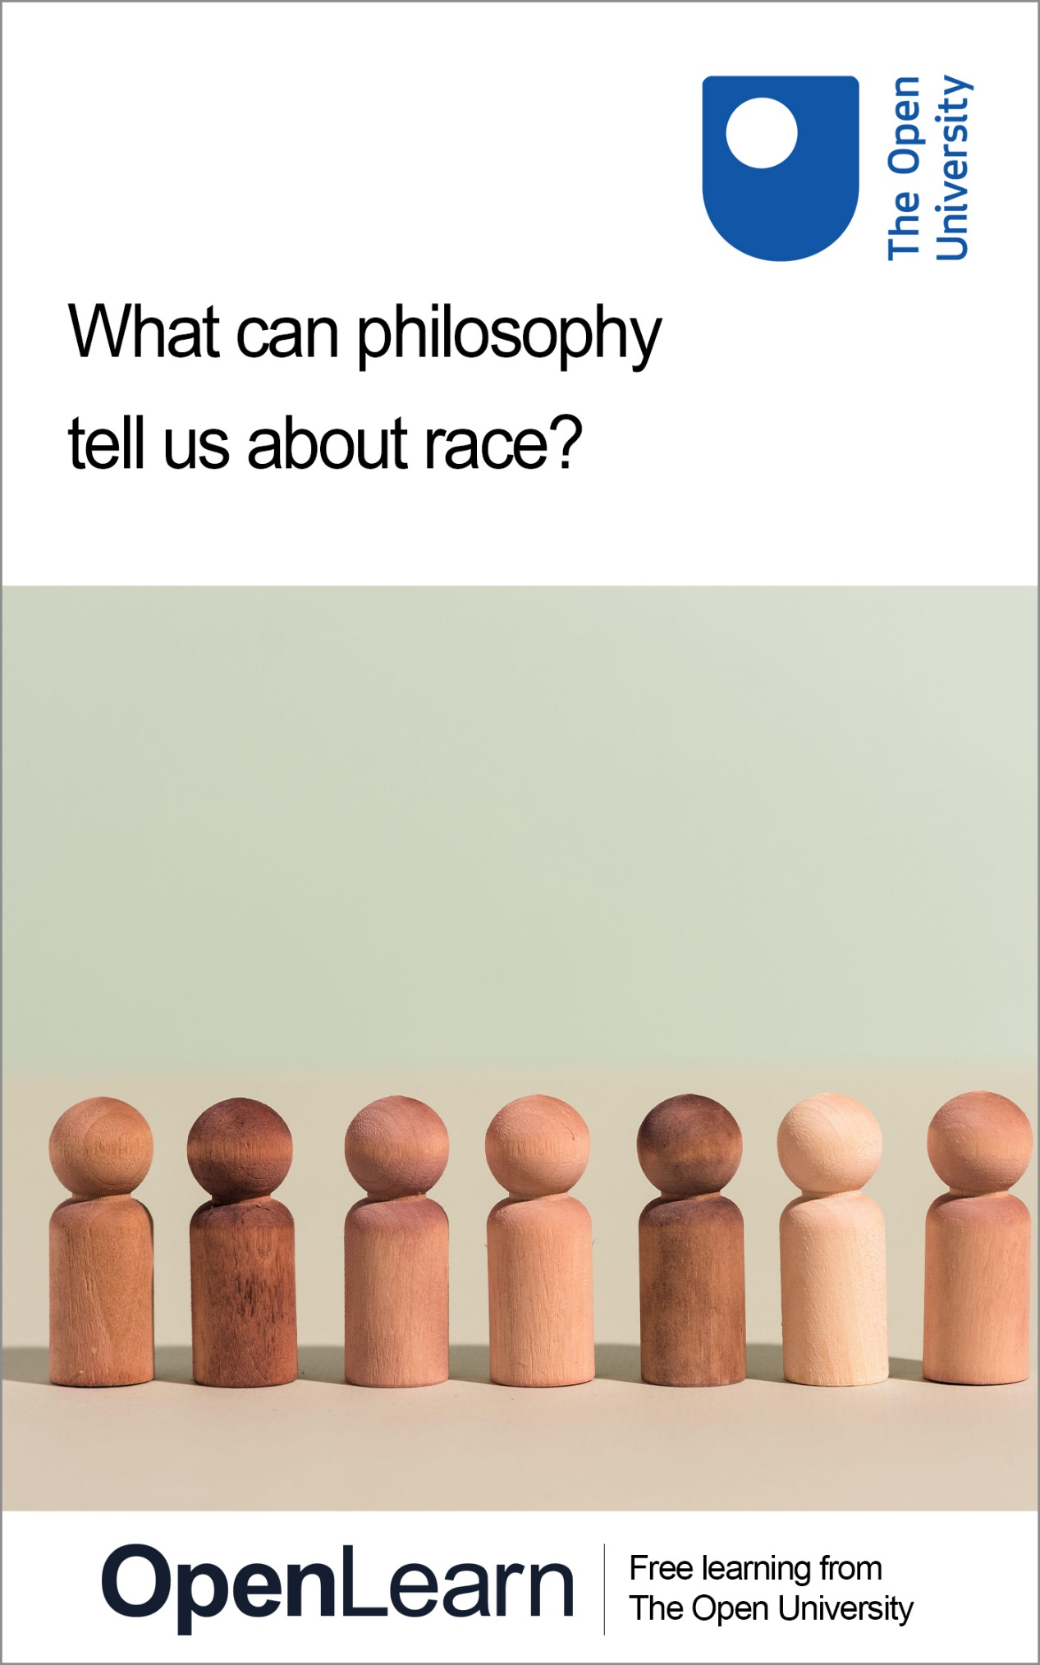

DA223_1

What can philosophy tell us about race?

About this free course
This free course is an adapted extract from the Open University course DA223 Investigating philosophy: www.open.ac.uk/courses/modules/da223 .
This version of the content may include video, images and interactive content that may not be optimised for your device.
You can experience this free course as it was originally designed on OpenLearn, the home of free learning from The Open University –
www.open.edu/openlearn/history-the-arts/what-can-philosophy-tell-us-about-race/content-section-0
There you’ll also be able to track your progress via your activity record, which you can use to demonstrate your learning.
First published 2025.
Unless otherwise stated, copyright © 2025 The Open University, all rights reserved.
Intellectual property
Unless otherwise stated, this resource is released under the terms of the Creative Commons Licence v4.0 http://creativecommons.org/licenses/by-nc-sa/4.0/deed.en. Within that The Open University interprets this licence in the following way: www.open.edu/openlearn/about-openlearn/frequently-asked-questions-on-openlearn. Copyright and rights falling outside the terms of the Creative Commons Licence are retained or controlled by The Open University. Please read the full text before using any of the content.
We believe the primary barrier to accessing high-quality educational experiences is cost, which is why we aim to publish as much free content as possible under an open licence. If it proves difficult to release content under our preferred Creative Commons licence (e.g. because we can’t afford or gain the clearances or find suitable alternatives), we will still release the materials for free under a personal end-user licence.
This is because the learning experience will always be the same high quality offering and that should always be seen as positive – even if at times the licensing is different to Creative Commons.
When using the content you must attribute us (The Open University) (the OU) and any identified author in accordance with the terms of the Creative Commons Licence.
The Acknowledgements section is used to list, amongst other things, third party (Proprietary), licensed content which is not subject to Creative Commons licensing. Proprietary content must be used (retained) intact and in context to the content at all times.
The Acknowledgements section is also used to bring to your attention any other Special Restrictions which may apply to the content. For example there may be times when the Creative Commons Non-Commercial Sharealike licence does not apply to any of the content even if owned by us (The Open University). In these instances, unless stated otherwise, the content may be used for personal and non-commercial use.
We have also identified as Proprietary other material included in the content which is not subject to Creative Commons Licence. These are OU logos, trading names and may extend to certain photographic and video images and sound recordings and any other material as may be brought to your attention.
Unauthorised use of any of the content may constitute a breach of the terms and conditions and/or intellectual property laws.
We reserve the right to alter, amend or bring to an end any terms and conditions provided here without notice.
All rights falling outside the terms of the Creative Commons licence are retained or controlled by The Open University.
Head of Intellectual Property, The Open University

Contents
- Introduction
- Learning outcomes
- 1 What is philosophy of race?
- 2 Defining race
- 3 Is race about ancestry?
  - 3.1 Comparing criteria for determining race
  - 3.2 Assessing your intuitions about race
- 4 Is race about power?
  - 4.1 Defining race as a position on a hierarchy
  - 4.2 Will race always exist?
- 5 What is racism?
  - 5.1 Are racial fetishes racist?
  - 5.2 Challenging the Mere Preferences Argument
- Conclusion
- References
- Acknowledgements
- Solutions
- Descriptions

Introduction
This free course introduces you to the philosophy of race and explores the ways in which philosophy impacts our understanding of the social world.
You will explore answers to two central questions:
- What is race?
- What is racism?
Along the way, you will consider what the term ‘race’ means, you will critically examine the role of ancestry and power in determining someone’s race, and you will explore the idea of racial fetishes. You will also encounter the philosophical tools of thought experiments and representing argument structure.

Note:
This course deals with topics on race and contains terms and language that you might find upsetting. Please consider carefully how you might want to engage with this.

This OpenLearn course is an adapted extract from the Open University course DA223 Investigating philosophy.

Learning outcomes
After studying this course, you should be able to:
- understand some of the questions philosophers of race investigate
- begin to evaluate the position that race is about ancestry and the position that race is about power
- understand why different definitions of ‘racism’ affect how people identify and respond to racism
- assess arguments for and against the moral acceptability of racial fetishes.

1 What is philosophy of race?
Race is a way of categorising people that has had, and continues to have, an enormous impact on people’s lives. Historically, what race someone was could determine what rights they had, where they could go to school, what job they could have, or what businesses or services they could use. Today, racial inequalities remain prevalent in many societies, including racial disparities in education, income, wealth, employment, incarceration and health outcomes.


View description - Uncaptioned Figure
View alternative description - Uncaptioned Figure

Different academic disciplines ask different sorts of questions about race. For example, historians of race may be interested in understanding the development of the idea of race or of race relations over time, social scientists may be interested in gathering empirical data about how racial inequalities are produced and persist, and psychologists may be interested in how racial bias manifests psychologically.
So what questions do philosophers ask about race? Some philosophers of race investigate ethical questions (for example, ‘should we keep talking about race?’ or ‘are racial fetishes wrong?’). Others investigate questions of political philosophy (for example, ‘how do racial hierarchies affect our conception of the relationship between the individual and the state?’). Philosophers of race are also interested in metaphysical questions. Metaphysics is the branch of philosophy concerned with the basic structure and reality of the world, and metaphysical questions come up across philosophy. Philosophers studying the metaphysics of race are interested in understanding the fundamental nature of race.
In this course, you will focus on two questions:
- What is race?
- What is racism?
These are important questions. The better you understand what race is, the better placed you are to tackle racism. Is it OK to talk about race and use racial categories in everyday life? What about in policymaking, science or medicine? And figuring out what racism is can help us to identify it, and work out what sorts of things we should be trying to get rid of or remedy.
In this course you’ll explore some different answers to these questions. Philosophers can (and often do) disagree, but this doesn’t mean that philosophy is just a matter of opinion. Philosophy offers a rigorous way of thinking about difficult questions. Philosophers try to construct rational arguments for their views, or rational arguments against their opponents’ positions. This back-and-forth might not end up in universal agreement but, even so, understanding the strengths and weaknesses of different positions can deepen our understanding of a particular issue, and can lead people to clarify and assess their own beliefs about an issue. By questioning and rigorously testing our beliefs, we can identify our prejudices or unreflective assumptions, and develop considered views that we can defend from criticism.

2 Defining race
In order to begin to answer the question ‘what is race?’, we need to start with a general idea of what we’re investigating. You’ll start by looking at a dictionary definition, which can be a useful starting point for getting a grip on how people ordinarily understand the meaning of a term.

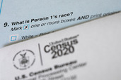
View description - Uncaptioned Figure
View alternative description - Uncaptioned Figure

Activity 1
Spend about fifteen minutes on this activity

1. Using a search engine or a physical dictionary, find a dictionary definition of race and enter it in the box below. The word ‘race’ has several different meanings, such as a competition to see who is the fastest, so make sure you select a definition that refers to a way of categorising humans.

Provide your answer...

2. Does this definition sound about right to you? Does it match (or roughly match) what you think you mean when (or if) you talk about race? If not, what would you change?

Provide your answer...

View discussion - Part

Dictionary definitions can be a starting point for understanding the meaning of a term, but often they don’t exactly match what philosophers mean by the term. Below is a definition of ‘race’ given by the philosopher of race Joshua Glasgow. This definition is what Glasgow thinks people usually mean when they talk about race. Glasgow is an American philosopher, and he restricts this definition for what people mean in the United States (US). This definition might sound familiar to you in your own social context, or it might be a bit different.

Races, by definition, are relatively large groups of people who are distinguished from other groups of people by having certain visible biological traits (such as skin colours) to a disproportionate extent.
(Glasgow, 2019, p. 117)

This definition is similar to the definition found in the Merriam-Webster dictionary. However, there are some differences. Glasgow’s definition doesn’t include any mention of shared ancestry – it only specifies that racial groups are distinguished by (generally) shared biological (physical) traits. This seems to match the way that people use or think about race in many places – for example, people often make judgements about what race someone is based on visible physical characteristics (for example, skin colour or facial features). Glasgow’s definition also specifies that races are ‘relatively large groups’. This also seems to reflect how race is used, at least in some places – for example, several national censuses that collect data on race list approximately five racial categories.
For example, these are the five racial categories listed on the 2020 US census:
- White
- Black or African American
- American Indian or Alaska Native
- Asian
- Native Hawaiian or Other Pacific Islander
You might not be entirely satisfied with Glasgow’s definition, but it at least gives us a starting point for investigating race. Do racial categories, understood as relatively large groups distinguished by differences in physical characteristics, correspond to real differences in the world? If so, what sorts of differences do they correspond to? Are they biological? Are they social? These are the questions that philosophers doing metaphysics of race are interested in, in order to figure out the fundamental nature of race.

3 Is race about ancestry?


View description - Uncaptioned Figure
View alternative description - Uncaptioned Figure

One answer to the question ‘what is race?’ is that race is a matter of ancestry. The idea that race has something to do with ancestry is fairly widespread, and you might find this idea appealing. After all, people often think of someone’s race as connected to their parents’ and grandparents’ race. It could also be that ancestry itself is a proxy for genetics: that race is really about genetic differences between groups. Some might argue that ancestry is a good proxy because these genetic differences arose out of the migration of different groups of humans to various parts of the globe. This kind of thinking – that race is about genetic differences, and ancestry is a good proxy for this – is widespread.
Access to at-home DNA tests that claim to provide information about our ancestry is a good illustration of the common assumption that race is determined by biology – specifically, genetics (and thereby ancestry). There have been several cases of people taking these tests and reporting their surprise at finding out they are ‘really’ another race than the one they thought they were. If someone thinks that a DNA test can tell them what race they ‘really’ are, then this suggests that they think race has something to do with genetics (and, therefore, ancestry).
If race is a matter of ancestry, then the racial categories that really exist are those that are based on differences in ancestry. Furthermore, what race an individual is will depend on facts about their ancestry. Finding out about someone’s ancestry will tell you what race that person ‘really’ is.
Ancestry seems to play some role in many people’s understanding of what race is. However, this doesn’t necessarily mean that race is fundamentally a matter of ancestry, or that what makes someone a particular race is their ancestry.
One objection to race being a matter of ancestry comes from Joshua Glasgow (2019). Glasgow thinks there is a mismatch between how people can be grouped based on ancestry, and how people are generally grouped based on race. Such a mismatch could arise in a case where, for example, someone was classified as Black by others based on their physical appearance, but a DNA ancestry test revealed that they have majority European ancestry.
Glasgow emphasises this point by introducing a thought experiment.

Thought experiments
Thought experiments are hypothetical or imaginary scenarios that are used to put an idea or position to the test. Thought experiments are common in philosophy, and can play an important role in philosophical arguments. Thought experiments can allow us to think through the potential consequences of a particular position, claim or principle. Reasoning in this way can clarify our intuitions, bring to our attention inconsistencies or tensions between claims, or demonstrate consequences of a claim.

This is Glasgow’s thought experiment: imagine that one day, because of a chemical introduced to the water supply, the physical appearance of everyone in the world is transformed, so everyone looks like the Dalai Lama. In this thought experiment, there are no longer any visible physical differences. However, there are still facts about people’s ancestry – some people have recent ancestry from Africa, some from Asia, and so on. Are there still races? Glasgow thinks not: according to his definition, races must have visible physical differences – race is about how we look. So, once everyone looks the same, races would no longer exist. Someone who thinks that race is based on ancestry would think that races do continue to exist, because differences in ancestry continue to exist.

3.1 Comparing criteria for determining race
Although Glasgow’s thought experiment is fantastical, the conflict between different criteria for assigning someone’s race can exist in real life. Now you will listen to an audio outlining some possible criteria for determining what race someone is, and afterwards you will work through your intuitions on some cases where these criteria conflict.

Activity 2
Spend about twenty five minutes on this activity

In the following audio, Azita Chellappoo from The Open University outlines some possible criteria for determining what race someone is. Listen to the audio and then answer the questions that follow. You can pause the audio and answer the questions as you go.

Audio content is not available in this format.
View transcript - Uncaptioned interactive content

1. Why is physical appearance often used to make judgements about what race someone is?

Provide your answer...
View discussion - Part

2. How does the relationship between ancestry and race vary across societies?

Provide your answer...
View discussion - Part

3. How might someone’s self-awareness of ancestry be different from their actual ancestry?

Provide your answer...
View discussion - Part

4. How might public awareness of someone’s ancestry be different from their actual ancestry?

Provide your answer...
View discussion - Part

3.2 Assessing your intuitions about race
Now you will take a look at two cases that test your intuitions about which criteria determine racial identity. In these cases the criterion of ancestry conflicts with other possible criteria for determining someone’s race. Your responses to these puzzles will indicate your own intuitions on the criteria for determining race. The cases are adapted from the 1998 essay ‘But What Are You Really? The Metaphysics of Race’ by the philosopher Charles Mills. Mills is writing within an American context, and thinking about race within the American racial system. You may have different responses to these cases than Mills does, depending on your own understanding of race.


View description - Uncaptioned Figure
View alternative description - Uncaptioned Figure

You’ll be asked to consider what race the person in each case would be judged to be depending on each criterion, and put down what your own intuition is. Once you’ve answered, you’ll be able to see what Mills’ intuition is.

Conscious Permanent Passing
Read the following case study and then carry out the activity that follows.

Naomi has Black ancestors and has been raised in a family that considers themselves Black. Due to the genetic lottery, her outward appearance is the same as those of European ancestry that are considered to be white. Naomi does not just want to pass as white in some contexts – her goal is ultimate assimilation. She wants to be taken for white. Maintaining contact with Black relatives, childhood friends, and neighbourhood acquaintances will obviously jeopardize this endeavour, so Naomi moves away from them, severs all relationships, and gives her children a highly pruned version of the family tree. Similarly, to avoid betrayal by ‘Black’ cultural traits, Naomi consciously steeps herself in culture associated with white Americans. Suppose that this act of assimilation is successful. Naomi is accepted by her white neighbours as white, there is no public awareness in her social world of her Black ancestry, and she does not experience racism. Though she is naturally nervous for the first few years, she gradually comes to relax and feel confident that her deception will never be discovered.
(Historically, in fact, tens of thousands of Black people in the US took this step. One such person, exposed after his death, was the prominent New York literary critic Anatole Broyard.)
(adapted from Mills, 1998, pp. 56–7)

Activity 3
Spend about twenty minutes on this activity

1. After reading the case above, fill out the options below for the four criteria. For ‘Physical Appearance’ and ‘Ancestry’ decide whether according to these criteria the individual is classified as white or Black. For ‘Self Awareness of Ancestry’ and ‘Public Awareness of Ancestry’ decide whether the answer is ‘yes’ or ‘no’ – whether the individual is aware of their own ancestry, and whether the public is aware of the individual’s ancestry. Then, put down what your intuition is about what race Naomi is. If you don’t have an intuition, you can put down ‘not sure’.
Physical Appearance: White or Black?

Provide your answer...

Ancestry: White or Black?

Provide your answer...

Self Awareness of Ancestry: Yes or No?

Provide your answer...

Public Awareness of Ancestry: Yes or No?

Provide your answer...

Your intuition on what race Naomi is:

Provide your answer...

2. Reflect on why you have the intuition that you do. How strong is your intuition? Is it based on any of the four criteria you have been introduced to?

Provide your answer...

View discussion - Part

Unconscious Passing
Read the following case study and then carry out the activity that follows.

In the previous case, Naomi was aware of her Black ancestry. Consider now a person who thinks his ancestry is white, but in fact has Black ancestry. One real-life example of this is Gregory Williams, who wrote about his experience in the 1995 book Life on the Colour Line: The True Story of a White Boy Who Discovered He Was Black. His physical appearance was that of a white person and he was raised to believe he was white. Suppose that Gregory never finds out about his Black ancestry and he lives his life believing he has white ancestry (and this is what others believe of him too).
(In real life, Gregory Williams later found out that his father had Black ancestry and had been himself passing as white. Gregory grew up in 1950s segregated Virginia, where what race someone was affected their entire lives. When his Black ancestry was revealed and he was reclassified as Black, this upended his life.)
(adapted from Mills, 1998, pp. 57–8)

Activity 4
Spend about twenty minutes on this activity

1. After reading the case above, fill out the options below for the four criteria. For ‘Physical Appearance’ and ‘Ancestry’ decide whether according to these criteria the individual is classified as white or Black. For ‘Self Awareness of Ancestry’ and ‘Public Awareness of Ancestry’ decide whether the answer is ‘yes’ or ‘no’ – whether the individual is aware of their own ancestry, and whether the public is aware of the individual’s ancestry. Then, put down what your intuition is about what race Gregory is. If you don’t have an intuition, you can put down ‘not sure’.
Physical Appearance: White or Black?

Provide your answer...

Ancestry: White or Black?

Provide your answer...

Self Awareness of Ancestry: Yes or No?

Provide your answer...

Public Awareness of Ancestry: Yes or No?

Provide your answer...

Your intuition on what race Gregory is:

Provide your answer...

2. Reflect on why you have the intuition that you do. How strong is your intuition? Does Gregory’s lack of awareness of his ancestry affect your intuition about his race?

Provide your answer...

View discussion - Part

After thinking through these cases, you may (or may not) have changed your mind about the importance of these criteria. Perhaps you are convinced that Mills’ cases show that ancestry does not determine race. You might have been pulled in different directions and ended up thinking that there is no right answer to the question ‘what race is this person?’ in these cases. If you think that public awareness of ancestry is what determines someone’s race in the cases you’ve read, this indicates that race is, in some way, social – what someone’s race is depends on what others in society believe.

4 Is race about power?
If someone’s race does not depend on their ancestry, what might it depend on? One answer is that it depends on something about society – how society is organised, the relations between people, and social processes that sort people into groups.

Activity 5
Spend about thirty minutes on this activity

Watch the following video.

Video content is not available in this format.
View transcript - Uncaptioned interactive content

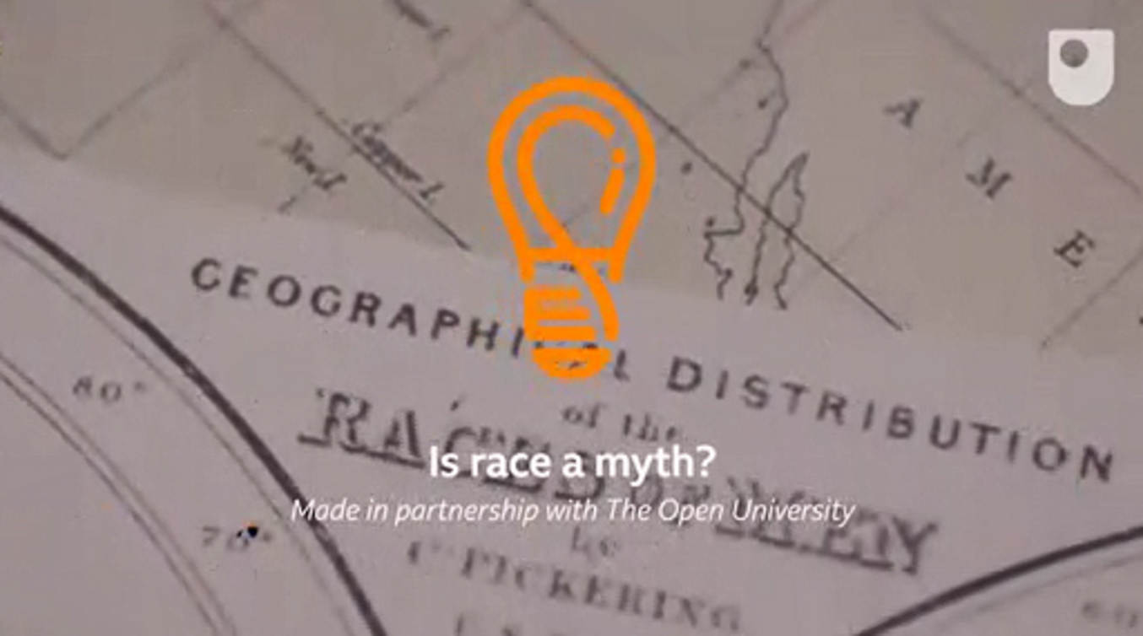

Now, watch the video again, answering the questions below as you go. You may need to pause the video or rewatch short segments.
1. In the video, race science is described as emerging at the same time as colonialism and slavery, and this is no coincidence. Why is this not a coincidence?

Provide your answer...
View discussion - Part

2. In the video, C. Brandon Ogbunu says that ‘the biology of race is not a useful concept’. Describe one reason given in the video for this.

Provide your answer...
View discussion - Part

3. Why might people have racial identities, even if there are no biological differences between races?

Provide your answer...
View discussion - Part

In the video you have just watched, you have heard race being described as a social construction. Social constructions can nevertheless be real, and can have important impacts on people’s lives. One example of this is money. Money is real – just think of what it can do and what you can’t do without it. But unlike other real things in the world like mountains or electrons, money is socially constructed in the sense that its value and function – what makes it real – depends on collective social agreement.
For example, a ten pound note is a piece of paper which we collectively agree is worth ten pounds. We can use that piece of paper to do things in the world – we can buy things with it. When someone goes to pay for a book with a ten pound note, they trust that the seller will accept this piece of paper in exchange for the book. When the seller accepts the ten pound note, they trust that they will be able to use it to purchase something, or deposit it in a bank. Paper banknotes are clearly symbolic – the difference between a ten pound and a fifty pound note has nothing to do with the value of the paper it’s printed on. Rather, a fifty pound note is worth more than a ten pound note because we have collectively agreed to treat it as such. Even forms of currency which might appear more intrinsically valuable, like gold, only have value (in terms of, say, what can be purchased with it or exchanged for it) because of a broad social agreement that gold as a common currency has this value.
Of course, money has enormous effects on our lives – fundamental aspects of someone’s life, like their health, wellbeing, and safety, are hugely dependent on how much money they have. So, money is a straightforward case of something that is socially constructed. And, despite being socially constructed and arising out of human interests and actions, it is not dependent on how single individuals or small groups of individuals perceive it. If someone decides that the ten pound note they are holding in their hand is actually worth fifty pounds, that won’t change what they can buy with it or the balance in their bank account if they deposit it. It won’t change the social reality that the ten pound note is worth ten pounds.
Whether a category such as race is part of social reality depends on the practices and assumptions within a particular society. Although social categories are dependent on human interests and behaviours, they are not dependent purely on any one individual’s perspective. For any particular society at a particular time, there will be a fact of the matter about which social categories exist in that society. Discovering what social categories exist in a society allows social scientists to generate accurate explanations and predictions about the workings of that society.

4.1 Defining race as a position on a hierarchy
What sorts of features of society might race be based on? Some philosophers think that race is a matter of power: hierarchical power relationships that are the fundamental social relations that underlie race. If race is a matter of power, then what race an individual is will depend on facts about their position in a social hierarchy.
Below is a definition of race as a matter of power, adapted from the definition provided by the American philosopher Sally Haslanger (2019).

Within a particular social context, races are groups whose members are:
- observed or perceived to have physical features that are taken to be evidence of ancestry from a particular geographical region
- marked as occupying either a subordinate (inferior) or privileged (superior) position on a social hierarchy based on these physical features
(Haslanger, 2019)

Condition (a) says that members of races are assumed to have ancestry from a particular geographical region (for example, Africa, Asia or Europe) on the basis of their physical features. Someone’s actual ancestry does not matter according to this definition. What matters is what other people judge an individual’s ancestry to be. What physical features are used to make these judgements can vary depending on the society in question.
Condition (b) says that having these physical features is what marks someone out for differential treatment. They are placed in either a subordinate or privileged position on a social hierarchy. Social hierarchies are systems in which some individuals enjoy a higher social status than others. Those who are privileged in a social hierarchy may have (for example) more access to wealth, more access to resources such as housing, employment, healthcare, and education, more opportunities, and be treated with more respect by others than those who are subordinated in a social hierarchy. Also, those who are subordinated in a social hierarchy may be at greater risk of harassment or assault, be discriminated against by others, or face harsher treatment within the criminal justice system. Societies with social hierarchies often have ideologies that justify this differential treatment.
Here’s an example of how this process might play out:

Akash and Ben live in the UK. They go to the airport to catch a flight to their holiday destination. Airport security spot the two: based on their skin colour, facial features, and hair texture, they make the assumption that Akash has ancestry from South Asia and Ben has ancestry from Europe. The security officers believe that South Asians are more likely to be involved in terroristic or trafficking activities than Europeans. Based on this assumption, they subject Akash to an extensive search and an unpleasant interrogation, while they let Ben sail through security.

In this example, the ancestry of both men is inferred based on features of their physical appearance. Within a particular society, certain physical markers will be used to infer ancestry and others will not. For example, skin colour and facial features may be commonly used to infer ancestry, while height or foot size may not be. The judgement of where Akash and Ben’s ancestors were from is the basis for their differential treatment. Akash is disadvantaged compared to Ben when he receives worse treatment than Ben by airport security. If this is not a peculiar quirk of these particular airport security officers, but instead a general pattern by which South Asians are disadvantaged, then Akash’s poorer treatment relative to Ben is part of systematic subordination and privilege within a social hierarchy.


View description - Uncaptioned Figure
View alternative description - Uncaptioned Figure

If race is a matter of power, this does not mean that every member of a subordinated race is disadvantaged relative to every member of a privileged race. One reason for this is because societies often have multiple social hierarchies: for example, on the basis of gender, class, sexual orientation, disability, migration status or physical attractiveness. Someone may be privileged in some of these dimensions and subordinated in others. Another reason is incidental or non-systematic variations in individuals’ circumstances or personalities that affect their access to resources or opportunities. However, if race really is a matter of power, a general hierarchy must exist within a society, and people must be placed at a position in that hierarchy based on their perceived ancestry.
Philosophers who think that race is fundamentally about power don’t deny biological dimensions of human diversity. They accept that there are differences in physical appearance between humans that are correlated with geographical ancestry – people with ancestors from certain regions are more likely on average to have certain skin colours, hair textures, or facial features. However, these philosophers deny that those differences constitute or determine race. Rather, they are characteristics that, in certain social contexts, trigger the positioning of an individual within a hierarchy. What makes someone the race that they are is where they are in a racial hierarchy.

4.2 Will race always exist?
The position that race is a matter of power defines race in terms of systematic privilege or systematic oppression. One consequence of this position is that if the power relationships – the racial hierarchy – cease to exist, then race itself will cease to exist. This is because race itself is a position in a racial hierarchy, so without a racial hierarchy there is no such thing as race. Therefore, the end of racism (the end of discrimination or differential treatment based on race) would also mean the end of race.
For some philosophers, the elimination of race in a society without racism is not particularly troubling. However, other philosophers have been skeptical of this idea, and have been wary of defining races and racial identities purely in terms of oppression. The philosopher Chike Jeffers has argued that race is fundamentally about both power and culture. He suggests that racial hierarchy and unequal power relations explain how race was invented, and is still an important part of what race is today. However, he also argues that once racial categorisation became part of social reality, and people began to identify as being members of particular races, particular cultural traditions developed within racial groups (for example, Black American cultural traditions). Culture has therefore become part of what race is.

Activity 6
Spend about thirty minutes on this activity

Read the below paragraph excerpted from the 2013 paper ‘The Cultural Theory of Race: Yet Another Look at Du Bois’s “The Conservation of Races”’ by Chike Jeffers. Read it through slowly and carefully. You may need to read it through again as you answer the questions below.

What it means to be a black person, for many of us, including myself, can never be exhausted through reference to problems of stigmatization, discrimination, marginalization, and disadvantage, as real and as large-looming as these factors are in the racial landscape as we know it. There is also joy in blackness, a joy shaped by culturally distinctive situations, expressions, and interactions, by stylizations of the distinctive features of the black body, by forms of linguistic and extralinguistic communication, by artistic traditions, by religious and secular rituals, and by any number of other modes of cultural existence. There is also pride in the way black people have helped to shape Western culture, not merely by means of the free labor and extraction of resources that economically supported this culture but also directly through cultural contributions, most prominently in music and dance. These contributions are racial in character – that is to say, they are cultural contributions whose significance can only be fully understood when they are placed in proper context as emerging from a racialized people. It does not seem necessary, however, to assume that the oppressive nature of this process of racialization must necessarily problematize the continued existence of the culture that emerged from it. There is, in fact, reason to think that the historical memory of creating beauty in the midst of struggling to survive oppression can and should persist as a thing of value in black culture long after that oppression has truly and finally been relegated to the past.
(Jeffers, 2019, p. 422)

1. What does Jeffers think is the problem with defining race purely in terms of power relations?

Provide your answer...
View discussion - Part

2. Does Jeffers think that race can still exist after the end of racial oppression? Why?

Provide your answer...

View discussion - Part

You have now explored the position that race is about power, and considered a challenge to this view: that race is not only about power, but is also about culture.

5 What is racism?
You have learned about two positions in the metaphysics of race debate – two answers to the question ‘what is race?’. Race and racism are linked ideas, especially for those who think that race itself only exists when racism (in the form of a social hierarchy) exists. But what, exactly, is racism? As with race, people have very different ideas about what racism is and when something is or is not racist.


View description - Uncaptioned Figure
View alternative description - Uncaptioned Figure

The philosopher Kwame Anthony Appiah wrote of racism that:

We see it everywhere, but rarely does anyone stop to say what it is, or to explain what is wrong with it.
(Appiah, 1990, p. 3)

One thing that philosophers do is try to clarify everyday concepts, such as racism. Philosophy can provide the tools of rigorous reasoning and analysis through which we can arrive at a more precise, more accurate, or more thorough understanding of the idea under investigation.
In the case of racism, philosophers have debated what racism, fundamentally or primarily, is. Is it based in features of institutions or social structures? Is it primarily interpersonal (about interactions between individuals)? Is something racist only when individual perpetrators have racist hearts or racist beliefs? Can something be racist if it has harmful or discriminatory effects, regardless of anyone’s intentions?
Why does providing an account of racism matter? One reason is that, in general, there is a shared sense that racism is something bad, to be gotten rid of or stamped out. Identifying something as racism means identifying something that should be eliminated. Furthermore, one might think that racism, compared with, say, mere prejudice, ignorance, or unkindness, is particularly bad – perhaps it should be a priority to eradicate racism in society. So, working out what racism is and therefore what counts as racism and what doesn’t is crucial to pinpointing what we should direct our efforts towards eliminating. In addition, the sorts of solutions that are most appropriate or appealing might differ depending on what we think racism is. For example, whether we ought to be focusing on changing people’s hearts and minds, whether we should be focusing on reducing harmful effects, or whether we should be focusing on remedying racist institutions or social structures.
Now you will watch a clip from a conversation with Dr Helen Ngo, who is a research fellow at Deakin University in Australia and an expert on the philosophy of racism. In this video Dr Ngo discusses how different definitions of racism impact how racism is identified and addressed.

Activity 7
Spend about twenty minutes on this activity

Watch the following video.

Video content is not available in this format.
View transcript - Uncaptioned interactive content

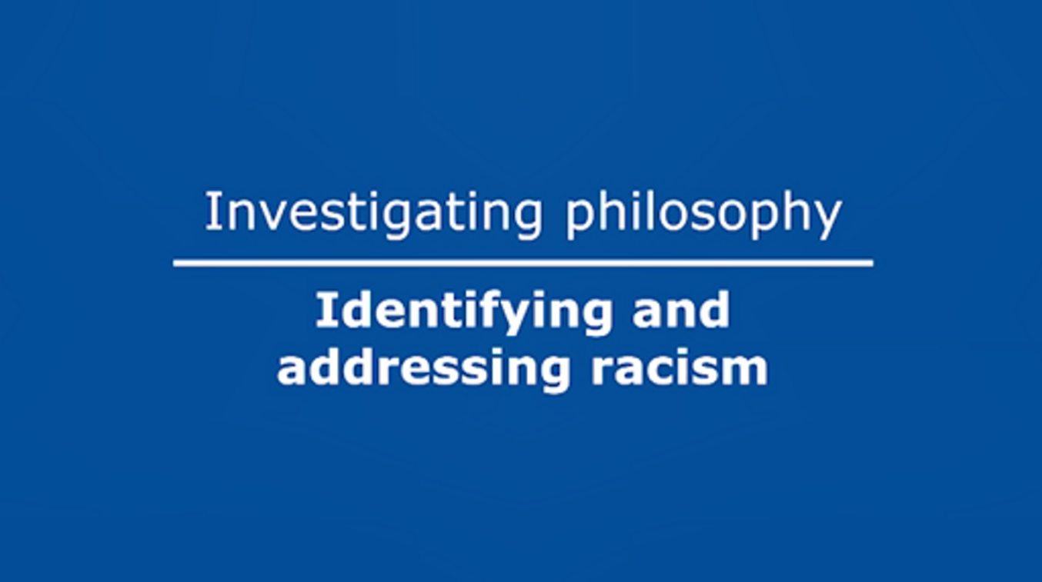

After watching the video, answer the following questions. You may need to watch the video again, pausing as you go.
1. In the video, Dr Ngo says that in the Australian context the dominant way that racism is understood is primarily as ‘actions or behaviours between individuals that are intended to subjugate another person’. What, according to Dr Ngo, is the problem with defining racism in this way?

Provide your answer...
View discussion - Part

2. Dr Ngo discusses the example of children’s books predominantly featuring white protagonists. How does this example illustrate the effect of a definition of racism on what is identified as a problem?

Provide your answer...
View discussion - Part

Providing a philosophical account of racism can give us a principled way to look out into the world and pick out what counts as racism and what does not, and therefore what we should try to get rid of and what we shouldn’t. The racial disparity in protagonists of children’s books provides one illustration of this.

5.1 Are racial fetishes racist?
There are cases that seem straightforwardly racist: for example, yelling a racial slur at someone of another race in order to frighten them. There are also cases that seem straightforwardly not racist, which all or most accounts of racism will identify as not instances of racism. However, there is also a grey area: cases which there may be significant disagreements about whether or not they count as racist. Philosophers have tried to rationally analyse some of these cases and provide arguments to resolve these disputes. Racial fetishes are an example that falls into this grey area. Racial fetishes are exclusive or near-exclusive sexual or romantic preferences for people of a race other than someone’s own.
In this section you will watch a conversation with Dr Robin Zheng, who is a Lecturer in Political Philosophy at the University of Glasgow. Dr Zheng is an expert on issues of moral responsibility and social inequality. The conversation focuses on the argument in her 2016 paper ‘Why yellow fever isn’t flattering: A case against racial fetishes’. In the first part, Dr Zheng discusses what racial fetishes are, and outlines a common argument made in defence of racial fetishes.

Argument Structure
As you will see in the video, Dr Zheng describes the Mere Preferences Argument as having two premises and a conclusion. The conclusion of an argument is the claim that the argument is trying to support. The premises of the argument are the reasons being offered to support the conclusion. In everyday life, people might express arguments as continuous text or sentences. For example, ‘Aparna cannot vote yet, she’s only 17’. Philosophers often present arguments in a way that makes the structure of the argument explicit, like this:
Premise 1 Aparna is 17
Premise 2 17 year olds cannot vote
Conclusion Aparna cannot vote
Bad arguments can be bad because one or more of their premises are false, or because the reasoning from the premises to the conclusion is faulty (i.e., the premises being true does not guarantee that the conclusion is true).
In the argument above, the conclusion necessarily follows from the premises (if 17 year olds cannot vote, and if Aparna is 17, then it must be the case that Aparna cannot vote). Whether this argument is successful or not will therefore depend on whether both its premises are true (for example, where or not Aparna is in fact 17).
Being able to figure out the structure of an argument puts you in a good position to begin evaluating an argument, spotting where the argument might go wrong, and making up your own mind about whether you accept the argument or not.

In this section you will examine the Mere Preferences Argument in defence of racial fetishes, and Dr Zheng’s argument against it.

Activity 8
Spend about twenty minutes on this activity

Watch the following video.

Video content is not available in this format.
View transcript - Uncaptioned interactive content

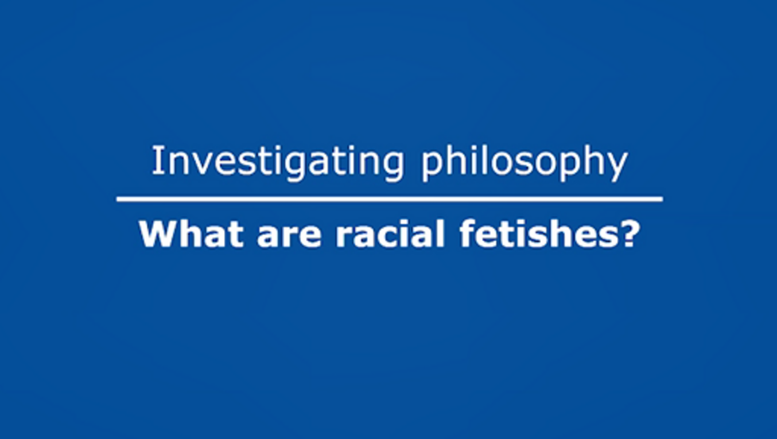

After watching the video, answer the following questions. You may need to watch the video again.
1. Drag and drop the premises and conclusion of the Mere Preferences Argument into the correct slots.

Preferences for racialised physical traits are not different from preferences for non-racialised physical traits.
‘Mere’ preferences for racialised physical traits are not morally objectionable.
There is nothing morally objectionable about sexual preferences for hair colour, eye colour, and other non-racialised physical traits.
Premise 2
Conclusion
Premise 1
View answer - Activity 8

The Mere Preferences Argument is an argument that concludes that racial fetishes are not morally objectionable. As racism is generally understood to be morally objectionable, if racial fetishes are not morally objectionable then they cannot be instances of racism.
In the next part of the conversation Dr Zheng outlines three possible strategies for challenging the premises of the Mere Preferences Argument, including the strategy that she herself adopts.

Activity 9
Spend about twenty five minutes on this activity

Watch the following video.

Video content is not available in this format.
View transcript - Uncaptioned interactive content

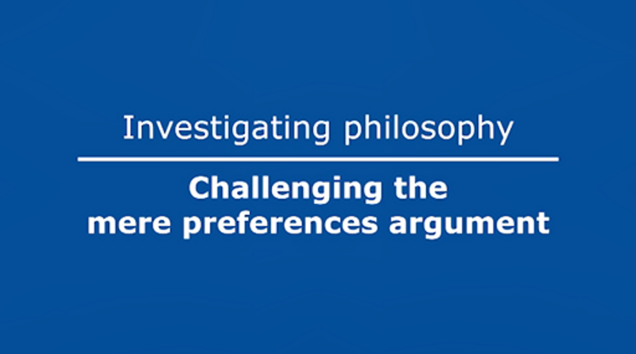

After watching the video, answer the following questions. You may need to watch the video again, pausing as you go.
1. Dr Zheng describes three possible strategies for challenging the Mere Preferences Argument: a challenge to the first premise, and two challenges to the second premise. What is the challenge to the second premise that she does not pursue, as she thinks it doesn’t go far enough?

Provide your answer...
View discussion - Part

2. Dr Zheng’s strategy is to challenge the second premise by focusing on the effects of racial fetishes. She suggests there are two important differences between racialised and nonracialised physical traits. What are these differences?

1.
2.
View discussion - Part

5.2 Challenging the Mere Preferences Argument
The two strategies for challenging the second premise of the Mere Preferences Argument lead to two different ways of identifying if a racial fetish is morally objectionable. The first strategy asserts that racial fetishes are always connected to racist stereotypes. As racist stereotypes are morally objectionable, racial fetishes are morally objectionable. Gathering evidence for this claim would involve studying the stereotypes held by people with racial fetishes, and the claim would be undermined if it was discovered that there are some individuals with racial fetishes who do not hold any racist stereotypes. If this was the case, then perhaps a racial fetish would be morally objectionable if it arose from racist stereotypes that someone holds (for example, if they held the belief that East Asian women are more submissive), but would be if they did not hold any such stereotypical beliefs.
Dr Zheng thinks that it is at least possible that some individuals’ racial fetishes don’t depend on racist stereotypes, for example if they are based in ‘idiosyncratic personal histories – a first girlfriend or sexual encounter, say’ (Zheng, 2016, p. 406). However, according to the second strategy (which she adopts), these racial fetishes would nevertheless be objectionable. This is because the second strategy focuses on the effects of racial fetishes on the targets of the fetish. According to the second strategy, figuring out if a racial fetish is objectionable involves looking at whether there are harmful effects on its targets.
There is substantial evidence for the negative effects of racial fetishes on East Asian women, from personal accounts, media reporting, and social science literature. Below are two quotations that illustrate the impact that racial fetishes have.

I never felt that I was being complimented for being myself, or the way I looked, but rather for being an Asian female who looked exotic. I stopped trusting any compliments, even ones which were not about my physical appearance.
(Chan, 1988 in Zheng, 2016, p. 408)

I still feel like I have been objectified, exotified, and hypersexualized because of my race and sometimes I have trouble trusting people who find me attractive because of that
(sMash, 2012 in Zheng, 2016, p. 408)

According to Zheng, the psychological burden imposed on East Asian women by racial fetishes constitutes a form of racism or racial disadvantage in itself. Additionally, these patterns of doubt and suspicion are part of a larger system of racial hierarchy.

Activity 10
Spend about twenty minutes on this activity

Read the following passage from Zheng (2016), and then complete the activity below.

By contrast, blondes and brunettes as such have not suffered histories of exploitation, colonization, slavery, persecution, and exclusion on the basis of phenotype. Nor does hair or eye colour track categorical differences across all social, economic, and political dimensions of life, including opportunities for health, education, jobs, relationships, legal protections, and more. But race does – in ways that Asian/American women and other people of colour experience on a daily basis. […] The [Mere Preferences Argument] thus fails to recognize the historical and categorical nature of differential treatment based on racialized phenotypes, in virtue of which racial fetishes form only one part of a general pattern and due to which people of colour continue to shoulder disproportionate psychic burdens.
(Zheng, 2016, pp. 409–10)

1. Drag and drop the premises and conclusion of Zheng’s argument into the correct slots. This argument includes a sub-conclusion, which has been entered for you. A sub-conclusion is a stepping-stone in an argument.

At this point, you may or may not be convinced by Zheng’s argument. Whether or not you are convinced, carefully and critically evaluating an argument involves considering objections to the argument. After assessing the objections, you will have a better sense of whether you think the argument is strong (perhaps because the objections are easily resolved or are not significant problems for the argument), or whether you think the argument is weak or fails (perhaps because the objections cannot be resolved or present significant problems).
In the final part of the conversation, Dr Zheng is asked to respond to two concerns: firstly, the worry that someone who has no racist feelings or beliefs would be considered a racist person under her account, and secondly, the challenge that racial preferences cannot be objectionable because they are not under an individual’s control.

Activity 11
Spend about twenty five minutes on this activity

Watch the following video.

Video content is not available in this format.
View transcript - Uncaptioned interactive content

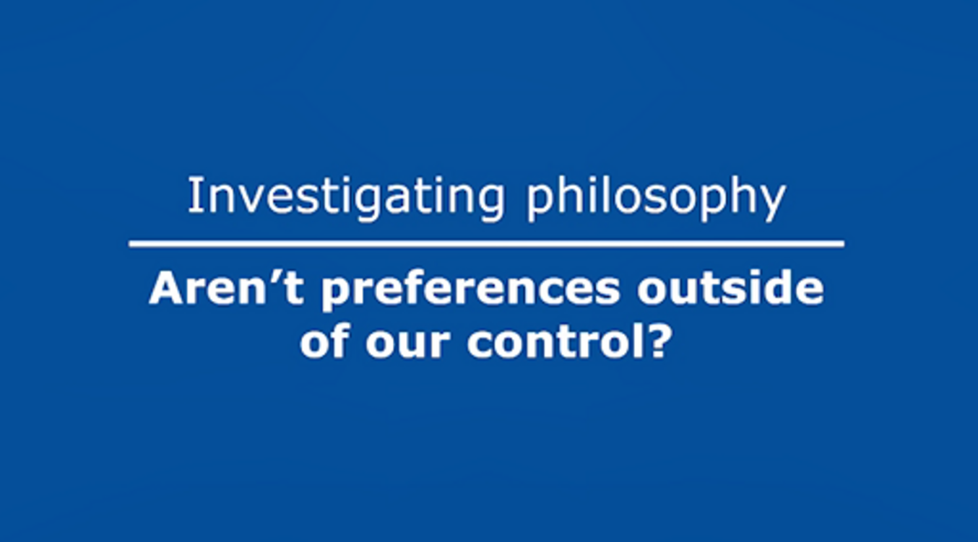

After watching the video, answer the following questions. You may need to watch the video again, pausing as you go.
1. (a) What is Dr Zheng’s response to the concern about calling someone racist who has a racial fetish but may not endorse any racial stereotypes?

She thinks that someone with a racial fetish just is a racist person.
She is not interested in evaluating whether someone is a racist person or not, only looking at the effects of their behaviour on others.
She thinks that there is nothing racist about racial fetish held by someone that does not endorse any racial stereotypes.
View answer - Part

(b) Do you find her response convincing? Why or why not?

Provide your answer...
View discussion - Part

2. (a) What is Dr Zheng’s response to the concern that racial fetishes are not morally objectionable because they are outside of our control?

She thinks someone may not be able to control basic feelings or desires, but they can control how they respond to and act on those feelings or desires.
She thinks that racial fetishes are entirely outside of people’s control, and that is a problem for her argument.
She thinks that people have complete control over their feelings and desires, and so have a responsibility to decide to feel differently.
View answer - Part

(b) Do you find her response convincing? Why or why not?

Provide your answer...
View discussion - Part

Conclusion
In this free course, What can philosophy tell us about race?, you have been introduced to what philosophy of race is, the kinds of questions philosophers of race ask, and why these questions matter. You have explored the question ‘what is race?’, and examined two answers to this question. You have considered the position that race is a matter of ancestry. You have encountered an objection to this view – that how people use race and assign people to races in everyday life does not depend upon ancestry – and have reflected on your intuitions in hypothetical cases. You have learned about the position that race is a matter of power, and confronted the objection that race is not just about power, but is also about culture.
You have also explored why defining or figuring out what racism is matters, and assessed the case of racial fetishes. Along the way, you learned about the philosophical tool of thought experiments, and how to represent arguments in premise-conclusion form.
This OpenLearn course is an adapted extract from the Open University course DA223 Investigating philosophy.

References
Appiah, K.A. (1990) ‘Racisms’, in Goldberg, D. (ed.) Anatomy of Racism. University of Minnesota Press, pp. 3–17.
Glasgow, J. (2019) ‘Is Race an illusion or a (very) basic reality?’, in Glasgow, J., Haslanger, S., Jeffers, C. and Spencer, Q. What is Race?: Four Philosophical Views. Oxford University Press, pp. 111–49.
Haslanger, S. (2019) ‘Tracing the sociopolitical reality of race’ in Glasgow, J., Haslanger, S., Jeffers, C. and Spencer, Q. (eds) What is Race?: Four Philosophical Views. Oxford University Press, pp. 4–37.
Jeffers, C. (2013) ‘The cultural theory of race: yet another look at Du Bois’s “The Conservation of Races”’, Ethics, 123(3), pp. 403–26.
Mills, C.W. (1998) ‘“But what are you really?”: the metaphysics of race’, Blackness Visible: Essays on Philosophy and Race. Cornell University Press, pp. 41–66.
Zheng, R. (2016) ‘Why yellow fever isn’t flattering: A case against racial fetishes’, Journal of the American Philosophical Association, 2(3), pp. 400–19.

Acknowledgements
This free course was written by Azita Chellappoo.
Except for third party materials and otherwise stated (see terms and conditions), this content is made available under a Creative Commons Attribution-NonCommercial-ShareAlike 4.0 Licence.
The material acknowledged below is Proprietary and used under licence (not subject to Creative Commons Licence). Grateful acknowledgement is made to the following sources for permission to reproduce material in this free course:
Images
Course image/Section 1 image: Photo: Chris Merriam/Alamy
Section 2 image: Photo: Kristoffer Tripplaar/Alamy
Section 3 image: Photo: Martin Shields/Alamy
Section 3.2 image: Photo: Khosrow Rajab Kordi/Alamy
Section 4.1 image: Photographer: Elijah Nouvelage/Bloomberg via Getty Images
Section 5 image: Photo: ronstik/Alamy
Audio/Video
Section 3.1 audio: The Open University
Section 4 video: Daniel Nils Roberts, for the BBC and The Open University partnership. Content from Pond 5, Shutterstock and Videoblocks
Sections 5 and 5.1 videos: The Open University
Every effort has been made to contact copyright owners. If any have been inadvertently overlooked, the publishers will be pleased to make the necessary arrangements at the first opportunity.
Don't miss out
If reading this text has inspired you to learn more, you may be interested in joining the millions of people who discover our free learning resources and qualifications by visiting The Open University – www.open.edu/openlearn/free-courses.

Solutions

Activity 1

Part

Discussion
In one dictionary, race is defined as ‘any one of the groups that humans are often divided into based on physical traits regarded as common among people of shared ancestry’ (Merriam-Webster.com, 2023). Under this definition, race refers to groups based on shared physical traits (such as skin colour, eye colour, hair texture and so on). These shared physical traits are believed to be an indicator of shared ancestry (or descent). You may think that this definition captures how a lot of people think about race.
Back to - Part

Activity 2

Part

Discussion
1. Physical appearance is typically readily available information. It is also often assumed to be reliable evidence of someone’s ancestry.
Back to - Part

Part

Discussion
2. In the US and the UK, ancestry is often taken to be necessary and sufficient for determining what race someone is. In other countries ancestry is less important, and other criteria such as physical appearance are more important. Also, the rules for the relationship between ancestry and race vary across societies.
Back to - Part

Part

Discussion
3. One example is that a person could have one idea of what their ancestry is before taking a DNA ancestry test, and the results could indicate that their ancestry is different to the idea they had before taking the test.
Back to - Part

Part

Discussion
4. One example is that people could make assumptions about someone’s race based on their physical appearance. However, if their actual ancestry was known they would be classified as a different race.
Back to - Part

Activity 3

Part

Discussion
1. Mills’ response:

Physical Appearance | White
Ancestry | Black
Self Awareness of Ancestry | Yes
Public Awareness of Ancestry | No
Naomi is | White

2. If your intuition is that Naomi is white, this could suggest that you think the criterion of physical appearance or public awareness of ancestry is important in determining what race someone is (and is more important than actual ancestry or self-awareness of ancestry). If your intuition is that Naomi is Black, this could suggest that you think ancestry (or self-awareness of ancestry) is more important in determining someone’s race. There might also be other criteria that are shaping your intuition. If you don’t have a strong intuition about Naomi’s race, or are undecided, perhaps this indicates that different criteria are pulling you in different directions.
Mills thinks this example tests the strength of our commitment to ancestry as a definitive criterion for race. He suggests that if our intuitions are somewhat tugged the other way here, this indicates that race could be more a matter of how other people classify us.
Back to - Part

Activity 4

Part

Discussion
1. Mills’ response:

Physical Appearance | White
Ancestry | Black
Self Awareness of Ancestry | No
Public Awareness of Ancestry | No
Gregory is | White

According to physical appearance Gregory is white, and according to ancestry he is Black. Neither Gregory himself nor the public are aware of his Black ancestry.
2. Mills thinks that one reason why someone might hesitate to think that Naomi (from the previous case) is Black is that she is aware of her ancestry and therefore can’t avoid thinking of herself as Black, or as a Black person pretending to be white. This might be affecting our intuitions about their race – Naomi might always be watchful and anticipating being exposed as Black, even if it never happens. And so, someone might think that the difference between the consciousness of the ‘real’ white person and the ‘apparent’ white person is enough to show that Naomi cannot really be white but is still Black. In Gregory’s case, he is not aware of his Black ancestry. If your intuition is still that Gregory is Black, this indicates that you think that ancestry is what determines race. Mills’ intuition is that Gregory is white, and he thinks that this shows the ancestry does not determine someone’s race – you might disagree.
Back to - Part

Activity 5

Part

Discussion
1. According to the speakers in the video, the idea of race as innate biological difference was a crucial justification for the horrors of colonialism and slavery. Therefore, it’s not a coincidence that it emerged as an idea around this time.
Back to - Part

Part

Discussion
2. The biology of race is not a useful concept, according to the speakers in the video, because the human species has very little genetic variation. There is no gene that exists in all and only the members of one race. Genetic similarities on the level of continental groups is very fuzzy and weak, to the extent that it is almost meaningless. Also, someone that has a particular ancestry (e.g. Indian heritage) can have more in common genetically with someone who has different ancestry than someone who also has Indian heritage.
Back to - Part

Part

Discussion
3. One reason that racial identities might still exist is because the idea that race is real (in a biological sense) has been around for a long time and therefore has affected how people have been viewed and treated by others, and how they have viewed themselves. Therefore, people that are classified as a particular race might have cultural similarities and shared traditions.
Back to - Part

Activity 6

Part

Discussion
1. Jeffers thinks that race – in this passage, being Black – cannot be defined purely in terms of oppression or disadvantage. He proposes that there is joy and pride in Black culture and Black cultural contributions.
Back to - Part

Part

Discussion
2. Yes, Jeffers thinks that race can and should still exist after the end of racial oppression. This is because there are distinctively racial cultural traditions, and the contributions of those traditions is valuable. Even though he thinks that the ‘process of racialization’ (the creation of race as a set of categories to divide humans into) was oppressive (based in unequal power relations), he thinks that the cultures that emerged out of this process can nevertheless be valued and held onto.
Back to - Part

Activity 7

Part

Discussion
1. According to Dr Ngo, this definition is too narrow. It can lead to a ‘politics of politeness’, where the way to deal with racism is to ‘be nice to each other’. Following this strategy would not address underlying racial disparities in society.
Back to - Part

Part

Discussion
2. If racism is defined as being predominantly interpersonal or as something that must be consciously intended, then the over-representation of white protagonists in children’s books would not count as racism. However, there are harmful effects for children and educators that arise from the racial disparity in protagonists of children’s books, which Dr Ngo claims are important to capture within our definition of racism.
Back to - Part

Activity 8

Answer
The correct matches are:
Preferences for racialised physical traits are not different from preferences for non-racialised physical traits.
Premise 2
‘Mere’ preferences for racialised physical traits are not morally objectionable.
Conclusion
There is nothing morally objectionable about sexual preferences for hair colour, eye colour, and other non-racialised physical traits.
Premise 1
Back to - Activity 8

Activity 9

Part

Discussion
1. The challenge to the second premise that Dr Zheng does not pursue is that preferences for racialised physical traits are different to preferences for non-racialised physical traits because racialised physical traits are always connected to racist stereotypes.
Back to - Part

Part

Discussion
1. Preferences for racialised physical traits produce unfair burdens on the targets of the racial fetish. For example, East Asian women report feeling doubt, suspicion, or insecurity when dating, because they are not sure whether someone is interested in them as an individual or because of their race. They feel homogenised (just one of a group), or otherised (they are held to a different standard to others).
2. Preferences for racialised physical traits contribute to the idea that there are racial differences in general and that we should treat different races differently.
Back to - Part

Activity 11

Part

Answer
Right:
She is not interested in evaluating whether someone is a racist person or not, only looking at the effects of their behaviour on others.
Wrong:
She thinks that someone with a racial fetish just is a racist person.
She thinks that there is nothing racist about racial fetish held by someone that does not endorse any racial stereotypes.
Back to - Part

Part

Discussion
You might find Dr Zheng’s response convincing, perhaps because you think that it is a useful strategy to look at the effects of a behaviour rather than deciding whether the person doing the behaviour is racist or not. Or, you might not find her response convincing, perhaps because you think someone who is not a racist person cannot perform racist behaviours.
Back to - Part

Part

Answer
Right:
She thinks someone may not be able to control basic feelings or desires, but they can control how they respond to and act on those feelings or desires.
Wrong:
She thinks that racial fetishes are entirely outside of people’s control, and that is a problem for her argument.
She thinks that people have complete control over their feelings and desires, and so have a responsibility to decide to feel differently.
Back to - Part

Part

Discussion
You might find Dr Zheng’s response convincing, perhaps because you agree that someone cannot control their feelings or desires, but they do have control over their actions and therefore they are able to take the strategy she suggests of reflecting on their preferences and trying to alter their behaviour. Or, you might not find her response convincing, perhaps because you think that it is very difficult for someone to change their behaviour if they have a strong racial preference.
Back to - Part

Descriptions

Uncaptioned Figure
A row of figures in different shades.
Back to - Uncaptioned Figure

Uncaptioned Figure
A row of figures in different shades.
Back to - Uncaptioned Figure

Uncaptioned Figure
Part of a census, asking the question ‘What is Person 1’s race?’.
Back to - Uncaptioned Figure

Uncaptioned Figure
Part of a census, asking the question ‘What is Person 1’s race?’.
Back to - Uncaptioned Figure

Uncaptioned Figure
A laptop on a table. On the screen is an ‘Ancestry Composition’ website.
Back to - Uncaptioned Figure

Uncaptioned Figure
A laptop on a table. On the screen is an ‘Ancestry Composition’ website.
Back to - Uncaptioned Figure

Uncaptioned Figure
A person holding a mask in front of their face.
Back to - Uncaptioned Figure

Uncaptioned Figure
A person holding a mask in front of their face.
Back to - Uncaptioned Figure

Uncaptioned Figure
People going through security at an airport.
Back to - Uncaptioned Figure

Uncaptioned Figure
People going through security at an airport.
Back to - Uncaptioned Figure

Uncaptioned Figure
Chess pieces on a chess board, with one piece a different colour to the others.
Back to - Uncaptioned Figure

Uncaptioned Figure
Chess pieces on a chess board, with one piece a different colour to the others.
Back to - Uncaptioned Figure

Uncaptioned interactive content

Transcript
AZITA CHELLAPPOO
You might already have some intuitions about what kinds of criteria determine someone’s race. In the cases you’ll turn to after this activity, you’ll be able to test and explore those intuitions. For now, I’ll briefly talk through some possible criteria that have been used in the past as well as get you thinking about how people make judgements about other people’s race.
One criterion is physical appearance. This is readily available information that’s often used to make judgements about the race of other people. People form conclusions about what race someone is based on a combination of physical characteristics like skin colour, facial features, or hair texture. Historically, physical appearance was used by racialists to make supposedly scientific judgements about race. Nowadays, in some societies (including, perhaps, the US and the UK), physical appearance isn’t thought to be necessarily what makes someone a particular race in itself, but instead it’s often assumed to be reliable evidence of someone’s ancestry.
Ancestry is the second criterion I’ll mention. In the US and the UK, for example, ancestry is often taken to be both necessary and sufficient for racial membership. This means that knowing someone’s ancestry would allow you to determine what race they are. However, this view of the relationship between ancestry and race is not universal. In other places, such as some Latin American countries, physical appearance is more important in determining race – so, siblings with different physical characteristics might be assigned to different races despite their identical ancestry. Also, the rules for how someone’s ancestry determines their race will vary across societies.
For example, historically in the US, the so-called ‘one drop’ rule determined the classification of individuals based on ancestry. This was reflected in the passing of laws in some US states in the twentieth century that defined any individual with at least one Black ancestor as Black.
This had a huge impact on people’s lives, in the context of a racially segregated society where someone’s race determined what school they could go to, what jobs they could have, where they could sit on the bus, who they could marry, and so on. This history continues to affect the relationship between ancestry and race in the US today.
Studies have shown that many people in the US with mixed ancestry (for example, who have one white and one Black parent) self-identify as Black and are regarded by others as Black. Former US president Barack Obama is one such example. Despite equal contributions of European and East African ancestry, Obama’s race has often been designated as Black (and sometimes as mixed-race or multiracial, but never as white). He’s been consistently presented as the first Black president of the US, rather than the 44th white president. And, Obama himself revealed that on the 2010 census he had ticked only the box for ‘Black or African American’, rather than multiple boxes, or the box for ‘White’.
Alternative rules for the relationship between ancestry and race have been in operation in different places at various times. For example, in the Dutch East Indies, children of Dutch men and Asian women were counted as Dutch. There are also systems where ‘intermediate’ or mixed racial categories are formally recognised as separate races.
The third criterion I’ll turn to is self-awareness of ancestry. This is different from what someone’s actual ancestry is. For example, individuals might have one idea of what their ancestry is before taking a DNA ancestry test, and another after receiving the results. If self-awareness of ancestry can play a role in determining someone’s race, then it’s possible someone’s race might change after they have learned of the results of a DNA ancestry test. For example, knowing the results might change how someone sees themselves or which race they identify as. You might not have thought about this before, but this is something you’ll come across in the cases that you look at next.
The last criterion I’ll bring up is public awareness of ancestry. In some of the cases you’ll turn to, what people think someone’s ancestry is and what their ancestry actually is can come apart. When you think through your intuitions on these cases, you’ll be able to decide whether you think it’s actual ancestry that matters for determining someone’s race or if it’s what people think someone’s ancestry is. Physical appearance is what’s often used to infer information about someone’s ancestry, but this is not necessarily always reliable. So, someone could be regularly assumed by others to have certain ancestry based on their physical appearance (and therefore be assumed to be a certain race), but if their actual ancestry was known they might be classified as a different race.
Keep these criteria in mind as you go through the cases in the next activity. You might find some of these criteria more plausible than others, and your judgements might change as you work through the cases.
Back to - Uncaptioned interactive content

Uncaptioned interactive content

Transcript
ANGELA SAINI:
I think we have a lot of preconceptions about what race really is.
C. BRANDON OGBUNU:
What is race has changed dramatically through time.
JONATHAN MARKS:
There is no official scientific definition of race.
TEXT ON SCREEN:
From an early age we’re taught that people of the world are made up of distinct, different races …
TV CHARACTER:
We’re all different.
TEXT ON SCREEN:
And talk of race is everywhere around us in society.
SOPHIE WILLIAMS:
I was aware that I wasn’t white.
TESSA MCWATT:
The teacher said, ‘No, no, Tess is something else’. And everybody’s eyes are on me, and I’m a really shy person. She said, ‘But what are you, Tessa?’
ANGELA SAINI:
A lot of people imagine that there is some biological tangibility to race, because we use it so much. Race really is a social construct, but just because something is a social construct, that doesn’t mean it doesn’t have meaning in people’s lives like money, or the nation state, or democracy, or all these other things that define how we live but are also constructed.
C. BRANDON OGBUNU:
It influences what you’re eating, it influences the type of healthcare you have access to, the type of schooling you have access to, how people feel about you. I mean, it’s a powerful marker for all of these things that we care about when we’re trying to run a society.
SOPHIE WILLIAMS:
Race has never been something that I don’t have to think about. It’s put on to us.
ANGELA SAINI:
When you look at the history and origins of this idea, you start to see it for what it really is, which is the manifestation of power.
TEXT ON SCREEN
The term ‘race’ first emerged in the English language in the late sixteenth century – and originally just meant ‘type’.
ANGELA SAINI:
People imagine that people have always thought about skin colour in this racialised way, and we really haven’t. That idea is no more than a few hundred years old.
JONATHAN MARKS:
It’s not really until the age of colonialism, in the seventeenth century, that you start getting the idea that each continent has its own individual kind of people. It arose at a very specific moment in history. In the seventeenth century, you’re taking long trips by ship, and you’re struck by how different people look than you remember them when you got on.
TEXT ON SCREEN
In 1735, Swedish scientist Carl Linnaeus set out to classify these apparently different peoples.
ISABELLE CHARMANTIER:
So, this is the first edition of Systema Naturae, so the Systems of Nature. And for man, Linnaeus distinguishes four varieties; these varieties correspond to the four continents. Where it really changes is in the 10th edition of Systema Naturae. This is the foundation of scientific racism. He brings in moral character, so the American is ‘red and choleric’, and stands up straight. The European, ‘white, sanguine, and muscular’. The Asian, ‘sallow, melancholic and stiff’. The African, ‘black, phlegmatic and lazy’. So these stereotypes have endured through the ages.
TEXT ON SCREEN
This was just the start of what came to be known as ‘race science’ – a discipline that emerged at the same time as colonialism and slavery. And that was no coincidence.
SOPHIE WILLIAMS:
If you’re going to take a group of people, and you’re going to decide that they’re not people anymore, then you need something to justify that.
ANGELA SAINI:
You can be defined very differently depending on the country that you’re in, or the time that you’re in. And that’s how these categories have always been used. They are political tools that change depending on their usefulness to whoever is doing the categorisation.
TEXT ON SCREEN
By the twentieth century, race science had given rise to eugenics – ‘the selection of desired heritable characteristics in order to improve future generations’. Britannica. Eugenics was used it its most extreme form by the Nazis to support the extermination of entire races. After World War Two, the UN brought together experts from across the world to officially declare that the idea of distinct races had no biological basis. When the humane genome was sequenced for the first time at the start of the twenty-first century, the DNA evidence also clearly challenged the idea of race as rooted in biology.
ANGELA SAINI:
We are one of the most homogeneous species on the planet.
JONATHAN MARKS:
Humans have far less genetic variation than chimpanzees do. And yet, those chimpanzees look the same to me.
ANGELA SAINI:
There were never any ‘pure’ races, there is no gene that exists in all the members of one race and not another. There is no black gene, there is no white gene.
JONATHAN MARKS:
Human groups overlap completely in their genetic variation.
TEXT ON SCREEN
So is there no scientific basis for race at all?
ANGELA SAINI:
In the same way that you’re related to your family, you can get a kind of fuzzy genetic similarity. But when you get to the continental level, which is really where we’re talking about race, that genetic similarity is so fuzzy, and so statistically weak, as to be almost meaningless.
C. BRANDON OGBUNU:
We have this envy of fields where things are hyper-simplistic. We want to be able to look at a genome and say that people are these kinds of concrete immutable things, that cannot be changed. Genetics doesn’t work that way, it’s the product of many genes interacting with each other and their environments. To fully answer the question about what a living thing is it’s going to be about much more than genes.
ANGELA SAINI:
If I were to go out on to the street today and find someone of Indian heritage like myself, and randomly then pick someone who is not of Indian heritage, it is perfectly statistically possible for my genome to have more in common with that person who isn’t of Indian heritage than that person who is.
TEXT ON SCREEN
If the idea of race has been created by society, what does that mean for how we see ourselves – and others?
TESSA MCWATT:
Even though race itself is a construct, racism is real and we are not in a post-racial society. Race keeps making itself and power keeps making race.
SOPHIE WILLIAMS:
Even though we know that race isn’t biological, we've been living with this idea of it being real for so long that it means that people who do have a shared racial identity have now cultural similarities which has been born out of hardship, but it’s still beautiful and important.
C. BRANDON OGBUNU:
The biology of race is not a useful concept. I have a different historical trajectory, I love the African American tradition, but it’s not better than anybody else’s, it’s just the one that I’m a part of.
JONATHAN MARKS:
I don’t think we’re going to stop classifying people because I think that’s how we make sense of the world. I think every generation is going to classify people according to the criteria that are politically important to them.
SOPHIE WILLIAMS:
I don’t think we need to find new boxes to put people in, I think we now have the opportunity to say, we understand that all of these things are a spectrum, in a way that we hadn’t considered before. So instead of finding new ways to categorise people we can just find new ways to exist better together.
TESSA MCWATT:
Race is a story that’s handed down and handed around. But we can choose the stories that we tell.
Back to - Uncaptioned interactive content

Uncaptioned interactive content

Transcript
AZITA CHELLAPPOO:
Investigating philosophy. Identifying and addressing racism.
Hi, I’m Dr Azita Chellappoo from The Open University, and I’m here with Dr Helen Ngo who is a research fellow at Deakin University.
HELEN NGO:
Hi, Azita. Thanks for inviting me.
AZITA CHELLAPPOO:
So there’s lots of different ways of understanding what racism is. Some people think of it in terms of individual actions or in terms of some policies and laws. For other people, it’s not just actions, but those actions have to be backed by subconscious racist beliefs or racist feelings.
And there’s also these processes of racialisation. Do you think that our definition or understanding of racism affects how we identify and then confront or dismantle racism in the real world?
HELEN NGO:
Yes, it absolutely does because if we understand racism in very narrow terms, then I think we’re only ever going to be able to identify it in a very sort of narrow set of circumstances. And in fact, what you tend to see is that when people try to point to instances of racism that don’t fall within that, then you end up in a kind of - I don’t know, cultural wars here. Oftentimes, that’s what you see.
So I guess to give an example, to go back to the different definitions of racism that we’ve touched on already, if we understand racism primarily as actions or behaviours between individuals that are intended to subjugate another person - and I take that example because I think in the Australian context, that tends to be the dominant way that we understand racism, as these interpersonal interactions, where, say, racial epithets etc might be thrown about.
If we take that as our definition of racism, then it only leads to a very narrow set of circumstances being identified as such. And in fact, what African American philosopher of race Naomi Zack has said is that it also just leads us to a politics of politeness, whereby we think the way to deal with racism is all just to be nice to each other, which does nothing at all to address the underlying racial disparities that we have socioeconomically, over-incarceration of First Nations people here.
AZITA CHELLAPPOO:
Could you give an example of where our understanding of racism affects whether or not we think something in the real world is racist?
HELEN NGO:
Yeah. So one example that I think can bring out this point nicely is that if you walk into a kids’ store or a bookshop, and you look around at the books that are on display, what you most likely will see that the books on display will predominantly feature white protagonists, kids, friends, families, etc.
And I think there was a study some years back actually based in the UK where people did a survey of children’s book titles readily available and found that you were seven times more likely to see an animal as the main protagonist than you were to see a person of colour, which really says something about the disparity. It’s sort of a known problem now in the publishing industry that there is an over-representation of white protagonists and an under-representation of people of colour.
Now, if we take a definition of racism, whereby we think it’s - that, for one, it’s predominantly interpersonal or, two, that we think that it’s - that it needs to be intended sort of through a process of conscious intention as well, we’ll probably struggle to see that as falling within the definition of racism.
We might think that it’s a problem, but it’s not necessarily racist. Or we might not even see that as a problem, actually. But then when you think of the flow-on effects, what does this mean for children when they don’t routinely see themselves in the books, don’t see themselves reflected in books, when they only see predominantly white children as actors who are doing - who are on adventures or involved in struggling with - struggling and learning to overcome certain problems?
What does it do for educators who are engaging with these books and children and how they respond to the children that they are constantly in touch with? And it has these sort of flow-on effects that I think are important to capture within our definition of racism. But I think that we don’t get there.
AZITA CHELLAPPOO:
Thank you for joining us, Helen. That was a really fascinating discussion.
HELEN NGO:
My pleasure, Azita. Nice talking to you.
Back to - Uncaptioned interactive content

Uncaptioned interactive content

Transcript
AZITA CHELLAPPOO:
Investigating philosophy. What are racial fetishes?
Hi, I’m Dr Azita Chellappoo from The Open University, and I’m here with Dr Robin Zheng, who’s a lecturer in political philosophy at the University of Glasgow.
ROBIN ZHENG:
Thanks so much for having me. I’m happy to be here.
AZITA CHELLAPPOO:
So, Robin, you’ve written a paper titled ‘Why Yellow Fever Isn’t Flattering, A Case Against Racial Fetishes’. And I’d like to explore that argument with you today. So you argue that racial fetishes are morally objectionable. So maybe let’s start with the question: what are racial fetishes?
ROBIN ZHENG:
Yeah, so I define racial preferences that are racial fetishes to be ones that are exclusive or near exclusively involving people from a race outside of your own. That could be for sex, for love, for romance. But the idea is that you have this way in which you prefer certain people of a certain race to the exclusion of others.
So one example of that is the yellow fever that you mentioned in the paper, which is a somewhat derogatory term, which we can talk about, for a specific kind of racial fetish in which white people, usually white men, have this preference for East Asian women. And so that would be an example of a racial fetish.
AZITA CHELLAPPOO:
You note that a common defence of racial fetishes is that they’re just a preference. And you call this the mere preference argument. Could you say a bit more about what that argument is?
ROBIN ZHENG:
Yeah, so this is something that you hear a lot from people and that you see a lot in media coverage and interviews and also scholarly studies when people who have this kind of racial fetish try to defend themselves. So the argument is really simple. It’s got two premises and a conclusion.
The first premise is that there’s nothing wrong with sexual preferences for things like hair colour or eye colour or these physical - merely physical traits. And that’s the first premise.
Then the second premise is that there’s no difference between racialised physical traits and nonracial physical traits. They’re just appearances.
And then finally, the conclusion from that is that, well, if there’s nothing wrong with preferring hair colour or eye colour or something like that, then there’s nothing wrong with preferring people of a certain race, so long as it’s just based on the way that they look.
Back to - Uncaptioned interactive content

Uncaptioned interactive content

Transcript
AZITA CHELLAPPOO:
Investigating philosophy. Challenging the mere preferences argument.
So where do you think that the mere preference argument goes wrong? Or why do you think that racial fetishes are nevertheless objectionable?
ROBIN ZHENG:
Yeah, this is kind of going to be a long answer because there are a couple of strategies that I think are pretty good but that I don’t ultimately adopt. One of them is to attack that first premise, that there’s nothing wrong with preferring certain hair colours or eye colours or other traits that you think are attractive.
And there are a lot of people who have argued that this is problematic. And I sympathise because love and sex and romance are goods that are currently unequally distributed. So there have been a lot of studies that show that beautiful people make more money and so on and so forth.
So you could dispute just that first claim by saying that physical appearance is this totally arbitrary thing that you’re born with. It doesn’t have anything to do with how good of a person you are or how talented or how skilled you are. And so it is unfair and morally problematic to prefer people who look a certain way compared to another way, when looks really aren’t what matters in relationships. So that’s one way you could go.
But it’s not my strategy. My strategy is instead to look at that second premise. And then, here, there’s another popular strategy, which I’m also sympathetic to but I think doesn’t go far enough. And so a strategy that a lot of people take is to say, no, no, no, there is something different about racial fetishes and preferences based on racialised physical traits. And that difference is that racialised physical traits are always connected to racist stereotypes.
So in the case of ‘yellow fever’, stereotypes that Asian women are particularly sexually alluring, that they’re exotic, that they are submissive or docile or really good in bed, those problematic stereotypes are at the root of racial fetishes. And that’s what makes them problematic.
So I think there’s actually a lot of evidence that supports this. If you look at history, in terms of different kinds of policies there have been, and if you look in the media in terms of the kinds of representations of Asian women there have been, it’s hard to deny that those stereotypes are really deeply entrenched.
But I agree with people who would make the objection that there might not be stereotypes in every case of yellow fever. So my strategy - finally we get to my strategy - is still to focus on the second premise, but I say that there are two important differences between racialised traits and non-racialised traits.
The first difference is that racialised traits, when they are the subject of a racial preference, a racial sexual preference, produce unfair burdens on the targets of the racial fetish.
So for instance, a lot of Asian women, East Asian women, have reported that they feel immediate feelings of doubt or suspicion or insecurity whenever they go out with someone who seems like they might be interested in them only because of their race. And the reason for that, I think, is that people don’t like to feel homogenised. They don’t like to feel that they’re just one like any other and that they could be replaced by any other who’s also an Asian woman. And they also don’t like to feel otherised in that they don’t like to feel like they’re being held to a different standard from everyone else. So whenever an Asian woman encounters someone of another race who’s interested in her, she might feel a sort of doubt about whether she’s really being loved for who she is or whether she’s being found attractive for who she is or whether it’s just because she’s Asian. And that just doesn’t feel good.
And no matter what the truth is, so whether the man actually does have the fetish or not, she has to deal with this kind of doubt and insecurity around it. And that’s a very unpleasant and difficult thing to have to navigate through. And it’s something that white women don’t have to do if they’re being approached by white men, for instance. And so that’s the kind of unfair burden that I think lands on Asian women who are subject in many cases to racial fetishes.
So that’s the first difference, is that unlike hair colour and eye colour, being liked for your race is something that makes you question whether you are really being liked or loved or approached for yourself or just as an object in a larger category.
And then the second difference, I think, is that racial preferences, racial fetishes themselves contribute to racial dynamics that uphold racial inequalities. So just the fact that there are people who have racial fetishes for Asian women will make everyone think, oh, what is it about Asian women? There must be something about them which makes them somehow different from other women.
And that difference, that othering, again, is contributing to this idea that the races are really distinct and that they have different properties and therefore that different treatment is warranted.
So overall, my strategy is to say that second premise of the argument is false because racialised physical traits, when they’re the basis of a sexual preference, they create psychological burdens for the targets of a racial fetish, psychological burdens that others don’t have to face.
And then also, that they contribute to the idea that races are real and differentiating factors that make it so that we should treat people differently according to their race.
Back to - Uncaptioned interactive content

Uncaptioned interactive content

Transcript
AZITA CHELLAPPOO:
Investigating philosophy. Aren’t preferences outside of our control?
Someone might feel that despite any kinds of advantages in looking at the effects, somebody might feel a little uncomfortable with someone being called racist when they don’t have any racist intentions themselves or sort of stereotypical beliefs or racist feelings. And they might be uncomfortable with this idea that sexual and romantic preferences can be morally objectionable in this way maybe because they’re outside of an individual’s control and maybe because they’re not associated with any particular sort of stereotypes or racist beliefs. How would you respond to this?
ROBIN ZHENG:
Yeah, so the first thing I would say is that I am also uncomfortable with the idea of calling somebody racist if they have a racial fetish and that really what I want to do is take that whole side of the question out of the picture. So I’m just not interested in evaluating, Are you a racist person or not? Are you a good person or not? That’s not what matters here. What matters is the effects of the kind of person that you are on others.
And so what I would say there is that, yes, you can’t control certain basic feelings or desires that you have. But you can definitely control how you respond to those feelings and desires. So there’s a big difference between somebody who has a racial fetish and they sort of embrace it, and they say, yeah, I have yellow fever, and I’m proud of it.
And there are some people who are like that, as opposed to someone who notices that they have this kind of preference, and then they ask themselves, Why do I have this preference? Is it a good thing? Is it something that I want to pursue? Am I OK with only dating people from a certain race, or should I think about what I really want in a relationship, and does race really make a difference to that?
And if not, maybe should I just try dating people who aren’t my initial top choice just to see what might happen and see if a relationship develops anyway? Those are two very different kinds of responses to one’s sexual preferences. And I do think that those responses are under our control.
Also, I think that, again, moving away from just what individuals do, we should be thinking a lot more about these big structural issues. So the fact that residential neighbourhoods are segregated by race and that there are big racial gaps in terms of who gets certain jobs or gets to go to a certain college, all of that kind of big-picture structural racial stratification is also making it difficult for people to break out of certain racial preferences that they have. And so any efforts that we can direct towards changing that environment is also something that’s under our control and that we can be held responsible for.
AZITA CHELLAPPOO:
Thank you so much, Robin, for joining us. That was a really, really interesting discussion.
ROBIN ZHENG:
Thanks, Azita, for having me. I really enjoyed it.
Back to - Uncaptioned interactive content

