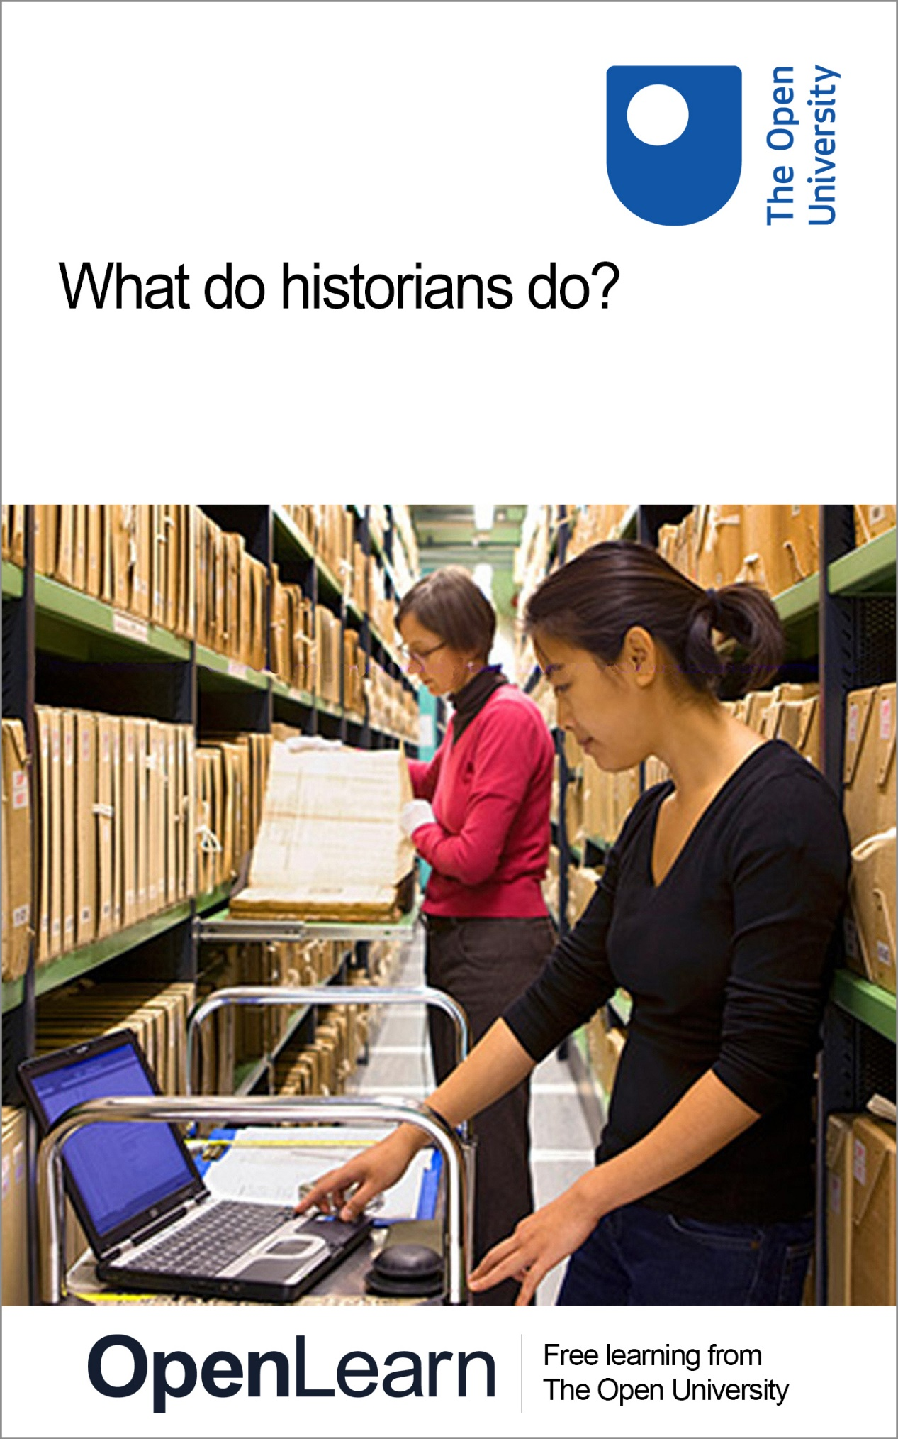

A883_1

What do historians do?

About this free course
This free course is an adapted extract from the Open University course A883 MA History part 1: https://www.open.ac.uk/postgraduate/modules/a883.
This version of the content may include video, images and interactive content that may not be optimised for your device.
You can experience this free course as it was originally designed on OpenLearn, the home of free learning from The Open University –
www.open.edu/openlearn/history-the-arts/what-do-historians-do/content-section-0
There you’ll also be able to track your progress via your activity record, which you can use to demonstrate your learning.
Copyright © 2023 The Open University
Intellectual property
Unless otherwise stated, this resource is released under the terms of the Creative Commons Licence v4.0 http://creativecommons.org/licenses/by-nc-sa/4.0/deed.en_GB. Within that The Open University interprets this licence in the following way: www.open.edu/openlearn/about-openlearn/frequently-asked-questions-on-openlearn. Copyright and rights falling outside the terms of the Creative Commons Licence are retained or controlled by The Open University. Please read the full text before using any of the content.
We believe the primary barrier to accessing high-quality educational experiences is cost, which is why we aim to publish as much free content as possible under an open licence. If it proves difficult to release content under our preferred Creative Commons licence (e.g. because we can’t afford or gain the clearances or find suitable alternatives), we will still release the materials for free under a personal end-user licence.
This is because the learning experience will always be the same high quality offering and that should always be seen as positive – even if at times the licensing is different to Creative Commons.
When using the content you must attribute us (The Open University) (the OU) and any identified author in accordance with the terms of the Creative Commons Licence.
The Acknowledgements section is used to list, amongst other things, third party (Proprietary), licensed content which is not subject to Creative Commons licensing. Proprietary content must be used (retained) intact and in context to the content at all times.
The Acknowledgements section is also used to bring to your attention any other Special Restrictions which may apply to the content. For example there may be times when the Creative Commons Non-Commercial Sharealike licence does not apply to any of the content even if owned by us (The Open University). In these instances, unless stated otherwise, the content may be used for personal and non-commercial use.
We have also identified as Proprietary other material included in the content which is not subject to Creative Commons Licence. These are OU logos, trading names and may extend to certain photographic and video images and sound recordings and any other material as may be brought to your attention.
Unauthorised use of any of the content may constitute a breach of the terms and conditions and/or intellectual property laws.
We reserve the right to alter, amend or bring to an end any terms and conditions provided here without notice.
All rights falling outside the terms of the Creative Commons licence are retained or controlled by The Open University.
Head of Intellectual Property, The Open University

Contents
- Introduction
- Learning outcomes
- 1 Historians work in a tradition
  - 1.1 Landscape history
  - 1.2 Land management
  - 1.3 Travel writing
  - 1.4 Enter the historians
  - 1.5 Summary of Section 1
- 2 Historians use objects (sometimes)
  - 2.1 Reasons for bottle feeding
  - 2.2 Advice on infant feeding
  - 2.3 Moving through time …
  - 2.4 Babies and the state
  - 2.5 Summary of Section 2
- 3 Historians challenge public understanding of the past
  - 3.1 The ‘Bloody Code’
  - 3.2 Historians and the Bloody Code
  - 3.3 Revisionists, post-revisionists and the decline of hanging
  - 3.4 Sentenced to death: the end of the road?
  - 3.5 Summary of Section 3
- Conclusion
- Glossary
- References
- Further reading
- Acknowledgements
- Solutions

Introduction
What do you imagine when you think of a historian?
Figure 1 shows Asa Briggs (1921–2016), an influential and successful historian, a Cambridge and London University graduate, former soldier, codebreaker at Bletchley Park and the third Chancellor of The Open University (1978–1994). Asa probably fits many people’s ideas of how a friendly historian might look. These days historians are more diverse: for example, they are not all male, white and tweed-jacketed! Still, they have a lot in common with Asa and work in much the same way.

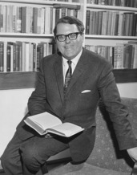
Figure 1 Lord Asa Briggs (1921–2016) was a British social historian specialising in the Victorian era and in the history of broadcasting in Britain. Briggs graduated from Sidney Sussex College, Cambridge, in 1941, and served in the Intelligence Corps at Bletchley Park (1942–45) before becoming a fellow of Worcester College in 1945 and embarking on an academic career.
View description - Figure 1 Lord Asa Briggs (1921–2016) was a British social historian specialising ...
View alternative description - Figure 1 Lord Asa Briggs (1921–2016) was a British social historian specialising ...

What, then, do historians actually do? Asking the internet produces a great many verbs: historians locate, collect, consider, analyse, develop, evaluate, assess, compare, write, argue and explain. While all the activities in this list are correct, what links them is evidence.
Historians work with evidence from the past and what all historians do, regardless of subject or time period, is to construct an understanding of the past from reading and analysing evidence. Evidence, known as primary sources, is the raw material of history and it is the core job of the historian to make sense of it.
In this free course you will explore some of the ways that historians work to develop our understanding of the past. You will learn about three aspects of the historian’s craft through three topic areas. You will start with landscape history to see how historians work within long-established traditions of learning and develop new scholarly subjects. Next you will move on to consider how historians can use everyday objects to connect with the ordinary experiences of people in the past. You will learn how artefacts from medical collections can contribute to social history research on infancy. Finally, you will examine criminal justice history to understand how research can challenge existing perceptions or myths about the past. Through the activities in each section you will experience a wide range of historical evidence and understand its importance for historians in constructing new knowledge.
You can find a list of definitions of key terms in the Glossary at the end of the course.
This OpenLearn course is an example of postgraduate-level study and gives some insight into the study of history you might undertake if you were to study the MA in History (A883/4).

Learning outcomes
After studying this course, you should be able to:
- appreciate how historians develop research ideas from different starting points
- understand some of the choices and processes involved in researching the past
- have a critical awareness of the wide range of sources historians use for evidence, beyond the textual to include visual, material and physical
- recognise that historians work within longstanding traditions of learning and knowledge construction.

1 Historians work in a tradition

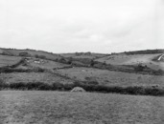
Figure 2 A photograph of Luxulyan, Cornwall, taken in August 1928.
View description - Figure 2 A photograph of Luxulyan, Cornwall, taken in August 1928.
View alternative description - Figure 2 A photograph of Luxulyan, Cornwall, taken in August 1928.

Academic history is made up of knowledge and methods that have evolved over generations. Historians often say they ‘stand on the shoulders of others’ as they try to develop the work of previous scholars. Working within a tradition of knowledge can mean challenging or changing that knowledge or finding new ways (methods) towards understanding the past. Sometimes new fields or areas of academic historical research emerge but, as you will see here, they still build on broader established traditions of knowledge construction. You are now going to explore how this works with landscape history. You will see how historians use cultural products, their own experience of being in a landscape and scholarly work to understand our changing environments.

1.1 Landscape history
Landscape history became a recognised branch of British academic history in the post-war period, marked by the publication of W.G. Hoskins’ book The Making of the English Landscape in 1955. While Hoskins’ was the first book to examine landscape change systematically, many before him had attempted to observe and explain the landscape and the impact of human activity upon it. Here you will see how map-makers, travel writers and collectors have all contributed to historians’ evidence of landscape and environment change. An important factor in how landscapes, both town and country, were understood was the advance in map-making in the early modern period.

Activity 1
Allow about 20 minutes

Look at this map made for King Henry VIII.

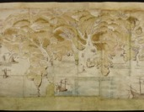
Figure 3 One of the coastal defences maps made for Henry VIII by order of Thomas Cromwell in 1539. ‘Henry VIII’s coastal defence maps’, British Library, Cotton Ms. Augustus I I, 35, 36, 38, 39.
View description - Figure 3 One of the coastal defences maps made for Henry VIII by order of Thomas ...
View alternative description - Figure 3 One of the coastal defences maps made for Henry VIII by order of Thomas ...

What do you notice about this map compared to modern maps you may use? Consider the projection (angle and perspective) of the map. Aside from its original intention what evidence do you think it might offer, say, to an urban or architectural historian?

Provide your answer...
View discussion - Activity 1

In the early seventeenth century the cartographer John Speed published the first atlas of English and Welsh county maps, The Theatre of the Empire of Great Britaine (1612), capturing a changing landscape. He is best known for his town plans which were famously detailed, showing gardens and orchards as well as the buildings and some activities in towns.

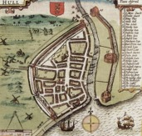
Figure 4 A map of Kingston upon Hull by John Speed, published in 1611.
View description - Figure 4 A map of Kingston upon Hull by John Speed, published in 1611.
View alternative description - Figure 4 A map of Kingston upon Hull by John Speed, published in 1611.

Speed’s town maps formed part of an atlas of Great Britain and were designed mainly for readers who would never visit the towns portrayed. These maps are very valuable to historians of early modern towns and are sometimes the only image we have of a town at that point in time. If you look at the map of Hull in Figure 4, for example, you can see the important buildings and get some indication of what went on in the locality.
Next you will look at how land ownership changes and travel created knowledge of the landscape.

1.2 Land management
By the late seventeenth century, many landed estates had changed hands and were newly recorded, measured and mapped. Map-makers drew in detailed changes and cartouches carrying information about the estate owners and their antecedents. These changes in landownership and management have left historians a wide variety of evidence including maps, vistas, sale contracts and land management records and a wealth of material relating to rights over rivers, navigation, coasts and resources such as minerals, timber and game. Over the eighteenth and into the nineteenth centuries maps became increasingly detailed, so the historian can glean a great deal of evidence from them.

Activity 2
Allow about 20 minutes

Look at this map from 1776. It shows part of a Scottish estate called Luss belonging to Sir James Colquhoun, baronet. What could you work out from this map? Jot down your ideas.

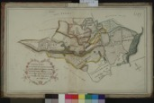
Figure 5 Map by Charles Ross, showing South Port Toumnahurich, Shigartan, Hillhouse, Tyna Crove, Tyinloine, Miln of Finlays, Ross Finlays, Shantron, Shimore, Shibeg, Blaruile. It comes from a one of a series of books of estate maps of lands on the western shores of Loch Lomond. This map was published in A Book of Maps of the Estate of Luss belonging to Sir James Colquhoun Baronet surveyed & planed by Charles Ross (1776).
View description - Figure 5 Map by Charles Ross, showing South Port Toumnahurich, Shigartan, Hillhouse, ...
View alternative description - Figure 5 Map by Charles Ross, showing South Port Toumnahurich, Shigartan, Hillhouse, ...

Provide your answer...
View discussion - Activity 2

1.3 Travel writing
After the restoration (1660), travel around Britain and Ireland became easier and fashionable for the wealthy, and travel writers such as Daniel Defoe and Celia Fiennes recorded their impressions of provincial change. Defoe was very focused on new buildings, fine houses and the state of towns while Fiennes (riding her pony) recorded everything she could count, fretted about the state of the roads and gave detailed descriptions of all she saw. This type of early travel writing, again designed for armchair readers, created material which historians can use today.

Activity 3
Allow about 25 minutes

Read this account of Celia Fiennes’ visit to Chesterfield in 1698 and make some notes about the evidence of rural and urban landscapes which it provides.
Tip: Consider how you might read this from an environment history point of view.

Here we Entred Darbyshire and went to Chesterffield 6 mile, and Came by ye Coale mines where they were digging. They make their mines at ye Entrance Like a Well and so till they Come to ye Coale, then they digg all the Ground about where there is Coale and set pillars to support it, and so bring it to ye well where by a basket Like a hand barrow by Cords they pull it up – so they Let down and up the miners with a Cord. Chesterffield Looks Low when you approach it from the Adjacent hill wch you descend, but then you ascend another to it. The Coale pitts and quaraes of stone are all about, Even just at ye town End, and in the town its all built of stone. Ye Church stands in a place of Eminency, the town Looks well, the Streets good, ye Market very Large. It was Satturday wch is their market day and there was a great Market Like some little ffaire, a great deale of Corne and all sorts of ware and ffowles there.
(Fiennes, 1888, pp. 76–7)

Provide your answer...
View discussion - Activity 3

Antiquarians and landscapes
As well as tourists, rural landscapes and townscapes were combed by the so-called ‘antiquarians’ of the eighteenth and nineteenth centuries. These were scholars and hobbyists, mainly gentlemen, who were enthusiastic about ‘antiquities’, the material evidence of the past. Antiquarians studied, recorded, drew, wrote about, and organised to preserve, such diverse things as Roman remains, medieval manuscripts, Norman castles and ancient burial sites. They were also often the butt of satirical sketches in novels and magazines.

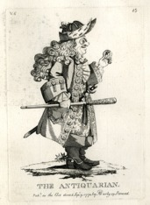
Figure 6 A caricature of an antiquarian, published by Matthias Darly, 39 Strand, 1773.
View description - Figure 6 A caricature of an antiquarian, published by Matthias Darly, 39 Strand, ...
View alternative description - Figure 6 A caricature of an antiquarian, published by Matthias Darly, 39 Strand, ...

1.4 Enter the historians

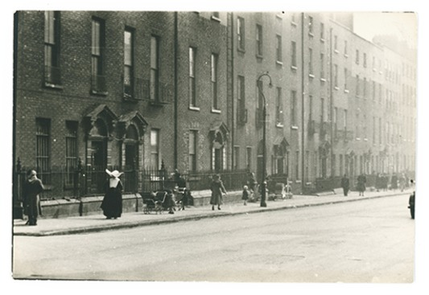
Figure 7 A photograph by Nevill Johnson of Lower Dominick Street, Dublin City, take in 1952 or 1953. Among the people captured is a nun from the Daughters of Charity of St Vincent de Paul order in full habit, complete with cornette.
View description - Figure 7 A photograph by Nevill Johnson of Lower Dominick Street, Dublin City, take ...
View alternative description - Figure 7 A photograph by Nevill Johnson of Lower Dominick Street, Dublin City, take ...

All these cultural trends generated cultural products (maps, drawings, descriptions) which are, in themselves, evidence of socio-economic developments and power relations. After all, a person had to be very rich to acquire an estate of land and only the well-off had the money and time to purchase and read travel literature. These products became primary source evidence for historians but also established a tradition of working on and in a landscape, observing and collecting material. Hoskins’ landmark book began a branch and a tradition of academic history and encouraged landscape, local and urban historians to go outside, to explore their place of study and to use their environment as evidence.
In the 1950s and 1960s historians like Hoskins, Joan Thirsk and Emyr Estyn Evans pioneered studies of rural landscapes and communities while Jack Simmons, H.J. Dyos and Asa Briggs developed further sub-fields or disciplines, including transport history and urban history. They were all united by a tradition of examining the environment around them and interpreting it as material evidence of the past. In the words of Asa Briggs: ‘There is no substitute for knowing a city: reading about it is second-best’ (1993, p. 12). The method of walking, observing and ‘knowing’ the environment also links these historians back to the map-makers, travel writers and antiquarians in the past who sought to know and explain the world they saw. Here you can see that increasingly diverse fields of academic history have developed their own traditions of scholarly research practice and literature (historiography) over the last half a century or so but are also rooted in a broader cultural context.
The economic and urban historian Richard Rodger studies the built environment today and shows how walking through streets and looking up can reveal evidence of migration and everyday life in the Victorian city:

Almost half the plaques recorded on Leicester terraced houses referred to Midlands towns and villages. Most numerous, perhaps predictably, were those from Leicestershire (18 per cent); contiguous counties accounted for 16 per cent of the place names recorded. This might be considered to chime with step migrations that stress sequential short distance moves from villages to small towns and then to cities, and this portability of place names warrants further research on Leicester and elsewhere as a means of understanding the role of nostalgia and the search for and significance of emotional connections for urban newcomers.
(Rodger, 2022, pp. 8–9)

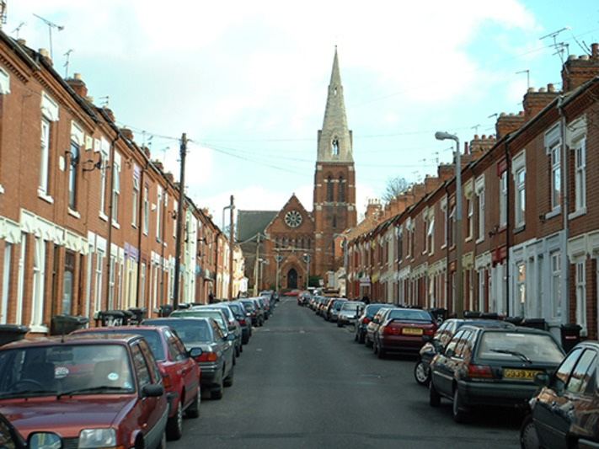
Figure 8 A photograph showing Frederick Road, Leicester a redbrick residential street of small terraced houses with a view of the front of St Saviour's Church (1877). This Victorian parish church was designed by the architect Sir George Gilbert Scott in the Early English style and built in Midland brick like the houses.
View description - Figure 8 A photograph showing Frederick Road, Leicester a redbrick residential street ...
View alternative description - Figure 8 A photograph showing Frederick Road, Leicester a redbrick residential street ...

Like the antiquarians before them, landscape historians may walk, draw and map a locality (rural or urban); they might also photograph or film it or use digital satellite technology (GIS) to map, record and measure accurately. New technologies aid historical research which has grown from a long tradition of wider knowledge construction and a more recent tradition of academic landscape history. Better understanding of the impacts of human activity on landscapes has seen environmental history grow in scale and importance in the twenty-first century. While antiquarians preserved ancient monuments, today’s historians can be active in local and civic history initiatives including public history and conservation activity. Modern academic landscape, urban and environmental history has expanded to include the history of conservation and environmental protest which have their roots in the nineteenth century.

1.5 Summary of Section 1
In this section on landscape history you have seen how past efforts to record and understand the environment resulted in cultural products historians can use for evidence today. You have also learned how some traditional cultural practices such as walking the landscape formed part of new academic understanding and knowledge construction. You now understand how historians work within traditions of scholarliness and also broader cultural traditions, to develop new history knowledge.
In the next section you will see how historians can be inspired by objects and how their research is focused on particular time periods.

2 Historians use objects (sometimes)
You have seen how historians work within traditions of learning, both academic traditions and also wider cultural practices, but all research starts somewhere; usually with a question! Curiosity is a valuable tool for historians if it is focused well. Something that can provide an apparently straightforward starting point for history research is an artefact. Ludmilla Jordanova, a historian of material culture, reminds us that ‘the form and function of every artefact have passed through the minds and bodies of the people who exercised choice in the past’ (2012, p. 7). Material culture (or objects and things) can give us powerful insights into past societies. We can look at a thing and start with the simplest of questions asking: what is it and what is it for?

Activity 4
Allow about 10 minutes

Here is an artefact from the Science Museum’s collection.

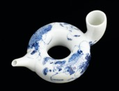
Figure 9 A ring-shaped porcelain bottle with painted decoration and signature. Made in Japan between 1780 and 1900.
View description - Figure 9 A ring-shaped porcelain bottle with painted decoration and signature. Made ...
View alternative description - Figure 9 A ring-shaped porcelain bottle with painted decoration and signature. Made ...

What do you think it might be?

Provide your answer...
View discussion - Activity 4

2.1 Reasons for bottle feeding

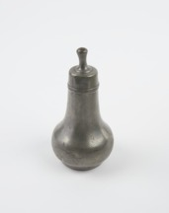
Figure 10 A pewter infant’s feeding bottle, made in Europe between 1601 and 1900.
View description - Figure 10 A pewter infant’s feeding bottle, made in Europe between 1601 and 1900 ...
View alternative description - Figure 10 A pewter infant’s feeding bottle, made in Europe between 1601 and 1900 ...

You may find this surprising, as people tend to think of formula feeding as a twentieth-century development and assume that in the past all babies were breastfed, but the reasons for bottle feeding infants are as old as humanity. Maternal mortality was high until the late nineteenth century so motherless babies were not uncommon; not all mothers were able to breastfeed and then there were the infants whose circumstances required artificial or supplementary feeding. Babies who were orphaned, abandoned, concealed or ill and those with a poorly-nourished or a working mother all needed feeding. In addition, mothers who began breastfeeding could suffer from infected breasts known as ‘milk fever’, obstructions, ulcers, pain and other problems which could result in bottle feeding.
If you begin with this artefact, it becomes apparent that it really only gives us half a story; a bottle must have some form of milk. Using our original object as a starting point we can move back and forth on a timeline and investigate what babies consumed through bottles and why.
If you move backwards chronologically from our porcelain bottle, early modern babies whose mothers could not feed them were often given to wet nurses, usually women of a lower socio-economic status with available breast milk. This was considered problematic, as in this period breast milk was thought to be a form of bodily fluid which could confer characteristics or morals and parents were often worried about the morality of the wet nurse. This cartoon shows that such anxieties were still present in Victorian times.

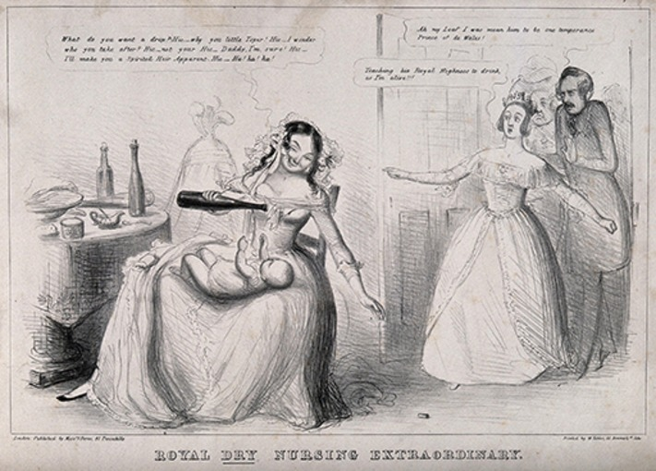
Figure 11 A satirical print which features a drunken nurse about to give the Prince of Wales (later Edward VII) a drop of alcohol as a horrified Queen Victoria and Prince Albert burst in on the scene. Lithograph, published by Messrs Fores, c.1841.
View description - Figure 11 A satirical print which features a drunken nurse about to give the Prince ...
View alternative description - Figure 11 A satirical print which features a drunken nurse about to give the Prince ...

2.2 Advice on infant feeding
As bottle feeding was used as an alternative or to supplement the mother’s milk, bottles could contain ‘pap’, a mixture of milk, water and some form of food. Babies were often fed to a recipe passed on by a traditional midwife who cared for both mother and baby. According to the historian Marylynn Salmon breastfeeding problems resulted in ‘severe stress’ in a period and culture where women were expected to be fecund, so early modern ‘women’s collections of medicinal recipes invariably included remedies for increasing inadequate milk supplies as well as recipes for supplementary feedings’ (1994, p. 262). Recipes and ingredients for infant bottles could vary according to class and region; mixtures of milk, water, barley, biscuits, oats and soup-like substances were all used. The advice offered by obstetrician William Smellie in his midwifery manual published in 1752 features typical ingredients:

If the child is brought up by hand, the food ought to imitate, as near as possible the mother’s milk: let it consist of loaf-bread and water, boiled up together… and mixed with the same quantity of new cow’s milk; and sometimes with the broth of fowl or mutton.
(Smellie, 1752, p. 440)

Although these were not ideal foods and some were dangerous, many babies were nourished in this manner. The greatest danger came from contaminated water, adulterated ingredients and unclean equipment harbouring bacteria.
In the seventeenth and eighteenth centuries, medical men became increasingly interested and involved in childbirth which had traditionally been a woman’s role. Here you can see this transition of midwifery from a traditional practice involving one gender to a more professionalised, ‘scientific’ and medicalised event involving another gender evidenced in a surgeon’s sign and this cartoon from 1793.

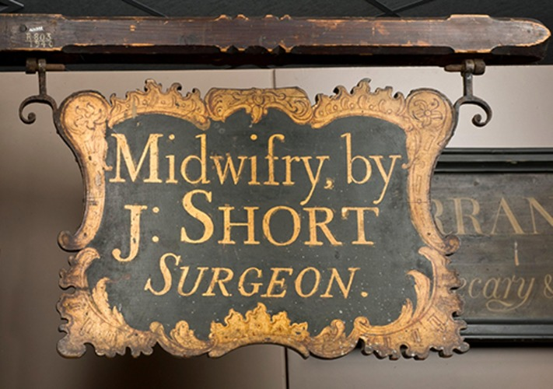
Figure 12 A surgeon’s sign, England. Made and displayed between 1750 and 1800.
View description - Figure 12 A surgeon’s sign, England. Made and displayed between 1750 and 1800.
View alternative description - Figure 12 A surgeon’s sign, England. Made and displayed between 1750 and 1800.

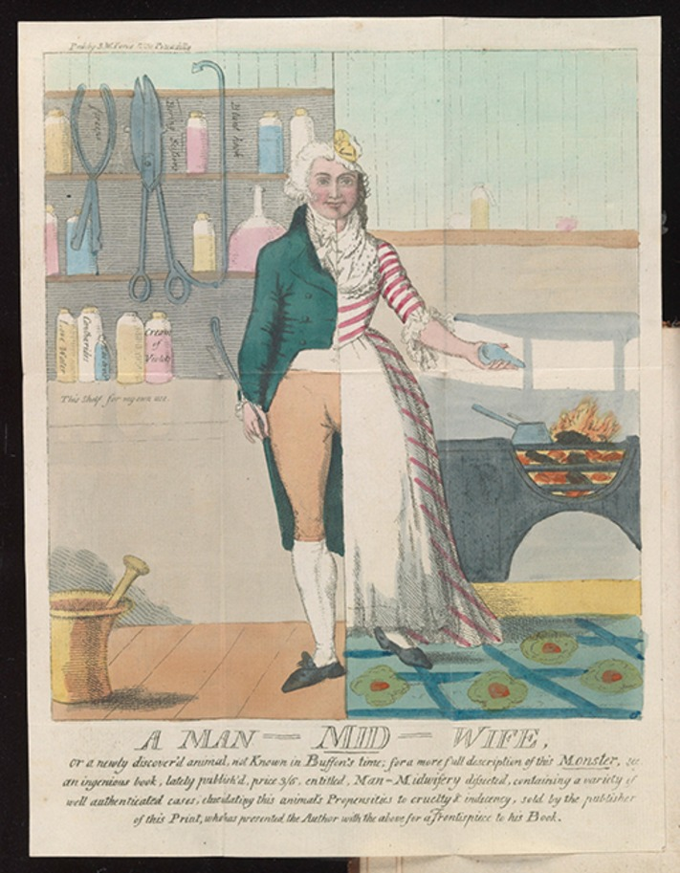
Figure 13 A caricature of a male midwife by Isaac Cruikshank, which depicts the male midwife as a hybrid ‘monster’ who crosses the boundary between male and female worlds. Published in Samuel William Forbes, Man-midwifery dissected; or, the obstetric family instructor (1793).
View description - Figure 13 A caricature of a male midwife by Isaac Cruikshank, which depicts the male ...
View alternative description - Figure 13 A caricature of a male midwife by Isaac Cruikshank, which depicts the male ...

These male doctors were also clear that breastfeeding was best for babies. They regarded breast milk as a form of medicine and blamed mothers who could not feed. The difficulty was what to do in such cases. One 1785 midwifery manual suggested that: ‘If necessity deprive the child of the natural support that ought to be afforded by the mother, a proper nurse must be proposed’ (Aitken, 1785, p. 66).
The issue of feeding was again connected to class, as Charles White wrote in 1773: ‘women of rank and those in the middle stations of life meet with difficulty giving suck to children’ (quoted in Salmon, 1994, p. 258). White believed this was a consequence of their fashionable clothing and advised that ‘hard working labouring women’ in loose clothes made good nurses.

Activity 5
Allow about 10 minutes

Have a look at these artefacts. Who do you think would have bought these and why?
Tip: Consider the material they are made of.

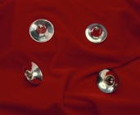
Figure 14 Four round objects, made between 1786 and 1821, from hallmarked sterling silver.
View description - Figure 14 Four round objects, made between 1786 and 1821, from hallmarked sterling ...
View alternative description - Figure 14 Four round objects, made between 1786 and 1821, from hallmarked sterling ...

Provide your answer...
View discussion - Activity 5

2.3 Moving through time …
Starting with our artefact, the feeding bottle, and working backwards, you can see that the whole area of childbirth, health and infant care produces many potential areas for research. We are led to consider issues of class, consumption, gender roles, professionalisation, knowledge transmission, custom and culture. If you were to continue researching you would need to make choices as to what topic and evidence to focus on.
Moving forward from the date of our bottle into the late nineteenth century we find the idea that ‘breast is best’ was very much debated. Influenced by the ideas of Darwin and population ‘improvement’, the medical profession, the British state and local authorities were all concerned with the health and mortality of the poorest babies. In the 1880s and 1890s, widespread reporting and the study of poor families, particularly in the largest urban slums, produced panic about the health of the next generation and dubious concepts of moral, physical and urban ‘degeneracy’.
In efforts to improve infant mortality rates, local authorities in large industrial cities began to offer mother and baby health services including health visitors, clinics and milk dispensaries in the 1890s and 1900s. Bottle feeding had been discouraged through the nineteenth century as milk, like much food in Victorian towns and cities, could be adulterated and laden with disease bacteria, so the introduction of safe powdered milk was a breakthrough. Local municipal and health authorities focused on supplying babies where the mother was malnourished and in poor health, hoping to break a perceived legacy of intergenerational poor health and urban degeneracy. The historian Valerie Fildes (1998) has shown how important such local authority action was to infant health and lower infant mortality, particularly improvements in health education and in supplying milk to mothers and babies.

Activity 6
Allow about 30 minutes

In the decades before national health services (1945 UK, 1957 Ireland) locally organised mother and infant services were vital. Look at this evidence from inter-war Liverpool’s Infant Welfare Centres. Do not worry too much about trying to take it all in at once; just focus on listing a few points. Who was being fed? What products were offered?
Tip: If you have time, you could try to see differences between the centres. What type of tentative theory might you develop as to their locations?

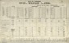
Figure 15 ‘City of Liverpool: Infant Welfare Centres’, 1928. An official document from the City Council showing maternity and child welfare statistics related to infant feeding.
View description - Figure 15 ‘City of Liverpool: Infant Welfare Centres’, 1928. An official document ...
View alternative description - Figure 15 ‘City of Liverpool: Infant Welfare Centres’, 1928. An official document ...

Provide your answer...
View discussion - Activity 6

2.4 Babies and the state
Despite the development of local children’s services, healthcare, particularly doctors, remained expensive and one concern of local health authorities was that they came into contact with sickly infants too late to help them. In order to know how many babies were born, where they were and which ones were at risk (usually in the poorest areas), the Notification of Births Act was passed in 1907. This legislation allowed local authorities to require families to register a birth within 48 hours. In 1915 this was made compulsory across the four nations of the UK allowing health visitors to identify underweight or unwell babies in the first ten days of their life.
As you can see, moving forward along a timeline from our original artefact, the topic of bottle feeding can lead us to ideas of public health, local provision, erroneous but powerful concepts of social degeneracy and the intervention of the state into the earliest days of family life. You have not even considered the growing role of large manufacturers and brands in this market.

Activity 7
Allow about 15 minutes

Have a look at this advertisement and notice the year of publication. What topics or concerns might a historian identify in this evidence?
Tip: Notice the flag symbolism.

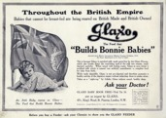
Figure 16 An advertisement for Glaxo baby food (i.e. milk or formula), published in the Illustrated War News, 4 November 1914.
View description - Figure 16 An advertisement for Glaxo baby food (i.e. milk or formula), published ...
View alternative description - Figure 16 An advertisement for Glaxo baby food (i.e. milk or formula), published ...

Provide your answer...
View discussion - Activity 7

2.5 Summary of Section 2
Hopefully you now understand how using a single artefact as a starting point can lead us to many different research topics, research paths and time periods and also into a range of controversies and debates. We need to consider our artefact in conjunction with other evidence; here we have used other material objects, medical publications, cartoons, advertisements, local authority records and government legislation as primary sources to examine the contexts and issues around infant bottle feeding. You have also seen how you need to find different sources to cross check or corroborate your conclusions.
In the next section you will see how historians try to correct erroneous ideas about the past.

3 Historians challenge public understanding of the past
In this third section you will see how historians use evidence to challenge and change existing knowledge and ideas about the past. Our understanding of history is constantly evolving but this knowledge can carry with it some established and widely held misconceptions or even myths. Recent research has changed our understanding of part of the law and criminal justice system, particularly how people were punished for crimes they committed.

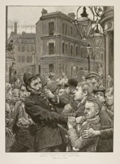
Figure 17 ‘Police work in the East End’, The Graphic, 28 December 1895.
View description - Figure 17 ‘Police work in the East End’, The Graphic, 28 December 1895.
View alternative description - Figure 17 ‘Police work in the East End’, The Graphic, 28 December 1895.

3.1 The ‘Bloody Code’
During the eighteenth century, state violence against the person was accepted and this included capital punishment (execution) for those convicted of certain crimes. Across the early eighteenth century more than 200 acts were passed to make up to 200 separate crimes punishable by the death sentence. The majority of these were property crimes that you might consider to be fairly petty, including shoplifting or stealing a rabbit. This system of law was popularly known as the ‘Bloody Code’ and meant that people who were found guilty of crimes like highway robbery or theft could be hanged the same as murderers. Historians have for some time debated the significance and use of the ‘Bloody Code’ and what it tells us about the society that used it.

The gallows and hanging in popular culture
The Bloody Code was supposed to act as a terrifying deterrent to those who would commit crime and there is no doubt that the idea of capital punishment and hangings loomed large in the public imagination in this period. There are many illustrations featuring penitent prisoners awaiting their execution day like this one in Figure 18 which shows dandies (very fashionable young men) visiting a condemned man:

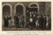
Figure 18 Social elites (or ‘English dandies’) visiting a man sentenced to hang at Newgate Prison. In this image, the visitors watch as the shackles (or irons) of the condemned man are removed by the blacksmith in the Press Yard. An engraving by Robert & George Cruikshank for Pierce Egan’s Life in London, published in 1823.
View description - Figure 18 Social elites (or ‘English dandies’) visiting a man sentenced to hang at ...
View alternative description - Figure 18 Social elites (or ‘English dandies’) visiting a man sentenced to hang at ...

You can also find accounts of the lives and crimes of the condemned in newspapers and pamphlets, and sometimes the convicts themselves created their own narratives through confessions or final speeches.

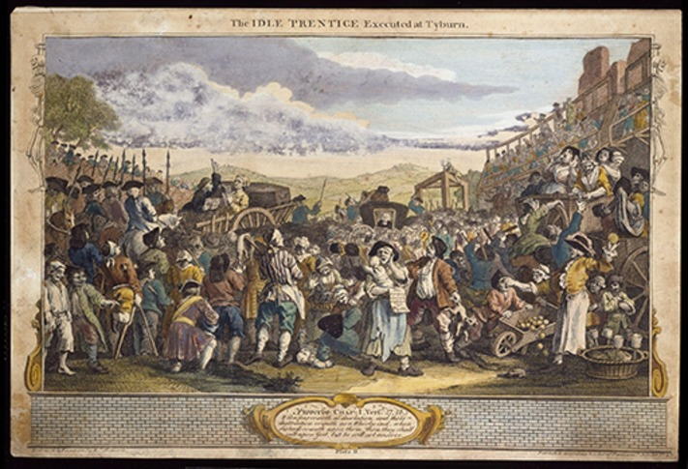
Figure 19 William Hogarth, ‘The Idle ‘Prentice Executed at Tyburn’, 1747. Hogarth’s famous print captures the festival-like atmosphere of a public execution at Tyburn in London during the eighteenth century.
View description - Figure 19 William Hogarth, ‘The Idle ‘Prentice Executed at Tyburn’, 1747. Hogarth’s ...
View alternative description - Figure 19 William Hogarth, ‘The Idle ‘Prentice Executed at Tyburn’, 1747. Hogarth’s ...

Many historic images of hangings present them as public spectacles. A fair-day-like atmosphere accompanied hangings in London for much of the eighteenth century. Prisoners convicted at the Old Bailey Courts were taken from the cells of Newgate Prison and walked in procession along what is now Oxford Street to Tyburn, an area near today’s Marble Arch, where up to 20 convicts might be hanged at once. There were only eight of these occasions a year and they were often considered to be a public holiday with ale houses packed and street vendors selling foods (including gingerbread people supposedly in the shape of the prisoners) and copies of the final speeches of the condemned.
The imagery of Tyburn is widespread in cultural products and we can find it featured in print media, paintings, ballads and novels often created with a moral purpose. But how common was the death sentence under the Bloody Code?

Activity 8
Allow about 45 minutes

Go to the Old Bailey Online website. Open the link in a new tab or window so you can easily navigate your way back to the course.
Here you will find the records of London’s central criminal court. You are going to examine handkerchief theft prosecutions for one year.
Go to the Search Home page and use ‘handkerchief’ as your keyword, choose ‘Theft> all subcategories’ as the offence and leave all the other fields blank except for the dates. In dates choose January 1770 to January 1771 and search.
Here you can see all the cases prosecuted in twelve months that included handkerchief theft. Read as many cases as you like and make very quick notes about values of property, verdicts and sentences.

Provide your answer...
View discussion - Activity 8

3.2 Historians and the Bloody Code

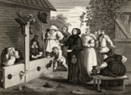
Figure 20 Hudibras and Ralpho in the stocks. An engraving by J. Romney after Hogarth, from The Works of Hogarth, 1833.
View description - Figure 20 Hudibras and Ralpho in the stocks. An engraving by J. Romney after Hogarth, ...
View alternative description - Figure 20 Hudibras and Ralpho in the stocks. An engraving by J. Romney after Hogarth, ...

Having undertaken some research yourself in the previous activity you have already found that the Bloody Code did not operate ‘as advertised’. In fact there was a lot of discretion and variability in verdicts, sentences and the carrying out of sentences. How should historians make sense of the clear gap that existed between the letter of the law and what actually happened? Let’s start with an established idea about the Bloody Code that dominated the writing of criminal justice history for most of the nineteenth and twentieth centuries.

The Whig view of history
The ‘Whig’ (or ‘Whiggish’) view of history comes from the old term for political Liberals (Whigs) and means an understanding of history as an evolutionary process. This view sees the history of any given subject as an increasingly civilising and evolving process leading to the rational and ‘better’ present now. To give an example; early Victorian Whigs (Liberals) argued that it was more civilised and rational for society to imprison people and correct their behaviours than to whip them or place them in the stocks. The development of the law and punishment was seen as progressing from disorganised brutal chaos, often called a ‘lottery’, towards a better and more rational ‘now’.
The Whiggish view of history tends to explain all historical developments as either moving towards, or as interruptions on the journey towards, some goal or improved ending. The Whig view of history emphasises moral improvement, rationalisation and institutional organisation (all quite Victorian!) and it lasted up until the 1960s. Today’s historians try to understand periods of time in the past as valuable to study and understandable for themselves rather than as an explainable stage of our journey to the here and now. The Whig view was a very useful tool for explaining things that were historically quite contradictory though!
Returning to the Bloody Code, for example, we know that a great number of crimes were punishable by the death sentence, but by the early nineteenth century this was not working as a deterrent because crime, especially theft, remained widespread. Through the eighteenth and nineteenth centuries, the use of hanging declined and non-violent property crime was increasingly punished by transportation or imprisonment. According to the Whig view of history, the use of hanging declined because the Bloody Code was illogical, hanging was an uncivilised spectacle and transportation or imprisonment were more humane. This explanation of an increasingly civilised society mirrored the arguments of the penal reformers in the 1820s and 1830s who wanted greater emphasis on reforming criminals and a prison building programme to do it in. From the 1970s onwards, some historians questioned this Whiggish explanation and their research looked closely at the Bloody Code and how the law operated.

3.3 Revisionists, post-revisionists and the decline of hanging

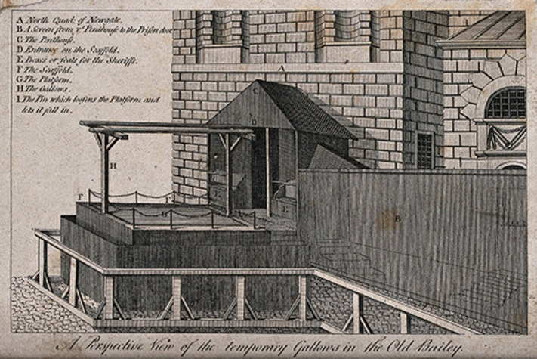
Figure 21 The temporary gallows erected at the Old Bailey (later Central Criminal Court), north of Newgate Prison.
View description - Figure 21 The temporary gallows erected at the Old Bailey (later Central Criminal ...
View alternative description - Figure 21 The temporary gallows erected at the Old Bailey (later Central Criminal ...

Whig history had explained the reluctance to enforce the Bloody Code by the rise of a more ordered and rational civilised society, but by the end of the twentieth century historians had begun to question and revise this view. These historians found (just as you have) that the Code did not operate exactly as it was written and some argued it ‘collapsed’, but not for the reasons given by Whig history. Their view is known as the revisionist approach.
Revisionist historians including J.M. Beattie (1986) and Douglas Hay (1980) argued that the Bloody Code was not really imposed in an arbitrary manner but was an instrument of elite control over social threats. Some revisionists argued that juries and prosecutors were deterred from convicting offenders in case they might be hanged so the use of the death sentence declined. Conversely, the revisionist V.A.C. Gatrell (1996) argued that it was because of the number of successful prosecutions, resulting in hangings, that so many crimes were pardoned. Ultimately, revisionist historians, like their Whig predecessors, agreed that hangings declined in popularity and number through the last decades of the eighteenth and first decades of the nineteenth centuries but disagreed on why this happened.
Post-revisionist historians including John Walliss (2018a), Peter King and Richard Ward (2015) have since researched the national and regional operation of the Bloody Code to determine the factors that impacted on sentencing and execution. Other post-revisionist historians have researched the response to specific crimes like forgery or infanticide.
To sum up this long and complex historiography very briefly, you could say that the Whig historians believed the Bloody Code system of law worked nationally as written but was too brutal and irrational to last. The revisionists argued that the law operated as written, but that people, including juries, mainly worked around it, either because it was too extreme or not really a deterrent. The post-revisionists argued that in many places the authorities only operated the Bloody Code in certain limited circumstances. You can see that this is quite a shift in understanding the operation of the Code which took time and, more importantly, careful research.

Activity 9
Allow about 30 minutes

Examining the implementation of the Bloody Code, post-revisionist historians Peter King and Richard Ward found very different sentencing policies throughout mainland Britain.
Access the following link in a new tab or window: Rethinking the Bloody Code in eighteenth century Britain: capital punishment at the centre and on the periphery. In the PDF version of the article, read from ‘The geography of the Bloody Code …’ on p. 166 to ‘… the capital sanction than the Welsh (Table 1)’.
What do you notice about this map and what did they measure?
Tip: Consider the distance of places from the capital.

Provide your answer...
View discussion - Activity 9

3.4 Sentenced to death: the end of the road?

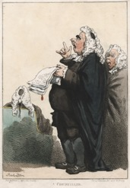
Figure 22 ‘A Counciller’ (i.e. lawyer) by Thomas Rowlandson, c.1810.
View description - Figure 22 ‘A Counciller’ (i.e. lawyer) by Thomas Rowlandson, c.1810.
View alternative description - Figure 22 ‘A Counciller’ (i.e. lawyer) by Thomas Rowlandson, c.1810.

If the Bloody Code was not implemented evenly, what was happening instead? Being found guilty of a crime under the Bloody Code could lead to a number of outcomes, as John Walliss has argued: ‘those who died on the gallows, after all, only represented a small percentage of all those who were sentenced to death’ (2018b, p. 3). Even in cases where the defendant had been found guilty and a death sentence was passed, often indicated in the court records as ‘death recorded’, all hope was still not lost. Juries could recommend mercy, judges could order transportation instead, or convicts could hope for a reprieve or pardon for their crimes. Pardons were granted by the Crown as a result of petitions from the friends, family and often the wider community of the condemned prisoner asking for mercy. Surprisingly, such petitions were often organised by people involved in the criminal justice system. Sheriffs performed regional law enforcement and administrative duties. Among other things they were responsible for the safe custody of prisoners and the proper execution of death sentences, yet they were often found collecting support and signatures for clemency requests especially in rural areas.
Women convicted could ‘plead their belly’, in other words claim that they were pregnant, which, if confirmed by a jury of matrons, could lead to a reprieve or commuted sentence. Women with ‘babes in arms’ were very likely to be reprieved. A condemned woman would hope that the local midwives could find some evidence of pregnancy on examination, and most could. Even where a guilty verdict had been reached and sentence had been passed, hanging was not inevitable or even the most likely outcome for the convict.

Activity 10
Allow about 25 minutes

Even where the verdict was ‘guilty’ and a sentence of death had been passed (recorded), the chances of it being carried out were low. Listen to Matthew Sweet interviewing the writer Naomi Wolf. Using your knowledge of operation of criminal justice in Britain and how historians do history consider the following:
Where did Wolf go wrong?
What steps could Wolf have taken to avoid making such errors in the interpretation of evidence?
Tip: Listen carefully to Sweet’s questions as they will give you clues!

Audio content is not available in this format.
View transcript - Uncaptioned interactive content

Provide your answer...
View discussion - Activity 10

3.5 Summary of Section 3
In this section you have seen how historiography develops as historians undertake careful research to establish a clearer picture of how the ‘Bloody Code’ operated (or did not) across different regions and nations. They have interrogated available records, particularly judicial statistics, examining language, regional differences and shifts over time to show how, although it was not impossible, people were unlikely to be hanged for property crimes, even when convicted.
As you have seen, this type of historical research can rely on multiple records, understanding legal documents and language and precise number-crunching, to correct misconceptions. Research into the prevalence of hangings also shows the significance of regional and national differences in understanding the past.
While the Whiggish view of history implied a growing rationality and a more humane approach to punishment, modern research and recent historiography have disagreed with this explanation. Both revisionist and post-revisionist historians have shown that past society was well aware of the complexity, difficulties and need for compassion when applying the law to offences and offenders. The picture that emerges around the Bloody Code is much more complex than a simple explanation might suggest. Here you have gained a good insight into the detailed work of writing history.

Conclusion
After all your hard work you should now:
- appreciate how historians develop research ideas from different starting points
- understand some of the choices and processes involved in researching the past
- have a critical awareness of the wide range of sources historians use for evidence, beyond the textual to include visual, material and physical
- recognise that historians work within longstanding traditions of learning and knowledge construction.
In this course you have considered just three possible aspects of the historian’s role: challenging preconceptions about the past, using artefacts and working within a tradition of learning. You have also had the chance to examine a range of primary sources and to undertake some record searching. You have encountered a variety of primary sources and learned about how historians use them as evidence. Hopefully you have learned to look carefully at all the evidence, and think twice too! A historian always looks twice, thrice, several times at everything. If you found this enjoyable the next step is to find out what period of history you would like to study.
This OpenLearn course is an example of postgraduate-level study and gives some insight into the study of history you might undertake if you were to study the MA in History (A883/4).

Glossary
Antiquarian
A person interested in ‘antiquities’ (ancient things) from previous times, particularly objects, buildings and cultural products
Bloody Code
A series of laws from the seventeenth and eighteenth centuries that attached the death penalty to a wide range of offences
Capital punishment
The death sentence and execution for those found guilty of certain crimes
Cartouche
A design image of a scroll usually used in a heraldic manner
GIS (Geographic Information System) mapping
A digital information system using satellite technology for accurate geographical recording
Historiography
The chronological ongoing writing of the history of a particular topic; essentially the history of a history!
Method
How historians approach, use and analyse their primary source evidence, for example they might use a statistical or geographical method
Periodisation
How historians divide time into manageable and identifiable sections with particular characteristics
Post-revisionist
A critique of a revisionist view or argument, not necessarily reactionary or reverting to a pre-revisionist position
Primary source
Something that dates from the time under examination and provides evidence of the past, legal records, maps, images, documents, buildings, artefacts and even hedgerows can all be primary sources
Revisionist
A reinterpretation of a long-established or traditional view or understanding
Secondary source
A piece of produced written history from research, this could be a text or a database of information for example

References
Aitken, J. (1785) Principles of Midwifery or Puerperal Medicine, United Kingdom: no publisher.
Beattie, J.M. (1986) Crime and the Courts in England 1660–1800, Princeton: Princeton University Press.
Briggs, A. (1993 [1963]) Victorian Cities, Berkeley: University of California Press.
Fiennes, C. (1888) Through England on a Side Saddle in the Time of William and Mary, Being the Diary of Celia Fiennes. With an introduction by Emily Wingfield Griffiths. London: Field and Tuer, The Leadenhall Press.
Fildes, V. (1998) ‘Infant feeding practices and infant mortality in England, 1900–1919’, Continuity and Change, 13(2), pp. 251–80.
Gatrell, V.A. (1996) The Hanging Tree: Execution and the English People 1770–1868, Oxford: Oxford University Press on Demand.
Hay, D. (1980) ‘Crime and justice in eighteenth- and nineteenth-century England’, Crime and Justice, 2, pp. 45–85.
Jordanova, L.J. (2012) The Look of the Past: Visual and Material Evidence in Historical Practice, Cambridge: Cambridge University Press.
King, P. and Ward, R. (2015) ‘Rethinking the bloody code in eighteenth-century Britain: Capital punishment at the centre and on the periphery’, Past & Present, 228(1), pp. 159–205.
Rodger, R. (2022) ‘The facade of power and the power of the facade: memory and meaning in Victorian cities’, Urban History, Cambridge University Press, pp. 1–36.
Salmon, M. (1994) ‘The cultural significance of breastfeeding and infant care in early modern England and America’, Journal of Social History, pp. 247–69.
Smellie, W. (1752) A Treatise on the Theory and Practice of Midwifery, United Kingdom: Bailliere Tindall..
Walliss, J. (2018a) ‘“The lottery of justice”: The Bloody Code in England, 1760–1830’, in The Bloody Code in England and Wales, 1760–1830, London: Palgrave Macmillan, pp. 51–85.
Walliss, J. (2018b) ‘New directions in the historiography of the administration of the Bloody Code’, History Compass, 16(8), p. 3.
White, C. (1773) A Treatise on the Management of Pregnant and Lying-in Women, United Kingdom: W. Johnston.

Further reading
Landscape history
Briggs, A. (1993 [1963]) Victorian Cities, Berkeley: University of California Press.
Dyos, H.J. and Wolff, M. (eds) (1998 [1973]) The Victorian City: Images and Realities, Abingdon: Routledge.
Evans, E.E. (1973) The Personality of Ireland: Habitat, Heritage and History, Cambridge: Cambridge University Press.
Hoskins, W.G. (1955) The Making of the English Landscape, London: Hodder and Stoughton.
Rodger, R. (2016) ‘The facade of power and the power of the facade: memory and meaning in Victorian cities’, Urban History, pp. 1–36.
Simmons, J. (1986) The Railway in Town and Country, 1830–1914, Newton Abbot: David and Charles.
Thirsk, J. (ed.) (1985) The Agrarian History of England and Wales 1640–1750: Agrarian Change, Cambridge: Cambridge University Press.
Artefacts and infant feeding
Apple, R.D. (1987) Mothers and Medicine: A Social History of Infant Feeding, 1890–1950, Madison: University of Wisconsin Press.
Bryder, L. (2009) ‘From breast to bottle: a history of modern infant feeding’, Endeavour, 33(2), pp. 54–9.
Ferguson, A.H., Weaver, L.T. and Nicolson, M. (2006) ‘The Glasgow Corporation Milk Depot 1904–1910 and its role in infant welfare: an end or a means?’, Social History of Medicine, 19(3), pp. 443–60.
Fildes, V. (1998) ‘Infant feeding practices and infant mortality in England, 1900–1919’, Continuity and Change, 13(2), pp. 251–80.
French, A. (ed.) (2019) Early Modern Childhood: An Introduction, Abingdon: Routledge.
Jordanova, L.J. (2012) The Look of the Past: Visual and Material Evidence in Historical Practice, Cambridge: Cambridge University Press.
Pollen, A. (2007) ‘Civilising sucking: the production of ceramic infant feeding devices in the eighteenth and nineteenth centuries’ in New Perspectives in British Cultural History, Cambridge: Cambridge Scholars Press, pp. 104–17.
Salmon, M. (1994) ‘The cultural significance of breastfeeding and infant care in early modern England and America’, Journal of Social History, pp. 247–69.
History of criminal justice
Beattie, J.M. (1986) Crime and the Courts in England 1660–1800, Princeton: Princeton University Press.
Emsley, C. (2013) Crime and Society in England: 1750–1900, Abingdon: Routledge.
Gatrell, V.A. (1996) The Hanging Tree: Execution and the English People 1770–1868, Oxford: Oxford University Press on Demand.
Handler, P. (2005) ‘Forgery and the end of the “Bloody Code” in early nineteenth-century England’, The Historical Journal, 48(3), pp. 683–702.
Hay, D. (1980) ‘Crime and justice in eighteenth-and nineteenth-century England’, Crime and Justice, 2, pp. 45–84.
King, P. and Ward, R. (2015) ‘Rethinking the bloody code in eighteenth-century Britain: capital punishment at the centre and on the periphery’, Past & Present, 228(1), pp. 159–205.
Walliss, J. (2018) ‘“The lottery of justice”: The Bloody Code in England, 1760–1830’, in The Bloody Code in England and Wales, 1760–1830, London: Palgrave Macmillan, pp. 51–85.

Acknowledgements
This free course was written by Denise McHugh and Rosalind Crone.
Except for third party materials and otherwise stated (see terms and conditions), this content is made available under a Creative Commons Attribution-NonCommercial-ShareAlike 4.0 Licence.
The material acknowledged below is Proprietary and used under licence (not subject to Creative Commons Licence). Grateful acknowledgement is made to the following sources for permission to reproduce material in this free course:

Images
Course image: from National Archives
Figure 1: © Fox Photos / Stringer / Getty Images Plus
Figure 2: Science Museum Group
Figure 3: © British Library Board. All Rights Reserved / Bridgeman Images
Figure 4: © WorldPhotos / Alamy Stock Photo
Figure 5: Courtesy of University of Glasgow Archives & Special Collections: MS Gen 1006, fols 14 &15
Figure 6: © The Trustees of the British Museum. Creative Commons Attribution-NonCommercial-ShareAlike 4.0 International (CC BY-NC-SA 4.0) license, https://creativecommons.org/licenses/by-nc-sa/4.0/
Figure 7: © RTÉ Archives
Figure 8: East Midlands Oral History Archive, University of Leicester
Figure 9: © Science & Society Picture Library / Contributor / Getty Images Plus
Figure 10: Science Museum Group © The Board of Trustees of the Science Museum, Attribution-NonCommercial-ShareAlike 4.0 International (CC BY-NC-SA 4.0) license, https://creativecommons.org/licenses/by-nc-sa/4.0/
Figure 11: Wellcome Collection, https://wellcomecollection.org/works/s9fay8sp. Public Domain Mark, https://creativecommons.org/share-your-work/public-domain/pdm/
Figure 12: Science Museum, London. Creative Commons Attribution 4.0 International (CC BY 4.0), https://creativecommons.org/licenses/by/4.0/
Figure 13: Wellcome Collection, Public Domain Mark License, https://creativecommons.org/publicdomain/mark/1.0/
Figure 14: © Science & Society Picture Library / Contributor / Getty Images Plus
Figure 15: Warwick Digital Collections, Creative Commons Attribution-NonCommercial-ShareAlike 4.0 International (CC BY-NC-SA 4.0) License. https://creativecommons.org/licenses/by-nc-sa/4.0/
Figure 16: © Illustrated London News Ltd/Mary Evans
Figure 17: © British Library Board. All Rights Reserved / Bridgeman Images
Figure 18: Florilegius/ Science Museum Group
Figure 19: © Victoria and Albert Museum, London.
Figure 20: Universal Images Group/ Science Museum Group
Figure 21: Wellcome Collection. Creative Commons Public Domain Mark 1.0, https://creativecommons.org/publicdomain/mark/1.0/
Figure 22: The Picture Art Collection / Alamy Stock Photo

Audio-visual
Activity 10 audio: BBC Sounds: Free Thinking: Censorship and Sex: 21 May 2019: https://www.bbc.co.uk/sounds/play/m00057k4
Every effort has been made to contact copyright owners. If any have been inadvertently overlooked, the publishers will be pleased to make the necessary arrangements at the first opportunity.
Don't miss out
If reading this text has inspired you to learn more, you may be interested in joining the millions of people who discover our free learning resources and qualifications by visiting The Open University – www.open.edu/openlearn/free-courses.

Solutions

Activity 1

Discussion
There are lots of aspects that you may have noticed, here are some:
- The map has a ‘bird’s eye’ projection looking at a three-dimensional landscape.
- Some features are exaggerated and the map features things (ships and defences) which did not yet exist or were not permanent features, so it is not only a map but also a plan of how the landscape might be used.
- It was created with an agenda to improve defences and so shows castles and forts but it also shows churches and other large buildings, the relative scale and position of towns and villages, and you can also see harbours, quaysides and town walls.
Your list could be different to this one and you will find it helpful to take your time, as even familiar items such as maps could look very different in the past.
Back to - Activity 1

Activity 2

Discussion
There are many aspects that you might have noted as there is a lot of detail here. You may have jotted down any of the following points:
- The land borders part of Loch Lomond shore so we know exactly where it was.
- The field boundaries are shown.
- There is an attempt to show hills and contours.
- Roads, tracks and buildings are shown.
- The map shows areas of woodland (this was very valuable for ship building at this time).
- We can see the field and place names.
- The map straddles a county boundary.
- The language on the map is a mix of English and Scots Gaelic.
- There is an effort to differentiate land quality – some is marked as ‘very fine’.
- We even know about an event as one field is marked ‘here a Fair is held annualy’ (sic).
You can see that there is a lot of information in this map and we may begin to understand how it would help the landowner in managing the land and maximising the income from it.
Back to - Activity 2

Activity 3

Discussion
You might have had to read this a few times as written English has changed over the last three centuries. Do try reading the text aloud as this can help with highlighting the meaning. You may find that you can gain a picture of a fine, stone-built, busy market town with a developing quarrying and mining industry. You can ‘see’ the impact of this industrial activity on the town margins and surrounding countryside. You are reading a description of industrial and environmental change in action. You can also learn quite a lot about Chesterfield’s economy from Fiennes’ description. As you can see from this snapshot, travel writing gives historians a real window into the past.
Back to - Activity 3

Activity 4

Discussion
This is a baby’s feeding bottle. As you can see it is made from porcelain, not glass or plastic, and it probably dates from the early nineteenth century. This one is fine china, decorated and imported from Japan, so was likely expensive but feeding bottles were everyday objects. In the middle ages they could be made from animal horn and in the early modern period pewter, leather and pottery were all used. Recent archaeology has even found feeding vessels with evidence of animals’ milk buried with bronze and iron age children.
Back to - Activity 4

Activity 5

Discussion
These uncomfortable-looking objects are nipple shields designed to make breastfeeding easier. Nipple shields were breastfeeding aids designed to be worn over the nipple and areola of the breast of a lactating woman to provide a larger surface for the baby to latch on to while permitting the flow of milk and making the mother more comfortable. They are well made with fine metal work and are silver so these are elite objects that would have been expensive. Their existence is proof of the difficulties some wealthy women were having with breastfeeding infants (as we know all women could) and are also evidence of their perseverance and willingness to spend money on trying to resolve feeding problems. We know less about the breastfeeding problems of poor women whose cases went unrecorded by expensive male midwives or doctors.
Back to - Activity 5

Activity 6

Discussion
There is a lot that you can glean from a document like this, but it also raises further questions too and you might feel you need other information to cross-check and truly make sense of it.
Some brief aspects that you might have listed include:
- In February 1928, Liverpool’s local authority was feeding 1,426 infants, 934 nursing mothers and 117 pregnant women.
- Only one infant received this service for free; these were subsidised, apparently means-tested, paid-for services.
- Mothers and infants received various milk products in the form of fresh milk, dried milk, cream or prepared and filled babies’ bottles.
- There are clear differences between the centres in the numbers of cases they are handling and the products they are supplying. The Harthill Welfare Centre seems to operate as a bottling and distribution point for infant feeding.
From this point you need more evidence, for example you might theorise that the Netherfield Road Centre was in a more deprived area than the Rathbone Road Centre, but it may just have been a larger centre or covered a larger or more populous catchment. You can see that Liverpool was spending significant amounts of money on this provision – over £11,000 so far that year (calendar, civic or financial?), but you would need more information (primary sources) to draw any conclusions.
It would also help to know about Liverpool’s birth rate and birth statistics to understand how significant this provision was and what proportion of the population it reached. Remember you have only seen a snapshot of a single week. Here you can see how the historian’s need for information grows; you might even like a street map of interwar Liverpool to locate these welfare centres!
Back to - Activity 6

Activity 7

Discussion
Here you can see the clear impact of nationalism and the wartime context; there is a real emphasis on the United Kingdom with both the Union Flag and the Irish harp represented, and ‘British made’ and ‘British owned’ are promoted as hallmarks of quality as well as being patriotic. The advertisement unites babies across the British Empire and suggests that healthy babies are ‘built’ with the right food. We might also notice the appeal to science and medicine in ‘germ-free’, ‘ask your doctor’ and the use of the word ‘particles’ instead of the phrase powdered milk. Glaxo were the biggest suppliers of powdered milk to local health authorities so were probably anxious to use different language when appealing to the private customer (note the implicit promise of an undisturbed night for parents!).
Back to - Activity 7

Activity 8

Discussion
You will notice that those found guilty were not automatically sentenced to death and hanged. There was a wide range of ‘secondary’ punishments (punishments used as an alternative to death) including transportation which was a common way of dealing with troublesome London youths, such as pickpockets. The perceived value of the item stolen mattered and so did the level of violence involved. Younger offenders and those committing property crimes, such as theft, that did not result in bodily harm or threats, were rarely sentenced to death despite the letter of the law. You may also have noticed how fascinating court records are in giving us a glimpse into everyday city life!
Back to - Activity 8

Activity 9

Discussion
King and Ward can be called post-revisionist historians; they have counted executions and compared them to population rates. You can see that their findings show that the further you were from London, the rarer it was to be hanged under the Bloody Code and the less likely people were to see hangings. In and around London, property crime was treated more harshly than elsewhere in the United Kingdom. Outside London, and across the four nations, the spectacle of Tyburn style public hanging was unusual.
Back to - Activity 9

Activity 10

Discussion
Wolf and Sweet are talking about a completely different category of crimes to those you have considered under the Bloody Code, but this discussion shows how very important it is to be accurate with records, statistics and language comprehension when handling legal and justice issues. Wolf has a literal understanding of the written word in British law, which you now know from your study of the Bloody Code was not necessarily how the law actually worked. Sweet’s responses show how this misunderstanding could have been avoided or corrected; Wolf should have kept going with her research and found out what happened to these men. It needed to be established if they did, in fact, hang and newspapers are a helpful source for this information. Wolf needed to read carefully what criminal justice historians had already written on the operation of the law and punishment in the nineteenth century. If several historians say that the last person executed for sodomy was in 1835, they are probably correct and your evidence to challenge this must be checked, corroborated and watertight!
Back to - Activity 10

Figure 1 Lord Asa Briggs (1921–2016) was a British social historian specialising in the Victorian era and in the history of broadcasting in Britain. Briggs graduated from Sidney Sussex College, Cambridge, in 1941, and served in the Intelligence Corps at Bletchley Park (1942–45) before becoming a fellow of Worcester College in 1945 and embarking on an academic career.

Description
A black and white photograph of a smiling man. The man wears a suit, tie, and glasses. He sits on the arm of a chair in front of a bookcase and holds an open book in his lap.
Back to - Figure 1 Lord Asa Briggs (1921–2016) was a British social historian specialising in the Victorian era and in the history of broadcasting in Britain. Briggs graduated from Sidney Sussex College, Cambridge, in 1941, and served in the Intelligence Corps at Bletchley Park (1942–45) before becoming a fellow of Worcester College in 1945 and embarking on an academic career.

Figure 2 A photograph of Luxulyan, Cornwall, taken in August 1928.

Description
A black and white photograph of a landscape. There are three low hills in the photograph and several fields which are divided by hedgerows.
Back to - Figure 2 A photograph of Luxulyan, Cornwall, taken in August 1928.

Figure 3 One of the coastal defences maps made for Henry VIII by order of Thomas Cromwell in 1539. ‘Henry VIII’s coastal defence maps’, British Library, Cotton Ms. Augustus I I, 35, 36, 38, 39.

Description
A manuscript drawing of a map. The map shows land, sea, and waterways. There are drawings of ships on the water and fortifications on some areas of the land. There are some blue and green areas on the map, but it is mostly brown and faded.
Back to - Figure 3 One of the coastal defences maps made for Henry VIII by order of Thomas Cromwell in 1539. ‘Henry VIII’s coastal defence maps’, British Library, Cotton Ms. Augustus I I, 35, 36, 38, 39.

Figure 4 A map of Kingston upon Hull by John Speed, published in 1611.

Description
A manuscript map of a town. To the left of the map is a green expanse with windmills, livestock and farmers. In the centre of the image is the town of Kingston upon Hull. The town is divided into sections, with buildings surrounding green areas. The key on the far right of the image lists the town’s important landmarks, including two churches (St Mary’s and Trinity), a guild hall, a free school, and six named gates which allow entry through the town walls. The town is protected by a fortified wall on the left side, and by a river on the right-hand side. Ships are shown on the river, and in a larger body of water at the bottom of the image. Across the river are three large buildings, labelled: the block houses, the castle, and the fortification.
Back to - Figure 4 A map of Kingston upon Hull by John Speed, published in 1611.

Figure 5 Map by Charles Ross, showing South Port Toumnahurich, Shigartan, Hillhouse, Tyna Crove, Tyinloine, Miln of Finlays, Ross Finlays, Shantron, Shimore, Shibeg, Blaruile. It comes from a one of a series of books of estate maps of lands on the western shores of Loch Lomond. This map was published in A Book of Maps of the Estate of Luss belonging to Sir James Colquhoun Baronet surveyed & planed by Charles Ross (1776).

Description
A manuscript map. The map is divided into several colour-coded areas. Some areas have drawings of trees, but most do not. Each area is labelled, corresponding to the place names listed in the figure description.
Back to - Figure 5 Map by Charles Ross, showing South Port Toumnahurich, Shigartan, Hillhouse, Tyna Crove, Tyinloine, Miln of Finlays, Ross Finlays, Shantron, Shimore, Shibeg, Blaruile. It comes from a one of a series of books of estate maps of lands on the western shores of Loch Lomond. This map was published in A Book of Maps of the Estate of Luss belonging to Sir James Colquhoun Baronet surveyed & planed by Charles Ross (1776).

Figure 6 A caricature of an antiquarian, published by Matthias Darly, 39 Strand, 1773.

Description
This is a black and white cartoon drawing of a man. He has long, curled hair and wears spectacles. He wears a long coat with turned up cuffs, a frilled shirt, and boots with spurs. The man smiles, staring at a coin in his hand. In his other hand is an ornate cane and he wears a sword. The ‘buttons’ on his coat are also coins and his hat has two peaks rising at the front. A small patch of earth is sketched below the man’s feet. There is no other background. At the bottom of the image are the words: ‘The Antiquarian’ printed in block text. Below this are the words: ‘Pub[lishe]d as the Act directs Sep 9 1773 by M Darly 39 Strand.’
Back to - Figure 6 A caricature of an antiquarian, published by Matthias Darly, 39 Strand, 1773.

Figure 7 A photograph by Nevill Johnson of Lower Dominick Street, Dublin City, take in 1952 or 1953. Among the people captured is a nun from the Daughters of Charity of St Vincent de Paul order in full habit, complete with cornette.

Description
A black and white photograph of a street. There are no vehicles visible in the image, but there is a road and a pavement for pedestrians. Several people are visible in the image, including a nun and a woman with a pram. Behind them stand a row of brick houses, most with railings.
Back to - Figure 7 A photograph by Nevill Johnson of Lower Dominick Street, Dublin City, take in 1952 or 1953. Among the people captured is a nun from the Daughters of Charity of St Vincent de Paul order in full habit, complete with cornette.

Figure 8 A photograph showing Frederick Road, Leicester a redbrick residential street of small terraced houses with a view of the front of St Saviour's Church (1877). This Victorian parish church was designed by the architect Sir George Gilbert Scott in the Early English style and built in Midland brick like the houses.

Description
A colour photograph of a residential street. Cars are parked on both sides of the road. On either side of the photograph are rows of red-brick terraced houses. At the far end of the street there is a red-brick church with a tall spire. There are no people visible in the photograph. Streetlights and telephone wires are visible in the image.
Back to - Figure 8 A photograph showing Frederick Road, Leicester a redbrick residential street of small terraced houses with a view of the front of St Saviour's Church (1877). This Victorian parish church was designed by the architect Sir George Gilbert Scott in the Early English style and built in Midland brick like the houses.

Figure 9 A ring-shaped porcelain bottle with painted decoration and signature. Made in Japan between 1780 and 1900.

Description
A colour photograph of a white porcelain bottle with a blue botanical pattern. The bottle is ring-shaped, with a spout on one side and a funnel on the other. The bottle rests on a black background.
Back to - Figure 9 A ring-shaped porcelain bottle with painted decoration and signature. Made in Japan between 1780 and 1900.

Figure 10 A pewter infant’s feeding bottle, made in Europe between 1601 and 1900.

Description
A colour photograph of a dark grey metallic object on a pale-grey background. The object is slender at the top and rounded at the bottom. At the top of the object is small protrusion or teat. A seam indicates that the top of the object is detachable. The object is slightly worn and scratched.
Back to - Figure 10 A pewter infant’s feeding bottle, made in Europe between 1601 and 1900.

Figure 11 A satirical print which features a drunken nurse about to give the Prince of Wales (later Edward VII) a drop of alcohol as a horrified Queen Victoria and Prince Albert burst in on the scene. Lithograph, published by Messrs Fores, c.1841.

Description
A black and white drawing. On the left of the image is a table with several bottles on it. In the centre of the image, a woman wearing a dress pours liquid from a wine bottle into the mouth of the baby on her knee. On the right of the image, a man and woman are shown coming into the room with expressions of shock. The woman precedes the man; she wears a formal dress and a crown. ‘Royal Dry Nursing Extraordinary.’
Back to - Figure 11 A satirical print which features a drunken nurse about to give the Prince of Wales (later Edward VII) a drop of alcohol as a horrified Queen Victoria and Prince Albert burst in on the scene. Lithograph, published by Messrs Fores, c.1841.

Figure 12 A surgeon’s sign, England. Made and displayed between 1750 and 1800.

Description
A photograph of a wooden shop sign with the text ‘Midwifry by J. Short Surgeon’ painted in gold. The background of the sign is painted dark, with the edges decorated in a gold pattern.
Back to - Figure 12 A surgeon’s sign, England. Made and displayed between 1750 and 1800.

Figure 13 A caricature of a male midwife by Isaac Cruikshank, which depicts the male midwife as a hybrid ‘monster’ who crosses the boundary between male and female worlds. Published in Samuel William Forbes, Man-midwifery dissected; or, the obstetric family instructor (1793).

Description
This is a coloured drawing of a person. On the left side, a man is depicted in appropriate male clothing for the period: a jacket and breeches. Behind him there is a cabinet with medicines and surgical instruments. The setting is a professional environment. The right-hand side of the figure wears female clothing for the period: a dress and lace cap. This female half stands before a grate with a fire. This side of the image is set in a home, with a patterned carpet and two bottles of medicine on a single shelf. Beneath the image is the wording: ‘A man-mid-wife.’
Back to - Figure 13 A caricature of a male midwife by Isaac Cruikshank, which depicts the male midwife as a hybrid ‘monster’ who crosses the boundary between male and female worlds. Published in Samuel William Forbes, Man-midwifery dissected; or, the obstetric family instructor (1793).

Figure 14 Four round objects, made between 1786 and 1821, from hallmarked sterling silver.

Description
This coloured photograph shows four silver metallic objects lying on red fabric. Each of the four objects is circular with a small opening in the centre.
Back to - Figure 14 Four round objects, made between 1786 and 1821, from hallmarked sterling silver.

Figure 15 ‘City of Liverpool: Infant Welfare Centres’, 1928. An official document from the City Council showing maternity and child welfare statistics related to infant feeding.

Description
A photograph of a document with typed and handwritten text. The document is dated ‘week ended February 4th 1928’. The top of the document is divided into three columns: ‘infants’, ‘nursing mothers’, and ‘ante-natal cases.’ In these columns are records of how much was paid for milk per day. For example, it shows that 13 nursing mothers paid 1d. per day. There is only one recorded case of ‘received milk free.’ The lower half of the page records the amount of milk, cream, and dried milk received in specific Infant Welfare Centres of Liverpool. The table shows a total of 11099 ‘bottles of infant food prepared’. The bottom of the table records ‘total cash for year’ for each centre: the totals range from £733 in Mill Street to £2043 at Park Road. The total cash received from all centres listed is £11169:7:3.
Back to - Figure 15 ‘City of Liverpool: Infant Welfare Centres’, 1928. An official document from the City Council showing maternity and child welfare statistics related to infant feeding.

Figure 16 An advertisement for Glaxo baby food (i.e. milk or formula), published in the Illustrated War News, 4 November 1914.

Description
A black and white advertisement. At the top of the image are the words: ‘Throughout the British Empire, babies that cannot be breast-fed are being reared on British made and British owned Glaxo the food that “Builds Bonnie Babies”.’ Glaxo is described as ‘enriched milk’, ‘a complete food for baby from birth.’ The text in the lower right of the image says: “Ask your doctor!”. The company’s address in King’s Road, London, is listed below. On the left side of the advertisement is a photograph of a baby labelled ‘An Irish baby reared on Glaxo- the food that builds bonnie babies.’ Behind the baby is a flag, with the Union Jack in the upper left and an Irish harp on the right.
Back to - Figure 16 An advertisement for Glaxo baby food (i.e. milk or formula), published in the Illustrated War News, 4 November 1914.

Figure 17 ‘Police work in the East End’, The Graphic, 28 December 1895.

Description
A black and white sketch of a street. In the background are several high-rise residential buildings. In the lower half of the image is a large crowd of people. In the immediate foreground, a police officer blows a whistle as he grabs a young man by the collar. The young man’s clothes are patched. Another man confronts the police officer, while other individuals look on with distrust. Out of frame, someone tries to pull the young man out of the police officer’s grip.
Back to - Figure 17 ‘Police work in the East End’, The Graphic, 28 December 1895.

Figure 18 Social elites (or ‘English dandies’) visiting a man sentenced to hang at Newgate Prison. In this image, the visitors watch as the shackles (or irons) of the condemned man are removed by the blacksmith in the Press Yard. An engraving by Robert & George Cruikshank for Pierce Egan’s Life in London, published in 1823.

Description
A coloured image showing a large group of men. Most of the men in the image are well-dressed in coats and top hats. Some of these men stand and talk to each other, but others watch the blacksmith removing the chains from a prisoner. The prisoner stands with arms folded next to the warden. On the far left, a reverend speaks to one of the visitors.
Back to - Figure 18 Social elites (or ‘English dandies’) visiting a man sentenced to hang at Newgate Prison. In this image, the visitors watch as the shackles (or irons) of the condemned man are removed by the blacksmith in the Press Yard. An engraving by Robert & George Cruikshank for Pierce Egan’s Life in London, published in 1823.

Figure 19 William Hogarth, ‘The Idle ‘Prentice Executed at Tyburn’, 1747. Hogarth’s famous print captures the festival-like atmosphere of a public execution at Tyburn in London during the eighteenth century.

Description
A coloured image showing hundreds of spectators at a public execution. On the right of the image is wooden stadium-style seating. In the foreground, people sell food and drink. The gallows are visible in the distance. To the left of the image is the procession of the condemned apprentice, whose cart is followed by mounted guards with pikes. The scene is chaotic and most people in the image are staring towards the gallows. At the bottom of the image is a quotation from Proverbs Chapter 1 Verses 27-8.
Back to - Figure 19 William Hogarth, ‘The Idle ‘Prentice Executed at Tyburn’, 1747. Hogarth’s famous print captures the festival-like atmosphere of a public execution at Tyburn in London during the eighteenth century.

Figure 20 Hudibras and Ralpho in the stocks. An engraving by J. Romney after Hogarth, from The Works of Hogarth, 1833.

Description
A black and white image showing two men in the stocks in a town square. Above the men hang their swords, boots and pistols. Other people, mostly women, gather around to witness the punishment. Some of the spectators seem amused, others curious.
Back to - Figure 20 Hudibras and Ralpho in the stocks. An engraving by J. Romney after Hogarth, from The Works of Hogarth, 1833.

Figure 21 The temporary gallows erected at the Old Bailey (later Central Criminal Court), north of Newgate Prison.

Description
A black and white drawing of gallows attached to Newgate Prison. On the right side of the image is a screened entrance to the gallows. The gallows are on a raised platform, with a low fence around the base. A covered area includes seats for those attending the execution. A key in the upper left-hand corner provides labels for the north quad of Newgate, the entrance to the scaffold, the entrance for the condemned, and seating for the sheriffs. There are no people in the image.
Back to - Figure 21 The temporary gallows erected at the Old Bailey (later Central Criminal Court), north of Newgate Prison.

Figure 22 ‘A Counciller’ (i.e. lawyer) by Thomas Rowlandson, c.1810.

Description
A satirical drawing in colour. A man in a black robe and white wig reads from a large official document. He stands side-on and appears to address someone out of frame. Behind the man stands another individual in dark robes and a white wig. The features of both men are greatly caricatured. To the left of the image, another man in a dark robe and white wig sits with his back to the viewer.
Back to - Figure 22 ‘A Counciller’ (i.e. lawyer) by Thomas Rowlandson, c.1810.

Uncaptioned interactive content

Transcript
MATTHEW SWEET
Naomi, can we come to this cultural term of 1857, Naomi. Flesh out what you think happens at this moment and how the temperature changes?
NAOMI WOLF
Sure, well, you know, as with the beauty myth, right, when you see a giant cultural shift and look at forces that seem to have brought it about, there is never a smoking gun, right, I can't say definitively X caused Y. However, this is, as I mentioned, there was a crisis point in 1857 in Britain of people who hadn't been empowered demanding empowerment and there was also a proliferation of pornography with new technologies being sold here in London and -
MATTHEW SWEET
We get mass - mass printing culture for the first time with the abolition of the paper tax
NAOMI WOLF
Exactly, and you also have the mass media, you know, news is travelling faster because of railroads and you know new technologies are literally shaking the foundations of who gets to keep and get hold of power and, at the same, time there are destabilising things happening like mutiny but most dramatically what's really forgotten is that the first wave of feminism was one of the biggest issues always in the nineteenth century in Britain as well as in America you know the woman question and highly, organised, educated, middle class women had lobbied in the 1840s and 1850s for a more equitable divorce law, right, so in 1857 the Matrimonial Causes Act was being codified by Parliament, you know, Gladstone was there it was, they were hammering out the first secular divorce law. Before that you had to go through the ecclesiastical courts, it took forever, it was very difficult to get a divorce. So people were scrutinising this very, very closely and what women were demanding was if he can divorce her for adultery, she should be able to divorce him for adultery, a fair law. Well, heterosexual men didn't want to do that, lawmakers didn't want to do that, and you can see in the Parliamentary record this humming and hawing like how do we get away from this is this still placate these clamouring, influential women who are submitting these petitions and so on. So you finally see them stumbling on this phrase "rape, sodomy, bestiality" and kind of going "oh, that, awesome, that solves the problem" and so they create this network of very difficult loopholes by which a woman can divorce an adulterous man if he abandons her for two years and if he's extremely violent to her and if he has sex with a relative of hers and if he rapes someone else and then let's throw in sodomy and bestiality because it is unlikely that the average adulterous heterosexual man will want you to have sex with an animal or another man. And so there had not been this discourse, this hysterical discourse of, you know, corruption, vice, abomination, degradation around sodomy up until literally that bill was passed and almost as a way to redirect the nation's attention away from this very successful scrutiny of heterosexual men's misdeeds. Suddenly there was what the historians call a moral panic around sodomites and sodomy and this coinage of this, you know, the tenor of aversion in homophobia that we inherit today and then you see for the next thirty years sentences that growing and growing in extremity, consensual male couples being arrested, in couples, being brought in, it's moved - sodomy is moved from the category of you know minor offences, like sheep stealing and coin clipping to rape, arson and murder, it's tried by magistrate rather than by jury of your peers so you are much more likely to be sentenced by a stranger from another social class and you get these mass arrests and then you get like elaborations on this in the 1870s – the venereological exams -
MATTHEW SWEET
Mass arrests and executions?
NAOMI WOLF
Exactly.
MATTHEW SWEET
Let's deal with the arrests, first. You mentioned that prosecutions for sodomy rise by fifty percent between 1858 and 1860 I mean what's that in numerical terms, because it's hard to read from a percentage?
NAOMI WOLF
That's a good question, I mean I was looking specifically at the Old Bailey records so it's just one court and I was looking at regional crime tables in national newspapers so I don't have a definitive answer except that the number of prosecutions rose by that amount.
MATTHEW SWEET
Who was executed?
NAOMI WOLF
Well that's really an important question because well first of all let me just note the vast majority of the sentences were penal servitude for life times or ten or fifteen years, or transportation to penal servitude in Australia because penal servitude was invented basically in 1857 as well in the law as an alternative to executions. Paradoxically, not having penal servitude saved a lot of lives because people really didn't want to sentence their neighbours to execution, you know, that's Bill and his friend Joe, we know them so when before 1857 there were vanishing few sentences but after 1857 with the introduction of penal servitude and the crackdown on this "vice" and the new kind of discourse that said that that man's sex with that other man threatened my nuclear family, right, which is a completely new idea. You get sentences as I mentioned of penal servitude for ten or fifteen years and I found, like, several dozen executions but that was again only looking the Old Bailey records and the crime tables.
MATTHEW SWEET
Several dozen executions?
NAOMI WOLF
Correct. And this corrects a misapprehension that is in every website that the last man was executed for sodomy in Britain in 1835.
MATTHEW SWEET
I don't think you're right about this. One of the cases that you look at that's salient in your report is Thomas Silver. it says "Teenagers were now convicted more often. Indeed that year - which is 1859 -, fourteen year old Thomas Silver was actually executed for committing sodomy, the boy was indicted for an unnatural offence, guilty, death recorded." This is the first time the phrase “unnatural offence” entered the Old Bailey records. Thomas Silver wasn't executed. Death recorded, I was really surprised by this, and I looked it up, death recorded is what’s in, I think, most of these cases that you have identified as execution, it doesn't mean that he was executed, it was a category that was created in 1823 that allowed judges to abstain from pronouncing a sentence of death on any capital convict whom they considered to be a fit subject for pardon. I don't think any of the executions you've identified here actually happened.
NAOMI WOLF
Well, that's a really important thing to investigate. What is your understanding of what death recorded means?
MATTHEW SWEET
Well, death recorded - this is also from my – I have just read you the definition of it now from the Old Bailey website. But I've got here a newspaper report about Thomas Silver and also something from the prisoner records that showed the date of his discharge.
NAOMI WOLF
“The prisoner was found guilty and sentence of death was recorded.”
MATTHEW SWEET
Yeah.
NAOMI WOLF
“The jury recommended the prisoner to mercy on account of his youth.”
MATTHEW SWEET
You see I think that this is a kind of - when I found this I didn't really know what to do with it because I think it is quite a big problem with your argument. Also it is the nature of the offence here. Thomas Silver committed an indecent assault on a six year old boy, and he served two and a half years for it in Portsmouth prison which doesn't seem too excessive, really. And I wonder about all the others because all the others that I've followed up, I can't find any evidence that any of these relationships that you've described were consensual. The other one you offer us, James Spencer, sixty year old tutor, he was a teacher who committed what was described as "felonious assaults" on school boys. One of these cases you offer is a bestiality case and not a buggery case. So I think that there is a problem here with this argument.
NAOMI WOLF
I mean I certainly will ask for the sources that you have. I mean, I was going by the Old Bailey records and regional crime tables and if there is, you know, further details to be added -
MATTHEW SWEET
Well, that's how I got this through that same sort of – through that same portal. I mean the problem is is that the Old Bailey records doesn't give you any detail at all, does it, it's just names and then – and then the verdict so there is no - you don't get any sense or there is nothing that I have seen that shows you what these relationships were and I wonder whether, you know, as I said, I can't see – I can’t see that any of them were definitely consensual, romantic relationships.
NAOMI WOLF
Well, there I do have to argue with you -
MATTHEW SWEET
You do!
NAOMI WOLF
Because I included in this version of the book selective cases and certainly if additional details showed that this kid was not executed that death recorded -
MATTHEW SWEET
Death recorded means the opposite.
NAOMI WOLF
So that's really, I mean that's really important and I need to investigate that and update the book accordingly and thank you so much for calling that to my attention.
MATTHEW SWEET
Well I am so glad - thank you for being so gracious about it because I wonder whether in a way you couldn't use it slightly to make a counter case to this that sodomy was punishable by death from I think from 1533 but the Victorians removed that capital punishment with this death recorded strategy making it a lesser offence rather than a greater one.
NAOMI WOLF
Well I do make that point that in 1857 penal servitude was introduced as a punishment to avoid having to sentence people to execution for sodomy but my research categorically shows that the convictions did escalate in the percentages that I identified.
MATTHEW SWEET
But do we really know what they were being convicted for, is my question, you can't really be certain about whether or not consensual relationships being prosecuted here because the only ones that seemed to have made an impact on the record are sexual assaults.
NAOMI WOLF
I don't agree with you in terms of all of the cases that I address in the thesis version of this and I'd be very surprised if that's the case with the majority of the sentences as well because you do see couples being brought in who are adult men consenting and you also see a lot of entrapment and as you go along in the later decades of the nineteenth century municipal police are you know they do have quotas to fill and they are sent to basically entrap people, to solicit people in public restrooms, in parts of parks that used to be meeting places for gay men and they do - you do see over and over and I talk about this in the book, so I would respectfully, you know, certainly look at your evidence, but I would really challenge you, I would be astonished if the majority of these were violent assaults or molestations of minor and in fact, that's not what the record shows if you look at all the Old Bailey convictions. It shows adults and it shows adults that were not accusing each other of violence, it shows adults who were either accused of sodomy with each other by the state not by each other, right, or it shows adults who were entrapped and it says the solicitation of buggery.
MATTHEW SWEET
You know …
NAOMI WOLF
Again respectfully - respectfully when you cite bestiality -
MATTHEW SWEET
Could that be – could that be consensual sex between two men, the description bestiality?
NAOMI WOLF
Well, I was going to say, indeed, the word bestiality was sometimes used for consensual relationships between men and often it's little bit unclear in the Old Bailey records because B dash dash dash Y and so it could be bestiality or buggery.
MATTHEW SWEET
This one has - this one is definitely bestiality as it stands -
NAOMI WOLF
As I believe I say in the book that is sometimes used as a term.
Back to - Uncaptioned interactive content

Figure 1 Lord Asa Briggs (1921–2016) was a British social historian specialising in the Victorian era and in the history of broadcasting in Britain. Briggs graduated from Sidney Sussex College, Cambridge, in 1941, and served in the Intelligence Corps at Bletchley Park (1942–45) before becoming a fellow of Worcester College in 1945 and embarking on an academic career.

Alternative description
A black and white photograph of a smiling man. The man wears a suit, tie, and glasses. He sits on the arm of a chair in front of a bookcase and holds an open book in his lap.
Back to - Figure 1 Lord Asa Briggs (1921–2016) was a British social historian specialising in the Victorian era and in the history of broadcasting in Britain. Briggs graduated from Sidney Sussex College, Cambridge, in 1941, and served in the Intelligence Corps at Bletchley Park (1942–45) before becoming a fellow of Worcester College in 1945 and embarking on an academic career.

Figure 2 A photograph of Luxulyan, Cornwall, taken in August 1928.

Alternative description
A black and white photograph of a landscape. There are three low hills in the photograph and several fields which are divided by hedgerows.
Back to - Figure 2 A photograph of Luxulyan, Cornwall, taken in August 1928.

Figure 3 One of the coastal defences maps made for Henry VIII by order of Thomas Cromwell in 1539. ‘Henry VIII’s coastal defence maps’, British Library, Cotton Ms. Augustus I I, 35, 36, 38, 39.

Alternative description
A manuscript drawing of a map. The map shows land, sea, and waterways. There are drawings of ships on the water and fortifications on some areas of the land. There are some blue and green areas on the map, but it is mostly brown and faded.
Back to - Figure 3 One of the coastal defences maps made for Henry VIII by order of Thomas Cromwell in 1539. ‘Henry VIII’s coastal defence maps’, British Library, Cotton Ms. Augustus I I, 35, 36, 38, 39.

Figure 4 A map of Kingston upon Hull by John Speed, published in 1611.

Alternative description
A manuscript map of a town. To the left of the map is a green expanse with windmills, livestock and farmers. In the centre of the image is the town of Kingston upon Hull. The town is divided into sections, with buildings surrounding green areas. The key on the far right of the image lists the town’s important landmarks, including two churches (St Mary’s and Trinity), a guild hall, a free school, and six named gates which allow entry through the town walls. The town is protected by a fortified wall on the left side, and by a river on the right-hand side. Ships are shown on the river, and in a larger body of water at the bottom of the image. Across the river are three large buildings, labelled: the block houses, the castle, and the fortification.
Back to - Figure 4 A map of Kingston upon Hull by John Speed, published in 1611.

Figure 5 Map by Charles Ross, showing South Port Toumnahurich, Shigartan, Hillhouse, Tyna Crove, Tyinloine, Miln of Finlays, Ross Finlays, Shantron, Shimore, Shibeg, Blaruile. It comes from a one of a series of books of estate maps of lands on the western shores of Loch Lomond. This map was published in A Book of Maps of the Estate of Luss belonging to Sir James Colquhoun Baronet surveyed & planed by Charles Ross (1776).

Alternative description
A manuscript map. The map is divided into several colour-coded areas. Some areas have drawings of trees, but most do not. Each area is labelled, corresponding to the place names listed in the figure description.
Back to - Figure 5 Map by Charles Ross, showing South Port Toumnahurich, Shigartan, Hillhouse, Tyna Crove, Tyinloine, Miln of Finlays, Ross Finlays, Shantron, Shimore, Shibeg, Blaruile. It comes from a one of a series of books of estate maps of lands on the western shores of Loch Lomond. This map was published in A Book of Maps of the Estate of Luss belonging to Sir James Colquhoun Baronet surveyed & planed by Charles Ross (1776).

Figure 6 A caricature of an antiquarian, published by Matthias Darly, 39 Strand, 1773.

Alternative description
This is a black and white cartoon drawing of a man. He has long, curled hair and wears spectacles. He wears a long coat with turned up cuffs, a frilled shirt, and boots with spurs. The man smiles, staring at a coin in his hand. In his other hand is an ornate cane and he wears a sword. The ‘buttons’ on his coat are also coins and his hat has two peaks rising at the front. A small patch of earth is sketched below the man’s feet. There is no other background. At the bottom of the image are the words: ‘The Antiquarian’ printed in block text. Below this are the words: ‘Pub[lishe]d as the Act directs Sep 9 1773 by M Darly 39 Strand.’
Back to - Figure 6 A caricature of an antiquarian, published by Matthias Darly, 39 Strand, 1773.

Figure 7 A photograph by Nevill Johnson of Lower Dominick Street, Dublin City, take in 1952 or 1953. Among the people captured is a nun from the Daughters of Charity of St Vincent de Paul order in full habit, complete with cornette.

Alternative description
A black and white photograph of a street. There are no vehicles visible in the image, but there is a road and a pavement for pedestrians. Several people are visible in the image, including a nun and a woman with a pram. Behind them stand a row of brick houses, most with railings.
Back to - Figure 7 A photograph by Nevill Johnson of Lower Dominick Street, Dublin City, take in 1952 or 1953. Among the people captured is a nun from the Daughters of Charity of St Vincent de Paul order in full habit, complete with cornette.

Figure 8 A photograph showing Frederick Road, Leicester a redbrick residential street of small terraced houses with a view of the front of St Saviour's Church (1877). This Victorian parish church was designed by the architect Sir George Gilbert Scott in the Early English style and built in Midland brick like the houses.

Alternative description
A colour photograph of a residential street. Cars are parked on both sides of the road. On either side of the photograph are rows of red-brick terraced houses. At the far end of the street there is a red-brick church with a tall spire. There are no people visible in the photograph. Streetlights and telephone wires are visible in the image.
Back to - Figure 8 A photograph showing Frederick Road, Leicester a redbrick residential street of small terraced houses with a view of the front of St Saviour's Church (1877). This Victorian parish church was designed by the architect Sir George Gilbert Scott in the Early English style and built in Midland brick like the houses.

Figure 9 A ring-shaped porcelain bottle with painted decoration and signature. Made in Japan between 1780 and 1900.

Alternative description
A colour photograph of a white porcelain bottle with a blue botanical pattern. The bottle is ring-shaped, with a spout on one side and a funnel on the other. The bottle rests on a black background.
Back to - Figure 9 A ring-shaped porcelain bottle with painted decoration and signature. Made in Japan between 1780 and 1900.

Figure 10 A pewter infant’s feeding bottle, made in Europe between 1601 and 1900.

Alternative description
A colour photograph of a dark grey metallic object on a pale-grey background. The object is slender at the top and rounded at the bottom. At the top of the object is small protrusion or teat. A seam indicates that the top of the object is detachable. The object is slightly worn and scratched.
Back to - Figure 10 A pewter infant’s feeding bottle, made in Europe between 1601 and 1900.

Figure 11 A satirical print which features a drunken nurse about to give the Prince of Wales (later Edward VII) a drop of alcohol as a horrified Queen Victoria and Prince Albert burst in on the scene. Lithograph, published by Messrs Fores, c.1841.

Alternative description
A black and white drawing. On the left of the image is a table with several bottles on it. In the centre of the image, a woman wearing a dress pours liquid from a wine bottle into the mouth of the baby on her knee. On the right of the image, a man and woman are shown coming into the room with expressions of shock. The woman precedes the man; she wears a formal dress and a crown. ‘Royal Dry Nursing Extraordinary.’
Back to - Figure 11 A satirical print which features a drunken nurse about to give the Prince of Wales (later Edward VII) a drop of alcohol as a horrified Queen Victoria and Prince Albert burst in on the scene. Lithograph, published by Messrs Fores, c.1841.

Figure 12 A surgeon’s sign, England. Made and displayed between 1750 and 1800.

Alternative description
A photograph of a wooden shop sign with the text ‘Midwifry by J. Short Surgeon’ painted in gold. The background of the sign is painted dark, with the edges decorated in a gold pattern.
Back to - Figure 12 A surgeon’s sign, England. Made and displayed between 1750 and 1800.

Figure 13 A caricature of a male midwife by Isaac Cruikshank, which depicts the male midwife as a hybrid ‘monster’ who crosses the boundary between male and female worlds. Published in Samuel William Forbes, Man-midwifery dissected; or, the obstetric family instructor (1793).

Alternative description
This is a coloured drawing of a person. On the left side, a man is depicted in appropriate male clothing for the period: a jacket and breeches. Behind him there is a cabinet with medicines and surgical instruments. The setting is a professional environment. The right-hand side of the figure wears female clothing for the period: a dress and lace cap. This female half stands before a grate with a fire. This side of the image is set in a home, with a patterned carpet and two bottles of medicine on a single shelf. Beneath the image is the wording: ‘A man-mid-wife.’
Back to - Figure 13 A caricature of a male midwife by Isaac Cruikshank, which depicts the male midwife as a hybrid ‘monster’ who crosses the boundary between male and female worlds. Published in Samuel William Forbes, Man-midwifery dissected; or, the obstetric family instructor (1793).

Figure 14 Four round objects, made between 1786 and 1821, from hallmarked sterling silver.

Alternative description
This coloured photograph shows four silver metallic objects lying on red fabric. Each of the four objects is circular with a small opening in the centre.
Back to - Figure 14 Four round objects, made between 1786 and 1821, from hallmarked sterling silver.

Figure 15 ‘City of Liverpool: Infant Welfare Centres’, 1928. An official document from the City Council showing maternity and child welfare statistics related to infant feeding.

Alternative description
A photograph of a document with typed and handwritten text. The document is dated ‘week ended February 4th 1928’. The top of the document is divided into three columns: ‘infants’, ‘nursing mothers’, and ‘ante-natal cases.’ In these columns are records of how much was paid for milk per day. For example, it shows that 13 nursing mothers paid 1d. per day. There is only one recorded case of ‘received milk free.’ The lower half of the page records the amount of milk, cream, and dried milk received in specific Infant Welfare Centres of Liverpool. The table shows a total of 11099 ‘bottles of infant food prepared’. The bottom of the table records ‘total cash for year’ for each centre: the totals range from £733 in Mill Street to £2043 at Park Road. The total cash received from all centres listed is £11169:7:3.
Back to - Figure 15 ‘City of Liverpool: Infant Welfare Centres’, 1928. An official document from the City Council showing maternity and child welfare statistics related to infant feeding.

Figure 16 An advertisement for Glaxo baby food (i.e. milk or formula), published in the Illustrated War News, 4 November 1914.

Alternative description
A black and white advertisement. At the top of the image are the words: ‘Throughout the British Empire, babies that cannot be breast-fed are being reared on British made and British owned Glaxo the food that “Builds Bonnie Babies”.’ Glaxo is described as ‘enriched milk’, ‘a complete food for baby from birth.’ The text in the lower right of the image says: “Ask your doctor!”. The company’s address in King’s Road, London, is listed below. On the left side of the advertisement is a photograph of a baby labelled ‘An Irish baby reared on Glaxo- the food that builds bonnie babies.’ Behind the baby is a flag, with the Union Jack in the upper left and an Irish harp on the right.
Back to - Figure 16 An advertisement for Glaxo baby food (i.e. milk or formula), published in the Illustrated War News, 4 November 1914.

Figure 17 ‘Police work in the East End’, The Graphic, 28 December 1895.

Alternative description
A black and white sketch of a street. In the background are several high-rise residential buildings. In the lower half of the image is a large crowd of people. In the immediate foreground, a police officer blows a whistle as he grabs a young man by the collar. The young man’s clothes are patched. Another man confronts the police officer, while other individuals look on with distrust. Out of frame, someone tries to pull the young man out of the police officer’s grip.
Back to - Figure 17 ‘Police work in the East End’, The Graphic, 28 December 1895.

Figure 18 Social elites (or ‘English dandies’) visiting a man sentenced to hang at Newgate Prison. In this image, the visitors watch as the shackles (or irons) of the condemned man are removed by the blacksmith in the Press Yard. An engraving by Robert & George Cruikshank for Pierce Egan’s Life in London, published in 1823.

Alternative description
A coloured image showing a large group of men. Most of the men in the image are well-dressed in coats and top hats. Some of these men stand and talk to each other, but others watch the blacksmith removing the chains from a prisoner. The prisoner stands with arms folded next to the warden. On the far left, a reverend speaks to one of the visitors.
Back to - Figure 18 Social elites (or ‘English dandies’) visiting a man sentenced to hang at Newgate Prison. In this image, the visitors watch as the shackles (or irons) of the condemned man are removed by the blacksmith in the Press Yard. An engraving by Robert & George Cruikshank for Pierce Egan’s Life in London, published in 1823.

Figure 19 William Hogarth, ‘The Idle ‘Prentice Executed at Tyburn’, 1747. Hogarth’s famous print captures the festival-like atmosphere of a public execution at Tyburn in London during the eighteenth century.

Alternative description
A coloured image showing hundreds of spectators at a public execution. On the right of the image is wooden stadium-style seating. In the foreground, people sell food and drink. The gallows are visible in the distance. To the left of the image is the procession of the condemned apprentice, whose cart is followed by mounted guards with pikes. The scene is chaotic and most people in the image are staring towards the gallows. At the bottom of the image is a quotation from Proverbs Chapter 1 Verses 27-8.
Back to - Figure 19 William Hogarth, ‘The Idle ‘Prentice Executed at Tyburn’, 1747. Hogarth’s famous print captures the festival-like atmosphere of a public execution at Tyburn in London during the eighteenth century.

Figure 20 Hudibras and Ralpho in the stocks. An engraving by J. Romney after Hogarth, from The Works of Hogarth, 1833.

Alternative description
A black and white image showing two men in the stocks in a town square. Above the men hang their swords, boots and pistols. Other people, mostly women, gather around to witness the punishment. Some of the spectators seem amused, others curious.
Back to - Figure 20 Hudibras and Ralpho in the stocks. An engraving by J. Romney after Hogarth, from The Works of Hogarth, 1833.

Figure 21 The temporary gallows erected at the Old Bailey (later Central Criminal Court), north of Newgate Prison.

Alternative description
A black and white drawing of gallows attached to Newgate Prison. On the right side of the image is a screened entrance to the gallows. The gallows are on a raised platform, with a low fence around the base. A covered area includes seats for those attending the execution. A key in the upper left-hand corner provides labels for the north quad of Newgate, the entrance to the scaffold, the entrance for the condemned, and seating for the sheriffs. There are no people in the image.
Back to - Figure 21 The temporary gallows erected at the Old Bailey (later Central Criminal Court), north of Newgate Prison.

Figure 22 ‘A Counciller’ (i.e. lawyer) by Thomas Rowlandson, c.1810.

Alternative description
A satirical drawing in colour. A man in a black robe and white wig reads from a large official document. He stands side-on and appears to address someone out of frame. Behind the man stands another individual in dark robes and a white wig. The features of both men are greatly caricatured. To the left of the image, another man in a dark robe and white wig sits with his back to the viewer.
Back to - Figure 22 ‘A Counciller’ (i.e. lawyer) by Thomas Rowlandson, c.1810.

