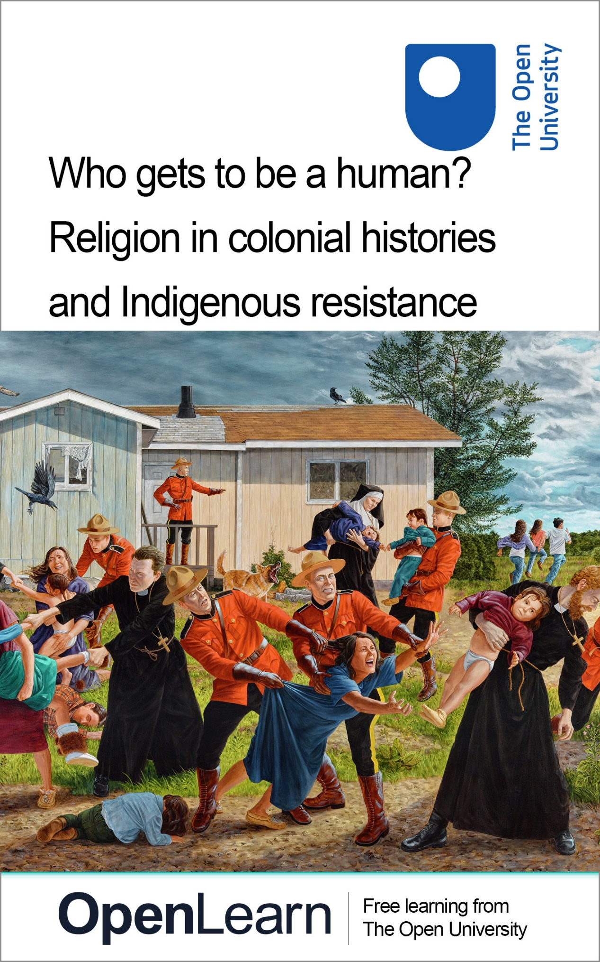

DA332_1

Who gets to be a human? Religion in colonial histories and Indigenous resistance

About this free course
This free course is an adapted extract from the Open University course DA332 Religion and global challenges in the past and present.
This version of the content may include video, images and interactive content that may not be optimised for your device.
You can experience this free course as it was originally designed on OpenLearn, the home of free learning from The Open University –https://www.open.edu/openlearn/history-the-arts/who-gets-be-human-religion-colonial-histories-and-indigenous-resistance/content-section-0
There you’ll also be able to track your progress via your activity record, which you can use to demonstrate your learning.
First published 2026.
Unless otherwise stated, copyright © 2026 The Open University, all rights reserved.
Intellectual property
Unless otherwise stated, this resource is released under the terms of the Creative Commons Licence v4.0 http://creativecommons.org/licenses/by-nc-sa/4.0/deed.en. Within that The Open University interprets this licence in the following way: www.open.edu/openlearn/about-openlearn/frequently-asked-questions-on-openlearn. Copyright and rights falling outside the terms of the Creative Commons Licence are retained or controlled by The Open University. Please read the full text before using any of the content.
We believe the primary barrier to accessing high-quality educational experiences is cost, which is why we aim to publish as much free content as possible under an open licence. If it proves difficult to release content under our preferred Creative Commons licence (e.g. because we can’t afford or gain the clearances or find suitable alternatives), we will still release the materials for free under a personal end-user licence.
This is because the learning experience will always be the same high quality offering and that should always be seen as positive – even if at times the licensing is different to Creative Commons.
When using the content you must attribute us (The Open University) (the OU) and any identified author in accordance with the terms of the Creative Commons Licence.
The Acknowledgements section is used to list, amongst other things, third party (Proprietary), licensed content which is not subject to Creative Commons licensing. Proprietary content must be used (retained) intact and in context to the content at all times.
The Acknowledgements section is also used to bring to your attention any other Special Restrictions which may apply to the content. For example there may be times when the Creative Commons Non-Commercial Sharealike licence does not apply to any of the content even if owned by us (The Open University). In these instances, unless stated otherwise, the content may be used for personal and non-commercial use.
We have also identified as Proprietary other material included in the content which is not subject to Creative Commons Licence. These are OU logos, trading names and may extend to certain photographic and video images and sound recordings and any other material as may be brought to your attention.
Unauthorised use of any of the content may constitute a breach of the terms and conditions and/or intellectual property laws.
We reserve the right to alter, amend or bring to an end any terms and conditions provided here without notice.
All rights falling outside the terms of the Creative Commons licence are retained or controlled by The Open University.
Head of Intellectual Property, The Open University

Contents
- Introduction
- Learning outcomes
- 1 Colonisation and race: The making of ‘us’ and ‘them’
  - 1.1 Under the colonial gaze: dehumanising and demonising shamans
  - 1.2 Indigenous mapping
- 2 Religion and colonialism
  - 2.1 ‘Save the man; kill the Indian’
  - 2.2 Colonising hair
  - 2.3 Decolonising hair
- 3 Religion and coloniality
  - 3.1 Reclaiming joik
  - 3.2 Religion as a ‘universal’
- Conclusion
- References
- Acknowledgements
- Glossary
- Solutions
- Descriptions

Introduction
The global challenge of growing inequalities is intricately linked to the distinction made between those historically regarded as human and those not. You may wonder why the question ‘Who gets to be a human?’ matters. Historically, not all people were considered fully human. Some were considered rational, civilised, and intelligent, thus human, while others were labelled as barbarian, animal-like, or primitive, and therefore not fully human.
This division between ‘civilised’ and ‘non-civilised’ played a vital role in justifying the colonisation and enslavement of those who were deemed ‘lesser human’, ‘other human’, or ‘non-human’, along with the perception of their lands as empty and waiting to be exploited.
The ‘Age of Discovery’, a wave of European colonisation which took place between the fifteenth and seventeenth centuries, marked the beginning of a new era in which European empires established control over so-called ‘discovered’ lands, framing them as terra nullius exploiting both the people and resources of these regions.
In this course, you will explore how some religions and religious categories were conceptualised and employed in ways that contributed to dehumanising colonised individuals and communities, many of whom organise and identify as Indigenous today. The capital ‘I’ in Indigenous indicates experiences of enduring shared colonial histories, as well as political initiatives for the recognition of collective rights.
This OpenLearn course is an adapted extract from the Open University course DA332 Religion and global challenges in the past and present.

Learning outcomes
After studying this course, you should be able to:
- understand the differences between colonisation, colonialism and coloniality
- recognise the role of religion and religious categories in the dehumanisation of colonised communities
- reflect on hierarchies of knowledge.

1 Colonisation and race: The making of ‘us’ and ‘them’
People have long categorised themselves into ‘us’ and ‘them’. It is common to make such distinctions as we navigate our lives. However, some ‘us’ and ‘them’ separations create far more powerful divisions, especially when supported by political, educational, and religious institutions.

Activity 1 Am I one of ‘us’ or one of ‘them’?
Allow approximately 10 minutes to complete this activity.

Take a moment to reflect on who you include when you think of ‘us’ and who you imagine as ‘them.’ Consider your participation in these groups.
- Did you choose to be part of them, or were you included by default?
- Have you ever moved from one group to another?
- What factors define belonging in these groups?

Provide your answer...
View discussion - Activity 1 Am I one of ‘us’ or one of ‘them’?

Many scholars argue that most inequalities are rooted in ‘us’ and ‘them’ divisions. The French philosopher Bruno Latour (1993, p. 97) calls this creation of polarities the Great Divide and traces it back to a conceptual division between humans and non-humans.
In the late seventeenth and eighteenth centuries, the Enlightenment emerged as a major intellectual movement centred on human reason and scientific knowledge. Humans became not only the subjects and objects of knowledge but a classificatory category, giving rise to one of history’s most divisive and destructive constructs – race.
According to a widely influential and celebrated Enlightenment philosopher Immanuel Kant (1724–1804), Native Americans were seen as the lowest of the four races (‘incapable of being educated and too weak for work in the fields’); the ‘Negroes’ were placed above (‘capable of being trained to be slaves but not in any other form of education’); the ‘Hindus’ as superior to ‘Negroes’ (‘capable of being educated in the arts, but not in the sciences’); and the ‘whites’ as ‘superior and the only non-defiant race’ (Kleingeld, 2007, p. 576–577).
As a result, colonised peoples were judged and classified by their suitability for enslavement and exploitation and deliberately placed at the bottom of racial hierarchies to justify colonial domination.

1.1 Under the colonial gaze: dehumanising and demonising shamans
The Indigenous Māori scholar Linda Tuhiwai Smith (1999, p. 28) argues that the categorisation of ‘primitive peoples’, based on colonial hierarchies of race, excluded Indigenous peoples not only from the realm of civilisation but from humanity itself. You will now learn how an example of a ‘shaman’ illustrates Tuhiwai Smith’s observation.
The drawing shown in Figure 1 is one of the first recorded accounts of shamans, depicted by the Dutch statesman Nicolaes Witsen (1641–1717). The word ‘shaman’ comes from the Evenki word šaman or xaman, which can loosely be translated into ‘agitated’, ‘excited’ or ‘raised’ (Znamenski, 2007, p. viii). Evenki are a Tungusic-speaking people of North Asia, whose lands currently stretch across the nation states of Russia, China and Mongolia.

Activity 2 Shaman and the colonial gaze
Allow approximately 10 minutes to complete this activity.

Take some time to examine Figure 1.

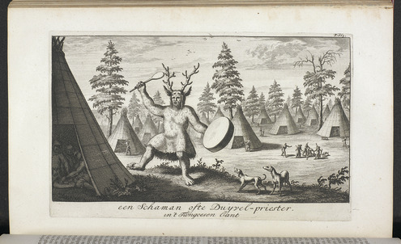
Figure 1 Tungus Shaman; or, the priest of the Devil. A drawing from Noord en Oost Tartarye [North and East Tartary] (1692) by Nicolaes Witsen. Courtesy of Tjeerd de Graaf, Nicolaas Witsen Project, Netherlands.
View description - Figure 1 Tungus Shaman; or, the priest of the Devil. A drawing from Noord en Oost ...

- Who or what do you think is depicted in this picture?
- Would you think that shamans were humans or some mythical creatures based on this image?

Provide your answer...
View discussion - Activity 2 Shaman and the colonial gaze

Witsen never personally encountered Evenki šaman and never visited Evenki lands during his brief travel to Russia between 1664 and 1665. His reports were largely based on stories he had heard from people he met during his travels.
Despite the questionable (indeed non-existent) evidence supporting Witsen’s account, his depiction of an Evenki šaman marked the start of the West’s ongoing fascination with shamans, who were believed to have abilities like being able to turn their bodies into animals, perform magic tricks and, most characteristically, leave their human bodies for spirit journeys, often with the use of drums. Stories about dark spirits tormenting shamans during their initiations, often defined as ‘shaman illness’, were of great interest to Europeans, who were keen to find a scientific explanation to such bodily experiences.
Most of the ethnographers studying Siberia came from Christian backgrounds and used Christian vocabularies to describe local practitioners and knowledge-holders, some of whom they described as shamans. Shamans were depicted as half-human, half-animal beings and as servants of the Devil, playing a significant role in feeding the colonial fantasies of European explorers eager to discover curiosities and wonders in the ‘newly explored worlds.’
In his study of shamans, Swedish historian of religion Olle Sundström (2012, p. 356) argues that ‘depicting foreign people’s spiritual and political leaders as frauds, maniacs or devil-worshippers could be the only reason needed to motivate colonisation and the subjugation of the land and the peoples’. The Russian conquest of Siberia, began in the sixteenth century and was strongly driven by economic motives. In particular, there was a significant interest in Siberian fur, often referred to us ‘soft gold,’ which at that time functioned as an important global currency.
Over time, the term ‘shaman’ was applied not only to Evenki šaman but also to various Indigenous practitioners in Siberia and then across colonised regions worldwide. Their knowledges, practices and worldviews were collectively categorised as ‘shamanism.’ What these people shared was not necessarily similar practices or skills, but a common experience of being defined through a colonial gaze – one that, at best, objectified and exoticised them, and at worst, demonised, criminalised, and dehumanised them.

1.2 Indigenous mapping
In Figure 2, you see a map of Sábmi. You might not be able to place this region at first glance, but if you look closely, you may recognise the contours of Scandinavia. Sábmi, or Sápmi, is the land inhabited by the Sámi people, stretching today across Norway, Sweden, Finland, and Russia.

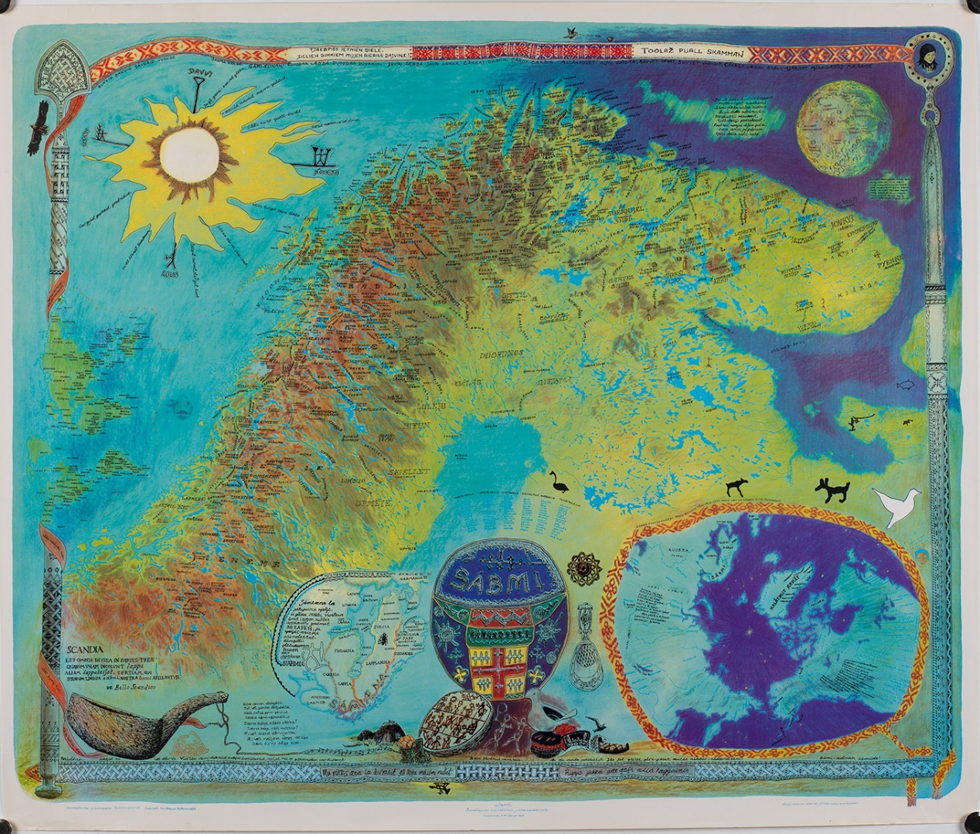
Figure 2 The Sábmi map of 1975 by Elle Hánsa/Keviselie/Hans Ragnar Mathisen
View description - Figure 2 The Sábmi map of 1975 by Elle Hánsa/Keviselie/Hans Ragnar Mathisen

This map was created by Sámi artist Keviselie (also known by his Sámi name Elle Hánsa and Norwegian name Hans Ragnar Mathisen), celebrated for his cartographic artworks. Keviselie’s map is not divided by the national borders and is filled with Sámi place names.
Sámi anthropologist Marit Myrvoll (2017, p. 107) notes how maps have been more effective tools of colonisation than weapons, commenting on the way many Sámi place names were lost by the turn of the twentieth century.

Activity 3 Putting Sápmi on the map
Allow approximately 20 minutes to complete this activity.

You will now listen to an excerpt from a podcast interview with Keviselie about the process of making the first map of Sápmi:

Audio content is not available in this format.
Audio 1: Putting Sápmi on the Map
View transcript - Audio 1: Putting Sápmi on the Map

After listening to the excerpt, answer the following questions:

1) What was the main reason Keviselie chose opaque plastic sheets to make the map of Sápmi instead of creating a lithograph? (Select one correct answer.)

Because plastic sheets had lower production costs.
Because Keviselie wanted the map to appear more modern.
Because the plastic sheets were easy to copy, making the map widely accessible rather than exclusive.
Because plastic sheets made the map waterproof.
View answer - Part

2) What makes Keviselie’s map meaningful for Sámi people? (Select three correct answers.)

It challenges established maps made from a colonial non-Sámi gaze.
The inclusion of Sámi place names reclaims a sense of connection and belonging to the land that colonial mapping erased.
It is a primarily an artwork rather than a functional map.
By removing national borders, the map challenges divisions imposed by nation-states.
View answer - Part

3) What are the three meanings of Sápmi according to Keviselie? (Choose three correct answers.)

Sámi language(s)
Sámi knowledge(s)
Sámi people(s)
Homeland of the Sámi people(s)
View answer - Part

2 Religion and colonialism
When European powers colonised North America, known as Turtle Island to many Native American peoples, Christian churches played a major role by operating government-funded residential schools in what today is known as Canada and the United States of America. In Canada, 60 per cent of residential schools were run by the Catholic Church, 30 per cent by the Anglican Church and the remaining 10 per cent were run by other Christian denominations (Feir, 2016).
Residential schools were a core part of colonialism, a system of domination that, in words of Tuhiwai Smith (1999, p. 31), ‘brought complete disorder to colonised peoples, disconnecting them from their histories, their landscapes, their languages, their social relations and their own ways of thinking, feeling and interacting with the world.’
Regardless of the disruptive and dehumanising nature of colonialism, it was presented as something beneficial for the colonised peoples. The means by which this narrative was implemented was through the promises of salvation, modernisation and civilisation. For this to hold any kind of credibility, the colonised peoples had to be imagined as uncivilised and in need of such salvation, a perception effectively reinforced by the term ‘primitive’.
Thousands of children passed through the schools, many of whom were forcibly removed from their families. Children in residential schools experienced widespread physical, mental, and sexual abuse. Many died, and those who survived continue to carry generational traumas. Residential schools actively operated until the 1970s, with the last ones closing in the United States in 1978 and in Canada as late as 1997.

2.1 ‘Save the man; kill the Indian’
In the residential schools, children were not allowed to speak their mother tongues and were forced to adopt Christianity. Christianity was taught as the only true knowledge system, while Indigenous ways of knowing and living were suppressed, stigmatised, and often prohibited. Children’s names were replaced by European Christian names, and sometime even numbers (which in many cases were used more than the names). They were also required to wear uniforms and have their hair cut.
In other words, the schools were explicitly designed to erase everything ‘Indian’, driven by the slogan ‘Save the Man, Kill the Indian’.

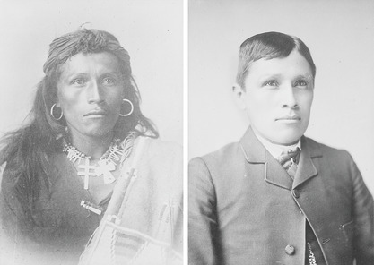
Figure 3 Photograph of Tom Torlino by John N. Choate, circa 1882. Before and after entering Carlisle Indian Industrial School.
View description - Figure 3 Photograph of Tom Torlino by John N. Choate, circa 1882. Before and after ...

2.2 Colonising hair
Cutting hair was a key part of assimilation processes and was often one of the first experiences children encountered when entering school. Cutting hair signified more than a mere physical change. For many communities, hair carries deep meaning, embodying and reflecting their values, experiences and relationships.
Watch the following video, where a survivor of a residential school, Fred, shares the impact that cutting hair had on him:

Video content is not available in this format.
Video 1: Fred recalls hair cutting in residential school as an attack on identity
View transcript - Video 1: Fred recalls hair cutting in residential school as an attack on identit ...

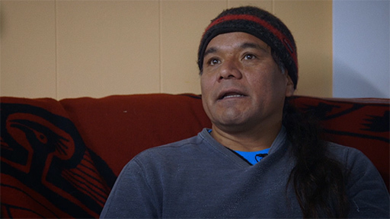

Activity 4 Religion and colonialism
Allow approximately 10 minutes to complete this activity.
In this part of the course, you learned about Tuhiwai Smith’s understanding of colonialism and residential schools for Indigenous children in North America. Complete the questions below based on what you have learned about the role of religious institutions in colonialism:

1) Who ran the residential schools for Indigenous children in Canada?

60 per cent of residential schools were run by
30 per cent by the
and the remaining 10 per cent were run by
Catholic Church
Anglican Church
other Christian denominations
View answer - Part

2) When did the last residential schools for Indigenous children close in the United States and Canada?

1891 in US and 1917 in Canada
1987 in US and 1990 in Canada
1941 in US and 1945 in Canada
1978 in US and 1997 in Canada
View answer - Part

3) What was the role of Christianity in residential schools for Schools to assimilate Indigenous children in the USA and Canada? (Select two correct answers.)

Christianity was taught as the only true religion.
Children were introduced to Christianity but could continue to follow their Indigenous practices and knowledges.
Children’s names were changed to Christian names.
Children could choose an additional Christian name while keeping their birthname in their mother tongue.
View answer - Part

2.3 Decolonising hair
In the following video, Theland Kicknosway explains the importance of hair to Indigenous people from the Potawatomi and Cree Nations. He is a member of Walpole Island, Bkejwanong Territory. Watch the video and then complete Activity 5.

Watch the video at YouTube.com.
Video 2: Theland Kicknosway: I wear these braids with pride

Activity 5 What is the meaning of your hair?
Allow approximately 10 minutes to complete this activity.

In the box below, reflect on the story of your hair, or perhaps hair loss.
- How much freedom do you have to express yourself through your hairstyle or facial hair?
- What values do you believe your approach to your hair represents?

Provide your answer...

3 Religion and coloniality
So far you have been introduced to the notions of colonisation and colonialism. The next key term that you will explore is ‘coloniality’. The term coloniality was introduced by the Peruvian scholar Aníbal Quijano as a response to academic Eurocentrism in order to address the coloniality of academic knowledge.
There are important distinctions between colonisation, colonialism and coloniality. While ‘colonisation’ broadly refers to the process of physically establishing colonies in ‘new’ territories, and ‘colonialism’ refers to entire systems of influence and exploitation, coloniality refers specifically to the control and management of knowledge by the ‘universals’ of Western modernity, Eurocentrism and global capitalism (Mignolo & Walsh, 2018).
It might be difficult to follow this rather dense definition of coloniality and what ‘universals’ mean in this context, but do not be discouraged. You will now learn how religion can be considered a ‘universal’ within colonial thought. To explore this, you will be guided through an example of the Sámi practice of joik, which shows how Indigenous ways of knowing and being were positioned within a hierarchical order of religion.

3.1 Reclaiming joik
Tyler Tully (2022, p. 9), an American religious studies scholar, argues that what English-speaking people refer to as ‘religion’ has no equivalent term in many other cultures and languages. Tisa Wenger (2022, p. 3), an American historian of religion, also argues that the word ‘religion’ is a product of specific European histories and has never been a comfortable fit for Indigenous knowledges and traditions.
You might be wondering, then, what the appropriate term is to describe the knowledges and practices of Indigenous peoples. The short answer to this is to use vernacular terms, meaning the terms that Indigenous people use themselves. You will now be introduced to the Sámi practice of joik and learn how it has been described using religious terminology and the impact of such translation.
Joik is a Sámi oral tradition that resembles singing. It was forbidden for generations, especially in Christian churches, where it was viewed as the work of ‘the devil’ (Kraft, 2015, p. 235). Today, joik has emerged as a key symbol of Sámi resilience. Historically, it has been linked to noaidi, often categorised as a ‘shamanic chant’ (Anderson, 2005).
However, joik is no longer prohibited or regarded exclusively as an expression of shamanism or even Sámi religion. Relocating joik away from ‘religion’ cuts the link to the categories that Sámi knowledges, worldviews and relations were historically classified into (such as ‘shamanism,’ ‘animism,’ ‘paganism,’ and even ‘devil-worship’). Presenting joik as it is, liberates it from being confined to hierarchical order of religions, which you will learn more about in the following section. This reclaiming of joik can be seen as an example of anticolonial or decolonial Indigenous resistance.
Today, many Sámi, including those who are not noaidi, perform joik to express their Sámi identity, as well as to advocate for political, social, and environmental causes that are important to them.

Activity 6 Reclaiming joik
Allow approximately 45 minutes to complete this activity.
You will now watch a talk by Mari Boine, a Sámi singer, musician, activist, and one of the most renowned performers of joik. As you watch, pay attention to how she presents herself and her homeland, Sápmi, and how she describes joik as a ‘way of remembering.’ Notice also how she discusses Sámi practices being labelled as ‘devil-worship,’ the effects this had on her and her community, and her journey of healing from colonial traumas.

Part 1

Start with watching first part of the video (00:00–06:30 mins) and then answer the following question.

Video content is not available in this format.
Video 3: Mari Boine: Unshaming my Indigenous Heritage
View transcript - Video 3: Mari Boine: Unshaming my Indigenous Heritage

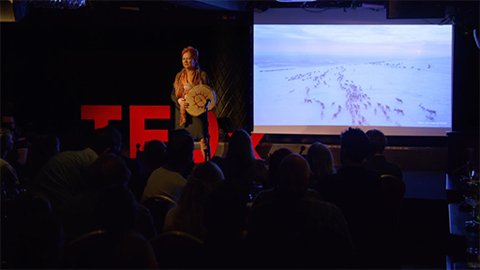

In this part of the video, Mari Boine introduces herself and her homeland Sápmi. She lists several names that were given by colonisers to her homeland. Select all the correct answers:

Lapland
Northern Norway
Greenland
Northern Scandinavia
Arctic
Finnmark
View answer - Part 1

Part 2

Now watch the next section of the video (06:30–08:40 mins) and then answer the following question.
In this part of the video, Mari Boine explains that berry picking was something elders taught in order to survive long winters, along with an unspoken message. What was that message? Select all the correct answers:

Never take more than nature can tolerate.
Nature exists primarily for human use.
Never take more than you need.
Take as much as you can while you can.
Leave a place as it was before you arrived.
Make sure you mark the places you go, so you and others know that it is your territory.
View answer - Part 2

Part 3

Continue watching the video (08:40–13:47 mins) and then answer the following question.
In this part of the video, Boine shares her understanding of joik as a way of remembering, as well as the impact of priests and missionaries. What did they do in Sápmi? Select all the correct answers:

Banned and burned Sámi drums.
Purge what they described as paganism.
Punished Sámi noaidis.
Respected noaidies as Sámi spiritual leaders in the same way as Christian priests.
Instil feelings of shame and self-hatred among Sámi people.
Affirm Sámi people’ sense of pride and self-worth.
Convince Sámi communities that their worldview was a devil worship.
Recognised Sámi ways of knowing as legitimate and equal to the Christian worldview.
View answer - Part 3

Part 4

Now watch the video to the end (13:47–26:52) and then answer the following question.
In this last part of the video (13:47–26:52), Boine talks about her experiences of performing around the world. She reflects on meeting Indigenous peoples from many regions and learning that the Sámi were not alone in being subjected to colonial violence. According to Boine, what experiences do Indigenous peoples worldwide share? Select all that apply:

People who have inherited myths, stories, songs, rituals, and strategies for survival.
Communities that voluntarily abandoned their ways of living, being and knowing.
Peoples who live in close relationship with their land and the Earth.
Communities that benefited equally from colonial economic development.
Subjected to colonial powers that attempted to demonise, displace, and erase Indigenous peoples and their collective knowledge.
View answer - Part 4

3.2 Religion as a ‘universal’
It was during the Enlightenment that the idea of religion as a universal aspect of human existence became firmly established. The assumption that religion exists in all societies led to the interpretation of a wide range of diverse and complex practices as ‘religions,’ even when people did not identify them as religious. This also gave rise to the classificatory category of ‘world religions,’ which typically include Christianity, Islam, Judaism, Hinduism and Buddhism. (For a critique of the ‘world religions paradigm’, see: Smith, 1993; Masuzawa, 2005; Fitzgerald, 2007; Cotter and Robertson, 2016).
Knowledges and practices of colonised Indigenous peoples were often described as either ‘devil-worship,’ as you learned from the example of Sámi joik, or placed into the categories ‘primitive religions’, ‘totemism’, ‘fetishism’, ‘tribal religions’, ‘primal religions’, ‘aboriginal religions’ and ‘shamanism.’ The notion of ‘devil-worship’ is a Christian-centric category, as it is rooted in Christian teachings that include the figure of the devil.
These so-called ‘smaller religions’ were juxtaposed against the religions of ‘civilised’ people, such as Christianity. In contrast, the religions of colonised Indigenous peoples, much like the people themselves, were positioned at the bottom of a hierarchy. Notably, these categories were imposed from the outside, rather than chosen by the people themselves, unlike Christianity or Islam, where followers commonly identify as Christian or Muslim.
The categorisation of diverse practices of colonised people, such as Sámi joik, into pre-defined religious categories illustrates how frameworks, predominantly rooted in European Christian perspectives, have shaped what counts as ‘religion’. A relatively limited, narrow understanding of religion was treated as a ‘universal’ and used to define, organise, and rank knowledges and the people who carry them.

Conclusion
In this course, you have explored how religion, religious institutions and religious categorisations have played a role in colonising projects. You were introduced to three important concepts – colonisation, colonialism and coloniality. You learnt that although related, each of them describes a different set of processes.
In reflecting on colonial histories, you have been introduced to the formative role of binaries like ‘civilised’ versus ‘primitive’ and ‘us’ versus ’them’ in justifying colonising and civilising missions imposed on colonised peoples. You learnt about the processes and consequences of classifying ‘humans’ and ‘religions’ into hierarchies. You learned the impact of defining Christianity as a religion of ‘civilised people’ and shamanism as a religion of ‘primitive people’. Thus, you now have the skills to critically approach other concepts and binaries that you may have been taking for granted.
You were introduced to various examples of colonising projects and initiatives, from the conquest of lands deemed empty or wild to economic exploitation and the control of colonised communities and their knowledges. At the same time, you explored how Indigenous peoples resisted these processes. Practices such as mapping, residential schools, and joik illustrate both the imposition of colonial power and the forms of anti-colonial resistance that emerged in response. These topics are explored in greater depth and detail in the Open University course DA332, Religion and global challenges in the past and present.

Activity 7 Key terms
Allow approximately 10 minutes to complete this activity.

Match the following terms with their definitions based on what you learned in the course.

Process of controlling and management of knowledge by universals of Western modernity and Eurocentrism.
Process of establishment of entire systems of control and exploitation of colonised communities.
Process of imperial conquest, ‘discovery’ and physical establishment of colonies in ‘new’ lands.
Coloniality
Colonialism
Colonisation
View answer - Activity 7 Key terms

References
Anderson, M. (2005) ‘The Saami Yoik: Translating Hum, Chant, or/and Song’, in Gorlée, D.L. (ed.) Song and Significance: Virtues and Vices of Vocal Translation. Amsterdam: Rodopi, pp. 213–233. Available at: https://doi.org/10.1163/9789401201544_008.
Cotter, C. and Robertson, D.G. (eds) (2016) After world religions: reconstructing religious studies. Abingdon: Routledge.
Feir, D.L. (2016) ‘The long-term effects of forcible assimilation policy: the case of Indian boarding schools’ The Canadian Journal of Economics, 49(2), pp. 433–480. Available at: https://library-search.open.ac.uk/permalink/44OPN_INST/j6vapu/cdi_proquest_journals_2009221986 (Accessed: 6 February 2025).
Fitzgerald, T. (2007) Discourse on civility and barbarity: a critical history of religion and related categories. Oxford: Oxford University Press.
Kleingeld, P. (2007) ‘Kant’s second thoughts on race’, The Philosophical Quarterly, 57(229), pp. 573–592.
Kraft, S.E. (2015) ‘Shamanism and Indigenous soundscapes: the case of Mari Boine’, in Fonneland, T., Kraft, S.E. and Lewis, J.R. (eds) Nordic Neoshamanisms. New York: Palgrave Macmillan, pp. 235–262. DOI: 10.1057/9781137461407_13.
Latour, B. (1993) We have never been modern. Cambridge, MA: Harvard University Press.
Masuzawa, T. (2005) The invention of world religions: or, how European universalism was preserved in the language of pluralism. Chicago, IL: The University of Chicago Press.
Mignolo, W. and Walsh, C. (2018) On decoloniality: concepts, analysis, and praxis. Durham: Duke University Press.
Myrvoll, M. (2017) ‘Gosa bássi várit leat jávkan? Where have all the sacred mountains gone’, in L. Heinämäki and T.M. Herrmann (eds) Experiencing and protecting sacred natural sites of Sámi and other Indigenous peoples: the sacred Arctic. Cham: Springer International Publishing, pp. 101–116.
Smith, J.Z. (1993) Map is not territory. Chicago, IL: The University of Chicago Press.
Sundström, O. (2012) ‘Is the shaman indeed risen in post-Soviet Siberia?’, Scripta Instituti Donneriani Aboensis, 24, pp. 350–387.
Tuhiwai Smith, L. (1999) Decolonizing methodologies: research and Indigenous peoples. New York, NY: Zed Books.
Tully, T. (2022) ‘Were all religions at one time “Indigenous”?’, in M.H. Bassett and N. Avalos (eds) Indigenous religious traditions in 5 minutes. Bristol, CT: Equinox Publishing, pp. 9–11.
Wenger, T. (2022) ‘Why does the title of this book use the phrase “Indigenous Religious Traditions” rather than “Indigenous religions”?’, in M.H. Bassett and N. Avalos (eds) Indigenous religious traditions in 5 minutes. Bristol, CT: Equinox Publishing.
Znamenski, A.A. (2007) The beauty of the primitive: shamanism and the Western imagination. New York, NY: Oxford University Press.

Acknowledgements
This free course was written by Liudmila Nikanorova.
Except for third party materials and otherwise stated (see terms and conditions), this content is made available under a Creative Commons Attribution-NonCommercial-ShareAlike 4.0 Licence.
The material acknowledged below is Proprietary and used under licence (not subject to Creative Commons Licence). Grateful acknowledgement is made to the following sources for permission to reproduce material in this free course:
Images
Course image: Kent Monkman (Fisher River Cree Nation), The Scream, 2017. Acrylic paint on canvas; 84 x 132 in. Denver Art Museum: Native Arts acquisition funds, purchased with funds from Loren G. Lipson, M.D, 2017.93. Photo: © Kent Monkman. Image Courtesy of the Denver Art Museum.
Figure 1 (Tungus Shaman): The earliest known depiction of Tungus Shaman; or, the priest of the Devil. A drawing from Noord en Oost Tartarye [North and East Tartary] (1692) by Nicolaes Witsen, Nicolaas Witsen Project, Netherlands. British Library archive/Bridgeman Images
Figure 2 (The Sábmi map of 1975): Included in the exhibition Kiruna Forever at ArkDes; photo by Björn Strömfeldt. [ArkDes]
Figure 3 (Tom Torlino): Beinecke Rare Book and Manuscript Library, Call Number WA MSS S-1175. Gift of Walter McClintock (Yale 1891, 1911 MAH), 1927-1949. Water McClintock Papers. Yale Collection of Western Americana, Beinecke Rare Book and Manuscript Library. Photo: Yale University Library
Audio / Visual
Video 1 (Fred recalls hair cutting in residential school as an attack on identity): https://www.youtube.com/watch?v=jh-DGJj1FaM Media One and the Canadian Museum for Human Rights.
Video 3 (Unshaming my indigenous heritage | Mari Boine): https://www.youtube.com/watch?v=eDYZRGWMacM TED; https://www.ted.com; CC BY–NC–ND 4.0
Audio 1 (Putting Sápmi on the Map. Sámi Activism through Art with Elle-Hánsa/ Hans Ragnar Mathisen): courtesy of Professor Siv Ellen Kraft; Kraft, S.E. and Tafjord, B.O. (2021) ‘Episode 2: Putting Sápmi on the Map. Sámi Activism through Art with Elle-Hánsa/ Hans Ragnar Mathisen’, Thinking About Indigenous Religions [podcast], 11 January.: https://open.spotify.com/episode/13BPGOrDu9cRFDRgGqAqig
Every effort has been made to contact copyright owners. If any have been inadvertently overlooked, the publishers will be pleased to make the necessary arrangements at the first opportunity.
Every effort has been made to contact copyright owners. If any have been inadvertently overlooked, the publishers will be pleased to make the necessary arrangements at the first opportunity.
Don’t miss out
If reading this text has inspired you to learn more, you may be interested in joining the millions of people who discover our free learning resources and qualifications by visiting The Open University – www.open.edu/openlearn/free-courses.

Glossary
Enlightenment
A European intellectual movement in the seventeenth and eighteenth centuries that emphasised reason and science, rather than tradition and religion.
Colonialism
Process of establishment of entire systems of control and exploitation of colonised communities.
Coloniality
Process of controlling and management of knowledge by universals of Western modernity and Eurocentrism.
Colonisation
Process of imperial conquest, ‘discovery’ and physical establishment of colonies in ‘new’ lands.
Great Divide
A concept used to refer to the creation of hierarchical polarities that establish divisions such as ‘humans’ and ‘non-humans’, or ‘Us’ and ‘Them’.
Indigenous
The term indigenous (with a lower case ‘i’) means ‘native, original inhabitant’, from the Latin indigen(a). Indigenous (with a capital ‘I’) refers to people with experiences of enduring shared colonial histories, as well as political initiatives for the recognition of collective rights.
Race
A pseudo-scientific belief, originating in the European Enlightenment, that humans can be divided into distinct groups characterised by physical and/or genetic differences that result in a group having physical, intellectual and moral advantages or disadvantages relative to other groups.
Shaman
A concept that originates from the Evenki term šaman or xaman used to describe an Evenki practitioner. During the eighteenth and nineteenth centuries, it evolved into a comparative concept often used to describe the practitioners and knowledge holders of colonised peoples. In the twentieth century, shaman became a term that some religious and spiritual practitioners worldwide began to self-identify.
Terra nullius
Latin: ‘land belonging to no one’
Wilderness
A concept similar to the term terra nullius that was used to describe colonised lands, particularly in the Arctic region, and to justify colonisation.

Solutions

Activity 1 Am I one of ‘us’ or one of ‘them’?

Discussion
You might have come up with a wide range of different examples of groups here. This might have included groups of ‘us’ that you identify with and that you potentially can choose to join or leave, like groups of friends, team-mates or neighbours. However, membership of some groups can be more fixed, such as family or fellow citizens of the same nation-state, which are often determined by birth or external institutions. Inclusion in or exclusion from these groups can therefore often be harder, though not always impossible, to change, for example through marriage, or gaining an additional citizenship.
Back to - Activity 1 Am I one of ‘us’ or one of ‘them’?

Activity 2 Shaman and the colonial gaze

Discussion
The presence of animal claws, furry skin and reindeer horns all suggest that shamans were not really humans. This depiction of an Evenki shaman was not produced with the Evenki audience in mind. It was made by Nikolaes Witsen for a European public, whom he likely hoped to impress with his travels in ‘mysterious’ lands previously not known to his audience. Coupled with the caption ‘the priest of the Devil’, this image represents an example of visual dehumanisation and the beginning of centuries-long demonisation of Indigenous religious practitioners categorised as shamans.
Back to - Activity 2 Shaman and the colonial gaze

Activity 3 Putting Sápmi on the map

Part

Answer
Right:
Because the plastic sheets were easy to copy, making the map widely accessible rather than exclusive.
Wrong:
Because plastic sheets had lower production costs.
Because Keviselie wanted the map to appear more modern.
Because plastic sheets made the map waterproof.
Back to - Part

Part

Answer
Right:
It challenges established maps made from a colonial non-Sámi gaze.
The inclusion of Sámi place names reclaims a sense of connection and belonging to the land that colonial mapping erased.
By removing national borders, the map challenges divisions imposed by nation-states.
Wrong:
It is a primarily an artwork rather than a functional map.
Back to - Part

Part

Answer
Right:
Sámi language(s)
Sámi people(s)
Homeland of the Sámi people(s)
Wrong:
Sámi knowledge(s)
Back to - Part

Activity 4 Religion and colonialism

Part

Answer
The correct matches are:
60 per cent of residential schools were run by
Catholic Church
30 per cent by the
Anglican Church
and the remaining 10 per cent were run by
other Christian denominations
Back to - Part

Part

Answer
Right:
1978 in US and 1997 in Canada
Wrong:
1891 in US and 1917 in Canada
1987 in US and 1990 in Canada
1941 in US and 1945 in Canada
Back to - Part

Part

Answer
Right:
Christianity was taught as the only true religion.
Children’s names were changed to Christian names.
Wrong:
Children were introduced to Christianity but could continue to follow their Indigenous practices and knowledges.
Children could choose an additional Christian name while keeping their birthname in their mother tongue.
Back to - Part

Activity 6 Reclaiming joik

Part 1

Answer
Right:
Lapland
Northern Norway
Northern Scandinavia
Arctic
Finnmark
Wrong:
Greenland
Back to - Part 1

Part 2

Answer
Right:
Never take more than nature can tolerate.
Never take more than you need.
Leave a place as it was before you arrived.
Wrong:
Nature exists primarily for human use.
Take as much as you can while you can.
Make sure you mark the places you go, so you and others know that it is your territory.
Back to - Part 2

Part 3

Answer
Right:
Banned and burned Sámi drums.
Purge what they described as paganism.
Punished Sámi noaidis.
Instil feelings of shame and self-hatred among Sámi people.
Convince Sámi communities that their worldview was a devil worship.
Wrong:
Respected noaidies as Sámi spiritual leaders in the same way as Christian priests.
Affirm Sámi people’ sense of pride and self-worth.
Recognised Sámi ways of knowing as legitimate and equal to the Christian worldview.
Back to - Part 3

Part 4

Answer
Right:
People who have inherited myths, stories, songs, rituals, and strategies for survival.
Peoples who live in close relationship with their land and the Earth.
Subjected to colonial powers that attempted to demonise, displace, and erase Indigenous peoples and their collective knowledge.
Wrong:
Communities that voluntarily abandoned their ways of living, being and knowing.
Communities that benefited equally from colonial economic development.
Back to - Part 4

Activity 7 Key terms

Answer
The correct matches are:
Process of controlling and management of knowledge by universals of Western modernity and Eurocentrism.
Coloniality
Process of establishment of entire systems of control and exploitation of colonised communities.
Colonialism
Process of imperial conquest, ‘discovery’ and physical establishment of colonies in ‘new’ lands.
Colonisation
Back to - Activity 7 Key terms

Descriptions

Figure 1 Tungus Shaman; or, the priest of the Devil. A drawing from Noord en Oost Tartarye [North and East Tartary] (1692) by Nicolaes Witsen. Courtesy of Tjeerd de Graaf, Nicolaas Witsen Project, Netherlands.
This black and white drawing shows an encampment outdoors with several tepee structures erected among tall evergreen trees. In the foreground a bare-chested human-like figure appears to be dancing. It is wearing a skirt, and its feet are bare. One leg is partially raised off the ground. In one hand it holds a drum, while the other hand, which is raised in the air, holds what appears to be a spoon or club. The figure has a head which features two prominent tall ears and furry feet resembling animal-like feet. Two dogs stand to the figure’s left, and one of them appears to be barking. In the background, in a clearing between the tepees, a group of men are talking.
Back to - Figure 1 Tungus Shaman; or, the priest of the Devil. A drawing from Noord en Oost Tartarye [North and East Tartary] (1692) by Nicolaes Witsen. Courtesy of Tjeerd de Graaf, Nicolaas Witsen Project, Netherlands.

Figure 2 The Sábmi map of 1975 by Elle Hánsa/Keviselie/Hans Ragnar Mathisen
Hans Ragnar Mathisen, Sábmi with only Sámi place names, 1975. This map presents the Indigenous Sámi names for places claimed by Norway, Sweden, Finland, and Russia. Included in the exhibition Kiruna Forever at ArkDes; photo by Björn Strömfeldt.
Back to - Figure 2 The Sábmi map of 1975 by Elle Hánsa/Keviselie/Hans Ragnar Mathisen

Figure 3 Photograph of Tom Torlino by John N. Choate, circa 1882. Before and after entering Carlisle Indian Industrial School.
Left: This image shows a black-and-white photograph of a young man. The man has a prominent nose and sharp cheekbones. He has a serious expression. He has long, dark hair, which is partially covered by a cloth wrapped around the top of his head and knotted at the front. The man has two large hoop earrings and is wearing a decorative necklace. The edges of the photo are faded, making it difficult to make out any further details.
Right: The image shows a black-and-white photograph of the same young man, though he looks very different. His hair is cut short and parted to the side; it is slicked down against his head. The man is wearing a neat jacket with a crisp collar. He is looking into the distance.
Back to - Figure 3 Photograph of Tom Torlino by John N. Choate, circa 1882. Before and after entering Carlisle Indian Industrial School.

Audio 1: Putting Sápmi on the Map

Transcript
Keviselie
First, I thought about making as a lithograph.
Liudmila
What is that?
Keviselie
Lithograph is you draw and paint, and so on, on stones and then print it. But there is a limit in the number you can print, so I thought that would be too exclusive. I wanted to have it spread out.
So I made then the map on the different originals, the plastic sheets that I have learned to know during my time as a drawing assistant, at an architect office here in Tulsa. So I knew that this was a very good material because it was opaque, and yet you could see through it, and you can also draw on it. And it resisted water and so on. So all my maps after then was made on this.
Then I went to the Norwegian cultural department and asked for a grant. And then they were very surprised that to see a map with no borders. And not only Norway, but Sweden, Finland, and part of Russia. So I think they were a bit skeptical. But I got a grant anyway. And then I printed 5,000 at Gröndahl, for colour print shop in Oslo. So I was present at the printing to make some adjustments.
Well, I have been told, and I believe it was a sensation in the Sápmi world. And also many non-Sápmi wanted to have this map. Yes. But I must also mention the year before, me and some others, Sápmi in Oslo and Bergen, we made the first Sápmi calendar. Ochta Sápmi joik 1904, 1975. But that we worked on it the year before, of course.
Liudmila
Which was also printed and distributed.
Keviselie
Yes, yes.
Liudmila
Wow. So it started with a calendar and then,
Keviselie
Then the map.
Liudmila
Then the map.
Keviselie
Yes.
Liudmila
But making the map, it’s so visual. It takes only two seconds to look at it. And we are so used to seeing established Western maps, where we see the borders of nation states. And just not seeing recognisable nation state is such a big message. And when you were attending the assembly, how did you present this map? How, what was the reaction?
Keviselie
The map was not yet printed.
Liudmila
No.
Keviselie
Because I was there. I think we left on November 1. But I had a blue copy of it, which I showed. And I have coloured it with coloured pencil. So many people were very impressed and interested in it. And I, of course, hope that other Indigenous people will do the same. And also at home in Sápmi, I thought that, by the way, the term Sápmi became relevant only after that.
Liudmila
Map.
Keviselie
Yeah. So this introduced the word Sápmi. Not many people are aware of that. At that time, it was called Sápmi with a B, but this was in '75. But the new orthography changed it to P after '79.
Liudmila
Ahh.
Keviselie
Yeah. So,
Liudmila
As a new foreigner coming to Norway and taking for granted so much, yes, Sápmi, this is the Sápmi area. But just several decades ago, it wasn't at all taken for granted.
Keviselie
No, it was called Sápmi Yanno, which means Sápmi land. In my view, it is a kind of a normalisation. So I asked some experts, isn't there a name because Sápmi looks like some translated from Norwegian, which it was. Yes, that is the word Sápmi. So then I used that one because it has three meanings. Sápmi means the language, the people, and the homeland of the Sápmi.
Back to - Audio 1: Putting Sápmi on the Map

Video 1: Fred recalls hair cutting in residential school as an attack on identity

Transcript
Fred
In our cultural teaching, we understood that the only time you ever cut your hair was if your parent or grandparents passed away. And these stories come around from other friends of ours that did return home from residential schools. And that’s the thing they would share with them was, you have to cut your hair because your parents don’t want you anymore or your parents are actually dead now. So you have to cut your hair.
So there’s a lot of these things. They use this mental tactic to try to break you down because, and that’s what a lot of it was, just trying to break you from your way of being. And we struggle and fought saying we didn’t want to get our hair cut. We couldn’t understand why they wanted to cut our hair.
Back to - Video 1: Fred recalls hair cutting in residential school as an attack on identity

Video 3: Mari Boine: Unshaming my Indigenous Heritage

Transcript
[APPLAUSE]
[NON-ENGLISH SPEECH]
MARI BOINE
As we all know, science often confirms what many Indigenous people have been saying in songs, in stories, in their worldview for thousands of years. Now, of course, it seems self-evident that rhythm is central to life. Our hearts beat, trees pulse, the tides pull, the sun rises.
But why was it that so many educated, sophisticated men, some of them scientists, sought to silence a simple rhythm instrument? This drum, a circle of wood and skin, that speaks to life, speaks of life to life. Here is my story. I hope it will inspire you.
[NON-ENGLISH SINGING]
Hi.
[APPLAUSE]
This song is called Gula Gula in English, ‘Hear the voices of the four mothers.’ It has been with me for decades now. It has become like a dear old friend. It has, together with my other songs, accompanied me all over the world to cities, towns, festivals, small intimate stages and concert halls.
And everywhere I go, I meet people who tell me your songs bring back forgotten dreams. People in big cities ask me, how is it possible that I feel your songs talk to me, touch something deep inside me, even if I don’t understand your words? I don’t always have an answer. I have the same questions in me, and they have led me to dive deeper into my ancestral heritage.
My name is Mari Boine. My traditional name is [NON-ENGLISH] Christine Mari, which means Mari, daughter of Christine, daughter of Beate, who was the daughter of Greta. I grew up in Sápmi, where I still live. Those who colonised us gave our land other names, Northern Scandinavia, Northern Norway, Finnmark, Lapland, The Arctic.
But for us, this is [INAUDIBLE], where our ancestors have survived under harsh conditions for 10,000 years, ever since the last Ice Age. The idea for Gula Gula came to me through an old joik, our traditional song and its rhythm. The lyrics woke me up one night and, so to say, demanded to be born.
In our culture, we believe that our ancestors can bring us messages through dreams if we are open, if we are listening.
[NON-ENGLISH]
‘The Earth is our mother. If we harm her, we die with her.’ This was the main message. The ancestors sent this old wisdom common to Indigenous peoples all over the world as a warning, as a reminder. I grew up by the most beautiful river, Anarjohka, which, due to colonisation, became the border between Norway and Finland.
We harvested and gathered from nature. My father and mother fished for salmon, so did the other families around us. Grandmothers and mothers and aunts took us children on countless trips to pick berries. My uncles and brothers hunted, put up snares, and went to check the snares in the morning.
Our summers were full of all kinds of gifts from nature, and our elders taught us how to preserve them to survive the long winters. Their unspoken message was never take more than you need and what nature can tolerate. Leave a place like it was before you arrived.
[NON-ENGLISH SINGING]
In parallel with this wonderful freedom, there was another reality, a strict religion that was introduced into intercept me by pietistic men who wanted to control all that was wild, savage, fruitful, and above all, feminine. My parents belonged to the part of my people who chose or were forced by circumstance to take seriously this doctrine.
Foreign priests and missionaries had for hundreds of years built churches in Sápmi, worked to purge it of what they called paganism, banned and burned our drums, punished our spiritual leaders, the noaidd, filled our people with self-hate and shame and convinced them their animistic outlook on life, their reverence for mother nature was devil worship.
So it was that my father, filled with this alien fear of sin and hell, gave long sermons on guilt, sin, and shame. And so it was that he tried to protect his children from our so-called demonic legacy, our godless history. I also grew up with a view of a sacred mountain, [NON-ENGLISH], with a sacred spring in the neighbourhood, [NON-ENGLISH].
But this I didn’t know then. But these were never mentioned or talked about, neither at school nor home, nor was it ever mentioned that we used to ask permission from nature before we cut down a tree or branch. What I grew up with were stories from the Bible saying that man should rule over nature, and that man should rule over woman. No stories saying that the animals and everything in nature were our relatives and should be treated with respect.
I later learned that the joik, our traditional singing, is a way of remembering. The knowledge was passed on through joik from one generation to the other. Every child was given a joik and welcomed to life and the society by a joik. We don’t sing about. We sing into being a person, landscape, animal, situation.
In the beginning there was not much joik in my music. My first years as a singer, I knew very little about my own culture. But I discovered the healing in music. I discovered that the music opened up a whole new world for me. I had grown up more with Christian hymns and pop music.
So first, there were these songs of therapy, some of them full of rage. As women, we are socialised to never express our rage and anger. But my experience is that there is a lot of healing in facing the rage inside you as long as you use it wisely. And the more I learned about my peoples’ history, the more songs of rage came out.
I used anger as a force to redirect colonial shame, to heal the trauma of dispossession and strengthen my connection to nature. And yes, I assure you, there were waves of shock in my family.
[NON-ENGLISH SINGING]
This song was a milestone for me. It paved the way back to my ancestral heritage. By diving deep into the richness of our culture, I discovered a way of living with a beautiful philosophy, with a respect for the laws of nature, with a humbleness for the laws of nature. For instance, I learned that we always greeted and gave thanks to the land for the gifts we were given.
We gave thanks to the salmon who gives its life in order for us to have something to eat. I learned that the wolf and the bear were respected co-inhabitants, and so clever that hunters had to use metaphors to describe them when they went out for hunting in order to evade detection.
Those who did not assist in the hunt, but benefited from the food, ritually participated by striking the skinned hide. There was no denial of one’s depth to nature. After you had hunted and eaten the meat of the bear, the bones were placed back together and buried in order for the bear to be reborn. This is a powerful reminder of the cycle of life and such a beautiful ritual, isn’t it?
The song that I started with, Gula Gula, was a song that led me to discover the shamanistic beat. Gula Gula was inspired by this traditional song loyal.
[NON-ENGLISH SINGING]
And for the first time, I dared to use a drum which opened another path to healing. The shamanistic beat is very close to our heartbeat. It is soothing. It can take us on a journey and connect us to the non-rational, nonlinear, and spiritual. This beat is one of the most beautiful gifts I have found. It has been a crucial part of my music ever since.
The more knowledge I as an adult gained about my own culture and heritage, the more this question came up. Why was it important to silence our heritage to make it disappear? The more I travelled around the world and became acquainted with other cultures, I realised that this had not only happened in Sápmi, but that this has happened all over the world.
To my great joy, I eventually discovered that we were not only a small, different group in Northern within Europe. We belong to a family of 370 million Indigenous people worldwide, people who have inherited myths, stories, songs, rituals, strategies of survival and life wisdom from those who were here before us and who lived close to their earth and land.
And almost everywhere, colonisers demonised, displaced, and erased the people and their collective knowledge and history. Why? And why does it still continue today? This question I have been asking many times since I finally, with the help of healing songs, I finally got rid of shame, confusion, and trauma.
My songs are born in the conflict between Indigenous philosophy of life and a culture of greed that has eternal growth as its mantra. In my songs, I have shared stories about what it’s like to be a human being in the middle of this conflict. In my lyrics, I continue asking why, while I observe that my people lose trial after trial because, among other reasons, it is not possible to prove that we have been here for thousands of years because our culture and dwellings left few traces.
It is an irony of fate that the fact that our culture was sustainable creates problems for my people today. Some claim that in order to succeed in the modern world, we need to leave all the old ways behind. I belong to those who think we should take with us the best from our ancestral heritage, and dare to take it with us into the new world of technology and science. Therefore, my music has always consisted of old traditional elements and modern musical expressions.
All over the world, this is our ultimate challenge, to restore the ancient wisdom and survival strategies that were sacrificed in the name of progress. Is it possible that those most responsible for colonisation damage to listen to Indigenous knowledge, to take our advice? Is it naive to think that it is possible?
My dream is a future where the best of science can meet the best of Indigenous knowledge, with curiosity and with respect, and together we could build a more sustainable world. The UN climate report that came out a few months ago states that it’s extremely urgent to change course.
Around the world, many of us have started to remember and take back the wisdom and knowledge of our ancestors. Many of us are trying to communicate this wisdom and knowledge because we see that it is now urgent to save mother earth. Every day I look for small signs of hope, and I’m so happy every time I find such because they are there.
I am one who carries the old songs, the old wisdom, and one who carries the torch given by the ancestors with a flame that should never go out.
[NON-ENGLISH SINGING]
Back to - Video 3: Mari Boine: Unshaming my Indigenous Heritage

