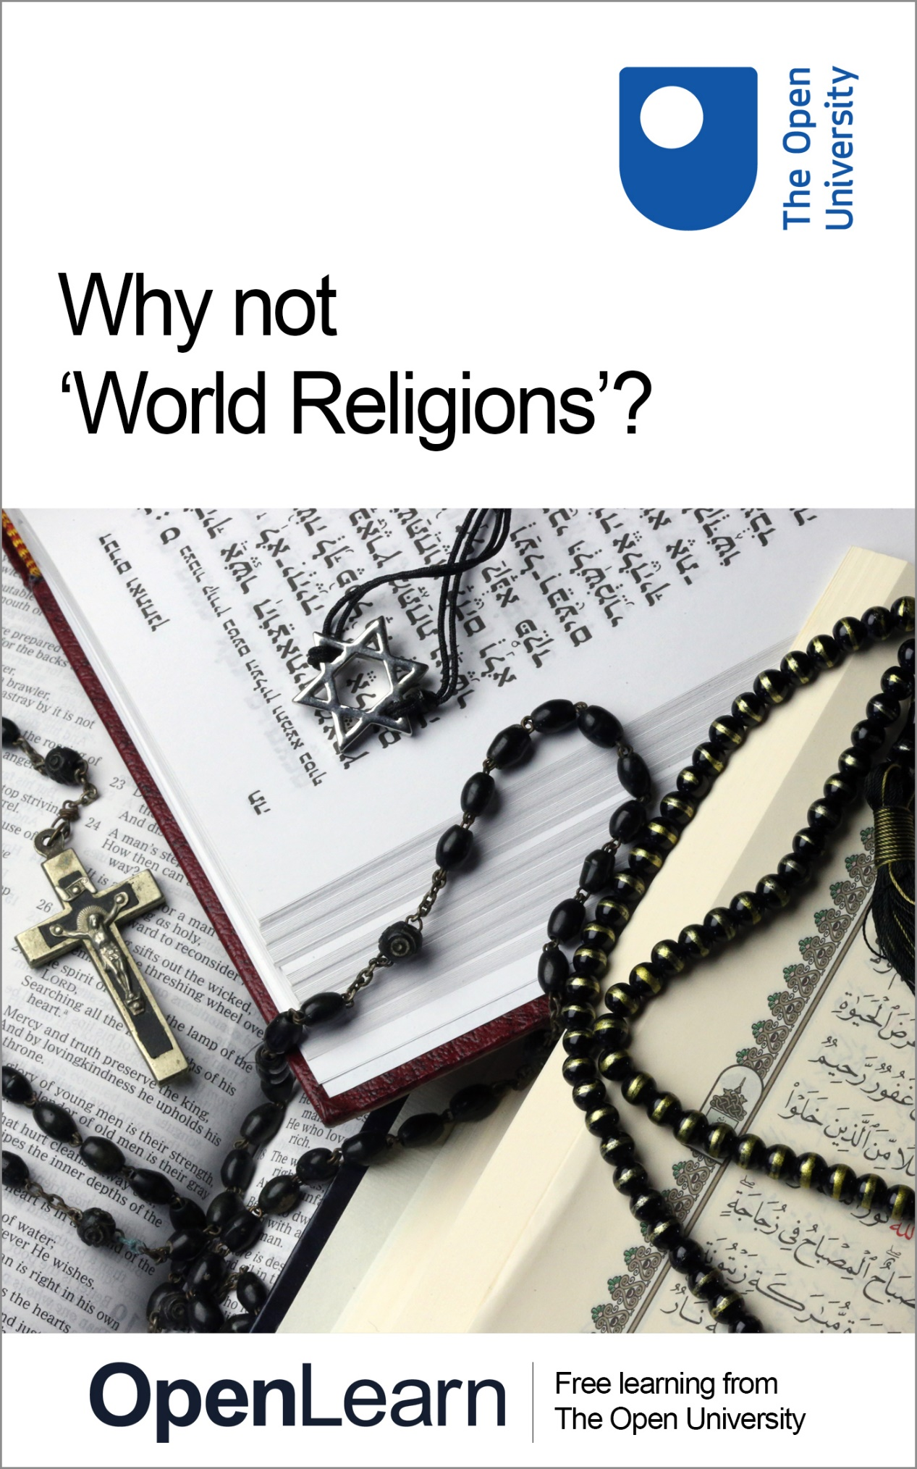

REL_3

Why not ‘World Religions’?

About this free course
Find out more about The Open University’s Religious Studies courses and qualifications: www.open.ac.uk/courses/search-result/religious-studies. .
This version of the content may include video, images and interactive content that may not be optimised for your device.
You can experience this free course as it was originally designed on OpenLearn, the home of free learning from The Open University –
www.open.edu/openlearn/history-the-arts/why-not-world-religions/content-section-0
There you’ll also be able to track your progress via your activity record, which you can use to demonstrate your learning.
Copyright © 2022 The Open University
Intellectual property
Unless otherwise stated, this resource is released under the terms of the Creative Commons Licence v4.0 http://creativecommons.org/licenses/by-nc-sa/4.0/deed.en_GB. Within that The Open University interprets this licence in the following way: www.open.edu/openlearn/about-openlearn/frequently-asked-questions-on-openlearn. Copyright and rights falling outside the terms of the Creative Commons Licence are retained or controlled by The Open University. Please read the full text before using any of the content.
We believe the primary barrier to accessing high-quality educational experiences is cost, which is why we aim to publish as much free content as possible under an open licence. If it proves difficult to release content under our preferred Creative Commons licence (e.g. because we can’t afford or gain the clearances or find suitable alternatives), we will still release the materials for free under a personal end-user licence.
This is because the learning experience will always be the same high quality offering and that should always be seen as positive – even if at times the licensing is different to Creative Commons.
When using the content you must attribute us (The Open University) (the OU) and any identified author in accordance with the terms of the Creative Commons Licence.
The Acknowledgements section is used to list, amongst other things, third party (Proprietary), licensed content which is not subject to Creative Commons licensing. Proprietary content must be used (retained) intact and in context to the content at all times.
The Acknowledgements section is also used to bring to your attention any other Special Restrictions which may apply to the content. For example there may be times when the Creative Commons Non-Commercial Sharealike licence does not apply to any of the content even if owned by us (The Open University). In these instances, unless stated otherwise, the content may be used for personal and non-commercial use.
We have also identified as Proprietary other material included in the content which is not subject to Creative Commons Licence. These are OU logos, trading names and may extend to certain photographic and video images and sound recordings and any other material as may be brought to your attention.
Unauthorised use of any of the content may constitute a breach of the terms and conditions and/or intellectual property laws.
We reserve the right to alter, amend or bring to an end any terms and conditions provided here without notice.
All rights falling outside the terms of the Creative Commons licence are retained or controlled by The Open University.
Head of Intellectual Property, The Open University

Contents
- Introduction
- Learning outcomes
- 1 What are World Religions?
- 2 Some examples
- 3 What do we do instead?
- Conclusion
- What next?
- Further reading
- Acknowledgements

Introduction
You’ve probably heard the term ‘World Religions’. You may have come across it in documentaries, newspapers or textbooks. Perhaps you’ve even done a course at school or university called ‘Introduction to World Religions’, or something similar. The idea that there are five or six ‘major’ or ‘world’ religions is so common that it seems natural to us today.
But have you stopped to think about what it means? What makes something a World Religion? Why do we group some religions – almost always the same five – in this way?
In this short course, you’re going to do just that. You’ll look at the potential issues with classifying religions like this, and why scholars are increasingly moving away from talking about World Religions. You’ll even brainstorm a few alternative models.
Along the way, you should begin to get a new perspective on how our ideas about religion, and religions, are tangled up with lots of other ideas, and when those ideas change (like if one group has the right to dominate others) our ideas about religion can change too.
Interested in taking your learning further? You might find it helpful to explore the Open University’s Religious Studies courses and qualifications.

Resources for teachers
There are discussion questions and a classroom activity suggested at the end of this course.

Learning outcomes
After studying this course, you should be able to:
- identify some different ways in which religion can be understood
- understand the historical reasons behind classifying some traditions as World Religions
- describe the contemporary consequences of how religions are classified.

1 What are World Religions?
In the following video, David G. Robertson outlines some of the problems with the World Religions model – that it presupposes a Christian idea of religion, misrepresents the religious lives of adherents, oversimplifies the diversity of traditions and marginalises non-elite voices. The interview emphasises that the concept of World Religions comes from a particular historical context.

Video content is not available in this format.
View transcript - Uncaptioned interactive content

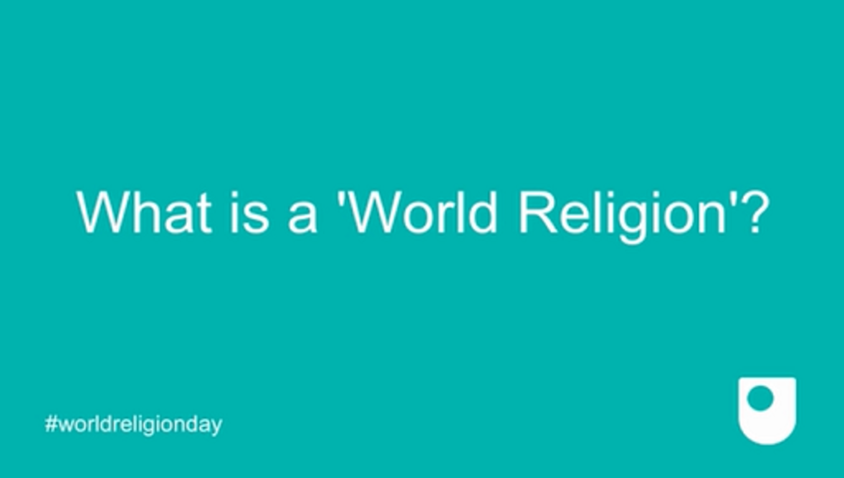

2 Some examples

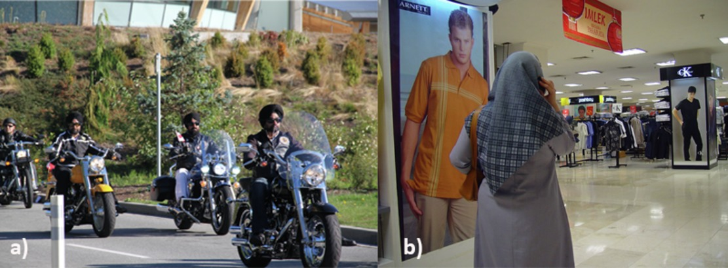
View description - Uncaptioned Figure
View description - Uncaptioned Figure

The World Religions model is a bit like the Premier League, but without relegation – the members are automatically treated as an elite group. (Other terms have the opposite function, like ‘cult’, which automatically marks something as ‘Not really’ a religion… But that’s a conversation for another time!)
But the fact is that the members don’t have as much in common as it might seem – and grouping them together as World Religions helps to present them as though they do. Even so, when we look more closely, it’s clear that you have to present these traditions in very specific ways to make it work at all:
- Hinduism – Hinduism is perhaps the clearest example of the influence of colonialism. ‘Hinduism’ – as a specific religious category – exists specifically because the British census needed a box for those who weren’t Christian or Muslim to tick. Of course, people were already doing and thinking the things they always had, but once it was recognised as a single religion, it was increasingly presented as a unified ‘system of belief’, with the Brahmins as priests, the Vedas as Bible and Brahma, Vishnu and Shiva as a Trinity of supreme Gods. The problem is that this represented only a small percentage of Indians, although it suited the educated elites, especially those who wished to portray India as a unified, modern nation on the international stage. Even today, religion in India is presented in introductory textbooks as a single, albeit multifaceted, tradition, ignoring literally hundreds of millions of people’s beliefs and practices.
- Judaism – is not a good fit with the World Religions model. It isn’t particularly large, with around two per cent of most western countries claiming Jewish identity. But identity, in this context, does not always mean what we would typically understand as religiously Jewish identity, as Jewishness is also considered a cultural and perhaps even ethnic identity. In fact, even in Israel, the only Jewish-majority state in the modern world, most people are secular Jews. This is also tied to the fact that Judaism is not a religion with a universal message – the covenant with God was with the Jews alone, and this identity is passed down the Mother’s line. It is possible to convert or marry in, but it’s not a tradition that actively evangelises. In fact, the position of Judaism in the World Religions model probably has more to do with its relationship to Christianity – and particularly the way that it is perceived by some as a forerunner of Christianity. For the Victorian colonial powers who saw Christianity as the pinnacle and end-point of all religion, this would be enough to grant it a permanent place at the table.
- Religion in Japan – censuses show religious identification in Japan as being more than 100%! That’s because Japanese people are happy to tick several boxes, because they tend to see religion as something you do, rather than something you are. They see no contradiction in having Buddhist funerals and Christian weddings, while taking part in public Shinto ceremonies. In fact, the idea of Shinto as a (single) religion was more-or-less forced on Japan during the US occupation after the end of the Second World War. This underlines that while the roots of the World Religions model is in the colonial period, its effects were being played out throughout the twentieth century, and continue today.

3 What do we do instead?

View description - Uncaptioned Figure
View description - Uncaptioned Figure

Despite all these issues, the World Religions model is still the standard approach in education – so much so, in fact, that it can seem difficult to think of different ways to begin teaching the subject. But the fact is, there are lots of alternatives! Here are just a few:
- Rather than teaching what members of so-called World Religions supposedly all ‘believe’, we can instead engage with their ideas and behaviours on an individual level. This ‘lived religion’ approach offers a much more dynamic understanding of religion – and a more accurate one. Thinking about what real people actually do, and the reasons why they do it, shows how important individual context is, and how intertwined religious ideas and identities are with other identities – ethnic, political, social, economic, and so on. This is the approach taken in the OpenLearn course Census stories: bringing statistics to life in Milton Keynes, created with Religious Studies staff at the OU, which is also free on OpenLearn.
- We can start with particular concepts we tend to associate with religion, and then examine these from a variety of perspectives. This is the approach taken by the Open University’s module, A227 Exploring religion: places, practices, texts and experiences, which looks at places, practices, texts and experiences, each time using a mixture of examples taken from well-known and less well-known religions as well as secular examples. OpenLearn also has a free taster for this module: Religious diversity: rethinking religion.
- Instead of thinking about religions as self-evident things, we can think about how things come to be classified as religious (or not) in different contexts. For example, we might look at how in secular states, some practices are permissible for members of religions that aren’t permissible to others, such as Sikhs not having to wear motorcycle helmets, or some Christians being allowed to refuse to cater for same-sex weddings. In these cases, what counts as ‘religion’ or not is very important, and is often decided in the court (usually without Religious Studies academics’ input!) – like in this case about Scottish nationalism. The exciting thing about this approach is that we don’t have to decide what a religion is, we can focus instead on thinking of the different ways in which religion can be understood, and become more aware of these different understandings in culture and society. These classifications are not just academic, but affect peoples’ real lives, in many different ways.

Conclusion

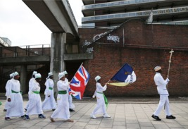
View description - Uncaptioned Figure
View description - Uncaptioned Figure

In this short course, you have learned about how the idea of classifying religions like we classify plants and animals appealed to many Europeans during the colonial period. You have also heard how the idea that some of those religions could be classified as ‘World Religions’ reflected their biases that Europe was the pinnacle of civilisation, and Christianity the pinnacle of religion. Yet this was an oversimplification that misrepresented the majority of people, even as it allowed some to claim greater legitimacy on the global stage. As you have seen, the model prioritises belief over practices and identity, marginalises non-elite voices and irons out contestations within and between traditions, and the complexities of individual religious lives.
You have also explored some different ways in which we might think about religions. In so doing, you have also learned that abandoning the idea of World Religions does not mean that we have to deny anyone their voice, or ignore the role of religion in peoples’ lives around the world. Quite the opposite – by not forcing by not forcing beliefs, practices and identities into neat boxes, we allow them to speak for themselves, and in the process gain a much clearer understanding of the staggering complexity of ordinary religious lives.

Questions for discussion
- How well does your religious identity fit the World Religions model? Are you a typical example of your World Religion, or not so much? In what ways? (Be honest – no judgements!)
- Or, is your religion not included? Why do you think that is?
- If you aren’t religious, are there things you do or believe that could be thought of as religious (e.g yoga, horoscopes, acupuncture, etc.)?
- Now think about people you know well, like your parents or friends or siblings. How are their religious lives similar to yours, and how are they different?

Classroom activity
As a group, come up with a plan for a course called Introduction to Religion in the Modern World – without using the World Religions model! You can use the ideas listed above, or come up with something different of your own. Where do you start? What do you include? What questions do you ask?

What next?
Check out the Religious Studies content on offer from OpenLearn.
Interested in taking your learning further? You might find it helpful to explore the Open University’s Religious Studies courses and qualifications.

Further reading
After World Religions, edited by Christopher Cotter and David G. Robertson, has a number of chapters suggesting different ways of teaching without World Religions, or of using World Religions to show how colonial ideas have affected our models of religion. The introductory chapter by the editors is a readable deep dive into the critiques that have been summarised in this course.
There’s more detail in these podcasts on the World Religions Paradigm and how we might teach and learn After World Religions.
You can check out our OpenLearn short course Census stories: bringing statistics to life in Milton Keynes for how to teach about lived religious diversity without relying on the ‘World Religions’ model.

Acknowledgements
This free course was written by David G. Robertson.
Except for third party materials and otherwise stated (see terms and conditions), this content is made available under a Creative Commons Attribution-NonCommercial-ShareAlike 4.0 Licence.
The material acknowledged below is Proprietary and used under licence (not subject to Creative Commons Licence). Grateful acknowledgement is made to the following sources for permission to reproduce material in this free course:

Images
Course image: © Godong/Contributor; Getty Images
Section 2 images: Left: U.S. Embassy and Consulates in Canada https://creativecommons.org/publicdomain/mark/1.0/; Right: Picture taken by Jonathan McIntosh; https://creativecommons.org/licenses/by/2.0/deed.en
Section 3 image: © FatCamera; Getty Images
Conclusion image: © Dan Kitwood/Staff; Getty Images
Every effort has been made to contact copyright owners. If any have been inadvertently overlooked, the publishers will be pleased to make the necessary arrangements at the first opportunity.
Don't miss out
If reading this text has inspired you to learn more, you may be interested in joining the millions of people who discover our free learning resources and qualifications by visiting The Open University – www.open.edu/openlearn/free-courses.

Uncaptioned Figure

Description
On the left: a colour photograph of a group of men wearing turbans riding motorcycles. On the right: a colour photograph of a woman in a shopping mall.
Back to - Uncaptioned Figure

Uncaptioned Figure

Description
A colour photograph of a teacher reading to a group of children.
Back to - Uncaptioned Figure

Uncaptioned Figure

Description
A colour photograph of a group of people wearing white and holding flags while walking along a path.
Back to - Uncaptioned Figure

Uncaptioned interactive content

Transcript
DAVID G. ROBERTSON
It seems entirely natural to us to talk about world religions. It’s in the media constantly. It’s in popular and academic books. It’s even encoded into the structure of many introductory courses at universities. But what makes something a world religion and not others? Why are Christianity, Islam, Judaism, Buddhism, and Hinduism always afforded this classification and not others?
Is it just numbers? If so, why is Judaism there and not, say, African religions? Is it that they have a universal message? Again, this doesn’t really apply to Judaism. The fact is that the idea of world religions actually has a very specific history. It emerges in the Victorian period when scholars like Max Muller and Cornelius Tiele set out to categorise religion in the same way that Linnaeus produced a taxonomy of the natural world.
Muller and Tiele were not neutral observers, however. They were very much a part of the colonial project. And so the data they produced was of nations that were being subjugated and that the colonial governments would have to deal with. Implicitly, they produced a categorisation that was based on Christianity.
So for example, in the case of Hinduism, Hinduism was presented as something that took place in temples, had priests, had a trinity, and holy texts just like Christianity. But, in fact, this was a relatively small aspect of Hinduism and only represented the position of a relatively small priestly elite.
Nevertheless, religions were classified on their similarity to Christianity. And those which had or could be presented as having a universal transcendent message were ranked higher than others. So the idea of world religions preserves this colonial position today. It presents religions as being these monolithic traditions which have gone along unchanged for centuries. And then prioritising the ideas of the elite, they, therefore, silence minorities, women, and the poor.
It also suggests that we have to have one religion and one only, which doesn’t work, for instance, in the case of Japan where one can be Buddhist, Shinto, and Christian in different contexts at different times. And it creates the idea of religions as these consistent things with their own agency which can speak in their own voice. So when we talk about world religions then instead of a neutral category, we’re actually preserving a Victorian colonial idea of religion and imposing it onto today’s world.
Back to - Uncaptioned interactive content

Uncaptioned Figure

Description
On the left: a colour photograph of a group of men wearing turbans riding motorcycles. On the right: a colour photograph of a woman in a shopping mall.
Back to - Uncaptioned Figure

Uncaptioned Figure

Description
A colour photograph of a teacher reading to a group of children.
Back to - Uncaptioned Figure

Uncaptioned Figure

Description
A colour photograph of a group of people wearing white and holding flags while walking along a path.
Back to - Uncaptioned Figure

