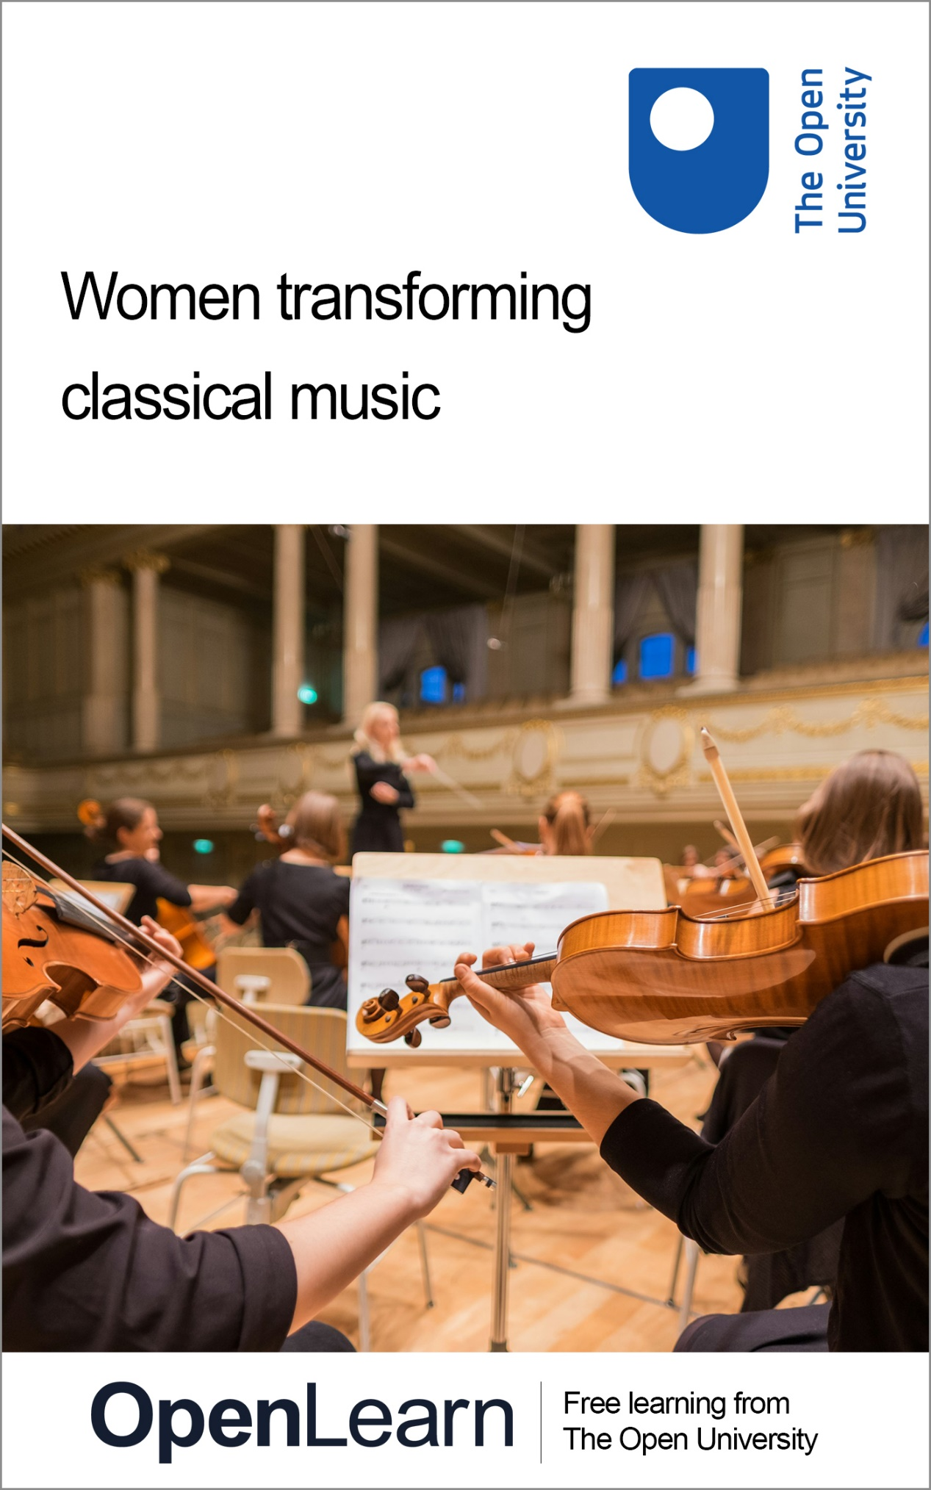

WTCM_1

Women transforming classical music

About this free course
This free course is an adapted extract from the Open University course .
This version of the content may include video, images and interactive content that may not be optimised for your device.
You can experience this free course as it was originally designed on OpenLearn, the home of free learning from The Open University –
There you’ll also be able to track your progress via your activity record, which you can use to demonstrate your learning.
First published 2025.
Unless otherwise stated, copyright © 2025 The Open University, all rights reserved.
Intellectual property
Unless otherwise stated, this resource is released under the terms of the Creative Commons Licence v4.0 http://creativecommons.org/licenses/by-nc-sa/4.0/deed.en. Within that The Open University interprets this licence in the following way: www.open.edu/openlearn/about-openlearn/frequently-asked-questions-on-openlearn. Copyright and rights falling outside the terms of the Creative Commons Licence are retained or controlled by The Open University. Please read the full text before using any of the content.
We believe the primary barrier to accessing high-quality educational experiences is cost, which is why we aim to publish as much free content as possible under an open licence. If it proves difficult to release content under our preferred Creative Commons licence (e.g. because we can’t afford or gain the clearances or find suitable alternatives), we will still release the materials for free under a personal end-user licence.
This is because the learning experience will always be the same high quality offering and that should always be seen as positive – even if at times the licensing is different to Creative Commons.
When using the content you must attribute us (The Open University) (the OU) and any identified author in accordance with the terms of the Creative Commons Licence.
The Acknowledgements section is used to list, amongst other things, third party (Proprietary), licensed content which is not subject to Creative Commons licensing. Proprietary content must be used (retained) intact and in context to the content at all times.
The Acknowledgements section is also used to bring to your attention any other Special Restrictions which may apply to the content. For example there may be times when the Creative Commons Non-Commercial Sharealike licence does not apply to any of the content even if owned by us (The Open University). In these instances, unless stated otherwise, the content may be used for personal and non-commercial use.
We have also identified as Proprietary other material included in the content which is not subject to Creative Commons Licence. These are OU logos, trading names and may extend to certain photographic and video images and sound recordings and any other material as may be brought to your attention.
Unauthorised use of any of the content may constitute a breach of the terms and conditions and/or intellectual property laws.
We reserve the right to alter, amend or bring to an end any terms and conditions provided here without notice.
All rights falling outside the terms of the Creative Commons licence are retained or controlled by The Open University.
Head of Intellectual Property, The Open University

Contents
- Week 1: How we got into this: barriers, challenges and solutions
  - Introduction
  - 1 Considering your own musical practice
  - 2 Barriers
  - 3 Challenges
  - 4 Solutions
  - 5 Summary of Week 1
- Week 2: Building gender diverse programmes
  - Introduction
  - 1 Potential strategies for building gender diverse programmes
  - 2 Important issues to consider when developing gender diverse programmes
  - 3 Practical considerations
  - 4 Sharing good practice: the Finding A Voice Music Festival
  - 5 Summary of Week 2
- Week 3: Programming historical women composers
  - Introduction
  - 1 Uncovering historical women composers
  - 2 Finding scores of works by historical women composers
  - 3 Creating new editions
  - 4 Summary of Week 3
- Week 4: Programming contemporary women composers
  - Introduction
  - 1 What is a ‘composer’ in the early twenty-first century?
  - 2 Working with living women composers
  - 3 Ways of working with and promoting living women composers
  - 4 Towards gender balanced programming
  - 5 Summary of Week 4
- Week 5: Presenting gender diverse programmes
  - Introduction
  - 1 Recap
  - 2 Sharing good practice: Illuminate
  - 3 Building your toolkit
  - 4 Summary of Week 5
- Week 6: Developing inclusive practices
  - Introduction
  - 1 Thinking intersectionally
  - 2 Thinking about diversifying programming more broadly
  - 3 Sharing good practice: Tŷ Cerdd/Music Centre Wales
  - 4 Summary of Week 6
  - Where next?
  - References
  - Acknowledgements
- Solutions
- Descriptions

Week 1: How we got into this: barriers, challenges and solutions

Introduction
Research completed by Donne Women in Music in 2024 found that 92.5 per cent of orchestral repertoire performed worldwide in the 2023/24 concert season was written by men, while music written by women made up just 7.5 per cent. (Donne Women in Music’s research was based on an examination of the repertoire presented by 111 orchestras based across 30 countries.) These statistics are a stark reminder of how male dominated the world of classical music is.

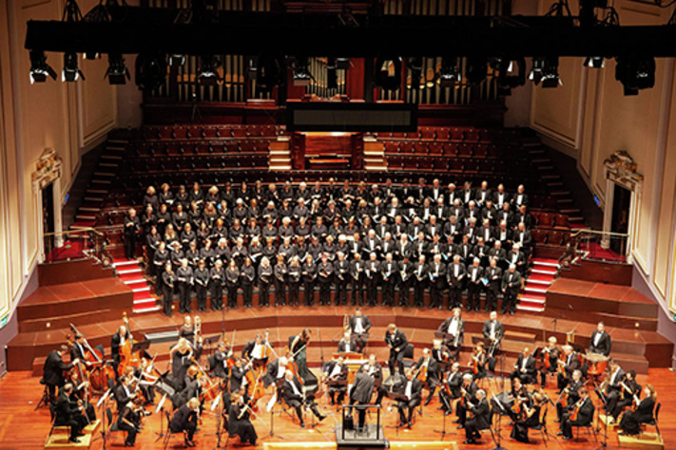
View description - Uncaptioned Figure

This week, you will reflect on how we got into this situation, including the historical exclusion of women composers from the classical music canon and music education, issues accessing scores of their compositions, and financial nervousness around programming works with which audiences might be unfamiliar. You will then turn your attention to how we might change things, covering where to find information and scores, creating new editions, and commissioning new works by women composers, which you will go on to consider in greater detail in Weeks 3 and 4. This week is illustrated by short interview clips with Gabriella Di Laccio, founder and curator of Donne Women in Music, who discusses her work advocating for greater gender equity within the classical music industry.
By the end of this week, you should be able to:
- recognise the historical barriers which have led to the traditional exclusion of women composers from the canon and from music education
- understand the remaining challenges to programming women’s music
- appreciate how you/your organisation might approach diversifying repertoire.

1 Considering your own musical practice

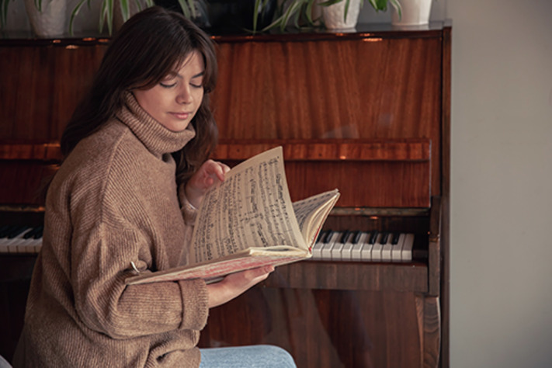
View description - Uncaptioned Figure

You will start this week by reflecting on your own musical practice.

Activity 1

Reflect on the following questions and write your answers in the text box below.
- How many works by women composers do you regularly perform/does your organisation regularly perform?
- How aware are you of women composers? How many can you name? How many of their compositions do you know/regularly listen to?

Provide your answer...
View discussion - Activity 1

If you don’t currently perform many works by women – or haven’t done so in the past – why is this? Has the historical study of women composers formed a large or a small part of your musical education? Did you study/perform any works by women when you were training? If you have been put off performing works by women, what were the reasons? Was it difficult to find scores of their works? Were you worried that audiences would be put off by hearing works that they might not be familiar with and that this might affect ticket sales? Did you have any concerns about how you might be perceived? For example, did you have any worries about being viewed as tokenistic or trying to be politically correct?
In what follows, you will consider the historical barriers that have excluded women composers from the classical music canon, the challenges to performing their works which still exist, and potential solutions to moving towards diversifying the repertoire which you perform.

2 Barriers


View description - Uncaptioned Figure

One of the biggest factors that has led to classical music repertoire being so male dominated is women composers’ exclusion from the classical music canon. Canon comes from the Greek word ‘kanon’ meaning a standard or rule. Applied to the arts, it means the series of timeless ‘masterpieces’ which are considered to represent the finest achievements within any given art form. The concept of a canon of artistic masterpieces first developed in literature and was then applied to music. The musical canon developed in the nineteenth century – a time when women had very few rights and were largely excluded from public life – and focused exclusively on male composers, such as Bach, Haydn, Mozart, Beethoven, Schubert, Schumann, Brahms, Tchaikovsky and Mahler.
The emerging classical music canon became firmly entrenched through performance. Public concert life developed rapidly during the nineteenth century, with many new concert halls and opera houses being built throughout Europe. The repeat performance of the composers and works that were gaining their place within the canon enshrined the idea that these were the ones most worthy of attention. Although there were many active women composers during the nineteenth century – such as Clara Schumann, Fanny Hensel (born Mendelssohn), Louise Farrenc, Emilie Mayer, Augusta Holmès, Cécile Chaminade and Ethel Smyth – women often struggled to gain opportunities, within such a deeply patriarchal society, to have their works performed. Consequently, they were then excluded from the canon. This exclusion normalised their absence from classical music repertoire and this problem persists to this day.
Until relatively recently, the canon also formed the bedrock of musical education and training. Women composers were only very rarely included within music history and many music students received a training which meant they never played, studied, or sometimes even heard a single piece of music by a woman as part of their musical education.
Absence is a powerful teaching tool. The absence of women composers from the canon and musical education has caused the ongoing absence of women from the performing repertoire today. These are the historical problems which we need to confront.

3 Challenges
Women composers’ exclusion from the classical music canon has created a set of practical challenges for those who would like to promote greater gender diversity within programming.

Activity 2

Watch the following interview with Gabriella Di Laccio, founder and curator of Donne Women in Music, discussing what she regards as the biggest challenges which those wishing to programme more music by women face.

Video content is not available in this format.
View transcript - Uncaptioned interactive content

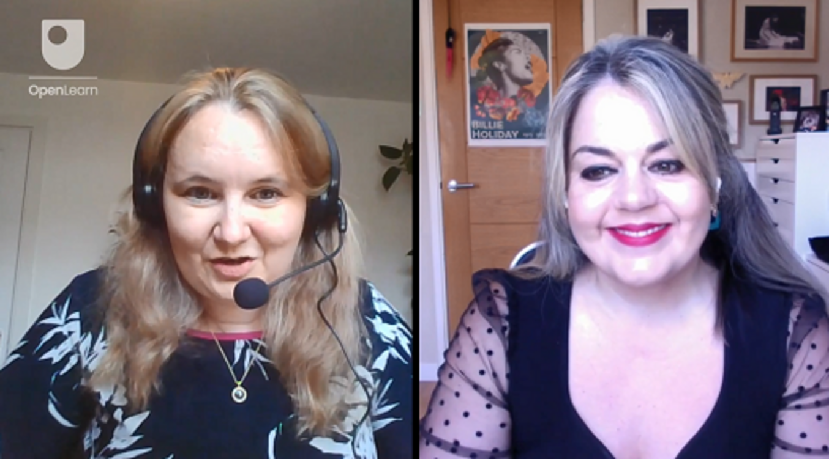

What does she identify as the key challenges that those seeking to diversify repertoire face?

Provide your answer...
View discussion - Activity 2

One of the biggest challenges that performers/organisations who want to perform works by women face is lack of availability of scores. Because women composers historically struggled to achieve public performances of their works, publishers were often reluctant to publish them, as they relied on musicians, ensembles and concert-organising organisations buying them in order to perform them for their revenue. They were very reluctant to publish works that people would be unlikely to perform and, therefore, unlikely to buy. This has become a cyclical problem, as the lack of availability of scores continues to make it difficult for women’s works to be performed today. Many pieces by women composers have never been published and still exist only in handwritten manuscript form.
Even when scores of women’s works do exist, performers/organisations can be reluctant to programme their music as audiences are often unfamiliar with it. This can lead to fears that programming unfamiliar works and composers will affect ticket sales and, therefore, the financial bottom line. At a time when the classical music industry is under huge financial pressure, it can take real courage to take what can sometimes appear a significant risk by programming women’s music. This fresh repertoire – and the associated potential to develop a new specialism – can, however, actually present real opportunities to build new audiences.

4 Solutions
Despite the significant challenges to performing women’s music that still exist, there are potential solutions to overcoming this.

Activity 3

Watch another clip of an interview with Gabriella Di Laccio, founder and curator of Donne Women in Music, discussing potential solutions to performing more music by women.

Video content is not available in this format.
View transcript - Uncaptioned interactive content

What does she identify as potential solutions?

Provide your answer...
View discussion - Activity 3

In the following weeks, you will consider further all the potential solutions which Gabriella mentions, including where to start researching historical women composers, how to find scores, creating editions, commissioning new works from living women composers, and building new audiences for women’s music.

5 Summary of Week 1


View description - Uncaptioned Figure

This week, you have reflected on your own musical practice and how aware you already are of women composers. You have considered how classical music came to be so male dominated and the challenges to changing this which remain, including difficulties accessing scores of women’s compositions and nervousness about programming unfamiliar works. You have also heard about the work which Gabriella Di Laccio is doing with Donne Women in Music to challenge this.
Next week, you will begin to think about how you might go about diversifying your own repertoire. You will also hear from Roísín Maher talking about how she is leading change in this area through her work directing the all-woman Finding A Voice Music Festival.
You can now go to Week 2.

Week 2: Building gender diverse programmes

Introduction
On International Women’s Day (8 March) in 2017 sisters Róisín and Clíona Maher founded the Finding A Voice Music Festival – an annual festival celebrating music by women composers – in Clonmel, Co. Tipperary (ROI). Now the sisters have built up such a strong audience for women’s music that up to 700 people attend the festival in this small Irish town every year.


View description - Uncaptioned Figure

In Week 1, you learned how classical music repertoire came to be so male dominated, what some of the challenges are to changing this (including access to scores of women’s compositions and nervousness around performing works with which audiences might be unfamiliar), and what some of the potential solutions to these challenges might be, such as researching and playing works by historical women composers or commissioning new works from living ones. This week, you will consider how you can go about building gender diverse programmes, or programmes which are even more diverse if you are already working in this area. This week is illustrated by a short interview with Roísín Maher, founder and director of the Finding a Voice Music Festival in the Republic of Ireland, who discusses her work running an all-woman music festival and advocating for greater gender equity within the Irish music industry.
By the end of this week, you should be able to:
- know some of the strategies which you could use to create gender diverse programmes, such as all-women concerts or themed programmes
- be aware of some of the issues which are important to consider when developing gender diverse programmes, including the timing and placement of women’s works
- understand some of the practical considerations which you’ll need to take into account when developing gender diverse programmes, including funding, audience engagement and outreach, and getting performers on board.

1 Potential strategies for building gender diverse programmes

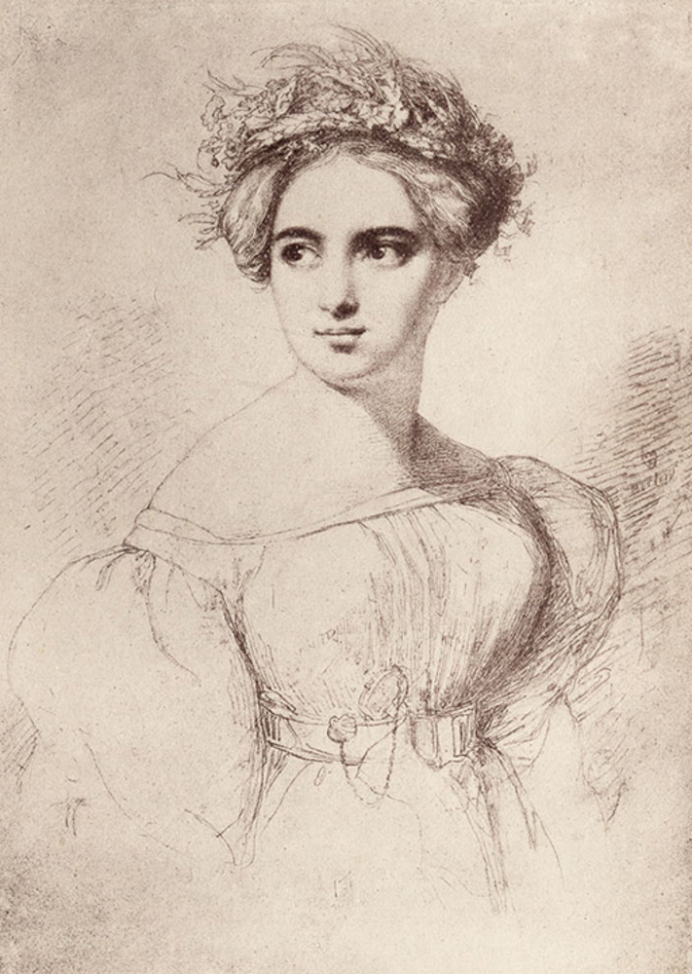
Figure 1 An illustration of the composer Fanny Hensel (born Mendelssohn), sketched in 1829 by Wilhem Hensel.
View description - Figure 1 An illustration of the composer Fanny Hensel (born Mendelssohn), sketched ...

There are a number of different ways that you could start to think about developing gender diverse programmes.
All-women programmes
You might want to go all out and curate a programme consisting entirely of works by women composers. This could bring together a range of works by women from across a broad historical spread or might focus on women from one particular historical period or one musical tradition. Unless you already have a lot of knowledge about women composers’ music and good access to scores, this might be the most challenging approach to take – particularly to start out – as it will involve a lot of research and a lot of learning of new material.
Themed programmes
An alternative and possibly slightly more straightforward way to start programming works by women (or more works by women, if you already do) is to incorporate women’s music into concerts alongside compositions by their male peers. A good way to start doing this is to think about starting to include women’s works into themed concerts. For example, if you are planning a recital of German Romantic Lieder, why not perform some songs by composers such as Clara Schumann or Fanny Hensel (born Mendelssohn) alongside works by their famous male counterparts, such as Franz Schubert or Robert Schumann. Or, if you are working on a programme of orchestral film music, why not play some scores by Rachel Portman and Natalie Wiseman, alongside those of John Williams and Danny Elfman.

2 Important issues to consider when developing gender diverse programmes

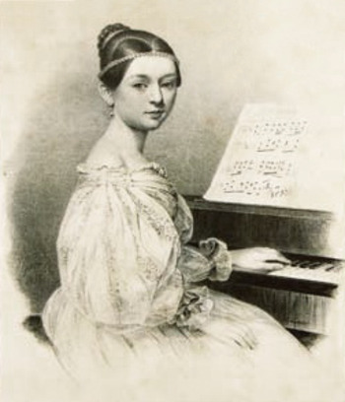
Figure 2 An illustration of the composer Clara Schumann, from an 1835 lithograph.
View description - Figure 2 An illustration of the composer Clara Schumann, from an 1835 lithograph. ...

Once you have decided how you want to include more works by women in your programming, there are some important issues to think about.

Activity 1

Part 1

When works by women are included on mixed programmes (i.e. incorporated alongside those of their male peers), they tend proportionally to make up a much smaller part of the programme. An analysis of the 2023 BBC Proms undertaken by the ISM (Independent Society of Musicians) found that less than 7 per cent of the music performed was by women, and that the duration of the works by women that were included took up less time. The average duration of women’s compositions was 11.5 minutes, whereas for men it was 28 minutes. Why do you think that this is problematic?

Provide your answer...
View discussion - Part 1

Part 2

In addition to taking up less time within overall programmes, when works by women are included within classical music festivals or concert series, they are often included as part of lunchtime concerts or other ‘fringe’ events, rather than as part of the main or evening concerts. Why is this also problematic?

Provide your answer...
View discussion - Part 2

3 Practical considerations


View description - Uncaptioned Figure

As you start work on diversifying your programming, there are a number of practical considerations which it can be useful to bear in mind. These can be a bit different to what you’d usually be thinking about when preparing a programme of all-male composers.
Funding
Although you’ll be used to applying for funding regularly, you might want to consider any additional support which you could apply for to programme women’s work. You will also need to think through any additional costs which you might have, such as hiring fees for parts, the costs associated with preparing a new edition, or extra rehearsal fees.
Some potential organisations which you could consider applying to are the various Arts Councils across the UK and Ireland (depending on where you are based): Arts Council England, Arts Council of Wales, Creative Scotland, Arts Council of Northern Ireland, or The Arts Council (ROI). The Association of British Orchestras (ABO) administers the Sirens Fund, which awards grants to support the performance of historical women composers. Women’s Philharmonic Advocacy also awards grants to support the programming of orchestral work by women in the US and internationally.
You might also want to consider signing up to Donne Women in Music’s mailing list, as their regular newsletter often includes details of funding to support the performance of women’s music. Additionally, the ISM maintains a good list of funding opportunities available to composers and performers.
Audience engagement
One of the principal reasons people often give for feeling reluctant to programme women’s music is that they are concerned that audiences will be unfamiliar with the works, and that this will affect ticket sales. There are steps that you can take, however, to help build audiences for this music.
You could commission a music researcher with a specialist interest in the particular composer whose work you are performing to write some programme notes or even consider tasking them to write a longer piece, which you could host on your website. You can find music researchers by using a search engine to search for people working on the composer which you will be performing. Many music researchers have active online presences. You could also consider hiring a researcher to deliver a pre-concert talk or even (if you have sufficient funding) to do some outreach or educational work with local schools and/or community groups interested in classical music.
Getting performers on board
Sometimes performers can initially be a bit reluctant to programme music by women, if they are unfamiliar with the music. This is often due to the time necessary to learn the new repertoire and the additional rehearsal time. The work can be challenging and take a lot of time to master. You need to think about incentivising this. For example, by offering some additional paid preparation time. An advantage, once the repertoire is learned, is that the performers will then have mastered new and unusual repertoire, which might help them to specialise and be able to offer different, less commonly heard, works within a competitive industry.

4 Sharing good practice: the Finding A Voice Music Festival
As you learned at the beginning of this week, the Finding A Voice Music Festival was founded by sisters Róisín and Clíona Maher in 2017. Each year they present a festival celebrating music by women composers around International Women’s Day (8 March) in Clonmel, Co. Tipperary (ROI).

Activity 2

Watch the following interview with Róisín Maher, co-founder and director of Finding A Voice, discussing her work organising the festival.

Video content is not available in this format.
View transcript - Uncaptioned interactive content

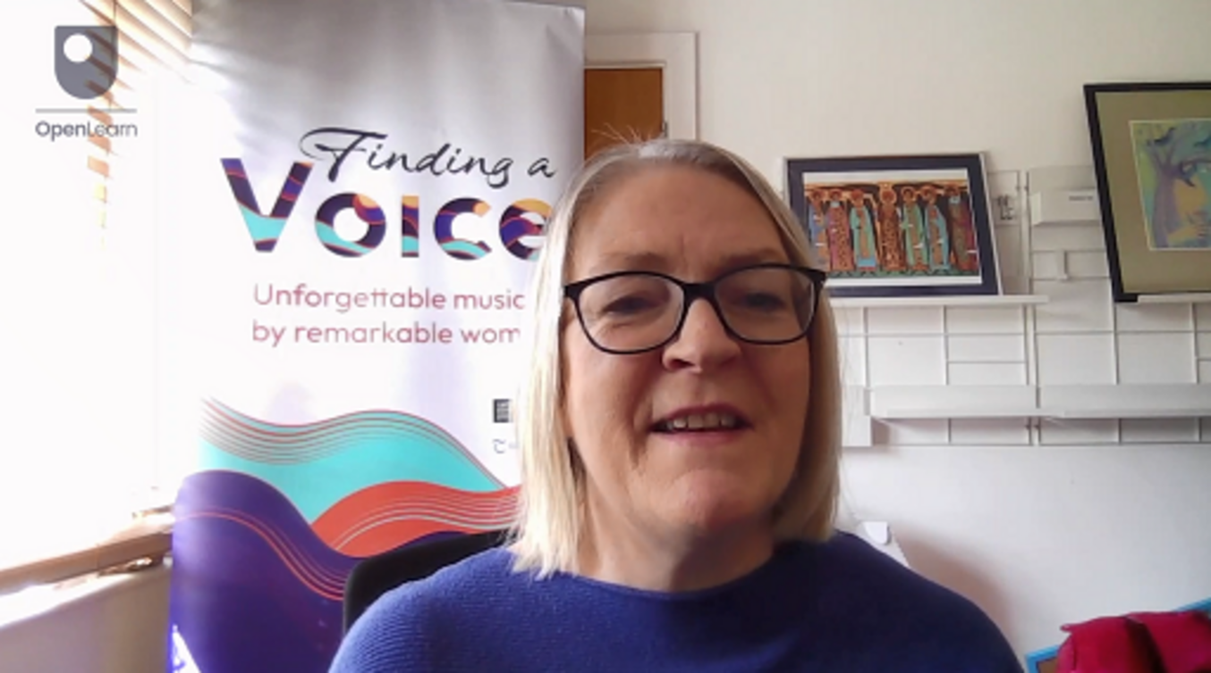

Then consider the following questions:
- How has Róisín approached building an audience for women’s music in Clonmel?
- How has she secured funding for the festival?
- What is her approach to curating programmes?

Provide your answer...
View discussion - Activity 2

5 Summary of Week 2

View description - Uncaptioned Figure

This week you have learned about different approaches to programming women’s music and considered the various issues and practicalities that you’ll need to think through when developing gender diverse programmes. You have heard from Roísín Maher discussing her work with the all-woman festival, Finding A Voice.
Next week you will consider how you can go about programming works by historic women composers, including where to find scores and resources and how to start making your own performance editions. You will hear from Tim Parker-Langston talking about his work developing Hensel Songs Online.
You can now go to Week 3.

Week 3: Programming historical women composers

Introduction

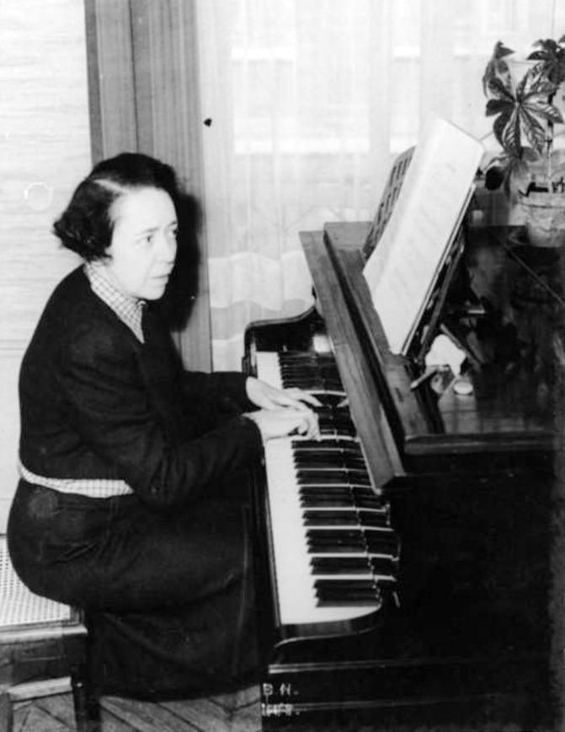
Figure 1 A photograph of Jeanne Leleu.
View description - Figure 1 A photograph of Jeanne Leleu.

Reviewing the 1947 production of Jeanne Leleu’s ballet Nautéos in Monte Carlo, an anonymous music critic proclaimed in the French newspaper Le Monde that: ‘France possesses in Jeanne Leleu its most talented female composer’ (cited in Hamer, 2018, p. 83). Although not often performed today, Leleu was a highly regarded composer during the earlier twentieth century. She won France’s famous composition competition, the Prix de Rome in 1923, pursued a successful career as both a composer and a pianist, and taught at the Paris Conservatoire.
Far from being an exception, many women composers pursued active and successful careers in the past. As you learned in Week 1, many of their names and works are not currently well known, however, as they have been excluded from the musical canon, from musical education, and consequently from the classical music repertoire which is still most often performed today.
This week, you will consider how to go about programming works by historical women composers. This week is illustrated by a short interview with Tim Parker-Langston, founder of Hensel Songs Online, who discusses his work raising the profile of Fanny Hensel (born Mendelssohn), preparing new editions of her songs, and making these available to other performers for free.
By the end of this week, you should be able to:
- have an understanding of historical women composers and where you can start researching them and their music
- be aware of where you can find scores of works by historical women composers
- understand how you might go about creating new editions of unpublished works by historical women composers.

1 Uncovering historical women composers

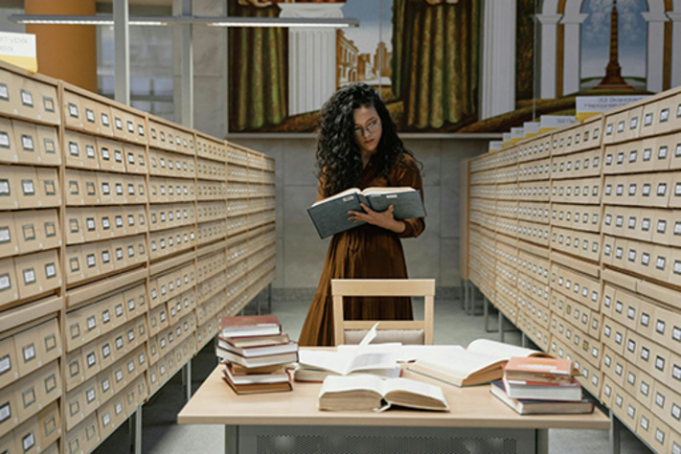
View description - Uncaptioned Figure

Once you have committed to diversifying your repertoire by programming more music by women, you will need to decide which to include. As you learned in Week 2, there are different approaches which you could take to building more diverse programmes. You could go all out and organise a whole concert of works by women composers, or you could add works by women into a themed programme.
If you are planning to add works by women into a themed programme, you will find The Big List of Women Composers, which has been compiled by Donne Women in Music, an invaluable resource. You can search this by musical period, genre, or country; so, you will be able to find multiple suggestions for women composers to add to your programme, whatever the theme. The Big List of Women Composers contains entries for more than 5,000 women composers. Entries provide basic biographical information and links to further resources.
The Composers section of the Women By Music website also brings together information on a wide range of historical women composers, including biographical information and lists of suggested reading should you wish to find out more about them. Additionally, the Boulanger Initiative also offers an extremely valuable open-access database of works by women and gender-marginalised composers.
Doing further research
When you have chosen which women composers to include and discovered some basic biographical information about their lives and careers, you may find yourself feeling curious about them and the musical cultures and contexts within which they worked, and eager to find out more. The academic study of women composers – which is often called Feminist Musicology or Women in Music Studies – has grown to be a relatively well-established field since music scholars and performers started to explore composers who have been excluded from the conventional music canon in the later twentieth century.
Below is a list of suggestions of accessible books about women composers which you might like to have a look at. If you have access to a local library or to one within a university or conservatoire, these titles should be available or (if they are not) you could ask the librarian or library team to arrange an inter-library loan for you:
- Judith Bowers and Jane Tick (eds) (1986) Women Making Music: The Western Art Tradition, 1150–1950. Urbana and Chicago: University of Illinois Press.
- James R. Briscoe (ed.) (2004) New Historical Anthology of Music by Women. Bloomington and Indianapolis: Indiana University Press.
- Julie C. Dunbar (2011) Women, Music, Culture: An Introduction. New York and London: Routledge.
- Sophie Fuller (1994) The Pandora Guide to Women Composers: Britain and the United States, 1629–Present. London: Pandora Books.
- Laura Hamer (ed.) (2021) The Cambridge Companion to Women in Music since 1900. Cambridge: Cambridge University Press.
- Karin Pendle (ed.) (1991) Women & Music: A History. Bloomington and Indianapolis: Indiana University Press.
- Julie Anne Sadie and Rhian Samuels (eds) (1994) The Grove Dictionary of Women Composers. London: Macmillan.
To find out more about your chosen women composers, you could also consider reaching out to a music researcher working on them. As you learned in Week 2, many music researchers maintain active online profiles and you will be able to find them through doing an internet search. As suggested in Week 2, if you reach out to a music researcher for advice, you might want to consider inviting them to write programme notes, present a pre-concert talk, or even involve them in some outreach work to help build your audience for the new work which you have chosen to programme.

2 Finding scores of works by historical women composers


View description - Uncaptioned Figure

Although, as you learned in Week 1, finding scores of women composers’ music can still prove challenging – because much less of it has been published compared to the work of men – a growing amount is easily (and often also freely) available online.
The International Music Score Library Project (IMSLP), which is also known as the Petrucci Library, is an extremely valuable resource for finding music scores online. It brings together a huge collection of music scores which are within the public domain. It is searchable by instrument, composer, nationality, and musical period, and includes a very large amount of women’s music (alongside that of other composers). You could even consider becoming a contributor to the collection yourself.
Specifically bringing together scores and music by women composers for free online, Music By Women also offers a large dedicated collection of works and music examples written by women. You will also find this extremely useful within a teaching context if you are involved in music education. The Women Composers Collection database from the Hathi Trust is another useful online resource.
The Piano Music She Wrote project, curated by pianists Sandra Mogensen and Erica Sipes, brings together a large collection of piano scores by women composers.

Activity 1

Although a lot of women’s music is now available online, quite a lot of it is still in handwritten manuscript form. Consider the following questions and write your answers in the text box below.
- Why might it be difficult to perform from a digitised copy of a handwritten manuscript score?
- How might you make such a piece easier to perform?

Provide your answer...
View discussion - Activity 1

3 Creating new editions
If you are investing time in researching and learning new repertoire by women composers, you might want to consider creating a new performance edition, which will make it easier for you to perform from. Once you have created your own new performance edition, you might also want to consider making it available to other performers too.

Activity 2

Watch the following interview with Tim Parker-Langston discussing his work raising the profile of the music of Fanny Hensel, creating new performance editions of her songs, and making these available to other performers via Hensel Songs Online.

Video content is not available in this format.
View transcript - Uncaptioned interactive content

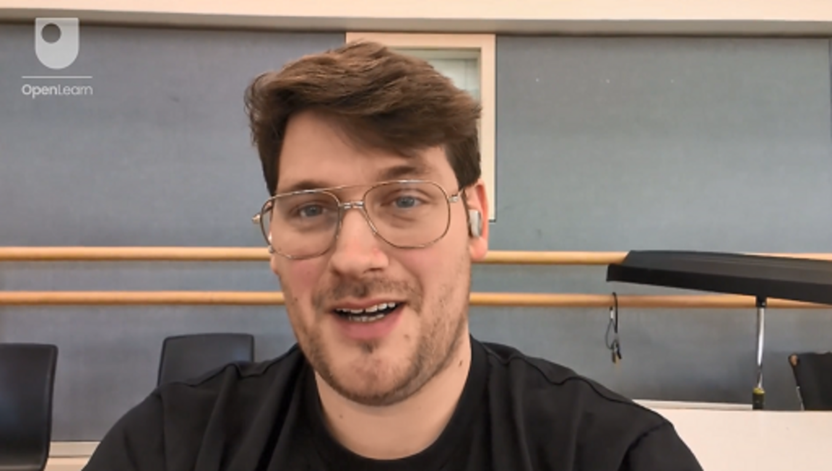

Then consider the following questions:
- Why did Tim choose to focus on Fanny Hensel.
- How has Tim gone about this work?

Provide your answer...
View discussion - Activity 2

For another excellent online resource dedicated to Fanny Hensel, see Hensel Pushers.

4 Summary of Week 3

View description - Uncaptioned Figure

This week, you have learned about how you can start researching historical women composers, where you can find scores of their music, what resources are already available for free online, and why you should consider creating your own performance editions. You have heard about Tim Parker-Langston’s work raising the profile of Fanny Hensel, creating editions of her songs, and making these available to other performers.
Next week, you will consider how you could diversify your repertoire by playing more music by living women composers or even commissioning new works. You will also hear from Stephan Meier, Artistic Director of Birmingham Contemporary Music Group (BCMG), talking about BCMG’s approach to commissioning new works from living women composers and how they are working towards gender balance within their programming.
You can now go to Week 4.

Week 4: Programming contemporary women composers

Introduction

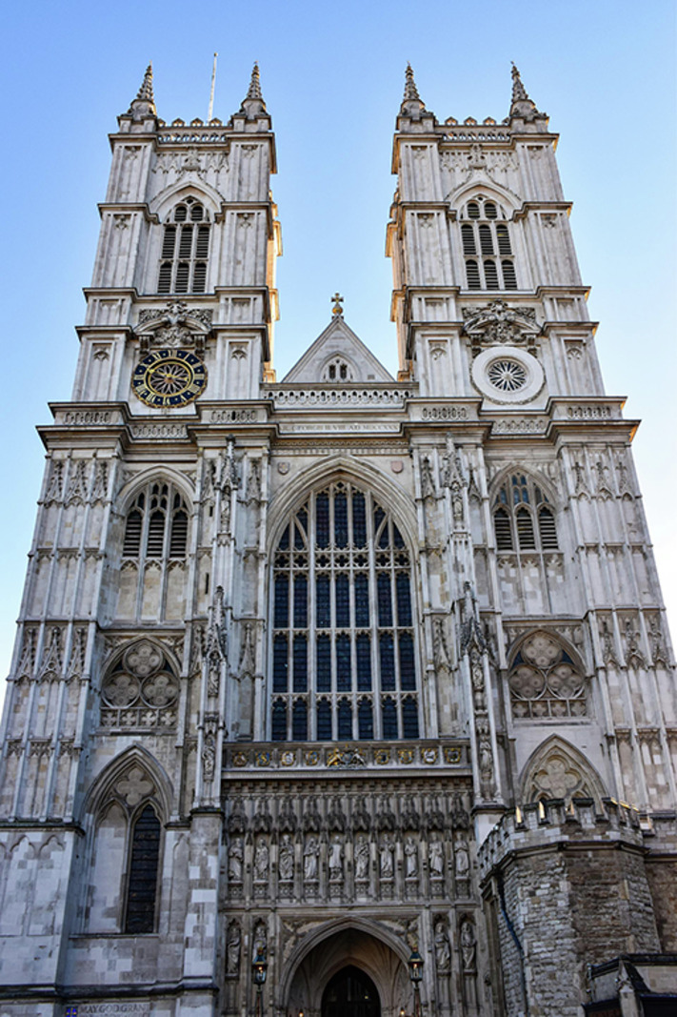
View description - Uncaptioned Figure

In 2014, Dame Judith Weir became the first woman to be appointed Master of the King’s Music (originally Master of the Queen’s Music), serving until 2024. Often considered broadly equivalent to the Poet Laureate, the Master of the King’s Music is a state musician post within the British Royal Household. The holder generally composes works to commemorate important royal events. During her tenure in the role, Weir composed music for the state funeral of Queen Elizabeth II and the coronation of King Charles III. Her appointment to such an important public musical role symbolised how fully accepted women composers had become within contemporary British classical music by the early twenty-first century, and how far things had moved on from the days when they were excluded from the musical canon (which you read about in Week 1).
This week, you will consider how to programme and more generally promote the work of contemporary women composers. This week is illustrated by a short interview with Stephan Meier, Artistic Director of Birmingham Contemporary Music Group (BCMG), talking about BCMG’s work promoting the work of contemporary women composers and working towards gender balanced programming.
By the end of this week, you should be able to:
- know how you can approach and work with living women composers
- be aware of a range of approaches you could take to promote the music of living women composers
- understand how you could go about working on projects with living women composers.

1 What is a ‘composer’ in the early twenty-first century?

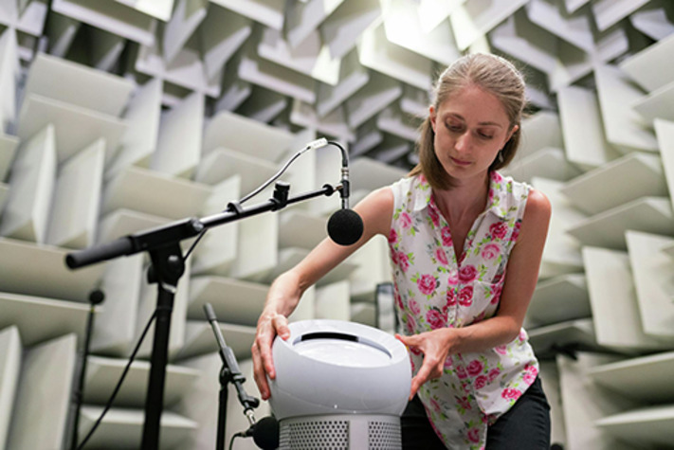
View description - Uncaptioned Figure

You are going to start this week by reflecting on what we mean by the term ‘composer’ in the early twenty-first century.

Activity 1

Reflect on the following questions and add your answers to the text box below.
- What do you understand the term ‘composer’ to mean today?
- Are there other types of ‘music creators’ whose work might also be considered to be a form of contemporary composition?

Provide your answer...
View discussion - Activity 1

When programming contemporary music, it is important to be aware that people producing music today might refer to themselves using different labels. Given the large part which electronics and electroacoustic composition has played in the development of art music since the later twentieth century, it’s also important to bear in mind that women creating sound-based works might not necessarily call themselves ‘composers’.

2 Working with living women composers

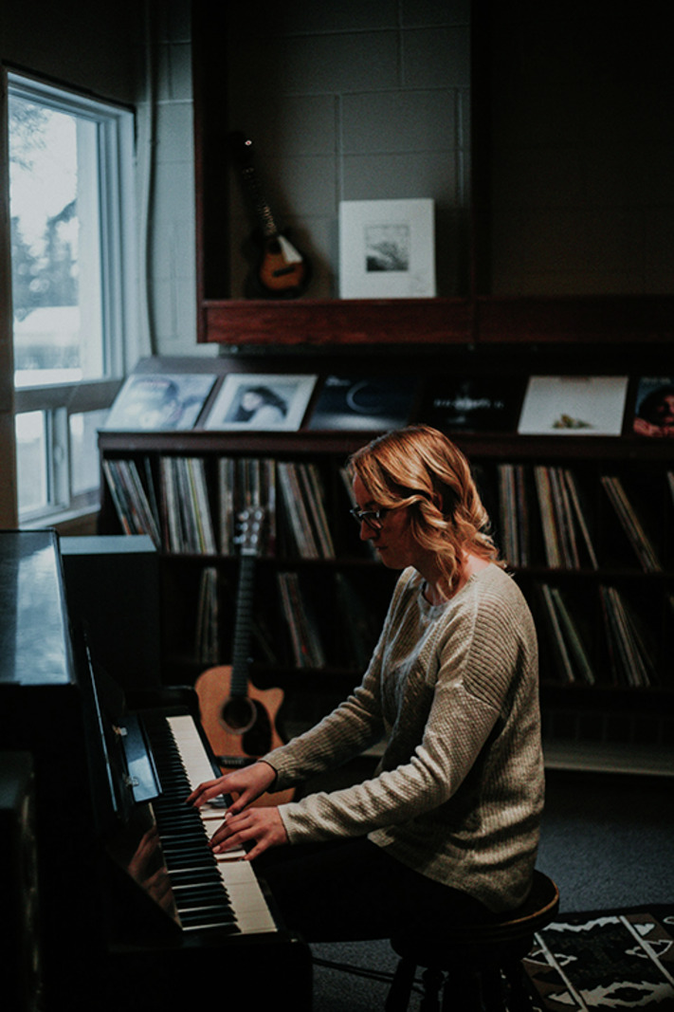
View description - Uncaptioned Figure

Working with living women composers removes many of the barriers of programming works by historical ones. They are alive, they can advocate for themselves, and they can provide copies of their own music (whether this be in the form of scores or sound art for diffusion).
There are lots of women composers and other types of music creators active today. Many maintain their own websites with lists of their works and contact details. There might already be works by particular women which you have heard and want to perform, or you might know women working in composition/music creation who you want to work with.
If you want to search for other women composers, you will find the F-List Directory of UK Female+ Musicians an invaluable resource. The F-List was created by Vick Bain, who is a leading campaigner for gender equity within the UK music industry. The F-List is a fully searchable directory of a large number of UK-based female+ musicians, songwriters and composers. The F-List defines itself as female+, as it is inclusive of transgender and gender diverse musicians. You can search for artists – including composers – by categories of musical role, genre, instrument and location. It is also an excellent resource if you want to search for other women musicians, such as local performers. The F-List also produces an extremely informative newsletter, which you might want to consider signing up for.

3 Ways of working with and promoting living women composers

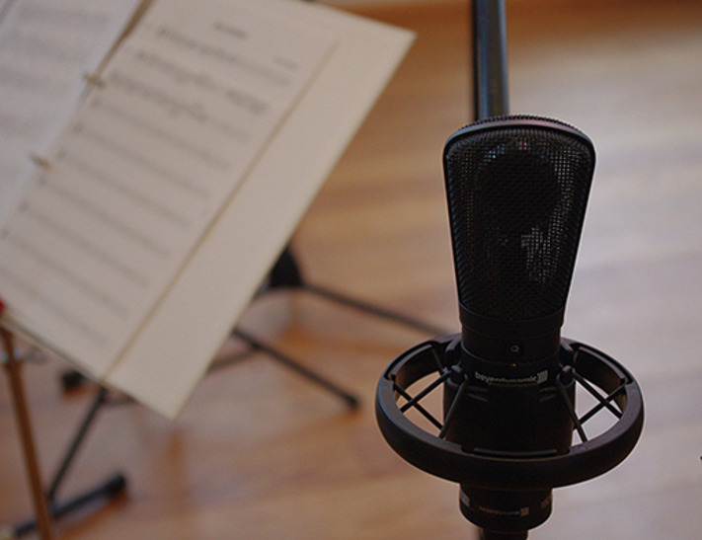
View description - Uncaptioned Figure

Depending on your interests and resources (you might be a solo performer, an amateur ensemble, or a professional music organisation), how you choose to work with and promote living women composers/music creators will vary, and it’s possible to mix and match a number of the different options suggested here.
Programming pre-existing works
One of the simplest ways of including music by living women composers/music creators is to programme works which they have already produced. If you’re doing this, it can be a nice idea to reach out to her to let her know and/or to invite her to your concert (if appropriate).
Commissions
If you have the resources, you might want to consider commissioning a new work from a living woman composer/music creator. Unless you have unlimited resources and are able to give your commissioned composer/music creator a totally free brief to create whatever they want, it’s really important to consider the fit of the composer/music creator to the purpose of your commission and any other parameters which you need to work within (e.g. length of piece, the forces available to realise it, and any financial restraints). You will hear Stephan Meier talking more about commissioning new works a little later this week.
Artist residencies
If your organisation is big enough and you are able to afford it, you could consider employing a living woman composer/music creator as an artist in residence. In addition to performing her music, you might want to invite her to be involved in outreach and/or education work with your local community or school(s).
Special projects
If you are working with a specific woman composer/music creator, and you have the contacts, you might also want to consider creating a new work as part of a special project with an education provider (school or university), community group, or community music ensemble. Depending on their input into the new work, the groups and communities which you work with might even become co-creators. Special projects such as these could be a commission and/or happen as part of an artist residency.

4 Towards gender balanced programming
In this section you are going to hear from Stephan Meier talking about BCMG’s work championing contemporary women composers. BCMG was founded in 1987 by musicians from the City of Birmingham Symphony Orchestra. They are one of the world’s leading specialist ensembles dedicated to contemporary music.

Activity 2

Watch the following interview in which Stephan Meier discusses BCMG’s work promoting the work of living women composers.

Video content is not available in this format.
View transcript - Uncaptioned interactive content

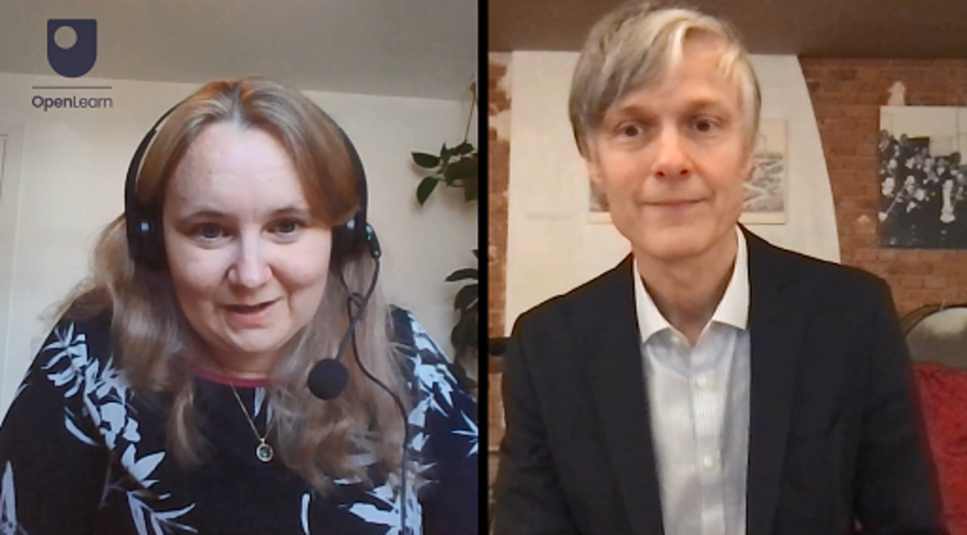

Then consider the following questions:
- How does BCMG champion contemporary women composers?
- What is BCMG’s approach to commissioning new works and composers and how are they working towards gender balanced programming?

Provide your answer...
View discussion - Activity 2

You will also have heard Stephan acknowledging that anonymous calls for new works are controversial. You will learn more about this debate in Week 6.

5 Summary of Week 4

View description - Uncaptioned Figure

This week, you have reflected on what the term composer/music creator can mean in the early twenty-first century. You have considered how you can work with contemporary women composers/music creators, including performing pre-existing works, commissioning new ones, engaging women as artists in residence, and working together with them and others on special projects. You have learned about how you can use the F-List Directory of UK Female+ Musicians to search for composers and other female+ musicians. You have also heard Stephan Meier discussing BCMG’s work championing women composers and working towards gender balanced programming.
Next week, you will reflect on how you can draw everything you have learned over the last four weeks together to start diversifying (or further diversifying) your own repertoire. You will hear Angela Slater discussing her work with the ensemble Illuminate, which exclusively promotes the work of women composers and performers.
You can now go to Week 5.

Week 5: Presenting gender diverse programmes

Introduction

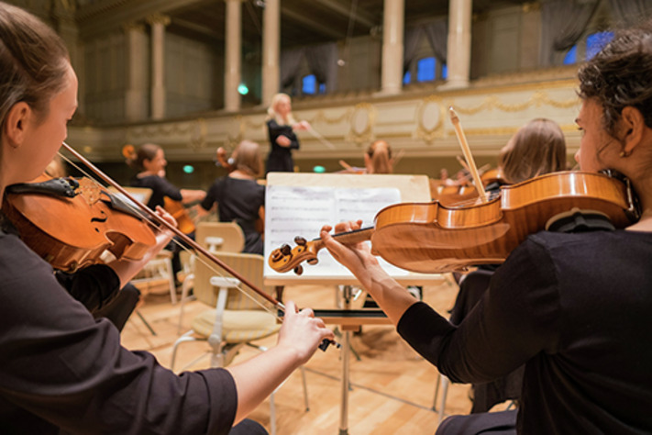
View description - Uncaptioned Figure

Keychange is an international movement which aims to encourage music festivals and organisations to commit to a 50 per cent representation of women and gender diverse people across their programming and staffing. Keychange 50:50 was originally set up in 2018 by Vanessa Reed, during her time as Chief Executive of the PRS Foundation, with the aim of achieving a 50:50 gender balance in music programming by 2022. Keychange is now led by the PRS Foundation, Reeperbahn Festival, and Musikcentrum Öst, and supported by Creative Europe alongside a wide range of international partners. Although the initial target of 50:50 by 2018 was not met, an ever-growing number of organisations remain pledged to this goal, which has become an international project. By committing to diversifying your own programming, you too are joining a large movement working towards gender equity within the music industry.
This week, you will consider how to bring together everything that you’ve learned so far. You will build your own toolkit to help you start diversifying your own programming (or diversifying it further if you are already working in this area). Additionally, you will hear from Angela Slater, composer and founder of Illuminate, talking about her work directing an all-woman ensemble which specialises in presenting work by historic and contemporary women composers.
By the end of this week, you should be able to:
- bring together everything that you have learned so far about what the challenges are around building gender diverse programmes, how you can contribute to making positive change, and strategies which you can adopt to perform works by historic and/or contemporary women composers
- create your own toolkit to help you start building your own gender diverse programmes.

1 Recap

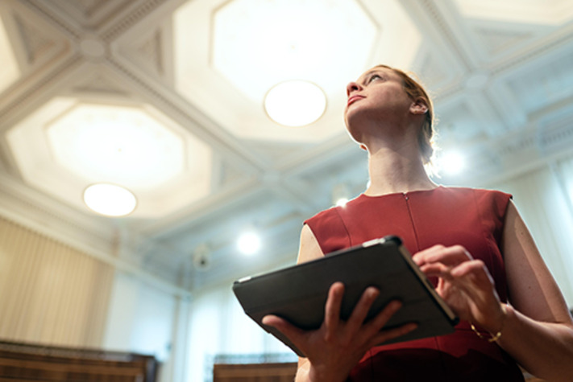
View description - Uncaptioned Figure

You will start this week by refreshing your memory on all the key learnings about diversifying programming which you have covered so far.

Activity 1

Part 1

Thinking back to what you learned in Week 1, consider the following questions:
- What were the historical barriers which led to women’s music not being included within the classical music repertoire as much as men’s?
- What can some of the challenges to performing more works by women composers be?

Provide your answer...
View discussion - Part 1

Part 2

Thinking back to Week 2, answer the following questions:
- What are some different approaches that you could take to programming women’s music?
- What are some of the issues which it’s important to bear in mind when including women’s music?
- What are some of the practical considerations which you need to think about when programming more music by women?

Provide your answer...
View discussion - Part 2

Part 3

Thinking back to Week 3, what are some of the benefits of making a performance edition of a previously unpublished work by a historic woman composer?

Provide your answer...
View discussion - Part 3

Part 4

Thinking back to Week 4, what are some of the different ways of working with contemporary women composers/music-creators?

Provide your answer...
View discussion - Part 4

2 Sharing good practice: Illuminate
Illuminate is an all-woman music ensemble founded by composer Angela Slater in 2017 to promote the work of historic and contemporary women composers.

Activity 2

Watch the following interview in which Angela Slater talks about her work with Illuminate.

Video content is not available in this format.
View transcript - Uncaptioned interactive content

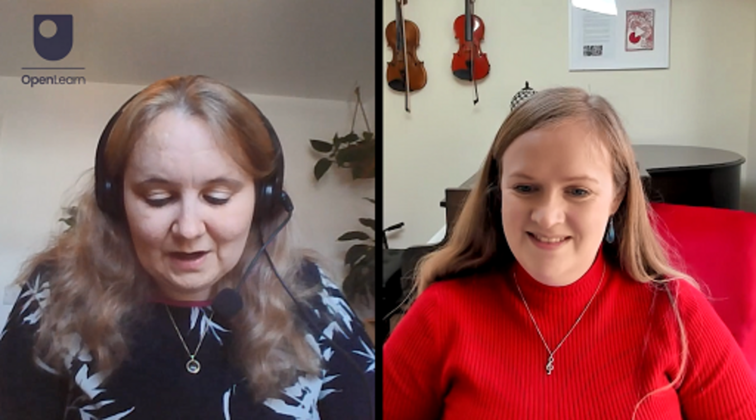

Then consider the following questions:
- What is Angela’s vision for Illuminate?
- What is her approach to programming?
- How does she ensure the financial sustainability of the project?
- How does she approach building new audiences for women’s music?

Provide your answer...
View discussion - Activity 2

When Angela introduced herself, you will also have heard her talking about how women composers were absent from her entire musical education, as was also the case for Gabriella Di Laccio and Tim Parker-Langston. In her discussion of her approach to programming, she also mentioned the issue of class privilege within classical music. This is an issue which you will hear more about in Week 6.

3 Building your toolkit

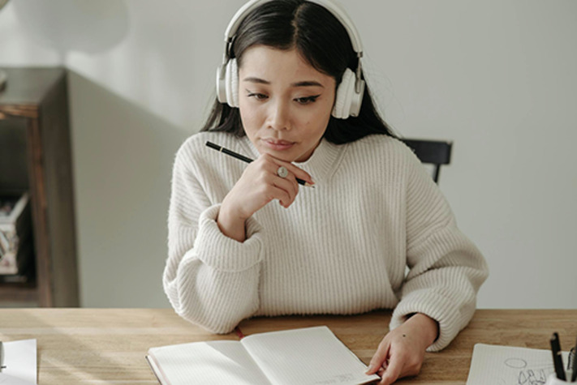
View description - Uncaptioned Figure

You are now going to complete an activity designed to help you think through the things you’ll need to consider when diversifying your repertoire. You will then be able to use this as a practical toolkit, which you can apply to diversifying your own repertoire. Think of this like a checklist to help you work through key stages of the process

Activity 3

Imagine your ideal concert including or consisting entirely of music by women. Fill in the blank sections of the toolkit below of the steps you’ll need to work through to bring it all together.
A Word version of the toolkit is also available if you would prefer to work in that way: Toolkit
Unfortunately the Word version of the Toolkit is not available in this format of the course. Please refer to the live OpenLearn course to access the Word version of the Toolkit.
Practical considerations
What is the venue?

Provide your answer...

What is the date and time of the concert (if known)?

Provide your answer...

Who is your likely audience (list all likely people/groups who might attend)?

Provide your answer...

Who will be performing?

Provide your answer...

Funding
What are your sources of funding?

Provide your answer...

Are there any particular sources of funding that you can apply for? (Remember to think about organisations which specifically promote the performance of women’s music.)

Provide your answer...

Do you have additional costs? (For example, will you need to factor in additional rehearsal time for performers to learn new works? Will you have to pay for someone to prepare a new performance edition? Will you need to hire a music scholar as consultant?)

Provide your answer...

Planning your programme
Are you going to present an all-woman concert or are you going to add works by women into a mixed programme?

Provide your answer...

Where are you going to source your scores?

Provide your answer...

Do you need to prepare/commission a new performance edition?

Provide your answer...

Do you need to identify a specialist music scholar to work with?

Provide your answer...

Are you commissioning a new work?

Provide your answer...

Building your audience
Who is going to write your programme notes?

Provide your answer...

Are you going to offer a pre-concert talk to offer more contextual information about the woman/women whose music you are performing?

Provide your answer...

Are you going to undertake any outreach/education activities?

Provide your answer...

Who is going to help you build your audience? For example, do you need to identify and work with a music scholar? If you are presenting the work of living women composers/music-creators, do you want to involve them? Will you be reaching out to and working with local community groups and/or education providers?

Provide your answer...

4 Summary of Week 5

View description - Uncaptioned Figure

This week, you have recapped all of your key learnings on the course so far and have considered further how you are going to embed them into your own practice to diversify (or further diversify) the repertoire which you perform. You have completed your own toolkit to support you starting work on building your own gender diverse programmes. You have also heard from Angela Slater talking about her week leading Illuminate.
Next week, you will consider how to support inclusive practices beyond gender. You will also hear from Deborah Keyser discussing her work as Director of Tŷ Cerdd/Music Centre Wales.
You can now go to Week 6.

Week 6: Developing inclusive practices

Introduction

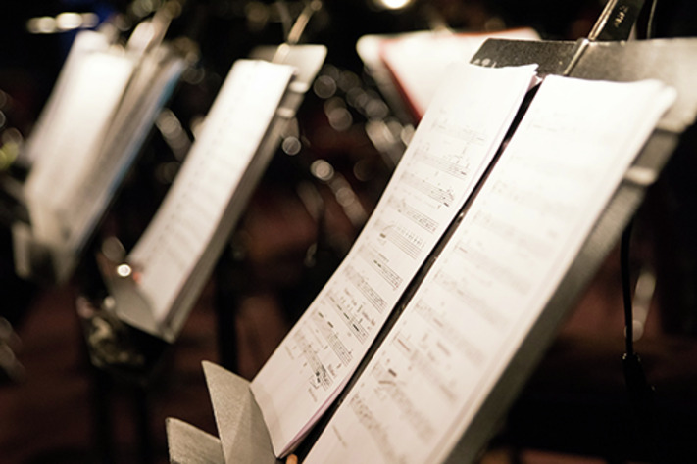
View description - Uncaptioned Figure

In Week 1 you learned that research completed by Donne Women in Music in 2024 found that 92.5 per cent of orchestral repertoire performed worldwide in the 2023/24 concert season was written by men, while music written by women made up just 7.5 per cent. (Donne Women in Music’s research was based upon an examination of the repertoire presented by 111 orchestras based across 30 countries.) Of this 7.5 per cent, 5.8 per cent was composed by white women, while music written by women from the global majority made up just 1.6 per cent of all orchestral music performed. These figures highlight that gender is not the only important factor to bear in mind when seeking to diversify programming, as composers have also been excluded from the performing canon along the lines of race, ethnicity, class, disability and/or neurodiversity, religion, and sexuality/sexual identity.
This week, you will start to consider how you might begin to diversify your programming beyond gender and how you can promote inclusive practices more broadly. You will also hear from Deborah Keyser discussing her work fostering inclusive practices as Director of Tŷ Cerdd/Music Centre Wales.
By the end of this week, you should be able to:
- have an understanding of the concept of intersectionality and how it has affected marginalisation within classical music programming
- think about how you can start to diversify your programming beyond gender, and what resources are available to help you
- have an awareness of how you can ensure equity of opportunity for those seeking to work within the classical music industry.

1 Thinking intersectionally


View description - Uncaptioned Figure

Women composers are not the only group who have traditionally been excluded from the classical music canon. Composers have also been excluded along the lines of race, ethnicity, class, disability and/or neurodiversity, religion, and sexuality/sexual identity. When thinking about developing more diverse programmes, it is really important to think intersectionally and not to focus exclusively on gender.
Intersectionality is a theory used within sociology and cultural theory. It was coined by US Civil Rights activist and prominent critical race theory (CRT) scholar Kimberlé Crenshaw in 1989. It describes how the overlapping or intersecting of marginalised identities (such as gender, race and class) contribute to discrimination and oppression.

Activity 1

How might intersectionality affect composers?

Provide your answer...
View discussion - Activity 1

While you are thinking about including more works by women composers, ensure that you also consider including works by composers who have been excluded from the traditional classical music performing repertoire for other reasons. As you move to including more works by women, try to ensure that you are not just focusing on middle-class, able-bodied, white women, but also thinking about including as diverse a range of different women composers as possible. In Week 2 you heard Róisín Maher talking about how she always tries to include non-white composers on the programme for Finding A Voice and in Week 5 you head Angela Slater discussing the issue of class privilege within classical music and how she tries to ensure that composers form different educational backgrounds are represented on her programmes with Illuminate.

2 Thinking about diversifying programming more broadly


View description - Uncaptioned Figure

As you have learned, women composers were not the only group who were excluded from the classical music canon. Historically, many composers were also excluded because of race, ethnicity, class, disability and/or neurodiversity, religion, and sexuality/sexual identity. The classical music canon was (for a very long time) dominated by the music of middle-class, white men. When you are thinking about diversifying the repertoire which you perform, it’s important to think about this intersectionally.
Beyond including more works by women, you could also think about diversifying your programmes more broadly, ensuring that you also perform music by composers from other groups who have historically been excluded. This section suggests a number of resources that you might find useful as you start to approach this.
The Institute for Composer Diversity, based at the School of Music at the State University of New York at Fredonia, brings together a range of extremely useful resources, including a number of databases of composers and works from historically excluded groups. The Resources for repertoire: composer diversity, pages brought together and hosted by the Julliard School, brings together multiple suggestions for essential online resources and suggestions for diversifying repertoire. Music by Black Composers is an extremely important resource for music by Black composers, including a range of repertoire directories, which also offers valuable pedagogic materials. plainsightSOUND is a research project focused on the stories of classical performers and composers active in Britain before 1970, which also includes a valuable database.
It is also important to think about fostering inclusive practice more generally. In the next section, you will hear Deborah Keyser discussing her work promoting inclusive practices at Tŷ Cerdd/Music Centre Wales.

3 Sharing good practice: Tŷ Cerdd/Music Centre Wales
Tŷ Cerdd/Music Centre Wales promotes and develops Welsh music and supports musicians based in Wales.

Activity 2

Watch the following interview in which Deborah Keyser discusses her work as Director of Tŷ Cerdd/Music Centre Wales.

Video content is not available in this format.
View transcript - Uncaptioned interactive content

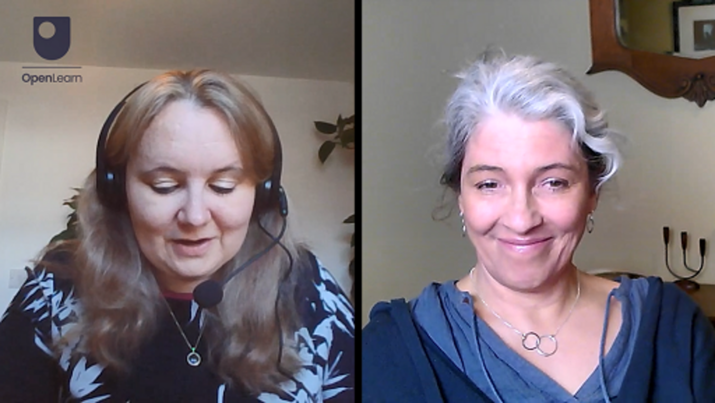

Then respond to the following questions:
- What sorts of barriers do people face which make it difficult for them to participate – or to participate fully – in the classical music industry?
- What can we do to mitigate these barriers to make access to the classical music industry more inclusive?
- How can we make application processes for opportunities within the classical music industry fairer?
- What sorts of adjustments can be appropriate, reasonable and helpful to consider?

Provide your answer...
View discussion - Activity 2

In Week 4, you heard Stephen Meier discussing the positive experiences that BCMG has had using anonymous selection, although he acknowledged that this practice is controversial. In this video clip, you have heard Deborah outlining what the issues with using anonymous selection are.
Ensuring equity of opportunity: Fair Access Principles
You heard Deborah Keyser discussing Tŷ Cerdd’s commitment to Sound and Music’s Fair Access Principles. These have been devised as a code of best practice for open and inclusive artist development programmes, competitions and awards. You can read the full principles, which you might like to consider signing your own organisation up to if you aren’t already, on the Sound and Music website.

4 Summary of Week 6

View description - Uncaptioned Figure

This week has moved beyond focusing primarily on gender to consider the need to diversify programming more broadly. You have been introduced to the concept of intersectionality and explored some key resources which you can use to help you diversify your programming further. You have also heard Deborah Keyser discussing her work with Tŷ Cerdd, who have signed up to Sound and Music’s Fair Access Principles.

Where next?
If you’ve enjoyed this course you can find more free resources and courses on OpenLearn.
New to University study? You may be interested in our courses in Music.
Making the decision to study can be a big step and The Open University has over 40 years of experience supporting its students though their chosen learning paths. You can find out more about studying with us by visiting our online prospectus.

References
Cohen, A.I. (1987) InternationalEncyclopedia of Women Composers, Second Revised and Enlarged Edition. New York: Books & Music USA.
Di Laccio, G. and Hardman, E. (2024) Equality and Diversity in Global Repertoire. Available at: https://donne-uk.org/wp-content/uploads/2021/03/DonneReport2024.pdf (Accessed: 7 April 2025).
ISM (Independent Society of Musicians) (2023) ‘An analysis of women composer and conductor involvement at the BBC Proms 2023’, 6 July. Available at: https://www.ism.org/news/ism-analysis-of-2023-bbc-proms-shows-less-than-7-of-music-programmed-was-composed-by-women/ (Accessed: 7 April 2025).
Hamer, L. (2018) Female Composers, Conductors, Performers: Musiciennes of Interwar France, 1919–1939. Abingdon and New York: Routledge.
Slater, A.E. (2022) ‘Invisible canons: a reflective commentary on the formation of my personal canon of women composers’, in Mathias, R. (ed.) The Routledge Handbook of Women’s Work in Music. London and New York: Routledge, pp. 177–86.

Acknowledgements
This free course was written by Laura Hamer.
With thanks to Ann Grindley (The Open University) who supported the development of this OpenLearn course, and to Lucy Hollingworth (The Open University) and Kenneth Baird (European Opera Centre), who also provided extremely helpful feedback. Many thanks to all of the interviewees for their valuable contributions: Gabriella Di Laccio (Donne Women in Music), Róisín Maher (Finding A Voice), Tim Parker-Langston (Hensel Songs Online), Stephan Meier (BCMG), Angela Slater (Illuminate), and Deborah Keyser (Tŷ Cerdd). Thanks also to Michael McCarthy (Music Theatre Wales) and Paula Scott (Welsh National Opera) for their valuable insights. Many thanks to Åsa Malmsten (The Open University) for all her support and input into the development of this OpenLearn course. Last but not least tremendous thanks to Hannah Parish, Claudia Torres Fernández, Marcus Young, and Luke Yorke from the OpenLearn team.
Except for third party materials and otherwise stated (see terms and conditions), this content is made available under a Creative Commons Attribution-NonCommercial-ShareAlike 4.0 Licence.
The material acknowledged below is Proprietary and used under licence (not subject to Creative Commons Licence). Grateful acknowledgement is made to the following sources for permission to reproduce material in this free course:
Week 1
Images
Course image: Photo by Manuel Nägeli on Unsplash
Introduction image: Photo by AfroRomanzo/https://www.pexels.com
Section 1 image: pvproductions/www.freepik.com
Section 2 image: Image by Pexels from Pixabay
Section 5 image: Designed by Freepik www.freepik.com
Audio/video
Section 3 video: The Open University
Section 4 video: The Open University
Week 2
Images
Introduction image: Photo by Miguel Bruna on Unsplash
Figure 1: Fanny Hensel (born Mendelssohn), sketched in 1829 by Wilhelm Hensel; https://www.library.yale.edu/musiclib/exhibits/mendelssohn/edited/FannyMendelssohnHensel_adjusted.jpg
Figure 2: By Julius Giere - Schumann-Portal, Public Domain, https://commons.wikimedia.org/w/index.php?curid=6580689
Section 3 image: Image by wal_172619 from Pixabay
Section 5 image: Designed by Freepik www.freepik.com
Audio/video
Section 4 video: The Open University
Week 3
Images
Figure 1: French composer Jeanne Leleu (1898-1947); Bibliothèque nationale de France, Public Domain, https://commons.wikimedia.org/w/index.php?curid=11200698
Section 1 image: Photo by Tima Miroshnichenko: https://www.pexels.com
Section 2 image: Photo by Engin Akyurt; https://www.pexels.com
Section 4 image: Designed by Freepik www.freepik.com
Audio/video
Section 3 video: The Open University
Week 4
Images
Introduction image: Photo by AXP Photography
Section 1 image: Photo by ThisIsEngineering:/https://www.pexels.com
Section 2 image: Photo by Priscilla Du Preez on Unsplash
Section 3 image: Image by alsterkoralle from Pixabay
Section 5 image: Designed by Freepik www.freepik.com
Audio/video
Section 4 video: The Open University
Week 5
Images
Introduction image: Photo by Manuel Nägeli on Unsplash
Section 1 image: Image by This_is_Engineering from Pixabay
Section 3 image: Photo by Pavel Danilyuk/https://www.pexels.com
Section 4 image: Designed by Freepik www.freepik.com
Audio/video
Section 2 video: The Open University
Week 6
Images
Introduction image: Photo by A J. on Unsplash
Section 1 image: Rawpixel.com www.freepik.com
Section 2 image: Rawpixel.com www.freepik.com
Section 4 image: Designed by Freepik www.freepik.com
Audio/video
Section 3 video: The Open University
Every effort has been made to contact copyright owners. If any have been inadvertently overlooked, the publishers will be pleased to make the necessary arrangements at the first opportunity.
Don't miss out
If reading this text has inspired you to learn more, you may be interested in joining the millions of people who discover our free learning resources and qualifications by visiting The Open University – www.open.edu/openlearn/free-courses.

Solutions

Activity 1

Discussion
There are no right or wrong answers here, and your responses will be very personal to you. You might already have an extensive knowledge of women composers and regularly champion their works, or you might be further towards the beginning of your journey to diversify your repertoire.
Back to - Activity 1

Activity 2

Discussion
You may have noted some of the following:
- ignorance of the repertoire (you may have found that Gabriella’s reflections on how women composers were absent from her own professional training and practice before she discovered Aaron’s Cohen’s International Encyclopedia of Women Composers resonated with your own responses in Activity 1)
- the need to invest time researching women’s music
- difficulties accessing scores of women’s music or not having a good quality performance edition available
- fear of programming unfamiliar music.
Back to - Activity 2

Activity 3

Discussion
You may have noted some of the following:
- adding pieces by women to your repertoire
- connecting with organisations that promote women’s music
- contextualising the music for audiences
- creative programming, such as including a work by a woman composer alongside more well-known works by a male peer
- developing new audiences
- commissioning new works by women
- creating performance editions of women’s works
- researching women composers and their music.
Back to - Activity 3

Activity 1

Part 1

Discussion
Giving significantly less time to women’s music within programmes enforces the idea that their works are less worth listening to. Including a very short work by one woman on a programme which is otherwise entirely made up of men’s works can also look tokenistic (whether intentional or not), which may lead to criticism.
Back to - Part 1

Part 2

Discussion
Not including women’s music in main concerts also sends the message that their works are less worthy listening to and less worthy of showcasing.
Back to - Part 2

Activity 2

Discussion
- Róisín includes the following approaches:
  - including different musical genres on the festival programme
  - contextualising the music by inviting performers to talk to the audience, composer interviews, pre-concert talks and post-concert Q&As
  - partnering with local cultural providers.
- Róisín explains that the festival is supported by lots of diverse funding streams, including:
  - The Arts Council of Ireland
  - local county council arts funding (Tipperary County Council)
  - commercial sponsorship
  - support in kind from RTÉ (the Irish national television and radio broadcaster)
  - ticket sales.
- Róisín suggests the following:
  - including as many different genres as possible
  - trying to avoid creating an alternative canon of women composers
  - considering the extent of the performers’ experience performing women’s music
  - focusing on significant anniversaries (such as the Clara Schumann Bicentenary in 2019)
  - promoting the work of Irish women composers
  - ensuring that works by composers from different races and ethnicities are included.
Back to - Activity 2

Activity 1

Discussion
- The composer’s handwriting could be difficult to decipher; depending on the historical period from which the piece dates, the score could include old-fashioned musical conventions (e.g. unusual clefs or symbols) which are no longer in common use; and the quality of digitised materials (depending on the source material) might be low quality and difficult to read from.
- You can make it easier to perform this music by making your own, up-to-date copy of the work, using modern clefs and musical notation, and using a music notation software package to set it. By doing this, you would effectively be creating your own new performance edition of the work.
Back to - Activity 1

Activity 2

Discussion
- Tim describes himself as ‘shamedly’ discovering Fanny Hensel just before embarking on his PhD and reflects on the shock of this, given his training and professional experience as a singer. (You might have found that his comments resonated with your own experiences, which you reflected on at the start of Week 1.) He also shares that he chose to focus on Hensel because he found her music emotionally visceral, distinct from her contemporaries, and was particularly struck by how different it was to that of her brother’s (Felix Mendelssohn).
- Tim explains that he used the high-quality scans of Hensel’s manuscript songs which the Staatsbibliothek zu Berlin had already made available online. He focused on producing practical performance editions which would be clear, easy to read, and user-friendly by removing the elements that a modern musician might find it difficult to read from. He then used Sibelius engraving software to create PDFs (including versions in different keys), which are hosted on Hensel Songs Online.
Back to - Activity 2

Activity 1

Discussion
There aren’t any fixed right or wrong answers to these questions, and how you responded will be personal to you and your particular musical tastes and interests. For question 1, you might have responded that a composer is someone who composes or otherwise creates new works of music. Question 2 invites you to consider people creating music today more broadly and uses the term ‘music creator’ to reflect this. Some music creators today who work with different forms of sound or electronics, prefer to refer to themselves as ‘sound artists’, ‘sonic artists’, ‘music programmers’, ‘sound engineers’, ‘electronic music producers’, or even ‘instrument builders’, though others prefer the term ‘electroacoustic composer’. You might also have broadened the term out to include songwriters.
Back to - Activity 1

Activity 2

Discussion
- Stephan discusses BCMG’s mission to find high-quality contemporary music. He also talks about the importance of finding gender balance and outlines some tactics to support this, including:
  - programming UK/Birmingham premiers of new works
  - giving new works a second performance
  - commissioning new works
  - contextualising new works
  - the importance of their education and outreach work.
- Stephan again highlights BCMG’s commitment to seeking high-quality contemporary music. He discusses the important of making this a meaningful experience for the performers, composers, and the audience, and underlines the importance of careful planning to bring all this together. He outlines some of the strategies which BCMG have used to work towards gender balance including:
  - open calls for new works
  - anonymous calls
  - ensuring a gender-balanced selection process.
Back to - Activity 2

Activity 1

Part 1

Discussion
- Women composers were excluded from the classical music canon which formed during the nineteenth century. Because their works weren’t included within the canon, they were left out of how the story of music history was told and their works weren’t included within music education or training programmes.
- Historically, less music by women than by men has been published. This can make it challenging to access scores of their works. Sometimes performers/organisations can be reluctant to programme works by women composers, as they are nervous that audiences will be unfamiliar with their works and that this will affect ticket sales.
Back to - Part 1

Part 2

Discussion
- You could curate an all-woman programme or alternatively you could add pieces by women into a mixed programme, which might be themed by historical music period or musical genre, etc.
- When including works by women on programmes, it’s important to think about timing and placement and to avoid your inclusion looking tokenistic.
- When programming more music by women, it’s important to consider funding, audience engagement, and how you will get performers on board.
Back to - Part 2

Part 3

Discussion
Some of the benefits of making a performance edition of a previously unpublished work by a historic woman composer are that it will make it easier for you to read and play the piece yourself. If you choose to make your new performance edition available to others, you will also be increasing the amount of music by women which is easily available to be performed.
Back to - Part 3

Part 4

Discussion
You could programme pre-existing works. If you have the necessary resources, you could also commission a new work, engage a woman composer/music-creator as an artist in residence, or work with them on a special project (which might include local community groups or education providers).
Back to - Part 4

Activity 2

Discussion
- Angela talks about having lots of different missions within Illuminate:
  - educating audiences, performers and composers about historical and contemporary women composers through their concerts, blog series and recordings
  - repeating performances of works beyond their premier to embed them within the canon
  - providing opportunities to composers from different backgrounds and ensuring that concerts take place in different parts of the UK.
- Angela discusses the need to strike a good balance between showcasing historical and contemporary women. She mentions practical considerations: works being written for particular ensembles and score availability. She also talks about adapting programmes depending on the audience, placing unfamiliar works on programmes with familiar ones, ‘sandwiching’ contemporary music between historical works, and maintaining dialogue with the performers.
- Angela talks about making regular grant applications and explains that Illuminate have previously received funding from: the Hinrichsen Foundation, GEMMA Classical Music Trust, Vaughan Williams Foundation, Arts Council England, Creative Scotland, and the Marchus Trust.
- Angela discusses how she has built new audiences for women’s music through:
  - Illuminate’s blog series where audiences can learn more about the composers
  - working with the concert series, venues and promoters that Illuminate are presenting their concerts with (you will have heard here highlighting her positive experience with BCMG, who you heard from in Week 4).
Angela also talks about her belief that audiences are underestimated and that in her experience audiences are often actually curious to hear new works.
Back to - Activity 2

Activity 1

Discussion
Certain composers can find themselves doubly marginalised. For example, because of their race and because of their gender, or because of their class background and because of their disability status. The intersectionality between their different and various characteristics can make it even harder for some composers to have their music heard.
Back to - Activity 1

Activity 2

Discussion
- Deborah stresses that the barriers that people can face are multiple and often intersectional, including:
  - class (which she sees as the lack of free music education in schools now exacerbating)
  - socioeconomic
  - disability
  - gender
  - caring responsibilities
  - cultural.
- Deborah reflects on how complex this can be and discusses various ideas, including:
  - paying people to participate in opportunities
  - positive action to support music-creators with particular characteristics, such as Tŷ Cerdd’s Penguin Pebbling pathway to support neurodivergent music creators
  - avoiding talking too much about specific genres and making opportunities open to people who have not had a formal music education and might be unable to read music notation
  - being very clear and more enabling.
- Deborah comments that this is a really big question and outlines various ideas, including:
  - making applications free
  - paying people for their time and covering expenses
  - ensuring accessible formats and simplifying the process
  - accepting video and/or audio applications
  - not asking for specific qualification levels
  - focusing on asking music creators to describe their practice
  - naming panel members
  - being clear about the process
  - not using anonymous selection.
- Deborah explains that reasonable adjustments can be as broad as the different people who we are working with. She talks about several, including:
  - having a safe, quiet space that people can use
  - working flexibly and being open to discussing people’s needs with them
  - accepting that adjustments will be different for different people
  - having named contacts people can talk to
  - providing support workers
  - making it possible for people to bring babies if they need to
  - helping to cover caring costs
  - thinking through wheelchair access and making physical adjustments to spaces.
Back to - Activity 2

Descriptions

Uncaptioned Figure
A photograph of an orchestra.
Back to - Uncaptioned Figure

Uncaptioned Figure
A photograph of a person looking at sheet music.
Back to - Uncaptioned Figure

Uncaptioned Figure
Bright lights behind a fence.
Back to - Uncaptioned Figure

Uncaptioned Figure
A rolled up manuscript.
Back to - Uncaptioned Figure

Uncaptioned Figure
A silhouette of a person with their fist in the air.
Back to - Uncaptioned Figure

Figure 1 An illustration of the composer Fanny Hensel (born Mendelssohn), sketched in 1829 by Wilhem Hensel.
An illustration of the composer Fanny Hensel.
Back to - Figure 1 An illustration of the composer Fanny Hensel (born Mendelssohn), sketched in 1829 by Wilhem Hensel.

Figure 2 An illustration of the composer Clara Schumann, from an 1835 lithograph.
An illustration of the composer Clara Schumann.
Back to - Figure 2 An illustration of the composer Clara Schumann, from an 1835 lithograph.

Uncaptioned Figure
A photograph of a person’s hands on a piano.
Back to - Uncaptioned Figure

Uncaptioned Figure
A rolled up manuscript.
Back to - Uncaptioned Figure

Figure 1 A photograph of Jeanne Leleu.
A black-and-white photograph of Jeanne Leleu playing the piano.
Back to - Figure 1 A photograph of Jeanne Leleu.

Uncaptioned Figure
A photograph of someone in the archives.
Back to - Uncaptioned Figure

Uncaptioned Figure
A photograph of books on a bookshelf.
Back to - Uncaptioned Figure

Uncaptioned Figure
A rolled up manuscript.
Back to - Uncaptioned Figure

Uncaptioned Figure
A photograph of Westminster Abbey, London.
Back to - Uncaptioned Figure

Uncaptioned Figure
A photograph of a sound engineer.
Back to - Uncaptioned Figure

Uncaptioned Figure
A photograph of a person playing the piano.
Back to - Uncaptioned Figure

Uncaptioned Figure
A photograph of a microphone.
Back to - Uncaptioned Figure

Uncaptioned Figure
A rolled up manuscript.
Back to - Uncaptioned Figure

Uncaptioned Figure
A photograph of an orchestra.
Back to - Uncaptioned Figure

Uncaptioned Figure
A photograph of a person with a tablet looking at their surroundings.
Back to - Uncaptioned Figure

Uncaptioned Figure
A photograph of a person wearing headphones, with a pen and notepad.
Back to - Uncaptioned Figure

Uncaptioned Figure
A rolled up manuscript.
Back to - Uncaptioned Figure

Uncaptioned Figure
A photograph of some musical scores.
Back to - Uncaptioned Figure

Uncaptioned Figure
An illustration of people connected by connected dots.
Back to - Uncaptioned Figure

Uncaptioned Figure
An illustration of people connected by connected dots.
Back to - Uncaptioned Figure

Uncaptioned Figure
A rolled up scroll.
Back to - Uncaptioned Figure

Uncaptioned interactive content

Transcript
LAURA HAMER
Thank you for joining me today, Gabriella. Could you tell us a little bit about yourself and about Donne Women in Music?
GABRIELLA DI LACCIO
I am a professional classical singer, opera singer, and I am also the founder of the Donne Foundation or as [it] is well known as Donne Women in Music. Donne means women in Italian. I’m originally from Brazil and I moved here to study, and I must say that for many, many years I never questioned the presence of women in the history of music because I simply accepted that there were less women when I was at college and afterwards when I continued with my professional career as a performer. The story of the reason why I decided to create a foundation now that promotes and amplifies women’s music was almost like a coincidence that I found this I brought here today, this encyclopaedia which was called [it’s upside down] the International Encyclopedia of Women Composers in a second-hand shop in South Bank. As you can see, this is a kind of a heavy two volumes and in this encyclopaedia, Aaron Cohen listed 6,000 women composers from pre-medieval times to 1984. I felt extremely ignorant and then I went and researched a bit more because as a woman in music, I felt like, oh, I should know these women. So when I started to learn all this beautiful music that I never heard, the stories behind these women, I decided to start a small passion project in 2018. It was a small website. I called it Donne Women in Music. I listed the Big List of women composers at the time had 4,000 names, which I inputted myself and I pressed go and then the rest is actually history. Now the foundation is a registered charity here. The resources are used by performers, by universities, by organisations. It has so much in this website. I invite all of you to visit because it has the Big List of women composers. It has playlists. It has educational videos. We produce this very important data research every year, looking at the number of pieces by women performed around the world, which is a very important piece of data if you are interested in learning more about what’s the real numbers.
LAURA HAMER
Could you tell us, what do you regard as being the biggest challenges which those who’d like to programme more music by women face?
GABRIELLA DI LACCIO
The first challenge is the ignorance of the repertoire. When I’m trying to talk to people because people say, oh, but there are questions like, oh, if the music was good, it would have made it. Or we don’t think about gender, we only think about quality. Then you have to remember that opportunities never came equal for people. Now it’s our job to really try to do our job to find these pieces first. The second challenge, then they’ll say that we decided, okay, I want to include. I think we have to take a conscious decision, I guess, when you are wishing to programme that we were going to have to spend some time. If you want to be inclusive, you’re going to have to dig deeper and to search with a lot of intention to find these works because some of them are unpublished, or the scores are not easy to find. It will not appear easily in front of you sometimes like so many other pieces.
LAURA HAMER
Could I ask you, how significant do you think is the fact that the scores of women’s music can often be more difficult to access? How significant do you think that is as a barrier?
GABRIELLA DI LACCIO
For me, it’s a crucial, very, very significant barrier. People don’t realise sometimes that without scores or having the music properly edited, it doesn’t have to be published by a big publishing house. It just needs to have a score that is a PDF or is available online or published as well, that is easy to read. I do a lot of Baroque music. I’m more used to dealing with manuscripts because Baroque music has a lot of manuscripts, handwritten. When we study that, we learn how to read manuscripts. Many people that are in the music industry don’t have time to learn how to read a manuscript. If you’re doing a rehearsal with an orchestra, for example, and the music is very hard to read, it will not work. Not having these proper editions published or online published creates a lot of problems because then if you have a small orchestra or it doesn’t have even to be a professional orchestra, but they really want to play this music, but they can’t find a good score to play. They’re not going to be able to do it because they won’t have money to buy or somebody to transcribe professionally that music. What happens is that music is not played, it doesn’t get recorded. If it doesn’t get recorded, we don’t listen on the radio, we don’t listen on Spotify or any streaming. What happens is we don’t get any familiarity with that music. Then we live in this vicious cycle. So not having the scores is a huge problem.
LAURA HAMER
Another challenge people often talk about is audiences and audiences being reluctant to go to pieces that they might not know, pieces by women that they’re unfamiliar with. How big do you think this is as an issue that this might affect ticket sales? Is it being a real fear for people to program things?
GABRIELLA DI LACCIO
I think this fear is very common. I hear that a lot. I understand the problem. I understand selling tickets is important. I know how important it is. We all have to sell tickets. Now having said that, I think this fear is more of the person behind the stage than an audience fear.
Back to - Uncaptioned interactive content

Uncaptioned interactive content

Transcript
LAURA HAMER
So, Gabriella, what do you see as potential solutions to performing more music by women?
GABRIELLA DI LACCIO
Me as a singer, if I want to include a piece, I can listen to more works by women. It’s so much easier today and then start little by little, amplifying my repertoire, or adding a piece as an encore if, for example, somebody asked me to perform and it wasn’t my control on the repertoire, little things like that. Or a programmer for a bigger orchestra or festival. The same thing, just try to listen to more things and connect maybe with organisations like Donne that can provide some help. And after we make the choices as well, I believe it’s very important how we present these pieces. Every time I present a new piece in my concerts, for example, I always tell a story. You don’t simply put a piece in the programme. You build a story behind [it], you invite people to be part of that conversation. And in every concert I’ve done that, everybody leaves with this hunger for learning a bit more about [the music] and planting that seed of curiosity in the audiences that I think is so important. I don’t feel audiences will have such a problem if, and that’s what I’m saying, if you find ways of presenting that piece in a creative way. For example, if you’re already doing a very famous piece that will bring an audience to the concert, you have no excuse. You can certainly add a couple more that people didn’t hear before, but you think, ‘Wow, I think this piece really is a person like Beethoven’s fifth. They will like this other piece’. So it’s just spending a bit more time and being creative. So this is for me an easy solution. If you want to not have to deal with the fear of audiences not coming, just put something very well known. And around that, create a concert programme that will have a nice conversation with that big piece. It’s either a composer from the same time, a woman, or from a similar theme that of the same... It’s just using creativity. I truly believe that another way of moving forward and very, very important would be commissioning new music by women. Making sure, and this is talking like one work at the beginning, that we can restore and publish more of the music that still remains in libraries, in archive boxes, sometimes in the houses of people. You know how many women, and I’m not some musicologist, I can [specify]... More than 20 houses I’ve been that I have seen music that is in literally archive boxes under a bed of someone’s house because they don’t know what to do, they don’t want to give it to somebody, they don’t have money to publish, and find creative ways to build new audiences. For me, I think this is the easier part because people are so open to new stories, to hear new things, to be inspired actually. I think the truth is we have so much music to be discovered and the inspirational stories behind every new piece, and this really will continue to open doors to new audiences, which is what we need. I truly believe this could be transformational, not only for the industry, but for all of us who are part of it.
LAURA HAMER
Thank you very much Gabriella for sharing your experience and your inspiring story.
Back to - Uncaptioned interactive content

Uncaptioned interactive content

Transcript
LAURA HAMER
Welcome, Roísín. Could you tell us a little bit about yourself and about the Finding A Voice Music Festival?
ROISIN MAHER
My name is Roísín Maher. I’m a lecturer in Munster Technological University, Cork School of Music, and I'm also the Co-Founder and Artistic Director of Finding A Voice Music Festival. I founded the festival in 2017 with my sister, Clíona, and we’ve just had our eighth version, eighth edition of the festival. And it is a festival of music by women composers and creators across different genres and eras. And it takes place around International Women’s Day [8 March] every year. So it runs over usually three or four days. And all the music is by women, but we include lots of different genres of music. So the focus is mainly classical music, but also jazz, improvised music, musical theatre, traditional Irish music, early music. So it’s very broad and singer-songwriters as well.
LAURA HAMER
Could you tell us a little bit about how you’ve approached building an audience for women's music in Clonmel?
ROISIN MAHER
I suppose the approach to building an audience is very much a work in progress. The audience in Clonmel is a rural audience in a town that’s comparatively underserved by music provision. And so to a certain extent, we have an advantage because audiences aren’t necessarily being offered a range of different musics. So people tend to take a chance, I suppose, really on Finding A Voice. I think that the approach has been kind of multi-pronged. And so we include music across different genres. So there’s usually popular music, traditional music, jazz, musical theatre. And that helps to build an audience because sometimes people will go to one thing and then take a chance on something else that they might not be as familiar with. There are a few hardcore festival pass holders who will go to pretty much everything in the festival. One of the other things that we do is to try and contextualise the music. So we have talks and encourage the performers to talk to the audience if that’s something that they feel comfortable with. We have interviews with composers, pre-concert talks, post-concert Q&As. So I think that that all helps us to build an audience. And we also partner up with other organisations and cultural providers in Clonmel. So for example, the local library, the museum, the art centre, and try and do work with them. We also partner up with a provider of music education in schools, music generation. And so we have workshops with secondary school students, primary school students in the run-up to the festival. And that all helps to build an audience as well. We also make sure that ticket pricing is something that is very affordable for people. There are always at least one or two events that are free, again, to encourage people to come and then perhaps book a ticket for something else later on. So there’s always something that’s free. We’ve also had a musician in residence in the past and that’s proved very successful. And we’ve had the musician in residence play in local nursing homes, in shopping malls, in schools. So again, I suppose, as I said, it’s a multi-pronged approach to building an audience. I suppose classical music audiences generally tend to be attracted by names that they recognise, you know, and that there might be one piece that they recognise and then they’ll go in and listen to other music that might not be as familiar. For us, we don’t have that because most of the music is unfamiliar to everyone, sometimes even including myself. But I think that one of the things we encourage the audience to do is, you know, feel like we’re all on an adventure of discovery. You know, we’re all hearing this music maybe live for the first time. You know, it might be the first time the performers have played it. So it’s about building trust over the years in the programming and in the performances and the music.
LAURA HAMER
And how have you secured funding for finding a voice, Roísín?
ROISIN MAHER
Well, we’ve been very fortunate in that we’ve been funded by the Arts Council of Ireland from the very beginning. So initially we applied for a Music Program Award, a Music Project Award, and we got funding under that stream for the first three years. And then since then we have gone under their Arts Grant funding, which is for more established activities. We also get funding from our local County Council, so Tipperary County Council, the Arts Office there. And we get a certain amount of commercial sponsorship. It’s quite low and it’s something that I’d like to build on. We’re also lucky to get support in kind from the National Broadcaster, which is RTÉ. So they have a program called RTÉ Supporting the Arts. And again, we’ve been fortunate enough to get support from that every year since the beginning. And what that does is it gives us free advertising on the National kind of classical music station Lyric FM. So that’s a huge cost saving, I suppose, and benefit to us. So lots of diverse stream. Obviously we’ve got audience ticket sales as well, but we do try to keep ticket prices very affordable. So that, I suppose, that’s part of the audience building as well, making things affordable.
LAURA HAMER
Could you tell us a bit about your approach to building programmes for the festival?
ROISIN MAHER
I look at the four days of the festival and try to include as many different genres of music as I can. It’s not always possible to include every different genre every year. And the focus is usually on contemporary and classical music. I look at what is planned and try to include something that is maybe a little bit different. So it could be musical theatre, it could be jazz, traditional music, something that's genre defining or defying. For the first few years, I was really determined not to create some alternative canon of works and composers in terms of women’s music. And so I would insist that performances not be repeated or particular pieces not be repeated. And then over the years, I’ve had to relax that partly because I realised that in fact, listening to different performances of the same piece by different performers is part of the experience for audiences. And it’s been interesting for me as well to see the pieces that start to emerge as being the ones that are repeated. The other thing I take into consideration when programming is the performers, their own background and their own experience in performing music by women. So some performers automatically include a lot of music by women composers. And so they might already have quite a bit of repertoire and it’s about really looking then at what would work best in this particular context. For other performers, they might never have performed a piece of music by a woman composer, or they might not have done a whole program of music by a woman composer. And so when it comes to that, I suppose it’s a process of negotiation really with performers. The other thing that I look at is what I like to call anniversary capitals. So looking at anniversaries, centenaries, bicentenaries and so on, significant dates in terms of women composers. 2019 was the Bicentenary of Clara Schumann. And so we did a lot of work around including pieces by Clara Schumann and also commissioning works that were inspired by Clara Schumann. It was also the 400th anniversary of the Italian composer Barbara Strozzi and so we also asked performers to include pieces by Strozzi if possible. I also ask performers where possible to include a piece by an Irish composer. So it’s very important to me that we’re supporting both contemporary and historical Irish composers. And also where possible to include non-white composers. So composers from Latin America, different parts of the world. It’s not always possible obviously if someone is presenting a programme of music from the Renaissance and Baroque, that might not be possible. But certainly if it is a programme of music from the19th, 20th, 21st century, it’s something that I encourage performers to look at.
LAURA HAMER
Thank you very much for sharing your experiences with the Finding A Voice festival, Roísín.
Back to - Uncaptioned interactive content

Uncaptioned interactive content

Transcript
TIM PARKER-LANGSTON
My name’s Tim Parker-Langston. I am a tenor singing [in] the chorus with the Royal Opera House and the Royal Opera Chorus. And alongside that I’ve been working on a PhD which I’ve just completed called ‘On the Songs of Fanny Hensel’ or Fanny Mendelsohn. And the project has been practice-centred and the idea being I wanted to create a methodology which put the dissemination and the creation of tangible resources and materials needed to address the gap of knowledge and the absence of nearly a third of Fanny Hensel’s nearly 250 songs from the concert hall. And Hensel Songs Online is that tangible output. It’s an online open-access resource which houses a complete performance edition of all 239 songs for solo voice and piano. The songs are hosted in a variety of keys. They should be accessible to any voice type. And it’s also possible to make requests of keys sent around that. The website also is a curated resource with playlists of available recordings of Fanny [Hensel] songs including several [that] have been made as a part of my doctoral work.
LAURA HAMER
Thank you, Tim. Could you tell us why did you choose to focus upon Fanny Hensel?
TIM PARKER-LANGSTON
I shamefully discovered Fanny Hensel not long before I decided to focus on her for my PhD and I think there was an element of it was that shock that someone who I’d quickly discovered had been revered and infamous within the world of women composers for nearly 40 years at the point of my research starting had never come across my awareness in a career training as a professional musician or in industry or in working. And that was paired with the fact that I just thought from very first instances of playing her songs that there was something very emotionally visceral, something that was distinct from any of the Lieder composers that were her contemporaries. I thought it was really fascinating how different her music and songs seemed to her brothers.
LAURA HAMER
Could you tell us about how you went about creating new editions of Hensel songs?
TIM PARKER-LANGSTON
It was possible to make the edition I made because of the fantastic archiving work that had been done by the Staatsbibliothek in Berlin. And at the point that I started my research, I had very high-quality digital access to scans of all the autograph manuscripts [which] were hosted without any kind of paywall, without any issues of access. So I was able to create the editions in the way I chose to do it, which was very much not to take a kind of critical edition approach, but instead take an approach which was focused towards performers like me and a user-friendly experience of getting the songs in a format that was clear and easy to read, reliable, reflective of what was in the autograph, but also addressed some of the elements of the autographs that might make them hard. And then it really was a question of going song by song. The source that I would use would differ depending on certain types of songs. For example, [for] many, many songs it was quite simple because there was only one copy or one version extant. So it was simply a case of engaging with that autograph manuscript, best representing it in a way that was legible and clear and accurate. In other cases, there were more than one versions of songs. And so I had to make a decision about how I wanted to engage with that. I decided to go to [the] later dated manuscript in terms of the technical elements. I used Sibelius engraving software, which I’ve been using all of my kind of musical life since being in school and had become very familiar with at university. I created a sort of big first draft of them all and then spent a very long period of time just playing through all of the songs again and again, finding errors in errata and correcting those as I went through, but also by doing so, really getting to know her music. And then at the end of that process, I had 239 PDFs in the original keys and about the same again, two or three times in different keys ready to create a website from.
LAURA HAMER
And what motivated you to make your editions available as open access for other performers?
TIM PARKER-LANGSTON
I found it quite aggravating, frustrating that I could encounter analyses or writing about songs that I couldn’t see in a score or hear. So I wanted to create something that would kind of like irrevocably take [that] away. I didn’t want another PhD or another book to start with, though many of her songs have not yet been published or performed, actually to be able to go, right, let’s just get past that point. And the reason it’s open access is because, you know, they’re not my songs, they’re hers.
LAURA HAMER
Thank you, Tim. Thank you so much for sharing your experience of the Hensel songs online and some knowledge from that project with us.
TIM PARKER-LANGSTON
Pleasure.
Back to - Uncaptioned interactive content

Uncaptioned interactive content

Transcript
LAURA HAMER
Welcome, Stephan. Thank you for joining us today. Could you tell us a little bit about yourself and about Birmingham Contemporary Music Group, BCMG?
STEPHAN MEIER
Birmingham Contemporary Music Group has been founded in ’87, with a very simple sounding aim of performing music for the first time. It has been founded by musicians from the City of Birmingham Symphony Orchestra, and I’m the current artistic director since 10 years or so. I’m myself a musician and conductor.
LAURA HAMER
Could you tell us a little bit about BCMG’s work championing contemporary women composers?
STEPHAN MEIER
Our core mission, obviously, is to create exciting musical experiences and, therefore, find the best music, which is recently or composed in the future. And some of this best music is written by female composers. So of course, this is our task to find the right balance and a balance that hasn’t always in the history of contemporary music been reached. And that’s a joy. We have a couple of options how to do this, like in programming pieces, like spotting existing pieces which, for example, have not been performed in the UK or not in Birmingham or not in their entirety, and so on and so on, or deserve a second performance for whatever reasons. And, of course, commissioning is another preferred measure. That’s, of course, one of the most exciting things as well for everybody involved, for the musicians, for the composer, and for the audiences. And there are lots of other actually, areas thinking of our learning work, thinking of some background information we produce to kind of make sense of it and embed it. Before someone turns out to be a great composer, let alone a musical genius, of course, there must be some sort of bringing people in contact. And we like the idea that it’s a good strategy to bring as many people in touch with music at an early age as possible. To find out. Children who have this knack, who have this affinity, like who-- they have that. They want to articulate ideas in their head, like with sounds. And so perhaps not even aware they have a talent to compose. They have the opportunity of inventing music, of creating music. And, of course, that’s an important part of our learning work.
LAURA HAMER
Could you tell us a bit more about BCMG’s approach to commissioning new works and working with new composers?
STEPHAN MEIER
Looking for the best contemporary music is a good strategy to try to make sense of it, try to create some meaningful experience for this triangle of musicians, composer, and audiences we create. These are the three core elements we bring together. Musicians who must be on there, like ahead of their of their game and good experience in avant garde technique and performance practices. The composers, who mostly, is very useful if they also are ahead of the game and well informed with all the other composers before them have done. And the audiences, who interestingly, play a big part in this. Because without audiences there’s no music full stop. So while, of course, the composer needs to come up with the new ideas and adding elements in it, for our task to create something meaningful is good to have all three elements in focus when planning events, when approaching composers, when discussing what would be the line up a composer would like to write for, what sort of event you like, the music to be presented in, and so on and so on. And then further, of course, it comes to the practicalities of it. So, of course, it’s helpful to have a little strategy lined out, as you need a timetable stretching two to five years ahead. We had some, actually, very good experiences with open calls. And also, we sometimes we’ve done them anonymously. And then there was actually, quite interesting and very useful for gender balance. There has been debates whether it’s good or bad, but we made really good experiences with this. Of course, it makes sense to have the panel gender-balanced.
LAURA HAMER
Thank you very much for sharing that. It’s all extremely interesting. So one last question, and that is, could you tell us about how BCMG is working towards gender-balanced programming?
STEPHAN MEIER
So, of course, in the care you apply to the strategic aspects of commissioning activity, you have this in mind, that of course, you want to contribute to the gender balance question in a meaningful way. If you imagine things, sometimes they happen. Various little steps become second nature.
LAURA HAMER
Thank you. Thank you very much, Stephan, for sharing all of that and for speaking with us today.

Back to - Uncaptioned interactive content

Uncaptioned interactive content

Transcript
LAURA HAMER
Welcome, Angela. Thank you for joining us today. Could you tell us a little bit about yourself and about Illuminate?
ANGELA SLATER
I’ve been working as a freelance composer for about the last 13 years, and I have a large catalogue of works at this point of almost 130 works, ranging from solo, chamber, orchestral works, concertos. And later this year, I will actually be embarking on my first full length opera, which is exciting. And with Illuminate, or what I now call Illuminate Women’s Music more often, it’s a project that I first thought up in 2017 and then launched properly in 2018. This was a time when I was still doing my PhD in composition, and I was really struggling to find composers that really spoke to me in my interest in mapping the natural world into my music. And then I began to come across composers such as Arlene Sierra, Emily Doolittle, Judith Weir, Jennifer Higdon, Charlotte Bray, and others. These composers actually spoke to me. And then it sort of-- it was this self-discovery that I realised that I hadn’t really been introduced to any music by women. And somehow I’d got through to PhD level and not being introduced to any music by women for my whole education. When I look back at school through my ABRSM exams, I hadn’t registered. And through my undergrad years, again, no women composers in any of the modules. So I just quite crudely began to write a list of women composers and their works and creating my own sense of a personal canon of female composers. And I was also realising whenever I was at a composition course or a conference to do with composition, I was either the only female composer there, or perhaps one of two. And so I began to think, this feels very strange. This isn’t right. So I actually went to the first international conference on women’s work in music in Bangor back in 2017, which was run by Rhiannon Mathias, where I learnt about a number of historical works by female composers who, again, I hadn’t been aware of previously, such as Morfydd Owen, Rebecca Clarke, Lili Boulanger, who seemed like-- well, to me now, feel like really obvious names. But at the time, they weren’t. And at that conference, I presented a paper that began to solidify the underpinnings and the ideology that formed Illuminate, called invisible canons towards a personal canon of female composers. So it was after I presented this paper, someone asked me, so how are we going to fix this? And I suddenly just said, well, I’m going to organise a concert of works with all women composers where the women can be the norm for once. So that’s where it all began, that I decided I was going to plan just one concert. I went on to develop Illuminate Women’s Music.
LAURA HAMER
Thank you so much for that, Angela. I think you’ve already answered this a bit. But could you tell us what your vision is now for Illuminate or Illuminate Women’s Music?
ANGELA SLATER
After that, I really solidified what I wanted Illuminate to be. And when I’m not always doing these pre-concert talks about Illuminate, I say it’s a space to highlight the creativity of women, both as composers and performers, and to demonstrate there’s a rich legacy of historical works written by women. And I suppose my Illuminate project, or Illuminate Women’s Music project, has lots of different missions within it. On one hand, it’s to educate both audiences and performers and the composers I commission about the historical composers and for the performers, of course, to educate them also about the living composers as well. And that’s through the concerts, but also through the blog series I run on the website and also through the digital legacy of recordings of the concert works that we have, which has obviously built up over the years. And then, particularly as I am a composer, to provide the composers with not just a world premiere performance. This is such a problem for living composers generally. And so I always would have about five or six concerts per season and obviously with the same performers as well, which is such a sort of unique privilege to be able to hear that work go beyond just that first performance. I’ve had the privilege of several seasons of now not just seeing my own works, but other people’s works go on this wonderful journey. And by the fifth concert or sixth concert, the performers know it at such a deeper level. That also tapped back into my thinking about of how I can get works into the canon. They need to have repeat performances. They need to be really embedded in our performers repertoire so that they would go on after the residence with Illuminate to perform them in their normal concerts surrounded by male composers as well. And that then there would be also a good digital copy of that piece which would allow composers to perhaps gain interest from other performers to go forwards. So really to create as much of a situation as possible for the works to have a legacy going forward in some way. And not just with the commission works, but with any of the historical works that we did as well. And then I suppose something I always called like a mini mission within Illuminate was also providing opportunities to different backgrounds of composers. I myself from a state school educated background from the East Midlands. And I’m always aware that the industry has such a huge problem with class and people don’t recognise their own privilege. I’m also quite conscious to make sure there’s both different educational backgrounds and the composers I commission and geographical reach because there’s such a slant on everyone needs to be in London or has to be from London. And so I try and fight against these other things a little bit within the project and linked to that is, of course, actually having the concerts nicely spread across the country.
LAURA HAMER
Could you tell us a bit about your approach to programming with Illuminate, and particularly how you ensure a good balance between performing historic women composers and promoting living ones?
ANGELA SLATER
So it’s always a balance between showcasing the historical legacy of women's creativity and the ongoing practice of today. And I think both are important. I think it depends on to an extent who the performers are. So I always have to consider practical things, whether there’s actually repertoire that exists for a certain ensemble. And then if there isn’t, how easily is it for me to adapt some existing historical repertoire? Are those works easily accessible regarding the sheet music? And all of these things impact on whether I can actually programme certain historical works. But I’m always slightly adapting the programming depending on the audience we have because I want to ensure that the concerts are accessible to a wide range of audiences. And so if I know it's a kind of audience that’s more used to the canon of classical works, then I might try and programme a few more historical works that though they haven’t heard before, are perhaps a more familiar sound world to them. And I sometimes do like a contemporary music sandwich, essentially where it’s a couple of contemporary works in between two historical works. I try as much as I can have a dialogue with the performers as well. Because at the end of the day, they’ve got to be the ones happy enough to perform it all.
LAURA HAMER
So Illuminate has been going now since 2017. Could you tell us a bit about how you’ve ensured the financial sustainability of the project.
ANGELA SLATER
So it’s still very much on a project by project basis. And so it’s just down to every year, unfortunately, doing a slog of grant applications. How I set it up in the first place is I had a group of people who were willing to do it in kind in a sense. And I said I’ll try to get as much funding as I can. And I remember that year we got money from the Hinrichsen Foundation, Gemma Classical Music Trust. And I think the Vaughan Williams Foundation as well. And it was enough for me to pay everyone apart from myself, basically. But what I wanted to do is prove the model worked so that the following year we went to Arts Council England and then I was able to get much more funding. And so it’s gone on. It was tricky the year after COVID. I didn’t actually bother to apply to Arts Council England. But since then, I’ve managed to garner more funding. Actually, we went up to Scotland this year, so we actually got funding from Creative Scotland, as well as the Marchus Trust and the Vaughan Williams Foundation. And so it’s back to actually being able to fund everyone, including myself and travel and all the rest of it.
LAURA HAMER
Thank you very much for sharing that, Angela. And the final question I’d like to ask you please is, how do you approach building new audiences for women’s music through your work with Illuminate?
ANGELA SLATER
One of the things I do is do a blog series to try and build audiences’ curiosity so they can learn about composers. It’s really working with the concert series and different venues and promoters that we go to. So usually, I’m slotting into some existing concert series that already have an audience, and then they become our audience. Also, I have had other organisations help us promote things. So when I was doing a concert in Birmingham, BCMG were very happy to share our concert information with their audience. And then that really allowed us to have a really strong reach to Birmingham audiences. And I think the other thing which is perhaps not so specifically related but is related is that I always think audiences are underestimated and that they can actually be quite curious about music. And sometimes we don’t have enough faith and trust in audiences that they’re happy to actually hear new music, whether that’s new music that’s actually old music but they’ve not heard it before, or actually new music. And those concert series that actually embrace that I’ve found that their audiences have really loved our concerts. Whereas I have had people say, oh, no, we can’t take a risk on this, and which has been quite frustrating over the years. So, yeah, it’s just this thing of building gradually our mailing list up through the different concert series and universities we’ve gone to. And then I suppose that’s built a trust in the brand.
LAURA HAMER
Thank you very much, Angela, for joining us and for sharing your work with Illuminate.
ANGELA SLATER
Thank you so much for having me. It’s been a pleasure talking to you.

Back to - Uncaptioned interactive content

Uncaptioned interactive content

Transcript
LAURA HAMER
Welcome, Deborah. Could you tell us a little bit about yourself and about Ty Cerdd?
DEBORAH KEYSER
My name is Deborah Keyser, and I’m the director of Ty Cerdd of Music Centre Wales. Ty Cerdd promotes and celebrates the music of Wales. Central to the work that we’re doing is artist development, so working with composers and music creators to support and develop their compositional practices and support their careers. And we also deliver funding for community groups and organisations across Wales, small pots of funding that will create new music and work with young people and put on concerts. And we have a record label, a recording studio, a publishing imprint.
LAURA HAMER
Could you tell me a bit about what you feel are the barriers which people face, which makes it difficult for them to participate or to participate fully within the classical music industry?
DEBORAH KEYSER
I mean, they’re multiple. And they’re intersectional, of course. The classical music industry in particular has had an issue with class, particularly now that there is less free music education. Certainly, I came through a system where it was free at point of use in my schools. And that’s very different now. But that means that the barriers are often steeped in socioeconomic barriers as well as other really clear barriers like being disabled. There are many fewer disabled people working in orchestras. And I think that gender remains a barrier. There’s a lot of work that’s been done in that area, obviously. But there are certain parts of classical music that I say are still dominated by men. And some of that is, I guess, about precedent and the way that the sector works, which it might be harder for people with caring responsibilities. Often, the mother is the primary carer, and often, women have caring responsibilities. So another one that I really should mention is, I guess, cultural. So there might be a barrier to classical music for lots of people.
LAURA HAMER
How do you feel that we can work around these barriers to make the classical music industry more inclusive?
DEBORAH KEYSER
That’s a really complex question. Or the answer is complex. I mean, a very obvious thing as a headline is paying people for opportunities, ensuring that people are not just able to do things if they are privileged enough to be able to afford to be there. And so that’s a really key one. But some of those barriers I was referring to earlier that might be socioeconomic, they might be cultural, or they might be educational, there may sometimes be need for some positive action in those areas. I’ve got a few examples actually. We advertise pathways to composers. And we were finding that for certain sorts of pathways, we were getting many fewer, for example, women, or much less diverse cohorts. And in our conversations with artists, we were finding that people who were neurodivergent or autistic were really feeling that some of our opportunities were not for them. They didn’t feel that was going to be a place that they could feel safe and be able to work. So we put together a pathway, which is called ‘penguin pebbling’, which is a term used in the neurodivergent community for sharing of gifts together. And it was ring-fenced for people who identified as neurodivergent. And that’s taught us an awful lot about the needs of neurodivergent and autistic people and creating a safe space for those people. And those artists were amazing and were brilliant and felt able to participate fully in that pathway. We have actually found that since that pathway, partly because we’d opened the door to them and these artists have become involved with us, they’ve been applying for other stuff that we do. So hopefully, that has helped bring down some barriers. But also, I think for us, it’s helped us understand how we can make our standard pathways, our non positive action pathways more inclusive and accessible. Thinking about education, what we try and do is not talk too much about genre, because artists are coming from lots of different perspectives and artistic experiences, very rarely describing themselves in particular genre terms. But we have found that if there is a notating or more classical pathway, that there are people who are definitely blocked from that if they’ve not had conservatoire or university or post-school composition experience. So we did a pathway called pathway to the orchestra. And it was very much for people who’ve not had that opportunity to study, who have amazing careers and practices as artists, but they have got that barrier to that more classical space, which is the orchestra. So that was a of a training programme. I think we can also be less opaque about what we’re doing. We can be really clear. We can have conversations with our constituencies and help those people be part of devising and identifying what the work we’re doing is. So it’s sort of a less top-down approach and a more enabling-from-within approach.
LAURA HAMER
Thank you, Deborah. That’s really, really interesting. And if we pick up a bit now on application processes, how do you feel we can make application processes for opportunities within the music industry more inclusive and more accessible?
DEBORAH KEYSER
That’s been one of the biggest questions we’ve been asking ourselves over the last few years. We’ve done a lot of work on this, and we’re not there yet, but we’re moving forward. And there were some sort of key principles. And the first one, I guess, is make them free to enter. Never ask people to pay because it’s an immediate barrier. And then if you’re offering an opportunity that’s going to involve people spending time, pay them for that time. Offer reimbursement for that time and for their expenses. Offer accessible formats. We know that there are lots of people who find writing and prose and having to answer questions in text very, very difficult. So we encourage people to apply by video or audio if they would like to. So yes, offering as accessible formats as we can. And making the application process simpler. For people who don’t do it for a living and find some of this stuff difficult, it’s a massive barrier. So don’t ask people to change the world in their application form. Really just help them help themselves. Help them tell you the stuff that they want to tell you. And that includes not adding unnecessary barriers like certain qualification levels. If we’re, if we’re talking about music, we want less to see their CV and what they’ve done and more to hear about their practice, how they describe it and what they’re most proud of. So that’s very much a talking to an artist on their own terms. Be transparent. Always name the panel members and explain the process that’s going to be gone through so that people can understand who’s looking at what and when and who’s going to be making decisions. And a really big one that still remains an issue is, don’t use anonymous selection. That has just continued to firm up barriers, if you like. And I know that there are still lots of processes that use anonymous selection. Why? Because anonymous selection doesn’t give you any more information than what you hear or see on the page. And that hides potential. It doesn’t show how much privilege or how many opportunities that artist has already had. And it also-- and I really believe this-- it enables us to continue to recruit in our own image. So it doesn’t open the aesthetic. It doesn’t allow music to move forwards led by the artists. It enables gatekeeping. So those are those are a few of the things, I think, that can really help application processes become just much more inclusive.
LAURA HAMER
Thank you, Deborah. If we think a bit now about adjustments that we can make to make things more inclusive, what sort of adjustments have you found or do you feel can be appropriate and reasonable and helpful?
DEBORAH KEYSER
I guess, this is sort of broad as the people we’re working with. But reeling back to the penguin pebbling project I was telling you about, some of the adjustments we made there through talking to the people that we were working with, we created a low light, calm, quiet space that people could remove themselves to. And it’s more regular than I ever imagined. And I completely understand why, that people need to leave a space and have another space that they can just be alone. I think that overwhelm is a thing for many, many more people than would even identify themselves. So that’s one quite simple thing to do, have a safe, quiet space that people can go to. Working flexibly and being open and discursive is really, really key here. So those adjustments might be different for different people. So at the very outset, explaining that whatever it is your need is, talk to us about it and named contact who can talk to you about what your particular needs might be. There are many people who have many, many needs. So those conversations help us frame the timetable, make that work for as many people as it can, providing support workers where necessary. Some people do need someone to come along and support them. And that’s a cost. So being really aware of that as music organisations. And helping to cover caring costs. Those are real costs as well. If people can bring babies with them, completely fine as well. And so working around, being much more flexible than, I guess, the music industry is used to being. And of course, making physical adjustments to spaces. Walking in someone else’s shoes or seeing the world through someone else’s lens is a really important thing. So I think the adjustments really come from that conversation at the front. What we do ask for is access riders. And we’ll explain to people what that means. It might be as simple as a phone call or a sentence, or it might be quite a sophisticated document. But those things will help us understand what that particular cohort that we’re working with will need. So yeah. I mean, that was quite a broad and not very specific answer because I think that actually, often, it’s hard to be specific until you know the people you’re working with. But yes. And there will be some very obvious things, like ensuring that the place you’re working with has wider left doors for a wheelchair.
LAURA HAMER
Thank you. Thank you very much for that, Deborah. It’s really helpful answer. So I know that Ty Cerdd has signed up to Sound and Music’s Fair Access Principles. Could you tell us a bit about why Ty Cerdd decided to do that?
DEBORAH KEYSER
Of course. Yes. So Ty Cerdd is part of the PRS Foundation’s Talent Development Network. We’ve been in the network for several years now. And it’s a really amazing network of organisations across the UK that are working in talent development in music, cross-genre. Sound and Music had been sharing with us some of the statistics that they’d been analysing at their end from their pathways and their projects. And they’d been noticing and identifying certain groups and genders that were not being represented in their work as much as others. And so we all, we all came together and started talking about the way that we were running our application processes and the sort of baseline that we were working on. And Sound and Music came up with these principles in collaboration with other people, but they very much Sound and Music’s principles. And some of those things I was talking about with in relation to applications very much identified in those principles. And it came at a time when we were really developing our artists’ development work, trying to become more inclusive, trying to engage with artists who maybe hadn’t had so many opportunities who we’d not worked with before. So this really fitted squarely into that piece of work.
LAURA HAMER
And could you tell us just a bit about what the impact of signing up to this has been for Ty Cerdd?
DEBORAH KEYSER
Absolutely. I mean, the impact has been significant. The principles have been a really, really important part of us moving forward, that artist development. And we had worked together as a team and a board to think about our values and our principles and where we want to go. And these really align with those. They sort of overlay what we’re already trying to do and are a very practical toolkit for making that work more inclusive and for enabling us to work with a broader range of artists. We have this slogan,‘If you’re making music in Wales, it’s Welsh music’, which has been actually really potent, really effective to communicate to people that, really, the doors are open. And so these two things aligned. The principles and that slogan really helped us move forward. Another really important part of the work on the principles has been that sharing with the cohort of organisations that is signed up. So they have been more than the sum of their parts, really. They’ve brought together a whole movement, if you like. And we’re even talking about how the principles can influence us as influencers, can help us advocate for more inclusive practices.
LAURA HAMER
Thank you very, very much, Deborah, for sharing all of your experiences with promoting inclusive practice at Ty Cerdd this morning.
DEBORAH KEYSER
Not at all. It’s been a pleasure. Thank you for asking me.
Back to - Uncaptioned interactive content

