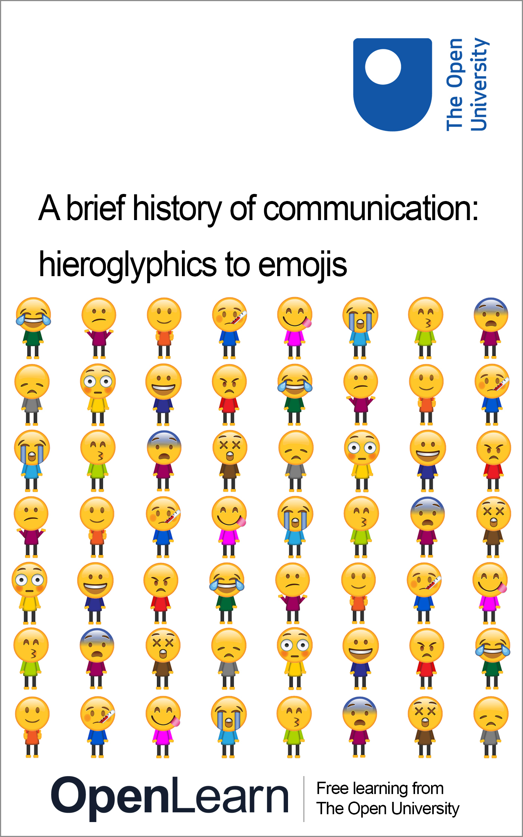

L101_1

A brief history of communication: hieroglyphics to emojis
About this free course
This free course is an adapted extract from the Open University course L101 Introducing English language studies - http://www.open.ac.uk/courses/modules/l101.
This version of the content may include video, images and interactive content that may not be optimised for your device.
You can experience this free course as it was originally designed on OpenLearn, the home of free learning from The Open University –
A brief history of communication: hieroglyphics to emojis
There you’ll also be able to track your progress via your activity record, which you can use to demonstrate your learning.
Copyright © 2018 The Open University
Intellectual property
Unless otherwise stated, this resource is released under the terms of the Creative Commons Licence v4.0 http://creativecommons.org/licenses/by-nc-sa/4.0/deed.en_GB. Within that The Open University interprets this licence in the following way: www.open.edu/openlearn/about-openlearn/frequently-asked-questions-on-openlearn. Copyright and rights falling outside the terms of the Creative Commons Licence are retained or controlled by The Open University. Please read the full text before using any of the content.
We believe the primary barrier to accessing high-quality educational experiences is cost, which is why we aim to publish as much free content as possible under an open licence. If it proves difficult to release content under our preferred Creative Commons licence (e.g. because we can’t afford or gain the clearances or find suitable alternatives), we will still release the materials for free under a personal end-user licence.
This is because the learning experience will always be the same high quality offering and that should always be seen as positive – even if at times the licensing is different to Creative Commons.
When using the content you must attribute us (The Open University) (the OU) and any identified author in accordance with the terms of the Creative Commons Licence.
The Acknowledgements section is used to list, amongst other things, third party (Proprietary), licensed content which is not subject to Creative Commons licensing. Proprietary content must be used (retained) intact and in context to the content at all times.
The Acknowledgements section is also used to bring to your attention any other Special Restrictions which may apply to the content. For example there may be times when the Creative Commons Non-Commercial Sharealike licence does not apply to any of the content even if owned by us (The Open University). In these instances, unless stated otherwise, the content may be used for personal and non-commercial use.
We have also identified as Proprietary other material included in the content which is not subject to Creative Commons Licence. These are OU logos, trading names and may extend to certain photographic and video images and sound recordings and any other material as may be brought to your attention.
Unauthorised use of any of the content may constitute a breach of the terms and conditions and/or intellectual property laws.
We reserve the right to alter, amend or bring to an end any terms and conditions provided here without notice.
All rights falling outside the terms of the Creative Commons licence are retained or controlled by The Open University.
Head of Intellectual Property, The Open University
978 1 4730 2844 9 (.kdl)
978 1 4730 2845 6 (.epub)

Contents
- Introduction
- Learning outcomes
- 1 Language and everyday technologies
- 2 A brief history of writing
- 3 Communicating in symbols and pictures
  - 3.1 Textspeak and language change
  - 3.2 Picture-based writing
- 4 The birth of writing
  - 4.1 Broadening the reach of language
  - 4.2 Different types of meaning-making
  - 4.3 From alphabet to emojis
- 5 The universality of body language
- 6 Emojis as a supplement to written language
- 7 Designing emojis
- Conclusion
- References
- Acknowledgements

Introduction
This free course, A brief history of communication: hieroglyphics to emojis, is an introduction to the history of writing and the key role it plays in human communication. Nowadays, it is difficult to think of language as existing without writing, but in the long history of humankind’s ability to use language it is only relatively recently that writing emerged. The course also looks as the vital relationship between technology and writing, and how the development of new technologies alter the way we communicate.
This OpenLearn course is an adapted extract from the Open University course L101 Introducing English language studies.

Learning outcomes
After studying this course, you should be able to:
- understand how different writing systems have developed over time
- understand how technology influences what we can do with language, and the form that language takes.

1 Language and everyday technologies
Language is an integral part of our lives. We listen to it in conversation, on the radio, on the TV and on our mobiles. We read it in emails, newspapers, study materials and scribbled notes. We use it to greet our friends, order a coffee, express how we feel or ask for information. In fact, it is hard to imagine how we could navigate our way through life without it. Language is such a common and pervasive feature of our everyday existence that we rarely think about what it is and how we use it.
In modern society, a huge amount of the language we use is mediated by technology of some sort. We don’t rely on language alone, but on communications technologies, which transport and carry the language we use. These technologies can take a vast number of different forms, and the nature of these different technologies have an influence on how it is we use language.

Activity 1 Looking at different technologies
Allow approximately 15 minutes

Have a think about all the different technologies you’ve used over the past 24 hours to communicate with people. Make a list, and try to be as detailed as possible in what you include. Once you’ve done this, look back over the list and think about what these various technologies made possible about your communication, and how it would have differed without access to them. You can collate your notes in the box below.

Provide your answer...
View discussion - Activity 1 Looking at different technologies

2 A brief history of writing
Before we begin examining in detail at how writing arose and the impact it has had on human communication, take a look at the following short video. Video 1 gives a succinct overview of the topics we’ll be covering in this course by reflecting back at the history of writing from the perspective of today’s obsession with emojis. While you’re watching, consider how a modern day writing system such as emojis shares several elements with other, earlier writing systems – but how it also has its own unique properties which make it perfectly suited to modern communication technologies.

Video content is not available in this format.
Video 1 A brief history of emojis
View transcript - Video 1 A brief history of emojis

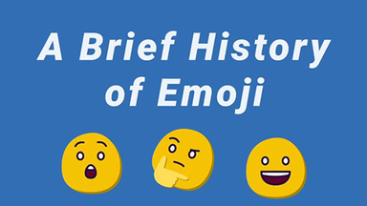

3 Communicating in symbols and pictures
In an article in the New York Post decrying recent trends in communication, the journalist Kyle Smith (2015) argued that ‘Tens of thousands of years ago, humans communicated in pictures. The thoughts they sought to convey weren’t complicated. That’s why we call them cavemen’. The broader argument he’s making in the article is that the way people communicate today shows a marked decline in terms of both sophistication and subtlety when compared to the way we communicated in the recent past. People’s language habits are on a downward spiral. They’re degenerating; becoming ‘dumbed down’, along with so much else in contemporary culture. The way we’re communicating today, he’d like to suggest, is in such disrepair that it has more in common with the way that prehistoric humans communicated.
The reason for his use of this rather odd comparison is that his real target is the popularity of emojis. Emojis – on the off-chance you’re not familiar with them; or are reading in some future era where they’ve been replaced by another form of technologically-enabled communication system – are the set of small picture-based characters that are used on online platforms to supplement communication. Their global spread began in 2011, when the computer firm Apple included them in the software for the iPhone’s operating system. Since then they’ve expanded in both popularity and number so that, by the end of the 2010s, they’d become a notable cultural phenomenon; they’re the subject of films and musicals, and they feature in everything from fashion design to architecture.


Figure 1 Emojis as a decorative feature in a building designed by architect Changiz Tehrani in the Dutch city of Amersfoort.
View description - Figure 1 Emojis as a decorative feature in a building designed by architect Changiz ...

3.1 Textspeak and language change
The principal function of emojis, though, is as a means of communication. And it’s in this context that laments such as the one in the New York Post are framed. Almost identical sentiments could be found in several other publications in the middle of the decade. For example, an article cited in the Huffington Post in 2016 complained that ‘after 5,000 years of technological progress, we’ve returned to eking approximate meaning from pictograms’ (Smithurst, cited in Gage, 2016). Or there was the assertion on CNBC that emojis are evidence of the ‘the death of written language’, and that we seem to be ‘regressing back to the age of hieroglyphs’ (Mody, 2015).
It was only a dozen or so years ago that the focus of these sorts of newspaper articles was on textspeak (or as it’s sometimes written, txtspk) – the medium-specific register that evolved around text messaging (Crystal, 2009). Things such as non-standard spelling, truncated grammar and a relaxed attitude to punctuation were cited as examples of ways in which this ruin was setting in. Ten years on and the odd initialism (an abbreviation made by pronouncing the initials of individual words) might persist – terms such as LOL (‘laugh out loud’) or tl;dr (‘too long; didn’t read’) retain their popularity. But other than a handful of examples, language continues much as it ever has. Texting didn’t have a fundamental influence on English, or any other language.
By the 2010s the moral panic over txtspk had mostly subsided, and the focus had shifted instead to emojis. Almost identical sentiments about them replacing English, ruining people’s literacy skills, and so on and so forth, simply shifted across from text messaging to emojis. And a common refrain throughout was that emojis were returning us to the origins of writing – and thus wiping out over 5000 years of progress.

3.2 Picture-based writing
Is it really the case then that five millennia after the Egyptians invented hieroglyphics we’re once again resorting to communication via little pictures? And if this is the case, is it really unravelling all the advances that have taken place in literate culture over the centuries? As with most moral panics, arguments framed along these lines are based on a complex of false premises and misassumptions. But in having a look at some of these, and identifying why they’re misguided, we can get a better idea of what language is and how it works.

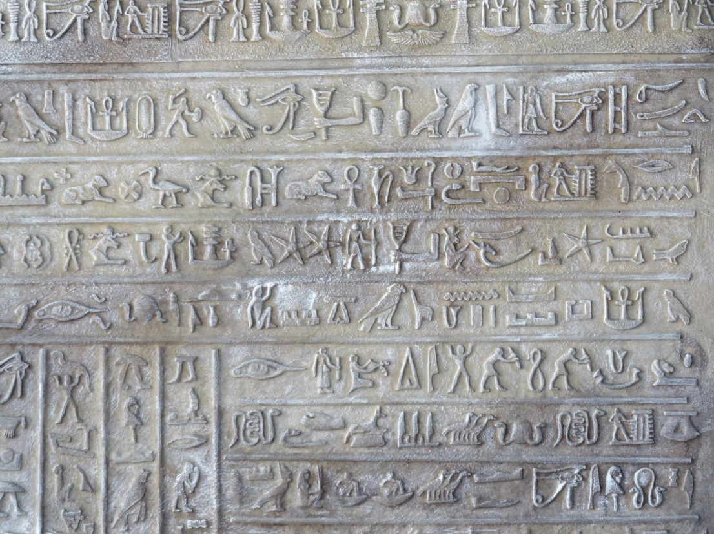
Figure 2 Hieroglyphics
View description - Figure 2 Hieroglyphics

The most straightforward answer to the two questions at the beginning of the paragraph above is that emojis aren’t really that similar to hieroglyphics at all. Yes, they’re pictographic in origin: their meanings are based on, or derive from, what they look like. But whereas hieroglyphics comprised a fully-formed writing system all by themselves, emojis are a supplement to other, pre-existing writing systems. In English-language cultures emojis are not replacing alphabetic writing. They’re adding to it. Specifically, they’re adding a way to convey what we might call ‘emotional framing’ to online conversations. They fill a particular need in modern-day communication – a need produced by the fact that social media platforms (such as Facebook, Twitter, Whatsapp) are part of a trend over the past few decades towards more informal communication, resulting in a more conversational style of writing than used to be the case. In this way emojis are an example of the way that human communication adapts to the contexts and technologies with which it’s used – a process which has been happening from the very beginnings of human culture.

4 The birth of writing
Language first evolved in humans around one hundred thousand years ago (putting a precise date on its evolution is a difficult – and controversial – issue). Up until the end of the fourth millennium BC, however, its usefulness was limited to what was possible with the human voice. In essence this meant that language could only be used for direct communication between people who were physically in the same space. A speech, for example, could only be heard by those who were able to congregate within earshot of it. For information to be passed from generation to generation it had to be committed to memory and recited over and again down through the years.

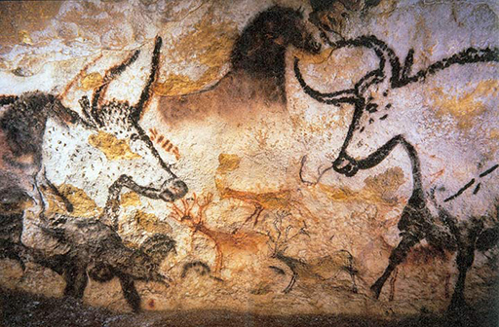
Figure 3 The Lascaux Caves paintings in south west France are some of the earliest known examples of sophisticated figurative art, dating back 20,000 years
View description - Figure 3 The Lascaux Caves paintings in south west France are some of the earliest ...

Around 5500 years ago, in the Sumerian region of Mesopotamia (in present-day Iraq), this began to change. Pictures and symbols had been used occasionally prior to this as a way of expressing ideas and messages – the earliest examples of human-made images date back some 40,000 years (Wilford, 2014). But they’d never been used as a systematic means of recording events and ideas. In need of a way to keep track of the goods they were trading, the Sumerians started engraving symbols on fired clay tablets. In Egypt at much the same time a similar scheme of symbols began being used as a way of recording the number and nature of people’s commodities. By the end of the fourth millennium BC, this innovation – writing – had developed into flexible and complex systems for recording the Sumerian and Egyptian languages.

4.1 Broadening the reach of language
The invention of writing changed both the way we use language and the benefits we’re able to get from it. It made it possible to accumulate knowledge with far greater ease and accuracy than had previously been the case, which in turn aided the development of science and the study of history. It did this by extending the capabilities of language by giving it an external and permanent existence. Messages which are written down can be passed easily from person to person and from age to age. They can be consulted and accurately copied. The same message can be read by an almost infinite number of people. Writing allows language to travel across time and space; it allows utterances to be transported effortlessly from place to place, from community to community, and from generation to generation. Writing was, in other words, the first major communications technology. All the many innovations in language technology that have followed this – from printing to the telegraph to the internet – then further extend this reach and speed, allowing for today’s immediate and effortless global communication.

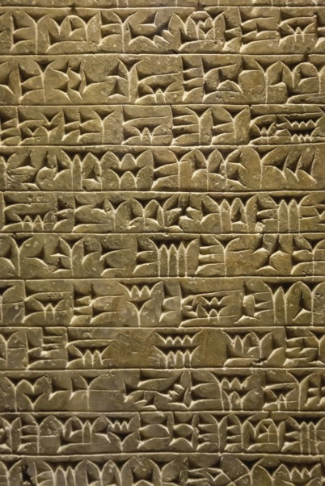
Figure 4 Sumerian cuneiform tablet
View description - Figure 4 Sumerian cuneiform tablet

The cuneiform script was used by the Sumerians from the end of the fourth millennium BC right up until the first century AD. The word ‘cuneiform’ means ‘wedge-shaped’ and refers to the marks made by the reeds with which it was written.

4.2 Different types of meaning-making
It’s worth noting however that writing as we know it today is not a single technology resulting from a single invention. It’s a combination of various innovations which took place over a long period, with differing effects in different parts of the world. But the stages of evolution it went through are very similar in all these different places. The earliest incarnations of all these writing systems were pictographic: they consisted of simplified drawings which were stylised representations of concrete entities. A picture of a bird meant ‘bird’. A picture of an egg meant ‘egg’.
As their use spread, so they began to gather broader meanings based on the context of this use, and to be combined together to create ideograms: symbols which represent ideas rather than objects. Bird plus egg, for example, represented fertility. A very significant stage in the development of writing systems was when they began to be used not simply to represent ideas, but also sounds. Hieroglyphics, for example, work both as a system of pictures representing objects and ideas; but also as a set of symbols which represent sounds which can then be combined to spell out words. If you wanted to write a person’s name, you broke it apart into its different component sounds, and then used symbols which corresponded to each of these sounds.
Once this happened writing could emulate spoken language rather than operating as a separate, parallel system of communication. And it was this transition which led to the fully flexible systems we have today (Schmandt-Besserat, n.d.).

4.3 From alphabet to emojis
A key invention in the evolution of writing – for languages in the West at least – was the alphabet. This originated somewhere in the vicinity of Egypt or Palestine around 2000 BC, and produced a writing system which was easy to learn, quick to write, and avoided the ambiguities of many earlier scripts. Writers and readers of English, for example, only need to know about 52 alphabetic signs (the lower and upper case letters) along with numerals, punctuation marks and a few symbols such as the ampersand (&) in order to be able to use the language. A reader of hieroglyphics would have had to have a working knowledge of about 600 characters to understand complex texts. The way the alphabet provided such a compact and flexible system was by severing completely the relationship between the look of a sign and its meaning. In other words, the shape of the letters we use today no longer physically resemble the concepts they’re referring to in any meaningful sense at all. Instead, each letter is related to a sound (or set of sounds), which combine together with other letters to create the sound of a w-o-r-d.
So where do emojis fit into this picture of developing communications technologies? As with all other writing systems, they have developed along with technology as human civilisation finds further ways to extend its intellectual reach. When messaging each other these days via mobile phones or other computer-based chat systems, we usually write in much the same way that we speak. But unlike speech, writing doesn’t always allow us to express emotion and mood in a direct or straightforward way. Tone of voice, facial expressions, gestures – these are all vital elements of face-to-face communication, but they’re stripped away in writing. Emojis offer a way of compensating for this. They’re a quick and concise way of adding a layer of emotional character to casual, text-based conversation. And it’s this that has propelled their global popularity.

5 The universality of body language
Emojis are grouped into different categories of symbols. By far the most popular are those which represent facial expressions (the smileys) and gestures. But does the fact that they’re so popular globally mean that they work as a type of global language? Or to put it another way, are people all across the world able to understand emojis in the same way, or do different cultures interpret some of the symbols in different ways?
One of the ways we can answer this is looking at the facial expressions and gestures on which emojis are based.

Activity 2 Types of body language
Allow approximately 20 minutes

Have a look at these uses of various different types of body language. Which signs or gestures do you think are universal (i.e. can be understood by anyone anywhere in the world) and which are culture-specific?

Interactive content is not available in this format.
Figures 5–9 Demonstrating different types of body language

- The smile: communicating that you’re happy
- The frown: communicating that you’re angry
- The shoulder shrug: communicating that you don’t know
- The thumbs up: communicating that you approve
- The thumb and finger circle: communicating that everything is OK

View discussion - Activity 2 Types of body language

6 Emojis as a supplement to written language
There’s more to emojis than just facial expressions or gestures, of course. Included among the 2000 plus characters are straightforward pictographic representations of animals, 🐬 🐒 food 🍰 🍑, the odd building 🏤 🏩, and a whole host of flags 🏳️‍🌈 🇬🇷 🏴󠁧󠁢󠁷󠁬󠁳󠁿. In this sense they do work in a similar way to the foundations of hieroglyphics. But because they exist alongside a range of other verbal and non-verbal resources – from conventional writing to the use of pictures and animated clips – they are not used as a replacement for traditional written English, but as an extension to it, often in creative or playful ways. So they’re not a language in the sense of a full, symbolic communication system such as English. But throughout history, human communication has always drawn on different types of expressive resources to complement and modulate the language we use – and emojis are just a recent example of this.

Activity 3 Translating emoji language
Allow approximately 15 minutes

One of the main differences between emojis and full writing systems like the alphabet is that emojis have a very limited set of symbols. Whereas in using the alphabet to write English we can combine the 26 letters in an almost infinite number of ways to create the sounds of words, for a pictographic system such as emojis you have to pick from the limited set of specific objects and ideas that are available. To illustrate the difficulties this presents, have a look at the following ‘sentence’, and try to translate it into English.


Figure 10 Emojis forming a sentence
View description - Figure 10 Emojis forming a sentence

View discussion - Activity 3 Translating emoji language

7 Designing emojis
Given that meaning is conveyed through the way the different symbols look, the design of emojis is obviously a very important element in how they work as a communicative system. In the next activity you’ll hear from Gedeon Maheux, co-founder of the graphic design company The Iconfactory. Gedeon has been involved in the design of emojis for companies such as Twitter and Facebook, and talks here about what goes into their creation.

Activity 4 Gedeon Maheux
Allow approximately 20 minutes

Listen to the interview below in which Gedeon Maheux discusses some of the issues around designing emojis and the impact they are having on society. In the interview, he mentions the Unicode Consortium, a regulatory group who decide on what becomes an emoji and what doesn’t. The Consortium also gives a rough template of what all the emojis should look like.


Figure 11 Gedeon Maheux
View description - Figure 11 Gedeon Maheux

As you listen to the interview, answer the following questions:
- In Gedeon’s view, why do people use emojis?
- What leeway does his company have in designing emojis?
- What evidence does he give of the ways in which people use communicative resources for their own ends?

Audio content is not available in this format.
Audio 1 Gedeon Maheux
View transcript - Audio 1 Gedeon Maheux

View discussion - Activity 4 Gedeon Maheux

Conclusion
In this free course, A brief history of communication: hieroglyphics to emojis, you’ve looked at what writing enables humans to do that spoken language does not. To summarise, writing allows people to preserve their messages in a permanent form. This, in turn, allows knowledge to accumulate and be passed on from generation to generation. As we’ve seen, language always has a very close relationship with the technologies we use to communicate, and that as these technologies develop, so the nature of language itself and the way we use it also does. Although the concept of writing might seem an intrinsic element of language for us today, its invention came tens of thousands of years after the evolution of spoken language in humans – and there are still a great number of communities which don’t have a written element to their language. Equally noteworthy is the fact that writing as we know it today didn’t appear fully-formed, but developed over several centuries. Today, we have access to a vast range of different communications technologies – including such things as emojis – and can choose these as best fits our purpose.
This OpenLearn course is an adapted extract from the Open University course L101 Introducing English language studies.

References
Crystal, D. (2009) Txtng: The Gr8 Db8. Oxford: Oxford University Press.
Gage, J. (2016) Are Emoticons And Emojis Destroying Our Language? The Huffington Post, http://www.huffingtonpost.com/joan-gage/emoticons-and-emojis-destroying-our-language_b_7950460.html (Accessed 9 November 2018).
Matsumoto, D. and Willingham, B. (2009) ‘Spontaneous Facial Expressions of Emotion in Congenitally and Non-Congenitally Blind Individuals’ in The Journal of Personality and Social Psychology, Vol. 96, No.1, pp.1 - 10.
Mody, S. (2015) Emojis: The death of the written language? CNBC, https://www.cnbc.com/2015/06/24/emojis-the-death-of-the-written-language.html (Accessed 9 November 2018).
Schmandt-Besserat, D. (n.d.) The Evolution of Writing, https://sites.utexas.edu/dsb/tokens/the-evolution-of-writing/ (Accessed 9 November 2018).
Smith, K. (2015) Emojis are ruining civilization, New York Post, 14 October, http://nypost.com/2015/10/14/emojis-are-ruining-civilization/ (Accessed 9 November 2018).
Wilford, J. N. (2014) Cave Paintings in Indonesia May Be Among the Oldest Known, New York Times, 8 October, https://www.nytimes.com/2014/10/09/science/ancient-indonesian-find-may-rival-oldest-known-cave-art.html (Accessed 9 November 2018).

Acknowledgements
This free course was written by Philip Seargeant, with additional material by David Hann. It was published in December 2018.
Except for third party materials and otherwise stated (see terms and conditions), this content is made available under a Creative Commons Attribution-NonCommercial-ShareAlike 4.0 Licence.
The material acknowledged below is Proprietary and used under licence (not subject to Creative Commons Licence). Grateful acknowledgement is made to the following sources for permission to reproduce material in this free course:
Every effort has been made to contact copyright owners. If any have been inadvertently overlooked, the publishers will be pleased to make the necessary arrangements at the first opportunity.

Images
Figure 1 (218690) Emoji as decorative feature: Architect - ‘Attika architekten’, Photographer - ‘Bart van Hoek’
Figure 2 (218416) Hieroglyphics: From Pixabay. Covered under Creative Commons licence CC0 1.0 Universal (CC0 1.0) Public Domain Dedication
Figure 3 (218696) The Lascaux Cave paintings: © Prof Saxx, cleared under Creative Commons Attribution-ShareAlike 3.0 Unported license (CC BY-SA 3.0)
Figure 4 (218698) Sumerian Cuneiform Tablet: © Igor Dmitriev/123RF.com
Figure 11 (218700) Gedoen Maheux: © Gedoen Maheux
Don’t miss out
If reading this text has inspired you to learn more, you may be interested in joining the millions of people who discover our free learning resources and qualifications by visiting The Open University – www.open.edu/openlearn/free-courses.

Activity 1 Looking at different technologies

Discussion
Much of the technology we use to communicate today is digital: email, smartphones, video chat, text messaging and so on. Most of these tools are now an intrinsic part of both our working and home lives. They allow us easy and immediate communication with people all around the world.
But it’s not just digital technology which plays a central role in the way we communicate. If you think of something as simple as scribbling down a note with a pen for someone to read, this involves technologies such as paper, ink and pen (there was a time, after all, before these had been invented). And of course, the most fundamental language technology of all is writing itself.
Back to Session 1 Activity 1

Activity 2 Types of body language

Discussion
The universally understood signals here are the facial expressions, especially those which convey basic emotions such as happiness, anger, fear and so on. These are often produced subconsciously, and evidence in fact suggests that they may be hard-wired into us (Matsumoto and Willingham, 2009). People who are blind from birth, for instance, still smile and frown, suggesting that facial expressions are both universal and innate.
The shoulder shrug to convey the idea that you’re indifferent, or don’t really know the answer to something, also seems to be universal, although it’s noteworthy that the accompanying facial expression (raised eyebrows and downturned mouth) is an important part of how the message is conveyed.
The thumbs up as a sign of approval is generally understood around the world. However, there are certain countries, such as Iran, where it has a negative meaning. It is interesting to note that, in Greece, where the sign once had a pejorative meaning, it no longer does. This may well be because of the way it’s used in a positive sense in global media, which has thus had an effect on its local meaning.
The so-called ‘OK’ sign made with thumb and forefinger touching in a circle is socially the most risky bit of body language of those presented here. There are a number of countries where its use would be understood as insulting. In France, for example, it is often used to represent zero and conveys the idea that someone or something is worthless, while in other countries, such as Brazil, it represents a certain bodily orifice (no, not the mouth) and is not meant as a compliment!
As these examples show, a great deal of body language is culturally learned. Indeed, even facial expressions, although universal, are influenced by culture. The degree to which people show emotion in public is regulated by cultural norms – it is perfectly acceptable in some cultures while not in others. It is also worth considering context when deciding what particular gestures and bodily expressions mean.
For these various reasons then, although the pictorial nature of emojis such as 😀, ☹️, 🤷‍♀️, 👌 and 👍 may make us suppose they can be universally understood, there are still culturally-specific elements in play.
Back to Session 5 Activity 1

Activity 3 Translating emoji language

Discussion
Given the very limited nature of the emoji lexicon, and the fact that it doesn’t include entire word classes such as adverbs or pronouns, you need to improvise if you want to convey any sort of complicated meaning.
In the example here, the person with his arm in the air stands for ‘I’. The apple and banana are straightforward enough, and having them next to each other suggests that they’re somehow related in this context (which gets round the absence of an ‘and’ in the lexicon). The picture of the dawn juxtaposed with a knife, fork and plate is being used to represent breakfast. So these symbols thus all roughly represent what they depict (they’re pictographic or ideographic).
The 8 and the 4, on the other hand, are being used to convey meaning in a rather different way – based on the sound of words, rather than their appearance. They’re both being used here as rebuses – a sort of puzzle where the picture of a word is used to represent another word which sounds exactly the same as it. So ‘eight’ here stands for ate; and ‘four’ for for. The whole ‘sentence’ thus reads: ‘I ate an apple and a banana for breakfast’.
If this wasn’t the meaning you derived from the sentence, not to worry. The object of the exercise is to illustrate quite how complex and flexible a full natural language such as English is, when compared to a system primarily based on pictures. But as we saw above, emojis aren’t in any sense an alternative to full languages such as English. There’s no sense that they’re replacing them. Instead, they offer supplementary possibilities for communication, adapted to the digital age in which we live.
Back to Session 6 Activity 1

Activity 4 Gedeon Maheux

Discussion

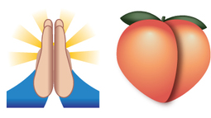
Figure 12 What do these emojis mean?
View description - Figure 12 What do these emojis mean?

Gedeon mentions the speed with which emojis can be used to communicate ideas. And why this makes them such a convenient form of communication. He also mentions that they are particularly effective at conveying emotion, as we discussed above and that this is certain to be a factor in their popularity. In drawing up the designs, his company has to adhere to the Unicode Standard so that everyone can recognise what each emoji is supposed to represent. This reflects a truth about language in general. A symbol - whether it’s a visual image or a word – needs to be mutually understood, otherwise communication breaks down. Gedeon’s company does, however, have a certain leeway in terms of the angle, lighting and colouring of the emojis. But despite the efforts he and his team make in creating clear, engaging pictures, there’s still the chance that people will use them in ways that weren’t intended or anticipated. He gives the examples of the way in which people use the peach emoji and the high-fives emoji to mean bottom and praying respectively. This again reveals an important truth about language in general – people will always use and adapt its resources for their own ends.
Back to Session 7 Activity 1

Figure 1 Emojis as a decorative feature in a building designed by architect Changiz Tehrani in the Dutch city of Amersfoort.

Description
photo of a building in the Dutch city of Amersfoort which uses smiley emojis as gargoyle-like decorative features
Back to Session 3 Figure 1

Figure 2 Hieroglyphics

Description
image of hieroglyphics
Back to Session 3 Figure 2

Figure 3 The Lascaux Caves paintings in south west France are some of the earliest known examples of sophisticated figurative art, dating back 20,000 years

Description
cave painting of animals such as bulls and horses from the Lascaux Caves in the south west of France
Back to Session 4 Figure 1

Figure 4 Sumerian cuneiform tablet

Description
A photo of a clay tablet from circa 2100 B.C., which engraved with writing in the cuneiform script. This consists of rows of wedge or triangular shaped marks, which were made by pushing the end of a reed into the clay.
Back to Session 4 Figure 2

Figure 10 Emojis forming a sentence

Description
Emojis forming a sentence
Back to Session 6 Figure 1

Figure 11 Gedeon Maheux

Description
photography of the graphic designer Gedeon Maheux
Back to Session 7 Figure 1

Figure 12 What do these emojis mean?

Description
an emoji of two hands being held together, maybe in prayer, and an emoji of a peach
Back to Session 7 Figure 2

Video 1 A brief history of emojis

Transcript
A brief History of Emoji. With over six billion sent everyday, emoji have gone truly global in the last few years, but where did they come from and how on earth did we ever manage to communicate effectively in the pre-emoji era?
Language first evolved around 100,000 years ago, allowing our ancestors to communicate simple ideas like 'fire' or 'cave' or more complex ideas like 'your cave is on fire'. About five and a half thousand years ago writing was invented in Mesopotamia, when people started engraving symbols on clay tablets. This marked a major step forward for civilisation, although wasn't entirely practical for sending love letters. At the same time, in Egypt people began scratching small pictures and symbols onto bone and ivory.
5,000 years later, Johannes Gutenberg invented the printing press, ensuring people could mass produced documents and share radical ideas like Protestantism and the recipe for Auntie Susan's vegetable broth. In the 19th century the telegraph was invented which led to an increase in long-distance communication, as well as cases of repetitive strain injury. In the late 20th century the combination of the internet and mobile phone gave birth to the video call. So now you have to look ill as well as sound ill when you pull a sickie. All of which finally bring us to the birth of emoji, so what exactly are emoji?
Back to Session 2 MediaContent 1

Audio 1 Gedeon Maheux

Transcript
PHILIP SEARGEANT
Hello. I’m Philip Sargent. And I’m joined today on the phone by Gedeon Maheux, co-founder of the Iconfactory, a graphic design company based in the United States and in Sweden, which specialises in software for creating and using icons, including a wide range of emoji. The Iconfactory was founded in 1996 and is now one of the leading studios in commercial icon design and includes Windows, Twitter, and Facebook among their clients. Gedeon, thank you for joining us today.
GEDEON MAHEUX
Thanks for having me.
PHILIP SEARGEANT
What do you see as the key purpose of emoji as a form of communication?
GEDEON MAHEUX
They’re a way for people to communicate quickly about some things or emotions or concepts that we are all familiar with in one way or another. And they are funner than typing out words. So when you have the opportunity to use an emoji instead of a long drawn-out sentence or something like that, if you can communicate it quickly with a simple pictogram, then a lot of people prefer to do that.
And there’s a lot of appeal there for that. And as technology advances and people’s attention spans become shorter and shorter, I think they have adopted this kind of language to a greater degree. People have become more enthusiastic about emoji.
PHILIP SEARGEANT
Do you think you could talk us through how you go about designing them?
GEDEON MAHEUX
It basically starts with the client who’s requesting the emoji, whether it’s Twitter or Facebook or someone else, and what their visual goals are for the emoji suite-- what they want to accomplish with that. We use that as a starting point. How do they want their emoji to be differentiated visually from what other platforms have done?
And we take that, and we use that as a jumping-off point to design several style looks and feels. For the emoji suite itself, we take some representation from the suite, whether it’s people, vehicles, or food, and we work them up in a number of different styles. And then we go back and forth with the client to refine those styles until they are approved.
PHILIP SEARGEANT
How much leeway do you have in terms of doing something which has to look like a particular thing and doing something which is unique or within a house style?
GEDEON MAHEUX
Every emoji has a Unicode standard. And so that emoji has to communicate that thing in a particular way. If we go outside of that guideline, then people won’t recognise it. Or when they transmit an emoji to a friend, they’ll see something different than what they’re expecting.
And so you can’t stray too far from the visual concept of the emoji itself. What you can do, obviously, is vary how that particular thing is depicted. The angle, the lighting, the colouring-- all of those things are up for grabs.
PHILIP SEARGEANT
What impact do you think they’ve had both on the way people communicate but also on society in general? Do you have a feel for that?
GEDEON MAHEUX
Oh, they’ve had quite a bit of impact. I can’t go anywhere in these days without seeing something emoji related, whether it’s in pop culture or in merchandise. Another is how those particular things affect, like, what we do when we communicate with each other, and how much further can we push it.
I mean, and what will they be replaced with? Will they be replaced with animated versions of themselves? Or stickers are probably pretty popular now, too. But they haven’t seemed to catch on as widespread as emoji. And I think that’s because they’re not as ubiquitous.
PHILIP SEARGEANT
That leads very nicely into the question of what you think the future of emoji might be, if you have any ideas of whether it’s going to just expand so much that it’ll become impossible to use or, as you say, whether something else will take over.
GEDEON MAHEUX
That’s a really tough question. Obviously, I think in the short term, the emoji language will continue to expand. Obviously, the Unicode consortium will add new entries into the emoji lexicon. And they will continue to do that for the foreseeable future. So we’ll always have new emojis coming down the pipe that people can use.
What will happen after that, I’m not sure. We saw a little bit of it this year with Apple’s Animojis in the iPhone X, with animated three-dimensional versions of some of the emojis. Is that practical for all emojis? No, not in any way, shape, or form.
Is it even desirable? And I’m not sure that it is. But for some emojis, such as the smiley faces and animals, it makes perfect sense. And people seem to love it. So that’s one possible feature.
One thing I really hope that they do is make it easier to find emojis in the keyboards and type them quicker. As the lexicon expands, it’s getting harder and harder to locate and type the emoji that you’ve been looking for. I really hope that that improves somehow.
PHILIP SEARGEANT
Do you think anything has changed in your thinking about the approach to the design?
GEDEON MAHEUX
One of the things that’s changed since we started creating them until now is the need to be diverse in emoji design-- I mean, to think about how people of different cultures and races will use an emoji. So when approaching the design of an emoji, we always try to consider, is there a way that this is inclusive in its design? It’s definitely something that we are mindful now that I’d say was less so when we first started designing emoji.
And I think that’s a good thing. In the end, it makes the emoji usable by a wider set of audience. And that’s always a plus.
PHILIP SEARGEANT
I wanted to ask you about how they actually convey meaning and whether there are any examples you’ve come across where you’ve thought it was intended to mean something, and then people pick it up and use it for a different purpose, either because they think it looks like that or for whatever other reason.
GEDEON MAHEUX
Yeah, there are so many examples of that it’s hard to pick just a few. And it’s interesting and fascinating. If I studied language for a living, I would definitely be studying this because it’s fascinating how people can appropriate something for their own use and then run with it. One example of that is the peach emoji.
I mean, obviously, it’s there to represent the fruit. But many people use it to represent someone’s bottom. And, in fact, when Apple recently changed the peach so that it looked less like a bottom, people were upset. And they wanted it returned to the previous design so that they could continue using it to represent the bottom, you know? And that’s one.
Another would be the high fives. There’s two hands that come up to give a high five. And people use that to represent praying. Actually, that’s not the original intent of the emoji. But because it can represent that visually, people do use it for that.
There’s a whole group of emojis that are like that. And it is fascinating to watch people use or adopt the particular emojis to mean something other than what it was originally intended to be. But I think that’s always the case with language.
PHILIP SEARGEANT
Gedeon, thank you so much for joining us today and for giving us your insights. It’s been a great pleasure to talk to you.
GEDEON MAHEUX
Oh, thanks so much for having me.
Back to Session 7 MediaContent 1

