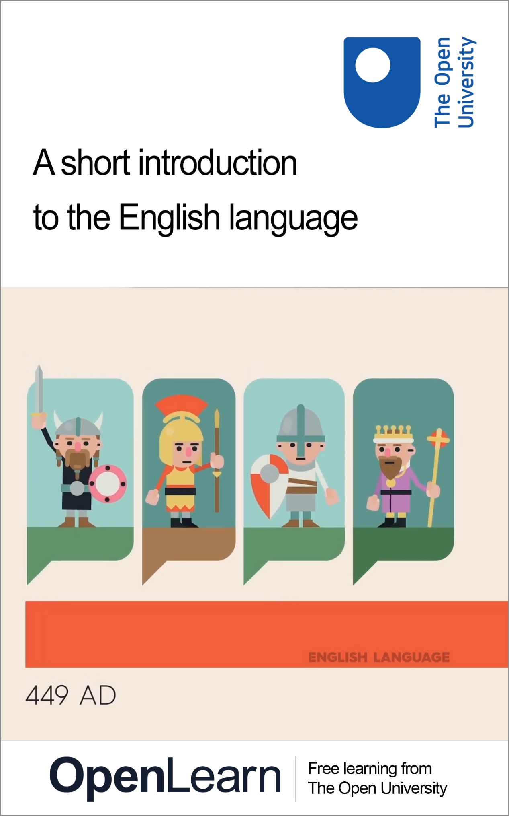

ENG_1

A short introduction to the English language

About this free course
Find out more about The Open University’s English language courses and qualifications: www.open.ac.uk/courses/english.
This version of the content may include video, images and interactive content that may not be optimised for your device.
You can experience this free course as it was originally designed on OpenLearn, the home of free learning from The Open University –
www.open.edu/openlearn/languages/a-short-introduction-the-english-language/content-section-0
There you’ll also be able to track your progress via your activity record, which you can use to demonstrate your learning.
Copyright © 2023 The Open University
Intellectual property
Unless otherwise stated, this resource is released under the terms of the Creative Commons Licence v4.0 http://creativecommons.org/licenses/by-nc-sa/4.0/deed.en_GB. Within that The Open University interprets this licence in the following way: www.open.edu/openlearn/about-openlearn/frequently-asked-questions-on-openlearn. Copyright and rights falling outside the terms of the Creative Commons Licence are retained or controlled by The Open University. Please read the full text before using any of the content.
We believe the primary barrier to accessing high-quality educational experiences is cost, which is why we aim to publish as much free content as possible under an open licence. If it proves difficult to release content under our preferred Creative Commons licence (e.g. because we can’t afford or gain the clearances or find suitable alternatives), we will still release the materials for free under a personal end-user licence.
This is because the learning experience will always be the same high quality offering and that should always be seen as positive – even if at times the licensing is different to Creative Commons.
When using the content you must attribute us (The Open University) (the OU) and any identified author in accordance with the terms of the Creative Commons Licence.
The Acknowledgements section is used to list, amongst other things, third party (Proprietary), licensed content which is not subject to Creative Commons licensing. Proprietary content must be used (retained) intact and in context to the content at all times.
The Acknowledgements section is also used to bring to your attention any other Special Restrictions which may apply to the content. For example there may be times when the Creative Commons Non-Commercial Sharealike licence does not apply to any of the content even if owned by us (The Open University). In these instances, unless stated otherwise, the content may be used for personal and non-commercial use.
We have also identified as Proprietary other material included in the content which is not subject to Creative Commons Licence. These are OU logos, trading names and may extend to certain photographic and video images and sound recordings and any other material as may be brought to your attention.
Unauthorised use of any of the content may constitute a breach of the terms and conditions and/or intellectual property laws.
We reserve the right to alter, amend or bring to an end any terms and conditions provided here without notice.
All rights falling outside the terms of the Creative Commons licence are retained or controlled by The Open University.
Head of Intellectual Property, The Open University

Contents
- Introduction
- Learning outcomes
- 1 What is language?
- 2 English in the world
- 3 Shakespeare’s language (or ‘It’s all Greek to me’)
- 4 Internet English
- 5 Emojis
- 6 Creativity and language
- 7 The language of comedy
- 8 The language of lying
- 9 The language of protest
- 10 Speaking robots
- 11 The future of language
- Conclusion
- Acknowledgements
- Solutions

Introduction
In this free course, A short introduction to the English language, you’ll be taken on a tour of the role that language plays in the lives of the human race, with a particular focus on the English language, and how this has emerged as a global force over the last few decades.
In eleven sections, each centred around a short video, you’ll look at what language is, at how the English language first came into existence, how it developed and has been spread across the world in the millennium and a half since its birth, and how it’s used in a range of different domains of life. You’ll look at the language of lying, the language of literature, of comedy and persuasion – and how all these fundamental characteristics of human life are ultimately made possible because of the faculty that our species has for language.
The course will end with an examination of whether human language may one day be adopted by robots, and what this, along with all the other developments in communications technologies, means for the future of language – and for our species more generally. In each section, the videos provide the main content but are accompanied by a short introduction to the relevant topic, as well as activities to help you reflect on those topics as you progress through the course.
Interested in taking your learning further? You might find it helpful to explore the Open University’s English language courses and qualifications.

Learning outcomes
After studying this course, you should be able to:
- understand the range of roles that language plays in people’s lives and in society
- understand how the English language has developed over the past 1,500 years, and how it has gained the status of a global language
- understand the challenges and opportunities that stem from the relationship between technology and language.

1 What is language?
You’ll start by looking at a basic, but rather complicated question: What is language?
The answer may seem straight-forward. Language is a means of communication. It’s what people use to exchange ideas with each other. It’s a way of encoding information in sound, writing or gestures which can then be passed from one person to another. But when we start to think about it in a little more detail, it’s not quite as simple as it may at first seem.

Activity 1

Part 1

Have a think about all the times and ways you’ve used language so far today.
- What have you used it to achieve?
- Could you have done these same things without language?
- What sorts of language have you used? Spoken, written, gestures or other forms of physical communication?
- Have you used predominantly English, or other languages as well?
Jot down any thoughts you have about this in the text box below. Once you’ve done so, save your answer and then read the comment for this part of the activity.

Provide your answer...

View discussion - Part

Part 2

Now watch the animation below, which gives a concise overview of what language is and what we use if for. While watching, keep an eye out particularly for the different functions or purposes we use language for.
Again, type your answer or thoughts into the text box and save your answer to read the comment for this activity.

Video content is not available in this format.
Video 1 What is language?
View transcript - Video 1 What is language?

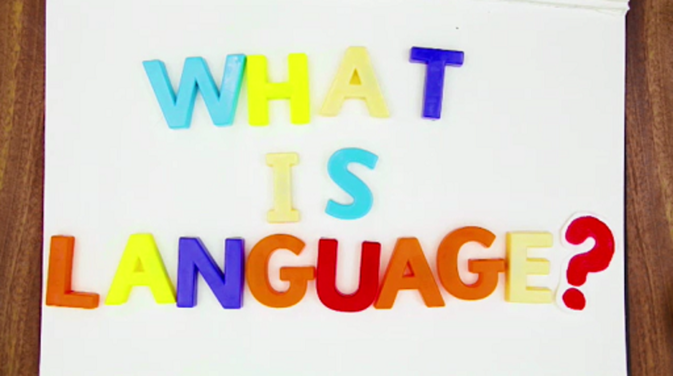

Provide your answer...

View discussion - Part

Over the next few sections, you’ll explore many of the ideas introduced in the animation in more detail. And you’ll start with a look at where the language that we’re communicating in now first came from.

2 English in the world
There’s a difference between language as a human faculty and a language such as English, Kiswahili or Japanese. Language (the faculty) is an abstract concept. English, Kiswahili and Japanese are concrete entities. They have their own specific histories and are used by particular communities who nearly always have a strong relationship with ‘their’ language. In Section 1, you looked at language as a general faculty of humankind. Something that’s innate to people in New Zealand, Tanzania or Japan, and everywhere else in the world. In this section, you’re going to look at a particular language, English. And you’ll start by looking at its history: at where it came from, how it developed, and how it has come to be the global force it is today.
What we call ‘English’ today is very different from the English that was spoken 1,500 years ago. In fact, the English language had been around for about 400 years before it even started to be called ‘English’. Its origins lie with a group of Germanic tribes from north Europe – who today we collectively refer to as the Anglo-Saxons – arriving on the island of Great Britain sometime during the fifth century AD. It took root in the country and began to be spread across the population there. But it wasn’t until the ninth century that the term ‘English’ began to be regularly used to refer to the language.
So how did the unnamed language that was originally spoken by a few tribes on a small island off the coast of continental Europe develop into the world’s pre-eminent lingua franca? And how has the language itself changed over the centuries as it’s been spread around the globe?
The next animation addresses all these questions, while also looking at how contact between English and other languages and cultures has had an influence on how the language is used in different parts of the world today.

Activity 2

While watching the video, look out for:
- the way that historical events have played a vital role in how English developed
- examples of how the form of English has changed from the period referred to as Old English to the language as it’s spoken today
- examples of words which have been introduced into the vocabulary of English from other languages (what are known as ‘loanwords’) as English speakers came into contact with speakers of other languages as a result of the historical events mentioned above.
Make some notes in the text box below and save your answer. There is no comment for this activity.

Video content is not available in this format.
Video 2 English in the world
View transcript - Video 2 English in the world

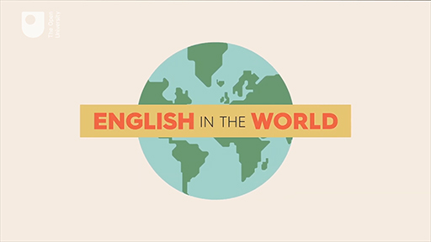

Provide your answer...

3 Shakespeare’s language (or ‘It’s all Greek to me’)
William Shakespeare’s work plays an almost unparalleled role in English-language literary culture. Shakespeare was writing in what’s known today as Early Modern English. Despite some differences in syntax and in the meaning of various words, the language is mostly intelligible to modern English speakers – and certainly more so than either Middle English (the language as it existed from about 1150 to 1500) or Old English (the language as it existed from about 450 to 1150) are. Although the English Shakespeare spoke is over 400 years old, his influence on today’s language can still be seen, both in the popularity of direct quotes from his work, and in the prevalence of words and phrases he either coined or popularised.
The following two animations look at the mark Shakespeare has left on modern English, with a particular focus on words and idioms.
The first film gives a brief introduction to the scope of this influence, and some of the words and phrases that he bequeathed the language.

Activity 3

While watching the video consider whether you were aware that all of these words and phrases dated back to Shakespeare.
Make some notes in the text box below and save your answer. There is no comment for this activity.

Video content is not available in this format.
Video 3 A history of English: Shakespeare
View transcript - Video 3 A history of English: Shakespeare

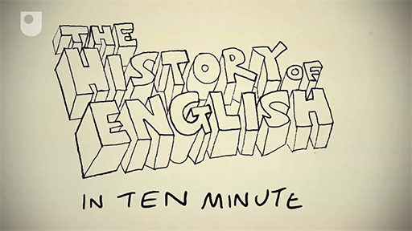

Provide your answer...

The next animation is a short, fictionalised dramatisation of an episode in Shakespeare’s life. Although it takes a few liberties with his biography, it shows the way that a phrase that’s still in use in modern English features in his work, it explains where the phrase originates from and the function it has in the narrative of one of his plays, and illustrates how it’s used in contemporary English conversation.
This is just one example of the many idioms that crop up in Shakespeare’s work. For a look at a range of other phrases, see the Shakespeare Speaks series from the BBC in collaboration with the OU.

Activity 4

Watch the video and try to identify the most important points.
Make some notes in the text box below and save your answer. There is no comment for this activity.

Video content is not available in this format.
Video 4 Shakespeare speaks: Greek to me
View transcript - Video 4 Shakespeare speaks: Greek to me

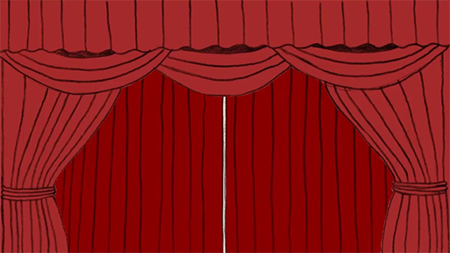

Provide your answer...

An important point with regards to Shakespeare’s influence on the English language is the relationship between culture and language. Many of the expressions we use in everyday conversation, as well as several individual words, take their meaning directly from specific cultural sources or historical events, and then have that meaning broadened into something more general. Take the name Romeo, for example. This can now be used to describe any young lover, but is dependent for this meaning on the archetype of the young lover in Shakespeare’s play. Similar examples from other writers include Scrooge and Pinocchio, or from history, Boycott and Quisling. In each of these cases, cultural artefacts or historical events provided the template for a general phenomenon, and the names of the original characters have entered English vocabulary as a way to refer to these phenomena.

4 Internet English
It’s something of a mantra in sociolinguistics (the study of language and its relationship to society) that all languages change over time. You’ve seen briefly in Sections 2 and 3 how 1,500 years of history have altered the shape of English. There are two main reasons why a language changes. It changes as society changes – as people move from place to place and mix with different communities, and as historical events such as wars, invasions, colonialism and imperialism alter the political make-up of the world. But it also changes under the influence of new technologies.
In this section and the next, you will jump forward several centuries from Shakespeare’s time and look at the impact that digital communications technologies have had on the use and nature of English over the last few years. Later in the course, you’ll look at the role that artificial intelligence is likely to play in the future of language.
As has been noted in the previous sections, the relationship between language and technology has a long history and has given rise to dramatic changes in the way humans live their lives and organise themselves in societies. The impact of the internet and other digital technologies are a prime example of this relationship. The combination of the internet and mobile technologies has radically altered our everyday routines over the past 30 years. And the pace of this change shows no signs of letting up.
There are many ways in which internet-related technology has altered both how we use language and, in some respects, the look and nature of language. One notable way is through the coining of new words to refer to the new concepts and practices that have developed around the technology. But this isn’t the only way in which vocabulary has changed under the influence of these new technologies.

Activity 5

Watch the short animation below and consider the different ways in which technology has an influence on language and the way we use it.
Jot down any thoughts you have about this in the text box below. Once you’ve done so, save your answer and then read the comment.

Video content is not available in this format.
Video 5 A history of English: internet English
View transcript - Video 5 A history of English: internet English

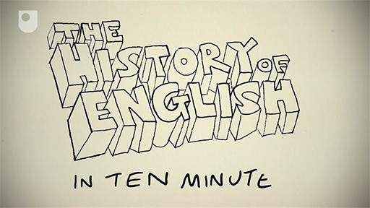

Provide your answer...

View discussion - Part

Beyond the coining of new words, however, internet and mobile communication has had an influence on literacy – in terms of the amount we now write, the way we use writing for conversational purposes, and the tendency to use abbreviations as a convenient and time-saving aspect of this more casual form of writing.
One element that isn’t covered in this animation though is the rise of visual communication in the era of digital communication technologies. Which brings us to the topic of emojis.

5 Emojis
You began this course by asking the question: What is language? In this section you’ll look at a related question: Are emojis a language? Or to put it another way: Do they count as a distinct language system in their own right? And if so, are they a truly universal language whose use transcends other linguistic boundaries?
Emojis are a visual form of communication for use in computer-mediated communication (CMC). You see emojis all over the place these days, from souvenir shops selling emoji-shaped candy to advertising billboards using emojis to sell fast food. But they’re primarily a form of online communication. They’re generated by computer technology and they fill a gap in what online communication offers us.
The gap they fill comes from the way that, as noted in the previous section, social media has led to the use of writing for conversational purposes. We chat with friends via speedily typed-out messages in short bursts. But when writing, we don’t have recourse to expressive features such as tone of voice, facial expressions, and other ‘non-linguistic’ forms of communication. So emojis can provide a simple way of expressing this emotional framing for language.
But are they also a language in their own right? Well, no. They’re not a substitute for a language like English or Chinese because they don’t allow for the same scope and complexity of expression. It would be nigh on impossible to ‘translate’ the previous sentence into emoji. What, for instance, is the emoji for ‘scope’? Or for ‘complexity’? And how would you deal with the meaning that’s conveyed by the words in the sentence being in the particular order that they are (i.e., the syntax of the sentence)? Instead, emojis are best seen as an extension of written languages. They provide us with additional resources that can better help us convey the meaning we want to convey.
Despite not being a language in their own right, however, they are nonetheless a complex and sophisticated means of communication, even if this isn’t the image they have in the popular imagination. The animation below explores the origins and development of emojis, and explains why it is they’ve become so popular for today’s online communication. As the film illustrates, emojis didn’t appear out of nowhere, but can be seen as one stage in the long development of writing and communication.

Activity 6

Watch the film and make a note of its key points.
Make some notes in the text box below and save your answer. There is no comment for this activity.

Video content is not available in this format.
Video 6 A brief history of emoji
View transcript - Video 6 A brief history of emoji

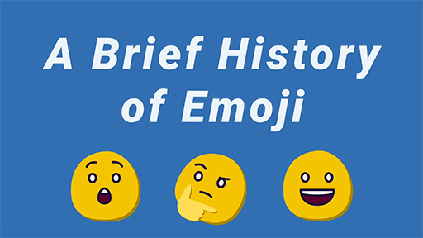

Provide your answer...

6 Creativity and language
In this section you’ll move to look at the relationship between language and some slightly more abstract or theoretical concepts.
One of the great strengths of human language is that it’s almost endlessly flexible. With a small group of standard sounds, or the set number of letters in an alphabet, we can express our feelings and ideas about almost any experience we encounter. Using that small collection of sounds or set number of letters, you can combine them to produce sentences which will never have been uttered by anyone else in the world before – and yet are still meaningful to anyone who speaks the same language as you.
It’s because of this property that the notion of creativity is so important for the way we use language. In some ways, every time we open our mouths to speak we’re engaging in a creative act in that we’re creating meaning for others to interpret. But this would be a rather broad definition of creativity. The video below looks in a more focused way into the relationship between language and creativity, at what we mean when we say something is creative, and at why the concept is so important in our lives.

Activity 7

Before watching the video, have a think about the following questions:
- How would you define ‘creativity’ if you were asked to do so?
- Do you think that creativity, as you’ve just defined it, is an important part of our everyday language use?
- Are there specific uses of language, or specific contexts in which language is used, which are particularly dependent on linguistic creativity?
Jot down any thoughts you have about this in the text box below. Once you’ve done so, save your answer and then read the comment.

Video content is not available in this format.
Video 7 Language and creativity
View transcript - Video 7 Language and creativity

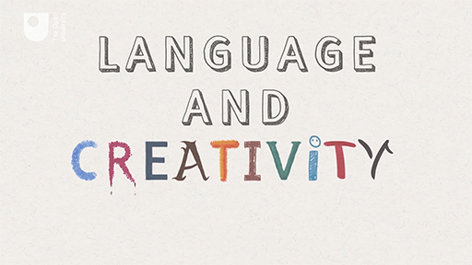

Provide your answer...

View discussion - Part

7 The language of comedy
One of the most important purposes for which we creatively manipulate language is humour. Pinning down precisely what constitutes humour is a perilous business, and the concept covers a huge range of different forms of action and expression, from gags to slapstick. Rather than concentrate on something archetypal like the linguistic format of a joke, however, in this section you’ll look at other ways in which a sensitivity to language can contribute to the creation of comedy.
In the video below, you’ll hear from the comedian Graham Fellows, creator and performer of the character of John Shuttleworth, about the various influences and motivations behind his creation. As you’ll see, issues related to language have played a central part in the creation of the character, but in rather subtle ways. The humour comes from his observations of how people in his hometown speak, both in terms of their accents and turns of phrase. He then mixes this with slightly incongruous examples of language play – rhymes such as ‘burial / Mary will’ and puns such as ‘undertake’. The result is something which highlights the whimsical absurdities of normal life – and everyday language use – without resorting to stereotype or mockery.
It’s worth noting that humour is often quite culturally-specific – it draws on an audience’s recognition of peculiarities and incongruities in the environment around them. This is certainly the case with the interview with Graham Fellows and the way that he creates his comedy from observations of the environment in which he was raised and has lived.

Activity 8

Watch the video and make a note of its key points.
Make some notes in the text box below and save your answer. There is no comment for this activity.

Video content is not available in this format.
Video 8 The language of comedy
View transcript - Video 8 The language of comedy

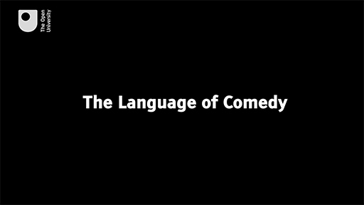

Provide your answer...

8 The language of lying
Lying is as integral to the human experience as humour is. Language may be the mechanism we have for expressing our inner thoughts to an external audience, but it’s not restricted to representing these thoughts exactly as we think them. We have the ability, through language, to create entirely imaginary worlds; to envisage and communicate scenarios which have never existed. It’s this faculty of thought-through-language which creates so much of the culture we live in and allows for myth-making and fictional storytelling. But it also provides us with the potential to lie.
Lying, as with humour, occurs in all areas of our lives. The video in this section, however, focuses predominantly on lying in politics. Politics is founded on persuasion – that’s, say, the act of convincing someone to do something they weren’t necessarily planning to do. Politicians need to persuade people to support them; they need to persuade people that their ideas for running the country are better than their rivals’ ideas; and that they have the skills to carry out these ideas. On the basis of this persuasion, the electorate votes for the politicians and invests them with political power. The whole system, in other words, relies on being able to trust what politicians say, which is why the issue of lying is so contentious in the context of politics.
So what exactly counts as a lie in politics? And is the context of politics any different from other contexts in which lying takes place? The films below look at why it is that humans lie, and what precisely the nature of the relationship is between politics and lying. They ask whether there’s a difference between a lie, an untruth and a falsehood, and consider what role lying plays in human communication.

Activity 9

As you watch the films, make some notes in the text box below and save your answer. There is no comment for this activity.

Video content is not available in this format.
Video 9 The language of lying part 1
View transcript - Video 9 The language of lying part 1

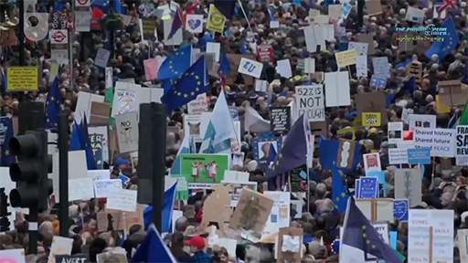

Video content is not available in this format.
Video 10 The language of lying part 2
View transcript - Video 10 The language of lying part 2

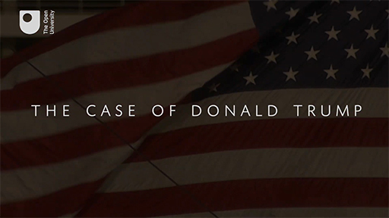

Provide your answer...

9 The language of protest
You don’t need to resort to lying, of course, to persuade people in politics. There are many other ways to try to convince people. But however powerful, persuasive, sincere and truthful your message might be, you need first to find a way to get people to hear it. And while those already in power have access to resources for mass communication – newspapers, television, radio and so on – those without power mostly don’t. They thus need to find other ways to share their message with the public.
The film below examines how protest movements go about communicating their message and particularly how those without access to traditional forms of power get their voices heard. How do they raise awareness of the issues that affect their lives, and how do they influence public opinion and put pressure on those in power?
The film focuses on protests around the climate crisis. Since 2019, Extinction Rebellion (XR) have staged a number of highly effective demonstrations, firstly in the UK and then spreading out across the globe, raising awareness about the climate emergency. The film follows a group from XR as they prepare to protest against the impact that the fashion industry is having on the environment. This is discussed within the context of political protest more generally – from the Arab Spring to the Black Lives Matter and Me Too movements. In examining the ways groups organise and plan their communications, and how they use language, symbols and collective spectacle to capture the attention of the public, it explains the vital part that protests play in the political protest, and why they continue to be such a central feature of contemporary life.

Activity 10

Watch the film and make some notes. Please note that some speakers use swear words in the video.
Make some notes in the text box below and save your answer. There is no comment for this activity.

Video content is not available in this format.
Video 11 The language of protest
View transcript - Video 11 The language of protest

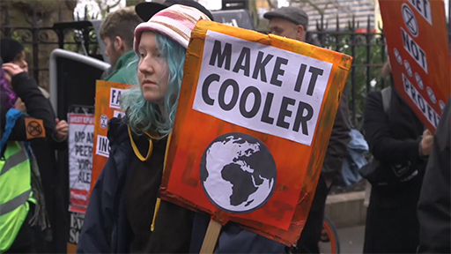

Provide your answer...

10 Speaking robots
It seems a very obvious point, but English is a human language, and the previous sections have all focused on this. English is spoken by humans when they speak to other humans. A lot of people might address their pets in English, but they have no expectation that the pets will also reply in English. Animal communication in a range of different species can be quite sophisticated, but it never has the same level of complexity and flexibility as human language does.
But how about machines and robots? As various types of machine become ever more integrated into our everyday lives, teaching them to ‘speak’ seems to be a logical next step. After all, spoken language is the most direct and intuitive form of interaction for humans. But can machines ever really ‘speak’ and communicate in the way that humans can? What are the challenges faced by researchers into trying to teach a machine how to speak? And what does this tell us about the nature of language itself?
These are the question explored in the video below.

Activity 11

Watch the video and make some notes in the text box below and save your answer. There is no comment for this activity.

Video content is not available in this format.
Video 12 Speaking robots
View transcript - Video 12 Speaking robots

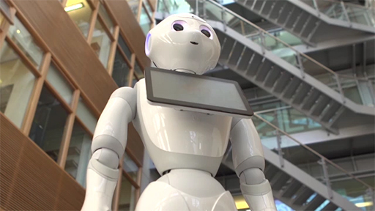

Provide your answer...

11 The future of language
As you saw at the start of this course, compared to the history of human language generally, English is relatively young having been around for just one and a half millennia. But in that time, it’s grown from a parochial language spoken by a few north European tribes to one used across the globe and spoken, to some extent or other, by over two billion people – not to mention a number of robots. As things stand at the moment, it’s the pre-eminent global lingua franca, and is viewed by a large proportion of the world’s population as being an important resource for prospering in life. This is not to say that its status in the world is unproblematic. There’s plenty of criticism of the way the language is a divisive force in societies, and how it helps the main Anglophone countries wield soft power across other parts of the world.
So what’s the future of English likely to be? And what part will it play in the future of human language more generally? As you’ve noted time and again, language is one of the essential characteristics of what it means to be human. It’s the foundation for our culture and civilisation. But with the rapid rise of new communication technologies, there’s been speculation in some parts that language as we know it may become obsolete in the near future.
In the last video in this course, you’ll look at all these questions.

Activity 12

Before watching the video, have a think about the following questions:
- What are the main factors that will likely influence the future of human language and communication?
- Should we be worried about some of the changes that will likely happen to the way we communicate in the future?
- And if we have concerns about how things might develop, is there anything we should be doing now to prevent our worst-case predictions coming true?
After you’ve watched the video, jot down any thoughts you have about this in the text box below. Once you’ve done so, save your answer and then read the comment.
Now watch the video.

Video content is not available in this format.
Video 13 The future of language
View transcript - Video 13 The future of language

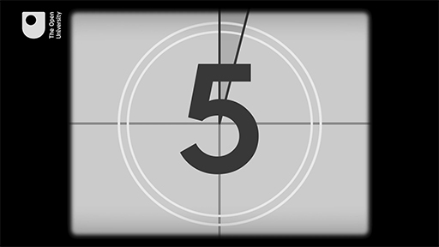

Provide your answer...

View discussion - Part

Conclusion
The importance language plays in our life can’t be underestimated yet it often goes unnoticed. By the time we’re just a handful of years old we’re all expert language users who can speak or sign, and understand when people talk to us.
But the expertise we have in using language doesn’t translate into knowing how language works, how particular languages (like English) have developed over the centuries, and the impact this history can have on the way we use language today. It’s for this reason that understanding a little about these things, and learning about the nature of language and the manifold ways in which we use it, can help us understand ourselves that much better.
Interested in taking your learning further? You might find it helpful to explore the Open University’s English language courses and qualifications.

Acknowledgements
This free course was written by Philip Seargeant.
Except for third party materials and otherwise stated (see terms and conditions), this content is made available under a Creative Commons Attribution-NonCommercial-ShareAlike 4.0 Licence.
The material acknowledged below is Proprietary and used under licence (not subject to Creative Commons Licence). Grateful acknowledgement is made to the following sources for permission to reproduce material in this free course:

Images
Course image: The Open University

Audio-visual
Videos 1, 2, 3, 5, 6, 7, 8, 9, 10, 11, 12 and 13: The Open University and its Licensees
Video 4: Shakespeare Speaks: Greek to Me; © BBC
Every effort has been made to contact copyright owners. If any have been inadvertently overlooked, the publishers will be pleased to make the necessary arrangements at the first opportunity.
Don't miss out
If reading this text has inspired you to learn more, you may be interested in joining the millions of people who discover our free learning resources and qualifications by visiting The Open University – www.open.edu/openlearn/free-courses.

Solutions

Activity 1

Part

Discussion
First off, you’re using language to read this course. This is written language, but in a moment, when you watch the video, it’ll include spoken language as well. Simply by going through the act of turning on the computer and navigating through to this page, you’ll have probably encountered – and had to produce – a variety of other language. So even for a small everyday task such as sitting down to do an online course, you’re using language for education purposes, for navigation purposes, perhaps for protecting your online identity through the use of passwords, and so on. And none of these things – at least in the way they are done in modern, everyday life – would have been possible without the use of language.
Back to - Part

Part

Discussion
As the video notes, language isn’t simply a tool we use for passing information from one person to another. This is certainly one of its main functions. However, language is also a central factor in the way we express our identity – and how others interpret our identity. It’s one of the main ways we have of establishing and maintaining relationships, as well as communicating our emotions and feelings.
Another important issue touched on in the video is that a crucial part of our experience of language comes from the relationship between language and technology. This has been the case for several millennia: as the animation notes, writing itself can be seen as a technology. In the era of digital technology though, this relationship is arguably more influential on the ways in which we use language than ever.
Back to - Part

Activity 5

Part

Discussion
Some of the new coinages mentioned in the film aren’t that new anymore. ‘Email’, for example, is very established now if not slightly past its sell-by date – or at least, it often feels more like a burden than like the exciting new frontier for communication it was back in the 1990s. And while the ability to ‘poke’ people in the early days of social media was a much-celebrated innovation, it proved to be rather ephemeral.
Back to - Part

Activity 7

Part

Discussion
As the video argues, to call something creative is to appreciate the effect it has in the conversation, especially in the way it makes us see things in a novel light. The concept is often associated with art, literature and high culture, but some sort of linguistic creativity can be found in almost any example of language use. There are, however, some domains in which it’s more salient than others and you’ll look at a couple of these in the next two sections.
Back to - Part

Activity 12

Part

Discussion
The biggest agent of change is almost certainly going to be technology. You’ve seen throughout this course that the history of language use has been shaped from the very beginning by developments in communications technology. As the animation argues, there are a lot of scenarios we can imagine which will have profound significance for our lives. These include whether machine translation will make learning a foreign language redundant; whether a mixture of brain-computer interfaces and artificial intelligence will mean that we’ll soon be able to talk to each other via computer-enabled technology. And how all this will affect issues such as privacy, surveillance and the future shape of society. All of these come with potential benefits and potential risks – and our challenge over the next few years and decades will be trying to ensure that the former outweigh the latter.
Back to - Part

Video 1 What is language?

Transcript
NARRATOR
What is language? Language is one of the defining features of what it means to be human. As the philosopher René Descartes once said, ‘There is no other animal, however perfect and fortunately situated, that can put words together in a manner to convey their thoughts.’
All animals communicate, of course, but the way they communicate isn’t anywhere close to being as flexible, wide-ranging or nuanced as us. Language is so fundamental to our nature that it’s used as a test to distinguish humans from robots. It was language above all else which let the human race turn itself from just another inhabitant of planet Earth into one which now dominates the rest of the animal kingdom.
Language first developed about 100,000 years ago, allowing people to work together and shape the society they were living in. Five thousand years ago, writing was invented. This revolutionised the way we record history and pass knowledge on from generation to generation.
But what exactly is language? By the age of three, almost all children have an expert knowledge of how to use it, but a knowledge of precisely what constitutes the phenomenon of language is much more elusive. According to the linguist Edward Sapir, language can be defined as a purely human and non-distinctive method of communicating ideas, emotions and desires by means of a system of voluntarily produced symbols. These symbols can be made by speech, writing or sign language, and although we might think of language as mostly consisting of words and the way they’re combined, other things like gestures, tone of voice and accent are all part of the way we communicate.
Then there’s the technology we use to communicate. These days this often means computers and smartphones, but writing itself is a technology. So is paper, ink and all sorts of other things. Every new technology that comes along alters the way we communicate. Some people take a very prescriptive view of how language should be used, but in reality it’s changing all the time. It doesn’t degenerate – it just adapts to the different contexts in which it’s used.
Language is also fundamental to our culture. It’s a badge of identity, both for individuals and groups. But this can lead to prejudice. People make assumptions about everything from someone’s education to their moral values based on how they speak.
Language also mediates the way we experience and understand the world. It influences the way we relate to each other, And ultimately, it’s connected to almost everything we do in society.
Back to - Video 1 What is language?

Video 2 English in the world

Transcript
NARRATOR
English in the World. The English language has existed for a little over one and a half thousand years, which in the grand scheme of things is just a blip in the history of human language, and an even smaller blip in the history of human kind. The language is called English because of its associations with England, which sounds straightforward enough. Although, it’s actually a bit more complicated than this. English had its roots here in the North of Europe. Although, of course, it wasn’t called English then. There were a number of Germanic tribes: the Angles, Saxons, and the Jutes, who crossed the channel. It wasn’t called the English Channel until the 18th century. And fanned out across the island of Great Britain, which at the time was inhabited by Britons who spoke Celtic languages, the ancestors of Welsh, Scottish, Gaelic, and Cornish. Before the Anglo-Saxons arrived, the Romans had also colonised large parts of the island, along with people from various parts of the Roman Empire. Later, the Vikings came, and then the Normans all speaking their own languages, and also mixing their languages with English.
[MUSIC PLAYING]
It wasn’t until the 14th century that English became properly established as the language of England and was used for the first time in parliament and in the law. The first King of England to speak English as his native language was Henry IV. Henry came to the throne in 1399, almost 1,000 years after the Anglo-Saxons arrived. But once English was established, it also began to spread, or more accurately, it began to be spread. The most important driver for this was colonialism. In lots of countries, English pushed out the local language and Indigenous forms of English developed. In other countries, English existed alongside the local languages and new forms developed. In the 20th century, it continued to spread through the entertainment industry, politics, the media, and technology, so that today it’s a truly global language.
Throughout its history, it’s always changing
[MUSIC PLAYING]
and will continue to do so far into the future.
Back to - Video 2 English in the world

Video 3 A history of English: Shakespeare

Transcript
NARRATOR
The history of English in 10 minutes. Chapter 3: Shakespeare, or a plaque on both his houses. As the dictionary tells us, about 2,000 new words and phrases were invented by William Shakespeare. He gave us handy words like eyeball, puppy dog, and anchovy, and more show offy words like dauntless, besmirch, and lacklustre. He came up with the word alligator, soon after he ran out of things to rhyme with crocodile. And a nation of tea drinkers finally took him to their hearts when he invented the hobnob. Shakespeare knew the power of catchphrases as well as biscuits. Without him, we would never eat our flesh and blood out of house and home. We’d have to say good riddance to the green eyed monster, and breaking the ice will be as dead as a doornail.
If you tried to get your money’s worth, you’d be given a short shrift. And anyone who laid it on with a trowel could be placed with his own petard. Of course, it’s possible other people use these words first, but the dictionary writers like looking them up in Shakespeare because there was more cross-dressing and people poking each other’s eyes out. Shakespeare’s poetry showed the world that English was a rich, vibrant language with limitless expressive and emotional power, and he still had time to open all those tea rooms in Stratford.
Back to - Video 3 A history of English: Shakespeare

Video 4 Shakespeare speaks: Greek to me

Transcript
[INSTRUMENTAL MUSIC PLAYING]
NARRATOR
It’s October 1599. Shakespeare has finished writing his history play, Julius Caesar, and is visiting a fair in his hometown of Stratford with his daughter. She has just had her fortune told.
WILLIAM SHAKESPEARE
Now, dear daughter, what did old Mother Howard say? What does the future hold for us, I wonder?
DAUGHTER
Oh, Father, Mother Howard talked a lot, but she had such a strange accent. I couldn’t understand a word she said.
[LAUGHTER]
WILLIAM SHAKESPEARE
You’re just like Casca in my play Julius Caesar.
DAUGHTER
Casca? He’s one of the men that kills Caesar, the Roman general. How can you say that, Father? I’m not a murderer.
[LAUGHTER]
WILLIAM SHAKESPEARE
Dear daughter, Casca was in a group of people who were listening to the great Roman speaker Cicero. But Cicero was speaking Greek, so Casca couldn’t understand him.
DAUGHTER
Oh. Why was Cicero speaking Greek?
WILLIAM SHAKESPEARE
That’s what educated people spoke in Roman times. Casca says that some of the people listening to Cicero could actually understand him. Here are the lines.
‘Those that understood him smiled at one another.’
CASCA
Those that understood him smiled at one another and shook their heads. But for my own part, it was Greek to me.
DAUGHTER
So Casca had no idea what Cicero was talking about just like me and Mother Howard?
[INSTRUMENTAL MUSIC PLAYING]
NARRATOR
We’ll leave them there for now. Fortune tellers were common in Shakespeare’s day, and they appear in many of his plays, including Macbeth, The Comedy of Errors, and Julius Caesar in which the fortune teller warns Caesar to ‘beware the Ides of March’, the day on which Caesar was eventually assassinated by his closest friends.
[SCREAMING]
The phrase, ‘It was Greek to me’ has become ‘It’s all Greek to me’ in modern English. And it’s used when something, not just a foreign language, is difficult to understand. For example, in a report about the 2015 Greek debt crisis, UK newspaper, The Daily Telegraph, carried the headline ‘It’s All Greek To Me: A Glossary of Eurozone Crisis Jargon’.
SPEAKER
I’ll never understand the rules of cricket. ‘Out for a duck’, ‘silly mid-off’, ‘googlies’? It’s all Greek to me.
[INSTRUMENTAL MUSIC PLAYING]
WILLIAM SHAKESPEARE
Now, tell me, daughter, did you understand anything Old Mother Howard said?
DAUGHTER
Yes, she talked about you, Father. She said that you’re going to be the most famous Englishman of all time. But I think she was making it up.
WILLIAM SHAKESPEARE
Oh! No, no, no. I’m sure she’s absolutely right about that. She’s obviously a very gifted woman. What shall we look at now, daughter?
DAUGHTER
Can we go to the gold store, Father, please?
WILLIAM SHAKESPEARE
I didn’t need a fortune teller to predict that. To gold or not to gold, that is the question.
[INSTRUMENTAL MUSIC PLAYING]
Back to - Video 4 Shakespeare speaks: Greek to me

Video 5 A history of English: internet English

Transcript
NARRATOR
The history of English in 10 minutes. Chapter 9: Internet English, or language reverts to type. In 1972, the first email was sent. Soon the internet arrived, a free global space to share information, ideas, and amusing pictures of cats. Before the internet, English changed through people speaking it, but the net brought typing back into fashion and hundreds of cases of repetitive strain injury. Nobody had ever had to download anything before, let alone use a toolbar. And the only time someone set up a firewall, it ended with a massive insurance claim and a huge pile of charred wallpaper. Conversations were getting shorter than the average attention span. Why bother writing a sentence when an abbreviation would do, and leave you more time to blog, poke, and reboot when your hard drive crashed?
In my humble opinion became IMHO. By the way became BTW. And if we’re honest that life threatening accident was pretty hilarious simply became fail. Some changes even passed into spoken English. For your information, people frequently asked questions like how can LOL mean laugh out loud and lots of love. But if you’re going to complain about that, then UG2BK.
Back to - Video 5 A history of English: internet English

Video 6 A brief history of emoji

Transcript
LAUREN LAVERN
A brief history of emoji. With over 6 billion sent every day, emoji have gone truly global in the last few years. But where did they come from, and how on Earth did we ever manage to communicate effectively in the pre emoji era?
[BUZZING]
Language first evolved around 100,000 years ago, allowing our ancestors to communicate simple ideas like ‘fire’ or ‘cave’ or more complex ideas like ‘your cave is on fire’.
[SCREAMING]
And then 5,500 years ago, writing was invented in Mesopotamia when people started engraving symbols on clay tablets. This marked a major step forward for civilisation. Although, it wasn’t entirely practical for sending love letters. At the same time in Egypt, people began scratching small picture symbols onto bone and ivory.
[AN ELEPHANT TRUMPETING]
5,000 years later, Johannes Gutenberg invented the printing press ensuring people could mass produce documents and share radical ideas like Protestantism and the recipe for auntie Susan’s vegetable broth. In the 19th century, the telegraph was invented, which led to an increase in long distance communication as well as cases of repetitive strain injury. In the late 20th century, the combination of the internet and mobile phone gave birth to the video call. So now you have to look ill as well as sound ill when you pull a sicky. All of which finally bring us to the birth of emoji. So what exactly are emoji?
The word is made of the Japanese characters for picture writing. They began life when their inventor noticed a craze for sending heart icons among Japanese teenagers as well as booming businessmen. Before emoji, emoticons had let you express how you felt by using combinations of punctuation marks. Now, though, there are emoji for almost everything.
There are ones with different sexual orientations, skin tones, and genders in various roles all purposefully designed to reflect a modern multiculturally diverse society. And then there are less intuitive emoji, like the levitating businessmen, and whatever this means.
[MUSIC PLAYING]
There’s an emoji for almost everything. Well, apart from an emoji for emojis. So what do people use them for?
When we talk a huge amount of meaning is conveyed through gestures, facial expressions, and tone of voice. And this can get lost in written language, particularly as it becomes more colloquial. So what in the past might have been written as ‘your hazel eyes remind me of a forest on the first days of autumn’, might now be ‘U R well fit’.
So in these modern times, being able to project feeling and emotion is especially important. And let’s be honest, even the harshest truths can be softened by an emoji.
[BING]
‘I puked in your car’.
[BING]
SPEAKER
Meh.
Back to - Video 6 A brief history of emoji

Video 7 Language and creativity

Transcript
SPEAKER 1: Language and creativity. What is creativity? And what does it have to do with language? Creativity is a notoriously difficult concept to define. The Oxford English Dictionary defines it as--
SPEAKER 2: The faculty of being creative, ability or power to create.
SPEAKER 1: The word derives from the adjective ‘creative’, which means--
SPEAKER 2: Having the quality of creating. Able to create. Relating to or involving imagination or original ideas.
SPEAKER 1: And this, in turn, comes from the verb ‘create’.
SPEAKER 2: To bring into being. Cause to exist. To produce where nothing was before.
SPEAKER 1: A dictionary definition only gets us so far. We can also look at how other people have defined it and the key features they’ve identified for it. Creativity is--
SPEAKER 3: Intelligence, having fun.
SPEAKER 2: The process of having original ideas that have value.
SPEAKER 3: Every act of creation is, first of all, an act of destruction.
SPEAKER 2: Creativity is not a capacity of special people, but a special capacity of all people.
SPEAKER 1: But perhaps it’s easiest to start by looking at the different contexts in which linguistic creativity can occur. This range includes high literary art.
SPEAKER 2: O, Romeo, Romeo, wherefore art thou, Romeo?
SPEAKER 3: Tyger Tyger, burning bright, in the forests of the night.
SPEAKER 1: And also everyday communication.
SPEAKERS: Education shouldn’t be a death sentence. Education shouldn’t be a death sentence. Education--
SPEAKER 2: People found guilty of not using punctuation deserve the longest sentence possible.
SPEAKER 1: We can also look at the wide range of ideas and practices that creativity can involve.
SPEAKER 3: Poetic. Dramatic. Literariness. Aesthetic. Foregrounding.
SPEAKER 2: Defamiliarisation.
SPEAKERS: Artful. Playful. Imaginative. Translating--
SPEAKER 2: Translating.
SPEAKER 3: Adapting. Revising.
SPEAKER 2: Revising.
SPEAKER 3: Remixing. Repeating. Recycling.
SPEAKER 2: Repeating, repeating.
SPEAKERS: Performance. Participation. Evaluation.
SPEAKER 3: Critique.
SPEAKER 1: Across all these definitions, a few key ideas crop up again and again. Creativity is seen as something which is new or novel, which is valued and which is appropriate to its context. But even pinning it down to these key ideas just leads to further questions.
SPEAKER 2: What does it mean to be novel?
SPEAKER 3: What counts as being appropriate?
SPEAKER 2: How can we judge value?
SPEAKER 3: And who decides?
SPEAKER 1: So how do we take an analytical approach to creativity? We can start by thinking of it in terms of three different aspects. We can look at it in terms of its products.
SPEAKER 2: Tyger, Tyger, burning bright, in the forests of the night.
SPEAKER 1: In terms of the processes it involves.
SPEAKER 3: A lamb walks into a baaah.
SPEAKER 1: And in terms of the purposes to which it is put.
[LAUGHTER]
When we study it, we can focus on different elements of the phenomenon and we can use different lenses to do this. We can use a textual lens to look at how language is manipulated in various ways to create a particular effect.
SPEAKER 2: Tyger, Tyger, burning bright, in the forests of the night.
SPEAKER 1: We can use a contextual lens to examine how meaning is tied to the social, cultural and historical context in which the communication takes place. And we can use a critical lens to examine the values and assumptions that are embedded in the context. For example, we can look at how value is assigned to act of creativity and the implications this has for society.
SPEAKER 3: 45 once, 45 twice, sold at 45 million.
SPEAKER 1: So where does this leave us? When people talk of something being creative, what they're usually doing is making a value judgment, and usually, a specifically positive value judgment. A highly--
SPEAKER 2: Creative--
SPEAKER 3: Piece of work--
SPEAKER 1: Sets his--
SPEAKER 2: Creative--
SPEAKER 3: Spirit in motion--
SPEAKER 1: Looking for--
SPEAKER 2: Creative--
SPEAKER 3: Alternatives.
SPEAKER 1: Tokyo’s a great--
SPEAKER 2: Creative--
SPEAKER 3: City.
SPEAKER 1: An all-around--
SPEAKER 2: Creative--
SPEAKER 3: Thinker.
SPEAKER 1: She’s a unique--
SPEAKER 2: Creative--
SPEAKER 3: Artist.
SPEAKER 1: People take a number of different positions about how exactly it should be studied. For example, whether the focus should be more on the products of creativity or on its process.
SPEAKER 2: Tyger, Tyger, burning bright, in the forests of the night.
SPEAKER 1: But despite these differences, it remains a very important topic for people from a wide range of disciplines.
SPEAKER 2: And the reasons for this are because of the key roles it plays in human communication.
SPEAKER 3: The fact that it’s a way of making what we say or write stand out, of initiating and responding to change.
SPEAKER 1: And ultimately, of organising our understanding and experience of the social world.
Back to - Video 7 Language and creativity

Video 8 The language of comedy

Transcript
[LIGHTHEARTED MUSIC]
[LAUGHS]
[CLICKING FILM REEL]
[MUSIC PLAYING]
GRAHAM FELLOWS
John Shuttleworth is a Northern character. He’s from Sheffield, which is where I’m from originally. But I started doing him when I moved to Manchester, and I think I was a little bit nostalgic for the Sheffield of my teens. So I started playing around with this sort of ‘Now then, how’s tha doin? Alright?’
But quite soon, I took him away from a Sheffield accent, from the sort of Billy Casper, sort of Kestrel for a Knave, sort of ‘Now then, how’s that doing? Alright?’. I can’t really do that anymore. And I think living in Manchester affected the accent, and it became ‘Just sort of like that, you know, sort of, you know’. Actually, because I live in Lincolnshire now, it’s gone a bit Lincolnshire. ‘You know’. Or is that Staffordshire? I don’t know.
[MUSIC PLAYING]
(SINGING) My wife Mary made a lovely shepherd’s pie and peas.
John Shuttleworth’s language is definitely not from the present day.
(SINGING) I said, that looks fantastic, love. And I tucked in hungrily.
I think it all comes back from my dad, who is kind of a little bit out of time. Well, he’s dead now. But when I started doing John, I probably-- in fact, I know I did, I used him as a template. Though, ironically, my father is from Croydon.
(SINGING) A shandy bass in a lady’s glass.
The line ‘a shandy bass in a lady’s glass’, that really is sort of me paying homage to Sheffield, to the working men’s club where I used to work in Sheffield. And I’m sure these guys used to come up, and they’d say, half a double diamond in a lady’s glass. But in this way of saying it in quite a butch way, I thought it was quite amusing. So yeah, I mean, I guess that’s a Northern expression. I don’t know if it’s used in the South, but lady’s glass.
(SINGING) I will attend you when you’re very ill, plump the pillows beneath your head. I’ll undertake your burial, or my wife Mary will if I’m already dead.
That came about because I think I realized ‘burial’ rhymed with ‘Mary will’. Mary is John’s wife, so I played around with the ‘undertake’. See, that was a little joke. I undertake-- ‘I’ll undertake your burial, or my wife Mary will if I’m already dead’.
(SINGING) I can’t go back to savoury now, oh no, my taste buds would go crazy. Can’t go back to savoury now.
‘I can’t go back to savoury’ is a song all about obsession, isn’t it? It’s about listing all the things in the meal and all the little aspects of the meal. So it’s very character-driven because John Shuttleworth would do that.
(SINGING) Hush now, my child, lie you very still. Eat your tomato soup and soft white bread.
[BEEPING TONES]
There’s a friend of mine who actually is-- all the time, he sort of says, oh, yes, that’s a bit claggy, isn’t it? Good old Northern word. You know, you’ve met people like that, that do that sort of thing. They’re self-conscious about the use of words because they love language. Well, John loves language, but he doesn’t know he does.
(SINGING) Oh, oh-oh, oh-oh, oh, oh, oh-oh, oh, oh.
[LIGHTHEARTED MUSIC]
Back to - Video 8 The language of comedy

Video 9 The language of lying part 1

Transcript
NICK DUFFELL: The first thing to say is that it’s incredibly natural and normal to tell the odd porky, especially if you want to save face in a situation or avoid hurting people’s feelings. My mother used to say, ‘Never hurt anyone’s feelings’. So I didn’t see you tell the most dreadful untruths in social situations.
BARONESS FOOKES: I would describe a lie as a deliberate misrepresentation of a fact. Deliberate. And I think that’s the key thing. If I may make the comparison with a murder it has to be deliberate to be murder or so reckless of the consequences as to be the same thing, which would distinguish it from manslaughter, where you do it by mistake. It’s not intended.
ASA BENNETT: Well, to me a lie is something that’s not correct, that has been delivered by someone who is intending maliciously to deceive. The intent behind it is key.
TONY THORNE: It’s intentionally saying something, which is untrue. And I think linguists would say that lies and lying are what they call or what we call a language universal and it means that something which occurs in all languages.
NICK DUFFELL: And one of the things that in psychotherapy and counseling, people have learned to realise that in an interaction between two people, that there exists different levels of the truth, there’s my truth, and there’s your truth and actually somewhere we might meet in the middle. So the truth is, it’s philosophically complex.
TONY THORNE: The word lie is actually quite unusual in one particular way and that is that there are almost no ways of saying lie in slang. In British English only, there’s the rhyming slang porky pie, telling porky pies, telling porkies. So a porky is a lie. Again, a light-hearted word. There’s the word fib, which means a sort of little, perhaps harmless lie, which isn’t really slang, but it’s an informal word. But there aren’t any others as far as I’m aware and that is really strange because slang has a thousands words for kill or rob or for anything sexually related.
I have a sense that it’s because even for slang, which deals with some of the most awful taboos in human behaviour, lies are so-- a real lie is so absolute and so indefensible maybe that slang doesn’t go there. Now that’s a very strange thing to imagine.
NICK DUFFELL: When someone is accused of lying, it sounds like a terrible insult. And, of course, it’s even more insulting if you actually are lying. Why do we accept the lies? Why do we not see through them?
TONY THORNE: But when we’re talking about lying, euphemisms are very popular because people who do lie or people who trade in lies never want to admit that they’re lying and try and avoid using the word altogether, unless they’re accusing someone else. So there are words like half-truth, untruth, evasion. All of these words have really usually mean lie. The real euphemisms where a politician, for example, is caught out telling what most people would consider to be a lie, and one that springs to mind is to misspeak or I misspoke.
BARONESS FOOKES: It always easy or at least people will try to make their point using a euphemism on the basis that they will get away with that. An example would be I think he’s being a stranger to the truth.
ASA BENNETT: And, of course, that is why then some politicians like Winston Churchill then coined euphemisms for lying then given these things. He coined the phrase the terminological inexactitude.
TONY THORNE: But it’s part of a long tradition, a long history, not a noble tradition, an ignoble tradition perhaps. But go back to Renaissance portraits and where the prince or the king is portrayed as slim and having an enormous codpiece, when for all we know the reality was other. Later on, George IV, I was looking the other day, the portrait in which he was portly, but in fact he was apparently massively and terrifyingly obese in reality. But, of course, they didn’t paint that.
NICK DUFFELL: When you start to normalise it over time, it becomes a way of life and then you’re living with long-term duplicity. We’ve got this going on and big time in our politics now and we start to normalise it.
TONY THORNE: When politicians are accused of lying, they bristle and they bluster and they overreact, partly this is because they hope by a strong reaction, they can deflect the accusation. But partly it’s because they know they’ve got to take it seriously.
ASA BENNETT: If you’re in Westminster, of course, one of the worst things you can do is directly accuse a member of parliament in the House of Commons of lying. And so that’s why if you have the term for the parliamentarians is misleading the house. And so that’s why the most they can say if they’re trying to gently warn a colleague about something they’ve said, is they are normal, gentlemen. I think you are accidentally misleading the House.
THERESA MAY: Thank you, Mr. Speaker. Can I say to the right honorable gentleman, that I think in his intervention from a sedentary position, he may have inadvertently misled the House on this matter. No, no?
SPEAKER OF THE HOUSE: What was that? I hope the word lie wasn’t used. But order, order! But order! I’m perfectly capable of handling this matter with alacrity and I shall do so.
BARONESS FOOKES: The term lie or lying carries with it a moral judgement. And I think that’s what distinguishes it from other means of describing what is a lie. So that is unparliamentary. And the speaker will stop somebody saying that or ask them to withdraw.
SPEAKER OF THE HOUSE: If a member on the frontbench used that word, I’m sorry, I’m not debating it. I’m not arguing. I’m not negotiating. That word must be withdrawn.
POLITICIAN: In courtesy to yourself, I withdraw for participants.
BARONESS FOOKES: Usually people do. If they don’t, the speaker has the power to name the member. And that will be followed immediately by a motion that x be suspended from service of the House. And if that is carried, and it usually I think will be because the speaker carries authority, then that person has to leave the House immediately and can’t return for five days. First offence.
TONY THORNE: Politicians sometimes have to admit that they didn’t tell the truth, but they-- no politician, I think, has ever certainly willingly used the word lie or has ever admitted to lying.
BARONESS FOOKES: When people say something outside as a politician, they are speaking in public at a meeting or on radio, television, or whatever it is. So it’s not quite the same thing as lying, specifically in the House of Commons. So that I would-- that’s where I would draw a distinction. And, of course, it can sometimes become a grey area because you can say something, which you mean, but which perhaps you’re not able to fulfill. Now this is where the promises, the manifestos, and so on come into play, or personal pledges.
But you have to remember that a politician is often dealing with a number of people who have very different points of view, probably controversial, contradictory. And if you’re trying to please somebody because you want to be elected, it is obviously a temptation to tell people what they want to hear, which may well then lead to your saying something, which you don’t believe yourself or don’t agree with, but you still say it. So that is a temptation.
NICK DUFFELL: It’s not so difficult to begin to recognise dissociation and projection, for example. You can see how that’s happened on a whole national level and over the Brexit issue, where we’ve projected all our fear of the future onto Romanian guest workers.
ASA BENNETT: When you look at something like Brexit, it does make sense and why the accusations of lying fly around because the stakes are so high and this is such an important process, that clearly the debate and rhetoric is really ratcheted up. You do encounter things that do not stand up when you scrutinise them. And so obviously it’s a responsibility of people like myself to hold these people to account, to assess their claims, and to call out when they’re not telling it straight.
TONY THORNE: And this is where I think that the mainstream media, again, whichever side you’re on, whether you’re pro-Brexit, pro-Trump, pro-Boris Johnson, pro-Theresa May, or pro-Jeremy Corbin, the mainstream media has been complicit in a sense in all of these untruths and half-truths because they haven't exposed them.
ASA BENNETT: Well, obviously, if the media isn’t there to hold politicians to account, who on earth would hold politicians to account? After all it’s our public duty to do this because if politicians feel they can get away scot-free with saying anything, then public debate itself suffers.
So, for example, we had an interesting case recently when after the referendum, an absolutely very fervent Remain campaigner was trying to haul Boris Johnson through the courts off the back of the vote Leave claim about we send 350 million per week to the EU, why not spend it on the NHS instead. It’s still rippling on today with, again, Boris Johnson only recently defending the figure with the figure having become discredited almost from the moment it was displayed.
ASA BENNETT: These spurious attempts to try and drag the courts in show why actually it’s responsible, it’s safer to rely on the media because this is our job.
TONY THORNE: It was incidentally, manifestly false. The 350 million was simply not so because it didn’t count the rebate that Margaret Thatcher had negotiated. For that reason only, it wasn’t true.
ASA BENNETT: Because effectively judges were being asked to rule on political debate, whereas actually that should be the job for the media. The court really would be Sky News, BBC News hauling out politicians, embarrassing them in that sense.
Back to - Video 9 The language of lying part 1

Video 10 The language of lying part 2

Transcript
[MUSIC PLAYING]
DONALD JOHN TRUMP: As President of the United States.
BARONESS FOOKES: Maybe people are more used to hearing or seeing people lying because we have the example over the Atlantic of President Trump. But I’m not even sure whether he knows that he’s lying or not. I mean, I’ve always taken the view that it is deliberate. But I’m not too sure whether with Trump whether he realises what he’s saying is the truth or not. I think he’s almost gone past it. I’m not a psychologist. But I think it would be very interesting to have somebody look at the state of mind which produces the effects that President Trump does.
NICK DUFFELL: And there is just so much information around. And you could see this with the confidence of, say, the way Donald Trump uses his lies to say, well, this truth is as good as any other truth. This is my truth. This could be fake news. You sort it out.
DONALD JOHN TRUMP: This is fake news put out by the media.
ASA BENNETT: But when you take the row over Trump’s inauguration, that very much was an early preview of what we’re about to see with the presidency itself, a constant rolling battle with the media in which those media rounds would distract from the substance of what was happening.
TONY THORNE: Trump’s associates actually doctored the photos, cropped them, so that they only showed the thick crowds at one end of the square, whereas Obama had filled the square. So that there’s incontrovertible documentary evidence. And still Donald Trump continued to insist that he’d drawn a bigger crowd.
ASA BENNETT: And so he was able to use the bully pulpit of the presidency to assert that actually, as his press Secretary ended up telling reporters, been the largest audience ever, period.
TONY THORNE: He knows that his hard core, his core supporters are not going to worry really whether it’s true or not. And that they will accept at face value anything he says, specifically this.
BARONESS FOOKES: I suppose one of the later ones was on the state visit when he claimed that, if we had a trade deal with America, with the United States, then the National Health Service would be included. The very next day, he said, oh, no, it wouldn’t be. Now, is that a lie or what is it? I mean, it gets almost beyond belief.
TONY THORNE: In fact, and I can’t judge the truth of this of course, but The Washington Post and other US journalists have tried to count the number of lies that they claim that Donald Trump has told since he took office. And the figure in April this year 2019 was 10,000.
BARONESS FOOKES: I know some people will compare President Trump with Boris Johnson in as much as they appear to say some contradictory things. I think there is a very vast difference between them, even though they appear to be friends. I think the trouble with Boris is that he gets carried away in a fit of exuberance and says something which perhaps he doesn’t really mean and will retract or amend at a later stage. Now, whether that is lying, I think is a grey area.
BORIS JOHNSON: Like some slumbering giant, we are going to rise and ping off the guy ropes of self-doubt.
TONY THORNE: And this goes right back, and perhaps is to some extent provable to his record when he was The Daily Telegraph correspondent in Brussels and he made up stories. He made up ludicrous stories about the bureaucracy of the European Union and their crazy pronouncements.
Some of these stories, they weren’t all attributed to Johnson, but were later repeated particularly in The Daily Mail about the idea that bananas would have to be straightened, that cows would have to wear pampers, and that Bombay mix would no longer be allowed to be called Bombay mix because it was a British imperial name, would have to be renamed. This was all nonsense.
ASA BENNETT: Well, certainly cynicism is very deeply embedded in the national psyche. And voters elsewhere around the world feel this like in the US. When it’s a distrust, not just of the political class, but also of establishment, figures, officials, and so this is why you see the BBC has been widely distrusted by some, even I, as part The Telegraph, will be distrusted by some people on Twitter and social media. This is why you have people going to alternative media outlets. They describe and decry the MSM, the mainstream media for peddling what they say is fake news, establishment narratives.
SPEAKER OF THE HOUSE: The question is the amendment be agreed to. As many as of that opinion will say, content.
AUDIENCE: Content.
SPEAKER OF THE HOUSE: Contrary, not content.
BARONESS FOOKES: Lying is stigmatised, I think, rightly because it shows distrust, how can you rely on somebody if they’re not telling you the truth. And so I think consistent lying, as I say, it unsettles people. It destroys integrity and trustworthiness in the system. So I think if it went on for too much, you could start to degrade the entire system. And I think that is why it’s so important.
[MUSIC PLAYING]

Back to - Video 10 The language of lying part 2

Video 11 The language of protest

Transcript
CLIVE RUSSELL: I’ve always been interested in changing the world effectively. And also I have two young children. When I look at them, I think, well, if I don’t do something, then I’m massively letting you down.
GARY YOUNGE: Unless there is some brake on neoliberal globalisation, which is making the poor poorer and the wealthy wealthier, we’ll see increasingly clashes.
FEYZI ISMAIL: People are seeing that these are global problems and so they want to be part of something that is an alternative.
LAURA FRANDSDEN: I recently graduated my master’s in womenswear fashion from Royal College of Arts. Through those studies, I kind of started to become more aware of the climate emergency. And it became quite clear to me that changing the fashion industry is essentially it’s a bit is a waste of time, when the fashion industry is within a system that is broken. And it became more clear that system change is what we need.
And then I heard about Extinction Rebellion, the fashion week protest they did. These guys are incredible. And I’m studying fashion, but right now I’m absolutely certain that I’d rather be on that side of the building.
CLARE FARRELL: For me it’s a real moment of reckoning for an industry, which fears cultural irrelevance because if we went and did a mock funeral outside a fossil fuel conference, they’d go, oh, go home now. We don’t care about you. We’re much bigger and stronger than you. The fashion industry are fearful of the change in culture in a way, which I think presents a unique opportunity to deal with a very, very polluting and toxic industry.
CROWD SINGING: ... Urgency.
LAURA FRANDSEN: And then we have the Cancel London Fashion Week campaign to get the British Fashion Council to cancel London fashion week in its current system, and instead use that platform of influential power they have to educate people about the crisis, to tell the truth.
FEYZI ISMAIL: I think people are turning more to protest because of, on the one hand, the unbearable living conditions despite the fact that people are in work in many cases, not able to make ends meet. The other I think is a combination of fear and anxiety about the future, over climate change, war, economic crisis.
GARY YOUNGE: What this spike in social protest shows us, electoral politics is failing to cohere some of the bigger cries for help change reform that the old parties aren’t coming in.
PHILIP SEARGEANT: One of the most fundamental things about protests and demonstrations is that people are trying to find ways of getting their voice heard, being able to put forward a political message without the backing of other political institutional forms.
MARIAM ABOELEZZ: Language can be a very effective way, can be used to communicate the messages of the protesters. But can also provide a very valuable window on the value systems, the cultural settings, the wider context in which a protest movement is taking place.
GARY YOUNGE: When it comes to using the language, I think social protesters are becoming increasingly blunt, which I think is different to being crude.
PROTESTOR: Furthermore, we call on all rebels to come out and continue the rebellion.
GARY YOUNGE: In most of these cases, you get something simple, repeatable, mimetic, that can be taken and used and applied sometimes across oceans. Me Too pretty much works anywhere. Black Lives Matter works in most places, where there are Black people, when there aren’t Black people, there are people who are stigmatised and brutalised.
PROTESTOR: When do we want it?
CROWD: Now!
PROTESTOR: What do we want?
CLARE FARRELL: So Extinction Rebellion was born out of a group of activists called Rising Up, which was a decentralised network across the UK of people interested in testing out tactics of civil disobedience and non-violent direct action. The Arts Factory, I guess it was born out of the idea that you need to produce stuff to serve the movement.
MILES GLYN: We really shouldn’t wear anything. She needs a bit of help on that.
CLIVE RUSSELL: So at the heart of the design that we created was this idea that it could be expanded by other people.
MILES GLYN: And then they’ll get used and we’ll get feedback on what makes people happier. But the big ones are really good for tying to trees. And I mean the idea was that one person could unfold it.
We are complete. Are we printing these for the fashion action going into action on Saturday. I mean everything we do has a certain look and a feel at the moment. I mean it just started by me making these things. The advantage is that I’ll make a thing and I can print with it on banners and/or flags or on people’s clothing.
Oh, fantastic. That’s the best one yet. And then from the same object, we get a very simple black and white image, which then goes to the graphic designers. And they work really well on the web as well.
SPEAKER: We’re printing symbol flags for an action on Saturday. And they have a specific colour palette. And then we do a little shuffle. And we have very strict consent rules when we’re on the block.
MILES GLYN: It’s about mass producing, but it is still handmade and it’s about working collectively together. I think that’s--
SPEAKER: Yeah, that’s the most important thing is that we do it together, community of artists so that we have lots of different skills but when we’re in the factory, we just hone down into sewing and printing.
LAURA FRANDSEN: I think in a time of crisis and a time of emergency and we’ve seen that throughout history as well, is that creativity is more important than ever.
We have a really clear set of colours that we use. We’re always using the same type font. We’re always using the same symbols. But I also think there’s something to the language that we’re using that is quite clear and quite bold, but also quite honest. So if the situation is fucked, we say it’s fucked because that’s the way it is.
CLARE FARRELL: When we set out there was like no one else talking like that. When we made that banner that said climate change, we’re fucked and hung it over the side of the Westminster Bridge, it was really like an experiment with language for us because nobody would say it like, OK, well, everyone says it in the boardroom at Greenpeace, but they don’t fucking write it in their newsletter, do they? What’s going on?
And I had meetings with environmentalists who were like, we know that our organisation is engaged in a strategy of managed defeat. But I’m sure their membership don’t know that they say that, right, over lunch.
LAURA FRANDSEN: Idea with the placards is to have coherent visual of the protest, but also to make them in a very DIY approach so that people can actually just replicate it and do it at home, but still contribute to that coherent visual aspect.
PHILIP SEARGEANT: The idea of intertextuality is often used very creatively. You appropriate the language of someone else and put it to new use for yourself. Extinction Rebellion’s Fashion Action Group took some very almost cliched slogans from the fashion world and then put a spin on them for their own purposes.
LAURA FRANDSEN: Green is the new black is a classic example that people are bringing their own contribution. And that is something we see quite often because it’s such a fashion language.
CLARE FARRELL: A lot of the messaging, I think, at the beginning was focused on being this very big container. And what’s important about doing it that way is that then people can put their smaller messages inside and people can bring more nuanced points of view.
CLIVE RUSSELL: So take something like rebel and make it a positive thing. Then that actually has a massive psychological impact on people because you’re saying it’s good to rebel. And, in fact, you can rebel for life. Rebelling for life is a really, really good thing because actually we all need life. And so you’re taking something that’s considered negative by the mainstream culture and making it a positive.
CLARE FARRELL: Again, that’s why I think people try to make things very visual, very real, and keep the words fairly concise and fairly simple.
MARIAM ABOELEZZ: Very difficult to define what a successful protest placard would look like. I would say, well, it has to be one that draws your attention. And it has to be one that brings the message across, effectively. It has to be striking. And remember that in any protest landscape, there will be millions of people carrying protest signs, all of them competing for attention, all of them want to be captured by, well, people’s eyes and camera lenses.
GARY YOUNGE: I think protest has changed a lot over the last decade or so. And the primary thing that has changed it and not the only thing is new technology. That new technology has kind of caffeinated the nature of protest and in virtual presence, which can be both huge and elusive. They exist as hashtags. They key into something real. They mobilise sometimes millions of people. But they can disappear as quickly as they appear
PHILIP SEARGEANT: Social media has changed the participatory aspect of demonstration. And that’s definitely had an impact on the type of placards people are making. Almost a celebration of this homegrown creativity expressed through placards, the fact that people will take a photograph of it. The photograph then will spread online, might get picked up by a newspaper.
FEYZI ISMAIL: In some ways I think with the internationalisation of protest and the globalisation of protest, I think English is increasingly being used. But if you look at, for example, the Arab world, I think most slogans are still in local languages. Most slogans are appealing to governments. Most slogans are appealing to other citizens. But, of course, you are seeing through social media the increasing use of English.
GARY YOUNGE: I don’t think that English can be considered an international language of protest. I mean, I do think that it is a global language so lots of people use it. I doubt that the gilet jaunes are demonstrating in English.
CLIVE RUSSELL: And there’s a great example in Holland. They realise that’s a massive mistake because when they did their first action in Holland, which was something to do with the Dutch royal family, they have some festival in Amsterdam at a certain point. And a load of them jumped in in the canal basically, to disrupt this ceremony.
And they got accused by the local press of being foreign students because all of the messaging was in English. So they quickly realised that mistake and obviously everything they’ve done since has been in Dutch.
CLARE FARRELL: And so I think when we set out you might know that we used to say we shift the Overton window on the-- firstly on the language that we use to describe the situation that we’re in, but also on the impression of what a responsible response looks like. What’s an appropriate thing to do in a moment like this? And arguably, I think we’ve done that quite well. The emergency bells are ringing through the mainstream media now and they didn’t really seem like they were before.
CLIVE RUSSELL: Hopefully, we’ve changed the way people to refer to climate change to something where we begin to refer to it as climate crisis rather than climate change.
LAURA FRANDSEN: But I think by keep repeating our name, by keep repeating who Extinction Rebellion is and keep repeating that we are in a mass extinction event, it’s going to start to resonate with people. Maybe not now, maybe not in the moment, but it’s going to start to-- it’s planting seeds in a way and make sure that we keep watering them.
- (SINGING) And we are singing, singing for our life.
GARY YOUNGE: The reality is that to fight gives no guarantee of success, but not to fight is guarantee of failure.
- (SINGING) And we are singing, singing for our life.
Back to - Video 11 The language of protest

Video 12 Speaking robots

Transcript
[MUSIC PLAYING]
BARIS SERHAN: What is this?
ROBOT: Just a second. It may be a cup.
As you can see, I’m a humanoid robot created by SoftBank Robotics.
PAUL PIWEK: So the history of computers and using language actually goes back to Alan Turing. During the war, actually, people started developing the first digital computers. After the war, they were then also developed for commercial purposes. Turing worked specifically on this.
And at the time, these computers, they were often referred to, not just by researchers, but also in the popular media, as electronic brains. And so there was a whole discussion about, can these machines-- can they actually think or not? Or will they ever be able to think? What does it actually mean for a computer to think?
OLD MAN: Hello.
ROBOT: Hello.
OLD MAN: Hello.
ROBOT: Hello.
OLD MAN: Hello.
ROBOT: Hello.
OLD MAN: Oh, dear.
ROBOT: We could do this forever.
OLD MAN: I know we could.
ANGELO CANGELOSI: We are trying to teach machine to speak. In particular, we are working with humanoid robots. And the reason we are doing this is because in a context where you have a humanoid robot living in your environment with you, helping you, for example, to prepare food, you want to be able, of course, to communicate via language, which is our natural form of interaction.
ROBOT: Would you like to talk about my impressive hardware?
ANGELO CANGELOSI: For example, the latest one is the Pepper robot, developed by a company in France, SoftBank Aldevron Robotics.
ROBO: I am a sophisticated combination of hardware and software designed to interact with humans and bring them joy. I attach sensors on my head, each of my hands, and inertial sensors in my chest and legs to help me keep my balance.
I can detect and avoid obstacles using the sonars, lasers, and bump sensors built into my legs.
ANGELO CANGELOSI: Communication between people, it’s not only a speech-based approach, but it's a non-verbal approach-- so, for example, emotional communication. We communicate expressing and understanding emotions through body movements or through face or emotional expressions.
ROBOT: I'm still learning how to understand human emotions. But I can analyse your face and notice when you smile or frown.
WOMAN: OK. Hmm.
ANGELO CANGELOSI: The off-the-shelf version of the Pepper actually is very similar to home assistants like Alexa, Siri, all these systems, in the sense that they are pre-programmed with a long list of words, a complex set of grammars, and they can talk about these without really referring to the meaning.
ROBOT: I play an instrument called music boxes. They are--
ANGELO CANGELOSI: This is a prerecorded, pre-programmed set of words and grammatical rules. And the Pepper, in some way, has no understanding of the meaning of words. It just can babble.
ROBOT: Don’t be shy. Put your hands on top of mine.
PAUL PIWEK: In more recent years, in the last decade or so, in the wider area of artificial intelligence, machine learning has become very popular, in particular, the use of what’s known as neural nets. What the machine learning algorithm or system does is it represents the English sentence as a number or a mathematical structure.
Basically, these neural nets, at some point, became very successful for recognising images. So if you give it an image, it will tell you, oh, this is an image with a house in it or something like that.
[MUSIC PLAYING]
BARIS SERHAN: Where is the red hammer? Pick up the blue cup.
ANGELO CANGELOSI: The iCub project is now a 10, 12-year-old project. The iCub that you see here will be nine years old on the 31st of March ’18. So it’s a nine-year-old boy. But I think it speaks, still, like a probably two-year-old child.
BARIS SERHAN: Learn ‘cup’.
ROBOT: Cup.
BARIS SERHAN: Learn ‘ball’.
ROBOT: I like to learn.
ANGELO CANGELOSI: Our approach is called developmental robotics. The scope is the ideas of developmental psychology. So we understand and we study how children learn, looking at psychology experiments.
We implemented the same protocols and the same strategies into our robots. And up to here, we are achieving progress in technology.
MOTHER: Where’s the cooker?
BABY: Cooker.
MOTHER: Cooker. Very clever. Where’s the kettle?
BABY: Kettle.
MOTHER: Kettle.
ANGELO CANGELOSI: One of the challenges is to understand speech, so to decode a wave sound into actual words. But I think the biggest challenge is to attach a meaning to these sounds. So as a baby, I can hear words like ‘dog’ and ‘red’. But the real challenge is how do I connect the word ‘dog’ to the actual perception of interaction with an animal and ‘red’ to the actual perception of the colour for the specific object?
MOTHER: Where is the yellow one. Can you say ‘yellow’? That’s yellow, isn’t it?
SPEAKER 5: [BABY TALK]
GRANDMOTHER: That’s right, yeah.
BARIS SERHAN: Learn ‘ball’.
ROBOT: I like to learn. This is a ball.
ANGELO CANGELOSI: In this demonstration, we are replicating the behaviour of two-year-old children between 18 and 24 months of age. This is when children are starting to name objects, individual words, or one or two words in maximum.
FATHER: What is it? What’s that?
BABY: [BABY TALK]
MOTHER: Good girl.
FATHER: This one?
BABY: Yeah.
FATHER: Yeah, but what’s it called?
BABY: Kum-bah.
FATHER: Kum-ba-bah.
BARIS SERHAN: Find ball.
ROBOT: OK. Now I’m looking for a ball.
ANGELO CANGELOSI: So you see in the demonstration that the robot is paying attention to the object. The tutor is moving the object around so that the robot can keep its attention there. And then, via joint attention with the human teacher, the robot pays attention to the same direction of vision, which is the object focus here. You can now say the name of the object.
BARIS SERHAN: What is this?
ROBOT: I think this is a ball.
ANGELO CANGELOSI: The simultaneous experience of seeing the object and hearing the label, the word for the object, allows the artificial intelligence algorithm behind the robot architecture, called artificial neural network, to learn the association. So it’s a pure speech, sound, and visual architecture, associative learning, like in Hebbian learning, the human brain. And this shows that the robot is the basis for further later acquisition of complex skills like grammar, combining two or three words together.
BARIS SERHAN: Stop detection.
ROBOT: OK. I will stop it.
ANGELO CANGELOSI: Our approach is really highly interdisciplinary. It means it requires the collaboration of experts from different fields. In particular, we require expertise from roboticists, who build our machines, from programmers, and AI people, artificial intelligence, who can program the AI techniques, but, of course, psychologists, a linguist, because they are those that tell us, what’s our current understanding of the way language and meaning and sound works, and, of course, how this applies, for example, in child development for language acquisition.
MOTHER: Where’s the toaster?
TOY: What shall we bake today?
BABY: [BABY TALK]
MOTHER: Toaster. You clever girl.
PAUL PIWEK: What I’ve really learned from doing research on human-computer interaction is-- and especially computer interaction using language-- is that you very quickly realise that things are a lot more complicated than you initially might have expected.
MOTHER: But there’s no water coming out of that tap, is there?
PAUL PIWEK: So usually, when I say ‘hello’ to somebody in the street, they might say ‘hi’ or ‘hello’ or ‘how are you?’ back. So there’s a fairly limited number of things.
But you can see where it sort of gets tricky. So when I say, ‘OK, what have you been up to today?’ Then it’s unlikely that you’re going to find the answer to that question in a huge collection of things that have been said previously, because it’s really what my plans and intentions and beliefs are right now that matter here. And those are not necessarily explicitly represented in any text or even in any prior dialogue that exists.
MOTHER: I know you’d like it to have water. But we can just pretend.
ANGELO CANGELOSI: I don’t believe that it’s possible to achieve human-level capabilities, at least in the medium-term or maybe during my lifetime, just because of the complexity of the task. Language is what makes us special amongst other skills, let’s say, as a human species. And I think we are very far from achieving this, in my lifetime at least.
BARIS SERHAN: What is this?
ROBOT: Sorry. I do not know this object.
Back to - Video 12 Speaking robots

Video 13 The future of language

Transcript
SPEAKER 1
Cassandra News Productions presents, The Future of Language-- the march of progress never stops. Our species, Homo sapiens, is forever on the move. Since the 1900s and ’90s, we’ve witnessed a revolution in the way we communicate. As our tools of communication change, so too does our language.
SPEAKER 2
And as our use of language changes, so too does the shape of society itself. When we look around our world today, we can see the positives and negatives of this relentless march of progress all pushing us inexorably towards the future. So what can we expect language to look like in 10, 50, or 100 years time? And how will this future language transform the way we live, and perhaps even transform civilisation as we know it? The only constant when it comes to language is change. All languages are continuously changing. There are two main reasons which drive this change. The first is the relationship language has with society. As society changes, so too does language and vice versa. The second is its relationship to technology. With new technologies, come new forms of language and new ways of using it.
One of the obsessions throughout history has been the idea that one day we’ll all be able to speak a universal language. Over the centuries, this dream has produced several different solutions. There have been the philosophical languages of the late Renaissance, the auxiliary languages like Esperanto in the early 20th century, and the rise of English as a global language in the second half of the 20th century. But whatever relative success some of these have had, none of them has ever achieved a really universal status. Today though, perhaps technology can solve this age-old problem through the use of machine translation and artificial intelligence. These are ways of harnessing the computational power of digital technology to manipulate huge amounts of data in order to analyse human speech.
There are other ways in which artificial intelligence is already changing language, with things like autocorrect and predictive text, which supposedly help us compose messages. But there are even more radical ideas in development as well. These include brain computer interfaces, where sensors are placed around or under the skull to read the way the brain processes our thoughts. With this sort of technology, you can type directly with your mind. And perhaps, one day, you'll be able to transfer your thoughts directly to another person without needing to speak or write at all. There are lots of possible advantages to these sorts of innovations. They can help with speech impairments, for example, and make communication around the world ever easier and quicker. But despite the advantages, whenever a new technology emerges, there's nearly always a panic in the media about whether it’s ruining language and if it’s undermining our culture and civilisation.
This has been the case with each new innovation and each new generation. But in each case, the language is simply changing rather than decaying. That’s not to say we shouldn’t worry about the way language is developing, but our focus shouldn’t be on whether apostrophes are going to become obsolete or whether no one uses the subjunctive properly anymore. It should be about what this increased incursion of computer technology into the way we use language might mean for things like surveillance and control.
What we should be wary of is what it means if a private company is sitting directly between our thoughts and our ability to express those thoughts. What it would be like if technology was constantly nudging us to speak in a particular way, and whether we want to live in a world in which everything we say, write, or think becomes data that can be monitored by a computer. But whatever the future brings, we can be sure that the human race will find ways to adapt to it. And that language, in one form or another, will remain central to our identities as human beings.
[MUSIC PLAYING]
Back to - Video 13 The future of language

