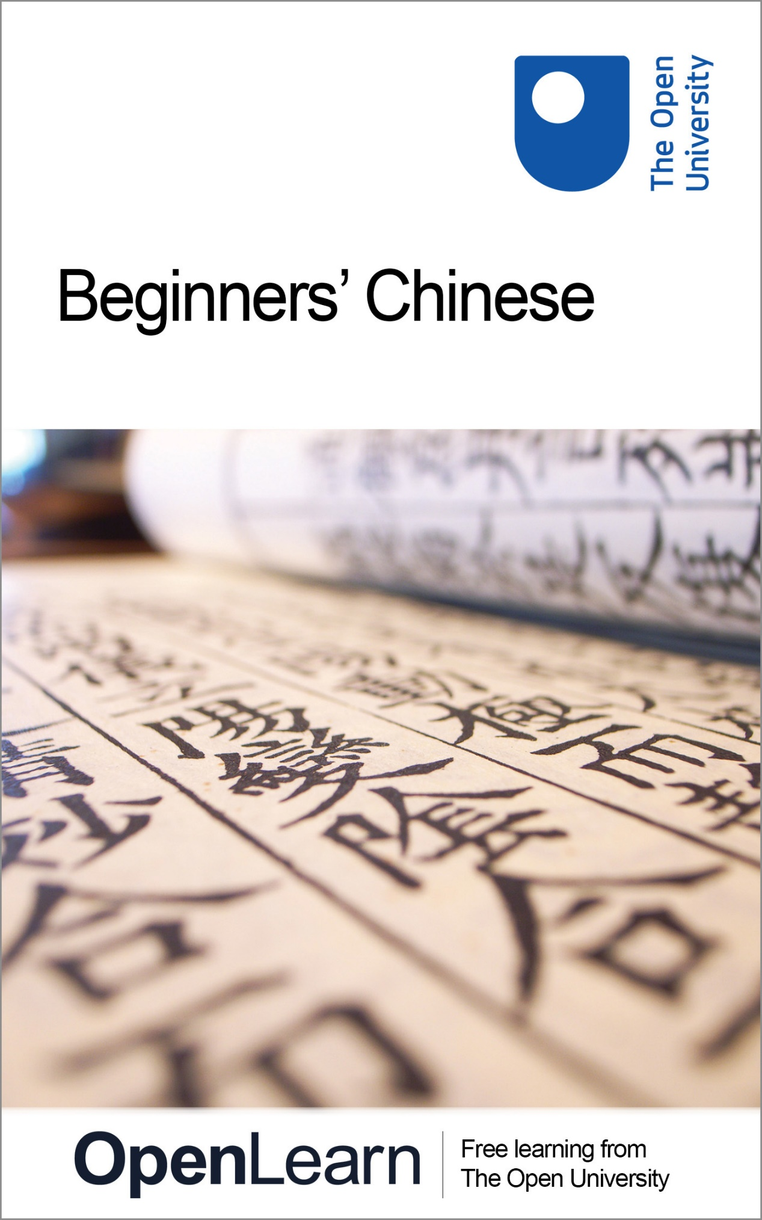

**CHN\_1   Beginners’ Chinese: a taster course**

**Beginners’ Chinese: a taster course**

**About this free course**

This OpenLearn course provides a sample of studying at beginner’s level for [non-accredited language learning](http://www.open.ac.uk/courses/language-short-courses).

This version of the content may include video, images and interactive content that may not be optimised for your device.

You can experience this free course as it was originally designed on OpenLearn, the home of free learning from The Open University <https://www.open.edu/openlearn/languages/beginners-chinese-taster-course/content-section-0>

There you’ll also be able to track your progress via your activity record, which you can use to demonstrate your learning.

Copyright © 2020 The Open University

**Intellectual property**

Unless otherwise stated, this resource is released under the terms of the Creative Commons Licence v4.0 <http://creativecommons.org/licenses/by-nc-sa/4.0/deed.en_GB>. Within that The Open University interprets this licence in the following way: [www.open.edu/openlearn/about-openlearn/frequently-asked-questions-on-openlearn](http://www.open.edu/openlearn/about-openlearn/frequently-asked-questions-on-openlearn) . Copyright and rights falling outside the terms of the Creative Commons Licence are retained or controlled by The Open University. Please read the full text before using any of the content.

We believe the primary barrier to accessing high-quality educational experiences is cost, which is why we aim to publish as much free content as possible under an open licence. If it proves difficult to release content under our preferred Creative Commons licence (e.g. because we can’t afford or gain the clearances or find suitable alternatives), we will still release the materials for free under a personal end-user licence.

This is because the learning experience will always be the same high quality offering and that should always be seen as positive – even if at times the licensing is different to Creative Commons.

When using the content you must attribute us (The Open University) (the OU) and any identified author in accordance with the terms of the Creative Commons Licence.

The Acknowledgements section is used to list, amongst other things, third party (Proprietary), licensed content which is not subject to Creative Commons licensing. Proprietary content must be used (retained) intact and in context to the content at all times.

The Acknowledgements section is also used to bring to your attention any other Special Restrictions which may apply to the content. For example there may be times when the Creative Commons Non-Commercial Sharealike licence does not apply to any of the content even if owned by us (The Open University). In these instances, unless stated otherwise, the content may be used for personal and non-commercial use.

We have also identified as Proprietary other material included in the content which is not subject to Creative Commons Licence. These are OU logos, trading names and may extend to certain photographic and video images and sound recordings and any other material as may be brought to your attention.

Unauthorised use of any of the content may constitute a breach of the terms and conditions and/or intellectual property laws.

We reserve the right to alter, amend or bring to an end any terms and conditions provided here without notice.

All rights falling outside the terms of the Creative Commons licence are retained or controlled by The Open University.

Head of Intellectual Property, The Open University

978-1-4730-3158-6 (.epub)   
978-1-4730-3159-3 (.kdl)

1.0

# Contents

* [Introduction](#Introduction1)
* [Learning outcomes](#LearningOutcomes1)
* [1 The Chinese language](#Session1)
  + [1.1 Varieties of Chinese](#Session1_Section1)
  + [1.2 Pinyin](#Session1_Section2)
  + [1.3 Tones](#Session1_Section3)
  + [1.4 Chinese characters](#Session1_Section4)
  + [1.5 Simplified and traditional forms of Chinese characters](#Session1_Section5)
  + [1.6 Word formation](#Session1_Section6)
  + [1.7 How to memorise and combine characters](#Session1_Section7)
* [2 Greetings](#Session2)
* [3 Introducing oneself](#Session3)
  + [3.1 Nationalities](#Session3_Section1)
  + [3.2 Professional titles and basic professions](#Session3_Section2)
* [4 Basic numbers](#Session4)
* [Conclusion](#Session5)
* [Further reading](#Session6)
* [Acknowledgements](#Acknowledgements1)
* [Solutions](#Solutions1)

## Introduction

This free course, Beginners' Chinese: a taster course, is introductory material for absolute beginners in Chinese. This course concentrates on Mandarin Chinese as a tool for communication, but also provides some insights into Chinese society and culture. It contains a brief introduction to the Chinese language, its scripts and sounds, and how words are formed. The language activities and audio extracts presented here are not meant for a complete course, but are samples to give you a taste of what it is like to learn Chinese. You will hear short conversations where people greet each other and introduce themselves, and learn how to count from one to ten. You’ll learn different ways of saying your name and greeting people, as well as give your telephone number.

Before you continue with this course, make sure you have enabled the Chinese font on your computer. Video 1 gives step-by-step instructions on how to do this for both PC and Mac users.

Start of Media Content

Video content is not available in this format.

**Video 1**

[View transcript - Video 1](" \l "Transcript1)

Start of Figure

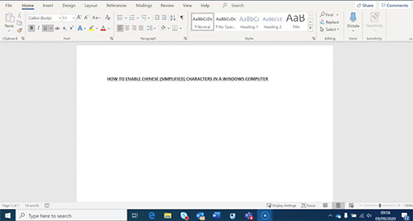

End of Figure

End of Media Content

Now watch Video 2 which explains how to type words in Chinese on a computer.

Start of Media Content

Video content is not available in this format.

**Video 2**

[View transcript - Video 2](" \l "Transcript2)

Start of Figure

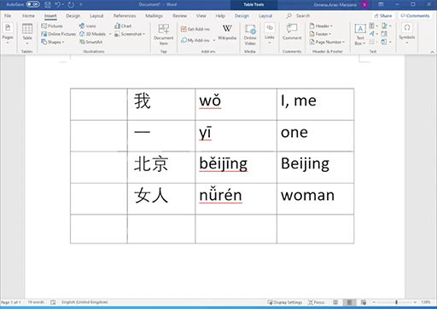

End of Figure

End of Media Content

You may wish to download the [Instructions on how to enable Chinese font and type characters](http://www.open.edu/openlearn/ocw/mod/oucontent/olinkremote.php?website=CHN_1&targetdoc=How%20to%20install%20the%20Chinese%20font) for your own reference.

Please note, to revert back to an English (or your primary language) keyboard on a Windows PC you will need to click on the Chinese character D:\AaaF\OUT\httpswwwopeneduopenlearnocw_cmid106502_2021-01-13_11-36-35_al22273\word\assets\chinesesymbol.jpg, which appears in the bottom right hand corner of your computer screen next to the date and time and where you will have originally switched from an English to Chinese keyboard. Once you have clicked on this character you will then be given the option to select the English keyboard. The same rules apply for reverting back to English on a Mac, however the character D:\AaaF\OUT\httpswwwopeneduopenlearnocw_cmid106502_2021-01-13_11-36-35_al22273\word\assets\chinesesymbol_mac.png will be found in the top right hand corner or your computer screen, again in the position where you originally switched your keyboard to Chinese.

This OpenLearn course provides a taster for studying other Chinese short courses at The Open University’s [Open Centre for Languages and Cultures](http://www.open.ac.uk/courses/language-short-courses) and the 15-credit [Learning to teach languages in primary schools (Beginners Mandarin Chinese)](http://www.open.ac.uk/scotland/study/teachers-learning-teach-languages/beginners-mandarin-chinese).

## Learning outcomes

After studying this course, you should be able to:

* demonstrate an awareness of the varieties of the Chinese language
* understand how the sound system of Mandarin Chinese (pinyin and tones) works
* understand that there are simplified and traditional forms of Chinese characters and have an awareness of how they are combined together to form new meanings
* demonstrate basic vocabulary and pronunciation related to greetings, numbers, names and nationalities
* demonstrate a cultural understanding of how professional titles are used to address people.

## 1 The Chinese language

The Chinese language, in its various forms, is spoken by the Han Chinese and is known in China as 汉语 hànyŭ (literally, Han language). The Han Chinese constitutes about 94 percent of China’s population. About 70 percent of the Han people speak Mandarin Chinese; the remaining 30 percent speak other related Chinese languages or dialects. Speakers of non-Chinese languages (e.g. Mongolian, Tibetan) make up about 6 percent of China’s population.

Mandarin Chinese is the official language of the People’s Republic of China and Taiwan, and one of the official languages of Singapore. It is also one of the six official languages of the United Nations. Mandarin and other forms of Chinese are spoken by many expatriate Chinese communities, both in Southeast Asia and overseas. The map below shows how the Chinese language has spread around the world.

Start of Figure

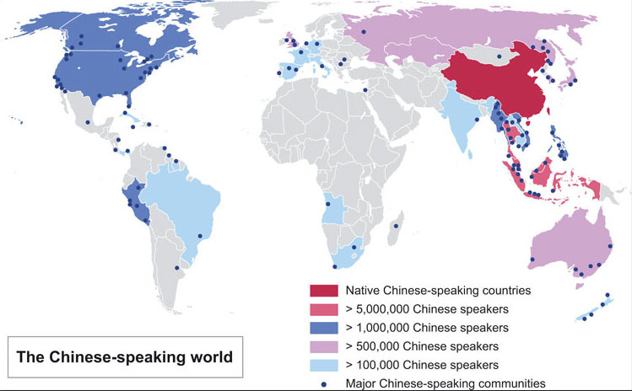

(Adapted from ASDFGHJ, ‘A map of the Sinophone world’, 24 January 2009, en.wikipedia.org/wiki/File:New-Map-Sinophone\_World.PNG, last accessed 29 May 2009)

**Figure 1** The Chinese-speaking world

[View description - Figure 1 The Chinese-speaking world](" \l "Session1_Description1)

End of Figure

## 1.1 Varieties of Chinese

Apart from Mandarin, the other six major varieties of spoken Chinese are Cantonese, Gan, Hakka, Min, Wu and Xiang. The map below shows the areas of China in which they are spoken and by approximately how many people, as well as the parts of China where non-Chinese languages are predominantly spoken.

Start of Figure

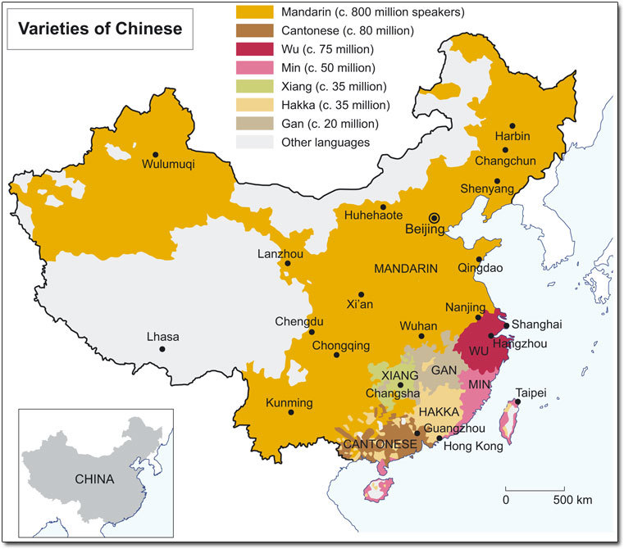

(Adapted from ‘Chinese dialects in China’, 1987, www.rcl.cityu.edu.hk/atlas/20/A2\_20.jpg, last accessed 29 May 2009, and Wu Yue, ‘Map of the Sinitic languages’, 2004, en.wikipedia.org/wiki/File:Map\_of\_sinitic\_languages-en.svg, last accessed 29 May 2009)

**Figure 2** Varieties of Chinese

[View description - Figure 2 Varieties of Chinese](" \l "Session1_Description2)

End of Figure

There is some debate among linguists about whether the different varieties of Chinese should be regarded as dialects or as languages in their own right. Interpretations depend on how ‘language’ and ‘dialect’ are defined. Furthermore, each dialect group consists of many sub-dialects, several of which are spoken widely enough to be categorised by some linguists as major dialects (or languages) that could justifiably be added to the list above.

The samples presented here teach Mandarin Chinese in its standardised modern form. Standard Mandarin Chinese is commonly referred to as 普通话 pŭtōng huà (common speech) in the People’s Republic of China, 国语 guó yŭ (national language) in Taiwan and 华语 huá yŭ (Chinese language) in Singapore. In this course, Mandarin Chinese will simply be referred to as ‘Chinese’.

Chinese is often perceived in the West as a difficult language, mainly because of its different character script and the fact that it is a tonal language – i.e. it uses tones to distinguish meanings. Chinese grammar, on the other hand, is quite simple compared to that of many European languages. There is no conjugation, number agreement or case change, so you only ever have to learn a word in one form.

To start, test your knowledge of the Chinese language with a quiz in Activity 1. You will then move on to learn about it in more depth by exploring pinyin, tones and word formation.

Start of Activity

**Activity 1 Chinese language general knowledge quiz**

Start of Question

Answer true or false.

1. Mandarin Chinese is the official language of the People’s Republic of China and Taiwan, and one of the official languages of Singapore and the United Nations.

End of Question

True

False

[View answer - Part](" \l "Session1_Interaction1)

[View discussion - Part](" \l "Session1_Discussion1)

Start of Question

2. The Han Chinese (who speak 汉语 hàn yŭ) constitute about 70 percent of China’s population.

End of Question

True

False

[View answer - Part](" \l "Session1_Interaction2)

[View discussion - Part](" \l "Session1_Discussion2)

Start of Question

3. Apart from Mandarin, there is only one more variety of spoken Chinese called Cantonese.

End of Question

True

False

[View answer - Part](" \l "Session1_Interaction3)

[View discussion - Part](" \l "Session1_Discussion3)

Start of Question

4. Chinese has a pictographic character script and is a tonal language.

End of Question

True

False

[View answer - Part](" \l "Session1_Interaction4)

[View discussion - Part](" \l "Session1_Discussion4)

End of Activity

## 1.2 Pinyin

There are various systems for transcribing Chinese sounds into the Roman alphabet. Pinyin was adopted as the official system in the People’s Republic of China in 1958, and has since become the standard and most-used form of transcription in schools, the media and elsewhere. This course uses pinyin in the teaching of pronunciation.

Watch the video below to learn more about how pinyin was created.

Start of Media Content

Video content is not available in this format.

**Video 3**

[View transcript - Video 3](" \l "Session1_Transcript1)

Start of Figure

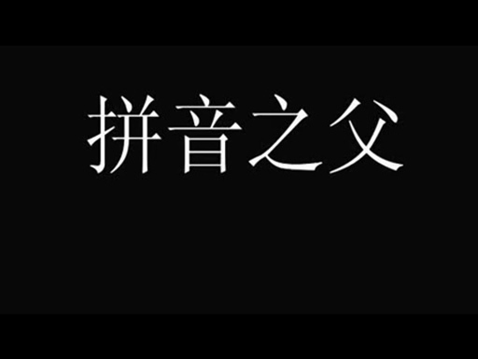

End of Figure

End of Media Content

Read the language note below about pinyin sounds and then, in the activity that follows, listen to how each one is pronouced.

Start of Box

**Language note: single finals and initials**

Chinese is a vowel-dominated language. In total, there are 35 vowel sounds, known as ‘finals’ because they occur at the end of syllables. The six vowel sounds you will hear in Activity 2 are called ‘single finals’ and are written in pinyin as a , e , i , o , u and ü . These simple vowel sounds are put together in various combinations to form 29 ‘compound finals’, which are beyond the scope of this course.

There are 23 consonant sounds in Chinese, called ‘initials’ because they appear at the start of syllables. Here are the 23 initials:

Start of Table

Table 1 Initials

|  |  |  |  |  |  |  |  |
| --- | --- | --- | --- | --- | --- | --- | --- |
| b | p | m | f | d | t | n | l |
| g | k | h | w | y | j | q | x |
| z | c | s | zh | ch | sh | r |  |

End of Table

End of Box

Start of Activity

**Activity 2 Finals and initials**

Start of Question

When you listen to the audio track below you will hear six single vowels, known as **finals** in Chinese. Repeat after each sound.

Start of Extract

a e i o u ü

End of Extract

You will then combine these vowels with some consonants, known as **initials** in Chinese. Note how similar they sound to some English consonants. Repeat after each sound.

Start of Extract

ba pa ma fa de te ne le gu ku hu wo yi

End of Extract

You will then hear some consonants, or **initials**, combined with the final i. Listen and repeat.

Start of Extract

ji qi xi zi ci si zhi chi shi ri

End of Extract

Start of Media Content

Audio content is not available in this format.

**Audio 1**

[View transcript - Audio 1](" \l "Session1_Transcript2)

End of Media Content

End of Question

End of Activity

## 1.3 Tones

Chinese is a tonal language. In Mandarin Chinese, there are four tones (five if you include the neutral tone). Tones are marked in pinyin as follows:

* 1st tone: ‾
* 2nd tone: ′
* 3rd tone: ˇ
* 4th tone: `

The 1st tone is a high level tone, the 2nd rises from medium to high, the 3rd falls from low medium to low and then rises to high, and the 4th falls from high to low (see Figure 3). The tone marks are put over the single finals a, e, i, o, u and ü. There are some syllables that do not have a tone mark (e.g. some particle words or last syllable in a word), and they are called ‘neutral tone’. The neutral tone is low and flat with no stress.

Start of Figure

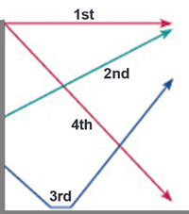

**Figure 3** The tones used in Mandarin Chinese

End of Figure

Each syllable has a definite tone. So syllables with different tones mean different things. For example, 王 wáng with the 2nd tone means ‘king’ and is also a common family name, whereas 忘 wàng with the 4th tone means ‘to forget’.

Start of Activity

**Activity 3 Tones**

Start of Question

Listen to the examples of the four tones on the audio track below, and repeat. You can follow the pinyin in Table 2 as you go. Don’t worry about the meaning of the words at this stage.

Start of Media Content

Audio content is not available in this format.

**Audio 2**

[View transcript - Audio 2](" \l "Session1_Transcript3)

End of Media Content

Start of Table

Table 2 Examples of the four tones in Mandarin Chinese

|  |  |  |  |  |
| --- | --- | --- | --- | --- |
| 1 | mā | má | mǎ | mà |
| 2 | tā | tá | tǎ | tà |
| 3 | zhī | zhí | zhǐ | zhì |
| 4 | jī | jí | jǐ | jì |

End of Table

End of Question

End of Activity

## 1.4 Chinese characters

Speakers of different dialects, especially the southern dialects, often cannot understand each other when they speak. However, literate Chinese people can communicate with each other in writing, as they share a common script: 汉字 hàn zì (lit. Han characters).

The Chinese character script is believed to have originated from stylised pictures of physical objects, which evolved over the centuries into characters formed from strokes. The total number of Chinese characters is estimated at about 50,000, of which roughly 3000 are used for everyday purposes. This course teaches simplified characters, which were introduced by the Chinese government in the 1950s in an attempt to increase literacy.

Each character in written Chinese represents a syllable. A word in Chinese can consist of one character (e.g. 中 zhōng , central), two characters ( 中国 Zhōngguó , China) or three characters ( 中国人 zhōngguórén , Chinese person/people). In Chinese texts, there is no spacing between characters. Traditionally there was no punctuation either, but this has since been adopted.

There is no obvious correlation between how characters are written and how they are pronounced. For example, the following three characters, made up of very different strokes, are all pronounced jing, albeit with different tones: 京 (1st tone) means ‘capital’; 井 (3rd tone) means ‘well’ (as in a water well); and 净 (4th tone) means ‘clean’.

## 1.5 Simplified and traditional forms of Chinese characters

In this section you will learn about traditional and simplified characters and work on some activities.

After the founding of the People’s Republic of China in 1949, the Chinese government introduced a range of ‘simplified characters’ ( 简体字 jiăntĭ zì) in an effort to improve the literacy level in the population. About 2,000 characters have been simplified and the rest of the characters remain the same. It is useful to be aware of traditional forms (sometimes referred to as ‘complex characters’ ) ( 繁体字 făntĭ zì ), as they are still used in Hong Kong, Taiwan and other overseas Chinese communities.

In most cases, the simplification of the 2000 characters involved reducing the number of strokes, while also preserving either the overall shape of the character or of one part of the character. Table 3shows some examples of characters in both simplified and traditional form, and the number of strokes that these forms comprise.

Start of Table

Table 3 Examples of traditional characters

|  |  |  |  |  |  |
| --- | --- | --- | --- | --- | --- |
|  |  | **简体字 jiăntĭ zì** | **Strokes** | **繁体字 făntĭ zì** | **Strokes** |
| xué | to learn | 学 | 8 | 學 | 16 |
| yī | medical | 医 | 7 | 醫 | 18 |
| mén | [plural suffix to make pronouns such as ‘we’] | 们 | 5 | 們 | 9 |
| guó | country | 国 | 8 | 國 | 11 |

End of Table

Now have a go at identifying simplified and traditional characters in Activity 4.

Start of Activity

**Activity 4 Identifying simplified and traditional characters**

Start of Question

Open Google Translate in a separate browser and select Chinese (Simplified) on the left side and Chinese (Traditional) on the right side. Then copy and paste the characters from the Simplified column in Table 4 into Google Translate to see how the same word looks in traditional Chinese.

Start of Table

Table 4 Simplified and traditional characters

|  |  |  |  |
| --- | --- | --- | --- |
| **English** | **Pinyin** | **Simplified** | **Traditional** |
| to love; love | ài | 爱 | *Provide your answer...* |
| book | shū | 书 | *Provide your answer...* |
| to meet | jiàn | 见 | *Provide your answer...* |

End of Table

End of Question

[View answer - Activity 4 Identifying simplified and traditional characters](" \l "Session1_Answer1)

End of Activity

## 1.6 Word formation

In this section and Section 1.7 you will look at combining characters to form new words. Begin by reading the language note below.

Start of Box

**Language note: word formation**

Words in Chinese are formed by one or more characters. For example, when you say ‘hello’ you use two characters ‘nĭ hăo’ 你好 (simplified Chinese). This literally translates as ‘you good’ and means ‘hello’ when greeting one person (i.e. not a group). To greet a group of people you use a combination of three characters nĭ men hăo 你们好 (simplified Chinese), which literally translates to ‘you all good’ and means ‘hello all’.

Another example is the word ‘China’, which is formed by combining two characters zhōng中 and guó国. 中 zhōng has multiple meanings such as middle, centre, inside. Similarly 国 guó can mean state, country, nation. Combined, ‘zhōng guó 中国’ literally translates to ‘central kingdom’.

End of Box

Start of Study Note

The free Chinese character learning app, Chinese@OU, is a useful resource to help you write, recognise visually and aurally, and memorise the most frequently-used characters, as well as form phrases and sentences in Chinese. Download the app to your mobile device following these [instructions](http://www.open.edu/openlearn/ocw/mod/oucontent/olinkremote.php?website=CHN_1&targetdoc=OU%20Character%20Learning%20Free%20App_Chinese@OU) and then explore the word searches in the even-numbered lessons to see how characters form words and expressions.

There are several other applications and online tools which you can use to explore the meanings of characters on their own or combined with others and which can help you improve your Chinese vocabulary. The Further reading section at the end of this course includes links to resources which you may find helpful.

End of Study Note

## 1.7 How to memorise and combine characters

In Chinese, some characters can look a bit like the objects they represent and so often a good way to memorise the characters is to imagine them pictorially.

For example, the character for a person ‘rén’ is 人, which looks like a person walking:

Start of Figure



**Figure 4** The character ‘rén 人’, meaning person, looks like a person walking.

End of Figure

Start of Study Note

To learn how to write this character, [download the Chinese@OU app](http://www.open.edu/openlearn/ocw/mod/oucontent/olinkremote.php?website=CHN_1&targetdoc=OU%20Character%20Learning%20Free%20App_Chinese@OU) to your mobile device and go to Lesson 3, writing section.

End of Study Note

A second example of how Chinese characters can be turned into an image that relates to its meaning is the word for ‘big’. Imagine a person with their arms wide open to signal something is big; the character for big, ‘dà 大, looks just like that.

Start of Figure



**Figure 5** The character ‘dà 大’, meaning big, looks like a person standing with their arms wide open.

End of Figure

Start of Study Note

To learn how to write this character, [download the Chinese@OU app](http://www.open.edu/openlearn/ocw/mod/oucontent/olinkremote.php?website=CHN_1&targetdoc=OU%20Character%20Learning%20Free%20App_Chinese@OU) to your mobile device and go to Lesson 6, writing section.

End of Study Note

Start of Activity

**Activity 5 Word combinations**

Start of Question

Based on what you have learned so far in this course, select the correct word combination for the definitions given.

End of Question

Start of Question

Adult/Big person (dà rén)

End of Question

大 + 人

大 + 国

中 + 国

医 + 生

学 + 中 + 文

我 + 们

[View answer - Part](" \l "Session1_Interaction5)

Start of Question

We (wŏ mén)

End of Question

大 + 人

大 + 国

中 + 国

医 + 生

学 + 中 + 文

我 + 们

[View answer - Part](" \l "Session1_Interaction6)

Start of Question

China (Zhōng guó)

End of Question

大 + 人

大 + 国

中 + 国

医 + 生

学 + 中 + 文

我 + 们

[View answer - Part](" \l "Session1_Interaction7)

Start of Question

A power (a dominant country) (dà guó)

End of Question

大 + 人

大 + 国

中 + 国

医 + 生

学 + 中 + 文

我 + 们

[View answer - Part](" \l "Session1_Interaction8)

Start of Question

Doctor (yī shēng)

End of Question

大 + 人

大 + 国

中 + 国

医 + 生

学 + 中 + 文

我 + 们

[View answer - Part](" \l "Session1_Interaction9)

Start of Question

Study Chinese (xué zhōng wén)

End of Question

大 + 人

大 + 国

中 + 国

医 + 生

学 + 中 + 文

我 + 们

[View answer - Part](" \l "Session1_Interaction10)

End of Activity

## 2 Greetings

In this section you will learn how to say some basic greetings in Chinese.

Start of Box

**Expressions used for greetings**

* Nǐ hăo 你好 (lit. ‘you good/well’) is the most commonly used greeting in Mandarin Chinese which can be used throughout the day. It is equivalent to ‘hello’ in English.

Start of Media Content

Audio content is not available in this format.

**Audio 3**

[View transcript - Audio 3](" \l "Session2_Transcript1)

End of Media Content

* Nín hăo 您好 (lit. ‘you good/well’) is a polite greeting because ‘nín’ is the polite form for ‘you’ (singular), similar to the French pronoun ‘vous’. It is used to greet someone you meet for the first time, or who is senior either in terms of age or status. It can be loosely translated as ‘How do you do?’

Start of Media Content

Audio content is not available in this format.

**Audio 4**

[View transcript - Audio 4](" \l "Session2_Transcript2)

End of Media Content

* Not too long ago when food was in short supply, the phrase ‘Have you eaten?’ (Nĭ chī le ma? 你吃了吗？) was a common greeting amongst neighbours. An appropriate response is to say ‘Chī le’ 吃了 for ‘Yes’ or ‘Méi chī’ 没吃 for ‘No’.
* Zăo ān 早安 (lit. morning peace) is a common greeting in the morning in Taiwan.

When parting from people, you say:

* Zàijiàn 再见 (lit. again see) meaning goodbye.

Start of Media Content

Audio content is not available in this format.

**Audio 5**

[View transcript - Audio 5](" \l "Session2_Transcript3)

End of Media Content

Note that although there are expressions in Chinese for ‘good morning’, ‘good afternoon’, ‘good evening’ and ‘good night’, they are not often used. Also, handshaking is seen as appropriate when greeting someone, however Chinese people do not feel comfortable being hugged or kissed in public.

End of Box

Start of Activity

**Activity 6 Greetings**

Start of Question

Listen to these different short expressions and select their English equivalents. You can listen to them as many times as you need to: just click on each one again to repeat it. If it is helpful, you can also look at the pinyin at the same time by clicking on ‘Transcript’.

End of Question

Start of Question

Start of Media Content

Audio content is not available in this format.

**Audio 6**

[View transcript - Audio 6](" \l "Session2_Transcript4)

End of Media Content

End of Question

Hello (informal)

How do you do? (formal)

Goodbye

None of the above

[View answer - Part](" \l "Session2_Interaction1)

Start of Question

Start of Media Content

Audio content is not available in this format.

**Audio 7**

[View transcript - Audio 7](" \l "Session2_Transcript5)

End of Media Content

End of Question

Goodbye

Thank you/Thanks

Not at all

None of the above

[View answer - Part](" \l "Session2_Interaction2)

Start of Question

Start of Media Content

Audio content is not available in this format.

**Audio 8**

[View transcript - Audio 8](" \l "Session2_Transcript6)

End of Media Content

End of Question

Hello (informal)

How do you do? (formal)

Goodbye

None of the above

[View answer - Part](" \l "Session2_Interaction3)

Start of Question

Start of Media Content

Audio content is not available in this format.

**Audio 9**

[View transcript - Audio 9](" \l "Session2_Transcript7)

End of Media Content

End of Question

Hello (informal)

How do you do? (formal)

Goodbye

None of the above

[View answer - Part](" \l "Session2_Interaction4)

End of Activity

## 3 Introducing oneself

In this section, you will learn about Chinese names, how Chinese people address each other and how profession titles are used.

When a Chinese name is given in full, the family name always precedes the given name. To take the former Chinese leader Deng Xiaoping as an example, the family name 邓 Dèng goes before the given name 小平 Xiǎopíng.

It is very common for Chinese people to address each other by their full names, even amongst friends or family. The most common Chinese family names have only one character. Chinese given names typically consist of two characters.

The titles 先生 xiānsheng (Mr), 小姐 xiăojie (Miss) and 女士 nǚshì (Madam) are popular in Hong Kong and Taiwan, and since the 1980s have been catching on in mainland China, too, especially in the business sector. They tend to be used on formal occasions when you are unsure of another person’s position or profession. The term 太太 tàitai (Mrs) is also used to address a married foreign woman but is not an appropriate way to address a married Chinese woman because Chinese women do not change their family names after marriage.

To say ‘My name is’ you say: Wŏ jiào… 我叫...

Start of Media Content

Audio content is not available in this format.

**Audio 10**

[View transcript - Audio 10](" \l "Session3_Transcript1)

End of Media Content

To ask a person’s name you can say:

* Nĭ jiào shénme? 你叫什么?

Start of Media Content

Audio content is not available in this format.

**Audio 11**

[View transcript - Audio 11](" \l "Session3_Transcript2)

End of Media Content

or:

* Nĭ jiào shénme míngzi? 你叫什么名字?

Start of Media Content

Audio content is not available in this format.

**Audio 12**

[View transcript - Audio 12](" \l "Session3_Transcript3)

End of Media Content

Practice these expressions a few times to consolidate it and then move on to Activity 7.

Start of Activity

**Activity 7 Names**

**Part A**

Start of Question

Listen to the audio track below to hear how these two people say their names, and how they address each other, then answer the following questions.

Start of Media Content

Audio content is not available in this format.

**Audio 13**

[View transcript - Audio 13](" \l "Session3_Transcript4)

End of Media Content

What is the woman’s full name?

End of Question

a) Wang Xiaoying

b) Wang Jing

c) Li Xiaoying

[View answer - Part A](" \l "Session3_Interaction1)

**Part B**

Start of Question

What is the man’s full name?

End of Question

a) Wang Xiaoying

b) Wang Jing

c) Li Xiaoying

[View answer - Part B](" \l "Session3_Interaction2)

End of Activity

## 3.1 Nationalities

In Chinese, many countries can be identified as they have ‘guó 国’ at the end. For example:

* Zhōng guó 中国 = China
* Yīng guó 英国 = Britain
* Fā guó 法国 = France
* Dé guó 德国 = Germany

There are, however, other countries and cities that do not have ‘guó 国’ at the end, such as:

* Xī bān yá 西班牙 = Spain
* Yì dà lì 意大利 = Italy
* Lúndūn 伦敦 = London
* Bĕi jīng 北京 = Beijing

Once you know the name of the country, nationalities in Mandarin Chinese are quite easy to learn. To say the nationality you only need to add the word ‘rén’ – which, as you’ve already learned, means ‘person’ – to the country name.

To find out someone’s nationality you would ask:

* 你是哪国人? Nĭ shì nǎ guó rén? = Where are you from?

Start of Media Content

Audio content is not available in this format.

**Audio 14**

[View transcript - Audio 14](" \l "Session3_Transcript5)

End of Media Content

The reply to this question would then be:

* 我是中国人 Wǒ shì Zhōngguórén = I’m Chinese.

Start of Media Content

Audio content is not available in this format.

**Audio 15**

[View transcript - Audio 15](" \l "Session3_Transcript6)

End of Media Content

* 我是英国人 Wǒ shì yīngguórén = I am British.

Start of Media Content

Audio content is not available in this format.

**Audio 16**

[View transcript - Audio 16](" \l "Session3_Transcript7)

End of Media Content

* 我是西班牙人 Wǒ shì Xībānyárén = I’m Spanish.

Start of Media Content

Audio content is not available in this format.

**Audio 17**

[View transcript - Audio 17](" \l "Session3_Transcript8)

End of Media Content

Then, if you want to know the specific area in the country someone is from you would ask:

* 你是中国什么地方人？ Nĭ shì Zhōngguó shénme dìfang rén? = What place in China are you from? (lit. you are China what place person?)

Start of Media Content

Audio content is not available in this format.

**Audio 18**

[View transcript - Audio 18](" \l "Session3_Transcript9)

End of Media Content

* 您是英国什么地方人？ Nín shì Yīng guó shénme dìfang rén? = Whereabouts in the UK are you from? (lit. You are UK what place person?)

Start of Media Content

Audio content is not available in this format.

**Audio 19**

[View transcript - Audio 19](" \l "Session3_Transcript10)

End of Media Content

In response to this, you may hear Chinese people say:

* 我是北京人Wǒ shì Bĕijīngrén = I’m from Beijing (lit. I’m Beijing person).

Start of Media Content

Audio content is not available in this format.

**Audio 20**

[View transcript - Audio 20](" \l "Session3_Transcript11)

End of Media Content

The question 什么地方... shénme dìfang means ‘What part of’. As you can see, the word order in Chinese differs to that of English, but you will learn more of that as you develop further learning of the language.

Start of Study Note

Learn more countries and nationalities in Lesson 3 of the [Chinese@OU app](http://www.open.edu/openlearn/ocw/mod/oucontent/olinkremote.php?website=CHN_1&targetdoc=OU%20Character%20Learning%20Free%20App_Chinese@OU).

End of Study Note

Start of Activity

**Activity 8 Names and nationalities**

Start of Question

Listen to the audio extract below in which Mr Wang ( 王先生 Wáng xiānsheng ) and Miss Li ( 李小姐 Lĭ xiǎojie ) talk about their places of origin. Identify their nationalities and the name of the city you hear, in the order you hear them. Do not worry if you do not understand the whole conversation

Start of Media Content

Interactive content is not available in this format.

End of Media Content

End of Question

[View answer - Activity 8 Names and nationalities](" \l "Session3_Answer1)

End of Activity

## 3.2 Professional titles and basic professions

Read the culture note and the reflection note that follows. Then reflect on your own culture.

Start of Box

**Culture note: professional titles**

China is very much a hierarchical society, where titles are important. Chinese people like to address each other by attaching professional titles or official positions, such as 老师 lăoshī (teacher) or 医生 yīshēng (doctor), to a family name. So you might hear someone being addressed as 李老师 Lĭ lăoshī (Teacher Li) or 王医生 Wáng yīshēng (Doctor Wang), for example.

End of Box

Start of Box

**Reflection point ( 想一想 Xiǎng yi xiǎng )**

In what contexts would you address people by their professional titles in your own culture? ‘Minister, could you clarify…’; ‘Madam Chairman, it is clear that…’; ‘Doctor, could you tell me…’ Can you think of any other titles that you would use in everyday life? Does the use of professional titles indicate respect for some professions above others, or is it just a matter of convention? Do you think that forms of address are becoming less formal?

End of Box

## 4 Basic numbers

In this section you will learn the basic numbers from 1–10 and how to form more complex numbers from these. You will also learn the hand gestures for these basic numbers.

Start of Box

**The numbers 0–99**

* 零 líng 0
* 一 yī 1
* 二 èr 2
* 三 sān 3
* 四 sì 4
* 五 wǔ 5
* 六 liù 6
* 七 qī 7
* 八 bā 8
* 九 jiǔ 9
* 十shí 10

Once you know the numbers 1–10 in Chinese, it is easy to form the rest of the numbers up to 99. For example:

* 十一shíyī 11 (ten one)
* 十二shí’èr 12 (ten two)
* 二十èrshí 20 (two ten)
* 三十sānshí 30 (three ten)
* 四十sìshí 40 (four ten)
* 二十一èrshíyī 21 (two ten one)
* 二十二èrshí’èr 22 (two ten two)

When you come to read Chinese, you will notice that Chinese people frequently write down numbers in Arabic numerals (0, 1, 2, etc.) – a habit that has become increasingly widespread in recent years. The numeral ‘0’ is used particularly often because the Chinese character for zero (零) is so complicated.

End of Box

In the next activity you will practise saying the numbers from zero to ten.

Start of Activity

**Activity 9 Numbers**

Start of Question

Listen to the numbers from 0 to 5 in Chinese. After each number, pause and repeat.

**0**   零 líng

**1**   一 yī

**2**   二 èr

**3**   三 sān

**4**   四 sì

**5**   五 wǔ

Start of Media Content

Audio content is not available in this format.

**Audio 21**

[View transcript - Audio 21](" \l "Session4_Transcript1)

End of Media Content

Now listen to numbers 6-10 in Chinese. After each number, pause and repeat.

**6**   六 liù

**7**   七 qī

**8**   八 bā

**9**   九 jiǔ

**10**   十 shí

Start of Media Content

Audio content is not available in this format.

**Audio 22**

[View transcript - Audio 22](" \l "Session4_Transcript2)

End of Media Content

End of Question

End of Activity

Start of Box

**Good and bad numbers**

As in most cultures, numbers have specific connotations in Chinese. For instance, Chinese regard eight as a lucky number because it sounds very similar to the word for ‘get rich’ (fā) or ‘good fortune’ in Cantonese. More importantly, eight lies at the heart of an ancient Chinese belief system, built around an eight-sided diagram called 八卦 bā guà. It has often been seen as providing a guide to life and has been applied to contexts as diverse as urban planning and diagnosis in traditional Chinese medicine. Because eight is a lucky number, the 2008 Beijing Olympic Games opened at 8 p.m. on the 8th day of the 8th month in 2008! Four, on the other hand, is not a good number in Chinese culture as 四 sì sounds similar to the word 死 sǐ meaning ‘death’ or ‘to die’.

End of Box

Start of Activity

**Activity 10 Phone numbers**

Start of Question

Telephone numbers are read out digit by digit. Listen to this telephone number. Can you write down the number you hear? Listen as many times as you want.

Start of Media Content

Audio content is not available in this format.

**Audio 23**

[View transcript - Audio 23](" \l "Session4_Transcript3)

End of Media Content

End of Question

[View answer - Activity 10 Phone numbers](" \l "Session4_Answer1)

End of Activity

Start of Study Note

**Culture note: hand gestures**

In Chinese there are special hand gestures for each number from 1 to 10. You can learn them and practice by copying those shown in Figure 6. Give it a try and have fun with numbers.

Start of Figure

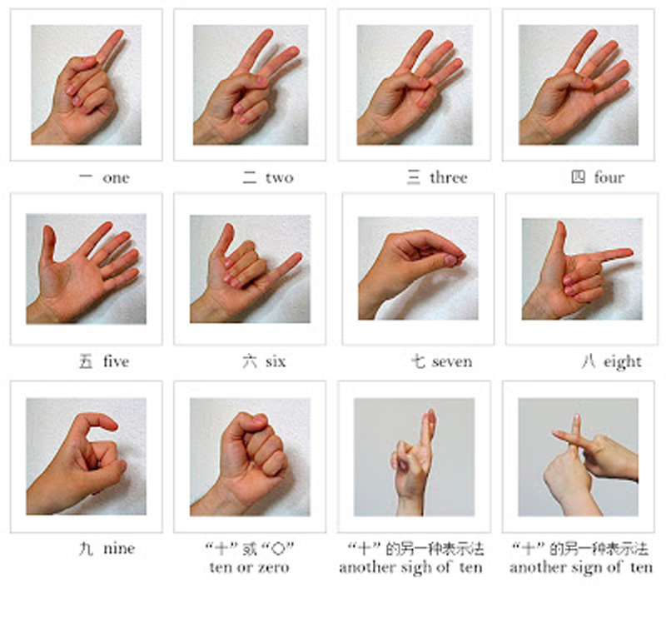

**Figure 6** Hand gestures for numbers one to ten.

[View description - Figure 6 Hand gestures for numbers one to ten.](" \l "Session4_Description1)

End of Figure

End of Study Note

## Conclusion

We hope you enjoyed this short taster course. You should now have some understanding about the structure of the Chinese language, the pronunciation of Mandarin Chinese, pinyin and characters and a few cultural practices of the use of professional titles and lucky numbers. Now that you have learned how to greet, say your name, nationality and numbers in Chinese, you may wish to progress your learning further by following The Open University’s [Chinese language and cultural courses.](http://www.open.ac.uk/courses/language-short-courses)

## Further reading

Here you can find some additional resources on Chinese language.

* [How to enable Chinese font and type characters](http://www.open.edu/openlearn/ocw/mod/oucontent/olinkremote.php?website=CHN_1&targetdoc=How%20to%20install%20the%20Chinese%20font)
* [A simple explanation of Chinese characters](http://blog.tutorming.com/mandarin-chinese-learning-tips/how-do-chinese-characters-work)
* Chinese@OU app:
  + [Instructions for download](http://www.open.edu/openlearn/ocw/mod/oucontent/olinkremote.php?website=CHN_1&targetdoc=OU%20Character%20Learning%20Free%20App_Chinese@OU)
  + [Why is an app an ideal way to learn a new language?](https://www.open.edu/openlearn/languages/chinese/download-our-chinese-characters-learning-apps)
* [Learn Chinese: Words related to education and learning](https://www.open.edu/openlearn/languages/chinese/learn-chinese-words-related-education-and-learning)
* [A taste of Mandarin Chinese language and culture](https://www.open.edu/openlearn/languages/beginners-chinese)

## Acknowledgements

This free course was written by The Open University Chinese course team. It was republished in October 2020.

Except for third party materials and otherwise stated (see [terms and conditions](http://www.open.ac.uk/conditions) ), this content is made available under a [Creative Commons Attribution-NonCommercial-ShareAlike 4.0 Licence](http://creativecommons.org/licenses/by-nc-sa/4.0/deed.en_GB) .

The material acknowledged below is Proprietary and used under licence (not subject to Creative Commons Licence). Grateful acknowledgement is made to the following sources for permission to reproduce material in this course:

Course image: [fnchng](https://www.flickr.com/photos/lesquare/) in Flickr made available under [Creative Commons Attribution-NonCommercial 2.0 Licence](https://creativecommons.org/licenses/by-nc/2.0/legalcode) .

Course image © AMD5150 (Via Flickr)

Figure 1: taken from en.wikipedia.org/wiki/File:New-Map-Sinophone\_World.PNG by ASDFGHJ.

Figure 2: adapted from www.rcl.cityu.edu.hk and en.wikipedia.org, licensed under the Creative Commons Attribution ShareAlike 3.0, Attribution ShareAlike 2.5, Attribution ShareAlike 2.0 and Attribution ShareAlike 1.0 License, creativecommons.org/licenses.

Figure 3: courtesy of Fernando Rosell-Aguilar and Ana Sánchez-Forner

Figure 4: lukasRychvalsky from Pixabay

Figure 5: Free Photos by Pixabay

Figure 6: (c) unidentified

Video 3: The Father of Pinyin: Copyright Guardian News & Media Ltd 2020 <https://www.youtube.com/watch?v=T7Bi_DVFecE&feature=emb_logo>

Every effort has been made to contact copyright owners. If any have been inadvertently overlooked, the publishers will be pleased to make the necessary arrangements at the first opportunity.

**Don't miss out**

If reading this text has inspired you to learn more, you may be interested in joining the millions of people who discover our free learning resources and qualifications by visiting The Open University – [www.open.edu/openlearn/free-courses](http://www.open.edu/openlearn/free-courses?utm_source=openlearn&utm_campaign=ol&utm_medium=ebook).

## Solutions

## Activity 1 Chinese language general knowledge quiz

### Part

#### Answer

**Right:**

True

**Wrong:**

False

[Back to - Part](" \l "Session1_Part1)

#### Discussion

True. Mandarin Chinese is the official language of China, Taiwan, one of the official languages in Singapore and one of the six official languages in the United Nations.

[Back to - Part](#Session1_Part1)

### Part

#### Answer

**Right:**

False

**Wrong:**

True

[Back to - Part](" \l "Session1_Part2)

#### Discussion

False. The Han Chinese constitute about 94 percent of China’s population. About 70 percent of the Han people speak Mandarin Chinese; the remaining 30 percent speak other related Chinese languages or dialects.

[Back to - Part](#Session1_Part2)

### Part

#### Answer

**Right:**

False

**Wrong:**

True

[Back to - Part](" \l "Session1_Part3)

#### Discussion

False. Apart from Mandarin, the other six major varieties of spoken Chinese are Cantonese, Gan, Hakka, Min, Wu and Xiang.

[Back to - Part](#Session1_Part3)

### Part

#### Answer

**Right:**

True

**Wrong:**

False

[Back to - Part](" \l "Session1_Part4)

#### Discussion

True. Chinese is often perceived in the West as a difficult language, mainly because of its different character script and the fact that it is a tonal language.

[Back to - Part](#Session1_Part4)

## Activity 4 Identifying simplified and traditional characters

#### Answer

Start of Table

Table 4 Simplified and traditional characters (completed)

|  |  |  |  |
| --- | --- | --- | --- |
| **English** | **Pinyin** | **Simplified** | **Traditional** |
| to love; love | ài | 爱 | 愛 |
| book | shū | 书 | 書 |
| to meet | jiàn | 见 | 見 |

End of Table

[Back to - Activity 4 Identifying simplified and traditional characters](" \l "Session1_Activity4)

## Activity 5 Word combinations

### Part

#### Answer

**Right:**

大 + 人

**Wrong:**

大 + 国

中 + 国

医 + 生

学 + 中 + 文

我 + 们

[Back to - Part](" \l "Session1_Part6)

### Part

#### Answer

**Right:**

我 + 们

**Wrong:**

大 + 人

大 + 国

中 + 国

医 + 生

学 + 中 + 文

[Back to - Part](" \l "Session1_Part7)

### Part

#### Answer

**Right:**

中 + 国

**Wrong:**

大 + 人

大 + 国

医 + 生

学 + 中 + 文

我 + 们

[Back to - Part](" \l "Session1_Part8)

### Part

#### Answer

**Right:**

大 + 国

**Wrong:**

大 + 人

中 + 国

医 + 生

学 + 中 + 文

我 + 们

[Back to - Part](" \l "Session1_Part9)

### Part

#### Answer

**Right:**

医 + 生

**Wrong:**

大 + 人

大 + 国

中 + 国

学 + 中 + 文

我 + 们

[Back to - Part](" \l "Session1_Part10)

### Part

#### Answer

**Right:**

学 + 中 + 文

**Wrong:**

大 + 人

大 + 国

中 + 国

医 + 生

我 + 们

[Back to - Part](" \l "Session1_Part11)

## Activity 6 Greetings

### Part

#### Answer

**Right:**

Hello (informal)

**Wrong:**

How do you do? (formal)

Goodbye

None of the above

[Back to - Part](" \l "Session2_Part2)

### Part

#### Answer

**Right:**

Thank you/Thanks

**Wrong:**

Goodbye

Not at all

None of the above

[Back to - Part](" \l "Session2_Part3)

### Part

#### Answer

**Right:**

How do you do? (formal)

**Wrong:**

Hello (informal)

Goodbye

None of the above

[Back to - Part](" \l "Session2_Part4)

### Part

#### Answer

**Right:**

Goodbye

**Wrong:**

Hello (informal)

How do you do? (formal)

None of the above

[Back to - Part](" \l "Session2_Part5)

## Activity 7 Names

### Part A

#### Answer

**Right:**

c) Li Xiaoying

**Wrong:**

a) Wang Xiaoying

b) Wang Jing

[Back to - Part A](" \l "Session3_Part1)

### Part B

#### Answer

**Right:**

b) Wang Jing

**Wrong:**

a) Wang Xiaoying

c) Li Xiaoying

[Back to - Part B](" \l "Session3_Part2)

## Activity 8 Names and nationalities

#### Answer

Well done!

* 中国 Zhōngguó (China) - is first
* 北京 Běijīng (Beijing) - is second
* 英国 Yīngguó (UK/Britain) - is third
* 伦敦 Lúndūn (London) – is fourth

[Back to - Activity 8 Names and nationalities](" \l "Session3_Activity2)

## Activity 10 Phone numbers

#### Answer

021 8549 3677

In some northern dialects, when saying telephone numbers, the number one is usually pronounced yāo to avoid confusion between the numbers one (yī) and seven (qī). Telephone numbers are always given digit by digit in Chinese: e.g. 77 would be ‘seven seven’, rather than ‘double seven’.

[Back to - Activity 10 Phone numbers](" \l "Session4_Activity2)

# Figure 1 The Chinese-speaking world

## Description

Map of the world colour-coded to show Chinese-speaking areas. China is coloured in deep red to show it is a Native Chinese-speaking country. Countries coloured in light red show those countries with more than 5 million Chinese speakers – this includes countries such as Indonesia and Thailand. Countries coloured in dark blue show those with more than 1 million Chinese speakers – this includes countries such as Vietnam, Philippines, Myanmar, the United States, Canada and Peru. Countries coloured in light purple show those with more than 500,000 Chinese speakers – this includes countries such as Australia, Russia, Kazakhstan and the UK. Countries coloured in light blue show those with more than 100,000 Chinese speakers – this includes countries such as Brazil, India, South Africa and Angola, New Zealand and the majority of western Europe. Dark blue dots on the map show the location of major Chinese-speaking communities.

[Back to - Figure 1 The Chinese-speaking world](" \l "Session1_Figure1)

# Figure 2 Varieties of Chinese

## Description

The majority of east China and west China predominantly speak Mandarin (circa 800 million speakers). In the far southeast, however, other varieties are spoken. For example, in Shanghai and Hangzhou the predominant variety of Chinese spoken is Wu (circa 75 million). Also in the southeast area, approximately 80 million speak Cantonese, approximately 50 million speak Min, 35 million speak Xiang, 35 million speak Hakka and 20 million speak Gan. In central China the map is coded as the population speaking ‘Other languages’.

[Back to - Figure 2 Varieties of Chinese](" \l "Session1_Figure2)

# Figure 6 Hand gestures for numbers one to ten.

## Description

Hand gestures displayed using left hand:

一 one: index finger up, all other fingers and thumb closed in palm.

二 two: index and middle fingers up, all other fingers and thumb closed in palm.

三three: three middle fingers up, thumb and little finger closed in palm.

四 four: all fingers up, thumb closed in palm.

五 five: all fingers and thumb up.

六 six: thumb and little finger up, three middle fingers closed in palm.

七 seven: thumb and fingers clasped together as if holding something in fingertips.

八 eight: thumb pointing upwards, index finger pointing outwards to the right. All other fingers closed in palm.

九 nine: a ‘c’-shape made with index finger and thumb.

十 ten or zero: a closed fist.

Another sign of ten: middle and index fingers (both left hand) crossed over each other.

Another sign of ten: Left-hand index finger pointing vertically upwards; right-hand index finger crossing over it horizontally.

[Back to - Figure 6 Hand gestures for numbers one to ten.](" \l "Session4_Figure1)

# Video 1

## Transcript

XIMENA ARIAS-MANZANO:

In this video, I'm going to show you how to enable Chinese characters on a Windows computer. First of all, you need to go to your start button and go to your settings. Once you're on your settings, you go to time and language. In time and language, you have a language section, then you will go down, scroll down to preferred languages, add a preferred language, and then type Chinese. It will come up as Chinese simplified or other types, traditional, and so on. But we're just going to do with the Chinese simplified, which is the standard.

We click on that, we click on Next, and it starts searching for the language features. Then, you will install it and it starts installing in your computer. It depends on how fast or how slow your system is. It will download it. And you can see how the colour is starting to show when the file is being downloaded. If you can see at the bottom of the screen also, you will see English, but once you click on that-- that has been installed now, so I can just close that window.

And at the bottom of my screen, I have a Word document open. I see English, if I click on that, it will give me the simplified Chinese that has been already downloaded. So I want to type in Chinese, I click on that and I go to my Word document, OK, and I would start typing. So if we want to type the word rén for person just write R-e-n, Ren and you will see the different Rens that come depending on what word you want. But we want person, so we click on number 1, or you just type number 1 in your computer, and that will turn into rén.

If you want to type number 1 is yī, you just type y-i, and the different characters will come up. And you note this is number 1, so you click on that, and that will be number one. Number 4, sì, you just type s-i, and the first one will be number 1, number 4, sorry. So you have to be careful of which word you want to choose.

Equally, if you want to type the current characters for Bĕijīng, which are two characters, you need to type them together. So the word appears together. If you type Bei first, then you will have to look for the right character for Bĕijīng. So Bei, and then jing, you will have to look for the right character, which is in order. But if you type Beijing together, that will come up as the word.

I'm going to show you how to set up the Chinese language on your MacBook. So first of all, you go into your system preferences and go to language. In language, you will have a list of the current languages you use, and if you want to add one more, click on the plus sign and pick the one you want, in this case, we want Chinese simplified. So we click on Add, and that will show you in the list. It asks you if you want to use it as your primary language but you say, no, use English, and close that.

Then when you have your Word document open, you go up to the little flag at the top of the screen. And if you click on that, it's showing the English language flag or the British flag. You want to change it to pinyin, to Chinese, click on that. You can also choose to hand-write it if you want, but you can use that to use pinyin. Then you go to your Word document and you type for example, nǐ hăo, and then you click on the number 1 that shows the right characters for hello, nǐ hăo.

[Back to - Video 1](" \l "MediaContent1)

# Video 2

## Transcript

XIMENA ARIAS-MANZANO:

In this section, I'm going to teach you how to type in Chinese. We use the system called pinyin. Pinyin, in this column. So to be able to find the right character, you need to type the word in pinyin. So for example, if we want to type the word wŏ, which is I or me, once you set up your language preference into Chinese, then you type the pinyin, w-o. And in here, you will have a selection of different characters that share the same sound but maybe-- what's obviously with different tones. So you will have a selection of characters you could choose from.

If you need an extra character, you will need to click on the arrow. And it will keep giving you all the extra characters that share the same sound. In this case, I want to pick the very first one so I go back, I click on that, or type number one. And that's the character that you have here. If we want to type number one, yī, just type y-i and the first one is not the one I'm looking for for number one but it's the second one. So I click on the second one.

Now if I want to type words that have two, three, or more characters, you need to type the pinyin together. So for example, in Bĕijīng, you have to type bei jing together and you will get the whole word. If you only type bei-- bei, you will get different bei. So then you will have to look for the right one. In this case is here, but it's easier to type up the whole word, Beijing. And you will be able to get the right one. OK. So this is the right one.

If you want to type, for example, the word for woman, nǚrén-- nǚrén. If you see the pronunciation of this nǚ, you will need to type up n-v instead of n-u. If you type n-u, you will not find the right character. So n-u-ren, if you see the one I typed up here, you will not find it. So you need to type n-v-ren and you will find nǚrén which is woman. And that is how you type the characters in Chinese.

Sometimes there are characters that you will need to scroll down a little bit to find them. For example, the word for pear is li. And it doesn't appear at the beginning of the list. So you will need to keep clicking on the arrow to be able to find the right character, if you know it already. So here it is li and that is the character for pear. So again, you need to know which character you are looking for, once you become more confident with learning the language.

[Back to - Video 2](" \l "MediaContent2)

# Video 3

## Transcript

[MUSIC PLAYING]

[TEXT ON SCREEN: pin yin zhi fu. The Father of Pinyin.]

SPEAKER:

He's 102, but he's still hard at work. Aside from the shelves of books in his modest Beijing flat, there's little to show that Zhou Youguang has helped up to a billion people in China to learn, to read, and write. It's 50 years since he developed a new way of representing Chinese on the page. And pinyin has become by far the most widely used method of putting the language into the Roman alphabet.

ZHOU YOUGUANG: People call me the father of pinyin. I say that's not true. I'm not the father of pinyin. I'm the son of pinyin.

It is the long tradition from the later years of Qing dynasty down to today.

SPEAKER:

Zhou found his place in the history books by chance. He was working in a New York bank when the communists took power, and he chose to return home to help rebuild his country's economy. Languages were only a hobby, but with few experts in the field, the government insisted he should take charge.

ZHOU YOUGUANG:

The government thought this is a very important work. At that time more Chinese were illiterate. It was not possible to establish a new country with so many illiterates.

SPEAKER:

Chinese has no alphabet. Each word has its own character, which doesn't show how you should say it, so pinyin helps children to associate words with the characters which represent them; and it teaches those brought up speaking other Chinese languages how to pronounce Mandarin.

ZHOU YOUGUANG:

That's the Chinese pronunciation of "Yingguó."

SPEAKER:

The work of his team has helped to slash the illiteracy rate in China from 80% to just 10%, but his change in career also proved a personal blessing when Mao's first campaign against intellectuals began in 1957.

ZHOU YOUGUANG:

Mao Zedong disliked greatly the economists, especially economic professors from America. By that time, I'd shifted to the line of language and writing. If I remained in Shanghai teaching economics, I think I certainly could be imprisoned for 20 years. And later during the Cultural Revolution, the Great Cultural Revolution, I was called 'fan dong pan de quan wei', a reactionary academic.

SPEAKER:

He was sent to work in the countryside, but as soon as he was rehabilitated, he picked up with his studies where he'd left them. He still publishes a paper each month and says he has no plans to take it easy as he approaches 103.

ZHOU YOUGUANG:

I retired long ago. I left my office at the age of 85, and since that time I read and then write in my home. This is a small room, a very small room.

[MUSIC PLAYING]

[Back to - Video 3](" \l "Session1_MediaContent1)

# Audio 1

## Transcript

You will now hear six single vowels known as finals in Chinese. Repeat after each sound.

a e i o u ü

Now we will combine these vowels with some consonants known as initials in Chinese. Note how similar they sound to some English consonants. Repeat after each sound.

ba pa ma fa de te ne le gu ku hu wo yi

Here are some consonants, or initials, combined with a final i. Listen and repeat.

ji qi xi zi ci si zhi chi shi ri

[Back to - Audio 1](" \l "Session1_MediaContent2)

# Audio 2

## Transcript

Now for examples of the four tones. Listen and repeat after each group.

mā má mǎ mà

tā tá tǎ tà

zhī zhí zhǐ zhì

jī jí jǐ jì

[Back to - Audio 2](" \l "Session1_MediaContent3)

# Audio 3

## Transcript

你好

nǐ hǎo

[Back to - Audio 3](" \l "Session2_MediaContent1)

# Audio 4

## Transcript

您好

nín hǎo

[Back to - Audio 4](" \l "Session2_MediaContent2)

# Audio 5

## Transcript

再见

zàijiàn

[Back to - Audio 5](" \l "Session2_MediaContent3)

# Audio 6

## Transcript

你好

nǐ hǎo

[Back to - Audio 6](" \l "Session2_MediaContent4)

# Audio 7

## Transcript

谢谢

xièxie

[Back to - Audio 7](" \l "Session2_MediaContent5)

# Audio 8

## Transcript

您好

nín hǎo

[Back to - Audio 8](" \l "Session2_MediaContent6)

# Audio 9

## Transcript

再见

zàijiàn

[Back to - Audio 9](" \l "Session2_MediaContent7)

# Audio 10

## Transcript

我叫...

Wŏ jiào

[Back to - Audio 10](" \l "Session3_MediaContent1)

# Audio 11

## Transcript

你叫什么?

Nĭ jiào shénme?

[Back to - Audio 11](" \l "Session3_MediaContent2)

# Audio 12

## Transcript

你叫什么名字?

Nĭ jiào shénme míngzi?

[Back to - Audio 12](" \l "Session3_MediaContent3)

# Audio 13

## Transcript

NARRATOR:

How do you greet someone and introduce yourself? Have a listen.

WANG JING:

你好。

Nǐ hăo.

LI XIAOYING:

你好。

Nǐ hăo.

WANG JING:

你叫什么?

Nĭ jiào shénme?

LI XIAOYING:

我叫李小英。

Wŏ jiào Lǐ Xiǎoyīng.

你呢

Nǐ ne?

WANG JING:

我叫王京。

Wŏ jiào Wáng Jīng.

[Back to - Audio 13](" \l "Session3_MediaContent4)

# Audio 14

## Transcript

你是哪国人?

Nĭ shì nǎ guó rén?

[Back to - Audio 14](" \l "Session3_MediaContent5)

# Audio 15

## Transcript

我是中国人

Wǒ shì Zhōngguórén

[Back to - Audio 15](" \l "Session3_MediaContent6)

# Audio 16

## Transcript

我是英国人

Wǒ shì yīngguórén

[Back to - Audio 16](" \l "Session3_MediaContent7)

# Audio 17

## Transcript

我是西班牙人

Wǒ shì Xībānyárén

[Back to - Audio 17](" \l "Session3_MediaContent8)

# Audio 18

## Transcript

你是中国什么地方人？

Nĭ shì Zhōngguó shénme dìfang rén?

[Back to - Audio 18](" \l "Session3_MediaContent9)

# Audio 19

## Transcript

您是英国什么地方人？

Nín shì Yīng guó shénme dìfang rén?

[Back to - Audio 19](" \l "Session3_MediaContent10)

# Audio 20

## Transcript

我是北京人

Wǒ shì Bĕijīngrén

[Back to - Audio 20](" \l "Session3_MediaContent11)

# Audio 21

## Transcript

零 líng

一 yī

二 èr

三 sān

四 sì

五 wǔ

[Back to - Audio 21](" \l "Session4_MediaContent1)

# Audio 22

## Transcript

六 liù

七 qī

八 bā

九 jiǔ

十 shí

[Back to - Audio 22](" \l "Session4_MediaContent2)

# Audio 23

## Transcript

líng    èr yī      bā wǔ      sì    jiǔ sān    liù      qī    qī

[Back to - Audio 23](" \l "Session4_MediaContent3)