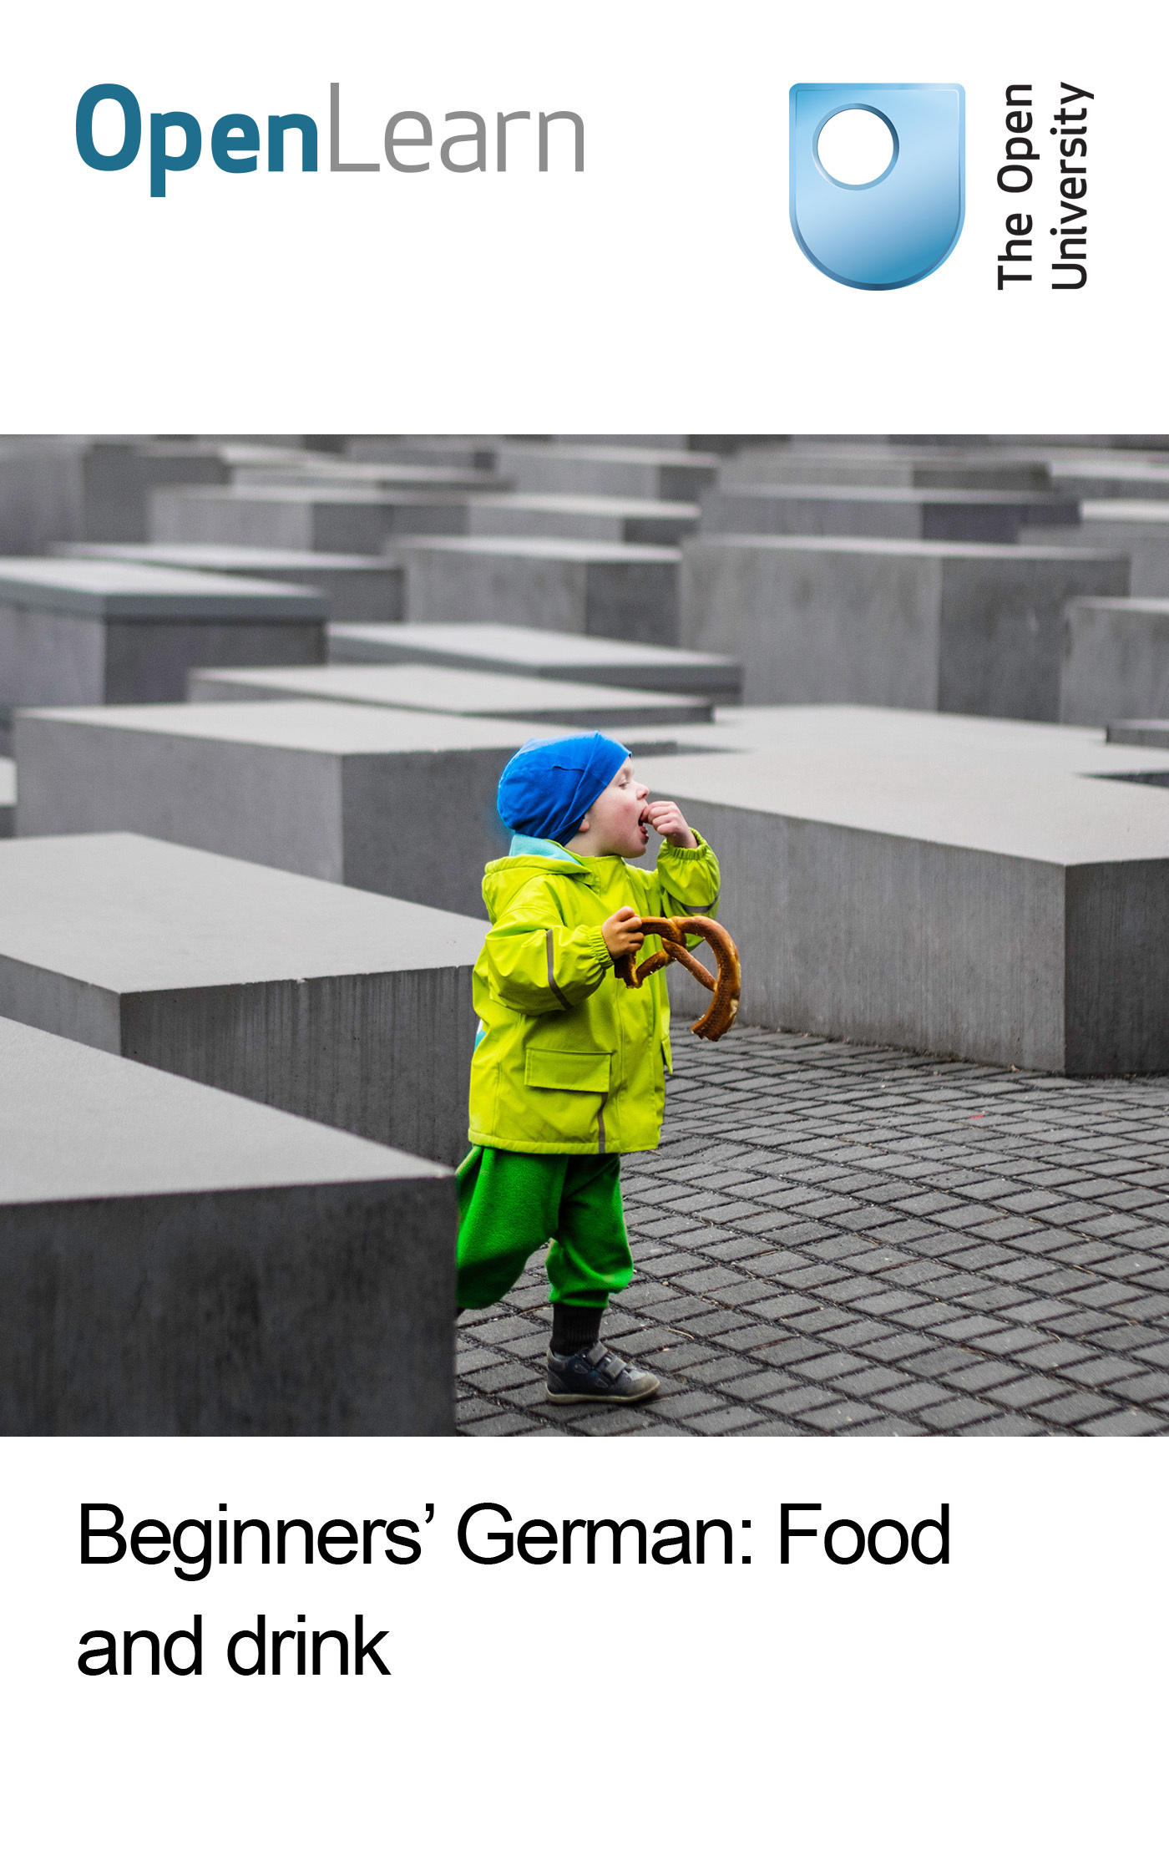

L193_2

Beginners' German: Food and drink
About this free course
This free course is an adapted extract from the Open University course L193 Rundblick: beginners' German http://www.open.ac.uk/study/undergraduate/course/l193.htm .
This version of the content may include video, images and interactive content that may not be optimised for your device.
You can experience this free course as it was originally designed on OpenLearn, the home of free learning from The Open University - http://www.open.edu/openlearn/languages/beginners-german-food-and-drink/content-section-0.
There you’ll also be able to track your progress via your activity record, which you can use to demonstrate your learning.
Copyright © 2016 The Open University
Intellectual property
Unless otherwise stated, this resource is released under the terms of the Creative Commons Licence v4.0 http://creativecommons.org/licenses/by-nc-sa/4.0/deed.en_GB . Within that The Open University interprets this licence in the following way: www.open.edu/openlearn/about-openlearn/frequently-asked-questions-on-openlearn . Copyright and rights falling outside the terms of the Creative Commons Licence are retained or controlled by The Open University. Please read the full text before using any of the content.
We believe the primary barrier to accessing high-quality educational experiences is cost, which is why we aim to publish as much free content as possible under an open licence. If it proves difficult to release content under our preferred Creative Commons licence (e.g. because we can’t afford or gain the clearances or find suitable alternatives), we will still release the materials for free under a personal end-user licence.
This is because the learning experience will always be the same high quality offering and that should always be seen as positive – even if at times the licensing is different to Creative Commons.
When using the content you must attribute us (The Open University) (the OU) and any identified author in accordance with the terms of the Creative Commons Licence.
The Acknowledgements section is used to list, amongst other things, third party (Proprietary), licensed content which is not subject to Creative Commons licensing. Proprietary content must be used (retained) intact and in context to the content at all times.
The Acknowledgements section is also used to bring to your attention any other Special Restrictions which may apply to the content. For example there may be times when the Creative Commons Non-Commercial Sharealike licence does not apply to any of the content even if owned by us (The Open University). In these instances, unless stated otherwise, the content may be used for personal and non-commercial use.
We have also identified as Proprietary other material included in the content which is not subject to Creative Commons Licence. These are OU logos, trading names and may extend to certain photographic and video images and sound recordings and any other material as may be brought to your attention.
Unauthorised use of any of the content may constitute a breach of the terms and conditions and/or intellectual property laws.
We reserve the right to alter, amend or bring to an end any terms and conditions provided here without notice.
All rights falling outside the terms of the Creative Commons licence are retained or controlled by The Open University.
Head of Intellectual Property, The Open University
978-1-4730-1285-1 (.kdl)
978-1-4730-0517-4 (.epub)

Contents
- Introduction
- Learning outcomes
- Teil 1
- Teil 2
- Teil 3
- Teil 4
- Teil 5
- Teil 6
- Teil 7
- Conclusion
- Keep on learning
- Acknowledgements

Introduction
This course focuses on your own preferences with regard to food and drink as well as some meal times and eating habits in German-speaking countries. You will read and hear about a range of types of food and drink.
You will also find out how to order and pay for things in cafes and restaurants.
Most importantly, you will find out what it’s like to read and listen to German in real contexts, and about developing strategies and studying useful phrases, which will help you to cope in a range of situations.
This OpenLearn course is an adapted extract from the Open University course L193 Rundblick: beginners' German.

Learning outcomes
After studying this course, you should be able to:
- speak about personal preferences with regard to food and drink
- order and pay for food and drink in a restaurant
- use the verbs essen and trinken
- demonstrate an awareness of different types of snacks, different meal times and different places to eat in German-speaking countries
- recognise the distinct pronunciation of German native speakers from Austria

Teil 1

A

This is a picture of a breakfast table with typical German breakfast foods. Look at the image and write down the numbers of the items listed below to match the picture. You should write the answers to this and other written activities off-line, e.g. using a notepad or word processor.

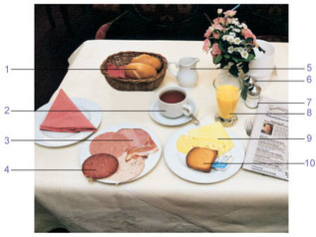
Figure 1
View description - Figure 1

_________ | der Kaffee | _________ | die Wurst
_________ | die Milch | _________ | das Brötchen
_________ | der Orangensaft | _________ | der Toast
_________ | der Käse | _________ | das Salz
_________ | der Schinken | _________ | der Pfeffer

View answer - A

Skills: Memorising nouns with pictures
A useful strategy for memorising nouns is to learn the words in connection with pictures until you can cover the words and name each of the items with its correct article using just the picture.

Language: Using der, die, das and ein, eine
In the first activity you came across some of the German articles der, die, das (the). Here is how they work:
These articles identify the grammatical gender of a noun. All German nouns have a grammatical gender. They are either masculine, feminine or neuter. Sometimes the gender is predictable, for example the word for man, Mann, is masculine and the word for woman, Frau, is feminine. But this is not true for a lot of nouns. They just happen to be either masculine or feminine or neuter. The article for each gender is different. The German for ‘the’ can be either der, die or das depending on the gender of the noun. Similarly, the German for ‘a/an’ can be ein or eine depending on the gender.

Table 1
 | ‘the’ |  | ‘a’
masculine (m.) nouns | der | der Kaffee | ein | ein Kaffee
feminine (f.) nouns | die | die Wurst | eine | eine Wurst
neuter (nt.) nouns | das | das Brötchen | ein | ein Brötchen
all nouns in the plural | die | die Eier | – | –

You can also see that all German nouns begin with a capital letter. Note that you may come across articles other than the ones above.

B

Now listen to three people talking about what they usually eat (essen) and drink (trinken) for breakfast (Frühstück). Don’t reach for the dictionary yet – see how much you can understand first. Then write down which items each person says they have for breakfast.

Audio content is not available in this format.
Audio 1
View transcript - Audio 1

Mann 1:
Mann 2:
Frau:

View answer - B

Culture: Traditional German breakfast foods

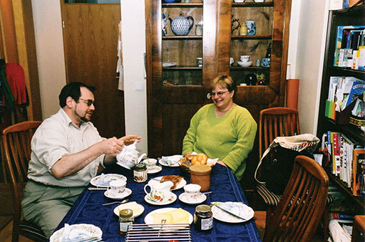
Figure 2
View description - Figure 2

Did you notice that none of the interviewees in the audio clip mentioned a cup of tea? Although the couple pictured here are drinking tea, coffee is much more popular at breakfast time. Slices of cold meat or slicing sausage (Aufschnitt, Wurst), ham (Schinken) and cheese (Käse) are also very common breakfast foods, as well as hard-boiled eggs (gekochte Eier) and Marmelade, which is not just marmalade (Orangenmarmelade) but any kind of jam.

Language: Personal pronouns
Here is a list of German pronouns.

Table 3
singular |  | plural |  | singular and plural
ich | I | wir | we | Sie | you (when talking to one or more adults who are not very close friends or relatives of yours)
du | you (when talking to a close friend, a relative or a child) | ihr | you (when talking to two or more close friends, relatives or children)
er | he | sie | they
sie | she
es | it

Note that sie with a small ‘s’ means ‘she’ and also ‘they’. Sie with a capital ‘S’ means ‘you’. There are several ways of saying ‘you’ in German (du, ihr and Sie) but Sie is the most useful for talking to German-speaking people when you meet them.

Language: The verbs essen and trinken
Here is the present tense of the irregular verb essen (to eat) and the regular verb trinken (to drink). You will see that the ending of the verb changes depending on whether it follows ich, du etc. Only the second and third person singular (du and er/sie/es) forms of essen are irregular, with a change in the vowel sound.

Table 4
essen | trinken
ich esse | ich trinke
du i sst /  Sie essen | du trinkst /  Sie trinken
er/sie/es i sst | er/sie/es trinkt
wir essen | wir trinken
ihr esst /  Sie essen | ihr trinkt /  Sie trinken
sie essen | sie trinken

C

Listen to five recorded questions about what various people have for breakfast, and answer according to the picture prompts below, replacing the person’s name each time with the appropriate personal pronoun. You may want to use the transcript to help you.
- Vokabeln
- Cornflakes (pl.) cornflakes
Beispiel (example)
You hear: Was isst Sara zum Frühstück?
You say: Sie isst Brötchen.
You hear: Sie isst Brötchen.

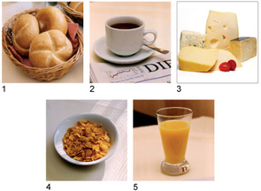
Figure 3
View description - Figure 3

Audio content is not available in this format.
Audio 2
View transcript - Audio 2

Teil 2

A

Here is a chance to practise the forms of essen you learned in the previous section. Write down the missing forms of the verbs to complete the sentences. Try it from memory first.
- Was _________ Sie zum Frühstück?
- Ich _________ Brötchen mit Schinken.
- Was _________ du zum Frühstück?
- Ich _________ Müsli und Jogurt.
- Was _________ ihr zum Frühstück?
- Wir _________ Brot mit Butter und Käse.
- Und was _________ Andreas?
- Er _________ Toast mit Marmelade.

View answer - A

B

- Vokabeln
- Sorten (f. pl.) kinds, sorts
It’s breakfast time at a hotel in Munich. Listen to the recording and number the items in the order in which the restaurant supervisor, Frau Vogt, mentions them. You don’t need to understand everything she says. Just focus on the items in this list.
- Brot _________
- Vollkornbrötchen _________
- Kaffee _________
- Jogurt _________
- Marmeladen _________
- Käse _________
- Obst _________
- Wurst _________

Audio content is not available in this format.
Audio 3
View transcript - Audio 3

View answer - B

Culture: German bread
You may have heard Frau Vogt say that she liked to eat Vollkornbrötchen (wholemeal rolls). She also said, ‘ Bei uns gibt es verschiedene Brotsorten.’ Over 300 different varieties of bread are produced in Germany, with many regional specialities. These include various types of Schwarzbrot (wholegrain rye bread), crusty bread from the Black Forest (Schwarzwälder Krustenbrot), dark rye bread from Westphalia (Westfälischer Pumpernickel), and many varieties of bread roll (Brötchen), which are known as Schrippen in and around Berlin, Semmeln or Weckerl in southern Germany and Austria, and Rundstücke in northern Germany.

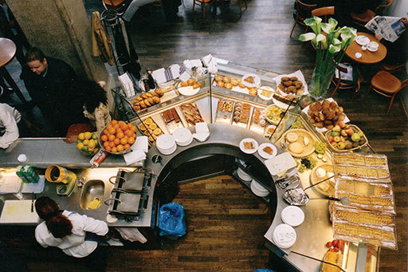
Figure 4
View description - Figure 4

C

Now see how much of the new vocabulary you remember. You hear two hotel guests being asked what they are having for breakfast. Notice the use of the verb frühstücken (to have breakfast). Number the pictures (a)–(d) in the order in which they are mentioned.

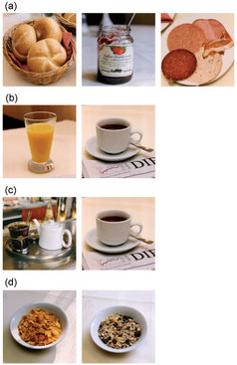
Figure 5

Audio content is not available in this format.
Audio 4
View transcript - Audio 4

View answer - C

Skills: Learning vocabulary by saying it out loud
You might like to try the following strategy for learning new words and phrases:
- Look at the word or phrase.
- Check its pronunciation using recordings, if available.
- Speak it out loud.
- Cover the text.
- Speak it out loud again.
- Write it down from memory.
- Check your spelling.
If you want a really challenging word to learn, try Frühstücksbüffet !

D

Here you review the expressions you have come across so far. You are playing the part of a member of the hotel staff. Listen to the questions and answers, and practise saying the answers yourself. You may want to use the transcript to help you.

Audio content is not available in this format.
Audio 5
View transcript - Audio 5

How would you have answered the last two questions? Practise giving your own answers

Teil 3

Language: Expressing likes and dislikes
If you want to say what you like to do in German, you just add gern after the verb (you may also hear people say gerne), and the verb (esse, trinke) stays the same. Think of gern as meaning ‘with pleasure’.

Florian isst Fleisch. | Florian eats meat.
Florian isst gern Fleisch. | Florian likes to eat meat. (lit. ‘Florian eats with pleasure meat.’)
Anna trinkt Kakao. | Anna drinks cocoa.
Anna trinkt gern Kakao. | Anna likes to drink cocoa.

To say you like it very much, add sehr gern; to say you don’t like something, add nicht gern.

Ich trinke sehr gern Wein. | I like (to drink) wine very much.
Er isst nicht gern Gemüse. | He doesn’t like (to eat) vegetables.

A

In this activity you will practise talking about what kinds of food and drink you like or dislike.
Respond to each question according to the written prompts. You may want to use the transcript to help you. If you wish, repeat the exercise, giving your own personal answers instead of the ones suggested.

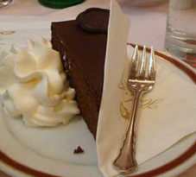
Figure 6

Question

Audio content is not available in this format.
Audio 9a 1

Prompt (a) Sachertorte
Model answer

Audio content is not available in this format.
Audio 9a 2
View transcript - Audio 9a 2

Question

Audio content is not available in this format.
Audio 9b 1

Prompt (b) Käse
Model answer

Audio content is not available in this format.
Audio 9b 2
View transcript - Audio 9b 2

Question

Audio content is not available in this format.
Audio 9c 1

Prompt (c) Kaffee
Model answer

Audio content is not available in this format.
Audio 9c 2
View transcript - Audio 9c 2

Question

Audio content is not available in this format.
Audio 9d 1

Prompt (d) Tee mit Zitrone
Model answer

Audio content is not available in this format.
Audio 9d 2
View transcript - Audio 9d 2

Question

Skills: Recording yourself
To practise and improve your German fluency and pronunciation you can try recording yourself and comparing your way of speaking with that of the speakers you hear in these materials. There are a number of free online recording tools available. The best approach to this kind of practice is that you do the speaking activities in these materials and record your responses. Then listen again to your response and re-record until you are happy with it. Finally, listen again to the recording in the activity and compare it with your own recording.

B

Listen to Herr Schuster and Frau Georg talking about what they like to eat and drink. Then decide which words from the list below would fit the gaps in the six statements to indicate how much they like or dislike certain things. You can then check your answer using the transcript.

Audio content is not available in this format.
Audio 6
View transcript - Audio 6

gern • nicht gern • sehr gern • gar nicht gern • besonders gern • überhaupt nicht gern
- Herr Schuster
- 1 Ja, ich trinke _________ Apfelsaft.
- 2 Ich esse _________ Käse.
- 3 Müsli esse ich _________ !
- Frau Georg
- 4 Nein, ich trinke _________ Kaffee.
- 5 Ich koche _________ griechisch.
- 6 Ich arbeite _________ im Restaurant.

C

Practise what you have learned about expressing likes and dislikes by writing sentences to say what you and other people like or don’t like using the cues below. Then write a few more sentences about your own personal preferences.

gern | nicht so gern
sehr gern | nicht gern
besonders gern | überhaupt nicht gern

Beispiel
(Thomas/essen) Gemüse ; Obst ; Pfirsiche
- Vokabeln
- das Gemüse vegetables
Thomas isst nicht gern Gemüse.
Er isst sehr gern Obst.
Er isst besonders gern Pfirsiche.
- (Frau Meyer/trinken) Saft ; Wein ; Rotwein
- (ich/kochen) italienisch ; mexikanisch ; chinesisch
- (wir/essen) Weißbrot ; Krustenbrot ; Vollkornbrot
- Und Sie …? Was essen Sie gern? Was trinken Sie gern? Was kochen Sie gern?

View answer - C

Comment
Notice the letter ß in Weißbrot. This is pronounced like s and is used instead of double- s after long vowel sounds in words like Weißbrot (white bread) and Straße (street).

D

You have come across quite a few words containing ch in the previous activities, such as Milch and Brötchen. This ch should sound like the ‘h’ in ‘human’. Practise your pronunciation as you listen and repeat what you hear in the recording. You may find it useful to record yourself in order to check that you are distinguishing the German ch from the English sounds ‘sh’ and ‘ck’.

Audio content is not available in this format.
Audio 7
View transcript - Audio 7

Teil 4

Culture: Meals and snacks in German-speaking countries
The three main meals (Hauptmahlzeiten) are das Frühstück, das Mittagessen and das Abendessen. Although some working patterns make it more convenient to have a hot meal in the evening, traditionally the main cooked meal in Germany, Austria and Switzerland is taken at lunchtime, with the evening meal often consisting of bread with a selection of cheeses, cold cooked meats and salads, hence the alternative name of das Abendbrot.
There are many different regional names for snack times between meals (Zwischenmahlzeiten). These include die Brotzeit in Bavaria, die Jause in Austria and das z’Nüni in Switzerland.
In many parts of Germany there is a tradition known as der Frühschoppen, where locals get together in a bar or inn (das Wirtshaus) after church on a Sunday morning for a chat over a glass of beer or wine. As regular customers, they will often have a table (der Stammtisch) which is always reserved for them.

A

You can buy food and drink in many different places. Match captions (a)–(f) to the right pictures.

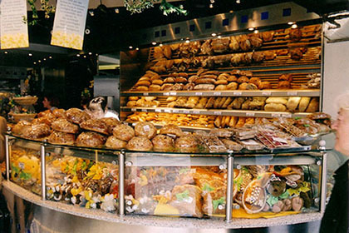
Photo 1
View description - Photo 1

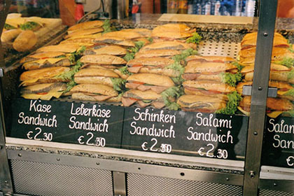
Photo 2
View description - Photo 2

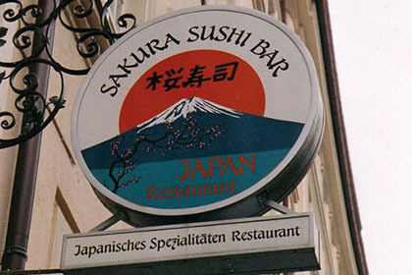
Photo 3
View description - Photo 3

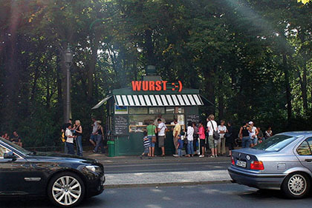
Photo 4
View description - Photo 4

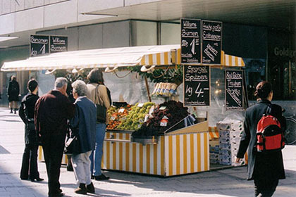
Photo 5
View description - Photo 5

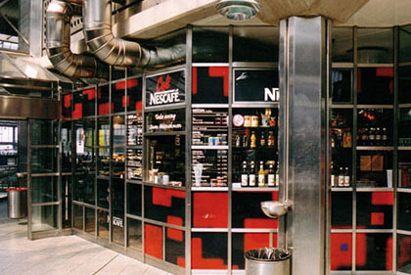
Figure 7
View description - Figure 7

- Hier kann man japanisch essen.
- Hier kann man Kaffee trinken.
- Hier kann man Bratwurst kaufen.
- Hier kann man ein Schinkenbrötchen kaufen.
- Hier kann man Obst und Gemüse kaufen.
- Hier kann man Brot kaufen.

View answer - A

Language: Making generalisations using man
Man is often translated into English as ‘one’. When you are talking about people in general in English, you might say ‘you’, ‘they’ or ‘people’ rather than the formal-sounding ‘one’, but man doesn’t have the same formal ring to it in German. Compare the following sentences, for example:

Was isst man hier? | What do people eat here? / What do they eat here?

To talk about what is on offer at certain places, you can combine man with kann :

Was kann man hier trinken? | What can you drink here? (lit. ‘What can one drink here?’)

The verb used with man takes the same verb form as with er/sie/es (e.g. man isst, man kann).

B

First read and also say out loud the list of words for places to eat. Watch the video clip, in which three people recommend places to eat out in Graz. Then select from the list below the German words the speakers use when referring to these places. In the list, the plural form is given in brackets.
Select one or more:
- die Bar (-s)
- das Café (-s)
- das Gasthaus (die Gasthäuser)
- der Gasthof (die Gasthöfe)
- die Gaststätte (-n)
- das Hotel (-s)
- die Imbissstube (-n)
- die Kneipe (-n)
- das Lokal (-e)
- das Restaurant (-s)

Video content is not available in this format.
Video 1
View transcript - Video 1

View answer - B

C

Before watching the video clip again, read the following list of adjectives out loud. Then select from the list the adjectives referring to food from the different countries which are mentioned.
Select one or more:
- chinesisch
- deutsch
- französisch
- griechisch
- indisch
- italienisch
- österreichisch
- spanisch
- thailändisch

Video content is not available in this format.
Video 1
View transcript - Video 1

View answer - C

Language: Saying what you would like
You may be asked Möchten Sie …? (Would you like …?) to establish what you would like. To respond, use the verb form ich möchte (I would like) or wir möchten (we would like).
Möchten Sie etwas zu essen bestellen? Would you like to order something to eat?
As you listen to these expressions in the recordings, pay particular attention to the ö and ch sounds and try to copy them.

D

- Vokabeln
- bestellt etwas zu essen orders something to eat
Read the introduction to the recording below and then listen to the conversation between Thomas and a waitress. Match the German and English phrases. Try to work out the meanings from the context without using a dictionary.
Thomas und Heike sitzen im Café. Thomas bestellt etwas zu essen und zu trinken.

1 | ein Kännchen Kaffee | (a) | Excuse me!
2 | mit Zitrone | (b) | we’d like
3 | zwei Stück Apfelkuchen | (c) | a pot of coffee
4 | mit Sahne | (d) | a glass of tea
5 | wir möchten | (e) | with lemon
6 | Sonst noch etwas? | (f) | with cream
7 | ein Glas Tee | (g) | Anything else?
8 | Entschuldigung! | (h) | two pieces of apple cake

Audio content is not available in this format.
Audio 11
View transcript - Audio 11

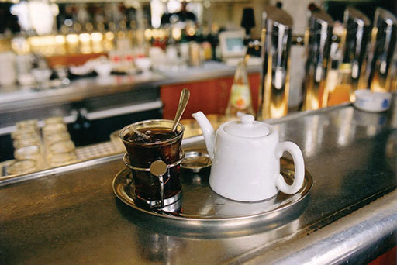
Figure 8
View description - Figure 8

View answer - D

Culture: Kaffee und Kuchen
Having coffee and cakes (Kaffee und Kuchen) with friends in a café or at home is a very popular way to take a late afternoon break in German-speaking countries. Some cafés specialise in what could be called the fourth meal of the day, serving coffee and a range of delicious cakes, such as cheesecake (Käsekuchen) or Austrian chocolate cake (Sachertorte). When visiting friends in the afternoon you may be offered a cup of coffee (eine Tasse Kaffee) and a piece of cake (ein Stück Kuchen). Notice that in these expressions there is no German equivalent for the English ‘of’.

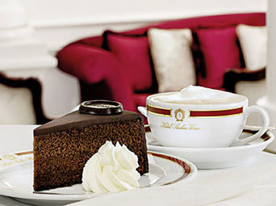
Figure 9
View description - Figure 9

Teil 5

A

When visiting friends or colleagues in Germany, you will normally be offered something to drink. In the recording you hear people offering a number of things to drink. It is up to you to choose whether to accept (ja, bitte) or decline (nein, danke) each one, so the answers to this activity depend on your own preferences.
Beispiel
You hear: Möchten Sie eine Tasse Kaffee?
You say: Ja, bitte./Nein, danke.

Audio content is not available in this format.
Audio 12
View transcript - Audio 12

Language: Speaking politely
When you are offered something you tend to say more than just ja and nein, for example ‘yes, please’ (ja, bitte) or ‘no, thank you’ (nein, danke). Danke on its own in this context is usually understood to mean nein, danke.
In the audio clip in Section 4 Activity D you may have noticed that the waitress used bitte schön in two different ways. First she used the phrase as a question: Bitte schön? meaning ‘Yes, please?’ to ask what the customers wanted. Later she said Bitte schön meaning ‘Here you are’ as she served the items.
There is a third situation where Bitte schön commonly occurs: in response to Danke schön it means ‘Don’t mention it’ or ‘You’re welcome’. Listen out for these three uses of Bitte schön and take particular note of the intonation used in each case.

B

Here is a written extract from a café conversation with a few key words missing. Use some of the language you have just learned to fill in the gaps.
In the previous activity you might have noticed the change of the indefinite article ein to einen. This is an indication of the use of the accusative case with masculine nouns that functions as an object in a sentence. The same happens when the definite article der becomes den.
- Vokabeln
- die Speisekarte menu
- die Kellnerin waitress

Gast | Entschuldigung! Die Speisekarte, bitte!
Kellnerin | Ja, sofort. … Bitte _________
(später)
Kellnerin | Möchten _________ bestellen?
Gast | Ja, ich _________ einen Kaffee, bitte.
Kellnerin | Eine Tasse oder ein _________ ?
Gast | Eine Tasse, bitte.
Kellnerin | Sonst noch _________ ?
Gast | Nein, danke.

Note: Check that you used capital letters in the right places.

View answer - B

C

Now it’s your turn to play the customer’s part, using the script you prepared in the previous activity. You may want to print out a copy of the answer to the previous activity to refer to. You start the dialogue by calling for the menu.
Beispiel
You say: Entschuldigung! Die Speisekarte, bitte.
You hear: Entschuldigung! Die Speisekarte, bitte.

Audio content is not available in this format.
Audio 13
View transcript - Audio 13

D

1
Here is a menu from a specialist fish restaurant. Read this menu, which will be used in the second part of this activity. You don’t need to understand every word but try to get a rough idea of what the items mean.

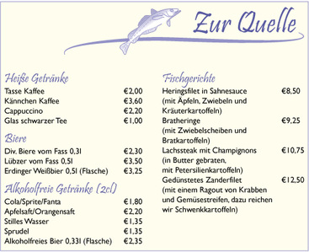
Figure 10
View description - Figure 10

2
Listen to the audio clip and practise ordering a main course by following the whispered prompts you hear. You start by calling (rufen) the waitress.

Audio content is not available in this format.
Audio 14
View transcript - Audio 14

Beispiel
You hear: Rufen Sie die Kellnerin.
You say: Entschuldigung!
You hear: Entschuldigung!

Teil 6

Task 1

Listen to this customer paying his bill, then rearrange the words from the list below to write down four expressions which correspond to the English equivalents.
das • getrennt • ich • macht • möchte • oder • so • stimmt • zahlen • zusammen
- I’d like to pay. _________ _________ _________ .
- Together or separately? _________ _________ _________ ?
- That comes to … _________ _________ .
- Keep the change. _________ _________

Audio content is not available in this format.
Audio 15
View transcript - Audio 15

View answer - Task 1

Task 2

- Vokabeln
- ich hatte I had
- kosten cost

1
Listen to this conversation between a diner and the waitress. Pay particular attention to the prices mentioned, then answer the questions below.

Audio content is not available in this format.
Audio 16
View transcript - Audio 16

- What is the price of the salmon steak?
- Which item costs €3.25?
- How much is the herring?
- What does the corrected bill come to?
- How much does the diner give the waitress altogether?

View answer - Task 2

Task 3

Now listen again, concentrating on the language used by the customer querying the bill. Practise using this language by reading aloud the customer’s part from the transcript as you play the clip.

Audio content is not available in this format.
Audio 16
View transcript - Audio 16

C

Use some of the language you have been learning by taking part in a dialogue that might take place at the end of a meal with a colleague in a restaurant. You want to pay separately, and you round your own bill up to €20. Begin by calling the waiter and follow the other prompts in the recording. Again, you may want to use the transcript as a model.

Audio content is not available in this format.
Audio 17
View transcript - Audio 17

D

Now listen to some customers paying separately, and note down the price of each item listed below.
- Tee mit Zitrone
- Tasse Kaffee
- Kännchen Kaffee
- Kuchen
- Wasser

Audio content is not available in this format.
Audio 19
View transcript - Audio 19

View answer - D

Language: Numbers 1–100
You have heard some of the numbers from 1 to 100 in the recordings. Here are the numbers 1–10 in writing:

0 – null  1 – eins  2 – zwei  3 – drei | 4 – vier  5 – fünf  6 – sechs  7 – sieben | 8 – acht  9 – neun  10 – zehn

The numbers from 11 to 20 are very similar to English:

11 – elf  12 – zwölf  13 – dreizehn  14 – vierzehn | 15 – fünfzehn  16 – sechzehn  17 – siebzehn  18 – achtzehn | 19 – neunzehn  20 – zwanzig

From 20 onwards, numbers follow a regular pattern:

21 – einundzwanzig  22 – zweiundzwanzig  23 – dreiundzwanzig  24 – vierundzwanzig | 30 – dreißig  40 – vierzig  50 – fünfzig  60 – sechzig | 70 – siebzig  80 – achtzig  90 – neunzig  100 – hundert or einhundert

Note how you say ‘one-and-twenty’ in German rather than ‘twenty-one’.

Teil 7

Culture: Imbissbuden

Figure 11
View description - Figure 11

You can buy different sausages, such as Bockwurst, Bratwurst and Currywurst, throughout the German-speaking countries in snack bars (Imbissbuden), and there are over 40 different regional varieties of Bockwurst alone. The sausages may be served in a bread roll (Brötchen), with potato salad (Kartoffelsalat), Sauerkraut or chips (Pommes frites or Fritten), and of course a little mustard (Senf).
Snack bars may be located in a mobile stand, a kiosk or a small shop, and many take the form of a Stehcafé or Stehimbiss, which provides no seating, just a few tall tables that customers can stand at while they eat their snacks. The Austrian Würstlstand pictured here is in Vienna (Wien).

A

This is a text about two of the most popular snacks in Germany: the Currywurst and the Döner. You do not have to understand every word but try to get the gist of the two paragraphs. Then decide whether the six statements below are richtig (true) or falsch (false) according to the text.

Täglich lockt die Currywurst

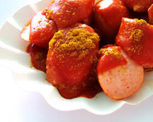
Figure 12
View description - Figure 12

Die Berliner Imbiss-Spezialität gibt es in vielen Variationen. In Berlin gibt es sogar ein Museum ihr zu Ehren: die „Currywurst“. Man sagt, Herta Heuwer hat die Currywurst am 4. September 1949 erfunden. An ihrem Imbissstand an der Ecke Kant-/Kaiser-Friedrich-Straße in Charlottenburg hat sie gebratene Brühwurst mit einer Soße aus Tomatenmark, Currypulver, Worcestershiresauce und weiteren Zutaten angeboten. Heute gibt es viele traditionelle Imbisse, wo man die Spezialität kaufen kann.

Döner + Falafel: Der Berliner Kultsnack

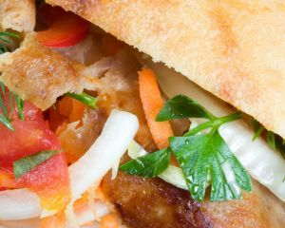
Figure 13
View description - Figure 13

Was ist fast noch typischer für Berlin als die Currywurst? Der Döner! Der Döner ist das beliebteste Fast Food-Gericht in Deutschland, und wo kann man das besser essen als Berlin? Nicht nur in Kreuzberg findet man an jeder Ecke einen Imbiss mit Döner und Falafel. Einige haben Kultstatus wie das Habibi am Winterfeldtplatz.
- Vokabeln
- ihr zu Ehren in its honour
- hat... erfunden invented
- hat... angeboten offered
- nicht nur not only

Comment
Brühwurst is not a specific type of sausage, but a category of uncooked sausage, usually of finely minced pork or beef, which has undergone some kind of heat treatment during the manufacturing process. Further cooking is then necessary prior to serving. 60% of all sausages in Germany fall into this category.

Es gibt nur wenige Sorten Currywurst.

richtig
falsch

In München gibt es ein Currywurst-Museum.

richtig
falsch

Man sagt, Herta Heuwer hat die Currywurst erfunden.

richtig
falsch

Man sagt, die erste Currywurst war an einem Imbissstand in Berlin-Charlottenburg.

richtig
falsch

Der Döner ist in Berlin auch sehr beliebt

richtig
falsch

Döner kann man nur in Kreuzberg kaufen.

richtig
falsch

For more information on the Currywurst-Museum in Berlin, see www.currywurstmuseum.de.

B

- Vokabeln
- einmal once, one portion
- zweimal twice, two portions
- dreimal three times, three portions
- das Grillhähnchen grilled chicken
- Pommes frites (pl.) chips
- eine Portion Pommes one portion of chips (colloquial)
Now practise ordering some items at an Imbissstube. The items you want are indicated on the following price list. Ask for each item separately in response to the questions you hear in the recording.

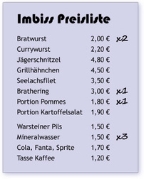
Figure 14
View description - Figure 14

Audio content is not available in this format.
Audio 29
View transcript - Audio 29

C

Here is a chance to practise using some numbers. Read the following statistical information collected in a Süddeutsche Zeitung survey about people’s favourite snacks, and answer the questions you hear in the recording. There is no need for complete sentences here; just answer in short phrases.
- Vokabeln
- beliebteste most popular
- bevorzugen prefer

Was für Snacks essen die Deutschen gern?
Wenn der kleine Hunger kommt, ist die Pizza für viele der beliebteste Snack. 71 Prozent der Deutschen bevorzugen das italienische Gericht, wenn sie sich unterwegs etwas zu essen kaufen.
Auf Platz zwei ist mit 61 Prozent der Befragten ganz klassisch das belegte Brötchen.
59 Prozent der Deutschen kaufen am Imbissstand Grillhähnchen.
Auf Platz vier mit 54 Prozent kommt der Klassiker an der Imbissbude – die Bratwurst.
Vor allem die 14- bis 29-Jährigen essen besonders gern Hamburger mit Pommes. Wenn man aber das Ergebnis nach Frauen und Männern trennt, ist es ganz anders. Frauen essen mehr fleischlose Speisen, besonders Sushi. Und auch mal einen vegetarischen Burger.
(shortened and adapted from: http://www.sueddeutsche.de/leben/fastfood-die-beliebtesten-snacks-der-deutschen-1.534483 )

Audio content is not available in this format.
Audio 33
View transcript - Audio 33

D

Look at the following explanation of the different items which are shown on a German wine label. Before reaching for your dictionary, see how many of them you can match to the English expressions below. Notice that items 5 and 7 both refer to the same information category. Choose the appropriate number for each English expression.

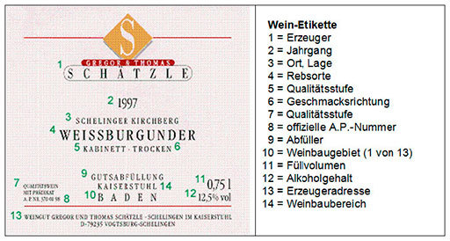
Figure 15
View description - Figure 15

Location
Quality
Year
Official control number
Alcohol content
Wine-producing area
Flavour
Bottler
Grape variety
Producer
Wine-producing region (1 of 13)
Producer’s address
Volume

View answer - D

Skills: Developing confidence in using numbers
Continue to review numbers until you feel confident to use and understand them. Whenever you see phone numbers, statistics, and so on, try to say the number to yourself in German. Write down some large numbers, record yourself saying them out loud, come back later to listen and write them down, then compare what you’ve written with the original list.

Comment
German bureaucracy requires many things to have an official number, and that includes bottles of wine. Therefore every German quality wine has a control number or A.P.Nr (Amtliche Prüfungsnummer) on the label. This shows that the wine has been officially tested against legal minimum standards. The various components of the number identify the testing station (die Prüfstelle), location (Ort) of the producer, the producer (der Erzeuger), the batch (die geprüfte Partie) and the year (das Jahr) when it was tested.
Source of information: http://weinverkostungen.de/die-amtliche-prufungsnummer-bei-wein-a-p-nr (23.8.12)

Skills: Making connections with German
The German and the English languages are very closely related. You will notice this in the large number of words that are either spelled the same, as in Computer, Radio, Taxi or Institution, or where words are very similar in spelling and pronunciation, as in Wein, Glas, Haus, Lampe, trinken.
However, there are also many other cultural parallels which can help you understand written German. Using the example of the wine label you will see that wine labels are very similar in German speaking countries and many other countries, with the items printed in identical positions etc. Such similarities also apply to many other contexts in everyday life. Just think of conventions for signs at train or bus stations, road signs, telephone books, emails etc.
So do trust your instincts and look for connections to support your understanding of the German language.

Conclusion
We hope you have enjoyed this course. Now you know how to talk about what food you like and dislike, and you have learned how to order food in a restaurant and what to say when you pay for it, you may wish to try this language out on your next visit to a German-speaking country!

Keep on learning



Study another free course
There are more than 800 courses on OpenLearn for you to choose from on a range of subjects.
Find out more about all our free courses.

Take your studies further
Find out more about studying with The Open University by visiting our online prospectus.
If you are new to university study, you may be interested in our Access Courses or Certificates.

What’s new from OpenLearn?
Sign up to our newsletter or view a sample.

For reference, full URLs to pages listed above:
OpenLearn – www.open.edu/openlearn/free-courses
Visiting our online prospectus – www.open.ac.uk/courses
Access Courses – www.open.ac.uk/courses/do-it/access
Certificates – www.open.ac.uk/courses/certificates-he
Newsletter – www.open.edu/openlearn/about-openlearn/subscribe-the-openlearn-newsletter

Acknowledgements
This course was written by the L193 Rundblick : beginners’ German course team.
Some branded products may be illustrated for the language teaching and learning purposes of this course only. The Open University does not endorse or recommend any of these products of which many variations would be available. See terms and conditions.
Except for third party materials and otherwise stated (see terms and conditions ), this content is made available under a Creative Commons Attribution-NonCommercial-ShareAlike 4.0 Licence .
Course image: Sascha Kohlmann in Flickr made available under Creative Commons Attribution-NonCommercial-ShareAlike 2.0 Licence .
The material acknowledged below is Proprietary and used under licence (not subject to Creative Commons Licence). Grateful acknowledgement is made to the following sources for permission to reproduce material in this course:
© Elena Kouptsova-Vasic/dreamstime.com.
All photos © The Open University except: Teil 1 C no. 3 : © Anpet2000(Andriy Petrenko)/Dreamstime; Teil 3 A : © Elizabeth Clifford; Teil 4 A no. 4 : © Capitan Jen/Flickr; Teil 4 D : © Maren Oredein; Teil 4 Culture: Kaffee und Kuchen : Kind permission given to use from Hotel Sacher/ Sacher.com; Teil 7 A : © visitBerlin/Philip Koschel; Teil 7 D : © Weingutschaetzle.de.
Audio material produced by The Open University.
Video material produced for The Open University by Salon Deluxe, Graz, Austria.
Every effort has been made to contact copyright owners. If any have been inadvertently overlooked, the publishers will be pleased to make the necessary arrangements at the first opportunity.
Don't miss out:
If reading this text has inspired you to learn more, you may be interested in joining the millions of people who discover our free learning resources and qualifications by visiting The Open University - www.open.edu/openlearn/free-courses

A

Answer
der Kaffee 2; die Milch 5; der Orangensaft 8; der Käse 9; der Schinken 3; die Wurst 4; das Brötchen 1; der Toast 10; das Salz 7; der Pfeffer 6
Back to Session 1 Activity 1

B

Answer

Table 2
 | Mann 1 | Mann 2 | Frau
Kaffee |  | ✘ | ✘
Milch | ✘
Müsli | ✘ |  | ✘
Ei |  |  | ✘
Toast | ✘ | ✘ | ✘
Brot | ✘ |  | ✘
Brötchen |  | ✘ | ✘
Schinken |  |  | ✘
Käse | ✘ | ✘ | ✘
Marmelade | ✘ | ✘ | ✘
Jogurt |  |  | ✘

Back to Session 1 Activity 2

A

Answer
- Was essen Sie zum Frühstück?
- Ich esse Brötchen mit Schinken.
- Was isst du zum Frühstück?
- Ich esse Müsli und Jogurt.
- Was esst ihr zum Frühstück?
- Wir essen Brot mit Butter und Käse.
- Und was isst Andreas?
- Er isst Toast mit Marmelade.
Back to Session 2 Activity 1

B

Answer
Brot 1; Vollkornbrötchen 8; Kaffee 7; Jogurt 5; Marmeladen 6; Käse 3; Obst 2; Wurst
Note: One of the words, Marmeladen (jams), is a plural.
Back to Session 2 Activity 2

C

Answer
- (a) Brötchen, Marmelade, verschiedene Wurstsorten
- (c) Tee, Kaffee
- (d) Cornflakes, Müsli
- (b) Orangensaft, Kaffee
Back to Session 2 Activity 3

C

Answer
- Frau Meyer trinkt sehr gern Saft. Sie trinkt gern Wein. Sie trinkt überhaupt nicht gern Rotwein.
- Ich koche gern italienisch. Ich koche besonders gern mexikanisch. Ich koche nicht so gern chinesisch.
- Wir essen nicht gern Weißbrot. Wir essen gern Krustenbrot. Wir essen sehr gern Vollkornbrot.
- Make sure your own sentences have the right verb forms: ich esse, ich trinke, ich koche .
Back to Session 3 Activity 3

A

Answer
1–(f), 2–(d), 3–(a), 4–(c), 5–(e), 6–(b)
Back to Session 4 Activity 1

B

Answer
The correct answers are:
die Bar; das Café; das Gasthaus; das Hotel; das Lokal; das Restaurant
Back to Session 4 Activity 2

C

Answer
The correct answers are:
chinesisch, griechisch, indisch, italienisch, thailändisch
Back to Session 4 Activity 3

D

Answer
1–(c), 2–(e), 3–(h), 4–(f), 5–(b), 6–(g), 7–(d), 8–(a)

Comment
Notice that Thomas asks for ein Glas Tee – tea is often served in a glass.

Back to Session 4 Activity 4

B

Answer

Gast | Entschuldigung! Die Speisekarte, bitte!
Kellnerin | Ja, sofort. … Bitte schön.
(später)
Kellnerin | Möchten Sie bestellen?
Gast | Ja, ich möchte einen Kaffee, bitte.
Kellnerin | Eine Tasse oder ein Kännchen?
Gast | Eine Tasse, bitte.
Kellnerin | Sonst noch etwas?
Gast | Nein, danke.

Note: Check that you used capital letters in the right places.
Back to Session 5 Activity 2

Task 1

Answer
- Ich möchte zahlen.
- Zusammen oder getrennt?
- Das macht …
- Stimmt so. (lit. ‘It’s correct like that.’)
Back to Session 6 Activity 1

Untitled activity

Task 2

Answer
- €10.75
- the beer
- €9.25
- €12.50
- €13.00
Back to Session 6 Part 1

D

Answer

Tee mit Zitrone | €2,20
Tasse Kaffee | €2,50
Kännchen Kaffee | €3,80
Kuchen | €2,50
Wasser | nichts

Back to Session 6 Activity 4

D

Answer
- Producer
- Year
- Location
- Grape variety
- Quality
- Flavour
- Quality
- Official control number
- Bottler
- Wine-producing region (1 of 13)
- Volume
- Alcohol content
- Producer's address
- Wine-producing area
Back to Session 7 Activity 5

Figure 1

Description
This is a photograph of a breakfast table with numbered lines pointing to the following items:
1. bread rolls
2. cup of coffee
3. slices of ham
4. slices of salami
5. jug of milk
6. pepper
7. salt
8. glass of orange juice
9. slices of cheese
10. slice of toast
Back to Session 1 Figure 1

Figure 2

Description
Photograph of a man and woman having breakfast
Back to Session 1 Figure 2

Figure 3

Description
These are photos of the following food items: 1: three bread rolls; 2: a cup of coffee; 3: different cheeses; 4: a bowl of cereal; 5: a glass of orange juice
Back to Session 1 Figure 3

Figure 4

Description
Photograph of a display of bread and cakes in a café
Back to Session 2 Figure 1

Photo 1

Description
Photo 1: bakery
Back to Session 4 Figure 1

Photo 2

Description
Photo 2: sandwich bar
Back to Session 4 Figure 2

Photo 3

Description
Photo 3: sushi bar
Back to Session 4 Figure 3

Photo 4

Description
Photo 4: hot dog stand
Back to Session 4 Figure 4

Photo 5

Description
Photo 5: fruit and vegetable stall
Back to Session 4 Figure 5

Figure 7

Description
Photo 6: café.
Back to Session 4 Figure 6

Figure 8

Description
Photograph of a pot and glass of tea
Back to Session 4 Figure 7

Figure 9

Description
Photograph of a Sachertorte cake and a cup of coffee
Back to Session 4 Figure 8

Figure 10

Description
This is the menu of the restaurant Zur Quelle. It offers the following items:
Heiße Getränke:
Tasse Kaffee €2,00
Kännchen Kaffee €3,60
Cappuccino €2,20
Glas schwarzer Tee €1,00
Biere:
Div. Biere vom Fass 0,3l €2,30
Lübzer vom Fass 0,5l €3,50
Erdinger Weißbier 0,5l (Flasche) €3,25
Alkoholfreie Getränke (2cl):
Cola/Sprite/Fanta €1,80
Apfelsaft/Orangensaft €2,20
Stilles Wasser €1,35
Sprudel €1,35
Alkoholfreies Bier 0,33l (Flasche) €2,35
Fischgerichte:
Heringsfilet in Sahnesauce (mit Äpfeln, Zwiebeln und Kräuterkartoffeln) €8,50
Bratheringe (mit Zwiebelscheiben und Bratkartoffeln) €9,25
Lachssteak mit Champignons (in Butter gebraten, mit Petersilienkartoffeln) €10,75
Gedünstetes Zanderfilet (mit einem Ragout von Krabben und Gemüsestreifen, dazu reichen wir Schwenkkartoffeln) €12,50
Back to Session 5 Figure 1

Figure 11

Description
Photograph of a snack stand in a busy street. The sign on it says Wiener Würstl
Back to Session 7 Figure 1

Figure 12

Description
Picture of pieces of German sausage in curry sauce
Back to Session 7 Figure 2

Figure 13

Description
Picture of falafel in flat bread
Back to Session 7 Figure 3

Figure 14

Description
This is the price list of a snack bar which lists the following items and prices, and (for those being ordered) how many are required:
Imbiss Preisliste
Bratwurst 2,00 € (= 2)
Currywurst 2,20 €
Jägerschnitzel 4,80 €
Grillhähnchen 4,50 €
Seelachsfilet 3,50 €
Brathering 3,00 € (= 1)
Portion Pommes 1,80 € (= 1)
Portion Kartoffelsalat 1,90 €
Warsteiner Pils 1,50 €
Mineralwasser 1,50 € (= 3)
Cola, Fanta, Sprite 1,70 €
Tasse Kaffee 1,20 €
Back to Session 7 Figure 4

Figure 15

Description
This image is an original wine label of a German wine. All items on the label are numbered. The items are the following:
1 Gregor & Thomas Schätzle
2 1997
3 Schelinger Kirchberg
4 Weissburgunder
5 Kabinett
6 Trocken
7 Qualitätswein mit Prädikat
8 AP NL 370 01 98
9 Gutsabfüllung
10 Baden
11 0,75l
12 12,5%
13 Weingut Gregor & Thomas Schätzle – Schelingen im Kaiserstuhl – D-79235 Vogtsburg – Schelingen
14 Kaiserstuhl
On the right is a key labelled Wein-Etikette with the following text:
1 = Erzeuger
2 = Jahrgang
3 = Ort, Lage
4 = Rebsorte
5 = Qualitätsstufe
6 = Geschmacksrichtung
7 = Qualitätsstufe
8 = offizielle A.P.-Nummer
9 = Abfüller
10 = Weinbaugebiet (1 von 13)
11 = Füllvolumen
12 = Alkoholgehalt
13 = Erzeugeradresse
14 = Weinbaubereich
Back to Session 7 Figure 5

Audio 1

Transcript
Hören Sie bitte.
Interviewerin
Und was essen Sie zum Frühstück?
Mann 1
Ähm, Brot, Toast und Marmelade, Käse, manchmal auch Milch mit Müsli … Ja, das ist es eigentlich.
Interviewerin
Und was essen Sie da zum Frühstück?
Mann 2
Brötchen, Toast mit Marmelade, Käse, ja …
Interviewerin
Und trinken Sie dazu was?
Mann 2
Kaffee.
Interviewerin
Sie trinken Kaffee?
Mann 2
Ja.
Interviewerin
Und was essen und trinken Sie zum Frühstück?
Frau
Ein Ei, Marmelade, Käse, Schinken, Müsli, Toast, Brötchen, Kaffee, Brot, und Jogurt.
Back to Session 1 MediaContent 1

Audio 2

Transcript
Bitte hören Sie und sprechen Sie.
Nummer 1
Was isst Sara zum Frühstück?
➜
Sie isst Brötchen.
Nummer 2
Und was trinkt sie?
➜
Sie trinkt Kaffee.
Nummer 3
Was essen Herr und Frau Stehmann zum Frühstück?
➜
Sie essen Käse.
Nummer 4
Was isst John zum Frühstück?
➜
Er isst Cornflakes.
Nummer 5
Und was trinkt er?
➜
Er trinkt Orangensaft.
Back to Session 1 MediaContent 2

Audio 3

Transcript
Hören Sie bitte.
Interviewerin
Sie haben hier ein tolles Frühstücksbüffet. Könnten Sie kurz erklären, was es da alles gibt?
Frau Vogt
Ja, bei uns gibt es verschiedene Brotsorten. Dann gibt’s, äh, frisches Obst, wie zum Beispiel Weintrauben, Erdbeeren, Äpfel, Birnen, Orangen, Kiwis. Äh, des Weiteren haben wir, äh, Käse und verschiedene Wurstsorten. Dann haben wir verschiedene Sorten Jogurt – Pfirsichjogurt, Kirschjogurt und Erdbeerjogurt. Danach Marmeladen, drei verschiedene Sorten, und heut’ haben wir Erdbeer-, Ananas- und Aprikosenmarmelade.
Interviewerin
Und was trinken die meisten Gäste zum Frühstück?
Frau Vogt
Kaffee eigentlich oder Tee, aber die meisten trinken Kaffee.
Interviewerin
Und Sie persönlich, was trinken Sie zum Frühstück?
Frau Vogt
Kaffee.
Interviewerin
Und was essen Sie zum Frühstück?
Frau Vogt
Mhm. Vollkornbrötchen mit Käse meistens.
Back to Session 2 MediaContent 1

Audio 4

Transcript
Bitte hören Sie.
Interviewerin
Was frühstücken Sie?
Mann 1
Ja, wir frühstücken Brötchen, Marmelade, verschiedene Wurstsorten, trinken dazu Tee, Kaffee.
Interviewerin
Was essen Sie zum Frühstück?
Mann 2
Cornflakes, Müsli.
Interviewerin
Und was trinken Sie?
Mann 2
Einen Orangensaft oder Kaffee.
Back to Session 2 MediaContent 2

Audio 5

Transcript
Bitte hören Sie und sprechen Sie.
Was frühstücken die meisten Gäste?
➜
Sie essen Brötchen und verschiedene Sorten Wurst oder Marmelade.
Und was gibt es zum Trinken?
➜
Es gibt Orangensaft und Kaffee.
Und Sie? Was trinken Sie?
➜
Ich trinke Tee oder Kaffee.
Was essen Sie meistens?
➜
Ich esse Cornflakes oder Müsli.
Back to Session 2 MediaContent 3

Audio 9a 2

Transcript
Listen: Was essen Sie gern?
Model: Ich esse gern Sachertorte.
Back to Session 3 MediaContent 2

Audio 9b 2

Transcript
Listen: Was essen Sie nicht so gern?
Model: Ich esse nicht so gern Käse.
Back to Session 3 MediaContent 4

Audio 9c 2

Transcript
Listen: Was trinken Sie sehr gern?
Model: Ich trinke sehr gern Kaffee.
Back to Session 3 MediaContent 6

Audio 9d 2

Transcript
Listen: Was trinken Sie überhaupt nicht gern?
Model: Ich trinke überhaupt nicht gern Tee mit Zitrone.
Back to Session 3 MediaContent 8

Audio 6

Transcript
Hören Sie bitte.
Herr Schuster : Ja, ich trinke gern Apfelsaft. Ich esse sehr gern Käse. Müsli esse ich überhaupt nicht gern!
Frau Georg : Nein, ich trinke nicht gern Kaffee. Ich koche besonders gern griechisch. Ich arbeite gar nicht gern im Restaurant.
Back to Session 3 MediaContent 9

Audio 7

Transcript
Hören Sie und sprechen Sie nach.
ich – mich – dich ➜
Ich trinke Milch. ➜
Trinkst du Milch? ➜
Ja, Milch für mich. ➜
Und für dich? ➜
Ich trinke nichts. ➜
Nimmst du ein Brötchen? ➜
Natürlich! ➜
Isst du gern griechisch? ➜
Nein, überhaupt nicht. ➜
Aber ich esse sehr gern chinesisch. ➜
Back to Session 3 MediaContent 10

Video 1

Transcript
Daniela Marterer:
In Graz kann man äh in der Innenstadt, in der Altstadt, sehr gut essen gehen. Es gibt ein paar sehr gute Restaurants, ein paar sehr gute Lokale und Bars
Isabella Kollmann:
Wir gehen schon manchmal essen. Dann nicht immer ins Gasthaus, weil das kochen wir selber auch, das heimische Gericht, sondern auch italienisch, griechisch oder chinesisch. Ich empfehle in Graz den „Konfuzius“. Das ist ein sehr gutes chinesisches Restaurant.
Daniela Kocmut:
Zum Beispiel das Café Weitzer im Hotel Weitzer. Das ist auch sehr gut. Die haben gute Mittagsmenüs, äh, dann gibt es hier in der Nähe ein indisches Restaurant, ein thailändisches Restaurant, ein italienisches, wo man dann jeden Tag was anderes ausprobieren kann.
Back to Session 4 MediaContent 1

Video 1

Transcript
Daniela Marterer:
In Graz kann man äh in der Innenstadt, in der Altstadt, sehr gut essen gehen. Es gibt ein paar sehr gute Restaurants, ein paar sehr gute Lokale und Bars
Isabella Kollmann:
Wir gehen schon manchmal essen. Dann nicht immer ins Gasthaus, weil das kochen wir selber auch, das heimische Gericht, sondern auch italienisch, griechisch oder chinesisch. Ich empfehle in Graz den „Konfuzius“. Das ist ein sehr gutes chinesisches Restaurant.
Daniela Kocmut:
Zum Beispiel das Café Weitzer im Hotel Weitzer. Das ist auch sehr gut. Die haben gute Mittagsmenüs, äh, dann gibt es hier in der Nähe ein indisches Restaurant, ein thailändisches Restaurant, ein italienisches, wo man dann jeden Tag was anderes ausprobieren kann.
Back to Session 4 MediaContent 2

Audio 11

Transcript
Hören Sie bitte.
Thomas
Entschuldigung!
Kellnerin
Bitte schön?
Thomas
Äh, wir möchten ein Kännchen Kaffee und ein Glas Tee, bitte.
Kellnerin
Tee mit Zitrone oder mit Sahne?
Thomas
Mit Zitrone, bitte.
Kellnerin
Sonst noch etwas?
Thomas
Zwei Stück Apfelkuchen, bitte.
Kellnerin
Bitte schön, ein Kännchen Kaffee, ein Glas Tee und zwei Stück Apfelkuchen.
Thomas
Vielen Dank.
Back to Session 4 MediaContent 3

Audio 12

Transcript
Hören Sie und sprechen Sie.
Möchten Sie eine Tasse Kaffee?
➜
Möchten Sie einen Tee mit Zitrone?
➜
Möchten Sie einen Orangensaft?
➜
Möchten Sie ein Glas Bier?
➜
Möchten Sie eine Cola?
➜
Möchten Sie ein Glas Milch?
➜
Möchten Sie einen Schnaps?
➜
Back to Session 5 MediaContent 1

Audio 13

Transcript
Hören Sie und sprechen Sie. Bitte beginnen Sie jetzt.
➜
Gast
Entschuldigung! Die Speisekarte, bitte!
Kellnerin
Ja, sofort. … Bitte schön.
Kellnerin
Möchten Sie bestellen?
➜
Gast
Ja, ich möchte einen Kaffee, bitte.
Kellnerin
Eine Tasse oder ein Kännchen?
➜
Gast
Eine Tasse, bitte.
Kellnerin
Sonst noch etwas?
➜
Gast
Nein, danke.
Back to Session 5 MediaContent 2

Audio 14

Transcript
Bitte hören Sie und sprechen Sie.
(Rufen Sie die Kellnerin.)
➜
Gast
Entschuldigung!
Kellnerin
Bitte schön? (Speisekarte)
➜
Gast
Die Speisekarte, bitte.
Kellnerin
Bitte schön? Was hätten Sie gern? (Bratheringe)
➜
Gast
Ich möchte Bratheringe, bitte.
Kellnerin
Einmal Bratheringe. Und was möchten Sie trinken? (ein Glas Weißbier)
➜
Gast
Ich möchte ein Glas Weißbier, bitte.
Kellnerin
Ein Glas Weißbier. Sonst noch etwas? (Nein)
➜
Gast
Nein, danke.
Back to Session 5 MediaContent 3

Audio 15

Transcript
Hören Sie bitte.
Gast
Entschuldigung! Ich möchte zahlen, bitte.
Kellnerin
Zusammen oder getrennt?
Gast
Zusammen.
Kellnerin
Das macht, ähm, €9,15, bitte.
Gast
Zehn Euro, bitte schön – stimmt so.
Kellnerin
Danke schön.
Back to Session 6 MediaContent 1

Audio 16

Transcript
Hören Sie bitte.
Gast
Entschuldigung!
Kellnerin
Ich komme gleich … Ja, bitte schön?
Gast
Zahlen, bitte!
Kellnerin
Moment, bitte. … Ähm, bitte schön – hier ist Ihre Rechnung.
Gast
Entschuldigung, stimmt das hier?
Kellnerin
Ja, das stimmt. Das Lachssteak kostet €10.75, und das Bier €3,25. Zusammen 14 Euro.
Gast
Aber ich hatte Bratheringe!
Kellnerin
Bratheringe? Ach, es tut mir leid! Die Bratheringe kosten nur €9,25 und das Bier €3,25. Das macht, ähm, €12,50.
Gast
Okay, 13 Euro, – stimmt so.
Back to Session 6 MediaContent 2

Audio 16

Transcript
Hören Sie bitte.
Gast
Entschuldigung!
Kellnerin
Ich komme gleich … Ja, bitte schön?
Gast
Zahlen, bitte!
Kellnerin
Moment, bitte. … Ähm, bitte schön – hier ist Ihre Rechnung.
Gast
Entschuldigung, stimmt das hier?
Kellnerin
Ja, das stimmt. Das Lachssteak kostet €10.75, und das Bier €3,25. Zusammen 14 Euro.
Gast
Aber ich hatte Bratheringe!
Kellnerin
Bratheringe? Ach, es tut mir leid! Die Bratheringe kosten nur €9,25 und das Bier €3,25. Das macht, ähm, €12,50.
Gast
Okay, 13 Euro, – stimmt so.
Back to Session 6 MediaContent 3

Audio 17

Transcript
Hören Sie und sprechen Sie.
(Rufen Sie den Kellner)
➜
Gast
Bedienung, bitte.
Kellner
Bitte schön? (zahlen)
➜
Gast
Wir möchten zahlen, bitte.
Kellner
Zusammen oder getrennt? (getrennt)
➜
Gast
Getrennt, bitte.
Kellner
Also, Sie hatten Zanderfilet, €12,50, eine Flasche Bier, €3,25, und eine Tasse Kaffee, zwei Euro. Das macht €17,75. (Sie zahlen 20 Euro.)
➜
Gast
Zwanzig Euro, stimmt so.
Kellner
Vielen Dank.
Back to Session 6 MediaContent 4

Audio 19

Transcript
Bitte hören Sie.
Gast 1
Zahlen, bitte!
Kellnerin
Zusammen oder getrennt?
Gast 1
Getrennt, bitte. Ich hatte einen Tee mit Zitrone.
Kellnerin
Der Tee, äh, das macht €2,20.
Gast 2
Ich hatte eine Tasse Kaffee.
Kellnerin
Kaffee, der kostet €2,50.
Gast 3
Ich hatte ein Kännchen Kaffee.
Kellnerin
Ein Kännchen Kaffee, das macht €3,80.
Gast 4
Ich hatte ein Stück Schokoladentorte und ein Glas Wasser.
Kellnerin
Die Kuchen kosten alle €2,50. Das Wasser kostet nichts. Das macht €2,50.
Back to Session 6 MediaContent 5

Audio 29

Transcript
Bitte hören Sie und sprechen Sie.
Imbissverkäuferin
Guten Tag, bitte schön?
➜
Kundin
Zweimal Bratwurst, bitte.
Imbissverkäuferin
Sonst noch etwas?
➜
Kundin
Einmal Brathering, bitte.
Imbissverkäuferin
Mit Pommes?
➜
Kundin
Ja, eine Portion Pommes, bitte.
Imbissverkäuferin
Möchten Sie auch etwas zu trinken?
➜
Kundin
Ja, bitte. Dreimal Mineralwasser.
Imbissverkäuferin
Bitte schön. … Auf Wiedersehen.
➜
Kundin
Danke. Auf Wiedersehen.
Back to Session 7 MediaContent 1

Audio 33

Transcript
Bitte hören Sie und sprechen Sie.
Wie viel Prozent der Deutschen essen am liebsten Pizza?
➜
Einundsiebzig Prozent.
Welcher Snack kommt auf Platz zwei mit einundsechsig Prozent?
➜
Das belegte Brötchen.
Wie viel Prozent kaufen Grillhähnchen am Imbissstand?
➜
Neunundfünfzig Prozent.
Und wie viel Prozent bevorzugen die Bratwurst?
➜
Vierundfünfzig Prozent.
Welche Altersgruppe isst gern Hamburger mit Pommes?
➜
Die Vierzehn- bis Neunundzwanzigjährigen.
Und was essen die Frauen besonders gern?
➜
Sushi oder vielleicht einen vegetarischen Burger.
Back to Session 7 MediaContent 2

