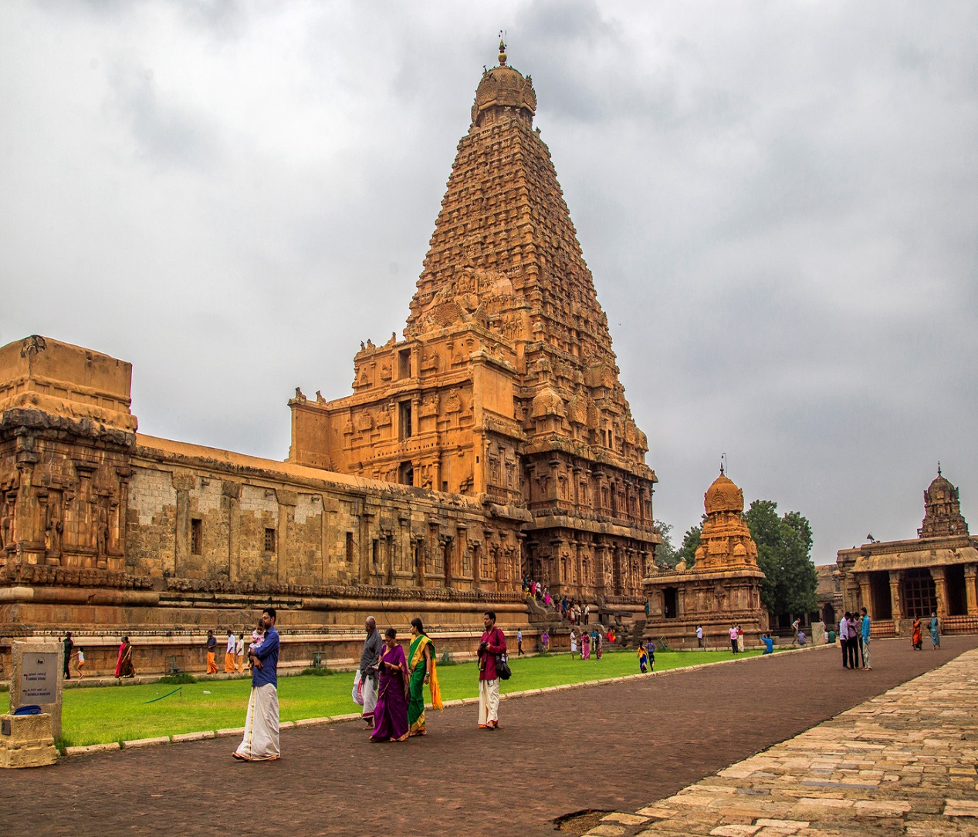

TAM_1

Beginners’ Tamil: a taster course

About this free course
This free course is an adapted extract from the Open University course .
This version of the content may include video, images and interactive content that may not be optimised for your device.
You can experience this free course as it was originally designed on OpenLearn, the home of free learning from The Open University –
Beginners’ Tamil: a taster course
There you’ll also be able to track your progress via your activity record, which you can use to demonstrate your learning.
Copyright © 2021 The Open University
Intellectual property
Unless otherwise stated, this resource is released under the terms of the Creative Commons Licence v4.0 http://creativecommons.org/licenses/by-nc-sa/4.0/deed.en_GB. Within that The Open University interprets this licence in the following way: www.open.edu/openlearn/about-openlearn/frequently-asked-questions-on-openlearn. Copyright and rights falling outside the terms of the Creative Commons Licence are retained or controlled by The Open University. Please read the full text before using any of the content.
We believe the primary barrier to accessing high-quality educational experiences is cost, which is why we aim to publish as much free content as possible under an open licence. If it proves difficult to release content under our preferred Creative Commons licence (e.g. because we can’t afford or gain the clearances or find suitable alternatives), we will still release the materials for free under a personal end-user licence.
This is because the learning experience will always be the same high quality offering and that should always be seen as positive – even if at times the licensing is different to Creative Commons.
When using the content you must attribute us (The Open University) (the OU) and any identified author in accordance with the terms of the Creative Commons Licence.
The Acknowledgements section is used to list, amongst other things, third party (Proprietary), licensed content which is not subject to Creative Commons licensing. Proprietary content must be used (retained) intact and in context to the content at all times.
The Acknowledgements section is also used to bring to your attention any other Special Restrictions which may apply to the content. For example there may be times when the Creative Commons Non-Commercial Sharealike licence does not apply to any of the content even if owned by us (The Open University). In these instances, unless stated otherwise, the content may be used for personal and non-commercial use.
We have also identified as Proprietary other material included in the content which is not subject to Creative Commons Licence. These are OU logos, trading names and may extend to certain photographic and video images and sound recordings and any other material as may be brought to your attention.
Unauthorised use of any of the content may constitute a breach of the terms and conditions and/or intellectual property laws.
We reserve the right to alter, amend or bring to an end any terms and conditions provided here without notice.
All rights falling outside the terms of the Creative Commons licence are retained or controlled by The Open University.
Head of Intellectual Property, The Open University
(.kdl)
(.epub)

Contents
- Introduction
- Learning outcomes
- 1 The Tamil language
- 2 Tamil script
  - 2.1 The sound of Tamil
- 3 Tamil greetings
- 4 Tamil names and introductions
- 5 Numbers
  - 5.1 Using numbers
- 6 Food and drink
  - 6.1 Fruits
- 7 Music
  - 7.1 Examples of Tamil music
- Conclusion
- References
- Acknowledgements
- Solutions

Introduction
This free course, Beginners’ Tamil: a taster course, introduces Tamil society and culture, Tamil scripts, and common phrases that will allow you to start having simple conversations in the language. You will also have plenty of opportunities to practise Tamil throughout the course with activities and quizzes.

Learning outcomes
After studying this course, you should be able to:
- demonstrate an awareness of the Tamil alphabet and sound, and a basic understanding of the Tamil language
- count up to 10 in Tamil
- name some of the traditional musical instruments used by Tamils
- name some of the fruits grown in Tamil Nadu
- greet a person in Tamil, and say simple phrases related to numbers, musical instruments and fruits with confidence.

1 The Tamil language
Tamil is one of the oldest languages in the world, and can be dated back to around 400 BC (Violatti, 2016). It is spoken by more than 85 million people (Ethnologue, 2021), most of them in Tamil Nadu (meaning ‘The Tamil Nation’), a state in southern India. Tamil is a language rich in literature, philosophy and music, and thus of interest to many people. It is one of the 22 official languages of India.

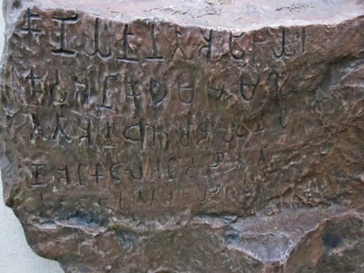
Figure 1 Tamil Brahmi inscription in Mangulam, Madurai district, Tamil Nadu, dated to c. 400 BC to c. 200 AD (Violatti, 2016)
View description - Figure 1 Tamil Brahmi inscription in Mangulam, Madurai district, Tamil Nadu, dated ...
View alternative description - Figure 1 Tamil Brahmi inscription in Mangulam, Madurai district, Tamil Nadu, dated ...

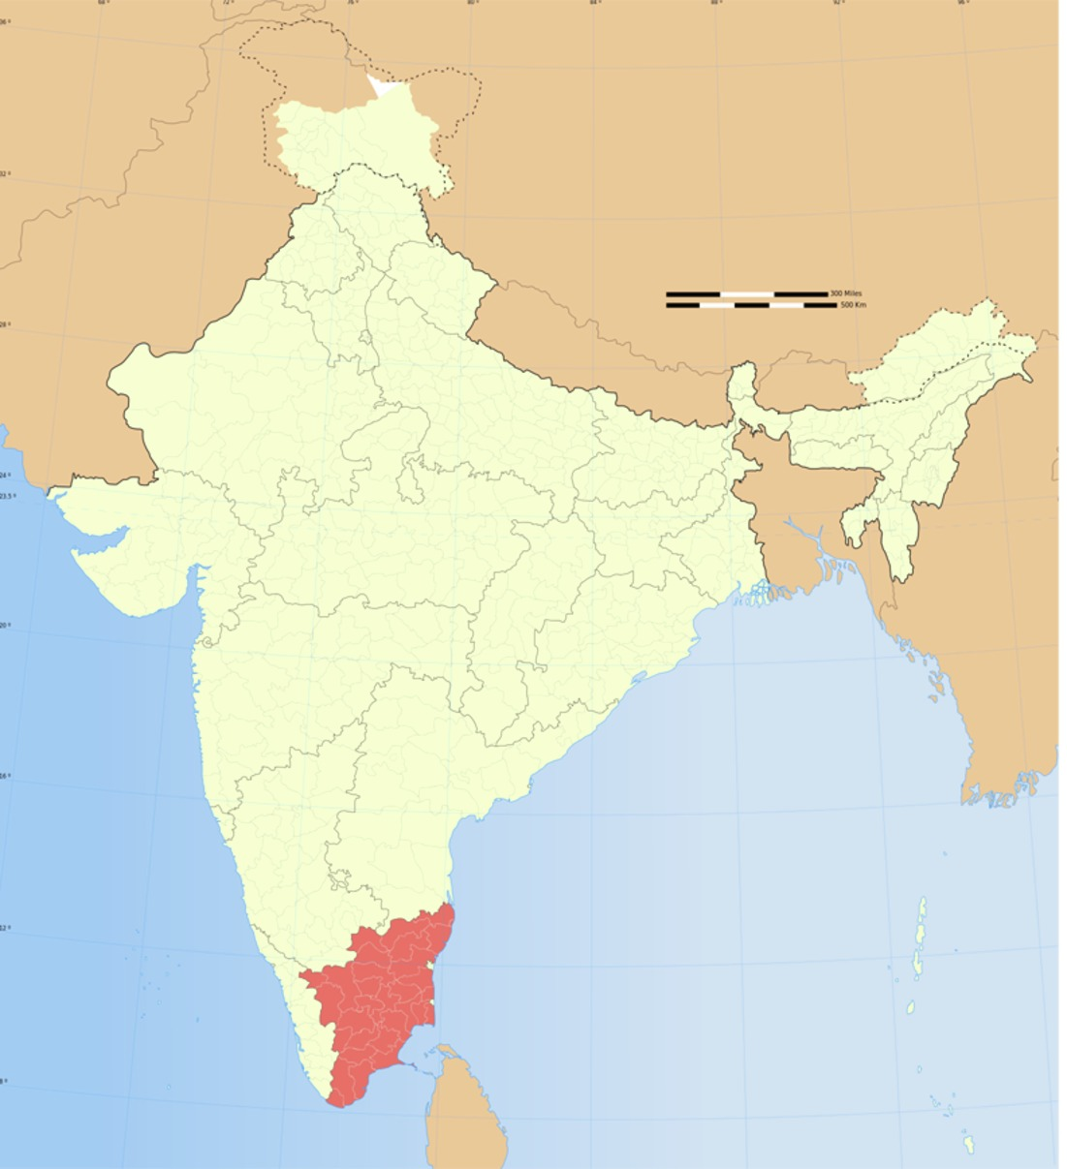
Figure 2 A map of India, with Tamil Nadu in red
View description - Figure 2 A map of India, with Tamil Nadu in red
View alternative description - Figure 2 A map of India, with Tamil Nadu in red

Tamil is the official language of Tamil Nadu and the Indian territory of Puducherry, and is one of the official languages in Sri Lanka and Singapore.
As well as in Singapore and Sri Lanka where Tamil is particularly prominent in Jaffna in the north of the island, and in the Vanni in the east, there are also large numbers of Tamil speakers in the diaspora in Malaysia, Mauritius, Fiji, South Africa, the United Kingdom, Canada, France, Australia and the USA. Significant Tamil minorities in the Indian states of Kerala, Andhra Pradesh, Karnataka and Telangana, and in the Andaman and Nicobar Islands, also speak the language.
Tamil is also used as a language of education in Sri Lanka, Malaysia and Singapore.
In England and Wales in 2011, the Tamil speaking-population was said to be 100 689 (Gopal and Matras, 2013) while Dissanayake some years earlier (2008) quoted a community estimate of 150 000.
The majority of Tamils are Hindus, with a smaller proportion being Christians and Muslims. Tamils tend to live in extended families, with the elderly often living with their adult children.

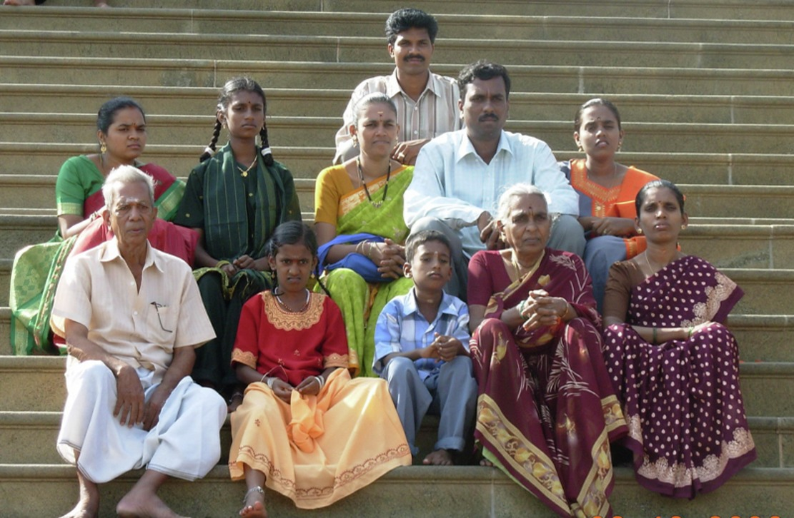
Figure 3 Three generations of a Tamil family – the women are wearing saris (saylay, in Tamil), while the patriarch is wearing a vertti, and the young girl in the front is wearing a pavaadai.
View description - Figure 3 Three generations of a Tamil family – the women are wearing saris (saylay, ...
View alternative description - Figure 3 Three generations of a Tamil family – the women are wearing saris (saylay, ...

Activity 1

True or false. Tamil is an official language only in India.

True
False
View answer - Part
View discussion - Part

True or false. Tamil is an ancient language.

True
False
View answer - Part
View discussion - Part

True or false. The majority of Tamils are Buddhists.

True
False
View answer - Part
View discussion - Part

2 Tamil script
The current Tamil script consists of 12 vowels (Table 1), 18 consonants (Table 2) and one special character, the āytam. The vowels and consonants combine to form 216 compound characters (see Section 2.1 for examples), giving a total of 247 characters. There are also Grantha letters originating from the 4th century, which are used with Sanskrit words, usually in religious contexts.
All consonants have an inherent vowel a, as with other Indic scripts. This inherent vowel is removed by adding a tittle called a pulli, to the consonantal sign. For example, ன is ṉa (with the inherent a) and ன் is ṉ (without a vowel).
The direction of writing is from left to right, in horizontal lines. The alphabet was originally written on palm fronds. As a result, the letters are made up mainly of curved strokes which would not have ripped the fronds.

Table 1 The 12 Tamil vowels
அ | a | எ | e
ஆ | aa | ஏ | ee
இ | i | ஐ | ai
ஈ | ii | ஒ | o
உ | u | ஓ | oo
ஊ | uu | ஔ | au

Table 2 The 18 Tamil consonants, with the Grantha letters
க்  k  [k], [ɡ], [x], [ɣ], [ɦ] | ங்  ṅ  [ŋ] | ச்  c  [t͡ɕ], [d͡ʑ], [s], [ɕ] | ஞ்  ñ  [ɲ] | ட்  ṭ  [ʈ], [ɖ], [ɽ] | ண்  ṇ  [ɳ]
த்  t  [t̪], [d̪], [ð] | ந்  n  [n̪] | ப்  p  [p], [b], [β] | ம்  m  [m] | ய்  y  [j] | ர்  r  [ɾ]
ல்  l  [l] | வ்  v  [ʋ] | ழ்  ḻ  [ɻ] | ள்  ḷ  [ɭ] | ற்  ṟ  [r], [t], [d] | ன்  ṉ  [n]
Grantha letters
ஜ  ja | ஷ  sha | ஸ  sa | ஹ  ha | க்ஷ  kṣha

2.1 The sound of Tamil
As mentioned in Section 2, the 12 vowels and 18 consonants in Tamil combine to form 216 compound characters. Listen to the two audios below for some examples and to hear how the sounds are pronounced.

Audio content is not available in this format.
க,கா,கி,கீ,கு,கூ,கெ,கே,கை,கொ,கோ,கௌ
View transcript - க,கா,கி,கீ,கு,கூ,கெ,கே,கை,கொ,கோ,கௌ

Audio content is not available in this format.
ச,சா,சி,சீ,சு,சூ,செ,சே,சை,சொ,சோ,சௌ
View transcript - ச,சா,சி,சீ,சு,சூ,செ,சே,சை,சொ,சோ,சௌ

Now listen to the pronunciation of some of the new words you have been introduced to so far in this course.

New vocabulary

Audio content is not available in this format.
Tamil | தமிழ்
View transcript - Tamil | தமிழ்

Audio content is not available in this format.
Tamil Nadu | தமிழ் நாடு
View transcript - Tamil Nadu | தமிழ் நாடு

Audio content is not available in this format.
Saylay | சேலை
View transcript - Saylay | சேலை

Audio content is not available in this format.
Vertti | வேட்டி
View transcript - Vertti | வேட்டி

Audio content is not available in this format.
Pavaadai | பாவாடை
View transcript - Pavaadai | பாவாடை

Activity 2

Interactive content is not available in this format.

3 Tamil greetings
Unlike many other languages where there are multiple ways of greeting, in Tamil there is just one way of greeting others. To greet someone in person or whilst on the telephone or internet, you would say ‘Vanakkam’ and, if meeting in person, you would say this with palms pressed against each other facing the person.
The word ‘Vanakkam’ implies respecting the person who comes in front of another person. This is just like the word ‘Namaste’ which is used in Northern India, Nepal, and in other regions where Hindi is spoken.

Figure 4 A couple saying ‘Vanakkam’ - (வணக்கம்).
View description - Figure 4 A couple saying ‘Vanakkam’ - (வணக்கம்).
View alternative description - Figure 4 A couple saying ‘Vanakkam’ - (வணக்கம்).

When saying goodbye to someone or leaving a gathering, Tamils will say, ‘Naan poyitu vaarein’ meaning ‘I’ll go and come back’. This is an indication of being in constant connection with people.
Table 3 lists some useful phrases to use when greeting others and when saying goodbye. Read through the table and then listen to how each phrase is pronounced in the study note that follows. You will then have a chance to practise saying some of the expressions in Activity 3.

Table 3 Greetings and essential expressions
Phrase in English | Phrase in Tamil | Pronunciation
Hello | வணக்கம். | Vanakkam
Are you well? | நீங்கள் நலமாக இருக்கிறீர்களா? | Neenkal Nalamaka Erukkirirkala?
Yes, I’m fine | ஆம், நான் நலமாக இருக்கிறேன். | Aam, naan nalamaka erukkiren
Thank you | நன்றி. | Nandhri
You are welcome | நீங்கள் வரவேற்கப்படுகிறீர்கள். | Neenkal varavetkappadukireerkal
I’m sorry | நான் வருந்துகிறேன்
Forgive me (this is a more common way of apologising in day-to-day communications) | என்னை மன்னித்துக்கொள்ளுங்கள். | Ennai manniththukollunkal
It doesn’t matter | அது ஒரு விடயம் இல்லை. (அது பறவாயில்லை) | Athu oru vidayam ellai (Athu paruvaayillai)
Goodbye | நான் போயிற்று வாறேன். | Naan poyitu vaarein
I have to leave now, as I have to fetch my son from school | நான் எனது மகனை பள்ளியில் இருந்து எடுக்கவேண்டி இருப்பதால், நான் இப்பொழுது போகவேண்டி இருக்கிறது. | Naan enathu makanai palliyil erunthu edukka vendi eruppathaal naan eppoluthu pokavendi erukkirathu

New vocabulary/phrases
Click on ‘Show transcript’ to reveal the transliteration (Tamil words using the English alphabet) of the vocabulary/phrases.

Audio content is not available in this format.
Hello | வணக்கம்.
View transcript - Hello | வணக்கம்.

Audio content is not available in this format.
Are you well? | நீங்கள் நலமாக இருக்கிறீர்களா?
View transcript - Are you well? | நீங்கள் நலமாக இருக்கிறீர்களா?

Audio content is not available in this format.
Yes, I’m fine | ஆம், நான் நலமாக இருக்கிறேன்.
View transcript - Yes, I’m fine | ஆம், நான் நலமாக இருக்கிறேன்.

Audio content is not available in this format.
Thank you | நன்றி.
View transcript - Thank you | நன்றி.

Audio content is not available in this format.
You are welcome | நீங்கள் வரவேற்கப்படுகிறீர்கள்.
View transcript - You are welcome | நீங்கள் வரவேற்கப்படுகிறீர்கள்.

Audio content is not available in this format.
Forgive me | என்னை மன்னித்துக்கொள்ளுங்கள்
View transcript - Forgive me | என்னை மன்னித்துக்கொள்ளுங்கள்

Audio content is not available in this format.
It doesn’t matter | அது ஒரு விடயம் இல்லை. (அது பறவாயில்லை)
View transcript - It doesn’t matter | அது ஒரு விடயம் இல்லை. (அது பறவாயில்லை)

Audio content is not available in this format.
Goodbye (literally, ‘I will go and come back’) | நான் போயிற்று வாறேன்.
View transcript - Goodbye (literally, ‘I will go and come back’) | நான் போயிற்று வாறேன்.

Audio content is not available in this format.
I have to leave now, as I have to fetch my son from school | நான் எனது மகனை பள்ளியில் இருந்து எடுக்கவேண்டி இருப்பதால், நான் இப்பொழுது போகவேண்டி இருக்கிறது.
View transcript - I have to leave now, as I have to fetch my son from school | நான் எனது மகனை பள்ளியில் ...

Now have a go at speaking Tamil yourself.

Activity 3

Record yourself saying the following statements and questions. Once you have recorded yourself, compare your recording with the model answer given.

Interactive content is not available in this format.

Interactive content is not available in this format.

Interactive content is not available in this format.

4 Tamil names and introductions
Tamils usually only have one name, but it can be quite long, for example, ‘Sivaloganathan’ (a male name, usually shortened, amongst family and friends, to ‘Siva’, or ‘Loga’, or ‘Nathan’). The first letter of the father’s name is then put as an initial. So, if the father of Sivaloganathan was named ‘Sriskantharajah’, Sivaloganathan would be known as ‘S. Sivaloganathan’.
Female names tend to be shorter than male names, for example, Saraswathi or Lakshmi, the name of two Hindu Goddesses. If you imagine Saras (the shortened form of Saraswathi, but which would never be used in a religious setting) to be Siva’s brother, she would go as ‘S. Saraswathi’ when filling in any paperwork.
In Tamil, as in many Asian languages, older people are addressed in respectful ways and suffixes for different categories of relatives are used. For example, your mother’s eldest brother would be your ‘Peria Maama’ (‘Peria’ means ‘most senior’; and ‘Maama’ means ‘paternal uncle’).

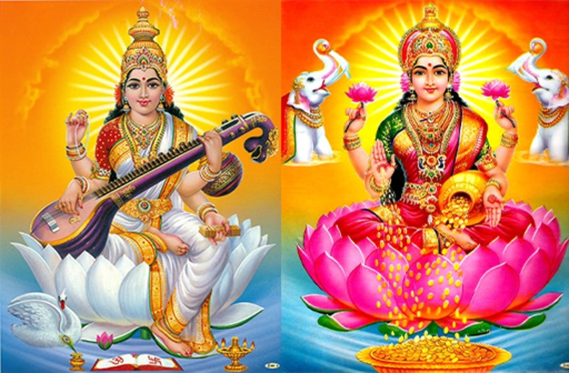
Figure 5 The Goddess Saraswathi, the provider of knowledge (left) and the Goddess Lakshmi, the provider of wealth (right)
View description - Figure 5 The Goddess Saraswathi, the provider of knowledge (left) and the Goddess ...
View alternative description - Figure 5 The Goddess Saraswathi, the provider of knowledge (left) and the Goddess ...

Now study Table 4 alongside the audios that follow in the study note. These are some useful phrases to use when introducing yourself, such as saying where you live, where you were born and a bit about your family. Once you have listened to the phrases, have a go at Activity 4.

Table 4 Introducing yourself
Phrase in English | Phrase in Tamil | Pronunciation
My name is Siva | எனது பெயர் சிவா. | Enathu peyar Siva
I live in Milton Keynes | நான் மில்டன் கீன்ஸ் இல் வாழ்கிறேன். | Naan Milton Keensil Vaalkiren
I was born in Jaffna, Sri Lanka | நான் இலங்கையின் யாழ்ப்பாணத்தில் பிறந்தேன். | Naan Elankaiyin Yalpanathil piranthen [Here, Sri Lanka (Elankai) comes before Jaffna (Yalpanam)]
I am married | நான் திருமணம் ஆனவர். | Naan thirumanam aanavar
I am single | நான் திருமணம் ஆகாதவர். | Naan thirumanam akathavar
I have two children, a boy, and a girl | எனக்கு இரண்டு குழந்தைகள், ஒரு ஆணும்,ஒரு பெண்ணும். | Enakku erandu kulanthaikal, oru aanum, oru pennnum
My son’s name is … | எனது மகனின் பெயர் ... | Enathu makanin peyar …
My daughter’s name is … | எனது மகளின் பெயர் ... | Enathu makalin peyar …

New vocabulary/phrases

Audio content is not available in this format.
My name is Siva | எனது பெயர் சிவா.
View transcript - My name is Siva | எனது பெயர் சிவா.

Audio content is not available in this format.
I live in Milton Keynes | நான் மில்டன் கீன்ஸ் இல் வாழ்கிறேன்.
View transcript - I live in Milton Keynes | நான் மில்டன் கீன்ஸ் இல் வாழ்கிறேன்.

Audio content is not available in this format.
I was born in Jaffna, Sri Lanka | நான் இலங்கையின் யாழ்ப்பாணத்தில் பிறந்தேன்.
View transcript - I was born in Jaffna, Sri Lanka | நான் இலங்கையின் யாழ்ப்பாணத்தில் பிறந்தேன்.

Audio content is not available in this format.
I am married | நான் திருமணம் ஆனவர்.
View transcript - I am married | நான் திருமணம் ஆனவர்.

Audio content is not available in this format.
I am single | நான் திருமணம் ஆகாதவர்.
View transcript - I am single | நான் திருமணம் ஆகாதவர்.

Audio content is not available in this format.
I have two children, a boy, and a girl | எனக்கு இரண்டு குழந்தைகள், ஒரு ஆணும்,ஒரு பெண்ணும்.
View transcript - I have two children, a boy, and a girl | எனக்கு இரண்டு குழந்தைகள், ஒரு ஆணும்,ஒரு ...

Audio content is not available in this format.
My son’s name is … | எனது மகனின் பெயர் ...
View transcript - My son’s name is … | எனது மகனின் பெயர் ...

Audio content is not available in this format.
My daughter’s name is … | எனது மகளின் பெயர் ...
View transcript - My daughter’s name is … | எனது மகளின் பெயர் ...

Activity 4

Select one. In what situation(s) would ‘Vanakkam’ be used?

When speaking on the telephone
When meeting someone face-to-face
When communicating by electronic media
All of the above.
View answer - Part

Unlike in many other societies, Tamils often just have one name.

True
False
View answer - Part

Interactive content is not available in this format.

5 Numbers
In this section you will learn how to count from zero to ten. Study Table 5 alongside the audio that follows to help you become familiar with numbers in Tamil.

Table 5 Numbers in Tamil
Number | Tamil script | Pronunciation
0 | பூச்சியம் | Poochchiam
1 | ஒன்று | Ondru
2 | இரண்டு | Erandu
3 | மூன்று | Moondru
4 | நான்கு | Naanku
5 | ஐந்து | Ainthu
6 | ஆறு | Aaru
7 | ஏழு | Erlu
8 | எட்டு | Ettu
9 | ஒன்பது | Onpathu
10 | பத்து | Paththu

Audio content is not available in this format.
Numbers 0–10
View transcript - Numbers 0–10

5.1 Using numbers
Giving your telephone number or saying your age are just two examples of when you might need to use numbers. How about giving your work identification number or your house number? Listen to the audios that follow to hear how you would say these two examples.

Audio content is not available in this format.
My work identification number is 1148 | எனது வேலை அடையாள இலக்கம் ஒன்று ஒன்று நான்கு எட்டு.
View transcript - My work identification number is 1148 | எனது வேலை அடையாள இலக்கம் ஒன்று ஒன்று நான்கு ...

Audio content is not available in this format.
My house number is 7 | எனது வீட்டு இலக்கம் ஏழு.
View transcript - My house number is 7 | எனது வீட்டு இலக்கம் ஏழு.

Now have a go at using numbers yourself in Activity 5.

Activity 5

Interactive content is not available in this format.

If someone tells you their locker code is ‘ettu, poochiam, ondru, onpathu’, what is their locker number?

Provide your answer...
View discussion - Part

Interactive content is not available in this format.

6 Food and drink
In Tamil culture, it is common to offer visitors a drink and some snacks soon after they arrive. The snacks are usually savoury for adults, and sweet for children.
Listen to the audios to hear how to offer someone a drink and also accept an offer for a tea.

Audio content is not available in this format.
What would you like to drink? Tea, coffee, a soft drink? | உங்களுக்கு என்ன குடிக்க விருப்பம்? தேநீர்,காப்பி,குளிர்பானம்.?
View transcript - What would you like to drink? Tea, coffee, a soft drink? | உங்களுக்கு என்ன குடிக்க ...

Audio content is not available in this format.
Tea would be nice, thank you | தேநீர் நன்றாக இருக்கும், நன்றி.
View transcript - Tea would be nice, thank you | தேநீர் நன்றாக இருக்கும், நன்றி.

(NB: Tea in Tamil culture comes automatically with milk and sugar!)

Audio content is not available in this format.
I have some nice murukku. I’ll bring it | நான் நல்ல முறுக்கு வைத்திருக்கிறேன். அதை நான் கொண்டு வருவேன்.
View transcript - I have some nice murukku. I’ll bring it | நான் நல்ல முறுக்கு வைத்திருக்கிறேன். அதை ...

Murukku (Figure 6), which was mentioned in the last audio, is a savoury, crunchy Indian snack, typically made from rice and urid (also called ‘urad’) daal flour, along with water, salt, chilli powder, asafoetida and either sesame seeds or cumin seeds. Once mixed together the ingredients are kneaded into a spiral or coil-shaped dough, either by hand or with a mould, before being deep-fried in vegetable oil.

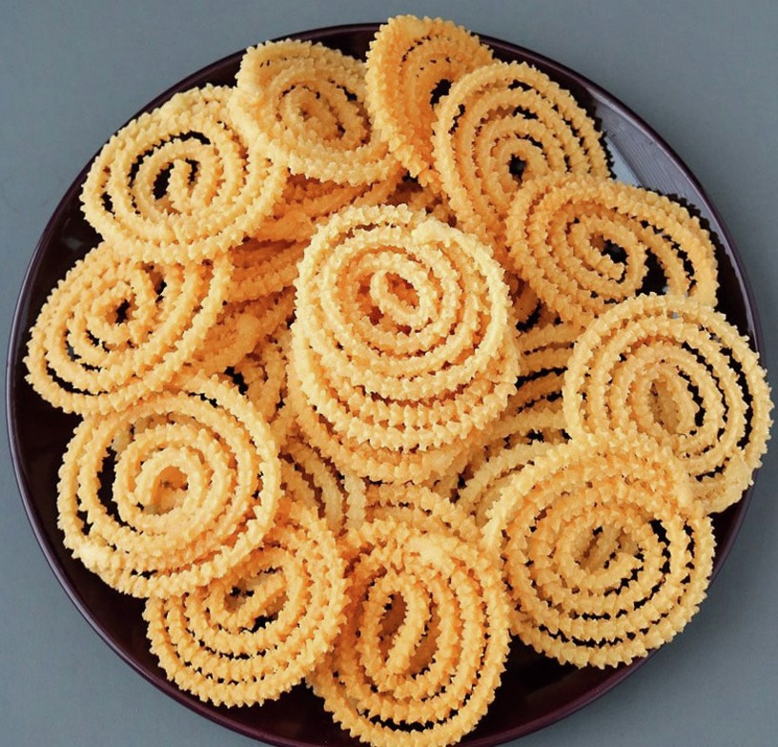
Figure 6 (முறுக்கு)
View description - Figure 6 (முறுக்கு)
View alternative description - Figure 6 (முறுக்கு)

Activity 6

Interactive content is not available in this format.

6.1 Fruits
Tamil Nadu is blessed with a tropical climate (though there are hilly areas, like Kodaikanal where it can get as cool as 2.7 ºC). The warm climate in Tamil Nadu favours the growth of several fruits, some of the most popular of which are shown in Table 6.

Table 6 Fruits grown in Tamil Nadu
Fruit | Illustration | Name in Tamil | Pronunciation
Papaya | 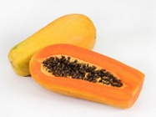 | பப்பாளி | Pappaali
Jackfruit | 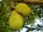 | பலாப்பழம் | Palaappalam
Wood apple | 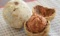 | விளாம்பழம் | Vilaampalam
Jambu | 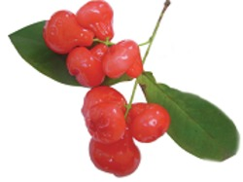 | ஜம்பு | Jambu
Nungu | 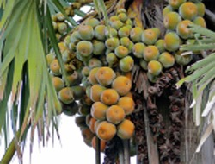 | நுங்கு | Nungu

Now listen to how to pronounce the names of the fruits given in Table 6 before testing your knowledge in Activity 7.

Video content is not available in this format.
Video 1 Fruits
View transcript - Video 1 Fruits

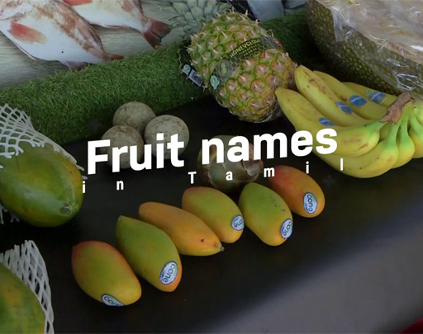
View alternative description - Uncaptioned Figure

Vocabulary

Audio content is not available in this format.
Papaya | பப்பாளி
View transcript - Papaya | பப்பாளி

Audio content is not available in this format.
Jackfruit | பலாப்பழம்
View transcript - Jackfruit | பலாப்பழம்

Audio content is not available in this format.
Wood apple | விளாம்பழம்
View transcript - Wood apple | விளாம்பழம்

Audio content is not available in this format.
Jambu | ஜம்பு
View transcript - Jambu | ஜம்பு

Audio content is not available in this format.
Nungu | நுங்கு
View transcript - Nungu | நுங்கு

Activity 7

Match the images of the fruit with the correct script.

விளாம்பழம்
நுங்கு
ஜம்பு
பப்பாளி
பலாப்பழம்
View answer - Activity 7

7 Music
Classical Tamil music belongs to the Carnatic school of music. Carnatic music is traditional to South India, whilst Hindustani music is associated with North India. Modern Tamil songs, particularly from films, are very popular in Tamil-speaking societies.
Figure 7 illustrates some of the instruments used in both traditional and modern Tamil music. Take a look at the different instruments and then move on to Section 7.1 where you will hear some of the instruments being played.

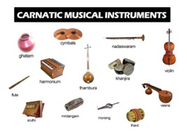
Figure 7 Instruments used in Carnatic music
View description - Figure 7 Instruments used in Carnatic music
View alternative description - Figure 7 Instruments used in Carnatic music

7.1 Examples of Tamil music
In this section you will have the opportunity to listen to some of the instruments used in Tamil music. In Video 2 a musical trio can be seen playing the mirdangam, electric violin, and morsing. The video is a recording from the national sadhana for the 95th Advent of Bhagawan Sri Sathya Sai Baba. You should watch the video from 45:07 to 47:17 to hear the music.

Watch the video at YouTube.com.
Video 2 Tamil music

Did you notice the bond between the musicians? For example at 47:08, when the violin player is pleasantly surprised by a note that the morsing player generates!
The vocabulary box below lets you hear how to pronounce these three instruments being played. Listen and practise the pronuniciation yourself and then continue on to hear the harmonium and morsing being played.

Vocabulary

Audio content is not available in this format.
Mirdangam | மிருதங்கம்
View transcript - Mirdangam | மிருதங்கம்

Audio content is not available in this format.
Electric violin | மின்சார வயலின்
View transcript - Electric violin | மின்சார வயலின்

Audio content is not available in this format.
Morsing | முகச்சங்கு
View transcript - Morsing | முகச்சங்கு

The morsing is a type of ‘jaw harp’, seen in many cultures, and known by various names, such as the Jew’s harp, mouth harp, gewgaw, guimbard, khomus, trump, Ozark harp, Galician harp, or murchunga.
Now watch Video 3, which gives a detailed explanation of the morsing, as well as a demonstration of how it is used.

Watch the video at YouTube.com.
Video 3 What is a morsing?

Finally, before having a go at the last activity in the course, watch Video 4.

Watch the video at YouTube.com.
Video 4 Harmonium recital

Activity 8

Match the images of the musical instruments with the correct word.

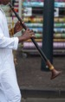
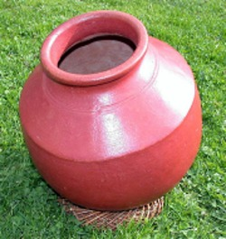
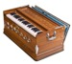
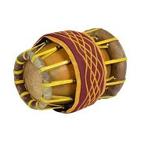
Nadaswaram
Ghatam
Harmonium
Thavil
View answer - Part

Name three stringed instruments used in Tamil music.

Provide your answer...
View discussion - Part

Conclusion
We hope you found this short course interesting and enjoyable! You should now have some knowledge of the history of the Tamil language, together with an understanding of the Tamil script and numbers. You will have acquired some familiarity with commonly used Tamil phrases, including the concept of ‘Vanakkam’, and you’ve also been introduced to some fruits from Tamil Nadu and instruments used in Tamil music.
If you enjoyed this taster in Tamil and would be interested in a longer, paid-for version of the course, you can express you interest by e-mailing oclc@open.ac.uk. Please provide your name and contact email address. Your contact details will be kept for the sole purpose of contacting you should a longer version of the course be produced in the future and will not be used for any other purpose.
If you change your mind and wish for your contact details to be deleted you can do this at any time by emailing again to oclc@open.ac.uk. Your details will be kept for a maximum of two years.

References
Dissanayake, Samanthi (8 December 2008). "UK Tamils polarised but powerful". BBC News. Online. Available at BBC NEWS | UK | UK Tamils polarised but powerful. (Accessed 22 March 2021).
Ethnologue (2021) Quoted in ‘List of languages by total number of speakers’, online. Available at List of languages by total number of speakers – Wikipedia (accessed 22 March 2021).
Gopal, D. and a Matras, Y. (2013). "What languages are spoken in England and Wales?" . ESRC Centre on Dynamics of Ethnicity (CoDE). Online. Available at what-languages-are-spoken-in-england-and-wales.pdf (manchester.ac.uk). Accessed 22 March 2021.
Violatti, C. (2016). Brahmi Script. World History Encyclopedia.online. Available at https://www.ancient.eu/Brahmi_Script/ (Accessed 22 March 2021).

Acknowledgements
This free course was prepared by Suresh Nesaratnam and Senathirajah Muthaiya. It was first published in July 2021.
Except for third party materials and otherwise stated (see terms and conditions), this content is made available under a Creative Commons Attribution-NonCommercial-ShareAlike 4.0 Licence.
The material acknowledged below and within the course is Proprietary and used under licence (not subject to Creative Commons Licence). Grateful acknowledgement is made to the following sources for permission to reproduce material in this free course:

Images/Tables
Course Image: © sabirmallick/Getty Images
Figure 1: sodabottle https://en.wikipedia.org/wiki/File:Mangulam_inscription.jpg https://creativecommons.org/licenses/by-sa/3.0/deed.en
Figure 2: planeMad/Wikimedia https://creativecommons.org/licenses/by-sa/2.0/https://en.wikipedia.org/wiki/File:India_Tamil_Nadu_locator_map.svg
Figure 3: madpai https://commons.wikimedia.org/wiki/File:Tamil_Family.jpg https://creativecommons.org/licenses/by/2.0/deed.en
Figure 4: VSanandhakrishna/Getty Images
Figure 5: Left: The Goddess Saraswathi, the provider of knowledge; Right: The Goddess Lakshmi, the provider of wealth. © unknown
Figure 6: https://www.utkaltoday.com/mullu-murukku-recipe/
Figure 7: ghatam: Sven.petersen placed in public domain; cymbals: bayshev/Getty Images; nadaswaram: By Rahdisas - Own work, CC BY-SA 4.0, https://commons.wikimedia.org/w/index.php?curid=92503798; violin: yarn/Getty Images; harmonium: ajaykampani/Getty Images; thambura: Martin Spaink https://creativecommons.org/licenses/by-sa/3.0/; khanjira: image: brian@silverbushmusic.com https://creativecommons.org/licenses/by-sa/3.0/; flute: Kanags https://creativecommons.org/licenses/by-sa/3.0/; sruthi: image from https://www.shrutibox.co.uk; mridangam: © unknown; morsing: © unknown; thavil: image from https://saraswathymusicals.com/thavil/ ; veena: Veena.svg: Sreejithk2000 derivative work: Gringer (talk) - Veena.svg https://creativecommons.org/licenses/by/3.0/
Table 6 and Activity 7: Papaya: varintorn/Pixabay; Jackfruit: lilimey /Pixabay; Wood Apple: (c) unknown; Jambu: https://www.bfnsrilanka.org/; Nungu: Bernard DUPONT from FRANCE https://creativecommons.org/licenses/by-sa/2.0/deed.en
Activity 8: top image: Nadaswaram: Gwengoat/Getty Images; second image: ghatam: Sven.petersen placed in public domain; third image: harmonium: ajaykampani/Getty Images; bottom image: thavil: image from https://saraswathymusicals.com/thavil/
Every effort has been made to contact copyright owners. If any have been inadvertently overlooked, the publishers will be pleased to make the necessary arrangements at the first opportunity.
Don't miss out
If reading this text has inspired you to learn more, you may be interested in joining the millions of people who discover our free learning resources and qualifications by visiting The Open University – www.open.edu/openlearn/free-courses.

Solutions

Activity 1

Part

Answer
Right:
False
Wrong:
True
Back to - Part

Discussion
False. As well as in India, Tamil is also an official language in Sri Lanka and Singapore.
Back to - Part

Part

Answer
Right:
True
Wrong:
False
Back to - Part

Discussion
True. Tamil is an ancient language, dating back to around 400 BC.
Back to - Part

Part

Answer
Right:
False
Wrong:
True
Back to - Part

Discussion
False. The majority of Tamils are Hindu.
Back to - Part

Activity 4

Part

Answer
Right:
All of the above.
Wrong:
When speaking on the telephone
When meeting someone face-to-face
When communicating by electronic media
Back to - Part

Part

Answer
Right:
True
Wrong:
False
Back to - Part

Activity 5

Part

Discussion
8019
Back to - Part

Activity 7

Answer
The correct matches are:
விளாம்பழம்
நுங்கு
ஜம்பு
பப்பாளி
பலாப்பழம்
Back to - Activity 7

Activity 8

Part

Answer
The correct matches are:
Nadaswaram
Ghatam
Harmonium
Thavil
Back to - Part

Part

Discussion
From Figure 7, you could have said the veena, thambura, and violin.
Back to - Part

Figure 1 Tamil Brahmi inscription in Mangulam, Madurai district, Tamil Nadu, dated to c. 400 BC to c. 200 AD (Violatti, 2016)

Description
A model of the Mangulam Tamil Brahmi inscription at Dakshin Chithra, Chennai.
Back to - Figure 1 Tamil Brahmi inscription in Mangulam, Madurai district, Tamil Nadu, dated to c. 400 BC to c. 200 AD (Violatti, 2016)

Figure 2 A map of India, with Tamil Nadu in red

Description
A map of India. A small section in the bottom right (south east of India) is coloured red to mark out Tamil Nadu.
Back to - Figure 2 A map of India, with Tamil Nadu in red

Figure 3 Three generations of a Tamil family – the women are wearing saris (saylay, in Tamil), while the patriarch is wearing a vertti, and the young girl in the front is wearing a pavaadai.

Description
A photo of eleven members of a Tamil family from three generations sat on three rows of steps. The women are wearing saris (saylay, in Tamil), while the patriarch is wearing a vertti, and the young girl in the front is wearing a pavaadai.
Back to - Figure 3 Three generations of a Tamil family – the women are wearing saris (saylay, in Tamil), while the patriarch is wearing a vertti, and the young girl in the front is wearing a pavaadai.

Figure 4 A couple saying ‘Vanakkam’ - (வணக்கம்).

Description
A cheerful South Indian couple greeting the camera with their hands pressed together and held up by the middle of their chests.
Back to - Figure 4 A couple saying ‘Vanakkam’ - (வணக்கம்).

Figure 5 The Goddess Saraswathi, the provider of knowledge (left) and the Goddess Lakshmi, the provider of wealth (right)

Description
Two posters side by side. The poster on the left is of the Goddess Saraswathi, the provider of knowledge. She is sat down on a white lotus flower playing the veena. A swan is also beside her. The poster on the right is of the Goddess Lakshmi, the provider of wealth. She is sat on a pink lotus flower with a bowl of coins in front of her. Coins are pouring out from one of her hands as well as a pot that she has on her lap. Two white elephants are either side of her.
Back to - Figure 5 The Goddess Saraswathi, the provider of knowledge (left) and the Goddess Lakshmi, the provider of wealth (right)

Figure 6 (முறுக்கு)

Description
A dish of murukku. The murukku are spiral-shaped and light beige.
Back to - Figure 6 (முறுக்கு)

Figure 7 Instruments used in Carnatic music

Description
A poster showing different carnatic musical instruments. It shows a ghatam, nadaswaram, violin, harmonium, flute, sruthi, mridangam, thambura, morsin, thavil, khanjira, veena and cymbals.
Back to - Figure 7 Instruments used in Carnatic music

க,கா,கி,கீ,கு,கூ,கெ,கே,கை,கொ,கோ,கௌ

Transcript
ka, kaa, ki, kii, ku, kuu, ke, kaay, kai, ko, koo, kow
Back to - க,கா,கி,கீ,கு,கூ,கெ,கே,கை,கொ,கோ,கௌ

ச,சா,சி,சீ,சு,சூ,செ,சே,சை,சொ,சோ,சௌ

Transcript
sa, saa, si, sii, su, suu, se, see, sai, so, soo, sow
Back to - ச,சா,சி,சீ,சு,சூ,செ,சே,சை,சொ,சோ,சௌ

Tamil | தமிழ்

Transcript
Thamil
Back to - Tamil | தமிழ்

Tamil Nadu | தமிழ் நாடு

Transcript
Thamil naadu
Back to - Tamil Nadu | தமிழ் நாடு

Saylay | சேலை

Transcript
Saylay
Back to - Saylay | சேலை

Vertti | வேட்டி

Transcript
Vertti
Back to - Vertti | வேட்டி

Pavaadai | பாவாடை

Transcript
Pavaadai
Back to - Pavaadai | பாவாடை

Hello | வணக்கம்.

Transcript
Vanakkam.
Back to - Hello | வணக்கம்.

Are you well? | நீங்கள் நலமாக இருக்கிறீர்களா?

Transcript
Neenkal Nalamaka Erukkirirkala?
Back to - Are you well? | நீங்கள் நலமாக இருக்கிறீர்களா?

Yes, I’m fine | ஆம், நான் நலமாக இருக்கிறேன்.

Transcript
Aam, naan nalamaka erukkiren.
Back to - Yes, I’m fine | ஆம், நான் நலமாக இருக்கிறேன்.

Thank you | நன்றி.

Transcript
Nandhri.
Back to - Thank you | நன்றி.

You are welcome | நீங்கள் வரவேற்கப்படுகிறீர்கள்.

Transcript
Neenkal varavetkappadukireerkal.
Back to - You are welcome | நீங்கள் வரவேற்கப்படுகிறீர்கள்.

Forgive me | என்னை மன்னித்துக்கொள்ளுங்கள்

Transcript
Ennai manniththukollunkal.
Back to - Forgive me | என்னை மன்னித்துக்கொள்ளுங்கள்

It doesn’t matter | அது ஒரு விடயம் இல்லை. (அது பறவாயில்லை)

Transcript
Athu oru vidayam ellai. (Athu paruvaayillai)
Back to - It doesn’t matter | அது ஒரு விடயம் இல்லை. (அது பறவாயில்லை)

Goodbye (literally, ‘I will go and come back’) | நான் போயிற்று வாறேன்.

Transcript
Naan poyitu vaarein.
Back to - Goodbye (literally, ‘I will go and come back’) | நான் போயிற்று வாறேன்.

I have to leave now, as I have to fetch my son from school | நான் எனது மகனை பள்ளியில் இருந்து எடுக்கவேண்டி இருப்பதால், நான் இப்பொழுது போகவேண்டி இருக்கிறது.

Transcript
Naan enathu makanai palliyil erunthu edukka vendi eruppathaal naan eppoluthu pokavendi erukkirathu.
Back to - I have to leave now, as I have to fetch my son from school | நான் எனது மகனை பள்ளியில் இருந்து எடுக்கவேண்டி இருப்பதால், நான் இப்பொழுது போகவேண்டி இருக்கிறது.

My name is Siva | எனது பெயர் சிவா.

Transcript
Enathu peyar Siva.
Back to - My name is Siva | எனது பெயர் சிவா.

I live in Milton Keynes | நான் மில்டன் கீன்ஸ் இல் வாழ்கிறேன்.

Transcript
Naan Milton Keensil Vaalkiren.
Back to - I live in Milton Keynes | நான் மில்டன் கீன்ஸ் இல் வாழ்கிறேன்.

I was born in Jaffna, Sri Lanka | நான் இலங்கையின் யாழ்ப்பாணத்தில் பிறந்தேன்.

Transcript
Naan elankaiyin Yalpanathil piranthen.
Back to - I was born in Jaffna, Sri Lanka | நான் இலங்கையின் யாழ்ப்பாணத்தில் பிறந்தேன்.

I am married | நான் திருமணம் ஆனவர்.

Transcript
Naan thirumanam aanavar.
Back to - I am married | நான் திருமணம் ஆனவர்.

I am single | நான் திருமணம் ஆகாதவர்.

Transcript
Naan thirumanam akathavar.
Back to - I am single | நான் திருமணம் ஆகாதவர்.

I have two children, a boy, and a girl | எனக்கு இரண்டு குழந்தைகள், ஒரு ஆணும்,ஒரு பெண்ணும்.

Transcript
Enakku erandu kulanthaikal, oru aanum, oru pennnum.
Back to - I have two children, a boy, and a girl | எனக்கு இரண்டு குழந்தைகள், ஒரு ஆணும்,ஒரு பெண்ணும்.

My son’s name is … | எனது மகனின் பெயர் ...

Transcript
Enathu makanin peyar …
Back to - My son’s name is … | எனது மகனின் பெயர் ...

My daughter’s name is … | எனது மகளின் பெயர் ...

Transcript
Enathu makalin peyar …
Back to - My daughter’s name is … | எனது மகளின் பெயர் ...

Numbers 0–10

Transcript
Poochchiam, Ondru, Erandu, Moondru, Naanku, Ainthu, Aaru, Erlu, Ettu, Onpathu, Paththu.
Back to - Numbers 0–10

My work identification number is 1148 | எனது வேலை அடையாள இலக்கம் ஒன்று ஒன்று நான்கு எட்டு.

Transcript
Enathu velai adaiyala elakkam ondru ondru naanku ettu.
Back to - My work identification number is 1148 | எனது வேலை அடையாள இலக்கம் ஒன்று ஒன்று நான்கு எட்டு.

My house number is 7 | எனது வீட்டு இலக்கம் ஏழு.

Transcript
Enathu veeddu elakkam erlu.
Back to - My house number is 7 | எனது வீட்டு இலக்கம் ஏழு.

What would you like to drink? Tea, coffee, a soft drink? | உங்களுக்கு என்ன குடிக்க விருப்பம்? தேநீர்,காப்பி,குளிர்பானம்.?

Transcript
Unkalukku enna kudikka viruppam? Theneer, kaappy, kulirpaanam?
Back to - What would you like to drink? Tea, coffee, a soft drink? | உங்களுக்கு என்ன குடிக்க விருப்பம்? தேநீர்,காப்பி,குளிர்பானம்.?

Tea would be nice, thank you | தேநீர் நன்றாக இருக்கும், நன்றி.

Transcript
Thenir nandraha erukkum, nandhri.
Back to - Tea would be nice, thank you | தேநீர் நன்றாக இருக்கும், நன்றி.

I have some nice murukku. I’ll bring it | நான் நல்ல முறுக்கு வைத்திருக்கிறேன். அதை நான் கொண்டு வருவேன்.

Transcript
Naan nalla murukku vaithirukkirein. Athey naan konduvarukkirein.
Back to - I have some nice murukku. I’ll bring it | நான் நல்ல முறுக்கு வைத்திருக்கிறேன். அதை நான் கொண்டு வருவேன்.

Video 1 Fruits

Transcript
[MUSIC PLAYING]
SENATHIRAJAH MUTHAIYA:
Vanakkam. Welcome to my shop.
This is wood apple. It comes from India and Sri Lanka. It is called in Tamil Vilaampalam.
This is papaya. It comes from India and Sri Lanka. It is called in Tamil Pappaali.
This is palmyra fruit. It comes from India and Sri Lanka. It is called in Tamil Nungu.
This is jackfruit. It comes from India and Sri Lanka. It is called in Tamil Palaappalam.
[MUSIC PLAYING]
Back to - Video 1 Fruits

Papaya | பப்பாளி

Transcript
Pappaali
Back to - Papaya | பப்பாளி

Jackfruit | பலாப்பழம்

Transcript
Palaappalam
Back to - Jackfruit | பலாப்பழம்

Wood apple | விளாம்பழம்

Transcript
Vilaampalam
Back to - Wood apple | விளாம்பழம்

Jambu | ஜம்பு

Transcript
Jambu
Back to - Jambu | ஜம்பு

Nungu | நுங்கு

Transcript
Nungu
Back to - Nungu | நுங்கு

Mirdangam | மிருதங்கம்

Transcript
miruthangam
Back to - Mirdangam | மிருதங்கம்

Electric violin | மின்சார வயலின்

Transcript
Minsara violin
Back to - Electric violin | மின்சார வயலின்

Morsing | முகச்சங்கு

Transcript
Muha changgu
Back to - Morsing | முகச்சங்கு

Figure 1 Tamil Brahmi inscription in Mangulam, Madurai district, Tamil Nadu, dated to c. 400 BC to c. 200 AD (Violatti, 2016)

Alternative description
A model of the Mangulam Tamil Brahmi inscription
Back to - Figure 1 Tamil Brahmi inscription in Mangulam, Madurai district, Tamil Nadu, dated to c. 400 BC to c. 200 AD (Violatti, 2016)

Figure 2 A map of India, with Tamil Nadu in red

Alternative description
Map of India, with Tamil Nadu highlighted
Back to - Figure 2 A map of India, with Tamil Nadu in red

Figure 3 Three generations of a Tamil family – the women are wearing saris (saylay, in Tamil), while the patriarch is wearing a vertti, and the young girl in the front is wearing a pavaadai.

Alternative description
A tamil family
Back to - Figure 3 Three generations of a Tamil family – the women are wearing saris (saylay, in Tamil), while the patriarch is wearing a vertti, and the young girl in the front is wearing a pavaadai.

Figure 4 A couple saying ‘Vanakkam’ - (வணக்கம்).

Alternative description
A couple greeting each other
Back to - Figure 4 A couple saying ‘Vanakkam’ - (வணக்கம்).

Figure 5 The Goddess Saraswathi, the provider of knowledge (left) and the Goddess Lakshmi, the provider of wealth (right)

Alternative description
The Goddess Saraswathi and the Goddess Lakshmi
Back to - Figure 5 The Goddess Saraswathi, the provider of knowledge (left) and the Goddess Lakshmi, the provider of wealth (right)

Figure 6 (முறுக்கு)

Alternative description
Murukku
Back to - Figure 6 (முறுக்கு)

Uncaptioned InlineFigure

Alternative description
Papaya
Back to - Uncaptioned InlineFigure

Uncaptioned InlineFigure

Alternative description
Jackfruit
Back to - Uncaptioned InlineFigure

Uncaptioned InlineFigure

Alternative description
Wood apple
Back to - Uncaptioned InlineFigure

Uncaptioned InlineFigure

Alternative description
Jambu
Back to - Uncaptioned InlineFigure

Uncaptioned InlineFigure

Alternative description
Nungu
Back to - Uncaptioned InlineFigure

Uncaptioned Figure

Alternative description
Back to - Uncaptioned Figure

Uncaptioned InlineFigure

Alternative description
Wood apple
Back to - Uncaptioned InlineFigure

Uncaptioned InlineFigure

Alternative description
Nungu
Back to - Uncaptioned InlineFigure

Uncaptioned InlineFigure

Alternative description
Jambu
Back to - Uncaptioned InlineFigure

Uncaptioned InlineFigure

Alternative description
Papaya
Back to - Uncaptioned InlineFigure

Uncaptioned InlineFigure

Alternative description
Jackfruit
Back to - Uncaptioned InlineFigure

Figure 7 Instruments used in Carnatic music

Alternative description
Poster showing carnatic musical instruments.
Back to - Figure 7 Instruments used in Carnatic music

Uncaptioned InlineFigure

Alternative description
Nadaswaram
Back to - Uncaptioned InlineFigure

Uncaptioned InlineFigure

Alternative description
Ghatam
Back to - Uncaptioned InlineFigure

Uncaptioned InlineFigure

Alternative description
Harmonium
Back to - Uncaptioned InlineFigure

Uncaptioned InlineFigure

Alternative description
Thavil
Back to - Uncaptioned InlineFigure

