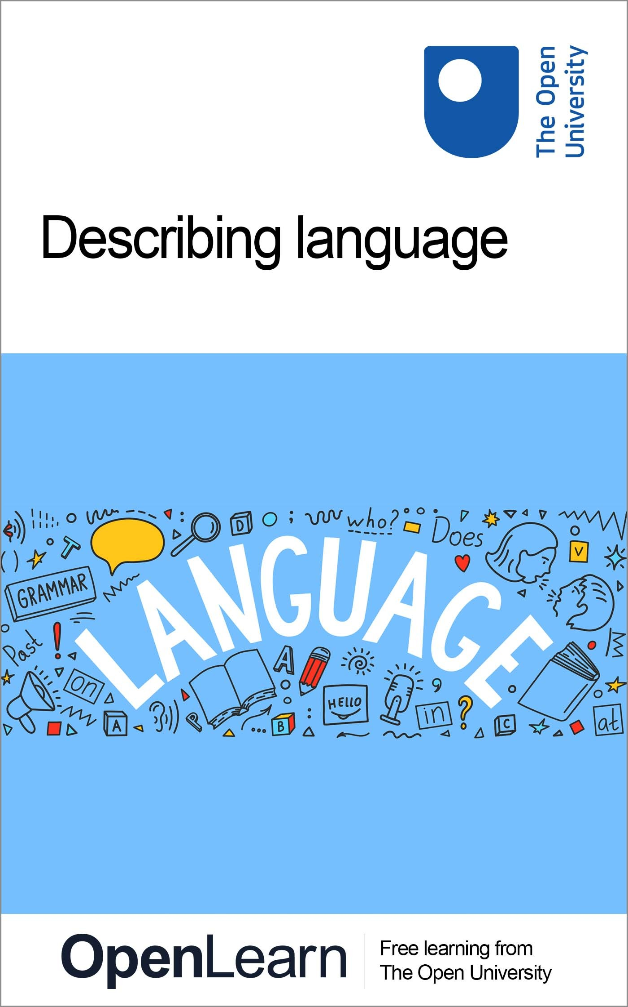

DIL_1

Describing Language

About this free course
This free course is an adapted extract from the Open University course .
This version of the content may include video, images and interactive content that may not be optimised for your device.
You can experience this free course as it was originally designed on OpenLearn, the home of free learning from The Open University –
There you’ll also be able to track your progress via your activity record, which you can use to demonstrate your learning.
Copyright © 2021 The Open University
Intellectual property
Unless otherwise stated, this resource is released under the terms of the Creative Commons Licence v4.0 http://creativecommons.org/licenses/by-nc-sa/4.0/deed.en_GB. Within that The Open University interprets this licence in the following way: www.open.edu/openlearn/about-openlearn/frequently-asked-questions-on-openlearn. Copyright and rights falling outside the terms of the Creative Commons Licence are retained or controlled by The Open University. Please read the full text before using any of the content.
We believe the primary barrier to accessing high-quality educational experiences is cost, which is why we aim to publish as much free content as possible under an open licence. If it proves difficult to release content under our preferred Creative Commons licence (e.g. because we can’t afford or gain the clearances or find suitable alternatives), we will still release the materials for free under a personal end-user licence.
This is because the learning experience will always be the same high quality offering and that should always be seen as positive – even if at times the licensing is different to Creative Commons.
When using the content you must attribute us (The Open University) (the OU) and any identified author in accordance with the terms of the Creative Commons Licence.
The Acknowledgements section is used to list, amongst other things, third party (Proprietary), licensed content which is not subject to Creative Commons licensing. Proprietary content must be used (retained) intact and in context to the content at all times.
The Acknowledgements section is also used to bring to your attention any other Special Restrictions which may apply to the content. For example there may be times when the Creative Commons Non-Commercial Sharealike licence does not apply to any of the content even if owned by us (The Open University). In these instances, unless stated otherwise, the content may be used for personal and non-commercial use.
We have also identified as Proprietary other material included in the content which is not subject to Creative Commons Licence. These are OU logos, trading names and may extend to certain photographic and video images and sound recordings and any other material as may be brought to your attention.
Unauthorised use of any of the content may constitute a breach of the terms and conditions and/or intellectual property laws.
We reserve the right to alter, amend or bring to an end any terms and conditions provided here without notice.
All rights falling outside the terms of the Creative Commons licence are retained or controlled by The Open University.
Head of Intellectual Property, The Open University

Contents
- Introduction and guidance
  - Introduction and guidance
  - Introduction and guidance
    - What is a badged course?
    - How to get a badge
- Week 1: Making words
  - Introduction
  - 1 What is language?
  - 2 English is one language among many
    - 2.1 What is the biggest language in the world?
    - 2.2 Where does English get its words from?
  - 3 Introducing morphology
  - 4 Free and bound morphemes
    - 4.1 More about morphemes
    - 4.2 Adding more morphemes
    - 4.3 What are the morphemes telling you?
  - 5 This week’s quiz
  - 6 Summary of Week 1
- Week 2: Nouns: naming things, places, people and ideas
  - Introduction
  - 1 Different kinds of words
    - 1.1 Word classes
    - 1.2 The word classes you will focus on
  - 2 This week’s words
    - 2.1 Different kinds of nouns
    - 2.2 Can you spot the different types of noun?
    - 2.3 All the noun types together
  - 3 Nouns make more nouns
  - 4 This week’s quiz
  - 5 Summary of Week 2
- Week 3: Verbs 1: how we describe what we do
  - Introduction
  - 1 A doing word?
    - 1.1 How verbs can shape meaning
  - 2 Verbs and morphemes
  - 3 Verb + verb = verb
    - 3.1 Auxiliary verbs
    - 3.2 Modal auxiliaries
    - 3.3 How modal auxiliaries can add nuance
    - 3.4 The range of functions of modal auxiliaries
  - 4 Categorising verbs
  - 5 This week’s quiz
  - 6 Summary of Week 3
- Week 4: Verbs 2: how verbs work together
  - Introduction
  - 1 Present, past and future?
    - 1.1 Tense in English
    - 1.2 Participles: verbs without any tense
  - 2 Regular and irregular verbs
    - 2.1 Irregular verbs at work
    - 2.2 What you know so far
  - 3 Verbs in other languages
  - 4 This week’s quiz
  - 5 Summary of Week 4
- Week 5: Adjectives: adding more information
  - Introduction
  - 1 What are things like?
    - 1.1 Finding the adjectives
  - 2 Types of adjectives
    - 2.1 What can adjectives tell us?
    - 2.2 Where do adjectives go?
    - 2.3 Comparing using adjectives
    - 2.4 Just talking nonsense?
  - 3 Adjectives working together
  - 4 New, improved! Adjectives and advertising
    - 4.1 Write your own advert
  - 5 This week’s quiz
  - 6 Summary of Week 5
- Week 6: All the bits in between
  - Introduction
  - 1 Adverbs
    - 1.1 Can you recognise an adverb?
    - 1.2 More things you can do with adverbs
  - 2 How words work together
    - 2.1 Open and closed class words
    - 2.2 Not all word classes can be expanded
    - 2.3 Can you tell what class a word is from its shape?
  - 3 Closed class words
    - 3.1 Pronouns
    - 3.2 Determiners
    - 3.3 Prepositions
    - 3.4 Conjunctions
  - 4 This week’s quiz
  - 5 Summary of Week 6
- Week 7: Putting it all together
  - Introduction
  - 1 The structure of language
    - 1.1 How to build a language
    - 1.2 Where do the words go?
    - 1.3 The order of words (in English)
  - 2 English sentence structure
    - 2.1 Subjects and objects
    - 2.2 A Latin headline
  - 3 How sentences are built
  - 4 Adding more information
    - 4.1 SVOCA
  - 5 This week’s quiz
  - 6 Summary of Week 7
- Week 8: Language in the real world
  - Introduction
  - 1 Sentence forms
    - 1.1 Asking questions
    - 1.2 Questions in other languages
    - 1.3 Giving commands and making exclamations
    - 1.4 Spotting different sentence forms
  - 2 Structure and sentence functions
  - 3 Combining sentences
    - 3.1 Making longer sentences
    - 3.2 Making more complex sentences
  - 4 Language in the real world
    - 4.1 Collocation
  - 5 Playing with language
  - 6 This week’s quiz
  - 7 Summary of Week 8
  - Next steps?
  - Tell us what you think
- References
- Acknowledgements
- Solutions

Introduction and guidance

Introduction and guidance

Introduction and guidance
This free badged course, Describing language, lasts 24 hours and is comprised of eight weeks. You can work through the course at your own pace, so if you have more time one week there is no problem with pushing on to complete a further week. The eight weeks are linked to ensure a logical flow through the course. They are:
- Making words
- Nouns: naming things, places, people and ideas
- Verbs 1: how we describe what we do
- Verbs 2: how verbs work together
- Adjectives: adding more information
- All the bits in between
- Putting it all together
- Language in the real world.
Each week should take you around 3 hours. There are a number of activities throughout the course where you are asked to note down your response. A text box is provided for you to do this, however if you would prefer to record your answers in another way that is fine.
At the end of each week there is also a quiz to help you check your understanding. And, if you want to receive a formal statement of participation, at the end of Weeks 4 and 8 there is a quiz which you need to pass.
After completing this course, you should be able to:
- identify different types of words including nouns, verbs, adjectives, conjunctions and prepositions
- understand how words pattern together in regular structures
- recognise different types of sentences
- describe how different structures can convey different meanings.

Moving around the course
In the ‘Summary’ at the end of each week, you will find a link to the next week. If at any time you want to return to the start of the course, click on ‘Full course description’. From here you can navigate to any part of the course.
It’s also good practice, if you access a link from within a course page (including links to the quizzes), to open it in a new window or tab. That way you can easily return to where you’ve come from without having to use the back button on your browser.
The Open University would really appreciate a few minutes of your time to tell us about yourself and your expectations for the course before you begin, in our optional start-of-course survey. Participation will be completely confidential and we will not pass on your details to others.

What is a badged course?
While studying Introduction to adolescent mental health you have the option to work towards gaining a digital badge.
Badged courses are a key part of The Open University’s mission to promote the educational wellbeing of the community. The courses also provide another way of helping you to progress from informal to formal learning.
Completing a course will require about 24 hours of study time. However, you can study the course at any time and at a pace to suit you.
Badged courses are available on The Open University’s OpenLearn website and do not cost anything to study. They differ from Open University courses because you do not receive support from a tutor, but you do get useful feedback from the interactive quizzes.

What is a badge?
Digital badges are a new way of demonstrating online that you have gained a skill. Colleges and universities are working with employers and other organisations to develop open badges that help learners gain recognition for their skills, and support employers to identify the right candidate for a job.
Badges demonstrate your work and achievement on the course. You can share your achievement with friends, family and employers, and on social media. Badges are a great motivation, helping you to reach the end of the course. Gaining a badge often boosts confidence in the skills and abilities that underpin successful study. So, completing this course could encourage you to think about taking other courses.

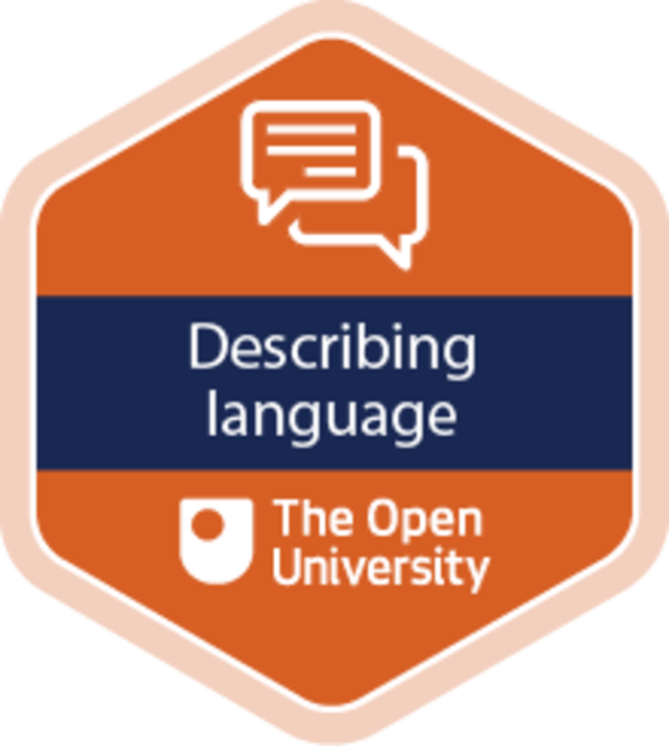
View description - Uncaptioned Figure

How to get a badge
Getting a badge is straightforward! Here’s what you have to do:
- read each session of the course
- score 50% or more in the two badge quizzes in Session 4 and Session 8.
For all the quizzes, you can have three attempts at most of the questions (for true or false type questions you usually only get one attempt). If you get the answer right first time you will get more marks than for a correct answer the second or third time. Therefore, please be aware that for the two badge quizzes it is possible to get all the questions right but not score 50% and be eligible for the badge on that attempt. If one of your answers is incorrect you will often receive helpful feedback and suggestions about how to work out the correct answer.
For the badge quizzes, if you’re not successful in getting 50% the first time, after 24 hours you can attempt the whole quiz, and come back as many times as you like.
We hope that as many people as possible will gain an Open University badge – so you should see getting a badge as an opportunity to reflect on what you have learned rather than as a test.
If you need more guidance on getting a badge and what you can do with it, take a look at the OpenLearn FAQs. When you gain your badge you will receive an email to notify you and you will be able to view and manage all your badges in My OpenLearn within 24 hours of completing the criteria to gain a badge.
Get started with Week 1.

Week 1: Making words

Introduction


Figure 1 Words in the world.
View description - Figure 1 Words in the world.
View description - Figure 1 Words in the world.

What makes a language? We use language in all its forms – speech, writing, signing – all day, every day, but we don’t often think about what language is and how it works. This week you’ll have a chance to do just that. You’ll start by thinking about how words work and how they are made and you’ll consider whether something can be ‘putdownable’, just a ‘guesstimate’, or ‘googlicious’.
You’ll have an opportunity to examine words closely and think about how they work. Like any formal study, this course will involve a certain amount of technical vocabulary, but as the topics you’ll cover are all parts of language, the terms you’ll learn are essentially labels for things you have been using perfectly well all your life.
By the end of this week, you should be able to:
- give a simple answer to the question ‘what is language?’
- understand how words are built
- identify different types of morphemes
- begin to analyse how language can be used creatively.
The Open University would really appreciate a few minutes of your time to tell us about yourself and your expectations for the course before you begin, in our optional start-of-course survey. Participation will be completely confidential and we will not pass on your details to others.

1 What is language?
Think about how language fits into your daily life. It’s there first thing in the morning when you listen to the radio, when you read the newspaper, or when you speak to your family over breakfast. It’s there as you check or reply to texts, tweets and emails on your phone (if you have a clever one) or your computer. And it carries on throughout the day, whether at work, while you study, or are at play. Language is such an important part of everyday life that it’s easy to take it for granted.
In this course you will have a chance to stand back from all this and have a think about what language is, what it does and how it works. You’ll start by carrying out a couple of activities to test what you already know.

Activity 1 What is language?
This activity should take around 5 minutes

Before you go any further, write down your own, brief definition of ‘language’.

Provide your answer...
View discussion - Activity 1 What is language?

Activity 2 Beginning to learn about language
This activity should take around 10 minutes

Now you’ve considered your own ideas about what language is, watch this short video and note down what it includes in its definition of language. Does anything that is included in the video surprise you? Why do you think that is?

Video content is not available in this format.
Video 1 What is language?
View transcript - Video 1 What is language?

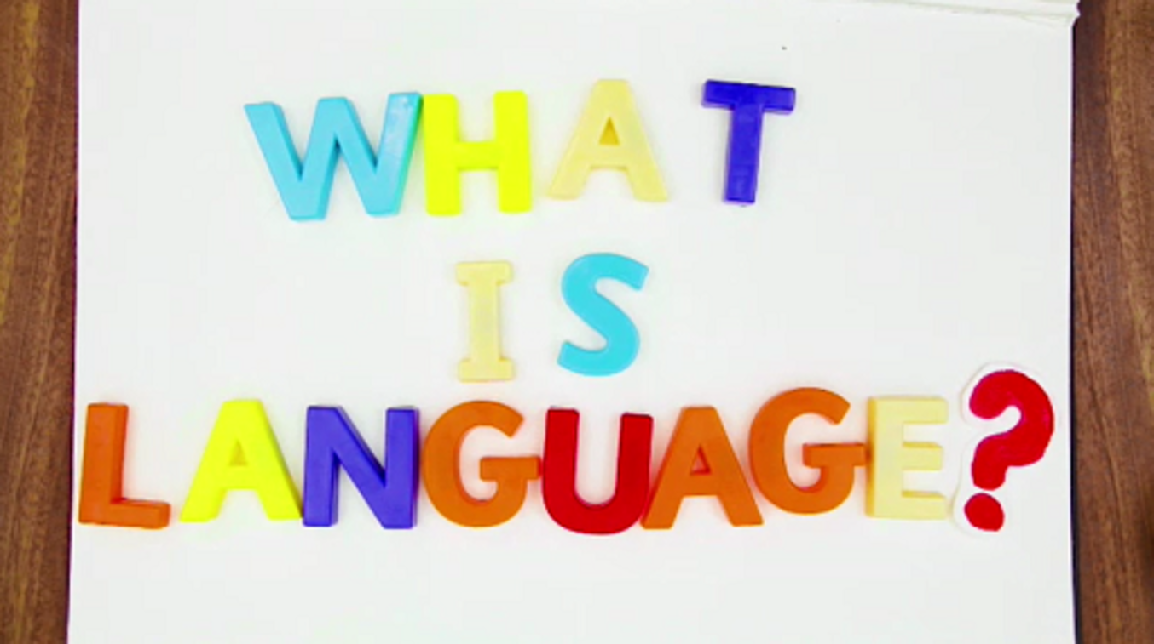

Provide your answer...
View discussion - Activity 2 Beginning to learn about language

Now ‘language’ in general, as a human capacity (or tool, resource, etc.) is one thing. What people actually do in daily life is use a particular language, such as English, French, Russian, Hindi, Mandarin Chinese, and so on. These different languages are originally connected to a people, country or region, and may, for historical reasons, be more or less similar to other languages.

2 English is one language among many


Figure 2 Greetings in different languages.
View description - Figure 2 Greetings in different languages.
View description - Figure 2 Greetings in different languages.

In this course you’ll mostly be considering examples from English, but much of what you learn here will also apply to other languages. To illustrate similarities and differences, you’ll also see some examples from other languages. If you know any other languages in addition to English, you might be able to spot these similarities yourself.

2.1 What is the biggest language in the world?
Many people speak English, and it is used widely in international communication, business and global culture, but that does not automatically mean it is the biggest language in the world.
According to the Ethnologue language website (Eberhard et al., 2020), the languages spoken by the largest number of people in the world are (in alphabetical order) English, Hindi, Mandarin Chinese and Spanish. The actual number of speakers of each language depends on who you count.

Box 1
Before taking a closer look at how many people speak these major languages, it is important to understand some of the terminology used to distinguish between different groups of speakers.
- First language: A language learned by a speaker from an early age in a family setting. For example, a child socialised in English in the UK will have English as their first language.
- Second language: A language learned by a speaker at a later stage than their first language, often in a school setting, and which is commonly used or encountered by that speaker only in certain areas of daily life such as dealing with the authorities or in higher education or broadcasting.
These definitions may shift over time as our knowledge about how people use language develops. There are ongoing debates about where to draw the boundary between first and second language speakers, which is related to the broader question about who has the power to draw such a boundary. Sometimes terms even fall out of favour: the terms native speaker and non-native speaker are now less commonly used in language research than they have been in the past.

Activity 3 The biggest language
This activity should take around 5 minutes

Think about your own perceptions of who speaks English, Hindi, Mandarin Chinese and Spanish. Rank each of these languages in terms of the following.
- The number of first language speakers you think they have.

Provide your answer...
View discussion - Part

- The number of first language speakers plus everyone who speaks the languages as a second (or third, or fourth) language.

Provide your answer...
View discussion - Part

These figures are, of course, approximate, as it’s not possible to survey everyone on the planet. You might also question who counts as a ‘second language’ speaker: someone who studied English at school but doesn’t use it regularly, or only someone who uses it proficiently? But the overall picture is clear: speakers of Mandarin Chinese and English far exceed those for Hindi and Spanish.
Most speakers of Mandarin are in China. What makes English distinctive among these major world languages is the huge number of people (around 750 million) who speak it as a second, third or additional language, and the fact these speakers are found all across the world.

2.2 Where does English get its words from?
English didn’t become the most spoken language in the world without being influenced by the other languages that it has come into contact with. This contact – the result of population movements, invasions, colonialism, and now global communications – has left an imprint on what English looks like in the twenty-first century. Table 1 shows just some examples of words that have been borrowed into English.

Table 1 Words borrowed into English
 |  | First recorded in English
Freckle | from the Old Norse freknur | 1386
Bamboo | from the Malay bambu | 1563
Barbecue | from the Spanish barbacoa | 1697
Ketchup | from the Chinese (Amoy dialect) ketchiap | 1711
Ghoul | from the Arabic ghul | 1786
Pyjamas | from the Urdu paejamah | 1801
Tzatziki | from the Greek τσατσίκι | 1960
Parkour | from the French parcours | 2002

You can see even from this small (in fact tiny!) sample that words have come into English from languages all around the world. Once they get into English, they tend to conform to English rules (spelling and pronunciation) and can sometimes ‘forget’ their origins. The Spanish for ‘the lizard’, for example, is el lagarto, which has ended up as alligator in English. We have a number of words from Arabic beginning with al-, which is also the equivalent of ‘the’: alcohol, algebra and the very modern sounding algorithm, which originates in ‘the man from Kwarizm’, the nickname of a ninth-century Persian mathematician from what is now Uzbekistan.
Not all English words have such exotic histories, of course, but even the most mundane are made up of some pretty exciting bits and pieces. This is what you will turn to now.

3 Introducing morphology
In order to take a look at how words are built, we can draw on morphology, one of the technical terms you will learn in language study. It means the study of how words are put together, and the different shapes they take. For example, if you look in most English dictionaries, you will find entries for the following words:
- make
- fight
- easy
But there are other forms of these words which most dictionaries don’t give separate entries for:
- make: makes, making, made
- fight: fights, fighting, fought
- easy: easier, easiest, easily
One part of morphology explains how these different forms of a word relate to each other. That is, how we can make fighting from fight and how we understand the relationship between these two forms.
Another part of morphology looks at how more complex words can be formed from simpler ones:
- make: remake, make-up, makeshift
- fight: fightback, firefight, firefighter
- easy: uneasy, uneasiness, speakeasy
Morphemes are the smallest meaningful unit of a language and they are the building blocks of words. For example, uneasy is un- + easy, and firefighter is fire + fight + er.

Activity 4 Let’s make some words
This activity should take around 10 minutes

Take a look at the list of morphemes below and give yourself two minutes to make as many different words from them as you can.

-ing | child | -ness | sad
sing | un- | -s | dis-
feel | -ed | appoint | -ish
friend | bad | -ly | love
-ally | appeal | walk | -al
bottle | -ment

Provide your answer...

When the two minutes are up, take a closer look at the words you have made. Do you notice any patterns? Could some morphemes stand on their own while others couldn’t? Could some only go at the beginning of a word? Note down your findings.

Provide your answer...
View discussion - Part

4 Free and bound morphemes
You are now going to look at the different kinds of morphemes. Before going into the details, and in case the terminology starts to sound complicated, remember that the most basic definition of morpheme is ‘word part’. Now, morphemes like potato, happy, four or turquoise can stand on their own as words. These are called free morphemes. If you use this type of morpheme in answer to a question, it tells us something specific:

Q: What’s this white stuff on top of the pie?
A: Potato.

Q: How did Lucas seem to you this morning?
A: Happy.

Q: How many children do Andres and Gemma have?
A: Four.

Q: What colour did you paint the walls?
A: Turquoise.

There are other morphemes which don’t do this. For example:
- anti-, dis-, pre-, un-
- -ed, -ful, -ing, -ly
This type of morpheme – also known as bound morphemes – can’t be used to answer a question. They do have meaning, but only when we attach them to another word. Look at the difference the morphemes in list a) make when we add them to the following words:
- depressant – antidepressant
- agree – disagree
- cooked – precooked
- lucky – unlucky
In each case, adding these morphemes at the start of a word causes a significant change in meaning. Most of the words on the right are the opposite of the words on the left (and ‘pre’ means ‘in advance’).
The items in list b) have a different effect:
- walk – walked
- harm – harmful
- play – playing
- stupid – stupidly
Adding these morphemes doesn’t change the basic meaning of the word on the left, but they do have an effect on how you can use the word.

4.1 More about morphemes
To summarise so far:
- Some morphemes can stand on their own as words: potato, apple, idea, cat, Tuesday. These are called free morphemes.
- Other morphemes like un-, -ly, dis-, -ness cannot be used on their own, and must be added to free morphemes. Using these bound morphemes changes the meaning or the grammatical properties of the word they are attached to.
It’s possible to add more than one bound morpheme to a free morpheme. For example, underestimation is made up of the free morpheme estimate plus the prefix (a bound morpheme at the start of a word) under- and the suffix (a bound morpheme at the end of a word) -tion (under + estimate + tion). To give another example, unsystematically is made up of the free morpheme system plus the prefix un- and two suffixes -atic and -ally (un + system + atic + ally). You can also put two free morphemes together to create words like hairbrush (hair + brush) and hangnail (hang + nail).

Activity 5 Finding free and bound morphemes
This activity should take around 15 minutes

Take a look at the list of words below. Some are free morphemes and can’t be divided any further. Others are made of a bound morpheme added to a free morpheme, either at the start (a prefix) or the end (a suffix).
Decide in which column each word should go. The first one has been done for you.
- entertainment
- friendship
- bottle
- butter
- impossible
- resistance
- disengage
- proudly
- water
- admirable
- banana

Free morpheme | Prefix + free morpheme | Free morpheme + suffix
Provide your answer... | Provide your answer... | entertain + ment
Provide your answer... | Provide your answer... | Provide your answer...
Provide your answer... | Provide your answer... | Provide your answer...
Provide your answer... | Provide your answer... | Provide your answer...
Provide your answer... | Provide your answer... | Provide your answer...
Provide your answer... | Provide your answer... | Provide your answer...
Provide your answer... | Provide your answer... | Provide your answer...
Provide your answer... | Provide your answer... | Provide your answer...
Provide your answer... | Provide your answer... | Provide your answer...
Provide your answer... | Provide your answer... | Provide your answer...
Provide your answer... | Provide your answer... | Provide your answer...

View discussion - Activity 5 Finding free and bound morphemes

4.2 Adding more morphemes
Words can quickly increase in size once more morphemes are added. Here is a diagram showing how the free morpheme character (9 letters long) adds three bound morphemes to become uncharacteristically (20 letters long).

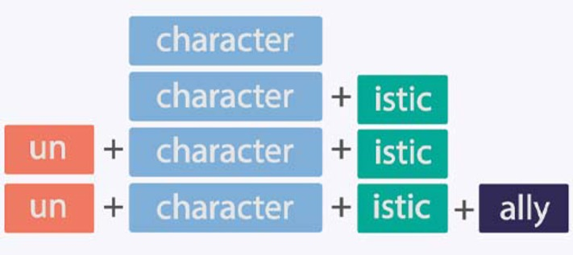
Figure 3 The building blocks of uncharacteristically.
View description - Figure 3 The building blocks of uncharacteristically.
View description - Figure 3 The building blocks of uncharacteristically.

Activity 6 Show me the morphemes
This activity should take around 20 minutes

Take a look at the examples below, each of which contains a new word made by combining morphemes in novel ways. First, identify which is the new word. Then break it down into its morphemes, before finally thinking about why the writer might have used this word and what effect it has on you as the reader. Do you know what each new word means?
- We just had another nonversation stood at the bus stop.

Provide your answer...
View discussion - Part

- Snickers: Get a degree in Snackonomics (Walsh, 2009)

Provide your answer...
View discussion - Part

- I’m quite good at spelling, but I’m so unkeyboardinated

Provide your answer...
View discussion - Part

- He’s always on his mobile phone; he’s just so cellfish.

Provide your answer...
View discussion - Part

This activity shows that, even if you’re not sure what a word means, and even if it’s a brand-new word, you can often still identify its morphemes. This ability probably helped you work out more or less what the new words in the examples meant. In fact advertisers who create new words rely on this ability. Using morphemes to create new words like this is just one way we can get creative with language.

4.3 What are the morphemes telling you?
You saw at the start of Section 4 that suffixes (bound morphemes attached to the end of a word) can change the grammatical properties of a word. In this section you’ll take a closer look at this feature of language.
One of the most important morphemes that we can add to nouns in English is -s. (You’ll learn more about nouns next week.) Adding -s to a noun allows you to show that you’re talking about more than one of something:

Singular | Plural
House | Houses
Table | Tables
Tree | Trees
Porcupine | Porcupines

Some adjustments are made for spelling:

Singular | Plural
Tomato | Tomatoes
Reply | Replies
Church | Churches
Knife | Knives

But there are only relatively few plurals that don’t follow this general pattern in English, such as:

Singular | Plural
Foot | Feet
Child | Children
Man | Men
Mouse | Mice

With verbs (which you’ll learn about in Weeks 3 and 4) the most important morpheme is probably -ed. When added to the basic form of the verb, it shows you are referring to the past, not the present: walk > walked, laugh > laughed, watch > watched. This is an important difference, and although there are some irregular verbs (sing > sang, feel > felt) most verbs use the -ed form.

Activity 7 Choose the right form of the word
This activity should take around 5 minutes

Interactive content is not available in this format.

Provide your answer...
View discussion - Activity 7 Choose the right form of the word

5 This week’s quiz
Well done – you have reached the end of Week 1. You can now check what you’ve learned this week by taking the end-of-week quiz.
Week 1 practice quiz
Open the quiz in a new or window and come back here when you have finished.

6 Summary of Week 1
You began this week by considering the question ‘what is language?’ You saw that language is a fundamental part of what makes us human and distinguishes us from animals. Language has enabled us to make our society, and the world, the way it is today. And speaking of the world, you also took a closer look at which languages are spoken by the most people.
Having started with the huge concept of ‘language’ you then turned your attention to the smallest units of meaning: morphemes. You examined these building blocks of words, considered the different characteristics and functions of ‘bound’ and ‘free’ morphemes, and learned how they combine to make longer words. Armed with this knowledge, you could unpack just some of the ways people use their knowledge of morphemes creatively in advertising, or simply to be more expressive in everyday communication (creating words like ‘guesstimate’ or ‘googlicious’).
Now you’ve looked at the way all words are put together, next week you’ll consider one of the largest groups of words in English. These are the words we use to name things, places, people and ideas – the grammatical category called ‘nouns’.
You can now go to Week 2.

Week 2: Nouns: naming things, places, people and ideas

Introduction


Figure 1 A man behind a counter in a market.
View description - Figure 1 A man behind a counter in a market.
View description - Figure 1 A man behind a counter in a market.

Imagine you are in a shop in a country where you don’t speak the language. Picture a shop (not a supermarket) with a counter and a shopkeeper behind it. You have a list of things you need to buy. Unless you are the world’s best mime (try ‘tinned pineapple chunks’!), you are also in need of the names (in the local language, of course) for the things you want to buy.
This week you will be looking at this part of the (English) language – the part we need to name things, places, people and ideas. These are the nouns, which are sometimes called ‘naming words’. Nouns are just one type of word class. The word classes are the basis of grammatical description of any language, and forms the main content of the rest of this course.
By the end of this week, you should be able to:
- describe what a noun is
- identify different types of noun
- begin to know the difference between different classes of word.

1 Different kinds of words


Figure 2 Parts of speech.
View description - Figure 2 Parts of speech.
View description - Figure 2 Parts of speech.

We can all talk, write or sign in our own language without having to think very much about what words we use or the order we put them in. When we want to talk about the language we use and how it works, however, we might find it more challenging – it’s a bit like the difference between driving a car, and explaining how its engine works.
One thing you’ll need as you learn to talk about language is a set of terms to identify and label different kinds of words. You’ll also need a way to sort words into groups that do the same sort of thing. This is the first step to explaining the grammar of a language. Names for sets of words are part of everyday language: ‘days of the week’, ‘months’, ‘numbers’, ‘colours’ and so on. The set you’ll be learning are the ‘parts of speech’. Some of the terms in this set may be familiar to you from school or from learning another language, or they may be mostly new. What you’ll already know depends on when and where you went to school, as fashions in education change. What is important to remember is that even if the terms are new, you have been using the words they refer to all your life, without thinking about it too much.
To illustrate the knowledge you’ve already got, you’ll take a look at how different types of words can be grouped together.

Activity 1 Different types of words at work
This activity should take around 15 minutes

Read the dialogue below then sort the bold words into the categories given in the table. Are they:
- a ‘naming word’ (for a thing or person)
- a ‘doing word’ (something that happened or that someone did or is doing)
- a ‘describing word’ (saying what something or someone is like)?
Add the words to the relevant columns in the table.
A. I brought a present for Amanda.
B. Can you afford it?
A. Oh, it wasn’t expensive. I bought it with some of the money I saved last year.
B. It’s beautiful! She’ll love it!

Naming words | Doing words | Describing words
Provide your answer... | Provide your answer... | Provide your answer...

View discussion - Activity 1 Different types of words at work

1.1 Word classes
The video in the next activity discusses some of the major word classes in English. It gives you a look ahead at what you’ll cover in the course.

Activity 2 The different word classes
This activity should take around 15 minutes

As you watch the video, consider the questions below. Don’t worry if you don’t get all the answers right at first, you can always watch the video again and return to this activity later in the course to refresh your memory.

Video content is not available in this format.
Video 1 Different sorts of words
View transcript - Video 1 Different sorts of words

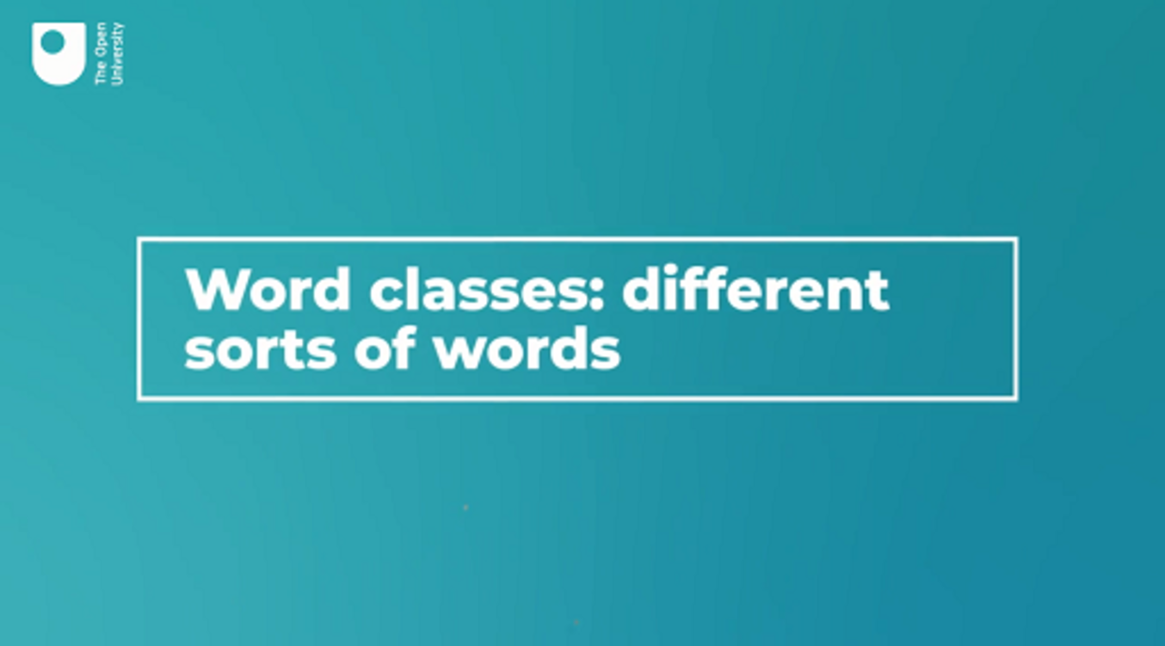

How many different word classes are mentioned in the video? How might you describe what each class does?

Provide your answer...
View discussion - Activity 2 The different word classes

Pronouns will be a topic for later in the course, but they’ve been mentioned now as they’re very common. Like all the other word classes, even if you didn’t know the name for them (or have forgotten), pronouns are something you’ve been using with great facility all your life, if English is your first language, or at least from very early on if you learned English at school. Pronouns are usually some of the first words you learn in language classrooms as knowing how to refer to yourself and others is a key aspect of communication.

1.2 The word classes you will focus on

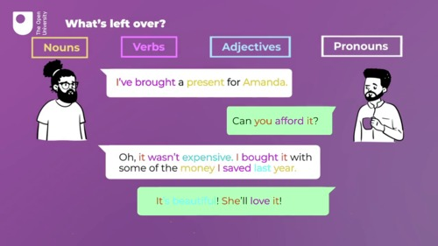
Figure 3 Examples of some word classes.
View description - Figure 3 Examples of some word classes.
View description - Figure 3 Examples of some word classes.

This course won’t cover all the word classes in the same detail. You’ll start with nouns, verbs and adjectives. In the second half of the course you’ll look at how these major word classes are combined into sentences and texts. This is done using smaller classes of more grammatical words, like pronouns (they or you), prepositions (in and under) and conjunctions (and or but), which you’ll be introduced to in Weeks 5–8.

2 This week’s words
In some ways nouns are the most basic parts of a language – they’re the ‘labels’ for things. You use them when saying:
- What there is – There are plenty of carrots.
- What you can see – Look at that elephant over there!
- What you want – Could I have the ¾ inch spanner, please?
If you didn’t know the meaning of the bold word in one of these examples (carrots, elephant, spanner), it would be difficult to get the main idea expressed in these sentences across in another way.
Nouns are central to knowing and using a language. When you say someone speaks Greek/Thai/Xhosa/etc., you expect that they will be able (if they also speak English!) to answer questions like:
- What is the Greek word for banana?
- What do Thai speakers call a rabbit?
- How do you say table in Xhosa?
It’s obviously not enough just to know the nouns (in addition to carrot, elephant and spanner there are at least four other types of words in the three example sentences above). But learning about nouns is a good place to start.

2.1 Different kinds of nouns
The next video explains some of the major categories of nouns. You’ll test your knowledge of different types of noun in the activities that follow. If you find the activities difficult, remember that you can always return to this explanatory video.

Activity 3 Proper or common nouns?
This activity should take around 15 minutes

As you watch the following video, make note of how many different types of nouns are mentioned in the text box below. You might want to watch the video more than once and remember that you can return to it at any point in the course.

Video content is not available in this format.
Video 2 Different kinds of nouns
View transcript - Video 2 Different kinds of nouns

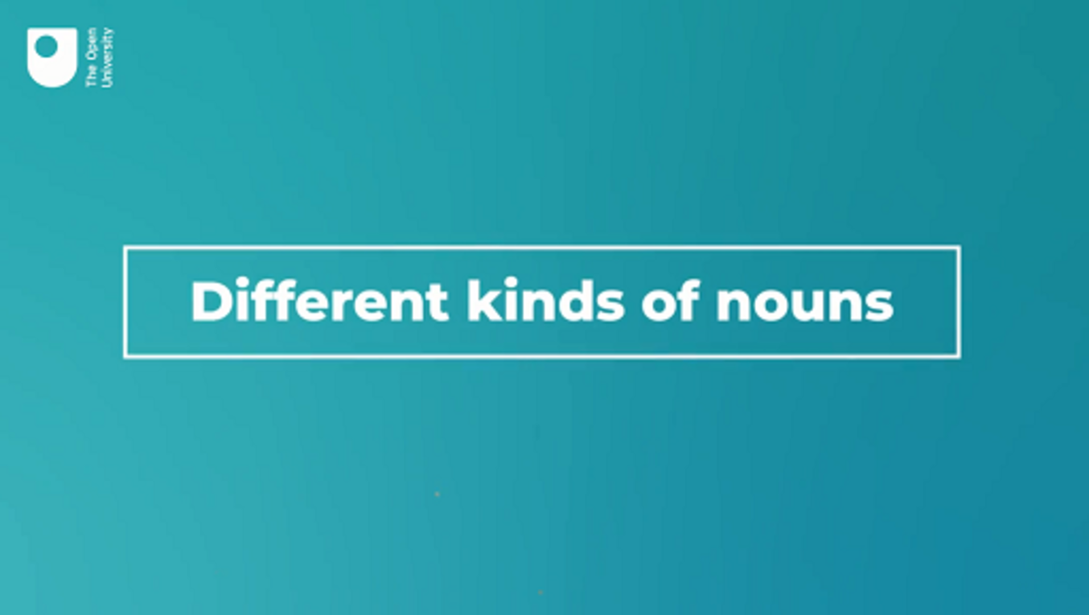

Provide your answer...
View discussion - Activity 3 Proper or common nouns?

2.2 Can you spot the different types of noun?
It’s time to put your new-found knowledge of nouns to the test. The next set of activities are designed to allow you to practise classifying different types of nouns. Don’t worry if you don’t get them all right first time – practice is key and you can return to these activities whenever you need them.

Activity 4 Proper or common nouns?
This activity should take around 15 minutes

Read the following passage and highlight proper nouns in yellow, and common nouns in blue.

Interactive content is not available in this format.

View discussion - Activity 4 Proper or common nouns?

Activity 5 Count or non-count nouns?
This activity should take around 15 minutes

Read the following passage, and consider the nouns shown in italics. Highlight count nouns in yellow and non-count nouns in blue. (As with the previous activity, if you find this activity difficult, you can rewatch the video in Section 2.1.)

Interactive content is not available in this format.

View discussion - Activity 5 Count or non-count nouns?

Some non-count nouns can also occasionally be used as count nouns. In these cases, it’s usually clear from the context that the meaning is ‘a single unit of’ the item:
- I had a yoghurt after lunch. (a pot of yoghurt)
- He bought a whole cheese from the delicatessen. (a wheel of cheese)
- Can you pass me a water? (a bottle of water)
In these cases, you might also get a sense that some words are missing: a yoghurt is shorthand for ‘a tub/pot of yoghurt’, a whole cheese is a ‘whole wheel of cheese’, and a water is really referring to ‘a bottle of water’. Importantly tub/pot, wheel, and bottle are all count nouns.

Activity 6 Abstract or concrete nouns?
This activity should take around 15 minutes

Read the following passage. Look at the nouns in italics. Highlight abstract nouns in yellow and concrete nouns in blue.

Interactive content is not available in this format.

Some abstract nouns are ‘big ideas’, like peace, freedom, progress – so big, in fact, that they are sometimes written with a capital letter (especially in slogans): ‘We want Peace, Freedom, Progress!’
Some concrete nouns are pretty obvious – they’re solid and take up room, like a table and chairs or a cow or a horse or an aeroplane. Others are less clear: a war is a major event involving lots of people, places and other events within it. It has a beginning, middle and (let’s hope) an end, so it’s definitely not just an idea somewhere up in the air. But if we’re not thinking of a particular event, and we mean ‘the absence of peace’, then war can be used like an abstract noun (‘We are against War and for Peace in every circumstance’).

2.3 All the noun types together
Although so far you’ve focused on each category of nouns separately, nouns can be classified into more than one group. This should be clear if you look at how the categories relate to each other in the tree diagram below.

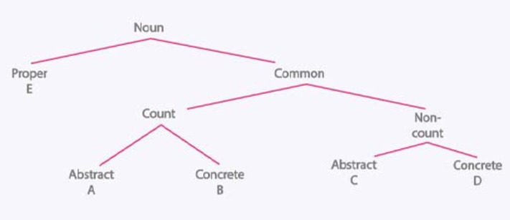
Figure 4 How nouns are categorised.
View description - Figure 4 How nouns are categorised.
View description - Figure 4 How nouns are categorised.

Activity 7 Where in the tree does the noun go?
This activity should take you around 5 minutes

Look at the tree diagram in Figure 4 and consider the following words:

banana, idea, Napoleon, petrol, revenge

Which word goes at A, B, C, D and E, and what categories does each fall under as a result? The first one has been done for you.

A. idea – a common, count, abstract noun B. C. D. E.
View discussion - Activity 7 Where in the tree does the noun go?

3 Nouns make more nouns


Figure 5 Making a compound noun.
View description - Figure 5 Making a compound noun.
View description - Figure 5 Making a compound noun.

Now that you’ve learned about individual nouns, there’s one other important characteristic of nouns that you need to get to grips with. Nouns can combine to form other nouns: Cardiff + City = Cardiff City, birthday + party = birthday party. In fact birthday is itself a combination of two other nouns: birth + day. In this way, many nouns are made up of other nouns, and form either a new word (sales + person = salesperson), or a phrase (fishing + permit = fishing permit).
It’s not always clear how to write these combined nouns (which we call compound nouns). For example, you can find people writing hair brush, hair-brush and hairbrush. In general, the more everyday and frequently used a compound is, and the longer it has been used in the language, the more likely it is to be written as one word, rather than as two, or with a hyphen. You can look back at the history of compounds in the Oxford English Dictionary, where you will find that a word such as ‘toothbrush’ was often written as tooth-brush or as two words until as recently as the 1920s.

Activity 8 Creating compound nouns
This activity should take around 20 minutes

Look at the two lists below, A and B. Can you form compounds (including phrases, single words and hyphenated words)? Make a list of as many as you can.

List A | List B
back  head  toe  pay  health | ache  cap  paste  check  care

Provide your answer...
View discussion - Activity 8 Creating compound nouns

You may have spotted that, in creating compound nouns, you were combining two free morphemes (which you learned about in Week 1). The open-ended nature of the noun word class demonstrated in this activity – we can always combine words or create new nouns – is an important feature of language. Language is not a fixed, unchanging code. There will always be more nouns on the way, whenever there is a new concept that needs defining or a new invention that needs a name. Language is always in flux!

4 This week’s quiz
Well done – you have reached the end of Week 2. You can now check what you’ve learned this week by taking the end-of-week quiz.
Error! Hyperlink reference not valid.
Open the quiz in a new or window and come back here when you have finished.

5 Summary of Week 2
This week you have looked at nouns: the words we use to name things, places, people and ideas.
Think back to the shopkeeper you imagined at the start of this week. When thinking about how you would purchase the items you needed, you would still need to find out the actual words for what you wanted to buy in the local language, but you now know more about the type of words that you’d need. In most cases, the things on your shopping list would be common nouns, concrete nouns, and a mixture of count and non-count nouns, such as pimientos rojos (red peppers) and leche (milk).
An important part of this week has been starting to think about language as made up of a set of different classes of words that do different things. You’ve had an overview of the word classes you’ll cover in the first part of the course (nouns, verbs and adjectives), and also a peek ahead to pronouns, which are covered later. There are also a few more classes that will come up later, but these will certainly do for the present.
You’ve had some practice in assessing and classifying nouns using some of the categories linguists and grammarians use and you’re starting to build up the vocabulary you’ll need to accurately describe language. You may have found that it’s not always easy to apply the new labels you’ve come across to different nouns, but you’ve taken your first steps on the way to systematically analysing the language around us.
Next week you will consider another of the largest groups of words in English. These are the words we use to talk about actions, or what people and things are doing – the grammatical category called verbs.
You can now go to Week 3.

Week 3: Verbs 1: how we describe what we do

Introduction
Mental health becomes a problem when it interferes with daily life.

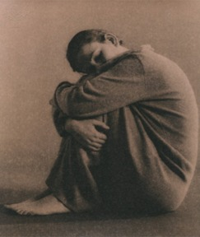
Figure 1
View description - Figure 1
View description - Figure 1

Although individuals vary, there are certain signs and behaviours that can signal that a young person is struggling with their mental health and in this session you’ll learn about some of them. Mental health depends on social, emotional and psychological wellbeing. The causes of mental health problems are often a combination of biology (how the brain and body work, especially in response to stress), psychological traits (e.g. personality type), the social environment (life experience), and sometimes certain chemical substances (such as alcohol or marijuana). A tendency to develop mental health problems can run in families, although the reasons for this are complicated and may include inequalities and poverty that run between generations. There is still a great deal of debate among researchers about how these factors interact. However, most experts now agree that there is rarely a single cause.
To get started on understanding some of the different dimensions that can affect mental health, watch the video, which features a group of young people describing their own experiences of mental health problems.

Video content is not available in this format.
Video 1: Mental health in our own words
View transcript - Video 1: Mental health in our own words



This session will introduce you to four sets of common mental health problems, starting with anxiety and depression. Anxiety and depression are commonly used terms, and you will get below the surface to discover what they mean. Anxiety and depression can sometimes develop into other behaviours such as eating disorders and self-harm. On your journey through this session, you may encounter material that can be unsettling, although we hope that the knowledge and understanding you gain will help you to become a more effective supporter of young people who are struggling with their mental health. If you are affected by any of the course material please refer to our support notes at the end of this session.

1 A doing word?
Let’s start with the idea that verbs are ‘doing words’. Lots of verbs certainly are about actions like someone or something moving or changing itself, or affecting or changing something or someone else. Look at the following examples:
- He hit his thumb with a hammer.
- They ate all the pies.
- I shot the sheriff.
- Pedro reads very quickly.
- She bought a new car.
And to show that it’s not only people who do things:
- The rain ruined the picnic.
But verbs can also involve mental activity and emotions:
- We want another chance.
- I hope so!
- Everyone expected them to win.
- She hates that sort of attitude.
- Andrea thought he was taller.
Verbs help us to make a connection between the thing or person doing something and what they are doing. In all the examples given above, the first word (nouns and pronouns, which you’ll learn about in Week 5) is called the ‘subject’ of the verb (who or what is doing the thing expressed by the verb). You’ll learn more about the subject (and other parts of a sentence) in Week 6. Verbs can also tell us a lot about the person or thing that is affected by an action – the ‘object’ of the verb (which you’ll also encounter in Week 6, but for now you’ll just focus on the verbs themselves).

Activity 1 Spot the verbs
This activity should take around 15 minutes

Read the following sentences and choose which word is the verb (there is only one verb in each sentence). Ask yourself: ‘what action (or emotion) is taking place here?’
1. I never saw so many flies before.

flies
saw
before
never
View answer - Part

2. They love everything new like that.

like
new
that
love
View answer - Part

3. Move the piano into the hall.

move
piano
hall
into
View answer - Part

4. Snow fell throughout the day.

day
snow
fell
throughout
View answer - Part

5. They went away in the end.

end
went
away
they
View answer - Part

6. Please request a form from the office.

request
form
please
office
View answer - Part
View discussion - Part

1.1 How verbs can shape meaning
Verbs are an incredibly important part of speech. Not only do they help us to structure our language, by allowing us to show who is doing what to whom, or who is experiencing a thought, feeling or emotion, they also add colour to the language we use and allow us to express shades of meaning. As such, verbs are an extremely useful resource for writers, advertisers and storytellers alike, and in the next activity you’ll have a chance to put your creative writing skills to the test.

Activity 2 Change the verb, improve the story
This activity should take around 20 minutes

Read the following short story and then rewrite your own version of it in the box below. You can only change the verbs that have been italicised in the original.

The astronaut stepped out of the pod door and onto the planet’s surface. She looked across the landscape to see the red hills. The astronaut smiled and thought about building a settlement. She opened her scientific equipment to take soil samples. As she worked, the astronaut saw three creatures looking at her from a few meters away. Heart beating quickly, the astronaut stood and moved towards the creatures and took a photograph. The creatures ran into the hills and the astronaut went back to her ship to tell her crewmates.

Provide your answer...
View discussion - Activity 2 Change the verb, improve the story

One thing you might have spotted when making your changes to this story is that, even though you changed some of the verbs, you didn’t change their endings. Replacing stepped with manoeuvred or smiled with grinned still meant that you used an -ed ending to make the story make sense. The same is true for swapping looking with peering, where the -ing form is used. This is because of the different morphemes (see Week 1) that verbs can take. You’ll take a closer look at morphemes in the next section.

2 Verbs and morphemes


Figure 2 To eat or 吃
View description - Figure 2 To eat or 吃
View description - Figure 2 To eat or 吃

You learned in Week 1 that in English we can use bound morphemes to change the meaning (or function) of a word: walk becomes walked or walks. But not all languages work in this way. In some languages (Mandarin Chinese, for example) the words don’t change from the form you’ll find in the dictionary. Virtually all the words in Mandarin Chinese are free morphemes and you don’t add bound morphemes (like -ing or -ed) to them to make new words.

eat in Mandarin Chinese is chī, 吃

This word is used in all cases, whereas in English we would change the word form depending on who was eating (I eat, she eats) and whether the action happened in the past (I eat becomes I ate).
In other languages (German, for example) words change their endings in many ways, much more than English does. German nouns change to show they are plural (like in English: door > doors), but nouns and adjectives (and the equivalent of the) can change to show who is ‘doing’ the verb and who is having something done to them.

der schwarze Hund beißt den dummen Mann  (the black dog bites the silly man) | der dumme Mann beißt den schwarzen Hund  (the silly man bites the black dog)

English has fewer changes than German, but it does have some. You saw last week that many nouns can be made plural by adding an -s, but verbs can also change too. For example, to show that a verb is referring to something in the past you add the bound morpheme -ed (or -d) to the dictionary form of the verb (live > lived; want > wanted). You can add the morpheme -ing to a verb to form what is known as the present participle (discussed in Section 3) (live > living; want > wanting). Even though this terminology might be new to you, chances are, you’re still able to decide what morpheme you need to convey your message.

Activity 3 Add the missing piece
This activity should take around 10 minutes

Interactive content is not available in this format.

View discussion - Activity 3 Add the missing piece

You may not yet know the rules you are following, but it should be possible to choose the correct morpheme (or none, if one is not required). If you puzzled over any of them, or got the wrong answer, try to imagine someone saying the relevant sentence in a natural context. Which version are you most likely to hear? In some cases, especially if your experience of English is as a second language speaker and/or you speak a particular dialect or variety of English, you may have opted for different answers. For now, just to keep things simple, you’ll focus on the forms that would be expected in (standard) British English.

3 Verb + verb = verb

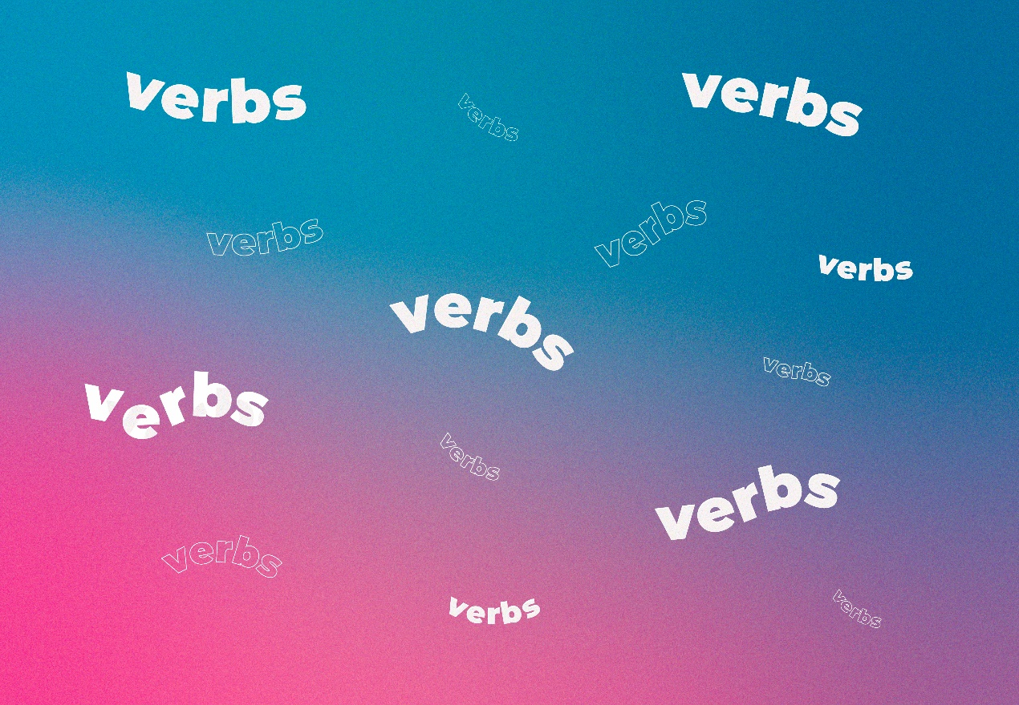
Figure 3 Verbs!
View description - Figure 3 Verbs!
View description - Figure 3 Verbs!

The example verbs so far have mostly been single words (bought, sat, think, etc.). But you’ve also seen that verbs can be made up of more than one word:

I’ve been working
He was phoning

You’ll now look at these multi-word verbs more closely.

3.1 Auxiliary verbs
Verbs like run, jump, think, ponder, love, hate, etc. are probably quite familiar to you. But there are also three particularly special verbs in English that deserve the spotlight: be, have and do. As you can see from the table below, be is more varied than the other verbs – it has three different forms that refer to the present (am, are and is), while most verbs have only two (for example, walk and walks). And it is unique in modern standard British English in having two forms to refer to the past (was and were).

Table 1
 | be |  | have | do
 | present | past
I | am | was | have | do
You | are | were | have | do
he/she/it | is | was | has | does
We | are | were | have | do
You | are | were | have | do
They | are | were | have | do
past |  |  | had | did

All three of these verbs can be used on their own:
- I have a good idea what he meant. (Here have = ‘possess’ or ‘own’)
- The morning is my favourite time of day. (Sentences with be tell us something about the identity or characteristics of the subject: Pierre and Marie are French; London is expensive; camping is boring.)
- She did her homework on the train. (Here do = ‘write’ or ‘complete’)
But when they are used with other verbs, be, have, and do are called auxiliary verbs; they act as ‘helpers’ (or ‘auxiliaries’) to add (grammatical) meaning to a sentence.
- I had run at a consistent pace. (Here had + run = the action (to run) happened in the past)
- He is waiting at the bus stop. (Is + waiting = the action (to wait) is happening now)
- They do sell those new kitchen mixers. (Do + sell = to emphasise that the action (to sell) actually happens)
The box below summarises some of the ways auxiliaries ‘help’.

Box 1
Be + -ing
A multi-word verb can involve be (am, is, are, was, were) and the main verb, plus the bound morpheme -ing:
- Everyone is wondering what to do next.
- He was sitting by himself near the door.
These emphasise what is/was happening at a particular moment.
Have + -ed
Other multi-word verbs include have, has or had and the main verb in a past form:
- They have lived there all their lives.
- Elena had seen the film many times before.
These place the action within a particular period of time (up to now with have, or a point in the past with had).
Do/don’t + verb
Do frequently combines with other verbs to form multi-word verbs. It is used to make sentences negative:
- Luis doesn’t like spinach.
- They don’t remember being here before.
It is also used to form questions:
- Do you speak Finnish?
- Doesn’t he understand us?
You will look at this in more detail in Week 8.

3.2 Modal auxiliaries
There are other auxiliary verbs which play an important part in English. These are the modal auxiliaries (sometimes just called modal verbs). Using these verbs allows us to change a verb from a simple statement of fact (this happened) to indicate how likely we think it is, or whether it is a good idea or not.

Activity 4 Spotlight on modal auxiliaries
This activity should take around 10 minutes

Watch the video below, which gives an overview of what you can do with these verbs.

Video content is not available in this format.
Video 1 Exploring modal auxiliaries
View transcript - Video 1 Exploring modal auxiliaries

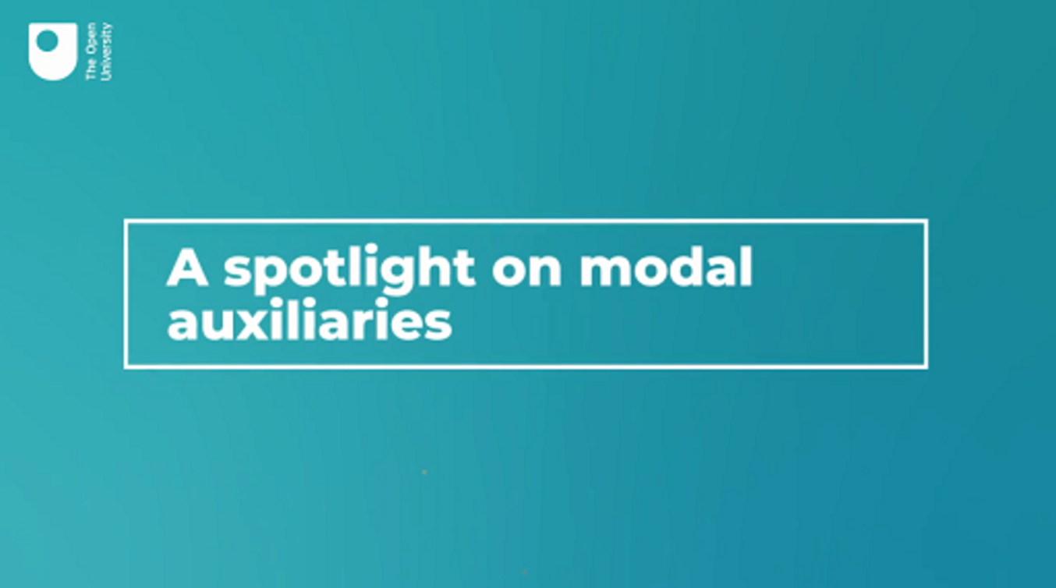

While watching, fill in the modal verbs used in some of the examples (if you like, you can think of some possibilities before watching, then check to see if you were right:

1. I ______ go to the beach tomorrow.
2. You ______ take plenty of suncream.
3. They ______ use up all the milk.
4. He ______ be there by now – it only takes an hour.
5. They ______ be at home – I’ve called them three times and there’s no answer.
View discussion - Activity 4 Spotlight on modal auxiliaries

3.3 How modal auxiliaries can add nuance
Consider the difference between an advertisement that claims a new face cream will help to reduce wrinkles versus one that may help to reduce wrinkles. Which option is the company promoting the face cream more likely to use? Why might they choose to hedge their bets and go with may help to?
Language doesn’t only deal with facts. It allows us to think and talk and write about things we’re not sure about, things that might not happen, and about possibility and desirability.

Activity 5 What can modal auxiliaries tell us?
This activity should take around 10 minutes

Look at these sentences:
- Robin Hood lived in Nottingham.
- There is life on other planets.
- The economy is going to crash.
- People are kind to their neighbours.
They are written as if they are facts: each just states that something is the case. But each of those statements can be questioned. Add modal auxiliaries to the main verb to make them more plausible or realistic:

1. Robin Hood ___ _____ lived in Nottingham.
2. There ____ be life on other planets.
3. The economy _____ be going to crash.
4. People _____ be kind to their neighbours.
View discussion - Activity 5 What can modal auxiliaries tell us?

3.4 The range of functions of modal auxiliaries
To summarise, the main modal auxiliaries are can, will, shall, might, must, dare, need, ought to, could, would, should, may, got to and have to. Many modal verbs can be used in two ways, one indicating how far the speaker thinks something is likely, the other indicating how far they think something is desirable or necessary.
The table below shows how you can use the same modal auxiliary to express different ideas. You don’t have to remember all of these; they are just here to show you some of the ways in which modal auxiliaries can be used to alter the meaning of a sentence or statement:

Table 2
Possibility/likelihood/certainty |  | Desirability/necessity/permission/obligation
logically necessary | He’s not answering – I guess he must be out. | compulsory | Construction site: Hard hats must be worn.
predictable | Who’s that at the door? Oh that will be Mariam. | determined | Whatever happens, I will wait for you.
probable | How long do the beans need? 20 minutes should be enough. | desirable | Some people think marijuana should be legalised.
possible | Careful – it could/might explode! | desirable | If you’re going out, you could/might get some milk.
possible | Tarmac can/may get very hot during summer. | permissible | You can/may take photos as long as you don’t use a flash.

As is often the case with language, the difference between modals can be a ‘grey area’. There is no firm dividing line between what will happen, what may happen, and what might happen, nor between what you must, should or could do.

4 Categorising verbs

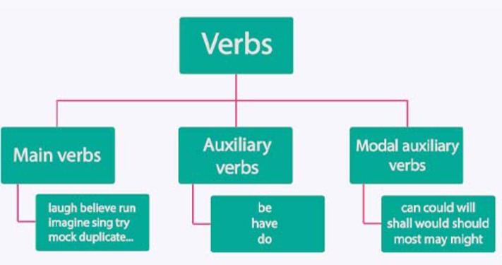
Figure 4 How verbs are related.
View description - Figure 4 How verbs are related.
View description - Figure 4 How verbs are related.

In order to put your knowledge about verbs to the test, the next activity gives you the chance to spot and categorise the different types of verbs that have been covered in this week’s work. You’ll need your knowledge of these verbs next week too, so spend some time making sure you can complete this activity. And remember, you can always revisit this week, or previous weeks’ material.

Activity 6 Find the auxiliary verbs
This activity should take around 10 minutes

Read the following passage, written by someone who is not very adventurous about food. Highlight the auxiliary verbs (be, have and do) in yellow as well as modal auxiliaries (can, could, might, etc.) in blue.

Interactive content is not available in this format.

There are a few new things here. You may have noticed do being used for emphasis: I do like a nice bit of haddock! You may also have noticed that two auxiliaries (will and be) were combined in: Most evenings I’ll be tucking into something tasty. It’s also worth pointing out that the will here is referring to a habit, and not the future. This is a similar use of will to:

If you will keep leaving the door open, is it any surprise things get stolen?

When you start looking at how we actually use language, you often find things are more varied and complex than simple grammar rules suggest. That’s why we use quite simple sentences as examples, but you should keep a look out for how the rules operate in the conversations and texts you engage with on a typical day.

5 This week’s quiz
Well done – you have reached the end of Week 3. You can now check what you’ve learned this week by taking the end-of-week quiz.
Week 3 practice quiz
Open the quiz in a new or window and come back here when you have finished.

6 Summary of Week 3
Think back to the pictures at the start of the week. Here are suggested descriptions:
- A woman is kicking/striking/booting a ball.
- Snow is running/streaming/racing/flooding down the mountain.
- A man is chopping/hacking/hitting wood with an axe.
This week has been all about verbs. You began by considering whether they can be classified as ‘doing words’. You saw that this is valid to an extent (we run, jump, cook and eat), but it only tells part of the story. Verbs also deal with thinking and emotions, and about what thinks look like, what they are, and how they seem.
You’ve also begun to examine the nuts and bolts of how verbs work. In next week’s material you’ll consider the difference between regular and irregular verbs and learn about the basic tenses (past and present). You’ll also continue to contrast how English verbs work with verbs in other languages.
You can now go to Week 4.

Week 4: Verbs 2: how verbs work together

Introduction


Figure 1 Past or future?
View description - Figure 1 Past or future?
View description - Figure 1 Past or future?

You’ve looked at verbs of various different kinds, and the kind of things they express. They can tell us about actions, states of mind, qualities, changes and other things. This is all very useful and informative, but we want to know more than just how to spot different verbs. In order to accurately describe language, we need to understand who or what is doing the verb, whether anyone or anything else is involved, and whether we are talking about the past, present or future.
The issue of verbs and time is the main topic for this week. You’ll look at how we deal with this in English, and compare how it’s done in some other languages too.
By the end of this week, you should be able to:
- understand the difference between present and past tense
- compare how verbs work in different languages.

1 Present, past and future?

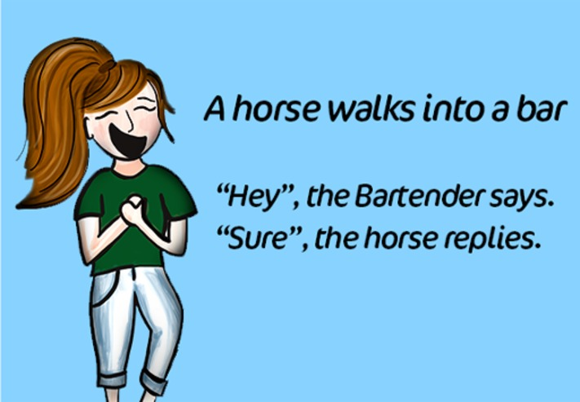
Figure 2 A horse walks into a bar.
View description - Figure 2 A horse walks into a bar.
View description - Figure 2 A horse walks into a bar.

There are occasions when it’s not at all important when something happened:

A horse walks into a bar…
Two men are stranded on a desert island…
A man gets into a lift on the third floor…

These are the introductions for jokes, shaggy dog stories and riddles, and the main thing about them is the situation, the dialogue and/or the outcome. It doesn’t matter what day, month or year these events happened (if they ever did). Most other types of story are different. We want to have the events situated in time – when did it happen, when did it finish, and so on.
If you want to show that something happened in the past in English, you change the form of the verbs you use. Most verbs indicate that something has happened in the past by adding the ending -ed to the basic verb (or just -d if it ends with ‘e’ already):
- I live in Colchester > I lived in Colchester.
- They want pizza for dinner > They wanted pizza for dinner.
Irregular verbs, which you’ll take a closer look at later on this week, also change, but in a different way:
- We eat a lot of fish > We ate a lot of fish.
- Sean buys his clothes in the market > Sean bought his clothes in the market.
The past forms of verbs like eat and buy aren’t predictable, so adult learners of English have to learn them one by one (with much heartache and sighing, no doubt!). If you grew up using English you didn’t have to be taught these verbs explicitly, because habit will have drummed them into you. Irregular verbs tend to be some of the most commonly used verbs, which is partly why they have not been regularised to follow the pattern used by other verbs.

1.1 Tense in English
The way we change verbs to indicate time is called tense. English has only two tenses: present and past. We can refer to the future in many different ways, but English doesn’t have a future tense in the same way that languages like French or Spanish do.
Here are just some examples of how we can refer to future events in English. The various ways give different shades of meaning to the verb, often about when you decided to do something, or how definite you think the future event is:
- I’ll do it tomorrow. (A spontaneous promise – which you might even keep!)
- I’m going to do it next. (You’ve thought about it and decided)
- I’m having a party next Saturday. (Something ‘on the calendar’)
- I leave in November. (It’s all planned, agreed and booked…)
- We are to meet soon. (It has been definitely arranged)
No doubt there are other possibilities. But none of them uses a form of the verb or a special morpheme which indicates the future, because there simply isn’t one. We can contrast this with French, where present je mange (I eat) contrasts with the future form je mangerai (I will eat/am going to eat), or Spanish, where the equivalent forms of the verb comer are como (I eat) and comeré (I will eat).

Activity 1 Into the past
This activity should take around 15 minutes

Here is an extract from a letter where the writer, who has just moved to another country, describes their new situation:

We live in a small cottage near a lake. Every morning I am first up. I do the washing up from dinner and I prepare breakfast in the kitchen. After breakfast I walk directly to the nearby village. I buy things for lunch and dinner and walk back by a different route, usually along the lake shore. I watch the birds swimming on the lake and listen to the breeze blowing through the trees. It’s very peaceful!

Now imagine the writer has moved house to a different place, and is describing what life used to be like living in the cottage. Rewrite the paragraph to explain what daily life was like:

We lived in a small cottage…

Provide your answer...
View discussion - Activity 1 Into the past

The simplest form of the past is used here (‘I prepared breakfast…’), but there are alternatives which you can use to emphasise the routine:

I used to prepare breakfast…
I would prepare breakfast…

1.2 Participles: verbs without any tense
There are other forms of the verb which are not different tenses. They are called participles (which just means ‘parts’).
The present participle ends in -ing (e.g. wanting, flying). This is used when we want to emphasise that something is in the process of happening, either in the present:

Of course I’ll bring it – I’m putting it into my bag as I speak!

Or the past:

I was crossing the street when a cyclist hit me.

The past participle will be discussed in the next section, on irregular verbs.

2 Regular and irregular verbs

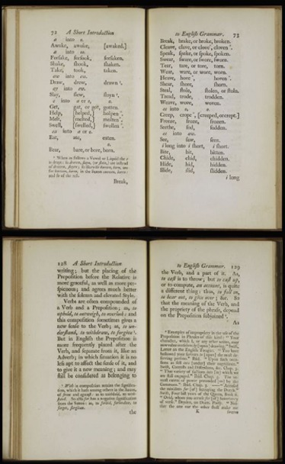
Figure 3 Grammar rules.
View description - Figure 3 Grammar rules.
View description - Figure 3 Grammar rules.

So far, you’ve been working with some fairly well-behaved verbs. However, there are a small number of verbs in English that don’t always play by the rules. For example, we sing but we don’t singed, we run but we don’t runned, we hide but we don’t hided. We call these special cases irregular verbs.

Activity 2 Spotlight on irregular verbs
This activity should take around 10 minutes

Watch the video below which explains what irregular and regular verbs are. After watching the video, complete the following activities. You can replay the video as necessary.

Video content is not available in this format.
Video 1 Regular and irregular verbs
View transcript - Video 1 Regular and irregular verbs

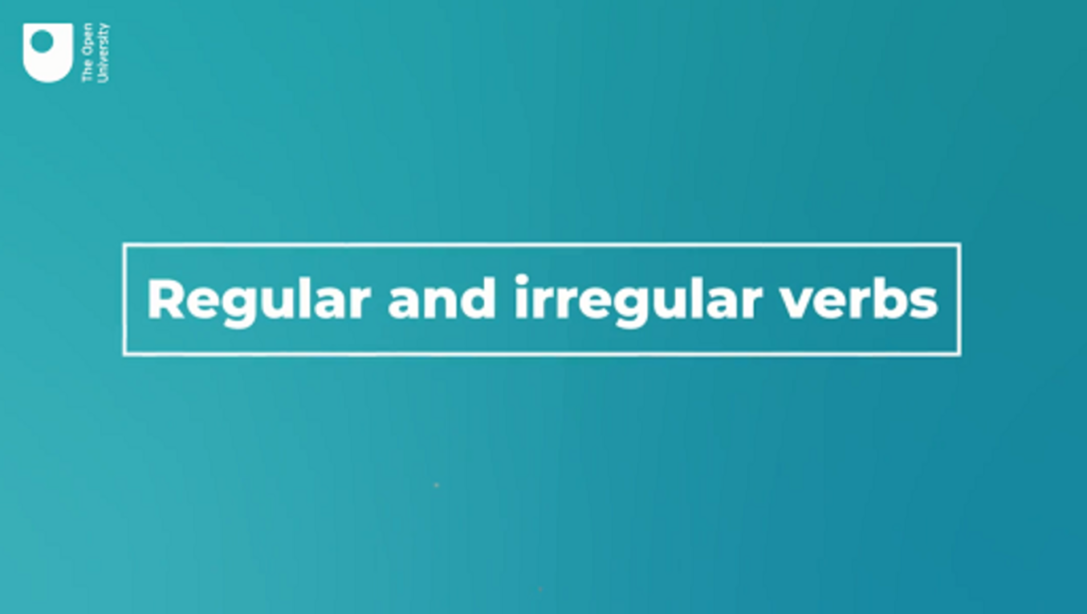

Activity 3 Irregular past and present
This activity should take around 15 minutes

Fill in this table with the standard forms of the irregular verbs mentioned in the video. A regular verb has been included for comparison.
Remember:
- Present tense = the basic form of the verb you find at the start of a dictionary entry
- Past tense = the simplest form of the verb used to refer to past time
- Past participle = another past form used in multi-word verbs

Present tense | Past tense form | Past participle
walk | walked | had walked
Provide your answer... | Provide your answer... | Provide your answer...
Provide your answer... | Provide your answer... | Provide your answer...
Provide your answer... | Provide your answer... | Provide your answer...
Provide your answer... | Provide your answer... | Provide your answer...
Provide your answer... | Provide your answer... | Provide your answer...
Provide your answer... | Provide your answer... | Provide your answer...
Provide your answer... | Provide your answer... | Provide your answer...

View discussion - Activity 3 Irregular past and present

Activity 4 (Un)grammatical?
This activity should take around 15 minutes

What does the video say about sentences like ‘I seen him’ and ‘I’ve went’?

Provide your answer...
View discussion - Activity 4 (Un)grammatical?

Having considered how the past tense is expressed in English, you’re now in a position to look at a real text and consider how it is used in a (very famous) story.

2.1 Irregular verbs at work
As noted earlier, irregular verbs tend to be common ones, so almost any text is likely to contain at least some irregular verbs being used alongside regular ones.

Activity 5 Find the irregular verbs
This activity should take around 20 minutes

Here is an extract from Charles Dickens’s A Christmas Carol (1847), in which the Ghost of Christmas Present shows the miser Scrooge how different people celebrate Christmas. Read through it and highlight the single-word verbs in the past which are irregular in blue and highlight the regular past tense forms in yellow.

Interactive content is not available in this format.

View discussion - Activity 5 Find the irregular verbs

2.2 What you know so far
In the past two weeks in particular you’ve come across a lot of important terminology that you’ll need to describe language accurately. Learning this terminology and being able to apply your knowledge to the analysis of real texts will mean that you can explain why texts work in the way that they do. And, as you’ll continue to explore in the next half of this course, you’ll be able to use your new skills to show how language can be used creatively. As verbs can be quite complicated if you’ve never looked at language in this way before, here’s a summary of all the important terms you need to know from the past two weeks.

Activity 6 Defining terms
This activity should take around 10 minutes

Interactive content is not available in this format.

View discussion - Activity 6 Defining terms

Having got all that under your belt, it should be admitted that English verb grammar is remarkably simple compared to many other languages. If you have studied or grown up with other languages, you may already know this, but it’s worth looking at the differences in a bit of detail, which is what you’ll do next.

3 Verbs in other languages
If you learned Spanish, German or French at school, you may remember toiling over complex verb forms that were very different from English. In fact, English verbs have a pretty limited number of forms compared to many other languages. Compare English with Spanish, for example.
In the present tense, most English verbs have only two forms:

 | Singular |  |  | Plural
First person | I | eat | we |  | eat
Second person | you (singular) | eat | you (plural) |  | eat
Third person | he/she/it | eats | they |  | eat

The table above shows which forms of the verb eat are used with different pronouns (you’ll learn more about pronouns in Week 6). Eat stays the same when used with I, you, we, and they, and only changes when used with he, she, or it, where the morpheme -s is added. The more technical way of saying this is that most regular verbs use -s when they are used with the third person singular (he walks, she jogs, it sings, etc.). Despite all the terminology, the table above shows that things are pretty simple. In fact there are dialects of English where things are even simpler. For example, if you were in Cardiff, in Wales, you might hear -s added for all the different ‘persons’: I lives, we lives, etc. (Awbery, 2006, p. 333).
In Spanish, in contrast, there is a different form of the verb for each person:

 | Singular |  |  | Plural
First person | (yo) | como | = I eat | (nosotros) | comemos | = we eat
Second person | (tu) | comes | = you* eat | (vosotros) | coméis | = you** eat
Third person | (él/ella) | come | = he/she eats | (ellos/ellas) | comen | = they eat
*this ‘you’ = one person; **this ‘you’ = several people (Spanish, like many other languages, has a different word for each case)

One reason for this variety is that Spanish usually leaves out the personal pronoun (the equivalent of I, you etc), so the ending carries the information which in English is provided by I, you, we, they etc:

¿comes pescado? Do you eat fish?
¿comen pescado? Do they eat fish?

The contrast is even more marked in the past tense. English has one form for all persons, whether the verb is regular (I warned, you warned, he/she/it warned, we warned, they warned) or irregular (eat > ate, swim > swam, find > found). Spanish again has a different form for each person:

 | Singular |  |  | Plural
First person | (yo) | comí | = I ate | (nosotros) | comimos | = we ate
Second person | (tu) | comiste | = you ate | (vosotros) | comisteis | = you ate
Third person | (él/ella) | comió | = he/she ate | (ellos/ellas) | comieron | = they ate

If you think English looks simple compared to Spanish, some languages go even further. In Mandarin Chinese the equivalent of eat is a single unchanging form (chī, 吃). This goes with every person (I eat, you eat, he/she/it eats, we eat, they eat) but is also used for past, present and future. There are, of course, other parts of Mandarin grammar which make clear what time is being referred to.

Activity 7 Find the verb in other languages
This activity should take around 15 minutes

Look at the sentences below and see if you can tell (or guess!) which word is the verb. Even if you don’t know the language at all, try using any clues you can find in the sentence. (This is not a test! It’s just a chance for you to apply your newfound knowledge of verbs to other languages.)
1. Spanish. ¿De veras no quieres el puesto? (Do you really not want the job?)

veras
puesto
quieres
el
View answer - Part

2. German. Wie viele Einwohner hat Deutschland überhaupt? (What population does Germany actually have?)

hat
überhaupt
viele
Einwohner
View answer - Part

3. French. Nous vous souhaitons un bon voyage! (Have a good trip!)

nous
vous
souhaitons
bon
View answer - Part

4. Mandarin Chinese. nǐ zhù zài nǎlǐ (Where do you live?)

nǐ
zài
nǎlǐ
zhù
View answer - Part
View discussion - Part

This activity was, as noted at the start, not a test. It was to help you think about how languages are similar and different to each other. If you are a speaker or learner of any of these languages, you can think about other aspects where the language you speak or study is closer to or further away from English. And remember, you are not expected to learn any different languages for this course – this activity is just for fun!

4 This week’s quiz
Now it’s time to complete the Week 4 badged quiz. It’s similar to previous quizzes, but this time instead of answering five questions there will be fifteen.
Week 4 compulsory badge quiz
Remember, this quiz counts towards your badge. If you’re not successful the first time, you can attempt the quiz again in 24 hours.
Open the quiz in a new tab or window then come back here when you’ve finished.

5 Summary of Week 4
Over the last few weeks you’ve looked at nouns and verbs, the most fundamental parts of a language. These word classes allow us to talk about the world and the things in it, and allow us to communicate what action or processes are happening. Next week you’ll consider a different group of words, the adjectives. These work closely with nouns, and are used to describe things in more detail. Without them our language would be colourless and not very precise, and in many circumstances it wouldn’t be easy to make clear what we were talking about.
You are now halfway through the course. The Open University would really appreciate your feedback and suggestions for future improvement in our optional end-of-course survey, which you will also have an opportunity to complete at the end of Week 8. Participation will be completely confidential and we will not pass on your details to others.
You can now go to Week 5.

Week 5: Adjectives: adding more information

Introduction

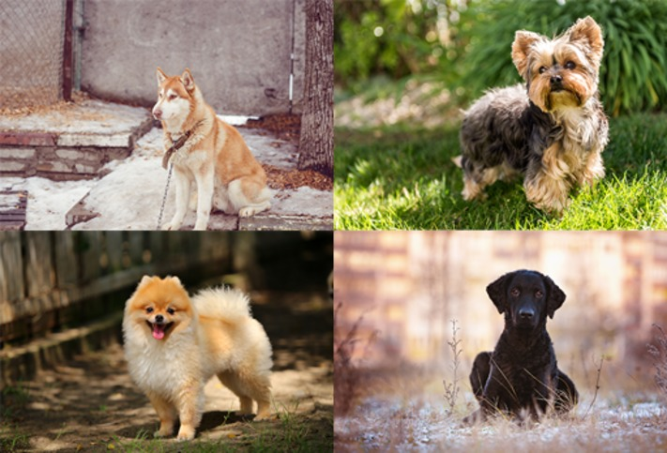
Figure 1 Four different pictures of a dog.
View description - Figure 1 Four different pictures of a dog.
View description - Figure 1 Four different pictures of a dog.

You’re now well on your way to working steadily through the main word classes. So far you’ve looked at nouns and verbs. You could get some way with communicating if a language only had nouns and verbs, but in order to communicate effectively, we need something more. For example, consider each of the pictures above. All of them are pictures of a dog.
If you were talking on the telephone to someone else who had copies of these four photos, how could you identify each one to them? Assuming you’re not both experts on dog breeds, one way would be to use the words in bold:
- The black one
- The small one with curly hair
- The perky one with fluffy fur
- The patient one with pointy ears and a short white and tan coat
The emboldened words are adjectives and this week you’ll look more closely at this very useful class of words.
By the end of this week, you should be able to:
- define and identify adjectives in simple sentences
- explain how nouns and adjectives work together
- write your own short text using adjectives creatively.

1 What are things like?
Adjectives are ‘describing words’. One way to think of them is as the kind of word you use when someone asks:
- What’s your new boss like?
- What’s your home town like?
- What’s their new house like?
If you had to answer questions like these in one word, what words might you use?
Here are some suggestions:
- intelligent, demanding, grumpy, inspiring …
- busy, exciting, peaceful, polluted …
- huge, old-fashioned, fancy, small …

1.1 Finding the adjectives
As with nouns and verbs, you’ve been using adjectives almost as long as you’ve been using English. When learning the language as children we will, very early on, know the difference between a red ball and a blue ball. For second language learners, adjectives are also introduced quite early on. So before going into the technical vocabulary, see how good you are at spotting adjectives in the first place.

Activity 1 Which words are adjectives?
This activity should take around 15 minutes

Read these sentences. Which word in each one is the adjective? Ask yourself: ‘what was it/he/etc. like?’
1. John’s birthday party was boring.

party
boring
birthday
was
View answer - Part

2. They need to buy new things for their flat.

new
flat
buy
need
View answer - Part

3. They made us all delicious sandwiches.

us
all
delicious
sandwiches
View answer - Part

4. I have met Melissa’s scary flatmate.

have
met
flatmate
scary
View answer - Part

5. We stayed in an utterly charming hotel.

charming
we
stayed
hotel
View answer - Part

6. The lake is the most peaceful place I know.

lake
peaceful
know
place
View answer - Part
View discussion - Part

2 Types of adjectives
There are lots of adjectives in English. Like nouns and verbs, there are so many it wouldn’t be possible to list them all. And as with nouns and verbs, new ones can always be invented.
Here are some entries for adjectives which were added to the Oxford English Dictionary in January 2020, with their definitions:

awesomesauce: Extremely good; excellent.
guber: Of or relating to a governor or governorship.
hench: Of a person: having a powerful, muscular physique; fit, strong.
(OED, 2020)

Even if these are new to you, they must have appeared in print or recorded speech often enough for the dictionary makers to think they were worth including.

Box 1
There are some adjectives which form small sets. For example:
- those which identify the owner of the following noun: my pencils, your uncle, our ambitions
- those that point out which thing or person you mean: this door, those tomatoes
- those that ask which thing or person you mean: which omelette?, whose giraffe?, what money?
Because these adjectives form limited sets, they are discussed next week, as part of a group called ‘determiners’.
If you like grammatical terminology – it is neat to have labels for everything! – you might like to know that some grammarians call these small sets of adjectives: a) possessive, b) demonstrative and c) interrogative adjectives. But you don’t need to know all of these labels for this course.

2.1 What can adjectives tell us?


Figure 2 A chalk board in a café.
View description - Figure 2 A chalk board in a café.
View description - Figure 2 A chalk board in a café.

This week you’ll focus on the larger categories of adjectives. These include adjectives that describe:
- Size: big, small, huge, minute, ginormous, tiny, humungous, microscopic, etc.
- Colour: from the basics like red, yellow, blue… all the way to ones which mainly feature in clothing catalogues, like taupe, cerise, teal, gamboge, etc.
- Shape: round, square, spherical, ovoid, bulky, lumpy, formless, curved, straight, bent, deep, wide, broad, long, etc.
- Appearance: tall, broad, skinny, plump, impressive, menacing, distinguished, hairy, shiny, wavy, spiky, etc.
- Character: honest, shifty, friendly, handy, boring, amusing, cynical, imaginative, creepy, picturesque, useless, unbearable, etc.
You could add more categories, and within each the list could go on and on… as far as your vocabulary stretches!

2.2 Where do adjectives go?
Typical adjectives can generally be used in two ways:
- before a noun:
  - a green parrot, some tasty fish, antique furniture, desperate remedies
- after a verb, referring back to the noun before it:
  - Hanna is clever, Lisbon sounds interesting, Jacobo felt tired
Most adjectives can be used in both positions, but some are more restricted. For example, awake and asleep only usually occur in the second structure. For example, he felt awake or they were soon asleep, but not an awake person, or the asleep children. On the other hand, some adjectives are only used before a noun, such as an only child, or the occasional mistake, but not their child was only or the mistake was occasional.

Activity 2 Add the adjectives
This activity should take around 15 minutes

After all those lists, it’s now time to put some of those adjectives to work. Read the following passage, and choose from the adjectives below to fill in the blanks:
- asleep
- blue
- bushy
- closer
- different
- long
- open
- pet
- right
- shabby
- still
- strangest
- thin
- tired
- thoughtful
- wooden

I knew as soon as I saw him he was _______. He was _______, with a _______ _______ beard, and was wearing a _______ suit made of _______ cloth. He had a _______ walking stick in his _______ hand. He was very _______, and at first I thought he had fallen _______, but when I got _______ I saw his eyes were _______. He had a _______ expression on his face, but he didn’t seem _______. The _______ thing about him was his _______ snake.
View discussion - Activity 2 Add the adjectives

2.3 Comparing using adjectives
Because adjectives describe things, they are often used for comparing things. You could own a large house, while your neighbour owns a larger house, but your cousin owns the largest house in the world! In simple terms, to compare two things (i.e. small and smaller or large and larger) the morpheme -er is added to the adjective. However, some longer adjectives, like extensive or inspiring add the word more beforehand to signal this comparison:

Paris is bigger than Lyon, and it’s more expensive too

If you have the most extreme example of something, you can show this by adding -est to the adjective. With longer adjectives the word most is added beforehand:

It’s the fastest car in the race, and the most expensive

Other ways of comparison include using less and least, or not as:

It’s less expensive than the French one
I thought it was the least interesting of all the places we visited
They’re not as worried as we are

Activity 3 Adjectives in comparison
This activity should take around 15 minutes

Put the adjective at the end of each sentence into the gap. Make sure you use the right form.

1. It’s the ____ film I’ve ever seen. (strange)
2. The rain is ____ than yesterday. (heavy)
3. The deficit is a lot ____ than it was the last year. (big)
4. They bought the ____ house in the village. (expensive)
5. Filippo’s disguise was the ____ of all, and he was soon arrested. (convincing)
View discussion - Activity 3 Adjectives in comparison

2.4 Just talking nonsense?


Figure 3 A clockwork orange.
View description - Figure 3 A clockwork orange.
View description - Figure 3 A clockwork orange.

Purely in terms of grammatical structure, it is possible to put almost any adjective in front of any noun. But this could easily produce nonsense: a round square, heavy feathers, jealous parsnips. Squares are, by definition, not round, feathers are proverbially light, and root vegetables don’t have emotions (so far as we know!). But these examples are not ungrammatical – it’s just that the meaning doesn’t match up with the world as we know it. In fact with a bit of imagination we can probably think of a context in which the phrases work. A children’s story about talking (and emotional) vegetables isn’t too hard to imagine, and if someone in a science fiction story was shrunk to the size of a flea they probably would find feathers rather weighty. The round square still poses a challenge, but not necessarily because of grammar.
As you can see, apparent nonsense can challenge us to produce creative interpretations. This is something that has been exploited by writers down the ages. A famous example comes from George Orwell’s Animal Farm (1945):

All animals are equal, but some animals are more equal than others.

If things are equal, they are the same as each other (at least in some way), so how can something be ‘more’ the same? The ironic explanation is that some of the animals in Orwell’s political parable are in fact more privileged than others.
Another example comes from Shakespeare’s Romeo and Juliet:

Parting is such sweet sorrow

How can something unpleasant (sorrow) also be pleasant (sweet)? It is, of course, all part of the crazy mixed-up experience of young love!
We can find further examples in everyday language: a living death, a deafening silence. These may once have been original and attention-grabbing, but repetition has long since turned them into the clichés.

Activity 4 Famous nonsense
This activity should take around 10 minutes

This is one of the most famous (and supposedly nonsensical) sentences in modern linguistics:

Colourless green ideas sleep furiously

What do you think it might mean? Why do you think it was written?

Provide your answer...

Watch the video to find out if you were right.

Video content is not available in this format.
Video 1 The meaning of colourless green ideas
View transcript - Video 1 The meaning of colourless green ideas

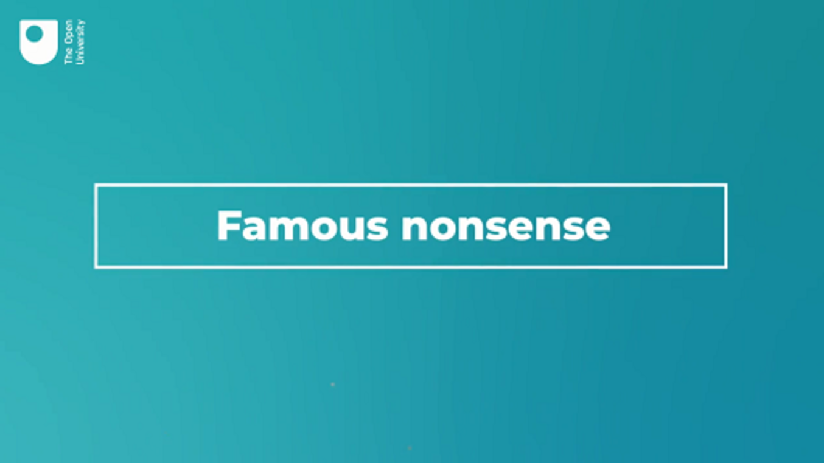

View discussion - Part

3 Adjectives working together
Just as nouns need verbs to help us communicate who is doing what to whom, adjectives need something to describe in order to make sense. If we were to stand in the street and shout Red! Most Expensive! Faster! our intended meaning would likely be lost. Thus adjectives’ primary function is not to stand alone but to work with other word classes (most commonly nouns) to express shades of meaning.

Activity 5 Ugly old-fashioned house or beautiful modern house?
This activity should take around 15 minutes

Consider these two sentences:
- The building was ugly and old fashioned.
- The building was beautiful and modern.
What sort of house do you think of when you imagine each one? Write some notes.

Provide your answer...
View discussion - Activity 5 Ugly old-fashioned house or beautiful modern house?

When considering how people, places, social groups, events, or objects are described using adjectives, you should consider how different words work together to produce cumulative evaluative effects.

4 New, improved! Adjectives and advertising
Advertising is designed to make you think that a product or service is better than alternative products/services. Whatever that ‘something’ is – a holiday, a car, a type of cheese, a large piece of furniture, or even a political party – adjectives can be used to try and sway your opinion.
If you look at adverts carefully and critically, you can start to work out what suggestions and associations advertisers are trying to suggest to their target consumers.

Activity 6 Advertise with adjectives
This activity should take around 15 minutes

What different sorts of product might be advertised using these adjectives? Jot down some products (or types of products) which come to mind.
- unique
- fast-acting
- timeless
- effective
- gentle
- exclusive
- mellow
- fascinating
- natural
- reliable
- handy
- distinctive
- all-new
- convenient
- luxury

Provide your answer...
View discussion - Activity 6 Advertise with adjectives

A recent extensive survey of advertising for high-end brands found that, whether they were selling perfume, leather coats or watches, the most common adjectives were of the non-specific kind – the most frequently used of all was exceptional (TranslateMedia, 2017).
This suggests that a fundamental decision has to be made before creating an advertisement – will the advertisers focus on the practical qualities of the product, or the reputation and aura of the brand? This probably depends a lot on the price of the product, and what sort of competition it faces. Whatever the decision is, it will almost certainly have an effect on the choice of adjectives used.
Look at adverts for products you are interested in (mobile phones perhaps? shoes? holidays abroad?) and compare the amount of emphasis on the practical aspects of the product and the amount of emphasis on the brand. How does this affect the adjectives used?

Activity 7 Analyse the adjectives in an advert
This activity should take around 30 minutes

Read through the advert below for the soft drink Fanta. List all the adjectives you can find.


Figure 4 Advertisement by Memac Ogilvy for Fanta, 2018

Please note that, to make it easy to read, the text of the advertisement is reproduced below.

Fanta. Like a burst of sunshine through a cool wisp of wind, it’s sweet and tangy, surprising and juicy. It tickles like a delicious secret that you cannot bear to share. And how lush it feels at every sip like an instant whiff of a fresh bouquet of flowers in spring! With a quick, sharp jolt of tart and a sudden burst of sugary-citrusy-sweetness, it leaves your tongue tingling pleasantly. Then, it curls deliciously around your taste buds, tantalizing your imagination & ripples happily down your spine.
Are you still with us? Great! Cause we would like you to try Fanta’s new taste, Deliciously Orange. Yes, right now! Just tear off a piece of this page, pop in your mouth & enjoy a Fanta by tasting this ad!
Fanta is a registered trademark of The Coca-Cola Company. This edible paper contains potato starch, wheat flour, cross-linked starch, flavouring, food colouring, artificial sweeteners, saccharin and food-safe ink.

Provide your answer...
View discussion - Activity 7 Analyse the adjectives in an advert

4.1 Write your own advert
The use of adjectives in advertisements is just one way that we can use language creatively. Taken to the extreme, we can consider the famous slogan first used by Pepsi in 1974 to describe its cola drink, where the creative potential of language is used to excess in a string of adjectives formed from present participles:

Lip smackin, thirst quenchin, ace tastin, motivatin, good buzzin, cool talkin, high walkin, fast livin, ever givin, cool fizzin

In the original, all the words were run together, but they have been separated here in the interests of readability!
In the next activity, you’ll have a chance to put your own creative skills to the test and come up with your own slogan and advertising copy.

Activity 8 What will you sell?
This activity should take around 30 minutes

Look at the photos below and choose one to write an advertisement for. Decide what the photo is trying to sell, and write the text to go with the photograph. Remember to attract the reader by suggesting attractive qualities through your choice of adjectives. You should decide how much emphasis you want to put on practical aspects, and how much on a more general desirable aura of exclusivity and quality.


Figure 5 Options for products to advertise.
View description - Figure 5 Options for products to advertise.
View description - Figure 5 Options for products to advertise.

Provide your answer...
View discussion - Activity 8 What will you sell?

5 This week’s quiz
Well done – you have reached the end of Week 5. You can now check what you’ve learned this week by taking the end-of-week quiz.
Week 5 practice quiz
Open the quiz in a new or window and come back here when you have finished.

6 Summary of Week 5
Adjectives are an incredibly useful word class. We can use them to:
- single out which particular item or idea you are referring to (which dog, house, subfield of quantum physics, etc.)
- say (or ask) what someone, something or some place is like
- make something sound more (or less!) attractive and interesting
- make people think (by using adjectives in a surprising or puzzling way).
You’ve now considered the three largest classes of words in English (nouns, verbs and adjectives) so you’re well on your way to being able to describe language accurately. From now on the emphasis will increasingly be on how these and other word classes are combined in sentences and whole texts.
Next week you will look at the smaller sets of words which form the connections between words from the larger classes. Some of these words have already been mentioned in passing – pronouns and determiners, for example – but now you will give them more attention.
You can now go to Week 6.

Week 6: All the bits in between

Introduction


Figure 1 Now how do these fit together?
View description - Figure 1 Now how do these fit together?
View description - Figure 1 Now how do these fit together?

You started this course by looking at the classes of words that make up the vast majority of the words you find in dictionaries: nouns (from aardvark to zebra) and verbs (from abandon to zonk). Last week, you saw how adjectives (from abstract to zany) add more information to nouns and can be used to make language more interesting, informative, and potentially persuasive. But these big chunky words for things that exist and happen out in the world are, of course, not all there is to language. They have to fit together to make sense, and there are other types of words that help us do this. This week, you’ll learn about the smaller classes of words that help to connect words from the big classes.
By the end of this week, you should be able to:
- explain the relationship between verbs and adverbs
- understand the difference between open and closed class words
- identify conjunctions, prepositions, determiners and pronouns.

1 Adverbs
An adverb, as you can probably guess, has something to do with verbs. Adverbs work with verbs in a similar way to how adjectives work with nouns. They make the verb more precise, or add detail to what the verb tells us. For example, he talks fast, I ran slowly, or the cat miaowed loudly.
In English, you can often make an adverb by adding the morpheme -ly to the end of an adjective.

Table 1
Adjective | Adverb
quick | quickly
slow | slowly
nice | nicely
easy | easily
sudden | suddenly
thoughtful | thoughtfully
close | closely
distant | distantly

Not every adverb ends in -ly, though (for example, fast or hard). The ones that do are mostly adverbs that tell us about how something was done or how something happened. But a few others, like too and also, can do this job as well.
Some adverbs tell us where and when the action of the verb took place: here, there, everywhere, always, never, still, yesterday, today, tomorrow are all adverbs.

1.1 Can you recognise an adverb?
Some words (including ones ending in -ly) can be an adjective or an adverb. You can tell which it is by seeing whether it gives you information about a noun (what is it like?) or a verb (how/where/when does/did it happen?).

Activity 1 Adjectives or adverbs?
This activity should take around 5 minutes

Take a look at the sentences below. Choose whether the word in bold is an adjective or an adverb in this sentence.
They caught the early train.

Adjective
Adverb
View answer - Part

He only wanted an ice cream.

Adjective
Adverb
View answer - Part

The broken glass was everywhere.

Adverb
Adjective
View answer - Part

Jane was an only child.

Adjective
Adverb
View answer - Part

The tarantella is a lively dance.

Adjective
Adverb
View answer - Part

Marjorie decided to have a piece of cake too.

Adverb
Adjective
View answer - Part

The train left early.

Adjective
Adverb
View answer - Part

She expected she would soon be promoted.

Adverb
Adjective
View answer - Part
View discussion - Part

1.2 More things you can do with adverbs
Adverbs can do more than tell us how someone does (or did) something (slowly, painfully, happily, expensively). Sometimes we can use adverbs to give us more information about an adjective. Maybe we think clever or hot or expensive is going too far, so we can add is quite clever, is fairly hot, or is somewhat expensive. Or if the adjective on its own isn’t strong enough, we can add really clever, immensely hot, or extremely expensive.
Another set of adverbs can show how often something happens: never, rarely, seldom, occasionally, sometimes, regularly, often, frequently, always. As you can see, a good number of these common adverbs don’t end in -ly.
Of those that do take this morpheme, there are some adverbs that can be used to show your opinion about or attitude towards something: understandably, unquestionably, arguably, basically, obviously, actually, naturally. These adverbs are often used at the start of a statement, such as obviously that was a mistake or understandably he was annoyed.

Activity 2 Can you spot the adverbs?
This activity should take around 10 minutes

In the following passage, see if you can highlight all the adverbs (there are fourteen). Once you’ve found them all, put each one in a column of the table below, according to the information that it is adding to the passage.

Interactive content is not available in this format.

Frequency (how often?) | Manner (how?) | Modifying an adjective | Showing opinion
Provide your answer... | Provide your answer... | Provide your answer... | Provide your answer...

View discussion - Activity 2 Can you spot the adverbs?

2 How words work together
Adverbs are quite a small word class when we consider just how many nouns, verbs and adjectives there are (and how many we could potentially invent in the future), but there are some word classes in English that are even smaller than the adverbs. To show why these smaller word classes are important, we can start by taking a look at what English would be like without them. What would it be like if we only had nouns, verbs, adjectives and adverbs to play with?

Activity 3 Little words that make a lot of sense
This activity should take around 10 minutes

Listen to the first recording which contains part of a short everyday conversation between two speakers. In this first version you will only hear nouns, verbs, adjectives and adverbs – the other words have been removed. Listen to this version of the conversation a few times to see how far you can understand the situation and what is being talked about. What do you think is going on?

Audio content is not available in this format.
Audio 1 Grammarless
View transcript - Audio 1 Grammarless

Provide your answer...

When you’re ready, you can now hear the full version of the clip to check if you were right.
How much of the conversation did you understand from the first version? What did you miss?

Audio content is not available in this format.
Audio 2 A full conversation
View transcript - Audio 2 A full conversation

Provide your answer...
View discussion - Part

2.1 Open and closed class words

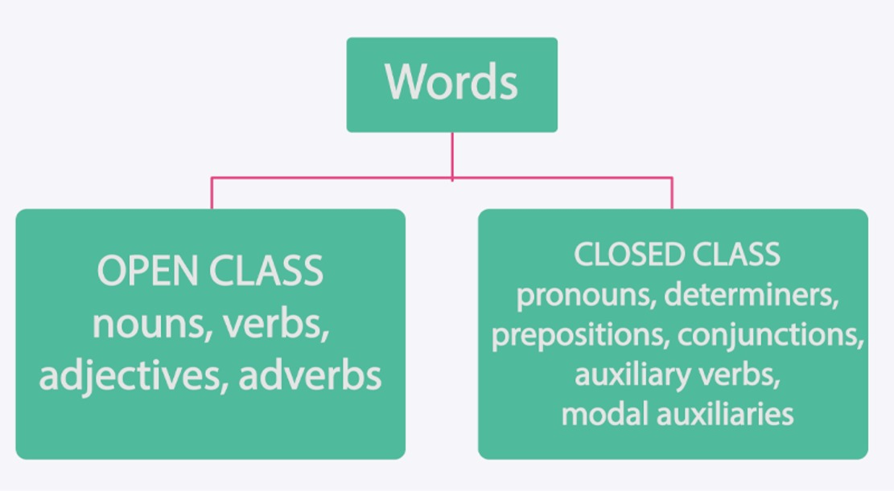
Figure 2 Open and closed class words.
View description - Figure 2 Open and closed class words.
View description - Figure 2 Open and closed class words.

You saw in Week 1 that we can create new words from bound and free morphemes. We can make new words using existing words as a model. It’s relatively easy to create new nouns, verbs, adjectives and adverbs, with new ones being coined all the time as new products, gadgets and ways of doing things are invented and developed. Not all new words survive very long, but the Oxford English Dictionary adds about 400–600 new words, senses and revisions to its online edition every three months. The March 2021 update contained a bumper 700 new items, and 750 revised entries (Dent, 2021). This creative capacity of these word classes means they are categorised as open class words. These word classes are open to new members and people show no sign of stopping!

2.2 Not all word classes can be expanded
The word classes you’ve looked at since Week 1 are the open classes. You’ve touched on pronouns and determiners, and you met modal auxiliaries and auxiliary verbs in Week 3. These smaller word classes are examples of what we call closed class words. These words don’t so much refer to things in the world, but rather act as a ‘glue’ to join the open class words together into phrases and sentences that mean something. You might also hear this type of word called function words or grammatical words.
Closed class words are small in number (and often in length), but they are very important in communicating meaning. Consider the difference made by the bold word in these sentences:

That’s not true! (what if …not wasn’t there?)
That’s my money (what if it was his, her or their?)
She wants that one (what if it was this?)
You have to stay here (what if it was I or we?)

Closed classes don’t change as readily as the open classes and they aren’t receptive to new words. The stability of the closed classes is important for communication and for language teaching.
The closed class words are mainly pronouns, determiners, prepositions, conjunctions and auxiliary verbs. Some of the names for these classes may be new to you if you haven’t studied grammar before, but you will soon see that the words they contain are very familiar.

2.3 Can you tell what class a word is from its shape?
There is often enough information in the form of a word, and its place in a sentence, to tell what word class it belongs to, even if the meaning is unclear or unknown. Nonsense poetry, as written by the Victorian writers Edward Lear (1812–88) and Lewis Carroll (1832–98), depends on this information to make it work. Let’s look at an example, an extract from the poem Jabberwocky by Lewis Carroll.

‘Twas brillig, and the slithy toves
Did gyre and gimble in the wabe;
All mimsy were the borogoves,
And the mome raths outgrabe.

You shouldn’t have a problem recognising and, the, did, in, all and were (they are all closed class words, which you’ll take a closer look at in a minute). But what about the other ones: brillig, slithy, toves, gyre, and the rest? Can you guess what class of words they are? Try the following activity to find out.

Activity 4 Making sense of nonsense
This activity should take around 10 minutes

Select the correct word class for each word.
Brillig

Pronoun
Adjective
Determiner
Auxiliary verb
Verb
Preposition
Noun
View answer - Part

Slithy

Adjective
Noun
Verb
Determiner
Auxiliary verb
Preposition
Pronoun
View answer - Part

Toves

Adjective
Pronoun
Preposition
Determiner
Verb
Auxiliary verb
Noun
View answer - Part

Gyre

Verb
Determiner
Pronoun
Adjective
Noun
Preposition
Auxiliary verb
View answer - Part

Gimble

Determiner
Pronoun
Noun
Verb
Preposition
Adjective
Auxiliary verb
View answer - Part

Wabe

Preposition
Pronoun
Verb
Determiner
Adjective
Noun
Auxiliary verb
View answer - Part

Mimsy

Pronoun
Adjective
Noun
Determiner
Verb
Auxiliary verb
Preposition
View answer - Part

borogoves

Adjective
Pronoun
Determiner
Noun
Preposition
Auxiliary verb
Verb
View answer - Part

Mome

Adjective
Noun
Pronoun
Preposition
Determiner
Auxiliary verb
Verb
View answer - Part

Raths

Verb
Pronoun
Adjective
Preposition
Noun
Determiner
Auxiliary verb
View answer - Part

outgrabe

Auxiliary verb
Verb
Adjective
Noun
Pronoun
Determiner
Preposition
View answer - Part
View discussion - Part

It’s not possible to give an accurate number of how many open class words there are in English; new words are always being created, and old ones fall out of use. But we can estimate that they make up the vast majority of the 20–40,000 words known by an average speaker of English. Luckily, there are many fewer closed class words in English. You’ll take a look at each main type in the next section.

3 Closed class words

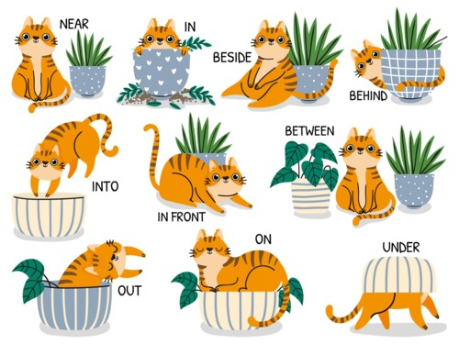
Figure 3 Some examples of closed class words.
View description - Figure 3 Some examples of closed class words.
View description - Figure 3 Some examples of closed class words.

You’ve met some of the closed class words before. In Week 3, you were introduced to the auxiliary verbs – be, have and do – which help to make multiword verbs (they were waiting, we have seen, it doesn’t matter). You also considered modal auxiliary verbs (can, must, should, might etc), which are also a closed class. These words ‘help’ other verbs and can show that an action or process is (or is not) allowed (you mustn’t go there!), advisable (he should wear a warm coat), likely (it might rain later) or possible (they can’t swim).

3.1 Pronouns
You’ve also met the pronouns before (specifically what we call the personal pronouns). Their main function is to help us talk and write about nouns without having to repeat them all the time. It would sound and look quite odd to keep repeating the nouns in a sentence, see a), so we use pronouns in their place instead, as in b).
- Eleanor loved Eleanor’s new coat. Eleanor thought Eleanor looked very fashionable in Eleanor’s new coat.
- Eleanor loved her new coat. She thought she looked very fashionable in it.
In English, pronouns can be used in different ways:
- To talk about ourselves: I and me
- To talk directly with another person or group: we, us, you
- To talk directly about another person or group: he, she, him, her, they, them
- To talk about non-human nouns: it, one, ones, them
Pronouns can be singular (I/me, you, he/him, she/her, it, one) or plural (we/us, you, they/them, ones).

Box 1
We have said that closed word classes tend not to change. But that doesn’t mean they never can. Notice that English does not distinguish between addressing one person (you) and more than one person (also you). English used to have a singular form (thou) but this is now only found in older, or old-fashioned texts. This is one example of a change in a closed word class, but it doesn’t happen very often. One important change taking place right now is that they is being used more and more to talk about just one person, to avoid the awkward he or she or he/she.

Activity 5 Find the pronouns
This activity should take around 15 minutes

Read through this passage and highlight any pronouns you find:

Interactive content is not available in this format.

View discussion - Activity 5 Find the pronouns

You might have highlighted my in the extract above, but this word acts more like an adjective than a pronoun as it doesn’t take the place of a noun. In fact, because it’s part of a small set of very specific words that denote possession, you’ll classify my as part of the next closed class you’re going to look at: determiners.

3.2 Determiners
Determiners are small words you put in front of a noun which tell you something about the thing (person, idea, etc.), but not as much as an adjective would. Determiners include a/an, the; this, that, these, those; my, your, his, her, our and their. You could put any of the determiners in the list in front of a noun like car, house or family, and it would tell you something about it, but it wouldn’t give you a clearer idea of what the thing was like:

her car, their house, his family (determiner only)
her noisy car, their tiny house, his appalling family (determiner plus adjective)

We use a or an – known as the indefinite articles – when we’re referring to something for the first time:

I saw a squirrel outside the kitchen window this morning eating an orange.

You use an when the next word starts with a vowel, as in orange. Notice that the (the definite article) is used before things that you know about already (such as the kitchen window). You would also use the if you were to refer to the squirrel (or the orange) again, as you’ve already introduced these things into conversation.
Determiners can also help you to identify which one(s) of a range of things you mean (this restaurant, that mountain, those shoes) and they can tell you who something belongs to (my idea, our picnic, your nonsense).

3.3 Prepositions

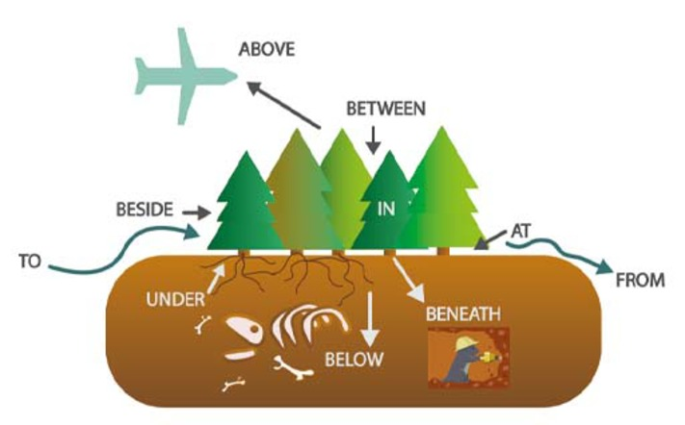
Figure 4 What prepositions can tell us.
View description - Figure 4 What prepositions can tell us.
View description - Figure 4 What prepositions can tell us.

Prepositions are words that indicate location or movement in physical space, mental space, or time. In other words, they tell you where (or when) something is, was, or will be. Examples include to, from, of, for, on, off, in, out, over, under, above, below, around, in front of, behind, before, after, inside, outside.

Activity 6 Add the prepositions
This activity should take around 10 minutes

Look at the sentences below. What prepositions from the list above would fill the gaps? The correct number of letters is given.

1. Mary met John _ _ Paris on Tuesday.
2. On Tuesday we travelled _ _ Paris.
3. Mary drove to Paris _ _ _ _ John.
4. John arrived _ _ the Louvre before Mary.
5. _ _ 5pm precisely John greeted Mary with a friendly smile at the Louvre.
6. In an instant the meeting changed _ _ _ _ business to celebration.
View discussion - Activity 6 Add the prepositions

3.4 Conjunctions
The final closed class you’ll consider here is the conjunctions. These are words which join things together. Conjunctions can join single words (bread and butter, tea or coffee, naughty but nice) or they can join short statements into longer sentences, such as We ate the biscuits and drank the milk or He wanted to go for a walk but it started to rain.
These conjunctions (and, or, but) are simple linking words. There are other conjunctions which are used to build up complex sentences, making logical and grammatical connections between the different parts. For example:

People got angry because we ran out of biscuits
It’s easy when you know the answer
I’ll text you if I have any problems

You’ll learn more about this type of conjunction in Week 7.

4 This week’s quiz
Well done – you have reached the end of Week 6. You can now check what you’ve learned this week by taking the end-of-week quiz.
Week 6 practice quiz
Open the quiz in a new or window and come back here when you have finished.

5 Summary of Week 6
This week you have seen that nouns, verbs and adjectives need help to communicate meaning effectively. Some small but important classes of words are needed to help connect the ‘big’ words together. You’ll need to know how to spot these smaller closed class words too if you’re going to describe language effectively.
You also need to put the words you use in the right order. Next week, you’ll see how words can be arranged in particular orders to express different ideas and communicate different kinds of meaning.
You can now go to Week 7.

Week 7: Putting it all together

Introduction


Figure 1 A Jedi Master’s language.
View description - Figure 1 A Jedi Master’s language.
View description - Figure 1 A Jedi Master’s language.

‘Important the order of words in language is’, as Yoda, the Jedi Master from Star Wars might put it. We can’t just put the words we want into any order and expect our meaning to be clear; we build words into sentences in a regular order. If we don’t follow this order, we might end up with sentences that people won’t understand. (At the very least, we might sound a bit odd!) This week, you’ll be looking at how to order words together so that we can use language effectively.
By the end of this week, you should be able to:
- explain that words do not occur in random sequences
- show how the ordering of words can change the meaning of a sentence
- find the subject and object of a sentence
- show how we build more than one idea into a more complex sentence.

1 The structure of language
As you saw from the Yoda example in the Introduction, it may be possible to make sense of oddly-ordered words if the idea they express is fairly short and simple. But if we are going to express complex topics in longer sentences, we have to put the words together into bigger groups, and combine those groups together, according to the rules of the language we are using.
In Week 6, you looked at grammatical words (the closed classes) and saw how they joined words from the bigger, open classes together. The closed classes add meaning and make communication more effective in various different ways:
- using pronouns (he, she, they, etc.) stops us repeating nouns
- using the indefinite (a/an) or definite articles (the) shows whether we’re introducing new information or talking about something we’ve mentioned before
- conjunctions (and, but, etc.) let us join our ideas together, explore alternatives, or point out problems (Chris or Jim will take you)
- modal auxiliary verbs (might, must, etc.) let us express how likely something is (it may rain later) or whether it’s a good idea (you shouldn’t talk with your mouth full). They also show whether we’re willing to do something (I’ll do the washing up) or see it as an obligation (we must tidy up).
The main focus this week is to investigate how we combine open and closed class words in the right order to get the most out of them. Like all the grammatical knowledge in this course, this is something you already know. It’s just a question of bringing that knowledge into focus.

1.1 How to build a language

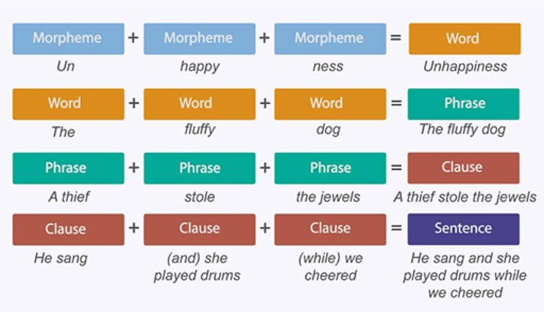
Figure 2 Different types of building blocks.
View description - Figure 2 Different types of building blocks.
View description - Figure 2 Different types of building blocks.

In order to explain how different parts of language fit together we’re going to need some new vocabulary. You already know that morphemes can be combined to make words and that words can be combined to make phrases. In this week’s work you’ll also see that phrases can be combined to make clauses and clauses can be combined to make sentences. But even without knowing all of this technical terminology, you still have an underlying sense of how words fit together. Test your knowledge in the following activity.

Activity 1 Making the words make sense
This activity should take around 10 minutes

Rearrange the words in these examples so that they make sense as a sentence.
1. all they pies the ate

Provide your answer...

2. want chance another we

Provide your answer...

3. sheriff the shot I

Provide your answer...

4. expected win to everyone them

Provide your answer...

5. quickly very reads Pedro

Provide your answer...
View discussion - Part

Hopefully you found it relatively simple to unscramble these sentences. That’s because you already have an underlying knowledge of English grammar. If you found this activity difficult, think about the exercise in terms of what patterns you can see in the way words can be arranged. For example, the first word in each sentence is the person/people doing (or thinking or feeling) whatever the sentence is about. If you felt that a particular word order was just ‘right’, even if you couldn’t exactly say why, that was your grammatical knowledge at work behind the scenes. Let’s bring that knowledge to centre stage.

1.2 Where do the words go?
The rules of grammar mean that, although there are many potentially different sentences, there are always similarities in the way words are ordered. Certain words (or rather word classes) go in certain places. Sometimes the place of the word actually tells us what the word means. Look at can in these examples:

You can see it from here
I bought a can of peas

It’s not the spelling that tells you which one means ‘be able to’, and which one means ‘a cylindrical, metal food container’ – it’s the grammatical context. Let’s see if you can find any patterns in how we order word classes.

Activity 2 What word class goes where?
This activity should take around 15 minutes

This sentence is famous for being used as practice by people learning to type on a computer keyboard:

The quick brown fox jumps over the lazy dog

Here are four sentences with a similar structure. Compare each of the sentences and think back through all the terminology you’ve learned so far. Choose the right word class for each slot.
- A small fierce dog barks at a frightened child.
- An angry young man sits on our favourite seat.
- Another really lovely plant grew from that tiny cutting.
- The huge bay window looks over their beautiful garden.

Interactive content is not available in this format.

View discussion - Activity 2 What word class goes where?

1.3 The order of words (in English)

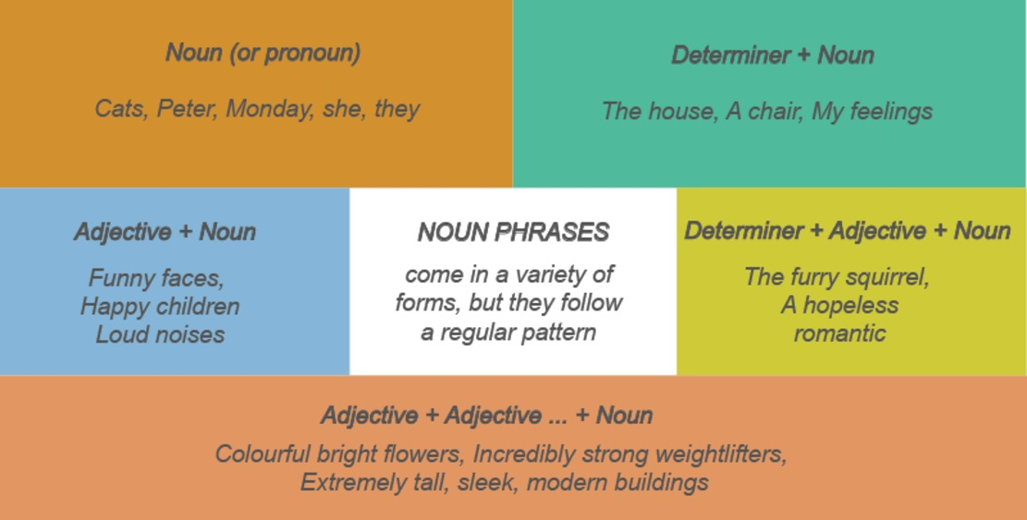
Figure 3 How to make a noun phrase.
View description - Figure 3 How to make a noun phrase.
View description - Figure 3 How to make a noun phrase.

Analysing the word order in The quick brown fox jumps over the lazy dog, we can make the following observations:
- Determiners (DET) go before nouns to make noun phrases – those shoes; the cat; that house
- Adjectives (ADJ) go before nouns (but after determiners) and are included in the noun phrase – those red shoes; the black cat; that enormous house
Based on what you’ve learned in earlier weeks, we might also add:
- Pronouns (PRO) can stand in for a whole noun phrase (see Figure 3 above)
- Prepositions (PREP) go before noun phrases, to form prepositional phrases – with high heels; in the garden; on a leafy avenue
- Auxiliaries (do/be/have and modal auxiliaries like must, can, etc.) go before other verbs – I do like; he could swim; we might buy one; you should avoid them
Don’t worry about learning all these rules right away. This list is just here to remind you of what you’ve already come across in this course so far.
Of course, other languages can use different word orders. In French and Spanish, for instance, adjectives often come after nouns, though notice that in French that’s not always the case*. In German, adjectives come before the noun, as they do in English (and as you can see, nouns start with a capital letter – a useful clue for learners!).

English | French | Spanish | German
red shoes | souliers rouges | zapatos rojos | rote Schuhe
the black cat | le chat noir | el gato negro | die schwarze Katze
a large house | une grande maison* | una casa grande | ein großes Haus
the British woman | la femme britannique | la mujer británica | die britische Frau
a strange man | un homme étrange | un hombre raro | ein fremder Mann

2 English sentence structure
Now you’ll pull your knowledge of word classes, noun phrases and verbs together. Words form larger units, or phrases. And it’s these whole phrases that fit together into sentences. Take the following examples (let’s imagine they are said about the same person):

Maria likes holidays.
My daughter’s best friend likes exotic and ridiculously expensive foreign travel.

In the first sentence we have just three words: a noun phrase (Maria), a verb (likes) and another noun phrase (holidays). In the second sentence there are more than three times as many words. But the words before and after likes in each sentence are doing similar things. They tell us who does the liking (My daughter’s best friend), and what it is they like (exotic and ridiculously expensive foreign travel). We can swap the noun phrases around and still have acceptable sentences:

My daughter’s best friend likes holidays.
Maria likes exotic and ridiculously expensive foreign travel.

So whether they contain only one noun (like Maria or holidays) or many words, these noun phrases are grammatically similar. Of course, as we’re describing language, there is some specialist terminology that helps us to describe how we order phrases.

2.1 Subjects and objects


Figure 4 Man bites dog newspaper front page.
View description - Figure 4 Man bites dog newspaper front page.
View description - Figure 4 Man bites dog newspaper front page.

In English, the order in which we use different phrases is important. In the following example, the only way we know who is doing the asking is by looking at the word order. The words are the same, but the order of the phrases is different, and this influences the meaning of each sentence.

The journalist quoted the politician
The politician quoted the journalist

The person mentioned in the noun phrase before the verb is performing the action of ‘quoting’ while the person mentioned in the noun phrase after the verb is the one being quoted. We label these two components of the sentence the subject and the object, respectively.
We can use these two labels to explain why the famous example of a good newspaper story headline MAN BITES DOG! is a sensation, while the alternative DOG BITES MAN! won’t sell newspapers.
In both these sentences the grammatical term for the first phrase is the subject of the sentence. The subject of a sentence is the person or thing the sentence is mostly about, and if any action takes place (for example, biting!), it’s the subject who does it. In most simple English sentences the subject comes before the verb. This is true in other languages too, but not in every language. The other noun in the ‘biting’ examples is the person or animal who is affected by what the subject does (they get bitten). This is the object of the sentence.

Activity 3 Find the subject and object
This activity should take around 10 minutes

Let’s see if you can identify the subjects and objects in some short sentences. Put the subjects and objects from each sentence into the table below.
- Mary and Juan ate all the pies
- The man who came to dinner brought a bottle of champagne
- John recognised the man in the orange stripy suit
- A girl called Susan Brown had answered the most questions
- Several onlookers watched the highly anticipated tennis final
- I lost my favourite pen
- The owner of the little dog from two streets over likes to play the loudest music
- The cat in the hat was fluffy
If you find this activity a little difficult, your first step should be to find the verb. Then work out what noun phrase comes before it (the subject) and what noun phrase comes after it (the object). Remember that noun phrases can be made up of several words. In order to help you, two answers have been completed for you.

 | Subject | Object
1 | Mary and Juan | all the pies
2 | The man who came to dinner | a bottle of champagne
3 | Provide your answer... | Provide your answer...
4 | Provide your answer... | Provide your answer...
5 | Provide your answer... | Provide your answer...
6 | Provide your answer... | Provide your answer...
7 | Provide your answer... | Provide your answer...
8 | Provide your answer... | Provide your answer...

View discussion - Activity 3 Find the subject and object

Some of the examples above were more difficult than others. While several sentences had very short and easy-to-spot subjects (John, I) some were a bit more complicated (The owner of the little dog from two streets over). You might also have spotted the different types of verbs used (main verbs like ate, auxiliaries like was, and some more complicated forms of verbs like likes to play).
The final example shows that not all verbs need an object. Sometimes, a person or thing just does something and the action doesn’t involve anyone or anything else:

The cat in the hat was fluffy
The sun set slowly behind the mountains
Grammar rocks!

In the second example, all the sun did was ‘set’, the rest of the sentence tells us how and where it did this, not that it did anything to anything else.

2.2 A Latin headline
Not all languages depend on word order in the way that English does. Let’s see what our newspaper headline Man bites dog! would look like in a language that marks subjects and objects a little bit differently.

Activity 4 Canis mordet hominem
This activity should take around 10 minutes

Watch the following video.

Video content is not available in this format.
Video 1 Word order and inflections in Latin
View transcript - Video 1 Word order and inflections in Latin

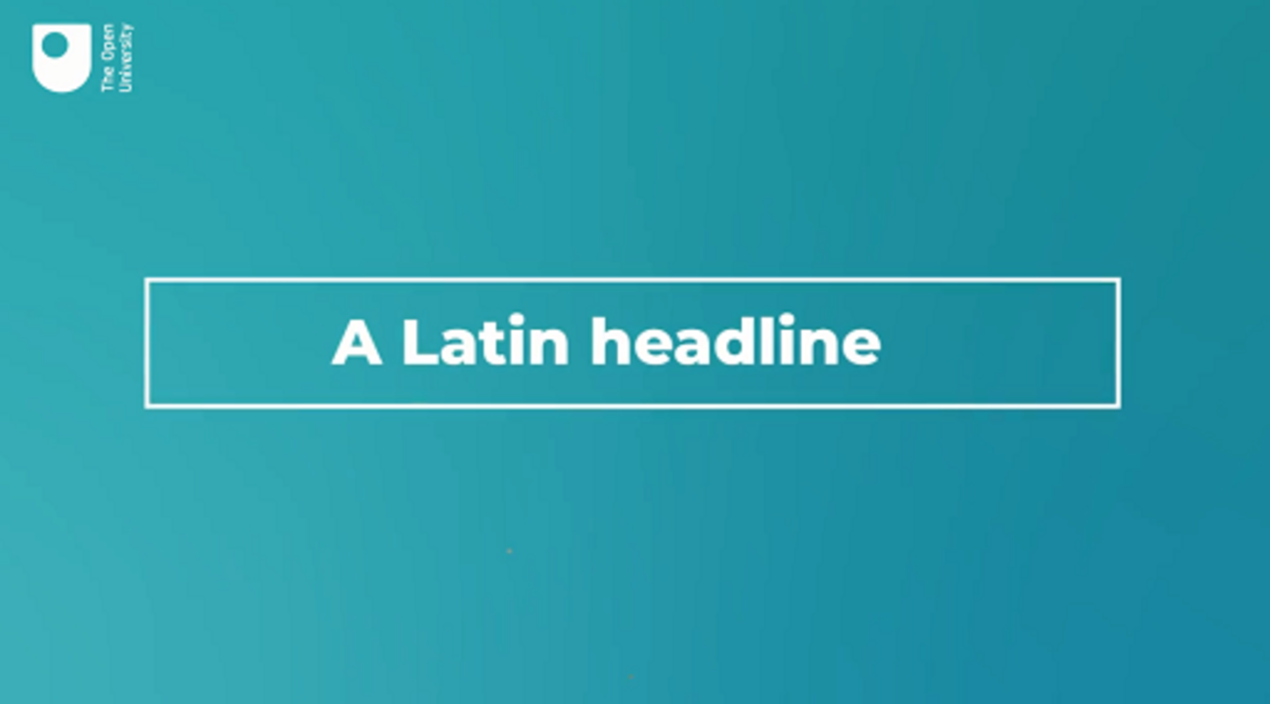

Can you summarise the differences between Latin and English that are described?

Provide your answer...
View discussion - Activity 4 Canis mordet hominem

3 How sentences are built
Most of the sentences you’ve seen so far have been quite simple. But now you know the basics about how subject, verbs and objects fit together, you can start to take a look at some of the different ways in which we can arrange phrases to make meaning in English. The easiest way to do this is by using diagrams.

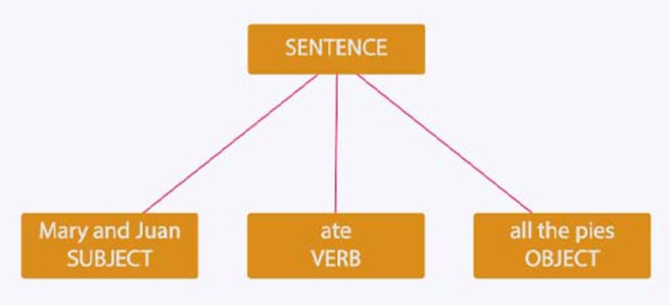
Figure 5 A simple sentence.
View description - Figure 5 A simple sentence.
View description - Figure 5 A simple sentence.

In this first diagram you can see the subject + verb + object structure that you’ve been looking at. This structure is the basic structure of English sentences and is known as SVO (subject, verb, object). We can use a similar structure to draw a sentence without an object. This structure is known as SV (subject, verb).

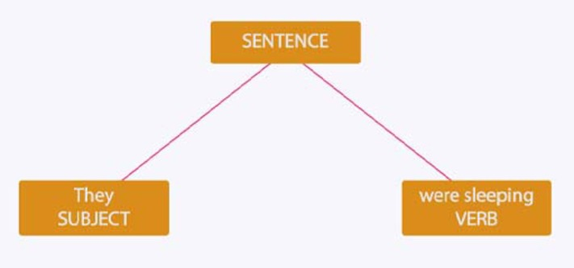
Figure 6 A sentence with no object.
View description - Figure 6 A sentence with no object.
View description - Figure 6 A sentence with no object.

There are also some sentences that can have more than one object, such as

Francesc gave his mother a cup of tea
I bought Gloria a vintage clock
Grandma told the children a bedtime story

The subjects are simple enough (Francesc, I and Grandma), but there are two objects in each example, which we would draw like this:

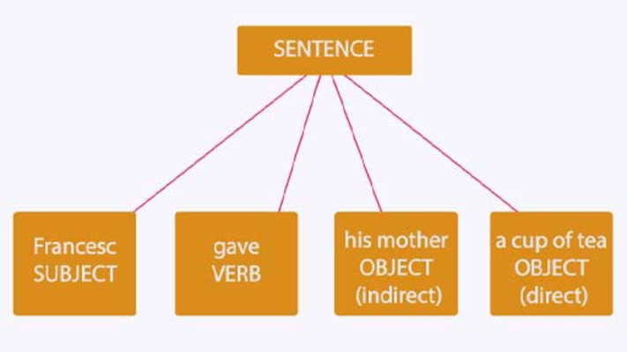
Figure 7 A sentence with two objects.
View description - Figure 7 A sentence with two objects.
View description - Figure 7 A sentence with two objects.

Many sentences that have two objects involve some form of giving and receiving. The subject (Francesc) gives the direct object (that which is directly acted upon, a cup of tea) to a recipient, known as the indirect object (his mother).
Finally, there are also sentences that tell us something about the subject although no action or process is taking place.

Stephanie is happy
I am hungry
The chinchilla is very fluffy

In these examples, we can’t classify happy, hungry and very fluffy as objects because they aren’t tangible things that the subject is acting upon. Rather, they simply give us more information about the subject and their experiences. These characteristics can be physical (very fluffy) or existential (happiness) and they can be permanent or fleeting. We call this component of the sentence a complement and you’ll often find them used with a form of the auxiliary verb BE.

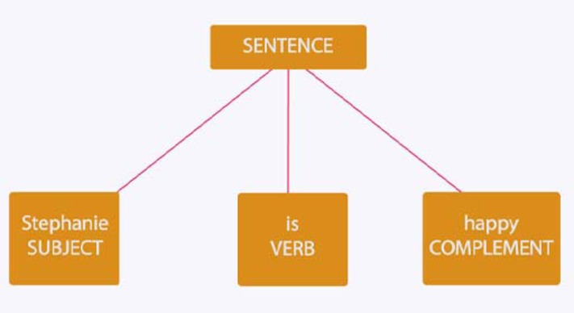
Figure 8 A sentence with a complement.
View description - Figure 8 A sentence with a complement.
View description - Figure 8 A sentence with a complement.

There are, of course, other grammatical structures used in English. We can add additional information to this basic structure about how, when, and where something happened. Now you’ve mastered the basics, you can take a closer look at how we can add more information to SVO.

4 Adding more information
Sentences are made up of different parts structured in a predictable and orderly way. Every sentence has at least a subject and a verb. Some sentences also have an object (or even two!). To this basic structure, we can add more information with additional phrases, and also combine short, simple sentences together into longer, more complex ones.
One way we can add more information to sentences is by including elements that tell us more about the context of an event or idea:

At the end of the day, you and your sisters made a delicious cake.
The former head of MI5 will give evidence at the hearing.
We can park in the village.
Toby is useful in an emergency.
In this episode Debbie is reunited with her long-lost twin.

These sentences go beyond the basic SVO or SV structures, as you can see in the table below.

 | Subject | Verb | Object
 | The former head of MI5 | will give | evidence | at the hearing
 | We | can park |  | in the village
 | Toby | is | useful | in an emergency
At the end of the day | you and your sisters | made | a delicious cake
In this episode | Debbie | is reunited |  | with her long-lost twin

The words in the first and last columns of the table aren’t subjects, verbs or objects. You might have noticed that they are all prepositional phrases. Their job is to add information such as where, when and how the action or event in the sentence took place. They can also be moved to another part of the sentence.

At the hearing, the former head of MI5 will give evidence.
In an emergency, Toby is useful.
Debbie is reunited in this episode with her long-lost twin.

We call these additions to the basic sentence structure adverbials (you might also find them referred to as adjuncts).

Activity 5 Find the prepositional phrases
This activity should take around 10 minutes

We can use prepositional phrases to make some really long sentences. How many different prepositional phrases can you find in the sentence below? Make a note of them in the box. It will help you to find the subject, verb and object first. (If you need a reminder about prepositional phrases, go back to Week 6.)

On Tuesday at the office canteen in the middle of morning break Thomas ate Lisa’s birthday cake from the box over in the corner out of sight.

Provide your answer...
View discussion - Activity 5 Find the prepositional phrases

While you have focused here on prepositional phrases, adverbials can take a variety of different forms. They can also include words like yesterday or last week to show the time of an event, as well as adverbs like quickly or quietly, which show the manner in which something took place.

4.1 SVOCA
You’ve now learned about all the different components of English sentences. We have specialist terminology to refer to who is performing the action or process expressed in a sentence (subject), what action, etc. is taking place (verb), who that action or process is affecting (object), or what characteristic the subject possesses (complement). Of course, there’s two different types of object (direct and indirect) and we can always add more information to sentences using adverbials. It’s time to put your knowledge to the test.

Activity 6 Spotting grammatical components
This activity should take around 20 minutes

For each of the following sentences, see if you can correctly identify the component in bold.
John saw the man in the orange stripy suit in his rear-view mirror

Subject
Object
Verb
Complement
Adverbial
View answer - Part

Mary and Juan ate all the pies

Subject
Object
Verb
Complement
Adverbial
View answer - Part

The cat in the hat was fluffy

Object
Subject
Complement
Adverbial
Verb
View answer - Part

I feel content

Object
Subject
Complement
Verb
Adverbial
View answer - Part

I lost my favourite pen yesterday

Object
Adverbial
Subject
Verb
Complement
View answer - Part

Mary and Juan ate all the pies

Object
Subject
Verb
Complement
Adverbial
View answer - Part

John saw the man in the orange stripy suit in his rear-view mirror

Object
Subject
Verb
Adverbial
Complement
View answer - Part

The owner of the little dog from two streets over likes to play the loudest music

Object
Subject
Verb
Complement
Adverbial
View answer - Part

The cat in the hat was fluffy

Object
Subject
Complement
Verb
Adverbial
View answer - Part

The man who came to dinner brought a bottle of champagne

Object
Verb
Complement
Adverbial
Subject
View answer - Part
View discussion - Part

If you want more practice spotting the different components of sentences, you might like to draw out each of the examples above using the tree diagrams that you came across earlier this week. The first one has been done for you.

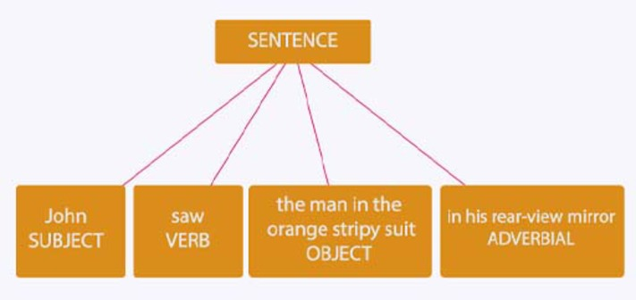
Figure 9 A sentence with an object and an adverbial.
View description - Figure 9 A sentence with an object and an adverbial.
View description - Figure 9 A sentence with an object and an adverbial.

5 This week’s quiz
Well done – you have reached the end of Week 7. You can now check what you’ve learned this week by taking the end-of-week quiz.
Week 7 practice quiz
Open the quiz in a new or window and come back here when you have finished.

6 Summary of Week 7
You have now been through the basic rules of English sentence structure and are now in no danger of sounding like Yoda. There has been a lot of new information about the structure of English this week, and it’s best to think about the different levels of structure that you’ve come across as building blocks. You already knew that we could add morphemes together to make words, but we can also add words together to make phrases.
In the next (and final) week, you’ll learn that phrases come together to make clauses, and clauses can be added together to make sentences. You’ll also focus on how we use sentences to ask questions, tell people what to do, and other useful things and you’ll consider some creative uses of language in English and other languages.
You can now go to Week 8.

Week 8: Language in the real world

Introduction


Figure 1 Questions and commands: ‘When do we have to …?’ ‘Do it now!’.
View description - Figure 1 Questions and commands: ‘When do we have to …?’ ‘Do it now!’.
View description - Figure 1 Questions and commands: ‘When do we have to …?’ ‘Do it now!’.

So far in this course you’ve seen how words are put together and how they need to be arranged in particular orders to make their meanings clear. But the majority of the sentences you’ve looked at so far have been rather simple. Most of them have just made statements: someone does something, something happened, something is a certain way. This would be enough if all we needed language to do was describe things. In practice, we use language for a lot more than that: to find information, to tell (or ask) people to do things, and to get things done. This week, you will see that sentences can do more than make a statement.
By the end of this week, you should be able to:
- explain the difference between different types of sentences
- explain the difference between form and function in English
- explain what an idiom is.

1 Sentence forms
Not all our language use is about making statements. Sometimes we need to seek out information. Sometimes we have to tell people what to do. You’ll begin this week by taking a closer look at the most common sentence structures in English.
- We can make statements (known as declaratives)
- We can ask questions (called interrogatives)
- We can give commands (the technical term being imperatives)
- And we can make exclamations (known, rather helpfully, as exclamatives)
Most of the sentences that you’ve come across so far have been declaratives, which take the standard subject, verb, object (SVO) or subject, verb, complement (SVC) structure. You’ll now consider what makes interrogatives, imperatives and exclamatives different from this well-established grammatical pattern.

1.1 Asking questions
Questions come in two main types. The first is yes/no questions, also known as a closed question, where you probably expect to hear yes or no as an answer.

Can we park here?
Is this houmous home-made?

People might give longer answers to these questions, but fundamentally what the person asking is wanting here is a yes or a no. We make closed questions by swapping the order of the subject and verb. So the declarative this houmous is home-made becomes the interrogative is this houmous home-made? (When we write such questions down, we also use a question mark, which is another easy way to spot a question!) When we have an auxiliary verb or a modal auxiliary, it’s that component that moves to the start of the sentence, so we can park here becomes can we park here? (rather than park we can here?, which would have us sounding like Yoda again!).
The other main type of question is called a wh- question or open question. These questions tend to start with one of the words who, where, when, what, why or how, which comes immediately before the verb:

Who told you that?
How do you make pancakes?

What these questions have in common is that they are looking for information – someone’s name, an explanation, etc. You can’t just grunt yes or no to these types of questions – you are expected to come up with more than that. That’s why open questions are favoured by interviewers (on TV or in hiring panels).
You can also turn a declarative into a question by adding a form of auxiliary DO and (sometimes) changing the form of the main verb:

They like to host parties > Do they like to host parties?
They watched the sun rise > Did they watch the sun rise?

1.2 Questions in other languages
In French yes/no questions are formed from the verb by inverting the subject and verb (or auxiliary verb):

Declarative | Translation | Interrogative
Vous aimez Londres. | You like London. | Aimez-vous Londres?
Il veut apprendre l’anglais. | He wants to learn English. | Veut-il apprendre l’anglais?

In Spanish the verb usually appears without a pronoun: I eat = como (see Week 3). This means there is no way to swap the order of the subject and the verb. For this reason, the main way of forming a yes/no question from a declarative in Spanish is simply to ask it with rising (questioning) intonation:

Declarative | Translation | Interrogative
Tiene dos casas. | She has two houses. | Tiene dos casas?
Quiere aprender el inglés. | He wants to learn English. | Quiere aprender el inglés?

1.3 Giving commands and making exclamations

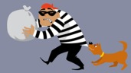
Figure 2 Stop thief!
View description - Figure 2 Stop thief!
View description - Figure 2 Stop thief!

Sometimes, when we want to get something done, we give orders or commands. This is the one time in English when we use the verb without a subject:

Put that book down
Go to your room
Stop thief!

Commands don’t need a subject because there is no need to express who the command is referring to. It’s always directed at you. If we want to make commands sound a little bit less abrupt, we can add something like will you?, or could you? at the end: Make me a sandwich, will you? This approach might get you a sandwich, but it’s unlikely to slow down the thief!
When we’ve finished asking questions and shouting orders, we might also want to express surprise, delight, annoyance, outrage, or any other strong emotion. In this instance, we can exclaim something:

What a great idea that was!
How kind you are!
What an idiot I’ve been!

As you can see, such exclamatives often begin with what or how, but other sentence forms can also express emotions. For example, a declarative sentence could be written with an exclamation mark at the end to show it is functioning as an exclamation, rather than a plain statement of fact:

That’s the fourth time this month he’s been late!

In writing, the best indicator you’ll have that something is an exclamative is the use of an exclamation mark at the end. When trying to spot exclamatives in speech, you can listen for the tone in which a sentence is delivered or whether particular words are emphasised.

I showed him not to do it that way!
She knew that was my milk in the fridge!

1.4 Spotting different sentence forms
When deciding if a sentence is a declarative, interrogative or imperative, the biggest clue is what order the subject and verb appear in (or whether there’s a subject at all!). You can also look out for question words like who and what at the start of the sentence.

Activity 1 Select the sentence function
This activity should take around 5 minutes

Decide what label matches the form of each sentence listed below. Consider what word the sentence starts with, whether it has a subject, whether its emphatically expressing emotion, or whether it’s merely stating something.
Can you see the tower from here?

Interrogative
Declarative
Imperative
Exclamative
View answer - Part

Hold the other end tight!

Declarative
Imperative
Interrogative
Exclamative
View answer - Part

I’m tired of all their ridiculous excuses!

Declarative
Interrogative
Imperative
Exclamative
View answer - Part

Why did she give you that funny look?

Declarative
Imperative
Interrogative
Exclamative
View answer - Part

How brave they are!

Declarative
Interrogative
Imperative
Exclamative
View answer - Part

I won’t be coming with you.

Declarative
Exclamative
Interrogative
Imperative
View answer - Part
View discussion - Part

One other thing we can do to change the form of a sentence (and its broader meaning) is make it negative. If we make a declarative sentence negative, the SVO order stays the same. When there is a single verb, we add a form of DO + not. With more complex verbs like will give, we add not to the (modal) auxiliary.

They live in London > They don’t live in London
The former head of MI5 will give evidence > The former head of MI5 will not give evidence

2 Structure and sentence functions
In most examples you’ll come across, the grammatical form of a sentence will match the function it performs. A question will look like an interrogative, and a command will look like an imperative. But this relationship doesn’t hold all the time. We can use a declarative to ask a question or give a command:

You expect me to believe that? (not Do you expect…?)
It’s cold in here (in the right context, this could mean ‘shut the window’)

We can use a question to give a command:

Would one of you two like to do the washing up? (when spoken by a parent to two teens)

And, as with Spanish, we can use a statement to ask a question if we say it with rising intonation (or use a question mark):

Susan is a trained scuba diver?

3 Combining sentences

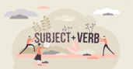
Figure 3 Subject + verb = clause.
View description - Figure 3 Subject + verb = clause.
View description - Figure 3 Subject + verb = clause.

Now you know all the different sentence types, you can start to look at more complex constructions. So far, we’ve been referring to the combination of a subject and a verb (and an object or complement) as a sentence. In some cases this is true, but the reality is a little bit more complicated than that. In linguistics, when we talk about the relationship between a subject and a verb, we talk about a clause. A clause is the simplest form of sentence, formed around one verb, and clauses can be combined into more complex sentences.

3.1 Making longer sentences
One way we can make longer sentences is to join more than one clause together. Most of the sentences you’ve looked at in the course have dealt with just one idea:

I brought a present for Amanda (Week 2)
Snow fell throughout the day (Week 3)
It’s less expensive than the French one (Week 5)

This type of sentence says one thing about one person or thing, and as a result is called a simple sentence. It has a single clause in it – that is, just one verb and one subject.
You’ve seen that words can be joined together in phrases using conjunctions such as and or but. The same goes for simple sentences. When two or more are joined using and, but, or or they form what is called a compound sentence.

They went to France that summer but they put the trip to Italy off until later.
I might bake a cake or I might buy one, and I should get some wine, too.
My sister bought a red dress and I tried on some shoes but we decided not to bother with hats.

A compound sentence is made of two or more clauses, but each clause makes sense as a sentence on its own.

3.2 Making more complex sentences
Another way to make longer sentences is to combine clauses so the sense of one clause depends on another. For example, clauses can be connected to show that one of the clauses is the reason, result or condition of the other, or because they are related in time. This is done by using subordinating conjunctions: so (that), because, if, whether, while, when, then, since, and others.

He’ll do it if you ask him nicely enough.
I’ll scream and scream until I’m sick!
They won’t hear you unless you shout really loud.
She gave up the job, although it paid a lot.

Instead of just adding one simple sentence to another with and or but, these conjunctions put one part of the sentence (the main clause) in charge, while the other (the subordinate clause) is made dependent. For example, the subordinate clause although it paid a lot doesn’t really make sense on its own. We need to attach it to the main clause She gave up the job to grasp the full meaning of the sentence. (By contrast, the main clause she gave up the job can stand on its own as a simple sentence.)

Activity 2 Sentence types
This activity should take around 10 minutes.

For each of the sentences below, decide whether it is a simple, compound or complex sentence.
1. I will wait for you in the gardens.

Compound
Simple
Complex
View answer - Part

2. We’ll go to Italy again next year if we can both get the time off.

Complex
Simple
Compound
View answer - Part

3. Since he left university, he had stayed in the same house.

Simple
Compound
Complex
View answer - Part

4. They studied archeology.

Compound
Complex
Simple
View answer - Part

5. The children did the washing up and their parents went shopping.

Compound
Simple
Complex
View answer - Part

6. You can ask Giorgio on Tuesday.

Compound
Simple
Complex
View answer - Part

7. She washed her hair so he could cut it.

Complex
Simple
Compound
View answer - Part

8. In the end they had a wasted trip.

Compound
Complex
Simple
View answer - Part

9. I wanted the pizza but ordered the salad.

Complex
Simple
Compound
View answer - Part

10. It was raining but we went anyway.

Simple
Compound
Complex
View answer - Part
View discussion - Part

The final thing to note about different sentence types is that we can combine compound and complex sentences (called compound-complex sentences):

If he wanted to stay he should have said something and I would have let him.

Here we have the subordinate clause If he wanted to stay and two main clauses joined by a coordinating conjunction: he should have said something and I would have let him.

4 Language in the real world
Because the focus of this course has been to teach you the terminology you’ll need to describe language, the majority of the examples that you’ve interacted with have been invented. This has been to keep you focused on the feature of language under scrutiny and to reduce the ‘noise’ that can be found in everyday language use. In the real world, you’ll likely find that, although the basic structures of language are present, people like to get creative with how they use morphemes, words, phrases, clauses and sentences. But fear not! You can use your new-found knowledge of language and grammatical structures to be able to explain when people move off the beaten track and use language creatively. Let’s test that knowledge now.

Activity 3 Getting creative
This activity should take around 15 minutes

Answer each question using as much language description terminology as you need.
1. What morphemes have been used to create the word ungreenable and what might this word mean?

Provide your answer...

2. What word class is heart in the sentence I heart New York and why might this be unusual?

Provide your answer...

3. What component of the clause appears to be missing in the slogan Got milk?

Provide your answer...
View discussion - Part

4.1 Collocation


Figure 4 A cup of...
View description - Figure 4 A cup of...
View description - Figure 4 A cup of...

You’ve already seen how word classes come together in expected patterns to make phrases and sentences. But word meanings can also pattern in similar ways. If you were asked to complete the following sentences, you’d likely choose tea/coffee, sugars and hot, respectively.

Do you want a cup of ____?
Yes, milk and two ____ please
Watch out, the mug is ____

This is because words do not carry their meaning in isolation. In a British context, being offered a cup of tea is a cultural norm and the phrase a cup of tea is well established. Similarly, we don’t understand each sentence we hear in isolation either; if you are familiar with making tea, you’ll know that milk and sugar are often also mentioned in the same context, and so, hearing the first question we are able to surmise that milk and two sugars is a likely response, while milk and two aubergines is not. Furthermore, patterns of word use build up over time and, when used frequently, these patterns come to be expected. Once these patterns have been established, we can get really creative with language and flout expectations by deviating from the established norm (often for humorous or dramatic effect).

Activity 4 More than the sum of its parts
This activity should take around 20 minutes

Watch the video below which explains how the meaning of a phrase can be more than the literal interpretation of the words it includes.

Video content is not available in this format.
Video 1 Collocation and idioms
View transcript - Video 1 Collocation and idioms

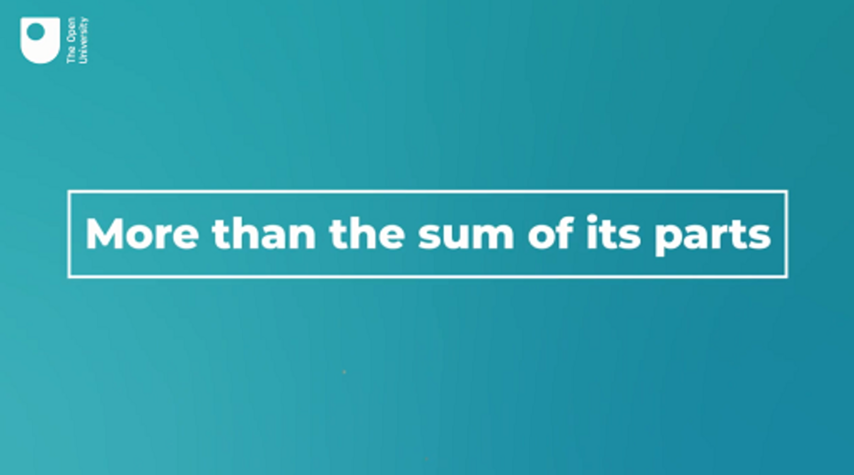

Activity 5 Complete the sentence
This activity should take around 20 minutes

Complete the following phrases by adding one of the following:
- Bob’s; the handle; hell; money; out of the bag.

1. They ran _________ for leather
2. I just have to switch the toaster on and _________ your uncle
3. My guess was right on the ___________
4. I wanted it to be a surprise but his sister let the cat ______________
5. He flies off ____________ at the slightest thing these days.
View discussion - Activity 5 Complete the sentence

5 Playing with language

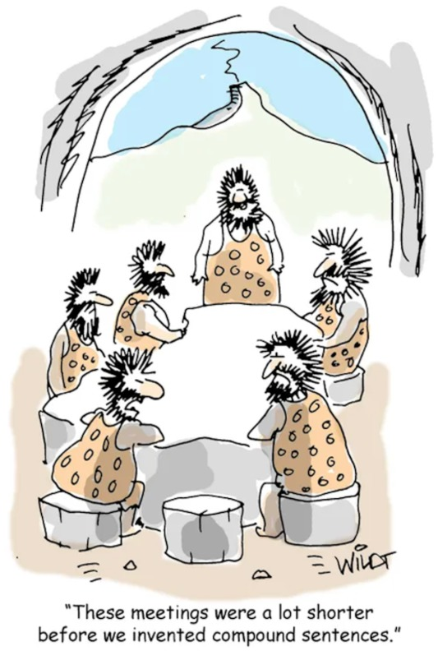
Figure 5 Morphology and humour
View description - Figure 5 Morphology and humour
View description - Figure 5 Morphology and humour

In the last eight weeks you’ve learned a lot. You’ll end with an activity that allows you to describe how language is used in the real world, but that might also make you laugh at the same time.

Activity 6 Why the long face?
This activity should take around 20 minutes

Explain what features of language make the following jokes funny. Think about the potential double meaning of words, but also about collocations, idioms and sentence structure.

- I waited an hour for my starter so I complained: ‘It’s not rocket salad’ (Lou Sanders)
- I never lie on my CV…because it creases it (Jenny Collier)
- I’m entering the world’s tightest hat competition. Just hope I can pull it off (William Andrews)
- People who ask, ‘can I ask you a question?’ Didn’t really give me a choice there, did you sunshine? (Billy Connolly)
- Behavioural psychology is the science of pulling habits out of rats. (Douglas Busch)
(Examples sourced from Greig 2019 (1–3) and Greig 2017 (4))

Provide your answer...
View discussion - Activity 6 Why the long face?

6 This week’s quiz
It’s now time to complete the Week 8 badged quiz. It is similar to the previous quizzes, but this time, instead of answering 5 questions there will be 15, covering Weeks 5–8.
Week 8 compulsory badge quiz
Remember that the quiz counts towards your badge. If you’re not successful the first time, you can attempt the quiz again in 24 hours.
Open the quiz in a new or window and come back here when you have finished.

7 Summary of Week 8
Congratulations on reaching the end of this course on describing language!
When you started this course the first question you came across was ‘What makes a language?’. Over the last eight weeks, you’ve used English as a case study to start to answer this question.
You now know how to spot all of the key components of a language (from morphemes to clauses) and you’ve learned how all of these different building blocks can be put together. What’s more, as you’ve seen this week in particular, now that you know how language is put together, you can spot where people flout the ‘rules’ and get creative with language.
You finished this week by looking at how language is used in the real world, and you’re encouraged to keep scrutinising the language you come across. You’ve mastered the basics and your journey into the wonderful world of language description has now begun … take your new-found skills with you and keep exploring!

Next steps?
Now that you’ve mastered the basics, why not take a look at some of the other resources we have on offer.
- If you are interested in learning a language such as French, Spanish, German, Chinese or Welsh, check out our short courses in the Open Centre for Languages and Cultures.
- Perhaps you want to know more about how English is used across time and space. In that case, our free short course on English in the World Today is the one for you. Or you might want to take a look at our materials on Exploring the English Language.
- If you’re ready to take the next step and undertake more formal study of English, you can take a look at all the English language courses we offer, including BA (Hons) English Language (R54), BA (Hons) Language Studies (Q30), BA (Hons) English Language and Literature (Q39), and BA (Hons) Arts and Humanities (R14).
Wherever your journey of discovery takes you next, you’ll be able to use what you’ve learned in this course to continue to explore how English and other languages work in the real world.

Tell us what you think
Now you’ve come to the end of the course, we would appreciate a few minutes of your time to complete this short end-of-course survey (you may have already completed this survey at the end of Week 4). We’d like to find out a bit about your experience of studying the course and what you plan to do next. We will use this information to provide better online experiences for all our learners and to share our findings with others. Participation will be completely confidential and we will not pass on your details to others.

References
Dent, J. (2021) ‘Here’s the whole box and dice on the OED March 2021 update’. Available at: https://public.oed.com/blog/the-oed-march-2021-update/ (Accessed: 22 March 2022).
Eberhard, D.M., Simons, G.F. and Fennig, C.D. (eds) (2020) Ethnologue: Languages of the World. 23rd edn, Dallas, Texas: SIL International. Available at: http://www.ethnologue.com (Accessed: 22 March 2022).
Oxford English Dictionary (2021) Available at: https://www.oed.com/ (Accessed: 22 March 2022).
Skračić, T. and Borak, M. (2016) ‘Poetics of Slogans in Yachting ADS’, European Journal of Multidisciplinary Studies, 1(2), pp. 222–34.
Walsh, S.L. (2009) ‘Snickers creates new words for delicious ad campaign’, Trendhunter. Available at: https://www.trendhunter.com/trends/snickers-ad-campaign (Accessed: 22 March 2022).
Ayto, J. (2019) ‘Words from the 21st century’. Available at: https://public.oed.com/blog/words-from-the-21st-century/ (Accessed: 22 March 2022).
Darboven, J.J. (2021) ‘J.J. Darboven converts all Tea Diamonds® to biodegradable material’. Available at: https://www.darboven.com/en-gb/news/tea-diamonds-made-of-biodegradable-material-1 (Accessed: 22 March 2022).
Greig, F. (2017) ‘75 of Billy Connolly’s best jokes, one-liners and quips’. Available at: https://inews.co.uk/light-relief/jokes/billy-connolly-jokes-quotes-106891 (Accessed: 22 March 2022).
Greig, F. (2019) ‘60 Edinburgh Fringe one-liners that really deserved to win Funniest Joke’. Available at: https://inews.co.uk/light-relief/jokes/edinburgh-fringe-one-liners-best-jokes-170356 (Accessed: 22 March 2022).
Awbery, G.W. (2006) ‘The English Language in Wales’ in Kingsley Bolton, Braj B. Kachru (eds) World Englishes: Critical Concepts in Linguistics, Volume 1. Routledge: Abingdon.
Robinson, J. (2019) ‘Regional voices: Non-standard grammar’, British Library, British Accents and Dialects. Available at: https://www.bl.uk/british-accents-and-dialects/articles/regional-voices-non-standard-grammar (Accessed: 22 March 2022).
Awbery, G.W. (2006) ‘The English Language in Wales’ in Kingsley Bolton, Braj B. Kachru (eds) World Englishes: Critical Concepts in Linguistics, Volume 1. Routledge: Abingdon.
Robinson, J. (2019) ‘Regional voices: Non-standard grammar’, British Library, British Accents and Dialects. Available at: https://www.bl.uk/british-accents-and-dialects/articles/regional-voices-non-standard-grammar (Accessed: 22 March 2022).
(OED) Oxford English Dictionary (2020) ‘New words list January 2020’. Available at: https://public.oed.com/updates/new-words-list-january-2020/ (Accessed: 22 March 2022).
TranslateMedia (2017) ‘How to describe “Luxury”’. Available at: https://www.translatemedia.com/translation-blog/how-to-describe-luxury/ (Accessed: 22 March 2022).
Twain, M. (1880) letter (written as Samuel L Clemens) to DW Bowser, 20 March 1880. Mark Twain Project. Available at: https://www.marktwainproject.org/xtf/view?docId=letters/UCCL01772.xml;style=letter;brand=mtp (Accessed: 22 March 2022).
Dent, J. (2021) ‘Here’s the whole box and dice on the OED March 2021 update’. Available at: https://public.oed.com/blog/the-oed-march-2021-update/ (Accessed: 22 March 2022).
Hultgren, A.K. (ed.) (2015) E304: Exploring English Grammar: 1, Grammar, context and meaning, Milton Keynes, The Open University.
North, S. (2015) English: A Linguistic Toolkit (2nd edn), Milton Keynes, The Open University.
North, S. (2015) English: A Linguistic Toolkit, 2nd edn, Milton Keynes, The Open University.

Acknowledgements
This free course was written by Laura Paterson, with additional materials from Liam Roger and Karen Angelosanto.
Except for third party materials and otherwise stated (see terms and conditions), this content is made available under a Creative Commons Attribution-NonCommercial-ShareAlike 4.0 Licence.
The material acknowledged below is Proprietary and used under licence (not subject to Creative Commons Licence). Grateful acknowledgement is made to the following sources for permission to reproduce material in this free course:

Week 1
Images
Course image: © Natalie_ / Getty Images
Figure 1: hvostik; Shutterstock.com
Figure 2: Anna Kutukova; Shutterstock.com

Week 2
Images
Figure 1: Müge Ayma; Getty Images
Figure 2: StunningArt; Shutterstock.com
Figures within Video 2: Patch the dog: Anna Zisk; Shutterstock.com / Medical team: Monkey Business Images; Shutterstock.com / Tomatoes: Shyripa Alexandr; Shutterstock.com / Heart: Roman Borodaev; Shutterstock.com.
Figure 5: Zolak; Shutterstock.com

Week 3
Images
Figure 1: left: Shawn Pecor; Shutterstock.vom; centre: Daniel Prudek; Shutterstock.com; right: pryzmat; Shutterstock.com
Figure 2: Rawpixel.com; Shutterstock.com

Week 4
Images
Figure 1: Denis Andricic; Shutterstock.com
Figure 3: Robert Lowth (1710–1787), A Short Introduction to English Grammar; 1762

Week 5
Images
Figure 1: top left: Elena Kravchenko, Moscow; Shutterstock.com; top right: Steve Bruckmann; Shutterstock.com; bottom left: Wasitt Hemwarapornchai; Shutterstock.com; bottom right: otsphoto; Shutterstock.com
Figure 2: Adiemus; Shutterstock.com
Figure 3: Hany Zakaria; Shutterstock.com
Figure 4: Memac Ogilvy for Fanta 2018
Figure 5: top left: Sinisa Botas; Shutterstock.com; top right: Ann1bel; Shutterstock.com; bottom left: stesilvers; Shutterstock.com; bottom right: Dreamer Company; Shutterstock.com

Week 6
Images
Figure 1: andriano; 123rf
Figure 3: Tartila; Shutterstock.com
Figure 4: mole cartoon: AlexeyZet; Shutterstock.com

Week 7
Images
Figure 1: Yuri Turkov; Shutterstock.com
Figure 4: DNY59; Getty Images

Week 8
Images
Figure 1: left: Nicola Katie; Getty Images; right: ND1939; Getty Images
Figure 2: Aleutie; Shutterstock.com
Figure 3: VectorMine; Shutterstock.com
Figure 4: virusowy; Getty Images
Figure within Video 1: illustration: Igor Zakowski; Shutterstock.com
Figure 5: Chris Wildt; https://www.cartoonstock.com/search?type=images&keyword=grammar&page=1&expanded=CS462938
Every effort has been made to contact copyright owners. If any have been inadvertently overlooked, the publishers will be pleased to make the necessary arrangements at the first opportunity.
Don't miss out
If reading this text has inspired you to learn more, you may be interested in joining the millions of people who discover our free learning resources and qualifications by visiting The Open University – www.open.edu/openlearn/free-courses.

Solutions

Activity 1 What is language?

Discussion
There are many aspects you could include in a definition of language, for example:
- a set of rules for speaking, writing or signing
- a means of communication
- a way of naming and describing things
- a tool to get things done.
More could be added to this list, and you may have included other things in your definition. You may have written down a list of several named languages and/or associated particular languages with different countries or people.
Back to - Activity 1 What is language?

Activity 2 Beginning to learn about language

Discussion
The video emphasises the importance of language in distinguishing human communication from animal communication. Many animals can communicate – dogs bark, cats hiss – but human language allows us to do this in much more complex ways. Language has helped us to cooperate with one another, to develop together in society and, as a species, to dominate the world.
You might also have noted that the video does not equate language with speech or writing – these are alternative channels for language, as are more recent technologies provided by computers and other digital systems, such as Twitter and WhatsApp.
Back to - Activity 2 Beginning to learn about language

Activity 3 The biggest language

Part

Discussion
First language (millions of speakers):

- Mandarin Chinese: 917
- Spanish: 460
- English: 379
- Hindi: 341
(Source: Eberhard, Simons and Fennig, 2020)

Back to - Part

Part

Discussion
All speakers (millions of speakers):

- English: 1132
- Mandarin Chinese: 1116
- Hindi: 615
- Spanish: 534
(Source: Eberhard, Simons and Fennig, 2020)

Mandarin Chinese has about twice as many first language speakers as Spanish, and almost two and a half times as many as English. However, an enormous number of people across the world speak English in addition to their first language (almost twice as many people as those who speak it as their first language). Adding all these speakers together puts English at the top of the list, just above Mandarin Chinese.
Back to - Part

Activity 4 Let’s make some words

Part

Discussion
You may have come up with some of the following: childish, badness, sadly, feelings, singing, appealing, appealed, bottles, friendly, friends, unfriendly, walked, lovely, etc. You might have found several more.
Taking a closer look at the words, child, sad, sing, appoint, friend, bad, love, appeal, and bottle make sense on their own, while -ing, -ly and un- need to be attached to another morpheme. You can also see that morphemes like un- and dis- tend to occur at the beginning of words, while -ment and -s tend to occur at the end. This shows that how we combine morphemes is not random. You’ll learn more about this in the next section.
Back to - Part

Activity 5 Finding free and bound morphemes

Discussion

Free morpheme | Prefix + free morpheme | Free morpheme + suffix
 |  | entertain + ment
 |  | friend + ship
bottle
butter
 | im + possible
 |  | resist + ance
 | dis + engage
 |  | proud + ly
water
 |  | admir[e] + able
banana

The ‘-ship’ added to friend has nothing to do with boats, so it is not a free morpheme in this case. It is a very old part of English. Other examples of words including this bound morpheme are fellowship, lordship, hardship and relationship.
If you were tempted to find ‘but’ + ‘er’ in butter, you should ask yourself what connection there is between the yellow stuff you spread on bread and the word ‘but’… Apart from the coincidence in the first three letters, there really isn’t any connection between them!
The bound morpheme ‘-ance’ produces a noun from a verb. You’ll learn more about nouns and verbs over the next three weeks. Other examples where adding a bound morpheme can turn a verb into a noun are compliance and defiance (from comply and defy).
Back to - Activity 5 Finding free and bound morphemes

Activity 6 Show me the morphemes

Part

Discussion
Nonversation: The bound morpheme non- (as in nonrefundable) is added to conversation (which is itself formed by adding the bound morphemes -ate and -ion to the free morpheme converse). In fact non- replaces the con- at the start of conversation. The result is a word that means a conversation where nothing much is said (i.e. small talk).
Back to - Part

Part

Discussion
Two free morphemes snack and economic have been used here with the bound morpheme -s (snack + economic + s) to create a (supposed) new field of academic study. Snackonomics appeared on a printed advertisement for a chocolate bar that was being promoted on university campuses.
Back to - Part

Part

Discussion
The new word unkeyboardinated can be defined as ‘the inability to type on a computer keyboard without making mistakes’. It is a combination of the free morpheme keyboard (which has itself developed from key + board, but most people probably now think of this as its own word – indeed, it has its own entry in most dictionaries) plus the prefix un- and the two suffixes -inate and -ed. It has a comic effect because it sounds similar to uncoordinated which likely helped you to unpack its meaning.
Back to - Part

Part

Discussion
This final example is a combination of two free morphemes cell (as in a mobile phone) and fish. The resulting word sounds like selfish and indeed it is supposed to mean someone who rudely ignores others because they are spending too much time on their mobile phone.
Back to - Part

Activity 7 Choose the right form of the word

Discussion
In 2006 I lived in a flat in the centre of town.
There are lots of cows in the field.
He wants to meet you.
How many children do they have?
That jacket does absolutely nothing for you!
Even if you’ve never heard or morphology before, your knowledge of English will probably have led you to the right answer without much hesitation. If you did choose a different answer, your meaning would probably still be understood by most English speakers, and some adult learners of English do say them.
Back to - Activity 7 Choose the right form of the word

Activity 1 Different types of words at work

Discussion

Naming words | Doing words | Describing words
present  Amanda  money | brought  afford  bought  saved  love | expensive  beautiful

This exercise is the first stage in sorting out the main classes of words which work together when we’re using English in our everyday lives. These three classes will be the focus of Weeks 2–5 of the course. If you’re still a little unsure of which word goes where, don’t worry – things should become clear over the next few weeks.
Back to - Activity 1 Different types of words at work

Activity 2 The different word classes

Discussion
There are the three classes of words from the previous activity:
- Nouns – for naming things.
- Verbs – for talking about actions and feelings, and also (in the case of be) relations between things.
- Adjectives – for describing things.
There are also:
- Pronouns – for ‘standing in’ for people and things, so we don’t have to keep repeating nouns (as you saw with it and she). Pronouns are also used for referring to people involved in a conversation (I and you).
Back to - Activity 2 The different word classes

Activity 3 Proper or common nouns?

Discussion
The following types of nouns were mentioned in the video: proper nouns and common nouns, count nouns and non-count nouns, concrete and abstract nouns. You’ll learn more about each type in the next activities.
Back to - Activity 3 Proper or common nouns?

Activity 4 Proper or common nouns?

Discussion
As you may have noticed, the proper nouns do all begin with a capital letter.
Back to - Activity 4 Proper or common nouns?

Activity 5 Count or non-count nouns?

Discussion
As you may have spotted, there are other nouns in the passage, such as:

activities, week, Saturday, butcher’s, dinner, Sunday, grocery, days, week, market

But the focus here is on some of the ones that make the count/non-count point most clearly.
Back to - Activity 5 Count or non-count nouns?

Activity 7 Where in the tree does the noun go?

Discussion
A. idea – a common, count, abstract noun
B. banana – a common, count, concrete noun
C. revenge – a common, non-count, abstract noun
D. petrol – a common, non-count, concrete noun
E. Napoleon – a proper noun
Back to - Activity 7 Where in the tree does the noun go?

Activity 8 Creating compound nouns

Discussion
There is no definitive answer here, unless we decide on a particular dictionary as the judge, because words are being used in new and unusual combinations every day. It’s the ability of nouns to be combined like this that makes it possible for us to talk about new situations and say new things. However, here are some of the more common combinations that you might have listed:
- Backache, headache (toe-ache is not impossible, but not fixed)
- Toe cap, pay cap
- Health care (or healthcare) is quite common, and toothcare (or tooth care) is perfectly plausible. Back care could occur (for example in an advice leaflet for patients) but seems less fixed.
- Health check, paycheck (in American English – this would be pay cheque in British English)
Back to - Activity 8 Creating compound nouns

Activity 1 Spot the verbs

Part

Answer
Right:
saw
Wrong:
flies
before
never
Back to - Part

Part

Answer
Right:
love
Wrong:
like
new
that
Back to - Part

Part

Answer
Right:
move
Wrong:
piano
hall
into
Back to - Part

Part

Answer
Right:
fell
Wrong:
day
snow
throughout
Back to - Part

Part

Answer
Right:
went
Wrong:
end
away
they
Back to - Part

Part

Answer
Right:
request
Wrong:
form
please
office
Back to - Part

Discussion
You may have noticed that some of the words in the examples above could be verbs or nouns, depending on the context. For example, ‘flies’ in 1) refers to a swarm of insects, so it is a noun, but you could also find the same sequence of letters used as a verb, as in ‘She flies to Berlin several times a month’. There are usually plenty of clues in a sentence that help you identify when a word is a noun or a verb. If a word is used after a, an or the, or an adjective like my or many, it is likely to be a noun, as in a run, my thoughts. When a word comes after a noun or pronoun (I, they) or the word to, it is more likely to be a verb, as in Jacques skis, she thought, to run.
Back to - Part

Activity 2 Change the verb, improve the story

Discussion
There are hundreds of possible answers for this activity. The original version of the text feels quite mechanical. The majority of the verbs used are quite common and do not necessarily convey the uniqueness of the situation that the story describes. One example of how changing the verbs could have made this story more engaging is given below. Here you’ll see that everyday verbs like looked have been changed for less common words like gazed and the relatively neutral form walked is replaced with tiptoed, to convey more about exactly how the astronaut approached the creatures.

The astronaut manoeuvred out of the pod door and onto the planet’s surface. She gazed across the landscape to appreciate the red hills. The astronaut grinned and wondered about building a settlement. She unpacked her scientific equipment to collect soil samples. As she toiled, the astronaut spotted three creatures peering at her from a few meters away. Heart pounding quickly, the astronaut stood and tiptoed towards the creatures and took a photograph. The creatures zoomed into the hills and the astronaut went back to her ship to notify her crewmates.

You may have also wanted to change some of the nouns, perhaps alien would have sounded more exciting than creature, or you might have changed the repetition of astronaut for other labels such as scientist and explorer. Further still, you might have wanted to add some adjectives like scaly and purple to describe the creatures and to increase how exciting the story was. In truth, all of these different parts of speech work together to achieve the overall effect of a text. But the important thing to take away from this exercise is just how much you could make a text seem more exciting simply by changing the verbs.
Back to - Activity 2 Change the verb, improve the story

Activity 3 Add the missing piece

Discussion
- -ed
- -s
- -ing
- -
- -ed
- -ing (dropping the ‘e’ > ‘phoning’)
- -
- -ing
Back to - Activity 3 Add the missing piece

Activity 4 Spotlight on modal auxiliaries

Discussion
- I might go to the beach tomorrow.
- You should take plenty of suncream.
- They mustn’t use up all the milk.
- He should be there by now – it only takes an hour.
- They can’t be at home – I’ve called them three times and there’s no answer.
Notice that auxiliaries, when used in the negative, take the negative morpheme -n’t directly instead of using auxiliary do:

 | Negative
I can hear you. | I can’t hear you.
They live here. | They don’t live here.

Back to - Activity 4 Spotlight on modal auxiliaries

Activity 5 What can modal auxiliaries tell us?

Discussion
- Robin Hood may have lived in Nottingham.
- There might be life on other planets.
- The economy could be going to crash.
- People should be kind to their neighbours.
These are not the only possible answers. For example, might and may are interchangeable here with little difference in meaning. Again, depending on your point of view, must is a possible answer in sentence 4. Which modal auxiliary you choose depends a lot on opinion and point of view.
Back to - Activity 5 What can modal auxiliaries tell us?

Activity 1 Into the past

Discussion
There may be some slight variation in your answer, but you most likely wrote something similar to the following:

We lived in a small cottage near a lake. Every morning I was first up. I did the washing up from dinner and I prepared breakfast in the kitchen. After breakfast I walked directly to the nearby village. I bought things for lunch and dinner and walked back by a different route, usually along the lake shore. I watched the birds swimming on the lake and listened to the breeze blowing through the trees. It was very peaceful!

Back to - Activity 1 Into the past

Activity 3 Irregular past and present

Discussion
The forms in italics aren’t specifically mentioned in the video, but you may have filled them in yourself.

Present/base form | Past tense form | Past participle
want | wanted | had wanted
hide | hid | had hidden
bring | brought | had brought
come | came | had come
go | went | had gone
be | was/were | had been
stand | stood | had stood
find | found | had found
bite | bit | had bitten
see | saw | had seen
throw | threw | had thrown
cut | cut | had cut
bet | bet | had bet

Back to - Activity 3 Irregular past and present

Activity 4 (Un)grammatical?

Discussion
While ungrammatical in standard British English, these are grammatical in non-standard dialects of English, and are used in casual speech by many people.
Modern linguists and grammarians study language as it is actually used, rather than focusing on how people think it should be used. They don’t generally find one form of a language better than others. This tolerant and permissive attitude makes little impression on many members of the general public, who hold strong opinions about the ‘wrong’ and ‘right’ way to speak (usually the way they do, of course). So despite what linguists say about all dialects being equally valid, many would feel that it may be safest to approximate more to a standard variety of English in, say, a job interview.
Back to - Activity 4 (Un)grammatical?

Activity 5 Find the irregular verbs

Discussion
Of course, there are other verbs in this extract, live, labour, know, see, and present participles, such as passing, howling, singing, etc. but the aim here was to find only those verbs that were single words and in the past tense.
If you want some extra practice at spotting verbs, you can go back through this text and try to highlight all the different forms of the auxiliary verbs (be, have, do) in pink as well as finding all the other main verbs.
Back to - Activity 5 Find the irregular verbs

Activity 6 Defining terms

Discussion
- A main verb expresses the action or process in a sentence (walk, sing, think, etc.).
- An auxiliary verb is a form of be, have or do.
- A modal verb is a helping verb like could, should, will, must, etc.
- To make a verb past tense we usually add an -ed morpheme.
- To make a verb the present participle we usually add an -ing morpheme.
- Some verbs are irregular, which means they take special forms for past tense (bought, saw, ran, etc.).
Back to - Activity 6 Defining terms

Activity 7 Find the verb in other languages

Part

Answer
Right:
quieres
Wrong:
veras
puesto
el
Back to - Part

Part

Answer
Right:
hat
Wrong:
überhaupt
viele
Einwohner
Back to - Part

Part

Answer
Right:
souhaitons
Wrong:
nous
vous
bon
Back to - Part

Part

Answer
Right:
zhù
Wrong:
nǐ
zài
nǎlǐ
Back to - Part

Discussion
If you have little or no familiarity with the language(s) in question, it’s a bit of a guessing game to try and choose the verb. But there are some clues. For example, you might guess that a short word like el in Spanish is unlikely to be a verb (in fact it’s the equivalent of ‘the’). In French, the words nous and vous look similar, so might not be the verb (they’re pronouns, equivalent to English ‘we’ and ‘you’). As for Mandarin, unless you know some of the language, this probably has to be a pure guess! This is because Mandarin is not related historically in any way to English, so there are no similarities (even distant ones) to act as clues, unlike voyage (= ‘trip’) in French, hat (= ‘has’) in German, or no (= ‘not’) in Spanish.
Back to - Part

Activity 1 Which words are adjectives?

Part

Answer
Right:
boring
Wrong:
party
birthday
was
Back to - Part

Part

Answer
Right:
new
Wrong:
flat
buy
need
Back to - Part

Part

Answer
Right:
delicious
Wrong:
us
all
sandwiches
Back to - Part

Part

Answer
Right:
scary
Wrong:
have
met
flatmate
Back to - Part

Part

Answer
Right:
charming
Wrong:
we
stayed
hotel
Back to - Part

Part

Answer
Right:
peaceful
Wrong:
lake
know
place
Back to - Part

Discussion
Again, if you’re unsure, try the ‘What’s X like?’ question: What was the birthday party like? What are the sandwiches like?
In 5) the answer to ‘What was the hotel like?’ could be two words: ‘utterly charming’, but the main one is charming. Utterly is there to make it stronger (like very or totally). You could say the hotel was charming. But it wouldn’t make much sense to say the hotel was utterly. It’s the same for most peaceful in 6). You could say the lake was peaceful but not the lake was most.
Back to - Part

Activity 2 Add the adjectives

Discussion
I knew as soon as I saw him he was different. He was thin, with a long bushy beard, and was wearing a shabby suit made of blue cloth. He had a wooden walking stick in his right hand. He was very still, and at first I thought he had fallen asleep, but when I got closer I saw his eyes were open. He had a thoughtful expression on his face, but he didn’t seem tired. The strangest thing about him was his pet snake.
There are a few possible alternatives here (‘a blue suit made of shabby cloth’?), but the main point here is to show examples of some of the different types of adjectives in context.
Back to - Activity 2 Add the adjectives

Activity 3 Adjectives in comparison

Discussion
1. It’s the strangest film I’ve ever seen. (strange)
2. The rain is heavier than yesterday. (heavy)
3. The deficit is a lot bigger than it was last year. (big)
4. They bought the most expensive house in the village. (expensive)
5. Filippo’s disguise was the least convincing of all, and he was soon arrested. (convincing)
Back to - Activity 3 Adjectives in comparison

Activity 4 Famous nonsense

Part

Discussion
The point of colourless green ideas sleep furiously was to create a sentence which was grammatically correct, but which had no possible meaning. However, our understanding of language isn’t as simple as Chomsky suggested. If we try hard enough, we can start to imagine scenarios where this sentence might make some sense even though, at first, it might seem like nonsense. If you came up with any possible meanings for the sentence, you were not alone!
Back to - Part

Activity 5 Ugly old-fashioned house or beautiful modern house?

Discussion
In the first sentence the author evaluates the building in negative terms describing it as ugly, while in the second they use the positive term beautiful. The evaluative language is easy to identify because we understand the adjective beautiful to signal something that is aesthetically pleasing, and the adjective ugly to signal something that is unpleasant.
Each building is also described as old fashioned or modern. These terms are less explicitly evaluative on their own: old fashioned isn’t always negative (old-fashioned courtesy), and modern isn’t always positive (the hectic pace of modern life). But in the context of these sentences they reinforce particular evaluations. In the first sentence not only is the building ugly, it’s also old fashioned and these two terms work together to increase the negative evaluation. Similarly, modern has positive connotations when used with beautiful, but you would picture a very different building if it was described as ugly and modern.
Back to - Activity 5 Ugly old-fashioned house or beautiful modern house?

Activity 6 Advertise with adjectives

Discussion
While all of these adjectives are positive, some seem to be about whether a product is good at its job (fast-acting, gentle, handy), while others suggest that the product is special in a less specific, not necessarily practical way (unique, exclusive, luxury). What these latter adjectives might mean is hard to pin down.
How, exactly, would a luxury soap bar be different from an ordinary one? Could luxury be used to describe any product? There’s certainly luxury toilet tissue, and luxury chocolates, but would you expect to find luxury bleach or luxury pan scrubbers?
Back to - Activity 6 Advertise with adjectives

Activity 7 Analyse the adjectives in an advert

Discussion
From the main advertisement text: cool, sweet, tangy, surprising, juicy, delicious, lush, instant, fresh, quick, sharp, sudden, sugary-citrusy, Great, new.
And from the ‘small print’: registered, edible, cross-linked, artificial, food-safe.
The advert text mostly uses short, punchy, positive adjectives. The one original item is sugary-citrusy which goes with sweetness. Together they form a phrase that extends across the whole width of the page, possibly to suggest the mouth-filling burst of flavour after that first sharp jolt. With this exception, the use of adjectives is relatively conventional, and the vibrant colour and varied lettering of the advert seem to make as much of an impact as the language here.
We can contrast the main advertisement with the administrative language of the small (in fact tiny!) print at the bottom of Fanta the advert, which lists the ingredients not of Fanta, but of the paper the advert is printed on. This is presumably a legal requirement, as artificial is unlikely to be something the manufacturers would want potential customers to associate with their product.
Back to - Activity 7 Analyse the adjectives in an advert

Activity 8 What will you sell?

Discussion
If you know another learner studying this course, you could agree to exchange your advertisements and compare what adjectives you have used. If you are studying alone, you could search online for advertisements for products similar to the one you’ve chosen (a pen, soap, fancy food or a yacht or cruise). Have you used similar adjectives to any of the adverts that you found?
Back to - Activity 8 What will you sell?

Activity 1 Adjectives or adverbs?

Part

Answer
Right:
Adjective
Wrong:
Adverb
Back to - Part

Part

Answer
Right:
Adverb
Wrong:
Adjective
Back to - Part

Part

Answer
Right:
Adjective
Wrong:
Adverb
Back to - Part

Part

Answer
Right:
Adjective
Wrong:
Adverb
Back to - Part

Part

Answer
Right:
Adjective
Wrong:
Adverb
Back to - Part

Part

Answer
Right:
Adverb
Wrong:
Adjective
Back to - Part

Part

Answer
Right:
Adverb
Wrong:
Adjective
Back to - Part

Part

Answer
Right:
Adverb
Wrong:
Adjective
Back to - Part

Discussion
Some words that end in -ly are not adverbs. Lively is an example here (some others include lovely and friendly) as it is telling us more about the noun (a dance) than the verb (is) and so it is an adjective, not an adverb. Some words, like only, can be both an adverb and an adjective depending on whether they tell us more about a verb or a noun. So it is important to carefully consider both the structure and the meaning of an example before assigning labels to each word.
Back to - Part

Activity 2 Can you spot the adverbs?

Discussion

Frequency (how often?) | Manner (how?) | Modifying (a verb or adjective) | Showing opinion
regularly  often  frequently  sometimes  always | hard  early  suddenly | nearly  extremely  really  vitally | naturally  obviously

If you spotted them all, well done. If there were a few you missed, take a look at the text again. (Note the two very common adverbs which don’t end in -ly, often and hard, and that lonely and lovely are both adjectives.)
Back to - Activity 2 Can you spot the adverbs?

Activity 3 Little words that make a lot of sense

Part

Discussion
After a couple of listens, you could probably work out most of what was being said and you probably got the gist of the conversation. You may also have been helped by the relative familiarity of the context (an accident during some domestic DIY, followed by a visit to hospital). But it probably took quite a bit of work for you to decide exactly what words were missing. Nevertheless, these little words that tie nouns, verbs, adjectives and adverbs together are crucial for allowing us to convey our meaning clearly.
Back to - Part

Activity 4 Making sense of nonsense

Part

Answer
Right:
Adjective
Wrong:
Pronoun
Determiner
Auxiliary verb
Verb
Preposition
Noun
Back to - Part

Part

Answer
Right:
Adjective
Wrong:
Noun
Verb
Determiner
Auxiliary verb
Preposition
Pronoun
Back to - Part

Part

Answer
Right:
Noun
Wrong:
Adjective
Pronoun
Preposition
Determiner
Verb
Auxiliary verb
Back to - Part

Part

Answer
Right:
Verb
Wrong:
Determiner
Pronoun
Adjective
Noun
Preposition
Auxiliary verb
Back to - Part

Part

Answer
Right:
Verb
Wrong:
Determiner
Pronoun
Noun
Preposition
Adjective
Auxiliary verb
Back to - Part

Part

Answer
Right:
Noun
Wrong:
Preposition
Pronoun
Verb
Determiner
Adjective
Auxiliary verb
Back to - Part

Part

Answer
Right:
Adjective
Wrong:
Pronoun
Noun
Determiner
Verb
Auxiliary verb
Preposition
Back to - Part

Part

Answer
Right:
Noun
Wrong:
Adjective
Pronoun
Determiner
Preposition
Auxiliary verb
Verb
Back to - Part

Part

Answer
Right:
Adjective
Wrong:
Noun
Pronoun
Preposition
Determiner
Auxiliary verb
Verb
Back to - Part

Part

Answer
Right:
Noun
Wrong:
Verb
Pronoun
Adjective
Preposition
Determiner
Auxiliary verb
Back to - Part

Part

Answer
Right:
Verb
Wrong:
Auxiliary verb
Adjective
Noun
Pronoun
Determiner
Preposition
Back to - Part

Discussion
Your expanding knowledge of morphology probably helped you here. The -s at the end of toves, borogroves and raths, for example, probably suggested to you that these words were plural nouns. This deduction is supported by the being directly before the word (or before what could be an adjective: slithy and mome). We can use grammatical information like this to help us understand any difficult text. But even a writer as creative as Lewis Carroll, who found it easy to invent what look and sound like new open class words, couldn’t come up with any useful new closed class words.
Back to - Part

Activity 5 Find the pronouns

Discussion
There were 22 pronouns in the text. Well done if you managed to find them all. Notice there are only 7 different pronouns (I, it, she, me, we, her and us), but most of them used several times. Such a lot of pronouns in such a short text gives some idea of how important these small words are in helping us talk about nouns without constantly repeating them.
If there were any you missed, take a closer look at the text again. As you read, look for words that seem to be standing in for a person.
Back to - Activity 5 Find the pronouns

Activity 6 Add the prepositions

Discussion
1. Mary met John in Paris on Tuesday.
2. On Tuesday we travelled to Paris.
3. Mary drove to Paris with John.
4. John arrived at the Louvre before Mary.
5. At 5pm precisely John greeted Mary with a friendly smile at the Louvre.
6. In an instant the meeting changed from business to celebration.
The parts of these sentences that begin with a preposition are examples of what we call prepositional phrases. They usually act as a single unit and we can move them around in the sentences quite a bit:

On Tuesday Mary met John in Paris
In Paris Mary met John on Tuesday
Mary met John on Tuesday in Paris

Back to - Activity 6 Add the prepositions

Activity 1 Making the words make sense

Part

Discussion
- They ate all the pies
- We want another chance
- I shot the sheriff
- Everyone expected them to win
- Pedro reads very quickly
Back to - Part

Activity 2 What word class goes where?

Discussion
You can see from the sentences above that words of the same type fit into the same slots. Notice that the pattern DET + ADJ + (ADJ +) NOUN occurs twice, once before the verb, and once after the preposition. You’ll look at these repeating patterns throughout this week.
Back to - Activity 2 What word class goes where?

Activity 3 Find the subject and object

Discussion

 | Subject | Object
1 | Mary and Juan | all the pies
2 | The man who came to dinner | a bottle of champagne
3 | John | the man in the orange stripy suit
4 | A girl called Susan Brown | the most questions
5 | Several onlookers | the highly anticipated tennis final
6 | I | my favourite pen
7 | The owner of the little dog from two streets over | the loudest music
8 | The cat in the hat | [no object]

Back to - Activity 3 Find the subject and object

Activity 4 Canis mordet hominem

Discussion
The difference is that English uses word order to show who does what, while Latin uses word endings to identify which noun is the subject and which noun is the object. This means word order in Latin can be very free, while in English it is much more fixed.
Back to - Activity 4 Canis mordet hominem

Activity 5 Find the prepositional phrases

Discussion

On Tuesday; At the office canteen; In the middle of morning break; From the box; In the corner; Out of sight.

In this example there is only a single subject (Thomas), a single verb (ate), and a single object (Lisa’s birthday cake). All the other elements are prepositional phrases that we can change, move around, or delete entirely and the sentence will still be grammatical: Thomas ate Lisa’s birthday cake.
Back to - Activity 5 Find the prepositional phrases

Activity 6 Spotting grammatical components

Part

Answer
Right:
Object
Wrong:
Subject
Verb
Complement
Adverbial
Back to - Part

Part

Answer
Right:
Subject
Wrong:
Object
Verb
Complement
Adverbial
Back to - Part

Part

Answer
Right:
Verb
Wrong:
Object
Subject
Complement
Adverbial
Back to - Part

Part

Answer
Right:
Complement
Wrong:
Object
Subject
Verb
Adverbial
Back to - Part

Part

Answer
Right:
Adverbial
Wrong:
Object
Subject
Verb
Complement
Back to - Part

Part

Answer
Right:
Object
Wrong:
Subject
Verb
Complement
Adverbial
Back to - Part

Part

Answer
Right:
Adverbial
Wrong:
Object
Subject
Verb
Complement
Back to - Part

Part

Answer
Right:
Verb
Wrong:
Object
Subject
Complement
Adverbial
Back to - Part

Part

Answer
Right:
Complement
Wrong:
Object
Subject
Verb
Adverbial
Back to - Part

Part

Answer
Right:
Subject
Wrong:
Object
Verb
Complement
Adverbial
Back to - Part

Discussion
The easiest starting point when identifying the components of a sentence is to find the verb. Because of what you know about word order in English, once you’ve found the verb, spotting the subject and the object (or complement) should be easy. Any information that is not a subject, verb, object, or complement, must be an adverbial.
Back to - Part

Activity 1 Select the sentence function

Part

Answer
Right:
Interrogative
Wrong:
Declarative
Imperative
Exclamative
Back to - Part

Part

Answer
Right:
Imperative
Wrong:
Declarative
Interrogative
Exclamative
Back to - Part

Part

Answer
Right:
Exclamative
Wrong:
Declarative
Interrogative
Imperative
Back to - Part

Part

Answer
Right:
Interrogative
Wrong:
Declarative
Imperative
Exclamative
Back to - Part

Part

Answer
Right:
Exclamative
Wrong:
Declarative
Interrogative
Imperative
Back to - Part

Part

Answer
Right:
Declarative
Wrong:
Exclamative
Interrogative
Imperative
Back to - Part

Discussion
Note that the first exclamative – I’m tired of all their ridiculous excuses! – is grammatically a declarative sentence, but it would most likely be used to express frustration or annoyance. There’s also an exclamation point at the end of the sentence for emphasis.
Back to - Part

Activity 2 Sentence types

Part

Answer
Right:
Simple
Wrong:
Compound
Complex
Back to - Part

Part

Answer
Right:
Complex
Wrong:
Simple
Compound
Back to - Part

Part

Answer
Right:
Complex
Wrong:
Simple
Compound
Back to - Part

Part

Answer
Right:
Simple
Wrong:
Compound
Complex
Back to - Part

Part

Answer
Right:
Compound
Wrong:
Simple
Complex
Back to - Part

Part

Answer
Right:
Simple
Wrong:
Compound
Complex
Back to - Part

Part

Answer
Right:
Complex
Wrong:
Simple
Compound
Back to - Part

Part

Answer
Right:
Simple
Wrong:
Compound
Complex
Back to - Part

Part

Answer
Right:
Complex
Wrong:
Simple
Compound
Back to - Part

Part

Answer
Right:
Compound
Wrong:
Simple
Complex
Back to - Part

Discussion
To decide if a sentence is compound or complex, look at the type of conjunction used. You can also ask yourself whether both clauses can stand alone as simple sentences. You might also have spotted that the subordinate clause can come at the start of the sentence, as long as the conjunction goes with it (compare with He had stayed in the same house since he left university).
Back to - Part

Activity 3 Getting creative

Part

Discussion
- The bound morphemes un and able have been added to the free morpheme green to create a new word. Potential meanings for this word (based on an understanding of what the different morphemes mean) include a garden that won’t grow, an object that will not turn green, or even someone who will not adopt environmentally friendly habits. You may have thought of other meanings.
- In this sentence the noun heart is acting as a verb. The meaning of this sentence can be taken to mean something similar to ‘I love New York’ with the meaning conveyed through the well-established relationship between the concept of love and the human heart.
- There is no subject in this clause. This may be an example of English following the same pattern as a language like Spanish where the subject pronoun is not written or spoken. This slogan might also be interpreted as a question, asking the reader or hearer if they have any milk. You might also have noticed that the verb got might not be what is expected here as auxiliary have would seem a more likely candidate rather than the lexical verb that has been used.
Back to - Part

Activity 5 Complete the sentence

Discussion
- They ran hell for leather
- I just have to switch the toaster on and Bob’s your uncle
- My guess was right on the money
- I wanted it to be a surprise but his sister let the cat out of the bag
- He flies off the handle at the slightest thing these days
Don’t worry if you didn’t get all of these right. Remember, people only learn the meaning of idioms by being exposed to them in some way.
Back to - Activity 5 Complete the sentence

Activity 6 Why the long face?

Discussion
- The humour in the first joke lies in adapting the idiom it’s notrocket science (meaning ‘this should be an easy task’) to a restaurant context where a salad including the leafy green vegetable rocket might be served.
- There are two different potential interpretations of the word lie (‘to not tell the truth’ and ‘to be horizontal on a bed or floor’). We expect that the first meaning will apply in this situation, but the subordinate clause because it creases it makes clear that the second meaning was intended. Here the person telling the joke is referring to physically lying on a piece of paper.
- The idiom pull it off usually refers to succeeding at the last minute despite difficult circumstances. Here the phrasing is being used literally to refer to taking a small hat off one’s head.
- By using an interrogative to ask can I ask you a question? the speaker has already asked a question and, as such, has demonstrated that they do, in fact, have the ability to ask a question. (Similarly, if you interpreted the modal auxiliary can as referring to permission here, they have shown that they do not need the addressee’s permission to perform the act of asking a question.)
- The expected expression is pull a rabbit out of a hat – an idiom which suggests finding a surprising/last minute solution to a problem. Here, the initial sounds of rabbit and hat have been switched so the phrase applies (rather insultingly) to a branch of psychology which often involves animal experiments.
Back to - Activity 6 Why the long face?

Figure 1 Words in the world.

Description
Eight cartoon people all wearing different colours appear with speech bubbles above their heads. There are no words in the bubbles, only dots and lines, so we can see that they are talking although we do not know what they’re saying.
Back to - Figure 1 Words in the world.

Figure 2 Greetings in different languages.

Description
Greetings akin to the word ‘hello’ are displayed in several languages, including Spanish, Italian, and Arabic.
Back to - Figure 2 Greetings in different languages.

Figure 3 The building blocks of uncharacteristically.

Description
The word ‘uncharacteristically’ is split into its constituent parts: un-, character, -istic, and -ally.
Back to - Figure 3 The building blocks of uncharacteristically.

Figure 1 A man behind a counter in a market.

Description
A man stands behind a counter on a market stall. There are a range of drinks and snacks are available.
Back to - Figure 1 A man behind a counter in a market.

Figure 2 Parts of speech.

Description
A man stands facing a black board with the word ‘grammar’ written in the middle. The words for the parts of speech appear in a circle around the outside: pronoun, adjective, verb, preposition, interjection, adverb, conjunction, noun
Back to - Figure 2 Parts of speech.

Figure 3 Examples of some word classes.

Description
At the top of the image are four words: nouns, verbs, adjectives and pronouns. There are then two cartoon figures and four speech bubbles. Person A says ‘I’ve brought a present for Amanda’. Person B says ‘Can you afford it? Person A says Oh, it wasn’t expensive. I bought it with some of the money I saved last year. Person B says ‘It’s beautiful! She’ll love it!
Back to - Figure 3 Examples of some word classes.

Figure 4 How nouns are categorised.

Description
An inverted tree shape shows how the different categories of nouns fit together. Proper (E) and common branch off first, underneath common there are branches for count and non-count, and underneath each of those there are branches for abstract (A, C) and concrete (B, D).
Back to - Figure 4 How nouns are categorised.

Figure 5 Making a compound noun.

Description
Two hands are holding jigsaw pieces. One has the word ‘team’ written on it, the other has the word ‘work’ written on it. The hands are pushing these pieces of the jigsaw together.
Back to - Figure 5 Making a compound noun.

Figure 1

Description
Depressed or sad young person sitting on the floor with head resting on knees and arms wrapped around legs.
Back to - Figure 1

Figure 2 To eat or 吃

Description
A top down shot of a table containing a broad range of foods from around the world. People are reaching in from all angles to share the food.
Back to - Figure 2 To eat or 吃

Figure 3 Verbs!

Description
A colourful image with the word ‘verbs’ repeated.
Back to - Figure 3 Verbs!

Figure 4 How verbs are related.

Description
Under the heading ‘verbs’ there are three lines leading to boxes labelled ‘main verbs’, ‘auxiliary verbs’ and ‘modal auxiliary verbs’ Under each of these headings, there are examples of the corresponding category of verbs.
Back to - Figure 4 How verbs are related.

Figure 1 Past or future?

Description
A signpost with two signs. The top one says ‘Future’ and points to the right, while the bottom on says ‘Past’ and points to the left.
Back to - Figure 1 Past or future?

Figure 2 A horse walks into a bar.

Description
A person is laughing at the following joke. A horse walks into a bar. ‘Hey’, the bartender says. ‘Sure’, the horse replies.
Back to - Figure 2 A horse walks into a bar.

Figure 3 Grammar rules.

Description
A sample page from the famous English grammar written by Robert Lowth
Back to - Figure 3 Grammar rules.

Figure 1 Four different pictures of a dog.

Description
Four images of an individual dog. Top left, a Husky on a lead. Top right, a Yorkshire Terrier running through some grass. Bottom left, a Pomeranian with its tongue hanging out. Bottom right, a small black dog (maybe a type of Labrador).
Back to - Figure 1 Four different pictures of a dog.

Figure 2 A chalk board in a café.

Description
A chalk board with a range of adjectives written in decorative script. The words include: lovely, fresh, soft, hot, fragrant, cool, amazing, healthy, and tasty.
Back to - Figure 2 A chalk board in a café.

Figure 3 A clockwork orange.

Description
An orange cut in half showing gears and mechanisms inside.
Back to - Figure 3 A clockwork orange.

Figure 5 Options for products to advertise.

Description
Four images showing options for products to advertise. Top left, a fountain pen sits on top of an open notebook. Top right, a multicoloured soap surrounded by teaspoons of bath salts. Bottom left, a plate of spaghetti. Bottom right, a yacht speeding across the ocean.
Back to - Figure 5 Options for products to advertise.

Figure 1 Now how do these fit together?

Description
A pair of hands playing with a pile of coloured blocks.
Back to - Figure 1 Now how do these fit together?

Figure 2 Open and closed class words.

Description
A tree diagram showing lists of open class words (nouns, verbs, adjectives, adverbs) and closed class words (pronouns, determiners, prepositions, conjunctions, auxiliary verbs, modal auxiliaries).
Back to - Figure 2 Open and closed class words.

Figure 3 Some examples of closed class words.

Description
This features a number of cartoon cats demonstrating some closed class words such as near, in, beside and behind.
Back to - Figure 3 Some examples of closed class words.

Figure 4 What prepositions can tell us.

Description
An image showing the words on, beside, under, below, beneath, at, from, to, etc. in relation to a patch of trees in the centre of the picture.
Back to - Figure 4 What prepositions can tell us.

Figure 1 A Jedi Master’s language.

Description
Berlin, Germany, March 2017: Master Yoda wax figure looking thoughtful and wise in Madame Tussaud's museum; Yuri Turkov / Shutterstock.com
Back to - Figure 1 A Jedi Master’s language.

Figure 2 Different types of building blocks.

Description
Coloured blocks showing that a morpheme plus a morpheme equals a word; a word plus a word equals a phrase; a phrase plus a phrase equals a clause; and a clause plus a clause equals a sentence
Back to - Figure 2 Different types of building blocks.

Figure 3 How to make a noun phrase.

Description
A table showing the different ways to make a noun phrase. These include using only nouns (cats, Peter, Monday, she, they), a determiner followed by a noun (The house, a chair, my feelings), an adjective followed by a noun (Funny faces, happy children, Loud noises), more than one adjective followed by a noun (Colourful bright flowers, incredibly strong weightlifters, extremely tall, sleek, modern buildings), and a determiner followed by one or more adjectives, followed by a noun (The furry squirrel, a hopeless romantic).
Back to - Figure 3 How to make a noun phrase.

Figure 4 Man bites dog newspaper front page.

Description
A stack of newspapers with the following written on the front page in bold type: Extra! Extra! Read all about it! MAN BITES DOG!!
Back to - Figure 4 Man bites dog newspaper front page.

Figure 5 A simple sentence.

Description
A tree diagram showing the components of a simple sentence. The word ‘Sentence’ is at the top of the diagram with three lines branching out from beneath it. The first line goes to the subject (Mary and Juan), the second line goes to the verb (ate), and the third line goes to the object (all the pies).
Back to - Figure 5 A simple sentence.

Figure 6 A sentence with no object.

Description
A tree diagram showing the components of a sentence with no object. The word ‘Sentence’ is at the top of the diagram with two lines branching out from beneath it. The first line goes to the subject (They), the second line goes to the verb (were sleeping).
Back to - Figure 6 A sentence with no object.

Figure 7 A sentence with two objects.

Description
A tree diagram showing the components of a sentence with two objects. The word ‘Sentence’ is at the top of the diagram with four lines branching out from beneath it. The first line goes to the subject (Francesc), the second line goes to the verb (gave), the third goes to one object (his mother), and the fourth goes to another object (a cup of tea).
Back to - Figure 7 A sentence with two objects.

Figure 8 A sentence with a complement.

Description
A tree diagram showing the components of sentence with a complement. The word ‘Sentence’ is at the top of the diagram with three lines branching out from beneath it. The first line goes to the subject (Stephanie), the second line goes to the verb (is), and the third line goes to the object (happy).
Back to - Figure 8 A sentence with a complement.

Figure 9 A sentence with an object and an adverbial.

Description
A tree diagram showing the components of a sentence with two objects. The word ‘Sentence’ is at the top of the diagram with four lines branching out from beneath it. The first line goes to the subject (John), the second line goes to the verb (saw), the third goes to the object (the man in the orange stripy suit), and the fourth goes to an adverbial (in his rear-view mirror).
Back to - Figure 9 A sentence with an object and an adverbial.

Figure 1 Questions and commands: ‘When do we have to …?’ ‘Do it now!’.

Description
On the left, a room full of people stand facing away from the camera with their hands raised to ask questions. On the right, a young girl points towards the camera.
Back to - Figure 1 Questions and commands: ‘When do we have to …?’ ‘Do it now!’.

Figure 2 Stop thief!

Description
A burglar in a black and white striped jumper is running away from a dog while carrying a bag of loot. The dog is biting the burglar’s shirt in order to stop him from getting away.
Back to - Figure 2 Stop thief!

Figure 3 Subject + verb = clause.

Description
Three small cartoon people are piecing together the words ‘subject’, ‘plus’, ‘verb’ with one holding a placard with indistinguishable writing on it
Back to - Figure 3 Subject + verb = clause.

Figure 4 A cup of...

Description
A top-down shot of a table covered in mugs of all colours. The mugs are all filled with different types of liquid (presumably different types of tea and coffee)
Back to - Figure 4 A cup of...

Figure 5 Morphology and humour

Description
A cartoon showing a group of cavemen in a cave with the caption ‘These meetings were a lot shorter before we invented compound sentences’.
Back to - Figure 5 Morphology and humour

Video 1 What is language?

Transcript
Narrator
What is language? Language is one of the defining features of what it means to be human.
As the philosopher René Descartes once said, ‘There is no other animal, however perfect and fortunately situated, that can put words together in a manner to convey their thoughts.’
All animals communicate, of course, but the way they communicate isn’t anywhere close to being as flexible, wide-ranging or nuanced as us. Language is so fundamental to our nature that it’s used as a test to distinguish humans from robots. It was language above all else which let the human race turn itself from just another inhabitant of planet Earth into one which now dominates the rest of the animal kingdom.
Language first developed about 100,000 years ago, allowing people to work together and shape the society they were living in. Five thousand years ago, writing was invented. This revolutionised the way we record history and pass knowledge on from generation to generation.
But what exactly is language? By the age of three, almost all children have an expert knowledge of how to use it, but a knowledge of precisely what constitutes the phenomenon of language is much more elusive. According to the linguist Edward Sapir, language can be defined as a purely human and non-distinctive method of communicating ideas, emotions and desires by means of a system of voluntarily produced symbols. These symbols can be made by speech, writing or sign language, and although we might think of language as mostly consisting of words and the way they’re combined, other things like gestures, tone of voice and accent are all part of the way we communicate.
Then there’s the technology we use to communicate. These days this often means computers and smartphones, but writing itself is a technology. So is paper, ink and all sorts of other things. Every new technology that comes along alters the way we communicate. Some people take a very prescriptive view of how language should be used, but in reality it’s changing all the time. It doesn’t degenerate – it just adapts to the different contexts in which it’s used.
Language is also fundamental to our culture. It’s a badge of identity, both for individuals and groups. But this can lead to prejudice. People make assumptions about everything from someone’s education to their moral values based on how they speak.
Language also mediates the way we experience and understand the world. It influences the way we relate to each other, And ultimately, it’s connected to almost everything we do in society.
Back to - Video 1 What is language?

Video 1 Different sorts of words

Transcript
NARRATOR
In this video, we're going to take a look at the different components of the English language. In order to help us identify some of the major word classes in English, we're going to examine a short extract of dialogue.
SPEAKER A
I've brought a present for Amanda.
SPEAKER B
Can you afford it?
SPEAKER A
Oh, it wasn't expensive. I bought it with some money I saved last year.
SPEAKER B
It's beautiful. She'll love it.
NARRATOR
Some of the easiest word classes to spot are the words that name things. We call these nouns. This word class includes people's names, like "Amanda", words for objects, like "present", as well as words for ideas and concepts. Another basic word class are the words we use for doing things. Actions, feelings, and so on. The name for this word class is verbs.
While some verbs are relatively easy to spot, such as words for actions like run, jump, and sing, there are other types of verb that might be less conspicuous. In fact, a word like "wasn't" is also a verb, but not one that's about doing. It's more about being. The same goes for the apostrophe s, short for "is," in "it's beautiful." Both of these examples are forms of the verb "to be."
Of course, we also have words that describe things. These are the adjectives, like "expensive" and "beautiful." These three word classes are the largest in English and many other languages. And they account for a lot of the words in our example. But there is still a lot of little words left. For example, there were five "it's" in our dialogue. They all refer to the same thing. Can you spot what it is?
SPEAKER A
I've brought a present for Amanda.
SPEAKER B
Can you afford it?
SPEAKER A
Oh, it wasn't expensive. I bought it with some of the money I saved last year.
SPEAKER B
It's beautiful. She'll love it.
NARRATOR
In each case, "it" refers back to the present mentioned in the very first line. You can read through the dialogue again, replacing "it" with "present."
SPEAKER A
I've brought a present for Amanda.
SPEAKER B
Can you afford a present?
SPEAKER A
Oh, the present wasn't expensive. I bought the present with some of the money I saved last year.
SPEAKER B
The present is beautiful. She'll love the present.
NARRATOR
Our example might now sound a bit odd, but it makes the same sense as the original dialogue, where we used "it" to replace the noun. And there's another word that's similar-- the "she" in the last line. What is that replacing? Here, "she" is replacing the "Amanda" from line one. Just like for "it", you can replace "she" with "Amanda," and it doesn't even sound odd. It's beautiful. Amanda will love it.
"It" and "she" are examples of a world class known as pronouns. They stand in for nouns so that we don't have to keep repeating ourselves, as you saw in the example with "present." Take a close look at the rest of the dialogue and see if you can spot any more words that look like pronouns.
There are two more pronouns here. The three examples of "I" refer to Speaker A. They are talking about themselves, so they are unlikely to use their own name and will use "I" instead to talk about their own actions. The "you" in line two also refers to Speaker A, because Speaker B is using this pronoun to address the person they are talking to.
Don't worry if this all seems a bit complicated. You'll have a chance to look at each of these word classes in turn. There are still a few more smaller word classes left, such as the prepositions, determiners, and modal auxiliaries. But we'll leave those to later. There's no need for a terminology overload at this stage in the course. For now, you've been introduced to the main word classes in English, and many other languages. And you can start to take a closer look at how they work.
Back to - Video 1 Different sorts of words

Video 2 Different kinds of nouns

Transcript
NARRATOR
In this video, we're going to take a closer look at the grammatical category known as nouns. If we start from the idea that nouns are for naming things, we might question what we actually mean by a thing. Things don't need to be something you can pick up and put in your pocket. They don't even need to be things you can touch or point to. Think about nouns like humanity, freedom, or poverty, for example.
There are several useful ways of classifying nouns that draw out some of the differences between those that refer to objects and those that refer to other things, like ideas. One of the first distinctions we can make is between common and proper nouns. Basically, this is the difference between the nouns "dog" and "Patch." There are many dogs, but only one Patch. Yes, it's not an unusual name for a dog. But every time an owner shouts, Patch, they are referring to only one particular animal.
The same goes for people's names. When someone says, hello, Luis, or Greta, or Samira, George, etc, the noun refers to one specific individual. These are all proper nouns. Other examples of proper nouns are France, Tokyo, Wednesday, Everest, Google, Shakespeare, Christmas, and a whole host of others.
As a rule, English proper nouns start with a capital letter. So they're quite easy to spot. Unlike in German, where all nouns start with a capital letter independent of what type they are. Another clue when trying to decide whether a word is a proper noun or not is to question whether it sounds odd to put an "a" or "an" in front of it. "A Birmingham" might sound a little strange. But "a dog" or "a cat" sounds fine.
Proper nouns don't like having "a" or "the" put in front of them. All the other nouns-- cat, cabbage, country, explanation, doubt, objection, prize, complication, and dog-- are classed as common nouns. Common nouns account for the overwhelming majority of nouns. Another major classification of nouns is into count nouns and non-count nouns. Or mass nouns, as they are sometimes called. Literally this means whether you can count how many of something there are.
All the common nouns we've just seen can be counted. One cat, two dogs, three prizes, 15 countries, and so on. But what about nouns like milk, grass, or traffic? We don't tend to say one milk, two milks, or seven traffics and four grasses. These are non-count nouns. We tend to refer to how much of these there are rather than how many. So you can have some milk, but not one milk. And so much traffic, but not five traffic.
If you wanted to count up the non-count nouns, in most cases, you have to refer to a unit or a container of some sort. So you might say a bottle, a glass, or a pint of milk. Or two bottles, two glasses, and two pints of milk. In this case, we're actually counting the bottles, glasses, and pints-- not the milk itself. You can see similar examples for grass, paper, and traffic. We can have a blade of grass or seven blades of grass, a ream of paper or four reams of paper, and a lane of traffic or six lanes of traffic.
Many known count nouns are materials such as food and drink. Things like butter, bread, or milk. They also relate to what things are made of. Things like wood, metal, granite, or plastic. Nouns for collections of things like furniture, information, or luggage, can also be non-count. One way to decide whether something is a count noun or a non-count noun is to see if adding a number in front of it and then an s after the noun sounds sensible.
So we can have seven hamsters, seven problems, and seven tools. These are the count nouns. But you wouldn't usually come across seven furniture, seven equipments, or seven granites. These are non-count nouns. There are some ambiguous cases that come about because words can have different senses. For example, we can say five cabbages when referring to the plant. But we would ask the question, would you like some cabbage, when referring to the food.
Or you might say, I've bought four irons in the last 12 months. Here, "iron" is a count noun referring to the household appliance. But iron can also be a non-count noun, as in, I saw a lot of scrap iron at the city's waste facility. These are some of the little glitches that tend to develop in languages which evolve largely unplanned over centuries. It would be very strange if after all this time, there weren't some odd examples like this tucked away here and there.
One final classification of nouns is their division into the categories of abstract nouns and concrete nouns. Concrete nouns are those that refer to things which can be perceived by the physical senses, such as a tree, a clock, the Sphynx, or a motorbike. There is a clear contrast, for example, between a living, breathing person like a nurse, and a big idea like humanity. Or a big piece of engineering like a train, and a concept like mobility. Both humanity and mobility refer to more abstract concepts, and as such, they are abstract nouns. Whereas the nurse and the train are concrete nouns.
Another everyday example would be the difference between a meal that you sit down to eat and enjoy, which is a concrete noun, and the broader concept of nutrition, which is an abstract noun. Nouns can and generally do fall into more than one of these categories. So for example, tomato is a common count concrete noun. Whereas love is a common non-count abstract noun.
Now that you've been introduced to these categories, you can start to test how good you are at sorting nouns into their different types.
Back to - Video 2 Different kinds of nouns

Video 1: Mental health in our own words

Transcript
SPEAKER 1
I was about 16 when I was diagnosed with depression. My doctors think that it stemmed from my parents divorced and struggling with school really.
SPEAKER 2
It all started when my father died when I was at high school.
SPEAKER 3
It all started in University during my final year.
SPEAKER 4
It all started when I was 16 I came out of a relationship I was in at the time I started purging and self-harming.
SPEAKER 5
I first realized I had a mental health problem when I was 15. I was cutting myself every day and crying all the time.
SPEAKER 6
Soon after the attack happened I started to feel throes of anxiety, panic attacks started creeping in.
SPEAKER 7
I first realized that I had a problem when I really wanted to stop all the things I was doing, but I just couldn't seem to stop no matter how badly I wanted to.
SPEAKER 8
I was suffering from hallucinations, which at the time were really scary because I didn't know what was reality and what was my imagination.
SPEAKER 4
At my worst I felt like I was absolutely worthless alienating and destructive with no help of recovery.
SPEAKER 9
I felt like I had this black cloud hanging constantly over my head and it's just a feeling that stays with you and you can't seem to get away from it at all and you feel completely alone.
SPEAKER 10
I felt like this was going to be it forever.
SPEAKER 8
I felt I say, I'd never reach any of my ambitions or my goals.
SPEAKER 11
I felt like I was in my own bubble hearing muffled voices of people around me.
SPEAKER 3
When I had my first mental break, proper mental breakdown and I decided to run away from home.
Back to - Video 1: Mental health in our own words

Video 1 Exploring modal auxiliaries

Transcript
NARRATOR
In this video, we'll shine a spotlight on an important set of verbs. We call these verbs the modal auxiliaries, and they include words like must, can, should, and might.
Like be, have, and do, they can be combined with other verbs to form a multi word verb. You can use them to make significant differences in meaning. Instead of simply using a verb to say that something happened or didn't happen, you can use model auxiliaries to convey lots of different meanings. We'll take a look at just some of them now.
One of the most common uses of modal auxiliaries is to use these words to express your ability or lack of it to do things. So you might say, she can speak Russian very well or you can't see them from here.
You can also use will to make it clear that you are referring to the future, often in promises and predictions. It will probably rain this afternoon. I'll make dinner tonight. Will you be there on Saturday?
You can also make it clear that you are not being definite in what you say. For example, I might go to the beach tomorrow. It could rain later. You may be right.
You can also make it clear that something is a good or bad idea. You should take plenty of sun cream. We shouldn't worry too much.
You can give permission to do things, say they are obligatory or even forbidden. She can take the spare cups and saucers. You must tidy the room after you finish. They mustn't use up all the milk. Other modal auxiliaries of this kind are words like need and needn't.
Finally, you can also use modal auxiliary verbs to make deductions about things. They can't be at home-- I've called them three times and there's no answer. He should be there by now it-- only takes an hour. A pay rise? You must be joking. In other words, you can't be serious.
As you can see, these little words offer powerful ways to express your meaning or your opinions and even make your authority clear. Keep an eye out or an ear out for these modal auxiliary verbs and see if you can spot the different jobs they do.
Back to - Video 1 Exploring modal auxiliaries

Video 1 Regular and irregular verbs

Transcript
NARRATOR
A grammar book contains lots of rules to explain how language works but these rules aren't like the law; not all bits of language necessarily obey them. Some grammar rules are more like observations or generalisations that are true in very many cases but not all. It's like saying birds are warm-blooded creatures that have two wings and can fly. There are obvious exceptions: ostriches, penguins, and emus for a start. There are, in fact, quite a lot of flightless birds, though most are rare and many are extinct. It turns out that being able to fly means you can escape most dangerous situations and survive. Some of the so-called rules of English grammar are similar to our overarching statement about birds: they apply in most cases, but there are still exceptions.
Take the rule for forming the past tense. You add the bound morpheme -ed to the end of the verb. So want gives the past form wanted, clean gives cleaned, and ask gives asked. The pronunciation of the ending is slightly different in each case here, but let's focus on the written form for now.
Other verbs don't follow this regular pattern and so they have an unpredictable past tense form. For example, the past tense form of hide is not hided, but hid. And the past of bring is brought. Come and go become came and went when these actions have happened in the past.
We call verbs that don't follow the general past tense rule the irregular verbs. There are about 200 irregular verbs in English. Most irregular of these, that is, the one with the highest number of different forms, is also the most common. Of course, we are talking about the auxiliary verb be.
This verb has three forms in the present: am, are and is. And, unique among English verbs, it also has two past tense forms, was and were. There are other forms of the verb be, been and being that are used in multiword verbs which is where the main verb gets some help from an auxiliary verb.
We can take a closer look at multiword verbs, including have, to see how this works in practice. I have been here all along, where were you? They had thought of moving house before. We have tried to explain so many times. This form of the verb been, thought, and tried is called the past participle.
For regular verbs, the past participle is the same as the simple past. You can see this by looking again at example 3. "We have tried to explain so many times." "We have tried--" the past participle-- and "I tried--" the past tense-- both use the -ed ending. The same is true for verbs like lived and asked.
Some irregular verbs also use the same form as the past tense, like example 2, "they had thought of moving house before" and words like brought, stood, and found. But other irregular verbs have a different past participle form, like example 1. "I have been here all along, where were you?" We would use am in the present, "I am here"; was in the past, "I was here"; and been as the past participle, "I have been".
The same is true for words like bite, see, and throw, which are bit, saw, and threw in the past tense but bitten, seen, and thrown when used with have to make the past participle. There are also some irregular verbs, like cut and bet, which use the same form to signify the present, past, and past participle.
These are the rules for standard British English. However, some non-standard dialects used the two past forms slightly differently. For example, in some dialects, people might say, "I seen him do it" or, "I already done it," using the standard British English past participle as the past tense. In other dialects, people may say, "I've went" instead of "I've gone," or "I've gave" instead of "I've given," using the standard British English past tense as the past participle.
From a linguistic point of view, this isn't bad grammar or ungrammatical, and it's certainly not lazy in any way. In these examples, people are just following different rules from those used in standard British English. In most cases, the majority of verbs and speakers will follow the basic rules you've just encountered but keep an ear out for those dialectal differences; they are just one component that makes the analysis of language so very interesting.
These differences demonstrate that language cannot be reduced to a simple set of rules. Language is always in flux and will change depending on who is using it.
Back to - Video 1 Regular and irregular verbs

Video 1 The meaning of colourless green ideas

Transcript
NARRATOR
In his early and very influential book Syntactic Structures 1957, the American linguist Noam Chomsky wanted to show that grammar was independent of meaning. To do this, he presented this sentence. Colourless green ideas sleep furiously. He contrasted this with the following string of exactly the same words. Furiously sleep ideas green colourless. He argued that we recognise the grammaticality of the first string of words. In other words, that it is a sentence while we see that the second is just the list of words.
The supposedly meaningless but grammatical sentence colourless green ideas sleep furiously caught the imagination of some of Chomsky's peers. It also piqued the interest of many others who had never read any of his work. Take a moment now to think about what this sentence might mean. There have been various attempts to provide a context in which colourless green ideas sleep furiously has a plausible meaning and it has been worked into more than one poem.
It helps that green doesn't have to refer to colour as it has several other meanings. Naive, inexperienced, environmental, envious, etc And colourless can mean lacking strong character. All this imaginative activity seems to have rather puzzled Chomsky himself, but it doesn't invalidate his basic point.
It certainly reminds us that we have an instinct to find meaning in language even when it seems to make little sense. This interpretive ability of ours is an essential part of what makes communication possible and it may be just as important to successful communication as our knowledge of the rules of grammar. It also may help to explain why computers which can already beat us at sums, chess and other strictly rule based activities are still a long way from being able to communicate freely in human language.
Back to - Video 1 The meaning of colourless green ideas

Audio 1 Grammarless

Transcript
SPEAKER 1
just ran Susan shop
SPEAKER 2
Oh yes?
SPEAKER 1
says Frank broken leg
SPEAKER 2
earth manage? doing?
SPEAKER 1
Well, know painting garage? ladder fixing shelf faraway wall seems ladder maybe wasn’t strong thought. One rungs gave way collapsed.
SPEAKER 2
badly hurt?
SPEAKER 1
hospital two days go back week. gave both fright
SPEAKER 2
bet did. anything do?
SPEAKER 1
taking shopping think cook things
SPEAKER 2
Ask help out lifts anything
SPEAKER 1
Back to - Audio 1 Grammarless

Audio 2 A full conversation

Transcript
SPEAKER 1
I just ran into Susan at the shop
SPEAKER 2
Oh yes?
SPEAKER 1
She says Frank has broken his leg
SPEAKER 2
How on earth did he manage that? What was he doing?
SPEAKER 1
Well, you know how they were painting their garage? He was up the ladder fixing a shelf to the faraway wall and it seems the ladder maybe wasn’t as strong as they thought. One of the rungs gave way and it collapsed.
SPEAKER 2
Has he been badly hurt?
SPEAKER 1
He was in hospital for two days and he has to go back in a week or so. It gave them both a fright.
SPEAKER 2
I’ll bet it did. Is there anything we can do?
SPEAKER 1
I’m taking some shopping over and I think I’ll cook a few things
SPEAKER 2
Ask if we can help out with lifts or anything
SPEAKER 1
Back to - Audio 2 A full conversation

Video 1 Word order and inflections in Latin

Transcript
NARRATOR
It is usually quite easy in English to work out who is doing what to whom. The girl kicked the ball, the tiger ate the steak, a clown with a big red nose scared the children, the scientist fell asleep. In each of these cases, the person or animal performing an action comes before the verb, the people or thing acted upon come after the verb, and in some cases, like with the last example the scientist fell asleep, there is nothing to be acted upon. The sentence just describes the subject's state of being.
This is the pattern for most English sentences, but not all languages use word order in the same way. We're going to compare the way English tells us who does with what happens in Latin. Latin was the language of the ancient Romans and of medieval Christianity. It evolved over many centuries and developed into many languages still used today, including Italian, Spanish, French, Catalan and Romanian, but nobody speaks only Latin as their own language today.
Let's consider again, the newspaper headline Man Bites dog! In Latin, you would say homo mordet canem, man bites dog. In fact, canis is where the word canine comes from.
To express the opposite, dog bites man, we would say, canis mordet hominem. We can see the verb mordet bites is the same in both sentences but if you look at the word for dog, it is canis when it's a subject and canem when it's the object, when it's the one being bitten. We have a different ending to the word because it is in a different grammatical case. The subject form is canis and the object form is canem. You can see the same thing happening with the word of a man. Homo is a subject form and hominem is the object.
This is because Latin is an inflected language where word endings change to show grammatical properties. English in fact used to be like this about 1,000 years ago in Anglo-Saxon times, but it's lost pretty much all of its inflections on nouns apart from indicating the plural by adding an s and adding an apostrophe s to show possession. But in Latin, you have these inflectional morphemes on all nouns and adjectives.
One consequence of Latin having all these inflections is that you can put the words in Latin in almost any order and the meaning will stay the same. Canem homo mordet, mordet homo canem, mordet canem homo. These all mean the same, the dog is the one that is bitten.
This feature of Latin means that word order was much freer in Latin than in English. For example, an adjective could be separated from the noun it described. This was useful for Roman poets who could play around with word order but it has been tricky for those learning Latin to get used to.
In English of course, word order is much more restricted and in most cases, it is the only way that we can tell who is doing what to whom. Sorry Rover.
Back to - Video 1 Word order and inflections in Latin

Video 1 Collocation and idioms

Transcript
NARRATOR
One of the ways that we can flout expectations when using language is to tamper with well-established patterns. In any language, some words occur very often with other words, so that if we leave spaces in sentences, anyone who knows the language and the relevant culture is likely to be able to fill in the gaps. I'd love a nice cup of-- in a British context, at least, the word that would go in this gap is most likely tea or coffee.
This is because the phrase a cup of tea or a cup of coffee is so well established. This feature of language, the way that words tend to occur together, is called collocation. Collocation is a part of our language knowledge that we often aren't aware of that is, of course, until someone goes against the rules.
For example, how would you react if someone said a cup of self-esteem, a cup of salt, or a cup of melted cheese? You might be able to make some meaning. Perhaps the cup of self-esteem refers to the notion of comfort that is often attached to sipping tea, while a cup of salt is analogous to a cup of sugar.
You probably struggled a bit more to come up with a meaning for a cup of melted cheese. But hey, it doesn't sound like a bad idea. Some collocations can be fixed phrases that have a special meaning on their own. What's more, their meaning is more than the sum of their parts. For example, it's raining cats and dogs doesn't literally mean that our furry friends are falling from the skies, but rather this expression is used to suggest that it is raining quite heavily.
Words that go together in a fixed way and where the meanings of the individual words don't tell you the meaning of the phrase are called idioms. If you looked up the meaning of rain, cat, and dog separately in a dictionary, you would never get to the meaning "really heavy rain." Because the meaning of it's raining cats and dogs is not clear from the words alone, idioms can be particularly difficult to understand if you don't possess the relevant social context, knowledge, and/or shared experience.
For example, if someone told you a summary of a longer story in a nutshell or despaired that they were trying to keep the wolf from the door, how would you know what they meant? Neither of these phrases can be interpreted literally. The only way you would know the intended meaning of these phrases is if you've come across them before.
One of the easiest ways to make clear how difficult idioms are to understand when you don't share the needed knowledge or social context is to look at them in a different language. For this, we can turn to Italian and French. Do you know what In boca a lupo, in the mouth of the wolf, means? How about Avoir du pain sur la planche, "you have bread on the board."
Take a moment to try and work out what these phrases might mean. We might use Ladrando a la luna to tell somebody that they are wasting their breath, but there's not necessarily any literal barking going on, nor does the person involved have to be looking at the moon. For Avoir du pain sur la planche, this refers to someone who has a lot of work to do. An equivalent idiom in English might be to have too much on your plate.
Unless you know Spanish, French, or Italian, you probably found it difficult to guess what these phrases mean. Although, it is interesting that some have roughly equivalent idioms in English. English idioms may seem obvious to you because you are familiar with them as an English speaker. If you think about it, though, phrases like "to kill two birds with one stone" or "the bee's knees" are likely to be just as puzzling as the Spanish, French, and Italian examples to someone who had not heard them before.
Also, there might be several different idioms used to express roughly the same meaning. The cat's pyjamas, the cat's whiskers, and the cat's meow all mean roughly the same thing as the bee's knees. Take a look at each of the examples on screen. It's raining cats and dogs. A cup of tea. That's not my cup of tea. That's a piece of cake. And decide which are idioms and which are general collocations.
Idioms differ from more general collocations in that their meaning is more than the sum of their parts. For example, while a cup of tea may still be an expected phrase, it has a literal meaning that refers to drinking a hot beverage, so it isn't an idiom. This contrasts with "that's not my cup of tea" and "that's a piece of cake," which have both a literal meaning-- it's a description of a dessert or a way of identifying which beverage is or isn't yours-- and they have an idiomatic meaning that suggests something is easy or not to one's taste.
And, staying with the food and drink theme, when we bite off more than we can chew, this usually refers to taking on too much work. It's an idiom rather than eating too much at once. Hopefully, you don't feel like you've bitten off more than you can chew encountering all these idioms in one go.
Back to - Video 1 Collocation and idioms

Uncaptioned Figure

Description
Digital badge for Introduction to adolescent mental health.
Back to - Uncaptioned Figure

Figure 1 Words in the world.

Description
Eight cartoon people all wearing different colours appear with speech bubbles above their heads. There are no words in the bubbles, only dots and lines, so we can see that they are talking although we do not know what they’re saying.
Back to - Figure 1 Words in the world.

Figure 2 Greetings in different languages.

Description
Greetings akin to the word ‘hello’ are displayed in several languages, including Spanish, Italian, and Arabic.
Back to - Figure 2 Greetings in different languages.

Figure 3 The building blocks of uncharacteristically.

Description
The word ‘uncharacteristically’ is split into its constituent parts: un-, character, -istic, and -ally.
Back to - Figure 3 The building blocks of uncharacteristically.

Figure 1 A man behind a counter in a market.

Description
A man stands behind a counter on a market stall. There are a range of drinks and snacks are available.
Back to - Figure 1 A man behind a counter in a market.

Figure 2 Parts of speech.

Description
A man stands facing a black board with the word ‘grammar’ written in the middle. The words for the parts of speech appear in a circle around the outside: pronoun, adjective, verb, preposition, interjection, adverb, conjunction, noun
Back to - Figure 2 Parts of speech.

Figure 3 Examples of some word classes.

Description
At the top of the image are four words: nouns, verbs, adjectives and pronouns. There are then two cartoon figures and four speech bubbles. Person A says ‘I’ve brought a present for Amanda’. Person B says ‘Can you afford it? Person A says Oh, it wasn’t expensive. I bought it with some of the money I saved last year. Person B says ‘It’s beautiful! She’ll love it!
Back to - Figure 3 Examples of some word classes.

Figure 4 How nouns are categorised.

Description
An inverted tree shape shows how the different categories of nouns fit together. Proper (E) and common branch off first, underneath common there are branches for count and non-count, and underneath each of those there are branches for abstract (A, C) and concrete (B, D).
Back to - Figure 4 How nouns are categorised.

Figure 5 Making a compound noun.

Description
Two hands are holding jigsaw pieces. One has the word ‘team’ written on it, the other has the word ‘work’ written on it. The hands are pushing these pieces of the jigsaw together.
Back to - Figure 5 Making a compound noun.

Figure 1

Description
Depressed or sad young person sitting on the floor with head resting on knees and arms wrapped around legs.
Back to - Figure 1

Figure 2 To eat or 吃

Description
A top down shot of a table containing a broad range of foods from around the world. People are reaching in from all angles to share the food.
Back to - Figure 2 To eat or 吃

Figure 3 Verbs!

Description
A colourful image with the word ‘verbs’ repeated.
Back to - Figure 3 Verbs!

Figure 4 How verbs are related.

Description
Under the heading ‘verbs’ there are three lines leading to boxes labelled ‘main verbs’, ‘auxiliary verbs’ and ‘modal auxiliary verbs’ Under each of these headings, there are examples of the corresponding category of verbs.
Back to - Figure 4 How verbs are related.

Figure 1 Past or future?

Description
A signpost with two signs. The top one says ‘Future’ and points to the right, while the bottom on says ‘Past’ and points to the left.
Back to - Figure 1 Past or future?

Figure 2 A horse walks into a bar.

Description
A person is laughing at the following joke. A horse walks into a bar. ‘Hey’, the bartender says. ‘Sure’, the horse replies.
Back to - Figure 2 A horse walks into a bar.

Figure 3 Grammar rules.

Description
A sample page from the famous English grammar written by Robert Lowth
Back to - Figure 3 Grammar rules.

Figure 1 Four different pictures of a dog.

Description
Four images of an individual dog. Top left, a Husky on a lead. Top right, a Yorkshire Terrier running through some grass. Bottom left, a Pomeranian with its tongue hanging out. Bottom right, a small black dog (maybe a type of Labrador).
Back to - Figure 1 Four different pictures of a dog.

Figure 2 A chalk board in a café.

Description
A chalk board with a range of adjectives written in decorative script. The words include: lovely, fresh, soft, hot, fragrant, cool, amazing, healthy, and tasty.
Back to - Figure 2 A chalk board in a café.

Figure 3 A clockwork orange.

Description
An orange cut in half showing gears and mechanisms inside.
Back to - Figure 3 A clockwork orange.

Figure 5 Options for products to advertise.

Description
Four images showing options for products to advertise. Top left, a fountain pen sits on top of an open notebook. Top right, a multicoloured soap surrounded by teaspoons of bath salts. Bottom left, a plate of spaghetti. Bottom right, a yacht speeding across the ocean.
Back to - Figure 5 Options for products to advertise.

Figure 1 Now how do these fit together?

Description
A pair of hands playing with a pile of coloured blocks.
Back to - Figure 1 Now how do these fit together?

Figure 2 Open and closed class words.

Description
A tree diagram showing lists of open class words (nouns, verbs, adjectives, adverbs) and closed class words (pronouns, determiners, prepositions, conjunctions, auxiliary verbs, modal auxiliaries).
Back to - Figure 2 Open and closed class words.

Figure 3 Some examples of closed class words.

Description
This features a number of cartoon cats demonstrating some closed class words such as near, in, beside and behind.
Back to - Figure 3 Some examples of closed class words.

Figure 4 What prepositions can tell us.

Description
An image showing the words on, beside, under, below, beneath, at, from, to, etc. in relation to a patch of trees in the centre of the picture.
Back to - Figure 4 What prepositions can tell us.

Figure 1 A Jedi Master’s language.

Description
Berlin, Germany, March 2017: Master Yoda wax figure looking thoughtful and wise in Madame Tussaud's museum; Yuri Turkov / Shutterstock.com
Back to - Figure 1 A Jedi Master’s language.

Figure 2 Different types of building blocks.

Description
Coloured blocks showing that a morpheme plus a morpheme equals a word; a word plus a word equals a phrase; a phrase plus a phrase equals a clause; and a clause plus a clause equals a sentence
Back to - Figure 2 Different types of building blocks.

Figure 3 How to make a noun phrase.

Description
A table showing the different ways to make a noun phrase. These include using only nouns (cats, Peter, Monday, she, they), a determiner followed by a noun (The house, a chair, my feelings), an adjective followed by a noun (Funny faces, happy children, Loud noises), more than one adjective followed by a noun (Colourful bright flowers, incredibly strong weightlifters, extremely tall, sleek, modern buildings), and a determiner followed by one or more adjectives, followed by a noun (The furry squirrel, a hopeless romantic).
Back to - Figure 3 How to make a noun phrase.

Figure 4 Man bites dog newspaper front page.

Description
A stack of newspapers with the following written on the front page in bold type: Extra! Extra! Read all about it! MAN BITES DOG!!
Back to - Figure 4 Man bites dog newspaper front page.

Figure 5 A simple sentence.

Description
A tree diagram showing the components of a simple sentence. The word ‘Sentence’ is at the top of the diagram with three lines branching out from beneath it. The first line goes to the subject (Mary and Juan), the second line goes to the verb (ate), and the third line goes to the object (all the pies).
Back to - Figure 5 A simple sentence.

Figure 6 A sentence with no object.

Description
A tree diagram showing the components of a sentence with no object. The word ‘Sentence’ is at the top of the diagram with two lines branching out from beneath it. The first line goes to the subject (They), the second line goes to the verb (were sleeping).
Back to - Figure 6 A sentence with no object.

Figure 7 A sentence with two objects.

Description
A tree diagram showing the components of a sentence with two objects. The word ‘Sentence’ is at the top of the diagram with four lines branching out from beneath it. The first line goes to the subject (Francesc), the second line goes to the verb (gave), the third goes to one object (his mother), and the fourth goes to another object (a cup of tea).
Back to - Figure 7 A sentence with two objects.

Figure 8 A sentence with a complement.

Description
A tree diagram showing the components of sentence with a complement. The word ‘Sentence’ is at the top of the diagram with three lines branching out from beneath it. The first line goes to the subject (Stephanie), the second line goes to the verb (is), and the third line goes to the object (happy).
Back to - Figure 8 A sentence with a complement.

Figure 9 A sentence with an object and an adverbial.

Description
A tree diagram showing the components of a sentence with two objects. The word ‘Sentence’ is at the top of the diagram with four lines branching out from beneath it. The first line goes to the subject (John), the second line goes to the verb (saw), the third goes to the object (the man in the orange stripy suit), and the fourth goes to an adverbial (in his rear-view mirror).
Back to - Figure 9 A sentence with an object and an adverbial.

Figure 1 Questions and commands: ‘When do we have to …?’ ‘Do it now!’.

Description
On the left, a room full of people stand facing away from the camera with their hands raised to ask questions. On the right, a young girl points towards the camera.
Back to - Figure 1 Questions and commands: ‘When do we have to …?’ ‘Do it now!’.

Figure 2 Stop thief!

Description
A burglar in a black and white striped jumper is running away from a dog while carrying a bag of loot. The dog is biting the burglar’s shirt in order to stop him from getting away.
Back to - Figure 2 Stop thief!

Figure 3 Subject + verb = clause.

Description
Three small cartoon people are piecing together the words ‘subject’, ‘plus’, ‘verb’ with one holding a placard with indistinguishable writing on it
Back to - Figure 3 Subject + verb = clause.

Figure 4 A cup of...

Description
A top-down shot of a table covered in mugs of all colours. The mugs are all filled with different types of liquid (presumably different types of tea and coffee)
Back to - Figure 4 A cup of...

Figure 5 Morphology and humour

Description
A cartoon showing a group of cavemen in a cave with the caption ‘These meetings were a lot shorter before we invented compound sentences’.
Back to - Figure 5 Morphology and humour

