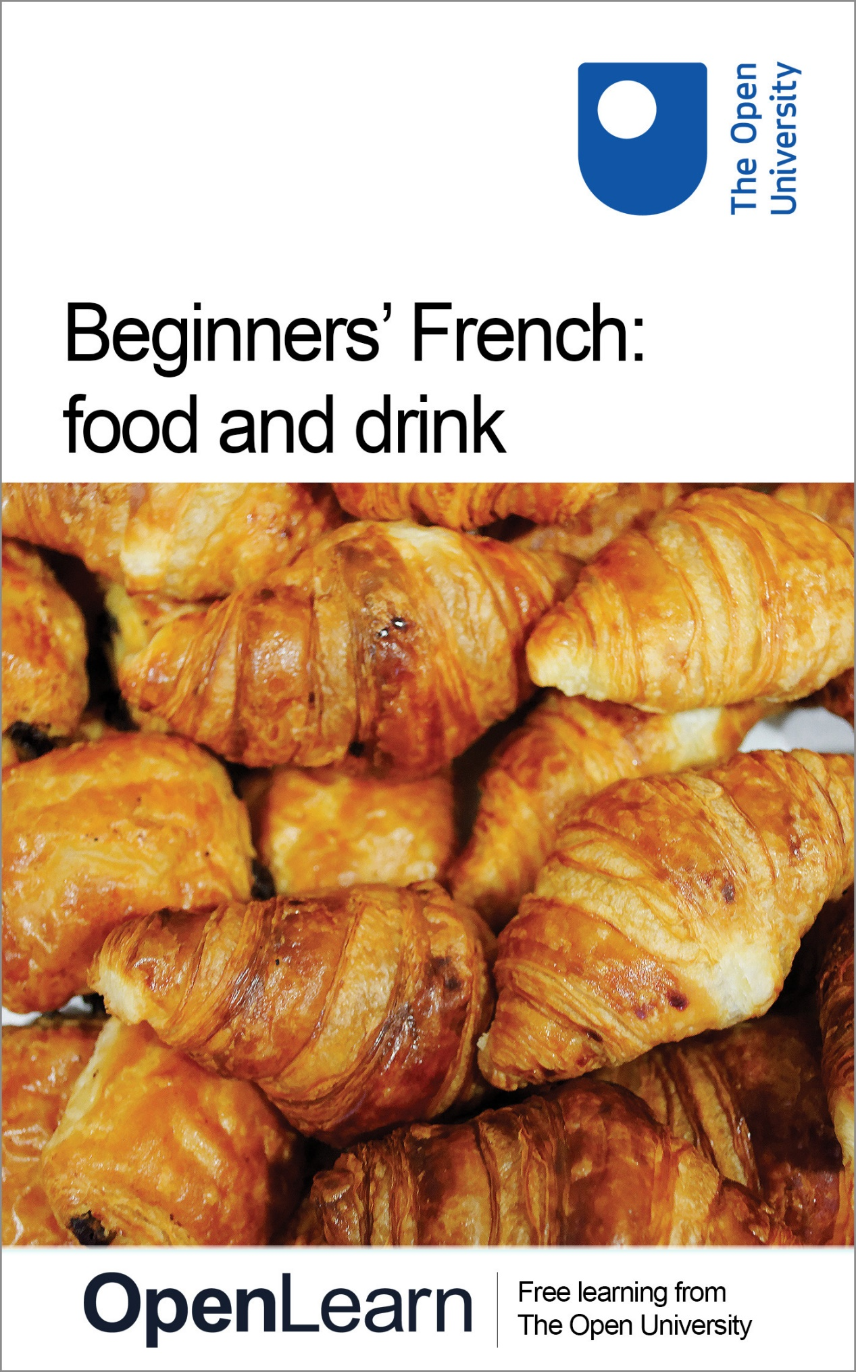

L192_2

Beginners’ French: food and drink

About this free course
This free course is an adapted extract from the Open University course L192 Bon départ: beginners' French http://www.open.ac.uk/study/undergraduate/course/l192.htm .
This version of the content may include video, images and interactive content that may not be optimised for your device.
You can experience this free course as it was originally designed on OpenLearn, the home of free learning from The Open University - http://www.open.edu/openlearn/languages/french/beginners-french-food-and-drink/content-section-0 .
There you’ll also be able to track your progress via your activity record, which you can use to demonstrate your learning.
Copyright © 2016 The Open University
Intellectual property
Unless otherwise stated, this resource is released under the terms of the Creative Commons Licence v4.0 http://creativecommons.org/licenses/by-nc-sa/4.0/deed.en_GB . Within that The Open University interprets this licence in the following way: www.open.edu/openlearn/about-openlearn/frequently-asked-questions-on-openlearn . Copyright and rights falling outside the terms of the Creative Commons Licence are retained or controlled by The Open University. Please read the full text before using any of the content.
We believe the primary barrier to accessing high-quality educational experiences is cost, which is why we aim to publish as much free content as possible under an open licence. If it proves difficult to release content under our preferred Creative Commons licence (e.g. because we can’t afford or gain the clearances or find suitable alternatives), we will still release the materials for free under a personal end-user licence.
This is because the learning experience will always be the same high quality offering and that should always be seen as positive – even if at times the licensing is different to Creative Commons.
When using the content you must attribute us (The Open University) (the OU) and any identified author in accordance with the terms of the Creative Commons Licence.
The Acknowledgements section is used to list, amongst other things, third party (Proprietary), licensed content which is not subject to Creative Commons licensing. Proprietary content must be used (retained) intact and in context to the content at all times.
The Acknowledgements section is also used to bring to your attention any other Special Restrictions which may apply to the content. For example there may be times when the Creative Commons Non-Commercial Sharealike licence does not apply to any of the content even if owned by us (The Open University). In these instances, unless stated otherwise, the content may be used for personal and non-commercial use.
We have also identified as Proprietary other material included in the content which is not subject to Creative Commons Licence. These are OU logos, trading names and may extend to certain photographic and video images and sound recordings and any other material as may be brought to your attention.
Unauthorised use of any of the content may constitute a breach of the terms and conditions and/or intellectual property laws.
We reserve the right to alter, amend or bring to an end any terms and conditions provided here without notice.
All rights falling outside the terms of the Creative Commons licence are retained or controlled by The Open University.
Head of Intellectual Property, The Open University
978-1-4730-1790-0 (.kdl)
978-1-4730-1022-2 (.epub)

Contents
- Introduction
- Learning outcomes
- 1 Food in France
  - 1.1 Talking about food in French
  - 1.2 Talking about what food you like
  - 1.3 Talking about what you dislike
- 2 Eating out in France
  - 2.1 Types of restaurants and menus
  - 2.2 Ordering food at a restaurant
  - 2.3 Paying your bill at a restaurant
- 3 Talking about eating habits
  - 3.1 Reading longer texts
- 4 Pronouncing the sounds [ s ] and [ z ]
- Conclusion
- Take the next step
- Acknowledgements
- Solutions

Introduction
In this free course, Beginners' French: food and drink, you will learn some basic vocabulary to talk about food and drink in French. You will learn how to express your likes and dislikes in relation to food, and you will learn how to order food and drinks in cafés or restaurants, and how to ask for your bill.
You will listen to French speakers in a variety of situations, and you will be provided with some skills for coping with reading texts. Cultural information throughout the course explains about customs surrounding meals and food habits in France.
This OpenLearn course is an adapted extract from the Open University course L192 Bon départ: beginners' French .

Learning outcomes
After studying this course, you should be able to:
- express likes and dislikes in relation to food and drink
- order food and drinks, and take part in simple exchanges
- pay restaurant or café bills
- demonstrate a better understanding of some food-related customs in France
- know how to approach reading longer texts

1 Food in France
In this section you will learn how to talk about food in French. In particular, you will learn how to say what food you like and dislike using the verbs aimer (‘to like’), adorer (‘to love’), and préférer (‘to prefer’) and the negative structure ne … pas .

1.1 Talking about food in French
Many French people place a great deal of importance on food – as the British often resort to talking about the weather, French people will fill the conversation with what they had for dinner the night before or what they are thinking of cooking that evening. Despite the growth in supermarkets, most French people still buy their bread from a local baker, and often visit markets to stock up on fresh, locally produced fruit, vegetables and meat. And although the pace of modern life has certainly affected how people eat, preparing food and taking time to enjoy it remain important.
Most regions boast an impressive diversity of dishes. From bouillabaisse (a fish soup from Provence) to choucroute (a dish of sauerkraut, sausages and pork, popular in Alsace), there are dozens of dishes and drinks to try when visiting a new region. Some regional specialities, such as foie gras or champagne , have become internationally famous.

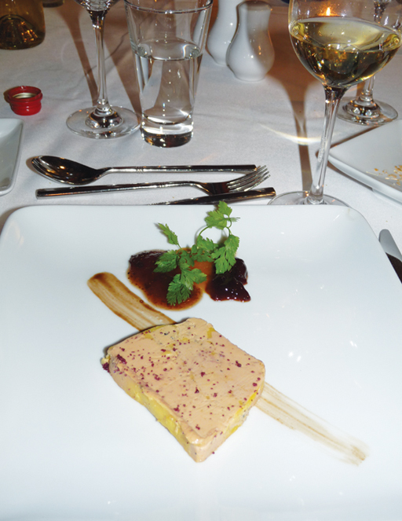
Figure 1 Le foie gras du sud-ouest

Activité 1

Task 1

Can you work out what the following French food items are? Drag the English words against the French terms they correspond to.

les légumes
la glace
le fromage
la viande rouge
l’ananas
les fruits de mer
le vin blanc
le poisson
les crudités
white wine
vegetables
sea food
red meat
raw vegetables
pineapple
ice cream
fish
cheese
View answer - Task 1

Task 2

Claudette Dupont and her husband, Paul, have invited their friends the Lenoirs and the Khalifes for dinner on Saturday. Claudette has made a list of what her guests and her husband like to eat.
Read her notes and for each name, select the item(s) that person likes.

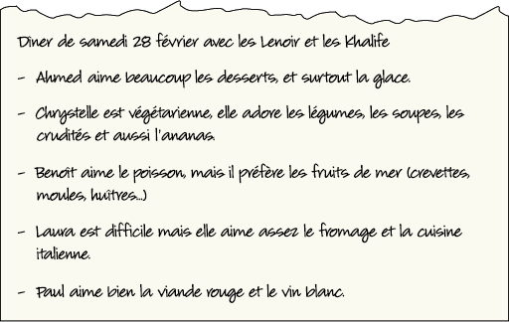
Figure 2
View description - Figure 2

Question 1

Ahmed

vegetables
ice cream
desserts
View answer - Question 1

Question 2

Chrystelle

cheese
vegetables
soups
View answer - Question 2

Question 3

Benoît

fish
sea food
white wine
View answer - Question 3

Question 4

Laura

cheese
fruit
Italian food
View answer - Question 4

Question 5

Paul

fish
white wine
red meat
View answer - Question 5

Activité 2

Task 1

We asked some French people what they like eating: Qu’est-ce que vous aimez manger ? Listen to the audio track, then select the correct answers below.

Audio content is not available in this format.
Audio 1
View transcript - Audio 1

Question 1

All the interviewees like fish.

True.
False.
View answer - Question 1

Question 2

Maryse, Philippe and Lionel like meat.

True.
False.
View answer - Question 2

Question 3

None of the interviewees like Italian food.

True.
False.
View answer - Question 3

Question 4

Maryse and Philippe like seafood.

True.
False.
View answer - Question 4

Question 5

Maryse likes cheese.

True.
False.
View answer - Question 5

1.2 Talking about what food you like

Talking about what you like using aimer , adorer and préférer + le/la/les
To express your likes, you can use several verbs: aimer , adorer or préférer .

Benoît aime le poisson. Benoît likes fish.
Chrystelle adore les légumes. Chrystelle loves vegetables.
Il préfère les fruits de mer. He prefers sea food.

Note that you will need a definite article . le, la, l’ or les ) when using the verbs of liking with a noun:

Il aime le poisson. He likes fish.
Il aime la viande. He likes meat.
Elle adore l ’ananas. She loves pineapple.
J’aime les desserts. I love dessert.

Beaucoup (‘a lot’), bien (‘rather a lot’) and assez (‘quite’), placed after the verb aimer , are used to say how much you like things. Surtout means ‘above all’.

Activité 3

Now watch this video clip, in which Élisa and Tobias are talking about food, and select which items of food that Tobias likes (below). Don’t worry if you don’t know the meaning of some of these words, concentrate on recognising the sounds for now. You can then check the meaning of each word in the comment when you check your answers.

Video content is not available in this format.
Video 1
View transcript - Video 1

les courgettes
les carottes
les haricots verts
les frites
les pâtes
le poulet
la viande
la sauce tomate
la confiture
le gruyère
le poisson
l’avocat
les betteraves
View answer - Activité 3
View comment - Activité 3

Activité 4

Now you are going to practise saying what you like and how much you like it. Listen to the questions and the prompts. Speak in the gaps to give your answers.

Exemple
(You hear) Vous aimez la cuisine italienne ?
(You hear) (Beaucoup)
(You say) Oui, j’aime beaucoup la cuisine italienne.

Audio content is not available in this format.
Audio 2
View transcript - Audio 2

1.3 Talking about what you dislike
To talk about what you dislike, you can use the negative form of the verbs used to express what you like. To form the negative in French, use ne before the verb and pas after the verb .ne becomes n’ in front of a verb starting with a vowel sound or an ‘h’):

Elle n’ aime pas les oignons. She doesn’t like onions.
Il n’ est pas français. He is not French.

You can use beaucoup and du tout with je n’aime pas to say how much you dislike something. If you use these words, they go after ne ... pas in the sentence:

Je n’ aime pas du tout la viande. I don’t like meat at all.
Il n’ aime pas beaucoup la cuisine nord-africaine. He doesn’t like North African food very much.

Note that in informal spoken French, people often omit the ne,

Je n’habite pas en France.→ J’habite pas en France. (I don’t live in France.)
Elle n’aime pas les sardines. → Elle aime pas les sardines. (She doesn’t like sardines.)

Activité 5

Claudette has just found out what her guests do not like to eat. Read her notes and identify all the words and phrases which express dislike.

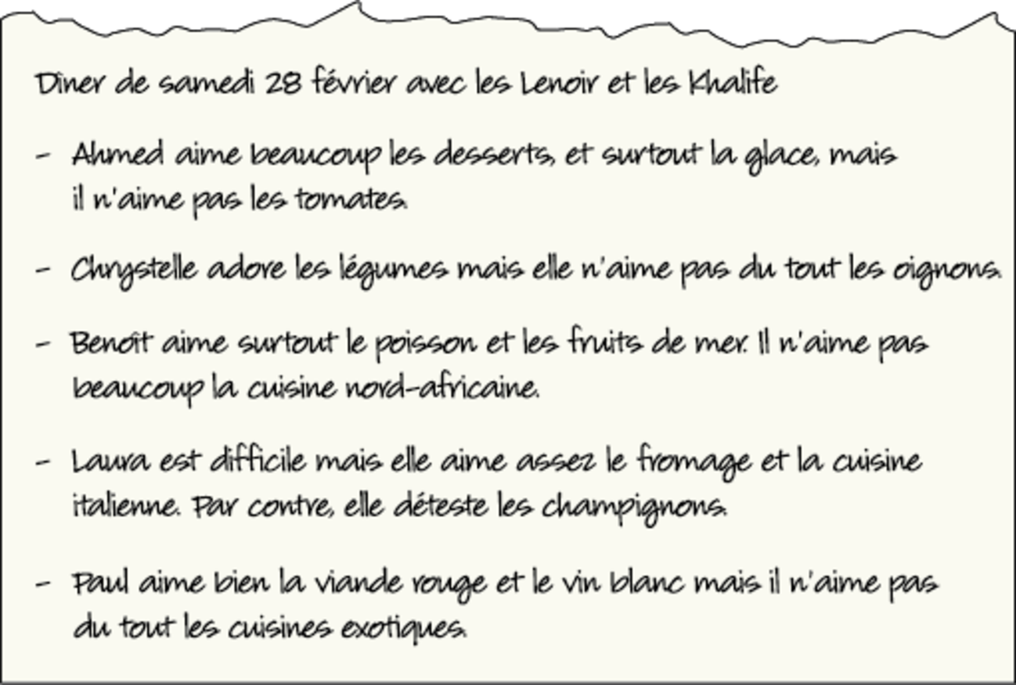
Figure 3
View description - Figure 3

Provide your answer...
View answer - Activité 5

Activité 6

Answer the following questions in the negative, using whole sentences and ne/n’ … pas, as shown in the example. Remember to put the negative elements in the correct place in your sentences.

Exemple
Il aime le poulet ? Non, il n’ aime pas le poulet.
Vous êtes docteur ? Non, je ne suis pas docteur.

- Vous êtes professeur ?
- Ils viennent de Montréal ?
- Vous aimez les huîtres ?
- Il parle portugais ?
- Vous avez 35 ans ?
- Elle habite en Angleterre ?
- Il est végétarien ?
- Elles sont étudiantes ?

Provide your answer...
View answer - Activité 6

Activité 7

Claudette’s son, Frédéric, is a very fussy eater. There are many things he won’t eat or drink. Listen to the audio track and, putting yourself in Frédéric ’s shoes, answer all the questions in the negative following the prompts you hear.

Exemple
(You hear) Tu aimes le café, Fred ?
(You hear) (Say no, you do not like coffee.)
(You say) Non, je n’aime pas le café.

Audio content is not available in this format.
Audio 6
View transcript - Audio 6

Activité 8

Claudette would like to invite you to her dinner party. Write a short message in French to tell her what kind of food you like and dislike.

Provide your answer...
View answer - Activité 8

2 Eating out in France
In this section you will learn how to order food using je voudrais, and you will learn vocabulary that is useful when you eat at a restaurant in France. You will read about eating out in France.

2.1 Types of restaurants and menus
You can find all sorts of different restaurants in France. There are Italian restaurants and pizzerias in practically every town; Vietnamese restaurants are also common. North African immigrants (from Algeria, Tunisia and Morocco) brought couscous (a grain related to semolina cooked with mutton, vegetables and spices), merguez (a spicy lamb sausage) and taboulé (a cold salad made with bulgur wheat and flavoured with mint and lemon).
‘Fusion’ cuisine, which makes use of a combination of international cooking styles, is on offer in a small but growing number of restaurants in France. However, it’s not easy to find vegetarian restaurants.

Le menu or la carte ?
Both le menu and la carte can be translated as ‘menu’ in English. French people will use either to request the menu in a restaurant. However, le menu is always used to refer to set menus. These are normally printed on a separate page in the menu . la carte ) or advertised at the entrance of the restaurant. Set menus can be advertised as, for example, menu à 21 €, menu gastronomique, menu touristique . The expression à la carte is used when you order your dishes from the full range of what is on offer. In brasseries and sandwicheries you may see the word formule instead of menu .

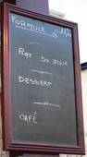
Figure 4

Activité 9

Look at the following pictures of restaurants and match them to the descriptions below, according to the type of cuisine they offer.
(Click on the photos or the words ‘View larger image’ to display a larger version of the photos.)

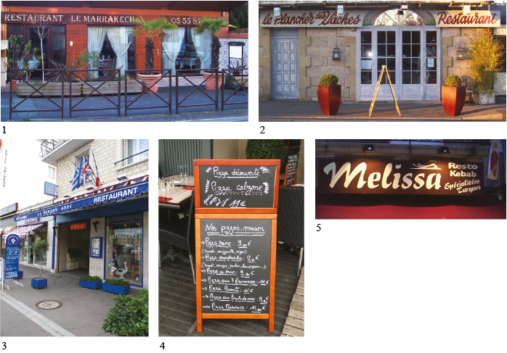
Figure 5

- un restaurant grec
- une couscousserie
- un restaurant kebab turc
- une pizzeria
- un restaurant de cuisine française

Provide your answer...
View answer - Activité 9

Activité 10

You are in a café-brasserie Le Bistro du Musée, deciding what to order. Look at the food items below and match the English dishes with their French equivalent.

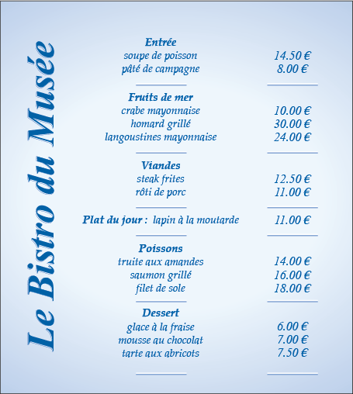
Figure 6
View description - Figure 6

une entrée
lapin à la moutarde
tarte aux abricots
plat du jour
today’s special
rabbit in mustard sauce
apricot tart
a starter
View answer - Activité 10

2.2 Ordering food at a restaurant

Using je voudrais + un/une + noun to order food
To order food, you can simply use the indefinite article un (masculine) or une (feminine) + the item. You would normally add s’il vous plaît (‘please’), at the end of the sentence:

Une soupe de poisson, s’il vous plaît. One fish soup, please.

If you want to order a specific quantity of items, you use the relevant number:

Trois croissants. Three croissants.
Deux pains au chocolat. Two pains au chocolat.
Un rôti de porc. One (plate of) roast pork.

You can also use the polite form (‘would like’) of the verb vouloir (‘want’): Je voudrais (‘I would like’) + article + item:

Je voudrais un rôti de porc. I’d like the roast pork.
Je voudrais une mousse au chocolat. I’d like the chocolate mousse.

Activité 11

You are about to have your lunch at the café-brasserie Le Bistro du Musée. You are going to place your order. Listen to the waitress and the prompts, and answer in the gaps in the audio track. To check your answers, look at the transcript.

Audio content is not available in this format.
Audio 8
View transcript - Audio 8

Café culture
If you order un café in France you will get un express (a strong black coffee). Make sure you say un grand café or un café allongé if you want a large black coffee, un café crème or just un crème if you want white coffee, and un grand crème if you want it large.
Traditional cafés in France are places where people go at any time of day and consume different drinks depending on the time of day. The food served in cafés is limited to light snacks, such as sandwiches or croque-monsieur . American-style coffee shops can now be found in larger French towns and cities, but are not as popular as traditional cafés.

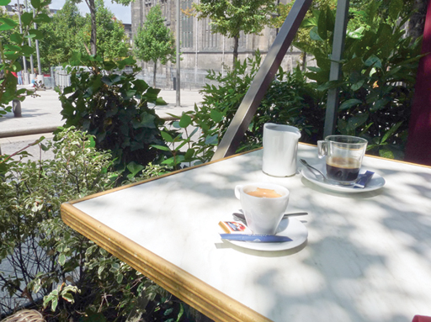
Figure 7

2.3 Paying your bill at a restaurant
This section teaches you how to pay your bill after a meal at a restaurant. You will also find out about the café culture in France.

Paying your bill: using ça fait / c’est combien ?
To ask for the price of an item or a meal, you can use:

C’est combien ?
Ça fait combien ?
Ça coûte combien ?

All mean ‘How much does it cost?’. Note that Ça coûte combien ? or Il/elle coûte combien ? tend to be used for items in shops.

Il coûte combien, ce T-shirt ? How much does this T-shirt cost?

To signal that you want to pay in a café or restaurant, you can use:

L’addition, s’il vous plaît. The bill, please.

The answer will be expressed in one of the following ways:

Vingt euros cinquante.
C’est vingt euros cinquante.
Ça coûte vingt euros cinquante.
Ça fait vingt euros cinquante.

All of which mean ‘That’ll be/That’s twenty euros fifty, please’.

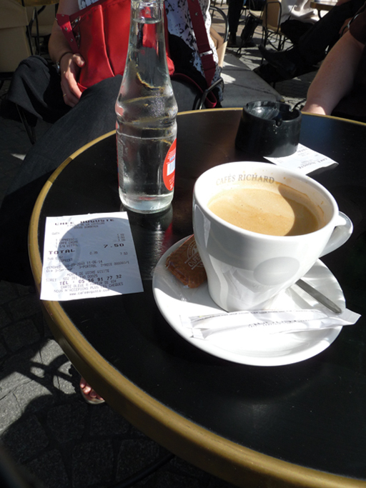
Figure 8

Activité 12

Now listen to the audio track below, paying attention to the questions and the prompts in the three dialogues. Play the role of the customer. Speak in the pauses following the prompts. To check your answers, look at the transcript.

Audio content is not available in this format.
Audio 23
View transcript - Audio 23

3 Talking about eating habits
In this section you will practise talking about what you eat, talking about different meals and eating habits.

Activité 13

Task 1

Match the French phrases below with their English translations.

Vous avez soif.
Vous avez faim.
Vous faites un régime.
Faire un gros repas.
Vous ne buvez rien.
Vous ne prenez rien / vous ne mangez pas.
Une boisson gazeuse.
C’est Noël.
You eat nothing.
You don’t drink anything.
You are thirsty.
You are on a diet.
You are hungry.
It’s Christmas.
Have a large meal.
A fizzy drink.
View answer - Task 1

Task 2

You want to eat healthily. Select the right answers in the quiz.

Question 1

Vous avez faim.

Vous aimez manger une barre de chocolat.
Vous mangez un ou deux fruits.
Vous ne mangez pas.
View answer - Question 1

Question 2

Vous avez soif.

Vous préférez une boisson gazeuse.
Vous ne buvez rien.
Vous prenez de l’eau minérale.
View answer - Question 2

Question 3

Pour le petit déjeuner...

Vous ne mangez pas.
Vous buvez du café.
Vous prenez des céréales, un thé et un fruit.
View answer - Question 3

Question 4

Au déjeuner, en général...

En général vous aimez faire un gros repas, de la viande, des frites et un dessert au chocolat.
Vous préférez travailler et vous ne prenez rien.
Vous mangez un sandwich, un fruit et un yaourt.
View answer - Question 4

Question 5

C’est Noël.

Vous mangez et buvez beaucoup.
Vous prenez de tout en petite quantité.
Vous faites un régime et choisissez de ne rien manger.
View answer - Question 5

3.1 Reading longer texts
In this section you will learn some tips to help you read longer texts in French. When you read longer texts, first look at the title, which will help you identify the topic and give you an idea of the content.
Illustrations (if there are any) may also help you to understand what a text is about.
Remember that there are usually a number of words in any text that are similar to those used in English. Using them as clues, you can often understand quite a lot of a text without resorting to your dictionary.
Aim to get the gist without attempting to understand every word. Use your dictionary if you need a more detailed comprehension.

Activité 14

Task 1

Read the text Les Français et les repas .

Les Français et les repas
Qu’est-ce qu’on mange en France ?
Le petit déjeuner
- 2% des Français ne prennent pas de petit déjeuner.
- La plupart des Français boivent plutôt du café (59%).
- 11% boivent un jus de fruits et 5% mangent un fruit le matin.
- Seulement 7% mangent des céréales.
- 59% mangent des tartines avec du beurre et/ou de la confiture.
- Le week-end, 17% des Français mangent des croissants, des pains au chocolat ou des pains aux raisins.
Le déjeuner
- 68% des Français déjeunent généralement chez eux en semaine.
- La plupart des Français (66%) mangent de la viande (bœuf, porc, poulet…)
- 38% mangent des légumes.
- Seulement 3% mangent un sandwich.
- 4% prennent un plateau-repas dans leur canapé.
- 17% (surtout les hommes et les personnes de plus de 55 ans) prennent une entrée, un plat et un dessert.
- De plus en plus, on prend un plat unique à midi.
Le dîner
- Le soir, les Français mangent en famille.
- Ils mangent souvent un repas complet (entrée, plat, et dessert).
- Les personnes de plus de 50 ans mangent souvent de la soupe et du fromage.
- Un Français sur dix mange des œufs le soir.
- Normalement on mange du fromage et un dessert.
- On boit de l’eau ou du vin.
- Le repas préféré des jeunes, c’est le steak-frites.

Find the French for:
- breakfast, lunch and dinner
- at home
- one-course meal
- TV dinner
- at lunchtime
- three-course meal

Provide your answer...
View answer - Task 1

Task 2

Read the text Les Français et les repas again and decide if the following statements are true or false.

Question 1

Few French people eat breakfast.

True.
False.
View answer - Question 1

Question 2

The most popular breakfast drink is coffee.

True.
False.
View answer - Question 2

Question 3

Cereal is not popular in France.

True.
False.
View answer - Question 3

Question 4

Most French people eat lunch at work during the week.

True.
False.
View answer - Question 4

Question 5

Most French people do not eat sandwiches for lunch.

True.
False.
View answer - Question 5

Question 6

Having just one course for lunch is increasingly popular.

True.
False.
View answer - Question 6

Question 7

In the evening, most French people eat just one course for dinner.

True.
False.
View answer - Question 7

4 Pronouncing the sounds [ s ] and [ z ]
In this section you will practise pronouncing the sounds [ s ] and [ z ].
Where there is a single ‘s’ between two vowels in a word, it is pronounced [ z ] as in ‘zero’, for example in the word poison. Where there is a double ‘s’ between two vowels this is pronounced [ s ] as in ‘mass’, for example in the word poisson. It is very important to distinguish between these sounds, as some words with quite similar spellings but very different meanings could otherwise be confused, e.g. dessert (‘dessert’) and désert (‘desert’)!

Activité 15

Task 1

Listen to the audio track and select whether you hear an ‘s’ sound (as in poisson) or a ‘z’ sound (as in raisin).

Audio content is not available in this format.
Audio 17
View transcript - Audio 17

Question 1

assiette

[s]
[z]
View answer - Question 1

Question 2

raisin

[s]
[z]
View answer - Question 2

Question 3

parmesan

[s]
[z]
View answer - Question 3

Question 4

soupe

[s]
[z]
View answer - Question 4

Question 5

croissant

[s]
[z]
View answer - Question 5

Question 6

pissaladière

[s]
[z]
View answer - Question 6

Question 7

boisson

[s]
[z]
View answer - Question 7

Question 8

cuisine

[s]
[z]
View answer - Question 8

Question 9

spécialités

[s]
[z]
View answer - Question 9

Question 10

soufflé

[s]
[z]
View answer - Question 10

Question 11

poisson

[s]
[z]
View answer - Question 11

Question 12

poison

[s]
[z]
View answer - Question 12

Question 13

désert

[s]
[z]
View answer - Question 13

Question 14

dessert

[s]
[z]
View answer - Question 14

Activité 16

Task 1

In this activity you will practise the pronunciation of the sounds [ s ] and [ z ].
Listen to each of the recordings below, then practise repeating the words with the appropriate pronunciation.

1.

Audio content is not available in this format.
Audio 5a
View transcript - Audio 5a

2.

Audio content is not available in this format.
Audio 5b
View transcript - Audio 5b

3.

Audio content is not available in this format.
Audio 5c
View transcript - Audio 5c

4.

Audio content is not available in this format.
Audio 5d
View transcript - Audio 5d

5.

Audio content is not available in this format.
Audio 5e
View transcript - Audio 5e

6.

Audio content is not available in this format.
Audio 5f
View transcript - Audio 5f

Conclusion
We hope you have enjoyed this course. Now that you know how to talk about what food you like and dislike, and that you have learned how to order food in a restaurant and what to say when you pay for it, you may wish to try this language out on your next visit to France or to another French-speaking country!
If you enjoyed this course, you might be interested in studying the Open University module L192 Bon départ: beginners' French. Or, if you are interested in other language short courses, rather than studying languages for a degree, you may want to have a look at what else is on offer here.

Take the next step

If you enjoyed this course, why not explore the subject further with our paid-for short course, Beginners French 1: eh oui!?
Find out more about Beginners French 1: eh oui!

Acknowledgements
Except for third party materials and otherwise stated (see terms and conditions), this content is made available under a Creative Commons Attribution-NonCommercial-ShareAlike 4.0 Licence .
Course image: Alex Brown in Flickr made available under Creative Commons Attribution-NonCommercial-ShareAlike 2.0 Licence .
The material acknowledged below is Proprietary and used under licence (not subject to Creative Commons Licence). Grateful acknowledgement is made to the following sources for permission to reproduce material in this free course:
Every effort has been made to contact copyright owners. If any have been inadvertently overlooked, the publishers will be pleased to make the necessary arrangements at the first opportunity.
Don't miss out
If reading this text has inspired you to learn more, you may be interested in joining the millions of people who discover our free learning resources and qualifications by visiting The Open University – www.open.edu/openlearn/free-courses.

Solutions

Activité 1

Task 1

Answer
The correct matches are:
les légumes
vegetables
la glace
ice cream
le fromage
cheese
la viande rouge
red meat
l’ananas
pineapple
les fruits de mer
sea food
le vin blanc
white wine
le poisson
fish
les crudités
raw vegetables
Back to - Task 1

Question 1

Answer
Right:
ice cream
desserts
Wrong:
vegetables
Back to - Question 1

Question 2

Answer
Right:
vegetables
soups
Wrong:
cheese
Back to - Question 2

Question 3

Answer
Right:
fish
sea food
Wrong:
white wine
Back to - Question 3

Question 4

Answer
Right:
cheese
Italian food
Wrong:
fruit
Back to - Question 4

Question 5

Answer
Right:
white wine
red meat
Wrong:
fish
Back to - Question 5

Activité 2

Question 1

Answer
Right:
True.
Wrong:
False.
Back to - Question 1

Question 2

Answer
Right:
True.
Wrong:
False.
Back to - Question 2

Question 3

Answer
Right:
False.
Wrong:
True.
Back to - Question 3

Question 4

Answer
Right:
False.
Wrong:
True.
Back to - Question 4

Question 5

Answer
Right:
True.
Wrong:
False.
Back to - Question 5

Activité 3

Answer
Right:
les haricots verts
les pâtes
la viande
la sauce tomate
le gruyère
le poisson
les betteraves
Wrong:
les courgettes
les carottes
les frites
le poulet
la confiture
l’avocat
Back to - Activité 3

Comment
Here are the translations of these words: les carottes (carrots); les haricots verts (green beans); les frites (chips); les pâtes (pasta); le poulet (chicken); la viande (meat); la sauce tomate (tomato sauce); la confiture (jam); le gruyère (Gruyère/hard cheese); le poisson (fish); l’avocat (avocado); les betteraves (beetroot).
Back to - Activité 3

Activité 5

Answer
You should have identified:

n’aime pas , for Ahmed
n’aime pas du tout , for Chrystelle
n’aime pas beaucoup , for Benoît
déteste , for Laura
n’aime pas du tout , for Paul.

Back to - Activité 5

Activité 6

Answer
You should have answered as follows.
- Non, je ne suis pas professeur.
- Non, ils ne viennent pas de Montréal.
- Non, je n’aime pas les huîtres.
- Non, il ne parle pas portugais.
- Non, je n’ai pas 35 ans.
- Non, elle n’habite pas en Angleterre.
- Non, il n’est pas végétarien.
- Non, elles ne sont pas étudiantes.
Note that n’ is used instead of ‘ne’ in sentences 3, 5, 6 and 7 because the verbs in question begin with a vowel or an ‘h’.
Back to - Activité 6

Activité 8

Answer
Here is one possible answer.

J’aime beaucoup les fruits de mer. J’aime aussi le poisson. J’adore la glace. Je n’aime pas du tout la viande rouge et je déteste les oignons. J’ai horreur des fast-foods !

Did you use a range of expressions from this section to express likes and dislikes?
Back to - Activité 8

Activité 9

Answer
The correct answers are:
1 b 2 e 3 a 4 d 5 c
Back to - Activité 9

Activité 10

Answer
The correct matches are:
une entrée
a starter
lapin à la moutarde
rabbit in mustard sauce
tarte aux abricots
apricot tart
plat du jour
today’s special
Back to - Activité 10

Activité 13

Task 1

Answer
The correct matches are:
Vous avez soif.
You are thirsty.
Vous avez faim.
You are hungry.
Vous faites un régime.
You are on a diet.
Faire un gros repas.
Have a large meal.
Vous ne buvez rien.
You don’t drink anything.
Vous ne prenez rien / vous ne mangez pas.
You eat nothing.
Une boisson gazeuse.
A fizzy drink.
C’est Noël.
It’s Christmas.
Back to - Task 1

Question 1

Answer
Right:
Vous mangez un ou deux fruits.
Wrong:
Vous aimez manger une barre de chocolat.
Vous ne mangez pas.
Back to - Question 1

Question 2

Answer
Right:
Vous prenez de l’eau minérale.
Wrong:
Vous préférez une boisson gazeuse.
Vous ne buvez rien.
Back to - Question 2

Question 3

Answer
Right:
Vous prenez des céréales, un thé et un fruit.
Wrong:
Vous ne mangez pas.
Vous buvez du café.
Back to - Question 3

Question 4

Answer
Right:
Vous mangez un sandwich, un fruit et un yaourt.
Wrong:
En général vous aimez faire un gros repas, de la viande, des frites et un dessert au chocolat.
Vous préférez travailler et vous ne prenez rien.
Back to - Question 4

Question 5

Answer
Right:
Vous prenez de tout en petite quantité.
Wrong:
Vous mangez et buvez beaucoup.
Vous faites un régime et choisissez de ne rien manger.
Back to - Question 5

Activité 14

Task 1

Answer
The correct answers are:
- breakfast, lunch and dinner: le petit déjeuner (breakfast); le déjeuner (lunch); le dîner (dinner).
- at home: chez eux
- one-course meal: plat unique
- TV dinner: un plateau-repas
- at lunchtime: à midi
- three-course meal: repas complet
Back to - Task 1

Question 1

Answer
Right:
False.
Wrong:
True.
Back to - Question 1

Question 2

Answer
Right:
True.
Wrong:
False.
Back to - Question 2

Question 3

Answer
Right:
True.
Wrong:
False.
Back to - Question 3

Question 4

Answer
Right:
False.
Wrong:
True.
Back to - Question 4

Question 5

Answer
Right:
True.
Wrong:
False.
Back to - Question 5

Question 6

Answer
Right:
True.
Wrong:
False.
Back to - Question 6

Question 7

Answer
Right:
False.
Wrong:
True.
Back to - Question 7

Activité 15

Question 1

Answer
Right:
[s]
Wrong:
[z]
Back to - Question 1

Question 2

Answer
Right:
[z]
Wrong:
[s]
Back to - Question 2

Question 3

Answer
Right:
[z]
Wrong:
[s]
Back to - Question 3

Question 4

Answer
Right:
[s]
Wrong:
[z]
Back to - Question 4

Question 5

Answer
Right:
[s]
Wrong:
[z]
Back to - Question 5

Question 6

Answer
Right:
[s]
Wrong:
[z]
Back to - Question 6

Question 7

Answer
Right:
[s]
Wrong:
[z]
Back to - Question 7

Question 8

Answer
Right:
[z]
Wrong:
[s]
Back to - Question 8

Question 9

Answer
Right:
[s]
Wrong:
[z]
Back to - Question 9

Question 10

Answer
Right:
[s]
Wrong:
[z]
Back to - Question 10

Question 11

Answer
Right:
[s]
Wrong:
[z]
Back to - Question 11

Question 12

Answer
Right:
[z]
Wrong:
[s]
Back to - Question 12

Question 13

Answer
Right:
[z]
Wrong:
[s]
Back to - Question 13

Question 14

Answer
Right:
[s]
Wrong:
[z]
Back to - Question 14

Figure 2

Description
This is an image of some hand-written notes, in French, which read as follows:
Dîner de samedi 28 février avec les Lenoir et les Khalife
– Ahmed aime beaucoup les desserts, et surtout la glace.
– Chrystelle est végétarienne, elle adore les légumes, les soupes, les crudités et aussi l’ananas.
– Benoît aime les poisson, mais il préfère les fruits de mer (crevettes, moules, huîtres...)
– Laura est difficile mais elle aime assez le fromage et la cuisine italienne.
– Paul aime bien la viande rouge et le vin blanc.
Back to - Figure 2

Figure 3

Description
This is an image of some hand-written notes, in French, which read as follows:
Dîner de samedi 28 février avec les Lenoir et les Khalife
– Ahmed aime beaucoup les desserts, et surtout la glace, mais il n’aime pas les tomates.
– Chrystelle adore les légumes mais elle n’aime pas du tout les oignons.
– Benoît aime surtout les poisson et les fruits de mer. Il n’aime pas beaucoup la cuisine nord-africaine.
– Laura est difficile mais elle aime assez le fromage et la cuisine italienne. Par contre, elle déteste les champignons.
– Paul aime bien la viande rouge et le vin blanc mais il n’aime pas du tout les cuisines exotiques.
Back to - Figure 3

Figure 6

Description
This is an image of a menu, which reads as follows:
Le Bistro du Musée
Entrée, soupe de poisson 14.50 €; pâté de compagne 8.00 €
Fruits de mer, crabe mayonnaise 10.00 €; homard grillé 30.00 €; langoustines mayonnaise 24.00 €
Viandes, steak frites 12.50 €; rôti de porc 11.00 €
Plat du jour, lapin à la moutarde 11.00 €
Poissons, truites aux amandes 14.00 €; saumon grillé 16.00 €; filet de sole 18.00 €
Dessert, glace à la fraise 6.00 €; mousse au chocolat 7.00 €; tarte aux abricots 7.50 €
Back to - Figure 6

Audio 1

Transcript
Les Français à table
Colette
Interviewer
Qu’est-ce que vous aimez manger ?
Colette
J’aime les légumes, les crudités …
Interviewer
Vous aimez le poisson ?
Colette
Le poisson, oui.
Interviewer
Les moules ?
Colette
Les coquillages, oui, les moules, les huîtres …
Interviewer
Vous aimez la cuisine italienne ?
Colette
Ah, j’aime beaucoup la cuisine italienne.
Maryse
Interviewer
Qu’est-ce que vous aimez manger ?
Maryse
J’aime la viande, le fromage, les légumes, les fruits.
Interviewer
Vous aimez le poisson ?
Maryse
J’aime le poisson.
Interviewer
Vous aimez la cuisine italienne ?
Maryse
Oui. J’aime les pâtes.
Philippe
Interviewer
Qu’est-ce que vous aimez manger ?
Philippe
J’aime bien manger la viande, le poisson…
Interviewer
Vous aimez la cuisine italienne ?
Philippe
J’aime bien la cuisine italienne, les pizzas et les pâtes, bien sûr.
Lionel
Interviewer
Qu’est-ce que vous aimez manger ?
Lionel
J’aime beaucoup la viande, les poissons, le poulet, les … les fruits de mer …
Interviewer
Vous aimez la cuisine italienne ?
Lionel
Oui, beaucoup, surtout les spaghetti.
Back to - Audio 1

Video 1

Transcript
Élisa
Tu aimes les courgettes ? Qu’est-ce que tu aimes ?
Tobias
Les haricots et la viande … et les pâtes.
Élisa
Et les pâtes ? T’aimes bien les pâtes? Tu aimes un petit peu ? Beaucoup ?
Tobias
Beaucoup ! J’aime beaucoup les pâtes.
Élisa
Ouais. Bon. Heu… Qu’est ce que je vais te donner à manger ?
Tobias
Avec de la viande avec mes pâtes, et de la sauce tomate et du gruyère.
Élisa
De la sauce tomate et du gruyère, d’accord.
Tobias
Et de la viande.
Élisa
Et de la viande. Oui. Euh, du poisson ?
Tobias
Ouais.
Élisa
Ouais. Ben, je ne sais pas, alors des haricots verts, de la viande et en entrée ? Euh, je vais faire des avocats.
Tobias
Non, pas des avocats.
Élisa
Pourquoi ?
Tobias
En entrée, je voudrais des betteraves.
Élisa
Des betteraves, ah ouais ?
Tobias
Il faut mettre du blanc dedans, et après ça devient rose et noir.
Élisa
D’accord … et moi je déteste les betteraves.
Tobias
Ah mais tu vas voir que c’est très bon.
Élisa
Ah je déteste ça, je ne veux pas en manger.
Tobias
Alors, alors c’est que moi qui vais manger tout le plat, des betteraves. Et toi, on va te donner quoi, comme entrée ? (Chuchotements)
Élisa
Des haricots verts froids ? Euh ben non, ben non, des œufs ?
Tobias
Oui, des œufs froids. Des œufs froids. Avec de l’aubergine !
Élisa
Avec de l’aubergine ? Froide ! Ça ne doit pas être bon …
Back to - Video 1

Audio 2

Transcript
Vous aimez la cuisine italienne ?
(Beaucoup)
Oui, j’aime beaucoup la cuisine italienne.
Vous aimez les fruits de mer ?
(Assez)
Oui, j’aime assez les fruits de mer.
Vous aimez la viande ?
(Bien)
Oui, j’aime bien la viande.
Back to - Audio 2

Audio 6

Transcript
Claudette
Tu aimes le café, Fred ?
(Say, no, you do not like coffee.)
Frederic
Non, je n’aime pas le café.
Claudette
Tu aimes le poisson ?
(Say, no you hate fish.)
Frederic
Non, je déteste le poisson.
Claudette
Et la viande, tu aimes la viande ?
(Say, no, you don’t like meat at all.)
Frederic
Ah, non, je n’aime pas du tout la viande !
Claudette
Et les légumes ? Tu aimes les légumes ?
(Say, no, you can’t stand vegetables.)
Frederic
Non, j’ai horreur des légumes.
Claudette
Et la glace, alors ?
(Say, no, you don’t like ice cream very much.)
Frederic
Non, je n’aime pas beaucoup la glace.
Claudette
Et les fruits de mer, tu aimes ça ?
(Say, no, you hate seafood.)
Frederic
Non, je déteste les fruits de mer.
Claudette
Mais que tu es difficile !
Back to - Audio 6

Audio 8

Transcript
La serveuse
Vous prenez une entrée, Madame ?
(Crabe mayonnaise)
La cliente
Oui, un crabe mayonnaise.
La serveuse
Et, puis après ?
(Lapin à la moutarde)
La cliente
Un lapin à la moutarde.
La serveuse
Et comme dessert ?
(Tarte aux abricots)
La cliente
Je voudrais une tarte aux abricots, s’il vous plaît.
Back to - Audio 8

Audio 23

Transcript
Dialogue 1
À la Brioche Dorée
(Ask how much it is, please.)
Le client
Ça fait combien, s’il vous plaît ?
La vendeuse
Ça fait quatre euros cinquante, s’il vous plaît.
(Repeat ‘four euros fifty!’ and ask how much does one pain au chocolat cost.)
Le client
Quatre euros cinquante !!! Il coûte combien le pain au chocolat ?
La vendeuse
Il coûte un euro cinquante, Monsieur.
(Say, okay. Here you are then.)
Le client
Ah bon. Bon, voilà.
La vendeuse
Merci, Monsieur. Bonne journée.
(Say, thank you, you too.)
Le client
Merci. À vous aussi.
Dialogue 2
Au café
(Call the waiter, and ask for the bill.)
Le client
Monsieur, l’addition, s’il vous plaît.
Le serveur
Oui, un instant … voici …
Dialogue 3
Dans un magasin
(Ask how much the truffle paté costs. 20 euros? Are you sure?)
Le client
Ah … euh. C’est combien le pâté aux truffes ? vingt euros ? Vous êtes sûre ?
L’employée
Euh, il y a une erreur, je crois, c’est douze euros vingt.
(Say, good, that’s more like it.)
Le client
Ah bon ! Je préfère ça !
Back to - Audio 23

Audio 17

Transcript
assiette, raisin, parmesan, soupe, croissant, pissaladière, boisson, cuisine, spécialités, soufflé, poisson, poison, désert, dessert
Back to - Audio 17

Audio 5a

Transcript
assiette
Back to - Audio 5a

Audio 5b

Transcript
poisson
Back to - Audio 5b

Audio 5c

Transcript
cuisine
Back to - Audio 5c

Audio 5d

Transcript
poison
Back to - Audio 5d

Audio 5e

Transcript
dessert
Back to - Audio 5e

Audio 5f

Transcript
désert
Back to - Audio 5f

