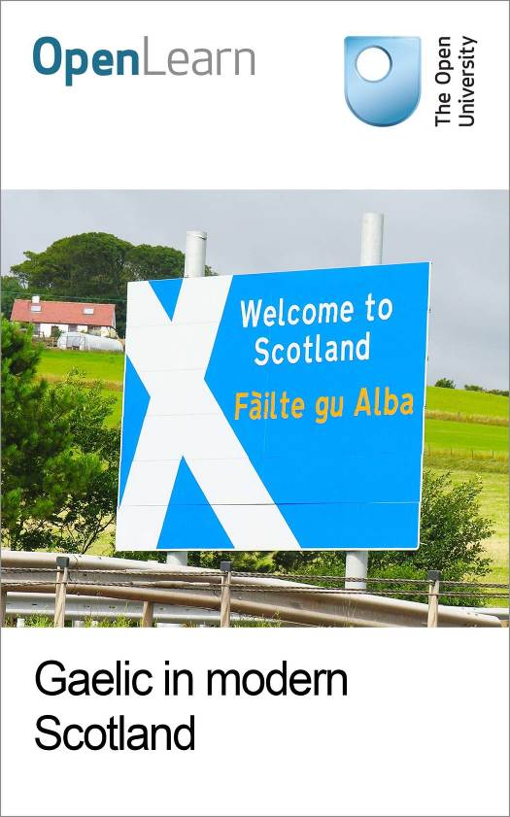

Gaelic_1

Gaelic in modern Scotland
About this free course
Find out more about studying with The Open University by visiting our online prospectus
This version of the content may include video, images and interactive content that may not be optimised for your device.
You can experience this free course as it was originally designed on OpenLearn, the home of free learning from The Open University – www.open.edu/openlearn/languages/more-languages/gaelic-modern-scotland/content-section-0
There you’ll also be able to track your progress via your activity record, which you can use to demonstrate your learning.
Copyright © 2016 The Open University
Intellectual property
Unless otherwise stated, this resource is released under the terms of the Creative Commons Licence v4.0 http://creativecommons.org/licenses/by-nc-sa/4.0/deed.en_GB. Within that The Open University interprets this licence in the following way: www.open.edu/openlearn/about-openlearn/frequently-asked-questions-on-openlearn. Copyright and rights falling outside the terms of the Creative Commons Licence are retained or controlled by The Open University. Please read the full text before using any of the content.
We believe the primary barrier to accessing high-quality educational experiences is cost, which is why we aim to publish as much free content as possible under an open licence. If it proves difficult to release content under our preferred Creative Commons licence (e.g. because we can’t afford or gain the clearances or find suitable alternatives), we will still release the materials for free under a personal end-user licence.
This is because the learning experience will always be the same high quality offering and that should always be seen as positive – even if at times the licensing is different to Creative Commons.
When using the content you must attribute us (The Open University) (the OU) and any identified author in accordance with the terms of the Creative Commons Licence.
The Acknowledgements section is used to list, amongst other things, third party (Proprietary), licensed content which is not subject to Creative Commons licensing. Proprietary content must be used (retained) intact and in context to the content at all times.
The Acknowledgements section is also used to bring to your attention any other Special Restrictions which may apply to the content. For example there may be times when the Creative Commons Non-Commercial Sharealike licence does not apply to any of the content even if owned by us (The Open University). In these instances, unless stated otherwise, the content may be used for personal and non-commercial use.
We have also identified as Proprietary other material included in the content which is not subject to Creative Commons Licence. These are OU logos, trading names and may extend to certain photographic and video images and sound recordings and any other material as may be brought to your attention.
Unauthorised use of any of the content may constitute a breach of the terms and conditions and/or intellectual property laws.
We reserve the right to alter, amend or bring to an end any terms and conditions provided here without notice.
All rights falling outside the terms of the Creative Commons licence are retained or controlled by The Open University.
Head of Intellectual Property, The Open University
978-1-4730-1933-1 (.kdl)
978-1-4730-1165-6 (.epub)

Contents
- Introduction
- Learning outcomes
- 1 Gaelic as a national language of Scotland
  - 1.1 Introduction
  - 1.2 History
  - 1.3 Place name evidence
  - 1.4 Retreat into the north and west
  - 1.5 Religion
  - 1.6 Education
- 2 Celtic roots and international reach
  - 2.1 Introduction
  - 2.2 The rise of the Celts
  - 2.3 Celtic place names
  - 2.4 The insular Celts
  - 2.5 The Brythonic languages
  - 2.6 The Goidelic languages
  - 2.7 The Celtic Diaspora
  - 2.8 Learners and enthusiasts worldwide
- 3 Gaelic in the modern era
  - 3.1 Who speaks Gaelic?
  - 3.2 Decline
  - 3.3 Revival
  - 3.4 Gaelic alive!
- 4 Gaelic – the rationale
  - 4.1 Bilingualism
  - 4.2 Why learn Gaelic?
  - 4.3 The rights of linguistic minorities
  - 4.4 Home and abroad: examples of bilingualism
- 5 How the Gaelic language works
  - 5.1 How do I say…?
  - 5.2 Gaelic: some basics
  - 5.3 New words: and evolving language
  - 5.4 How to learn Gaelic
  - 5.5 Options for children
- 6 Gaelic culture: a national asset
  - 6.1 The art of the Gàidhealtachd
  - 6.2 Gaelic music and song
  - 6.3 Dance
  - 6.4 Gaelic literature
  - 6.5 Sports and pastimes
- 7 FAQs
- Notes
- Conclusion
- Keep on learning
- Further reading
- Acknowledgements

Introduction
Modern Scotland is a multi-lingual country. Gaelic, Scots and English, along with newer introductions from Europe and beyond, all influence the way Scotland’s people now speak to each other and to the rest of the world.
Created with the positive encouragement of Bòrd na Gàidhlig and with support from BBC Alba, this course – available in both Gaelic and English – has been designed to provide a resource for people with a personal or professional interest in increasing their knowledge and understanding of the development and impact of Scottish Gaelic and its culture. It aims to surprise and challenge where necessary; to provide links and ideas for further research; and, for some, to kick-start a journey into learning a language which is integral to Scotland’s national identity.
The course is made up of seven sections which can be studied in sequence or individually. This course is also available on our OpenLearn Works website, where you can download and customise these materials to use in your own teaching or staff development.

Contents
- Gaelic as a national language of Scotland
  - Here you will learn how Gaelic sits alongside Scots and English as one of Scotland’s national languages. For example, by exploring the origin of place-names, you will learn about the influence of Gaelic right across Scotland.
- Celtic roots and international reach
  - This section provides an introduction to the origins and Celtic roots of Gaelic and its close linguistic relations including Irish and Manx. You will also hear and see how emigration from Scotland took Gaelic to the Americas and how there are now learners of Gaelic across the world.
- Gaelic in the modern era
  - Provides an up to date picture of who is speaking Gaelic now. It will help you understand the reasons for the decline in the number of Gaelic speakers in Scotland in the 20th century and the work currently being done by government, educational institutions and independent agencies to support and grow Gaelic language acquisition. There are links here to where to go if you decide you want to take your study of Gaelic further.
- Gaelic – the rationale
  - Asks you to consider the value of bi-lingualism/multi-lingualism to individuals and society. It draws on the example of New Zealand to explore how other countries have sought to protect and celebrate the contribution of their indigenous minority languages.
- How the Gaelic language works
  - Hear Gaelic spoken and practice for yourself. Audio resources will give you an insight into how Gaelic spelling, grammar and pronunciation work.
- Gaelic culture: a national asset
  - Lots of pictures, clips and links to people, places and events will help you learn how Gaelic language and culture continue to make a significant contribution to Scotland’s literature, visual arts, music, dance and sporting life.
- FAQs
  - A list of frequently asked questions (FAQs) for people who need quick and easy access to the facts and figures concerning Gaelic
Find out more about studying with The Open University by visiting our online prospectus

Learning outcomes
After studying this course, you should be able to:
- understand how Gaelic sits alongside Scots and English as one of Scotland’s national languages
- understand the origins and Celtic roots of Gaelic and its close linguistic relations, including Irish and Manx, and the Gaelic Diaspora
- understand who is speaking Gaelic now, the decline in Gaelic speakers in the twentieth century and the work currently being done by government, educational institutions and independent agencies to support and grow Gaelic language acquisition the value of bi-lingualism/multi-lingualism to individuals and society, and the efforts made by countries like New Zealand to protect and celebrate the contribution of indigenous minority languages
- understand how Gaelic is spoken
- understand how Gaelic language and culture continue to make a significant contribution to Scotland’s literature, visual arts, music, dance and sporting life.

1 Gaelic as a national language of Scotland

1.1 Introduction
Modern Scotland, like most nations of the world, is a multilingual entity with a complex linguistic history. In many people’s eyes, Gaelic belongs predominantly to the Highlands and (west coast) Islands, but the linguistic division of Scotland along the Highland/Lowland line reflects only the latter part of the country’s long history.
Indeed, of recorded Scottish languages, Gaelic defers solely to English with regard to its maximum geographical extent. The only modern administrative regions which have no significant Gaelic heritage are the Northern Isles of Orkney and Shetland, which remained outside the Scottish kingdom (and the later ‘Gàidhealtachd’) at the time of Gaelic pre-eminence and whose inhabitants view themselves as belonging largely to the Norse sphere of influence. In this section, we will explore the links between Gaelic and Scotland, both Highland and Lowland.

1.2 History
In the early part of the first millennium AD, the predominant languages in the British Isles were Celtic. Britain was dominated by P-Celtic or Brythonic, whose modern descendants are Welsh, Cornish and Breton, whereas the population of Ireland predominantly spoke Q-Celtic or Goidelic, from which Scottish Gaelic, Irish Gaelic and Manx Gaelic are derived. It is generally thought that immigration from Ireland brought Gaelic into parts of Wales, Cornwall, the Isle of Man and western Scotland, but the language survived in the long term only in Scotland and Man.
In the days before mechanised transport, it was the sea, rather than the land, that provided the easiest means of travel for people and goods and, given their close maritime connections, it was natural that regular communication took place between north-eastern Ireland and western Scotland.
By around 500 AD the small kingdom of Dál Riata¹ had expanded from Ulster to include a large swathe of western Scotland. This maritime region was populated by people known to Latin writers as Scotti, whose language was Gaelic. In Scotland their country, which eventually stretched from the Mull of Kintyre to as far north as Loch Broom, was referred to as Airer Goídel (the coastline of the Gaels), Earra-Ghàidheal in modern Gaelic, Argyll in its anglicised form.

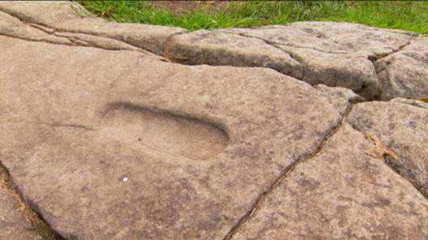
Figure 1 The footprint carved in the rock on the top of Dunadd in Argyll was used in the ceremonies to inaugurate the Gaelic kings of Dál Riata. The nearby inscription in Ogham, long thought to be Pictish, is in fact Gaelic.

The Scots came across other linguistic groups as they extended their influence across Scotland. The dominant people in the north were the Picts, who are thought largely to have spoken a P-Celtic language. Across the south were the Cumbric people, also speaking a P-Celtic tongue and, in the south-east, the Anglians, speakers of a Germanic tongue, which was the ancestor of modern Scots and English. For the next 600 years or so Gaelic was to expand at the expense of other languages, except in the far north and north-west, where it came under pressure from Norse from the 9th century onwards.
The church of St Columba (521-97), whose Gaelic name Colm Cille (Calum Cille in today’s vernacular) means ‘dove of the church’, played an important role in the Gaelic expansion.
From the monastery of Iona, established by Columba in 563, daughter monasteries were established and prosyletisation by Scottish and Pictish missionaries took Christianity across the country, founding institutions in which the vernacular tongue appears, more and more, to have been Gaelic.
For example, the marginal notes in the Book of Deer², written at the monastery of Deer in lowland Aberdeenshire in the 12th century, and which claim the institution was founded directly from Iona, are written in Gaelic.

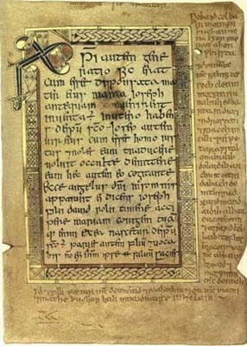
Figure 2 An example of marginal notes in the Book of Deer written in Gaelic in in the 12th century. Click here to see a map showing the location of Deer in Aberdeenshire.

Seemingly remote today, Iona was, in Columba’s time, at the centre of a maritime ‘highway’ linking communities along the length of western Scotland and northern Ireland. It was a place of great influence and played a crucial role in the conversion of the Picts and Northumbrians to Christianity. In Gaelic the island’s name is Eilean Ì (the island of Ì) or Ì Chaluim Chille (Columba’s Ì), giving Icolmkill, by which name it was known for centuries in English. The modern English name Iona derives from a mistranscription of the Latin form Ioua (Insula). The video clip below illustrates the important geographical position of the Western Isles.

Video content is not available in this format.
The Western Isles
Courtesy of BBC

It is thought that the world-famous Book of Kells (now in Trinity College, Dublin) was started, and perhaps even completed, in Iona during the 8th century AD, before being removed to Ireland for safekeeping during the times of the Viking raids on the Hebrides in the late 8th century. Click here for more information on the Book of Kells.

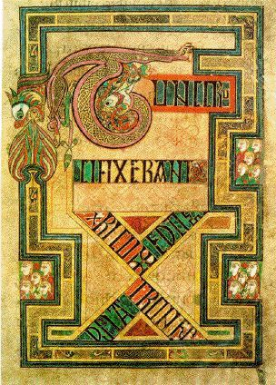
Dsmdgold/Wikipedia
Figure 3 Decorated text from the Book of Kells

There is no significant evidence for Scottish military conquest of the Picts, or that the Picts were driven out physically. Around 841 Kenneth (Cinaed) mac Alpín became King of Dál Riata and, two years later, he unified the Picts and Scots under his leadership. As the language of status and government, Gaelic became nationally dominant, absorbing Pictish. The kingdom was called Alba (and still is in Gaelic), an ancient term related to Albion which, in the days before the Anglo-Saxon invasions, had referred to the whole of Britain.
Records of the country being called Scotlandby English-speakers date from the 11th century; by this stage it is thought that Gaelic was the dominant language of the country, in both status and number of speakers.
The earliest records we have of written Gaelic are on stone in a script known as Ogham. But by the 6th century AD, monks in monastical scriptoria were starting to explore the use of the alphabet of the Church language – Latin – to write their own Gaelic vernacular. English and Gaelic have thus shared a similar alphabet for a very long time but, of course, the Latin letters had to be adapted to portray sounds which were not necessarily of identical quality in each language.
Anglophone readers soon learn that the English ‘rules’ which relate particular letters and letter combinations to particular sounds (and which are notoriously irregular in English) do not apply in Gaelic. The Gaelic language has its own rules. For example, a ‘b’ in the middle of a word is more like an English ‘p’. And a Gaelic peculiarity, not generally found in English, is the Svarabhakti (or ‘helping’) vowel (the term comes from ancient Sanskrit). This is a vowel sound which is not written but generally repeats (approximately) the preceding vowel. Alba, for example, is pronounced approximately ‘Al-uh-puh’.
Click on the sound file to hear its correct pronunciation

Audio content is not available in this format.
Alba

Gaelic slowly replaced Cumbric in most of southern Scotland, including the old kingdom of Strathclyde, in late medieval times. It is thought that, following the Scottish victory over the Northumbrians at the Battle of Carham³ (in the Borders) in 1018, Gaelic stemmed an Anglian advance in the south-east.
But it is unlikely that Gaelic, while being spoken by some of the ruling classes in Lothian and the south-east as far south as the border with England (and perhaps even across it), was ever numerically dominant in that part of the country. In 1091, when a Gaelic-speaking king ruled the lands north of the Tweed, except the far north and west which was under Norse control, the Anglo-Saxon chronicle records that Malcolm III (1058-93) went with his army ‘ut of Scotlande into Lodene on Englaland’ (out of Scotland into Lothian in England), presumably meaning that the dominant speech in Lothian was Anglian, or Inglis.
Malcolm III’s rule coincided with the challenge to Gaelic’s place at the pinnacle of Scottish power, and the start of its decline in southern and eastern Scotland can be dated from around the late 11th century.
Malcolm Canmore was a polyglot Gaelic king (his nickname derived from the Gaelic Ceann Mòr, ‘big head’, either in reference to a physical feature or to his kingship). He took the throne following the slaying of MacBeth at the Battle of Lumphanan in 1057. He married Margaret, a half-English princess whose brother’s claim to the throne of England was thwarted by the Norman invasion of 1066. Margaret, later canonised, promoted the cause of the English language in court and church.

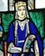
Figure 4 Queen Margaret, who promoted the cause of the English language in the Scottish court and church

Successive monarchs established and supported royal burghs in Gaelic Scotland, in which the ruling classes, often of Norman or Flemish ancestry, spoke English and were loyal to the crown.
Anglo-Norman magnates were granted land in various localities. While their preferred languages might originally have been Norman French and Latin, they became largely anglicised. The exceptions are some noted Highland clans of Norman origin⁴ – such as the Frasers, Grants and Chisholms – which became fully Gaelicised. At this stage it was only in the south and along the east coast that Gaelic was losing sway and, while the royal court, now firmly established in Edinburgh, might have spoken English, Norman French and Latin, the majority tongue of the ordinary people in Scotland as a whole was still Gaelic. It probably didn’t lose that status until the 15th century⁵.
However, the monarchs didn’t entirely divorce themselves from Gaelic tradition, Alexander III, for example, being crowned at Scone in 1249 in the traditional Gaelic manner. Robert Bruce, King of the Scots from 1306 until 1329, and victor at the Battle of Bannockburn in 1314, was of mixed parentage and almost certainly spoke Gaelic, among other languages; his father was of Norman extraction while his mother was from Carrick (now southern Ayrshire), then a Gaelic stronghold.
The Declaration of Arbroath, an appeal (written in Latin) to the Pope in 1320 for official recognition of Scotland’s status as an independent nation, makes it clear that the country’s nobles saw themselves as Scots, not Britons, Picts, Norwegians, Danes or English. The national identity had been forged, to a very large degree, by the Gaels.

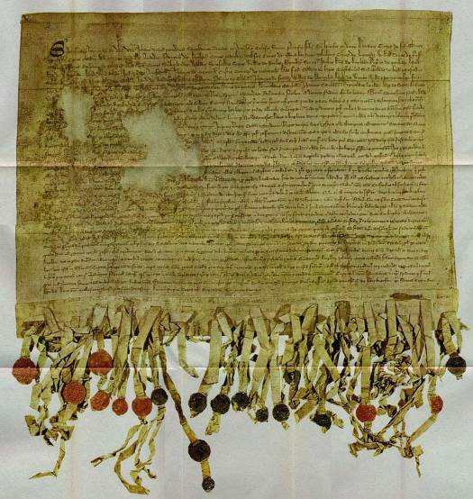
Figure 5 The Declaration of Arbroath is a famous document held in the National Archives of Scotland. Written at the time of the wars of independence with the English, which started with Edward I’s attempt to conquer Scotland in 1296, the declaration is a letter from the country’s earls and barons to the Pope, asking him to recognize Scotland’s status as an independent nation. While their claim that the Scots had migrated from ‘Greater Scythia by the Tyrrhene Sea and the Pillars of Hercules’ would be questioned by modern historians, their sense of Scottish identity is manifest in their affirmation that the ‘Britons they first drove out, the Picts they utterly destroyed, and, even though very often assailed by the Norwegians, the Danes and the English, they took possession of that home with many victories and untold efforts; and, as the historians of old time bear witness, they have held it free of all bondage ever since’

While Gaelic was losing ground in the south and east, the opposite process was taking place in the north and west, with many people of Norse or mixed Norse-Gaelic ancestry being assimilated into Gaelic society. Perhaps the most famous is Somerled, who first appears in 1140 as the regulus or king of Kintyre. When both David I of Scotland and Olaf, King of Man, died in 1153, Somerled moved to extend his control over the Hebrides, eventually achieving mastery of a sea kingdom stretching from Man to Lewis, thumbing his nose in the process at the Norwegians who had long claimed sovereignty over the isles. Innse Gall, ‘The Isles of the Foreigners’, were once more becoming Scottish, and the dynasty created by Somerled was to become The Lords of the Isles, a Gaelic-speaking polity that grew to challenge the power of the kings of Scotland in the west and which finally succumbed only in the late 15th century. Watch the video clip below to find out more about the Lordship of the Isles. The video stresses the strength of this Gaelic-speaking sub-kingdom.

Video content is not available in this format.
The Lordship of the Isles
Courtesy of BBC

Norway ceded sovereignty over its territories in Scotland, with the exception of Orkney and Shetland, to the Scottish crown in the Treaty of Perth (1266), strengthening the hand of Gaelic throughout the west and north, and ensuring a full regaelicisation⁶ of the Hebrides. Norn, the local descendant of Norse, clung on for some time in Caithness, gradually being replaced by Scots in the north-eastern half of the area and by Gaelic in its south-western half.
By the late 14th century the anglicisation of southern and eastern Scotland had reached such an extent that the term ‘Highlander’ (or Hielandman) had become synonymous with ‘Gaelic-speaker’. To the Gael, the Highlands became the Gàidhealtachd (the land of the Gael) and the Lowlands the Galltachd (land of the non-Gael), although the Gaelic folk-memory has always appreciated the historical links the language had with Lowland Scotland. Click below to listen to the pronunciation of Gàidhealtachd and Galltachd.

Audio content is not available in this format.
Gàidhealtachd

Audio content is not available in this format.
Galltachd

By this stage, many English-speakers viewed the Gaels with hostility and considered them culturally and socially inferior. But as one English-speaker writing in the 1380s, John of Fordun, makes clear, Gaelic was still viewed, even in his community, as ‘the Scottish speech’.

‘[T]wo languages are spoken among them, the Scottish and the Teutonic; the latter of which is the language of those who occupy the seaboard and plains, while the race of Scottish speech inhabits the Highlands and out-lying islands. The people of the coast are of domestic and civilised habits, trusty, patient and urbane, decent in their attire, affable and peaceful, devout in Divine worship … the Highlanders and people of the islands, on the other hand, are a savage and untamed nation, rude and independent, given to rapine, ease-loving, of a docile and warm disposition, comely in person, but unsightly in dress, hostile to the English-speaking people and language … and exceedingly cruel.’

1.3 Place name evidence
The spread of Gaelic across Scotland is demonstrated by the place names left behind by Gaelic-speakers. In some cases the Gaels adapted names created earlier by Pictish, Cumbric, Norse, or even English speakers, but in many instances they created their own nomenclature anew (some of which became modified in turn by other linguistic groups).
A classic Gaelic naming element is baile⁷, a place of permanent settlement as small as a farm but as large as a village or town, usually anglicized as bal-, balla- or occasionally bella-. The distribution of bailenames demonstrates the historic spread of the Gaelic-speaking population across Scotland, with a large number in Aberdeenshire, Angus and Fife, and examples found, for example, in Kirkcudbrightshire (Balcary, Balmaclellan, Balmingan), Dumfriesshire (Ballaggan, Baltersan), Selkirkshire (Balnakiel) and East Lothian (Balgone, Ballencrieff).
Another naming element is achadh⁸ (often shortened to acha- or ach-), originally a ‘field’ but which became applied to settlements. The only parts of Scotland where these are rare are the far south-east, possibly because the Gaels who settled there did not work the land to any great degree, and the Western Isles, owing to the influence of Norse terminology there. In the south and east of the country, the anglicised form is usually auch-; examples include Auchinbo and Auchintoul (Aberdeenshire), Auchendinny and Auchendoon in Midlothian, and Auchabrick and Auchenree in Wigtownshire. Examples in the Highlands include Achachork and Achnacloich (Skye), Achanalt and Achnashellach (Ross-shire) and Achavanich (Caithness).
While the oldest names can sometimes pose problems of interpretation, the later (generally Highland) names are mostly transparent. For example, Achachork is Achadh a’ Choirce (the field of the oats), Achnacloich is Achadh na Cloiche (the field of the stone), Achanalt is Achadh nan Allt (the field of the burns) and Achnashellach is Achadh nan Seileach (the field of the willows).
Other Gaelic place name elements which have a wide distribution in Scotland include kil- (Gaelic cill ‘church, churchyard’), tully or tilly- (Gaelic tulach, ‘hillock, knoll’) and knock (Gaelic cnoc, ‘hill’).
Examples of the first are Kilmarnock, Kilbirnie and Kilpatrick (Ayrshire), Kilbride (several, including Lanarkshire and Argyll), Kilallan (Renfrewshire), Kilfeddar (Wigtownshire), Kilbucho (Peeblesshire), Kilconquhar (Fife) and Kildrummy (Aberdeenshire).
Tulach examples include Tillydrine, Tillyfourie and Tillytarmont (Aberdeenshire) and Tullybelton, Tullyfergus and Tullymurdoch (Perthshire).
Knock is found in Big Knock (Peeblesshire), East and West Knock (Angus) and many places simply called Knock or The Knock.
In the Gàidhealtachd, the Ordnance Survey collected not anglicised versions of Gaelic originals as in the examples above, but thousands of pure Gaelic names, some of them going back to the earliest days of Dál Riata, but others much more modern. A great number of these are morphologically complex and pose a map-reading challenge to many Scots today, but they also provide a fantastically rich thread within the nation’s cultural tapestry.
Take, for example, Meall a’ Choire Chreagaich (the lump-shaped hill of the craggy corrie), Cnoc Alltan Iain Duinn (the hill of the small burn of brown-haired John), Allt Cnoc Àirigh an t-Seilich Bhig (the burn of the hill of the shieling of the small willow), and Rubha Camas nam Meanbh-chuileag (the headland of the bay of the midges).
Use the audio links below to listen to the pronunciations of these names:

Audio content is not available in this format.
Meall a’ Choire Chreagaich

Audio content is not available in this format.
Cnoc Alltan Iain Duinn

Audio content is not available in this format.
Allt Cnoc Àirigh an t-Seilich Bhig

Audio content is not available in this format.
Rubha Camas nam Meanbh-chuileag

If you are interested in hearing the correct pronunciation of the names of the Munros – Scotland’s mountains over 3,000 ft – click here.
Use the map below to explore the Gaelic and anglicised versions of the names of some well-known cities and towns in Scotland. Click on each place name to see its origin and hear its Gaelic pronunciation.

Interactive content is not available in this format.

1.4 Retreat into the north and west
By the end of the 15th century, the Inglis speech of the south-east was being referred to by its speakers as ‘Scottis’, indicating that Lowland Scots, while speaking a language closely related to that of their English neighbours, were Scottish in identity. Scots and Gaelic borrowed vocabulary from each other, as did Scots and Norse, and Gaelic and Norse.
Examples of words which entered Gaelic from Scots are bodhaig (from bouk, a body), dìg (ditch), eàrlas (arles, a pledge, token), poca (pock, poke, a bag) and radan (rattan, a rat). Scots words which derive from Gaelic include ben (beinn, a mountain), claymore (claidheamh mòr, a big sword), corrie (coire, a cauldron shaped bowl in the mountains), ghillie (gille, a servant), kyle (caol, a narrows), machair (machair, a plain) and whisky (uisge-beatha, water of life).
But, despite Gaelic’s status as a founding language of Scotland, Lowland writers started to refer to it as Irische or Ersch. This is seen in the famous poetic ‘Flyting of Dunbar and Kennedy’, written in Scots in around 1505, in which Lothian-born William Dunbar pours scorn on the Gaelic-speaking Walter Kennedy for being Heland and an Ersch Katherane (ironically using a word derived from Gaelic) whereas Kennedy tells Dunbar that Gaelic is all trew Scottismennis leid (all true Scotsmen’s language) and suggests that the latter would be happier living in England.
Kennedy, a significant and well-connected figure, was not from the Highlands at all, but from Carrick. This area and neighbouring Galloway remained Gaelic-speaking (their dialect is known as Galwegian Gaelic) long after the language had retreated from the rest of southern mainland Scotland, probably well into the 17th century. The dialect in nearby Arran, which was probably similar to Galwegian Gaelic, survived until the 20th century.
Dunbar’s disdain towards Kennedy’s Gaelic roots in Carrick (modern Ayrshire) is clear in the following stanza:

Sic eloquence as thay in Erschry use,  In sic is sett thy thraward appetyte.  Thow hes full littill feill of fair indyte.  I tak on me, ane pair of Lowthiane hippis  Sall fairar Inglis mak and mair perfyte  Than thow can blabbar with thy Carrik lippis. | Such eloquence as they in Irishry [Gaeldom] use  Is what defines your perverse taste.  You have very small aptitude for good verse-making.  I'll wager, a pair of Lothian hips  Shall fairer English make and more polished  Than thou can blabber with thy Carrick lips.

During the late 16th century, it is reckoned that half of Scotland’s population lived north of the Tay and a very large number of them spoke only Gaelic. Their language, way of life and tendency to be less than fully loyal to the Edinburgh-based monarch were an affront to King James VI, who embarked on a programme to unify the nation by turning his subjects into a monoglot English-speaking people. He attempted to break the power of the Highland clans and to plant Lowlanders in Gaelic-speaking areas, although he was notably unsuccessful in Lewis, where a band of would-be settlers, known as the Fife Adventurers, were forcibly resisted.
Following the union of the Crowns of Scotland and England in 1603, the king (now James I of England) felt emboldened to press his case for the eradication of the Gaelic language. In the Statutes of Iona (1609) he forced clan chiefs to send their eldest child to school in the Lowlands in order to anglicise them, and an Act of the Privy Council⁹ on 10 December 1616 expresses the desire that the ‘vulgar Inglishe toung be universallie plantit, and the Irische language … may be abolisheit and removeit’. The Act promoted the establishment of English-language schools in every parish, regardless of linguistic heritage.
It has been estimated¹⁰ that Gaelic was spoken by some 290,000 people, 23 per cent of Scotland’s population, in 1755. The total was down slightly to 254,000 in 1891 but by then this represented only 6.8 per cent of the national population. Gaelic was by now very much a minority language nationally although still very strong locally in much of the rural Highlands and Hebrides.

1.5 Religion
Because of the exclusion of Gaelic from government and most aspects of national public life, the Church was of great importance as one of the few national institutions where the language could be used in a high-register milieu. From the 17th century onwards, the Kirk made an effort to provide a Gaelic-speaking ministry for the Highlands, although a shortage of qualified ministers caused difficulties.
However, hostility to the language in official circles in the Lowlands ensured that the translation of the full scriptures into Gaelic was tardy, the first attempt being the reprinting in 1690 of the Irish Bible in Roman, rather than (Irish) Gaelic, script. This was unsatisfactory, as the Classical Irish Gaelic of the Bible did not adequately represent the Scottish vernacular.
The Scottish Gaelic New Testament was only completed in 1767 and the Old Testament in 1801, fully two hundred years after the publication of the Welsh Bible.

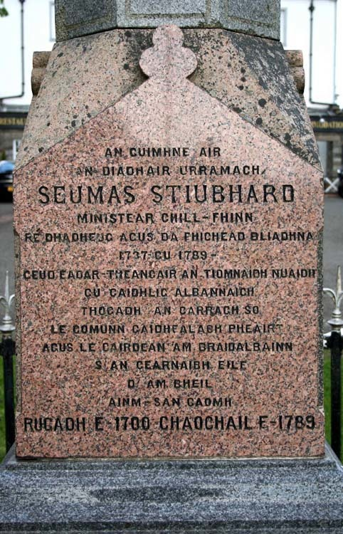
Figure 6 Memorial to the translator of the New Testament, Rev James Stuart, outside the Church of Scotland in Killin, Perthshire

1.6 Education
Any natural growth that might have taken place within the Gaelic-speaking population continued to be stymied by emigration (voluntary and forced) from Gaelic communities and an education system that discouraged the language’s use. The Society in Scotland for the Propagation of Christian Knowledge¹¹, established in 1709, played an important role in the education of young Gaels through the 18th and 19th Centuries. Initially, their attitude to the language was outwardly hostile and the speaking of Gaelic was banned even in the playground.
In 1750, the Society demanded of pupils ‘either in the School house or when playing about the doors thereof to speak Earse [Gaelic] on pain of being chastised and that the Schoolmasters appoint Censors to note down and report to the Schoolmaster such as transgress this rule’, but in 1766 they permitted the introduction of Gaelic reading in order to improve English reading among Gaelic-speaking children. And in 1825, still with their eye on improving English fluency, they recommended that Gaelic-speaking children ‘should instead of being taught first to read English as has been Universally practiced throughout the Highlands, be taught first to read Gaelic’.
However, when education was brought under the state’s control as a result of the 1872 Education (Scotland) Act, Gaelic was deliberately excluded. The view of Mr D Sime, Inspector of Schools for Ross, Caithness and Sutherland, is typical of establishment attitudes at the time. In 1878 he wrote, ‘I should regard the teaching of Gaelic in schools in any shape or form as a most serious misfortune.’
Later acts, while recognising the right of Gaelic to be taught as a subject in certain schools, failed to reinstate any sort of bilingual education. Gaelic was to be treated as entirely peripheral and, in the bulk of the Scottish education system, that remains its circumstance today.
The result has been a further lowering of the language’s status, a general ignorance among the populus that Gaelic was a founding language of the nation and was once spoken over most of its landmass, and the inability of the majority of Scots to read the map of Scotland, more than half of which is covered with Gaelic place names.
Along with continued economic hardship and depopulation in the Highlands and Islands, lack of Gaelic-medium education at school resulted in a dramatic fall in speaker numbers to under a 100 000 in the latter part of the 20th century. As a linguistic and cultural minority in a country increasingly dominated by English, the world’s most powerful language for communication, science and commerce, the Gaels have felt beleaguered and, at times, unappreciated by many fellow Scots. A large number of them finally fell prey to the orthodoxy that Gaelic was a hindrance to progress, and stopped speaking the language to their children.
But many within Gaeldom, and their supporters throughout Scotland and the wider world, have never abandoned their philosophical stance that Gaelic was not just a minority tongue belonging to their own community (and worthy, on that basis, of a valued place in a just society), but that it was also a national language of Scotland. Gaelic’s claim upon, and contribution to, the national life, culture and identity of Scotland was recognised by the Scottish Parliament in 2005 when the Gaelic Language (Scotland) Act¹² was passed with all-party support. The act declared that Gaelic had national status as ‘an official language of Scotland commanding equal respect to the English language’.
While it is the devolved Scottish Parliament that has taken prime responsibility for the development of the language, recent political developments also have a UK and European context. The UK is a signatory to the European Charter for Regional or Minority Languages, which obliges it to counter any measures which would ‘endanger the maintenance or development’ of Gaelic in Scotland. Gaels are increasingly appreciating that they are one of many minority language groups on a multilingual continent, in which a large percentage of the populace speak two or more languages. As the intellectual, social and cultural advantages of multilingualism become more widely understood in Scottish society, it is likely that Gaelic will become steadily more attractive to people from a wide array of cultural backgrounds.

2 Celtic roots and international reach

2.1 Introduction
Scotland is often defined as a ‘Celtic’¹³ nation, a characteristic it shares with other ‘fringe’ nations of the British Isles, most notably Ireland and Wales. It is often assumed, therefore, that ‘Celtic’ refers to geography and/or politics, or even ‘ethnic’ characteristics. In fact, ‘Celtic’ is a linguistic definition, referring to a group of related languages.
Scotland can be defined as a ‘Celtic’ nation because of its linguistic background. Pictish and Cumbric were Celtic languages, as is Gaelic, arguably the language which had the greatest influence in establishing a Scottish identity.
But not all languages spoken in Scotland are, or were, Celtic. Scots and English are Germanic, as was Old Norse. In this section, we shall explore the Celtic languages and the sense of Celtic identity that still exists in Scotland and beyond.

2.2 The rise of the Celts
The majority of Europe’s languages, including Gaelic, belong to a family known as Indo-European, so labelled because it includes most of the tongues of South Asia (with the exception of southern India), as well as Europe. Until a major expansion from the 15th century onwards, including the creation of overseas empires, these languages were largely restricted to Europe and southern and western Asia. Now they have a global distribution, with almost 3 billion native speakers and include some of the world’s most populous languages, such as Spanish, English, Hindi, Portuguese, Bengali, Russian, German and French.
Within the Indo-European family, there are several subgroupings identified by linguists. For example, English, Dutch and Norwegian belong to the Germanic subgroup, French, Italian and Spanish to the Italic subgroup, with Russian, Slovak and Polish being classified as Slavic tongues. One of the subgroups is Celtic, which contains the six living Celtic languages – Gaelic, Irish, Manx, Welsh, Breton and Cornish – and some that are now extinct eg Gaulish, Galatian, Celtiberian, Pictish and Cumbric.

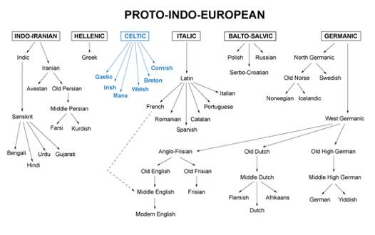
Figure 7 One model of a language tree showing the relationships between (major) languages of the Indo-European family

The earliest records of the Celts date from around 500 BC, when Greek texts referred to peoples to their north as Keltoi. The Latin term was Celtae, used of tribes and nations now understood to have been Celtic-speaking. The term was at this stage restricted to continental peoples.
The use of Celtic in relation to peoples of the British Isles dates from the 17th century when the linguist Edward Lhuyd made a comparative study of Welsh, Gaelic, Irish, Cornish and Breton, and established that these were related to each other and also to the extinct language of Gaul, which was indisputably Celtic.
For example the Gaulish mapos (‘son’) has its equivalent in modern Welsh mab and the Gaelic mac; the Gaulish tarvos (‘bull’) is closely related to the Welsh tarw and the Gaelic tarbh.
The following table shows some words in Gaelic, Irish, Welsh and Cornish which would appear to share a common origin (in a common Celtic ancestral language):

Table 1 Words in Gaelic, Irish, Welsh and Cornish which share a common origin
Scottish Gaelic | Irish Gaelic | Welsh | Cornish | English
aimsir | aimsir | amser |  | time, weather
anail | anáil | anadl | anall | breath
cath | cath | cad | kas | battle
caol | caol | cul | cul | slender
cnò | cnó | cneuen | know | nut
creamh | creamh | craf |  | wild garlic
cù | cú | ci | ki | dog, hound
làn | lán | llawn | leun | full
roth | roth | rhod | ros | wheel
taigh | teach | ty | ti | house
troigh | troigh | troed | troes | foot

The continental Celts were not a politically unified people – there was no such thing as a Celtic empire – but Celtic-speaking peoples, sharing some degree of common culture, lived across a wide swathe of Europe. They left virtually no written records so our knowledge of them comes largely from the Greeks and Romans, from the archaeological record, and from the place names they left behind.
The first Celtic culture to emerge, around the 8th century BC, is associated with finds made near the Austrian village of Hallstatt and is known as the Hallstatt Culture.

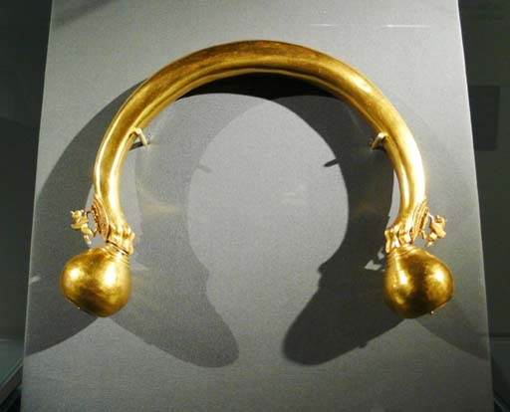
Rosemania/Flickr
Figure 8 A golden torque, an example of Hallstatt culture

Excavations provided evidence of a rich material culture and trading links to the Mediterranean world. Around the 5th century BC, we see the emergence of the La Tène Culture, named for excavations made at La Tène in Switzerland.

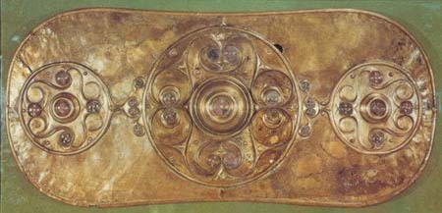
Figure 9 An example of La Tène art

This was also Celtic and appears to have been more expansive in nature; decorated metalwork of La Tène style have been found in Britain and Ireland, for example.

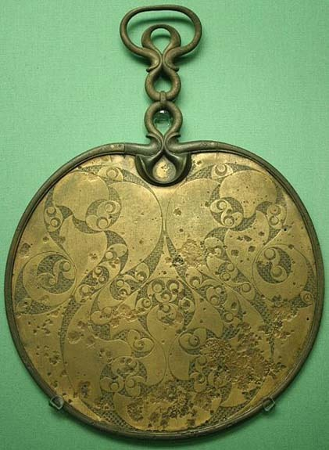
Figure 10 A Romano-Celtic mirror

It is uncertain what languages were being spoken in the British Isles at the time, but it is likely that Celtic was already among them. By the 3rd century BC, the Celts had spread across a large part of continental Europe, from modern Portugal to Belgium and Germany, into northern Italy, through the Danube basin and even down into Turkey.

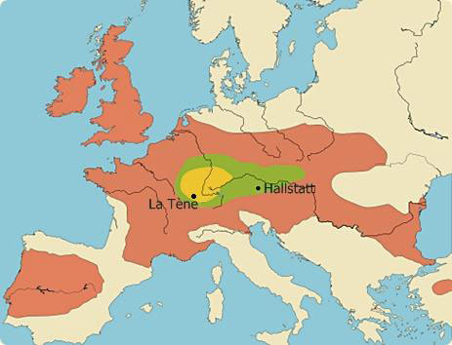
Figure 11 The spread of Celtic languages through continental Europe (Above and below)

2.3 Celtic place names
Historical records of tribe names and place names give a strong indication of the spread of Celtic languages. For example, dunum or dunon, a fort, is found in the recorded names of Lugdunum (now Lyons, France and Leyden, Netherlands), Camulodunum (now Colchester, England), Kambodunon (now Kempten, Germany), Minnodunum (now Moudon, Switzerland), Lugidunum (now Legnica, Poland) and Singidunum (now Belgrade, Serbia). There is also a 2nd century AD record of a Tarvedu(nu)m ‘bull fort’ in the far north of Scotland, thought to represent modern Dunnet Head in Caithness. While most of these names have become obsolete, many place names still contain this element, or its descendant form, in countries where Celtic languages remain extant. Scottish examples include Dùn Dè (Dundee), Dùn Phàrlain (Dunfermline) and Dùn Gabhail (Dungavel).
Territory names with Gal- in them mark the spread of the Celtic peoples, as another term used by the Greeks for the Celts was Galatae; the Romans referred to Galli. There is a Galicia both in north-western Spain and in the borderlands of Ukraine and Poland.

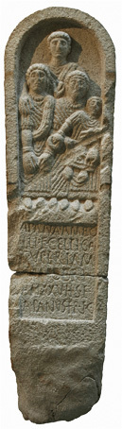
Figure 12 An example of a Celtic Stele

The adjective ‘Gallic’, meaning French, refers to that country’s origins as the Celtic land of Gaul(interestingly the Gaelic word Gall, a ‘Lowlander’, originally meant a Gaul). Galatia, in the centre of modern Turkey, boasts an ancient Celtic heritage which sprang from a migration of Celts from the middle Danube into Macedonia and Greece in the 3rd century BC. Some thousands of these Celts, both warriors and their families, were invited to participate in a conflict in Anatolia, after which they remained in the country. The Galatians are famed as the recipients of Paul’s Epistle, now a book of the Bible, and as late as the 4th century AD, St Jerome wrote that they spoke the same language as the natives of an area of the German Rhineland.

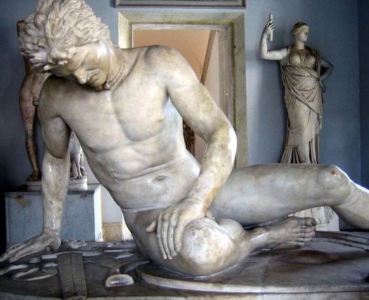
Figure 13 The Dying Gaul, a Roman statue based on a Greek bronze original actually depicts a Galatian warrior. Like other Celts the Galatians went into battle naked.

2.4 The insular Celts
In the early part of the first millennium AD, the continental Celtic languages came under pressure from other linguistic groups, most notably the Romans, and by AD 500 even the once-powerful Gaulish had been all but extinguished. In Britain and Ireland, however, Celtic languages and cultures were still vibrant. This group, from which all of today’s Celtic languages (including Breton) have evolved, is called Insular Celtic.

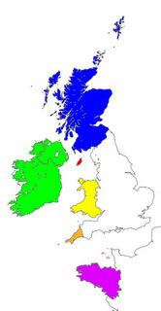
Figure 14 A map showing the ‘Celtic countries’ of today – Scotland, Ireland, Man, Wales, Cornwall and Brittany – each of which boasts its own Celtic language. All of them, including Breton (which was taken to Armorica by British settlers), are classified as Insular Celtic languages

Even by this stage, Insular Celtic was far from uniform. From a theoretical Proto-Celtic common ancestor, two groups had evolved – P-Celtic (also known as Brythonic) and Q-Celtic (or Goidelic)¹⁴. The P- and Q- names are based on how each group treated the ancient ‘Q’ sound in Proto-Celtic. The Goidelic speakers simplified this to a ‘c’ sound, while the Brythonic Celts converted it to a ‘p’ sound. Each branch of Insular Celtic was represented in both Ireland and Britain, but Ireland was dominated by Goidelic speakers, while most of Britain was Brythonic.
The major division within Insular Celtic is still in evidence today. The surviving Brythonic languages – Welsh, Cornish and Breton – bear similarities to each other and permit some degree of mutual comprehension. The Goidelic languages – Scottish Gaelic, Irish Gaelic and Manx Gaelic – also have close relationships to each other; a fluent speaker of Scottish Gaelic, for example, can understand the basics of a simple conversation in Irish Gaelic. Even in Columba’s day (6th century AD), however, a translator was required for the Irish-born saint to converse with a Pictish king: the churchman’s language was Q-Celtic, whereas the Picts spoke a P-Celtic language.
The difference between the two groups can be seen in words still in currency in modern Celtic languages. For example the Goidelic mac (‘son’) has its equivalent in the Brythonic map and the Goidelic ceann (‘head’) is analogous to the Brythonic pen. Here are some other comparisons, using Welsh and Scottish Gaelic as examples:

Table 2 Comparisons between Goidelic and Brythonic words still used in modern Celtic languages
Welsh (Brythonic/P-Celtic) | Gaelic (Goidelic/Q-Celtic) | English
pa | ciod | what
pair | coire | cauldron
plant | clann | children
pump | còig | five
pwy | cò | who

2.5 The Brythonic languages
The Brythonic languages have suffered considerable language death in the British Isles (Pictish and Cumbric in Scotland, for example, disappeared centuries ago), and the circumstances of the survivors are extremely varied.
Welsh is the most successful of all the Celtic languages, with around 580,000 people in Wales claiming to speak Welsh in the 2001 Census. It is classified by UNESCO as ‘vulnerable’, whereas all the other Celtic languages are either ‘definitely endangered’ or ‘critically endangered’.
Encouragingly, the percentage of the Welsh population with the full range of skills (i.e. able to speak, read and write Welsh) increased from 13.6 per cent in 1991 to 16.3 per cent in 2001. Welsh has also made considerable progress in achieving improved official status in Wales.
Cornish, like Welsh, is a descendant of the Brythonic language once spoken across southern Britain. Welsh and Cornish were effectively isolated from each other after the victory of the West Saxons at the Battle of Dyrham (near Bath) in AD 577.
Cornish is thought to have been spoken by up to 38,000 people in the early 14th century but it declined dramatically under pressure from English from the mid-16th century and disappeared as a community language in the 18th century. It is now in a revival phase and boasts several hundred fluent, or semi-fluent, speakers. For more information on the history of Cornish, click here (right-click to open the link in a new window or tab).
Brittany’s modern Celtic heritage derives not from a continental Gaulish ancestry, but largely as a result of immigration of Brythonic speakers from Britain following the Anglo-Saxon invasions of the 5th century AD onwards. The Breton language’s closest relative is therefore Cornish.
Today Breton¹⁵ has around 300 000 speakers, but numbers have fallen dramatically from about a million in 1945. In its traditional heartland in western Brittany, the percentage of the population speaking the language has decreased from 90 per cent in 1900 to less than 25 per cent today.

2.6 The Goidelic languages
Three descendant languages of early Goidelic are spoken today and they all face significant challenges. The strongest is Irish Gaelic (Gaeilge), an official language of the Irish Republic (Éire), which was declared to be in daily use by 340,000 people in the 2002 Census, with some 1,571,000 claiming to be Irish-speaking to some degree (although many experts claim that the reality of numbers on the ground using Irish on a daily basis is much less than this). In Northern Ireland a further 167,000 people claimed to speak Irish in the 2001 UK Census, some 10 per cent of the province’s population, with some 75,000 claiming more or less total fluency. The best areas to hear spoken Irish are in the small Gaeltacht areas, where the language has primacy; most of these are in rural parts of the west.
Scottish Gaelic (Gàidhlig), like Irish, is classified by UNESCO as ‘definitely endangered’ but, in reality, it is in a poorer situation than Irish, having fallen to a low of 92,400 people in Scotland who claimed some language ability in 2001. This was made up of 58,700 speakers and 33,700 who could read, write or understand it.
However, this situation is improving – between 1991 and 2001 the number of speakers fell 11 per cent, but the number of people with reading and writing ability increased 7.5 per cent and 10 per cent respectively. While it has suffered a catastrophic decline, Gaelic is still easily in the top half of the world’s languages measured on numbers of speakers and, following the Gaelic Language (Scotland) Act of 2005, it is now the recipient of significant state funding.
The primary Scottish Government agency working on behalf of the Gaelic Language is Bòrd na Gàidhlig, whose headquarters are in Inverness, the capital of the Highlands. Its website is here.
Goidelic has been on the Isle of Man since the 5th century AD and its descendant, Manx Gaelic (Gaelg), is still spoken today, having survived long periods of political domination by Norse and English. Man was part of the Gaelic-speaking Lordship of the Isles, which encompassed the Hebrides. Following the death of the last native (first-language) speaker in 1974, experts classified Manx as ‘extinct’. This, however, ignored the fact that there remained a fluent speaker community, based around people who had learned Manx as a second tongue.
UNESCO has now upgraded Manx to the same status as Cornish – ‘critically endangered’. In reality, because of language activism and support from the Isle of Man Government, Manx has come back from the brink and is in a recovery phase. There is now a limited amount of Manx-medium education, and the number of speakers has increased dramatically over the last few decades, from 165 in 1961 to 1,689 in 2001.
The differences between the three Goidelic languages have been enhanced by the loss of dialectal forms that might have acted as bridges between them. For example, the Gaelic of Rathlin Island was very close to Scottish Gaelic, while the extinct Scottish dialects of Kintyre and Galloway probably bore similarities to Irish, as well as to Manx. Even today the Gaelic of Argyll employs words and phrases which might be seen by more northerly Scottish Gaels as ‘Irishisms’, as shown by the examples below.

Table 3 Differences and similarities between Goidelic languages
Irish Gaelic | Argyll Gaelic | Northern Scottish Gaelic | English
ascaill | asgaill | achlais | armpit
citeal | ceatal | coire | kettle
comharsa | coimhearsnach | nàbaidh | neighbour
cosúil | cosail | coltach | like, resembling
dreoilín | dreòlan | dreathann-donn | wren
go raibh maith agat | gun robh maith agad | tapadh leat | thank you
gruaig | gruag | falt | hair of the head
olann | olann | clòimh | wool
sé | sè | sia | six
siopa | siop | bùth | shop

Similarly, most Scottish Gaelic speakers would find the Donegal (Ulster) dialect of Irish more readily comprehensible than those spoken further south in Ireland (the dialectal variance within Irish is more marked than that within Scottish Gaelic). This can be illustrated by the sentence: ‘How are you?’

Table 4 How are you?
Scottish | Ciamar a tha thu? / Dè mar a tha thu?
Ulster (north west Ireland) | Cad é mar atá tú?
Connacht (central west Ireland) | Cén chaoi a bhfuil tú?
Munster (south west Ireland) | Conas atá tú?

But this is only a rule of thumb and, perhaps paradoxically, Munster forms can sometimes seem familiar to Scots; for ‘How are you?’, for example, some Scottish Gaelic speakers would say: ‘Cionnas a tha thu?’!
Despite the obvious similarities, there are some fairly significant differences between Scottish and Irish Gaelic that allow them to be classified now as sister languages, rather than dialects of the one tongue (which would have been the case a few hundred years ago, when Gaelic was spoken continously from Cork to Caithness).
The simple present verbal tense, still a part of Irish Gaelic, has been replaced in Scottish Gaelic by the present continous, employing a verbal noun. Thus, the Irish tuigim (‘I understand’) is paralleled by the Scottish tha mi a’ tuigsinn (literally ‘I am at understanding’). And an old common negative verbal form nichon has been abbreviated differently in each country, giving ní in Ireland and chan in Scotland (although chan is also found in Ulster). Thus we get chan eil airgead agam (‘I don’t have money’) in Scottish Gaelic and níl airgead agam in Irish.
The accents, which indicate vowel lengthening, are different in each language. In Irish they are all acute and in Scottish Gaelic, following reform of the orthography in the early 1980s, they are all grave. Thus, welcome signs in Ireland say ‘Fáilte’ whereas in Scotland they proclaim ‘Fàilte’. Some words bear emphasis on the final syllable in Irish, particularly in southern dialects, whereas Scottish Gaelic almost always places the emphasis on the first syllable of a word. Thus salmon is bradan (Scottish) and bradán (Irish); bread is aran (Scottish) and arán (Irish).
Scottish Gaelic has retained the classical Gaelic usage of the plural personal pronoun sibh in order to show respect to an individual (as with vous in French). Thus, in speaking to a person a generation older, a Scot would say ‘Ciamar a tha sibh?’ rather than using the singular, familiar ‘Ciamar a tha thu?’ In contrast, an Irish speaker would only ever use sibh to speak to more than one person.
The rules for inflexion, that is the modification of a word in relation to grammatical requirements, also vary a little between Irish and Scottish Gaelic, and their vocabularies have been differentially affected by neighbouring tongues. For example, Scottish Gaelic has borrowed loanwords from Norse and Scots, which are not generally paralleled in Irish (although Irish does have some Norse borrowings). However, they have both borrowed heavily, and similarly, from English.
The softer consonant sounds characteristic of Scottish Gaelic are the result, not only of a greater amount of lenition (a softening of consonants indicated in writing by an intrusive ‘h’ following the lenited consonant), but also of pre-aspiration (where an intrusive ‘h’ or ‘ch’ is pronounced, but not written, before the consonant). The latter is not present in Irish, but is found in Icelandic, Faroese and Norwegian (and intriguingly in philologically unrelated Arctic languages like Sami and Greenlandic). Pre-aspiration means that the word mac (‘son’) is pronounced ‘mak’ in Irish but ‘machk’ in Scottish Gaelic.
The orthographical systems of Scottish Gaelic and Irish Gaelic are quite similar, being modernised variants of what was employed for the writing of the classical Gaelic used by the educated elite of both countries; thus readers of Scottish Gaelic can get the gist of an Irish text and vice-versa. Manx, however, is substantially different and largely opaque to readers of the other two Gaelics. Its orthography was developed in the 17th century and it owes much to the English, and to a lesser degree Welsh, systems of representing sounds with letters. Some of the differences can be appreciated in the table below.

Table 5 Orthographical similarities between Scottish and Irish Gaelic, with differences from Manx Gaelic
Scottish Gaelic | Irish Gaelic | Manx Gaelic | English
a’ bhean | an bhean | yn ven | the wife, woman
ceann | ceann | kione | a head
deoch | deoch | jough | a drink
Dimàirt | Dé Máirt | Jemayrt | Tuesday
gu leòr | go leor | di liooar | enough
iasg | iasc | eeast | a fish
loch | loch | logh | a lake
seòmar | seomra | shamyr | a room
teth | te | çheh | hot

2.7 The Celtic Diaspora
The movement of Celtic-speaking peoples to other parts of the world, which has led to millions of North Americans, Australians, and New Zealanders being able to claim Celtic ancestry, weakened the languages in their homelands. It also generally failed to establish linguistic beachheads in the recipient lands, most of which, being in the British Empire, were dominated linguistically by English. Scottish Gaelic, for example, flourished briefly in parts of Australia and New Zealand, but is now spoken in both countries only by small numbers of emigrant Scots and local enthusiasts. There are two notable exceptions to that general picture – Welsh in Patagonia and Scottish Gaelic in Nova Scotia.
There are still Welsh speakers in Argentina, descendants of a migration that began in 1865 to Chubut Province, with the express purpose of creating communities where the Welsh language and culture would not be destroyed by assimilation, as was happening with emigration to North America. They have struggled to retain their linguistic heritage in the face of competition from Spanish but, with growing assistance from Wales, there is renewed interest in learning and promoting the Welsh language in Argentina¹⁶.
The establishment of Scottish Gaelic in Canada began much earlier, in the 18th century, as a result of economic (and later forced) migration of Highland Scots. Gaelic-speaking communities existed in many parts of Canada, most notably Ontario, Quebec, New Brunswick, Prince Edward Island and Nova Scotia. In 1867, at the time of Canadian confederation, it is reckoned that Scottish Gaelic was Canada’s third language after English and French, with some 200,000 speakers. At this stage many emigrant Irish Gaels also retained their native tongue, giving 19th century Canada an intensity of Gaelic heritage never experienced in any other country outside Scotland, Ireland or Man.
The standard-bearer for Scottish Gaelic in modern Canada, and indeed in North America as a whole, has been the province of Nova Scotia (Alba Nuadh), and most particularly Cape Breton Island. While the language has virtually died elsewhere in the country (beyond small groups of enthusiasts and learners), a population of native speakers has been maintained in Nova Scotia, although this is now down to just a few hundred people, compared to nearly 100,000, a third of the province’s population, at the end of the 19th century.
Watch the video clip below to find out more about how Gaelic has been renewed in Nova Scotia.

Video content is not available in this format.
Speaking Gaelic in Nova Scotia
Courtesy of BBC

It is not only the language that has been retained in Nova Scotia; there is also a flourishing Gaelic-related culture there, with a strong heritage of music (notably fiddle playing) and dance (particularly step-dancing). It is the one place outside Scotland that has retained a tradition of singing group songs to accompany the waulking, or fulling, of tweed – a uniquely Scottish Gaelic phenomenon. Nova Scotian Gaels have made a major contribution to the global heritage of Gaelic storytelling, singing, writing and publishing, and the province is the only place outside Scotland where the Scottish Gaelic language is specifically supported by an arm of government. In 2006 the Nova Scotian Government created an Office of Gaelic Affairs, under the oversight of a Minister, to ‘work with Nova Scotians in the renewal of Gaelic language and culture in the Province’. The Nova Scotian Gaelic community also created its own flag (below).

Figure 15 The flag of the Nova Scotian Gaelic community

2.8 Learners and enthusiasts worldwide
There are significant numbers of Gaelic learners outside Scotland, many of them utilising the opportunities for learning provided by internet resources, or engaging in distance learning courses like the Cùrsa Inntrigidh at Sabhal Mòr Ostaig. Some of these are in countries which were traditional recipients of emigrant Gaels, such as Australia, New Zealand, Canada, the United States and Argentina, as well as England, Wales and Ireland.

Video content is not available in this format.
Blogging in Gaelic from Los Angeles in the United States

But Gaelic learners, some of whom have achieved moderate or total fluency, are also to be found in countries as diverse as Brazil, China, Russia, Kazakhstan, Hungary, Poland, Austria and Switzerland. Most of these are not descendants of emigrant Gaels, but people of varied cultural backgrounds who have taken an interest in Gaelic as individuals, having been attracted to the language in a variety of ways, such as through music, storytelling, an interest in Celtic heritage or history, or falling in love with the landscape and/or people of the Gàidhealtachd.
The most numerous of this latter group are to be found in Germany. Michael Klevenhaus is a fluent Gaelic-speaking German who has written a handbook in German for students of Gaelic (Schottisch-Gälisch: Wort für Wort), and who teaches the language to students at the University of Bonn. A considerable number of Germans have learned Gaelic to fluency and some are now making a living within the Gaelic economy in Scotland.

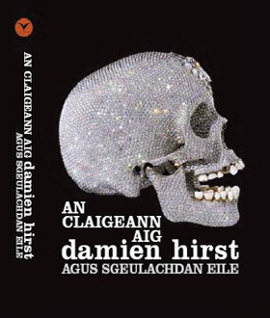
Figure 16 A collection of modern short stories written and published in Gaelic (above) then translated into German (below)

Gaelic learners are an important addition to the modern world of Gaelic, demonstrating (to native Scots among others!) that the language can not only be learned to fluency as an adult without too much difficulty, but that it possesses a powerful attractiveness to people outside its traditional community, who will bring with them new energy and vision.

3 Gaelic in the modern era

3.1 Who speaks Gaelic?

3.1.1 I do!
‘Mise’, in answer to the question ‘Who speaks Gaelic?’, means ‘I do’. ‘Mise’ is pronounced ‘mish-uh’.
It also means ‘I am …’, when someone is introducing himself or herself. Here three Gaelic speakers living in Scotland in 2011 tell you a little about themselves.

Karen
‘Mise Karen. I'm 18 years old and I have lived in Inverness all my life. My Grampa's family were native Gaelic speakers and my parents wanted me to learn the language too. I'm very pleased I did. I went to the Gaelic Medium Unit in Inverness and have been lucky to have had so many opportunities especially on the music aspect since. This September I'm off to Glasgow University to study Gaelic and History and perhaps Politics.’
Crìsdean
‘Mise Crìsdean. I spoke English and French at home and learned Gaelic in school and in a Gaelic college. I have had various jobs in the Gaelic world.’
Dòmhnall-Iain
‘Mise Dòmhnall-Iain. I was brought up in a Gaelic speaking community in the Western Isles but have mostly lived and worked in cities such as Glasgow and Inverness. I use Gaelic regularly, at home, socially and when working.’

3.1.2 The big picture
There were 58,652 people in Scotland who spoke Gaelic at the time of the 2001 National Census, while a further 33,700 could understand the language.
Of the Gaelic speakers, 33,315 (57 per cent of the total) lived in the historical Gaelic heartland of the Highlands and Islands. The Western Isles (15,723 speakers) had the highest concentration at 62.3 per cent, with several parishes at or over 80 per cent. The Isle of Skye (3,999) was 35.5 per cent Gaelic speaking in 2001, with one parish at over 70 per cent. Argyll & Bute and the Highland Council area (minus Skye) accounted for the most of the remaining 13,593, including 2,820 in the City of Inverness. Gaelic is in everyday use in many of these communities, particularly in the Western Isles and Skye.

Table 6 Summary of Gaelic-speaking areas in Scotland
Area | Gaelic
Eilean Siar (Western Isles) | 15,723
Skye & Lochalsh | 3,999
Rest of Highland (Mainland) | 8,670
Argyll & Bute | 4,168
Other main Gaelic areas | 755
Total, Gaelic areas | 33,315

There were 25,337 Gaelic speakers outwith the traditional Gaelic area in 2001. They could be found in all parts of Scotland, with significant concentrations in cities such as Glasgow (5,731), Edinburgh (3,132) and Aberdeen (1,420). Many of these speakers also use Gaelic on a regular basis, both in social and more formal contexts, in effect forming loosely-knit sub-communities within these cities.

Table 7 Summary of the number of Gaelic speakers in Scotland
Area | Gaelic
Total, Gaelic areas | 33,315
Rest of Scotland | 25,337
Total | 58,652

A detailed map showing the percentage of Gaelic speakers in all parishes in Scotland is contained in the General Register Office (GRO) Report on the 2001 Census and can be accessed here.
The average age of the Gaelic speakers recorded in the 2001 Census, at 45.9 years, was 18 per cent higher than the Scottish average of 39. This age imbalance is also evident from comparison of the following age bands:

Table 8 Average age of Gaelic speakers
Age group | Gaelic speakers
0-20 years | 10,158
45-64 years | 16,855

This graph, compiled by research agency Sgrùd, sets out the situation in graphic form.

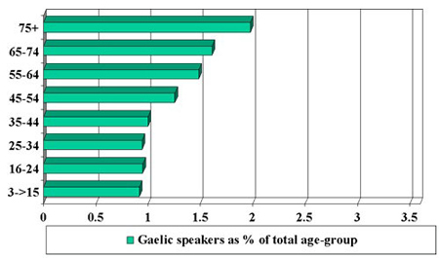
Analysis: K. MacKinnon © 2003 SGRÙD Research. Click here for additional graphs.

Most of the older Gaelic speakers are native speakers who have learned the language in the home and community, usually (although not in all cases) in the Highlands and Islands. Among the younger generation, the majority now learn the language in school, especially through Gaelic medium education: they can be found throughout Scotland. There are also a growing number of adult learners, including many non-Scots.

Box 1
Detailed information from the 2001 Census Gaelic Report can be accessed from the following sites:
- Text
- Tables
- Charts

3.2 Decline
Having been brought to Scotland from Ireland in the early part of the millennium, Gaelic had become the dominant language of the country by the end of that millennium. However, it has been in decline for most of the period since then, for a variety of reasons.
A combination of political, economic, cultural and educational factors described above had, by the beginning of the 20th century, launched a spiral of decline which resulted in the 254,415 Gaelic speakers of 1891 falling, decade by decade, to 58,652 by 2001, as shown on this graph (compiled by the research agency Sgrùd):

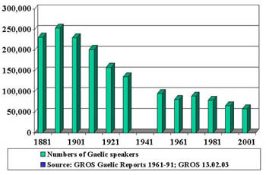

3.2.1 Politics and economics
The displacement of Gaelic by Norman French at the court of King Malcolm Canmore and Queen Margaret in the 11th century is an early milestone in this process. This was followed by the gradual establishment of Scots as the language of the new Lowland burghs from the 12th century. Over the course of the following centuries, Gaelic has been driven back inexorably towards the north and west of the country.
Attempts by the Scottish Crown to bring the Highland and Islands under their control included legislation, such as the Statutes of Iona of 1609, aimed at weakening Gaelic, in particular among the clan aristocracy. The statutes stipulated, for example, that the eldest sons of clan chiefs were to be educated in English at Lowland schools.

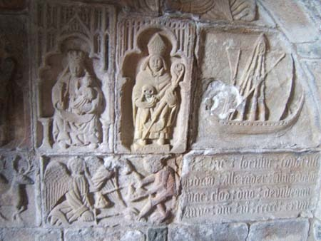
Figure 17 Galleys, a symbol of the power of the Highland clans were also banned by the Statutes of Iona
View description - Figure 17 Galleys, a symbol of the power of the Highland clans were also banned by ...

A state of ‘diglossia’ developed over time in which English became the language of government and public life, with Gaelic confined for the most part to social interaction in lower-status home-neighbourhood domains.
In modern times, the main issue has been lack of positive support for Gaelic in law rather than active discrimination against it. This has been the focus of a political campaign which is described in the next section.
The Gaelic speaking heartland of the Highlands and Islands has suffered particularly badly from poverty, unemployment and emigration over the years, accentuated by events such as the Clearances and potato famine of the 19th century and the world wars of the 20th. This has impacted on Gaelic in two main ways.
Firstly, it has meant that Gaelic-speaking communities have been broken up and the Gaelic speakers, mostly young, dispersed to places like Glasgow or Canada.
More insidiously, the economic situation created a widespread perception that Gaelic was of little or no financial value, which in its turn led to schools ‘educating children for exile’ and to parents opting against passing the language on to their children.

3.2.3 Education and cultural influences
Although the private, mostly church-based, organisations which had run school education in the Highlands before then had provided education in Gaelic, the 1872 Education (Scotland) Act, which made school education compulsory in Scotland, completely ignored the existence of the language. As a consequence, Gaelic came to be effectively excluded from the schools, especially as language of teaching, and indeed was often positively discriminated against.

Box 2
‘Archy has a vivid memory of when he was very young sitting on his grandfather’s knees, gazing into his intensely blue eyes and white beard, and being told about the persecution the children were subjected to when his grandfather, Archibald, was a boy at school for speaking in Gaelic. They were severely belted and a tessera board (maide-crochaidh) was hung round their neck and if they had not betrayed another Gaelic speaking class-mate by 4pm they got another belting. If the child had not handed over the board by the morning attendance at school another belting was administered and so on.’
The Shielfoot Macphersons and a Journey of Discovery’ by Ewen S. L. MacPherson, in Creag Dhubh 1994 No. 46, the magazine of the Clan MacPherson Association

Various campaigns have been waged and curricular initiatives launched over the years to remedy this situation. The 1918 Education Act which required authorities in Gaelic areas ‘to make adequate provision for Gaelic’, the Inverness-shire Gaelic Education Scheme, the Western Isles Bilingual Education Project and, most recently, Gaelic medium education (GME) are examples of this, which will be described in the next section.
In the period following the Second World War, and especially from the 1960s on, the Highlands and Islands became more open to outside cultural influences, mainly through television and the access it gave to the burgeoning popular culture of that period. One result of this was to make Gaelic and all that went with it seem outdated to the young, leading many to opt out of speaking Gaelic, often contrary to parental wishes and despite educational initiatives such as the Western Isles Bilingual Education Project.

3.3 Revival

Phase 1
The 19th century in the Highlands was a time of poverty and conflict but things were beginning to change for the better by its end. In Gaelic, 1891 saw the launch of the first organisation set up in support of the language. An Comunn Gàidhealach’s first achievement was to create a major music festival, the Mod, which continues to this day to promote Gaelic music and to raise the profile of the language. It also set up local branches and, at national level, took part in political campaigns such as that which led to the inclusion of a clause in the 1918 Education (Scotland) Act. This act gave official recognition to Gaelic by requiring the new educational authorities ‘make adequate provision for Gaelic in Gaelic-speaking areas’.

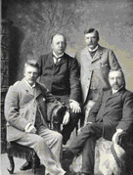
Figure 18 The founders of An Comunn Gàidhealach
View description - Figure 18 The founders of An Comunn Gàidhealach

Phase 2
The next phase of the Gaelic revival began just after the Second World War, running through to around 1980, and saw the voluntary sector, represented by An Comunn, being overtaken by a new cadre of activists. They initiated important developments in Gaelic publishing, broadcasting and education, either by gaining positions of influence within existing institutions (such as the BBC) or by setting up parallel systems for Gaelic (such as the Gaelic Books Council from 1968).
The main characteristic of this phase was the evolution of a professional infrastructure for Gaelic development, largely funded from the public purse.
The emphasis in education now was on developing Gaelic as a medium of teaching. The Inverness-shire Gaelic Education Scheme (in the 1960s and 1970s) and the Western Isles Bilingual Education Project (from 1975) are examples of this, both aiming to encourage Gaelic-speaking pupils to use the language ‘as a natural language for the exploration and description of experience’.

Phase 3
There are three main strands to the third phase of the Gaelic revival.
Gaelic medium immersion education (GME), based on a Welsh model, was one of these. Starting in the early 1980s this has now spread throughout the country, with some 4,000 youngsters involved at all stages.

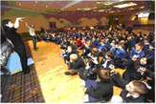
Figure 19 ‘Latha Mòr na Gàidhlig’ (The Big Gaelic Day), held in the Highlands in 2005, brought together 500 GME pupils from throughout Scotland.
View description - Figure 19 ‘Latha Mòr na Gàidhlig’ (The Big Gaelic Day), held in the Highlands in ...

In immersion education children are taught almost entirely in the target language, even where most of them do not speak it. The approximately 80 per cent of children in GME who come from non-Gaelic speaking homes learn to understand the language quickly and are able to communicate freely in it by the end of their schooling.
GME is regarded as the best hope for the future of Gaelic, creating new Gaelic speakers in communities where parents no longer have the language.

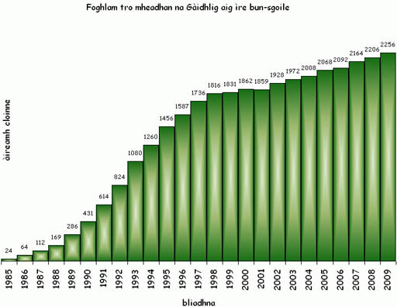
Figure 20 Gaelic Medium Primary School Education pupil numbers

There are also learners’ classes in primary and secondary schools. Information on Gaelic education generally is available here.
The second strand in the revival has included a renaissance in Gaelic (and Celtic) music - which continues to gain popularity both among Gaels and in the wider Scottish public - and the development of a comprehensive broadcasting service in Gaelic, including a dedicated Gaelic television channel (described more fully in the case studies).
The third strand in the revival has been the adoption by the Scottish Parliament of the Gaelic Language (Scotland) Act in 2005. This created a non-governmental public body, Bòrd na Gàidhlig, which advises the government on Gaelic. The body is also required to produce a national plan for Gaelic and to assist other public bodies in producing plans. The key principle enshrined in the Act is that ‘the Gaelic and English languages should be accorded equal respect’. A copy of the Act (2005) and of Bòrd na Gàidhlig’s first National Plan for Gaelic (2007) can be accessed here and an overview can be seen in the box below.

Box 3 Gaelic Language (Scotland) Act 2005

The Act – an Overview
3. The Gaelic Language (Scotland) Act 2005 establishes a body, Bòrd na Gàidhlig (the Bòrd), to promote the use and understanding of the Gaelic language and enables the Bòrd to require certain public bodies to prepare and implement plans which will set out how they will use the Gaelic language in the exercise of their functions.
4. Section 1 establishes the Bòrd with the functions of promoting the use and understanding of the Gaelic language; promoting and advising on Gaelic language, culture and education matters; and reporting to the Scottish Ministers on the implementation of the European Charter for Regional or Minority Languages in relation to the Gaelic language.
5. Section 2 requires the Bòrd to develop a national Gaelic language plan setting out how it proposes to exercise those functions.
6. Sections 3 to 8 enable the Bòrd to require relevant public authorities to prepare and implement Gaelic language plans. These plans will set out how the public authority will use the language in connection with the exercise of its functions.
7. Section 9 provides for the Bòrd to issue guidance on the provision and development of Gaelic education.

Prognosis
The Gaelic revival of the past 100 years has followed two contrasting trajectories, one showing a steady improvement in the language’s status while the other shows the number of Gaelic speakers steadily falling (although the rate is slowing down). Bòrd na Gàidhlig’s National Plan for Gaelic (2007) set a target of 65,000 Gaelic speakers by 2021. While some regard this as optimistic, it does seem likely that the number will stabilise in the medium term, albeit at a lower figure than this target.

3.4 Gaelic alive!

Education
Pupils start GME at an early age, usually in a Gaelic playgroup or nursery class. There are two all-Gaelic primary schools (in Inverness and Glasgow); otherwise GME is delivered as classes in two-language schools. Secondary GME provision is patchy, but all pupils in primary GME have the option of taking language classes in secondary school that lead to the ‘Gàidhlig’ (or fluent speaker) SQA exams.

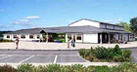
Figure 21 The purpose-built Inverness Gaelic school, known as ‘Bun-Sgoil Ghàidhlig Inbhir Nis’ (BSGI), which opened in 2007.
View description - Figure 21 The purpose-built Inverness Gaelic school, known as ‘Bun-Sgoil Ghàidhlig ...

For more information you can access the school website here.

Community
Gaelic is in everyday use in many communities, especially in the Western Isles and Skye but also, in a more limited way, in the Gaelic communities-within-communities of the cities. This can mean buying the groceries in the local shop or supermarket, socialising in a club or pub or taking part in a local radio programme.

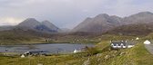
Figure 22 Harris, a stronghold of the Gaelic language
View description - Figure 22 Harris, a stronghold of the Gaelic language

Many Churches – Protestant and Catholic – use Gaelic in worship. One of the most distinctive, and impressive, forms of Gaelic culture, in fact, is the unaccompanied psalm singing which has evolved over the centuries in the Presbyterian church in the Islands. The clip below is an example from Lewis.

Watch the video at YouTube.com.
Unaccompanied psalm singing from Lewis

Broadcasting
MG ALBA is funded by the Scottish Government in order to enable quality television programmes to be made and shown in Gaelic. In partnership with the BBC it has established BBC ALBA, a Gaelic digital TV channel (available on Freeview from 2011). For information on MG ALBA visit their website.
BBC ALBA provides a comprehensive broadcasting service in Gaelic, on radio, television and the internet, including children’s programming, a news and current affairs service and light entertainment, including sport. The video below is an example of the type of programming BBC Alba provides.

Video content is not available in this format.
An extract from BBC Alba’s features programme Eorpa
Courtesy of BBC

Music
Celtic (including Gaelic) music has enjoyed a remarkable growth in popularity in recent years, as evidenced by the success of festivals such as Blas (in the Highlands), HebCelt (Western Isles) and Celtic Connections (Glasgow).
For more information on the festivals visit:
- www.blas-festival.com
- www.hebceltfest.com
- www.celticconnections.com
You can watch video clips from the 2010 BLAS festival here.
Fèisean are teaching festivals at which the learners, who are mostly young, can learn a wide variety of Gaelic cultural skills from professional tutors.
There are some 40 fèisean at present, supported by a national organisation, Fèisean nan Gàidheal. Their map, shown here, shows the location of fèisean taking place in 2011.
Gaelic mods, national and local, are competitive festivals of Gaelic music catering for both adults and children. For more information go here.
Aspects of the Gaelic heritage which are less directly related to the language have also been experiencing a revival in recent years. For example, traditional dancing, such as stepdance which has been reintroduced from Cape Breton, Nova Scotia, is becoming increasingly popular. For information visit Dannsa’s website or this online Scottish dancing resource. We also cover the importance of music and dancing in Section 6.

Signage
The Gaelic Language Act’s aspiration of ‘equal respect’ for Gaelic and English has resulted in an increase in the visual presence of the language, for example on external and internal building signage, road signs and commercial products.
Gaelic is also use sometimes for public announcements, for example on ferries to the Western Isles.

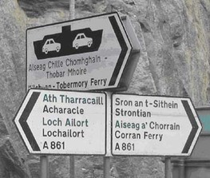
Figure 23 Gaelic signage in Scotland (above and below)

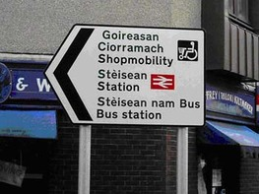

Family
Many parents with children in GME learn Gaelic in order to support their children’s learning. Apart from classes there are residential events in which families can participate together. The photo below is from one such event in Skye in 2006. The following link is to CNAG’s ‘Cuir is Fàs’ magazine, which contains a report of an event held in Lewis in 2010.

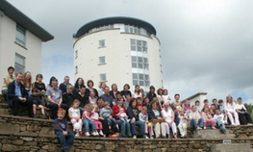
Figure 24 Parents and children at a GME residential learning event in Skye in 2006

As well as those families which enrol their children in GME, there are also families where one or more parent speaks Gaelic and the language is passed on to the next generation in the traditional way at home (and usually reinforced by GME). There is now the possibility that this can once again become the norm, given that there is once again a generation of Gaelic speakers of child-raising age.

4 Gaelic – the rationale

4.1 Bilingualism
Bilingualism is the norm in most of the world and is likely to become even more so in the future. Research has shown that speaking two (or more) languages has distinct benefits for the individual and for society at large.

4.1.1 The benefits to the individual
Up to the 1960s, most of the research on bilingualism focused on immigrant populations in the United States and usually concluded that bilingual children did less well in intelligence tests than their single-language counterparts, reinforcing the popular view of the time that speaking two languages ‘confuses the minds of children’. This research is now regarded as unreliable for a number of reasons, but chiefly because it failed to take account of the socio-economic backgrounds of the young people tested.
A major research project carried out in Montreal in 1962 was the first to question the received wisdom on this matter. The linguists Elizabeth Peal and Wallace Lambert compared the performance in tests of ‘balanced bilinguals’ – i.e., children who were equally fluent in French and English – with monolinguals of the same age and with a similar socio-economic background. They found that the bilinguals performed better in most of the tests and they concluded that ‘a bilingual child is a youngster whose experience with two language systems seems to have left him with a mental flexibility, a superiority in concept formation, a more diversified set of mental abilities.’
Although the Peal/Lambert study has, in its turn, been shown to have flaws, it set the tone for much of the research that followed, which has consistently shown the relationship between bilingualism and children’s cognitive development in a positive light.
Recent research has aimed to define this relationship more precisely. Some studies have focused on the languages themselves, including the bilingual’s competence in them: one expert, for example, concluded that there is a ‘threshold level’ at which the beneficial effects of bilingualism come into play. The relative status of the languages has also been looked at, one study suggesting that ‘where the home language is that of the majority, ‘additive’ bilingualism is best promoted by providing initial instruction in the second language’ (this is the norm in Gaelic medium education).
Some researchers have tried to identify the precise aspects of ‘cognitive development’ which are affected by bilingualism. Ellen Bialystok, of York University, Toronto, for example, found in several studies that bilingual children were better at prioritising and multi-tasking than monolinguals and suggested that the ‘juggling of two languages’ which bilingualism implies strengthens the brain’s ‘executive control system’. While most of Bialystok’s work involves children, in February 2011 she published a paper which concluded that using two languages appeared to delay the onset of Alzheimer’s Disease in older people, for similar reasons.

Figure 25 Ellen Bialystok

A fuller account of Ellen Bialystok’s work can be found in her ‘Cognitive effects of bilingualism: How linguistic experience leads to cognitive change’ in The International Journal of Bilingual Education and Bilingualism (2007).
In conclusion, while the relationship between bilingualism and cognitive development is a complex one, a broad consensus is beginning to emerge which is summarised as follows by Anne Brasier of Kagoshima University (Japan) in The relationship between bilingualism and the cognitive development of bilingual children (1999):

‘Research has overwhelmingly concluded that bilingualism per se does not have any negative effects on cognition. In fact the opposite increasingly appears to be the case: that high levels of bilingualism have accelerating effects on children’s cognitive development.’

4.1.2 Learning other languages
Individuals who have become fluent in two languages at an early age are often more successful at learning other languages than those who have not. This is also true of language communities (e.g. Holland or Switzerland). There are several reasons for this.
One is that having mastered a second language gives the learner the confidence to tackle, and to use, a third (or fourth). Since self-consciousness is one of the major factors which inhibits language learning in adults, this is an important advantage.
In addition, bilinguals develop learning techniques and coping strategies when acquiring their second language that they can transfer to new language situations, especially those involving immersion in a new language such as moving to a foreign country.
Research has shown that bilingual children’s ‘metalinguistic ability’ is more developed than that of their single-language counterparts, i.e. that they are better at distinguishing between the ‘form’ of language (how something is said) and its ‘meaning’ (what is said). One project, for example, tested whether children used ‘semantic’ (or meaning) cues to group words rather than simply going by the sound or shape of the word. It found that bilingual children were able to employ this more advanced approach at an earlier age.
Research on this subject continues but again there is a growing consensus that early bilingualism makes it easier to learn other languages. For a review of the research, click here.

Crìsdean’s story
‘I was born and brought up on Skye in a Gaelic-speaking community but the languages we spoke at home were English and French (my father is French). I had the opportunity to learn Gaelic when a Gaelic medium class opened in Portree Primary School.’

Figure 26

‘When I left school I attended Sabhal Mòr Ostaig, Scotland’s Gaelic college, and I have been working in the Gaelic world since then. I feel quite fortunate that I am able to speak Gaelic, as well as my first two languages.’

4.1.3 The benefits to the community

Box 4 Final report and recommendations of The Nuffield Languages Inquiry, 2000

From the foreword by Sir Trevor McDonald OBE and Sir John Boyd KCMG
Our mandate from the Nuffield Foundation, to look at the UK’s capability in languages and to report on what we need to do as a nation to improve it, was timely. Every day we are confronted by evidence that we live in a shrinking world. The breaking down of international barriers, a process which will move much further and faster in the course of this new century, has placed a premium on our ability to talk to our neighbours in the global village … The scale of what needs to be done has become ever more striking as our work has gone on. At the moment, by any reliable measure, we are doing badly. We talk about communication but don’t always communicate. There is enthusiasm for languages but it is patchy. Educational provision is fragmented, achievement poorly measured, continuity not very evident. In the language of our time, there is a lack of joined-up thinking.

Box 5 Foreign languages in the upper secondary school: the causes of decline

Joanna McPake, Lindsay Lyall (SCRE); Richard Johnstone, Lesley Low (University of Stirling)

Introduction
In November 1996, researchers at the Scottish Council for Research in Education (SCRE) and the Institute of Education at the University of Stirling began a study of the causes of decline in uptake of Higher courses in modern languages in Scottish secondary schools. The study was funded by The Scottish Office Education and Industry Department (SOEID) in response to evidence from the Scottish Qualifications Authority (SQA) that the numbers of students entered for Higher examinations in modern languages had fallen by approximately 50 per cent between 1976 and 1996, and consequent widespread concern about the effects of declining capability in modern languages on Scottish industry and trade and on Scotland’s role within Europe.

There is a growing consensus in Scotland and in the UK more widely that:
- learning other languages is increasingly important for us in the modern world
- we continue to lag behind other countries in this regard.
While commentators are usually thinking of languages like German or Chinese when making such comments, this also strengthens the case for Gaelic in Scotland, in that:
- the process of learning one language, as shown above, makes it easier to learn another, whatever the languages
- Gaelic is taught and used across Scotland, making it relatively accessible as a language with which to start the language learning process
- learning a second language such as Gaelic creates ‘another window on the world’, contributing to the multi-cultural mindset that is so important in the modern world
- in particular, it can help broaden the linguistic horizons of a society that has, for the most part, become reconciled to speaking only one language, English, and tends to lack the confidence and motivation necessary to learn others.
In addition, those involved in planning the teaching of other languages can learn a good deal from the successful approaches developed in Gaelic - in particular the immersion method with young children and variations on it for adult learners.

4.2 Why learn Gaelic?

4.2.1 A cultural answer
One of the main reasons that people living in Scotland start learning Gaelic or enrol their children in GME is because they feel that the language is an important part of the Scottish heritage and identity, as well as a living component of the diverse society that is modern Scotland.
As discussed in Section 1.3, Gaelic’s contribution to the Scottish identity extends to the country’s name, ‘Scoti’ being the Romans’ name for the Gaelic-speakers from Ireland whom they encountered here. The origin of many Scottish icons, such as tartan, is also closely associated with Gaelic, and Gaelic’s rich musical tradition has influenced Scottish music generally, as well as being popular in its own right.
Place names preserve a memory of the cultures that have inhabited an area in times gone by and that have contributed to its present character. Most parts of Scotland have names that indicate a Gaelic past. Some of these terms are geographical: Troon in Ayrshire, for example, is sometimes referred to as An t-sròn - the nose, i.e. the bill-like headland which is a prominent feature of Troon harbour. Others can throw a light on an area’s forgotten history. Dalneigh, for example, is the name of a housing estate in the city of Inverness but its original Gaelic name – ‘Dail an Eich’ or ‘horse pasture’ – speaks of a more agricultural past. Ironically, a tenuous link with that past has been established recently with the setting up of an allotments scheme in Dalneigh.

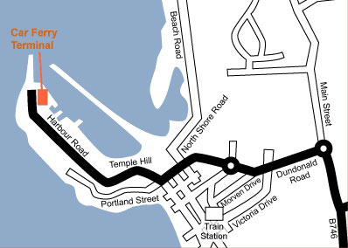
Figure 27A map of An t-sròn,‘the nose’
View description - Figure 27 A map of An t-sròn, ‘the nose’

If you are interested in Gaelic place names and would like more information, and a gazeteer of Gaelic names, visit the Ainmean-Àite na h-Alba/Gaelic Place Names of Scotland website.

4.2.2 A practical answer
There are also more pragmatic reasons why parents and others show an interest in learning Gaelic – or having their children learn it - namely that there is a wide range of career opportunities for which Gaelic is at least an advantage and often a requirement.
Here are some examples of people who use Gaelic in their work.

Iain’s story

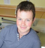
Figure 28

‘I am from South Uist and I have lived here almost all my life. I was brought up speaking Gaelic – apparently when I went to school I had very little English! I studied at Stirling University, graduating from there with a degree in English literature in 2008 I am now working for the BBC as a journalist in Uist and Barra, travelling between the islands to report on local news. When I am not doing that I can usually be found working on the family croft.’

Sìne’s story

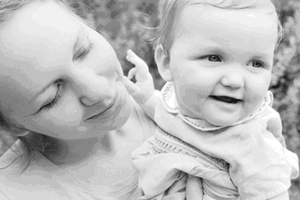
Figure 29

‘I was born and raised in Cape Breton, Canada where I and my three brothers grew up speaking Gaelic. I came to Scotland in 1998 and took a degree in the Gaelic College, Skye. I trained as a teacher and am now a Gaelic medium primary teacher in the Highlands. My husband and I live in Inverness and we have a little girl.’

4.3 The rights of linguistic minorities

4.3.1 Introduction
Another possible answer to the question, ‘Why should we support a minority language like Gaelic?’ is that the rights of linguistic minorities are enshrined in both international and national law, as described in the next four sections.

4.3.2 United Nations
The United Nations, at its 92nd plenary meeting on 18 December 1992, adopted a Declaration on the Rights of Persons belonging to National or Ethnic, Religious and Linguistic Minorities, Article 1 of which requires that
- States shall protect the existence and the national or ethnic, cultural, religious and linguistic identity of minorities within their respective territories and shall encourage conditions for the promotion of that identity.
- States shall adopt appropriate legislative and other measures to achieve those ends.

4.3.3 European Charter for Regional or Minority Languages
Article 22 of the European Charter of Fundamental Rights states, as a broad principle, that: ‘The Union respects cultural, religious and linguistic diversity.’
This is defined more clearly in the European Charter for Regional or Minority Languages adopted by the Council of Europe in 1992, the purpose of which is to encourage the preservation and promotion of indigenous languages throughout Europe.
The UK Government signed the European Charter for Regional or Minority Languages in 2000 and it was ratified by the UK Parliament in 2001. The Council of Europe’s Committee of Experts visits countries that have signed up to the Charter on a regular basis in order to monitor its implementation.

4.3.4 Gaelic Language (Scotland) Act
On 21 April 2005 the Scottish Parliament passed the Gaelic Language (Scotland) Act. The purpose of the act, in the language of its introductory text, is:

‘To establish a body having functions exercisable with a view to securing the status of the Gaelic language as an official language of Scotland commanding equal respect to the English language, including the functions of preparing a national Gaelic language plan, of requiring certain public authorities to prepare and publish Gaelic language plans in connection with the exercise of their functions and to maintain and implement such plans, and of issuing guidance in relation to Gaelic education.’

Box 6 Gaelic Language (Scotland) Act 2005

The Act – an overview
- These Explanatory Notes have been prepared by the Scottish Executive in order to assist the reader of the Act. They do not form part of the Act and have not been endorsed by the Parliament.
- The Notes should be read in conjunction with the Act. They are not, and are not meant to be, a comprehensive description of the Act. So where a section or schedule, or part of a section or schedule, does not seem to require any explanation or comment, none is given.
- The Gaelic Language (Scotland) Act 2005 establishes a body, Bòrd na Gàidhlig (the Bòrd), to promote the use and understanding of the Gaelic language and enables the Bòrd to require certain public bodies to prepare and implement plans which will set out how they will use the Gaelic language in the exercise of their functions.
- Section 1 establishes the Bòrd with the functions of promoting the use and understanding of the Gaelic language; promoting and advising on Gaelic language, culture and education matters; and reporting to the Scottish Ministers on the implementation of the European Charter for Regional or Minority Languages in relation to the Gaelic language.
- Section 2 requires the Bòrd to develop a national Gaelic language plan setting out how it proposes to exercise those functions.
- Sections 3 to 8 enable the Bòrd to require relevant public authorities to prepare and implement Gaelic language plans. These plans will set out how the public authority will use the language in connection with the exercise of its functions.
- Section 9 provides for the Bòrd to issue guidance on the provision and development of Gaelic education.

This overview forms an introduction to the 2005 act. A copy of the act and of Bòrd na Gàidhlig’s first National Plan for Gaelic (2007) may be accessed here.
Bòrd na Gàidhlig was constituted in 2005 as the body referred to in the Act. It produced a National Plan for Gaelic (including a national strategy for Gaelic education) in 2007 and has since overseen the production of Gaelic Plans by a number of public bodies.

4.4 Home and abroad: examples of bilingualism

4.4.1 Te Reo Maori
In most parts of the world, bilingualism (or multilingualism) is the norm. There are minority languages like Gaelic in most countries, often with similar problems and aspirations. Increasingly, minority language communities are becoming aware of what they have in common and what they can learn from each other.
The Maori language from New Zealand has been the big success story on the minority language scene in recent years. Basing their approach on the writings of the American sociolinguist, Joshua Fishman – and in particular his Reversing Language Shift of 1991 – the Maori language community, with the help of the New Zealand government, put a strategy in place which has transformed the fortunes of the language and become a model of good practice by minority language communities worldwide.
What they have achieved so far gives hope to threatened language communities, such as Gaelic, that language decline can be reversed if there is the will.
Tipene Chrisp, policy manager in the New Zealand government’s Ministry of Maori Development, described their strategy in a presentation to a conference on Gaelic organised by the Highland Council in Inverness in 2005.

‘By the late 1970s, it was predicted that the Maori language would be dead by 2010. This dire prediction sparked significant action to revitalise Maori in the early 1980s.
There was some recognition of the importance of home and community in this early phase. However, this recognition was quickly overtaken by our emphasis on formal education and broadcasting as the primary means for language revitalisation. It wasn’t until the Maori Language Conference of 1995 that home and community language development returned to the agenda.
The renewed emphasis on home and community language development was based on Fishman’s focus on intergenerational language transmission. We absorbed this theoretical approach over time and were inspired by it. It has been adopted as the central platform of our strategy.
We realised quite early that Government cannot directly influence intergenerational language transmission. We can only take indirect measures that support the creation of an environment that is conducive to intergenerational language transmission in homes and communities. Our research indicated that there were three broad instruments for providing this indirect support:
- Incentives (mainly indirect, such as preferential access to particular schools)
- information (originally text-based for reasons of cost but now involving a range of media, including storylines in TV soaps)
- advice (delivered mainly through language planning at the community level and a system of family language mentors on the home front).’

The essence of the Maori language approach is that the family and the community are crucial to the continued survival of the language and, therefore, restoring ‘intergenerational language transmission’ is their principal aim. The kohanga reo, or ‘language nests’, which provide early immersion education in Maori, have played a key role in this strategy. The video clip below describes kohanga reo.

Watch the video at YouTube.com.

For information on the Maori language generally, visit He Korero mo Te reo Maori.

4.4.2 The bilingual poet
Aonghas MacNeacail, although he uses only the Gaelic form of his name, writes highly acclaimed poetry in both Gaelic and English. There are many journalists, actors and broadcasters who do the same, thus extending their range and marketability.

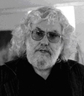
Figure 30 Aonghas MacNeacail

Aonghas’s poem on Marilyn Monroe, written in both languages, is given below. Click here to visit Aonghas MacNeacail’s website.

Marilyn Monroe by Aonghas Macneacail
òr 'na do ghruaig | gold in your hair
òr ann an ìnean do chas | gold in the nails on your feet
òr ann an ruisg chadalach do shùilean beò | gold in the sleepy lids of your living eyes
òr 'na do ghruaidhean, 'nam fathann athaidh | gold in your cheeks, in their rumour of a blush
òr ruadh do bhilean | red gold of your lips
òr sa ghualainn mhin àrd a' fasgadh do smig | gold in the raised shoulder that shelters your chin
òr anns a' bhroilleach ghealltanachd | gold in your breasts, their promise
paisgte 'na bhad | enfolded in wisps
òr 'na do chneas seang, air miadan do chruachan | gold in your slender waist, on the meadows of your hip
ann an lùb nan sliasaid is | in the curve of thigh and
air glùin nan dìomhaireachd | on your knee of mysteries
rinn d' adhbrainn òrach | your golden ankle gave
dannsa caol | slim dances
do gach sùil a shealladh | that any eye could see
airgead-beò 'na do chuislean | quicksilver in your veins
airgead-beò 'na do chridhe | quicksilver in your heart
airgead-beò gu na h-iomaill | quicksilver to every corner
dhe d' anam | of your soul
agus d' osnadh, do ghàire | and your sighs, your laugh
do ghuth-seinn, do ghuth-labhairt | your singing, your speech
mar bhraoin de dh'òr | like a mist of gold
agus do gach fear a chùm | and to every man who kept you
air lios leaghteach nan dealbh thu | on the screen's dissolving field
òr, o | gold, from
bhàrr calgach do chlaiginn gu | the maned top of your skull
buinn rùisgte do chas | to the bare soles of your feet
òr, òr, òr, | gold, gold, gold,
beò no marbh | alive or dead
their cuid nach robh thu cho cùbhraidh | some say you weren't so fragrant
's iad a' deothal an t-sùigh | as they suck the substance
a sporan suilt òrach do bhèin | from the fertile purse of your skin
òr, òr, òr | gold, gold, gold

5 How the Gaelic language works

5.1 How do I say…?
Here are some common expressions in Gaelic. Listen to them by clicking on the audio link, then try saying them.

How are you?
Ciamar a tha thu?

Audio content is not available in this format.

[I’m] fine.
Tha gu math.

Audio content is not available in this format.

Good morning
Madainn mhath.*

Audio content is not available in this format.

Good afternoon (or evening)
Feasgar math.*

Audio content is not available in this format.

Come in.
Thig a-steach.

Audio content is not available in this format.

Get out!
Mach à seo!

Audio content is not available in this format.

Many thanks.
Mòran taing.

Audio content is not available in this format.

Cheers!
Slàinte!

Audio content is not available in this format.

What’s doing?
Dè tha dol?

Audio content is not available in this format.

I’m busy.
Tha mi trang.

Audio content is not available in this format.

Can you say it again?
An can thu rithist e?

Audio content is not available in this format.

Please.
Mas e do thoil e.

Audio content is not available in this format.

* Note: Nouns in Gaelic, as in many languages, can be masculine or feminine: that is why it is ‘feasgar math’ (masculine) but ‘madainn mhath’ (feminine).

5.2 Gaelic: some basics

5.2.1 Gaelic grammar – a taster
Gaelic is part of the ‘Indo-European’ family of languages and so is related, distantly, to languages like English and French, as is shown by the names for the numbers 1-3. Click on the audio links below to hear how these numbers are pronounced in Gaelic.

Audio content is not available in this format.

Audio content is not available in this format.

Audio content is not available in this format.

Table 9 Numbers
 | Gaelic | Italian | French | Danish | English
1 | aon | uno | un | een | one
2 | dà | due | deux | to | two
3 | trì | tre | trois | tre | three

Their shared ancestry also means that Gaelic grammar has a lot in common with these languages, although there are also some differences. For example, unlike English (but like French) the adjective in Gaelic usually comes after the noun. An example is Gleann Mòr where ‘gleann’ means ‘glen’ and ‘mòr’ means ‘big’. That is why the stress is on the last element in Highland names like Glenmore or Aviemore.

Audio content is not available in this format.

The following is a typical Gaelic sentence, with explanatory notes:
Tha mi a’ sgrìobhadh litir. (I am writing a letter.)

Audio content is not available in this format.

Table 10 Breaking down the sentence
1 | 2 | 3 | 4
Tha | mi | a’ sgrìobhadh | litir.

- ‘Tha’ is the equivalent of ‘am’ in English. Although we say ‘I am’, ‘you are’, ‘he is’, it is always ‘tha’ in Gaelic, i.e.: ‘tha mi’, ‘tha thu’, ‘tha e’.
- Notice that the words are in a different order in Gaelic, ‘tha’ coming before ‘mi’.
- ‘A’ sgrìobhadh’ means ‘writing’: compare ‘scribe’ and ‘scribble’.
- ‘Litir’ means ‘a letter’: Gaelic doesn’t have the equivalent of English ‘a’ or ‘an’.

5.2.2 Sounds and letters
In this section you’ll notice that words have been pronounced with different accents. These accents are from Harris, Lewis and North Uist. Can you hear the regional distinctions?
Gaelic vowels can be long or short. The long ones are shown by a grave accent, e.g.:
- bata (with a short a in the first syllable) means ‘a stick’

Audio content is not available in this format.

Audio content is not available in this format.

Audio content is not available in this format.

- bàta (with a long à) means ‘a boat’.

Audio content is not available in this format.

Audio content is not available in this format.

Audio content is not available in this format.

Consonants can also have two sounds - as in English (e.g. the ‘d’ in ‘door’ and in ‘duke’). The Gaelic ‘d’, when it is next to the letters ‘a’, ‘o’ or ‘u’, is like the ‘d’ in ‘door’:
- ‘doras’ (a door)

Audio content is not available in this format.

Audio content is not available in this format.

Audio content is not available in this format.

- ‘dà’ (two).

Audio content is not available in this format.

Audio content is not available in this format.

Audio content is not available in this format.

However, it is like the ‘d’ in ‘duke’ when next to the letters ‘e’ or ‘i’:
- ‘de’ (from, of)

Audio content is not available in this format.

Audio content is not available in this format.

Audio content is not available in this format.

- ‘idir’ (at all).

Audio content is not available in this format.

Audio content is not available in this format.

Audio content is not available in this format.

Some consonants interact with ‘h’, which changes the sound of the letter. For example, when you are addressing someone called ‘Màiri’ (Mary), you say ‘Mhàiri’ (pronounced ‘vaary’).

Audio content is not available in this format.

Audio content is not available in this format.

Audio content is not available in this format.

Some people use this form as a name in English.
Gaelic has more individual sounds than English but uses fewer letters. The letters therefore have to work harder but, in fact, Gaelic spelling is quite consistent. Try saying the following words and then click on the link to hear them spoken by a Gaelic speaker.
Remember, the first part of the word is usually stressed in Gaelic, look out for the grave accent and think of the effect of ‘e’ and ‘i’ on the letters beside them, including ‘s’!

aran (bread)

Audio content is not available in this format.

Audio content is not available in this format.

Audio content is not available in this format.

balach (boy)

Audio content is not available in this format.

Audio content is not available in this format.

Audio content is not available in this format.

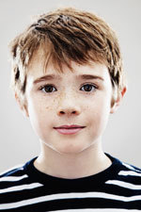

còta (coat)

Audio content is not available in this format.

Audio content is not available in this format.

Audio content is not available in this format.

deoch (a drink)

Audio content is not available in this format.

Audio content is not available in this format.

Audio content is not available in this format.

cidsin (kitchen)

Audio content is not available in this format.

Audio content is not available in this format.

Audio content is not available in this format.

làr (floor)

Audio content is not available in this format.

Audio content is not available in this format.

Audio content is not available in this format.

madainn mhath (good morning)

Audio content is not available in this format.

Audio content is not available in this format.

Audio content is not available in this format.

rathad (road, with silent ‘th’)

Audio content is not available in this format.

Audio content is not available in this format.

Audio content is not available in this format.

seo (here)

Audio content is not available in this format.

Audio content is not available in this format.

Audio content is not available in this format.

tòrr (a lot, a hill).

Audio content is not available in this format.

Audio content is not available in this format.

Audio content is not available in this format.

5.3 New words: and evolving language

5.3.1 Developing terminology: some initiatives
Gaelic was not used much in the past in contexts like education or news broadcasting and for that reason it didn’t fully develop at that time the specialised vocabulary which is needed to talk about things like, for example, chemistry or the economy.
However, in the past few decades Gaelic has been used more and more in such spheres and so the appropriate terminology and registers have had to be developed quickly.
After Gaelic medium primary school education began in 1985, for example, the local authorities concerned brought together subject specialists and Gaelic academics and in 1992 issued Faclan Ùra Gàidhlig (‘new Gaelic words’), a list of new Gaelic terms authorised for use in Gaelic medium classrooms and teaching materials.
The list has been regularly updated since then and it is now being overtaken by the work of An Seotal, an agency set up under the wing of the national Gaelic resource centre, Stòrlann Nàiseanta na Gàidhlig, to produce lists of specialised terms for use in schools.

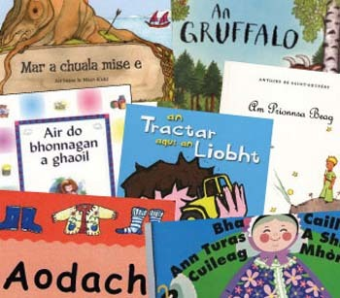

Administration
The Scottish Parliament published Faclair na Pàrlamaid, a list of terms for use in government business in 2001.
A similar list of terms for use in local government business is being compiled at present by The European Language Initiative (TELI).
You can access the parliamentary Gaelic dictionary here.

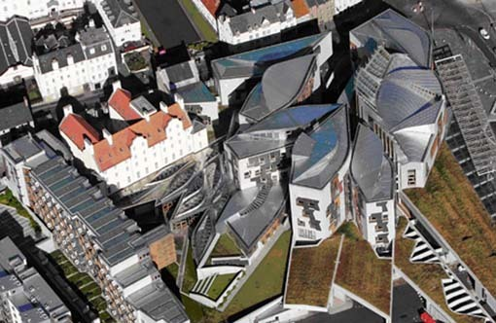
Figure 31 The Scottish Parliament building

News and current affairs
The main originator and user of new Gaelic words is the BBC in its various news and current affairs broadcasting, on radio, television and in its developing online services. There is not as yet a complete list of these new terms but an interim checklist can be accessed on the BBC website.

The way forward
Moves are underway at present to coordinate these various initiatives and the lists of new words and expressions that they are producing. This is likely to culminate within the next few years in the creation, by Bòrd na Gàidhlig, of a Gaelic Academy.

5.3.2 Creating new Gaelic words
The following five examples show the different approaches that are used in creating new words in Gaelic to meet changing needs.

Table 11
English term | Gaelic term | Origin/Method
triangle | triantan | Gaelic ‘trian’ – a third part or something made of three parts. This is an example of a well-established Gaelic word having been adapted for a new use.
geography | cruinn-eòlas | Based on the Gaelic ‘cruinne’ (world) and ‘eòlas’ (knowledge) (‘-eòlas’ is also used as the equivalent of ‘-ology’). This is an example of a concept being ‘defined’ in Gaelic.
television | telebhisean | Many Gaelic words have Greek or Latin roots, filtered though English. Often these are international terms.
rectangle | ceart-cheàrnach | This is made up of ‘ceart’ (the Gaelic for ‘right’) and ‘ceàrn’ (the Gaelic for ‘angle’). This is a translation of the Latin-derived ‘rectangle’ and so is referred to as a ‘loan translation’. The meaning is clearer than ‘rectangle’ since the word is made up of Gaelic rather than Latin elements.
credit crunch | staing creideis | ‘Staing’ (crisis) + ‘creideas’. The Gaelic word ‘creideas’ (originally ‘credibility’) has been ‘stretched’ to match English ‘credit’ (as in ‘credit card’): this is referred to as a ‘loan shift’.

Now that you have read about the origin of these words, listen to how they are pronounced.

triantan

Audio content is not available in this format.

cruinn-eòlas

Audio content is not available in this format.

telebhisean

Audio content is not available in this format.

ceart-cheàrnach

Audio content is not available in this format.

staing creideis

Audio content is not available in this format.

5.3.3 Gaelic loanwords in English
All languages take words from each other. Gaelic borrows from English – after all, almost all Gaelic speakers also speak English – but English has also borrowed from Gaelic over the years. Examples include a number of words for geographical features associated with Scotland such as:
- ben (beinn)
- brae (bràigh)
- corry (coire).
- glen (gleann)
- loch (loch).
Words of cultural origin include:
- caber (from ‘cabar’ – a tree trunk).
- ceilidh
- clan (from ‘clann’ – children)
- galore (‘gu leòr’ – enough)
- slogan (probably from ‘sluagh-ghairm’ – a war cry)
- sporran (‘sporan’ – a purse)
- whisky (from ‘uisge’, short for ‘uisge-beatha’ – water of life)
More speculative suggestions of borrowings from Gaelic to English include:
- grotty (from ‘grod’ – rotten)
- smashing (from ‘’S math sin’ - that’s good)
- shoot (from ‘siuthad’ – go on)
- twig (from ‘tuig’ – understand)!

5.4 How to learn Gaelic
The most common, and by far the most effective, method of acquiring a language is when it is learned by children in the home and developed in the community. This still happens in Gaelic, although not as much as in the past.
The other methods of learning languages can be divided into two broad categories, although there is a good deal of overlap between them. These are:
- form-led learning, where the emphasis is on teaching the basic grammar of the language, usually in a school or evening class setting
- meaning-led learning, where the focus is on using the language for practical purposes while learning it, as happens in immersion education (either in classes or in a less structured way in the community when one moves to a new country).
Experience world-wide has shown that the second of these approaches brings learners more quickly to the level of communicative competence – chiefly because the ‘total immersion’ process creates a powerful incentive to learn the language – but that this can sometimes be at the expense of grammatical correctness.
Form-led learning, often referred to as second-language teaching, can also be effective, especially with students with an aptitude for language, but the proportion achieving communicative competence is usually much lower than for immersion and it tends to take longer.
All the courses described in the sections that follow lie somewhere on this spectrum.

5.4.1 Adult learners
Below is a video of some adult learners explaining why they are learning Gaelic.

Video content is not available in this format.
Why learn Gaelic?
Courtesy of BBC

The traditional way for adults to start learning Gaelic has been to attend an evening class, usually for a two-hour session once a week during the winter leisure-class season (which usually runs for 20 weeks). The methodology in these classes varies but tends to be at the ‘form-led’ end of the spectrum. They may follow a book-based course or a television series such as ‘Speaking our Language’ or, less commonly, be tailored by the teacher to the needs of the class.
Short courses are a variation on this approach, with classes compressed into a one or two week period, often in a residential setting which gives scope for practising the language outwith class. Often learners combine short courses with the weekly variety.
There are also a number of websites which enable learners to start learning Gaelic online, which will be discussed in the next section.
Evening classes, residential sessions and online courses are a good way to start learning Gaelic, providing an introduction to the basics in a relaxed atmosphere and often with opportunities to experience Gaelic culture and to socialise with like-minded people. They are less effective at helping learners to progress beyond the initial stage, however, and so classes often have members who are at different stages.
For adult students who already have a good grasp of the basics or who would prefer to learn at a faster pace, the most interesting development in recent years has been the growth of the ‘Ùlpan’ style of course. This is based on methodology pioneered in Israel with Hebrew and refined in Wales with Welsh. Ùlpan is a structured, progressive course with the emphasis on communication. It comprises 200 units which may be delivered in different configurations, ranging from twice-weekly classes over 3 years to a more intensive delivery pattern, mainly residential, which could see the course completed in 9 or 10 weeks. A flexible approach which marries week-by-week delivery with occasional concentrated inputs is also possible. The aim of the Ùlpan method is to bring the learner, stage by stage, to the level of full communicative competence in Gaelic by the end of the course.
Information on all of the above courses, including advice on what is available (or could be made available) in your area, can be obtained from the Gaelic Learners Association Clì Gàidhlig.
BBC Alba offers a range of internet-based sites to support learners of Gaelic at different ages and stages.
Click here for a full list.

Figure 32 Some resources for online Gaelic learning from BBC Alba. From left: Colin and Cumberland, Air Splaoid, and Dealas.

The Highland Council website contains the following tools for learners:
- an introduction to Gaelic
- a ‘toolkit’ of expressions which can be used in various settings.
You will be able to find ‘Basic Gaelic for Parents’, a list of words and expression for use by parents with their children, here.
Sabhal Mòr Ostaig’s ‘Cùrsa Inntrigidh’ is intended to prepare students for entry to the college’s courses but is open to others as well. Click here for more information.

5.4.2 Adult learning in action: some examples
Adults are learning Gaelic throughout Scotland – and beyond. In many areas learners have set up their own support or conversation groups. Details of the websites of three of these – from Fife, Glasgow and Australia – are given below.
Cearcall Còmhraidh Fìobha is a network of adult Gaelic learners who meet regularly and hold events in parts of Fife. Their attractive website can be accessed here.
Meetup Gàidhlig Ghlaschu is a similar group in the Glasgow area. The following extract from their website - – give the views of some of the members about the group.
What are members saying?

‘A bunch of lovely people who made me feel very welcome!’
Leona Buchanan

‘It is a very friendly, informal group. Everyone is accepted no matter what level their Gaelic is and it helps gain confidence in speaking’
Evelyn

There is also a Facebook page for a Gaelic learners group in Australia.

5.5 Options for children
More and more people living in Scotland, whether or not they themselves are Gaelic speakers or Gaelic learners, are taking steps to ensure that their children have the opportunity to learn Gaelic. There are a number of reasons for this, but the most important are appreciation of the cultural significance of the language to Scotland and the perceived advantages to their children, academically and in terms of career prospects.
The options available to parents and young learners vary from area to area. The main ones are described here in general terms. To find out what is available (or could be made available) in your area, contact your local authority’s education service or visit the Bòrd na Gàidhlig website. You will also find an FAQ on the same site.

Gaelic medium education
GME is a form of ‘immersion’ education, in which learners are taught through the target language (in this case Gaelic) at the same time as they are acquiring skills and knowledge across the curriculum.
Most children in GME have little or no Gaelic when they first enter the system (usually at around 0-3). They learn the language through using it, in combination with some direct teaching which mostly takes the form of games, songs and stories. In almost all cases, pupils in GME are able to communicate freely in Gaelic by the time they leave school.
Immersion is a method favoured by many minority language communities, with Welsh a notable example, but it is also used with majority languages: French immersion education is well-established and successful in Canada, for example.

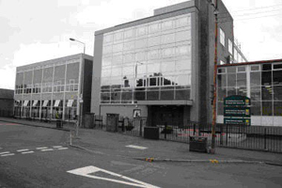
Figure 33 Glasgow Gaelic School
View description - Figure 33 Glasgow Gaelic School

GME is provided by local authorities in response to parental demand. Policies vary but usually authorities require evidence of a viable level of uptake that is sustainable for the foreseeable future. There may also be cost, staffing and accommodation issues which have to be resolved at local level. For information, contact your local education service, the Gaelic parental association Comann nam Pàrant or Bòrd na Gàidhlig.

Gaelic Learners in the Primary School (GLPS)
This is a national scheme which provides training for teachers (including language tuition) and teaching materials to enable them to teach some Gaelic to pupils, usually in the upper stages of primary school. Its aim is to inform the youngsters about Gaelic language and culture as part of multi-cultural education and, where that is an option, to prepare them to continue learning Gaelic in secondary school.

Gaelic classes in secondary school
Gaelic Learners classes usually start in S1 (or before) and cater for complete beginners. They offer a pathway to SQA National Qualifications in ‘Gaelic (Learners)’ and currently are on offer in schools throughout Scotland.
There are also ‘fluent speaker’ Gaelic classes in secondary schools in most areas where GME is provided in the primary school. These have their own National Qualification (NQ) exams, which are formally entitled ‘Gàidhlig’ and are broadly the equivalent of the NQ exams in English.
There is some Gaelic medium subject teaching at the secondary school level but provision is patchy.
Information on GLPS and on the teaching of Gaelic as a subject can be found on the Bòrd na Gàidhlig website.

6 Gaelic culture: a national asset

6.1 The art of the Gàidhealtachd
The art history of the Scottish Gàidhealtachd (Gaelic speaking areas) has received little attention, even though it is known to be important.That is a crucial absence, for the recognition of visual traditions – both in terms of history and current activity – is fundamental to the international perception and everyday wellbeing of any culture. Divorcing a culture from the significance of its visual art traditions can be used to imply cultural inadequacy¹⁷.
Some works such as the Book of Durrow and the Book of Kells are, of course, well known. But as well as those Iona manuscripts of the 7th to the 9th century, the Scottish Gàidhealtachd also gave us works such as the Book of Deer, (a 10th century Latin Gospel Book from Old Deer in Aberdeenshire) and the Celtic Psalter from the 10th and 11th Centuries (which contains hand-written psalms in Latin, with illustrations.) And in the 14th, 15th and 16th centuries one finds the remarkable stone carvings of the West Highland School of Sculpture, the era of the Lordship of the Isles.

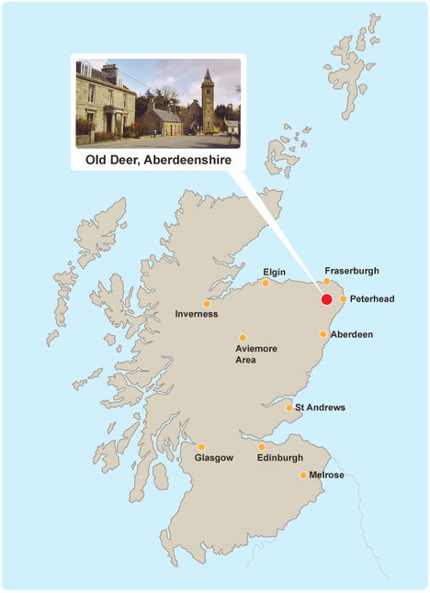
Figure 34 The Book of Deer is a 10th century Latin gospel book from Old Deer in Aberdeenshire. An image of the Book of Deer can be found here.

It is an irony that the disruptions of the Jacobite period and its aftermath led to tartan, that great visual product of the Gàidhealtachd, first being banned and then being commercialised without benefit to the Gàidhealtachd. Yet its importance persists in Gàidhealtachd art, whether in the 18th century work of the Clan Grant painter Richard Waitt or in the 19th century work of artists such as John Blake McDonald (1829-1901).
A work like McDonald’s Glencoe 1692 might at first sight seem to be merely historical or literary illustration. But when one notes that it was painted in 1879, during the period of land agitation that led in 1886 to the Crofters Act, (which gave crofters security of tenure for the first time) one can recognise it as a visual revisiting of a key moment of Highland history. The painting thus refers to contemporary politics every bit as much as does the emigrant theme of John Watson Nicol’s (1856-1926) Lochaber No More, painted four years later.

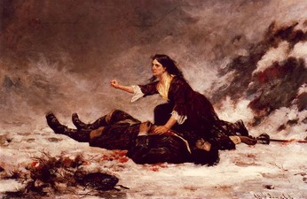
Figure 35 Glencoe 1692 by John Blake McDonald (1829-1901)

It is instructive to note that it was a Gaelic-speaking artist from Kintyre, William McTaggart (1835-1910) who, more than any other artist, laid the foundations for modern Scottish art. The contrast between McTaggart’s pioneering paintings and the stereotype of the Highlands could hardly be more marked.
In 1911 that greatest of Gaelic learners Edward Dwelly, the lexicographer who was born near Arundel in 1864, emphasised the visual aspect of the Gàidhealtachd in his illustrated Gaelic-English dictionary (more on this in a moment), not least through the work of the Stornoway artist Malcolm MacDonald. He helped Dwelly to illustrate the dictionary and was one of the first trained visual artists from the Western Isles. He studied at the Glasgow School of Art and the École des Beaux-Artes in Paris, and produced a number of fine oil paintings of Lewis and of sailing ships.
By that time key historical works such as the great crosses of Iona and Islay and the works of the West Highland School centuries had been recorded by 19th century artists like Andrew Gibb and James Drummond.
Gibb, in volume two of John Stuart’s Sculptured Stones of Scotland, published in 1867, recorded works such as the Kildalton Cross in Islay and St Martin’s Cross in Iona. Equally important was Drummond’s Sculptured Monuments of Iona and the West Highlands, published in 1881, which drew attention to the West Highland School of Sculpture after a long period of neglect.
Following on from this there developed a Celtic Revival art of high quality. One of the great books of the Celtic Revival - and, indeed, of the Arts and Crafts Movement - was the collection of Gaelic hymns and incantations, Carmina Gadelica, edited and translated by Alexander Carmichael and published in 1900.

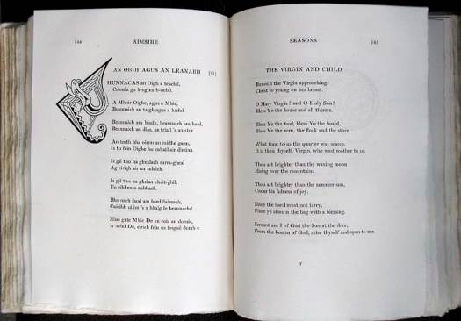
Figure 36 Pages from Volume 1 of Carmina Gadelica, a collection of Gaelic hymns and incantations

That first edition takes its place as part of Gàidhealtachd visual art. It not only reflects the aesthetic values of its time on a high level but it also revisits earlier Gàidhealtachd art stretching back well over a millennium, not least The Book of Deer. The artist was Alexander Carmichael’s wife, Mary (see Macdonald, M., 2008, ‘The Visual Dimension of Carmina Gadelica’ in Stiubhart, D. U., ed., The Life and Legacy of Alexander Carmichael, Port of Ness: The Islands Book Trust).
Edward Dwelly took inspiration from Carmina Gadelica for the title page of the first edition of his dictionary, Faclair Gàidhlig – air son nan sgoiltean. Le Dealabhan/A Gaelic Dictionary, underlining the aesthetic as well as linguistic links between the two works. The ‘F’ of ‘Faclair’ is closely related to the ‘F’ of ‘Failt’ on page 108 of volume one of Carmina Gadelica.

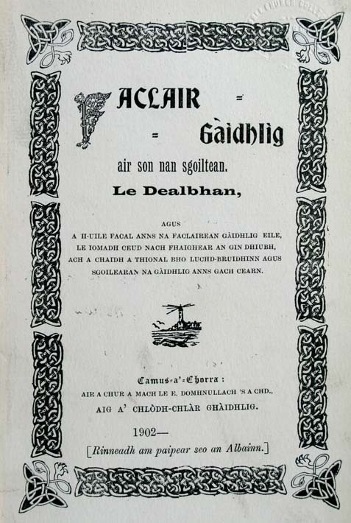
Figure 37 The title page of the first edition of Dwelly’s Gaelic Dictionary

Thus by the early years of the 20th century there was great potential for articulation of visual art as an integral part of wider Gaelic culture. So why did that not happen, at least in any sustainable way?
One factor was the loss of population through emigration, so eloquently portrayed in William McTaggart’s Sailing of the Emigrant Ship, painted in 1895.

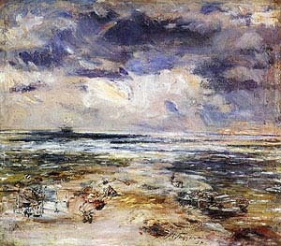
Figure 38 William McTaggart, The Sailing of the Emigrant Ship, National Gallery of Scotland

During that same late 19th century period the de facto anti-Gaelic provisions of the Education Act of 1872 were felt in full force (for a writer’s commentary on this see Campbell, A. P., 2006, Invisible Islands, Glasgow: Otago). The new educational message was that Gaelic was irrelevant as a language. The implication was that the visual tradition was irrelevant also.
McTaggart’s painting has inspired artists of today such as Will Maclean to respond strongly issues such as land ownership. Maclean’s memorial cairns at Balallan, Aignis and Gress in Lewis are good examples of this.

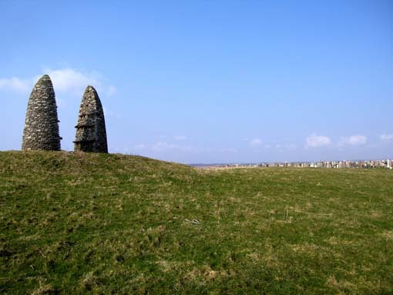
Figure 39 An example of Will Maclean’s Memorial Cairns (Aignis)

The response by artists of today to Gaelic poetry has also been powerful. In 2002 An Leabhar Mòr/The Great Book of Gaelic brought together the responses to Gaelic poetry of 100 artists from Scotland and Ireland.These included, for example, Will Maclean working with Aonghas Macneacail, Mhairi Killin working with Meg Bateman, Kate Whiteford evoking the words of Murdo MacFarlane, Floraidh Mackenzie responding to the words of Derick Thomson, Elizabeth Ogilvie working with a song by 17th century poet Màiri nighean Alasdair Ruaidh, and Calum Angus Mackay exploring the work of 18th century bard Duncan Bàn Macintyre.
This major project by Pròiseact Nan Ealan led to an international touring exhibition which toured internationally for a decade after its creation. The establishment of an artists’ residency programme at Sabhal Mòr Ostaig in 2007 should also be noted, not least with respect to the work of Gill Russell and Eoghan Mac Colla.
Work by artists involved in An Leabhar Mòr, including Helen Macalister, Donald Smith, Donald Urquhart, Norman Shaw and Frances Walker, was at the heart of an important reassessment of Scottish Gàihealtachd art held at the City Art Centre in Edinburgh from November 2010 to March 2011.

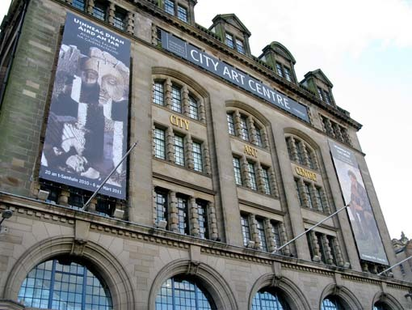
Figure 40 City Art Centre, Edinburgh

Precursors of this exhibition include As an Fhearann/From the Land: Clearance, Conflict and Crofting (1986), Togail Tìr/Marking Time: The Map of the Western Isles (1989), and the Calanais exhibition in 1995, an international response by contemporary artists to a key Highland archaeological site.
Notable also from recent years in the sculpture, Crannghal, designed by Will Maclean and Arthur Watson and installed at Sabhal Mor Ostaig in 2006. It refers in its boat-like form to the transmission of knowledge throughout the Gàidhealtachd, and in its ‘unfinished’ quality to the fact that this task is not yet complete. Land and language issues are intertwined in such art. These are recognised key cultural issues throughout the world, not least from an ecological perspective. For that reason among many others, the visual art of the Scottish Gàidhealtachd is resonant on local, national and international levels.

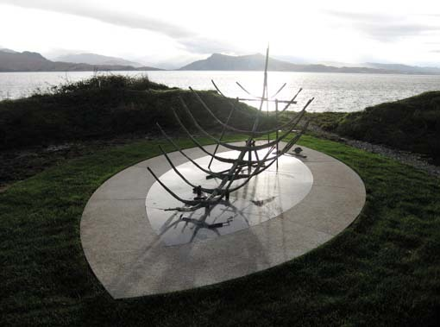
Murdo MacDonald
Figure 41 Crannghal, a sculpture designed by Will Maclean and Arthur Watson and installed at Sabhal Mor Ostaig in 2006

6.2 Gaelic music and song
From rock to pop and rap, from waulking songs (òrain luaidh) to mouth music (puirt-a-beul), from harps (the clàrsach), to bagpipes (pìoban), psalm singing (sailm) and opera, the generic term ‘Gaelic music’ knows very few boundaries.
Generally speaking, Gaelic music and song is divided into categories such as ‘traditional’ and ‘popular’, with distinctive categories such as psalm singing and waulking songs giving the language a wide range of interpretation and styles. Its strong oral tradition means that highly personalised and dynamic versions of sometimes ancient lyrics have been the norm and the transcription of melodies is a relatively modern feature.
Waulking songs, for example, are characterised by refrains, composed of meaningless vocables or a mixture of vocables and words, or of words alone. These work songs were used to lighten the work-load as women were waulking or handling tweed.

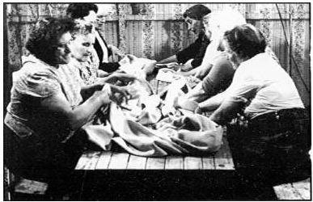
Figure 42 A waulking song group in South Uist.

Click here to hear a waulking song.

Leading the singing
Gaelic psalm singing, by way of contrast, presents a unique style of singing Scottish Psalter tunes in unison. The style is characterised by the precentor, or lead singer, giving out the psalm line by line, being followed by the congregation.
Modern interpretations of this genre have seen internationally acclaimed performances of Gaelic Psalms world-wide and a series of CDs has been issued capturing live, unrehearsed examples of what has been described as ‘the only church music in the British Isles with any soul’.
Listen to the audio clip below for an example of psalm singing, recorded in the Free Church Seminary, Stornoway.

Audio content is not available in this format.
Psalm singing

Instrumental music
There are three musical instruments directly associated with Gaelic musical tradition: the clàrsach (harp) the fiddle and the bagpipes. All three have undergone something of a modern revival with a new, dynamic generation of tradition bearers challenging the more conservative delivery of the past, whilst at the same time maintaining the integrity of the tradition.
The clàrsach is now synonymous with a particular stream of Celtic musicianship whilst fiddling has become one of Scotland’s most vibrant musical scenes.
Listen to some solo harp playing by Wendy Stewart from her CD ‘About Time’ by clicking here.
The links between Gaelic singing and piping are inextricable. Generally speaking there are two types of pipe music: ceòl mòr – ‘great music’ –
referring to the classical music known as ‘pibroch’; and ceòl beag – ‘small music’ – the marches, airs and dance tunes such as strathspeys, reels jigs and hornpipes.
Scotland now has its own National Piping Centre, the national centre of excellence for the instrument and its music, based in Glasgow, near the Royal Conservatoire of Scotland. The Piping Centre incorporates rehearsal rooms, an auditorium, an interpretation centre, reference library and a hotel and conference facility. Its patron is Prince Charles. You can listen to pipe music on The National Piping Centre website.

The cèilidh – home of Gaelic music and song
Wherever there is a gathering of Gaelic speakers, there is usually a cèilidh, or ‘gathering’ with song or music at the centre of the activity. A cèilidh can be either formal or informal – a meeting of friends where stories and tales would be told and songs are sung. In more recent times, the cèilidh has become a mixture of dance and formal entertainment and part of a wider public entertainment scene, although it still remains and important part of community life as a means of visiting friends and keeping up to date with local affairs.
‘Ceilidhs’ have effectively become ‘concerts’ and are often the centre-pieces and highlights of major festivals and events such as Celtic Connections in Glasgow each January, the Hebridean Celtic Festival in the Hebrides and Celtic Colours International Festival in Cape Breton.
Go to the following sites for further information:
- www.celticconnections.com
- www.celtic-colours.com
- www.hebceltfest.com

Royal National Mod
The Royal National Mod (‘Am Mòd Nàiseanta Rìoghail’ in Gaelic) is the annual national Gaelic festival of song, arts and culture and the equivalent of the Welsh Eisteddfod. Organised by An Comunn Gàidhealach (The Gaelic Association), it includes a competitive element as well as a very lively ‘Fringe’. It was first held in Oban in 1892 and continues to be the highest profile annual event showcasing Gaelic culture.

Fèisean nan Gàidheal
The Gaelic word for a festival or feast is ‘Fèis’. This word is now synonymous with the Fèis movement which is a grouping of Gaelic arts festivals the primary function of which is tuition. Each Fèis provides an opportunity for individuals (mostly young people) to acquire and/or develop their skills in aspects of the Gaelic arts from song to dance, drama and traditional music on a wide range of instruments.
The first Fèis was held on the island of Barra in 1981. The National Association of Gaelic Arts Youth Festivals was established in 1991 and now hosts nearly 50 events with around 5,000 participants throughout Scotland annually. The movement is now one of the most successful arts initiatives in Scotland and accredited with giving major impetus to the revival and increasing popularity of Gaelic and Scottish music and song amongst young people. For more information visit the following website.

Bliadhna nan Òran/The Year of Song
The year 2010 was the Year of Song on BBC Radio nan Gàidheal and BBC ALBA and throughout the year an unparalleled line-up of music-related programmes were broadcast, with a different song chosen for each day of the year.
Its website allows users to access content quickly and simply by means of four key sections: songs, writers, themes and singers. The site currently offers the opportunity to listen to over 800 songs with supporting lyrics, 360 excerpts from radio programmes, and over 550 video clips. Biographical information is also available for over 500 singers and writers.
All 365 Song for the Day programmes are also available, including audio and accompanying verbatim transcripts for each.

Collections
Tobar an Dualchais/Kist o Riches is a collaborative project which has been set up to preserve, digitise, catalogue and make available online several thousand hours of Gaelic and Scots recordings. This website contains a wealth of material such as folklore, songs, music, history, poetry, traditions, stories and other information. The material has been collected from all over Scotland and beyond from the 1930s onwards.
The recordings come from the School of Scottish Studies (University of Edinburgh), BBC Scotland and the National Trust for Scotland's Canna Collection. The material includes stories recorded by John Lorne Campbell on wax cylinders in 1937, folklore collected all over Scotland by Calum Maclean in the 1950s; Scots songs recorded by Hamish Henderson from travelling people in the 1960s and archival material broadcast by BBC Radio nan Gàidheal. You can access the website here.

Stellar quality
A number of individual performers of Gaelic music and song have gone on to become award-winning, internationally-acclaimed artistes. Singer and musician Julie Fowlis and rock band Runrig are two of the most notable.
Gaelic singer Julie Fowlis has attracted UK-wide attention and a significant following built on success in music awards and at festivals throughout Britain and Ireland.
Ignoring much advice to pursue a career in more mainstream music, Julie has remained true to her roots and the Gaelic language. She performs all her material in Gaelic, finding her inspiration and creativity from the music, history and culture of her homeland.
Since being presented with her award as BBC Radio 2 Folk Singer of the Year 2008 (the first ever Scottish Gaelic singer to win this prestigious award), the Daily Telegraph predicted that ‘Fowlis could be the first Scottish Gaelic crossover star in the making’
The singer has compiled a remarkable CV in a very short time. She is no stranger to awards and distinctions, winning Gaelic Singer Of The Year and Album Of The Year at the Scots Trad Music Awards 2007. She won Album of the Year a second time in 2010. She has also been repeatedly nominated for the BBC Radio 2 Folk Singer of the Year. Her single 'Blackbird' was also playlisted on BBC Radio 2, the first Scottish Gaelic artist to achieve this distinction. She was also the first Scottish Gaelic artist to appear on the legendary show 'Later…with Jools Holland’ in 2007.
She is perhaps most proud of her award as Scotland's Gaelic Ambassador - ‘Tosgaire na Gàidhlig’, bestowed by the Scottish Parliament in 2008/2009, the first person to ever receive this honour.
The Scottish rock group Runrig, formed in Skye in 1973, have been, along with Capercaillie, the highest profile exponents of Gaelic music on the popular stage. Runrig have released more than 15 albums, with a significant amount of their material in Gaelic. The group released a written collection of 115 of their songs with illustrations in 2000.
Runrig’s material draws heavily on locations, history, politics and people unique to the bands roots in the western isles of Scotland. Their fan base is world-wide ranging from the United Kingdom, to substantial audiences in Denmark, and Germany, and more traditionally ‘Scottish’ areas such as Nova Scotia. In 2006 Runrig played their first concert in the United States, at a benefit for the charity ‘Glasgow the Caring City’ in New York City.
Runrig’s iconic re-recording of the song Loch Lomond (Hampden Remix) to raise funds for the BBC's annual Children In Need appeal included the 'Tartan Army' (Scotland's Hampden Football Supporters), and pop star Rod Stewart on backing vocals. It reached number 9 in the UK Singles Chart. In the summer of 1995, Runrig made history by putting a Scottish Gaelic song, An Ubhal As Airde, into the UK Top 20. It entered the chart 10 at number 18. The band has been inducted into the Scottish Traditional Music Hall of Fame, through the Scottish Traditional Music Awards.
The start of 2011 saw a new Gaelic band Mànran attempt to recreate Runrig’s success with a Gaelic song Làtha math (‘A Good day’). The song met with limited success, reaching number 61 in the UK charts, selling nearly 5,500 copies, but it was number 1 in the UK singer/songwriter chart and the band had 55,000 hits on its website on the day after the song’s release.

The opera Hiort: St Kilda
Gaelic music and song was launched onto the international stage by Pròiseact nan Ealan, the Gaelic National Arts Agency. The specially commissioned opera Hiort: St Kilda, with music by Jean-Paul Dessy and David Graham, and libretto by Iain Finlay MacLeòid, told the story of the people of the St Kilda islands and how they dealt with day-to-day life before the islands were evacuated in 1930. Hiort is St Kilda in Scottish Gaelic.
The power, emotion and appeal of this story connected Gaelic with European culture at many levels and set Gaelic language and culture, as well as Gaelic broadcasting, on a unique international stage.

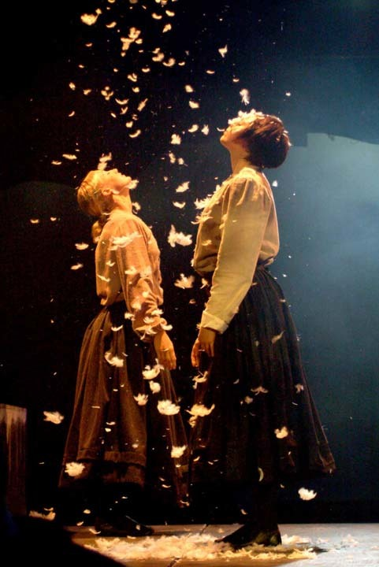
Courtesy of Proisect nan Ealan, the Gaelic National Arts Agency
Figure 43 A scene from the opera Hiort: St Kilda

The Belgian production of the opera, St Kilda: L’île des Hommes-Oiseaux, was performed at the Edinburgh Festival Theatre as a highlight of the Edinburgh International Festival 2009. It was one of five productions performed simultaneously in Scotland, France, Germany, and Austria, as well as Belgium. An element of the production was also broadcast live from St Kilda to all 5 locations. The Belgian production was restaged and toured to France in late 2008.
The Belgian production presented a unique interpretation of the St Kildan story. It was shown live to the world in a special broadcasting project which brought six European countries together.

Gaelic in the charts
Perhaps the most famous success for a Gaelic singer in the popular music charts was the 1981 song Japanese Boy, sung by Aneka (real name Mary Sandeman), which reached number 1. She was well known for the Oriental image she adopted for the song. After her brief foray into pop she established herself as an accomplished singer of Scottish traditional music under her real name.

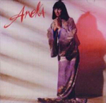
Figure 44 The cover from Aneka’s popular 1981 song Japanese Boy

Studying Gaelic music
The department of Scottish Music at the Royal Conservatoire of Scotland offers the only honours degree in Scottish traditional music in the world. The course offers a broad based training to talented traditional musicians, enabling them to pursue a variety of careers, or further study. A degree in piping is run in collaboration with the National Piping Centre, which is internationally recognised as a centre of excellence in Highland bagpipe teaching.
Mary Ann Kennedyis one former student of RSAMD who has gone on to become a major figure on the Scottish music and broadcasting scene. She now lives in Lochaber where she and her husband run Watercolour Music Studios. A traditional music background and a classical training coupled with 15 years’ experience working with the BBC has established her as a major figure in the Scottish music scene, equally respected as a performer and as an authoritative commentator on world, classical, traditional and folk music.
Mary Ann's musical career covers several roles as performer, producer, writer and teacher. She has won several major awards, including the Concours Internationale de l'Harpe Celtique and both National Mod Gold Medals. Her band, Cliar, won the all-time Best Album accolade at the inaugural Scots Trad Music Awards, and earned her a Saltire Award.
Her broadcast credits include radio work for BBC Radio Scotland, BBC Radio 3, RTE and BBC Radio nan Gàidheal, and presentation and performance on BBC Scotland, BBC2, TG4 and BBC4, fronting major series and specials on world and traditional Scottish and Irish music.
James Graham fromLochinver has similarly excelled as a young traditional musician since undertaking the RSAMD BA Scottish Music course. James belongs to Assynt in Lochinver, Sutherland and started competing at local Mod competitions as a 9 year-old.
Now an accomplished piper and singer, he studied Gaelic song under the tutelage of Kenna Campbell, one of a number of key figures passing on their skills and traditions. In 2004, James won the BBC Scotland Young Traditional Musician of the Year award. He was the first male performer and first Gaelic singer to take the prize. In 2007 he won the Gold Medal at the Royal national Mod and has gone on to release a number of acclaimed CDs.
James has also completed a further two years of study at Sabhal Mòr Ostaig, where he took an HND in Gaelic language and culture.
He has continued to develop his work as a live performer and has worked on a number of award-winning television and radio programmes, including Transatlantic Sessions 4.

Community events
Ceòlasis a music and dance summer school featuring expert tuition in piping, fiddling, singing, Scotch reels and quadrilles, step dancing and the Gaelic language. It is set within the Gaelic-speaking community of South Uist in the Outer Hebrides. Ceòlas explores the vital connections between Scottish traditional music, Gaelic song and dance while allowing ample opportunity for participants to enjoy all these art forms in cèilidhs and in homes, the places which fostered them.

Where Gaelic music is ‘cool’?
In 1999, recognising the wealth of traditional music activity generated by the Fèis movement and others, Highland Council led a plan to establish a residential Centre of Excellence specialising in traditional music. The bid was successful, and the National Centre of Excellence in Traditional Music - Sgoil Chiùil na Gàidhealtachd - was established at Plockton High School in Wester Ross in May 2000 with funding of £500,000 over three years from the Scottish Executive’s Excellence Fund, with additional input from The Highland Council.
The choice of location was significant. Plockton, on the west coast of Ross-shire just opposite the Isle of Skye, is at the heart of a wide community which has long been known for its support of traditional music and Gaelic culture. Both the school and the wider community have good track records of achievement, particularly in piping and in Gaelic medium education.
The Plockton project is unique amongst the centres of excellence set up at the time in that it concentrates specifically on one genre of music - traditional music. That that genre is has been regarded by many people as testament to the huge growth in popularity and intrinsic importance and value of Scotland’s native musical culture. It was also decided early in the life of the project that it would not be strictly vocational.
Many graduates of the school, which survived a funding crisis in 2011 due to a public campaign of support, have gone on to pursue highly successful careers as the professional musicians.

6.3 Dance

Historical background
Of all the Gaelic art forms, dance has had, perhaps surprisingly, the least impact and it is in its modern manifestations and representations through Highland Games that it is best known. Many current forms of dance activity have displaced older versions, or are modifications of ritual celebrations and some have, over time, become more associated with children’s play activities and entertainment. There are also interesting sub-sets of mainstream activity, with military institutions developing their own interests and styles, the most notable being the introduction of Highland dancing to the Royal Edinburgh Military Tattoo.
Throughout the world, however, Highland dancing is recognised as one of the iconic activities of Scotland and its presence on the global stage is, in no small measure, due to the presence of Highland émigrés from the 19th century in particular. Highland dancing was, simply, one of the cultural anchors which enabled a displaced people to entertain themselves and retain some semblance of their life back in the home country in, for example, Geelong, Australia.

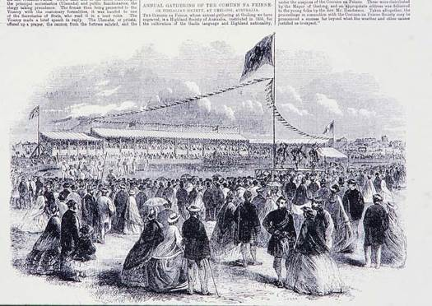
Figure 45 An extract from the Illustrated London News in 1857, which reported on the Highland Games in Geelong, Australia, organised by the Highland Society Comunn na Feinne. Dancing was a central activity at the games, both for display and competition.

Step dance in Canada
Although step dancing is unique to Canada, there are three distinct styles within the country: Cape Breton Style, French Canadian Style and Ottawa Valley Style. All three draw heavily on the traditions of dance in Scotland and Ireland and were brought to Canada by emigrants from the Highlands of Scotland and Ireland.
Step dancing is a fast paced, rugged and energetic style of dance usually performed to traditional fiddle music. It generally requires limited surface movement and is concentrated on foot work involving limited hand and arm motion. Step dancing is usually performed on a board with a hard, smooth surface, wearing character shoes with special clickers attached to the toe and heel. Similar to Highland country dancing and Irish dancing, it has a competitive element beyond its social context of community dances.
Step dancing follows the popular pattern of an eight-bar step. Although the traditional method of right then left foot is most common among dancers, many times dancers creatively dance on only one foot before moving on to the next step. This is usually done when creating steps defined for a specific piece of music.
There are many different types of step dances. All have different tempos, timing and accents. The different dances include: reels, jigs, clogs, strathspeys, hornpipes, waltz-clogs, polkas, and two-steps.

Watch the video at YouTube.com.

Highland dancing
The modern term Highland dance or Highland dancing is used today to refer to a style of athletic solo dancing which developed in the Gaelic Highlands of Scotland. It now has a hugely competitive element at Highland Games, attracting world-wide interest and participation, which contrasts significantly with the concept of ceilidh or community dancing.
Highland dance evolved into its current form during the 19th and 20th Centuries largely in the context of competitions at Highland games), where it is often performed to the accompaniment of Highland bagpipe music and comes with an elaborate structure of judging and performance ritual.

Watch the video at YouTube.com.

Highland dancing is not the same as Scottish country dancing, which is both a social dance like ballroom dancing (that is, a dance which is danced with a partner or partners) and a formation dance similar to square dancing (a dance in which an important element is the pattern of group movement about the dance floor).
Some Highland dances do derive from traditional social dances, however. An example is the Highland Reel, also known as the Foursome Reel, in which groups of four dancers alternate between solo steps facing one another and a figure-of-eight style with intertwining progressive movement. Most Highland dances are performed solo. Highland Dance is recognised as a sport by Sportscotland.

Dancing with swords and kilts
It seems that forms of sword dancing have been performed by warriors in many parts of Europe over a long period of time. Ritualistic and combative dances portraying epic deeds and martial skills were a familiar feature in Scottish tradition and folklore.
The British Government's policy of suppression against Highland culture culminated in 1747 with the Act of Proscription, banning the wearing of kilts by civilian males. The Act was repealed in 1782 and in the early 19th century, there was something of a romanticisation of Highland culture.

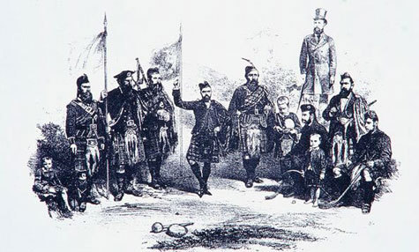
Figure 46 The Book of the Club of True Highlanders, published in 1881, had dancing as its centerpiece when assembling the key elements of ‘Highland culture’

The process of romanticisation received the royal seal of approval with the public wearing of the kilt by George IV in 1822; henceforth tartan’s popularity was assured. Queen Victoria’s subsequent enthusiasm for aspects of Highland culture included piping and dancing and it was during this period that dancing became popular at Highland Games public events.
Highland dancing was an integral part of the games from the very start of their modern revival, but the dances performed at games were mostly for the convenience of judges. Many older, traditional dances were lost at this time as they were not required for competition.

Organisation
Many Highland gatherings worldwide, and almost all in the United States, recognise the Scottish Official Board of Highland Dancing (SOBHD), formed in 1950, as the world governing body of Highland dancing. A World Highland Dance Championship has been held annually at the Cowal Highland Gathering since 1934.

Highland dances

The Sword Dance
Highlanders are said to have developed the sword dance ‘as a necessary preparation for the management of the broad-sword… used in certain dances to exhibit their dexterity’ (Logan, James. The Scottish Gael p. 440).
This included dancing over two naked swords which are laid across each other on the floor, some while a dancer moves nimbly around them. Dexterously placing the feet by a peculiar step in the intervals between crossed blades, as in the ‘Gillie Chaluim’, has long been linked with dances before a decisive battle or as a victory dance.
Legend has it that on the eve of battle Highland chiefs would call out the clan’s best dancers, who would dance the sword dance. If the dancers successfully avoided touching either blade, then it was considered an omen that the next day's battle would be in the clan’s favour.
A more practical explanation behind the meaning of this dance can be found in the training halls of older styles of fencing, where students of the sword developed their footwork by following geometric patterns of crosses, squares and triangles marked out on the floor. Click here to see an example.

The Highland Fling
One of the best known Highland Dances is the Highland Fling, said to be a dance of triumph at the end of a battle. Another (no less romantic) theory is that it was performed before battles (like the sword dance), on top of the dancer’s shield. The shield would have a spike in the middle, around which the dancer would do the dance that involves flicking of the feet, jumping and careful stepping supposedly to drive evil spirits away. The dancer is confined to one spot.

Watch the video at YouTube.com.

The Reel of Tulloch
Ruidhle Thulaichean (anglicised as ‘The Reel of Tulloch’) is said (perhaps dubiously) to have originated when a congregation had to wait at a church for a minister on a cold wedding day. During the delay they allegedly whistled a Highland tune while someone improvised a dance. A more gruesome version of the story is that the dance derives from a rough game of football that some workmen building a castle played when they unearthed a human skull. A variation is that inhabitants of of Tulloch played with the severed head of an enemy.
The genesis of the song is discussed in an article entitled ‘The reel of Tulloch in fact and fiction’, about the folklore attached to it and the so-called Tulloch Tragedy, published in The Transactions of Gaelic Society of Inverness (volume LIX, pages 118-128).
The song itself is published in Archibald Sinclair’s 1879 collection An t-Òranaiche.

Their britheamhan na tìre
Ma labhras iad an fhìrinn:
‘De na thig de cheòl à fidhlean
S e rìgh dhiubh Na Tulaichean.’
The judges of this land
Will say if you believe them:
‘When music comes from any fiddle
the Reel of Tulloch’s the King.’
Archibald Sinclair, An t-Òranaiche, Glasgow 1879 pages 117-120

You can see a photo of soldiers dancing the Reel of Tulloch here.

Seann Triubhas
The Seann Triubhas (pronounced ‘shawn trewas’ and meaning ‘old or unwanted trousers’ in Gaelic) is romantically associated with the proscription of Highland garb after the 1745 rebellion. The steps involve much shaking of the legs, symbolic of shedding the dreaded ‘trewes’; the final, faster step(s) show the joy of returning to the kilt. However, the dance is considerably younger, with most of the steps performed today dating from the late 19th century.

Watch the video at YouTube.com.

Like other dance traditions, what is called ‘Highland dancing’ is a hybrid form that has been constantly changing according to contemporary aesthetics and interpretations of the past. While some elements may be centuries old, other elements are much more modern. The vast majority of dances now performed were composed in the last century.

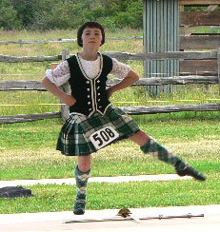
Figure 47 Highland dancing has seen a constant evolution in style and interpretation

Country dancing
Scottish country dances are categorised as reels (including hornpipes), jigs, and strathspeys, according to the type of music to which they are danced. The first two types (also called quick-time dances) feature fast tempos, quick movements and a lively feel. The third type (strathspey) has a much slower tempo and a more formal, stately feel. There are also 9/8 jigs, minuets and waltz-time dances, although they make up a very small part of the repertoire.

Dancers and sets
Scottish country dancing is generally done in organised formations referred to as ‘sets’. Sets usually consist of three or four couples, but some dances call for larger sets of five, six or even more couples. Couples are usually mixed, but women will dance with women or men with men depending on the make-up of the assembly.
Scottish country dancing is a hugely social and inclusive activity which is enjoyed by many, of all ages. Many SCD groups enjoy putting on ‘demonstrations’ showing near-to-perfect dancing involving all aspects of technique.

Modern country dancing and the Royal Scottish Country Dance Society
During the early 20th century, Scottish country dance still had a part in social entertainment especially in rural Scotland, even though the number of dances within the active repertoire had diminished. Country dancing was in danger of dying out when in 1923 the Scottish Country Dance Society (SCDS) was founded in Glasgow, with the goal of preserving ‘country dances as danced in Scotland’ (this was only recently changed to read ‘Scottish country dances’).
The SCDS began to collect and publish the remaining dances as well as reconstruct (or reinterpret) from old sources dances that were no longer being danced. In the process, the dances and technique, which might differ considerably depending on where in Scotland a dance would be collected, were strictly standardised.
The society achieved Royal patronage in 1947 and became known as the Royal Scottish Country Dance Society (RSCDS).
Fairly soon after the inception of the SCDS people started inventing new dances in the spirit of the older ones, but also introducing new figures not part of the ‘traditional’ canon. Today there are over 11,000 dances catalogued, of which fewer than 1,000 can be considered ‘traditional’.

Hebridean dance
The term ‘Hebridean dancing’ is a fairly modern one and probably first came into use at the English Folk Dance and Song Society’s festival at the Royal Albert Hall, London in 1934, when Fearchar Macneil from Barra was asked to perform some dances known in South Uist and Barra. It is believed that these dances acquired this label to differentiate them from the more widely known Highland dances and to pinpoint their place of origin.
The solo dances now embraced by the term Hebridean dances, and of which several versions are known, are Tulloch Gorm, Highland Laddie, Over the Water to Charlie, (Scotch) Blue Bonnets, Flowers of Edinburgh, First of August, Scotch Measure and Aberdonian Lassie.
Only fragments of the dances Jacky Jar, The Lads wi’ the Kilt, Over the Water and Over the Hill, Carraig Fhearghais, Over the Hills and Far Away, and Petronella survive to this day.
It is not known with any certainty where these dances originated but we do know that dances bearing these names were all taught by dancing master Eòghann Mac Lachlainn (Ewen MacLachlan), c. 1799-1879, who taught dancing primarily in South Benbecula, South Uist, Eriskay and in Barra in the mid-1800s.
The dances, as we know them today, are performed in a more relaxed and rather spontaneous manner than Highland dancing, and they often involve a great deal of percussive footwork.
In the mid-1980s there was a move amongst the local people in Barra and South Uist to preserve these dances which could have been lost forever. There were still several people on the islands who knew these dances from their youth and had been taught them by pupils of pupils of Ewen MacLachlan.
The dances were subsequently introduced to Fèis Bharraigh (Barra Festival) and in both South Uist and Barra the dances were introduced to children by local tradition bearers.
The television documentary Tiugainn a’ Dhannsa (‘Let’s Dance’) examined the role of village halls in Scottish communities throughout the 20th century. These former centres of music and dance have been torn down in many areas to be replaced by buildings catering to the needs of a very different generation. The programme used nostalgic anecdotes to recall the heyday of the village dance. The book Hebridean Dances:Dannsa nan Eileanach (published by Acair Ltd and illustrated by Jon Paul) has 12 detailed descriptions and diagrams of dances from Barra.

Modern dance
Creative Scotland helps to develop dance in Scotland through support of dance-based organisations, buildings, and choreographers, along with developing audiences. Scottish Dance Theatre is Scotland’s national contemporary dance company.

6.4 Gaelic literature
Gaelic literature has had a long and varied history and in the past half century has firmly established itself as an important part of the wider Scottish literary scene.

6.4.1 Poetry
The Gaelic poetry of the 17th century is interesting more for the light it throws on the clan-based society of the time than for its literary merit. Comprising mostly praise of chiefs, it is an example of verse used for propaganda purposes and of poets as the spin-doctors of their day.
The 18th century saw the Highlands opening out to the outside world, as education spread and the travel became easier (especially after the failure of the Jacobite Rising of 1745/6). A recognisably modern form of society was beginning to emerge and this is reflected in the poetry of the time, which is marked by new styles of writing and a wider range of subjects, including the nature poetry of Donnchadh Bàn (Duncan Macintyre), the love songs of Uilleam Ros (William Ross), and the satire of Sutherland poet Rob Donn (Robert Mackay).

Rannan às an eadar-theangachadh Bheurla aig Iain Mac a’ Ghobhainn air ‘Moladh Beinn Dòbhrainn’ le Donnchadh Bàn Mac an t-Saoir.  Greadhainn bu gheal cèir,  Faghaid air an dèidh –  ’S laghach leam an sreud  A bha sròineiseach.  …..  ’S aigeannach fear eutrom  Gun mhòrchuis  Thèid fasanta na èideadh  Neo-spòrsail.  Tha mhantal uime fhèin,  Caithtiche nach trèig –  Bratach dhearg mar chèir  Bhiodh mar chòmhdach air. | This image of the deer as the nobility of the glens is from Iain Crichton Smith’s free translation of Donnchadh Bàn’s tour-de-force, ‘Praise of Ben Dòrain’.  Herds with white rumps race -  hunters in the chase.  O I love the grace  of these noble ones.  …..  Spirited and delicate  and shy,  in fashionable coat  he goes by  in mantle well arrayed,  suit that will not fade,  dress of waxen-red  that he's wearing now.

The 19th century and the first half of the 20th century – an era of much poverty and social upheaval in the Highlands – produced little of merit in Gaelic poetry, although some of the subjects and styles of the great 18th century poets has survived, through this period and up to the present day, in the work of the local poets known as ‘village bards’ (some of whom are much more than that).
Then, out of the blue, a slim volume was published in 1943 which brought Gaelic poetry at one fell swoop into line with the best writing of its time in English and other languages. Sorley MacLean managed to bring together in Dàin do Eimhir the best of the Gaelic tradition and of world literature and he did so with an infectious enthusiasm that has inspired generations of Gaelic writers up to the present day.
MacLean the poet was torn between the demands of love and family on the one hand, and his sense of duty and political ideals on the other, of which socialism and the Spanish Civil War are the keynotes. He interweaved this inner conflict with other themes to produce, in Dàin do Eimhir, a multi-textured sequence of poems which is highly-wrought both artistically and emotionally.

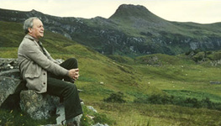
Figure 48 Sorley MacLean

Click on the audio clips below to hear a interview with Sorley MacLean.

Audio content is not available in this format.
Interview with Sorley MacLean – Part 1
View transcript - Interview with Sorley MacLean – Part 1

Audio content is not available in this format.
Interview with Sorley MacLean – Part 2
View transcript - Interview with Sorley MacLean – Part 2

Audio content is not available in this format.
Interview with Sorley MacLean – Part 3
View transcript - Interview with Sorley MacLean – Part 3

Audio content is not available in this format.
Interview with Sorley MacLean – Part 4
View transcript - Interview with Sorley MacLean – Part 4

Among the other notable Gaelic poets of the late 20th and early 21st centuries are Derick Thomson, Iain Crichton Smith, Aonghas Macneacail, Catriona Montgomery, Meg Bateman, and Myles Campbell.
Thomson, in particular, has written and published poetry over six decades, changing his style and preoccupations over time but retaining the qualities that make him an outstanding poet, namely:
- a subtle intellect, emotional depth and the ability to seamlessly blend the two
- free verse which has the musicality of the traditional song metres – but more flexibility
- robust, yet precise, use of language
- a wry wit and a sharp sense of irony.
The following poem is a typical example of that sense of irony:

Alba v. Argentina, 2/6/79  mìos às dèidh Taghadh na Pàrlamaid, 3/5/79  Glaschu a’ cur thairis  le gràdh dùthcha,  leòmhainn bheucach  air Sràid an Dòchais,  an Central  mùchte le breacan,  cop air Tartan bho mhoch gu dubh,  is mùn nam fineachan air a’ bhlàr;  iolach-catha a’ bàthadh bùrail nam busaichean –  Sco-o-t-land, Sco-o-t-land –  Alba chadalach,  mìos ro fhadalach. | Scotland v. Argentina, 2/6/79  a month after the General Election, 3/5/79  Glasgow erupting  with patriotism,  growling lions  on Hope Street,  the Central  choked with Tartan,  foaming from dawn to dusk,  and clansmen’s piss on the battlefield;  the battle-cry drowning the buses’ drone –  Sco-o-t-land, Sco-o-t-land –  sleepy Scotland,  a month late.

An example of the work of the younger poets, Aonghas Macneacail’s ‘Marilyn Monroe’, can be seen in Section 4. Written in Gaelic and English, it has a more modern feel than Thomson’s work but is equally skillful and insightful.

6.4.2 Drama and Fiction
The short story, novel and play first appeared in Gaelic in the early 20th century but it was only in the 1960s and 1970s that these genres achieved the same standing as poetry in Gaelic. Indeed, many would argue that the short story is now the quintessential Gaelic literary form.
The two most successful and prolific Gaelic short story writers of this period have been Iain Crichton Smith and John Murray. Smith’s stories cover a wide range of themes and settings and are characterised by intellectual rigour, poetic imagery and precision in their use of language.
Murray is a short story writer of a more conventional stamp, creating an array of interesting story lines and characters and deploying a wide variety of styles with consummate ease. The skillful use of language and humour are key features of Murray’s style
The main writers of Gaelic plays include the innovative Finlay MacLeod and the more traditional Paul MacInnes. MacLeod is best known for impressionistic pieces such as Ceann Cropic (the first Gaelic play on television in 1976), although the children’s radio adventure series Na Balaich air Rònaidh (1968) employs a more conventional narrative approach.
Despite these two success stories, however, Gaelic playwrights have been hamstrung by a lack of opportunities to show their work, on stage or through the media, and, similarly, short story writing has been affected by the closure of the literary magazine, Gairm, in 2002.
It is only in the past two decades that the Gaelic novel has reached maturity, due largely to Ùr-sgeul (‘New story’), a promotional scheme run by the Gaelic Books Council.
Angus Peter Campbell’s An Oidhche mus do Sheòl is one of the novels fostered by Ùr-sgeul. A family chronicle, it follows an array of interesting characters through various social and historical situations, in the Islands, Glasgow and Civil War-era Spain. This novel contains some strong writing, interesting insights and accurate descriptions of historical settings: in scope it is reminiscent of the ‘Great American Novel’, and has both the strengths and weaknesses of that genre.
Catriona Lexy Campbell is a younger writer, with a lighter touch, but she also shows great skill in creating characters and plots and is an undoubted future talent. Other novelists published in the Ùr-sgeul series include Martin Macintyre, Norman Campbell and Norman MacLean.

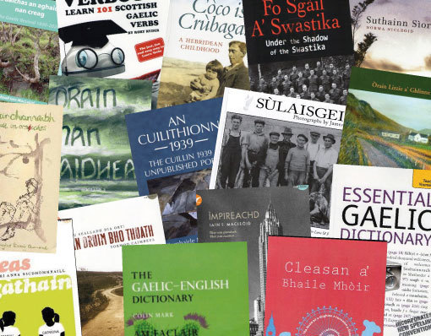

6.4.3 Songs and tales
Among the great treasures of Gaelic literature are the songs which have come down in the oral tradition, some of them very old. A popular example is ‘Griogal Cridhe’, a song of great sensitivity and beauty, which can be dated as it refers to an historical event, the persecution of the Clan Macgregor in the late 16th century. It features on the BBC’s Bliadhna nan Òran website: though the text is in Gaelic, various versions of the song can be enjoyed by clicking on the icons on the right of the page.
Recently, individuals and groups such as Runrig have composed Gaelic songs with a more modern flavour. Many of Runrig’s songs have been covered by other singers or groups. ‘Cearcall a’ Chuain’, for example, was recorded by a Gaelic choir and can be heard on the BBC website.
Gaelic also has a rich heritage of traditional Gaelic folk tales, of which John F Campbell’s 19th century Popular Tales of the West Highlands is a well known collection. Attempts have been made in recent years to revive the storytelling tradition: although this has not been uniformly successful, the tales themselves survive alongside the songs as a treasure trove of Gaelic lore, complementing the growing corpus of contemporary poetry and fiction in the language.

6.5 Sports and pastimes
Scotland, including the Gaelic-speaking areas, has a very rich tradition of games and pastimes which were a crucial part of life, both in urban and rural environments. They were important elements of young people’s lives and preceded the introduction of more formalised and regulated sports in the late 19th century.
These games and pastimes were often linked to the seasons or to specific times such as New Year, Christmas and other special occasions. They were games of chance and skill, of contest and forfeit; they involved ghosts and witches, courtship and marriage divination and well worship; gambling, feats of skill and strength, ball games and dance games.
Many of them involved singing, chanting or clapping, and their musical content very likely forms a basis for many traditional songs and tunes.
A number of significant collections and publications exist, detailing the wide range of games and pastimes and a number of organisations such as the Folklore Society and The School of Scottish studies at Edinburgh University have done important work in preserving the rich store of activities, including variations of the same games as interpreted and passed on throughout the country.
The Statistical Accounts of Scotland are an invaluable source of information on games and pastimes in the 19th century.

Box 7 Some games and pastimes

Cluich an taighe (‘The Home Game’)
Played with three circles 60 yards apart; participants gather in one of them; and one other person outside with a ball. The person with the ball tries to hit the others while passing between the circles making them ‘prisoner’.

Stracair
A bat game played by opposing teams with the aim to get a ball (ball-speil) into a hole in the ground.

Iomairt air a’ bhall
Played with a ball thrown against a wall, players assuming names; when name is called, designated player has to try and catch it before it hits the ground; if player fails to catch it he/she then has to avoid being hit by the player who threw it at the wall.

Iomairt air a’ gheata
Played with a bat or thick stick two against two. The game involves striking a small stick trying to get it into a ‘cailleach’ or hole; the other two players protect the ‘gate’; sometimes called Cat and Dog or Cat and Bat.

Iomairt air an Stainchear
A version of rounders or ‘bases’ with the name possibly derived from the English stanchel (stanchion/a station/upright/support). The bat is shaped like a cricket bat, the ball made of yarn, wound round a cork centre.

Shinty
Among the sports which came of age and began to be regulated in the 19th century, shinty was undoubtedly the most important to the Gaels.
Shinty - iomain or camanachd in Gaelic - was probably introduced to Scotland along with Christianity and the Gaelic language nearly two thousand years ago by Irish missionaries. The game, or some similar version of stick and ball activity, has been played through time virtually UK-wide, from the more hospitable and gentler plains of the Scottish Borders; from the Yorkshire moors to Blackheath in London, to wind-swept St Kilda as the intrepid traveller Martin Martin described on his epic voyage round the Hebrides around 1695:

‘They use for their diversions short clubs and balls of wood; the sand is a fair field for this sport and excercise in which they take great pleasure and are very nimble at it; they play for some eggs, fowls, hooks and tobacco; and so eager are they for victory that they strip themselves to their shirts to obtain it.’

Shinty world-wide
Shinty is a game of great antiquity and is strictly amateur. It is linked (not always with complete accuracy) to golf and ice hockey, and is also to be found in a much wider space from the plains of Montevideo in the mid-nineteenth century, to Toronto and Canada’s Maritime Provinces; from the blistering heat of New Year’s Day in Australia over 150 years ago, to Cape Town and also the war-ravaged wastes of Europe through two World Wars. There is now a burgeoning group of players and clubs in the United States of America.

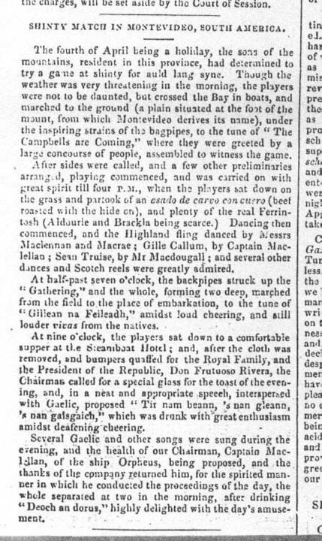
Figure 49 Report of a shinty match in Montevideo from the Inverness Courier, 13 July 1842

Origins
There is no doubt but that shinty (or more accurately, some early form of the stick and ball game) was played in pagan times. In Scottish terms, the earliest written reference to shinty or ‘schynnie’ is in 1589, in the Kirk Session Records of Glasgow. This is reproduced in full below. The passage of interest (which is marked with an X) reads:

‘that nane be fund castand stanes wi th in the kirkis zardes, or playing at futeball, goff, carrick or schynnie’ (Kirk Session Records, Glasgow, 16th October, 1589)

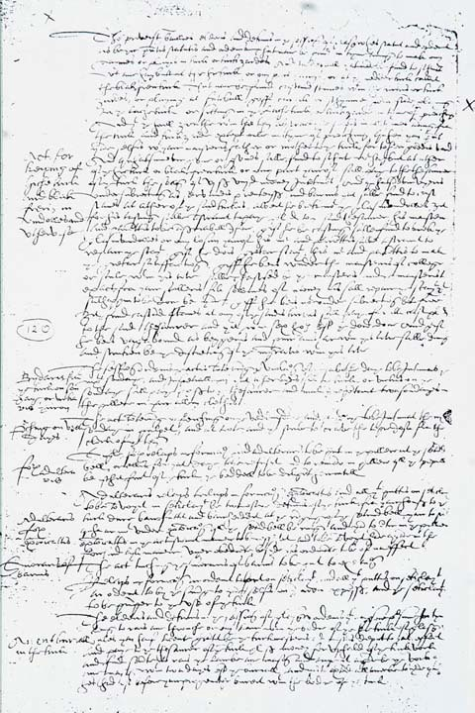
Figure 50 The earliest written reference to shinty or ‘schynnie’ in 1589, in the Kirk Session Records of Glasgow for 1589

The Book of the Club of True Highlanders, published by the Society of True Highlanders in 1881 regarded shinty as being ‘undoubtedly the oldest known Keltic sport or pastime….The origin of this game is lost in the midst of ages... ….played by Noah himself; and if by Noah, in all probability by Adam and his sons.’

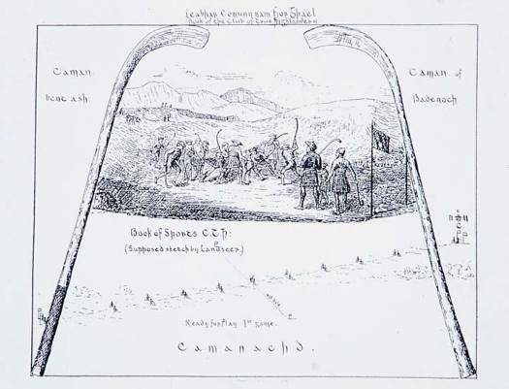
Figure 51 The Book of the Club of True Highlanders’ depiction of shinty

The word ‘shinty’
The term ‘shinty’ itself requires some explanation. Iomain, or more latterly camanachd, were the Gaelic terms, meaning driving. ‘Shinty’ (or its variants shindy, shinnie, shindig etc), however, has proved much more contentious, and the general view is that it is derived from the Gaelic sinteag – a ‘leap, bound’. Shinnie, in fact is held to be the older of the two (around 1600) with shintiereplacing it some 100 years later.

Shinty’s part in festivals
There was no event of greater importance in connection with the celebration of the advent of the New Year in the Highlands than the New Year’s Day Shinty Match. Very often ‘A cask of whisky strong’, was the victor’s prize. These contests were often between two districts or parishes, with no limit to the numbers taking part (as many as 2,000 men engaged), from the forenoon until darkness fell. Occasionally a hogs-head of whisky was given to the winners by the proprietor.
One of the best sources for determining shinty’s ‘place and space’ is the dictionary. In Jamieson's Etymological Dictionary of the Scottish Language we find shinty sandwiched between ‘Shinnock’ and ‘Shiolag’. Perhaps more surprisingly however, the English Dialect Dictionary (EDD) records shinham in the north of England, shinnins and shinnop in Yorkshire, and shinny and shinty in the north of England generally, and as far south as Lincolnshire, Nottinghamshire and Gloucestershire. The dictionary mentions shinty being played in Workington in Cumberland as late as 1888, when two boys were fined for playing the game in the street and a third ‘was let off, having been well thrashed by his parent’.

Shinty’s place in society
Shinty was of much wider interest than just being the expression of some local conflict, or a landlord’s patronage. The Penny Magazine of January 31, 1835, produced by the Society for the Diffusion of Useful Knowledge provides us with a useful visual representation of shinty as it was perceived at the time.

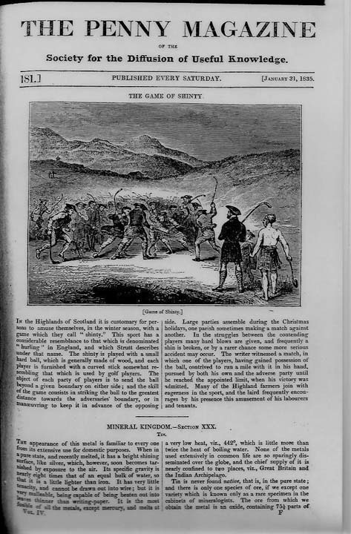

Shinty beyond the Scottish border
Shinty was not confined to the Highlands, or even Scotland. The first club established in England was Cottonopolis, Manchester, formed prior to December, 1875. The pages of the Highlander newspaper, particularly in the late 1870s and early 1880s, read more like an account of English Premier league football matches with details of games and frequent references to Birmingham, Manchester Camanachd, Old Trafford, the Highland Camanachd Club of London, Cottonopolis, Bolton, Nottingham Forest and Stamford Bridge.
There was feverish activity in shinty terms on both sides of the border, and across the world from the Cape of Good Hope to Australia and New Zealand; from Toronto in Canada, to New York, where a team was formed in 1903.
Perhaps the most convincing evidence of shinty’s translation to Australia is a water-colour painting by the Scot John Rae in 1842.

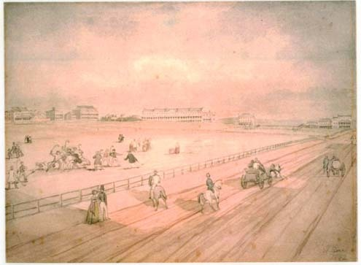
Figure 52 Shinty in Sydney 1840 by John Rae

The scene depicted appears to show shinty being played. It is one of a series painted by Rae, a Scotsman who apparently arrived in Sydney in December, 1839, a year after the ‘St George’, the vessel which left Oban in 1838, packed with Badenoch folk, and for which the famous Gaelic song ‘Guma Slàn do na fearaibh’ (‘Good health to the fellows…’) was composed. These are the words as printed by Thomas Sinton in The Poetry of Badenoch, Inverness, 1906.

A health to the fellows,  Who’ll cross o’er the sea!  To the country of promise,  Where no cold they will feel.-  A health to the fellows,  Who’ll cross o’er the sea!  A health to the goodwives!  We’ll hear no complaining;  They’ll follow us heartily  Over the sea.  And the beautiful maidens  Going with us together,-  They’ll get husbands to marry,  Who’ll give ear-rings of gold. | Gu 'm a slàn do na fearaibh  Thèid thairis a' chuan  Gu talamh a' gheallaidh,  Far nach fairich iad fuachd.  Gu 'm a slàn etc.  Gu 'm a slàn do na mnàthan  Nach cluinnear an gearan,  'S ann thèid iad gu smearail,  'G ar leantuinn thar 'chuan;  Gu 'm a slàn etc.  'Us na nìghneagan bòidheach,  A dh'fhalbhas leinn còmhladh,  Gheibh daoine ri'm pòsadh,  A chuireas òr 'nan dà chluais.  Gu 'm a slàn etc.

Shinty in Australia
It should come as no surprise then when we find that in Geelong, Victoria, a society was established by Highlanders to maintain the culture and traditions of their people. ‘Comunn na Feinne’ (The Fingalian Society) lasted from the 1850s to the 1940s and featured shinty at its New Year gatherings, particularly in its early years.

Shinty’s retreat
Shinty is often regarded as having retreated to the Gàidhealtachd (Highlands of Scotland) by the nineteenth century. From there it was re-introduced to the Lowlands by people who were encouraged or forced to move south. The children at New Lanark played and there was an active shinty club in the Vale of Leven in the 1870s; certainly it was Highlanders in exile who played in the matches which were held in Glasgow and Edinburgh, and much further afield, from the 1870s onwards. In 1816 members of the Burgess Golfing Society complained that their play on Bruntsfield Links was being made hazardous by shinty players.
There is a significant corps of visual evidence confirming shinty’s existence in the city at the same point. A large watercolour painting by Charles Altamont Doyle (1832-93), which is held in the National Museum in Edinburgh depicts an area of the city, Duddingston Loch. The scene shows a crowd of adults playing three sports, shinty, curling skating. Contemporary press reports in 1876 indicate some 6,000 may have been present.

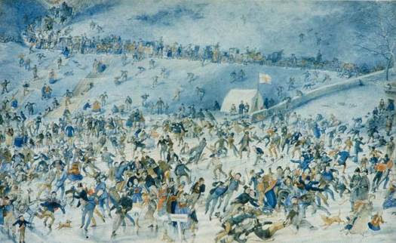
Figure 53 Shinty on Duddingston Loch by Charles Altamont Doyle (1832-93)

Shinty in universities
One of the finest historical expositions of shinty and its context, as well as Gaelic vocabulary, is by the famous scholar Alexander MacBain of Inverness who produced it for Alexander Littlejohn, a Londoner of Scottish origins who donated the fabulous Littlejohn trophy and album to the University of Aberdeen, for play between student teams from Scottish universities.

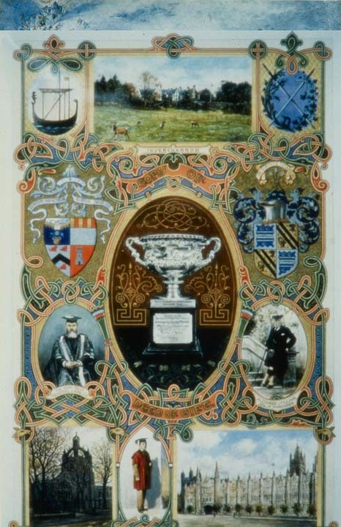
Figure 54 The Littlejohn album

Shinty in the 21st century
A series of hugely interesting and memorable exhibition matches 100 years ago were the immediate catalyst leading to the formation of the Camanachd Association, shinty’s ruling body. The game has developed from a series of loosely organised clubs and structures, into a progressive organisation with around 50 clubs of varying strengths competing on a regular basis, commanding national media attention and significant sponsorship.

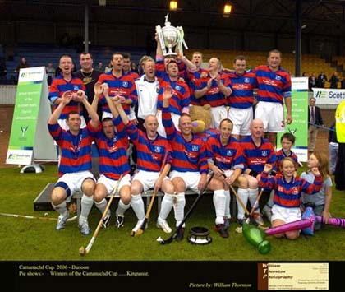
Figure 55 Kingussie have dominated the modern era of shinty with arguably the greatest ever player Ronald Ross (front, far left) breaking all goal-scoring records. He was awarded the MBE for his accomplishments in 2011. Kingussie won the Scottish championship at Dunoon in 2006.

Shinty has approximately 2,000 players (men, women and children) and between 2,500 and 3,000 members of the Camanachd Association, with teams playing at various levels from primary school age to senior (adult). In Ireland, the Gaelic Athletic Association, a multi-million pound business, runs an organisation of over 200,000 players – a ratio of 100 hurlers for every shinty player. However, Scotland has consistently managed to compete with Ireland in the modern series of full international matches in the compromise game of shinty/hurling.

Shinty as a national asset
Shinty in its organised form has come a long way as an organised sport. However, the continuing dilemma is whether to promote the ancient sport of the Gael as a modern, vibrant game, or to preserve it as a quaint aspect of Highland culture. It has, after all, survived the ravages of two World Wars and has also seen off the many economic disasters – past and more recent – which have beset the Highlands. The falling birth-rate and school closures are but another historical affliction.

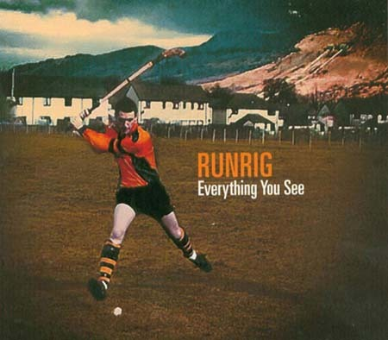
Figure 56 Scotland’s shinty captain Gary Innes, an accomplished musician has featured on CD tracks with the famous Scottish band Runrig

Shinty’s players and administrators regard their sport as one of the greatest games in the world. Shinty is also one of Scotland's truly national - indeed international - assets, which has an important, and hitherto largely ignored place in the space of world sport. For too long now historians, and particularly sports historians, have at best under-valued, at worst ignored, shinty’s rightful place and space in world sport.

7 FAQs

1 Where does Gaelic come from?

View answer - Untitled activity

2 How many Gaelic speakers are there?

View answer - Untitled activity

3 Where is Gaelic spoken now?

View answer - Untitled activity

4 Where can I find out about Gaelic organisations?

View answer - Untitled activity

5 Where can I find out about Gaelic place-names?

View answer - Untitled activity

6 Is Gaelic a difficult language to learn?

View answer - Untitled activity

7 Are there separate Gaelic schools?

View answer - Untitled activity

8 Is Irish Gaelic the same as Scottish Gaelic?

View answer - Untitled activity

9 What is the legal status of Gaelic?

View answer - Untitled activity

10 What is the Gaelic Mod?

View answer - Untitled activity

11 Where can I find out about Gaelic books and publishing?

View answer - Untitled activity

12 Where can I find out about children’s books and school books?

View answer - Untitled activity

13 Where are the Gaelic radio and TV channels to be found?

View answer - Untitled activity

14 Can you study Gaelic at universities and colleges?

View answer - Untitled activity

15 Where is Scotland’s national Gaelic college?

View answer - Untitled activity

16 Can you get software in computers for Gaelic?

View answer - Untitled activity

17 What are the most useful Gaelic dictionaries?

View answer - Untitled activity

18 Where can I find out about Gaelic personal names?

View answer - Untitled activity

19 Are there any Gaelic newspapers?

View answer - Untitled activity

20 Does Gaelic have a different alphabet from English?

View answer - Untitled activity

21 Are Gaelic and Scots similar in any way?

View answer - Untitled activity

22 Is Gaelic spoken abroad or just in Scotland?

View answer - Untitled activity

23 Are Gaelic road signs safe?

View answer - Untitled activity

24 Is there such a thing as ‘standard Gaelic’ (different dialects)

View answer - Untitled activity

25 What qualifications could I get in Gaelic to help get a job?

View answer - Untitled activity

26 Can Gaelic be called a national language of Scotland?

View answer - Untitled activity

27 How much does the Scottish Government spend on Gaelic?

View answer - Untitled activity

28 Shouldn't children be learning Chinese, or a modern European language instead of Gaelic?

View answer - Untitled activity

29 What are the benefits of bilingualism?

View answer - Untitled activity

30 Where can I find out about Gaelic songs?

View answer - Untitled activity

Notes
- Not all historians accept the view that Scotland’s Gaels originated as a result of immigration from Ireland to Scotland in the early to mid-First Millennium AD. Much of the evidence for that view comes from ancient manuscripts such as Senchus Fer nAlban (The History of the Men of Scotland) and the Annals of Tigernach, but the copies we possess of these documents were rewritten centuries after the events and might have been altered for political purposes. Some historians argue that the ‘legends’ of an Irish origin for Scottish Gaelic obfuscate the possibility of a continuity that takes the Gaels back well into the Iron Age (circa 700 BC to 500 AD) in Scotland.
- The Book of Deer is a very significant Scottish document. Written on vellum in the 10th century, and containing portions of the gospels in Latin, its greatest claim to fame is the marginal notes which were added in the 12th Century in the Gaelic of the time. Here is a section dealing with the origin of the place name ‘Deer’:
Colum Cille & Drostán mac Cosgreg a dalta tángator a hÍ mar ro falseg Dia doib gonic' Abbordoboir, & Bede cruthnec robo mormær Buchan ar a ginn; & ess é ro thidnaig doib in gathraig-sain in saere go bráith ó mormaer & ó thosec. Tángator as a athle-sen in cathraig ele, & do-raten ri Colum Cille sí, iar fa llán do rath Dé. Acus do-rodloeg ar in mormær i. Bede go-ndas tabrad dó, & ní tharat. Acus ro gab mac dó galar, iar n-ére na glérec, & robo marb act mad bec. Iar sen do-chuid in mormaer d'attac na glérec go ndéndaes ernacde lesin mac go ndísad slánte dó; & do-rat i n-edbairt doib ua Cloic in Tiprat gonice Chloic Pette Mec-Garnait. Do-rónsat i n-ernacde, & tánic slá dó. Iar sen do-rat Collum Cille do Drostán in chadraig-sen, & ro-s benact, & fo-rácaib in mbréther, ge bé tísad ris, ná bad blienec buadacc. Tángator déara Drostán ar scarthain fri Collum Cille. Ro laboir Colum Cille, ‘Bed Déar a anim ó shunn imacc.’
The English translation is:
Columba and Drostan son of Coscrach, his disciple, came from Iona, as God guided them, to Aberdour; and Bede the Pict was mormaer of Buchan on their arrival; and it is he who bestowed on them that monastery, in freedom till Doomsday from mormaer and toisech. They came after that to the other monastery, and it pleased Columba, for it was full of the grace of God. And he begged the mormaer, that is, Bede, that he should give it to them, and he did not. And a son of his took a sickness, after the clerics had been refused, and was all but dead. Thereupon the mormaer went to beseech the clerics that they should make a prayer on behalf of the boy, that health might come to him; and he gave to them land as a grant from Cloch in Tiprat as far as Cloch Peitte Meic-Garnait. They made the prayer, and health came to him. Thereupon Columba gave Drostan that monastery, and blessed it, and left the curse that whoever should go against it should not be full of years or of success. Drostan's tears [déra] came as he was parting from Columba. Columba said, ‘Let Deer be its name from this on.’
- In his classic publication, The History of the Celtic Place-Names of Scotland, Professor W J Watson wrote: ‘Malcolm, son of Kenneth, routed the Northumbrians in the great and decisive battle of Carham in AD 1018, and fixed the boundary of Scotland practically as it stands now... It was during this period, probably from about AD 960 onwards, that Gaelic came to be current in Lothian; there is some evidence that it extended beyond the present boundary of Scotland.’
- People in the Scottish diaspora tend to pronounce the surname Menzies as ‘MEN-zeez’ and are intrigued by the native Scottish pronunciation ‘MING-iss’. It appears that the clan’s progenitors originated in Mesnieres in Normandy. They were called de Meyneris in English after the Norman French fashion and Mèinnearach in Gaelic (similarly Bruce was de Brus in English and Brus in Gaelic). The ‘z’ in Menzies was not originally a ‘z’ at all but a letter called ‘yogh’ in the old Scots and Middle English alphabets, written ‘ȝ’ but pronounced like a ‘y’. Typesetters often found the yogh unavailable to them and they replaced it with the similar letter ‘z’, altering the pronunciation of this surname in English, but not in Gaelic (where it’s still Mèinnearach). The replacement of the yogh with a ‘z’ has also led to the aberrant spellings of some Scots words and names based on Gaelic eg capercailzie (capall coille, ‘horse of the forest’), MacKenzie (MacCoinnich, ‘son of Kenneth’) and Cockenzie (Cùil Choinnich, ‘Kenneth’s nook’).
- In his Historia Majoris Britanniae (1521), the Lothian-born philosopher John Mair (or Major) wrote of the linguistic divide in Scotland, referring to Gaelic as ‘Irish’: ‘The Irish tongue is in use among the former, the English tongue amongst the latter. One half of Scotland speaks Irish and all these as well as the Islanders … belong to the Wild Scots. In dress, in the manner of their outward life, and in good morals, .. these come behind the householding Scots.’
While he made clear, as did other Lowlanders of his day, that he had little admiration for the Gaels, he nevertheless made the interesting comment that ‘most of us spoke Irish a short time ago’.
- The Gaelic and Norse languages interacted significantly with each other over many centuries, leaving a legacy which can still be seen in Gaelic (Old Norse borrowed Gaelic words like àirigh, coinneamh and gadan but its descendant, Norn, has long since become extinct). Modern Gaelic words like uinneag (window), sgeir (sea-rock) and sgarbh (cormorant) are of Norse origin, as is much of the vocabulary connected to the maritime environment. Norse may also have influenced Gaelic speech patterns, such as the accent on the Isle of Lewis and the pre-aspiration found in most dialects of Scottish Gaelic but not in Irish. Pre-aspiration is the insertion of a ‘h’ or ‘ch’ sound in front of certain consonants. It means that, for example, Gaels generally pronounce mac (‘a son’) as ‘machk’ whereas Irish speakers say ‘mak’.
- An invaluable book is WHF Nicolaisean, Scottish Place-Names: their Study and Significance (Batsford 1976). For example, a map on page 137 shows the distribution of Gaelic place names containing baile. The historical spread across Lowland, as well as Highland, Scotland is clear.
- An invaluable book is WHF Nicolaisean, Scottish Place-Names: their Study and Significance (Batsford 1976). A map on page 140 shows the distribution of Gaelic place names containing achadh. While the oldest names can sometimes pose problems of interpretation, the later (generally Highland) names are mostly transparent. For example, Achachork is Achadh a’ Choirce (the field of the oats), Achnacloich is Achadh na Cloiche (the field of the stone), Achanalt is Achadh nan Allt (the field of the burns) and Achnashellach is Achadh nan Seileach (the field of the willows).
- The Privy Council’s Act of December 1616 said as follows: Forsameikle as the Kingis Majestie having a speciall care and regaird that the trew religioun be advancit and establisheit in all the pairtis of this kingdome and that all his Majesties subjectis especiallie the youth, be exercised and trayned up in civilitie, godliness, knawledge, and learning, that the vulgar Inglishe toung be universallie plantit, and the Irische language, whilk is one of the cheif and principall causes of the continewance of barbarite and incivilitie amongis the inhabitantis of the Ilis and Heylandis, may be abolishit and removeit; and quhair as thair is no measure more powerfull to further his Majesties princlie regaird and purpois that the establisheing of Scooles in the particular parroches of this Kingdom whair the youthe may be taught at least to write and reid, and be catechised and instructed in the groundis of religioun.
- Charles Withers’ book Gaelic in Scotland 1698-1981: The Geographical History of a Language (John Donald, 1984) contains a map of the Gàidheatachd in 1765 and a table of the Gaelic-speaking population in about 1765 by county. It is interesting to note that both Caithness and Nairnshire were both more than 50 per cent Gaelic-speaking at that time. Withers calculated the actual number of Gaelic speakers in Scotland then at 289,798 (p71).
- The Society in Scotland for the Propagation of Christian Knowledge wrote: ‘Nothing can be more effectual for reducing these Countries to order and making them usefull to the Commonwealth, than teaching them their duty to God, their King and Countrey, and rooting out their Irish language, and this has been the care of the Society so far as it could, for all the Schollars are taught in English.’
- The Gaelic Language (Scotland) Act 2005 is mainly concerned with improving the status and visibility of the language in organizations which come under the devolved Scottish Parliament (http://www.legislation.gov.uk/asp/2005/7). The Bill for the Act was passed by the Parliament on 21st April 2005 and received Royal Assent on 1st June 2005. The following is its preamble: An Act of the Scottish Parliament to establish a body having functions exercisable with a view to securing the status of the Gaelic language as an official language of Scotland commanding equal respect to the English language, including the functions of preparing a national Gaelic language plan, of requiring certain public authorities to prepare and publish Gaelic language plans in connection with the exercise of their functions and to maintain and implement such plans, and of issuing guidance in relation to Gaelic education.
- Referring to language, the word is pronounced (and sometimes written) ‘Keltic’. The pronunciation ‘Seltic’ is generally reserved for sports teams, notably a famous football club in Glasgow.
- Some scholars postulate that P-Celtic evolved (with the subsitution of p- for qu-) in central Europe during the first millennium BC but that it failed to reach Ireland or the Celtic speaking parts of the Iberian Peninsula, which remained Q-Celtic. Thus, the division between the two branches of the existing Celtic languages is a long-standing one.
- A good reference source with information about Breton – and indeed all other five living Celtic languages – their history, current status and efforts to reverse their decline is Ó Néill, Diarmuid (ed.) Rebuilding the Celtic Languages: Reversing Language Shift in the Celtic Countries. Y Lolfa, 2005.
- A good reference source with information about Welsh in Argentina is Ó Néill, Diarmuid (ed.) Rebuilding the Celtic Languages: Reversing Language Shift in the Celtic Countries Y Lolfa 2005.
- For example, the administrators of British India in the late nineteenth century were keen to suggest that Indian art was merely a derivative of ancient Greek art, and consequently of limited value. Such ‘analysis’ can rationalise neglect.

Conclusion
This free course provided an introduction to studying Philosophy. It took you through a series of exercises designed to develop your approach to study and learning at a distance and helped to improve your confidence as an independent learner.

Keep on learning

Study another free course
There are more than 800 courses on OpenLearn for you to choose from on a range of subjects.
Find out more about all our free courses.

Take your studies further
Find out more about studying with The Open University by visiting our online prospectus.
If you are new to university study, you may be interested in our Access Courses or Certificates.

What’s new from OpenLearn?
Sign up to our newsletter or view a sample.

For reference, full URLs to pages listed above:
OpenLearn – www.open.edu/openlearn/free-courses
Visiting our online prospectus – www.open.ac.uk/courses
Access Courses – www.open.ac.uk/courses/do-it/access
Certificates – www.open.ac.uk/courses/certificates-he
Newsletter – www.open.edu/openlearn/about-openlearn/subscribe-the-openlearn-newsletter

Further reading
An Lasair – anthology of 18th century Gaelic verse, ed. Ronald Black, Polygon, 2001
An Tuil - anthology of 20th century Gaelic verse, ed. Ronald Black, Polygon, 1999
An Oidhche mus do sheòl i, Angus Peter Campbell, Ùr-sgeul, 2003
Samhraidhean Dìomhair, Catriona Lexy Campbell, Ùr-sgeul, 2009
Bùrn is Aran, Iain Crichton Smith, Gairm, Glasgow, 1960
An Aghaidh Choimheach, John Murray, Gairm, Glasgow, 1973
An Claigeann aig Damien Hirst - 3 volume anthology, Ùr-sgeul, 2008
Na Balaich air Rònaidh, Finlay Macleod, Aberdeen University Press, 1972
Songs of Gaelic Scotland, ed. Anne Lorne Gillies, Birlinn, 2010
Flower of the West, Aberdeen, 2000 (History of Runrig)
The Companion to Gaelic Scotland, edited by Derick Thomson, Oxford, 1983
John Purser, Scotland’s Music. Edinburgh, 1992
James Hunter, The Fiddle Music of Scotland, 1987
The Highland Bagpipe and its music. Roderick Cannon, Edinburgh, 2002
Hugh Cheape A National Collection of the National Instrument (book and CD) 2008
CD :Psalms from the Hebrides of Scotland Vols 1-3. Ridge Records RR031
Scottish Tradition: Music from the Western Isles: Tangent Records Number 2. TNGM10

Acknowledgements
The course was funded by generous donations from The Open University’s alumni. Thank you.
Section 1 Gaelic as a national language of Scotland was written by Roddy Maclean
Section 2 Celtic roots and international reach was written by Roddy Maclean
Section 3 Gaelic in the modern era was written by Dr Donald John MacLeod
Section 4 Gaelic – the rationale was written by Dr Donald John MacLeod
Section 5 How the Gaelic language works was written by Dr Donald John MacLeod
Section 6.1 The art of the Gàidhealtachd was written by Professor Murdo MacDonald
Section 6.2 Gaelic music and song was written by Dr Hugh Dan MacLennan
Section 6.3 Dancewas written by Dr Hugh Dan MacLennan
Section 6.4 Gaelic literature was written by Dr Donald John MacLeod
Section 6.5 Sports and pastimes was written by Dr Hugh Dan MacLennan
Section 7 FAQs was written by Dr Hugh Dan MacLennan
This course was edited in English by Jo MacDonald and Lucy MacLeod, and in Gaelic by Jo MacDonald.
Grateful acknowledgement is made to the following people for their support and permission to reproduce material in this course:
BBC ALBA
Bòrd na Gàidhlig
National Galleries Scotland
Dr Will Lamb
Dr Alasdair MacCaluim
Fiona Dunn
Dr Donald W Stewart
Kathryn Farrell
Except for third party materials and otherwise stated (see terms and conditions), this content is made available under a Creative Commons Attribution-NonCommercial-ShareAlike 4.0 Licence
Course image: Andrea Nardi
in Flickr made available under Creative Commons Attribution-ShareAlike 2.0 Licence.
Various audiovisual clips used courtesy of BBC ALBA.
Audio clip of a waulking song: ‘Cò Siud Thall air Sràid na h-Eala?’ Tobar an Dualchais/Kist o Riches www.tobarandualchais.co.uk
Box 6: The Act - an overview http://www.gaidhlig.org.uk/
Unit image: iStock
Figure 1: Footprint of Dunadd: from Rìoghachd nan Eilean, Programme 1 by Ishbel MacLean Productions for BBC
Figure 4: Queen Margaret: This image is made available by Wikipedia on Creative Commons Attribution-Share Alike 3.0 Unported
Figure 6: James Stuart Memorial: courtesy of © Roddy Maclean
Figure 7: Language tree: courtesy of Jack Lynch
Figure 8: courtesy of Rosemania/Flickr
Figure 9: La Tene Art: http://autocww.colorado.edu
Figure 11: 2.2 Map: courtesy of Tormod Kinnes http://oaks/nvg.org/celin (c) 2000-2010
Figure 15: Flag: courtesy of Office of Gaelic Affairs, a Division of the Department of Communities, Culture and Heritage, Province of Nova Scotia, Canada
Figure 16: Book covers from: Damien Hirst's Skull available in German (Der Schadel von Damien Hirst translated by Michael Klevenhaus) and Gaelic (An Claigeann aig Damien Hirst): Ur-sgeul http://www.ur-sgeul.com/
Profile pictures courtesy of ©Dr Donald John Macleod,
Figure 19: Big Gaelic Day: courtesy The Highland Council www.highland.gov.uk
Figure 20: Gaelic Medium Primary School Education pupil numbers: http://www.cnag.org.uk
Figure 21: www.bsgi.highland.sch.uk
Figure 22: Wikimedia
Figure 24: GME residential learning event in Skye in 2006: www.cnag.org.uk
Figure 25: Ellen Bialystok: news.yorku.can
Figure 26: Dr Donald John Macleod
Figure 27: A map of An t-Sròn, ‘the nose’: http://www.allferries.co.uk
Figures 28 and 29: Iain and Sìne courtesy of Iain and Sìne
Figure 30: Aonghas MacNeacail: http://www.aonghasmacneacail.co.uk, courtesy of Aonghas MacNeacail
Section 5 images: iStockphoto.com
Montage of children’s book covers adapted from: Mar a Chuala mise e, told by Màiri Kidd, illustrated by Nicola O' Byrne, Stòrlann, 2011; Aodach, by Catherine Anholt , Acair Ltd (2007); Bha cailleach ann turas a shluig cuileag mhòr ,by Pam Adams, Swindon, Child's Play (International), 1996; An Tractar agus an Liobht by Catriona Black, Acair Ltd ( 2010); An Gruffalo by Julia Donaldson , Acair Ltd ( 2007); Air do bhonnagan a ghaoil edited by Norman Campbell , Acair Ltd (2005); Am Prionnsa Beag by Antoine De Saint-Exupery , Nadine Sauer Edition Tintenfa (2008). Courtesy of Comhairle nan Leabhraichean www.gaelicbooks.net
Figure 31: Scottish Parliament : © unknown
Figure 32: Illustrations: BBC ALBA
Figure 33:www.glasgowgaelic.glasgow.sch.uk
Figure 34: Map iStockphoto.com, Old Deer image made available from Wikimedia
Figure 38: William McTaggart, The Sailing of the Emigrant Ship, National Gallery of Scotland
Figure 39: An example of Will Maclean’s Memorial Cairns (Aignis), courtesy of Prof. Murdo MacDonald
Figure 40: City Art Centre, Edinburgh: courtesy of Prof. Murdo MacDonald
Figure 41: Crannghal, courtesy of Prof. Murdo MacDonald
Figure 43: A scene from the opera Hiort: St Kilda: Courtesy of Pròiseact nan Ealan, the Gaelic National Arts Agency
Figure 44: Cover from Aneka’s ‘Japanese Boy’ (1981) , Hansa International
Figure 47: Highland dancing made available on Wikipedia on a Creative Commons Attribution-Sharealike 3.0 Unported License (CC-BY-SA)
Figure 48: Sorley MacLean – courtesy of Dr Julian Toms
Figure 54: The Littlejohn Album: photo courtesy of Dr H D MacLennan.
Figure 55: Shinty in 21st century: photo Willie Thornton of Largs
Figure 56: Runrig ‘Everything You See’ (2007) album cover
Montage of adult books adapted from: Fo Sgàil a Swastika: Under the Shadow of the Swastika by Donald J MacDonald , Acair Ltd ( 2000); Essential Gaelic Dictionary – by Boyd Robertsonhttp://www.amazon.co.uk/Essential-Gaelic-Dictionary-Teach-Yourself/dp/1444103997/ref=sr_1_1?s=books&ie=UTF8&qid=1312368163&sr=1-1 and Ian MacDonald, Teach Yourself ( 2010); Suthainn Sìor by Norma NicLeòid, Ùr-Sgeul 2011; Òrain Lizzie a’ Ghlinne by Ealasaid Shutharlan, [Stornoway] Comhairle nan Leabhraichean 2010; Sùlaisgeir: Authors: Catriona MacGeoch, John Love, Finlay Macleod, Acair Ltd ( 2010); Cleasan A' Bhaile Mhòr by Catriona Lexy Campbell, Sandstone Press Ltd; SMP ed edition (2009); Ìmpireachd by Iain F. MacLeòid, 2010, Ùr-Sgeul 2010; Cocoa and Crabs/Coco is Crùbagan: A Hebridean Childhood by Flora MacDonald , The Islands Book Trust ( 2009); Verbots: Learn 101 Scottish Gaelic Verbs by Rory Ryder , Tsunami Systems (2009); An Cuilithionn 1939: The Cuillin 1939 and Unpublished Poems by Sorley Maclean, Christopher Whyte (Editor); Association for Scottish Literary Studies (2011); The Gaelic-English Dictionary: A Dictionary of Scottish Gaelic by Colin Mark, Routledge; 1 edition (2003); An Druim Bho Thuath by Tormod Caimbeul, Ùr-Sgeul 2011; Cleas Sgàthain by Màiri Anna NicDhòmhnaill, Publisher: Ùr-Sgeul 2008; Dualchas an Aghaidh nan Creag (The Gaelic Revival 1890–2020) by Dòmhnall Iain MacLeòid, Clò Beag 2011; Òrain nan Gàidheal: Gaelic Sea-Songs and Lullabies v. 3: Songs of the Gael edited by Bruce Campbell, Gairm Publications (1994); Meas Air Chrannaibh (Fruit on Branches) by Angus Peter Campbell, Acair Ltd (2007)
Graph: © K MacKinnon, Sgrùd, www.sgrud.org.uk
Graph: Compiled by the research agency Sgrùd www.sgrud.org.uk
Poem: Marilyn Monroe by Aonghas MacNeacail http://www.aonghasmacneacail.co.uk/ ©aonghasmacneacail Courtesy of Aonghas MacNeacail
Poem: Alba v Argentina 2.6.79 Scotland v. Argentina 2.6.79 © Derick Thomson
Western Isles; Lordship of the Isles; Eorpa; Why Learn Gaelic: courtesy of BBC
Don't miss out:
If reading this text has inspired you to learn more, you may be interested in joining the millions of people who discover our free learning resources and qualifications by visiting The Open University - www.open.edu/openlearn/free-courses

Untitled activity

Answer
Gaelic is one of Scotland’s national languages. Scottish Gaelic is a language of the Celtic family—it is a close relative of Welsh, Cornish and Breton, but shares a more intimate relationship with Irish and Manx Gaelic. These three Gaelic or Goidelic languages descend from a common ancestor, spoken in Ireland in the late first millennium BC and early first millennium AD.
Writers in Latin referred to the inhabitants of Ireland, and thus the speakers of this ancestor language, as Scoti, and to Ireland as Scotia, but early in the middle ages, they adopted a name for themselves from their British cousins—Goídil, Gaels. Gaelic had spread to north-western Britain, to Argyll, by the 6th century at the very latest.
It is generally thought that Gaelic arrived through the migration of Gaels, of Scoti across the Sea of Moyle, though this is the subject of some debate. By the 6th century it was the language of the rulers of Argyll, and of their kingdom of Dál Riata, which still included parts of County Antrim in the north of Ireland. It was the language also of its churchmen, who still had close kinship and political ties to Ireland.
Back to Session 7 Activity 1

Untitled activity

Answer
The total number of people recorded as being able to speak and/or read and/or write and/or understand Gaelic in the 2001 census was 92,400 (1.9 per cent of the Scottish population). Of these, the total number of people who could speak Gaelic was 58,652 (1.2 per cent of the Scottish population).

Table 12 Census 2001 Data
 | All persons aged 3 and over (=100%) | Able to speak the language | Speak, read or write | Speak, read, write or understand
Scotland | 4,900,492 | 58,652 (1.2%) | 65,674 (1.3%) | 92,386 (1.9%)

While the number of Gaelic speakers declined overall in the last census, the number of people able to speak and also to read and write Gaelic increased between 1991 and 2001 reflecting a growth in Gaelic literacy and growing numbers of Gaelic learners. The number of children aged 5-15 able to speak Gaelic also increased between 1991 and 2001.
Back to Session 7 Activity 2

Untitled activity

Answer
Gaelic speakers are spread throughout Scotland. Of the Gaelic speakers identified in the 2001 census, just over half lived in the Highland counties (the Highland Council, Argyll & Bute Council and Comhairle nan Eilean Siar areas) and just under half (45 per cent) in the Lowland areas.
Gaelic is spoken by a majority of people in the Comhairle nan Eilean Siar area and in the parish of Kilmuir in the Isle of Skye within the Highland Council area. Only just over a quarter of speakers live in localities where Gaelic speakers form a majority.
There is a high degree of urbanisation within the Gaelic speech community with large concentrations of Gaelic speakers living in Greater Glasgow, Edinburgh, Inverness and Aberdeen. For example, 11,211 Gaelic speakers, or 19 per cent of all Gaelic speakers, live in Greater Glasgow according to the 2001 census.
There are also some Gaelic speakers world-wide, mainly through families emigrating for employment and historical reasons such as forced emigration. Gaelic is still spoken in Cape Breton in Canada where there is significant activity in education and the arts; there are also a significant number of people new to the language learning Gaelic in countries such as Germany, Spain, the Eastern European states and North America. Japanese scholars have also shown interest in Gaelic.
Back to Session 7 Activity 3

Untitled activity

Answer
There are a number of key organisations involved in Gaelic affairs. The Scottish Government publishes information about its own activities and has links to other organisations. Local authorities do likewise.
Bòrd na Gàidhlig (the Gaelic Board) is the principal publicly funded agency charged with developing the language and it has specific responsibility for education.
BBC ALBA is the new television channel and along with BBC Radio nan Gàidheal provides information about programming and related content. The BBC site has very helpful material for learners, as well as archive material.
The universities of Glasgow, Aberdeen and Edinburgh all have Celtic Studies or Gaelic Departments and Scotland’s Gaelic College Sabhal Mòr Ostaig in Skye, which is part of the University of the Highlands and Islands, is the main higher education establishment offering a wide range of courses and research facilities.
Back to Session 7 Activity 4

Untitled activity

Answer
Ainmean-Àite na h-Alba - Gaelic Place-Names of Scotland - is the national advisory partnership for Gaelic place-names in Scotland. Its purpose is to agree correct forms of Gaelic place-names for maps, signs and general use. It draws on the expertise of member organisations, local knowledge and historical sources to agree authoritative forms of Gaelic place-names.
To ensure consistent spelling it uses established principles such as the Gaelic Orthographic Conventions and the guidance it has produced on Gaelic place names.
AÀA has been working with Ordnance Survey, local councils, roads authorities and other public bodies since 2000 to provide Gaelic names for maps and signs. To meet the growing demand for reliable information on Gaelic place-names, it is setting up the national Gaelic place-name gazetteer referred to in the National Plan for Gaelic.
Back to Session 7 Activity 5

Untitled activity

Answer
There is no straightforward answer to this. There is no language which can be identified as the easiest or most difficult, the best to learn or the least useful. Nor is there any guide or limit as to how long it takes one to learn a language or even become fairly proficient.
The single most important factor in learning any additional language is application (persistence in the face of challenges) and patience (maintaining a reasonable sense of perspective on what can be achieved in particular circumstances).
Frequent practice is very important and if a learner can become immersed in a language, by living and or working in a community where the language is used on a regular basis then the chances of picking up a language are better.
Listening to television and radio output helps, as does reading, particularly if a language is being assimilated to study literature.
A useful source of information on how to learn a new language, is Omniglot.
For a Gaelic-specific perspective on language learning, see Bilingualism Matters.
The Gaelic learners’ support organisation Clì Gàidhlig is a good starting point for Gaelic learning. My Gaelic is also a useful place to visit for advice and information linking to social network sites.
There are a number of other websites such as Bòrd na Gàidhlig or the BBC’s Gaelic services which have advice on where and how to learn the language. A number of institutions and organisations offer distance or on-line learning courses. The Gaelic Books Council (Comhairle nan Leabhraichean) can offer advice also on learners’ tools such as DVDs, CDs and other materials.
Back to Session 7 Activity 6

Untitled activity

Answer
There are two Gaelic schools at primary level which also have secondary departments, in Inverness and in Glasgow, which was the first to be established. Demand for places at the schools continues to grow. Glasgow had 311 pupils in 2007 and this increased to 509 and by session 2010/11 the number had risen to 580.
There are around 2,500 primary and secondary schoolchildren in Gaelic-medium education (GME) nationally at present, with a further 700 children in Gaelic-medium nurseries.
The number of pupils who are in GME at primary school level has risen from 24 in 1985 to 2,256 five years later in 2010. There were 390 pupils in GME at secondary school level in the school year 2009/10. In 58 nurseries run by local authorities, there were 856 children registered in the school year 2009/10.
Within English-medium education between 2,500 and 3,000 learners study Gaelic as a secondary subject each year between S1 and S6.Many children in English-medium primary schools also take part in the Gaelic Language in the Primary Schoolscheme each year.
The number of students who are in Gaelic further or higher education, or who are taking a Gaelic course at that level, has continued to rise also.
Parents should contact their local authority or Bòrd na Gàidhlig for advice on matters relating to Gaelic education provision.
Back to Session 7 Activity 7

Untitled activity

Answer
Scottish Gaelic is a language of the Celtic family—it is a close relative of Welsh, Cornish and Breton, but shares a more intimate relationship with Irish and Manx Gaelic. These three Gaelic or Goidelic languages descend from a common ancestor, spoken in Ireland in the late first millennium BC and early first millennium AD.
In modern terms, it is perfectly possible for some speakers of the Irish version to communicate directly. A great deal of vocabulary is shared and the linguistic challenges of developing modern lexicon and registers are common. Indeed broadcasting organisations have teamed up to produce radio programming using presenters from both sides of the Irish Sea.
Due to its geographical proximity and for historical reasons, the Gaelic spoken on the Scottish island of Islay is probably the nearest to modern Irish.
Back to Session 7 Activity 8

Untitled activity

Answer
The Gaelic Language (Scotland) Act 2005 was passed by the Scottish Parliament with a view to securing the status of the Gaelic language as an official language of Scotland commanding equal respect to the English language.
One of the key features of the 2005 Act is the provision enabling and agency Bòrd na Gàidhlig (the Scottish Government’s principal Gaelic development body) to require public bodies to prepare Gaelic Language Plans. This provision was designed to ensure that the public sector in Scotland plays its part in creating a sustainable future for Gaelic by raising its status and profile and creating practical opportunities for its use.
The principle of equal respect was incorporated into the 2005 Act by the Scottish Parliament as a positive statement about the value and worth of Gaelic, in recognition of the fact that users of Gaelic aspire to use Gaelic as normally as possible in their lives, that there should be a generosity of spirit towards Gaelic across Scotland, and that the language should not suffer from any lack of respect either at an individual or corporate level.
Back to Session 7 Activity 9

Untitled activity

Answer
The Royal National Mod, to give it its full title, is Scotland’s main Gaelic festival and the equivalent of the Welsh Eisteddfod. The word ‘mod’ itself means a ‘gathering’ or ‘event’.
The Mod is organised by An Comunn Gàidhealach, which is one of the oldest and most respected Gaelic membership-based organisations. Founded in Oban in 1891, it has long been a leading light in the teaching, learning and use of the Gaelic language and the study and cultivation of Gaelic literature, history, music and art.
Through the organisation and running of the Royal National Mòd and grass roots community development work, An Comunn Gàidhealach continues to further its aim of supporting and developing all aspects of the Gaelic language, culture, history and heritage at local, national and international levels. The Mod takes place annually (in October) at various venues throughout Scotland.
Back to Session 7 Activity 10

Untitled activity

Answer
The Gaelic Books Council (Comhairle nan Leabhraichean), which is based in Glasgow, was set up to encourage and promote the study, teaching, knowledge and appreciation of Gaelic writing and the public performance of creative works in Gaelic.
The Books Council can advise on all matters relating to Gaelic books, publishing and learning resources. Its stated vision is to secure a sustainable future for Gaelic literature and publishing in Scotland, increasing the number and readership of Gaelic books in a variety of genres, helping to increase the number Gaelic learners and users to achieve fluency.
Back to Session 7 Activity 11

Untitled activity

Answer
Stòrlann Nàiseanta na Gàidhlig (the National Gaelic Resource Centre) co-ordinates the production and distribution of curriculum resources for Gaelic education. They produce and distribute teaching resources to nurseries, primary schools, secondary schools and lifelong learning groups.
Some of Stòrlann’s resources are available for purchase by the general public and a range of free interactive resources for families can also be found at Gaelic 4 Parents, where families can also access support with homework and other issues relating to Gaelic education.
Back to Session 7 Activity 12

Untitled activity

Answer
BBC ALBA, which was launched in 2008, is the Gaelic television channel. It is a partnership between the BBC and MG Alba.
BBC ALBA is available on the following platforms:
- Freeview channel 8
- Cable channel 188
- Sky channel 168
- Freesat channel 110
- Live on BBC iPlayer
- 10 hours of content per week is also available to view on demand via BBC iPlayer.
BBC Radio nan Gàidheal is the BBC’s award-winning national Gaelic radio service which broadcasts on FM. It broadcasts a mix of speech based, music and sports programming with extensive news coverage seven days a week.
Radio nan Gàidheal is available on FM transmitters in Scotland (except the Borders, Dumfries and Galloway, Ayrshire, Orkney and Shetland); it can also be heard on digital television platforms, DAB Digital Radio, and online. Radio programmes can also be sourced live or for seven days after transmission on the BBC’s iPlayer.
BBC Radio nan Gàidheal broadcasts alongside a graphical overlay on the Scottish Gaelic digital television channel ALBA during periods when the TV service is not broadcasting programmes.
BBC Radio na Gàidheal can be found on FM: 103.5-105 MHz,
DAB, Freeview: 720 (Scotland only), Freesat: 713 (110), Sky: 0139 (168), Virgin Media: 934; RDS: BBC GAEL
Some local or community radio stations such as Moray Firth Radio, based in Inverness, broadcast Gaelic material as do community radio stations such as Isles FM in the Western Isles, Oban FM in Argyll, Cuillin FM in Skye and Nevis Radio in the Lochaber area.
Back to Session 7 Activity 13

Untitled activity

Answer
There are a number of courses available related to Gaelic at colleges and universities in Scotland and others abroad in places such as Canada. Courses are available which are taught entirely through the medium of Gaelic – such as those on offer at Sabhal Mòr Ostaig on Skye and Lews Castle College on Lewis, both of which are parts of the University of the Highlands and Islands (UHI). There are also degrees in Celtic and Gaelic in the universities of Glasgow, Edinburgh and Aberdeen, with Gaelic a key element of many of those degrees. There are also teacher training courses at Strathclyde University and Northern College in Aberdeen.
You can also get more information from the Gaelic Teachers site, or the Bòrd na Gàidhlig.
Back to Session 7 Activity 14

Untitled activity

Answer
Founded in 1973, Sabhal Mòr Ostaig (the Great Barn of Ostaig,) on Skye has become internationally recognised as a National Centre for the Gaelic language and culture. The College is an academic partner within UHI, the University of the Highlands and Islands www.uhi.ac.uk and provides high quality education and research opportunities through the medium of Scottish Gaelic.
Sabhal Mòr Ostaig is a modern, innovative college and has excellent learning resources on-campus including an exceptional library collection, broadcast and recording facilities, residential student accommodation and a Gaelic-medium childcare facility. In Session 2011/12 student numbers stand at approximately 90 on full-time courses, 260 on distance learning and access courses, and up to 800 on short courses each year.
The College's activities are greatly enhanced by co-operative links within the wider Gaelic community and the College is home to a number of creative and cultural projects such as Tobar an Dualchais (The Kist o’ Riches), Faclair na Gàidhlig (The Gaelic Dictionary), Soillse, the new research centre and the multimedia and design company Cànan.
The College also plays a leading role in the promotion of the Gaelic arts and culture and hosts a programme of residencies for artists in music, literature, drama and the visual arts.
Back to Session 7 Activity 15

Untitled activity

Answer
There are a number of software programmes which have been developed to enable Gaelic to be used on computers.
The Microsoft Captions Language Interface Pack (CLIP) is a simple language translation solution that uses tooltip captions to display results. CLIP can be used as a language aid, to see translations in various languages and dialects. CLIP is designed to enable and support indigenous languages and native dialects and is the result of collaboration between Microsoft and local communities. Users are able to download multiple languages, switching target translations quickly and easily. Translations are available between English and Scottish Gaelic.
There are a number of software products available for teaching grammar and vocabulary, for both DOS and Macs.
There are spell-checkers available, for example, An Dearbhair, which was developed originally for Microsoft Word 2003 and can be downloaded here.
There are spell-checkers available, for example, An Dearbhair, which was developed originally for Microsoft Word 2003 and can be downloaded here.
Gaelic can also be used to Google. There is also a Gaelic interface for Firefox.
The Gaelic terminology database Seotal has published a list of Gaelic terms which are useful relating to internet use and the management of websites. It is available from Seotal.
Back to Session 7 Activity 16

Untitled activity

Answer
A good Gaelic dictionary is a key component of any learner’s toolkit for their studies. Gaelic-English translation and English to Gaelic translation are both essential tools. Free online Gaelic translations are also available on some websites.
The Teach Yourself Essential Gaelic Dictionary, updated and re-published in 2010, is the most accessible and useful modern dictionary.
A number of other dictionaries by Angus Watson, Gordon MacLennan and Colin Mark are also useful and information on all of these is available at Comhairle nan Leabhraichean.
A number of online dictionary resources are also available such as Dwelly/Dwelly online which is a version of Edward Dwelly’s famous Illustrated Dictionary, which was for many years the standard tool.
The Stòr-data Briathrachais Gàidhlig or Gaelic terminology database produced by Sabhal Mòr Ostaig contains a wide range of vocabulary
The Scottish Government’s Faclair na Pàrlamaid (Dictionary of Parliamentary Terms), published in 2001, contains a list of vocabulary relating to the use of Gaelic in local authority and government areas.
Faclair na Gàidhlig (The Dictionary of the Scottish Gaelic Language) is an inter-university initiative by the Universities of Aberdeen, Edinburgh, Glasgow, Strathclyde and Sabhal Mòr Ostaig UHI. This will be an historical dictionary of Scottish Gaelic comparable to the multi-volume resources already available for Scots and English, the Dictionary of the Older Scottish Tongue, the Scottish National Dictionary and the Oxford English Dictionary. The Dictionary of the Scottish Gaelic Language will be published initially in electronic format.
The dictionary will document fully the history of the Gaelic language and culture from the earliest manuscript material onwards, placing Gaelic in context with Irish and Scots. Of equal importance, it will show the relationship between Scottish Gaelic and Irish.
Back to Session 7 Activity 17

Untitled activity

Answer
Some traditional Gaelic names have no direct equivalents in English. Oighrig is rendered as Euphemia or Henrietta and Diorbhal is ‘matched’ with Dorothy simply on the basis of a certain similarity in spelling. Gormul, for which there is nothing similar in English, is rendered as 'Gormelia' or even 'Dorothy'. Beathag is ‘matched’ with Becky or Rebecca, or even Betsy or Sophie.
Some names have come into Gaelic from Old Norse. For example Somhairle, which is conventionally rendered in English as Sorley or, historically, Somerled.
Some traditional Gaelic names have become so well known that English versions of them are used outside Gaelic-speaking areas. These include Ailean, Aonghas, Dòmhnall, Donnchadh, Coinneach, Murchadh (Alan, Angus, Donald, Duncan, Kenneth, Murdo). Iain (John), Alasdair (Alexander), Uilleam (William), Catrìona (Catherine), Raibert (Robert), Cairistìona (Christina), Anna (Ann), Màiri (Mary), Seumas (James), Pàdraig (Patrick) and Tómas (Thomas) are also used. The well-known name Hamish, and the recently established Mhairi (pronounced [vaːri]) come from the Gaelic for, respectively, James, and Mary.
The book Gaelic Personal Names by Donncha O'Corrain and Fidelma Maguire, published in April 1981, is a useful starting point for further information.
Back to Session 7 Activity 18

Untitled activity

Answer
There are no Gaelic newspapers as such but a number carry weekly opinion columns, features or news coverage, such as The Inverness Courier, Press & Journal, Oban Times, Stornoway Gazette and West Highland Free Press.
An t-Albannach (The Scotsman) is the only national paper which carries any Gaelic material.
A number of community newspapers, particularly in the Western Isles, carry Gaelic material on a regular basis and this material is now also appearing on websites.
Back to Session 7 Activity 19

Untitled activity

Answer
There are 18 letters in the Gaelic alphabet and each of them was traditionally linked to the name of a tree or plant. The letters which are not used are : j, k, q, v, w, x, y, z.
The Scottish Qualifications Authority’s guidance document on Gaelic orthography advises on how to deal with the adaptation of words using any of these letters.
Back to Session 7 Activity 20

Untitled activity

Answer
Scots is not to be confused with Scottish English or Scottish Gaelic. It is spoken in Scotland, Northern Ireland, and the Republic of Ireland. A Scottish Government study found that 85 per cent of respondents (being a representative sample of Scotland's adult population) claimed to speak Scots to varying degree.
Classified as a ‘traditional language’ by the Scottish Government, Scots is classified as a ‘regional or minority language’ under the European Charter for Regional or Minority Languages, ratified by the United Kingdom in 2001. It is sometimes called Lowland Scots to distinguish it from Scottish Gaelic.
Since there are no universally accepted criteria for distinguishing languages from dialects, scholars and other interested parties often disagree about the linguistic, historical and social status of Scots. Consequently, Scots is often regarded as one of the ancient varieties of English, but with its own distinct dialects. Alternatively, Scots is sometimes treated as a distinct Germanic language, in the way Norwegian is closely linked to, yet distinct from, Danish.
In the 2011 Scottish census a question on Scots language ability was included for the first time.
Back to Session 7 Activity 21

Untitled activity

Answer
Gaelic has been spoken continuously for more than 200 years on Cape Breton Island and in Nova Scotia and these are now the only places where Gaelic is to be found on a daily basis beyond Scotland.
To a lesser extent the language is also spoken on nearby Prince Edward Island, New Brunswick, Glengarry County in present-day Ontario and by emigrant Gaels living in major Canadian cities such as Toronto.
A Gaelic Economic-impact Study completed by the Nova Scotia government in 2002 estimated that Gaelic generated over $23.5 million annually, with nearly 380,000 people attending approximately 2,070 Gaelic events annually. This study inspired a subsequent report, The Gaelic Preservation Strategy, which polled the community's desire to preserve Gaelic while seeking consensus on adequate reparative measures.
Oifis Iomairtean na Gàidhlig (Office of Gaelic Affairs), the provincial department was established in December 2006, charged with promoting and engaging the province's Gaelic-speaking community.
Over a dozen public institutions offer Gaelic courses, (such as a Canadian History course in Gaelic at North Nova Education Centre, Nova Scotia) in addition to advanced programmes conducted at Cape Breton, St Francis Xavier, and Saint Mary's Universities, and the Atlantic Gaelic Academy.
The Gaelic College of Celtic Arts and Crafts in St Ann's offers Gaelic summer classes.
Back to Session 7 Activity 22

Untitled activity

Answer
In many countries such as Belgium, Finland, Ireland and Switzerland bilingual road signs are accepted as a normal feature of daily life and attract little or no undue comment or attention.
In other countries where multilingualism is not the norm, the issue of multilingual road signs has been controversial at times. The issues most frequently cited are safety and cost.
There is no evidence to support any suggestions that multilingual road signs are unsafe. Gaelic signage is regarded as being very important in terms of raising the visibility and normalisation of the language in everyday life.
For a comparative study of the use of minority languages in road signage in Norway, Scotland and Italy, which deals with related issues, see the following article.
Back to Session 7 Activity 23

Untitled activity

Answer
Gaelic is a rich and expressive language which, like every other dynamic language, including English, has absorbed a wide range of words from other languages through the ages. Latin, Greek, French, Norse and English have all been mined as the language continues to grow. But it is also true that a significant number of Scottish and Irish Gaelic words have been borrowed by other languages, especially English.
You could almost say there’s Gaelic galore, or gu leòr (‘plenty, enough’), in our everyday speech. Do you twig, or tuig (‘understand’)? Great, maybe you fancy a nip of whisky, or uisge-beatha (literally the ‘water of life’)? And after a dram (drama) or two, you might be ready for a ceilidh, or a cèilidh (‘a concert or visit’).
Back to Session 7 Activity 24

Untitled activity

Answer
More and more companies around the country are looking for people who can use Gaelic. The public and private sector alike are increasing the number of vacancies where it may be of benefit if the candidate has Gaelic or a basic grasp of the language.
Gaelic is seen as a major advantage in areas such as tourism, teaching, broadcasting and in many other related roles. As well as being an interesting language and an integral part of Scotland’s culture and heritage, Gaelic is part of the modern way of life for many. Learning Gaelic will not only allow you to have an understanding of history, songs and literature but can also help your career. There are now hundreds of jobs throughout Scotland for those who speak Gaelic, and as the Gaelic community continues to grow, so is the expected number of Gaelic related jobs available.
Universities offer a variety of degree courses in Gaelic and/or Celtic Languages with combinations of many other subjects. The main institutions teaching Gaelic are the Universities of Glasgow, Aberdeen and Edinburgh, along with the national Gaelic College Sabhal Mòr Ostaig on Skye, Lews Castle Colge in Stornoway, Telford Colge in Edinburgh and Stow College in Glasgow.
The Scottish Qualifications Authority (SQA) offers separate courses for fluent speakers and learners, with those for fluent speakers entitled ‘Gàidhlig’. SQA's Gaelic (Learners) and Gàidhlig courses offer candidates the opportunity to acquire or increase oral fluency and literacy in Gaelic. Candidates also develop awareness of historical and contemporary aspects of the culture, ethos and environment of the Gaelic-speaking community.
Back to Session 7 Activity 25

Untitled activity

Answer
In that the language was spoken throughout most of the country over time, Gaelic has a legitimate case. That is not to say it is the national language. Gaelic is a language central to the importance of Scottish cultural life. Gaelic was the language of the old kings of Scotland. MacBeth and Robert the Bruce both spoke Gaelic; and many place names still bear testimony to the spread of Gaelic speakers throughout Scotland after their arrival from Ireland.
There are very few regions of Scotland that do not boast at least a smattering of places originally named by Gaelic speakers, from Balerno (baile airneach, ‘hawthorn farm’) in Midlothian to Baile Màrtainn in South Uist; from Craigentinny (creag an t-sionnaich, ‘fox craig’) in Edinburgh to Aultivullin (allt a’ mhuilinn, ‘mill burn’) in the far north of Sutherland; and from Drummore (druim mòr, ‘big ridge’) on the Mull of Galloway to Cairnbulg (càrn builg, ‘gap cairn’) near Fraserburgh.
In many places where Gaelic is no longer spoken as a native tongue, such as Galloway, Fife, or Aberdeenshire, the landscape is still predominantly one named by Gaelic speakers. In the 12th and 13th Centuries, the high point of the expansion of Gaelic as a language in Scotland, Gaelic speakers could be found nearly everywhere. Research shows that the 12th century was when the most ubiquitous Gaelic place-names, those employing the words baile (‘farm, settlement’), and achadh (‘field’), were coined.
Back to Session 7 Activity 26

Untitled activity

Answer
The Scottish Government budget for Gaelic and is approximately £23 million in 2011-12. This is approximately 0.07 per cent of the Scottish Government’s overall budget of £29 billion. Of the £23 million, Bòrd na Gàidhlig is allocated £5.1 million; the Gaelic Specific Grants Scheme used to support local authorities in providing Gaelic education has an allocation of £4.6 million, which is shared among 21 local authorities across Scotland; and MG Alba receives support of £11.8 million for the Gaelic television channel BBC ALBA and related activities. The Gaelic Schools Capital Fund has £1.1 million reserved to help local authorities with capital projects such as school building work.
Back to Session 7 Activity 27

Untitled activity

Answer
Scotland is a multilingual country where, according to a recent survey, at least 106 different languages are spoken. In a population of over 5 million, this wide range of languages holds significant potential for cultural diversity, economic opportunity, and enriched education. The Scottish Government has recognised Gaelic as a national asset.
In many parts of the world it is common for children to be exposed to two or even more languages right from birth, but bilingualism is a relatively new phenomenon in most of Europe. As a consequence, growing up with more than one language is often regarded as 'special' and even 'dangerous' for a child’s development, and bilingualism is still surrounded by negative beliefs and misunderstandings. This is largely due to lack of information. The benefits of bilingualism are simply not as well recognised as they should be and the truth of the matter is that learning languages, any number of them, is a very worthwhile activity which can benefit learners in all sorts of way.
Back to Session 7 Activity 28

Untitled activity

Answer
Research has shown that bilingualism is beneficial for children’s development and their future. Children exposed to different languages become more aware of different cultures, other people and other points of view. They also tend to be better than monolinguals at 'multitasking' and focusing attention, they often are more precocious readers, and generally find it easier to learn other languages. Bilingualism gives children much more than two languages.
Gaelic Medium Education (GME) is available in 14 Local Authorities across Scotland and is seen as one of the most effective ways of achieving fluency. GME has been successful in achieving high levels of interest.
Recent Edinburgh University research shows that children educated through Gaelic are on par with or outperform children educated in one language. Children educated in GME are at an advantage learning other ones. Bilinguals can access different literatures and more ways of thinking and acting. Gaelic bilinguals have a better understanding of their place in wider Scottish culture identity, and are able to access many career opportunities. Children experiencing different languages at an early age tend to be more focussed than monolinguals at 'multitasking’; they are better readers, and generally find it easier to learn other languages.
Back to Session 7 Activity 29

Untitled activity

Answer
The Tobar an Dualchais or Kist o’ Riches website was officially launched in 2010. The site contains thousands of recordings from throughout Scotland in Gaelic and Scots. The material includes stories, songs, folklore, poetry, factual information and lots more. The material has been collected from all over Scotland and beyond from the 1930s onwards.
The recordings come from the School of Scottish Studies (University of Edinburgh), BBC Scotland and the National Trust for Scotland's Canna Collection. The material includes stories recorded by John Lorne Campbell on wax cylinders in 1937, folklore collected all over Scotland by Calum Maclean in the 1950s; Scots songs recorded by Hamish Henderson from travelling people in the 1960s and archival material broadcast by BBC Radio nan Gàidheal
2010 was the Year of Song (Bliadhna nan Òran) on BBC Radio nan Gàidheal and BBC ALBA and throughout the year an unparalleled line-up of music-related programmes were broadcast, including Òran an La, Song of the Day, featuring a different song with contextual information for each day of the year.
The website is the legacy of this project and it allows users to access content/information about the songs, quickly and simply by means of 4 key sections: songs, writers, themes and singers. The site currently offers the opportunity to listen to over 800 songs with supporting lyrics, 360 excerpts from radio programmes, and over 550 video clips. Biographical information is also available for over 500 singers and writers.
Back to Session 7 Activity 30

Figure 17 Galleys, a symbol of the power of the Highland clans were also banned by the Statutes of Iona

Description
Galleys, a symbol of the power of the Highland clans were also banned by the Statutes of Iona
Back to Session 3 Figure 3

Figure 18 The founders of An Comunn Gàidhealach

Description
The founders of An Comunn Gàidhealach
Back to Session 3 Figure 4

Figure 19 ‘Latha Mòr na Gàidhlig’ (The Big Gaelic Day), held in the Highlands in 2005, brought together 500 GME pupils from throughout Scotland.

Description
‘Latha Mòr na Gàidhlig’ (The Big Gaelic Day), held in the Highlands in 2005, brought together 500 GME pupils from throughout Scotland.
Back to Session 3 Figure 5

Figure 21 The purpose-built Inverness Gaelic school, known as ‘Bun-Sgoil Ghàidhlig Inbhir Nis’ (BSGI), which opened in 2007.

Description
purpose-built Inverness Gaelic school, known as ‘Bun-Sgoil Ghàidhlig Inbhir Nis’ (BSGI), which opened in 2007
Back to Session 3 Figure 7

Figure 22 Harris, a stronghold of the Gaelic language

Description
Harris, a stronghold of the Gaelic language.
Back to Session 3 Figure 8

Figure 27 A map of An t-sròn, ‘the nose’

Description
An t-sron map
Back to Session 4 Figure 3

Figure 33 Glasgow Gaelic School

Description
Figure 44 Glasgow Gaelic School
Back to Session 5 Figure 13

Interview with Sorley MacLean – Part 1

Transcript
IAIN CRICHTON-SMITB
Sorley I heard you once saying something about that it's very very difficult to translate Gaellic poetry into English.
SORLEY MACLEAN
Well, I think fundamentally, there is the difficulty of the sound, because on the whole and especially with our Skye dialect there is a tendency for the vowel to be longer than it is in English, and therefore even the assonances stand out more than vowel assonances would do in, in English. Of course there is another syntactical difference because I think Gaellic is wonderfully good at expressing degrees and places of emphasis with the use of natural inversions, and particles than English is nowadays at any rate. I think that is a big difficulty besides of course so much Gaellic poetry is outside the main European traditions. I try myself to be as literal as possible, I mean, logically, but of course the sound is awfully difficult.
IAIN CRICHTON-SMITR
Yes, I suppose that it what we have to remember about poetry that you are translating not just words but complete units of sound and words.
SORLEY MACLEAN
I think if you're doing a line by line translation it is very desirable to have approximately the same number of syllables, in a line, but that is terribly difficult.
IAIN CRICHTON-SMITH
And there's such a lot of assonance in Gaellic there, there is a lot of music which English really cannot get at and it sounds natural in Gaellic doesn't it? Assonance actually sounds more natural sometimes in Gaellic than in English.
SORLEY MACLEAN
Yes, mind you it's very offen inevitable in Gaellic because there are so many fewer vowels than consonants. And therefore it is at once more natural I think and stands out more too because of the relative length of the vowel.
CEANN LOCH ACINEART
Comhlan bheanntan, stoiteachd bheanntan, corr-lios bheanntan fasmhor, cruinneachadh mhullaichean, thulaichean, shleibhtean, tighinn 'sa' bheucadch ghabhaidh. Elrigh ghleanntan, choireachan udlaidh, laighe 'S a'bhuirich chracaich; sineadh chluaineagan, shuaineagan srulach, briodal's an dubhlachd arsaidh. Eachdraidh bheanntan, marcachd mhullaichean, deann-ruith shruthanach cathair, sleamhnachd leacannan, seangachd chreachainnean, strannraich leacanach ard-bheann. Onfhadh-chrois mhullaichean, confhadh-shlios thulaichean, monmhar luim thurraidean marsail, gorm-shliosan Mhosgaraidh, storim-shliosan mosganach, borb-bhiodan mhonaidhean arda.
SIMON MACKENZIE
KINLOCH AINORT
A company of mountains, an upthrust of mountains a great garth of growing mountains a concourse of summits, of knolls, of hills coming on with a fearsome roaring. A rising of glens, of gloomy corries, a lying down in the antlered bellowing; a stretching of green nooks, of brook mazes, prattling in the age-old mid-winter. A cavalry of mountains, horse-riding summits, a streaming headlong haste of foam, a slipperiness of smooth flat rocks, small-bellied bare-summits, flat-rocks snoring of high mountains. A surge-belt of hill-tops, impetuous thigh of peaks, the murmuring bareness of marching turrets, green flanks of Mosgary, crumbling storm-flanks, barbarous pinnacles of high moorlands.
IAIN CRICHTON-SMITH
Well, I suppose, even someone who doesn't know any Gaellic would notice that reading the Gaellic version that there are all these similar sounds like "mhullaichean, thulaichean", and "chluaineagan, and shuaineagan" and so on. This gathering together of lots of adjectives and l6ts of nouns and so on, this is something that we find traditionally in Gaellic isn't is, certainly in earlier Gaellic.
SORLEY MACLEAN
This poem is fundamentally semi-surrealist, with a confusion of the senses. I mean, in the sense of that things heard, things seen in terms of things heard, and vice versa, and there is also the fact that it is on a day of wind and rain and swirling mists, where mountains tops appear and disappear, and seem to move. Now in this poem I've been asked again and again by Gaels where on earth the rhythm came from, and I think myself that the rhythm is inspite of the great number of assonances and all that, that the rhythm is fundamentally original, and by the way there is a bigger congregation of nouns than of adjectives.
IAIN CRICHTON-SMITH
Yes. I suppose really that the closest you might get to something like this in English would be, may be some of the poems of Hopkins, where he draws from the Welsh. I think sometimes he has a series of nouns or a series of adjectives and so on.
SORLEY MACLEAN
Douglas Young always used to tell me that there's an awful lot of sprung rhythm in my verse. But I didn't agree with him, however it may be something like that.
IAIN CRICHTON-SMITH
I notice also that in this particular poem, and I've noticed also in some of your other nature poems that you've got quite a lot of comparison of mountains and so on to women, especially a kind of sexual mountains, like "impetuous thigh of peaks".
SORLEX MACLEAN
I wouldn't quite agree that it's here. You see I think there you see it was more the suggestion of the horse rider there you see.
IAIN CRICHTON-SMITH
Oh Yes
SORLEY MACLEAN
I think. You see you have to say a word for "seangachd", "small-belliedness", you see that word "seangachd" in Gaellic, you know, is often used of a horse, the small belly of a horse, and it's a terribly difficult word to get an equivalent in English ...
IAIN CRICHTON-SMITH
Yes, yes, yes. It's quite specialised ...
SORLEY MACLEAN
... You see this first word seang, the adjective "seangachd", small-bellied, and it's used more of horses than of human beings, though it can be used of human beings too, and of course, it's a word that expresses great approbation.
Back to Session 6 MediaContent 6

Interview with Sorley MacLean – Part 2

Transcript
CURAI DHEAN
Chan fhaca mi Lannes aig Ratasbon no MacGill-Fhinnein aig Allt Eire no Gill-Iosa sig Cull-Lodair, ach chunnaic mi Sasunnach 'san Eiphit. Fear beag truagh le gruaidhean plulceach is gluinean a' bleith a cheile, aodann guireanach gun tlachd ann - comhdach an spioraid bu troine. Cha robh buaidh air " 'san tigh-osda 'n am nan dorn a bhith 'gan dunadh", ach leoghann e ri uchd a' chatha, anns na frasan guineach mugach. Thainig uair-san leis na sligean, leis na spealgan-laruinn bearnach, anns an toit is anns an lasair, ann an crith is maoim na h-araich. Thainig flos dha 'san fhrois pheileir e bhith gu spreigearra 'na dhuilnach: is b'e sin e £had 'S a mhair e, ach cha b' fhada fhuair e dh' uine.
Chum e ghunnachan ris na tancan, a' bocail le sgriach shracaidh stairnich gus an d' fhuair e fhein mu 'n stamaig an deannal ud a chuir ri lar e, bial sios an gainmhich 'is an greabhal, gun diog o ghuth caol grannda. Cha do chuireadh crois no meadal ri uchd no ainm no g' a chairdean: cha robh a bheag dhe fhoirne maireann, 'S nan robh cha bhoidh am facal laidir; 'S CO dhuibh, ma sheasas ursann-chatha leagar moran air a shailleabh gun dui1 ri cliu, nach iarr am meadal no cop 'sam bith a bial na h-araich. Chunnaic mi gaisgeach mor a Sasuinn, fearachan bochd nach laigheadh suil air; cha br Alasdair a Gleannan Garadh - is thua e aal beaa air mo shuilean.
SIMON MACKENZIE HEROES
I did not see Lannes at Ratisbon nor MacLennan at Auldearn nor Gillies MacBain at Culloden, but I saw an Englishman in Egypt. A poor little chap with chubby cheeks and knees grinding each other, pimply unattractive face - garment of the bravest spirit. He was not a hit "in the pub in the time of the fists being closed", but a lion against the breast of battle, in the morose wounding showers. His hour came with the shells, with the notched iron splinters, in the smoke and flame, in the shaking and terror of the battlefield. Word came to him in the bullet shower that he should be a hero briskly, and he was that while he lasted but it wasn't much time he got.
He kept his guns to the tanks, bucking with tearing crashing screech, until he himself got, about the stomach, that biff that put him to the ground, mouth down in sand and gravel, without a chirp from his ugly high-pitched voice. No cross or medal was put to his chest or to his name or to his family; there were not many of his troop alive, and if there were their word would not be strong. And at any rate, if a battle post stands many are knocked down because of him, not expecting fame, not wanting a medal or any froth from the mouth of the field of slaughter. I saw a great warrior of England, a poor manikin on whom no eye would rest; no Alasdair of Glen Garry; and he took a little weeping to my eyes.
IAIN CRICHTON-SMITH
Sorley, I think one of the obvious things here would be who MacLennan at Auldearn was, who Gillies MacBain at Culloden was, because I suppose for a reader outside the Gaellic tradition, I suppose they would want to know first of all why in particular you might have chosen these two. In Gaellic tradition of course one would understand why you chose Alasdair of Glen Garry at the end, because he is of course mentioned in a great Gaellic poem, and one of these poems which says that the hero is always blue-eyed and very handsome and very generous and so on. I wondered why in particular you chose MacLennan and Gillies MacBain.
SORLEY MACLEAN
Well, Napoleon's Marshal1 Lannes was very very famous for his physical courage, he wasn't evidently the most clever of Napoleon's Marshalls, but his physical courage was a by-word, and of course Browning's poem, you know, "We French Stormed Ratisboone" mentions him, at the storming of Ratisbonne. Now MacLennan at the battle of Aulderan between the Royalists under Montreuse, and the covantanters, the MacKenzie, Earl of Seaforth was on the covananting side, but he was thinking of turning his court and when he saw that the deal was likely to go with the Royalists he ordered his men to retreat.
Now the head of the family of the MacLennans and Glensheil who were the hereditary banner men said this banner has never gone back in the hands of one of my people and it's not going back today. And the MacLenn? stood and were absolutely desimated and it is borne out by the Red Rose of Kintail. That was in 1645. Now Gillies MacBain was second in command of the Glanhuttor regiment at Culloden and his feats were almost unbelievable, I believe when he was found dead he had about 30 bayonet wounds. Of course Alasdair of Glen Garry refers to a man who lived, died about 1720 and about whom there are a speight of Gaellic elegies attributing every possible physical and moral virtue, even widom, and of course the most famous of them and the best is by a distant relative Cicerly of Julia of daughter of the chief of Kepoff who begins and ends a poem "Alasdair of Glen Garry, today you brought weeping to my eyes". So one has to know quite a lot about One1 l ic- snecial Cael l ic historv.
IAIN CRICHTON-SMITH
Yes I think this poem is fairly clear that you've got this poor person who is physically very small and not at all handsome looking in comparison with someone like Alasdair of Glen Garry, but at the same time he had this courage, he had his kind of courage, so I don't think there's any other major problems of any kind in this particular one. The other thing in translation that you might get references in translation that you have to understand or you could maybe get them footnoted, but it's better I think to get from the author himself, the idea why he chose these particular people. Oh there is one other thing, the last line in the Gaellic and the last line in the English. In the Gaellic it says
SORLEY MACLEAN
is thug e gal beag air mo shuilean
IAIN CRICHTON SMITH
and in English it says
SIMON MACKENZIE
and he took a little weeping to my eyes.
IAIN CRICHTON-SMITH
Would you say that was a particularly Gaellic expression?
SORLEY MACLEAN
Ah, well, it is really almost a quotation. Of course the difficulty about that is, you see, "little" and "weeping" are both disyllables, whereas "gal" is a monosyllable and so is "beag", you for "little". Perhaps it would have been better if I had said "he took a small weeping" but that would be rather articifical wouldn't it?
IAIN CRICHTON-SMITH
Oh Yes, yes, yes, yes.
Back to Session 6 MediaContent 7

Interview with Sorley MacLean – Part 3

Transcript
SORLEY MACLEAN
GLAC A' BHAIS
Thubhairt Nasach air choireigin gun tug am Furair air ais do fhir na Gearmailte 'a' choir agus an sonas bas fhaotainn anns an arich'. 'Na shuldhe marbh an "Glaic a' Bhais" fo Dhruim Ruidhiseit, gill' og 'S a logan sios m' a ghrusidh 'S a thuar grisionn. Smaoinich mi air a' choir 'S an agh a fhuair e bho Fhurair, bhith tuiteam ann an raon an air gun eiright tuilleadh; air a' ghreadhnachas 'S air a' chliu nach d' fhuair e 'na aonar, ged b' esan bu bhronaiche snuadh ann an glaic air laomadh le cuileagan mu chuirp ghlas' air gainmhich lachduinn 'S i salach-bhuidhe 'S lan de raip 'S de spruidhlich catha. Page 18 An robh an gille air an dream a mhab na h-Iudhaich 'S na comunnaich, no air an dream bu mhotha, dhiubh-san a threoraicheadh bho thoiseach a1 gun deoin gu buaireadh agus bruaillean cuthaich gach blair air sgath uachdaran? Ge b'e a dheoin-san no a chas, a neoichiontas no mhiorun, cha do nochd e toileachadh 'na bhas £0 Dhruim Ruidhiseit.
SIMON MACKENZIE
DEATH VALLEY
Some Nazi or other has said that the Fuehrer had restored to German manhood the 'right and joy of dying in battle'. Sitting dead in "Death Valley" below the Fuweisat Ridge a boy with his forelock down about his cheek and his face slate-grey; I thought of the right and the joy that he got from his Fuehrer, of falling in the field of slaughter to rise no more; Of the pomp and the fame that he had, not alone though he was the most piteous to see in a valley gone to seed with flies about grey corpses on a dun sand dirty yellow and full of the rubbish and fragments of battle. Page 20 Was the boy of the band who abused the Jews and Communists, or of the greater band of those led, from the beginning of generations, unwillingly to the trial and mad delirium of every war for the sake of rulers? Whatever his desire or mishap, his innocence or maglignity, he showed no pleasure in his death below the Ruweisat Ridge
IAIN CRICHTON-SMITH
I like this poem very much because I think it shows a kind, what you might almost call a Greek justice especially in the last verse there.
SIMON MACKENZIE
Whatever his desirer or mishap, his innocence or maglignity, he showed no pleasure in his death below the Ruweisat Ridge
IAIN CRICHTON-SMITH
It's very strongly focussed, I presume this was an actual individual that you actually saw?
SORLEY MACLEAN
Oh Yes, He, I was almost obsessed with the face of the boy. There wasn't a mark on him, and he looked so young. He was killed obviously by a bomb blast, or mine blast. The point is he was sitting up straight, which was curiously piteous in its way.
IAIN CRICHTON-SMITH
You decided to put this epigraph at the top.
SIMON MACKENZIE
Some Nazi or other has said that the Fuehrer had restored to German manhook the 'right and joy of dying in battle'.
SORLEY'MACLEAN
I thought it was desirable at the time, because you see I had been struck by the phrase that I saw translated somewhere, before, before this.
IAIN CRICHTON-SMITH
Yes. Sorley is the epigraph common in Gaellic poetry? I know that you've used it in "Hallaig" I think.
SORLEY MACLEAN
I can't think it is common at all in older Gaellic poetry.
IAIN CRICHTON-SMITH
I can't bring to mind very many myself, no. The other thing is there are two verses here run into each other without a break
SIMON MACKENZIE
of the pomp and the fame that he had, not alone, though he was the most piteous to see in a valley gone to seed with flies about grey corpses on a dun sand dirty yellow and full of the rubbish and fragments of battle.
IAIN CRICHTON-SMITH
Is it common for Gaellic verses to run into each other like that and not be self-contained. Though I suppose it is quite common in modern English poetry, but is it common in Gaellic poetry?
SORLEY MACLEAN
Well, I suppose it has become fairly common nowadays. This was written in '43, or perhaps even in the end of '42 and certainly it wasn't common then.
AN TE DH' AN TUG M1
An te dh' an tug mi uile ghaol cha tug i gaol dhomh air a shon; ged a chuirradh mise air a sailleabh cha do thuig i 'n tamailt idir. Ach tric an smuaintean na h-oidhchr an uair bhois m' aigne 'na coille chiair, thig osag chuimhne 'g gluasad duillich, ag cur a furtachd gu luasgan. Agus bho dhoimhne coille chuim, o fhrairnhach snodhaich 'S meangach rneanbh, bidh eubha throm: carson bha h-aille mar fhosgladh faire ri latha?
SIMON MACKENZIE
SHE TO WHOM I GAVE
She to whom I gave all love gave me no love in return; though my agony was for her sake, she did not understand the shame at all. But often in the thoughts of night when my mind is a dim wood a breeze of memory comes, stirring the foliage, putting the wood's assuagement to unrest. And from the depths of my body's wood, from sap-filled root and slender branching, there will be the heavy cry: why was her beauty like a horizon opening the door to day?
IAIN CRICHTON-SMITH
I suppose in this one again we come back to this relationship between nature imagery and people.
SORLEY MACLEAN
When this poem came out of very very unusal circumstances whichrleft me for over two years in a kind of perplexity. It is true that from the time I was a young boy I was obsessed with woods and mountains. You see, we had those wonderful woods of Raisay when I was a young boy, with every kind of tree imaginable. Well I suppose they're almost obsessive images in, in my verse. You will notice here I think the restraint of the assonances. And something almost like a dying foal, which I think is actually suits the mood of the poem. There is about this poem a kind of hesitancy. A kind of coming down, a hesitancy suggesting I think a perplexity, and it was written in a time of great perplexity.
IAIN CRICHTON-SMITH
Yes, I think I understand what you mean, because in some of the other poems that you've done, some of the love poems, you get a kind of harmony which is given by the assonances, whereas here you don't actually use in the fourth line any kind of harmony with the second line in any of the verses. So I suppose this, this really replicates in a way the lack of harmony in the poem itself. I can understand that
Back to Session 6 MediaContent 8

Interview with Sorley MacLean – Part 4

Transcript
SORLEY MACLEAN FUARAN
Tha cluaineag ann an iomall sleibh far an ith na feidh ius biolaire; 'na taobh suil uisge rnhor reidh, fuaran leugach cuimir ann. Air latha thainig mi le m' ghaol gu taobh a' chaochain iomallaich, chrom i h-aodann sios ri bhruaich 'S cha robh a thuar fhein tuilleadh air. Rainig mi a' chluaineag chein a rithist liom fhein iomadh uair, agus nuair choirnhead mi 'san t-srulaich cha robh ach gnuis te m' ulaidh innt'. Ach bha na glinn is iad a'falbh is calbh nam beann gun fhuireach rium, cha robh a choltas air na sleibhtean gum facas m'eudail ulaidhe.
SIMON MACKENZIE
A SPRING
At the far edge of a mountain there is a green nook where the deer eat water-cress, in its side a great unruffled eye of water, a shapely jewel-like spring. One day I came with my love to the side of the remote brook. She bent her head down to its brink and it did not look the same again. I reached the distant little green many a time again, alone and when I looked into the swirling water there was in it only the face of my treasure-trove. But the glens were going away and the pillared mountains were not waiting for me: the hills did not look as if my chanced-on treasure had been seen.
IAIN CRICHTON-SMITH
This poem of course shows again these assonances very strongly I think in this particular poem. I think this one probably more than any of the others shows these kind of assonances.
SORLEY MACLEAN
Tha cluaineag ann an iomall sleibh far an ith na feidh lus biolaire; 'na taobh suil uisge mhor reidh, fuaran leugach cuimir ann.
IAIN CRICHTON-SMITH
Is this incident, if we can call it a particular incident, is this based again on a real incident, or something that you actually imagined as a poem?
SORLEY MACLEAN
I don't think it is based on a real incident.
IAIN CRICHTON-SMITH
Remember that I mentioned about your way of humanising landscape. I notice tht in this one for instance you've got
SIMON MACKENZIE
in its side a great unruffled eye of water
IAIN CRICHTON-SMITH
Is this something that happens in Gaellic poetry previous to your own?
SORLEY MACLEAN
I think it is a perfectly natural thing, I mean it's a very Gaellic thing, but for instance, if you take the word "ridge" in English, the Gaellic for that is "dhruim", and
IAIN CRICHTON-SMITH
"dhruim" of course meaning, meaning
SORLEY MACLEAN
"the back",
IAIN CRICRTON-SMITH
"the back"
SORLEY MACLEAN
And how you use the word for a neck and for an arm, the forearm, and the upper arm, and the knee, is so very often used, and the shin, for what you might call topographical features. I think it is very Gaellic but I think. . .
IAIN CRICHTON-SMITH
It's not exclusively Gaellic.
SORLEY MACLEAN
It's not exclusively Gaellic, but I think the Gaels are more inclined to it than other languages that I can think of.
IAIN CRICHTON-SMITH
I was wondering looking at this poem again, when you're writing your poems were there any particular poets that influenced you either in Gaellic or in English, even though you're writing in Gaellic.
SORLEY MACLEAN
Well, I find it very difficult to say, when I wrote English as well as Gaellic I was affected by people like the early Pound and Eliot, and people like that. It's curious that I had a kind of youthful mania for Shelley, but I don't think he influenced my own verse in the least. Blake I think did, and of course in Gaellic it was more the anonymous song and probably William Ross.
IAIN CRICHTON-SMITH
I suppose one of the differences that people would notice if they could actually read Gaellic in comparison with modern English poetry certainly is the musical quality of your poetry. Obviously you believe strongly in the oral side of poetry don't you?
SORLEY MACLEAN
Oh yes. Yes, I believe very strongly in the oral side of poery. I always have, and I think it is difficult for a Gael to be otherwise inclinded. For instance when you think that practically all Gaellic poetry up to this century, practical1 all was meant to be sung or in the case of the old herioc ballards to be chanted. It's a very, very, very, very strong tradition in Gaellic, until this century and after all it's awfully difficult to get out of your roots altogether.
Back to Session 6 MediaContent 9

