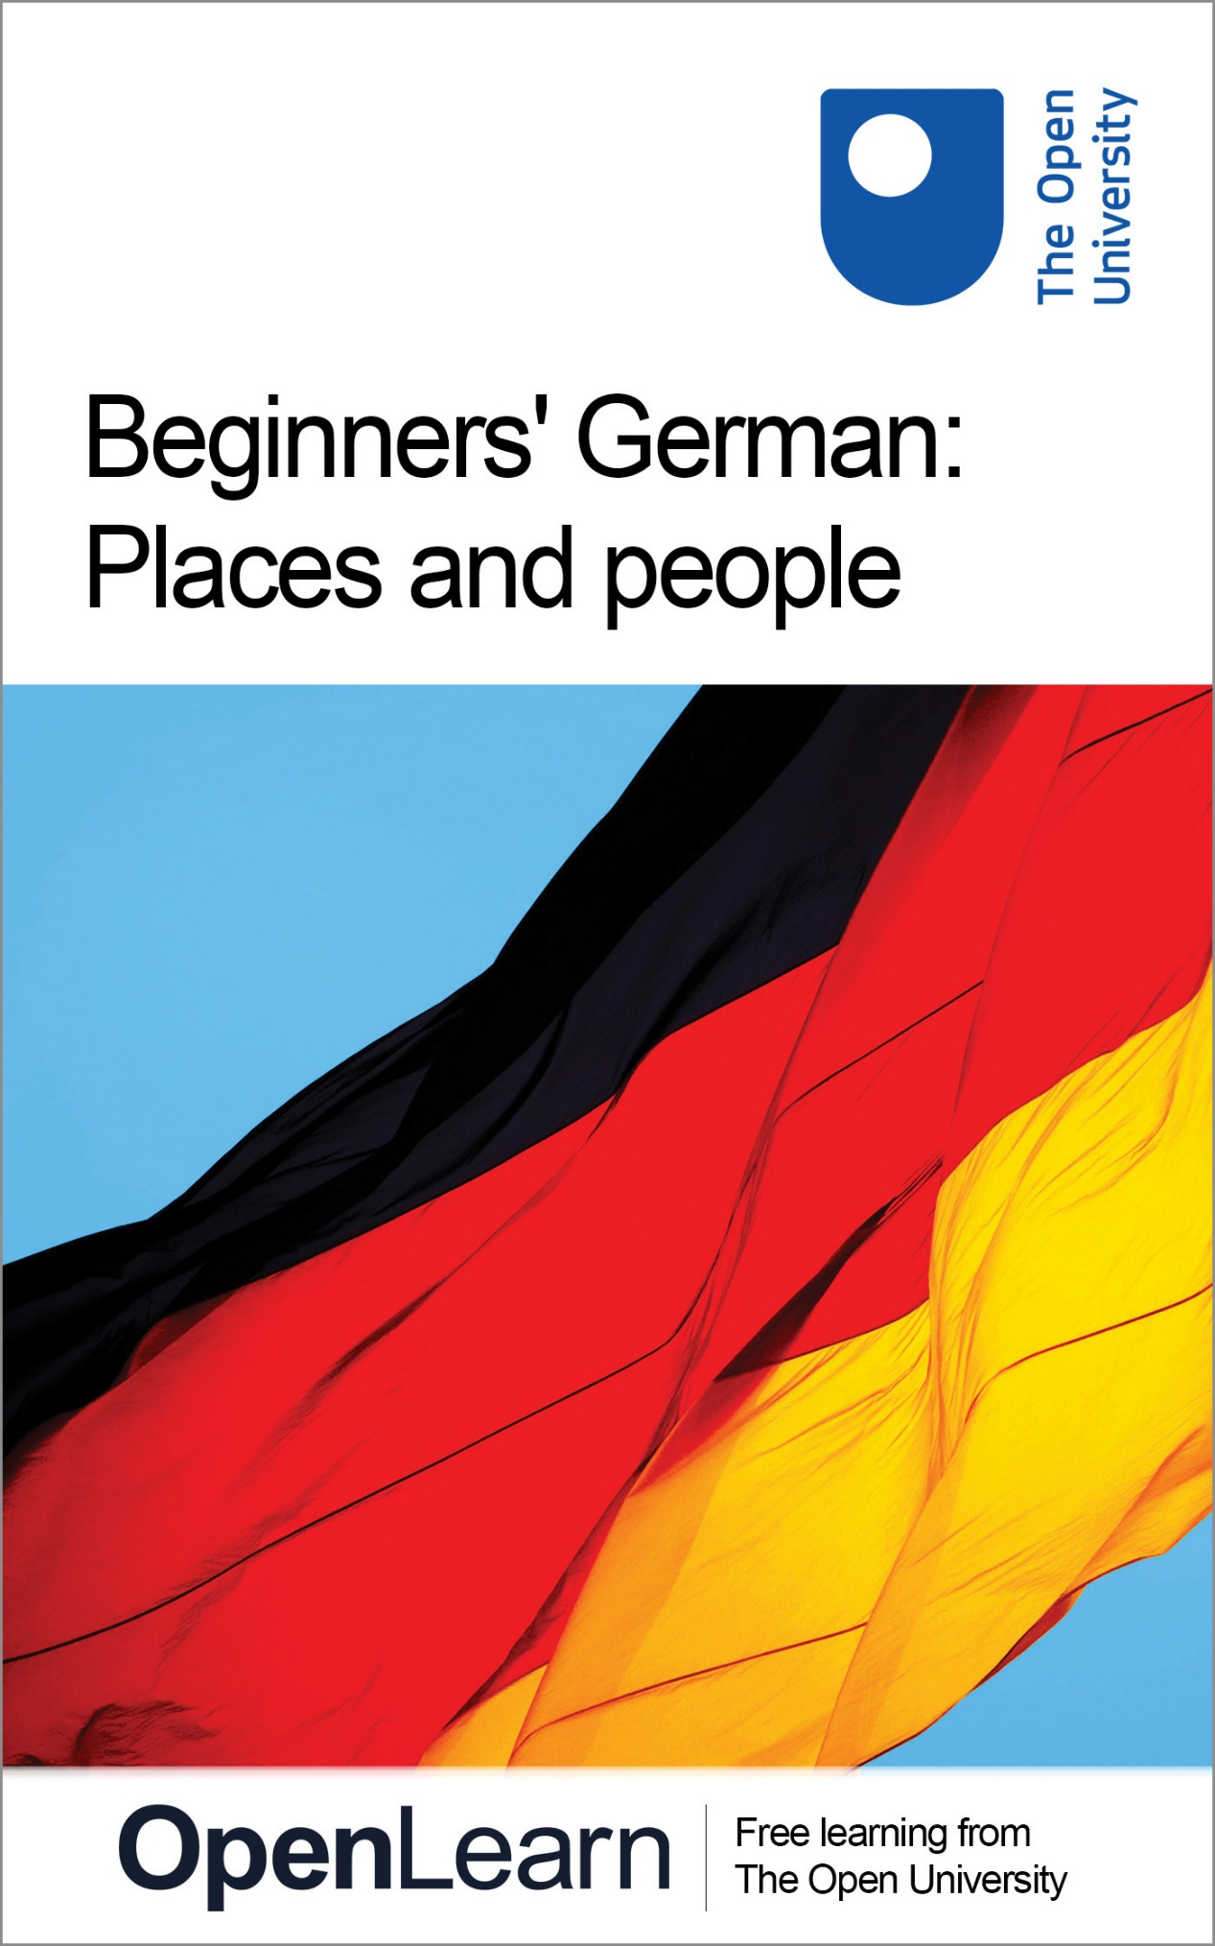

L193_1

Beginners' German: Places and people

About this free course
This free course is an adapted extract from a previous edition of the Open University course L193 Rundblick: beginners' German: www3.open.ac.uk/study/undergraduate/course/l193.html
This version of the content may include video, images and interactive content that may not be optimised for your device.
You can experience this free course as it was originally designed on OpenLearn, the home of free learning from The Open University - http://www.open.edu/openlearn/languages/german/beginners-german-places-and-people/content-section-0
There you’ll also be able to track your progress via your activity record, which you can use to demonstrate your learning.
Copyright © 2016 The Open University
Intellectual property
Unless otherwise stated, this resource is released under the terms of the Creative Commons Licence v4.0 http://creativecommons.org/licenses/by-nc-sa/4.0/deed.en_GB. Within that The Open University interprets this licence in the following way: www.open.edu/openlearn/about-openlearn/frequently-asked-questions-on-openlearn. Copyright and rights falling outside the terms of the Creative Commons Licence are retained or controlled by The Open University. Please read the full text before using any of the content.
We believe the primary barrier to accessing high-quality educational experiences is cost, which is why we aim to publish as much free content as possible under an open licence. If it proves difficult to release content under our preferred Creative Commons licence (e.g. because we can’t afford or gain the clearances or find suitable alternatives), we will still release the materials for free under a personal end-user licence.
This is because the learning experience will always be the same high quality offering and that should always be seen as positive – even if at times the licensing is different to Creative Commons.
When using the content you must attribute us (The Open University) (the OU) and any identified author in accordance with the terms of the Creative Commons Licence.
The Acknowledgements section is used to list, amongst other things, third party (Proprietary), licensed content which is not subject to Creative Commons licensing. Proprietary content must be used (retained) intact and in context to the content at all times.
The Acknowledgements section is also used to bring to your attention any other Special Restrictions which may apply to the content. For example there may be times when the Creative Commons Non-Commercial Sharealike licence does not apply to any of the content even if owned by us (The Open University). In these instances, unless stated otherwise, the content may be used for personal and non-commercial use.
We have also identified as Proprietary other material included in the content which is not subject to Creative Commons Licence. These are OU logos, trading names and may extend to certain photographic and video images and sound recordings and any other material as may be brought to your attention.
Unauthorised use of any of the content may constitute a breach of the terms and conditions and/or intellectual property laws.
We reserve the right to alter, amend or bring to an end any terms and conditions provided here without notice.
All rights falling outside the terms of the Creative Commons licence are retained or controlled by The Open University.
Head of Intellectual Property, The Open University
978 1 47300 151 0 (.epub)
978 1 47300 056 8 (.kdl)

Contents
- Introduction
- Learning outcomes
- 1 Talking about places and locations
  - 1.1 People and places
  - 1.2 Pronunciation
  - 1.3 Location
  - 1.4 Numbers 0–10
- 2 Understanding information about countries and languages
  - 2.1 Where is German spoken?
  - 2.2 Useful expressions
  - 2.3 Personal pronouns
- 3 Giving and understanding personal information
  - 3.1 Where do you come from?
  - 3.2 Where do you live?
- 4 Ordering and paying for things
  - 4.1 Using ‘man’
  - 4.2 Café conversations
  - 4.3 What the customer wants
  - 4.4 Your turn to order
- Conclusion
- Take the next step
- Acknowledgements
- Solutions

Introduction
This free course focuses on planning and preparing for a journey through German-speaking countries. You will read and hear about a range of places and people.
You will learn the names of things you need to remember when travelling and, most importantly, you will find out what it’s like to read and listen to German in real contexts, and about developing strategies and studying useful phrases, which will help you to cope in a range of situations.
You will also find out how to order and pay for things in cafes and restaurants.
This OpenLearn course is an adapted extract from a previous edition of the Open University course L193 Rundblick: beginners' German.

Learning outcomes
After studying this course, you should be able to:
- demonstrate knowledge of the singular forms of personal pronouns, singular forms of the regular verb kommen and generalisations using man
- use improved vocabulary and pronunciation related to place names, numbers 0–10, countries, finding out what is available when ordering and paying for things, ordering and paying for food
- understand the cultures of places and people in Germany, Switzerland and Austria, German-speaking minorities
- address people, imitate German pronunciation, and read for gist
- learned how to work out meanings from the contexts.

1 Talking about places and locations
In this section, you have a first look at places and people in Germany, Austria and Switzerland. You familiarise yourself with the pronunciation of place names in German, and you talk about the location of cities and towns in German-speaking countries. You also talk about where some people come from (some well-known and some not so well-known).

1.1 People and places
You will start this section by looking at the geography of some German-speaking countries.

Übung 1

Here is a map showing places in Germany, Switzerland and Austria. To start with, listen to the audio extract beneath the map. Can you understand where the various people are from? Which of the labelled places do you hear mentioned in the clip?

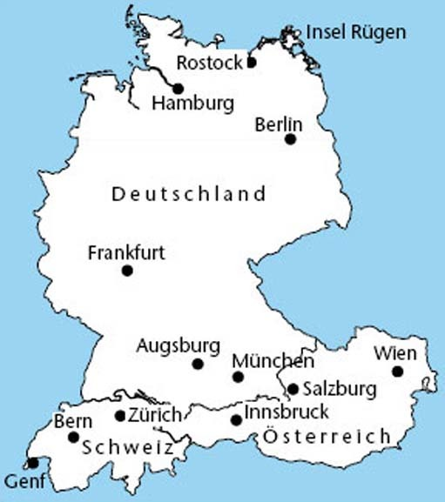

Audio content is not available in this format.
Übung 1
View transcript - Übung 1

View discussion - Part

Which of the places have you heard of before (or perhaps even visited)? Make a note of them. Do you know any other places in Germany, Austria and Switzerland? Where are they?

Provide your answer...
View discussion - Part

Übung 2

Now listen to the pronunciation of the place names. Repeat each name as you hear it.
Hören Sie und sprechen Sie nach.

Audio content is not available in this format.
Übung 2
View transcript - Übung 2

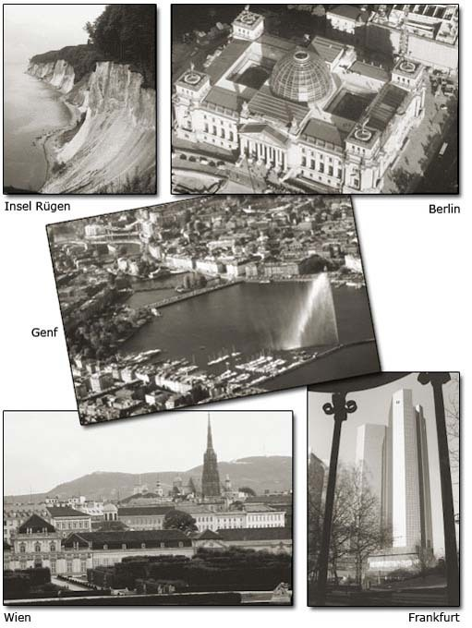

1.2 Pronunciation
German uses the same letters as English, with some additions: ‘a’, ‘o’ and ‘u’ can sometimes be found with two dots over them (called Umlaut). They sound slightly different from ‘a’, ‘o’, and ‘u’ on their own. The letter ‘ß’ represents a double ‘s’ and is pronounced like an ‘s’.
At this stage, all the German you need to use is presented in the audio clips. Listen to the words and phrases and try to imitate the pronunciation of the speakers. You will find that German pronunciation becomes very easy to predict after a while. As the course progresses, you will be introduced to some of the rules and asked to practise individual sounds.

Übung 3

How are the following letters or groups of letters pronounced in German? Listen to this audio extract again and, if you like, make some personal notes on the pronunciation. Write down something that will help you remember how to say the word when you see it written down. The first one has been done as an example.
Bitte hören Sie und schreiben Sie.

Audio content is not available in this format.
Übung 3
View transcript - Übung 3

- ‘eu’ in Deutschland: sounds like ‘oy’ in ‘joy’
- ‘ü’ in München:sounds like …
- ‘ch’ in München: sounds like …
- ‘au’ in Augsburg: sounds like …
- ‘ö’ in Köln: sounds like …
- ‘a’ in Hamburg: sounds like …
- ‘ei’ in Österreich: sounds like …
- ‘w’ in Wien: sounds like …
- ‘ie’ in Wien: sounds like …
- ‘z’ in Zürich: sounds like …

View answer - Übung 3

1.3 Location
In the previous activities you have been looking at the location of places in Germany, Austria and Switzerland. If you had to give this information in German, this is the vocabulary you would need:
- Vokabeln
- das ist … that is … / this is …
- in Deutschland in Germany
- in Norddeutschland in northern Germany
- in Süddeutschland in southern Germany
- in Österreich in Austria
- in der Schweiz in Switzerland

Übung 4

Listen to the names of some places and say, in German, where they all are. Repeat this activity until you are happy with your pronunciation.
Bitte hören Sie und sprechen Sie. Hier ist ein Beispiel.
- You hear: Hamburg
- You say: Hamburg? Das ist in Norddeutschland.
- You hear: Hamburg? Hm, das ist in Norddeutschland!

Audio content is not available in this format.
Übung 4
View transcript - Übung 4

View answer - Übung 4

Übung 5

Now listen to people saying who they are and where they come from. Then, complete the sentences below.

Audio content is not available in this format.
Übung 5
View transcript - Übung 5

- 1. Claudia Grothe kommt aus …

Provide your answer...

- 2. Jasmin kommt aus …

Provide your answer...

- 3. Ulf kommt aus …

Provide your answer...

- 4. Dieter Hoffmann kommt aus …

Provide your answer...

- 5. Bärbel Kleingarn kommt aus …

Provide your answer...

- 6. Peter Neißendorfer kommt aus …

Provide your answer...

View answer - Part

So far you have been talking about places, but what about the people who come from these places? You already know Das ist … which you can use for introducing them. And then you could say:
- er kommt aus … he comes from …
- sie kommt aus … she comes from …
And you may also want to introduce yourself:
- mein Name ist … my name is …
- ich komme aus … I come from …

Übung 6

Click the following link and complete the activity. Then, move on to the question below.
Open the quiz now.
Und Sie? (Introduce yourself. You can look up the name of your country in a dictionary, if you like.)

Provide your answer...
View answer - Übung 6

1.4 Numbers 0–10
Before you can complete the final activity in this section, you need to understand numbers up to ten. Here they are in writing:

0 | 1 | 2 | 3 | 4 | 5 | 6 | 7 | 8 | 9 | 10
null | eins | zwei | drei | vier | fünf | sechs | sieben | acht | neun | zehn

Übung 7

Listen to the audio extract and read the numbers, paying close attention to pronunciation. Then listen again and repeat out loud until you are happy with your own pronunciation.
Bitte hören Sie und sprechen Sie nach.

Audio content is not available in this format.
Übung 7
View transcript - Übung 7

Übung 8

Now listen to the audio and look at the pictures below for some more practice in presenting people and pronouncing names. Listen out for the numbers, and then name the relevant person. Here's an example.
Bitte hören Sie und sprechen Sie. Hier ist ein Beispiel.
- You hear: Nummer eins
- (picture number 1 shows Sigmund Freud)
- You say: Das ist Sigmund Freud.
- You hear: Das ist Sigmund Freud.

Audio content is not available in this format.
Übung 8
View transcript - Übung 8

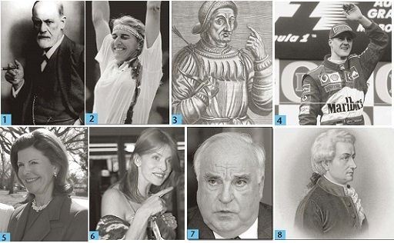

2 Understanding information about countries and languages
In this section, you have a look at countries all over the world and meet some of the people who live there. You learn to recognise more names for countries, understand some information about the German language as well as basic personal information. You also learn to use regular verbs and pronouns such as ‘I’, ‘you’, ‘he’ and ‘she’.

2.1 Where is German spoken?
So far, this course has looked at places in Germany, Austria and Switzerland. In this activity, you'll learn about other countries around the world where you might hear German being spoken.

Übung 9

The countries listed below (among many others) have German minorities living within their borders who speak either standard German or a German dialect, or both. Before reading more about why this is the case, decide which continent they belong to by arranging the countries in the blank table below. One has been done as an example.
Bitte ordnen Sie.

Australian • Brasilien • Dänemark • Frankreich • Italien • Kanada • Kasachstan • Namibia • Polen • Rumänien • Russland • USA

Afrika | Asien | Australian/Ozeanien | Europa | Südamerika | Nordamerika
Provide your answer... | Provide your answer... | Provide your answer... | Dänemark | Provide your answer... | Provide your answer...
 | Provide your answer... |  | Provide your answer... |  | Provide your answer...
 |  |  | Provide your answer...
 |  |  | Provide your answer...
 |  |  | Provide your answer...
 |  |  | Provide your answer...

Now listen to this audio clip, which will help you check your answers above. Listen out for the pronunciation of the different countries in German.
Bitte hören Sie.

Audio content is not available in this format.
Übung 9
View transcript - Übung 9

View answer - Übung 9

2.2 Useful expressions
Here are some useful expressions for you to understand when reading about the German language.
- Vokabeln
- Deutsch German
- Hochdeutsch standard German
- Deutsche Germans
- Land, länder country, countries
- Staat, staaten state, states
- Sprache language
- Muttersprache mother tongue
- Minderheitensprache minority language
- Landessprache national language
- offizielle Sprache official language
- sprechen, spricht speak, speaks

Übung 10

Look at the extracts below to learn more about places where German is spoken. You will probably not understand all of it yet, but keep a look out for the countries mentioned in each paragraph. You may like to make some notes.
Bitte markieren Sie.

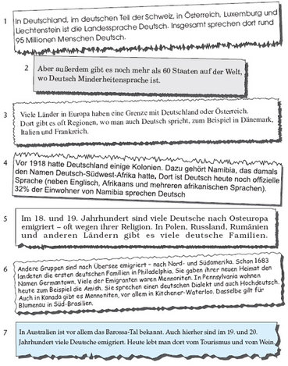

View discussion - Übung 10

Übung 11

Now go through the extracts again. Even without understanding much German, can you guess what kind of information is given in each of them? Read the English summaries below and decide which one represents each of the German extracts.
Bitte ordnen Sie zu.

German is the national language in a number of European countries.
There are also countries all over the world where German is spoken as a minority language.
Many Germans left their home, for example for religious reasons, and went to live in Eastern Europe.
Germans also went overseas. For example, you can find a large number of Mennonites in both North and South America.
German emigration to Australia concentrated in the Barossa Valley, a famous wine-growing area which attracts many tourists.
Germany used to have some colonies, where German is still spoken today.
German is also spoken by some of the people who live in regions that share a border with Germany.
Extract 7
Extract 6
Extract 5
Extract 4
Extract 3
Extract 2
Extract 1
View answer - Übung 11
View discussion - Übung 11

Übung 12

The following audio clip contains five short dialogues in which people talk about their origins. Listen and read the sentences below. They each contain one error. Rewrite the sentences correctly.
Hören Sie und korrigieren Sie die Sätze.
- Vokabeln
- Herr Mr
- Frau Mrs, Miss, Ms
- meine Familie my family
- meine Mutter my mother

Audio content is not available in this format.
Übung 12
View transcript - Übung 12

- 1. Marcos Schneider kommt aus Deutschland.

Provide your answer...

- 2(a). Frau Lahn kommt aus Hahndorf. Das ist in Namibia.

Provide your answer...

- 2(b). Frau Lahns Familie kommt aus Österreich.

Provide your answer...

- 3. Frau Lengenfelder kommt aus der Schweiz.

Provide your answer...

- 4. Herr Söder kommt aus Norddeutschland.

Provide your answer...

- 5. Frau Schweigert kommt aus Kanada.

Provide your answer...

View answer - Part

2.3 Personal pronouns
In order to talk about yourself and other people you need the German for ‘I’, ‘you’, ‘he’, ‘she’ and ‘it’ (personal pronouns).
- ich – I
- du – you (when talking to a close friend, a relative or a child)
- er – he
- sie – she
- es – it
- Sie – you (when talking to an adult who is not a very close friend or relative)
Note that sie with a small letter means ‘she’, whereas Siewith a capital letter means ‘you’.

Using kommen
While listening to the interviews you may have noticed the different forms of the verb kommen (to come). The form kommen – which is the one you will find in a dictionary – is called the infinitive. In the infinitive almost all German verbs end in –en, but when used in a sentence, –en is replaced by another ending depending on the person you are talking about. Here are the forms of kommen in the singular.
- kommen
- ich komme
- du kommst
- er, sie, es kommt
- Sie kommen

Übung 13

Listen to this audio again:

Audio content is not available in this format.
Übung 13
View transcript - Übung 13

Now fill in the gaps in the following quiz by dragging the different forms of kommen to their correct positions.
Open the quiz now.

View answer - Übung 13

Übung 14

Complete the sentences in this quiz with the grammatically correct personal pronouns.
Open the quiz now

View answer - Übung 14

3 Giving and understanding personal information
In this section, you will get more practice in answering questions and giving basic personal information. You'll also learn to use more personal pronouns and regular verbs.

3.1 Where do you come from?
Start this section by listening to conversations about various countries. You may find this vocabulary useful:
- Vokabeln
- Entschuldigung excuse me
- Entschuldigung, woher kommen Sie? excuse me, where do you come from?
- bitte please
- wohnen to live

Übung 15

Listen to people being asked where they come from, paying particular attention to which countries are mentioned. After listening, complete the activity below, organising the countries in the order they were mentioned.

Audio content is not available in this format.
Übung 15
View transcript - Übung 15

1
2
3
4
5
6
7
8
9
10
11
Wales
Schottland
Russland
Italien (Norditalien)
Irland
Großbritannien
Frankreich
England
Deutschland
der Schweiz
Brasilien
View answer - Übung 15

Übung 16

Below is a map with arrows pointing to different countries. Listen to the audio and look at the map at the same time. When asked where you come from, answer as indicated by the arrows.
Bitte hören Sie und sprechen Sie. Hier ist ein Beispiel.
- Sie hören: Woher kommen Sie?
- Sie sagen: Ich komme aus Deutschland.
- (because arrow no. 1 is pointing to Germany)
- Sie hören: Ich komme aus Deutschland.

Audio content is not available in this format.
Übung 16
View transcript - Übung 16

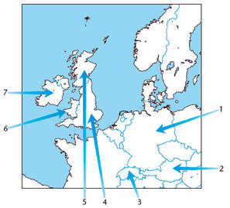

Übung 17

Below is some information about eight people who all have German as their mother tongue, but they come from and live in different countries. You were introduced to some of them in the previous sections. Fill in the gaps in the table below, noting where they live and which country they come from.
Bitte lesen Sie und schreiben Sie.

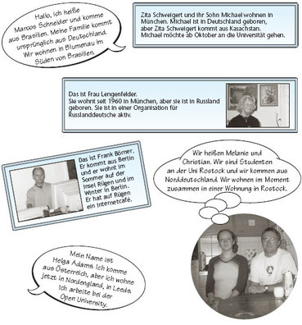

Name | wohnt in | kommt aus
Marcos Schneider | Provide your answer... | Provide your answer...
Zita Schweigert | Provide your answer... | Provide your answer...
Michael Schweigert | Provide your answer... | Provide your answer...
Frau Lengenfelder | Provide your answer... | Provide your answer...
Frank Börner | Provide your answer... | Provide your answer...
Melanie | Provide your answer... | Provide your answer...
Christian | Provide your answer... | Provide your answer...
Helga Adams | Provide your answer... | Provide your answer...

View answer - Übung 17

3.2 Where do you live?
In the previous sections, you learned about personal pronouns when talking about one person or one thing only (the singular). Below is a list of all pronouns, singular and plural. You came across some of them in the audio extracts and when reading the introductions in Übung 17.

Personal pronouns

Singular | Plural | Singular and plural
ich – I  du – you (when talking to a close friend, a relative or a child)  er – he  sie – she  es – it | wir – we  ihr – you (when talking to two or more close friends, relatives or children)  sie – they | Sie – (when talking to one or more adults who are not very close friends or relatives of yours)

Note that sie with a small ‘s’ means ‘she’ and also ‘they’.
You will have noticed that there are different ways of saying ‘you’ in German. Sie is the most useful when you meet German-speaking people. You mainly use Sie throughout this course, but you also learn more about the different ways of addressing people later on.

Übung 18

You also need to know how to use verbs with pronouns in the plural. The table below shows all the forms for kommen. ‘komm-’ is the stem of the verb that is always the same. Endings are then added according to who you are talking about. Like kommen the verb wohnen is regular. They both work in the same way. Write down the forms for wohnen. The first one has been done for you.
Bitte schreiben Sie die Formen von „wohnen“ in die Tabelle.

 |  | kommen | wohnen
singular | ich | komme | wohne
 | du | kommst | Provide your answer...
 | er/sie/es | kommt | Provide your answer...
plural | wir | kommen | Provide your answer...
 | ihr | kommt | Provide your answer...
 | sie | kommen | Provide your answer...
singular and plural | Sie | kommen | Provide your answer...

View answer - Übung 18

Übung 19

Listen to the audio extracts and practise the different forms of wohnen.
Hören Sie und sprechen Sie. Hier ist ein Beispiel.
- Sie hören: ich
- Sie sagen: ich wohne
- Sie hören: ich wohne

Audio content is not available in this format.
Übung 19
View transcript - Übung 19

Übung 20

Use the information from Übung 17 (repeated below), to match the answers with the questions in the following activity.

- Vokabeln
- Wo wohnen Sie? Where do you live?
- Wo wohnt er/sie? Where does he/she live?

Wo wohnt Marcos Schneider?
Woher kommen Melanie und Christian?
Woher kommt Frau Lengenfelder?
Wo wohnt Herr Börner?
Wo wohnt Frau Schweigert?
Wo wohnt Frau Adams?
Sie wohnt in München.
Sie wohnt in Leeds.
Sie kommt aus Russland.
Sie kommen aus Norddeutschland.
Er wohnt in Blumenau.
Er wohnt in Berlin und auf der Insel Rügen.
View answer - Übung 20

Übung 21

Match the questions and answers below. You will need to look closely at both the grammar and the content.

Woher kommt Wilhelm Tell?
Woher kommt Wolfgang Amadeus Mozart?
Woher kommt Frau Adams?
Wo wohnen die Amish?
Wo wohnt Frau Lengenfelder?
Wo wohnen Melanie und Christian?
Wo wohnen Zita und Michael Schweigert?
Woher kommt Marcos Schneider?
Sie wohnt in München.
Sie wohnen in Rostock.
Sie wohnen in Pennsylvania.
Sie wohnen in München.
Sie kommt aus Österreich.
Er kommt aus Österreich.
Er kommt aus der Schweiz.
Er kommt aus Brasilien
View answer - Übung 21

Übung 22

In this activity, listen to the audio to practise giving some personal information about the people you have come across in this section. Make sure you are familiar with the information given in the extracts in Übung 17, then answer the questions.
Bitte hören Sie und sprechen Sie. Hier ist ein Beispiel.
- Sie hören: Entschuldigen Sie bitte, wie ist Ihr Name? (Lengenfelder)
- Sie sagen: Mein Name ist Lengenfelder.
- Sie hören: Wo wohnen Sie?
- Sie sagen: Ich wohne in München.
- Sie hören: Und woher kommen Sie?
- Sie sagen: Ich komme aus Russland.

Audio content is not available in this format.
Übung 22
View transcript - Übung 22

4 Ordering and paying for things
You will now visit the island of Rügen, off Germany’s Baltic coast. You’ll learn to use the pronoun man to talk about the things you can do.

4.1 Using ‘man’

Making generalisations using ‘man’
When you are talking about people in general in English, you might say ‘you’, ‘they’ or ‘people’ rather than the formal-sounding ‘one’. But man doesn’t have the same formal ring to it in German. Man takes the same verb form as er/sie/es. Compare the following sentences, for example:
- Was kann man hier essen? What can you eat here? (literally: What can one eat here?)
- Was trinkt man hier? What do people drink here?
- Man bekommt überall Wein You (can) get wine anywhere

Übung 23

You can buy food and drink in many different places. In the activity below, match the descriptions with the right picture numbers.

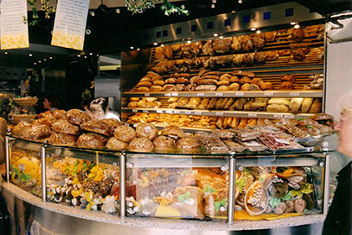
Photo 1
View description - Photo 1

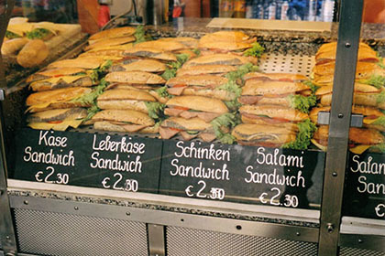
Photo 2
View description - Photo 2

Photo 3
View description - Photo 3

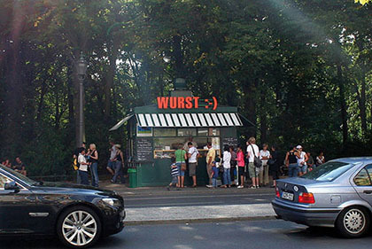
Photo 4
View description - Photo 4

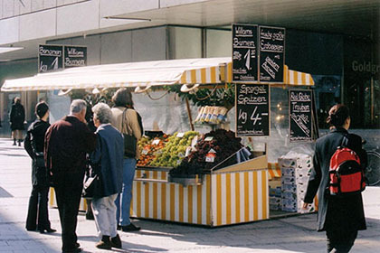
Photo 5
View description - Photo 5

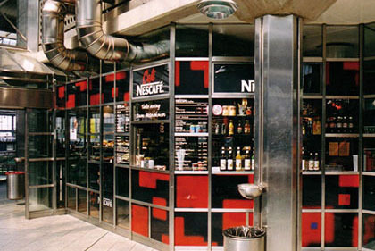
Photo 6
View description - Photo 6

Hier kann man japanisch essen.
Hier kann man Kaffee trinken.
Hier kann man Bratwurst kaufen.
Hier kann man ein Schinkenbrötchen kaufen.
Hier kann man Obst und Gemüse kaufen.
Hier kann man Brot kaufen.
Photo 6
Photo 5
Photo 4
Photo 3
Photo 2
Photo 1
View answer - Übung 23

Übung 24

On the island of Rügen, you might hear someone asking about what you can eat and drink there. Listen for the key words and fill in the gaps in the following sentences. You don’t need to understand everything.
Hören Sie und schreiben Sie.

Audio content is not available in this format.
Übung 24
View transcript - Übung 24

- Vokabeln
- aus der Umgebung from the surrounding area
- wer Fisch mag, der ist hier genau richtig anyone who likes fish feels at home here

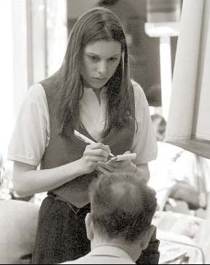

- 1. Was kann man auf Rügen essen?
Man kann _____ essen.

Provide your answer...

- 2. Was trinkt man?
Man trinkt _____.

Provide your answer...

- 3. Was bekommt man auch?
Man bekommt überall auch _____.

Provide your answer...

View answer - Part

4.2 Café conversations

Übung 25

Listen to this conversation in a café. Try to work out the meanings from the context without using a dictionary. Then do the quiz below.

Audio content is not available in this format.
Übung 25
View transcript - Übung 25

keep the change
anything else?
two pieces of apple cake
a glass of tea
I'd like to pay, please
that comes to
with cream
a pot of coffee
with lemon
together or separately
excuse me
we'd like
zwei Stück Apfelkuchen
zusammen oder getrennt
wir möchten
stimmt so
sonst noch etwas
mit Zitrone
mit Sahne
Ich möchte zahlen, bitte
entschuldigung
ein Kännchen Kaffee
ein Glas Tee
das macht
View answer - Übung 25

Übung 26

Listen to the audio again (and look at the transcript if you'd like). The waitress says bitte schön twice. Can you guess from the context what the phrase means in each case (two different meanings)? Write down what you think the different meanings are.
Lesen Sie und schreiben Sie.

Audio content is not available in this format.
Übung 26
View transcript - Übung 26

Provide your answer...
View answer - Übung 26

Übung 27

Here are some extracts from everyday café conversations with a few key words missing.
Use some of the phrases you have learned to fill in the gaps.
Lesen Sie und schreiben Sie.
- GAST: Entschuldigung! Die Speisekarte, bitte!
- KELLNER: Ja, sofort. … Bitte _____.
- (später)
- KELLNER: Möchten _____ bestellen?
- GAST: Ja, ich _____ einen Kaffee, bitte.
- KELLNER: Eine Tasse oder ein _____ ?
- GAST: Eine Tasse, bitte.
- KELLNER: Sonst noch _____ ?
- GAST: Nein, danke.
- (später)
- KELLNER: Bitte schön?
- GAST: _____, bitte.
- KELLNER: Das _____ €2,50, bitte.
- GAST: €3,00 – _____ so.
- KELLNER: Vielen _____. Auf Wiedersehen.

View answer - Übung 27

Übung 28

Now it's your turn to play the customer's part, using your script from Übung 27. Speak aloud as you play the audio.
Hören Sie und sprechen Sie. Sie sind der Gast. Hier ist ein Beispiel.
- Sie sagen: Entschuldigung! Die Speisekarte, bitte.
- Sie hören: Entschuldigung! Die Speisekarte, bitte.

Audio content is not available in this format.
Übung 28
View transcript - Übung 28

View answer - Übung 28

4.3 What the customer wants

Übung 29

Look at this drawing of a busy restaurant. The customers are trying to attract the waiter’s attention. What does each group want?

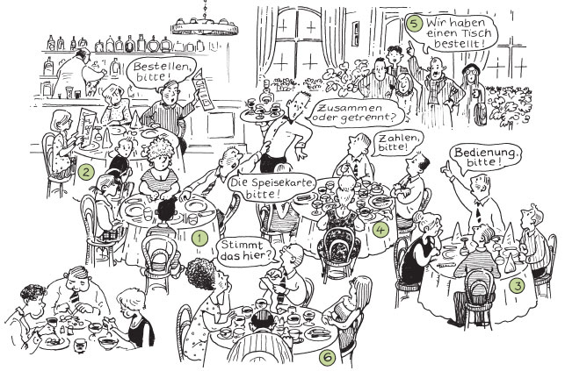

This group wants a table they have reserved
This group wants to attract the waiter's attention
This group wants the menu
This group wants to order
This group wants to pay
This group wants to query the bill
Group 6
Group 5
Group 4
Group 3
Group 2
Group 1
View answer - Übung 29

4.4 Your turn to order

Übung 30

Here is the menu at a restaurant:

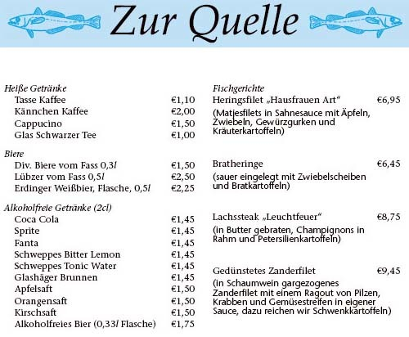

You decide to order fish at this restaurant. Begin by calling the waiter, then follow the cues in the audio extract.
Hören Sie und sprechen Sie. Hier ist ein Beispiel.
- Sie hören: Rufen Sie den Kellner.
- Sie sagen: Entschuldigung!

Audio content is not available in this format.
Übung 30
View transcript - Übung 30

Übung 31

Did you enjoy your meal? The waiter seems to have disappeared, so you ask the waitress (die Kellnerin) for your bill. You only hear the first cue in the audio, so use the notes below to guide you through the rest of the dialogue.
Hier ist ein Beispiel.
- Sie hören: Rufen Sie die Kellnerin.
- Sie sagen: Bedienung, bitte!

Audio content is not available in this format.
Übung 31
View transcript - Übung 31

- I’d like to pay, please.
- Excuse me, is this right?
- But I had (ich hatte) fried herring!
- OK, €10 – keep the change.

Conclusion
This free course provided an introduction to studying Languages. It took you through a series of exercises designed to develop your approach to study and learning at a distance and helped to improve your confidence as an independent learner.
This OpenLearn course is an adapted extract from a previous edition of the Open University course L193 Rundblick: beginners' German.
If you enjoyed this course, you might be interested in studying the Open University module L193 Rundblick: beginners' German. Or, if you are interested in other language short courses, rather than studying languages for a degree, you may want to have a look at what else is on offer here.

Take the next step

If you enjoyed this course, why not explore the subject further with our paid-for short course, Beginners German 1: fang an!?
Find out more about Beginners German 1: fang an!

Acknowledgements
Except for third party materials and otherwise stated (see terms and conditions), this content is made available under a Creative Commons Attribution-NonCommercial-ShareAlike 4.0 Licence.
The material acknowledged below is Proprietary and used under licence (not subject to Creative Commons Licence). Grateful acknowledgement is made to the following sources for permission to reproduce material in this course:
Course image: Jay Plemon in Flickr made available under Creative Commons Attribution-NonCommercial 2.0 Licence.

Figures
Übung 2 (top left) © Xeniel-Dia
Übung 2 (top right) Courtesy of German National Tourist Office
Übung 2 (middle): Geneve Tourisme/swiss-image.ch
Übung 2 (bottom left) Courtesy of the Austrian National Tourist Ofice
Übung 6 (clockwise) (1) © Mary Evans Picture Library; (2) Courtesy of Mary Evans Picture Library; (4) Courtesy of Shell; (5) © Mary Evans Picture Library; (6) © AP Photo/Roberto Pfeil; (7) © AP Photo/Rene Macura; (8) © AP Photo/Jacqueline Roggenbrodt
Übung 17 (top) Courtesy of Anna Lengenfelder.
Every effort has been made to contact copyright owners. If any have been inadvertently overlooked, the publishers will be pleased to make the necessary arrangements at the first opportunity.
Don't miss out
If reading this text has inspired you to learn more, you may be interested in joining the millions of people who discover our free learning resources and qualifications by visiting The Open University – www.open.edu/openlearn/free-courses.

Solutions

Übung 1

Part

Discussion
The places mentioned were Frankfurt, München (Munich), Berlin, Innsbruck and Zürich.
Back to - Part

Part

Discussion
What you've written depends entirely on your own experiences. The aim of this activity is to make you think about what you know already, and encourage you to have a look at a map to find out more about the location of places you have heard of.
Back to - Part

Übung 3

Answer
The answer depends on what you find helpful and on your own mother tongue, accent and knowledge of other languages. Here are some suggestions:
- ‘eu’ in Deutschland sounds like ‘oy’ in ‘joy’;
- ‘ü’ in München sounds like nothing in English (it is pronounced right at the front of your mouth, halfway between ‘ee’ and ‘oo’);
- ‘ch' in München sounds a bit like ‘H’ in ‘Hugh’;
- ‘au’ in Augsburg sounds like ‘ou’ in ‘ouch’;
- ‘ö’ in Köln sounds a bit like ‘oeu’ in the French word ‘boeuf ’ (but your lips are more closed and pointed when you pronounce it);
- ‘a’ in Hamburg sounds like ‘u’ in ‘hum’ (in Standard English);
- ‘ei’ in Österreich sounds like ‘I’;
- ‘w' in Wien sounds like ‘v’ in ‘Vienna’;
- ‘ie’ in Wien sounds like ‘ee’ in ‘see’;
- ‘z’ in Zürich sounds like ‘tz’ in ‘Switzerland’.
Back to - Übung 3

Übung 4

Answer
As is the case in English, countries in German in general do not have articles (for example you would say ‘Germany’ not ‘the Germany’). There are a few exceptions though and Schweiz is one of them. That's why you had to say Das ist in der Schweiz.)
Back to - Übung 4

Übung 5

Part

Answer
This is where the people come from:
- Claudia Grothe kommt aus Norddeutschland.
- Jasmin kommt aus Innsbruck.
- Ulf kommt aus Rostock.
- Dieter Hoffmann kommt aus Köln.
- Bärbel Kleingarn kommt aus Hamburg.
- Peter Neißendorfer kommt aus München.
Apart from ich komme aus … (I come from …), people were also saying ich bin in … geboren (I was born in …).
Back to - Part

Übung 6

Answer
These are the answers to the activity, showing how each person should be introduced:
- Das ist Sigmund Freud. Er kommt aus Österreich.
(The Austrian neurologist and founder of psychoanalysis lived from 1856 to 1939.)
- Das ist Steffi Graf. Sie kommt aus Deutschland.
(Tennis player Steffi Graf was born in 1969.)
- Das ist Wilhelm Tell. Er kommt aus der Schweiz.
(The semi-legendary Swiss patriot was first mentioned in a chronicle in 1470.)
- Das ist Michael Schumacher. Er kommt aus Deutschland.
(The German racing driver was born in 1969.)
- Das ist Königin Silvia. Sie kommt aus Deutschland.
(Silvia, Queen of Sweden, was born in Heidelberg in 1943 as Silvia Renate Sommerlath, the daughter of a West German businessman and his Brazilian wife.)
- Das ist Nastassja Kinski. Sie kommt aus Deutschland.
(The actress – and daughter of actor Klaus Kinski – was born in 1960).
- Das ist Helmut Kohl. Er kommt aus Deutschland.
(The former German chancellor was born in 1930.)
- Das ist Wolfgang Amadeus Mozart. Er kommt aus Österreich.
(The Austrian composer lived from 1756 to 1791.)
This is how you could have introduced yourself:
Mein Name ist _____. Ich komme aus _____ (England, Schottland, Wales, Irland, usw.).
Back to - Übung 6

Übung 9

Answer
Here is a completed table for you to check.

Afrika | Asien | Australian/Ozeanien | Europa | Südamerika | Nordamerika
Namibia | Kasachstan | Australien | Dänemark | Brasilien | Kanada
 | Russland |  | Frankreich |  | USA
 |  |  | Italien
 |  |  | Polen
 |  |  | Rumänien
 |  |  | Russland

Back to - Übung 9

Übung 10

Discussion
Translating some sentences, these are the countries mentioned in each text.
- Germany, (the German part of) Switzerland, Austria, Luxembourg, Liechtenstein
- more than 60 countries where German is a minority language
- Germany, Austria, Denmark, Italy, France
- Germany, Namibia
- Poland, Russia, Romania
- places in the USA, Canada, (Southern) Brazil
- Australia
Back to - Übung 10

Übung 11

Answer
The correct matches are:
German is the national language in a number of European countries.
Extract 1
There are also countries all over the world where German is spoken as a minority language.
Extract 2
Many Germans left their home, for example for religious reasons, and went to live in Eastern Europe.
Extract 5
Germans also went overseas. For example, you can find a large number of Mennonites in both North and South America.
Extract 6
German emigration to Australia concentrated in the Barossa Valley, a famous wine-growing area which attracts many tourists.
Extract 7
Germany used to have some colonies, where German is still spoken today.
Extract 4
German is also spoken by some of the people who live in regions that share a border with Germany.
Extract 3
Back to - Übung 11

Discussion
If you found the correct English extracts for some or all of the texts, you will have understood the most important information given. When reading in a foreign language it's important not to be scared by the number of new words and structures that are being used, but to concentrate on what you can understand.
Back to - Übung 11

Übung 12

Part

Answer
Here are the corrected versions of the sentences:
- 1. Marcos Schneider kommt aus Brasilien.
- 2(a). Frau Lahn kommt aus Hahndorf. Das ist in Australien.
- 2(b). Frau Lahns Familie kommt aus Deutschland.
- 3. Frau Lengenfelder kommt aus Russland.
- 4. Herr Söder kommt aus Dänemark.
- 5. Frau Schweigert kommt aus Kasachstan.
In the dialogues the question word woher was used several times. It means ‘where from’.
Back to - Part

Übung 13

Answer
These are the forms of kommen which fit into the sentences:
- Hallo, mein Name ist Marcos Schneider. – Hallo. Kommst du aus Deutschland?
- Ich komme aus Hahndorf im Barossa-Tal. Meine Familie kommt aus Deutschland.
- Woher kommen Sie? – Ich bin in Sibirien geboren, in Russland.
- Guten Tag, Herr Söder. Kommen Sie aus Norddeutschland? – Nein, ich kommeaus Dänemark.
- Woher kommen Sie? – Ich bin auch Deutscher, also Nationalität Deutsch.
Back to - Übung 13

Übung 14

Answer
Here are the sentences with the correct personal pronouns:
- Hallo, mein Name ist Sam Schmidt – ich komme aus Namibia.
- Dein Deutsch ist perfekt! Kommst du aus Deutschland?
- Das ist Peter Neißendorfer – er kommt aus München.
- Das ist Claudia Grothe – sie kommt aus Norddeutschland.
- Frau Lengenfelder – kommen Sie hier aus München? Nein, ich komme aus Russland.
Back to - Übung 14

Übung 15

Answer
The correct matches are:
1
der Schweiz
2
Großbritannien
3
England
4
Schottland
5
Wales
6
Deutschland
7
Russland
8
Irland
9
Brasilien
10
Italien (Norditalien)
11
Frankreich
Back to - Übung 15

Übung 17

Answer
Here's the table correctly filled out:

Name | wohnt in | kommt aus
Marcos Schneider | Blumenau (Brasilien) | Brasilien
Zita Schweigert | München | Kasachstan
Michael Schweigert | München | Deutschland
Frau Lengenfelder | München | Russland
Frank Börner | Rügen/Berlin | Berlin
Melanie | Rostock | Norddeutschland
Christian | Rostock | Norddeutschland
Helga Adams | Leeds (Nordengland) | Österreich

Back to - Übung 17

Übung 18

Answer
Here are the forms of wohnen:

wohnen
ich wohne
du wohnst
er/sie/es wohnt
wir wohnen
ihr wohnt
sie wohnen
Sie wohnen

Back to - Übung 18

Übung 20

Answer
The correct matches are:
Wo wohnt Marcos Schneider?
Er wohnt in Blumenau.
Woher kommen Melanie und Christian?
Sie kommen aus Norddeutschland.
Woher kommt Frau Lengenfelder?
Sie kommt aus Russland.
Wo wohnt Herr Börner?
Er wohnt in Berlin und auf der Insel Rügen.
Wo wohnt Frau Schweigert?
Sie wohnt in München.
Wo wohnt Frau Adams?
Sie wohnt in Leeds.
Back to - Übung 20

Übung 21

Answer
The correct matches are:
Woher kommt Wilhelm Tell?
Er kommt aus der Schweiz.
Woher kommt Wolfgang Amadeus Mozart?
Er kommt aus Österreich.
Woher kommt Frau Adams?
Sie kommt aus Österreich.
Wo wohnen die Amish?
Sie wohnen in Pennsylvania.
Wo wohnt Frau Lengenfelder?
Sie wohnt in München.
Wo wohnen Melanie und Christian?
Sie wohnen in Rostock.
Wo wohnen Zita und Michael Schweigert?
Sie wohnen in München.
Woher kommt Marcos Schneider?
Er kommt aus Brasilien
Back to - Übung 21

Übung 23

Answer
The correct matches are:
Hier kann man japanisch essen.
Photo 3
Hier kann man Kaffee trinken.
Photo 6
Hier kann man Bratwurst kaufen.
Photo 4
Hier kann man ein Schinkenbrötchen kaufen.
Photo 2
Hier kann man Obst und Gemüse kaufen.
Photo 5
Hier kann man Brot kaufen.
Photo 1
Back to - Übung 23

Übung 24

Part

Answer
These were the key words.
- Man kann Fisch essen.
- Man trinkt Bier.
- Man bekommt überall auch Wein.
Back to - Part

Übung 25

Answer
The correct matches are:
keep the change
stimmt so
anything else?
sonst noch etwas
two pieces of apple cake
zwei Stück Apfelkuchen
a glass of tea
ein Glas Tee
I'd like to pay, please
Ich möchte zahlen, bitte
that comes to
das macht
with cream
mit Sahne
a pot of coffee
ein Kännchen Kaffee
with lemon
mit Zitrone
together or separately
zusammen oder getrennt
excuse me
entschuldigung
we'd like
wir möchten
Back to - Übung 25

Übung 26

Answer
Bitte schön? – Yes, please? (How can I help you?)
Bitte schön. – Here you are. (When handing something over.)
There is a third situation where bitte schön commonly occurs – in response to danke schön it means ‘don’t mention it’ or ‘you’re welcome’.
Back to - Übung 26

Übung 27

Answer
The full text is given below. Check that you used capital letters in the right places.
- GAST: Entschuldigung! Die Speisekarte, bitte!
- KELLNER: Ja, sofort. … Bitte schön.
- (später)
- KELLNER: Möchten Sie bestellen?
- GAST: Ja, ich möchte einen Kaffee, bitte.
- KELLNER: Eine Tasse oder ein Kännchen?
- GAST: Eine Tasse, bitte.
- KELLNER: Sonst noch etwas?
- GAST: Nein, danke.
- (später)
- KELLNER: Bitte schön?
- GAST: Zahlen, bitte.
- KELLNER: Das macht €2,50, bitte.
- GAST: €3,00 – stimmt so.
- KELLNER: Vielen Dank. Auf Wiedersehen.
Having coffee and cakes with friends in a café or at home is a very popular way to take a late afternoon break in Germany.
Back to - Übung 27

Übung 28

Answer
Back to - Übung 28

Übung 29

Answer
The correct matches are:
This group wants a table they have reserved
Group 5
This group wants to attract the waiter's attention
Group 3
This group wants the menu
Group 1
This group wants to order
Group 2
This group wants to pay
Group 4
This group wants to query the bill
Group 6
Back to - Übung 29

Photo 1

Description
Photo 1: bakery
Back to - Photo 1

Photo 2

Description
Photo 2: sandwich bar
Back to - Photo 2

Photo 3

Description
Photo 3: sushi bar
Back to - Photo 3

Photo 4

Description
Photo 4: hot dog stand
Back to - Photo 4

Photo 5

Description
Photo 5: fruit and vegetable stall
Back to - Photo 5

Photo 6

Description
Photo 6: café.
Back to - Photo 6

Übung 1

Transcript
FRAU 1
Sind Sie auch aus Frankfurt?
MANN 1
Nein, München.
FRAU 1
Und Sie?
FRAU 2
Berlin.
FRAU 3
Ich komm’ aus Innsbruck.
FRAU 2
Ihr Mann auch?
MANN 2
Nein, nein, aus Zürich.
FRAU 1
Ist ja ganz international hier! Und Sie? Woher sind Sie?
FRAU 4
Sorry? I’m afraid I don’t understand a word you’re saying!
Back to - Übung 1

Übung 2

Transcript
DEUTSCHLAND
Rostock →
Insel Rügen →
Berlin →
München →
Augsburg →
Frankfurt →
Köln →
Hamburg →
ÖSTERREICH
Wien →
Salzburg →
Innsbruck →
SCHWEIZ
Zürich →
Bern →
Genf →
Back to - Übung 2

Übung 3

Transcript
DEUTSCHLAND
Rostock →
Insel Rügen →
Berlin →
München →
Augsburg →
Frankfurt →
Köln →
Hamburg →
ÖSTERREICH
Wien →
Salzburg →
Innsbruck →
SCHWEIZ
Zürich →
Bern →
Genf →
Back to - Übung 3

Übung 4

Transcript
Abschnitt 3
1. Hamburg
→
Hamburg? Hm, das ist in Norddeutschland!
2. Bern
→
Bern? Hm, äh, ja … das ist in der Schweiz!
3. Wien
→
Wien – das ist in Österreich!
4. Rostock
→
Rostock? Ähm, das ist, äh, in Norddeutschland?
5. Genf
→
Genf? Ja, das ist in der Schweiz.
6. München
→
München – das ist in Süddeutschland!
Back to - Übung 4

Übung 5

Transcript
Abschnitt 4
Bitte hören Sie.
1. Mein Name ist Claudia Grothe. Ich komm’ aus Norddeutschland.
2. Mein Name ist Jasmin. Ich komme aus Innsbruck.
3. Mein Name ist Ulf. Ich komme hier aus Rostock.
4. Mein Name ist Dieter Hoffmann. Ich komme aus Köln.
5. Mein Name ist Bärbel Kleingarn. Ich bin in Hamburg geboren.
6. Mein Name ist Peter Neißendorfer. Ich bin in München geboren.
Back to - Übung 5

Übung 7

Transcript
Abschnitt 5
Bitte hören Sie und sprechen Sie nach.
null →
eins →
zwei →
drei →
vier →
fünf →
sechs →
sieben →
acht →
neun →
zehn →
zehn, neun, acht, sieben, sechs, fünf, vier, drei, zwei, eins, null
[ROCKET LAUNCH SOUND EFFECT]
Back to - Übung 7

Übung 8

Transcript
Abschnitt 6
Bitte hören Sie und sprechen Sie.
Nummer eins
→
Das ist Sigmund Freud.
Nummer drei
→
Das ist Wilhelm Tell.
Nummer vier
→
Das ist Michael Schumacher.
Nummer sieben
→
Das ist Helmut Kohl.
Nummer acht
→
Das ist Wolfgang Amadeus Mozart.
Back to - Übung 8

Übung 9

Transcript
Abschnitt 7
Bitte hören Sie.
Afrika – Namibia
Asien – Kasachstan, Russland
Australien/Ozeanien – Australien
Europa – Dänemark, Frankreich, Italien, Polen, Rumänien, Russland
Südamerika – Brasilien
Nordamerika – Kanada, USA
Back to - Übung 9

Übung 12

Transcript
Dialog 1
MARCOS
Hallo, mein Name ist Marcos Schneider.
STUDENTIN
Hallo. Kommst du aus Deutschland?
MARCOS
Nein, aus Blumenau. Das ist in Brasilien.
STUDENTIN
Oh.
Dialog 2
MANN
Ihr Deutsch ist perfekt, Frau Lahn. Woher in Australien kommen Sie?
FRAU LAHN
Ich komme aus Hahndorf im Barossa-Tal. Meine Familie kommt aus Deutschland.
Dialog 3
INTERVIEWERIN
Wie ist Ihr Name, bitte?
FRAU LENGENFELDER
Mein Name ist Lengenfelder.
INTERVIEWERIN
Woher kommen Sie?
FRAU LENGENFELDER
Ich bin in Sibirien geboren, in Russland.
Dialog 4
FRAU
Guten Tag, Herr Söder. Kommen Sie aus Norddeutschland?
HERR SÖDER
Nein, ich komme aus Dänemark.
Dialog 5
INTERVIEWERIN
Wie ist Ihr Name?
MICHAEL SCHWEIGERT
Mein Name ist Michael Schweigert.
INTERVIEWERIN
Woher kommen Sie?
MICHAEL SCHWEIGERT
Ich bin auch Deutscher, also Nationalität Deutsch. Meine Mutter aber ist geboren in Kasachstan.
Back to - Übung 12

Übung 13

Transcript
Dialog 1
MARCOS
Hallo, mein Name ist Marcos Schneider.
STUDENTIN
Hallo. Kommst du aus Deutschland?
MARCOS
Nein, aus Blumenau. Das ist in Brasilien.
STUDENTIN
Oh.
Dialog 2
MANN
Ihr Deutsch ist perfekt, Frau Lahn. Woher in Australien kommen Sie?
FRAU LAHN
Ich komme aus Hahndorf im Barossa-Tal. Meine Familie kommt aus Deutschland.
Dialog 3
INTERVIEWERIN
Wie ist Ihr Name, bitte?
FRAU LENGENFELDER
Mein Name ist Lengenfelder.
INTERVIEWERIN
Woher kommen Sie?
FRAU LENGENFELDER
Ich bin in Sibirien geboren, in Russland.
Dialog 4
FRAU
Guten Tag, Herr Söder. Kommen Sie aus Norddeutschland?
HERR SÖDER
Nein, ich komme aus Dänemark.
Dialog 5
INTERVIEWERIN
Wie ist Ihr Name?
MICHAEL SCHWEIGERT
Mein Name ist Michael Schweigert.
INTERVIEWERIN
Woher kommen Sie?
MICHAEL SCHWEIGERT
Ich bin auch Deutscher, also Nationalität Deutsch. Meine Mutter aber ist geboren in Kasachstan.
Back to - Übung 13

Übung 15

Transcript
Dialogue 1
INTERVIEWERIN
Entschuldigung, woher kommen Sie?
FRAU
Aus der Schweiz.
Dialogue 2
INTERVIEWERIN
Entschuldigung, woher kommen Sie?
FRAU
Wir kommen aus Großbritannien.
INTERVIEWERIN
Aus England?
FRAU
Nein, nein! Ich komme aus Schottland.
MANN
Und ich aus Wales.
INTERVIEWERIN
Ach so!
Dialogue 3
INTERVIEWERIN
Und Sie? Woher kommen Sie?
MANN
Aus Deutschland.
INTERVIEWERIN
Und Ihre Frau – kommt sie auch aus Deutschland?
MANN
Nein, meine Frau kommt aus Russland.
Dialogue 4
INTERVIEWER
Entschuldigung, woher kommst du?
MÄDCHEN
Aus Irland.
Dialogue 5
INTERVIEWERIN
Entschuldigung, woher kommen Sie?
MANN
Aus Brasilien.
INTERVIEWERIN
Ach, wirklich?
Dialogue 6
INTERVIEWER
Bitte, woher kommen Sie?
FRAU
Aus Südtirol.
INTERVIEWER
Wo ist das?
FRAU
Ja, in Norditalien.
Dialogue 7
INTERVIEWERIN
Hallo, woher kommt ihr?
KINDER
Wir kommen aus Frankreich.
Back to - Übung 15

Übung 16

Transcript
Abschnitt 10
Bitte hören Sie und sprechen Sie.
Dialogue 1
INTERVIEWER
Woher kommen Sie?
→
FRAU
Ich komme aus Deutschland.
Dialogue 2
INTERVIEWERIN
Woher kommen Sie?
→
MANN
Ich komme aus Österreich.
Dialogue 3
INTERVIEWER
Entschuldigung, woher kommen Sie?
→
FRAU
Ich komme aus der Schweiz.
Dialogue 4
INTERVIEWER:IN
Hallo, woher kommen Sie?
→
FRAU
Ich komme aus England.
INTERVIEWERIN
Aus Nordengland oder aus Südengland?
→
FRAU
Aus Südengland.
Dialogue 5
INTERVIEWER
Bitte, woher kommen Sie?
→
FRAU
Ich komme aus Schottland.
INTERVIEWER
Ach ja?
Dialogue 6
INTERVIEWERIN
Woher kommen Sie?
→
MANN
Ich komme aus Wales.
Dialogue 7
INTERVIEWER
Entschuldigung, woher kommen Sie?
→
FRAU
Ich komme aus Irland.
INTERVIEWER
Aus Nordirland oder aus der Republik Irland?
→
FRAU
Aus der Republik Irland.
INTERVIEWER
Ja? Ich war im August in Cork. Das war fantastisch!
Back to - Übung 16

Übung 19

Transcript
Abschnitt 11
Bitte hören Sie und sprechen Sie.
ich →
ich wohne
du →
du wohnst
Christian und Melanie →
sie wohnen
wir →
wir wohnen
Marcos Schneider →
er wohnt
Frau Lengenfelder →
sie wohnt
Ja, aber, WO wohnt sie?
Sie wohnt in München!
Back to - Übung 19

Übung 22

Transcript
Abschnitt 12
Bitte hören Sie und sprechen Sie.
Dialogue 1
INTERVIEWER
Entschuldigen Sie bitte, wie ist Ihr Name?
(Lengenfelder)
→
FRAU LENGENFELDER
Mein Name ist Lengenfelder.
INTERVIEWER
Wo wohnen Sie?
→
FRAU LENGENFELDER
Ich wohne in München.
INTERVIEWER
Und woher kommen Sie?
→
FRAU LENGENFELDER
Ich komme aus Russland.
Dialogue 2
INTERVIEWERIN
Wie ist Ihr Name?
(Frank Börner)
→
HERR BÖRNER
Mein Name ist Frank Börner.
INTERVIEWERIN
Woher kommen Sie?
→
HERR BÖRNER
Ich komme aus Berlin.
INTERVIEWERIN
Und wo wohnen Sie?
→
HERR BÖRNER
Ich wohne in Berlin und auf der Insel Rügen.
Dialogue 3
INTERVIEWERIN
Wie ist Ihr Name?
(Melanie)
→
MELANIE
Mein Name ist Melanie.
INTERVIEWER
Und wie ist Ihr Name?
(Christian)
→
CHRISTIAN
Mein Name ist Christian.
INTERVIEWERIN
Also, ähm, Christian und Melanie, woher kommen Sie?
→
CHRISTIAN
Wir kommen aus Norddeutschland.
MELANIE
Ja, Norddeutschland.
INTERVIEWERIN
Und wo wohnen Sie?
→
MELANIE
Wir wohnen in Rostock.
Dialogue 4
INTERVIEWER
Wie ist Ihr Name?
(give your own name)
→
INTERVIEWER
Woher kommen Sie?
→
INTERVIEWER
Und wo wohnen Sie?
→
Back to - Übung 22

Übung 24

Transcript
Abschnitt 13
Hören Sie bitte.
INTERVIEWERIN
Was kann man hier essen?
MANN
Essen, ja – insbesondere der Fisch hier aus der Umgebung, und ich denke, wer Fisch mag, der is’ hier genau richtig.
INTERVIEWERIN
Und was trinkt man hier?
MANN
Man trinkt Bier. Dieses Bier bekommt man auch in verschiedenen Formen, als Schwarzbier, als helles Bier und man bekommt überall auch Wein.
Back to - Übung 24

Übung 25

Transcript
Abschnitt 14
Hören Sie bitte.
THOMAS
Entschuldigung!
KELLNERIN
Bitte schön?
THOMAS
Äh, wir möchten ein Kännchen Kaffee und ein Glas Tee, bitte.
KELLNERIN
Tee mit Zitrone oder mit Sahne?
THOMAS
Mit Zitrone, bitte.
KELLNERIN
Sonst noch etwas?
THOMAS
Zwei Stück Apfelkuchen, bitte.
(später)
KELLNERIN
Bitte schön, ein Kännchen Kaffee, ein Glas Tee und zwei Stück Apfelkuchen.
THOMAS
Vielen Dank.
(später)
THOMAS
Entschuldigung! Ich möchte zahlen, bitte.
KELLNERIN
Zusammen oder getrennt?
THOMAS
Zusammen, bitte.
KELLNERIN
Das macht, ähm, €9,15 bitte.
THOMAS
€10, bitte schön – stimmt so.
KELLNERIN
Danke schön.
Back to - Übung 25

Übung 26

Transcript
Abschnitt 14
Hören Sie bitte.
THOMAS
Entschuldigung!
KELLNERIN
Bitte schön?
THOMAS
Äh, wir möchten ein Kännchen Kaffee und ein Glas Tee, bitte.
KELLNERIN
Tee mit Zitrone oder mit Sahne?
THOMAS
Mit Zitrone, bitte.
KELLNERIN
Sonst noch etwas?
THOMAS
Zwei Stück Apfelkuchen, bitte.
(später)
KELLNERIN
Bitte schön, ein Kännchen Kaffee, ein Glas Tee und zwei Stück Apfelkuchen.
THOMAS
Vielen Dank.
(später)
THOMAS
Entschuldigung! Ich möchte zahlen, bitte.
KELLNERIN
Zusammen oder getrennt?
THOMAS
Zusammen, bitte.
KELLNERIN
Das macht, ähm, €9,15 bitte.
THOMAS
€10, bitte schön – stimmt so.
KELLNERIN
Danke schön.
Back to - Übung 26

Übung 28

Transcript
Abschnitt 15
Hören Sie und sprechen Sie. Bitte beginnen Sie jetzt.
→
GAST
Entschuldigung! Die Speisekarte, bitte!
KELLNER
Ja, sofort. … Bitte schön.
(später)
KELLNER
Möchten Sie bestellen?
→
GAST
Ja, ich möchte einen Kaffee, bitte.
KELLNER
Eine Tasse oder ein Kännchen?
→
GAST
Eine Tasse, bitte.
KELLNER
Sonst noch etwas?
→
GAST
Nein, danke.
(später)
KELLNER
Bitte schön?
→
GAST
Zahlen, bitte.
KELLNER
Das macht €2,50, bitte.
→
GAST
€3,00 – stimmt so.
KELLNER
Vielen Dank. Auf Wiedersehen.
Back to - Übung 28

Übung 30

Transcript
Abschnitt 16
Bitte hören Sie und sprechen Sie.
(Rufen Sie den Kellner.)
→
GAST
Entschuldigung! Kellner Bitte schön?
(Speisekarte)
→
GAST
Die Speisekarte, bitte.
(später)
KELLNER
Bitte schön? Was hätten Sie gern?
(Bratheringe)
→
GAST
Ich möchte Bratheringe, bitte.
KELLNER
Einmal Bratheringe. Und was möchten Sie trinken?
(ein Glas Weißbier)
→
GAST
Ich möchte ein Glas Weißbier, bitte.
KELLNER
Ein Glas Weißbier. Sonst noch etwas?
(Nein)
→
GAST
Nein, danke.
Back to - Übung 30

Übung 31

Transcript
Abschnitt 17
Bitte hören Sie und sprechen Sie.
(Rufen Sie die Kellnerin.)
→
GAST
Bedienung, bitte!
KELLNERIN
Ich komme gleich … Ja, bitte schön?
→
GAST
Zahlen, bitte!
KELLNERIN
Moment, bitte. … Ähm, bitte schön – hier ist Ihre Rechnung.
→
GAST
Entschuldigung, stimmt das hier?
KELLNERIN
Ja, das stimmt. Das Lachssteak kostet €8,75, und das Bier €2,25. Zusammen €11.
→
GAST
Aber ich hatte Bratheringe!
KELLNERIN
Bratheringe? Ach, es tut mir Leid! Die Bratheringe kosten nur €6,45 und das Bier €2,25.
Das macht, ähm, €8,70.
→
GAST
Okay, €10, – stimmt so.
Back to - Übung 31

