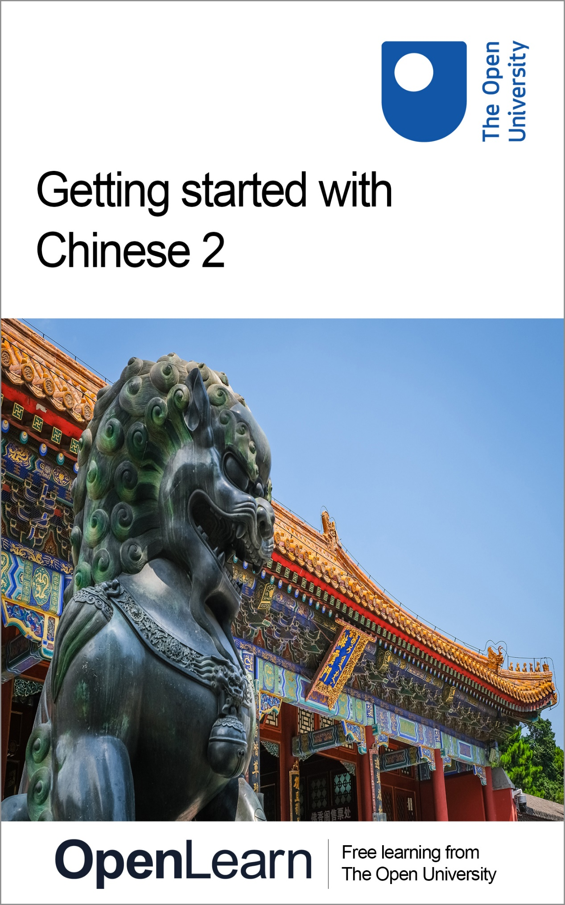

LXC002_1

Getting started with Chinese 2

About this free course
This free course is an adapted extract from the Open University course developed from extract parts of LXC002 - Beginners Chinese 2: 开始吧 kāishĭ ba! - http://www.open.ac.uk/courses/short-courses/lxc002.
This version of the content may include video, images and interactive content that may not be optimised for your device.
You can experience this free course as it was originally designed on OpenLearn, the home of free learning from The Open University –
Getting started with Chinese 2
There you’ll also be able to track your progress via your activity record, which you can use to demonstrate your learning.
Copyright © 2021 The Open University
Intellectual property
Unless otherwise stated, this resource is released under the terms of the Creative Commons Licence v4.0 http://creativecommons.org/licenses/by-nc-sa/4.0/deed.en_GB. Within that The Open University interprets this licence in the following way: www.open.edu/openlearn/about-openlearn/frequently-asked-questions-on-openlearn. Copyright and rights falling outside the terms of the Creative Commons Licence are retained or controlled by The Open University. Please read the full text before using any of the content.
We believe the primary barrier to accessing high-quality educational experiences is cost, which is why we aim to publish as much free content as possible under an open licence. If it proves difficult to release content under our preferred Creative Commons licence (e.g. because we can’t afford or gain the clearances or find suitable alternatives), we will still release the materials for free under a personal end-user licence.
This is because the learning experience will always be the same high quality offering and that should always be seen as positive – even if at times the licensing is different to Creative Commons.
When using the content you must attribute us (The Open University) (the OU) and any identified author in accordance with the terms of the Creative Commons Licence.
The Acknowledgements section is used to list, amongst other things, third party (Proprietary), licensed content which is not subject to Creative Commons licensing. Proprietary content must be used (retained) intact and in context to the content at all times.
The Acknowledgements section is also used to bring to your attention any other Special Restrictions which may apply to the content. For example there may be times when the Creative Commons Non-Commercial Sharealike licence does not apply to any of the content even if owned by us (The Open University). In these instances, unless stated otherwise, the content may be used for personal and non-commercial use.
We have also identified as Proprietary other material included in the content which is not subject to Creative Commons Licence. These are OU logos, trading names and may extend to certain photographic and video images and sound recordings and any other material as may be brought to your attention.
Unauthorised use of any of the content may constitute a breach of the terms and conditions and/or intellectual property laws.
We reserve the right to alter, amend or bring to an end any terms and conditions provided here without notice.
All rights falling outside the terms of the Creative Commons licence are retained or controlled by The Open University.
Head of Intellectual Property, The Open University
978-1-4730-3204-0 (.kdl)
978-1-4730-3205-7 (.epub)

Contents
- Introduction
  - Introduction
  - Open Centre for Languages and Cultures
- Week 1: I learn Chinese in the evening
  - Introduction
  - 1 How to refer to different languages
  - 2 Daily activities
  - 3 Time expressions
  - 4 Names of countries, people and language
  - 5 What would you say?
  - 6 Build a language notebook
  - 7 Practising and consolidating
  - 8 Typing Chinese characters
  - 9 Word formation
  - 10 This week’s quiz
  - 11 Summary of Week 1
- Week 2: What are you going to do tomorrow evening?
  - Introduction
  - 1 I watch TV on Monday morning
  - 2 I am going to London tomorrow
  - 3 Asking questions with ‘what’ and ‘where’
  - 4 Use of dōu 都 (both/all)
  - 5 dōu 都: asking about habitual actions
  - 6 Emphatic dōu 都 in statements
  - 7 Location, location, location
  - 8 Choice questions with háishi 还是
  - 9 What would you say?
  - 10 Build a language notebook
  - 11 Practising and consolidating
  - 12 Head components
  - 13 This week’s quiz
  - 14 Summary of Week 2
- Acknowledgements
- Solutions

Introduction

Introduction
你们好！Nĭmen hăo!
Welcome to Getting started with Chinese 2!
This two-week course will teach you how to ask questions using ‘what’ and ‘where’, use time expressions in the correct order and speak about different activities such as watching TV and learning Chinese. Little by little you will improve your ability to make more sophisticated conversations and to understand more complex language in a variety of different scenarios.
Each week comprises 3–4 hours of interactive activities, explanations, exercises and tips about language learning. It is a good idea to keep notes either on paper or electronically in your preferred digital device so that you can keep track of your progress. At the end of both weeks you will have a quiz with 10 questions to revise what you have been learning and check your progress. Each week also has consolidation and expansion activities, and you will be encouraged to build your own phrase book little by little.
One important thing to do before you start is to take some time to decide how you will allocate your time to your studies. Learning Chinese, like learning any language, is a gradual process; it’s often described as a ‘marathon, not a sprint.’ Little and often is the best approach, so if possible, spread your 3-4 hours over the week, rather than devoting one whole afternoon or evening. This will give you plenty of opportunities to revisit vocabulary and language structures, to revise quickly what you did last time and above all, to practise and consolidate. This is the best way to learn vocabulary and perfect your pronunciation and tones. If you are keen to learn characters, you can make paper flashcards or use some apps such as Quizlet to make digital flashcards.
After completing this course, you will be able to:
- refer to different languages and use different terms such as China, Chinese books, Chinese people and Chinese language
- talk about activities, such as watching TV and learning Chinese
- recognise where time expressions should be placed in sentences
- ask questions with shénme 什么 (‘what’), nǎr 哪儿 (‘where’) and understand the different usages of dōu 都 (‘all, both’)
- ask a choice question with háishì 还是 (‘or’).

Open Centre for Languages and Cultures
This course has been developed from extract parts of LXC002 - Beginners Chinese 2: 开始吧 kāishĭ ba!. The Open University has launched a dedicated learning centre called The Open Centre for Languages and Cultures. OpenLearn is supporting this project and is providing extracted units of all courses on The Open Centre in our dedicated Language and Cultures Hub.
The Open Centre for Languages and Cultures is the exciting new home for non-accredited language and intercultural communication short courses. You can study a wide range of language and language related subjects with us anywhere in the world, in any time zone, whatever your motivation – leisure, professional development or academic.
It’s the one stop shop for engaging with languages, professional communication and intercultural dialogue.
Our short courses allow us to be agile and responsive to the needs of learners who want to be part of a global society. We offer non-accredited short courses in a range of subjects including modern languages and languages for business and the workplace. We are also leading the way in developing short courses for academic research methods and pre-sessional English with IELTS, which will be available for registration in due course.
The Open Centre for Languages and Cultures is an international leader in online language learning and intercultural communications, built on our pioneering pedagogy and research.

What makes the Open Centre different?
- The OU is the leader in online learning and teaching with a heritage of more than 50 years helping students achieve their learning ambitions.
- The short courses are underpinned by academic rigour and designed by native speakers experienced in producing engaging materials for online learning of languages and cultures.
- The graduating nature of the courses means that learners can build up their language and skills over time.
- Learners will also gain a better understanding of the culture(s) associated with the language(s) they study enabling the development of intercultural communication skills.
- Learners can mix and match the short courses and study more than one course at a time.
Once this course is complete you will be directed to OpenLearn’s hub for language content where you will be able to build on your newly found language skills.
Now that you’re fully prepared, it’s time to start on Week 1.

Audio content is not available in this format.
View transcript - Uncaptioned interactive content

Week 1: I learn Chinese in the evening

Introduction
In this first week, you will learn how to refer to names of languages; how to talk about activities such as watching TV and learning Chinese; how to use different terms such as China, Chinese books, Chinese people and Chinese language; and where time expressions should be placed in sentences.
Wǒmen kāishǐ ba! 我们开始吧! (Let’s start).

1 How to refer to different languages
You may already know country names such Zhōngguó 中国 (China), Yīngguó 英国 (United Kingdom) or Fǎguó 法国 (France), now you will learn how to turn the country names into their corresponding language.

Activity 1

Match the following maps with the correct languages.

yìdàlìwén 意大利文
déwén 德文
fǎwén 法文
yīngwén 英文
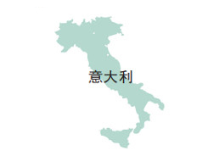
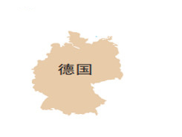
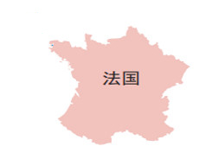
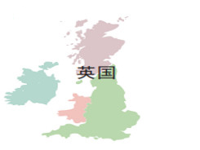
View answer - Part

Using the answers from the previous question complete the following statements, matching the correct parts of their sentences. How do you form the names of various languages?

If the relevant country name ends in the character, guó 国,
If the relevant country name does not end in the character guó 国,
replace guó 国 (country) with wén 文 (language).
add wén 文 in order to form the name of the language
View answer - Part

2 Daily activities
Table 1 lists some new vocabulary which you can use to talk about different daily activities. Read and repeat the words aloud and then copy them into your notebook.

Table 1 Vocabulary to speak about daily activities
Chinese | English
xué 学 | learn, study
zuò 做 | make, do
xiě 写 | write
kàn 看 | see, watch, look; read
shàng wǎng 上网 | surf the internet
zhuānyè 专业 | major, subject
yīngwén 英文 | English language
zhōngwén 中文 | Chinese language
wénxué 文学 | literature
diànshì 电视 | TV
shū 书 | book
hànzì 汉字 | Chinese character
wǎnshang 晚上 | evening
tiāntiān 天天 | every day
fàn 饭 | meal

Note that 网 wǎng is the shortened word for internet: the equivalent of the English ‘net’. The full term in Chinese is hùlián wǎng 互联网 (lit. inter-connect net).

Activity 2

Listen to the words given in Table 1 in the audio below. Pause and repeat each word as many times as you want. Then, write down the five words that you found more difficult to remember in the space below.

Audio content is not available in this format.
View transcript - Uncaptioned interactive content

Provide your answer...

You have just learned some new verbs and nouns. Now, match the following nouns with the appropriate verb.

xiě 写
zuò 做
shàng 上
hànzì 汉字
fàn 饭
wǎng 网
View answer - Part

Look at the pictures and decide if the statement underneath is true or false.

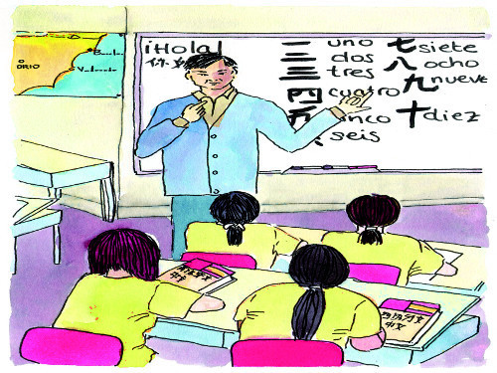
Figure 1
View description - Figure 1

Tāmen xué zhōngwén. 他们 学中文。

True
False
View answer - Part
View discussion - Part

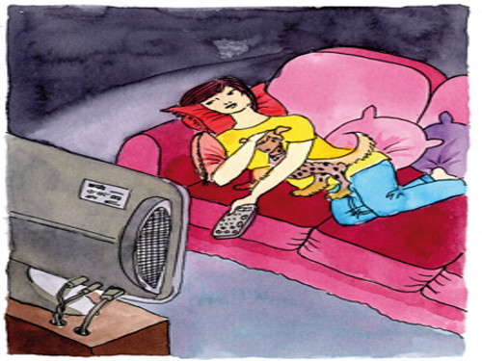
Figure 2
View description - Figure 2

Tā kàn diànshì. 她 看 电视。

True
False
View answer - Part
View discussion - Part

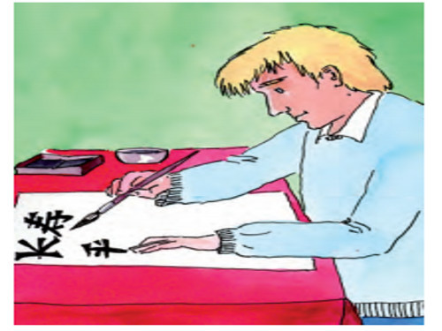
Figure 3
View description - Figure 3

Dàwèi xiě hànzì. 大卫写 汉字。

True
False
View answer - Part
View discussion - Part

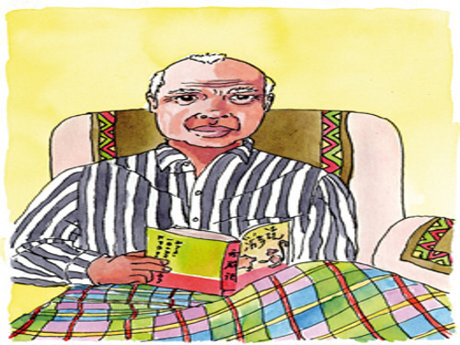
Figure 4
View description - Figure 4

Tā kàn yīngwén shū. 他 看英文书。

True
False
View answer - Part
View discussion - Part

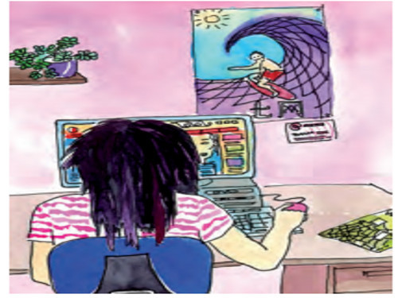
Figure 5
View description - Figure 5

Wǒ shàng wǎng. 我上网。

True
False
View answer - Part
View discussion - Part

3 Time expressions
Now have a go at Activities 3 and 4.

Activity 3

Listen to the recordings and answer the True/False questions that follow. (Try to answer without revealing the transcript).

Audio content is not available in this format.
View transcript - Uncaptioned interactive content

They watch TV every evening.

True
False
View answer - Part

Audio content is not available in this format.
View transcript - Uncaptioned interactive content

I write Chinese characters in the evening.

True
False
View answer - Part

Select the correct option to complete this sentence.
From the above listening, we can conclude: in Chinese, time expressions such as ‘every morning’, ‘in the evening’ etc. must be placed:

before the verbs such as ‘watch TV / surf the internet’ etc.
at the end of a sentence, as in English.
View answer - Part

Activity 4

Listen to the audio and select the activities you hear. (Try to answer without revealing the transcript).

Audio content is not available in this format.
View transcript - Uncaptioned interactive content

Learn Chinese.
Watch TV.
Go online.
Read English books.
View answer - Part

Listen to the audio and select the activities you heaer. (Try to answer without revealing the transcript).

Audio content is not available in this format.
View transcript - Uncaptioned interactive content

Learn Chinese literature.
Write Chinese characters.
Go online.
Watch movies.
Cook.
View answer - Part

4 Names of countries, people and language
In English, the words ‘English’, ‘French’, ‘Spanish’, etc. are used not only to designate language and a person’s nationality but can also function as adjectives in front of nouns (e.g. ‘English newspaper’, ‘French poet’, ‘Spanish city’). In Chinese, however, a distinction is made. As you have already seen, the character wén 文 is added to a country name to designate language and the character rén 人 to designate a person. When associating a country with anything else, however, you use just the country name in front of the noun in question, as shown in the table below. In these examples, the country name functions as an adjective.

Table 2 Names of countries, people and language
Country names as adjectives | Languages | People
Zhōngguó wénxué 中国文学  Chinese literature | zhōngwén 中文  Chinese | zhōngguórén 中国人  Chinese person/people
Xībānyá diànyĭng 西班牙电影  Spanish film | xībānyáwén 西班牙文  Spanish | xībānyárén 西班牙人  Spaniard

Note that there can be some ambiguity when saying something like:

Zhōngguó xiăoshuō 中国小说 a Chinese novel

In this example, it could be that the novel is in the Chinese language, but it could also be that it was originally written by a Chinese writer but has been translated into another language. The ambiguity is removed if the language name rather than the country name is placed before the noun.

zhōngwén xiăoshuō 中文小说 a novel in Chinese

Activity 5
Choose the English words that correspond to the underlined characters (forms).

Zhōngguó hěn dà 中国很大。

Chinese people
China
View answer - Part

Zhōngguó diànyĭng hǎo kàn. 中国电影好看。

Chinese
China
View answer - Part

Lǐ Yīng xué Făguó wénxué. 李英学法国文学 。

French
France
View answer - Part

5 What would you say?
Now have a go at Activity 6.

Activity 6

Describe the following pictures in Chinese. Then, listen to the model description and record your answer trying to sound like the model. You can play it back or try a new recording as many times as you like by pressing ‘Start again’ or ‘Re-record’.

Interactive content is not available in this format.

Interactive content is not available in this format.

Interactive content is not available in this format.

Interactive content is not available in this format.

6 Build a language notebook
Building a language notebook is a way to note down, each week, new vocabulary and expressions, and also tips about pronunciation, grammar, culture and communication in general that will support you as you start to learn Chinese.

Activity 7

What would you write in each box, if anything? Would you add more boxes?

Table 3 Language notebook
Key vocabulary | Provide your answer...
Key sentences | Provide your answer...
Culture | Provide your answer...
Language | Provide your answer...

View discussion - Activity 7

7 Practising and consolidating
In the next activity you will work as an interpreter.

Activity 8

Listen to the sentences given in English and then record yourself saying them in Chinese. Play back your recording and then listen to a model answer given in the feedback section.

Interactive content is not available in this format.

Interactive content is not available in this format.

8 Typing Chinese characters
You will now have a go at typing Chinese characters.

Activity 9

Follow these instructions on enabling Chinese font and typing characters. Once you have enabled the Chinese font, the most common method used in inputting Chinese characters is to type in the Pinyin.
Below are the key characters used this week. Try to type them using the Pinyin input into the box below. Carefully read the characters below so that when you type, you are able to choose the correct ones.
Remember, when using the Pinyin input method, you don’t need to worry about tones. All you need to type is the correct Pinyin spelling.

Table 5 Typing Chinese characters
xué 学 | to learn, to study | Provide your answer...
zuò 做 | to make, to do | Provide your answer...
xiě 写 | to write | Provide your answer...
kàn 看 | to see, to watch, to look; to read | Provide your answer...
shàng wǎng 上网 | to surf the internet | Provide your answer...
zhuānyè 专业 | major; subject | Provide your answer...
yīngwén 英文 | English language | Provide your answer...
zhōngwén 中文 | Chinese language | Provide your answer...
wénxué 文学 | literature | Provide your answer...
diànshì 电视 | TV | Provide your answer...
shū 书 | book | Provide your answer...
hànzì 汉字 | Chinese character | Provide your answer...
wǎnshang 晚上 | evening | Provide your answer...
tiāntiān 天天 | everyday | Provide your answer...

9 Word formation
Words in Chinese are formed by one or more characters. In this section you will look at combining characters to form new words.

Box 1 Word formation
shàng 上 (to go to) + wǎng 网 (net) = shàngwǎng 上 网 (surf the internet)
xué 学 (to learn, school) + shēng 生 (new) = xuéshēng 学生 (pupil, student)
wăn 晚 (late) + shang 上 (up, above) = wănshang 晚上 (evening)
zhuān 专 (specialised) + yè 业 (course, industry) = zhuānyè 专业 (subject, major, special field)
yīng 英 (hero, Britain) + wén 文 (language, culture) = yīngwén 英文 (English language)
hàn 汉 (Han Chinese) + 字 zì (character) = hànzì 汉字 (Chinese character)
电 diàn (electricity, electric) + 视 shì (viewing, vision, sight) = 电视 diànshì (television).
Note that it literally means ‘electric viewing’!

Reminder…
字 in 名字 míngzi (name) is the same 字 as in 汉字 hànzì (Chinese character) except that here it is pronounced with the 4th tone.

Activity 10

Match up the Chinese words with their English equivalents. All the characters have been introduced, but they are in combination with different characters to form new meanings.
Drag each answer (above) into the correct slot (below)

Chinese character
Chinese name
watch TV
see you in the evening
university student
teacher(s) and student(s)
good-looking
hànzì 汉字
zhōngwén míngzì 中文名字
kàn diànshì 看电视
wănshang jiàn 晚上见
dà xuéshēng 大学生
shī shēng 师生
hǎokàn 好看
View answer - Part

10 This week’s quiz
Check what you’ve learned this week by taking the end-of-week quiz.
Week 1 quiz
Open the quiz in a new window or tab (by holding ctrl [or cmd on a Mac] when you click the link), then return here when you have done it.

11 Summary of Week 1
Now you have reached the end of Week 1, reflect a little on what you have learnt.

Activity 11

In the box below, note down what you have found easy, useful or fun, and what was more difficult. At the end of the course, you can download your weekly reflection.

Provide your answer...

Now, you might want to share in the space below some of your daily activities in Pinyin or characters. If you want to type Pinyin with tone marks, you can follow the simple instructions from the PDF file, How to type Pinyin with tone marks on a PC. You may start the sentence with Nǐ hǎo 你好.

Provide your answer...

Next week you are going to learn how to say what you will do tomorrow, revise how to ask questions with shénme 什么 and nǎ'r 哪儿, learn different usages of dōu 都, how to say what you do at a certain place and how to ask a choice question with háishì 还是.

Audio content is not available in this format.
View transcript - Uncaptioned interactive content

I enjoy learning Chinese!

Week 2: What are you going to do tomorrow evening?

Introduction
This week, you are going to learn how to talk about what you be will doing tomorrow; how to ask questions with shénme 什么 (‘what’) and nǎr 哪儿 (‘where’) and find out the different usages of dōu 都 (‘all, both’). You will also practise how to say what you do at a certain place and will learn how to ask a choice question with háishì 还是 (‘or’).
我们开始吧! (Let’s start)

1 I watch TV on Monday morning
You’ll start this week with a listening activity.

Activity 1

Listen to the recordings and write down their English translations. The key words to listen for are days of the week. You may remember the formula to form days of the week: xīngqīyī 星期 (week day) + numbers from one to six for Monday to Saturday. For example, ‘Friday’ in Chinese is xīngqīyīwŭ 星期五. For Sunday, there are two terms: xīngqítiān 星期天 and xīngqírì星期日.

Audio content is not available in this format.
View transcript - Uncaptioned interactive content

Provide your answer...
View answer - Part

Audio content is not available in this format.
View transcript - Uncaptioned interactive content

Provide your answer...
View answer - Part

2 I am going to London tomorrow
In Week 1, you learned that time expressions must be placed before the verb in Chinese. Box 1 looks at how to use this rule when speaking about the future.

Box 1 Expressing the immediate future.
As you may have learned already, Chinese verbs do not change their form, so tense is conveyed instead by the context, usually a time expression. The future tense (especially the immediate future) in Chinese is usually expressed by time expressions such as ‘this evening’, ‘tomorrow’, etc.

Wǒ míngtiān xiàwǔ qù Lúndūn. 我明天下午去伦敦。
lit. I tomorrow afternoon go London. (I’m going to go to London tomorrow afternoon.)

Nǐ jīntiān wǎnshang zuò shénme? 你今天晚上做什么？
lit. you this evening do what? (What are you doing this evening?)

The following list includes time expressions which indicate the future, as well other vocabulary which will help you to form sentences about what you are planning to do. You may already recognise some. Write them down in your notebook and practise saying them aloud.
- míngtiān 明天 (tomorrow).
- míngtiān wǎnshang 明天晚上 (tomorrow evening).
- míng wǎn 明晚 (tomorrow evening).
- míngtiān shàngwǔ 明天上午 (tomorrow morning).
- míngtiān xiàwǔ 明天下午 (tomorrow afternoon).
- shénme 什么 (what).
- qù 去 (to go).
- nǎr 哪儿 (where).
- Běijīng 北京 (Beijing).
- Lúndūn 伦敦 (London).

Activity 2

Choose the correct Chinese translations for the English sentences. Tick all that apply.
I am going to learn Chinese tomorrow morning.

Míngtiān shàngwǔ wǒ xué zhōngwén. 明天上午我学中文.
Wǒ míngtiān shàngwǔ xué zhōngwén. 我明天上午学中文.
Wǒ xué zhōngwén míngtiān shàngwǔ. 我学中文明天上午.
Míngtiān wǒ shàngwǔ xué zhōngwén. 明天我上午学中文.
View answer - Part
View discussion - Part

Which of the following sentences are correct to mean “She is going to London tomorrow afternoon”? Select all that apply.

Tā míngtiān xiàwǔ qù Lúndūn. 她明天下午去伦敦.
Tā míngtiān xiàwǔ qù Lúndūn. 他明天下午去伦敦.
Tā qù Lúndūn míngtiān xiàwǔ. 她去伦敦明天下午.
Míngtiān xiàwǔ tā qù Lúndūn. 明天下午她去伦敦.
Míngtiān tā xiàwǔ qù Lúndūn. 明天她下午去伦敦.
View answer - Part
View discussion - Part

From the above sentences, we can conclude: time expressions such as, ‘tomorrow evening, ‘tomorrow’ etc. in Chinese can be placed:

before the subject, (e.g., ‘she’).
after the subject.
If the time expression has two parts such ‘tomorrow’ and ‘afternoon’, the time expression can be split up, i.e., ‘tomorrow ’ goes before the subject, and ‘afternoon’ goes after the subject.
at the end of a sentence as in English.
View answer - Part

3 Asking questions with ‘what’ and ‘where’
Now have a go at Activity 3.

Activity 3

Choose the correct Chinese translations for the English sentences below. Tick all that apply.
He is going to watch TV tomorrow evening.

Míngtiān tā wǎnshang kàn diànshì. 明天他晚上看电视.
Wǎnshang tā míngtiān kàn diànshì. 晚上他明天看电视.
Tā kàn diànshì míngtiān wǎnshang. 他看电视明天晚上.
Míngtiān wǎnshang tā kàn diànshì. 明天晚上他看电视.
Tā míngtiān wǎnshang kàn diànshì. 他明天晚上看电视.
View answer - Part

What is he going to do tomorrow evening?

Tā míngtiān wǎnshang zuò shénme? 他明天晚上做什么?
Míngtiān wǎnshang tā zuò shénme? 明天晚上他做什么?
Míngtiān tā wǎnshang zuò shénme? 明天他晚上做什么?
Shénme tā míngtiān wǎnshang zuò? 什么他明天晚上做?
Tā míngtiān wǎnshang shénme zuò? 他明天晚上什么做?
Tā zuò shénme míngtiān wǎnshang ? 他做什么明天晚上?
View answer - Part

Compare the following sentences and then answer the question that follows.
Tā míngtiān wǎnshang zuò shénme? 他明天晚上做什么?
Tā míngtiān wǎnshang kàn diànshì. 他明天晚上看电视.
Where does the question word shénme 什么 go in a question sentence?

The question word shénme 什么 replaces the answer diànshì 电视, and it occupies the same place as diànshì 电视. In the above question, shénme 什么 goes at the end of the question sentence as diànshì 电视 goes in the answer sentence. In the question sentence, the verb zuò 做 to do is used to replace the verb kàn 看 to watch in the answer sentence.
shénme 什么 like ‘what’ in English usually goes at the beginning of a question sentence.
View answer - Part

Interactive content is not available in this format.

Choose the correct Chinese translations for the English sentences.
I am going to Bejing tomorrow.

Wǒ qù Běijīng míngtiān.我去北京明天.
Wǒ míngtiān qù Běijīng.我明天去北京.
Míngtiān wǒ qù Běijīng.明天我去北京.
Wǒ qù míngtiān Běijīng.我去明天北京.
View answer - Part

Where are you going tomorrow?

Nǎr nǐ jīntiān míngtiān qù? 哪儿你今天明天去?
Nǐ míngtiān nǎr qù? 你明天哪儿去?
Nǐ míngtiān qù nǎr? 你明天去哪儿?
Nǐ qù nǎr míngtiān? 你去哪儿明天?
Míngtiān qù nǐ nǎr? 明天你去哪儿?
View answer - Part

Compare the following two sentences and answer the question below.
Nǐ míngtiān qù nǎr? 你明天去哪儿?
Wǒ míngtiān qù Běijīng. 我明天去北京.
Where does the question word nǎr 哪儿 (‘where’) go in a question sentence?

Nǎr 哪儿 like ‘where’ in English usually goes at the beginning of a question sentence.
The question word Nǎr 哪儿 in the question sentence replaces the answer Běijīng 北京 in the answer sentence, and it goes at the same place as 北京. So nǎr 哪儿 goes at the end of the question sentence as Běijīng 北京 in the answer sentence.
View answer - Part

4 Use of dōu 都 (both/all)
The adverb dōu 都 (both/all) is placed before the verb in statements. Depending on the meaning of the sentence, when negated it can be placed before or after the negation word. Learn more about its usage by having a go at Activity 4.

Activity 4

The following Chinese sentence should read 'Are all the teachers British?'. Is this true or false?
Lǎoshīmen dōu shì Yīngguó rén ma? 老师们都是英国人吗？

True
False
View answer - Part

Where should dōu 都 be placed in a sentence?

at the beginning as in the English sentence.
before the verb (e.g., ‘shì 是’).
View answer - Part

The following Chinese sentence should read 'Not all of them are doctors'. Is this true or false?
Tāmen dōu bù shì yīshēng. 他们都不是医生。

True
False
View answer - Part
View discussion - Part

The following Chinese sentence should read 'Not all of us live in London.' Is this true or false?
Wǒmen bù dōu zhù zài Lúndūn. 我们不都住在伦敦。

True
False
View answer - Part

So, we can conclude that dōu bù 都不 and bù dōu 不都 have different meanings. Which means what?

total negation/none
partial negation/not all
dōu bù 都不
bù dōu 不都
View answer - Part

5 dōu 都: asking about habitual actions
The adverb dōu 都 can be used to ask about habitual actions:

Nǐ wǎnshang dōu zuò shénme? 你晚上都做什么？
What do you usually do in the evening?

Note that dōu 都 cannot be used in the reply:

Kàn shū, xiězì, shàngwăng …看书、写字、上网 …
reading books, writing characters, going online…

Activity 5

Listen to the following question in Chinese. Record your response, play back your recording and then listen to a model answer given in the feedback.

Interactive content is not available in this format.

6 Emphatic dōu 都 in statements
Note that when talking about something that happens frequently, dōu 都 (all) normally follows the time expression (e.g. tiāntiān 天天 every day) to emphasise its frequency. Again, the whole phrase must be placed before the verb.

Table 1 dōu 都 used in statements
Tāmen | tiāntiān | dōu | kàn | diànshì
他们 | 天天 | 都 | 看 | 电视。
lit. they every day all watch TV (They watch TV every day.)

Activity 6

Interactive content is not available in this format.

Where is dōu 都 placed within a sentence? Write down your conclusion in your notebook and then reveal the answer.

View answer - Part

7 Location, location, location
You have learned before that, in Chinese, time expressions such as ‘tomorrow evening’, ‘tomorrow’ etc. must be placed before the verb (time + verb), as in:

Wǒ xīngqītiān wǎnshang kàn diànyǐng. 我星期天晚上看电影。
lit. I Sunday evening watch movies/a movie. (I watch movies/a movie on Sunday evening.)

Similarly, expressions of location should also be placed before the verb. The sentence structure looks like this: zài 在 (at/in) + a place + do something.

Wǒ zài Běijīng xué zhōngwén. 我在北京学中文.
lit. I in Beijing learn Chinese. (I learn Chinese in Beijing. )

Activity 7

Choose the correct Chinese translation.
I study Chinese literature in Beijing.

Wǒ xué Zhōngguó wénxué zài Běijīng. 我学中国文学在北京。
Wǒ zài Běijīng xué Zhōngguó wénxué. 我在北京学中国文学。
Wǒ xué zài Běijīng Zhōngguó wénxué. 我学在北京中国文学。
View answer - Part

He learns French in France.

Tā xué zài Fàguó fǎwén. 他学在法国法文。
Tā xué fǎwén zài Fàguó. 他学法文在法国。
Tā zài Fàguó xué fǎwén. 他在法国学法文。
View answer - Part

From the above, we can conclude: In Chinese the location of expressions such as , ‘in Beijing, ‘in France’ etc. must be placed…

before the verb, as in ‘in France I study’.
at the end of a sentence, as usually happens in English.
View answer - Part

8 Choice questions with háishi 还是
To ask a question that offers a choice of answers, you need to use háishi 还是, a question word which is equivalent to the construction ‘Do…/Does…/Are…/Is…/Would …or …?’ in English.

Table 2 Example 1 of a choice question using háishi 还是
Tā shì | Yīngguórén | háishì | měiguórén?
她 是 | 英 国 人 | 还 是 | 美 国 人？
lit. She is British, or American (Is she British or American?)

Table 3 Example 2 of a choice question using háishi 还是
Nǐ kàn | diànshì, kàn shū, | háishì | xiě hànzì?
你 看 | 电 视 , 看书, | 还 是 | 写 汉 字 ?
lit. You watch TV, read books or write characters? (Do you watch TV, read books or write characters?)

Activity 8

Interactive content is not available in this format.

Interactive content is not available in this format.

Do you need the question word 吗 at the end of a choice question?

Yes
No
View answer - Part

9 What would you say?
Based on what you have learned so far complete Activity 9.

Activity 9

Interactive content is not available in this format.

Look at the picture and decide which statement is true.

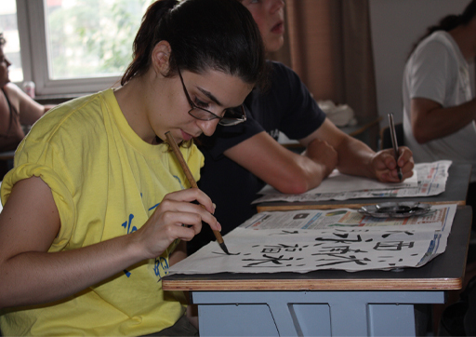
Figure 1
View description - Figure 1

Wǒ dìdì tiāntiān dōu xiě hànzì. 我弟弟天天都写汉字。
Wǒ dìdì tiāntiān dōu kàn diànshì. 我弟弟天天都看电视。
View answer - Part

Interactive content is not available in this format.

10 Build a language notebook
Building a language notebook is a way to note down, each week, new vocabulary and expressions, as well as tips about pronunciation, grammar, culture and communication in general that will support you as you start to learn Chinese.

Activity 10

What would you write into each box, if anything? Would you add more boxes?

Table 4 Language notebook
Key phrases in Pinyin | Provide your answer...
Key words | Provide your answer...
Culture | Provide your answer...
Language | Provide your answer...
Word formation | Provide your answer...

View discussion - Activity 10

11 Practising and consolidating
To help consolidate what you have learned in this week, now have a go at Activity 11.

Activity 11

Match the English sentences with their Chinese equivalents.

Nǐ xué shénme zhuānyè? 你学 什 么 专 业？
Wáng Xiǎojiě tiāntiān wǎnshang dōu xiě hànzì. 王 小 姐 天 天 晚 上 都 写 汉 字。
Wǒ xué Yīngguó wénxué. 我 学 英 国 文 学。
What do you study as your major?
Miss Wang writes Chinese characters every evening.
I study English literature.
View answer - Part

Match the English word with the corresponding Chinese word.
To learn, to study

zì 字
suì 岁
xué 学
yīng 英
View answer - Part

Match the English word with the corresponding Chinese word.
Evening

hǎode 好的
wǎnshang 晚上
xīqī 星期
míngtiān 明天
View answer - Part

12 Head components
Head components, also known as ‘radicals’, offer associated meanings to words. Many characters share the same head component.

Table 6 Head components rì 日 and 氵
Head component | Meaning association | Meaning association | Examples
日 | sun, time | rì zì páng 日字旁 | míng 明 (rì 日+ yuè 月= bright)
氵 | water | sān diăn shuĭ 三点水 | hàn 汉 (氵+ 又= Han Chinese)

As the table shows, the characters that contain the ‘sun head component’ (rì 日) normally have meanings associated with the sun, time or light. For example, zăo 早 means ‘morning’ and it has got the ‘sun head component’ on the top part. One can interpret that as the sun has risen. rì 日 is also an independent character as in xīngqīrì 星期日(Sunday).
The characters that contain the ‘water head component’ (氵) usually have something to do with water. The character hàn 汉 (now refers to Han Chinese) originally referred to a river.
Note that this head component is not an independent character but only a building block in forming characters.

Activity 12

Read through the note on head components rì 日, then go through the characters you have learned so far or check a dictionary and find three more characters that contain the head component 日 and give their English meaning.

Provide your answer...

Can you find the English meaning of the following two characters that contain 氵?
Use a dictionary and write down their Pinyin and their English meanings.
- 江
- 海

Provide your answer...
View answer - Part

13 This week’s quiz
Check what you’ve learned this week by taking the end-of-week quiz.
Week 2 quiz
Open the quiz in a new window or tab (by holding ctrl [or cmd on a Mac] when you click the link), then return here when you have done it.

14 Summary of Week 2
Now you have reached the end of Week 2, reflect on what you have learnt this week.

Activity 13

In the box below, note down what you have found easy, what was more difficult, and how you plan to improve.

Provide your answer...

Audio content is not available in this format.
View transcript - Uncaptioned interactive content

lit. good study/learn. This is a common phrase used to encourage learners to work hard!
This OpenLearn course is an adapted extract from the Open University badged course LXC002 - Beginners Chinese 2: 开始吧 kāishĭ ba!. Visit the OpenLearn’s hub for language content where you will be able to build on your newly found language skills.

Acknowledgements
This free course was first published in February 2021.
Except for third party materials and otherwise stated (see terms and conditions), this content is made available under a Creative Commons Attribution-NonCommercial-ShareAlike 4.0 Licence.
The material acknowledged below and within the course is Proprietary and used under licence (not subject to Creative Commons Licence). Grateful acknowledgement is made to the following sources for permission to reproduce material in this free course:

Images
Introduction
Course image: Photo by Magda Ehlers from Pexels
Week 1
Section 2, Figure 1 and Activity 6, Image 1: Ana Sánchez
Section 2, Figure 2 and Activity 6, Image 2: Ana Sánchez
Section 2, Figure 3: Ana Sánchez
Section 2, Figure 4 and Activity 6, Image 3: Ana Sánchez
Section 2, Figure 5 and Activity 6, Image 4: Ana Sánchez
Week 2
Section 9, Figure 1: courtesy of Fu Qian
Every effort has been made to contact copyright owners. If any have been inadvertently overlooked, the publishers will be pleased to make the necessary arrangements at the first opportunity.
Don't miss out
If reading this text has inspired you to learn more, you may be interested in joining the millions of people who discover our free learning resources and qualifications by visiting The Open University – www.open.edu/openlearn/free-courses.

Solutions

Activity 1

Part

Answer
The correct matches are:
yìdàlìwén 意大利文
déwén 德文
fǎwén 法文
yīngwén 英文
Back to - Part

Part

Answer
The correct matches are:
If the relevant country name ends in the character, guó 国,
replace guó 国 (country) with wén 文 (language).
If the relevant country name does not end in the character guó 国,
add wén 文 in order to form the name of the language
Back to - Part

Activity 2

Part

Answer
The correct matches are:
xiě 写
hànzì 汉字
zuò 做
fàn 饭
shàng 上
wǎng 网
Back to - Part

Part

Answer
Right:
True
Wrong:
False
Back to - Part

Discussion
True. This is a drawing of a class learning Chinese with Chinese words on the board.
Back to - Part

Part

Answer
Right:
True
Wrong:
False
Back to - Part

Discussion
True. This is a drawing of a girl watching TV.
Back to - Part

Part

Answer
Right:
True
Wrong:
False
Back to - Part

Discussion
True. This is a drawing of a western man writing Chinese characters.
Back to - Part

Part

Answer
Right:
False
Wrong:
True
Back to - Part

Discussion
False. This is a drawing of a man reading a Chinese book, not an English book
Back to - Part

Part

Answer
Right:
True
Wrong:
False
Back to - Part

Discussion
True. This is a drawing of a person surfing on the internet.
Back to - Part

Activity 3

Part

Answer
Right:
False
Wrong:
True
Back to - Part

Part

Answer
Right:
True
Wrong:
False
Back to - Part

Part

Answer
Right:
before the verbs such as ‘watch TV / surf the internet’ etc.
Wrong:
at the end of a sentence, as in English.
Back to - Part

Activity 4

Part

Answer
Right:
Learn Chinese.
Watch TV.
Wrong:
Go online.
Read English books.
Back to - Part

Part

Answer
Right:
Write Chinese characters.
Go online.
Watch movies.
Wrong:
Learn Chinese literature.
Cook.
Back to - Part

Activity 5

Part

Answer
Right:
China
Wrong:
Chinese people
Back to - Part

Part

Answer
Right:
Chinese
Wrong:
China
Back to - Part

Part

Answer
Right:
French
Wrong:
France
Back to - Part

Activity 7

Discussion
This is a suggestion as to how you may have filled in the boxes.

Table 4 Example of a completed language notebook for Week 1
Key vocabulary in characters, Pinyin, and English | 学 xué | to learn, to study
 | 做 zuò | to make, to do
 | 写 xiě | to write
 | 看 kàn | to see, to watch, to look; to read
 | 上网 shàng wǎng | to surf the internet
 | 专业 zhuānyè | major; subject
 | 英文 yīngwén | English language
 | 中文 zhōngwén | Chinese language
 | 文学 wénxué | literature
 | 电视 diànshì | TV
 | 书 shū | book
 | 汉字 hànzì | Chinese character
 | 晚上 wǎnshang | evening
 | 天天 tiāntiān | everyday
 | 今晚 jīn wǎn | this evening; tonight
Key sentences | I write Chinese characters in the evening.  Wǒ wǎnshang xiě hànzì. 我 晚 上 写 汉 字。
I read books, watch TV and surf the Internet in the evenings.
Wǒ wǎnshang kàn shū, kàn diànshì, shàng wǎng. 我 晚 上 看 书, 看 电 视, 上 网。
What subject do you study?
Nǐ xué shénme zhuānyè? 你 学 什么 专 业？
I study Chinese literature.
Wǒ xué Zhōngguó wénxué. 我学中国文学.
Language | - How to change country names (usually ends with guó 国) to languages: replace guó 国 with wén 文 if there is guó 国 in the country name, if there is not guó 国 in the country name, add wén 文;  - How to say people of a country country name + rén 人  - How to say some daily activities.  - Time expressions must go before verbs.

You may have filled your table in differently, or you may have a different idea about how to build on what you are learning. Your learning journey is personal, so you need to keep notes in a way that is appropriate to you.
Take some time, now, to establish your own language notebook.
Back to - Activity 7

Activity 10

Part

Answer
The correct matches are:
Chinese character
hànzì 汉字
Chinese name
zhōngwén míngzì 中文名字
watch TV
kàn diànshì 看电视
see you in the evening
wănshang jiàn 晚上见
university student
dà xuéshēng 大学生
teacher(s) and student(s)
shī shēng 师生
good-looking
hǎokàn 好看
Back to - Part

Activity 1

Part

Answer
I learn Chinese on Monday and Tuesday evenings. I watch TV on Wednesday evenings.
Back to - Part

Part

Answer
I write Chinese characters on Thursday evenings. I surf the internet on Friday evenings. I watch movies on Sunday evenings.
Back to - Part

Activity 2

Part

Answer
Right:
Míngtiān shàngwǔ wǒ xué zhōngwén. 明天上午我学中文.
Wǒ míngtiān shàngwǔ xué zhōngwén. 我明天上午学中文.
Míngtiān wǒ shàngwǔ xué zhōngwén. 明天我上午学中文.
Wrong:
Wǒ xué zhōngwén míngtiān shàngwǔ. 我学中文明天上午.
Back to - Part

Discussion
You learned in Week 1 that time expressions must be placed before the verb. In the above sentences, you can see that time expressions can be before or after the subject (e.g. wǒ我).
Time expressions can also be split up as in Míngtiān wǒ shàngwǔ xué zhōngwén. 明天我上午学中文. Míngtiān 明天 goes before wǒ 我, shàngwǔ 上午 goes after wǒ 我.
Back to - Part

Part

Answer
Right:
Tā míngtiān xiàwǔ qù Lúndūn. 她明天下午去伦敦.
Míngtiān xiàwǔ tā qù Lúndūn. 明天下午她去伦敦.
Míngtiān tā xiàwǔ qù Lúndūn. 明天她下午去伦敦.
Wrong:
Tā míngtiān xiàwǔ qù Lúndūn. 他明天下午去伦敦.
Tā qù Lúndūn míngtiān xiàwǔ. 她去伦敦明天下午.
Back to - Part

Discussion
Please note the difference between tā 他 --he and tā 她 --she.
Back to - Part

Part

Answer
Right:
before the subject, (e.g., ‘she’).
after the subject.
If the time expression has two parts such ‘tomorrow’ and ‘afternoon’, the time expression can be split up, i.e., ‘tomorrow ’ goes before the subject, and ‘afternoon’ goes after the subject.
Wrong:
at the end of a sentence as in English.
Back to - Part

Activity 3

Part

Answer
Right:
Míngtiān tā wǎnshang kàn diànshì. 明天他晚上看电视.
Míngtiān wǎnshang tā kàn diànshì. 明天晚上他看电视.
Tā míngtiān wǎnshang kàn diànshì. 他明天晚上看电视.
Wrong:
Wǎnshang tā míngtiān kàn diànshì. 晚上他明天看电视.
Tā kàn diànshì míngtiān wǎnshang. 他看电视明天晚上.
Back to - Part

Part

Answer
Right:
Tā míngtiān wǎnshang zuò shénme? 他明天晚上做什么?
Míngtiān wǎnshang tā zuò shénme? 明天晚上他做什么?
Míngtiān tā wǎnshang zuò shénme? 明天他晚上做什么?
Wrong:
Shénme tā míngtiān wǎnshang zuò? 什么他明天晚上做?
Tā míngtiān wǎnshang shénme zuò? 他明天晚上什么做?
Tā zuò shénme míngtiān wǎnshang ? 他做什么明天晚上?
Back to - Part

Part

Answer
Right:
The question word shénme 什么 replaces the answer diànshì 电视, and it occupies the same place as diànshì 电视. In the above question, shénme 什么 goes at the end of the question sentence as diànshì 电视 goes in the answer sentence. In the question sentence, the verb zuò 做 to do is used to replace the verb kàn 看 to watch in the answer sentence.
Wrong:
shénme 什么 like ‘what’ in English usually goes at the beginning of a question sentence.
Back to - Part

Part

Answer
Right:
Wǒ míngtiān qù Běijīng.我明天去北京.
Míngtiān wǒ qù Běijīng.明天我去北京.
Wrong:
Wǒ qù Běijīng míngtiān.我去北京明天.
Wǒ qù míngtiān Běijīng.我去明天北京.
Back to - Part

Part

Answer
Right:
Nǐ míngtiān qù nǎr? 你明天去哪儿?
Míngtiān qù nǐ nǎr? 明天你去哪儿?
Wrong:
Nǎr nǐ jīntiān míngtiān qù? 哪儿你今天明天去?
Nǐ míngtiān nǎr qù? 你明天哪儿去?
Nǐ qù nǎr míngtiān? 你去哪儿明天?
Back to - Part

Part

Answer
Right:
The question word Nǎr 哪儿 in the question sentence replaces the answer Běijīng 北京 in the answer sentence, and it goes at the same place as 北京. So nǎr 哪儿 goes at the end of the question sentence as Běijīng 北京 in the answer sentence.
Wrong:
Nǎr 哪儿 like ‘where’ in English usually goes at the beginning of a question sentence.
Back to - Part

Activity 4

Part

Answer
Right:
True
Wrong:
False
Back to - Part

Part

Answer
Right:
before the verb (e.g., ‘shì 是’).
Wrong:
at the beginning as in the English sentence.
Back to - Part

Part

Answer
Right:
False
Wrong:
True
Back to - Part

Discussion
The answer is: False. This sentence means ‘None of them are doctors’. To convey ‘not all of them’, dōu 都 should be placed between bù 不 and shì 是: Tāmen bù dōu shì yīshēng. 他们不都是医生。
Back to - Part

Part

Answer
Right:
True
Wrong:
False
Back to - Part

Part

Answer
The correct matches are:
total negation/none
dōu bù 都不
partial negation/not all
bù dōu 不都
Back to - Part

Activity 6

Part

Answer
dōu 都 must be placed straight before the verb in a sentence.
Back to - Part

Activity 7

Part

Answer
Right:
Wǒ zài Běijīng xué Zhōngguó wénxué. 我在北京学中国文学。
Wrong:
Wǒ xué Zhōngguó wénxué zài Běijīng. 我学中国文学在北京。
Wǒ xué zài Běijīng Zhōngguó wénxué. 我学在北京中国文学。
Back to - Part

Part

Answer
Right:
Tā zài Fàguó xué fǎwén. 他在法国学法文。
Wrong:
Tā xué zài Fàguó fǎwén. 他学在法国法文。
Tā xué fǎwén zài Fàguó. 他学法文在法国。
Back to - Part

Part

Answer
Right:
before the verb, as in ‘in France I study’.
Wrong:
at the end of a sentence, as usually happens in English.
Back to - Part

Activity 8

Part

Answer
Right:
No
Wrong:
Yes
Back to - Part

Activity 9

Part

Answer
Right:
Wǒ dìdì tiāntiān dōu xiě hànzì. 我弟弟天天都写汉字。
Wrong:
Wǒ dìdì tiāntiān dōu kàn diànshì. 我弟弟天天都看电视。
Back to - Part

Activity 10

Discussion
This is a suggestion as to how you may have filled in the table.

Table 5 Example of a completed language notebook for Week 2
Key phrases | - Nǐ míngtiān qù nǎr? 你明天去哪儿?  - Wǒ míngtiān qù Běijīng 我明天去北京.  - Nǐ míngtiān zuò shénme? 你明天做什么?  - Wǒ míngtiān xué fǎwén, kàn diànshì, xiě hànzì. 我明天学法文, 看电视, 写汉字.  - Nǐ wǎnshang dōu zuò shénme? 你晚上都做什么?  - Nǐ míngtiān shàngwǔ háishì míngtiān wǎnshang qù Běijīng? 你明天上午还是明天晚上去北京?
Key words | - míngtiān 明天 (tomorrow).  - míngtiān wǎnshang 明天晚上 (tomorrow evening).  - míng wǎn 明晚 (tomorrow evening).  - míngtiān shàngwǔ 明天上午 (tomorrow morning).  - míngtiān xiàwǔ 明天下午 (tomorrow afternoon).  - shénme 什么 (what).  - qù 去 (to go).  - nǎr 哪儿 (where).  - Běijīng 北京 (Beijing).  - Lúndūn 伦敦 (London).
Culture
Language | - Use shénme 什么 to ask a ‘what’ question  - Use nǎr 哪儿 to ask a ‘where’ question  - Different usages of dōu 都  - How to ask a choice question with háishì 还是
Word formation

You may have filled the table in differently, or you may have a different idea about how to build on what you are learning. Your learning journey is personal, so you need to keep notes in a way that is appropriate to you.
Take some time now to establish your own language notebook.
Back to - Activity 10

Activity 11

Part

Answer
The correct matches are:
Nǐ xué shénme zhuānyè? 你学 什 么 专 业？
What do you study as your major?
Wáng Xiǎojiě tiāntiān wǎnshang dōu xiě hànzì. 王 小 姐 天 天 晚 上 都 写 汉 字。
Miss Wang writes Chinese characters every evening.
Wǒ xué Yīngguó wénxué. 我 学 英 国 文 学。
I study English literature.
Back to - Part

Part

Answer
Right:
xué 学
Wrong:
zì 字
suì 岁
yīng 英
Back to - Part

Part

Answer
Right:
wǎnshang 晚上
Wrong:
hǎode 好的
xīqī 星期
míngtiān 明天
Back to - Part

Activity 12

Part

Answer
- Jiāng 江--river
- hǎi 海—sea
Back to - Part

Figure 1

Description
Drawing of a class learning Chinese with Chinese words on the board.
Back to - Figure 1

Figure 2

Description
Drawing of a girl watching TV.
Back to - Figure 2

Figure 3

Description
Drawing of a western man writing Chinese characters.
Back to - Figure 3

Figure 4

Description
Drawing of a man reading a Chinese book, not an English book.
Back to - Figure 4

Figure 5

Description
Drawing of a person surfing on the internet.
Back to - Figure 5

Figure 1

Description
A girl writing Chinese
Back to - Figure 1

Uncaptioned interactive content

Transcript
kāshĭ ba
Back to - Uncaptioned interactive content

Uncaptioned interactive content

Transcript
xué 学
zuò 做
xiě 写
kàn 看
shàng wǎng 上网
zhuānyè 专业
yīngwén 英文
zhōngwén 中文
wénxué 文学
diànshì 电视
shū 书
hànzì 汉字
wǎnshang 晚上
tiāntiān 天天
Back to - Uncaptioned interactive content

Uncaptioned interactive content

Transcript
Tāmen tiāntian zǎoshang kàn diànshì. 他们天天早上看电视。
Back to - Uncaptioned interactive content

Uncaptioned interactive content

Transcript
Wǒ wǎnshang xiě hànzì. 我 晚 上 写 汉 字
Back to - Uncaptioned interactive content

Uncaptioned interactive content

Transcript
Wǒ xīngqīyī hé xīngqī’èr wǎnshang xué zhōngwén. Wǒ xīngqīsān wǎnshang kàn diànshì. 我星期一和星期二晚上学中文。我星期三晚上看电视。
Back to - Uncaptioned interactive content

Uncaptioned interactive content

Transcript
Wǒ xīngqīsì wǎnshang xiě hànzì. Wǒ xīngqīwǔ wǎnshang shàng wǎng. Wǒ xīngqītiān wǎnshang kàn diànyǐng. 我星期四晚上写汉字。我星期五晚上上网。我星期天晚上看电影。
Back to - Uncaptioned interactive content

Uncaptioned interactive content

Transcript
Wǒ xǐhuān xué zhōngwén 我喜欢学中文!
Back to - Uncaptioned interactive content

Uncaptioned interactive content

Transcript
Wǒ xīngqīyī hé xīngqī’èr wǎnshang xué zhōngwén.Wǒ xīngqīsān wǎnshang kàn diànshì.
我星期一和星期二晚上学中文。我星期三晚上看电视。
Back to - Uncaptioned interactive content

Uncaptioned interactive content

Transcript
Wǒ xīngqīsì wǎnshang xiě hànzì.Wǒ xīngqīwǔ wǎnshang shàng wǎng.Wǒ xīngqītiān wǎnshang kàn diànyǐng.
我星期四晚上写汉字。我星期五晚上上网。我星期天晚上看电影。
Back to - Uncaptioned interactive content

Uncaptioned interactive content

Transcript
Hǎo hao xuéxí 好好学习！
Back to - Uncaptioned interactive content

