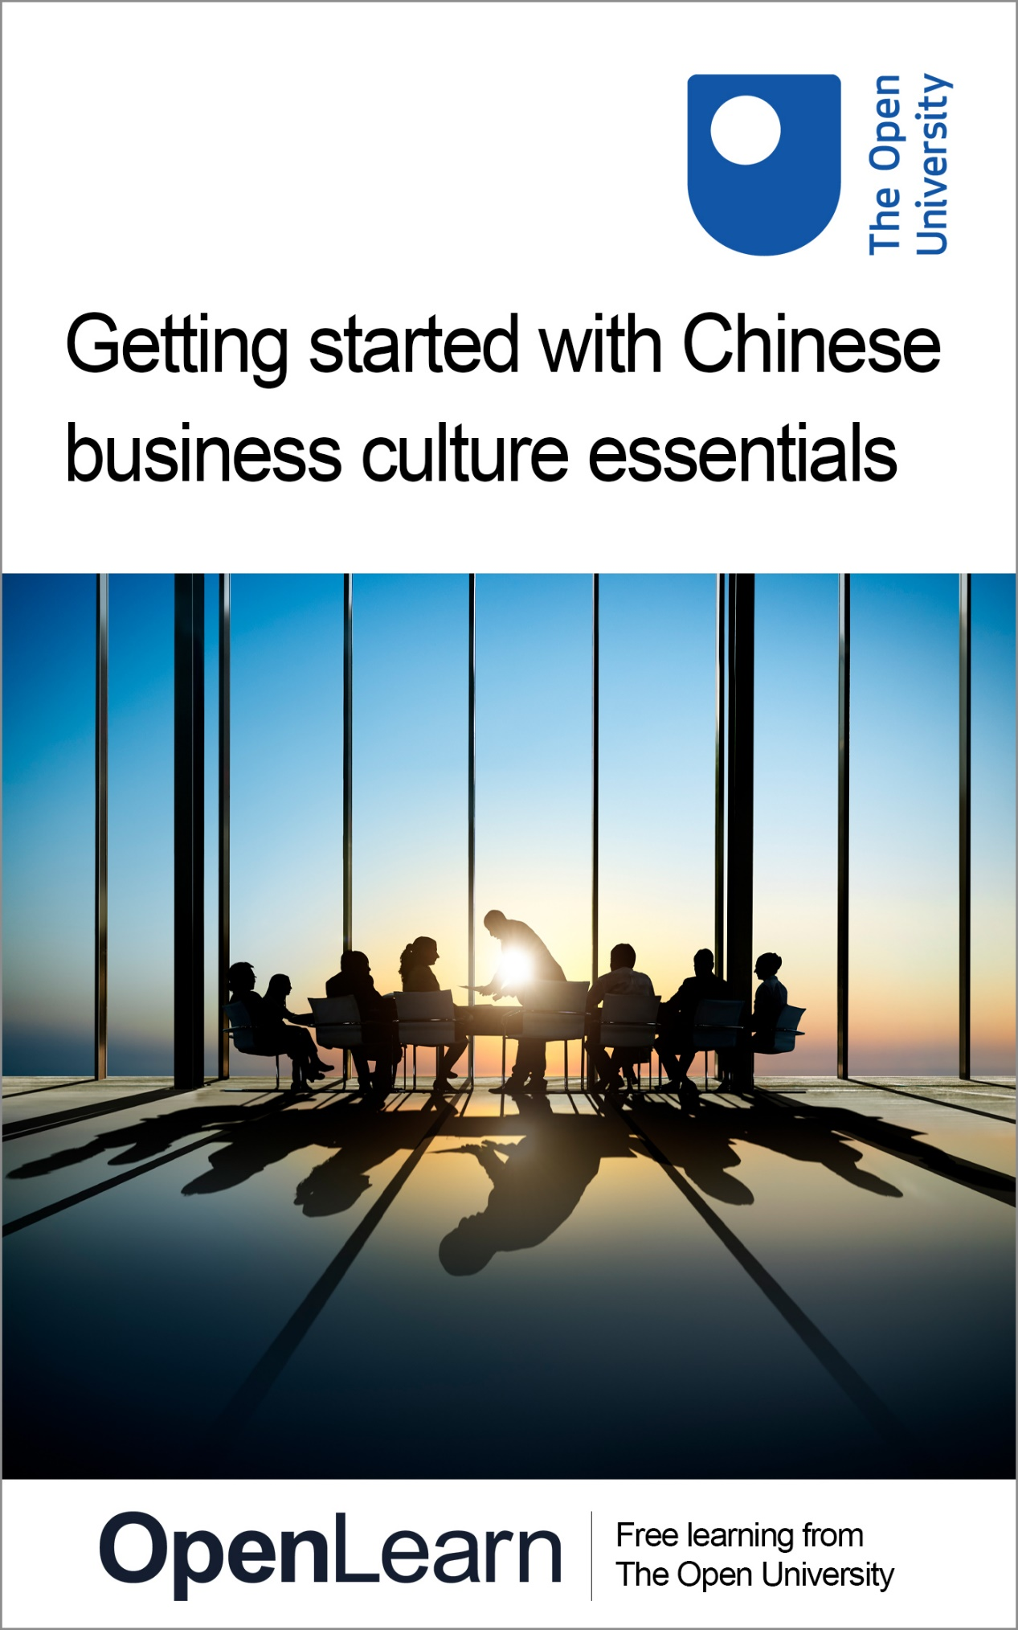

LXC050_1 Getting started with Chinese business culture essentials

Getting started with Chinese business culture essentials

About this free course
This free course is an adapted extract from the Open University course developed from extract parts of LG002 Chinese business culture essentials - https://www.open.ac.uk/courses/short-courses/lg002.
This version of the content may include video, images and interactive content that may not be optimised for your device.
You can experience this free course as it was originally designed on OpenLearn, the home of free learning from The Open University –
Getting started with Chinese business culture essentials
There you’ll also be able to track your progress via your activity record, which you can use to demonstrate your learning.
Copyright © 2021 The Open University
Intellectual property
Unless otherwise stated, this resource is released under the terms of the Creative Commons Licence v4.0 http://creativecommons.org/licenses/by-nc-sa/4.0/deed.en_GB. Within that The Open University interprets this licence in the following way: www.open.edu/openlearn/about-openlearn/frequently-asked-questions-on-openlearn. Copyright and rights falling outside the terms of the Creative Commons Licence are retained or controlled by The Open University. Please read the full text before using any of the content.
We believe the primary barrier to accessing high-quality educational experiences is cost, which is why we aim to publish as much free content as possible under an open licence. If it proves difficult to release content under our preferred Creative Commons licence (e.g. because we can’t afford or gain the clearances or find suitable alternatives), we will still release the materials for free under a personal end-user licence.
This is because the learning experience will always be the same high quality offering and that should always be seen as positive – even if at times the licensing is different to Creative Commons.
When using the content you must attribute us (The Open University) (the OU) and any identified author in accordance with the terms of the Creative Commons Licence.
The Acknowledgements section is used to list, amongst other things, third party (Proprietary), licensed content which is not subject to Creative Commons licensing. Proprietary content must be used (retained) intact and in context to the content at all times.
The Acknowledgements section is also used to bring to your attention any other Special Restrictions which may apply to the content. For example there may be times when the Creative Commons Non-Commercial Sharealike licence does not apply to any of the content even if owned by us (The Open University). In these instances, unless stated otherwise, the content may be used for personal and non-commercial use.
We have also identified as Proprietary other material included in the content which is not subject to Creative Commons Licence. These are OU logos, trading names and may extend to certain photographic and video images and sound recordings and any other material as may be brought to your attention.
Unauthorised use of any of the content may constitute a breach of the terms and conditions and/or intellectual property laws.
We reserve the right to alter, amend or bring to an end any terms and conditions provided here without notice.
All rights falling outside the terms of the Creative Commons licence are retained or controlled by The Open University.
Head of Intellectual Property, The Open University
978-1-4730-3238-5 (.kdl)
978-1-4730-3239-2 (.epub)

Contents
- Introduction
- 1 What is culture?
- 2 Culture and the perspective of others
- 3 Intercultural competence
- 4 The importance of family
- 5 A little goes a long way
- 6 Chinese greetings
- Conclusion
- References
- Acknowledgements
- Solutions

Introduction
China is the world’s most populated country, with a continuous culture stretching back 5000 years. The country’s name, Zhōngguó (中国), literally ‘the Middle Kingdom’, shows how Chinese people have traditionally identified their land as the centre of the universe.

View description - Uncaptioned Figure

Many of the elements that make up the foundations of the modern world originated in China, including paper, gunpowder, credit banking, paper money and the compass. Today, China is an upper-middle income country and the world’s second largest economy with the fastest growth rate. It is also one of the top exporters, attracting record amounts of foreign investment. But despite its modern western façade, many of the elements that make up the traditional character of the Chinese people continue to exist and thrive.
By the end of this taster course, you will be able to:
- understand better the concept of culture
- confidently discuss the issue of cultural norms and misunderstandings caused by stereotypes of a particular culture
- recognise the key indicators of intercultural competence
- understand the importance of family and how that translates in business settings
- appreciate the importance of speaking a little Chinese
- say some greetings in Chinese.
This OpenLearn taster course is an adapted extract from the Open University short course LG002 Chinese business culture essentials.

1 What is culture?
What do you think of when the term ‘culture’ is mentioned? It is likely that the first images that come to mind are related to everyday situations and behaviours. However, the Iceberg metaphor shown in Figure 1 illustrates that there are many assumptions, values, beliefs and customs that are deeply rooted and condition our behaviours, but which, crucially, are not necessarily visible at first sight.

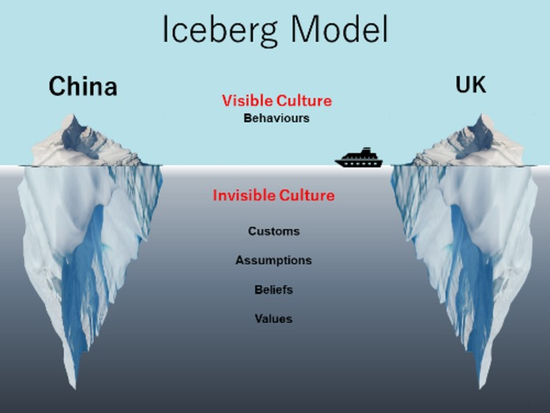
Figure 1 The iceberg model image is an adaptation of Edward T. Hall’s Cultural Iceberg
View description - Figure 1 The iceberg model image is an adaptation of Edward T. Hall’s Cultural ...

In their book Hidden Differences, Hall and Hall (1987, p. xvii) said: ‘Despite popular beliefs to the contrary, the single greatest barrier to business success is the one erected by culture’.
But ‘culture’ is a term with many different meanings and which may be understood in many different ways. In Activity 1, you will be presented with two definitions that will provide a foundation for learning more about intercultural competence and appreciating how much values, attitudes and behaviours both shape and are shaped by culture.

Activity 1

Read the following definitions of ‘culture’ quoted in Spencer-Oatey’s (2012) book entitled What is Culture?.

Definition 1
Culture consists of patterns, explicit and implicit, of and for behaviour acquired and transmitted by symbols, constituting the distinctive achievements of human groups.
(Kroeber and Kluckhohn, 1952, cited in Spencer-Oatey, 2012, p. 2)

Definition 2
Culture is a fuzzy set of basic assumptions and values, orientations to life, beliefs, policies, procedures and behavioural conventions that are shared by a group of people, and that influence (but do not determine) each member's behaviour and [their] interpretations of the 'meaning' of other people's behaviour.
(Spencer-Oatey, 2008, cited in Spencer-Oatey, 2012, p. 2)

Now decide whether the following statements correspond to ideas expressed in Definition 1, Definition 2, or both.

a. Culture can be defined in terms of conscious and unconscious behavioural patterns of given social groups.

Definition 1
Definition 2
Both Definition 1 and Definition 2
View answer - Part

b. Culture is something that humans learn.

Definition 1
Definition 2
Both Definition 1 and Definition 2
View answer - Part

c. Humans are not always aware of the world and perceive social interactions according to the culture of the group they belong to.

Definition 1
Definition 2
Both Definition 1 and Definition 2
View answer - Part

2 Culture and the perspective of others
One of the main objectives of this taster course is to raise your awareness of how we often take our own cultural values to be the norm and how stereotypes of a particular culture can be formed that may hamper communication.
When communicating with individuals that belong to a different cultural milieu, you should be aware of cultural differences, but it is also important to acknowledge the fact that there is usually a great number of overlapping similarities.
It is natural to register what you find surprising, rather than what you find normal, and this creates unconscious generalisations. However, these cultural generalisations and stereotypes are prone to being based on biased impressions and experiences, involuntarily exaggerated or limited to specific environments. Moreover, they usually apply to the most visible parts of culture (the surface of the iceberg), which are the more conspicuous behaviours of cultural aspects such as food, traditions, rites, etc.
Prejudice arises when negative judgements are applied to these stereotypes.

Figure 1 (repeated) The iceberg model image is an adaptation of Edward T. Hall’s Cultural Iceberg
View description - Figure 1 (repeated) The iceberg model image is an adaptation of Edward T. Hall’s ...

Activity 2

In the TED talk ‘The Danger of a Single Story’, the novelist Chimamanda Adichie tells the story of how she found her authentic cultural voice, and warns that if only a single story about another person or country is heard, there is a risk of critical misunderstanding.
Watch the video and answer the following questions.

Watch the video at YouTube.com.

1. What are the consequences of a single story according to Chimamanda Adichie?

Provide your answer...
View feedback - Part

2. If you have been hearing a single story about Chinese culture, what is it? Describe it in the following box.

Provide your answer...
View feedback - Part

3. If you have heard a single story, after watching the TED talk above, what are your views now towards Chinese culture?

Provide your answer...
View feedback - Part

3 Intercultural competence
In the BBC television series China on Four Wheels, produced in collaboration with The Open University, the BBC reporter Anita Rani was invited by her hosts to sample some traditional food.
In Activity 3 you will watch a clip from the series, but first familiarise yourself with the concept of ‘intercultural communicative competence’ proposed by Professor Michael Byram (1997) with the five key elements:
- attitudes
- knowledge
- skills of interpreting and relating
- skills of discovery and interaction
- critical cultural awareness.
In terms of ‘attitudes’, Byram refers to a person’s attitudes of curiosity and openness, and the ability to suspend judgement. Regarding knowledge, it is about trying to learn about the cultural backgrounds of the people you work with so that you are aware of the different kinds of experiences and expectations they may have, and you can reflect on your own culture and its approaches to how things are done.
As for the skills of interpreting and relating and the skills of discovery and interaction, they will be developed alongside a curiosity for knowledge and an open-minded attitude. The final element is also linked with the other four elements: critical cultural awareness, one’s ability to critically evaluate oneself and others (Byram, 1997).

Activity 3

Watch the video clip of Anita Rani in China on four wheels from 02:05 and reflect on the following questions. Write your thoughts in the box below.
(Open the video in a new tab or window by holding down Ctrl (or Cmd on a Mac) when you click on the link.)
Video link: China on four wheels
- Was there anything in Anita’s behaviour that was inappropriate? If yes, what was it and why in your view was it inappropriate?
- If it was you, how would you have handled the situation?
- In terms of intercultural competence, which aspect(s) does Anita need to improve on?
- When working with people from different cultures, what knowledge do you need to acquire?
- What skills do you think Anita Rani needs to develop? What attitudes do you think she needs to cultivate?
- Consider how you can develop your own intercultural competency in terms of knowledge, skills and attitudes.

Provide your answer...
View feedback - Activity 3

4 The importance of family
Although family is important in every society, it is particularly so in Chinese culture. The concept of family includes extended families, no matter how distant the relation is. If someone is a relative (亲戚 qīnqi) it means you can rely on this person for help far more than an outsider.
The complexity of Chinese kinship terms on the one hand reflects the different roles each person in the family is supposed to play, and on the other hand reinforces the importance of family. For example, the English word ‘cousin’ has eight Chinese equivalents depending on gender, age, and side of the family (paternal/maternal).
Look at Table 1, which sets out some of the Chinese words and phrases for family members.

Table 1 Chinese words and phrases for family members
Paternal side | Maternal side
堂哥 táng gē  older, male, father’s brothers’ sons | 表哥 biǎo gē  older, male, mother’s siblings’ sons or father’s sisters’ sons
堂弟 táng dì  younger, male, father’s brothers’ sons | 表弟 biǎo dì  younger, male, mother’s siblings’ sons or father’s sisters’ sons
堂姐 táng jiě  older, female, father’s brothers’ daughters | 表姐 biǎo jiě  older, female, mother’s siblings’ or father’s sisters’ daughters
堂妹 táng mèi  younger, female, father’s brothers’ daughters | 表妹 biǎo mèi  younger, female, mother’s siblings’ or father’s sisters’ daughters

Note: Traditionally, children always take their father’s surname. So, the rule is that all the cousins who share the same family name have the ‘táng’ prefix, and those that have different family names have the ‘biǎo’ prefix.

Activity 4

Part 1

Study Table 1 then try to answer the following question.
- Who should the most important person (or people) be in the traditional Chinese family?
- Traditionally, if a Chinese person had eight cousins as described in the table above, who would be the most important one and why?

Provide your answer...
View feedback - Part 1

Part 2

The family is the building block of Chinese society. This has a significant impact on the Chinese economy and therefore on doing business in China.
The success story of KFC in China can tell us a lot about this impact. Carry out an online search on the KFC case study to find out why KFC was successful in breaking into the Chinese market and how this success was related to the importance of family.

View feedback - Part 2

5 A little goes a long way
Nelson Mandela once said:

If you talk to a man in a language he understands, that goes to his head. If you talk to him in his language, that goes to his heart.
Nelson Mandela (BBC, no date)

In an interview with OpenLearn, well-known BBC journalist Reeta Chakrabarti, who has been exposed to many languages and cultures, shared her experiences. She thinks that language opens the door to a culture. She explained:

You can get under the skin of a culture in the way that you can’t if you don’t speak the language, and you can make connections with people, have very immediate connections with them if you speak the language and that’s true; true in India and in France, and we all know when we go on holiday, don’t we, if you can speak a few words of the local language, people appreciate it and you can just get on better with people.
Reeta Chakrabarti (2016)

You can listen to the interview by visiting ‘Reeta Chakrabarti on language and culture’ on OpenLearn (Open the link in a new tab or window by holding down Ctrl (or Cmd on a Mac) when you click on the link.)
Many westerners who have lived and worked in China have had similar experiences. Not only does speaking a little Chinese show your respect for and interest in Chinese culture, but it can also act as an ice-breaker, which will make your working experiences more enjoyable and at the same time establish some common ground with your Chinese colleagues. So, a little goes a long way.
Mr Smith worked in China for six months on behalf of Perkins Engines Company Ltd. In a personal account he says:

A small amount of language goes a long way (obviously), and is fun (obviously). I'm not a good learner, but was able to direct taxis, speak a bit about myself, and order food. My Chinese friends and colleagues were sincerely impressed with the efforts I made … and although I was far from conversant, this helped strengthen relationships, and went a good way to break down cultural walls between me and my colleagues…

He also comments on the topics of conversation:

‘[in general] Chinese people can be very inquisitive and don't have the same sense of personal space that Brits might. This is not rudeness but it can feel like it, and I had to try and suppress my anger at such intrusion at times. A stranger once approached me in a train station in Suzhou, stood right in my face, and in one breath, said ‘Hello my name is Qian, what’s your name, how old are you, are you married […]?’

So, be prepared to be asked very personal questions. Generally speaking, to a Chinese person such questions might not be considered private, but rather as questions to establish common ground when you first meet someone.
In the next section you will learn some basic greetings and phrases in Chinese.

6 Chinese greetings
In this section you will look at some common greetings in Mandarin Chinese.

Nǐ hăo or nín hăo?
你好 nǐ hăo (lit. you good/well) is the most commonly used greeting in Chinese and can be used throughout the day. Its more formal or polite form is 您好 nín hăo (hello/how do you do?) which is used when you meet somebody for the first time or if you greet someone who is senior to you, either in terms of age or status.

Activity 5

Listen to the following expressions used to greet someone, say ‘goodbye’ and express gratitude and apology. Listen to the model then record yourself saying the expressions. You can then play back your recording to compare it with the model. You can reveal the transcript if you wish.
You can play your recording back or try a new one as many times as you like by pressing ‘Start again’ or ‘Re-record’.

Interactive content is not available in this format.

Interactive content is not available in this format.

Interactive content is not available in this format.

Interactive content is not available in this format.

Interactive content is not available in this format.

Interactive content is not available in this format.

Interactive content is not available in this format.

Conclusion
This taster course has introduced you to the concepts of culture and intercultural competence. You have discussed how people often take their own cultural values to be the norm, and how stereotypes of a particular culture can be formed that may hamper communication and cause misunderstanding.
You have had the opportunity to reflect on your own experiences and others’ in relation to Chinese cultures and traditions, such as the importance of family. It is hoped that these discussions and reflections will help you develop a degree of cultural intelligence and intercultural sensitivity that can be applied to other situations beyond Chinese-speaking cultures.
You have also heard a testimony from someone who worked in China reflecting on how speaking a little Chinese helped establish common ground in their dealings with Chinese people.
If you wish to explore how hierarchy in Chinese culture affects business interactions; learn more about the concepts of guanxi, mianzi and harmony as well as traditional festivals and gift-giving, register to do the full short course LG002 Chinese business culture essentials. If you want to learn the Chinese language systematically, have a look at the Chinese language courses provided by The Open University’s Open Centre for Languages and Cultures.
This OpenLearn taster course is an adapted extract from the Open University short course LG002 Chinese business culture essentials.

References
British Broadcasting Corporation (BBC) (no date) BBC Learning English - Moving Words: Nelson Mandela. Available at: https://www.bbc.co.uk/worldservice/learningenglish/movingwords/shortlist/mandela.shtml (Accessed 18 September 2020).
Byram, M. (1997) Teaching and assessing intercultural communicative competence. Clevendon: Multilingual Matters.
Chakrabarti, R. (2016) ‘Reeta Chakrabarti on language and culture’, OpenLearn, 9 June. Available at: https://www.open.edu/openlearn/languages/more-languages/linguistics/reeta-chakrabarti-on-language-and-culture (Accessed 18 September 2020).
Hall, E. T. (1989) Beyond culture. New York: Anchor Books.
Hall, E. T. and Hall, M. R. (1987) Hidden Differences: Doing Business with the Japanese. New York: Anchor Books.
Spencer-Oatey, H. (2012) What is Culture? A Compilation of Quotations. Available at: https://warwick.ac.uk/fac/soc/al/globalpad/openhouse/interculturalskills/global_pad_-_what_is_culture.pdf (Accessed 12 March 2020).
TED (2009) The danger of a single story | Chimamanda Ngozi Adichie. 7 October. Available at: https://www.youtube.com/watch?v=D9Ihs241zeg (Accessed 9 March 2021).

Acknowledgements
This free course was first published in March 2021.
Except for third party materials and otherwise stated (see terms and conditions), this content is made available under a Creative Commons Attribution-NonCommercial-ShareAlike 4.0 Licence.
The material acknowledged below is Proprietary and used under licence (not subject to Creative Commons Licence). Grateful acknowledgement is made to the following sources for permission to reproduce material in this free course:

Images
Course image: Rawpixel / iStock
Introduction: metamorworks / iStock / Getty Images Plus
Figure 1: Image adapted from image by Edward T Hall and taken from - https://www.solutiontree.com/blog/moving-beyond-visible-culture/
Every effort has been made to contact copyright owners. If any have been inadvertently overlooked, the publishers will be pleased to make the necessary arrangements at the first opportunity.
Don't miss out
If reading this text has inspired you to learn more, you may be interested in joining the millions of people who discover our free learning resources and qualifications by visiting The Open University – www.open.edu/openlearn/free-courses.

Solutions

Activity 1

Part

Answer
Right:
Definition 1
Wrong:
Definition 2
Both Definition 1 and Definition 2
Back to - Part

Part

Answer
Right:
Definition 1
Wrong:
Definition 2
Both Definition 1 and Definition 2
Back to - Part

Part

Answer
Right:
Definition 2
Wrong:
Definition 1
Both Definition 1 and Definition 2
Back to - Part

Activity 2

Part

Feedback
In the video, Adichie says:

The consequence of a single story is this: it robs people of dignity. It makes our recognition of equal human dignity difficult. It emphasises how we are different rather than how we are similar.
(Adichie, 2009, quoted in TED, 2009, 13:54)

If you are not aware of the different practices and beliefs of people you work with who are from different cultures, you run the risk of having a biased view towards a particular culture. As a result, you will not be able to develop the skills and attitudes needed to get along with colleagues who come from different cultures.
Back to - Part

Part

Feedback
Just a few prompts to get you thinking: Is the story about how polluted Chinese cities are, which causes all Chinese people to wear masks? Is it about people jumping queues and being rude? Or is it about beautiful calligraphy and papercutting?
Back to - Part

Part

Feedback
As Adichie says:

The single story creates stereotypes, and the problem with stereotypes is not that they are untrue, but that they are incomplete. They make one story become the only story.
(Adichie, 2009, quoted in TED, 2009, 13:11)

The story you have heard or experienced relating to Chinese culture is just one experience of many. China is a huge country with a big population, regional differences and 56 minority groups. Whenever you hear a story, positive or negative, you must not jump to conclusions but instead connect it with other stories and figure out the reasons behind it.
Back to - Part

Activity 3

Feedback
In the BBC clip, Anita knew about sea cucumber being a delicacy in Chinese culture, but her understanding stopped at that stage and she allowed her own standards on food texture and taste to influence her reaction and behaviour. She was not sensitive enough to the feelings of her host and, if it was a business dinner, this behaviour might cause the host to feel offended and could have a negative impact on the business relationship.
This example demonstrates that just having cultural knowledge is not enough. You need to internalise cultural knowledge and reflect on the new information, comparing it with similar aspects of practices in one’s own culture. For example, there are many types of food in the western diet, such as cheese, that people in China might find odd.
You could further develop your intercultural competency by knowing how to contrast cultural differences and predict misunderstandings (and adapt your behaviour accordingly). In a given situation you can suspend judgement by buying some time, stopping talking, and observing and listening. Putting yourself in the other person’s context can help you to adapt your behaviour.
Back to - Activity 3

Activity 4

Part 1

Feedback
- The traditional Chinese family structure gave ultimate power to the oldest male in the family, whilst children had no or little say in family matters, even important ones such as who they wanted to marry.
- If a Chinese person had eight cousins, the importance of them in the family would be: eldest male on the father’s side, followed by the younger male on the father’s side, then eldest male on the mother’s side. This is because of China’s ancestor worship, which is all about carrying on the family line.
Back to - Part 1

Part 2

Feedback
When breaking into the Chinese market, KFC was mindful of the different eating patterns between Chinese and US customers. The Chinese people studied tended to eat together in families or groups. The Americans, on the other hand, were often lone diners. KFC represented this cultural difference in the physical settings of the Chinese restaurants: larger tables, more floor space; the atmosphere better suited to families. Similarly, they provided giant tubs so that people could share large order options for multiple individuals, and made a special effort to welcome extended families and groups.
Back to - Part 2

Uncaptioned Figure

Description
An blue image of a city skyline with skyscrapers in the background with a map of the world on top. There are lines connecting different parts of the world.
Back to - Uncaptioned Figure

Figure 1 The iceberg model image is an adaptation of Edward T. Hall’s Cultural Iceberg

Description
Image of two icebergs labelled ‘China’ and ‘UK’. Along the surface line one can read ‘Visible Culture: behaviours’. Under the surface, the words that appear are: ‘Invisible Culture: customs, assumptions, beliefs, values’.
Back to - Figure 1 The iceberg model image is an adaptation of Edward T. Hall’s Cultural Iceberg

Figure 1 (repeated) The iceberg model image is an adaptation of Edward T. Hall’s Cultural Iceberg

Description
Image of two icebergs labelled ‘China’ and ‘UK’. Along the surface line one can read ‘Visible Culture: behaviours’. Under the surface, the words that appear are: ‘Invisible Culture: customs, assumptions, beliefs, values’.
Back to - Figure 1 (repeated) The iceberg model image is an adaptation of Edward T. Hall’s Cultural Iceberg

