LXF001_1

Getting started with French 1

About this free course
This free course is an adapted extract from the Open University course developed from extract parts of LXF001 - Beginners French 1: eh oui! - http://www.open.ac.uk/courses/short-courses/lxf001.
This version of the content may include video, images and interactive content that may not be optimised for your device.
You can experience this free course as it was originally designed on OpenLearn, the home of free learning from The Open University –
Getting started with French 1
There you’ll also be able to track your progress via your activity record, which you can use to demonstrate your learning.
Copyright © 2021 The Open University
Intellectual property
Unless otherwise stated, this resource is released under the terms of the Creative Commons Licence v4.0 http://creativecommons.org/licenses/by-nc-sa/4.0/deed.en_GB. Within that The Open University interprets this licence in the following way: www.open.edu/openlearn/about-openlearn/frequently-asked-questions-on-openlearn. Copyright and rights falling outside the terms of the Creative Commons Licence are retained or controlled by The Open University. Please read the full text before using any of the content.
We believe the primary barrier to accessing high-quality educational experiences is cost, which is why we aim to publish as much free content as possible under an open licence. If it proves difficult to release content under our preferred Creative Commons licence (e.g. because we can’t afford or gain the clearances or find suitable alternatives), we will still release the materials for free under a personal end-user licence.
This is because the learning experience will always be the same high quality offering and that should always be seen as positive – even if at times the licensing is different to Creative Commons.
When using the content you must attribute us (The Open University) (the OU) and any identified author in accordance with the terms of the Creative Commons Licence.
The Acknowledgements section is used to list, amongst other things, third party (Proprietary), licensed content which is not subject to Creative Commons licensing. Proprietary content must be used (retained) intact and in context to the content at all times.
The Acknowledgements section is also used to bring to your attention any other Special Restrictions which may apply to the content. For example there may be times when the Creative Commons Non-Commercial Sharealike licence does not apply to any of the content even if owned by us (The Open University). In these instances, unless stated otherwise, the content may be used for personal and non-commercial use.
We have also identified as Proprietary other material included in the content which is not subject to Creative Commons Licence. These are OU logos, trading names and may extend to certain photographic and video images and sound recordings and any other material as may be brought to your attention.
Unauthorised use of any of the content may constitute a breach of the terms and conditions and/or intellectual property laws.
We reserve the right to alter, amend or bring to an end any terms and conditions provided here without notice.
All rights falling outside the terms of the Creative Commons licence are retained or controlled by The Open University.
Head of Intellectual Property, The Open University
978-1-4730-3175-3 (.kdl)
978-1-4730-3176-0 (.epub)

Contents
- Introduction
  - Introduction
  - Open Centre for Languages and Cultures
- Week 1: Say hello: ‘Bonjour!’
  - Introduction
  - 1 Say hello: ‘Bonjour!’
  - 2 Say goodbye: ‘Au revoir !’
  - 3 Saying hello and goodbye
  - 4 To kiss or shake hands?
  - 5 Greeting or parting?
  - 6 What would you say?
  - 7 Recognising ‘u’ and ‘ou’ sounds
  - 8 Practising ‘u’ and ‘ou’ sounds
  - 9 Using ‘tu’ and ‘vous’
  - 10 This week’s quiz
  - 11 Summary of Week 1
- Week 2: Names and nationality
  - Introduction
  - 1 Tu t’appelles comment ? Tu es français/ française ? (What is your name? Are you French?)
  - 2 Saying your name and nationality
  - 3 Adjectives of nationality
  - 4 Practising masculine and feminine forms
  - 5 Practise adjectives of nationality
  - 6 Focussing on pronunciation
  - 7 Listening practice
  - 8 Speaking practice
  - 9 How to memorise vocabulary
  - 10 This week’s quiz
  - 11 Summary of Week 2
  - Next steps
- Acknowledgements
- Solutions

Introduction

Introduction
Welcome to this free course, Getting started with French 1.

Figure 1 Bonjour !
View description - Figure 1 Bonjour !

This course offers you an excellent start to your French learning journey. Starting from the basics, simple greetings and saying your name, you’ll progress towards being able to start to understand conversations in French.
Each week comprises 3–4 hours of interactive activities, explanations, exercises and tips about language-learning. It’s a good idea to keep notes either on paper in a notebook or on your preferred digital device; in any case each week you’ll be encouraged to add to your own personal phrase book and decide how best you can go about memorising and practising key phrases and vocabulary, and there is a weekly quiz for you to practise what you’ve been learning.
You’ll start by learning how to greet someone and say goodbye, but first of all, take some time, now, to decide how you’ll allocate your time to your studies. Learning French, like learning any language, is a gradual process; it’s often described as ‘a marathon, not a sprint.’ ‘Little and often’ is the best approach, so if at all possible spread your 3–4 hours over the week, rather than devoting one whole afternoon or evening. This will give you plenty of opportunities to revisit vocabulary and language structures, to revise quickly what you did last time and above all to practise and consolidate. This is the best way to learn vocabulary and perfect your accent.
It’s also a very good idea to involve your family and friends; let them know you’ve decided to start learning French and they can help you when you practise what you’ve been learning, or leave you in peace when you need to study.
After completing this course, you will be able to:
- say hello, goodbye and some of the first phrases you might use when meeting a French speaker
- give your name and nationality
- use greetings and partings in different settings
- recognise 'u' and 'ou' sounds and the basic rules of French pronunciation
- distinguish between masculine and feminine forms, spot the differences between them when reading and listening, and pronounce each form correctly.

Open Centre for Languages and Cultures
This course has been developed from extract parts of LXF001 - Beginners French 1: eh oui!. The Open University has launched a dedicated learning centre called The Open Centre for Languages and Cultures. OpenLearn is supporting this project and is providing extracted units of all courses on The Open Centre in our dedicated Language and cultures Hub.
The Open Centre for Languages and Cultures is the exciting new home for non-accredited language and intercultural communication short courses. You can study a wide range of language and language related subjects with us anywhere in the world, in any time zone, whatever your motivation – leisure, professional development or academic.
It’s the one stop shop for engaging with languages, professional communication and intercultural dialogue.
Our short courses allow us to be agile and responsive to the needs of learners who want to be part of a global society. We offer non-accredited short courses in a range of subjects including modern languages and languages for business and the workplace. We are also leading the way in developing short courses for academic research methods and pre-sessional English with IELTS, which will be available for registration in due course.
The Open Centre for Languages and Cultures is an international leader in online language learning and intercultural communications, built on our pioneering pedagogy and research.

What makes the Open Centre different?
- The OU is the leader in online learning and teaching with a heritage of more than 50 years helping students achieve their learning ambitions.
- The short courses are underpinned by academic rigour and designed by native speakers experienced in producing engaging materials for online learning of languages and cultures.
- The graduating nature of the courses means that learners can build up their language and skills over time.
- Learners will also gain a better understanding of the culture(s) associated with the language(s) they study enabling the development of intercultural communication skills.
- Learners can mix and match the short courses and study more than one course at a time.
Once this course is complete you will be directed to OpenLearn’s hub for language content where you will be able to build on your newly found language skills.
Now that you’re fully prepared, it’s time to start on Week 1.
Bon courage !

Week 1: Say hello: ‘Bonjour!’

Introduction
At the beginning of this week you’ll learn how say hello and goodbye in French, as well as some of the first phrases you might use when meeting a French speaker.
You’ll also be introduced to using greetings and partings in different settings and have your understanding of this tested with activities throughout the week.
Finally, you’ll be introduced to the 'u' and 'ou' sounds and build on this so you become familiar with some basic rules of French pronunciation.
This OpenLearn course is an adapted extract from the Open University course LXF001 Beginners French 1: eh oui!.

1 Say hello: ‘Bonjour!’
It’s so important to make a good first impression, so to start with you’ll learn how to greet people in French.

Activity 1

Listen to these different greetings and see if you can spot them in the box below. Don’t be satisfied with just one listening; listen to them again until they become more familiar, and why not try and copy what you hear too?

Audio content is not available in this format.
View transcript - Uncaptioned interactive content

Expressions used for greetings
To greet somebody, you say:

Bonjour ! Hello!/Good morning!/Good afternoon!
Bonsoir ! Good evening!
Salut ! Hi!

Salut ! is informal and can be used to mean both ‘hello’ and ‘goodbye’ (according to context). It is normally used between people who know each other well or between young people.
These expressions are often followed by:

Ça va ? (informal) How are you?
Vous allez bien ? (formal) How are you?

In formal situations, monsieur, madame or mademoiselle always accompanies bonjour and au revoir. They are much more frequently used in French than their English equivalents (‘sir’ and ‘madam’). For example, you might say Bonjour madame to a female receptionist in a hotel, or Bonjour monsieur to a male post office employee. Mademoiselle (‘miss’) is less frequently used nowadays, especially with women over the age of twenty-five.
You can respond:

Ça va (bien), merci. Et toi ? (informal) Fine/very well, thanks. And you?
Ça va (bien), merci. Et vous ? (formal) Fine/very well, thank you. And you?

2 Say goodbye: ‘Au revoir !’
You’ll now listen to different ways of taking leave of someone.

Activity 2

You have just learnt that ‘salut !’ is informal and can mean either ‘hello’ or ‘goodbye’. Can you hear it in this recording? As you listen, try and spot each phrase in the box below, and try copying what you hear as you did before.

Audio content is not available in this format.
View transcript - Uncaptioned interactive content

Expressions used when leaving
When parting from people, you say:

Au revoir ! Goodbye!
À bientôt ! See you soon!
À tout à l’heure ! See you later!
Bonsoir ! Goodnight!
Bonne journée ! Have a good day!
Bonne soirée ! Have a good evening!
Bon voyage ! Have a good trip/journey!

3 Saying hello and goodbye
Now you’re more familiar with expressions for greeting and taking your leave, have a go at Activity 3.

Activity 3

Look at the illustrations below. For each, choose the conversation that fits the picture.

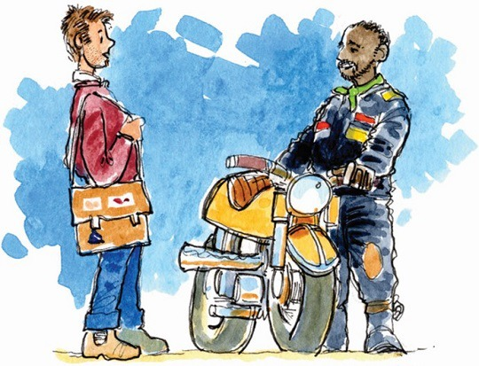
Figure 1
View description - Figure 1

‘Au revoir Annie.’//‘Salut, à bientôt.’
‘Bonsoir Éléonore, vous allez bien ?’//‘Bien, et vous ?’//‘Bien merci, bonne soirée.’
‘Salut Éric.’//‘Salut Henri, ça va ?’//‘Oui, ça va, et toi ?’//‘Oui, ça va bien.’
‘Au revoir, bonne journée.’//‘À ce soir !’
‘Bonjour Monsieur Thomas.’//‘Bonjour mademoiselle.’
View answer - Part

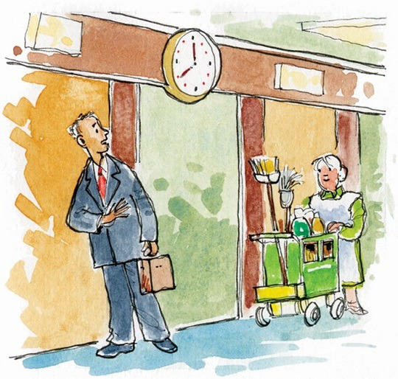
Figure 2
View description - Figure 2

‘Au revoir Annie.’//‘Salut, à bientôt.’
‘Au revoir, bonne journée.’//‘À ce soir !’
‘Salut Éric.’//‘Salut Henri, ça va ?’//‘Oui, ça va, et toi ?’//‘Oui, ça va bien.’
‘Bonjour Monsieur Thomas.’//‘Bonjour mademoiselle.’
‘Bonsoir Éléonore, vous allez bien ?’//‘Bien, et vous ?’//‘Bien merci, bonne soirée.’
View answer - Part

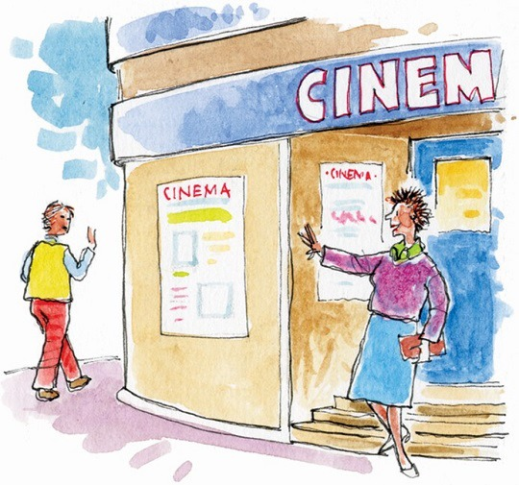
Figure 3
View description - Figure 3

‘Au revoir Annie.’//‘Salut, à bientôt.’
‘Bonsoir Éléonore, vous allez bien ?’//‘Bien, et vous ?’//‘Bien merci, bonne soirée.’
‘Au revoir, bonne journée.’//‘À ce soir !’
‘Salut Éric.’//‘Salut Henri, ça va ?’//‘Oui, ça va, et toi ?’//‘Oui, ça va bien.’
‘Bonjour Monsieur Thomas.’//‘Bonjour mademoiselle.’
View answer - Part

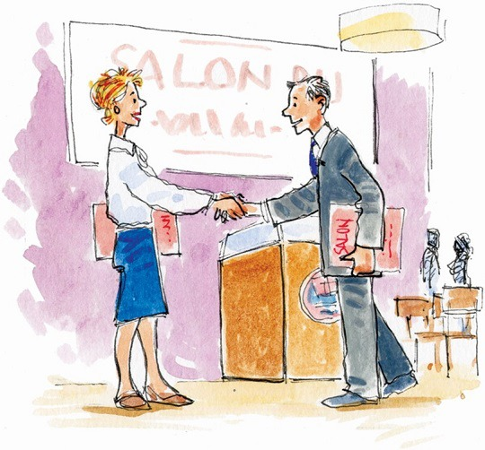
Figure 4
View description - Figure 4

‘Au revoir Annie.’//‘Salut, à bientôt.’
‘Bonjour Monsieur Thomas.’//‘Bonjour mademoiselle.’
‘Bonsoir Éléonore, vous allez bien ?’//‘Bien, et vous ?’//‘Bien merci, bonne soirée.’
‘Au revoir, bonne journée.’//‘À ce soir !’
‘Salut Éric.’//‘Salut Henri, ça va ?’//‘Oui, ça va, et toi ?’//‘Oui, ça va bien.’
View answer - Part

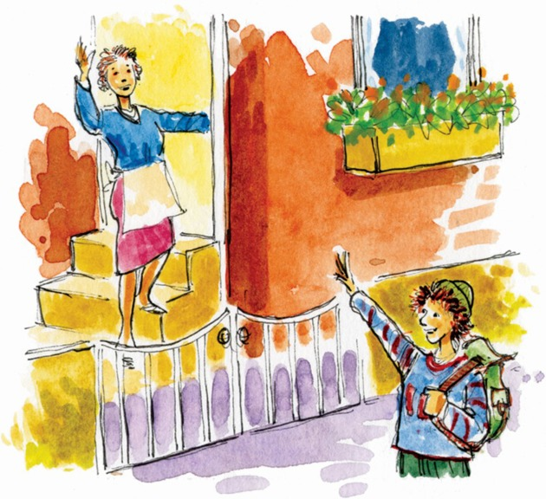
Figure 5
View description - Figure 5

‘Au revoir Annie.’//‘Salut, à bientôt.’
‘Bonsoir Éléonore, vous allez bien ?’//‘Bien, et vous ?’//‘Bien merci, bonne soirée.’
‘Salut Éric.’//‘Salut Henri, ça va ?’//‘Oui, ça va, et toi ?’//‘Oui, ça va bien.’
‘Au revoir, bonne journée.’//‘À ce soir !’
‘Bonjour Monsieur Thomas.’//‘Bonjour mademoiselle.’
View answer - Part

How did you get on? If you were not sure of any of these answers, the discussion below may help explain it for you.

View comment - Part

4 To kiss or shake hands?
When meeting someone, what is the custom where you come from? Does it depend whether you know the other person or not? Imagine you have a French visitor staying with you who has been invited for a meal with some colleagues whom they’ve never met. What advice would you give them? Should they shake hands? Kiss? How many times? Does it depend on the gender or age of the person they’re meeting?

Figure 6
View description - Figure 6

In France, custom requires that you shake hands when you greet people and when you leave them. This social rule is followed by men and women, young and old. If the two people are related or are very good friends, instead of shaking hands they often kiss each other on both cheeks. The number of kisses varies between regions. In Paris, for example, you would give four kisses alternating between cheeks, but in the south of France people only give two kisses, once on both cheeks. It isn’t uncommon for young people who have never met before to kiss one another, and more and more men are happy to kiss or hug on television, for example.
However, kissing isn’t a universal habit among French-speakers. For example, in the French overseas département Guadeloupe (one of the French Caribbean islands), it isn’t advisable to kiss somebody of the opposite sex in public if you’re meeting that person for the very first time, regardless of age. Similarly, French Muslims may not exchange kisses as often as other French people do.

Activity 4

Look at the photos carefully and, for each one, drag and drop the appropriate description beside the photo.

Two young boys leave their grandparents and they all wave goodbye.
Two colleagues, who may not have met before, shake hands.
Two brothers kiss cheeks when meeting.
Two colleagues, who know each other well, kiss cheeks when they meet.
View answer - Activity 4

5 Greeting or parting?
Now have a go at Activity 5.

Activity 5

Look at the photos again. What do you think these people were saying to each other as they were greeting or parting? In each case, select the appropriate words underneath the photo. Note: ‘Bienvenue’ means ‘welcome’.

View description - Uncaptioned Figure

‘Bonjour Monsieur Bouin. Bienvenue.’//‘Merci.’
‘Bonjour Christine.’//‘Salut, ça va ?’
‘Salut, ça va ?’//‘Oui, et toi ?’
‘Au revoir, à bientôt !’//‘À bientôt !’
View answer - Part

View description - Uncaptioned Figure

‘Salut, ça va ?’//‘Oui, et toi ?’
‘Bonjour Monsieur Bouin. Bienvenue.’//‘Merci.’
‘Au revoir, à bientôt !’//‘À bientôt !’
‘Bonjour Christine.’//‘Salut, ça va ?’
View answer - Part

View description - Uncaptioned Figure

‘Bonjour Monsieur Bouin. Bienvenue.’//‘Merci.’
‘Au revoir, à bientôt !’//‘À bientôt !’
‘Bonjour Christine.’//‘Salut, ça va ?’
‘Salut, ça va ?’//‘Oui, et toi ?’
View answer - Part

View description - Uncaptioned Figure

‘Au revoir, à bientôt !’//‘À bientôt !’
‘Bonjour Monsieur Bouin. Bienvenue.’//‘Merci.’
‘Bonjour Christine.’//‘Salut, ça va ?’
‘Salut, ça va ?’//‘Oui, et toi ?’
View answer - Part

6 What would you say?
Based on what you have learnt so far in this course, have a go at answering the questions in Activity 6.

Activity 6

Listen to the recordings: which of the three options is the most appropriate response, do you think? What would you say? Click on the correct answer for each question.

Audio content is not available in this format.
View transcript - Uncaptioned interactive content

Au revoir.
Oui ça va.
À bientôt.
View answer - Part

Audio content is not available in this format.
View transcript - Uncaptioned interactive content

Très bien et vous ?
À ce soir..
Enchanté.
View answer - Part

Audio content is not available in this format.
View transcript - Uncaptioned interactive content

Au revoir !
Bon voyage !
Oui ça va, et toi ?
View answer - Part

Audio content is not available in this format.
View transcript - Uncaptioned interactive content

Bonsoir.
Au revoir. À bientôt.
Bien, merci.
View answer - Part

Once you’ve checked that your answers are correct, try listening again, and this time say the response out loud yourself.

7 Recognising ‘u’ and ‘ou’ sounds
You have just been practising your spoken French by listening carefully and copying what you hear. You may have also relied on reading a short script to make sure you got it right.
However, if you rely too much on reading you’ll tend to allow the influence of your own language to take over and your pronunciation will be affected. Copying what you hear without looking at a ‘script’ is a very good idea when learning new phrases and expressions so aim to do that before reading the words, if you can, even if you don’t understand every word.
You can also concentrate on individual sounds by learning and practising words or phrases that contain those sounds. One pair of sounds that is often challenging, for English speakers in particular, is ‘u’ and ‘ou.’ You have already heard the ‘u’ sound in ‘salut,’ and the ‘ou’ sound in ‘vous.’

Activity 7

Listen to the recording; there are six words which contain either the ‘u’ sound or the ‘ou’ sound. As you listen to each word, pay careful attention to the sound. You can look at the words at the same time, if that is helpful, by clicking on ‘Transcript’.

Audio content is not available in this format.
View transcript - Uncaptioned interactive content

‘u’ and ‘ou’sounds appear very frequently in French. It is important to be able to make the distinction between them, in both listening and speaking. You have just been listening to some examples; you could try repeating these many times to copy exactly what you hear. You may need quite a lot of practice to get it just right. As you practise, think about how you shape your mouth and where your tongue is when you make the sounds. These tips may be helpful:
- the sound u, as in ‘salut’, is pronounced with closely rounded, protruding lips, while the tip of your tongue is raised at the front of your mouth. (You might find it helpful to practise by saying ‘oo’, then switch to ‘ee’ without changing your lip position.)
- the sound ou, as in ‘vous’, ‘tout’, ‘bonjour’, is pronounced with the same lip position, but with the middle part of your tongue raised at the back of your mouth. It’s a bit like the sound ‘oo’ as in ‘zoo’ in English.
Try saying them one after the other and note the changing position of your tongue.

Activity 8

Now listen to the next recording, where you’ll hear pairs of words containing these two sounds. Many of these words will be new to you but don’t worry about understanding what is being said. The important thing, at this stage, is for you to hear the difference between the two sounds, and to copy it as accurately as you can. You can look at the words at the same time, if that is helpful, by clicking on ‘Transcript’.

Audio content is not available in this format.
View transcript - Uncaptioned interactive content

8 Practising ‘u’ and ‘ou’ sounds
In the next activity, you’ll have a go at practising your pronunciation of the two sounds ‘u’ and ‘ou’ .

Activity 9

Listening to the pairs of words given below, then record yourself and listen to the playback. Remember the suggestions you’ve just read about the pronunciation of these two sounds, and copy what you hear too, in order to get your pronunciation just right. So, listen, record and listen again to the four pairs of words.

Audio content is not available in this format.
View transcript - Uncaptioned voice recording

Audio content is not available in this format.
View transcript - Uncaptioned voice recording

Audio content is not available in this format.
View transcript - Uncaptioned voice recording

Audio content is not available in this format.
View transcript - Uncaptioned voice recording

9 Using ‘tu’ and ‘vous’
At the start of this week you were introduced to a number of expressions for greetings, some of which were formal and some informal. You may have noticed that the word vous (=’you’) is sometimes used in the formal expressions. One important aspect of learning French is to understand how and when to use formal and informal language. Both tu and vous can be used to mean ‘you’ when addressing another person. Practise them as part of your pronunciation practice for the two sounds ‘u’ and ‘ou’. Also, note that:
- vous is more formal than tu, and is used particularly when the speaker wishes to address the listener respectfully; this may be due to differences in age or perceived status, or in more formal situations when meeting someone for the first time;
- tu is normally used among friends and relatives, and when talking to children; teenagers and young adults, between themselves, will more naturally use the tu form from the outset.
There are no hard and fast rules as it also depends on the setting, the person you’re talking to and how formal you prefer to be. It’s always safer to use vous and wait for the person you’re speaking with to invite you to use tu.

Activity 10

Watch these short video clips where people are meeting in various different situations.

Video content is not available in this format.
View transcript - Uncaptioned interactive content

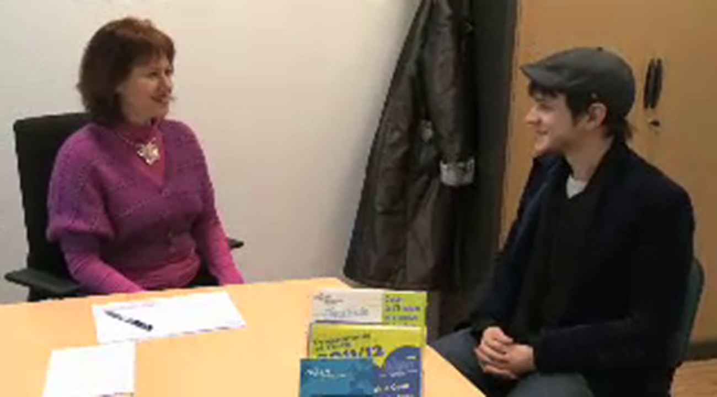

It is unlikely that you’ll understand, or even hear, every word, but listen out for the use of vous and tu and how these words are pronounced. Notice what gestures the people use. What is the relationship between the people who are meeting, do you think? Write your thoughts in the box below.

Provide your answer...
View comment - Activity 10

Félicitations ! You have come to the end of your first week’s study! Be sure to go over again any parts you found challenging, or might have forgotten, before you try the Quiz.

10 This week’s quiz
Check what you’ve learned this week by taking the end-of-week quiz.
Week 1 quiz
Open the quiz in a new window or tab (by holding ctrl [or cmd on a Mac] when you click the link), then return here when you have done it.

11 Summary of Week 1
Building your language skills happens little by little and it’s very important for you to keep returning to vocabulary and structures you’ve been learning, as well as adding new ones.
Without checking back, can you remember a formal and an informal way to say ‘hello’ and ‘goodbye’? What is the difference between ‘tu’ and ‘vous’?
You may have answered these questions with ease, but how quickly will you remember the answers in two or three weeks’ time? Now is the time to get organised and start formalising the way you develop your language skills.

Building a language notebook

This is something you can develop week by week, which is entirely personal to you. You may find that you want to change the way you go about it as the weeks progress; don’t worry if that happens. The important thing is that you find a way to note down, each week, new vocabulary and expressions, and also tips about pronunciation, grammar, culture and communication in general that will support you as you start to learn French.
How will you do this? Whether you keep your notes on paper or digitally, it’s important to get organised, so here is an idea that may help, based on your Week 1 studies:

Table 1 Language notebook
Key phrases | Provide your answer...
Pronunciation | Provide your answer...
Culture | Provide your answer...
Language | Provide your answer...

What would you write into each box, if anything? Would you add more boxes?

View comment - Building a language notebook

Practising and consolidating

The best way to remember new vocabulary and key phrases is to practise. What did you find difficult? How could you manage better next time?
In Week 1, you were introduced to an important point of pronunciation which should help with your listening and speaking skills. Did you practise the different sounds ‘u’ and ‘ou’?
Why not return to that section and practise again. If you would like further practice, watch this screencast:

Video content is not available in this format.
View transcript - Uncaptioned interactive content

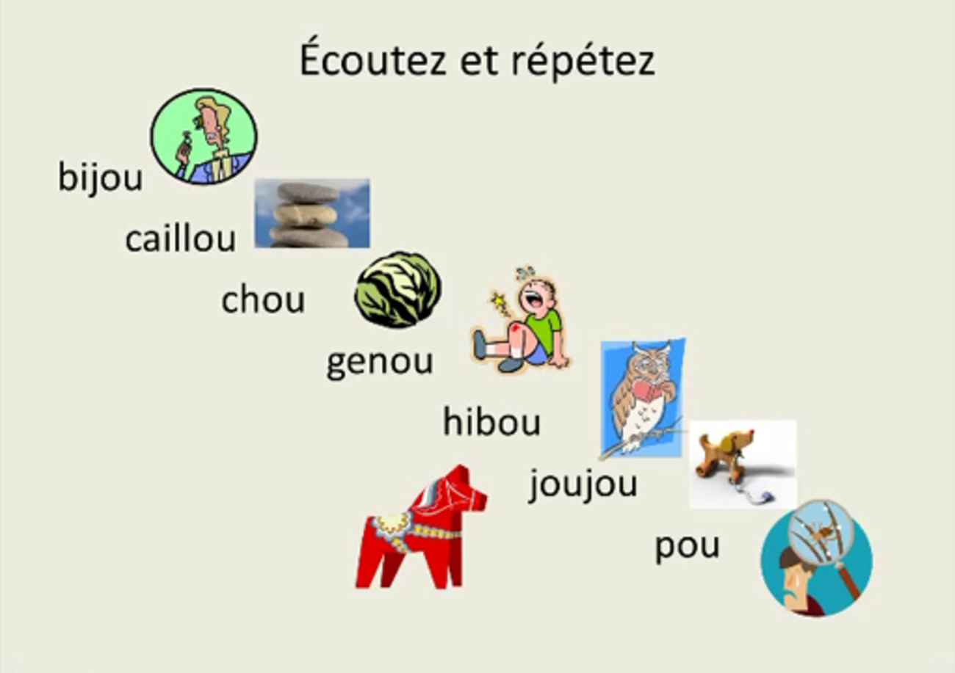

Now you’ve reached the end of Week 1, reflect a little on what you’ve been learning. In the box below, note down what you’ve found easy, useful or fun, and what was more difficult.

Week 1 Reflection

What was easy, useful or fun this week?

Provide your answer...

What was more difficult?

Provide your answer...

Félicitations !
You have come to the end of Week 1. Next week you’ll be learning how to introduce yourself and say your nationality, and you’ll be able to work further on your pronunciation and listening skills.

Week 2: Names and nationality

Introduction

Figure 1
View description - Figure 1

Now you’re confident enough to greet people appropriately, you’re going to learn how to say a bit more about yourself by giving your name and nationality. You’ll find out that, in French, you need to distinguish between masculine and feminine forms, and that will mean you’ll learn how to spot these differences when reading and listening, and how to pronounce each form correctly. You’ll have the chance to practise this and learn how to say many different nationalities.
Have you got a good dictionary? You might need to refer to one for one of the activities this week, so think about how you plan to look words up when you need to. There are many online dictionaries available, or perhaps you prefer to use a printed version. Either way, find one that suits you but also is reliable and accurate.
Last week you started to keep your own language notebook; this week you’ll be adding to it. In particular we suggest you make notes on the grammar you’ll be studying (the verb ‘to be’) and how you’re going to memorise vocabulary (we give you some tips).
Bon courage !

1 Tu t’appelles comment ? Tu es français/ française ? (What is your name? Are you French?)
To start this week, you’ll look at how to introduce yourself by giving your name and nationality.

Activity 1

Figure 2
View description - Figure 2

Read the two sentences below. What two ways do these people use to introduce themselves? What do you think ‘je suis’ means? Do you notice any other differences between the way they give their nationality? Write your thoughts in the box below.
- Salut. Moi, c’est Lucy. Je suis anglaise.
- Bonjour. Je m’appelle Charlie. Je suis anglais et français.

Provide your answer...
View answer - Activity 1

Saying your name
You’ve just come across some French-speakers giving their name and their nationality.
To give your name in French you would most commonly use:

Je m’appelle – I’m called (literally, ‘I call myself’).

In informal contexts or among friends you can also say:

Moi, c’est Lucy.
Moi, je m’appelle Lucy.

Lucy uses ‘moi’ here just for emphasis. Literally it means ‘Me, my name is […]’.
When someone asks your name, you would hear:

Tu t’appelles comment ? (informal)
Vous vous appelez comment ? (more formal speech)

Saying your nationality
To give your nationality, you use the adjective of your country. An adjective is a word that describes something, so, for example, France is the name of the country, but French is the word that describes something or someone from that country: ‘I like French cheese.’ ‘I am French.’
Note, however, that French adjectives of nationality can slightly change their form, that is, the way they’re written, as you noticed when you looked at the way Lucy and Charlie introduced themselves.

Charlie says: Je suis anglais (this is the ‘masculine’ form)
Lucy says: Je suis anglaise (this is the ‘feminine’ form, with an -e added)

Here are some more examples; note how the spelling for the masculine and feminine forms are different.

Table 1 Masculine and feminine forms
Masculine | Feminine
français | française | French
espagnol | espagnole | Spanish
italien | italienne | Italian
anglais | anglaise | English
allemand | allemande | German

2 Saying your name and nationality
Now have a go at Activity 2.

Activity 2

Figure 3
View description - Figure 3

Listen to a variety of people giving their nationality and match their names to the correct nationality.

Audio content is not available in this format.
View transcript - Uncaptioned interactive content

espagnole
française
allemand
belge
italienne
Maria
Margaux
Uwe
Daniel
Anna
View answer - Activity 2
View comment - Activity 2

3 Adjectives of nationality
Now you know how to say a few nationalities and that ‘je suis’ means ‘I am’, have a go at translating the nationalities in the activity below.

Activity 3

Can you translate all these nationalities into English? You may need to use a dictionary.
- Je suis canadien.
- Je suis japonais.
- Je suis gallois.
- Je suis australien.
- Je suis chinois.
- Je suis finlandais.
- Je suis hollandais.
- Je suis polonais.
- Je suis hongrois.
- Je suis écossais.
- Je suis russe.
- Je suis irlandais.
- Je suis américain.
- Je suis suisse.

Provide your answer...
View answer - Activity 3

The ‘être’ verb
‘Je suis’ is part of the verb ‘être’, ‘to be.’ Here are some more parts of the verb:
- Je suis – I am
- Il est – he is
- Elle est – she is
Note that the ‘j’ in ‘je’ is a capital letter only when it is at the start of a sentence.

4 Practising masculine and feminine forms
Now try practising these different forms. You may need to refer back to the activity in Section 3 to check.

Activity 4

Select all the nationalities which are in the masculine form:

australien
chinois
finlandaise
hollandaise
polonais
View answer - Part

Now select all the nationalities which are in the feminine form:

hongrois
écossaise
galloise
irlandaise
américain
View answer - Part

What gender is the writer of this sentence? Select the correct response:
‘Je suis suisse.’

The writer is male
We cannot tell whether the writer is male or female
The writer is female
View answer - Part

5 Practise adjectives of nationality
Now have a go at Activity 5.

Activity 5

Imagine you’re in Tours, in France, and just getting to know a group of people who are all gathered together at the start of a course for learners of French.
Look for clues and select the correct form of the adjective of nationality:

Elisabeth ? Elle est (German).
Maribel est (Spanish).
Anouchka, elle est (Russian).
Anna-Maria est (Italian).
Moi, je m’appelle Carlos et je suis (Spanish).
allemande
espagnole
russe
italienne
espagnol
View answer - Activity 5

Before you move on, make sure you’ve noted in your language notebook any new vocabulary or structures that you’ve learned so far this week.

6 Focussing on pronunciation
You’ve just been noting how the word for nationality is different in the masculine and feminine forms. You listened to some people introducing themselves at the start of this week, too. You might like to return to that activity in Section 2 as part of your practice, because now you’re going to listen more carefully and hone your listening skills. You’re going to focus on how the different spelling influences the sound of the words you’ve been learning this week. How will careful listening help you to understand? If the word looks different in writing, how will it sound, when spoken?
By working carefully through these activities, you’ll discover answers to these questions. You’ll also learn some important tips about pronunciation which will help you when you speak French.

Pronunciation of final consonants
As a general rule, final consonants in French (except c, r, f, l) are silent (Paris is pronounced as ‘paree’). When followed by an -e, however, they become pronounced:
- in the words allemand and français you don’t pronounce the final d or s;
- but in the feminine forms allemande and française, the d and the s are pronounced (as [d] and [z] respectively).
Note that word-final -e itself is not pronounced.

Table 2 Pronunciation of final consonants
Final consonant not pronounced | Final consonant pronounced
anglais | anglaise
normand | normande
grand | grande
petit | petite

Activity 6

Now try listening for some adjective endings yourself. Listen to the speaker and select the words that you hear.

Audio content is not available in this format.
View transcript - Uncaptioned interactive content

français
française
anglais
anglaise
canadien
canadienne
japonais
japonaise
allemand
allemande
gallois
galloise
View answer - Activity 6

Activity 7

Now try some yourself. Listen to the pairs of nationalities and repeat them. Press ‘record’ and play back your recording then compare it with the original. Listen, record and listen again.

Audio content is not available in this format.
View transcript - Uncaptioned voice recording
Audio content is not available in this format.
View transcript - Uncaptioned model voice recording

Audio content is not available in this format.
View transcript - Uncaptioned voice recording
Audio content is not available in this format.
View transcript - Uncaptioned model voice recording

Audio content is not available in this format.
View transcript - Uncaptioned voice recording
Audio content is not available in this format.
View transcript - Uncaptioned model voice recording

Audio content is not available in this format.
View transcript - Uncaptioned voice recording
Audio content is not available in this format.
View transcript - Uncaptioned model voice recording

Audio content is not available in this format.
View transcript - Uncaptioned voice recording
Audio content is not available in this format.
View transcript - Uncaptioned model voice recording

Audio content is not available in this format.
View transcript - Uncaptioned voice recording
Audio content is not available in this format.
View transcript - Uncaptioned model voice recording

7 Listening practice
Now have a go at Activity 8.

Activity 8

Listen to the speaker. Is the nationality you hear masculine or feminine?

Audio content is not available in this format.
View transcript - Uncaptioned interactive content

masculine
feminine
View answer - Part

Audio content is not available in this format.
View transcript - Uncaptioned interactive content

masculine
feminine
View answer - Part

Audio content is not available in this format.
View transcript - Uncaptioned interactive content

masculine
feminine
View answer - Part

Audio content is not available in this format.
View transcript - Uncaptioned interactive content

masculine
feminine
View answer - Part

Audio content is not available in this format.
View transcript - Uncaptioned interactive content

masculine
feminine
View answer - Part

Audio content is not available in this format.
View transcript - Uncaptioned interactive content

masculine
feminine
View answer - Part

Audio content is not available in this format.
View transcript - Uncaptioned interactive content

masculine
feminine
View answer - Part

Audio content is not available in this format.
View transcript - Uncaptioned interactive content

masculine
feminine
View answer - Part

8 Speaking practice
Based on what you have learnt so far this week, have a go at Activity 9.

Activity 9

Imagine someone has asked you: ‘Tu t’appelles comment ? Tu es français ? Tu es française ? Tu es de quelle nationalité’ ?’ What would you say?
Try introducing yourself. Listen again to the people in Section 2, if you need a model to imitate.
Here is another example for you.

Audio content is not available in this format.
View transcript - Uncaptioned interactive content

Remember to use ‘je suis,’ ‘I am,’ and take care to use the correct form of the word for your nationality.
You might also like to record yourself – for example, using a Voice recorder app on your phone – so that you can listen back to your pronunciation and practise making it sound authentic.

9 How to memorise vocabulary
You’ve been learning a lot of words to do with nationalities this week. Some of them may have been quite easy to recognise, or perhaps you knew them already. Others may have been harder. How will you remember the harder ones?
Learning vocabulary is, of course, a key part of learning a language and everyone has their preferred way of doing it. It’s important for you to get into the habit of memorising new words as they come along, and to keep reminding yourself of ones you picked up earlier too.

Memorising vocabulary
There are several ways of memorising vocabulary – here are a couple of useful methods.
- Using a piece of card, write the French on one side and its translation on the other, then practise translating from one language to the other and checking each side of the card in turn.
- Make lists of target vocabulary, classifying the words in a logical order.
You’ll be picking up a lot of key vocabulary as you work through this course. However, you don’t necessarily need to remember all of it: you should personalise your learning and memorise what is most relevant to your situation. For example, in this activity you might not want to learn all the nationalities that we’ve introduced, but only the ones that you’ll use to talk about yourself and your close family and friends. This is what we mean by ‘target’ vocabulary.

What can you do so far? Run through this list and practise the structures without looking them up:
- Greet someone
- Say your name
- Say your nationality, using the appropriate pronunciation
How will you record this? Using one of the methods suggested in the box, you could put the nationality in French on one side of a card and the English (or your own language) on the other. Alternatively, you could target the expressions which will be most useful for you by, for example, writing how you would introduce yourself using all the structures learnt so far. Keep these in your own language notebook.
That’s all the activities for this week. Is there anything you need to look back at before moving on to this week’s quiz?
Bon courage !

10 This week’s quiz
Check what you’ve learned this week by taking the end-of-week quiz.
Week 2 quiz
Open the quiz in a new window or tab (by holding ctrl [or cmd on a Mac] when you click the link), then return here when you have done it.

11 Summary of Week 2
This week, your language notebook will probably contain notes about how to say your name and nationality, and you may also have started building up some useful vocabulary with all the new words you’ve been learning for the different nationalities. Remember the tip about ‘target vocabulary’ and start to be a bit selective, so that you don’t feel you need to remember every word you come across but concentrate on the ones that will be important to you.
Think about the way you might group the words you learn, too. In a dictionary they appear in alphabetical order but in your notebook you may prefer to keep ‘verbs’ (you learned parts of the verb ‘to be’ this week), nouns (naming words) and adjectives (like ‘French’ for example) in separate sections. Or you might have a section for useful phrases (‘je m’appelle Bob’).
So it’s a very good idea to take some time to reflect on how you’ll remember vocabulary. You read some tips in the ‘How to memorise vocabulary’ box which gave a couple of suggestions, but you’ll find your own preferred way of doing this which is effective for you. Learning a language takes time, and in order to get that vocabulary to stick in your mind you need to go over it frequently and regularly.
How did you get on with the listening activities this week? Can you see how these can be a good way for you to remember vocabulary? When you listen to, and repeat a phrase such as ‘je suis anglaise,’ not only are you remembering the vocabulary but you’re also practising the pronunciation, and this is a very good way of building vocabulary. When you read a word in French on a page or the screen, you’re tempted to read it in the accent of your own language. By practising the tips on pronunciation (this week, it was about the pronunciation of the final consonant in French words), you’re learning more about the language but also contributing to your bank of vocabulary and expressions. Try not to rely solely on writing everything down, but record yourself speaking and build your listening skills as you do the activities in this course.
Take some time to check that your language notebook is up-to-date, and reflect a little on what you’ve been doing this week.

Week 2 Reflection

What was easy, useful or fun this week?

Provide your answer...

What was more difficult?

Provide your answer...

This OpenLearn course is an adapted extract from the Open University badged course LXF001 Beginners French 1: eh oui!.

Next steps
Learning French will take you on a fascinating journey as you learn about the language and the society and culture of the people who speak it. We hope that you’ll continue your French studies with the Open University on our Beginners French courses:
LXF001 Beginners French 1: eh oui !!
LXF002 Beginners French 2: Bien sûr!
LXF003 Beginners French 3: absolument!!
Or continue your learning adventure on OpenLearn with our free courses in our Language and Cultures Hub.
But whatever you decide to do, we wish you Bonne continuation et bonne chance !

Acknowledgements
This free course was first published in January 2021.
Except for third party materials and otherwise stated (see terms and conditions), this content is made available under a Creative Commons Attribution-NonCommercial-ShareAlike 4.0 Licence.
The material acknowledged below and within the course is Proprietary and used under licence (not subject to Creative Commons Licence). Grateful acknowledgement is made to the following sources for permission to reproduce material in this free course:

Images
Introduction
Course image: Photo by fauxels from Pexels
Introduction, Figure 1: © Nullplus | Dreamstime.com
Week 1
Week 1, Figure 6: skynesher / IStock/Getty Images
Week 1, Activity 4 and 5, Image 1: simonkr / iStock / Getty Images
Week 1, Activity 4, Image 2/ Activity 5, Image 4: Yuralaits / 123rf
Week 1, Activity 4, Image 3/Activity 5 Image 2, Image : nullplus / iStock / Getty Images Plus
Week 1, Activity 4, Image 4/Activity 5, Image 3: webphotographeer / iStock / Getty Images
Week 2
Week 2, Figure 1: webphotographeer / iStock / Getty Images
Week 2, Figure 2, left: Emma Smith
Week 2, Figure 2, right: Image by Sarah Martin from Pixabay
Week 2, Figure 3, left: Image by Michelle Maria from Pixabay
Week 2, Figure 3, 2nd left: © Elodie.Vialleton
Week 2, Figure 3, middle: Image by Pexels from Pixabay
Week 2, Figure 3 2nd right: © Jerome.Devaux
Week 2, Figure 3, right: © Helene.Pulker
Every effort has been made to contact copyright owners. If any have been inadvertently overlooked, the publishers will be pleased to make the necessary arrangements at the first opportunity.
Don't miss out
If reading this text has inspired you to learn more, you may be interested in joining the millions of people who discover our free learning resources and qualifications by visiting The Open University – www.open.edu/openlearn/free-courses.

Solutions

Activity 3

Part

Answer
Right:
‘Salut Éric.’//‘Salut Henri, ça va ?’//‘Oui, ça va, et toi ?’//‘Oui, ça va bien.’
Wrong:
‘Au revoir Annie.’//‘Salut, à bientôt.’
‘Bonsoir Éléonore, vous allez bien ?’//‘Bien, et vous ?’//‘Bien merci, bonne soirée.’
‘Au revoir, bonne journée.’//‘À ce soir !’
‘Bonjour Monsieur Thomas.’//‘Bonjour mademoiselle.’
Back to - Part

Part

Answer
Right:
‘Bonsoir Éléonore, vous allez bien ?’//‘Bien, et vous ?’//‘Bien merci, bonne soirée.’
Wrong:
‘Au revoir Annie.’//‘Salut, à bientôt.’
‘Au revoir, bonne journée.’//‘À ce soir !’
‘Salut Éric.’//‘Salut Henri, ça va ?’//‘Oui, ça va, et toi ?’//‘Oui, ça va bien.’
‘Bonjour Monsieur Thomas.’//‘Bonjour mademoiselle.’
Back to - Part

Part

Answer
Right:
‘Au revoir Annie.’//‘Salut, à bientôt.’
Wrong:
‘Bonsoir Éléonore, vous allez bien ?’//‘Bien, et vous ?’//‘Bien merci, bonne soirée.’
‘Au revoir, bonne journée.’//‘À ce soir !’
‘Salut Éric.’//‘Salut Henri, ça va ?’//‘Oui, ça va, et toi ?’//‘Oui, ça va bien.’
‘Bonjour Monsieur Thomas.’//‘Bonjour mademoiselle.’
Back to - Part

Part

Answer
Right:
‘Bonjour Monsieur Thomas.’//‘Bonjour mademoiselle.’
Wrong:
‘Au revoir Annie.’//‘Salut, à bientôt.’
‘Bonsoir Éléonore, vous allez bien ?’//‘Bien, et vous ?’//‘Bien merci, bonne soirée.’
‘Au revoir, bonne journée.’//‘À ce soir !’
‘Salut Éric.’//‘Salut Henri, ça va ?’//‘Oui, ça va, et toi ?’//‘Oui, ça va bien.’
Back to - Part

Part

Answer
Right:
‘Au revoir, bonne journée.’//‘À ce soir !’
Wrong:
‘Au revoir Annie.’//‘Salut, à bientôt.’
‘Bonsoir Éléonore, vous allez bien ?’//‘Bien, et vous ?’//‘Bien merci, bonne soirée.’
‘Salut Éric.’//‘Salut Henri, ça va ?’//‘Oui, ça va, et toi ?’//‘Oui, ça va bien.’
‘Bonjour Monsieur Thomas.’//‘Bonjour mademoiselle.’
Back to - Part

Part

Comment
Figure 1: Two friends, male, so using informal greetings.
Figure 2: You can see it is evening and the man is leaving work; remember ‘Bonne soirée’ means ‘have a good evening’.
Figure 3: Here, ‘salut’ means ‘goodbye’.
Figure 4: Note how the young woman is using the formal ‘Monsieur’.
Figure 5: Remember ‘bonne journée’ means ‘have a good day.’ The little boy is obviously going off to school.
Back to - Part

Activity 4

Answer
The correct matches are:
Two young boys leave their grandparents and they all wave goodbye.
Two colleagues, who may not have met before, shake hands.
Two brothers kiss cheeks when meeting.
Two colleagues, who know each other well, kiss cheeks when they meet.
Back to - Activity 4

Activity 5

Part

Answer
Right:
‘Au revoir, à bientôt !’//‘À bientôt !’
Wrong:
‘Bonjour Monsieur Bouin. Bienvenue.’//‘Merci.’
‘Bonjour Christine.’//‘Salut, ça va ?’
‘Salut, ça va ?’//‘Oui, et toi ?’
Back to - Part

Part

Answer
Right:
‘Salut, ça va ?’//‘Oui, et toi ?’
Wrong:
‘Bonjour Monsieur Bouin. Bienvenue.’//‘Merci.’
‘Au revoir, à bientôt !’//‘À bientôt !’
‘Bonjour Christine.’//‘Salut, ça va ?’
Back to - Part

Part

Answer
Right:
‘Bonjour Christine.’//‘Salut, ça va ?’
Wrong:
‘Bonjour Monsieur Bouin. Bienvenue.’//‘Merci.’
‘Au revoir, à bientôt !’//‘À bientôt !’
‘Salut, ça va ?’//‘Oui, et toi ?’
Back to - Part

Part

Answer
Right:
‘Bonjour Monsieur Bouin. Bienvenue.’//‘Merci.’
Wrong:
‘Au revoir, à bientôt !’//‘À bientôt !’
‘Bonjour Christine.’//‘Salut, ça va ?’
‘Salut, ça va ?’//‘Oui, et toi ?’
Back to - Part

Activity 6

Part

Answer
Right:
Oui ça va.
Wrong:
Au revoir.
À bientôt.
Back to - Part

Part

Answer
Right:
Très bien et vous ?
Wrong:
À ce soir..
Enchanté.
Back to - Part

Part

Answer
Right:
Oui ça va, et toi ?
Wrong:
Au revoir !
Bon voyage !
Back to - Part

Part

Answer
Right:
Au revoir. À bientôt.
Wrong:
Bonsoir.
Bien, merci.
Back to - Part

Activity 10

Comment
The first two short scenarios show people who know each other very well. They are using tu and they kiss when they meet. The second pair of short films show people in much more formal settings using the formal address of vous. The young man may be coming for an interview and he shakes hands with the woman at the desk. In the last film we see two colleagues but in a formal setting; they address each other using their formal titles and the ‘vous’ form of address.
Back to - Activity 10

Building a language notebook

Comment
Here’s a suggestion for how you could fill in your boxes:

Table 2 Example of a completed language notebook for Week 1
Key phrases | Hello/goodbye:  Salut (can be hello or goodbye)  Bonne journée = have a good day  A tout à l’heure = see you soon/later
Pronunciation | ‘u’/’ou’  As in ‘salut/bonjour’
Culture | Use ‘monsieur/madame’ in all sorts of situations, including shops  ‘mademoiselle’ not used so much these days  Shake hands – normal  Kiss – depends  Tu/vous: informal/formal address
Language | Tu/vous: both mean ‘you.’

You may have filled the boxes in differently, or you may have a different idea about how to build on what you’re learning. Your learning journey is personal, so you need to keep notes in a way that is appropriate to you.
Take some time now to establish your own personal language notebook.
Back to - Building a language notebook

Activity 1

Answer
One says ‘Moi, c’est’, the other uses ‘Je m’appelle’. ‘je suis’ means ‘I am.’ Charlie has dual nationality, he’s English (anglais) and French (français). Lucy is English: notice that there is an -e at the end of ‘anglaise’ for her, but not for Charlie. You may have noticed, too, that the nationality doesn’t start with a capital letter, as it does in English.
Back to - Activity 1

Activity 2

Answer
The correct matches are:
espagnole
Maria
française
Margaux
allemand
Uwe
belge
Daniel
italienne
Anna
Back to - Activity 2

Comment
You already know a few nationalities and understand that if the writer is French (male), you would say ‘français’ and if the writer was French (female) you would say (‘française’). However, if the nationality already ends in -e, like ‘belge’ (Belgian), you don’t add a further -e for the feminine form. This means that the spelling is the same for masculine and feminine.
Back to - Activity 2

Activity 3

Answer
- I am Canadian.
- I am Japanese.
- I am Welsh.
- I am Australian.
- I am Chinese.
- I am Finnish.
- I am Dutch.
- I am Polish.
- I am Hungarian.
- I am Scottish.
- I am Russian.
- I am Irish.
- I am American.
- I am Swiss.
Back to - Activity 3

Activity 4

Part

Answer
Right:
australien
chinois
polonais
Wrong:
finlandaise
hollandaise
Back to - Part

Part

Answer
Right:
écossaise
galloise
irlandaise
Wrong:
hongrois
américain
Back to - Part

Part

Answer
Right:
We cannot tell whether the writer is male or female
Wrong:
The writer is male
The writer is female
Back to - Part

Activity 5

Answer
The correct matches are:
Elisabeth ? Elle est (German).
allemande
Maribel est (Spanish).
espagnole
Anouchka, elle est (Russian).
russe
Anna-Maria est (Italian).
italienne
Moi, je m’appelle Carlos et je suis (Spanish).
espagnol
Back to - Activity 5

Activity 6

Answer
Right:
français
anglais
canadienne
japonais
allemande
galloise
Wrong:
française
anglaise
canadien
japonaise
allemand
gallois
Back to - Activity 6

Activity 8

Part

Answer
Right:
feminine
Wrong:
masculine
Back to - Part

Part

Answer
Right:
masculine
Wrong:
feminine
Back to - Part

Part

Answer
Right:
masculine
Wrong:
feminine
Back to - Part

Part

Answer
Right:
feminine
Wrong:
masculine
Back to - Part

Part

Answer
Right:
feminine
Wrong:
masculine
Back to - Part

Part

Answer
Right:
masculine
Wrong:
feminine
Back to - Part

Part

Answer
Right:
feminine
Wrong:
masculine
Back to - Part

Part

Answer
Right:
masculine
Wrong:
feminine
Back to - Part

Figure 1 Bonjour !

Description
Young adults kissing in the streets of Paris
Back to - Figure 1 Bonjour !

Figure 1

Description
This is a drawing of two young lads standing next to a motorbike. They are talking to each other. They are dressed casually, one is carrying a bag on his shoulder and the other is holding on to the motorbike.
Back to - Figure 1

Figure 2

Description
This is a drawing of a corridor outside of an office. A man in a suit is standing by the office door, waving goodbye to a cleaning lady who is holding a cleaning kit. A clock on the wall inside the office indicates that it is 8 p.m.
Back to - Figure 2

Figure 3

Description
This is a drawing of two women waving goodbye to each other as they leave a cinema.
Back to - Figure 3

Figure 4

Description
This is a drawing of two business people dressed in suits – a man and a woman – shaking hands with each other.
Back to - Figure 4

Figure 5

Description
This is a drawing of a young girl leaving her house, with Mum on the doorstep waving goodbye. The girl is on the pavement outside the garden gate. She is carrying a French school satchel and wearing a coat, skirt and hat.
Back to - Figure 5

Figure 6

Description
Photo of a man and a woman shaking hands inside a cafe. Both are smiling in a friendly manner.
Back to - Figure 6

Uncaptioned Figure

Description
Photo of a man and woman aged 60–70 with two young boys, both waving goodbye to as the boys leave the grandparents house.
Back to - Uncaptioned Figure

Uncaptioned Figure

Description
Photo of two young men kissing cheeks, each holding the other’s arm.. They are both dressed casually, one is wearing a cream-coloured coat, the other a black coat.
Back to - Uncaptioned Figure

Uncaptioned Figure

Description
Photo of two women standing in their workplace and kissing on the cheek. They are both dressed in a smart-casual style.
Back to - Uncaptioned Figure

Uncaptioned Figure

Description
Photo of two men sitting by a desk in an office and shaking hands. They are both wearing shirts without jackets in an informal work style.
Back to - Uncaptioned Figure

Figure 1

Description
Young adults exploring the streets of Paris
Back to - Figure 1

Figure 2

Description
Two portrait photographs. Portrait 1 shows a young woman with white skin and straight blonde hair, in which she is wearing a flower. A dance club is in the background. Portrait 2 shows a young boy around ten years old. He has long blond hair and blue eyes.
Back to - Figure 2

Figure 3

Description
Five portrait photographs, showing the following. (1) A woman aged around 30 with white skin and long light brown hair. She is wearing lipstick and large earrings and a bright blue sky is in the background. (2) A woman in her thirties with white skin, short straight dark hair, dark eyes, and glasses. (3) A man laughing. He is around 40, with white skin, a short beard and moustache, and no hair on the top of his head. He is wearing a smart blue jacket and an open-necked white shirt. (4) A man of around 40 with white skin, a neat beard and moustache and no hair on the top of his head. He is wearing a casual shirt. (5) A woman of around 40, with white skin, shoulder-length light brown hair, and glasses. She is wearing a coat and the outside of a building is in the background.
Back to - Figure 3

Uncaptioned interactive content

Transcript
1
Bonjour !
2
Salut ! Ça va ?
3
Bonsoir !
4
Bonsoir Paul ! Ça va ?
5
Salut !
Back to - Uncaptioned interactive content

Uncaptioned interactive content

Transcript
6
Au revoir !
7
À bientôt, Christine !
8
À bientôt !
9
Au revoir !
10
Au revoir ! Bonne journée !
11
À bientôt, Michelle !
12
Bon voyage !
13
Salut Nicole !
14
Salut Philippe, et bonne soirée !
Back to - Uncaptioned interactive content

Uncaptioned interactive content

Transcript
1
Bonjour, ça va ?
Back to - Uncaptioned interactive content

Uncaptioned interactive content

Transcript
2
Bonjour, vous allez bien ?
Back to - Uncaptioned interactive content

Uncaptioned interactive content

Transcript
3
Salut, tu vas bien ?
Back to - Uncaptioned interactive content

Uncaptioned interactive content

Transcript
4
Au revoir et bonne journée !
Back to - Uncaptioned interactive content

Uncaptioned interactive content

Transcript
1
Salut !
2
Bonjour !
3
journée
4
tu
5
vous
6
tout
Back to - Uncaptioned interactive content

Uncaptioned interactive content

Transcript
u – ou
vue – vous [sight/you]
rue – roue [street/wheel]
nu – nous [nude/we]
tu – tout [you/all]
cul – cou [bottom/neck]
du – doux [some/soft]
bu – bout [drank/end]
su – sous [knew/under]
Back to - Uncaptioned interactive content

Uncaptioned voice recording

Transcript
vue – vous
Error! Hyperlink reference not valid.

Uncaptioned voice recording

Transcript
rue – roue
Error! Hyperlink reference not valid.

Uncaptioned voice recording

Transcript
nu – nous
Error! Hyperlink reference not valid.

Uncaptioned voice recording

Transcript
tu – tout
Error! Hyperlink reference not valid.

Uncaptioned interactive content

Transcript
A
Hello JB comment tu vas ?
B
Salut, tu vas bien ?
A
Ouais
B
Bon alors, qu’est-ce que tu deviens ?
…
A
Bonjour Mireille !
B
Martine, salut ! Quelle surprise ! Tu vas bien ?
A
Très bien et toi ?
…
(On frappe à la porte)
A
Entrez ! Bonjour monsieur
B
Bonjour madame
A
Allez-y, asseyez-vous
B
Je vous remercie
A
Bonjour
B
Bonjour
(On frappe à la porte)
A
Oui entrez !
B
Bonjour, madame la Principale
A
Bonjour, monsieur le Principal adjoint
Back to - Uncaptioned interactive content

Uncaptioned interactive content

Transcript
Bonjour !
Today we are going to look at the u and the ou sounds in French. This is what were going to do, remember you can pause my recording at any time and you can also go back.
The ou sound in French is close to the oo sound in English, in zoo or oops. To get an idea of the position of the mouth try saying zoo or oops in English or try a scary noise oooh and notice the position of your lips.
They are round, pushed forward and the mouth is almost closed.
Say ou
Le cou
Maintenant, écoutez et répetéz
bijou caillou chou genou hibou joujou pou
Now this is a very interesting list of words. We all learn all these words by heart because in the plural they end in x instead of s. now your turn. You read the words first then listen to my recording. Remember you can pause my recording at any time.
bijou caillou chou genou hibou joujou pou
Now lets talk about the position of the tongue for the ou sounds. Its at the back of your mouth, and up, the middle part of your tongue is slightly raised and this is a reminder about the position of the lips.
Now we get to compare the u and the ou sounds. For both sounds, the lips are rounded, pushed forward and the mouth is almost closed.
For the ou sound the tongue is towards the back and up
For the u sound you need to move your tongue forward and place the tip behind your lower teeth, the front part of the tongue is curved up. In fact for the u sound the tongue is in the same position as for ee/i.
Now you can switch from the ou sound to the u sound just by moving your tongue. Say ou. Keep your lips in the same position, rounded, pushed forward, and the mouth is almost closed, now move your tongue behind your lower teeth, the front part of the tongue is curved up. Say u. Did this work for you? If not, try another method.
You can switch from the ee position of the mouth to the u sound without moving your tongue. Say ee (tea, cheese). In fact the i sound French is slightly shorter.
Île
Notice how you are smiling. Keep your tongue in the same position and change the position of your lips. So they are rounded, pushed forward, and the mouth is almost closed.
Let’s try to pronounce some u sounds. écoutez et répetéz.
Salut tu une nature utile du vu bu tutu
Back to - Uncaptioned interactive content

Uncaptioned interactive content

Transcript
Maria
Salut ! Je m’appelle Maria. Je suis espagnole.
Margaux
Salut ! Moi, c’est Margaux. Je suis française.
Uwe
Je m’appelle Uwe. Je suis allemand.
Daniel
Bonjour. Je m’appelle Daniel. Je suis belge.
Anna
Salut. Je m’appelle Anna. Je suis italienne.
Back to - Uncaptioned interactive content

Uncaptioned interactive content

Transcript
1.
français
2.
anglais
3.
canadienne
4.
japonais
5.
allemande
6.
galloise
Back to - Uncaptioned interactive content

Uncaptioned voice recording

Transcript
français – française
Error! Hyperlink reference not valid.

Uncaptioned model voice recording

Transcript
français – française
Error! Hyperlink reference not valid.

Uncaptioned voice recording

Transcript
anglais – anglaise
Error! Hyperlink reference not valid.

Uncaptioned model voice recording

Transcript
anglais – anglaise
Error! Hyperlink reference not valid.

Uncaptioned voice recording

Transcript
canadien – canadienne
Error! Hyperlink reference not valid.

Uncaptioned model voice recording

Transcript
canadien – canadienne
Error! Hyperlink reference not valid.

Uncaptioned voice recording

Transcript
japonais – japonaise
Error! Hyperlink reference not valid.

Uncaptioned model voice recording

Transcript
japonais – japonaise
Error! Hyperlink reference not valid.

Uncaptioned voice recording

Transcript
allemand – allemande
Error! Hyperlink reference not valid.

Uncaptioned model voice recording

Transcript
allemand – allemande
Error! Hyperlink reference not valid.

Uncaptioned voice recording

Transcript
gallois – galloise
Error! Hyperlink reference not valid.

Uncaptioned model voice recording

Transcript
gallois – galloise
Error! Hyperlink reference not valid.

Uncaptioned interactive content

Transcript
1.
irlandaise
Back to - Uncaptioned interactive content

Uncaptioned interactive content

Transcript
2.
canadien
Back to - Uncaptioned interactive content

Uncaptioned interactive content

Transcript
3.
italien
Back to - Uncaptioned interactive content

Uncaptioned interactive content

Transcript
4.
française
Back to - Uncaptioned interactive content

Uncaptioned interactive content

Transcript
5.
galloise
Back to - Uncaptioned interactive content

Uncaptioned interactive content

Transcript
6.
chinois
Back to - Uncaptioned interactive content

Uncaptioned interactive content

Transcript
7.
américaine
Back to - Uncaptioned interactive content

Uncaptioned interactive content

Transcript
8.
australien
Back to - Uncaptioned interactive content

Uncaptioned interactive content

Transcript
Bonjour. Je m’appelle Charlie. Je suis anglais et français.
Back to - Uncaptioned interactive content

