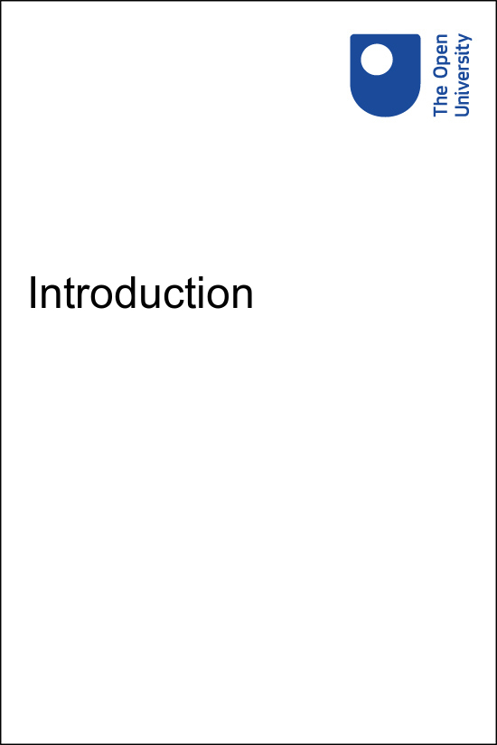

LXG001_1 Getting started with German 1

Introduction

About this free course
This free course is an adapted extract from the Open University course developed from extract parts of LGXG001 - Beginners German 1: fang an! - https://www.open.ac.uk/courses/short-courses/lgxg001.
This version of the content may include video, images and interactive content that may not be optimised for your device.
You can experience this free course as it was originally designed on OpenLearn, the home of free learning from The Open University –
Getting started with German 1
There you’ll also be able to track your progress via your activity record, which you can use to demonstrate your learning.
Copyright © 2020 The Open University
Intellectual property
Unless otherwise stated, this resource is released under the terms of the Creative Commons Licence v4.0 http://creativecommons.org/licenses/by-nc-sa/4.0/deed.en_GB. Within that The Open University interprets this licence in the following way: www.open.edu/openlearn/about-openlearn/frequently-asked-questions-on-openlearn. Copyright and rights falling outside the terms of the Creative Commons Licence are retained or controlled by The Open University. Please read the full text before using any of the content.
We believe the primary barrier to accessing high-quality educational experiences is cost, which is why we aim to publish as much free content as possible under an open licence. If it proves difficult to release content under our preferred Creative Commons licence (e.g. because we can’t afford or gain the clearances or find suitable alternatives), we will still release the materials for free under a personal end-user licence.
This is because the learning experience will always be the same high quality offering and that should always be seen as positive – even if at times the licensing is different to Creative Commons.
When using the content you must attribute us (The Open University) (the OU) and any identified author in accordance with the terms of the Creative Commons Licence.
The Acknowledgements section is used to list, amongst other things, third party (Proprietary), licensed content which is not subject to Creative Commons licensing. Proprietary content must be used (retained) intact and in context to the content at all times.
The Acknowledgements section is also used to bring to your attention any other Special Restrictions which may apply to the content. For example there may be times when the Creative Commons Non-Commercial Sharealike licence does not apply to any of the content even if owned by us (The Open University). In these instances, unless stated otherwise, the content may be used for personal and non-commercial use.
We have also identified as Proprietary other material included in the content which is not subject to Creative Commons Licence. These are OU logos, trading names and may extend to certain photographic and video images and sound recordings and any other material as may be brought to your attention.
Unauthorised use of any of the content may constitute a breach of the terms and conditions and/or intellectual property laws.
We reserve the right to alter, amend or bring to an end any terms and conditions provided here without notice.
All rights falling outside the terms of the Creative Commons licence are retained or controlled by The Open University.
Head of Intellectual Property, The Open University
978-1-4730-3177-7 (.kdl)
978-1-4730-3178-4 (.epub)

Contents
- Introduction
- Open Centre for Languages and Cultures
- Acknowledgements

Introduction
Welcome to this free course, Getting started with German 1.

Figure 1
View description - Figure 1

This course will take you on a journey through Germany, Austria and Switzerland and introduce you to the language skills you need to start understanding and using German.
You will start from the basics – simple greetings, introducing yourself and using numbers. In this 2-week course you’ll progress towards being able to join conversations in German.
So, how will it work? Each week comprises 3–4 hours of activities, such as quizzes, reading and listening materials and tips about language learning. It’s a good idea to keep notes, either on paper, or on your preferred digital device; in any case, each week you’ll be encouraged to add to your own personal language notebook and decide how best you can go about memorising and practising key phrases and vocabulary.
Some of the activities encourage you to record yourself speaking German, for example on a mobile or tablet. Once you have recorded a word or sentence you can listen to yourself and, often, there will be a model answer for you to compare your own recording to. This will help you improve your accent and develop confidence when speaking. So, you might want to think about which recording tool or software to use for those exercises.
First of all, however, take some time to decide how you’ll allocate time to your studies. Learning German, like learning any language, is a gradual process; it’s often described as ‘a marathon, not a sprint.’ ‘Little and often’ is the best approach, so if at all possible, spread your 3–4 hours over the week, rather than devoting one whole afternoon or evening. This will give you plenty of opportunities to revisit vocabulary and language structures, to revise quickly what you did last time and above all to practise and consolidate. This is the best way to learn vocabulary and perfect your accent.
The course lasts two weeks, with approximately three hours of study each week. You can work through the course at your own pace, so if you have more time one week there is no problem with pushing on to complete another week’s study.
After completing this course, you will be able to:
- say hello, goodbye and some of the first phrases you might use when meeting a German speaker
- count from one to ten
- understand the basic rules of German pronunciation
- pronounce different German-speaking countries and places
- introduce oneself and say where one is from.

Open Centre for Languages and Cultures
This course has been developed from extract parts of LGXG001 - Beginners German 1: fang an!. The Open University has launched a dedicated learning centre called The Open Centre for Languages and Cultures. OpenLearn is supporting this project and is providing extracted units of all courses on The Open Centre in our dedicated Language and cultures Hub.
The Open Centre for Languages and Cultures is the exciting new home for non-accredited language and intercultural communication short courses. You can study a wide range of language and language related subjects with us anywhere in the world, in any time zone, whatever your motivation – leisure, professional development or academic.
It’s the one stop shop for engaging with languages, professional communication and intercultural dialogue.
Our short courses allow us to be agile and responsive to the needs of learners who want to be part of a global society. We offer non-accredited short courses in a range of subjects including modern languages and languages for business and the workplace. We are also leading the way in developing short courses for academic research methods and pre-sessional English with IELTS, which will be available for registration in due course.
The Open Centre for Languages and Cultures is an international leader in online language learning and intercultural communications, built on our pioneering pedagogy and research.

What makes the Open Centre different?
- The OU is the leader in online learning and teaching with a heritage of more than 50 years helping students achieve their learning ambitions.
- The short courses are underpinned by academic rigour and designed by native speakers experienced in producing engaging materials for online learning of languages and cultures.
- The graduating nature of the courses means that learners can build up their language and skills over time.
- Learners will also gain a better understanding of the culture(s) associated with the language(s) they study enabling the development of intercultural communication skills.
- Learners can mix and match the short courses and study more than one course at a time.
Once this course is complete you will be directed to OpenLearn's hub for language content where you will be able to build on your newly found language skills.
Now that you’re fully prepared, it’s time to start on Week 1.
Los geht’s! Let’s start!

Acknowledgements
This free course was first published in December 2020.
Except for third party materials and otherwise stated (see terms and conditions), this content is made available under a Creative Commons Attribution-NonCommercial-ShareAlike 4.0 Licence.
The material acknowledged below and within the course is Proprietary and used under licence (not subject to Creative Commons Licence). Grateful acknowledgement is made to the following sources for permission to reproduce material in this free course:

Images
Course image: Image by Kai Pilger from Pixabay
Introduction, Figure 1: jakobradlgruber / 123rf
Every effort has been made to contact copyright owners. If any have been inadvertently overlooked, the publishers will be pleased to make the necessary arrangements at the first opportunity.
Don't miss out
If reading this text has inspired you to learn more, you may be interested in joining the millions of people who discover our free learning resources and qualifications by visiting The Open University – www.open.edu/openlearn/free-courses.

Figure 1

Description
Young woman riding a bicycle in Berlin
Back to - Figure 1

