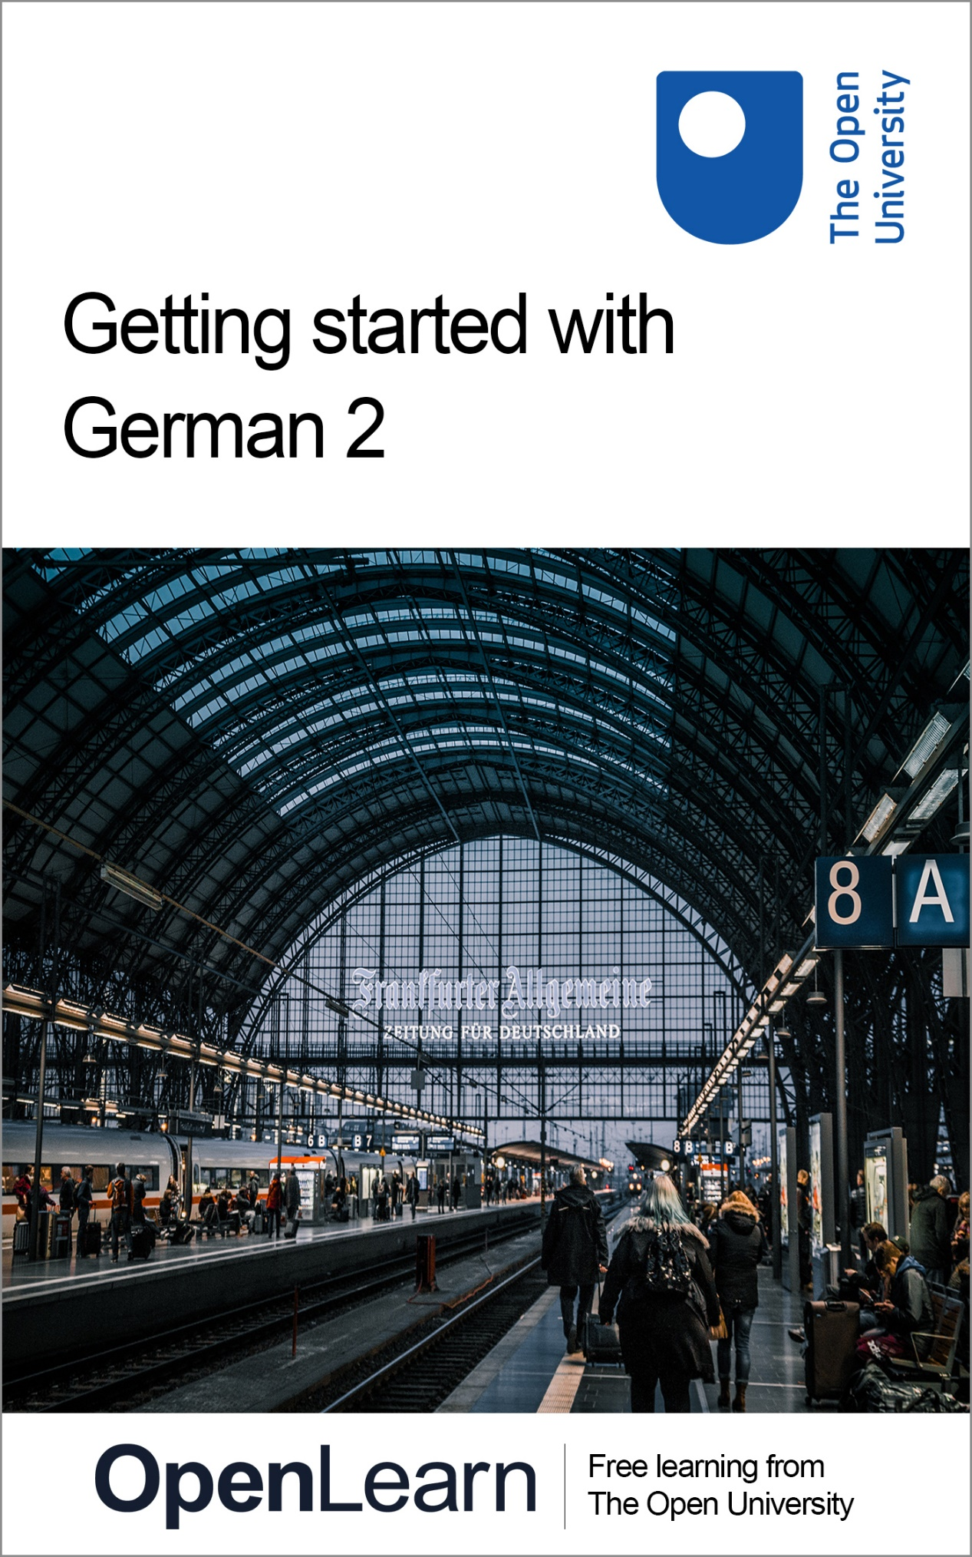

LXG002_1

Getting started with German 2

About this free course
This free course is an adapted extract from the Open University course developed from extract parts of LXG002 Beginners German 2: mit Vergnügen! - http://www.open.ac.uk/courses/short-courses/lxg002.
This version of the content may include video, images and interactive content that may not be optimised for your device.
You can experience this free course as it was originally designed on OpenLearn, the home of free learning from The Open University –
Getting started with German 2
There you’ll also be able to track your progress via your activity record, which you can use to demonstrate your learning.
Copyright © 2021 The Open University
Intellectual property
Unless otherwise stated, this resource is released under the terms of the Creative Commons Licence v4.0 http://creativecommons.org/licenses/by-nc-sa/4.0/deed.en_GB. Within that The Open University interprets this licence in the following way: www.open.edu/openlearn/about-openlearn/frequently-asked-questions-on-openlearn. Copyright and rights falling outside the terms of the Creative Commons Licence are retained or controlled by The Open University. Please read the full text before using any of the content.
We believe the primary barrier to accessing high-quality educational experiences is cost, which is why we aim to publish as much free content as possible under an open licence. If it proves difficult to release content under our preferred Creative Commons licence (e.g. because we can’t afford or gain the clearances or find suitable alternatives), we will still release the materials for free under a personal end-user licence.
This is because the learning experience will always be the same high quality offering and that should always be seen as positive – even if at times the licensing is different to Creative Commons.
When using the content you must attribute us (The Open University) (the OU) and any identified author in accordance with the terms of the Creative Commons Licence.
The Acknowledgements section is used to list, amongst other things, third party (Proprietary), licensed content which is not subject to Creative Commons licensing. Proprietary content must be used (retained) intact and in context to the content at all times.
The Acknowledgements section is also used to bring to your attention any other Special Restrictions which may apply to the content. For example there may be times when the Creative Commons Non-Commercial Sharealike licence does not apply to any of the content even if owned by us (The Open University). In these instances, unless stated otherwise, the content may be used for personal and non-commercial use.
We have also identified as Proprietary other material included in the content which is not subject to Creative Commons Licence. These are OU logos, trading names and may extend to certain photographic and video images and sound recordings and any other material as may be brought to your attention.
Unauthorised use of any of the content may constitute a breach of the terms and conditions and/or intellectual property laws.
We reserve the right to alter, amend or bring to an end any terms and conditions provided here without notice.
All rights falling outside the terms of the Creative Commons licence are retained or controlled by The Open University.
Head of Intellectual Property, The Open University
978-1-4730-3212-5 (.kdl)
978-1-4730-3213-2 (.epub)

Contents
- Introduction
  - Introduction
  - Open Centre for Languages and Cultures
- Week 1: Frühstück!
  - Introduction
  - 1 At the breakfast table
  - 2 Let’s have breakfast!
  - 3 Practising the irregular verb essen
  - 4 Was essen Sie zum Frühstück?
  - 5 Was essen Sie zum Frühstück?
  - 6 The irregular verb nehmen
    - 6.1 Checking verb forms in your dictionary
  - 7 Wurstsorten, Brotsorten
  - 8 Food vocabulary
  - 9 This week’s quiz
  - 10 Summary of Week 1
- Week 2: Ich esse gern…
  - Introduction
  - 1 The adverb gern
  - 2 gern, sehr gern, nicht gern
  - 3 What do you like to eat?
  - 4 My favourite cuisine
  - 5 More likes and dislikes
  - 6 Pronunciation
  - 7 Writing about likes and dislikes
  - 8 This week’s quiz
  - 9 Summary of Week 2
  - Next steps
- Acknowledgements
- Solutions

Introduction

Introduction
Almost 100 million people speak German as their main language. Most of them live in Germany, Austria and Switzerland, making German one of the most widely used languages in Europe. Now associated with economic success, science and technology, German also has a long-standing reputation as language of poets and thinkers.

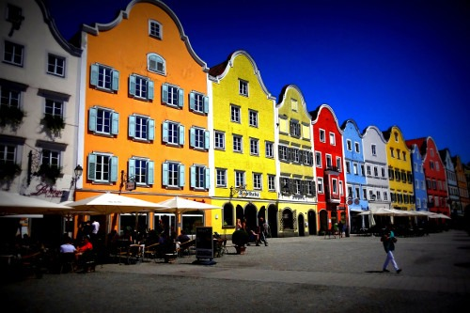
View description - Uncaptioned Figure

In this course you will journey to Germany, Austria and Switzerland and further progress your linguistic skills needed for understanding and using the German language. Studying 3-4 hours a week, the course offers the perfect opportunity to continue the development of skills needed to communicate effectively in German in everyday contexts.
After completing this course, you will be able to:
- understand how to use regular and irregular verbs in the present tense
- use the adverb gern or gerne in a sentence
- discuss food and drink likes and dislikes and talk about a typical breakfast table in German-speaking countries
- appreciate the different strategies for learning vocabulary and using a dictionary to help with verb forms
- understand word order in sentences.

Open Centre for Languages and Cultures
This course has been developed from extract parts of LXG002 - Beginners German 2: mit Vergnügen!. The Open University has launched a dedicated learning centre called The Open Centre for Languages and Cultures. OpenLearn is supporting this project and is providing extracted units of all courses on The Open Centre in our dedicated Language and Cultures Hub.
The Open Centre for Languages and Cultures is the exciting new home for non-accredited language and intercultural communication short courses. You can study a wide range of language and language related subjects with us anywhere in the world, in any time zone, whatever your motivation – leisure, professional development or academic.
It’s the one stop shop for engaging with languages, professional communication and intercultural dialogue.
Our short courses allow us to be agile and responsive to the needs of learners who want to be part of a global society. We offer non-accredited short courses in a range of subjects including modern languages and languages for business and the workplace. We are also leading the way in developing short courses for academic research methods and pre-sessional English with IELTS, which will be available for registration in due course.
The Open Centre for Languages and Cultures is an international leader in online language learning and intercultural communications, built on our pioneering pedagogy and research.

What makes the Open Centre different?
- The OU is the leader in online learning and teaching with a heritage of more than 50 years helping students achieve their learning ambitions.
- The short courses are underpinned by academic rigour and designed by native speakers experienced in producing engaging materials for online learning of languages and cultures.
- The graduating nature of the courses means that learners can build up their language and skills over time.
- Learners will also gain a better understanding of the culture(s) associated with the language(s) they study enabling the development of intercultural communication skills.
- Learners can mix and match the short courses and study more than one course at a time.
Once this course is complete you will be directed to OpenLearn’s hub for language content where you will be able to build on your newly found language skills.
Now that you’re fully prepared, it’s time to start on Week 1.

Week 1: Frühstück!

Introduction
You’ll start this week by looking at a typical breakfast table you could expect to find at many cafés or homes in German-speaking countries.
During the working week, people might be more rushed in the morning, but at weekends breakfast is taken quite seriously. Traditionally, you would often find a range of fresh bread rolls, a boiled egg, ham, cheese and something sweet, like jam, honey and maybe a slice of brioche or a croissant. Cereals, yogurt, fruit and fruit juices are becoming increasingly popular, and there usually is plenty of coffee or tea, too.
While learning about various breakfast options, you will practise using regular and irregular verbs in the present tense. You will also learn new vocabulary to help you to talk about food and drink. To help you memorise these new words, you will look at strategies for learning vocabulary and find out how your dictionary can help you with verb forms.
This OpenLearn course is an adapted extract from the Open University course LXG002 - Beginners German 2: mit Vergnügen!
Viel Spaß!

1 At the breakfast table
In this first activity you’ll test to see what vocabulary you already know for German food and drink, in particular those items you would find around the breakfast table.

Activity 1

Part 1

Interactive content is not available in this format.

Part 2

Would you eat any of these food items first thing in the morning or does your breakfast look quite different? Take a minute to think about what a typical breakfast in your country looks like. What food or drink is the most popular?
Write down in German your five top breakfast items in the box below. In order to do that, you might need to check some words in a dictionary first.

Provide your answer...

2 Let’s have breakfast!
Now have a go at Activity 2, in which you’ll hear people describing what they usually eat for breakfast.

Activity 2

Listen to three people saying what they usually eat for breakfast. From the list below, select all words you can hear. Some words are mentioned more than once.

Audio content is not available in this format.
View transcript - Uncaptioned interactive content

Kaffee
Honig
Milch
Müsli
Orangensaft
Ei
Eier
Toast
Tee
Croissant
Brot
Brötchen
Schinken
Wurst
Tomaten
Käse
Oliven
Marmelade
Jogurt
View answer - Activity 2

In Activity 2, apart from German words for certain food and drink, you also heard two important verbs: essen (to eat) and trinken (to drink). Trinken is a regular verb. You might already be familiar with the verb forms in the present tense, but in Table 1, there is a quick reminder.

Table 1 The present tense of the regular verb trinken
trinken
ich trinke | wir trinken
du trinkst | ihr trinkt
er/sie/es trinkt | Sie/sie trinken

The verb essen, however, is slightly irregular. Like some other irregular verbs – for example sprechen (to speak) or fahren (to travel) – you can see that there is a vowel change in the 2nd and 3rd person singular.

Table 2 The present tense of the irregular verb essen
essen
ich esse | wir essen
du isst | ihr esst
er/sie/es isst | Sie/sie essen

3 Practising the irregular verb essen
You’ll now practise using the irregular, but very common verb essen that was introduced in the last section.

Activity 3

Interactive content is not available in this format.

Interactive content is not available in this format.

4 Was essen Sie zum Frühstück?
In this section you are going to practise the verb essen again, but also try out a new way to memorise vocabulary.
So far, several new nouns connected to food have been introduced. How many food items can you remember spontaneously? Try to say them out loud – without going back to the previous sections – and see how many new words you can list.
Can you also remember the gender of all those new nouns? Was it der, die or das? It is good to know that the definite article (der/die/das) is not needed when you refer to a food item in general terms. For example, you would say: Ich esse Brot und Käse zum Frühstück. Ich trinke Kaffee.
However, if you refer to a ‘unit’ of food, you would use the indefinite article. For example: Ich esse ein Ei und trinke ein Glas Orangensaft (one egg, one glass of orange juice). Therefore, you will need to know the gender of the noun you want to use such as ein Ei (nt.) but eine Banane (f.).
So, as always, it is important to memorise the article with any new noun you learn. But how to remember all those new words? Images can be a great help. Try this: First, start learning new words in connection with pictures – word and image together. The next step is to cover the words and, just using the pictures, name the German word that is depicted with its correct article.

Activity 4

Try this method with the following six food items.

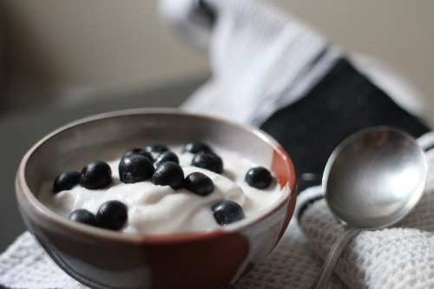
Figure 1 die (or das) Jogurt
View description - Figure 1 die (or das) Jogurt

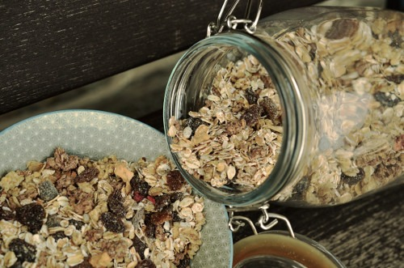
Figure 2 das Müsli
View description - Figure 2 das Müsli

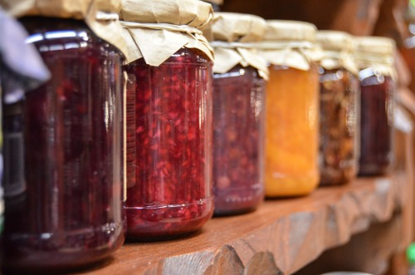
Figure 3 die Marmelade
View description - Figure 3 die Marmelade

Figure 4 das Ei
View description - Figure 4 das Ei

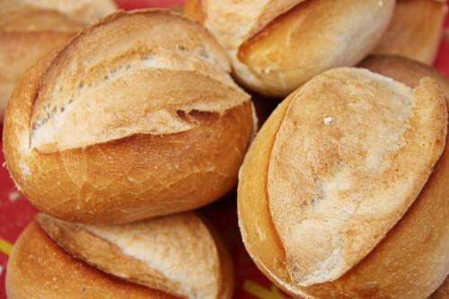
Figure 5 das Brötchen / die Brötchen (pl)
View description - Figure 5 das Brötchen / die Brötchen (pl)

Figure 6 der Käse
View description - Figure 6 der Käse

How did you get on with learning those new words? If you like this method and if it works for you, you could print off the photo of the breakfast table in Section 1 and write in the words for the food and drink featured. Alternatively, you can make your own mind map or posters in your notebook to help you learn new vocabulary. Like in Activity 4, start with a few words (five or six) and then build up your list slowly.
Now, remembering the new vocabulary you have just learny, have a go at Activity 5.

Activity 5

In this activity you will only see the picture clues to answer a question and test your vocabulary. It is important that in your answer, you use the same form of the verb as is used in the question. For example, if the verb in the question is used in the 3rd person singular (er or sie), use the same form in the answer. If the plural form is used in the question, your answer will also use a plural form. Replace any names with personal pronouns. For example, die Familie becomes sie (because die Familie is a feminine noun) but Herr König becomes er: The clue is in the title Herr (Mister).
Here is an example:

Question: Was isst die Familie Grünberg zum Frühstück?

Figure 7
View description - Figure 7

Answer: Sie isst Jogurt.

Now you have a go.
Please note that case is important for each of the question parts below.

Interactive content is not available in this format.

Interactive content is not available in this format.

Interactive content is not available in this format.

Interactive content is not available in this format.

Und Sie? Was essen Sie zum Frühstück?
Write your answer in the notebook. In the next section, you’ll practise talking about breakfast.

5 Was essen Sie zum Frühstück?
Now you are equipped with a lot of new vocabulary and know the forms of the verb essen, you can focus on speaking about breakfast. Use the audio in Activity 6 to practise asking questions and responding to them.
Focus in particular on the pronunciation of any new words. Do this activity several times until you are happy with the pronunciation and you feel your answer sounds natural. Then record yourself using a mobile device and check the recording to see if you need to keep working on your pronunciation.

Activity 6

Part 1

Listen to the questions and answers on the audio and repeat what you hear.

Audio content is not available in this format.
View transcript - Uncaptioned interactive content

Part 2

Now go back to your notes from the previous section. There you answered the question:

Was essen Sie zum Frühstück?

Record your answer. Why not talk about other people too? What about your partner, siblings, parents, friends or children? What do they have for breakfast? Say out loud a few sentences about their eating habits and then record yourself. You might want to take a few notes first (in particular to remind yourself of the correct forms of essen you will need.)
Here is an example for how you could start.

Ich esse Toast mit Marmelade zum Frühstück und ich trinke Tee. Aber meine Kinder essen Cornflakes mit Milch und trinken Orangensaft. Mein Mann isst….

6 The irregular verb nehmen
You’ll now look at another common but slightly irregular verb. Table 3 shows the present tense (Präsens) of the verb nehmen (to take). As you can see, similar to essen, only the second and third person singular (du and er/sie/es) forms of nehmen are irregular.

Table 3 The present tense of the irregular verb nehmen
nehmen
ich nehme | wir nehmen
du nimmst | ihr nehmt
er/sie/es nimmt | Sie/sie nehmen

You can use the verb nehmen to replace the verbs essen and trinken, especially if there is a choice or you want to refer to drink and food (essen can only be used with food, trinken only with drinks, but nehmen can be used for either or both).

Activity 7

Part 1

Imagine you are having breakfast at a cafe or hotel and can chose any five items from this buffet. What would you choose?

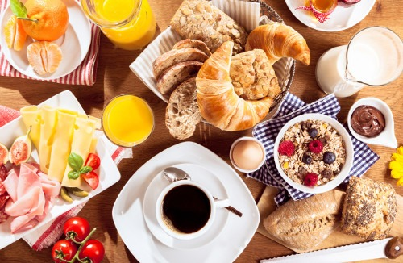
Figure 8 A breakfast table
View description - Figure 8 A breakfast table

List your choices, using the verb nehmen. Click on ‘reveal answer’ to see a model response
Was nehmen Sie?

Provide your answer...
View answer - Part 1

Part 2

Now try using other forms of the verb nehmen.

Interactive content is not available in this format.

Part 3

Now write your own sentences. Here are two examples for you, but you don’t have to stop there. Write some more sentences in your notebook. Or even better, come back to this activity another time, practising the verb nehmen to check that you can still remember all its different forms.

Write one sentence saying what Christina is having. Use the verb nehmen and the picture clue to help you construct your sentence.
Please note case is important.

Interactive content is not available in this format.

Interactive content is not available in this format.

6.1 Checking verb forms in your dictionary
So far this week you have learned two irregular verbs essen and nehmen. These are very common ones, but of course there are others. So, how would you know whether a new verb you want to use is regular or irregular? Box 1 explains how you can use a dictionary to check not only the meaning of a word, but also some grammar.

Box 1 Using a dictionary to check verb forms
Many dictionaries indicate in the German–English section if a verb is irregular, for example by using the abbreviation unreg. (unregelmäßig).
This week you have come across the verbs essen and nehmen, which have irregular du (second person singular) and er/sie/es (third person singular) forms. You might already know some others such as fahren, schlafen, sprechen etc. In order to add more verbs to the list you need to find the pages in your dictionary that list irregular (sometimes described as ‘strong’) verbs. Dictionaries usually contain lists of irregular verbs which give the er/sie/es form and the du form.

7 Wurstsorten, Brotsorten
Another useful verb when discussing breakfast is frühstücken (to have breakfast). This verb is regular though, so you can say Ich frühstücke im Garten (I have breakfast in the garden) or Frau Meyer frühstückt im Hotel (Ms Meyer has breakfast at the hotel).

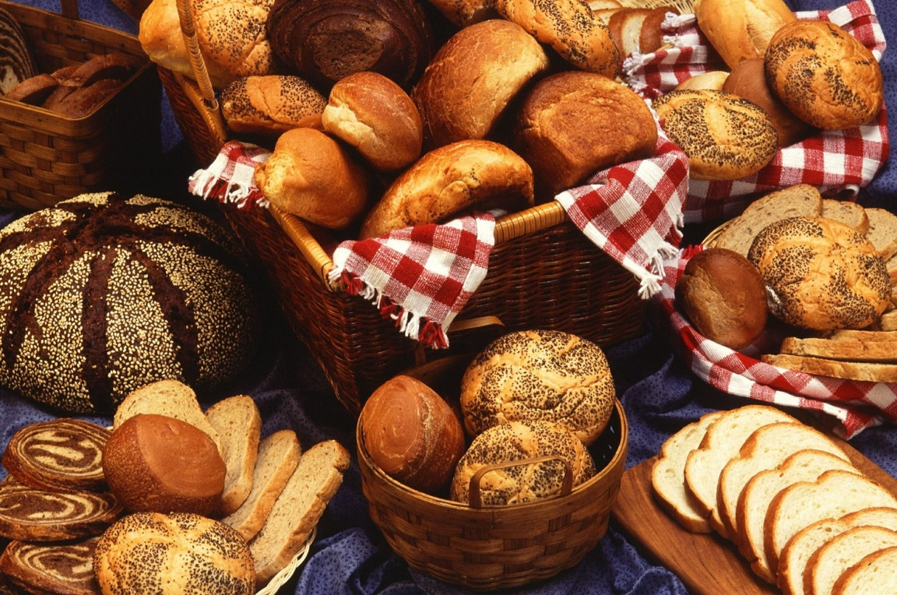
View description - Uncaptioned Figure

Activity 8

In audio below, you will hear frühstücken used in the question Was frühstücken Sie? Listen to the answer and tick all the food items that are mentioned.

Audio content is not available in this format.
View transcript - Uncaptioned interactive content

Brötchen
Ei
Wurst
Marmelade
Honig
Käse
Schinken
Tee
Kaffee
Orangensaft
View answer - Activity 8

Activity 9

You might have already heard that Wurst (thinly sliced cold sausage and other meat cuts) are a popular food item in German-speaking countries. There are many different varieties (die Sorte; pl: die Sorten).
The man in the audio in Activity 8 refers to Wurstsorten (different types of cold meat) but you can apply this word to other food and drink such as Brotsorten (different types of bread, of which there are many in German speaking countries ), Obstsorten (types of fruit) or Weinsorten, Biersorten etc.

Interactive content is not available in this format.

8 Food vocabulary
You have been learning so many new words this week, let’s see what you can remember.

Activity 10

Listen to the audio – you have heard the first part already in the last section – and place the images of these breakfast items in the correct order, as mentioned in the audio.

Audio content is not available in this format.
View transcript - Uncaptioned interactive content

1.
2.
3.
4.
5.
6.
7.
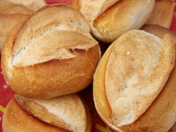
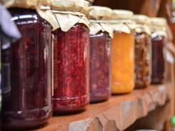
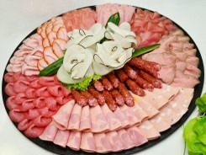
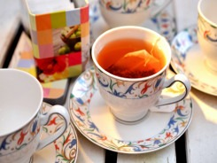
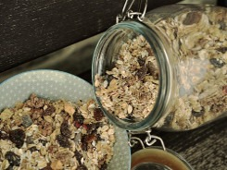
View answer - Activity 10

9 This week’s quiz
Check what you’ve learned this week by taking the end-of-week quiz.
Week 1 quiz
Open the quiz in a new window or tab (by holding ctrl [or cmd on a Mac] when you click the link), then return here when you have done it.

10 Summary of Week 1
How did you get on with this first week of the course? You learned about some common but irregular verbs (essen and nehmen) forms. What about regular verb forms? Can you remember all the endings needed in the present tense or do you need to revise them before moving on?
There was a lot of new vocabulary, too. What about the vocabulary learning strategies you have tried this week. Were they helpful? Make a note in your language notebook. Whichever method you decide to use to memorise vocabulary, remember to always learn the gender (der/die/das) with a new noun and any irregular endings with a new verb.
When learning lots of new vocabulary you will find that you can be selective and focus on language that is important to you. For example, if you are a vegetarian, you might be less interested in the varieties of cold meat available at a German breakfast table. Start with what is relevant to you and then build your pool of vocabulary slowly.
Next week, you will start expressing opinions – saying what you like or don’t like to eat or drink. You will also be working more on your pronunciation skills. Before moving on though, reflect a little on what you’ve been learning. In the box below, note down what you’ve found easy, useful or fun, and what was more difficult this week.

Week 1 Reflection

What was easy, useful or fun this week?

Provide your answer...

What was more difficult?

Provide your answer...

You can now go to Week 2.

Week 2: Ich esse gern…

Introduction
Last week introduced some vocabulary you need when talking about breakfast. This week you will build on that and say what food and drink you actually like and what you are not so keen on.

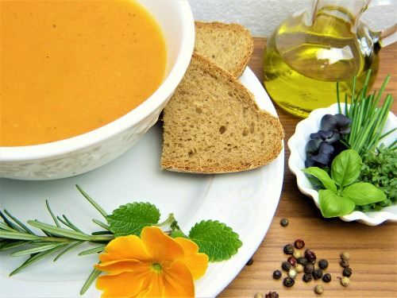
View description - Uncaptioned Figure

To express likes and dislikes, the adverb gern or gerne (both versions are used by native speakers and there is absolutely no difference between them) is extremely useful. To use the adverb in a sentence, you’ll need to look at word order and practise constructing your own sentences. In addition, this week you will have an opportunity to work on your speaking skills and pronunciation.
First, you will revise some vocabulary to get you talking.
Guten Appetit! Enjoy your meal!

1 The adverb gern
If you want to say what you like to do in German, you can do so by just adding the word gern after the verb (you may also hear people say gerne). The verb itself (for example ich esse, ich trinke) stays the same. Think of gern as meaning ‘with pleasure’.

Activity 1

Complete the sentences below by following the prompt and adding the correct form of essen or trinken in the gap.
The sentences will also show where in the adverb gern should be placed.
Here is an example:

Complete this question using the correct form of essen:
Was _________Sie gern zum Frühstück?
Answer: Was essen Sie gern zum Frühstück?

Please note that case is important when answering the questions below.

Interactive content is not available in this format.

Interactive content is not available in this format.

Interactive content is not available in this format.

2 gern, sehr gern, nicht gern
Now, some things you will like more than others. How can you say that you like something very much, or a little, or not at all?

Activity 2

Look at these smiley or not so smiley faces. Which variations of gern do you think matches which emoji? Please note the words for ‘not’ (nicht) and for ‘especially/particularly’ (besonders).
Drag and drop the expressions to match the images. If you’re unsure whether you’re correct, just click on‚ ‘reveal answer’ to check.

besonders gern
überhaupt nicht gern
gern
nicht gern
nicht so gern
sehr gern
View answer - Activity 2

Box 1 Expressing likes and dislikes
It’s worth remembering that gern is an adverb. It adds further information about the verb and, therefore, needs to be close to it. In a basic statement, only negations (e.g. nicht, überhaupt nicht) or graduations (e.g. sehr, total, besonders) should come between the verb and gern.
Here are some examples

Table 2 Using gern in a sentence
Florian isst Fleisch. | Florian eats meat.
Florian isst gern Fleisch. | Florian likes to eat meat.
Anna trinkt Kakao. | Anna drinks cocoa.
Anna trinkt gern Kakao. | Anna likes to drink cocoa.

To say you like it very much, add sehr gern; to say you don’t like something, add nicht gern.

Table 3 Using sehr gern and nicht gern
Ich trinke sehr gern Wein. | I like (to drink) wine very much.
Er isst nicht gern Gemüse. | He doesn’t like (to eat) vegetables.

3 What do you like to eat?
Now have a go at Activity 3.

Activity 3

Part 1

Interactive content is not available in this format.

Part 2

There were a couple of new words in this activity. Can you guess their meaning?
- im Restaurant
- griechisch

View answer - Part 2

Part 3

Now, use your language notebook to write your own answers to the following questions. You will need to decide which of the variations of gern that were introduced in the previous secton you wish to use.
You can see a model answer for each question in the feedback. This should help you check that the general structure of your sentences is correct, but your response to the questions might look quite different.
- Essen Sie gern Käse? (Do you like to eat cheese?)
- Trinken Sie gern Kaffee? (Do like to drink coffee?)
- Kochen Sie gern italienisch? (Do you like to cook Italian food?)
- Gehen Sie gern ins Restaurant? (Do you like go to a restaurant?)

View answer - Part 3

4 My favourite cuisine
What type of food do you like best? Activity 4 looks at some of the popular cuisines.

Activity 4

Read the sentences and match them with their English translations. Then check your answers.
Some of the words describing popular cuisines you have come across already, others you might be able to guess.

I like to eat Chinese.
I like to eat Italian.
I like to eat Indian.
I like to eat Mexican.
I like to eat Greek.
I like to eat French.
Ich esse gern chinesisch.
Ich esse gern italienisch.
Ich esse gern indisch.
Ich esse gern mexikanisch.
Ich esse gern griechisch.
Ich esse gern französisch.
View answer - Part

What is your favourite cuisine? If it isn’t one of the above, you might have to check the word in the dictionary. Write down your answer, then read out the German sentences, including your own answer to practise. Once you feel confident enough, record yourself on a mobile device.

5 More likes and dislikes
You’ll now build some more sentences expressing likes and dislikes. You can use the adverb gern and all associated expressions with any verb – it does not have to refer to food and drink – but you will need to consider the word order carefully. Remember that the verb usually comes second in a statement. The adverb gern then has to be placed close to the verb it refers to. However, if you want to express a dislike, the word nicht has to be even closer to the verb.

Activity 5

Place the words in the correct order to create five sentences.

Interactive content is not available in this format.

Interactive content is not available in this format.

Interactive content is not available in this format.

Interactive content is not available in this format.

Interactive content is not available in this format.

6 Pronunciation
You have come across quite a few words containing ch during the last two weeks. For example, you have used the words Milch and Brötchen.
Use the audio below several times to practise the German ch-sound. Practise your pronunciation as you listen and repeat what you hear in the recording. Then record yourself using a mobile device in order to check that your pronunciation is similar to the one you can hear in the audio.

Audio content is not available in this format.
View transcript - Uncaptioned interactive content

Activity 6

The figure below shows an image of a famous chocolate cake from Vienna: die Sachertorte.

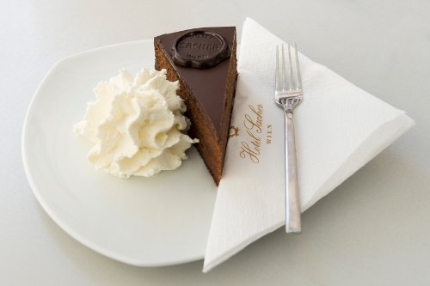
View description - Uncaptioned Figure

To practise the pronunciation and use of gern, nicht gern etc, listen and repeat the questions that are asked in the audios below about this cake and other food and drink. Then record yourself answering the questions. Model answers are given in the feedback, although of course your likes and dislike might be different!

Interactive content is not available in this format.

Interactive content is not available in this format.

Interactive content is not available in this format.

Interactive content is not available in this format.

Interactive content is not available in this format.

Interactive content is not available in this format.

7 Writing about likes and dislikes
In this final section, you will practise writing about likes and dislikes. Use the key in Table 4 to complete Activity 7 and say what you and other people like or don’t like. Then think of a few more sentences about your own personal preferences. Write them down in your language notebook.

Table 4 Like and dislike key
= gern | = nicht so gern
= sehr gern | = nicht gern
= besonders gern | = überhaupt nicht gern

Activity 7

Beispiel/Example
(Thomas/essen) Tomaten; Obst; Pfirsiche
Answer: Thomas isst nicht gern Tomaten. Er isst sehr gern Obst. Er isst besonders gern Pfirsiche.

(Frau Meyer/trinken) Saft; Wein; Bier

Provide your answer...

(ich/kochen) italienisch; mexikanisch; chinesisch

Provide your answer...

(wir/essen) Wurst; Schinken; Käse

Provide your answer...

(Thorsten/gehen) ins Museum; ins Theater; ins Restaurant

Provide your answer...

Was essen Sie gern?

Provide your answer...

Was trinken Sie gern?

Provide your answer...

Was kochen Sie gern?

Provide your answer...

8 This week’s quiz
Check what you’ve learned this week by taking the end-of-week quiz.
Week 2 quiz
Open the quiz in a new window or tab (by holding ctrl [or cmd on a Mac] when you click the link), then return here when you have done it.

9 Summary of Week 2
This week you learned how to say what you like and dislike using the adverb gern or gerne. Combining this with the vocabulary you were introduced to in Week 1 you have been able to practise your speaking, listening and writing skills.
Before you move on, take some time to check that your language notebook is up-to-date, and reflect a little on what you’ve been doing this week.
What was most difficult this week? Why? You can record your reflections here.

Week 2 Reflection

What was most useful this week? Why?

Provide your answer...

Provide your answer...

How am I going to practice what I learned this week?

Provide your answer...

This OpenLearn course is an adapted extract from the Open University badged course LXG002 - Beginners German 2: mit Vergnügen!
.

Next steps
Learning German will take you on a fascinating journey as you learn about the language and the society and culture of the people who speak it. We hope that you’ll continue your German studies with the Open University on our Beginners German courses:
- LXG001 Beginners German 1: fang an!
- LXG002 Beginners German 2: mit Vergnügen!
- LXG003 Beginners German 3: richtig so!
Or continue your learning adventure on OpenLearn with our free courses in our Languages and Cultures Hub.

Acknowledgements
This free course was first published in February 2021.
Except for third party materials and otherwise stated (see terms and conditions), this content is made available under a Creative Commons Attribution-NonCommercial-ShareAlike 4.0 Licence.
The material acknowledged below and within the course is Proprietary and used under licence (not subject to Creative Commons Licence). Grateful acknowledgement is made to the following sources for permission to reproduce material in this free course:

Images
Introduction
Course image: Photo by Sascha Hormel from Pexels
Introduction image: Image by wurliburli from Pixabay
Week 1
Section 1 and Section 6, Figure 8: stockcreations/Shutterstock
Section 4, Figure 1 and Figure 7: Image by Rohtopia from Pixabay
Section 4, Figure 2 and Section 4, Activity 5, image 2 (muesli): Image by congerdesign from Pixabay
Section 4, Figure 3 and Section 4, Activity 5, image 3 (jam): Image by Michal Jarmoluk from Pixabay
Section 4, Figure 4 and Section 4, Activity 5, image 4 (egg): Piqsels
Section 4, Figure 5 and Section 4, Activity 5, image 5 (bread rolls): Image by Manfred Richter from Pixabay
Section 4, Figure 6 and Section 4, Activity 5, image 6 (cheese): Image by lipefontes0 from Pixabay
Section 6, Activity 7, Part 3, Q1, left image: Image by Jan Vašek from Pixabay
Section 6, Activity 7, Part 3, Q1, right image: Image by congerdesign from Pixabay
Section 6, Activity 7, Part 3, Q2: Image by gadost0 from Pixabay
Section 7: Bild von Public Domain Images onPixabay
Section 8, Activity 10: Tea: Image by congerdesign from Pixabay
Section 8, Activity 10: Coffee: Image by gadost0 from Pixabay
Section 8, Activity 10: Meat platter: Image by congerdesign from Pixabay
Section 8, Activity 10: Orange juice: Image by Jan Vašek from Pixabay
Section 8, Activity 10: Jam: Image by Michal Jarmoluk from Pixabay
Section 8, Activity 10: Muesli: Image by congerdesign from Pixabay
Section 8, Activity 10: Rolls: Image by Manfred Richter from Pixabay
Week 1 Quiz, Question 4: Image by Free-Photos from Pixabay
Week 1 Quiz, Question 5: Image by Nick Stafford from Pixabay
Week 2
Introduction: Image by silviarita from Pixabay
Section 6: Kemter/iStock/Getty
Week 2 Quiz, Question 10: Image by LuckyLife11 from Pixabay
Every effort has been made to contact copyright owners. If any have been inadvertently overlooked, the publishers will be pleased to make the necessary arrangements at the first opportunity.
Don't miss out
If reading this text has inspired you to learn more, you may be interested in joining the millions of people who discover our free learning resources and qualifications by visiting The Open University – www.open.edu/openlearn/free-courses.

Solutions

Activity 2

Answer
Right:
Kaffee
Milch
Müsli
Ei
Toast
Brot
Brötchen
Schinken
Käse
Marmelade
Jogurt
Wrong:
Honig
Orangensaft
Eier
Tee
Croissant
Wurst
Tomaten
Oliven
The correct answers were: Brot, Toast, Marmelade, Käse, Milch, Müsli, Ei, Schinken Brötchen, Kaffee, Jogurt.
Back to - Activity 2

Activity 7

Part 1

Answer
Here is a model. Please note that your answer might be different from the model given.

Ich nehme Brot, Schinken, Käse, ein Ei und Orangensaft.

Back to - Part 1

Activity 8

Answer
Right:
Brötchen
Wurst
Marmelade
Tee
Kaffee
Wrong:
Ei
Honig
Käse
Schinken
Orangensaft
The correct answers are: Brötchen, Marmelade, Wurst, Tee, Kaffee.
Back to - Activity 8

Activity 10

Answer
The correct matches are:
1.
2.
3.
4.
5.
6.
7.
Back to - Activity 10

Activity 2

Answer
The correct matches are:
besonders gern
überhaupt nicht gern
gern
nicht gern
nicht so gern
sehr gern
The correct answer is:

Table 1 Answer to Activity 2
= gern | = nicht so gern
= sehr gern | = nicht gern
= besonders gern | = überhaupt nicht gern

Back to - Activity 2

Activity 3

Part 2

Answer
im Restaurant – in/at a restaurant
griechisch – Greek
Back to - Part 2

Part 3

Answer
Here are some model answers. Please note that your answers may vary from the models given.
- Ich esse nicht so gern Käse.
- Ich trinke überhaupt nicht gern Kaffee.
- Ich koche gern italienisch.
- Ich gehe sehr gern ins Restaurant.
Back to - Part 3

Activity 4

Part

Answer
The correct matches are:
I like to eat Chinese.
Ich esse gern chinesisch.
I like to eat Italian.
Ich esse gern italienisch.
I like to eat Indian.
Ich esse gern indisch.
I like to eat Mexican.
Ich esse gern mexikanisch.
I like to eat Greek.
Ich esse gern griechisch.
I like to eat French.
Ich esse gern französisch.
Back to - Part

Uncaptioned Figure

Description
Market square, row of colourful houses
Back to - Uncaptioned Figure

Figure 1 die (or das) Jogurt

Description
A bowl of yoghurt and berries
Back to - Figure 1 die (or das) Jogurt

Figure 2 das Müsli

Description
Photo of a bowl of muesli
Back to - Figure 2 das Müsli

Figure 3 die Marmelade

Description
A photo of several jars of jam
Back to - Figure 3 die Marmelade

Figure 4 das Ei

Description
Photo of an egg
Back to - Figure 4 das Ei

Figure 5 das Brötchen / die Brötchen (pl)

Description
A photo of breadrolls
Back to - Figure 5 das Brötchen / die Brötchen (pl)

Figure 6 der Käse

Description
Slices of Emmental cheese
Back to - Figure 6 der Käse

Figure 7

Description
Photo of a bowl of yoghurt and berries
Back to - Figure 7

Figure 8 A breakfast table

Description
Breakfast table with coffee, orange juice, bread, cheese, ham, fruit muesli, egg, milk jam and fruit
Back to - Figure 8 A breakfast table

Uncaptioned Figure

Description
Types of German bread
Back to - Uncaptioned Figure

Uncaptioned Figure

Description
Image of a bowl of soup, fresh herbs and some brown bread
Back to - Uncaptioned Figure

Uncaptioned Figure

Description
This is an image of a famous chocolate cake from Vienna: die Sachertorte. It is sitting on a plate with some cream and a fork.
Back to - Uncaptioned Figure

Uncaptioned interactive content

Transcript
Hören Sie bitte.
Interviewerin
Und was essen Sie zum Frühstück?
Mann 1
Ähm, Brot, Toast und Marmelade, Käse, manchmal auch Milch mit Müsli … Ja, das ist es eigentlich.
Interviewerin
Und was essen Sie da zum Frühstück?
Mann 2
Brötchen, Toast mit Marmelade, Käse, ja …
Interviewerin
Und trinken Sie dazu was?
Mann 2
Kaffee.
Interviewerin
Sie trinken Kaffee?
Mann 2
Ja.
Interviewerin
Und was essen und trinken Sie zum Frühstück?
Frau
Ein Ei, Marmelade, Käse, Schinken, Müsli, Toast, Brötchen, Kaffee, Brot, und Jogurt.
Back to - Uncaptioned interactive content

Uncaptioned interactive content

Transcript
Bitte hören Sie und sprechen Sie.
Nummer 1
Was isst Sara zum Frühstück?
→
Sie isst Brötchen.
Nummer 2
Und was trinkt sie?
→
Sie trinkt Kaffee.
Nummer 3
Was essen Herr und Frau Stehmann zum Frühstück?
→
Sie essen Käse.
Nummer 4
Was isst John zum Frühstück?
→
Er isst Cornflakes.
Nummer 5
Und was trinkt er?
→
Er trinkt Orangensaft.
Back to - Uncaptioned interactive content

Uncaptioned interactive content

Transcript
Bitte hören Sie.
1.
Interviewerin
Was frühstücken Sie?
Mann 1
Ja, wir frühstücken Brötchen, Marmelade, verschiedene Wurstsorten, trinken dazu Tee, Kaffee.
Back to - Uncaptioned interactive content

Uncaptioned interactive content

Transcript
Bitte hören Sie.
1.
Interviewerin
Was frühstücken Sie?
Mann 1
Ja, wir frühstücken Brötchen, Marmelade, verschiedene Wurstsorten, trinken dazu Tee, Kaffee.
2.
Interviewerin
Was essen Sie zum Frühstück?
Mann 2
Cornflakes, Müsli.
Interviewerin
Und was trinken Sie?
Mann 2
Einen Orangensaft oder Kaffee.
Back to - Uncaptioned interactive content

Uncaptioned interactive content

Transcript
Hören Sie und sprechen Sie nach.
ich – mich – dich →
Ich trinke Milch. →
Trinkst du Milch? →
Ja, Milch für mich. →
Und für dich? →
Ich trinke nichts. →
Nimmst du ein Brötchen? →
Natürlich! →
Isst du gern griechisch? →
Nein, überhaupt nicht. →
Aber ich esse sehr gern chinesisch. →
Back to - Uncaptioned interactive content

