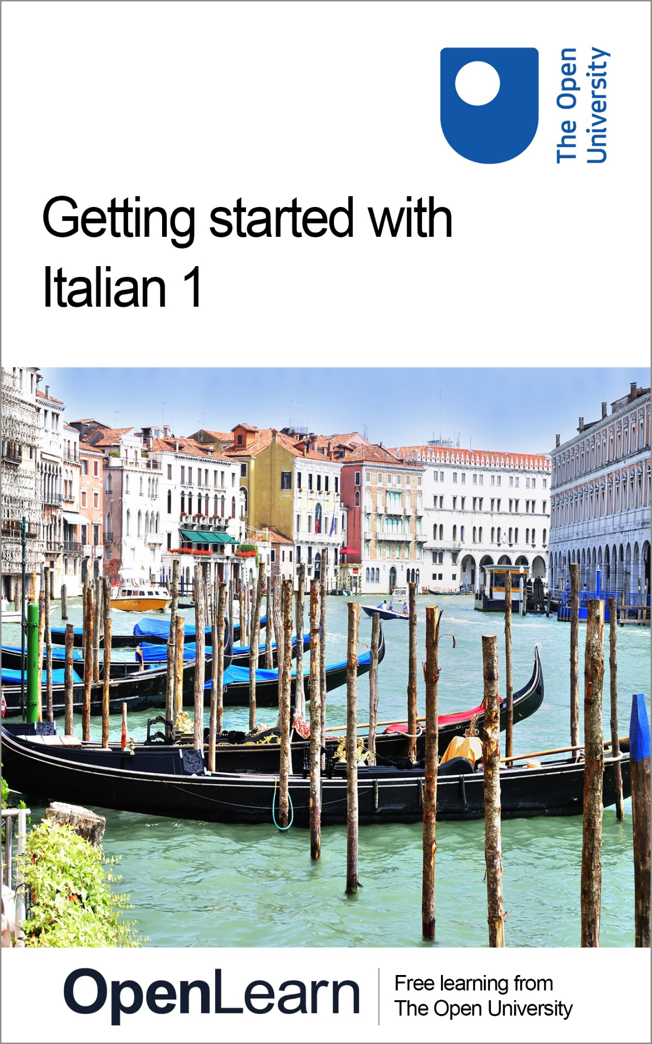

ALT_1

Getting started with Italian 1

About this free course
This free course is an adapted extract from the Open University course developed from extract parts of LXI001 - Beginners Italian 1: primi passi - http://www.open.ac.uk/courses/short-courses/lxi001.
This version of the content may include video, images and interactive content that may not be optimised for your device.
You can experience this free course as it was originally designed on OpenLearn, the home of free learning from The Open University –
Getting started with Italian 1
There you’ll also be able to track your progress via your activity record, which you can use to demonstrate your learning.
Copyright © 2020 The Open University
Intellectual property
Unless otherwise stated, this resource is released under the terms of the Creative Commons Licence v4.0 http://creativecommons.org/licenses/by-nc-sa/4.0/deed.en_GB. Within that The Open University interprets this licence in the following way: www.open.edu/openlearn/about-openlearn/frequently-asked-questions-on-openlearn. Copyright and rights falling outside the terms of the Creative Commons Licence are retained or controlled by The Open University. Please read the full text before using any of the content.
We believe the primary barrier to accessing high-quality educational experiences is cost, which is why we aim to publish as much free content as possible under an open licence. If it proves difficult to release content under our preferred Creative Commons licence (e.g. because we can’t afford or gain the clearances or find suitable alternatives), we will still release the materials for free under a personal end-user licence.
This is because the learning experience will always be the same high quality offering and that should always be seen as positive – even if at times the licensing is different to Creative Commons.
When using the content you must attribute us (The Open University) (the OU) and any identified author in accordance with the terms of the Creative Commons Licence.
The Acknowledgements section is used to list, amongst other things, third party (Proprietary), licensed content which is not subject to Creative Commons licensing. Proprietary content must be used (retained) intact and in context to the content at all times.
The Acknowledgements section is also used to bring to your attention any other Special Restrictions which may apply to the content. For example there may be times when the Creative Commons Non-Commercial Sharealike licence does not apply to any of the content even if owned by us (The Open University). In these instances, unless stated otherwise, the content may be used for personal and non-commercial use.
We have also identified as Proprietary other material included in the content which is not subject to Creative Commons Licence. These are OU logos, trading names and may extend to certain photographic and video images and sound recordings and any other material as may be brought to your attention.
Unauthorised use of any of the content may constitute a breach of the terms and conditions and/or intellectual property laws.
We reserve the right to alter, amend or bring to an end any terms and conditions provided here without notice.
All rights falling outside the terms of the Creative Commons licence are retained or controlled by The Open University.
Head of Intellectual Property, The Open University
978-1-4730-3179-1 (.kdl)
978-1-4730-3180-7 (.epub)

Contents
- Introduction
  - Introduction
  - Open Centre for Languages and Cultures
- Week 1: Drinks and snacks at an Italian bar
  - Introduction
  - 1 Drinks sold at the bar
  - 2 Pronouncing the names of drinks
  - 3 Listening practice
  - 4 Nouns and their gender
  - 5 Distinguishing between masculine and feminine nouns
  - 6 Indefinite articles
  - 7 Practice
  - 8 Un bar tipico
  - 9 Plural nouns
  - 10 Reading a bar menu
  - 11 This week’s quiz
  - 12 Summary of Week 1
- Week 2: Ordering at the bar
  - Introduction
  - 1 Al bar
  - 2 Un caffè per favore
  - 3 Paying for drinks and snacks
  - 4 Desidera?
  - 5 Key phrases
  - 6 Vocabulary practice
  - 7 Speaking practice
  - 8 Historic Italian coffee house
  - 9 Listening for more detail
  - 10 Definite articles
  - 11 This week’s quiz
  - 12 Summary of Week 2
- Acknowledgements
- Solutions

Introduction

Introduction

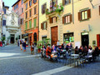
Figure 1
View description - Figure 1

Are you fascinated by the Italian culture and lifestyle, cuisine, historic cities, art and beautiful landscapes? Have you always loved the sound and musicality of the Italian language? Perhaps you’ve visited an Italian city and wished you could chat with local people. Or maybe you would like to be able to read a menu, talk about yourself, or talk about yours or other people’s jobs.
Whatever your reasons for learning Italian, this two-week course gives you a chance to start a new exciting learning experience. You’ll start from the basics to ordering food and drinks at the bar.
Each week comprises of 3–4 hours of interactive activities, explanations, exercises and tips about language learning. It’s a good idea to keep notes either on paper or on your preferred digital device. Each week you’ll be encouraged to revise your notes and to add to your own personal phrase book and decide how best you can go about memorising and practising key phrases and vocabulary. Keep a record of your own learning journey, think about aspects you enjoy and aspects you find challenging and reflect on how you can overcome these challenges; this will help you consolidate your learning as well as adapt your own practice to your own learning style. Throughout the course, you will be invited to reflect on your learning in the consolidation activities at the end of each week.
There is also a weekly quiz for you to practise what you’ve been learning.
You’ll start by learning some vocabulary and expressions related to food and drink, but first of all, take some time to decide how you’ll allocate your time to your studies. Learning Italian, like learning any language, is a gradual process; it’s often described as ‘a marathon, not a sprint.’ ‘Little and often’ is the best approach, so if at all possible, spread your 3–4 hours over the week, rather than devoting one whole afternoon or evening. This will give you plenty of opportunities to revisit vocabulary and language structures, to revise quickly what you did last time and above all to practise and consolidate. This is the best way to learn vocabulary and improve your accent. Don’t forget to take notes of your own learning journey: jot down aspects of your learning that you find enjoyable as well as the challenging ones and think of the ways in which you overcame these challenges.
It’s also a very good idea to involve your family and friends; let them know you’ve decided to start learning Italian and maybe they can help you or leave you in peace when you need to study.
Now that you know what’s in store for you, you are ready to get started.
Buon lavoro!

Open Centre for Languages and Cultures
This course has been developed from extract parts of LXI001 - Beginners Italian 1: primi passi. The Open University has launched a dedicated learning centre called The Open Centre for Languages and Cultures. OpenLearn is supporting this project and is providing extracted units of all courses on The Open Centre in our dedicated Language and Cultures Hub.
The Open Centre for Languages and Cultures is the exciting new home for non-accredited language and intercultural communication short courses. You can study a wide range of language and language related subjects with us anywhere in the world, in any time zone, whatever your motivation – leisure, professional development or academic.
It’s the one stop shop for engaging with languages, professional communication and intercultural dialogue.
Our short courses allow us to be agile and responsive to the needs of learners who want to be part of a global society. We offer non-accredited short courses in a range of subjects including modern languages and languages for business and the workplace. We are also leading the way in developing short courses for academic research methods and pre-sessional English with IELTS, which will be available for registration in due course.
The Open Centre for Languages and Cultures is an international leader in online language learning and intercultural communications, built on our pioneering pedagogy and research.

What makes the Open Centre different?
- The OU is the leader in online learning and teaching with a heritage of more than 50 years helping student achieve their learning ambitions.
- The short courses are underpinned by academic rigour and designed by native speakers experienced in producing engaging materials for online learning of languages and cultures.
- The graduating nature of the courses means that learners can build up their language and skills over time.
- Learners will also gain a better understanding of the culture(s) associated with the language(s) they study enabling the development of intercultural communication skills.
- Learners can mix and match the short courses and study more than one course at a time.
Once this course is complete you will be directed to OpenLearn’s hub for language content where you will be able to build on your newly found language skills.
Now that you’re fully prepared, it’s time to start on Week 1.

Week 1: Drinks and snacks at an Italian bar

Introduction
In this first week, you’ll be learning the names of some drinks and snacks commonly sold in Italian bars. You’ll hear how to pronounce them correctly, and learn some useful phrases for ordering. Finally, we’ll cover the basic principles of masculine and feminine nouns, and using indefinite articles. At the end, you can test your learning with a quick quiz.
This OpenLearn course is an adapted extract from the Open University course LXI001 Beginners Italian 1: primi passi.

1 Drinks sold at the bar
One of the first things visitors do when they visit Italy is enjoy a drink at a bar. You will start by learning the names of some popular drinks.

Activity 1

Drag and drop the names of some popular drinks to its corresponding picture. Start with the ones you are already familiar with and try to guess the ones you don’t know. You may be surprised how many words you are already familiar with or are able to guess.

Interactive content is not available in this format.

2 Pronouncing the names of drinks
Now that you know the names of some drinks, it’s time to learn to pronounce them and learn more.

Activity 2
Listen and repeat the names of different cold and hot drinks, trying to match the pronunciation and intonation of the speaker. Use the transcript to help you follow the audio and to learn how each word is written.

Cold drinks

Audio content is not available in this format.
View transcript - Uncaptioned interactive content

Hot drinks

Audio content is not available in this format.
View transcript - Uncaptioned interactive content

Un caffè, per favore!
You may find coffee-drinking traditions in Italy different from those in the UK or in your own culture. If you ask for un caffé, you will be served an espresso coffee. A caffè ristretto is an espresso which is even more concentrated than usual. An espresso with a tiny amount of milk is a macchiato, sometimes described as a macchiato caldo (if the milk is hot) or a macchiato freddo (if the milk is cold). You might like to try a caffè corretto, a coffee with a drop of a spirit or liqueur such as grappa in it.
For Italians un cappuccino is a morning drink only, never taken after a meal. If you want a long coffee, you should ask for un caffè americano. Another milky but not so frothy coffee is un caffelatte, which is sometimes served in hotels at breakfast.
Such is the importance of coffee in Italian life that some customers pay for two coffees, one to drink themselves and one paid for in advance as a charitable act for anyone in need who might drop in in the hope of a free coffee – the so-called caffè sospeso.

3 Listening practice
Now have a go at Activity 3.

Activity 3

A group of friends are ordering drinks from a waiter. Listen and identify the drinks mentioned. Then write down the names of the drinks in Italian.

Audio content is not available in this format.
View transcript - Uncaptioned interactive content

Provide your answer...
View answer - Activity 3

Per favore, grazie, prego
The expression per favore (‘please’) is used much less often than ‘please’ is in English. It is not considered impolite to omit per favore when asking for something.
On the other hand, grazie (‘thank you’) is used often.
It is customary to respond to grazie by saying prego. This means ‘not at all / you’re welcome / don’t mention it’ (the literal meaning is ‘I beg you’) but is used more routinely than these equivalent English expressions.

4 Nouns and their gender

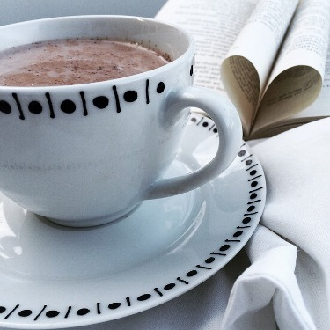
Figure 1
View description - Figure 1

In Activity 3 you heard people ordering una birra and un bicchiere di vino bianco, among other drinks. In Italian the word for beer (birra) is feminine, while the word for glass (bicchiere) is masculine. Read the following explanation to find out about Italian nouns and their grammatical gender and why you need to get to grips with this concept as soon as possible in your Italian studies.

Nouns and their gender
When learning a foreign language for the first time, you will become familiar with simple grammatical terms such as ‘noun’, ‘verb’, ‘adjective’ and so on. People, animals, objects and abstract concepts are all nouns. All Italian nouns – not just people and animals – have a gender; they are either masculine or feminine.
Knowing the gender of nouns is important since it determines the form of the article (‘the’ or ‘a’ in English) that you use with them and the form of the adjectives that describe them.
Nouns ending in -o are usually masculine:
- un aperitivo an aperitif
- uno spuntino a snack
Nouns ending in -a are usually feminine:
- una birra a beer
- un’aranciata an orangeade
Nouns ending in -e are not so easy: some are masculine and some are feminine. Where they relate to people, it is easy to guess their gender.
- un padre a father (masculine)
- una madre a mother (feminine)
But in other cases, you simply have to learn the gender of each noun rather than following a rule.
- maionese mayonnaise (feminine)
It is also possible to identify the gender of some nouns ending in -e by looking at the cluster of letters that precede the -e . For instance, singular nouns ending in -ore are masculine, nouns ending in -zione are feminine.
- un liquore liqueur (masculine)
- una lezione lesson (feminine).
Most words imported into Italian from other languages are masculine:
- un caffè a coffee
- un tè a tea
As for any rule, there are exceptions. If in doubt, a dictionary will tell you the gender of each word.

5 Distinguishing between masculine and feminine nouns
Based on what you have learned so far about masculine and feminine nouns, now try Activity 4.

Activity 4

Interactive content is not available in this format.

Vocabolario
un amaro a digestive liqueur
un cornetto a croissant

6 Indefinite articles

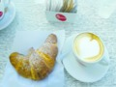
Figure 2
View description - Figure 2

All the nouns you’ve learnt so far are preceded by un, un’ and una. These are called indefinite articles and you will now learn how they are used.

Un caffè e un cornetto
The Italian equivalent of the English ‘a’ or ‘an’ (the indefinite article) is either un, uno, una or un’. The form depends on whether the noun it relates to is masculine or feminine and whether the noun starts with a vowel (a, e, i, o, u) or a consonant.

Masculine nouns
- Use un with most masculine nouns.
  - un bicchiere a glass
  - un aperitivo an aperitif
- Use uno also before a masculine noun beginning with s + consonant (for example sc-, sp-).
  - uno scontrino a receipt
  - uno spuntino a snack
- Use uno before a masculine noun beginning with gn, pn, ps, x, z, or with i or y followed by another vowel.
  - uno zio an uncle
  - uno yogurt a yogurt

Feminine nouns
- Use una with a feminine noun beginning with a consonant.
  - una birra a beer
  - una pizza a pizza
- Use un’ before a feminine noun beginning with a vowel.
  - un’aranciata an orangeade
  - un’acqua minerale a mineral water

7 Practice
Based on what you learned in the previous section, now try Activity 5.

Activity 5
Select the appropriate indefinite articles un, uno, una or un’ for each of the words given below.

1. gelato

un
uno
una
un'
View answer - Part

2. acqua minerale

un
uno
una
un'
View answer - Part

3. succo di frutta

un
uno
una
un'
View answer - Part

4. bicchiere di vino bianco

un
uno
una
un'
View answer - Part

5. scontrino

un
uno
una
un'
View answer - Part

6. amaro

un
uno
una
un'
View answer - Part

7. bar

un
uno
una
un'
View answer - Part

8. pasta

un
uno
una
un'
View answer - Part

9. espresso

un
uno
una
un'
View answer - Part

10. succo di mela

un
uno
una
un'
View answer - Part

11. spremuta

un
uno
una
un'
View answer - Part

12. tè

un
uno
una
un'
View answer - Part

13. pizza

un
uno
una
un'
View answer - Part

8 Un bar tipico
You will now look at how to order more than one item.

Activity 6

When you order more than one item, you need to use a plural noun.
Look at the illustration below of Un bar tipico and match each letter to the corresponding plural noun. Some of the words you have come across already; others will involve some guesswork.

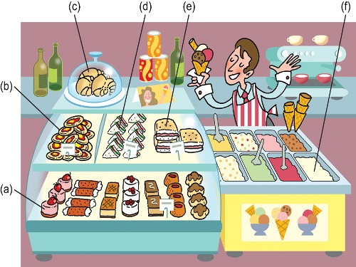
Figure 3 Un bar tipico
View description - Figure 3 Un bar tipico

paste
pizzette
cornetti
tramezzini
panini
gelati
a.
b.
c.
d.
e.
f.
View answer - Activity 6

9 Plural nouns
In Activity 6, you were given examples of nouns in their plural form. In Activity 7 you will match these to their singular form.

Activity 7

All the words in the previous step were in the plural form. Read them again below and match each of them to the corresponding singular form. Then read the explanation below.

pasta
pizzetta
cornetto
tramezzino
panino
gelato
paste
pizzette
cornetti
tramezzini
panini
gelati
View answer - Activity 7

Plural nouns
The different groups of nouns have different plural forms.
- Masculine nouns ending in -o form their plural in -i:
  - un cornetto a croissant - due cornetti two croissants
- Feminine nouns ending in -a form their plural in -e:
  - una pizza a pizza - due pizze two pizzas
- Both masculine and feminine nouns ending in -e form their plural in -i:
  - un liquore a liqueur - due liquori two liqueurs
  - una lezione a lesson - due lezioni two lessons
As you might expect, there are exceptions. Some words do not change form in the plural, such as:
- nouns ending in a consonant and one-syllable nouns:
  - un bar a bar - due bar two bars
- nouns imported from another language:
  - una brioche a brioche - due brioche two brioches
- and nouns with a written accent on their final syllable:
  - un'attività an activity - due attività two activities
  - un caffé a coffee - due caffè two coffees

10 Reading a bar menu
Now have a go at Activity 8.

Activity 8

Look at the price list (listino prezzi) below and, using the box below, write the singular or plural, as appropriate, of each word in it. Notice that the food items are all in the plural form and the drinks are all in the singular.

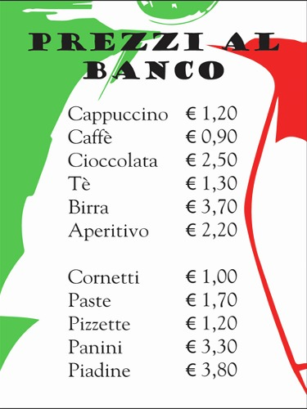
Figure 4
View description - Figure 4

Vocabolario
una piadina a flatbread wrap

Esempio
cornetti (plural) → cornetto (singular)
cappuccino (singular) → cappuccini (plural)

Cappuccino → Caffè → Cioccolata → Tè → Birra → Aperitivo → Cornetti → Paste → Pizzette → Panini → Piadine →
View answer - Activity 8

Lo sapevi?
Al banco o al tavolo
In most cafés in Italian towns there are two sets of prices, both of which, by law, should be clearly displayed: the price you pay standing at the counter (al banco) and the price you pay sitting down at a table (al tavolo). In smaller towns or rural areas, there is usually only one set of prices and you can sit either inside or outside without paying extra.

11 This week’s quiz
Check what you’ve learned this week by taking the end-of-week quiz.
Week 1 quiz
Open the quiz in a new window or tab (by holding ctrl [or cmd on a Mac] when you click the link), then return here when you have done it.

12 Summary of Week 1
It is useful to keep notes on the main points to remember, which could be grammar rules, vocabulary or expressions. The way in which you choose to keep this record of your learning is up to you: a simple paper notebook, an electronic document, mind maps or any means which suits you. It is important that you add to it regularly so that all key learning points are together in one place and easily accessible for reference and revision. Many students also find that writing notes helps them to understand grammar points and to memorise vocabulary and expressions. Adding an example of your own to each rule, term and expression will help you fix them in your memory. A useful tip for you this week is to find a way to keep a record of new vocabulary: you can, for instance, use colour-coded flashcards organised by topics. You could start with two sets of cards, one for drinks and one for food and you could add new words as you learn them.

Keeping a record of your learning

Whether you keep your notes on paper or digitally, it’s important to get organised, so here is an idea that may help, based on your Week 1 studies:

Table 1 Language notebook
Key phrases: | Provide your answer...
Pronunciation: | Provide your answer...
Culture: | Provide your answer...
Language: | Provide your answer...

What would you write into each box, if anything? Would you add more boxes?

Week 2: Ordering at the bar

Introduction

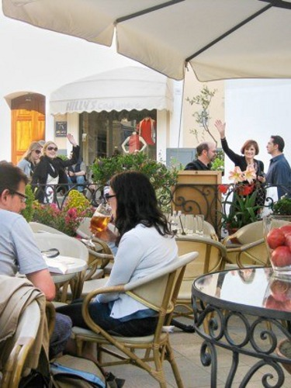
Figure 1
View description - Figure 1

Now that you know the Italian names of the most popular drinks and snacks and can distinguish between masculine and feminine nouns, you are ready to learn how to order them in an Italian caffè. This week you will learn some of the key phrases you’ll need when ordering food and drinks through listening and reading activities. You will also have the opportunity to learn about some of the most famous Italian historic bars and the specialities you can savour when visiting them. Finally, you will look at definite articles and their use before singular and plural nouns.
Have you got a good dictionary? You might need to refer to one for some of the activities this week, so think about how you plan to look words up when you need to. There are many online dictionaries available, or perhaps you prefer to use a printed version. Either way, find one that suits you and that is also reliable and accurate.
Last week you started to keep your own language notebook; this week you’ll be adding to it. In particular we suggest you make notes on the grammar you’ll be studying.
Buon lavoro!

1 Al bar

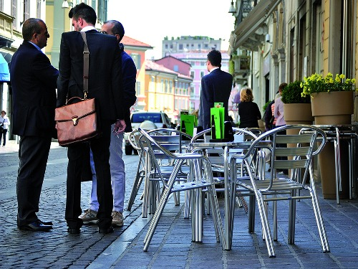
Figure 2 La pausa caffé
View description - Figure 2 La pausa caffé

Il bar is a very important part of Italian life. There are an estimated 121,000 in Italy, usually open from early morning until late evening. The bar is more like a café than an English bar, a place where one can drop in for un caffè during the working day (the so-called pausa caffè) and have a chat with friends and colleagues. Customers often share opinions on a variety of subjects ranging from politics and football, to work, gossip, cinema and fashion.
The Italian bar is probably at its busiest first thing in the morning, when people grab a coffee and a cornetto (‘croissant’) at the counter. It is busy again at lunchtime when those not going home for lunch eat a sandwich or a snack. Finally, in the early evening (at the end of the working day) people drop in for an aperitivo before dinner. Some people might also come and have a drink or an ice cream later in the evening. Most bars, however basic, have small tables on the pavement outside where you can sit and watch the world go by.
Another role played by the bar is that of a corner shop. Most of them will sell you milk if you run out.
The bar-gelateria will sell you ice cream in polystyrene boxes (vaschette) to take home for a special occasion, while at the bar-pasticceria you can buy trays of pasticcini ('little cakes') or dolci such as tiramisu to take to friends’ homes if you are invited for a meal.
Think about bars and cafés in your country. When do people go to them and what for?

2 Un caffè per favore
Based on what you have learnt so far in this course, have a go at Activity 1.

Activity 1

Maria and Piera have met for breakfast in a caffè. Listen to the recording and try to work out what they are ordering. Listen as many times as necessary and then tick the food items and drinks that are mentioned by the speakers.
They seem to be placing their order twice. Do you know why that is?

Audio content is not available in this format.
View transcript - Uncaptioned interactive content

un cappuccino
un cornetto
un aperitivo
un caffè
un panino
una brioche
un tè
una pasta
una cioccolata
View answer - Activity 1

3 Paying for drinks and snacks

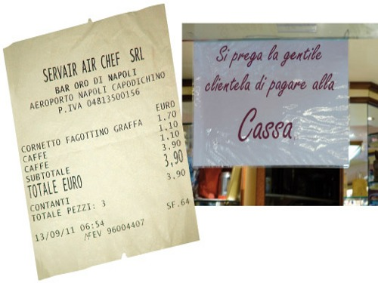
Figure 3 Uno scontrino (left), Un cartello (right)
View description - Figure 3 Uno scontrino (left), Un cartello (right)

In many Italian bars and caffès, particularly the more upmarket ones in cities, or in train stations and airports you go to the cash desk (la cassa) first and say what you want. You pay and are given a receipt which you then give to the person serving, repeating your order. In fact, there is often a sign (un cartello) telling you to go the cash desk first, pay the cashier (il cassiere / la cassiera) and get a till receipt (uno scontrino). The sign might say something like Si prega di fare lo scontrino alla cassa (‘Please obtain a receipt [first] from the till’) or simply Si prega di pagare alla cassa (‘Please pay [first] at the till’).

4 Desidera?

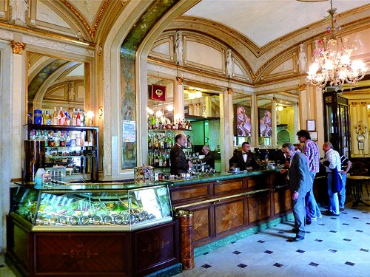
Figure 4 Caffè Gambrinus, Napoli
View description - Figure 4 Caffè Gambrinus, Napoli

There are some common expressions that you will hear when in an Italian bar and caffè. Have a go at Activity 2 now to see if you can work out what these phrases mean.

Activity 2

Listen to the recording from Activity 1 again (repeated below) and match each of the following expressions from the dialogue to its English equivalent. At this stage it is useful to learn common expressions like these as set phrases rather than trying to work out what each word means.

Audio content is not available in this format.
View transcript - Uncaptioned interactive content

What would you like?
I would like
For me
Excuse me!
How can I help?
For you (formal)
So
Desidera?
Vorrei
Per me
Scusi!
Mi dica?
Per lei?
Allora...
View answer - Activity 2

5 Key phrases
In an Italian bar, the person serving (il cameriere or la cameriera) – or the cassiere if you have to pay first – will ask you what you want in one of the following ways:
- Desidera? What would you like? (literally: You want?)
- Mi dica. How can I help? (literally: Tell me.)
- E per Lei? (And) for you?
To say what you would like, use:
- Vorrei… I would like …
- (E) per me… (And) for me
If you need to attract the waiter’s or barman’s attention, you say:
- Scusi! Excuse me!
When the person serving adds up the order to check that they have got it right, they usually begin with:
- Allora... So...
You might also hear customers say buongiorno (‘good morning’) or buonasera (‘good afternoon/evening’) before they place their order.

6 Vocabulary practice
Now see if you can use the expressions you’ve just learnt.

Activity 3

Read the dialogue and select the appropriate word from the drop-down menu to complete each sentence.

Interactive content is not available in this format.

7 Speaking practice
So far, you have practised listening to orders. In the next speaking activity you’ll have a go at ordering drinks yourself.

Activity 4

Now you can order some drinks yourself. Listen to the audio and answer the questions following the prompts in English, as in the example below.

Esempio
- You hear: Buongiorno. Desidera?
  - (A coffee.)
- You say: Un caffè.
- You hear: Un caffè.

Audio content is not available in this format.
View transcript - Uncaptioned interactive content

8 Historic Italian coffee house

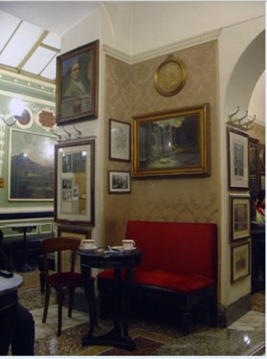
Figure 5 Caffè Greco, Roma
View description - Figure 5 Caffè Greco, Roma

The history of the Gran Caffè in Italy goes back to the introduction of coffee into Europe in the early seventeenth century. The first European coffee houses were established in Venice, a centre of trade between Italy and the East. The coffee houses were a meeting place for intellectuals and artists, and often became cultural landmarks. A few famous examples are the Gran Caffè Gambrinus in Naples (1860), favoured by Oscar Wilde, Ernest Hemingway and Jean-Paul Sartre, the Florian in Venice (1720), frequented by Giacomo Casanova and Charles Dickens, the Caffè Pedrocchi in Padua (1831), the Caffè degli Specchi in Trieste (1839), the Caffè Greco in Rome (1760), haunt of Richard Wagner and Orson Welles, and the Caffè Fiorio in Turin (1780), whose customers included Cavour and Nietzsche.

Activity 5

Now listen to the recording and match the name of each caffè and the town in which it is located.
Don’t worry if you only catch some of the words or only get a very general idea of what is being talked about. Remember that your main purpose for listening is to carry out the task and that you can do this without understanding every word; even when you listen to something in your own language you will find that you rarely hear every word, unless you are really concentrating on the message.

Audio content is not available in this format.
View transcript - Uncaptioned interactive content

Caffè Fiorio
Caffè Gambrinus
Caffè Florian
Caffè Greco
Caffè San Marco
Turin
Naples
Venice
Rome
Trieste
View answer - Activity 5

9 Listening for more detail

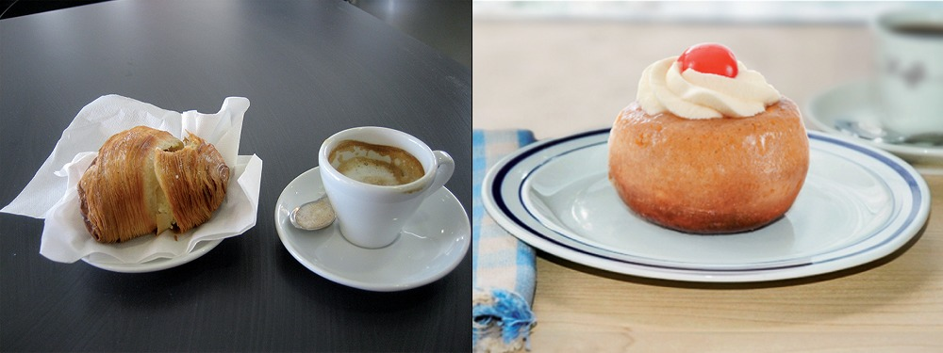
Figure 6 La sfogliatella (left), Il babà (right)
View description - Figure 6 La sfogliatella (left), Il babà (right)

Now have a go at Activity 6.

Activity 6

Interactive content is not available in this format.

10 Definite articles
Now have a go at Activity 7.

Activity 7

Read the transcript of the recording about historic Italian coffee houses (copied below). Write down the specialities of each coffee house with the correct form of the definite article that precedes them. Then read the explanation below on the definite article.

Esempio
Il gelato

Transcript: In Italia ci sono molti caffè storici. Sono eleganti e raffinati, e offrono varie specialità. Il Caffè Fiorio è a Torino. Le sue specialità sono il gelato in estate e la cioccolata calda in inverno. A Napoli c’è il Caffè Gambrinus, famoso per le sfogliatelle e i babà. È anche molto conosciuto il Caffè Florian di Venezia, dove servono il tipico liquore al caffè. Un caffè storico molto importante di Roma è il Caffè Greco, rinomato per la focaccia di polenta. Il Caffè San Marco, invece, è a Trieste. Serve gli aperitivi con gli spuntini salati.

Provide your answer...
View answer - Activity 7

Definite article il, la, lo, l’, i, le, gli
In Italian, the definite article (meaning ‘the’) is used, as in English, to indicate a specific person or object; for example, something just mentioned or requested.
- Ecco il cappuccino. Here is the cappuccino.
- Ecco la pizza. Here is the pizza.
It is also used, unlike English, when referring to a category of objects.
- Le sue specialità sono il gelato e la cioccolata calda. Its specialities are ice cream and hot chocolate.
The Italian word for English ‘the’ (the definite article) is il, la, lo, l’ and the plural forms i, le and gli. The form depends on the gender (masculine/feminine) and number (singular/plural) of the noun it refers to and also on the first letter of that noun.
Masculine nouns take il with singular and i with the plural.
- il bicchiere the glass - i bicchieri the glasses
- il cornetto the croissant - i cornetti the croissants
Masculine nouns beginning with s + consonant (for example sc, sp), gn, pn, ps, x, z, and i or y followed by another vowel, take lo with the singular and gli with the plural.
- lo scontrino the receipt - gli scontrini the receipts
- lo zio the uncle - gli zii the uncles
- lo yogurt the yogurt - gli yogurt the yogurts
Feminine nouns take la with the singular and le with the plural.
- la birra the beer - le birre the beers
- la pizza the pizza - le pizze the pizzas
Nouns beginning with a vowel (a, e, i, o, u) take l’ in the singular and gli or le in the masculine and feminine plural forms respectively.
- l’aperitivo the aperitif - gli aperitivi the aperitifs
- l’aranciata the orangeade - le aranciate the orangeades

11 This week’s quiz
Check what you’ve learned this week by taking the end-of-week quiz.
Week 2 quiz
Open the quiz in a new window or tab (by holding ctrl [or cmd on a Mac] when you click the link), then return here when you have done it.

12 Summary of Week 2
Well done for completing Week 2!
The phrases, vocabulary and cultural insights you learnt this week should give you the confidence to order food and drinks at an Italian caffè.
You have also learnt several grammatical rules and may wonder how it will be possible to learn them all and apply them when necessary. For example, if your first language is English, you may find it hard to learn the different types of Italian definite and indefinite articles.
Memorising all these rules now may be difficult but remember that you have just started and have only had a few opportunities to practise. Don't worry about remembering everything. Just make good notes and go back to them when you meet the same words and grammatical structures again. Little by little you will start recognising and even using them. One way to learn articles more quickly is to make lists of new words and their associated articles. Group these words according to the article that preceded them. As you move on with your studies, add more words to your list.

Keeping a record of your learning
Use the boxes below to place the nouns you have learned so far into their correct categories / with their correct definite articles.

Il + masculine singular noun

Example: il caffè

La + feminine singular noun

Example: la pizza

i + masculine singular noun

Example: i bicchieri

gli + masculine plural noun

Example: gli aperitivi

l’+ singular noun starting with a vowel

Example: l’amaro

This OpenLearn course is an adapted extract from the Open University course LXI001 Beginners Italian 1: primi passi.
Visit the OpenLearn’s hub for language content where you will be able to build on your newly found language skills.

Acknowledgements
This free course was first published in December 2020.
Except for third party materials and otherwise stated (see terms and conditions), this content is made available under a Creative Commons Attribution-NonCommercial-ShareAlike 4.0 Licence.
The material acknowledged below and within the course is Proprietary and used under licence (not subject to Creative Commons Licence). Grateful acknowledgement is made to the following sources for permission to reproduce material in this free course:

Images
Introduction
Course image: Image by 272447 from Pixabay
Introduction, Figure 1: (c) Konstantinos Papaioannou/Dreamstime.com
Week 1
Week 1, Activity 1, Glass of red wine: (c) Ljupco Smokovski/Dreamstime.com
Week 1, Activity 1, A pint of beer: (c) Anna Proudfoot
Week 1, Activity 1, Fruit juice: Agency of the United States Department of Agriculture – USDA
Week 1, Activity 1, Apertif in a glass with an olive: Rose-marie Henriksson/Dreamstime.com
Week 1, Activity 1, Small bottle of mineral water: MK74/Dreamstime.com
Week 1, Activity 1, Glass of white wine: Valetyn74/Dreamstime.com
Week 1, Activity 1, Cup of tea: Laurel Fan, available under Creative Commons Attribution-ShareAlike 2.0 Generic license (CC BY-SA 2.0) https://commons.wikimedia.org/wiki/File:Cup_of_tea,_Scotland.jpg
Week 1, Activity 1, Cappuccino: (c) Nejron/Dreamtime.com
Week 1, Activity 1, Small cup of coffee: Alexsander Nakic/istockphoto.com
Week 1, Figure 1: Image by T Caesar from Pixabay
Week 1, Figure 2: Anna Proudfoot
Week 1 quiz, Q1: Lemone, cleared under Creative Commons Attribution - ShareAlike 4.0 International license (CC BY-SA 4.0) https://en.wikipedia.org/wiki/Espresso#/media/File:Tazzina_di_caff%C3%A8_a_Ventimiglia.jpg
Week 1 quiz, Q2: Image by Pexels from Pixabay
Week 1 quiz, Q3: (C) Jazzbobrown
Week 1 quiz, Q4A: Image by PublicDomainPictures from Pixabay
Week 1 quiz, Q4B: Kobako, cleared under Creative Commons,Attribution-ShareALike 2.5 Generic license (CC BY-SA 2,5) https://commons.wikimedia.org/wiki/File:Piadina.jpg
Week 1 quiz, Q4C: paPisc cleared under Creative Commons Attribution - ShareAlike 2.0 Generic license (CC BY-SA 2.0) https://farm4.staticflickr.com/3236/3051738365_0c877bf705_o.jpg
Week 1 quiz, Q4D: Stella, cleared under Creative Commons Attribution - ShareALike 4.0 International License (CC BY -SA 4.0) https://it.wikipedia.org/wiki/File:Le_pizzette_di_Siracusa_-_Pizzeria_Mundo_Maya.jpg
Week 1 quiz, Q4E: Jesús Gorriti, cleared under Creative Commons Attribution - ShareAlike 2.0 Generic license (CC BY-SA 2.0) https://www.flickr.com/photos/91572751@N00/1449041790
Week 1 quiz, Q4F: Bing, cleared under Creative Commons Attribution - NonCommercial - ShareAlike 2.0 Generic license (CC BY-NC-SA 2,0) https://www.flickr.com/photos/cherrylet/4638752695/
Week 1 quiz, Q4G: Lotus Head, cleared under Creative Commons Attribution ShareALike 3.0 Unported license ((CC BY SA 3.0) https://commons.wikimedia.org/wiki/File:Ice_Cream_dessert_02.jpg
Week 2
Week 2, Figure 1: Anna Proudfoot
Week 2, Figure 2: © Claudiu Marius Pascalina/Dreamstime.com
Week 2, Figure 3: Anna Proudfoot
Week 2, Figure 4: Anna Proudfoot
Week 2, Figure 5: © Konstantinos Papaioannou - Dreamstime.com
Week 2, Figure 6: Anna Proudfoot
Every effort has been made to contact copyright owners. If any have been inadvertently overlooked, the publishers will be pleased to make the necessary arrangements at the first opportunity.
Don't miss out
If reading this text has inspired you to learn more, you may be interested in joining the millions of people who discover our free learning resources and qualifications by visiting The Open University – www.open.edu/openlearn/free-courses.

Solutions

Activity 3

Answer
The drinks mentioned are:
- una birra
- un caffè
- un bicchiere di vino bianco
- un tè
- un succo di frutta
Back to - Activity 3

Activity 5

Part

Answer
Right:
un
Wrong:
uno
una
un'
Back to - Part

Part

Answer
Right:
un'
Wrong:
un
uno
una
Back to - Part

Part

Answer
Right:
un
Wrong:
uno
una
un'
Back to - Part

Part

Answer
Right:
un
Wrong:
uno
una
un'
Back to - Part

Part

Answer
Right:
uno
Wrong:
un
una
un'
Back to - Part

Part

Answer
Right:
un
Wrong:
uno
una
un'
Back to - Part

Part

Answer
Right:
un
Wrong:
uno
una
un'
Back to - Part

Part

Answer
Right:
una
Wrong:
un
uno
un'
Back to - Part

Part

Answer
Right:
un
Wrong:
uno
una
un'
Back to - Part

Part

Answer
Right:
un
Wrong:
uno
una
un'
Back to - Part

Part

Answer
Right:
una
Wrong:
un
uno
un'
Back to - Part

Part

Answer
Right:
un
Wrong:
uno
una
un'
Back to - Part

Part

Answer
Right:
una
Wrong:
un
uno
un'
Back to - Part

Activity 6

Answer
The correct matches are:
paste
a.
pizzette
b.
cornetti
c.
tramezzini
d.
panini
e.
gelati
f.
Back to - Activity 6

Activity 7

Answer
The correct matches are:
pasta
paste
pizzetta
pizzette
cornetto
cornetti
tramezzino
tramezzini
panino
panini
gelato
gelati
Back to - Activity 7

Activity 8

Answer
- Cappuccino – cappuccini
- Caffè – caffè
- Cioccolata – cioccolate
- Tè – tè
- Birra – birre
- Aperitivo – aperitivi
- Cornetti – cornetto
- Paste- pasta
- Pizzette – pizzetta
- Panini – panino
- Piadine - piadina
Back to - Activity 8

Activity 1

Answer
Right:
un cappuccino
un caffè
una brioche
una pasta
Wrong:
un cornetto
un aperitivo
un panino
un tè
una cioccolata
Maria and Piera order twice because in many Italian caffé you need to go to the till to place and pay for your order before being served.
They order:
- un cappuccino
- un caffè
- una brioche
- una pasta
Back to - Activity 1

Activity 2

Answer
The correct matches are:
What would you like?
Desidera?
I would like
Vorrei
For me
Per me
Excuse me!
Scusi!
How can I help?
Mi dica?
For you (formal)
Per lei?
So
Allora...
- Desidera? - What would you like?
- Vorrei - I would like
- Per me - For me
- Scusi!- Excuse me!
- Mi dica- How can I help?
- Per Lei- For you (formal)
- Allora- So
Back to - Activity 2

Activity 5

Answer
The correct matches are:
Caffè Fiorio
Turin
Caffè Gambrinus
Naples
Caffè Florian
Venice
Caffè Greco
Rome
Caffè San Marco
Trieste
- Turin - Caffè Fiorio
- Naples- Caffè Gambrinus
- Venice - Caffè Florian
- Rome- Caffè Greco
- Trieste- Caffè San Marco
Back to - Activity 5

Activity 7

Answer
Here are the specialities from the transcript, with some of the forms of the Italian word for ‘the’ before them.
- la cioccolata
- le sfogliatelle
- i babà
- il tipico liquore al caffè
- la focaccia di polenta
- gli aperitivi
- gli spuntini
Back to - Activity 7

Figure 1

Description
Photo of the tables and chairs of a bar in a cobbled street with a church at the end of it. There are customers sitting at tables opposite to the façade of attractive old buildings with shutters and a balcony.
Back to - Figure 1

Figure 1

Description
Picture showing a cup of hot chocolate.
Back to - Figure 1

Figure 2

Description
This is a photo of a croissant and a cup of coffee on a caffè table; there are sugar sachets in a container and a paper napkin under the croissant.
Back to - Figure 2

Figure 3 Un bar tipico

Description
This is a drawing of the counter of a bar, with a barman serving ice creams from the ice cream section beside the counter. The six items labelled are: (a) small cakes, (b) mini-pizzas, (c) croissants, (d) sandwiches, (e) panini, (f) ice creams.
Back to - Figure 3 Un bar tipico

Figure 4

Description
This is a café price list showing the following items: (in the first half): cappuccino, caffè, cioccolata, tè, birra, aperitivo. (in the second half): cornetti, paste, pizzette, panini, piadine; The prices are under the title Prezzi al banco.
Back to - Figure 4

Figure 1

Description
Photo of people having drinks at an outdoor bar.
Back to - Figure 1

Figure 2 La pausa caffé

Description
This photo shows some businessmen leaving an outdoor table of a bar, having finished their morning coffee break, in a street in Rome.
Back to - Figure 2 La pausa caffé

Figure 3 Uno scontrino (left), Un cartello (right)

Description
There are two photos, The photo on the left is of a till receipt from an airport bar, showing the following words: Servair Air Chef SRL, Bar Oro di Napoli, Aeroporto Napoli Capodichino, and a VAT (IVA in Italian) number. The purchases listed, with prices in euros, are: Cornetto fagottino graffa 1,70, Caffè 1,10, Caffè 1,10, Subtotale 3,90, TOTALE EURO 3,90, Contanti Totale pezzi: 3, and the date and time of issue. The photo on the right is of a laminated sign hanging from the ceiling reading: Si prega la gentile clientela di pagare alla Cassa.
Back to - Figure 3 Uno scontrino (left), Un cartello (right)

Figure 4 Caffè Gambrinus, Napoli

Description
Photo of an elegant, traditional-style caffè counter with veneer panelling below, marble floor and gilt-decorated arches above.
Back to - Figure 4 Caffè Gambrinus, Napoli

Figure 5 Caffè Greco, Roma

Description
Photo of a room of the Caffè Greco, with a gentlemen sitting on a red-covered bench seating reading a paper. There are paintings and mirrors on the walls and small round marble-topped tables.
Back to - Figure 5 Caffè Greco, Roma

Figure 6 La sfogliatella (left), Il babà (right)

Description
There are two photos. The left-hand photo is of a pastry on a small plate and an espresso-size cup of coffee beside it. The right-hand photo is of a rum-baba with cream and glace cherry on top, on a small plate.
Back to - Figure 6 La sfogliatella (left), Il babà (right)

Uncaptioned interactive content

Transcript
INSTRUCTOR:
Cold drinks. English - Italian - Italian.
An orangeade. Un’aranciata.//Un’aranciata.
An orange juice. Una spremuta d’arancia.// Una spremuta d’arancia.
An apple juice. Un succo di mela.// Un succo di mela.
An aperitif. Un aperitivo.//Un aperitivo.
A liqueur. Un liquore.//Un liquore.
A beer. Una birra.//Una birra.
A mineral water. Un’acqua minerale.//Un’acqua minerale.
A sparkling wine. Uno spumante.//Uno spumante.
A glass of white wine. Un bicchiere di vino bianco.// Un bicchiere di vino bianco
Back to - Uncaptioned interactive content

Uncaptioned interactive content

Transcript
INSTRUCTOR:
Hot drinks.
A coffee. Un caffè.//Un caffè.
A tea. Un tè.// Un tè.
A cappuccino. Un cappuccino.// Un cappuccino.
An espresso. Un espresso.//Un espresso.
A macchiato coffee. Un macchiato.//Un macchiato.
A milky coffee. Un caffelatte.//Un caffelatte.
A hot chocolate. Una cioccolata.// Una cioccolata.
Back to - Uncaptioned interactive content

Uncaptioned interactive content

Transcript
Listen to a group of friends ordering drinks from a waitress and try to identify what drinks they are ordering.
CAMERIERA:
Buongiorno. Prego.
PAOLO:
Vorrei una birra.
ANNA:
Per me, un caffè.
TOMMASO:
Un bicchiere di vino bianco.
MARISA:
Un tè.
FILIPPO:
Un succo di frutta.
CAMERIERA:
Va bene. Una birra, un caffè, un bicchiere di vino bianco, un tè e un succo di frutta. Ecco.
PAOLO:
Grazie.
Back to - Uncaptioned interactive content

Uncaptioned interactive content

Transcript
CASSIERE:
Desidera?
MARIA:
Vorrei un cappuccino e una brioche.
PIERA:
E per me un caffè e una pasta.
CASSIERE:
Quattro euro.
MARIA:
Ecco.
CASSIERE:
Ecco lo scontrino
MARIA:
Grazie.
Scusi!
BARISTA:
Mi dica.
MARIA:
Vorrei un cappuccino e una brioche.
BARISTA:
E per Lei?
PIERA:
Per me un caffè e una pasta.
BARISTA:
Allora, un cappuccino, un caffè, una brioche e una pasta.
Back to - Uncaptioned interactive content

Uncaptioned interactive content

Transcript
CASSIERE:
Desidera?
MARIA:
Vorrei un cappuccino e una brioche.
PIERA:
E per me un caffè e una pasta.
CASSIERE:
Quattro euro.
MARIA:
Ecco.
CASSIERE:
Ecco lo scontrino
MARIA:
Grazie.
Scusi!
BARISTA:
Mi dica.
MARIA:
Vorrei un cappuccino e una brioche.
BARISTA:
E per Lei?
PIERA:
Per me un caffè e una pasta.
BARISTA:
Allora, un cappuccino, un caffè, una brioche e una pasta.
Back to - Uncaptioned interactive content

Uncaptioned interactive content

Transcript
Now you will be placing some orders yourself. Listen to the questions and follow the prompts, as in the example.
Esempio
You hear: Buongiorno. Desidera?
(a coffee)
You say: Un caffè.
You hear: Un caffè.
Your turn now.
1 – Che cosa prendi?
(For me, a beer.)
– Per me una birra.
2 – Tu cosa prendi, Antonella?
– (An ice cream.)
– Un gelato.
3 – Carlo, per te?
(A glass of red wine.)
– Un bicchiere di vino rosso.
4 – Buongiorno. Desidera?
(A mineral water.)
– Un’acqua minerale.
Back to - Uncaptioned interactive content

Uncaptioned interactive content

Transcript
INSTRUCTOR:
Here is some information about some historic Italian coffee houses.
In Italia ci sono molti caffè storici. Sono eleganti e raffinati, e offrono varie specialità. Il Caffè Fiorio è a Torino. Le sue specialità sono il gelato in estate e la cioccolata calda in inverno. A Napoli c’è il Caffè Gambrinus, famoso per le sfogliatelle e i babà. È anche molto conosciuto il Caffè Florian di Venezia, dove servono il tipico liquore al caffè. Un caffè storico molto importante di Roma è il Caffè Greco, rinomato per la focaccia di polenta. Il Caffè San Marco, invece, è a Trieste. Serve gli aperitivi con gli spuntini salati.
Back to - Uncaptioned interactive content

