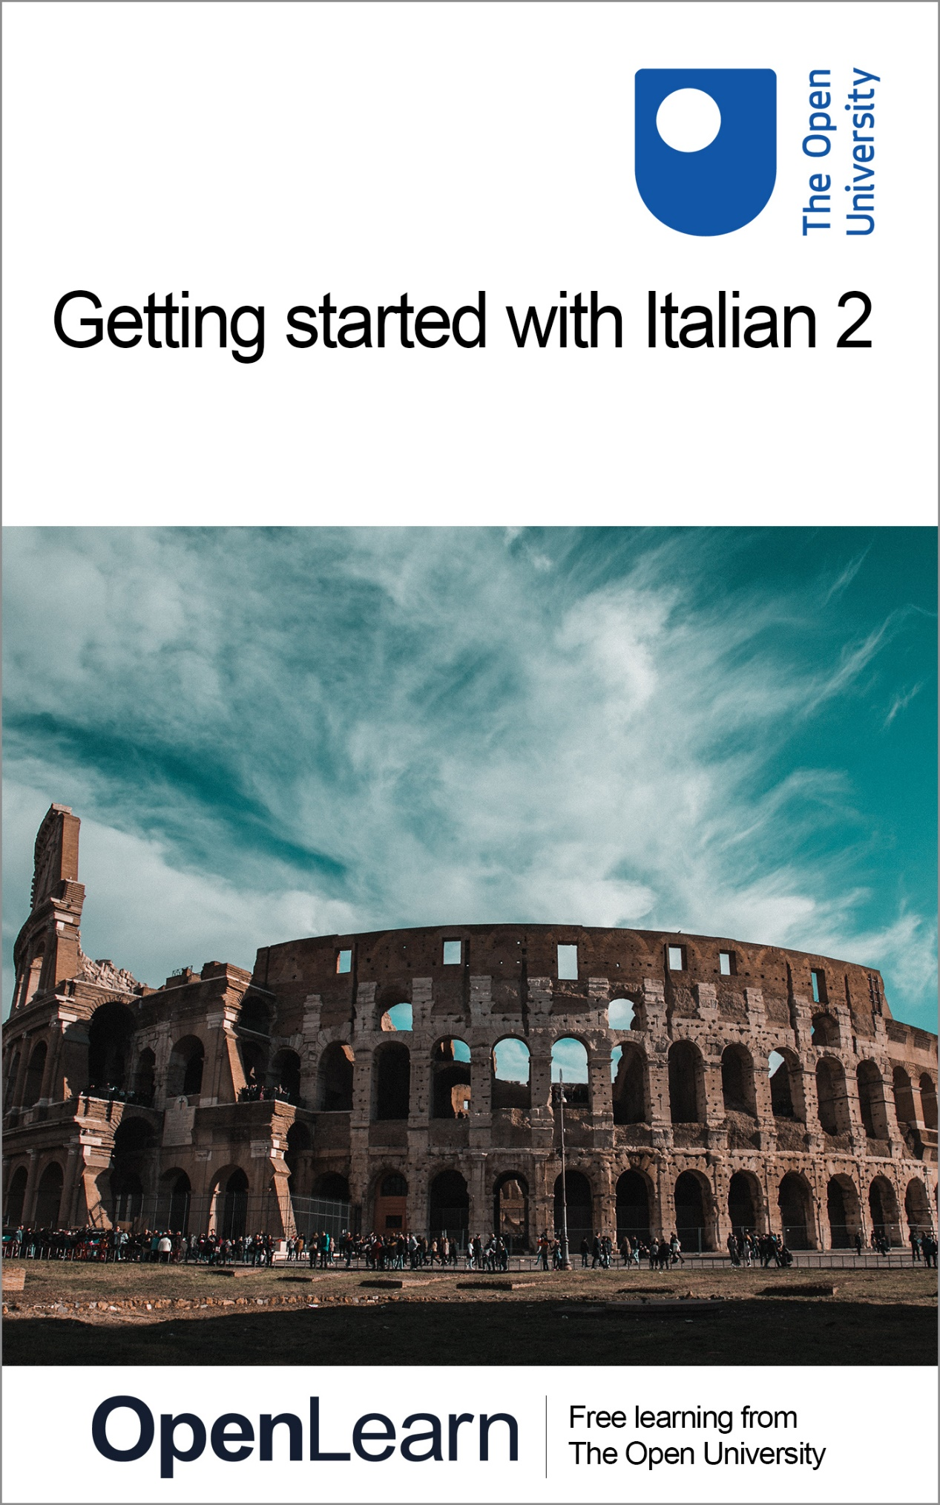

ALT_1

Getting started with Italian 2

About this free course
This free course is an adapted extract from the Open University course .
This version of the content may include video, images and interactive content that may not be optimised for your device.
You can experience this free course as it was originally designed on OpenLearn, the home of free learning from The Open University –
There you’ll also be able to track your progress via your activity record, which you can use to demonstrate your learning.
Copyright © 2021 The Open University
Intellectual property
Unless otherwise stated, this resource is released under the terms of the Creative Commons Licence v4.0 http://creativecommons.org/licenses/by-nc-sa/4.0/deed.en_GB. Within that The Open University interprets this licence in the following way: www.open.edu/openlearn/about-openlearn/frequently-asked-questions-on-openlearn. Copyright and rights falling outside the terms of the Creative Commons Licence are retained or controlled by The Open University. Please read the full text before using any of the content.
We believe the primary barrier to accessing high-quality educational experiences is cost, which is why we aim to publish as much free content as possible under an open licence. If it proves difficult to release content under our preferred Creative Commons licence (e.g. because we can’t afford or gain the clearances or find suitable alternatives), we will still release the materials for free under a personal end-user licence.
This is because the learning experience will always be the same high quality offering and that should always be seen as positive – even if at times the licensing is different to Creative Commons.
When using the content you must attribute us (The Open University) (the OU) and any identified author in accordance with the terms of the Creative Commons Licence.
The Acknowledgements section is used to list, amongst other things, third party (Proprietary), licensed content which is not subject to Creative Commons licensing. Proprietary content must be used (retained) intact and in context to the content at all times.
The Acknowledgements section is also used to bring to your attention any other Special Restrictions which may apply to the content. For example there may be times when the Creative Commons Non-Commercial Sharealike licence does not apply to any of the content even if owned by us (The Open University). In these instances, unless stated otherwise, the content may be used for personal and non-commercial use.
We have also identified as Proprietary other material included in the content which is not subject to Creative Commons Licence. These are OU logos, trading names and may extend to certain photographic and video images and sound recordings and any other material as may be brought to your attention.
Unauthorised use of any of the content may constitute a breach of the terms and conditions and/or intellectual property laws.
We reserve the right to alter, amend or bring to an end any terms and conditions provided here without notice.
All rights falling outside the terms of the Creative Commons licence are retained or controlled by The Open University.
Head of Intellectual Property, The Open University

Contents
- Introduction
  - Introduction
  - Open Centre for Languages and Cultures
- Week 1: Talking about the time
  - Introduction
  - 1 Asking what the time is
  - 2 Saying what the time is
  - 3 Asking and saying the time
  - 4 Expressing ‘ten past’ and ‘ten to’
  - 5 Saying what the time is (‘past’ and ‘to’)
  - 6 Practising your listening and speaking skills
  - 7 Practising your pronunciation
  - 8 This week’s quiz
  - 9 Summary of Week 1
- Week 2: Talking about the time (continued)
  - Introduction
  - 1 Listening to time announcements
  - 2 Using the 24-hour clock
  - 3 Telling the time using the 24-hour clock
  - 4 Saying what time it is
  - 5 Expressing the time of day
  - 6 Talking about different times of the day
  - 7 Saying what time is it in the rest of the world
  - 8 This week’s quiz
  - 9 Summary of Week 2
  - Next steps
- Acknowledgements
- Solutions

Introduction

Introduction
Welcome to this free course, Getting started with Italian 2.
Whatever your reasons for learning Italian, this two-week course gives you a chance to start a new and exciting learning experience. The course will focus on telling and giving the time in Italian.
Each week comprises of 3–4 hours of interactive activities, explanations, exercises and tips about language learning. It’s a good idea to keep notes either on paper or on your preferred digital device. Each week you’ll be encouraged to revise your notes and to add to your own personal phrase book and decide how best you can go about memorising and practising key phrases and vocabulary. Keep a record of your own learning journey, think about aspects you enjoy and aspects you find challenging and reflect on how you can overcome these challenges; this will help you consolidate your learning as well as adapt your own practice to your own learning style. Throughout the course, you will be invited to reflect on your learning in the consolidation activities at the end of each week.
There is also a weekly quiz for you to practise what you’ve been learning.
You are going to learn and practise how to ask and say the time. This will involve using numbers as well as practising your speaking and listening skills. Before you start, you might like to revise numbers in Italian.
When saying the time, the pronunciation of numbers is very important if you want to be correctly understood, so you might want to say the numbers out loud as you revise them. You will also have a chance to practise pronunciation in some of the activities that follow.

Open Centre for Languages and Cultures
This course has been developed from extract parts of LXI002 - Beginners Italian 2: in cammino. The Open University has launched a dedicated learning centre called The Open Centre for Languages and Cultures. OpenLearn is supporting this project and is providing extracted units of all courses on The Open Centre in our dedicated Language and Cultures Hub.
The Open Centre for Languages and Cultures is the exciting new home for non-accredited language and intercultural communication short courses. You can study a wide range of language and language related subjects with us anywhere in the world, in any time zone, whatever your motivation – leisure, professional development or academic.
It’s the one stop shop for engaging with languages, professional communication and intercultural dialogue.
Our short courses allow us to be agile and responsive to the needs of learners who want to be part of a global society. We offer non-accredited short courses in a range of subjects including modern languages, and languages for business and the workplace. We are also leading the way in developing short courses for academic research methods and pre-sessional English with IELTS, which will be available for registration in due course.
The Open Centre for Languages and Cultures is an international leader in online language learning and intercultural communications, built on our pioneering pedagogy and research.
What makes the Open Centre different?
- The OU is the leader in online learning and teaching with a heritage of more than 50 years helping student achieve their learning ambitions.
- The short courses are underpinned by academic rigour and designed by native speakers experienced in producing engaging materials for online learning of languages and cultures.
- The graduating nature of the courses means that learners can build up their language and skills over time.
- Learners will also gain a better understanding of the culture(s) associated with the language(s) they study enabling the development of intercultural communication skills.
- Learners can mix and match the short courses and study more than one course at a time.
Once this course is complete you will be directed to OpenLearn’s hub for language content where you will be able to build on your newly found language skills.
Now that you’re fully prepared, it’s time to start on Week 1.
Buon lavoro!

Week 1: Talking about the time

Introduction

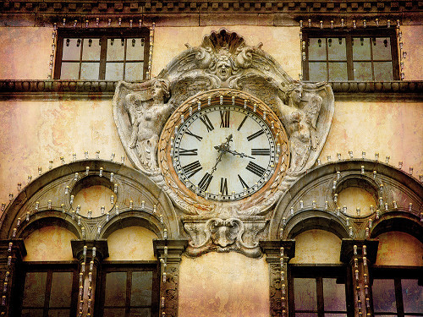

In this first week, you are going to learn and practise how to ask and say the time. This will involve using numbers as well as practising your speaking and listening skills. Before you start, you might want to revise Italian numbers.
When saying the time, the pronunciation of numbers is very important if you want to be correctly understood, so you might want to say the numbers out loud as you revise them. You will also have a chance to practise pronunciation in some of the activities that follow.
At the end of the week, you can test your learning with a quick quiz.
This OpenLearn course is an adapted extract from the Open University course LXI002 Beginners Italian 2: in cammino.

1 Asking what the time is
You’ll start this week by testing your knowledge of how to tell the time in Italian.

Activity 1

Interactive content is not available in this format.

2 Saying what the time is
Next, you’ll have a chance to hear people saying the time.

Activity 2

Listen to the following people asking and being told the time and put these dialogues in the correct order.

Interactive content is not available in this format.

3 Asking and saying the time
To ask the time, you can either say:
- Che ore sono? What time is it? (literally: What hours are they?)
or:
- Che ora è? What time is it? (literally: What hour is it?)
To say the time, you use the verb essere. For all plural hour times use sono:
- Sono le due. It’s two o’clock.
- Sono le undici. It’s eleven o’clock.
but for ‘one o’clock’ use è:
- È l’una. It’s one o’clock.
As you can see from the examples above, the definite article – le for plural hours and la (shortened to l’) for una – is used, followed by the hour.
For midday and midnight, è is used, without the article:
- È mezzogiorno. It’s midday.
- È mezzanotte. It’s midnight.
To emphasise an exact time on the hour, you can add in punto (‘on the dot’).
- Sono le undici in punto. It’s eleven o’clock precisely.

4 Expressing ‘ten past’ and ‘ten to’
Next, you’ll think about how ‘past’ and ‘to’ are expressed in Italian when giving the time.

Activity 3

Interactive content is not available in this format.

Interactive content is not available in this format.

Interactive content is not available in this format.

Interactive content is not available in this format.

Interactive content is not available in this format.

Interactive content is not available in this format.

5 Saying what the time is (‘past’ and ‘to’)
For minutes past the hour, use e.
- Sono le cinque e dieci. It’s ten past five.
- È l’una e venticinque. It’s twenty-five past one.
For minutes to the hour use meno.
- Sono le sei meno venti. It’s twenty to six.
- È l’una meno cinque. It’s five to one.
For ‘half past’, use mezzo or mezza (there is no difference in meaning).
- È mezzanotte e mezza. It’s half-past midnight.
- Sono le undici e mezzo. It’s half-past eleven.
For ‘quarter past’ or ‘quarter to’, use un quarto with e or meno.
- Sono le cinque e un quarto. It’s (a) quarter past five.
- È l’una meno un quarto. It’s (a) quarter to one.
For ‘quarter to’ you can also use e tre quarti (‘three-quarters past’).
- Sono le dodici e tre quarti. It’s (a) quarter to one. / It’s twelve forty-five.

6 Practising your listening and speaking skills
Now you’ll have the opportunity to test your listening and speaking skills.

Activity 4

Listen to the questions and respond according to the prompts while recording yourself. Then play back your recording and listen to the model answer.
1.

Interactive content is not available in this format.

2.

Interactive content is not available in this format.

3.

Interactive content is not available in this format.

4.

Interactive content is not available in this format.

5.

Interactive content is not available in this format.

7 Practising your pronunciation
Next, you’ll continue to practise your pronunciation of times.

Activity 5
Look at each clockface, say what time it is and record your answer. Then play back your recording and listen to a model answer.

1.

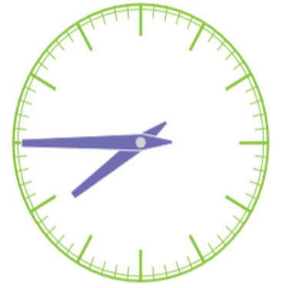
View description - Uncaptioned Figure

Interactive content is not available in this format.

2.

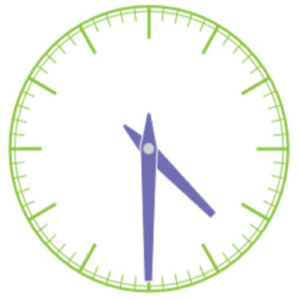
View description - Uncaptioned Figure

Interactive content is not available in this format.

3.

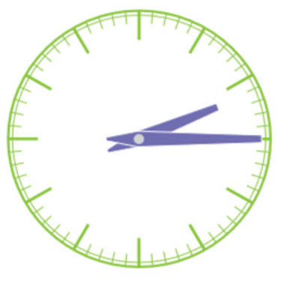
View description - Uncaptioned Figure

Interactive content is not available in this format.

4.

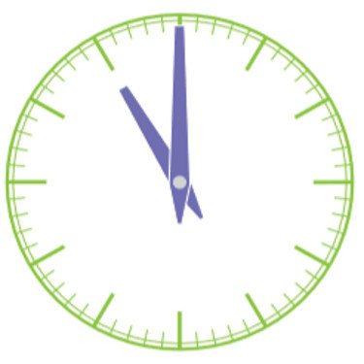
View description - Uncaptioned Figure

Interactive content is not available in this format.

5.

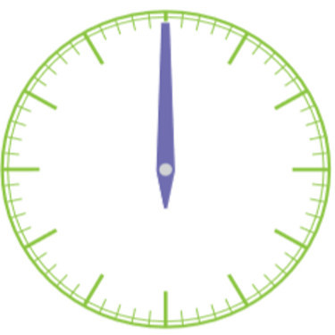
View description - Uncaptioned Figure

Interactive content is not available in this format.

8 This week’s quiz
Check what you’ve learned this week by taking the end-of-week quiz.
Week 1 quiz
Open the quiz in a new window or tab (by holding ctrl [or cmd on a Mac] when you click the link), then return here when you have done it.

9 Summary of Week 1
It is useful to keep notes on the main points to remember, which could be grammar rules, vocabulary or expressions. The way in which you choose to keep this record of your learning is up to you: a simple paper notebook, an electronic document, mind maps or any means which suits you. It is important that you add to it regularly so that all key learning points are together in one place and easily accessible for reference and revision. Many learners also find that writing notes helps them to understand grammar points and to memorise vocabulary and expressions. Adding an example of your own to each rule, term and expression will help you fix them in your memory.

Keeping a record of your learning
Whether you keep your notes on paper or digitally, it’s important to organise them, so here is an idea that may help, based on your Week 1 studies:

Key phrases

Provide your answer...

Pronunciation

Provide your answer...

Culture

Provide your answer...

Language

Provide your answer...

Think about what you would write in each box. Would you add more boxes? It’s up to you!

Now let’s move on to Week 2.

Week 2: Talking about the time (continued)

Introduction

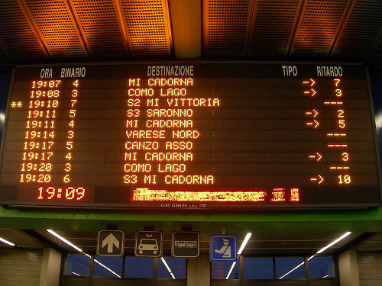
View description - Uncaptioned Figure

Last week you learned how to ask and say what the time is. This week you’re going to learn and practise how to ask and say the time using the 24-hour clock, which is commonly used for arrival and departure times, and for opening and closing times of shops and services. You’ll also learn how to talk about different times of the day, such as morning, afternoon and evening.
Traditionally Italians divide the day into three parts depending on when they are having their meals, which varies in different parts of the country: for example, in the North the morning usually stretches until 12:30–1 p.m. and the afternoon starts after that. In the South the morning stretches until 1:30–2:30 p.m. and the afternoon starts after that. It’s very important to keep this in mind when learning about how to talk about parts of the day: for example, ‘let’s meet in the early afternoon’ for some Italians means meeting no earlier than 2:30–3 p.m.

1 Listening to time announcements
In the first activity this week, you’ll listen to some time announcements.

Activity 1

Interactive content is not available in this format.

2 Using the 24-hour clock
The 24-hour clock is used in situations when it is important to avoid any confusion between a.m. and p.m., such as when travelling or talking about timetables or schedules. It is also used by online or telephone ‘speaking clocks’ (l’orologio parlante), which tell you the precise time (l’ora esatta). To say the time in the 24-hour format, use sono or è followed by the hour, then e and then the minutes.
- Sono le diciotto e trentacinque. It’s eighteen thirty-five.
- Sono le quindici e ventidue. It’s fifteen twenty-two.
- È l’una. It’s one o’clock.
Note that in Italian, as in English, we do not use the expressions un quarto, mezza/mezzo and tre quarti when telling the time with the 24-hour clock. Instead, we use numbers: quindici, trenta and quarantacinque.

3 Telling the time using the 24-hour clock
Next, you’ll test your learning of telling the time.

Activity 2

Interactive content is not available in this format.

Interactive content is not available in this format.

Interactive content is not available in this format.

Interactive content is not available in this format.

Interactive content is not available in this format.

4 Saying what time it is
In this next activity, you’ll test your spoken skills.

Activity 3
Look at each of the clock faces and say what time it is (p.m.) using the 24-hour clock and recording your answer. Then check your answer.

1.

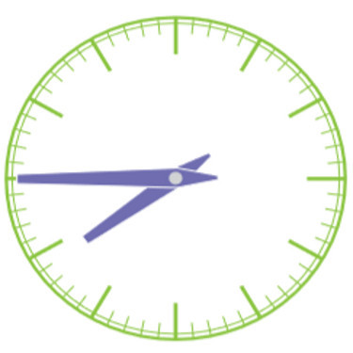
View description - Uncaptioned Figure

Interactive content is not available in this format.

2.

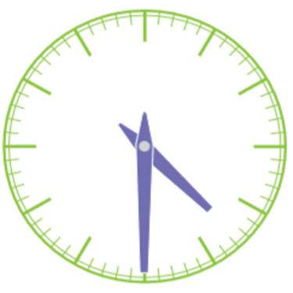
View description - Uncaptioned Figure

Interactive content is not available in this format.

3.

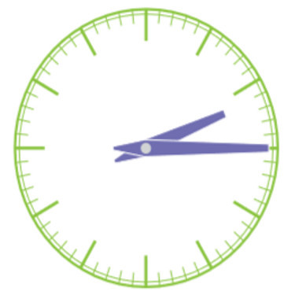
View description - Uncaptioned Figure

Interactive content is not available in this format.

4.

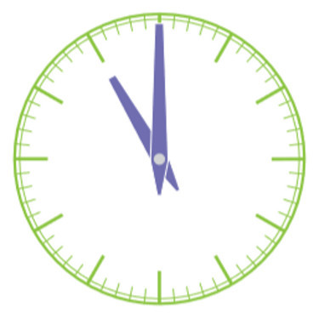
View description - Uncaptioned Figure

Interactive content is not available in this format.

5.

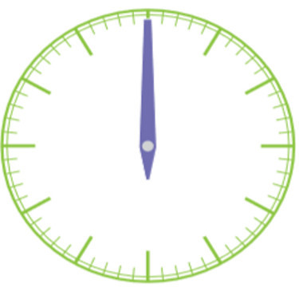
View description - Uncaptioned Figure

Interactive content is not available in this format.

5 Expressing the time of day
In the next activity, you’ll explore expressing the time of day.

Activity 4

Interactive content is not available in this format.

6 Talking about different times of the day
To specify whether the time referred to is mattina (morning), pomeriggio (afternoon), sera (evening) or notte (night), use di after the indication of time.
- Sono le sette di mattina.
- It’s seven o’clock in the morning.
  - Di mattina tends to be used until 11 a.m.
- Sono le nove di sera.
- It’s nine o’clock in the evening.
  - Di sera tends to be used until 11 p.m. (but usage can vary depending on the part of the country).
- Sono le due di notte.
- It’s two o’clock in the morning.
  - Di notte is used for the early morning hours.
With pomeriggio, it’s more common to use del than di.
- Sono le tre del pomeriggio.
- It’s three o’clock in the afternoon.
  - Del pomeriggio tends to be used until 6 p.m. (but usage can vary depending on the part of the country).
Note that the abbreviations a.m. and p.m. are not used in Italian at all.

7 Saying what time is it in the rest of the world
When it is 11 a.m. in Rome, what time is it in the rest of the world?

Activity 5
Select the correct sentence describing the time for each one of the following cities.

Roma – 11 a.m.

Sono le undici del pomeriggio.
Sono le undici di mattina.
Sono le undici di sera.
Sono le undici di notte.
View answer - Part

Londra – 10 a.m.

Sono le dieci del pomeriggio.
Sono le dieci di sera.
Sono le dieci di notte.
Sono le dieci di mattina.
View answer - Part

Canberra – 7 p.m.

Sono le sette di sera.
Sono le sette del pomeriggio.
Sono le sette di mattina.
Sono le sette di notte.
View answer - Part

Pechino – 5 p.m.

Sono le cinque di sera.
Sono le cinque di mattina.
Sono le cinque del pomeriggio.
Sono le cinque di notte.
View answer - Part
View discussion - Part

Buenos Aires – 6 a.m.

Sono le sei del pomeriggio.
Sono le sei di sera.
Sono le sei di mattina.
Sono le sei di notte.
View answer - Part

San Francisco – 2 a.m.

Sono le due del pomeriggio.
Sono le due di notte.
Sono le due di sera.
Sono le due di mattina.
View answer - Part
View discussion - Part

Santiago – 5 a.m.

Sono le cinque del pomeriggio.
Sono le cinque di sera.
Sono le cinque di notte.
Sono le cinque di mattina.
View answer - Part

Auckland – 9 p.m.

Sono le nove di sera.
Sono le nove del pomeriggio.
Sono le nove di mattina.
Sono le nove di notte.
View answer - Part
View discussion - Part

8 This week’s quiz
Check what you’ve learned this week by taking the end-of-week quiz.
Week 2 quiz
Open the quiz in a new window or tab (by holding ctrl [or cmd on a Mac] when you click the link), then return here when you have done it.

9 Summary of Week 2
Well done for completing Week 2 and reaching the end of this course!
This week you have worked with numbers. Numbers can be difficult to use in context: we can say them in a sequence (e.g. from 1 to 10, from 10 to 100), but when we need to tell or understand the time in a foreign language we suddenly find out that we are processing the information slower than in our language. This is because numbers are a language themselves, therefore you are dealing with two languages at the same time: the foreign language that you are learning and the language of numbers. If then you are throwing in an English translation, you end up with three languages at the same time.
Here are two tips on how to deal with it:
- when you are telling the time in Italian, picture it in your mind as you would see it on a clockface (like the ones that you have seen in the activities carried out this week) rather than thinking of it as expressed in English
- in the same way, when listening to somebody telling the time in Italian, picture it in your mind as you would see it on a clockface rather than translating it into English.
This means that you will be dealing with only two languages at a time (Italian and numbers), therefore making it easier for yourself
This OpenLearn course is an adapted extract from the Open University course LXI002 Beginners Italian 2: in cammino.

Next steps
We hope that you’ll continue your Italian studies with The Open University on our Beginners Italian courses:
- Beginners Italian 1: primi passi
- Beginners Italian 2: in cammino
- Beginners Italian 3: stai andando bene!
Or continue your learning adventure on OpenLearn with our free courses in our Language and Cultures Hub.

Acknowledgements
This free course was first published in June 2021.
Except for third party materials and otherwise stated (see terms and conditions), this content is made available under a Creative Commons Attribution-NonCommercial-ShareAlike 4.0 Licence.
The material acknowledged below and within the course is Proprietary and used under licence (not subject to Creative Commons Licence). Grateful acknowledgement is made to the following sources for permission to reproduce material in this free course:

Intro

Images
Course image: Photo by Davi Pimentel from Pexels

Week 1

Images
Introduction figure: © iStockphoto.com/CrazyD
Activity 1 figures: ©LE FOTO DI MAXI / Flickr - This file is licensed under the Creative Commons Attribution-No Derivatives Licence https://creativecommons.org/licenses/by-nd/2.0/; © Anna Proudfoot

Week 2

Images
Introduction figure: Fabio, Cleared under Creative Commons Attribution 2.0 Generic license (CC BY 2.0) http://commons.wikimedia.org/wiki/File:Tabellone_Bovisa.jpg
Activity 4 figures: © Viditu / flickr - This file is licensed under the Creative Commons Attribution-2.0-Generic Licence https://creativecommons.org/licenses/by/2.0/; © Christian Bortes / flickr This file is licensed under the Creative Commons Attribution-2.0-Generic Licence https://creativecommons.org/licenses/by/2.0/; Amikishiyev/123RF; © Rosino / flickr - This file is licensed under the Creative Commons Attribution-Share Alike Licence https://creativecommons.org/licenses/by-sa/2.0/
Every effort has been made to contact copyright owners. If any have been inadvertently overlooked, the publishers will be pleased to make the necessary arrangements at the first opportunity.
Don't miss out
If reading this text has inspired you to learn more, you may be interested in joining the millions of people who discover our free learning resources and qualifications by visiting The Open University – www.open.edu/openlearn/free-courses.
Except for third party materials and otherwise stated (see terms and conditions), this content is made available under a Creative Commons Attribution-NonCommercial-ShareAlike 4.0 Licence.
The material acknowledged below is Proprietary and used under licence (not subject to Creative Commons Licence). Grateful acknowledgement is made to the following sources for permission to reproduce material in this free course:
Every effort has been made to contact copyright owners. If any have been inadvertently overlooked, the publishers will be pleased to make the necessary arrangements at the first opportunity.
Don't miss out
If reading this text has inspired you to learn more, you may be interested in joining the millions of people who discover our free learning resources and qualifications by visiting The Open University – www.open.edu/openlearn/free-courses.

Solutions

Activity 5

Part

Answer
Right:
Sono le undici di mattina.
Wrong:
Sono le undici del pomeriggio.
Sono le undici di sera.
Sono le undici di notte.
Back to - Part

Part

Answer
Right:
Sono le dieci di mattina.
Wrong:
Sono le dieci del pomeriggio.
Sono le dieci di sera.
Sono le dieci di notte.
Back to - Part

Part

Answer
Right:
Sono le sette di sera.
Wrong:
Sono le sette del pomeriggio.
Sono le sette di mattina.
Sono le sette di notte.
Back to - Part

Part

Answer
Right:
Sono le cinque del pomeriggio.
Wrong:
Sono le cinque di sera.
Sono le cinque di mattina.
Sono le cinque di notte.
Back to - Part

Discussion
Del pomeriggio tends to be used until 6 p.m.
Back to - Part

Part

Answer
Right:
Sono le sei di mattina.
Wrong:
Sono le sei del pomeriggio.
Sono le sei di sera.
Sono le sei di notte.
Back to - Part

Part

Answer
Right:
Sono le due di notte.
Wrong:
Sono le due del pomeriggio.
Sono le due di sera.
Sono le due di mattina.
Back to - Part

Discussion
Di notte is used for the early morning hours.
Back to - Part

Part

Answer
Right:
Sono le cinque di mattina.
Wrong:
Sono le cinque del pomeriggio.
Sono le cinque di sera.
Sono le cinque di notte.
Back to - Part

Part

Answer
Right:
Sono le nove di sera.
Wrong:
Sono le nove del pomeriggio.
Sono le nove di mattina.
Sono le nove di notte.
Back to - Part

Discussion
Di sera tends to be used until 11 p.m.
Back to - Part

Uncaptioned Figure

Description
A clockface showing a quarter to eight.
Back to - Uncaptioned Figure

Uncaptioned Figure

Description
A clockface showing half past four.
Back to - Uncaptioned Figure

Uncaptioned Figure

Description
A clockface showing a quarter past two
Back to - Uncaptioned Figure

Uncaptioned Figure

Description
A clockface showing eleven o’clock
Back to - Uncaptioned Figure

Uncaptioned Figure

Description
A clockface showing midday/midnight
Back to - Uncaptioned Figure

Uncaptioned Figure

Description
Picture of an electronic departures board in an Italian train station.
Back to - Uncaptioned Figure

Uncaptioned Figure

Description
A clock face showing a quarter to eight.
Back to - Uncaptioned Figure

Uncaptioned Figure

Description
A clock face showing half past four.
Back to - Uncaptioned Figure

Uncaptioned Figure

Description
A clock face showing a quarter past two.
Back to - Uncaptioned Figure

Uncaptioned Figure

Description
A clock face showing eleven o’clock.
Back to - Uncaptioned Figure

Uncaptioned Figure

Description
A clock face showing midday/midnight.
Back to - Uncaptioned Figure

