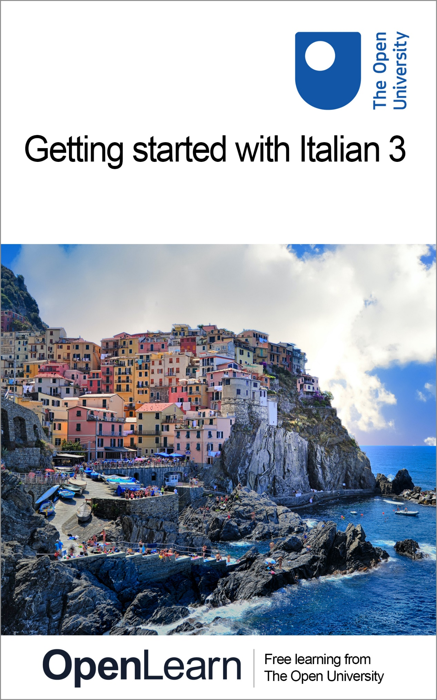

ALT_1

Getting started with Italian 3

About this free course
This free course is an adapted extract from the Open University course .
This version of the content may include video, images and interactive content that may not be optimised for your device.
You can experience this free course as it was originally designed on OpenLearn, the home of free learning from The Open University –
There you’ll also be able to track your progress via your activity record, which you can use to demonstrate your learning.
Copyright © 2021 The Open University
Intellectual property
Unless otherwise stated, this resource is released under the terms of the Creative Commons Licence v4.0 http://creativecommons.org/licenses/by-nc-sa/4.0/deed.en_GB. Within that The Open University interprets this licence in the following way: www.open.edu/openlearn/about-openlearn/frequently-asked-questions-on-openlearn. Copyright and rights falling outside the terms of the Creative Commons Licence are retained or controlled by The Open University. Please read the full text before using any of the content.
We believe the primary barrier to accessing high-quality educational experiences is cost, which is why we aim to publish as much free content as possible under an open licence. If it proves difficult to release content under our preferred Creative Commons licence (e.g. because we can’t afford or gain the clearances or find suitable alternatives), we will still release the materials for free under a personal end-user licence.
This is because the learning experience will always be the same high quality offering and that should always be seen as positive – even if at times the licensing is different to Creative Commons.
When using the content you must attribute us (The Open University) (the OU) and any identified author in accordance with the terms of the Creative Commons Licence.
The Acknowledgements section is used to list, amongst other things, third party (Proprietary), licensed content which is not subject to Creative Commons licensing. Proprietary content must be used (retained) intact and in context to the content at all times.
The Acknowledgements section is also used to bring to your attention any other Special Restrictions which may apply to the content. For example there may be times when the Creative Commons Non-Commercial Sharealike licence does not apply to any of the content even if owned by us (The Open University). In these instances, unless stated otherwise, the content may be used for personal and non-commercial use.
We have also identified as Proprietary other material included in the content which is not subject to Creative Commons Licence. These are OU logos, trading names and may extend to certain photographic and video images and sound recordings and any other material as may be brought to your attention.
Unauthorised use of any of the content may constitute a breach of the terms and conditions and/or intellectual property laws.
We reserve the right to alter, amend or bring to an end any terms and conditions provided here without notice.
All rights falling outside the terms of the Creative Commons licence are retained or controlled by The Open University.
Head of Intellectual Property, The Open University

Contents
- Introduction
  - Introduction
  - Open Centre for Languages and Cultures
- Week 1: Talking about arrival and departure times
  - Introduction
  - 1 Revising the 12-hour clock
  - 2 Revising the 24-hour clock
  - 3 At Piombino’s tourist office
  - 4 Asking about arrival and departure times
  - 5 Visiting the Tuscan Archipelago
  - 6 The Tuscan Archipelago
  - 7 Visiting the Tuscan Archipelago (continued)
  - 8 Speaking practice
  - 9 Italian ferry and hydrofoil service
  - 10 This week’s quiz
  - 11 Summary of Week 1
- Week 2: Enquiring about train times
  - Introduction
  - 1 The Italian rail network
  - 2 Italian trains
  - 3 Checking availability of trains
  - 4 Talking about the availability of something
  - 5 Grammar practice
  - 6 Train timetables
  - 7 More practice
  - 8 Speaking practice
  - 9 This week’s quiz
  - 10 Summary of Week 2
  - Next steps
- Acknowledgements
- Solutions

Introduction

Introduction
Whatever your reasons for learning Italian, this two-week course gives you a chance to start a new exciting learning experience or to continue learning in Italian. You will have the opportunity to learn how to talk about travel times and ask about arrival and departure times. You will also find out about trains in Italy and learn vocabulary for talking about different types of trains.
Each week comprises 3–4 hours of interactive activities, explanations, exercises and tips about language learning. It’s a good idea to keep notes either in a notebook or on your preferred digital device. Each week you’ll be encouraged to revise your notes and to add new vocabulary to your language notebook and decide how best you can memorise and practise key phrases and vocabulary. There is also a weekly quiz for you to practise what you’ve been learning.
It’s also a very good idea to involve your family and friends; let them know you’ve decided to start learning Italian and maybe they can help you or leave you in peace when you need to study.
Buon lavoro!

Open Centre for Languages and Cultures
This course has been developed from extracts of LXI003 - Beginners Italian 3: stai andando bene!. The Open University have launched a dedicated learning centre called The Open Centre for Languages and Cultures. OpenLearn is supporting this project and is providing extracted units of all courses on The Open Centre in our dedicated Language and Cultures Hub.
The Open Centre for Languages and Cultures is the exciting new home for non-accredited language and intercultural communication short courses. You can study a wide range of language and language related subjects with us anywhere in the world, in any time zone, whatever your motivation – leisure, professional development or academic.
It’s the one stop shop for engaging with languages, professional communication and intercultural dialogue.
Our short courses allow us to be agile and responsive to the needs of learners who want to be part of a global society. We offer non-accredited short courses in a range of subjects including modern languages, and languages for business and the workplace. We are also leading the way in developing short courses for academic research methods and pre-sessional English with IELTS, which will be available for registration in due course.
The Open Centre for Languages and Cultures is an international leader in online language learning and intercultural communications, built on our pioneering pedagogy and research.
What makes the Open Centre different?
- The OU is the leader in online learning and teaching with a heritage of more than 50 years helping student achieve their learning ambitions.
- The short courses are underpinned by academic rigour and designed by native speakers experienced in producing engaging materials for online learning of languages and cultures.
- The graduating nature of the courses means that learners can build up their language and skills over time.
- Learners will also gain a better understanding of the culture(s) associated with the language(s) they study enabling the development of intercultural communication skills.
- Learners can mix and match the short courses and study more than one course at a time.
Once this course is complete you will be directed to OpenLearn’s hub for language content where you will be able to build on your newly found language skills.
Now that you’re fully prepared, it’s time to start on Week 1.

Week 1: Talking about arrival and departure times

Introduction

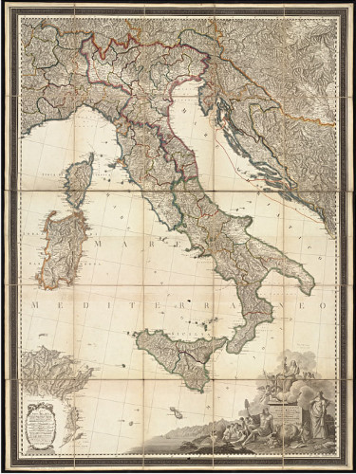
View description - Uncaptioned Figure

In Week 1 you are going to learn and practise how to make enquiries about travel times using the 12-hour and the 24-hour clock. This will involve using numbers as well as practising your speaking and listening skills. Before you start, you might want to revise Italian numbers.
When telling the time, the pronunciation of numbers is very important if you want to be correctly understood, so you might want to say the numbers out loud as you revise them. You will also have a chance to practise pronunciation in some of the activities that follow.
Finally, you will also have the opportunity to learn about the Tuscan Archipelago and about ferry services in Italy.
This OpenLearn course is an adapted extract from the Open University course LXI003 - Beginners Italian 3: stai andando bene!.

1 Revising the 12-hour clock
You’ll start by revising how to say the time so that you can understand the information you are about to be given.

Activity 1

Look at the clocks below and say the time out loud using the 12-hour clock. To check your answers, listen to the audio track. Use the transcript as well if necessary.
Guardate gli orologi qui sotto e dite l’ora ad alta voce.

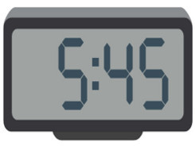
View description - Uncaptioned Figure

Audio content is not available in this format.
View transcript - Uncaptioned interactive content

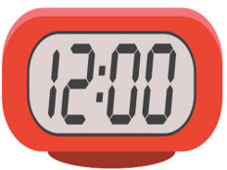
View description - Uncaptioned Figure

Audio content is not available in this format.
View transcript - Uncaptioned interactive content

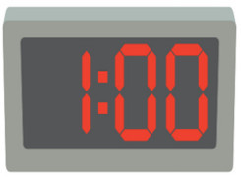
View description - Uncaptioned Figure

Audio content is not available in this format.
View transcript - Uncaptioned interactive content

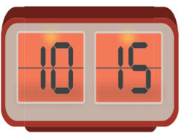
View description - Uncaptioned Figure

Audio content is not available in this format.
View transcript - Uncaptioned interactive content

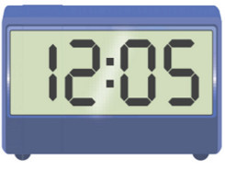
View description - Uncaptioned Figure

Audio content is not available in this format.
View transcript - Uncaptioned interactive content

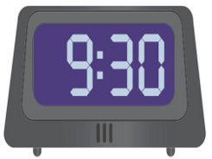
View description - Uncaptioned Figure

Audio content is not available in this format.
View transcript - Uncaptioned interactive content

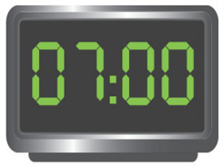
View description - Uncaptioned Figure

Audio content is not available in this format.
View transcript - Uncaptioned interactive content

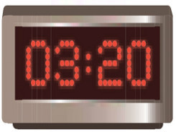
View description - Uncaptioned Figure

Audio content is not available in this format.
View transcript - Uncaptioned interactive content

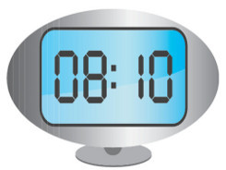
View description - Uncaptioned Figure

Audio content is not available in this format.
View transcript - Uncaptioned interactive content

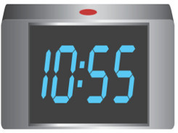
View description - Uncaptioned Figure

Audio content is not available in this format.
View transcript - Uncaptioned interactive content

2 Revising the 24-hour clock
Practise the 24-hour clock by using it to rewrite the following times, in Italian. Follow the example.
Riscrivete le frasi qui sotto adoperando il sistema orario a 24 ore.
Esempio
Sono le sei di sera. → Sono le diciotto.

Activity 2

Interactive content is not available in this format.

Interactive content is not available in this format.

Interactive content is not available in this format.

Interactive content is not available in this format.

Interactive content is not available in this format.

Interactive content is not available in this format.

Interactive content is not available in this format.

Interactive content is not available in this format.

3 At Piombino’s tourist office
You are on the west coast of Italy, in Piombino, Tuscany, and have gone to the tourist information office to find out the times of ferries to the islands. While you are queuing at the tourist information office, you overhear some customers asking about departure and arrival times for various ferries (traghetti).

Activity 3

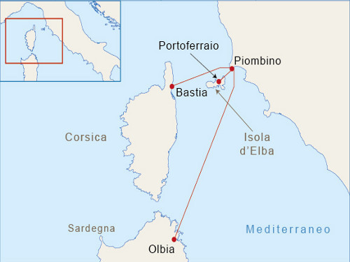
View description - Uncaptioned Figure

Listen to the audio track and fill in the table with the missing times.
Ascoltate l’audio e inserite gli orari di partenza o arrivo nella tabella.

Audio content is not available in this format.
View transcript - Uncaptioned interactive content

Interactive content is not available in this format.

4 Asking about arrival and departure times
To ask what time a train, bus, plane or boat leaves or arrives, and to understand the reply, you will need to know the verbs arrivare (‘to arrive’) and partire (‘to leave’, as in ‘to depart’, ‘to set on a journey’). The present tense of both verbs is regular.
– A che ora arriva il traghetto?
– What time does the ferry arrive?
– Il traghetto arriva a mezzanotte.
– The ferry arrives at midnight.
– A che ora parte l’aereo?
– What time does the plane leave?
– L’aereo parte la sera tardi.
– The plane leaves late in the evening.
Remember the combined forms of a (‘at’) and the definite article which are used in telling the time.
La barca parte all’una in punto.
– The boat leaves at one o’clock on the dot.
La nave per Olbia parte alle quattordici.
– The ship for Olbia leaves at 14:00.
For regular departures, you may hear ogni (‘every’) being used.
La barca fa il giro dell’isola ogni mattina.
– The boat does a tour around the island every morning.
Il pullman per Firenze parte ogni due ore.
– The bus for Florence leaves every two hours.
Ogni does not change form, whether used with a singular or plural noun, or with a masculine or feminine noun.

5 Visiting the Tuscan Archipelago
You are at Portoferraio on Elba, the main island in the Tuscan Archipelago. You would like to take a boat trip around the island and visit some of the other islands in the archipelago.
Write answers, in Italian, to the following questions, using the information in the leaflet below.
Scrivete le risposte alle domande usando informazioni nel testo.

Activity 4

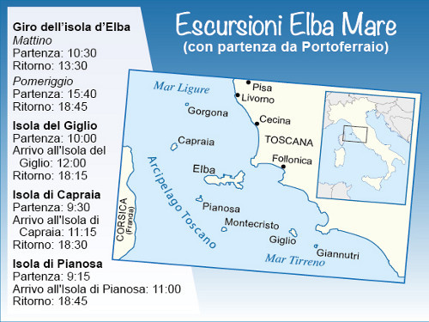
View description - Uncaptioned Figure

Interactive content is not available in this format.

Interactive content is not available in this format.

Interactive content is not available in this format.

Interactive content is not available in this format.

Interactive content is not available in this format.

Interactive content is not available in this format.

Interactive content is not available in this format.

6 The Tuscan Archipelago
The Tuscan Archipelago is off the coast of Tuscany and is a popular holiday destination for both Italian and foreign tourists. There are seven islands in the archipelago: Elba, Giglio, Giannutri, Capraia, Pianosa, Montecristo and Gorgona.
The largest one is Elba (224 km²), which boasts beautiful beaches, medieval villages and one of the largest marine parks in Europe. It was also Napoleon’s home during his first exile from May 1814 to February 1815 (his two residences are a main tourist attraction).
The island of Giglio is much smaller (24 km²) and offers not only beautiful panoramic views but also two picturesque small towns: Giglio Porto (on the coast) and Giglio Castello (inland).
Capraia is popular among snorkellers and scuba divers, who explore the seabed in search of its underwater archaeological remains.
Pianosa can only be visited with an organised guided tour because it was the seat of a maximum-security prison for terrorists and mafia criminals between 1968 and 2011, when it was closed down for good.

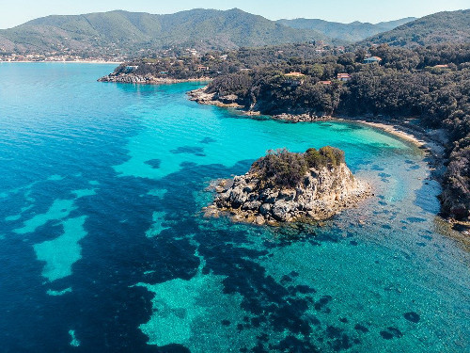
Vista panoramica dell’ Isola d’Elba
View description - Vista panoramica dell’ Isola d’Elba

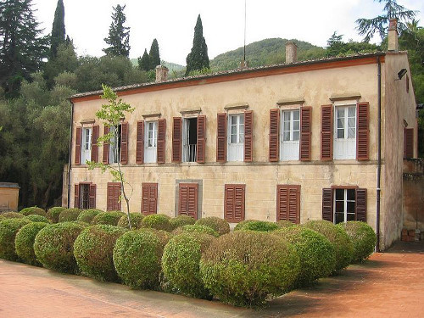
Villa San Martino, casa di Napoleone.
View description - Villa San Martino, casa di Napoleone.

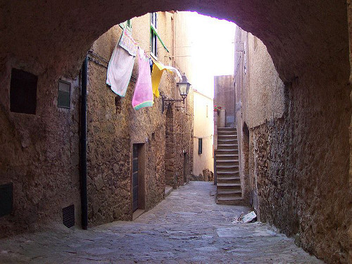
Isola del Giglio, Giglio Castello.
View description - Isola del Giglio, Giglio Castello.

7 Visiting the Tuscan Archipelago (continued)
Now write the questions you would ask to find out information for the trips to Capraia and Pianosa. Follow the example.
Adesso scrivete le domande per chiedere informazioni sui viaggi per Capraia e Pianosa.
Esempio:
Parte alle nove e trenta di mattina.
Answer: A che ora parte la barca per l’isola di Capraia / per Capraia?

Activity 5

Interactive content is not available in this format.

Interactive content is not available in this format.

Interactive content is not available in this format.

Interactive content is not available in this format.

8 Speaking practice
You’ll now practise asking about departure and arrival times.

Activity 6

Listen to the audio track and record yourself asking questions following the prompts. Then listen to the model answer. Follow the example.
Ascoltate l’audio e fate le domande. Seguite l’esempio.
Esempio
You hear: Ask what time the ferry to Capri departs.
You say: A che ora parte il traghetto per Capri?

Audio content is not available in this format.
View transcript - Uncaptioned interactive content

1.

Interactive content is not available in this format.

2.

Interactive content is not available in this format.

3.

Interactive content is not available in this format.

4.

Interactive content is not available in this format.

5.

Interactive content is not available in this format.

9 Italian ferry and hydrofoil service
Italy has a total of almost 8,500 km of coastline, including the mainland and numerous islands around the country. The main links between islands and mainland are by ferries and hydrofoils. The main Italian ports of embarkation for the large islands of Sicilia and Sardegna are (from North to South) Genova, Livorno, Civitavecchia, Napoli and Villa San Giovanni (on the tip of the boot, opposite Sicily).
The network of ferry services is well developed. Large ferries (navi) service the islands of Sardegna and Sicilia, while smaller islands are served by small ferries (traghetti) and hydrofoils (aliscafi). Ferries and hydrofoils also operate between towns on the northern lakes of Como, Garda and Maggiore.
Ticket prices are usually reasonable but vary according to the time of year and are most expensive during the summer. Some services operate during the summer only and some journeys are very long. For example, the Genova–Palermo boat takes 23 hours and provides sleeping facilities in the form of reclining seats (poltrone), couchettes (cuccette) and cabins (cabine). On the other hand, ferries leave from Villa San Giovanni (on the mainland) for Messina (in Sicilia) every 15 minutes during peak hours and the service operates 24 hours per day.
Ferries also operate like a bus service on the lakes, carrying passengers (and often cars) from one side to the other and calling at lake islands. The car ferry service is usually convenient, as some of the northern lakes are long and narrow, and driving around them takes hours.

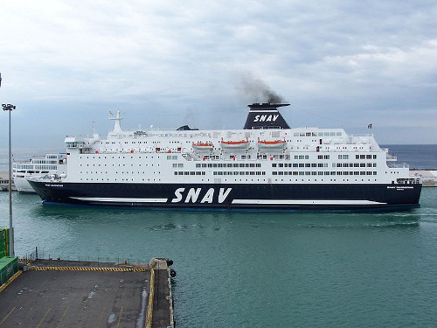
Traghetto per la Sardegna.
View description - Traghetto per la Sardegna.

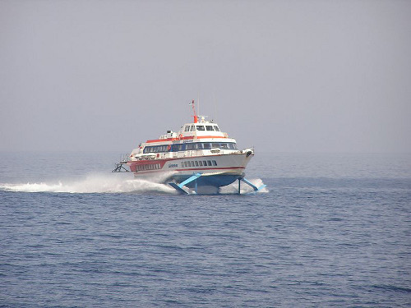
Aliscafo in alto mare.
View description - Aliscafo in alto mare.

10 This week’s quiz
Check what you’ve learned this week by taking the end-of-week quiz.
Week 1 quiz
Open the quiz in a new window or tab (by holding ctrl [or cmd on a Mac] when you click the link), then return here when you have done it.

11 Summary of Week 1
It is useful to keep notes on the main points to remember, which could be grammar rules, vocabulary or expressions. The way in which you choose to keep this record of your learning is up to you: a simple paper notebook, an electronic document, mind maps or any means which suits you. It is important that you add to it regularly so that all key learning points are together in one place and easily accessible for reference and revision. Many learners also find that writing notes helps them to understand grammar points and to memorise vocabulary and expressions. Adding an example of your own to each rule, term and expression will help you fix them in your memory.
Whether you keep your notes on paper or digitally, it’s important to get organised, so here is an idea that may help, based on your Week 1 studies.

Week 1 Reflection

What would you write into each box, if anything? Would you add more boxes?

Pronunciation

Provide your answer...

Culture

Provide your answer...

Language

Provide your answer...

You can now go to Week 2.

Week 2: Enquiring about train times

Introduction

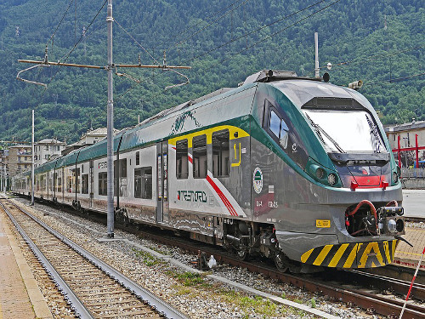
View description - Uncaptioned Figure

This week, you will find out about the Italian rail network and learn vocabulary for talking about different types of train. You will also learn how to ask about the availability of trains to certain destinations and to use c’è (‘there is’) and ci sono (‘there are’).

1 The Italian rail network

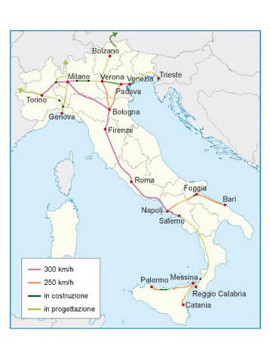
Linee dei Treni ad Alta Velocità (TAV)
View description - Linee dei Treni ad Alta Velocità (TAV)

Travelling by train can be a cheap and convenient means of getting around in Italy, although to travel from Brennero in the far north-east to Reggio Calabria at the southern tip of Italy would take at least 15 hours and involve three changes of train.
The Italian rail network, previously known as Ferrovie dello Stato (FS), is now known as Trenitalia. Still state-owned, it is heavily subsidised, which keeps ticket prices low. As in other European countries, it is now possible to buy most tickets online. In 2012, the privately owned Italo began services between 30 stations in main cities using 300 km/h high speed trains.
The Treni ad Alta Velocità (TAV), or fast through-trains, link several major cities in both the north and south. At the other end of the spectrum, many parts of the country are still heavily dependent on the treni regionali (regional trains), which are slow and stop frequently. Somewhere in between are the treni nazionali (national trains), which link major towns throughout Italy.
The rail network is very much a product of the country’s geography. Central and southern Italy are divided along most of their length by the natural barrier of the Appenines, meaning that east–west rail links are few and far between. In the Po Valley in the north of Italy, however, east–west rail links are good, with a fast train network extending from Genoa in the west to Trieste in the east.
There are still areas of the country where stations are either non-existent or far from the town they are named after (for example, in rural Tuscany or the hill towns of the south and Sicily). In some cities, a bus service links the station to the town centre. To take just one example, the popular tourist destination of Assisi has a station in the nearby town of Santa Maria degli Angeli from which travellers can reach Assisi’s historical town centre by bus. In contrast, many regional airports, such as Pisa and Rome Fiumicino, have their own train station with frequent shuttle services to the main train station.
In recent decades, there has been heavy investment in the high-speed rail network and this is set to expand further, despite ongoing protests (anti-TAV) against its expansion in the north of Italy. The map above shows the current high-speed network and its planned expansion.

2 Italian trains
You’ll now expand on your reading of Italian.

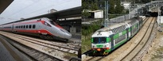
View description - Uncaptioned Figure

Activity 1

Read the following text. Then, below it, tick the statements that are true.
Leggete il testo e decidete quali delle frasi seguenti è corretta.
I treni in Italia
In Italia alcuni treni viaggiano solo all’interno delle regioni e altri viaggiano su tutto il territorio nazionale.
I treni regionali si fermano in quasi tutte le stazioni e collegano i piccoli centri. Hanno solo la seconda classe e costano poco ma viaggiano lentamente, a circa 100 km orari. Però c’è anche un regionale veloce, economico ma meno frequente. Su molti treni si può portare la bicicletta pagando il supplemento bici.
I treni nazionali (Intercity e Frecciabianca) collegano città grandi e medie su tutto il territorio nazionale, hanno prima e seconda classe e viaggiano tra i 150 e 200 km orari.
Ci sono anche i Treni ad Alta Velocità (TAV). Le linee TAV coprono 1.342 km del territorio e collegano alcune delle principali città, in particolare: Roma e Firenze nel Centro; Napoli e Salerno nel Sud; Bologna, Milano e Torino nel Nord. Altre linee sono in parte in costruzione, in parte in progettazione. I Treni ad Alta Velocità viaggiano tra i 250 e i 300 km orari e sono di due tipi: Frecciarossa e Frecciargento.
I Frecciarossa viaggiano a 300 km orari e si fermano solo nelle città principali. Hanno la carrozza ristorante e quattro classi (standard, premium, business ed executive). Tra Roma e Milano c’è un Frecciarossa ogni ora, dalle 6 di mattina alle 7 di sera.
I Frecciargento viaggiano a 250 km orari, collegano principalmente Roma con le città del Sud (come Bari) e le città del Nord-Est (come Venezia), ma si fermano in alcune stazioni intermedie. Hanno due classi (prima e seconda) e una carrozza bar. Tra Roma e Venezia c’è un Frecciargento ogni ora, dalle 6 del mattino alle 7 di sera.
Vocabolario
alcuni, alcune (some when used with plural nouns)
si fermano (from fermarsi) they stop
collegano (from collegare) they connect
costano (from costare) they cost
in parte partly
a 250 km orari at 250 km per hour
si può portare one can take
dalle 6 del mattino from 6 o’clock in the morning

I treni regionali hanno la prima classe.
I treni regionali fermano nelle piccole città.
I treni regionali sono sempre molto veloci.
I Treni ad Alta velocità vanno solo nelle grandi città.
I Frecciarossa viaggiano spesso tra Roma e Milano.
Molte persone prendono un Frecciarossa alle 8 di sera.
Gli Intercity hanno la classe premium.
I Frecciarossa hanno la classe business.
I Frecciargento si fermano nelle piccole città.
I Frecciargento hanno il bar.
View answer - Part

Look at the text again and find the equivalent in Italian for the following expressions.
Guardate di nuovo il testo e trovate l’equivalente italiano delle seguenti espressioni.

città grandi e medie
alcune delle principali città
altre linee sono in parte in costruzione, in parte in progettazione
le stazioni intermedie
la carrozza ristorante
large and medium-sized cities
some of the main cities
other lines are partly being built, partly at the planning stage
stations in between
restaurant carriage
View answer - Part

3 Checking availability of trains
You’ll now use your listening skills.

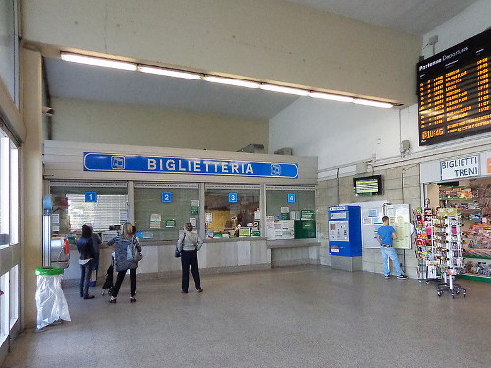
View description - Uncaptioned Figure

Activity 2

Listen to the audio track and tick the cities that are mentioned by the speakers.
Ascoltate l’audio e indicate quali città vengono menzionate.
Vocabolario
stamattina this morning

Audio content is not available in this format.
View transcript - Uncaptioned interactive content

Genova
Milano
Trieste
Napoli
Roma
L’Aquila
Trento
Firenze
Ancona
Aosta
Catanzaro
Bologna
Perugia
Bari
Campobasso
Cagliari
Venezia
Potenza
Torino
Palermo
View answer - Part

Now listen to the audio track again and write in Italian the information given by the person at the railway information office. Check your answers against the transcript.
Riascoltate l’audio e scrivete in italiano le informazioni fornite dall’impiegato. Usate la trascrizione per controllare le risposte.

Provide your answer...

4 Talking about the availability of something

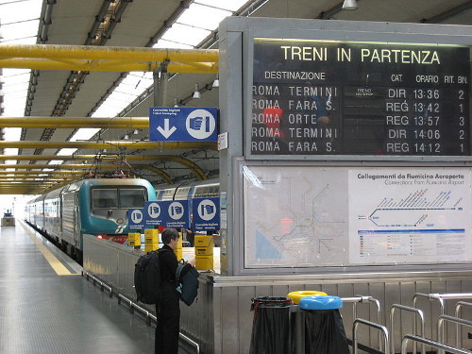
View description - Uncaptioned Figure

To talk about the availability of something (such as trains or buses or planes), you can use c’è or its plural form ci sono.
C’è un treno per Napoli?
Is there a train for Naples?
Ci sono posti liberi?
Are there any free seats?
C’è un Frecciarossa alle 19:45.
There’s a Frecciarossa train at 19:45.
There is no difference in word order between a statement – for example, C’è un treno – and a question – C’è un treno? To make a sentence sound like a question, you simply need to alter your intonation by raising your voice at the end.

5 Grammar practice
You’ll now have the opportunity to focus on grammar.

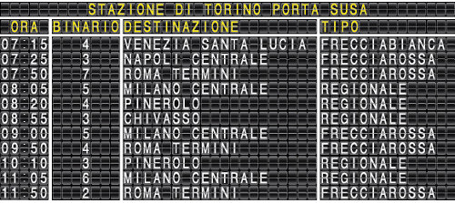
Electronic departure board, Torino Porta Susa station
View description - Electronic departure board, Torino Porta Susa station

Activity 3

At the information office in Turin railway station, passengers are asking for information about trains to a variety of destinations. Look at the electronic departure board above and answer their enquiries, writing down your answer. Use c’è and ci sono as appropriate.
Usate la tabella elettronica per rispondere alle domande dei passeggeri. Scrivete le vostre risposte qui sotto.
Esempio
Scusi, c’è un treno per Venezia?
→ Sì, c’è un Frecciabianca alle 7:15.

Interactive content is not available in this format.

Interactive content is not available in this format.

Interactive content is not available in this format.

Interactive content is not available in this format.

Interactive content is not available in this format.

6 Train timetables

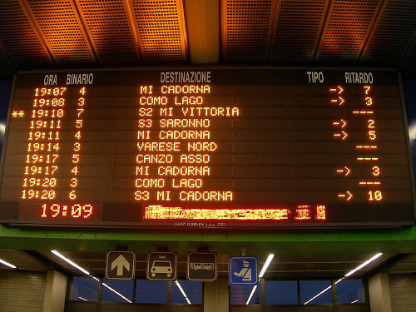
View description - Uncaptioned Figure

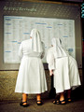
View description - Uncaptioned Figure

Train timetables are available on the Italian railways (Trenitalia) website. As in most European cities, Italian railway stations provide live departure and arrival information on digital electronic boards (‘Partenze’ and ‘Arrivi’ respectively), showing the scheduled time (ora), platform (binario), destination (destinazione) or station of origin (provenienza), type of train (tipo) (for example, Intercity, regionale, etc.) and any delay (ritardo). These electronic boards generally only show trains departing or arriving over the next two to three hours.
You will also find large printed timetables on notice boards (one for Partenze and one for Arrivi) listing all regular train departures and arrivals for a 24-hour period, in chronological order, with information on platform, destination, type of train and stops in between. The sheer number of trains on one poster, however, and the number of people crowded around the same board, can often make it quite difficult to find your train details, especially if you know the destination but don’t have information about the departure time. To avoid this problem, many passengers use the Trenitalia app to check train times and progress in real time and to view the latest arrivals and departure information of a particular station.

7 More practice
You’ll now listen to people asking about the availability of trains at different times of the day.

Activity 4

Listen to the following audio recording.

Audio content is not available in this format.
View transcript - Uncaptioned interactive content

Complete the sentences with the appropriate word or expression from the drop-down menu. Then listen again to the dialogues on the audio track to check your answers.

Interactive content is not available in this format.

8 Speaking practice
Next, you’ll further explore train times.

Activity 5

You are at the information office in Turin railway station and you want to ask for information about trains to a variety of destinations. Listen to the audio track and ask the questions following the prompts, using c’è and ci sono as appropriate.

Audio content is not available in this format.
View transcript - Uncaptioned interactive content

Vocabolario
stasera this evening

9 This week’s quiz
Check what you’ve learned this week by taking the end-of-week quiz.
Week 2 quiz
Open the quiz in a new window or tab (by holding ctrl [or cmd on a Mac] when you click the link), then return here when you have done it.

10 Summary of Week 2
This week you have learned about the Italian rail network and the vocabulary for talking about different types of train. You should also be able to ask about the availability of trains to specific destinations and to use c’è (‘there is’) and ci sono (‘there are’).
The expressions c’è and ci sono are very frequently used. To practise them, look at the timetables of your local trains and practise saying which trains are available in the morning (la mattina), in the afternoon (il pomeriggio) and in the evening (la sera).
You have now reached the end of this course.
This OpenLearn course is an adapted extract from the Open University course LXI003 Beginners Italian 3: stai andando bene!.

Next steps
We hope that you’ll continue your Italian studies with The Open University on our Beginners Italian courses:
- Beginners Italian 1: primi passi
- Beginners Italian 2: in cammino
- Beginners Italian 3: stai andando bene!
Or continue your learning adventure on OpenLearn with our free courses in our Language and Cultures Hub.

Acknowledgements
This free course was first published in June 2021.
Except for third party materials and otherwise stated (see terms and conditions), this content is made available under a Creative Commons Attribution-NonCommercial-ShareAlike 4.0 Licence.
The material acknowledged below and within the course is Proprietary and used under licence (not subject to Creative Commons Licence). Grateful acknowledgement is made to the following sources for permission to reproduce material in this free course:

Introduction

Images
Course image: Photo by Frans Van Heerden from Pexels

Week 1

Images
Introduction figure: Norman B. Leventhal Map Center cleared under Creative Commons Attribution 2.0 Generic license (CC BY 2.0) https://www.flickr.com/photos/24528911@N05/5376030500
Section 6 figures: Image by DanieleFiaschi from Pixabay; Furukama, https://it.m.wikipedia.org/wiki/File:Elba_VillaSanMartino.jpg. This file is licensed under the Creative Commons Attribution Licence CC BY-SA 3.0. https://creativecommons.org/licenses/by-sa/3.0/deed.it; Patpatpat, cleared under Creative Commons Attribution 2.0 Generic license (CC BY 2.0) https://it.wikipedia.org/wiki/File:Isola_del_Giglio01.jpg
Section 9 figures: Cap. Eustachio Patalano https://commons.wikimedia.org/wiki/File:Snav_sardegna_31-10-2007_(5).jpg; Petr Vykoukal, cleared under Creative Commons Attribution - ShareAlike 3.0 Unported license (CC BY-SA 3.0) https://commons.wikimedia.org/wiki/File:Aliscafo.jpg

Week 2

Images
Introduction image: Image by Erich Westendarp from Pixabay
Section 1 image: © Sinigagl - This file is licensed under the Creative Commons Attribution-Share Alike Licence http://creativecommons.org/licenses/by-sa/3.0/ http://it.wikipedia.org/wiki/File:Italy_TAV_new.png
Section 3 image: Arbalete/Wikimedia. https://commons.wikimedia.org/wiki/File:Sesto_San_Giovanni_-_stazione_ferroviaria_-_interno.jpg. This file is licensed under the Creative Commons Attribution Licence. https://creativecommons.org/licenses/by-sa/3.0/deed.en
Section 4 image: Michael Janke/Flickr. https://www.flickr.com/photos/35702041@N00/4062407184. This file is licensed under the Creative Commons Attribution Licence https://creativecommons.org/licenses/by/NC/ND/2.0/
Section 6 images: Fabio, Cleared under Creative Commons Attribution 2.0 Generic license (CC BY 2.0) http://commons.wikimedia.org/wiki/File:Tabellone_Bovisa.jpg; ArtMarie/iStockphoto.com
Every effort has been made to contact copyright owners. If any have been inadvertently overlooked, the publishers will be pleased to make the necessary arrangements at the first opportunity.
Don't miss out
If reading this text has inspired you to learn more, you may be interested in joining the millions of people who discover our free learning resources and qualifications by visiting The Open University – www.open.edu/openlearn/free-courses.

Solutions

Activity 1

Part

Answer
Right:
I treni regionali fermano nelle piccole città.
I Treni ad Alta velocità vanno solo nelle grandi città.
I Frecciarossa viaggiano spesso tra Roma e Milano.
I Frecciarossa hanno la classe business.
I Frecciargento hanno il bar.
Wrong:
I treni regionali hanno la prima classe.
I treni regionali sono sempre molto veloci.
Molte persone prendono un Frecciarossa alle 8 di sera.
Gli Intercity hanno la classe premium.
I Frecciargento si fermano nelle piccole città.
The correct answers are:
I treni regionali fermano nelle piccole città.
I Treni ad Alta velocità vanno solo nelle grandi città.
I Frecciarossa viaggiano spesso tra Roma e Milano.
I Frecciarossa hanno la classe business.
I Frecciargento hanno il bar.
Back to - Part

Part

Answer
The correct matches are:
città grandi e medie
large and medium-sized cities
alcune delle principali città
some of the main cities
altre linee sono in parte in costruzione, in parte in progettazione
other lines are partly being built, partly at the planning stage
le stazioni intermedie
stations in between
la carrozza ristorante
restaurant carriage
Back to - Part

Activity 2

Part

Answer
Right:
Trieste
Napoli
Firenze
Bologna
Bari
Venezia
Wrong:
Genova
Milano
Roma
L’Aquila
Trento
Ancona
Aosta
Catanzaro
Perugia
Campobasso
Cagliari
Potenza
Torino
Palermo
The correct answers are:
Trieste, Napoli, Firenze, Bologna, Bari, Venezia.
Back to - Part

Uncaptioned Figure

Description
Old map of Italy and its larger political divisions in1802. Neighbouring territories and regional provinces are highlighted with coloured borders. The land is intricately detailed, depicting the country's mountainous topography, rivers and adjacent seas. The Mare Mediterraneo, Mare Adriatico and Mare Tirreno are noticeably labelled along with classical embellishments in the bottom corners of the map.
Back to - Uncaptioned Figure

Uncaptioned Figure

Description
A digital clock showing the following time: a quarter to six
Back to - Uncaptioned Figure

Uncaptioned Figure

Description
A digital clock showing the following time: twelve o'clock
Back to - Uncaptioned Figure

Uncaptioned Figure

Description
A digital clock showing time: one o'clock
Back to - Uncaptioned Figure

Uncaptioned Figure

Description
Figure description - A digital clock showing the following time: a quarter past ten.
Back to - Uncaptioned Figure

Uncaptioned Figure

Description
Figure description - A digital clock showing the following time: five past twelve.
Back to - Uncaptioned Figure

Uncaptioned Figure

Description
A digital clock showing the following time: nine thirty.
Back to - Uncaptioned Figure

Uncaptioned Figure

Description
A digital clock showing the following time: seven o'clock.
Back to - Uncaptioned Figure

Uncaptioned Figure

Description
A digital clock showing the following time: twenty past three.
Back to - Uncaptioned Figure

Uncaptioned Figure

Description
Figure description - A digital clock showing the following time: ten past eight.
Back to - Uncaptioned Figure

Uncaptioned Figure

Description
Figure description - A digital clock showing the following time: five to eleven.
Back to - Uncaptioned Figure

Uncaptioned Figure

Description
This is a map of Italy showing the ferry routes between Piombino on the mainland and: Portoferraio on Elba; Bastia on Corsica; and Olbia on Sardinia. There is a timetable showing the following departure and arrival times from Piombino: to Olbia, leaves at [blank], arrives at 16:35; to Portoferraio, leaves at 14:35, arrives at [blank]; to Bastia, leaves at [blank], arrives at 18:10.
Back to - Uncaptioned Figure

Uncaptioned Figure

Description
This is a map of the area showing the following schedule for day trips from:
Portoferraio on Elba: Giro dell’isola d’Elba, Mattino, Partenza: 10:30, Ritorno: 13:30. Pomeriggio, Partenza: 15:40, Ritorno: 18.45. Isola del Giglio, Partenza: 10:00, Arrivo all'Isola del Giglio: 12.00, Ritorno: 18:15.
Back to - Uncaptioned Figure

Vista panoramica dell’ Isola d’Elba

Description
A panoramic view of the Island of Elba and its sea. The caption says: Vista panoramica dell’ Isola d’Elba.
Back to - Vista panoramica dell’ Isola d’Elba

Villa San Martino, casa di Napoleone.

Description
A two-storey 19th century country house and its gardens. The caption says: Villa San Martino, casa di Napoleone.
Back to - Villa San Martino, casa di Napoleone.

Isola del Giglio, Giglio Castello.

Description
A paved street in a Medieval borough. The caption says: Isola del Giglio, Giglio Castello.
Back to - Isola del Giglio, Giglio Castello.

Traghetto per la Sardegna.

Description
A large ferry leaving the harbour. The caption says: Traghetto per la Sardegna.
Back to - Traghetto per la Sardegna.

Aliscafo in alto mare.

Description
An hydrofoil travelling at full speed. The caption says: Aliscafo in alto mare.
Back to - Aliscafo in alto mare.

Uncaptioned Figure

Description
Regional Trenord train at a platform with mountain background
Back to - Uncaptioned Figure

Linee dei Treni ad Alta Velocità (TAV)

Description
This is a map of Italy showing the routes served by high-speed trains. Trains travelling at 300 kms per hour link Salerno with Napoli, Roma, Firenze, Bologna, Milano and Torino. Trains travelling at 250 kms per hour link Bari with Foggia in the South, Bologna with Verona and Padova in the North, and Messina with Catania and Palermo in Sicily, although sections of these lines are still being built. Other lines shown as under construction or at the planning stage link Torino with Genova, Genova with Milano and Verona with Bolzano in the North and Salerno with Reggio Calabria in the South.
Back to - Linee dei Treni ad Alta Velocità (TAV)

Uncaptioned Figure

Description
Two photographs showing different trains found in Italy. The photograph on the left is of a silver high speed 'bullet train' with red stripes. It is of sleek design with a long nose ideal for travelling very fast over long distances. The photograph on the right shows a less aerodynamic train with a flat nose and double decker carriages for passengers. It is white with green stripes and serves commuters living in the same region.
Back to - Uncaptioned Figure

Uncaptioned Figure

Description
Picture of an Italian ticket office. It is situated in the main entrance to the station. There are four counters and some people queuing in front of the first one. There is a large sign containing the word ‘Biglietteria’ which means ticket office.
Back to - Uncaptioned Figure

Uncaptioned Figure

Description
Picture of an Italian departure platform showing a train and a live departure board. The departure board lists five destinations, and departure times.
Back to - Uncaptioned Figure

Electronic departure board, Torino Porta Susa station

Description
Electronic departure board for Stazione di Torino Porta Susa has four columns showing departure time, platform, destination and train type for the following trains: 7:15, 4, Venezia Santa Lucia, Frecciabianca; 7:25, 3, Napoli Centrale, Frecciarossa; 7:50, 7, Roma Termini, Frecciarossa; 8:05, 5, Milano Centrale, Regionale; 8:20, 4, Pinerolo, Regionale; 8:55, 3, Chivasso, Regionale; 9:00, 5, Milano Centrale, Frecciarossa; 9:50, 4, Roma Termini, Frecciarossa; 10:10, 3, Pinerolo, Regionale; 11:05, 6, Milano Centrale, Regionale; 11:50, 2, Roma Termini, Frecciarossa.
Back to - Electronic departure board, Torino Porta Susa station

Uncaptioned Figure

Description
This is an image of an electronic departure board at a train station.
Back to - Uncaptioned Figure

Uncaptioned Figure

Description
This is an image of two nuns checking a large paper timetable on the wall of a train station.
Back to - Uncaptioned Figure

Uncaptioned interactive content

Transcript
Sono le sei meno un quarto.
Back to - Uncaptioned interactive content

Uncaptioned interactive content

Transcript
È mezzogiorno
[or]
È mezzanotte.
Back to - Uncaptioned interactive content

Uncaptioned interactive content

Transcript
È l’una.
Back to - Uncaptioned interactive content

Uncaptioned interactive content

Transcript
Sono le dieci e un quarto.
Back to - Uncaptioned interactive content

Uncaptioned interactive content

Transcript
Sono le dodici e cinque.
Back to - Uncaptioned interactive content

Uncaptioned interactive content

Transcript
Sono le nove e mezza.
Back to - Uncaptioned interactive content

Uncaptioned interactive content

Transcript
Sono le sette.
Back to - Uncaptioned interactive content

Uncaptioned interactive content

Transcript
Sono le tre e venti.
Back to - Uncaptioned interactive content

Uncaptioned interactive content

Transcript
Sono le otto e dieci.
Back to - Uncaptioned interactive content

Uncaptioned interactive content

Transcript
Sono le undici meno cinque.
Back to - Uncaptioned interactive content

Uncaptioned interactive content

Transcript
Listen to some people in the tourist information office in Piombino asking about departure and arrival times for the ferries.
1.– A che ora parte il traghetto per Olbia?
– Parte alle undici e venti.
– E a che ora arriva?
– Arriva alle sedici e trentacinque.
2.– A che ora parte il traghetto per Portoferraio?
– Parte alle quattordici e trentacinque.
– E a che ora arriva?
– Arriva alle quindici e trentacinque.
3 – A che ora parte il traghetto per Bastia?
– Parte alle sedici e dieci e arriva alle diciotto e dieci.
Back to - Uncaptioned interactive content

Uncaptioned interactive content

Transcript
Esempio
You hear: Ask what time the ferry to Capri departs.
You say: A che ora parte il traghetto per Capri?
Back to - Uncaptioned interactive content

Uncaptioned interactive content

Transcript
Listen to these people asking if there are trains to different destinations.
1. – Scusi, c’è un treno per Trieste stamattina?
– Sì, c’è un regionale alle dieci e trenta.
2. – Scusi, ci sono treni diretti per Firenze?
– Sì, c’è un Frecciarossa ogni due ore.
3. – Scusi, c’è un treno la mattina per Bari?
– No, mi dispiace, non c’è. C’è un treno il pomeriggio.
4. – Mi scusi, c’è un treno per Napoli la mattina presto?
– Sì, c’è un regionale alle sette e venti.
5. – Mi scusi, vorrei andare a Bologna. C’è un treno la sera tardi?
– No, ma ci sono due treni il pomeriggio, uno alle sedici e venti e uno alle diciotto e quaranta.
6. – Scusi, per andare a Venezia c’è un treno regionale?
– Sì, c’è il regionale delle undici e cinquanta.
Back to - Uncaptioned interactive content

Uncaptioned interactive content

Transcript
Listen to the following people asking about the availability of trains at different times of day.
1
Scusi, c’è un treno per Milano?
– Sì, c’è un Frecciarossa alle quindici e c’è un regionale alle sedici e venticinque.
2
C’è un Frecciarossa per Pisa?
– No, non c’è. C’è solo un regionale alle quindici e quaranta.
3
C’è un treno il pomeriggio per Napoli?
– Sì, c’è un Frecciarossa alle sedici e cinque. E anche un Frecciarossa la sera, alle diciannove e quarantacinque.
4
Vorrei andare a Roma. C’è un treno la mattina?
– Sì, ci sono due Freciarossa, uno alle sette e trentacinque e uno più tardi, alle otto e cinquanta.
5
Per andare a Viareggio c’è un treno il pomeriggio tardi?
– Si, c’è un regionale alle diciassette e venti.
6
Scusi, la mattina c’è un treno per Pistoia?
– No, non ci sono treni per Pistoia la mattina.
7
C’è un treno per Siena?
– Sì, ci sono due regionali, uno la sera, alle venti e dieci, e un altro la notte, a mezzanotte e quaranta.
Back to - Uncaptioned interactive content

Uncaptioned interactive content

Transcript
Listen to the prompt and use it to ask for information about trains, using c’è or ci sono as appropriate.
Esempio
You hear: (Vercelli, this morning)
You say: Scusi, c’è un treno per Vercelli stamattina?
Now it’s your turn.
1. (Aosta, tomorrow evening)
Scusi, c’è un treno per Aosta domani sera?
2. (Rome, tomorrow afternoon)
Scusi, c’è un treno per Roma domani pomeriggio?
3. (direct trains for Venice)
Scusi, ci sono treni diretti per Venezia?
4. (a fast train for Florence this afternoon)
Scusi, c’è un treno veloce per Firenze oggi pomeriggio?
5. (a Frecciarossa for Milan this evening)
Scusi, c’è un Frecciarossa per Milano stasera?
6. (a Eurocity for Naples tomorrow morning)
Scusi, c’è un Eurocity per Napoli domani mattina?
Back to - Uncaptioned interactive content

