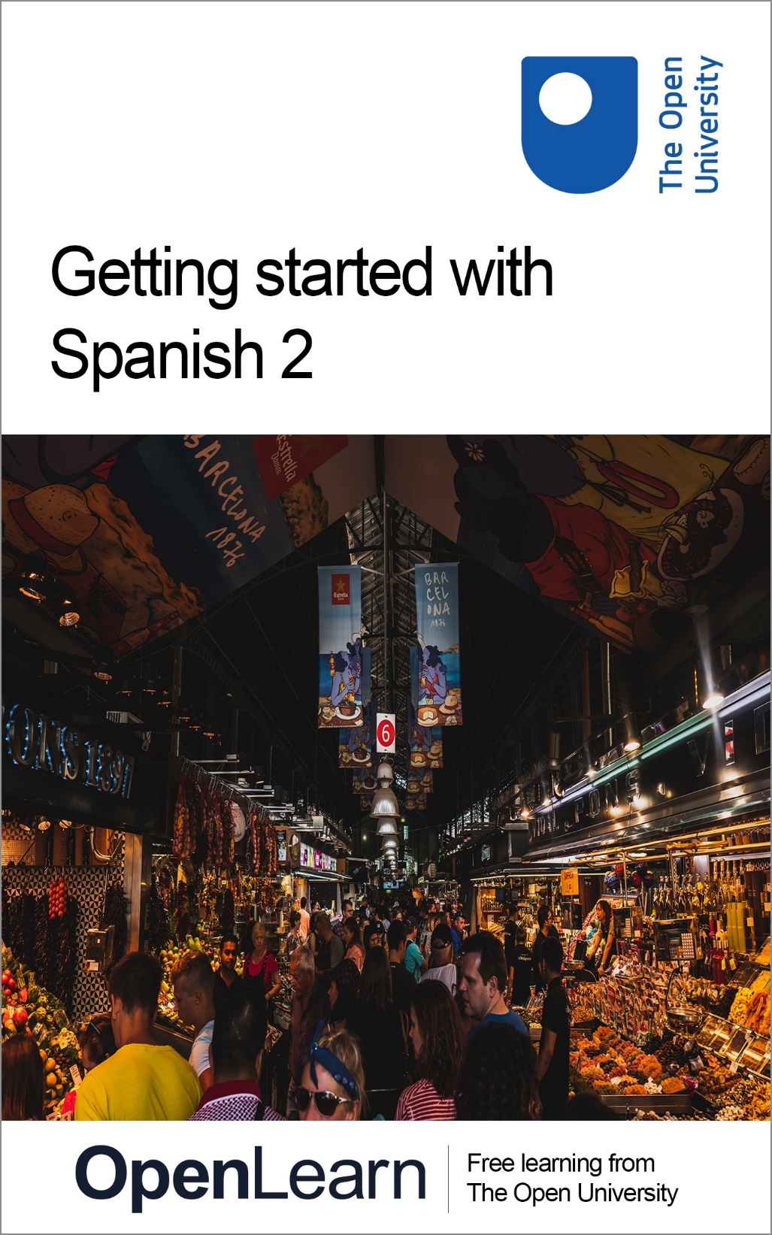

LXS002_1

Getting started with Spanish 2

About this free course
This free course is an adapted extract from the Open University course developed from extract parts of LXS002 - ¡En marcha!.
This version of the content may include video, images and interactive content that may not be optimised for your device.
You can experience this free course as it was originally designed on OpenLearn, the home of free learning from The Open University –
Getting started with Spanish 2
There you’ll also be able to track your progress via your activity record, which you can use to demonstrate your learning.
Copyright © 2021 The Open University
Intellectual property
Unless otherwise stated, this resource is released under the terms of the Creative Commons Licence v4.0 http://creativecommons.org/licenses/by-nc-sa/4.0/deed.en_GB. Within that The Open University interprets this licence in the following way: www.open.edu/openlearn/about-openlearn/frequently-asked-questions-on-openlearn. Copyright and rights falling outside the terms of the Creative Commons Licence are retained or controlled by The Open University. Please read the full text before using any of the content.
We believe the primary barrier to accessing high-quality educational experiences is cost, which is why we aim to publish as much free content as possible under an open licence. If it proves difficult to release content under our preferred Creative Commons licence (e.g. because we can’t afford or gain the clearances or find suitable alternatives), we will still release the materials for free under a personal end-user licence.
This is because the learning experience will always be the same high quality offering and that should always be seen as positive – even if at times the licensing is different to Creative Commons.
When using the content you must attribute us (The Open University) (the OU) and any identified author in accordance with the terms of the Creative Commons Licence.
The Acknowledgements section is used to list, amongst other things, third party (Proprietary), licensed content which is not subject to Creative Commons licensing. Proprietary content must be used (retained) intact and in context to the content at all times.
The Acknowledgements section is also used to bring to your attention any other Special Restrictions which may apply to the content. For example there may be times when the Creative Commons Non-Commercial Sharealike licence does not apply to any of the content even if owned by us (The Open University). In these instances, unless stated otherwise, the content may be used for personal and non-commercial use.
We have also identified as Proprietary other material included in the content which is not subject to Creative Commons Licence. These are OU logos, trading names and may extend to certain photographic and video images and sound recordings and any other material as may be brought to your attention.
Unauthorised use of any of the content may constitute a breach of the terms and conditions and/or intellectual property laws.
We reserve the right to alter, amend or bring to an end any terms and conditions provided here without notice.
All rights falling outside the terms of the Creative Commons licence are retained or controlled by The Open University.
Head of Intellectual Property, The Open University

Contents
- Introduction
  - Introduction
  - Open Centre for Languages and Cultures
- Week 1 What time is it?
  - Introduction
  - 1 What time is it?
  - 2 Asking and telling the time
  - 3 Practising times
  - 4 Listening practice
  - 5 Speaking practice
  - 6 What time is it?
  - 7 a.m. and p.m.
  - 8 Times at different stages of the day
  - 9 This week's quiz
  - 10 Summary of Week 1
- Week 2: Everyday activities
  - Introduction
  - 1 Everyday activities
  - 2 Saying what you do
  - 3 Daily routines
  - 4 The present tense of regular verbs
  - 5 Reading comprehension
  - 6 Finding verbs in a dictionary
  - 7 Using the present tense
  - 8 Speaking practice
  - 9 The correct present tense form
  - 10 Sounds for the letter ‘r’
  - 11 Listen and repeat ‘r’ and ‘rr’
  - 11 This week’s quiz
  - 11 Summary of Week 2
- Acknowledgements
- Solutions

Introduction

Introduction
¡En marcha! Let's get up and running!

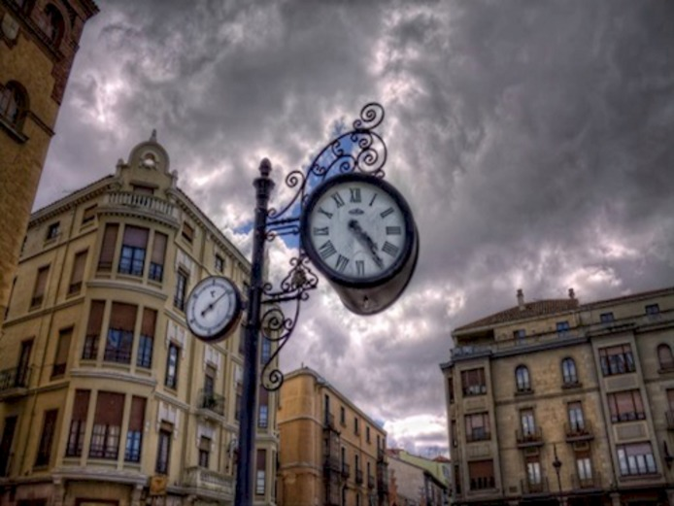
View description - Uncaptioned Figure

This is the second beginners Spanish course, Getting started with Spanish 2. You might have already gone through the previous course in this program or you might be joining us now for the first time. Regardless, we hope you enjoy the course and find it useful.
This two-week course is the next step in your learning journey. Each week comprises 3–4 hours of interactive activities, explanations, exercises and tips about language-learning. It’s a good idea to keep notes either on paper in a notebook or on your preferred digital device; in any case each week you’ll be encouraged to add to your own personal phrase book and decide how best you can go about memorising and practising key phrases and vocabulary. There is also a weekly quiz for you to practise what you’ve been learning.
You’ll start by learning how to tell the time in Spanish, but first of all, take some time to decide how you’ll allocate your time to your studies. Learning Spanish, like learning any language, is a gradual process; it’s often described as ‘a marathon, not a sprint.’ ‘Little and often’ is the best approach, so if at all possible spread your 3–4 hours over the week, rather than devoting one whole afternoon or evening. This will give you plenty of opportunities to revisit vocabulary and language structures, to revise quickly what you did last time and above all to practise and consolidate. This is the best way to learn vocabulary and perfect your accent.
After studying this course, you should be able to:
- ask the time, and tell the time to others
- develop pronunciation, fluency and intonation through practice
- conjugate verbs in the present tense
- report on daily routines and favoured activities
- appreciate the different 'r' sounds in the Spanish language

Open Centre for Languages and Cultures
This course has been developed from extracts of LXS002 - Beginners Spanish 2: ¡En marcha!. The Open University have launched a dedicated learning centre called The Open Centre for Languages and Cultures. OpenLearn is supporting this project and is providing extracted units of all courses on The Open Centre in our dedicated Language and Cultures Hub.
The Open Centre for Languages and Cultures is the exciting new home for non-accredited language and intercultural communication short courses. You can study a wide range of language and language related subjects with us anywhere in the world, in any time zone, whatever your motivation – leisure, professional development or academic.
It’s the one stop shop for engaging with languages, professional communication and intercultural dialogue.
Our short courses allow us to be agile and responsive to the needs of learners who want to be part of a global society. We offer non-accredited short courses in a range of subjects including modern languages, and languages for business and the workplace. We are also leading the way in developing short courses for academic research methods and pre-sessional English with IELTS, which will be available for registration in due course.
The Open Centre for Languages and Cultures is an international leader in online language learning and intercultural communications, built on our pioneering pedagogy and research.
What makes the Open Centre different?
- The OU is the leader in online learning and teaching with a heritage of more than 50 years helping student achieve their learning ambitions.
- The short courses are underpinned by academic rigour and designed by native speakers experienced in producing engaging materials for online learning of languages and cultures.
- The graduating nature of the courses means that learners can build up their language and skills over time.
- Learners will also gain a better understanding of the culture(s) associated with the language(s) they study enabling the development of intercultural communication skills.
- Learners can mix and match the short courses and study more than one course at a time.
Once this course is complete you will be directed to OpenLearn's hub for language content where you will be able to build on your newly found language skills.
Now that you’re fully prepared, it’s time to start on Week 1.

Week 1 What time is it?

Introduction
¡Bienvenido/a a semana 1! Welcome to Week 1!
In this first week, you will learn how to tell the time in Spanish, including asking other people and answering others' questions about the time. You will practise this through a variety of speaking and listening activities.
Enjoy the week!
This OpenLearn course is an adapted extract from the Open University course LXS002 Beginners Spanish 2: ¡En marcha!

1 What time is it?
Let’s make a start by listening to a group of school children that are learning how to tell the time.

Activity 1

Audio content is not available in this format.
View transcript - Uncaptioned interactive content

Can you identify how the teacher asks the time? Listen and select the question she asks.

¿Qué hora es?
¿Es la una?
¿Son las dos?
View answer - Part

Audio content is not available in this format.
View transcript - Uncaptioned interactive content

Listen to the recording again and select the two expressions the children use after the time.

en punto
y cuarto
y media
menos cuarto
View answer - Part

2 Asking and telling the time
To ask and tell the time (la hora) in Spanish, use the following expressions.
- ¿Qué hora es? What time is it? / What’s the time?
- La una. / Es la una. It’s one o’clock.
- Las dos. / Son las dos. It’s two o’clock.
- Las tres. / Son las tres. It’s three o’clock.
Notice that the article la / las is always used with times. It is feminine because it refers to the noun hora / horas.
Note that the answer is in the singular (Es la una) for one o’clock and in the plural for all other times (Son las dos / tres / cuatro…).
More precise time is given in the following way.

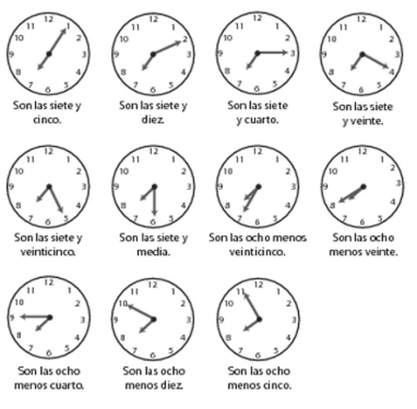
View description - Uncaptioned Figure

3 Practising times
Match the following times with their equivalents in digits. Choose from the list.

Activity 2

Question 1
Las ocho y veinte = las _________

00:00
12:45
20:20
View answer - Part

Question 2
La una menos cuarto = las _________

12:45
20:20
11:40
View answer - Part

Question 3
Las tres y veinticinco = las _________

11:40
14:50
03:25
View answer - Part

Question 4
Las siete y cuarto = las _________

07:15
09:00
22:05
View answer - Part

Question 5
Las nueve en punto = las _________

07:15
22:05
09:00
View answer - Part

Question 6
Las doce menos veinte = las _________

20:20
11:40
14:50
View answer - Part

Question 7

Interactive content is not available in this format.

Question 8

Interactive content is not available in this format.

Question 9

Interactive content is not available in this format.

Question 10

Interactive content is not available in this format.

4 Listening practice
This activity will give you some practice in telling the time as part of spoken conversation.

Activity 3

Audio content is not available in this format.
View transcript - Uncaptioned interactive content

Listen to the recording and select all the times mentioned.

12:00
12:05
12:10
12:30
12:35
12:40
12:45
View answer - Activity 3

5 Speaking practice
Look at the following clock faces and practise saying the times aloud.
You may want to record yourself and then listen to the recording.

Activity 4

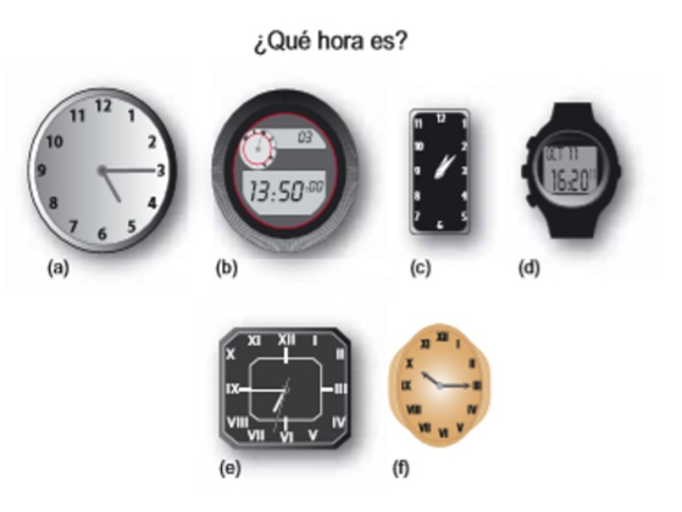
View description - Uncaptioned Figure

Reflection
Note that with the 24-hour clock the time can also be given by reading the numbers; for example:
- 2:50 – (Son) las dos cincuenta
- 20:35 – (Son) las veinte treinta y cinco

View discussion - Activity 4

6 What time is it?
In this activity you will practise asking and telling the time, focusing on the intonation of the questions. You will practise ‘shadow reading’, that is reading aloud as you listen to the recording of that text. This is a good way to practise your pronunciation, fluency and intonation.

Activity 5

Read out loud the questions below as you listen to the audio recording. Try to imitate the speaker’s speed, her pronunciation and intonation, and try to keep up with her!
—¿Qué hora es?
—Martina, ¿qué hora es?
—¿Qué hora es, Pedro?
—Margarita, ¿qué hora es?

Audio content is not available in this format.
View transcript - Uncaptioned interactive content

Audio content is not available in this format.
View transcript - Uncaptioned interactive content

Audio content is not available in this format.
View transcript - Uncaptioned interactive content

Audio content is not available in this format.
View transcript - Uncaptioned interactive content

Activity 6

Now listen to these prompts, and ask each person the time. There will be a gap for you to ask the question out loud before the model answer is given. Pay attention to the pronunciation of each person’s name and to the intonation of the question (the rise and fall of the voice) after addressing each person. Practise as many times as you wish.

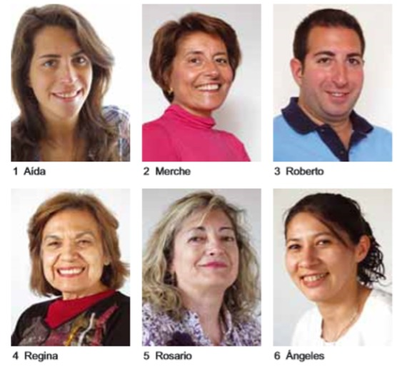
View description - Uncaptioned Figure

Example
You hear: Ask María.
You say: María, ¿qué hora es?

Audio content is not available in this format.
View transcript - Uncaptioned interactive content

Audio content is not available in this format.
View transcript - Uncaptioned interactive content

Audio content is not available in this format.
View transcript - Uncaptioned interactive content

Audio content is not available in this format.
View transcript - Uncaptioned interactive content

Audio content is not available in this format.
View transcript - Uncaptioned interactive content

Audio content is not available in this format.
View transcript - Uncaptioned interactive content

7 a.m. and p.m.
Listen to the following times and try to determine the expressions used to indicate whether it is a.m. and p.m.

Audio content is not available in this format.
View transcript - Uncaptioned interactive content

Activity 7

1. The expression for a.m. is …

de la mañana
de la tarde
de la noche
View answer - Part

2. There are two expressions for p.m., they are …

de la mañana
de la tarde
de la noche
View answer - Part
View discussion - Part

8 Times at different stages of the day
When using the 12-hour clock the expressions de la mañana, de la tarde or de la noche are frequently added to indicate whether it is a.m. or p.m.

Son las ocho y media de la mañana. It’s half past eight in the morning.
Son las dos de la tarde. It’s 2 p.m.
Son las diez de la noche. It’s 10 p.m.
Son las doce. Es mediodía. It’s 12 p.m. It’s midday.
Son las doce de la noche. Es medianoche. It’s 12 a.m. It’s midnight.

Activity 8

Listen to the times and convert them into a full sentence using either Es or Son, as in the example. There will be a gap for you to ask the question out loud before the model answer is given. You may like to record your answer on a phone and play it back to check your pronunciation.

Example
You hear: Las tres de la tarde.
You say: Son las tres de la tarde.

Audio content is not available in this format.
View transcript - Uncaptioned interactive content

Audio content is not available in this format.
View transcript - Uncaptioned interactive content

Audio content is not available in this format.
View transcript - Uncaptioned interactive content

Audio content is not available in this format.
View transcript - Uncaptioned interactive content

Audio content is not available in this format.
View transcript - Uncaptioned interactive content

Audio content is not available in this format.
View transcript - Uncaptioned interactive content

9 This week's quiz
Check what you’ve learned this week by taking the end-of-week quiz. This is optional practice, but will help to consolidate what you've learned.
Week 1 quiz
Open the quiz in a new window or tab (by holding ctrl [or cmd on a Mac] when you click the link), then return here when you have done it.

10 Summary of Week 1
Now you have reached the end of Week 1, reflect a little on what you have learnt. In the box below, note down what you have found easy, useful or fun, and what was more difficult.

Week 1 Reflection

What was easy, useful or fun this week?

Provide your answer...

What was more difficult?

Provide your answer...

What do I need to practice?

Provide your answer...

¡Enhorabuena!
You have come to the end of Week 1. Next week you’ll be learning how to talk about everyday activities, you’ll learn about the sound of the r and you’ll be able to work further on your pronunciation and listening skills.
¡Hasta la semana que viene!
You can now move on to Week 2.

Week 2: Everyday activities

Introduction
¡Bienvenido/a a semana 2! Welcome to Week 2!

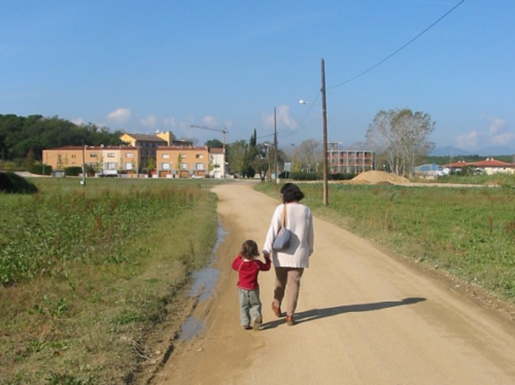
View description - Uncaptioned Figure

You will see that this week introduces quite a bit of new vocabulary and grammar, especially the conjugation of new verbs in the present tense. It is really important that you learn these, as there is nothing more frustrating when learning a new language than starting to say a sentence and getting stuck because you can’t remember the word or the verb form you need!
Have you got a good dictionary? Do you use a dictionary online? You might need to refer to one for at least one of the activities this week, so think about how you plan to look words up when you need to. There are many online dictionaries available, or perhaps you prefer to use a printed version. Either way, find a dictionary that suits you and that is also reliable and accurate.
Enjoy the week!
This OpenLearn course is an adapted extract from the Open University course LXS002 Beginners Spanish 2: ¡En marcha!

1 Everyday activities
In this activity you will learn vocabulary relating to everyday activities and how to say when you usually do them.

Activity 1

Listen to this clip as various people are asked about their everyday activities. Then look at the drawings below, which depict some of these activities. Drag and drop the descriptions to the matching drawings underneath.

Audio content is not available in this format.
View transcript - Uncaptioned interactive content

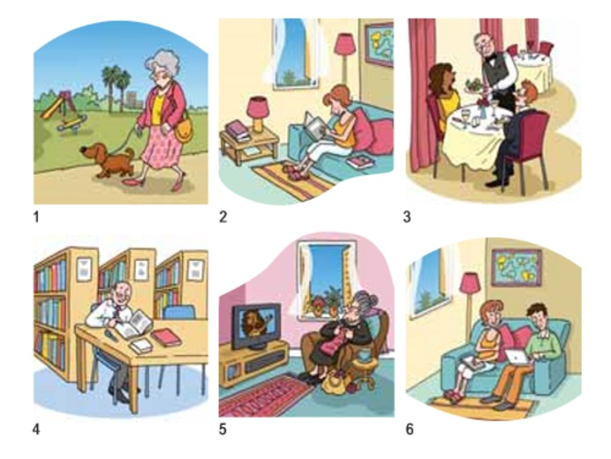
View description - Uncaptioned Figure

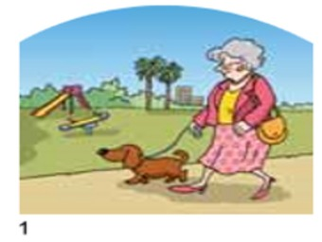
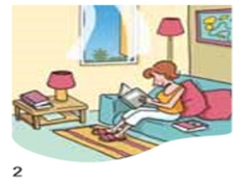
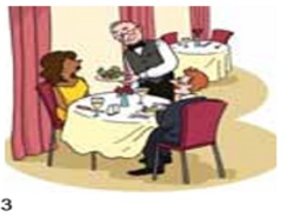
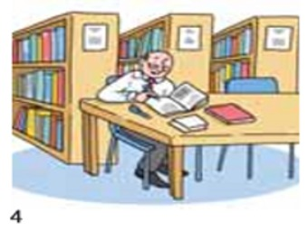
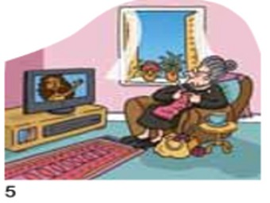
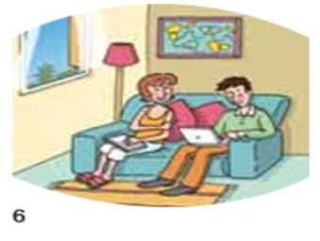
Paseo, paseo por el parque.
Yo leo, normalmente leo.
Trabajo en un restaurante.
Estudio, estudio en la biblioteca.
Veo la televisión.
Juan escribe, escribe novelas en el ordenador
View answer - Activity 1

2 Saying what you do
To say what you do on a regular basis, use the verb in the present tense (el presente).
- ¿Qué haces normalmente? What do you usually do?
- Paseo. I go for a walk.
- Estudio. I study.
- Veo la televisión. I watch television.
You can also talk about a specific time in the day.
- ¿Qué haces normalmente a las diez de la mañana? What do you normally do at ten o’clock in the morning?
- Desayuno a las diez de la mañana. I have breakfast at ten o’clock in the morning.
To say what you do in a specific part of the day:
- ¿Qué haces normalmente por la tarde? What do you normally do in the afternoon?
- Por la tarde paseo. I go for a walk in the afternoon.
Note the contrast between a las dos de la tarde, to refer to a specific time in the afternoon (Como a las dos de la tarde), and por la tarde, to refer to what you do in the afternoon in general (Estudio por la tarde).

3 Daily routines
Listen to this audio clip, then answer the questions in the activity beneath.

Audio content is not available in this format.
View transcript - Uncaptioned interactive content

Activity 2

Interactive content is not available in this format.

Interactive content is not available in this format.

Interactive content is not available in this format.

Interactive content is not available in this format.

Interactive content is not available in this format.

Reflection
You will have noticed that in your answers the form of the verb always ends in -o (trabajo, estudio, paseo, leo, escribo). That is because you are saying ‘I work’, ‘I study’, ‘I go for a walk’, ‘I read’, ‘I write’, and the ending for the first person (I = yo) of regular verbs in the present is always -o.

Listen again to each person talking about what they do in the morning and repeat out loud their answers.

Audio content is not available in this format.
View transcript - Uncaptioned interactive content

4 The present tense of regular verbs
Verbs have two parts: a stem and an ending. To find out what the stem of a verb is, drop the -ar, -er or -ir of the infinitive (trabaj-, com-, viv-). For regular verbs the stem does not change. To form the present tense, just add the present tense endings of the respective conjugation to the stem. The endings show the person and the number (for example, trabajo = first person singular).

 | -ar | -er | -ir
 | trabaj-ar | com-er | escrib-ir
(yo) | trabaj-o | com-o | escrib-o
(tú) | trabaj-as | com-es | escrib-es
(él/ella, usted) | trabaj-a | com-e | escrib-e
(nosotros/-as) | trabaj-amos | com-emos | escrib-imos
(vosotros/-as) | trabaj-áis | com-éis | escrib-ís
(ellos/ellas, ustedes) | trabaj-an | com-en | escrib-en

Verbs whose infinitives end in -ir have the same endings as -er verbs in the present tense, except for the nosotros and vosotros forms.

5 Reading comprehension
Read this brief email sent by Verónica to her friend Marta. First concentrate on understanding the gist – there is some vocabulary provided below to help. When you have a rough idea of the email's meaning, try completing the multiple choice questions underneath.

Activity 3

Hola Marta:
Soy miembro de Acción Solidaria en Chile. El objetivo de nuestra organización es facilitar y ayudar con trabajar distintos a los discapacitados. ¡Quieren y pueden trabajar! Ofrecemos cursos para fabricar objetos, aprender carpintería, informática y hacer repostería. Los discapacitados fabrican objetos, aprenden carpintería y a usar computadoras. Es bonito. Todos aprendemos mucho.
También trabajamos en escuelas especiales con niños de todas las edades con limitación físicas o mentales. Tenemos colaboradores que usan la lengua de señas en las clases cuando los niños tienen discapacidad auditiva. Los niños aprenden mucho y están contentos.
Mi hermano también colabora con la asociación. Él da clases de carpintería y yo contacto con nuestros colaboradores para organizar actividades. ¿Colabora con nosotros?
Un abrazo,
Vero

Vocabulario
ayudar | to help
discapacitado | a disabled
hacer repostería | baking
la computadora (LAm) | computer
la lengua de señas | sign language
la discapacidad auditiva | hearing disability

Which statement best describes what the email is about?

Sending Marta publicity about Acción Solidaria, the organisation she works for.
Telling Marta what sort of work this organisation does.
The sort of work the organisation does and asking Marta to collaborate.
View answer - Part

What does Acción Solidaria do in special schools?

Acción Solidaria trains teachers.
Acción Solidaria works with the children.
Acción Solidaria teaches languages.
View answer - Part

What does Verónica’s brother do?

He is a teacher.
He is a student.
He works in IT.
View answer - Part

6 Finding verbs in a dictionary
When you want to look up a verb in the dictionary, you will generally find only the infinitive form. So, if you are reading a text and come across a verb you don’t know, such as corremos, you first need to detach the ending (in this case -emos) to get the stem (in this case corr-) from which you get the infinitive correr (‘to run’); you know it’s an -er verb because of the e in -emos. Now you can look up the verb correr in the dictionary.
If the verb form you are looking up happens to be irregular, this procedure for finding the stem may not work. For example, if you have the verb form es, you need to know that es is the third person singular of ser.

7 Using the present tense
Complete the following sentences with the correct form of the verb in brackets. Remember to remove the -ar from the infinitive to get the stem and then add the appropriate ending for that person. Remember the accent for the vosotros form.

If you don’t already know how to type accented and special characters (covered in Getting started with Spanish 1), then you should find out now. Make sure you can type all of these characters: á é í ó ú ü ñ ¿ ¡
On most mobile devices, press and hold a letter on the touchscreen keyboard and you get a popup showing all the possible accents. On a Mac computer or most mobile devices, hold down the letter and select an accent from the pop-up. On a PC, hold down the Alt key and type on the numeric keypad a number code. A further option for both PCs and Macs is to set your computer to use a Spanish keyboard layout; on a PC, go to ‘Start’ and open the ‘Control Panel’, then click on ‘Date, Time, Language, and Regional Options’ (‘Region and Language’ then ‘Keyboards and languages’ in Windows 7).

Activity 4

Question 1

Interactive content is not available in this format.

Question 2

Interactive content is not available in this format.

Question 3

Interactive content is not available in this format.

Question 4

Interactive content is not available in this format.

Question 5

Interactive content is not available in this format.

Question 6

Interactive content is not available in this format.

Question 7

Interactive content is not available in this format.

Question 8

Interactive content is not available in this format.

Question 9

Interactive content is not available in this format.

Question 10

Interactive content is not available in this format.

8 Speaking practice
Now try the following activity for some speaking practice.

Activity 5

Listen and answer the questions, following the prompts as in the example you hear.

Example
You hear: ¿Qué haces normalmente en la oficina?
You hear: (trabajar con computadoras)
You say: Trabajo con computadoras.

Audio content is not available in this format.
View transcript - Uncaptioned interactive content

9 The correct present tense form
Have a go at this activity to practise the present tense form.

Activity 6

Complete the sentences below with the correct present tense form of the verb in brackets. Choose from the drop-down menu.

Interactive content is not available in this format.

10 Sounds for the letter ‘r’
Listen to the following pairs of words, in which the only difference is the sound of the letter r.

Audio content is not available in this format.
View transcript - Uncaptioned interactive content

Note that the difference in sound depends on whether the word is spelled with a single r or a double rr.
- pero but
- perro dog
- cero zero
- cerro hill
- caro expensive
- carro cart
- coro choir
- corro I run
- curo I cure
- curro slang word for 'work'
In these pairs the difference in sound and spelling gives a different meaning. Although in general the context would help a listener understand what you mean, you should be aware of the difference and practise these sounds as you come across them.

Sounds for the letter ‘r’
The sound for r is produced by a single flap of the tongue against the roof of the mouth close to your gums, as in cero or pero.
The sound for double rr is produced in the same way, but by flapping the tongue several times, producing a stronger and longer sound as in cierra and cerrado.
When the letter r is at the beginning of a word it is pronounced with the strong sound of the double rr in the middle of a word; for example, rata, ratón.

11 Listen and repeat ‘r’ and ‘rr’
In this final activity, you will hear and practise the 'r' and 'rr' sounds.

Activity 7

Listen and repeat ‘r’
Read the following sequence of words with the softer and shorter sound for the letter r (ere), then listen and repeat out loud.
- hora
- abre
- ¿A qué hora abre?
- ¿A qué hora abre la panadería?
- ¿A qué hora abre la zapatería?
- Abre por la tarde

Audio content is not available in this format.
View transcript - Uncaptioned interactive content

Listen and repeat ‘rr’
Read the following sequence of words with the stronger and longer sound for the letter r (erre), then listen and repeat out loud. When the sound occurs in the middle of the word, the word is written with the double rr.
- Cierra
- Correos
- ¿A qué hora cierra Correos?
- Carrera
- Correr
- ¿A qué hora corres?
- ¿A qué hora empieza la carrera?

Audio content is not available in this format.
View transcript - Uncaptioned interactive content

11 This week’s quiz
Check what you’ve learned this week by taking the end-of-week quiz. This is optional practice, but will help to consolidate what you've learned.
Week 2 quiz
Open the quiz in a new window or tab (by holding ctrl [or cmd on a Mac] when you click the link), then return here when you have done it.

11 Summary of Week 2
Now you’ve reached the end of Week 2, reflect a little on what you’ve been learning. In the box below, note down what you’ve found easy, useful or fun, and what was more difficult.

Week 2 Reflection

What was easy, useful or fun this week?

Provide your answer...

What was more difficult?

Provide your answer...

What do I need to practice?

Provide your answer...

¡Enhorabuena!
You have now reached the end of this course.
This OpenLearn course is an adapted extract from the Open University course LXS002 Beginners Spanish 2: ¡En marcha!
Visit the OpenLearn’s hub for language content where you will be able to build on your newly found language skills.

Acknowledgements
This free course was first published in April 2021.
Except for third party materials and otherwise stated (see terms and conditions), this content is made available under a Creative Commons Attribution-NonCommercial-ShareAlike 4.0 Licence.
The material acknowledged below and within the course is Proprietary and used under licence (not subject to Creative Commons Licence). Grateful acknowledgement is made to the following sources for permission to reproduce material in this free course:

Images
Course image: Photo by Chait Goli from Pexels
Introduction © Marc / Flickr (CC BY-NC-SA 2.0)
Every effort has been made to contact copyright owners. If any have been inadvertently overlooked, the publishers will be pleased to make the necessary arrangements at the first opportunity.
Don't miss out
If reading this text has inspired you to learn more, you may be interested in joining the millions of people who discover our free learning resources and qualifications by visiting The Open University – www.open.edu/openlearn/free-courses.

Solutions

Activity 1

Part

Answer
Right:
¿Qué hora es?
Wrong:
¿Es la una?
¿Son las dos?
Back to - Part

Part

Answer
Right:
en punto
y media
Wrong:
y cuarto
menos cuarto
Back to - Part

Activity 2

Part

Answer
Right:
20:20
Wrong:
00:00
12:45
Back to - Part

Part

Answer
Right:
12:45
Wrong:
20:20
11:40
Back to - Part

Part

Answer
Right:
03:25
Wrong:
11:40
14:50
Back to - Part

Part

Answer
Right:
07:15
Wrong:
09:00
22:05
Back to - Part

Part

Answer
Right:
09:00
Wrong:
07:15
22:05
Back to - Part

Part

Answer
Right:
11:40
Wrong:
20:20
14:50
Back to - Part

Activity 3

Answer
Right:
12:00
12:10
12:30
12:40
12:45
Wrong:
12:05
12:35
Back to - Activity 3

Activity 4

Discussion
The times are as follows, with alternative ways of saying them.
The answers in brackets refer to the 12-hour clock.
- Las cinco y cuarto. Son las cinco y cuarto.
- Las trece cincuenta. Son las trece cincuenta. (Son las dos menos diez).
- La una y diez. Es la una y diez.
- Las dieciséis veinte. Son las dieciséis veinte. (Son las cuatro y veinte).
- Las siete menos cuarto. Son las siete menos cuarto.
- Las diez y cuarto. Son las diez y cuarto.
Back to - Activity 4

Activity 7

Part

Answer
Right:
de la mañana
Wrong:
de la tarde
de la noche
Back to - Part

Part

Answer
Right:
de la tarde
de la noche
Wrong:
de la mañana
Back to - Part

Discussion
These expressions distinguish different parts of the day: morning, afternoon and evening/night. The next section will explore this more closely.
Back to - Part

Activity 1

Answer
The correct matches are:
Paseo, paseo por el parque.
Yo leo, normalmente leo.
Trabajo en un restaurante.
Estudio, estudio en la biblioteca.
Veo la televisión.
Juan escribe, escribe novelas en el ordenador
Back to - Activity 1

Activity 3

Part

Answer
Right:
The sort of work the organisation does and asking Marta to collaborate.
Wrong:
Sending Marta publicity about Acción Solidaria, the organisation she works for.
Telling Marta what sort of work this organisation does.
Back to - Part

Part

Answer
Right:
Acción Solidaria works with the children.
Wrong:
Acción Solidaria trains teachers.
Acción Solidaria teaches languages.
Back to - Part

Part

Answer
Right:
He is a teacher.
Wrong:
He is a student.
He works in IT.
Back to - Part

Uncaptioned Figure

Description
This is a photo of some old buildings in León, Spain. Two ornate clocks can be seen in the photo.
Back to - Uncaptioned Figure

Uncaptioned Figure

Description
These are eleven drawings of clock faces illustrating the following times, from top to bottom: five past seven (Son las siete y cinco); ten past seven (Son las siete y diez); a quarter past seven (Son las siete y cuarto); twenty past seven (Son las siete y veinte); twenty-five past seven (Son las siete y veinticinco); half past seven (Son las siete y media); twenty-five to eight (Son las ocho menos vienticinco); twenty to eight (Son las menos viente); a quarter to eight (Son las menos cuarto); ten to eight (Son las menos diez); five to eight (Son las ocho menos cinco).
Back to - Uncaptioned Figure

Uncaptioned Figure

Description
This is an image containing the question ¿Qué hora es? above six watch faces in different styles. Each watch has a letter: (a) shows a quarter past five; (b) 13:50; (c) ten past one; (d) 16:20; (e) a quarter to seven and (f) a quarter past ten.
Back to - Uncaptioned Figure

Uncaptioned Figure

Description
These are photos of six people, five women and one man. Their names are: Aída, Merche, Roberto, Regina, Rosario and Ángeles.
Back to - Uncaptioned Figure

Uncaptioned Figure

Description
This is a photo of a mother with her young child walking along a road towards some houses in the distance.
Back to - Uncaptioned Figure

Uncaptioned Figure

Description
These are drawings of various people engaged in popular everyday activities, numbered as follows: 1. A middle-aged woman walking a dog in a park; 2. A young woman reading in a sitting room; 3. A middle-aged man dressed in waiter’s clothes in a restaurant; 4. A middle-aged man studying in a library; 5. An elderly lady in her sitting room watching television; 6. The young woman in number 2 pointing at a man in his 20s sitting on the sofa next to her typing.
Back to - Uncaptioned Figure

Uncaptioned interactive content

Transcript
NARRATOR:
Listen to these children and their teacher telling the time.
TEACHER:
Miguel, ¿qué hora es?
MIGUEL:
Las doce en punto.
TEACHER:
Alba, ¿qué hora es?
ALBA:
La una en punto.
TEACHER:
Carolina, ¿qué hora es?
CAROLINA:
Las once y media.
TEACHER:
¿Qué hora es?
CAROLINA:
Las diez y media.
Back to - Uncaptioned interactive content

Uncaptioned interactive content

Transcript
NARRATOR:
Listen to these children and their teacher telling the time.
TEACHER:
Miguel, ¿qué hora es?
MIGUEL:
Las doce en punto.
TEACHER:
Alba, ¿qué hora es?
ALBA:
La una en punto.
TEACHER:
Carolina, ¿qué hora es?
CAROLINA:
Las once y media.
TEACHER:
¿Qué hora es?
CAROLINA:
Las diez y media.
Back to - Uncaptioned interactive content

Uncaptioned interactive content

Transcript
SPEAKER 1:
Español de bolsillo
SPEAKER 2:
¿Qué hora es?
Son las doce en punto.
Son las doce y diez.
Son las doce y media.
Es la una menos veinte.
Es la una menos cuarto.
Back to - Uncaptioned interactive content

Uncaptioned interactive content

Transcript
SPEAKER:
¿Qué hora es?
Back to - Uncaptioned interactive content

Uncaptioned interactive content

Transcript
SPEAKER:
Martina, ¿qué hora es?
Back to - Uncaptioned interactive content

Uncaptioned interactive content

Transcript
SPEAKER:
¿Qué hora es, Pedro?
Back to - Uncaptioned interactive content

Uncaptioned interactive content

Transcript
SPEAKER:
Margarita, ¿qué hora es?
Back to - Uncaptioned interactive content

Uncaptioned interactive content

Transcript
SPEAKER:
1 (Ask Aída.)
SPEAKER:
Aída, ¿qué hora es?
Back to - Uncaptioned interactive content

Uncaptioned interactive content

Transcript
SPEAKER:
2 (Ask Merche.)
SPEAKER:
Merche, ¿qué hora es?
Back to - Uncaptioned interactive content

Uncaptioned interactive content

Transcript
SPEAKER:
3 (Ask Roberto.)
SPEAKER:
Roberto, ¿qué hora es?
Back to - Uncaptioned interactive content

Uncaptioned interactive content

Transcript
SPEAKER:
4 (Ask Regina.)
SPEAKER:
Regina, ¿qué hora es?
Back to - Uncaptioned interactive content

Uncaptioned interactive content

Transcript
SPEAKER:
5 (Ask Rosario.)
SPEAKER:
Rosario, ¿qué hora es?
Back to - Uncaptioned interactive content

Uncaptioned interactive content

Transcript
SPEAKER:
6 (Ask Ángeles.)
SPEAKER:
Ángeles, ¿qué hora es?
Back to - Uncaptioned interactive content

Uncaptioned interactive content

Transcript
NARRATOR:
Listen to the following times.
Son las cuatro de la mañana.
Son las diez de la mañana.
Son las tres de la tarde.
Son las cinco de la tarde.
Son las once de la noche.
Son las doce de la noche.
Back to - Uncaptioned interactive content

Uncaptioned interactive content

Transcript
SPEAKER:
(La una de la tarde.)
SPEAKER:
Es la una de la tarde.
Back to - Uncaptioned interactive content

Uncaptioned interactive content

Transcript
SPEAKER:
(Las cinco de la mañana.)
SPEAKER:
Son las cinco de la mañana.
Back to - Uncaptioned interactive content

Uncaptioned interactive content

Transcript
SPEAKER:
(Las siete y media de la mañana.)
SPEAKER:
Son las siete y media de la mañana.
Back to - Uncaptioned interactive content

Uncaptioned interactive content

Transcript
SPEAKER:
(Las diez de la noche.)
SPEAKER:
Son las diez de la noche.
Back to - Uncaptioned interactive content

Uncaptioned interactive content

Transcript
SPEAKER:
(Las doce de la noche.)
SPEAKER:
Son las doce de la noche.
Back to - Uncaptioned interactive content

Uncaptioned interactive content

Transcript
SPEAKER:
(La una de la mañana.)
SPEAKER:
Es la una de la mañana.
Back to - Uncaptioned interactive content

Uncaptioned interactive content

Transcript
INTERVIEWER
Señora, ¿usted qué hace normalmente por la tarde? ¿Pasea, lee, estudia?
PERSON 1
Paseo, paseo por el parque, paseo a mi perro por el parque.
INTERVIEWER
Y usted, ¿qué hace?
PERSON 2
Yo leo, normalmente leo.
INTERVIEWER
¿Usted lee?
PERSON 3
No, no, yo trabajo en un restaurante.
INTERVIEWER
Y usted, ¿qué hace? ¿Trabaja, estudia?
PERSON 4
Estudio en la biblioteca.
INTERVIEWER
¿Y usted, señora, qué hace por las tardes?
PERSON 5
Veo la televisión.
INTERVIEWER
¿Y Juan? ¿Qué hace Juan por las tardes?
PERSON 6
Juan escribe, escribe novelas.
Back to - Uncaptioned interactive content

Uncaptioned interactive content

Transcript
NARRATOR:
What does each person do?
SPEAKER 1:
Gerardo, ¿tú qué haces normalmente por la mañana? ¿Paseas, lees, trabajas?
GERARDO:
Trabajo, normalmente trabajo en una oficina.
SPEAKER 1:
Y tú Iker, ¿qué haces?
IKER:
Pues normalmente estudio Matemáticas.
SPEAKER 1:
Juana, ¿y tú qué haces?
JUANA:
Yo trabajo, trabajo en un bar.
SPEAKER 1:
Señor Redoli, ¿usted qué hace por la mañana?
SEÑOR REDOLI:
Paseo, paseo por la plaza.
SPEAKER 1:
¿Y la señora Redondo qué hace? A ver, ¿usted qué hace, doña María?
SEÑORA REDONDO:
Ah, yo leo novelas de misterio y escribo cartas. ¿Y tú, Nuria?
NURIA:
Yo estudio, estudio Psicología y Francés.
Back to - Uncaptioned interactive content

Uncaptioned interactive content

Transcript
NARRATOR:
What does each person do?
SPEAKER 1:
Gerardo, ¿tú qué haces normalmente por la mañana? ¿Paseas, lees, trabajas?
GERARDO:
Trabajo, normalmente trabajo en una oficina.
SPEAKER 1:
Y tú Iker, ¿qué haces?
IKER:
Pues normalmente estudio Matemáticas.
SPEAKER 1:
Juana, ¿y tú qué haces?
JUANA:
Yo trabajo, trabajo en un bar.
SPEAKER 1:
Señor Redoli, ¿usted qué hace por la mañana?
SEÑOR REDOLI:
Paseo, paseo por la plaza.
SPEAKER 1:
¿Y la señora Redondo qué hace? A ver, ¿usted qué hace, doña María?
SEÑORA REDONDO:
Ah, yo leo novelas de misterio y escribo cartas. ¿Y tú, Nuria?
NURIA:
Yo estudio, estudio Psicología y Francés.
Back to - Uncaptioned interactive content

Uncaptioned interactive content

Transcript
NARRATOR:
Listen to these questions about what you usually do and answer following the prompts, as in the example.
SPEAKER 1:
Ejemplo
¿Qué haces normalmente en la oficina?
SPEAKER 2:
(trabajar con computadoras)
Trabajo con computadoras.
NARRATOR:
Now it’s your turn.
SPEAKER 1:
A - ¿Qué haces normalmente en la escuela?
SPEAKER 2:
(enseñar informática)
Enseño informática.
SPEAKER 1:
B - ¿Qué haces normalmente a las diez de la mañana?
SPEAKER 2:
(hablar con el secretario)
Hablo con el secretario.
SPEAKER 1:
C - ¿Qué haces normalmente a las tres y media?
SPEAKER 2:
(terminar de trabajar)
Termino de trabajar.
SPEAKER 1:
D - ¿Qué haces normalmente a las nueve de la mañana?
SPEAKER 2:
(llamar por teléfono a mi jefe)
Llamo por teléfono a mi jefe.
SPEAKER 1:
E - ¿Qué haces por las mañanas?
(estudiar)
Estudio.
SPEAKER 1:
F - Y por las tardes, ¿qué haces?
SPEAKER 2:
(trabajar en un hospital)
Trabajo en un hospital.
Back to - Uncaptioned interactive content

Uncaptioned interactive content

Transcript
NARRATOR:
Listen for the difference in these pairs of words.
SPEAKER 1:
pero – perro; cero – cerro; caro – carro; coro – corro; curo – curro
Back to - Uncaptioned interactive content

Uncaptioned interactive content

Transcript
NARRATOR:
Listen and repeat the following sequence of words and expressions with the softer and shorter sound for the letter ere.
SPEAKER:
hora
abre
¿A qué hora abre?
¿A qué hora abre la panadería?
¿A qué hora abre la zapatería?
Abre por la tarde.
Back to - Uncaptioned interactive content

Uncaptioned interactive content

Transcript
NARRATOR:
Listen and repeat the following words with the stronger and longer sound of the letter erre.
SPEAKER 1:
cierra
Correos
¿A qué hora cierra Correos?
carrera, correr
¿A qué hora corres?
¿A qué hora empieza la carrera?
Back to - Uncaptioned interactive content

