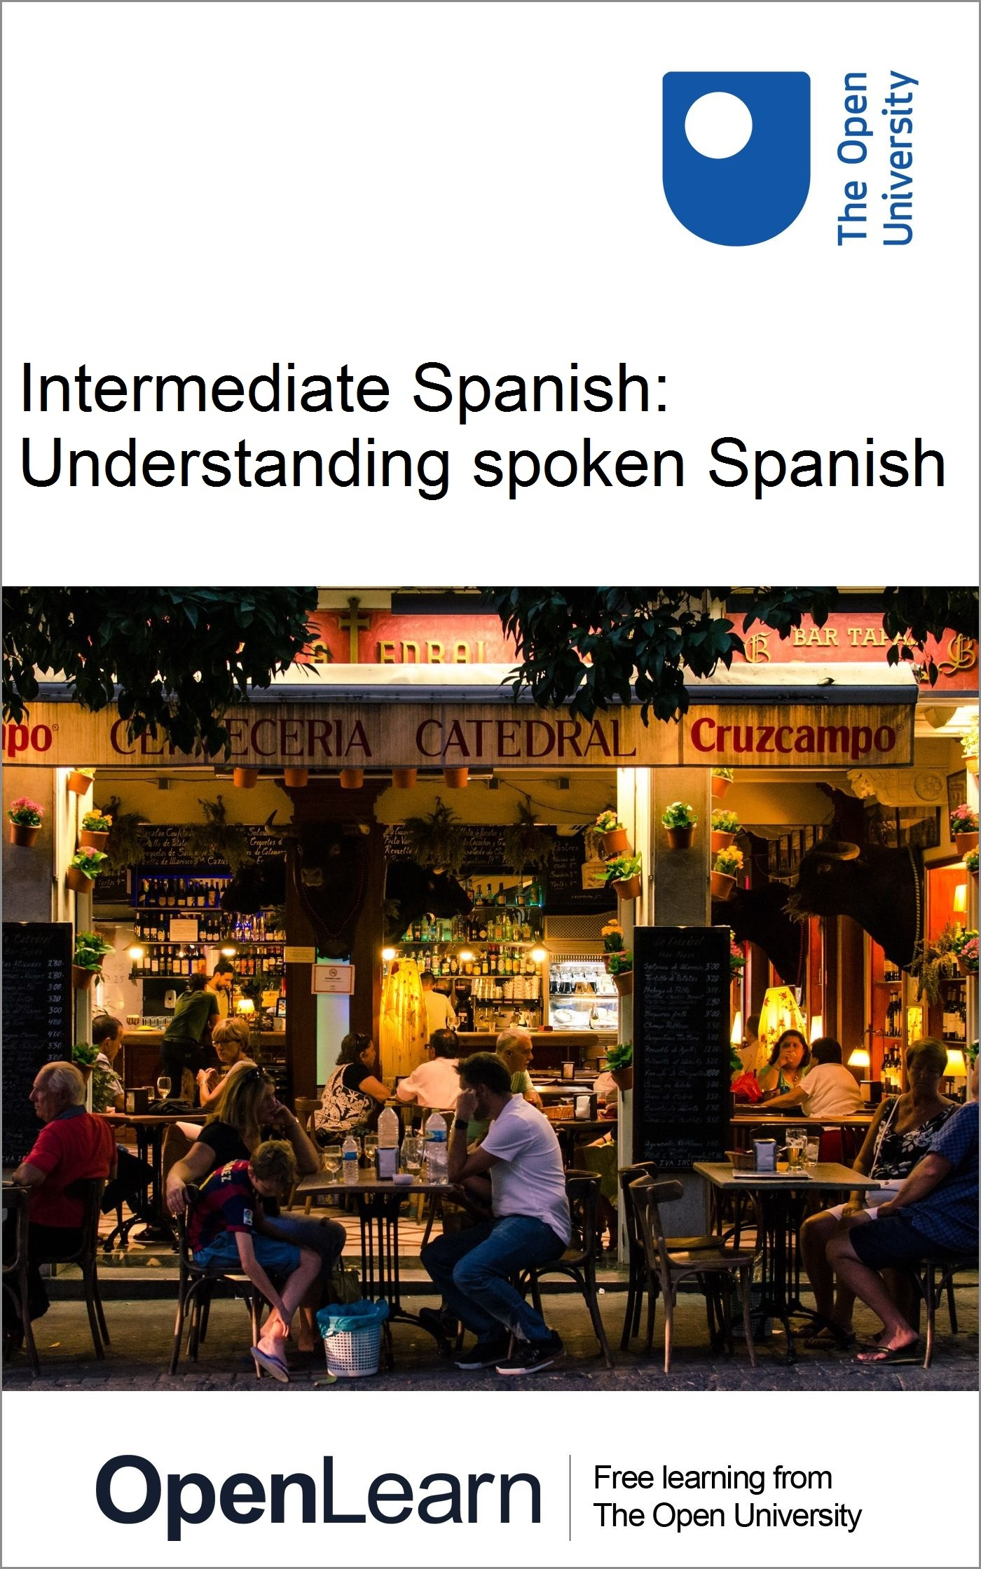

L116_1

Intermediate Spanish: Understanding spoken Spanish

About this free course
This free course is an adapted extract from the Open University course L116 Spanish Studies 1: language and culture of the Spanish-speaking world www.open.ac.uk/courses/modules/l116 .
This version of the content may include video, images and interactive content that may not be optimised for your device.
You can experience this free course as it was originally designed on OpenLearn, the home of free learning from The Open University –
www.open.edu/openlearn/languages/intermediate-spanish-understanding-spoken-spanish/content-section-0
There you’ll also be able to track your progress via your activity record, which you can use to demonstrate your learning.
Copyright © 2017 The Open University
Intellectual property
Unless otherwise stated, this resource is released under the terms of the Creative Commons Licence v4.0 http://creativecommons.org/licenses/by-nc-sa/4.0/deed.en_GB. Within that The Open University interprets this licence in the following way: www.open.edu/openlearn/about-openlearn/frequently-asked-questions-on-openlearn. Copyright and rights falling outside the terms of the Creative Commons Licence are retained or controlled by The Open University. Please read the full text before using any of the content.
We believe the primary barrier to accessing high-quality educational experiences is cost, which is why we aim to publish as much free content as possible under an open licence. If it proves difficult to release content under our preferred Creative Commons licence (e.g. because we can’t afford or gain the clearances or find suitable alternatives), we will still release the materials for free under a personal end-user licence.
This is because the learning experience will always be the same high quality offering and that should always be seen as positive – even if at times the licensing is different to Creative Commons.
When using the content you must attribute us (The Open University) (the OU) and any identified author in accordance with the terms of the Creative Commons Licence.
The Acknowledgements section is used to list, amongst other things, third party (Proprietary), licensed content which is not subject to Creative Commons licensing. Proprietary content must be used (retained) intact and in context to the content at all times.
The Acknowledgements section is also used to bring to your attention any other Special Restrictions which may apply to the content. For example there may be times when the Creative Commons Non-Commercial Sharealike licence does not apply to any of the content even if owned by us (The Open University). In these instances, unless stated otherwise, the content may be used for personal and non-commercial use.
We have also identified as Proprietary other material included in the content which is not subject to Creative Commons Licence. These are OU logos, trading names and may extend to certain photographic and video images and sound recordings and any other material as may be brought to your attention.
Unauthorised use of any of the content may constitute a breach of the terms and conditions and/or intellectual property laws.
We reserve the right to alter, amend or bring to an end any terms and conditions provided here without notice.
All rights falling outside the terms of the Creative Commons licence are retained or controlled by The Open University.
Head of Intellectual Property, The Open University
1.0

Contents
- Introduction
- Learning outcomes
- 1 Introducing the course
- 2 Predicting content
  - 2.1 Listening to introductions
  - 2.2 Anticipating, listening out for and practising unfamiliar sounds
- 3 Using knowledge of your own language
  - 3.1 Recognising cognates
  - 3.2. Pronouncing cognates
- 4 Using cultural knowledge
  - 4.1 Happiness and contentment
  - 4.2 Body language
- 5 Using subtitles
  - 5.1 Interlingual subtitles
  - 5.2 Intralingual subtitles
- 6 Coping with unfamiliar language
  - 6.1 Recognising idiomatic language
  - 6.2 Using transcripts
- 7 Deducing meaning
  - 7.1 Understanding the gist
  - 7.2 Listening for detail
  - 7.3 Recognising native speaker techniques
- Conclusion
- Take the next step
- Acknowledgements
- Solutions

Introduction
Each section of this free course, Intermediate Spanish: Understanding spoken Spanish, will help you develop an understanding of spoken Spanish through watching video portraits of six people talking at a natural pace about themselves and their lives. Using videos for language improvement is powerfully motivating because as well as hearing people talk, you pick up cultural clues and body language, all in authentic scenarios which make language learning meaningful.
The more you watch and listen to Spanish in this way, the more you will understand. As you start, just relax and enjoy the sound of the language with its range of accents. Simply being able to recognise from the intonation, for example, that a question has been asked is an important step towards understanding natural language.
The video clips you will watch in this course are all authentic, that is, they are unscripted and spontaneous. They show people from Spain or Spanish-speaking countries talking about themselves at normal speed.

Strategies for understanding video resources
You may not be aware of this, but when you watch a video or movie in your mother tongue, you are constantly using various strategies to help you make sense of what you are seeing. This course will enable you to recognise the strategies you already use in interpreting spoken language, and will help you adapt them so you can understand everyday speech in Spanish through the medium of videos. The language level used in this course corresponds to B1 in the Common European Framework of Reference for Languages (COE).
These are some key strategies you will explore through the course:
- Predicting content
- Using knowledge of your own language
- Using cultural knowledge
- Using subtitles
- Coping with unfamiliar language
- Deducing meaning
This OpenLearn course is an adapted extract from the Open University course L116 Spanish Studies 1: language and culture of the Spanish-speaking world.

Learning outcomes
After studying this course, you should be able to:
- develop strategies for understanding video resources in Spanish
- understand Spanish spoken at natural speed
- understand and give personal information in Spanish
- use knowledge of other languages and cultures to decode what is heard in Spanish.

1 Introducing the course
Before you start the course, watch the following video which gives useful hints and tips when trying to improve your understanding of spoken Spanish.

Video content is not available in this format.
View transcript - Uncaptioned interactive content

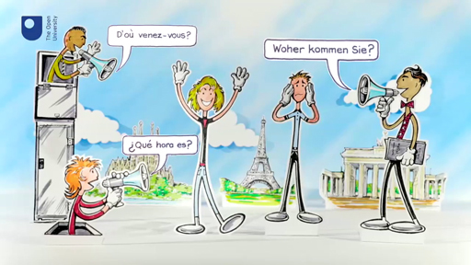

2 Predicting content
The video clips in this course are not scripted; they include language which the people we interviewed used naturally. The materials include vocabulary and grammar you may not fully understand. Even this, however, is an important part of the process of learning a new language. It is likely that you understand some of what you are seeing and hearing to begin with, and that you can build on this one step at a time. Some language courses script audio visual materials and focus on the vocabulary and grammar being taught at that moment. This is useful for learning to reinforce expressions and phrases, but authentic materials prepare the learner for hearing Spanish in real life.
Being able to predict what a speaker might say will help you listen out for language you are familiar with. Anticipating what you might hear prepares you to identify individual words or details such as names or places.

2.1 Listening to introductions
In this section, you are going to practise listening out for people’s personal details by anticipating what people might say when introducing themselves.


Figure 1 Introductions
View description - Figure 1 Introductions

Actividad 1

Before you watch a series of videos in the next activity, choose three aspects from the following list that you would mention to introduce yourself and write them down in the box.
- Edad
- Nacionalidad
- Lugar de origen
- Nombre
- Profesión
- Lugar de residencia

Provide your answer...
View answer - Actividad 1

Actividad 2

Which expressions would you expect to hear when someone introduces themselves? Match the expressions with the different categories of information.

Ejemplo
Edad ➜ Tengo… años

Edad
Nacionalidad
Lugar de origen
Nombre
Profesión
Lugar de residencia
Tengo… años
Soy…
Nací en…
Me llamo…
Trabajo de/en…
Vivo en…
View answer - Actividad 2
View feedback - Actividad 2

Actividad 3

Now listen to the six speakers in the video below, and complete the following table with the information they provide about themselves.

Video content is not available in this format.
View transcript - Uncaptioned interactive content

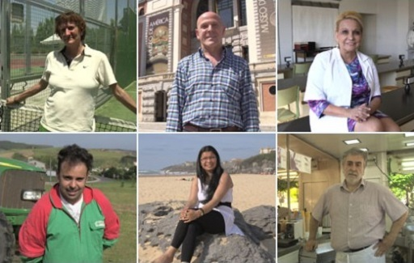
View description - Uncaptioned Figure

Nombre | Edad | Lugar de origen (país) | Lugar de residencia
Manuel Rivero | Provide your answer... | Provide your answer...
Paloma Zancajo | 50 años | Provide your answer... | Provide your answer...
Celia Sánchez Ramos | Provide your answer... | Zaragoza
Antonio Feal Dopico | Provide your answer... | Provide your answer...
Amalia Schubert Arévalo(s) | Provide your answer... | Provide your answer...
Andrés Ponga Colina | Provide your answer... | Provide your answer... | Provide your answer...

View answer - Actividad 3

Box 1: Using context and visual clues to make predictions
Knowing aspects of the theme, the context or the speakers can help you predict the content of what you are going to listen to. For instance, while watching a movie you will be able to identify a situation where people greet or introduce each other so this social context will help you to listen out for and recognise some of the key words likely to come up in this context. Knowing that in such a situation you will most likely hear the names of people and specific places will help you to be alert and prepared for when that happens. At this stage the most important thing is that you are able to identify when these are expressed. As in your own language, you may not clearly capture those names, but you can recognise when they are said in the sentence. Predicting is about knowing when to expect them.
None of the people you heard talked about their occupation or nationality, and only some mentioned where they live. However, by looking at the surrounding background you could make a guess at where they live. The additional visual clues of how they are dressed also provide you with crucial contextual information about what they might do for a living and what they might be talking about in their introduction.

2.2 Anticipating, listening out for and practising unfamiliar sounds
Being able to understand names and places can tell you a lot about what the speaker intends to say. However, it can be difficult to pronounce and understand foreign names because often we apply the sounds, stress patterns and intonation of our mother tongue.

Actividad 4

In this section, you can listen how Spanish people pronounce the sounds of names in English. Pay attention to the following aspects:
- How the Spanish speaker pronounces the names with the consonant ‘h’.
- How the Spanish speaker pronounces the names starting with the consonant ‘s’.
- In the box below, make a note of how the names with the consonant ‘h’ are pronounced, and also the names beginning with ‘s’.

Video content is not available in this format.
View transcript - Uncaptioned interactive content

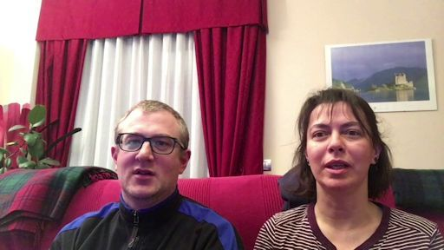

Provide your answer...
View discussion - Actividad 4

Box 2: Understanding names and places
When it comes to understanding native Spanish speakers knowing what kind of pronunciation to expect will help you catch places and names more easily.
Although the consonant h is not pronounced at all in Spanish, Spanish speakers usually pronounce English names and words with h making them sound like a Spanish j (jota, jamón, personaje, etc.).
The combination s+consonant in a syllable does not exist in Spanish. Words that contain this combination of consonants often start with the vowel ‘e’ (español, estructura, Esteban, estilo) When it comes to pronouncing this combination of consonants in English, Spanish speakers therefore tend to replicate this common combination and create an extra syllable, pronouncing an e in front of the s: Scarlet is pronounced as Escarlet.

Actividad 5

Having listened to native Spanish speakers in Actividades 3 and 4, now think of the following:
- How do you think a Spanish speaker would pronounce your name and surname?
- How would they pronounce the place where you are from and where you live?
- How would you help him / her to pronounce those names correctly in English?
Take into consideration what you know about pronunciation of certain consonants and differences in sounds and intonation.

Provide your answer...

Actividad 6

Now it is your turn to say something about yourself. Remember that when talking about yourself in Spanish, you need to be aware that a native Spanish speaker might find it difficult to understand names and places in English. To help them, slow down if necessary, without exaggerating too much.
As a last resort, native speakers of other languages sometimes adapt their pronunciation to imitate a Spanish native speaker, pronouncing ‘h’ like a ‘j’ and adding extra ‘e’ at the front of words that start with ‘s+ consonant'.
Say out loud your name, your age, the name of the place where you were born and where you live using the prompts provided. Imagine you are introducing yourself to a group of Spanish speakers. Put yourself in their shoes and make sure that they understand the pronunciation of all names and places.
Use some or all of the following prompts to help you structure your introduction.
- Me llamo…
- Tengo… años
- Nací en…
- Vivo en…
- Soy…
- Trabajo de/en…

3 Using knowledge of your own language
Your knowledge about how Spanish sounds and works helps you build up your understanding, but your own language(s) and your knowledge of other languages can also be extremely helpful.

3.1 Recognising cognates

Box 3: Using cognates
When watching videos in Spanish, you will recognise some words or phrases because they are similar to the ones used in your own language(s) or other languages you might know. These are known as cognates. Cognates are words that have the same or similar meaning, spelling and pronunciation in two languages. They are a useful aid when learning a language.
The following are examples of Spanish and English cognates: doctor/doctor, centre/centro, radio/radio. Some languages, like Spanish, have thousands of cognates with English. Sometimes, using your knowledge of the pronunciation, intonation and rhythm of words, you will able to decode other words or phrases that you have never heard before in Spanish.
Just beware of differences in spelling! Identifying a cognate does not help you draw conclusions about the spelling. When listening, you should be able to work out how to spell most words in Spanish as the writing of sounds is very predictable.

Actividad 7

Being aware of words which have the same or similar meaning and spelling in English can help you not only understand authentic Spanish, but also expand your vocabulary in Spanish .
Do you recognise the following words? Write down their English cognate.

Español | English cognate
Actor | Actor
Arte | Provide your answer...
Banco | Provide your answer...
Concierto | Provide your answer...
Cultura | Provide your answer...
Memoria | Provide your answer...
Problema | Provide your answer...
Romántico | Provide your answer...
Tráfico | Provide your answer...
Verbo | Provide your answer...
Violencia | Provide your answer...

View answer - Actividad 7

Actividad 8

Now listen to Paloma Zancajo talking about what she values most in life. Indicate the six cognates you hear in Spanish from the list below:

Video content is not available in this format.
View transcript - Uncaptioned interactive content

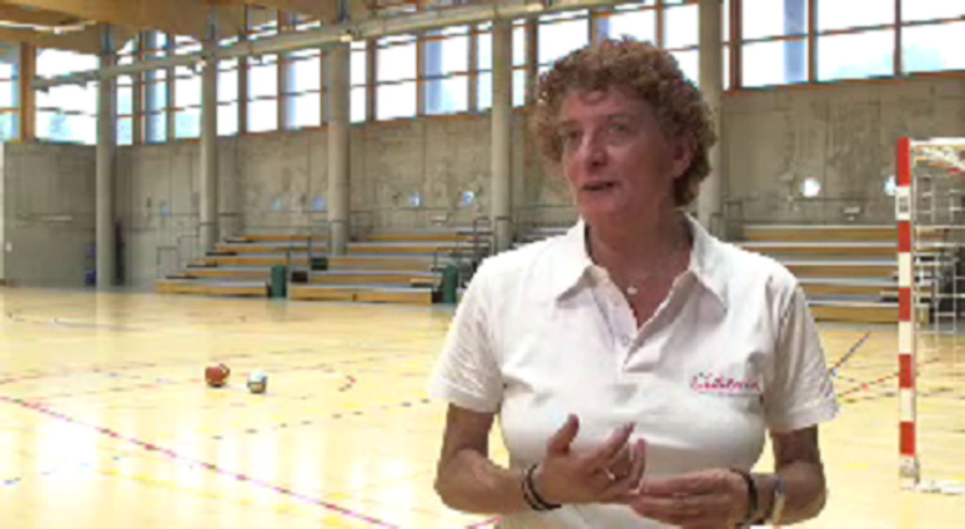

abundance
associated
no
curiosity
elegance
family
honesty
ideal
justice
liberty
magic
persons
View answer - Actividad 8

Actividad 9

Watch Paloma Zancajo talk about what she values most in life again. Then choose the correct option(s) to complete the statements below.

Video content is not available in this format.
View transcript - Uncaptioned interactive content

Para Paloma lo más importante en la vida es _________.

la familia
el dinero
el tiempo libre
View answer - Part

Para Paloma los valores más importantes son _________, __________ y _________ porque ayudan a desarrollarse a las personas.

la libertad
la sinceridad
la solidaridad
el respeto
la justicia
el amor
la tolerancia
la honestidad
View answer - Part

Actividad 10

Paloma also talks about what surprises people about her. Read the transcript of what she says and identify the eight cognates that have similar spelling in English. Then write them down below. List cognates that appear multiple times only once.

Transcript
“La gente se sorprende mucho cuando me conoce(n) porque no lo aparento pero soy una persona muy paciente, tengo mucha paciencia. O sea, parezco muy nerviosa, parezco muy tal, ¿no? Pero luego la gente cuando… bueno pues cuando me va conociendo dicen: “Paloma, ¡qué paciencia tienes! ¿no?“ Que no debe ser muy habitual en la gente pero yo no sé si es por deformación profesional o porque pues la gente me dice que la paciencia, ¿no? La paciencia que… que tienes.”

Provide your answer...

Provide your answer...

Provide your answer...

Provide your answer...

Provide your answer...

Provide your answer...

Provide your answer...

Provide your answer...

Provide your answer...
View answer - Part
View comment - Part

3.2. Pronouncing cognates
You will now look out for cognates.

Actividad 11

Listen to Paloma again and pay particular attention to the pronunciation of the cognates you identified in Actividad 10.

Video content is not available in this format.
View transcript - Uncaptioned interactive content

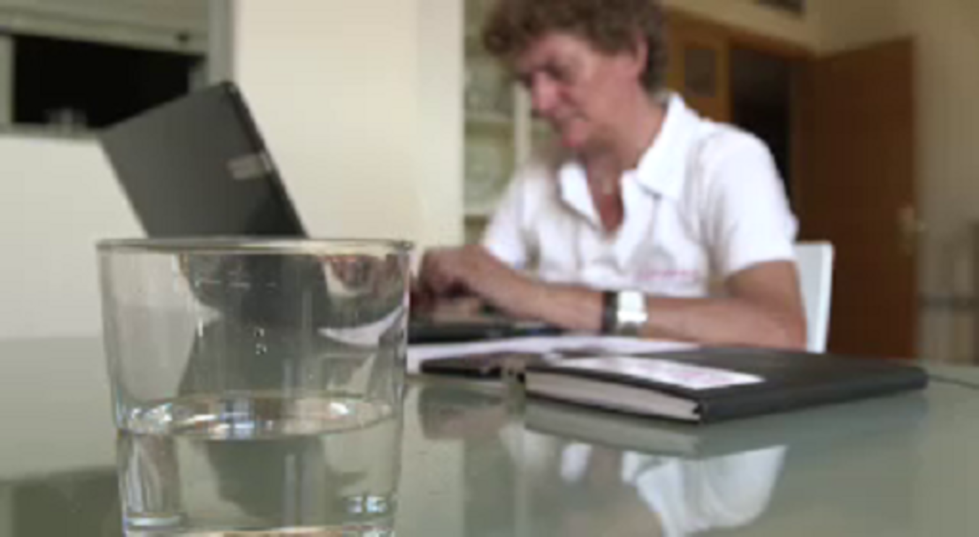

Actividad 12

Now read aloud the cognates Paloma has used.

no

aparento

persona

paciente

paciencia

nerviosa

habitual

deformación

profesional

4 Using cultural knowledge

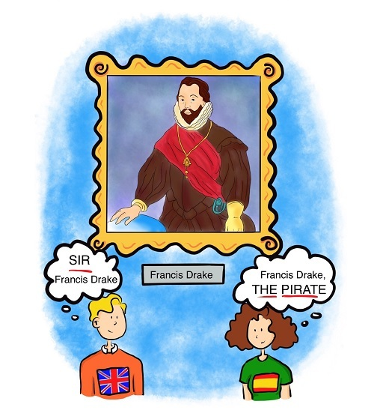
Figure 2 Francis Drake
View description - Figure 2 Francis Drake

Knowledge of any differences and similarities between your own and the Spanish culture is also important for understanding native Spanish speakers. Your personal experiences will influence your interpretation of what you see and your interpretation of what people might be interested in or value most. So you need to be aware that these experiences might not always be transferable into other cultural contexts. Knowing about cultural similarities and differences will aid your understanding.

4.1 Happiness and contentment
In this section you will listen to and watch Andrés Ponga Colina. As you do the exercises, think about the background cultural knowledge you are using from your own experience to help you interpret what he says, and maybe work out what makes him contented. You will also use contextual clues from the video to help you understand what he is saying.

Actividad 13

First of all, identify the three things from the list that make you happiest.
- familia
- trabajo
- éxito
- dinero
- amor
- salud
- animales
- amigos
- viajes
- estudios
- tiempo libre

Actividad 14

You have already met Andrés Ponga Colina. Watch this video extract with the sound off and try to work out
- where Andrés lives.
- what he does for a living.

Video content is not available in this format.
View transcript - Uncaptioned interactive content

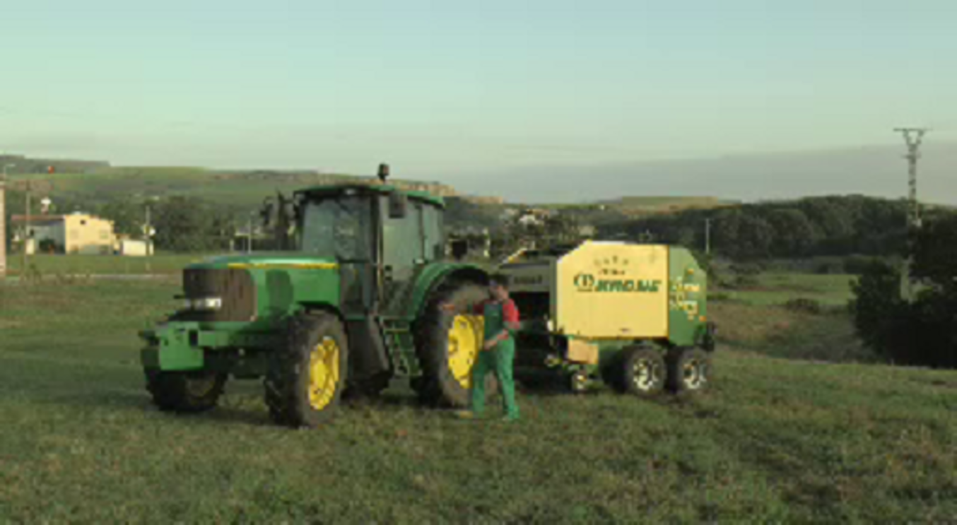

View answer - Actividad 14

Actividad 15

Now watch the video with the sound on and find out what the most important things are for Andrés in his life. Complete the following sentences in Spanish according to the things he mentions.

Video content is not available in this format.
View transcript - Uncaptioned interactive content

Para Andrés hay cuatro cosas importantes en la vida:… A Andrés lo que le hace más feliz es:…
View answer - Actividad 15

Actividad 16

Are you similar to Andrés? What is important to you in life? Jot down notes and then practise saying out loud in Spanish what is important to you and what makes you happy.
You can use the following prompts.
- Para mí las cosas importantes en la vida son _________.
- A mí lo que me hace más feliz es _________.

View answer - Actividad 16

4.2 Body language
In this section, we will look at how non-verbal communication gives clues to meaning and helps the understanding of foreign language visual media.

Box 4: Reading body language
One of the significant advantages of watching a video or a film is that it offers you visual support. You gain information about the context and the characters and also pick up gestures, facial expressions and body language that can help you infer meaning from speech and understand more of the spoken language.
Indeed, body language plays a crucial role in communication and an awareness of it and how it can vary from culture to culture, can be particularly important in developing the ability to understand in a real environment. Body language is made up of a whole range of features (eye contact, facial expression, proximity, posture and gesture), many of which we combine together without ever thinking about what it is we are doing or what we are expressing.

Actividad 17

Now watch this video in which two brothers, Alberto and Javier Soto, talk about their love and passion for their family business. Pay particular attention to their gestures and how these emphasise the ideas they want to communicate. Match the phrases below with the body part they use for emphasis as they say these phrases. If you want, you can watch it with English subtitles.

“Mi padre y un tío”
“Cuando les hablas de la money”
“Ves, hacerse, sí lo hacemos”
“Coges la puerta de tu casa”
“Siendo un poquito manitas”
“Compramos la pizza, llegamos a casa, abrimos el microondas”
“No lo comparemos con el cocido”
“Estoy superorgulloso de ser carpintero”
“Yo tengo una hija y él tiene dos”
Cabeza
Dedos
Dedo índice
Manos en puño
Palma de las manos
Brazos
Cabeza y brazos
Cara
Cabeza, dedos y brazos
View answer - Actividad 17
View discussion - Actividad 17

5 Using subtitles
The rise in popularity of subtitled television programmes over the last few years means that more people are accustomed to using them. In a language learning environment, watching videos with subtitles can support not only your listening and reading comprehension skills, but also your knowledge of grammar and vocabulary.
In this section you are going to explore and practise the use of subtitles to support your comprehension and your language learning while watching and listening to Dr Celia Sánchez-Ramos.

Box 5: Intralingual and interlingual subtitles
Subtitles support your language learning by helping you visualise what you hear, especially if the language is challenging (either because of the vocabulary or grammar), because it is too fast and you cannot distinguish word boundaries, or because you are listening to an unfamiliar pronunciation, accent or register.

Interlingual subtitles
Standard subtitles are also known as interlingual subtitles (videos in foreign language with mother tongue captions). Watching a video with interlingual subtitles helps your brain process a foreign language by making connections, linking image, sound and text – the last two being distinct sets of verbal support – with translation. (Danan, 1992).

Intralingual subtitles
Intralingual subtitles (sound and subtitles in the same language) are believed to help improve listening and word recognition by helping students to identify sounds and distinguish between words.

Transcripts
While subtitles appear on the screen simultaneously with the spoken word and are not necessarily an exact match of what is being said, transcripts offer a word-for-word transcription of the audio in the video and are available as a separate document. In this course you have various opportunities to use them for your learning of Spanish.

5.1 Interlingual subtitles
In this activity you are going to explore and practise the use of subtitles to support your comprehension and your language learning while watching and listening to Dr Celia Sánchez-Ramos.
Of course, subtitles are not only used for learning. Many people use subtitles when they watch films, documentaries or even when they watch music videos. Answer these questions to reflect on your own use of subtitles.

Actividad 18

Do you tend to use subtitles when watching films in Spanish or in other languages?

Provide your answer...

Do you use subtitles in English (or your mother tongue) or in Spanish?

Provide your answer...

If you use English or mother tongue subtitles, in what circumstances do you decide to use them?

Provide your answer...
View answer - Part

If you decide to use subtitles in Spanish when watching a Spanish film, why might this be?

Provide your answer...
View answer - Part

Actividad 19

Though you may find the use of subtitles distracting or tiring when you start, you will develop strategies to use them effectively the more you become accustomed to seeing them on screen.
Let’s look at interlingual subtitles first. Listen to Celia and find out what kind of person she is. Click the button marked CC on the screen and then watch the video with the subtitles in English turned on.

Video content is not available in this format.
View transcript - Uncaptioned interactive content

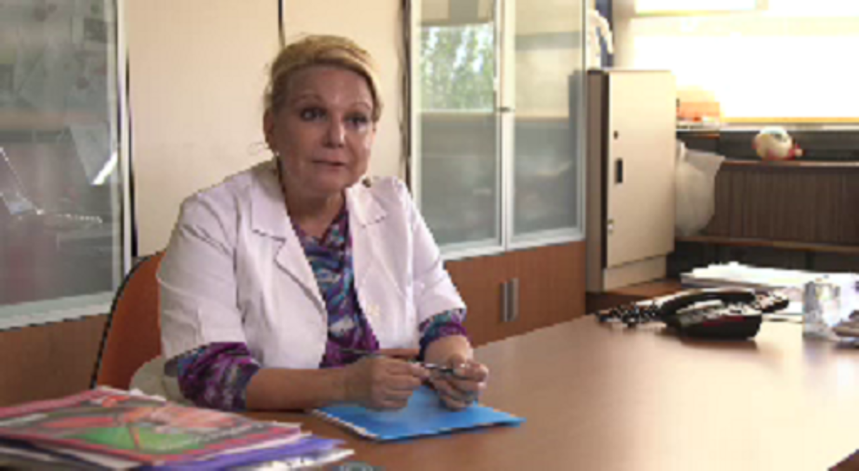

Actividad 20

In this video Celia talks about the things that make her happy. Watch the video with the English subtitles turned on and decide whether the statements are true or false.

Video content is not available in this format.
View transcript - Uncaptioned interactive content

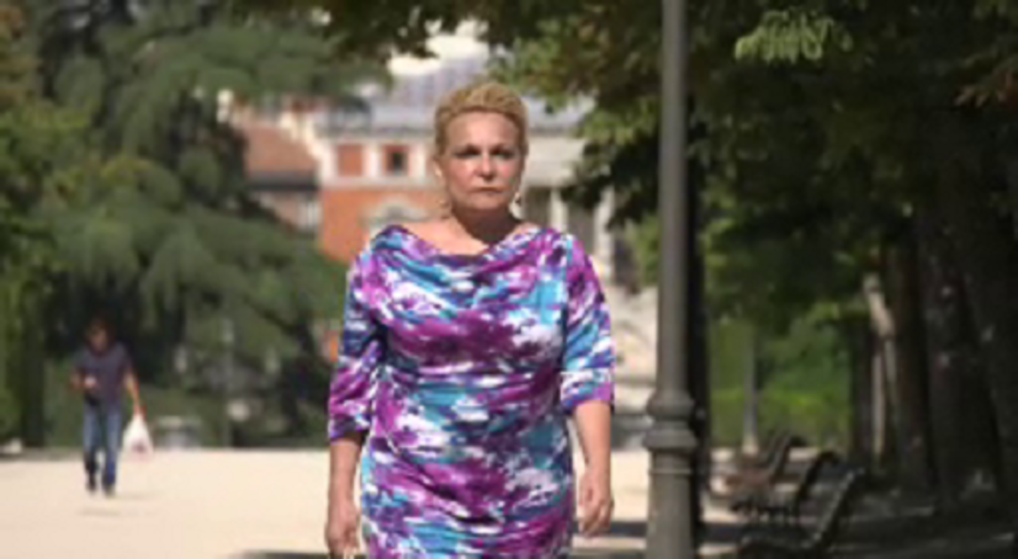

Celia es feliz porque no pide demasiado.

Verdadero
Falso
View answer - Part

Celia es feliz cuando ayuda a los demás.

Verdadero
Falso
View answer - Part

Celia es feliz porque con su edad no tiene miedo.

Verdadero
Falso
View answer - Part

Celia tiene grandes expectativas profesionales.

Verdadero
Falso
View answer - Part

Celia es una buena ama de casa.

Verdadero
Falso
View answer - Part

Actividad 21

Watch the final part of the video. Watch it without subtitles. Then put the following list of things Celia values in the order she mentions them in the video. Check your answer in the transcript.

Video content is not available in this format.
View transcript - Uncaptioned interactive content



First:
Second:
Third:
Fourth:
Fifth:
Sixth:
La amistad
Hacer agradable la vida de mi entorno
Sentirme bien conmigo misma
Poner objetivos a corto plazo y a medio plazo
Ilusionarme con nuevas metas
La automotivación
View answer - Actividad 21

5.2 Intralingual subtitles
To practise the use of intralingual subtitles, watch the video of Celia with Spanish subtitles. Make a note of five new words or expressions you are not familiar with.

Actividad 22

To practise the use of intralingual subtitles, watch the video of Celia with Spanish subtitles. Make a note of five new words or expressions you are not familiar with.

Video content is not available in this format.
View transcript - Uncaptioned interactive content



Provide your answer...

Actividad 23

Add the five words and phrases you identified in Actividad 22 to the table below. Then complete the rest of the table by looking them up in a dictionary. The first link will take you to a monolingual Spanish only online dictionary, and the second to a Spanish-English one.
- Link: Diccionario de la lengua española
- Link: WordReference

New word or phrase | English | Spanish definition
de trato fácil | easy going | persona flexible, agradable, positiva y servicial
entorno | environment, context | círculo(s) donde se vive o se mueve una persona, por ejemplo el trabajo, el hogar, etc.
Provide your answer... | Provide your answer... | Provide your answer...
Provide your answer... | Provide your answer... | Provide your answer...
Provide your answer... | Provide your answer... | Provide your answer...
Provide your answer... | Provide your answer... | Provide your answer...
Provide your answer... | Provide your answer... | Provide your answer...

View answer - Actividad 23

6 Coping with unfamiliar language
Developing skills to learn how to cope with unfamiliar vocabulary or unfamiliar language will help you to stay motivated when you are learning a language. You also get to enjoy watching videos and films in Spanish! Next, you are going to practise how to handle new vocabulary and everyday, colloquial language by analysing part of a video, then practising using subtitles, transcripts and shadow reading.

Actividad 24

You already know that Antonio Feal Dopico is 64 years old and he is from La Coruña in northern Spain. Now watch the full introduction and put the aspects of his life in the order he mentions them. That way you will focus on the gist of what he says and get an overview of the structure of his introduction without worrying about the meaning of each individual word. Despite being faced with unfamiliar vocabulary you should be able to understand the gist of what Antonio is talking about, even if it takes a few listens.

Video content is not available in this format.
View transcript - Uncaptioned interactive content

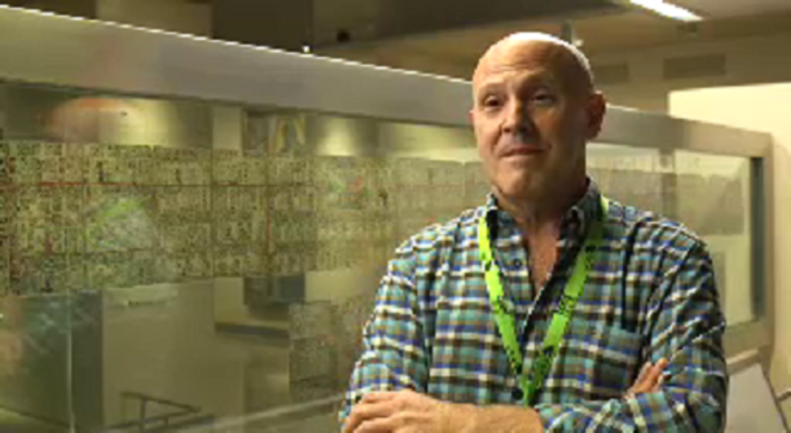

1
2
3
4
5
Datos personales
Trabajo
Personalidad
Idiomas
Cambios en su vida
View answer - Actividad 24

Actividad 25

In section 2 we looked at cognates as a useful starting point for dealing with unfamiliar language and expanding active vocabulary. But beware of false friends, words like the four words below that look like cognates but do in fact have different meanings.
Watch the video of Antonio in which he talks about one of his obsessions and a gift he has, and try to work out what the four words mean in English. Beware of false friends.
Then watch the video again, this time with English subtitles and check your answer against the subtitles and write down the correct translation in the table below.

Video content is not available in this format.
View transcript - Uncaptioned interactive content

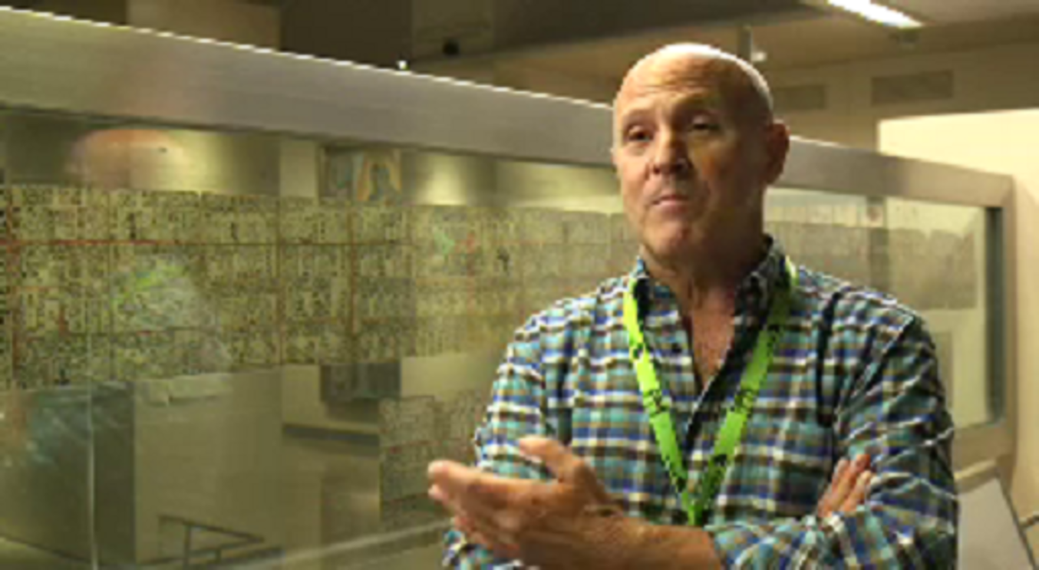

Particular | Provide your answer...
Manía | Provide your answer...
Facilidad | Provide your answer...
Idiomas | Provide your answer...

View answer - Actividad 25

6.1 Recognising idiomatic language
Language becomes more complicated for the learner when people use day-to-day language, familiar expressions or ways of putting things that can be difficult to understand. In this section, you will practise identifying idiomatic language.

Actividad 26

Watch the whole video of Antonio and write down in Spanish how he expresses the following ideas.

Video content is not available in this format.
View transcript - Uncaptioned interactive content

I retired 4 years ago | Me jubilé hace 4 años
I perform the functions… | Provide your answer...
I fundamentally value affection | Provide your answer...
…gathered around a table | Provide your answer...
I have a gift for languages | Provide your answer...
I am determined to learn Chinese right now | Provide your answer...
To be born again | Provide your answer...
For a change! | Provide your answer...

View answer - Actividad 26

6.2 Using transcripts
Transcripts are useful tools in language learning with videos. Here you will learn a technique to help your pronunciation and speaking of Spanish; later in the course you will use them again to identify features of colloquial speech to help your understanding.

Box 6: Shadow reading (1)
Shadow reading using a transcription of the words by the speakers is also a good technique to practise listening, reading and speaking. One technique you can use is this: Listen to the video material at least once to become familiar with the pronunciation and the content. When you think you are familiar with it, try to imitate the speaker by reading his or her words from the transcript. You can try to talk at the same time as the speaker, or you can wait until he or she finishes the sentence and then pause the video and read out loud what he or she said.

Actividad 27

Now that you have a better understanding of what Antonio says, practise shadow reading with an extract of his video. While you listen to him, read the transcript out loud, imitating Antonio's pronunciation and intonation as closely as possible.

Video content is not available in this format.
View transcript - Uncaptioned interactive content

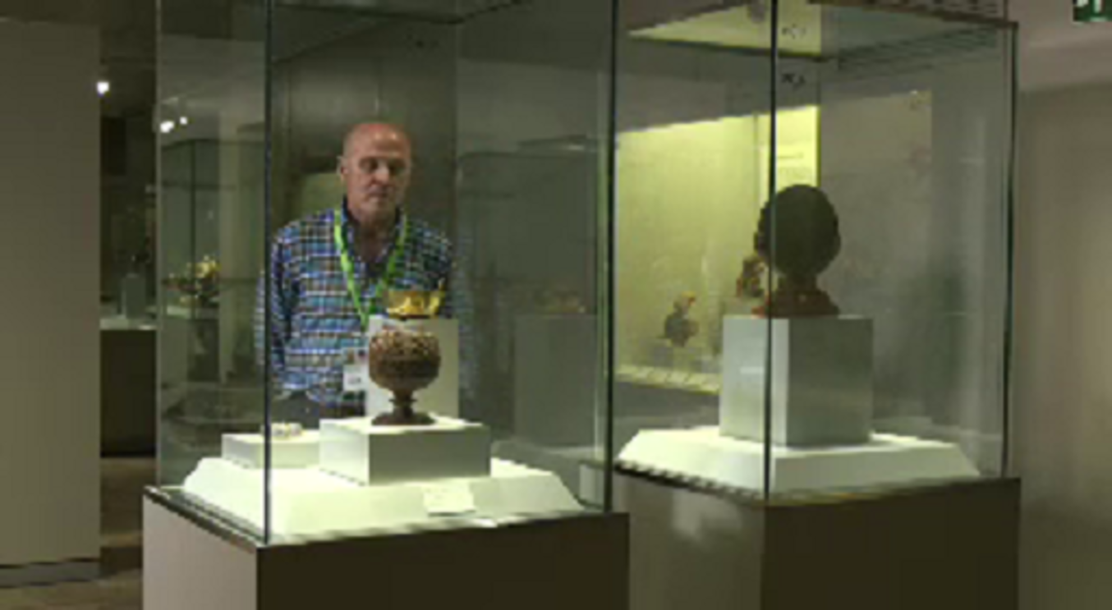

7 Deducing meaning
Sometimes we all face the challenge of not being able to hear clearly or understand what is being said in a foreign language film, perhaps because of background noise, the speed of the language or the speaker’s pronunciation of words. For example, a Spanish speaker from Andalusia will typically drop the letter ‘s’ from the end of words. You may feel frustrated when you can’t distinguish each word that is being said. In the final part of this course, you can practise some useful strategies to help yourself overcome this challenge.

Box 7: Deducing meaning
In your own language, you deal on a daily basis with understanding other speakers despite background noise, unfinished words and sentences, ungrammatical sentences, unpronounced letters and information not fully given. In your own language your mind will automatically fix incorrect language or fill in the gaps of what you can’t hear or understand.
When learning a foreign language you need to rely on other strategies to fill in those gaps, such as making an informed guess based on the knowledge and experience you already have of languages and of the specific situation or topic, whether you are talking to a native speaker or watching a video.
When watching videos you have the advantage of being able to pause and go back or to view more than once.

7.1 Understanding the gist
In this activity you are going to practise your deductive skills by listening to Amalia Schubert Arévalo’s story. Amalia's speech is natural, with hesitations and pronunciations you may find unclear.

Actividad 28

First, watch a short extract of Amalia’s video without subtitles and identify which of the following topics she is talking about:

Video content is not available in this format.
View transcript - Uncaptioned interactive content

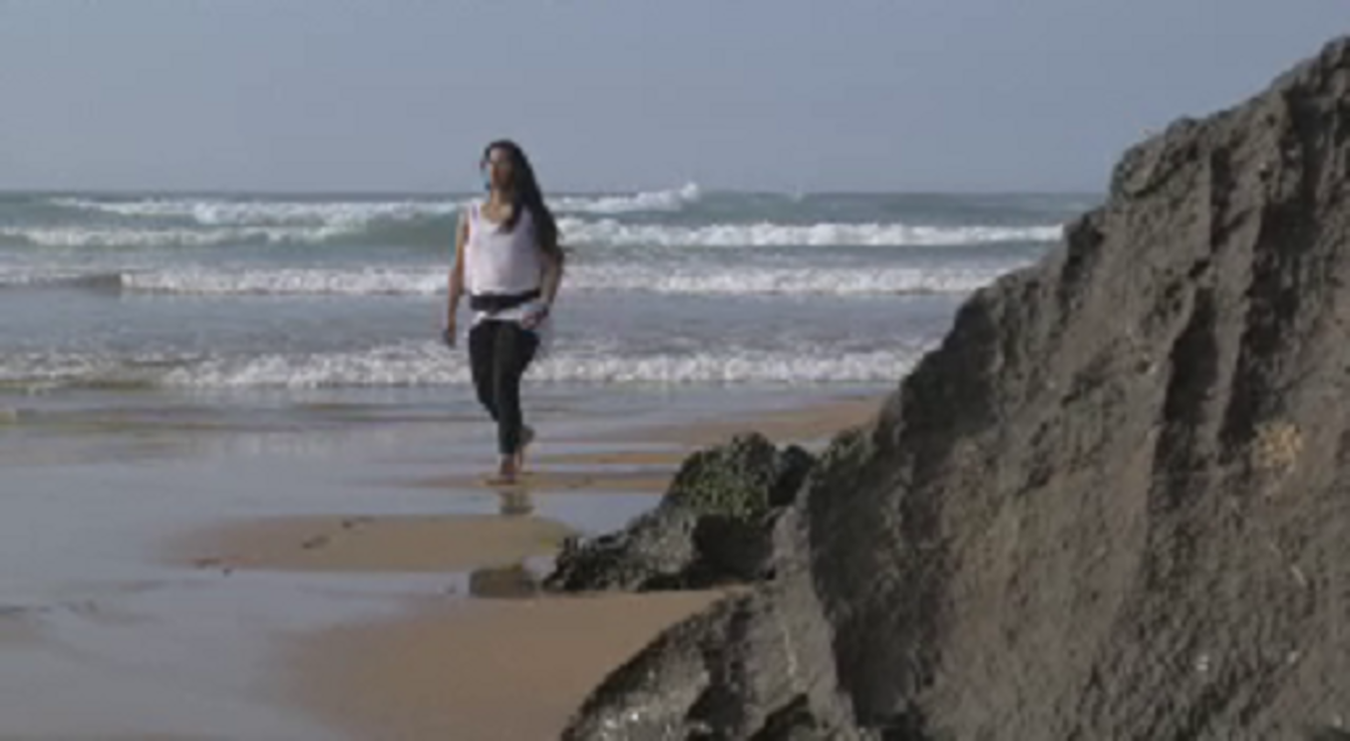

Her experience of living in Ajo.
Travelling to different countries.
Emigrating to Spain from Paraguay.
Her family holidays.
View answer - Actividad 28

7.2 Listening for detail
Now watch Amalia again and focus on the details she provides in the video. Which of these things does Amalia mention?

Actividad 29

Select the correct answer from the drop-down menu.

Video content is not available in this format.
View transcript - Uncaptioned interactive content

Interactive content is not available in this format.

Box 8: Shadow reading (2)
As you practised in section 6.2, shadow reading using a transcription of the words by the speakers is a good technique to practise listening, reading and speaking. As before, listen to the video material at least once to become familiar with the pronunciation and the content. When you think you are familiar with it, try to imitate the speaker by reading his or her words from the transcript. You can try to talk at the same time as the speaker, or you can wait until he or she finishes the sentence and then pause the video and read out loud what he or she said.

Actividad 30

Now that you have heard a bit of Amalia’s story, think of how she comes across and of how you would describe her personality. Then listen to another extract and pay attention to the words she uses to talk about her personality. Even if you don’t understand every detail of Amalia’s description of herself, you’ll see that by understanding just a few words, in this case adjectives, you’ll be able to deduce a lot of the rest and build up a picture of what Amalia is like. Make a note of all the adjectives you hear that describe her.

Video content is not available in this format.
View transcript - Uncaptioned interactive content

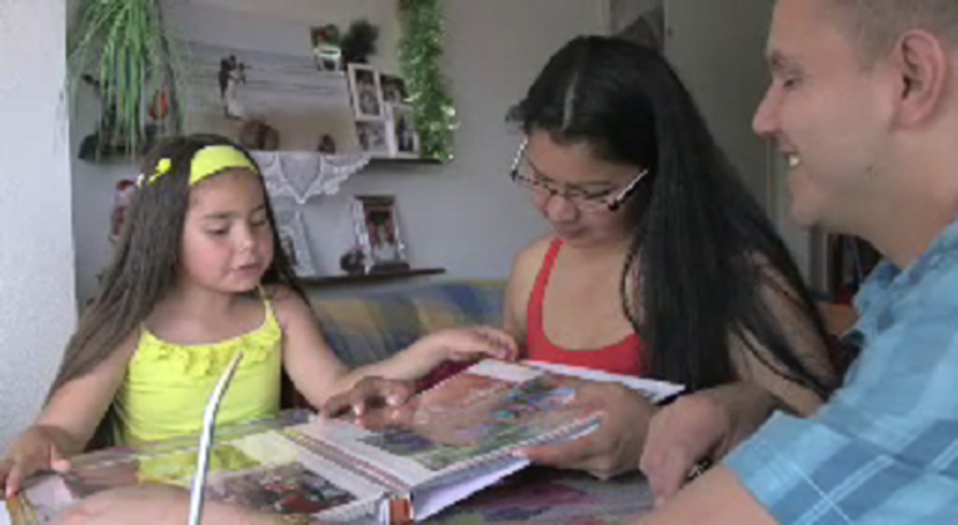

Provide your answer...
View answer - Actividad 30

7.3 Recognising native speaker techniques
Amalia’s speech shows some common signs of natural speech. These are things we all do in our mother tongue to correct ourselves when speaking spontaneously without much time to think. An awareness of these techniques – repetition, correction, addition, reformulation and omission, alongside ‘fillers’ (such as ‘um’ and ‘ah’) – will help you ignore them and identify the essential information of a message. You’ll be able to follow the train of thought and deduce what Amalia might have intended to say.

Actividad 31

Listen to another extract and then, using the transcript, identify examples of these techniques.

Technique | Examples
Repetition | Provide your answer...
Correction | Provide your answer...
Addition | Provide your answer...
Reformulation | Provide your answer...
Omission | Provide your answer...

Video content is not available in this format.
View transcript - Uncaptioned interactive content

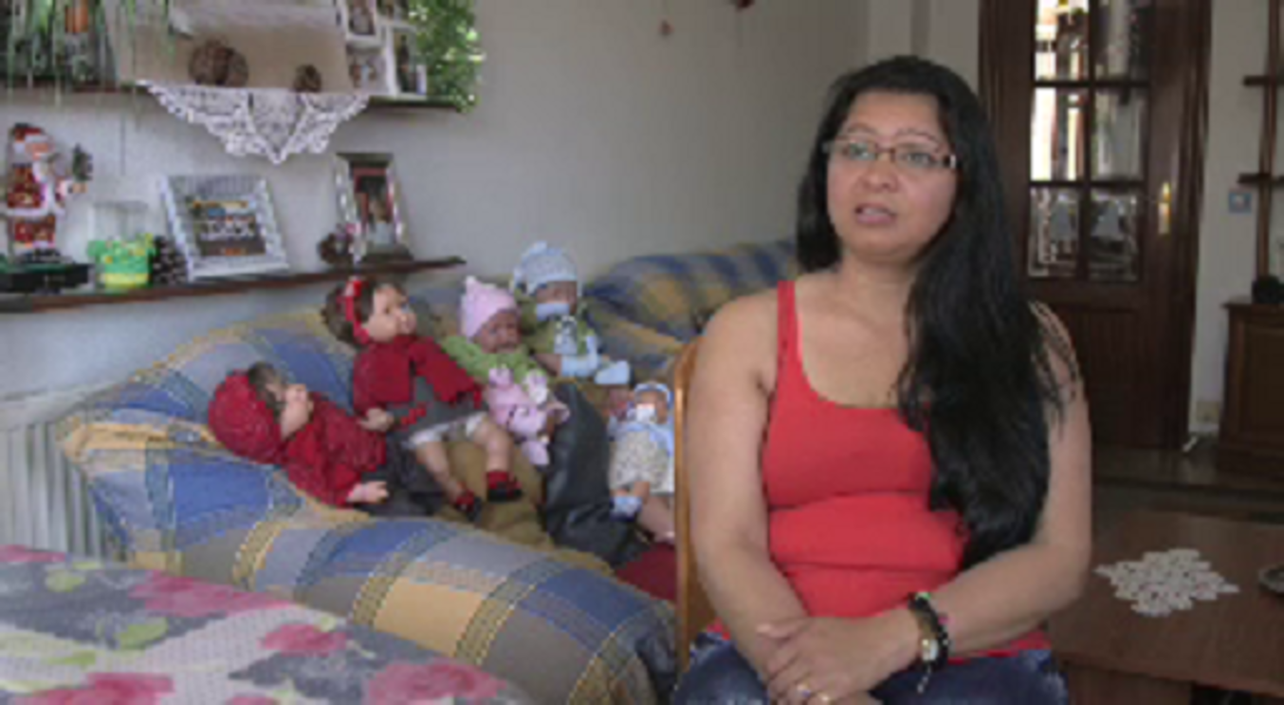

View answer - Actividad 31

Conclusion
This free course, Intermediate Spanish: Understanding spoken Spanish, has offered you some advice on working with audio-visual materials in Spanish. We hope that this has given you a step on the way to working independently and enjoyably with materials to develop your Spanish further. There is much material that is readily accessible online. Take every opportunity to watch, read and listen. You can listen to Spanish radio, use the internet and social media (for example, Youtube, online newspapers, Twitter) with subtitles or translations when available. As you have practised in this course, the use of subtitles in English or in Spanish is a good learning strategy. If you are interested in a topic in your mother tongue, follow this up with finding out more about it in Spanish.
This OpenLearn course introduces some of the characters and contexts that can be found in the Open University course L116 Spanish Studies 1: language and culture of the Spanish-speaking world.

Take the next step



If you enjoyed this course, why not explore the subject further with our paid-for short course, Beginners Spanish 3: ¡Adelante!?
Find out more about Beginners Spanish 3: ¡Adelante!

Acknowledgements
This course was written by Dr Alicia Peña-Calvo.
Except for third party materials and otherwise stated (see terms and conditions), this content is made available under a Creative Commons Attribution-NonCommercial-ShareAlike 4.0 Licence.
The material acknowledged below is Proprietary and used under licence (not subject to Creative Commons Licence). Grateful acknowledgement is made to the following sources for permission to reproduce material in this course:

Images
Course image: © AndreaMPhoto
Figure 1 © kupicoo/istockphoto
Figure 2 © Fernando Rosell-Aguilar

AV
'Carpinteros - Wood Work'. Used with permission from Alejandro Suarez Lozano https://vimeo.com/58824747
Every effort has been made to contact copyright owners. If any have been inadvertently overlooked, the publishers will be pleased to make the necessary arrangements at the first opportunity.

Don't miss out
1. Join over 200,000 students currently studying with The Open University – http://www.open.ac.uk/choose/ou/open-content
2. Enjoyed this? Find out more about this topic or browse all our free course materials on OpenLearn – http://www.open.edu/openlearn/
3. Outside the UK? We have students in over a hundred countries studying online qualifications – http://www.openuniversity.edu/ – including an MBA at our triple accredited Business School

Solutions

Actividad 1

Answer
Any of these types of information could be used by someone providing basic information about themselves so in situations such as introductions to other people you need to get ready to listen to relevant language in those areas.
Back to - Actividad 1

Actividad 2

Answer
The correct matches are:
Edad
Tengo… años
Nacionalidad
Soy…
Lugar de origen
Nací en…
Nombre
Me llamo…
Profesión
Trabajo de/en…
Lugar de residencia
Vivo en…
Back to - Actividad 2

Feedback
Lugar de origen ➜ Nací en… (‘Soy de… ’ is another way to express origin)
Nombre ➜ Me llamo… (‘Mi nombre es…’ is another way to express your name)
Profesión ➜ Trabajo de/en… (‘Soy …’ is another way to express profession)
Back to - Actividad 2

Actividad 3

Answer

Nombre | Edad | Lugar de origen (país) | Lugar de residencia
Manuel Rivero | 55 años | Santander (en el norte de España)
Paloma Zancajo | 50 años | Madrid | Madrid
Celia Sánchez Ramos | 56 años | Zaragoza (noroeste de España)
Antonio Feal Dopico | 64 años | La Coruña (España)
Amalia Schubert Arévalo(s) | 29 años | Santa Rosa del Aguaray
Andrés Ponga Colina | 34 años | Santander, (capital de Cantabria | Ajo

Back to - Actividad 3

Actividad 4

Discussion
These are the names you heard:
- Steven Spielberg
- Scarlett Johansson
- Harry Styles
- Whitney Houston
- Buckingham
- Stonehenge
- Stratford
- Hollywood
Notice how the native speaker of Spanish tends to adapt the English pronunciation of ‘h’ and ‘s’ to fit the Spanish sound system. ‘H’ sounds like the Spanish ‘j’. Words beginning with ‘sc’, ‘sl’, ‘sm’, ‘sn’, ‘sp’ and ‘st’ have an ‘e’ added to them.
Back to - Actividad 4

Actividad 7

Answer

Español | English cognate
Actor | Actor
Arte | Art
Banco | Bank
Concierto | Concert
Cultura | Culture
Memoria | Memory
Problema | Problem
Romántico | Romantic
Tráfico | Traffic
Verbo | Verb
Violencia | Violence

Back to - Actividad 7

Actividad 8

Answer
Right:
no
family
honesty
justice
liberty
persons
Wrong:
abundance
associated
curiosity
elegance
ideal
magic
Paloma uses the following words:
- familia – family
- libertad – liberty
- justicia – justice
- personas– persons
- honestidad – honesty
Even though the word 'persons' is not commonly used in English, an awareness of the cognate can help you pick up on more details in an authentic conversation.
Notice that some words are not spelt exactly the same in Spanish and English, but are quite similar, so we can work out what they might mean.
Back to - Actividad 8

Actividad 9

Part

Answer
Right:
la familia
Wrong:
el dinero
el tiempo libre
Back to - Part

Part

Answer
Right:
la libertad
la justicia
la honestidad
Wrong:
la sinceridad
la solidaridad
el respeto
el amor
la tolerancia
Back to - Part

Actividad 10

Part

Answer
- no
- aparento
- persona
- paciente
- paciencia
- nerviosa
- habitual
- deformación
- profesional
Back to - Part

Comment
Note how Paloma uses the term ‘deformación profesional’ in order to distinguish patience acquired as part of the job from a more innate patience.
Back to - Part

Actividad 14

Answer
Just by looking at the visual clues in the video, you can see that Andrés lives in a village, in the countryside. You will have guessed that he is a farmer looking after his cattle and working in the fields. We see him having lunch with his family. These visual clues can lead us to believe that Andrés is likely to be talking about his family, his work and his animals, and that these are the things that make him happy.
Back to - Actividad 14

Actividad 15

Answer
For Andrés it is important in life is to have some tranquillity, peace (tranquilidad), to be happy (felicidad), the support of your family (familia que te apoye) and have a partner. For him, the thing that makes him happy is his family (familia).
Back to - Actividad 15

Actividad 16

Answer
Your answer will be individual to you, but here is an example:
Para mí las cosas importantes en la vida son la familia, la salud y la seguridad financiera.
A mí lo que me hace más feliz es estar con mi familia y disfrutar de una comida juntos.
Back to - Actividad 16

Actividad 17

Answer
The correct matches are:
“Mi padre y un tío”
Cabeza
“Cuando les hablas de la money”
Dedos
“Ves, hacerse, sí lo hacemos”
Dedo índice
“Coges la puerta de tu casa”
Manos en puño
“Siendo un poquito manitas”
Palma de las manos
“Compramos la pizza, llegamos a casa, abrimos el microondas”
Brazos
“No lo comparemos con el cocido”
Cabeza y brazos
“Estoy superorgulloso de ser carpintero”
Cara
“Yo tengo una hija y él tiene dos”
Cabeza, dedos y brazos
Back to - Actividad 17

Discussion
Note that cocido is a Spanish stew. Javier is comparing the difference between microwave meals and home-cooked food to explain the difference between pre-fabricated and artisanal furniture.
Back to - Actividad 17

Actividad 18

Part

Answer
You might choose subtitles in your own language for a variety of reasons:
- To help with understanding unfamiliar accents
- Because I have hearing problems
- To make sure I don't miss any information
Back to - Part

Part

Answer
You might choose subtitles in Spanish for these sort of reasons:
- To understand everything
- To learn new words
- To learn new accents
- To cope with unfamiliar accents
Back to - Part

Actividad 20

Part

Answer
Right:
Verdadero
Wrong:
Falso
Back to - Part

Part

Answer
Right:
Verdadero
Wrong:
Falso
Back to - Part

Part

Answer
Right:
Verdadero
Wrong:
Falso
Back to - Part

Part

Answer
Right:
Falso
Wrong:
Verdadero
Back to - Part

Part

Answer
Right:
Falso
Wrong:
Verdadero
Back to - Part

Actividad 21

Answer
The correct matches are:
First:
La amistad
Second:
Hacer agradable la vida de mi entorno
Third:
Sentirme bien conmigo misma
Fourth:
Poner objetivos a corto plazo y a medio plazo
Fifth:
Ilusionarme con nuevas metas
Sixth:
La automotivación
Back to - Actividad 21

Actividad 23

Answer
You may have noted some of these words.

New word or phrase | English | Spanish definition
de trato fácil | easy going | persona flexible, agradable, positiva y servicial
entorno | environment, context | círculo(s) donde se vive o se mueve una persona, por ejemplo el trabajo, el hogar, etc.
buen humor | Good humoured | Tendencia alegre de una persona
sentirme bien conmigo misma | Feeling good about myself | (Note that misma is feminine and a male would say: mismo)
a corto plazo | Short term | Dentro de un periodo breve
Nuevas metas | New goals | Fin a que se dirigen las acciones o deseos
Falta de miedo | Lack of fear | Sin angustias o aprensiones

Back to - Actividad 23

Actividad 24

Answer
The correct matches are:
1
Datos personales
2
Trabajo
3
Personalidad
4
Idiomas
5
Cambios en su vida
Back to - Actividad 24

Actividad 25

Answer
In this context, these are the ways in which these words would be interpreted.

Particular | Peculiar, unusual. Here the word does not mean ‘particular’.
Manía | Obsession. This is here a false friend of the word ‘mania’.
Facilidad | Ease. The word ‘facility’ is not commonly used with this meaning.
Idiomas | Languages. This is a false friend of the word ‘idioms’.

Back to - Actividad 25

Actividad 26

Answer

I retired 4 years ago | Me jubilé hace 4 años
I perform the functions | Desempeño las funciones como
I fundamentally value affection | Fundamentalmente valoro el cariño
…gathered around a table | Reunidos en torno a una mesa
I have a gift for languages | Tengo facilidad para los idiomas
I am determined to learn Chinese right now | Estoy empeñado en aprender chino ahora mismo
To be born again | Volver a nacer
For a change! | ¡Por variar!

Back to - Actividad 26

Actividad 28

Answer
Right:
Emigrating to Spain from Paraguay.
Wrong:
Her experience of living in Ajo.
Travelling to different countries.
Her family holidays.
Back to - Actividad 28

Actividad 30

Answer
You may not have heard or understood all the characteristics of Amalia’s personality but by imagining them in advance, you may have been able to anticipate some of the adjectives she uses to describe herself. Amalia uses the following:
- alegre (happy)
- simpática (friendly)
- abierta (extrovert)
- buena persona (a good person)
- trabajadora (hard working)
- divertida (fun)
She also explains that she get angry quite quickly. For this final trait she uses a colloquial expression
- “me enfado con una rapidez que no veas” which means “you wouldn’t believe how quickly I get angry”.
Back to - Actividad 30

Actividad 31

Answer
You may have identified these examples in Amalia’s speech. You will see that they are no obstacle for understanding of the information she provides. With practice you will be able to recognise these techniques among the important content of someone’s message.

Technique | Examples
Repetition | Lo más importante… lo más importante
Correction | con mi… conmigo
Addition | y
Reformulation | lo básico, lo más importante  cuando voy a mi… a ver a
Omission | es lo más… [importante]

Back to - Actividad 31

Figure 1 Introductions

Description
A woman is holding out her hand introducting two men who are shaking hands while another woman looks on.
Back to - Figure 1 Introductions

Uncaptioned Figure

Description
This is a photo collage of the six speakers in the video, looking at the camera and smiling.
Back to - Uncaptioned Figure

Figure 2 Francis Drake

Description
A cartoon-style drawing shows a portrait of Francis Drake wearing a red sash and with his right hand resting on a globe. The portrait is entitled 'Francis Drake'. Below him, a blond boy with a Union flag on his jumper has the speech bubble 'SIR Francis Drake', and a dark haired girl with the Spanish flag on her t-shirt has a speech bubble showing the words, ' Francis Drake THE PIRATE'.
Back to - Figure 2 Francis Drake

Uncaptioned interactive content

Transcript
[MUSIC PLAYING]
Listening to a foreign language can be very exciting. But at the same time, it can be quite overwhelming. A good strategy is to focus on what you do understand, such as brand names, places, or other cognates that sound familiar. A cognate is a word that is similar in two or more languages, such as the Spanish words música, problema, or internacional. But how can you ignore what you don't understand, so that you can focus on what you do know? There are many words called fillers, which you can ignore because they don't carry key information.
Another technique is listening for common word combinations or chunks. For example, in Spanish, por lo tanto, estoy de acuerdo or vale la pena are chunks. A word of caution though, chunks tend to be said quickly. Estoydacuero or toydacuerdo. Try familiarising yourself with words that appear often in a given context. Looking at the starters on the menu, for instance, will help you quickly break down de primero la sopa a la ensalada into separate words.
Remember, when you're interacting with others in real life, they're taking clues and signals from you as much as you are from them. So don't be afraid to ask people to repeat, speak more slowly, or clarify the meaning of specific words. If you don't understand something, don't nod out of politeness. Let people know. Get as much exposure to the language as possible-- podcasts, films, music. There's plenty of choice out there. Don't focus on trying to understand everything you hear. Instead, try to enjoy the sound and flow and get comfortable with it.
Get more from the Open University. Check out the links on screen now.
Back to - Uncaptioned interactive content

Uncaptioned interactive content

Transcript
MANUEL
Hola, mi nombre es Manuel Rivero, tengo 55 años y soy de Santander, norte de España.
PALOMA
Me llamo Paloma Zancajo, tengo 50 años y nací en Madrid y vivo en Madrid.
CELIA
Me llamo Celia Sánchez Ramos, tengo desde hace pocos días 56 años y nací en la ciudad de Zaragoza que está situada en el noreste de España.
ANTONIO
Bueno, mi nombre es Antonio Feal Dopico, eh, nací en La Coruña… en el año 1950. Tengo por tanto 64 años.
AMALIA
Mi nombre es Amalia Schubert Arévalo[s]… Tengo 29 años. Soy de Santa Rosa del Aguaray, Paraguay.
ANDRÉS
Me llamo Andrés Ponga Colina. Nací en Santander capital, capital de Cantabria. Eh… hace 34 años… y… y desde que salí de Santander, pues, vivo aquí, pues, en este pueblo que se llama Ajo.
Back to - Uncaptioned interactive content

Uncaptioned interactive content

Transcript
SPEAKER 1
Steven Spielberg
SPEAKER 2
Steven Spielberg
SPEAKER 1
Scarlett Johansson
SPEAKER 2
Scarlett Johansson
SPEAKER 1
Harry Styles
SPEAKER 2
Harry Styles
SPEAKER 1
Whitney Houston
SPEAKER 2
Whitney Houston
SPEAKER 1
Buckingham
SPEAKER 2
Buckingham
SPEAKER 1
Stonehenge
SPEAKER 2
Stonehenge
SPEAKER 1
Stratford
SPEAKER 2
Stratford
SPEAKER 1
Hollywood
SPEAKER 2
Hollywood
Back to - Uncaptioned interactive content

Uncaptioned interactive content

Transcript
Paloma
Para mí en la vida lo más importante es la familia, eh… no solamente la familia de cuna, sino también la familia que, bueno pues, a lo largo de los años, eh son amistades que se acaban convirtiendo pues en parte tuya, ¿no? Y en el plano, eh, más, eh, de valores por decirlo de alguna manera, tendríamos, bueno pues, sobre todo… Básicamente es la libertad. Una persona que no se puede desarrollar en libertad no es persona, no puede… Entonces para mí es… es un aspecto básico. En segundo lugar la justicia ¿no? Creo que, bueno pues, que lo mismo, ¿no? Eh… Las personas, eh… en un ambiente justo podemos desarrollarnos mucho mejor que en… que en entornos que no lo son. Y por último, la honestidad. Eh… Creo que sin cualquiera de estas tres cosas es imposible eh… que, que un individuo pueda… pueda llegar a desarrollarse.
Back to - Uncaptioned interactive content

Uncaptioned interactive content

Transcript
Paloma
Para mí en la vida lo más importante es la familia, eh… no solamente la familia de cuna, sino también la familia que, bueno pues, a lo largo de los años, eh son amistades que se acaban convirtiendo pues en parte tuya, ¿no? Y en el plano, eh, más, eh, de valores por decirlo de alguna manera, tendríamos, bueno pues, sobre todo… Básicamente es la libertad. Una persona que no se puede desarrollar en libertad no es persona, no puede… Entonces para mí es… es un aspecto básico. En segundo lugar la justicia ¿no? Creo que, bueno pues, que lo mismo, ¿no? Eh… Las personas, eh… en un ambiente justo podemos desarrollarnos mucho mejor que en… que en entornos que no lo son. Y por último, la honestidad. Eh… Creo que sin cualquiera de estas tres cosas es imposible eh… que, que un individuo pueda… pueda llegar a desarrollarse.
Back to - Uncaptioned interactive content

Uncaptioned interactive content

Transcript
Paloma
La gente se sorprende mucho cuando me conoce[n] porque no lo aparento pero soy una persona muy paciente, tengo mucha paciencia. O sea, parezco muy nerviosa, parezco muy tal, ¿no? Pero luego la gente cuando… bueno pues, cuando me va conociendo dicen: “Paloma, ¡qué paciencia tienes! ¿no?“ Que no debe ser muy habitual en la gente pero yo… no sé si es por deformación profesional o porque pues la gente me dice que la paciencia, ¿no? La paciencia que… que tienes.
Back to - Uncaptioned interactive content

Uncaptioned interactive content

Transcript
Andrés
Me llamo Andrés Ponga Colina. Nací en Santander capital, capital de Cantabria. Eh… hace 34 años… y … y desde que salí de Santander pues vivo aquí, pues en este pueblo que se llama Ajo.
La gente que me conoce me describiría pues como una persona, yo creo que lo primero trabajadora, eh, alegre… porque siempre hay que tener una sonrisa en la cara, y… y honrada.
Para mí las cosas más importantes de la vida es [son] la tranquilidad y la felicidad. Lo que me hace más feliz en la vida pues, lo primero es la familia. La familia es muy importante en mi vida, que te apoyen en… en los proyectos, en el trabajo que tengas.
También lo más importante en la vida es tener una pareja al lado que te aporte felicidad, tranquilidad, apoyarte en los momentos que quizás no estés al cien por cien. Y esos son las cosas más importantes, tener una buena pareja al lado.
Back to - Uncaptioned interactive content

Uncaptioned interactive content

Transcript
Andrés
Me llamo Andrés Ponga Colina. Nací en Santander capital, capital de Cantabria. Eh… hace 34 años… y … y desde que salí de Santander pues vivo aquí, pues en este pueblo que se llama Ajo.
La gente que me conoce me describiría pues como una persona, yo creo que lo primero trabajadora, eh, alegre… porque siempre hay que tener una sonrisa en la cara, y… y honrada.
Para mí las cosas más importantes de la vida es [son] la tranquilidad y la felicidad. Lo que me hace más feliz en la vida pues, lo primero es la familia. La familia es muy importante en mi vida, que te apoyen en… en los proyectos, en el trabajo que tengas.
También lo más importante en la vida es tener una pareja al lado que te aporte felicidad, tranquilidad, apoyarte en los momentos que quizás no estés al cien por cien. Y eso son las cosas más importantes, tener una buena pareja al lado.
Back to - Uncaptioned interactive content

Uncaptioned interactive content

Transcript
Celia
Las personas que me conocen en el día a día de trabajo, eh, mis hijos por ejemplo también, pues yo creo que me describirían como una persona activa, vital, eh… generalmente de buen humor, pero cuando me enfado, seria y rotunda. Y… afable con la gente, eh, yo creo que en general una persona de trato fácil.
Back to - Uncaptioned interactive content

Uncaptioned interactive content

Transcript
Celia
Yo creo que me hacen felices [feliz] muchas cosas, yo soy fácil de contentar en ese sentido. No le pido a la vida grandes hitos. Mm… me hace feliz el trabajo bien hecho, me hace feliz una buena respuesta, me hace feliz, mm… mm… sentirme útil, me hace feliz eh… sí. Me hace feliz, mm… saber que me voy a caer y me voy a levantar. Es decir, esto que dan los años que tiene que ver con la madurez, que tiene que ver con la falta de miedo.
La gente no se esperaría de mí, pues, a lo mejor que sea una buena ama de casa. Pues no se esperarían de mí, mi entorno, eso, no lo soy. Entonces no se lo esperan porque no lo soy.
Back to - Uncaptioned interactive content

Uncaptioned interactive content

Transcript
Celia
En mi vida es importante la…, la amistad por supuesto, eh, hacer agradable la vida de mi entorno, eh, sentirme bien conmigo misma, ¡muy importante! Cada día, muy importante, poner objetivos a corto plazo y a medio plazo, satisfacerme cuando los cumplo, ilusionarme con nuevas metas y ¡ah! la automotivación, el…, quizás sea una de mis normas de vida, la automotivación, que, en mi opinión, está íntimamente ligada a la madurez.
Back to - Uncaptioned interactive content

Uncaptioned interactive content

Transcript
Celia
Me llamo Celia Sánchez-Ramos, tengo desde hace pocos días 56 años y nací en la ciudad de Zaragoza que está situada en el noreste de España.
Las personas que me conocen en el día a día de trabajo, eh, mis hijos por ejemplo también, pues yo creo que me describirían como una persona activa, vital, eh… generalmente de buen humor, pero cuando me enfado, seria y rotunda. Y… afable con la gente, eh, yo creo que en general una persona de trato fácil.
En mi vida es importante la…, la amistad por supuesto, eh, hacer agradable la vida de mi entorno, eh, sentirme bien conmigo misma, ¡muy importante! Cada día, muy importante, poner objetivos a corto plazo y a medio plazo, satisfacerme cuando los cumplo, ilusionarme con nuevas metas y ¡ah! la automotivación, el…, quizás sea una de mis normas de vida, la automotivación, que, en mi opinión, está íntimamente ligada a la madurez.
Yo creo que me hacen felices [feliz] muchas cosas, yo soy fácil de contentar en ese sentido. No le pido a la vida grandes hitos. Mm… me hace feliz el trabajo bien hecho, me hace feliz una buena respuesta, me hace feliz, mm… mm… sentirme útil, me hace feliz eh… sí. Me hace feliz, mm… saber que me voy a caer y me voy a levantar. Es decir, esto que dan los años que tiene que ver con la madurez, que tiene que ver con la falta de miedo.
La gente no se esperaría de mí, pues, a lo mejor que sea una buena ama de casa. Pues no se esperarían de mí, mi entorno, eso, no lo soy. Entonces no se lo esperan porque no lo soy.
Back to - Uncaptioned interactive content

Uncaptioned interactive content

Transcript
Antonio
Bueno, mi nombre es Antonio Feal Dopico, eh… nací en La Coruña… en el año 1950. Tengo por tanto 64 años.
Me jubilé hace 4 años y desde entonces desempeño las funciones como voluntario cultural en el Museo de América, enseñándolo a escolares, jubilados… y como yo, y todo tipo de público.
La gente que me conoce[n] me describe[n] como buena persona, simpático y sobre todo muy cariñoso. En mi vida valoro mucho la amistad sincera, eh… valoro la buena mesa y… pero vamos, fundamentalmente valoro el cariño, la amistad… y la… la buena gente.
Lo que más feliz me hace en la vida son los amigos, y si estamos reunidos en torno a una mesa, mucho mejor.
Eh… algo…, contaros algo sobre mí par… muy particular, tengo una manía, que me gusta contabilizarlo todo, desde contar barrotes de ventanas, y una gran facilidad para los idiomas. Estoy empeñado en aprender chino ahora mismo.
Si tuviera que volver a nacer, si tuviera que volver a vivir, hay muchas cosas que he hecho que… que repetiría. Otras muchas no, otras muchas no. Yo creo que haría, tendría que hacer un repaso con mucha calma y seguramente haría otra vida, seguramente. No es que me disguste la mía, pero seguramente haría otra, ¡por variar!
Si tuviese que decidir qué cambios fundamentales, eh… hubiese hecho, eh… habría terminado una carrera de ciencias, posiblemente Física.
Back to - Uncaptioned interactive content

Uncaptioned interactive content

Transcript
Antonio
Something about me … something peculiar… I have an obsession with counting everything, from the bars of the windows …, and a great gift for languages. I’m determined to learn Chinese right now.

Antonio
Eh… algo…, contaros algo sobre mí par… muy particular, tengo una manía, que me gusta contabilizarlo todo, desde contar barrotes de ventanas, y una gran facilidad para los idiomas. Estoy empeñado en aprender chino ahora mismo.
Back to - Uncaptioned interactive content

Uncaptioned interactive content

Transcript
Antonio
Bueno, mi nombre es Antonio Feal Dopico, eh… nací en La Coruña… en el año 1950. Tengo por tanto 64 años.
Me jubilé hace 4 años y desde entonces desempeño las funciones como voluntario cultural en el Museo de América, enseñándolo a escolares, jubilados… y como yo, y todo tipo de público.
La gente que me conoce[n] me describe[n] como buena persona, simpático y sobre todo muy cariñoso. En mi vida valoro mucho la amistad sincera, eh… valoro la buena mesa y… pero vamos, fundamentalmente valoro el cariño, la amistad… y la… la buena gente.
Lo que más feliz me hace en la vida son los amigos, y si estamos reunidos en torno a una mesa, mucho mejor.
Eh… algo…, contaros algo sobre mí par… muy particular, tengo una manía, que me gusta contabilizarlo todo, desde contar barrotes de ventanas, y una gran facilidad para los idiomas. Estoy empeñado en aprender chino ahora mismo.
Si tuviera que volver a nacer, si tuviera que volver a vivir, hay muchas cosas que he hecho que… que repetiría. Otras muchas no, otras muchas no. Yo creo que haría, tendría que hacer un repaso con mucha calma y seguramente haría otra vida, seguramente. No es que me disguste la mía, pero seguramente haría otra, ¡por variar!
Si tuviese que decidir qué cambios fundamentales, eh… hubiese hecho, eh… habría terminado una carrera de ciencias, posiblemente física.
Back to - Uncaptioned interactive content

Uncaptioned interactive content

Transcript
Antonio
Me jubilé hace 4 años y desde entonces desempeño las funciones como voluntario cultural en el Museo de América, enseñándolo a escolares, jubilados… y como yo, y todo tipo de público.
La gente que me conoce[n] me describe[n] como buena persona, simpático y sobre todo muy cariñoso. En mi vida valoro mucho la amistad sincera, eh… valoro la buena mesa y… pero vamos, fundamentalmente valoro el cariño, la amistad… y la… la buena gente.
Back to - Uncaptioned interactive content

Uncaptioned interactive content

Transcript
Lo… Lo que más me… le sorprendió a mi familia fue que me vine para aquí para España, que ello[s] no tenían ni idea que yo estaba preparando el viaje, y le[s] llamé, le[s] llamé cuando ya estaba aquí en Ajo instalado[a]. Una semana después llamé a mi madre y… y se lo conté y… no, no, no… no se lo creyó y me costó muchísimo convencerla.
Back to - Uncaptioned interactive content

Uncaptioned interactive content

Transcript
Amalia
Lo… Lo que más me… le sorprendió a mi familia fue que me vine para aquí para España, que ello[s] no tenían ni idea que yo estaba preparando el viaje, y le[s] llamé, le[s] llamé cuando ya estaba aquí en Ajo instalado[a]. Una semana después llamé a mi madre y… y se lo conté y… no, no, no… no se lo creyó y me costó muchísimo convencerla.
Back to - Uncaptioned interactive content

Uncaptioned interactive content

Transcript
Amalia
La gente que me conoce[n] diría que soy muy alegre, muy simpática[s], muy abierta así mm… eh… como persona. También soy muy buena persona, muy… muy trabajadora me dicen ellos y mm… y así…
Y… y otra cosa, la… la gente que me ve así muy… muy divertida, muy abierta y eso… pero cuando me enfado, me enfado con una rapidez que no veas, y eso. Y siempre me dicen: “¡No me lo esperaba eso de ti, con la reacción que tienes!” Pero soy así.
Back to - Uncaptioned interactive content

Uncaptioned interactive content

Transcript
Amalia
Lo más importante para mí en la vida es mi familia, es lo más… mi familia, la salud, que es sobre todo, y… el trabajo, luego ya viene lo… lo demás, claro. Pero eso es lo básico, lo más importante, y mi madre… con mi… conmigo siempre. Lo que más me hace feliz es cuando voy a mi… a ver a mi familia en Paraguay y reunirme otra vez con mis… con mis hermanos y a comer la comida de mi madre.
Back to - Uncaptioned interactive content

