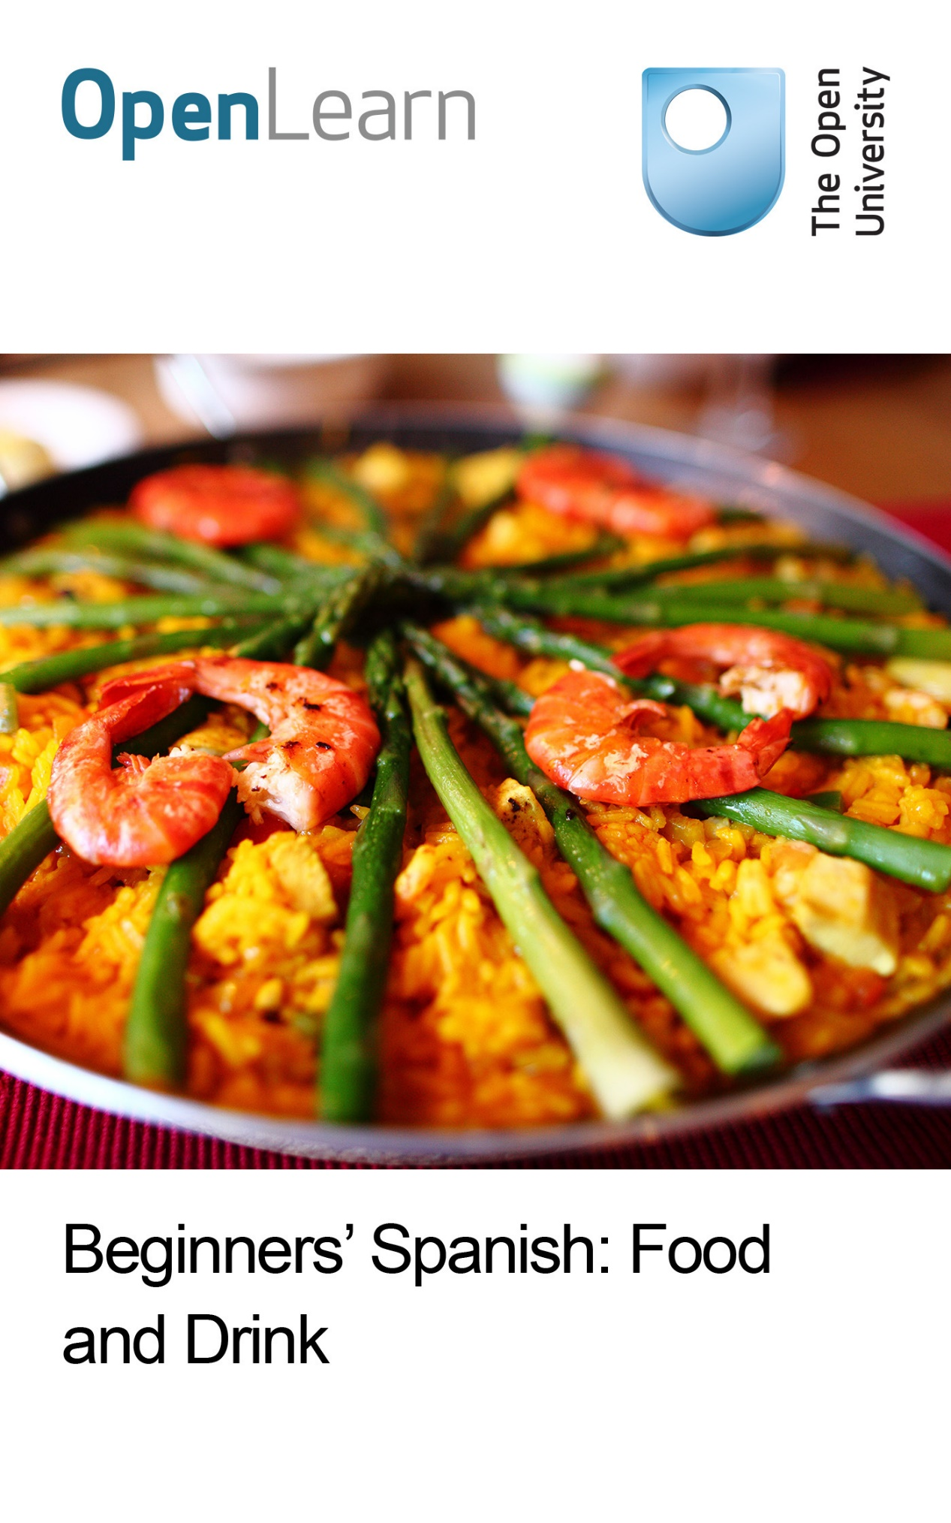

L194_2

Beginners’ Spanish: food and drink

About this free course
This free course is an adapted extract from the Open University course L194 Portales: beginners' Spanish: www3.open.ac.uk/study/undergraduate/course/l194.html
This version of the content may include video, images and interactive content that may not be optimised for your device.
You can experience this free course as it was originally designed on OpenLearn, the home of free learning from The Open University - www.open.edu/openlearn/languages/spanish/beginners-spanish-food-and-drink/content-section-0
There you’ll also be able to track your progress via your activity record, which you can use to demonstrate your learning.
Copyright © 2016 The Open University
Intellectual property
Unless otherwise stated, this resource is released under the terms of the Creative Commons Licence v4.0 http://creativecommons.org/licenses/by-nc-sa/4.0/deed.en_GB. Within that The Open University interprets this licence in the following way: www.open.edu/openlearn/about-openlearn/frequently-asked-questions-on-openlearn. Copyright and rights falling outside the terms of the Creative Commons Licence are retained or controlled by The Open University. Please read the full text before using any of the content.
We believe the primary barrier to accessing high-quality educational experiences is cost, which is why we aim to publish as much free content as possible under an open licence. If it proves difficult to release content under our preferred Creative Commons licence (e.g. because we can’t afford or gain the clearances or find suitable alternatives), we will still release the materials for free under a personal end-user licence.
This is because the learning experience will always be the same high quality offering and that should always be seen as positive – even if at times the licensing is different to Creative Commons.
When using the content you must attribute us (The Open University) (the OU) and any identified author in accordance with the terms of the Creative Commons Licence.
The Acknowledgements section is used to list, amongst other things, third party (Proprietary), licensed content which is not subject to Creative Commons licensing. Proprietary content must be used (retained) intact and in context to the content at all times.
The Acknowledgements section is also used to bring to your attention any other Special Restrictions which may apply to the content. For example there may be times when the Creative Commons Non-Commercial Sharealike licence does not apply to any of the content even if owned by us (The Open University). In these instances, unless stated otherwise, the content may be used for personal and non-commercial use.
We have also identified as Proprietary other material included in the content which is not subject to Creative Commons Licence. These are OU logos, trading names and may extend to certain photographic and video images and sound recordings and any other material as may be brought to your attention.
Unauthorised use of any of the content may constitute a breach of the terms and conditions and/or intellectual property laws.
We reserve the right to alter, amend or bring to an end any terms and conditions provided here without notice.
All rights falling outside the terms of the Creative Commons licence are retained or controlled by The Open University.
Head of Intellectual Property, The Open University
978 1 47300 153 4 (.epub)
978 1 47300 058 2 (.kdl)

Contents
- Introduction
- Learning outcomes
- Actividad 1
- Actividad 2
- Actividad 3
- Actividad 4
- Actividad 5
- Actividad 6
- Actividad 7
- Actividad 8
- Actividad 9
- Conclusion
- Take the next step
- Acknowledgements
- Solutions

Introduction
This free OpenLearn course, Beginners' Spanish: food and drink, requires some basic knowledge of Spanish. You will be able to use some basic vocabulary relating to food, drinks, meals, quantities and measures. You will also have the opportunity to practise how to order a meal, go shopping and pay for food. You will listen to Spanish speakers in a variety of situations, and you will learn skills for coping with extended listening. Cultural notes also explain about customs to do with meals and food shopping in Spain.
This OpenLearn course is an adapted extract from the Open University course L194 Portales: beginners' Spanish.

Learning outcomes
After studying this course, you should be able to:
- take part in simple exchanges when buying food in shops or at the market in Spain
- understand basic information about prices and quantities in Spanish
- order food and drinks in a bar or restaurant using Spanish
- ask for the bill in Spanish
- have a better understanding of some customs relating to food shopping and meals in Spain.

Actividad 1
Markets in Spain and Latin America are full of vibrant colours, noise, scents and fresher products than you would find in most supermarkets. In this activity you will practise how to shop for recipe ingredients.

A

Pilar, a regular customer at the market, is comparing prices in the frutería before she buys anything. Listen to the following audio track and write down the prices you hear, as in the example.
Escucha y escribe.

Audio content is not available in this format.
Fruit and vegetables
View transcript - Fruit and vegetables

Ejemplo

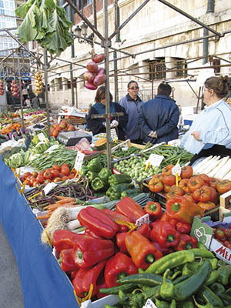
Figure 1
View description - Figure 1

View answer - A

Language: Asking for prices
Here are some useful expressions to ask for prices when shopping for food.

¿Cuánto es? | How much is it?
¿Cuánto vale / cuesta? | How much does it cost?
¿Cuánto valen / cuestan? | How much do they cost?

When asking the price of goods whose prices fluctuate daily, like fish or fruit in markets, the following expressions are used.

¿A cuánto está el bacalao? | How much is cod going for (today)?
¿A cuánto están las cerezas? | How much are cherries (today)?

Comment
The verb valer, commonly used to ask for prices, means literally ‘to be worth’. It is also used very frequently in the following expressions.

Vale la pena. | It is worth it.
No vale la pena. | It is not worth it.

B

Now listen to the audio track below and follow the prompts to ask for the prices of the items you hear.
Escucha y habla.

Audio content is not available in this format.
Prices
View transcript - Prices

C

Here is some vocabulary for items of food that you may want to buy. Match the phrases in Spanish with the relevant products.
Relaciona.

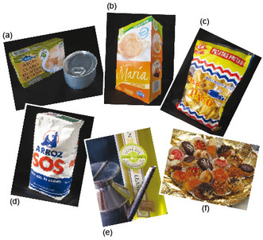
Figure 2
View description - Figure 2

- una botella de aceite
- una caja de galletas
- una bolsa de patatas fritas
- una bandeja de dulces
- un paquete de arroz
- una lata de atún

View answer - C

D

Listen to the following audio track and match the quantities listed below with the relevant products, as you hear them mentioned. Which quantity or product has not been mentioned?
Escucha y relaciona.

Audio content is not available in this format.
Shopkeeper and customer
View transcript - Shopkeeper and customer

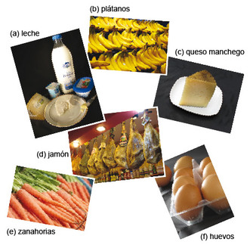
Figure 3
View description - Figure 3

- 100 gramos de…
- un cuarto de kilo de…
- medio kilo de…
- un kilo de…
- un litro de….
- media docena de…

View answer - D

Comment
Weights and measures are metric in all Spanish-speaking countries, so when someone says un cuarto de or medio de it is assumed that it is a quarter of a kilo or half a kilo.

Language: Weights and quantities
Here are some of the more common phrases used to talk about weights and quantities when shopping.

un kilo de fresas | a kilo of strawberries
medio kilo de carne picada | half a kilo of mince
un cuarto de kilo de queso de cabra | a quarter of a kilo of goat's cheese
un litro de aceite de oliva | a litre of olive oil
una docena de huevos | a dozen eggs
media docena de huevos | half a dozen eggs
una lata de espárragos | a tin of asparagus
una caja de bombones | a box of chocolates
una bolsa de magdalenas | a bag of fairy cakes
un paquete de azúcar | a packet of sugar
una bandeja de canapés | a tray of canapés
una botella de zumo de naranja | a bottle of orange juice

Actividad 2
In this activity you will listen to quantities and prices being talked about while shopping at a market.

A

Verónica is retired and often does some shopping for her elderly neighbour. Here she goes to the market. Listen to the following audio track and write down the prices and quantities of all the items she buys.
Escucha y escribe .

Audio content is not available in this format.
Vero in the market
View transcript - Vero in the market

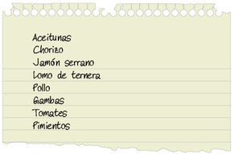
Figure 4
View description - Figure 4

View answer - A

Language: Shopping for food
Here are some useful phrases that you will need to use or understand when shopping for food.

¿Qué le pongo? / ¿Qué le doy? | What can I get you? (lit. What shall I give you?)
¿Qué desea? | What would you like?
Me pone… / Me da… | Can I have…
¿Algo más? / ¿Otra cosita? | Anything else?
¿Qué más quiere? | What else would you like?
Nada más. ¿Cuánto es? | Nothing else. How much is it?

B

Now it’s time to make your own shopping list and practise asking for things.
Think of a favourite recipe and make a list of the products and the amounts you need to cook it. Look up any words you don’t know in the dictionary. Think of the expressions needed to ask how much each of the products on your list costs and to ask for the required amounts. Practise saying them aloud, paying particular attention to the intonation.
Haz una lista y habla.

Actividad 3
In this activity you will learn how to pronounce the sounds /p/, /t/ and /k/ correctly in Spanish.

A

Listen to the following audio track and repeat the following words.
Escucha y repite.

Audio content is not available in this format.
Pronunciation
View transcript - Pronunciation

pescado • carne • cordero • cuarto de kilo • charcutería • cosita • cuánto

Language: The pronunciation of the sounds /p/, /t/ and /k/
In Spanish these sounds correspond to the following spellings.

Sound | Spelling | Examples
/p/ | p | pasa, pera, pimiento, pulpo
/t/ | t | tomate, patata, atún
/k/ | c (+ a, o, u)  qu (+ i, e)  k | casa, poco  quien, queso  kilo

Note that if you pronounce these sounds in Spanish whilst holding a piece of paper in front of your mouth, the paper should not move at all.

B

Listen to the following audio track and repeat the words and phrases, paying attention to the pronunciation of the letters ‘p’, ‘t’ and ‘c’. Then repeat the sentences, imitating the pronunciation of the speaker. You may wish to use the transcript.
Escucha y repite.

Audio content is not available in this format.
Pronouncing p, t and c
View transcript - Pronouncing p, t and c

The following feature, Español de bolsillo, provides recordings of key phrases to help you with revision.

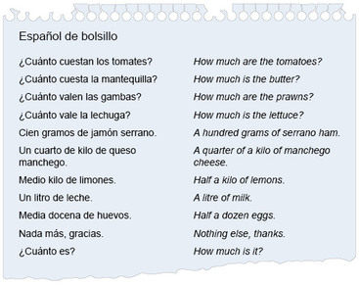
Figure 5
View description - Figure 5

Audio content is not available in this format.
How much?
View transcript - How much?

Actividad 4

You are now going to listen to a radio documentary about the Mercado Central in Valencia.

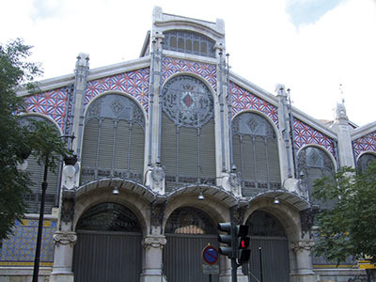
Figure 6
View description - Figure 6

Read the following questions. Then listen to the audio track below and answer them in English.
Escucha y contesta.

Audio content is not available in this format.
En portada
View transcript - En portada

- How big is the market?
- What produce is sold in the market?
- Why do people go to the market instead of the supermarket?
- In what way was the market a world first?

View answer - Activity

Skills: Listening to longer extracts
Listening to longer authentic recordings is a good way of building up your listening skills, but you shouldn’t worry if you only catch some of the words or get only a very general idea of what is being talked about. The purpose is to understand the key points rather than every detail. Listen first for the gist before listening for specific information. Remember that you can do this without understanding every word; even when you listen in your own language you will find that you rarely hear every word, unless you are really concentrating on the message (as in airport announcements).

Culture: Shopping in Spain

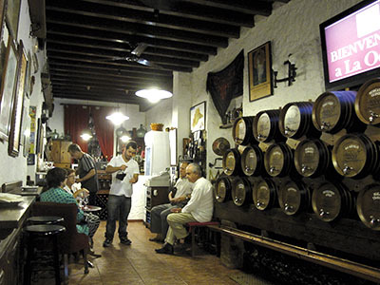
Figure 7
View description - Figure 7

Although large supermarkets have become more and more prevalent in Spain, many families still do part of their weekly and daily shopping in smaller local shops.
Bread, for example, is something that Spaniards buy daily in the many panaderías that can be found in every town and city. Cakes and pastries, which were traditionally sold in pastelerías, are now commonly sold in panaderías too.
Many people still prefer to buy fresh produce such as fruit and vegetables in the market, whilst meat, fish and cooked meats are often bought in small local independent shops which may offer better quality and service than large supermarkets.
A few bodegas still exist where customers can bring their own bottles or garrafas to buy wine by the litre. Although the expression vino de garrafa is given to cheap, nasty wine, some wine sold in bodegas is very good, and a lot cheaper than bottled wine!

Vocabulario
- la garrafa demijohn, carafe

Actividad 5
In this activity you will accompany Lía, a young woman who lives in Madrid, on an evening out. You will learn how to order drinks and food in a bar in Spanish.

A

Today Lía has sent an invitation to her friends through Facebook. Look at her message and choose the correct answers to the questions that follow.
Lee y elige la opción correcta.

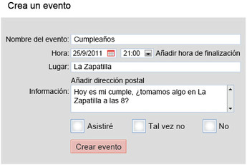
Figure 8
View description - Figure 8

- ¿Por qué se reúnen Lía y sus amigos?
  - Es el cumpleaños de Lía.
  - Lía tiene hambre.
  - Es el último día de trabajo de Lía.
- ¿Qué es La Zapatilla?
  - una zapatería
  - un bar de tapas
  - una academia de flamenco

View answer - A

Culture: Tapas

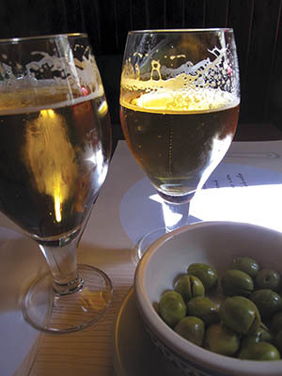
Figure 9
View description - Figure 9

In Spain, people often go to a bar before lunch or dinner to have a drink, usually accompanied by a small portion of food called a tapa. Tapas were traditionally served on a small round or oval plate. The origin of the word tapa is supposedly related to the old custom of bartenders placing a plate as a lid (tapa) over a glass of wine to protect it from dust or flies. Nowadays in some regions, bars don’t charge for the tapa, which comes free with the drink. Frequently people go to one or more bars to try out different tapas. This is called tapear, ir de tapeo or ir de tapas, and eating like this can often amount to a full meal.

B

Look at the pictures below and write down the name of each drink, choosing from the words or phrases in the box. One has been done for you.
Escribe los nombres de las bebidas.

zumo de piña • batido de chocolate • vino tinto • cubata • copa de coñac • mosto • caña de cerveza • agua mineral • refresco de naranja • gaseosa

Vocabulario
- el cubata / el cubalibre mixed drink of rum and coke
- el mosto = el zumo de uva

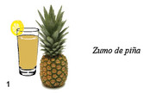
View description - Uncaptioned Figure

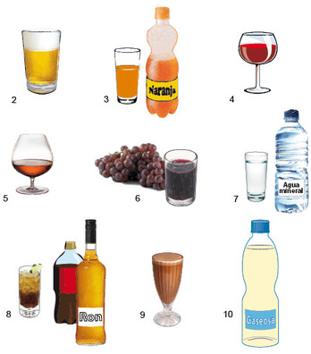
Figure 10
View description - Figure 10

View answer - B

C

Classify the drinks into alcoholic and non-alcoholic.
Clasifica.
Bebidas con alcohol:
Bebidas sin alcohol:

View answer - C

D

Lía and her friends are now at La Zapatilla. Listen to the following audio track in which Antón, one of Lía’s friends, asks everyone what they would like to drink. Then write down what each of them chooses.

Audio content is not available in this format.
Drinks orders
View transcript - Drinks orders

Escucha y escribe.
- Lía
- Miguel
- Noemí
- Iker
- Bea
- Antón

View answer - D

E

Listen to the following audio track in which Antón places his drinks order at the bar. Unfortunately he didn’t make notes of the drinks his friends wanted and he makes a mistake. Look at your notes from Step D and identify where he went wrong. Then give the correct order to the waiter in Spanish.
Escucha, identifica y pide.

Audio content is not available in this format.
Placing an order
View transcript - Placing an order

View answer - E

Actividad 6
Lía and her friends decide to order a few tapas.

A

Match the list of common tapas in the left-hand column to their meaning in English.
Enlaza.

Ejemplo
1 calamares fritos – (e) fried squid rings

1 calamares fritos  2 tortilla de patatas  3 mejillones al vapor  4 queso  5 jamón serrano  6 empanadillas de pulpo  7 aceitunas  8 albóndigas con tomate | (a) meatballs in tomato sauce  (b) cheese  (c) Spanish cured ham  (d) olives  (e) fried squid rings  (f) potato omelette  (g) octopus pasties  (h) steamed mussels

View answer - A

Culture: Tapas, pinchos and raciones

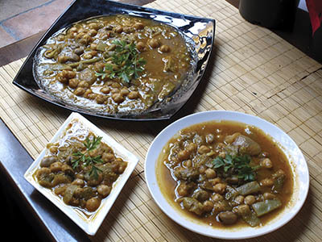
Figure 11
View description - Figure 11

A tapa is a very small portion. If you are hungry or you are sharing your meal with more people, you may want to order a media ración (half portion) or even a ración (whole portion).
There is some regional variation in the type of tapas offered. For instance, in the north of Spain people have pinchos, which is a bite of food on a toothpick. The traditional pincho is very simple, for example a small portion of Spanish omelette skewered onto a piece of bread with a toothpick, although in some up-market bars pinchos can be extremely sophisticated. The tradition is to take them directly from the counter and, when you’ve finished, let the waiter know how many you’ve had. This custom is changing, however, and in some new establishments you have to keep the toothpicks in order to be charged accordingly.

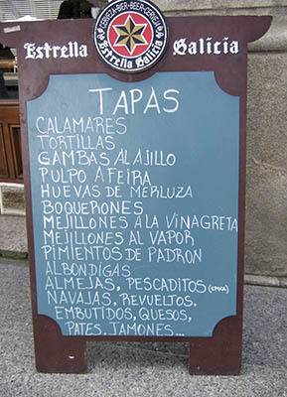
Figure 12
View description - Figure 12

Typical tapas in Galicia are octopus (boiled and served with oil and paprika) and fried green peppers (pimientos de Padrón). In central Spain, all types of cheese and cured meats, together with cooked food, from meatballs to fried vegetables, are served as tapas. In Andalusia, the main tapas are fried fish, chorizo and different types of cheese. In Central America, bocas are the equivalent of tapas. In Argentina they are called picadas, and they consist mostly of olives, ham or cheese.

B

Listen to the following audio track where Lía and her friends discuss what they want to eat. Write down what they decide to order.
Escucha y anota.

Audio content is not available in this format.
Ordering food
View transcript - Ordering food

View answer - B

Comment
Notice how the sentence ¡Camarero, por favor! is used to call the waiter. Listen to the audio again, paying attention to the intonation.

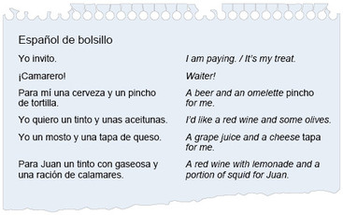
Figure 13
View description - Figure 13

Audio content is not available in this format.
I'm paying
View transcript - I'm paying

Actividad 7
In this activity you are going to look at a menu and order food.

A

Look at the restaurant menu below. Dishes are divided into three categories and normally served in this order: de primero, de segundo, de postre. Decide which categories the following three dishes would normally belong in.
Mira y decide.

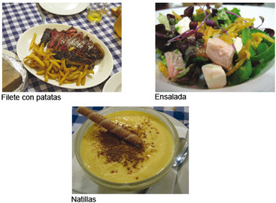
Figure 14
View description - Figure 14

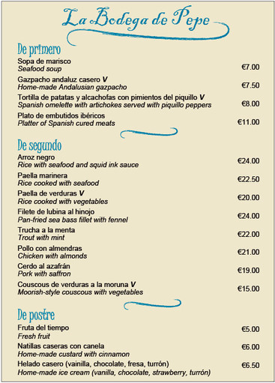
Figure 15
View description - Figure 15

View answer - A

Culture: Meal times
In Spain, the main meals are lunch (la comida, orel almuerzo) and the evening meal (la cena). Lunch is usually between 2.00 and 3.00 and dinner between 9.00 and 10.00. Spaniards do not bother much about breakfast, which is generally very light, but at work they have a mid-morning break and they can have a snack, which can vary from a savoury sandwich with a glass of wine to a cup of coffee or hot chocolate with pastries. An alternative to pastries is the traditional churros, a type of fritter traditionally dunked into hot chocolate. Coffee or hot chocolate also forms the basis for an afternoon snack, or merienda, shared with family or friends. The merienda is usually between 5.00 and 7.00.
In Latin America, meal times vary slightly from one country to another. In Chile, for instance, lunch is generally between 1.00 and 2.00. The afternoon snack of tea and light pastries which is called las onces is served at 5.00. The evening meal (which is called comida in Chile) is served at about 8.30, earlier than in Spain.

B

Read the menu again and group the dishes into the categories listed below. Use their main ingredient to help you decide on the right category. One in each category has been done for you as examples.
Lee y agrupa.
- Carnes: pollo
- Pescados y mariscos: sopa de marisco
- Verduras: gazpacho andaluz
- Fruta y dulces: fruta del tiempo

View answer - B

C

Time to order some food! Write down what you would order:
- if you were a vegetarian, and
- if you loved fish and seafood.
Escribe.
You can start like this:
- Soy vegetariana. De primero… y de segundo…
- ¡Me gusta mucho el pescado y me encanta el marisco! Para mí, de primero… y de segundo…

View answer - C

D

Listen to some customers placing their orders on the following audio track. Write down what you hear.
Escucha, identifica y anota.

Audio content is not available in this format.
Ordering a meal
View transcript - Ordering a meal

View answer - D

Language: Ordering a meal
The following questions and answers are frequently used when ordering a meal.

¿Qué van a tomar de primero? | What would you like to have for your first course?
Para mí, una sopa de marisco. | For me seafood soup, please.
De primero, un gazpacho. | As first course a gazpacho.
¿Qué van a tomar de segundo? | What would you like to have for your second course?
De segundo quiero paella. | For my second course I’d like paella.
Para mí pescado a la plancha. | For me grilled fish, please.
Y de postre, ¿qué van a tomar? | What would you like to have for your dessert?
De postre voy a tomar un helado. | For dessert I’ll have an ice cream.
Y yo un flan. | And a crème caramel for me.

Note that por favor is not necessarily used in this context.

E

You are in a restaurant. Listen to the audio track below and follow the prompts to order a meal.
Escucha y participa.

Audio content is not available in this format.
Following prompts to order a meal
View transcript - Following prompts to order a meal

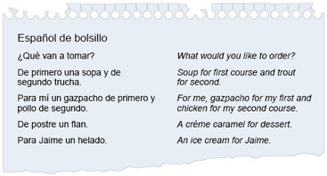
Figure 16
View description - Figure 16

Audio content is not available in this format.
Taking an order
View transcript - Taking an order

Actividad 8
This activity is about the last stage of a meal and getting the bill.

A

After desserts have been served the waiter normally asks about coffee or other drinks. Listen to the audio track below and write down which of the following drinks are ordered.
Escucha y escribe.

Vocabulario
- el cortado expresso coffee with a dash of milk
- la manzanilla camomile tea
- el poleo menta peppermint tea

Audio content is not available in this format.
At the end of a meal
View transcript - At the end of a meal

- un café solo
- una manzanilla
- un cortado
- un poleo menta
- un café con leche
- un té verde

View answer - A

Culture: After-dinner conversation (La sobremesa)

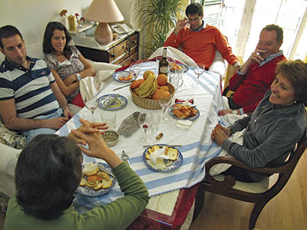
Figure 17
View description - Figure 17

A feature of relaxed meals in Spain is the opportunity to continue chatting over coffee and possibly liqueurs after a meal. This has a special name, la sobremesa, and it is regarded as an important part of the occasion for friends and family, whether at home or in a restaurant. This is also true of business lunches: Spaniards are very particular about food and wine, and business deals are often made over lunch or dinner in a restaurant. Chatting together after a meal is known as estar de sobremesa.

B

Listen to the short dialogues on the following audio track and decide which are initiated by the customer and which by the waiter.
Escucha y decide.

Audio content is not available in this format.
End of meal dialogue
View transcript - End of meal dialogue

View answer - B

C

Listen to the dialogues in Casa Domingo and El Clavel on the following audio track and answer the questions.
Escucha y contesta.

Audio content is not available in this format.
Short dialogue
View transcript - Short dialogue

- In which restaurant does the customer attract the waiter’s attention to ask for the bill?
- In which restaurant can you pay with a credit card?
- In which restaurant does the customer pay less?

View answer - C

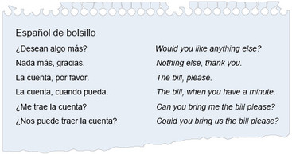
Figure 18
View description - Figure 18

Audio content is not available in this format.
Requesting the bill
View transcript - Requesting the bill

Actividad 9
In this activity you are going to find out more about Valencian cuisine and one of the city’s famous restaurants by the sea.

Listen to the documentary on the audio track below and answer the following questions in English.
Escucha y contesta.

Vocabulario
- los placeres pleasures
- la langosta lobster
- los fideos noodles
- las personas mayores elderly people
- la realeza royalty
- las paredes walls
- el conejo rabbit
Time for another edition of the documentary series En portada. This programme is all about eating out, one of the most enjoyable things to do in Valencia.

Audio content is not available in this format.
Eating out
View transcript - Eating out

- List some of the ingredients of the traditional dishes mentioned.
- What is the main ingredient in Valencian cooking?
- What is the favourite meal of the local people interviewed?
- What sort of a restaurant is La Rosa? When was it opened?
- Does it attract an international clientele? Mention three names.
- What is possible for clients dining indoors?

View answer - Activity

Skills: Shadow reading
Shadow reading means reading the transcript aloud while listening to the speaker on the recording. This technique will help you improve your pronunciation, intonation and fluency.

Conclusion
This free course provided an introduction to studying languages. It took you through a series of exercises designed to develop your approach to study and learning at a distance and helped to improve your confidence as an independent learner.
If you enjoyed this course, you might be interested in studying the Open University module L194 Portales: beginners' Spanish. Or, if you are interested in other language short courses, rather than studying languages for a degree, you may want to have a look at what else is on offer here.

Take the next step

If you enjoyed this course, why not explore the subject further with our paid-for short course, Beginners Spanish 2: ¡En marcha!?
Find out more about Beginners Spanish 2: ¡En marcha!

Acknowledgements
This free course was written by L194 Portales: Beginners' Spanish course team.
Except for third party materials and otherwise stated (see terms and conditions), this content is made available under a Creative Commons Attribution-NonCommercial-ShareAlike 4.0 Licence.
The material acknowledged below is Proprietary and used under licence (not subject to Creative Commons Licence). Grateful acknowledgement is made to the following sources for permission to reproduce material in this course:
Course image: Ulf Bodin in Flickr made available under Creative Commons Attribution-NonCommercial-ShareAlike 2.0 Licence.

Photos
All photos © Mike Truman (including Actividades 5 and 6 (top): with thanks to La Taberna de la Abuela, Málaga) except: Actividad 1 Step D: (top middle) © Steve Hopson, (bottom left) © Kander; Actividad 4: (top) © Fernando Rosell-Aguilar; Actividad 6: (bottom) © Beatriz de los Arcos.

Audio
Audio material produced by Lowland Masters for The Open University.
Every effort has been made to contact copyright owners. If any have been inadvertently overlooked, the publishers will be pleased to make the necessary arrangements at the first opportunity.
Don't miss out
If reading this text has inspired you to learn more, you may be interested in joining the millions of people who discover our free learning resources and qualifications by visiting The Open University – www.open.edu/openlearn/free-courses.

Solutions

A

Answer
- plátanos – uno cincuenta el kilo (€1,50)limones – uno veinte el kilo (€1,20)
- patatas – setenta céntimos el kilo (€0,70)
- tomates – uno setenta el kilo (€1,70)
- lechuga – noventa céntimos (€0,90)
Back to - A

C

Answer
1–(e); 2–(b); 3–(c); 4–(f); 5–(d); 6–(a).
Back to - C

D

Answer
1–(c); 2–(d); 4–(b) and (e); 5–(a); 6–(f).
The quantity that was not mentioned was medio kilo.
Back to - D

A

Answer

Item | Quantity | Total price
aceitunas | 250 g | €3,60
chorizo | ½ kg | €7,90
jamón serrano | 200 g | €6,50
gambas | 1 kg | €13
pollo | 2 | €10
lomo de ternera | 1½ kg | €12 (“a 8 euros el kilo”)
tomates | 1 kg | €1
pimientos | ½ kg | €0,50

Back to - A

Answer
- It is enormous - the biggest fresh food market in Europe.
- Fruit, vegetables, fish, seafood, meat, charcuterie, spices, nuts, flowers.
- Because there is more variety, the produce is fresher and the prices are cheaper.
- It was the first market to use online ordering.
Back to - Activity

A

Answer
1 – (a); 2 – (b).
Back to - A

B

Answer
The names of the drinks are:
1 zumo de piña; 2 caña de cerveza; 3 refresco de naranja; 4 vino tinto; 5 copa de coñac; 6 mosto; 7 agua mineral; 8 cubata; 9 batido de chocolate; 10 gaseosa.
Back to - B

C

Answer
Bebidas con alcohol: caña de cerveza, vino tinto, copa de coñac, cubata.
Bebidas sin alcohol: zumo de piña, refresco de naranja, mosto, agua mineral, batido de chocolate, gaseosa.
Back to - C

D

Answer
These are the drinks each person ordered.
Lía – una cerveza; Miguel – un mosto; Noemí – un tinto y un agua; Iker – una cerveza; Bea – un tinto; Antón – una Coca-Cola.
Back to - D

E

Answer
Antón ordered one red wine only, not two (one for Noemí and one for Bea). This is the correct order as you would give it:
Camarero, por favor, dos cervezas, dos tintos, un agua, un mosto y una Coca-Cola.
Back to - E

A

Answer
1 – (e); 2 – (f); 3 – (h); 4 – (b); 5 – (c); 6 – (g); 7 – (d); 8 – (a).
Back to - A

B

Answer
They order: tortilla de patatas (dos raciones), jamón serrano (una ración), queso (una ración), empanadillas de pulpo (siete), calamares (dos raciones).
Back to - B

A

Answer
De primero: ensalada; de segundo, filete con patatas; de postre, natillas.
Back to - A

B

Answer
Carnes: plato de embutidos ibéricos, pollo con almendras, cerdo al azafrán.
Pescados y mariscos: sopa de marisco, arroz negro, paella marinera, filete de lubina al hinojo, trucha a la menta.
Verduras: gazpacho andaluz casero, tortilla de patatas y alcachofas con pimientos del piquillo, paella de verduras, couscous de verduras a la moruna.
Fruta y dulces: fruta del tiempo, natillas caseras con canela, helado casero.
Back to - B

C

Answer
Here is a possible answer.
- Soy vegetariana. De primero, gazpacho andaluz y de segundo paella de verduras.
- ¡Me gusta mucho el pescado y me encanta el marisco! Para mí, de primero sopa de marisco y de segundo, trucha a la menta.
Back to - C

D

Answer
De primero: gazpacho, sopa de marisco.
De segundo: paella marinera, trucha a la menta.
Back to - D

A

Answer
The drinks ordered are: un cortado, un café solo, un poleo menta, un té verde.
Back to - A

B

Answer
All the dialogues take place at the end of the meal. 1, 2, 3 are initiated by the customer, and are different ways of asking for the bill. 4 and 5 are initiated by the waiter, asking about the meal.
Back to - B

C

Answer
1 and 2: Restaurante El Clavel; 3: Casa Domingo.
Back to - C

Answer
- Some of the ingredients mentioned are: seafood (marisco), lobster (langosta), squid (calamares), rice (arroz), fish (pescado), noodles (fideos), vegetables (verduras), rabbit (conejo), and chicken (pollo).
- The main ingredient is rice.
- Paella is the clear favourite.
- It is a traditional restaurant, offering regional dishes, which was opened in 1925.
- Yes, it does. Three clients mentioned are Norman Foster, Umberto Eco, and Jeremy Irons.
- Clients who dine indoors can watch the paella being prepared.
Back to - Activity

Figure 1

Description
This is a photo of someone shopping at a vegetable stall.
Back to - Figure 1

Figure 2

Description
These are photos of: (a) a tin of tuna; (b) a box of biscuits; (c) a packet of crisps; (d) a packet of rice; (e) a bottle of oil; (f) a tray of cakes.
Back to - Figure 2

Figure 3

Description
These are photos of: (a) a bottle of milk and other lactic products; (b)some bunches of bananas; (c) a wedge of cheese; (d) some legs of ham; (e) carrots; (f) a box of eggs.
Back to - Figure 3

Figure 4

Description
This is an image of a scrap of paper with a shopping list on it containing the following items: aceitunas, chorizo, jamón serrano, lomo de ternera, pollo, gambas, tomates, pimientos.
Back to - Figure 4

Figure 5

Description
The English translations are as follows: How much are the tomatoes? How much is the butter? How much are the prawns? How much is the lettuce? A hundred grams of Serrano ham. A quarter of a kilo of manchego cheese. Half a kilo of lemons. A litre of milk. Half a dozen eggs. Nothing else, thanks. How much is it?
Back to - Figure 5

Figure 6

Description
This is an image of the façade of the Mercado Central of Valencia, a Modernist building.
Back to - Figure 6

Figure 7

Description
This is an image of the inside of a wine merchants’ with customers sitting down to have a drink. and barrels of wine stacked on three rows on the wall.
Back to - Figure 7

Figure 8

Description
This is a Facebook message which reads as follows: Crea un evento. Nombre del evento: Cumpleaños. Hora 25/9/2011 21:00 Añadir hora de finalización. Lugar: La Zapatilla. Añadir dirección postal. Información: Hoy es mi cumple, ¿tomamos algo en La Zapatilla a las 8? Asistiré, Tal vez no, No. Crear evento.
Back to - Figure 8

Figure 9

Description
This is an image of two glasses of beer and a small dish of olives served as a tapa.
Back to - Figure 9

Uncaptioned Figure

Description
This is an image of a glass of pineapple juice and has a caption that says zumo de piña. It is numbered 1.
Back to - Uncaptioned Figure

Figure 10

Description
These are 9 images of drinks, numbered from 2 to 10 and without captions. Image 2 is a glass of beer, 3 is an orange soft drink, 4 is a glass of red wine, 5 is a glass of brandy, 6 is a glass of grape juice, with some grapes by the side, 7 is mineral water, 8 is rum and coke, 9 is a chocolate milkshake, 10 is a bottle of lemonade.
Back to - Figure 10

Figure 11

Description
This is a photo showing the relative sizes of a tapa, a media ración and a ración.
Back to - Figure 11

Figure 12

Description
This is a photo of a traditional bar blackboard with a list of tapas: calamares, tortillas, gambas al ajillo... The blackboard is about one metre high and is standing on the pavement.
Back to - Figure 12

Figure 13

Description
The English translations are as follows: I am paying. / It’s my treat. Waiter! A beer and an omelette pincho for me. I’d like a red wine and some olives. A grape juice and a cheese tapa for me. A red wine with lemonade and a portion of squid for Juan.
Back to - Figure 13

Figure 14

Description
These are three pictures with the names of the dishes written underneath, as follows: Filete con patatas, ensalada and natillas.
Back to - Figure 14

Figure 15

Description
This is a restaurant menu for La Bodega de Pepe. The menu is divided into 3 sections. The first reads: De primero and below the following dishes are listed with their English translations: Sopa de marisco, seafood soup. Gazpacho andaluz casero, home-made Andalusian gazpacho (marked with a capital V for vegetarian). Tortilla de patatas y alcachofas con pimientos del piquillo (marked with a V), Spanish omelette with artichokes served with piquillo peppers. Plato de embutidos ibéricos , Platter of Spanish cured meats. The second section reads De Segundo. The dishes listed are: Arroz negro, rice with seafood and squid ink sauce. Paella marinera, rice cooked with seafood. Paella de verduras (marked with a V), rice cooked with vegetables. Filete de lubina al hinojo, pan-fried sea bass with fennel. Trucha a la menta, trout with mint. Pollo con almendras, chicken with almonds. Cerdo al azafrán, pork with saffron. Couscous de verduras a la moruna, Moorish-style couscous with vegetables. The third section reads De postre and the dishes listed are: Fruta del tiempo, fresh fruit. Natillas caseras con canela, home-made custard with cinnamon. Helado casero (vainilla, chocolate, fresa, turrón), home-made ice cream (vanilla, chocolate, strawberry, turrón).
Back to - Figure 15

Figure 16

Description
The English translations are as follows: What would you like to order? Soup for first course and trout for second. For me, gazpacho for my first and chicken for my second course. A crème caramel for dessert. An ice cream for Jaime.
Back to - Figure 16

Figure 17

Description
This is a photo of a group of people sitting at a table at home, chatting after a meal.
Back to - Figure 17

Figure 18

Description
The English translations are as follows: Would you like anything else? Nothing else, thank you. The bill, please. The bill, when you have a minute. Can you bring me the bill please? Could you bring us the bill please?
Back to - Figure 18

Fruit and vegetables

Transcript
Here’s someone asking about the price of fruit and vegetables.
—¿Cuánto valen los plátanos?
—Uno cincuenta el kilo.
—¿A cuánto están los limones?
—Los limones a uno veinte el kilo.
—¿Cuánto vale el kilo de patatas?
—Setenta céntimos.
—¿A cuánto está el kilo de tomates?
—A uno setenta.
—¿Y cuánto cuesta esta lechuga?
—La lechuga noventa céntimos. Pero ¿compra o no compra?
Back to - Fruit and vegetables

Prices

Transcript
Use the prompts to ask the price of each item.
Ejemplo
(calamares)
¿Cuánto cuestan los calamares?
or
¿Cuánto valen los calamares?
Now it’s your turn.
(huevos)
—¿Cuánto cuestan los huevos?
(mantequilla)
—¿Cuánto cuesta la mantequilla?
(queso de cabra)
—¿Cuánto cuesta el queso de cabra?
(madalenas)
—¿Cuánto valen las madalenas?
(chorizo)
—¿Cuánto vale el chorizo?
(pollo)
—¿Cuánto cuesta el pollo?
Back to - Prices

Shopkeeper and customer

Transcript
Listen to this dialogue between a shopkeeper and a customer.
—¿Qué le pongo?
—Me da cien gramos de queso.
—Sí. ¿Algo más?
—Sí, un cuarto de jamón.
—¿Otra cosita?
—Sí, un kilo de zanahorias y un kilo de plátanos.
—¿Algo más?
—Hmm… Ah sí. Un litro de leche y media docena de huevos, por favor.
—¿Es todo?
—Eh… sí. ¿Cuánto es, por favor?
Back to - Shopkeeper and customer

Vero in the market

Transcript
Listen to Vero buying some things in the market for her elderly neighbour.
Vero Me pone doscientos cincuenta gramos de aceitunas, medio kilo de chorizo y doscientos gramos de jamón serrano, por favor. ¿Cuánto es?
Propietario A ver… doscientos cincuenta gramos de aceitunas son tres euros sesenta… medio kilo de chorizo son siete euros noventa y doscientos gramos de jamón son seis euros cincuenta. En total…
Propietaria Hola, buenos días. ¿Qué le pongo?
Vero A ver… ¿Cuánto cuestan las gambas?
Propietaria ¿Las gambas? Trece euros el kilo.
Vero Me pone un kilo de gambas.
Vero Hola. ¿Me pone dos pollos, por favor? Los pollos valen cinco euros cada uno ¿verdad?
Propietaria Sí, señora, en total diez euros. ¿Algo más?
Vero Ah sí… un kilo y medio de lomo de ternera. ¿Cuánto cuesta el kilo?
Propietaria El lomo de ternera está caro hoy. Está a ocho euros el kilo. ¿Le pongo?
Vero Sí por favor. Aquí tiene. Son veintidós euros ¿no?
Propietario Tomates, tomates, pimientos a un euro el kilo ¡venga!
Vero Ah, muy buen precio. Me pone un kilo de tomates y medio kilo de pimientos verdes, por favor.
Back to - Vero in the market

Pronunciation

Transcript
Listen and repeat, pronouncing each word carefully.
pescado, carne, cordero, cuarto de kilo, charcutería, cosita, cuánto
Back to - Pronunciation

Pronouncing p, t and c

Transcript
Listen and repeat, paying attention to the pronunciation of the letters ‘p’, ‘t’ and ‘c’.
pescado, pollo, parmesano, patatas, pimientos, plátanos, tapas, tomates, ternera, tocino, tenemos, tostado, tomillo, estómago, cuánto, cuesta
Tenemos pescado y pollo.
Compramos patatas, pimientos y plátanos.
Tomamos tapas, ternera con tocino y tomates.
¿Cuánto cuesta el tomillo?
Preferimos el pan tostado.
Back to - Pronouncing p, t and c

How much?

Transcript
Español de bolsillo
¿Cuánto cuestan los tomates?
¿Cuánto cuesta la mantequilla?
¿Cuánto valen las gambas?
¿Cuánto vale la lechuga?
Cien gramos de jamón serrano.
Un cuarto de kilo de queso manchego.
Medio kilo de limones.
Un litro de leche.
Media docena de huevos.
Nada más, gracias.
¿Cuánto es?
Back to - How much?

En portada

Transcript
Now it’s time for another programme in our documentary series En portada. This one is about the market hall in Valencia, El Mercado Central, where the architecture, atmosphere and the quality of the fresh produce makes shopping there a unique experience.
Presentadora Bienvenidos a En portada. En el programa de hoy vamos de compras al Mercado Central de Valencia. ¿Tienen la lista de la compra preparada? ¡Pues vamos!
El Mercado Central está en el centro de Valencia, muy cerca de la Plaza del Ayuntamiento. ¡Es enorme! Es el mercado de productos frescos más grande de toda Europa.
El edificio es precioso: es de principios del siglo XX y su estilo es modernista.
En las calles del Mercado hay puestos donde venden fruta y verdura, pescado y marisco, carne y charcutería, especias, frutos secos, flores…
Vamos a hablar con algunos clientes sobre sus hábitos de compra.
Entrevistadora ¿Dónde hace la compra normalmente?
Entrevistado 1 Compro aquí en el Mercado Central y algunas veces también compro en el supermercado.
Entrevistadora ¿Dónde haces la compra normalmente?
Entrevistada 2 A veces voy a un supermercado, pero la fruta y la verdura la compro siempre aquí.
Entrevistada 3 Bueno, la verdura y la carne en el Mercado.
Entrevistada 4 Normalmente la verdura y la fruta en el Mercado, y el resto en el supermercado.
Presentadora La gente compra aquí porque hay más variedad, los productos son más frescos, y los precios son económicos. Los clientes nos explican por qué vienen al Mercado.
Entrevistado 1 Porque hay más variedad, hay más… está más barato.
Entrevistada 2 Porque hay más donde elegir. Encuentras ofertas…
Entrevistado 5 Las cosas más frescas y mucha más calidad.
Presentadora La región de Valencia es famosa por su huerta, donde se cultivan frutas y verduras de calidad superior, que exporta a todo el mundo.
Muchos vendedores de los puestos del Mercado tienen su huerta y venden los productos que cultivan.
El Mercado simboliza la tradición de la región y también simboliza el progreso: fue el primer mercado del mundo en utilizar internet para vender sus productos. Nos habla una empleada del servicio de atención al cliente.
Entrevistadora ¿Cuál es la dirección de internet?
Empleada Nuestra dirección es www.mercadocentralvalencia.es
Entrevistadora ¿Qué tipo de gente compra por internet?
Empleada Suelen ser empresarios, comerciantes… Gente de treinta a cuarenta años.
Presentadora La compra por internet de productos del Mercado empieza en el año 1996, y funciona muy bien.
A ver, tengo que hacer la compra. ¿Cuál es la dirección? www.mercadocentralvalencia.es. Bien. ¡Huy, qué página web tan bonita!
Historia, puestos, servicios del Mercado, recetas aquí, compra por internet… ¡Aquí está! Tengo que registrarme: nombre, edad… ya está. Bueno, pues la lista de la compra: quiero un kilo de limones, un kilo de tomates, un kilo de peras…
Back to - En portada

Drinks orders

Transcript
Listen to Antón taking drinks orders from his friends.
Antón ¡Hola Lía, guapa! ¿Qué quieres tomar? ¡Yo invito!
Lía ¡Gracias, Antón! Pues una cerveza fresquita.
Antón Vale. ¿Y tú Miguel?
Miguel Yo un mosto, que tengo que conducir.
Antón Marchando un mosto para Miguel. Noemí ¿qué tomas?
Noemí Ah ¿invitas tú? ¡Qué bien! Pues un tinto y un agua.
Antón ¿Y tú, Iker?
Iker Una cerveza, como la chica del cumpleaños.
Antón Vale. Bea ¿qué te pido?
Bea Gracias Antón, un tinto.
Antón Estupendo, y para mí una Coca-Cola.
Back to - Drinks orders

Placing an order

Transcript
Here’s Antón placing an order with the waiter.
—Camarero por favor, dos cervezas, un tinto, un agua, un mosto, y para mí, una Coca-Cola.
Back to - Placing an order

Ordering food

Transcript
The group is discussing the food they want to order.
Miguel Lía, oye ¿pedimos unos pinchos o una ración de algo? Es que tengo un hambre…
Lía Umm… vale, una ración de tortilla de patatas.
Miguel No, mejor dos, que somos muchos.
Lía ¿Y un poco de jamón y queso?
Miguel Vale, pues una ración de jamón serrano y otra de queso.
Noemí A mí me encantan las empanadillas de pulpo de este bar.
Miguel Pues venga, siete empanadillas. ¿Algo más?
Iker Sí, dos raciones de calamares ¿no?
Lía Vale, perfecto. A ver si viene el camarero. ¡Camarero, por favor!
Back to - Ordering food

I'm paying

Transcript
Español de bolsillo
Yo invito.
¡Camarero!
Para mí una cerveza y un pincho de tortilla.
Yo quiero un tinto y unas aceitunas.
Yo un mosto y una tapa de queso.
Para Juan un tinto con gaseosa y una ración de calamares.
Back to - I'm paying

Ordering a meal

Transcript
Listen to some customers ordering a meal at a restaurant.
—¿Y para comer? ¿Qué van a tomar?
—Sí, yo voy a tomar de primero un gazpacho, y de segundo una paella marinera.
—Yo, de primero una sopa de marisco y después una trucha a la menta.
—Gracias. Enseguida lo tenemos.
Back to - Ordering a meal

Following prompts to order a meal

Transcript
Use the prompts to order a meal.
Ejemplo
—¿Qué va a tomar de primero?
(ensalada)
—De primero voy a tomar ensalada.
Now it’s your turn.
1 —¿Qué va a tomar de primero?
(sopa de marisco)
—De primero voy a tomar sopa de marisco.
—¿Y de segundo?
(pollo)
—De segundo voy a tomar pollo.
—Y de postre ¿qué va a tomar?
—(helado de vainilla)
—De postre voy a tomar helado de vainilla.
2 —¿Qué va a tomar de primero?
(gazpacho)
—De primero voy a tomar gazpacho.
—¿Y de segundo?
(arroz negro)
—De segundo voy a tomar arroz negro.
—Y de postre ¿qué va a tomar de postre?
(flan)
—De postre voy a tomar flan.
Back to - Following prompts to order a meal

Taking an order

Transcript
Español de bolsillo
¿Qué van a tomar?
De primero una sopa y de segundo trucha.
Para mí un gazpacho de primero y pollo de segundo.
De postre un flan.
Para Jaime un helado.
Back to - Taking an order

At the end of a meal

Transcript
What do these people order at the end of their meal?
1 —¿Va a tomar café?
—Sí, un cortado por favor.
2 —¿Los señores van a tomar café?
—Sí, un café solo.
—Y para mí, un poleo menta.
3 —¿Quiere café?
—No, voy a tomar un té verde.
Back to - At the end of a meal

End of meal dialogue

Transcript
What are these short dialogues about?
1 —¿Me trae la cuenta, por favor?
—Por supuesto, enseguida.
2 —¿Nos puede traer la cuenta, por favor?
—Enseguida la traigo.
3 —Cuando pueda ¿nos trae la cuenta?
—Sí, al momento.
4 —¿Qué tal todo?
—¡Muy bueno! Todo muy rico.
5 —¿Desean algo más?
—No, nada más, gracias.
Back to - End of meal dialogue

Short dialogue

Transcript
Here are a couple of short dialogues in two different restaurants.
Restaurante Casa Domingo
Camarera ¿Qué tal el postre?
Cliente Buenísimo.
Camarera ¿Desean algo más?
Cliente No, nada más. La cuenta, por favor.
Camarera A ver, dos menús del día y los cafés… son 30 euros.
Cliente ¿Puedo pagar con tarjeta?
Camarera No, lo siento, solo aceptamos efectivo.
Restaurante El Clavel
Cliente ¡Camarero! ¿Nos cobra cuando pueda?
Camarero Un momentito, enseguida voy.
(música)
Camarero Aquí tienen la cuenta. Dos primeros, dos segundos, la bebida y los cafés… Son 40 euros.
Cliente ¿Puedo pagar con tarjeta?
Camarero Sí, por supuesto.
Back to - Short dialogue

Requesting the bill

Transcript
Español de bolsillo
¿Desean algo más?
Nada más, gracias.
La cuenta, por favor.
La cuenta, cuando pueda.
¿Me trae la cuenta?
¿Nos puede traer la cuenta?
Back to - Requesting the bill

Eating out

Transcript
Presentadora Hola a todos, y bienvenidos a una nueva edición de En portada. Hoy les vamos a hablar de la cocina valenciana, y visitaremos uno de los restaurantes más famosos de Valencia, el restaurante La Rosa.
Uno de los grandes placeres de visitar Valencia son sus restaurantes. La mayoría de estos restaurantes ofrecen platos típicos de la cocina tradicional valenciana, preparada con productos frescos del mar, ríos, montañas y huertas de la región.
—¿Y para comer?
—Para comer yo tomaré una paella de marisco.
—Una de langosta.
—Y de primero tomaré una ensalada valenciana.
—De primero unos calamares.
Presentadora En los mejores restaurantes la carta suele cambiar según la estación del año, pero el plato rey es el arroz o los arroces en sus múltiples formas. Por ejemplo, el arroz a banda se prepara con pescado y marisco; el arroz negro, con calamares en su tinta negra. Otro plato típico es la fideuà, como una paella pero no tiene arroz, tiene fideos. Pero naturalmente, el protagonista en los restaurantes es la paella. Vamos a preguntar a un grupo de personas mayores cuál es su comida preferida.
Entrevistadora ¿Cuál es su comida preferida?
Entrevistada 1 La paella valenciana, por eso soy valenciana.
Entrevistado 2 Paella de verduras.
Entrevistado 3 Fideuà. Y la segunda arroz a banda.
Entrevistada 4 La fideuà.
Entrevistada 5 Paella, paella.
Entrevistada 6 Me gusta mucho la paella.
Entrevistada 7 La paella valenciana.
Entrevistador ¿Cuál es su comida preferida?
Entrevistado 8 A mí todas. La paella, la paella.
Presentadora Bueno, está claro que la paella es la favorita. Y uno de los restaurantes valencianos donde mejor se prepara la paella es el restaurante La Rosa, en la Playa de la Malvarrosa.
La Rosa es un restaurante tradicional. Está abierto desde 1925. Sus propietarios son dos primos, Pedro Collante y Juan Miguel Martínez.
En La Rosa han comido artistas de fama mundial: escritores, actores, cantantes, ministros, y hasta miembros de la realeza española. En las paredes del restaurante hay fotos de Norman Foster, Umberto Eco, Jeremy Irons, y muchos otros personajes célebres. Juan Miguel nos identifica estos personajes.
Entrevistadora ¿Quién es ella?
Juan Miguel La alcaldesa de Valencia, y junto a ella está Norman Foster, arquitecto.
Entrevistadora Y ¿quién es ese?
Juan Miguel Un personaje muy importante en Italia: Umberto Eco.
Entrevistadora ¿Y ellos quiénes son?
Juan Miguel: ¿Ellos quiénes son? Allí tenemos a los propietarios del restaurante junto a Jeremy Irons, actor.
Presentadora Los clientes pueden comer dentro y ver cómo se cocina la paella típica de Valencia, con conejo y pollo. O fuera en la terraza con el Mediterráneo enfrente, que abre el apetito.
—Pues, esta noche vamos a cenar paella.
—Muy bien. Y ¿qué tipo de paella?
—¡Paella valenciana, por supuesto!
—Bon profit! ¡Que aproveche!
Back to - Eating out

