
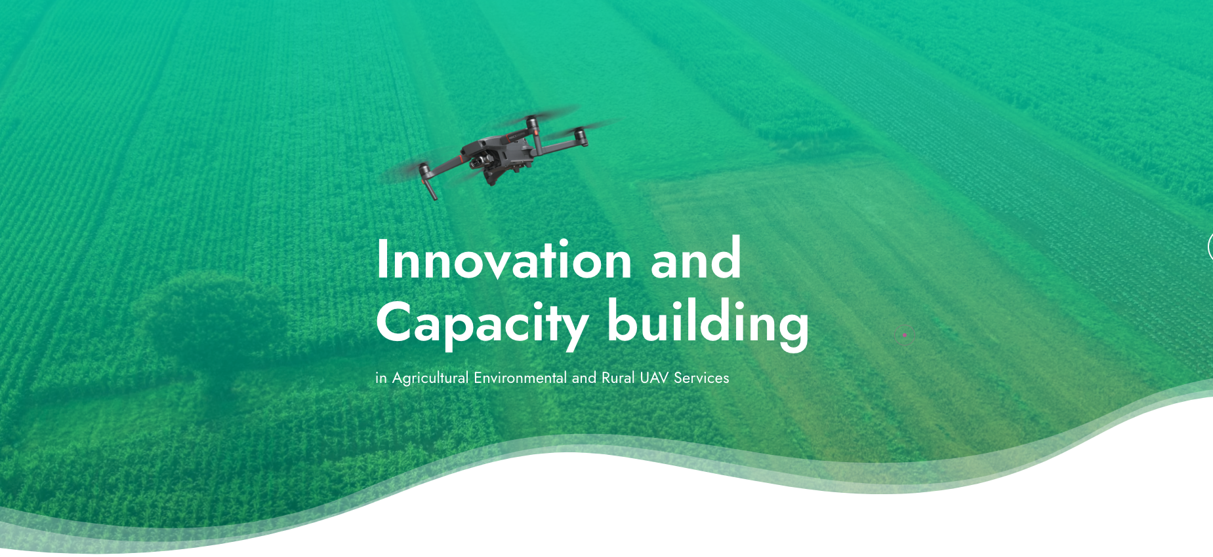

PULL Open Call for Farming, Forestry and Rural Challenges (FFRC)

Proposal template



Table of Contents
1. Executive Summary 3
2. General information 3
3. Proposal description 3
3.1 Type of applicant 4
3.2 General description 4
3.3 Objectives 4
3.4 Work plan and activities 4
3.5 Team 4
3.6 Expected results and deliverables 4
4. Business and societal impact 4
4.1 Business challenge 4
4.2 Societal challenge 5
5. Technology impact 5
5.1 Description of applied technology 5
5.2 Graphical overview 5
5.3 Technology Readiness Level 5
6. Other aspects 5
6.1 Sustainability impact 5
6.2 Impact on rural areas 5
6.3 Financial impact 6
6.4 Multi-actors’ involvement 6
6.5 Ethical issues 6
6.6 Additional video material (optional) 6
7. Costs justification and funding 7
7.1 Deliverables List 7
7.2 Budget and cost justification 8

Executive Summary
Please provide a brief overview of the proposal (objectives and expected outcomes).

General information
This information is mandatory and will be used by the evaluation committee to assess the suitability and expertise of the applicants.

General details
Proposal title
Proposal Acronym

Applicant’s details
Company/Organization name
Sector
Full address
VAT/Registration number
SME/ Food producer/ Environmental monitoring/ Rural cooperative
Legal representative
email
Contact phone

Proposal description
IMPORTANT: The allowed font type is “Arial” and the minimum font size is 11 points, the paragraph spacing 6pt and the line spacing single. The page size is A4, and all margins (top, bottom, left and right) must be at least 15 mm (not including any footers or headers). Proposals that do not comply with these requirements will be excluded from evaluation as non-eligible.
The total length of the entire proposal, including the tables on Costs justification and funding (paragraph 6), must not be more than 10 pages (cover page and Table of content are included in this 10 pages limit). Removing explanatory text in the proposal template, located below the paragraph sub-titles is allowed. External evaluators are instructed to dismiss the pages after the 10th page from the evaluation.

Type of applicant
Please tick the boxes to select the sector/drone related competences of your company. Multiple selection is allowed.

Agri-food producer
Environmental monitoring entities
Rural community/cooperative

General description
Briefly describe the background of your application (the question to solve) and how the proposed solution addresses the topics of the PULL Open Call for Farming, Forestry and Rural Challenges (FFRC).

Objectives
Write the key objectives of the proposed solution.

Work plan and activities
Draft the workplan and key activities of the proposed solution including a clear timeline. This workplan should address 3 key phases of implementation plan – Design, Development, Market – as stated in the Applicants’ Guide.
Please add a timeline or Gantt chart to illustrate the proposed work plan.

Team
Please present your team members and provide information on their education, experience, and skills.

Expected results and deliverables
Describe the key expected results and deliverables that the proposal will achieve and deliver. Propose SMART indicators, where appropriate, to make the main objectives and expected results measurable.

Please keep in mind that there are already 3 mandatory deliverables, summarizing each of the phase of the implementation and are tied with the payment. However, you can add additional deliverable in each of the implementation phase if you wish.

Business and societal impact

Business challenge
Describe the business challenge and business potential. Demonstrate how the proposed solution will reach the end-users and state the estimated number of end-users.
Special attention should be paid to the following elements:
- Business model: describe which business model(s) is proposed and what are the financial projections for the next 3 years;
- Describe how the project will develop the value proposition and KPIs. A first glance of these issues should be included in the proposal.
- Substantiate your business model by relating it to a general business model, for example the Business Model Canvas (BMC). To learn more, visit www.BusinessModelGeneration.com and www.BusinessModelGeneration.com/book.
- Scalability: describe how the proposed business case will be able to scale in the European and international markets; formulate a few important KPIs, with which the business impact can be measured.
- Business innovation: clearly describe the innovative elements of the product and its business model.

Societal challenge
Describe the societal challenge and how your proposed solution will tackle it. Describe the Societal Readiness Level (SRL) of your proposed solution. Provide an assessment of societal adaptation of your proposed solution in terms of how your technology/ product/ process/ intervention, or innovation (whether social or technical) will be integrated into the targeted rural community. Provide socio-economic evidence to support your arguments and (if applicable) provide special reference to vulnerable/ socially marginalized groups.

Technology impact

Description of applied technology
Please describe the technology you will be using in your solution. What are the benefits comparing to other technologies?

Graphical overview
If applicable, please provide visual presentation of your solution.

Technology Readiness Level
Please describe the starting Technology Readiness Level of the proposed solution in accordance with the EU TRL scale and the target Technology Readiness Level.

Other aspects

Sustainability impact
Describe the environmental and other sustainability impacts of the Innovation Development in the agri-food sector. Formulate a few important KPIs, with which the impact could be measured.

Impact on rural areas
Describe how your project will address challenges of rural areas in your region/ country and beyond. Describe how your project is aligned with regional/ national and European policies about rural areas. Refer to the RIS3 strategy of your region if applicable.

Financial impact
Describe any relevant implication and support from public or private entities. Explain additional financial support you received from public or private resources for the development of this solution, and your approach to further fundraising in the future.

Multi-actors’ involvement
Describe to what extent the different actors of the agri-food chain/end-users are involved in the proposed solution.

Ethical issues
Describe how you will comply with European Union ethical rules/principles by following an “ethics by design”-way of working, whereby ethical and legal principles, on the basis of GDPR, competition law compliance, absence of data bias are implemented since the beginning of the design process. When defining the operational requirements, it is also important to take into account the interactions between humans and drone usage, in accordance with the Commission Delegated Regulation (EU) 2020/1058.

Additional video material (optional)
If you wish to support your application with additional video material, please provide a valid YouTube or Vimeo link, (public or unlisted) without restrictions for viewing, not longer than 5 minutes. Evaluators may choose not to take this optional video material into account during evaluation and this material will not carry additional points.

Costs justification and funding

Deliverables List

No | Deliverable Name/Description | Type | Delivery Date | Phase | Overall Cost (€) | Note
1 | DESIGN - a report/deliverable that summarizes the plan for the implementation of the sub-project | R | M02 | DESIGN |  | Cannot exceed 30% of the overall budget
2 | DEVELOPMENT - a report/deliverable that summarizes the results of the experiment development. | R | M09 | DEVELOPMENT |  | Cannot exceed 50% of the overall budget
3 | MARKET - a report/deliverable that summarizes the market associated activities (even the ones performed along the sub-project’s development) | R | M12 | MARKET |  | Cannot exceed 20% of the overall budget
Total Deliverables Cost |  |  |  |  |  | 100%

Budget and cost justification
Note that all costs must be entered in EUR currency, in the full amount, e.g., 50,000.00 EUR. VAT is not eligible per Horizon Europe rules.

Budget | Applicant
Personnel Cost
Travel Cost
Equipment Cost
Other goods/services
Subcontracting
Indirect costs
Total Cost

In case VAT is not eligible according to the national legislation, a registration number from the respective national authority (National business registry, Commercial court or similar) must be provided.
It includes the overall costs associated with the respective deliverable (personnel, travel, equipment, other, subcontracting and indirect costs) in Euros
R - report
The overall cost of Deliverable No. 1 DESIGN can be up to 15,000 EUR.
The overall cost of Deliverable No. 2 DEVELOPMENT can be up to 25,000 EUR.
The overall cost of Deliverable No. 3 MARKET can be up to 10,000 EUR.
Cost of the personnel realizing the deliverables.
Travel costs necessary for the execution of the sub-project.
Only the depreciation cost of the equipment should be included.
In case of subcontracting this should be clearly justified.
Indirect costs (overheads) could be up to 25% of the direct cost. Subcontracting is not included in indirect cost calculation.
Winning proposal may have a total cost less or equal to €50,000. Total cost should be equal to total deliverables cost.

