Risk Management Plan (RMP) - SUMMARY
Scope
Risk management must cover all areas of our business: all locations, all subsidiaries and Joint Ventures and all types of risk.
Accountability & Governance
The Board are accountable for ensuring that effective risk management is happening across the Group. The Board define the Group’s risk appetite and agree the principal and emerging risks.
Each area must have named individuals accountable (Risk Leader) and responsible (Risk Co-ordinator) for risk management and for providing evidence (at least every six month) to demonstrate that risk management is effective in their area.
Risk appetite framework (RAF)
We will not accept any risk with an 8 impact and a >50% probability.
Businesses must define their local risk appetite, which must align to but not exceed Group levels.
Mandatory Risk data for each risk
- Risk title
- Risk owner
- Tagging by principal risk
- Root cause(s), Risk event and Consequence(s) (Bow tie)
- Key controls (compliant with Internal Controls Framework (ICFW) requirements)
- Actions (with owner, status and completion date)
- Risk level (Gross, Current and Residual)
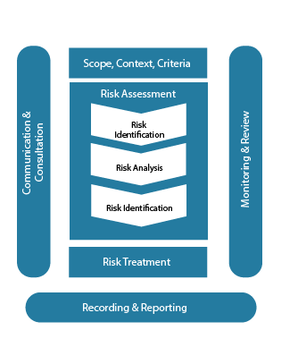
Risk process
All areas shall follow the risk process in figure 1.
Mandatory rules
- Current risk level shall only be assessed as lower than the Gross risk if effective controls are in place
- Independent assurance shall be in place for all key actions and controls
- Residual risk shall only be assessed as lower than the Current risk level if funded, resourced treatment actions are in place
- Risks must only be assessed using the standard impact variables and must use the Group scoring scheme
- Incidents that have a material impact must be recorded and communicated
- Any risk with a likelihood of greater than 75% must have contingency plans, be reflected in cash impact and captured as an incident
- A basis of estimate must be provided for all risks
- All risk should be recorded in the agreed tool
- Risks shall be linked to the relevant objective and/or financial forecast
- Each business must exercise Business Continuity plans at least once a year
- All risks (and associated actions and controls) should be review 4 times a year.
Risk reporting
All risks where the Gross or Current impact is 7 or above shall be escalated to the Group risk committee. In addition each area shall also report on:
- Impact of incidents
- Total value at risk
- Risk reduction achieved
- Data quality
Risk and Finance
Only actions and controls that are resourced and funded shall be included as part of treatment plans.
Financial contingency must be based on the aggregated current risk level and provision made for the aggregated residual risk level.
Performance targets
All areas shall achieve 100% in risk effectiveness assessments
Scoring scheme to be used across the Group - Impact
 | 1 | 2 | 3 | 4 | 5 | 6 | 7 | 8 | 9 | 10
Financial
HSE
Reputation

Scoring scheme to be used across the Group - Probability
Probability Bands | Band
>75% | A
50-75% | B
25-50% | C
1-25% | D
<1% | E

