Digital Literacies School Review
Why carry out a digital literacies school review?

Developing digital literacies within your school is key to providing pupils and staff with the skills and confidence they need to use technology autonomously and collaboratively, not only to support their learning but also in the workplace and their daily lives. If pupils are to participate socially, culturally and economically as digital citizens, they need to learn how to make informed use of technology, safely and responsibly, in order to contribute to wider society. However, despite being immersed in a technology-rich environment, many learners and staff lack a clear sense of how technology can be contextualised to effectively support learning.
The Digital Literacies School Review allows schools to take a holistic approach to reviewing how digital literacies are developed and embedded within their school, from strategy to practice, and offers the following advantages:
- Prepares pupils for the workplace by developing their digital competencies

- Improves the quality of teaching and learning by offering more flexible and engaging models of delivery

- Addresses staff CPD needs to ensure that they are empowered to help pupils make best use of technology

- Contributes towards a safe and responsible learning environment, minimising the risks of cyberbullying and inappropriate online behaviours

- Supports senior leaders to develop strategies focusing on digital literacies that join-up good practice across the school

Guidance for carrying out the review
The review is a short survey, which can be completed in around an hour, which encourages reflection on strategies, support services and curriculum design / monitoring and their contributions to digital literacy. The review also encourages the consideration of suitable actions in the short, medium and long term.
The review can be completed in a range of different ways (some examples are listed below), depending on the resources available and the needs of your school:
- At a senior leadership team meeting

- By a digital work group, tasked with producing a digital literacy strategy

- As part of a creative process in preparation for reviewing and re-writing teaching and learning, or online learning strategies

- By a single manager (for example the Head of IT or Digital Lead) wishing to gain a snapshot of provision, to help make the case for wider consideration of digital literacy by the school.

- In preparation for inspection

1. Ice breaker: What does digital literacy mean for your school?
Courses that embed core digital skills, as well as subject specific use of technology, enable students to gain the skills and confidence they need to use digital technology not only to support their learning but also in the workplace.
(http://www.jisc.ac.uk/developingdigitalliteracies)
By digital literacy we mean those capabilities which fit an individual for living, learning and working in a digital society: for example, the skills to use digital tools to undertake writing and critical thinking; as part of personal development planning; and as a way of showcasing achievements.
(http://www.jisc.ac.uk/developingdigitalliteracies)

At the Open University, digital and information literacy refers to the skills of OU students using digital technologies to achieve personal, study, and work-related goals. Digital literacy includes the ability to find and use information (otherwise known as information literacy) but goes beyond this to encompass communication, collaboration and teamwork, social awareness in the digital environment, understanding of e-safety and creation of new information; all underpinned by critical thinking and evaluation.
(https://www.open.ac.uk/libraryservices/subsites/dilframework)

Based on the definition of digital literacy above, identify the key aspects of digital literacy that relate most to your own role, explaining why they are important to the group. Reflecting on all the various facets of digital literacy, rank the bubbles below in order of importance at your school. Consider the implications for the pupil as well as the school challenges.
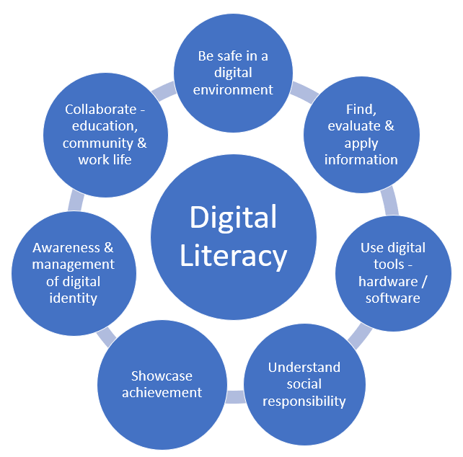
2. Strategies and policies

2.1 What key strategic documents have elements that address digital literacies? (e.g.Online Learning strategy, teaching and learning strategy, e safety/social media policy, staff/pupil induction material, etc.) You may find it useful to include draft strategies here. In which strategies do you think digital literacies should be included? | 2.2 What skills,  competencies or  learning experiences does this document  commit the school to supporting? Include both staff and pupils | 2.3 How does the  document say that support for staff and pupils will be provided? Who takes responsibility for  communicating and  monitoring the strategy?

2.4 Describe any recent or proposed future changes to school strategies or priorities, which may not yet be reflected in formal documentation, which are relevant to digital literacies and their support

2.5 Are there any immediate actions you would like to note?

3. What support is available to support digital literacies outside the classroom?

3.1 What services are involved in helping pupils and staff develop their digital literacies? | 3.2 What skills or  competencies are  supported by these  services? | 3.3 What type(s) of support are offered? How do pupils access support?
e.g. online content via the learning platform like Teams of Google Classroom, staff delivering information handling, social media training, etc. | e.g. search and evaluation skills, working collaboratively online for group work etc. | e.g. blended learning approaches, etc.

3.4 How are any of these services changing their approach to supporting pupils and staff to reflect changes, needs, expectations or priorities related to digital literacies?
e.g. How could these services communicate and work more collaboratively with curriculum areas to support digital literacies?

3.5 Are there any immediate actions you would like to note?

4. Special projects or initiatives

4.1 Are there any school initiatives or projects concerning digital literacies? | 4.2 What skills or competencies do these projects include? | 4.3 What are the main aim(s) and proposed benefits of these initiatives or projects and how is the impact measured and shared across the organisation?
e.g. Internet safety week,  after school / lunchtime programme of  activities, mobile learning  technology to record /capture learning, ebooks, assessment, etc | e.g. awareness of e-safety, avoiding cyberbullying, improving research skills, enriching learning, etc | e.g. reduce number of internet safety incidents, invigorating learning through the use of inspirational digital  technologies, etc

4.4 Are there any immediate actions you would like to note?

5. Support in programmes of study
Thinking about how the curriculum is designed, approved and monitored:

5.1 Who is typically involved in curriculum design and/or approval? Do any of these roles include expertise in e-learning, digital technologies, information skills, or digital media?
5.2 How, if at all, do school processes for design, approval and monitoring ask about skills or competencies?
5.3 What support do teaching staff have for developing their digital skills with a view to embedding digital literacies into their teaching and learning practice?

Thinking about how programmes of study include support for digital, information and media literacies:

5.4 When and how are subject-specific technologies and resources typically introduced, used and (where relevant) assessed?
5.5 Who typically delivers such modules or sessions? Who typically assesses them (if they are assessed)?
5.6 What opportunities are there for teaching staff to develop their own capacity to support learners' digital, information and media literacies?

Reflecting on the diversity of practice at your organisation:

5.7 Thinking about a subject team that has done most to integrate digital capability into the curriculum, what have they done? Why do you think they have been pioneers?
5.8 Thinking about teams that have not engaged with digital capability, what do you think have been their main barriers and concerns?

5.9 Are there any immediate actions you would like to note?

6.School support including the learning environment

6.1 What opportunities (if any) do pupils have to reflect on and plan their own skills development? | e.g. reflective journals, personalised learning, etc.
6.2 What digital skills and competencies are pupils expected to have across all curriculum subjects? How are these supported? | e.g. searching for and evaluating information, communicating and collaborating online, etc.
6.3 How do you think pupils currently develop their digital capabilities? Who is involved? | e.g. what online extra-curricular activities are available within the school to develop the pupils’ digital skills or competencies further?
6.4 How are pupils involved in decisions about the learning environment,  infrastructure, and access to subject information / study materials? | e.g. pupil representative council, curriculum feedback, etc.
6.5 To what extent can pupils use their own technologies for learning? What challenges do they encounter? | e.g. universal availability of wifi? Power sockets for pupil laptops, etc
6.6. What efforts are being made to ensure equality of digital opportunity, e,g, laptop loans, device hire. | e.g. Information Advice Guidance (IAG) issues and home learning access, baseline subject elements like online essay submission - are all subjects on the learning platform? Access to the internet at school and at home.

6.7 Are there any immediate actions you would like to note?

7. Reflections
7.1 What do you think are the best aspects of your school provision and support?

7.2 Where do you think are the significant gaps (if any) in your school’s provision and support?

7.3 Reflecting on the difference between the strategic documents you reviewed in Section 2 and the responses you gave in sections 3-6, what do you think are the most significant actions your school should take to ensure its strategic commitments are being followed through in practice?

7.4 Next steps: priority actions
Looking back over all the actions from the previous questions what should the school prioritise in the next 3 months, 1 year, and 3 years, to take forward digital literacy as an agenda?
Short term objectives (e.g. three months or less)
Action | Who is responsible? | Completion date

Medium term objectives (e.g. three months to a year)
Action | Who is responsible? | Completion date

Long term objectives (e.g. a year to three years)
Action | Who is responsible? | Completion date

The Digital Literacies School Review has been repurposed from the JISC Design Studio’s Digital Literacies Institutional Audit tool, available under a Creative Commons license from https://www.webarchive.org.uk/wayback/archive/20140701101500/http:/www.jiscrsc.ac.uk/support-for/digital-literacy/organisational-review.aspx

