LANGSTU_1

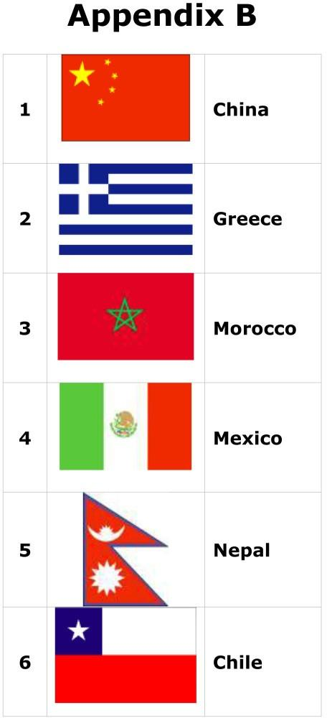

1 Китай 2 Греція 3 Морокко 4 Мексика 5 Непал 6 Чілі

Taken from: Aimhigher Kent & Medway/The Open University Original copyright © The Open University (2004) Reproduced for OpenLearn 2010 www.open.ac.uk/openlearn

