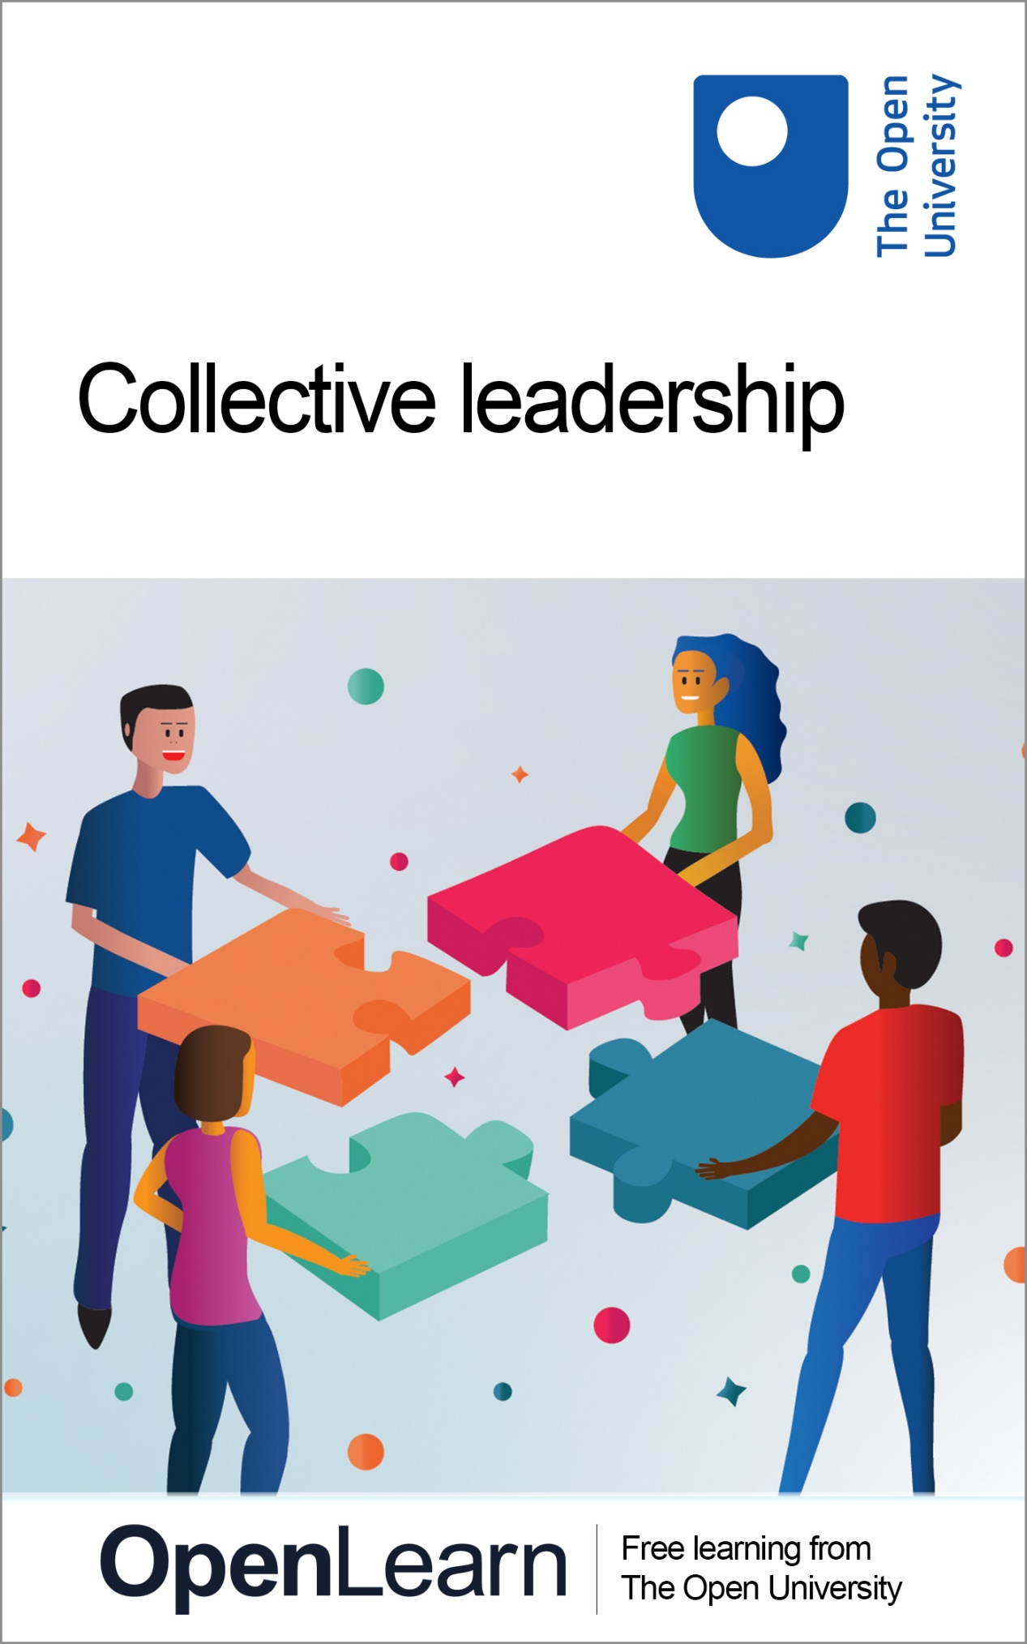

B208_1

Collective leadership

About this free course
This free course is an adapted extract from the Open University course B208 Developing leadership http://www.open.ac.uk/courses/modules/b208.
This version of the content may include video, images and interactive content that may not be optimised for your device.
You can experience this free course as it was originally designed on OpenLearn, the home of free learning from The Open University – www.open.edu/openlearn/money-business/collective-leadership/content-section-0
There you’ll also be able to track your progress via your activity record, which you can use to demonstrate your learning.
Copyright © 2019 The Open University
Intellectual property
Unless otherwise stated, this resource is released under the terms of the Creative Commons Licence v4.0 http://creativecommons.org/licenses/by-nc-sa/4.0/deed.en_GB. Within that The Open University interprets this licence in the following way: www.open.edu/openlearn/about-openlearn/frequently-asked-questions-on-openlearn. Copyright and rights falling outside the terms of the Creative Commons Licence are retained or controlled by The Open University. Please read the full text before using any of the content.
We believe the primary barrier to accessing high-quality educational experiences is cost, which is why we aim to publish as much free content as possible under an open licence. If it proves difficult to release content under our preferred Creative Commons licence (e.g. because we can’t afford or gain the clearances or find suitable alternatives), we will still release the materials for free under a personal end-user licence.
This is because the learning experience will always be the same high quality offering and that should always be seen as positive – even if at times the licensing is different to Creative Commons.
When using the content you must attribute us (The Open University) (the OU) and any identified author in accordance with the terms of the Creative Commons Licence.
The Acknowledgements section is used to list, amongst other things, third party (Proprietary), licensed content which is not subject to Creative Commons licensing. Proprietary content must be used (retained) intact and in context to the content at all times.
The Acknowledgements section is also used to bring to your attention any other Special Restrictions which may apply to the content. For example there may be times when the Creative Commons Non-Commercial Sharealike licence does not apply to any of the content even if owned by us (The Open University). In these instances, unless stated otherwise, the content may be used for personal and non-commercial use.
We have also identified as Proprietary other material included in the content which is not subject to Creative Commons Licence. These are OU logos, trading names and may extend to certain photographic and video images and sound recordings and any other material as may be brought to your attention.
Unauthorised use of any of the content may constitute a breach of the terms and conditions and/or intellectual property laws.
We reserve the right to alter, amend or bring to an end any terms and conditions provided here without notice.
All rights falling outside the terms of the Creative Commons licence are retained or controlled by The Open University.
Head of Intellectual Property, The Open University

Contents
- Introduction
- Learning outcomes
- 1 What is leadership?
- 2 Individual leadership versus collective leadership
  - 2.1 Working collaboratively
  - 2.2 An example of collective leadership
  - 2.3 Case study 1
- 3 Leadership practices to promote collective leadership
  - 3.1 The Collective Canyon
  - 3.2 Collective leadership in practice
  - 3.3 Collective leadership is not easy!
  - 3.4 Case Study 2
- Conclusion
- Tell us what you think
- References
- Further reading
- Acknowledgements
- Solutions

Introduction
Welcome to the free course, Collective leadership, which explores the traits and skills of an effective leader in an organisational setting.
There are many practices that could be considered and that you may be familiar with, however this course focuses on three leadership practices that have been referred to as the ‘extraordinarization of the mundane’ by the Swedish Academics Alvesson and Sveningsson (2003). At various points throughout the course, you will also have an opportunity to hear from the leaders of a variety of organisations.
This introductory course will help you to recognise these three practices, along with many others, and build on them through the lens of collective leadership.
This OpenLearn course is an adapted extract from the Open University course B208 Developing leadership.

The Open University would really appreciate a few minutes of your time to tell us about yourself and your expectations for the course before you begin, in our optional start-of-course survey. Once you complete the course we would also value your feedback and suggestions for future improvement, in our optional end-of-course survey. Participation will be completely confidential and we will not pass on your details to others.

Learning outcomes
By the end of this course, you should be able to:
- briefly describe leadership theory, considering the leader, the follower and the collective
- understand the metaphor of the ‘Collective Canyon’
- understand the importance of a collective leadership approach.

1 What is leadership?
The subject of leadership is highly contested and has many different definitions: ‘There are almost as many definitions of leadership as there are persons who have attempted to define the concept’, according to Bass (1990, p. 11).
This is particularly evident when you consider that, in 2020, a Google search suggested that there are over 47 million books and articles on leadership available worldwide. The American consultant Joe Iarocci (2015) estimated that there are on average four books a day being published with the words ‘leader’ or ‘leadership’ in the title.
First, you will hear from an influential leader in the Royal Air Force (RAF) – Air Commodore Paul Godfrey. During this short video, he shares his insights about what leadership means to him. Watch it and do the first activity below. You might find it useful to make notes.

Video content is not available in this format.
Video 1 Air Commodore Paul Godfrey: What is leadership?
View transcript - Video 1 Air Commodore Paul Godfrey: What is leadership?

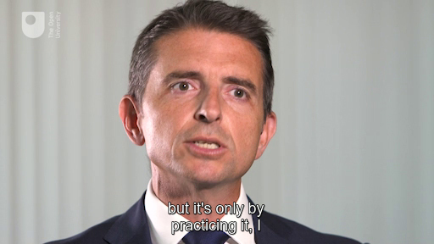

Activity 1 What makes a good leader?
Allow about 20 minutes

- Spend 5 minutes listing the names of leaders who have influenced you. They might be famous, or someone you know personally – for example, a relative, a colleague, a former teacher, or even a friend.
- Considering this list, spend about 10 minutes noting why you believe they are great leaders. What are their practices, qualities and skills that make them stand out?
- For another few minutes, think about these qualities.
- What type of skills are they?
- Are they specific to the person you have thought of, or are they generic skills that can be learned?
- Is the person an individual leader making a difference? Or are they in an environment that brings other people together to create and achieve a shared goal?

View discussion - Activity 1 What makes a good leader?

In the next actvity you will review and consider theories around leadership.

Actvity 2 Reading on current theories and research
Allow about 60 minutes

Now read the following article and reconsider your reflections.
Leadership: Current Theories, Research, and Future Directions

The next section will build on what you have learned about the individual leader and compare it to leadership as a collective process.

2 Individual leadership versus collective leadership
This short animation will hopefully help you think more about what leadership really is: is it about the ‘person’ or is it about a collective ‘process’? The animation starts by looking at the heroic leaders of the past, all seen as powerful individuals, before going onto consider the idea that to achieve effective results it is often about people working together – leadership as a ‘process’ of influencing, facilitating and negotiating.

Video content is not available in this format.
View transcript - Uncaptioned interactive content

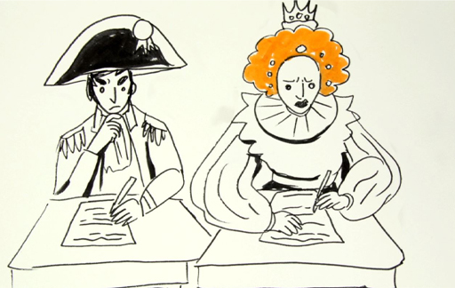

Over the past decade it has been recognised in leadership literature that leadership is not just about the ‘person’, but it involves far more; it is also about process. This rest of this section considers this concept of leadership also involving the follower.

2.1 Working collaboratively
You will now hear from a highly experienced leader who is a Chief Constable in the police force in England. His name is Chief Constable Giles York and he believes that, to ensure your organisation has an opportunity to work effectively, understanding and working collaboratively can help make a difference.
While you listen to Chief Constable York, think about yourself as a follower; without followers, there would not be leaders. Make some notes on the topics he discusses and then complete the activity that follows.

Video content is not available in this format.
Video 2 Chief Constable Giles York
View transcript - Video 2 Chief Constable Giles York

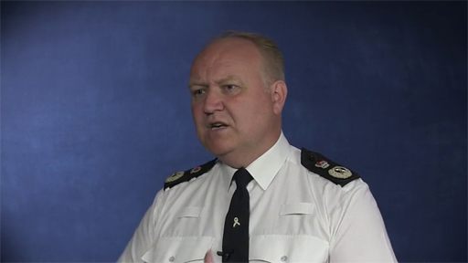

Activity 3 What type of follower are you?
Allow about 60 minutes

- Having listened to the perspective of leader/follower relationships from Chief Constable York, now read In Praise of Followers by Lawrence Suda.
- Spend about 10 minutes thinking about what type of follower you are.
- Whether it is while you are studying, working or part of a club, how do you view yourself as a colleague or team player?
- What skills, qualities and traits do you bring to the ‘collective’?

View discussion - Activity 3 What type of follower are you?

2.2 An example of collective leadership
You will now consider collective leadership in more detail by watching the following video. Ellie Garraway is a Chief Operating Officer for a charity, working in the voluntary sector. She explains the importance of collective leadership from her personal experiences.

Video content is not available in this format.
Video 3 Ellie Garraway
View transcript - Video 3 Ellie Garraway

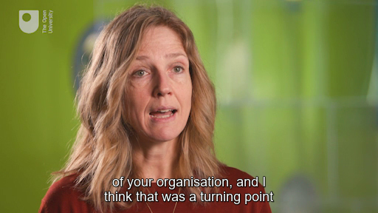

2.3 Case study 1
To assist in understanding collective leadership in practice, the following case study is a real example of how an elected public official engaged with the electorate to help them realise they could work together to improve ‘their’ city.

Activity 4 The ‘nerdy’ professor
Allow around 30 minutes

Read the case study at the link below. While you are reading it, there are two questions in the introduction for you to think about. But think especially about how the ‘nerdy Professor’ worked to connect with the different age groups, cultures and languages across the Canadian city of Calgary.
Doing politics differently: How a ‘nerdy Professor’ engaged with the citizens of Calgary

View discussion - Activity 4 The ‘nerdy’ professor

Having considered the individual leader as ‘person’ and leadership as a process, you are now going to consider a few practices that might benefit from working more collectively to improve follower engagement. This will be done by considering the metaphor of the Collective Canyon.

3 Leadership practices to promote collective leadership
First, here is Air Commodore Paul Godfrey again talking about his experiences of collective leadership throughout his career.

Video content is not available in this format.
Video 4 Paul Godfrey: what is collective leadership?
View transcript - Video 4 Paul Godfrey: what is collective leadership?

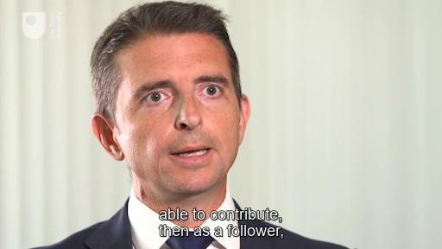

You are now going to focus on the importance of leadership practices as part of collective leadership.

3.1 The Collective Canyon
The following animation introduces the metaphor of the Collective Canyon. This is the ‘space between’ leaders and followers where the relationships, communication, trust and any other social actions happen.

Video content is not available in this format.
The Collective Canyon
View transcript - The Collective Canyon

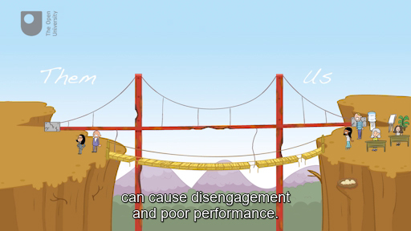

These practices are sometimes strong between certain individuals or teams or departments. Between others they are weak and therefore need extra attention and maintenance to strengthen them and ensure that collective leadership is effective.
The article below by Mats Alvesson and Stefan Sveningsson supports the argument that building these relationships brings various positive effects for both leaders and followers.
Managers doing leadership: the extra-ordinarization of the mundane

3.2 Collective leadership in practice
You will now hear about real examples from two leaders in the voluntary sector. One is Ellie Garraway again, and the other is Clare Walton, who is a Chief Executive Officer of a charity. They both talk about collective leadership and the more ‘mundane’ leadership practices that they, and other people around them, use. These practices ensure that relationships are strong, and that individuals in the organisations – leaders and followers – are fully engaged to make a difference.

Activity 5 Collective leadership and the mundane
Allow around 15 minutes

Video content is not available in this format.
Video 5 Ellie Garraway
View transcript - Video 5 Ellie Garraway

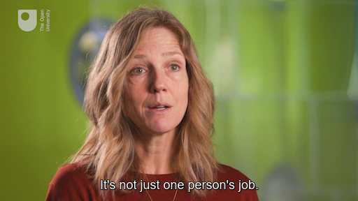

Video content is not available in this format.
Video 6 Ellie Garraway
View transcript - Video 6 Ellie Garraway

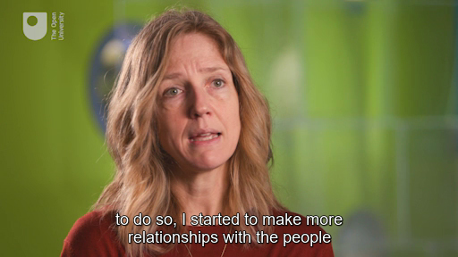

Clare Walton talks about some of the practices employed at her charity which help forge strong working relationships.

Video content is not available in this format.
Video 7 Clare Walton
View transcript - Video 7 Clare Walton

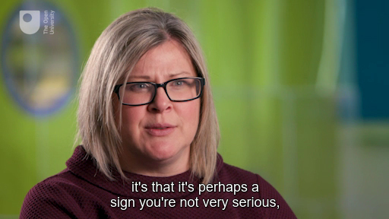

View discussion - Activity 5 Collective leadership and the mundane

3.3 Collective leadership is not easy!
Now watch the second part of the animation on the Collective Canyon. It demonstrates that just because you have put in the effort at the start, or rebuilt a bridge, it does not mean that your job as a leader is done. Maintaining these ‘bridges’, to keep the ‘space between’ as an effective collective space, takes continual effort by both the leaders and the followers.

Video content is not available in this format.
View transcript - Uncaptioned interactive content

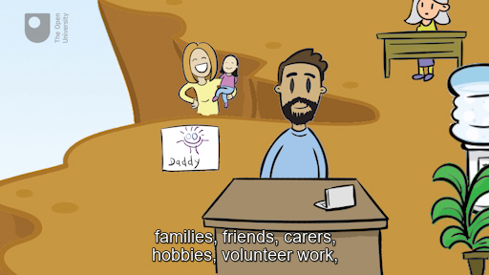
Animation 3 – Collective leadership is not easy !

The next case study is going to bring these practices, and others, together. It is a real example of working collectively in a hospital in the USA.

3.4 Case Study 2

Figure 1
View description - Figure 1

Read the case study in the activity below about how the Positive Deviance Approach improved working relationships to reduce MRSA infection in an American hospital.

Activity 6 Positive Deviance Approach
Allow around 20 minutes

When reading the article from Singhal, Buscell and McCandless, think in particular about the following questions:
- How did Positive Deviance bring people together?
- What role did the Chief Executive play?

View discussion - Activity 6 Positive Deviance Approach

Conclusion
You have now reached the end of this free course on collective leadership. This is only a taster about what is meant by leadership and working collaboratively within an organisational setting.
The course touched on the Collective Canyon to help you think about leadership practices. You also heard from leaders from a variety of backgrounds who have shared their experiences and insights.
To finish, there is one more insight to share with you. In the final video, Air Commodore Paul Godfrey reflects on who has inspired him to be the leader that he is today. It is an important part of working in a collective. Remember that, as a leader or a follower, you are being watched by many others. These could be new people to the organisation, contractors, customers, less senior personnel, and so on. What you do, how you think, and how you react is all part of casting your own shadow – this shadow influences the people around you.

Video content is not available in this format.
Video 8 Paul Godfrey: Inspirational leadership
View transcript - Video 8 Paul Godfrey: Inspirational leadership

This OpenLearn course is an adapted extract from the Open University course B208 Developing leadership.

Tell us what you think
Now you’ve come to the end of the course, we would appreciate a few minutes of your time to complete this short end-of-course survey. We’d like to find out a bit about your experience of studying the course and what you plan to do next. We will use this information to provide better online experiences for all our learners and to share our findings with others. Participation will be completely confidential and we will not pass on your details to others.

References
Alvesson, M. and Sveningsson, A. (2003) ‘Managers doing leadership: the extra-ordinarization of the mundane’, Human Relations, 56(12), pp. 1435–59 .
Avolio, B., Walumbwa, F. and Weber T. J. (2009) ‘Leadership: Current theories, research, and future directions’, Management Department Faculty Publications, University of Nebraska, pp. 421–449.
Bass, B. (1990) Bass and Stogdill’s Handbook of leadership: A survey of theory and research. New York: The Free Press.
Iarocci, J. (2015) ‘Why are there so many leadership books? Here are 5 reasons’, Leadership Books, Cairnway: Serve. Lead. Now. Available at: https://serveleadnow.com/why-are-there-so-many-leadership-books/ (Accessed 13 February 2020).
Nye, J. S. (2008) The Powers to Lead. Oxford: Oxford University Press.
Singhal, A., Buscell, P. and McCandless, K. (2009) ‘Saving lives by changing relationships: Positive deviance for MRSA control and prevention in a US Hospital’, Positive Deviance Wisdom Series, 3,Boston, MA, Tufts University.
Suda, L. (2014) ‘In praise of followers’, PM World Journal, 3(2), pp 1–11.

Further reading
Avolio, B. J., Walumbwa, F. O. and Weber, T. J. (2009) ‘Leadership: Current theories, research and future directions’, Annual Review of Psychology, 60, pp. 421–49.

Acknowledgements
This free course was written by Clare Holt. It was first published in May 2020.
Except for third party materials and otherwise stated (see terms and conditions), this content is made available under a Creative Commons Attribution-NonCommercial-ShareAlike 4.0 Licence.
The material acknowledged below is Proprietary and used under licence (not subject to Creative Commons Licence). Grateful acknowledgement is made to the following sources for permission to reproduce material in this free course:
Every effort has been made to contact copyright owners. If any have been inadvertently overlooked, the publishers will be pleased to make the necessary arrangements at the first opportunity.
Images
Figure 1: © spotmatikphoto / 123 Royalty Free
Text
Activity 2: Source, Avolio, B., Walumbwa, F. and Weber T. J. (2009) ‘Leadership: Current theories, research, and future directions’, Management Department Faculty Publications, pp. 421–449, University of Nebraska.
Activity 3: Source, Suda, L. (2014) ‘In praise of followers’, PM World Journal, 3(2), pp 1–11.
Activity 4: Source, Dr Clare Holt (2013) Doing politics differently: How a ‘nerdy Professor’ engaged with the citizens of Calgary. Courtesy: Dr Clare Holt.
Section 3.1: Source, Alvesson, M., & Sveningsson, S. (2003). Managers Doing Leadership: The Extra-Ordinarization of the Mundane. Human Relations, 56(12), 1435–1459.
Activity 6: Source, Singhal, A., Buscell, P. and McCandless, K. (2009) Saving Lives by Changing Relationships, Positive Deviance for MRSA Control and Prevention in a U.S. Hospital, Number 3. With kind permission.
Don't miss out
If reading this text has inspired you to learn more, you may be interested in joining the millions of people who discover our free learning resources and qualifications by visiting The Open University – www.open.edu/openlearn/free-courses.

Solutions

Activity 1 What makes a good leader?

Discussion
Leadership is subjective. If you showed this list to someone else who also knew these people, would they agree with you? While you are considering these skills and qualities, are they contextual? Maybe they are relational? How might they be interpreted by other people?
Back to - Activity 1 What makes a good leader?

Activity 3 What type of follower are you?

Discussion
If you look back at the list of qualities that people expect from leaders, many of the skills, traits and competencies are the same qualities needed in effective followers. Both entities need to demonstrate initiative, independence, commitment to common goals, and courage. A follower can provide enthusiastic support of a leader, especially one where there is trust and respect. However, a follower should not fail to challenge a leader who is unethical or threatens the values or objectives of the organisation.
It could be argued that ineffective followers are as much to blame for poor performance or ethical and legal lapses within organisations as poor and unethical leaders are. Therefore, as a follower, individuals have a responsibility to speak up when leaders do things wrong.
Back to - Activity 3 What type of follower are you?

Activity 4 The ‘nerdy’ professor

Discussion
Naheed Nenshi used social media to connect to a wider and younger audience but he recognised that it was not going to connect with everyone. However, to be ‘collective’, he realised the importance of being relational – meeting people face-to-face at coffee mornings. It was an opportunity to have a two-way conversation with Nenshi, in community settings where there were opportunities for open and honest conversations.
Rather than talking using political rhetoric and complicated jargon, Nenshi believed in sharing ‘big ideas’ for Calgary, listening to what the people of the city wanted.
For example, to connect with the people of NE Calgary, Nenshi’s team realised that they needed to work with community leaders and talk to people in a language and manner that they would understand and connect with. By translating leaflets and involving respected community leaders, an open and honest conversation was providing opportunities for change in Calgary.
Back to - Activity 4 The ‘nerdy’ professor

Activity 5 Collective leadership and the mundane

Discussion
Now you have heard the different ‘mundane’ practices from Ellie and Clare, do you recognise these practices in your place of work? As potential leaders, do you recognise these practices in yourself? What is your view with regards to the limitations of these shared collective leadership practices?
Back to - Activity 5 Collective leadership and the mundane

Activity 6 Positive Deviance Approach

Discussion
Positive Deviance was a way to get everyone in the hospital to talk and share ideas. It was people from all levels of the organisation, not just the leaders, working together towards a common goal and to make a difference to the issue of MRSA infection. It helped to break down hierarchical, cultural and social barriers, giving individuals permission to speak up when it was necessary without fear of being ignored or shouted down for speaking out of turn. The improvisations – or improvs as they were called by the hospital staff – allowed individuals to learn from each other in a simulated environment and, therefore, to speak more openly and challenge honestly.
Involving the Chief Executive as the overall ‘leader’ of the hospital ensured that there was buy-in from the top. With the Chief Executive being present and supportive, there was an element of permission giving to everyone else in the organisation to own the problem, change their behaviours, break down barriers, and gradually change the organisational culture (even if this was done subliminally).
Back to - Activity 6 Positive Deviance Approach

Figure 1

Description
A photo showing a hosipital corridor. There are three members of medical staff and one is speaking to an elderly lady, who is standing with the support of a walking frame. The corridor is well lit and wide.
Back to - Figure 1

Video 1 Air Commodore Paul Godfrey: What is leadership?

Transcript
PAUL GODFREY
So I guess, leadership for me, I mean, boiled down into simple terms, it's getting people to do a task, whether that task is going to the shops and getting the shopping, whether that task is running an air station, which is something I've had to do in a previous job.
And when I say people, that can be one person. If I'm flying along, I've got a wingman, I'm leading that wing man around the place. If I'm leading an air station, I've got 2 and a half thousand people in there.
So to me, leadership is a very personal thing. And I think it is something that you grow into. I think it's something that, like anything, you can learn the basics. You can learn the basics of skiing, but it's only by practicing it, I think, that you get to understand how you actually navigate your way down a slope or through sludgy snow, whatever it happens to be.
And think I've developed my style over a number of years, and probably by being a follower in the first place and seeing what it feels like on the wing following a leader around the place, and just seeing how they do things, seeing what I like, how I feel under the leadership of that individual.
Back to - Video 1 Air Commodore Paul Godfrey: What is leadership?

Uncaptioned interactive content

Transcript
NARRATOR
The heroic leader-- wise, noble, charismatic. You'll find this individualistic take on leadership everywhere, from legends to Shakespeare plays to modern world history. The scene was set in Plato's Republic, which focused on the exceptional leader-- qualified, respected, and admired.
And it's an approach that's continued to this day with companies using psychometric tests to recruit the most suitable individual to lead. But this individualistic approach has been described by Alvesson and Sveningsson as narrow and leader-centric. In it, leaders are surrounded by heroic vale, romanticised as an exceptional individual capable of dazzling transformation through their vision, charisma, and convincing manner.
Collective leadership takes a far more social view. It's a shared, relational, and inclusive approach and gives team members more input and involvement. This can be a slow and time-consuming process. But, done right, it provides leaders with alternative perspectives and helps them make better informed decisions.
[MUSIC PLAYING]
Back to - Uncaptioned interactive content

Video 2 Chief Constable Giles York

Transcript
GILES YORK
Hello, I'm Giles York, Chief Constable for Sussex police. And I've been asked to talk about collective leadership. And what does it mean in a practical setting of policing?
So what I'd like to be able to do is cover probably three parts that I think is where collective leadership is relevant in policing. The first thing I'd like to do is cover the perceptions of policing from outside. And possibly, what I might call is a common misconception of what policing looks like from the outside. I think what I'd then like to be able to cover off is what does collective leadership look and feel like in policing? And probably, in Sussex police today, what have we done to develop it? And then the third bit I'd like to be able to say is, and what needs to be different for us to be able to make a step change for the future?
So the first of those is the perceptions. Quite a lot of people look at policing from the outside and they see this first, and they think we're like the military, and we follow orders all the time, and it's all about discipline. And actually, do you know what? On the inside, it doesn't really feel like that. In 28 years of policing, in 26 years of being a supervisor, I think I've probably only given one order. And that was in the middle of a football match fight. So that's the one time I have given an order.
The vast majority of the time, it's about trying to move people as a collective, giving them an understanding of why it is where we want to be able to get to. So that's one of the things I'd like to kind of push out from policing is, it's not all about law, order, lawful orders, and following discipline, and you say it, I'll do it. Actually, there's a huge amount of discretion that sits at the police constable level in policing. That's what sets it aside from so many other organisations, is the powers are invested in the constable, not in the hierarchy of policing. And so only by using collective leadership are we able to exploit the power of that discretion.
So the second part of it, in Sussex police, we have been on a very deliberate journey. a journey over about the last seven years, of using a term I don't necessarily warm to, but about empowering our staff, trusting them, putting in deliberate actions and processes that says, we want you to make a decision. And if you make a decision, we'll trust the results that comes out of it. We've been trying to do away with what's colloquially known as the 9 o'clock jury-- the people who come into the office in the morning and start judging what happened at 4 o'clock in the morning.
My stance is, if you have done your best with the skills and abilities available to you, the equipment I've given to you, then I will try to protect you as much as possible. If you choose to transgress, act criminally, neglectfully, exploit people, then I will try to do everything I can to get you out of my organisation. So there's some very clear lines here about asking people to do challenging, difficult things, understanding the approach that they take to it, and supporting them in it.
It may sound an odd phrase to be associated with something like policing, law enforcement, but one of the statements that we've had in the past during this programme of change has been, it's better to do the right thing than just follow the rules. Trusting people in their judgement, that they know what the right thing is to do, and not just say, well, the policy says this, or the book says that. That's the judgement I need, not only in my leadership, but actually, in everybody conducting work within policing. So I think that's where we've got to within Sussex police around collective leadership.
So what's that step change that we need for the future? It's about absolutely clarity and certainty to officers and staff making those challenging decisions, giving a framework-- and I think it does need a framework-- that defines, this was a mistake that I made, this was an honest mistake with all the capabilities and facilities I had to my hand at the time. Being really clear about saying, but you know what? This was a deliberate act. This was something intended to do wrong. And we need to be able to hold people to account to do that. And the public expect us to hold people to account for behaving in that way.
So within Sussex police, I can set the standards and enforce those standards time and again and be able to support people in the challenging decision making that they make. And we are held to account externally by the IOPC. And sometimes it is their behaviour that's seen by officers that says, I feel less supported. I don't feel that I'll be protected if I make these challenging decisions.
And I'm really reassured by some of the changes that we're seeing in them now and an assurance from their new chief exec that says, I get it. I understand it. A lot of the black box thinking that goes on around saying, only if we can be honest in feedback, only if we can really understand it, can we change the way we do our service for the better. All the time, we feel the need to be defensive and push things away from us. We will never honestly change our approach to things.
So in closing, what I'd say, whatever your perception of policing from the outside, please be assured it's not lawful orders, following policy, and always following the book. It is about trusting discretion, giving powers right down to the constable level that says, it's better to do the right thing than just follow the rules. We've been working on a programme on that in Sussex police over many years, around empowering people and trying to create the environment where they feel trusted to do the right thing. It's about creating a just organisation, where they know that their actions will be supported, when they've been conducted in the right way. And absolutely, I think the step change is around creating that environment of trust right across policing, in the way that we've seen it in other bodies, like health, where the law has actually changed to allow people to be really honest about what's going on.
Back to - Video 2 Chief Constable Giles York

Video 3 Ellie Garraway

Transcript
ELLIE GARRAWAY
I work in the charity sector. And I think we are pushed to be collaborative as a sector between organisations anyway, so there is a sort of a natural leaning towards finding ways to collaborate with others.
Leadership has always been about enabling other people to be brilliant. So I've never really believed in people who are sort of lower down, if you like, if you view it hierarchically, should have any less skill, talent, knowledge, than anyone else, and it's your job to make other people free to be brilliant basically.
So I think the collaborative bit for me is about bringing together the talents of your team to solve the problems of your organisation, and I think that was a turning point perhaps in my own leadership journey is recognising that I don’t have to come up with everything myself. And in fact, it's far better when other people come up with answers to their sort of organisational issues.
Back to - Video 3 Ellie Garraway

Video 4 Paul Godfrey: what is collective leadership?

Transcript
PAUL GODFREY
If I've got a team and we've got a task, I want everyone to buy into that task. I want everyone to have the opportunity to contribute to a solution, because what I've found is that if you've contributed to that solution, if you're allowed, if you've got the culture of being able to contribute, then as a follower, you really bought into that particular idea.
And you will then go and execute that task, which is what this is all about, to the utmost of your ability, and have an understanding of why we're executing that task as well.
I think a lot in the military is talked about, and outside the military as well, there's the famous story of JFK, whether it happened or not visiting the space programme, and the guy who's sweeping the floor in there.
JFK saying, what are you doing? And he says, I'm putting a man on the moon. That's ultimately, as a leader, what you want everyone who works for you to be able to understand where they fit, where their little cog fits in the big machine, no matter how small that cog is, and to understand why they're doing that.
Because if they do that, they'll go to the ends of the earth for you. And I, as a leader. I don't need to be stood there barking orders. There's times for that in a wartime situation, World War I, the trenches, those sorts of things, very different kind of leadership style may be required.
But to me, it is about empowering the people that I work with. It's about an understanding of the task, and it's about being able to contribute throughout.
Back to - Video 4 Paul Godfrey: what is collective leadership?

The Collective Canyon

Transcript
[MUSIC PLAYING]
NARRATOR
In every organisation, from blue chip multinationals to your local guide or scout pack, there are leaders and followers. To be a leader, you need followers. And followers do far more than just follow. They, themselves, can be leaders in their own team, at home, and in their social life.
We all want people in organisations to work together towards a common goal with open communication, trust, respect, and sharing their knowledge and experiences.
Building relational bridges across the collective canyon is one way to consider getting the best results, but they're not always well or easily maintained bridges. Disconnect, disinterest, and lack of communication between them and us can cause disengagement and poor performance.
People stop effectively communicating and giving feedback for fear of upsetting each other. In turn, this can cause contradictions in opinion. Therefore, protecting incompetence, rather than confronting it. The bridges become weak, frayed, and broken.
Many bosses view building relationships as trivial, mundane, and soft. And that remembering a birthday or asking about someone's family diverts the focus from work and is, therefore, a waste of time and company money. In fact, the most effective leaders and therefore, effective collectives, get the best results because of effective relationships. Remembering the more mundane activities like listening, trusting, and remembering that people are, more often than not, doing their best.
Back to - The Collective Canyon

Video 5 Ellie Garraway

Transcript
ELLIE GARRAWAY
There has to be an individual element to it. People have got to be accountable for their areas. But I think our natural style probably inside the organisation is bringing subgroups of people together to look at particular things. So we have a little working group that looks at impact, for example. It's not just one person's job.
We have a working group that look at marketing. Again, that isn't one person's job. Our team meetings are very lively. We're not afraid to challenge each others assumptions, and that is encouraged. So I think that our natural style is if there's an issue in the organisation, we approach it by talking it through with each other.
Back to - Video 5 Ellie Garraway

Video 6 Ellie Garraway

Transcript
ELLIE GARROWAY
Definitely what I experienced when I first arrived was I was led in a way I would describe as quite protective. So there was a bit of sort of micromanaging, a bit of, oh, you're my member of staff. And so, I'll kind of keep you over here.
So there wasn't really that collaborative way of working. It was more like I will directly line manage you, and I will let you know what you need to do. There's no need for you to go and talk to those other people that are in this organisation particularly.
And although, at first, that was quite comforting and reassuring. It's like, OK. I've got somebody else who is taking accountability for everything, and they're going to tell me what to do, and I'll just do it.
But quite quickly, that became quite limiting. And so, probably without consciously making a decision to do so, I started to make more relationships with the people in the organisation. And through doing that, then became increasingly frustrated by being sort of over managed.
And so, I think that probably it did have quite a big influence on me then deciding how I would want to manage once I started to manage people. Well, listening definitely. I mean, I spend so much of my time on the telephone as we have a remote team.
So we don't all work in the same place as each other. But I feel like being available to listen to people is probably the most important thing I've got to offer. So listening without doubt, I think.
Yeah, the chatting, actually being interested in people's lives. For me, relationship is at the centre of everything. So if you haven't got relationships with people, I'm not saying you've all got to be best friends, because I don't really subscribe to that.
But there has to be a level of relationship there that you want to work with each other, that you can contribute to your team, and they can contribute back to you. And in order to do that, you've got to build something between you.
So yes, chatting to them about their lives, being interested in their lives, them being interested in yours, that isn't a performance, that's genuine. And I think that's really important to how people then feel about working where they work and being cared about.
I think humour is really important. I think being able to laugh with people, and not to take everything too seriously is really important. People have got to enjoy themselves.
So definitely listening, definitely chatting, definitely a bit of humour, those things are sort of bread and butter, I think of everyday as part of working life, and I think they should be.
Back to - Video 6 Ellie Garraway

Video 7 Clare Walton

Transcript
CLARE WALTON
I do chat quite a bit. I find that it's useful. It puts people at ease. It makes people feel relaxed. I think it can also have another interesting effect, which causes people to underestimate you.
I think I've begun to notice that if you appear to be chatty, to talk to some people it's that it's perhaps a sign you're not very serious, and that you need to be very serious in these types of roles.
But we, as a team, we have people who like to kind of talk and engage. And it's other sort of things like making sure that our work environments nice to be in. So someone came along the other day and had gone out and bought some flowers, and that quite often happens.
And there's biscuits, and making sure everyone's got a cup of tea, and those little things that, if one person's making a cup of tea, everybody is asked if they want a drink every time. Those things are really, they're important to me, and making sure everyone's got their own cup, everyone's got their own particular type of tea.
I think at one point, we actually had a kind of a colour chart of this is- If you're making someone a cuppa for the first time, this is what you need to think about.
Back to - Video 7 Clare Walton

Uncaptioned interactive content

Transcript
[MUSIC PLAYING]
NARRATOR
Reading and understanding more about collective leadership and improving working relations all sounds wonderful. But building and maintaining the numerous bridges over the collective canyon requires constant work. People are all different. We have different personalities, values, varying outlooks, many different priorities and interests in our lives.
In organisations, they often forget that we have home lives, families, friends, carers, hobbies, volunteer work, and so on. Leaders sometimes have to make difficult decisions- redundancies, budget cuts, office closures. There is also a tendency that leaders spin an over positivity alongside this.
It's what Collinson has termed Prozac leadership. This is a warning that bosses do not have all the answers, with the word Prozac being used to symbolise the widespread social addiction to excessive positivity. Collinson's discussion around Prozac leadership, drawing on the metaphor of Prozac, suggests that leaders' excessive positivity is often characterised by a reluctance to consider alternative voices. Not listening to what the others in the organisation have to say and only focusing on positive rhetoric and not reality can leave organisations ill-prepared to deal with unexpected events.
In summary, Prozac leadership encourages leaders to believe their own narratives, that everything is going well, in turn discouraging followers from raising problems or admitting mistakes. The focus moving from the individual in leadership studies to the ideological of the collective often reads as if it's going to fix all the problems in organisations. This is far from reality.
However, more of a focus on the relational aspects of leadership, improving communication, establishing trust, and encouraging individuals to have an active voice can certainly help an organisation overcome complex problems and work more effectively. One final warning. Relationships and trust can take a long time to build and establish between individuals, but it can be destroyed in seconds. Being more aware of ourselves around others can make a huge difference when working as a collective.
Back to - Uncaptioned interactive content

Video 8 Paul Godfrey: Inspirational leadership

Transcript
PAUL GODFREY
I'd like to hope that I come across as someone who is inclusive. I am always asking an opinion in a room, whether it's a meeting of three people, whether it's flying on a big mission, whether it's in a huge finance meeting, we're absolutely engaging with each individual to ensure that we've got everything covered, and there aren't any great ideas that we've missed.
I'd like to think I'm empowering, in that once we've got those ideas, that individual is absolutely free to go off and implement that idea, even if they might fail. That tolerance, there's another trait, tolerance of failure, I think is huge in leadership.
Because name me one thing you've ever learned that you haven't failed at once. You have to keep doing this, and at one point, you'll get it right. Honesty, I think is important. I like to think I'm honest, in both good and bad ways.
In that, when I say good and bad ways, I mean, telling people the good things that they've done. Also, being honest about when something has failed. Someone knows when they failed.
But not hiding it in a military flying perspective, if you hid, if you were economical with the truth in a debrief, and someone doing something dangerous, and they know that something they're doing dangerous. They can get away with it. They might end up killing someone.
I think probably, finally, is I'd like to think I always go back to the decisions that I made, and find out whether they were the right decisions in the end. So always looking for those lessons, the debrief.
That's something that's drummed to you from day one in the military. So for 27 years now, I've been debriefing everything that we do. So it kind of comes naturally, not necessarily in every walk of life that I've seen. But I think it's important to go back and understand what worked, what didn't work, so that you don't pick that particular option in the future.
That's the whole point in failure, is you don't pick that one again. So I think those are the major traits that I'd like to be perceived as having. And I'm still looking for more. Everyone is individual. Everyone settles into their own way of leading.
So you see the person standing up. It's all about shouting. It's all about the task. You see the people that are very focused on the group, and how we going to get through this. And you kind of pick your own way through. You pick the things that you like.
And so, I don't think I've necessarily had one person influence me. I think I've just been a sponge and picked up the various elements that I think have made a good leader. I don't necessarily think that I'm the greatest leader in the world, and I think that's one thing as well.
Always look to improve yourself. Probably the biggest trait I think that I've come to understand about being a good leader is self-awareness, is understanding when you're a bit grumpy. You haven't had your coffee in the morning.
Is understanding how that might come across to individuals. Because you want to come across as balanced. You want to come across as someone they can talk to, as someone who understands when something changes.
So that self-awareness has become something that is very important to me definitely. And it's something I've seen in lots and lots of people over the years. It's obvious that they understand if they're about to get a bit shouty. It's obvious if they understand that you might have just asked a stupid question.
But they don't treat you as if you're stupid when you've asked that question. So it's a massively broad subject, but I think it's all about being that magpie, picking the shiny bits that you see around the place, and then, seeing what works for you.
Back to - Video 8 Paul Godfrey: Inspirational leadership

