B293_1

Companies and financial accounting

About this free course
This free course is an adapted extract from the Open University course B293 Companies and financial accounting .
This version of the content may include video, images and interactive content that may not be optimised for your device.
You can experience this free course as it was originally designed on OpenLearn, the home of free learning from The Open University –
There you’ll also be able to track your progress via your activity record, which you can use to demonstrate your learning.
Copyright © 2019 The Open University
Intellectual property
Unless otherwise stated, this resource is released under the terms of the Creative Commons Licence v4.0 http://creativecommons.org/licenses/by-nc-sa/4.0/deed.en_GB. Within that The Open University interprets this licence in the following way: www.open.edu/openlearn/about-openlearn/frequently-asked-questions-on-openlearn. Copyright and rights falling outside the terms of the Creative Commons Licence are retained or controlled by The Open University. Please read the full text before using any of the content.
We believe the primary barrier to accessing high-quality educational experiences is cost, which is why we aim to publish as much free content as possible under an open licence. If it proves difficult to release content under our preferred Creative Commons licence (e.g. because we can’t afford or gain the clearances or find suitable alternatives), we will still release the materials for free under a personal end-user licence.
This is because the learning experience will always be the same high quality offering and that should always be seen as positive – even if at times the licensing is different to Creative Commons.
When using the content you must attribute us (The Open University) (the OU) and any identified author in accordance with the terms of the Creative Commons Licence.
The Acknowledgements section is used to list, amongst other things, third party (Proprietary), licensed content which is not subject to Creative Commons licensing. Proprietary content must be used (retained) intact and in context to the content at all times.
The Acknowledgements section is also used to bring to your attention any other Special Restrictions which may apply to the content. For example there may be times when the Creative Commons Non-Commercial Sharealike licence does not apply to any of the content even if owned by us (The Open University). In these instances, unless stated otherwise, the content may be used for personal and non-commercial use.
We have also identified as Proprietary other material included in the content which is not subject to Creative Commons Licence. These are OU logos, trading names and may extend to certain photographic and video images and sound recordings and any other material as may be brought to your attention.
Unauthorised use of any of the content may constitute a breach of the terms and conditions and/or intellectual property laws.
We reserve the right to alter, amend or bring to an end any terms and conditions provided here without notice.
All rights falling outside the terms of the Creative Commons licence are retained or controlled by The Open University.
Head of Intellectual Property, The Open University

Contents
- Introduction
- Learning outcomes
- 1 Legal forms of business entity
  - 1.1 Sole traders
  - 1.2 Partnerships
  - 1.3 Companies limited by shares
  - 1.4 The legal characteristics of the modern corporation
- 2 The market environment and sources of company finance
  - 2.1 Sources of company finance
  - 2.2 Equity finance (share capital)
  - 2.3 Loan finance (debt capital or loan capital)
  - 2.4 Primary and secondary markets
- 3 The interests and information requirements of company stakeholders
- 4 Three perspectives on the role of companies and financial reporting in society
- 5 Comparing sole trader and company financial statement formats
  - 5.1 Sole trader financial statements
  - 5.2 Company financial statements
  - 5.3 Statement of changes in equity
  - 5.4 Statement of cash flows
- Conclusion
- References
- Acknowledgements
- Solutions

Introduction
Companies and financial accounting, serves as an introduction to the understanding of the legal characteristics of limited companies and how the ways in which they are financed impact on their financial reporting and role in society.
Session 1 introduces sole proprietorships, partnerships and limited companies as three common forms of business entity and discusses the legal characteristics of the modern corporation. The corporate legal form has characteristics that make companies very different business entities from sole traders or general partnerships. Learning about these characteristics will help you understand the different perspectives of the role of companies and company financial accounting in society. Session 2 briefly describes the markets in which companies operate and looks in more detail at how limited companies raise financing through ordinary shares and loan capital. Session 3 introduces the interests of company stakeholders, and Session 4 discusses three perspectives on companies and their role in society. Finally, Session 5 compares the formats of company financial statements with those of sole traders and explains the differences.

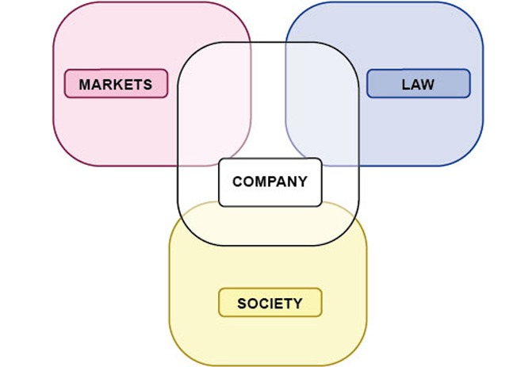
Figure 1 The company in context
View description - Figure 1 The company in context

This OpenLearn course is an adapted extract from the Open University course B293 Financial accounting in context.

Learning outcomes
After studying this course, you should be able to:
- understand the legal characteristics of limited companies and how these characteristics are different from those of sole traders and partnerships
- understand company financing through share capital and loan capital
- understand the interests and information needs of different company stakeholders
- identify and explain three perspectives on the role of companies and company financial reporting in society
- understand the differences in layout between financial statements for companies and those of sole traders, and explain how and why they are different from sole trader financial statements.

1 Legal forms of business entity
Figure 2 provides an overview of the forms of business organisation differentiated in UK law. Legal forms of business entity may vary slightly between countries. However, in most countries there will be sole traders, partnerships, private limited companies and public limited companies.

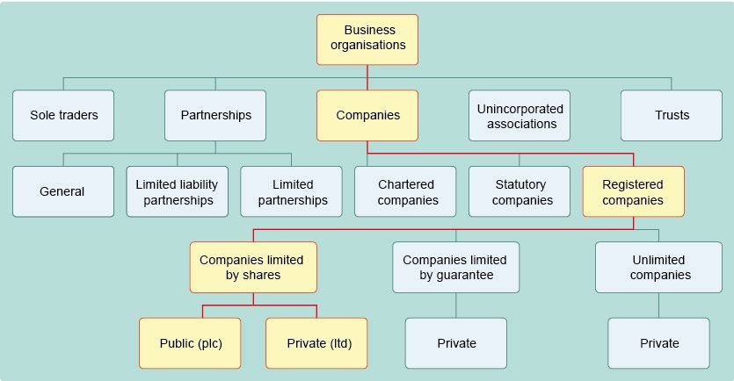
Figure 2 Different business organisations by reference to legal form
View description - Figure 2 Different business organisations by reference to legal form

Capital starts from opening capital at 1 January 20X2 to which is added the profit for the year and from which is deducted the drawing during the period to arrive at the closing capital at 31 December 20X2.
This course will introduce you to:
- sole traders
- partnerships
- private limited companies and public limited companies.

1.1 Sole traders
A sole trader is a business entity owned by a natural person (a human being). In the UK, there is no formal procedure for setting up or winding down a sole trader business. However, the sole trader is responsible for registering with Her Majesty’s Revenue and Customs authority (HMRC) as self-employed, and for registering for Value Added Tax (VAT) if the taxable revenue is more than £85,000 (at the time of writing).
In other countries things may be slightly different. For example, in the Netherlands, all types of business must register with the Chamber of Commerce. Registration with the Chamber of Commerce will automatically result in registration for income tax and VAT purposes as well.
In the eyes of the law, the sole trader as a person and as a business are one and the same. The implications are that the owner of the sole trader business:
- raises finance by investing his or her own money, borrowing money from family or friends, obtaining a personal (unsecured) loan, or a loan secured on assets
- personally owns the assets of the business
- has unlimited liability for the debts, torts and crimes of the business
- is entitled to the profits of the business
- makes the decisions on the nature and running of the business.
In addition, when the owner decides to stop working or passes away, the sole trader business will have to be wound up.
Unlike many entities, the type and format of financial statements are not specified by regulations for sole traders in the UK. However, sole traders would normally prepare basic financial statements adequate for taxation purposes, as well as for their own needs. You will look at these in more detail later in the course.
See Figure 3 for a summary of sole traders.

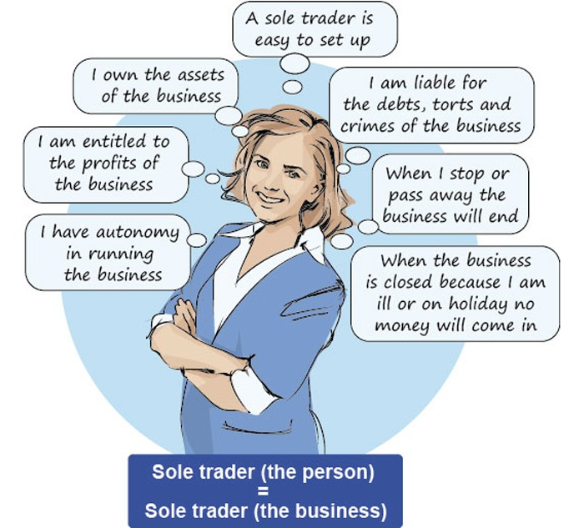
Figure 3 Summary of sole traders
View description - Figure 3 Summary of sole traders

1.2 Partnerships
A partnership is a business entity owned by two or more persons who each invest money and/or other assets, and who work together with the aim of making a profit. The greater number of owners means that, in comparison with a sole trader, more finance becomes available – this is a common reason for forming a partnership. A partnership is also a means of sharing the risks and management of the business.
In the eyes of the law, the partners of a general partnership:
- are agents of the business, which allows the partners to manage the business and enter into contracts on behalf of the business
- have joint and several liability for the debts and torts of the business.
In the UK, there are three types of partnership: general partnership, limited partnership and limited liability partnership. As the number of partnerships is on the decline, this course will not go into the details of partnerships any further.

1.3 Companies limited by shares
Companies limited by shares have at least the following two characteristics: they have a separate legal personality and their shareholders have limited liability. Here you will take a brief look at these two characteristics.
Companies are incorporated businesses. This means that a company is a business which has a legal personality that is separate from the legal personalities of its owners. Company law sets out formal incorporation requirements that can take considerable time to comply with.
Implications of having a separate legal personality include:
- Companies can enter into contracts, or sue and be sued in their own right.
- Once incorporated, the company will continue until it is formally wound up.
- The assets of the company are protected against the personal creditors of the shareholders.
Limited liability refers to the liability of the shareholders for the debts, torts and crimes of the company being limited to the amount they paid for the shares, or the money they owe on the shares if they have not yet been fully paid up.

Activity 1 Advantages and disadvantages of sole traders and companies
Allow about 10 minutes

The purpose of this activity is to compare the main characteristics of a sole trader or a company, and to identify some advantages and disadvantages associated with each.

Write three advantages and three disadvantages of organising a business as a sole trader and three advantages and three disadvantages of organising a business as a company.

Provide your answer...
View feedback - Activity 1 Advantages and disadvantages of sole traders and companies

1.3.1 Private limited companies and public limited companies
Companies limited by shares come as private limited companies (those who have Ltd attached to their name) and public limited companies (those who have plc, PLC or Plc attached to their name, or ccc in Welsh).
Note that in most countries including the UK there are many more private limited companies than public limited companies. The reason is that most of these companies are very small.
Table 2 shows the translation of the terms ‘public limited company’ and ‘private limited company’ in different languages.

Table 2 Public and private limited companies in selected countries
UK | Public limited liability company (plc) | Private limited liability company (Ltd)
France | Société Anonyme (SA) | Société à Responsabilité Limitée (SARL)
Germany | Aktiengesellschaft (AG) | Gesellschaft mit beschränkter Haftung (GmbH)
Italy | Società per azioni (SPA) | Società a responsabilità limitata (SRL)
Netherlands | Naamloze Vennootschap (NV) | Besloten Vennootschap (BV)
Spain | Sociedad Anónima (SA) | Sociedad de Responsabilidad Limitada (SL or SRL)
Japan | Kabushiki Kaisha (KK) | Godo Kaisha (GK)

Private limited companies cannot list their shares on a stock exchange because their shares are not allowed to be traded by the investing public. Shareholders of private limited companies usually must ask permission from the other shareholders in the company to sell their shares to a new shareholder. Investors in private limited companies therefore invest for the long term in a particular company.
Public limited companies can list their shares on a stock exchange where they can be traded by the investing public. A listed company is a public limited company that has its shares of another class of securities (for example, corporate bonds) listed on the UK’s official list. A quoted company is a public limited company whose shares are:
- included in the UK’s official list, or
- listed on a stock exchange in a country in the European Economic Area (EEA), or
- listed on the New York Stock Exchange or the NASDAQ.
Private and public limited companies must have at least one shareholder. Small companies may have only a few shareholders. Large companies, and especially quoted companies, can have thousands or even hundreds of thousands of shareholders.

1.3.2 A note on groups and holding companies
A shareholder can be a natural person, but it can also be another legal person (company). Nowadays, a company can be established for purposes other than trading goods or providing services. For example, companies can be set up to enjoy tax benefits or to create a control structure.
Often, what is referred to as a company is actually a group of companies owned by a parent company. Sometimes, the parent company is a holding company.
A holding company does not usually trade. Its sole purpose is to own the shares of other companies in a group, which it then controls through a pyramid structure of voting rights. Groups and holding companies are outside the scope of this course. However, since quoted companies are generally corporate groups, you will often come across groups and holding companies when looking for information on the internet.
In this course, we focus on single entity companies, that is, companies that are not part of a group. However, since quoted companies are generally corporate groups, you will often come across groups and holding companies when looking for information on the internet.

1.4 The legal characteristics of the modern corporation
In the literature the term ‘the modern corporation’ indicates a quoted public limited company. According to Armour et al. (2009, p. 5), the modern corporation has all five of the following characteristics:
- separate legal personality
- limited liability of its shareholders
- centralised delegated management under a board structure
- transferable shares (in the case of listed companies: freely tradable shares)
- absentee investor ownership.
You will look at these each in turn next.

1.4.1 Separate legal personality
All companies have a separate legal personality. The first corporations were established because separate legal personality gives a corporation a life beyond that of its individual shareholders or members. Think, for example, of the City of London Corporation, which was established in the Middle Ages and, until 2006, used to be called the Corporation of London.
Implications of having a separate legal personality include:
- Once incorporated, the company will continue until it is formally wound up.
- Companies can enter into contracts, or sue and be sued in their own right.
- The personal creditors of the company’s shareholders do not have a claim on the company’s assets.
- The creditors of the company will be paid before the shareholders, because shareholders have a residual claim on the company’s assets.
Some consider a company a ‘legal fiction’ because it is not a natural person. As such, they regard the company as a legal tool for the shareholders to increase their wealth. The more successful and profitable the company, the larger the increase in the shareholders’ residual interest in the company will be.

1.4.2 Limited liability
Potential investors in unlimited companies had been reluctant to take the risk of losing both their investment and their personal assets. Therefore, the government introduced limited liability in UK company law in the mid-nineteenth century. The aim was to encourage more people to invest in companies, for example those involved in the construction of railways, canals and other infrastructure ventures, but later also in manufacturing and other industries.
In other words, unlimited liability of shareholders for a company’s obligations related to debts, torts and crimes, puts constraint on the ability of the company to raise capital. Limited liability shields the personal assets of the shareholders from the creditors of the company. That is why investing in a limited company is less risky than investing in an unlimited company. The downside of limited liability is that it reduces the incentive for shareholders to closely monitor the directors.

1.4.3 Centralised delegated management under a board structure
In very small limited companies, often the owner-shareholders are also directors and active managers. Larger limited companies have a larger number of shareholders, who will delegate the actual management of a company to professional managers (board of directors) (Armour et al., 2009, p. 11).
Delegated management causes the separation of the ownership of the company and the control of the company. In principle, the shareholders are supposed to monitor the directors to ensure that the directors are indeed acting in the best interests of the shareholders. As mentioned earlier, in practice, limited liability reduces the shareholders’ incentive to do so.
Company law in different countries places different emphasis on the responsibilities of the board of directors. Directors have a duty to promote the success of the company for the benefit of the shareholders.

1.4.4 Transferable and freely tradable shares
Private limited companies often have a clause in the Articles of Association which states that a shareholder needs approval from the other shareholders to sell or transfer their shares. This characteristic makes shareholders in private limited companies investors for the long term.
Shareholders in public limited companies can advertise their shares to the public. Being able to sell their shares to the public allows public limited companies to raise capital much more easily than private limited companies.
Public limited companies must publicly disclose more information than private companies. Most public limited companies are not listed on a stock exchange. Unlisted public limited companies may be traded in over the counter (OTC) markets. OTC markets are markets in which financial assets, including shares, are traded other than through a formal stock exchange. Most OTC trading is done by institutional investors (such as pension funds) between themselves. The largest OTC market in the world is the National Association of Securities Dealers Automated Quotations Systems (NASDAQ) in the USA.
The reason why public limited companies can raise capital more easily is that investors in public limited companies can buy and sell shares more easily. Shares in listed or quoted companies are the most liquid. Liquidity refers to the ease with which you can sell an asset for cash. A low level of liquidity makes an investment less attractive and less convenient. A high level of liquidity enables investors to buy and sell shares easily and frequently, but it also dis-incentivises them to spend time and effort on monitoring the board of directors.

1.4.5 Absentee investor ownership
Modern portfolio investment is generally based on an assessment of the risk of a company in comparison with the risk of its peers and the return on their investment (that is dividends and the increase in the share price). Portfolio investors, including institutional investors such as investment trusts and pension funds, regularly balance their investment portfolios based on these two characteristics.
Speculators make decisions to hold and sell shares based on the movements in share prices. A speculator deals in financial assets with a view to making a quick profit from favourable price movements. This is a little like betting which assets will go up in price and which will go down. Short-term investors and speculators have no incentive at all to monitor the directors because if they don’t like what they see, they will simply sell their shares.
The five legal characteristics of the modern corporation discussed above are shown in the blue (law) part of Figure 4 below.

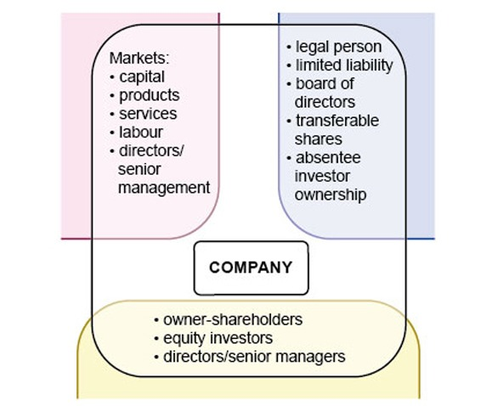
Figure 4 The legal characteristics of the modern corporation
View description - Figure 4 The legal characteristics of the modern corporation

In Section 2 you will learn about markets, and especially about the company’s need to raise equity capital and loan capital on capital markets.

Activity 2 The modern corporation
Allow about 10 minutes

The purpose of this activity is to understand the characteristics of private limited companies, public limited companies and quoted or listed public limited companies.

Think about answers to the following question:
Among private limited companies, public limited companies and quoted public limited companies, which is more likely to have all five characteristics of ‘the modern corporation’?

Provide your answer...
View feedback - Activity 2 The modern corporation

Activity 3 Single-entity companies
Allow about 5 minutes

The purpose of this activity is to understand that single entity companies are more likely to be small or medium-sized private limited companies or public limited companies.

Which type of company is most likely to be a single-entity company?

Provide your answer...
View feedback - Activity 3 Single-entity companies

2 The market environment and sources of company finance
The economic environment in which companies operate in market economies is characterised by markets for goods, services, labour, senior managers and, last but not least, capital. In market economies, the assumption is that private property rights, competition, the pursuit of profit, and market prices that are set through the forces of supply and demand are the best way to bring about an efficient allocation of resources in the economy.
Different markets will have different characteristics which are outside the scope of this course. However, it is important to note that market prices of goods and raw materials, both historic and current, are important in determining the financial position and financial performance of a company. Similarly, the market prices of services and labour play a vital role in determining company success. In addition, the market for senior managers is relevant for large and listed companies where there is a clear separation between the ownership of the company’s shares and the control of its resources.
Finally, companies raise their debt and equity capital in capital markets. Financial reporting is one of the main sources of information for investors on which to base their decisions. Because companies are not likely to provide financial reports that are comparable and because managers and shareholders do not have the same information about the company, financial reporting standards and capital market regulations are necessary to protect the interests of investors, lenders, creditors and other company stakeholders.
Figure 5 summarises the discussion on the market, legal and social context of company financial accounting so far.

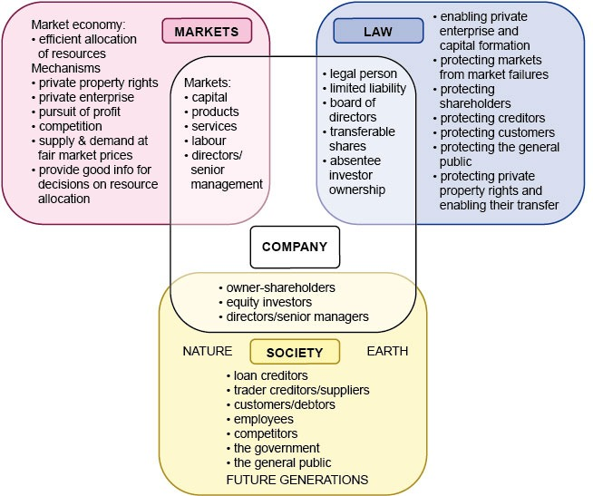
Figure 5 The market, legal and social context of companies
View description - Figure 5 The market, legal and social context of companies

2.1 Sources of company finance
Sources of company finance include equity capital, debt capital, and retained earnings. In this section you will look at share capital in the form of ordinary and preference shares, and debt capital in the form of bank loans and debt securities such as debentures (corporate bonds).
Private limited companies, public limited companies and listed public limited companies have different options for raising finance.
- Private limited liability companies must obtain their financing privately. This means that most private companies issue shares to a number of people within a relatively small circle and borrow money from the same people or from banks.
- Public limited liability companies may advertise their shares to the public. Potentially, this makes it easier to attract new shareholders and issue additional shares.
- Listed companies issue shares and long-term debt securities on capital markets and sell short-term debt securities on financial markets. Listed companies are therefore able to attract capital and borrowings from a larger number of investors.

2.2 Equity finance (share capital)
Equity of net assets is the residual interest of the assets of the company after deducting all its liabilities. Equity comprises the nominal share capital, share premium account, retained earnings and any other reserves.
In terms of types of shares, there are ordinary shares and preference shares. In theory, there are also deferred shares but they are very rare.

Ordinary shares
Ordinary shares are the most common type of equity capital. Ordinary shareholders usually carry one vote per share. Ordinary shareholders receive dividends if there is enough profit left over after preference shareholders have been paid their fixed dividends. When a company is wound up, ordinary shareholders have the right to the residual capital that is left over after all creditors, lenders and preference shareholders have been paid.

Preference shares
Preference shares used to be popular in the late nineteenth and early twentieth centuries. They are much less popular these days. Many companies will only have ordinary shares. Preference shares give preference shareholders a prior right to receive a dividend, usually a fixed dividend. Preference shareholders often do not have voting rights.

Redeemable and irredeemable preference shares
Redeemable preference shares are preference shares that the company may buy back at a specific date in the future or at the shareholder’s or the company’s option. The redeemable preference shares will then be cancelled and the shareholders repaid. For this reason, they are more like debentures in nature. Therefore, dividend payments on redeemable preference shares are usually treated in the financial statements as an (interest) expense instead of a distribution of profit.
Irredeemable preference shares are preference shares that will not be bought back by the company. Irredeemable preference shares (also called participating preference shares) remain in existence like ordinary shares and may carry voting rights if this is stipulated in the company’s constitution, although in the UK this is not very common.

Dividends and capital maintenance
Having sold shares to raise capital, the law requires that this capital not be reduced or distributed to the shareholders in unauthorised ways. Capital maintenance requirements are intended to protect creditors and lenders.
Dividends can only be paid if declared and authorised in accordance with the Articles of Association. Also, the Companies Act 2006 stipulates that a company must not pay dividend out of its share capital. A ‘company may only pay dividends out of profits available for the purpose’ (Companies Act 2006), that is, out of retained earnings.
In general, directors recommend the payment of a dividend and the company declares the dividend by passing an ordinary resolution in the AGM.
‘Distributable profits’ means accumulated, realised profits less accumulated realised losses (in so far as not utilised already). To calculate the amount of distributable profits, the Companies Act 2006 stipulates that ‘relevant accounts’ must be used. Relevant accounts are compiled using either New UK GAAP or EU adopted IFRS, and will usually be audited accounts. A private limited company may be exempt from an external audit owing to its small size.

Increasing share capital
Companies can increase their share capital in the following three ways.
- Secondary public offering. Issuing new shares to the public. Shares can be issued at a nominal value or par value but they are often sold at a premium. Secondary public offerings are only available to public limited companies. Private limited companies are not allowed to offer their shares to the public.
- Rights issue. This involves the offer of new shares to existing shareholders in proportion to their existing shareholding. This method is available to both private and public limited companies. For a public limited company, a rights issue to existing shareholders may have a greater chance of success than a secondary public offering. It is also cheaper in terms of issue and administration costs.
- Bonus issue. A bonus issue (also called capitalisation issue or scrip issue) is an issue of fully paid shares to existing shareholders free of charge, also in proportion to their existing shareholding. This method is available to both private and public limited companies. A bonus issue may take the place of dividends if a company lacks the cash to pay cash dividends. Therefore, a bonus issue amounts to a stock dividend. It is funded from the company’s reserves. This involves transferring a part of the company’s reserves to its share capital. It is simply a rearrangement within the company’s equity. The company does not receive any cash from a bonus issue. In many countries this is one of the few purposes for which the share premium account may be used.

Activity 4 The Body Shop bonus share issue
Allow about 20 minutes

The purpose of this activity is to understand how companies might use bonus issues using the example of The Body Shop in 1984.

The Body Shop had a share capital of £100 between 1976 and March 1984. On 1 March 1984:
- The authorised share capital of the company was increased to £51,000. This meant that the company was allowed to issue up to £51,000 in share capital.
- Each £1 ordinary share was then divided into 20 ordinary shares of £0.05 each.
- A bonus issue (scrip issue) of 1,000,000 ordinary shares was made on the basis of 500 ordinary £0.05 shares for each ordinary share in issue (The Body Shop International plc, 1984).

Anita held 25% of the shares, Gordon held 25% of the shares, and a third shareholder held 50% of the shares.

What was the consequence of this bonus issue for the three shareholders of The Body Shop?

View feedback - Activity 4 The Body Shop bonus share issue

2.3 Loan finance (debt capital or loan capital)
Companies can obtain debt capital in several ways, such as obtaining a loan from a bank, or issuing debentures (or bonds) or other debt instruments.
A debenture is evidenced by a formal document issued by the company which acknowledges its indebtedness, and will generally set out the terms of the loan, for example, rates of interest, dates the interest is payable (usually every six months), repayment of capital, etc.
Debentures may be issued by two methods:
- public offer
- private placement (where the offer is being made to a select group of persons).
While public companies can issue debentures using either method, private companies may only issue debentures using the private placement method.
It is common for a debenture to be secured or charged on a company’s assets, but it need not be. A prudent lender may insist on securing the loan on one or more assets of the company because a secured creditor has the right to be paid before unsecured creditors in the event that a company is liquidated.
As mentioned above, it is common for loans and debentures to be secured on a company’s asset(s). There are two types of charges:
- fixed charges
- floating charges.

Fixed charges
A fixed charge is when a loan or debenture is secured on a specific, identified asset (often land and/or buildings). The effect is that the company cannot sell the asset without the chargee’s agreement until the period of the charge comes to an end.

Floating charges
A floating charge attaches to a particular class of assets, which would typically change frequently during a normal trading cycle, for example bulk goods. It is a useful device for obtaining security over a company’s current assets, as it allows a company to deal freely with such assets, and provides a wider range of assets that can be charged.
A floating charge does not attach to any particular asset until crystallisation occurs. Crystallisation means that an event specified in the debenture document occurs which causes the charge to attach, such as the company being unable to pay its debts, especially the debenture interest. The company ceasing to trade or going into liquidation will also cause a floating charge to crystallise. A floating charge also has lower priority than any fixed charge.

Priority and registration of charges
The priority of a charge for repayment depends on the type of charge and whether or not it has been registered with the Registrar of Companies, which must be done within 21 days of creation of the charge. If the charge is not registered, if created within 12 months of winding-up, a liquidator may ignore it. Non-registration also results in the company and all officers in default being fined and makes the money borrowed repayable at once.

Activity 5 Comparing loan and share capital
Allow about 15 minutes

The purpose of this activity is to understand advantages and disadvantages of loan capital when compared to share capital.

Think of advantages and disadvantages of debt capital over share capital. What advantages and disadvantages can you think of?

Provide your answer...
View feedback - Activity 5 Comparing loan and share capital

Activity 6 Sources of finance for small and medium-sized businesses
Allow about 15 minutes

The purpose of this activity is to learn about the different sources of company finance for small and medium-sized companies.

To remind you of the different sources of financing watch the video on sources of finance for small and medium-sized companies, and take notes on the sources of financing to which you had not yet been introduced.

Video content is not available in this format.
View transcript - Uncaptioned interactive content

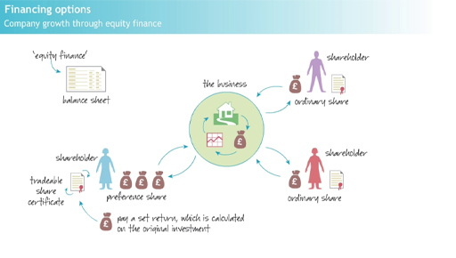

View feedback - Activity 6 Sources of finance for small and medium-sized businesses

2.4 Primary and secondary markets
A financial market is a place where those who wish to borrow or raise capital can meet those who are willing to provide it. There are two main types of financial market.
- Primary markets deal in new issues of finance, such as issues of new shares or debentures. When a public limited company issues shares for the first time to be sold on the stock exchange, it is called Initial Public Offering (IPO). When the company later seeks to increase its share capital it can do so through a secondary public offering.
- Secondary markets deal in trading of what might be termed ‘second-hand’ or ‘pre-owned’ financial assets of various kinds: for example, securities, bonds, debentures/loan stock. They do not provide new funds, but allow holders of existing assets to sell them on to other investors. It is thought that a well-developed secondary market should reduce price volatility of traded assets through regular trading activities. Well-developed secondary markets are essential for diversification, risk shifting, hedging and arbitrage.
The UK has a capital market in the form of the London Stock Exchange (LSE), which deals in two major types of security – company securities (shares and long-term loan stock/debentures) and public sector stocks. The advantage of the LSE is that it provides liquidity, is transparent and it is regulated. AIM is the London Stock Exchange’s international market for smaller companies.
Furthermore, unlisted public limited companies can offer their shares and debentures on the over the counter (OTC) market. That is, on a market that is not a stock exchange.

Activity 7 Primary and secondary markets
Allow about 10 minutes

The purpose of this activity is to learn to distinguish between primary and secondary markets.

Public limited companies raise capital in primary markets. They do not raise capital in secondary markets. Why then are secondary markets very important for their ability to raise capital?

View feedback - Activity 7 Primary and secondary markets

3 The interests and information requirements of company stakeholders
So far, this course has only discussed shareholders and directors as parties with an interest in the company. However, there are other stakeholders who will have an interest in a company and its financial accounting information.
A stakeholder is anyone who is, or has the potential to be, influenced by the operations of a company. Companies often try to manage different stakeholder interests to their advantage.
The following activity encourages you to think of company stakeholders and their interests.

Activity 8 Stakeholder interests and information needs
Allow about 30 minutes

The purpose of this activity is:
- to become familiar with different stakeholders in a company
- to understand the different stakeholders’ interests and information needs.

Looking at the list of stakeholders below, can you think what their interests and information needs are? Fill in the column on the right hand side.

Table 4: The interests and information needs of company stakeholders
Stakeholders | Stakeholder interests and information needs
Shareholders in private limited companies | Provide your answer...
Current and potential shareholders in public limited companies | Provide your answer...
Loan creditors | Provide your answer...
Suppliers and trade creditors | Provide your answer...
Customers (current and potential) | Provide your answer...
Employees | Provide your answer...
Competitors | Provide your answer...
The general public, including tax payers,  community and special interest groups  (including those arguing on behalf of future generations and nature) | Provide your answer...
The government, including regulators,  tax authorities, local authorities, departments  and agencies involved in the development of economic policies | Provide your answer...

View feedback - Activity 8 Stakeholder interests and information needs

4 Three perspectives on the role of companies and financial reporting in society
The allocation of a bundle of property rights over shareholders, the company and the directors creates the possibility for conflicting interests. In addition, market imperfections, the limits of the law, and the company seeking to be perceived as legitimate by its stakeholders, create even greater scope for conflicting interests.
In this section you will consider the following three different views on what companies are, what their role in society should be, and what the purpose of company financial reporting should be:
- the company as a legal fiction
- the company as an institution in its own right
- the company as an institution adding value to society.

The company as legal fiction
Some people regard companies as a legal fiction, which is to be used as a tool to increase the wealth of its shareholders and other equity investors. In this case, the directors must act in the best interests of the shareholders and equity investors whilst obeying the law.
Under the proprietary theory of the objective of financial accounting, financial accounting and reporting are primarily aimed at providing shareholders and other equity investors with information for their decisions.

The company as an institution in its own right
Others regard companies as institutions in their own right. A company has to survive by co-ordinating and reconciling the interests of its stakeholders. To this purpose, one would expect an ‘enlightened shareholder focus’ and/or a stakeholder management approach from the directors.
Under the entity theory, the objective of financial accounting and reporting is to provide information that is useful to shareholders and other investors as well as creditors and other users of financial statements.

The company as institution adding value to society
The third view is that companies derive their social legitimacy as an institution in their own right by adding value, and being responsible, to society at large or the community in which they operate. The directors of the company would have to aim at economic, social and ecological sustainability in the operations, financing and governance of the company.
Under the social theory, financial accounting and reporting have to be supplemented by other types of information that demonstrate that the company has operated sustainably, added value rather than created externalities, and has behaved ethically and responsibly.

Activity 9 Your perspective on the role of companies in society
Allow about 10 minutes

The purpose of this activity is to identify and express your opinion on the role of companies in society.

Think for a moment about which of the three perspectives you agree with, and why?

Interactive content is not available in this format.

View discussion - Activity 9 Your perspective on the role of companies in society

5 Comparing sole trader and company financial statement formats
The balance sheet is the fundamental financial statement because it expresses the balance sheet equation (Assets = Capital + Liabilities or Assets – Liabilities = Capital) which underlies double-entry bookkeeping and financial accounting. The balance sheet summarises the balances in the general ledger accounts related to assets (the resources of the business), liabilities (the debts and other obligations of the business) and capital (the owners’ equity) at a date. The balance sheet shows the financial position of the business at a point in time.
The income statement summarises the changes in assets and liabilities (recorded as the flow of income and expenses during a period of time) that generated the profit or loss for the period. The income statement shows the financial performance of the business over a period of time.
Flow statements for a period link the balance sheet at the start of the period to the balance sheet at the end of the period. The income statement is a flow statement because it shows how income and expenses caused the increase or decrease in capital from one period to the next. The cash flow statement is a flow statement because it shows the increase or decrease in cash from one period to the next. The statement of changes in equity is also a flow statement.
Figure 6 below shows an example of how the flow statements link the opening and closing balance sheets.

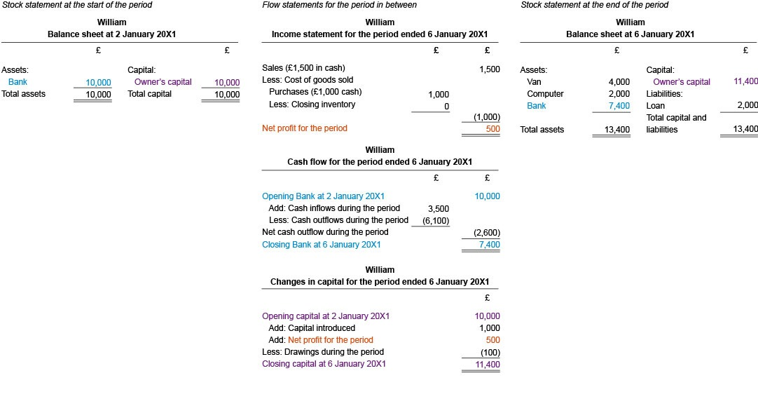
Figure 6 An example showing the relationship between stocks and flows of William’s business
View description - Figure 6 An example showing the relationship between stocks and flows of William’s ...

In Section 5.1 you will look at the balance sheet and income statement for a sole trader. In Section 5.2 you will look at the same financial statements for a company. Section 5.3 discusses the statement of changes in equity for a company and Section 5.4 looks at cashflow statement for a company.

5.1 Sole trader financial statements
In order to be able to compare sole trader financial statements with company financial statements this section first introduces sole trader financial statements. Below are the balance sheet and the income statement for a sole trader called Ian Hodgins.

Balance sheet
Below is the balance sheet for Ian Hodgins at 31 December 20X2. It shows total assets = total capital + total liabilities.
Non-current assets are shown at their cost less the accumulated depreciation which equals net book value. Current assets are shown at their historical costs. Liabilities are also shown as non-current and current liabilities.
Capital starts from opening capital at 1 January 20X2 to which is added the profit for the year and from which is deducted the drawing during the period to arrive at the closing capital at 31 December 20X2.

Ian Hodgins Balance sheet at 31 December 20X2
 | Cost | Accumulated  depreciation | Net book  value
 | £ | £ | £
ASSETS
Non-current assets | 100,000 | 10,000 | 90,000
 | 100,000 | 100,000 | 90,000
Current assets
Inventory |  | 9,200
Receivables |  | 7,600
Prepayments |  | 600
Bank |  | 4,000
 |  |  | 21,400
Total assets |  |  | 111,400
CAPITAL AND LIABILITIES
Capital
Balance at 1st January 20X2 |  |  | 75,000
Add: Profit for the year |  |  | 19,700
Less: drawings |  |  | (900)
Total capital balance at 31 December 20X2 |  |  | 93,800
Liabilities
Non-current liabilities
Interest free loan from Dad |  |  | 6,000
Current liabilities
Payables |  | 8,800
Accruals |  | 2,800
 |  |  | 11,600
Total capital and liabilities |  |  | 111,400

Income statement
Below is the income statement for Ian Hodgins for the year ended 31 December 20X2. At the top is the trading account, which is the part that determines gross profit for the period. This is followed by the remaining part of the income statement, which shows overheads and determines net profit for the period.

Ian Hodgins Income statement for the year ended 31 December 20X2
 | £ | £
Sales revenue |  | 160,000
Cost of sales: Opening inventory | 3,300
Add: Purchases | 109,100
Less: Closing inventory | (9,200)
Cost of goods sold |  | (103,200)
Gross profit |  | 56,800
Less: Other expenses:
Rent | 24,000
Electricity | 3,800
Business rates | 3,400
Depreciation expense | 5,000
Irrecoverable receivables expense | 900
 |  | 37,100
Net profit for the year |  | 19,700

5.2 Company financial statements
A set of company financial statements would include:
- a statement of financial position (balance sheet)
- a statement of financial performance (income statement or statement of profit or loss)
- a statement of cash flows
- a statement of changes in equity
However, small private limited companies generally only produce a statement of financial position and a statement of financial performance.

5.2.1 Statement of financial position
Although many people use the terms ‘balance sheet’ and ‘income statement’, the International Accounting Standards Board (IASB) which sets the accounting standards that listed companies in many countries have to follow, uses the terms ‘statement of financial position’ and ‘statement of financial performance’. In this course we follow the IASB’s terminology.

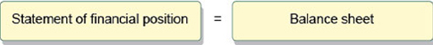
Figure 7 Balance sheet = statement of financial position
View description - Figure 7 Balance sheet = statement of financial position

Below is an example of the statement of financial position for an imaginary company called Cleopatra Ltd.

Cleopatra Ltd Statement of financial position as at 28 February 20X9
ASSETS | Note | £ | £
Non-current assets at net book value (NBV)
Property and equipment | 1 | 18,000
Vehicles | 1 | 56,250
 |  |  | 74,250
Non-current investment |  |  | 18,000
Total non-current assets at NBV |  |  | 92,250
Current assets
Inventory |  | 70,000
Receivables | 2 | 89,110
Prepayments |  | 1,000
Bank |  | 62,490
 |  |  | 222,600
Total assets |  |  | 314,850
EQUITY AND LIABILITIES
Equity
Share capital: Ordinary shares |  | 80,000
Reserves: Retained earnings |  | 107,100
 |  |  | 187,100
Liabilities
Non-current liabilities
6% debentures |  |  | 40,000
Current liabilities
Trade payables |  | 63,500
Accruals |  | 5,200
Corporation tax payable |  | 19,050
 |  |  | 87,750
Total equity and liabilities |  |  | 314,850

- Depreciation policy: Cleopatra Ltd depreciates non-current assets as follows:
- property and equipment – straight-line method over 20 years
- motor vehicles – reducing balance method 25% per annum.
- Net receivables: receivables are shown net of an allowance for receivables of 5%.

Activity 10 Comparing sole trader and company financial statements, Part 1
Allow about 15 minutes

The purpose of this activity is to compare the balance sheet of a sole trader with the statement of financial position of a company in order to identify the differences.

Refer back to the balance sheet for Ian Hodgins.
Identify how the statement of financial position for Cleopatra Ltd is different from the balance sheet for Ian Hodgins.

View feedback - Activity 10 Comparing sole trader and company financial statements, Part 1

5.2.2 Statement of financial performance
As mentioned above, the IASB calls the income statement the statement of financial performance. However, the IASB requires listed companies to prepare one ‘statement of profit or loss and other comprehensive income’ or a separate ‘statement of profit or loss’ and a separate ‘statement of comprehensive income’.

Why is there not just one type of statement of financial performance?
This is because a statement of financial performance can be prepared from the following two perspectives on what ‘the bottom line’ in a statement of financial performance should show.
- Profit or loss – that is, net profit (or loss) generated from transactions which is recorded in the retained earnings account and is distributable to shareholders in the form of dividends. In this case, the statement of financial performance can also be called ‘statement of profit or loss’ or ‘income statement’.
- Comprehensive income – that is, profit generated from transactions plus income as a result of any changes in assets and liabilities from other causes other than dividend payments and share capital increases or decreases. For example, the increase or decrease in the market price of investment assets or other non-current assets, changes in the estimations of pension assets or liabilities. These are beyond the scope of this course because they are too advanced.
In this case, the statement of financial performance can also be called ‘statement of profit or loss and other comprehensive income’ or ‘comprehensive income statement’. To complicate matters further, these two can also be presented separately as a statement of profit or loss and a statement of other comprehensive income.
Figure 8 expresses the explanation above visually.

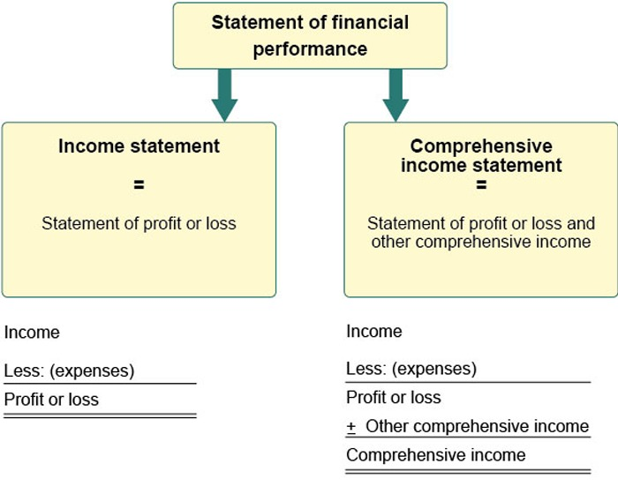
Figure 8 Two types of statements of financial performance
View description - Figure 8 Two types of statements of financial performance

Below is an example of the statement of financial performance for Cleopatra Ltd.

Cleopatra Ltd statement of financial performance for the year ended 28 February 20X9
 | Note | £
Sales revenue |  | 620,000
Less: Cost of sales |  | (352,500)
Gross profit |  | 267,500
Less: Administrative expenses | 3 | (120,100)
Less: Distribution expenses | 3 | ( 49,750)
Operating profit (profit before interest and tax) |  | 97,650
Less: Finance costs |  | ( 2,400)
Profit before tax |  | 95,250
Less: Corporation tax |  | (19,050)
Net profit for the year |  | 76,200

- Administrative expenses and distribution costs: distribution costs include the depreciation of vehicles and vehicle running expense. All other expenses are included in administrative expenses.

Activity 11 Comparing sole trader and company financial statements, Part 2
Allow about 15 minutes

The purpose of this activity is to compare the income statement of a sole trader with the statement of profit or loss of a company and identify the differences.

Refer back to the income statement for Ian Hodgins.
Identify how the statement of financial performance for Cleopatra Ltd (a company) is different from the income statement for Ian Hodgins (a sole trader).

View feedback - Activity 11 Comparing sole trader and company financial statements, Part 2

5.3 Statement of changes in equity
Below is the statement of changes in equity for Cleopatra Ltd. The statement of changes in equity shows how the change in the equity section of the statement of financial position of a company has come about. It shows the increase due to profit for the year. It also shows the decrease due to dividend payments during the year. It would also show any increase due to new share issues.

Cleopatra Ltd Statement of changes in equity for the year ended 28 February 20X9
 | Shares | Retained  earnings | Total equity
 | £ | £ | £
Balance as at 1 March 20X8 | 80,000 | 33,300 | 113,300
Dividends paid |  | ( 2,400) | ( 2,400)
Total profit for the year |  | 76,200 | 76,200
Balance as at 28 February 20X9 | 80,000 | 107,100 | 187,100

You have now been introduced to the formats of the three main company financial statements: the statement of financial performance, the statement of financial position and the statement of changes in equity. To recap, the statement of financial performance shows, in detail, the company’s financial performance over the year and shows the profit or loss to be included in the retained earnings reserve in the statement of financial position and the statement of changes in equity.

Activity 12 Memorising financial statements formats
Allow about 60 minutes

The purpose of this activity is to gain practice at writing out the financial statement formats and to memorise their layouts.

Write out by hand the headings of the layouts for:
- the statement of financial performance
- the statement of financial position
- the statement of changes in equity.
Do this a few times in order to memorise their layouts or formats.
Note that there is no feedback for this activity.

5.4 Statement of cash flows
The statement of financial performance shows the profit of the company based on the accrual concept. This differs from net cash (cash income less cash expenses) because the statement of financial performance shows revenues and expenses in the accounting financial year to which they relate, rather than when the income or expense is received or paid. Income is recognised in the financial year it has been earned and expenses are recognised in the year they have been incurred in the process of generating the associated income.
The cash flow statement focuses only on cash receipts and payments. The cash flow statement shows the main areas of cash generation or expenditure under three main categories:
- cash flow from operating activities
- cash flow from investing activities
- cash flow from financing activities.
Figure 9 shows the summary format of the cash flow statement.

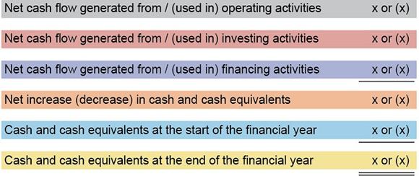
Figure 9 Summary format of the cash flow statement
View description - Figure 9 Summary format of the cash flow statement

The cash flow statement shows the change in cash and cash equivalents over the financial year (the fourth line in Figure 9).
The cash flows from operating (the first line), investing (the second line) and financing (the third line) activities are shown separately, and the total of the different activities gives the increase or decrease in cash over the year (the fourth line).
The net increase or decrease in cash over the year (the fourth line) is then added to the opening cash position at the start of the year (the fifth line) to obtain the closing cash position at the end of the year (the sixth line).
This can be checked against the cash position of the company in the closing statement of financial position.
Note that the net cash flow may show an increase or decrease.
Opening and closing cash and cash equivalents may be positive or negative, i.e. overdrafts. Positive cash balances are shown under current assets in the statement of financial position and negative cash balances or overdrafts are shown as under current liabilities in the statement of financial position.
The cash flow statement shows if a company is able to generate enough cash from its operations. It also shows how much cash is used in investment activities. Investment activities are intended to generate cash in the future. The cash flow statement shows if cash is raised through financing activities rather than from operations.

Conclusion
In this course you have learned about the legal characteristics of private and public limited companies. You have also learned about different sources of company finance. Furthermore, you were introduced to the interests and information requirements of company stakeholders, and three different perspectives on the role of companies in society. Finally, you learned about the differences between sole trader and company financial statement formats.
This OpenLearn course is an adapted extract from the Open University course B293 Financial accounting in context.

References
Armour, J., Hansmann, H. and Kraakman, R. (2009) ‘Chapter 1: What is corporate law?’, in Kraakman, R., Armour, J., Davies, P., Enriques, L., Hansmann, H., Hertig, G., Hopt, K., Kanda, H. and Rock, E. (2009) The Anatomy of Corporate Law: A Comparative and Functional Approach, Oxford, UK and New York, Oxford University Press.
Companies Act 2006 (Great Britain). Available at: www.legislation.gov.uk/ukpga/2006/46/contents (Accessed: 30 April 2020).
The Body Shop International plc (1984) Listing of particulars. Available at: beta.companieshouse.gov.uk/company/01284170/filing-history?page=30 (Accessed: 12 March 2019).

Acknowledgements
This free course was written by Carien VanMourick. It was first published in October 2020.
Except for third party materials and otherwise stated (see terms and conditions), this content is made available under a Creative Commons Attribution-NonCommercial-ShareAlike 4.0 Licence.
The material acknowledged below is Proprietary and used under licence (not subject to Creative Commons Licence). Grateful acknowledgement is made to the following sources for permission to reproduce material in this free course:
Image
Course image: RomoloTavani / iStock / Getty Images Plus
Every effort has been made to contact copyright owners. If any have been inadvertently overlooked, the publishers will be pleased to make the necessary arrangements at the first opportunity.
Don't miss out
If reading this text has inspired you to learn more, you may be interested in joining the millions of people who discover our free learning resources and qualifications by visiting The Open University – www.open.edu/openlearn/free-courses.

Solutions

Activity 1 Advantages and disadvantages of sole traders and companies

Feedback

Table 1 Comparing sole traders and companies
 | Advantages | Disadvantages
Sole trader | A sole trader is simple to set up | A sole trader has unlimited liability for the debts and torts of the business
 | A sole trader is entitled to all the profits of the business (subject to paying VAT and personal income tax) | A sole trader has complete responsibility for the business and, unless they have employees who keep the business open, will not be paid when closed due to illness, holiday and so on
 | A sole trader is responsible to the customers, suppliers, the government and has autonomy in running the business | When the sole trader stops or dies, the business is also very likely to end
Company limited by shares | Legal personality means that a company will continue until it is formally wound up | Setting up a company requires a formal procedure
 | Legal personality means that a company can contract, sue or be sued in its own right | A company has more administrative requirements than other types of business entity
 | Members/shareholders have limited liability | Shareholders do not have the automatic right to participate in the management of the company
 | It is easier to raise financing for a company than for a sole trader | Companies are subject to regulation under company law

Back to - Activity 1 Advantages and disadvantages of sole traders and companies

Activity 2 The modern corporation

Feedback
A small private limited company with only a few shareholders is likely to have only two of the five characteristics of the modern corporation: legal personality and limited liability.
A large private company with many shareholders is likely to have a centralised delegated board of directors.
A small public limited company will have at least three characteristics because its shares are transferable, but a larger company is also likely to have a delegated board of directors.
Only a listed or quoted public limited company will have all the characteristics of the modern corporation.

Table 3 Private, public and quoted companies
Private limited company | Public limited company | Quoted public limited company
Legal personality | Legal personality | Legal personality
Limited liability | Limited liability | Limited liability
If small: owner-directors | If small: owner-directors | Delegated board of directors
Permission to sell shares | Transferable shares | Freely tradable shares
Shareholder ownership | Shareholder/investor ownership | Absentee investor ownership

Back to - Activity 2 The modern corporation

Activity 3 Single-entity companies

Feedback
Private limited companies are often smaller than public limited companies. Therefore private limited companies and very small public limited companies are more likely to be single entity companies, although there are exceptions. In the UK, companies are often organised as groups. Learning to prepare and interpret group accounts is outside the scope of this course.
Back to - Activity 3 Single-entity companies

Activity 4 The Body Shop bonus share issue

Feedback
Although the authorised share capital increased from £100 to £51,000, the issued share capital increased from £100 to £100 + £50,000 = £50,100.

Working
Each £1 ordinary share was then divided into 20 ordinary shares of £0.05 each. This means that instead of 100 shares of £ each, there were now 100 × 20 = 2,000 shares of £0.05 each.
A bonus issue (scrip issue) of 1,000,000 ordinary shares was made on the basis of 500 ordinary £0.05 shares for each ordinary share in issue. In other words, 2,000 shares × 500 = 1,000,000 shares × £0.05 amounted to an increase in share capital of £50,000.
- Anita’s shareholding increased from £25 to £25 + £12,500 = £12,525
- Gordon’s shareholding increased from £25 to £25 + £12,500 = £12,525
- The third shareholder’s shareholding increased from £50 to £50+ £25,000 = £25,050

Back to - Activity 4 The Body Shop bonus share issue

Activity 5 Comparing loan and share capital

Feedback
Advantages:
- Debentures are usually cheaper to issue and may be issued at a discount.
- There are fewer restrictions on redemption, and they do not ‘dilute’ control of the company as they do not carry voting rights.
- The board does not usually need authorisation from the shareholders to issue debentures.
- The interest payable is an allowable deduction from profits for corporate tax purposes.
Disadvantages:
- Companies in financial difficulty may find it difficult to pay the required interest, so failure to pay may compel lenders to instigate liquidation and/or administration procedures, if the debentures are secured.
- Also, if companies have a high level of debentures (and/or other loans) in comparison with share capital, they are said to have high gearing, and this adversely affects the market price of public company shares.
Back to - Activity 5 Comparing loan and share capital

Activity 6 Sources of finance for small and medium-sized businesses

Feedback
The video discussed equity and debt finance, which you learned about earlier, but also about trade credit and leasing as means through which small and medium-sized business finance their operations. Accounting for leasing is an advanced topic, so it is outside the scope of this course.
Back to - Activity 6 Sources of finance for small and medium-sized businesses

Activity 7 Primary and secondary markets

Feedback
One answer is liquidity. Investors value liquidity because they are more willing to buy shares and other securities if they know that they can easily sell them, when they have to or want to sell them.
Secondly, share prices give an indication of the market’s opinion on how well the company is doing. Listed companies will want to make sure that their share price is slowly but gradually going up, because that is what makes investors want to invest in their shares.
Back to - Activity 7 Primary and secondary markets

Activity 8 Stakeholder interests and information needs

Feedback

Table 4 The interests and information needs of company stakeholders (Completed)
Stakeholders | Stakeholder interests and information needs
Shareholders in private limited companies | They will be interested in profitability, liquidity and cash flow, which will determine the dividends they receive. If they are not the managers of the company, they will also be interested in how well the managers have discharged their stewardship responsibilities.
Current and potential shareholders in public limited companies | Investors make decisions to hold shares, buy shares or sell shares. They will be interested in the security of their investment, and also the return on their investment. The financial strength and solvency of the company is shown in the balance sheet. Past profits may also be a guide to how well the company will perform in the future, so this information will also be of interest to potential or future investors.
Loan creditors | Lenders need to know that loans made will be repaid, and that interest due on loans will be paid when it falls due. They also want to see if there is a healthy equity cushion. If assets have been used as security for loans, then they will also look to ensure that assets are retained.
Suppliers and trade creditors | They need to know that they will be paid. So they will be interested in a business’s financial health, especially in terms of its solvency. They like to see healthy amounts of cash, and that there are not overdrafts or large loans.
Customers (current and potential) | Customers need to know whether a business will be able to continue supplying them with goods/services in the future, especially if they deal with a business regularly or significant sums of money are involved. Customers might, however, be concerned that goods sold to them have been overpriced if they perceive that profit levels are very high.
Employees | Employees (and also trade unions) will wish to know about the security of their jobs, pay rises, pension issues, and potential redundancies, so will be interested in the long term survival of a business. They will also be interested in directors’ salaries and benefits.
Competitors | Competitors will wish to compare their own performance with that of their rivals, and will carry out various detailed analyses to evaluate strategic advantages, and so on.
The general public, including tax payers, community and special interest groups (including those arguing on behalf of future generations and nature) | The general public and special interest groups will wish to assess the effect of a business on the economy, the environment and communities, at local, national and international levels, as well as future generations.
The government, including regulators, tax authorities, local authorities, departments and agencies involved in the development of economic policies | HM Revenue & Customs will use the profit shown by income statements as a starting point to assess how much tax is payable. Government departments may be interested in collecting data about certain aspects for statistical analysis, or in numbers of jobs created or lost.

Back to - Activity 8 Stakeholder interests and information needs

Activity 9 Your perspective on the role of companies in society

Discussion
The three answers represent, to a certain extent, value judgements. However, increasingly the idea is that a company should also be adding value to society.
Back to - Activity 9 Your perspective on the role of companies in society

Activity 10 Comparing sole trader and company financial statements, Part 1

Feedback
The main differences in the balance sheet format for a sole trader and the format for the statement of financial position for a company caused by the difference in type of legal entity are as follows:
- In the capital section of the sole trader, the only accounts are the capital and drawings accounts. The profit for the period is transferred from the income and expense account that makes up the income statement. The sole trader pays personal income tax, but this is not shown in the financial statements of the business as there is no difference between the sole trader as a business and as a person.
- In the capital section of the company, the three accounts are the share capital account, the share premium account and the retained earnings account. There is no drawings account or a dividend account. This is because dividends must be paid out of profit and therefore reduce the retained earnings account.
- The non-current assets in the statement of financial position are simply shown at net book value (NBV). Usually, detailed information about the costs and depreciation of different non-current assets will be given in a separate schedule in the notes to the financial statements.
- The current liabilities section in the statement of financial position shows corporate income tax payable. A company pays corporation tax. The five shareholders pay tax over their dividends, but this has nothing to do with the company’s financial position or financial performance.
Back to - Activity 10 Comparing sole trader and company financial statements, Part 1

Activity 11 Comparing sole trader and company financial statements, Part 2

Feedback
The differences in the format of the income statement for a sole trader and the format of the statement of financial performance (profit or loss statement) for a company are as follows:
- The statement of profit or loss for a company is simpler than the income statement for a sole trader because details are provided in the notes to the financial statements.
- In the statement of profit or loss for a company, administrative expenses and distribution expenses are headings that capture a number of items that would be shown separately in the income statement for a sole trader. The reason is, again, that details are usually provided in the notes.
- Operating profit (or profit before tax and interest, if there are no extraordinary items) and profit before tax are items that do not appear in the income statement for a sole trader because income tax is dealt with as part of the sole trader’s personal tax return.
Back to - Activity 11 Comparing sole trader and company financial statements, Part 2

Figure 1 The company in context

Description
Figure 1 shows a white rectangular form entitled ‘company’. On the left hand side is a pink rectangular form entitled ‘Markets’. It overlaps partly with the company. On the right hand side is another rectangular form entitled ‘Law’. It overlaps partly with the company. At the bottom is the final rectangular for entitled ‘Society’. It overlaps partly with the company. These indicate the company in the context of markets, the law and society.
Back to - Figure 1 The company in context

Figure 2 Different business organisations by reference to legal form

Description
Figure 2 provides an overview of forms of business organisation differentiated in UK law. Among those, it more specifically indicates the types of company that this OpenLearn course deals with: private limited company and public limited company. Against a green background, the organisations that are the topic of this course are shown in yellow. The others are shown in grey. The main types of business organisation are: sole traders, partnerships, companies, unincorporated associations and trusts. Partnerships (grey) There are three types of partnership: general partnership, limited liability partnerships and limited partnerships. Companies (yellow) There are three types of company: chartered companies (grey), statutory companies (grey), and registered companies (yellow). There are three types of registered company: companies limited by shares (yellow), companies limited by guarantee which are private (grey), and unlimited companies which are private (grey). There are two type of company limited by shares: private limited companies (Ltd) (yellow) and public limited companies (plc) (yellow). A red line runs from business organisations to companies, to registered companies, to companies limited by shares, and finally to private and public limited companies.
Back to - Figure 2 Different business organisations by reference to legal form

Figure 3 Summary of sole traders

Description
Figure of a woman with a number of speech bubbles around her. The speech bubbles explain what is meant by the term ‘sole trader’. The speech bubbles read:
- I have autonomy in running the business
- I am entitled to the profits of the business
- I own the assets of the business
- A sole trader is easy to set up
- I am liable for the debts, torts and crimes of the business
- When I stop or pass away the business will end
- When the business is closed because I am ill or on holiday no money will come in.
At the bottom of the figure is a box which reads: Sole trader (the person) = Sole trader (the business)
Back to - Figure 3 Summary of sole traders

Figure 4 The legal characteristics of the modern corporation

Description
Figure 4 zooms in on the white rectangular form representing the company from Figure 1, which includes the parts of Markets (pink), Law (blue) and Society (yellow) that overlap with the company. The markets (pink) part shows the markets in which the company has to function and compete: capital, products, services, labour, directors/senior management. The law (blue) part shows the legal characteristics of the modern corporation as outlined in Section 1.4. 1 separate legal personality; 2 limited liability of its shareholders; 3 centralised delegated management under a board structure; 4 transferable shares (in the case of listed companies: freely tradable shares); 5 absentee investor ownership. The society (yellow) part shows the owners, shareholders and directors of the company.
Back to - Figure 4 The legal characteristics of the modern corporation

Figure 5 The market, legal and social context of companies

Description
Figure 5 zooms out from Figure 3 and includes more detail on the sections for markets, law and society. Markets: At the top of the pink rectangle it states what is often regarded as the purpose of a market economy, which is the allocation of resources. It then mentions the mechanism through which the market achieves the allocation of resources: Private property rights; Private enterprise; The pursuit of profit; Competition for the scarce resources; Supply and demand at fair market prices; Provide useful information for resource allocation decisions. Law: In the blue rectangular form it states that, in a market economy, a function of the law is to enable private enterprise and capital formation. The law: protects markets from market failures; protects shareholders, creditors, customers and the general public; protects private property rights and enables their transfer. Society: The bottom rectangular form for the social context of companies says. Society comprises: loan creditors; trade creditors/suppliers; customers/debtors; employees; competitors; the government; the general public; future generations; nature/earth.
Back to - Figure 5 The market, legal and social context of companies

Figure 6 An example showing the relationship between stocks and flows of William’s business

Description
Figure 6 shows William’s balance sheet as at 2 January on the left hand side (the stock statement at the start of the period) and William’s balance sheet as at 6 January on the right hand side (the stock statement at the end of the period). The stock statement at the start of the period shows Bank £10,000 in blue and Owner’s capital £10,000 in purple. Debit side: Total assets £10,000 = Credit side: Total capital £10,000. The stock statement at the end of the period shows Bank £7,400 in blue and owner’s capital £11,400 in purple. In black it shows also on the debit side the assets of van £4,000 and computer £2,000. In black it shows on the credit side a loan of £2,000. Hence total assets (Bank + Van + Computer) £13,400 = total capital and liabilities £13,400. The flow statements link these two balance sheets at two points in time by showing what happened during that period. The first flow statement is the income statement for the period ended 6 January. It shows in black £1,500 sales less £1,000 cost of sales = £500 profit, whereby the profit number is shown in orange. The second flow statement is William’s cash flow statement which reconciles the opening bank balance of £10,000 at 2 January with the closing bank balance of £7,400 at 6 January (both in blue). Opening cash £10,000 plus £3,500 cash inflow less £6,100 cash outflow leads to a net cash outflow of £2,600 during the period. The third flow statement is William’s statement of changes in capital for the period ended 6 January which reconciles opening capital £10,000 (purple) to closing capital £11,400 (purple) by adding £1,000 of capital introduced during the period and the profit for the period of £500 (orange), and then deducting drawings of £100.
Back to - Figure 6 An example showing the relationship between stocks and flows of William’s business

Figure 7 Balance sheet = statement of financial position

Description
Figure 7 shows two yellow rectangular boxes with an = symbol in between. In the left hand box it says ‘statement of financial position’ and in the right hand box it says ‘balance sheet’.
Back to - Figure 7 Balance sheet = statement of financial position

Figure 8 Two types of statements of financial performance

Description
Figure 8 shows that there are two types of statements of financial performance. On the left hand side it shows the income statement (or statement of profit or loss). In this statement, income less expenses equals profit or loss, which is the bottom line of the statement. On the right hand side, it shows the Comprehensive income statement (or Statement of profit or loss and other comprehensive income). In this statement, income less expenses equals profit or loss, and profit or loss plus or minus other comprehensive income equals comprehensive income.
Back to - Figure 8 Two types of statements of financial performance

Figure 9 Summary format of the cash flow statement

Description
The cash flows from operating (the first line), investing (the second line) and financing (the third line) activities are shown separately, and the total of the different activities gives the increase or decrease in cash over the year (the fourth line). The net increase or decrease in cash over the year (the fourth line) is then added to the opening cash position at the start of the year (the fifth line) to obtain the closing cash position at the end of the year (the sixth line). This can be checked against the cash position of the company in the closing statement of financial position. Note that the net cash flow may show an increase or decrease. Opening and closing cash and cash equivalents may be positive or negative, i.e. overdrafts. Positive cash balances are shown under current assets in the statement of financial position and negative cash balances or overdrafts are shown as under current liabilities in the statement of financial position.
Back to - Figure 9 Summary format of the cash flow statement

Uncaptioned interactive content

Transcript
NARRATOR
In this presentation, we'll show the variety of sources of finance for a business as it matures. The different types and amounts of finance comprise the overall capital structure. The choice about capital structure, in particular the amount of equity versus debt, is a strategic decision. this involves a consideration of the risk-return trade off of each source of finance in the context of what type of business it is, its activities, and its environment.
On incorporation at startup, equity funds the newly formed company. The owners-- in other words, the shareholders-- contribute cash in return for a share of the business. Each shareholder is given a share certificate.
The return to shareholders is a dividend, which is paid at the discretion of the directors and any capital gain or increase in the value of their shares. The risk for shareholders is that there is no obligation for the business to repay them if the company becomes bankrupt. This means that shareholders can lose the amount they originally invested in the business.
Another source of finance available to a business at startup is from its suppliers. This is shown in trade payables on the balance sheet. This is a short term source of finance shown in current liabilities. If suppliers are happy with the company's ability to pay cash in the future, they may offer credit terms. This would allow a business to defer payment for a set period, commonly 30 days. Careful management of trade payables can result in suppliers funding the business in the short term.
After startup, a business uses its existing cash to support future growth by increasing its investment in non-current assets. Further sources of finance may be necessary to supplement equity finance. This process increases the size of a company's balance sheet.
Debt borrowing comes in an array of forms, primarily bonds issued by the company and bank loans. Bonds and bank loans are structured around investors depositing money with a company for a fixed period of time. It's a contractual arrangement enforced by law and receiving interest payments, which can be fixed or variable.
At the end of a loan period, a business pays back the original sum that was lent to it. Returns for the investor or lender are contractual and must be met by a business. Debt borrowing can be secured on business assets. In the case of default, the company's assets can be taken by the debt holder, converted to cash, and used to settle any amounts that are outstanding.
A variety of equity finance may appear on the balance sheet as the business continues to develop and grow. There are different types of equity capital.
The shares issued to shareholders at startup are typically ordinary shares. Preference shares are another type of equity and are issued in the form of a tradable share certificate. Preference shares have some of the characteristics of debt.
Preference shares pay a set return-- for example, 5%-- which is calculated on the original investment. Holders of preference shares receive dividends before ordinary shareholders, hence the name preference shares.
In the case of bankruptcy, the same preference applies to the preference share capital that has been invested. Any cash available for shareholders will go to the preference shareholders before the ordinary shareholders. Preference shares can be redeemable, that is repaid is set time, or irredeemable, which means that the investment is permanent. Ordinary shares are typically irredeemable.
Leasing gives rise to both leased assets and lease liabilities. Leasing transactions involve the company paying periodic fixed amounts, usually monthly, in order to use an asset or set of assets, for example, of furniture and equipment for a set period. The terms in a leasing contract determine whether leased assets and lease liabilities are shown in a company's balance sheet.
For a financed lease, the leased asset and the associated financing commitment as shown on the balance sheet. This occurs where the terms of the contract-- for example, the price and the length of the lease period-- mean that, in effect, the company is purchasing the asset to use as part of its business operation.
The other type of lease contract, called an operating lease, results in no additions or change to the balance sheet. Included in the current liabilities is an overdraft, which is a short term form of bank borrowing. A business may need to use an overdraft to plug a short term gap in cash resources.
However, using an overdraft as a form of financing can be risky as the lender can demand that the overdraft is repaid at any time. It can also be expensive for a business as a higher rate is charged by the lender. This is to compensate the lender for making funds available on tap and as a result, losing investment opportunities.
Convertible loans stock is a form of financing issued as a loan. It typically has a fixed return and a fixed period, which at a future date decided by the issuer is converted into ordinary shares. So the loan, in other words, the debt finance becomes equity.
Convertible debt is issued when there may be a lack of investor appetite for the business. Structuring the debt as a loan initially ensures some degree of security for investors with the promise of enhanced gains in the future after the loan has been converted to equity. You've now reached the end of this presentation.
Back to - Uncaptioned interactive content

